Australian Public Assessment Report for Hepcludex
  - Active ingredient: Bulevirtide
  - Sponsor: Gilead Sciences Pty Ltd
February 2026

About the Therapeutic Goods Administration (TGA)
- The Therapeutic Goods Administration (TGA) is part of the Australian Government Department of Health, Disability and Ageing and is responsible for regulating therapeutic goods, including medicines, medical devices, and biologicals.
- The TGA administers the Therapeutic Goods Act 1989 (the Act), applying a risk management approach designed to ensure therapeutic goods supplied in Australia meet acceptable standards of quality, safety, and efficacy.
- The work of the TGA is based on applying scientific and clinical expertise to decision-making, to ensure that the benefits to the Australian public outweigh any risks associated with the use of therapeutic goods.
- The TGA relies on the public, healthcare professionals and industry to report problems with therapeutic goods. The TGA investigates reports received to determine any necessary regulatory action.
- To report a problem with a therapeutic good, please see the information on the TGA website.

About AusPARs
- The Australian Public Assessment Report (AusPAR) provides information about the evaluation of a prescription medicine and the considerations that led the TGA to approve or not approve a prescription medicine submission. Further information can be found in Australian Public Assessment Report (AusPAR) guidance.
- AusPARs are prepared and published by the TGA.
- AusPARs are static documents that provide information that relates to a submission at a particular point in time. The publication of an AusPAR is an important part of the transparency of the TGA’s decision-making process.
- A new AusPAR may be provided to reflect changes to indications or major variations to a prescription medicine subject to evaluation by the TGA.

Copyright
© Commonwealth of Australia 2026
This work is copyright. You may reproduce the whole or part of this work in unaltered form for your own personal use or, if you are part of an organisation, for internal use within your organisation, but only if you or your organisation do not use the reproduction for any commercial purpose and retain this copyright notice and all disclaimer notices as part of that reproduction. Apart from rights to use as permitted by the Copyright Act 1968 or allowed by this copyright notice, all other rights are reserved and you are not allowed to reproduce the whole or any part of this work in any way (electronic or otherwise) without first being given specific written permission from the Commonwealth to do so. Requests and inquiries concerning reproduction and rights are to be sent to the TGA Copyright Officer, Therapeutic Goods Administration, PO Box 100, Woden ACT 2606 or emailed to <tga.copyright@tga.gov.au>.

Contents
List of abbreviations 4
Product submission 5
Submission details 5
Product background 6
Disease or condition 6
Current treatment options 6
Clinical rationale 6
Regulatory status 7
Australian regulatory status 7
International regulatory status 7
Registration timeline 7
Assessment overview 8
Quality evaluation summary 8
Nonclinical evaluation summary 9
Clinical evaluation summary 10
Summary of clinical studies 10
Pharmacology 10
Efficacy 14
Safety 20
Risk management plan 23
Risk-benefit analysis 24
Delegate’s considerations 24
Proposed action 25
Advisory Committee considerations 25
Assessment outcome 25
Specific conditions of registration 26
Product Information and Consumer Medicine Information 26

List of abbreviations
Abbreviation | Meaning
ACM | Advisory Committee on Medicines
ADA | Anti-drug antibodies
ALT | Alanine aminotransferase
ARTG | Australian Register of Therapeutic Goods
ASA | Australian-specific annex
AUC | Area under the concentration time curve
C_{av} | Average concentration
CHD | Chronic hepatitis D
CI | Confidence interval
CL | Clearance
C_{max} | Maximum concentration
CMI | Consumer Medicines Information
CYP | Cytochrome P450 enzymes
DLP | Data lock point
EU | European Union
HBV | Hepatitis B virus
HBsAg | Hepatitis B surface antigen
HDV | Hepatitis delta virus
NTCP | Sodium taurocholate co-transporting polypeptide
PCR | Polymerase chain reaction
PEG-INF/PEG-INFα | Pegylated interferon alpha
PI | Product Information
PSUR(s) | Periodic safety update report(s)
RMP | Risk management plan
SC | Subcutaneous
TEAE(s) | Treatment emergent adverse event(s)
TGA | Therapeutic Goods Administration
Vd | Volume of distribution

Product submission

Submission details
Type of submission: | New chemical entity
Product name: | Hepcludex
Active ingredient: | Bulevirtide
Decision: | Approved
Date of decision: | 22 July 2024
Date of entry onto ARTG: | 30 July 2024
ARTG number: | 407179
Black Triangle Scheme  for the current submission: | Yes
Sponsor’s name and address: | Gilead Sciences Pty Ltd  Level 28, 385 Bourke Street  Melbourne, Victoria 3000
Dose form: | Powder for injection
Strength: | 2 mg
Container: | Vial
Pack size: | 30 vials
Approved therapeutic use for the current submission: | Hepcludex is indicated for the treatment of chronic hepatitis delta virus (HDV) infection in adults with compensated liver disease.
Route of administration: | Subcutaneous
Dosage: | The recommended dosage in adults is Hepcludex 2 mg once daily administered by subcutaneous injection.  For further information regarding dosage, such as dosage modifications to manage adverse reactions, refer to the Product Information.
Pregnancy category: | B1  Drugs which have been taken by only a limited number of pregnant women and women of childbearing age, without an increase in the frequency of malformation or other direct or indirect harmful effects on the human fetus having been observed.  Studies in animals have not shown evidence of an increased occurrence of fetal damage.  The use of any medicine during pregnancy requires careful consideration of both risks and benefits by the treating health professional. The pregnancy database must not be used as the sole basis of decision making in the use of medicines during pregnancy. The TGA does not provide advice on the use of medicines in pregnancy for specific cases. More information is available from obstetric drug information services in your state or territory.

Product background
This AusPAR describes the submission by Gilead Sciences Pty Ltd (the sponsor) to register Hepcludex (bulevirtide) 2 mg, powder for injection, vial for the following proposed indication:
Hepcludex is indicated for the treatment of chronic hepatitis delta virus (HDV) infection in adults with compensated liver disease.

Disease or condition
Hepatitis delta virus (HDV) infection is a severe form of viral hepatitis caused by HDV, a defective RNA virus that requires the presence of the hepatitis B surface antigen (HBsAg) envelope protein for its complete replication and transmission. Thus, HDV only occurs in individuals already infected with hepatitis B virus (HBV).
Hepatitis delta virus (HDV) can cause acute or fulminant hepatitis either as a coinfection with HBV or superinfection in a patient with pre-existing chronic hepatitis B infection, leading to chronicity in 70 to 90% of cases. Chronic HDV infection may lead to cirrhosis, fibrosis, and hepatocellular carcinoma.
The estimated prevalence in Australia is approximately 10,000 patients. 8 genotypes have been identified with genotype 1 being most common in Australia.

Current treatment options
Whilst nucleoside/nucleotide analogues are used for underlying HBV infection, they are not effective in HDV infection in patients with chronic hepatitis D (CHD). There are no broadly approved treatments available for CHD. Current guidelines of the American Association for the Study of Liver Diseases, the Asia Pacific Association for the Study of the Liver and the European Association for the Study of the Liver recommend off-label use of pegylated interferon alpha (PEG-IFNα) for 12 months. Response rates with PEG-IFNα have been reported as ranging from 17% to 35% and associated with adverse events (AEs) such as flu-like symptoms, anaemia, neutropaenia and thrombocytopaenia. Moreover, of those patients who achieved complete response (undetectable HDV RNA post-treatment) when treated with PEG-IFNα, approximately 50% relapse in long-term follow-up.

Clinical rationale
Bulevirtide works by inactivating the sodium/bile acid cotransporter which acts as both a receptor for hepatitis B and hepatitis D entry into hepatocytes.
In view of there being no broadly approved alternative therapy to PEG-IFNα treatment for CHD, there is a significant unmet need for development of newer therapeutics targeting this significant and potentially serious infection.

Regulatory status

Australian regulatory status
This product is considered a new chemical entity for Australian regulatory purposes.

International regulatory status
At the time the TGA considered this submission, a similar submission had been considered by other regulatory agencies. The following table summarises these submissions and provides the indications where approved.
Table 1: International regulatory status
Region | Submission date | Status | Approved indications
European Economic Area and United Kingdom | 10 October 2019 | Approved on 31 July 2020 | Hepcludex is indicated for the treatment of chronic hepatitis delta virus (HDV) infection in plasma (or serum) HDV-RNA positive adult patients with compensated liver disease.
Great Britain | 10 October 2019 | Approved on 26 August 2021 | Hepcludex is indicated for the treatment of chronic hepatitis delta virus (HDV) infection in plasma (or serum) HDV-RNA positive adult patients with compensated liver disease.
Switzerland | 26 April 2023 | Approved on 5 February 2024 | Hepcludex is indicated for the treatment of chronic hepatitis delta virus (HDV) infection in adults with compensated liver disease.

Registration timeline
The following table captures the key steps and dates for this submission.
This submission was evaluated under the standard prescription medicines registration process.
The active ingredient with its proposed indication was given orphan drug designation.
Table 2: Timeline for Submission PM-2023-01186-1-2
Description | Date
Designation (Orphan) | 15 March 2023
Submission dossier accepted and first round evaluation commenced | 1 May 2023
Evaluation completed (End of round 2) | 6 May 2024
Advisory committee meeting | 6 and 7 June 2024
Registration decision (Outcome) | 22 July 2024
Registration in the ARTG completed | 30 July 2024
Number of working days from submission dossier acceptance to registration decision* | 160
*Statutory timeframe for standard submissions is 255 working days

Assessment overview
A summary of the TGA’s assessment for this submission is provided below.

Quality evaluation summary
Bulevirtide acetate is a chemically synthesised peptide containing only naturally occurring amino acids, with a myristic acid residue at the N-terminus and an amidated C-terminus. All amino acids are in the L configuration. The peptide does not contain any cysteine residues and therefore there are no disulphide bonds.
Figure 1: Structure of bulevirtide
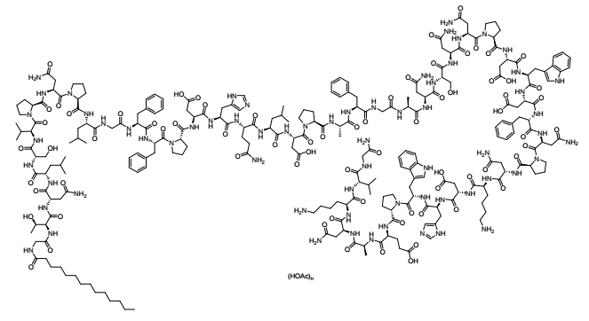
The proposed drug product is presented as a sterile, preservative-free, white to off-white lyophilised powder, in a clear glass vial with a grey butyl rubber stopper, and an aluminium overseal with a polypropylene flip off cap. The proposed pack size is 30 vials.
The recommended dosage in adults is 2 mg once daily administered by subcutaneous injection. The drug product is to be reconstituted with 1 mL sterile water for injection.
A 24-month shelf life for the drug product when stored at 2 °C to 8 °C is recommended.
Approval for registration of the proposed product is recommended from a quality perspective.

Nonclinical evaluation summary
The submitted nonclinical dossier was in accordance with the relevant ICH guideline for the nonclinical assessment of pharmaceuticals (ICH M3(R2)) and for biological medicines (ICH S6). The overall quality of the nonclinical dossier was satisfactory. Pivotal safety-related studies were Good Laboratory Practice compliant.
Bulevirtide is a 47-amino acid lipopeptide based on the region of the hepatitis B virus (HBV) envelope (HBV surface antigen, HBsAg) that interacts with sodium taurocholate co-transporting polypeptide (NTCP) to enable ingress of encapsulated HDV into hepatocytes. In vitro, bulevirtide bound to human, rat, rabbit and dog hepatocytes, which was indicative of NTCP binding (since NTCP expression is localised to the liver). Binding to NTCP was shown to be dependent on the presence of the HBsAg essential peptide sequence, 9’-NPLGFFP-15’ and a terminal myristic acid group. In primary cultures of human hepatocytes, bulevirtide inhibited viral infection by known HBV genotypes (A to H) and HDV genotypes (1 to 8), sourced from laboratory strains and clinical isolates, at similar concentration ranges (IC₅₀ 0.21 nM to 0.7 nM). These concentrations were within total clinical maximum concentration (C_{max}) and average concentration (C_{av}) ranges. In vivo studies demonstrated reduction in viraemia in mouse models that carried human HDV and HBV infections. Viraemia rebounded when bulevirtide dosing ceased. Overall, the pharmacology studies were adequate to support the proposed clinical indication.
Bulevirtide is expected to act selectively in the liver on cells that express NTCP. Non-specific binding was observed in vitro in cultured rat hepatic stellate cells, which was unrelated to bulevirtide peptide sequence and is of uncertain significance. Considering there was no evidence of cytotoxicity by bulevirtide in cultured stellate cells or in vivo (in repeat dose study), the non-specific binding of bulevirtide to the hepatic stellate cells is of low toxicological relevance.
Safety pharmacology studies assessed effects on the cardiovascular, respiratory and central nervous systems. No adverse effects were seen on central nervous system and respiratory functions in rats (at exposures ≥ 4.7 times the clinical C_{max}) and cardiovascular function in dogs (at exposures 17 times the clinical C_{max}). Thus, effects on these organ system functions are not expected during clinical use of bulevirtide.
Overall, the pharmacokinetic profile in animals was qualitatively similar to that of humans. Bulevirtide was rapidly absorbed in rats and participants and moderately absorbed in dogs. Half-life was similar in rats, dogs and humans (ranging between 1.5 to 7 hours). Plasma protein binding of bulevirtide was very high in all animal species and humans (> 99%). Bulevirtide showed rapid and specific distribution to the liver in all tested species, with the exception of cynomolgus monkeys. There was limited distribution of bulevirtide-associated radioactivity to other tissues, except the gastrointestinal tract. As a peptide, bulevirtide is subject to enzymatic cleavage into smaller peptides and excreted as peptide fragments, amino acids or other products of protein catabolism.
Bulevirtide did not demonstrate clinically relevant inhibitory effects on Cytochrome P450 (CYP) or efflux and uptake transporters.
Bulevirtide had a low order of acute toxicity through the subcutaneous route in rats and dogs.
Repeat-dose toxicity studies using the subcutaneous route were conducted in rats (up to 26 weeks) and dogs (13 weeks). Maximum exposures (as area under the concentration time curve (AUC)) were sufficiently high in rats and dogs (≥ 11 times and 82 times clinical AUC at the maximum recommended human dose, respectively). Bulevirtide was well-tolerated with limited toxicity findings. Elevated bile acid levels in dogs were not associated with any other corresponding treatment-related changes. Injection site findings were noted (subcutaneous haemorrhaging, inflammatory changes at the injection site) and seen in all groups, including vehicle controls.
As a peptide product, bulevirtide is not expected to interact with genetic material; hence genotoxicity studies were not performed, which is acceptable. In lieu of dedicated studies, the sponsor provided a carcinogenicity risk assessment in which the weight of evidence indicates a low carcinogenic risk for bulevirtide.
Fertility was not affected in male and female rats treated with bulevirtide at exposure levels ≥ 8.5 times the clinical AUC. There were no treatment-related embryofetal development findings in rats and rabbits at relative exposures 12 times and 124 times the clinical AUC, respectively. Maternal bile acid levels were elevated in the rabbit study with no evidence of adverse effects on embryofetal development. Similarly, pre-/postnatal development studies in rats did not identify any treatment-related effects on neonatal development and growth. Although not tested, due to its size, bulevirtide is not expected to cross the placenta or transfer in milk.
The nonclinical evaluation has recommended that Bulevirtide be assigned to pregnancy class C (rather than B1) based on the potential for bile acids to be potentially harmful to fetal health. The TGA has recommended that bulevirtide be assigned to pregnancy class B1 based on the totality of data.

Clinical evaluation summary

Summary of clinical studies
The clinical dossier contains four efficacy studies (MYR301, MYR202, MYR203 and MYR204). Of these, the pivotal safety and efficacy analysis is mainly based on the ongoing Phase III Study, MYR301. Studies MYR202 and MYR203 provide supportive efficacy data and post-treatment follow-up cohorts. Although bulevirtide is proposed for monotherapy, the latter two studies also examined combination treatment with PEG-IFNα and tenofovir and this may be relevant in the context of concomitant hepatitis B therapy.

Pharmacology

Pharmacokinetics
Bulevirtide is a 47 amino acid peptide with a myristic acid residue at the N-terminus and an amidated C-terminus.

Pharmacokinetics in healthy participants
The absolute bioavailability of bulevirtide after subcutaneous (SC) doses of 5 mg and 10 mg was 48% and 57% respectively in healthy participants.
The drug is highly protein bound in plasma (> 99%). The volume of distribution (Vd) of bulevirtide following a single dose in healthy participants ranged from 247 L to 43 L, decreasing as dose increased over the range of 800 micrograms to 10 mg SC.
It is assumed bulevirtide is eliminated by general protein catabolic processes, but this was not directly examined. It is not renally excreted.
Clearance (CL) decreased with increasing hepatitis dose following both single and multiple doses in healthy individuals over the range 800 micrograms to 10 mg. Over this same range, AUC and C_{max} increased at a greater than dose proportional rate in healthy participants.
The effect of non-dose-proportional increases in drug level was greater in doses of 5 mg and 10 mg SC.

Pharmacokinetics in the target population
Table 3: Pharmacokinetics of bulevirtide in target population from Study MYR202 pharmacokinetics
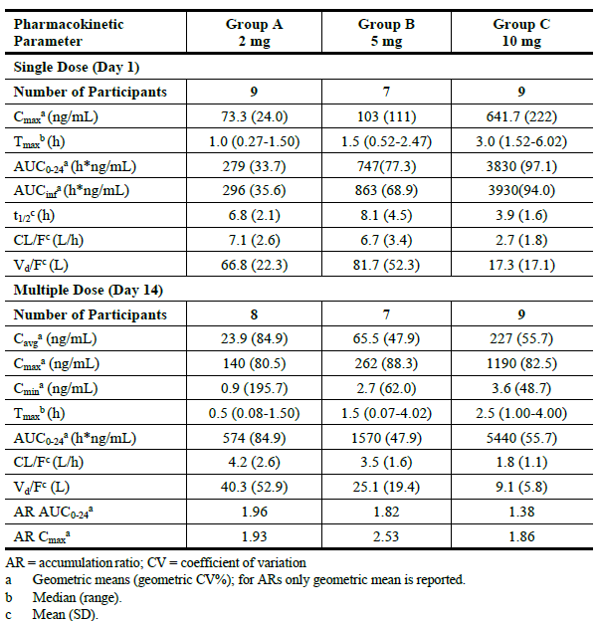
The non-proportional increase in AUC, with reduced CL and Vd were observed in this population.
The clinical evaluation noted that the C_{max} and AUC in participants with hepatitis D are higher than in healthy participants by approximately 2.8 to 3.8-fold after repeat dosing.
Steady state appears to be achieved by the end of the first week of dosing.

Impaired hepatic function
Bulevirtide is not metabolised by specific hepatic enzyme systems and so the effect of hepatic impairment is likely to be minimal. However, a PK analysis conducted in 154 participants with mild hepatic impairment and cirrhosis (Child-Pugh class A) indicated that cirrhosis is a significant co-variate for bulevirtide C_{max} and AUC. These figures were 38% and 42% higher in patients with cirrhosis than in those without (both having hepatic impairment) respectively.
No studies have been conducted in patients with more severe hepatic impairment.

Impaired renal function
Participants with mild renal impairment (creatinine clearance 60 to 90 mL/min) showed no change in AUC or C_{max} for Hepcludex. No studies have been conducted in participants with moderate or severe renal impairment. However, since no bulevirtide was detected in urine it is unlikely that renal impairment is a significant factor in drug elimination.

Age
Age does not appear to be a significant influence on bulevirtide exposure in the study in which it was examined, but none of the studies enrolled participants > 65 years of age or paediatric participants (< 18 years).

Population pharmacokinetics data
A population pharmacokinetics analysis was conducted on 4032 bulevirtide samples from 414 participants enrolled in Phase II and the pivotal Phase III study. This identified no additional covariates which are likely to be of clinical significance.

Drug interactions
Potential interaction between bulevirtide and the antiviral tenofovir was examined in healthy participants in a Phase II Study (MYR102) and in patients with hepatitis D. Both indicate an increase in bulevirtide AUC and C_{max} of 1.8 and 2.4-fold in healthy participants, and a lower increase in steady state concentrations (approximately 1.5-fold) observed in hepatitis D participants. The clinical relevance of these increases is not clear.
Potential interaction between bulevirtide and PEG-IFNα was examined in Study MYR203 and in the population pharmacokinetics analysis. This indicated no, or a clinically insignificant decrease, in bulevirtide exposure when it was co-administered with PEG-IFNα compared to monotherapy.
Potential interaction with CYP3A4 inhibitors was examined in a Phase II study which examined co-administration of bulevirtide and midazolam. There was no statistically significant effect of co-administration on the pharmacokinetics of hepatitis detected.

Pharmacodynamics

Bile acids
The effect of bulevirtide on plasma levels of bile salts was examined through sampling in several studies, including the pivotal efficacy trial. Bulevirtide increased levels of total bile acids after single and multiple dose administration, with area under the concentration time curve from zero to 24 hours increasing approximately 14-fold after a single dose and 19-fold after repeated doses of Hepcludex.
Table 4: Effect of adding bulevirtide to tenofovir on bile salts in Study MYR102
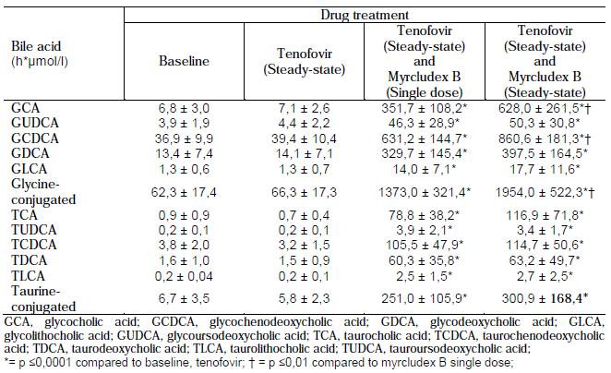Note: Myrcludex is an alternate trade name for Hepcludex.

Immunogenicity
A significant proportion of participants treated with Hepcludex developed anti-drug antibodies (ADA). In participants treated with bulevirtide and tenofovir, 15.6% of participants across all groups were ADA positive at 12 weeks. In participants treated with bulevirtide and PEG-IFNα between 93% and 100% of all patients in three groups developed ADA over 72 weeks of treatment. This is compared to 53.3% of bulevirtide 2 mg monotherapy participants who were ADA positive over 72 weeks of treatment. The development of ADA did not appear to influence efficacy.

Modelled effect on hepatitis D virus
Study MYR202 was used to develop a pharmacokinetic and pharmacodynamic model of disease progression, mainly to correlate the bulevirtide and hepatitis D virus levels observed in the efficacy Study MYR202.
Figure 2: Hepatitis D virus levels observed over 60 weeks with 24 weeks of receiving bulevirtide 2 mg/day
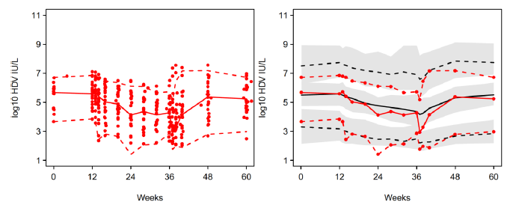
Left hand box: Scatterplot of observations in Study MYR202.
Right hand box: Mean (solid) and 95% confidence bounds (dashed) of observations (red) and predictive model (black).
There was a wide range of virological responses to bulevirtide treatment. The model was able to predict 90% of the results and was used to project a median time to where hepatitis D levels were likely to be zero. For the 2 mg/day dose of bulevirtide this was a median time of 2.88 years of treatment. The Delegate notes that no clinical data for this period of treatment has been provided.

Efficacy

Pivotal Study MYR301
Study MYR301 is an ongoing Phase III randomised controlled trial that has examined the efficacy of bulevirtide in participants with hepatitis D. The sponsor has provided a report of the first 48 weeks of treatment between April 2019 and November 2020.
Participants (n = 150) in the study were randomised 1:1:1 to one of three groups for a planned 144 weeks of treatment. In group A bulevirtide treatment was delayed by 48 weeks, which means they are a placebo group for the purposes of this evaluation.
Figure 3: Design of Study MYR301
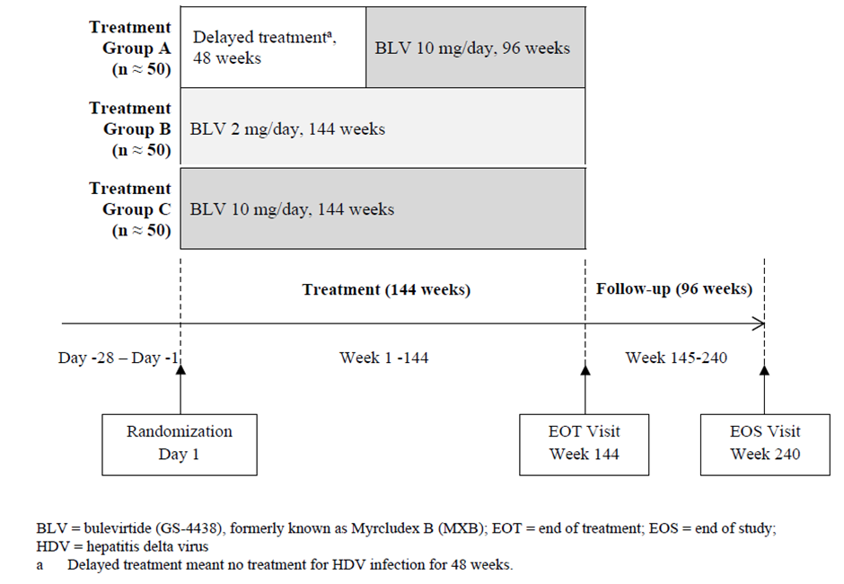
The primary endpoint of the study was the proportion of participants achieving a combined response at Week 48, defined as both:
- Undetectable hepatitis D RNA or decreased hepatitis delta virus RNA by ≥ 2 log10 IU/mL from baseline and,
- Alanine aminotransferase (ALT) normalisation.
Study MYR301 included adult participants 18 to 65 years of age who had positive serology or polymerase chain reaction (PCR) results for hepatitis D within 6 months of screening. It included participants who also had ALT levels > 1 but < 10 times the upper limit of normal and no or mild hepatic impairment (Child-Pugh score < 7). Participants with hepatitis C were excluded.
Figure 4: Participants disposition in Study MYR301
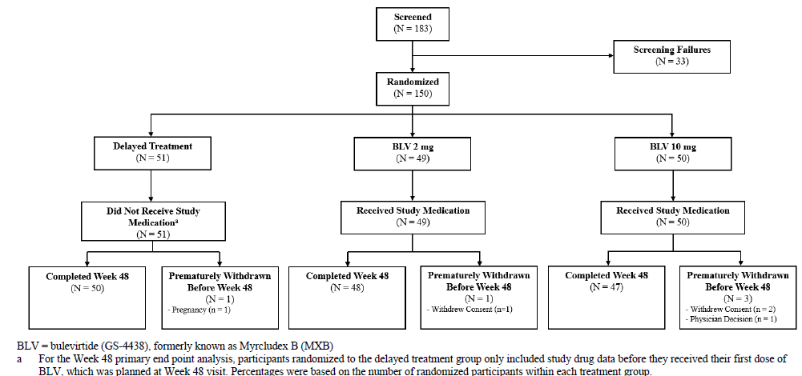
At 48 weeks, the proportion of participants achieving the primary endpoint was 44.9% (95% confidence interval (CI) 30.7 to 59.8%) in the bulevirtide 2 mg/day group compared to 2% (95% CI 0.0 to 10.4%) in the no-treatment group, which was a significant difference (p < 0.001).
For the secondary efficacy endpoint of normalisation of ALT at Week 48 this was 51.0% and 56.0% for bulevirtide 2 mg and 11.8% for delayed treatment.
Figure 5: Hepatitis D virus RNA over time in Study MYR301
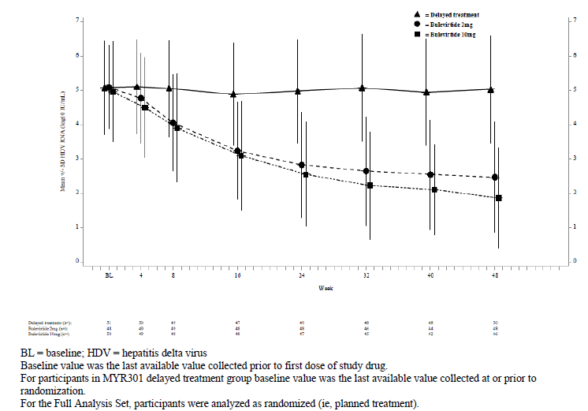

Study MYR202
Study MYR202 was an open-labelled study that compared the efficacy of bulevirtide in combination with tenofovir (245 mg/day) compared to tenofovir alone in 120 participants randomised equally to four groups. This included 28 participants who received Hepcludex 2 mg/day plus tenofovir and 30 participants who received tenofovir alone for 24 weeks of treatment.
The enrolled population was the same as that in Study MYR301.
The primary endpoint in the study was the rate of hepatitis D virus RNA response, defined as:
- RNA negativity or,
- Decrease in hepatitis D RNA by ≥ 2 log10 IU/mL from baseline to Week 24.
This endpoint was achieved by 53.6% of participants who received bulevirtide 2 mg/day plus tenofovir compared to 3.6% of participants who received tenofovir alone.
Table 5: Proportion of participants achieving primary endpoint in Study MYR202
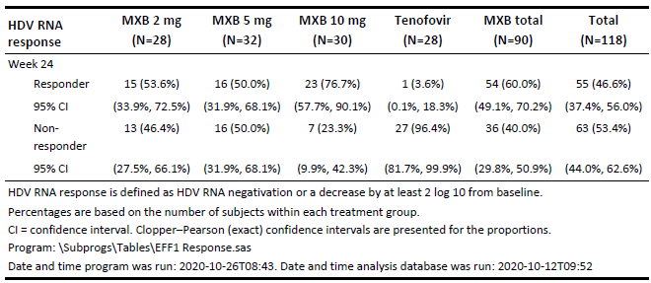
A subgroup analysis compared the proportion of participants with or without cirrhosis at baseline who achieved the primary endpoint. In the bulevirtide 2 mg plus tenofovir group 53.3% (8 out of 15) of the participants with cirrhosis at baseline achieved a hepatitis D RNA response, and only one participant on tenofovir monotherapy did. This indicated the response rate in participants with cirrhosis was similar to that in participants without cirrhosis.
Figure 6: Hepatitis D levels after 48 weeks follow-up after 24 weeks treatment in Study MYR202
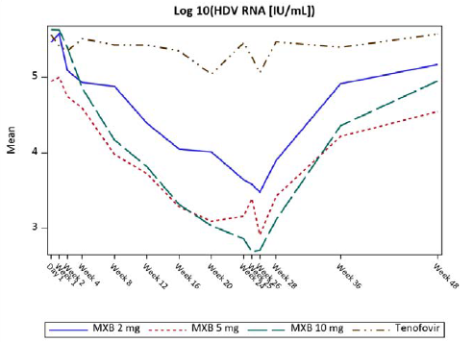
Bulevirtide treatment caused a reduction in hepatitis D levels over the period of treatment, which can be attributed to bulevirtide because tenofovir monotherapy produced no significant effect. The Delegate notes that viral levels returned to baseline levels after treatment was ceased.

Study MYR203
Study MYR203 was an open-label Phase II study that examined the efficacy of bulevirtide in 90 participants equally randomised to 6 groups (n = 15) of treatment for 48 weeks, with 24 weeks of follow-up to Week 72. Treatment consisted of PEG-IFNα in combination with Hepcludex, bulevirtide monotherapy, Hepcludex plus tenofovir, or PEG-IFNα monotherapy. The relevant group of the study for this application was group D, 2 mg Hepcludex/day.
The enrolled population was similar to that in the other MYR studies.
The primary endpoint was the proportion of participants who achieved a negative hepatitis D RNA PCR at 72 weeks follow-up. This was achieved by 6.7% (95% CI 0.2 to 31.9%) of patients taking bulevirtide 2 mg/day. No participant on PEG-IGNα alone was hepatitis D RNA negative at 72 weeks. However, 53% (95% CI 26.6 to 78.7%) of participants who took bulevirtide 2 mg/day plus PEG-IFNα were hepatitis D RNA negative at the end of follow up.
Table 6: Proportion of participants reaching negative hepatitis D RNA at 72 weeks of treatment in Study MYR203
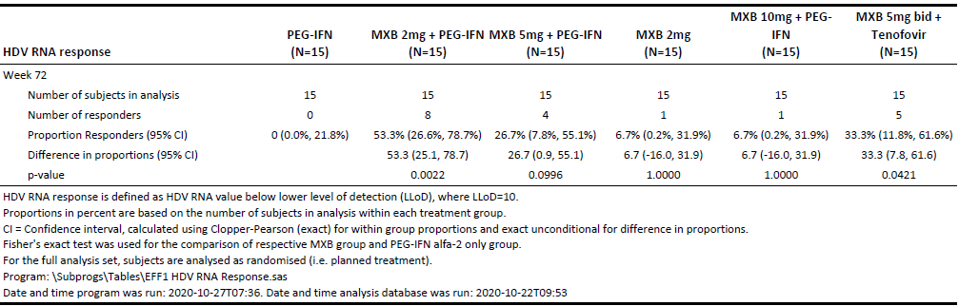
Figure 7: Hepatitis D RNA over 48 weeks of treatment and 72 weeks of observation in Study MYR203
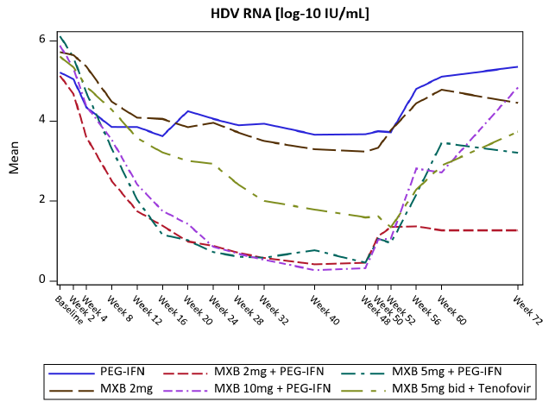
Mean hepatitis D RNA levels generally decreased on bulevirtide 2 mg/day treatment, but more so on combination treatment with PEG-IFNα. However, in all treatment groups there was a rebound in mean hepatitis D RNA following the end of active treatment.

Study MYR204
Study MYR204 was a similar study to Study MYR203, examining the effect of bulevirtide or PEG-IFNα alone or bulevirtide in combination with PEG-IFNα in 175 randomised participants. The study is ongoing and is planned to observe participants to 144 weeks with up to 96 weeks of bulevirtide treatment. This application included an interim 24-week report.
The primary endpoint was the proportion of participants reaching undetectable hepatitis D RNA levels at 24 weeks (for the interim report).
At 24 weeks, group B (bulevirtide 2 mg/day) achieved a response rate of 30%. None of the other groups included the proposed dose of bulevirtide 2 mg/day in combination with PEG-IFNα.

Safety
No studies were conducted specifically to examine adverse events. Adverse event data has been presented from Studies MYR301, MYR203 and MYR204.
Table 7: Summary of treatment groups in the integrated safety analysis
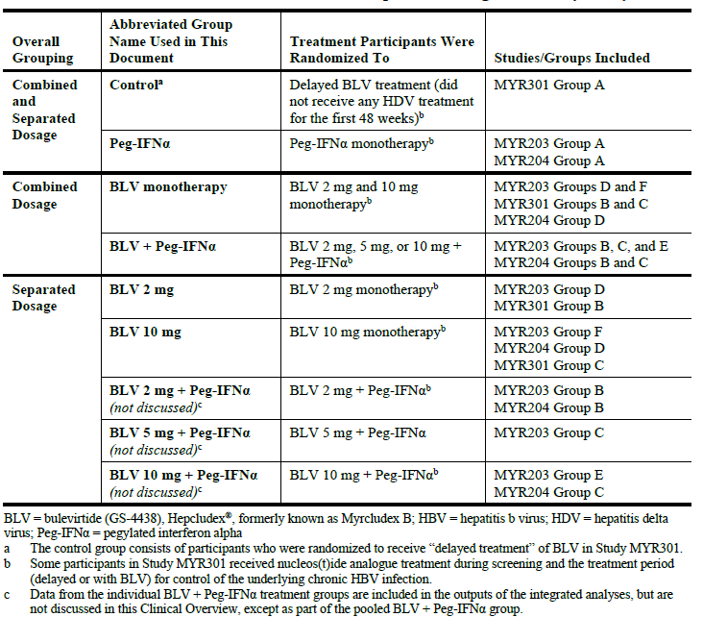
In these studies, 324 participants had at least one dose of bulevirtide either as monotherapy or in combination with PEG-IFNα. Of these, 64 participants received bulevirtide 2 mg/day monotherapy and almost all (98.4%) of these were for 48 weeks of treatment. The participants who were in the delayed treatment group of Study MYR301 were used as a control as they were not receiving any active treatment during this period.
Table 8: Overall analysis of adverse events in integrated safety analysis
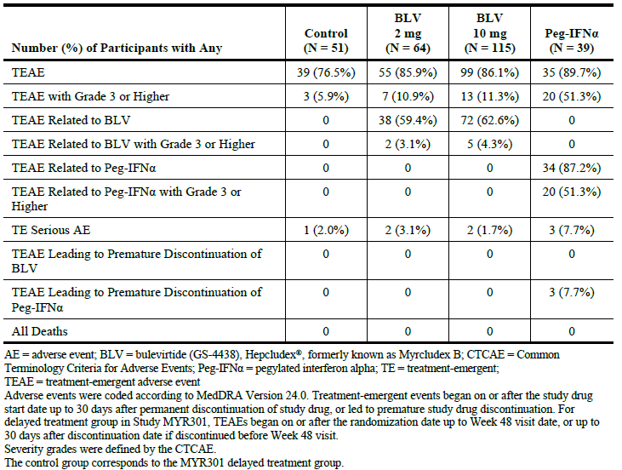
The majority of participants reported at least one treatment emergent adverse event (TEAE), of which most were not serious (Grade 1 to 2) and a small percentage serious (3.1%).
Table 9: Treatment emergent adverse events reported in > 10% of participants in study population
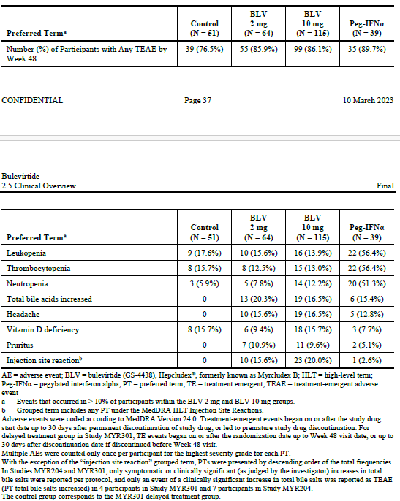
These adverse events occurred at approximately the same rate for 2 mg and 10 mg doses of bulevirtide monotherapy groups, but the addition of PEG-IFNα produced additional adverse events related to that therapy. Dizziness, fatigue, nausea, asthenia and eosinophilia were all reported at higher rates in the bulevirtide monotherapy group than in the controls.

Deaths, serious adverse events and discontinuations
There was one death reported in a participant receiving bulevirtide 2 mg plus PEG-IFNα who discontinued treatment due to an anaplastic astrocytoma. This was assessed as not related to either therapy.
Exacerbation of hepatitis occurred in 4 participants receiving bulevirtide following discontinuation of treatment. In one of these cases there was a reactivation of HBV-DNA replication, in one case there was a transient rise in ALT associated with weakness, and in two cases there was an asymptomatic rise in ALT. All cases resolved. The sponsor has noted that increases in viral replication are not unexpected when discontinuing an antiviral.

Hepatic safety
On treatment, the proportion of participants who experience a hepatic flare was slightly higher in the bulevirtide 2 mg/day group than in controls (17.2% and 15.7% respectively) but was lower than with PEG-IFNα groups (21.5% to 46.7%).
Drug induced liver injury was not reported in any bulevirtide monotherapy groups.
Thirteen percent (13.0%) of participants in the bulevirtide monotherapy groups met at least one of the 3 components of liver injury by Hy’s law, compared to 21.5% of those in the control groups.

Injection site reactions
The proportion of participants with injection site reactions was similar between bulevirtide 2 mg monotherapy (15.6%) and Hepcludex plus PEG-IFNα (13.8% to 20.0%). Injection site reactions were not reported in the control group, but these participants did not receive a placebo group but no treatment (that is, no injections).

Eosinophilia
Across the studies, 12 participants reported eosinophilia and 3 eosinophil count increased, of which 12 occurred in bulevirtide monotherapy groups.
Ten participants had raised eosinophils at two or more consecutive visits, and two experienced potential hepatic flare events. In neither case did the hepatic events occur concurrently with the raised eosinophil count, both in bulevirtide monotherapy groups. These flares resolved.

Renal safety
Renal and urinary adverse events were reported at low rates across both bulevirtide and control treatment groups (8.4% and 10.3% respectively).
Bile salt levels were compared in participants with mild renal impairment (creatine clearance 60 to 90 mL/min) and those with normal function (creatine clearance > 90 mL/min). There were no differences in mean bile salt levels between these two group in bulevirtide treated participants.

Risk management plan
The sponsor submitted European Union (EU) Risk Management Plan (RMP) version 3.0 (date 8 November 2022; data lock point (DLP) 30 July 2022) and Australian specific annex (ASA) version 0.1 (date March 2023) in support of this application.
In response to the TGA question sent on 20 June 2023, the sponsor has submitted ASA version 0.2 (dated June 2023) in association with previously submitted EU-RMP version 3.0 (date 8 November 2022; DLP 30 July 2022).
The summary of safety concerns and their associated risk monitoring and mitigation strategies are summarised in Table 10. The TGA may request an updated RMP at any stage of a product's life cycle, during both the pre-approval and post-approval phases.
Table 10: Summary of safety concerns
Summary of safety concerns |  | Pharmacovigilance |  | Risk Minimisation
 |  | Routine | Additional | Routine | Additional
Important identified risks | Hepatitis exacerbation after drug discontinuation |  | * |  | None
Important potential risks | None | - | - | - | -
Missing information | Use in patients with moderate or severe renal impairment |  | None |  | None
Missing information | Use in patients with decompensated liver disease |  | None |  | None
Missing information | Long term safety of bile acid elevation |  | *† |  | None
*MYR301 and MYR204 – Clinical trials (No Australian sites)
†GS-US-589-6206 – A registry study (No Australian sites)
The summary of safety concerns in the ASA aligns with the approved EU-RMP. The sponsor was requested to provide justification for not including ‘use in pregnancy’ as missing information. The sponsor’s justification for not including ‘use in pregnancy’ as missing information in the summary of safety concerns was acceptable from an RMP perspective.
The sponsor has proposed routine pharmacovigilance for all safety concerns. The sponsor has proposed additional pharmacovigilance in the form of clinical trials and a registry study for ‘hepatitis exacerbation after drug discontinuation’ and ‘long term safety of bile acid elevation’. The sponsor has agreed to provide results of the studies in a revised RMP when available.
The sponsor has proposed only routine risk minimisation activities, through draft Product information (PI) and Consumer Medicine Information (CMI), for all safety concerns. No additional risk minimisation activities have been proposed. The risk minimisation plan is acceptable from an RMP perspective. The sponsor was requested to amend the draft PI and CMI.
The RMP evaluation recommended conditions of registration relating to the versions of the risk management plan, requirement for periodic safety update reports, and inclusion of the medicine in the Black Triangle Scheme.

Risk-benefit analysis

Delegate’s considerations
Bulevirtide is an antiviral which prevents entry of hepatitis D into target cells, and there is a clear un-met need for targeted hepatitis D treatments. Bulevirtide is able to produce a reduction in viral load and improvement in ALT in many participants while they remain on therapy for up to 48 weeks. However, the majority of participants experience virological rebound and, rarely, a transient worsening of hepatic function after discontinuation of treatment. The Delegate notes that the sponsor has not specified a period of treatment.
In the pivotal Study MYR301 approximately 45% of participants achieved undetectable (< lower limit of quantitation [LLOQ], target no detected) hepatitis delta virus (HDV) RNA or decreased by ≥ 2 log10 IU/mL from baseline and ALT normalisation at 48 weeks of therapy, however Study MYR203 indicated that only 6.7% of participants had undetectable hepatitis D levels 24 weeks after ceasing this period of monotherapy treatment (that is, at 72 weeks). The achievement of undetectable hepatitis D levels does not, therefore, seem to be a reliable indicator of hepatitis D being eliminated.
Bulevirtide monotherapy seems well tolerated and there is no specific toxicity that emerges in combination with PEG-IFNα that is not expected from PEG-IFNα itself, particularly leukopenia. There is, however, relatively short-term data available compared to the likely length of therapy with bulevirtide and this limits the certainty with which long term adverse events can be excluded.

Proposed action
Pending the advice of Advisory Committee on Medicines (ACM), the Delegate is inclined to approve the inclusion of bulevirtide in the ARTG for the indication:
Hepcludex is indicated for the treatment of chronic hepatitis delta virus (HDV) infection in adults with compensated liver disease.

Advisory Committee considerations
The Advisory Committee on Medicines (ACM), having considered the evaluations and the Delegate’s overview, as well as the sponsor’s response to these documents, advised the following.

Specific advice to the Delegate
The ACM advised the following in response to the Delegate’s specific request for advice:
- Is the efficacy of bulevirtide as demonstrated over 24 to 48 weeks of therapy sufficient to demonstrate clinically meaningful efficacy.
The ACM was of the view that there was sufficient evidence to demonstrate clinically meaningful efficacy over a treatment period of 24 to 48 weeks. This response was sustained up to 72 weeks. The limited available treatment options for HDV were noted.
The ACM advised that additional long term efficacy data would be needed to confirm the clinical benefit of bulevirtide, noting that approximately half of patients who tested negative for HDV RNA at 24 weeks post-treatment relapsed during the course of follow up. However, the ACM advised that as HDV is not curable, this rate of relapse was not unexpected. The ACM was of the view that complete eradication of HDV was likely not feasible with current treatments as intrahepatic HDV is difficult to eradicate.

Advisory committee conclusion
The ACM considered this product to have an overall positive benefit-risk profile for the indication:
Hepcludex is indicated for the treatment of chronic hepatitis delta virus (HDV) infection in adults with compensated liver disease.

Assessment outcome
Based on a review of quality, safety, and efficacy, the TGA decided to register Hepcludex (bulevirtide) 2 mg, powder for injection, vial, indicated for:
Hepcludex is indicated for the treatment of chronic hepatitis delta virus (HDV) infection in adults with compensated liver disease.

Specific conditions of registration
- Hepcludex (bulevirtide) is to be included in the Black Triangle Scheme. The PI and CMI for Hepcludex must include the black triangle symbol and mandatory accompanying text for five years, which starts from the date that the sponsor notifies the TGA of supply of the product.
- The Hepcludex EU-Risk Management Plan (RMP) (version 3.0, dated 8 November 2022, data lock point 30 July 2022), with Australian Specific Annex (version 0.2, dated June 2023), included with submission PM-2023-01186-1-2, and any subsequent revisions, as agreed with the TGA will be implemented in Australia.
- An obligatory component of risk management plans is routine pharmacovigilance. Routine pharmacovigilance includes the submission of periodic safety update reports (PSURs).
Reports are to be provided in line with the current published list of EU reference dates and frequency of submission of PSURs until the period covered by such reports is not less than three years from the date of the approval letter.
The reports are to at least meet the requirements for PSURs as described in the European Medicines Agency’s Guideline on good pharmacovigilance practices (GVP) Module VII-periodic safety update report (Rev 1), Part VII.B Structures and processes. Note that submission of a PSUR does not constitute an application to vary the registration. Each report must have been prepared within ninety calendar days of the data lock point for that report.

Product Information and Consumer Medicine Information
For the most recent Product Information (PI) and Consumer Medicine Information (CMI), please refer to the TGA PI/CMI search facility.

Therapeutic Goods Administration
PO Box 100 Woden ACT 2606 Australia
Email: info@tga.gov.au Phone: 1800 020 653 Fax: 02 6203 1605
https://www.tga.gov.au
Reference/Publication #

This is the original indication proposed by the sponsor when the TGA commenced the evaluation of this submission. It may differ to the final indication approved by the TGA and registered in the Australian Register of Therapeutic Goods.
Heidrich et al., Late HDV RNA relapse after peginterferon alpha-based therapy of chronic hepatitis delta, Hepatology, 2014; 60(1): 87-97. doi: 10.1002/hep.27102.
The Child-Pugh score is used to assess the prognosis of chronic liver disease. The score employs five clinical measures of liver disease. Each measure is scored 1 to 3, with 3 indicating most severe derangement. Class A: 5 to 6 points, least severe liver disease, one to five year survival rate of 95%. Class B: 7 to 9 points, moderately severe liver disease, one to five year survival of 75%. Class C: 10 to 15 points, most severe liver disease, 1 to 5 year survival rate 50%.
Hys law states a drug may be at risk of causing liver injury if: The drug causes hepatocellular injury, generally defined as an elevated ALT or AST by 3-fold or greater above the upper limit of normal. Often with aminotransferases much greater (5-10x) than the upper limit of normal. Among subjects showing such aminotransferase elevations, they also have elevation of their serum total bilirubin of greater than 2× the upper limit of normal, without findings of cholestasis (defined as serum alkaline phosphatase activity less than 2× the upper limit of normal). No other reason can be found to explain the combination of increased aminotransferase and serum total bilirubin, such as viral hepatitis, alcohol abuse, ischemia, preexisting liver disease, or another drug capable of causing the observed injury.

