Australian Public Assessment Report for Elfabrio
  - Active ingredient: pegunigalsidase alfa
  - Sponsor: Chiesi Australia Pty Ltd
March 2026

About the Therapeutic Goods Administration (TGA)
- The Therapeutic Goods Administration (TGA) is part of the Australian Government Department of Health, Disability and Ageing and is responsible for regulating therapeutic goods, including medicines, medical devices, and biologicals.
- The TGA administers the Therapeutic Goods Act 1989 (the Act), applying a risk management approach designed to ensure therapeutic goods supplied in Australia meet acceptable standards of quality, safety, and efficacy.
- The work of the TGA is based on applying scientific and clinical expertise to decision-making, to ensure that the benefits to the Australian public outweigh any risks associated with the use of therapeutic goods.
- The TGA relies on the public, healthcare professionals and industry to report problems with therapeutic goods. The TGA investigates reports received to determine any necessary regulatory action.
- To report a problem with a therapeutic good, please see the information on the TGA website.

About AusPARs
- The Australian Public Assessment Report (AusPAR) provides information about the evaluation of a prescription medicine and the considerations that led the TGA to approve or not approve a prescription medicine submission. Further information can be found in Australian Public Assessment Report (AusPAR) guidance.
- AusPARs are prepared and published by the TGA.
- AusPARs are static documents that provide information that relates to a submission at a particular point in time. The publication of an AusPAR is an important part of the transparency of the TGA’s decision-making process.
- A new AusPAR may be provided to reflect changes to indications or major variations to a prescription medicine subject to evaluation by the TGA.

Copyright
© Commonwealth of Australia 2026
This work is copyright. You may reproduce the whole or part of this work in unaltered form for your own personal use or, if you are part of an organisation, for internal use within your organisation, but only if you or your organisation do not use the reproduction for any commercial purpose and retain this copyright notice and all disclaimer notices as part of that reproduction. Apart from rights to use as permitted by the Copyright Act 1968 or allowed by this copyright notice, all other rights are reserved and you are not allowed to reproduce the whole or any part of this work in any way (electronic or otherwise) without first being given specific written permission from the Commonwealth to do so. Requests and inquiries concerning reproduction and rights are to be sent to the TGA Copyright Officer, Therapeutic Goods Administration, PO Box 100, Woden ACT 2606 or emailed to <tga.copyright@tga.gov.au>.

Contents
List of abbreviations 4
Product submission 6
Submission details 6
Product background 7
Condition 7
Current treatment options 7
Clinical rationale 8
Regulatory status 8
Australian regulatory status 8
International regulatory status 8
Registration timeline 12
Assessment overview 13
Quality evaluation summary 13
Nonclinical evaluation summary 14
Clinical evaluation summary 15
Summary of clinical studies 15
Pharmacology 18
Efficacy 24
Safety 31
Risk management plan 36
Risk-benefit analysis 36
Pharmacology 36
Efficacy 37
Safety 37
Advisory Committee considerations 38
Assessment outcome 39
Specific conditions of registration 39
Product Information and Consumer Medicine Information 40

List of abbreviations
Abbreviation | Meaning
ACM | Advisory Committee on Medicines
ADA | Anti-drug antibodies
ARTG | Australian Register of Therapeutic Goods
AUC | Area under the plasma concentration-time curve
BLISS | Barisoni Lipid Inclusion Scoring System (BLISS)
CL | Clearance from plasma
C_{max} | Maximum observed concentration
CMI | Consumer Medicines Information
Delegate | The Delegate of the Secretary of the Department of Health, Disability and Ageing who decided the submission under section 25 of the Act.
E4W | Every four weeks
E2W | Every two weeks
eGFR | Estimated glomerular filtration rate
ERT | Enzyme replacement therapy
α-GAL-A | α-galactosidase A
(Gb-3) | globotriaosylceramide
Lyso-Gb3) | globotriaosylsphingosine
IV | Intravenous
ITT | Intention to treat
LVMI | Left Ventricular Mass Index
nAbs | neutralising antibodies
PD | pharmacodynamics
PEG | Polyethylene glycol
PI | Product Information
PK | Pharmacokinetics
PRX-102 | Development name for pegunigalsidase alfa
PSUR | Periodic safety update report
RMP | Risk management plan
SAE | Serious adverse event
SD | Standard deviation
SE | Standard error
t_{1/2} | Half-life in the terminal elimination phase
TGA | Therapeutic Goods Administration
T_{max} | Maximum concentration within a dosing interval
TEAEs | Treatment-emergent adverse events
UPCR | Urine protein-to-creatinine ratio
V_{z} | Volume of distribution during the terminal phase

Product submission

Submission details
Type of submission: | New chemical entity
Product names: | Elfabrio
Active ingredient: | Pegunigalsidase alfa
Decision: | Approved
Date of decision: | 12 May 2025
Approved therapeutic use for the current submission: | Elfabrio is indicated for long-term enzyme replacement therapy in adult patients with a confirmed diagnosis of Fabry disease.
Date of entry into ARTG | 26 May 2025
ARTG number: | 446710
Black Triangle Scheme | Yes
Sponsor’s name and address: | Chiesi Australia Pty Ltd, Level 7, Suite 1, 500 Bourke Street, Melbourne, VIC 3000.
Dose form: | Clear, colourless solution
Strength: | Each vial contains 20 mg of pegunigalsidase alfa in a volume of 10 mL (2 mg/mL).
Container: | 15R Type I glass vial with a chlorobutyl rubber stopper and sealed with aluminium flip off cap.
Pack size: | 1, 5 or 10 vials per carton
Route of administration: | Intravenous infusion
Dosage: | 1 mg/kg of body weight administered once every two weeks  For further information regarding dosage, refer to the Product Information.
Pregnancy category: | Category B3  Drugs which have been taken by only a limited number of pregnant women and women of childbearing age, without an increase in the frequency of malformation or other direct or indirect harmful effects on the human fetus having been observed.  Studies in animals have shown evidence of an increased occurrence of fetal damage, the significance of which is considered uncertain in humans.  The use of any medicine during pregnancy requires careful consideration of both risks and benefits by the treating health professional. The pregnancy database must not be used as the sole basis of decision making in the use of medicines during pregnancy. The TGA does not provide advice on the use of medicines in pregnancy for specific cases. More information is available from obstetric drug information services in your state or territory.

Product background
This AusPAR describes the submission by Chiesi Australia Pty Ltd (the Sponsor) to register Elfabrio (pegunigalsidase alfa) for the following proposed indication:
Elfabrio is indicated for long-term enzyme replacement therapy in adult patients with a confirmed diagnosis of Fabry disease.

Condition
Fabry disease is an X-linked lysosomal storage disorder caused by alterations in the gene that encodes the enzyme α-galactosidase A (α-GAL-A) leading to deficient or absent enzymatic activity. α-GAL-A is required for metabolism of the glycosphingolipid substrate globotriaosylceramide (Gb-3) and its degradation product globotriaosylsphingosine (Lyso-Gb3). Reduced α-Gal A activity is associated with the progressive accumulation of glycosphingolipid substrates in tissues (particularly the kidneys, heart, and brain) resulting in disruption of normal cellular activity and leading to the development of serious complications and reduced life expectancy.
Fabry disease is regarded as a rare disease with originally estimated prevalence of 1:40,000 males and 1:117,000 of the general population; however, the prevalence may be substantially higher than these estimates due to non-specific disease manifestations, delays in diagnosis, late-onset mutations, and marked phenotypic variation, particularly in female patients.
Fabry disease expresses itself differently in males and females, with males generally more severely affected than females. Affected males are hemizygotes and may present with a severe ‘classic’ phenotype but some may present with late-onset manifestations. Affected females are heterozygotes and have a variable clinical phenotype (typically milder than males) due to the mosaicism effect.
Clinical manifestations may include neuropathic pain and acroparaesthesia, telangiectasia and angiokeratomas, hypohidrosis, cornea verticillata (opacities), hearing loss, gastrointestinal symptoms, renal disease, cardiac involvement (hypertrophic cardiomyopathy, conduction defects, arrhythmia, valvular disease, and coronary artery disease), and cerebrovascular disease.

Current treatment options
Therapeutic options for Fabry disease include enzyme replacement therapy (ERT) and the pharmacological chaperone, migalastat. ERT involves exogenous IV administration of purified recombinant α-GAL-A and can be used across the entire spectrum of disease-causing mutations. Two ERT products are registered in Australia: Replagal (agalsidase alfa) and Fabrazyme (agalsidase beta). Replagal has been registered in Australia since 2002 and Fabrazyme since 2006. The dose of Replagal is 0.2 mg/kg by IV infusion every 2 weeks and the dose of Fabrazyme is 1 mg/kg by IV infusion every 2 weeks. The approved indications are:
Replagal (agalsidase alfa ghu) is indicated for long-term enzyme replacement therapy of patients with Fabry Disease (α -galactosidase A deficiency).
Fabrazyme is indicated for long-term enzyme replacement therapy in patients with a confirmed diagnosis of Fabry disease (α-galactosidase deficiency).
Galafold (migalastat) is a pharmacological chaperone designed to selectively and reversibly bind to the active sites of certain mutant forms of α-Gal A. Migalastat binding stabilises these mutant forms of α-Gal A in the endoplasmic reticulum and facilitates their proper trafficking to lysosomes where dissociation of migalastat restores α-Gal A activity. This treatment is used only in patients with an amenable mutation. Galafold has been registered in Australia since 2017. Galafold is administered orally and the dose is 123 mg (1 capsule) every other day. The approved indication is:
Galafold is indicated for long-term treatment of adult and adolescent patients 12 years and older with a confirmed diagnosis of Fabry disease (α-galactosidase A deficiency) and who have an amenable mutation (see the table in Section 5.1 Pharmacodynamic Properties, Mechanism of action).

Clinical rationale
Pegunigalsidase alfa is a PEGylated, covalently cross-linked recombinant form of human α-galactosidase A (α-GAL-A) developed as an ERT for the treatment of patients with Fabry disease. The rationale for the development of Elfabrio is that the PEGylation of pegunigalsidase alfa results in increased stability and improved availability of active enzyme in the circulation throughout the dosing interval and a reduction in treatment-induced anti-drug antibodies (ADAs) and neutralising antibodies (nAbs).

Regulatory status

Australian regulatory status
This product is considered a new chemical entity for Australian regulatory purposes.

International regulatory status
At the time the TGA considered this submission, a similar submission had been considered by other regulatory agencies. Table 1 summarises these submissions and provides the indications where approved.
Table 1. International regulatory status at the time the TGA considered this submission
Country/region | Marketing authorisation details (tradename, licence) | Submission date | Approval date (if applicable) | Approved indication
European Union Centralised | Elfabrio EMEA/H/C/005618 | 25 January 2022 | 4 May 2023 | Elfabrio is indicated for long-term enzyme replacement therapy in adult patients with a confirmed diagnosis of Fabry disease (deficiency of alpha-galactosidase).
USA | Elfabrio BLA 761161 | 27 May 2020 | 09 May 2023 | Elfabrio is a hydrolytic lysosomal neutral glycosphingolipid-specific enzyme indicated for the treatment of adults with confirmed Fabry disease.
United Kingdom | Elfabrio PLGB 08829/0210 | 28 February 2023 | 07 August 2023 | Elfabrio is indicated for long-term enzyme replacement therapy in adult patients with a confirmed diagnosis of Fabry disease (deficiency of alpha-galactosidase).
Switzerland | Elfabrio 69257 | 20 April 2023 | 11 September 2023 | Elfabrio is indicated for long-term enzyme replacement therapy in adult patients with a confirmed diagnosis of Fabry disease (deficiency of alpha-galactosidase).
Israel | Elfabrio | 3 July 2023 | 24 June 2024 | Elfabrio is indicated for long-term enzyme replacement therapy in adult patients with a confirmed diagnosis of Fabry disease (deficiency of alpha-galactosidase).
Russia | Elfabrio | 14 July 2023 | 13 January 2025 | Elfabrio is indicated for long-term enzyme replacement therapy in adult patients with a confirmed diagnosis of Fabry disease (deficiency of alpha-galactosidase).
Taiwan | Elfabrio | 14 August 2023 | 24 April 2025 | Elfabrio is indicated for long-term enzyme replacement therapy in adult patients with a confirmed diagnosis of Fabry disease (deficiency of alpha-galactosidase).
Colombia | Elfabrio | 25 September 2023 | 23 December 2025 | Elfabrio is indicated for long-term enzyme replacement therapy in adult patients with a confirmed diagnosis of Fabry disease (deficiency of alpha-galactosidase).
Peru | Elfabrio | 25 September 2023 | 20 May 2024 | Elfabrio is indicated for long-term enzyme replacement therapy in adult patients with a confirmed diagnosis of Fabry disease (deficiency of alpha-galactosidase).
Brazil | Elfabrio | 30 October 2023 | Pending | Elfabrio is indicated for long-term enzyme replacement therapy in adult patients with a confirmed diagnosis of Fabry disease (deficiency of alpha-galactosidase).
Singapore | Elfabrio | 27 February 2024 | 20 February 2025 | Elfabrio is indicated for long-term enzyme replacement therapy in adult patients with a confirmed diagnosis of Fabry disease (deficiency of alpha-galactosidase).
Hong Kong | Elfabrio | 21 June 2024 | Pending | Elfabrio is indicated for long-term enzyme replacement therapy in adult patients with a confirmed diagnosis of Fabry disease (deficiency of alpha-galactosidase).
Canada | Elfabrio | 24 June 2025 | 09 December 2025 | ELFABRIO (pegunigalsidase intravenous injection) is indicated for long-term enzyme replacement therapy in adult patients with a confirmed diagnosis of Fabry disease (deficiency of alpha-galactosidase).
South Korea | Elfabrio | 17 July 2024 | Pending | Elfabrio is indicated for long-term enzyme replacement therapy in adult patients with a confirmed diagnosis of Fabry disease (deficiency of alpha-galactosidase).
Serbia | Elfabrio | 22 October 2024 | 17 December 2025 | Elfabrio is indicated for long-term enzyme replacement therapy in adult patients with a confirmed diagnosis of Fabry disease (deficiency of alpha-galactosidase).

Registration timeline
Table 2. Timeline for Elfabrio (pegunigalsidase alfa), Submission PM-2024-01551-1-1 captures the key steps and dates for this submission.
This submission was evaluated under the standard prescription medicines registration process.
Table 2. Timeline for Elfabrio (pegunigalsidase alfa), Submission PM-2024-01551-1-1
Description | Date
Submission dossier accepted and first round evaluation commenced | 31 May 2024
Evaluation completed | 28 February 2025
Advisory committee meeting | 4 April 2025
Registration decision (Outcome) | 12 May 2025
Registration in the ARTG completed | 26 May 2025
Number of working days from submission dossier acceptance to registration decision* | 174
*Statutory timeframe for standard submissions is 255 working days

Assessment overview

Quality evaluation summary
Pegunigalsidase alfa is a polyethylene glycol (PEG)-ylated, covalently cross-linked recombinant human protein α-galactosidase A (α-GAL-A).
Pegunigalsidase alfa is internalised to the lysosomes of cells derived from patients with Fabry disease, where it hydrolyses terminal alpha-galactosyl moieties from the glycolipid globotriaosylceramide (Gb3) to yield galactose and lactosylceramide.
Cellular uptake of pegunigalsidase alfa is a combination of endocytosis and mannose mediated receptor uptake. Using these specific cells uptake is inhibited by Mannan, confirming that at least part of the uptake is through mannose receptor. Pegunigalsidase alfa does not contain mannose-6-phosphate as part of its glycan structure, therefore uptake through M6P receptor is not anticipated.
The complete cDNA of human alpha-GAL-A encodes a 429-amino acid protein. After entering the endoplasmic reticulum, a 31-amino acid signal peptide is removed, producing a mature 398-amino acid protein, starting with the sequence LDNGL. The plant-produced recombinant version differs: it is comprised of 437 amino acids including a 33-amino acid leader peptide derived from Arabidopsis ABP1, the 398-amino acid human alpha-GAL-A sequence, and a C-terminal endoplasmic reticulum retention sequence (SEKDEL) of 6 amino acids. The mature protein includes an additional SEKDEL sequence, totalling 405 amino acids. The immature recombinant human α-galactosidase-A (prh-alpha-GAL-A) is a homodimeric protein consisting of two identical, non-covalently bound subunits. The prh-alpha-GAL-A is produced using recombinant DNA technology in genetically modified followed by purification techniques.
The prh-alpha-GAL-A is chemically modified using a bis-functional PEG-based crosslinker to yield the pegunigalsidase alfa drug substance. The chemical reaction results in PEGylated prh-alpha-GAL-A monomers, the majority of which are cross-linked to give a covalently bound “homodimer” through PEG chains. Figure 1 illustrates the homodimeric structure of the enzyme composed of 2 subunits (blue and pink ribbons) with the addition of PEG chains connected to various lysine residues (green and red random chains). Two PEG chains crosslink the subunits, while 6 PEG chains are attached only to one lysine residue. The protein structure is derived from the structure of human alpha-galactosidase found in the PDB database (accession number 1R46) and visualized by the Pymol program. The PEG chains have been positioned manually.
Figure 1. Pegunigalsidase alfa structure
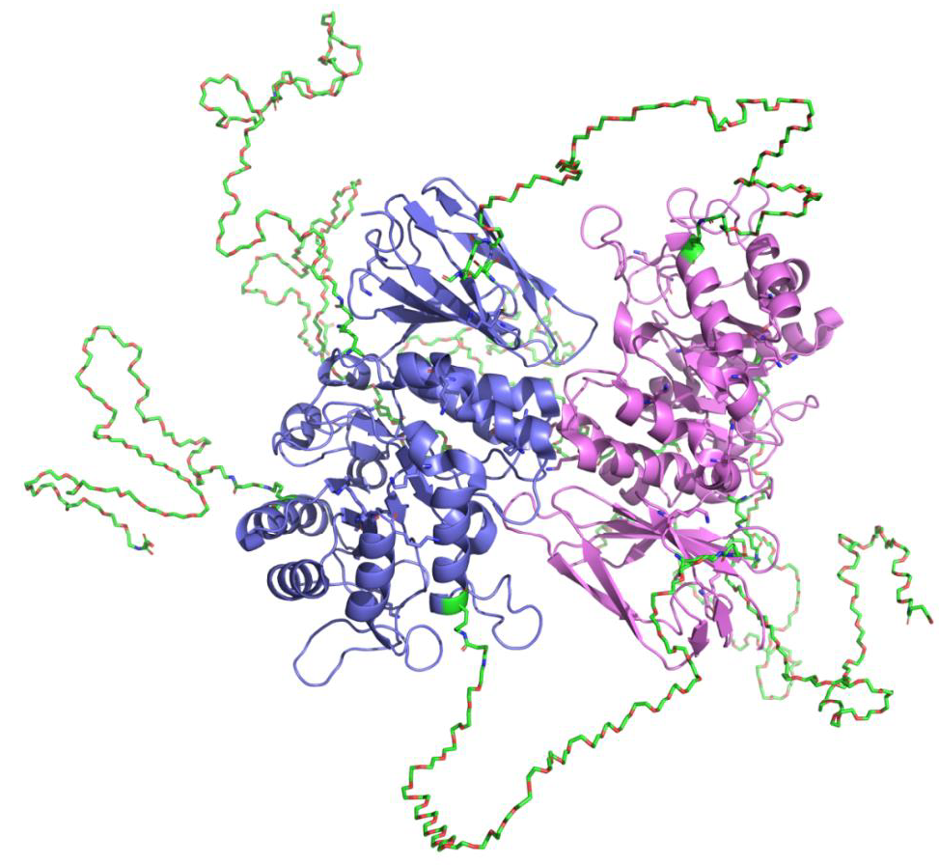
The manufacturing process is detailed in the evaluation report. All excipients are well known pharmaceutical ingredients and their quality is compliant with Ph. Eur/BP/USP standards. There are no novel excipients used in the finished product formulation. All analytical methods used for testing of the finished product are satisfactorily described in the dossier and non-compendial methods have been validated. The container closure is considered suitable for its intended use as demonstrated by compatibility and stability studies.
Adequate data have been presented for sterility, adventitious agents (viral, transmissible spongiform encephalopathy and mycoplasma), container and endotoxin safety assessments to ensure product quality and safety.
The shelf life of the drug substance is 60 months at -70°C.
The shelf life of the drug product is 48 months at 5 ±3°C.
There are no objections to approval from a quality perspective.

Nonclinical evaluation summary
In vitro, pegunigalsidase alfa demonstrated enzymatic activity in hydrolysing the natural glycosphingolipid substrate and synthetic substrate of α-GAL-A. Pegunigalsidase alfa was internalised and localised to the lysosome in patient skin fibroblasts in vitro. The uptake of pegunigalsidase alfa by fibroblasts in vitro was confirmed at clinically relevant concentrations in non-clinical species and humans.
In vivo studies in a Fabry mouse model at the proposed or similar clinical doses (1 or 2 mg/kg IV) and clinically relevant concentrations of pegunigalsidase alfa demonstrated α-GAL-A activity and reduced Gb3 accumulation in primary target organs.
No secondary pharmacology studies have been conducted. This is acceptable. Safety pharmacology studies were limited to examinations in chronic toxicity studies. Allergenic responses confounded interpretation of the results, however, no direct cardiovascular (including ECG), respiratory or CNS effects were observed at clinically relevant doses.
Tissue distribution studies were limited but demonstrated exposure in primary Fabry target organs. Pharmacology studies do not suggest significant brain penetration. No metabolism or excretion studies were performed. This is acceptable.
No drug interaction studies were conducted. This is acceptable. Cytochrome P450-mediated drug interactions with pegunigalsidase alfa are not anticipated.
No acute toxicity studies were conducted. This is acceptable. Chronic toxicity studies resulted in allergenic responses and identified the liver (elevations in AST, hepatocyte necrosis, hepatocytic vacuolation or Kupffer cell hypertrophy; in mice and monkeys) and kidney (multifocal nephropathy and interstitial lymphocytic infiltration; in mice) as target organs of toxicity at clinically relevant doses.
No genotoxicity or carcinogenicity studies were conducted with pegunigalsidase alfa. This is acceptable for a recombinant human enzyme.
Fertility was unaffected in male and female rats treated with pegunigalsidase alfa at exposure levels up to 4 times the clinical AUC. Embryofetal toxicity in rabbits and skeletal alterations in rats and rabbits were observed at clinically relevant doses. Consequently, the proposed Pregnancy Category B2 is not appropriate. Pregnancy Category B3 is recommended. Pre- and post-natal development studies are planned post-authorisation and should be provided to TGA when available. Milk transfer was demonstrated in rats.
Antibodies to pegunigalsidase alfa observed in mice and monkeys following repeated IV dosing were associated with allergenic responses. Anti-pegunigalsidase alfa IgG antibodies observed in pregnant rabbits were observed in conjunction with maternotoxicity.
The draft Product Information is acceptable from a non-clinical perspective.
There is no non-clinical objection to registration of pegunigalsidase alfa for the proposed indication.

Clinical evaluation summary

Summary of clinical studies
The clinical development program supporting this application (comprised:
- Phase 1/2 dose-ranging studies (n=18) to evaluate PK, PD, exploratory efficacy, and safety of pegunigalsidase alfa 0.2, 1.0, 2.0 mg/kg IV every 2 weeks (E2W) for 12 months in ERT-naïve adult patients (3 months in PB-102-F01, 9 months in PB-102-F02).
- Phase 1/2 open-label long-term extension study (n=15) to evaluate PD, exploratory efficacy, and safety of pegunigalsidase alfa 1.0 mg/kg IV E2W up to 60 months in adult patients (PB-102-F03).
- Phase 3 randomised, double-blind, active-controlled, switch-over study (n=78) to evaluate the efficacy and safety of pegunigalsidase alfa versus agalsidase beta 1.0 mg/kg E2W for 24 months in adult patients with impaired renal function (PB-102-F20, BALANCE).
- Phase 3 open-label single arm, switch-over study (n=22) to evaluate efficacy and safety of pegunigalsidase alfa 1.0 mg/kg IV E2W for 12 months in adult patients previously treated with agalsidase alfa (PB-102-F30, BRIDGE).
- Phase 3 open-label, switch-over study (n=30) to evaluate efficacy and safety of pegunigalsidase alfa 2.0 mg/kg IV every 4 weeks (E4W) for 12 months in adult patients previously treated with agalsidase alfa or agalsidase beta (PB-102-F50, BRIGHT).
- Interim analysis for a Phase 3 open-label extension study (n=29) to evaluate the long-term safety and efficacy of pegunigalsidase alfa 2.0 mg/kg IV E4W in adult patients who participated in PB-102-F50 (PB-102-F51). At time of submission up to 48 months data was available.
There are also two additional ongoing studies to evaluate long-term efficacy and safety:
- Phase 3 open-label extension study (n=97) to evaluate long-term safety, efficacy, and PD of pegunigalsidase alfa 1.0 mg/kg IV E2W for up to 48 months in patients who participated in the previous PB-102-F03/F30/F20 studies (PB-102-F60, BRILLIANCE).
- Expanded access program for US-based patients to receive pegunigalsidase alfa 1.0 mg/kg IV E2W prior to marketing (PB-102-F90).
Figure 2. Schematic Presentation of the Clinical Development Programª
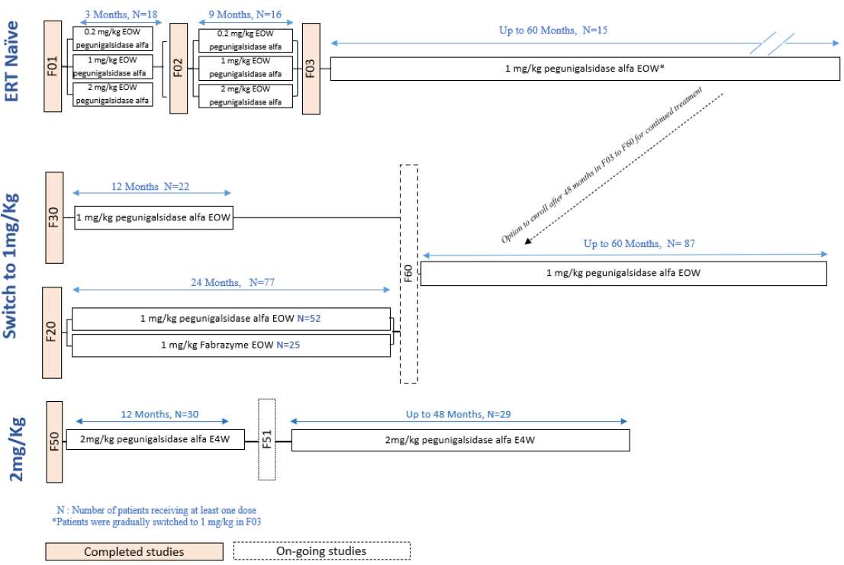
*Overall enrolled patients in PB-102-F60: N=97
a. (cut-off date for ongoing study PB-102-F51: 08 August 2021; for ongoing study PB-102-F60: 15 July 2021)
The proposed commercial formulation was used in the clinical studies. The design of the clinical development program was informed by scientific advice from the EMA and FDA.
The proposed use is in adult patients, in line with the submitted clinical dataset. Paediatric use remains under investigation.

Pharmacology

Pharmacokinetics
The pharmacokinetics (PK) of pegunigalsidase alfa was assessed in studies PB-102-F01/F02, PB-102-F20, and PB-102-F50.
Pegunigalsidase alfa is administered by IV infusion, so is 100% bioavailable. Pegunigalsidase alfa is not expected to bind to plasma proteins.
The metabolism and excretion of pegunigalsidase alfa have not been evaluated. Pegunigalsidase alfa is expected to be metabolically degraded through peptide hydrolysis in a similar manner to endogenous proteins.
No studies have been conducted in subjects with hepatic or renal impairment. The molecular weight of pegunigalsidase alfa is ~116 KDa, which is twice the cut-off value for glomerular filtration. No significant impact on the PK of pegunigalsidase alfa is expected in patients with impaired renal or hepatic function.
No PK drug interaction studies were conducted. As a recombinant human protein, pegunigalsidase alfa is an unlikely candidate for CYP450-mediated drug-drug interactions.
PB-102-F01 was an open-label, dose ranging study of 18 ERT-naïve adult Fabry patients who were treated with one of three doses (0.2 mg/kg n=6; 1.0 mg/kg n=8; 2.0 mg/kg n=4) of pegunigalsidase alfa E2W for 12 weeks. PB-102-F01 was followed by a 9-month extension study, PB-102-F02, at the same dose assigned in PB-102-F01. The PK of pegunigalsidase alfa was evaluated for 16 PK-evaluable patients in PB-102-F01/F02 (0.2 mg/kg E2W, n= 6; 1.0 mg/kg E2W, n=6; 2.0 mg/kg E2W, n=4). Serial blood sampling was conducted, and PK profiles were determined on Day 1, and after 3, 6, and 12 months of treatment. On Day 1, mean values for dose-normalised AUC_{0-2wk} were similar for all dose levels, suggesting linear dose-proportionality, but at 3 and 6 months there was a tendency for mean dose-normalised AUC_{0-2wk} to increase with dose, and at 12 months, the mean dose-normalised AUC_{0- 2wk} values were distinctly higher for 1 mg/kg and 2 mg/kg than for 0.2 mg/kg. Across the 3 dose groups, mean t_{1/2} ranged from ∼53 – 121 h. For patients who received 1 mg/kg and 2 mg/kg, there were increases in mean C_{max}, AUC_{0-∞} and t_{1/2} with increasing duration of treatment and corresponding decreases in CL and V_{z} (Table 3).
Table 3. PK parameters of pegunigalsidase alfa by Treatment Group and Visit (PB-102-F01/F02)
Treatment Group | Number of Patients | Protocol Visit | Mean Infusion Length (hr) | Mean ± SD
 |  |  |  | AUC_{0–t} (ng·hr/mL) | C_{max} (ng/mL) | t_{1/2}(h) | CL (mL/hr/kg) | V_{z} (mL/kg) | T_{max} (hr)
0.2 mg/kg IV EOW | 6 | Day 1 | 4.04 | 62835 ± 28944 | 1858 ± 531 | 60.3 ± 19.6 | 2.96 ± 0.81 | 246 ± 68 | 4.40 ± 0.56
0.2 mg/kg IV EOW | 6 | Month 3 | 2.02 | 68940 ± 60554 | 1787 ± 935 | 60.3 ± 44.5 | 1.61 ± 2.25 | 282 ± 99 | 2.38 ± 0.49
0.2 mg/kg IV EOW | 6 | Month 6 | 2.01 | 86121 ± 82585 | 3230 ± 2761 | 53.4 ± 36.6 | 5.07 ± 5.36 | 212 ± 98 | 2.45 ± 0.54
0.2 mg/kg IV EOW | 6 | Month 12 | 1.50 | 68750 ± 21769 | 2670 ± 557 | 63.0 ± 27.2 | 2.44 ± 1.04 | 219 ± 114 | 1.52 ± 0.02
1 mg/kg IV EOW | 6 | Day 1 | 5.49 | 375625 ± 127233 | 11123 ± 2409 | 78.9 ± 10.3 | 2.85 ± 0.66 | 321 ± 71 | 5.84 ± 1.83
1 mg/kg IV EOW | 6 | Month 3 | 4.36 | 478466 ± 164702 | 11870 ± 2447 | 85.7 ± 28.4 | 2.30 ± 0.79 | 271 ± 89 | 5.04 ± 1.86
1 mg/kg IV EOW | 6 | Month 6 | 3.87 | 688489 ± 191101 | 13265 ± 3022 | 96.5 ± 31.4 | 1.58 ± 0.59 | 226 ± 116 | 4.39 ± 1.49
1 mg/kg IV EOW | 6 | Month 12 | 3.28 | 1333955 ± 830014 | 17320 ± 6058 | 121.0 ± 22.0 | 1.12 ± 0.65 | 186 ± 91 | 3.83 ± 1.84
2 mg/kg IV EOW | 4 | Day 1 | 6.37 | 575488 ± 176086 | 16625 ± 4299 | 70.7 ± 18.0 | 3.41 ± 0.68 | 345 ± 105 | 6.41 ± 0.37
2 mg/kg IV EOW | 4 | Month 3 | 6.03 | 1392917 ± 508760 | 25975 ± 4875 | 83.1 ± 16.5 | 1.57 ± 0.53 | 179 ± 33 | 6.34 ± 0.50
2 mg/kg IV EOW | 4 | Month 6 | 5.12 | 1309647 ± 343484 | 22425 ± 3041 | 117.0 ± 8.0 | 1.63 ± 0.39 | 274 ± 58 | 5.36 ± 0.37
2 mg/kg IV EOW | 4 | Month 12 | 3.13 | 1885929 ± 400544 | 35150 ± 8137 | 110.0 ± 14.0 | 1.05 ± 0.26 | 169 ± 54 | 3.28 ± 0.37
AUC_{0-t}, = Area under the plasma concentration-time curve from 0 hours to the last measurable concentration; C_{max} = Maximum observed concentration: t_{1/2}. = Half-life in the terminal elimination phase; CL = Clearance from plasma; V_{z} = Volume of distribution during the terminal phase; T_{max} = Maximum concentration within a dosing interval; SD = Standard deviation; EOW = every other week.
PK was evaluated in a subset of 17 patients treated with pegunigalsidase alfa 1 mg/kg E2W in PB-102-F20. Mean t_{1/2} ranged from ∼83 – 97 h. Mean T_{max} ranged from 1.7 – 3.2 h, consistent with time of end of infusion. Mean V_{z} ranged from ∼9 – 13 L, and mean CL ranged from 0.193 – 0.557 L/h. The pattern of increasing C_{max} and AUC with increasing duration of treatment observed in PB-102-F01/F02 was not seen in PB-102-F20 (Table 4).
Table 4. PK parameters of pegunigalsidase alfa by Visit (PB-102-F20)
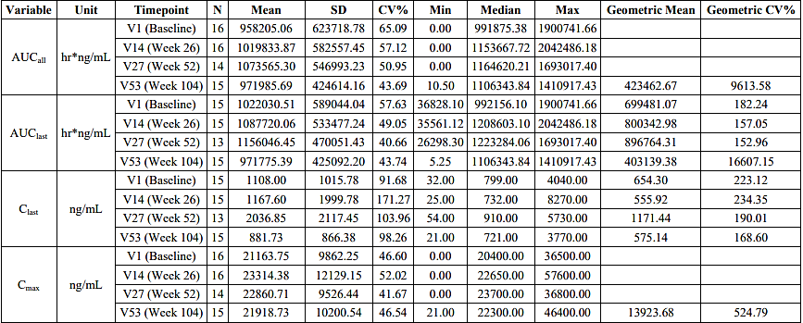
AUC_{last}= Area under the curve from time zero to last measurable concentration; C_{last} = last measurable concentration; C_{max} -= maximum observed drug concentration; CV = coefficient of variation; max = maximum: min = minimum; N = number of patients; SD = standard deviation; T_{last} = time to last measurable concentration; T_{max} = time to maximum concentration; V = Visit.
PK findings in Study PB-102-F50 (pegunigalsidase alfa 2 mg/kg Q4W) are presented in Table 5.
Table 5. PK parameters of pegunigalsidase alfa by Visit (PB-102-F50)
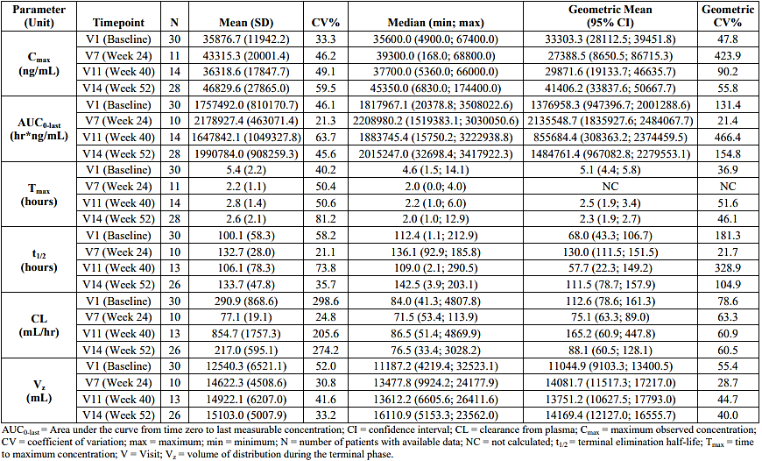
AUC_{last} = Area under the curve from time zero to last measurable concentration; CI = confidence interval; CL = clearance from plasma; C_{max} = maximum observed concentration; CV = coefficient of variation; max = maximum; min = minimum; N = number of patients with available data; NC = not calculated; t_{1/2} = terminal elimination half-life; T_{max}= time to maximum concentration; V = Visit; V_{z} = volume of distribution during the terminal phase.
PB-102-F20 evaluated the impact of anti-drug antibodies (ADA) on the PK of pegunigalsidase alfa (also referred to as PRX-102). The presence of ADA at baseline appeared to have an important impact on PK parameters (Figure 3, Figure 4). Patients negative for ADA at baseline had AUC_{inf}, C_{max}, and t_{1/2} values that were >18-fold, >3.6-fold, and >13-fold greater, respectively, compared to patients with positive ADA at baseline, with differences observed at all time points.
Figure 3. Boxplot of AUCinf by ADA Status at Baseline and Visit (PB-102-F20)
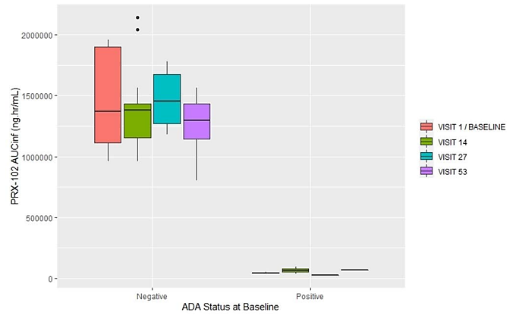
Figure 4. Boxplot of C_{max} by ADA Status at Baseline and Visit (PB-102-F20)
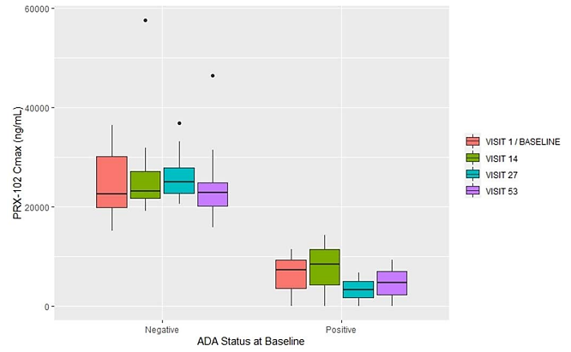
Five population pharmacokinetic and PK/PD analyses were included in the submission: ICX-B152, ICX-B173 (MSAR1), ICX-B173 (MSAR2), ICX-B160, ICX-B213. ICX-B173 included data from Studies F01/F02, F20 and F50, and MSAR2 supersedes MSAR1.

Pharmacodynamics
The main pharmacodynamics (PD) markers assessed in PB-102-F01/F02 were plasma Lyso-Gb3 and renal Gb3 inclusion bodies. In the overall population, plasma Lyso-Gb3 concentration decreased significantly in response to the treatment (p=0.010), from a mean of 66.7±19.5 to 22.6±5.1 ng/mL. All 16 patients showed a reduction in plasma Lyso-Gb3 concentration from Baseline, (Table 6). A reduction in plasma Lyso-Gb3 concentration was observed across all doses, with the largest percent reduction (-59.9%) observed with 1.0 mg/kg (n=6), though this should be interpreted with caution due to the small number of patients in each group and large differences between male and female patients.
Table 6. Plasma Lyso-Gb3 (ng/mL) - Individual Results over 12 Months (PB-102-F01/F02)
Treatment (mg/kg) | Day 0 (ng/mL) | Week 52 (ng/mL) | Change from Baseline (ng/mL) | Percentage Change from Baseline (%)
0.2 | 19.2 | 17.7 | -1.5 | -7.8
1 | 5.1 | 2.8 | -2.3 | -45.1
1 | 14.4 | 7.1 | -7.3 | -50.7
1 | 193.4 | 46.7 | -146.7 | -75.9
1 | 123.0 | 35.6 | -87.4 | -71.0
2 | 61.8 | 30.8 | -31.0 | -50.2
0.2 | 66.5 | 25.2 | -41.3 | -62.1
1 | 80.8 | 17.2 | -63.6 | -78.7
1 | 6.8 | 4.2 | -2.6 | -38.2
0.2 | 112.5 | 40.0 | -72.6 | -64.5
2 | 3.4 | 2.6 | -0.8 | -23.5
2 | 5.0 | 2.2 | -2.8 | -55.6
0.2 | 272.9 | 69.5 | -203.4 | -74.5
2 | 10.8 | 7.3 | -3.5 | -32.4
0.2 | 84.7 | 45.7 | -39.0 | -46.0
0.2 | 7.5 | 7.1 | -0.4 | -5.3
Figure 5. Change in Lyso-Gb3 over Time in Males (PB-102-F01/F02)
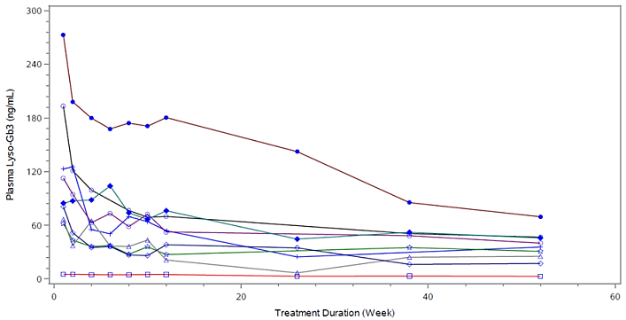
Figure 6. Change in Lyso-Gb3 over Time in Females (PB-102-F01/F02)
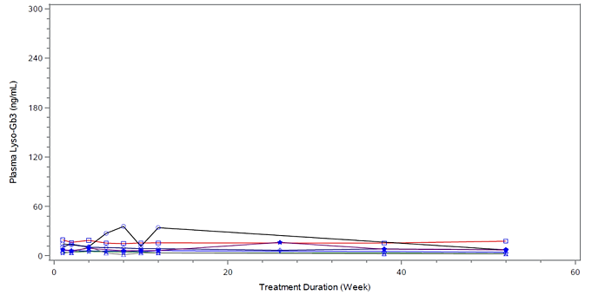
The Barisoni Lipid Inclusion Scoring System (BLISS) was used for scoring Gb3 inclusions in kidney peritubular capillary (PTC) biopsy samples. Mean BLISS score reduction following 6 months of treatment with pegunigalsidase alfa is shown in Figure 7. Of the 14 patients with available kidney Gb3 inclusions, 12 showed a reduction in BLISS score from baseline at Month 6 (Table 7). 11 out of 14 (78.6%) patients with available biopsies had ≥50% reduction in their BLISS score following 6 months of treatment with pegunigalsidase alfa, and 12 out of 14 (85.7%) had ≥20% reduction.
Figure 7. Mean BLISS Score Reduction in Gb3 Inclusions in Renal Biopsies PTC following 6 Months Treatment with Pegunigalsidase Alfa
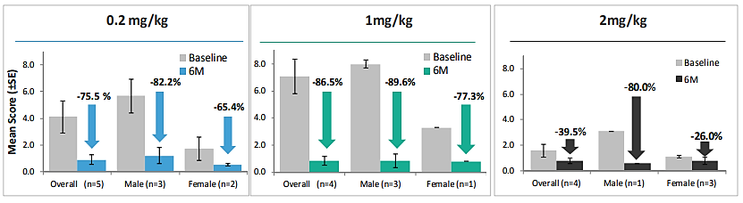
Table 7. Gb3 in Kidney Peritubular Capillaries – Quantitative BLISS Score at Month 6
Dose | Gender | Mean BLISS score
Dose | Gender | Baseline | Absolute Change from Baseline | Percentage (%) Change from Baseline
0.2 mg/kg* | F | 2.63 | -2.05 | -77.85
0.2 mg/kg* | M | 3.32 | -3.04 | -91.74
0.2 mg/kg* | M | 7.65 | -5.27 | -68.88
0.2 mg/kg* | M | 6.10 | -5.25 | -86.08
0.2 mg/kg* | F | 0.84 | -0.44 | -52.91
1.0 mg/kg** | M | 0.44 | 0.51 | 116.98
1.0 mg/kg** | F | 3.30 | -2.55 | -77.31
1.0 mg/kg** | M | 9.00 | -8.56 | -95.19
1.0 mg/kg** | M | 8.29 | -6.47 | -78.04
1.0 mg/kg** | M | 7.87 | -7.51 | -95.44
2.0 mg/kg | M | 3.09 | -2.47 | -79.97
2.0 mg/kg | F | 1.20 | -0.89 | -73.59
2.0 mg/kg | F | 0.92 | -0.19 | -20.50
2.0 mg/kg | F | 1.17 | 0.19 | 16.06
* One patient had no GB3 kidney biopsy data due to a technical error and is excluded from the 0.2 mg/kg group.
** One patient had no baseline GB3 kidney biopsy data due to the absence of kidney cortex tissue in the sample and is excluded from the 1.0 mg/kg treatment group
In PB-102-F01/F02, most of the assessed echocardiography parameters were stable after 12 months of treatment. Male patients had a minor mean decrease from baseline in Left Ventricular Mass Index (LVMI) in both the 0.2 mg/kg and 1.0 mg/kg treatment groups. Female patients had a marginal mean increase from baseline in LVMI in all three treatment groups. In PB-102-F03, no relevant changes in echocardiography parameters from screening were observed. Echocardiography parameters remained within normal ranges for most patients over 60 months of treatment.
15 patients (8 males, 7 females) who completed PB-102-F02 were enrolled in the long-term follow-up study PB-102-F03. Five patients discontinued from the study: three due to consent withdrawal, one due to a fatal, unrelated adverse event and one due to other reasons (pregnancy). Plasma Lyso-Gb3 levels over time from baseline in PB-102-F01 are shown in Figure 8. The proportion of patients with a reduction from baseline of ≥75% in plasma Lyso-Gb3 concentration increased over the 60-month treatment period with pegunigalsidase alfa. All patients reached ≥50% reduction by Month 24.
Figure 8. Mean (+/- SE) Plasma Lyso-Gb3 Over Time from Baseline (Visit 1 in PB-102-F01) by Gender and Overall (Efficacy Population).
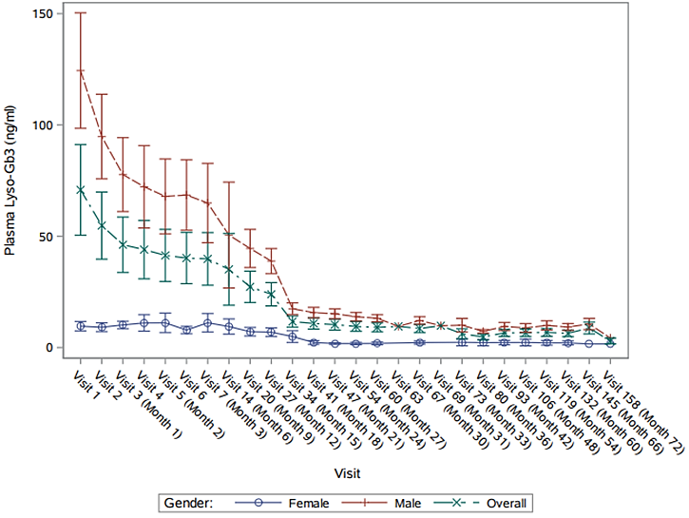
A thorough QT study was not required as enzyme replacement products are not expected to affect the hERG channel.
Dose selection for the pivotal phase 3 Study (PB-102-20) was based on PK, PD, exploratory efficacy, and safety data from Study PB-102-F01/F02.

Efficacy

Study PB-102-F20
This was a randomised, double-blind, active control study to evaluate the efficacy and safety of pegunigalsidase alfa compared to agalsidase beta (Fabrazyme) in adult patients with Fabry disease and deteriorating renal function. The study was conducted at 29 study centres in 12 countries between August 2016 and October 2021. The choice of active comparator was informed by regulatory advice during clinical development. Dose selection for the pivotal study (1 mg/kg E2W) was based on PK, PD, exploratory efficacy, and safety data from the Phase 1/2 Study PB-102-F01/F02.
The study included symptomatic adult patients aged 18 to 60 years with Fabry disease. Males were required to have plasma and/or leucocyte alpha galactosidase activity <30% mean normal levels and one or more of neuropathic pain, cornea verticillata, or clustered angiokeratoma. Females were required to have historical genetic test results consistent with pathogenic mutations (or in the case of novel mutations a first-degree male family member with Fabry disease with the same mutation) and one or more of neuropathic pain, cornea verticillata, or clustered angiokeratoma. Participants were required to have a screening estimated glomerular filtration rate (eGFR) 40 to 120 mL/min/1.73m², linear slope of eGFR more negative than -2 mL/min/1.73m²/yr, and had to have been taking Fabrazyme (agalsidase beta) for at least 1 year prior to study entry and on a stable dose for at least the last 6 months.
Following screening, eligible patients were randomised in a 2:1 ratio to either switch to pegunigalsidase alfa 1 mg/kg E2W or continue treatment with agalsidase beta 1 mg/kg E2W, with randomisation stratified by urine protein-to-creatinine ratio (UPCR, < or ≥1 g/g). The first few infusions were administered at the site, and patients could thereafter receive treatment at home if the investigator and the sponsor’s Medical Monitor agreed that it was safe to do so.
78 patients were enrolled, with 53 assigned to pegunigalsidase alfa and 25 to agalsidase beta. One pegunigalsidase alfa patient withdrew before receiving study treatment, so there were 52 pegunigalsidase alfa patients and 25 agalsidase beta patients in the safety and intention to treat (ITT) analysis populations. Five pegunigalsidase alfa patients and 1 agalsidase beta patient discontinued prior to reaching Month 24. For 2 patients in the pegunigalsidase alfa arm, the reason for discontinuation was an adverse event (AE).
Age was similar across both groups, with an overall mean age of 44.3 years (range 18 to 60 years). Overall, 61% were male and 39% female, with a greater proportion of males in the agalsidase beta arm (72%) compared to the pegunigalsidase alfa arm (56%). Most males were categorised as ‘classic’ phenotype (27/29 [93.1%] in pegunigalsidase alfa arm and 14/18 [77.8%] in agalsidase beta arm), whereas all female patients were categorised as ‘non-classic’. Baseline eGFR data were similar in both groups. The overall mean eGFR was 73.69 mL/min/1.73 m² (range 30.2 to 125.9). At baseline, 72.7% of patients had UPCR ≤0.5 gr/gr. Overall, 54.5% of patients were taking ACEi or ARB medications at baseline, with the percentage higher in the agalsidase beta arm (64.0%) than the pegunigalsidase alfa arm (50.0%). All patients with UPCR levels ≥1.0 gr/gr received ACEi or ARB medications.
The primary efficacy endpoint was annualised change (slope) in eGFR. Secondary efficacy endpoints included change from baseline to all time points in eGFR, UPCR category, LVMI by MRI, exercise tolerance (stress test), plasma Lyso-Gb3, urine Lyso-Gb3, plasma Gb3, Mainz Severity Score Index (MSSI), frequency of pain medication use, short form brief pain inventory (BPI), and quality of life questionnaire (EQ-5D-5L). Other secondary efficacy endpoints included incidence of Fabry Clinical Events (FCE) and achievement of Fabry Kidney Disease therapeutic goals.
The primary analysis was to demonstrate non-inferiority of pegunigalsidase alfa to agalsidase beta with respect to eGFR slope after 1 year (interim analysis) and 2 years (final analysis). The power was computed assuming a one-sided two-sample t-test with a one-sided alpha level of 0.025 and a non-inferiority margin of -3.0 mL/min/1.73 m²/year. The non-inferiority margin was selected based on knowledge of the natural history of the disease and data published on the effect of available treatments on renal function deterioration in Fabry Disease patients.
The pre-specified non-inferiority criterion for the primary endpoint, eGFR slope, was not met in the interim analysis at 1 year but was met in the final analysis at 2 years. In the final analysis in the ITT population, estimated median eGFR slopes were -2.514 in the pegunigalsidase alfa group and -2.155 in the agalsidase beta group, a between-group difference of -0.359 (95% CI: -2.444, 1.726). The lower limit of the 95% CI was greater than the non-inferiority margin of -3.0 mL/min/1.73 m²/year, fulfilling the pre-specified non-inferiority criterion (Table 8). Analysis of the PP set showed a similar result with a between-group difference of -0.118 (95% CI: -2.450, 2.213). A planned analysis using the stratification factor, UPCR, as covariate showed a between-group difference of 0.282 (95% CI: -1.789, 2.353). Similar findings were seen for most other sensitivity and supportive analyses of the primary endpoint. Findings from subgroup analyses of the primary endpoint are shown in Figure 9.
Secondary efficacy outcomes were presented descriptively. Findings are shown below for change from baseline in eGFR over time (Figure 10), distribution of patients by UPCR category (Table 9), change from baseline in LVMI (Table 10), change in plasma Lyso-Gb3 over time (Figure 11), Mainz Severity Score (Table 11), BPI (Table 12), EQ-5D-5L quality of life questionnaire (Table 13), and Fabry clinical events (Table 14). In the pegunigalsidase alfa group, the majority of Fabry clinical events (5 cardiac, 1 cerebrovascular, 1 renal) occurred within the first 12 months of switching to pegunigalsidase alfa. Interpretation of between-group differences for secondary endpoints is limited by the small dataset. ADA status did not have a clear effect on eGFR slope.
Table 8. eGFR slope analysis using quantile regression for the median (primary efficacy analysis) – ITT, PP sets
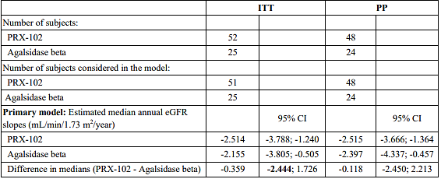
Notes: Analysis is based on a quantile regression for the median with eGFR slope of each individual patient as dependent variable and treatment arm as covariate of the model. All observations are used including unscheduled visits.
Figure 9. Forest plot of eGFR difference in slopes – subgroups within ITT set
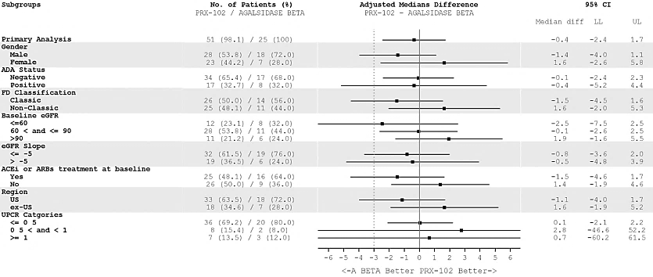
FD = Fabry Disease; UPCR = Urinary protein to creatinine ratio; ACEi = Angiotensin converting enzyme inhibitors; ARBs = Angiotensin receptor blockers; LL= Lower Limit; UL= Upper Limit, ADA = Anti-drug antibody, eGRF = estimated glomerular filtration rate. Note: Vertical dotted line drawn at the prespecified non-inferiority margin of -3.0 ml/min/1.73 m²/year.
Figure 10. Change from baseline in eGFR ± SE over time – ITT set
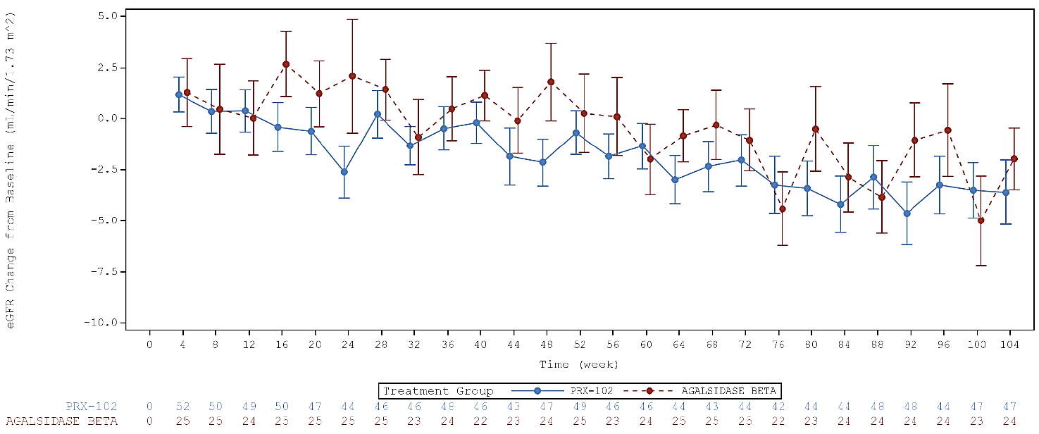
Table 9. Patients by UPCR Categories in PB-102-F20 – ITT Set
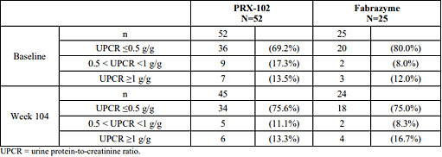
Table 10. Summary of left ventricular mass index (g/m²) by gender and hypertrophy status – ITT set
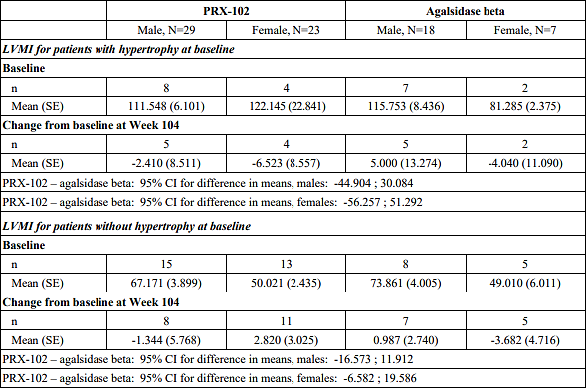
Figure 11. Mean plasma Lyso-Gb3 +/- SE over time
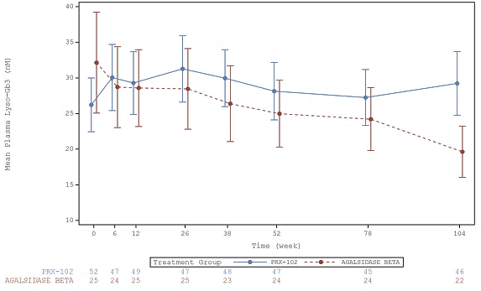
Table 11. Change in overall score on the Mainz Severity Score Index at Week 104 – ITT set
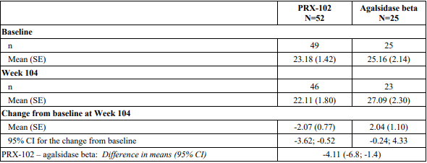
Table 12. Change in scores on Short Form Brief Pain Inventory at Week 104 – ITT set
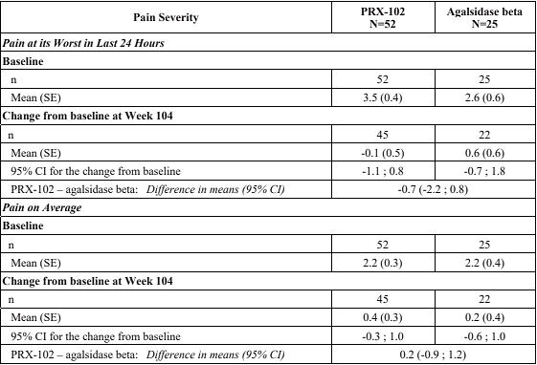
Table 13. Proportion of patients with change in quality of life questionnaire (EQ-5D-5L) at Week 104 - ITT set
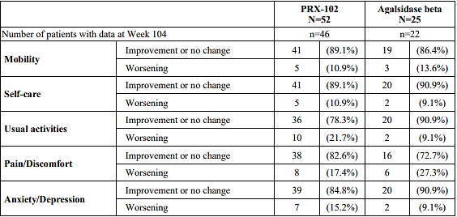
Table 14. Number of Patients with Fabry Clinical Events in PB-102-F20 - ITT Set
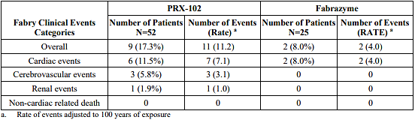

Study PB-102-F30
This was a Phase 3, open-label, single arm, switch-over study to evaluate safety and efficacy of pegunigalsidase alfa 1 mg/kg IV E2W for 12 months in adult patients treated with agalsidase alfa for at least 2 years and on a stable dose for at least 6 months. The primary objective was safety; efficacy was a secondary objective, with exploratory efficacy endpoints including mean annualised change in eGFR, LVMI, and plasma lyso-Gb3.
22 patients (15 males and 7 females) were enrolled and treated. In the efficacy population (n=20), the mean annualised eGFR slope was -5.90 mL/min/1.73 m²/year pre-switch and -1.19 mL/min/1.73 m²/year post-switch. Overall, the mean LVMI increased by 4.1 g/m² from baseline to Month 12 but remained within normal ranges, with a greater increase in females than males. Overall, a continuous decline in plasma lyso-Gb3 concentration was observed for most male participants up to Month 9, before plateauing. Baseline concentrations were low for all females and remained relatively stable through to Month 12. At Month 12, all participants had experienced a decrease in plasma lyso-Gb3 from baseline, regardless of ADA status, and most (16/20) participants achieved a reduction in concentration from baseline by ≥20%.

Study PB-102-F50
This was a Phase 3, open-label, single arm, switch-over study to evaluate safety and efficacy of pegunigalsidase alfa 2 mg/kg IV E4W for 12 months in adult patients treated with agalsidase alfa or agalsidase beta for at least 3 years and on a stable dose for at least 6 months. The primary objective was safety; efficacy was a secondary objective, with exploratory endpoints including eGFR, eGFR slope, plasma lyso-Gb3.
30 patients (24 males and six females) were enrolled and treated. One patient discontinued (withdrew consent) after receiving their first dose. One participant switched to pegunigalsidase alfa 1.0 mg/kg E2W at Week 40 and was excluded from Week 52 efficacy data.
Mean absolute eGFR values remained stable during the study: 99.44 and 100.65 mL/min/1.73 m² at baseline (n=29) and Week 52 (n=28), respectively. The mean (SE) annualised eGFR slope in the efficacy population was -1.79 (0.69) mL/min/1.73 m²/year pre-switch and -2.92 (1.05) mL/min/1.73 m²/year post-switch. Plasma lyso-Gb3 levels were stable throughout the study, with an overall mean (SE) of 19.4 (3.4) nM at baseline and 22.2 (3.6) nM at Week 52.

Safety
The safety of pegunigalsidase alfa 1 mg/kg E2W was informed by Phase 1 & 2 studies in ERT-naïve adult patients (PB-102-F01, PB-102-F02, PB-102-F03) and Phase 3 studies in pre-treated adult patients (pivotal study PB-102-F20, the open-label switch-over study PB-102-F30, and the ongoing open-label extension study PB-102-F60). An integrated safety analysis assessed safety across five cohorts of patients who received pegunigalsidase alfa in the clinical development program. Overall exposure to pegunigalsidase at the proposed dose (1 mg/kg E2W, Cohort 1, N=111) was ∼293 patient years. 70 patients (43 male, 27 female) received pegunigalsidase alfa 1 mg/kg E2W for >24 months.
This overview focusses on safety findings from the pivotal active-controlled study PB-102-F20 which provided safety data over a 24-month period for patients randomised to receive either pegunigalsidase alfa (n=52) or agalsidase beta (n=25) 1 mg/kg E2W. Safety of pegunigalsidase alfa 2 mg/kg E4W was evaluated in Studies PB-102-F50 and PB-102-F51 but this dosing regimen was not proposed for registration in this application.

Study PB-102-F20
The overall safety profile of pegunigalsidase alfa was similar to agalsidase beta in Study PB-102-F20 (15). Treatment-emergent adverse events (TEAEs) were reported more frequently in male than female patients in both treatment arms, reflecting differences in baseline disease severity across sexes (Table 16).
Table 15. Summary of treatment-emergent adverse events – Safety population PB-102-F20
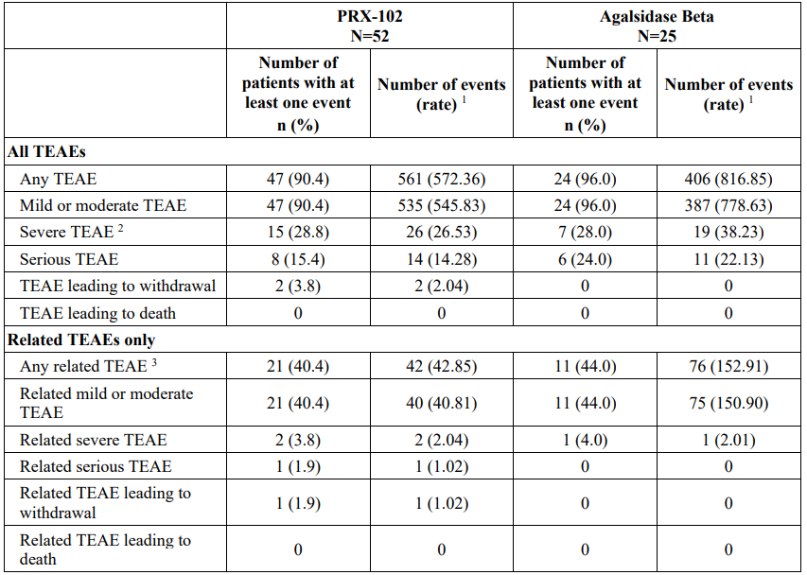
¹ Rate is calculated as the adjusted number of events per 100 years of exposure. ² Events classified as “Very Severe” per CTCAE severity in the eCRF are included in the category “Severe”. ³ A TEAE was defined as related if was reported as possibly, probably, or definitely related to study drug.
Table 16. Summary of treatment-emergent adverse events by gender – Safety set PB-102-F20
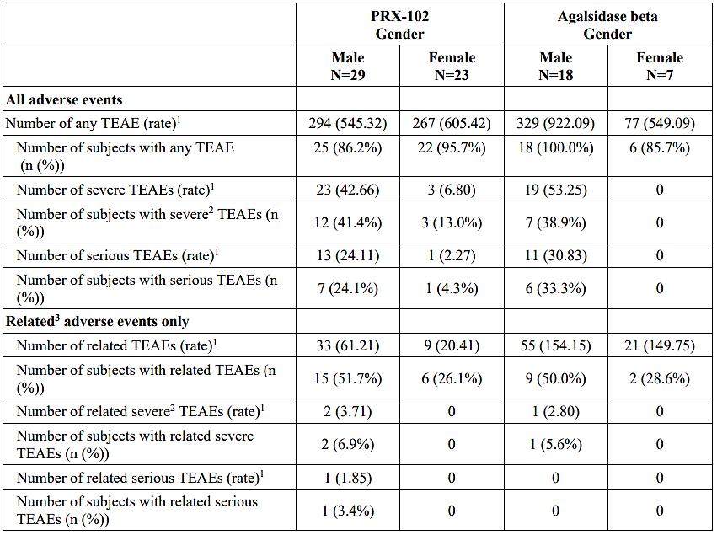
¹ Rate is calculated as the adjusted number of events per 100 years of exposure. ² Events classified as “Very Severe” per CTCAE severity in the eCRF are included in the category “Severe”. ³ A TEAE was defined as related if was reported as possibly, probably, or definitely related to study drug.
Within the pegunigalsidase alfa group, the most frequently reported TEAEs by PT were nasopharyngitis and headache (21.2% of patients each), diarrhoea (19.2% of patients), nausea, and fatigue (17.3% of patients each). Of the 561 events reported in the pegunigalsidase alfa arm, 64.2% were mild, 31.2% were moderate, and 4.6% were severe. Of the 406 events reported in the agalsidase beta arm, 74.4% were mild, 20.9% were moderate, and 4.7% were severe.
Infusion related reactions (IRR) were defined as TEAEs which occurred during the infusion or within 2 hours after its completion and where causality was assessed as definitely, probably, or possibly related to study treatment (Table 17).
Table 17. Summary of IRRs occurring within 2 hours of infusion - Safety set, PB-102-F20
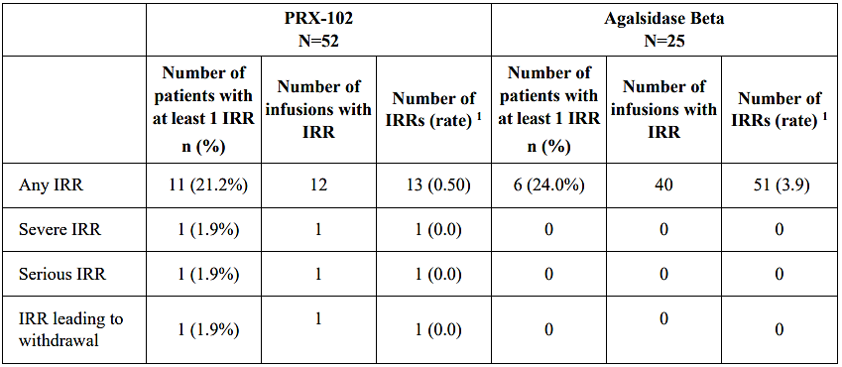
¹ Rate = adjusted rate of events per 100 infusions.
There were no deaths in the study. The only serious adverse event (SAE) that was considered related to study drug was a severe event of hypersensitivity in a patient in the pegunigalsidase alfa arm, which occurred on the first study day. This participant remained in the study and experienced a second hypersensitivity event of moderate intensity during the second infusion and subsequently withdrew from the study. One other participant in the pegunigalsidase alfa arm discontinued from the study due to AE; this was due to progression of pre-existing renal disease to end stage disease, which was rated as severe but not serious and not related to study treatment.
One patient in the pegunigalsidase alfa arm underwent a renal biopsy as part of investigations for persistent proteinuria. This biopsy confirmed the presence of immune complex mediated membranoproliferative glomerulonephritis with subendothelial IgG deposits and lambda and kappa Ig deposits. Immune complexes found in the capillary and endothelial cells were positive for alpha galactosidase. This severe TEAE led to treatment interruption but not study discontinuation. The safety risk relating to this event is addressed in sections 4.4 and 4.8 of the Product Information.
The safety evaluation did not raise concerns in relation to laboratory parameters and ECG findings. No studies on the effects on the ability to drive and use machines have been performed; however, the observed safety profile is not expected to result in an impairment of motor or mental abilities.
Safety was reviewed with regard to ADA status. At baseline, 18 (34.6%) patients in the pegunigalsidase alfa group and 8 (32.0%) patients in the agalsidase beta group were IgG ADA positive, and all but one were also positive for nAbs. Treatment-emergent IgG ADA were reported in six (11.5%) patients in the pegunigalsidase alfa group (3 seroconverted from negative to positive, and 3 were positive at baseline and had ≥4-fold increase in titre during the study) and in five (20.0%) in the agalsidase beta group. Five of the 18 initially positive participants in the pegunigalsidase alfa group became negative by Week 104. Serious TEAEs were reported more frequently in ADA-positive patients in both treatment arms (Table 18).
Table 18. Summary of treatment-emergent adverse events by ADA status – Safety population PB-102-F20
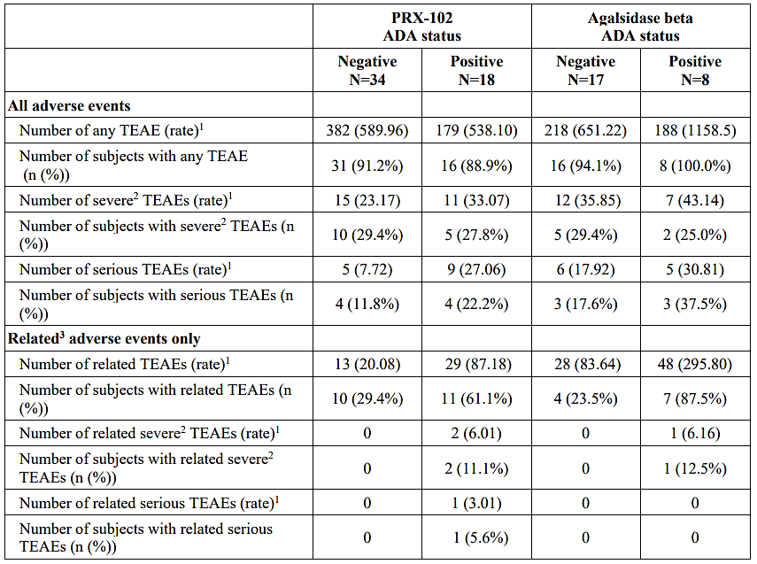
¹ Rate is calculated as the adjusted number of events per 100 years of exposure. ² Events classified as “Very Severe” per CTCAE severity in the eCRF are included in the category “Severe”. ³ A TEAE was defined as related if was reported as possibly, probably, or definitely related to study drug.

Special populations
There are limited data on pegunigalsidase alfa use in pregnant women. Two pregnancies have been reported in the overall clinical development program for pegunigalsidase alfa, despite a requirement for contraception. One pregnancy was reported in PB-102-F03; the patient had normal ultrasound findings at Week 13 of gestation but decided to terminate the pregnancy at Week 14 for personal reasons. Another pregnancy was reported in PB-102-F60; the pregnancy occurred after more than 5 years of treatment with pegunigalsidase alfa in PB-102-F01/02/03 and PB-102-F60 and led to discontinuation from the study. The pregnancy resulted in the birth of a healthy baby at gestational week 40. There are no data on the presence of pegunigalsidase alfa in human milk, the effects on the breast fed infant, or the effects on milk production.
No safety data for paediatric patients were presented in this application. Ongoing studies are investigating paediatric use.
Home infusion was allowed in all studies based on Investigator and the Medical Monitor’s judgement. In total, 93 (65%) patients received at least an infusion at home. Across the studies, four IRRs were SAEs and all four occurred soon after the start of the first infusion, leading to treatment interruption. No serious or severe hypersensitivity reactions were observed in participants who continued longer term treatment with pegunigalsidase alfa beyond six months.

Risk management plan
The Sponsor submitted EU-RMP version 1.0 (date 31 January 2023; data lock point 8 October 2021) and Australia specific annex version 1.0 (date 29 April 2024) in support of this application. The summary of safety concerns presented in the ASA (Table 19) align with the EU RMP. The proposed pharmacovigilance and risk minimisation activities are acceptable. In Australia, Elfabrio will be administered only by health care professionals so the HCP guide is the relevant additional risk minimisation activity.
Table 19. Summary of safety concerns
Summary of safety concerns |  | Pharmacovigilance |  | Risk Minimisation
 |  | Routine | Additional | Routine | Additional
Important identified risks | Hypersensitivity Reactions (infusion related) | ü | – | ü | ü*†
Important potential risks | Medication errors in the home infusion setting | ü | – | ü | ü*†
Missing information | None
*Healthcare professional guide (ASA)
†Healthcare professional/patient/carers guide and Healthcare brochure (EU RMP only)

Risk-benefit analysis

Pharmacology
Elfabrio was developed with a pegylated structure to enhance the stability and availability of active enzyme in the circulation. The mean t_{1/2} of pegunigalsidase alfa (∼79 – 121 hours at the proposed dose in Study PB-102-F01/02) is notably longer than other ERT products for Fabry disease (Fabrazyme ∼82 – 119 minutes, Replagal ∼89 – 108 minutes). The proposed dosing interval is every 2 weeks, the same as the two registered ERT products.
In patients who received 1 mg/kg E2W or 2 mg/kg E2W in Study PB-102-F01/F02, there were increases in mean C_{max}, AUC_{0-∞} and t_{1/2} with increasing duration of treatment and corresponding decreases in CL and V_{z}. This may suggest a saturated clearance, though the effects of the small sample size, bias, and presence of ADA on the interpretation of these findings are uncertain. A pattern of increasing exposure with increasing duration of treatment was not observed in the PK evaluations of PB-102-F20 and PB-102-F50.
The PK section of the draft Product Information advises that the PK findings (PB-102-F01/F02) suggest a saturated clearance, but there was substantial variability of the PK findings within and across the clinical studies and it is not clear what saturated clearance means in the context of a pegylated protein. Further explanation is requested from the Sponsor, and advice is sought from ACM regarding the PK findings.

Efficacy
The main efficacy study (PB-102-F20) was a randomised, active-controlled study comparing pegunigalsidase alfa 1 mg/kg E2W to agalsidase beta (Fabrazyme) 1 mg/kg E2W in adult patients with Fabry disease and deteriorating renal function over 2 years. Participants were required to have slope of eGFR more negative than -2 mL/min/1.73m²/yr at baseline and had to have been taking agalsidase beta for at least 1 year prior to study entry and on a stable dose for at least the prior 6 months.
78 patients were enrolled, with 53 assigned to pegunigalsidase alfa and 25 to agalsidase beta. The study included male and female patients, so there was a mix of clinical phenotypes, including classic and non-classic disease.
The primary efficacy endpoint was annualised change (slope) in eGFR. Non-inferiority was assessed at one year (interim analysis) and two years (final analysis), with a pre-specified non-inferiority margin of -3.0 mL/min/1.73 m²/year. The study met the pre-specified non-inferiority criteria in the final analysis at two years. The evaluation commented on concerns raised by international regulators regarding the suitability of the pre-specified non-inferiority margin as a reliable measure of non-inferior outcome. Whilst there remains some uncertainty regarding the validity of the pre-specified non-inferiority margin in this small study population with large variability in clinical phenotype and severity of disease manifestations, the primary endpoint provides support for similar efficacy of pegunigalsidase alfa (proposed dose) compared to agalsidase alfa (approved dose). Secondary efficacy outcomes were presented descriptively, and interpretation of between group differences is limited by the small study population and variability in clinical manifestations across study participants.
Findings from PB-102-F20 are supported by favourable PD findings in treatment-naïve participants in Study PB-102-F01/02, including reductions in plasma Lyso-Gb3 concentrations and mean BLISS scores following treatment with pegunigalsidase alfa.
Efficacy findings in the open-label switch study PB-102-F30 were exploratory but provided support for the maintenance of efficacy in patients who switched from agalsidase alfa to pegunigalsidase alfa 1 mg/kg E2W.

Safety
The safety dataset for pegunigalsidase alfa is small, but in the context of the rarity of the disease, the extent of exposure in the safety dataset is acceptable. 70 patients (43 male, 27 female) received pegunigalsidase alfa 1 mg/kg E2W for >24 months. Fabry disease is characterised by substantial phenotypic variability, particularly between male and female patients, but also within male and female populations, which impacts on interpretation of safety findings in small study populations.
In the randomised, active-controlled study PB-102-F20, pegunigalsidase alfa 1 mg/kg E2W was generally well tolerated, with a similar safety profile to agalsidase beta 1 mg/kg E2W. The most frequently reported TEAEs by PT were nasopharyngitis and headache (21.2% of patients each), diarrhoea (19.2%), nausea, and fatigue (17.3% each). The proportion of patients reporting any IRR was similar across the two treatment arms. In the pegunigalsidase alfa arm, only one patient discontinued from the study due to AE considered related to study treatment (hypersensitivity). SAEs were reported more frequently in ADA-positive patients in both treatment arms. One case of immune complex mediated membranoproliferative glomerulonephritis was reported in Study PB-102-F20.
Elfabrio will be administered only by healthcare professionals. The option for infusion in the home setting is reasonable for patients who are medically stable and tolerating their infusions well. Safety risks are adequately described in the Product Information.

Proposed indication
The proposed indication is consistent with the submitted dataset. Use of pegunigalsidase alfa in paediatric patients is being studied and is not proposed in this application.

Uncertainties and limitations of the data
Fabry disease is a rare disease, so the clinical trial populations are understandably small. The genetic nature of the disease results in marked variability in clinical phenotype, particularly between male and female patients. The small clinical dataset and variability in disease manifestations contribute to greater uncertainty in the interpretation of efficacy and safety outcomes.
A 2 mg/kg E4W dosing regimen was evaluated in the open-label, single arm, switch-over study PB-102-F50 and the ongoing extension study PB-102-F51. Safety was the primary objective of PB-102-F50 and efficacy findings were exploratory. The 2 mg/kg E4W regimen is not proposed for registration in this application.

Conclusion
The t_{1/2} of pegunigalsidase alfa is notably longer than other ERT products for Fabry disease, consistent with the pegylated structure. The proposed dose is 1 mg/kg Q2W, the same dosing frequency as the two registered ERT products.
There are limitations in the efficacy dataset. The pivotal study compared pegunigalsidase alfa 1 mg/kg Q2W to agalsidase beta 1 mg/kg Q2W over two years and met the pre-specified non-inferiority criterion for annualised change (slope) in eGFR in the final analysis at two years. Whilst there remains some uncertainty regarding the validity of the pre-specified non-inferiority margin, the finding of similar efficacy to agalsidase beta with regard to eGFR slope in the final analysis of the pivotal study is supported by descriptive secondary efficacy outcomes as well as favourable PD findings in treatment-naïve participants in Study PB-102-F01/02.
The safety of pegunigalsidase alfa has been adequately characterised in the context of a small study population. The overall safety profile of pegunigalsidase alfa was similar to agalsidase beta in Study PB-102-F20. Specific safety risks identified in the clinical development program are adequately described in the draft Product Information.

Advisory Committee considerations
The Advisory Committee on Medicines (ACM), having considered the evaluations and the Delegate’s overview, as well as the sponsor’s response to these documents, advised the following.
The ACM advised the following in response to the Delegate’s specific request for advice:
- What is ACM’s perspective on the PK of pegunigalsidase alfa and the description of saturated clearance in the draft Product Information?
The ACM noted that the metabolism of protein-based drugs is less well understood and difficult to characterise for an individual medicine.
The PK statement is not unreasonable. The ACM considered the term ‘saturable’ rather than ‘saturated’ clearance more appropriate as all clearance pathways are evidently not saturated.
It was noted that the wording may be confusing to clinicians and that the US label avoids assigning a potential mechanism.
The proposed wording recommended by the ACM for the PI was:
“The observed mean maximum plasma concentration (Cmax), area under the concentration-time curve (AUC) and elimination half-life (t½) of pegunigalsidase alfa increased with increasing duration of treatment (Table 6). There were corresponding decreases in clearance (CL) and terminal volume of distribution (Vx) suggesting a saturated clearance”.
- What is ACM’s perspective on the adequacy of the efficacy findings, in the context of a rare disease with variable clinical phenotype?
Despite data limitations, partially accounted for by the rarity of the disease, the ACM concluded that overall, the data suggests similar efficacy and safety to the currently available ERTs. This was deemed adequate for registration approval in the context of the rarity of Fabry disease.
Additionally, the ACM noted that further data is emerging, which will inform regulatory advice and clinical use in the future.

Advisory committee conclusion
The ACM considered this product to have an overall positive benefit-risk profile for the indication:
“Elfabrio is indicated for long-term enzyme replacement therapy in adult patients with a confirmed diagnosis of Fabry disease.”

Assessment outcome
Based on a review of quality, safety, and efficacy, the TGA decided to register Elfabrio (pegunigalsidase alfa) for the following indication:
Elfabrio is indicated for long-term enzyme replacement therapy in adult patients with a confirmed diagnosis of Fabry disease.

Specific conditions of registration
Elfabrio (pegunigalsidase alfa) is to be included in the Black Triangle Scheme. The PI and CMI for Elfabrio must include the black triangle symbol and mandatory accompanying text for five years, which starts from the date of first supply of the product.
The Elfabrio EU-Risk Management Plan (RMP) (version 1.0, dated 31 January 2023, data lock point 8 October 2021), with Australia-Specific Annex (ASA) (version 1.0, dated 29 April 2024), included with submission PM-2024-01551-1-3, and any subsequent revisions, will be implemented in Australia.
An obligatory component of risk management plans is routine pharmacovigilance. Routine pharmacovigilance includes the submission of periodic safety update reports (PSURs).
Reports are to be provided in line with the current published list of EU reference dates and frequency of submission of PSURs until the period covered by such reports is not less than three years from the date of this approval letter. Each report must be submitted within ninety calendar days of the data lock point for that report.
The reports are to at least meet the requirements for PSURs as described in the European Medicines Agency’s Guideline on good pharmacovigilance practices (GVP) Module VII-periodic safety update report (Rev 1), Part VII.B Structures and processes. Note that submission of a PSUR does not constitute an application to vary the registration.
Laboratory testing & compliance with Certified Product Details (CPD)
- All batches of Elfabrio supplied in Australia must comply with the product details and specifications approved during evaluation and detailed in the Certified Product Details (CPD).
- When requested by the TGA, the Sponsor should be prepared to provide product samples, specified reference materials and documentary evidence to enable the TGA to conduct laboratory testing on the Product. Outcomes of laboratory testing are published biannually in the TGA Database of Laboratory Testing Results http:// www.tga.gov.au/ws-labs-index and periodically in testing reports on the TGA website.

Certified Product Details
The Certified Product Details (CPD), as described in Guidance 7: Certified Product Details of the Australian Regulatory Guidelines for Prescription Medicines (ARGPM), in PDF format, for the above products should be provided upon registration of these therapeutic goods. In addition, an updated CPD should be provided when changes to finished product specifications and test methods are approved in a Category 3 application or notified through a self-assessable change.
A template for preparation of CPD for biological prescription medicines can be obtained from the TGA website:
- Certified Product Details
- Certified Product Details form

Product Information and Consumer Medicine Information
For the most recent Product Information (PI) and Consumer Medicine Information (CMI), please refer to the TGA PI/CMI search facility.

Therapeutic Goods Administration
PO Box 100 Woden ACT 2606 Australia
Email: info@tga.gov.au Phone: 1800 020 653 Fax: 02 6203 1605
https://www.tga.gov.au

This is the original indication proposed by the sponsor when the TGA commenced the evaluation of this submission. It may differ to the final indication approved by the TGA and registered in the Australian Register of Therapeutic Goods.
The 2 mg/kg E4W dosage is not proposed for registration.
Patients had never received ERT previously or not received ERT in the previous 6 months and had a negative anti-pegunigalsidase alfa antibody test.
The study was originally designed to assess superiority at 2 years, but this was amended to non-inferiority following FDA approval of Fabrazyme®. The final SAP was agreed with the FDA and finalised prior to database lock.
Table 44 clinical evaluation report.
Australian Product Information, Fabrazyme & Replagal

