Australian Public Assessment Report for Rapiblyk
  - Active ingredient: Landiolol hydrochloride
  - Sponsor: Phebra Pty Ltd
February 2026

About the Therapeutic Goods Administration (TGA)
- The Therapeutic Goods Administration (TGA) is part of the Australian Government Department of Health, Disability and Ageing and is responsible for regulating therapeutic goods, including medicines, medical devices, and biologicals.
- The TGA administers the Therapeutic Goods Act 1989 (the Act), applying a risk management approach designed to ensure therapeutic goods supplied in Australia meet acceptable standards of quality, safety, and efficacy.
- The work of the TGA is based on applying scientific and clinical expertise to decision-making, to ensure that the benefits to the Australian public outweigh any risks associated with the use of therapeutic goods.
- The TGA relies on the public, healthcare professionals and industry to report problems with therapeutic goods. The TGA investigates reports received to determine any necessary regulatory action.
- To report a problem with a therapeutic good, please see the information on the TGA website.

About AusPARs
- The Australian Public Assessment Report (AusPAR) provides information about the evaluation of a prescription medicine and the considerations that led the TGA to approve or not approve a prescription medicine submission. Further information can be found in Australian Public Assessment Report (AusPAR) guidance.
- AusPARs are prepared and published by the TGA.
- AusPARs are static documents that provide information that relates to a submission at a particular point in time. The publication of an AusPAR is an important part of the transparency of the TGA’s decision-making process.
- A new AusPAR may be provided to reflect changes to indications or major variations to a prescription medicine subject to evaluation by the TGA.

Copyright
© Commonwealth of Australia 2026
This work is copyright. You may reproduce the whole or part of this work in unaltered form for your own personal use or, if you are part of an organisation, for internal use within your organisation, but only if you or your organisation do not use the reproduction for any commercial purpose and retain this copyright notice and all disclaimer notices as part of that reproduction. Apart from rights to use as permitted by the Copyright Act 1968 or allowed by this copyright notice, all other rights are reserved, and you are not allowed to reproduce the whole or any part of this work in any way (electronic or otherwise) without first being given specific written permission from the Commonwealth to do so. Requests and inquiries concerning reproduction and rights are to be sent to the TGA Copyright Officer, Therapeutic Goods Administration, PO Box 100, Woden ACT 2606 or emailed to <tga.copyright@tga.gov.au>.

Contents
List of abbreviations 4
Product submission 6
Submission details 6
Product background 8
Disease or condition 8
Current treatment options 8
Clinical rationale 9
Regulatory status 9
Australian regulatory status 9
International regulatory status 9
Registration timeline 10
Assessment overview 10
Quality evaluation summary 10
Nonclinical evaluation summary 11
Clinical evaluation summary 12
Summary of clinical studies 12
Pharmacology 14
Risk management plan 28
Risk-benefit analysis 29
Delegate’s considerations 29
Proposed action 31
Assessment outcome 31
Specific conditions of registration 31
Product Information and Consumer Medicine Information 32

List of abbreviations
Abbreviation | Meaning
ACM | Advisory Committee on Medicines
ACV | Advisory Committee on Vaccines
AE | Adverse Event
AESI | Adverse events of special interest
AF | Atrial fibrillation
AFl | Atrial Flutter
AOP | AOP Orphan Pharmaceuticals
API | Active pharmaceutical ingredient
ARTG | Australian Register of Therapeutic Goods
ASA | Australia-specific annex
AUC | Area under the concentration-time curve
AUC_{0-t} | Area under concentration-time curve from time zero to the time of last measurable concentration
AUC_{0-∞} | Area under the concentration time curve from time zero to infinity
AV | Atrioventricular
BP | Blood pressure
CL | Clearance
C_{max} | Maximum concentration
C_{ss} | Cause specific survival
CMI | Consumer Medicines Information
CNS | Central nervous system
CYP450 enzymes | Cytochrome P450 enzymes
DBP | Diastolic blood pressure
DLP | Data lock point
EU | European Union
FAS | Full analysis set
GLP | Good Laboratory Practice
hERG | human ether-à-go-go-related gene
HR | Heart rate
ICH M3 (R2) | Guidance on non-clinical safety studies for the conduct of human clinical trials and marketing authorization for pharmaceuticals
ICH Q3A (R2) | Impurities in new drug substances
ICH Q3B (R2) | Impurities in new drug products
IV | Intravenous
LV | Left ventricular
mmHg | Millimetres of mercury
N | Number of subjects
ng | Nanograms
PD | Pharmacodynamics
PI | Product Information
PK | Pharmacokinetics
PR interval | Time from the onset of the P wave to the start of the QRS complex
PSUR | Periodic safety update report
PT | Preferred term
QTc | Corrected QT interval
RBC | Red blood cell
RMP | Risk management plan
SBP | Systolic blood pressure
SD | Standard deviation
SOC | System Organ Class
SVT | Supraventricular tachyarrhythmia/ tachycardia
t_{1/2} | Half life
TGA | Therapeutic Goods Administration
Vd | Volume of distribution

Product submission

Submission details
Type of submission: | New chemical entity
Product name: | Rapiblyk
Active ingredient: | Landiolol hydrochloride
Decision: | Approved
Date of decision: | 12 June 2025
Date of entry onto ARTG: | 13 June 2025
ARTG number: | 463165
□Black Triangle Scheme  for the current submission: | Yes
Sponsor’s name and address: | Phebra Pty Ltd  19 Orion Road,  Lane Cove West,  NSW 2066, Australia.
Dose form: | 300 mg powder for injection vial
Container: | Clear 50 mL glass vial.
Pack size: | Each carton contains 1 vial.
Approved therapeutic use for the current submission: | Rapiblyk is indicated in adults for -  - supraventricular tachycardia and for the rapid control of ventricular rate in patients with atrial fibrillation or atrial flutter in perioperative, postoperative, or other circumstances where short-term control of the ventricular rate with a short acting agent is desirable.  - non-compensatory sinus tachycardia where, in the physician’s judgment the rapid heart rate requires specific intervention.  Rapiblyk is not intended for use in chronic settings.
Route of administration: | Intravenous infusion
Dosage: | The infusion is usually started with an infusion rate of 10 - 40 micrograms/kg/min, which will establish the heart rate lowering effect within 10 - 20 minutes.  If rapid onset of the heart rate lowering effect is desired (within 2 to 4 minutes), an optional loading dose of 100 micrograms/kg/min for 1 minute can be considered, followed by continuous intravenous infusion of 10 - 40 micrograms/kg/min.  Lower starting doses should be used for patients with cardiac dysfunction.  Maximum dose: The maintenance dose may be increased up to 80 micrograms/kg/min for a limited time period if the cardiovascular status of the patient requires and allows such an increase of the dose and the maximum daily dose is not exceeded.  The maximum recommended daily dose of landiolol hydrochloride is 57.6 mg/kg/day (e.g. infusion of 40 micrograms/kg/min for 24 hours). There is limited experience with Rapiblyk infusion durations beyond 24 hours for doses >10 micrograms/kg/min.  For further information regarding dosage, such as dosage modifications to manage adverse reactions, refer to the Product Information.
Pregnancy category: | Pregnancy Category C  There are no adequate and well controlled studies in pregnant women. Data on the use of Rapiblyk in pregnant women is limited. In a placebo-controlled clinical study in 32 patients scheduled for caesarean delivery, 200 micrograms/kg Rapiblyk administered at time of anaesthesia induction attenuated the haemodynamic response caused by tracheal intubation. No adverse events were reported. No differences were observed in foetal Apgar scores at one minute and five minutes between Rapiblyk-treated and untreated patients. Because of its high beta-1 selectivity, Rapiblyk did not affect uterine contractions.  Landiolol is expected to cross the placenta, with drug-related radioactivity detected in the placenta and at low levels in the foetus. As a precautionary measure, it is preferable to avoid the use of Rapiblyk during pregnancy. Based on the pharmacological action of beta-blocking agents, in the later period of pregnancy, side effects on the foetus and neonate (especially hypoglycaemia, hypotension and bradycardia) should be taken into account. If the treatment with Rapiblyk is considered necessary, the uteroplacental blood flow and foetal growth should be monitored. The newborn must be closely monitored.  The use of any medicine during pregnancy requires careful consideration of both risks and benefits by the treating health professional. The pregnancy database must not be used as the sole basis of decision making in the use of medicines during pregnancy. The TGA does not provide advice on the use of medicines in pregnancy for specific cases. More information is available from obstetric drug information services in your state or territory.

Product background
This AusPAR describes the submission by Phebra Pty Ltd to register Rapiblyk (landiolol hydrochloride) 300mg powder for injection vial for the following proposed indication:
Rapiblyk is indicated in adults for:
• supraventricular tachycardia and for the rapid control of ventricular rate in patients with atrial fibrillation or atrial flutter in perioperative, postoperative, or other circumstances where short-term control of the ventricular rate with a short acting agent is desirable.
• non-compensatory sinus tachycardia where, in the physician’s judgment the rapid heart rate requires specific intervention.
Rapiblyk is not intended for use in chronic settings.

Disease or condition
Supraventricular tachycardia (SVT) is a relatively common cardiac arrhythmia. Exact incidence and prevalence rates vary, but it is estimated to affect around 2.25 per 1,000 persons annually. Obtaining comprehensive epidemiological data on SVTs in Australia poses challenges due to the absence of national reporting systems and limited local studies. SVT can occur across all age groups, but it is more frequently observed in adults, particularly within the aging population.
Descriptions of SVT epidemiology often rely on data from North American and European populations, with no significant differences in SVT occurrence between Australia and the European Union (EU). Since SVT occurs across all races and ethnicities, there are no specific risk management considerations for Aboriginal or Torres Strait Islander people.
While SVTs are known to occur spontaneously in individuals with no prior cardiac history, several risk factors that have been identified, including increasing age, hypertension, diabetes and obesity. Furthermore, surgical procedures induce stress in patients and have been identified as key triggers, increasing the frequency of arrhythmias up to 100-fold.
Surgical stress, anaesthesia or intubation can trigger a substantial surge of endogenous catecholamines, stimulating β1-adrenoreceptors located primarily on cardiac cells, resulting in elevated heart rate (HR) and blood pressure (BP).
Beta blockers are commonly used for HR control in the peri-operative context, as they limit and attenuate sympathetic and neuroendocrine responses to stress during surgery. Their fast onset and offset of action, flexible dosing, rapid dose adaptation, with minimal impact on blood pressure are of important clinical interest for use in the peri-operative setting. Beyond surgical settings, short-acting beta blockers are used for HR control in patients presenting with acute supraventricular tachycardia/ supraventricular tachyarrhythmia (SVT) including atrial fibrillation (AF).

Current treatment options
Landiolol hydrochloride (landiolol) belongs to the same pharmacological class as esmolol, approved by the TGA in 1993 for similar indications as sought here (as Brevibloc). Esmolol (Brevibloc and generic brands) is a β1-selective adrenergic blocking agent with rapid onset and a short duration of action (elimination half-life is approximately 9 minutes).
Furthermore, other current medication treatments may include digoxin, verapamil, diltiazem and adenosine. Key treatment strategies for SVT involve identifying and addressing contributing factors, such as excessive intake of caffeine, alcohol, or nicotine, use of recreational drugs, and underlying conditions like hyperthyroidism, with a focus on reducing or eliminating these triggers.

Clinical rationale
Landiolol is a highly selective beta-1-adrenoreceptor antagonist (the selectivity for beta-1-receptor blockade is 255 times higher than for beta-2-receptor blockade) that inhibits the positive chronotropic effects of the catecholamines adrenaline and noradrenaline on the heart, where beta-1-receptors are predominantly located. Landiolol, as with other beta-blockers, is thought to reduce sympathetic drive, resulting in a reduction in heart rate, reduced spontaneous firing of ectopic pacemakers, slowing the conduction and increasing the refractory period of the AV node. In clinical studies, landiolol controlled tachycardia in an ultra-short acting manner with a fast onset and offset of action, with demonstrated anti-ischaemic and cardioprotective effects. Rapid control of SVT particularly before, during and after surgery are crucial for positive patient outcomes.

Regulatory status

Australian regulatory status
This product is considered a new chemical entity for Australian regulatory purposes. The application was submitted for evaluation under the COR-A process based on the European evaluation (decentralised procedure).
It is a mixed application comprising published data on the pharmacology, efficacy, and safety of Landiolol, as well as four pharmacokinetic (PK)/ pharmacodynamic (PD) studies sponsored by AOP Orphan. The first literature search strategy for the application submitted to the EMA was conducted up to 30 June 2022. For this COR-A application a second search for published literature was performed for the period 1 July 2022 to 30 June 2024. In the second search, only one additional piece of literature was published in 2023 (safety data) describing the use of landiolol in the septic shock population which is outside the scope of the proposed use in this application.
The application was initially submitted under the proposed tradename Rapibloc but this was assessed as not acceptable, and the tradename has been revised to Rapiblyk.

International regulatory status
This application was submitted through the TGA’s Comparable Overseas Regulator A (COR-A) process, using evaluation reports from The Netherlands as the reference member state and Belgium, Spain, Ireland, and Portugal as the concerned member states.
Landiolol has been approved in Japan since 2002. An extensive clinical program in Japanese subjects was performed by Ono Pharmaceutical in support of the registration of landiolol (Onoact) in Japan and in the post-licensing phase of the product. The key clinical studies of landiolol have been published and are available in the public domain.
AOP Orphan Pharmaceuticals developed this product which is marketed internationally under various trade names (eg. Rapibloc, Raploc, Landiobloc). Marketing authorisation was obtained in 24 European countries via the decentralised procedure in 2016 for the same indication as proposed in this application, and subsequently in UK and Switzerland in 2022.
Marketing approval in The Netherlands was received on 20 December 2023 following evaluation in an EMA decentralised procedure. Marketing authorisation was obtained in Canada on 20 November 2023 and in USA on 22 November 2024.

Registration timeline
The following table captures the key steps and dates for this submission.
This submission was evaluated under the standard prescription medicines registration process.
Table 1: Timeline for Submission PM-2024-04271-1-3
Description | Date
Submission dossier accepted and first round evaluation commenced | 31 October 2024
Evaluation completed (End of round 2) | 3 June 2025
Registration decision (Outcome) | 12 June 2025
Registration in the ARTG completed | 13 June 2025
Number of working days from submission dossier acceptance to registration decision* | 78
* The COR-A process has a 120 working day evaluation and decision timeframe.

Assessment overview
A summary of the TGA’s assessment for this submission is provided below.

Quality evaluation summary
The drug substance is manufactured by chemical synthesis. The proposed specification was developed in-house and adequately controls the identity, potency, purity and chemical and physical properties of the drug substance relevant to the dose form. The synthetic impurities are controlled to either ICH Q3A or where higher were adequately qualified. The analytical methods used to analyse the product were adequately described and validated.
Risk evaluations on the potential presence of nitrosamines and elemental impurities were performed and adequate control strategies are in place.
The drug product is a white to almost white lyophilised powder, presented in a clear 50 mL Type I glass vial with grey chlorobutyl elastomer stopper, yellow flip-off cap and aluminium seal. It is to be marketed in a pack size of 1 vial. The formulation includes the drug substance, mannitol as a bulking agent and sodium hydroxide to adjust pH and both the formulation and manufacturing process are common for the dosage form.
The product must be reconstituted to a concentration of 6 mg/mL in 0.9% Sodium chloride solution, 5% Glucose solution, Ringer’s solution or Ringer’s lactate solution before use, and chemical compatibility with these diluents at the appropriate concentration is adequately demonstrated.
The drug product specifications adequately control the quality of the drug product at release and throughout the shelf-life. The analytical methods used to analyse the product were adequately described and validated. The impurities are controlled according to ICH Q3B, or where higher, were adequately qualified. Nitrosamine impurities are adequately controlled by tests in the drug product and drug substance specifications. A shelf life of 24 months when stored below 25°C is supported.
The Sponsor provided a justification for labelling the product as the salt (300 mg landiolol hydrochloride) rather than the free base (280 mg landiolol) based on the long history of use and extensive published data referencing landiolol hydrochloride. The labels and draft Product Information are acceptable from a pharmaceutical chemistry perspective. There is no objection to the registration of Rapiblyk from a quality and pharmaceutical chemistry perspective.

Nonclinical evaluation summary
The submitted Module 4 dossier was primarily literature-based and was generally in accordance with ICH M3(R2). The GLP (Good Laboratory Practice) status of the cited repeated dose toxicity studies could not be confirmed and no information on systemic exposure levels was available regarding these studies. Thus, it is unknown if clinical exposure levels were achieved in these repeat-dose toxicity studies.
In vitro, landiolol inhibited the β1-receptor with nanomolar potency. Metabolites M1 and M2 were considerably less potent (~100-fold) than landiolol at the β1-receptor. Landiolol displayed greater potency at the β1-receptor than for β2 and β3 -receptors. In vivo, landiolol inhibited tachycardia induced by sympathetic electrical nerve stimulation or administration of the β1-agonist isoproterenol and improved epinephrine-induced tachycardia and low cardiac output in dogs. Negative chronotropic effects of landiolol were also demonstrated in guinea pig and rabbit hearts. The non-clinical data support the proposed clinical indication.
Safety pharmacology studies indicated no likely pharmacologically mediated adverse effects on CNS, respiratory or gastrointestinal function. Landiolol caused transient decreased spontaneous motor activity and bradypnea in rats and decreased both blood pressure and heart rate in anesthetised dogs at clinically relevant exposures. In anesthetised dogs, landiolol also caused a significant prolongation of PR interval at clinically relevant exposures, but there were no significant changes in QTc. This is a known class effect of β1-blockers. No significant inhibition of hERG K+ channel tail current was observed at clinically relevant concentrations. No adverse effects on QTc interval are predicted during clinical use.
Overall, the pharmacokinetic profile in animals was qualitatively similar to that of humans. Landiolol half-life values were similar in rats and humans but slightly longer in dogs. Plasma protein binding of landiolol was low across all species (7% in humans). Tissue distribution of landiolol was limited except in tissues involved in elimination (kidney, liver, urinary bladder) and penetration into brain and reproductive organs was limited. The major enzymes involved in metabolism were carboxylesterase in rat plasma and liver and dog liver, and pseudocholinesterase in human plasma. The main human metabolites M1 and M2 were significant metabolites in rats and dogs. Drug-related material was excreted via urine and faeces with urine as the predominant route of excretion in humans and animal species.
Landiolol is hydrolysed by pseudocholinesterase in human plasma and liver; therefore, drugs that undergo hydrolysis by pseudocholinesterase (e.g., suxamethonium chloride) may affect landiolol exposures. Landiolol is not a substrate for CYP450 enzymes and is not considered a substrate for renal transporters or for hepatic uptake transporters. Inducers/inhibitors of these enzymes and transporters are unlikely to affect landiolol exposures. Studies investigating landiolol as a substrate of P-gp and BCRP were not conducted. Landiolol and its metabolites M1 and M2 showed no significant inhibitory effects on the metabolic activity of cytochrome P450 enzymes (CYP 1A2, 2C9, 2C19, 2D6, and 3A4) at clinically relevant concentrations but their induction potential of liver enzymes is unknown. The potential for landiolol and its metabolites M1 and M2 to inhibit transporters were not studied.
Landiolol had a lower acute toxicity following IV infusion in dogs compared with IV bolus dosing, expectedly, whereas it had a markedly higher acute toxicity following IV bolus injection in both rats and dogs. A repeat-dose toxicity study by the clinical route (IV infusion) was conducted in dogs (4 weeks). Clinical exposure levels were achieved at mid and highest tested dose in dogs. Adequate exposure to metabolites M1 and M2 were also achieved. Additional repeat-dose toxicity studies using the IV bolus route were conducted in rats and dogs (up to 4 weeks) where exposure levels were not measured. Target organ systems for toxicity were the cardiovascular (prolonged PR interval), nervous (tremor), haematological (decreased RBC count, haematocrit and haemoglobin) and gastrointestinal (vomiting, nausea, diarrhea) systems.
Landiolol was not mutagenic in a bacterial mutagenicity assay in vitro, or chromosomal aberration assays in vitro (lymphoma cells) or in vivo (mouse and rat bone marrow). No carcinogenicity studies were conducted, which is considered acceptable.
Fertility was unaffected in male and female rats treated with landiolol at subclinical exposure levels. A decrease in placental weights, a significant decrease in the day-4 survival rate, and an increased incidence of unossified talus, were observed in rats receiving ≥50 mg/kg/day landiolol (~0.35 times the clinical AUC) during pregnancy. Decreases in the day-4 survival rate, suppression of body weight gain during the lactation period, decreased number of ossified phalanges and increased incidence of unossified talus in pups culled on postpartum day 4 were evident in pups of rats treated with landiolol during pregnancy and lactation. Landiolol was not teratogenic in either rats or rabbits. Landiolol was shown to cross the placenta and drug-related material was detected in the milk of lactating rats (up to 70% of maternal plasma levels). Pregnancy category C, as proposed by the Sponsor, is supported.
Landiolol did not cause haemolysis in rat and human blood, did not cause any significant local irritation in rabbits after IV and paravenous routes, and is not expected to be phototoxic. The proposed limit for six impurities in the drug product has been adequately qualified by submitted toxicity data.
There is no non-clinical objection to the registration of Rapiblyk, subject to resolution of outstanding comments from the non-clinical evaluation.

Clinical evaluation summary

Summary of clinical studies
The clinical dossier comprises of published data on the pharmacology, efficacy and safety of landiolol (Onoact) plus four AOP-sponsored pharmacokinetic (PK)/ pharmacodynamic (PD) studies (Table 2) and one physiology-based pharmacokinetic (PBPK) modelling study. Rapiblyk and Onoact share the same active pharmaceutical ingredient (API) and are administered by intravenous infusion after reconstitution as simple solutions. The formulation of Rapiblyk is the same as the Landiolol lyophilizate 600 mg formulation used in the clinical studies, except for the amount of API.
Table 2: Overview of AOP-sponsored studies with Landiolol
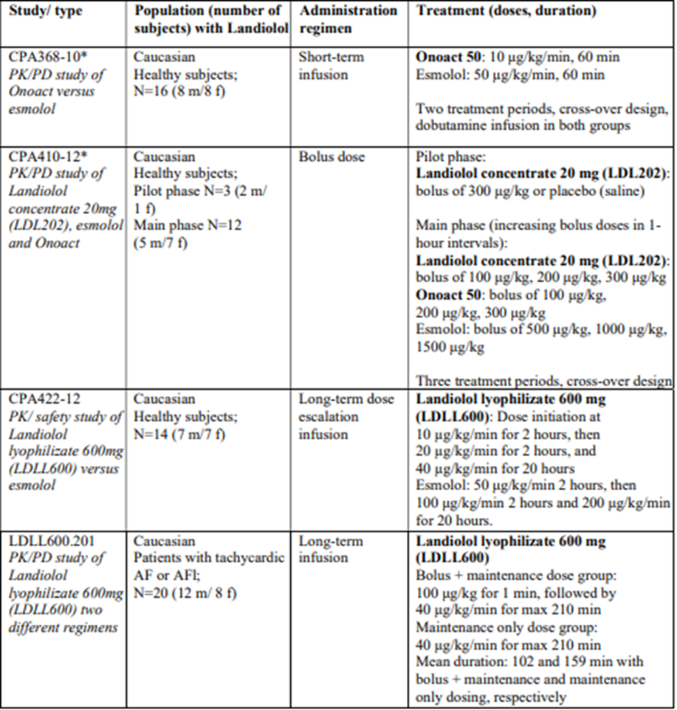
AF=atrial fibrillation, AFl=atrial flutter, f=female, m=male, N=number of subjects.

Pharmacology

Pharmacokinetics (PK)
The PK of landiolol following IV administration was evaluated in four AOP-sponsored studies and six published studies with Onoact.,,,,, The lack of a study directly comparing the PK of Rapiblyk and Onoact is supported by regulatory guidance.
Three AOP-sponsored Phase 1 studies evaluated the PK of landiolol and its two inactive metabolites, M1 and M2, in healthy caucasian subjects, and the Phase 2 Study LDLL600.201 evaluated the PK of landiolol in caucasian patients with atrial fibrillation (AF) or atrial flutter (AFl).
Study CPA368-10 compared the PK of landiolol (Onoact) and esmolol. Maximum blood concentrations were higher for landiolol than for esmolol (191 and 162 ng/mL, respectively), and were reached at 36 and 24 minutes, respectively. Both products had a short t_{1/2} (3.5 and 3.7 minutes, respectively).
Study CPA410-12 showed that comparable exposure to landiolol was achieved following bolus administration of Landiolol concentrate 20 mg and Onoact (Table 3).
Table 3: PK parameters of Landiolol (Landiolol concentrate 20 mg [LDL202] versus Onoact) in study CPA410-12 (PK population)
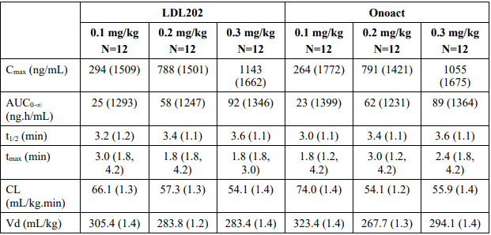
concentration curve from time zero to infinity, CL=clearance, Cmax=maximum concentration, N=number of subjects, PK=pharmacokinetic, SD=standard deviation, t1/2 =half-life, tmax=time to Cmax, Vd=volume of distribution.
Study CPA422-12 characterised the PK of landiolol compared to esmolol following sequential continuous infusion of Rapibloc Lyo 600 mg at 10 μg/kg/min for 2 hours, followed by 20 μg/kg/min for 2 hours and 40 μg/kg/min for 20 hours, and esmolol at 50 μg/kg/min for 2 hours, followed by 100 μg/kg/min for 2 hours and 200 μg/kg/min for 20 hours (Figure 1). Dose-proportionality was shown for AUC_{0-t} and C_{max} in the investigated dose range. Landiolol t_{1/2} was 4.5 min compared to esmolol 6.9 min.
Figure 1: Mean (SD) concentration time profiles of Landiolol (LDLL600) and esmolol in Study CPA422-12 (PK population)
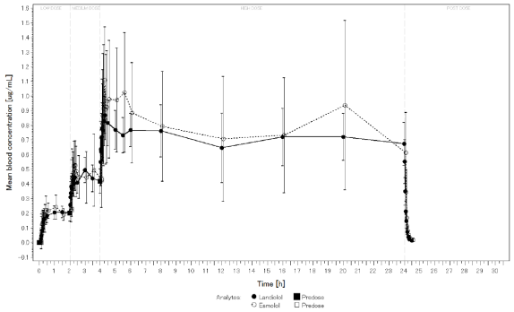
The Phase 2 Study LDLL600.201 evaluated the PK of landiolol in caucasian patients with AF or AFl. Dosage regimens evaluated were continuous infusion of 40 μg/kg/min (maximal total duration of 210 min), and bolus infusion of 100 μg/kg/min for one minute and then continuous infusion of 40 μg/kg/min (maximal total duration of 211 min), with dose changes permitted based on clinical criteria. After bolus + maintenance dosing, stable concentrations were observed between 60- and 190-minutes post-dose, while after maintenance only dosing, concentrations were stable between 30- and 190-minutes post-dose (Figure 2). When dose changes were corrected to a standard dose, both dosing schemes provided stable dose 20 minutes after treatment start. Total and maximum exposure were higher in the bolus + maintenance than in the maintenance only dosing group. After discontinuation of infusion, landiolol concentrations decreased rapidly with both dosing schemes. Clearance and volume of distribution (Vd) were higher in the maintenance only than in the bolus + maintenance dosing group, and t_{1/2} was similar for the two dosing regimens (Table 4).
Figure 2: Mean concentration time profiles of Landiolol (bolus + maintenance versus maintenance only dosing scheme) in study LDLL600.201 (PPS population)
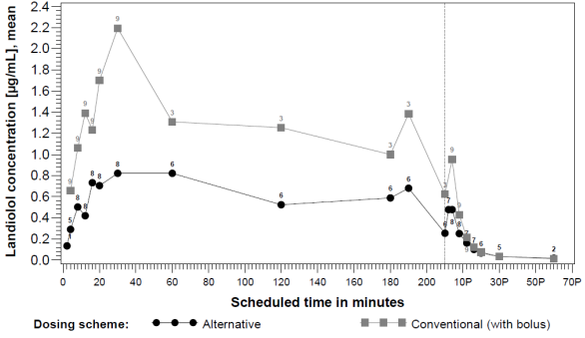
Table 4: PK parameters of Landiolol (bolus + maintenance versus maintenance only dosing scheme) in study LDLL600.201 (PPS population)
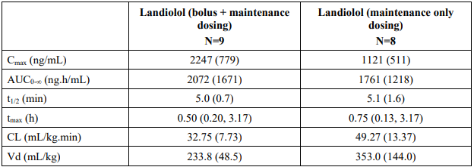
Mean (SD) are presented for all values, except for tmax which is presented as median (range). AUC0-∞=area under the concentration curve from time zero to infinity, CL=clearance, Cmax=maximum concentration, N=number of subjects, SD=standard deviation, t1/2 =half-life, tmax=time to Cmax, Vd=volume of distribution.
When administered by continuous intravenous infusion, the concentration of landiolol in blood reached steady-state values about 15 minutes after initiation of administration. Steady-state can also be achieved faster (up to 2 - 5 minutes) with regimens that use a higher loading dose infused for 1 minute followed by continuous infusion at a lower dosage. The PK of landiolol is dose proportional across the proposed dose range.
The apparent volume of distribution of landiolol is about 3 L/kg and for the main metabolite 0.3 L/kg. The protein binding for landiolol is low (< 10%) and dose dependent.
Landiolol is metabolised by carboxylesterase in liver and pseudocholinesterase in plasma mainly into two inactive metabolites, M1 and M2. As landiolol is rapidly metabolised, only 10% of the dose is excreted in urine. The metabolites are also mainly excreted in urine and 90% is excreted within 24 hours.
The PK of landiolol has not been evaluated in patients with renal impairment. The impact of renal impairment on the pharmacokinetics is expected to be limited as landiolol is rapidly metabolised, only 10% of the dose is excreted by urine. Even though the metabolites are mainly excreted in urine, the clinical impact of renal impairment on the metabolites is also expected to be limited as the metabolites are both inactive.
The impact of liver function on the pharmacokinetics of landiolol was investigated in six patients with mild to moderate hepatic impairment and six healthy volunteers. Blood concentrations of landiolol were higher in patients with hepatic impairment (increase in geometric mean C_{max}, C_{ss} and AUC_{0-∞} values in patients compared to healthy volunteers: +42%, +35% and +44%, respectively), but t_{1/2} was similar in patients and healthy subjects. The PBPK model predicted the influence of hepatic impairment on the PK of Landiolol, and the effect of hepatic impairment was expected to be only marginal and unlikely to affect the safety and efficacy profile of landiolol. The effect of severe hepatic impairment has not been evaluated.
No PK drug interaction studies were performed. It is not expected that the distribution and metabolism will be affected by other medicinal products.
The PBPK modelling study integrated published data from Onoact studies as well as clinical data from the four AOP-sponsored studies. The PBPK modelling study simulated PK values for landiolol in two populations (Caucasians and Japanese) with varying health status (healthy subjects, patients with tachycardia/reduced cardiac indices, patients with altered metabolic enzyme blood concentrations) and overall provided evidence for Caucasian and Japanese comparability. The simulations were in general in good agreement with the observed data for the different dosing regimens and in different study populations and were considered acceptable.

Pharmacodynamics (PD)
In the Onoact clinical development program, three dose-finding studies were conducted in Japanese subjects, one in patients with paroxysmal AF/AFl/SVT , one in patients with perioperative tachyarrhythmia and one in patients with persisting postoperative SVT . All three studies showed a dose dependent reduction of heart rate after landiolol infusion.
The Onoact clinical development program also included three PK/PD studies performed in 97 healthy Japanese or Chinese subjects, one study on 6 Japanese subjects with hepatic impairment (versus 6 healthy patients), one study on 19 Japanese patients with cardiac arrhythmias and one study on 18 Japanese patients undergoing cardio-vascular surgery. Infusion of landiolol resulted in a rapid dose-dependent decrease in heart rate (HR). Heart rate, controlled by landiolol infusion, was not affected by administration of heparin.
In the four AOP-sponsored studies, infusion of landiolol produced decreases in heart rate in healthy patients and in patients with tachycardic AF or AFl. In Study CPA422-12, landiolol infusion had a more pronounced effect on heart rate at most time points compared to esmolol, whereas blood pressure decreases were similar for landiolol and esmolol (Figure 3). The reduction in HR was sustained throughout the 20-hour continuous infusion of landiolol 40 μg/kg/min and returned to baseline after discontinuation.
Figure 3: Mean systolic and diastolic blood pressure, heart rate and blood concentration time profiles of Landiolol (LDLL600) and esmolol in study CPA422-12- treatment period (PK population)
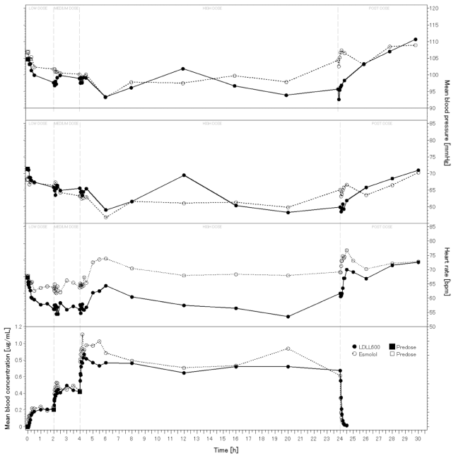
In Study LDLL600.201, analysis of HR, systolic blood pressure (SBP) and diastolic blood pressure (DBP) showed no significant difference between the two dosing regimens. In the FAS population overall, HR was reduced 4 minutes after initiation of continuous administration from the baseline mean value of 125.0 bpm to 113.0 bpm (-9.6%), and further to 103.8 bpm (-17.0%) after 16 minutes. Mean HR further decreased to 101.5 bpm (-18.8%) at 30 minutes and 94.2 bpm (-24.6%) at 60 minutes. Mean SBP was reduced during infusion of landiolol from 137.3 mmHg (baseline) by between 1.2 and 13.3 mmHg. DBP showed only small reductions from baseline mean value of 93.2 mmHg during the infusion, with the lowest value of 87.1 mmHg recorded two minutes after start of administration.

Efficacy
The evaluation of efficacy is based on 19 published clinical studies with Onoact (Table 5), as well as one AOP-sponsored study (Study LDLL600.201). For most studies in the peri- or post-operative setting, the majority of patients presented with elevated HR due to sinus tachycardia at baseline. For most studies in the non-surgical setting, the majority of patients presented with elevated HR due to AF at baseline.
The published studies evaluated a range of dosing regimens which completely cover the proposed dosing regimen for Rapiblyk (Table 6). Landiolol doses were categorised as LL (1 to <10 µg/kg/min), L (10 µg/kg/min), M (20 µg/kg/min), H (40 µg/kg/min), HH (80 µg/kg/min). Studies in patients with LV dysfunction/heart failure,, used low dose regimens, with starting doses ranging between 1 and 10 µg/kg/min. Three of the published studies included active comparators (diltiazem, ; digoxin¹³), and 8 were placebo controlled. The placebo-controlled studies were considered the most relevant for the assessment of efficacy. The efficacy evaluation focussed on the following key efficacy endpoints (noting there were some inconsistencies in endpoint definitions across the studies):
- Moderate improvement in HR reduction (HR reduction ≥20% from baseline)
- Substantial improvement in HR reduction (HR reduction ≥30% from baseline)
- Change in HR from baseline.
Table 5: Tabular overview of Onoact studies
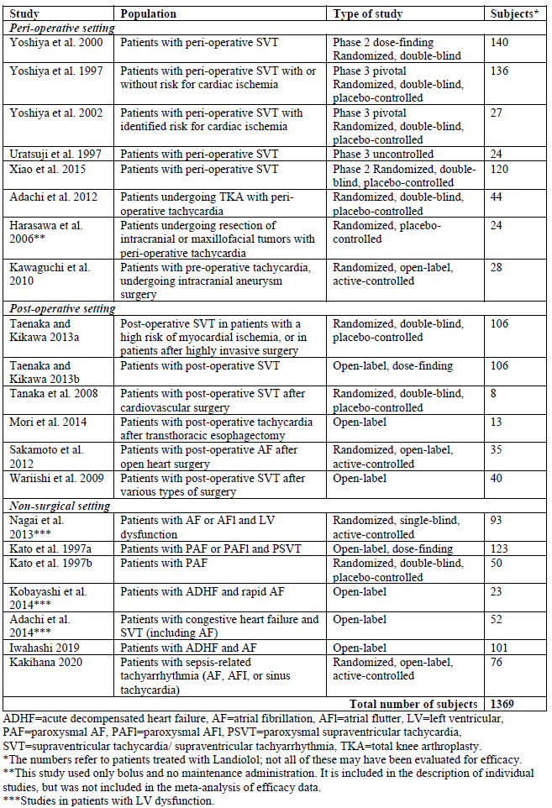
Table 6: Exposure in Onoact efficacy studies
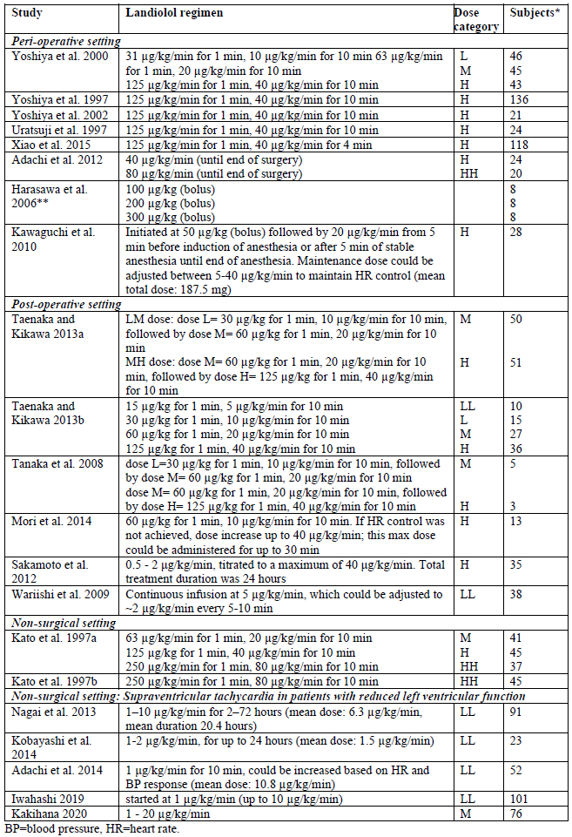
Moderate improvement in HR reduction
In all of the studies, landiolol led to moderate improvement in HR reduction or better in a substantial proportion of patients (Figure 4). Dose dependency was observed between 10 and 40 µg/kg/min in the two dose-finding studies using maintenance doses up to 40 µg/kg/min.^{11,} In the dose-finding study by Kato et al.¹⁰, using maintenance doses between 20 and 80 µg/kg/min, similar efficacy was observed for the two higher doses 40 and 80 µg/kg/min, suggesting a plateau of treatment effect at 40 µg/kg/min. In the two non-surgical studies evaluating low dose landiolol in patients with LV dysfunction,^{13,15} relatively high proportions of patients had moderate improvement in HR reduction with landiolol.
Figure 4: Moderate improvement in HR reduction or better (bar chart with frequency and 95% CI)
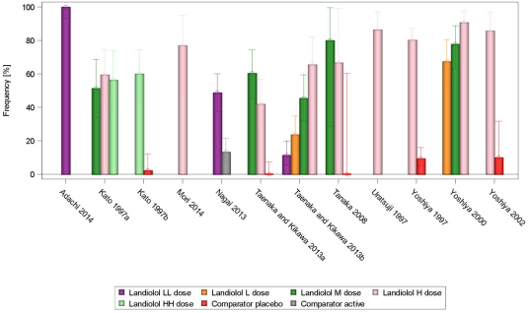
In placebo-controlled studies evaluating a 40 µg/kg/min maintenance dose, landiolol was better than placebo in achieving moderate improvement in HR reduction (Figure 5). In the meta-analysis pooling data from the placebo-controlled studies, landiolol was better than placebo in moderate improvement in HR reduction, with similar results for the M and H doses.
Figure 5: Moderate improvement in HR reduction or better (Forest plot with 95% CIs)
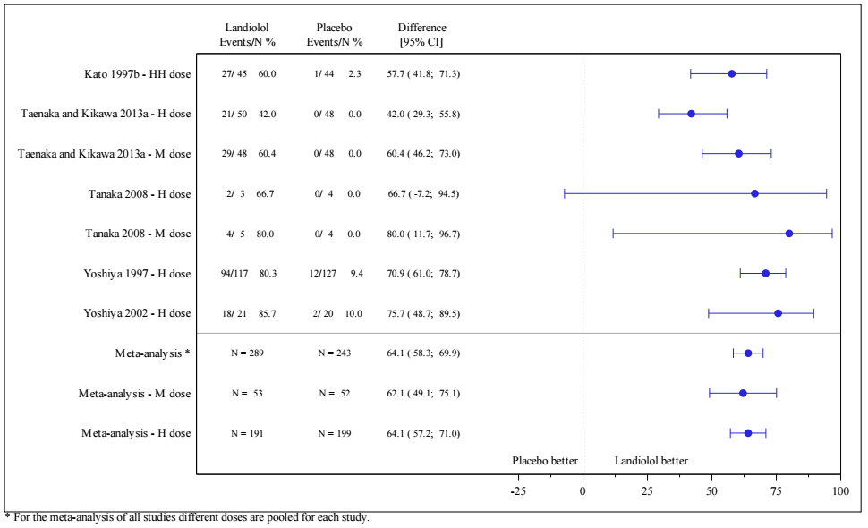

Substantial improvement in HR reduction
The definition of substantial improvement was not consistent across the studies, with some studies assessing restoration of sinus rhythm. The proportion of patients with substantial improvement in HR reduction/restoration of sinus rhythm ranged from 13.6% to 66.7% with the landiolol H dose in the surgical setting studies (Figure 6). In the non-surgical setting, landiolol was administered to patients with heart failure and AF at low doses, and the results varied from a very minor effect on sinus rhythm in the Adachi study to high proportion of patients with conversion to sinus rhythm in the Kobayashi study within the 24-hour treatment interval. It is possible that the long treatment interval of up to 24 hours in the latter study contributed to the high proportion of patients with conversion to sinus rhythm.
Overall, there was large variability in the results, and no dose-dependent effect of landiolol was seen across the studies. Differences in endpoint definitions and timepoints of assessment did not allow clear comparisons between studies and did not allow a clear differentiation between effect on rate control versus rhythm control.
Figure 6: Substantial improvement in HR reduction/restoration of sinus rhythm (bar chart with frequency and 95% confidence intervals)
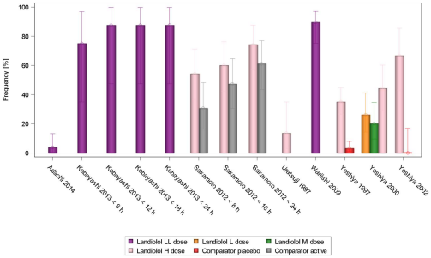
In placebo-controlled studies, landiolol (H dose) was better than placebo for substantial improvement in HR reduction/restoration of sinus rhythm (Figure 7). Differences in endpoint definitions in the two studies may have contributed to the numerically different results.
Figure 7: Substantial improvement in HR reduction/restoration of sinus rhythm (Forest plot with 95% CIs)
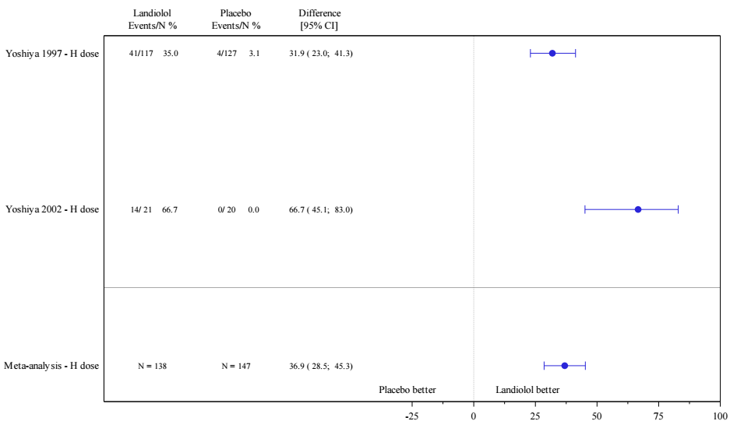
Change in HR from baseline
The change in HR from baseline was assessed in 11 studies, with 9 of these studies evaluating H dose landiolol (125 µg/kg for 1 min followed by 40 µg/kg/min). In the majority of studies, H dose landiolol was administered over a period of 11 minutes. For the peri-and post-operative studies, the mean change in HR from baseline to 11 min ranged from -18.9% to -34.9% for H dose landiolol, and for the non-surgical studies, the mean change in HR from baseline to 11 min ranged from -8.4% to -20.3% (Figure 8). In studies evaluating different doses, dose-dependent effects on HR were mostly observed.
Figure 8: Percent change in HR from baseline at various timepoints (mean with standard error), studies using the H dose
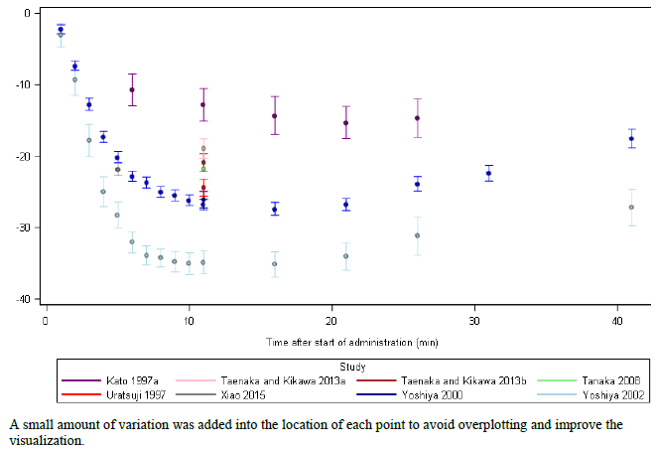

Study LDLL600.201
This was a Phase 2, single-centre, open-label, two-arm study evaluating landiolol in patients with tachycardic AF or AFl with baseline HR 100 – 200 bpm. 20 patients were randomised, 10 to bolus + maintenance dosing and 10 to maintenance only dosing (Figure 9).
Figure 9: Study design
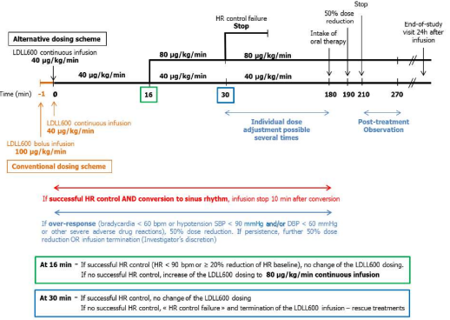
The primary endpoint (patients with successful HR control, defined as HR˂90 bpm or ≥20% reduction of HR from baseline, achieved and maintained during the first 16 min after continuous landiolol infusion start) was achieved by 50% of patients in the overall analysis set (60.0% in maintenance only group and 40.0% in bolus + maintenance group). The frequency of patients with successful HR control at any timepoint was 65% for the overall analysis set (90.0% in maintenance only group and 40.0% in bolus + maintenance group). In the maintenance only group the median time to successful HR control was 12.0 min (95% CI [8.0, 16.0], based on N=9) and in the bolus + maintenance group the median time to successful HR control was 8.0 min (95% CI [4.0, 14.0], based on N=4).

Safety
The clinical safety dataset is derived from 38 published clinical studies with Onoact (19 placebo-controlled, 5 active-controlled, 4 no-treatment-controlled, 10 uncontrolled and 4 AOP-sponsored studies of landiolol). Thirty-seven of the Onoact studies were conducted in Japan and 1 in China. The Onoact studies evaluated landiolol as treatment for pre-existing tachycardia (i.e. elevated HR at baseline) and in subjects with HR not elevated at baseline. The AOP-sponsored studies evaluated landiolol in healthy subjects (Studies CPA368-10, CPA410-12 and CPA422-12) and in patients with tachycardic AF or AFl (Study LDLL600.201).
Over two thousand, one hundred patients (2,101 patients, 1800 unique patients) were treated with landiolol in the Onoact studies. Adverse event (AE) data from the published studies was pooled and presented for “all studies”, “placebo-controlled studies”, “active-controlled studies” and “no-treatment-controlled studies”. The underlying database includes all AEs which were assessed as study drug-related; in case no information on the relationship was available from the publication, the AE was considered as related (i.e. worst-case approach). Serious AEs (SAEs) and deaths were reported in 6 of the 38 studies. For the description of SAEs and deaths, all events were considered, independent of their relationship to study drug.
The overall frequency of AEs with landiolol was 16.52% (all landiolol studies). On the PT level, the most frequent AEs were hypotension (6.43%), and bradycardia (1.52%).
In placebo-controlled studies, similar overall AE frequencies were observed with landiolol (14.58%) and placebo (14.30%). In the SOC vascular disorders, AEs were reported in 7.34% of landiolol-treated patients compared to 4.05% of placebo patients, driven mainly by the PT hypotension (5.40% vs 1.08%). In the SOC cardiac disorders, AEs were reported in 6.21% of placebo-treated patients compared to 2.16% of landiolol patients, driven mainly by the PTs tachycardia and atrial fibrillation (2.70% and 2.02%, respectively, with placebo, and 1.19% and 0.54%, respectively, with landiolol).
In active-controlled studies, overall AE frequencies were similar for landiolol and active comparator (34.72% versus 38.76%). In the SOC cardiac disorders, AEs were reported in 9.33% of landiolol-treated patients compared to 6.70% of placebo patients, driven mainly by the PT bradycardia (8.81% vs 4.78%). The PT hypotension was reported in 10.88% of patients treated with landiolol and 12.92% with active comparator.
Adverse events in patients with left ventricular dysfunction were examined in 145 subjects in two studies.^{13,15} Adachi et al.¹⁵ was an uncontrolled study in which 52 patients with congestive heart failure and SVT were treated with landiolol, initiated at 1 µg/kg/min and titrated up to 20 µg/kg/min. Nagai et al.¹³ was an active-controlled study in which 93 patients with AF or AFl and LV dysfunction were treated with landiolol administered at 1–10 µg/kg/min for 2–72 hours (mean dose 6.3 µg/kg/min, mean treatment duration 20.4 hours). The safety profile in these studies was similar to the overall population.
In an analysis by dose, no dose-dependent effect of landiolol on AE frequencies was observed.
Adverse events of special interest (AESI) included hypotension/decreased blood pressure, bradycardia/decreased heart rate, cardiac failure, shock, sinus arrest/cardiac arrest/complete AV block, and bronchospasm (Table 7).
Table 7: Adverse events of special interest in Onoact studies (all studies, safety set)
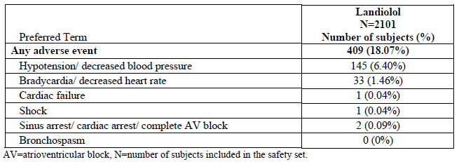
Some of the published studies reported changes in QT interval with landiolol. The QT interval is known to be affected by HR; methods to correct for this include Bazett’s formula (QTcB) and the Fridericia formula (QTcF). Findings from the AOP-sponsored study LDL600.201 showed an increase in uncorrected QT interval time, a decrease in QTcB interval time and a stable QTcF interval time. In vitro ion channel data, including hERG assay, support the notion that landiolol presents low Torsades de pointes risk.
Safety findings in the four AOP-sponsored clinical studies were consistent with the safety profile of landiolol in the Onoact studies.
Recovery of heart rate and blood pressure to pre-administration values was observed within 30 minutes of discontinuation of landiolol. None of the studies reported a rebound phenomenon.
The safety of landiolol has been evaluated in various clinical settings, including peri-operative, post-operative, and non-surgical settings. Overall, the data do not suggest any important clinically relevant differences in the safety profile between these settings. PD drug interactions have been observed when landiolol is administered concurrently with drugs acting on the cardiovascular system and anaesthetic agents, as effects on conduction, cardiac function or blood pressure may be more pronounced. The dosage and administration of landiolol was established in clinical studies where pre-anaesthetic and anaesthetic agents were used concomitantly. The proposed Product Information contains guidance regarding interactions with other medicines, including antiarrhythmic drugs and anaesthetic agents. Landiolol is administered only in well-controlled clinical settings with monitoring of cardiac and haemodynamic parameters.
Safety in elderly patients (over 65 years) was assessed in two post-marketing surveys conducted by the PDMA (Japan). Overall adverse reaction incidence rates in patients over 65 years in the two surveys (7.5% and 9.3%) were similar to patients under 65 years (7.0% and 8.2%)
Safety data in patients with hepatic impairment are available from the literature, from the PDMA assessment report, and the two post-marketing surveys conducted by the PDMA. Landiolol is primarily metabolised by blood cholinesterases and is not largely affected by hepatic insufficiency. The proposed dosing guidance recommends careful dosing starting with the lowest dose in patients with hepatic impairment.
Safety data in patients with renal impairment are available from the literature and from two post-marketing surveys conducted by the PMDA. The metabolism of landiolol is largely independent of renal function. No dose adjustment is recommended for patients with renal impairment.
Review of post-market safety data did not identify any new safety concerns.

Risk management plan
The risk management plan is presented in EU-RMP version 3.0 (dated 28 February 2024; DLP 2 February 2023) and ASA version 3.0 (dated April 2025). The summary of safety concerns, pharmacovigilance plan, and risk minimisation activities are acceptable (Table 8). The TGA may request an updated RMP at any stage of a product's life cycle, during both the pre-approval and post-approval phases.
Table 8: Summary of safety concerns
Summary of safety concerns |  | Pharmacovigilance |  | Risk Minimisation
 |  | Routine | Additional | Routine | Additional
Important identified risks | None
Important potential risks | None
Missing information | Use in pregnancy and breastfeeding | ü* |  | ü^
* EU RMP only
^ SmPC section 4.4, 4.6, PL section 3, Legal status: Prescription only medicine (POM) (EU RMP only)
RMP evaluator recommendations regarding conditions of registration
- Rapiblyk (Landiolol hydrochloride) is to be included in the Black Triangle Scheme. The PI and CMI for Rapiblyk must include the black triangle symbol and mandatory accompanying text for five years, which starts from the date of first supply of the product.
- The Rapiblyk EU-Risk Management Plan (RMP) version 3.0 (dated 28 February 2024, data lock point 2 February 2023), with Australia-Specific Annex (ASA) version 3.0 (dated April 2025), included with submission PM-2024-04271-1-3, and any subsequent revisions, as agreed with the TGA will be implemented in Australia.
- An obligatory component of risk management plans is routine pharmacovigilance. Routine pharmacovigilance includes the submission of periodic safety update reports (PSURs).
Reports are to be provided in line with the current published list of EU reference dates and frequency of submission of PSURs until the period covered by such reports is not less than three years from the date of this approval letter. Each report must be submitted within ninety calendar days of the data lock point for that report.
The reports are to at least meet the requirements for PSURs as described in the European Medicines Agency’s Guideline on good pharmacovigilance practices (GVP) Module VII-periodic safety update report (Rev 1), Part VII.B Structures and processes. Note that submission of a PSUR does not constitute an application to vary the registration.
Further information regarding the TGA’s risk management approach can be found in risk management plans for medicines and biologicals and the TGA's risk management approach. Information on the Australia-specific annex (ASA) can be found on the TGA website.

Risk-benefit analysis

Delegate’s considerations
Efficacy
A total of 1,192 patients were treated with landiolol (Onoact) in 19 published efficacy studies. Landiolol was administered in peri-operative, post-operative, and non-surgical settings. Most patients treated in peri- or post-operative settings had elevated HR due to sinus tachycardia, whereas most patients treated in non-surgical settings had elevated HR due to AF. The published studies evaluated a range of dosing regimens which completely cover the proposed dosing regimen. Studies in patients with LV dysfunction/heart failure¹³⁻¹⁵ used low dose regimens, with starting doses ranging between 1 and 10 µg/kg/min, and this is reflected in the proposed dosing guidance.
Moderate improvement in HR reduction or better (HR reduction of ≥20% from baseline) was observed in all of the published studies. A dose-dependent effect was seen between 10 and 40 µg/kg/min in the dose-finding studies published by Taenaka and Kikawa¹² and Yoshiya et al.¹¹ In the dose-finding study by Kato et al.¹⁰ using doses between 20 and 80 µg/kg/min, similar efficacy was observed for the two higher doses 40 and 80 µg/kg/min. Assessment of substantial improvement in HR reduction (HR reduction of ≥30% from baseline)/restoration of sinus rhythm was limited by differences in endpoint definitions and timepoints of assessment across the studies, but landiolol H dose (125 µg/kg for 1 min followed by 40 µg/kg/min for 10 min) was superior to placebo in two placebo-controlled studies. In peri-and post-operative studies, the mean change in HR from baseline to 11 min with landiolol (H dose) ranged from -18.9% to -34.9%. In non-surgical studies, the mean change in HR from baseline ranged from -8.4% at 11 min to -20.3% at 11 min.
In Study LDLL600.201, successful HR control was achieved and maintained during the first 16 min after continuous landiolol infusion start (primary endpoint) in 50% of patients overall (60% in the maintenance only group, 40% in the bolus + maintenance group). In the maintenance only group (40 µg/kg/min) the median time to successful HR control was 12.0 min (N=9) and in the bolus + maintenance group (100 µg/kg/min for 1 minute followed by 40 µg/kg/min) the median time to successful HR control was 8.0 min (N=4).
Safety
The clinical safety dataset comprises 38 published clinical studies with Onoact, 4 AOP-sponsored clinical studies, and post-marketing safety data. The safety of landiolol has been assessed in placebo-controlled studies, active-controlled studies and no-treatment-controlled studies. Overall, the safety profile of landiolol is consistent with the expected safety profile of a short-acting cardio-selective beta-blocker. In the published studies, the most common adverse events related to landiolol were hypotension and bradycardia. Discontinuation due to adverse events was mainly due to decreased blood pressure, hypotension and bradycardia which are all known side effects of beta-blockers. Recovery of heart rate and blood pressure to pre-administration values occurred within 30 minutes of discontinuation of landiolol. No new safety concerns have been identified in the post-market safety dataset.
Treatment with landiolol is administered in well-controlled clinical settings with monitoring of cardiac and haemodynamic parameters. For all patients, the dose should be titrated based on clinical response. A lower starting dose should be used in patients with LV dysfunction.
Proposed Indications
The proposed indications are the same as the approved indications in Europe, and comparable to the approved Australian indications for Brevibloc (esmolol).
Proposed Dose
Rapiblyk is intended for intravenous use in a monitored setting. Only an appropriately qualified healthcare professional should administer Rapiblyk. The dosage of Rapiblyk should be titrated individually. The infusion is usually started at a rate of 10 - 40 µg/kg/min which will establish the heart rate lowering effect within 10 - 20 minutes. If rapid onset of the heart rate lowering effect is desired (within 2 to 4 minutes), an optional loading dose of 100 µg/kg/min for 1 minute can be considered, followed by continuous intravenous infusion of 10 - 40 µg/kg/min. Lower starting doses (from 1 µg/kg/min) should be used for patients with cardiac dysfunction.
The proposed dosing guidance is supported by the clinical dataset. The Sponsor provided a justification for expressing the dose as the salt, landiolol hydrochloride, rather than the free base, based on the long history of use internationally and extensive published data referencing landiolol hydrochloride. This is acceptable, but the Product Information should include a statement in Section 4.2 advising that the dosing guidance is based on the salt, not the free base.

Proposed action
The quality, efficacy and safety of Rapiblyk for the proposed use have been satisfactorily established. There are no clinical issues requiring advice from ACM. There are several outstanding issues from the non-clinical evaluation which need to be addressed.

Assessment outcome
Based on a review of quality, safety, and efficacy, the TGA decided to register Rapiblyk (landiolol hydrochloride) 300 mg powder for injection vial, indicated for:
Rapiblyk is indicated in adults for:
- supraventricular tachycardia and for the rapid control of ventricular rate in patients
    - with atrial fibrillation or atrial flutter in perioperative, postoperative, or other
    - circumstances where short-term control of the ventricular rate with a short acting
    - agent is desirable.
- non-compensatory sinus tachycardia where, in the physician’s judgment, the rapid heart
    - rate requires specific intervention.
Rapiblyk is not intended for use in chronic settings.

Specific conditions of registration
- Rapiblyk (Landiolol hydrochloride) is to be included in the Black Triangle Scheme. The PI and CMI for Rapiblyk must include the black triangle symbol and mandatory accompanying text for five years, which starts from the date of first supply of the product.
- The Rapiblyk EU-Risk Management Plan (RMP) version 3.0 (dated 28 February 2024, data lock point 2 February 2023), with Australia-Specific Annex (ASA) version 3.0 (dated April 2025), included with submission PM-2024-04271-1-3, and any subsequent revisions, as agreed with the TGA will be implemented in Australia.
- An obligatory component of risk management plans is routine pharmacovigilance. Routine pharmacovigilance includes the submission of periodic safety update reports (PSURs).
Reports are to be provided in line with the current published list of EU reference dates and frequency of submission of PSURs until the period covered by such reports is not less than three years from the date of this approval letter. Each report must be submitted within ninety calendar days of the data lock point for that report.
The reports are to at least meet the requirements for PSURs as described in the European Medicines Agency’s Guideline on good pharmacovigilance practices (GVP) Module VII-periodic safety update report (Rev 1), Part VII.B Structures and processes. Note that submission of a PSUR does not constitute an application to vary the registration.

Product Information and Consumer Medicine Information
For the most recent Product Information (PI) and Consumer Medicine Information (CMI), please refer to the TGA PI/CMI search facility.

Therapeutic Goods Administration
PO Box 100 Woden ACT 2606 Australia
Email: info@tga.gov.au Phone: 1800 020 653 Fax: 02 6203 1605
https://www.tga.gov.au
Reference/Publication #

This is the original indication proposed by the sponsor when the TGA commenced the evaluation of this submission. It may differ to the final indication approved by the TGA and registered in the Australian Register of Therapeutic Goods.
Hindricks et al. 2020 ESC Guidelines for the diagnosis and management of atrial fibrillation developed in collaboration with the European Association of Cardio-Thoracic Surgery (EACTS). Eur Heart J 2020 Aug 29.
Nakashima M, Kanamaru M. Phase I study of ONO-1101, a new ultra short acting β1-blocking agent in healthy volunteers. Rinsho Iyaku. 2000;16:1531–56. (Japanese)
Murakami M., Furuie, H., Matsuguma, K., Wanibuchi, A., Kikawa, S. and Irie, S. (2005) Pharmacokinetics and Pharmacodynamics of Landiolol Hydrochloride, an Ultra Short-acting β1-Selective Blocker, in a Dose Escalation Regimen in Healthy Male Volunteers. Drug Metabolism and Pharmacokinetics, 20 (5): 337-344, https://doi.org/10.2133/dmpk.20.337.
Atarashi, H., Kuruma, A., Yashima, M., Saitoh, H., Ino, T., Endoh, Y., & Hayakawa, H. (2000). Pharmacokinetics of landiolol hydrochloride, a new ultra-short-acting beta-blocker, in patients with cardiac arrhythmias. Clinical pharmacology and therapeutics, 68(2), 143–150. https://doi.org/10.1067/mcp.2000.108733
Wang, M., Zhang, Q., Hua, W., Zhou, W., Huang, M., & Wang, H. (2014). Pharmacokinetics, pharmacodynamics, and safety of landiolol hydrochloride in healthy Chinese subjects. Drug research, 64(3), 141–145. https://doi.org/10.1055/s-0033-1354368
Takahata, T., Yasui-Furukori, N., Sakamoto, J., Suto, K., Suto, T., Tateishi, T., & Munakata, A. (2005). Influence of hepatic impairment on the pharmacokinetics and pharmacodynamics of landiolol hydrochloride, an ultra-short-acting beta1-blocker. Drugs in R&D, 6(6), 385–394. https://doi.org/10.2165/00126839-200506060-00006
Naoki Matsumoto, Tohru Aomori, Masafumi Kanamoto, et al. Influence of Hemodynamic Variations on the Pharmacokinetics of Landiolol in Patients Undergoing Cardiovascular Surgery. Biological and Pharmaceutical Bulletin. 2012, Vol.35, No.10, p.1655. https://doi.org/10.1248/bpb.b110727
Note for Guidance on the Investigation of Bioavailability and Bioequivalence (CPMP/EWP/QWP/1401/98).
Kato K, Hayakawa H, Atarashi H, Sugimoto T, Inoue H, Hiejima K, et al. Clinical trial of an ultra short acting β₁-blocker; landiolol hydrochloride (ONO-1101), on paroxysmal atrial fibrillation or flutter and paroxysmal supraventricular tachycardia: An open label, dose finding study (late phase II study). Rinsho Iyaku (J Clin Ther Med) 1997; 13: 4873(53)–4901(81) [in Japanese].
Yoshiya I, Ogawa R, Okumura F, et al. Clinical evaluation of an ultra short acting beta-1-blocker landiolol hydrochloride (ONO-1101) on perioperative supraventricular tachyarrhythmia: a double-blind, dose finding study (late phase II study) (in Japanese). Rinsyoiyaku (J Clin Ther Med). 2000;16(10):1557–77.
Taenaka, N., & Kikawa, S. (2013). The effectiveness and safety of landiolol hydrochloride, an ultra-short-acting β1-blocker, in postoperative patients with supraventricular tachyarrhythmias: a multicenter, randomized, double-blind, placebo-controlled study. American journal of cardiovascular drugs : drugs, devices, and other interventions, 13(5), 353–364. https://doi.org/10.1007/s40256-013-0035-2
Nagai, R., Kinugawa, K., Inoue, H., Atarashi, H., Seino, Y., Yamashita, T., Shimizu, W., Aiba, T., Kitakaze, M., Sakamoto, A., Ikeda, T., Imai, Y., Daimon, T., Fujino, K., Nagano, T., Okamura, T., Hori, M., & J-Land Investigators (2013). Urgent management of rapid heart rate in patients with atrial fibrillation/flutter and left ventricular dysfunction: comparison of the ultra-short-acting β1-selective blocker landiolol with digoxin (J-Land Study). Circulation journal : official journal of the Japanese Circulation Society, 77(4), 908–916. https://doi.org/10.1253/circj.cj-12-1618
Kobayashi, S., Murakami, W., Myoren, T., Tateishi, H., Okuda, S., Doi, M., Nao, T., Wada, Y., Matsuzaki, M., & Yano, M. (2014). A low-dose β1-blocker effectively and safely slows the heart rate in patients with acute decompensated heart failure and rapid atrial fibrillation. Cardiology, 127(2), 105–113. https://doi.org/10.1159/000355312
Adachi, T., Sato, A., Baba, M., Hiraya, D., Hasegawa, T., Kuroki, K., Hoshi, T., & Aonuma, K. (2014). Novel use of the ultra-short-acting intravenous β1-selective blocker landiolol for supraventricular tachyarrhythmias in patients with congestive heart failure. Heart and vessels, 29(4), 464–469. https://doi.org/10.1007/s00380-013-0377-3
Kawaguchi, M., Utada, K., Yoshitani, K., Uchino, H., Takeda, Y., Masui, K., Sakabe, T., & Intraoperative Landiolol for Intracranial Aneurysm Surgery Trial (ILAST) Investigators (2010). Effects of a short-acting [beta]1 receptor antagonist landiolol on hemodynamics and tissue injury markers in patients with subarachnoid hemorrhage undergoing intracranial aneurysm surgery. Journal of neurosurgical anesthesiology, 22(3), 230–239. https://doi.org/10.1097/ANA.0b013e3181d0c2e4
Sakamoto, A., Kitakaze, M., Takamoto, S., Namiki, A., Kasanuki, H., Hosoda, S., & JL-KNIGHT study group (2012). Landiolol, an ultra-short-acting β₁-blocker, more effectively terminates atrial fibrillation than diltiazem after open heart surgery: prospective, multicenter, randomized, open-label study (JL-KNIGHT study). Circulation journal : official journal of the Japanese Circulation Society, 76(5), 1097–1101. https://doi.org/10.1253/circj.cj-11-1332
Taenaka, N., & Kikawa, S. (2013). Dose-dependent effect of landiolol, a new ultra-short-acting β(1)-blocker, on supraventricular tachyarrhythmias in postoperative patients. Clinical drug investigation, 33(7), 505–514. https://doi.org/10.1007/s40261-013-0093-x

