Australian Public Assessment Report for Ospomyv, Xborso
  - Active ingredient: Denosumab
  - Sponsor: Samsung Bioepis AU Pty Ltd
February 2026

About the Therapeutic Goods Administration (TGA)
- The Therapeutic Goods Administration (TGA) is part of the Australian Government Department of Health, Disability and Ageing and is responsible for regulating therapeutic goods, including medicines, medical devices, and biologicals.
- The TGA administers the Therapeutic Goods Act 1989 (the Act), applying a risk management approach designed to ensure therapeutic goods supplied in Australia meet acceptable standards of quality, safety, and efficacy.
- The work of the TGA is based on applying scientific and clinical expertise to decision-making, to ensure that the benefits to the Australian public outweigh any risks associated with the use of therapeutic goods.
- The TGA relies on the public, healthcare professionals and industry to report problems with therapeutic goods. The TGA investigates reports received to determine any necessary regulatory action.
- To report a problem with a therapeutic good, please see the information on the TGA website.

About AusPARs
- The Australian Public Assessment Report (AusPAR) provides information about the evaluation of a prescription medicine and the considerations that led the TGA to approve or not approve a prescription medicine submission. Further information can be found in Australian Public Assessment Report (AusPAR) guidance.
- AusPARs are prepared and published by the TGA.
- AusPARs are static documents that provide information that relates to a submission at a particular point in time. The publication of an AusPAR is an important part of the transparency of the TGA’s decision-making process.
- A new AusPAR may be provided to reflect changes to indications or major variations to a prescription medicine subject to evaluation by the TGA.

Copyright
© Commonwealth of Australia 2025
This work is copyright. You may reproduce the whole or part of this work in unaltered form for your own personal use or, if you are part of an organisation, for internal use within your organisation, but only if you or your organisation do not use the reproduction for any commercial purpose and retain this copyright notice and all disclaimer notices as part of that reproduction. Apart from rights to use as permitted by the Copyright Act 1968 or allowed by this copyright notice, all other rights are reserved and you are not allowed to reproduce the whole or any part of this work in any way (electronic or otherwise) without first being given specific written permission from the Commonwealth to do so. Requests and inquiries concerning reproduction and rights are to be sent to the TGA Copyright Officer, Therapeutic Goods Administration, PO Box 100, Woden ACT 2606 or emailed to <tga.copyright@tga.gov.au>.

Contents
List of abbreviations 4
Product submission 6
Submission details 6
Product background 8
Disease or condition 8
Current treatment options 9
Clinical rationale 9
Regulatory status 10
Australian regulatory status 10
International regulatory status 10
Registration timeline 10
Assessment overview 11
Quality evaluation summary 11
Nonclinical evaluation summary 12
Clinical evaluation summary 12
Summary of clinical studies 12
Pharmacology 12
Efficacy 14
Safety 20
Risk management plan 24
Pharmacovigilance plan 26
Risk minimisation plan 26
Risk-benefit analysis 27
Delegate’s considerations 27
Proposed action 28
Assessment outcome 28
Specific conditions of registration 29
Product Information and Consumer Medicine Information 30

List of abbreviations
Abbreviation | Meaning
ACM | Advisory Committee on Medicines
ACV | Advisory Committee on Vaccines
ADA | Antidrug antibody
ANOVA | Analysis of variance
ARTG | Australian Register of Therapeutic Goods
ASA | Australia-specific annex
AUEC_{0-M6} | Area under the effect curve from time 0 to month 6
AUC_{inf} | Area under the concentration time curve from time zero to infinity
AUC_{last} | Area under the plasma concentration time curve from time zero to the last measurable time point
BMD | Bone mineral density
CHO | Chinese hamster ovary
CI | Confidence interval
C_{max} | Maximum concentration
CMI | Consumer Medicines Information
CTX | c-telopeptide of type 1 collagen
DLP | Data lock point
EMA | European Medicines Agency
EU | European Union
FAS | Full analysis set
FDA | Food and Drug Administration (USA)
GMP | Good Manufacturing Practice
HC | Health Canada
HRT | Hormone replacement therapy
IP | Investigational products
LS | Least square
MFDS | Ministry of Food and Drug Safety (Republic of Korea)
N | Number of subjects
n | Number of subjects in the analysis
Nabs | Neutralising antibodies
ONJ | Osteonecrosis of the jaw
OPG | Osteoprotegerin
PFS | Pre-filled syringe
PI | Product information
PK | pharmacokinetic
PMO | Postmenopausal osteoporosis
PPS | Per protocol set
PSUR | Periodic safety update report
PT | Preferred term
RMP | Risk management plan
SAE | Serious adverse event
SAF1 | Safety Set 1
SC | Subcutaneous
SOC | System Organ Class
TGA | Therapeutic Goods Administration
TEAEs | Treatment emergent adverse events
USA/ US | United States of America

Product submission

Submission details
Type of submission: | New biosimilar entity
Product names: | Ospomyv, Xborso
Active ingredient: | Denosumab (rch)
Decision: | Approved
Date of decision: | 13 June 2025
Date of entry onto ARTG: | 9 July 2025
ARTG numbers: | 445963, 445964
Black Triangle Scheme  for the current submission: | No
Sponsor’s name and address: | Samsung Bioepis AU Pty Ltd  Suite 1, Level 11, 66 Goulburn Street,  Sydney NSW 2000  Australia
Dose forms: | Ospomyv (denosumab) 60 mg/1 mL solution for injection pre-filled syringe (445963)  Xborso (denosumab) 120 mg/1.7 mL solution for injection vial (445964)
Containers: | Ospomyv: Type 1 glass syringe with stainless steel needle with needle guard.  Xborso: Type I glass vial with stopper and seal with flip-off cap
Pack sizes: | One vial or one pre-filled syringe.
Approved therapeutic use for the current submission: | The approved indication for Ospomyv are:  The treatment of osteoporosis in postmenopausal women. Ospomyv significantly reduces the risk of vertebral, non-vertebral and hip fractures.  Treatment to increase bone mass in men with osteopaenia receiving androgen deprivation therapy for non-metastatic prostate cancer (see section 5.1 Pharmacodynamic properties, Clinical trials).  Treatment to increase bone mass in men with osteoporosis at increased risk of fracture.  Treatment to increase bone mass in women and men at increased risk of fracture due to long-term systemic glucocorticoid therapy.  The approved indication for Xborso are:  Prevention of skeletal related events in patients with multiple myeloma and in patients with bone metastases from solid tumours.  Treatment of giant cell tumour of bone in adults or skeletally mature adolescents that is recurrent, or unresectable, or resectable but associated with severe morbidity.  Treatment of hypercalcaemia of malignancy that is refractory to intravenous bisphosphonate.
Route of administration: | Subcutaneous (SC) injection
Dosage: | Ospomyv: a single subcutaneous injection of 60 mg, once every 6 months.  Xborso: a single subcutaneous injection of 120 mg, once every 4 weeks into the thigh, abdomen or upper arm. For the treatment of giant cell tumour of bone and hypercalcaemia of malignancy, a loading dose of 120 mg on days 8 and 15 of the initial 4-week treatment period.  Daily supplementation with calcium and vitamin D is recommended or required in all patients, unless hypercalcaemia is present.  For further information regarding dosage, such as dosage modifications to manage adverse reactions, refer to the Product Information.
Pregnancy category: | Pregnancy Category: D  There are no adequate and well-controlled studies of denosumab in pregnant women.  Denosumab is contraindicated for use during pregnancy and in women trying to get pregnant. Premenopausal women with reproductive potential should be advised of the potential effects of denosumab in pregnancy. Contraception should be discussed. Women should be advised not to become pregnant during and for at least 5 months after treatment with denosumab.  The use of any medicine during pregnancy requires careful consideration of both risks and benefits by the treating health professional. The pregnancy database must not be used as the sole basis of decision making in the use of medicines during pregnancy. The TGA does not provide advice on the use of medicines in pregnancy for specific cases. More information is available from obstetric drug information services in your state or territory.

Product background
This AusPAR describes the submission by Samsung Bioepis AU Pty Ltd to register Ospomyv (denosumab rch) 60 mg/1 mL solution for injection pre-filled syringe and Xborso (denosumab rch) 120 mg/1.7 mL solution for injection vial for the following proposed indication:
The proposed indication for Ospomyv (biosimilar to Prolia) -
The treatment of osteoporosis in postmenopausal women. Ospomyv reduces the risk of vertebral, non-vertebral and hip fractures.
Treatment to increase bone mass in men with osteopaenia receiving androgen deprivation therapy for non-metastatic prostate cancer
Treatment to increase bone mass in men with osteoporosis at increased risk of fracture.
Treatment to increase bone mass in women and men at increased risk of fracture due to long-term systemic glucocorticoid therapy.
The proposed indication for Xborso (biosimilar to Xgeva) -
Prevention of skeletal related events in patients with multiple myeloma and in patients with bone metastases from solid tumours.
Treatment of giant cell tumour of bone in adults or skeletally mature adolescents that is recurrent, or unresectable, or resectable but associated with severe morbidity.
Treatment of hypercalcaemia of malignancy that is refractory to intravenous bisphosphonate.
Denosumab is a monoclonal antibody that targets and inhibits RANKL, a protein that regulates bone resorption. The proposed therapeutic indications are consistent with the indications approved for Prolia and Xgeva in Australia.

Disease or condition

Osteoporosis/osteopaenia
Osteoporosis/osteopaenia is a disorder of low bone mass, characterised by unfavourable changes in bone mineral density (BMD), bone formation and resorption, bone geometry, and bone microarchitecture. This results in decreased bone strength and an increased fracture risk. Osteopaenia is defined as a BMD t-score between -1.0 and -2.5, and osteoporosis as a BMD t-score of -2.5 or smaller.

Primary osteoporosis
Bone loss due the physiological changes of aging (including oestrogen or androgen deficiency due to ageing) is typically referred to as primary osteoporosis.

Secondary osteoporosis
Bone loss due to other factors (e.g. androgen deprivation or glucocorticoid therapy, or malignancy-related bone loss) is typically referred to as secondary osteoporosis.

RANK/RANKL/OPG system
The receptor activator of nuclear factor kappa-B ligand (RANKL) is a type II homotrimeric transmembrane protein, and mainly expressed in osteocytes, osteoblasts, and bone marrow stromal cells. RANKL binds to RANK, expressed in osteoclast progenitor cells and osteoclasts, and induces osteoclastogenesis. Osteoprotegerin (OPG) is a decoy receptor for RANKL produced by mature osteoblasts and osteocytes and upon binding RANKL prevents the ligand’s interaction with RANK. Thus, the RANK/RANKL/OPG signalling pathway system and the ratio of its components profoundly affects healthy or pathologic bone remodelling.
Oestrogen deficiency induces RANKL expression (by reducing its suppression) and reduces OPG expression and thus facilitates osteoclastogenesis. Concurrent vitamin D deficiency impairs calcium absorption and leads to secondary hyperparathyroidism and thus may contribute to bone loss.
Tumour cells may produce cytokines, chemokines, and hormones that can increase RANKL expression and thus induce osteoclastic bone resorption and osteolytic metastasis.

Current treatment options
Treatment for primary and secondary osteoporosis/osteopaenia is typically dependent on disease severity, causative factors, and drug-specific factors (e.g. contraindications). Management options include:
- Lifestyle adjustments (e.g. smoking and alcohol use cessation, falls prevention programs, physical activity)
- Calcium and vitamin D supplementation
- Antiresorptive pharmacotherapy including:
  - Oral bisphosphonates (e.g. alendronate)
  - Bone-forming anabolic agents (e.g. teriparatide)
  - RANKL inhibitors (e.g. denosumab)
  - Other agents (e.g. hormone replacement therapy (HRT), raloxifene, calcitonin).

Clinical rationale
Denosumab is a fully human IgG2 monoclonal antibody with high affinity and specificity for RANK ligand (RANKL). RANKL exists as a transmembrane or soluble protein. RANKL is essential for the formation, function and survival of osteoclasts, the sole cell type responsible for bone resorption.
Osteoclasts play an important role in bone loss associated with postmenopausal osteoporosis and hormone ablation. Denosumab binds with high affinity and specificity to RANKL, preventing RANKL from activating its only receptor, RANK, on the surface of osteoclasts and their precursors, independent of bone surface. Prevention of RANKL/RANK interaction inhibits osteoclast formation, function and survival, thereby decreasing bone resorption and increasing bone mass and strength in both cortical and trabecular bone.
A key mediator of bone destruction in bone disease related to metastatic tumours and multiple myeloma is increased osteoclast activity, stimulated by RANKL. Prevention of RANKL-RANK interaction results in reduced osteoclast numbers and function and thereby decreases bone resorption and cancer-induced bone destruction.
In some nonclinical models RANKL inhibition resulted in reduced bone lesions and delayed formation of de novo bone metastases. RANKL inhibition reduced skeletal tumour growth, an additive effect when combined with other anti-cancer therapies.

Giant cell tumour of the bone
Giant cell tumours of bone are characterised by stromal cells expressing RANKL and osteoclast-like giant cells expressing RANK. In patients with giant cell tumour of bone, denosumab binds to RANKL, significantly reducing or eliminating osteoclast-like giant cells. Consequently, osteolysis is reduced and proliferative tumour stroma can be replaced with non-proliferative, differentiated, woven new bone which may show an increase in density.

Hypercalcaemia of malignancy refractory to intravenous bisphosphonates
The primary aetiology of both skeletal and humoral hypercalcaemia of malignancy is increased bone resorption, which leads to elevated calcium concentrations in the extracellular fluid. The increase in bone resorption is initiated by the release of signalling molecules such as PTHrP, prostaglandins, and cytokine by malignant and stromal cells. These molecules stimulate osteoblasts and other stromal cells to express RANKL, which upon binding its receptor RANK upregulates osteoclast recruitment and differentiation and thus bone resorption, with a resultant increase in calcium concentrations of the extracellular fluid and serum. Denosumab binds to RANKL preventing RANK/RANKL mediated osteoclast formation, function, and survival thereby lowering serum calcium levels.

Regulatory status

Australian regulatory status
This product is considered a new biosimilar medicine for Australian regulatory purposes.
Prolia (reference medicine for Ospomyv) was first registered on the ARTG in June 2010 and Xgeva (reference medicine for Xborso) was first registered on the ARTG in September 2011. On 23 August 2024, Jubbonti and Wyost were registered as biosimilars to Prolia and Xgeva. On 4 April 2025, Stoboclo and Osenvelt were registered as biosimilars to Prolia and Xgeva.

International regulatory status
At the time the TGA considered this submission, similar applications were submitted to the United States of America (USA) Food and Drug Administration (FDA) in February 2024, the European Medicines Agency (EMA) via the centralised procedure in March 2024, to the Ministry of Food and Drug Safety (MFDS) of Republic of Korea in March 2024, and to Health Canada (HC) in April 2024. No major differences in the submissions were noted.

Registration timeline
The following table captures the key steps and dates for this submission.
This submission was evaluated under the standard prescription medicines registration process.
Table 1: Timeline for Submission PM-2024-01517-1-5
Description | Date
Submission dossier accepted and first round evaluation commenced | 31 May 2024
Evaluation completed (End of round 2) | 18 March 2025
Registration decision (Outcome) | 13 June 2025
Registration in the ARTG completed | 9 July 2025
Number of working days from submission dossier acceptance to registration decision* | 218
*Statutory timeframe for standard submissions is 255 working days

Assessment overview
A summary of the TGA’s assessment for this submission is provided below.

Quality evaluation summary
Denosumab is a glycosylated IgG2 -based monoclonal antibody that selectively binds to receptor activator of nuclear factor- κB ligand (RANKL). The active ingredient was produced using recombinant DNA technology in CHO cells. Information about the manufacturing, storage and control facilities for the active substance has been provided in the dossier.
The active substance of Ospomyv/Xborso (denosumab- company code: SB16) has been developed as a similar biological medicinal product (biosimilar) to that of the currently registered reference product Prolia/Xgeva (denosumab). The sponsor has demonstrated that Ospomyv/Xborso (denosumab), is comparable to EU Prolia/Xgeva (denosumab) in terms of structure, species, function and degradation profile. An additional bridging comparability study between the EU and AU Prolia/Xgeva demonstrated EU Prolia/Xgeva to be representative of the Australian registered product (AU Prolia/Xgeva).
Ospomyv/ Xborso are sterile, preservative-free, clear, colourless to slightly yellow solution for injection at pH 5.2. The solution may contain trace amounts of translucent to white proteinaceous particles. The sponsor provided the stability data of active ingredient for supporting the proposed shelf-life. Store at 2°C to 8°C (Refrigerate. Do not freeze). Keep the pre-filled syringe or vial in the outer carton in order to protect from light.
Do not excessively shake the pre-filled syringe. If removed from the refrigerator, store the pre-filled syringe below 25°C (room temperature) and must be used within a single period of 60 days, but not exceeding the original expiry date. If not used within this period of up to 60 days, Ospomyv or Xborso may be returned to the refrigerator for future use. Any Ospomyv or Xborso that has already been exposed to room temperature for a single period of up to 60 days, and is exposed to room temperature the second time, should be used as soon as possible or discarded. Do not use Ospomyv or Xborso after the expiry date printed on the label.
There are no objections on quality grounds to the approval of Ospomyv (denosumab) and Xborso (denosumab).

Nonclinical evaluation summary
No new nonclinical data or further nonclinical evaluation were required for this submission. The TGA considers that previously submitted and evaluated data satisfactorily address nonclinical aspects of safety/efficacy relating to this submission.^{2,3}

Clinical evaluation summary

Summary of clinical studies
The following two clinical studies have been submitted as per Table 2.
Table 2: Details of clinical studies submitted for SB16 denosumab.

Pharmacology
The main purpose of the pharmacokinetic (PK) studies was to demonstrate the PK similarities of SB16 with the reference products.
Both clinical studies (SB16-1001 and SB16-3001) provided pharmacokinetic information to the comparability assessment. Overseas reference products EU Prolia and US Prolia and EU Xgeva and US Xgeva were used in the studies but bridged to AU Prolia and AU Xgeva.

Phase 1 PK Study SB16-1001

Design
A randomised, double-blind, three-arm, parallel group (1:1:1), single-dose study to compare the pharmacokinetics, pharmacodynamics, safety, tolerability, and immunogenicity of denosumab (SB16 denosumab, EU sourced Prolia, and US sourced Prolia) in 168 healthy male subjects aged 28-55 years. The study was conducted in one centre in France and 2 centres in the US between 21 October 2020 and 9 November 2022 (last subject last visit).
Blood samples for PK analysis were collected at 0 (pre-dose), 12, 24, 48, 96, 144, 192, 240, 288, 336, 504, 672, 1008, 1344, 2016, 2688, 3360, 4032, and 4704 hours post-dose.

PK parameters
Descriptive PK parameter results are presented in Table 3 (Pharmacokinetic Analysis Set).

Comparison between SB16 and EU sourced Prolia
The ANOVA geometric LS mean ratio (90% CI) for SB16 and EU sourced Prolia in AUCinf, Cmax, and AUClast were 1.01 (0.93 to 1.10), 1.02 (0.95 to 1.10), and 1.02 (0.94 to 1.12), respectively, which were within the pre-specified CI limit of 0.80 to 1.25 (Pharmacokinetic Analysis Set) (Table 3).
Table 3. Study SB16-1001. Statistical Comparison of Primary Pharmacokinetic Parameters between SB16 and EU sourced Prolia (Pharmacokinetic Analysis Set).
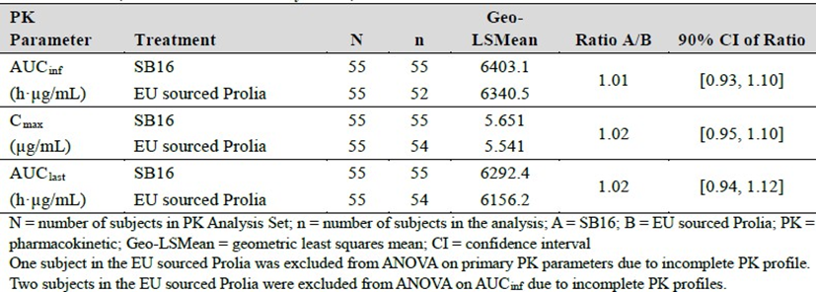

Comparison between SB16 and US sourced Prolia
The ANOVA geometric LS mean ratio (90% CI) for SB16 and US sourced Prolia in AUCinf, Cmax, and AUClast were 0.99 (0.91 to 1.08), 1.07 (0.99 to 1.15), and 1.01 (0.92 to 1.10), respectively, which were within the pre-specified CI limits of 0.80 to 1.25 (Pharmacokinetic Analysis Set) (Table 4).
Table 4. Study SB16-1001. Statistical Comparison of Primary Pharmacokinetic Parameters between SB16 and US sourced Prolia (Pharmacokinetic Analysis Set).
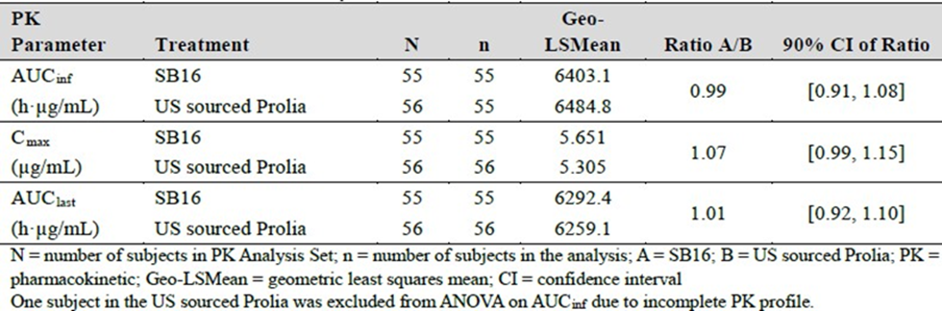

Comparison between EU sourced Prolia and US sourced Prolia
The ANOVA results of AUCinf, Cmax, and AUClast for the comparison of EU sourced Prolia and US sourced Prolia in the Pharmacokinetic Analysis Set are presented in Table 5.
Table 5. Study SB16-1001. Statistical Comparison of Primary Pharmacokinetic Parameters between EU sourced Prolia and US sourced Prolia (Pharmacokinetic Analysis Set).
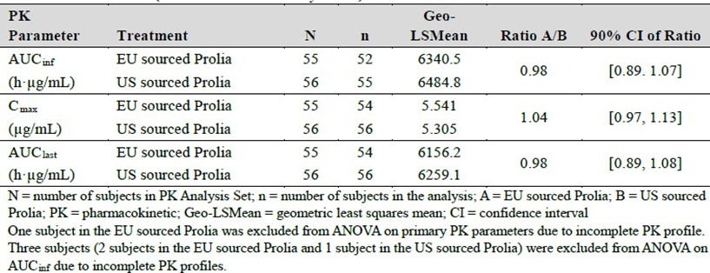

Pivotal Phase 3 Study SB16-3001 – PK results

Supportive PK results
Phase 3 Study SB16-3001 was supportive for PK. In the postmenopausal osteoporosis (PMO) patient target population, the mean serum denosumab concentrations were comparable between SB16 and Prolia treatment groups up to Month 12, and also between SB16+SB16, Prolia+SB16, and Prolia+Prolia treatment groups after transition, up to Month 18.

Pharmacodynamics
There were no notable differences between SB16 denosumab and EU-sourced PROLIA and US-sourced PROLIA in relation to their effects on CTX in Study SB16-1001 and SB16 denosumab and EU-sourced PROLIA in relation to their effects on CTX, AUEC0-M6 and P1NP in Study SB16-3001.

Efficacy

Pivotal Phase 3 Study SB16-3001

Design
A phase 3, randomised, double-blind, multi-centre (40 centres in 5 countries), 2-arm parallel-group (1:1), actively controlled clinical equivalence study to compare the efficacy, safety, pharmacokinetics, pharmacodynamics, and immunogenicity between SB16 and EU sourced Prolia in 457 postmenopausal women aged 55 to 80 years with osteoporosis (PMO) (Figure 1). The study was conducted between 26 November 2020 and 3 January 2023.
Primary efficacy objective: to demonstrate the equivalence of SB16 to Prolia in terms of percent change from baseline in lumbar spine bone mineral density (BMD) at Month 12 in subjects with PMO.
Figure 1. Study SB16-3001. Study design schema.
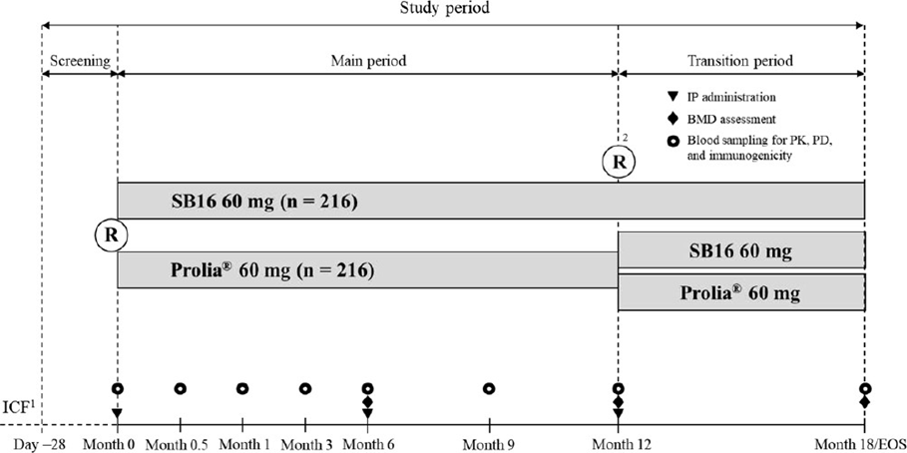
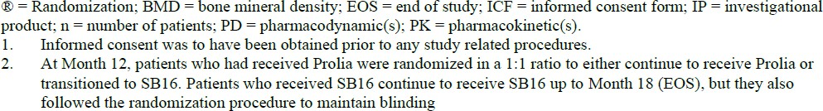

Main inclusion criteria:
- Postmenopausal women (defined as lack of menstrual period for at least 12 months prior to Screening, for which there was no other pathological or physiological cause) who were 55 to 80 years of age.
- Ambulatory and visually unimpaired to participate in the study at Screening, in the opinion of the Investigator.
- Absolute BMD consistent with T-score at the total hip or lumbar spine of ≥ ‒4 and ≤ ‒2.5, determined by central imaging centre at Screening.
- At least three evaluable vertebrae within L1 to L4, one evaluable femoral neck, and one evaluable hip joint for BMD measurement, determined by central imaging centre at Screening.
- Biologic (defined as any therapeutic monoclonal antibody or fusion receptor protein, including denosumab, denosumab biosimilars, or romosozumab) naïve at Screening.
- Body weight of ≥ 50 kg and ≤ 90 kg at Screening.

Main exclusion criteria:
- One severe or more than two moderate vertebral fractures on spinal X-ray according to Genant classification, determined by central imaging centre at Screening.
- History of hip fracture or bilateral hip replacement at Screening.
- Uncorrected vitamin D deficiency (defined as serum 25-hydroxyvitamin D level < 20 ng/ mL [50 nmol/L]) at Screening.
- Hypercalcaemia or hypocalcaemia (defined as albumin-adjusted serum calcium for hypocalcaemia < 2.1 mmol/L or for hypercalcaemia > 2.62 mmol/L) at Screening.
- Inadequate haematological function at Screening.
- Inadequate renal or hepatic function at Screening.
- Relevant allergic reactions, hypersensitivity or intolerances.
- Use of any medications that could affect BMD.
Treatments: Patients were administered subcutaneous 60 mg of SB16 or Prolia once every 6 months for up to 18 months. Non-investigational products administered were elemental calcium (> 1 g per day) and Vitamin D (> 800 IU per day).
- Main Period: Eligible patients received either SB16 or Prolia subcutaneously at Months 0 and 6 with BMD assessments at Months 6 and 12.
- Transition Period: At Month 12, patients who had received Prolia in the Main Period were randomised again in a 1:1 ratio to either continue on Prolia (Prolia+Prolia) or transitioned to SB16 (Prolia+SB16). Patients who had received SB16 in the Main Period continued to receive SB16, but they also followed the randomisation procedure to maintain blinding. Patients were followed up to Month 18.
Randomisation: An interactive web response system (IWRS) was used for the randomisation.

Baseline characteristics:
- Patient demographics: The mean age was 66.4 years (range: 52 to 81 years) and 59.7% were ≥ 65 years. All patients were female, and 90.8% were White. The mean BMI was 25.01 kg/m2 (range: 18.7 to 36.3 kg/m2).
- Disease characteristics (Table 6): The mean duration of PMO was 3.10 years. The mean duration since menopause was 16.18 years. 31.1% had a previous fracture history. The mean baseline T-score at lumbar spine was comparable between groups (–3.04 in the SB16 and –3.05 in the Prolia Overall treatment groups).
Table 6: Study SB16-3001. Baseline Disease Characteristics by Treatment Group (Randomized Set).
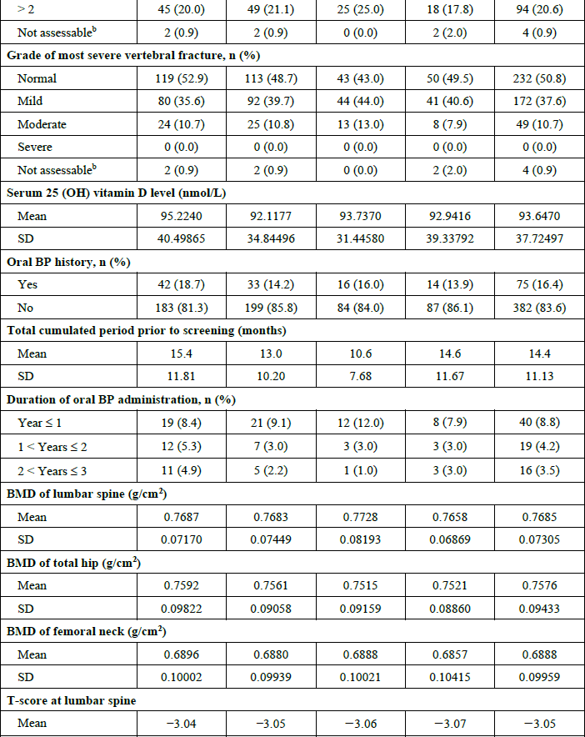
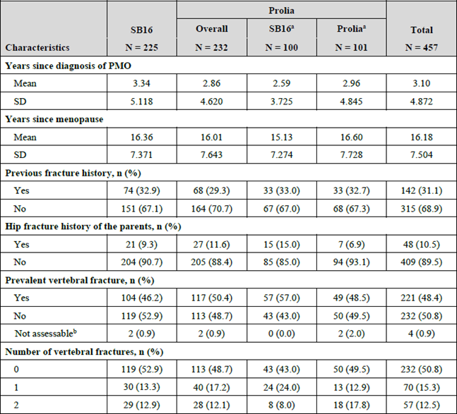
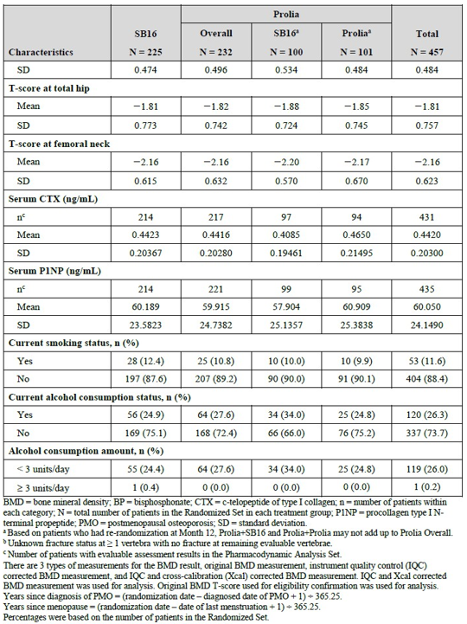
Patient disposition: Table 7.
Table 7: Study SB16-3001. Patient Disposition by Treatment Group (Enrolled Set).
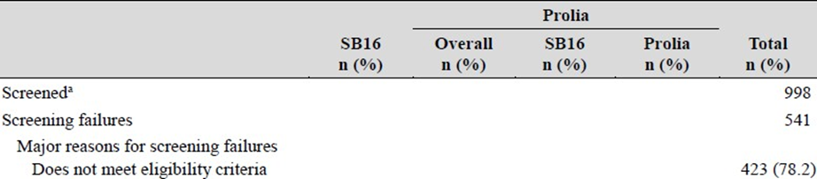
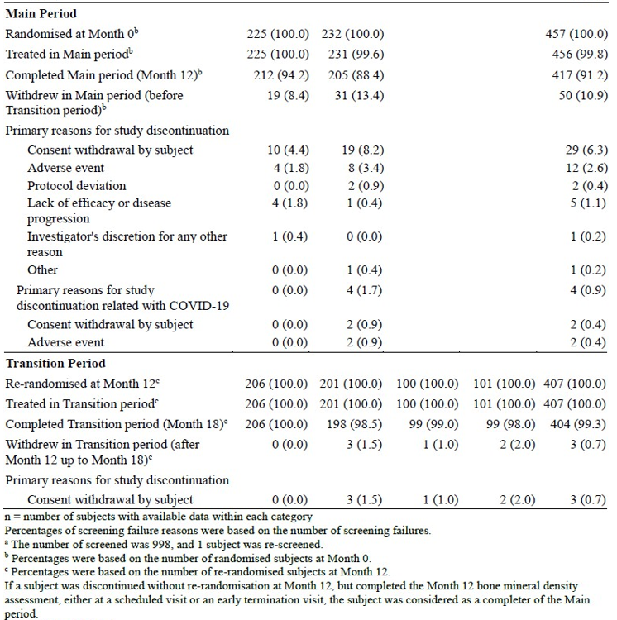

Magnitude of the treatment effect and its clinical significance
Primary efficacy endpoint: The primary efficacy endpoint was the percent change from baseline in BMD for lumbar spine at Month 12:
- Primary analysis: In the PPS analysis, the LS mean difference (95% CI) between SB16 and Prolia treatment groups was 0.39 (–0.36, 1.13) (contained within the equivalence margin of [–2.0, 2.0]) (Table 8).
- Supportive analysis: In the FAS (Multiple Imputation) analysis, the LS mean difference (95% CI) between SB16 and Prolia treatment groups was 0.33 (–0.36, 1.03) (contained within the equivalence margin of [–2.0, 2.0]) (Table 9).
The sensitivity and subgroup analyses were generally supportive of the primary analysis.
Secondary efficacy endpoints included the percent change from baseline in lumbar spine BMD at Month 6 and Month 18. Results are shown in Table 10, and are considered supportive of the primary outcome.
Table 8: Study SB16-3001. Primary endpoint results at Month 12 (PPS).
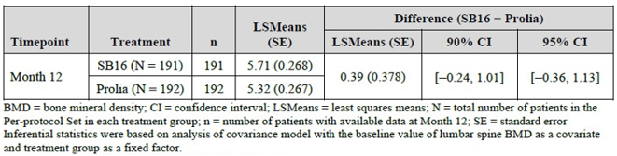
Table 9: Study SB16-3001. Primary endpoint results at Month 12 (FAS) (Multiple Imputation).
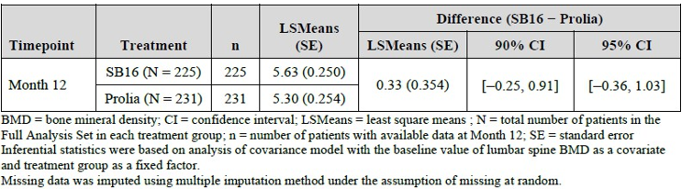
Table 10: Study SB16-3001. Secondary endpoints: Analysis of Percent Change from Baseline in Lumbar Spine Bone Mineral Density (BMD) at Month 6 and Month 18 (FAS).
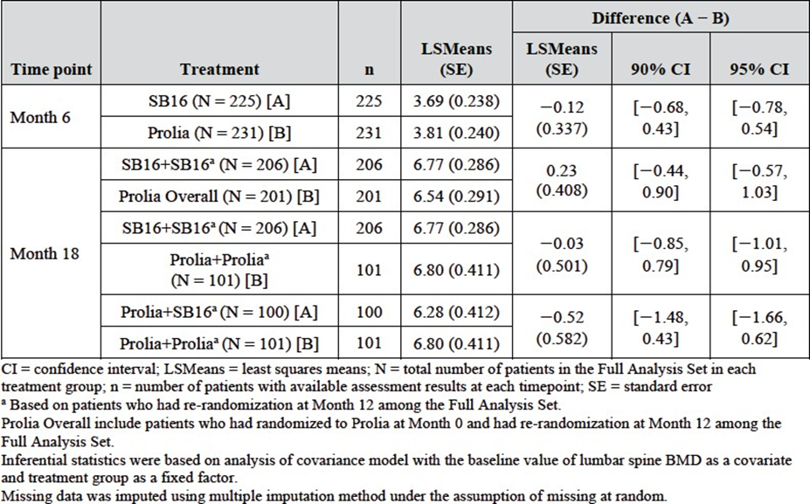

Safety
Both clinical studies included in the submission provided safety data. The phase I study (Study SB16-1001) provided safety in healthy male volunteers, while the most relevant safety data was obtained in the pivotal study SB16-3001.
The complete safety results are discussed in the CER and the clinical dossier. This overview focusses on the Study SB16-3001 – Safety Set 1 (SAF1), in which Safety Set 1 (SAF1) (n=456) consisted of all patients who received at least one IP. Safety Set 2 (SAF2) (n=407) consisted of all patients in the SAF1 who received IP after re-randomisation at Month 12. Patients were analysed according to the treatment received.

Exposure
Study SB16-3001 (SAF1): Out of randomised 457 patients were, 456 (99.8%) received at least 1 injection of SB16 or Prolia. The mean exposure duration up to Month 12 was 351.8 days for SB16 and 338.2 days for Prolia. The mean duration of exposure to IP up to Month 18 was 518.5 days for SB16 in the SB16 treatment group and 496.4 days in the Prolia Overall treatment group (543.4 days for Prolia+SB16 and 542.9 days for Prolia+ Prolia treatment groups) (Table 11).
Table 11: Study SB16-3001. Summary of Exposure to Investigational Product by Treatment Group (SAF1).
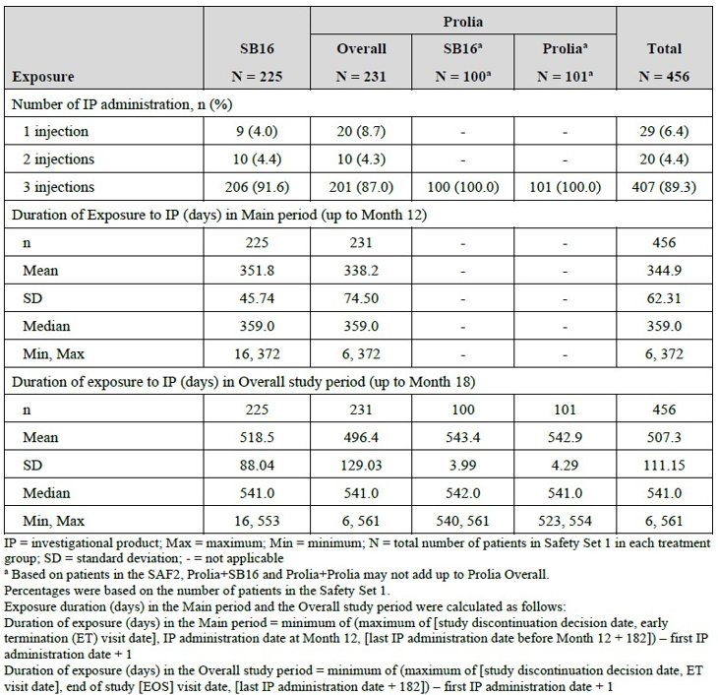

Adverse event overview
Study SB16-3001 (SAF1): 351 (77.0%) patients experienced at least one TEAE in the Overall study period (173 [76.9%] in the SB16 group, 178 [77.1%] in the Prolia Overall group, 76 [76.0%] in the Prolia+SB16 group, and 82 [81.2%] in the Prolia+Prolia group), of which 351 (77.0%) patients had 1094 TEAEs. Generally, the proportion of patients who reported at least one TEAE, the incidence, and the severity was comparable across groups.
Overall study period: At SOC level, the most frequently reported TEAEs were - infections and infestations (36.0%), musculoskeletal and connective tissue disorders (25.9%), and metabolism and nutrition disorders (23.5%). The most frequently reported PT was hypocalcaemia (11.0%). Overall, the incidences and frequency of the majority of the TEAEs by SOC or PT were comparable across groups.

Treatment related adverse event (adverse drug reaction) overview
Study SB16-3001 (SAF1): The majority of the TEAEs was not considered related to the investigational products (IP) (1010 out of 1094 TEAEs were not considered related) in the Overall study period. The number of TEAEs related to the IP were - 84 events in 60 (13.2%) patients with 27 [12.0%] patients in the SB16, 33 [14.3%] patients in the Prolia. Overall, 9 [9.0%] patients in the Prolia+SB16, and 18 [17.8%] patients in the Prolia+Prolia treatment groups (Table 12).
Table 12: Study SB16-3001. TEAEs with Incidence > 5% of Patients by System Organ Class and Preferred Term in the Overall Study Period (SAF1).
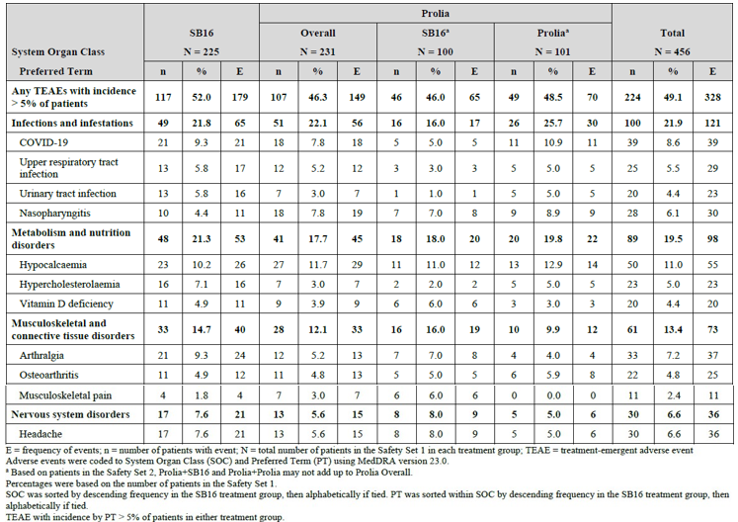

Deaths
Study SB16-3001: No death was reported.

Serious adverse events
Study SB16-3001: 23 (5.0%) patients (5.3% for SB16 vs. 4.8% for the Prolia Overall treatment group) had 29 serious TEAEs (SAE). No SAEs were considered related to the IP.

Discontinuations
Study SB16-3001: Four (1.8%) patients in the SB16 treatment group experienced TEAEs that led to permanent discontinuation of the IP (arachnoid cyst, headache, acute phase reaction, tooth fracture, and alopecia) vs. 8 (3.5%) in the Prolia. Overall treatment group (‘presyncope’, ‘alopecia’, ‘dental caries’, ‘haemorrhoids’, ‘noninfective gingivitis’, ‘COVID-19’, ‘diverticulitis’, ‘upper respiratory tract infection’, ‘breast cancer’, and ‘lung adenocarcinoma’).

Adverse events of special interest
AESIs in Study SB16-3001 (overall period shown) (Table 13):
Table 13: Study SB16-3001. Treatment-Emergent Adverse Events of Special Interest (AESI) by System Organ Class in the Overall Study Period (SAF1).
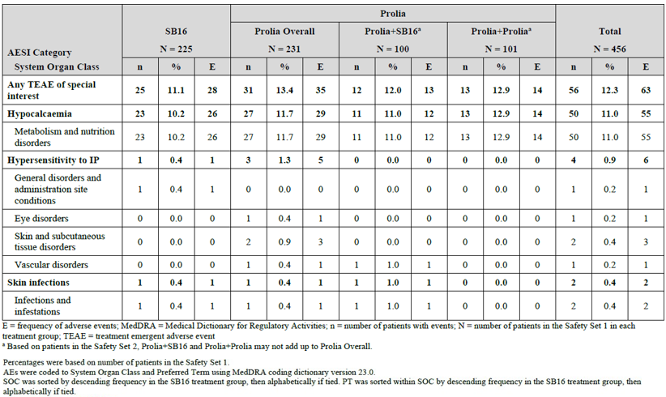
Hypocalcaemia: For SB16, this was reported in 23 (10.2%) patients in the overall study period with 24 events in 22 (9.8%) patients during the main period and 2 events in 2 (1.0%) patients during the transition period. For the Prolia Overall group, there were 29 events in 27 (11.7%) patients during the main period and no events in the transition period.
Hypersensitivity to IP: One (0.4%) patient in the SB16 treatment group experienced injection site erythema, and 3 (1.3%) patients in the Prolia treatment group had swelling of eyelid, erythema, pruritus, rash, and hot flush. There was no hypersensitivity to IP events in the Transition period.
Skin infections: One (0.4%) patient in the SB16 treatment group had herpes zoster, and one (0.4%) patient in the Prolia treatment group experienced erysipelas. There were no skin infections in the Transition period.
Osteonecrosis of the jaw: No event reported.
Atypical femoral fracture: No event reported.

Immunogenicity and antidrug antibodies
Overall, the incidence of patients with post-dose antidrug antibodies (ADAs) positive to denosumab was 2 (3.6%), none, and 4 (7.1%) of subjects in the SB16, EU Prolia, and US Prolia treatment groups, respectively. There were no statistical differences in the incidence between SB16 and EU Prolia, SB16 and US Prolia, and EU Prolia and US Prolia treatment groups. None of the patients with post-dose ADA positive to denosumab had a positive result for NAbs.

Pharmacology study
The types and frequencies of adverse effects reported in subjects receiving SB16 and EU Prolia and US Prolia used in the Phase 1 Study were generally comparable.

Post-market experience
No data are available for SB16.

Risk management plan
The sponsor, Samsung Bioepis AU Pty Ltd, has proposed separate risk management plans (RMPs) for Ospomyv and Xborso as summarised in Table 14 and Table 15, respectively. The TGA may request an updated RMP at any stage of a product's life cycle, during both the pre-approval and post-approval phases.
For Ospomyv, the EU-RMP version 1.2 (dated 09 October 2024; DLP 24 September 2024) and updated ASA version 1.1 (dated 28 November 2024) were included in this submission. For Xborso, the EU-RMP version 1.2 (dated 04 October 2024; DLP 24 September 2024) and updated ASA version 1.1 (dated 28 November 2024) were included in this submission.
Table 14: The proposed summary of safety concerns and their associated risk monitoring and mitigation strategies for Ospomyv.
Summary of safety concerns |  | Pharmacovigilance |  | Risk Minimisation
 |  | Routine | Additional | Routine | Additional
Important identified risks | Hypocalcaemia | ✓* | – | ✓ | –
Important identified risks | Skin infection leading to hospitalisation | ✓* | – | ✓ | –
Important identified risks | Osteonecrosis of the jaw | ✓* | – | ✓ | –
Important identified risks | Hypersensitivity reactions | ✓* | – | ✓ | –
Important identified risks | Atypical femoral fracture | ✓* | – | ✓ | –
Important identified risks | Hypercalcaemia in paediatric patients receiving denosumab and after treatment discontinuation | ✓ | – | ✓ | –
Important potential risks | Fracture healing complications | ✓* | – | – | –
Important potential risks | Infection | ✓* | – | ✓ | –
Important potential risks | Cardiovascular events | ✓ | – | – | –
Important potential risks | Malignancy | ✓* | – | – | –
Missing information | None
*Follow up questionnaires
Table 15: The proposed summary of safety concerns and their associated risk monitoring and mitigation strategies for Xborso.
Summary of safety concerns |  | Pharmacovigilance |  | Risk Minimisation
 |  | Routine | Additional | Routine | Additional
Important identified risks | Osteonecrosis of the jaw | ✓* | – | ✓ | –
Important identified risks | Atypical femoral fracture | ✓* | – | ✓ | –
Important identified risks | Hypercalcaemia several months after the last dose in patients with giant cell tumour of bone and in patients with growing skeletons | ✓ | – | ✓ | –
Important potential risks | Cardiovascular events | ✓ | – | – | –
Important potential risks | Malignancy | ✓ | – | – | –
Important potential risks | Delay in diagnosis of primary malignancy in giant cell tumour of bone | ✓ | – | – | –
Important potential risks | Hypercalcaemia several months after the last dose in patients other than those with giant cell tumour of bone or growing skeletons | ✓ | – | – | –
Missing information | Patients with prior intravenous bisphosphonate treatment | ✓ | – | ✓ | –
Missing information | Safety with long-term treatment and with long-term follow up after treatment in adults and skeletally mature adolescents with giant cell tumour of bone | ✓ | – | – | –
Missing information | Off-label use in patients with giant cell tumour of bone that is resectable where resection is unlikely to result in severe morbidity | ✓ | – | – | –
*Follow up questionnaires
The summary of safety concerns for Ospomyv and Xborso align with the summary of safety concerns in its associated EU-RMPs and the RMPs for the innovator products. Subject to the evaluation of the clinical aspects of the safety specification, the summary of safety concerns for Ospomyv and Xborso is acceptable from an RMP perspective.

Pharmacovigilance plan
The sponsor has proposed routine pharmacovigilance for all safety concerns for Ospomyv and Xborso including targeted follow up questionnaires for specific safety concerns in each ASA. No additional pharmacovigilance activities have been proposed. The pharmacovigilance plan for Ospomyv and Xborso aligns with the pharmacovigilance plan for the innovator products and are acceptable from an RMP perspective.

Risk minimisation plan
The sponsor has proposed routine risk minimisation only in the form of PI and CMI for some of the safety concerns and no additional risk minimisation activities have been proposed. At round 2, the sponsor has amended the PI, CMI and ASA as requested. The risk minimisation plans for Ospomyv and Xborso are acceptable from an RMP perspective.
Further information regarding the TGA’s risk management approach can be found in risk management plans for medicines and biologicals and the TGA's risk management approach. Information on the Australia-specific annex (ASA) can be found on the TGA website.

Risk-benefit analysis

Delegate’s considerations

Clinical trial program
The clinical trial program consisted of one phase I study (Study SB16-1001) and one phase III study (Study SB16-3001). Pharmacology and clinical safety data (pharmacokinetic and pharmacodynamic) were obtained from both studies, with Study SB16-1001 providing evidence for PK biosimilarity. Clinical efficacy data were obtained from the SB16-3001 study in patients with osteoporosis that provided evidence for clinical equivalence, including data on switching agents.

Quality and bridging
The clinical trial program used US-licensed (Study SB16-1001) and EU-licensed Prolia (Studies SB16-1001 and SB16-3001) rather than AU-licenced Prolia or Xgeva. The sponsor has demonstrated that Ospomyv/Xborso (denosumab) is comparable to EU Prolia/Xgeva (denosumab) in terms of structure, species, function and degradation profile. An additional bridging comparability study between the EU and AU Prolia/Xgeva demonstrated EU Prolia/Xgeva to be representative of the Australian registered product (AU Prolia/Xgeva).
There were no objections on quality grounds to the approval of Ospomyv (denosumab) and Xborso (denosumab).

Pharmacology
Based on the PK data provided, the serum denosumab concentrations and PK parameters were generally consistent between those who received SB16 and Prolia and PK biosimilarity was established.

Efficacy

Study design and primary endpoint
There were no significant objections to the study design.
The applicant has justified the indication/patient population investigated in the clinical study SB16-3001 (osteoporosis in postmenopausal women as the most appropriate population). This is considered acceptable.
In Study SB16-3001, the primary efficacy endpoint was the percent change from baseline in BMD for lumbar spine at Month 12. That chosen variable differed from the primary efficacy variable in the pivotal trial for the reference product Prolia, which was the incidence of new vertebral fractures. However, the applicant has justified the choice of endpoint.
For the initial registration of an agent targeting osteoporosis, the use of the incidence of new vertebral fractures as an endpoint variable is still preferred, but for biosimilarity assessments, an appropriately designed BMD endpoint was considered suitable. However, incidences of new vertebral, nonvertebral, and hip fractures should have been included as other endpoints in the study.

Equivalence margin
Therapeutic equivalence was based on whether the primary efficacy endpoint (percent change from baseline in BMD for lumbar spine at Month 12) 2-sided 95% confidence interval (CI) of least squares means for the treatment difference between Ospomyv and Prolia falls within the predefined equivalence margin of (-2.0%, 2.0%). This margin has been sufficiently justified with margins previously used by the comparative studies with denosumab or alendronate. Despite the justification, the equivalence margin is considered rather wide, and a tighter margin would have been ultimately preferable, for example (-1.5%, 1.5%). It is noted that an equivalence margin of (-1.45%, 1.45%), and (-1.503%, 1.503%) had been accepted previously for Jubbonti/Wyost, and Stoboclo/Osenvelt, respectively. Furthermore, it is noted that the 95% CI of the primary endpoint result in SB16-3001 was entirely contained in the tighter margins used in the other Prolia/Xgeva biosimilar applications.

Efficacy results
In Study SB16-3001, in the PPS analysis, the LS mean difference (95% CI) between SB16 and Prolia treatment groups was 0.39 (–0.36, 1.13) and thus contained within the pre-specified equivalence margin of (–2.0, 2.0). This result is supported by the FAS analysis and by the secondary endpoints.

Safety
The safety profile of the reference product Prolia and Xgeva is well characterised.

Safety profile
Overall, the safety profiles of Prolia and SB16 were considered to be similar. However, the sample size was not large enough to detect rare adverse events including ONJ or atypical femoral fracture. Furthermore, the study did not assess long-term safety. There are no post-market data available.
None of the patients with post-dose ADA positive to denosumab had a positive result for NAbs.

Regulatory considerations and translation to clinical practice

Extrapolation to other indications
In the clinical trial program, similarity between SB16 and Prolia was demonstrated for the treatment of osteoporosis.
An unfavourable impact on clinical efficacy and safety in the extrapolated indications is not expected for the biosimilar.

Proposed action
Overall, the extrapolation from the comparative data generated in post-menstrual women with osteoporosis to all approved indications of Prolia and Xgeva was considered acceptable.
There were no outstanding issues, and the applicant agreed to the TGA-requested PI changes. The application was not referred to the ACM, in particular given the regulatory precedent with Jubbonti/ Wyost and Stoboclo/Osenvelt. The application was approved on 13 June 2025.

Assessment outcome
Based on a review of quality, safety, and efficacy, the TGA decided to register Ospomyv (denosumab) 60 mg/1 mL solution for injection pre-filled syringe and Xborso (denosumab) 120 mg/1.7 mL solution for injection vial indicated for:
The approved indication for OSPYMOV are:
The treatment of osteoporosis in postmenopausal women. Ospomyv significantly reduces the risk of vertebral, non-vertebral and hip fractures.
Treatment to increase bone mass in men with osteopaenia receiving androgen deprivation therapy for non-metastatic prostate cancer (see section 5.1 Pharmacodynamic properties, Clinical trials).
Treatment to increase bone mass in men with osteoporosis at increased risk of fracture.
Treatment to increase bone mass in women and men at increased risk of fracture due to long-term systemic glucocorticoid therapy.
The approved indication for XBORSO are:
Prevention of skeletal related events in patients with multiple myeloma and in patients with bone metastases from solid tumours.
Treatment of giant cell tumour of bone in adults or skeletally mature adolescents that is recurrent, or unresectable, or resectable but associated with severe morbidity.
Treatment of hypercalcaemia of malignancy that is refractory to intravenous bisphosphonate.

Specific conditions of registration
- The Ospomyv EU-Risk Management Plan (RMP) version 1.2 (dated 09 October 2024, data lock point 24 September 2024), with Australia-Specific Annex (ASA) version 1.1 (dated 28 November 2024), and Xborso EU-Risk Management Plan (RMP) version 1.2 (dated 04 October 2024, data lock point 24 September 2024), with Australia-Specific Annex (ASA) version 1.1 (dated 28 November 2024) included with submission PM- 2024-01517-1-5, and any subsequent revisions, as agreed with the TGA will be implemented in Australia.
- This approval does not impose any requirement for the submission of Periodic Safety Update reports (PSURs). You are reminded that sections 29A and 29AA of the Therapeutic Goods Act 1989 provide for penalties where there has been failure to inform the Secretary in writing, as soon as a person has become aware, of:
  - information that contradicts information already given by the person under this Act;
  - information that indicates that the use of the goods in accordance with the recommendations for their use may have an unintended harmful effect;
  - information that indicates that the goods, when used in accordance with the recommendations for their use, may not be as effective as the application for registration or listing of the goods or information already given by the person under this Act suggests;
  - information that indicates that the quality, safety or efficacy of the goods is unacceptable.
- Laboratory testing & compliance with Certified Product Details (CPD)
- All batches of Ospomyv (denosumab) 60 mg/1.0 mL solution for injection in prefilled syringe and Xborso (denosumab) 120 mg/1.7 mL solution for injection vial supplied in Australia must comply with the product details and specifications approved during evaluation and detailed in the Certified Product Details (CPD).
- When requested by the TGA, the Sponsor should be prepared to provide product samples, specified reference materials and documentary evidence to enable the TGA to conduct laboratory testing on the Product. Outcomes of laboratory testing are published biannually in the TGA Database of Laboratory Testing Results https://www.tga.gov.au/resources/publication/tga-laboratory-testing-reports and periodically in testing reports on the TGA website.
- The actual date of commencement of supply is to be notified to the Branch Head, Prescription Medicines Authorisation Branch, TGA. Should it be decided not to proceed to supply, notification to this effect should be provided.
- Certified Product Details
The Certified Product Details (CPD), as described in Guidance 7: Certified Product Details of the Australian Regulatory Guidelines for Prescription Medicines (ARGPM), in PDF format, for the above products should be provided upon registration of these therapeutic goods. In addition, an updated CPD should be provided when changes to finished product specifications and test methods are approved in a Category 3 application or notified through a self-assessable change.
A template for preparation of CPD for biological prescription medicines can be obtained from the TGA website [for the form] https://www.tga.gov.au/form/certified-product-details-cpd-biologicalprescription-medicines [for the CPD guidance] https://www.tga.gov.au/guidance-7-certified-product-details
- It is a specific condition of registration for biosimilar medicines that the Product Information and Consumer Medicine Information documents be updated within ONE month of safety-related changes made by the reference product. It is your responsibility to routinely check the TGA website at www.ebs.tga.gov.au for any updates to the innovator Product Information.

Product Information and Consumer Medicine Information
For the most recent Product Information (PI) and Consumer Medicine Information (CMI), please refer to the TGA PI/CMI search facility.

Therapeutic Goods Administration
PO Box 100 Woden ACT 2606 Australia
Email: info@tga.gov.au Phone: 1800 020 653 Fax: 02 6203 1605
https://www.tga.gov.au

This is the original indication proposed by the sponsor when the TGA commenced the evaluation of this submission. It may differ to the final indication approved by the TGA and registered in the Australian Register of Therapeutic Goods.
AusPAR for Denosumab - Prolia – (2019) Australian Public Assessment Report for Denosumab
AusPAR for Denosumab – Xgeva (2011) Australian Public Assessment Report for Denosumab
Langdahl, B., Chung, Y. S., Plebanski, R., Czerwinski, E., Dokoupilova, E., Supronik, J., Rosa, J., Mydlak, A., Rowińska-Osuch, A., Baek, K. H., Urboniene, A., Mordaka, R., Ahn, S., Rho, Y. H., Ban, J., & Eastell, R. (2025). Proposed Denosumab Biosimilar SB16 vs Reference Denosumab in Postmenopausal Osteoporosis: Phase 3 Results Up to Month 12. The Journal of clinical endocrinology and metabolism, 110(6), e1951–e1958. https://doi.org/10.1210/clinem/dgae611

