Australian Public Assessment Report for Sondelbay, Teriparintas and Teriparaccord
  - Active ingredients: teriparatide
  - Sponsor: Accord Healthcare Pty Ltd
December 2025

About the Therapeutic Goods Administration (TGA)
- The Therapeutic Goods Administration (TGA) is part of the Australian Government Department of Health, Disability and Ageing and is responsible for regulating therapeutic goods, including medicines, medical devices, and biologicals.
- The TGA administers the Therapeutic Goods Act 1989 (the Act), applying a risk management approach designed to ensure therapeutic goods supplied in Australia meet acceptable standards of quality, safety, and efficacy.
- The work of the TGA is based on applying scientific and clinical expertise to decision-making, to ensure that the benefits to the Australian public outweigh any risks associated with the use of therapeutic goods.
- The TGA relies on the public, healthcare professionals and industry to report problems with therapeutic goods. The TGA investigates reports received to determine any necessary regulatory action.
- To report a problem with a therapeutic good, please see the information on the TGA website.

About AusPARs
- The Australian Public Assessment Report (AusPAR) provides information about the evaluation of a prescription medicine and the considerations that led the TGA to approve or not approve a prescription medicine submission. Further information can be found in Australian Public Assessment Report (AusPAR) guidance.
- AusPARs are prepared and published by the TGA.
- AusPARs are static documents that provide information that relates to a submission at a particular point in time. The publication of an AusPAR is an important part of the transparency of the TGA’s decision-making process.
- A new AusPAR may be provided to reflect changes to indications or major variations to a prescription medicine subject to evaluation by the TGA.

Copyright
© Commonwealth of Australia 2025
This work is copyright. You may reproduce the whole or part of this work in unaltered form for your own personal use or, if you are part of an organisation, for internal use within your organisation, but only if you or your organisation do not use the reproduction for any commercial purpose and retain this copyright notice and all disclaimer notices as part of that reproduction. Apart from rights to use as permitted by the Copyright Act 1968 or allowed by this copyright notice, all other rights are reserved and you are not allowed to reproduce the whole or any part of this work in any way (electronic or otherwise) without first being given specific written permission from the Commonwealth to do so. Requests and inquiries concerning reproduction and rights are to be sent to the TGA Copyright Officer, Therapeutic Goods Administration, PO Box 100, Woden ACT 2606 or emailed to <tga.copyright@tga.gov.au>.

Contents
List of abbreviations 4
Product submission 5
Submission details 5
Product background 6
Disease or condition 6
Current treatment options 7
Clinical rationale 7
Regulatory status 8
Australian regulatory status 8
International regulatory status 8
Registration timeline 9
Assessment overview 9
Quality evaluation summary 9
Nonclinical evaluation summary 10
Clinical evaluation summary 10
Pharmacology 11
Efficacy 17
Safety 18
Risk Management Plan evaluation 21
Discussion 21
Assessment outcome 21
Specific conditions of registration 22
Product Information and Consumer Medicine Information 22

List of abbreviations
Abbreviation | Meaning
ACM | Advisory Committee on Medicines
AEs | Adverse events
ARTG | Australian Register of Therapeutic Goods
AUC_{0-t} | Area under the serum concentration versus time curve from time zero to the last measurable concentration
AUC_{0-∞} | Area under the serum concentration versus time curve from time zero to infinity
AUEC_{0-t} | Area under serum calcium vs. time curve from time zero to the last measurable concentration
BMD | Bone mineral density
CIs | Confidence intervals
C_{max} | Maximum measured serum concentration
CMI | Consumer Medicines Information
E_{max} | Maximum measured serum calcium concentration
INTG8 | Teriparatide
LSMs | Least squares means
PD | pharmacodynamic
PI | Product Information
PSUR | Periodic safety update report
PTH | Parathyroid hormone
rhPTH | Recombinant human parathyroid hormone
RMP | Risk management plan
TGA | Therapeutic Goods Administration
T_{max} | Time to reach the maximum measured serum concentration

Product submission

Submission details
Type of submission: | New chemical entity
Product names: | Sondelbay, Teriparintas and Teriparaccord
Active ingredient: | teriparatide
Decision: | Approved
Date of decision: | 11 August 2025
Date of entry onto ARTG: | 2 October 2025
ARTG numbers: | Sondelbay (407484), Teriparintas (407485) and Teriparaccord (407486)
Black Triangle Scheme: | No
Sponsor’s name and address: | Accord Healthcare Pty Ltd Level 24, 570 Bourke Street, Melbourne, VIC, 3000
Dose form: | Solution for injection
Strength: | teriparatide 250 micrograms/mL
Container: | Sondelbay, Teriparintas, and Teriparaccord (407486) are supplied as 600 micrograms/2.4 mL (250 micrograms/mL) in a 3 mL prefilled cartridge [pen]. The pen provides 28 doses of 20 micrograms/80 microlitres. Teriparintas is available in packs of one or three pens.
Pack sizes: | 1 or 3 prefilled cartridges
Approved therapeutic use for the current submission: | Sondelbay, Teriparintas, and Teriparaccord are indicated for the treatment of osteoporosis in postmenopausal women and the treatment of primary osteoporosis in men when other agents are considered unsuitable and when there is a high risk of fractures.  Sondelbay, Teriparintas, and Teriparaccord are indicated for the treatment of osteoporosis associated with sustained systemic glucocorticoid therapy in women and men at high risk for fracture
Route of administration: | subcutaneous injection
Dosage: | 20 micrograms administered once daily  For further information regarding dosage, refer to the Product Information.
Pregnancy category: | Category B3  Drugs which have been taken by only a limited number of pregnant women and women of childbearing age, without an increase in the frequency of malformation or other direct or indirect harmful effects on the human fetus having been observed.  Studies in animals have shown evidence of an increased occurrence of fetal damage, the significance of which is considered uncertain in humans.

Product background
This AusPAR describes the submission by Accord Healthcare Pty Ltd (the Sponsor) to register Sondelbay, Teriparintas and Teriparaccord (teriparatide) for the following proposed indications:
Treatment of osteoporosis in postmenopausal women and in men at increased risk of fracture; and
Treatment of osteoporosis associated with sustained systemic glucocorticoid therapy in women and men at increased risk for fracture.
Sondelbay, Teriparintas and Teriparaccord are biosimilars to that of the Australian innovator product, Forteo (AUSTR 80333).

Disease or condition

Osteoporosis
Osteoporosis is characterised by both low bone mineral density (BMD) and microarchitectural deterioration of bone tissue, leading to decreased bone strength, increased bone fragility, and a consequent increase in fracture risk. Osteoporosis is a ‘silent disease’ because deterioration of skeletal tissue proceeds with no symptoms until a symptomatic fracture occurs, and thus the condition is under-recognised and affected individuals are undertreated.
A 2012 burden of disease analysis report estimated that, in 2022, 6.2 million Australians aged >50 years would have osteoporosis or osteopenia, an increase of 31% from 2012. This modelling predicted a similar increase in the rate of fractures, from 140,882 in 2012 to 183,105 in 2022. In addition to significant health and social burden, poor bone health exerts considerable economic pressure on Australia’s healthcare system, with the total direct and indirect costs of osteoporosis and osteopenia predicted to reach $3.84 billion by 2022.
Based on the World Health Organisation (WHO) definition of osteoporosis and osteopenia (Table 1), approximately 3% of men and 13% of women in Australia aged 50–69 years are osteoporotic, rising to 13% and 43% for men and women aged >70 years.
Fifty-five per cent of men and 49% of women between 50 and 69 years of age are osteopenic, with a similar revalence in those aged >70 years. By 2022, approximately 72% of women and 62% of men aged >50 years will have osteoporosis or osteopenia based on WHO criteria.,
Table 1: WHO definitions of osteoporosis and osteopenia
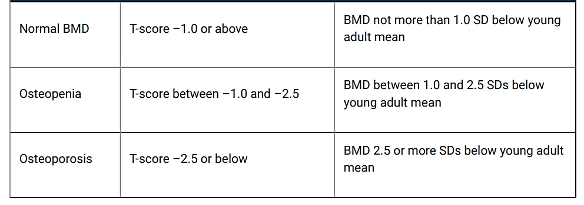

Current treatment options
Pharmacological approaches to prevention and treatment may be divided as follows:
- antiresorptive therapy (inhibits osteoclast activity)
  - bisphosphonates (e.g. alendronate, risedronate, zoledronate/zoledronic acid)
  - denosumab
  - menopausal hormone therapy (e.g. oestrogen, tibolone)
  - selective oestrogen receptor modulators (SERMs; e.g. raloxifene)
- osteoanabolic therapy (predominant stimulatory effect on osteoblasts)
  - teriparatide
  - romosozumab (also inhibits osteoclast activity)

Clinical rationale
Endogenous 84-amino acid parathyroid hormone (PTH) is the primary regulator of calcium and phosphate metabolism in the bone and kidney. The physiological actions of PTH include regulation of bone metabolism, renal tubular reabsorption of calcium and phosphate, and intestinal calcium absorption. Teriparatide is a recombinant human parathyroid hormone (rhPTH), identical in sequence to the active fragment, the 34 N-terminal amino acids (1-34) of the natural endogenous 84 amino acid human PTH.
The biological actions of PTH and teriparatide are mediated through binding to specific high-affinity cell surface receptors. Teriparatide and the 34 N-terminal amino acids of PTH bind to these receptors with the same affinity and have the same physiological actions on bone and kidney.
Once-daily administration of teriparatide stimulates new bone formation on trabecular and cortical (periosteal and/or endosteal) bone surfaces by preferential stimulation of osteoblastic activity over osteoclastic activity. The anabolic effects of teriparatide manifest as an increase in skeletal mass, an increase in markers of bone formation and resorption, and an increase in bone strength.

Regulatory status

Australian regulatory status
This product is considered a new biosimilar medicine for Australian regulatory purposes.

International regulatory status
At the time the TGA considered this submission, a similar submission had been considered by other regulatory agencies. Table 2 summarises these submissions and provides the indications where approved.
Table 2: International regulatory status
Region | Submission date | Status | Indications (requested/ approved)
European Union | 05 March 2021 | Approved (24 March 2022) | As below
United Kingdom | 01 April 2021 | Approved (04 March 2022) | As below
Switzerland | 04 June 2021 | Approved (18 August 2022) | As below
Singapore | 03 March 2022 | Approved (01 June 2023) | As below

Indications approved in EU:
Treatment of osteoporosis in postmenopausal women and in men at increased risk of fracture. In postmenopausal women, a significant reduction in the incidence of vertebral and non-vertebral fractures but not hip fractures have been demonstrated.
Treatment of osteoporosis associated with sustained systemic glucocorticoid therapy in women and men at increased risk for fracture.
Indications approved in UK:
Treatment of osteoporosis in postmenopausal women and in men at increased risk of fracture. In postmenopausal women, a significant reduction in the incidence of vertebral and non-vertebral fractures but not hip fractures have been demonstrated.
Treatment of osteoporosis associated with sustained systemic glucocorticoid therapy in women and men at increased risk for fracture.
Indications approved in Switzerland:
Sondelbay is indicated for the treatment of postmenopausal women with manifest osteoporosis and a high risk of fracture. A significant reduction in the incidence of vertebral and nonvertebral fractures has been shown in postmenopausal women with osteoporosis.
Sondelbay is indicated in men with primary or hypogonadal osteoporosis high fracture risk. Sondelbay increases in men with primary or hypogonadal osteoporosis the bone mineral density. Treatment of glucocorticoid-induced osteoporosis in adults at increased risk of fracture.
Indications under evaluation in Singapore:
Treatment of postmenopausal women with osteoporosis who are at high risk for fracture (defined herein as having a history of osteoporotic fracture or multiple risk factors for fracture) or who have failed or are intolerant of previous osteoporosis therapy, based upon physician assessment. In postmenopausal women with osteoporosis, teriparatide increases BMD and reduces the risk of vertebral and nonvertebral fractures. To increase bone mass in men with primary or hypogonadal osteoporosis who are at high risk for fracture. These include men with a history of osteoporotic fracture, or who have multiple risk factors for fracture, or who have failed or are intolerant to previous osteoporosis therapy, based upon physician assessment. In men with primary or hypogonadal osteoporosis, teriparatide increases BMD. The effects of teriparatide on risk for fracture in men have not been studied. For the treatment of men and women with glucocorticoid-induced osteoporosis at high risk for fracture.

Registration timeline
Table 3 captures the key steps and dates for this submission.
This submission was evaluated under the standard prescription medicines registration process.
Table 3: Timeline for Sondelbay, Teriparintas and Teriparaccord, submission PM-2023-01370-1-5
Description | Date
Submission dossier accepted and first round evaluation commenced | 1 June 2023
Evaluation completed | 8 February 2024
Registration decision (Outcome) | 11 August 2025
Registration in the ARTG completed | 2 October 2025
Number of working days from submission dossier acceptance to registration decision* | 180
*Statutory timeframe for standard submissions is 255 working days

Assessment overview

Quality evaluation summary
INTG8 is a proposed biosimilar of teriparatide, which is manufactured using a strain of Escherichia coli modified by recombinant DNA technology. INTG8 contains recombinant human parathyroid hormone (PTH; 1-34) and is also called rhPTH (1-34). It has an identical sequence to the 34 N-terminal amino acids (the biologically active region) of the 84-amino acid human PTH. Teriparatide has a molecular weight of 4117.8 Daltons.
During the development of Sondelbay/Teriparintas/Teriparaccord, Forsteo (EU product) was used as the main reference product to demonstrate biosimilarity in terms of quality and non-clinical comparability exercise. Additional bridging comparability study was performed between the EU Forsteo and AU Forteo to present EU Forsteo as representative of the Australian registered product (Forteo; AUST R 80333).
Extensive characterisation studies involving comparison of primary, secondary and tertiary structures, physicochemical properties and biological activities showed that Sondelbay/Teriparintas/Teriparaccord and the EU reference medicine Forsteo are generally similar.
Overall, the Sponsor has demonstrated that Sondelbay/Teriparintas/ Teriparaccord is comparable to Forteo in terms of structure, species, function and degradation profile (i.e. physicochemically and biologically).
There are no objections on quality grounds to the approval of Sondelbay/Teriparintas/ Teriparaccord (teriparatide).

Nonclinical evaluation summary
The nonclinical dossier contained two comparative studies, concerning repeat dose toxicity and immunogenicity. The scope of the nonclinical dataset is adequate under the relevant TGA adopted EMA guideline.
A Good Laboratory Practice-compliant comparative repeat dose toxicity study was performed in rats, and involved once daily subcutaneous injections for 4 weeks, and used EU sourced Forsteo (alternative tradename to Forteo) as the reference product. Findings in the studies were related to the primary pharmacological action of teriparatide on bone, and comparable for the two teriparatide products. However, no information was provided to verify the comparability of EU sourced Forsteo and Australian sourced Forteo.
In vitro data indicated low and comparable immunogenicity for Sondelbay / Teriparaccord / Teriparintas, EU sourced Forsteo and US sourced Forteo.
The ability of the nonclinical studies to support comparability to Australian Forteo depends on the conclusion of the quality Evaluator regarding the identity of Forteo/Forsteo products across jurisdictions. Provided that EU sourced Forsteo is considered to be identical or highly comparable to Australian Forteo, there are no nonclinical objections to the registration of Sondelbay / Teriparaccord / Teriparintas.
The proposed Product information document is considered to be acceptable from a nonclinical perspective. Statements dealing with nonclinical matters and the Pregnancy Category (B3) are consistent with the approved Australian PI for Forteo.

Clinical evaluation summary
Clinical evaluation was guided by the following TGA-adopted guidance:
- European Medicines Agency. Guideline on similar biological medicinal products containing biotechnology-derived proteins as active substance: non-clinical and clinical issues. 2015.
- European Medicines Agency. Guideline on the investigation of bioequivalence. 2010.

Pharmacology

Pharmacokinetics

Sites and mechanism of absorption
Teriparatide reaches peak serum concentrations about 30 minutes after subcutaneous injection of a 20 microgram dose and declines to non-quantifiable concentrations within 3 hours.

Absolute bioavailability
The absolute bioavailability of teriparatide is approximately 95% based on pooled data from 20, 40, and 80 microgram doses.

Volume of distribution
The volume of distribution is approximately 1.7 L/kg.

Metabolism
No metabolism or excretion studies have been conducted with teriparatide. Peripheral metabolism of PTH is thought to occur by non-specific mechanisms in the liver followed by excretion via the kidney.

Routes and mechanisms of excretion
As stated in the product information document (PI), teriparatide is eliminated through hepatic and extra-hepatic clearance (approximately 62 L/hr in women; 94 L/hr in men). No excretion studies have been performed with teriparatide. However, the mechanism of elimination of PTH (1-34) and intact PTH have been extensively described.

Pharmacokinetic interactions
No relevant studies have been provided in this submission. However, the PI (largely based on the reference product Forteo) identifies a number of potential interactions with teriparatide 40 micrograms (twice the recommended dose of Sondelbay). The use of diuretics such as hydrochlorothiazide or frusemide in conjunction with teriparatide may further exaggerate the action of PTH or its derivatives in elevating serum calcium. Caution regarding concomitant digoxin use is connected to the theoretical risk of hypercalcaemia, again due to the action of teriparatide. Previous studies involving women with hypertension and treatment with calcium channel antagonists or atenolol have identified no clear impacts on blood pressure when administered with teriparatide. Although not studied, co-administration of teriparatide with anticoagulants require appropriate precautions against haematoma formation at the injection site.

Bioequivalence to relevant registered products
Study 0258-20 was undertaken to compare the pharmacokinetics of Sondelbay (INTG8) with its biosimilar reference product Forsteo (20 microgram teriparatide/20 micromilitre pre-filled pen, Eli Lilly Nederland B.V., The Netherlands).
Geometric Least Squares Means (LSMs), Confidence Intervals (CIs), intra-subject coefficient of variation, and power were the components relevant to the bioequivalence analysis. Tables 4 and 5 summarise the statistical comparisons of pharmacokinetic (PK) parameters between INTG8 vs Forteo and INTG8 vs Forsteo
Table 4: PK Statistical Comparison between INTG8 and Forteo (n=105 if not otherwise indicated)
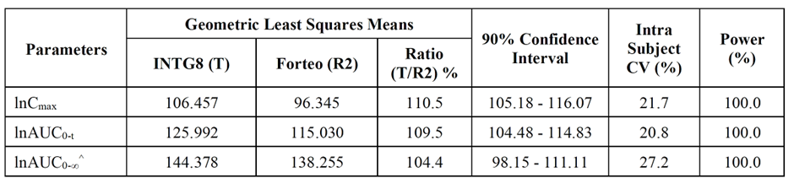^N=103.
Note: Terminal rate constant (lambda_z) cannot be estimated based on obtained concentration data for subject no. 1012 (Period-I, INTG8) and 1095 (Period-I, Forteo). Hence, AUC_{O-inf} cannot be calculated. In absence of comparator data, same was also excluded from the other treatment arm
Table 5: PK Statistical Comparison between INTG8 vs. Forsteo
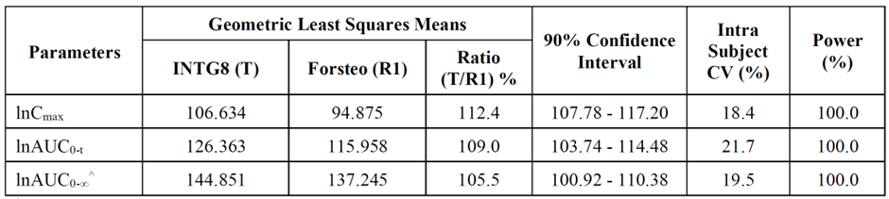
^N=103.
Note: Terminal rate constant (lambda_z) cannot be estimated based on obtained concentration data for subject no. 1012 (Period-I, INTG8) and 1057 (Period-I, Forteo). Hence, AUCO-inf cannot be calculated. In absence of comparator data, same was also excluded from the other treatment arm
Analysis on the ln-transformed C_{max}, AUC_{0-t} and AUC_{0-∞} of INTG8 relative to Forsteo and Forteo was performed and demonstrated the 90% CIs of the geometric LSM ratios were within the acceptance range of 80.00% to 125.00% as outlined in the bioequivalence guidance of the EMA.

Clinical evaluator’s overall conclusions on pharmacokinetics and bioequivalence
The following conclusions are framed (where relevant) to the guidance adopted by the TGA.
Firstly, the study population chosen in Study 0258-20 as outlined in the Dossier was acceptable. There is no current indication in the literature that there is any variation in the PTH-receptor density between healthy individuals and those with osteoporosis. According to the PI for Forteo, PK characteristics are not expected to vary according to age. Healthy subjects are the preferred population for a crossover study and the demographic profile of each of the groups were well balanced across the treatment arms. The decision to perform the study in healthy subjects (men aged 18-45 years and postmenopausal women aged 45-65 years) helped ensure homogeneity of the study population and included the potential target patients of either gender population. The inclusion and exclusion criteria were appropriate. The exclusion criteria appropriately excluded patients with relevant diseases/disorders/medication that could impact on BMD. PK and pharmacodynamic (PD) profiles of teriparatide products have not been extensively studied in different ethnic groups; however, the available data encompassing Caucasian, Chinese and Japanese women do not indicate clinically significant differences.
The study design and protocol appear reasonable. The randomising schedule and assessor-blinding protocol appear appropriate, with no indication of any bias. The single dose 20 microgram teriparatide SC injection used in the study matches the daily dose of the currently approved product Forteo and is appropriate. Given the half-life of teriparatide (given subcutaneously) in serum is close to 60 minutes across the literature, the designated washout period of 24 hours between the dosing days was suitable. The chosen primary and secondary endpoints of the study are reasonable. The protocol had no notable amendments. All 105 subjects who received treatment dosing satisfactorily completed the study with none taking any concomitant medications during the study.
There were statistically significant Group, Sequence, Sequence*Group, Formulation, Period (Group)and Subject (Sequence*Group) effects in this study – these are deemed not clinically relevant.
In addition, all but one of the PK parameters do not cross 1. This is relevant as the EMA guideline on similar biological medicinal products (accepted by the TGA) states that 90% CIs of ratios of biosimilar to reference products within a pre-specified, justified acceptance range may not, by itself, be sufficient and that the location and width of the CI should also be taken into account in the interpretation of similarity.
A small number of samples were designated “not reportable” with most cases due to haemolysis. As a result of the treatment of these results in the study, they are unlikely to have a notable impact on the overall data.
Overall, bioequivalence criteria were satisfied between INTG8 vs. Forteo and INTG8 vs. Forsteo. The 90% CIs of the geometric LSM ratios for the parameters C_{max}, AUC_{0-t} and AUC_{0-∞} were within the 80.00%-125.00% acceptance range as specified in EMA guidance.

Pharmacodynamics
Study 0258-20 assessed the PD profile of a healthy population by measuring their corrected total serum calcium levels following a single dose of INTG8, Forteo and Forsteo via subcutaneous administration.

Mechanism of action
The biological actions of PTH and teriparatide are mediated through the binding to specific PTH cell-surface receptors. Teriparatide is the active fragment (1-34) of endogenous human PTH, manufactured using recombinant DNA technology. Teriparatide binds to these receptors with similar affinity as PTH and has the same actions in bone and kidney.

Pharmacodynamic effects
Endogenous 84-amino-acid PTH is the primary regulator of calcium and phosphate metabolism in bone and kidney. Physiological actions of PTH include regulation of bone metabolism, renal tubular reabsorption of calcium and phosphate, and intestinal calcium absorption. Like endogenous PTH, teriparatide is not expected to accumulate in bone or other tissues.
The skeletal effects of teriparatide depend upon the pattern of systemic exposure. Once daily therapeutic administration of teriparatide increases apposition of new bone on trabecular and cortical (endosteal and periosteal) bone surfaces by preferential stimulation of osteoblastic activity over osteoclastic activity. In contrast, continuous excess of endogenous PTH, as occurs in hyperparathyroidism, may be detrimental to the skeleton because bone resorption may be stimulated more than bone formation. This distinction between the pharmacological action of administered teriparatide on one hand and the pathophysiological action of hypersecreted PTH in hyperparathyroidism - particularly primary hyperparathyroidism - is an important one. Osteopenia (diminished BMD) or even osteoporosis is a feature of primary hyperparathyroidism and may progress to more severe forms of parathyroid bone disease principally as a consequence of excessive osteoclastic activity under the influence of PTH. It is a matter of the degree to which PTH receptors in bone are exposed to PTH, which determines the predominance of osteoblastic over osteoclastic activity.

Time course of pharmacodynamic effects
If using the elevation in serum calcium levels as an indication of the pharmacodynamic response to PTH or administered teriparatide, the calcium levels were at their peak at approximately 4-6 hours post-dose returning to near baseline levels within 16 hours.

Relationship between drug concentration and pharmacodynamic effects
No relevant data has been provided in this submission. However, the Sponsor has presented the following pharmacodynamic results from Study 0258-20. This study’s secondary objectives were to assess and compare the pharmacodynamics, local tolerance, safety, and tolerability of INTG8 against Forteo and Forsteo following a single 20 microgram subcutaneous injection in healthy men and postmenopausal women. Total serum calcium levels have been used as a marker of the pharmacodynamic response to teriparatide. As the above background information indicates, total serum calcium levels can reflect the pharmacodynamic activity of teriparatide. The PD parameters for INGT8, Forsteo and Forteo have been summarised in the Table 6.
Table 6: Baseline Non-Adjusted Corrected Total Serum Calcium Levels after Administration of INTG8, Forsteo and Forteo)
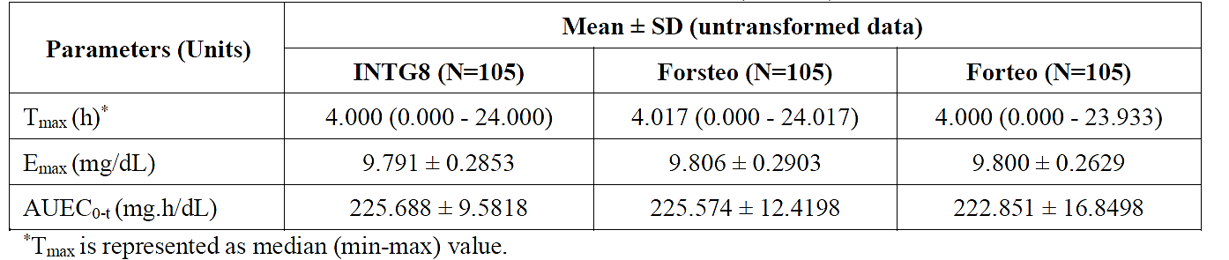
The geometric LSM ratios for baseline non-adjusted E_{max} (maximum measured serum calcium concentration) and AUEC_{0-t} (area under serum calcium vs. time curve from time zero to the last measurable concentration) were 99.9% and 101.6% respectively for INTG8 vs. Forteo and 99.9% and 100.1% respectively for INTG8 vs. Forsteo. The CIs of the geometric LSM ratios, calculated from the analysis on the ln-transformed corrected total serum calcium level parameters E_{max} and AUEC_{0-t} of both INTG8 vs. Forteo and INTG8 vs. Forsteo were within the acceptance limits of 80.00% to 125.00%.
Further statistical comparisons are displayed in Table 7 and 8.
Table 7: Summary of Statistical Comparisons of Corrected Total Serum Calcium Levels Parameters (INTG8 vs. Forteo)
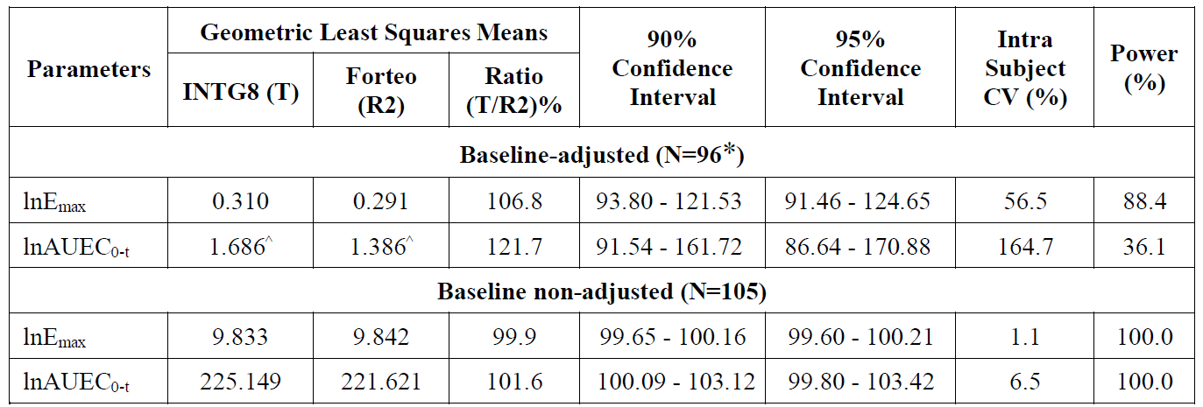
^N=90
Note 1: * Subjects 1006 (Period-I, INTG8). 1006 (Period-III. Forteo), 1012 (Period-I. INTG8). 1037 (Period-III, INTG8), 1045 (Period-II. Forteo), 1060 (Period-III. INTG8). 1066 (Period-II. INTG8). 1080 (Period-I. INTG8). 1087 (Period-II, INTG§8), 1088 (Period-Il. INTG8) and 1100 (Period-I, INTG8) had pre-dose sample as NR, post-dose sample could not be baseline- adjusted and hence same was excluded from statistical analysis. In absence of comparator data, all these subjects were also excluded from the other treatment arm.
Note 2: ^ Subjects 1001 (Period-I, Forteo), 1019 (Period-I, Forteo). 1021 (Period-I, Forteo). 1032 (Period-I, Forteo). 1072 (Period-I, INTG8) and 1084 (Period-I, INTG8) had zero corrected total serum calcium levels of the study hence pharmacodynamic parameters E_{max} and AUEC_{0-t} could not be calculated after In-transformation. In absence of comparator data, same was also excluded from the other treatment arm.
Table 8: Summary of Statistical Comparisons of Corrected Total Serum Calcium Levels Parameters (INTG8 vs. Forsteo)
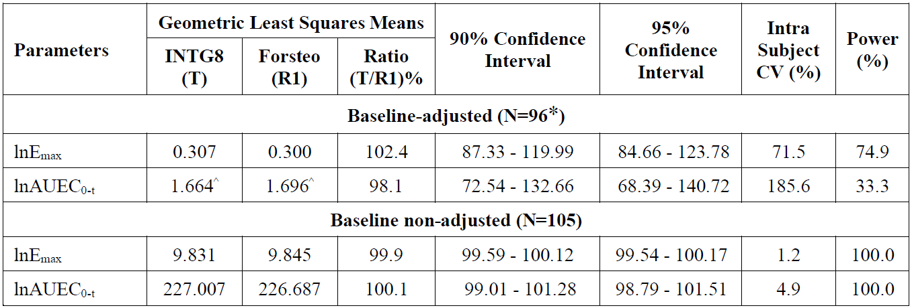
^N=92.
Note 1: * Subjects 1006 (Period-I, INTG8), 1012 (Period-I, INTG8), 1037 (Period-III, INTG8), 1060 (Period-III, INTG8), 1066 (Period-II, INTG8), 1080 (Period-I, INTG8), 1087 (Period-II, INTG8), 1088 (Period-II, Forsteo) and 1100 (Period-II, INTG8) had pre-dose sample as NR, post-dose sample could not be baseline-adjusted and hence same was excluded from statistical analysis. In absence of comparator data, all these subjects were also excluded from the other treatment arm.
Note 2: ^ Subjects 1008 (Period-I, Forsteo), 1027 (Period-I, Forsteo), 1072 (Period-I, INTG8) and 1084 (Period-I, INTG8) had zero corrected total serum calcium levels of the study hence pharmacodynamic parameters Emax and AUEC0-t could not be calculated after ln-transformation. In absence of comparator data, same was also excluded from the other treatment arm.
Tables 9 and 10 outline the ANOVA p-values and inter-subject CV for corrected total serum calcium levels for INTG8 vs. Forteo and INTG8 vs. Forteo.
Table 9: ANOVA p-values and Inter-subject CV for Corrected Total Serum Calcium Levels (INTG8 vs. Forteo)
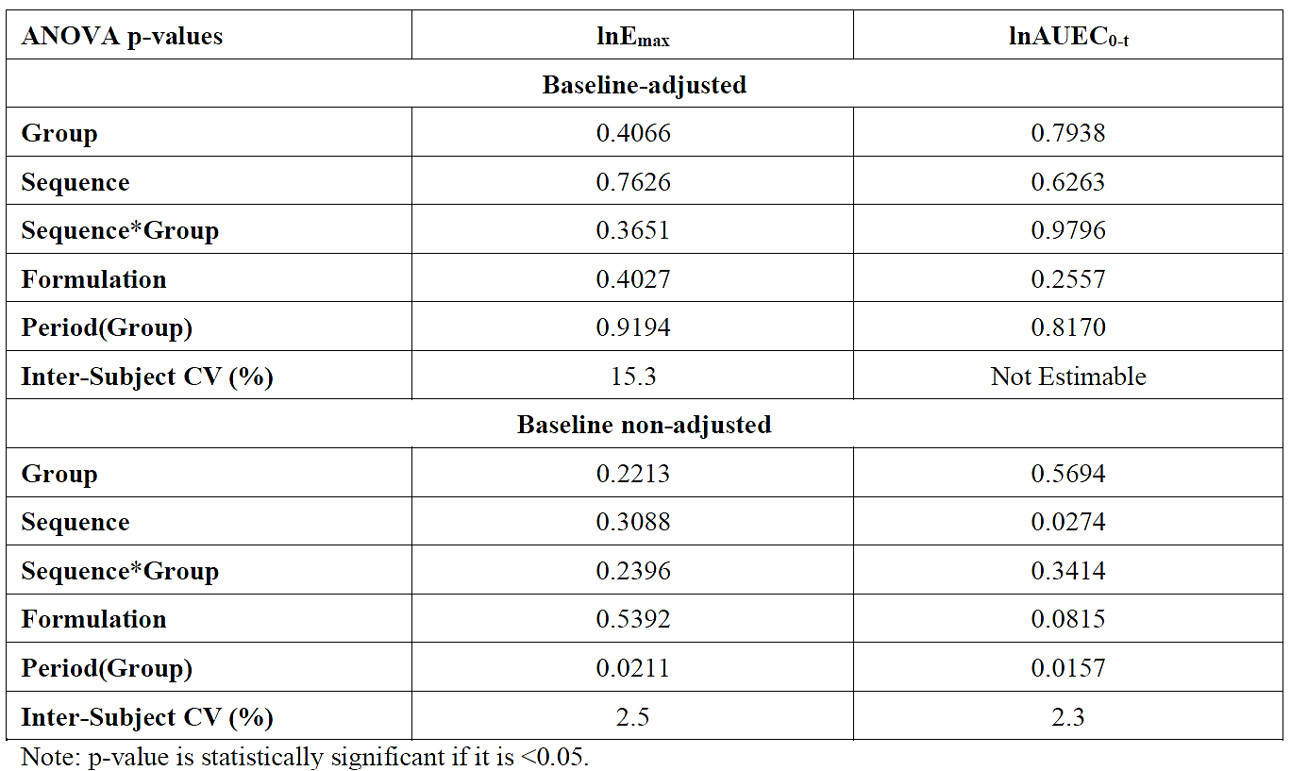
When comparing INTG8 and Forteo, Period(Group) was found to be statistically significant for the ln-transformed E_{max} and AUEC_{0-t} of baseline non-adjusted corrected total serum calcium levels.
Table 10: ANOVA p-values and Inter-subject CV for Corrected Total Serum Calcium Levels (INTG8 vs. Forsteo)
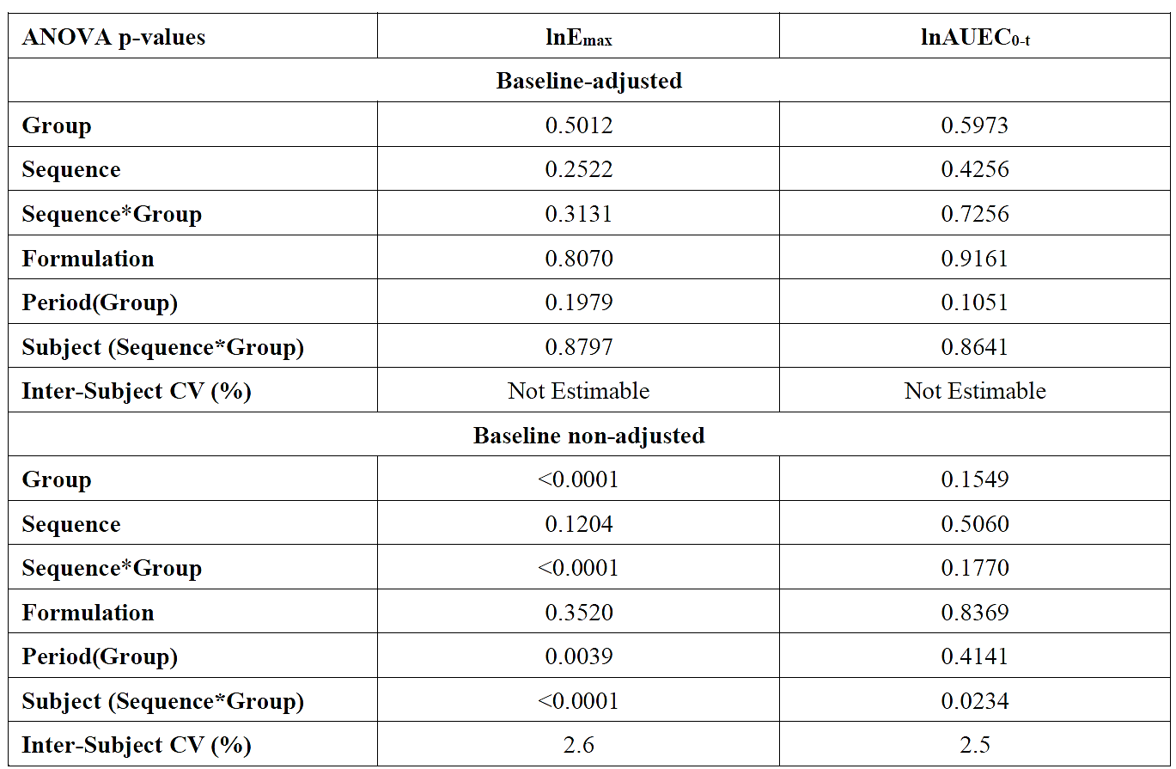
When comparing INTG8 and Forsteo, the following effects were found to be statistically significant for the ln-transformed E_{max} of baseline non-adjusted corrected total serum calcium levels: Group, Sequence*Group, Period(Group) and Subject(Sequence*Group) effects. Regarding the ln-transformed AUEC_{0-t} of baseline non-adjusted corrected total serum calcium levels, only Subject(Sequence*Group) effect was found to be statistically significant.

Evaluator’s overall conclusions on pharmacodynamics
Teriparatide has been synthesised to mimic the biologically active region of endogenous parathyroid hormone and therefore matches the binding to specific receptors at the same affinity as PTH. It is expected that the pharmacodynamics of teriparatide will also match the reference product Forteo.
The total corrected calcium levels data from Study 0258-20 were calculated from all 105 subjects. The geometric LSM ratios for baseline non-adjusted E_{max} and AUE_{C0-t} were 99.9% and 101.6% respectively for INTG8 vs. Forteo and 99.9% and 100.1% respectively for INTG8 vs. Forsteo.
The above two tables also present baseline-adjusted data. However, as a secondary endpoint, the study was not powered to compare baseline-adjusted data.
Overall, Study 0258-20 demonstrates evidence that Sondelbay, Teriparintas, and Teriparaccord is a biosimilar of Forteo and Forsteo.

Efficacy
No study for Sondelbay has been performed solely to assess efficacy. This submission contained Study 0258-20 which included efficacy data and consisted of a comparative PK study comprising healthy subjects and used serum calcium as a pharmacodynamic parameter. Therefore the main question for the clinical evaluation was not to ascertain the absolute level of efficacy of Sondelbay, but to determine bioequivalence between it and the reference products Forteo and Forsteo.
The Sponsor has proposed the same dosing regimen in their submitted PI as found in the PI of the existing approved formulation Forteo – the “recommended dose of Sondelbay is 20 micrograms administered once daily by subcutaneous injection in the thigh or abdomen”. The Sponsor has adhered to this 20 microgram dose in their comparative PK/PD study 0258-20.

Safety
Although the primary objective of Study 0258-20 was focussed on demonstrating pharmacokinetic bioequivalence against reference products, it also aimed to assess and compare the local tolerance, safety and tolerability of Sondelbay against the reference products. The following data related to safety were collected from all 105 subjects from the study – adverse effects, clinical laboratory measurements, vital signs and 12-lead electrocardiograms (ECG).

Patient exposure
The known patient exposure to the Sponsor’s teriparatide product is limited to the data from Study 0258-20 presented in the Dossier. In that study, each of the 105 subjects were administered a single 20 microgram dose of INTG8, Forsteo or Forteo in each study period. All 105 were included in the safety assessment – also defined as the safety set.
Table 11: Extent of Exposure
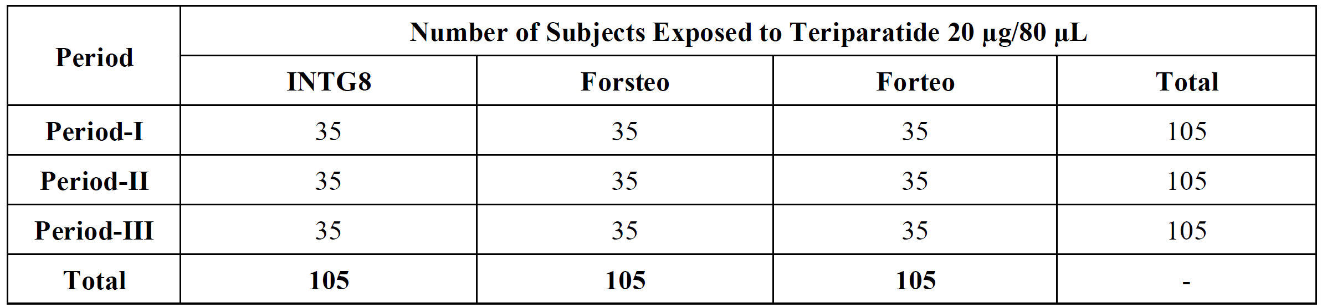

Adverse events
Adverse events (AEs) were categorised according to MedDRA in Table 12.
Table 12: Summary of Adverse Events by System Organ Class (Safety Set)
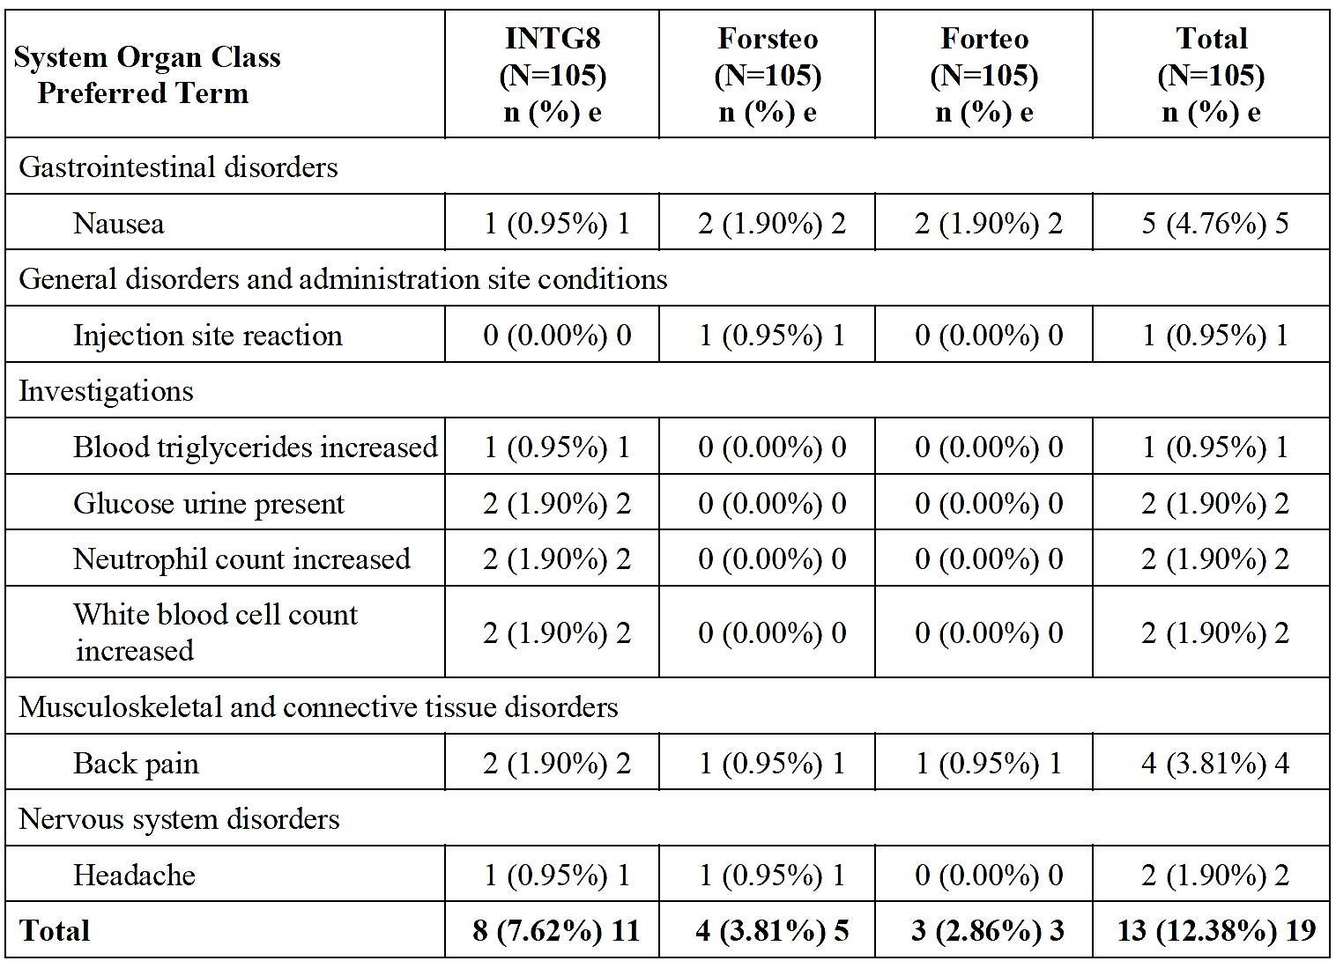
N = Number of subjects in respective treatment.
n = Number of subjects in respective categories; e = Number of events.
Percentages are based on total number of subjects in each category.
Each subject is counted at the most once within each PT.
Adverse Events are coded using Medical Dictionary for Regulatory Activities (MedDRA) version 23.1.
Nineteen AEs were reported by 13 (12.4%) of the 105 subjects, with 11 AEs in 8 (7.6%) of 105 subjects are they received INTG8, compared to 5 AEs in 4 subjects (3.8%) after Forsteo administration and 3 AEs in 3 subjects (2.9%) after Forteo was administered. All the AEs were assessed as mild.

Deaths and other serious adverse events
There were no deaths during study 0258-20. There were no other serious or significant adverse effects.

Discontinuations due to adverse events
No subject discontinued from the study due to adverse events.

Liver function and liver toxicity
The following laboratory variables (specific to liver function/toxicity) and the absolute change from the screening values were measured – these included AST, ALT, albumin, alkaline phosphatase, amylase, bilirubin, GGT. According to P-values calculated based on ANOVA, there were no statistically significant changes measured, besides lipase which was not considered clinically significant.

Haematology and haematological toxicity
Laboratory tests covering haematology-related markers were performed during screening and also at the end of the study (i.e. 28 days after the dose received in Period III). The laboratory reports at both time points were considered clinically acceptable for all subjects. Two subjects were found to have an increase in their white blood cell count and neutrophil count during their post-study safety assessment but were lost to follow-up.

Electrocardiograph findings and cardiovascular safety
Twelve-lead electrocardiograph recordings were performed at the following points in the study: – at screening, 5 hours (+/- 1 hour) after the dose in each period and at the end of the study. The study concluded that no subjects were found to have clinically significant ECG abnormalities. All subjects were deemed to have either normal or acceptable ECGs with a small number found to have sinus bradycardia which was deemed not to be clinically significant.

Vital signs and clinical examination findings
Firstly, subjects with orthostatic hypotension were not included in the study. Parameters including blood pressure, respiratory rate, radial pulse rate and axillary body temperature were measured at pre-dose, 1-, 3- and 10-hours post-dose and during each clinical examination. The study concluded that none of the subjects had any clinically significant vital sign abnormalities.

Serious skin reactions
In Study 0258-20, there were no reports of serious skin reactions.

Safety related to drug-drug interactions and other interactions
No studies relating to drug-drug interactions were included in this submission. Nevertheless, please see Section 4.2.6 of this report which discusses the potential drug interactions of teriparatide as found in the Sondelbay proposed PI (largely based on the reference product Forteo).

Post marketing experience
INTG8 has been marketed in India under the brand name “Terifrac” by Intas Pharmaceuticals Limited, India following its approval by the relevant Indian authorities on 1 November 2010 for the treatment of osteoporosis in postmenopausal women at high risk of fracture. The Sponsor has included Periodic Safety Update Reports (PSUR) from 01 November 2010 to 31 October 2022 inclusive. During this particular period, there were no reports of any spontaneous or serious adverse reactions with Terifrac received and no action was taken by regulatory bodies or Intas themselves regarding safety.

Evaluator’s overall conclusions on clinical safety
The design of the study limits the ability to obtain safety data. There were only 105 subjects, and each subject had one dose of each of the three different products across 3 consecutive days. The sole laboratory measurements were performed 28 days after the third treatment for each subject, which made it particularly challenging to be able to link whether the three treatments had any impact on these measurements, let alone narrowing any impacts down to one single treatment. Also, the treatment period was not reflective of the typical duration of daily teriparatide treatment. Therefore, any rare, or slow-developing adverse events, or those triggered by cumulative exposure would be unlikely to be detected in this study, nor would an accurate reflection of anti-drug antibodies be likely to develop during the study period.

Risk management plan evaluation
A Risk Management Plan (RMP) was not provided with this biosimilar application which is acceptable.

Discussion
INTG8 has been developed as a proposed biosimilar to Forteo (teriparatide), with comparable indication, proposed dose and route of administration.
It is noted that no dedicated efficacy study was submitted to support biosimilarity. Therefore, this application requires that similar efficacy and safety can be confidently deduced from the similarity of physicochemical characteristics, biological activity/potency, and PK and PD profiles of the biosimilar and the reference product.
Comprehensive comparisons of physicochemical and biological quality attributes were undertaken to demonstrate biosimilarity of INTG8 to EU-sourced Forteo (Forsteo). A bridging study demonstrated high similarity of Australian-sourced Forteo to EU-sourced Forteo (Forsteo) supporting biosimilarity of INTG8 to the Australian reference product.
The clinical development consisted of one single dose PK study in healthy volunteers comparing three formulations of teriparatide (INTG8, EU sourced Forteo (Forsteo) and US sourced Forteo) to evaluate the pharmacokinetics, pharmacodynamics, safety, and immunogenicity of INTG8 compared to EU-sourced Forteo (Forsteo) and US-sourced Forteo. The Study was evaluated as being satisfactory. For PK, the 90% CIs of the geometric LSM ratios, derived from the analysis on the ln-transformed C_{max}, AUC_{0-t} and AUC_{0-∞} of INTG8 relative to EU-sourced Forteo (Forsteo) were within the acceptance range of 80% to 125%. Bioequivalence was also demonstrated for other comparisons including the US reference product. PD data is also considered supportive.

Conclusions
Biosimilarity of INTG8 to Forteo (teriparatide) has satisfactorily been demonstrated, and therefore a benefit/risk balance comparable to the reference product can be concluded

Assessment outcome
Based on a review of quality, safety, and efficacy, the TGA decided to register Sondelbay, Teriparintas and Teriparaccord (teriparatide) for the following indications:
Sondelbay, Teriparintas, and Teriparaccord are indicated for the treatment of osteoporosis in postmenopausal women and the treatment of primary osteoporosis in men when other agents are considered unsuitable and when there is a high risk of fractures.
Sondelbay, Teriparintas, and Teriparaccord are indicated for the treatment of osteoporosis associated with sustained systemic glucocorticoid therapy in women and men at high risk for fracture

Specific conditions of registration
Laboratory testing & compliance with Certified Product Details (CPD)
- All batches of Sondelbay/ Teriparintas/ Teriparaccord supplied in Australia must comply with the product details and specifications approved during evaluation and detailed in the Certified Product Details (CPD).
- When requested by the TGA, the Sponsor should be prepared to provide product samples, specified reference materials and documentary evidence to enable the TGA to conduct laboratory testing on the Product. Outcomes of laboratory testing are published biannually in the TGA Database of Laboratory Testing Results http://www.tga.gov.au/ws-labs-index and periodically in testing reports on the TGA website.
Certified product details
The Certified Product Details (CPD), as described in Guidance 7: Certified Product Details of the Australian Regulatory Guidelines for Prescription Medicines (ARGPM), in PDF format, for the above products should be provided upon registration of these therapeutic goods. In addition, an updated CPD should be provided when changes to finished product specifications and test methods are approved in a Category 3 application or notified through a self-assessable change.
A template for preparation of CPD for biological prescription medicines can be obtained from the TGA website
[for the form] https://www.tga.gov.au/resources/resources/forms/certified-product-details-cpd-biological-prescription-medicines
[for the CPD guidance] https://www.tga.gov.au/resources/guidance/submitting-certified-product-details-cpd-biological-prescription-medicines

Product Information and Consumer Medicine Information
For the most recent Product Information (PI) and Consumer Medicine Information (CMI), please refer to the TGA PI/CMI search facility.

Therapeutic Goods Administration
PO Box 100 Woden ACT 2606 Australia
Email: info@tga.gov.au Phone: 1800 020 653 Fax: 02 6203 1605
https://www.tga.gov.au
Reference/Publication #

This is the original indication proposed by the sponsor when the TGA commenced the evaluation of this submission. It may differ to the final indication approved by the TGA and registered in the Australian Register of Therapeutic Goods.
Royal Australian College of General Practitioners. Osteoporosis management and fracture prevention in post-menopausal women and men over 50 years of age. March 2024. Available at: RACGP - Osteoporosis management and fracture prevention in post-menopausal women and men > 50 years of age
Watts JJ, Abimanyi-Ochom J, Sanders KM. Osteoporosis costing all Australians: A new burden of disease analysis – 2012 to 2022. Osteoporosis Australia, 2013 (https://healthybon esaustralia.org.au/wp-content/uploads/2022/09/ burden-of-disease-analysis-2012-2022.pdf)
Chen W, Simpson JM, March LM, et al. Comorbidities only account for a small proportion of excess mortality after fracture: A record linkage study of individual fracture types. J Bone Miner Res 2018;33(5):795–802. (https://doi.org/1 0.1002/jbmr.3374)
RACGP, 2024.
European Medicines Agency. Similar biological medicinal products containing biotechnology-derived proteins as active substance: non-clinical and clinical issues - Scientific guideline. 2015. Available at https://www.ema.europa.eu/en/documents/scientific-guideline/guideline-similar-biological-medicinal-products-containing-biotechnology-derived-proteins-active-substance-non-clinical-and-clinical-issues-revision-1_en.pdf
EMA, 2015
European Medicines Agency. Guideline on the investigation of bioequivalence. 2010. Available at https://www.ema.europa.eu/en/documents/scientific-guideline/guideline-investigation-bioequivalence-rev1_en.pdf
EMA, 2010.
EMA, 2010.

