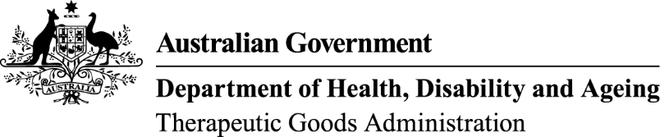
TGA use only

This form, when completed, will be classified as 'For official use only'.
For guidance on how your information will be treated by the TGA see: Treatment of information provided to the TGA at <https://www.tga.gov.au/treatment-information-provided-tga>.

Application for a Certificate of Free Sale or an Export Certificate for a medical device
The TGA issues Certificates of Free Sale and Export Certificates for medical devices under Section 58 of the Therapeutic Goods Act 1989. For more information see: Export certification for medical devices.
Complete this form to apply for a Certificate of Free Sale or an Export Certificate. If you do not provide all of the information requested, we may be unable to process the application. Email your completed application form, accompanying schedule (if required) and your completed credit card authorisation form to: accountsrec@health.gov.au.
I am applying for a:
Certificate of Free Sale and have a current Australian Register of Therapeutic Goods (ARTG) inclusion that allows the product(s) to be supplied and sold within Australia and exported from Australia; or an
Export Certificate and have a current Export Only ARTG inclusion that allows the product(s) to be exported from Australia

Sponsor details
Sponsor name
Sponsor address
Client identification number
Contact person
Contact number
Email address

Product details
ARTG Number | GMDN Code
Alternatively, if you need to include additional devices on the certificate, you can state ‘refer to schedule’ in the table above and provide the information in a schedule accompanying your application form.

Schedule to accompany certificate
If additional information is required, you will need to provide that information in a schedule accompanying your application form.
Only one schedule can be submitted per application form.
The schedule must be submitted in an accessible electronic document, such as a Microsoft Word document in portrait orientation.
Indicate if your application is accompanied by a schedule.

Electronic or hard copies
The certificate is to be supplied (select one option):
Electronic copy via email
Hard copy via post (you will receive two copies)

Fees
There is an application fee associated with the processing of your application for a Certificate of Free Sale or an Export Certificate. The current fee can be found on the TGA’s Schedule of fees and charges under ‘Exports’.
Indicate the current fee for the processing of your application. The completed and signed credit card authorisation form must be for this amount.  You will be charged one fee for each certificate requested. | $

Sponsor declaration
I declare that the kinds of medical devices specified in the application are kinds of medical devices that are currently included in the ARTG or otherwise the subject of an exemption, authorisation or approval under the Therapeutic Goods Act 1989 (the Act);
I declare that the products set out in any accompanying schedule relate to the kinds of medical devices that are currently included in the ARTG or otherwise the subject of an exemption, authorisation or approval under the Act;
I declare that the products are available for lawful supply, for use in humans or as an IVD, in Australia;
I declare that the information contained in the application form and any accompanying schedule, is true and correct as at the date of signing.
 | Providing information that is false or misleading to a Commonwealth entity or in connection with a Commonwealth law is a serious offence subject to criminal penalties under the Criminal Code Act 1995.

Signature of authorised person
Name
Date
Your position in relation to the sponsor

Application submission
Submit the following to accountsrec@health.gov.au:
- a completed application form
- a completed credit card authorisation form
- accompanying schedule (if required)
The current application fee for a Certificate of Free Sale and an Export Certificate can be found on the TGA’s Schedule of fees and charges under ‘Exports’.
It is the sponsor’s responsibility to ensure this application is accompanied by all relevant documentation.

