Established acceptable intake for other nitroso-structures in medicines
Last updated
TBA 2026
- Listen
- Print
- Share
Below is a list of established AI limits for some other N-nitroso-structures. N-Nitroso-structures include N-nitrosoguanidines, N-nitroso-indoles and N-nitrosoureas. These apply for all routes of administration.

Established AI limits for some nitrosamine impurities are listed separately.

A revision table listing updates to the AI limit information for nitrosamines and other N-nitroso-structures is available separately.

Established acceptable intake for other N-nitroso-structures in medicines

N-Nitroso-structure  (CAS number, Abbreviation) | Source² | N-Nitroso-structure molecular structure | AI limit  (ng/day)¹ | First published
N-Nitroso-biotin /  5-((3aS,4S,6aR)-1-nitroso-2-oxohexahydro-1H-thieno[3,4-d]imidazol-4-yl)pentanoic acid  (56859-26-8) | Biotin | 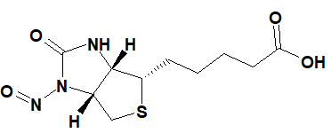 | 1500 | 24 January 2025
N-Nitroso-cimetidine /  3-cyano-1-methyl-2-[2-[(5-methyl-1H-imidazol-4-yl)methylsulfanyl]ethyl]-1-nitrosoguanidine  (73785-40-7) | Cimetidine | 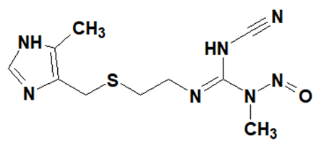 | 553 | 24 January 2025
N-Nitroso-clonidine /  N-(2,6-dichlorophenyl)-1-nitroso-4,5-dihydroimidazol-2-amine  (148950-49-6) | Clonidine | 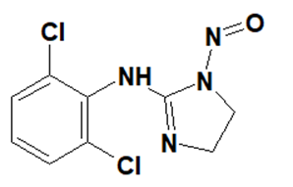 | 553 | 24 January 2025
N-Nitroso-clonidine-2 /  N-(2,6-dichlorophenyl)-N-(4,5-dihydro-1H-imidazol-2-yl)nitrous amide | Clonidine | 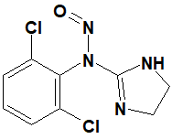 | 553 | 24 January 2025
N-Nitroso-eletriptan /  (S)-3-((1-methylpyrrolidin-2-yl)methyl)-1-nitroso-5-(2-(phenylsulfonyl)ethyl)-1H-indole | Eletriptan | 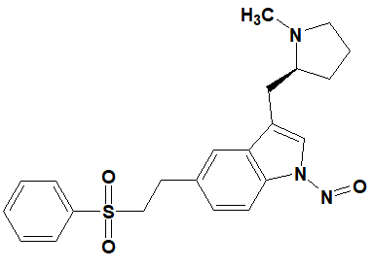 | 1500 | 24 January 2025
N-Nitroso-melatonin /  N-(2-(5-methoxy-1-nitroso-1H-indol-3-yl)ethyl)acetamide  (278783-22-5) | Melatonin | 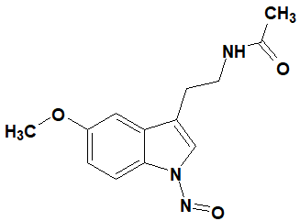 | 1500 | 24 January 2025
1-Nitroso-moxonidine /  N-(4-chloro-6-methoxy-2-methylpyrimidin-5-yl)-N-(4,5-dihydro-1H-imidazol-2-yl)nitrous amide | Moxonidine | 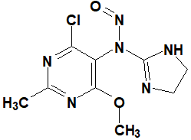 | 553 | 24 January 2025
1-Nitroso-moxonidine Impurity 3 /  4-chloro-6-methoxy-2-methyl-N-(1-nitroso-4,5-dihydro-1H-imidazol-2-yl)pyrimidin-5-amine | Moxonidine | 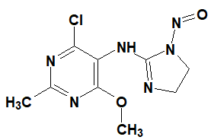 | 553 | 24 January 2025
N-Nitroso-naratriptan /  N-methyl-2-[3-(1-methylpiperidin-4-yl)-1-nitrosoindol-5-yl]ethanesulfonamide  (1216880-64-6) | Naratriptan | 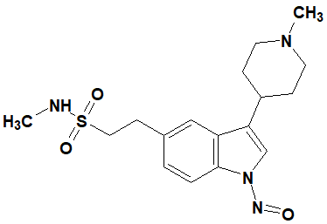 | 1500 | 24 January 2025
N-Nitroso-rizatriptan /  2-(5-((1H-1,2,4-triazol-1-yl)methyl)-1-nitroso-1H-indol-3-yl)-N,N-dimethylethan-1-amine | Rizatriptan | 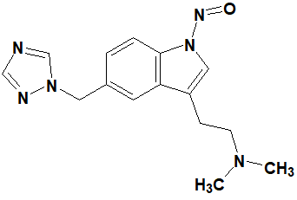 | 1500 | 24 January 2025
N-Nitroso-sumatriptan /  1-(3-(2-(dimethylamino)ethyl)-1-nitroso-1H-indol-5-yl)-N-methylmethanesulfonamide | Sumatriptan | 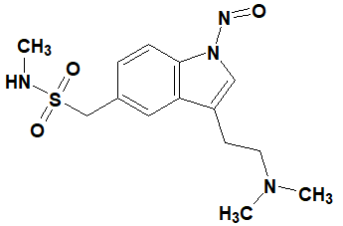 | 1500 | 24 January 2025
N-Nitroso-tadalafil /  (2R,8R)-2-(1,3-benzodioxol-5-yl)-6-methyl-17-nitroso-3,6,17-triazatetracyclo[8.7.0.03,8.011,16]heptadeca-1(10),11,13,15-tetraene-4,7-dione | Tadalafil | 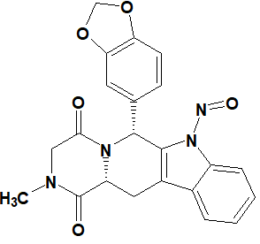 | 1500 | 24 January 2025
N-Nitroso-tizanidine /  N-(5-chlorobenzo[c][1,2,5]thiadiazol-4-yl)-N-(4,5-dihydro-1H-imidazol-2-yl)nitrous amide | Tizanidine | 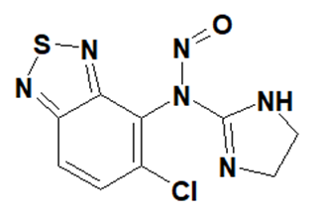 | 553 | 24 January 2025
N-Nitroso-tizanidine Impurity 3 /  N-(5-chlorobenzo[c][1,2,5]thiadiazol-4-yl)-N-(4,5-dihydro-1H-imidazol-2-yl)nitrous amide | Tizanidine | 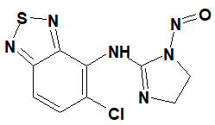 | 553 | 24 January 2025
N-Nitroso-tryptophol /  2-(1-nitrosoindol-3-yl)ethanol  (120314-14-9) | Tryptophol | 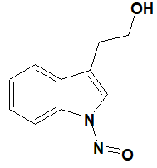 | 1500 | 24 January 2025
N-Nitroso-zolmitriptan /  (4S)-4-[[3-[2-(dimethylamino)ethyl]-1-nitrosoindol-5-yl]methyl]-1,3-oxazolidin-2-one | Zolmitriptan | 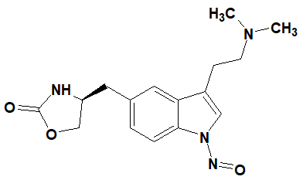 | 1500 | 24 January 2025
N-Methyl-N’-nitro-N-nitrosoguanidine /  1-methyl-3-nitro-1-nitrosoguanidine  (70-25-7, MNNG) |  | 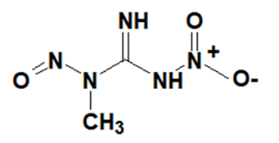 | 553 | 24 January 2025

NMI: Non mutagenic impurity should be controlled to ICH Q3A and ICH Q3B guideline limits

1 Acceptable Intake (AI) Limit to be applied to maximum daily dose (MDD) of the drug product.

2 Potential presence of nitroso-structure impurities with structures derived from drug substances or their related impurities. This does not mean that the impurity will be found in all products or pharmaceutical forms containing the drug substance. Please refer to EMA’s Q&A for details.

