Australian Public Assessment Report for Steqeyma
  - Active ingredient: Ustekinumab
  - Sponsor: Celltrion Healthcare Australia Pty Ltd
December 2025

About the Therapeutic Goods Administration (TGA)
- The Therapeutic Goods Administration (TGA) is part of the Australian Government Department of Health, Disability and Ageing and is responsible for regulating therapeutic goods, including medicines, medical devices, and biologicals.
- The TGA administers the Therapeutic Goods Act 1989 (the Act), applying a risk management approach designed to ensure therapeutic goods supplied in Australia meet acceptable standards of quality, safety, and efficacy.
- The work of the TGA is based on applying scientific and clinical expertise to decision-making, to ensure that the benefits to the Australian public outweigh any risks associated with the use of therapeutic goods.
- The TGA relies on the public, healthcare professionals and industry to report problems with therapeutic goods. The TGA investigates reports received to determine any necessary regulatory action.
- To report a problem with a therapeutic good, please see the information on the TGA website.

About AusPARs
- The Australian Public Assessment Report (AusPAR) provides information about the evaluation of a prescription medicine and the considerations that led the TGA to approve or not approve a prescription medicine submission. Further information can be found in Australian Public Assessment Report (AusPAR) guidance.
- AusPARs are prepared and published by the TGA.
- AusPARs are static documents that provide information that relates to a submission at a particular point in time. The publication of an AusPAR is an important part of the transparency of the TGA’s decision-making process.
- A new AusPAR may be provided to reflect changes to indications or major variations to a prescription medicine subject to evaluation by the TGA.

Copyright
© Commonwealth of Australia 2025
This work is copyright. You may reproduce the whole or part of this work in unaltered form for your own personal use or, if you are part of an organisation, for internal use within your organisation, but only if you or your organisation do not use the reproduction for any commercial purpose and retain this copyright notice and all disclaimer notices as part of that reproduction. Apart from rights to use as permitted by the Copyright Act 1968 or allowed by this copyright notice, all other rights are reserved and you are not allowed to reproduce the whole or any part of this work in any way (electronic or otherwise) without first being given specific written permission from the Commonwealth to do so. Requests and inquiries concerning reproduction and rights are to be sent to the TGA Copyright Officer, Therapeutic Goods Administration, PO Box 100, Woden ACT 2606 or emailed to <tga.copyright@tga.gov.au>.

Contents
List of abbreviations 4
Product submission 7
Submission details 7
Product background 9
Information on the conditions 9
Current treatment options 10
Clinical rationale 11
Regulatory status 11
Australian regulatory status 11
International regulatory status 11
Registration timeline 12
Assessment overview 12
Quality evaluation summary 12
Nonclinical evaluation summary 13
Clinical evaluation summary 13
Summary of clinical studies 13
Pharmacology 14
Efficacy 17
Safety 22
Risk management plan 31
Risk-benefit analysis 32
Delegate’s considerations 32
Biosimilarity 32
Proposed action 36
Independent expert advice 36
Advisory Committee on Medicines considerations 36
Assessment outcome 38
Specific conditions of registration 39
Product Information and Consumer Medicine Information 39

List of abbreviations
Abbreviation | Meaning
Λz | Terminal elimination rate constant
%AUCextrap | AUC extrapolated from time zero to infinity as a percentage of total area under the concentration time curve
ADA | Anti-drug antibody
AE | Adverse event
AUC | Area under the concentration-time curve
AUC0-inf | Area under the concentration-time curve from zero to infinity
BASG | Austrian Federal Office for Safety in Health Care
CD | Crohn’s disease
CHMP | Committee for Medicinal Products for Human Use
CI | Confidence interval
CMI | Consumer Medicines Information
CL/F | Apparent total systemic clearance
Cmax | Maximum serum concentration
CPK | Creatine phosphokinase
CT-P43 | Steqeyma
DLQI | Dermatology Life Quality Index
DMARD | Disease modifying antirheumatic drugs
DNA | Deoxyribonucleic acid
EMA | European Medicines Agency
EOS | End of study
EU | European Union
FAS | Full analysis set
FDA | Food and Drug Administration (US)
GCP | Good clinical practice

Abbreviation | Meaning
Ig | Immunoglobulin
IL | Interleukin
ISR | Injection site reaction
ITT | Intention to treat
LLoQ | Lower limit of quantification
mAbs | Monoclonal antibodies
MTX | Methotrexate
NAb | Neutralising antibody
NK | Natural killer (cells)
p40 | 40 kDa human protein
PASI | Psoriasis area and severity index
pAUC0-204hr | Partial area under the concentration-time curve from time zero to 204 hours
pAUC0-336hr | Partial area under the concentration-time curve from time zero to 336 hours
pAUC1008hr-last | Partial area under the concentration-time curve from time 1008 hours to the last quantifiable concentration
PFS | Pre-filled syringe
PPS | Per-protocol set
Ps | Psoriasis
PsA | Psoriatic arthritis
PT | Preferred term
SC | Subcutaneous
SD | Standard deviation
sPGA | Static Physician’s Global Assessment
SmPC | Summary of Product Characteristics (EMA)
SOC | System Organ Class
t1/2 | Terminal elimination half-life
TEAE | Treatment emergent adverse event
TESAE | Treatment emergent serious adverse event
Tmax | Time to maximum serum concentration
TNF | Tumour necrosis factor
URTI | Upper respiratory tract infection
VAS | Visual analogue scale
Vz/F | Apparent volume of distribution during the terminal phase

Product submission

Submission details
Type of submission: | New chemical entity
Product name: | STEQEYMA ustekinumab 45 mg/0.5 mL solution for injection pre-filled syringe with safety guard  STEQEYMA ustekinumab 90mg/1 mL solution for injection pre-filled syringe with safety guard  STEQEYMA ustekinumab 130 mg/26 mL concentrate for solution for infusion vial
Active ingredient(s): | Ustekinumab
Decision: | Approved for registration in the Australian Register of Therapeutic Goods (ARTG)
Date of decision: | 2 September 2024
Date of entry into ARTG: | 11 September 2024
ARTG numbers: | 420572, 420570, 420571
Black Triangle Scheme  for the current submission: | No
Sponsor’s name and address: | Celltrion Healthcare Australia Pty Ltd
Dose forms: | For Subcutaneous Administration  Solution for subcutaneous injection. The solution is clear to slightly opalescent, colourless to pale yellow.  For Intravenous (IV) Infusion Only  Concentrate for solution for infusion. The solution is clear to slightly opalescent, colourless to pale yellow.
Strengths: | For Subcutaneous Administration  STEQEYMA 45 mg solution for injection in pre-filled syringe. Each pre-filled syringe contains 45 mg ustekinumab in 0.5 mL.  STEQEYMA 90 mg solution for injection in pre-filled syringe Each pre-filled syringe contains 90 mg ustekinumab in 1 mL.  For Intravenous (IV) Infusion Only  STEQEYMA 130 mg concentrate for solution for infusion Each vial contains 130 mg ustekinumab in 26 mL (5 mg/mL).
Containers: | Glass Type I Clear Syringe (45 mg/0.5 mL solution)  Glass Type I Clear Syringe (90 mg/1 mL solution)  Glass Type I Clear Vial (130 mg/26 mL solution)
Pack sizes: | 1
Approved therapeutic use for the current submission: | Plaque Psoriasis  Adults  STEQEYMA is indicated for the treatment of adult patients (18 years or older) with moderate to severe plaque psoriasis who are candidates for phototherapy or systemic therapy.  Paediatric population, 6 years and older  STEQEYMA is indicated for the treatment of moderate to severe plaque psoriasis in children and adolescent patients from 6 years of age (60kg and over) who are inadequately controlled by, or are intolerant to, other systemic therapies or phototherapies.  Psoriatic Arthritis (PsA)  STEQEYMA, alone or in combination with methotrexate, is indicated for the treatment of signs and symptoms of active psoriatic arthritis in adult patients (18 years and older) where response to previous non-biological DMARD therapy has been inadequate.  Crohn’s Disease  STEQEYMA is indicated for the treatment of adult patients with moderately to severely active Crohn’s disease who have had an inadequate response, lost response, or were intolerant to either conventional therapy or a TNFα antagonist or have medical contraindications to such therapies.  Ulcerative Colitis  STEQEYMA is indicated for the treatment of adult patients with moderately to severely active ulcerative colitis.
Dosage: | For further information regarding dosage, such as dosage modifications to manage adverse reactions, refer to the Product Information.
Pregnancy category: | Category B1.  Drugs which have been taken by only a limited number of pregnant women and women of childbearing age, without an increase in the frequency of malformation or other direct or indirect harmful effects on the human fetus having been observed.  Studies in animals have not shown evidence of an increased occurrence of fetal damage.  The use of any medicine during pregnancy requires careful consideration of both risks and benefits by the treating health professional. The pregnancy database must not be used as the sole basis of decision making in the use of medicines during pregnancy. The TGA does not provide advice on the use of medicines in pregnancy for specific cases. More information is available from obstetric drug information services in your state or territory.

Product background
This AusPAR describes the submission by Celltrion Healthcare Australia Pty Ltd (the sponsor company) to register STEQEYMA ustekinumab 45 mg/0.5 mL solution for injection pre-filled syringe with safety guard, STEQEYMA ustekinumab 90mg/1 mL solution for injection pre-filled syringe with safety guard, and STEQEYMA ustekinumab 130 mg/26 mL concentrate for solution for infusion vial for the following proposed indications:
Plaque Psoriasis
  - STEQEYMA is indicated for the treatment of adult patients (18 years of older) with moderate to severe plaque psoriasis who are candidates for phototherapy or systemic therapy.
  - STEQEYMA is indicated for the treatment of moderate to severe plaque psoriasis in children and adolescent patients from 6 years of age who are inadequately controlled by, or are intolerant to, other systemic therapies or phototherapies.
Psoriatic Arthritis
  - STEQEYMA, alone or in combination with methotrexate, is indicated for the treatment of signs and symptoms of active psoriatic arthritis in adult patients (18 years and older) where response to previous non-biological DMARD therapy has been inadequate.
Crohn’s Disease
  - STEQEYMA is indicated for the treatment of adult patients with moderately to severely active Crohn’s disease who have had an inadequate response, lost response, or were intolerant to either conventional therapy or a TNFα antagonist or have medical contraindications to such therapies.
Ulcerative Colitis
  - STEQEYMA is indicated for the treatment of adult patients with moderately to severely active ulcerative colitis.

Information on the conditions
As per the proposed STEQEYMA product information (PI). Ustekinumab is a human IgG1 kappa monoclonal antibody that’s binds to the shared p40 protein subunit of human cytokine interleukin (IL)-12 and IL-23. Its main mechanism of action is via inhibition of IL-12 and IL-23 by preventing to p40 protein from binding to the IL-12Rbetal receptor protein expressed on the surface of immune cells.
IL-12 and IL-23 are secreted by activated antigen presenting cells. IL-12 stimulates natural killer cells and drives differentiation of CD4+ T cells toward T-helper 1 phenotype and stimulates interferon gamma production. IL-23 induces the T-helper 17 pathway and promotes secretion of IL-17A, IL-21 and IL-22. Elevated levels of IL-12 and IL-23 have been found in the serum and in psoriatic skin lesions in patients with psoriasis. IL-12 and IL-23 levels are elevated in the intestines and lymph nodes of patients with Crohn’s with increased serum levels of interferon gamma and IL-17A also being noted.

Current treatment options
The proposed indications for Steqeyma are for treatment of plaque psoriasis (including children 6 years and older), psoriatic arthritis, Crohn’s disease, and ulcerative colitis.
Plaque psoriasis, if limited, can respond to topical corticosteroids and emollients. Further topical treatments include topical Vitamin D analogues, tar and topical retinoids.
Ultraviolet B light (UVB) phototherapy is also a commonly prescribed treatment for limited plaque psoriasis. In practice a combination of topical steroids, Vitamin D analogue, topical retinoids and UVB phototherapy are prescribed to treat this condition.
Moderate to severe plaque psoriasis often requires treatment with systemic therapies including oral agents such as retinoids, methotrexate, cyclosporine, apremilast or biological immunotherapy. Multiple biological agents are available for the treatment of psoriasis including:
- anti-tumour necrosis agents adalimumab, etanercept and infliximab
- anti-Interleukin (IL) 12/IL-23 agent ustekinumab
- anti-IL 17 agents secukinumab or ixekizumab and the anti- IL-23/IL-39 agents guselkumab, tildrakizumab and Risankizumab.
Mild to moderate Psoriatic Arthritis can initially be treated with combinations of Non-steroidal anti-inflammatory medications (NSAIDS) and/or immunosuppressive therapy such as methotrexate, cyclosporine or leflunomide.
Moderate to severe psoriatic arthritis is often treated with biological agents such as tumour necrosis factor (TNF) including etanercept, adalimumab or infliximab. Other biological therapies that can be considered for treatment of psoriatic arthritis include IL-17 inhibitors such as ixekizumab or bimekizumab.
Moderate to severe Crohn’s disease is often initially treated with induction therapy, which can involve a combination of biological therapy, such as TNF inhibitors (infliximab or adalimumab) and another immunosuppressive agent (e.g azathioprine). Other biological therapies that can be used as treatment for moderate-severe Crohn’s include IL-12 and IL-23 inhibitors such as ustekinumab or IL-23 inhibitors such as risankizumab. Immunosuppressive therapies commonly used as ongoing treatment include azathioprine or 6-marcaptopurine which is sometimes combined with a biological therapy. Newer biological therapies for the treatment of Crohn’s disease include is the anti-alpha-4-beta-7 integrin monoclonal antibody Vedolizumab and the anti-alpha-4 integrin antibody Natalizumab. The Janus Kinase (JAK) inhibitor upadacitinib is also approved in the United States for moderate-Crohn’s disease not responding to anti-TNFA therapy.

Medical treatment of moderate to severe ulcerative colitis induction therapy often involves a combination of anti-TNF agents, immunosuppressive medication (e.g azathioprine) and/or glucocorticoids. Glucocorticoids would aim to be ceased after induction and not used for long term remission due to their side effect profile. Other agents used for treatment of moderate to severe ulcerative colitis include biological agents such as ustekinumab, mirikizumab or vedolizumab. Sphingosine-1-phosphate receptor modulators (ozanimod and etrasimod) and the JAK inhibitors tofacitinib and upadacitinib are also approved in the United States for treatment of adults with moderate to severe ulcerative colitis.

Clinical rationale
The Sponsor proposes that the motivation for the clinical development program was to provide a viable alternative product for the Australian market. They provided the following rationale within the clinical dossier, in addition to the benefit of demonstrating bio similarity:
‘CT-P43 is a cost-effective alternative to the reference product and thus could improve patient access, flexibility of the supply chain and ultimately reduce the cost of ustekinumab in approved indications.’
Of note, as above, CT-P43 refers to the term used to describe Steqeyma during the clinical development program, and these labels are used interchangeably throughout the report.

Regulatory status

Australian regulatory status
This product is considered a new chemical entity medicine for Australian regulatory purposes.
Steqeyma is a biosimilar product with the nominated reference product being Ustekinumab (Stelara) which is currently registered in Australia.
Stelara was first registered in the Australian Register of Therapeutic Goods (ARTG) on 28 July 2009 with the most recent revision being on the 9 November 2023.

International regulatory status
At the time the TGA considered this submission, a similar submission was being considered by the European Union (EU), United States (US) and Canada.

Registration timeline
The following table captures the key steps and dates for this submission.
Table 1: Timeline for Submission PM-2023-03606-1-1
Description | Date
Submission dossier accepted and first round evaluation commenced | 3 October 2023
Advisory committee meeting | 1-2 August 2024
Registration decision (Outcome) | 2 September 2024
Registration in the ARTG completed | 11 September 2024
Number of working days from submission dossier acceptance to registration decision* | 209 days
*Statutory timeframe for standard submissions is 255 working days
* The COR-A has a 120 working day evaluation and decision timeframe.
* The COR-B process has a 175 working day evaluation and decision timeframe.

Assessment overview
A summary of the TGA’s assessment for this submission is provided below.

Quality evaluation summary
Regarding biosimilarity, the module 3 quality summary report referenced below noted minor differences between the Steqeyma and references EU/US Stelara. None of these differences are felt to have a significant impact on safety or efficacy. Overall, after the module 3 evaluation it was felt the sponsor has demonstrated that Steqeyma is comparable to Stelara in terms of structure, species, function and degradation profile (specifically physiochemically and biologically). No concerns regarding compatibility between the AU Stelara and EU/US Stelara were raised based on the submitted bridging data provided by the sponsor.
During the development of Steqeyma, Stelara was used as the main reference product to demonstrate biosimilarity in terms of quality and non-clinical comparability exercise. Additional bridging comparability study was performed between the EU/US and AU Stelara to present EU/US Stelara as representative of the Australian registered product (AU Stelara). All comparability studies presented in the dossier (2-way similarity assessments, additional mechanism of action studies, degradation, stability and the bridging studies) conclude that
CT-P43 is highly similar to EU-approved, US-licensed and Australian-sourced Stelara in terms of protein content, primary and higher order structure, purity/impurity, glycan profiles, post translational modifications and biological activity.
Extensive characterisation studies involving comparison of primary, secondary and tertiary structures, physicochemical properties and biological activities showed that Steqeyma and EU/US Stelara, PFS and vial presentations, are generally similar. However, several differences have been noted as highlighted below:
- Lower level of heavy chain C-terminal lysine in Steqeyma compared to Stelara.
- Slightly higher proline amidation levels in Steqeyma.
- Slightly different cIEF electropherograms (minor peaks), related to sialic acid variants. Lower levels of acidic group and basic group variants in Steqeyma.
- Slightly different oligosaccharide profiles.
- Slightly lower product-related impurities (HMW/LMW species) and higher level of monomer in Steqeyma.
- Slightly higher level of intact IgG in Steqeyma PFS and slight difference in levels of non-glycosylated heavy chain.
- Steqeyma displayed slightly lower FcγR binding affinities than Stelara.
Steqeyma and EU-Stelara contain variants with the same post-translational modifications, with some slight differences in levels of variants. The differences in glycosylation and non-glycosylated heavy chain levels were investigated experimentally and shown to have no impact on Steqeyma binding affinity or biological activity. The slightly lower FcγR binding affinity displayed by Steqeyma compared with EU-Stelara is unlikely to impact clinical efficacy as the mechanism of action of ustekinumab is mainly driven by binding of the antibody Fab region to IL-12/IL-23 p40 subunit, and not via Fc-dependent functions. Overall, these minor differences are highly unlikely to impact clinical safety or efficacy.
The Sponsor has demonstrated that Steqeyma is comparable to Stelara in terms of structure, species, function and degradation profile (i.e physicochemically and biologically).
The module 3 quality summary report states that regarding the chemical, pharmaceutical and biological aspects this product is considered acceptable when used in accordance with the conditions defined in the PI.

Nonclinical evaluation summary
Module 4 contained one comparative PK and repeat dose toxicity study (8416958) in Cynomolgus monkeys over 4 weeks which compared CT-P43 and EU STELARA.
No meaningful differences between Steqeyma and Stelara were observed in the comparative PK and toxicity studies.

Clinical evaluation summary

Summary of clinical studies
The sponsors’ clinical program to demonstrate comparability between the reference product Stelara (ustekinumab) and the proposed biosimilar product Steqeyma (ustekinumab) is based on 3 completed clinical studies as outlined below:
- Study CT-P43 1.1 – Phase 1 comparative PK study
- Study CT-P43 1.2 – Phase 1 comparative PK study
- Study CT-P43 3.1 – Phase 3 comparative efficacy and safety study
The phase 3 comparative efficacy study to demonstrate comparability in efficacy between Stelara and Steqeyma compared the efficacy of these products relating to one of the proposed indications, which was moderate to severe plaque psoriasis.

Pharmacology

Pharmacokinetics (PK)

Study CT-P43 1.1
This was a Phase 1, randomised, double-blind, parallel group, single-dose study to compare the pharmacokinetics and immunogenicity of three subcutaneous forms of ustekinumab (CT-P43, EU-approved Stelara and US-licensed Stelara) in healthy male subjects. All ustekinumab doses were pre-filled syringes of 45mg/0.5mL ustekinumab.
The primary objective of this study was to demonstrate pharmacokinetic similarity in terms of Area under the curve from time zero to infinity (AUC_{0-inf}) and maximum serum concentration (C_{max}) for CT-P43, EU-approved Stelara and US-licensed Stelara in healthy males up to day 127.
Secondary objectives included evaluation of safety of CT-P43 compared with EU-approved Stelara in healthy males up to day 29 and to assess pharmacokinetic, additional safety and immunogenicity of CT-P43 and EU-approved Stelara during this timeframe.
The study consisted of 2 parts. Part 1 where preliminary safety data was collected up to day 29 and part 2, where subjects were enrolled and randomised in a 1:1:1 ratio to receive either CT-P43, EU-Stelara or US-Stelara. In Part 2 subjects were administered the study drug on day 1 and followed for 127 days. A total of 23 serum samples were taken over part 2 of the study period (day 1 to day 127) for PK analysis of ustekinumab. All subjects received a single dose of ustekinumab.
Part 1 had 30 subjects enrolled randomised in a 1:1 ratio with 14 receiving CT-P43 and 16 receiving EU-Stelara. In part 2, 241 subjects were randomised with 80 in CT-P43 group, 82 in the EU-Stelara group and 79 in the US-Stelara group. Entry criteria were healthy males between 18-55 years of age with a body weight between 60kg – 100kg and BMI between 18.5-29.9kg/m². Demographic characteristics were balanced across each treatment group.
In part 2 there were 241 subjects included in the intention to treat (ITT) set with 238 (98.8%) of subjects being included in the pharmacokinetic (PK) data asset. The final pharmacokinetic data set included 80 subjects in the CT-P43 group, 81 subjects in the EU-Stelara group and 77 in the US-Stelara group. The pharmacokinetic data set was defined as all randomised participants who received the full dose of study drug and had at least 1 post treatment PK concentration data collected with an above the lower limit of quantification (0.075 ug/mL). Statistical analysis was based on an analysis of covariance model with covariates of these stratification factors. Point estimates were calculated from back transforming the least squares mean of natural log transformed values and difference in the least square means.
Results of the pharmacokinetic concentration analysis show that the ratio of geometric means for CT-P43 compared to EU-Stelara in terms of AUC_{0-inf} was 124.36 (90% CI 115.58, 133.82). Geometric means for CT-P43 compared to US Stelara was 126.40 (90% CI 117.37, 136.13). For C_{max} the ratio of geometric means for CT-P43 compared to EU-Stelara was 116.18 (90% CI 108.42, 124.49) and for CT-P43 compared to US-Stelara the geometric means were 112.02 (90% CI 104.45, 120.13). The results showed that the ratio of geometric means for CT-P43 compared to US-Stelara for the AUC_{0-inf} was above the upper limit for bioequivalence of between 80-125% with a CI of 90%. Results showed that when comparing C_{max} and AUC_{0-inf} CT-P43 displayed higher values in comparison to both EU-Stelara and US-Stelara.
Other measured PK values of T_{max}, half-life and apparent clearance appeared comparable between CT-P43, EU-Stelara and US-Stelara.

Table 2: Statistical analysis of primary serum PK parameters for ustekinumab in the PK set in Study CT-P43 1.1
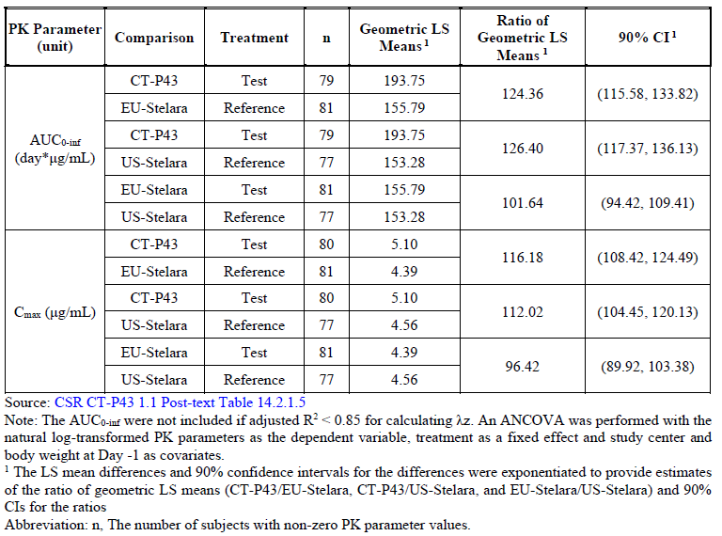
Immunogenicity analysis showed that 13 (16.3%) subjects, 24 (29.3%) subjects and 34 (43.6%) subjects in the CT-P43, EU-Stelara and US-Stelara groups respectively showed at least 1
post-treatment anti-drug antibody (ADA) positive result with 5 (6.3%), 6 (7.3%) and 9 (11.5%) subjects in the CT-P43, EU-Stelara and US-Stelara groups respectively showing evidence of neutralizing antibodies (NAb).

Study CT-P43 1.2
This was a phase 1, randomised, double-blind, parallel-group, single dose study to compare the PK, safety and immunogenicity of three subcutaneous formulation of ustekinumab (CT-P43, EU-Stelara and US-licensed Stelara in healthy Japanese male subjects.
The primary objective of this study was to demonstrate PK similarity for AUC_{0-inf} and C_{max} of CT-P43, EU-Stelara and US-Stelara in healthy Japanese male subjects up to 113 days. Secondary objectives included assessing other PH parameters, safety and immunogenicity of CT-P43, EU-Stelara and US-Stelara in this study population.
There were 3 treatment arms in this trial with subjects randomised in a 1:1:1 ratio to receive either: CT-P43, EU-Stelara or US Stelara to receive a single 45mg/0.5mL subcutaneous dose of the study drug (ustekinumab) via pre-filled syringe. 331 subjects were randomised in this trial with 114 subjects in the CT-P43 group, 110 in the EU-Stelara group and 107 in the US-Stelara group.
Entry criteria included healthy, Japanese males between 18 to 55 years of age with a body weight from 50-90kg and BMI between 18.5-29.9 kg/m². Demographic characteristics between groups were well matched with all subjects being of Japanese ethnicity.
Of the 331 subjects in the ITT set, a total of 320 (96.7%) were included in the final PK data set. The PK set was defined as all randomly assigned subjects who received full dose of study drug and who had at least one post treatment PK result with a concentration above the lower limit of quantification (0.075µg/ml). Of the 11 subjects excluded from the PK data set, 6 discontinued prior to first dose being administered and 5 were excluded due to their last ustekinumab concentration being their highest measured concentration. The PK dataset underwent statistical analysis of log-transformed primary endpoints based on an analysis of covariance model. Back transformation of least squared means difference was conducted with 90% CI’s provided for the ratio of geometric LSM and 90% CI’s for these ratios.
Results showed that the ratio of geometric Means for both AUC_{0-inf} and C_{max} were within the range of bioequivalence between 80-125% with 90% CI’s when CT-P43 was compared with both EU-Stelara and US-Stelara (Table 2).
Other measured PK data including T_{max}, half-life and apparent clearance were all comparable between CT-P43, EU-Stelara and US-Stelara. Immunogenicity analysis showed that 18 (16.2%) subjects, 48 (44.4%) subjects and 42 (39.6%) subjects in the CT-P43, EU-Stelara and US-Stelara groups respectively showed at least 1 post-treatment ADA positive result with 14 (12.6%), 18 (16.7%) and 16 (15.1%) subjects in the CT-P43, EU-Stelara and US-Stelara groups respectively showing evidence of NAb’s.
Table 3: Statistical analysis of primary PK parameters for ustekinumab in the PK set of Study CT-P43 1.2
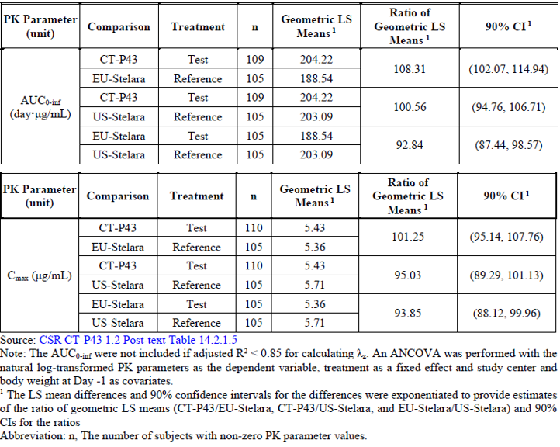

Efficacy

Study CT-P43 3.1
This was a phase 3, double-blind, randomised, active-controlled parallel group study comparing efficacy and safety of CT-P43 and EU-Stelara in patients with moderate to severe plaque psoriasis. The trial commenced on 11th January 2021 with the last subjects visit date on 12th May 2022.
The primary objective of the trial was to demonstrate equivalence between CT-P43 and EU-Stelara in terms of efficacy as determined by the mean percent improvement from baseline in the Psoriasis and Severity Index (PASI) score at week 12. The primary efficacy endpoint was the mean percent improvement from baseline in PASI score at week 12.
Secondary efficacy endpoints measured included:
- PASI scores at weeks 0, 2, 4, 8, 12, 16, 28, 40 and 52 with mean improvement in PASI scores from baseline measured at these intervals
- Proportion of patients who achieve percentage improvement in PASI score of 50, 75, 90 and 100 at each of the follow up times
- Proportion of patients with static physician global assessment improvement on a 5 point scale of clear (0) to almost clear (1) at these regular follow up time intervals.
- The change in Dermatology Life Quality Index (DLQI) score from baseline at the regular follow up intervals.
Exploratory endpoints included change in patient pain visual analogue scale from baseline and change in patient global assessment from baseline in the patient with PsA, at the regular follow up intervals.
A total of 509 patients were randomized to receive either CT-P43 (N=256) or EU-Stelara (N=253) in a 1:1 ratio. The study was conducted across 34 study centres in 4 countries. Patients in this study received either CT-P43 or EU-Stelara at a dose of 45mg or 90mg subcutaneously via pre-filled syringe based on weight (Patients <100kg received 45mg, patients >100kg received 90mg). Patients received the study drug at weeks 0, 4, 16, 28 and 40. The study consisted of a screening period (0-42 days,), treatment period (week 0 to week 16), treatment period 2 (week 16-week 40) and end of study period (week 40-week 52). Patients who had a 50% improvement in PASI scores at week 12 were eligible to progress into period 2 of the study. Leading into treatment period 2 of the study at week 16 all patients in the EU-Stelara group were further randomised in a 1:1 ratio to continue to receive EU-Stelara or change to treatment with CT-P43.
Figure 1: Summary of CT-P43 3.1 study design
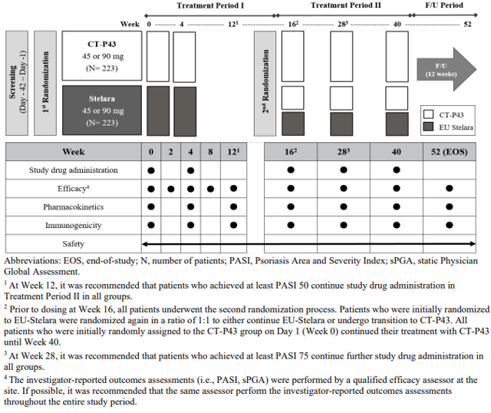

Inclusion criteria for this study were male or female patients, aged 18-80 years with moderate to severe chronic psoriasis (with or without psoriatic arthritis) as defined by the follow criteria prior to first administration of study drug:
- A PASI score ≥12
- In involved body surface area (BSA) ≥10%
- An sPGA score of ≥3
Demographic characteristics were generally well matched for all treatment arms in both treatment periods 1 and 2 of the study. Patients were also well matched in terms of Age of psoriasis diagnosis, prior use of phototherapy, prior use of biological therapy and prior use of non-biologic systemic agents. The number of patients with prior use of biologic agents was 82 (16.1%) patients (38 [14.8%] patients in the CT-P43 group and 44 [17.4%] patients in the EU-Stelara group; 38 [15.0%], 21 [16.8%], and 23 [18.5%] patients in the CT-P43 maintenance, EU-Stelara maintenance, and switched to CT-P43 groups, respectively). The most frequently reported prior use of biologic agent by PT was adalimumab (45 [8.8%] patients in total), followed by secukinumab (22 [4.3%] patients in total).
A total of 7 (1.4%) patients discontinued the study (3 from CT-P43 group and 4 from EU-Stelara group) during treatment period 1. 502 patients continued onto treatment period 2 with 253 continuing CT-P43 maintenance, 125 continuing EU-Stelara maintenance and 124 switching from EU-Stelara to CT-P43. Of these 502 patients 15 (3%) discontinued during the study period (10, 3 and 2 patients from the CT-P43 maintenance, EU-Stelara maintenance and CT-P43 switch group respectively).
The final analysis of the PK dataset included 256 subjects in the CT-P43 group and 248 EU-Stelara group. In treatment period 2, 248 subjects were analysed in the CT-P43 maintenance group. 118 out of 248 subjects in the Stelara maintenance group and 117 subjects in the subjects who were changed to CT-P43 group within the PK dataset. 6 (1.2%) of subjects were excluded from the PPS at week 12 (3 in each treatment group), each due to use of prohibited medication or treatment as major protocol deviation.

Table 4: Analysis of data sets for Treatment period 1 for study CT-P43 3.1
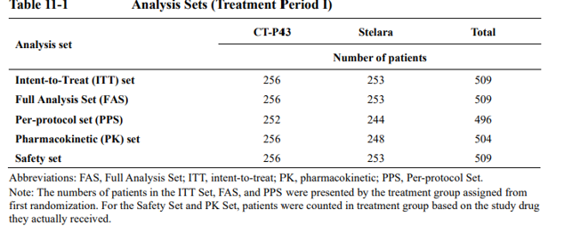

Table 5: Analysis of data sets for Treatment period 2 for study CT-P43 3.1
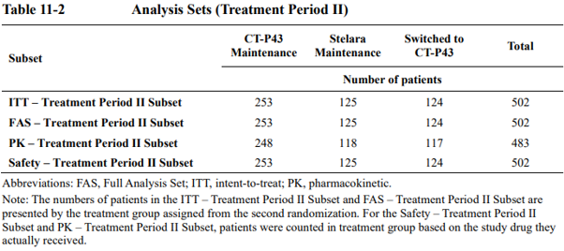

Results of the PK data analysis with mean ustekinumab concentrations are presented in Figure 2. The sponsor has suggested that serum ustekinumab concentration were similar across treatment groups when measured at regular intervals.
Figure 2: Mean serum concentration of ustekinumab in treatment groups in Study CT-P43 3.1 (PK Set)
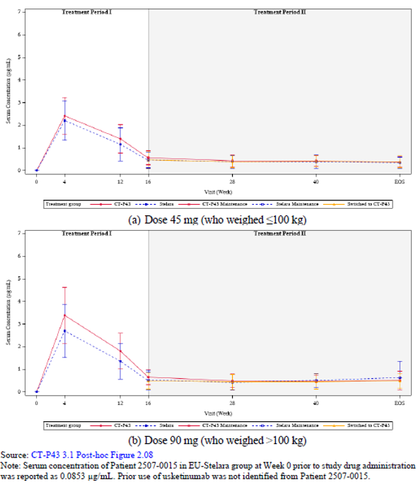

Regarding immunogenicity, 33 (12.9%) subjects in the CT-P43 and 86 (34%) in the EU-Stelara groups respectively were found to have at least 1 ADA positive result after study drug exposure. During transition from EU-Stelara to CT-P43 at week 16, 27 (21.6%) subjects and 25 (20.2%) subjects in the EU-Stelara maintenance and the switch to CT-P43 groups respectively showed at least one ADA positive result.
Primary efficacy results as measured by the mean percent improvement from baseline in PASI scores at week 12 are presented in Table 6. Table 7 shows these results with a sensitivity analysis with missing imputation using a missing at random assumption being performed on the full analysis set (FAS) set of data.
Table 6: Statistical analysis of mean percent improvement from baseline in PASI Score at Week 12 in Study CT-P43 3.1 (FAS and PSS sets)
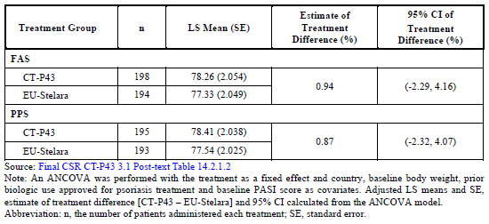

Table 7: Mean percent improvement from baseline in PASI score at Week 12 in Study CT-P43 3.1 - multiple imputation sensitivity analysis of FAS set
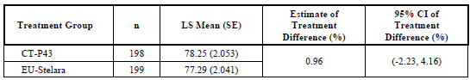

These efficacy results show the least square mean percentage improvement in PASI of the full analysis set (FAS) was 78.26 (SE 2.054) I the CT-P43 group and 77.33 (SE 2.049) in the
EU-Stelara group with an estimate of treatment difference of 0.94 (95% CI of -2.29, 4.16). Sensitivity analysis of mean improvement in PASI scores at week 12 on the FAS were conducted using the analysis of covariance (ANCOVA), Multiple imputation (MI) with a missing at random assumption (MAR) was used for the imputation method with these results being displayed in table 7, this showed a mean percentage PASI score change at week 12 of 78.25 (SE 2.053) in the CT-P43 group and 77.29 (2.041) in the EU-Stelara group and an estimated treatment difference of 0.96 (95% CI -2.23, 4.16). Mean percentage improvements over from baseline over the entire treatment periods (treatment period 1 and 2) are shown in figure 3.
PASI scores were measured at regular intervals during the trial treatment period II from week 16 to week 40. At week 16 mean PASI scores for the full analysis set in the CT maintenance group (N=253) were 2.03, for the Stelara maintenance group it was 2.40 (N=125) and for the switched to CT-P43 group (N=124) it was 2.81. At week 40 mean PASI scores for the full analysis set in the CT maintenance group were 1.09 (-0.94), for the Stelara maintenance group it was 1.51 (-0.89) and for the switched to CT-P43 group it was 1.38 (-1.43). Percentage improvement from baseline in PASI score during treatment period II were similar between groups and showed that at week 40 there was a mean percentage improvement from baseline PASI score of 95.31% in CT-P43 maintenance, 92.44% in Stelara maintenance and 94% in the switched to the CT-P43 group.
Figure 3: Mean percent improvement from baseline in PASI score for each group in Study CT-P43 3.1 - FAS
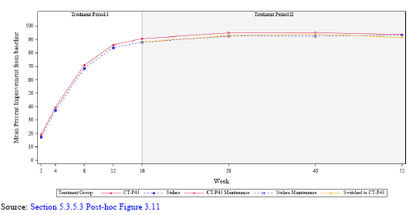

A ‘best-worse scenario’ was performed where missing values were imputed as 0%. The mean PASI score at week 12 based in this best-worst case scenario showed an estimated treatment difference of 2.86% (95% CI -0.78, 6.51) between CT-P43 and EU-Stelara. This treatment difference fell between the pre-defined equivalence margins of +/- 15% between groups.
Other secondary and exploratory outcomes have not been reviewed.

Safety
The 3 clinical studies submitted had safety data collected. The overall numbers in the safety data set analysis from all 3 studies was 1104. The number of subjects available for safety analysis from each study are presented in table 8.
Table 8: Summary of subjects included in the Safety Sets across all presented clinical trials.
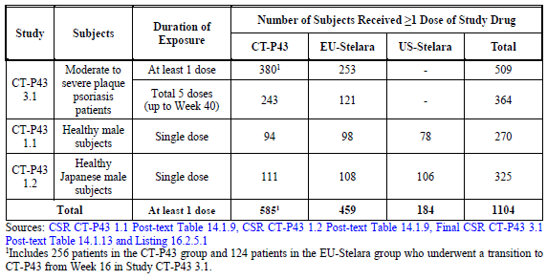

Safety analysis study CT-P43 1.1
In Part 1 of this trial a total of 30 subjects underwent safety analysis with 14 subjects in the CT-P43 group and 16 in the EU-Stelara group. In Part 2, 240 subjects (80 subjects in the CT-P43 group, 82 subjects in the EU-Stelara group and 78 subjects in the US-Stelara group) received at least a single dose of ustekinumab and were therefore included in the safety analysis.
In Part 1 of this study 1 subject withdrew from the EU-Stelara group due to reason of ‘withdrawal by subject’. Of the randomised subjects in part 2, 11 (4.6%) subjects discontinued the study with the most frequent reason being ‘withdrawal by subject’.
Table 9: Summary of TEAEs in Study CT-P43 1.1 (Part 2 Safety Set)
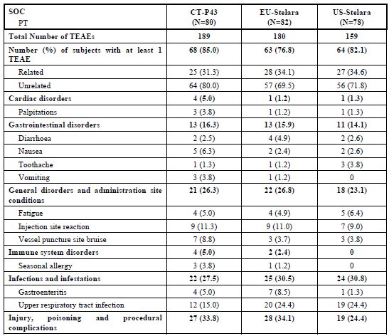

Table 9 (continued): Summary of TEAEs in Study CT-P43 1.1 (Part 2 Safety Set)
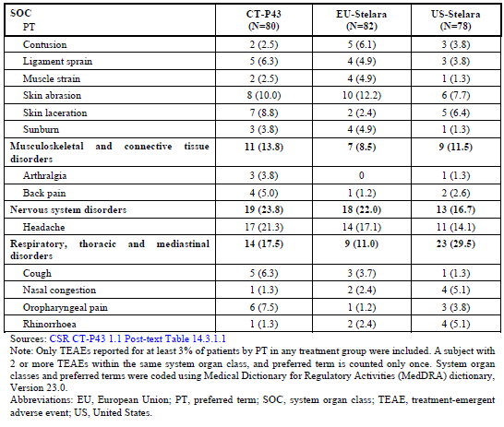
In Part 1 of this study the number of treatment emergent adverse events (TEAE’s) were 5 (35.7%) and 8 (50%) in the CT-P43 and EU-Stelara group respectively.
In part 2 of this study the number of subjects with at least 1 TEAE were 68 (85%), 63 (76.8%) and 64 (82.1%) in the CT-P43, EU-Stelara and US-Stelara groups respectively. There were similar rates of TEAE’s deemed related and unrelated to the investigational product between groups. Rates of infection, injection site reactions and gastrointestinal disorders were similar across groups. 2 subjects reported hypersensitivity reactions during the study period (1 in CT-P43 group and 1 in EU-Stelara group), both reactions were classified as grade 1.
There were 4 subjects in part 2 who developed serious TEAEs during the study period - 2 (2.5%) were in the CT-P43 group and 2 (2.6%) in the US-Stelara group. Three of these subjects experienced accidental injury/falls and one subject experienced abdominal pain with no clear cause. There were no deaths during part 1 or part 2 of this study.
The most frequent reported grade 3 or higher laboratory parameter were creatinine phosphokinase (CK) elevations with CTCAE grade 4 laboratory parameters for CK occurring in 8 (3.3%) of subjects (1 [1.3%] in CT-P43 group, 2 [2.4%] in EU-Stelara group and 5 [6.4%] in the US-Stelara group). These values were considered abnormal, but not clinically significant by the investigator and were not reported as TEAEs except in 1 subject. This subject in the US-Stelara group had the TEAE of elevated CK on day 2, this event was deemed not serious and had recovered by the time of end of study visit.

Safety analysis study CT-P43 1.2
In this study a total of 331 subjects were randomised with 325 subjects (111 subjects in the CT-P43 group, 108 subjects in the EU-Stelara group and 106 subjects in the US-Stelara group) receiving a single dose of study ustekinumab and were thus included in the safety analysis. Of the 331 randomised subjects 14 (4.2%) discontinued the study (5 subjects in both the CT-P43 and EU-Stelara group and 4 in the US-Stelara group) with the most frequent reported reason being ‘withdrawal by subject’.
TEAEs as shown in table 10 occurred in 61 (55%) subjects in the CT-P43 group, 54 (50%) of subjects in the EU Stelara group and 48 (45.3%) of subjects in the US-Stelara group. Overall rates of infection were comparable between treatment groups and all infections were deemed grade 1 or grade 2 in severity. Injection site reactions were the most frequently reported TEAE occurring in 22 (19.8%) of the CT-P43 group, 14 (13%) of the EU-Stelara group and 10 (9.4%) of the US-Stelara group. All injection site events were grade 1 in severity.

Table 10: Summary of TEAEs in Study CT-P43 1.2 (Safety Set)
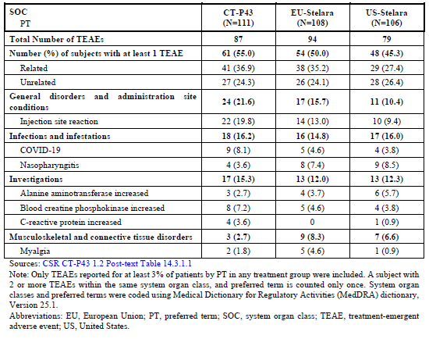
Hypersensitivity reactions occurred in 1 (0.9%) subject in the EU-Stelara group and was grade 1 in severity. The number of TEAE by intensity of grade 3 or higher was similar across treatment groups with 5 (4.5%) reported events occurring in the CT-P43 group, 4 (3.7%) in the EU-Stelara group and 3 (2.8%) in the US-Stelara group.
The most frequently reported grade 3 or 4 laboratory TEAE was increased CK levels occurring in 3 (2.7%) subjects in the CT-P43 group, 2 (1.9%) in the EU-Stelara group and 3 (2.8%) in the US-Stelara group. These events were reported as non-serious TEAE’s.

Safety analysis study CT-P43 3.1
The study design has been previously discussed under the clinical (module 5) data evaluation. 509 subjects were randomised and included in the safety data set for this study. 256 subjects in the CT-P43 group and 253 in the EU-Stelara group. Subjects received either 45mg or 90mg of subcutaneous ustekinumab based on weight (if >100kg subjects received higher 90mg ustekinumab dose), 58 (22.7%) subjects in the CT-P43 group and 54 (21.3%) subjects in the EU-Stelara group weighed >100kg.
Extent of exposure is reflected in table 11, which shows how many subjects received all 5 doses of ustekinumab during the trial period. 243 (94.9%) of subjects in the CT-P43 group and 242 (95.7%) of subjects in the EU-Stelara group received the week 40 ustekinumab dose and completed the planned total of 5 doses administered. Early termination of study due to ‘withdrawal of subject’ were reported in 8 subjects overall (5 in CT-P43 maintenance group, 2 in EU-Stelara group and 1 in the switched to CT-P43 group). Early termination due to adverse events occurred in 5 subjects overall (3 in CT-P43 maintenance group, 1 in EU-Stelara group and 1 in the switched to CT-P43 group) with 1 death occurring during the study period in the CT-P43 maintenance group.

Table 11: Summary of total number of ustekinumab doses received by each treatment group.
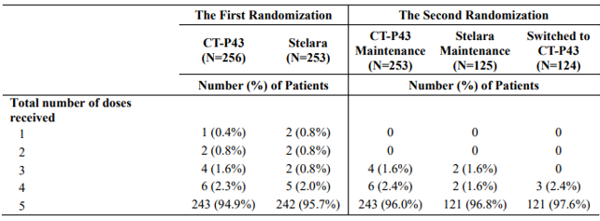

A summary of prior and concomitant medication use relevant to the study is summarised in Table 12. Prior and concomitant use of immunosuppressant therapy, biological agents, vaccines and corticosteroids were comparable between treatment groups.
For the overall study duration including both treatment periods 1 and 2 the total number of subjects with ≥1 TEAE were: 137 (53.5%) in the CT-P43 group, 64 (51.2%) in the EU-Stelara maintenance group and 75 (60.5%) in the switched to CT-P43 group. Number of subjects who experienced ≥1 TESAE were: 9 (3.5%) in the CT-P43 group, 5 (4%) in the EU-Stelara maintenance group and 3 (2.4%) in the switched to CT-P43 group. During the overall study period including treatment periods 1 and 2 rates of TEAE and TESAE appeared similar between groups. The number of subjects who experienced any TEAE of infection and injection site reaction were similar between all treatment groups for the overall study period, overview of TEAE for the safety data set are outlined in table 13. Rates of TEAE deemed related to study drug were also similar across all treatment groups for treatment periods 1 and 2.

Table 12: Prior and concomitant medication use in Study CT-P43 3.1 (Safety Set)
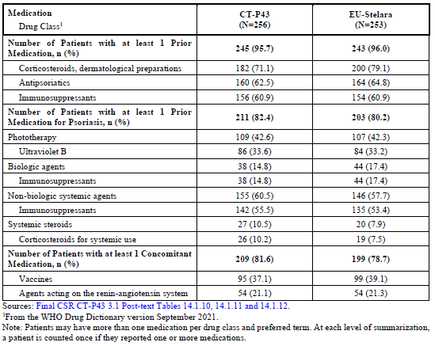

Table 13: Overview of TEAEs in Study CT-P43 3.1 across study periods 1 and 2
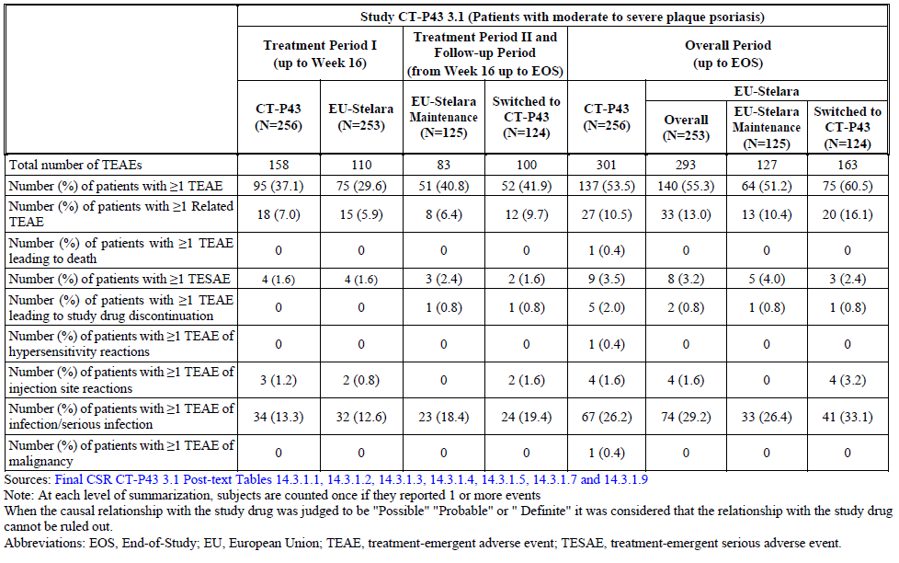

A summary of all TEAEs by system organ classification and preferred term is presented in Table 14.
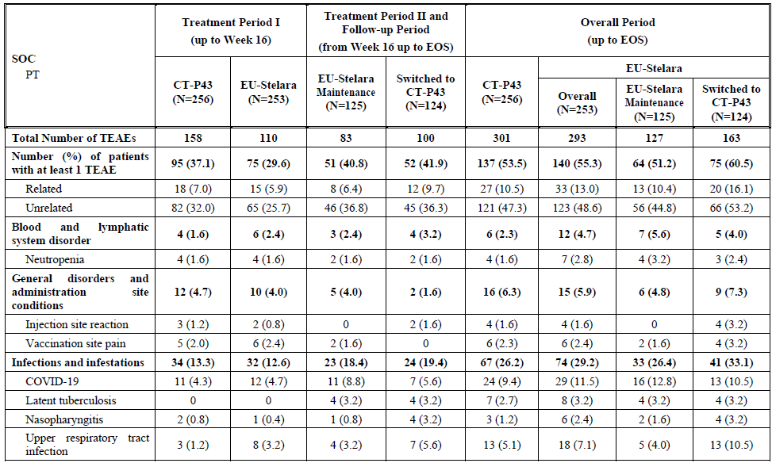
Table 14: Summary of all TEAEs in Study CT-P43 3.1 (Safety Sets across all treatment periods)
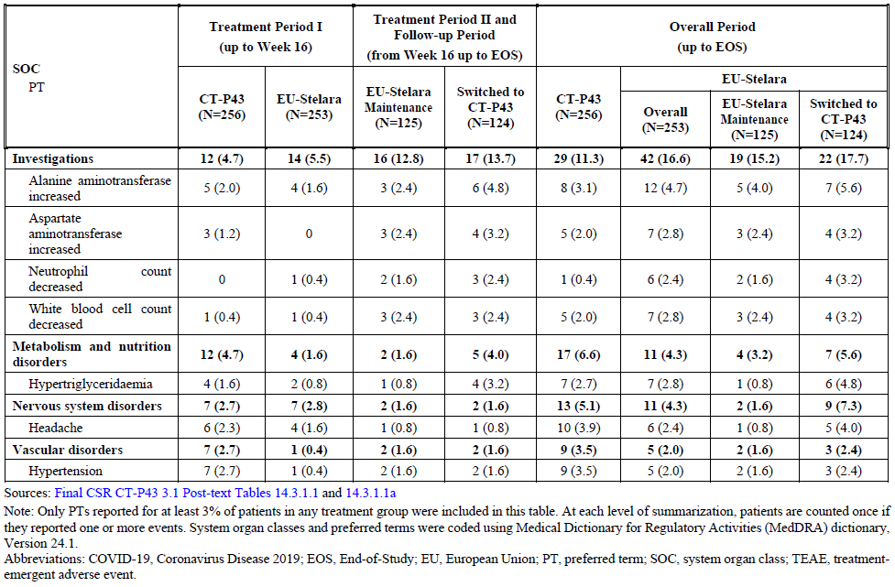

The TEAE of upper respiratory tract infection and COVID-19 appeared similar in each treatment group over study periods 1 and 2. As shown in Table 13, 1 subject experienced the TEAE of hypersensitivity reaction in the CT-P43 maintenance group during treatment period 2, this was deemed a grade 3 reaction and did not result in study drug discontinuation.
Overall, there were similar rates of grade 3 or higher TEAEs in each treatment group that occurred at rates of ≥1%. During the overall study period there were 24 (9.4%) events of grade 3 or higher TEAE’s occurring in ≥1% in the CT-P43 group and 25 (9.9%) in the combined
EU-Stelara maintenance group and switched to CT-P43 group, the EU-Stelara maintenance group and CT-P43 groups also had similar rates of TEAEs. Regarding TEAEs of grade 3 or higher in categories of infections and neutropenia, these rates were similar across treatment groups.
1 death occurred during the study period in a 37-year-old male with a medical history of psoriasis, tobacco smoking and obesity who was in the CT-P43 in treatment period 1 and continued CT-P43 in treatment period 2. 68 days after the week 28 dose of CT-P43 the patient died suddenly from an extensive myocardial infarction, the sponsors narrative states that the patient fell in the street. The event of myocardial infarction resulting in death was deemed unrelated to the study drug by the investigator.
TESAEs are summarised in table 15. During the overall study period rates of TESAEs were similar across groups with 9 (3.5%) events occurring in the CT-P43 group, 5 (4.0%) occurring in the EU-Stelara maintenance group and 3 (2.4%) in the switched to CT-P43 group. There were 2 cases of TESAE felt to be related to study drug, both in the CT-P43 maintenance group. The first was a 64-year-old white female who developed breast carcinoma which was found on mammogram with no other symptoms found during treatment period 2 of study, study investigators deemed there was a possible connection between this event and the study drug. The second was a 59-year-old white male who experienced the grade 3 event of COVID-19 pneumonia, requiring hospitalization. This subject received supplemental oxygen and was discharged from hospital 11 days later; there was deemed to be a possible connection between this event and the study drug.

Table 15: Summary of TESAEs in Study CT-P43 3.1 (Safety Sets - all Treatment Periods)
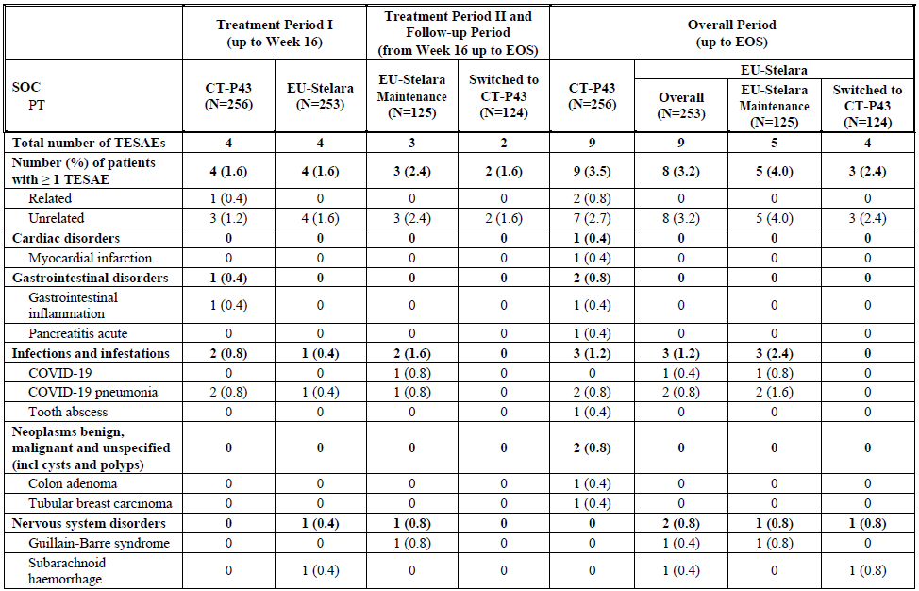
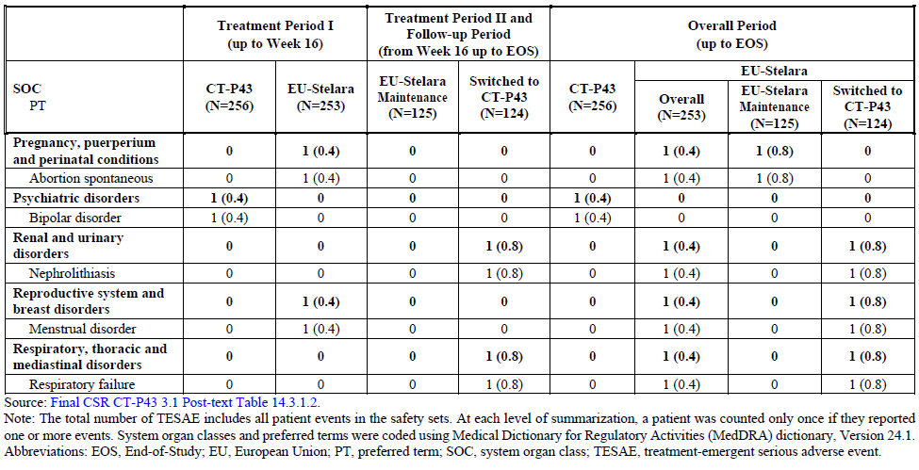
There did not appear to be any clear significant difference in the total frequency of TESAE between treatment groups and no clear pattern of differences in TESAE when reviewed by system organ class (SOC) and preferred terms (PT).
There was 1 (0.4%) subject in the CT-P43 group who experienced a grade 3 TEAE classified as hypersensitivity reaction. The signs and symptoms of the hypersensitivity were a grade 3 headache with investigators deeming these symptoms of probably causality to study drug. In the overall treatment period, 4 (1.6%) subjects in both the CT-P43 group and 4 (4.2%) subjects in the switched to CT-P43 group experienced injection site reactions with all events graded 1 or 2 in intensity. As previously mentioned, the adverse event of infections/serious infections was similar between treatment groups with this TEAE occurring in 67 (26.2%) in the CT-P43 group and 74 (29.2%) in the EU-Stelara maintenance group and switched to CT-P43 groups combined. There were 3 (1.2%) subjects who experienced infections defined as serious in both the CT-P43 group and the overall combined EU-Stelara maintenance group and switched to CT-P43 groups.
Hypertriglyceridemia was the most frequent reported grade 3 or higher laboratory parameter reported for 19 (7.5%) in the CT-P43 group, 5 (4.0%) EU-Stelara maintenance group and 7 (5.6%) in the switched to CT-P43 group and 1 (0.4%) in the EU-Stelara group during the first randomization period (treatment period 1). The second most commonly reported CTCAE
Grade 3 or higher laboratory parameters was decreased neutrophil count, which was reported in 7 (2.8%) subjects in the CT-P43 group, 7 (5.6%) in the EU-Stelara maintenance group and 8 (6.4%) in the switched to CT-P43 group.

Immunogenicity
Based on evidence presented in the U.S Stelara PI ~6.0% of subjects with psoriasis or psoriatic arthritis developed anti-drug antibodies.
Across all studies CT-P43 appeared to show a lower rate of ADA development compared to Stelara. In Study CT-P43 3.1 there were 33 (12.9%) of subjects in the CT-P43 group and 86 (34%) in the EU-Stelara were found to have at least 1 ADA positive result after study drug exposure over the entire study period with no clear change in ADA incidence following the group that switched from EU-Stelara to CT-P43 at week 16.
In study CT-P43 1.1 part 1 there were similar rates of ADA and NAb across treatment groups with part 2 showing lower rates of ADA post study drug treatment in the CT-P43 group compared to the EU-Stelara and US-Stelara groups. In Study CT-P43 1.2 lower rates of ADA post study drug treatment were also observed in the CT-P43 group compared to both the EU-Stelara and US-Stelara groups.

Risk management plan
No RMP evaluation was required for this submission, despite the inclusion of the EU RMP for Steqeyma and the Australia-Specific Annex (ASA) within the clinical dossier. As part of initial communication between the application assessment team and the sponsor, the RMP was to be reviewed as a post approval RMP update and not as part of the initial evaluation process. Refer to TGA’s guidance on ‘when an RMP is required’.
The TGA may request an updated RMP at any stage of a product's life cycle, during both the pre-approval and post-approval phases. Further information regarding the TGA’s risk management approach can be found in risk management plans for medicines and biologicals and the TGA's risk management approach. Information on the Australia-specific annex (ASA) can be found on the TGA website.

Risk-benefit analysis

Delegate’s considerations
The clinical evaluator has stated that the benefit-risk balance for Steqeyma appears favourable based on the submitted clinical data and recommends approval of Steqeyma in the proposed forms and for the proposed indications. This is pending a favourable determination from quality and non-clinical evaluation processes.

Biosimilarity

Quality
As per section ‘manufacturing and quality control’ in this document there were minor differences noted between Steqeyma and the EU/US reference product Stelara, however these differences were felt highly unlikely to impact on clinical safety or efficacy. Overall, it is felt the sponsor has demonstrated comparability between Steqeyma and the EU/US STELARA in terms of structure, species, function and degradation profile (i.e physicochemically and biologically).
The Additional bridging comparability studies performed between the EU/US and AU Stelar concluded that CT-P43 (Steqeyma) is highly similar to EU-approved, US-licensed and Australian-sourced Stelara in terms of protein content, primary and higher order structure, purity/impurity, glycan profiles, post translational modifications and biological activity.

Pharmacokinetics
Study CT-P43 1.1 investigated PK parameters to demonstrate similarity between 3 different forms of subcutaneous administration of Ustekinumab (CT-P43, EU-Stelara and US-Stelara). The primary outcome was to demonstrate pharmacokinetic similarity between these different formulations of ustekinumab. There were 238 in the pharmacokinetic data set with subjects divided in a 1:1:1 ratio between the CT-P43 group, EU-Stelara group and US-Stelara group.
In terms of demonstrating bioequivalence between products the study did not meet its primary endpoint with the ratio of geometric LS mean for AUC _{0-inf} between CT-P43 and US-Stelara being 126.4 (90% CI). The ratio of geometric LS mean for C_{max} was noted to be higher for CT-P43 when compared to both EU-Stelara and US- Stelara but was within the 80-125% accepted interval for bioequivalence. The sponsor stated the reason for the observed PK differences between the
CT-P43 group and the EU-Stelara/US-Stelara groups was due to higher protein content measured in the CT-P43 lots compared to the EU-Stelara/US-Stelara lots used in study 1.1. The sponsor has also said post-hoc analysis of study 1.1 was done, when there was dose correction for protein content of drug products and additional analysis of subjects who were negative or had low titres of ADA antibodies sponsor states that AUC_{0-inf} and C_{max} ratios fell within bioequivalence range.
This led to a second study CT-P43 1.2 with the primary PK outcome of demonstrating bioequivalence between the same 3 formulations of ustekinumab is in study CT-P43 1.1. Subjects in this study were all healthy Japanese males aged 18-55 divided in a 1:1:1 ratio to receive CT-P43, EU-Stelara or US-Stelara. There were 320 subjects included in the final PK data set. Study CT-P43 1.2 PK results met primary endpoints with the ratio of geometric LS mean for AUC _{0-inf} and C_{max} falling within the 80-125% accepted interval for bioequivalence.
The limitations and uncertainties of this PK study are that it included subjects of only one ethnicity, with all subjects being Japanese. Furthermore, the sponsor states study CT-P43 1.2 accounted for the differences in protein content between study drug batches that were present in study CT-P43 1.1. The sponsor states that reference batches of study drugs in study CT-P43 1.2 contained similar protein content across all 3 treatment groups. Differences in protein content between the reference product and the study drug product that may have affected PK parameters in study CT-P43 1.1 need to be considered when comparing biosimilarity between the reference product and sponsors proposed product.
Whilst I acknowledge the ratio of geometric LS mean for AUC_{0-inf} fell slightly outside the accepted range for bioequivalence between CT-P43 and US Stelara being 126.4 (90% CI) in study CT-P43 1.1. I note all other PK parameters between CT-P43, EU Stelara and US-Stelara did fall in the accepted range of 80-125% (with CI 90%) for bioequivalence. Although only containing one ethnicity, being Japanese males in study CT-P43 1.2 the ratio of geometric LS means clearly fell in the accepted intervals for bioequivalence of 80-125% with a 90% CI between CT-P43, EU-Stelara and US Stelara for AUC_{0-inf} and C_{max.}
Taking both studies into account and acknowledging the uncertainty raised by differing protein content between reference product and sponsors product batches affecting PK as well as study CT-P43 1.2 only having Japanese males included I find overall that there has been sufficient evidence provided from the PK analysis between the sponsors product CT-P43 (STEQEYMA) and the reference products EU-Stelara and US-Stelara to demonstrate adequate PK similarity between CT-P43 and the reference products EU-Stelara and US-Stelara.
The sponsor has stated in response to evaluators questions that anyone who had previously received the reference monoclonal antibody ustekinumab was excluded from enrolling in trial CT-P43 3.1, therefore no subgroup analysis could be performed in this trial regarding development of ADA in those previously treated with ustekinumab.

Clinical efficacy
The sponsor has sought to have all indications that are currently approved for the reference product Stelara approved for Steqeyma. These include plaque psoriasis, psoriatic arthritis, Crohn’s disease and ulcerative colitis. In the sponsors document ‘clinical overview’ on page 60 the sponsor provides a justification for the extrapolation of indication with explanation regarding IL-12 and IL-23 signalling being important in the pathogenesis of all the indications sought and how interruption of this pathway can reduce cytokine pathways mediated by T Helper-1 and T helper-17 cells which are involved in the pathophysiology of these diseases. The delegate agrees with the justification provided and that clinical extrapolation of indication from clinical study in CTP43 3.1 (moderate to severe plaque psoriasis) to the other sought indications is reasonable.
The clinical evidence of comparable safety and efficacy for CT-P43 (Steqeyma) compared to the reference product EU-Stelara is primarily provided by study CT-P43 3.1. This trial chose the indication of moderate-severe chronic psoriasis with the primary endpoint of mean change in PASI score at week 12 to demonstrate comparability in efficacy between CT-P43 and the reference product EU-Stelara. This study divided subjects in a 1:1 ratio to receive either CT-P43 or EU-Stelara with a total of 509 subjects (256 in CT-P43 group and 253 in EU-Stelara group) included in the full analysis set. Subjects received ustekinumab 45mg or 90mg subcutaneously based on body weight.
The primary efficacy outcome was met with a mean percentage reduction in PASI score at week 12 of 78.26% in the CT-P43 group and 77.33% in the EU-Stelara group for the FAS. The estimated treatment difference was 0.94 (95% CI of -2.29, 4.16), this value fell within the predefined equivalence margin of +/- 15% set by the sponsor. I find that these results support CT-P43 in demonstrating comparable efficacy for the indication of moderate-severe psoriasis compared to the reference product EU-Stelara and support biosimilarity between these 2 products.
The secondary efficacy outcome of PASI scores during treatment period II, where CT-P43 maintenance, Stelara maintenance and switched to CT-P43 treatment groups were analysed. During treatment period II where mean PASI scores at weeks 16 and week 40 were obtained mean PASI scores at week 40 for the full analysis set in the CT maintenance group were 1.09 (-0.94 change compared to week 16), for the Stelara maintenance group it was 1.51 (-0.89 change compared to week 16) and for the switched to CT-P43 group it was 1.38 (-1.43 change compared to week 16). Percentage improvement from baseline in PASI score during treatment period II were similar between groups and showed that at week 40 there was a mean percentage improvement from baseline PASI score of 95.31% in CT-P43 maintenance, 92.44% in Stelara maintenance and 94% in the switched the CT-P43 group. The improvements in mean PASI scores comparing week 16 and week 40 and similar mean percentage improvement from baseline in PASI scores in the switched to CT-P43 group supports that there is no clear loss of efficacy when patients were switched from Stelara to CT-P43.
Mean plasma concentrations of ustekinumab, especially beyond the week 16 treatment period when subjects were dosed at regular intervals of 12 weeks appeared similar between groups in the measured PK data set.

Safety
Overall, the submitted safety data presented in studies CT-P43 1.1, CT-P43 1.2 and CT-P43 3.1 did not raise any new safety concerns or safety signals when comparing adverse events between CT-P43 and the Stelara reference product.
Immunogenicity data from studies CT-P43 1.1, CT-P43 1.2 and CT-P43 3.1 showed that CT-P43 had lower rates of ADA compared to the reference Stelara product. Study CT-P43 3.1 clinical report states that the mean percent improvement from baseline in the PASI scores at week 12 for the ADA positive and ADA negative subgroups was similar, regardless of ADA positivity and were similar between the 2 groups in the ADA positive and ADA negative subgroups. Serum ustekinumab concentrations were also similar between CT-P43 maintenance, EU-Stelara maintenance and the switched to CT-P43 groups during treatment 2 study period with ustekinumab PK profiles remaining similar when subjects were transitioned from EU-Stelara to CT-P43 and compared to the maintenance EU-Stelara group.

Uncertainties and limitations of data
The sponsor has not submitted any specific clinical or pharmacokinetic studies to support bioequivalence or PK similarity between the intravenous formulation of CT-P43 and Stelara. Although this is an area of uncertainty the approach of demonstrating Biosimilarity between subcutaneously administered formulations of biological products when these products can be given by both intravenous and subcutaneous formulations is supported by the relevant European Medicines Agency guidelines (“Guideline on similar biological medicinal products containing biotechnology-derived proteins as active substance: non-clinical and clinical issues”, Section 5.1). This guideline states that when reference products can be administered by intravenously and subcutaneously that the evaluation of the subcutaneous route is usually sufficient as it covers both absorption and elimination, therefore it is possible to waive the evaluation of intravenous administration if comparability in both absorption and elimination has been demonstrated via the subcutaneous route.
Furthermore, in response to this question regarding extrapolation of bioequivalence between subcutaneous and intravenous formulation the sponsor has referenced a randomized controlled trial where a single dose for IV induction using ustekinumab was used for treatment of Crohn’s disease. In this trial subjects were treated in a 1:1:1 ratio with placebo, ustekinumab 130mg IV or ustekinumab 6mg/kg IV (this trial used the same IV induction dosing as recommended in the Steqeyma PI). Adverse events in this trial were similar between the placebo, ustekinumab 130mg and ustekinumab 6mg/kg groups which provides some supporting evidence of safety using the recommended IV induction doses of ustekinumab for the proposed indications.
Overall, I think the approach the sponsor has taken is reasonable and extrapolation of Biosimilarity between the subcutaneous intravenous formulations of CT-P43 and Stelara is adequate based on the submitted data evidence using the subcutaneous formulations.
There have been no paediatric pharmacokinetic or clinical studies done by the sponsor. The manufacturing and quality review of the sponsor’s submitted data is felt to show comparability between Steqeyma and the reference EU/US STELARA in terms of structure, species, function and degradation profile (i.e. physicochemically and biologically). The delegate feels that comparability between Steqeyma and the EU/US Stelara has been demonstrated to an acceptable degree to maintain the paediatric indication present for the reference product Stelara and is a proposed indication for Steqeyma, which is: ‘Steqeyma is indicated for the treatment of moderate to severe plaque psoriasis in children and adolescent patients from 6 years of age who are inadequately controlled by, or are intolerant to, other systemic therapies or phototherapies.’ It is also noted by the delegate that the 45mg ustekinumab vial, which is offered by the reference product Stelara is NOT currently being made available by the sponsor, therefore Steqeyma will not have the 45mg vial presentation available. I note a clear warning in the proposed PI in section 4.2 under heading ‘dosing’ stating “Healthcare providers should be advised that there is no dosage form of STEQEYMA available which allows dosing of less than 45 mg by subcutaneous injection. As a result, there are no suitable STEQEYMA dosage forms for a paediatric psoriasis patients weighing less than 60 kg. Other ustekinumab products with suitable dosage form is available”. The delegate feels that the sponsor has clearly explained Steqeyma does not have the dosage form available to dose less then 45mg and thus there are no suitable STEQEYMA dosage forms for paediatric psoriasis patients weighing <60kg. The sponsor has provided further information stating that other ustekinumab products have the appropriate dosage form for this population. The delegate finds this warning and explanation acceptable to healthcare professionals regarding dosing in paediatric psoriasis patients.

Proposed conditions of registration

Laboratory testing & compliance with Certified Product Details (CPD)
i) All batches of STEQEYMA supplied in Australia must comply with the product details and specifications approved during evaluation and detailed in the Certified Product Details (CPD).
ii) When requested by the TGA, the Sponsor should be prepared to provide product samples, specified reference materials and documentary evidence to enable the TGA to conduct laboratory testing on the Product. Outcomes of laboratory testing are published biannually in the TGA Database of Laboratory Testing Results http://www.tga.gov.au/ws-labs-index and periodically in testing reports on the TGA website.

Certified Product Details
The Certified Product Details (CPD), as described in Guidance 7: Certified Product Details of the Australian Regulatory Guidelines for Prescription Medicines (ARGPM), in PDF format, for the above products should be provided upon registration of these therapeutic goods. In addition, an updated CPD should be provided when changes to finished product specifications and test methods are approved in a Category 3 application or notified through a self-assessable change.
A template for preparation of CPD for biological prescription medicines can be obtained from the TGA website:
- [for the form] https://www.tga.gov.au/form/certified-product-details-cpd-biological-prescription-medicines
- [for the CPD guidance] https://www.tga.gov.au/guidance-7-certified-product-details

Proposed action
The delegate believes that the sponsor has adequately established with the submitted pharmacokinetic, clinical and quality data that Steqeyma is comparable to the reference EU/US/AU products Stelara and that biosimilarity between these products has been demonstrated.

Independent expert advice
The Delegate received the following independent expert advice.

Advisory Committee on Medicines considerations
The Advisory Committee on Medicines (ACM) having considered the evaluations and the Delegate’s overview, as well as the sponsor’s response to these documents, advised the following.

Specific advice to the delegate
The ACM advised the following in response to the Delegate’s specific request for advice:
1. The ACM opinion on the adequacy of data to support biosimilarity between Stelara and Steqeyma based on the submitted pharmacokinetic studies.
The ACM advised that the data is adequate to support a high level of biosimilarity between Steqeyma and the reference product Stelara. In their deliberation, the ACM discussed the data from the CT-P43 1.1 and CT-P43 1.2 studies, which compared Steqeyma with both formulations of Stelara, both EU and US registered products. The initial study CT-P43 1.1 showed notable difference in AUC and Cmax due to inconsistent protein content between formulations. With post-hoc analysis accounting for this inconsistency and differences in anti-drug antibodies, AUC and Cmax were found to be in accepted range. The subsequent study CT-P43 1.2 was conducted with an entirely Japanese cohort and found all pharmacokinetic parameters within accepted range for bioequivalence with Stelara. There was no reason for the ACM to believe that the population differences between the two studies would account for differing clearance rates between formulations.

The CT-P43 3.1 study compared the effectiveness of Steqeyma against the EU formulation of Stelara. The primary outcome of the study was a PASI score at 12 weeks of treatment, which showed no significant difference between Steqeyma and EU Stelara. Additionally, trial participants were switched from Steqeyma to Stelara with no notable adverse events or loss in efficacy. This study was considered to be robust by the ACM
2. The ACM opinion on the adequacy of submitted data demonstrating biosimilarity to support Steqeyma’s use in the paediatric population who are ≥ 6 years old for psoriasis.
The ACM noted that there were no paediatric participants in the pharmacokinetic studies. This omission was deemed acceptable given the high level of biosimilarity with STELARA, allowing for reasonable extrapolation of this bioequivalence to the paediatric population.
3. The ACM opinion on Steqeyma not currently having the 45 mg vial presentation available to dose paediatric patients < 60kg. Does warning under section 4.2 ‘dosing’ adequately explain this issue?
The ACM was of the view that the explanation in s 4.2 of the PI is adequate to explain the dosing restrictions. Additionally, it was noted that STEQEYMA would typically be dispensed through hospital pharmacies for young children requiring dose adjustment with the vial presentation, adding a level of oversight for paediatric use.
The ACM noted that an additional 45mg vial dosing form would be desirable to allow for greater flexibility in dosing. The ACM considered whether the indication should also exclude patients under 60kg until this dose form is made available by the sponsor. Given it is not practically possible to dose children less than 60kg with the available presentations, the committee recommended this restriction should be included in the indication until the 45mg vial dose form was made available.

Advisory committee conclusion
The ACM considered this product to have an overall positive benefit-risk profile for the indications:
Plaque Psoriasis
Adults
STEQEYMA is indicated for the treatment of adult patients (18 years or older) with moderate to severe plaque psoriasis who are candidates for phototherapy or systemic therapy.
Paediatric population, 6 years and older
STEQEYMA is indicated for the treatment of moderate to severe plaque psoriasis in children and adolescent patients from 6 years of age AND over 60kg who are inadequately controlled by, or are intolerant to, other systemic therapies or phototherapies.
Psoriatic Arthritis (PsA)
STEQEYMA, alone or in combination with methotrexate, is indicated for the treatment of signs and symptoms of active psoriatic arthritis in adult patients (18 years and older) where response to previous non-biological DMARD therapy has been inadequate.
Crohn’s Disease
STEQEYMA is indicated for the treatment of adult patients with moderately to severely active Crohn’s disease who have had an inadequate response, lost response, or were intolerant to either conventional therapy.

Ulcerative Colitis
STEQEYMA is indicated for the treatment of adult patients with moderately to severely active ulcerative colitis.

Assessment outcome
Based on a review of quality, safety, and efficacy, the TGA decided to register:
- 420570 - Steqeyma (ustekinumab) 90mg/1 mL solution for injection pre-filled syringe with safety guard
- 420571 - Steqeyma (ustekinumab) 130 mg/26 mL concentrate for solution for infusion vial
- 420572 - Steqeyma (ustekinumab) 45 mg/0.5 mL solution for injection pre-filled syringe with safety guard
The approved indications for these therapeutic goods are:
Plaque Psoriasis
Adults
Steqeyma is indicated for the treatment of adult patients (18 years or older) with moderate to severe plaque psoriasis who are candidates for phototherapy or systemic therapy.
Paediatric population, 6 years and older
Steqeyma is indicated for the treatment of moderate to severe plaque psoriasis in children and adolescent patients from 6 years of age (60kg and over) who are inadequately controlled by, or are intolerant to, other systemic therapies or phototherapies.
Psoriatic Arthritis (PsA)
Steqeyma, alone or in combination with methotrexate, is indicated for the treatment of signs and symptoms of active psoriatic arthritis in adult patients (18 years and older) where response to previous non-biological DMARD therapy has been inadequate.
Crohn’s Disease
Steqeyma is indicated for the treatment of adult patients with moderately to severely active Crohn’s disease who have had an inadequate response, lost response, or were intolerant to either conventional therapy or a TNFα antagonist or have medical contraindications to such therapies.
Ulcerative Colitis
Steqeyma is indicated for the treatment of adult patients with moderately to severely active ulcerative colitis.

Specific conditions of registration
Laboratory testing & compliance with Certified Product Details (CPD)
- All batches of STEQEYMA supplied in Australia must comply with the product details and specifications approved during evaluation and detailed in the Certified Product Details (CPD).
- When requested by the TGA, the Sponsor should be prepared to provide product samples, specified reference materials and documentary evidence to enable the TGA to conduct laboratory testing on the Product. Outcomes of laboratory testing are published biannually in the TGA Database of Laboratory Testing Results http://www.tga.gov.au/ws-labs-index and periodically in testing reports on the TGA website.
Certified Product Details
The Certified Product Details (CPD), as described in Guidance 7: Certified Product Details of the Australian Regulatory Guidelines for Prescription Medicines (ARGPM), in PDF format, for the above products should be provided upon registration of these therapeutic goods. In addition, an updated CPD should be provided when changes to finished product specifications and test methods are approved in a Category 3 application or notified through a self-assessable change.
A template for preparation of CPD for biological prescription medicines can be obtained from the TGA website:
- [for the form] https://www.tga.gov.au/form/certified-product-details-cpd-biological-prescription-medicines
- [for the CPD guidance] https://www.tga.gov.au/guidance-7-certified-product-details

Product Information and Consumer Medicine Information
For the most recent Product Information (PI) and Consumer Medicines Information (CMI), please refer to the TGA PI/CMI search facility.

Therapeutic Goods Administration
PO Box 100 Woden ACT 2606 Australia
Email: info@tga.gov.au Phone: 1800 020 653 Fax: 02 6203 1605
https://www.tga.gov.au
Reference/Publication #

Fischer B.A & Buchanan R.W. Treatment of Psoriasis in adults. In: UpToDate, Connor RF (Ed), Wolters Kluwer. (Accessed on March 20th, 2024)
Fischer B.A & Buchanan R.W. Treatment of Psoriasis in adults. In: UpToDate, Connor RF (Ed), Wolters Kluwer. (Accessed on March 20th, 2024)
Fischer B.A & Buchanan R.W. Treatment of Psoriatic Arthritis. In: UpToDate, Connor RF (Ed), Wolters Kluwer. (Accessed on March 20th, 2024)
Fischer B.A & Buchanan R.W. Medical management of moderate to severe Crohn’s disease in adults. In: UpToDate, Connor RF (Ed), Wolters Kluwer. (Accessed on March 20th, 2024)
Feagan B.G, Sandborn W.J, Gasink C et al. (2016). Ustekinumab as Induction and Maintenance Therapy for Crohn’s Disease. New England Journal of Medicine. 375;20.

