▼This medicinal product is subject to additional monitoring in Australia. This will allow quick identification of new safety information. Healthcare professionals are asked to report any suspected adverse events at www.tga.gov.au/reporting-problems.

AUSTRALIAN PRODUCT INFORMATION
SEPHIENCE™ (sepiapterin) oral powder
- NAME OF THE MEDICINE
Sepiapterin

QUALITATIVE AND QUANTITATIVE COMPOSITION
SEPHIENCE 250 mg: Each sachet contains 250 mg of sepiapterin. SEPHIENCE 1000 mg: Each sachet contains 1000 mg of sepiapterin. Excipients with known effect:
SEPHIENCE 250 mg: Each sachet contains 100 mg mannitol and 400 mg isomalt. SEPHIENCE 1000 mg: Each sachet contains 400 mg mannitol and 1600 mg isomalt.
Contains 1.4 g mannitol and 5.8 g isomalt per maximum recommended daily dose for a 60 kg adult. Products containing isomalt or mannitol may have a laxative effect or cause diarrhoea. Contains sucralose.
For the full list of excipients, see Section 6.1 List of excipients.

PHARMACEUTICAL FORM
Oral powder. Yellow to orange powder for oral use.

CLINICAL PARTICULARS

THERAPEUTIC INDICATIONS
SEPHIENCE is indicated for the treatment of hyperphenylalaninaemia (HPA) in adult and paediatric patients with phenylketonuria (PKU).

DOSE AND METHOD OF ADMINISTRATION
Treatment with SEPHIENCE must be initiated and supervised by a physician experienced in the treatment of PKU.

Dosage
The recommended dose of SEPHIENCE, to be administered orally once daily is based on age and body weight (see Table 1). The maximum recommended dose in paediatric patients
≥2 years of age and adults is 60 mg/kg/day.
Table 1: Recommended dose of SEPHIENCE based on patient’s age and body weight
Age | Recommended dose: mg/kg of SEPHIENCE per day
0 to <6 months | 7.5 mg/kg/day
6 to <12 months | 15 mg/kg/day
12 months to <2 years | 30 mg/kg/day
≥2 years | 60 mg/kg/day
As HPA due to PKU is a chronic condition, SEPHIENCE is intended for long-term use. Discontinuation of treatment
The determination of responsiveness for a patient with PKU and the discontinued use of SEPHIENCE is at the discretion of the treating physician.
Baseline blood phenylalanine (Phe) levels should be measured by an experienced clinician. SEPHIENCE (7.5 mg/kg for 0 to <6 months of age, 15 mg/kg for 6 to <12 months of age, 30 mg/kg for 12 months to <2 years of age, and 60 mg/kg for ≥2 years of age) should be administered to patients for 14 consecutive days. In the pivotal Phase 3 clinical study, patients who experienced a ≥15% reduction in blood Phe were classified as responsive. No
controlled efficacy and safety data are available in patients who do not experience a reduction of 15% or greater reduction in blood Phe levels after receiving sepiapterin for 14 days.
Patients who are unresponsive to sepiapterin should be evaluated by the treating physician regarding the risks and benefits of SEPHIENCE.

Administration
SEPHIENCE should be administered orally once a day with food using mg/kg/day dosing.
SEPHIENCE should be mixed in water, apple juice, or a small amount of soft foods (such as apple sauce or jams).
The powder should be mixed well for at least 30 seconds with water or apple juice, and for at least 60 seconds with soft food. Once mixed, the dose should be administered immediately.
If not administered immediately, the liquid and soft food mixtures can be administered within 6 hours when stored below 25°C, or within 24 hours when stored in the refrigerator. Before administration, the liquid mixture and soft food mixture should be stirred once again for at least 30 and 60 seconds, respectively.
An accurate measuring device (e.g., oral syringe or medicine cup) with suitable graduations should be used to ensure administration of the appropriate volume of liquid mixture.
To ensure complete delivery of the dose, rinse the oral syringe or medicine cup with additional water or juice and swallow the contents immediately.
For patients weighing 16 kg or less
- SEPHIENCE should be mixed in 9 mL of water or apple juice per 250 mg sachet, and a portion of this mixture corresponding to a required dose should be administered orally via an oral dosing syringe.
- The preparation should be mixed well for 30 seconds or more until uniform and free of lumps before drawing into the dosing syringe.
- Once drawn up, the dose should be administered immediately.
The number of 250 mg sachet(s) required and the volume of liquid mixture to be administered are provided in Tables 2 to 5 for patients weighing 16 kg or less at different doses (7.5, 15, 30 and 60 mg/kg/day).
Table 2: Recommended dose in patients 0 to <6 months of age: 7.5 mg/kg/day
Body weight (kg) | Total dose (mg/day) | Number of 250 mg sachets required | Volume to be administered (mL)
2 | 15 | 1 | 0.6
3 | 22.5 | 1 | 0.9
4 | 30 | 1 | 1.2
5 | 37.5 | 1 | 1.5
6 | 45 | 1 | 1.8
7 | 52.5 | 1 | 2.1
8 | 60 | 1 | 2.4
9 | 67.5 | 1 | 2.7
10 | 75 | 1 | 3.0
11 | 82.5 | 1 | 3.3
12 | 90 | 1 | 3.6
13 | 97.5 | 1 | 3.9
14 | 105 | 1 | 4.2
15 | 112.5 | 1 | 4.5
16 | 120 | 1 | 4.8
Table 3: Recommended dose in patients 6 to <12 months of age: 15 mg/kg/day
Body weight (kg) | Total dose (mg/day) | Number of 250 mg sachets required | Volume to be administered (mL)
2 | 30 | 1 | 1.2
3 | 45 | 1 | 1.8
4 | 60 | 1 | 2.4
5 | 75 | 1 | 3.0
6 | 90 | 1 | 3.6
7 | 105 | 1 | 4.2
8 | 120 | 1 | 4.8
9 | 135 | 1 | 5.4
10 | 150 | 1 | 6.0
11 | 165 | 1 | 6.6
12 | 180 | 1 | 7.2
13 | 195 | 1 | 7.8
14 | 210 | 1 | 8.4
15 | 225 | 1 | 9.0
16 | 240 | 1 | 9.6
Table 4: Recommended dose in patients 12 months to <2 years of age: 30 mg/kg/day

Body weight (kg) | Total dose (mg/day) | Number of 250 mg sachets required | Volume to be administered (mL)
2 | 60 | 1 | 2.4
3 | 90 | 1 | 3.6
4 | 120 | 1 | 4.8
5 | 150 | 1 | 6.0
6 | 180 | 1 | 7.2
7 | 210 | 1 | 8.4
8 | 240 | 1 | 9.6
9 | 270 | 2 | 10.8
10 | 300 | 2 | 12.0
11 | 330 | 2 | 13.2
12 | 360 | 2 | 14.4
13 | 390 | 2 | 15.6
14 | 420 | 2 | 16.8
15 | 450 | 2 | 18.0
16 | 480 | 2 | 19.2
Table 5: Recommended dose in patients ≥2 years of age weighing 16 kg or less: 60 mg/kg/day
Body weight (kg) | Total dose (mg/day) | Number of 250 mg sachets required | Volume to be administered (mL)
6 | 360 | 2 | 14.4
7 | 420 | 2 | 16.8
8 | 480 | 2 | 19.2
9 | 540 | 3 | 21.6
10 | 600 | 3 | 24.0
11 | 660 | 3 | 26.4
12 | 720 | 3 | 28.8
13 | 780 | 4a | 31.2
14 | 840 | 4a | 33.6
15 | 900 | 4a | 36.0
16 | 960 | 4a | 38.4
ª Four 250 mg sachets or one 1000 mg sachet can be used.
For patients weighing more than 16 kg
The recommended dose of SEPHIENCE in patients ≥2 years of age weighing more than 16 kg is calculated based on body weight (60 mg/kg/day). The entire contents of each
SEPHIENCE sachet should be mixed with water, apple juice (10 mL for each 250 mg sachet, 20 mL for each 1000 mg sachet), or soft foods (2 tablespoons total).
The calculated daily dose should be rounded to the nearest multiple of 250 or 1000 mg, as appropriate. For instance, a calculated dose of 1251 to 1374 mg should be rounded down to 1250 mg corresponding to 1×250 mg sachet and 1×1000 mg sachet. A calculated dose of 1375 to 1499 mg should be rounded up to 1500 mg corresponding to 2×250 mg sachets and 1×1000 mg sachet.

CONTRAINDICATIONS
Hypersensitivity to sepiapterin or to any of the excipients listed in Section 6.1 List of excipients.

SPECIAL WARNINGS AND PRECAUTIONS FOR USE

Dietary intake
Patients treated with SEPHIENCE should undergo regular clinical assessments to align with their healthcare provider on appropriate dietary Phe intake (such as monitoring of blood Phe and tyrosine levels and nutritional intake).

Monitor patients when co-administering SEPHIENCE and medications known to be inhibitors of dihydrofolate reductase (DHFR)
Co-administering SEPHIENCE with inhibitors of DHFR (e.g., trimethoprim, methotrexate, pemetrexed and pralatrexate) may require more frequent monitoring of blood Phe levels because these drugs may inhibit the enzymatic conversion of sepiapterin to tetrahydrobiopterin (BH4) by inhibiting the enzyme DHFR.

Long-term safety data
Long-term safety data in patients with PKU are limited (see Section 4.8 for Adverse Reactions evaluated to date for SEPHIENCE).

Use in hepatic impairment
The safety and efficacy of SEPHIENCE in patients with hepatic impairment have not been established. Caution should be exercised when prescribing to such patients.

Use in renal impairment
The safety and efficacy of SEPHIENCE in patients with renal impairment have not been established. Caution should be exercised when prescribing to such patients.

Use in the elderly
The safety and efficacy of SEPHIENCE in patients 65 years of age and older have not been established. Caution should be exercised when prescribing in patients 65 years of age and older.

Paediatric use
Paediatric patients with PKU, aged 0 years and older, have been treated with SEPHIENCE in clinical studies. In the Phase 3 pivotal study, patients less than 2 years of age were not included in the placebo-controlled portion of the study (see Section 5.1 Pharmacodynamic properties, Clinical trials). Frequent blood monitoring is recommended in the paediatric population to ensure adequate blood Phe level control.

Effects on laboratory tests
No data available.

INTERACTIONS WITH OTHER MEDICINES AND OTHER FORMS OF INTERACTIONS

Sepiapterin reductase (SR) inhibitors
Orally administered sepiapterin is quickly absorbed and rapidly and extensively converted by SR and carbonyl reductase to 7,8-dihydrobiopterin (BH2), which is then unidirectionally converted to BH4 by DHFR. Co-administration of a SR inhibitor is expected to have minimal effect on biotransformation of sepiapterin due to the compensatory effect of carbonyl reductase. Normal blood Phe levels were reported in patients with SR deficiency.
Nevertheless, caution and more frequent monitoring of blood Phe are recommended when SEPHIENCE is co-administered with SR inhibitors, such as sulfasalazine or sulfamethoxazole.

DHFR inhibitors
DHFR mediates the conversion of BH2 to BH4, inhibition of DHFR could potentially result in lower BH4 concentration. However, the impact on sepiapterin concentration is expected to be minimal due to the existence of multiple pathways for the elimination. Caution and more frequent monitoring of blood Phe are required in patients when sepiapterin is co-administered with a DHFR inhibitor, such as trimethoprim, methotrexate, pemetrexed and pralatrexate (see Section 4.4).

Vasodilatory medicinal products
Caution is recommended during concomitant use of SEPHIENCE with medicinal products that cause vasodilation by affecting nitric oxide (NO) metabolism or action, including classical NO donors (e.g. glyceryl trinitrate [GTN], isosorbide dinitrate [ISDN] and sodium nitroprusside [SNP]), phosphodiesterase type 5 (PDE-5) inhibitors (e.g. sildenafil, vardenafil, or tadalafil), and minoxidil. In animal studies, BH4 administered orally in combination with a PDE-5 inhibitor had no effect on blood pressure.

Levodopa
Caution should be exercised when prescribing SEPHIENCE to patients receiving treatment with levodopa to monitor neurological disorders such as exacerbation of convulsion, increased excitability and irritability, seizures, and exacerbation of seizures.

FERTILITY, PREGNANCY AND LACTATION

Effects on fertility
No clinical studies on the effect of human fertility have been conducted for sepiapterin.
Sepiapterin was found to have no effect on fertility and reproductive function of male and female rats when given prior to and throughout mating in male and female rats and continuing to gestation day 7 in females at oral doses up to 300 mg/kg/day (approximately 7-fold the plasma exposure (AUC) at maximum recommended human dose [MRHD]).

Use in pregnancy – Pregnancy Category B1
There are no adequate and well-controlled studies with SEPHIENCE in pregnant women.
No adverse effects on embryofetal development were observed with sepiapterin in rats at oral doses up to 1000 mg/kg/day (9-times the BH4 exposure in patients at the MRHD) or in rabbits at oral doses up to 1000 mg/kg/day (5-times the BH4 exposure in patients at the MRHD). Postnatal survival and development were unaffected in the rat at 300 mg/kg/day (relative exposure, 7).
Caution should be exercised when prescribing to pregnant women.

Use in lactation
There are insufficient data to assess the presence of sepiapterin in human milk and no data on the effects on milk production. Caution should be exercised when taking SEPHIENCE during lactation.
A risk to the newborns/infants cannot be excluded. A decision must be made whether to discontinue breast-feeding or to discontinue/abstain from SEPHIENCE therapy taking into account the benefit of breast-feeding for the child and the benefit of therapy for the woman.

EFFECTS ON ABILITY TO DRIVE AND USE MACHINES
It is not anticipated that SEPHIENCE would affect the ability to drive or operate machinery or cause impairment of mental ability.

ADVERSE EFFECTS (UNDESIRABLE EFFECTS)

Clinical trials
The safety profile for SEPHIENCE is based on clinical trials in patients with PKU, Study 1 (Part 1 open label, Part 2 placebo control), Study 2 (active control) and Study 3 (long-term open label), that involved patients who received SEPHIENCE doses from 20 to 60 mg/kg/day (see Section 5.1 Pharmacodynamic properties, Clinical trials). The frequency of adverse reactions was calculated based on pooled data from the 2 pivotal clinical studies in patients with PKU (Study 1 and Study 3). These data included 222 patients who were exposed to sepiapterin up to 60 mg/kg/day of which: 15 (6.8%) were <2 years old, 25 (11.3%) were 2 to
<6 years old, 46 (20.7%) were 6 to <12 years old, 55 (24.8%) were 12 to <18 years old, and 81 (36.5%) were ≥18 years old, and the median duration of treatment was 34.286 weeks.
Table 6 lists adverse reactions reported in ≥2% of patients treated with SEPHIENCE at a frequency greater than that of the placebo group in Part 2 of Study 1, which are currently considered as adverse reactions that may occur with administration of SEPHIENCE. The frequency of these adverse reactions derived from pooled study data is also included.
Table 6: Adverse reactions for SEPHIENCE in patients with PKU that occurred in ≥2% of SEPHIENCE-treated patients and more frequently than in placebo (Study 1, Part 2) and their frequency from pooled study data (Studies 1 and 3)
Adverse reaction (Preferred Term) | SEPHIENCE N=56  n (%) | Placebo N=54 n (%) | Frequency of adverse reaction from pooled studiesª  N=222
Adverse reaction (Preferred Term) | SEPHIENCE N=56  n (%) | Placebo N=54 n (%) | Frequency n (%) | Frequency category^{b}
Diarrhoea | 4 (7.1) | 1 (1.9) | 33 (14.9) | Very common
Headache | 4 (7.1) | 1 (1.9) | 34 (15.3) | Very common
Upper respiratory tract infection | 3 (5.4) | 1 (1.9) | 44 (19.8) | Very common
Abdominal pain^{c} | 3 (5.4) | 1 (1.9) | 27 (12.2) | Very common
Faeces discoloured | 2 (3.6) | 0 | 10 (4.5) | Common
ª Frequency of adverse reaction was pooled from pivotal studies PKU-003 and PKU-004.
^{b} Frequency of adverse reaction category defined as follows: very common (≥1/10); common (≥1/100 to <1/10); uncommon (≥1/1,000 to <1/100); rare (≥1/10,000 to <1/1,000); very rare (<1/10,000) and not known (cannot be estimated from available data).
^{c} Includes Abdominal pain, Abdominal pain upper and Abdominal discomfort.
No additional adverse reactions were identified for SEPHIENCE in patients with PKU from the open-label part of Study 1, Study 2, long-term Study 3, or from the review of other PKU studies involving SEPHIENCE.
Overall, all adverse reactions for SEPHIENCE were either mild or moderate in intensity, and SEPHIENCE was well tolerated across all age groups, including paediatrics. No
treatment-related serious adverse reactions were reported in SEPHIENCE-treated patients with PKU in clinical trials.
In total in PKU studies, 5 patients discontinued from the study due to treatment-related adverse events: mild anxiety and mild vomiting in 2 patients in Study 1, and mild/moderate episodes of constipation, mild flatulence, severe haemorrhagic diathesis, moderate headache and disturbance in attention in 3 patients in Study 3.
No significant laboratory findings, inclusive of indicators of renal or hepatic dysfunction, were observed in adult and paediatric patients with PKU treated with SEPHIENCE in clinical trials.
Long-term safety data in patients with PKU are limited, particularly for paediatric patients aged 2 years and younger.

Reporting suspected adverse effects
Reporting suspected adverse effects after registration of the medicinal product is important. It allows continued monitoring of the benefit-risk balance of the medicinal product. Healthcare professionals are asked to report any suspected adverse effects at www.tga.gov.au/reporting- problems.

OVERDOSE
For information on the management of overdose, contact the Poisons Information Centre on 13 11 26 (Australia).
Higher doses than the recommended maximum daily dose have been evaluated in clinical studies (i.e., 80 mg/kg/day in the Phase 1 healthy volunteer Study PKU-001), with no observed safety issues. The acute effects of overdose have not been evaluated. Patients should be advised to notify their physicians in case of overdosage.
No specific antidote is available for overdose with SEPHIENCE. Treatment of overdose with SEPHIENCE consists of general supportive measures including monitoring of vital signs and observation of the clinical status of the patient.

PHARMACOLOGICAL PROPERTIES

PHARMACODYNAMIC PROPERTIES
Pharmacotherapeutic group: Other alimentary tract and metabolism products, Various alimentary tract and metabolism products, ATC code: A16AX28.

Mechanism of action
Sepiapterin acts as a dual pharmacological chaperone (sepiapterin and BH4) to improve the activity of the defective phenylalanine hydroxylase (PAH) enzyme, achieving a high concentration of BH4 intracellularly. Sepiapterin is a natural precursor of the enzymatic
co-factor BH4, a critical co-factor for PAH. By enhancing the conformational stability of misfolded PAH enzyme and increasing the intracellular concentrations of BH4, SEPHIENCE is able to effectively reduce blood Phe levels.

Pharmacodynamic effects
Cardiac electrophysiology
At the recommended SEPHIENCE dosage of 60 mg/kg orally once daily, no clinically relevant QT prolongation was observed.

Clinical trials
The efficacy of SEPHIENCE was evaluated in 3 clinical studies in patients with PKU.
Study 1 (Study PTC923-MD-003-PKU) was a 2-part, global, randomised, double-blind, placebo-controlled study of 157 patients of all ages with PKU.
Part 1 of the study tested for responsiveness to SEPHIENCE, with 14 days of open-label treatment followed by a minimum of 14 days washout. Further, 73.1% (114/156) of study patients demonstrated a ≥15% reduction in blood Phe levels in response to SEPHIENCE. The dose of SEPHIENCE in patients ≥2 years of age was 60 mg/kg/day.
Patients were instructed to continue their usual diet without modification.
Patients ≥2 years of age who experienced a ≥15% reduction in blood Phe levels were classified as responsive and continued into Part 2 (n=110). After the washout period from Part 1, patients who were SEPHIENCE-responsive were randomised to either SEPHIENCE 20 mg/kg daily for Weeks 1 and 2, 40 mg/kg daily for Weeks 3 and 4 and 60 mg/kg daily for Weeks 5 and 6 (n=56), or placebo (n=54) for 6 weeks. The primary efficacy was assessed by the mean change in blood Phe level from baseline to Weeks 5 and 6 in the SEPHIENCE- treated group compared to placebo in patients who demonstrated a ≥30% reduction in blood Phe levels during Part 1. In Part 2, demographics were well balanced between the 2 treatment arms (Table 7). The median age at the time of informed consent was 14 years (range: 2-54), and patients, in terms of race, were predominantly white (91.8%). More than half (65.5%) of the 110 patients had PKU diagnosed at birth, and the majority (82.7%) had ‘biochemically defined’ non-classical PKU.
Table 7: Demographics and baseline characteristics
 | Participants in Part 1 only  (n=47) | Randomised and treated participants in Part 2 |  |  | Overall treated participants  (n=157)
 | Participants in Part 1 only  (n=47) | SEPHIENCE (n=56) | Placebo (n=54) | Overall (n=110) | Overall treated participants  (n=157)
Age (years)
Mean (SD) | 18.4 (15.07) | 16.5 (11.12) | 18.4 (10.65) | 17.4 (10.88) | 17.7 (12.24)
Median (min, max) | 15.0 (1, 61) | 13.0 (2, 47) | 15.0 (4, 54) | 14.0 (2, 54) | 14.0 (1, 61)
Age category, n (%)
≥1 - <2 years | 3 (6.4) | 0 | 0 | 0 | 3 (1.9)
≥2 - <6 years | 5 (10.6) | 7 (12.5) | 3 (5.6) | 10 (9.1) | 15 (9.6)
≥6 - <12 years | 11 (23.4) | 17 (30.4) | 12 (22.2) | 29 (26.4) | 40 (25.5)
≥12 - <18 years | 10 (21.3) | 14 (25.0) | 19 (35.2) | 33 (30.0) | 43 (27.4)
≥18 years | 18 (38.3) | 18 (32.1) | 20 (37.0) | 38 (34.5) | 56 (35.7)
SD, standard deviation
The difference between the 2 treatment groups was statistically significant (p <0.0001) (Table 8, Figure 1(A)). The proportion of patients with baseline blood Phe concentration ≥360 μmol/L who achieved a blood Phe concentration <360 μmol/L (with blood Phe reduction from baseline ≥30% during Part 1) was 84.1% in the sepiapterin group and 9.3% in the placebo group, p <0.0001. The proportion of patients with baseline blood Phe concentration
≥360 μmol/L who achieved a blood Phe concentration <360 μmol/L (with blood Phe reduction from baseline ≥15% during Part 1) was 78.0% in the sepiapterin group and 10.4% in the placebo group, p <0.0001.
Table 8: Mean change in blood Phe levels from baseline to Week 5 and Week 6 in Study 1 Part 2 (Primary Analysis Set with Phe reduction from baseline ≥30% during Part 1)
 | SEPHIENCE (n=49) | Placebo (n=49) | Difference SEPHIENCE  vs. Placebo | p value
Baseline*
Mean (SD) | 646.11 (253.007) | 654.04 (261.542)
Weeks 5 and 6*
Mean (SD) | 236.04 (174.942) | 637.85 (259.886)
Mean change from baseline (μmol/L) | -410.07 (204.442) | -16.19 (198.642)
Mean % change from baseline (SD) | -62.82 (20.704) | 1.39 (29.166)
LS mean estimate for the mean change from baseline
LS mean (SE) | -415.75 (24.066) | -19.88 (24.223) | -395.87 (33.848) | < 0.0001
95% CI | (-463.52, -367.97) | (-67.97, 28.21) | (-463.07, -328.66)
Abbreviations: CI, confidence interval; LS, least squares; MMRM, mixed model for repeated measures; n, number of patients; Phe, phenylalanine; SD, standard deviation, SE, standard error
*Baseline is the average of Day -1 and Day 1 blood Phe levels in Part 2.
**Blood Phe levels were based on average values during Weeks 5 and 6.
Note: LS means, standard errors, confidence intervals and p values are based on the MMRM model on change from baseline in blood Phe level with treatment, baseline Phe stratum (<600 or ≥600 μmol/L), visit and treatment-by-visit interaction; baseline blood Phe as fixed effects; and a random participant effect with an unstructured covariance matrix.
In the population of patients with classical PKU (cPKU), mean blood Phe levels at baseline were similar between the SEPHIENCE and placebo groups. A statistically significant
(p <0.0001) difference in the least squares mean change in blood Phe level from baseline to Weeks 5 and 6 was observed following treatment with SEPHIENCE (n=6) compared with placebo (n=9) in these patients. At Week 6, in patients who received SEPHIENCE, a 69% reduction in blood Phe was observed versus an increase of 3% in patients who received placebo (Figure 1(B)).
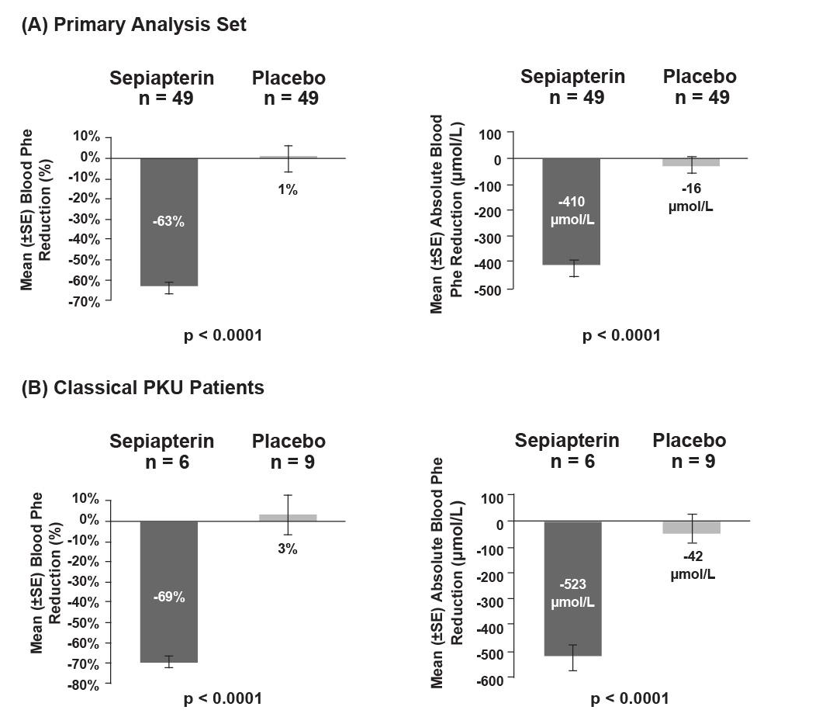
Figure 1: Mean percent change and absolute change in blood Phe level from baseline for SEPHIENCE vs. Placebo in the (A) Primary Analysis Set and (B) Patients with classical PKU
Abbreviations: Phe, phenylalanine; PKU, phenylketonuria; SE, standard error
Study 2 (Study PKU-002) was a Phase 2, all-comers, randomised, double-crossover, open-label, active-controlled, proof-of-concept study in patients aged 18 to 60 years with PKU. The study consisted of 6 sequence groups of 4 patients per group for a total of 24
patients. Each sequence group was randomised to receive 7-day treatments of SEPHIENCE 60 mg/kg/day, SEPHIENCE 20 mg/kg/day and sapropterin dihydrochloride 20 mg/kg/day in random order, followed by a 7-day washout after each treatment. Results of the primary efficacy weekly mean analysis demonstrated a statistically significant decrease in blood Phe concentrations relative to baseline for all treatments (n=24). A greater proportion of patients receiving SEPHIENCE treatment, regardless of dose, experienced blood Phe level reductions of at least 10%, 20% and 30% compared with patients receiving sapropterin 20 mg/kg/day.
More patients receiving SEPHIENCE 60 mg/kg/day achieved normalised blood Phe levels (<120 μmol/L) and blood Phe levels within the target range (≤360 μmol/L) compared with sapropterin 20 mg/kg/day. The difference between the treatment groups was statistically significant (Table 9). In patients with cPKU, treatment with SEPHIENCE (60 mg/kg/day) resulted in a significant decrease in blood Phe concentration relative to baseline.
Table 9: Analysis of change from baseline in weekly mean Dried Blood Sampling Phe levels in Study 2 (Efficacy Population)

Model | LS Mean/Difference (SE) | p value
LS means (SE) change from baseline
SEPHIENCE 60 mg/kg/day | -206.4 (41.8) | <0.0001
Sapropterin 20 mg/kg/day | -91.5 (41.7) | 0.0339
Pairwise comparisons (differences)
SEPHIENCE 60 mg/kg/day vs sapropterin 20 mg/kg/day | -114.9 (39.0) | 0.0098
Abbreviations: LS, least squares; Phe, phenylalanine; SE, standard error
Note: A separate baseline is defined for each treatment period and is defined as the last available nonmissing observation prior to first study drug administration for each period.
Model includes fixed effects for baseline results of each treatment period, treatment group, sequence, period and a random subject effect within each sequence. p values for LS means pairwise comparisons from F-test, p values for LS means=0 test from t-test.
Study 3 (Study PTC923-MD-004-PKU) is an ongoing, Phase 3, multicentre, open-label study to assess the safety and dietary Phe tolerance during long-term treatment with SEPHIENCE in patients with PKU. Eligible participants included patients aged <2 years who were SEPHIENCE-responsive in Part 1 of Study 1 and patients ≥2 years old who completed Part 2 of Study 1. At data cutoff date, 169 patients, including 65 adult and 104 paediatric patients (median age: 14 years, range: 2 months to 55 years) received treatment with SEPHIENCE. Interim data indicate that daily SEPHIENCE administration is associated with an approximately 2.3-fold increase in mean daily Phe consumption (27.6 mg/kg/day at baseline versus 62.5 mg/kg/day at Week 26) while maintaining Phe levels <360 μmol/L (Figure 2).
Majority of the patients reached at least a 15% (76.7% of patients) or 30% (67.4% of patients) reduction in blood Phe. These data indicate that sepiapterin treatment may allow liberalisation of the highly restrictive diet that patients with PKU must adhere to.
Figure 2: Mean (SD) dietary Phe consumption over time during dietary Phe tolerance assessment (Dietary Phe Tolerance Analysis Set)
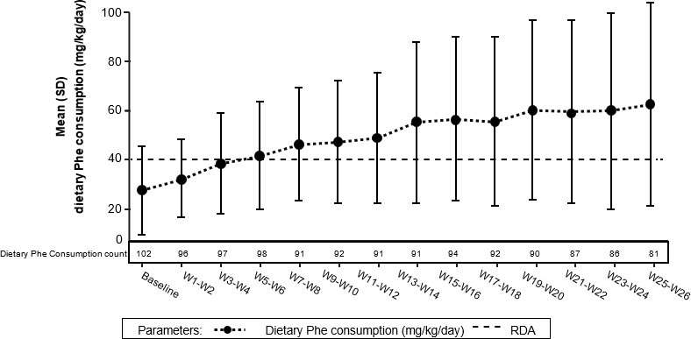
Abbreviations: Phe, phenylalanine; PKU, phenylketonuria; RDA, recommended daily allowance; SD, standard deviation; W, week
Note: Baseline is defined as the average of daily dietary Phe consumption (mg/kg/day) at Month 1. The RDA for an adult with PKU is 0.8 g protein/kg, which is equivalent to approximately 40 mg/kg/day of Phe. 1 g of protein is equivalent to approximately 50 mg of Phe.

PHARMACOKINETIC PROPERTIES

Absorption
Following oral administration, sepiapterin is quickly absorbed and the peak plasma concentrations occur after approximately 1 to 3 hours and decline to below the limit of quantitation (0.75 ng/mL) rapidly (generally by 12 hours). The maximum plasma sepiapterin concentration (Cmax) was approximately 2.80 ng/mL following the 60 mg/kg once daily dose for 7 days with a high-fat high-calorie diet. No accumulation of sepiapterin was observed following repeated dosing.
When sepiapterin was administered with a low-fat meal in the dose range of 20 to 60 mg/kg, BH4 exposures were 1.69- to 1.72-fold higher for Cmax and 1.62- to 1.73-fold higher for AUC0-24h compared to administration under fasted conditions. When sepiapterin was administered with a high-fat, high-calorie meal, BH4 exposures were 2.21- to 2.26-fold higher for Cmax and 2.51- to 2.84-fold higher for AUC0-24h compared to administration under fasted conditions.

Distribution
Sepiapterin mean human plasma protein binding is 15.4% in the presence of 0.1% dithiothreitol (DTT) in the concentration range of 0.1 to 10 μM. BH4 mean human plasma protein binding was between 24.1% and 41.3% in the concentration range 2 to 15 μM in the presence of 0.5% β-mercaptoethanol.

Metabolism
Sepiapterin is metabolised by SR/carbonyl reductase (CR) and DHFR in a 2-step unidirectional process to form pharmacologically active metabolite BH4. BH4 is further metabolised non-enzymatically or enzymatically mediated by aromatic amino acid hydroxylases, such as PAH, tyrosine hydroxylase (TH) and tryptophan hydroxylase (TPH), and pterin-4α-carbinolamine dehydratase (PCD), dihydropteridine reductase (DHPR), xanthine oxidase (XO) and nitric oxide synthase (NOS) in various tissues.
Extensive metabolism of sepiapterin was observed in humans following a single oral dose of
¹⁴C-sepiapterin.

Elimination/Excretion
Following oral administration, sepiapterin is quickly absorbed and converted to BH4. Sepiapterin plasma concentration is remarkably lower than BH4 and declines rapidly to below the limit of quantitation generally by 12 hours post dose. Sepiapterin Cmax and AUC0-24h are generally less than 2% of those of BH4. The terminal half-life of BH4 is approximately
5 hours.
Following a single oral dose of radiolabelled sepiapterin 4000 mg to adult healthy subjects, a mean of 6.7% dosed radioactivity was recovered in urine and 26.2% in faeces with the combined total recovery of 32.9% by 240 hours. The low total mass recovery is likely due to formation of volatile metabolites in human intestine.

PRECLINICAL SAFETY DATA

Genotoxicity
Based on the weight of evidence, sepiapterin is not genotoxic. Sepiapterin was negative in the Ames assay. Sepiapterin was positive in an in vitro chromosomal aberration assay without metabolic activation but not with metabolic activation. Sepiapterin was negative in the in vivo (micronucleus and comet) assays in rats.

Carcinogenicity
No carcinogenicity studies have been conducted with sepiapterin.

PHARMACEUTICAL PARTICULARS

LIST OF EXCIPIENTS
microcrystalline cellulose isomalt
mannitol croscarmellose sodium xanthan gum
colloidal anhydrous silica sucralose
magnesium stearate

INCOMPATIBILITIES
Not applicable.

SHELF LIFE
In Australia, information on the shelf life can be found on the public summary of the Australian Register of Therapeutic Goods (ARTG). The expiry date can be found on the packaging.
Shelf life after preparation
Each prepared dose is best administered immediately after preparation. The prepared dose should be discarded if not used within 24 hours of preparation when stored refrigerated (2°C to 8°C) or within 6 hours when stored below 25°C.

SPECIAL PRECAUTIONS FOR STORAGE
Store below 25°C.

NATURE AND CONTENTS OF CONTAINER
SEPHIENCE is supplied in individual heat-sealed laminated aluminium foil sachets comprising polyethylene terephthalate, white extruded polyethylene (polyester/foil bond), aluminium foil (moisture barrier) and a heat-seal ionomeric resin (adhesive).
SEPHIENCE 250 mg or 1000 mg: Each carton contains 30 sachets.

SPECIAL PRECAUTIONS FOR DISPOSAL
In Australia, any unused medicine or waste material should be disposed of in accordance with local requirements.

PHYSICOCHEMICAL PROPERTIES

Chemical structure
The chemical name of sepiapterin is 2-amino-6-[(2S)-2-hydroxypropanoyl]-7,8-dihydro-3H- pteridin-4-one. The molecular formula is C9H11N5O3, and the molecular weight is 237.22 g/mol.
Sepiapterin has the following structural formula:
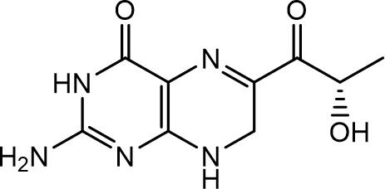

CAS number 17094-01-8

MEDICINE SCHEDULE (POISONS STANDARD)
S4 – Prescription only medicine

SPONSOR
PTC Therapeutics Australia Pty Limited
Suite 1617 & 1619, Level 16, 1 Denison Street North Sydney NSW 2060
Australia
For medical enquiries about SEPHIENCE, contact apacmedinfo@ptcbio.com or call 1800 312 963.

DATE OF FIRST APPROVAL
dd mmm yyyy

DATE OF REVISION
Not applicable

Summary table of changes

Section Changed | Summary of new information
N/A | First Product Information

