Australian Public Assessment Report for Osenvelt, Stoboclo
  - Active ingredient: Denosumab
  - Sponsor: Celltrion Healthcare Australia Pty Ltd
December 2025

About the Therapeutic Goods Administration (TGA)
- The Therapeutic Goods Administration (TGA) is part of the Australian Government Department of Health, Disability and Ageing and is responsible for regulating therapeutic goods, including medicines, medical devices, and biologicals.
- The TGA administers the Therapeutic Goods Act 1989 (the Act), applying a risk management approach designed to ensure therapeutic goods supplied in Australia meet acceptable standards of quality, safety, and efficacy.
- The work of the TGA is based on applying scientific and clinical expertise to decision-making, to ensure that the benefits to the Australian public outweigh any risks associated with the use of therapeutic goods.
- The TGA relies on the public, healthcare professionals and industry to report problems with therapeutic goods. The TGA investigates reports received to determine any necessary regulatory action.
- To report a problem with a therapeutic good, please see the information on the TGA website.

About AusPARs
- The Australian Public Assessment Report (AusPAR) provides information about the evaluation of a prescription medicine and the considerations that led the TGA to approve or not approve a prescription medicine submission. Further information can be found in Australian Public Assessment Report (AusPAR) guidance.
- AusPARs are prepared and published by the TGA.
- AusPARs are static documents that provide information that relates to a submission at a particular point in time. The publication of an AusPAR is an important part of the transparency of the TGA’s decision-making process.
- A new AusPAR may be provided to reflect changes to indications or major variations to a prescription medicine subject to evaluation by the TGA.

Copyright
© Commonwealth of Australia 2025
This work is copyright. You may reproduce the whole or part of this work in unaltered form for your own personal use or, if you are part of an organisation, for internal use within your organisation, but only if you or your organisation do not use the reproduction for any commercial purpose and retain this copyright notice and all disclaimer notices as part of that reproduction. Apart from rights to use as permitted by the Copyright Act 1968 or allowed by this copyright notice, all other rights are reserved, and you are not allowed to reproduce the whole or any part of this work in any way (electronic or otherwise) without first being given specific written permission from the Commonwealth to do so. Requests and inquiries concerning reproduction and rights are to be sent to the TGA Copyright Officer, Therapeutic Goods Administration, PO Box 100, Woden ACT 2606 or emailed to <tga.copyright@tga.gov.au>.

Contents
List of abbreviations 4
Product submission 7
Submission details 7
Product background 9
Disease or condition 10
Current treatment options 11
Clinical rationale 11
Regulatory status 11
Australian regulatory status 11
International regulatory status 12
Registration timeline 14
Assessment overview 14
Quality evaluation summary 14
Nonclinical evaluation summary 15
Clinical evaluation summary 16
Summary of clinical studies 16
Pharmacology 16
Efficacy 21
Safety 28
Risk management plan 34
Risk-benefit analysis 36
Delegate’s considerations 36
Assessment outcome 38
Specific conditions of registration 38
Product Information and Consumer Medicine Information 39

List of abbreviations

Abbreviation | Meaning
λ_{z} | Elimination rate constant
%AUC_{ext} | Percentage of the area extrapolated for calculation of AUC_{0-inf} (area under the concentration time curve from time zero to infinity)
ACM | Advisory Committee on Medicines
ACV | Advisory Committee on Vaccines
ADA | Anti-drug antibody
AE | Adverse event
AESI | Adverse event of special interest
ALT | Alanine aminotransferase
ALP | Alkaline phosphatase
ARTG | Australian Register of Therapeutic Goods
ASA | Australia-specific annex
AST | Aspartate aminotransferase
AU | Australian
AUC_{0-last} | Area under the concentration time curve from time zero to time of last quantifiable serum concentration
AUC_{0-inf} | Area under the concentration time curve from time zero to infinity
BMD | Bone mineral density
CI(s) | Confidence interval(s)
CL/F | Apparent clearance
C_{max} | Maximum concentration
CMI | Consumer Medicines Information
COVID-19 | Coronavirus disease 2019, SARS-CoV-2
CPD | Certified Product Details
CPK | Creatine phosphokinase
C_{trough} | Trough concentration
CT-P41 | Stoboclo (denosumab)
DLP | Data lock point
DXA scan | Dual-energy X-ray absorptiometry scan
ECG | Electrocardiogram
EOS | End of study
EQ-5D-5L | EuroQoL-5 Dimensions-5 Levels Health Survey
EU | European Union
FAS | Full Analysis Set
FDA | Food and Drug Administration
HRT | Hormone replacement therapy
IgG2 | Immunoglobulin G2 antibody
LS mean | Least square mean
MRT | Mean residence time
NAbs | Neutralising antibodies
ONJ | osteonecrosis of the jaw
OPAQ-SV | Osteoporosis Assessment Questionnaire-Short Version
OPG | Osteoprotegerin
PD | Pharmacodynamics
PFS | Pre-filled syringe
PI | Product Information
PK | Pharmacokinetic
pAUC_{0-W16} | Partial area under the concentration-time curve from 0 to 16 weeks
pAUC_{W16-inf} | Partial area under the concentration-time curve from 16 weeks to infinity
PPS | Per Protocol Set
PSUR | Periodic safety update report
PT | Preferred term
PTH | Parathyroid hormone
RANK | Receptor activator of nuclear factor kappa-β
RANKL | Receptor activator of nuclear factor kappa-β ligand
RMP | Risk management plan
SAE(s) | Serious adverse event(s)
SC | Subcutaneous
SD | Standard deviation
SE | Standard error
s-CTX | Serum carboxy-terminal collagen crosslinks
T_{1/2} | Half life
TEAE(s) | Treatment-emergent adverse event(s)
TESAEs | Treatment emergent serious adverse events
TGA | Therapeutic Goods Administration
T_{max} | Time after administration of a drug when the maximum plasma concentration is reached
ULN | Upper limit of normal
URTI | Upper respiratory tract infection
US(A) | United States (of America)
Vd | Volume of distribution
V_{z}/F | Apparent volume of distribution of peripheral compartment

Product submission

Submission details
Type of submission: | New biosimilar entity
Product names: | Osenvelt  Stoboclo (previously: Roldenclo)
Active ingredient: | denosumab
Decision: | Approved
Date of decision: | 28 March 2025
Date of entry onto ARTG: | 4 April 2025
ARTG numbers: | 442990 and 442991
Black Triangle Scheme  for the current submission: | No
Sponsor’s name and address: | Celltrion Healthcare Australia Pty Ltd  Suite 13-03, 31 Market Street,  Sydney, NSW 2000  Australia
Dose forms: | 442990 – Osenvelt - denosumab (rch) 70 mg/mL solution for injection vial  442991 – Stoboclo - denosumab (rch) 60 mg/mL solution for injection pre-filled syringe (PFS)
Strengths: | Each vial contains a deliverable dose of 120 mg denosumab in 1.7 mL of solution (70 mg/mL).  Each 1 mL single-use pre-filled syringe contains 60 mg denosumab.
Containers: | Osenvelt: glass vial.  Stoboclo: pre-filled syringe with automatic needle guard.
Pack sizes: | Single vial or one Type 1 glass syringe
Approved therapeutic use for the current submission: | The approved indications for Osenvelt are:  Prevention of skeletal related events in patients with multiple myeloma and in patients with bone metastases from solid tumours.  Treatment of giant cell tumour of bone in adults or skeletally mature adolescents that is recurrent, or unresectable, or resectable but associated with severe morbidity.  Treatment of hypercalcaemia of malignancy that is refractory to intravenous bisphosphonate.  The approved indications for Stoboclo are:  The treatment of osteoporosis in postmenopausal women. Stoboclo significantly reduces the risk of vertebral, non-vertebral and hip fractures.  Treatment to increase bone mass in men with osteopaenia receiving androgen deprivation therapy for non-metastatic prostate cancer.  Treatment to increase bone mass in men with osteoporosis at increased risk of fracture.  Treatment to increase bone mass in women and men at increased risk of fracture due to long-term systemic glucocorticoid therapy.
Route of administration: | Solution for subcutaneous (SC) injection.
Dosage: | The recommended dose of Osenvelt for the prevention of skeletal related events is 120 mg administered as a single subcutaneous injection once every 4 weeks into the thigh, abdomen or upper arm.  The recommended dose of Osenvelt for the treatment of giant cell tumour of bone and hypercalcaemia of malignancy is 120 mg administered as a single subcutaneous injection once every 4 weeks into the thigh, abdomen or upper arm with a loading dose of 120 mg on days 8 and 15 of the initial 4-week treatment period.  Daily supplementation with at least 500 mg calcium and 400 IU vitamin D is required in all patients, unless hypercalcaemia is present.  The recommended dose of Stoboclo is a single subcutaneous (SC) injection of 60 mg, once every 6 months. If Stoboclo treatment is discontinued, consider transitioning to an alternative antiresorptive therapy.  To reduce the risk of hypocalcaemia, patients must be adequately supplemented with calcium and vitamin D. In the major clinical trials of denosumab, daily supplementation with 1,000 mg of calcium and at least 400 IU vitamin D was recommended.  Stoboclo - Administration should be performed by an individual who has been adequately trained in injection techniques.  For further information regarding dosage, such as dosage modifications to manage adverse reactions, refer to the Product Information.
Pregnancy category: | Pregnancy Category D  There are no adequate and well-controlled studies of denosumab in pregnant women. Denosumab is contraindicated for use during pregnancy and in women trying to get pregnant. Advise females of reproductive potential to use highly effective contraception during therapy, and for at least 5 months after the last dose of denosumab.  The use of any medicine during pregnancy requires careful consideration of both risks and benefits by the treating health professional. The pregnancy database must not be used as the sole basis of decision making in the use of medicines during pregnancy. The TGA does not provide advice on the use of medicines in pregnancy for specific cases. More information is available from obstetric drug information services in your state or territory.

Product background
This AusPAR describes the submission by Celltrion Healthcare Australia Pty Ltd to register –
- Stoboclo (denosumab-rch): 60 mg/mL solution for injection single-use pre-filled syringe (PFS) containing 60 mg of denosumab,
- Osenvelt (denosumab-rch): 70 mg/mL solution for injection vial containing 120 mg of denosumab
for the following proposed indications for Stoboclo (biosimilar to Prolia):
The treatment of osteoporosis in postmenopausal women. Stoboclo significantly reduces the risk of vertebral, non-vertebral and hip fractures.
Treatment to increase bone mass in men with osteopaenia receiving androgen deprivation therapy for non-metastatic prostate cancer.
Treatment to increase bone mass in men with osteoporosis at increased risk of fracture.
Treatment to increase bone mass in women and men at increased risk of fracture due to long-term systemic glucocorticoid therapy.
for the following proposed indications for Osenvelt (biosimilar to Xgeva):
Prevention of skeletal related events in patients with multiple myeloma and in patients with bone metastases from solid tumours.
Treatment of giant cell tumour of bone in adults or skeletally mature adolescents that is recurrent, or unresectable, or resectable but associated with severe morbidity.
Treatment of hypercalcaemia of malignancy that is refractory to intravenous bisphosphonate.

Disease or condition
Osteoporosis/osteopaenia
Osteoporosis/osteopaenia is a disorder of low bone mass, characterised by unfavourable changes in bone mineral density (BMD), bone formation and resorption, bone geometry, and bone microarchitecture. This results in decreased bone strength and an increased fracture risk. Osteopaenia is defined as a BMD t-score between -1.0 and -2.5, and osteoporosis as a BMD t-score of -2.5 or smaller.
Primary osteoporosis
Bone loss due the physiological changes of aging (including oestrogen or androgen deficiency due to ageing) is typically referred to as primary osteoporosis.
Secondary osteoporosis
Bone loss due to other factors (e.g. androgen deprivation or glucocorticoid therapy, or malignancy-related bone loss) is typically referred to as secondary osteoporosis.
RANK/RANKL/OPG system
The receptor activator of nuclear factor kappa-B ligand (RANKL) is a type II homotrimeric transmembrane protein, and mainly expressed in osteocytes, osteoblasts, and bone marrow stromal cells. RANKL binds to RANK, expressed in osteoclast progenitor cells and osteoclasts, and induces osteoclastogenesis. Osteoprotegerin (OPG) is a decoy receptor for RANKL produced by mature osteoblasts and osteocytes and upon binding RANKL prevents the ligand’s interaction with RANK. Thus, the RANK/RANKL/OPG signalling pathway system and the ratio of its components profoundly affects healthy or pathologic bone remodelling.
Oestrogen deficiency induces RANKL expression (by reducing its suppression) and reduces OPG expression and thus facilitates osteoclastogenesis. Concurrent vitamin D deficiency impairs calcium absorption and leads to secondary hyperparathyroidism and thus may contribute to bone loss.
Tumour cells may produce cytokines, chemokines, and hormones that can increase RANKL expression and thus induce osteoclastic bone resorption and osteolytic metastasis.
Osteoporosis imposes a significant health burden in Australia and worldwide. The Australian Institute of Health and Welfare (AIHW) estimated that approximately 924,000 Australians (3.8% of the total population) were affected by osteoporosis or osteopenia, although there is likely to be a significant underestimation due to the silent nature of the diseases. According to a study that analysed the burden of osteoporosis in Australia between 2012-2022, 66% of those over 50 years of age (approximately 4.74 million people) were thought to be affected by osteoporosis and osteopenia. Over the 10-year period, it was estimated that approximately 1.6 million cases of fractures were attributable to osteoporosis and osteopenia. Osteoporotic fractures occur most frequently in the vertebrae, carpals, hips, pelvis and upper arms. Many patients require long-term nursing home care, which would leave a significant burden on the patient’s family and society.

Current treatment options
Treatment for primary and secondary osteoporosis/osteopaenia is typically dependent on disease severity, causative factors, and drug-specific factors (e.g. contraindications).
Management of osteoporosis usually requires multifaceted approach involving pharmacological and non-pharmacological therapies. Non-pharmacological therapies include lifestyle changes including physical activity and weight bearing exercises, as well as cessation of smoking. Dietary supplements such as calcium and vitamin D are also commonly recommended.
Management with pharmacological therapies include antiresorptive pharmacotherapy such as:
- Oral bisphosphonates (e.g. alendronate)
- Bone-forming anabolic agents (e.g. teriparatide)
- RANKL inhibitors (e.g. denosumab)
- Other agents (e.g. hormone replacement therapy (HRT), raloxifene, calcitonin)

Clinical rationale
Denosumab is an inhibitor of receptor activator of nuclear factor kappa-β ligand (RANKL). RANKL is a transmembrane or soluble protein essential for the formation, function, and survival of osteoclasts, the cells responsible for bone resorption. Denosumab binds to RANKL with high affinity and specificity, thereby preventing the activation of its receptor, RANK, on the surface of osteoclast precursors and osteoclasts. Prevention of the RANKL/RANK interaction inhibits osteoclast formation, function and survival, thereby decreasing bone resorption and increasing bone mass and strength in both cortical and trabecular bone.
Denosumab was the first biologic therapy approved to treat osteoporosis. Unlike bisphosphonates, denosumab can be used in women with compromised renal function. In a large trial (FREEDOM study), it was shown that the relative risks of fracture in those receiving denosumab vs placebo were 68%, 40%, 20%, and 16% for radiographic vertebral, hip, nonvertebral, and wrist fractures, respectively, along with increased BMD., As with bisphosphonates, rare cases of atypical femoral fractures and osteonecrosis of the jaw have been observed with denosumab treatment.
Management of osteoporosis usually requires multifaceted approach involving pharmacological and non-pharmacological therapies. Non-pharmacological therapies include lifestyle changes including physical activity and weight bearing exercises, as well as cessation of smoking. Dietary supplements such as calcium and vitamin D are also commonly recommended.

Regulatory status

Australian regulatory status
This product is considered a new biosimilar medicine for Australian regulatory purposes. Prolia (innovator product for Stoboclo) was first registered on the Australian Register of Therapeutic Goods (ARTG) in June 2010. Xgeva (innovator product for Osenvelt) was first registered on the ARTG in September 2011.

International regulatory status
At the time the TGA considered this submission, similar submissions were being considered by other regulatory agencies, including the US, Canada, and Republic of Korea. The following tables summarises these submissions and provides the proposed indications.
Table 1: International regulatory status of Stoboclo
Region | Submission date | Status | Approved indications
USA (FDA) | 30 November 2023 | Under consideration | - Treatment of postmenopausal women with osteoporosis at high risk for fracture.  - Treatment to increase bone mass in men with osteoporosis at high risk of fracture.  - Treatment for glucocorticoid-induced osteoporosis in men and women at high risk for fracture.  - Treatment to increase bone mass in men at high risk for fracture receiving androgen deprivation therapy for nonmetastatic prostate cancer.  - Treatment to increase bone mass in women at high risk for fracture receiving adjuvant aromatase inhibitor therapy for breast cancer.
Republic of Korea | 29 December 2023 | Under consideration | - Treatment of postmenopausal women with osteoporosis at high risk for fracture.  - Treatment to increase bone mass in men with osteoporosis at high risk of fracture.  - Treatment for glucocorticoid-induced osteoporosis in men and women at high risk for fracture.  - Treatment to increase bone mass in men at high risk for fracture receiving androgen deprivation therapy for nonmetastatic prostate cancer.  - Treatment to increase bone mass in women at high risk for fracture receiving adjuvant aromatase inhibitor therapy for breast cancer.
Health Canada | 29 December 2023 | Under consideration | - Treatment of postmenopausal women with osteoporosis at high risk for fracture.  - Treatment to increase bone mass in men with osteoporosis at high risk of fracture.  - Treatment to increase bone mass in men with nonmetastatic prostate cancer receiving androgen deprivation therapy, who are at high risk of fracture.  - Treatment to increase bone mass in women receiving adjuvant aromatase inhibitor therapy for nonmetastatic breast cancer.  - Treatment to increase bone mass for the treatment and prevention of glucocorticoid-induced osteoporosis in women and men at high risk for fracture.
Table 2: International regulatory status of Osenvelt
Region | Submission date | Status | Approved indications
USA (FDA) | 30 November 2025 | Under consideration | - Prevention of skeletal-related events in patients with multiple myeloma and in patients with bone metastases from solid tumours.  - Treatment of adults and skeletally mature adolescents with giant cell tumour of bone that is unresectable, or where surgical resection is likely to result in severe morbidity.  - Treatment of hypercalcaemia of malignancy refractory to bisphosphonate therapy.
Republic of Korea | 29 December 2023 | Under consideration | - Prevention of skeletal-related events in patients with multiple myeloma and in patients with bone metastases from solid tumours.  - Treatment of adults and skeletally mature adolescents with giant cell tumour of bone that is unresectable, or where surgical resection is likely to result in severe morbidity.
Health Canada | 29 December 2023 | Under consideration | - Reducing the risk of developing skeletal-related events in patients with multiple myeloma and in patients with bone metastases from breast cancer, prostate cancer, non-small cell lung cancer, and other solid tumours.  - Treatment of adults and skeletally mature adolescents with giant cell tumour of bone that is unresectable, or where surgical resection is likely to result in severe morbidity.  - Treatment of hypercalcaemia of malignancy that is refractory to intravenous bisphosphonate.

Registration timeline
The following table captures the key steps and dates for this submission.
This submission was evaluated under the standard prescription medicines registration process.
Table 3: Timeline for Submission PM-2024-00632-1-5
Description | Date
Submission dossier accepted and first round evaluation commenced | 2 April 2024
Evaluation completed (End of round 2) | 2 December 2024
Registration decision (Outcome) | 28 March 2025
Registration in the ARTG completed | 4 April 2025
Number of working days from submission dossier acceptance to registration decision* | 203
*Statutory timeframe for standard submissions is 255 working days

Assessment overview
A summary of the TGA’s assessment for this submission is provided below.

Quality evaluation summary
Denosumab is a human monoclonal IgG2 antibody, that targets and binds with high affinity and specificity to RANKL, a transmembrane or soluble protein essential for the formation, function, and survival of osteoclasts, the cells responsible for bone resorption.
During the development of Stoboclo, US Prolia was used as the main reference product to demonstrate bio-similarity in terms of quality and non-clinical comparability exercise. An additional bridging comparability study was performed between the US and AU Prolia to present US Prolia as representative of the Australian registered product (AU Prolia).
During the development of Osenvelt, US Xgeva was used as the main reference product to demonstrate bio-similarity in terms of quality and non-clinical comparability exercise. An additional bridging comparability study was performed between the US and AU Xgeva to present US Xgeva as representative of the Australian registered product (AU Xgeva).
Extensive characterisation studies involving comparison of primary, secondary and tertiary structures, physicochemical properties and biological activities showed that Stoboclo/Osenvelt and US Prolia/Xgeva are generally similar.
Overall, the Sponsor has demonstrated that Stoboclo/Osenvelt is comparable to Prolia /Xgeva in terms of structure, species, function and degradation profile (i.e. physicochemically and biologically).
Stability data have been generated under stressed and real time conditions to characterise the stability profile of the product. Following evaluation, the recommended storage conditions are
- 48 months when stored at 5 ± 3 °C for 60mg PFS
  - The product may be stored at temperatures up to a maximum of 25 °C (77 °F) for a period of up to 30 days. The product must be discarded if not used within the 1-month period.
- 36 months when stored at 5 ± 3 °C for 120 mg vial.
  - The product may be stored at 25 °C for a maximum single period of up to 30 days in the carton.
The product is not photostable, therefore should be protected from direct light. Additional precautions state the products should not be frozen or vigorously shaken and stored in its original container.
The quality of this product is considered to be acceptable. Information on development, manufacture and control of the active substance and finished product have been presented in a satisfactory manner. The results of tests carried out indicate consistency and uniformity of important product quality characteristics, and these in turn lead to the conclusion that the product should have a satisfactory and uniform performance in clinical use. There are no objections on quality grounds to the approval of:
  - Stoboclo (denosumab) 60 mg/mL solution for injection pre-filled syringe.
  - Osenvelt (denosumab) 70 mg/mL solution for injection vial.

Nonclinical evaluation summary
The scope of the nonclinical program is adequate under the relevant EU guideline. The pharmacological assessments performed across Module 3 with Stoboclo and US-sourced Prolia are considered adequate to cover the mechanism of action of denosumab for all indications. No data were provided in Module 4 to verify the comparability of the US-sourced and Australian-sourced Prolia.
The formulation of Stoboclo/Osenvelt differs slightly from that of Prolia/Xgeva. Stoboclo/Osenvelt in the levels of acetate/acetic acid.
No meaningful differences between Stoboclo and US-sourced Prolia were observed in a comparative pharmacokinetic and toxicity study in cynomolgus monkeys. However, the study is not considered sensitive enough to be relied upon to detect differences between the biosimilar and the reference product. Therefore, adequate comparability and determination of bio-similarity will need to rely upon Modules 3 and 5 evaluations.
No comparative study was conducted between Osenvelt and Xgeva, which is considered acceptable as the same active ingredients were used to formulate Stoboclo and Prolia, respectively.
Conclusions and recommendations
Minor changes to the draft Product Information documents are recommended.
- Pregnancy category
  - Statements in Stoboclo and Osenvelt dealing with nonclinical matters and the Pregnancy Category (D) are consistent with the approved Australian PI for Prolia and Xgeva, respectively.

Clinical evaluation summary

Summary of clinical studies
The clinical trial program consisted of two phase I studies (Study CT-P41 1.1 and Study CT-P41 1.2), and one phase III study (Study CT-P41 3.1.).
- Pharmacology data (pharmacokinetic and pharmacodynamic) were obtained from:
  - Study CT-P41 1.1 which assessed the pharmacokinetic (PK) of CT-P41 (Stoboclo) and EU-sourced Prolia (as a comparator)
  - Study CT-P41 1.2 and Study CT-P41 3.1 which compared the pharmacokinetic (PK) and pharmacodynamic of CT-P41(Stoboclo) with US-sourced Prolia (as a comparator).
- Clinical efficacy data were provided in the pivotal CT-P41 3.1 study.
- Safety data were obtained from all three studies (CT-P41 1.1, CT-P41 1.2, and Study CT-P41 3.1).

Pharmacology
The main purpose of the pharmacokinetic (PK) studies was to demonstrate the PK similarities of CT-P41 (Stoboclo) with that of Prolia. In Study CT-P41 3.1, the PD similarity between the CT-P41 and US-licensed Prolia was demonstrated.

Phase 1 PK Study CT-P41 1.1
This study was a pilot phase 1, randomised, double-blind, two-arm, parallel group, single-dose study, which was designed to evaluate the safety, immunogenicity, PK and pharmacodynamics (PD) of CT-P41 and EU-approved Prolia in healthy male subjects.
A study drug (CT-P41 or EU-approved Prolia) was administered subcutaneously via pre-filled syringe on Day 1 and subjects were followed up for 134 days for safety, immunogenicity, PK and PD assessments. Subjects were stratified by body weight (< 80 kg versus ≥ 80 kg) measured on Day -1 as a part of the randomisation for balanced distribution. Serum concentration of denosumab in 30 healthy male participants between the two groups over the study period (134 days) were comparable until the end of the study.
Following administration of CT-P41 or EU-approved Prolia, mean (CV%) of peak (C_{max}) was comparable across both treatment groups (4.723 [20.1321] and 5.277 [16.2263] μg/mL in the CT-P41 and EU-approved Prolia treatment groups, respectively). Mean (CV%) of AUC_{0-last} was 227.371 (43.5795) and 284.503 (19.2917) day•μg/mL for CT-P41 and EU-approved Prolia treatment groups, respectively (Table 4). Mean (CV%) of AUC_{0-inf} was comparable between the 2 treatment groups (271.111 [22.8570] and 293.450 [20.6457] day•μg/mL for CT-P41 and EU-approved Prolia treatment groups, respectively). Median T_{max} occurred at 13.9993 days for the CT-P41 treatment group and at 9.9757 days for the EU-approved Prolia treatment group, within a range for both treatments of 3.208 to 20.999 days (minimum to maximum). Mean T_{1/2} was 22.249 and 21.261 days for the CT-P41 and EU-approved Prolia treatment groups, respectively, with CV% values of 32.1951% and 31.9997%, respectively. Mean λ_{z}, CL/F, V_{z}/F, and %AUC_{ext} were comparable across both treatments (Table 4).
Table 4. Serum Pharmacokinetic Parameters of Denosumab by Treatment Group (PK Population)
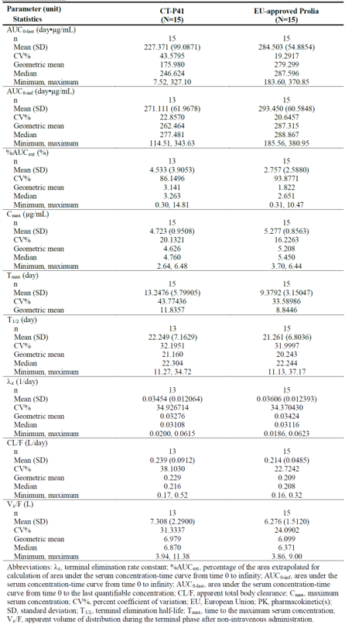

Phase 1 PK Study CT-P41 1.2
This study compared PK, PD, safety, and immunogenicity between CT-P41 and US-licensed Prolia in healthy male subjects. A study drug (CT-P41 or US-licensed Prolia) was administered SC via PFS on Day 1 and subjects were followed up for 253 days or until early withdrawal visit for PK, PD, safety, and immunogenicity assessments. A total of 154 healthy male volunteers were included. As with Study CT-P41 1.1, the serum concentrations of denosumab were similar between the two study groups.
The primary PK endpoints were similar between the CT-P41 and US-licensed Prolia groups, with a geometric LS mean AUC_{0-inf} of 319.4 and 297.7 day•μg/mL; AUC_{0-last} of 313.8 and 293.7 day•μg/mL; C_{max} of 5.52 and 5.46 μg/mL, respectively. The ratio of geometric LS means and 90% CIs for all primary endpoints were within the equivalence margin of 80% to 125% (Table 5).
Table 5. Study CT-P41 1.2. Statistical Analysis of Primary PK Parameters (ANCOVA) (PK Set).
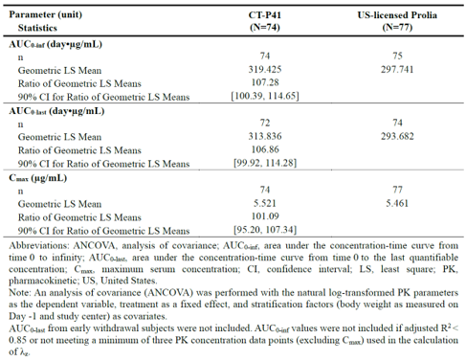
The secondary PK endpoints were similar between the groups, with the following mean values (Table 6): pAUC_{0-W16} of 320.1 and 294.4 day•μg/mL, pAUC_{W16-inf} of 16.6 and 14.7 day•μg/mL, T_{max} 12.2 and 10.9 days, T_{1/2} of 16.8 and 16.2 days, %AUC_{ext} of 1.08 and 0.83, λ_{z} of 0.044 and 0.047, CL/F of 0.19 and 0.22 L/day, V_{z}/F of 4.42 and 4.75L, and MRT of 43.2 and 41.6 days, respectively.
Table 6. Secondary Pharmacokinetic Parameters of Denosumab by Treatment Group: PK Set.
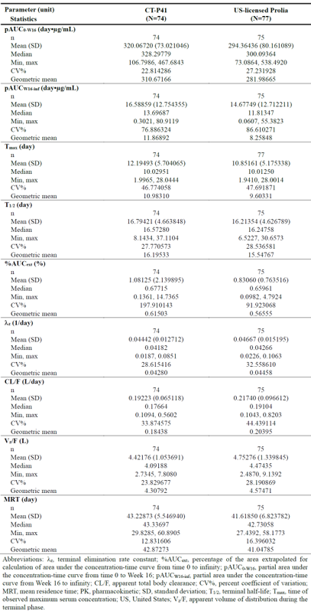

Phase 3 Study CT-P41 3.1
This was a double-blind, randomised, active-controlled, Phase 3 study to evaluate the efficacy, PK, PD, and safety including immunogenicity of CT-P41 compared with US-licensed Prolia in postmenopausal women with osteoporosis. 477 women aged 50 to 80 years with osteoporosis (based on the BMD T-score ≤− 2.5 and ≥− 4.0 at the lumbar spine from DXA scan at screening) received study treatment. All patients were to also receive daily supplementation containing at least 1,000 mg of elemental calcium and at least 400 IU vitamin D from randomisation to EOS visit and the data are collected via patient’s diary.
The study was divided into two periods:
- In Treatment Period I (up to Week 52), the participants were randomised 1:1 to receive either CT-P41 or Prolia.
- In Treatment Period II (from Week 52 to Week 78), approximately half of those who received Prolia in Period I were Switched to receive CT-P41.
The serum concentrations of denosumab were comparable between the two groups in Treatment Period I, and comparable between the CT-P41 maintenance, Prolia maintenance, and Switched to CT-P41 groups in Treatment Period II.
In Treatment Period I, the following PK parameters (mean) were assessed up to Week 26 for the CT-P41 and US-licensed Prolia groups: C_{trough} (46.8 and 31.7 ng/mL at Day 1; 75.6 and 64.0 ng/mL at Week 26), C_{max} (6158.9 and 5767.2 ng/mL), AUC_{0-t} (386032.7 and 357072.0 day•μg/mL), T_{max} (13.2 and 12.3 days), V_{d} (7.0 and 7.7L), and T_{1/2} (28.3 and 28.6 days).
In Treatment Period II, C_{trough} at Week 52 were assessed in all three groups. The mean C_{trough} values were 73.5, 61.6, and 129.9 ng/mL respectively, with the median C_{trough} of 0 ng/mL in all three groups. The high C_{trough} in the Switched to CT-P41 group is thought to be due one of the subjects having a very high reading at Week 52.
Overall, based on the PK data provided, the serum denosumab concentrations and PK parameters appeared to be generally consistent between those who received CT-P41 and US-licensed Prolia.
Additionally, the pharmacodynamic results provided evidence that the effects of CT-P41 and Prolia were generally equivalent with regard to s-CTX and P1NP reduction.

Efficacy

Pivotal phase 3 Study CT-P41 3.1

Design
Phase 3, double-blind, randomised, active-controlled, parallel-group (1:1) clinical equivalence study to evaluate the efficacy, PK, PD, and safety including immunogenicity of CT-P41 compared with US-licensed Prolia in 479 postmenopausal women with osteoporosis.
All patients were to also receive daily supplementation containing at least 1,000 mg of elemental calcium and at least 400 IU vitamin D from randomisation to EOS visit.
Primary efficacy objective: To demonstrate the equivalence of CT-P41 to US-licensed Prolia in terms of efficacy in postmenopausal women with osteoporosis as determined by percent change from baseline in BMD for lumbar spine (L1 to L4) at Week 52.
Figure 1. Study CT-P41 3.1. Study design schema.
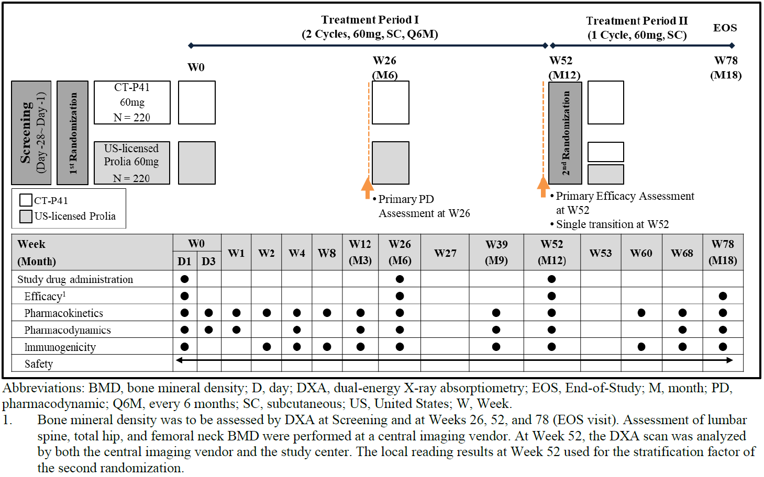
Key inclusion criteria included:
- Women aged 50 to 80 years.
- Body weight between 40.0 and 99.9 kg.
- Postmenopausal, either by natural or surgical means.
- Bone mineral density T-score ≤− 2.5 and ≥− 4.0 at the lumbar spine (L1 to L4) as assessed by the central imaging vendor based on DXA scan at Screening.
- At least 3 vertebrae (L1-L4) and at least 1 hip evaluable by DXA scan at Screening.
- Patient with albumin-adjusted total serum calcium ≥8.5 mg/dL (≥2.125 mmol/L) at Screening.
- Patient had adequate hepatic function at Screening (AST, ALT ≤ 3 x ULN, ALP and total bilirubin ≤ 2 x ULN).
- In good general health as determined by medical history, physical examination, and laboratory tests and able to walk without assistance.
Key exclusion criteria included:
- Patients previously received denosumab, any other monoclonal antibodies, or biologic agents for osteoporosis.
- Patients with the following medical histories:
  - One severe or >2 moderate vertebral fractures (severe fracture is defined as >40% vertebral height loss and moderate fracture was defined as 25% to 40% vertebral height loss
  - Hip fracture
  - Hyper/hypoparathyroidism
  - Current hyper/hypothyroidism
  - Bone disease and metabolic disease (except for osteoporosis) that might interfere with the interpretation of the results including osteomalacia, osteogenesis imperfecta, Paget’s disease, rheumatoid arthritis, ankylosing spondylitis, osteopetrosis, fibrous dysplasia, an elevation of ALP at the investigator’s discretion, Cushing’s disease, hyperprolactinemia, malabsorption syndrome, advanced scoliosis or extensive lumbar fusion
  - History and/or current oral or dental conditions including osteomyelitis or ONJ, or requirement for dental surgery
  - History of any malignancy within 5 years
  - New York Heart Association (NYHA) Class III or IV chronic heart failure, any unstable cardiovascular disease, pulmonary disease, autoimmune disease, or ECG abnormalities which could be judged as clinically significant at the investigator’s discretion
- Patients with the following laboratory results
  - Serum 25-OH vitamin D <20 ng/mL
  - Estimated glomerular filtration rate <30 mL/min/1.73 m²
  - Haemoglobin <10 g/dL
- Patient who had a history of and/or concurrent use of medications including any of the following:
  - Receipt of intravenous bisphosphonates, fluoride, and strontium for osteoporosis within the last 5 years
  - Receipt of oral bisphosphonates ≥3 years cumulatively or any dose of oral bisphosphonates within 12 months prior to Screening
  - Use of parathyroid hormone (PTH) or its derivatives, systemic hormone-replacement therapy (estrogen with or without progestogen), selective estrogen-receptor modulator, tibolone, calcitonin, or calcitriol within 12 months
  - Use of other bone active drugs including heparin, anticonvulsives (except benzodiazepines), systemic ketoconazole, anabolic steroids, testosterone, androgens, adrenocorticotropic hormone, cinacalcet, aluminium, lithium, protease inhibitors, methotrexate, or gonadotropin-releasing hormone agonists within 3 months
  - Use of oral or parenteral glucocorticosteroids (>5 mg/prednisone daily or equivalent for >10 days) within 3 months
Treatments
- Treatment Period I: patients received 60 mg SC of either CT-P41 or US-licensed Prolia on Week 0 (Day 1) and Week 26, as per the first randomisation.
- Treatment Period II: patients received 60 mg SC of either CT-P41 or US-licensed Prolia at Week 52 as per the second randomisation.
Calcium and vitamin D were co-administered to prevent low serum calcium level while taking study drugs.
Randomisation: An interactive web response system (IWRS) was used for the randomisation. The randomisation was balanced by using permuted blocks.
- Treatment Period I: 1:1 ratio to receive 60 mg of either CT-P41 or US-licensed Prolia; stratified by age (<65 years vs ≥65 years), baseline BMD T-score at the lumbar spine (≤ − 3.0 vs. > − 3.0), and prior bisphosphonates therapy (Yes vs. No)
- Treatment Period II: Prior to dosing at Week 52, patients in the US-licensed Prolia group were randomly assigned again in a ratio of 1:1 to either undergo transition to CT-P41 (switching arm) or continue US-licensed Prolia (non-switching arm). All patients who were initially randomly assigned to CT-P41 on Day 1 (Week 0) continued their treatment with CT-P41 on Week 52. The second randomisation process was conducted in all groups to maintain the study blind. The second randomisation to treatment assignment was stratified by change from baseline in BMD for lumbar spine at Week 52 (≥3% vs <3%).
Baseline characteristics: In both studies, demographics and baseline characteristics were reasonably balanced between groups (CT-P41 vs. US-licensed Prolia):
- Patient demographics (Table 7): In total, the mean (SD) age of patients was 65.7 (6.42) years. All patients were White. The mean (SD) screening BMI of patients was 25.08 (4.277) kg/m². 277 (57.8%) were ≥65 years. The baseline BMD T-score at the lumbar spine was >-3.0 for 239 (49.9%) patients (120 [50.0%] patients and 119 [49.8%] patients in the CT-P41 and US-licensed Prolia groups, respectively). 60 (12.5%) patients (32 [13.3%] vs. 28 [11.7%] patients) had used bisphosphonates therapy prior to the first administration of the study drug. The two groups were well balanced within each level of all stratification factors including age, baseline BMD T-score at the lumbar spine and prior bisphosphonates therapy.
Table 7. Demographics and Stratification Details at Screening: ITT Set.
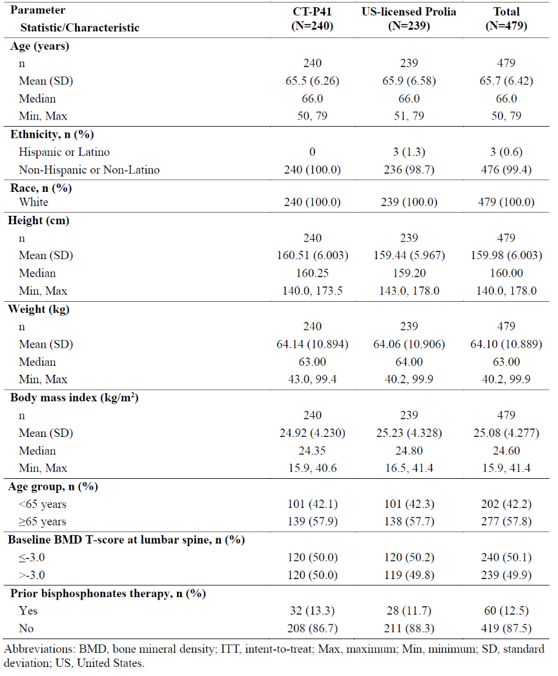
- Disease characteristics (Table 8): 109 (22.8%) patients (59 [24.6%] vs. 50 [20.9%] patients) had at least 1 vertebral fracture confirmed by lateral spine X-ray at baseline. 168 (35.1%) patients (75 [31.3%] vs. 93 [38.9%]) reported previous nonvertebral fracture history or had at least 1 nonvertebral fracture at baseline. For semi-quantitative grade at baseline, the majority of vertebral fracture was Grade 0 from T4 to L4. The majority of nonvertebral fractures had low-level trauma as trauma severity. Four patients reported a hip bone fracture, and it was confirmed by the investigator that the site of fracture was specifically pelvis. For nonvertebral fractures, 27 cases of surgery were reported. There were no patients who reported pathologic fracture. The mean (SD) baseline BMD T-scores in total were -3.075 (0.3864), -1.696 (0.6809), and -1.981 (0.6076) for lumbar spine, total hip, and femoral neck, respectively.
Table 8. Baseline Disease Characteristics: ITT Set.
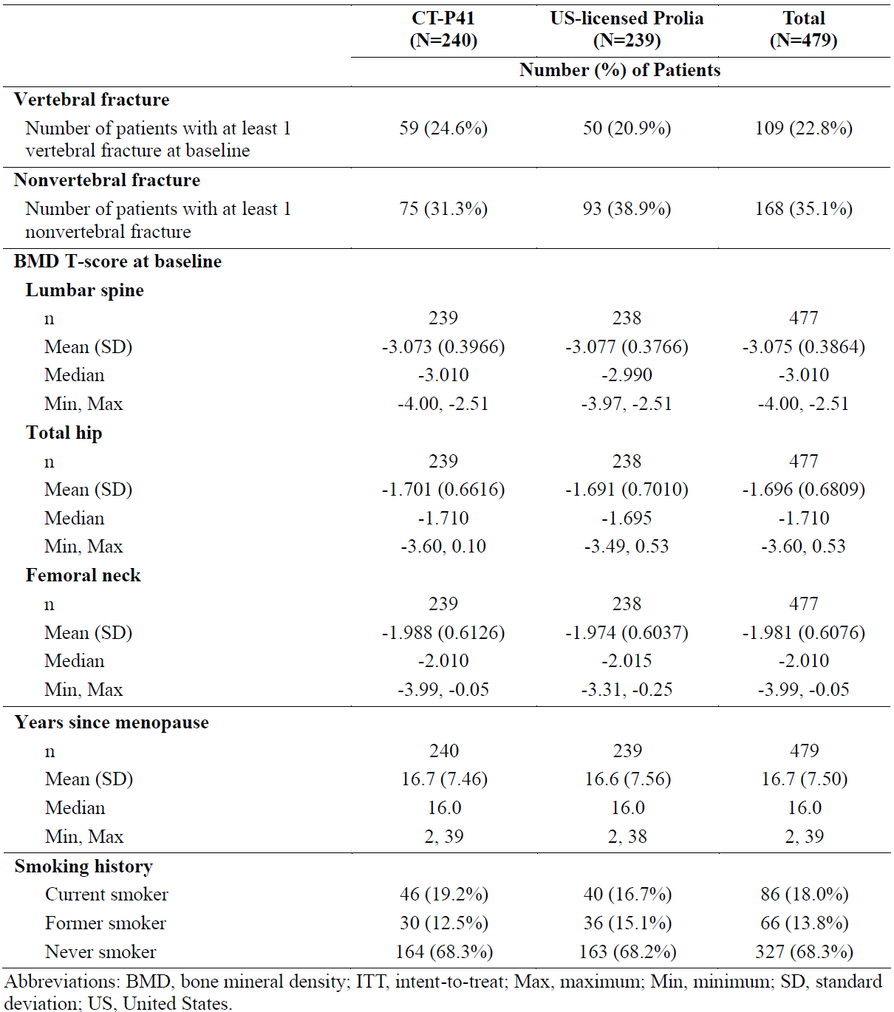

Magnitude of the treatment effect and its clinical significance
Primary efficacy endpoint:
The primary efficacy endpoint was the percent change from baseline in BMD for lumbar spine (L1 to L4) by dual-energy X-ray absorptiometry (DXA) at Week 52.
In the FAS analysis, the LS mean (SE) of percent change from baseline in BMD for lumbar spine by DXA at Week 52 was 4.9317 (0.31508) and 5.0706 (0.32714) in the CT-P41 and US-licensed Prolia groups, respectively (Table 9). Hence, the treatment difference (95% CI) was -0.139 (-0.826, 0.548) (FAS) with the CI within the pre-specified equivalence margin of ±1.503%.
This result is supported by the per-protocol set (PPS) analysis with a treatment difference (95% CI) of -0.280 (-0.973, 0.414) (PPS).
Secondary efficacy endpoints:
- Percent change from baseline in BMD for lumbar spine (L1 to L4), total hip, and femoral neck by DXA at Weeks 26, 52, and 78:
  - Treatment Period I at Week 26, the mean percent changes from baseline for the CT-P41 and Prolia groups were 3.79 and 3.48 for lumbar spine, 1.79 and 1.29 for total hip, and 1.57 and 1.23 for femoral neck, respectively. At Week 52, the mean percent changes were 5.49 and 5.66 for lumbar spine, 2.79 and 2.43 for total hip, and 2.23 and 1.95 for femoral neck.
  - Treatment Period II at Week 78: The mean percent changes from baseline for the CT-P41 maintenance, Prolia maintenance, and Switched to CT-P41 groups were 6.79, 6.60, and 7.05 for lumbar spine; 3.41, 2.70, and 3.43 for total hip; and 2.97, 2.47, and 2.89 for femoral neck, respectively.
- Incidences of new vertebral, nonvertebral, and hip fractures during the study:
  - Treatment Period I: two confirmed vertebral fractures (one each in the CT-P41 and Prolia groups). Nonvertebral fracture was reported in 2 (0.8%) vs. 4 (1.7%) patients. There was no hip fracture reported.
  - Treatment Period II: no new vertebral fracture reported, and non-vertebral fractures were reported in 2 patients in the CT-P41 maintenance group only.
- Change from baseline in health-related quality of life at Weeks 26, 52, and 78: The mean changes from baseline in the physical function, emotional status, and back pain OPAQ-SV scores were small in the CT-P41 and US-licensed Prolia groups, and generally similar between the two groups. The mean changes from baseline in the EQ-5D-5L index value and EQ VAS score were small and generally comparable between the treatment groups.
Table 9. Study CT-P41 3.1. Primary endpoint: Percent Change from Baseline in BMD for Lumbar Spine by DXA at Week 52 (ANCOVA) (FAS and PPS).
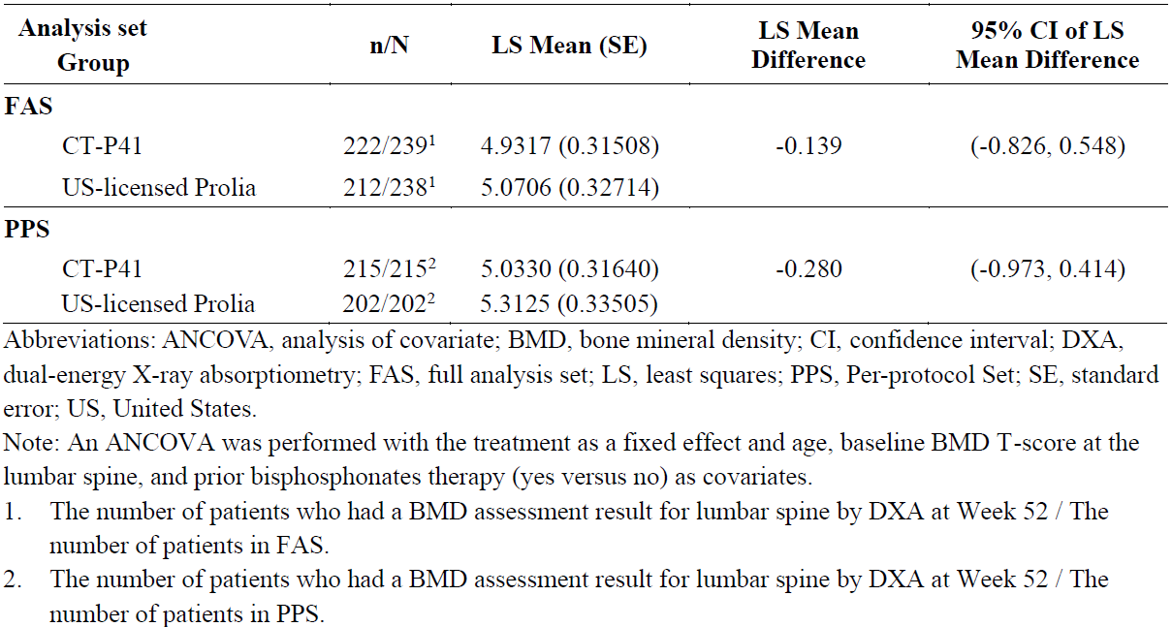

Safety
All three studies included in the submission provided safety data. The two phase I studies (Studies CT-P41 1.1 and CT-P41 1.2) provided safety in healthy male volunteers, while the most relevant safety data was obtained in the pivotal study CT-P41 3.1. Subjects were analysed based on the treatment received in each treatment period.

Exposure
The Safety Set was defined as all subjects who received at least one dose (full or partial) of either of the study drugs (CT-P41 or Prolia) and includes data from 658 subjects in 3 clinical studies (Table 10).
This overview focusses on the overall period for the Safety Set of Study CT-P41 3.1 in the target population.
Table10. Clinical Studies. Number of Subjects Who Received at Least 1 Dose of Study Drug (CT-P41 or Prolia) in the CT-P41 (Safety Set).
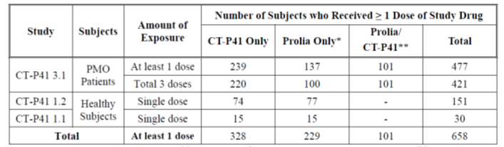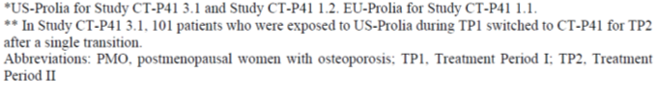

Adverse event overview
Study CT-P41 3.1, Treatment Period I
A similar proportion of participants experienced treatment-emergent adverse events (TEAEs) in the CT-P41 vs. US-licenced Prolia groups (75.7% vs. 70.2%). The most frequently reported TEAEs were COVID-19 (11.7% vs. 10.9%), upper respiratory tract infection (10.5% vs. 8.4%), and arthralgia (10.0% vs. 8.8%) in the CT-P41 and US-licensed Prolia groups, respectively. The majority of the TEAEs were Grade 1 or Grade 2 in intensity. Grade 3 TEAEs occurred in 2.5% vs. 5.9%. There was one (0.4%) case of Grade 4 ischaemic stroke in the Prolia group, and one (0.4%) case of Grade 5 coronary artery disease in the CT-P41 group which resulted in death but considered unrelated to study treatment.
Incidence of injection site reactions was 2.1% vs. 1.3% in the CT-P41 and US-licensed Prolia groups, respectively. Drug-related hypersensitivity/allergic reactions occurred in the US-licensed Prolia group only (0.8%). Incidence of infections was 37.7% vs. 28.2% in the CT-P41 and US-licenced Prolia groups respectively. Only 1 case of COVID-19 in the US-licensed Prolia group was reported as a serious case. Hypocalcaemia occurred in 2.5% of the CT-P41 group and 2.9% of the Prolia group, all Grade 1 in intensity. Osteonecrosis of the jaw occurred in the US-licensed Prolia group in 1 patient (0.4%). No TEAEs classified as atypical femoral fracture were reported during Treatment Period I. Incidence of dermatologic reactions was 5.4% and 4.2% in the CT-P41 and US-licenced Prolia groups, respectively. The majority of laboratory abnormalities for both groups were Grade 1 or Grade 2, with the most commonly reported Grade 3 being neutrophil count decreased (0.8% vs. 1.7%); no Grade 4 laboratory abnormality was reported.
Study CT-P41 3.1, Treatment Period II
The incidence of TEAEs in the three groups (CT-P41 maintenance, US-licensed Prolia maintenance, and Switched to CT-P41 groups) was 48.6%, 41.0%, and 53.5%, respectively. The most frequently reported TEAE was URTI (5.9%, 4.0% and 10.9%), followed by COVID-19 (3.6%, 3.0% and 5.9%). The most frequently reported Grade 3 TEAE was blood CPK increased (1.0%, 1.0%, and 0%). Two Grade 4 TEAEs (angina unstable and gastrointestinal perforation) were reported in 1 patient each from CT-P41 maintenance group, considered to be unrelated to CT-P41. There was one Grade 5 genital neoplasm malignant female in CT-P41 maintenance group which resulted in death but was not considered to be related to the study treatment. There were 12 TESAEs reported (3.6%, 2.0%, and 0%), all of which were considered to be unrelated to the study treatment.
Injection site reactions occurred in 4 (1.0%) patients in the CT-P41 maintenance (3 [1.4%]) and the switched to CT-P41 (1 [1.0%]) groups, which were all Grade 1 in severity and non-serious. Drug-related hypersensitivity/allergic reactions occurred in one (0.5%) patient in the CT-P41 maintenance group (pruritus and rash erythematous), which was Grade 2 in severity and non-serious. The incidence of infections was 18.6%, 18.0%, and 25.7% in the CT-P41 maintenance, US-licensed Prolia maintenance, and switched to CT-P41 groups, respectively. The slightly higher proportion of infections in the switched to CT-P41 group was mainly due to the higher proportion of patients reported with upper respiratory tract infection (11 [10.9%] patients), COVID-19 (6 [5.9%] patients) and viral upper respiratory tract infection (3 [3.0%] patients). However, these events were all non-serious, Grade 1 or 2 in severity and considered unrelated to the study drug.
Hypocalcaemia occurred in 1.8% of the participants in the CT-P41 maintenance group, which were Grade 1 and 2 in severity and non-serious. Osteonecrosis of the jaw and atypical femoral fracture were not reported. Dermatologic reactions occurred in 2 (2.0%) patients in the US-licensed Prolia maintenance group and 2 (2.0%) patients in the switched to CT-P41 group. No serious TEAEs were reported, and all cases were considered to be unrelated by the investigator. Most of the laboratory abnormalities were Grade 1 or Grade 2 in severity; Grade 3 abnormalities included two (0.91%) participants in the CT-P41 maintenance group (CPK increased and hypertriglyceridaemia) and two (2.0%) participants from the US-licensed Prolia maintenance group (CPK increased and neutrophil count decreased).
Study CT-P41 3.1, Overall Period (Table 11)
Overall, 376 (78.8%) patients experienced at least 1 TEAE and the proportions were similar among groups (193 [80.8%] vs. 183 [76.9%]); and 177 [80.5%], 75 [75.0%], and 82 [81.2%] patients in the CT-P41 maintenance, US-licensed Prolia maintenance, and Switched to CT-P41 groups, respectively.
The most frequently reported TEAEs for patients in total were COVID-19 (71 [14.9%] patients in total; 36 [15.1%] and 35 [14.7%] patients in the CT-P41 and US-licensed Prolia group, respectively; and 33 [15.0%], 18 [18.0%], and 17 [16.8%] patients in the CT-P41 maintenance, US-licensed Prolia maintenance, and Switched to CT-P41 groups, respectively) followed by URTI (68 [14.3%] patients in total; 36 [15.1%] and 32 [13.4%] patients in the CT-P41 and US-licensed Prolia group, respectively; and 35 [15.9%], 11 [11.0%], and 17 [16.8%] patients in the CT-P41 maintenance, US-licensed Prolia maintenance, and Switched to CT-P41 groups, respectively).
Table 11. Study CT-P41 3.1. TEAEs in ≥3% of patients using PT by SOC and PT (Overall Period) (Safety Set).
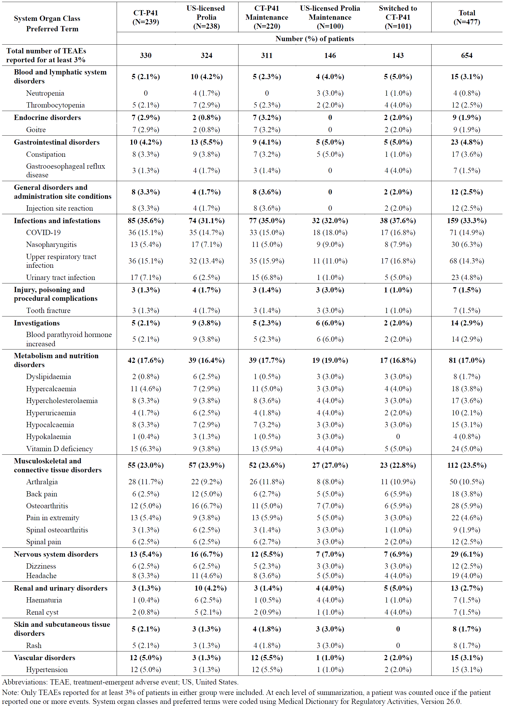

Treatment related adverse event (adverse drug reaction) overview
Study CT-P41 3.1, Overall Period
The proportions of patients who experienced at least 1 TEAE considered by the investigator to be related to the study drug was 103 (21.6%) patients in total (54 [22.6%] and 49 [20.6%] patients in the CT-P41 and US-licensed Prolia groups, respectively; and 49 [22.3%], 19 [19.0%], and 20 [19.8%] patients in the CT-P41 maintenance, US-licensed Prolia maintenance, and Switched to CT-P41 groups, respectively).
Based on PT, the most frequently reported TEAEs considered by the investigator to be related to the study drug were blood PTH increased in 14 (2.9%) patients (5 [2.1%] and 9 [3.8%] patients in the CT-P41 and US-licensed Prolia groups, respectively; and 5 [2.3%], 6 [6.0%], and 2 [2.0%] patients in the CT-P41 maintenance, US-licensed Prolia maintenance, and Switched to CT-P41 groups, respectively), followed by injection site reaction in 12 (2.5%) patients (8 [3.3%] and 4 [1.7%] patients in the CT-P41 and US-licensed Prolia groups, respectively; and 8 [3.6%], and 2 [2.0%] patients in the CT-P41 maintenance and Switched to CT-P41 groups, respectively).

Deaths
A total of 2 deaths were reported with one occurring in each Treatment Period (I and II), in the CT-P41 group, and the CT-P41 maintenance group, respectively. Both were considered unrelated to the study drug.

Serious adverse events
Study CT-P41 3.1, Overall Period: All TESAEs are summarised in Table 12.

Table 12. Study CT-P41 3.1. Treatment-Emergent Serious Adverse Events (TESAEs) using PT by SOC and PT (Overall Period) (Safety Set).
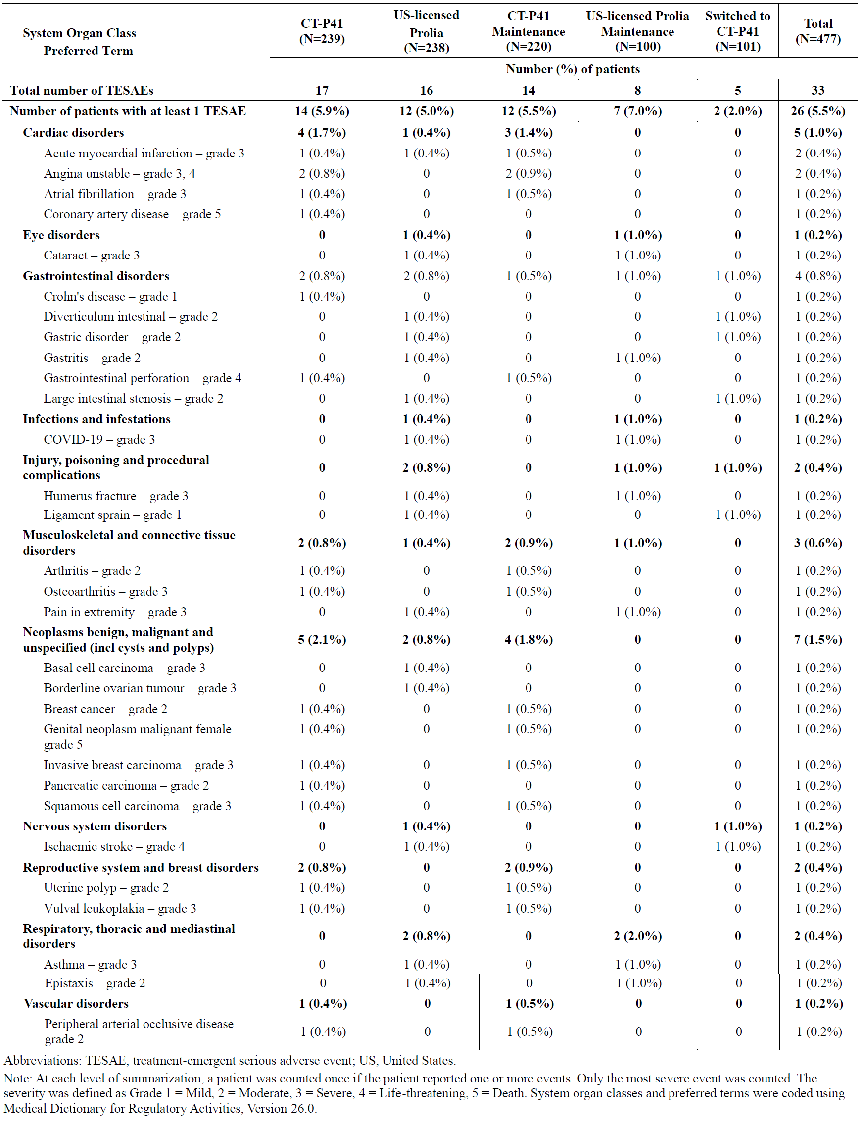

Discontinuations
Study CT-P41 3.1: All discontinuations occurred in Treatment Period I. Overall, 10 (2.1%) patients experienced at least 1 TEAE leading to study drug discontinuation and the proportions of patients were same between the 2 groups (5 [2.1%] patients each in the CT-P41 and US-licensed Prolia groups). All TEAEs leading to study drug discontinuation were reported for 1 patient in either group. Only the TEAEs of ONJ and cataract, which were both reported from the US-licensed Prolia group, were considered related to study drug by the investigator, which led to study drug discontinuation.

Immunogenicity
In all three studies, the rate of ADA was high in all groups, which is likely secondary to the high sensitivity of the test. No PMO patients had neutralising antibodies (NAbs). No impact by ADAs or NAbs was apparent.

Pharmacology studies
In Study CT-P41 1.1, 40% of the participants in the CT-P41 group had TEAEs while 80% of the participants in the US-licensed Prolia group had TEAEs. This may be due to the low number of participants. All TEAEs were Grade 1 or Grade 2 in intensity. There was one AESI of Grade 1 hypocalcaemia in the Prolia group. There were no SAEs.
In Study CT-P41 1.2, the overall rate of TEAEs were similar between the CT-P41 and Prolia groups (74.3% and 76.6%, respectively). The most common AEs were blood calcium decreased (37.8% vs. 45.5%), COVID-19 (10.8% vs. 9.1%) and nasopharyngitis (8.1% vs. 10.4%). There were some Grade 3 (2.7% vs. 0%) and Grade 4 AEs (2.7% and 1.3%). There were no hypersensitivity/allergic reactions. There were no SAEs or reports of ONJ. Injection site reactions occurred in 2.7% in CT-P41 group, 0% in US-Prolia group, and 1.3% in total.

Adverse events of special interest
AESIs in Study CT-P41 3.1 (overall period shown):
Injection Site Reaction: reported for 8 (3.3%) patients in the CT-P41 group, 4 (1.7%) patients in the US-Prolia group, no patients in the US-Prolia Maintenance group and 2 (2.0%) patients in the Switched to CT-P41 group. All patients recovered.
Drug-related Hypersensitivity/Allergic Reactions: reported for 1 (0.4%) patient in the CT-P41 group, 2 (0.8%) patients in the US-Prolia group, 1 (1.0%) patient in the US-Prolia Maintenance group and 1 (1.0%) patient in the Switched to CT-P41 group. All patients recovered.
Infections: reported for 111 (46.4%) patients in the CT-P41 group, 90 (37.8%) patients in the US-Prolia group, 36 (36.0%) patients in the US-Prolia Maintenance group and 47 (46.5%) patients in the Switched to CT-P41 group. In 5 (2.1%) patients, 1 (0.4%) patient, 0 patient and 1 (1.0%) patient in the CT-P41 group, US-Prolia group, US-Prolia Maintenance group and Switched to CT-P41 group, respectively, were reported with infections that were considered related to the study drug. All TEAEs of infections were Grade 1 or 2 in intensity, with only one exception of a COVID-19 case in the US-licensed Prolia group during TP1, which was serious and Grade 3.
Hypocalcaemia: reported for 8 (3.3%) patients in the CT-P41 group, 7 (2.9%) patients in the US-Prolia group, 3 (3.0%) patients in the US-licensed Prolia Maintenance group and 3 (3.0%) patients in the Switched to CT-P41 group. All were Grade 1 or 2 in intensity.
Osteonecrosis of Jaw (ONJ): one patient in the US-licensed Prolia group reported ONJ considered as related to the study drug by the investigator and was non-serious Grade 2 in intensity.
Atypical Femoral Fracture: none.
Dermatologic Reactions: reported for 13 (5.4%) patients in the CT-P41 group, 13 (5.5%) patients in the US-Prolia group, 8 (8.0%) patients in the US-Prolia Maintenance group and 4 (4.0%) patients in the Switched to CT-P41 group. All events were all non-serious and Grade 1 or 2 in intensity.

Post-market experience
No data available for CT-P41.

Risk management plan
The sponsor, Celltrion Healthcare Australia, has proposed separate risk management plans (RMPs) for Osenvelt and Stoboclo. In the Section 31 response, the sponsor has submitted Osenvelt EU-RMP version 0.2 (dated 4 September 2024, DLP 12 January 2024) and ASA version 1.1 (dated 22 October 2024); and Stoboclo EU-RMP version 0.2 (dated 4 September 2024 and DLP 12 January 2024) and ASA version 1.1 (Dated 22 October 2024).
The summary of safety concerns and their associated risk monitoring and mitigation strategies are summarised in Table 13 (Stoboclo), and Table 14 (Osenvelt) below. The TGA may request an updated RMP at any stage of a product's life cycle, during both the pre-approval and post-approval phases.
Table 13: Summary of safety concerns: Stoboclo
Summary of safety concerns |  | Pharmacovigilance |  | Risk Minimisation
 |  | Routine | Additional | Routine | Additional
Important identified risks | Hypocalcaemia | * | – |  | –
Important identified risks | Skin infection leading to hospitalisation | * | – |  | –
Important identified risks | Osteonecrosis of the jaw | * | – |  | –
Important identified risks | Hypersensitivity reactions | * | – |  | –
Important identified risks | Atypical femoral fracture | * | – |  | –
Important identified risks | Hypercalcaemia in paediatric patients receiving denosumab and after treatment discontinuation |  | – |  | –
Important potential risks | Fracture healing complications | * | – | – | –
Important potential risks | Infection | * | – |  | –
Important potential risks | Cardiovascular events |  | – | –
Important potential risks | Malignancy | * | – |  | –
Missing information | None
*Targeted follow up forms

Table 14: Summary of safety concerns: Osenvelt
Summary of safety concerns |  | Pharmacovigilance |  | Risk Minimisation
 |  | Routine | Additional | Routine | Additional
Important identified risks | Osteonecrosis of the jaw | * | – |  | –
Important identified risks | Atypical femoral fracture | * | – |  | –
Important identified risks | Hypercalcaemia several months after the last dose in patients with giant cell tumour of bone and in patients with growing skeletons |  | – |  | –
Important potential risks | Cardiovascular events |  | – | – | –
Important potential risks | Malignancy |  | – |  | –
Important potential risks | Delay in diagnosis of primary malignancy in giant cell tumour of bone |  | – | – | –
Important potential risks | Hypercalcaemia several months after the last dose in patients other than those with giant cell tumour of bone or growing skeletons |  | – | – | –
Missing information | Patients with prior intravenous bisphosphonate treatment |  | – |  | –
Missing information | Safety with long-term treatment and with long-term follow up after treatment in adults and skeletally mature adolescents with giant cell tumour of bone |  | – | – | –
Missing information | Off-label use in patients with giant cell tumour of bone that is resectable where resection is unlikely to result in severe morbidity |  | – | – | –
*Targeted follow up forms
The safety concerns in the Stoboclo and Osenvelt ASAs align with the safety concerns in its associated EU RMP and with the RMP for the innovator products. The summary of safety concerns for Stoboclo and Osenvelt are acceptable from an RMP perspective.
Pharmacovigilance plan
The sponsor has proposed routine pharmacovigilance for all safety concerns including targeted questionnaires for specific safety concerns in each ASA. No additional pharmacovigilance activities have been proposed (see tables above). The pharmacovigilance plan in the Stoboclo and Osenvelt ASAs align with the pharmacovigilance plan in the associated EU RMPs for Stoboclo and Osenvelt and with the innovator RMP and are acceptable from an RMP perspective.
Risk minimisation plan
The sponsor has proposed routine risk minimisation only for some safety concerns and no additional risk minimisation activities (see tables above). Differences between the Osenvelt ASA and the innovator ASA in regard to the routine risk minimisation for safety concerns ‘malignancy’ and ‘patients with prior intravenous bisphosphonate treatment’ have been satisfactorily addressed by the sponsor and the PI for Osenvelt is now consistent with the PI for the innovator with regards to ‘malignancy’.
Summary
At round 2, the sponsor has amended the PI, CMI and ASA as requested. The risk minimisation plans for both Stoboclo and Osenvelt are acceptable from an RMP perspective.
Further information regarding the TGA’s risk management approach can be found in risk management plans for medicines and biologicals and the TGA's risk management approach. Information on the Australia-specific annex (ASA) can be found on the TGA website.

Risk-benefit analysis

Delegate’s considerations

Clinical trial program
The clinical trial program consisted of two phase I studies (Study CT-P41 1.1 and Study CT-P41 1.2) and one phase III study (Study CT-P41 3.1). Pharmacology and clinical safety data (pharmacokinetic and pharmacodynamic) were obtained from all three studies, with Study CT-P41 1.2 providing evidence for PK bio-similarity. Clinical efficacy data were obtained from the pivotal CT-P41 3.1 study in patient with osteoporosis that provided evidence for clinical equivalence.

Quality and bridging
The clinical trial program used US-licensed and EU-licensed Prolia (rather than AU-licenced Prolia or Xgeva).
For Stoboclo, US-licensed Prolia was used as the main reference product to demonstrate bio-similarity in terms of quality and non-clinical comparability exercise. An additional bridging comparability study was performed between the US and AU Prolia to present US Prolia as representative of the Australian registered product.
For Osenvelt, US-licensed Xgeva was used as the main reference product to demonstrate bio-similarity in terms of quality and non-clinical comparability exercise. An additional bridging comparability study was performed between the US and AU Xgeva to present US Xgeva as representative of the Australian registered product.
Extensive characterisation studies involving comparison of primary, secondary and tertiary structures, physicochemical properties and biological activities showed that Stoboclo/Osenvelt and US Prolia/Xgeva are generally similar.
There were no objections from a quality perspective to the approval of this application.

Pharmacology
Based on the PK data provided, the serum denosumab concentrations and PK parameters were generally consistent between those who received CT-P41 and US-licensed Prolia. In Study CT-P41 1.2 PK bio-similarity was established. In Study CT-P41 3.1, the PD similarity of CT-P41 versus US-licensed Prolia was demonstrated by AUEC of s-CTX over the initial 6 months

Efficacy
Study design and primary endpoint
There are no objections to the study design. In Study CT-P41 3.1, the primary efficacy endpoint was the percent change from baseline in BMD for lumbar spine (L1 to L4) by dual-energy X-ray absorptiometry (DXA) at Week 52. That chosen variable differed from the primary efficacy variable in the pivotal trial for the reference product Prolia, which was the incidence of new vertebral fractures.
For the initial registration of an agent targeting osteoporosis, the use of the incidence of new vertebral fractures as an endpoint variable is still preferred, but for bio-similarity assessments, an appropriately designed BMD endpoint was considered suitable. Additionally, incidences of new vertebral, nonvertebral, and hip fractures were included as secondary endpoints.
Equivalence margin
Therapeutic equivalence was based on whether the primary efficacy endpoint (percent change from baseline in BMD for lumbar spine (L1 to L4) by dual-energy X-ray absorptiometry (DXA) at Week 52) 2-sided 95% confidence interval (CI) of least squares means for the treatment difference between Stoboclo and Prolia falls within the predefined equivalence margin of (-1.503%, 1.503%).
The applicant has justified the equivalence margin based on a variety of items including: the lumbar spine BMD changes at 1 year with of other bone modifying agents; a correlation of lumbar BMD improvement with risk of fracture reduction; previously agreed equivalence/non-inferiority margins for similar agents. It is noted that for Jubbonti/Wyost (PM-2023-03741-1-5), an equivalence margin of (-1.45%, 1.45%) had been accepted. A margin tighter than (-1.503%, 1.503%) could have been advantageous, but the chosen margin is overall acceptable.
Efficacy results
In Study CT-P41 3.1, in the FAS analysis, the LS mean (SE) of percent change from baseline in BMD for lumbar spine by DXA at Week 52 was 4.9317 (0.31508) and 5.0706 (0.32714) in the CT-P41 and US-licensed Prolia groups, respectively. Hence, the treatment difference (95% CI) was -0.139 (-0.826, 0.548) (FAS) with the CI within the pre-specified equivalence margin of ±1.503%. This result is supported by the PPS analysis and by the secondary endpoints.
It is noted that the number of fractures (vertebral and non-vertebral) in the two groups were low, which may be, at least in part, due to the beneficial effect of denosumab. The study was not powered for assess differences in incidences of fractures.

Safety
The safety profile of the reference product Prolia and Xgeva is well characterised.
Safety profile
Overall, the safety profiles of the CT-P41, Prolia, and Switched to CT-P41 groups are considered to be similar. However, the sample size was not large enough to detect rare adverse events including ONJ or atypical femoral fracture. Furthermore, the study did not assess long-term safety. There are no post-market data available.
No PMO patients had neutralising antibodies (NAbs) and no impact by ADAs or NAbs was apparent.

Regulatory considerations and translation to clinical practice
Extrapolation to other indications
In the clinical trial program, similarity between Stoboclo and Prolia was demonstrated for the treatment of osteoporosis.
The sponsor has provided a justification for extrapolation to these indications, mainly with regard to the common receptor target (RANKL) and active site indicating a shared mechanism of action in the different indications. The same extrapolation of indication had been previously accepted for Jubbonti/Wyost (PM-2023-03741-1-5).
An unfavourable impact on clinical efficacy and safety in the extrapolated indications is not expected for the biosimilar.

Approval indications
Overall, the extrapolation from the comparative data generated in post-menstrual women with osteoporosis to all approved indications of Prolia and Xgeva was considered acceptable.

Outstanding issues and conclusion
There were no outstanding issues, and the applicant agreed to the TGA-requested PI changes. The application was not referred to the ACM, in particular given the regulatory precedent with Jubbonti/Wyost (PM-2023-03741-1-5).

Assessment outcome
Based on a review of quality, safety, and efficacy, the TGA decided to register:
Osenvelt denosumab (rch) 70 mg/mL solution for injection vial (442990)
Stoboclo denosumab (rch) 60 mg/mL solution for injection pre-filled syringe (442991)
The approved indications for Osenvelt are:
Prevention of skeletal related events in patients with multiple myeloma and in patients with bone metastases from solid tumours.
Treatment of giant cell tumour of bone in adults or skeletally mature adolescents that is recurrent, or unresectable, or resectable but associated with severe morbidity.
Treatment of hypercalcaemia of malignancy that is refractory to intravenous bisphosphonate.
The approved indications for Stoboclo are:
The treatment of osteoporosis in postmenopausal women. Stoboclo significantly reduces the risk of vertebral, non-vertebral and hip fractures.
Treatment to increase bone mass in men with osteopaenia receiving androgen deprivation therapy for non-metastatic prostate cancer .
Treatment to increase bone mass in men with osteoporosis at increased risk of fracture.
Treatment to increase bone mass in women and men at increased risk of fracture due to long-term systemic glucocorticoid therapy.

Specific conditions of registration
- The Osenvelt EU-Risk Management Plan (RMP) version 0.2 (dated 4 September 2024, data lock point 12 January 2024), with Australian Specific Annex version 1.1 (dated 22 October 2024), and Stoboclo EU-Risk Management Plan (RMP) version 0.2 (dated 4 September 2024, data lock point 12 January 2024), with Australian Specific Annex version 1.1 (dated 22 October 2024), included with submission PM-2024-00632-1-5, and any subsequent revisions, as agreed with the TGA will be implemented in Australia.
- This approval does not impose any requirement for the submission of Periodic Safety Update reports. You are reminded that sections 29A and 29AA of the Therapeutic Goods Act 1989 provide for penalties where there has been failure to inform the Secretary in writing, as soon as a person has become aware, of:
- information that contradicts information already given by the person under this Act;
- information that indicates that the use of the goods in accordance with the recommendations for their use may have an unintended harmful effect;
- information that indicates that the goods, when used in accordance with the recommendations for their use, may not be as effective as the application for registration or listing of the goods or information already given by the person under this Act suggests;
- information that indicates that the quality, safety or efficacy of the goods is unacceptable.
- It is a specific condition of registration for biosimilar medicines that the Product Information and Consumer Medicine Information documents be updated within ONE month of safety-related changes made by the reference product. It is your responsibility to routinely check the TGA website at www.ebs.tga.gov.au for any updates to the innovator Product Information.
- Laboratory testing & compliance with Certified Product Details (CPD)
  - All batches of
- Stoboclo denosumab 60 mg/mL solution for injection pre-filled syringe
- Osenvelt denosumab 70 mg/mL solution for injection vial
supplied in Australia must comply with the product details and specifications approved during evaluation and detailed in the Certified Product Details (CPD).
  - When requested by the TGA, the Sponsor should be prepared to provide product samples, specified reference materials and documentary evidence to enable the TGA to conduct laboratory testing on the Product. Outcomes of laboratory testing are published biannually in the TGA Database of Laboratory Testing Results. http://www.tga.gov.au/ws-labs-index and periodically in testing reports on the TGA website.
- Certified Product Details
The Certified Product Details (CPD), as described in Guidance 7: Certified Product Details of the Australian Regulatory Guidelines for Prescription Medicines (ARGPM), in PDF format, for the above products should be provided upon registration of these therapeutic goods. In addition, an updated CPD should be provided when changes to finished product specifications and test methods are approved in a Category 3 application or notified through a self-assessable change.
A template for preparation of CPD for biological prescription medicines can be obtained from the TGA website [for the form] https://www.tga.gov.au/form/certified-product-details-cpd-biologicalprescription-medicines and [for the CPD guidance] https://www.tga.gov.au/guidance-7-certified-product-details

Product Information and Consumer Medicine Information
For the most recent Product Information (PI) and Consumer Medicine Information (CMI), please refer to the TGA PI/CMI search facility.

Therapeutic Goods Administration
PO Box 100 Woden ACT 2606 Australia
Email: info@tga.gov.au Phone: 1800 020 653 Fax: 02 6203 1605
https://www.tga.gov.au
Reference/Publication #

Prolia (ARTG ID 159322) was first registered in Australia on 22 June 2010.
This is the original indication proposed by the sponsor when the TGA commenced the evaluation of this submission. It may differ to the final indication approved by the TGA and registered in the Australian Register of Therapeutic Goods.
Xgeva (ARTG ID 175041) was first registered in Australia on 8 September 2011.
This is the original indication proposed by the sponsor when the TGA commenced the evaluation of this submission. It may differ to the final indication approved by the TGA and registered in the Australian Register of Therapeutic Goods.
Chronic musculoskeletal conditions: Osteoporosis and minimal trauma fractures - Australian Institute of Health and Welfare (aihw.gov.au)
Watts JJ, Abimanyi-Ochom J, Sanders KM. Osteoporosis costing all Australians. A new burden of disease analysis – 2012 to 2022. Osteoporosis Australia. (https://healthybonesaustralia.org.au/wp-content/uploads/2022/09/burden-of-disease-analysis-2012-2022.pdf)
Warriner A H, Patkar N M, Curtis J R, Delzell E, Gary L, Kilgore M, et al. Which fractures are most attributable to osteoporosis? J. Clin. Epidemiol. 2011; 64: 46–53.
Cummings SR, San Martin J, McClung MR, et al. Denosumab for prevention of fractures in postmenopausal women with osteoporosis. N Engl J Med. 2009;361:756–765.
Simon JA, Recknor C, Moffett AH, et al. Impact of denosumab on the peripheral skeleton of postmenopausal women with osteoporosis: bone density, mass, and strength of the radius, and wrist fracture. Menopause. 2013;20:130–137.

