Australian Public Assessment Report for Opuviz
  - Active ingredient: Aflibercept
  - Sponsor: Samsung Bioepis AU Pty Ltd
December 2025

About the Therapeutic Goods Administration (TGA)
- The Therapeutic Goods Administration (TGA) is part of the Australian Government Department of Health, Disability and Ageing and is responsible for regulating therapeutic goods, including medicines Opuviz, medical devices, and biologicals.
- The TGA administers the Therapeutic Goods Act 1989 (the Act), applying a risk management approach designed to ensure therapeutic goods supplied in Australia meet acceptable standards of quality, safety, and efficacy.
- The work of the TGA is based on applying scientific and clinical expertise to decision-making, to ensure that the benefits to the Australian public outweigh any risks associated with the use of therapeutic goods.
- The TGA relies on the public, healthcare professionals and industry to report problems with therapeutic goods. The TGA investigates reports received to determine any necessary regulatory action.
- To report a problem with a therapeutic good, please see the information on the TGA website.

About AusPARs
- The Australian Public Assessment Report (AusPAR) provides information about the evaluation of a prescription medicine and the considerations that led the TGA to approve or not approve a prescription medicine submission. Further information can be found in Australian Public Assessment Report (AusPAR) guidance.
- AusPARs are prepared and published by the TGA.
- AusPARs are static documents that provide information that relates to a submission at a particular point in time. The publication of an AusPAR is an important part of the transparency of the TGA’s decision-making process.
- A new AusPAR may be provided to reflect changes to indications or major variations to a prescription medicine subject to evaluation by the TGA.

Copyright
© Commonwealth of Australia 2025
This work is copyright. You may reproduce the whole or part of this work in unaltered form for your own personal use or, if you are part of an organisation, for internal use within your organisation, but only if you or your organisation do not use the reproduction for any commercial purpose and retain this copyright notice and all disclaimer notices as part of that reproduction. Apart from rights to use as permitted by the Copyright Act 1968 or allowed by this copyright notice, all other rights are reserved and you are not allowed to reproduce the whole or any part of this work in any way (electronic or otherwise) without first being given specific written permission from the Commonwealth to do so. Requests and inquiries concerning reproduction and rights are to be sent to the TGA Copyright Officer, Therapeutic Goods Administration, PO Box 100, Woden ACT 2606 or emailed to <tga.copyright@tga.gov.au>.

Contents
List of abbreviations 4
Product submission 5
Submission details 5
Product background 6
Disease or condition 6
Current treatment options 7
Regulatory status 8
Australian regulatory status 8
International regulatory status 8
Registration timeline 8
Assessment overview 9
Quality evaluation summary 9
Nonclinical evaluation summary 9
Clinical evaluation summary 9
Efficacy 10
Safety 15
Risk management plan 26
Risk-benefit analysis 26
Assessment outcome 27
Specific conditions of registration 27
Product Information and Consumer Medicine Information 28

List of abbreviations
Abbreviation | Meaning
ADA | Anti-drug antibody
AMD | Age-related macular degeneration
ARTG | Australian Register of Therapeutic Goods
BCVA | Best corrected visual acuity
BRVO | Branch retinal vein occlusion
CMI | Consumer Medicines Information
CNV | Choroidal neovascularisation
CRVO | Central retinal vein occlusion
CST | Central subfield thickness
DME | Diabetic macular oedema
ETDRS | Early Treatment Diabetic Retinopathy Study
IVT | Intravitreal
PI | Product Information
PK | Pharmacokinetics
PPS | Per-Protocol Set
PSUR | Periodic safety update report
RMP | Risk management plan
SB15 | Opuviz
TEAEs | Treatment emergent adverse events
TGA | Therapeutic Goods Administration
VEGF | Vascular endothelial growth factor

Product submission

Submission details
Type of submission: | New Biosimilar
Product name: | Opuviz
Active ingredient: | aflibercept
Decision: | Approved
Date of decision: | 10 September 2025
Date of entry onto ARTG: | 18 September 2025
ARTG numbers: | 456527, 456528
Black Triangle Scheme: | No
Sponsor’s name and address: | Samsung Bioepis AU PTY LTD Suite 1, Level 11, 66 Goulburn Street, Sydney NSW 2000
Dose form: | Solution
Strength: | 40 mg/mL
Containers: | Vial-only pack  Each carton includes a glass vial containing approximately 100 µL of extractable volume, with an elastomeric rubber stopper. Pack size of 1 vial.  Vial + filter needle pack  Each carton includes a glass vial containing approximately 100 µL of extractable volume, with an elastomeric rubber stopper, and an 18 G filter needle. Pack size of 1 vial + 1 filter needle.
Approved therapeutic use for the current submission: | Opuviz 2 mg (aflibercept) is indicated in adults for the treatment of:  - neovascular (wet) age-related macular degeneration (wet AMD)  - visual impairment due to macular oedema secondary to central retinal vein occlusion (CRVO)  - visual impairment due to macular oedema secondary to branch retinal vein occlusion (BRVO)  - diabetic macular oedema (DME)  - visual impairment due to myopic choroidal neovascularisation (myopic CNV).
Routes of administration: | Intravitreal injection
Dosage: | The recommended dose for Opuviz 40 mg/mL is 2 mg aflibercept, equivalent to an injection volume of 50 µL For further information regarding dosage refer to the Product Information.
Pregnancy category: | Category D  Drugs which have caused, are suspected to have caused or may be expected to cause, an increased incidence of human fetal malformations or irreversible damage. These drugs may also have adverse pharmacological effects.  The use of any medicine during pregnancy requires careful consideration of both risks and benefits by the treating health professional. The pregnancy database must not be used as the sole basis of decision making in the use of medicines during pregnancy. The TGA does not provide advice on the use of medicines in pregnancy for specific cases. More information is available from obstetric drug information services in your state or territory.

Product background
This AusPAR describes the submission by Samsung Bioepis Pty Ltd (the Sponsor) to register Opuviz (aflibercept), a biosimilar to the reference product Eylea, for the same indications that are currently approved in Australia for Eylea as follows:
-Treatment of neovascular (wet) age-related macular degeneration (wet AMD)
-Treatment of visual impairment due to macular oedema secondary to central retinal vein occlusion (CRVO)
-Treatment of visual impairment due to macular oedema secondary to branch retinal vein occlusion (BRVO)
-Treatment of diabetic macular oedema (DME)
-Treatment of visual impairment due to myopic choroidal neovascularization (myopic
CNV)

Disease or condition
Only neovascular (wet) AMD is discussed here as this was the disease studied for biosimilarity in the current submission. The Sponsor’s justification for extrapolation to other proposed indications is addressed in the Discussion section of this document.

Neovascular (wet) age-related macular degeneration
Age-related macular degeneration (AMD) is the most common cause of blindness in developed countries. In Australia, macular degeneration is the most common cause of blindness in people aged over 65 years; in 2017-18, the prevalence of self-reported macular degeneration in this age group was 4.5%. A characteristic finding in early AMD, which precedes the visual loss in late AMD, is the deposition of drusen (extracellular material) in and around Bruch’s membrane in the macula.
At any stage of AMD, new vessels can invade the outer retina, subretinal or sub retinal pigment epithelium space, resulting in macular neovascularization, which is the hallmark of neovascular AMD or wet AMD. The exudative stage of wet AMD becomes apparent when these new vessels leak or rupture, resulting in fluid accumulation and/or haemorrhages, and distortion and deterioration in vision. Without treatment, wet AMD typically results in extensive fibrosis with severe central vision loss.

Current treatment options
Counselling patients about the importance of a healthy lifestyle, including smoking cessation, adherence to a healthy diet and promoting physical exercise, is an important part of the management of AMD.
Intravitreal anti-vascular endothelial growth factor (VEGF) injections constitute the first-line of treatment for wet AMD.
Anti-VEGF agents currently approved for use in Australia for the same indications proposed for Opuviz include:
- aflibercept (Eylea), approved for:
  - neovascular AMD
  - macular oedema secondary to branch retinal vein occlusion (BRVO) or central retinal vein occlusion (CRVO)
  - diabetic macular oedema (DMO)
  - myopic choroidal neovascularisation
- ranibizumab (Lucentis), approved for:
  - neovascular AMD
  - DMO
  - choroidal neovascularisation secondary to pathologic myopia
  - macular oedema secondary to retinal vein occlusion (RVO)
- faricimab (Vabysmo)
  - neovascular AMD
  - DMO
- brolucizumab (Beovu)
  - neovascular AMD
  - DMO

Regulatory status

Australian regulatory status
This application is the initial submission for Opuviz in Australia. The reference product, Eylea aflibercept (rch) 40 mg/mL solution for intravitreal injection, was first registered on the ARTG on 7 March 2012.

International regulatory status
At the time the TGA considered this submission, a similar submission had been considered by other regulatory agencies.
The Opuviz vial was approved in the US in May 2024 for the following indications:
Opuviz is a vascular endothelial growth factor (VEGF) inhibitor indicated for the treatment of patients with:
-neovascular (Wet) Age-Related Macular Degeneration (AMD)
- macular edema following Retinal Vein Occlusion (RVO)
- Diabetic Macular Edema (DME)
- Diabetic Retinopathy (DR)
The Opuviz vial has also been approved by the EMA.
Opuviz is indicated for adults for the treatment of:
-neovascular (wet) age-related macular degeneration (AMD),
-visual impairment due to macular oedema secondary to retinal vein occlusion (branch RVO or central RVO),
-visual impairment due to diabetic macular oedema (DME),
-visual impairment due to myopic choroidal neovascularisation (myopic CNV).
Opuviz was approved in Korea by the Ministry of Food and Drug Safety (MFDS) in February 2024 and in Japan by the Pharmaceuticals and Medical Devices Agency (PMDA) in June 2024.

Registration timeline
Table 1 captures the key steps and dates for this submission.
This submission was evaluated under the standard prescription medicines registration process.
Table 1: Timeline for Opuviz (aflibercept), Submission PM-2024-03080-1-5
Description | Date
Submission dossier accepted and first round evaluation commence | 2 September 2024
Evaluation completed | 15 May 2025
Registration decision (Outcome) | 10 September 2025
Registration in the ARTG completed | 18 September 2025
Number of working days from submission dossier acceptance to registration decision* | 213
*Statutory timeframe for standard submissions is 255 working days

Assessment overview

Quality evaluation summary
During the development of Opuviz (referred to frequently as SB15 in this report), US-licenced Eylea was used as the main reference product to demonstrate biosimilarity in terms of quality and non-clinical comparability exercise. An additional bridging comparability study was performed between the US and Australian Eylea to demonstrate US Eylea was representative of the Australian registered product (Eylea).
Extensive characterisation studies involving comparison of primary, secondary and tertiary structures, physicochemical properties and biological activities showed that Opuviz and US Eylea are generally similar.
There were minor differences noted which were considered highly unlikely to impact clinical safety or efficacy, therefore biosimilarity was adequately demonstrated.
Overall, the Sponsor has demonstrated that Opuviz is comparable to Eylea in terms of structure, species, function and degradation profile (i.e. physicochemically and biologically).
There are no objections on quality grounds to the approval of Opuviz aflibercept 40 mg/mL solution for intravitreal injection.

Nonclinical evaluation summary
The nonclinical dossier contained a comparative repeat-dose toxicity study following intravitreal (IVT) dosing. The scope of the nonclinical program is adequate under the relevant EU guideline. The repeat-dose study was conducted using US-sourced Eylea 2 mg as the reference product. No data were provided in the nonclinical dossier to verify the comparability of the US-sourced and Australian-sourced Eylea.
No significant differences between toxicity profiles of Opuviz and Eylea were observed in the comparative repeat-dose toxicity study in monkeys. However, the power of the study to discern any differences is considered low.
The ability of the nonclinical studies to support comparability to Australian Eylea depended on the conclusion of the quality evaluator regarding the identity of Eylea products across jurisdictions. Given that US-sourced Eylea was demonstrated to be identical or highly comparable to the Australian product, there were no nonclinical objections to the registration of Opuviz.

Clinical evaluation summary
Study SB15-3001 was submitted to support this biosimilar application.

Efficacy

Study SB15-3001
Study SB15-3001 is a Phase III randomised, double-masked, parallel group, multicentre study. The study duration was 56 weeks, with re-randomisation of the Eylea arm at Week 32.

Primary objective
To demonstrate the equivalence in efficacy of Opuviz compared to Eylea in subjects with neovascular AMD.

Secondary objectives
- To evaluate the safety of Opuviz compared to Eylea
- To evaluate the systemic exposure of Opuviz compared to Eylea in subjects participating in pharmacokinetics (PK) evaluation
- To evaluate the immunogenicity of Opuviz compared to Eylea
The study was conducted at 56 investigational sites across 10 countries (Croatia, Czech Republic, Estonia, Hungary, Japan, Latvia, Poland, Republic of Korea, Russia, and United States [US]).

Study treatments
Only one eye was designated as the study eye. Subjects were administered 2 mg SB15 (Opuviz) or 2 mg US sourced Eylea IVT into the study eye every 4 weeks for the first 3 months (i.e., at Weeks 0, 4, and 8), followed by once every 8 weeks up to Week 48 (a total of 8 doses of IP) unless they were discontinued early from the IP.
Dosing visits were allowed within ± 7 days of the scheduled dosing date (except Week 0 [Day 1], visit window not allowed).

Efficacy variables and outcomes
The primary efficacy endpoint was the change from baseline in best corrected visual acuity (BCVA) at Week 8.
Visual acuity was assessed using original series ETDRS (Early Treatment Diabetic Retinopathy Study) charts or 2702 series Number charts at a starting distance of 4 meters, and then continue at a distance of 1 meter, if required by ETDRS protocol. Subjects had to use the same type of chart consistently from Screening to Week 56 (end of study visit) or at an early termination visit.
The average retinal thickness in the central 1-mm area in the ETDRS grid (central subfield thickness [CST] and total retinal thickness [TRT]), the presence of intra- or sub-retinal fluid and sub- retinal pigment epithelium fluid was evaluated using optical coherence tomography. The choroidal neovascularisation (CNV) area and the presence of CNV leakage were also evaluated using fundus photography/fluorescein angiography (FP/FA).
Figure 1. Schematic representation of the study design for Study SB15-3001
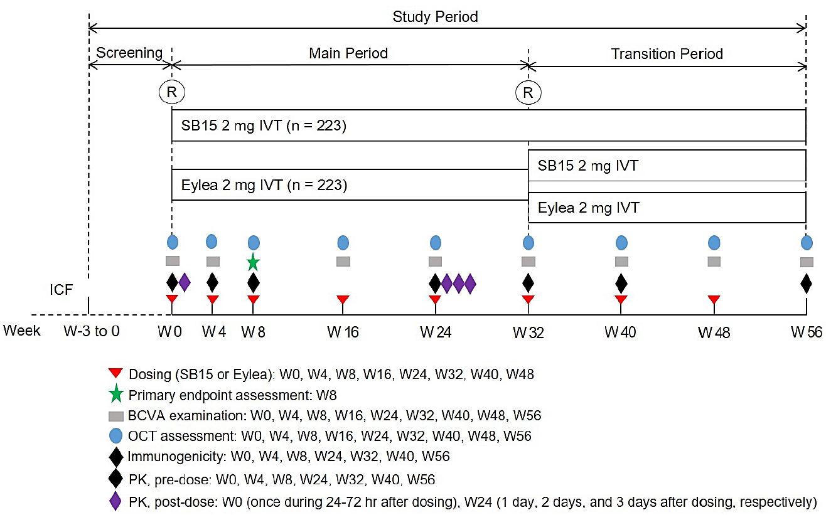
BCVA = best corrected visual acuity; hr = hour; ICF = informed consent form; IVT = intravitreal; OCT = optical coherence tomography; PK = pharmacokinetics; R = randomisation, SB15 = Opuviz; W = week.

Results for the primary efficacy outcome
Table 2. Sensitivity Analysis of Change from Baseline in BCVA Based on Available Case at Week 8 (Per-Protocol Set)
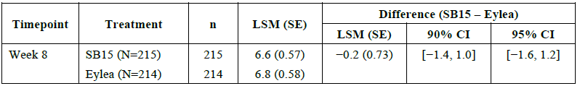
BCVA = best corrected visual acuity (total letter score); CI = confidence interval; LSM = least square mean; N = number of subjects in the Per-Protocol Set; n = total number of subjects with available data at Week 8; SE = standard error
Inferential statistics were based on analysis of covariance model with the baseline BCVA as a covariate and country and treatment as fixed factors.
Table 3. Primary Analysis of Change from Baseline in BCVA at Week 8 (Full Analysis Set)
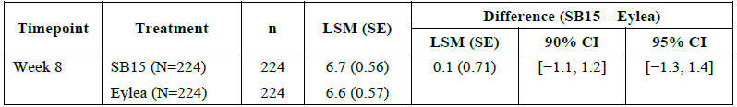
BCVA = best corrected visual acuity (total letter score); CI = confidence interval; LSM = least square mean; MAR = Missing-at-Random; MI = multiple imputation, N = number of subjects in the Full Analysis Set; n = total number of subjects with available data at Week 8; SE = standard error
Inferential statistics were based on analysis of covariance model with the baseline BCVA as a covariate and country and treatment as fixed factors.
BCVA letter scores at 4 meter and 1 meter were imputed by MI method with the assumption of monotone missing pattern and regression method under the MAR.

Study SB15-3001 - efficacy in wet AMD
Study SB15-3001 was a Phase III randomised, double-masked, parallel group, multicentre study with a duration of 56 weeks. A switching design was incorporated, with the Eylea arm being re-randomised into the Eylea+SB15 arm and the Eylea+Eylea arm at Week 32. Primary efficacy was assessed at Week 8.
The inclusion and exclusion criteria appear broadly appropriate for the study objective of demonstrating comparable efficacy. Patients aged ≥ 50 years with anti-VEGF treatment naïve, active subfoveal CNV lesions secondary to AMD were eligible. Broadly speaking, patients meeting criteria which may impact the interpretation of efficacy or increase particular safety risks were excluded. A list of 39 exclusion criteria was provided by the CSR with no summary.
Dosing of aflibercept was appropriately concordant with the approved schedule for Eylea in treating wet AMD. Assessing the primary efficacy endpoint at Week 8 is appropriate as this is expected to be a sensitive timepoint in detecting between-group differences, given the treatment effect plateaus from 12-weeks onward, as seen in the pivotal studies for Eylea. The use of ETDRS charts to assess BCVA is appropriate.
Randomisations were done centrally, and the study was double blinded. The use of ANCOVA to adjust for baseline BCVA is appropriate. The predefined 90%/95% CI equivalence margin of ± 3 letters is acceptable and stated to be concordant with preferences of the Food and Drug Administration and European Medicines Agency
Risks of bias from loss to follow-up and treatment discontinuation are low. Up to Week 56, 22/449 (5%) patients discontinued study treatment, and ~24 patients discontinued from the study. The per-protocol set at Week 8 included 429/449 (95.5%) of randomised patients.
Major protocol deviations were experienced by 21% of subjects and 33% experienced minor protocol deviations. This primarily impacts the interpretability of secondary endpoints and efficacy endpoints beyond Week 8. While the per-protocol set, by definition, should not be impacted by protocol deviations, some of the definitions appear somewhat lenient e.g., allowing dosing visits within ± 7 days instead of a tighter timeframe.
Baseline demographics and disease characteristics were provided for the randomised set but not the Per-Protocol Set (PPS). The evaluator expects these sets to be similar given the latter comprises 95.5% of the former. The SB15 arm and the pre-transition Eylea arm were broadly balanced, with the notable exceptions of:
- Gender: 52.7% vs. 58.7% females
- Mean central subfield thickness: 353 μm vs. 382 μm
- Presence of intra-retinal fluid: 47.8% vs. 60.4%
- Lesion type: 61.6% vs. 52% with occult lesion type
The clinical significance of the gender imbalance is unknown. Clinical relevance of the other identified imbalances is discussed further below.
The study’s choice of primary endpoint, change in BCVA from baseline to Week 8 based on the FAS with missing values imputed assuming missing-at-random, is suboptimal for the purpose of establishing bio-similarity. Protocol deviations can lead to outcomes from two groups appearing more similar than they really are, and the validity of the missing-at-random assumption is unclear.
The analysis based on the PPS and available case should therefore be used instead as the primary indicator of efficacy. Based on the PPS, comparable efficacy to Eylea was demonstrated in terms of change in BCVA from baseline to week 8, with a between-group least-squares mean difference of -0.2 and 95% CI of -1.6 to 1.2, which is confined within the pre-specified interval of –3 to 3.
The aforementioned imbalances in baseline disease characteristics may negatively impact the validity of the primary outcome. According to one narrative literature review, the presence of intra-retinal fluid may be associated with poorer visual acuity, and according to another, occult lesions may respond faster to anti-VEGF therapy than classic lesions. Imbalances in both these characteristics at baseline favour the SB15 arm (less with intra-retinal fluid and more with occult lesion type), raising concerns that the efficacy of SB15 may have been overestimated in study SB15-3001.
Subgroup analysis based on lesion type provides some reassurance, noting that the analysis is based on the FAS. Subgroup analyses of Week 8 change in BCVA by baseline central subfield thickness or presence of intra-retinal fluid are unavailable. A Clinical Question was posed and the submitted ad-hoc analysis adjusted for baseline CST and presence of intra-retinal fluid, along with the previous subgroup analysis based on lesion type has provided some level of reassurance.
BCVA results beyond week 8 appear comparable between SB15 vs. Eylea+Eylea. Anatomical outcomes, including change in CST, proportion of patients with intra- or sub-retinal fluid, change in CNV area, and proportion of patients with active CNV leakage also appear broadly comparable between SB15 and Eylea+Eylea. Results are descriptive and interpretability is limited by protocol deviations, missing data, and imbalances in baseline demographics and disease characteristics between SB15 vs. Eylea+Eylea.
The Eylea arm was re-randomised at Week 32 to receive either SB15 or Eylea up to week 48 (3 doses). BCVA outcomes at Week 56 appear comparable between the Eylea+SB15 and Eylea+Eylea arms. Results for the anatomical outcomes appear more mixed. Overall, the relevance of results is unclear. In switching studies of bio-similar products, PK and PD endpoints are generally considered more sensitive than clinical endpoints in detecting changes that may arise from switching. Efficacy results with baseline values as the reference e.g., BCVA, are of unclear interpretive value when re-randomisation occurred at Week 32. It’s also unclear whether there is much room for clinical efficacy to differ between switched and unswitched arms after having already received 5 doses of treatment. These uncertainties are in addition to limitations described in the previous paragraph, which also apply to the comparison between Eylea+SB15 vs. Eylea+Eylea.
In summary, comparability between SB15 and Eylea in terms of change in BCVA score from baseline to Week 8 has been established using the per-protocol set. Imbalances in baseline central subfield thickness, presence of intra-retinal fluid and lesion type may have negatively impacted the validity of the primary endpoint, and the Sponsor was asked to respond to this concern. BCVA results beyond Week 8, anatomical outcomes and results from the switching component of the study are descriptive only.

Extrapolation of dosing
The current PI of Eylea describes a treat-and-extend regime, and data on up to 16-week intervals are available for Eylea. No efficacy data using the treat-and-extend regime is available for SB15, nor any human intravitreal PK data. Approval of the treat-and-extend regime for SB15 therefore relies on indirect extrapolation from the standard dosing.

Extrapolation of indications
The Sponsor seeks to extrapolate the comparable efficacy to the following approved indications of Eylea:
- visual impairment due to macular oedema secondary to central retinal vein occlusion (CRVO)
- visual impairment due to macular oedema secondary to branch retinal vein occlusion (BRVO)
- diabetic macular oedema (DME)
- visual impairment due to myopic choroidal neovascularisation (myopic CNV).
A document titled “Extrapolation of Indications” was submitted by the Sponsor. In brief, the following scientific justifications are provided:
- Mechanism of action: Overexpression of VEGF and its role in retinal disease underlies the common pathway for pathogenesis of AMD, visual impairment due to macular oedema secondary to CRVO and BRVO, DME, and myopic CNV.
- Quality attributes: physicochemical and biological methods were performed to demonstrate the analytical similarity between SB15 and Eylea. Minor differences observed between SB15 and Eylea were investigated and were not considered to have impacts on efficacy and safety.
- Representativeness of patient population:
  - Neovascular AMD is known for its homogeneous disease progressions with fewer confounding factors than DME or RVO.
  - According to the efficacy outcomes reported for the other anti-VEGF agent, ranibizumab, the overall difference in BCVA changes between the ranibizumab and the control groups was largest in AMD patients among all other indications, i.e. RVO, and DME.
  - Based on the above justifications, the evaluator considers it acceptable to extrapolate the comparable efficacy to Eylea, as demonstrated in study SB15-3001, to other indications.
The Sponsor also cited a comparable systemic PK in study SB15-3001. This should not be considered evidence supportive of extrapolation, given the large variability of PK data in study SB15-3001 and that systemic exposure has no bearing on efficacy.

Safety

Patient exposure
Table 4. Summary of Exposure to Investigational Product (Safety Set 1)
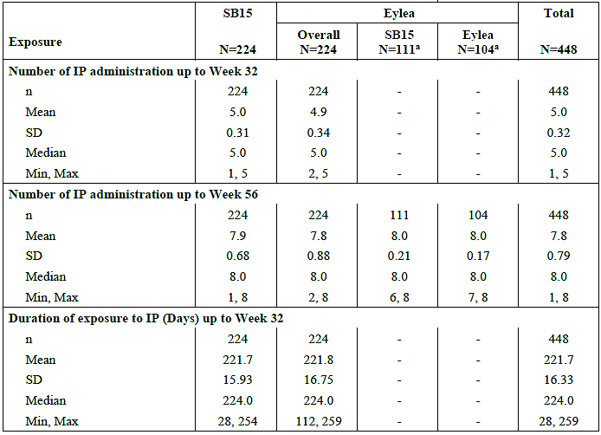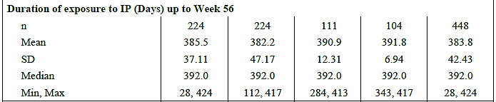
IP = investigational product; N = number of subjects in the Safety Set 1; n = number of subjects
a. Based on subjects in Safety Set 2, Eylea+SB15 and Eylea+Eylea may not add up to Eylea Overall.
Percentages were based on the number of subjects in the Safety Set 1.
Exposure duration (days) up to Week 32/Week 56 were calculated as follows:
If IP is completed or discontinued on or after Week 8, exposure duration up to Week 32 = Last IVT injection date before Week 32 — first IVT injection date + 56 days; exposure duration up to Week 56 = Last IVT injection date — first IVT injection date + 56 days.
If IP is discontinued before Week 8, exposure duration up to Week 32/Week 56 = Last IVT injection date + 28 days — first IVT injection date.

Adverse events
The are three pairs of randomised comparisons relevant to safety evaluation:
- SB15 vs. Eylea+Eylea over 56 weeks (Overall period; N ~328)
- SB15 vs. Eylea over 32 weeks, before re-randomisation (Main period; N ~ 448)
- Eylea+SB15 vs. Eylea+Eylea, ~Week 32 until Week 56 (Transition period; N ~ 215)
The first comparison (Overall Period), provides safety information on SB15 vs. Eylea without switching. Although this comparison has fewer patient numbers than the second comparison, it has a longer exposure and follow-up period.
The third comparison, which is the most suitable for evaluating the effect of switching, will also be reviewed. Results from the second comparison were briefly reviewed for safety signals.
The safety summaries provided by the Sponsor present the number and proportion of patients experiencing treatment emergent adverse events (TEAEs) in each arm i.e., n (%), as well as the frequency of events themselves, E. The evaluation of safety is based on the former, n (%).

Overview of adverse events
Table 5. Overview of TEAEs
 | SB15 | Eylea
 | N=224  n (%) E | Overall  N=224  n (%) E | SB15  N=111  n (%) E | Eylea  N=104  n (%) E
Overall period (Safety Set 1)
TEAEs | 144 (64.3) 315 | - | - | 64 (61.5) 149
Severe | 13 (5.8) 18 | - | - | 7 (6.7) 7
Ocular TEAEs in the study eye | 55 (24.6) 68 | - | - | 15 (14.4) 21
Severe | 2 (0.9) 2 | - | - | 1 (1.0) 1
Non-ocular TEAEs  Severe | 104 (46.4) 205  11 (4.9) 16 | -  - | -  - | 49 (47.1) 109  6 (5.8) 6
AESI | 15 (6.7) 16 | - | - | 5 (4.8) 5
Intraocular Inflammation TEAEs (study eye) | 0 (0.0) 0 | - | - | 0 (0.0) 0
TEAEs leading to IP discontinuation | 3 (1.3) 6 | - | - | 0 (0.0) 0
Serious TEAEs | 22 (9.8) 27 | - | - | 13 (12.5) 13
Ocular (study eye) | 4 (1.8) 4 | - | - | 2 (1.9) 2
Non-ocular | 16 (7.1) 21 | - | - | 11 (10.6) 11
TEAEs leading to death | 1 (0.4) 1 | - | - | 1 (1.0) 1
Screening and Main period (Safety Set 1)
TEAEs | 108 (48.2) 175 | 99 (44.2) 193 | - | -
Severe | 9 (4.0) 12 | 7 (3.1) 9 | - | -
Ocular TEAEs in the study eye | 41 (18.3) 46 | 28 (12.5) 33 | - | -
Severe | 1 (0.4) 1 | 0 (0.0) 0 | - | -
Non-ocular TEAEs  Severe | 74 (33.0) 110  8 (3.6) 11 | 68 (30.4) 137  7 (3.1) 9 | -  - | -  -
AESI | 11 (4.9) 11 | 6 (2.7) 6 | - | -
Intraocular Inflammation TEAEs (study eye) | 0 (0.0) 0 | 1 (0.4) 1 | - | -
TEAEs leading to IP discontinuation | 0 (0.0) 0 | 1 (0.4) 1 | - | -
Serious TEAEs | 12 (5.4) 15 | 15 (6.7) 17 | - | -
Ocular (study eye) | 3 (1.3) 3 | 1 (0.4) 1 | - | -
 | N=224  n (%) E | Overall  N=224  n (%) E | SB15  N=111  n (%) E | Eylea  N=104  n (%) E
Non-ocular | 8 (3.6) 11 | 14 (6.3) 16 | - | -
TEAEs leading to death | 0 (0.0) 0 | 1 (0.4) 1 | - | -
Transition period (Safety Set 2)
TEAEs | - | - | 39 (35.1) 94 | 31 (29.8) 48
Severe | - | - | 4 (3.6) 7 | 5 (4.8) 5
Ocular TEAEs in the study eye | - | - | 12 (10.8) 14 | 3 (2.9) 5
Severe | - | - | 0 (0.0) 0 | 1 (1.0) 1
Non-ocular TEAEs  Severe | -  - | -  - | 25 (22.5) 62  3 (2.7) 6 | 24 (23.1) 39  4 (3.8) 4
AESI | - | - | 0 (0.0) 0 | 3 (2.9) 3
Intraocular Inflammation TEAEs (study eye) | - | - | 0 (0.0) 0 | (0.0) 0
TEAEs leading to IP discontinuation | - | - | 0 (0.0) 0 | 0 (0.0) 0
Serious TEAEs | - | - | 6 (5.4) 10 | 6 (5.8) 6
Ocular (study eye) | - | - | 0 (0.0) 0 | 1 (1.0) 1
Non-ocular | - | - | 6 (5.4) 9 | 5 (4.8) 5
TEAEs leading to death | - | - | 0 (0.0) 0 | 1 (1.0) 1
Main period = W0 until before re-randomisation at Week 32; Transition period = Re-randomisation at Week 32 until Week 56; Overall period = screening period + main period + transition period; n = number of subjects with event; E = frequency of events.

All adverse events (irrespective of relationship to study treatment)

Ocular adverse events in study SB15-3001
Table 6. Ocular Treatment-Emergent Adverse Events in the Study Eye by Preferred Term (> 1% in Any Treatment Group) with System Organ Class in the Overall Period (Safety Set 1)
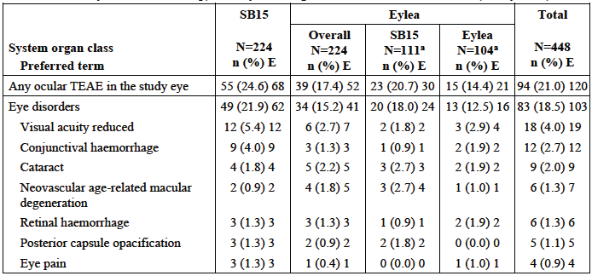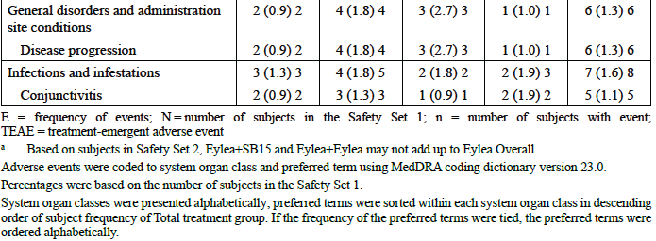
E = frequency of events; N=number of subjects in the Safety Set 1; n = number of subjects with event; TEAE = treatment-emergent adverse event
a Based on subjects in Safety Set 2, Eylea+SB15 and Eylea+Eylea may not add up to Eylea Overall.
Adverse events were coded to system organ class and preferred term using MedDRA coding dictionary version 23.0.
Percentages were based on the number of subjects in the Safety Set 1.
System organ classes were presented alphabetically; preferred terms were sorted within each system organ class in descending order of subject frequency of Total treatment group. If the frequency of the preferred terms were tied, the preferred terms were ordered alphabetically.

Treatment related adverse events (adverse drug reactions)
Table 7. Overview of treatment related adverse events
 |  | SB15 |  | Eylea
 |  | N=224  n (%) E |  | Overall  N=224  n (%) E |  | SB15  N=111  n (%) E |  | Eylea  N=104  n (%) E
Overall period (Safety Set 1)
Ocular TEAEs (study eye)
Related to drug |  | 5 (2.2) 5 |  | - |  | - |  | 0 (0.0) 0
Related to IVT injection |  | 11 (4.9) 11 |  | - |  | - |  | 2 (1.9) 2
Non-ocular TEAEs
Related to drug |  | 0 (0.0) 0 |  | - |  | - |  | 0 (0.0) 0
Related to IVT injection |  | 1 (0.4) 1 |  | - |  | - |  | 0 (0.0) 0
Screening and Main Period (Safety Set 1)
Ocular TEAEs (study eye)
Related to drug | 3 (1.3) 3 |  | 1 (0.4) 1 |  | - |  | -
Related to IVT injection | 11 (4.9) 11 |  | 3 (1.3) 3 |  | - |  | -
Non-ocular TEAEs
Related to drug | 0 (0.0) 0 |  | 1 (0.4) 1 |  | - |  | -
Related to IVT injection | 1 (0.4) 1 |  | 0 (0.0) 0 |  | - |  | -
Transition period (Safety Set 2)
Ocular TEAEs (study eye)
Related to drug | - |  | - |  | 1 (0.9) 1 |  | 0 (0.0) 0
Related to IVT injection | - |  | - |  | 1 (0.9) 1 |  | 0 (0.0) 0
Non-ocular TEAEs
Related to drug | - |  | - |  | 0 (0.0) 0 |  | 0 (0.0) 0
Related to IVT injection | - |  | - |  | 0 (0.0) 0 |  | 0 (0.0) 0

Deaths
In total, 3 (0.7%) subjects died in the main and transition periods: 1 (0.4%) subject in the Eylea treatment group with primary cause of death reported as circulatory collapse in the main period, 1 (0.5%) subject in the SB15+SB15 treatment group with unknown cause of death, and 1 (1.0%) subject in the Eylea+Eylea treatment group due to cerebrovascular accident (which was a non-ocular AESI) in the transition period. None of these events were considered related to the IP.

Ocular serious TEAEs
Table 8. Ocular Serious Treatment-Emergent Adverse Events in the Study Eye by System Organ Class and Preferred Term in the Overall Period (Safety Set 1)
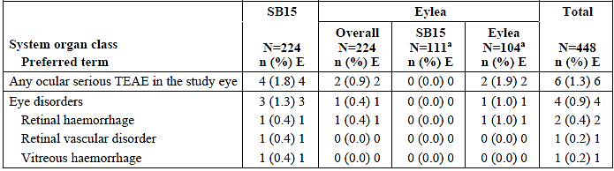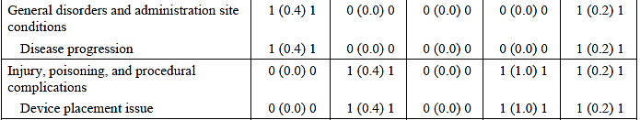
E = frequency of events; N = number of subjects in the Safety Set 1; n = number of subjects with event; [EAE = treatment-emergent adverse event
Adverse events were coded to system organ class and preferred term using MedDRA coding dictionary version 23.0.
a Based on subjects in Safety Set 2, Eylea+SB15 and Eylea+Eylea may not add up to Eylea Overall.
Percentages were based on the number of subjects in the Safety Set 1.
System organ classes were presented alphabetically; preferred terms were sorted within each system organ class in descending order of subject frequency of Total treatment group. If the frequency of the preferred terms were tied, the preferred terms were ordered alphabetically.
Table 9. Ocular Serious Treatment-Emergent Adverse Events in the Study Eye by System Organ Class and Preferred Term in Transition Period (Safety Set 2)
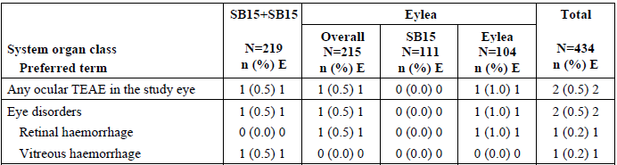
E = frequency of events; N = number of subjects in the Safety Set 2; n = number of subjects with event; TEAE = treatment-emergent adverse event.
Adverse events were coded to system organ class and preferred term using MedDRA coding dictionary version 23.0.
Percentages were based on the number of subjects in the Safety Set 2.
System organ classes were presented alphabetically; preferred terms were sorted within each system organ class in descending order of subject frequency of Total treatment group. If the frequency of the preferred terms were tied, the preferred terms were ordered alphabetically.

Comments on adverse events in study SB15-3001
The pivotal study SB15-3001 provided randomised comparisons of adverse events in patients with wet AMD over 56 weeks. Exposure was comparable across treatment groups. Limitations of the safety data include:
- 91/449 (20%) patients had a diagnosis of wet AMD in the fellow eye at baseline, and more would have been diagnosed throughout the study. The use of Eylea in the fellow eye in these patients may reduce the study’s sensitivity in detecting non-ocular safety signals.
- The sample size does not allow for the detection of uncommon safety signals, and extensive exclusion of patients with comorbidities, while helpful in removing potential confounders, may reduce the study’s sensitivity in detecting signals that would have been more apparent if underlying risk factors were present.
- Protocol deviations, the somewhat asymmetrical loss to follow-up, and differences in baseline characteristics (e.g., gender and lens status) between SB15 vs. Eylea+Eylea and Eylea+SB15 vs. Eylea+Eylea may also affect result validity.
- Interpretation of safety data on switching (Eylea+SB15 vs. Eylea+Eylea) is limited by the smaller sample size and short duration of exposure to switched treatment (3 doses).

SB15 vs. Eylea+Eylea over 56 weeks
The key comparison pair was SB15 vs. Eylea+Eylea over 56 weeks (Overall period, N ~328). Compared to Eylea, a higher proportion of patients treated with SB15 experienced ocular TEAEs in the study eye (24.6% vs. 14.4%), partially driven by the PTs of “visual acuity reduced” and “conjunctival haemorrhage”. There was also a small difference in related ocular TEAEs, higher in the SB15 arm. Proportions of patients with severe or serious ocular TEAEs were comparable, which is reassuring.
Proportions of patients experiencing non-ocular TEAEs, including severe and serious non-ocular TEAEs, were comparable. TEAEs leading to discontinuation were reported in 1.3% and 0% of the SB15 and Eylea+Eylea arms, respectively.

SB15 vs. Eylea over 32 weeks
Examining SB15 vs. Eylea over 32 weeks (Main period, N ~448) also allows for the comparison of SB15 alone vs. Eylea alone without switching. Other than summaries, results were not replicated the in CER given the expected overlap with the comparison of SB15 vs. Eylea+Eylea over 56 weeks. Results presented in the body of the CSR were briefly reviewed.
There was an increase in the proportion of patients experiencing ocular TEAEs in the study eye (18.3% vs. 12.5%) with SB15 compared to Eylea. The small difference in related ocular TEAEs were again seen. There were no or small differences in severe or serious ocular TEAEs. There was a small difference in non-ocular TEAEs (33% vs. 30.4%), with no difference in severe or serious non-ocular TEAEs. Overall, acknowledging some differences to the comparison of SB15 vs. Eylea+Eylea over 56 weeks, no additional safety signals was identified by the evaluator.

Eylea+SB15 vs. Eylea+Eylea
The effect of switching from Eylea to SB15 can be examined by comparing Eylea+SB15 vs. Eylea+Eylea over weeks ~32 to 56 (Transition Period, N~215). A higher proportion of patients who switched to SB15 experienced ocular TEAEs (10.8% vs. 2.9%) in the study eye compared to no switching, partially driven by the PTs of “posterior capsule opacification” and “xeropthalmia”. There was no increase in severe or serious ocular TEAEs. Proportions of patients with non-ocular TEAEs, including severe and serious non-ocular TEAEs, were comparable.

Deaths
There were three deaths:
- 1 in the SB15 arm (unknown cause)
- 1 in the Eylea arm (circulatory collapse)
- 1 in the Eylea+Eylea arm (cerebrovascular event)
For one subject in the SB15 arm, although the cause of death was stated as unknown, the narrative suggests it was possibly related to cardiac failure, with the subject only discharged 2 weeks prior to death from an admission for newly diagnosed cardiac failure. Autopsy also lists atherosclerotic heart disease and unspecified heart failure among the findings. The significance of this death in the SB15 arm is unclear. Concerning aspects include the relatively young age and that the shortness of breath, a typical symptom of heart failure, started roughly 7 months into SB15 treatment. On the other hand, the subject had a long-standing history of hypertension.

Concluding comment on adverse events in study SB15-3001
In summary, over 56 weeks, higher incidences of ocular TEAEs and related ocular TEAEs were seen with SB15 compared to Eylea. Severe and serious ocular TEAEs were reassuringly comparable. No additional safety signals were identified by examining SB15 vs. Eylea over 32 weeks. Switching from Eylea to SB15 appear to be associated with a higher frequency of ocular TEAEs compared to no switching, again with no increase in severe or serious ocular TEAEs. One death was reported in the SB15 arm, probably related to heart failure. Various limitations to the interpretation of safety data are noted.

Ocular adverse events of special interest
Table 10. Ocular Adverse Events of Specific Interest (AESI) in Study Eye by System Organ Class and Preferred Term in the Overall Period (Safety Set 1)
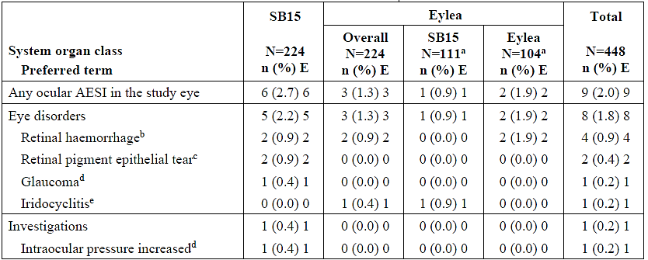
AESI: = adverse events of special interest; DA = disc area; E = frequency of events; IOP = intraocular pressure; N = number of subjects in the Safety Set 1; n = number of subjects with event
Adverse events were coded to system organ class and preferred term using MedDRA coding dictionary version 23.0.
a. Based on subjects in Safety Set 2, Eylea+SB15 and Eylea+Eylea may not add up to Eylea Overall.
b. AESI Category 7: Subretinal haemorrhage with the size of 1 DA or more involving the centre of the fovea, or if the size of the haemorrhage 1s > 50% of the total lesion area.
c AESI Category 6: Retinal pigment epithelial tear
4 AESI Category 1: New onset pre-injection IOP of > 25 mmHg
5 AESI Category 4: Any case of non-infectious intraocular inflammation such as iritis, vitritis, and iridocyclitis
Percentages were based on the number of subjects in the Safety Set 1.
System organ classes were presented alphabetically; preferred terms were sorted within each system organ class in descending order of subject frequency of Total treatment group. If the frequency of the preferred terms were tied, the preferred terms were ordered alphabetically.

Immunogenicity and immunological events
Blood samples for immunogenicity assessment were planned to be collected in all randomised subjects. Blood samples were collected prior to injection of investigational product. A total of 3 out of 224 (1.3%) subjects and 1 out of 224 (0.4%) subjects with available results in the SB15 and Eylea treatment groups, respectively, had a positive anti-drug antibody ADA response at pre-treatment.
Table 11. Incidence of Overall Anti-Drug Antibody (ADA) by Visit and Treatment Group (Safety Set 1)
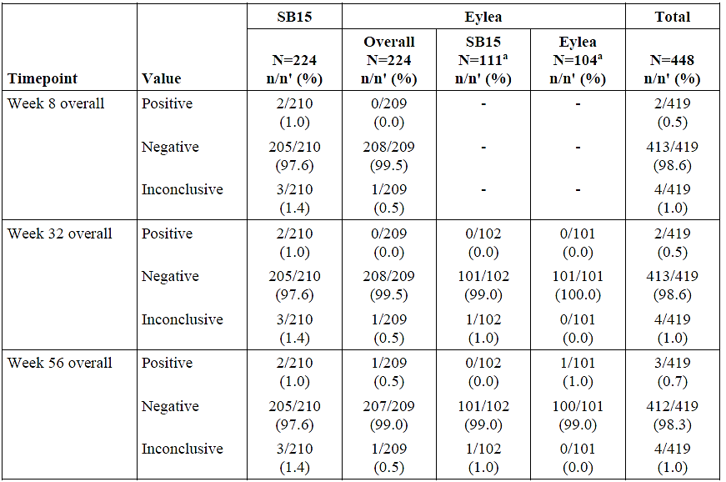
N = number of subjects in the Safety Set 1; n = number of subjects with event of interest; n': number of subjects with available assessment results at each visit Percentages were based on n'.
* Based on subjects in Safety Set 2, Eylea+SB15 and Eylea+Eylea may not add up to Eylea Overall.
Overall ADA results were determined as Positive for a subject with treatment-induced or treatment-boosted ADA, where treatment-induced ADA indicates at least one positive result after pre-dose of Week 0 for subjects with negative ADA at pre-dose of Week 0, and treatment-boosted ADA indicates at least one positive result with higher titre level compared to pre-dose of Week 0 after pre-dose of Week 0 for subjects with positive ADA at pre-dose of Week 0.
Overall ADA result was defined as Negative for a subject with negative ADA at Week 0 and without positive ADA until Week 8, Week 32, and Week 56. Overall ADA result was defined as Inconclusive for a subject with positive ADA at Week 0 and without positive result with higher titre level observed after pre-dose of Week 0 up to Week 8, Week 32, and Week 56.
- If the fellow eye received Eylea due to AMD during the study period after randomisation, the ADA results obtained aftertreatment for the fellow eye were excluded in the summary.
The 2 patients in the SB15 treatment group had treatment-induced positive ADA results at most assessments over the 56-week observation period. The majority of the detected ADA across all treatment groups were generally of low titre (50 or less) up to Week 56. Five subjects (2.2%) in the SB15 treatment group, 3 subjects in the Eylea+SB15 (2.7%) treatment group, and 1 subject in the Eylea+Eylea treatment group (1.0%) with positive ADA response had 1 or more instances of a positive NAb response up to Week 56.

Comments on safety issues of possible regulatory impact

SB15 vs. Eylea+Eylea over 56 weeks
Comparing SB15 to Eylea+Eylea over 56 weeks (Overall Period), no major concerns have been identified for issues described under. The evaluator noted a small imbalance in the cardiac disorders SOC (3.1% vs. 0%), and further notes a small imbalance in the vascular disorders SOC (6.3% vs. 2.9%). While some uncertainties exist, these differences are considered to probably not be of clinical significance.
By Week 56, treatment-induced or treatment-boosted ADA was reported in 1% and 1% of subjects in the SB15 and Eylea+Eylea arms, respectively. This suggests a comparable immunogenicity profile, although the ~21% missing data by Week 56 is noted. Validity of the bioanalytic assays for ADA and NAb have not been evaluated.
Over 56 weeks, ocular and non-ocular AESIs were broadly comparable between the SB15 and Eylea+Eylea arms, as were TEAEs for intraocular inflammation. If PTs of “retinal pigment epithelial tear” and “retinal tear” are both counted, a small imbalance was seen at 3 vs. 0 events. Again, the small difference is probably not of clinical significance.
While the frequencies of glaucoma and intraocular pressure increased were broadly balanced, there was an imbalance in having a history of glaucoma at baseline (3.1% vs. 8.4%). Similarly, although the risk of arterial thromboembolic events was broadly balanced over 56 weeks, this is on the background of less patients having a history of ischaemic heart disease and related disorders in the SB15 arm at baseline. These imbalances in baseline medical history add uncertainties to the interpretation of results.

Main period and transition period
A brief review of relevant data in the main period (SB15 vs. Eylea over 32 weeks) does not identify any major additional concerns. An imbalance in arterial thromboembolic events was noted at 2.2% vs. 0.4% (clinical evaluator’s calculation). While this adds to the uncertainties, the evaluator notes that ATEs over 56 weeks appear more balanced. A review of relevant data in the transition period (Eylea+SB15 vs. Eylea+Eylea, ~weeks 32 to 56) did not reveal any notable patterns.

Issues with no available data
“Medication errors” is listed as an important potential risk in the Eylea RMP. No dedicated summary of this issue was provided in the CSR, and no human factor studies have been submitted. While the proposed RMP for SB15 appropriate retained “Medication errors”, this nonetheless presents an area of uncertainty.
Other important potential risks listed by the RMP include “off-label use and misuse” and “embryo-fetotoxicity”. The former is difficult to study under trial settings, though theoretically the risk of (mis)using one vial for multiple injections may be greater with SB15 compared to Eylea, given the higher extractable volume. No Module 5 data has been submitted regarding embryo-fetotoxicity and no comments can be made.
Eylea PI section 4.4 recommends withholding treatment in the event of a decrease in BCVA of ≥ 30 letters. No serious ocular TEAE of “visual acuity reduced” was reported during the Overall Period.

Concluding comment on issues with possible regulatory impact
In summary, no major concerns have been identified based on the available data on issues of possible regularly impact, though small imbalances in the cardiac disorders SOC, vascular disorders SOC, retinal/retinal pigment epithelial tears, and arterial thromboembolic events (main period) are noted. “Medication errors” and “Off-label use and misuse” are areas of uncertainty. Interpretation of safety data is limited by issues addressed as well as imbalances in baseline medical history.

Comments on extrapolation of safety
The Sponsor proposed that the type and incidence of adverse reactions observed for Eylea are consistent across indications. The Sponsor acknowledged that adverse reactions rates cannot be directly compared between clinical trials due to the varying conditions and dosing regiments.
While the Sponsor’s argument is acknowledged, the evaluator notes that a more important issue is whether wet AMD represents a sensitive population in detecting differences in safety outcomes. This does not appear to have been clearly addressed by the Sponsor.
Nonetheless, the evaluator notes that RVO is associated with comorbidities such as cardiovascular disease and glaucoma, whereas DME is associated with diabetes. Studying safety in patients with wet AMD therefore has the potential advantage of having less confounding by complications of co-morbidities. Based on this, the evaluator has no objection to the extrapolation of safety to other indications.

Overall conclusions on clinical safety
The pivotal study SB15-3001 provided randomised comparisons of SB15 vs. Eylea (Eylea+Eylea) in terms of safety over 56 weeks. A higher proportion of patients treated with SB15 experienced ocular TEAEs (24.6% vs. 14.4%) compared to Eylea. Overall frequencies of severe or serious ocular TEAEs were however comparable. Switching from Eylea to SB15 was also associated with higher frequencies of ocular TEAEs (10.8% vs. 2.9%). One patient died roughly 7 months into SB15 treatment, the clinical significance of which is unclear.
No major concerns have been identified based on the available data on issues of possible regularly impact, though small imbalances in the cardiac disorders SOC, vascular disorders SOC, retinal/retinal pigment epithelial tears and arterial thromboembolic events are noted. “Medication errors”, an RMP important potential risk, is an area of uncertainty.
No major concerns have been identified based on the available data on issues of possible regularly impact, though small imbalances in the cardiac disorders SOC, vascular disorders SOC, retinal/retinal pigment epithelial tears and arterial thromboembolic events are noted. “Medication errors” and “Off-label use and misuse” are areas of uncertainty.
The sample size precludes the detection of uncommon safety signals, and extensive exclusion of patients with comorbidities may have reduced the study’s sensitivity in detecting signals that would have been more apparent if underlying comorbidities were present. Interpretability of non-ocular TEAEs is limited by exposure to Eylea in the fellow eye. Protocol deviations, loss to follow-up and imbalances in baseline characteristics and medical history may also affect result validity. Interpretation of data on switching is limited by the smaller sample size and short duration of exposure to switched treatment.
There are no objections to the extrapolation of safety to other indications.

Risk management plan
Samsung Bioepis AU Pty Ltd has submitted EU-RMP version 1.1 (date 12 March 2024; DLP 21 February 2024) and ASA version 1.0 (date 4 June 2024) in support of this application. With the s31 responses, the Sponsor provided an updated ASA version 1.1 (date 5 March 2025).
The summary of safety concerns and their associated risk monitoring and mitigation strategies are summarised in Table 12. The TGA may request an updated RMP at any stage of a product's life-cycle, during both the pre-approval and post-approval phases.
Table 12. Summary of safety concerns
Summary of safety concerns |  | Pharmacovigilance |  | Risk Minimisation
 |  | Routine | Additional | Routine | Additional
Important identified risks | Endophthalmitis (likely infectious origin) | * | – |  | †
Important identified risks | Intraocular inflammation | * | – |  | †
Important identified risks | Transient intraocular pressure increase | * | – |  | †
Important identified risks | Retinal pigment epithelial tears |  | – |  | †
Important identified risks | Cataract (especially of traumatic origin) |  | – |  | †
Important potential risks | Medication errors |  | – |  | †
Important potential risks | Off-label use and misuse |  | – |  | †
Important potential risks | Embryo-foetal toxicity |  | – |  | †
Missing information | None | – | – | – | –
*Follow-up questionnaires
†Patient’s Guide
The clinical and nonclinical evaluators did not recommend any changes to the summary of safety concerns. The summary of safety concerns is identical to that of the reference product and is acceptable.
The pharmacovigilance plan is in line with the reference product and is acceptable.
A Patient’s Guide will be implemented as an additional risk minimisation activity in Australia, in line with the Australian reference product. The risk minimisation plan is acceptable.

Risk-benefit analysis
SB15 (Opuviz) has been developed as a biosimilar candidate to Eylea (aflibercept), with the same amino acid sequence, and route of administration (intravitreal ([IVT] injection). The medical need for Eylea (aflibercept) in the approved indications is well documented, as it has meaningful benefit to the various patient populations.
Comprehensive comparisons of physicochemical and biological quality attributes were undertaken to demonstrate biosimilarity of SB15 to Eylea (US). A bridging study demonstrated high similarity of Australian-sourced Eylea to US-sourced Eylea supporting biosimilarity of SB15 (Opuviz), the Australian reference product.
One comparative clinical study was provided (Study SB15-3001) which compared the efficacy of SB15 to the reference product, Eylea, licensed in the US (Eylea (US)), as the primary objective, with safety and immunogenicity as secondary objectives. This study was a randomized, double-masked, multicentre, active-controlled study in adult subjects with neovascular (wet) AMD. A switching design was incorporated, with the Eylea arm being re-randomised into the Eylea+SB15 arm and the Eylea+Eylea arm at Week 32.
Biosimilarity in clinical efficacy was demonstrated between SB15 and Eylea (US) in terms of change in BCVA (measured by ETDRS chart) from baseline to week 8, with a between-group least-squares mean difference of -0.2 and 95% CI of -1.6 to 1.2, which was within the appropriate pre-specified equivalence margin of –3 to 3 letters. Further descriptive analyses of additional efficacy endpoints showed no clinically meaningful differences between SB15 and Eylea (US). Results from Study SB15-3001 also show that the transition from Eylea (US) to SB15 did not result in a clinically meaningful impact on efficacy and persistence of efficacy through week 56 was also observed in Study SB15-3001.
Safety results from Study SB15-3001 showed no clinically important differences between SB15 and Eylea (US). No new safety signals were identified. A low incidence of binding ADAs was observed for the treatment groups.
With regards to justification for extrapolation of clinical data to the other approved Eylea indications, aflibercept is administered intravitreally, and therefore systemic PK data has limited value in predicting efficacy and ocular safety. Data from the PK sub-study within study SB15-3001 is descriptive in nature. Nevertheless, mechanism of action, quality attributes and representativeness of patient population are sound scientific justifications and the extrapolation of the clinical data for nAMD to other approved Eylea indications for SB15 is considered acceptable.

Assessment outcome
Based on a review of quality, safety, and efficacy, the TGA decided to register Opuviz (aflibercept) for the following indications:
Opuviz 2 mg (aflibercept) is indicated in adults for the treatment of:
-neovascular (wet) age-related macular degeneration (wet AMD)
-visual impairment due to macular oedema secondary to central retinal vein occlusion (CRVO)
-visual impairment due to macular oedema secondary to branch retinal vein occlusion (BRVO)
-diabetic macular oedema (DME)
-visual impairment due to myopic choroidal neovascularisation (myopic CNV).

Specific conditions of registration
The Opuviz EU-Risk Management Plan (RMP) (version 1.1, dated date 12 March 2024; DLP 21 February 2024), with Australia-Specific Annex (ASA) (version 1.1, dated 5 March 2025), included with submission PM-2024-03080-1-5, and any subsequent revisions, as agreed with the TGA will be implemented in Australia.
An obligatory component of risk management plans is routine pharmacovigilance. Routine pharmacovigilance includes the submission of periodic safety update reports (PSURs).
Reports are to be provided in line with the current published list of EU reference dates and frequency of submission of PSURs until the period covered by such reports is not less than three years from the date of this approval letter. Each report must be submitted within ninety calendar days of the data lock point for that report.
The reports are to at least meet the requirements for PSURs as described in the European Medicines Agency’s Guideline on good pharmacovigilance practices (GVP) Module VII-periodic safety update report (Rev 1), Part VII.B Structures and processes. Note that submission of a PSUR does not constitute an application to vary the registration.
Laboratory testing & compliance with Certified Product Details (CPD)
- All batches of Opuviz aflibercept supplied in Australia must comply with the product details and specifications approved during evaluation and detailed in the Certified Product Details (CPD).
- When requested by the TGA, the Sponsor should be prepared to provide product samples, specified reference materials and documentary evidence to enable the TGA to conduct laboratory testing on the Product. Outcomes of laboratory testing are published biannually in the TGA Database of Laboratory Testing Results http://www.tga.gov.au/ws-labs-index and periodically in testing reports on the TGA website.
Certified product details
The Certified Product Details (CPD), as described in Guidance 7: Certified Product Details of the Australian Regulatory Guidelines for Prescription Medicines (ARGPM), in PDF format, for the above products should be provided upon registration of these therapeutic goods. In addition, an updated CPD should be provided when changes to finished product specifications and test methods are approved in a Category 3 application or notified through a self-assessable change.
A template for preparation of CPD for biological prescription medicines can be obtained from the TGA website
[for the form] https://www.tga.gov.au/resources/resources/forms/certified-product-details-cpd-biological-prescription-medicines
[for the CPD guidance] https://www.tga.gov.au/resources/guidance/submitting-certified-product-details-cpd-biological-prescription-medicines

Product Information and Consumer Medicine Information
For the most recent Product Information (PI) and Consumer Medicine Information (CMI), please refer to the TGA PI/CMI search facility.

Therapeutic Goods Administration
PO Box 100 Woden ACT 2606 Australia
Email: info@tga.gov.au Phone: 1800 020 653 Fax: 02 6203 1605
https://www.tga.gov.au

Wong WL, Su X, Li X, Cheung MG, Klein R, Cheng C, Wong TY. Global prevalence of age-related macular degeneration and disease burden projection for 2020 and 2040: a systematic review and meta-analysis Lancet Glob Health, 2 (2014), pp. e106-116
Australian Institute of Health and Welfare. Eye health. Last updated 11 February 2021. https://www.aihw.gov.au/reports/eye-health/eye-health/contents/how-common-is-visual-impairment
Fleckenstein M, Keenan TDL, Guymer RH, et al. Age-related macular degeneration. Nat Rev Dis Primers. 2021;7(1):31.
Spaide, R. F. et al. Consensus nomenclature for reporting neovascular age-related macular degeneration data: Consensus on Neovascular Age-Related Macular Degeneration Nomenclature Study Group. Ophthalmology 127, 616–636 (2020).
Fleckenstein M, 2021.
European Medicines Agency. Guideline on similar biological medicinal products. 2015
Kaiser PK, Wykoff CC, Singh RP, Khanani AM, Do DV, Patel H, et al. Retinal Fluid and Thickness as Measures of Disease Activity in Neovascular Age-Related Macular Degeneration. Retina. 2021;41(8):1579-86
Mathis T, Holz FG, Sivaprasad S, Yoon YH, Eter N, Chen LJ, et al. Characterisation of macular neovascularisation subtypes in age-related macular degeneration to optimise treatment outcomes. Eye (Lond). 2023;37(9):1758-65

