Australian Public Assessment Report for Anzupgo
  - Active ingredient: delgocitinib
  - Sponsor: LEO Pharma
December 2025

About the Therapeutic Goods Administration (TGA)
- The Therapeutic Goods Administration (TGA) is part of the Australian Government Department of Health, Disability and Ageing and is responsible for regulating therapeutic goods, including medicines, medical devices, and biologicals.
- The TGA administers the Therapeutic Goods Act 1989 (the Act), applying a risk management approach designed to ensure therapeutic goods supplied in Australia meet acceptable standards of quality, safety, and efficacy.
- The work of the TGA is based on applying scientific and clinical expertise to decision-making, to ensure that the benefits to the Australian public outweigh any risks associated with the use of therapeutic goods.
- The TGA relies on the public, healthcare professionals and industry to report problems with therapeutic goods. The TGA investigates reports received to determine any necessary regulatory action.
- To report a problem with a therapeutic good, please see the information on the TGA website.

About AusPARs
- The Australian Public Assessment Report (AusPAR) provides information about the evaluation of a prescription medicine and the considerations that led the TGA to approve or not approve a prescription medicine submission. Further information can be found in Australian Public Assessment Report (AusPAR) guidance.
- AusPARs are prepared and published by the TGA.
- AusPARs are static documents that provide information that relates to a submission at a particular point in time. The publication of an AusPAR is an important part of the transparency of the TGA’s decision-making process.
- A new AusPAR may be provided to reflect changes to indications or major variations to a prescription medicine subject to evaluation by the TGA.

Copyright
© Commonwealth of Australia 2025
This work is copyright. You may reproduce the whole or part of this work in unaltered form for your own personal use or, if you are part of an organisation, for internal use within your organisation, but only if you or your organisation do not use the reproduction for any commercial purpose and retain this copyright notice and all disclaimer notices as part of that reproduction. Apart from rights to use as permitted by the Copyright Act 1968 or allowed by this copyright notice, all other rights are reserved and you are not allowed to reproduce the whole or any part of this work in any way (electronic or otherwise) without first being given specific written permission from the Commonwealth to do so. Requests and inquiries concerning reproduction and rights are to be sent to the TGA Copyright Officer, Therapeutic Goods Administration, PO Box 100, Woden ACT 2606 or emailed to <tga.copyright@tga.gov.au>.

Contents
List of abbreviations 4
Product submission 5
Submission details 5
Product background 6
Disease or condition 6
Current treatment options 7
Clinical rationale 8
Regulatory status 8
Australian regulatory status 8
International regulatory status 8
Registration timeline 8
Assessment overview 9
Quality evaluation summary 9
Drug substance 9
Drug product 9
Biopharmaceutics 10
Nonclinical evaluation summary 10
Clinical evaluation summary 12
Pharmacology 12
Efficacy 15
Safety 28
Risk management plan 36
Risk-benefit analysis 36
Efficacy 36
Safety 37
Conclusions and Recommendation 38
Assessment outcome 38
Specific conditions of registration 38
Product Information and Consumer Medicine Information 39

List of abbreviations
Abbreviation | Meaning
ACM | Advisory Committee on Medicines
AEs | Adverse events
ARTG | Australian Register of Therapeutic Goods
CHE | Chronic hand eczema
CMI | Consumer Medicines Information
DLQI | Dermatology Life Quality Index
HECSI | Hand Eczema Severity Index
HESD | Hand Eczema Symptom Diary
IGA-CHE | Investigator’s Global Assessment for CHE
HEIS | Hand eczema impact scale
HEIS PDAL | Hand eczema impact scale Proximal Daily Activity Limitations
PI | Product Information
PYO | Patient-years of observation
PK | Pharmacokinetics
PSUR | Periodic safety update report
RMP | Risk management plan
SOC | System-organ class
TGA | Therapeutic Goods Administration

Product submission

Submission details
Type of submission: | New chemical entity
Product name: | Anzupgo
Active ingredient: | delgocitinib
Decision: | Approved
Date of decision: | 27 August 2025
Date of entry onto ARTG: | 5 September 2025
ARTG number: | 470745
Black Triangle Scheme | Yes
Sponsor’s name and address: | LEO Pharma, Suite 3, Level 1, 5 Lamington Street, New Farm QLD 4005
Dose form: | Cream
Strength: | Each gram of Anzupgo cream contains 20 mg of delgocitinib
Container: | Laminate tube with an aluminium barrier layer and an inner layer of low-density polyethylene fitted with a polypropylene flip-top cap.
Pack sizes: | 15 g or 60 g
Approved therapeutic use for the current submission: | Anzupgo is indicated for the treatment of moderate to severe chronic hand eczema (CHE) in adults for whom topical corticosteroids are inadequate or inappropriate.
Routes of administration: | Anzupgo should be applied twice daily to the affected skin of the hands and wrists.
Pregnancy category: | Category B1  Drugs which have been taken by only a limited number of pregnant women and women of childbearing age, without an increase in the frequency of malformation or other direct or indirect harmful effects on the human fetus having been observed. Studies in animals have not shown evidence of an increased occurrence of fetal damage.  The use of any medicine during pregnancy requires careful consideration of both risks and benefits by the treating health professional. The pregnancy database must not be used as the sole basis of decision making in the use of medicines during pregnancy. The TGA does not provide advice on the use of medicines in pregnancy for specific cases. More information is available from obstetric drug information services in your state or territory.

Product background
This AusPAR describes the submission by LEO Pharma (the Sponsor) to register Anzupgo (delgocitinib) for the following proposed indication:
Anzupgo is indicated for the treatment of moderate to severe chronic hand eczema (CHE) in adults for whom topical corticosteroids are inadequate or inappropriate.

Disease or condition
Hand eczema is a common inflammatory disorder involving the skin of the hands with a lifetime prevalence of 15%, and a one-year prevalence of around 10% in the general population. Published literature defines chronic hand eczema (CHE) as hand eczema persisting for more than 3 months, or which recurs 2 or more times within 12 months, with up to two thirds of individuals affected by hand eczema meeting this definition of CHE.2, Moderate to severe disease, comprising around one third of cases, is associated with marked disease burden and functional impact.
The aetiology of CHE is complex and multifactorial; multiple subtypes of hand eczema are implicated, including irritant contact dermatitis, atopic dermatitis and allergic contact dermatitis, with progression from acute eczema to CHE in an individual patient often due to a combination of factors. CHE is a common occupational disease particularly among those who are exposed to water, chemical irritants, or performing frequent hand-washing in their work, for example hairdressers, food handlers or healthcare workers.2,4 Perhaps driven by traditional gender-based occupational and caring roles CHE is more common in females compared to males, around 1.5 to 2-fold more common, with an average age of onset in the mid-twenties,2 however, hand eczema and CHE also occurs in children. A history of atopic dermatitis is a strong risk factor for CHE, whilst it also occurs more frequently among those with other atopic diseases such as asthma or allergic rhinoconjunctivitis, with dry skin also an identified risk factor.2,3,4
Clinical manifestations are variable and may evolve over time. In acute stages hand eczema commonly presents with lesions which are erythematous, papular and/or vesicular, with associated oedema.2,3,4 With development of chronic disease lesions can become thickened, hyperkeratotic, with prominent scaling and fissures, and common associated symptoms include itch and pain.3,4 Lesions are typically bilateral and may involve the palmar, dorsal surface or both, and the wrists.4 Diagnosis typically includes a detailed occupational and exposure history, as well as skin patch testing using commercially available panels of common precipitants and exposures specific to the individual patient.2,4
Whilst there is no universally accepted classification for hand eczema or CHE the most recent European Society of Contact Dermatitis guideline supports classification by aetiological subtypes and clinical subtypes, with four variants under each; aetiological subtypes include irritant contact dermatitis, allergic contact dermatitis, atopic hand eczema, and protein contact dermatitis, whilst clinical subtypes include hyperkeratotic hand eczema, acute recurrent vesicular hand eczema, nummular hand eczema, and pulpitis. Any subtype can theoretically be seen in CHE by meeting the definition of chronicity outlined above. Whilst measures of disease severity may be infrequently used in clinical practice tools have been developed specific to hand eczema, with Physician Global Assessment (PGA) one example with categorisation as mild, moderate or severe based on objective skin findings and extent of involvement.4
The pathophysiology of CHE involves epidermal barrier disruption and cutaneous inflammation resulting from non-specific or specific immune responses to irritants and antigens encountered in the skin.2 Specific immune responses vary according to the predominant aetiology, irritant contact, allergic or atopic, however, broadly may involve innate and adaptive immune responses culminating in inflammation, keratinocyte proliferation, and epidermal hyperplasia.2 Various pro-inflammatory cytokines and other mediators, and their associated cell signalling pathways, are implicated in this process. Of note, in the clinical setting a combination of precipitants and aetiologies may be seen for an individual patient. CHE is associated with significant negative impact on quality of life with the overall disease burden magnified by impaired psychosocial, occupational and economic function.3,4

Current treatment options
Avoidance of irritants and allergens, including both those identified as a precipitant for a specific patient during clinical work-up as well as common irritants, is a cornerstone of CHE management.4,5 In addition, hand-washing habits can be modified to avoid harsh soaps, to prioritise proper drying and application of emollient/moisturiser afterward, and personal protective equipment such as gloves can be used to reduced exposure to irritants. Frequent, multiple times per day, use of emollient/moisturiser is recommended for all patients to improve/maintain skin barrier function.5,
Topical corticosteroids are generally considered to be first-line pharmacological treatment, with choice of potent, high-potency, or super high-potency agents as a once or twice daily application guided by clinical findings and response.4,5,6 After induction of remission, topical corticosteroids may be used less frequently as a regular maintenance treatment.4 Despite this place as first-line therapy there is little high-quality clinical data to support efficacy of topical corticosteroids in CHE. The topical calcineurin inhibitors, which are approved for use in atopic dermatitis, can be used as steroid sparing agents with limited clinical data supporting efficacy.5,6
For patients not adequately responsive to topical treatment options include phototherapy, either UV-B or topical psoralen plus UV-A.4,6 The medical literature describes use of laser treatment, Botulinum toxin and iontophoresis, however clinical data to guide therapy is very limited.6
Systemic treatment options are generally reserved for patients with severe disease, or disease not adequately responsive to treatment. Short courses of oral corticosteroid may be used to achieve rapid disease control,4,6 though long-term or recurrent use is limited by the safety profile. Multiple different immunomodulators have been used in CHE with limited clinical data to support efficacy, including the oral retinoids acitretin and alitretinoin, azathioprine, cyclosporine, methotrexate and mycophenolate mofetil.4,6 None of these medicines currently have an approved indication for CHE in Australia, with their use being off label. Data from small case-series suggests that the biologic agent dupilumab, an interleukin (IL) 4/IL-13 receptor antagonist, has some efficacy for treatment of non-atopic CHE.4 There are no products currently included in the Australian Register of Therapeutic Gods (ARTG) which have an approved indication for CHE or hand eczema specifically, though both indications are captured under the terminology ‘corticosteroid-responsive dermatoses’ and similar, common to multiple approved topical corticosteroids.

Clinical rationale
Delgocitinib is a JAK inhibitor targeting activity of all 4 members of the JAK family of enzymes, including JAK1, JAK2, JAK3, and TYK2. Many immune-mediated chronic inflammatory diseases, such as CHE, rely on a number of inflammatory cascades mediated by interplay between cytokines and immune and tissue cells; by inhibiting the activity of several members of the JAK family, a pan-JAK inhibitor can block the activity of multiple pro-inflammatory cytokines implicated in disease.

Regulatory status

Australian regulatory status
This product is considered a new chemical entity for Australian regulatory purposes.

International regulatory status
At the time the TGA considered this submission, a similar submission had been considered by other regulatory agencies. Anzupgo was approved by the European Medicines Agency via the EU centralized procedure on 19 September 2024, which is the evaluation constituting this COR application to the TGA. The approved EU indication is the same as the proposed Australian indication:
for the treatment of moderate to severe chronic hand eczema (CHE) in adults for whom topical corticosteroids are inadequate or inappropriate.
Applications to register Anzupgo have been submitted in multiple other countries with regulatory decisions still pending, including Switzerland, Republic of Korea, Canada, USA, United Arab Emirates and the United Kingdom. Proposed indications in these jurisdictions are similar to those proposed in Australia. Approvals in Switzerland (11/13/2024) United Kingdom (11/29/2024) and United Arab Emirates (12/19/2024) have been granted since submission of this application.

Registration timeline
Table 1 captures the key steps and dates for this submission. This submission was submitted through the TGA’s Comparable Overseas Regulator B process, using evaluation reports from the European Medicines Agency. The full dossier was submitted to the TGA.
Table 1: Timeline for Anzupgo Submission, PM-2024-05194-1-1
Description | Date
Submission dossier accepted and first round evaluation commenced | 2 January 2025
Evaluation completed | 19 August 2025
Registration decision (Outcome) | 27 August 2025
Registration in the ARTG completed | 5 September 2025
Number of working days from submission dossier acceptance to registration decision* | 124
* The COR-B process has a 175 working day evaluation and decision timeframe.

Assessment overview

Quality evaluation summary

Drug substance
Delgocitinib is a white to almost white powder. It contains 2 stereocentres and in total 4 stereoisomers exist. Delgocitinib is the isomer with the absolute configuration 3S,4R.
Delgocitinib exists in different polymorphic forms. Seven anhydrous crystal forms (6, 10, 12, 15, 17, 18 and 27) and two monohydrate crystal forms (5 and 16) have been identified. Several polymorphic forms have been manufactured by the proposed process and assessed to have very similar solubility, hygroscopicity and stability.
The proposed specification adequately controls the identity, potency, purity and chemical and physical properties of the drug substance relevant to the dose form. The synthetic impurities are controlled to ICH Q3A. The analytical methods used to analyse the product were adequately described and validated.
Risk evaluations on the potential presence of nitrosamines and elemental impurities were performed. No significant risk was identified.
The retest period is 3 years when stored in secondary packaging (sensitivity to light).

Drug product
The delgocitinib cream is a white to slightly brown cream containing 20 mg/g (2% w/w) of the active ingredient which is completely dissolved in the aqueous phase of the formulated oil in water emulsion. It is packaged in a laminate tube with an aluminium barrier layer and an inner layer of low-density polyethylene fitted with a polypropylene flip-top cap. The cream is packaged in 15 g (starter pack) and 60 g tubes.
The manufacturing process is a conventional process for semi-solid preparations using standard equipment.
The drug product specifications adequately control the quality of the drug product at release and throughout the shelf-life. The impurities are controlled to either ICH Q3B or where higher were adequately qualified. The analytical methods used to analyse the product were adequately described and validated. A risk assessment on the potential contamination of the product with nitrosamine impurities did not identify any significant risk.
A shelf life of 36 months when stored below 25°C with condition ‘Do not freeze’, is supported. The in-use shelf life is 12 months after first opening.
Microbiology aspects were separately assessed by the TGA Laboratories Branch, and these were found to be acceptable.

Biopharmaceutics
The drug product formulation used in the Phase 3 clinical studies is the same as the product formulation proposed for registration. No bridging studies were required.
There are no objections to registration from a quality perspective.

Nonclinical evaluation summary
The submitted nonclinical dossier was in accordance with the relevant ICH guideline for the nonclinical assessment of pharmaceutical (ICH M3(R2)). The overall quality of the nonclinical dossier was adequate. All pivotal safety-related studies were GLP compliant. It is noted that the non-clinical in vivo studies have been performed either orally as solution or topically on skin. The dermal administration has used the ointment formulation, except for dermal bioavailability and local tolerance studies in minipigs which used the commercial cream formulation.
In vitro, delgocitinib targeted all four members of the JAK family with nanomolar affinity and inhibited the activity of human JAK1, JAK2, JAK3 and TYK2 with an IC50 value 2.8, 2.6, 12.5 and 57.8 nmol/L, respectively. Delgocitinib inhibited the proliferation of IL-2 induced T-cells with comparable nanomolar potency across multiple species including humans. Delgocitinib also inhibited IL-21 induced proliferation of human B-cells, IL-13 secretion by mast cells, the production of TNF-α by human monocytes. Delgocitinib reversed the IL-4 and IL-13 mediated reduction of skin barrier-related differentiation markers in human keratinocytes. While the primary pharmacology studies supported the proposed mechanism of action (i.e. inhibition of JAK activity), the inhibitory activity of delgocitinib against JAK1, JAK2, JAK3, and TYK2 was demonstrated at higher concentrations than those expected in humans (clinical Cmax 1.6 nM) at the maximum recommended human dose (MRHD).
In vivo, delgocitinib demonstrated suppression of skin inflammation in a mouse skin inflammation model (DNFB-induced dermatitis) following 29-day oral dosing and in a rat skin inflammation model (DNCB-induced dermatitis) following a 3-week topical application. Repeated oral and a single-dose topical treatment with delgocitinib suppressed the IL-31- induced scratching behaviour in mice. Topical administration of delgocitinib (0.5%) in an induced dry skin mouse model improved skin barrier function (increased the expression of filaggrin and the total amount of Natural Moisturizing Factor (NMF)). In vivo, these studies lend support to the proposed clinical indication, however in the absence of exposure data in these models, efficacy for the proposed indication at expected clinical exposures following MRHD will rely on clinical data.
The set of secondary pharmacodynamic studies do not raise any systemic off-target concerns.
No adverse effects on the respiratory, cardiovascular, central nervous, renal or gastrointestinal systems are expected in clinical settings based on nonclinical safety pharmacology studies.
Delgocitinib was shown to penetrate human skin in vitro. Low systemic exposures to delgocitinib were apparent in all species (including humans) after dermal administration. Following dermal application of 14C-delgocitinib ointment, bioavailability was low in rats (intact skin - 2.6% and damaged skin - 5.4% (removal of the stratum corneum) and minipigs (~1%). Plasma protein binding of delgocitinib was low in all animal species and humans. The main human metabolites were also seen in animals. Overall, the pharmacokinetic profile in animals was adequately similar to that of humans.
Based on in vitro studies, CYP3A4 inhibitors/inducers could alter delgocitinib exposures in patients. Delgocitinib is not expected to alter the exposure of co-administered drugs that are CYP450 substrates. Delgocitinib was a substrate of P-gp, and inhibitors/inducers of P-gp may affect delgocitinib exposure levels. The systemic exposure of delgocitinib following topical administration was observed to be negligible across clinical trials. Given the expected low systemic exposures, drug-drug interactions are unlikely following topical administration of delgocitinib cream (20 mg/g).
Delgocitinib had a low order of acute oral toxicity in mice, rats and dogs.
Repeat-dose toxicity studies by the oral route were conducted in rats (up to 6 months) and dogs (up to 9 months), and via the dermal (clinical) route in minipigs (up to 9 months). Maximum exposures (AUC) were very high in rats and dogs, while low but adequate maximum relative local exposures were achieved in minipigs. Major findings for delgocitinib were seen in the peripheral blood, thymus, spleen, and bone marrow. Transient reddening of the skin in rats and dogs (oral mucosa, conjunctiva or auricle) was attributed to the vasorelaxing action of delgocitinib. Haematological changes in rats and dogs (decrease in WBC, RBC, lymphocyte, eosinophil, basophil, large unstained cell counts, haemoglobin concentration and haematocrit values), as well as suppression of antibody production in rats and opportunistic infections related to demodicosis in dogs were attributed to the pharmacological activity of delgocitinib (JAK inhibition). Above findings were observed at very high exposures following oral repeated dosing in rats and dogs and therefore considered of limited clinical relevance. Additionally, similar findings were not observed following topical application of delgocitinib in minipigs.
A weight of evidence approach indicates delgocitinib does not pose a genotoxic concern.
Delgocitinib was not carcinogenic in a 2-year oral carcinogenicity study in mice. In rats, there was an increased incidence of thymoma/hyperplasia in females, and an increased incidence of Leydig cell tumour/hyperplasia, pancreatic acinar cell adenoma/hyperplasia and subcutaneous lipoma in males following oral dosing. A NOEL was not established for carcinogenicity in rats. Thymomas are rare in rodents and humans, with unknown mechanism of development, but given the very high relative exposure, these tumours are not of clinical concern. Leydig cell tumours have been shown to be rodent-specific and therefore not relevant to humans. While the increased incidence of subcutaneous lipoma and pancreatic acinar cell adenoma/hyperplasia is likely related to treatment with delgocitinib, these findings were observed at very high oral exposures and are therefore unlikely to be clinically relevant following topical application. Overall, delgocitinib is unlikely to be carcinogenic in humans for the proposed indication at the MRHD.
Impairment of female fertility and early embryonic development was observed in rats following oral dosing. No teratogenicity was observed in rats or rabbits. Embryofetal lethality, decreased fetal weight, increased incidence of fetal skeletal and visceral variations, were observed in rats and rabbits following oral dosing. These findings were likely associated with the pharmacological action of delgocitinib. All findings were observed at very high exposures and are unlikely to be clinically relevant following topical application. In an oral pre/postnatal development study in rats, food consumption was decreased in the dams during the lactation period, which was considered to affect delivery and fetal viability. Reduced offspring survival and body weight was seen in rats at very high maternal exposures.
While Anzupgo is not proposed for paediatric use, the submission did include data on juvenile toxicity, which revealed effects on growth and development (including effects on bone growth, pubertal maturation, motor activity and learning and memory).
Delgocitinib ointment was mildly irritating to the skin of rabbits but not minipigs. Delgocitinib ointment was not a skin sensitiser in vivo or an eye irritant in vitro.
In a rat immunotoxicity study, suppression of T-cell dependent antibody response (TDAR), decreases in the number of all lymphocyte subsets (mainly CD8+ T cells and NK cells) in the peripheral blood, and decreases in immature and mature lymphocyte counts in the thymus (at exposures >141 times the clinical AUC) were observed. These changes were observed at very high exposures and were considered to be related to the immunosuppressive effects of pan- JAK inhibitors.
Delgocitinib was not phototoxic following a single oral and dermal administration in mice and guinea pigs, respectively.
The impurity profile is toxicologically acceptable.
There are no objections to registration from a nonclinical perspective.

Clinical evaluation summary

Pharmacology

Pharmacokinetics
There were 9 clinical studies overall providing evaluable pharmacokinetic (PK) data with 3 of these studies, 1273, 2285, and 1402 conducted in adults with CHE and with study treatment delgocitinib 20 mg/g cream. A brief summary of each study is provided below
Study 1273: phase 2b randomised, vehicle-controlled, double-blind, 16-week dose-ranging study enrolling 208 adults with mild to severe CHE, randomised to study treatment delgocitinib cream in 1 mg/g, 3 mg/g, 8 mg/g and 20 mg/g strengths, with primary endpoint relating to efficacy, and additional PK endpoints. Of note, formulation of the delgocitinib cream used in this study differed from the formulation used in study 2285 and the phase 3 studies, containing the excipient disodium edetate at a slightly higher concentration than in the commercial formulation.
- Study 2285: phase 1 open-label, single-arm, single-centre, 1-week PK and safety study enrolling 16 adult subjects with moderate to severe CHE, study treatment delgocitinib cream 20 mg/g, and primary endpoints C_{max} and AUC at day 1 and day 8.
- Study 1402: phase 3 randomised, vehicle-controlled, double-blind, 16-week efficacy and safety study, enrolling 472 adult subjects with moderate to severe CHE, study treatment delgocitinib cream 20 mg/g, which included PK results.
- Study 1180: phase 2a randomised, vehicle-controlled, double-blind, 8-week proof-of-concept study enrolling 91 adults with mild to severe CHE, study treatment delgocitinib ointment 30 mg/g (distinct strength and dosage form to that proposed in this application), primary endpoints relating to efficacy but including PK results.
- Study 1409: phase 1 randomised, double-blind, placebo-controlled, parallel-group, single-dose QT prolongation, safety and PK study enrolling 40 healthy adult subjects, study treatment oral delgocitinib in 1.5 mg, 3 mg, 6 mg and 12 mg dosing, including PK result.
- Study NBX1-1: phase 1 randomised, placebo-controlled, single-blind, two-part safety and PK study, enrolling healthy Japanese male subjects, study treatment oral delgocitinib in 1 mg, 5 mg, 25 mg, 50 mg, and 100 mg doses, including PK results.
- Study 1181: phase 1 open-label, single-arm, two-part, 8-week safety and PK study enrolling adults, adolescents and children with moderate to severe atopic dermatitis (distinct to the indication sought in this application), study treatment delgocitinib cream 20 mg/g, including PK results.
- Study 1275: phase 2b randomised, vehicle-controlled, double-blind, 5-arm, parallel-group, 8-week dose-ranging study, enrolling 200 adults with mild to severe atopic dermatitis, study treatment delgocitinib cream in 1 mg/g, 3 mg/g, 8 mg/g, and 20 mg/g strengths, including PK results.

Absorption and bioavailability
The primary objective of study 2285 was to evaluate PK of twice daily application of delgocitinib cream 20 mg/g for one week, in adults with moderate to severe CHE. A thin layer of cream was applied to affected area twice daily, approximately 12 hours apart, with study staff performing applications on days 1 and 8 and other applications undertaken by subjects at home. PK sampling was conducted at day 1, day 8 and day 11. There was evaluable PK data from 15 adult subjects aged 22 to 69 years, subjects applying on average 0.87 g of delgocitinib cream 20 mg/g to affected areas of the hands and wrists twice daily for 8 days. The geometric mean Cmax (geometric SD) was 0.50 ng/mL (6.165) at Day 1 and 0.46 ng/mL (1.740) at Day 8, with corresponding mean tmax (SD) of 3.4 hours (4.17) and 6.4 hours (4.36) respectively. Geometric mean AUC0-12 (geometric SD) was 2.5 h x ng/mL (5.21) at Day 1 and 3.7 h x ng/mL (1.74) at Day 8. Systemic exposure based on C_{max} and AUC between days 1 and 8 was therefore similar. Cmax results were similar to those seen for subjects with atopic dermatitis in study 1275, with the delgocitinib cream 20 mg/g strength.
In the phase 3 study 1402, with twice daily application of delgocitinib cream 20 mg/g, PK sampling was undertaken at study weeks 1, 4 and 16 with blood samples taken 2-6 hours post-dose. Results showed lower geometric mean plasma delgocitinib concentration at week 16 (0.11 ng/mL, range 0.00 – 4.63) compared to week 1 (0.21 ng/mL, range 0.00 – 5.65) and week 4 (0.21 ng/mL, range 0.00 – 29.20).
PK of delgocitinib after oral administration was characterised in studies NBX1-1 and 1409, showing rapid absorption and roughly dose-proportional exposure. The relative bioavailability of delgocitinib in the cream 20 mg/g dosage form was low, approximately 0.5-0.6%, when compared to oral administration.

Distribution and elimination
Data relating to distribution and elimination was derived predominantly from studies using oral delgocitinib as study treatment. The apparent volume of distribution is 112 L to 199 L after oral administration, with plasma protein binding of approximately 29% at a concentration of
30 ng/mL. In study NBX1-1 following oral administration 70 - 80% of the administered dose was excreted unchanged in urine over a collection interval of 48 hours, suggesting that delgocitinib does not undergo significant metabolism.
Following repeated topical application of delgocitinib cream in study 2285 the average half-life was estimated to be 20.3 hours. There was no evidence of CYP450 enzyme inhibitory or inducing effect by delgocitinib in in vitro studies at clinically relevant plasma concentrations. Based on in vitro studies delgocitinib is metabolised primarily via CYP3A4/5, however, given low bioavailability and low metabolism overall it was accepted by the EMA assessment that no clinically relevant safety concerns are likely to arise from CYP3A4 inhibition.

Dose proportionality and inter-individual variability
In study 1273, which studied 4 different strengths of delgocitinib cream (1, 3, 8, and 20 mg/g) in an atopic dermatitis indication, there was low systemic exposure across all doses, though with a tendence to increase with dose, evidenced by the geometric mean range 0.02 to 0.26 ng/mL for the different strengths.
In study 2285 conducted in subjects with moderate to severe CHE there was high inter-individual variability in exposure parameters C_{max} and AUC following the first application of delgocitinib on Day 1, with geometric coefficient variation (CV) exceeding 100% for both, however, declining significantly at steady-state after one week of treatment on study Day 8. In contrast, in study 1402, also conducted in subjects with moderate to severe CHE, plasma delgocitinib concentrations showed increasing variability over time. Of note, overall systemic delgocitinib exposure was low across the studies containing evaluable PK data, regardless of inter-individual variability observed.

PK in special populations
PK parameters were analysed for 96 subjects in study 1402 with mild or moderate renal impairment (eGFR 30 to 89 mL/min/1.73m²) with no clinically relevant differences observed compared to the overall study population. The Sponsor contends that based on this, and due to low systemic exposure of topically applied delgocitinib, that no dose adjustment is recommended in patients with renal impairment. Similarly, based on low systemic exposure and limited metabolism the Sponsor contends that changes in hepatic function are unlikely to impact on elimination of delgocitinib, and proposed that no dose adjustment is required in patients with hepatic impairment. Both positions were accepted by the EMA assessment.

Drug-drug interactions
Whilst no clinical interaction studies with orally or topically administered delgocitinib were performed, given low systemic exposure after topical administration, the Sponsor argued that risk of clinically relevant drug-drug interactions was low, and that interaction studies were not necessary. In vitro studies with CYP450 enzymes found no significant inhibitory or inducing effect of delgocitinib at clinically relevant plasma concentrations.

Conclusions of EMA assessment
The PK of delgocitinib was considered to be sufficiently characterised in the target indication. Topical application of delgocitinib cream 20 mg/g to the hands and wrists of patients with moderate to severe CHE resulted in low systemic bioavailability, that delgocitinib has low metabolic turnover, and is predominantly excreted unchanged renally. There were no questions relating to PK or PD posed to the Sponsor by the EMA at Day 80 or Day 120 Assessments.

Pharmacodynamics
Studies 1180, 1273, and 1401, briefly summarised above under ‘Pharmacokinetics’, investigated certain PD biomarkers and Staphylococcus aureus colonisation as exploratory objectives. In study 1180 specific inflammatory markers, and key skin barrier integrity markers, were investigated via micro-array gene expression profiling of biopsy samples. In study 1273 biomarkers were histologically quantified from skin biopsies using preparative and staining methods along with digital image analysis, whilst S.aureus skin colonisation was assessed using qPCR of the femA gene, and general microbial diversity was assessed using cDNA sequencing. In study 1401 samples containing mRNA were collected from a subset of subjects via tape stripping of lesional and non-lesional skin, gene expression of pre-selected genes was assessed via qPCR. Overall, results suggested that delgocitinib may cause changes in expression of various genes in skin biopsies, reduce T cells (CD3+) and S.aureus colonisation in the skin.

Efficacy
Efficacy of delgocitinib in CHE is primarily supported by the 2 pivotal studies 1401 and 1402, with identical study design including a 16-week study period, and the long-term extension study 1403 with an up to 36-week as-needed treatment period. Figure 1 shows an overview of the pivotal studies and relation to the long-term extension study.
Figure 1. Overview of pivotal studies 1401 and 1402, and the long-term extension study 1403
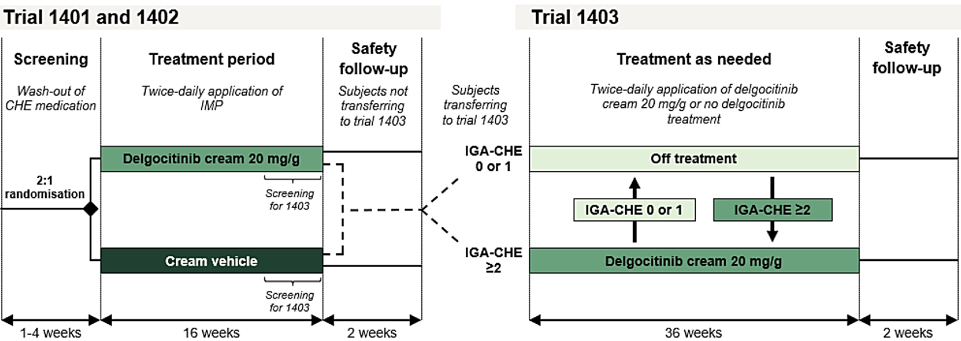
Abbreviations: CHE = chronic hand eczema; IGA-CHE = Investigators Global Assessment for chronic hand eczema; IMP = investigational medicinal product.
Choice of dose for the pivotal studies was based on results of the dose-ranging study 1273 (briefly summarised above under Pharmacokinetics). In this study 258 adults with mild to severe CHE and recent history of inadequate response to topical corticosteroid (or for whom topical corticosteroids were inadvisable) were randomised 1:1:1:1:1 to delgocitinib cream 1 mg/g, 3 mg/g, 8 mg/g, or 20 mg/g, or cream vehicle, randomisation stratified by severity of CHE according to the Investigator’s Global Assessment for CHE (IGA-CHE) and region. Study treatment was administered twice daily for 16 weeks; one 15 g tube of delgocitinib cream was considered maximum for treatment of the whole surface of both hands twice daily for one week. With regard to the primary endpoint, IGA-CHE treatment success defined as an IGA-CHE score of 0 (clear) or 1 (almost clear) with at least a 2-step improvement from baseline to week 16, delgocitinib cream 8 mg/g and 20 mg/g showed statistically significant treatment effect compared to vehicle, with responder rates of 36.5% and 37.4% respectively, compared to 8.0% in the vehicle group.
In the following sections study design, statistical analysis and results for the pivotal studies 1401 and 1402 will be described together.

Rating scales used in the pivotal studies
IGA-CHE is a single item clinician-reported outcome which assesses global disease severity at a given timepoint, developed and validated by the applicant based on the Physician’s Global Assessment. The subject’s disease is scored on a 5-point scale from 0 (clear) to 4 (severe), in terms of the clinical characteristics erythema, scaling, hyperkeratosis/lichenification, vesiculation, oedema, and fissures. The scale was used early in the clinical development program, in study 1273, and adjusted slightly for the pivotal studies based on discussion with health authorities. The Sponsor conducted analyses of the IGA-CHE using blinded data from the phase 3 study 1401, assessing quality of completion of IGA-CHE, test-retest reliability, construct validity, and ability to detect change. Clinically meaningful change in the IGA-CHE was determined using anchor-based and distribution-based approaches.
The Hand Eczema Severity Index (HECSI) is a validated clinician reported measure to assess severity and extent of CHE. A subject’s hand is divided into 5 areas, fingertips, fingers, palms of hands, back of hands, and wrists, and for each area the intensity of each of 6 clinical signs is scored from 0 (non/absent) to 3 (severe). The 6 clinical signs are erythema, induration/papulation, vesicles, fissures, scaling, and oedema. In addition, the extent (percentage) of the area affected within each hand area is scored as follows: 0 = 0%, 1 = 1-25%, 2 = 26-50%, 3 = 51-75%, and 4 = 76-100%. This extent score is then multiplied by the sum of intensity scores for each hand area. The total HECSI score may therefore range from 0 to 360, with higher scores indicating greater severity.
The Hand Eczema Symptom Diary (HESD) is a 6-item patient-reported instrument developed and validated by the Sponsor. Subjects assess the worst severity of their itch, pain, cracking, redness, dryness, and flaking over the past 24 hours, scored on an 11-point numeric scale from 0 (no symptom) to 10 (severe). The HESD score is an average of the 6 items.
The Hand eczema impact scale (HEIS) is a 9-item patient-reported instrument, developed and validated by the Sponsor, in which subjects assess how much their CHE impacts their daily activities (HEIS PDAL), embarrassment due to appearance of their hands, frustration with CHE, sleep, work, and physical functioning over the previous 7 days. Each item is rated on a 5-point scale, from 0 (not at all) to 4 (extremely). The HEIS score is the average of the 9 items, and 6 domain scores including HEIS PDAL can be calculated.
The Dermatology Life Quality Index (DLQI) is a validated patient-reported instrument consisting of 10 items addressing the subject’s perception of the impact of their skin disease over the last 7 days.

Pivotal studies, 1401 and 1402
Studies 1401 and 1402 were randomised, double-blind, vehicle-controlled efficacy and safety trials in adult subjects with moderate to severe CHE. Subjects were randomised 2:1 to delgocitinib cream 20 mg/g or cream vehicle to be applied twice daily for the 16-week treatment period. Study treatment was discontinued if rescue treatment was initiated for CHE. There was a 2-week off-treatment follow-up period for safety assessments, though subjects transferring to the long-term extension study 1403 did not complete the safety follow-up in the parent study. Key inclusion criteria included age over 18 years, CHE defined as hand eczema that had persisted for more than 3 months or returned twice or more within the preceding 12 months, IGA-CHE score of 3 or 4 at baseline, HESD itch score of ≥4 at baseline, a documented recent history of inadequate response to topical corticosteroids or for whom topical corticosteroids are documented to be otherwise medically inadvisable. Key exclusion criteria included concurrent skin diseases on the hands, active atopic dermatitis requiring medical treatment in regions other than the hands and feet, active psoriasis, hyperkeratotic hand eczema in combination with a history of psoriasis on any part of the body, clinically significant infection on the hands, systemic treatment with immunosuppressive drugs within 28 days prior to baseline, use of tanning beds, phototherapy or bleach baths on the hands within 28 days prior to baseline, and previous or current treatment with JAK inhibitors (oral or topical). Additional exclusion criteria based on medical history included clinically significant infection within 28 days prior to baseline, history of known primary immunodeficiency, history of cancer, ALT or AST ≥2x ULN at screening, and pregnant or lactating women.
Classification of CHE subtype was determined by the investigator according to the definitions outlined in Table 2. Of note, in European sites classification included mandatory diagnostic patch testing with at least a relevant baseline series including the most important contact allergens relevant to the locality; if subjects had a diagnostic patch test performed within 3 years prior to screening this could be used, otherwise, a patch test was to be completed preferably prior to the baseline visit, but no later than the 8 week visit.
Table 2. Classification of CHE by subtype, studies 1401 and 1402.
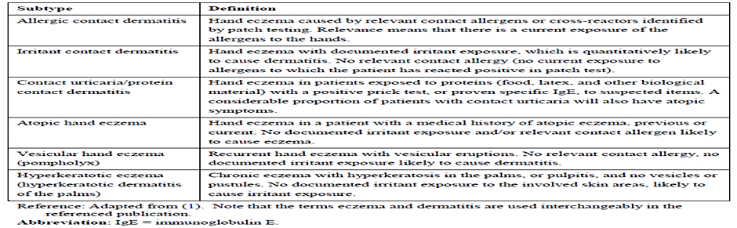
Study treatment was to be applied twice daily approximately 12 hours apart, for 16 weeks. Application of study treatment on initially affected areas and new lesions was to be continued regardless of clearance status until week 16, and was to be applied to clean, dry hands, fingers, fingertips, and wrists in a thin layer covering the affected areas. Subjects were to continue their usual skin care routine for the hands regarding emollients, however, emollients were not to be used on affected areas within 2 hours before and after application of study treatment. Rescue treatment could be initiated at the discretion of the investigator to treat intolerable CHE symptoms, resulting in discontinuation of study treatment.
The primary efficacy endpoint was IGA-CHE treatment success at week 16, defined as an IGA-CHE score of 0 or 1 (clear or almost clear) with at least a 2-step improvement from baseline. Key secondary efficacy endpoints included the following:
- HECSI-75 at weeks 8 and 16,
- HECSI-90 at week 16,
- IGA-CHE treatment success at weeks 4 and 8,
- Percentage change in HECSI score from baseline to week 16,
- Reduction of HESD itch score (weekly average) of ≥4 points from baseline at weeks 2, 4, 8, and 16,
- Reduction of HESD score (weekly average) of ≥4 points from baseline at weeks 4, 8, and 16,
- Reduction of HESD pain score (weekly average) of ≥4 points from baseline at weeks 4, 8, and 16,
- Reduction of Dermatology Life Quality Index (DLQI) score of ≥4 points from baseline at week 16,
- Change in HESD itch score (weekly average) from baseline to week 16,
- Change in HESD score (weekly average) from baseline to week 16,
- Change in HESD pain score (weekly average) from baseline to week 16,
- Change in HEIS score from baseline to week 16,
- Change in HEIS PDAL score from baseline to week 16,
- Change in DLQI score from baseline to week 16.
In terms of sample size calculations, with a one-sided significance level of 2.5% a sample size of 470 subjects randomised in study 1401 and 450 subjects randomised in study 1402 would provide at least 99% power for detecting a treatment difference for the primary endpoint, assuming an IGA-CHE treatment success response rate at week 16 of 40% compared to 10% for cream vehicle, based on results of the phase 2b study 1273. Randomisation of subjects was stratified by region, Europe or North America, and baseline IGA-CHE score, 3 or 4.
In terms of statistical analysis, for the primary and key secondary endpoints confirmatory one-sided superiority hypotheses were tested for delgocitinib cream 20 mg/g versus cream vehicle based on the primary analysis for the primary estimand. A closed testing procedure with hierarchical tests, alpha splitting and alpha recycling was used to control the overall type I error at a nominal one-sided 2.5% level. Superiority was to be established for the primary endpoint before testing of key secondary endpoints was to proceed. If a test was significant, the significance level was reallocated according to the weight and direction of the arrows as specified in Figure 2. Each of the following hypotheses were to be tested at their local significance level, with the process repeated until no further tests were significant.
Figure 2. Schema of closed testing procedure for primary and key secondary efficacy endpoints, studies 1401 and 1402.
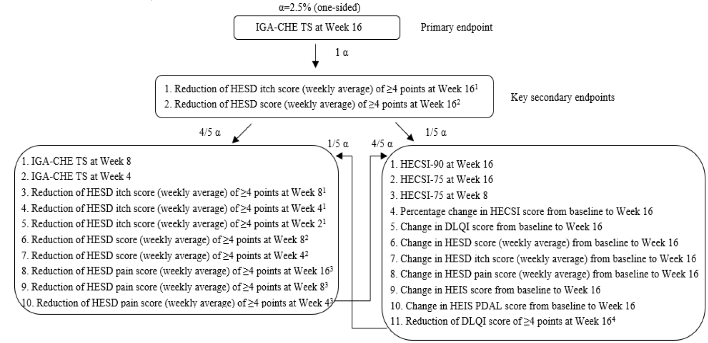
Abbreviations: DLQI = Dermatology Life Quality Index; HECSI = Hand Eczema Severity Index; HECSI-75 = at least 75% improvement in HECSI score from baseline; HECSI-90 = at least 90°o improvement in HECSI score from baseline; HEIS = Hand Eczema Impact Scale; HESD = Hand Eczema Symptom Diary; IGA-CHE = Investigator’s Global Assessment for chronic hand eczema; IGA-CHE TS = IGA-CHE treatment success, i.e. an IGA-CHE score of 0 (clear) or 1 (almost clear) with a >2-step improvement from baseline; PDAL = Proximal Daily Activity Limitations.
Efficacy endpoints were analysed using the Full Analysis Set (FAS), comprising all subjects randomised and exposed to study treatment, whilst safety endpoints were analysed in the Safety Analysis Set (SAF), comprising all subjects exposed to study treatment.
Three estimands were defined for binary and continuous endpoints, the primary estimand termed composite, the first supplementary estimand termed pandemic modified composite strategy, and the second supplementary estimand termed treatment policy strategy. For time-to-event endpoints a ‘while on treatment’ strategy was used that evaluated response to treatment prior to the occurrence of the intercurrent event of interest. The primary estimand composite strategy evaluated the treatment effect in adult subjects with moderate to severe CHE, without initiation of rescue treatment or permanent discontinuation of study treatment. Binary endpoints were assessed as the difference in response rates between delgocitinib cream 20 mg/g and cream vehicle. The difference in response rates between the two treatment groups were analysed using the Cochran-Mantel-Haenszel (CMH) test stratified by region and baseline IGA-CHE score, with the difference in response rates with 95% CI calculated by the Mantel-Haenszel method. For continuous endpoints the population level summary was the difference in mean change (or percentage change) from baseline to the endpoint of interest between treatment groups. Non-response imputation was done using worst observation carried forward (WOCF). The change from baseline to the endpoint of interest was analysed using an ANCOVA model with effects of treatment group, region, baseline IGA-CHE score, and baseline value. Least squares means were estimated using observed margins, with the difference in LS means between treatment groups presented along with 95% CI and nominal p-value.
Overall, in study 1401, 566 subjects were screened and 487 randomised, whilst in study 1402 557 subjects were screened and 473 randomised, with all randomised subjects included in the FAS. Proportion of subjects completing the trial was greater than 90% among all treatment groups in both studies, with the exception of the cream vehicle group in study 1402 (79.9% completion). In study 1401 there were 118 important protocol deviations reported at the subject-level in total, including 14 related to violation of eligibility criteria, and 94 subject-level deviations not related to eligibility criteria that were considered to impact results for individual subjects. In study 1402 there were 115 important protocol deviations at subject-level, 23 related to violation of eligibility criteria, and 83 subject-level violations not related to eligibility criteria considered to impact results for individual subjects.
Baseline demographics for randomised subjects in both pivotal studies 1401 and 1402 are presented in Table 3, whilst baseline disease characteristics are presented in Table 4.
Table 3. Baseline demographics, randomised subjects, studies 1401 and 1402
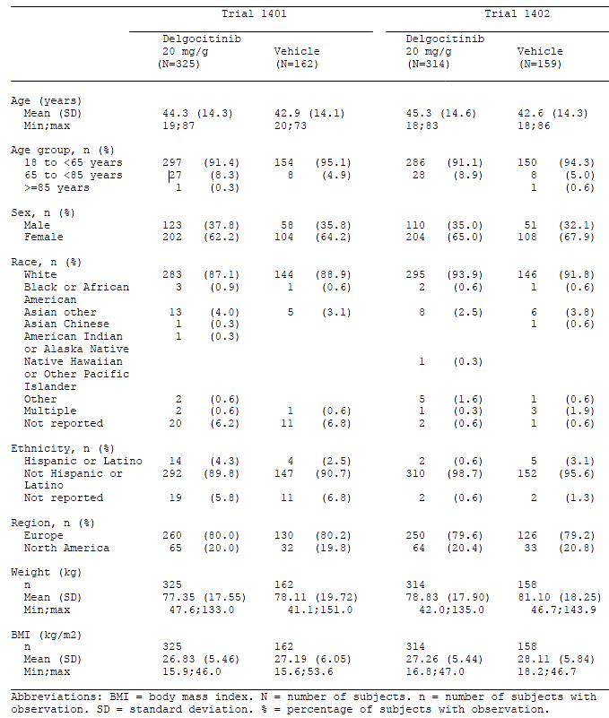
Abbreviations: BMI = body mass index; N = number of subjects; n = number of subjects with observation; SD = Standard deviation; % = percentage of subjects with observation.
Table 4. Baseline disease characteristics, randomised subjects, studies 1401 and 1402.
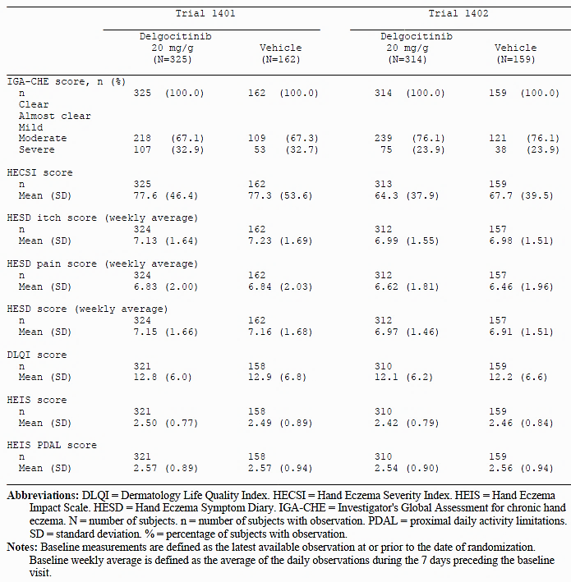
Abbreviations: DLQI = Dermatology Life Quality Index. HECSI = Hand Eczema Seventy Index. HEIS = Hand Eczema Impact Scale. HESD = Hand Eczema Symptom Diary. IGA-CHE = Investigator's Global Assessment for chronic hand eczema. N = number of subjects. n = number of subjects with observation. PDAL = proximal daily activity limitations. SD = standard deviation. % = percentage of subjects with observation.
Notes: Baseline measurements are defined as the latest available observation at or prior to the date of randomization. Baseline weekly average is defined as the average of the daily observations during the 7 days preceding the baseline visit.
Of note, baseline disease severity measured by IGA-CHE score was slightly higher in study 1401, with 32.9% of subjects in the delgocitinib cream group and 32.7% of subjects in the cream vehicle group respectively classified as severe, compared to 23.9% in both treatment groups in study 1402. Mean HECSI score at baseline, and weekly average HESD itch score at baseline, were also slightly higher in both treatment groups in study 1401 compared to the corresponding treatment groups in study 1402. There were some minor differences across the studies in terms of duration of CHE and hand eczema subtype, as summarised in Table 5.
Table 5. Characteristics of chronic hand eczema diagnosis, randomised subjects, studies 1401 and 1402.
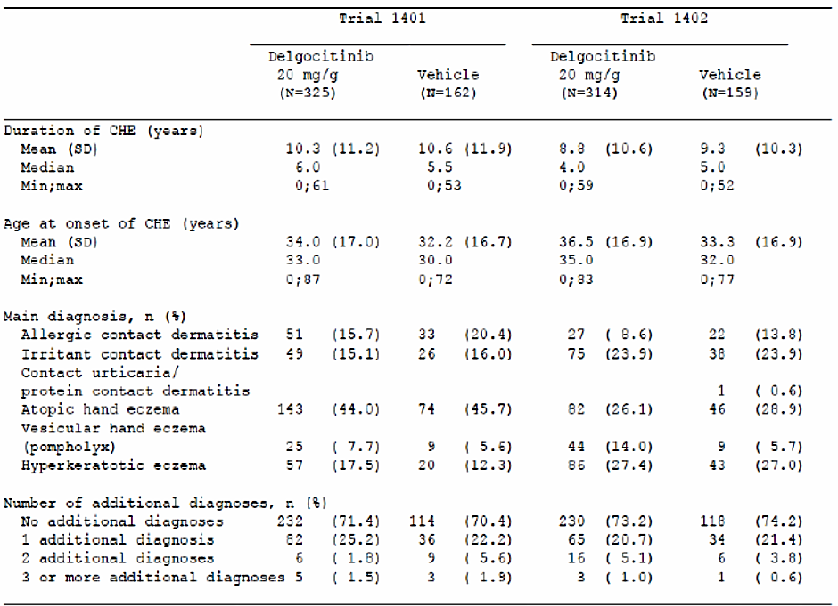
Abbreviations: CHE = chronic hand eczema. N = number of subjects. n = number of subjects with observation. SD = standard deviation. % = percentage of subjects with observation.
Notes: Duration of CHE is calculated as the year of screening minus year of CHE diagnosis. Age at onset of CHE is calculated as the age of the subject minus the duration of CHE (years).
Almost all subjects across the pivotal studies had used previous treatment for CHE, the most common recorded being potent (Group III) topical corticosteroids, with other potency topical corticosteroids, topical calcineurin inhibitors, oral corticosteroids and oral retinoids also recorded across the studies. Reflective of study inclusion criteria, almost all subjects in both studies had inadequate response to topical corticosteroids in the last 12 months recorded.
In terms of results, Table 6 summarises results for the primary and all key secondary efficacy endpoints for both pivotal studies, 1401 and 1402. All endpoints were statistically significant according to the pre-determined statistical analysis plan. Of note, all IGA-CHE and HECSI based endpoints showed greater treatment difference between delgocitinib and cream vehicle, in favour of delgocitinib, in study 1402 compared to study 1401.
Table 6. Results for primary and key secondary efficacy endpoints, primary (composite) estimand, studies 1401 and 1402.
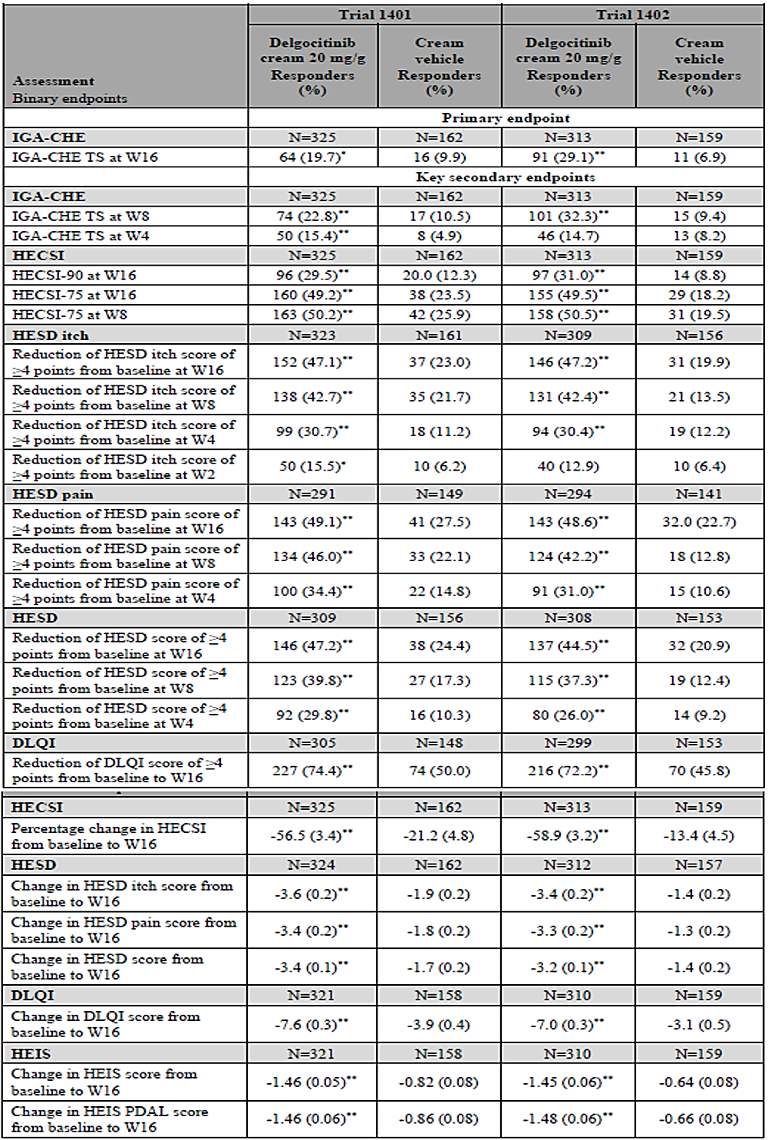
Abbreviations: DLQI—Dermatology Life Quality Index. HECSI=Hand Eczema Severity Index. HECSI-90=at least 90% improvement m HECSI score from baseline. HECSI-75=at least 75% improvement in HECSI score from baseline. HEIS=Hand Eczema Impact Scale. HES D=Hand Eczema Symptom Diary. IGA-CHE=Investigator’s Global Assessment for chronic hand eczema IGA-CHE TS=IGA-CHE treatment success, i.e. an IGA-CHE score of 0 (clear) or 1 (almost clear) with a :>2-step improvement from baseline. LSMean=least squares mean. N=number of subjects with data available at baseline. PDAL=proximal daily activity limitations. SE=standard error. W=week.
Notes: The treatment difference was statistically significant with adjustment for multiplicity for all endpoints. Endpoints are not presented in the order of the testing hierarchy.
*p=:0.01. **p<0.001
Analyses using the first supplementary and second supplementary estimands were supportive of the primary analysis. Across the studies there was a reduction in treatment compliance over time. In study 1401 rescue treatment was used by 7 (2.2%) subjects in the delgocitinib group and 7 (4.3%) in the vehicle group, compared to 3 (1.0%) subjects and 12 (7.5%) subjects respectively in study 1402. Figure 3 demonstrates onset of efficacy in terms of the primary endpoint IGA-CHE treatment success, as measured at Weeks 1, 2, 4, 8, 12, and 16, data presented individually for studies 1401 and 1402, and pooled.
Figure 3. IGA-CHE treatment success by visit, studies 1401, 1402 and pooled results.
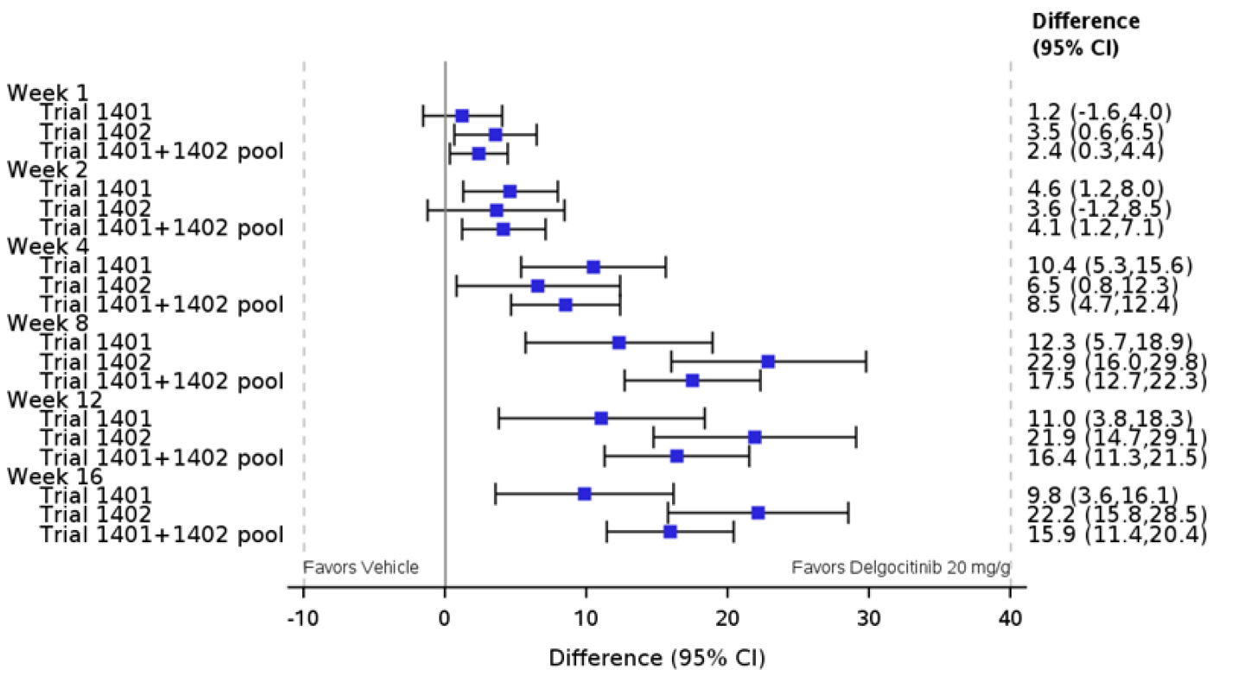
Abbreviations: CI = confidence interval. IGA-CHE = Investigator’s Global Assessment for chronic hand eczema. IGA-CHE TS = IGA-CHE treatment success i.e. IGA-CHE score of 0 (clear) or 1 (almost clear) with a ≥2-step improvement from baseline. IMP = investigational medicinal product.
Notes: Responders were defined as subjects who achieved IGA-CHE TS. Composite estimand: data considered non-response if observed after initiation of rescue treatment or after permanent discontinuation of IMP. Missing data imputed as non-response. For Trials 1401 and 1402: Both the Mantel-Haenszel risk difference and Cochran-Mantel-Haenszel test were stratified by region and baseline IGA-CHE score. For the 1401 and 1402 pool: Both the Mantel-Haenszel risk difference and Cochran-Mantel-Haenszel test were stratified by trial, region and baseline IGA-CHE score.
Subgroup analysis based on the primary efficacy endpoint using pooled data from studies 1401 and 1402 showed generally consistent treatment difference between delgocitinib cream 20 mg/g and cream vehicle within subgroups based on age, sex, body mass index, weight, race, ethnicity and region. In terms of subgroups according to disease severity and hand eczema subtype treatment difference was generally similar between subgroups, with the exception of hyperkeratotic eczema; IGA-CHE treatment success was recorded for 15/143 (10.5%) subjects in the delgocitinib group and 5/63 (7.9%) subjects in the cream vehicle group, with treatment difference 2.1 (95% CI -6.8, 11.0).

Long-term extension study, 1403
Study 1403 was the open-label extension study for parent studies 1401 and 1402, comprising screening (weeks -4 to week 0), with baseline visit on Day 1 at the same time as the end-of-treatment visit for the parent study. The treatment period for study 1403 was 36 weeks, in which subjects received delgocitinib cream 20mg/g twice daily as needed, with a 2-week safety follow-up from weeks 36 to 38. Inclusion in study 1403 reflected the criteria for the parent studies; subjects must have completed the treatment period in the parent study, have complied with the clinical trial protocol in the parent study to the satisfaction of the investigator, and women of childbearing potential must have used acceptable form of birth control. Exclusion criteria for study 1403 included subjects who prematurely discontinued treatment or initiated rescue treatment in the parent study, and those who experienced an adverse event in the parent trial which precluded further treatment in the opinion of the investigator.
At baseline (Day 1) subjects were evaluated by the investigator to determine CHE severity, those with IGA-CHE score of 0 or 1 were not assigned treatment with delgocitinib but continued routine skin care with emollient. Subjects with IGA-CHE ≥2 started treatment with twice-daily delgocitinib cream 20 mg/g and continued until IGA-CHE score of 0 or 1 was achieved. If a subject experienced worsening CHE symptoms while off-treatment they were to contact the study site to schedule a visit, and if IGA-CHE score ≥2 was confirmed delgocitinib was commenced. Similarly, if a subject observed improvement in CHE symptoms on-treatment, they were to contact the study site to schedule a visit, and if IGA-CHE score of 0 or 1 was confirmed, they were instructed to stop delgocitinib treatment and return any unused cream. Rescue treatment could be used at the discretion of the investigator, at which time delgocitinib treatment was discontinued and the subject withdrawn from the study.
The primary endpoint was number of treatment-emergent adverse events (TEAEs) from baseline to week 36, summarised below in safety, while secondary endpoints included efficacy measures as follows:
- IGA-CHE score at each scheduled visit from baseline up to week 36,
- IGA-CHE score of 0 (clear) or 1 (almost clear) at each scheduled visit from baseline to week 36,
- HECSI score at each scheduled visit from baseline to week 36,
- HECSI-75 at each scheduled visit from baseline to week 36,
- HECSI-90 at each scheduled visit from baseline to week 36.
No sample size calculation as undertaken, with expected sample size of 600 based on enrolment in parent studies, and no comparative analyses were performed.
In total 810 subjects were screened, and 801 enrolled, 560 of which had received delgocitinib as study treatment in the parent study, and 241 of which had received cream vehicle in the parent study. Proportion of subjects completing treatment in study 1403 was 82.9%, with lack of efficacy and withdrawal by subject the most common reasons recorded for discontinuation.
There were 14 important subject-level protocol deviations considered to impact results for the subjects, with 9 of these related to missing/late primary endpoint assessment. There were site-level deviations relating to blood pressure assessments, concerning 34 subjects.
Baseline demographics were generally reflective of those recorded for the parent studies. Disease characteristics at baseline are summarised in Table 7, according to parent trial treatment group.
Table 7. Baseline disease characteristics, study 1403, by parent study treatment group.
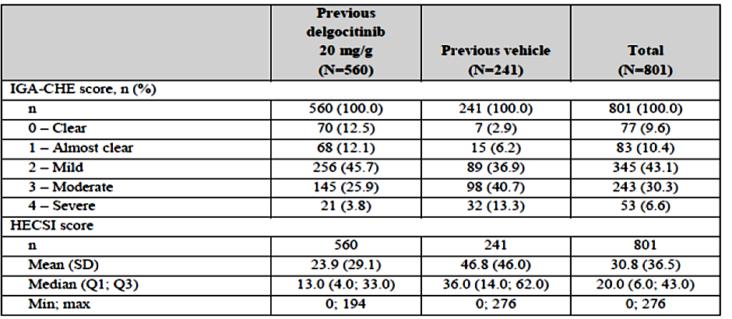
Abbreviations: HECSI = Hand Eczema Severity Index; IGA-CHE = Investigator’s Global Assessment for chronic hand eczema; max = maximum; min = minimum; N = number of subjects; n = number of subjects with observation; Q1 = first quartile; Q3 = third quartile; SD = standard deviation.
Table 8 provides a summary of secondary efficacy endpoints for study 1403, presenting results for IGA-CHE score 0 or 1, HECSI-90 and HECSI-75 at study 1403 baseline and week 36, by parent trial treatment group.
Table 8. Summary of key secondary efficacy endpoints, study 1403, full safety population.
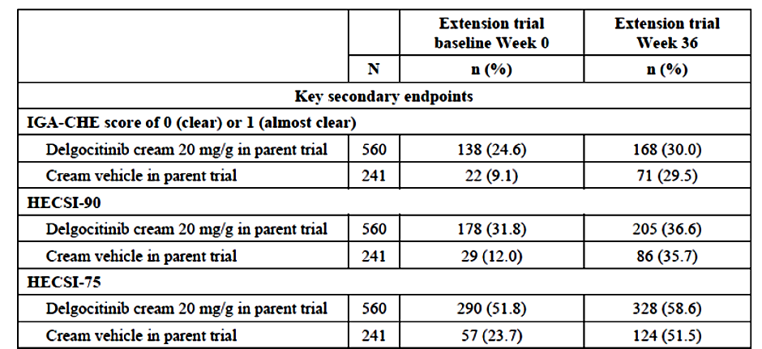
IGA-CHE treatment success responders treated with delgocitinib in the parent studies started the extension study, 1403, off treatment (n=138), and while being off treatment the estimated median time to first IGA-CHE score of ≥2 for these subjects was 4 weeks; whilst off treatment, estimated proportion of these subjects maintaining IGA-CHE score of 0 or 1 was 40.6% at week 4, and 28.3% at week 8.
IGA-CHE treatment success non-responders treated with delgocitinib in the parent studies started the extension studies on treatment (n=422), of whom, estimated cumulative portion with IGA-CHE score of 0 or 1 at the end of the treatment period was 48.1%.
For IGA-CHE treatment success non-responders treated with cream vehicle in the parent studies (n=219), the estimated cumulative portion with IGA-CHE score of 0 or 1 at the end of the treatment period was 54.4%.
Of 138 IGA-CHE treatment success responders treated with delgocitinib in the parent studies, 122 re-initiated delgocitinib during study 1403 upon getting IGA-CHE score of ≥2 during the first off-treatment period, with estimated median time to regain IGA-CHE score of 0 or 1 of 8 weeks.

Summary of EMA assessment of clinical pharmacology and efficacy
Questions to the Sponsor relating to efficacy are included in the EMA Day 80 Assessment Report and addressed in the Day 150 Clinical Joint Assessment Report provided in the dossier. The EMA noted that the most conclusive results were seen for atopic hand eczema and irritant contact dermatitis CHE subtypes, and questioned extrapolation of efficacy data from the pivotal studies to a general CHE population given that the subtypes nummular hand eczema and pulpitis were not included as specific subtypes in the pivotal studies, whilst there was minimal efficacy data from subjects with chronic urticaria/protein contact dermatitis. The Sponsor’s justification included overlap between the different CHE subtypes, in particular the frequent coexistence of nummular hand eczema and pulpitis with more common subtypes including irritant contact dermatitis, allergic contact dermatitis, and atopic hand eczema, as well as the commonality of pathophysiology between the subtypes.
With respect to pharmacodynamics the EMA noted the exploratory nature of investigations using PD biomarkers and S.aureus colonisation in studies 1180, 1273, and 1401, requesting that this information be removed from the SmPC. The Sponsor argued that PD investigations were conducted using standardised and validated methods, and that PD information was highly relevant to prescribers, particularly considering that CHE represents an unprecedented indication. This was not accepted by the EMA, however, the Rapporteur suggested inclusion of a general sentence in the SmPC relating to S.aureus colonisation. The ‘pharmacodynamic effects’ section of the final SmPC does not contain information relating to PD biomarkers or S.aureus colonisation; it is noted that the Sponsor has sought to include this information in the proposed Australian PI.
The EMA asked the Sponsor to elaborate on observed difference in size of treatment effect for the primary efficacy endpoint between the pivotal studies 1401 and 1402, with a larger magnitude treatment effect observed in study 1402. The Sponsor conducted a simulation study to test random variability, seeking to demonstrate statistical variability as at least partially implicated in the observed difference in treatment effect. The EMA accepted this as a contributory factor but also noted that systematic differences in baseline demographics and disease characteristics were also likely implicated, however, did not pursue this issue further.
With respect to long-term efficacy beyond 16 weeks, following a question regarding utility of efficacy data from study 1403 to determine long term efficacy, it was agreed by the EMA that efficacy data from this long-term extension study was sufficient to support chronic use of delgocitinib on an as-needed basis.
In response to agency questions the Sponsor provided greater detail regarding efficacy results from the long-term extension study 1403 sufficient for the EMA to agree that, in the case of incomplete efficacy response at week 16 of treatment, further improvement may be seen with continued twice daily use, independent of CHE subtype, CHE severity or duration. On this basis, continuation past 16 weeks for partial responders was considered justifiable, though no firm direction on maximum treatment duration could be made. Based on the provision of further analysis of efficacy data from study 1403 by the Sponsor, it was also accepted by the EMA that, for subjects re-initiating delgocitinib treatment, treatment response can be regained in approximately the same timeframe as for initial treatment, approximately 8 weeks, though with clinically relevant improvement seen from week 2 based on HESD pain and itch scores.
Overall, according to the Day 210 Assessment Report, the EMA considered the instruments used for clinical efficacy measurement, including those developed by the Sponsor, to be fit for purpose, and choice of primary and secondary efficacy endpoints was considered to adequately reflect both clinician’s and patient’s view on CHE. Statistical methods were considered appropriate. Results for primary and key secondary efficacy endpoints were considered to demonstrate clinically relevant benefit for moderate to severe CHE.

Safety
Evaluable safety data was mainly obtained from the pivotal Phase 3 studies 1401 and 1402, their open-label extension study 1403, and the Phase 2b study 1273. Safety data from the following additional studies was also included:
- Study 2285, Phase 1 PK study in adult subjects (N= 16 subjects exposed to delgocitinib),
- Study 1180, phase 2a study in adult subjects (N= 91),
- Study 1181, maximal use study in paediatric and adult subjects (N= 46),
- Study 1275, Phase 2b study in adult subjects (N= 250),
- Study 1408, investigating phototoxic potential in healthy subjects (N= 35),
- Study 1411, investigating photoallergic potential in healthy subjects (N= 60),
- Study 1409, a cardiovascular/QTc study with systemically administered delgocitinib (N= 40),
- Study 1426, an ongoing Phase 3 study in adolescent subjects 12-17 years (N= 92),
- Study 1528, an ongoing Phase 3 study in adult subjects (planned N= 510).
For the safety evaluation data were integrated into the following 4 pools:
Primary pool: safety data from studies 1273, 1401, and 1402. These studies provided 16-week controlled trial design for comparison of delgocitinib and cream vehicle,
- Long-term safety pool: safety data from studies 1401, 1402, and 1403, used as the main source of the evaluation of long-term safety up to 52 weeks.
- Intermittent-use pool: safety data from studies 1401, 1402, and 1403, used to supplement evaluation of long-term safety of as-needed treatment after 16 weeks of continuous treatment, data presented according to treatment in the corresponding feeder studies 1401 and 1402.
- Exposure pool: safety data from all trials (1181,1273,1275,1401,1402, 1403 and 2285) with delgocitinib cream in 1, 3, 8, or 20 mg/g concentrations.
Patient exposure was calculated for each pool based on patient-years of observation (PYO), accounting for intermittent exposure in study 1403 For the primary pool calculated PYO was 214.72 years, for the long-term safety pool PYO was 603.08 years, for the intermittent-use pool PYO was 573.21 years, and for the exposure pool PYO was 729.13 years (Table 9). All adverse events were described as treatment-emergent, that is starting after the first application of study treatment, or if starting prior, worsening after the first application.
Table 9. Overall extent of exposure by trial and by pool
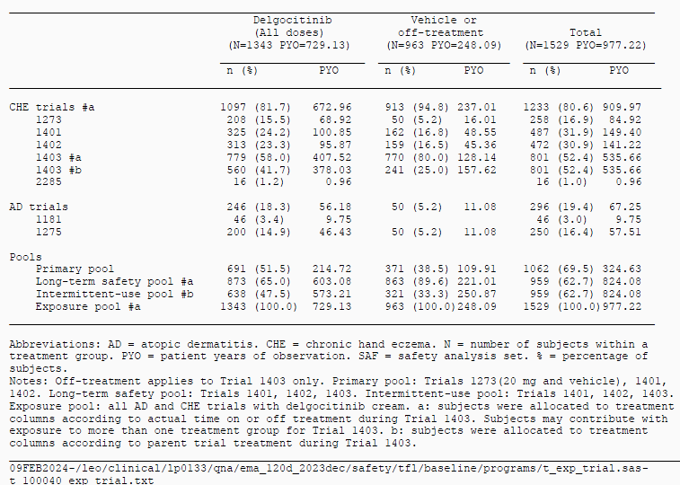
Abbreviations: AD = atopic dermatitis. CHE = chronic hand eczema. N = number of subjects within a treatment group. PYO = patient years of observation. SAF = safety analysis set. % = percentage of subjects.
Notes: Off-treatment applies to Trial 1403 only. Primary pool: Trials 1273(20 mg and vehicle), 1401, 1402, Long-term safety pool: Trial 1401, 1402, 1403. Intermittent-use pool: Trials 1401, 1402, 1403. Exposure pool: all AD and CHE trials with delgocitinib cream. a: subjects were allocated to treatment columns according to actual time on or off treatment during Trial 1403. Subjects may contribute with exposure to more than one treatment group for Trial 1403. b: subjects were allocated to treatment columns according to parent trial treatment during Trial 1493.

Common adverse events
Overall proportion of subjects with adverse events (AEs) and calculated event rates were similar for delgocitinib cream 20 mg/g and cream vehicle; 48.2% and 49.0%, and 315.0 and 334.7 events/PYOx100, respectively. Severe AEs (2.1% and 2.7% of subjects, and 9.5 and 15.8 events/PYOx100, respectively) and serious AEs (SAEs) (1.5% and 1.7% of subjects, 5.4 and 7.6 events/PYOx100, respectively) were also similar between delgocitinib and vehicle. Overall, the majority of AEs were non-serious, mild or moderate in intensity, and resolved before the end of the studies.
In the primary pool the most common AEs by system-organ class (SOC) was infection and infestations, primary driven by the preferred terms (PTs) COVID-19 and nasopharyngitis, and skin and subcutaneous tissue disorders, primarily driven by PTs hand dermatitis and eczema. Figure 4 gives an overview of most common AEs in the primary pool, comparing delgocitinib cream 20mg/g and cream vehicle for each AE, and categorised according to severity.
Figure 4. Most common adverse events (≥1%), primary pool.
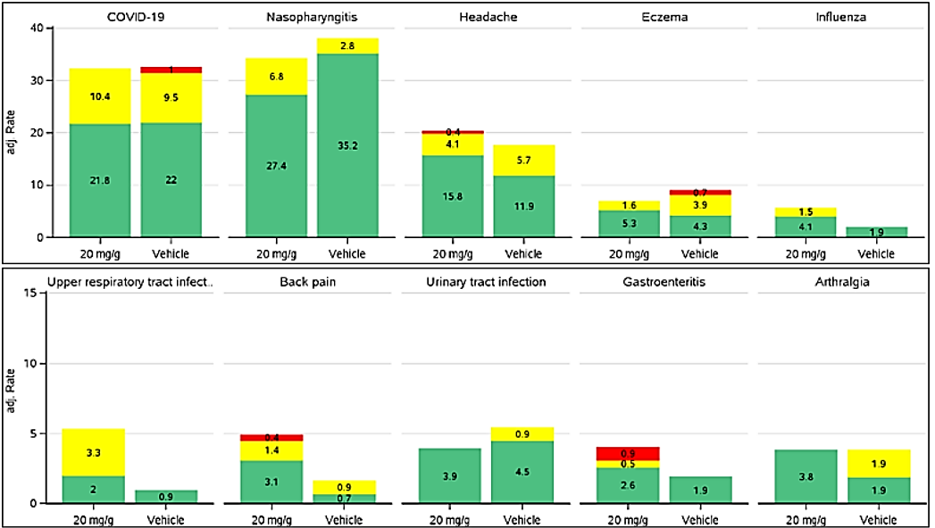
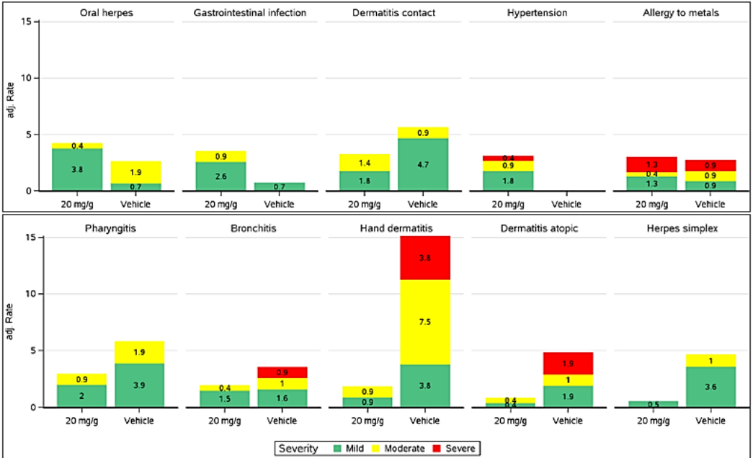
Abbreviations: Adj. = adjusted; AE = adverse event; E = number of events; IMP = investigational medicinal product; MedDRA = Medical Dictionary for Regulatory Activities; PT = preferred term; PYOs patient years of observation; SAF = safety analysis set. R = (E/PYO)*100; COVIO-19 = coronavirus disease 2019.
Notes: AEs with start date on or after the date of first IMP application or with a worsening in severity after first IMP application are included. Classification according to MedDRA version 24.0. Treatment groups are defined as actual treatment. AEs are sorted by decreasing percentages in treatment column delgocitinib 20 mg/g. P is calculated as number of days from first IMP application in parent trial to end of trial divided by 365.25. % and rate are adjusted based on the number of subjects in each trial.
Back pain and hypertension were reported more frequently for subjects receiving delgocitinib compared to vehicle; hypertension was reported for 7 subjects (1.0%, 3.1 events / PYOx100) receiving delgocitinib vs 0 subjects with vehicle, and back pain was reported for 10 subjects (1.6%, 4.9 events / PYOx100) receiving delgocitinib compared to 2 subjects (0.5%, 1.6 events / PYOx100) with vehicle. The Sponsor considered these imbalances to be random in nature and not of clinical significance, with their analysis showing no clustering with respect to time to onset.
Most AEs overall in the primary pool were mild or moderate in intensity. Severe AEs were reported in 2.1% subjects receiving delgocitinib and 2.7% receiving cream vehicle. In the Long-term pool there were 14 subjects (1.6%) in the delgocitinib group with a severe AE in the SOC infections and infestations, corresponding to an adjusted event rate of 2.7 events / PYOx100.
In terms of AEs considered possibly or probably related to study treatment by the investigator, the overall proportion was lower for delgocitinib (6.0% of subjects) compared to cream vehicle (8.2%), with most classified as mild. In total 3 severe AEs related to study treatment were reported: 1 event of streptococcal infection in the delgocitinib group, and 2 events of hand dermatitis for 2 subjects in the cream vehicle group. None of the SAEs were judged by the investigator or the sponsor as being related to IMP.

Deaths
Three deaths were reported across the delgocitinib clinical development program, all in the extension study 1403. All events were assessed as not related to treatment with delgocitinib cream by both the investigator and Sponsor.

Serious adverse events
In the Primary pool reporting frequencies and calculated rates of SAEs were similar for delgocitinib (1.5% of subjects, 5.4 events /PYOx100) and vehicle (1.7% of subjects, 7.6 events /PYOx100). No SAEs were considered related to study treatment. There was a numerical imbalance in reporting of events in the SOC infections and infestations, with 4 subjects reporting 4 events in the delgocitinib group and none in the vehicle group; there was no pattern in type of infection, and no events were related to the treatment area. There was one reported SAE of epilepsy in a 20-year-old female subject with no past history of seizures but a family history of epilepsy or seizures, occurring 10 days after first dosing of delgocitinib, and one reported SAE of generalised tonic-clonic seizure in a 27-year-old female subject occurring 6 days after first administration of delgocitinib.
In the Exposure pool reporting rates of SAE were similar for delgocitinib (2.8% of subjects, 6.0 events /PYOx100) and vehicle (1.5% of subjects, 7.3 events /PYOx100), with no SAEs considered related to study treatment.

Discontinuation due to adverse events
In the Primary pool AEs leading to withdrawal and/or permanent discontinuation were reported at low frequencies overall, with higher frequency in the vehicle group (4.5% of subjects) compared to the delgocitinib group (1.0% of subjects). The most common reason for discontinuation was hand dermatitis.

Safety focus areas
The safety focus areas (SFA) of ‘dermal safety’ covered PTs application site reactions, acnes, local skin infections, skin atrophy, and local tolerability. There were also dedicated studies to investigate phototoxic and photoallergic potential (studies 1408 and 1411). In the primary pool local skin infections were reported at similar rates in the delgocitinib and cream vehicle groups, with all mild or moderate intensity. Application site reactions were reported less frequently in the delgocitinib group (1.0% subjects, 4.1 events / PYOx100) than in those who received vehicle (2.5% subjects, 10.4 events / PYOx100), implicating excipients in the cream formulation rather than the delgocitinib active ingredient. All application site reactions were classified as mild or moderate intensity, with >75% of events in the delgocitinib group having an early onset, within the first week of treatment. Application site reactions were determined by the Sponsor to be a common adverse drug reaction (ADR).
Results from study 1408 regarding phototoxic potential showed positive reactions in between 4 and 10 subjects (11% to 29%) across 5 treatments, delgocitinib 1, 3, 8, and 20 mg/g and cream vehicle, at 24 or 48 hours after irradiation. All subjects experiencing a positive skin reaction on study treatment also experienced a skin reaction on cream vehicle. No reactions rated higher than score 1 (erythema). The Sponsor concluded no clinically relevant difference between study treatment and cream vehicle at 24 or 48 hours after irradiation. In the photoallergic potential study 1411 there were no positive skin reactions recorded.
For the SFA allergic reactions, in the primary pool this was reported in 5.4% subjects on delgocitinib compared to 10.0% subjects on cream vehicle, with the Sponsor concluding that no event captured by ‘allergic reactions’ appeared to reflect genuine allergic reaction to delgocitinib cream. The reported rate of allergic reactions was lower in the Long-term safety pool compared to the primary pool for both treatment groups.
The SFA ‘serious or severe infection’ was reported in 7 subjects (1.0%) in the delgocitinib group and 2 subjects (0.6%) in the cream vehicle group, corresponding to adjusted event rates of 3.6 events / PYOx100, and 1.9 events / PYOx100, respectively. One of these events was a severe streptococcal skin infection in a subject who received delgocitinib cream, leading to withdrawal from the study. In the Long-term safety pool 20 subjects (2.3%) in the delgocitinib group and 7 subjects (0.8%) in the vehicle/off-treatment group had serious or severe infections recorded, adjusted event rates of 3.6 events /PYOx100 and 3.2 events /PYOx100, respectively. Given this numerical imbalance the Sponsor undertook further analysis of serious and severe infection based on the Long-term safety pool, concluding that there was no increase in the rate of serious or severe infections for subjects treated with delgocitinib as needed beyond 16 weeks, and that no causal relationship was found between delgocitinib and serious or severe infections based on low overall numbers of events, no pattern or clustering of individual event types, and similar proportions of subjects with events across treatment groups. Furthermore, spreading of serious or severe infections to become systemic or disseminated, which could be suspected of a systemic immunosuppressant, was not observed.
For the SFA herpes viral infections reported rates were similar between delgocitinib (1.3% subjects, 4.7 events /PYOx100) and vehicle (2.1% subjects, 8.1 events /PYOx100), with all events non-serious and mild or moderate intensity. No events were considered by the investigator as related to delgocitinib. In the Long-term safety pool 18 subjects (2.1%) had a herpes viral infection in the delgocitinib group, and 11 subjects (1.3%) in the vehicle group, corresponding to event rates of 3.5 events /PYOx100 and 5.9 events /PYOx100, respectively. Three events of the PT herpes zoster were reported in study 1403, 2 reported while on treatment and one while off treatment, all classified as mild or moderate and judged by the investigator not related to study treatment. According to the Sponsor, based on low number and event rates, and the similar proportion of subjects with events across treatment groups, no causal relationship between delgocitinib and herpes viral infections was identified.
An SFA low blood cell count was reported in 7 subjects on delgocitinib compared to one subject on vehicle in the primary pool, with all events classified as non-serious, mild or moderate in intensity, and transient in nature. Three subjects in the delgocitinib group had low levels of lymphocytes or lymphopenia reported, although their lymphocyte counts were within normal range (>1.0 x10⁹ cells/L). None of these events were considered related to study treatment by investigators. In the Long-term safety pool 7 additional events of ‘lymphocytopenia’ were reported by 5 subjects, including 5 events reported by 4 subjects while on delgocitinib and 2 events reported by 2 subjects while off treatment; of these 2 subjects had lymphocyte counts <1.0 x10⁹ cells/L, one subject on day 256 while on treatment (0.7 x10⁹ cells/L) and one subject on day 238 while off treatment (0.9 x10⁹ cells/L). The Sponsor assessed results as not of clinical significance and identified no causal relationship with delgocitinib.
The SFA elevated lipid parameters was recorded for 15 subjects (2.1%, 8.1 events /PYOx100) for delgocitinib and 5 subjects (1.4%, 6.5 events /PYOx100) for vehicle in the primary pool. In the Long-term safety pool, there was no increase in reporting of elevated lipids over time. No clinically relevant changes or differences between treatment groups was observed for any lipid parameter based on evaluation of mean laboratory values over time, shifts from baseline to end of treatment, and individual subject abnormalities across treatment groups. The Sponsor concluded no causal relationship with delgocitinib.
No cases, either based on AE reports or laboratory measurements, of drug-induced liver injury (Hy’s law) or hepatic failure were reported. Hepatic AEs were reported by overall few subjects in either treatment group, with no clustering observed. In the Long-term pool AEs in the SOC hepatobiliary disorders and hepatic AEs in the SOC investigations were reported at low (<1%) frequencies, with no clustering noted.
No events of deep vein thrombosis, pulmonary embolism, cardiovascular events of interest, or Torsades de pointes/QT prolongation were reported with delgocitinib in the Exposure pool. Based on four safety focus area searches, ‘embolic and thrombotic events’, ‘cardiovascular events of interest’, ‘all-cause mortality’, and ‘Torsades de pointes/QT prolongation’, 6 subjects had events captured, 2 subjects while on delgocitinib cream and 4 while on cream vehicle or off treatment, or during safety follow-up.
Study 1409 was a QTc study based on orally administered delgocitinib, with a randomised, double-blind, placebo-controlled, parallel-group, single-dose, single-centre design, conducted in healthy subjects. The study was performed in 2 parts, each containing 2 dose cohorts, each cohort consisting of 8 subjects receiving a single dose of delgocitinib and 2 subjects receiving placebo. The 2 dose levels evaluated in Part 1 were 6 mg (Cohort A) and 12 mg (Cohort B), and the 2 dose levels evaluated in Part 2 were 3 mg (Cohort C) and 1.5 mg (Cohort D). In total 40 subjects received delgocitinib, with all included in the safety analysis set and in QT/QTc analysis set. The primary analysis was based on concentration-QTc modelling of the relationship between delgocitinib plasma concentrations and change from baseline in QTcF with the intent to exclude an effect of placebo-corrected change from baseline in QTcF >10 msec at clinically relevant plasma concentrations. The effect of delgocitinib on heart rate (HR), PR internal, and QRS complex was also evaluated at each post-dose time point. LS mean placebo-corrected change in QTcF ranged from -6.1 ms (at 6 hours post dose in the 1.5 mg dose group) to 7.0 ms (at 12 hours post dose in the 3 mg dose group), without evidence of dose-dependency. In the highest dose group (12 mg) the largest LS mean change in QTcF was 5.2 ms, observed 4 hours post dose. Table 10 outlines predicted change in QTcF at different geometric mean peak delgocitinib concentration, suggesting that a change in QTcF exceeding 10 msec can be excluded within the full observed range of plasma concentration up to approximately 125 ng/mL.
Table 10. Predicted change in QTcF interval at geometric mean peak delgocitinib concentrations, study 1409, PK/QTc analysis set
Based on a linear mixed-effects model with ΔQTcF as the dependent variable. time-matched delgocitinib plasma concentration as an explanatory variate, centred baseline QTcF as an additional covariate. treatment (active = 1 or placebo = 0) and time as fixed effects, and a random intercept per subject.
Abbreviations: CI = confidence interval; C_{max}, = maximum observed plasma concentration;
Δ= change from baseline; AA = placebo-corrected change from baseline; PK = Pharmacokinetic(s); QTc = QT corrected for heart fate; QTcF = QT interval corrected using Fridericia’s formula.
The Sponsor concluded based on these results that delgocitinib did not have a clinically relevant effect on ECG parameters.
In addition, no clinically relevant differences in vital signs measurement, including blood pressure (BP) and HR, or ECG, were observed in any treatment groups from baseline to end of treatment in the Primary pool. Overall, the Sponsor concluded no evidence of cardiovascular effects or cardiovascular safety concerns for delgocitinib cream 20 mg/g.
In the Exposure pool malignancies were reported at a similar rate between delgocitinib cream 20 mg/g (0.55 events /PYOx100) and vehicle/off-treatment (0.40 events /PYOx100). Each malignancy PT was only reported once. Brief case narratives were provided relating to 4 malignancies occurring in subjects treated with delgocitinib, including once case of malignant melanoma occurring 3 months after study completion, cases of gallbladder adenocarcinoma and metastatic oesophageal cancer presenting on day 1 of delgocitinib treatment, one case of non-melanoma skin cancer (NMSC) occurring outside the treatment area 57 days after the first dose of delgocitinib cream, and one case of breast cancer identified on day 286 of treatment with delgocitinib cream. The Sponsor concluded that time to onset of these 4 malignancies was shorter than the known latency periods for these types of malignancies, which supports that carcinogenesis started prior to delgocitinib treatment. The Sponsor concluded no evidence of causal relationship with delgocitinib.

Laboratory findings
There were no clinically relevant changes in haematological or clinical chemistry parameters.

Post-marketing experience
Post-marketing data submitted to the EMA was up to a data lock point of 30 December 2022, including data from Japan where delgocitinib in the ointment dosage form was launched in June 2020. The estimated number of patients exposed to a 0.25% product was 150,640, and to a 0.5% product was 1,264,367. Cumulatively, 2,050 case reports containing 2,473 events had been received. Most frequently reported SOC were general disorders and administration site conditions (1,042 events [42.1%]), skin and subcutaneous tissue disorders (625 events [25.3%]), injury, poisoning and procedural complications (486 events [19.6%]), and infections and infestations (249 events [10.1%]). By PT the most common AEs were application site erythema, dermatitis contact, application site irritation, and application site acne. There were 62 events of eczema herpeticum reported, and 40 events of herpes simplex infection.
A separate search of the database was conducted relating to safety focus areas relating to safety concerns for JAK inhibitors. One post-marketing case of malignancy was identified, a female patient treated with delgocitinib ointment (Corectim), approved in Japan for atopic dermatitis reporting metastatic breast carcinoma, with limited information regarding delgocitinib exposure or details or the diagnosis, except that the patient had a history of breast adenocarcinoma. There were no cases of NMSC in the database. No cases of embolic or thrombotic events, cardiovascular events of interest, or fatal case reports were identified.

Summary of EMA assessment of clinical safety
The EMA considered the safety dataset to be appropriate overall, though noted that the long-term extension study 1403 was a single-arm study, with a comparator for long-term treatment with delgocitinib cream 20 mg/g therefore not available. The Intermittent use pool was considered to reflect the intended clinical use of delgocitinib, which included 612 subjects exposed to delgocitinib for 26 weeks or above, and 181 subjects with 52 weeks or above exposure. This data was considered to be limited in size by the EMA, but sufficient to meet minimum requirements expressed in applicable EMA regulatory guidance.
It was noted that there is no data on skin safety in immunocompromised patients who may theoretically be more prone to both skin infection and disseminated infection, however, given the minimal systemic exposure of delgocitinib cream and diminishing exposure in time owing to improvements in skin barrier function, this was not pursued further.
The EMA assessment concluded that analysis of common AEs supports a favourable safety profile, and that in line with limited absorption and low systemic exposure, there seems overall limited potential for systemically mediated adverse effects, despite individual AEs reported that could be referred to as systemic, for example headache.
It was noted that pre-defined SFAs did not include AEs of interest to the JAK inhibitor class, including major adverse cardiovascular events (MACE), malignancy, serious infection, and all-cause mortality, though most of these events were covered by the Sponsor elsewhere in the safety analysis.
The EMA specifically noted the higher proportion of subjects and rate of events reported for ‘serious or severe infections’ for delgocitinib compared to vehicle (1.0% of subjects and 3.6 events/PYOx100, and 0.6% of subjects and 1.9 events /PYOx100, respectively), but noted no apparent pattern in type of event, and agreed that the risk with delgocitinib currently appears limited. The Sponsor committed to close follow-up of this issue, including via routine pharmacovigilance and reporting in future periodic safety update reports (PSURs).
The EMA agreed that safety data in the dossier did not identify safety risks regarding malignancies but noted that lengths of exposure limit the currently available evidence, and that NMSC is identified as an important potential risk with long-term use of other JAK inhibitors.
There were a low number of elderly subjects (>65 years) in the primary pool (n=82, 7.7% overall). It was noted that a slightly higher systemic exposure was observed among elderly subjects, and that application site reactions were reported more frequently. Overall, however, no safety concerns specific to elderly patients were identified.
No studies were performed with subjects with severe hepatic or renal impairment, and as such the Sponsor agreed to PI text which reflects this.

Risk management plan
LEO Pharma Pty Ltd has submitted EU-RMP version 0.3 (dated 17 July 2024; DLP 10 October 2023) and ASA version 1.0 (dated 07 November 24) in support of this application. In its Section 31 response, the Sponsor has submitted ASA version 2.0 (dated 04 June 2025). In its post Milestone 5 response, the Sponsor has submitted an updated ASA version 3.0 (dated 09 July 2025).
The summary of safety concerns and their associated risk monitoring and mitigation strategies are summarised in Table 11. The TGA may request an updated RMP at any stage of a product's life-cycle, during both the pre-approval and post-approval phases.
Table 11: Summary of safety concerns
Summary of safety concerns |  | Pharmacovigilance |  | Risk Minimisation
 |  | Routine | Additional | Routine | Additional
Important identified risks | None | – | – | – | –
Important potential risks | Non-melanoma skin cancer at long-term use | * | † |  | –
Missing information | None | – | – | – | –
*Enhanced safety surveillance of NMSC cases
†Danish Post-marketing registry study (PASS)
The summary of safety concerns in the ASA aligns with the EU-RMP. At Round 2, the Sponsor has included ‘Non-melanoma skin cancer (NMSC) at long-term use’ as an important potential risk for delgocitinib in Australia. The safety concerns are acceptable from an RMP perspective.
Only routine pharmacovigilance measures have been proposed in Australia. This aligns with the EU-RMP and is acceptable. The Sponsor has established enhanced surveillance, and a Danish nationwide registry based long-term PASS for the risk of non-melanoma skin cancer in Europe. The Sponsor has provided assurance that the enhanced safety surveillance of NMSC cases reported in the post-marketing setting will be conducted in Australia.

Risk-benefit analysis

Efficacy
Across both pivotal trials, a significantly greater proportion of subjects achieved the primary endpoint—Investigator’s Global Assessment for Chronic Hand Eczema Treatment Success (IGA CHE TS)—at Week 16 with delgocitinib compared to the vehicle group. In the primary analysis using the composite estimand, 19.7% and 29.1% of subjects treated with delgocitinib 20 mg/g cream twice daily reached IGA CHE TS, versus 9.9% and 6.9% in the vehicle arms of studies 1401 and 1402, respectively. These results corresponded to estimated treatment differences of 9.8% (95% CI: 3.6, 16.1; p=0.006) in study 1401 and 22.2% (95% CI: 15.8, 28.5; p<0.001) in study 1402.
Primary outcome was supported by supplementary estimands, which accounted for potential COVID-19 impacts (pandemic-modified composite) and applied a treatment policy approach that included outcomes regardless of rescue therapy or permanent discontinuation. Multiple sensitivity analyses further confirmed consistency with the primary analysis.
Key secondary endpoints supported the primary objective findings. For objective signs of CHE, higher proportions of subjects achieved HECSI 75 and HECSI 90, and greater reductions in HECSI scores from baseline to Week 16 were observed with delgocitinib compared to vehicle. Regarding subjective symptoms, more subjects reported a ≥4-point reduction from baseline in weekly average HESD itch, pain, and total scores. Improvements from baseline to Week 16 in these measures also favoured delgocitinib.
In terms of quality of life, delgocitinib was superior to vehicle in achieving a ≥4-point reduction in DLQI from baseline to Week 16, as well as in changes from baseline in DLQI, HEIS, and HEIS PDAL scores. Across all key secondary endpoints included in the multiplicity-controlled testing hierarchy, delgocitinib yielded statistically significant improvements over vehicle.
Overall, these findings indicate that delgocitinib provides a clinically meaningful benefit in moderate to severe CHE, as evidenced by both clinician-reported outcomes (ClinROs) and patient-reported outcomes (PROs), encompassing disease severity, symptom burden, and quality of life. Regarding long-term efficacy, subjects with an incomplete response at Week 16 (i.e., not achieving IGA CHE TS but showing some improvement) experienced further gains irrespective of CHE subtype, baseline severity, or disease duration. In the extension study, treatment responses (IGA CHE scores of 0 or 1) were regained following re-initiation of delgocitinib in approximately the same timeframe as initial treatment, with a median of 8 weeks to regain IGA CHE 0/1. Clinically relevant improvements in mean daily HESD pain and itch were observed as early as Week 2. The observed times to loss and subsequent regain of IGA CHE response following initial and repeat re-initiation support the as-needed use of delgocitinib.
Of note, delgocitinib cream has not been evaluated in combination with other topical medicinal products and co-application on the same skin area cannot be recommended.

Safety

Local tolerability
The majority of application site reactions were mild in severity with no serious or severe events being reported. In the Primary pool, 4.9% of subjects using delgocitinib reported severe stinging or burning at Week 1, compared to 11.1% of subjects using the vehicle. By Week 4, the figures were 2.4% for delgocitinib and 5.0% for vehicle, and at the end of treatment, 0.3% for delgocitinib versus 1.2% for vehicle. These findings suggest that the reactions may be attributed to the formulation rather than the active ingredient itself.

Infections
In the Primary pool, serious or severe infections were reported in 1.0% of subjects treated with delgocitinib, compared to 0.6% of those treated with the vehicle. In the Long-term pool, the incidence was 2.3% for delgocitinib and 0.8% for the vehicle or off-treatment group. No cases of herpes zoster were reported in either group in the Primary pool. However, in the Long-term pool, herpes zoster was reported in 0.2% of subjects on delgocitinib and 0.1% of subjects off treatment. Additionally, Japanese post-marketing data recorded one serious and ten non-serious cases of herpes zoster.

Other adverse events
Hypertension was reported in 1.0% of subjects using delgocitinib, with no cases in the vehicle group. Elevated lipid parameters were observed in 2.1% of subjects on delgocitinib and 1.4% on vehicle. Lymphocytopenia was reported in 0.4% of subjects using delgocitinib, with no cases in the vehicle group. Three rare events of PT deafness were reported, two involving delgocitinib cream 20 mg/g and one involving the 1 mg/g formulation. Two cases of seizure disorders were noted among subjects on delgocitinib, with none reported in the placebo group.

Reproductive Toxicity
Animal studies have demonstrated that delgocitinib is embryotoxic and foetotoxic at doses significantly exceeding human exposure levels. Furthermore, delgocitinib was found to be present in the milk of lactating rats, indicating potential risks during breastfeeding.
The size of the safety database was limited, especially as it relates to longer-term effects. While significant outright safety concerns have not been identified, many of the unfavourable effects associated with systemically administered JAK inhibitors are infrequent and some are associated with long latencies. In addition, they are most relevant in frail populations (elderly patients, smokers, patients with a history of malignancy) that appear to have been represented only to a limited extent in the development programme. As such, the power of the database for detection of such effects can be considered quite low.

Conclusions and Recommendation
Delgocitinib demonstrated clinically relevant benefits in the treatment of moderate to severe chronic hand eczema (CHE) in adults for whom topical corticosteroids are inadequate or inappropriate.
Majority of the unfavourable effects associated with delgocitinib cream are limited to local tolerability issues. Although some subjects reported severe stinging or burning upon application, the proportion was lower for delgocitinib than for the vehicle, suggesting that the formulation may be responsible rather than the active ingredient.
Overall, the submitted data and subsequent responses by the Sponsor, support the registration for Anzupgo (delgocitinib). The Delegate agrees with the therapeutic indication proposed by the Sponsor which is similar to the one approved by the EMA.
The Sponsor has proposed following therapeutic indication for Anzupgo
Indicated for the treatment of moderate to severe chronic hand eczema (CHE) in adults for whom topical corticosteroids are inadequate or inappropriate.’

Assessment outcome
Based on a review of quality, safety, and efficacy, the TGA decided to register Anzupgo (delgocitinib) for the following indication:
Anzupgo is indicated for the treatment of moderate to severe chronic hand eczema (CHE) in adults for whom topical corticosteroids are inadequate or inappropriate

Specific conditions of registration
Anzupgo (delgocitinib) is to be included in the Black Triangle Scheme. The PI and CMI for Anzupgo must include the black triangle symbol and mandatory accompanying text for five years, which starts from the date of first supply of the product.
The Anzupgo EU-Risk Management Plan (RMP) (version 0.3, dated 17 July 2024, data lock point 10 October 2023), with Australia-Specific Annex (ASA) (version 3.0, dated 09 July 2025), included with submission PM-2024-05194-1-1, and any subsequent revisions, as agreed with the TGA will be implemented in Australia.
An obligatory component of risk management plans is routine pharmacovigilance. Routine pharmacovigilance includes the submission of periodic safety update reports (PSURs).
Reports are to be provided in line with the current published list of EU reference dates and frequency of submission of PSURs until the period covered by such reports is not less than three years from the date of this approval letter. Each report must be submitted within ninety calendar days of the data lock point for that report.
The reports are to at least meet the requirements for PSURs as described in the European Medicines Agency’s Guideline on good pharmacovigilance practices (GVP) Module VII-periodic safety update report (Rev 1), Part VII.B Structures and processes. Note that submission of a PSUR does not constitute an application to vary the registration.

Product Information and Consumer Medicine Information
For the most recent Product Information (PI) and Consumer Medicine Information (CMI), please refer to the TGA PI/CMI search facility.

Therapeutic Goods Administration
PO Box 100 Woden ACT 2606 Australia
Email: info@tga.gov.au Phone: 1800 020 653 Fax: 02 6203 1605
https://www.tga.gov.au
Reference/Publication #

This is the original indication proposed by the Sponsor when the TGA commenced the evaluation of this submission. It may differ to the final indication approved by the TGA and registered in the Australian Register of Therapeutic Goods.
Weidinger S, Novak N. Hand eczema. Lancet. 2024;404:2476-86.
Weisshaar E. Chronic hand eczema. American Journal of Clinical Dermatology. 2024;25:909-926.
Sheehan MP. Ed: Fowler J, Hussain Z, Corona R. Chronic hand eczema. UpToDate. Updated 25 February 2025.
Thyssen JP, Schuttelaar MLA, Alfonso JH et al. Guidelines for diagnosis, prevention and treatment of hand eczema. Contact Dermatitis. 2022;86:357-378.
Rademaker M, Armour K, Baker C et al. Management of chronic hand and foot eczema. An Australia/New Zealand Clinical narrative. Australasian Journal of Dermatology. 2021;62:17-26.
ICH Q3A (R2) Impurities in new drug substances - Scientific guideline. 2006. Available at: https://www.ema.europa.eu/en/ich-q3a-r2-impurities-new-drug-substances-scientific-guideline
ICH Q3B (R2) Impurities in new drug products - Scientific guideline. 2006. Available at https://www.ema.europa.eu/en/ich-q3b-r2-impurities-new-drug-products-scientific-guideline
ICH M3 (R2) Non-clinical safety studies for the conduct of human clinical trials for pharmaceuticals - Scientific guideline. 2013. Available at https://www.ema.europa.eu/en/ich-m3-r2-non-clinical-safety-studies-conduct-human-clinical-trials-pharmaceuticals-scientific-guideline

