Varying entries in the ARTG
  - Medical devices and IVD medical devices
Version 6.0, November 2025

Copyright
© Commonwealth of Australia 2023
This work is copyright. You may reproduce the whole or part of this work in unaltered form for your own personal use or, if you are part of an organisation, for internal use within your organisation, but only if you or your organisation do not use the reproduction for any commercial purpose and retain this copyright notice and all disclaimer notices as part of that reproduction. Apart from rights to use as permitted by the Copyright Act 1968 or allowed by this copyright notice, all other rights are reserved and you are not allowed to reproduce the whole or any part of this work in any way (electronic or otherwise) without first being given specific written permission from the Commonwealth to do so. Requests and inquiries concerning reproduction and rights are to be sent to the TGA Copyright Officer, Therapeutic Goods Administration, PO Box 100, Woden ACT 2606 or emailed to <tga.copyright@tga.gov.au>.

Contents
Background 4
Changes that may require variation of an ARTG entry: 4
Decision to vary an entry 4
Unique Product Identifier (UPI) 5
Variant 5
How to vary an entry in the ARTG 5
Fees 5
Forms 6
Class III/AIMD variation application form 6
Class III – Software for programming another medical device 6
Device Change Request (Request Change) Application Form 7
Multiple ARTG entries – Same change 7
Request for information 7
Manufacturer – Same Quality Management System (QMS) 8
Intended purpose – Changes 8
GMDN code and term 8
TGA Conformity Assessment Certificates 8
IVD Variation application form 8
Making a decision on your application 10
Approval 10
Rejection 10
How do I request a variation of my ARTG entry? 10
The application process 11
Class III/AIMD Variation form user guide 12
Payment of application fee 18
Request Change (Device Change Request) form user guide 18
Payment of application fee 25
IVD Variation application instructions 25

Background
This guidance is for sponsors applying for a variation to the Australian Register of Therapeutic Goods (ARTG) entry of a medical device or IVD medical device.
It is important that the information included in the ARTG is kept up-to-date and is correct from a public health, regulatory and transparency point of view. When any information included in the ARTG has changed, the sponsor should consider if they need to request us to vary the respective ARTG entry.
If you want to correct an ARTG entry that is incomplete or incorrect, you will need to apply to us under subsection 9D (1) of the Therapeutic Goods Act 1989 by submitting either a Variation to Class III/AIMD, IVD Variation or Device Change Request (DCR) application.

Changes that may require variation of an ARTG entry:
- Information entered on the ARTG is not complete or correct
- Manufacturer’s details (e.g. name or address) have changed
- Change of GMDN code by the manufacturer to a more relevant, active, or preferred code
- Change to the intended purpose of the device by the manufacturer (e.g. broadening or reducing clinical indications)
- Manufacturer has added or removed product variants
- Total number of devices has changed (increased or decreased)
- Manufacturer changed the Unique Product Identifier (UPI)
- Sponsor wants to vary the list of IVD devices included in the ARTG entry
There is no legislated timeframe for the evaluation of an application to vary an ARTG.
 | Please note  This guidance does not cover notification of a change in sponsorship or change of sponsor name. For these changes, you are required to complete the relevant form related to the changes and make the relevant declarations which are processed under regulation 10F of the Therapeutic Goods Regulations 1990. Change of Sponsor forms are available on our website.

Decision to vary an entry
Decisions about variations of ARTG entries are made under Section 9D of the Therapeutic Goods Act 1989. We will vary the ARTG entry if the sponsor requests a variation that:
- reduces the class of persons for whom the kind of medical device is suitable, or
- adds a warning, restriction or precaution.
We will not accept a request for variation if:
- the result of the proposed variation would be that the device is no longer a device of the same kind, or
- the proposed variation indicates any reduction in the quality, safety or performance of the medical device for the purposes for which it is to be used.
An application to vary an ARTG must not change the kind of device and must meet the criteria of 41BE of the Therapeutic Goods Act 1989.
41BE - Therapeutic Goods Act
41BE of the Therapeutic Goods Act (the Act) states that a device is the taken to be of the same kind as another medical device if they:
(a) have the same sponsor; and
(b) have the same manufacturer; and
(c) have the same device nomenclature system code; and
(d) have the same medical device classification; and
(e) are the same in relation to such other characteristics as the regulations prescribe, either generally or in relation to the medical devices of the kind in question.

Unique Product Identifier (UPI)
For Class III, Class AIMD, and Class 4 IVD medical devices (excluding immunohaematology reagents that are Class 4 IVDs), and IVD companion diagnostics, the unique product identifier (UPI) also defines the kind of medical device. Regulation 1.6 of the Therapeutic Goods (Medical Device) Regulations 2002 specify this in relation to s 41BE(1)(e ) of the Act.

Variant
The Regulations dictionary defines a ‘variant’ as a medical device, the design of which has been varied, to accommodate different patient anatomical requirements (for example, relating to the shape, size, length, diameter, or gauge of the device) or any other variation approved by the Secretary for this definition, if the variation does not change the intended purpose of the device.
If you are unsure whether you need to make an application to vary your ARTG, please contact the Devices Information Team.

How to vary an entry in the ARTG

Fees
The current fees for variations to an ARTG inclusion can be found in our Schedule of fees and charges under ‘Variations’. These are set in accordance with Schedule 9, Part 2 Item 2A of the Therapeutic Goods Regulations 1990.
The application fee for a Variation is different depending on the class of the medical device.
The fee paid for the application is not refundable.
The variation fee for relinking manufacturer evidence from an EU MDD certificate to an EU MDR certificate is reduced. An application can include up to 10 ARTG entries under the one fee, if all of them are relinking to the same manufacturer evidence ID.

Forms
The variation application forms are located within the sponsor TGA Business Services (TBS) online portal.
There are three application forms available:
- Class III/AIMD variation application form
- Request change application form (Device Change Request)
- IVD Variation application form

Class III/AIMD variation application form
A variation form is designed to request variation of the information included in the ARTG for a specific device of the kind of which is either Class III or Class AIMD.
A variation can be submitted to vary the UPI, total number of devices, functional description or product variant list.
Note that an ARTG entry is not limited to the information visible in the public ARTG entry. It also includes any supporting information provided with the dossier or subsequent variations that are held by us and were considered to be relevant to the initial decision.
The following information should be attached to the variation application to substantiate any changes and that demonstrate that the variation does not reduce the quality, safety or performance of the medical device:
- Sponsor explanation of changes
- Design Examination certificate or equivalent document, if applicable
- Manufacturer’s Declaration of Conformity (DoC), if applicable
- Instructions for Use (IFU), if applicable
- Information provided with the device (labelling), if applicable
- Surgical technique, if applicable
- Approval of significant change document from the notified body, if applicable
In cases where the design of the device has changed, the manufacturer is requested to demonstrate that the variation neither indicates any significant change of the intended purpose of the devices of the kind, nor results in the device no longer being the device of the same kind.
All changes must be approved by the relevant notified body issuing the certification for that specific kind of device. This process must be completed prior to seeking a variation of your ARTG entry.

Class III – Software for programming another medical device
For Class III software that is used for the programming of another medical device and the software has been versioned to incorporate a new medical device (Class III or Class AIMD), the new (hardware) device must first be approved by us prior to the submission of a variation application.
We will process these variations within a target timeframe of 3-5 business days to allow for the transition of the software device to be used with the (hardware) devices for which it is intended.

Device Change Request (Request Change) Application Form
A Device Change Request (DCR) is the most frequently used form to vary information in the ARTG entry for medical devices and IVD medical devices
A Device Change Request can be submitted to vary manufacturer details, GMDN code and term, intended purpose, and de-linking and re-linking manufacturer evidence ID.
The following information can be attached to the Device Change Request application to substantiate any changes and do not reduce the quality, safety or performance of the medical device or IVD medical device:
- Additional supporting documentation (e.g. manufacturer or notified body letter)
- Design Examination certificate or equivalent document, if applicable
- Manufacturer’s Declaration of Conformity (DoC), if applicable
- Instructions for Use (IFU), if applicable
- Information provided with the device (labelling), if applicable
- Surgical technique, if applicable
- Approval of significant change document from the notified body, if applicable
Note
The sponsor of an ARTG entry (or agent on behalf of the sponsor) is the only person who can request to vary that entry. A DCR application from someone who is not the sponsor of the ARTG entry will not be processed.

Multiple ARTG entries – Same change
The sponsor can submit one DCR form for up to 10 ARTG entries where the request is the same for each entry.

Request for information
We may ask you for more information under section 41JA or section 31 of the Therapeutic Goods Act 1989 to enable the delegate to make an informed decision on whether the requested change is acceptable and does not change the kind of device in the Register.
It is an offence not to comply with such a notice or to provide information that is false or misleading in a material particular.
We allow you to provide the information or documents with a reasonable time, being not less than 10 working days from the day on which the notice is given, as is specified in the section 41JA or section 31 notice. The response period will be clearly stipulated in the notice. If we have not given you sufficient time to respond, you may ask us for an extension in writing to the delegate requesting an extension of time.

Manufacturer – Same Quality Management System (QMS)
When considering requests for variation of the manufacturer's name or address, we will assess whether the manufacturer responsible for applying the QMS related to the design, production, packaging, and labelling of the device is still the same.
If the manufacturing quality system and control over the design and production has changed, (acquisition, bankruptcy, death, winding up) we may not accept the request to change the ARTG entry and may require the sponsor to submit a new application for inclusion of the kind of device in the ARTG.
If the manufacturer can demonstrate that the QMS remains exactly the same and has not changed due to a name change or relocation, then this will be accepted.

Intended purpose – Changes
If the manufacturer has changed the intended purpose of the device of which has not been previously assessed by us, such as broadening the clinical indications, the sponsor is required to apply for a change to the ARTG.
Changes that expand or contract the intended purpose must not change the kind of device or the classification of the device. This is required to be taken into consideration prior to submitting the variation application.

GMDN code and term
The GMDN code and term applied to the kind of device in the ARTG at the time of inclusion is valid for the whole life cycle of the ARTG entry.
We do not require the sponsor to vary the GMDN code if it becomes obsolete (inactive) in the TGA GMDN or the GMDN agency database.
However, the manufacturer who is responsible for determining the appropriate GMDN code for a device or range of devices may decide to apply a more relevant active term to describe their device. In this case the sponsor can request to vary the GMDN code on the ARTG entry by submitting an application to us.
The GMDN code and term must not change the kind of device in the ARTG and must align with the intended purpose, classification, and product characteristics of the device.

TGA Conformity Assessment Certificates
For ARTG entries supported by TGA Conformity Assessment Certificates, the manufacturer must, under section 41EJ of the Act, notify our Devices Conformity Assessment Section (DCAS) of any plans for changes to the quality management system; product range covered by those systems; or product design of the kinds of medical devices covered by the TGA issued conformity assessment certificate.
The sponsor should first contact devices@tga.gov.au to check whether they are required to submit a Conformity Assessment Application Form for any changes to the device and subsequent change to the ARTG entry.

IVD Variation application form
Class 1, 2 and 3 IVD medical device ARTG entries are for a kind of device. The supply of an additional device of the kind requires notifying us if the additional device is consistent with a device described by Regulation 5.12 of the Regulations.
The variation of the ARTG entry for the approval to supply the additional device of the kind requires the identification of the additional device. The application form has Device Product Characteristic questions that are mapped to Regulation 5.3(1)(j) of the Regulations. If you answer yes to any of the questions in the Device Product Characteristics section of the form you will be prompted to identify the device (with the name of the device, as it appears on the labelling for the device). You must use the ‘Add’ function to add the additional device of the kind to the application for variation. Do not delete the existing active IVD unless you are no longer supplying the device.
Some devices require notification but are not captured by the questions in the Device Product Characteristics section of the form. For example, devices that are captured by Regulation 5.3(1)(j)(viii) are not required to be identified, unless the device is also consistent with another sub-paragraph of Regulation 5.3(1)(j).
Note
A variation is needed to add another device of the kind. If the variation is about information in the ARTG entry or about a performance characteristic for existing devices, a change request application is needed.
A change to the intended purpose in the ARTG entry also requires a change request application. However, if you intend to supply an additional device of the kind that requires notification to us, and a change in the intended purpose in the ARTG entry is also required, you should attach a document including the replacement intended purpose to the variation application form.
When applying for a variation to an IVD medical device please attach the manufacturer’s Australian declaration of conformity.
Note: the IVD variation form is not applicable for Class 4 IVDs as these ARTG entries have a single UPI.
Note
The IVD variation form is not applicable for Class 4 IVDs as these ARTG entries have a single UPI.

Making a decision on your application

Approval
Once we have made a decision to vary the ARTG, we will send you a decision letter. Read the decision letter carefully, especially the list of changes approved that is in line with the variation request. You are required to wait for approval before implementing a change. You are breaching a condition of inclusion in the ARTG if you implement a variation before the Secretary has approved it.

Rejection
If the delegate makes a decision not to vary the ARTG, the decision letter will include a statement of the reasons for the decision; and information on your rights to seek a review of the decision.
Under section 60 of the Therapeutic Goods Act, a person whose interests are affected by an initial decision made under the Act may, by notice in writing given to the Minister, request the Minister to reconsider the initial decision.

How do I request a variation of my ARTG entry?
The following questions will assist you when deciding which application form you need to use:
- Is your device a Class III or AIMD device, and are you requesting to vary information relating to any of the following:
  - UPI
  - Total number of devices
  - Functional description
  - Product variant list
- YES - use the Class III/AIMD Variation Application form.
- Is your device an IVD device, and is the additional device of the kind a device that requires notification (Regulation 5.12)?
- YES - use the IVD Variation Application form.
In ALL other cases, use the (Device Change Request) form.

The application process
You need to login into your sponsor TGA Business Services (TBS) account to access the application forms.
Step 1 - Login to TGA Business Services
Enter your username and password.
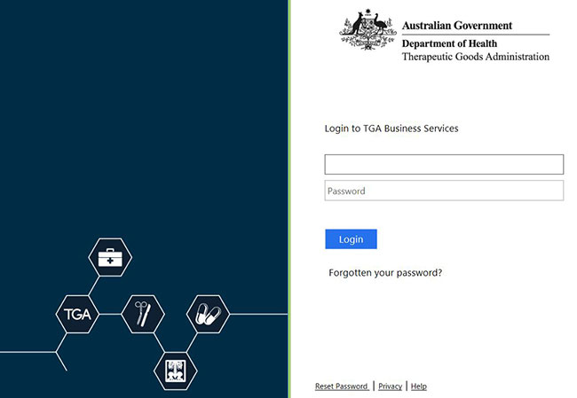
Step 2 - Select the relevant variation application type
From the ‘Applications’ menu, under the heading Medical Device select the relevant variation application type.
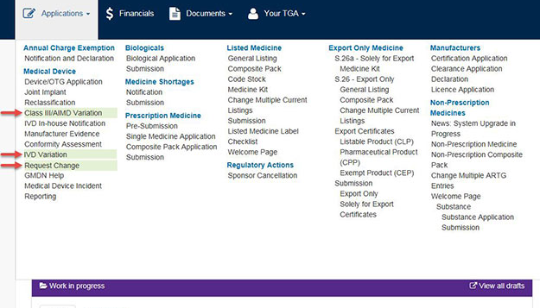
Step 3 - Select relevant form
There are three application forms available:
- Class III/AIMD Variation
- Request change (Device Change Request) – All classes of devices
- IVD Variation

Class III/AIMD Variation form user guide
The Class III/AIMD Variation application form is used to vary an existing Class III or Class AIMD ARTG entry.
To make a variation to an existing Class III/AIMD ARTG entry, select ‘Class III/AIMD Variation’ from the ‘Applications’ drop-down menu.
Page 1
Under the ‘Application Details’ section, the ‘Sponsor’s own reference’ field will be blank to start with. This will be populated in the next few steps.
The ‘Sponsor Details’ section will be pre-populated with your information. If the information is incorrect, please amend them.
Next, search for the ARTG entry you wish to vary, by selecting the ‘Search’ button as highlighted below.
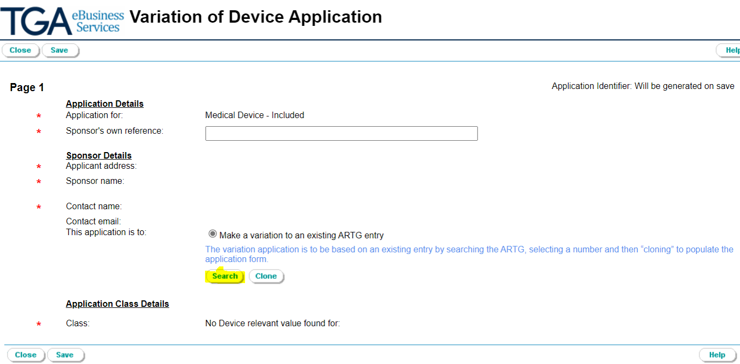
A pop-up window will appear – ‘Code Picker - ARTG ID’.
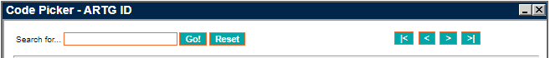
This will list all the possible ARTG entries available for your selection.
Note: If the list is long (e.g., multiple pages), you can refine your search by entering key words in the ‘Search for…’ field to narrow down the list.
From the list you can choose the ARTG entry you want to vary or enter your ARTG number and press ‘Go!’. Once selected, the Code Picker window will close.
To continue, click on the ‘Clone’ button (highlighted below).
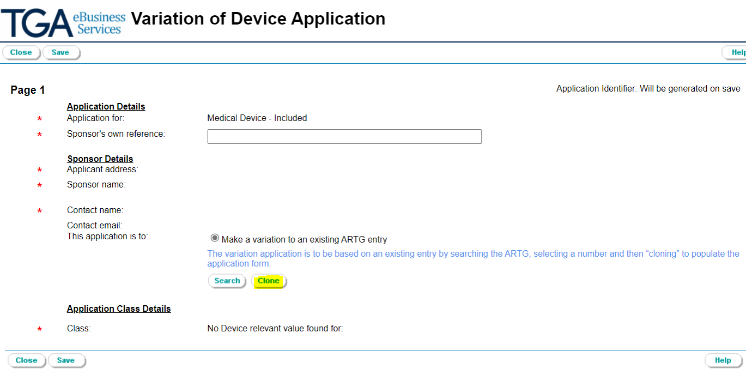
A dialogue box will appear. Clicking ‘OK’ will populate the application form with all the details from the selected ARTG entry for use in the new application to vary.
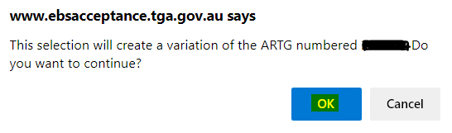
The ‘Sponsor’s own reference’ field under ‘Application Details’ will now be filled.
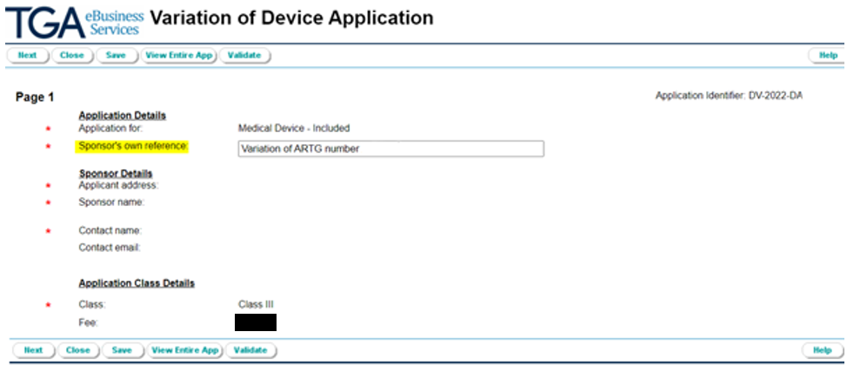
Click ‘Next’ to continue.
Page 2
The following page is where you will make the variation(s) to the ARTG entry.
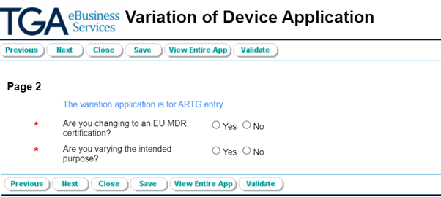
If you select ‘Yes’ to ‘Are you changing to an EU MDR certification?’, please enter the ‘Date of effect for EU MDR changes’.
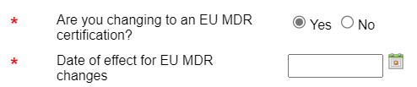
If you are varying the intended purpose in the ARTG entry, amendments can be made in the free text field for the proposed intended purpose. Please select the appropriate radio button below to reflect the intended purpose (refer to the example below).
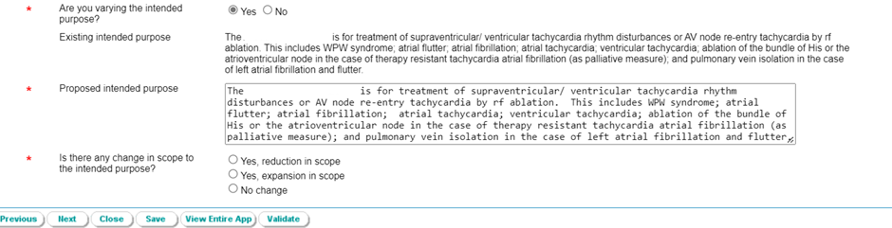
You can then proceed to the next page of the form. All the details you see initially are the same as the original device you selected to change.
Page 3
Under Manufacturing Details (Other Classes), you can modify the details for the ‘Unique product identifier’, ‘Functional description’, and the ‘Total number of devices covered’.
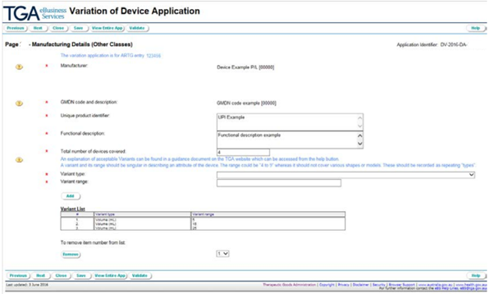

Variant type: you can add an entry to your ‘Variant List’ from the drop-down menu.
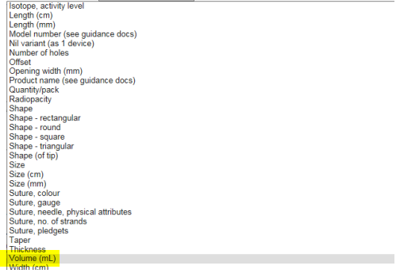
Variant range: you can include the new variant range and click on the ‘Add’ button.
You can only select and add one variant at a time to the application.
If you are adding / removing variants, the total number of devices covered by the entry may also change. If this is the case, you are required to change this field in the application to reflect the correct total number of devices.
Note

A value in the variant range must only relate to one physical characteristic of the device, e.g. diameter.
Different sizes of a variant type can be listed individually in the variant list or, for example, listed once with a variant range of "4 to 9", as long as that range doesn't also cover other physical characteristics of the device.
To remove an entry from the Variant List, select the entry number (#) you want to remove using the small dropdown menu located directly below the list. Then click on ‘Remove’ button. You can only remove one entry at a time.
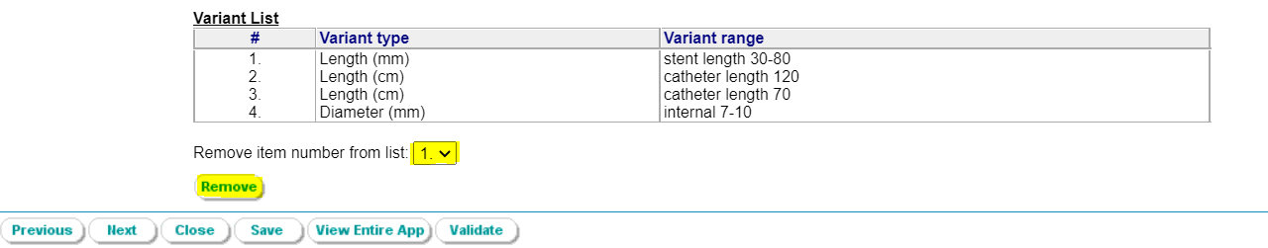
Once you’ve finished modifying on this page, click on ‘Next’ button to proceed.
Page 4
The final page of the form ‘Applicant’s Certification’ allows you to review the information and attach supporting information.
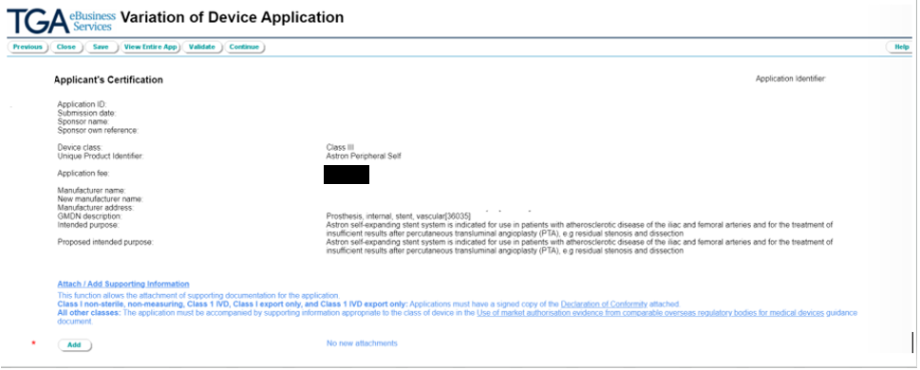
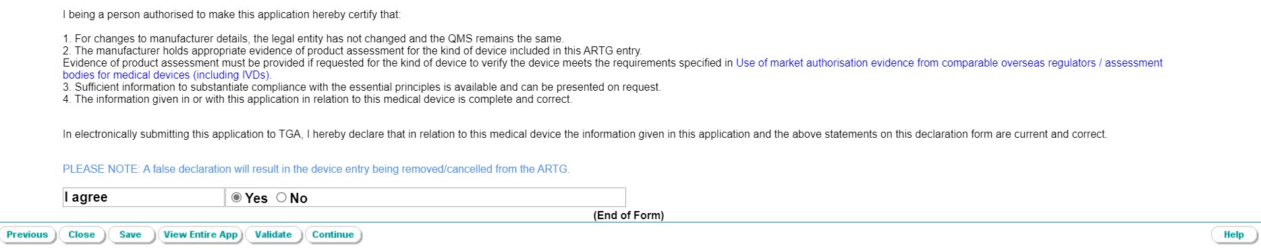
Attach/Add Supporting Information: select the ‘Add’ button which opens the File Upload box. Select the ‘Document type’ (e.g., a Design Examination Certificate), then select the ‘Choose File’ button to search for the document. Once completed, click on the ‘Add’ button to attach the document to your application.
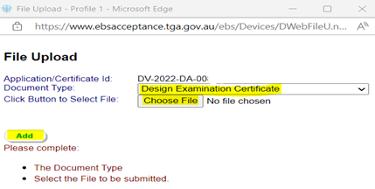
Attached documents can be removed by selecting the ‘Remove’ button.
If you agree with the terms of the declaration select the radio button ‘Yes’, then click the ‘Validate’ button.
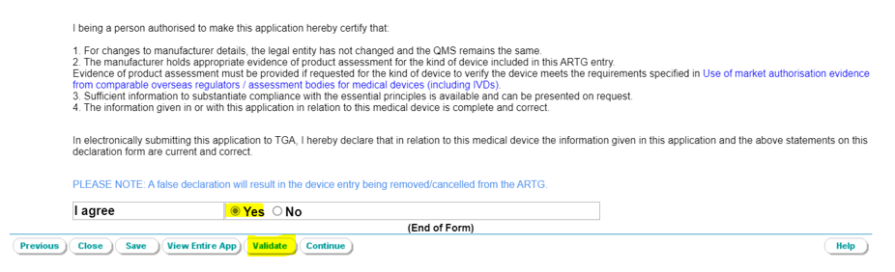
If there are any validation errors, they will appear in ‘blue bold’ text in the top left-hand corner of the form (see example below).
Note: All validation errors highlighted in blue text must be addressed first to proceed.
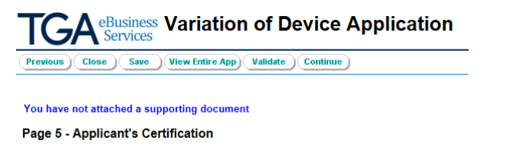
Once you have successfully validated your application, please review your entire application before you submit, by selecting ‘View Entire App’


Note
If you click on ‘Close’ button, the application will be saved in your Drafts list.
If you want to go back and edit your form, select the ‘Edit’ button, then ‘Previous’ button to go back and make changes. Once you are happy with your application, select ‘Validate’ and then ‘Continue’ to submit.
Once your application has been submitted for processing, your Application ID will be displayed (see example below).
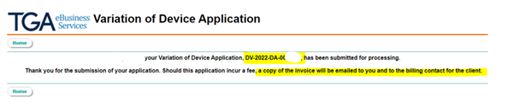

Payment of application fee
An invoice will be sent out under a separate notice once the application has been receipted by us.
When the sponsor has paid the invoice, the application will join the assessment queue.

Request Change (Device Change Request) form user guide
The Device Change Request application form is used to vary existing ARTG entries.
To make a device change request, select ‘Request Change’ from the applications drop-down menu. It will take you to the first page of the application form.
The ‘Sponsor Details’ section will be pre-populated with your information. Please amend if necessary.
Select ‘Variation to ARTG Included Entry (Medical Devices and IVDs)’ under the Change type field.
Next, search for the ARTG entry you wish to vary, by selecting the ‘Search’ button as highlighted below.
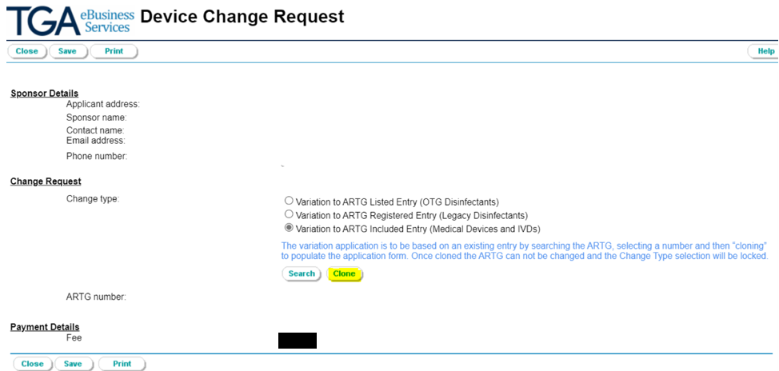
A pop-up window will appear – ‘Code Picker - ARTG ID’
This will list all the ARTG entries available for the medical devices you have registered.
Note: If the list is long (e.g., multiple pages), you can refine your search by entering key words in the ‘Search for…’ field to narrow the list.
From the list you can choose the ARTG entry you want to vary or enter your ARTG number and press ‘Go!’. Once selected, the Code Picker window will close.
To continue, click on the ‘Clone’ button (highlighted below).
A dialogue box will appear. Clicking on ‘OK’ will populate the application form with all the details from the selected ARTG entry for use in the new application to vary.
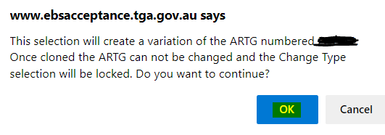
The application form will now show the ARTG entry to be varied. Click ‘Next’ to continue.
The following page is where you will make the variation(s) to the ARTG entry. Please ensure you complete the mandatory questions on of the application form (as shown below with the red asterisks).
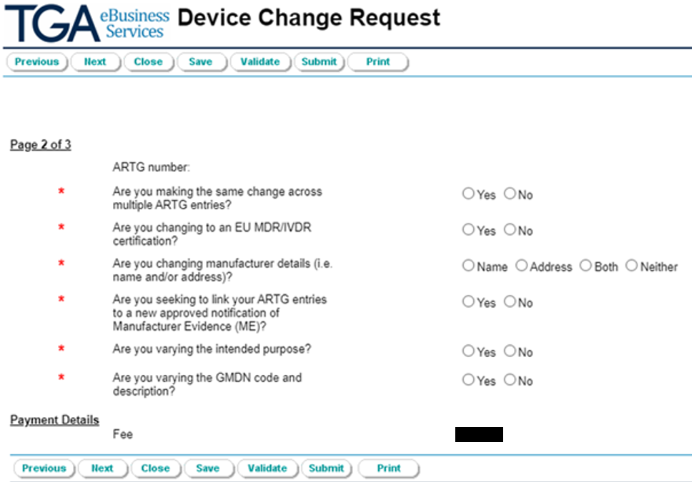
If you are making the same change across multiple ARTG entries, select ‘Yes’. You will need to search for the ARTG entries you wish to vary, by clicking on the ‘Search’ button, this will open a new search window titled Code Picker - ARTG ID.
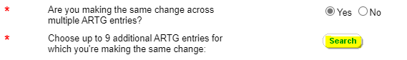
You can choose up to 9 additional ARTG entries for which you are making the same change.
Click on the ‘Search’ button to proceed. You can add one entry at a time.
Once selected, the Code Picker window will close.
Note
One Device Change Request application form can be used for up to 10 ARTG entries if the change request is same for each entry.
Examples of this could be a change of manufacturer’s name and /or address, or change of manufacturer evidence ID.
If you intend to remove the chosen ARTG entry, you need to select the ARTG from the list and click on the ‘Remove’ button. Note that you can only remove one entry at a time.
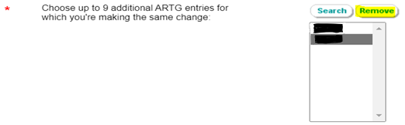
If you select ‘Yes’ to ‘Are you changing to an EU MDR/IVDR certification?’, please enter the ‘Date of effect for EU MDR/IVDR changes.
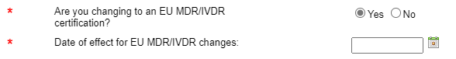
If you are varying the manufacturer details (i.e., manufacturer name and/or address), you will need to provide evidence supporting this change, either through an already approved Manufacturer Evidence, or, through supporting evidence to be uploaded at a later page.
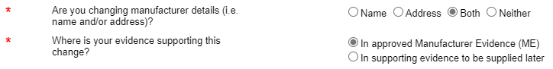
Note
The supporting evidence is a letter from the manufacturer or notified body stating when and why manufacturer details (name or address) changed, that the quality management system did not change, and the company remains the same manufacturing legal entity.
If you intend to link your ARTG entries to a new approved manufacturer evidence, you need to choose the manufacturer evidence identifier from the drop-down menu.
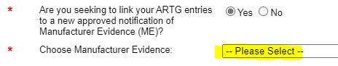
If you are varying the intended purpose in the ARTG entry, amendments can be made in the free text field for the ‘New intended purpose’. Please select the appropriate radio button below to reflect the intended purpose (refer to the example below).
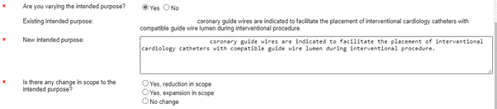
If you intend to vary the GMDN code and description, select ‘Yes’ and then click on the ‘Search’ button, which will open a new search window.
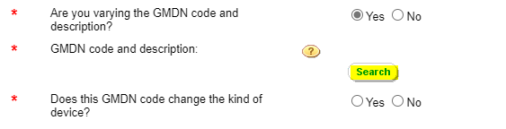
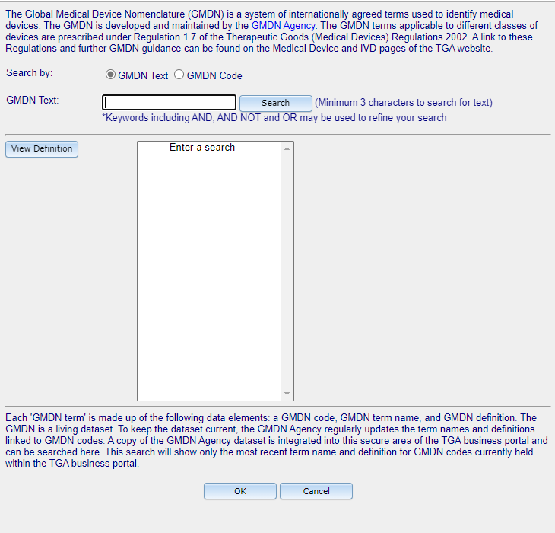
Your search can be refined by selecting either the ‘GMDN Text’ or the ‘GMDN Code’. Select the GMDN code and term that is relevant for the kind of device in the nominated ARTG entry and click on ‘OK’ to proceed. The selected GMDN code and term will appear in the application form.
Note: The proposed GMDN code should not change the kind of device.
Select ‘Next’ to continue.
If there are further changes not already identified, please provide information on the other changes you are seeking in the ‘Please describe changes’ field (as highlighted below).
If you have recently submitted DCR or variation applications which are of relevance to this current application, please provide the submission/application ID(s).
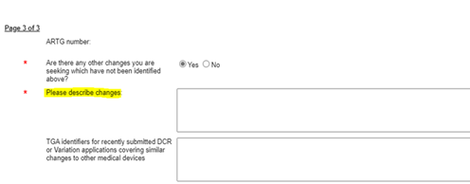
Attach/Add Supporting Information: select the ‘Add’ button which opens the ‘File Upload’ box.
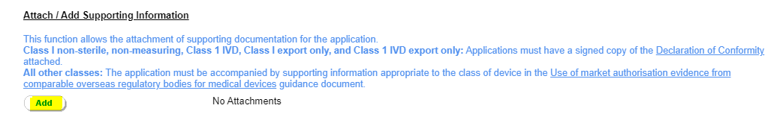
Select the ‘Document Type’, then select the ‘Choose File’ button to search for the document. Once completed, click on the ‘Add’ button to attach the document to your application.
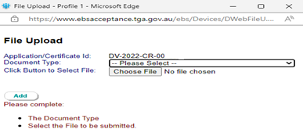
If you agree with the terms of the declaration, select the radio button ‘Yes’, then click on the ‘Submit’ button.
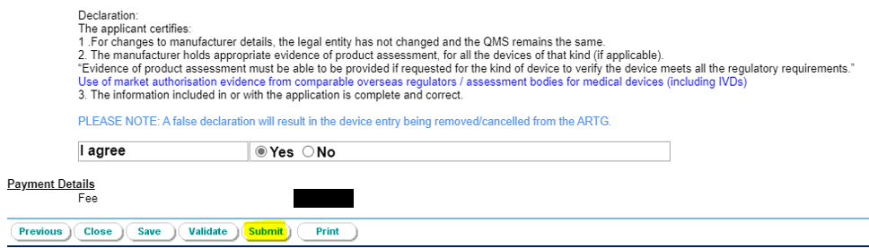
If there are any validation errors, they will appear in ‘blue bold’ text in the top left-hand corner of the form (see example below).
Note: All validation errors highlighted in blue text must be addressed first to proceed.

If you intend to make changes to any of the previous pages, clicking on the ‘Previous’ button will take you to the previous pages of the application form.
Note
If you click on the ‘Close’ button, the application will be saved in your Drafts list.
Once you have corrected the error(s) in the application, click on the ‘Submit’ button. This will end the session.
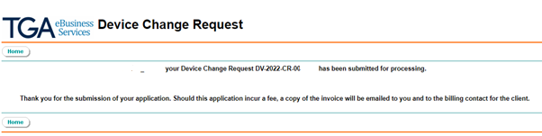

Payment of application fee
An invoice will be sent out under a separate notice once the application has been receipted by us.
When the sponsor has paid the invoice, the application will join the assessment queue.

IVD Variation application instructions
An application to vary an IVD entry is like the Class III/AIMD process, however the first page displays as Variation of IVD Device Application.
Complete the Sponsor reference field with information that will differentiate the application from similar applications.
Use the Search function to review your current ARTG entries and select the ARTG entry that you intend to vary. The ARTG entry will display in the form. Use the Clone function to capture information from the ARTG for this entry.
The Application Class Details section of the form requires careful scrutiny.
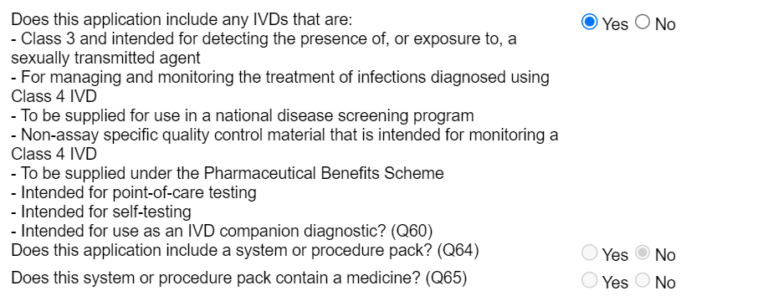
If the additional device of the kind is consistent with any of the devices described as above, answer Yes and the form will display the IVD Name and Category Section. Enter the name of the device and select the option from the displayed list (note that more than one category can be selected). Complete the relevant fields and select the Add button to include the additional IVD on the New IVD Names and Categories list.
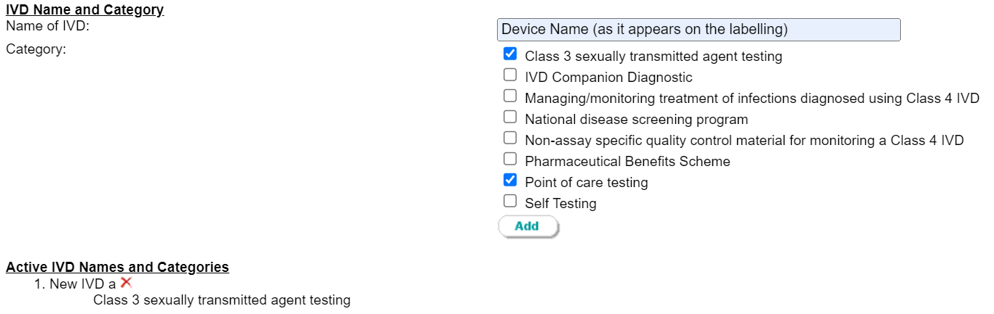
On the bottom left of the form the current (active) devices identified in the ARTG entry are displayed with a red cross. Do NOT press this red cross unless you require the inactivation of the device (no longer supplied). The inactivation of the device will remove it from the ARTG certificate.
Upon the use of the Add function the new device will appear on the bottom left of the application for variation form.
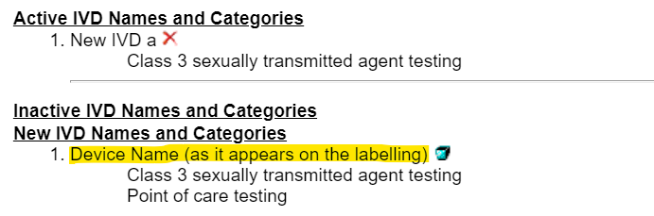
Once you have added the extra details, select the Next button to continue.
The final page of the form allows you to review information and attach supporting information.
To attach supporting information, select the Add button which opens the File Upload box.
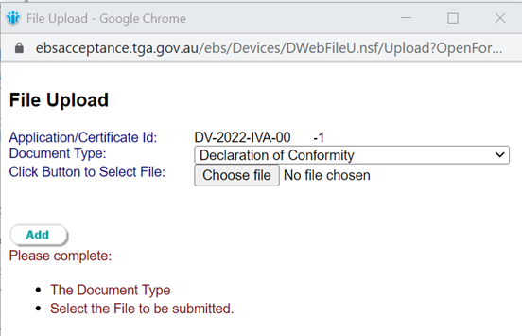
You will need to select Document type, and then select the Browse button to search for the document. Once complete, select the Add button to attach the document to your application.
Please agree with the terms of the declaration and select the Validate button.
If there are any validation errors, they will appear in 'blue bold' text in the top left-hand corner of the form. You need to correct any of these to proceed.
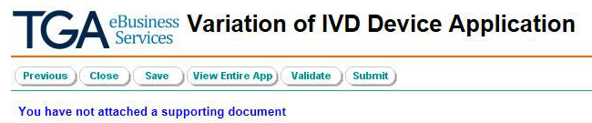
If you Save and then close the application after you have reviewed the whole document the application will be saved into your draft folder.
Once you have successfully validated the application, select ‘Submit’.

Version history
Version | Description of change | Author | Effective date
V6.0 | Updated screenshots to remove outdated fees | Medical Devices Authorisation Branch | December 2025
V5.0 | Removed DCAS contact email. Added devices contact email address. | Medical Devices Authorisation Branch | July 2024
V4.0 | Inclusion of fee information | Medical Devices Authorisation Branch | August 2023
V3.0 | Updated fees related information based on the amended Regulations due to medical device fees for 2023-24. | Medical Devices Authorisation Branch | July 2023
V2.0 | Revised to add additional steps | Medical Devices Authorisation Branch | October 2022
V1.0 | Draft | Medical Devices Authorisation Branch | November 2016

Therapeutic Goods Administration
PO Box 100 Woden ACT 2606 Australia
Email: info@tga.gov.au Phone: 1800 020 653 Fax: 02 6203 1605
https://www.tga.gov.au
Reference/Publication:

