Established acceptable intake for other N-nitroso-structures in medicines
N-Nitroso-structure  (CAS number, Abbreviation) | Source² | N-Nitroso-structure molecular structure | AI limit  (ng/day)¹ | First published
N-Nitroso-biotin /  5-((3aS,4S,6aR)-1-nitroso-2-oxohexahydro-1H-thieno[3,4-d]imidazol-4-yl)pentanoic acid  (56859-26-8) | Biotin | 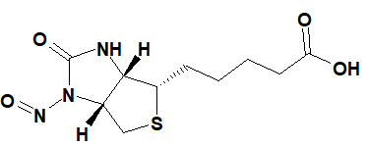 | 1500 | 24 January 2025
N-Nitroso-cimetidine /  3-cyano-1-methyl-2-[2-[(5-methyl-1H-imidazol-4-yl)methylsulfanyl]ethyl]-1-nitrosoguanidine  (73785-40-7) | Cimetidine | 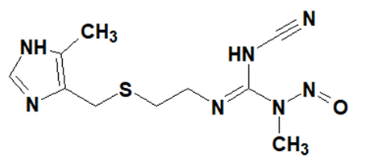 | 553 | 24 January 2025
N-Nitroso-clonidine /  N-(2,6-dichlorophenyl)-1-nitroso-4,5-dihydroimidazol-2-amine  (148950-49-6) | Clonidine | 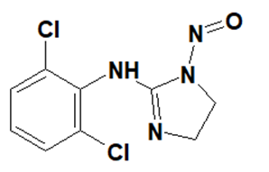 | 553 | 24 January 2025
N-Nitroso-clonidine-2 /  N-(2,6-dichlorophenyl)-N-(4,5-dihydro-1H-imidazol-2-yl)nitrous amide | Clonidine | 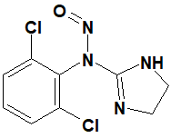 | 553 | 24 January 2025
N-Nitroso-eletriptan /  (S)-3-((1-methylpyrrolidin-2-yl)methyl)-1-nitroso-5-(2-(phenylsulfonyl)ethyl)-1H-indole | Eletriptan | 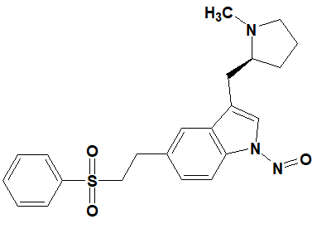 | 1500 | 24 January 2025
N-Nitroso-melatonin /  N-(2-(5-methoxy-1-nitroso-1H-indol-3-yl)ethyl)acetamide  (278783-22-5) | Melatonin | 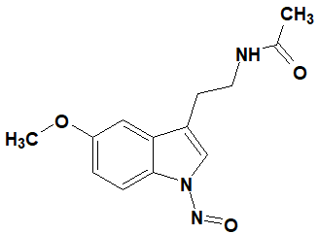 | 1500 | 24 January 2025
1-Nitroso-moxonidine /  N-(4-chloro-6-methoxy-2-methylpyrimidin-5-yl)-N-(4,5-dihydro-1H-imidazol-2-yl)nitrous amide | Moxonidine | 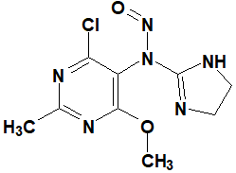 | 553 | 24 January 2025
1-Nitroso-moxonidine Impurity 3 /  4-chloro-6-methoxy-2-methyl-N-(1-nitroso-4,5-dihydro-1H-imidazol-2-yl)pyrimidin-5-amine | Moxonidine | 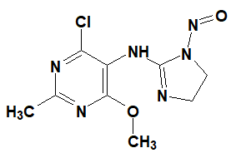 | 553 | 24 January 2025
N-Nitroso-naratriptan /  N-methyl-2-[3-(1-methylpiperidin-4-yl)-1-nitrosoindol-5-yl]ethanesulfonamide  (1216880-64-6) | Naratriptan | 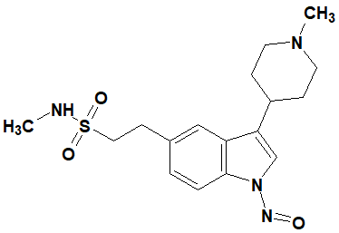 | 1500 | 24 January 2025
N-Nitroso-rizatriptan /  2-(5-((1H-1,2,4-triazol-1-yl)methyl)-1-nitroso-1H-indol-3-yl)-N,N-dimethylethan-1-amine | Rizatriptan | 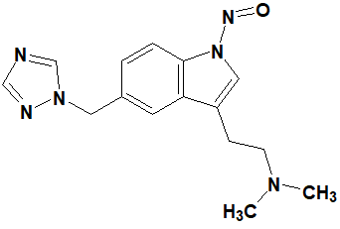 | 1500 | 24 January 2025
N-Nitroso-sumatriptan /  1-(3-(2-(dimethylamino)ethyl)-1-nitroso-1H-indol-5-yl)-N-methylmethanesulfonamide | Sumatriptan | 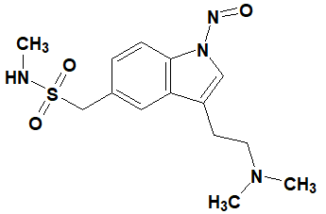 | 1500 | 24 January 2025
N-Nitroso-tadalafil /  (2R,8R)-2-(1,3-benzodioxol-5-yl)-6-methyl-17-nitroso-3,6,17-triazatetracyclo[8.7.0.03,8.011,16]heptadeca-1(10),11,13,15-tetraene-4,7-dione | Tadalafil | 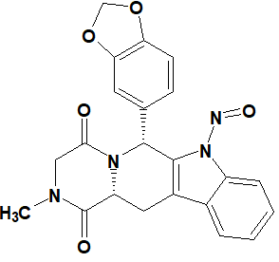 | 1500 | 24 January 2025
N-Nitroso-tizanidine /  N-(5-chlorobenzo[c][1,2,5]thiadiazol-4-yl)-N-(4,5-dihydro-1H-imidazol-2-yl)nitrous amide | Tizanidine | 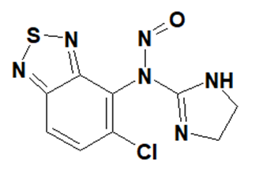 | 553 | 24 January 2025
N-Nitroso-tizanidine Impurity 3 /  N-(5-chlorobenzo[c][1,2,5]thiadiazol-4-yl)-N-(4,5-dihydro-1H-imidazol-2-yl)nitrous amide | Tizanidine | 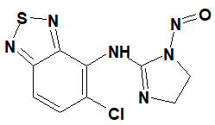 | 553 | 24 January 2025
N-Nitroso-tryptophol /  2-(1-nitrosoindol-3-yl)ethanol  (120314-14-9) | Tryptophol | 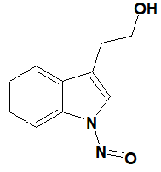 | 1500 | 24 January 2025
N-Nitroso-zolmitriptan /  (4S)-4-[[3-[2-(dimethylamino)ethyl]-1-nitrosoindol-5-yl]methyl]-1,3-oxazolidin-2-one | Zolmitriptan | 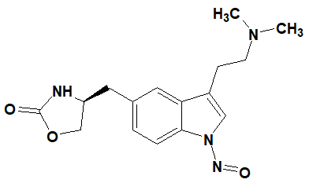 | 1500 | 24 January 2025
N-Methyl-N’-nitro-N-nitrosoguanidine /  1-methyl-3-nitro-1-nitrosoguanidine  (70-25-7, MNNG) |  | 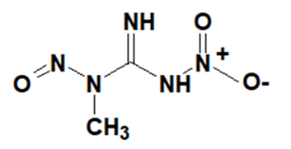 | 553 | 24 January 2025

