Established acceptable intake for nitrosamines in medicines
Last updated
29 January 2026

Below is a list of established AI limits for some nitrosamine impurities. These apply for all routes of administration.

Established AI limits for some other N-nitroso-structures. N-Nitroso-structures that include N-nitrosoguanidines, N-nitroso-indoles and N-nitrosoureas impurities are listed separately.

A revision table listing updates to the AI limit information for nitrosamines and other N-nitroso-structures is available separately.

Established acceptable intake for nitrosamines in medicines

Nitrosamine  (CAS number, Abbreviation) | Source² | Nitrosamine structure | AI limit  (ng/day)¹ | CPCA  Potency category | First published
Default class specific threshold of toxicological concern TTC | - |  | 18.0 | Default limit | -
3-((Ethyl(nitroso)amino)methyl) benzenesulfonate  (N-M8) | Dextromethorphan | 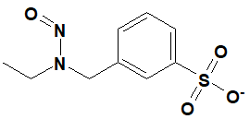 | 18 | 1 | 29 July 2024
N-Nitroso-N-ethyl-benzylamine /  N-benzyl-N-ethylnitrous amide  (20689-96-7, NBEA) | - | 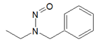 | 18 | 1 | 29 July 2024
1-Methyl-4-nitrosopiperazine  (16339-07-4, MeNP/MNP) | Rifampicin | 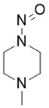 | 400 | 3 | 20 July 2022  Updated 24 August 2023
1-Methyl-4-nitrosopiperazine  (16339-07-4, MeNP/MNP) | Sildenafil |  | 400 | 3 | 3 November 2025
1-Nitroso-pyrrolopiperidine | - | 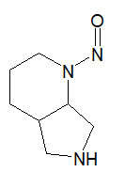 | 1500 | 4 | 24 August 2023
2-Nitroso-octahydrocyclopenta(c)pyrrole  (54786-86-6) | Gliclazide | 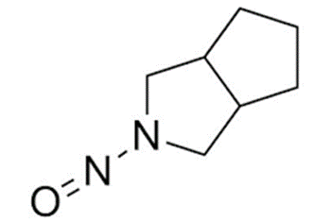 | 1700 |  | 24 August 2023
3-Amino-N-nitrosopiperidine  (2819242-71-0) | Alogliptin | 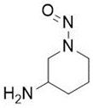 | 400 | 3 | 16 October 2023
4-(Methylnitrosoamino)-1-(3-pyridinyl)-1-butanone  (64091-91-4, NNK) | - | 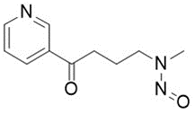 | 100 |  | 5 January 2023
7-Nitroso-3-(trifluoromethyl)-5,6,7,8-tetrahydro[1,2,4]triazolo-[4,3-a]pyrazine  (2892260-32-9, NTTP) | Sitagliptin | 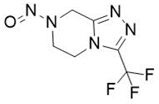 | 100 | 2 | 20 July 2022  Updated 29 July 2024
Nitroso impurity C” [N-(2,6-dimethylphenyl)-2-(4-nitrosopiperazin-1-yl)acetamide] | Ranolazine | 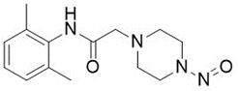 | 400 | 3 | 24 August 2023
N-Nitroso-orphenadrine  (NMOA) | Orphenadrine | 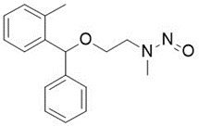 | 18 | 1 | 24 August 2023
N-Nitroso-praziquanamine /  [2-nitroso-2,3,6,7-tetrahydro-1H-pyrazino[2,1-a]isoquinolin-4(11bH)-one]  (115822-46-3) | Arpraziquantel | 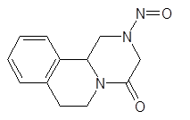 | 1500 | 4 | 24 August 2023
N-Methyl-N-nitrosophenethylamine  (13256-11-6, NMPEA) | - | 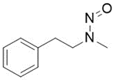 | 8.0 |  | 5 January 2023
N-Nitroso-1,2,3,6-tetrahydropyridine  (55556-92-8, NTHP) | - | 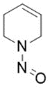 | 37.0 |  | 20 July 2022
N-Nitroso derivative of rotigotine impurity B /  N-(5-hydroxy-1,2,3,4-tetrahydronaphthalen-2-yl)-N-propylnitrous amide | Rotigotine | 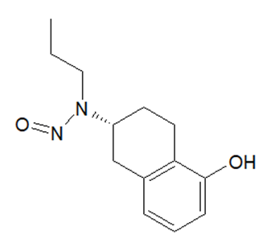 | 400 | 3 | 16 October 2023
N-Nitroso derivative of rotigotine impurity C /  N-(5-hydroxy-1,2,3,4-tetrahydronaphthalen-2-yl)-N-(-2-(thiophen-2-yl)ethyl)nitrous amide | Rotigotine | 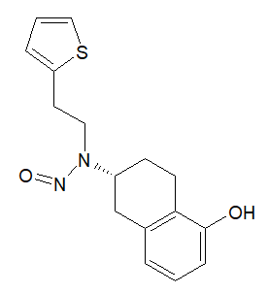 | 1500 | 4 | 16 October 2023
N-Nitroso-2,6-pipecoloxilidide /  desbutyl bupivacaine nitroso impurity  (3035512-94-5) | Ropivacaine | 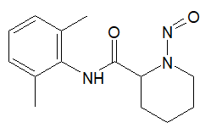 | 1500 | 4 | 24 August 2023
N-Nitroso-2,6-pipecoloxilidide /  desbutyl bupivacaine nitroso impurity  (3035512-94-5) | Bupivacaine |  | 1500 | 4 | 3 November 2025
N-Nitroso-acarbose /  N-nitroso-4,6-dideoxy-4-[(1S,2S,3R,4S,5S)-3,4,5-trihydroxy-2-(hydroxymethyl)cyclohexyl]-α-D-glucopyranosyl-(1→4)-α-D-glucopyranosyl-(1→4)-α-D-glucopyranosyl-(1→4)-D-glucopyranose | Acarbose |  | 1500 | 5 | 31 July 2025
N-Nitroso-acebutolol | Acebutolol | 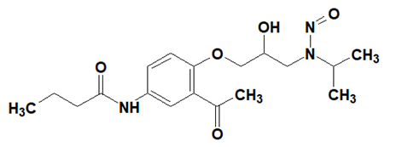 | 1500 | 4 | 15 October 2024
N-Nitroso-2-(7-methoxy-1-naphthyl)-N-[2-(7-methoxy-1-naphthyl)ethyl]ethylamine | Agomelatine | 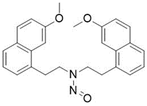 | 100 | 2 | 29 July 2024
N-Nitroso-desmethyl-almotriptan | Almotriptan |  | 18 | 1 | 3 November 2025
N-Nitroso-ambroxol | Ambroxol | 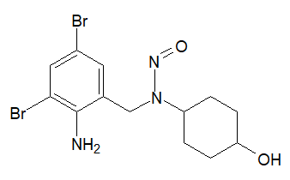 | 1500 |  | 24 August 2023  Updated 31 January 2024
N-Nitroso-N-desethyl-amiodarone  (678982-38-2) | Amiodarone |  | 18 | 1 | 3 November 2025
N-Nitroso-apixaban impurity B /  5-[4-[3-carbamoyl-1-(4-methoxyphenyl)-7-oxo-4,5-dihydropyrazolo[3,4-c]pyridin-6-yl]-N-nitrosoanilino]pentanoic acid | Apixaban | 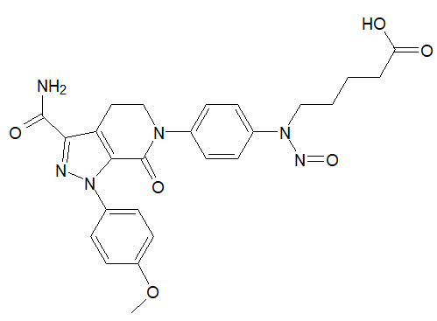 | 1500 | 4 | 24 April 2024
1-(2,3-Dichlorophenyl)-4-nitrosopiperazine  (2221987-86-4) | Aripiprazole | 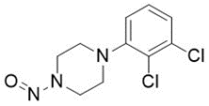 | 400 | 3 | 31 January 2024
N-Nitroso-articaine /  methyl 4-methyl-3-(2-(nitroso(propyl)amino)propanamido)thiophene-2-carboxylate | Articaine | 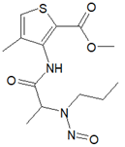 | 1500 | 4 | 29 July 2024
N-Nitroso-aryl piperazine /  N-nitroso-desalkylquetiapine  (NDAQ) | Quetiapine | 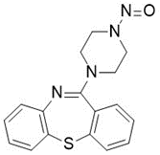 | 400 | 3 | 24 August 2023
N-Nitroso-atomoxetine | Atomoxetine | 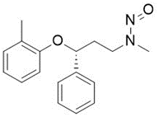 | 100 |  | 24 August 2023
N-Nitroso-atenolol  (134720-04-0) | Atenolol | 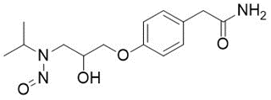 | 1500 | 4 | 24 August 2023
N-Nitroso-azacyclonol  (1038-06-8) | Azacyclonol | 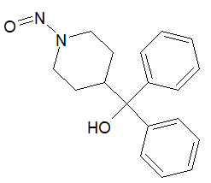 | 400 | 3 | 31 January 2024
N-Nitroso-desmethyl-azelastine | Azelastine | 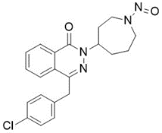 | 100 | 2 | 31 January 2024
N-Nitroso-azithromycin | Azithromycin | 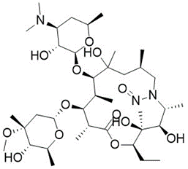 | NMI |  | 24 August 2023
N-Nitroso-benzathine /  N-nitroso-N,N'-dibenzylethanediamine /  N-benzyl-N-(2-(benzylamino)ethyl)nitrous amide  (NNB) | Benzathine |  | 18 | 1 | 31 July 2025
N-Nitroso-benazepril | Benazepril | 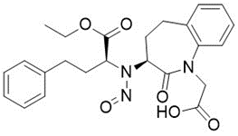 | 1500 | 5 | 24 August 2023
3-(Dimethylamino)propyl 2-[benzyl(nitroso)amino]benzoate | Benzydamine | 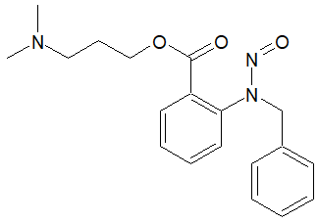 | 400 | 3 | 29 July 2024
N-Nitroso-berotralstat /  (R)-1-(3-(aminomethyl)phenyl)-N-(5-((3-cyanophenyl)((cyclopropylmethyl) (nitroso)amino)methyl)-2-fluorophenyl)-3-(trifluoromethyl)-1H-pyrazole-5-carboxamide | Berotralstat | 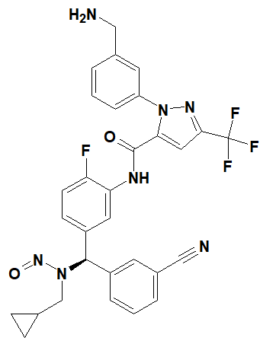 | 1500 |  | 3 November 2025  Updated 29 January 2026
N-Nitroso-betahistine  (32635-81-7) | Betahistine | 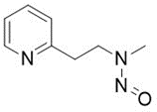 | 18 | 1 | 24 August 2023
N-Nitroso-betaxolol | Betaxolol | 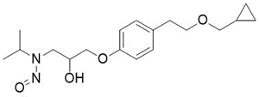 | 1500 | 4 | 31 January 2024
N-Nitroso-bilastine impurity 2 /  1-(2-ethoxyethyl)-2-(1-nitrosopiperidin-4-yl)-1H-benzo[d]imidazole | Bilastine | 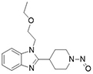 | 400 | 3 | 29 July 2024
N-Nitroso-bisoprolol  (2820170-76-9, NBP) | Bisoprolol | 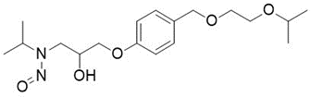 | 1500 | 4 | 24 August 2023
N-Nitroso-brinzolamide /  (R)-4-(ethyl(nitroso)amino)-2-(3-methoxypropyl)-3,4-dihydro-2H-thieno[3,2-e][1,2]thiazine-6-sulfonamide 1,1-dioxide | Brinzolamide |  | 100 | 2 | 31 July 2025
N-Nitroso-bumetanide  (2490432-02-3, NNB) | Bumetanide | 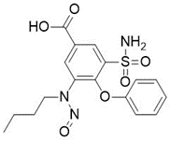 | 1500 |  | 24 August 2023  Updated 29 January 2026
N-Nitroso-bupropion /  N-tert-butyl-N-[1-(3-chlorophenyl)-1-oxopropan-2-yl]nitrous amide  (2763780-10-3) | Bupropion | 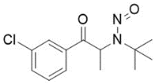 | NMI |  | 24 August 2023  Updated 4 February 2025
N-Nitroso-buspirone Impurity 1 /  2-(4-nitrosopiperazine-1-yl)-pyrimidine  (872826-80-7) | Buspirone | 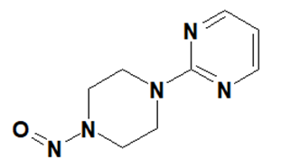 | 400 | 3 | 15 October 2024
N-Nitroso-desmethyl-cabergoline /  (6aR,9R,10aR)-7-allyl-N-(ethylcarbamoyl)-N-(3-(methyl(nitroso)amino)propyl)-4,6,6a,7,8,9,10,10a-octahydroindolo[4,3-fg]quinoline-9-carboxamide | Cabergoline |  | 18 | 1 | 30 April 2025
N-Nitroso-carvedilol /  N-(3-((9H-carbazol-4-yl)oxy)-2-hydroxypropyl)-N-(2-(2-methoxyphenoxy)ethyl)nitrous amide  (2248746-67-8) | Carvedilol |  | 400 | 3 | 31 July 2025
N-Nitroso-caspofungin /  (10R,12S)-N-((2R,9S,11R,12S,14aS,15S,20S,25aS)-20-((R)-3-amino-1-hydroxypropyl)-12-((2-aminoethyl)(nitroso)amino)-23-((1S,2S)-1,2-dihydroxy-2-(4-hydroxyphenyl)ethyl)-2,11,15-trihydroxy-6-((R)-1-hydroxyethyl)-5,8,14,19,22,25-hexaoxotetracosahydro-1H-dipyrrolo[2,1-c:2’,1’-l][1,4,7,10,13,16]hexaazacyclohenicosin-9-yl)-10,12-dimethyltetradecanamide | Caspofungin | 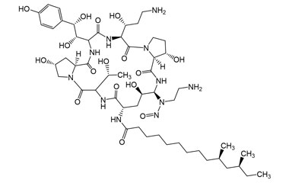 | 1500 | 4 | 29 July 2024
N-Nitroso-celiprolol | Celiprolol | 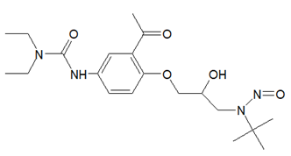 | 1500 | 5 | 31 January 2024
N-Nitroso-cilazapril  (1053740-92-3) | Cilazapril | 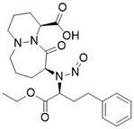 | 1500 | 5 | 24 August 2023
N-Nitroso-cinacalcet | Cinacalcet | 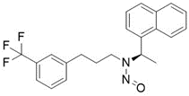 | 400 | 3 | 31 January 2024
1-(Diphenylmethyl)-4-nitrosopiperazine /  1-benzhydryl-4-nitrosopiperazine  (1698-25-5) | Cinnarizine | 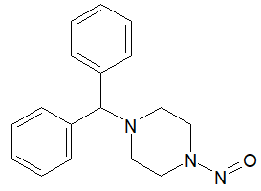 | 400 | 3 | 29 July 2024
N-Nitroso-ciprofloxacin  (864443-44-7) | Ciprofloxacin | 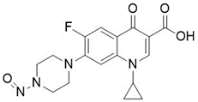 | NMI |  | 24 August 2023  Updated 15 October 2024
N-Nitroso-N-desmethyl-clarithromycin /  N-[(2S,3R,4S,6R)-2-[[(3R,4S,5S,6R,7R,9R,11R,12R,13S,14R)-14-ethyl-12,13-dihydroxy-4-[(2R,4R,5S,6S)-5-hydroxy-4-methoxy-4,6-dimethyloxan-2-yl]oxy-7-methoxy-3,5,7,9,11,13-hexamethyl-2,10-dioxo-oxacyclotetradec-6-yl]oxy]-3-hydroxy-6-methyloxan-4-yl]-N-methylnitrous amide | Clarithromycin | 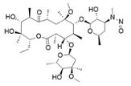 | NMI |  | 29 July 2024
N-Nitroso-clozapine /  8-chloro-11-(4-methylpiperazin-1-yl)-5-nitroso-5H-dibenzo[b,e][1,4]diazepine  (156632-03-0) | Clozapine | 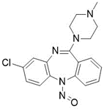 | 1500 | 5 | 24 April 2024
N-Nitroso-clozapine EP Impurity C /  8-chloro-11-(4-nitrosopiperazin-1-yl)-5H-dibenzo[b, e][1, 4]diazepine | Clozapine | 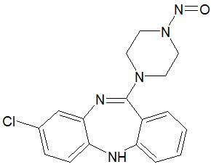 | 400 | 3 | 24 April 2024
N-Nitroso-didecylamine | Colesevelam | 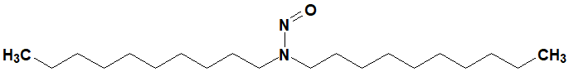 | 100 | 2 | 4 February 2025
2,2,5-Trimethyl-3-nitroso-1,3-oxazolidine  (77400-46-5, TMNO) | Cyanocobalamine | 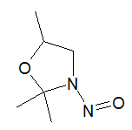 | 1500 | 4 | 24 April 2024
N-Nitroso-dabigatran etexilate  (NDAB) | Dabigatran etexilate | 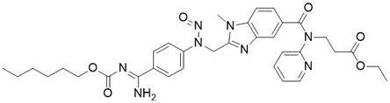 | 1500 |  | 5 January 2023  Updated 24 August 2023  Updated 24 April 2024
N-Nitroso-dalbavancin /  (2S,3S,4R,5R,6S)-6-[[(1S,2R,19R,22R,34S,37R,40R,52R)-5,32-dichloro-52-[3-(dimethylamino)propylcarbamoyl]-2,26,31,44,49-pentahydroxy-22-[methyl(nitroso)amino]-21,35,38,54,56,59-hexaoxo-47-[(2R,3S,4S,5S,6R)-3,4,5-trihydroxy-6-(hydroxymethyl)oxan-2-yl]oxy-7,13,28-trioxa-20,36,39,53,55,58-hexazaundecacyclo[38.14.2.23,6.214,17.219,34.18,12.123,27.129,33.141,45.010,37.046,51]hexahexaconta-3,5,8,10,12(64),14(63),15,17(62),23(61),24,26,29(60),30,32,41(57),42,44,46(51),47,49,65-henicosaen-64-yl]oxy]-3,4-dihydroxy-5-(10-methylundecanoylamino)oxane-2-carboxylic acid | Dalbavancin |  | 1500 | 4 | 30 April 2025
5-Chloro-4-methyl-2-[(2S)-2-methyl-1-nitrosopyrrolidin-2-yl]-1H-benzimidazole  (IDOR-1135-8758) | Daridorexant | 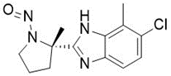 | 1500 | 5 | 31 January 2024
N-Nitroso-dasatinib /  N-(2-chloro-6-methylphenyl)-2-((6-(4-(2-hydroxyethyl)piperazin-1-yl)-2-methylpyrimidin-4-yl)(nitroso)amino)thiazole-5-carboxamide | Dasatinib |  | 1500 | 5 | 30 April 2025
N-Nitroso-N-deshydroxyethyl-dasatinib /  N-(2-chloro-6-methylphenyl)-2-((2-methyl-6-(4-nitrosopiperazin-1-yl)pyrimidin-4-yl)amino)thiazole-5-carboxamide  (2135905-86-9) | Dasatinib | 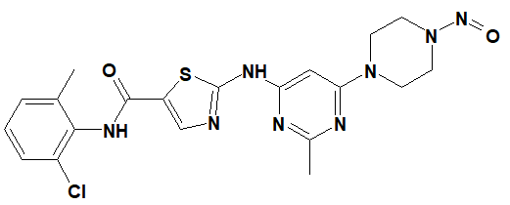 | 400 | 3 | 4 February 2025
N-Nitroso-desloratadine  (1246819-22-6) | Desloratadine | 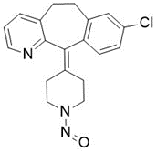 | 400 | 3 | 24 August 2023
N-Nitroso-N-desmethyl dextromethorphan /  (4bS,8aS,9S)-3-methoxy-11-nitroso-6,7,8,8a,9,10-hexahydro-5H-9,4b-(epiminoethano)phenanthrene  (N-DEX) | Dextromethorphan | 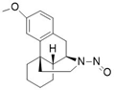 | 1500 | 4 | 29 July 2024
N-Nitroso-desmethyl-dimetindene /  N-methyl-N-(2-(3-(1-(pyridin-2-yl)ethyl)-1H-inden-2-yl)ethyl)nitrous amide  (NO-DDMT) | Dimetindene | 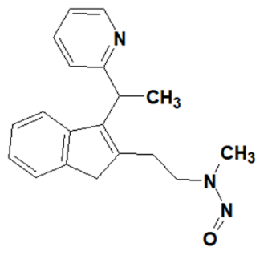 | 18 | 1 | 15 October 2024
N-Nitroso-desmethyl-edoxaban /  N-1-(5-chloropyridin-2-yl)-N2-((1S,2R,4S)-4-(dimethylcarbamoyl)-2-(5-nitroso-4,5,6,7-tetrahydrothiazolo[5,4-c]pyridine-2-carboxamido)cyclohexyl)oxalamide 4-methylbenzenesulfonate | Edoxaban | 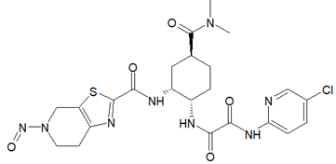 | 100 | 2 | 29 July 2024
N-Nitroso-desmethyl trimebutine | Trimebutine | 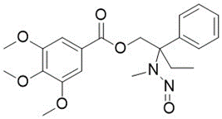 | 1500 | 5 | 24 August 2023
N-Nitroso-trientine Impurity 1 /  N-(2-aminoethyl)-N-(2-((2-aminoethyl)amino)ethyl)nitrous amide  (2817316-41-7) | Trientine | 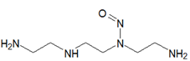 | 18 | 1 | 29 July 2024
N-Nitroso-desmethylazithromycin | Azithromycin | 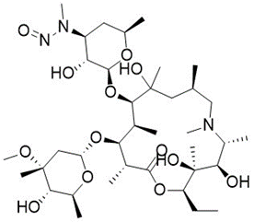 | NMI |  | 24 August 2023
N-Nitroso-desmethyl-chloropyramine  (N-DMCP) | Chloropyramine | 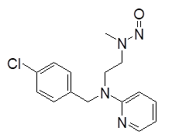 | 18 | 1 | 24 August 2023
N-Nitroso-desmethyl-chlorphenamine /  N-(3-(4-chlorophenyl)-3-(pyridin-2-yl)propyl)-N-methylnitrous amide | Chlorphenamine | 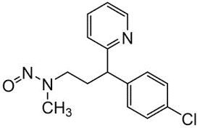 | 18 | 1 | 4 February 2025
N-Nitroso-desmethyl-citalopram /  N-(3-(5-cyano-1-(4-fluorophenyl)-1, 3-dihydroisobenzofuran-1-yl)propyl)-N-methylnitrous amide | Citalopram | 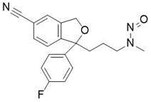 | 100 |  | 31 January 2024  Updated 29 July 2024
N-Nitroso-desmethyl-tripelennamine | Tripelennamine | 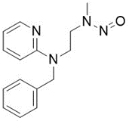 | 18 | 1 | 24 August 2023
(2S,4R)-N-(6-Bromopyridin-2-yl)-4-fluoro-1-nitrosopyrrolidine-2-carboxamide | Danicopan |  | 1500 | 4 | 3 November 2025
N-Nitroso-desvenlafaxine | Desvenlafaxine | 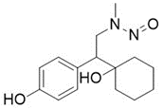 | 18 | 1 | 31 January 2024
N-Nitroso-diclofenac  (66505-80-4) | Diclofenac | 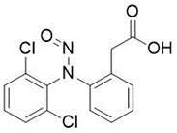 | 78000 |  | 24 August 2023  Updated 15 October 2024
N-Nitroso‐N-desmethyl‐diltiazem  (3036581-85-5) | Diltiazem |  | 100 |  | 3 November 2025
N-Nitroso-diethanolamine  (1116-54-7, NDELA) | - | 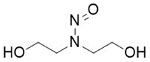 | 1900 |  | 5 January 2023
N-Nitroso-diethylamine  (55-18-5, NDEA) | - | 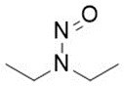 | 26.5 |  | 15 September 2019
N-Nitroso-diethylamine  (55-18-5, NDEA) | Entacapone |  | 26.5 |  | 3 November 2025
N-Nitroso-diisopropylamine /  N,N-di(propan-2-yl)nitrous amide  (601-77-4, DIPNA/NDIPA) | - | 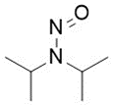 | 1500 | 5 | 15 September 2019  Updated 29 July 2024
N-Nitrosodiisopropanolamine /  1, 1'-(nitrosoimino)bis-2-propanol  (53609-64-6) | - | 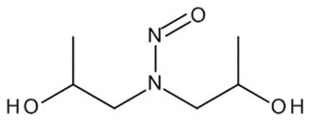 | 400 | 3 | 24 April 2024
N-Nitroso-dimethylamine  (62-75-9, NDMA) | - | 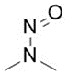 | 96.0 |  | 15 September 2019
N-Nitroso-dimethylamine  (62-75-9, NDMA) | Ranitidine |  | 96.0 |  | 15 September 2019
N-Nitroso-dimethylamine  (62-75-9, NDMA) | Nizatidine |  | 96.0 |  | 15 September 2019
N-Nitroso-dimethylamine  (62-75-9, NDMA) | Metformin |  | 96.0 |  | 15 September 2019
N-Nitroso-di-n-butylamine  (924-16-3, NDBA) | - | 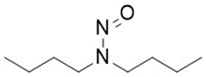 | 26.5 |  | 20 July 2022
N-Nitroso-N-desmethyl-diphenhydramine /  N-(2-benzhydryloxyethyl)-N-methylnitrous amide  (55855-43-1) | Diphenhydramine / Dimenhydrinate | 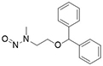 | 100 |  | 29 July 2024  Updated 29 January 2026
N-Nitroso-diphenylamine  (86-30-6, NDPh) | - | 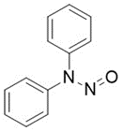 | 78000 |  | 5 January 2023
N-Nitroso-dipropylamine  (621-64-7, NDPA) | - | 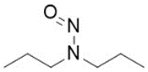 | 26.5 |  | 20 July 2022
N-Nitroso-doravirine dimer  (NDD) | Doravirine |  | 1500 |  | 3 November 2025
N-Nitroso-desmethyl-doxylamine /  N-methyl-N-(2-(1-phenyl-1-(pyridin-2-yl)ethoxy)ethyl)nitrous amide | Doxylamine |  | 100 |  | 3 November 2025
N-Nitroso-dorzolamide | Dorzolamide | 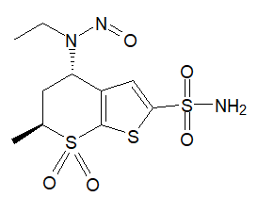 | 1500 |  | 31 January 2024
N-Nitroso-duloxetine  (2680527-91-5, NDLX) | Duloxetine | 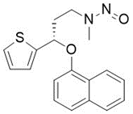 | 100 |  | 20 July 2022
N-Nitroso-desmethyl-eletriptan /  5-[2-(benzenesulfonyl)ethyl]-3-[[(2R)-1-nitrosopyrrolidin-2-yl]methyl]-1H-indole | Eletriptan | 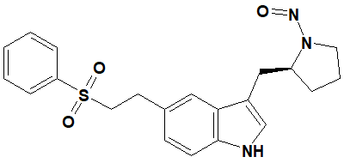 | 1500 | 4 | 4 February 2025
N-Nitroso-enalapril | Enalapril | 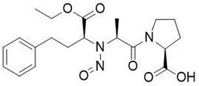 | 1500 | 5 | 24 August 2023
N-Nitroso-epinephrine / N-nitroso-adrenaline | Epinephrine / Adrenaline | 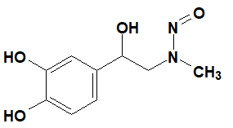 | 100 | 2 | 4 February 2025
N-Nitroso-esmolol | Esmolol | 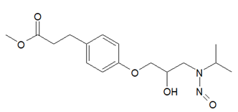 | 1500 | 4 | 31 January 2024
N-Nitroso-ethylisopropylamine /  N-ethyl-N-propan-2-ylnitrous amide  (16339-04-1, EIPNA/NEIPA) | - | 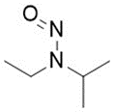 | 400 | 3 | 15 September 2019  Updated 29 July 2024
N-Nitroso-felodipine | Felodipine | 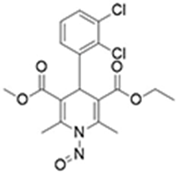 | 1500 | 5 | 24 August 2023
N-Nitroso-fenfluramine /  N-ethyl-N-[1-[3-(trifluoromethyl)phenyl]propan-2-yl]nitrous amide  (19023-40-6) | Fenfluramine | 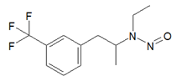 | 400 | 3 | 29 July 2024
N-Nitroso-flecainide /  N-((1-nitrosopiperidin-2-yl)methyl)-2, 5-bis(2, 2, 2-trifluoroethoxy)benzamide  (2901109-58-6) | Flecainide | 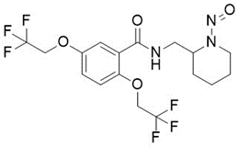 | 1500 | 4 | 24 April 2024
N-Nitrosofluoxetine  (150494-06-7) | Fluoxetine | 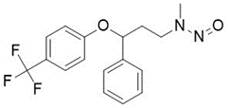 | 100 |  | 5 January 2023
N-Nitroso-folic acid /  2-[[4-[(2-amino-4-oxo-3H-pteridin-6-yl)methyl-nitrosoamino] benzoyl]amino]pentanedioic acid  (26360-21-4, NFA) | Folic acid | 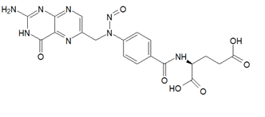 | 1500 | 4 | 24 August 2023  Updated 29 July 2024
N-Nitroso-calcium folinate | Calcium folinate / Calcium levofolinate | 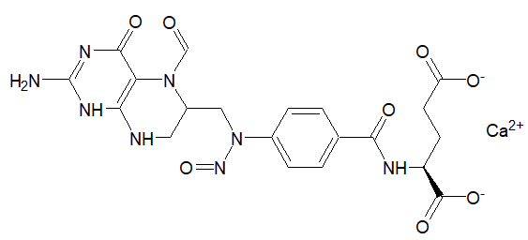 | NMI |  | 31 January 2024
N-Nitroso-frovatriptan /  (6R)-6-[methyl(nitroso)amino]-6,7,8,9-tetrahydro-5H-carbazole-3-carboxamide | Frovatriptan |  | 400 | 3 | 31 July 2025
N-Nitroso-furosemide /  4-chloro-2-[furan-2-ylmethyl(nitroso)amino]-5-sulfamoylbenzoic acid  (2708280-93-5) | Furosemide | 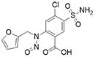 | 1500 |  | 29 July 2024
N-Nitroso-desmethyl-galantamine /  (4aS,6R,8aS)-3-methoxy-11-nitroso-4a,5,9,10,11,12-hexahydro-6H-benzo[2,3]benzofuro[4,3-cd]azepin-6-ol | Galantamine | 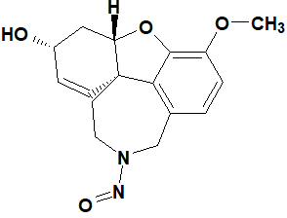 | 18 | 1 | 4 February 2025
N-Nitroso-hydrochlorothiazide  (63779-86-2, NHCTZ) | Hydrochlorothiazide | 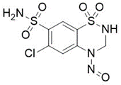 | NMI |  | 24 August 2023
N-Nitroso hydroxychloroquine EP Impurity C /  N-(4-((7-chloroquinolin-4-yl)amino)pentyl)-N-(2-hydroxyethyl)nitrous amide | Hydroxychloroquine |  | 100 | 2 | 3 November 2025
N-Nitroso hydroxychloroquine EP Impurity D /  N-(4-((7-chloroquinolin-4-yl)amino)pentyl)-N-ethylnitrous amide | Hydroxychloroquine |  | 18 | 1 | 3 November 2025
N-Nitroso-hydroxyzine Impurity A /  1-((4-chlorophenyl)(phenyl)methyl)-4-nitrosopiperazine  (2005-04-1) | Hydroxyzine |  | 400 | 3 | 3 November 2025
N-Nitroso imatinib | Imatinib | 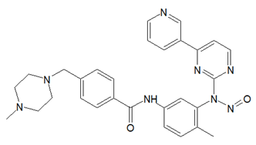 | 1500 | 5 | 31 January 2024
Indapamide impurity A /  2-methyl-1-nitroso-2,3-dihydroindole  (85440-79-5) | Indapamide | 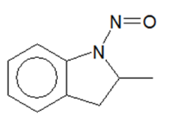 | 1500 | 5 | 31 January 2024
N-Nitroso-ethylenediamine-triacetic acid  (862542-34-5) | Isosorbide mononitrate | 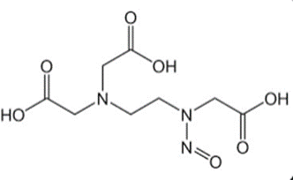 | 1500 | 4 | 31 January 2024
N-Nitroso-iminodiacetic acid  (25081-31-6) | Isosorbide mononitrate | 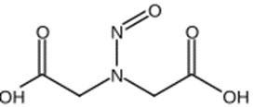 | 1500 | 4 | 31 January 2024
N‐Nitroso‐ivacaftor /  N-(2,4-di-tert-butyl-5-hydroxyphenyl)-1-nitroso-4-oxo-1,4-dihydroquinoline-3-carboxamide | Ivacaftor | 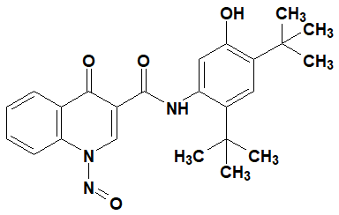 | 1500 | 5 | 4 February 2025
N-Nitroso-ketamine /  N-[1-(2-chlorophenyl)-2-oxocyclohexyl]-N-methylnitrous amide  (86144-35-6) | Ketamine | 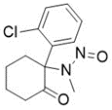 | 1500 | 5 | 24 August 2023
N-Nitroso-labetalol  (2820170-74-7) | Labetalol | 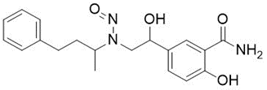 | 1500 | 4 | 24 August 2023
N-Nitroso-landiolol | Landiolol | 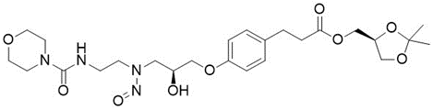 | 400 | 3 | 24 August 2023
N-Nitroso-leniolisib | Leniolisib | 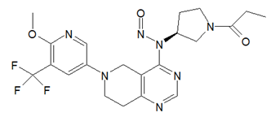 | 1500 | 5 | 31 January 2024
N-Nitroso-desmethyl-lercanidipine /  3-(1-((3,3-diphenylpropyl)(nitroso)amino)-2-methylpropan-2-yl) 5-methyl 2,6-dimethyl-4-(3-nitrophenyl)-1,4-dihydropyridine-3,5-dicarboxylate | Lercanidipine |  | 100 | 2 | 30 April 2025
N-Nitroso-desmethyl-lercanidipine impurity C /  3-(1-((3,3-diphenylpropyl)(nitroso)amino)-2-methylpropan-2-yl) 5-methyl 2,6-dimethyl-4-(3-nitrophenyl)pyridine-3,5-dicarboxylate | Lercanidipine |  | 100 | 2 | 30 April 2025
N-Nitroso-levofloxacin  (1152314-62-9) | Levofloxacin | 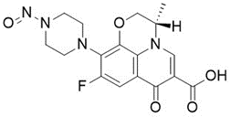 | 1500 | 4 | 24 August 2023
N-Nitroso-desethyllidocaine | Lidocaine / Lignocaine | 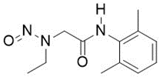 | 100 | 2 | 31 January 2024
N-Nitroso-lisinopril /  N2-((S)-1-carboxy-3-phenylpropyl)-N2-nitroso-L-lysyl-L-proline  (519175-80-5, NLP) | Lisinopril | 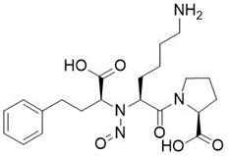 | NMI |  | 24 August 2023  Updated 29 July 2024
N-Nitroso-maprotiline /  N-(3-(9, 10-dihydro-9, 10-ethanoanthracen-9-yl)propyl)-N-methylnitrous amide  (204268-61-1) | Maprotiline | 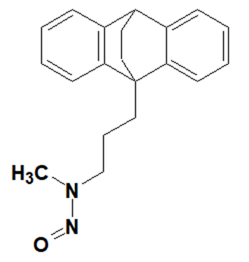 | 18 | 1 | 15 October 2024
N-Nitroso-masitinib /  4-[(4-nitrosopiperazin-1-yl)methyl]-N-(4-methyl-3-{[4-(pyridin-3-yl)-1,3-thiazol-2-yl]amino}phenyl)benzamide | Masitinib | 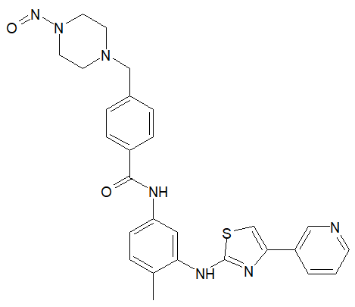 | 400 | 3 | 24 April 2024
N-Nitroso-mefenamic acid  (2114-63-8) | Mefenamic acid | 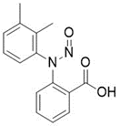 | 78000 |  | 5 January 2023
N-Nitroso-iminodibenzyl /  10,11-dihydro-5-nitroso-5H-dibens[b,f]azepine /  2‐nitroso‐2‐azatricyclo[9.4.0.0³,⁸] pentadeca‐1(11),3(8),4,6,12,14‐hexaene)  (7458-08-4) | Melipramin (Imipramine) |  | 78000 |  | 15 October 2024
N-Nitroso-meropenem /  (4R, 5S, 6S)-3-(((3S, 5S)-5-(dimethylcarbamoyl)-1-nitrosopyrrolidin-3-yl)thio)-6-((R)-1-hydroxyethyl)-4-methyl-7-oxo-1-azabicyclo[3.2.0]hept-2-ene-2-carboxylic acid | Meropenem | 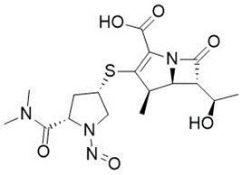 | 1500 | 4 | 24 April 2024
N-Nitroso-methylphenidate  (55557-03-4, NMPH) | Methylphenidate | 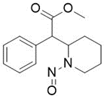 | 1300 |  | 20 July 2022
N-Nitroso-ritalinic acid /  2-(1-nitrosopiperidin-2-yl)-2-phenylacetic acid | Methylphenidate | 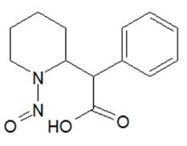 | 1500 | 4 | 24 April 2024
N-Nitroso-methylaminoantipyrine /  N-(1,5-dimethyl-3-oxo-2-phenylpyrazol-4-yl)-N-methylnitrous amide  (73829-38-6, NMAA) | Metamizole |  | 100 | 2 | 3 November 2025
N-Nitroso-metoprolol  (138768-62-4) | Metoprolol | 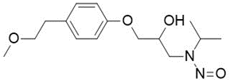 | 1500 | 4 | 24 August 2023
N-Nitroso-N-desmethyl-mianserin /  2-nitroso-1,2,3,4,10,14b-hexahydrodibenzo[c,f]pyrazino[1,2-a]azepine | Mianserin |  | 400 | 3 | 30 April 2025
N-Nitroso-mirabegron | Mirabegron | 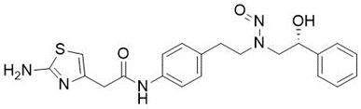 | 400 | 3 | 24 August 2023
N-(2-Hydroxy-2-phenylethyl)-N-(4-nitrophenethyl)nitrous amide /  (R)-N-(2-hydroxy-2-phenylethyl)-N-(4-nitrophenethyl)nitrous amide  (MBL-2-NO) | Mirabegron | 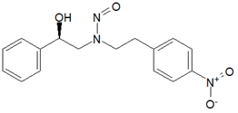 | 400 | 3 | 29 July 2024
N-(4-Aminophenethyl)-N-(2-hydroxy-2-phenylethyl)nitrous amide /  (R)-N-(4-aminophenethyl)-N-(2-hydroxy-2-phenylethyl)nitrous amide  (MBL-3-NO) | Mirabegron | 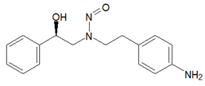 | 400 | 3 | 29 July 2024
N-Nitroso-mirdametinib /  N-(2,3-dihydroxypropoxy)-3,4-difluoro-2-((2-fluoro-4-iodophenyl)(nitroso)amino)benzamide | Mirdametinib |  | 78000 |  | 3 November 2025
N-Nitroso-mirtazapine | Mirtazapine | 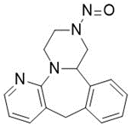 | 400 | 3 | 31 January 2024
N-Nitroso-morpholine  (59-89-2, NMOR) | - | 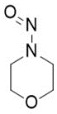 | 127.0 |  | 20 July 2022
N-Nitroso-morpholine  (59-89-2, NMOR) | Molsidomine |  | 127.0 |  | 3 November 2025
N-Nitroso-moxifloxacin | Moxifloxacin | 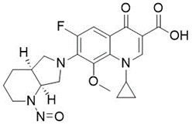 | 1500 | 4 | 24 August 2023
N-Nitroso-nadolol  (134720-06-2) | Nadolol |  | 1500 | 5 | 3 November 2025
N-Nitroso-nor-oxycodone /  (4R,4aS,7aS,12bS)-4a,9-dihydroxy-3-nitroso-2,3,4,4a,5,6-hexahydro-1H-4,12-methanobenzofuro[3,2-e]isoquinolin-7(7aH)-one | Nalmefene | 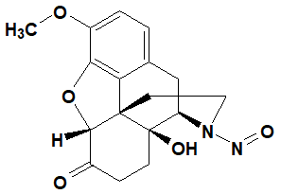 | 1500 | 4 | 4 February 2025
N-Nitroso-nebivolol  (1391051-68-5, NNEB) | Nebivolol | 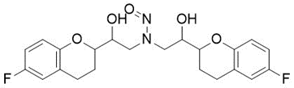 | NMI |  | 24 August 2023  Updated 31 July 2025
N-Nitroso-methylethanolamine /  N-(2-hydroxyethyl)-N-methylnitrous amide  (26921-68-6, NMELA) | Nefopam |  | 100 | 2 | 3 November 2025
N-Nitroso-anabasine /  3-(1-nitrosopiperidin-2-yl)pyridine  (37620-20-5, NAB) | Nicotine | 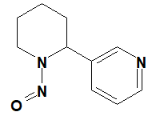 | 1500 | 4 | 4 February 2025
N-Nitroso-anatabine /  3-[(2S)-1-nitroso-3,6-dihydro-2H-pyridin-2-yl]pyridine  (71267-22-6, NAT) | Nicotine | 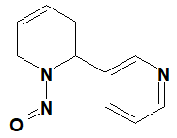 | 1500 | 4 | 4 February 2025
N-Nitroso-nornicotine /  3-[(2S)-1-nitrosopyrrolidin-2-yl]pyridine  (16543-55-8, NNN) | Nicotine | 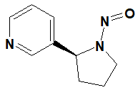 | 100 |  | 4 February 2025
N-Nitroso-nilotinib /  4-methyl-N-(3-(4-methyl-1H-imidazol-1-yl)-5-(trifluoromethyl)phenyl)-3-(nitroso(4-(pyridin-3-yl)pyrimidin-2-yl)amino)benzamide  (2925306-68-7) | Nilotinib | 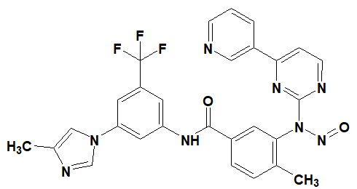 | 1500 | 5 | 4 February 2025
N-Nitroso desmethyl nintedanib | Nintedanib | 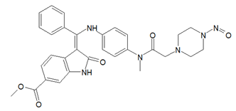 | 400 | 3 | 31 January 2024
N-Nitroso-nirogacestat /  (S)-2-(((S)-6, 8-difluoro-1, 2, 3, 4-tetrahydronaphthalen-2-yl)amino)-N-(1-(2-methyl-1-(neopentyl(nitroso)amino)propan-2-yl)-1H-imidazol-4-yl)pentanamide | Nirogacestat |  | 1500 |  | 3 November 2025
N-Nitroso-nirogacestat impurity 1 /  (S)-2-(((S)-6,8-difluoro-1,2,3,4-tetrahydronaphthalen-2-yl)(nitroso)amino)-N-(1-(2-methyl-1-(neopentylamino)propan-2-yl)-1H-imidazol-4-yl)pentanamide | Nirogacestat |  | 1500 | 5 | 3 November 2025
N-Nitroso-norfloxacin /  1-ethyl-6-fluoro-7-(4-nitrosopiperazin-1-l)-4-oxo-1,4-dihydroquinoline-3-carboxylic acid  (74011-53-3) | Norfloxacin |  | NMI |  | 31 July 2025
N-Nitroso-posaconazole Impurity 1 /  1-(4-(((3R,5R)-5-((1H-1,2,4-triazol-1-yl)methyl)-5-(2,4-difluorophenyl)tetrahydrofuran-3-yl)methoxy)phenyl)-4-nitrosopiperazine | Posaconazole | 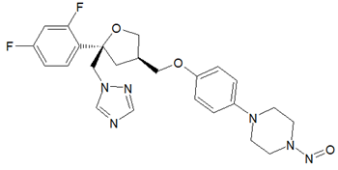 | 400 | 3 | 29 July 2024
N-Nitroso-propafenone /  N-(2-hydroxy-3-(2-(3-phenylpropanoyl)phenoxy)propyl)-N-propylnitrous amide | Propafenone | 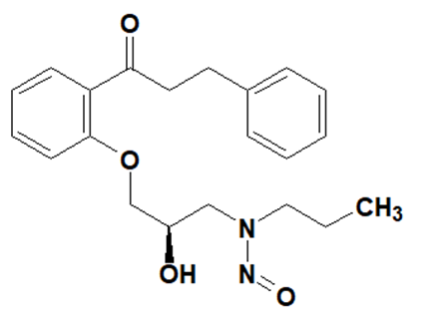 | 100 | 2 | 15 October 2024
N-Nitroso-propafenone impurity B /  (R,E)-N-(3-(2-cinnamoylphenoxy)-2-hydroxypropyl)-N-propylnitrous amide | Propafenone |  | 100 | 2 | 3 November 2025
N-Nitroso-N-ethyl-valaciclovir | Valaciclovir | 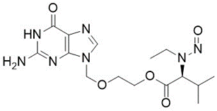 | 400 | 3 | 24 August 2023
N-Nitroso-N-methyl-valaciclovir | Valaciclovir | 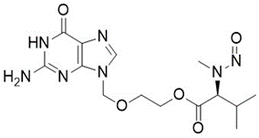 | 1500 |  | 24 April 2024  Updated 29 January 2026
N-Nitroso-vibegron  (S)-N-(4-(((2R,5S)-5-((R)-hydroxy(phenyl)methyl)-1-nitrosopyrrolidin-2-yl)methyl)phenyl)-4-oxo-4,6,7,8-tetrahydropyrrolo[1,2-a]pyrimidine-6-carboxamide | Vibegron | 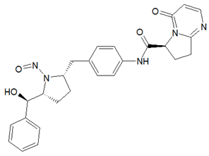 | 1500 | 5 | 29 July 2024
N-Nitroso-N-methyl-4-aminobutyric acid /  4-[methyl(nitroso)amino]butanoic acid  (61445-55-4, NMBA) | - | 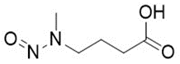 | 1500 | 4 | 15 September 2019  Updated 29 July 2024
N-Nitroso-N-methylaniline /  N-methyl-N-phenylnitrous amide  (614-00-6, NMPA) | - | 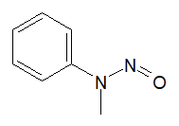 | 100 | 2 | 31 January 2024
N-Nitroso-nortriptyline  (55855-42-0, NNORT) | Amitriptyline, Nortriptyline | 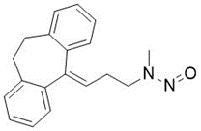 | 18 | 1 | 20 July 2022  Updated 15 October 2024
4-Nitroso-methyl piperazine-1-carboxylate  (N-nitroso PMEC) | Omecamtiv mecarbil | 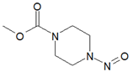 | 400 | 3 | 29 July 2024
2-(4-Nitrosopiperazin-1-yl)ethanol  (48121-20-6) | Opipramol | 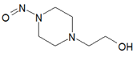 | 400 | 3 | 29 July 2024
N-Nitroso-paroxetine  (2361294-43-9) | Paroxetine | 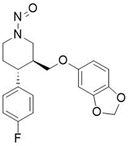 | 1300 |  | 5 January 2023
N-Nitroso-p-chloro-benzylamino-pyridine  (N-CBAP) | Chloropyramine | 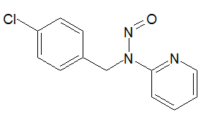 | 100 | 2 | 24 August 2023
N-Nitroso-perindopril | Perindopril | 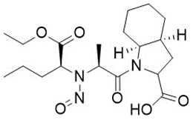 | NMI |  | 24 August 2023  Updated 29 January 2026
N-Nitroso-phenylephrine  (78658-64-7) | Phenylephrine | 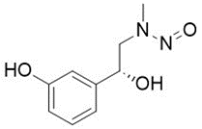 | 100 | 2 | 24 August 2023
N-Nitroso-piperazine  (5632-47-3, NPZ) | - | 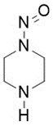 | 400 | 3 | 24 August 2023
N-Nitroso-piperidine  (100-75-4) | - | 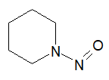 | 1300 |  | 20 July 2022
N-Nitroso-pramipexole | Pramipexole | 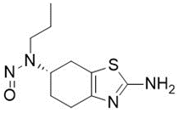 | 400 | 3 | 24 August 2023
N-Nitroso-propranolol  (84418-35-9) | Propranolol | 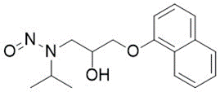 | 1500 | 4 | 24 August 2023
N-Nitroso-pseudoephedrine  (1850-88-0) | Pseudoephedrine | 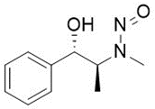 | 1500 |  | 24 August 2023  Updated 29 January 2026
N-Nitroso-pyrrolidine  (930-55-2, NPYR) | - | 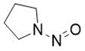 | 1700 |  | 5 January 2023
N-Nitroso quetiapine HEEP impurity /  2-(2-(4-nitrosopiperazin-1-yl)ethoxy)ethan-1-ol  (73486-81-4) | Quetiapine | 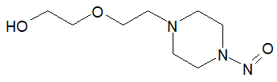 | 1500 |  | 31 January 2024
N-Nitroso-quinapril | Quinapril | 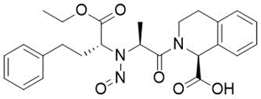 | NMI |  | 24 August 2023
N-Nitroso-ramipril | Ramipril | 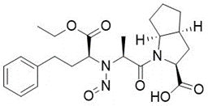 | NMI |  | 24 August 2023  Updated 29 January 2026
N-nitroso ranolazine impurity 1 /  1-(2-methoxyphenoxy)-3-(4-nitrosopiperazin-1-yl)propan-2-ol | Ranolazine | 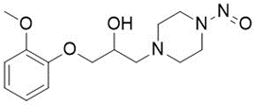 | 400 | 3 | 31 January 2024
N-Nitroso-rasagiline  (2470278-90-9) | Rasagiline | 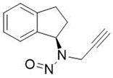 | 100 | 2 | 20 July 2022  Updated 24 August 2023
N-Nitroso-reboxetine | Reboxetine | 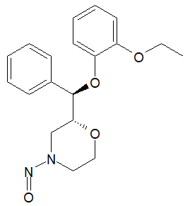 | 127 |  | 24 August 2023
N-Nitroso-ribociclib impurity 1 /  7-cyclopentyl-N,N-dimethyl-2-((5-(4-nitrosopiperazin-1-yl)pyridine-2-yl)amino)-7H-pyrrolo[2,3-d]pyrimidine-6-carboxamide | Ribociclib | 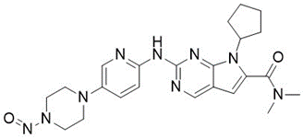 | 400 | 3 | 31 January 2024
N-Nitroso-desformyl-riociguat /  N-(4,6-diamino-2-(1-(2-fluorobenzyl)-1H-pyrazolo[3,4-b]pyridin-3-yl)pyrimidin-5-yl)-N-methylnitrous | Riociguat | 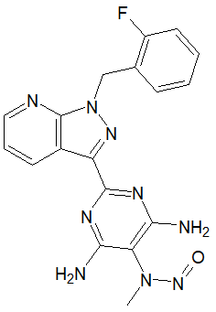 | 100 | 2 | 29 July 2024
N-Nitroso-2,4-thiazole amine /  N-((2-isopropylthiazol-4-yl)methyl)-N-methylnitrous amide  (NNTA) | Ritonavir | 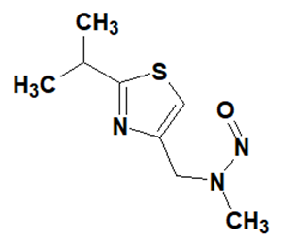 | 18 | 1 | 15 October 2024
N-Nitroso-2,4-thiazole amine /  N-((2-isopropylthiazol-4-yl)methyl)-N-methylnitrous amide  (NNTA) | Cobicistat |  | 18 | 1 | 3 November 2025
N-Nitroso-rivaroxaban open-ring acid /  (S)-2-(2-((4-(5-((5-chlorothiophene-2-carboxamido)methyl)-2-oxooxazolidin-3-yl)phenyl)(nitroso)amino)ethoxy) acetic acid | Rivaroxaban | 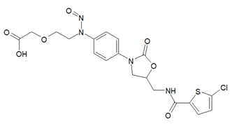 | 1500 | 4 | 31 January 2024
N-Nitroso-rivaroxaban amide /  (S)-5-chloro-N-(2-hydroxy-3-(nitroso (4-(3-oxomorpholino)phenyl)amino) propyl)thiophene-2-carboxamide | Rivaroxaban | 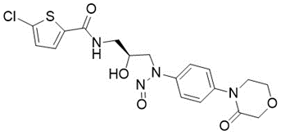 | 1500 | 4 | 31 January 2024
Rivaroxaban nitroso impurity 1 /  N-(2-hydroxyethyl)-N-phenyl-nitrous amide  (25413-76-7, N-Nitroso KCR-1) | Rivaroxaban | 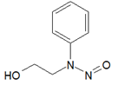 | 1500 | 4 | 29 July 2024
Rivaroxaban nitroso impurity 2 /  N-(3-(1,3-dioxoisoindolin-2-yl)-2-hydroxypropyl)-N-(4-(3-oxomorpholino) phenyl)nitrous amide | Rivaroxaban | 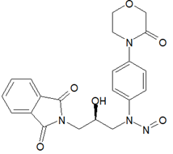 | 1500 | 4 | 29 July 2024
Rivaroxaban nitroso impurity 5 /  N-(3-chloro-2-hydroxypropyl)-N-(4-(3-oxomorpholino)phenyl)nitrous amide  (N-Nitroso RVR-A) | Rivaroxaban | 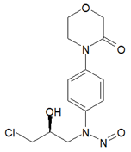 | 1500 | 4 | 29 July 2024
N-Nitroso-desmethyl-rivastigmine /  [3-[(1S)-1-[methyl(nitroso)amino] ethyl]phenyl] N-ethyl-N-methyl carbamate | Rivastigmine | 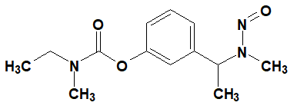 | 100 | 2 | 15 October 2024
N-Nitroso-N-desmethyl-rizatriptan /  N-(2-(5-((1H-1,2,4-triazol-1-yl)methyl)-1H-indol-3-yl)ethyl)-N-methylnitrous amide | Rizatriptan | 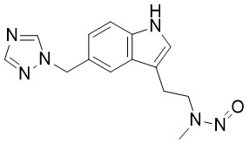 | 18 | 1 | 15 October 2024
N-Nitroso-despropyl-ropinirole /  N-(2-(2-oxoindolin-4-yl)ethyl)-N-propylnitrous amide | Ropinirole |  | 18 | 1 | 31 July 2025
N-Nitroso-safinamide /  (2S)-2-[[4-[(3-fluorophenyl)methoxy]phenyl]methyl-nitrosoamino]propanamide  (2657645-00-4) | Safinamide |  | 400 | 3 | 31 July 2025
N-Nitroso-salbutamol  (2919946-71-5) | Salbutamol | 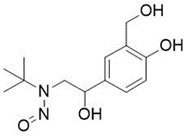 | 1500 | 5 | 24 August 2023
N-Nitroso-sertraline | Sertraline | 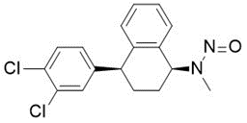 | 100 | 2 | 24 August 2023  Updated 16 October 2023  Updated 15 October 2024
N-Nitroso-desmethyl-sildenafil | Sildenafil | 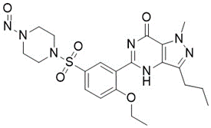 | 400 | 3 | 31 January 2024
N-Nitroso-silodosin /  1-(3-hydroxypropyl)-5-[(2R)-2-[nitroso-[2-[2-(2,2,2-trifluoroethoxy)phenoxy]ethyl]amino]propyl]-2,3-dihydroindole-7-carboxamide | Silodosin | 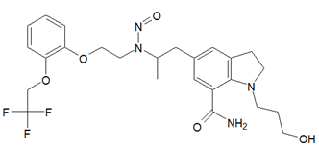 | 1500 | 4 | 24 April 2024
N-Nitroso-sotalol  (134720-07-3) | Sotalol | 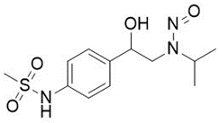 | 1500 | 4 | 24 August 2023
N-Nitroso-desmethyl sumatriptan | Sumatriptan | 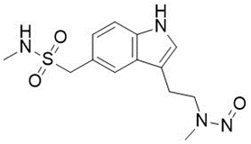 | 18 | 1 | 31 January 2024
N-Nitroso-desmethyl-tamoxifen /  (Z)-N-(2-(4-(1, 2-diphenylbut-1-en-1-yl)phenoxy)ethyl)-N-methylnitrous amide | Tamoxifen | 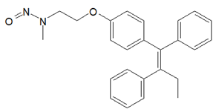 | 18 | 1 | 24 April 2024
N-Nitroso-tamsulosin  (2892260-31-8) | Tamsulosin | 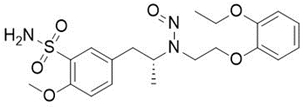 | 1500 | 4 | 20 July 2022  Updated 24 August 2023
N-Nitroso terazosin impurity C /  N-nitroso 6,7-dimethoxy-2-(1-piperazinyl)-4-quinazolinamine /  N-nitroso 2-(1-piperazinyl)-4-amino-6, 7-dimethoxyquinazoline | Terazosin | 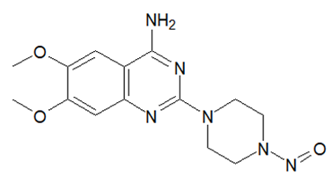 | 400 | 3 | 24 April 2024
N-Nitroso terazosin impurity N /  (4-nitrosopiperazin-1-yl)(tetrahydrofuran-2-yl)methanone  (2470438-57-2) | Terazosin | 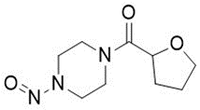 | 400 | 3 | 24 April 2024
N-Nitroso-desmethyl-terbinafine /  (E)-N-(6,6-dimethylhept-2-en-4-yn-1-yl)-N-(naphthalen-1-ylmethyl)nitrous amide  (NDT / NHNA) | Terbinafine | 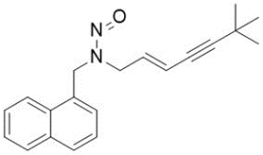 | 18 | 1 | 31 January 2024
N-Nitroso-terbinafine impurity A /  N-methyl-N-(napthalen-1-ylmethyl)nitrous amide  (296760-88-8, NTA / NMNA) | Terbinafine | 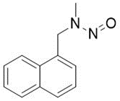 | 18 | 1 | 31 January 2024
N-Nitroso-terbinafine degradant /  N-[(2E)-6,6-dimethyl-2-hepten-4-yn-1-yl]-N-nitrosomethanamine  (NTD / NHMA) | Terbinafine | 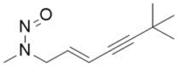 | 18 | 1 | 31 January 2024
N-Nitroso-tetracaine | Tetracaine | 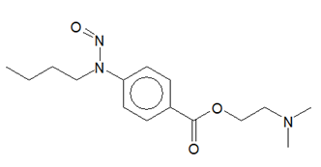 | 400 | 3 | 31 January 2024
N‐Nitroso‐ticagrelor  (2476859-55-7) | Ticagrelor | 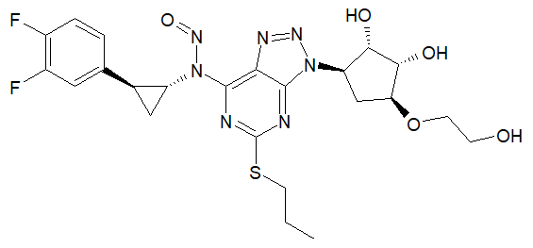 | 1500 | 5 | 31 January 2024
N-Nitroso-tigecycline /  (4S, 4aS, 5aR, 12aS)-9-(2-(tert-butyl(nitroso)amino)acetamido)-4, 7-bis(dimethylamino)-3, 10, 12, 12a-tetrahydroxy-1, 11-dioxo-1, 4, 4a, 5, 5a, 6, 11, 12a-octahydrotetracene-2-carboxamide | Tigecycline | 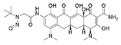 | NMI |  | 29 July 2024
N-Nitroso-desmethyl-tramadol /  N-[[(1R,2R)-2-hydroxy-2-(3-methoxyphenyl)cyclohexyl]methyl]-N-methylnitrous amide | Tramadol | 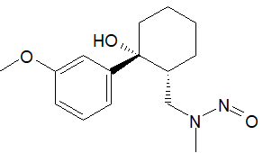 | 18 | 1 | 29 July 2024
N-Nitroso-trandolapril /  (2S,3aR,7aS)-1-(N-((S)-1-ethoxy-1-oxo-4-phenylbutan-2-yl)-N-nitroso-L-alanyl)octahydro-1H-indole-2-carboxylic acid | Trandolapril | 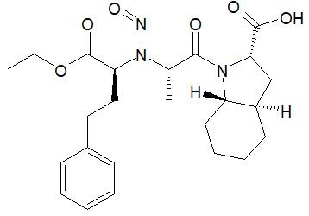 | 1500 | 5 | 29 July 2024
N-Nitroso-trimetazidine  (92432-50-3, NTMZ) | Trimetazidine | 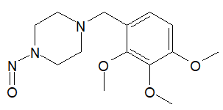 | 400 | 3 | 24 August 2023
2-(N-Nitrosomethylamino)-N-[6-(trifluoromethoxy)-1,3-benzothiazol-2-yl]acetamide  (NNT) | Troriluzole |  | 100 | 2 | 30 April 2025
N-Nitroso-sarcosine /  2-[methyl(nitroso)amino]acetic acid  (13256-22-9, NSAR) | Troriluzole |  | 1500 | 4 | 30 April 2025
N-Nitroso-urapidil | Urapidil | 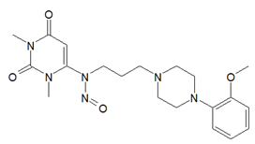 | 1500 | 4 | 31 January 2024
N-Nitroso-varenicline  (2755871-02-2, NNV) | Varenicline | 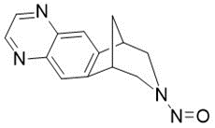 | 400 | 3 | 20 July 2022  Updated 16 October 2023
N-Nitroso-desvaleryl-valsartan /  (S)-2-(((2'-(1H-tetrazol-5-yl)- [1,1′-biphenyl]-4-yl) methyl)(nitroso)amino)- 3-methylbutanoic acid  (2254485-68-0) | Valsartan | 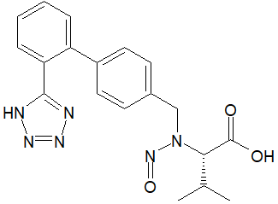 | NMI |  | 29 July 2024
N-Nitroso-valsartan cyano-desvalerylmethylester /  (S)-Methyl 2-(((2'-cyano-[1,1'-biphenyl]-4-yl)methyl)(nitroso) amino)-3-methylbutanoate | Valsartan | 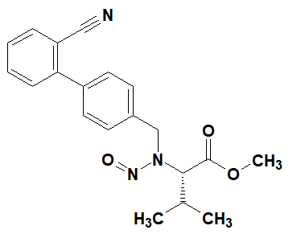 | 100 | 2 | 15 October 2024
N-Nitroso-vancomycin /  (1S,2R,18R,19R,22S,25R,28R,40S)-48-[(2S,3R,4S,5S,6R)-3-[(2S,4S,5S,6S)-4-amino-5-hydroxy-4,6-dimethyloxan-2-yl]oxy-4,5-dihydroxy-6-(hydroxymethyl)oxan-2-yl]oxy-22-(2-amino-2-oxoethyl)-5,15-dichloro-2,18,32,35,37-pentahydroxy-19-[[(2R)-4-methyl-2-[methyl(nitroso)amino]pentanoyl]amino]-20,23,26,42,44-pentaoxo-7,13-dioxa-21,24,27,41,43-pentazaoctacyclo[26.14.2.23,6.214,17.18,12.129,33.010,25.034,39]pentaconta-3,5,8(48),9,11,14,16,29(45),30,32,34(39),35,37,46,49-pentadecaene-40-carboxylic acid  (155386-25-7) | Vancomycin |  | 1500 | 4 | 30 April 2025
N-Nitroso-vanzacaftor /  (13S,Z)-26-(3-(2-(dispiro[2.0.24.13]heptan-7-yl)ethoxy)-1H-pyrazol-1-yl)-15,15-dimethyl-61,62-dihydro-5-thia-4,7-diaza-2(2,3),6(6,2)-dipyridina-1(1,3)-pyrrolidinacyclodecaphan-3-one 5,5-dioxide | Vanzacaftor | 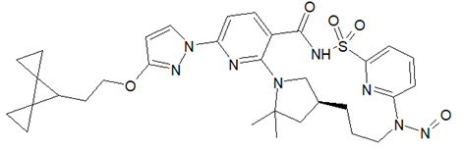 | 1500 | 4 | 15 October 2024
N-Nitroso venlafaxine EP Impurity D /  N-(2-(1-hydroxycyclohexyl)-2-(4-methoxyphenyl)ethyl)-N-methylnitrous amide  (2680662-11-5) | Venlafaxine |  | 18 | 1 | 3 November 2025
N-Nitroso venlafaxine EP Impurity H /  N-(2-(1-hydroxycyclohexyl)-2-(4-methoxyphenyl)ethyl)-N-(4-methoxyphenethyl)nitrous amide | Venlafaxine |  | 100 | 2 | 3 November 2025
N-Nitroso-vildagliptin | Vildagliptin | 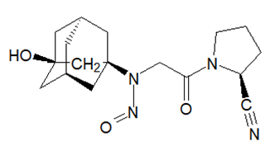 | 1500 | 5 | 24 August 2023
N-Nitroso vildagliptin amide impurity /  (S)-1-(2-(((1R, 3R, 5R, 7S)-3-hydroxyadamantan-1-yl)(nitroso)amino)acetyl)pyrrolidine-2-carboxamide | Vildagliptin | 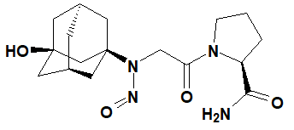 | 1500 | 5 | 15 October 2024
N-Nitroso-L-prolinamide /  (S)-1-nitrosopyrrolidine-2-carboxamide  (79108-51-3) | Vildagliptin | 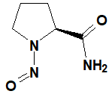 | 1500 | 4 | 4 February 2025
N-Nitroso-L-prolinenitrile /  (S)-1-nitrosopyrrolidine-2-carbonitrile | Vildagliptin | 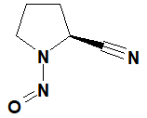 | 1500 | 4 | 4 February 2025
N-Nitroso-vortioxetine | Vortioxetine | 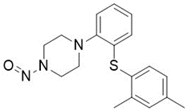 | 400 | 3 | 24 August 2023
N‐Nitroso‐desmethyl‐zolmitriptan /  N-methyl-N-[2-[5-[[(4S)-2-oxo-1,3-oxazolidin-4-yl]methyl]-1H-indol-3-yl]ethyl]nitrous amide | Zolmitriptan | 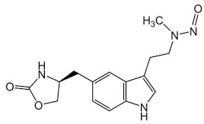 | 18 | 1 | 4 February 2025
N-Methyl-N-nitrosoanthranilate /  methyl 2-(methyl(nitroso)amino)benzoate  (68061-82-5, NO-MMA) | Methyl N-methylanthranilate | 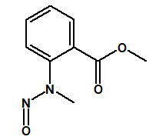 | 100 | 2 | 29 January 2026
N-Nitroso-4-phenylpiperazine /  1-nitroso-4-phenylpiperazine  (14340-33-1) | Levodropropizine | 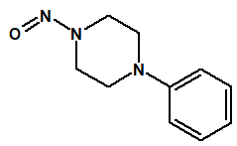 | 400 | 3 | 29 January 2026
N-Nitroso-cytisine /  (1R,5R)-3-nitroso-1,2,3,4,5,6-hexahydro-8H-1,5-methanopyrido[1,2-a][1,5]diazocin-8-one  (19634-60-7) | Cytisine | 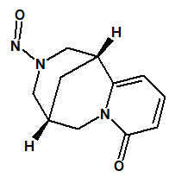 | 400 | 3 | 29 January 2026
N-Nitroso-desbutyl-lumefantrine /  (Z)-N-butyl-N-(2-(2,7-dichloro-9-(4-chlorobenzylidene)-9H-fluoren-4-yl)-2-hydroxyethyl)nitrous amide | Lumefantrine | 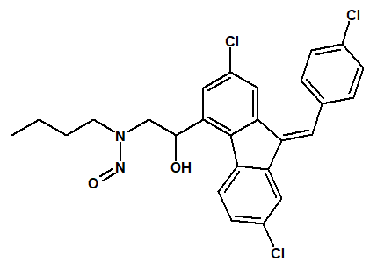 | 1500 |  | 29 January 2026
N-Nitroso-desmethyl-mifepristone /  N-[4-[(8S,11R,13S,14S,17S)-17-hydroxy-13-methyl-3-oxo-17-prop-1-ynyl-1,2,6,7,8,11,12,14,15,16-decahydrocyclopenta[a]phenanthren-11-yl]phenyl]-N-methylnitrous amide | Mifepristone | 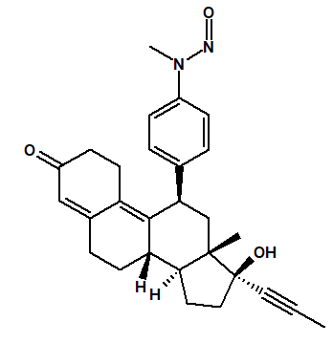 | 100 | 2 | 29 January 2026
N-Nitroso-desmethyl-tapentadol /  N-[(2R,3R)-3-(3-hydroxyphenyl)-2-methylpentyl]-N-methylnitrous amide | Tapentadol | 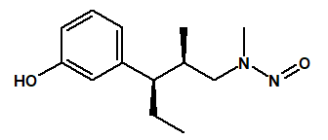 | 18 | 1 | 29 January 2026
N-Nitroso-selumetinib /  6-(4-bromo-2-chloro-N-nitrosoanilino)-7-fluoro-N-(2-hydroxyethoxy)-3-methylbenzimidazole-5-carboxamide | Selumetinib | 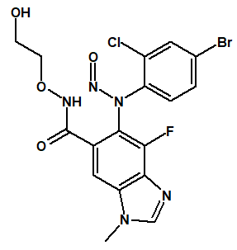 | 78000 |  | 29 January 2026
N-Nitroso-ephedrine /  N-[(1S,2R)-1-hydroxy-1-phenylpropan-2-yl]-N-methylnitrous amide  (7181-48-8) | Ephedrine | 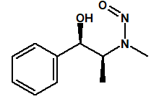 | 1500 | 4 | 29 January 2026
N-Nitroso-relebactam | Relebactam | 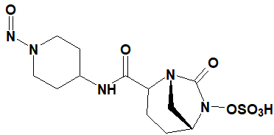 | 400 | 3 | 29 January 2026
N-Nitroso-olanzapine | Olanzapine |  | 1500 | 5 | 29 January 2026
N-Nitroso-elagolix | Elagolix | 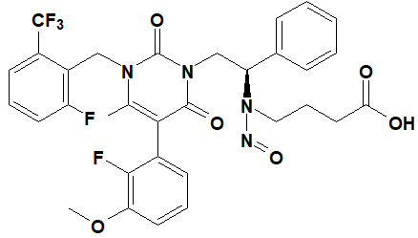 | 1500 | 4 | 29 January 2026
2-(2-(4-Nitrosopiperazin-1-yl) ethoxy)ethan-1-ol  (73486-81-4) | Hydroxyzine |  | 1500 |  | 29 January 2026

CPCA: Carcinogenic Potency Categorisation Approach
NMI: Non mutagenic impurity should be controlled to ICH Q3A and ICH Q3B guideline limits

1 Acceptable Intake (AI) Limit to be applied to maximum daily dose (MDD) of the drug product. These limits are applicable only if a product contains a single N-nitrosamine.

2 Potential presence of nitrosamine impurities with structures derived from drug substances or their related impurities. This does not mean that the impurity will be found in all products or pharmaceutical forms containing the drug substance. Please refer to EMA’s Q&A on the risk factors for the presence of nitrosamines for details.

