Australian Public Assessment Report for Uteknix
  - Active ingredient: Ustekinumab
  - Sponsor: Cipla Australia Pty Ltd
October 2025

About the Therapeutic Goods Administration (TGA)
- The Therapeutic Goods Administration (TGA) is part of the Australian Government Department of Health, Disability and Ageing and is responsible for regulating therapeutic goods, including medicines, medical devices, and biologicals.
- The TGA administers the Therapeutic Goods Act 1989 (the Act), applying a risk management approach designed to ensure therapeutic goods supplied in Australia meet acceptable standards of quality, safety, and efficacy.
- The work of the TGA is based on applying scientific and clinical expertise to decision-making, to ensure that the benefits to the Australian public outweigh any risks associated with the use of therapeutic goods.
- The TGA relies on the public, healthcare professionals and industry to report problems with therapeutic goods. The TGA investigates reports received to determine any necessary regulatory action.
- To report a problem with a therapeutic good, please see the information on the TGA website.

About AusPARs
- The Australian Public Assessment Report (AusPAR) provides information about the evaluation of a prescription medicine and the considerations that led the TGA to approve or not approve a prescription medicine submission. Further information can be found in Australian Public Assessment Report (AusPAR) guidance.
- AusPARs are prepared and published by the TGA.
- AusPARs are static documents that provide information that relates to a submission at a particular point in time. The publication of an AusPAR is an important part of the transparency of the TGA’s decision-making process.
- A new AusPAR may be provided to reflect changes to indications or major variations to a prescription medicine subject to evaluation by the TGA.

Copyright
© Commonwealth of Australia 2025
This work is copyright. You may reproduce the whole or part of this work in unaltered form for your own personal use or, if you are part of an organisation, for internal use within your organisation, but only if you or your organisation do not use the reproduction for any commercial purpose and retain this copyright notice and all disclaimer notices as part of that reproduction. Apart from rights to use as permitted by the Copyright Act 1968 or allowed by this copyright notice, all other rights are reserved, and you are not allowed to reproduce the whole or any part of this work in any way (electronic or otherwise) without first being given specific written permission from the Commonwealth to do so. Requests and inquiries concerning reproduction and rights are to be sent to the TGA Copyright Officer, Therapeutic Goods Administration, PO Box 100, Woden ACT 2606 or emailed to <tga.copyright@tga.gov.au>.

Contents
List of abbreviations 4
Product submission 6
Submission details 6
Product background 8
Disease or condition 8
Current treatment options 9
Clinical rationale 9
Regulatory status 10
Australian regulatory status 10
International regulatory status 10
Registration timeline 12
Assessment overview 13
Quality evaluation summary 13
Nonclinical evaluation summary 14
Clinical evaluation summary 14
Pharmacology 14
Efficacy 20
Safety 26
Risk management plan evaluation 36
Risk-benefit analysis 37
Delegate’s considerations 37
Advisory Committee considerations 40
Assessment outcome 41
Specific conditions of registration 41
Product Information and Consumer Medicine Information 42

List of abbreviations
Abbreviation | Meaning
ACM | Advisory Committee on Medicines
ACV | Advisory Committee on Vaccines
ADA | Antidrug antibody
AESI | Adverse event of special interest
ANCOVA | Analysis of covariance
ARTG | Australian Register of Therapeutic Goods
ASA | Australia-specific annex
AUC_{0-inf} | Area under the concentration time curve from time zero to infinity
AUC_{0-t} | Area under concentration-time curve from time zero to the time of last measurable concentration
BMI | Body mass index
BSA | Body surface area
CD | Crohn’s disease
CI(s) | Confidence interval(s)
C_{max} | Maximum concentration
CMI | Consumer Medicines Information
C_{trough} | Trough concentration
DLP | Data lock point
DLQI | Dermatology Life Quality Index
DMARD | Disease modifying antirheumatic drug
ECG | Electrocardiogram
EMA | European Medicines Agency
EoS | End of study
EU | European Union
FDA | Food and Drug Administration (United States of America)
GMRs | Geometric mean ratios
HIV | Human immunodeficiency virus
IL-12 | Interleukin 12
IL-23 | Interleukin 23
ISRs | injection site reactions
ITT | Intention-To-Treat
LS | Least squares
MTX | Methotrexate
nAb | Neutralizing antibody
PASI | Psoriasis area and severity index
PD | Pharmacodynamic(s)
PI | Product Information
PK | Pharmacokinetic(s)
PsA | Psoriatic arthritis
PsO | Plaque psoriasis
PSUR | Periodic safety update report
PT | Preferred term
PUVA | Psoralen plus ultraviolet A
RMP | Risk management plan
RP | Reference Product
SOC | System Organ Class
SPC | Supplementary Protection Certificate
sPGA | Static Physician Global Assessment
t_{1/2} | Half life
TB | Tuberculosis
TEAE(s) | Treatment-emergent adverse event(s)
T_{max} | Time after administration of a drug when the maximum plasma concentration is reached
TNFα | Tumour necrosis factor alpha
TGA | Therapeutic Goods Administration
UK | United Kingdom
US | United States (of America)

Product submission

Submission details
Type of submission: | New chemical entity
Product name: | Uteknix
Active ingredient: | ustekinumab
Decision: | Approved
Date of decision: | 20 January 2025
Date of entry onto ARTG: | 11 February 2025
ARTG numbers: | 422259 and 422260
Black Triangle Scheme  for the current submission: | Yes
Sponsor’s name and address: | Cipla Australia Pty Ltd  Level 1 / 132-136 Albert Road  South Melbourne Vic 3205
Dose forms: | Solution for injection
Strengths: | 45 mg/0.5 mL or 90 mg/1 mL
Container: | Syringe
Pack size: | One pre-filled syringe
Approved therapeutic use for the current submission: | Plaque psoriasis  Uteknix is indicated for the treatment of adult patients (18 years or older) with moderate to severe plaque psoriasis who are candidates for phototherapy or systemic therapy.  Psoriatic arthritis (PsA)  Uteknix, alone or in combination with methotrexate, is indicated for the treatment of signs and symptoms of active psoriatic arthritis in adult patients (18 years and older) where response to previous non-biological DMARD therapy has been inadequate.  Uteknix has not been approved for use in children or adolescents under the age of 18 years.  Uteknix has not been approved for use in patients with Crohn’s disease or ulcerative colitis.
Route of administration: | Subcutaneous injection
Dosage: | The recommended dose of Uteknix is 45 mg administered at Weeks 0 and 4, then every 12 weeks thereafter. Alternatively, 90 mg administered over Weeks 0 and 4, then every 12 weeks thereafter may be used in patients with a body weight greater than 100 kg.  For further information regarding dosage, such as dosage modifications to manage adverse reactions, refer to the Product Information (PI).
Pregnancy category: | Category B1  The available clinical experience with use of ustekinumab is limited. Data from prospectively collected pregnancies following exposure to ustekinumab resulting in live birth with known outcomes, including more than 450 pregnancies exposed during the first trimester, do not indicate an increased risk of malformations in the newborn. However, the risk of harm to a foetus from ustekinumab use in pregnancy cannot be completely excluded.  Developmental toxicity studies of ustekinumab were conducted in cynomolgus monkeys. No evidence of maternal toxicity, embryotoxicity or teratogenicity was observed at doses up to 45 mg/kg following weekly or twice weekly administration via the intravenous or subcutaneous routes, respectively, during the period of organogenesis. However, animal reproductive and developmental studies are not always predictive of human response.  Ustekinumab may be given to a pregnant woman if the benefit clearly outweighs the risk.  The use of any medicine during pregnancy requires careful consideration of both risks and benefits by the treating health professional. The pregnancy database must not be used as the sole basis of decision making in the use of medicines during pregnancy. The TGA does not provide advice on the use of medicines in pregnancy for specific cases. More information is available from obstetric drug information services in your state or territory.

Product background
This AusPAR describes the submission by Cipla Australia to register Uteknix (ustekinumab) 45 mg/0.5 mL and 90 mg/1.0 mL pre-filled syringe presentations (for subcutaneous injection) for the following proposed indications:
Plaque psoriasis
Uteknix is indicated for the treatment of adult patients (18 years or older) with moderate to severe plaque psoriasis who are candidates for phototherapy or systemic therapy.
Psoriatic arthritis
Uteknix, alone or in combination with methotrexate, is indicated for the treatment of signs and symptoms of active psoriatic arthritis in adult patients (18 years and older) where response to previous non-biological DMARD therapy has been inadequate.

Disease or condition
Psoriasis is a chronic, immune-mediated inflammatory skin disease with a variety of clinical manifestations affecting approximately 2 to 3% of the population worldwide, with prevalence estimates in Australia ranging from 2.3 to 6.6%. Chronic plaque psoriasis is the most common subtype characterised by well-demarcated erythematous plaques with an overlying coarse scale often associated with itch, with extent of involvement ranging from localised disease to involvement of the majority of the body surface area. Other recognised subtypes include guttate psoriasis, pustular psoriasis and erythrodermic subtypes. Psoriasis shows no significant difference in prevalence or incidence between males and females, with peak ages of onset reported as 30 to 39 years and 50 to 69 years, though it can occur at any age.² The clinical course of psoriasis is highly variable, but it tends to be a chronic disease. Patients with psoriasis are at risk for psoriatic arthritis, which may manifest before or after skin manifestations.
Psoriatic arthritis is a chronic inflammatory arthritis which occurs in approximately 20% of patients with psoriasis. Clinical manifestations are variable and inflammatory changes may affect small joints, large joints, the axial skeleton, as well as enthesitis and dactylitis. Pain and stiffness in inflamed joints is the most common manifestation, with fatigue a common associated symptom.⁵ Stiffness is classically worse with immobility, and relieved by physical activity. Joint involvement is variable and may be categorised as symmetric or asymmetric, and polyarthritis or oligoarthritis, with less than five joints involved.^{4,5} Apart from psoriatic skin disease, other common extraarticular manifestations include nail changes and uveitis. The diagnosis is typically clinical.^{4,5}

Current treatment options
Treatment of psoriasis depends on location and severity of disease. Topical treatments which may be used alone or in combination include topical corticosteroids, tars (often in combination with a keratolytic such as salicylic acid) and calcipotriol. For severe disease, or disease not adequately treated by topical preparations, treatment options include phototherapy, non-biologic systemic therapies including methotrexate, acitretin, apremilast and ciclosporin, as well as biologic therapies with a number of different targets, including IL-17A, IL-12 and IL-23, IL-23 alone, and TNFα. Biologic agents currently included on the ARTG which list plaque psoriasis as an approved therapeutic indication include: adalimumab, bimekizumab, certolizumab, etanercept, guselkumab, infliximab, ixekizumab, risankizumab, secukinumab, tildrakizumab, and ustekinumab. The small molecule medicine deucravacitinib is also indicated for plaque psoriasis.
Treatment of psoriatic arthritis depends on specific clinical manifestations and severity, and forms part of global psoriatic treatment which considers domains of skin, nail and musculoskeletal manifestations. General principles of treatment include the targeting of multiple domains of disease with a single drug or regimen to minimise polypharmacy, and an aim for good control of disease to mitigate joint destruction due to arthritis.
Non-steroidal anti-inflammatory drugs have a role for most patients, while intra-articular corticosteroid injection is an option for monoarticular or oligoarticular disease.⁶ There are a number of disease-modifying drug options for patients with peripheral joint predominant disease; conventional agents including methotrexate, sulfasalazine, or leflunomide, biologic agents targeting tumour necrosis factor including adalimumab, infliximab, certolizumab, etanercept and golimumab, as well as biologic agents with other targets including ustekinumab and secukinumab.^{6,} Apremilast has particular utility for patients with prominent enthesitis and dactylitis.⁷ In patients with axial skeleton predominant disease biologic agents are generally preferred to conventional disease modifying agents, including agents targeting tumour necrosis factor and IL-17, whilst for some patients Janus kinase inhibitors such as tofacitinib or upadacitinib may be used.

Clinical rationale
Ustekinumab is a recombinant human IgG1 kappa monoclonal antibody that specifically binds to the shared p40 protein subunit of the human cytokines IL-12 and IL-23, inhibiting receptor binding and subsequent signalling pathways. IL-12 is implicated in differentiation of CD4+ T cells toward the Th1 pathway with subsequent interferon-gamma production, whilst IL-23 induces the Th17 T-cell pathway with subsequent secretion of additional cytokines. Ustekinumab has demonstrated efficacy in psoriasis, psoriatic arthritis, Crohn’s disease and ulcerative colitis.
Uteknix is a biosimilar to the innovator product Stelara (ustekinumab). This application seeks approval for Uteknix in 45 mg/0.5 mL pre-filled syringe and 90 mg/1.0 mL prefilled syringe presentations, corresponding to two of the six currently approved presentations for Stelara. If approved, Uteknix will be an alternative to Stelara and other ustekinumab biosimilar products. If the supply of one or more ustekinumab products is disrupted, the availability of a number of biosimilar ustekinumab products on the ARTG will enable ongoing access to treatment.t

Regulatory status

Australian regulatory status
The innovator product, Stelara, was first included in the ARTG in 2009 and is currently approved for the following therapeutic indications:
- Plaque Psoriasis, Adults: Stelara is indicated for the treatment of adult patients (18 years or older) with moderate to severe plaque psoriasis who are candidates for phototherapy or systemic therapy.
- Plaque psoriasis, paediatric population 6 years or older: Stelara is indicated for the treatment of moderate to severe plaque psoriasis in children and adolescent patients from 6 years of age who are inadequately controlled by, or are intolerant to, other systemic therapies or phototherapies.
- Psoriatic arthritis: Stelara, alone or in combination with methotrexate, is indicated for the treatment of signs and symptoms of active psoriatic arthritis in adult patients (18 years and older) where response to previous non-biological DMARD therapy has been inadequate.
- Crohn’s disease: Stelara is indicated for the treatment of adult patients with moderately to severely active Crohn’s disease who have had an inadequate response, lost response, or were intolerant to either conventional therapy or a TNFα antagonist or have medical contraindications to such therapies.
- Ulcerative colitis: Stelara is indicated for the treatment of adult patients with moderately to severely active ulcerative colitis.
The biosimilar medicine Wezlana was included on the ARTG in January 2024, with the same approved therapeutic indications as for Stelara.
Uteknix has not appeared in the ARTG previously.

International regulatory status
At the time the TGA considered this submission, a similar submission had been considered by other regulatory agencies.
Stelara
The United States (US) prescribing information for Stelara includes broadly similar therapeutic indications to the approved Australian PI, with an additional indication for treatment of psoriatic arthritis in children 6 years of age and older.
The European Union (EU) Supplementary Protection Certificate (SPC) for Stelara includes similar therapeutic indications to the Australian PI.
AVT04/Uteknix
Of note, according to the European Medicines Agency (EMA) Assessment Report for Uzpruvo, whilst Stelara has an approved indication for moderately to severely active ulcerative colitis in the EU, this indication was withdrawn from the Uzpruvo application due to a pending patent for the indication.
Table 1: International regulatory status
Region | Submission date | Status | Approved indications
European Union (EU) | October 2022 | Approved, as Uzpruvo on 05 January 2024 | Uzpruvo 45 mg solution for injection in pre-filled syringe and 90 mg solution for injection in pre-filled syringe:  Plaque psoriasis - Uzpruvo is indicated for the treatment of moderate to severe plaque psoriasis in adults who failed to respond to, or who have a contraindication to, or are intolerant to other systemic therapies including ciclosporin, methotrexate (MTX) or psoralen and ultraviolet (PUVA).  Paediatric plaque psoriasis - Uzpruvo is indicated for the treatment of moderate to severe plaque psoriasis in children and adolescent patients from the age of 6 years and older, who are inadequately controlled by, or are intolerant to, other systemic therapies or phototherapies.  Psoriatic arthritis (PsA) - Uzpruvo, alone or in combination with MTX, is indicated for the treatment of active PsA in adult patients when the response to previous non-biological disease-modifying anti-rheumatic drug (DMARD) therapy has been inadequate.  Crohn’s disease - Uzpruvo is indicated for the treatment of adult patients with moderately to severely active Crohn’s disease who have had an inadequate response with, lost response to, or were intolerant to either conventional therapy or a tumour necrosis factor (TNF) α antagonist or have medical contraindications to such therapies.
United States (US) | October 2022 | Approved, as Selarsdi on 16 April 2024 | Selarsdi is a human interleukin-12 and -23 antagonist indicated for the treatment of:  Adult patients with:  • moderate to severe plaque psoriasis (PsO) who are candidates for phototherapy or systemic therapy.  • active psoriatic arthritis (PsA).  • moderately to severely active Crohn’s disease (CD).  • moderately to severely active ulcerative colitis.  Paediatric patients 6 years and older with:  • moderate to severe plaque psoriasis, who are candidates for phototherapy or systemic therapy.  • active psoriatic arthritis (PsA).
Canada | November 2022 | Approved as Jamteki on 09 November 2023 | Plaque Psoriasis -Jamteki (ustekinumab) is indicated for  the treatment of chronic moderate to severe plaque psoriasis in adult patients who are candidates for phototherapy or systemic therapy.  the treatment of chronic moderate to severe plaque psoriasis in pediatric patients (6-17 years of age) who are inadequately controlled by, or are intolerant to, other systemic therapies or phototherapies.  Psoriatic Arthritis - Jamteki (ustekinumab) is indicated for the treatment of adult patients with active psoriatic arthritis. Jamteki can be used alone or in combination with methotrexate (MTX).  Crohn’s Disease - Jamteki/Jamteki I.V. (ustekinumab) is indicated for the treatment of adult patients with moderately to severely active Crohn’s disease, who have had an inadequate response, loss of response to, or were intolerant to either immunomodulators or one or more tumour necrosis factor-alpha (TNFα) antagonists, or have had an inadequate response, intolerance or demonstrated dependence on corticosteroids.  Ulcerative Colitis - Jamteki/Jamteki I.V. (ustekinumab) is indicated for the treatment of adult patients with moderately to severely active ulcerative colitis who have had an inadequate response with, lost response to, or were intolerant to either conventional therapy or a biologic or have medical contraindications to such therapies.
United Kingdom (UK) | November 2023 | Approved as Uzpruvo on 26 March 2024 | The approved therapeutic indications in the United Kingdom (UK) are consistent the same as authorised by the European Union.

Registration timeline
The following table captures the key steps and dates for this submission.
This submission was evaluated under the standard prescription medicines registration process.
Table 2: Timeline for Submission PM-2023-03558-1-1
Description | Date
Submission dossier accepted and first round evaluation commenced | 3 October 2023
Evaluation completed | 6 November 2024
Advisory committee meeting | 3 October 2024
Registration decision (Outcome) | 20 January 2025
Registration in the ARTG completed | 11 February 2025
Number of working days from submission dossier acceptance to registration decision* | 185
*Statutory timeframe for standard submissions is 255 working days

Assessment overview
A summary of the TGA’s assessment for this submission is provided below.

Quality evaluation summary
Ustekinumab is a fully human IgG1Ƙ monoclonal antibody that binds with specificity to the shared p40 protein subunit of the human cytokines IL-12 and IL-23. Ustekinumab inhibits the bioreactivity if human IL-12 and IL-23 by preventing p40 from binding to the IL-12Rβ1 receptor protein expressed on the surface of immune cells. The molecular weight of ustekinumab is approximately 148.6 kDa. Ustekinumab is produced by mammalian 17-SP2/0-S cells cultured by continuous perfusion.
Manufacturing, purification and formulation steps were adequately described in the dossier for the ustekinumab active substance. The overall quality of the ustekinumab active substance was demonstrated via adequate control of the starting material, control of critical steps and intermediates, process validation, extensive characterisation using orthogonal and state-of-the-art analytical methods, control of impurities and contaminants, generation of robust reference materials and batch analyses that covered multiple manufacturing campaigns.
Ustekinumab finished product Uteknix is a sterile solution available in a single-dose, 1 mL long glass syringe with a fixed 29-gauge, 0.5-inch needle (container), and a plunger stopper. Each syringe contains either 0.5 mL nominal fill (45 mg) or 1.0 mL nominal fill (90 mg) of ustekinumab, histidine, histidine hydrochloride monohydrate, sucrose, polysorbate 80 and water for injections in a preservative-free histidine-buffered solution. The container closure is considered suitable for its intended use as demonstrated by compatibility and stability studies. The formulation development has been adequately described in drug substance manufacture and the final formulation intended for marketing was used in the phase III clinical trials.
In terms of stability of the finished product, data have been generated under accelerated, stressed and real time conditions to characterise the stability profile of the product. Submitted data supported a shelf life of 20 months when stored at 5°C ± 3°C. The evaluation acknowledged the following commitments from the sponsor, regarding shelf life of the finished product:
- Completion of the ongoing stability studies for the entire, proposed shelf life,
- Placement of additional commercial batches, to a total of at least three, on long term stability studies through the proposed shelf life,
- Reporting of any confirmed out-of-specification results to the TGA with mitigation strategies,
- Submission of all data to the TGA when available via a minor variation application.
In-use stability data have also been submitted. The recommended shelf life and storage conditions for the opened/reconstituted/diluted product are up to 30 days when stored at 30°C ± 2°C/65% ± 5% RH.
The permitted temperature excursions are:
- 0°C to 2°C each time for up to 48 hours in total, not more than three times
- 8°C to 13°C each time for up to 48 hours in total, not more than three times
During clinical development EU-sourced Stelara was used as the main reference product, with the dossier including a bridging comparability study between EU and Australian sourced Stelara, confirming comparability of the two. Extensive characterisation studies involving comparison of primary, secondary and tertiary structures, physicochemical properties and biological activities showed that Uteknix and EU/US Stelara are generally similar.
Secondary quality evaluations were undertaken, including for sterility, adventitious agents, container and endotoxin safety, with no outstanding issues or objections raised. Overall, there are no objections on quality grounds to the approval of Uteknix (ustekinumab) 45 mg/0.5 mL and Uteknix (ustekinumab) 90 mg/1.0 mL solution for injection pre-filled syringe.

Nonclinical evaluation summary
The nonclinical evaluation considered the scope of the nonclinical program adequate according to relevant guidance, Guideline on Similar Biological Medicinal Products Containing Monoclonal Antibodies – Non-clinical and Clinical Issues: EMA/CHMP/BMWP/403543/2010. Comparative in-vitro pharmacology studies between AVT04 and EU-Stelara were included in the dossier, primarily for quality evaluation. Across these studies, the nonclinical evaluation did note a difference between AVT04 and Stelara in binding to FcγRIIIa (158V) and FcγRIIIa (158F), which was thought attributable to higher afucosylation levels of Stelara. These differences were not considered relevant for in-vivo effects, as neither AVT04 or Stelara induced downstream effects of FcγRIIIa and FcγRIIIb binding.
The nonclinical statements, and pregnancy category (B1) were assessed as appropriate and in accordance with the currently approved PI for Stelara.
The drug substance has the same amino acid sequence as Stelara.
The nonclinical data contained comparative pharmacokinetic and repeat-dose toxicity studies with AVT04 and Chinese-approved Stelara in cynomolgus monkeys, however, given that Chinese-approved Stelara was not compared with Australian-approved Stelara, these were not considered for the assessment of biosimilarity.
There were no nonclinical objections to registration of AVT04, and no changes to the proposed PI were recommended.

Clinical evaluation summary

Pharmacology

Pharmacokinetics
The pharmacokinetics (PK) of ustekinumab are summarised in the Australian PI for Stelara and were not evaluated in the clinical evaluation as part of this submission. The dossier included two clinical studies assessing PK similarity between AVT04 and Stelara, studies AVT04-GL-101 and AVT04-GL-301.

Study AVT04-GL-101
This was a first-in-human Phase I, randomised, double-blind, single-dose, parallel-group, 3-arm study which compared PK, safety, tolerability and immunogenicity of AVT04, EU-approved Stelara and US-licensed Stelara in healthy adult subjects. It was conducted across four centres, two in both Australia and New Zealand, between June 2021 and March 2022. The primary objective was to compare PK of AVT04 with EU-approved and US-licensed Stelara, and the PK of EU-approved and US-licensed Stelara, in terms of co-primary endpoints maximum concentration (C_{max}) and area under the concentration time curve from 0 to infinity (AUC_{0-inf}) following a single 45 mg/0.5 mL subcutaneous injection in healthy subjects. Secondary endpoints included additional PK, safety and immunogenicity parameters.
Major inclusion criteria included being a healthy man or woman, aged 18 to 55 years, body weight 50.0 to 90.0 kg with body mass index (BMI) 17.0 to 30.0 kg/m², a medical history without major pathology in the opinion of the primary investigator, with basic physical examination, ECG and laboratory parameters falling within clinically acceptable limits. Major exclusion criteria included history of previous exposure to IL-12 and/or IL-23 inhibitors, chronic obstructive pulmonary disease, diabetes mellitus, history of active or latent tuberculosis (TB) not adequately treated, active infection or recent infection, or live vaccines in the preceding 4 weeks. The study sought to include at least 10% of subjects of Japanese origin and ethnicity.
Study duration for each subject was 17 weeks, consisting of a 4-week screening period, 13-week treatment and assessment period, and an end-of-study visit at Day 92. Randomisation occurred on study Day 1 in a 1:1:1 ratio, stratified by ethnicity and body weight as follows: Japanese, non-Japanese ≤ 80 kg and non-Japanese > 80 kg.
A total of 298 subjects were randomised, 98 in the AVT04 treatment group, 101 in the EU-Stelara group, and 99 in the US-Stelara group, with two subjects withdrawing from each of the latter two groups prior to receiving a dose. 10 subjects failed to complete the study, six in the AVT04 group, three in the EU-Stelara group, and seven in the US-Stelara group with withdrawn consent and loss to follow-up the most common reasons. Demographics were comparable across the treatment groups; overall 60.9% of subjects were female, mean age was 31.5 years, 70.7% were White, and 6.8% of Japanese ethnicity.
Pairwise comparisons were performed for each primary PK parameter, C_{max} and AUC_{0-inf}, including AVT04 (Test) versus EU-approved Stelara (Reference), AVT04 (Test) versus US-licensed Stelara (Reference), and US-licensed Stelara (Test) vs. EU-approved Stelara (Reference); an ANCOVA on the logarithmic scale was used, including treatment and body weight at Baseline as covariates, with least squares means for treatment, their differences and 90% confidence intervals (Cis) for the differences obtained. PK similarity would be demonstrated if the 90% CIs of the geometric mean ratios (GMRs) for both C_{max} and AUC_{0-inf} were entirely contained within the equivalence margin of 0.8 to 1.25 for all pairwise comparisons.
The statistical analysis plan included descriptive summary of protein content-normalised PK parameters as a sensitivity analysis under ‘Pharmacokinetic Analyses’, whilst the plan for analyses of PK similarity stated: ‘The analysis of PK similarity was repeated using protein-content normalized exposure PK parameters and the same ANCOVA model’, referring to the ANCOVA model referenced above for the primary analysis of PK similarity. PK parameters were protein-adjusted as follows: parameter = original PK parameter x (expected protein content (45 mg)/actual injected volume [mL] x protein concentration [mg/mL]). Samples for PK assessment were taken within 1 hour pre-dose, at 8 hours and 12 hours post-dose, and then daily from Day 2 to Day 12, at Day 15, once weekly until Day 64, followed by once fortnightly until Day 92 which was end-of-study.
Figure 1 demonstrates, in linear and semi-logarithmic presentation, geometric mean concentration-time curves according to treatment group, based on the PK analysis population. As can be seen, geometric mean C_{max} values for AVT04 and US-Stelara were similar, both slightly higher than EU-Stelara, while time after administration of a drug when the maximum plasma concentration is reached (T_{max}) was consistent across the groups at around 168 hours (7 days). Geometric mean half-life (t_{1/2}) was higher in the AVT04 group at 477.9 hours, compared to 438.2 hours and 431.9 hours for EU-Stelara and US-Stelara respectively. PK parameters are further summarised in Table 3.
Figure 1. Mean (± Standard Deviation) serum concentration-time profile of ustekinumab by treatment group, on linear (top) and semilogarithmic (bottom) scales, pharmacokinetic study population.

Table 3. Summary of ustekinumab pharmacokinetic parameters by treatment, pharmacokinetic analysis population.⁹
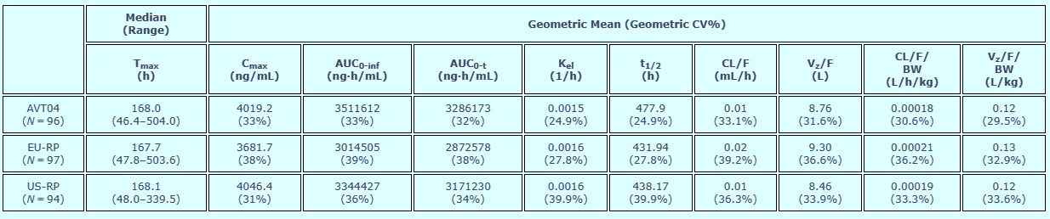
AUC0-inf: Area under the concentration-curve from time zero extrapolated to infinite time; AUC0-t: Area under the concentration-curve from time zero to the last quantifiable concentration; BLQ: Below the lower limit of quantification (25 ng/mL); BW: body weight adjusted; CL/F: apparent clearance; Cmax: maximum serum concentration; CV%: coefficient of variation; Kel: terminal elimination rate constant; LLOQ: lower limit of quantitation; t1/2: apparent terminal elimination half-life; Tmax: time of maximum serum concentration; Vz/F: apparent volume of distribution. N: Total number of subjects in the relevant population.
In terms of analysis of PK similarity, for the co-primary endpoint C_{max}, the 90% CIs of the GMRs were entirely contained within the margins of 80% and 125% for each of the 3 pairwise comparisons, meeting the prespecified criteria for bioequivalence. For the co-primary endpoint AUC_{0-inf}, the prespecified criteria were not met, with the comparison of AVT04 versus EU-Stelara showing the 90% CI of the GMR was 108.1% to 126.4%, exceeding the prespecified margin, while results for the other two pairwise comparisons (AVT04 verses US-Stelara and EU-Stelara versus US-Stelara) were entirely contained between 80% and 125%. Therefore, PK similarity of AVT04 and EU-Stelara could not be established according to the prespecified primary test of bioequivalence. Sensitivity analysis using the key secondary endpoint AUC_{0-t} showed 90% CIs of the GMRs contained within the prespecified margins for all 3 of the pairwise comparisons, including for the AVT04 versus EU-Stelara comparison; though the point estimate (114.7%) and upper bound of the 90% CI (123.6%) were relatively higher compared to other pairwise comparisons, suggesting higher ustekinumab exposure in the AVT04 group. Table 4 summarises results of the analysis of PK similarity.
Table 4. Similarity assessment of ustekinumab pharmacokinetic parameters by treatment, Pharmacokinetic population.
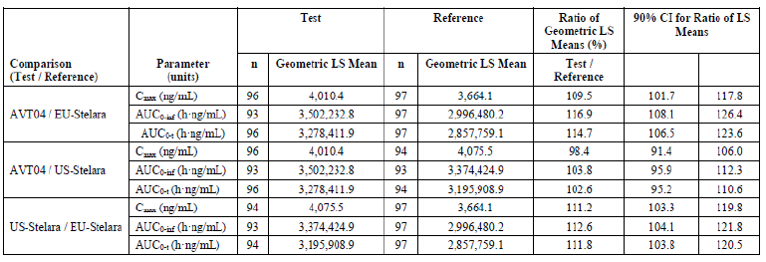
An analysis of PK similarity following protein content normalisation was performed. The 90% CIs of the GMRs for both co-primary endpoints C_{max} and AUC_{0-inf} were entirely contained between 80% and 125% for each of the 3 pairwise comparisons. Therefore, following protein content normalisation, equivalence criteria were met. These results are summarised in Table 5. Drug protein content for EU-Stelara, at 82.3 mg, was found to deviate from the nominal and expected value, 90 mg per 1 mL, and was approximately 10% lower than that determined for AVT04 (91 mg), and around 7% lower than US-Stelara (88.3 mg).
Table 5. Pharmacokinetic similarity assessment of serum ustekinumab protein content-normalised exposure pharmacokinetic parameters by treatment, pharmacokinetic population.
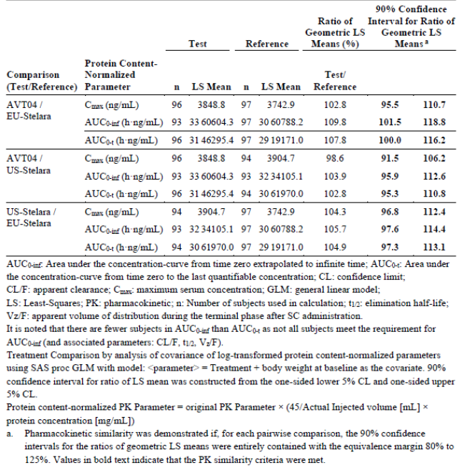
Subgroup analyses showed that systemic exposure to ustekinumab was body weight dependent, in keeping with what is known for the innovator product, with geometric means for PK exposure parameters lower in the > 80 kg subgroup. For the Japanese subgroup geometric mean C_{max,} area under concentration-time curve from time zero to the time of last measurable concentration (AUC_{0-t}), and AUC_{0-inf} values were consistent with overall PK population. Comparative analysis of PK parameters according to immunogenicity subgroup was performed, however, was exploratory in nature, with low subject numbers per subgroup.

Study AVT04-GL-301
Study AVT04-GL-301 was the pivotal Phase III equivalence study submitted in the dossier, with the primary objective to evaluate therapeutic equivalence between AVT04 and EU-Stelara, and a secondary objective to compare steady-state PK of AVT04 and EU-Stelara. The PK aspects of this study will be summarised here.
This randomised, double-blind, multicentre study was conducted over 52 weeks comprising two stages, a primary efficacy assessment stage from Day 1 to Week 15, and long-term efficacy and safety assessment stage from Week 16 to Week 52. In Stage 2 patients originally randomised to receive AVT04 in Stage 1 continued to receive AVT04, while those randomised to EU-Stelara in Stage 1 were re-randomised in a 1:1 ratio to receive AVT04 or continue receiving EU-Stelara.
Pharmacokinetic assessment included serum trough concentrations at steady-state for both AVT04 and EU-Stelara. Overall, results across the treatment groups were comparable, with mean serum trough concentration increasing from Baseline to Week 16, decreasing to Week 28, and increasing by Week 52 to levels similar to those observed at Week 16, as shown in Table 6.
Table 6. Serum trough pharmacokinetic concentrations over time, safety analysis set, by treatment group.
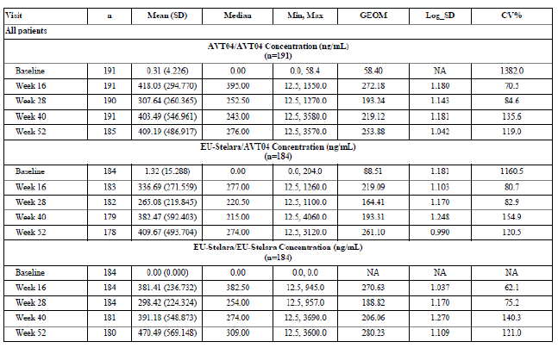

Sponsor response to TGA questions
Following clinical evaluation, the sponsor was asked to provide additional information regarding differences in drug protein content between study treatments, rationale for performing protein content normalised analysis of PK similarity, and possible clinical implications. In response, the sponsor noted difficulty in procurement of a reference product batch of EU-Stelara of sufficient batch size and expiry date and outlined detailed steps for batch selection.
The sponsor also discussed results of the AVT04 versus EU-Stelara comparison in Study AVT04-GL-101 alongside PK results for the same comparison in Study AVT04-GL-301. Point estimates of the GMRs for AVT04/EU-Stelara comparison of AUC_{0-inf} in Study AVT04-GL-101 were 116.9% for the primary analysis and 109.8% for the protein content normalised analysis, while in Study AVT04-GL-301, which utilised the same batch of EU-Stelara, AVT04/EU-Stelara ratios of the geometric means for trough concentration (C_{trough}) values at Week 4 and Week 16 were 117% and 113% respectively. Overall, higher ustekinumab exposure following administration of a single dose of AVT04 compared to a single dose of EU-Stelara can be inferred from these results.
In addressing possible clinical implications of higher ustekinumab exposure the sponsor referenced data from Phase II and III registrational trials for ustekinumab which suggest a lack of dose response in rates of adverse events. The sponsor also cited efficacy data from multiple Phase III studies to evidence a well-described exposure-response relationship, with plateau in the relationship between ustekinumab serum concentration and efficacy across a broad range of concentrations. Further, given the use of the same batch of EU-Stelara in both studies AVT04-GL-101 and AVT04-GL-301, the sponsor noted the lack of clinically relevant difference in safety and efficacy parameters observed between AVT04 and EU-Stelara treatment groups in Study AVT04-GL-301 as further supporting the claim that the observed higher ustekinumab exposure does not have significant clinical implications. Results of Study AVT04-GL-301 are discussed in further detail below.
The clinical evaluation considered the sponsor’s response appropriate, though noted that analysis following protein content normalisation was not prespecified in detail in the statistical analysis plan and was originally planned as a sensitivity analysis, as opposed to the pivotal test of bioequivalence.

Pharmacodynamics
The application did not include clinical studies assessing pharmacodynamic (PD) similarity of AVT04 and Stelara, with pertinent pharmacodynamic properties of ustekinumab described in the approved Australian PI for Stelara. Study AVT4-GL-101, a Phase I PK study, included the exploratory objective to compare ex-vivo inhibition of IFN-γ, IL-22, IL-4 and IL10 release between AVT04, EU-Stelara and US-Stelara. These effector cytokines were chosen as representative of IL-23 and IL-12 mediated signalling. Blood samples used for this analysis originated from a subgroup of 45, out of the 294 healthy volunteers in Study AVT04-GL-101, 15 for each study treatment. Data provided in response to a TGA question after clinical evaluation showed that, in general, target engagement and cytokine secretion was similar between AVT04, EU-Stelara and US-Stelara, with minor differences in IL-22 and IL-10 secretion observed, though were not considered significant given the exploratory nature of the analysis and small number of subjects.

Efficacy
The dossier included statements from the sponsor justifying the choice of plaque psoriasis as the indication used to assess efficacy and equivalence of AVT04 to a reference product. Of the approved indications for Stelara the highest placebo-adjusted response rate was found for plaque psoriasis, making it the most sensitive indication for detection of difference between a biosimilar and reference product.

Study AVT04-GL-301¹⁰
Study AVT04-GL-301 was a Phase III, randomised, double-blind, multicentre study conducted between 3 June 2021 and 11 October 2022 at 30 sites across Europe. The primary objective was to evaluate therapeutic equivalence of AVT04 compared to EU-Stelara in the treatment of moderate to severe chronic plaque psoriasis, with primary efficacy endpoint being percent improvement in PASI from Baseline to Week 12, and secondary efficacy endpoints including:
- PASI50 (50% improvement in PASI), PASI75, PASI90 and PASI100 response rates at weeks 4, 8, 12, 16, 28, 40 (end-of-treatment) and 52 (end-of-study),
- Percent improvement in PASI from Baseline to Week 4, 8, 16, 28, 40 and 52,
- Area under the effect curve for PASI from Baseline through Week 12,
- Proportion of patient achieving static Physician Global Assessment (sPGA) responses of clear (0) or almost clear (1) at Weeks 4, 8, 12, 16, 28, 40 and 52.
- Change in Dermatology Life Quality Index (DLQI) scores from Baseline to Weeks 12, 28, 40 and 52.
- Change in percentage BSA affected by chronic plaque psoriasis from Baseline to Weeks 4, 8, 12, 16, 28, 40 and 52.
Secondary objectives also included comparison of safety, tolerability and immunogenicity, which will be considered in further detail in subsequent sections.
Study AVT04-GL-301 schematic is presented in Figure 2. The active period of the study comprised two stages: Stage 1, primary efficacy assessment stage from Day 1 to Week 15, and Stage 2, long-term efficacy and safety assessment from Week 16 to Week 52. Within Stage 1, patients were randomly assigned into an AVT04 treatment group (denoted Group 1) or EU-Stelara treatment group (Group 2) in a 1:2 ratio on Day 1, stratified by presence or absence of previous biologic treatment for plaque psoriasis and according to body weight; ≤ 80 kg, > 80 kg to ≤ 100 kg, and > 100 kg. In line with recommended dosing for Stelara, patients ≤ 100kg received 45 mg dose of study treatment, and those > 100kg received 90 mg dose.
In Stage 2, from study Week 16, patients originally randomised into Group 1 (AVT04) continued to receive AVT04 every 12 weeks at Weeks 16, 28 and 40, while those originally in Group 2 (EU-Stelara) were re-randomised into Groups 2A and 2B in a 1:1 ratio; Group 2A switched to AVT04, while 2B continued to receive EU-Stelara, with all dosing according to weight and at the same 12 week intervals.
At Week 28 non-responsive patients, defined as PASI improvement < 50% from Baseline, were not administered study treatment with end-of-treatment assessment completed at that time.
Figure 2. Study schematic for AVT-GL-301.¹⁰
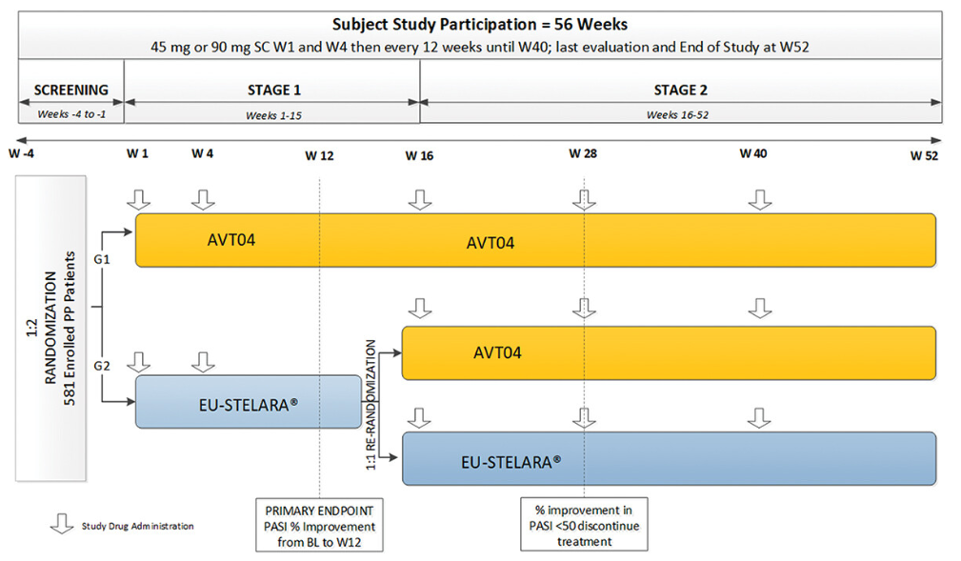
Key inclusion criteria were males or females aged 18 to 75 years old, with moderate to severe plaque psoriasis of at least 6 months duration, with involved BSA ≥ 10%, PASI ≥ 12 and static Physician’s Global Assessment (sPGA) ≥ 3 (moderate) at screening and at Baseline, stable psoriatic disease for at least 2 months, candidate for systemic therapy based on previous failure, inadequate response, intolerance or contraindication to at least 1 systemic anti-psoriatic therapy, negative QuantiFERON test for tuberculosis, naïve to ustekinumab therapy, and female patients who were not pregnant or breastfeeding and agreed to effective contraception if a woman of childbearing potential.
A summary of key exclusion criteria is as follows:
- Diagnosed with psoriatic arthritis, alternative form of psoriasis, or other systemic autoimmune or inflammatory disorder,
- Prior use of the following medications within specified time periods, or potential need to use during the study:
  - Topical medications within 2 weeks of baseline visit, excepting low- to mid-potency topical corticosteroids on face, eyes, scalp, palms, soles, genital area,
  - PUVA phototherapy and/or UVB phototherapy within 4 weeks,
  - Nonbiologic systemic therapies for psoriasis within 4 weeks,
  - Systemic steroid within 4 weeks,
  - Investigational agent within 90 days or 5 half-lives,
  - Any therapeutic agent targeting IL-12, IL-17 or IL-23 at any time,
- Received live or attenuated vaccines in 4 weeks prior to baseline visit,
- Underlying condition which, in the opinion of the investigator or designee, significantly immunocompromised the patient, and/or placed the patient at unacceptable risk if receiving immunomodulatory therapy,
- Active infection,
- Patient positive for human immunodeficiency virus (HIV), hepatitis C virus antibody, hepatitis B surface antigen, and/or hepatitis B core antibody,
- History of malignancy within 5 years,
- Active neurological disease,
- Moderate to severe heart failure.
- Uncontrolled diabetes mellitus type 1 or 2, in the judgement of the investigator.
Sample size determination was based on meta-analysis of reference product studies PHOENIX1 and PHOENIX2 (reference product STELARA Studies - NCT00267969 and NCT00307437, respectively), showing difference in mean PASI percent improvement from Baseline to Week 12 with EU-Stelara versus placebo of 70.7%, 95% CI 69.1% to 72.3%; using the lower bound of the CI as a conservative estimate of treatment effect a 10% equivalence margin was expected to retain 85.5% of the original ustekinumab effect, and a 15% margin 78.3% of the original effect. According to FDA guidance with equivalence margins at ±10%, assuming true difference in mean percent PASI improvement of 2.5% between test and reference treatments, a conservative estimate of standard deviation (27.4%, observed in PHOENIX1) and expected 5% withdrawal rate to Week 12, a sample size of 528 in 1:2 randomisation would give 89.9% power in a 5% level test (associated with a 90% CI).
Following EMA guidance, with equivalence margins ±15%, under the same conditions, a sample size of 462 patients in 1:2 randomisation would give 99.5% power in a 2.5% level test (associated with a 95% CI). Analysis of the primary efficacy endpoint proceeded under both conditions to meet different regulatory requirements. In comparing similarity of AVT04 and EU-Stelara, for FDA purposes, if the 90% CI for the adjusted difference in means in percentage PASI improvement from Baseline to Week 12 between the test and reference groups was within the range -10% to 10% similarity was established, whilst for EMA purposes, if the 95% CI was within the range -15% to 15% then clinical similarity was established.
The primary endpoint was analysed using an ANCOVA model, estimates for the adjusted difference in means between treatment groups at Week 12 were obtained from the model and 2-sided 90% and 95% CIs for the adjusted difference in means was provided to address equivalence. Analyses of the primary efficacy endpoint were performed for the per protocol analysis set. Equivalence tests on the primary endpoint using the intention-to-treat (ITT) set up to study Week 16 served as sensitivity analysis. Analysis of secondary efficacy endpoints was performed on the ITT set to evaluate similarity of AVT04 and EU-Stelara, however, were considered descriptive in nature with no procedures to account for multiple comparisons instituted.
Overall, 581 patients were randomised, 194 into Group 1 (AVT04) and 387 into Group 2 (EU-Stelara). Baseline characteristics and demographics were well balanced between the groups; in the ITT set up to Week 16 (Stage 1) patients were predominantly male (62.7%), White (99.3%), with median age 40 years, and 5.7% of patients aged over 65 years. Prior use of biologic medicines was recorded in 7.6% in total, 7.7% in the AVT04 group and 7.5% in EU-Stelara group, and psoriatic disease characteristics well balanced between groups, with majority of patients having moderate severity according to sPGA (64.2%), with median PASI at baseline of 20 overall, and mean %BSA affected slightly higher in the AVT04 group at 13.231% compared to 12.256% in the EU-Stelara group. Figure 3 outlines disposition of study patients across Stage 1 (up to 16 weeks) and Stage 2, and for the different treatment groups, Group 1 (AVT04) and Group 2 (EU-Stelara) in Stage 1, as well as Group 2A (EU-Stelara/AVT04) and Group 2B (EU-Stelara/EU-Stelara) in Stage 2 of the study, including brief reasons for study withdrawal at each study time point.
Figure 3. Disposition of study patients.
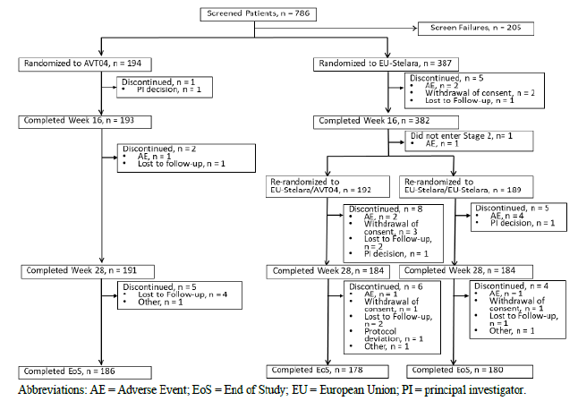
There were 466 patients in total (80.2%) with at least 1 protocol deviation recorded, of whom 111 patients had major deviations recorded. The majority of protocol deviations related to the crisis in Ukraine. The impact of protocol deviations on data quality and study integrity was considered to be minor.
In terms of results for the primary efficacy endpoint, least squares mean for percent PASI improvement from Baseline to Week 12 was similar between the treatment groups, 87.3% improvement in the AVT04 group and 86.8% in the EU-Stelara group (RP). Equivalence between treatment groups was established in terms of the primary endpoint according to both FDA and EMA criteria. As shown in Table 7, the 90% CI of the least squares (LS) means difference in percentage PASI improvement from Baseline to Week 12 was -2.14% to 3.01%, and 95% CI of the LS means difference was -2.63% to 3.50%, fully contained within the prespecified margins of -10% to 10% and -15% to 15% respectively. Equivalence testing for the body weight ≤ 100 kg strata also met prespecified equivalence criteria.
Table 7. Analysis of covariance of percent improvement in PASI from Baseline to Week 12- Per Protocol Set (all patients, and patients with body weight ≤ 100 kg).¹⁰
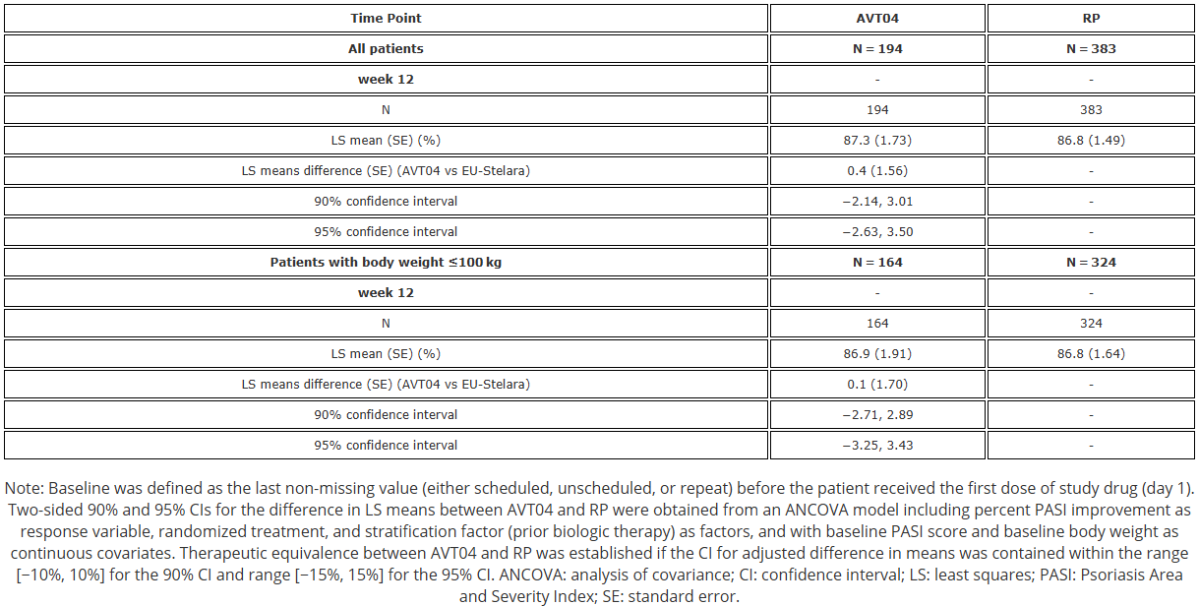
Sensitivity analyses also met prespecified criteria for clinical similarity, including percent PASI improvement from Baseline to Week 12 using observed data in the ITT set, and using the ITT set and last observation carried forward data. Subgroup analyses were performed for patients grouped by body weight, prior biologic therapy for psoriasis, age, gender, antidrug antibody (ADA) status and neutralising antibody (Nab) status, demonstrating no major differences in treatment effect between subgroups, with only the results for the NAb positive subgroup (which included 11 patients in the AVT04 treatment group and 51 patients in the EU-Stelara treatment group) falling outside the -15% to 15% margin of equivalence, as shown in Figure 4. The sponsor noted the small sample size of the NAb positive subgroup, and the fact that the study was not powered to demonstrate equivalence for a subgroup of this size, as factors that should be considered in interpretation of this result.
Figure 4. Forest plot of 95% confidence interval of percent improvement in PASI from Baseline to Week 12, intentions to treat set.
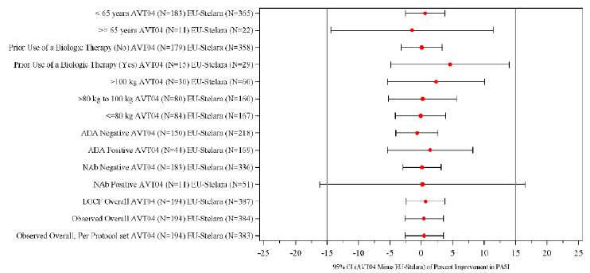
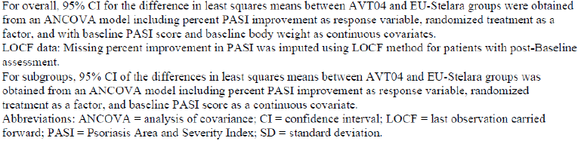
Results for secondary efficacy endpoints supported findings for the primary endpoint. In general, both the proportion of patients achieving PASI50, PASI75, PASI90 and PASI100 at each study timepoint, and percent improvement in PASI from Baseline at each study timepoint, were similar across the treatment groups. Re-randomisation of patients in the EU-Stelara group in Stage 2 of the study did not result in meaningful differences in results of secondary efficacy endpoints at study timepoints from Week 16 to Week 52. Overall, the clinical evaluator concluded that Study AVT04-GL-301 employed an appropriate study design and appropriate efficacy endpoints, and that equivalent efficacy between AVT04 and EU-Stelara was satisfactorily established.

Safety
The sponsor justified choice of plaque psoriasis as the approved indication with which to compare safety of AVT04 and the innovator product given that ustekinumab is prescribed as monotherapy for this indication, reducing the likelihood of confounding safety findings due to concomitant medication. Evaluable safety data was provided in the Phase I Study AVT04-GL-101 and Phase III Study AVT04-GL-301.
In terms of extent of exposure during clinical development, in Study AVT04-GL-101, of 298 randomised healthy adult subjects 98 received a single 45 mg/0.5 mL subcutaneous dose of AVT04, with the remaining subjects receiving a 45 mg /0.5 mL dose of either EU-Stelara or US-Stelara. In Study AVT04-GL-301 adult patients with plaque psoriasis received weight-based dosing with study treatments administered at Day 1, Weeks 4, 16, 28 and 40; 194 patients randomised to the AVT04 group in Stage 1 received AVT04 throughout the study, with 194 completing to Week 16, 191 to Week 28 and 186 to end-of-study, whilst of the 387 patients randomised to EU-Stelara in Stage 1, 192 received AVT04 in Stage 2 of the study, with 184 completing Week 28 and 178 to end-of-study.

Study AVT04-GL-101⁹
The number of subjects reporting at least one treatment emergent adverse event (TEAE) during the study was similar between treatment groups; 68.4% in the AVT04 group, 67.7% in the EU-Stelara group, and 71.1% in the US-Stelara group. Common treatment-emergent adverse event (TEAEs) by System Organ Class (SOC) were: infections and infestations (AVT04 group 24.5%, EU-Stelara group 26.3%, US-Stelara group 26.8%), nervous system disorders (AVT04 25.5%, EU-Stelara 19.2%, US-Stelara 28.9%), general disorders and administration site conditions (AVT04 20.4%, EU-Stelara 17.2%, US-Stelara 27.8%). Of note, TEAEs by SOC nervous system disorders occurred more frequently in the AVT04 group (30 subjects, 25.5%) compared to the EU-Stelara group (19 subjects, 19.2%). By preferred term (PT) the most frequent TEAEs were headache, upper respiratory tract infection, injection site erythema, back pain and fatigue. Reflecting the difference between AVT04 and EU-Stelara groups by SOC nervous system disorders, slightly higher rate of headache was reported in the AVT04 group (19 subjects, 19.4%) compared to the EU-Stelara group (14 subjects, 14.1%). These safety results are summarised in Table 8.
Table 8. Study AVT04-GL-101 frequency of treatment-emergent adverse events occurring in ≥ 5% of subjects in any treatment group, safety population.⁹

Table 8. Study AVT04-GL-101 frequency of treatment-emergent adverse events occurring in ≥ 5% of subjects in any treatment group, safety population (continued)⁹
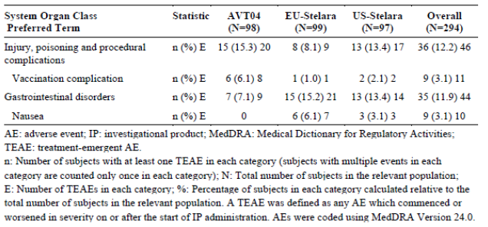
Overall, the majority of TEAEs were classified as mild in severity, with moderate TEAEs reported by 5.8% of subjects overall, and 6 subjects (2.0% of total) reporting TEAEs categorised as severe, two subjects in the AVT04 group, three in the EU-Stelara group, and one in the US-Stelara group. There were no deaths reported in Study AVT04-GL-101. There were 3 serious adverse events reported, one in each treatment group; anaphylactic reaction for one subject in the AVT04 group, abdominal pain for one subject in the EU-Stelara group, and cerebrovascular accident in the US-Stelara group. None of these events were considered related to the study treatment, and case narratives were provided. For the anaphylactic reaction occurring in the AVT04 group the case narrative confirms that this reaction occurred on study Day 56, and whilst a specific trigger was not identified, the study treatment was considered unlikely given the passage of time since dose administration. There were no clinically meaningful changes identified in laboratory parameters, ECG parameters, or vital signs.
In terms of adverse events of special interest (AESI) the frequency of subjects who experienced at least one event was similar across the treatment groups, 10.2% in the AVT04 group, 9.1% in the EU-Stelara group and 12.4% in the US-Stelara group. Local administration site reactions were the most common AESI overall, being slightly more common in the US-Stelara group at 11.3% compared to 10.2% in the AVT04 group and 8.1% in the EU-Stelara group, and all reactions were considered mild in severity.

Study AVT04-GL-301¹⁰

Stage 1: Baseline to Week 16
In Stage 1 of the study rates of any TEAE were similar between treatment groups, with 67 patients (34.5%) in the AVT04 group reporting 104 TEAEs, compared to 130 patients (33.6%) in the EU-Stelara group reporting 223 TEAEs. The most common TEAEs by SOC were infections and infestations (AVT04 group 17.0%, EU-Stelara group 14.5%), and investigations abnormal (AVT04 group 8.2%, EU-Stelara group 8.5%).
The majority of TEAEs in Stage 1 were categorised as mild or moderate severity. Three patients reported TEAEs leading to early termination of the study, all in the EU-Stelara group. There were no deaths recorded in Stage 1 of the study, and of the seven serious adverse events recorded, all occurred in the EU-Stelara group and none were attributed to the study treatment. There were no clinically meaningful changes in laboratory parameters, ECG parameters or vital signs recorded during Stage 1.
AESI addressed in the study included warnings and precautions included in the EU-Stelara product label, including serious infections, malignancies, hypersensitivity reactions, reversible posterior leukoencephalopathy syndrome, non-infectious pneumonia, and injection site reactions (ISRs). As shown in Table 9, ISR was the most frequent AESI in Stage 1 of the study, with 4 ISRs reported by 3 patients (1.5%) in the AVT04 group, and 14 ISRs reported by 13 patients (3.4%) in the EU-Stelara group. All ISRs were classified as mild in severity, with the exception of one ISR in the EU-Stelara group, classified as moderate severity.
Table 9. Treatment emergent adverse events of special interest by system organ class and preferred term, safety analysis set, up to Week 16 (Stage 1), all patients.

Stage 2: Week 16 to Week 28
Following re-randomisation of the EU-Stelara cohort at Week 16, a total of 21 patients (10.9%) reported 26 TEAEs in the AVT04/AVT04 group, 30 patients (15.6%) reported 35 TEAEs in the EU-Stelara/AVT04 group, and 29 patients (15.3%) reported 36 TEAEs in the EU-Stelara/EU-Stelara group. The nature of TEAEs when considered by SOC and PT generally reflected those recorded in Stage 1 of the study, though rates of specific TEAEs were generally lower when compared to Stage 1, as shown in Table 10. Frequency of specific TEAEs was broadly similar across the treatment groups, noting the relatively low frequency of events overall. The majority of TEAEs were categorised as mild or moderate in severity.
Table 10. Treatment emergent adverse events (in at least 1% of patients) by system organ class and preferred term, safety analysis set, from Week 16 to Week 28, all patients.
There were no deaths recorded from Week 16 to Week 28, and one patient, in the EU-Stelara/EU-Stelara treatment group, experienced a serious TEAE, namely anaemia and Vitamin B12 deficiency which was deemed by investigators as not related to the study treatment. In terms of TEAE leading to early termination from the study there was one patient (0.5%) in the AVT04/AVT04 group, 3 patients (1.6%) in the EU-Stelara/AVT04 group, and 4 patients (2.1%) in the EU-Stelara/EU-Stelara group; none of these TEAEs were deemed by study investigators as related to study treatments. There were no clinically meaningful changes in laboratory parameters, ECG parameters or vital signs observed from Week 16 to Week 28. Frequency of AESI was lower when compared to Stage 1 of the study, with no AESI reported in the AVT04/AVT04 group, 3 patients (1.6%) reporting an AESI in the EU-Stelara/AVT04 group, and 2 patients (1.1%) reporting an AESI in the EU-Stelara/EU-Stelara group; ISR was the most frequent AESI recorded.

Stage 2: Week 28 to End-of-Study
Overall frequency of TEAEs was higher from Week 28 to end-of-study (EoS) when compared to the earlier part of Stage 2, from Week 16 to Week 28, but lower when compared to Stage 1 of the study. A total of 32 patients (16.6%) reported 49 TEAEs in the AVT04/AVT04 treatment group, 42 patients (21.9%) reported 66 TEAEs in the EU-Stelara/AVT04 group, and 39 patients (20.6%) reported 49 TEAEs in the EU-Stelara/EU-Stelara group. When considered by SOC abnormal investigations was most common in this part of the study, in contrast to earlier parts of the study, with higher rates recorded in both the EU-Stelara/AVT04 group (22 patients, 12%) and EU-Stelara/EU-Stelara group (20 patients, 10.9%), compared to the AVT04/AVT04 group (9 patients, 4.7%). Overall TEAEs from study Week 28 to EoS are summarised in Table 11. The majority of TEAEs were categorised as mild or moderate. Three patients in the AVT04/AVT04 group experienced severe TEAEs, including increased blood creatine phosphokinase, increased blood triglycerides, thrombosis, and anaemia with vitamin B12 deficiency, none of which were deemed related to the study treatment by investigators. In the EU-Stelara/AVT04 group two patients experienced severe TEAEs, increased blood creatine phosphokinase and COVID-19 infection, neither of which was assessed as related to study treatments.
Table 11. Treatment emergent adverse events (in at least 1% of patients) by system organ class and preferred term, safety analysis set, from Week 28 to End of Study, all patients.
There were no deaths recorded from Week 28 to EoS, and one patient in each group had a serious TEAE recorded, intervertebral disc protrusion in the AVT04/AVT04 group, lower respiratory tract infection in the EU-Stelara/AVT04 group, and otosclerosis in the EU-Stelara/EU-Stelara group, none of which were considered by investigators as related to study treatment. One patient in the EU-Stelara/EU-Stelara group reported two TEAEs that led to early termination of the study, neither of which were deemed serious TEAEs. Abnormal laboratory parameters in this phase of the study are captured in Table 11, and there were no clinically meaningful changes in ECG parameters or vital signs.
There were no patients in the AVT04/AVT04 group reporting an AESI, 3 patients (1.6%) in the EU-Stelara/AVT04 group, and 2 patients (1.1%) in the EU-Stelara/EU-Stelara group, predominantly constituting mild ISRs.

Immunogenicity

Study AVT04-GL-101⁹
Serum samples for immunogenicity assessment were collected at study Day 1 (pre-dose and post-dose), Day 9, Day 15, Day 29, Day 57, Day 78 and Day 92/EoS. Samples were screened for antibodies binding to ustekinumab in AVT04, EU-Stelara and US-Stelara, and samples positive for antibodies further assessed for the ability of antibodies to neutralise the study treatment. Serum ustekinumab concentration was also reported to assist in interpretation of antibody data.
Detection of ADAs progressively increased throughout the study with highest positivity rates seen at Day 92/EoS, with 27 patients (27.6%) in the AVT04 group, 48 patients (48.5%) in the EU-Stelara group and 44 patients (45.4%) in the US-Stelara group positive at EoS. Rate of antibody positivity was lower in the AVT04 group at each study time point compared to the other treatment groups. Similar trends, though lower frequencies, were observed for NAbs. These results are summarised in Table 12.
Table 12. Summary of detection of antidrug antibodies and neutralising antibodies, immunogenicity population.⁹
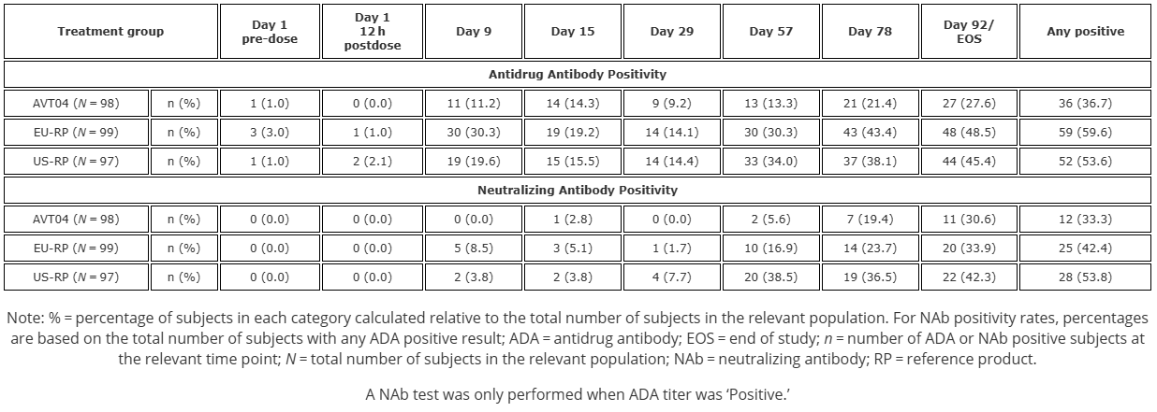
Subgroup analysis of PK parameters based on presence of ADAs and NAbs was performed with the caveat that low sample sizes within subgroups warrants caution in interpreting results, and results were considered exploratory in nature. In the ADA positive subgroup, which included 36 in the AVT04 group, 58 in the EU-Stelara group, and 52 in the US-Stelara group, geometric means of the systemic exposure PK parameters C_{max}, AUC_{0-t}, and AUC_{0-inf} were lower compared to the ADA negative subgroup, and t_{1/2} was also lower. The magnitude of difference in systemic exposure PK parameters between ADA positive and ADA negative subgroups was similar within each treatment group. Illustrating these findings for the AVT04 treatment group are Table 13, which presents PK parameters for the ADA positive subgroup of the AVT04 treatment group, and Table 14, which presents PK parameters for the ADA negative subgroup, allowing comparison between the subgroups. Interpretation of systemic exposure PK parameters in NAb subgroups was hampered by small sample sizes and outlier results.
Table 13. Summary of dose-adjusted serum ustekinumab pharmacokinetic parameters, AVT04 treatment group, antidrug antibody positive subgroup.
Table 14. Summary of dose-adjusted serum ustekinumab pharmacokinetic parameters, AVT04 treatment group, antidrug antibody negative subgroup.
Safety analysis by ADA and NAb status was undertaken, however, results were subject to small sample sizes in subgroups and low absolute numbers of TEAEs in each subgroup. Given this, the clinical evaluation concluded that imbalances in TEAEs between subgroups were likely due to chance, and that there were no major identifiable differences in safety noted between subgroups.

Study AVT04-GL-301¹⁰
Pre-dose serum samples were collected to assess for ADAs at Weeks 4, 12, 16, 28, 40 (End-of-treatment) and 52 (EoS), with positive results further characterised by titre and neutralising capacity. Overall, in Stage 1 of the study up to Week 16, 49 patients (25.4%) in the AVT04 group had binding ADAs, of which 13 patients had NAbs, while 184 patients (48.2%) in the EU-Stelara group had ADAs, of which 57 patients had NAbs.
In Stage 2 it was noted that frequency of binding ADAs decreased over time in all treatment groups. Trends in NAbs differed slightly, remaining largely stable in the AVT04/AVT04 and EU-Stelara/EU-Stelara groups, and declining between study Week 16 and Week 52 in the EU-Stelara/AVT04 group.
As discussed above under ‘Efficacy’, subgroup analysis for the primary endpoint, percent improvement in PASI from Baseline to Week 12, showed that the 95% CI of LS means difference for the NAb positive subgroup fell just outside the prespecified margins for clinical similarity of -15% to 15%, with the 95% CI being -15.7 to 15.81. The sponsor contended that this result was not clinically relevant, given the low sample size of the subgroups (11 patients in the AVT04 group and 51 patients in the EU-Stelara group), the fact that the result fell only marginally outside the margin for clinical similarity, and by week 16 the 95% CI was fully contained within the margins (-12.24, 12.55). The clinical evaluation considered this justification acceptable. The investigators concluded, based on results of efficacy endpoints up to Week 16 and EoS, the observed difference in frequency of ADAs and NAbs between treatment groups did not seem to meaningfully impact efficacy.
Analysis of safety according to ADA and NAb subgroups was undertaken, though similarly subject to limitations of small sample sizes in subgroups, and low overall frequency of TEAEs. Overall, the clinical evaluation concluded that the frequency of TEAEs did not significantly differ between subgroups, and that particularly for NAb positive and negative subgroups, that imbalances in TEAEs could likely be explained by chance relating to small sample sizes. The investigators concluded that, within the limitations noted, ADA and NAb status did not appear to impact safety in a clinically meaningful way.

Other- extrapolation to other indications
The dossier did not include clinical studies relating to psoriatic arthritis, which is sought as a therapeutic indication, therefore use of Uteknix in this indication requires extrapolation. The sponsor has provided the following justification in support of extrapolation:
- Common mechanism of action; the effect of ustekinumab in both plaque psoriasis and psoriatic arthritis is solely mediated by binding the shared p40 subunit of IL-12 and IL-23, with resulting interruption of Th1 and Th17 cytokine pathways, which are implicated in pathophysiology.
- Similarity of PK between the indications, using a reference from published medical literature to evidence similarity of ustekinumab half-life, apparent clearance, apparent volume of distribution, and absorption rate constant between patients with mild to severe plaque psoriasis and psoriatic arthritis.
- Safety and immunogenicity; integrated analysis of Phase II and III clinical studies, covering a total of 5,884 ustekinumab treated patients, showed a consistent safety profile across the approved indications, with generally low immunogenicity which was comparable across indications.
- Choice of plaque psoriasis as the indication for Study AVT04-GL-301 was as the most sensitive indication for detection of any differences between the proposed biosimilar and innovator product, given the greatest placebo-adjusted response rate seen in this indication during clinical development of Stelara, and use of ustekinumab as monotherapy in this indication, limiting influence of concomitant medications.
- Sponsor’s consultation with EMA and FDA during clinical development which endorsed choice of plaque psoriasis as the most appropriate indication to demonstrate biosimilarity.
The clinical evaluation considered this justification of extrapolation to be acceptable.

Clinical evaluation outcome
The clinical evaluation assessed benefit-risk balance as favourable.

Risk management plan evaluation
Cipla Australia Pty Ltd initially submitted Aus-risk management plan (RMP) version 1.0 (08 April 2024; data lock point (DLP) 04 March 2024) in support of this application. As they have an EU registered product, an EU-RMP was requested and the sponsor provided EU-RMP version 0.4 (03 November 2023; DLP 12 May 2022). The sponsor has retitled the Aus-RMP to the Australia-specific annex (ASA) v1.0 (20 June 2024) as requested. The sponsor has provided ASA v1.1 (19 July 2024).
The proposed summary of safety concerns and their associated risk monitoring and mitigation strategies are summarised below in Table 15.
Table 15: Summary of safety concerns
Summary of safety concerns |  | Pharmacovigilance |  | Risk Minimisation
 |  | Routine | Additional | Routine | Additional
Important identified risks | Serious systemic hypersensitivity reactions* | ^ | – |  | –
Important potential risks | Serious infections (including mycobacterial and salmonella infections) | ^ | – |  | –
Important potential risks | Malignancy | ^ | – |  | –
Important potential risks | Cardiovascular (CV) events | ^ | – |  | –
Important potential risks | Serious depression including suicidality |  | – |  | –
Important potential risks | Exposure during pregnancy |  | – |  | –
Missing information | Long-term safety in paediatric psoriasis patients 6 years and older |  | – |  | –
Missing information | Long-term impact on growth and development in paediatric psoriasis patients 6 years and older |  | – |  | –
Missing information | Long-term safety in adult patients with moderately to severely active Crohn’s disease |  | – |  | –
Missing information | Long-term safety in adult patients with moderately to severely active ulcerative colitis# |  | – |  | –
*EU-RMP only #ASA only ^Follow-up form
The safety concerns in the ASA align with the reference product, Stelara, and are acceptable.
The pharmacovigilance plan in the ASA generally aligns with the reference product, Stelara, and is acceptable.
The risk minimisation plan in the ASA aligns with the reference product and is acceptable.
The RMP evaluation recommended conditions of registration relating to the versions of the risk management plan, and inclusion of the medicine in the Black Triangle Scheme.
The TGA may request an updated RMP at any stage of a product's life-cycle, during both the pre-approval and post-approval phases. Further information regarding the TGA’s risk management approach can be found in risk management plans for medicines and biologicals and the TGA's risk management approach. Information on the Australia-specific annex (ASA) can be found on the TGA website.

Risk-benefit analysis

Delegate’s considerations
This application seeks to register Uteknix (designated AVT04 during clinical development), a biosimilar of the innovator product Stelara (ustekinumab), however, only some of the registered presentations and approved therapeutic indications for Stelara are sought in the current application. The sponsor is seeking registration of 45 mg/0.5 mL and 90 mg/1.0 mL pre-filled syringe presentations (for subcutaneous injection) of Uteknix for the indications plaque psoriasis and psoriatic arthritis in adult patients only. Additional registered presentations for Stelara, including 45 mg/0.5 mL and 90 mg/1.0 mL pre-filled pen, 45 mg/0.5 mL solution for infusion as a single-use vial, and 130 mg/26 mL solution for infusion as a single-use vial, are not sought for Uteknix in this application. Currently approved therapeutic indications for Stelara which are not sought for Uteknix in this application include plaque psoriasis in the paediatric population (6 years and older), Crohn’s Disease and Ulcerative Colitis.
Pharmacokinetic similarity between Uteknix and the innovator product is supported by one Phase I study in healthy adult subjects in which pre-specified criteria for PK similarity between AVT04, EU-Stelara and US-Stelara were not met on primary analysis, however, were met after drug protein content normalisation of PK parameters. Equivalent efficacy between Uteknix and the innovator product is supported by one Phase III study in which prespecified criteria for equivalence were met. Safety data obtained during clinical development did not identify major differences between Uteknix and the reference product, whilst assessments of immunogenicity suggested lower rate of development of ADAs and NAbs to ustekinumab in those treated with Uteknix compared to the reference product. These issues will be expanded upon in the following discussion.

Proposed indication
The application seeks approval for treatment of plaque psoriasis and psoriatic arthritis in adult patients, two of the five currently approved indications for Stelara in Australia. Clinical development of AVT04 centred on plaque psoriasis, on the basis that this was the most sensitive indication for detection of differences in efficacy, safety and immunogenicity between the proposed biosimilar and reference product. This rationale is considered reasonable. Justification of extrapolation of clinical development data to the proposed indication psoriatic arthritis referenced a common mechanism of action underpinning therapeutic effect of ustekinumab in both indications and evidence of similarity of PK, safety and immunogenicity of ustekinumab between indications. This justification is acceptable, however, given immunogenicity data in the dossier shows some differences between AVT04 and Stelara reference products further questions will be posed to the sponsor regarding the immunogenicity element of the justification for extrapolation, and to the Advisory Committee on Medicines (ACM) regarding the sponsor’s justification for extrapolation generally.

Pharmacokinetic equivalence
Comparison of PK of AVT04 and Stelara reference products, represented by EU-sourced Stelara and US-sourced Stelara, was the primary objective of AVT04-GL-101, a Phase I, first-in-human, randomised, double-blind, single-dose, parallel-group, 3-arm study. A total of 298 healthy adult subjects aged 18 to 55 years were randomised across three treatment groups, each receiving a single 45 mg subcutaneous dose of study treatment. Pairwise comparisons between all treatment groups were undertaken for the co-primary endpoints C_{max} and AUC_{0-inf}, with PK similarity established if the 90% CIs of the geometric mean ratios were entirely contained within the equivalence margin of 0.8 to 1.25 for both co-primary endpoints, across all pairwise comparisons. Equivalence was not established based on primary analysis, with the upper bound of the 90% CI of the GMR for AUC_{0-inf} in the AVT04/EU-Stelara comparison (126.4) falling just outside the prespecified equivalence margin. All pairwise comparisons for the co-primary endpoint C_{max} met the criteria for equivalence, whilst all other pairwise comparisons for AUC_{0-inf} excepting the AVT04/EU-Stelara comparison met equivalence criteria. Therefore, based on primary analysis, PK similarity of AVT04/US-Stelara, and US-Stelara/EU-Stelara was established, whilst PK similarity of AVT04/EU-Stelara could not be established.
Analysis of PK similarity was repeated using drug protein-content normalised exposure PK parameters, utilising the same method of statistical analysis, and criteria for equivalence. This analysis resulted in the 90% CIs of the GMRs for both co-primary endpoints C_{max} and AUC_{0-inf} entirely contained between 80% and 125% for each of the 3 pairwise comparisons. Therefore, following protein content normalisation, equivalence criteria were met. The sponsor reported that drug protein content for EU-Stelara, at 82.3 mg, was found to deviate from the nominal and expected value, 90 mg per 1 mL, and was approximately 10% lower than that determined for AVT04 (91 mg), and around 7% lower than US-Stelara (88.3 mg). In response to TGA questions, the sponsor has detailed difficulties in procuring a representative batch of EU-Stelara for the clinical development program, with the batch ultimately chosen being the only option in terms of sufficient quantity and shelf-life, and whilst being representative of EU-Stelara for all quality parameters, drug protein concentration for this batch was lower than expected.
The statistical analysis plan for Study AVT04-GL-101 did not explicitly state that protein content normalised analysis was a requisite component of the overall determination of PK similarity, nor that PK similarity could be established via an alternative analysis if the primary analysis of PK similarity did not meet the pre-determined criteria for equivalence. Furthermore, there were no pre-determined thresholds identified in the clinical study report which would trigger analysis of PK similarity using protein content normalised PK parameters. The sponsor stated that conduct of a sensitivity analysis using protein-content normalised PK parameters aligned with EMA guidance EMEA/CHMP/BMWP/42832/2005 Rev1, ‘Guideline on similar biological medicinal products containing biotechnology-derived proteins as active substance: non-clinical and clinical issues’. This guidance contains the following relevant statement: ‘Correction for protein content may be acceptable on a case-by-case basis if pre-specified and adequately justified’. It is the Delegate’s view that, whilst conduct of PK similarity analysis based on protein content normalised PK parameters is reasonable given reported differences in drug protein content between the study treatments, this was not sufficiently prespecified nor adequately justified in the statistical analysis plan or clinical study report for AVT04-GL-101 more broadly.
Point estimates of the GMRs for comparison of AUC_{0-inf} in both primary analysis and protein content normalised analysis (116.9% and 109.8% respectively) support an inference of higher systemic ustekinumab exposure following administration of AVT04 compared to EU-Stelara. PK results of Study AVT04-GL-301, namely a comparison of AVT04/EU-Stelara C_{trough} levels at different study time points, appear to support this inference of higher systemic ustekinumab exposure in the AVT04 group. Subgroup analyses demonstrated that systemic ustekinumab exposure was body-weight dependent, in keeping with what is known about the innovator product, however, did not identify any other factor contributing to the higher systemic exposure observed for AVT04 in the clinical studies. In considering the potential contribution of differences in immunogenicity between AVT04 and EU-Stelara to observed differences in systemic ustekinumab exposure the exploratory nature of subgroup comparisons, based on low numbers of subjects and patients in respective subgroups, is noted. However, descriptive immunogenicity data across both Studies AVT04-GL-101 and AVT04-GL-301 showed consistently lower rates of ADA and NAb positivity at each study time point for subjects treated with AVT04. A question will be posed to the sponsor regarding the plausible link between higher observed systemic ustekinumab exposure and lower immunogenicity of AVT04 compared to reference.
The sponsor contended that higher systemic ustekinumab exposure with AVT04 compared to EU-Stelara did not result in clinically meaningful differences in efficacy or safety, on the basis of both the AVT04 clinical development program as summarised in this AusPAR, and integration of data from additional Phase II and Phase III registrational trials for ustekinumab across multiple indications demonstrating no dose effect in the occurrence AEs or SAEs, and a plateau in the relationship between serum concentration of ustekinumab and clinical efficacy. Further advice regarding clinical implications of higher systemic ustekinumab exposure following administration of AVT04 will be sought from the ACM.
Overall, notwithstanding identified deficiencies with regard to pre-specification and adequate justification of the use of protein content normalised PK parameters for the purposes of PK similarity analysis, the Delegate is satisfied based on totality of results from Study AVT04-GL-101 that PK equivalence between AVT04 and both reference treatments has been established, and that use of protein content normalised PK parameters is justifiable with respect to the AVT04/EU-Stelara comparison. The sponsor’s justification that higher systemic ustekinumab exposure following administration of AVT04 does not result in identifiable or clinically meaningful differences in efficacy or safety is considered reasonable, however, further advice will be sought from ACM.

Efficacy
Efficacy of AVT04 for plaque psoriasis is supported by Study AVT04-GL-301, a Phase III, randomised, double-blind equivalence study comparing AVT04 and EU-Stelara which randomised 581 patients with moderate to severe plaque psoriasis, with a total study duration of 52 weeks. Primary and key secondary efficacy endpoints based on PASI and sPGA scoring were appropriate. Pre-determined equivalence criteria as detailed in the statistical analysis plan conformed with relevant FDA and EMA guidance. Equivalence criteria were met for the primary efficacy endpoint, percent PASI improvement from Baseline to Week 12, whilst results of subgroup analyses and analysis of secondary efficacy endpoints were supportive. Of note, re-randomisation of patients in the EU-Stelara treatment group in Stage 2 of the study from Week 16 resulted in 192 patients switching from EU-Stelara to AVT04, which did not result in meaningful differences in terms of secondary efficacy endpoints at study timepoints from Week 16 to Week 52. The sponsor’s justification that plaque psoriasis represented the most sensitive indication for detection of differences in efficacy based on the highest placebo-adjusted response rate during clinical development for Stelara is considered acceptable.

Safety
In general safety data were comparable for AVT04 and the innovator products with no new safety signals identified. The majority of TEAEs across the clinical development program were categorised as mild in severity. In Study AVT04-GL-101 there was one SAE recorded in the AVT04 treatment group, anaphylactic reaction, not attributed to the study treatment, with the case narrative provided supporting this conclusion. In Stage 1 of Study AVT04-GL-301 there was a slightly higher rate of infection/infestation in the AVT04 group compared to EU-Stelara group, accounted for predominantly by COVID-19 and upper respiratory tract infection, however this trend was not consistent across Stage 2 of the study. Analysis of AESIs, based on warnings and precautions in the EU-Stelara product label, showed low numbers of events overall, with a slightly higher rate in the EU-Stelara group attributable largely to a higher rate of ISR seen in that group.
Interpretation of safety analyses according to ADA and NAb subgroups across both studies is difficult given low numbers of subjects/patients per subgroup, and low frequency of specific adverse events.

Proposed action
Overall, the evidence provided is considered adequate to support approval of Uteknix (ustekinumab) as a biosimilar of Stelara (ustekinumab), in the 45 mg/0.5 mL pre-filled syringe and 90 mg/ 1.0 mL pre-filled syringe, for the indications sought, namely psoriasis and psoriatic arthritis in adult patients. However, prior to a final decision, further input is sought from the sponsor and ACM.

Advisory Committee considerations
The Advisory Committee on Medicines (ACM) having considered the evaluations and the Delegate’s overview, as well as the sponsor’s response to these documents, advised the following.

Specific advice to the delegate
- Does the ACM hold any concerns relating to clinical implications of lower immunogenicity of Uteknix compared to reference Stelara products?
The ACM considered the data from the AVT04-GL-101 trial, including subgroup analysis for immunogenicity.
The ACM noted the difference in immunogenicity between Uteknix, Stelara-EU and Stelara-US. This difference was considered to be consistent with other Stelara biosimilar products. The ACM held the view that the significance of this difference was unclear but was unlikely to be of clinical concern.
- Does the ACM hold any concerns relating to clinical implications of higher systemic ustekinumab exposure following administration of Uteknix compared to reference products?
The ACM advised that due to the wide pharmacokinetic/pharmacodynamic window, and the weight-based dosing regimen; a higher level of systemic exposure was not likely to be of concern and unlikely to translate to a clinically meaningful effect.
- What is the ACM’s view on extrapolation of clinical data to the proposed psoriatic arthritis indication?
The ACM advised that the use of plaque psoriasis trial data to extrapolate efficacy to other indications was reasonable as plaque psoriasis shares many pathogenic similarities with psoriatic arthritis and there is no clear demonstration of difference in PK/PD response.
- What is the ACM’s opinion regarding the potential for off-label use of this product, and clinical implications of such use? Does the proposed PI adequately mitigate risks?
The ACM was of the opinion that off-label use was likely, but that there were no significant safety concerns arising from potential off-label use.
The ACM noted however, that rapid switching between products could be a cause for concern, as this could lead to pharmacovigilance signals being more difficult to identify. The ACM advised that the PI would be largely adequate at mitigating the risks this could pose.
The ACM advised in favour of a slight change in wording section 1 of the product information to read.
‘Uteknix is a biosimilar medicine to Stelara. The evidence for comparability supports the use of Uteknix for the listed indications only.’

Advisory committee conclusion
The ACM considered this product to have an overall positive benefit-risk profile for the indication:
Plaque psoriasis
Uteknix is indicated for the treatment of adult patients (18 years or older) with moderate to severe plaque psoriasis who are candidates for phototherapy or systemic therapy.
Psoriatic arthritis
Uteknix alone or in combination with methotrexate, is indicated for the treatment of signs and symptoms of active psoriatic arthritis in adult patients (18 years and older) where response to previous non-biological DMARD therapy has been inadequate.

Assessment outcome
Based on a review of quality, safety, and efficacy, the TGA decided to register Uteknix (ustekinumab) 45 mg/0.5 mL solution for injection pre-filled, and 90 mg/1 mL solution for injection pre-filled syringe indicated for:
Plaque psoriasis
Uteknix is indicated for the treatment of adult patients (18 years or older) with moderate to severe plaque psoriasis who are candidates for phototherapy or systemic therapy.
Psoriatic arthritis (PsA)
Uteknix, alone or in combination with methotrexate, is indicated for the treatment of signs and symptoms of active psoriatic arthritis in adult patients (18 years and older) where response to previous non-biological DMARD therapy has been inadequate.
Uteknix has not been approved for use in children or adolescents under the age of 18 years.
Uteknix has not been approved for use in patients with Crohn’s disease or ulcerative colitis.

Specific conditions of registration
- Uteknix (ustekinumab) is to be included in the Black Triangle Scheme. The PI and CMI for Uteknix must include the black triangle symbol and mandatory accompanying text for five years, which starts from the date of first supply of the product.
- The ustekinumab EU-Risk Management Plan (RMP) version 0.4 (dated 03 November 2023, data lock point 12 May 2022), with Australian Specific Annex version 1.1 (dated 19 July 2024), included with submission PM-2023-03558-1-1, and any subsequent revisions, as agreed with the TGA will be implemented in Australia.
- Laboratory testing & compliance with Certified Product Details (CPD)
- All batches of Uteknix (ustekinumab) 45 mg/0.5 mL solution for injection pre-filled syringe and Uteknix(ustekinumab) 90 mg/1 mL solution for injection pre-filled syringe supplied in Australia must comply with the product details and specifications approved during evaluation and detailed in the Certified Product Details (CPD).
- When requested by the TGA, the sponsor should be prepared to provide product samples, specified reference materials and documentary evidence to enable the TGA to conduct laboratory testing on the Product. Please note that outcomes of laboratory testing may be published on the TGA website.
- The Certified Product Details (CPD), as described in Guidance 7: Certified Product Details of the Australian Regulatory Guidelines for Prescription Medicines (ARGPM), in PDF format, for the above products should be provided upon registration of these therapeutic goods. In addition, an updated CPD should be provided when changes to finished product specifications and test methods are approved in a Category 3 application or notified through a self-assessable change.
A template for preparation of CPD for biological prescription medicines can be obtained from the TGA website
[for the form] https://www.tga.gov.au/form/certified-product-details-cpd-biologicalprescription-medicines
[for the CPD guidance] https://www.tga.gov.au/guidance-7-certified-product-details

Product Information and Consumer Medicine Information
For the most recent Product Information (PI) and Consumer Medicine Information (CMI), please refer to the TGA PI/CMI search facility.

Therapeutic Goods Administration
PO Box 100 Woden ACT 2606 Australia
Email: info@tga.gov.au Phone: 1800 020 653 Fax: 02 6203 1605
https://www.tga.gov.au
Reference/Publication #

This is the original indication proposed by the sponsor when the TGA commenced the evaluation of this submission. It may differ to the final indication approved by the TGA and registered in the Australian Register of Therapeutic Goods.
Parisi R, Symmons DPM, Griffiths CEM, Ashcroft DM, Identification and Management of Psoriasis and Associated ComorbidiTy (IMPACT) project team. Global epidemiology of psoriasis: a systematic review of incidence and prevalence. J Invest Dermatol. 2013;133(2):377-85. https://doi.org/10.1038/jid.2012.339
Feldman SR. Psoriasis: Epidemiology, clinical manifestations, and diagnosis. Connor R (Editor). UpToDate, Wolters Kluwer. Updated on 21 September 2022. Accessed on 1 May 2024. Retrieved from: https://www. uptodate.com
Tiwari V, Brent LH. Psoriatic Arthritis. StatPearls, National Library of Medicine. Updated on 7 January 2024. Accessed on 1 May 2024. https://www.ncbi.nlm.nih.gov/books/NBK547710/
Gladman DD. Clinical manifestations and diagnosis of psoriatic arthritis. Connor R (Editor). UpToDate, Wolters Kluwer. Updated on 12 April 2023. Accessed on 1 May 2024.
Therapeutic Guidelines. Spondyloarthritides, including psoriatic arthritis. 2017.
Ritchlin C. Treatment of peripheral psoriatic arthritis. Connor R (Editor). UpToDate, Wolters Kluwer. Updated 15 April 2024. Accessed 9 May 2024.
Gladman DD. Treatment of psoriatic arthritis. Connor R (Editor). UpToDate, Wolters Kluwer. Updated 29 September 2023. Accessed 9 May 2024.
Wynne, C., Hamilton, P., McLendon, K., Stroissnig, H., Smith, M., Duijzings, P., Ruffieux, R., Otto, H., Sattar, A., Haliduola, H. N., Leutz, S., & Berti, F. (2023). A randomized, double-blind, 3-arm, parallel study assessing the pharmacokinetics, safety, tolerability and immunogenicity of AVT04, an ustekinumab candidate biosimilar, in healthy adults. Expert opinion on investigational drugs, 32(5), 417–427. https://doi.org/10.1080/13543784.2023.2215426
Feldman, S. R., Reznichenko, N., Berti, F., Duijzings, P., Ruffieux, R., Otto, H., Haliduola, H. N., Leutz, S., & Stroissnig, H. (2023). Randomized, double-blind, multicenter study to evaluate efficacy, safety, tolerability, and immunogenicity between AVT04 and the reference product ustekinumab in patients with moderate-to-severe chronic plaque psoriasis. Expert opinion on biological therapy, 23(8), 759–771. https://doi.org/10.1080/14712598.2023.2235263

