Australian Public Assessment Report for Lamzede
  - Active ingredient: Velmanase alfa
  - Sponsor: Chiesi Australia Pty Ltd
October 2025

About the Therapeutic Goods Administration (TGA)
- The Therapeutic Goods Administration (TGA) is part of the Australian Government Department of Health, Disability and Ageing and is responsible for regulating therapeutic goods, including medicines, medical devices, and biologicals.
- The TGA administers the Therapeutic Goods Act 1989 (the Act), applying a risk management approach designed to ensure therapeutic goods supplied in Australia meet acceptable standards of quality, safety, and efficacy.
- The work of the TGA is based on applying scientific and clinical expertise to decision-making, to ensure that the benefits to the Australian public outweigh any risks associated with the use of therapeutic goods.
- The TGA relies on the public, healthcare professionals and industry to report problems with therapeutic goods. The TGA investigates reports received to determine any necessary regulatory action.
- To report a problem with a therapeutic good, please see the information on the TGA website.

About AusPARs
- The Australian Public Assessment Report (AusPAR) provides information about the evaluation of a prescription medicine and the considerations that led the TGA to approve or not approve a prescription medicine submission. Further information can be found in Australian Public Assessment Report (AusPAR) guidance.
- AusPARs are prepared and published by the TGA.
- AusPARs are static documents that provide information that relates to a submission at a particular point in time. The publication of an AusPAR is an important part of the transparency of the TGA’s decision-making process.
- A new AusPAR may be provided to reflect changes to indications or major variations to a prescription medicine subject to evaluation by the TGA.

Copyright
© Commonwealth of Australia 2025
This work is copyright. You may reproduce the whole or part of this work in unaltered form for your own personal use or, if you are part of an organisation, for internal use within your organisation, but only if you or your organisation do not use the reproduction for any commercial purpose and retain this copyright notice and all disclaimer notices as part of that reproduction. Apart from rights to use as permitted by the Copyright Act 1968 or allowed by this copyright notice, all other rights are reserved and you are not allowed to reproduce the whole or any part of this work in any way (electronic or otherwise) without first being given specific written permission from the Commonwealth to do so. Requests and inquiries concerning reproduction and rights are to be sent to the TGA Copyright Officer, Therapeutic Goods Administration, PO Box 100, Woden ACT 2606 or emailed to <tga.copyright@tga.gov.au>.

Contents
List of abbreviations 4
Product submission 5
Submission details 5
Product background 6
Disease or condition 6
Current treatment options 7
Clinical rationale 7
Regulatory status 7
Australian regulatory status 7
International regulatory status 7
Registration timeline 11
Assessment overview 11
Quality evaluation summary 11
Nonclinical evaluation summary 12
Clinical evaluation summary 13
Pharmacology 13
Efficacy 16
Safety 27
Recommendation following the clinical evaluation 31
Risk management plan 32
Risk-benefit analysis 32
Advisory Committee considerations 34
Assessment outcome 35
Specific conditions of registration 35
Product Information and Consumer Medicine Information 36

List of abbreviations
Abbreviation | Meaning
3MSCT | 3-minute stair climb test
6MWT | 6-minute walk test
ACM | Advisory Committee on Medicines
AESI | Adverse event of special interest
ADAs | antidrug antibodies
ADR | Adverse drug reaction
AM | Alpha-mannosidosis
ARTG | Australian Register of Therapeutic Goods
ASA | Australia-specific annex
AUC | Area under the concentration-time curve
BOT2 | Bruininks-Oseretsky test of motor proficiency 2nd edition
C_{max} | Maximum drug concentration
CL | Drug clearance
CMI | Consumer Medicines Information
CSF | cerebrospinal fluid
CHAC | childhood health assessment questionnaire
DLP | Data lock point
ERT | Enzyme replacement therapies
FEV1 | forced expiratory volume in one second
FVC | forced vital capacity
Lamazym | velmanase alfa
LAMAN | Lysosomal acid alpha-mannosidase
PEF | peak expiratory flow
PI | Product Information
PK | Pharmacokinetics
popPK | Population pharmacokinetics
PSUR | Periodic safety update report
PTA | pure tone audiometry
RMP | Risk management plan
t_{1/2} | Drug half life
TEAE | Treatment-emergent adverse event
TGA | Therapeutic Goods Administration
T_{max} | Time to maximum drug concentration

Product submission

Submission details
Type of submission: | New biological entity
Product name: | Lamzede
Active ingredient: | velmanase alfa
Decision: | Approved
Date of decision: | 13 March 2025
Date of entry onto ARTG: | 26 March 2025
ARTG number: | LAMZEDE velmanase alfa 10 mg powder for injection vial (442450)
Black Triangle Scheme | Yes
Sponsor’s name and address: | Chiesi Australia Pty Ltd, Level 7, Suite 1, 500 Bourke Street, Melbourne, VIC 3000
Dose form: | Powder for injection
Strength: | Each vial contains 10 mg of velmanase alfa.  After reconstitution, one mL of the solution contains 2 mg of velmanase alfa (10 mg/5 mL).
Container: | Sterile, single-use Type 1 glass 10 mL vial with a bromobutyl rubber stopper, an aluminium seal and a polypropylene flip off cap.
Pack size: | 1, 5 or 10 vials per carton
Approved therapeutic use for the current submission: | Enzyme replacement therapy for the treatment of non-central nervous system manifestations in patients with alpha-mannosidosis.
Routes of administration: | intravenous infusion
Dosage: | 1 mg/kg of body weight administered once every week by intravenous infusion at a controlled speed  For further information regarding dosage, refer to the Product Information.
Pregnancy category: | Category D  Drugs which have caused, are suspected to have caused or may be expected to cause, an increased incidence of human fetal malformations or irreversible damage. These drugs may also have adverse pharmacological effects.  The use of any medicine during pregnancy requires careful consideration of both risks and benefits by the treating health professional. The pregnancy database must not be used as the sole basis of decision making in the use of medicines during pregnancy. The TGA does not provide advice on the use of medicines in pregnancy for specific cases. More information is available from obstetric drug information services in your state or territory.

Product background
This AusPAR describes the submission by Chiesi Australia Pty Ltd (the sponsor) to register Lamzede (velmanase alfa) for the following proposed indication:
Enzyme replacement therapy for the treatment of non-central nervous system manifestations in patients with alpha-mannosidosis.

Disease or condition
Alpha-mannosidosis (AM) is a rare (1:500 000) lysosomal storage disease caused by deficiency of alpha-mannosidase in the lysosome. It is an autosomal recessive disorder due to MAN2B1 mutations (chromosome 19). The enzyme deficiency leads to progressive accumulation of mannose-rich N-linked oligosaccharides in tissues. These oligosaccharides impair cell function and can lead to apoptosis.
The following clinical problems can develop: mental retardation, motor function disturbances, cerebral abnormalities (brain MRI can show a partially empty sella turcica, cerebellar atrophy, white matter signal alterations, demyelination and gliosis), hearing impairment, coarsening of facial features (these may include a large head circumference, prominent forehead, flattened nasal bridge, macroglossia and a short neck), skeletal abnormalities (including asymptomatic osteopenia, focal lytic or sclerotic lesions and osteonecrosis), immunodeficiency, psychiatric symptoms (intellectual disability) and worsening general health; liver, cardiac and renal abnormalities are encountered rarely. Infections are a significant problem due to defects in both cellular and humoral immunity.
AM exists on a spectrum of severity, with 3 subtypes have been described:
- Type 1 (mild) – presents after first decade with myopathy and ataxia; patients may live into their four or fifth decade.
- Type 2 (moderate) – presents before age 10 with skeletal abnormalities, myopathy, ataxia; patients may live until early adulthood.
- Type 3 (severe) – presents in early childhood with intellectual decline, skeletal abnormalities, recurrent infection, central nervous system deterioration; patients may live until the end of the first decade.
Symptoms and severity of AM varies widely among patients, including amongst those with the same mutations. The ultra-rare nature of the disease and the high heterogeneity in signs, symptoms and severity and diagnostic delay (on average occurring several years after the disease onset), make it difficult to design and use any classification. It is indeed recognised that AM encompasses “a continuum of clinical findings from a perinatal-lethal form (manifest as prenatal loss) to an asymptomatic form or one that is diagnosed initially in adulthood” [Malm 2001].

Current treatment options
The standard of care currently is symptomatic treatment targeting the major manifestations of disease, as well as general supportive care. Haematopoietic stem cell transplant has been tried with variable results.
Whilst the ARTG includes enzyme replacement therapies (ERT) for a number of other lysosomal storage diseases, there is no registered treatment for alpha-mannosidosis.

Clinical rationale
Velmanase alfa is a recombinant human alpha-mannosidase. Lysosomal acid alpha-mannosidase (LAMAN) is an exoglycosidase which cleaves α(1 → 2), α(1 → 3), and α(1 → 6) mannosidic linkages found in high-mannose and hybrid-type glycans. Genetic deficiency of alpha-mannosidase leads to the accumulation of non-degraded oligosaccharides in lysosomes and the symptoms and signs of AM. The objective of treatment with velmanase alfa is to administer the deficient enzyme IV, from where it will be internalized by the cells and transported to the lysosomes where it will act as the endogenous enzyme that is deficient in these patients. The ERT is intended for life-long administration in order to potentially normalize oligosaccharide levels in cells of the body, to prevent progression of the disease thereby preventing development of further abnormalities and to improve the patient’s condition.

Regulatory status

Australian regulatory status
This product is considered a new biological entity for Australian regulatory purposes. Velmanase alfa was designated as an orphan drug for the treatment of alpha-mannosidosis on 6 December 2023.

International regulatory status
At the time the TGA considered this submission, a similar submission had been considered by other regulatory agencies. The following table summarises these submissions and provides the indications where approved.
Table 1: International regulatory status (last updated January 2025)
Country/region | Marketing authorisation details (tradename, licence) | Submission date | Approval date (if applicable) | Approved indication
European Union Centralised | LAMZEDE EMEA/H/C/003922 | 30 August 2016 | 23 March 2018 | Enzyme replacement therapy for the treatment of non-neurological manifestations in patients with mild to moderate alpha-mannosidosis. See sections 4.4 and 5.1.
Brazil | LAMZEDE 1.0058.0121.001-8 | 06 December 2019 | 06 April 2020 | Enzyme replacement therapy for the treatment of non-neurological manifestations in patients with mild to moderate alpha-mannosidosis.
United Kingdom | LAMZEDE  PLGB 08829/0188 | 22 January 2021 | 01 January 2021 | Enzyme replacement therapy for the treatment of non-neurological manifestations in patients with mild to moderate alpha-mannosidosis. See sections 4.4 and 5.1.
Ukraine | LAMZEDE UA/18519/01/01 | 12 October 2020 | 22 February 2021 | Enzyme replacement therapy for the treatment of non-neurological manifestations in patients with mild to moderate alpha-mannosidosis.
Saudi Arabia | LAMZEDE 2605210755 | 18 March 2020 | 26 May 2021 | Enzyme replacement therapy for the treatment of non-neurological manifestations in patients with mild to moderate alpha-mannosidosis.
Israel | LAMZEDE  168-14-36602-00 | 06 July 2020 | 18 August 2021 | Enzyme replacement therapy for the treatment of non-neurological manifestations in patients with mild to moderate alpha-mannosidosis (see sections 4.4 and 5.1).
Mexico | LAMZEDE 213300EL870219 | 13 July 2020 | 09 March 2022 | Enzyme replacement therapy for the treatment of non-neurological manifestations in patients with mild to moderate alpha-mannosidosis.
United Arab Emirates | LAMZEDE  55279-1570-76764 | 01 July 2021 | 01 July 2022 | Enzyme replacement therapy for the treatment of non-neurological manifestations in patients with mild to moderate alpha-mannosidosis. See sections 4.4 and 5.1.
Switzerland | LAMZEDE 68591 | 07 December 2021 | 26 August 2022 | Enzyme replacement therapy for the treatment of non-neurological manifestations in patients with mild to moderate alpha-mannosidosis.
Kuwait | LAMZEDE 8548/JAN 23 | 01 December 2021 | 06 February 2023 | Enzyme replacement therapy for the treatment of non-neurological manifestations in patients with mild to moderate alpha-mannosidosis. See sections 4.4 and 5.1.
USA | LAMZEDE BLA 761278 | 18 June 2022 | 16 February 2023 | LAMZEDE is indicated for the treatment of non-central nervous system manifestations of alpha-mannosidosis in adult and pediatric patients.
Bahrain | LAMZEDE DRN-10087/23 | 16 May 2022 | 12 March 2023 | Enzyme replacement therapy for the treatment of non-neurological manifestations in patients with mild to moderate alpha-mannosidosis. See sections 4.4 and 5.1.
Qatar | LAMZEDE  23-5669 | 27 April 2023 | 20 July 2023 | Enzyme replacement therapy for the treatment of non-neurological manifestations in patients with mild to moderate alpha-mannosidosis. See sections 4.4 and 5.1.
Colombia | LAMZEDE  INVIMA 2025MB-0000148 | 18 March 2022 | 08 September 2025 | Enzyme replacement therapy for the treatment of non-neurological manifestations in patients with mild to moderate alpha-mannosidosis. See sections 4.4 and 5.1.
Russia | LAMZEDE  ЛП-No.(005241)-(RG-RU) | 27 September 2022 | 19 April 2024 | Enzyme replacement therapy for the treatment of non-neurological manifestations in patients with mild to moderate alpha-mannosidosis. See sections 4.4 and 5.1.
Chile | Under evaluation | 31 March 2023 | Pending | Enzyme replacement therapy for the treatment of non-neurological manifestations in patients with mild to moderate alpha-mannosidosis. See sections 4.4 and 5.1.
Costa Rica | LAMZEDE  MB-IT-24-00016 | 12 May 2023 | 16 August 2024 | Enzyme replacement therapy for the treatment of non-neurological manifestations in patients with mild to moderate alpha-mannosidosis. See sections 4.4 and 5.1.
Hong Kong | LAMZEDE  HK-68164 | 09 August 2023 | 04 March 2024 | Enzyme replacement therapy for the treatment of non-neurological manifestations in patients with mild to moderate alpha-mannosidosis. See sections 4.4 and 5.1.
Ecuador | LAMZEDE  286-MBE-0325 | 06 October 2023 | 17 March 2025 | Enzyme replacement therapy for the treatment of non-neurological manifestations in patients with mild to moderate alpha-mannosidosis. See sections 4.4 and 5.1.
Oman | LAMZEDE  D08965A | 02 November 2023 | 25 June 2024 | Enzyme replacement therapy for the treatment of non-neurological manifestations in patients with mild to moderate alpha-mannosidosis. See sections 4.4 and 5.1.
South Korea | Under review | 31 July 2024 | Pending | Enzyme replacement therapy for the treatment of non-central nervous system manifestations in patients with alpha-mannosidosis.

Registration timeline
The following table captures the key steps and dates for this submission.
This submission was evaluated under the standard prescription medicines registration process.
Table 2: Timeline for Lamzede (PM-2024-00621-1-3) registration
Description | Date
Designation (Orphan) | 6 December 2023
Submission dossier accepted and first round evaluation commenced | 2 April 2024
Evaluation completed | 5 December 2024
Advisory committee meeting | 7 February 2025
Registration decision (Outcome) | 13 March 2025
Registration in the ARTG completed | 26 March 2025
Number of working days from submission dossier acceptance to registration decision* | 243 days
*Statutory timeframe for standard submissions is 255 working days

Assessment overview

Quality evaluation summary
The protein expressed in the genetically modified CHO cells is a 1 011 amino acid precursor, which includes a 49 residue N-terminal sequence. Following removal of this sequence, the enzyme contains 962 amino acids with a calculated molecular mass of 108 713 Da.
Information about the manufacture, storage and control facilities for the active substance are provided in the dossier. The velmanase alfa active substance is manufactured at Rentschler Biopharma SE (Laupheim, Germany) and GMP compliance has been demonstrated.
Following purification, the active substance is stored at -70 +/- 10°C. The overall quality was demonstrated via adequate control of the starting material, control of critical steps, process validation, extensive characterisation, control of impurities and contaminants and generation of robust reference materials and batch analyses.
The finished drug product is manufactured at Patheon, Ferentino FR, Italy. The process has been described in sufficient detail. The finished product is a powder for solution for infusion containing 10mg/vial of velmanase alfa. Other ingredients in the drug product are dibasic sodium phosphate dihydrate, monobasic sodium phosphate dihydrate, mannitol and glycine. The product is presented in a 10mL type 1 glass vial sealed with a 20mm bromobutyl rubber stopper, aluminium seal and polypropylene cap.
The recommended storage condition is 36 months at 5 +/- 3°C. As the drug product is not photostable, it must be stored in the carton and protected from light.
For patient administration, reconstitution is with 5mL of sterile water for injection. The reconstituted drug product is a colourless liquid with pH 7.5 +/- 0.5 and a concentration of 2mg/mL. The recommended shelf life and conditions for the reconstituted drug product are 24 hours at 2 – 8°C. The reconstituted drug product cannot be frozen and must be protected from light.
Secondary evaluations for sterility, adventitious agents (viral, TSE, mycoplasma), container safety and endotoxin were carried out at all relevant steps of manufacture. Adequate data have been presented for these aspects.
There were no objections on quality grounds to the approval of velmanase alfa (LAMZEDE) 10mg powder for injection vial.
In addition, the quality evaluator has recommended that a Sponsor S14 request for non-compliance with certain aspects of TGO 91 be accepted. This is acceptable to the Delegate.

Nonclinical evaluation summary
The submitted nonclinical dossier was in accordance with the relevant ICH guideline for the nonclinical assessment of biological medicines (ICH S6). All pivotal safety-related studies were GLP compliant. This evaluation report has used the assessments and considerations detailed in reviews conducted by the EMA (Rapporteur & Co-Rapporteur Day 80 Critical Assessment Reports) and the US FDA.
In vitro, low variable uptake of velmanase alfa was noted in fibroblast of different origins including fibroblasts from an alpha-mannosidosis patient, where it was delivered to the lysosomes. The mannose 6-phosphate receptor is involved in the uptake of velmanase alfa into fibroblasts. In vivo, velmanase alfa reduced stored oligosaccharides from brain, spleen, liver, kidney, and heart and caused microscopic reduction of vacuolation in liver Kupffer cells, sinus endothelial cells, and hepatocytes in α-mKO (alpha mannosidase knock-out) and immune tolerant Tg+/α-mKO mice, lending some support for the proposed clinical indication.
Safety pharmacology was addressed in repeat-dose toxicity studies. No treatment related adverse effects on CNS, respiratory system or ECG were noted at doses that correspond to high relative exposures.
Pharmacokinetic profiles in TG+/α-mKO mice, rats, rabbits and monkeys were reasonably comparable to humans. Tissue distribution was limited as indicated by low volume of distribution, but its presence was clearly observed in liver, heart, spleen, lungs, thymus, kidney and brain.
Repeat-dose toxicity studies by the IV route were conducted in Tg+/α-mKO mice (26 weeks) and cynomolgus monkeys (up to 13 weeks). At the NOAEL, exposures (AUC) were high in mouse and monkey studies, despite anti-drug antibody formation in both species. No toxicologically significant effects were observed in the repeat-dose toxicity studies.
No genotoxicity studies were submitted for evaluation, which is acceptable.
No carcinogenicity study was conducted; however, malignant histiocytoma of ovary (rare tumour) was observed in one female in the rat pre- and postnatal development study at a dose of 30 mg/kg every third day (ER_{AUC} 21). The relevance of this observation for humans is unknown and cannot be ruled out. If additional studies are performed to further assess the carcinogenicity risk of velmanase alfa, these should be submitted in a subsequent submission should the drug be registered.
Fertility was unaffected in male and female rats treated with velmanase alfa at doses up to 30 mg/kg IV twice weekly (ER_{AUC} 21). In embryofetal development studies, an increased incidence of malformations was observed in rats in the absence of significant maternal toxicity at 20 mg/kg/day (ER_{AUC} 49). Increased incidence of variations (incomplete ossification of bones) was seen in rabbits at maternotoxic dose of 30 mg/kg/day (ER_{AUC} 33). Lower fetal and placental weights observed in rabbits at 30 mg/kg/day (ER_{AUC} 33) were not considered adverse due to being associated with significantly lower maternal body weight gain. The NOAEL was at 10 mg/kg/day for rats (ER_{AUC} 11) and rabbits (ER_{AUC} 0.2). In the pre- and postnatal development study in rats, there were no treatment-related observed effects on developmental milestones, neurological evaluations, or reproductive development. No adverse effects were observed in the offspring up to the highest dose tested of 30 mg/kg (ER_{AUC} 21). The Sponsor has proposed Pregnancy Category B2, which is not considered appropriate for this product given findings of embryofetal malformations in rats and embryofetal variations in rabbits. Pregnancy Category D is considered more appropriate for velmanase alfa.
There was no treatment related adverse finding in the rat juvenile studies. Transient signs of allergic reaction (swelling of feet/limbs, muzzles, and tail base) were observed following dosing in animals across all reproductive and developmental toxicity studies.
There was no adverse treatment–related finding at the IV infusion sites.
There are no nonclinical objections to the registration of velmanase alfa for the proposed indication.

Clinical evaluation summary
The initial drug product was an isotonic phosphate buffer solution that was stored frozen. It was used for phase 1 study rhLAMAN-02. A lyophilisation process was then developed and the subsequent study (rhLAMAN-03) utilised both the frozen and the lyophilised product. Subsequent clinical studies utilised the lyophilised product and the proposed marketing formulation. The Sponsor did not expect any changes to the performance of velmanase alfa based on these differences.

Pharmacology

Pharmacokinetics
No pharmacokinetics (PK) studies in healthy volunteers were conducted.
Phase 1 study rhLAMAN-02 was a dose escalation study in 10 patients with AM. Patients received weekly infusions of velmanase alfa at 6.25 U/kg, 12.5 U/kg, 25 U/kg, 50 U/kg or 100 U/kg. Patients continued with their assigned dose until they could be rolled over into a subsequent phase 2 study (rhLAMAN-03). Due to the dose escalation procedure, patients at the 6.25 U/kg dose received 5 infusions and patients at the 100 U/kg dose received 1 infusion during rhLAMAN-02. Seven out of 10 patients were male; the median age was 13.5 years (range 7.6 – 17.5 years) and all completed the study.
C_{max} increased dose proportionally, whereas AUC increased more than dose proportionally (by a factor of 1.42). The CL decreased with increasing dose and this corresponded to an increasing t_{1/2}. At the lowest dose of 6.25 U/kg it was 9 hours and at 100 U/kg it was 48 hours. Some of these observations could have been due to the significant % of the AUC that was extrapolated, especially at the lower doses.
Phase 2a study rhLAMAN-03 was a randomized, open-label, multiple dose study of the efficacy and safety of velmanase alfa in patients with AM. Patients who completed the 02 study were randomised to weekly infusions of 25 U/kg or 50 U/kg for a total of 55 infusions. PK data was collected as a secondary endpoint. Frequent sampling occurred with the 10th dose to adequately characterise parameters at steady state. C_{max} increased proportionally from 25 U/kg to 50 U/kg and AUC increased more than proportionally (159120 to 444046 µg.h/L). The t_{1/2} increased with dose from 24.2 h to 51.2 h across these two dose levels.
In the pivotal phase 3 study rhLAMAN-05 velmanase alfa concentrations were evaluated after the first administration. Highest plasma concentrations were observed 10 minutes post infusion (T_{max}) and returned to baseline pre-infusion levels by day 7. Exposure was lower in patients aged < 12 years compared to those aged 12-18 years and > 18 years (Table 3). Note there was no overlap in exposure when considering the < 12-year group and the > 18-year group for the AUC. In this dataset, pre-infusion mean concentration was 112 µg/L, mean C_{max} was 8653 µg/L (note range of 3710 – 23200) and 7 days post infusion was 112 µg/L.
Table 3: AUC according to age bracket rhLAMAN-05
Age Bracket | AUC_{0-last} (µg*h/L)
<12 | N | 4
<12 | Mean (SD) | 61430 (15435)
<12 | Median | 65081
<12 | Geo Mean (CV) | 59787 (25)
<12 | Min; Max | 40481; 75076
12-<18 | N | 3
12-<18 | Mean (SD) | 103450 (48703)
12-<18 | Median | 128581
12-<18 | Geo Mean (CV) | 93522 (47)
12-<18 | Min; Max | 47314; 134454
≥18 | N | 8
≥18 | Mean (SD) | 96182 (12403)
≥18 | Median | 100433
≥18 | Geo Mean (CV) | 95467 (13)
≥18 | Min; Max | 77932; 114862
Study rhLAMAN-10 was a phase 3b study in which PK was assessed after the first dose of 25 U/kg (i.e. 1mg/kg) and at steady state. The C_{max} was slightly lower at steady state and the variation was considerably less. AUC (both to time and to infinity) was higher at steady state than on day 1, with a corresponding longer t_{1/2} and lower clearance.
Phase 2 study rhLAMAN-08 involved 5 patients < 6 years and PK was evaluated at the first dose and at 6 months. In these patients, exposure (C_{max} and AUC) was similar on day 1 and at steady state.
The half-life of between 17 and 30 hours at the proposed clinical dose at steady state and the intracellular persistence of the enzyme for at least 2 days, support weekly dosing of velmanase alfa.
PK in patients with impaired renal or hepatic function was not evaluated.

Population PK data
A population PK (popPK) study was included in the dossier (CHI-01-06). The final dataset contained 420 plasma concentrations from 34 patients. The median age was 17 (range 6 – 35 years), median body weight 62.6 kg (range 18.7 kg to 105 kg) and median body mass index 24.5 (range 14.6 to 35.4 kg/m²).
A two-compartment model with first-order elimination provided an adequate fit for the data. The structural model included clearance, central volume of distribution, peripheral volume of distribution and intercompartmental clearance. A combined additive and proportional residual error model was used to describe the residual variability.
Body weight was found to be a significant covariate for all four PK parameters and was added to the model. Neither age nor sex were significant covariates and model underestimation was evidence at high concentrations. As most of the high concentrations were from early studies in the high dose groups (i.e. higher than the proposed clinical dose) and that observations for clearance and central volume of distribution were lower than in other studies, accounting for study effect resulted in significant improvement in the model fit.
Overall, the model predicted concentrations correlated highly with the observed concentrations. Using the final popPK model, post-hoc simulations were conducted to explore dose linearity and time-dependency. These simulations found almost dose proportional increases in exposure (across the range 6.25 – 100 U/kg) and negligible accumulation following multiple doses.
Exposure in patients aged 0 to 17 years was also explored using the model with systemic exposure being comparable across the ages at a dose of 25 U/kg (1mg/kg). This supported the proposed therapeutic dose, which is independent of age or gender.
An additional study (CHIE-PMX-LAMZEE-3823) updated the popPK model using additional data from patients < 6 years, considered the effects of antidrug antibodies (ADAs) on exposure and assessed for an exposure-response relationship.
A new 3 compartment popPK model was developed. The new model did not show clinically relevant dependency of body weight and age at the 1mg/kg dose, indicating appropriateness of the proposed posology (i.e. 1 mg/kg for all patients regardless of age or weight). Lower velmanase alfa exposures were found in subjects developing ADAs.
Based on the rhLAMAN-10 study, the 8 ADA positive patients had a lower exposure at steady state compared to the 23 ADA negative patients (mean C_{max} 2365 µg/L vs. 7881 µg/L) (Figure 1). One patient (subject 520) had a very high ADA level of 1012 U/mL in study rhLAMAN-10 and had no quantifiable velmanase alfa concentration. This patient previously had a lower ADA level and detectable velmanase alfa.
Figure 1. Exposure on day 1 and at steady state by ADA status
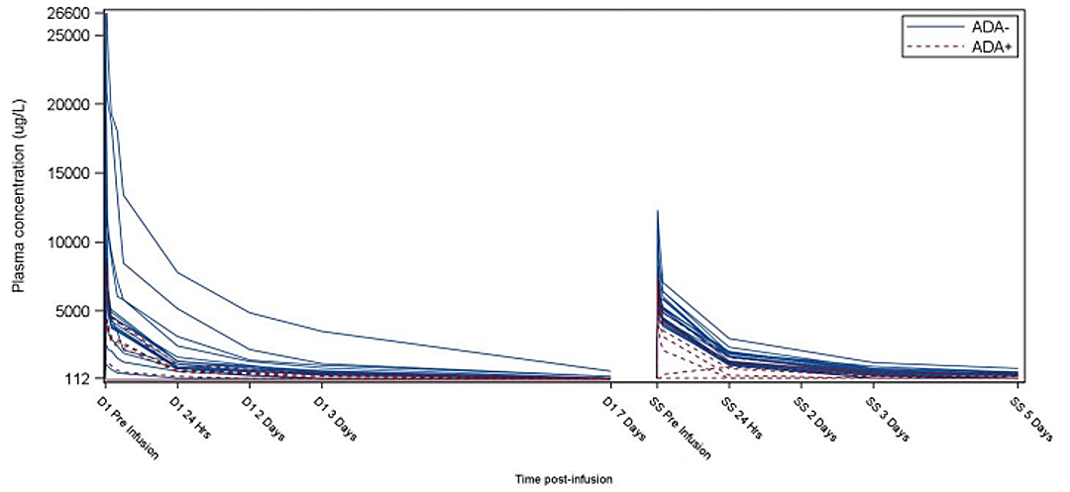
D1, Day 1=PK assessment of first rhLAMAN administration. SS, steady stat=Last PK assessment of rhLAMAN-07/ rhLAMAN-09/ rhLAMAN-10
Based on additional analyses requested by the FDA, an ADA level > 30 U/mL was considered to be associated with a clear reduction in drug exposure. An effect at ADA levels 10 – 30 U/mL cannot be excluded.

Pharmacodynamics
Biomarker assessment consists of measuring n-mannose oligosaccharide (GlcNac(Man)n) in serum, cerebrospinal fluid (CSF) and urine (this is the most abundant oligosaccharide reported). Treatment with velmanase alfa is expected to reduce their concentration and this represents the primary mode of action of the drug. GlcNac(Man)n was measured in 5 studies (02, 03, 04, 05, 10) using high-performance liquid chromatography and mass spectrometry. As serum oligosaccharides represent a primary efficacy outcome in the trials, pharmacodynamics are considered in the main efficacy section below.

Efficacy
In phase 2a study rhLAMAN-03 two potential therapeutic doses of 1 and 2 mg/kg weekly were studied. These doses were based on an accumulated understanding of in vitro and in vivo pre-clinical data and the available human PK data, as well as knowledge extrapolated from other ERTs sharing similar cellular uptake profiles. Both doses were found to be similarly effective and thus 1mg/kg (equivalent to slightly more than 25 U/kg) was chosen for further efficacy studies. These data are detailed further below.
Pivotal Study rhLAMAN-05 was a phase 3, double blind, randomised, placebo-controlled, parallel group study of repeated velmanase alfa infusions in patients with AM over 52 weeks. Fifteen patients were randomised to velmanase alfa and 10 to placebo and all completed the trial. Treatment was with velmanase alfa 1mg/kg or placebo infused weekly (7+/- 3 days). The study was conducted in 6 countries in the EU, with the primary site being the Copenhagen University Hospital, Department of Paediatrics.
The primary efficacy outcomes were the change from baseline to week 52 in serum oligosaccharides and in the 3-minute stair climb test (3MSCT). The key secondary efficacy outcomes were the change in 6-minute walk test (6MWT) and forced vital capacity (FVC %) predicted of normal over the same period.
The other secondary efficacy outcomes were:
- Change from baseline to other visits in the Bruininks-Oseretsky test of motor proficiency (BOT2) (total score and domain scores).
- Change from baseline to other visits in the Leiter R (total score and domain scores).
- Change from baseline to other visits in CSF oligosaccharides and Cerebrospinal fluid biomarkers (Tau, NFL and GFAp).
- Change from baseline to other visits in pulmonary function tests: forced expiratory volume in one second (FEV1) (L), FEV1 (%), FVC (L) and peak expiratory flow (PEF) (L/s).
- Change from baseline to other visits in pure tone audiometry (PTA) (air conduction left and right ear and bone conduction for the best ear).
- Change from baseline to other visits in the questionnaires childhood health assessment questionnaire (CHAQ) and EuroQol 5 Dimension (EQ-5D) (total score and domain scores).
Major inclusion criteria included having alfa-mannosidase activity < 10% of normal, an age between 5 and 35 inclusive and without any echocardiogram abnormalities that were considered not being suitable for trial inclusion in the opinion of the investigator. Major exclusion criteria were not being able to walk without support and presence of chromosomal abnormalities and syndromes which affect psychomotor development in their own right.
Allowed pre-infusion medications were antihistamines, low dose steroid, ibuprofen and paracetamol. Anaesthetic medications were also allowed to support lumbar puncture and all other medications were documented as concomitant medications (and were not restricted).
Efficacy assessments were performed at baseline, 26 weeks and 52 weeks. The full analysis set included all patients who received at least one dose of treatment and had at least one post-baseline efficacy measurement. The safety set included all patients who received at least one dose. There was no formal estimation of sample size. Twenty-five subjects was considered a reasonable number when considering the rarity of the condition, recruitment potential and what would be needed to allow assessment of efficacy and safety. The primary and key secondary endpoints were analysed using an ANCOVA model to determine adjusted means and associated 95% confidence intervals and p values. A responder analysis was also undertaken (responder defined as at least a 70% reduction in serum oligosaccharides and at least a 10% increase in 3MSCT, 6MWT and FVC).
The mean age at inclusion was 18.5-19.7 across the arms and age distribution by 3 categories (<12, 12 to < 18 and ≥ 18 years) was similar. The mean BMI was 24.7-25.1 and other demographic characteristics were similar. There were some notable differences between the arms in terms of disease characteristics. These were mainly in the percentage of patients able to climb at least 65 steps or walk at least 500m. Both percentages were lower in the velmanase alfa arm vs. placebo (for both measures, 13.3% vs. 40%). Also, the mean baseline FVC (velmanase alfa 2.5; placebo 3.3L) and FEV1 (velmanase alfa 2.3L; placebo 2.9L) were numerically lower. Baseline cognitive function was similar for the velmanase alfa and placebo arms, as were oligosaccharides in serum (6.8 vs. 6.6 µmol/L) and CSF (11.4 vs. 10.3 µmol/L). Disease causing mutations were detected in all patients.
In terms of the primary efficacy outcomes:
- There was a statistically significant greater reduction in serum oligosaccharides in the velmanase alfa arm vs. the placebo arm. The adjusted mean change from baseline to week 52 was -5.11 µmol/L in the velmanase alfa arm and -1.61 µmol/L in the placebo arm. Adjusted mean difference between the arms was -3.50 µmol/L (95% CI -4.36, -2.62; p<0.001). The adjusted mean of the relative % change from baseline to week 52 was -77.6% with velmanase alfa and -24.14% with placebo.
- The responder analysis for the primary outcome of change in serum oligosaccharide found a higher percentage were responders in the velmanase alfa arm vs. the placebo arm (86.7% vs. 0%; p<0.0001). Patients in the < 18 years and ≥ 18 years subgroups responded similarly.
- There were no significant differences in either the absolute or percentage change from baseline in the 3-minute stair climb test in the velmanase alfa and placebo arms. Furthermore, there was no statistically significant difference between the arms observed. Despite this finding, there was a slight trend to less deterioration in 3MSCT in terms of relative change with velmanase alfa, as well as a slight trend to absolute increase in steps climbed (compared to a decrease with placebo) (Table 4).
- The responder analysis for the 3-minute stair climb test found a trend to a higher percentage of responders with velmanase alfa compared to placebo (26.7% vs. 10%). Patients in the < 18-year-old subgroup showed a nominal improvement in the 3MSCT for those treated with velmanase alfa and a decrease in those treated with placebo.
Table 4. 3MSCT relative and absolute step count change from baseline
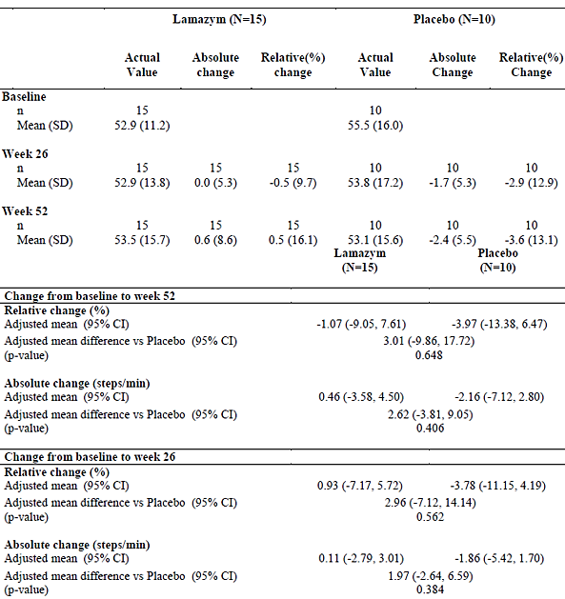
In terms of the key secondary endpoints:
- The adjusted absolute change in 6MWT was +3.74m with velmanase alfa and -3.61m with placebo, and relative change was 0.64% and -1.2%, respectively. None of these met statistical significance, nor did the differences between the 2 arms.
- The responder analysis of change in 6MWT, at the ≥ 15% change threshold, found 13.3% in the velmanase alfa arm and 10% in the placebo arm. Analysis of the < 18-year-old subgroup found more pronounced change in the 6MWT distance (at 52 weeks it had increased by 12.3m or 2% in the velmanase alfa arm, compared to 3.6m or 1.2% in the placebo arm). In the ≥ 18-year-old group a decrease was seen, although it was smaller than the placebo group (Table 5).
- The adjusted mean % increase in FVC was 10.11% with velmanase alfa and 1.58% with placebo at week 52 compared to baseline. The adjusted absolute mean difference was 8.20 (% of predicted) with velmanase alfa and 2.30 with placebo. These findings did not reach statistical significance, although the trend was apparent.
- The responder analysis of the change in FVC, at the ≥ 10% threshold, found 50% responders in the velmanase alfa arm and 22.2% in the placebo arm. As with other endpoints, a more pronounced trend was found in the < 18-year-old group (Table 6).
Table 5: Change from baseline in 6MWT by age group
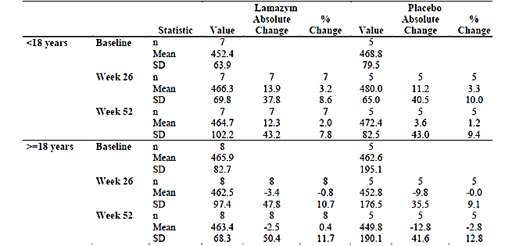
Table 6: FVC (% of Predicted): Relative (%) and Absolute Changes from Baseline
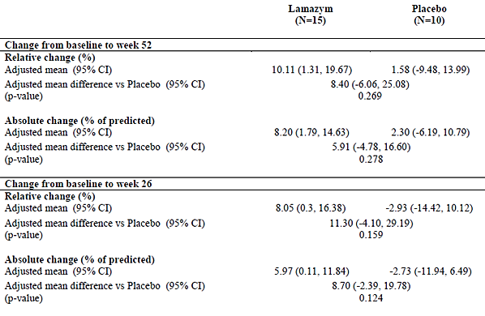
In terms of the other secondary efficacy outcomes, no statistically significant differences between velmanase alfa and placebo were found. Despite this some trends can be seen in several of these endpoints which support a treatment effect of velmanase alfa:
- Responder analysis of the lung function test components found higher response rates in the velmanase alfa arm compared with placebo (Table 7).
Table 7: Responder analysis at 52 weeks for additional lung function test components
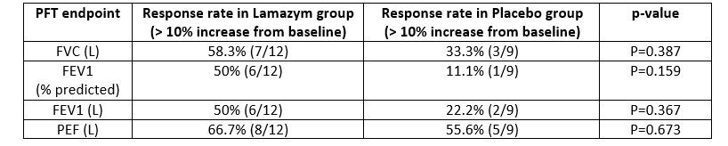
- There was a trend to a better adjusted mean relative change in Bruininks-Oseresky test of Motor Proficiency (BOT2) to week 52 with velmanase alfa as compared to placebo (adjusted mean difference of 6%, favouring velmanase alfa). Subset scores for body coordination, fine motor control and manual coordination tended to favour velmanase alfa, whereas running speed and agility test favoured placebo.
- The cognition test results (Leiter International Performance Scale-Revised test/Leiter R) were similar for the velmanase alfa and the placebo arms.
- Overall, there were no notable differences in CSF biomarkers (oligosaccharides, tau, neurofilament protein, glial fibrillary acidic protein) between the two arms.
- Hearing ability measured by pure tone audiometry showed individual variability and no significant effects of velmanase alfa compared to placebo.
- Differences in the various quality of life questionnaires were not seen.
Integrating the data from rhLAMAN-05 (i.e. combining biomarker, functional and quality of life assessments), a comparison of % responders in the major domains was undertaken. Treatment with velmanase alfa, rather than placebo, at month 12 resulted in more patients being in a responder category (Table 8). Responders are here defined as those patients being able to reach the Minimally Clinical Important Difference (MCID) for each parameter.
Table 8: Pharmacodynamic and efficacy response at month 12, rhLAMAN-05
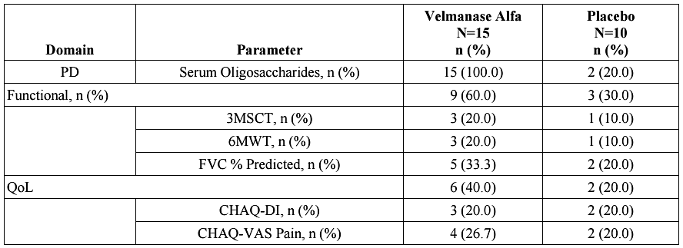
Abbreviations: 3MSCT: 3-Minute Stair Climb Test; 6MWT, 6-Minute Walk Test; CHAQ: Childhood Health Assessment Questionnaire; Dl: Disability Index; FVC: Forced vital capacity; MCID: Minimal clinically important difference; PD: Pharmacodynamic; QoL: Quality of life; VAS: Visual Analog Scale.
N: Number of subjects in the population, n: Number of subjects with MCID improvement.
Supportive study rhLAMAN-04 was a phase 2b, open label trial evaluating the efficacy and safety of velmanase alfa in treatment of patients with AM. All 9 patients came from earlier trials (rh-LAMAN-01 and rhLAMAN 03). All patients were treated with 1mg/kg for at least 6 months (following 12 months of treatment in the feeder trials). Maximum infusion rate was 45mL/hour with duration of at least 50 minutes. Evaluations occurred at visits 13a and 26a.
The primary efficacy outcomes were the reduction of oligosaccharides in blood and CSF, improvement in the 3MSCTm 6MWT and pulmonary function test compared to baseline (baseline was the baseline of the feeder trial). Secondary measures included MRI/magnetic resonance changes, CSF biomarkers, motor function testing (BOT2), hearing, cognition (Leiter R) and health questionnaires.
Inclusion and exclusion criteria were based on the feeder studies (rhLAMAN-02 and rhLAMAN-03). Major inclusion criteria were < 10% of normal alpha-mannosidase activity, aged between 5 and 20 inclusive and the ability to undergo the required assessments. Major exclusion criteria included requiring support to walk, other known chromosomal abnormalities or syndrome affecting psychomotor function, significant comorbidities and findings on echocardiogram that would preclude participation.
In terms of patient characteristics, the mean age was 11.8 years (range 7 – 17), mean BMI 22.2 (range 14.6-27.3) and 70% male. The mean baseline 3MSCT was 157 steps and the mean 6MWT was 444m.
The mean serum oligosaccharide concentration was significantly lower at month 18 than at baseline (0.89 µmol/L vs. 9.40 µmol/L; p<0.001). This result also represents at 89.36% reduction in the biomarker over this time period (95% CI -99.21, -79.50; p<0.001). It rose slightly from the end of the feeder trial (i.e. the 12-month time point) when it was 0.44 µmol/L. This is consistent with ongoing dosing of velmanase alfa at 1mg/kg continuing to achieve a low serum oligosaccharide concentration.
The mean CSF oligosaccharide concentration was not significantly lower at month 18 than baseline (8.67 µmol/L vs. 10.70 µmol/L; p=0.086). Of note, there was a general trend for a decrease over the initial 12 months (in trials rh-LAMAN-01 and 03), followed by an increase in CSF concentration, as can be seen in the individual patient plots (Figure 2).
Figure 2: Individual CSF oligosaccharides by time, from baseline
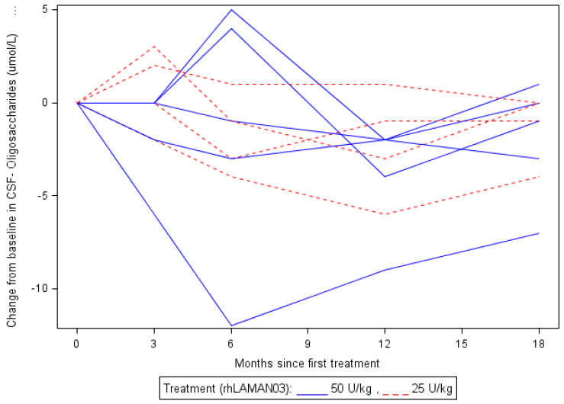
There was an increase in the mean value of 3-minute stair climb test from 156.6 steps at baseline to 197.22 steps at month 18. This difference was significant both in terms of absolute step increase (39.33 steps) and percentage increase (27.51%).
There was a significant increase in the mean 6-minute walk test distance from 444.45m at baseline to 524.00m at month 18. This represents a 20.9% increase from baseline (95% CI 0.63-41.18;p=0.045).
The mean FVC increased from 2.07 to 2.80 at 18 months (i.e. 0.60 change from baseline with p=0.003 or 27% increase from baseline with p=0.002). The change in % predicted FVC was smaller and not significant. The mean FEV1 increased from 1.93 to 2.33 at 18 months (i.e. 0.28 change from baseline with p=0.035 or 13% increased from baseline with p=0.031). No change was detected in terms of % predicted FEV1.
Supportive study rhLAMAN-07 was a phase 3b, multicentre, uncontrolled, open-label study of long-term safety in patients previously enrolled in other studies (8 patients from rhLAMAN-02, 05, 08) or new to velmanase alfa (5 patients). This study was conducted over a 9-year period at 3 sites in France. Of note, this study incorporated home infusions. As this was primarily a safety studies patients who were not able to complete efficacy assessments (e.g. motor assessments) could still be included. Secondary objective of this study included efficacy outcomes (serum oligosaccharides, 3MSCT, 6MWT, lung function, hearing, cognitive development, motor proficiency and quality of life).
This study of 13 patients provided the longest-term exposure amongst any of the submitted studies. The mean duration of exposure was 68.71 months overall (80.80 months in adult patients and 63.33 months in paediatric patients). The maximum exposure was 140.8 months. Compliance with treatment was high at 86% overall. Major and minor protocol violations were common (procedural and yearly assessment related).
Paediatric patients were aged 4 to 15 years and adult patients aged 18 to 36. Medical history was consistent with signs and symptoms seen in AM. The most common concomitant problems were ear and labyrinthine disorders, psychiatric disorders, hypoacusis, intellectual disability, speech disorder and psychomotor retardation.
In terms of serum oligosaccharides, except for one patient, all patientsexperienced substantial (in the range of 70-80%) and sustained reductions in serum oligosaccharides (Figure 3).
Figure 3: Serum oligosaccharides % change from baseline to each time window
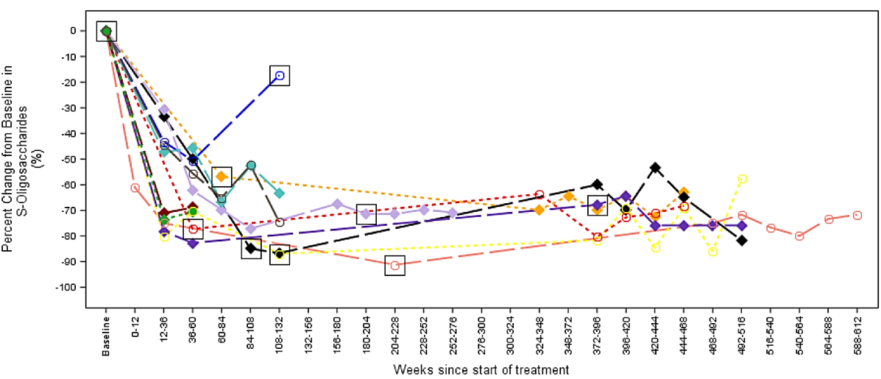
Paediatric is defined as <18 years. Adult is defined as >=18 years.
Dotted line=Adult. Dashed line=Paediatric. Circle=Female. Diamond=Male. Square=entry to RHLAMAN-0? for patients from parental studies.
Baseline is defined as treatment baseline.
Age groups are defined considering the age at treatment baseline.
Values of the same patient as captured during the corresponding visit windowing are summarised as average.
All but 1 of the 7 patients contributing CSF oligosaccharide measurements had modest percentage decreases at approximately the 2 years from baseline. The overall % change was -11.8%.
Given the small number of patients in the study, the inclusion of paediatric patients and adults and the different durations of exposure to velmanase alfa, it is difficult to draw conclusions from mean changes in the major clinical outcomes – i.e. 3MSCT, 6MWT, lung function test and motor assessments. What is apparent from plots of individual patient trajectories in these areas, is that paediatric patients tended to have greater improvements in their parameters and that changes in mobility/exercise tolerance were not dramatic over extended periods of time (Figure 4 and Figure 5). The data is difficult to interpret in the absence of a control group in this study.
Figure 4: 3-minute stair climb test % change from baseline for individual patients
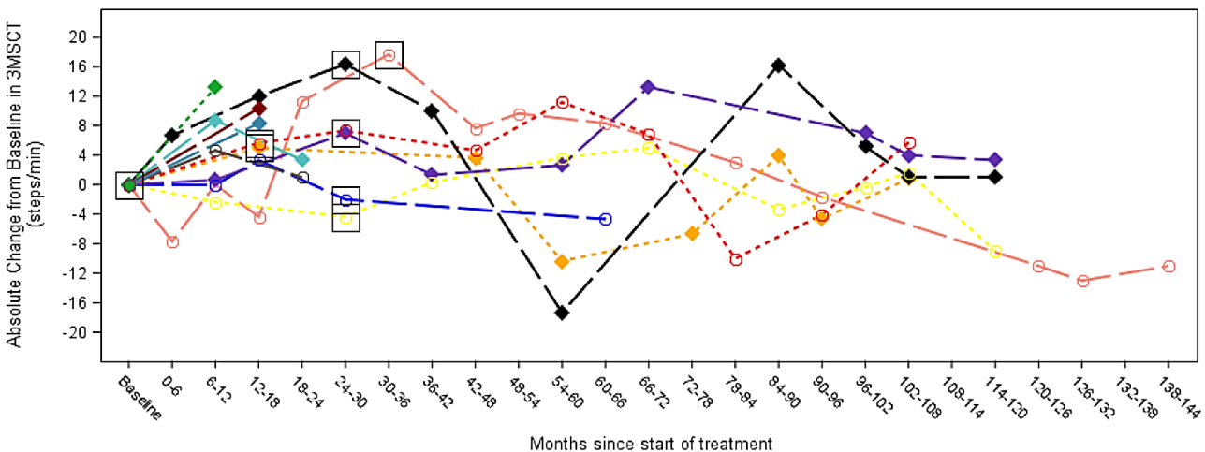
Paediatric is defined as <18 years. Adult is defined as >=18 years.
Dotted line=Adult. Dashed line=Paediatric. Circle=Female. Diamond=Male. Square=entry to RHLAMAN-O? for patients from parental studies.
Baseline is defined as treatment baseline.
Age groups are defined considering the age at treatment baseline.
Values of the same patient as captured during the corresponding visit windowing are summarized as average.
Profile plots are presented only for subjects with available data.
Figure 5: FVC (% predicted) % change from baseline
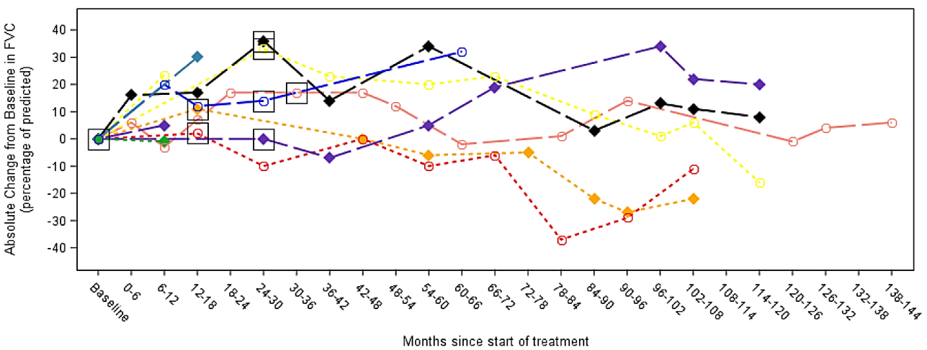
Paediatric is defined as <18 years. Adult is defined as >=18 years.
Dotted line=Adult; Dashed line=Paediatric; Circle=Female; Diamond=Male; Square=entry to RHLAMAN-07 for patients from parental studies.
Baseline is defined as treatment baseline.
Age groups are defined considering the age at treatment baseline.
Values of the same patient as captured during the corresponding visit windowing are summarized as average.
Profile plots are presented only for subjects with available data.
For patients with available data, all had impaired hearing at baseline. Over the course of treatment, the changes in hearing varied from deterioration, no change and improvement.
Supportive study rhLAMAN-09 was a phase 3b, multi-centre- uncontrolled, open-label study evaluating long term safety and efficacy in 8 patents with AM who had participated in rhLAMAN-4 and 05. Efficacy was assessed by serum oligosaccharides, 3MSCT, 6MWT, lung function, hearing, cognitive development, motor proficiency and quality of life.
All patients had a decrease in serum oligosaccharides at all assessed time points. Decreases were generally sustained and % changes at end of study ranged from -57.1% to -80.0%.
Supportive study rhLAMAN-08 was a phase 2 multicentre, open label study of repeated velmanase alfa treatments in patients aged < 6 years with AM. Five patients were enrolled ranging from 3.7 to 5.9.
The median % change in serum oligosaccharides (GlcNac(Man)2) was -65% (6 months), -73% (12 months), -79% (18 months) and -74% (24 months). Functional capacity tests were administered to some patients but it is difficult to draw firm conclusions. After 24 months of treatment 6MWT improved for 3 patients, decreased from 1 patient and could not be obtained from 1 patient. At the same timepoint, the 3MSCT improved for 2 patients and decreased for 3 patients. Quality of life questionnaires administered to parents tended to show improvements in all domains, which included self-care, mobility and social function.
The velmanase alfa clinical development described so far incorporated 3 early development studies (02, 03, 04), a placebo-controlled study (05), long term follow up studies (07, 09) and a paediatric age < 6 study (08). All of these have been described. Study rhLAMAN-10 involved 33 patients from the previous studies and included PK and a detailed clinical assessment. Part of the data evaluation was an integrated analysis of all previous assessments as well as those obtained specifically during study 10. It was considered of major importance to bring together all the relevant study data in support of velmanase alfa safety and efficacy.
In rhLAMAN-10 the median age was 15 (range 6 to 35 years) and all patients were white and most (60.6%) male. This dataset included approximately 50% of patients in the EU with AM who were identified in a previously conducted prevalence survey.
The mean absolute change from baseline serum oligosaccharides to last observation was -4.59 µmol/L (95% CI: -5.74,-3.45;p<0.001) and the mean % change was -62.8% (95% CI: -74.68%, -50.85%; p<0.001).
Statistically significant changes in 3MSCT from baseline were seen at month 6 and all subsequent time points to month 48 (except at month 24). The mean absolute change to month 12 was +4.3 steps (p=0.010) and to last observation +6.4 steps (p=0.001) (representing a % change of +9.3% and +13.8%, respectively). As in previous analyses, a greater benefit was seen in paediatric patients aged ≥ 6 to < 18 years.
Statistically significant changes in the 6MWT from baseline were seen at months 18 (+55.5m, p=0.020) and month 48 (+69.7m, p=0.033). The change from baseline was not statistically significant at the last observation (though numerically positive at +22.4m). Again, the largest gain was seen in the paediatric patients.
In terms of lung function, improvements in FVC % predicted from baseline were seen at month 12 and at last observation. At last observation the percentage increase was +8.5% (p=0.011). A responder analysis showed in this representative cohort of patients, lung function (by FVC % predicted) stabilised or improved in 64.5% of patients.
Patient assessment in the clinical trials was extensive and in addition to the oligosaccharides, exercise/mobility and lung function parameters, other assessments included function, disability, quality of life, motor proficiency, hearing and immunoglobulins. A trend to improvement in the CHAQ-DI (DI = disability index, is scored from 0-3 with 3 being the greatest disability and minimal clinically important difference being 0.13) between baseline and last observation was found (mean absolute reduction of 0.13, i.e. improvement, p=0.095).
There were statistically significant absolute and percentage increases for IgG (Table 9).
Table 9: rhLAMAN change from baseline to the last observation in serum IgG
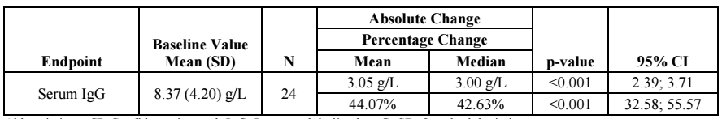
Abbreviations: CI: Confidence interval; IgG: Immunoglobulin class G; SD: Standard deviation.
N: Number of subjects from parental study rhLAMAN-05.
The rhLAMAN-10 analysis is also useful for comparing where the patients were at after 12 months and then at the last observation. When considering the main outcomes of oligosaccharides, motor and quality of life, there appeared to be ongoing improvement, or at least stabilisation, which is supportive of ongoing treatment with velmanase alfa (as deterioration is to be expected) (Table 10).
Table 10: Integrated analysis - responders in each domain at month 12 and last observation
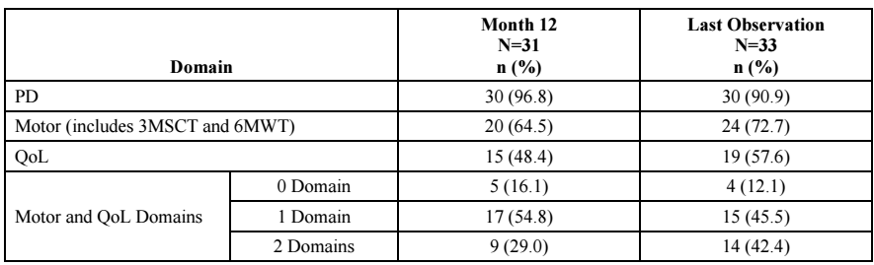
Abbreviations: 3MSCT: 3-Minute Stair Climb Test; 6MWT: 6-Minute Walk Test; MCID: Minimal clinically important difference, PD: Pharmacodynamic; QoL: Quality of life.
N: Number of subjects in the population; n: Number of subjects with MCID improvement.
The Sponsor provided real world evidence (i.e. case reports) showing velmanase alfa use in very young patients:
- A 7-month male baby was started on velmanase alfa 1mg/kg weekly (with antihistamine and antipyretic premedications) and after 2 months showed biochemical improvement (67% reduction in oligosaccharides) and some clinical improvement. There were no reported infusion related reactions during this interval.
- A 28-month-old female was commenced on velmanase alfa 1mg/kg and received 59 weekly infusions. The patient experienced some infusion related reactions which were managed through adjusting the rate, premedication or symptomatic treatment.
- A 6-week-old female commenced velmanase alfa with premedication (antihistamine, antipyretic) for a total of 39 infusions. No safety issues were reported.
- A 10-month-old female patient commence treatment, but experienced infusion related reaction 6 months into therapy (rash on face, trunk, limbs, mild pharyngeal oedema, sporadic inspiratory wheezing).

Safety
The integrated safety analysis included in the dossier is based on the rhLAMAN-10 integrated analysis, updated for serious TEAEs/ADRs/fatal events in the Development Safety Update Report and rhLAMAN-08 in patients < 6 years old. As previously explained, rhLAMAN-10 integrated analysis covers rhLAMAN-02, 03, 04, 05, 07 and 09, as well as those patients who had entered via the compassionate use program.
During clinical development a total of 40 subjects received velmanase alfa in the setting of a clinical study and 26 as part of compassionate use access (13 of these had been in previous clinical trials).
Table 11 shows the duration of exposure to velmanase alfa according to age categories. Note that 100% of participants ≥ 6 years were treated for 6 to 12 months and 75.8% for 18 – 24 months. Of the 5 patients < 6 years, 4 were treated for 24 to 30 months. In rhLAMAN-10 the median exposure was 776 days and the range was 357 to 1625 days. In The mean duration of exposure for patients < 6 years was 27.7 months.
Table 11: Exposure intervals for patient in clinical development program
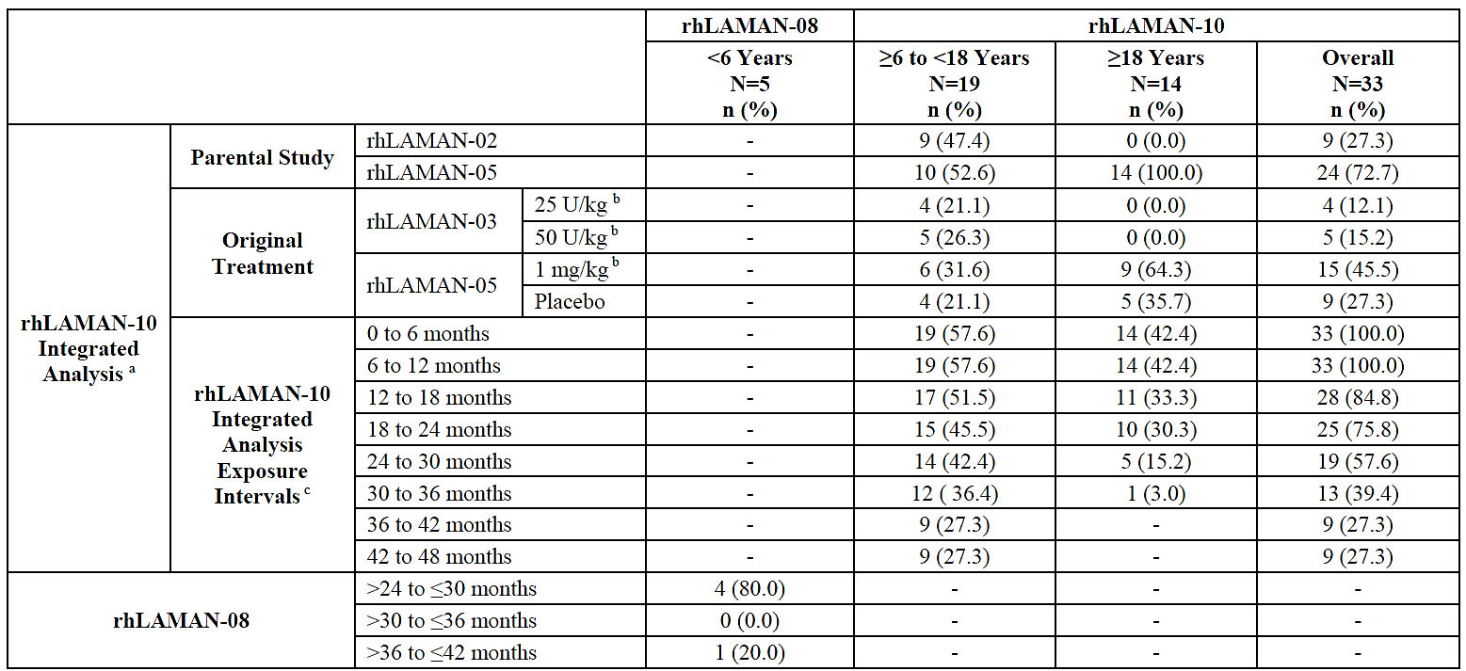
Abbreviations: FAS: Full Analysis Set: SAS: Safety Analysis Set.
N: Number of subjects in the Safety population for rhLAMAN-08 and number of subjects in the FAS for rhLAMAN-10; n: Number of subjects.
a. One subject is only included from the time of enrolment in rhLAMAN-05: One subject only had recorded data during placebo treatment.
b. Velmanase alfa.
c. Routine safety data were not collected during all exposure intervals.
Note: The SAS was identical to the FAS in rhLAMAN-10
The most frequently seen TEAEs in rhLAMAN-10, occurring at a frequency of ≥ 5% were: lymphadenopathy (6.1%), conjunctival hyperaemia (6.1%), eye pruritus (6.1%), abdominal pain upper (6.1%), diarrhoea (15.2%), nausea (6.1%), toothache (6.1%), vomiting (21%), fatigue (6.1%), edema peripheral (9.1%), pyrexia (27.3%), hypersensitivity (9.1%), acute tonsilitis (6.1%), ear infection (15.2%), gastroenteritis (12.1%), influenza (9.1%), laryngitis (6.1%), nasopharyngitis (66.7%), otitis media (6.1%), urinary tract infection (6.1%), arthropod bite (6.1%), contusion (12.1%), excoriation (9.1%), wound (21.2%), arthralgia (15.2%), back pain (12.1%), pain in extremity (15.2%), dizziness (9.1%), headache (33.3%), loss of consciousness (6.1%), syncope (6.1%), pollakiuria (6.1%), cough (21.2%), rhinorrhoea (6.1%), acne (6.1%), skin erythema (6.1%), rash (12.1%), scar pain (6.1%) and catheter removal (6.1%).
The most frequently seen TEAEs (≥40% patients) in rhLAMAN-08 were otitis media, nasopharyngitis, rhinitis, conjunctivitis, ear infection, gastroenteritis, tonsilitis, upper respiratory tract infection, vomiting, diarrhoea, dental caries, pyrexia, cough, oropharyngeal pain, fall, ligament sprain and swelling face.
As per the integrated safety set, different rates of various types of AE were seen in different age groups (Table 12). Nearly all participants experienced TEAEs, but serious TEAEs were far more common in patients < 6 years compared to older patients. ADRs were also more common in patients < 6 years. There were no TEAEs leading to discontinuation or death. AESI, based on anaphylactic reaction (Standardised MedDRA query), was found in 100% of patients < 6 years and 35.7-63.2% in patients ≥ 6 years. When considering those considered to be related to velmanase alfa, the rate was 40% in patients < 6 and 0-7.9% in older patients.
Table 12: Summary of TEAE, integrated safety set
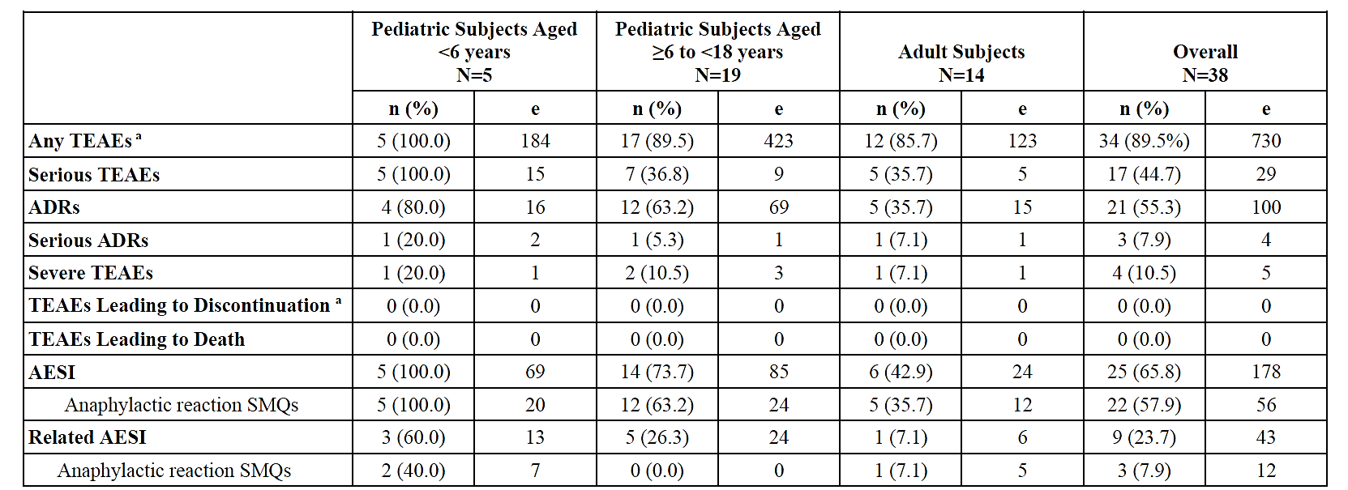
Abbreviations: ADR: Adverse drug reaction: AE: Adverse event: AESI: Adverse event of special interest: IRR: Infusion-related reaction: ISS: Integrated Summary of Safety: MedDRA: Medical Dictionary of Regulatory Activities: SMQ: Standardized MedDRA Query: TEAE: Treatment-emergent adverse event (i.e. AE with onset date/time > date of first study drug intake).
e: Number of events: N: Number of subjects in the Safety Set: n: number of subjects with the event.
a. One subject discontinued due to IRRs during rhLAMAN-03. Data for this subject from rhLAMAN-02 and rhLAMAN-O3 is not included in the ISS. This includes 4 mild ADRs (1 event of pyrexia and 3 events of anaphylactoid reaction). 3 mild unrelated TEAEs (oropharyngeal pain. nasopharyngitis. and tracheitis). and 1 moderate unrelated TEAE (upper respiratory tract infection).
There were only 5 severe TEAEs in 4 patients. These included concussion in a 4-year-old female (not related), loss of consciousness in a 15 year old male (possibly related), tremor and pyrexia in a 9 year old male (probably related) and sepsis in a 23 year old female (not related). Serious TEAEs, by preferred term, each occurred in only 1 patient during the studies. The most common system organ classes involved were infections and infestations (5 patients) and musculoskeletal and connective tissue disorders (4 patients).
Serious ADRs occurred in 3 patients:
- A 6 year old male experienced chills and hyperthermia 65 minutes after the onset of the infusion and responded to medical treatment.
- A 15 year old male experienced loss of consciousness 14 months after commencing treatment and 7.8 days after the last dose. He was found unconscious in his bed at night, was thought to have had a tonic seizure, and improved within a few minutes.
- A 35 year old female experienced acute kidney injury in the context of long term ibuprofen dose. The kidney injury was detected 2 days after the last dose of velmanase alfa, which she had for 291 days. Velmanase alfa was interrupted for 4 weeks and the event resolved despite ongoing treatment.
AEs of special interest (AESI) included Standardized MedDRA Query selections for anaphylactic reaction, hypersensitivity, oropharyngeal allergic conditions and terms possibly due to infusion-related reaction (IRRs) (nausea, vomiting, pyrexia, chills, feeling hot, malaise, hyperhidrosis, hyperthermia). The data generated by these search terms were then interrogated to determine likelihood of representing concerning hypersensitivity reactions.
In terms of honing in on the AEs that were of special interest, considered related and occurred in close proximity to the infusion (i.e. IRRs, anaphylaxis, other hypersensitivity reactions):
- Anaphylactic reaction –ADRs possibly representing anaphylaxis occurred in 3 patients and were urticaria, eyelid oedema, cyanosis and ocular hyperaemia and occurred within 2 hours of infusion finish. Analysis found that none of them represented anaphylaxis.
- Hypersensitivity – ADRs possibly representing hypersensitivity occurred in 7 paediatric patients (2 aged < 6 years and 5 aged ≥ 6 to 18 years; 28 events in total). The events were chills (11 events), pyrexia (8 events), vomiting (3 events), hyperthermia (2 events) and single events of nausea, feeling hot, malaise and hyperhidrosis. Some of these were considered as IRRs.
- Oropharyngeal allergic conditions – none were recorded in this category.
All IRRs occurred in patients aged ≥ 6 to 18 years and most involved changes in temperature without respiratory symptoms or associated rashes. All were mild or moderate and all resolved. Of the 3 patients who experienced infusion related reactions, one of them accounted for 14/19 events (the events were mainly “anaphylactoid reaction” and “chills”). The patient with the frequent events was the same patient with the very high ADA levels and who received treatment with variable, but lengthy, courses of oral prednisolone. Considering the approximately 2800 infusions in rhLAMAN-10, only 1 in 147 led to an IRR. Pre-medication was instituted where considered appropriate (oral antihistamine, paracetamol, corticosteroids).

Placebo controlled data from rhLAMAN-05
This study was the only placebo controlled trial in the dossier. It is useful to review the incidence of AEs between the groups (Table 13). The high level review of AEs types, seriousness and severity found a higher incidence of serious TEAEs with velmanase alfa compared to placebo. This difference was not so apparent for serious TEAEs considered related.
Table 13: Summary of AEs rhLAMAN-05
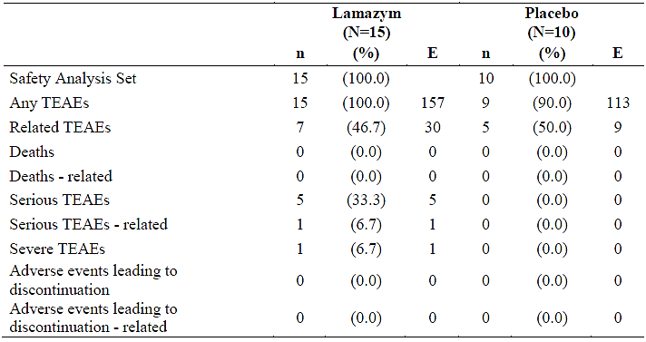
For TEAEs that were reported in at least 2 patients and taking into account the small numbers in the trial, no large differences were found between the groups (Table 14).
Table 14: TEAEs reported in at least 2 patients
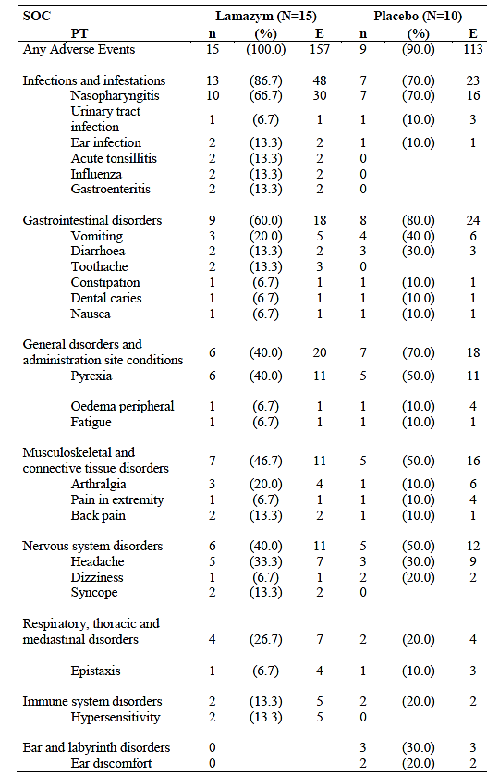

Immunogenicity
ADAs were monitored at regular intervals in all velmanase alfa trials. A number of assays – including both for total ADA and neutralizing ADA – were developed.
In rhLAMAN-10, 10 patients (30.3%) were ADA positive at any time and 23 (69.7%) were ADA negative at all times. Two of the 10 ADA positive were only positive at baseline and were negative following velmanase alfa treatment. Of the 8 (24.2% of all patients) positive on-treatment patients, only 2 had values ≥ 5 U/mL (maximum values of 1012 U/mL and 440 U/mL). Half of the ADA positive patients had treatment-induced ADA responses (i.e. 12.1% of total population). Two of these persistently positive patients corresponded to the highest ADA values and both of these experienced IRRs. These two patients were successfully managed with reduced infusion rate and premedication with antihistamines and corticosteroids. These measures allowed ongoing treatment even in patients with high ADA levels.
There was an association with elevated levels of ADA and IRRs. Although infrequent, IRRs were significant problems for certain individuals in the studies. These IRRs were mild to moderate and were consistent with immune complex-mediated hypersensitivity reactions.
Neutralizing antibodies were measured in rhLAMAN-05 and were detected in both active and placebo patients.
The following effects of ADAs on velmanase alfa outcomes were found:
- rhLAMAN-10
  - Lesser reduction in serum oligosaccharide in the ADA positive population. The patient with very high ADA (1012U/L) had an increase in serum oligosaccharide.
  - There were smaller gains in 3MSCT and 6MWT in the ADA positive population.
- rhLAMAN-08
  - 4 of the 5 patients had positive ADA status and 3 of these tested positive for nADA at times. Despite the high incidence of ADA development, positive effects of velmanase alfa were still detected.
- The associated of ADA with reduced velmanase alfa efficacy was mainly driven by a single subject in the 10 and 08 studies.

Post market safety
Based on PSURs already supplied by the Sponsor:
- A 16 year old male experienced urticaria whilst being treated with velmanase alfa. This was considered a serious event.
- A 2 year old female experienced events consisting of cough, hypoxia, rash and vomiting. This was considered a serious event.
- Other reports consistent with hypersensitivity: rash, infusion related reaction, pharyngeal oedema, urticaria.
During the home infusion program in Italy, 10 non-serious ADRs have been documented (5 patients). These include missed dose, nervousness/agitation, off-label dosing and unspecified neurological disorder.
The SPARKLE registry is a post authorisation safety study that is ongoing. A small number of participants have received treatment in the home setting.

Recommendation following the clinical evaluation
The evaluator felt there were limitations in terms of the rhLAMAN-05 pivotal trial’s ability to delineate the clinical efficacy of velmanase alfa (beyond biomarker change) because of its small size and the lack of a patient-specific and domain-specific approach. Within these limitations the evaluator still considered the trial as adequate to support registration in this context. The safety signals were not considered prohibitive.

Risk management plan
EU-RMP Version 11.1 (date 3 Aug 2023; DLP 22 Mar 2023).
ASA Version 1.0 (date 26 Feb 2024).
The summary of safety concerns and their associated risk monitoring and mitigation strategies are summarised in Table 15. The TGA may request an updated RMP at any stage of a product's life-cycle, during both the pre-approval and post-approval phases.
Table 16: Summary of safety concerns
Summary of safety concerns |  | Pharmacovigilance |  | Risk Minimisation
 |  | Routine | Additional | Routine | Additional
Important identified risks | Infusion-related reactions | ü | ü* | ü | –
Important identified risks | Immunogenicity | ü | ü* | ü | –
Important identified risks | Hypersensitivity | ü | ü* | ü | –
Important potential risks | Loss of consciousness | ü | ü* | ü | –
Important potential risks | Acute renal failure | ü | ü* | ü | –
Important potential risks | Medication errors due to self-administration#/home infusion | ü | ü* | ü | ü†
Missing information | Long term safety | ü | ü* | – | –
Missing information | Safety in non-Caucasian patients | ü | ü* | – | –
Missing information | Safety in pregnant or lactating women | ü | ü* | ü | –
Missing information | Safety in patients with hepatic or renal insufficiency | ü | ü* | ü | –
Missing information | Safety in patients not capable of performing endurance test | ü | ü* | – | –
*Patient registry in the EU
†HCP Home Infusion Guide
#Self-administration is not proposed for Australia
The RMP evaluator considered the safety concerns and proposed pharmacovigilance as acceptable. The Sponsor will submit the Home Infusion Guide for healthcare professionals (a risk minimisation activity) for review before product launch.

Risk-benefit analysis

Indication
The proposed indication is:
Enzyme replacement therapy for the treatment of non-central nervous system manifestations in patients with alpha-mannosidosis.
There is no limitation by age (i.e. any age patient can be treated following diagnosis) and this is appropriate on the basis that 1) AM is a genetic condition that can manifest in early life, 2) there is clinical trial data in patients as young as 3.7 years old and post-market experience in infants as young as 6 weeks old, and 3) early treatment has the potential to reduce accumulation of irreversible end organ damage.
The proposed indication does not include the severity descriptor “mild-moderate” and the Delegate considers this appropriate as patient suitability for treatment in this extremely rare and variable disease, should probably reside with the specialist clinician. Also the ”mild-moderate” severity limitation was used as an entry criterion for the clinical trials as patient with severe disease would not be able to complete many of the assessments. ACM will be asked about this.

Efficacy
The clinical trial program established the efficacy of velmanase alfa to reduce the serum oligosaccharide concentration. Raised serum oligosaccharides are not a “bystander” biomarker, but represent the main pathogenesis of AM.
Demonstrating clinical efficacy in terms of the major non-CNS disease manifestations – mobility, exercise capacity and motor skills – is challenging given the very small population available to study (i.e. to demonstrate statistical significance), the heterogeneity of the disease presentation, the range of ages required to be studied and that substantial reversal of established organ dysfunction may not occur (as opposed to stabilisation of clinical state).
The Sponsor did provide supportive data for clinical benefit. For example, responder analysis of the 3MSCT (co-primary endpoint) in rhLAMAN-05 found 26.7% responders with velmanase alfa and 10% with placebo (non-significant difference). For that outcome, patients in the < 18 year old subgroup showed a larger nominal improvement with velmanase alfa than placebo. Responder analysis of the change in FVC (i.e. lung function) found 58.3% responders in the velmanase alfa arm and 33.3% in the placebo arm (not significant difference).
Data from integrated analysis rhLAMAN, although not placebo controlled, was consistent with either stabilisation or slight improvement of disease manifestations (motor and quality of life). In addition the benefit in terms of oligosaccharide reduction was maintained. Another relevant biomarker that showed improvement was serum IgG (which increased and was statistically significant).
Study rhLAMAN-08 provided data for children aged between 3.7 and 5.9 years (n=5). These patients experienced substantial reduction in serum oligosaccharides. Clinical outcomes were variable. For example, for the 3MSCT endpoint, two patients improved and three declined.

Safety
The two main safety concerns relates to hypersensitivity / infusion related reactions and the development of ADAs. Both of these safety concerns also appear to be related to some extent.
Hypersensitivity and infusion related reactions included events such as hyperthermia, chills, rash (including urticaria), nausea, vomiting. Overall if seems to fair to make the following observations:
- these events were infrequent and concentrated in certain individuals
- could occur even after an extended period of tolerating therapy
- had an association with high ADA concentrations
- could be partially managed with either pre-medication or treatment (with antihistamines, antipyretics, corticosteroids)
- did not limit ability to continue treatment with velmanase alfa
It is not completely clear the extent to which true anaphylaxis occurred in the clinical development program, but seems to have occurred in the post-market space. The Sponsor will be asked to clarify. At this stage it appears there is a risk of significant infusion related reactions and anaphylaxis with velmanase alfa treatment.
ADAs occurred on treatment in around a quarter of patients. Most of these were low concentration, with high concentration and persistent responses, being recorded in only a few individuals. These patients with high ADA concentration experienced infusion reactions and tended to have an attenuation of efficacy. It appears that measurement of ADAs may be important in clinical care of patients on velmanase alfa. The Sponsor will be asked about this.
Administration of enzyme replacement therapy at home is commonly described in the relevant TGA approved product information documents. The Sponsor wishes to document the option of home infusions for velmanase alfa as well. Whilst this seems reasonable, it is appropriate to limit administration by healthcare professionals able to manage problems that occur during the infusion (and for a period of observation afterwards). The Sponsor and ACM will be asked about this.

Deficiencies in data
The major deficiencies which have been discussed in the body of the report relate to the lack of statistically significant, controlled comparisons to support the long term clinical benefits of velmanase alfa for patients with AM. Given the constraints of studying a very small population with variable disease manifestations, these deficiencies are acknowledged but not prohibitive for registration. The Sponsor has provided data – including detailed clinical assessments – that supports registration.

Conclusions
The Delegate considers that velmanase alfa should be entered into the ARTG for the treatment of alpha-mannosidosis on the basis that the benefits are likely to outweigh the risks in this rare, progressive and life limiting condition.

Advisory Committee considerations
The Advisory Committee on Medicines (ACM), having considered the evaluations and the Delegate’s overview, as well as the sponsor’s response to these documents and requests for clarification, advised the following.
Is ACM in agreement with not referencing disease severity in the indication?
There is an accepted continuum of disease severity with three broadly described phenotypes, mild, moderate and severe, however, there is no standardisation of clinical severity for alpha mannosidosis. The ACM advised that referencing the severity of disease in the indication was not appropriate and would limit clinical discretion. The suggested approach of prioritising early intervention is consistent with the clinical approaches used in other lysosomal storage disorders.
Is ACM in agreement with the advice provided in the PI around mitigating hypersensitivity/anaphylaxis risk, with reference to a) Home infusions, b) premedications, c) Anything else.
The ACM held the opinion that home infusions were vital in the long-term treatment of patients with alpha-mannosidosis. These infusions should always be supervised by a suitable healthcare professional.
The ACM noted that the treatment burden of alpha mannosidosis is extremely high on patients and families. Home infusions should be standard of care to alleviate this burden after an initial stabilisation period of administration in a specialist clinic. The ACM additionally noted that infusion related reactions and hypersensitivity reactions can occur unexpectedly, further highlighting that infusions must be performed with care and under appropriate supervision.
The ACM expressed concern over the infusion rate protocol, suggesting that a slower initial rate of infusion may be considered by the prescriber as they would potentially lead to lower rates of infusion related reactions.
Premedications should be seriously considered by treating physicians, especially in children and those with intercurrent illness.
The ACM advised that the PI should include sufficient, detailed and practical information on hypersensitivity reactions, infusion associated reactions, and immunogenicity. In these regards the ACM referenced examples of the PIs of other ERTs in which sufficiently detailed information was provided
Does the PI adequately convey to clinicians the issues around ADAs?
The ACM advised that the proposed PI was adequate to describe the issues around ADAs.
ADA panels are not used in standard clinical practice, except in the event of a patient who does not respond to treatment, but the ACM advised that treatment would be discontinued regardless of the result.

ACM conclusion
The ACM considered this product to have an overall positive benefit-risk profile for the indication:
Treatment of non-central nervous system manifestations of alpha-mannosidosis

Assessment outcome
Based on a review of quality, safety, and efficacy, the TGA decided to register 442450 - LAMZEDE velmanase alfa 10 mg powder for injection vial, indicated for:
Enzyme replacement therapy for the treatment of non-central nervous system manifestations in patients with alpha-mannosidosis

Specific conditions of registration
Lamzede (velmanase alfa) is to be included in the Black Triangle Scheme. The PI and CMI for Lamzede must include the black triangle symbol and mandatory accompanying text for five years, which starts from the date of first supply of the product.
The Lamzede EU-Risk Management Plan (RMP) (version 11.0, date 3 August 2023; DLP 22 March 2023), with Australia-Specific Annex (version 1.0, dated 26 February 2024), included with submission PM-2024-00621-1-3, and any subsequent revisions, as agreed with the TGA will be implemented in Australia.
An obligatory component of risk management plans is routine pharmacovigilance. Routine pharmacovigilance includes the submission of periodic safety update reports (PSURs).
Reports are to be provided in line with the current published list of EU reference dates and frequency of submission of PSURs until the period covered by such reports is not less than three years from the date of this approval letter. Each report must be submitted within ninety calendar days of the data lock point for that report.
The reports are to at least meet the requirements for PSURs as described in the European Medicines Agency’s Guideline on good pharmacovigilance practices (GVP) Module VII-periodic safety update report (Rev 1), Part VII.B Structures and processes. Note that submission of a PSUR does not constitute an application to vary the registration.
Laboratory testing & compliance with Certified Product Details (CPD)
- All batches of < LAMZEDE velmanase alfa 10 mg powder for injection vial > supplied in Australia must comply with the product details and specifications approved during evaluation and detailed in the Certified Product Details (CPD).
- When requested by the TGA, the Sponsor should be prepared to provide product samples, specified reference materials and documentary evidence to enable the TGA to conduct laboratory testing on the Product. Outcomes of laboratory testing are published biannually in the TGA Database of Laboratory Testing Results http://www.tga.gov.au/ws-labs-index and periodically in testing reports on the TGA website.
Certified Product Details
The Certified Product Details (CPD), as described in Guidance 7: Certified Product Details of the Australian Regulatory Guidelines for Prescription Medicines (ARGPM), in PDF format, for the above products should be provided upon registration of these therapeutic goods. In addition, an updated CPD should be provided when changes to finished product specifications and test methods are approved in a Category 3 application or notified through a self-assessable change.
A template for preparation of CPD for biological prescription medicines can be obtained from the TGA website
[for the form] https://www.tga.gov.au/form/certified-product-details-cpd-biological- prescription-medicines
[for the CPD guidance] https://www.tga.gov.au/guidance-7-certified-product-details

Product Information and Consumer Medicine Information
For the most recent Product Information (PI) and Consumer Medicine Information (CMI), please refer to the TGA PI/CMI search facility.

Therapeutic Goods Administration
PO Box 100 Woden ACT 2606 Australia
Email: info@tga.gov.au Phone: 1800 020 653 Fax: 02 6203 1605
https://www.tga.gov.au
Reference/Publication #

This is the original indication proposed by the sponsor when the TGA commenced the evaluation of this submission. It may differ to the final indication approved by the TGA and registered in the Australian Register of Therapeutic Goods.

