Australian Public Assessment Report for Eydenzelt
  - Active ingredient: Aflibercept
  - Sponsor: Celltrion Healthcare Australia Pty Ltd
October 2025

About the Therapeutic Goods Administration (TGA)
- The Therapeutic Goods Administration (TGA) is part of the Australian Government Department of Health, Disability and Ageing and is responsible for regulating therapeutic goods, including medicines, medical devices, and biologicals.
- The TGA administers the Therapeutic Goods Act 1989 (the Act), applying a risk management approach designed to ensure therapeutic goods supplied in Australia meet acceptable standards of quality, safety, and efficacy.
- The work of the TGA is based on applying scientific and clinical expertise to decision-making, to ensure that the benefits to the Australian public outweigh any risks associated with the use of therapeutic goods.
- The TGA relies on the public, healthcare professionals and industry to report problems with therapeutic goods. The TGA investigates reports received to determine any necessary regulatory action.
- To report a problem with a therapeutic good, please see the information on the TGA website.

About AusPARs
- The Australian Public Assessment Report (AusPAR) provides information about the evaluation of a prescription medicine and the considerations that led the TGA to approve or not approve a prescription medicine submission. Further information can be found in Australian Public Assessment Report (AusPAR) guidance.
- AusPARs are prepared and published by the TGA.
- AusPARs are static documents that provide information that relates to a submission at a particular point in time. The publication of an AusPAR is an important part of the transparency of the TGA’s decision-making process.
- A new AusPAR may be provided to reflect changes to indications or major variations to a prescription medicine subject to evaluation by the TGA.

Copyright
© Commonwealth of Australia 2025
This work is copyright. You may reproduce the whole or part of this work in unaltered form for your own personal use or, if you are part of an organisation, for internal use within your organisation, but only if you or your organisation do not use the reproduction for any commercial purpose and retain this copyright notice and all disclaimer notices as part of that reproduction. Apart from rights to use as permitted by the Copyright Act 1968 or allowed by this copyright notice, all other rights are reserved and you are not allowed to reproduce the whole or any part of this work in any way (electronic or otherwise) without first being given specific written permission from the Commonwealth to do so. Requests and inquiries concerning reproduction and rights are to be sent to the TGA Copyright Officer, Therapeutic Goods Administration, PO Box 100, Woden ACT 2606 or emailed to <tga.copyright@tga.gov.au>.

Contents
List of abbreviations 4
Product submission 5
Submission details 5
Product background 6
Disease or condition 6
Current treatment options 6
Clinical rationale 7
Regulatory status 7
Australian regulatory status 7
International regulatory status 7
Registration timeline 9
Assessment overview 9
Quality evaluation summary 9
Nonclinical evaluation summary 10
Clinical evaluation summary 10
Summary of clinical studies 10
Pharmacology 11
Efficacy 11
Safety 14
Risk management plan 18
Risk-benefit analysis 19
Assessment outcome 21
Specific conditions of registration 22
Product Information and Consumer Medicine Information 22

List of abbreviations
Abbreviation | Meaning
ADA | Anti-drug antibodies
ARTG | Australian Register of Therapeutic Goods
ASA | Australia-specific annex
BCVA | best corrected visual acuity
C_{max} | maximum concentration
CMI | Consumer Medicines Information
CT-P42 | Eydenzelt
DM | Diabetes mellitus
DLP | Data lock point
DME | Diabetic macular edema
DMO | Diabetic macular oedema
ETDRS | Early Treatment of Diabetic Retinopathy Study
IVT | Intravitreal
mCNV | Myopic choroidal neovascularisation
nAbs | Neutralising antibodies
PI | Product Information
PlGF | Placental growth factor
RMP | Risk management plan
TEAEs | Treatment emergent adverse events
TGA | Therapeutic Goods Administration
T_{max} | Time to maximum concentration
VEGF | Vascular Endothelial Growth Factor

Product submission

Submission details
Types of submission: | New biosimilar
Product name: | Eydenzelt
Active ingredient: | aflibercept
Decision: | Approved
Date of decision: | 24 March 2025
Date of entry onto ARTG: | 31 March 2025
ARTG numbers: | Eydenzelt aflibercept (rch) 40 mg/mL solution for intravitreal injection pre-filled syringe (431931)  Eydenzelt aflibercept (rch) 40 mg/mL solution for intravitreal injection vial with needle (431932)
Black Triangle Scheme | No
Sponsor’s name and address: | Celltrion Healthcare Australia Pty Ltd, Suite 13.03, 31 Market Street, Sydney, 2000, Australia
Dose form: | Solution
Strength: | Each 1 mL of Eydenzelt solution contains 40 mg aflibercept
Containers: | Eydenzelt is supplied in a single-use vial or pre-filled syringe.  Vial  Each carton includes a type I glass vial containing approximately 0.1 mL of extractable volume, with an elastomeric rubber stopper, and an 18 G x 38.1 mm 5 micron sterile filter needle for single-use only.  The intravitreal injection should be performed with a 30G x 12.7 mm injection needle and 1 mL Luer lock syringe (not included).  Pre-filled syringe  Each carton includes a sealed blister pack with a sterile pre-filled Luer lock syringe, containing approximately 0.09 mL of extractable volume, sealed with an elastomeric plunger stopper and an elastomeric tip cap that is part of a closure system with Luer lock adaptor. The syringe has a pre- attached plunger rod and a finger flange.  The intravitreal injection should be performed with a 30-gauge x 12.7 mm sterile injection needle (not included).
Pack size: | One vial or pre-filled syringe per carton.
Approved therapeutic use for the current submission: | Eydenzelt 2 mg (aflibercept) is indicated in adults for the treatment of visual impairment due to myopic choroidal neovascularisation (myopic CNV).
Routes of administration: | Intravitreal injection
Dosage: | The recommended dose for Eydenzelt is 2 mg aflibercept, equivalent to an injection volume of 50 μL.  For further information regarding dosage, refer to the Product Information.
Pregnancy category: | Category D  Drugs which have caused, are suspected to have caused or may be expected to cause, an increased incidence of human fetal malformations or irreversible damage. These drugs may also have adverse pharmacological effects. Accompanying texts should be consulted for further details.  The use of any medicine during pregnancy requires careful consideration of both risks and benefits by the treating health professional. The pregnancy database must not be used as the sole basis of decision making in the use of medicines during pregnancy. The TGA does not provide advice on the use of medicines in pregnancy for specific cases. More information is available from obstetric drug information services in your state or territory.

Product background
This AusPAR describes the submission by Celltrion Healthcare Australia Pty Ltd (the sponsor) to register Eydenzelt (aflibercept) for the following proposed indications:
Neovascular (wet) age-related macular degeneration (wet AMD)
Visual impairment due to macular oedema secondary to central retinal vein occlusion (CRVO)
Visual impairment due to macular oedema secondary to branch retinal vein occlusion (BRVO)
Diabetic macular oedema (DME)
Visual impairment due to myopic choroidal neovascularisation (myopic CNV)
Eydenzelt is a biosimilar to the registered product Eylea (aflibercept).

Disease or condition
Myopic choroidal neovascularisation (mCNV) is a complication of pathological myopia and may be vision-threatening. There are 3 main stages of mCNV: active, scar, and atrophic. The ‘active’ stage is associated with damage to photoreceptors and central visual loss. In the ‘scar’ stage, a fibrous pigmented scar forms (Fuchs’ spot). In the final ‘atrophic’ stage, Finally, chorioretinal atrophy forms around the regressed CNV.

Current treatment options
Anti- Vascular Endothelial Growth Factor (VEGF) therapy is typically the first-line and preferred treatment for myopic CNV. Photodynamic therapy is an alternative therapy option.

Clinical rationale
Aflibercept is a recombinant fusion protein of portions of human VEGFR-1 and VEGFR-2 extracellular domains fused to the Fc portion of human IgG1. Aflibercept exerts its therapeutic effects by binding to VEGF-A and placental growth factor (PlGF) and thereby inhibiting the binding and activation of these cognate VEGFRs. VEGF-A and PlGF are members of the VEGF family of angiogenic factors that can act as mitogenic, chemotactic, and vascular permeability factors for endothelial cells. VEGF acts via two receptor tyrosine kinases; VEGFR-1 and VEGFR-2, present on the surface of endothelial cells. PlGF binds only to VEGFR-1, which is also present on the surface of leucocytes. Excessive activation of these receptors by VEGF-A can result in pathological neovascularization and excessive vascular permeability. PlGF can synergize with VEGF-A in these processes and is also known to promote leucocyte infiltration and vascular inflammation. Aflibercept acts as a soluble decoy receptor that binds to VEGF-A, and PlGF, and thereby can inhibit the binding and activation of these cognate VEGFRs.

Regulatory status

Australian regulatory status
This product is considered a new biosimilar medicine for Australian regulatory purposes.

International regulatory status
At the time the TGA considered this submission, a similar submission had been considered by other regulatory agencies. Table 1 summarises these submissions and provides the indications sought/approved.
Table 1: International regulatory status at the time the TGA considered this submission
Region | Filing Date for Marketing Authorisation | Status | Indications
United States (US) | 29th June 2023 | Under review | Neovascular (Wet) Age-Related Macular Degeneration (AMD)  Macular Edema Following Retinal Vein Occlusion (RVO)  Diabetic Macular Edema (DME)  Diabetic Retinopathy (DR)
Korea | 26th July 2023 | Under review | Neovascular (Wet) Age-Related Macular Degeneration (AMD)  Macular Edema Following Retinal Vein Occlusion (RVO)  Diabetic Macular Edema (DME)  Myopic choroidal neovascularisation (myopic CNV)
Canada | 28th July 2023 | Under review | The treatment of neovascular (wet) age-related macular degeneration(AMD)  The treatment of visual impairment due to macular edema secondary to central retinal vein occlusion (CRVO)  The treatment of visual impairment due to macular edema secondary to branch retinal vein occlusion (BRVO)  The treatment of diabetic macular edema (DME)  The treatment of myopic choroidal neovascularization (myopic CNV)
European Union (EU) | 23rd November 2023 | Under review | Neovascular (wet) age-related macular degeneration (AMD)  Visual impairment due to macular oedema secondary to retinal vein occlusion (branch RVO or central RVO)  Visual impairment due to diabetic macular oedema (DME)  Visual impairment due to myopic choroidal neovascularisation (myopic CNV)

Registration timeline
Table 2 captures the key steps and dates for this submission.
This submission was evaluated under the standard prescription medicines registration process.
Table 2: Timeline for Eydenzelt submission
Description | Date
Submission dossier accepted and first round evaluation commenced | 31 January 2024
Evaluation completed | 29 November 2024
Registration decision (Outcome) | 24 March 2025
Registration in the ARTG completed | 31 March 2025
Number of working days from submission dossier acceptance to registration decision* | 292 days
*Statutory timeframe for standard submissions is 255 working days

Assessment overview

Quality evaluation summary
Aflibercept is a recombinant fusion protein combining domains of human VEGFR-1 and VEGFR-2 fused to human IgG1 Fc, acting as a soluble decoy receptor inhibiting VEGF-A and placental growth factor. Eydenzelt contains aflibercept produced from a Chinese Hamster Ovary (CHO-K1) cell line, formulated with the excipients histidine, sodium chloride, trehalose and polysorbate 20. Two drug product presentations are manufactured: vials filled in Type I glass with filter needles, and silicon oil-free cyclo olefin polymer pre-filled syringes (PFS) with chlorinated butyl rubber stoppers. Compatibility studies confirmed no adverse impact on product quality.
Manufacturing involved processes with defined critical process parameters and validated in-process controls that ensured consistent quality. Process validation included multiple consecutive commercial-scale batches demonstrating robustness and impurity clearance, including residual host cell proteins, DNA, and endotoxins. Control strategies defined critical quality attributes that included aggregation, glycosylation, charge variants, potency, and residual impurities. Specifications for drug substance and product included tests for identity, purity, biological activity, and stability, validated per ICH Q2 guidelines.
Drug substance stability supports a proposed 36-month shelf life at -75±15°C. Drug product stability studies for vial and PFS presentations include long-term, accelerated, stressed, and photostability tests and support a shelf life of 12 months at 2-8°C.
Extensive analytical characterization comparing Eydenzelt and EU-approved Eylea demonstrated high similarity in primary structure, post-translational modifications, higher order structure, and biological activity. Minor differences were observed in charge variants, glycation, and glycosylation patterns, but these are reconciled due to the mechanism of action and in vitro functional equivalence.
Functional assays confirmed comparable VEGF binding and blockade across isoforms, PlGF binding, and Galectin-1 interactions. Differences in Fc receptor binding affinities were attributed to glycan variations but considered not to affect therapeutic activity. Eydenzelt exhibited slightly higher monomer content and lower high molecular weight species and impurities than Eylea, which is considered a favourable attribute.
Product names and labelling for vial and PFS presentations conformed with Therapeutic Goods Order 91.
There were no objections to the registration of Eydenzelt from a quality perspective.

Nonclinical evaluation summary
The nonclinical dossier contained a comparative repeat-dose toxicity study following intravitreal (IVT) dosing. The scope of the nonclinical program is adequate under the relevant EU guideline. These studies were conducted using EU-sourced Eylea as the reference product.
No significant differences between toxicity profiles of Eydenzelt and Eylea were observed in the comparative repeat-dose toxicity study in monkeys. Notable findings in the study comprised ophthalmic inflammation, with slightly less inflammation with Eydenzelt cf. Eylea. Systemic and local aflibercept exposures were comparable following treatment with Eydenzelt and Eylea. In the vitreous humor, higher aflibercept concentrations were observed in males cf. females. Due to high interindividual variability in vitreous humor concentrations, any difference between Eydenzelt and Eylea was not obvious.
The Sponsor confirmed that the Eydenzelt formulation has remained identical during manufacturing process development. While manufacturing Process A was used for the DS used in the nonclinical studies, Process C was optimised for proposed commercialisation. The Sponsor stated that the changes during the manufacturing development process did not adversely impact product quality. Although differences in the batches from different processes did not affect the quality of Eydenzelt, its impact on the pharmacokinetics and safety could not be determined. Additionally, toxicity studies in non-human primates had limited relevance due to the small group sizes and high interindividual variability. Therefore, comparability in regard to safety between the proposed biosimilar product, Eydenzelt and the reference product, Eylea relied solely on the clinical evaluation.
The ability of the nonclinical studies to support comparability to Australian Eylea depended on the conclusion of the quality Evaluator regarding the identity of Eylea products across jurisdictions. Given that EU-sourced Eylea was considered to be identical or highly comparable to the Australian product, there were no nonclinical objections to the registration of Eydenzelt

Clinical evaluation summary

Summary of clinical studies
The clinical development program for the proposed Eydenzelt biosimilar consisted of one Phase 3 therapeutic similarity study (Table 3) conducted in patients with diabetic macular oedema DME (Study CT-P42 3.1).
Table 3. Overview of clinical study CT-P42 3.1
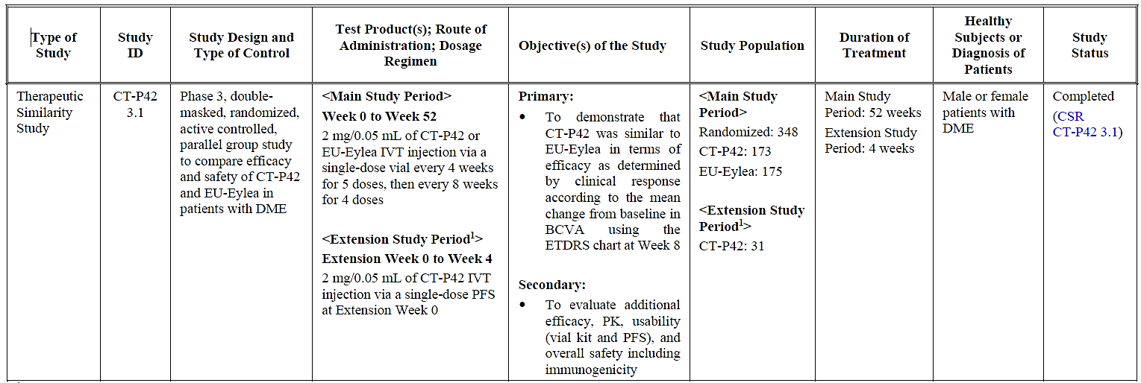
1. After the completion of Main Study Period, a total of 31 patients from Main Study Period regardless of the treatment group in Main Study Period. were enrolled in a 4-week open-label. single-arm extension study to evaluate the usability efficacy and safety of CT-P42.
Abbreviations: BCVA, best corrected visual acuity; CSR. clinical study report; DME, diabetic macular oedema: ETDRS, Early Treatment of Diabetic Retinopathy Study; IVT, intravitreal; PFS, pre-filled syringe; PK, pharmacokinetics.

Pharmacology
No clinical Phase 1 pharmacokinetic (PK) studies (e.g. bioequivalence studies) were conducted. This was justified by the applicant with the low systemic exposure of IVT aflibercept, and the potential ethical issues regarding invasiveness of IVT injections in healthy volunteers.
The PK profile of CT-P42 (Eydenzelt) and Eylea were evaluated in a subset of patients in the clinical Phase 3 Study CT-P42 3.1. Study CT-P42 3.1 provided plasma concentration data following the first and fifth IVT injections.
Secondary PK endpoints were maximum concentration (C_{max}) and time to maximum concentration (T_{max}) for free VEGF-unbound) aflibercept in plasma, which were measured at pre-defined intervals after the first (C_{max1} and T_{max1}) and fifth (C_{max2} and T_{max2}) IVT injections.
Regarding immunogenicity, anti-drug antibodies (ADAs) and neutralising antibodies (nAbs) incidence was assessed during Study CT-P42 3.1 in the Safety Set.

Efficacy

Pivotal phase 3 Study CT-P42 3.1

Design
Phase 3, double-masked, randomised, active-controlled, parallel-group (1:1) 52-week clinical equivalence study to compare efficacy and safety of CT-P42 and EU-Eylea® in 348 adult patients with diabetic macular oedema.
The study was performed at 83 centres across Czech Republic, Estonia, Germany, Hungary, Latvia, Lithuania, Poland, Russia, Slovakia, Spain, Ukraine, Republic of Korea, and India. The study period was 22 July 2021 (first participant assigned) to 24 April 2023 (last participant last visit).
Primary efficacy objective: to demonstrate similarity in efficacy between Eydenzelt and Eylea in terms of clinical response as determined by the mean change from baseline at week 8 in best corrected visual acuity (BCVA) using the Early Treatment of Diabetic Retinopathy Study (ETDRS) score.
Secondary efficacy objective: to evaluate additional efficacy parameters, PK, usability, and overall safety including immunogenicity of Eydenzelt.
Figure 1. Study CT-P42 3.1. Study design schema.
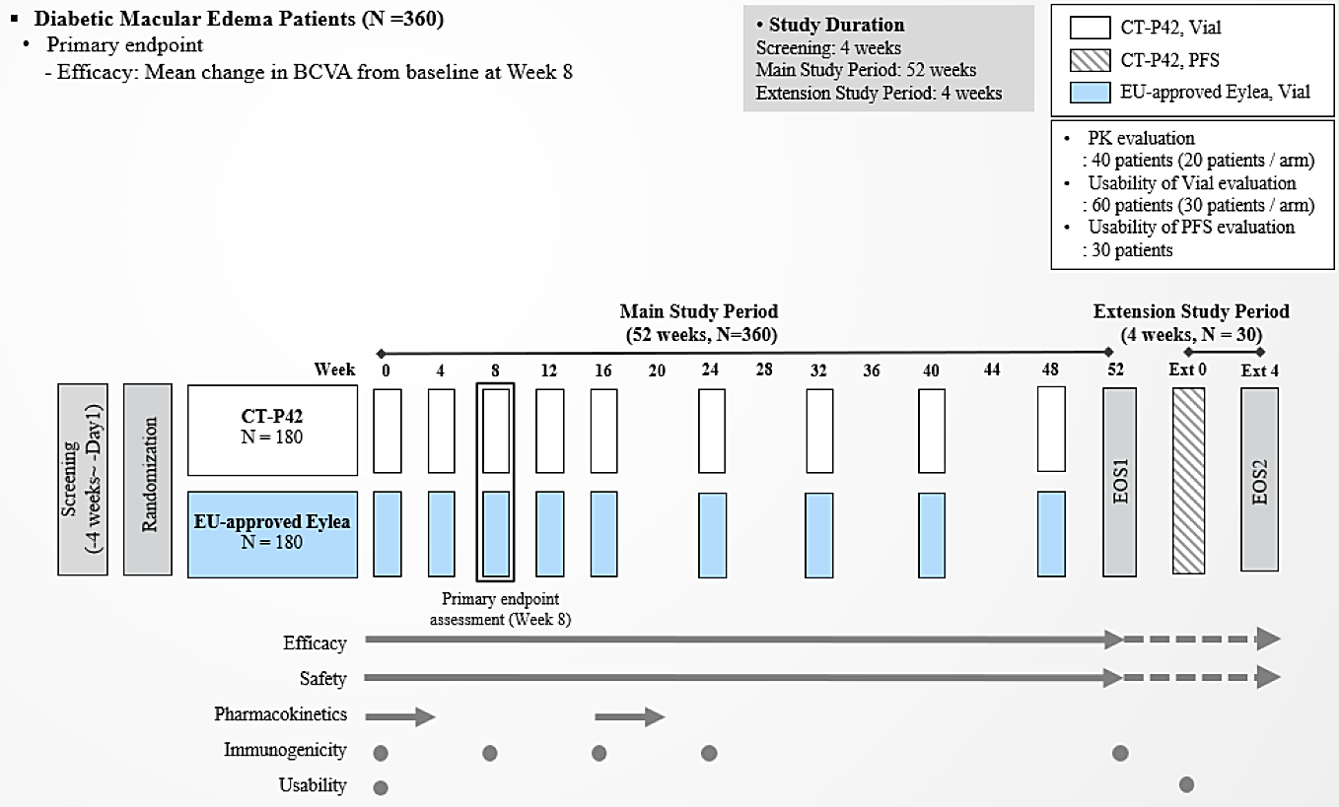
Abbreviations: BCVA, Best Corrected Visual Acuity; EOS1, first end-of-study; EOS2, second end-of-study; Ext 0, Extension Week 0; Ext 4, Extension Week 4; EU, European Union; N, number of patients; PFS, prefilled syringe; PK, pharmacokinetics.
Key inclusion criteria included:
- male or female adults aged ≥18 years of age
- type 1 or type 2 diabetes mellitus (DM)
- DME secondary to DM involving the centre of the macula (defined as the optical coherence tomography (OCT) central subfield) in the study eye
- central subretinal thickness ≥350µm as assessed by OCT, based on central results in the study eye at Screening
- BCVA by ETDRS score of 73 to 34 (approximately equivalent to a US Snellen score of 20/40 to 20/200) at Screening and Day 1
- decrease in vision determined to be primarily the result of DME in the study eye
Key exclusion criteria included:
- only one functional eye
- a history (at the time of enrolment) of one or more ocular conditions, not including DME, as listed in the study protocol that may affect visual acuity, the ability to assess the eye, affect interpretation of the results, or that may result in the requirement for medical or surgical intervention during the study.
- a history of, or current (at the time of enrolment) systemic condition as listed in the protocol, including uncontrolled DM
- previous or concomitant treatment with aflibercept (systemic or ocular), other ocular anti-angiogenic agents, intraocular or periocular corticosteroids within 180 days or fluocinolone acetonide implant within 36 months, laser photocoagulation in the study eye within 90 days, history of vitreoretinal or any intraocular surgery in the study eye within 90 days, yttrium-aluminium-garnet capsulotomy in the study eye within 30 days, treatment with any investigational medicinal product/device within 30 days or 5 half lives
- pregnant or breastfeeding

Treatments
Main study period: Participants received either 2 mg (in 0.05 mL) Eydenzelt or Eylea single dose vial via IVT injection every 4 weeks for 5 doses, then every 8 weeks for 4 doses, up to Week 52. No dose was given at Week 52
Open-label extension study period: 31 participants who completed the main study period up to Week 52, regardless of initial randomisation, were assigned to receive a single dose of 2 mg (in 0.05 mL) Eydenzelt at study visit 10 / Extension Week 0 (eight weeks after the last dose at the investigator’s discretion).

Randomisation and masking
Main study period: Randomisation using an interactive web response system. Baseline BCVA (<55 letters versus ≥55 letters) and country were used as stratification factors. The overall randomisation code was broken on 20 January 2023 for reporting, after the database lock for data up to Week 24 for all participants. Unmasked analyses were performed as outlined in SAP version 1. Investigators, participants, and predefined masked staff remained masked to the randomisation codes until all participants completed the study and the database was locked for the final CSR. Once all participants completed the study, a database lock for the whole study period was performed on 21 July 2023 to allow analysis for the final CSR as per SAP version 2.0.
Extension study period: This study period was open-label and consisted of only the Eydenzelt (PFS) treatment arm.

Baseline characteristics
In both studies, demographics and baseline characteristics were reasonably balanced between groups:
Patient demographics: The mean (SD) age for the Eydenzelt group was 62.5 (9.6) years, and 62.9 (10.3) years for the Eylea group. The majority were male for both the Eydenzelt group (61.3%) and Eylea group (55.4%). Most patients were White (Eydenzelt 64.7%; Eylea 64.0%) or Asian (Eydenzelt 35.3%; Eylea 36.0%). The mean (SD) age in the extension study period (SS-E set) was 64.7 (10.8) years, with 58.1% male and all were White.
Disease characteristics: The mean (SD) duration of DM for participants in the main study period (ITT set) was 13.599 (8.8011) years in the Eydenzelt group and 14.0202 (9.5446) years in the Eylea group. The mean (SD) duration of DME was 0.5913 (1.4285) years for the Eydenzelt group, and 0.8395 (1.9134) years for the Eylea group (range: 0 to 14 years for both groups). Most participants had a HbA1c ≤8% (Eydenzelt 65.3%; Eylea 66.3%), and a BCVA ETDRS score of ≥55 letters at baseline (Eydenzelt 71.7%; Eylea 73.7%). Overall, 93.1% of participants had diagnosed Type II DM, 75.6% had bilateral DME.
The baseline HbA1c in the extension study period was similarly distributed across the cut-off, with 51.6% of participants having a baseline HbA1c of ≤8%. Most (77.4%) participants had a baseline BCVA ETDRS score ≥55 letters.

Magnitude of the treatment effect and its clinical significance
The primary efficacy endpoint was the mean change from baseline in BCVA using the ETDRS eye chart at Week 8 (main study period). The least squares (LS) mean (standard error (SE)) change from baseline in BCVA at week 8 was 9.43 (0.798) letters in the Eydenzelt group, and 8.85 (0.775) letters in the Eylea group. The estimated LS mean treatment difference (95% CI) was:
- 0.58 (-0.73, 1.88) (FAS)
- 0.38 (-0.90. 1.66) (PPS)
This was within the pre-defined equivalence margin of ±3 letters (-3.0, 3.0) with the 95% CI for the estimate of treatment difference in LS means including 0 for both FAS and PPS.
Table 4. Study CT-P42 3.1. Primary efficacy endpoint: Mean change from baseline in BCVA at Week 8 (FAS and PPS).
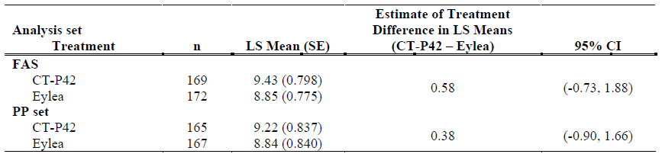
Abbreviations: ANCOVA, analysis of covariance: BCVA, Best Corrected Visual Acuity: FAS. full analysis set: LS, least squares; n. number of patients with BCVA score at Week 8; PP, per-protocol: SE. standard error.
Notes: An ANCOVA was performed with change from baseline in BCVA at Week 8 as the dependent variable, treatment as a factor. and baseline BCVA and country as covariates. Statistical analyses for primary efficacy endpoint were conducted only for the study eye.
The sensitivity analysis of the primary endpoint which used multiple imputations and the missing at random assumption yielded a comparative result.
Subgroup analyses of the primary endpoint were generally consistent with the main analysis.
Change from baseline in BCVA at Week 52: The least squares (LS) mean (standard error (SE)) change from baseline in BCVA was 12.1 (8.9) letters in the Eydenzelt group, and 11.1 (9.9) letters in the Eylea group.

Safety
Study CT-P42 3.1 provided safety data for the main study period and the extension study period. The Safety Set for Main Study Period (primary set for safety analysis) was defined as all randomly assigned patients who received at least 1 full or partial dose of study drug in Main Study Period. Patients were analysed based on the treatment actually received.

Exposure
The extent of exposure to aflibercept in Study CT-P42 3.1 for the summary is shown in Table 5. During the extension study period, all 31 enrolled participants received a single dose of 2 mg Eydenzelt PFS at extension Week 0. The majority of participants completed all nine injections during the main study period.
348 patients with DME received 2 mg/0.05 mL of CT-P42 or EU-Eylea IVT injection every 4 weeks for 5 doses, and, then every 8 weeks for 4 doses: 174 patients were exposed to CT-P42 and 174 patients were exposed to EU-Eylea. During the extension study period, 16 participants received a single dose of CT-P42 after administration of EU-Eylea in the main study period.
Table 5. Study CT-P42 3.1. Duration of exposure.
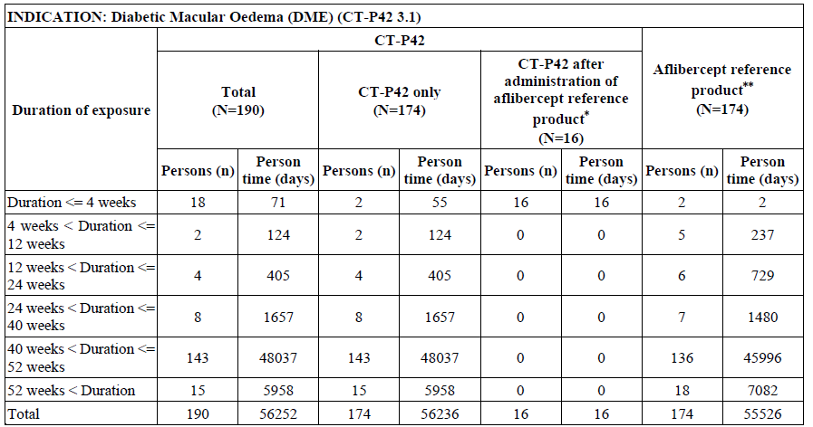
Protocol Number: CT-P42 3.1.
Abbreviation: n=number of patients.
*Patients who received a single dose of CT-P42 in the extension study period after administration of aflibercept reference product in the main study period.
**Patients exposed to aflibercept reference product during main study period is included in this column. Person time (days) for each arm is calculated as follows.
CT-P42 only: Date of Last Exposure to Treatment — Date of First Exposure to Treatment + 1.
CT-P42 after administration of aflibercept reference product: Date of Last Exposure to CT-P42 Treatment —
Date of First Exposure to CT-P42 Treatment + 1.
CT-P42 total: Duration from ‘CT-P42 only’ and ‘CT-P42 after administration of aflibercept reference product’.
Aflibercept reference product: (Date of Last Exposure to Treatment — Date of First Exposure to Treatment + 1)
or ([Date of First Exposure of CT-P42] — [Date of First Exposure to Treatment]).

Adverse event overview
Treatment emergent adverse events (TEAEs) regardless of causality are summarised in Table 6. Overall, 226 (64.9%) participants reported at least one TEAE, with a similar proportion between groups (62.6% and 67.2% participants in the Eydenzelt and Eylea treatment groups, respectively). A total of 587 TEAEs were reported, with 269 TEAEs in the Eydenzelt group, and 318 in the Eylea group. Most participants experienced TEAEs of grade 1 or 2 in severity intensity. Within the Eydenzelt treatment group, 32 (18.4%) and 47 (27.0%) participants experienced at least one TEAE of highest severity of grade 1 or grade 2, respectively, regardless of relationship to the study drug. This was similar to the Eylea group, with 33 (18.9%) and 47 (27.0%) participants, respectively. Grade 3 TEAEs were reported for 34 (19.5%) participants in the Eydenzelt group, and for 37 (21.3%) participants in the Eylea group. Overall, five (1.4%) participants experienced a grade 4 TEAE, and five (1.4%) experienced a grade 5 TEAE.
The most frequently reported TEAEs regardless of causality and by system organ class (SOC), were eye disorders, experienced by 51 (29.3%) participants in the Eydenzelt group, and 59 (33.9%) participants in the Eylea group. The most frequently reported TEAE by preferred term was diabetic retinal oedema (17 (9.8%) vs. 23 (13.2%)) for the Eydenzelt group and Eylea group, respectively. The most frequently reported grade 3 or higher TEAE by PT was hypertension (2 (1.1%) vs. 4 (2.3%)) for the Eydenzelt group and Eylea group, respectively.
At least one non-ocular TEAE was reported by 86 (49.4%) participants in the Eydenzelt group, and by 93 (53.4%) participants in the Eylea group. The most frequently reported PT was hypertension experienced by 11 (6.3%) and 16 (9.2%) participants, respectively.
Ocular TEAEs in the study eye were reported for 31 (17.8%) of participants in the Eydenzelt group, and 38 (21.8%) in the Eylea group (Table 7).

CT-P42 3.1 Final CSR
During the Main Study Period, the proportion of patients who experienced at least 1 ocular TEAE in the study eye was similar in the CT-P42 group (31 [17.8%] patients) compared with the Eylea group (38 [21.8%] patients).
Ocular TEAEs in the fellow eye were reported for 37 (21.3%) participants in the Eydenzelt group, and 45 (25.9%) participants in the Eylea group.

CT-P42 3.1 Final CSR
During the Main Study Period, the proportion of patients who experienced at least 1 ocular TEAE in the fellow eye was similar between the 2 treatment groups (37 [21.3%] patients in the CT-P42 group and 45 [25.9%] patients in the Eylea group).

Extension study period (SS-E)
Five TEAEs were reported for three (9.7%) participants, all of which were Grade 1 or Grade 2 in severity. One (3.2%) participant reported an ocular TEAE of ‘diabetic retinal oedema’ (Grade 2) in the fellow eye, and two participants reported non-ocular TEAEs of PTs ‘influenza’, ‘blood creatinine increased’, ‘blood uric acid increased’, and ‘glycosylated haemoglobin increased’. All five TEAEs were considered unrelated to the study drug.
Table 6. Study CT-P42 3.1. Treatment-Emergent Adverse Events by Relationship and Intensity. Safety Set for Main Study Period.
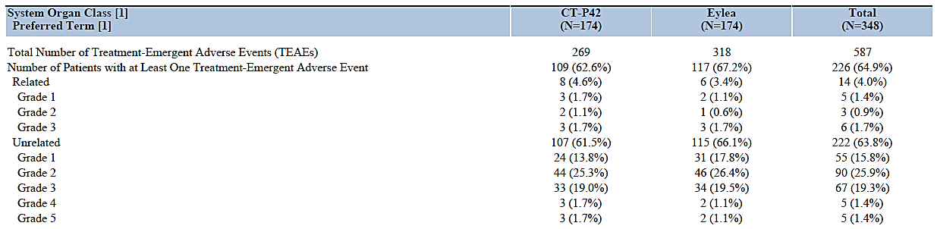
Note: The total number of TEAEs count includes events for all patients in the Safety set for Main Study Period. At each level of summarization, patients are counted once if they reported one or more events. Only the most severe event is counted. The event is considered to be related if the relationship is defined as ‘Possible’, ‘Probable’ and ‘Definite’. The intensity is defined as Grade 1 = Mild, 2 = Moderate, 3 = Severe, 4 = Life-threatening, 5 = Death.
Table 7. Study CT-P42 3.1. Ocular (study eye) TEAEs reported for ≥ 1% of participants in any treatment group by PT (Safety Set in main study period).
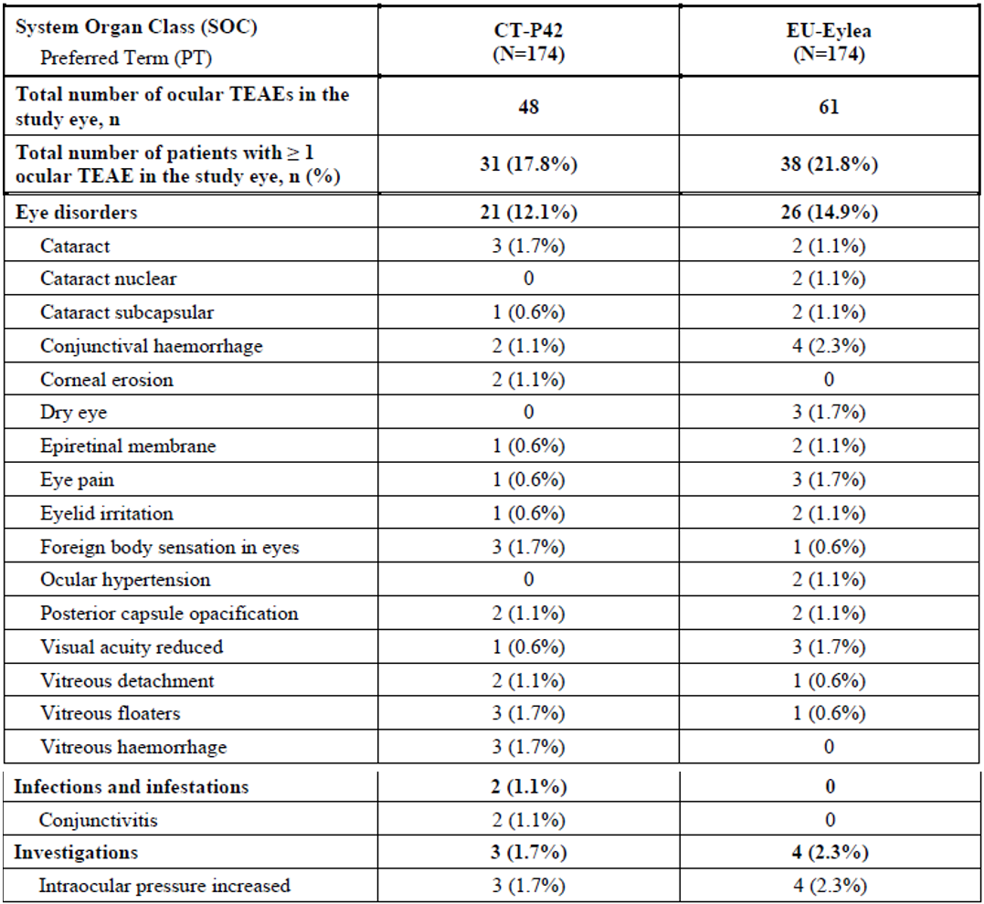

Treatment related adverse event (adverse drug reaction) overview
Eight (4.6%) participants in the Eydenzelt group and six (3.4%) participants in the Eylea group reported adverse events (AEs) which were considered related to the study treatment.
Two grade 3 ocular ADRs (epiretinal membrane, macular ischaemia (SAE)) and one grade 3 cardiac ADR (myocardial infarction) were reported in the Eydenzelt group did not occur in the Eylea treatment group. However, arterial thromboembolic events after IVT use of VEGF inhibitors are currently described in the reference PI.Ocular ADRs were reported for seven (4.0%) and four (2.3%) participants in the Eydenzelt and Eylea groups, respectively. The reported PTs were under the SOC ‘eye disorder’, and the PT ‘intraocular pressure increased’. No ocular TEAEs reported in the fellow eye were considered related to the study drug, and no ADRs were reported for the extension study period.

Deaths
Five participants died due to TEAEs, with 3 (1.7%) in the Eydenzelt group and 2 (1.1%) in the Eylea group. In all cases, deaths were not considered related to the study drug.

Serious adverse events
Treatment emergent serious adverse events (TESAEs) were reported for 19 (10.9%) participants in the Eydenzelt group, and 17 (9.8%) participants in the Eylea group. Three (1.7%) participants in the Eydenzelt group and two (1.1%) participants experienced at least one TEAE leading to death.

Adverse events of special interest
AEs of special interest (AESIs) included arterial thromboembolic events and IVT therapy injection related reactions. Eight (4.6%) participants from each treatment group reported at least one arterial thromboembolic event. IVT injection procedure related TEAEs were reported for 7 (4.0%) participants in the Eydenzelt group, and 16 (9.2%) participants in the Eylea group.

Immunogenicity
Three (1.7%) participants in the Eydenzelt group and 2 (1.1%) participants in the Eylea group tested positive for ADA at Week 0 prior to first study drug administration. All 5 participants were negative for NAb.
During the main study period, 169 (97.1%) participants in each treatment group maintained negative ADA results following first study drug administration. 3 (1.7%) participants in the Eydenzelt group and 4 (2.3%) participants in the Eylea group reported at least one ADA positive result after first drug administration. 2 participants in each treatment group reported positive NAb results at post-treatment visits, and one participant in each treatment group were ADA positive at Week 0 and at all post-treatment visits.

Special populations
The safety profiles of Eydenzelt and Eylea administered to individuals with DME were generally similar across age, race, and sex subgroups in Study CT-P42 3.1. No notable trends were observed.

Human factor/useability sub-study
Usability assessments for the proposed Eydenzelt vial kit and PFS were incorporated into the main study period (vial kit) and extension study period (PFS) of Study CT-P42 3.1. The aim of was to evaluate the ability of the administering ophthalmologists to follow the instructions for use and administer the IVT injection.
A 100% successful injection rate (vial kit) by the healthcare professionals was observed for all 95 participants in the main study period. A 100% successful injection (PFS) rate by the healthcare professionals was observed for all 30 participants in the extension study period.

Post-market experience
No post-marketing data are available as Eydenzelt has not been marketed in any health jurisdiction.

Risk management plan
Pharma to Market Pty Ltd, on behalf of Celltrion HealthCare Australia Pty Ltd, has submitted EU-RMP version 0.2 (dated 3 November 2023; DLP 21 July 2023) and ASA version 1.0 (dated 13 December 2023) in support of this application. In response to the section 31 request, the sponsor has provided ASA version 1.1 (dated 19 August 2024) in association with the EU-RMP version 0.3 (dated 12 July 2024; DLP 21 July 2023). In response to the round 2 recommendations, the sponsor has provided ASA version 1.2 (dated 14 October 2024) in association with the previously submitted EU-RMP version 0.3 (dated 12 July 2024; DLP 21 July 2023).
The summary of safety concerns and their associated risk monitoring and mitigation strategies are summarised in Table 8. The TGA may request an updated RMP at any stage of a product's life-cycle, during both the pre-approval and post-approval phases.
Table 8: Summary of safety concerns
Summary of safety concerns |  | Pharmacovigilance |  | Risk Minimisation
 |  | Routine | Additional | Routine | Additional
Important identified risks | Endophthalmitis (likely infectious origin) | * | – |  | †
Important identified risks | Intraocular inflammation | * | – |  | †
Important identified risks | Transient intraocular pressure increase | * | – |  | †
Important identified risks | Retinal pigment epithelial tears |  | – |  | †
Important identified risks | Cataract (especially of traumatic origin) |  | – |  | †
Important potential risks | Medication errors |  | – |  | †
Important potential risks | Off-label use and misuse |  | – |  | †
Important potential risks | Embryo-foetotoxicity |  | – |  | †
Missing information | None
*Specific targeted follow-up questionnaires
† Educational programs for Health Care Professionals (HCPs) and Patients

Pharmacovigilance plan
The sponsor has proposed routine pharmacovigilance activities for all safety concerns that includes specific targeted follow-up questionnaires for endophthalmitis, intraocular inflammation and transient intraocular pressure increase. The pharmacovigilance plan aligns with the innovator and is acceptable from an RMP perspective.

Risk minimisation activities
The sponsor has proposed routine risk minimisation activities for all safety concerns. Additional risk minimisation activities have been proposed in the form of educational programs for patients for all safety concerns. The sponsor has committed to provide the TGA with copies of the draft educational materials at least 6 weeks prior to commercialisation of the product.

Risk-benefit analysis

Clinical trial program
The clinical development program for the proposed Eydenzelt biosimilar consisted of one Phase 3 therapeutic similarity study conducted in patients with diabetic macular oedema DME (Study CT-P42 3.1).
A clinical Phase 1 PK study was not conducted. This was justified by the applicant with the low systemic exposure of IVT aflibercept, and the potential ethical issues regarding invasiveness of IVT injections in healthy volunteers. The PK profile of Eydenzelt were evaluated in a subset of patients in the clinical Phase 3 Study CT-P42 3.1 which provided plasma concentration data following the first and fifth IVT injections.

Quality and bridging
The clinical trial program used EU-licensed Eylea (rather than AU-licenced Eylea). A bridging study demonstrated that the EU-licensed Eylea used in Study CT-P42 3.1 is comparable to AU-licenced Eylea. There were no objections to the selection of tests used in this bridging study. The results of study demonstrated that the EU- and Australian-Eylea were all within similar ranges in all tests with no obvious deviations observed. There were no objections from a quality perspective to the approval of this application.

Pharmacology
A large PK measurement variation was observed and likely due to the limited number of subjects in the PK Set. However, there was no evidence of relevant systemic exposure with concentrations too low for clinically relevant systemic VEGF binding.

Efficacy

Study design
There are no objections to the study design for the purposes of comparing an aflibercept (rch) biosimilar medicine to the aflibercept (rch) reference product, Eylea.

Primary endpoint
The BCVA primary efficacy endpoint was measured at Week 8, i.e. after two initiation injections. This is in contrast to the pivotal studies for Eylea (VIVID and VISTA) that used a BCVA primary endpoint at Week 52, and consequently the same endpoint would have been expected for a clinical equivalence study for a biosimilar.
The Week 8 endpoint was appropriately justified by the applicant with the use of the time point of the time-response graph at which the potential to detect clinically meaningful differences in BCVA is maximised, or at least sufficiently large to establish a difference, or in this case to demonstrate the lack of a difference. This is also important for efficacy extrapolation purposes. In this specific instance, the Week 8 primary BCVA endpoint is considered acceptable, congruent with reasonable scientific evidence. It is noted that Week 52 BCVA data are also available, albeit only using descriptive statistics.

Equivalence margin
Therapeutic equivalence was based on whether the primary efficacy endpoint (mean change from baseline in BCVA by ETDRS letter score at Week 8) 2-sided 95% confidence interval of least squares means for the treatment difference between Eydenzelt and Eylea falls within the predefined equivalence margin of (-3.0, 3.0) letters.
The applicant has sufficiently justified the equivalence margin based on the design of the ETDRS chart (5 letters per line), specific regulatory guidance for visual acuity, the aflibercept vs. laser treatment effect size, and previously accepted non-inferiority margins. Overall, the margin is considered acceptable.

Efficacy results
Based on the equivalence study, Study CT-P42 3.1, similarity between Eydenzelt and Eylea was demonstrated for the treatment of diabetic macular oedema, based on the primary efficacy endpoint of change from baseline in BCVA by ETDRS letter score at Week 8, with an equivalence (similarity) margin of ±3 letters. The secondary analyses were supportive. Extrapolation considerations are discussed further below.

Safety
The safety profile of the reference product Eylea 2 mg is well established.

Safety profile
Based on the clinical data provided by the main study period of study CT-P42 3.1, the safety profile of Eydenzelt appears generally similar to the reference product. The incidence of TEAEs, ADRs, and SAEs were generally similar between the products. The safety database of 174 patients treated for up to 52 weeks with Eydenzelt was considered of sufficient size, but rare adverse effects would not necessarily have been detected. The immunogenicity profile of Eydenzelt appears to be similar to that of Eylea.

Human factor study
The usability assessments for the proposed Eydenzelt vial kit and PFS to evaluate the ability of the administering ophthalmologists to follow the instructions for use and administer the IVT injection had a favourable outcome.

Extrapolation to other indications
In the clinical trial program, similarity between Eydenzelt and Eylea was demonstrated for the treatment of diabetic macular oedema (DME).
The applicant justified the proposed extrapolation of indications. This is outlined in the CER section 2.1.3. The justification includes a shared mechanism of action between indications, the structural analysis of the biosimilar, and the clinical evidence regarding PK, efficacy and safety. An extrapolation consideration would typically also consider a shared valid clinical model, a similar dosing regimen, and generalisability (external validity) of the study sample regarding relevant populations. Based on this an unfavourable impact on clinical efficacy and safety in the extrapolated indications is not expected for the biosimilar.
Overall, the extrapolation from DME to all approved indications of Eylea 2 mg was considered acceptable and would have been approved, but the applicant changed their application during the evaluation phase to only one of the reference product indications, namely ‘Visual impairment due to myopic choroidal neovascularisation (myopic CNV)’.

Regulatory considerations and translation to clinical practice

Product information
Given the recent registration of high-dose Eylea 8 mg, appropriate changes in the Eydenzelt PI have been implemented to ensure that it is recognised as a biosimilar to Eylea 2 mg. Furthermore, PI changes to comply with the biosimilar PI guidance were implemented.

Approval indication
The applicant changed their application during the evaluation phase to only one of the reference product indications, namely ‘Visual impairment due to myopic choroidal neovascularisation (myopic CNV)’. This was accepted.

Assessment outcome
Based on a review of quality, safety, and efficacy, the TGA decided to Eydenzelt (aflibercept) for the following extension of indications or change in dose regime:
Eydenzelt 2 mg (aflibercept) is indicated in adults for the treatment of visual impairment due to myopic choroidal neovascularisation (myopic CNV).

Specific conditions of registration
The actual date of commencement of supply is to be notified to the Branch Head, Prescription Medicines Authorisation Branch, TGA. Should it be decided not to proceed to supply, notification to this effect should be provided.
The Eydenzelt EU-Risk Management Plan (RMP) (version 0.3, dated 12 July 2024, data lock point 21 July 2023), with Australia-Specific Annex (ASA) (version 1.2, dated 14 October 2024), included with submission PM-2023-05951-1-5, and any subsequent revisions, as agreed with the TGA will be implemented in Australia.
This approval does not impose any requirement for the submission of Periodic Safety Update reports. You are reminded that sections 29A and 29AA of the Therapeutic Goods Act 1989 provide for penalties where there has been failure to inform the Secretary in writing, as soon as a person has become aware, of:
- information that contradicts information already given by the person under this Act;
- information that indicates that the use of the goods in accordance with the recommendations for their use may have an unintended harmful effect;
- information that indicates that the goods, when used in accordance with the recommendations for their use, may not be as effective as the application for registration or listing of the goods or information already given by the person under this Act suggests;
- information that indicates that the quality, safety or efficacy of the goods is unacceptable.
Laboratory testing & compliance with Certified Product Details (CPD)
- All batches of Eydenzelt aflibercept supplied in Australia must comply with the product details and specifications approved during evaluation and detailed in the Certified Product Details (CPD).
- When requested by the TGA, the Sponsor should be prepared to provide product samples, specified reference materials and documentary evidence to enable the TGA to conduct laboratory testing on the Product. Outcomes of laboratory testing are published biannually in the TGA Database of Laboratory Testing Results http://www.tga.gov.au/ws-labs-index and periodically in testing reports on the TGA website.
The Certified Product Details (CPD), as described in Guidance 7: Certified Product Details of the Australian Regulatory Guidelines for Prescription Medicines (ARGPM), in PDF format, for the above products should be provided upon registration of these therapeutic goods. In addition, an updated CPD should be provided when changes to finished product specifications and test methods are approved in a Category 3 application or notified through a self-assessable change.

Product Information and Consumer Medicine Information
For the most recent Product Information (PI) and Consumer Medicine Information (CMI), please refer to the TGA PI/CMI search facility.

Therapeutic Goods Administration
PO Box 100 Woden ACT 2606 Australia
Email: info@tga.gov.au Phone: 1800 020 653 Fax: 02 6203 1605
https://www.tga.gov.au

This is the original indication proposed by the sponsor when the TGA commenced the evaluation of this submission. It may differ to the final indication approved by the TGA and registered in the Australian Register of Therapeutic Goods.
ICH Q2(R2) Validation of analytical procedures. 2024
Equivalent to metric Snellen scores of 6/12 to 6/60.

