AUSTRALIAN PRODUCT INFORMATION EYDENZELT® (AFLIBERCEPT) (RCH) SOLUTION FOR INTRAVITREAL INJECTION (2MG DOSING)

- NAME OF THE MEDICINE
Aflibercept (rch)
EYDENZELT (for 2 mg dosing) is a biosimilar medicine to the reference product EYLEA® (aflibercept) (for 2 mg dosing). The evidence for comparability supports the use of EYDENZELT for the listed indication.
The comparability to support the use of EYDENZELT 2mg has been demonstrated with regards to physicochemical characteristics and efficacy and safety outcomes [see section 5.1 Pharmacodynamic properties, Clinical trials and 4.8 Adverse effects (undesirable effects)].

QUALITATIVE AND QUANTITATIVE COMPOSITION
Aflibercept is a recombinant fusion protein consisting of portions of human VEGF receptor 1 and 2 extracellular domains fused to the Fc portion of human IgG1. Aflibercept is produced in Chinese hamster ovary (CHO) K1 cells by recombinant DNA technology.
For the full list of excipients, see Section 6.1 List of excipients.
EYDENZELT 40 mg/mL (vial for 2 mg dosing): Each 1 mL of EYDENZELT solution contains 40 mg aflibercept. Each vial has a solution volume of 283 μL. This amount is sufficient to deliver a single dose of 50 μL solution for intravitreal injection containing 2 mg aflibercept.
EYDENZELT 40 mg/mL (pre-filled syringe for 2 mg dosing): Each 1 mL of EYDENZELT solution contains 40 mg aflibercept. Each pre-filled syringe has a solution volume of 182 μL. This amount is sufficient to deliver a single dose of 50 μL solution for intravitreal injection containing 2 mg aflibercept.
EYDENZELT is intended for 2 mg dosing only with a maximum solution injection volume of 50 μL. No
EYDENZELT presentation is suitable for 8 mg dosing.

PHARMACEUTICAL FORM
Solution for intravitreal injection.
The solution is clear to slightly opalescent, colourless to very pale brownish yellow, preservative- free, iso-osmotic solution.
The drug product is supplied as either a single-use pre-filled syringe or as a single-use vial.

CLINICAL PARTICULARS

Therapeutic indications
EYDENZELT 2 mg (aflibercept) is indicated in adults for the treatment of:
    - Visual impairment due to myopic choroidal neovascularisation (myopic CNV).

Dose and method of administration
EYDENZELT is for intravitreal injection only.
It must only be administered by a qualified ophthalmologist experienced in administering intravitreal
injections.

Dosage
The recommended dose for EYDENZELT is 2 mg aflibercept, equivalent to an injection volume of
50 μL. The interval between doses injected into the same eye should not be shorter than one month.
Advice on treatment initiation and maintenance of therapy specific to each patient population is described in the section below. Monitoring should be done at injection visits. The monitoring and treatment schedule should be determined by the treating ophthalmologist based on the individual patient’s response. If visual and anatomic outcomes indicate that the patient is not benefiting from continued treatment, EYDENZELT 2 mg should be discontinued.
Treatment of visual impairment due to myopic choroidal neovascularisation (myopic CNV) EYDENZELT treatment is initiated with one injection of 2 mg EYDENZELT (equivalent to 50 μL).
Additional doses should be administered only if visual and/or anatomic outcomes indicate that the disease persists. Recurrences are treated like a new manifestation of the disease.

Method of administration
Intravitreal injections must be carried out according to medical standards and applicable guidelines by a qualified ophthalmologist experienced in administering intravitreal injections. In general, adequate anaesthesia and asepsis, including topical broad spectrum microbicide, have to be ensured. Surgical hand disinfection, sterile gloves, a sterile drape, and a sterile eyelid speculum (or equivalent) are recommended.
Immediately following the intravitreal injection, patients should be monitored for elevation in intraocular pressure. Appropriate monitoring may consist of a check for perfusion of the optic nerve head or tonometry. If required, sterile equipment for paracentesis should be available.
Following intravitreal injection patients should be instructed to report any symptoms suggestive of
endophthalmitis (e.g., eye pain, redness of the eye, photophobia, blurring of vision) without delay.
Each pre-filled syringe or vial should only be used for the treatment of a single eye. The pre-filled syringe and the glass vial contain more than this recommended dose. Therefore, the excess volume must be expelled before injecting (see section ‘Instruction for use/handling’). Injecting the entire volume of the glass vial or the pre-filled syringe could result in overdose (see section 4.9 ‘Overdose’).
- EYDENZELT 40 mg/ml (vial for 2 mg dosing): To administer 2 mg aflibercept (equivalent to 50 μL solution for injection), eliminate all bubbles and expel excess drug by slowly depressing the plunger so that the flat plunger edge aligns with the line that marks 0.05 mL (equivalent to 50 μL) on the syringe before injecting.
- EYDENZELT 40 mg/ml (pre-filled syringe for 2 mg dosing): To administer 2 mg aflibercept (equivalent to 50 μL solution for injection), eliminate all bubbles and excess drug in the pre- filled syringe by slowly depressing the plunger to align the base of the plunger dome (not the tip of the dome) with the black dosing line on the syringe, this will ensure a delivery equivalent to 50 μL i.e. 2 mg aflibercept .
After injection any unused product or waste material must be discarded.

Instructions for use / handling
The vial and the pre-filled syringe are for single use in one eye only. Both the vial and the pre-filled syringe contain a larger solution volume than needed for an injection of 50 μL (0.05 mL). Extraction of multiple doses from a single vial or pre-filled syringe may increase the risk of contamination and subsequent infection.
Do not use if the package or its components are expired, damaged, or have been tampered with.
Prior to administration visually inspect the solution for injection. Do not use the vial or pre-filled syringe if particulates, cloudiness, or discolouration are visible. Do not use if any part of the pre-filled syringe is damaged or loose, or if the syringe cap is detached from the Luer-lock.
Prior to usage, the EYDENZELT unopened vial or pre-filled syringe blister pack may be stored at room temperature (25°C) for up to 24 hours. After opening the vial or blister pack, proceed under aseptic conditions.
Caution: Storage condition for EYDENZELT is at 2°C to 8°C and keep the vial or pre-filled syringe blister pack in its carton in order to protect from light.
Once removed from the refrigerator the product must be discarded if not used. It must not be returned to the refrigerator.
For the intravitreal injection a 30 G x 12.7 mm injection needle should be used.
Note for the Filter Needle provided with the vial pack:
Filter (Fill) Needle, is not for skin injection. Do not autoclave the Filter (Fill) Needle. The filter needle is non-pyrogenic. Do not use it if individual packaging is damaged.
Discard the used Filter (Fill) Needle in approved sharps collector.
Caution: Re-use of the filter needle may lead to infection or other illness/injury.
For intravitreal injection vial

 |  |  |  | The EYDENZELT vial kit includes the  following single use materials:  - 18G x 38.1 mm, 5 micron sterile filter needle  - Vial | Supplies not included in the kit:  - 30G x 12.7 mm injection needle  - 1 mL Luer lock Syringe
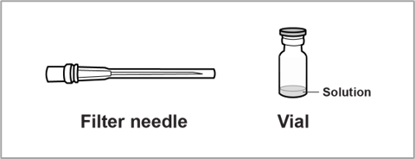
1. | Gather your supplies.  Using aseptic technique, gather your supplies and place them on a clean, flat surface.
2. | Inspect EYDENZELT  Look at the vial and make sure you have the correct medicine (EYDENZELT) and dosage.  Check the expiration date on the label to make sure it has not passed.  - Do not use EYDENZELT if particulates, cloudiness, or discoloration are visible.  - Do not use if the expiration date has passed. | 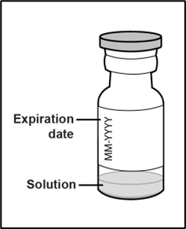
3. | Remove the protective plastic cap from the vial | 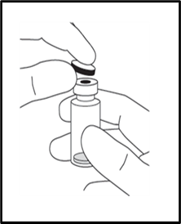
4. | Disinfect the outer part of the rubber stopper of the vial with an alcohol wipe | 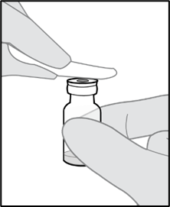

5. | Attach the filter needle to the syringe  Remove the 18G × 38.1 mm, 5-micron filter needle, supplied in the carton, and a 1 mL Luer lock syringe, not included in the carton, from their packaging.  Attach the filter needle to the syringe by twisting it onto the Luer lock syringe tip. |  |  |  |  |  | 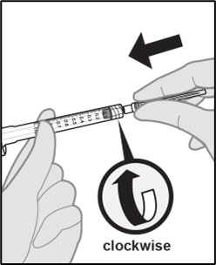
6. | Insert the filter needle into the vial  Using aseptic technique, push the filter needle into the center of the vial stopper until the needle is completely inserted into the vial, and the tip touches the bottom or bottom edge of the vial.  Tilt the vial during withdrawal, keeping the bevel of the filter needle submerged in the liquid to deter the introduction of air.  Withdraw all of the EYDENZELT vial contents into the syringe.  Note: Ensure that the plunger rod is drawn sufficiently back when emptying the vial in order to completely  empty the filter needle. |  |  |  |  |  | 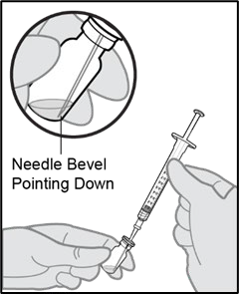
7. | Remove the filter needle.  Remove the filter needle from the syringe.  Properly dispose of the filter needle.  - Do not use the filter needle for intravitreal injection.  - Do not recap the filter needle to prevent pre-injection needle sticks.
8. | Attach the injection needle to the syringe. Remove the 30G × 12.7 mm injection needle, not included in the carton, from its packaging.  Using aseptic technique, attach the injection needle to the syringe by firmly twisting the injection needle onto the Luer lock syringe tip. |  |  |  |  |  | 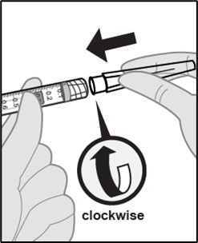
9. |  |  | 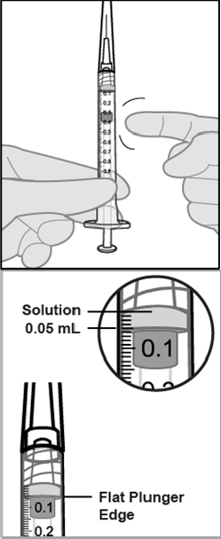  Check for air bubbles.  Holding the syringe with the injection needle pointing  up, check for air bubbles in the syringe.  If there are bubbles, gently tap the syringe with your finger until the bubbles rise to the top.
10. |  |  | Remove air bubbles and confirm correct dose.  To remove all of the bubbles and to expel excess drug, SLOWLY depress the plunger so that the plunger tip aligns with the line that marks 0.05 mL on the syringe.
11. |  |  | When ready to administer EYDENZELT, remove the plastic needle cap from the needle. |  |  | 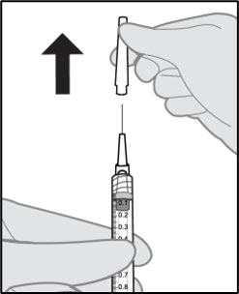
12 |  |  | When ready, complete the intravitreal injection.  The intravitreal injection procedure should be carried out under controlled aseptic conditions, which include surgical hand disinfection and the use of sterile gloves, a sterile drape, and a sterile eyelid speculum (or equivalent). Adequate anesthesia and a topical broad–spectrum microbicide should be given prior to the injection.  Each vial should only be used for the treatment of a single eye. If the contralateral eye requires treatment, a new vial should be used and the sterile field, syringe, gloves, drapes, eyelid speculum, filter, and injection needles should be changed before EYDENZELT is administered to the other eye.
13 |  |  | The vial is for single use only.  Any unused medicinal product or waste material should be disposed of in accordance with local requirements. Extraction of multiple doses from a single vial may increase the risk of  contamination and subsequent infection.
14 |  | After the injection, monitor the patient.  Immediately following the intravitreal injection, patients should be monitored for elevation in intraocular pressure. Appropriate monitoring may consist of a check for perfusion of the optic nerve head or tonometry. If required, a sterile paracentesis needle should be available.  Following intravitreal injection, patients and/or caregivers should be instructed to report any  signs and/or symptoms suggestive of endophthalmitis or retinal detachment (e.g., eye pain,  redness of the eye, photophobia, blurring of vision) without delay.

For intravitreal injection pre-filled syringe
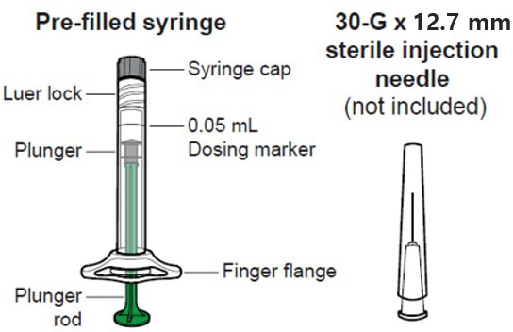

The EYDENZELT PFS includes the following  single use materials:  - sterile pre-filled Luer lock syringe sealed with an elastomeric plunger stopper and an elastomeric tip cap |  |  | Supplies not included:  - 30G x 12.7 mm injection needle
1. | Gather your supplies.  Using aseptic technique, gather your supplies and place them on a clean, flat surface.
2. | Open the carton.  When ready to administer EYDENZELT, open the carton and remove the sterilized blister pack. Carefully peel open the sterilized blister pack ensuring the sterility of its contents.  - Do not remove the pre-filled syringe from the sterilized blister pack until you  are ready to assemble it with the injection needle.  - Do not use the pre-filled syringe if the expiration date has passed.  - Do not open the sterile pre-filled syringe blister outside the clean administration room
3. | Remove the pre-filled syringe.  Using aseptic technique, remove the pre-filled syringe from the sterilized blister pack.
4. | Inspect the pre-filled syringe and drug product.  4a. Look at the pre-filled syringe and make sure it is not damaged and the syringe cap is attached to the Luer lock.  - Do not use if any part of the pre-filled syringe is damaged or if the syringe cap is detached from the Luer lock.  4b. Look at the medicine and confirm that it is clear to slightly opalescent, colourless to very pale brownish-yellow, and free of particles.  - Do not use if particulates, cloudiness, or discoloration are visible.
5. | Twist off the syringe cap.  Twist off the syringe cap by holding the pre-filled syringe in one hand and the syringe cap with the thumb and forefinger of the other hand.  - Do not snap off the syringe cap.  - To avoid compromising the sterility of the drug product, do not pull back on the plunger rod. |  |  | 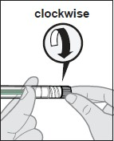
6. | Attach the needle to the pre-filled syringe.  Using aseptic technique, firmly twist the 30-gauge ×  12.7 mm injection needle onto the Luer-lock syringe tip. |  |  | 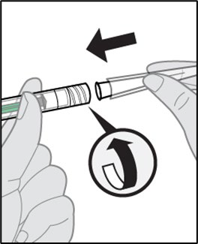
7. | Check for air bubbles.  Hold the pre-filled syringe with the needle pointing up and check the pre-filled syringe for bubbles. If there are bubbles, gently tap the pre-filled syringe with your finger until the bubbles rise to the top.
 | 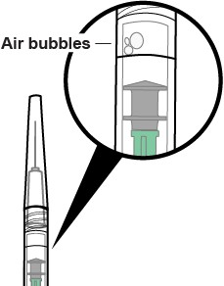 |  |  | 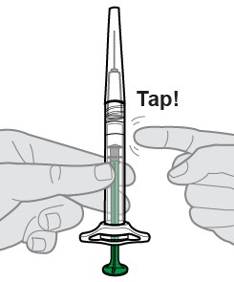
8. |  | Remove air bubbles and set the dose.  To remove all bubbles and expel excess drug, SLOWLY depress the plunger rod to align the plunger dome edge with the dosing marker shown on the barrel of the pre- filled syringe (equivalent to 0.05 mL i.e. 2 mg EYDENZELT).  Note: This accurate positioning of the plunger is very important because incorrect plunger positioning can lead to delivering more or less than the labelled dose.
 |  | 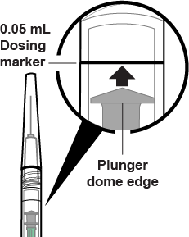 |  |  | 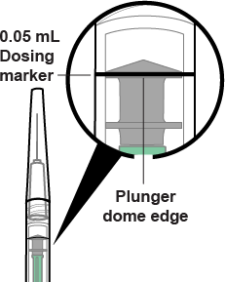
9. |  | Remove the needle shield.  When ready to administer EYDENZELT, remove the plastic needle shield from the needle. |  |  | 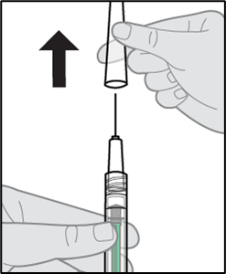
10. |  | When ready, complete the intravitreal injection.  The intravitreal injection procedure should be carried out under controlled aseptic conditions, which include surgical hand disinfection and the use of sterile gloves, a sterile drape, and a sterile eyelid speculum (or equivalent). Adequate anesthesia and a topical broad–spectrum microbicide should be given prior to the injection.  Each sterile, pre-filled syringe should only be used for the treatment of a single eye. If the contralateral eye requires treatment, a new sterile, pre-filled syringe should be used and the sterile field, syringe, gloves, drapes, eyelid speculum, filter, and injection needles should be changed before Eydenzelt is administered to the other eye.  Inject by pressing the plunger rod carefully and with constant pressure. Do not apply additional pressure once the plunger rod has reached the bottom of the syringe. A small residual volume may remain in the syringe after a full dose has been injected. This is normal.  Do not administer any residual solution observed in the syringe.
11. |  | Inject while pressing the plunger rod carefully and with constant pressure.  - Do not apply additional pressure once the plunger has reached the bottom of the syringe.  - Do not administer any residual solution observed in the syringe.
12. |  | The pre-filled syringe is for single use only.  Extraction of multiple doses from a pre-filled syringe may increase the risk of contamination and subsequent infection. Any unused medical product or waste material should be disposed of in accordance with local requirements.
13. |  | After the injection, monitor the patient.  Immediately following the intravitreal injection, patients should be monitored for elevation in intraocular pressure. Appropriate monitoring may consist of a check for perfusion of the optic nerve head or tonometry. If required, a sterile paracentesis needle should be available.  Following intravitreal injection, patients and/or caregivers should be instructed to  report any signs and/or symptoms suggestive of endophthalmitis or retinal detachment (e.g., eye pain, redness of the eye, photophobia, blurring of vision)  without delay.

Dosage adjustment in:
Patients with hepatic and/or renal impairment
No specific studies in patients with myopic CNV with hepatic and/or renal impairment were conducted with aflibercept. Available data for patients with other eye conditions treated with intravitreal aflibercept do not suggest a need for dose adjustment in hepatic and/or renal impairment (see Section 5.2 Pharmacokinetic properties).
Use in elderly
Available data do not suggest a need for a dose adjustment in these patients (see Section 5.1 Pharmacodynamic properties, Clinical trials).

Contraindications
    - Known hypersensitivity to aflibercept or to any of the excipients (see Section 6.1 List of excipients)
    - Ocular or periocular infection
    - Active severe intraocular inflammation

Special warnings and precautions for use
EYDENZELT (aflibercept) is indicated for the treatment of visual impairment due to myopic choroidal neovascularisation (myopic CNV) in adults (see section 4.1 Therapeutic Indications). This section also contains information about aflibercept in other conditions.

Endophthalmitis, Retinal vasculitis and/or retinal occlusive vasculitis
Intravitreal injections, including those with aflibercept, have been associated with endophthalmitis and more rarely, with retinal vasculitis and/or retinal occlusive vasculitis ( (see Section 4.8 Adverse effects (Undesirable effects)). Proper aseptic injection technique must always be used when administering aflibercept. Patients should be instructed to report any symptoms suggestive of endophthalmitis, retinal vasculitis or retinal occlusive vasculitis without delay and should be managed appropriately.

Retinal detachment
Intravitreal injections, including those with aflibercept, have been associated with retinal detachment (see section 4.8 Adverse effects (Undesirable effects).

Increase in intraocular pressure
Transient increases in intraocular pressure have been seen within 60 minutes of an intravitreal injection, including with aflibercept (see Section 4.8 Adverse effects (Undesirable effects)). Special precaution is needed in patients with poorly controlled glaucoma. In all cases both the intraocular pressure and the perfusion of the optic nerve head must therefore be monitored and managed appropriately.

Immunogenicity
As this is a therapeutic protein, there is a potential for immunogenicity. Patients should be instructed to report any signs or symptoms of intraocular inflammation, e.g., pain, photophobia, or redness, which may be a clinical sign attributable to hypersensitivity.

Arterial thromboembolic events
There is a potential risk of arterial thromboembolic events (ATEs) following intravitreal use of VEGF inhibitors (see Section 4.8 Adverse effects (Undesirable effects)). ATEs include vascular death (e.g., due to stroke or myocardial infarction), non-fatal strokes and non-fatal myocardial infarction.
The risk of stroke may be greater in patients with known risk factors including a history of stroke or transient ischaemic attack (TIA). Patients should be carefully evaluated by their doctor to assess whether the benefits of treatment outweigh the potential risks.

Bilateral treatment
The safety and efficacy of bilateral treatment with aflibercept have not been systematically studied (see Section 5.1 Pharmacodynamic properties, Clinical trials). If bilateral treatment is performed at the same time this could lead to an increased systemic exposure, which could increase the risk of systemic adverse events.

Retinal pigment epithelial tear
Risk factors associated with the development of a retinal pigment epithelial tear after anti-VEGF therapy for wet AMD, include a large and/or high pigment epithelial retinal detachment. When initiating anti-VEGF therapy, caution should be used in patients with these risk factors for retinal pigment epithelial tears.

Withholding treatment
Treatment should be withheld in patients with rhegmatogenous retinal detachment or stage 3 or 4 macular holes.
In the event of a retinal break the dose should be withheld and treatment should not be resumed until the break is adequately repaired.
In the event of either a decrease in best-corrected visual acuity (BCVA) of ≥30 letters compared with
the last assessment of visual acuity; or a subretinal haemorrhage involving the centre of the fovea or
if the size of the haemorrhage is ≥50% of the total lesion area, the dose should be withheld and
treatment should not be resumed earlier than the next scheduled treatment.
The dose should be withheld in the event of performed or planned intraocular surgery within the previous or next 28 days.
In patients presenting with clinical signs of irreversible ischaemic visual function loss, the treatment is not recommended.

Populations with limited data
There is only limited experience with aflibercept treatment in diabetic patients with an HbA1c over 12% or with proliferative diabetic retinopathy or Type 1 diabetes. Aflibercept has not been studied in patients with active systemic infections or in patients with concurrent eye conditions such as retinal detachment or macular hole. There is also no experience of treatment with aflibercept in patients with uncontrolled hypertension. In myopic CNV there is no experience with aflibercept in the treatment of non-Asian patients, patients who have previously undergone treatment for myopic CNV, and patients with extrafoveal lesions.

This lack of information should be considered by the ophthalmologist when treating such patients.

Use in the elderly
Available data do not suggest a need for a dose adjustment with aflibercept in these patients (see Section 5.1 Pharmacodynamic properties, Clinical trials).. There is limited experience in patients with DME aged 75 years and older.

Paediatric use
The safety and efficacy of aflibercept have not been studied in children or adolescents.

Effects on laboratory tests
No relevant effects on laboratory tests are known.

Traceability
In order to improve the traceability of biological medicines, the trade name and the batch number of the administered product should be clearly recorded in the patient’s medical record and/or dispensing record.

Interactions with other medicines and other forms of interactions
No formal drug interaction studies have been performed with aflibercept.

Fertility, pregnancy and lactation

Effects on fertility
Effects on male and female fertility were assessed as part of a 6-month study in monkeys with intravenous administration of aflibercept at doses ranging from 3 to 30 mg/kg every one to two weeks. Absent or irregular menses associated with alterations in female reproductive hormone levels and changes in sperm morphology and motility (considered consequential to male fertility) were observed at all dose levels. Based on C_{max} and AUC for free aflibercept observed at the 3 mg/kg intravenous dose, the systemic exposures were approximately 4900-fold and 1500-fold higher, respectively, than the exposure observed in humans after an intravitreal dose of 2 mg. All changes were reversible.

Use in pregnancy
Pregnancy Category D¹
There are limited data on the use of aflibercept in pregnant women. Women of childbearing potential have to use effective contraception during treatment and for at least 3 months after the last intravitreal injection of aflibercept.
Aflibercept should not be used during pregnancy unless the potential benefit outweighs the potential risk to the foetus. The treating ophthalmologist in consultation with the treating obstetrician need to consider the individual benefit-risk balance for each patient. This includes a consideration of timing of treatment, delaying treatment and other potential treatment options.
Studies in animals have shown reproductive toxicity, including a series of external, visceral, skeletal malformations, after systemic administration.
Aflibercept produced malformations and other foetal abnormalities in pregnant rabbits with intravenous administration (at 3 to 60 mg/kg once every 3 days during the period of organogenesis) and with subcutaneous administration (0.1 to 1 mg/kg on gestational days 1, 7, and 13). A No Observed Effect Level (NOEL) for adverse effects on embryo- foetal development was not established.
At the lowest dose tested (0.1 mg/kg), the systemic exposures based on C_{max} and cumulative AUC for free aflibercept were approximately 13-and 10-fold higher, respectively, when compared to corresponding values observed in humans after an intravitreal dose of 2 mg.

Use in lactation.
It is unknown whether aflibercept is excreted in human milk. A risk to the breast-fed child cannot be excluded. Aflibercept is not recommended during breast-feeding. A decision must be made whether to discontinue breast-feeding or to abstain from aflibercept therapy.

Effects on ability to drive and use machines
Patients may experience temporary visual disturbances after an intravitreal injection with aflibercept and the associated eye examinations (see Section 4.8 Adverse effects (Undesirable effects). Patients should not drive or use machinery until visual function has recovered sufficiently.

¹ Drugs which have caused, are suspected to have caused or may be expected to cause, an increased incidence of human foetal malformations or irreversible damage. These drugs may also have adverse pharmacological effects. Accompanying texts should be consulted for further details.

Adverse effects (Undesirable effects)
EYDENZELT is indicated for the treatment of visual impairment due to myopic choroidal neovascularisation (myopic CNV) in adults (see Section 4.1 Therapeutic indications). This section also contains information about aflibercept in other conditions.

Summary of the safety profile
A total of 3102 patients treated with aflibercept constituted the safety population in eight Phase III studies. Amongst those, 2501 patients were treated with the recommended dose of 2 mg.
Serious adverse reactions related to the injection procedure have occurred in less than 1 in 2400 intravitreal injections with aflibercept and included endophthalmitis, retinal detachment, cataract traumatic, cataract, vitreous detachment and intraocular pressure increased (see Section 4.4 Special warnings and precautions for use).
The most frequently observed adverse reactions (in at least 5% of patients treated with aflibercept) were conjunctival haemorrhage (25.0%), visual acuity reduced (11.1%), eye pain (10.2%), cataract (7.6%), intraocular pressure increased (7.5%), vitreous detachment (7.4%), and vitreous floaters (6.9%).
In wet AMD, these adverse reactions occurred with a similar incidence in the ranibizumab treatment group.

Tabulated list of adverse reactions
The safety data described in Table 1 below include all adverse reactions (serious and non-serious) from eight Phase III studies with a reasonable possibility of causality to the injection procedure or medicinal product over the 96 weeks study duration for wet AMD, over 100 weeks for CRVO, over 100 weeks for DME, over 52 weeks for BRVO and over 48 weeks for myopic CNV.
The adverse reactions are listed by system organ class and frequency using the following convention: very common (≥1/10), common (≥1/100 to <1/10), uncommon (≥1/1,000 to <1/100), rare (≥1/10,000 to < 1/1,000 patients). Within each frequency grouping, adverse drug reactions are presented in order of decreasing seriousness.

Table 1: All treatment-emergent adverse drug reactions reported in patients in Phase III studies.

System Organ Class | Very common  (≥1/10) | Common  (≥1/100 to <1/10) | Uncommon  (≥1/1,000 to <1/100) | Rare  (≥1/10,000 to  <1/1,000)
Immune system disorders |  |  | Hypersensitivity***
Eye disorders | Visual acuity reduced, Conjunctival haemorrhage, Eye pain | Retinal pigment epithelial tear*, Detachment of the retinal pigment epithelium, Retinal degeneration, Vitreous haemorrhage, Cataract,  Cataract cortical, | Endophthalmitis**, Retinal detachment, Retinal tear,  Iritis, Uveitis, Iridocyclitis,  Lenticular opacities, | Blindness, Cataract traumatic, Vitritis, Hypopyon
 |  | Cataract nuclear, Cataract subcapsular, Corneal erosion, Corneal abrasion,  Intraocular pressure increased, Vision blurred,  Vitreous floaters, Vitreous detachment, Injection site pain, Foreign body sensation in eyes,  Lacrimation increased, Eyelid oedema,  Injection site haemorrhage, Punctate keratitis, Conjunctival hyperaemia  Ocular hyperaemia | Corneal epithelium defect,  Injection site irritation, Abnormal sensation in eye,  Eyelid irritation, Anterior chamber flare, Corneal oedema
* Conditions known to be associated with wet AMD. Observed in the wet AMD studies only.
** Culture positive and culture negative endophthalmitis
*** including allergic reactions

Post-marketing experience
In addition, the following adverse reactions have also been reported during the post-marketing period of aflibercept, for which a frequency could not be estimated.

Immune system  disorders: | hypersensitivity (including rash, pruritus, urticaria, and isolated cases of severe  anaphylactic/anaphylactoid reactions).
Eye disorders: | retinal vasculitis and retinal occlusive vasculitis, scleritis

Description of selected adverse reactions
The following adverse reaction of aflibercept are considered expected:
Anterior chamber flare, corneal epithelium defect, lenticular opacities, ocular hyperaemia, endophthalmitis, hypopyon, cataract traumatic, severe anaphylactic/anaphylactoid reactions.
Arterial thromboembolic events (ATEs) are adverse events potentially related to systemic VEGF inhibition. There is a theoretical risk of arterial thromboembolic events following intravitreal use of VEGF inhibitors.
ATEs, as defined by Antiplatelet Trialists' Collaboration (APTC) criteria, include nonfatal myocardial infarction, nonfatal stroke, or vascular death (including deaths of unknown cause).
In the wet AMD phase III studies, there was an increased incidence of conjunctival haemorrhage in patients receiving anti-thrombotic agents. This increased incidence was comparable between patients treated with ranibizumab and aflibercept.
The incidence of adjudicated APTC ATEs in the VIEW 1 and VIEW 2 wet AMD studies during the 96 weeks study period was 3.3% (60 out of 1824) in the combined group of patients treated with aflibercept (2.4% in the EYLEA 2Q4 arm and 3.6% in the EYLEA 2Q8 arm), compared to 3.2% (19 out of 595) in patients treated with ranibizumab.
The incidence of adjudicated APTC ATEs in the CRVO studies (GALILEO and COPERNICUS) during the 76/100 weeks study duration was 0.6% (2 out of 317) in patients treated with at least one dose of EYLEA compared to 1.4% (2 out of 142) in the group of patients receiving only sham treatment.
The incidence of adjudicated APTC ATEs in the DME studies (VIVID^{DME} and VISTA^{DME}) during the 100 weeks study duration was 6.4% (37 out of 578) in the combined group of patients treated with aflibercept compared with 4.2% (12 out of 287) in the control group.
The incidence of APTC ATEs in the BRVO study (VIBRANT) during the 52 week study duration was 0% (0 out of 91) in patients treated with aflibercept compared with 2.2% (2 out of 92) in the control group.
The incidence of APTC ATEs in the myopic CNV study (MYRROR) during the 48 week study duration was 1.1% (1 out of 91) in the group of patients treated with aflibercept compared to 0% (0 out of 31) in the group of patients in the control group.
As with all therapeutic proteins, there is a potential for immunogenicity with aflibercept.

Comparability of EYDENZELT with EYLEA (2 mg)
There were no notable differences in the incidence or nature of adverse events between the EYDENZELT 2 mg and EYLEA 2 mg treatment groups in Study CT-P42 3.1, and the safety profile of each treatment group was in line with the known safety profile of EYLEA 2 mg.
Immunogenicity was evaluated in Study CT-P42 3.1 using an MSD-ECL method. Only samples confirmed positive for anti-drug antibodies (ADAs) were subsequently analysed for neutralising antibodies (NAbs). The incidences of postdose ADA and NAb in DME patients were similar between EYDENZELT 2 mg and EYLEA 2 mg treatment groups with ADA of 1.7% for EYDENZELT vs. 2.3% for EYLEA and NAb of 1.1% for both treatment groups.

Reporting suspected adverse effects
Reporting suspected adverse reactions after registration of the medicinal product is important. It allows continued monitoring of the benefit-risk balance of the medicinal product. Healthcare professionals are asked to report any suspected adverse reactions at www.tga.gov.au/reporting- problems.

Overdose
Overdosing with increased injection volume may increase intraocular pressure. Therefore, in case of overdosage intraocular pressure should be monitored and if deemed necessary by the treating physician, adequate treatment should be initiated (see section Instructions for use / handling).
For information on the management of overdose, contact the Poisons Information Centre on 13 11 26 (Australia).

PHARMACOLOGICAL PROPERTIES

Pharmacodynamic properties
Pharmacotherapeutic group: Ophthalmologicals / Antineovascularisation agents

ATC code: | S01LA05

Mechanism of action
Vascular endothelial growth factor-A (VEGF-A) and placental growth factor (PlGF) are members of the VEGF family of angiogenic factors that can act as potent mitogenic, chemotactic, and vascular permeability factors for endothelial cells. VEGF acts via two receptor tyrosine kinases, VEGFR-1 and VEGFR-2, present on the surface of endothelial cells. PlGF binds only to VEGFR-1, which is also present on the surface of leukocytes. Excessive activation of these receptors by VEGF-A can result in pathological neovascularisation and excessive vascular permeability. PlGF can synergise with VEGF-A in these processes, and is also known to promote leukocyte infiltration and vascular inflammation. A variety of ocular diseases is associated with pathologic neovascularisation and vascular leakage, and/or can result in thickening and oedema of the retina, which is thought to contribute to vision loss.
Aflibercept acts as a soluble decoy receptor that binds VEGF-A and PlGF with higher affinity than their natural receptors, and thereby can inhibit the binding and activation of these cognate VEGF receptors. The equilibrium dissociation constant (K_{D}) for aflibercept binding to human VEGF-A₁₆₅ is
0.5 pM and to human VEGF-A₁₂₁ is 0.36 pM. The K_{D} for binding to human PlGF-2 is 39 pM.

Pharmacodynamic effects
Myopic choroidal neovascularisation (myopic CNV)
Myopic CNV is a frequent cause of vision loss in adults with pathologic myopia. Eyes with pathologic myopia are elongated, often excessively, and have, in addition, pathologic tissue alterations such as retinal pigment epithelial thinning and defects, lacquer cracks and Bruch’s membrane ruptures, choroidal neovascularisation, subretinal haemorrhage and choroidal atrophy. As a consequence of ruptures of Bruch’s membrane, myopic CNV develops as a wound healing mechanism and at the same time represents the most vision-threatening event in pathologic myopia.
In patients treated with aflibercept (one injection given at the start of therapy, additional injection given in case of disease persistence or recurrence) retinal thickness assessed by OCT decreased soon after treatment initiation and the mean CNV lesion size was reduced. The mean change in CRT from baseline to week 24 was statistically significant favouring aflibercept.

Table 2: Pharmacodynamic parameter at week 24 and week 48 in MYRROR study (Full Analysis Set with LOCF ^{a)})

MYRROR
Efficacy Outcomes | 24 Weeks |  | 48 Weeks
Efficacy Outcomes | Aflibercept 2 mg ^{b)}  (N = 90) | Sham (N = 31) | Aflibercept 2 mg ^{c)}  (N = 90) | Sham / Aflibercept 2 mg ^{d)}  (N = 31)
Mean change in central retinal thickness from baseline | -79 | -4 | -83 | -57
Difference in LS mean e,f,g,h)  (97.5% CI)  p-value | -78  (-109, -47)  p < 0.0001 |  | -29  (-60, 2)  P = 0.0650

- LOCF: Last Observation Carried Forward
- aflibercept 2 mg administered at baseline and potentially every 4 weeks in case of disease persistence or recurrence.
- aflibercept 2 mg administered from week 24 through week 44 potentially every 4 weeks in case of disease persistence or recurrence
- Mandatory injection of aflibercept 2 mg at week 24, thereafter potentially every 4 weeks in case of disease persistence or recurrence through week 44.
- Difference is aflibercept 2 mg minus sham at week 24; difference is aflibercept 2 mg minus sham/ aflibercept 2 mg at week 48
- LS mean: Least square means derived from ANCOVA model
- CI: Confidence Interval
- LS mean difference and 95% CI based on an ANCOVA model with treatment group and country (country
designations) as fixed effects, and baseline BCVA as covariant.

Comparability of Eydenzelt with Eylea®
In vitro studies
EYDENZELT batches demonstrated comparable properties with respect to the biological activity when compared to EYLEA based on VEGF-A and -B binding, cell-based human vascular endothelial growth factor (VEGF) blockade, inhibition of human VEGF-A induced proliferation of human umbilical vein endothelial cells (HUVECs), galectin-1 binding affinity and Fc receptors binding (SPR).

Clinical trials
Myopic choroidal neovascularisation (myopic CNV)
The safety and efficacy of aflibercept were assessed in a randomised, multi-centre, double-masked, sham-controlled study (MYRROR) in patients with myopic CNV. A total of 121 patients were treated and evaluable for efficacy (90 with aflibercept). Patients were randomly assigned in a 3:1 ratio to either 2 mg aflibercept administered once at study start (with additional injections given in the case of disease persistence or reoccurrence) or sham injections. In total 6 injections was possible until the week 24 primary endpoint assessment in the study.
After the first 6 months, patients initially randomised to sham were eligible to receive the first dose of aflibercept at week 24. Following this, patients in this former sham arm and also patients in the arm initially randomised to active treatment continued to be eligible for additional injections in case of disease persistence or recurrence.
Patient ages ranged from 27 to 83 years with a mean of 58 years. Approximately 36% (33/91) of the patients randomised to treatment with aflibercept were 65 years of age or older, and approximately 10% (9/91) were 75 years of age or older.
The primary efficacy endpoint was the change in visual acuity at week 24 compared to baseline. The confirmatory secondary efficacy endpoint was the proportion of patients who gained at least 15 letters in BCVA at week 24 compared to baseline.
The difference between treatment groups was statistically significant in favour of aflibercept for the primary and confirmatory secondary efficacy endpoints at week 24. Differences for both endpoints were maintained through week 48.
Detailed results from the analyses are shown in Table 13and Figure 5 below.

Table 3: Efficacy outcomes at week 24 (primary analysis) and in week 48 in MYRROR study (Full Analysis Set with LOCF^{a)}

MYRROR
Efficacy Outcomes | 24 Weeks |  | 48 Weeks
Efficacy Outcomes | Aflibercept 2 mg^{b)}  (N = 90) | Sham (N = 31) | Aflibercept 2 mg^{c)}  (N = 90) | Sham / Aflibercept 2 mg^{d)}  (N = 31)
Mean change in BCVA letter score as measured by ETDRS from baseline (SD)^{e)} | 12.1  (8.3) | -2.0  (9.7) | 13.5  (8.8) | 3.9  (14.3)
Difference in LS mean ^{f,g,h,i)}  (95% CI)  p-value | 14.1  (10.8, 17.4)  p < 0.0001 |  | 9.5  (5.4, 13.7)  p < 0.0001
Proportion of patients who gained at least 15 letters in BCVA^{e} from baseline | 38.9% | 9.7% | 50.0% | 29.0%
Weighted difference ^{f,h,j)}  (95% CI)  p-value | 29.2%  (14.4, 44.0)  p = 0.0001 |  | 21.0%  (1.9, 40.1)  p = 0.0308
- LOCF: Last Observation Carried Forward
- Aflibercept 2 mg administered at baseline and potentially every 4 weeks in case of disease persistence or recurrence.
- Aflibercept 2 mg administered from week 24 through week 44 potentially every 4 weeks in case of disease persistence or recurrence
- Mandatory injection of aflibercept 2 mg at week 24, thereafter potentially every 4 weeks in case of disease
persistence or recurrence through week 44.
- BCVA: Best Corrected Visual Acuity
ETDRS: Early Treatment Diabetic Retinopathy Study SD: Standard Deviation
- Difference is aflibercept 2 mg minus sham at Week 24 and aflibercept 2 mg minus sham/ aflibercept 2 mg at week 48.
- LS mean: Least square means derived from ANCOVA model
- CI: Confidence Interval
- LS mean difference and 95% CI based on an ANCOVA model with treatment group and country (country
designations) as fixed effects, and baseline BCVA as covariant.
- Difference and 95% CI are calculated using Cochran-Mantel-Haenszel (CMH) test adjusted for country (country
designations)

Figure 1: Mean change from baseline to week 48 in visual acuity by treatment group for the MYRROR study (Full Analysis Set, LOCF)
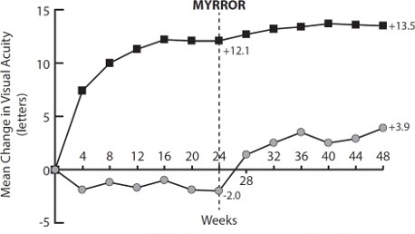

 | Aflibercept 2 |  | Control Group
Mg

Treatment effects in all evaluable subgroups were in general, consistent with the results in the overall populations.

Comparability of Eydenzelt with Eylea®
The clinical comparability between EYDENZELT and EYLEA was demonstrated in randomised controlled double masked parallel group Phase 3 study in patients with Diabetic Macular Oedema (DME).
The result of the primary endpoint, the mean change from baseline in BCVA (as measured by ETDRS letter score) at Week 8 between the EYDENZELT and EYLEA treatment groups, is presented in Table 14 below as measured by ETDRS letter score. The estimate of treatment difference in LS means change from baseline in BCVA between EYDENZELT and EYLEA at Week 8 was 0.58 letters and the 95% CI was [-0.73, 1.88], which was entirely within the predefined equivalence margin of ± 3 letters.

Table 4: Analysis of Mean Change from Baseline in BCVA (as measured by ETDRS letter score) at Week 8 in Study CT-P42 3.1 (Full Analysis Set)

Timepoint | Treatment | n | LS Mean (SE) | Estimate of Treatment Difference in LS Means  (EYDENZELT – EYLEA) ^{a)}
 |  |  |  | Mean | [95% CI]
Week 8 | EYDENZELT  (N=173) | 169 | 9.43 (0.798) | 0.58 | [-0.73, 1.88]
Week 8 | EYLEA (N=175) | 172 | 8.85 (0.775) | 0.58 | [-0.73, 1.88]
ANCOVA = analysis of covariance; BCVA = best corrected visual acuity; CI = confidence interval; ETDRS = Early Treatment Diabetic Retinopathy Study; LS mean = least squares mean; N = total number of patients; n = total number of patients with BCVA score at Week 8; SE = standard error
^{a)} An ANCOVA was performed with change from baseline in BCVA at Week 8 as the dependent variable, treatment as a factor, and baseline BCVA and country as covariates.

Pharmacokinetic properties

Absorption and Distribution
Aflibercept is slowly absorbed from the eye into the systemic circulation after intravitreal administration and is predominantly observed in the systemic circulation as an inactive, stable complex with VEGF; however only free aflibercept is able to bind endogenous VEGF.
In a pharmacokinetic sub-study with frequent sampling in patients with wet AMD, maximum plasma concentrations of free aflibercept (systemic C_{max}) were low, with a mean of approximately 0.02 μg/mL (range 0 to 0.054) within 1 to 3 days after 2 mg intravitreal injection, and were undetectable two weeks following dosage in almost all patients. Aflibercept does not accumulate in the plasma when administered intravitreally every 4 weeks.
These pharmacokinetic results were consistent in pharmacokinetic sub-studies in patients with CRVO, BRVO, DME or myopic CNV, with mean C_{max} of free aflibercept in plasma in the range of 0.03 to 0.05 μg/mL and individual values not exceeding 0.14 μg/mL. Thereafter, plasma concentrations of free aflibercept declined to values below or close to the lower limit of quantitation generally within one week; undetectable concentrations were reached before the next administration after 4 weeks in all patients.

Table 5: Tabulated summary of free aflibercept in plasma by indication

Indication | Mean C_{max} of free Aflibercept (µg/mL)
Myopic CNV | 0.03*
*Based on a single subject
The mean maximum plasma concentration of free aflibercept is approximately 50 to 500 times below the aflibercept concentration required to inhibit the biologic activity of systemic VEGF by 50% in animal models. It is estimated that after intravitreal administration of 2 mg to patients, the mean maximum plasma concentration of free aflibercept is more than 100-fold lower than the concentration of aflibercept required to half-maximally bind systemic VEGF. Therefore, systemic pharmacodynamic effects are unlikely.

Metabolism
As aflibercept is a protein-based therapeutic, no metabolism studies have been conducted.

Excretion
Free aflibercept binds VEGF to form a stable, inert complex. As with other large proteins, both free and bound aflibercept are expected to be cleared by proteolytic catabolism.

Patients with renal/hepatic impairment
No special studies in patients with renal impairment or hepatic impairment have been conducted with aflibercept.

Population pharmacokinetic analysis revealed that systemic exposures to aflibercept in patients with mild to severe renal impairment were similar to those with normal renal function. Mild hepatic impairment had no influence on systemic exposures to aflibercept compared to patients with normal hepatic function.

See also ‘Dosage adjustment in patients with hepatic and/or renal impairment section 4.2

Preclinical safety data

Genotoxicity
No studies have been conducted on the mutagenic or clastogenic potential of aflibercept. As a large protein molecule, aflibercept is not expected to interact directly with DNA or other chromosomal material.

Carcinogenicity
No studies have been conducted on the carcinogenic potential of aflibercept.

PHARMACEUTICAL PARTICULARS

List of excipients
Polysorbate 20 Histidine
Histidine hydrochloride monohydrate Sodium Chloride
Trehalose
Water for injections

Incompatibilities

EYDENZELT must not be mixed with other medicinal products.

Shelf life
In Australia, information on the shelf life can be found on the public summary of the Australian Register of Therapeutic Goods (ARTG). The expiry date can be found on the packaging.

Special precautions for storage
Store at 2°C to 8°C (Refrigerate. Do not freeze).
Protect from light. Keep the vial in its carton in order to protect from light.
Once removed from the refrigerator the product must be discarded if not used. It must not be returned to the refrigerator.
Keep the pre-filled syringe in its blister pack and carton in order to protect from light.

Nature and contents of container
EYDENZELT is supplied in a single-use vial or pre-filled syringe.

Vial
Each carton includes a type I glass vial containing approximately 0.1 mL of extractable volume, with an elastomeric rubber stopper, and an 18 G x 38.1 mm 5 micron sterile filter needle for single-use only.
The intravitreal injection should be performed with a 30G x 12.7 mm injection needle and 1 mL Luer lock syringe (not included). Ensure a 30G x 12.7 mm injection needle and 1 mL Luer lock syringe are available.

Pre-filled syringe
Each carton includes a sealed blister pack with a sterile pre-filled Luer lock syringe, containing approximately 0.09 mL of extractable volume, sealed with an elastomeric plunger stopper and an elastomeric tip cap that is part of a closure system with Luer lock adaptor. The syringe has a pre- attached plunger rod and a finger flange.
The intravitreal injection should be performed with a 30-gauge x 12.7 mm sterile injection needle (not
included). Ensure a 30-gauge x 12.7 mm injection needle is available.

Special precautions for disposal
In Australia, any unused medicine or waste material should be disposed of by taking to your local pharmacy.

Physicochemical properties

Chemical structure
The secondary and tertiary structures of aflibercept as well as the amino acid structure are shown in Figure 6 and Figure 7.

Figure 2: Aflibercept secondary and tertiary structures
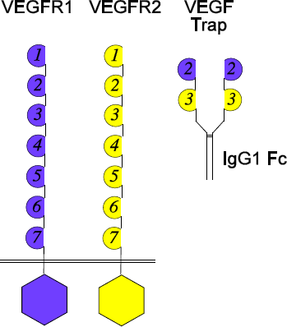

Figure 3: Aflibercept amino acid structure


Chemical names: | Vascular endothelial growth factor receptor type VEGFR-1 (synthetic  human immunoglobulin domain 2 fragment) fusion protein with vascular endothelial growth factor receptor type VEGFR-2 (synthetic human immunoglobulin domain 3 fragment) fusion protein with immunoglobulin G1 (synthetic Fc fragment), dimer des-432-lysine- [human vascular endothelial growth factor receptor 1-(103-204)- peptide (containing Ig- like C2-type 2 domain) fusion protein with human vascular endothelial growth factor receptor 2-(206-308)-peptide (containing Ig-like C2-type 3 domain fragment) fusion protein with human immunoglobulin G1-(227 C- terminal residues)-peptide (Fc fragment)], (211-211’:214-214’)-  bisdisulfide dimer
Molecular weight: | 97 kDa (protein molecular weight)  115 kDa (total molecular weight)

CAS number
862111-32-8

MEDICINE SCHEDULE (POISONS STANDARD)
PRESCRIPTION ONLY MEDICINE (S4)

SPONSOR
Celltrion Healthcare Australia Pty Ltd Suite 13.03, 31 Market Street
Sydney 2000, Australia
Phone: 1800 325 228

DATE OF FIRST APPROVAL
DD/MM/YYYY

DATE OF REVISION
DD/MM/YYYY
Summary table of changes

Section Changed | Summary of new information

