Australian Public Assessment Report for Enrylaze
  - Active ingredient: crisantaspase
  - Sponsor: Jazz Pharmaceuticals ANZ
November 2025

About the Therapeutic Goods Administration (TGA)
- The Therapeutic Goods Administration (TGA) is part of the Australian Government Department of Health, Disability and Ageing and is responsible for regulating therapeutic goods, including medicines, medical devices, and biologicals.
- The TGA administers the Therapeutic Goods Act 1989 (the Act), applying a risk management approach designed to ensure therapeutic goods supplied in Australia meet acceptable standards of quality, safety, and efficacy.
- The work of the TGA is based on applying scientific and clinical expertise to decision-making, to ensure that the benefits to the Australian public outweigh any risks associated with the use of therapeutic goods.
- The TGA relies on the public, healthcare professionals and industry to report problems with therapeutic goods. The TGA investigates reports received to determine any necessary regulatory action.
- To report a problem with a therapeutic good, please see the information on the TGA website.

About AusPARs
- The Australian Public Assessment Report (AusPAR) provides information about the evaluation of a prescription medicine and the considerations that led the TGA to approve or not approve a prescription medicine submission. Further information can be found in Australian Public Assessment Report (AusPAR) guidance.
- AusPARs are prepared and published by the TGA.
- AusPARs are static documents that provide information that relates to a submission at a particular point in time. The publication of an AusPAR is an important part of the transparency of the TGA’s decision-making process.
- A new AusPAR may be provided to reflect changes to indications or major variations to a prescription medicine subject to evaluation by the TGA.

Copyright
© Commonwealth of Australia 2025
This work is copyright. You may reproduce the whole or part of this work in unaltered form for your own personal use or, if you are part of an organisation, for internal use within your organisation, but only if you or your organisation do not use the reproduction for any commercial purpose and retain this copyright notice and all disclaimer notices as part of that reproduction. Apart from rights to use as permitted by the Copyright Act 1968 or allowed by this copyright notice, all other rights are reserved and you are not allowed to reproduce the whole or any part of this work in any way (electronic or otherwise) without first being given specific written permission from the Commonwealth to do so. Requests and inquiries concerning reproduction and rights are to be sent to the TGA Copyright Officer, Therapeutic Goods Administration, PO Box 100, Woden ACT 2606 or emailed to <tga.copyright@tga.gov.au>.

Contents
List of abbreviations 4
Product submission 5
Submission details 5
Product background 6
Disease or condition 6
Current treatment options 8
Clinical rationale 8
Regulatory status 12
Australian regulatory status 12
International regulatory status 12
Registration timeline 13
Assessment overview 13
Quality evaluation summary 13
Nonclinical evaluation summary 14
Clinical evaluation summary 15
Summary of clinical studies 15
Pharmacology 15
Efficacy 19
Safety 26
Risk management plan 32
Risk-benefit analysis 32
Assessment outcome 36
Specific conditions of registration 37
Product Information and Consumer Medicine Information 37

List of abbreviations
Abbreviation | Meaning
ALL | Acute Lymphoblastic Leukaemia
ADA | Anti-Drug Antibody
AESI | Adverse Event of Special interest
ARTG | Australian Register of Therapeutic Goods
BSA | Body surface area
BSV | Between-subject variability
CL | Drug clearance
CMI | Consumer Medicines Information
CV | Coefficient of variation
IM | Intramuscular
IV | Intravenous
LBL | Lymphoblastic lymphoma
JZP-458 | Enrylaze
MWF | Monday, Wednesday, Friday
Nab | Neutralising antibodies
NSAA | Nadir Serum Asparaginase Activity
PI | Product Information
PK | Pharmacokinetics
PSUR | Periodic safety update report
RMP | Risk management plan
SAA | Serum Asparaginase Activity
TGA | Therapeutic Goods Administration
T_{max} | Time to maximum concentration
V | Volume of distribution
VOD | Veno-occlusive disease

Product submission

Submission details
Type of submission: | New biological entity
Product name: | Enrylaze
Active ingredient: | crisantaspase
Decision: | Approved
Date of decision: | 10 April 2025
Date of entry onto ARTG: | 16 April 2025
ARTG number: | 423019
Black Triangle Scheme | Yes
Sponsor’s name and address: | Jazz Pharmaceuticals ANZ Pty Ltd, Suite 214, Level 2 165 Phillip Street Sydney, NSW, 2000 Australia
Dose form: | Clear to opalescent, colourless to slightly yellow solution.
Strength: | Each vial of 0.5 mL solution contains 10 mg of crisantaspase  (L-asparaginase from Erwinia chrysanthemi) produced by recombinant DNA technology in Pseudomonas fluorescens
Containers: | Type 1 clear borosilicate glass vial with a capacity of 2 mL sealed with a halobutyl rubber stopper and aluminium overseal and a violet plastic cap.
Pack size: | 3 vials/pack
Approved therapeutic use for the current submission: | Enrylaze is indicated as a component of a multi-agent chemotherapeutic regimen, for the treatment of acute lymphoblastic leukemia (ALL) and lymphoblastic lymphoma (LBL) in adults and paediatric patients (1 month and older) who have developed hypersensitivity or silent inactivation to E. coli-derived asparaginase.
Routes of administration: | injection/infusion
Dosage: | Enrylaze is dosed in mg/m² and not in units/m² as used for other asparaginase preparations. Crisantaspase products may not be bioequivalent and should not be assumed to be interchangeable.  The recommended dosage of Enrylaze follows either a Monday/Wednesday/Friday schedule, or a 48-hourly schedule:  - Monday/Wednesday/Friday  - 25 mg/m² on Mondays  - 25 mg/m² on Wednesdays  - 50 mg/m² on Fridays  - 48-hourly  - 25 mg/m² once every 48 hours  For further information regarding dosage refer to the Product Information.
Pregnancy category: | Category D  Drugs which have caused, are suspected to have caused or may be expected to cause, an increased incidence of human fetal malformations or irreversible damage. These drugs may also have adverse pharmacological effects. Accompanying texts should be consulted for further details.  The use of any medicine during pregnancy requires careful consideration of both risks and benefits by the treating health professional. The pregnancy database must not be used as the sole basis of decision making in the use of medicines during pregnancy. The TGA does not provide advice on the use of medicines in pregnancy for specific cases. More information is available from obstetric drug information services in your state or territory.

Product background
This AusPAR describes the submission by Jazz Pharmaceuticals ANZ Pty Ltd (the sponsor) to register Enrylaze (crisantaspase) for the following proposed indication:
ENRYLAZE is indicated as a component of a multi-agent chemotherapeutic regimen for the treatment of acute lymphoblastic leukaemia (ALL) and lymphoblastic lymphoma (LBL) in adults and paediatric patients (1 month and older) who developed hypersensitivity or silent inactivation to E. coli-derived asparaginase.

Disease or condition
Acute Lymphoblastic leukaemia (ALL) and lymphoblastic lymphoma (LBL) is a group of haematological malignancies arising from B-cells, T-cells or a mixed lineage. ALL results from malignant transformation of a lymphocyte in the bone marrow. Clonal expansion of early lymphoid progenitor cells replace the normal haematopoietic cells in the bone marrow and enter blood and extramedullary sites. Most ALL arises in precursor B cells (80%) and the remainder occurs in T cells. LBL is an aggressive non-Hodgkin lymphoma arising from immature lymphoblasts.
ALL may occur at all ages but has a peak incidence in people aged 0 to 4 years and is more common in boys than girls. In paediatric patients younger than 15 years, ALL makes up 25% of all cancer diagnoses.
There were 431 cases of ALL diagnosed in Australia in 2020. The 5-year survival rate in the Australian population with ALL has improved from 55% for all ALL patients in 1988-1992 to 75.2% in 2016-2020. In the latter 5-year period, the observed 5-year survival rate progressively declined with age: from 94.6% in children aged 0 to 14 years to 80.2% in patients aged 15 to 24 years and 26.6% in adults aged 60 to 79 years.
The aetiology of ALL is largely unknown. Some factors associated with a greater risk of disease include Trisomy 21 syndrome, exposure to diagnostic X-rays as an infant, previous chemotherapy, and parental exposure to certain pesticides.
Presentation is commonly non-specific, with a combination of constitutional symptoms such as fever, weight loss, night sweats together with symptoms related to bone marrow failure, fatigue and dyspnoea due to anaemia, bruising due to thrombocytopenia and infections due to neutropenia. Lymphadenopathy, splenomegaly and hepatomegaly may occur. CNS involvement may be present at diagnosis and present as cranial nerve deficits or meningismus. T-cell ALL also may present with a mediastinal mass and superior vena cava obstruction.
Diagnosis is established by the presence of 20% or more lymphoblasts in the bone marrow or peripheral blood. Morphology, flow cytometry immunophenotyping, molecular and cytogenetic testing is performed to determine the subtype and to assist in risk stratification and treatment guidance. The World Health Organisation (WHO) classification divides ALL into B-lymphoblastic leukemia/lymphoma and T-lymphoblastic leukemia/lymphoma, and further subtypes according to the presence of recurrent genetic abnormalities (Table 1).
Table 1. WHO Classification system for Acute Lymphoblastic Leukemia
B lymphoblastic leukemia/lymphoma:
- B-lymphoblastic leukemia/lymphoma, not otherwise specified (NOS)
- B-lymphoblastic leukemia/lymphoma with recurrent genetic abnormalities
  - B-lymphoblastic leukemia/lymphoma with t(9;22)(q34.1;q11.2); BCR-ABL1
  - B-lymphoblastic leukemia/lymphoma with t(v;11q23.3); KMT2A rearranged
  - B-lymphoblastic leukemia/lymphoma with t(12;21)(p13.2;q22.1); ETV6-RUNX1
  - B-lymphoblastic leukemia/lymphoma with hyperdiploidy
  - B-lymphoblastic leukemia/lymphoma with hypodiploidy
  - B-lymphoblastic leukemia/lymphoma with t(5;14)(q31.1;q32.3) IL3-IGH
  - B-lymphoblastic leukemia/lymphoma with t(1;19)(q23;p13.3); TCF3-PBX1
  - Provisional: B-lymphoblastic leukemia/lymphoma, BCR-ABL1–like
  - Provisional: B-lymphoblastic leukemia/lymphoma with iAMP21
T lymphoblastic leukemia/lymphoma:
  - Provisional: Early T-cell precursor lymphoblastic leukemia
  - Provisional: Natural killer (NK) cell lymphoblastic leukemia/lymphoma
Untreated ALL is fatal, with a life expectancy of days to weeks. Treatment with intensive multi-agent chemotherapy protocols may be curative in children, with survival rates greater than 90%. Outcomes are poorer in adults with ALL, with prolonged survival rates less than 20% in patients aged more than 60 years. This disparity in outcome with age is not fully understood but is attributed to differences in the disease characteristics in the age groups and greater tolerance of aggressive chemotherapy protocols by children. More recently, outcomes in Philadelphia chromosome positive ALL have been improved through the addition of a tyrosine kinase inhibitor to the treatment regimen.

Current treatment options
Treatment of ALL is urgent, complicated and high risk. The aim is to achieve remission. Most regimens include 4 standard drugs delivered in an induction regimen over 5 weeks: prednisolone, vincristine, daunorubicin, asparaginase. Most (96%) children enter remission. Relapse has a poor prognosis, and it is the main reason for treatment failure.
There are a number of different treatment protocols described internationally such as COG USA, AEIOP-GFM Europe and Germany, ANZCCSG Australasia but they all have common features.
- Induction therapy lasts 4 to 6 weeks and includes a glucocorticoid, vincristine, asparaginase, and optional use of an anthracycline. Almost all patients attain remission, but relapse is inevitable without additional therapy.
- Consolidation comprises 6 to 8 months of intensive combination chemotherapy and may include an 8-week delayed-intensification (re-induction) phase.
- Maintenance comprises low-intensity therapy with daily oral mercaptopurine or thioguanine and weekly oral methotrexate for 18 to 30 months.
Intrathecal chemotherapy (and/or cranial radiation in adults) is administered for CNS prophylaxis. Early allogeneic stem cell transplantation may be considered in some high-risk patients.
There is some tailoring of the regimens according to patient age group (paediatric, adolescent/young adult, adult <65 years, adult ≥ 65 years), ALL type, presence of specific cytogenetic abnormalities such as the Philadelphia chromosome, risk categorisation and the presence of co-morbidities.

Clinical rationale
In normal cells, asparagine is not an essential amino acid. It can be generated from aspartic acid and glutamine through the activity of asparagine synthetase. Lymphoblastic cells lack or have low levels of asparagine synthetase and are dependent on exogenous sources. Asparaginase depletes the levels of circulating synthetase, depriving leukaemia cells of this amino acid, preventing DNA, RNA and protein synthesis, and resulting in the apoptosis of the leukaemia cell.
Asparaginase is an integral component of multicomponent regimens used to treat patients with ALL. The use of asparaginase was first reported in paediatric ALL in the 1960’s., Since then, intensive and prolonged asparaginase depletion has remained a key component of multi-agent ALL treatment in children. There are three main types: E. coli-derived asparaginase (native, or pegylated; ‘pegaspargase’ i.e. Oncaspar), Erwinia chrysanthemi-derived asparaginase (crisantaspase; Erwinase) and recombinant crisantaspase (Rylaze [USA]/Enrylaze).
E. coli derived asparaginase, either native or pegylated, has been the initial asparaginase used for many decades. Due to hypersensitivity reactions (around 1/3 of patients) or silent inactivation (where there is an unexplained lack of activity presumed secondary to neutralising antibodies) E. coli-derived asparaginase may not be suitable for all patients.
Asparaginase acts on extracellular glutamine, and depletion of both asparagine and glutamine may be required for optimal effects of asparaginase on malignant lymphoblasts.,,,,
Asparaginase treatment is believed to inhibit liver protein synthesis due to asparagine, and possibly glutamine, depletion. Impaired liver protein synthesis results in lower levels of plasma proteins normally produced by the liver, with the changes in plasma protein concentrations following the course of plasma glutamine and asparagine changes, with recovery after cessation of asparaginase treatment. It is also postulated that impaired liver protein synthesis is the mechanism of asparagine-induced liver injury, due to the loss of protein and enzyme functions responsible for lipid and bilirubin transport and secretion.
Therapeutic drug monitoring with measurement of trough serum asparaginase activity [also known as Nadir Serum Asparaginase Activity (SAA)] levels may be considered. The National Comprehensive Cancer Network Guideline Version 2.2024 ALL states that “Generally accepted SAA targets included a minimum trough of ≥0.1 IU/mL. However, data indicate that when SAA levels fall below 0.4 IU/mL, asparagine is no longer completely depleted and begins to rebound, suggesting an optimal trough of ≥ 0.4 IU/mL”. It is noted that the NCCN guidelines has included this statement through several iterations. The guidelines also recommend the optimal timing for the trough for recombinant asparaginase Erwinia chrysanthemi is 48 hours.
Asparaginase has known serious toxicities, including allergic reactions, pancreatitis, thrombosis, CNS toxicity and hepatotoxicity, which may have fatal outcome. As these toxicities increase with patient age, asparaginase is rarely used in older patients. Guidelines for monitoring asparaginase treatment and managing adverse effects are widely available.,,,
The major limitation to the use of asparaginase in ALL treatment is the development of hypersensitivity reactions. As asparaginase is a foreign protein, it can trigger an immune response and the development of anti-asparaginase antibodies. These antibodies may precipitate hypersensitivity reactions and may also inactivate asparaginase, diminishing the clinical effect. Hypersensitivity reactions range from mild to life threatening and include pruritus, urticaria, rash, bronchospasm, hypotension, and anaphylaxis. It has been reported that severe clinical allergic reactions are seen in 24% of children and 29% of adults after their first exposures to asparaginase.
Anti-asparaginase antibodies may be present in the absence of clinically evident hypersensitivity reaction and may cause rapid inactivation of administered asparaginase, resulting in suboptimal asparagine depletion (silent inactivation)., A finding of unexpectedly very low nadir serum asparaginase activity (NSAA) levels may suggest the presence of neutralising antibodies.
Premedication with anti-histamine, proton pump inhibitor ± corticosteroid has been recommended to reduce the occurrence of hypersensitivity reactions. This practice is, however, controversial. The Australian eviQ website recommends against it, stating “standard Australian practice (e.g. ALLG ALL trials) is currently to not pre-medicate with any drugs prior to pegaspargase administration, due to the possibility of masking signs of clinical allergy resulting from enzymatic inactivation by anti-asparaginase antibodies”. Whereas the NCCN Guidelines advise that premedication can be considered provided it is combined with measurement of NSAA levels and that this approach “can reduce the incidence and severity of adverse events and the need for substitution of pegaspargase with Erwinia”.

Asparaginase availability and use in Australia
The Australian eviQ website provides a section on the management of asparaginase therapy. It advises that pegaspargase should not be used in patients with previous anaphylaxis or severe hypersensitivity to asparaginase formulations and provides a table with the recommended dosing of crisantaspase for substitution of pegaspargase, and administration advice (Table 2].
Table 2. eviQ Dosing and administration recommendations for asparaginase formulations
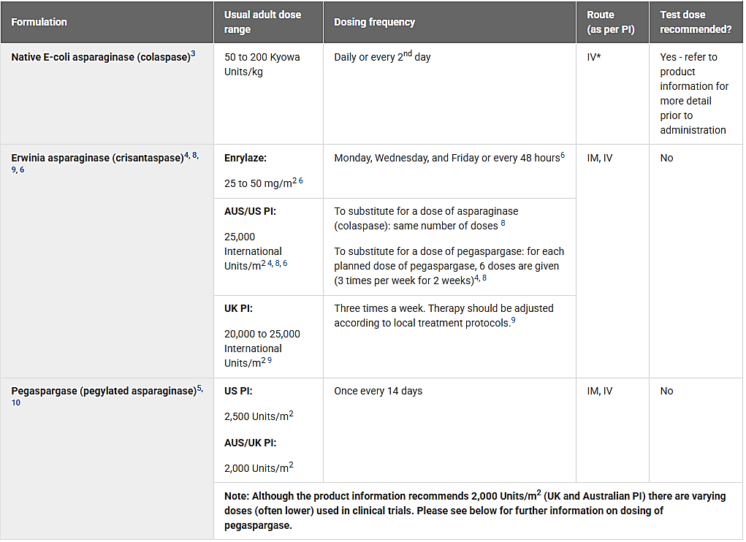
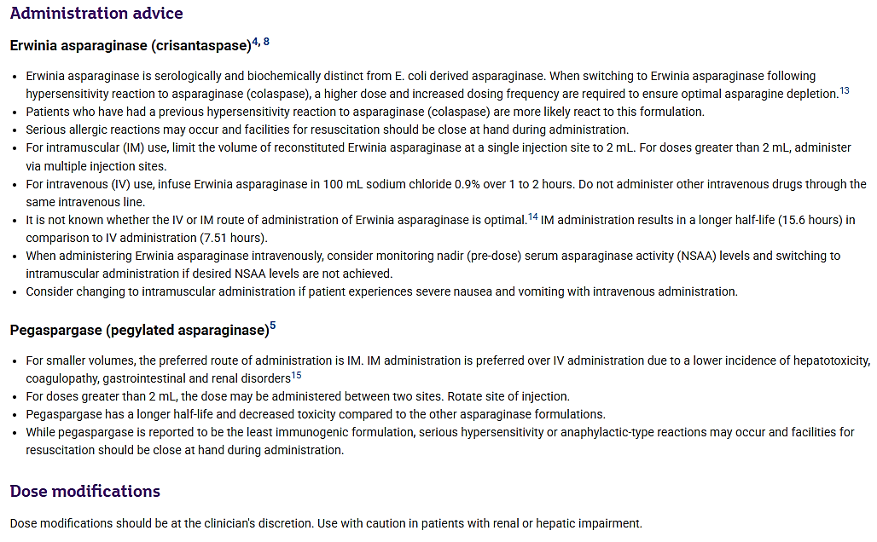
Monitoring of NSAA is not recommended routinely in this eviQ guideline but is recommended when administering crisantaspase intravenously.
The August 2024 ANZCHOG Guideline on Serum Asparaginase Activity Monitoring in Children and Adolescents recommends routine therapeutic drug monitoring with asparaginase activity level testing in all patients receiving asparaginase preparations. According to the guideline, there are four institutions in Australia that perform these assays, one each in Perth, Brisbane, Sydney and Melbourne. The guideline gives sample and sample preparation instructions. The recommended target level in this guideline is 0.1 IU/mL. The guideline recommends NSAA once per course for crisantaspases. For Enrylaze, specifically, the guideline recommends the monitoring is performed at 48 hours after a dose if the dosing is every 48 hours, and at 72 hours (prior to the Monday dose) if the dosing is Monday/Wednesday and Friday.
This guideline also recommends premedication and suggests a pre-medication schedule.

Crisantaspase in substitution for pegaspargase
It is estimated that around 30% of patients develop a treatment limiting hypersensitivity to
E coli-derived asparaginase. Current practice is to change these patients to a different asparaginase preparation. The current NCCN Guidelines (Version 2.2024) recommends recombinant asparaginase currently approved by the FDA for all patients who have developed hypersensitivity during treatment with pegylated E coli-derived asparaginase.
Children with likely silent inactivation (maximum NSAA < 0.10 IU/mL) of native E coli asparaginase who continue to receive E coli asparaginase appear to have a poorer clinical outcome compared to patients with overt clinical allergy or those monitored prospectively for silent inactivation who are switched to an alternative asparaginase.
Substitution of crisantaspases for pegylated asparaginase requires more frequent SAA monitoring due to pharmacokinetic (PK) differences.

Regulatory status

Australian regulatory status
This product is considered a new biological entity for Australian regulatory purposes.

International regulatory status
Enrylaze is approved in the EU for the following indication:
ENRYLAZE is indicated as a component of a multi-agent chemotherapeutic regimen for the treatment of acute lymphoblastic leukaemia (ALL) and lymphoblastic lymphoma (LBL) in adults and paediatric patients (1 month or older) who developed hypersensitivity or silent inactivation to E-coli derived asparaginase.
Enrylaze is approved in Switzerland for the following indication:
ENRYLAZE is indicated as a component of a multi-agent chemotherapeutic regimen for the treatment of acute lymphoblastic leukaemia (ALL) and lymphoblastic lymphoma (LBL) in adult and paediatric patients who have developed hypersensitivity or silent inactivation to E. coli-derived asparaginase. Enrylaze is indicated for patients 1 month or older.
In Canada, recombinant crisantaspase is approved for the following indication:
RYLAZE (crisantaspase recombinant) is indicated as a component of a multi-agent chemotherapeutic regimen for the treatment of:
Acute lymphoblastic leukaemia (ALL) and lymphoblastic lymphoma (LBL) in adult and pediatric patients 1 year or older who have developed hypersensitivity to E. coli-derived asparaginase.
In the United States, recombinant crisantaspase is approved for the following indication:
RYLAZE is an asparagine specific enzyme indicated as a component of a multi-agent chemotherapy regimen for the treatment of acute lymphoblastic leukaemia (ALL) and lymphoblastic lymphoma (LBL) in adult and pediatric patients 1 month or older who have developed hypersensitivity to E. coli-derived asparaginase.
The Rylaze label states, “The determination of efficacy was based on a demonstration of the achievement and maintenance of nadir serum asparaginase activity (NSAA) above the level of 0.1 U/mL”. In February 2023, the FDA issued a Complete Response letter for the proposed IV dose.

Registration timeline
Table 3 captures the key steps and dates for this submission, which was evaluated under the Comparable Overseas Regulators-B (COR-B) pathway.
The active ingredient with its proposed indication was given orphan drug designation on 9 August 2023
Table 3. Timeline for Submission PM-2023-04267-1-6
Description | Date
Designation (Orphan) | 9 August 2023
Submission dossier accepted and first round evaluation commenced | 31 October 2023
Evaluation completed | 6 June 2024
Registration decision (Outcome) | 10 April 2025
Registration in the ARTG completed | 16 April 2025
Number of working days from submission dossier acceptance to registration decision* | 367 days
* The COR-B process has a 175 working day evaluation and decision timeframe.

Assessment overview

Quality evaluation summary
JZP-458 (crisantaspase) is a non-disulfide bonded tetrameric enzyme consisting of 4 identical polypeptide subunits with a combined molecular weight of 140 kDa. It is produced via recombinant DNA technology with Pseudomonas fluorescens as the host cell, using a cultivation process with nutritive feeds. The production steps were described to the satisfaction of the evaluator.
The evaluator found that the overall quality of the active substance was demonstrated via adequate control of the starting material, control of critical steps and intermediates, process validation, extensive characterisation using orthogonal and state-of-the-art analytical methods, control of impurities and contaminants, generation of robust reference materials and batch analyses that covered multiple manufacturing campaigns.
Stability data generated under real time support a shelf life of the drug substance when stored at when stored at -20°C± 5°C.
The evaluator found the submission included sufficient detail to describe the manufacturing process for the drug product and finished product testing. The evaluator noted the reference standard, and many of the test methods for release testing and stability testing of the finished product, are the same those used for the active substance.
The finished product is presented in a 2mL Type I clear glass vial with a butyl rubber stopper and crimped with an aluminium seal with violet plastic flip-off cap. All excipients are well known pharmaceutical ingredients and their quality complies with the relevant pharmacopoeial standards. The formulation is the same as the formulation used in the Phase 2/3 study.
Following assessment of stability data generated under stressed and real-time conditions, the evaluator recommended a shelf-life of 3 years when stored at 2 to 8°C (protected from light). The evaluator noted stability studies have been conducted in accordance with relevant ICH guidelines.
The finished product is proposed to be shipped at 2-8°C. The Sponsor has not requested any permitted temperature excursions for this product.
After a review of the in-use/compatibility data, the evaluator recommendations:
- the finished product when prepared for intramuscular administration in a polypropylene syringe (as outlined in the draft Enrylaze Product Information) may be held at room temperature at 8 hours or up to 24 hours at 2-8°C.
- the finished product when prepared for intravenous administration in an infusion bag (as outlined in the draft Enrylaze Product Information) may be held at room temperature (15-25°C) for 12 hours or refrigerated at 2-8°C for up to 24 hours. The storage times start from withdrawing the required volume from the unopened vials. The 12 or 24-hour storage time includes the recommended 2-hour infusion time.
There were no objections to registration from a quality perspective.

Nonclinical evaluation summary
The nonclinical evaluator had no objections to the registration of Enrylaze.
A limited number of nonclinical studies were conducted with Enrylaze (JZP-458). Most clinical data were obtained from studies with Erwinia chrysanthemi derived crisantaspase. The evaluator noted Erwinia chrysanthemi derived asparaginase has been used in clinical practice internationally for decades resulting in the acquisition of significant clinical safety data. The sponsor’s justification for the limited data was considered acceptable.
Key findings specific to the recombinant crisantaspase (JZP-458) and commentary from the evaluation included the following:
Acute B-cell lymphoblastic leukemia cell line and T-cell lymphoblastic leukemia cell lines were the most sensitive to the anti-proliferative effects of JZP-458.
- JZP-458 has dual asparaginase and glutaminase activity.
- JZP-458 half-lives in mouse and rat (1-2 h) were broadly comparable to published half-lives of Erwinia asparaginases and shorter than in humans.
- Secondary pharmacodynamic effects included immunosuppression, hyperglycaemia, hepatotoxicity, thrombosis, and neurotoxicity.
- Clinical signs of CNS toxicity (ataxia, tremors, and convulsions) were noted in moribund animals in single dose and repeat dose toxicity studies.
- JZP-458 is not expected to be genotoxic. No genotoxicity or carcinogenicity studies were conducted in line with current guidelines.

Clinical evaluation summary

Summary of clinical studies
One study with primarily a pharmacology focus, and one main study were provided in support of the submission.
Study JZP458-101 (Study 101) was a randomised, single-centre, open-label study to evaluate the safety, tolerability, and PK of a single dose of JZP-458 via a single 2-hour infusion or intramuscular (IM) administration in 30 healthy adult participants. It also included a dosing arm to enable comparison between the PK profiles of Erwinase and JZP458.
Study JZP458-201 (Study 201) was a Phase 2/3, open-label, multicentre, dose confirmation, efficacy, safety, and PK study of JZP-458 in participants with ALL/LBL who were hypersensitive to E-coli-derived asparaginases (allergic reaction or silent inactivation).
One IM and one IV/IM population PK model provided in the submission support the alternative treatment regimens.
In the studies, serum asparaginase activity (using an enzymatic activity assay technique) has been used for the quantification of JZP-458 PK.

Pharmacology

Pharmacokinetics
Observed PK in healthy volunteers showed:
- after IM administration, the median T_{max} of JZP458 was 24-36 hours, the mean absolute bioavailability was 34.5-36.8%, and the mean (%CV) half-life was 19.1-23.4 hours (21.8-23.6%).
- after IV administration the mean (%CV) volume of distribution of JZP458 was 1.94 L (22.4%) and 1.79 L (16.6%) following doses of 25 mg/m² and 37.5 mg/m², doses respectively.
- after IV administration the mean (%CV) clearance of JZP458 was 0.125 L/h (22.4%) and 0.107 L/h (16.6%) following dose of 25 mg/m² and 37.5 mg/m², doses respectively, and the mean (%CV) half-life was 11.5-12.6 hours (11.2-12.8%).
No drug-drug interaction studies were conducted. The elimination of JZP458 is expected to be by proteolytic catabolism, so direct drug-drug interactions are unlikely.
Renal elimination is unlikely because of the size of the molecule, and impairment of renal function is unlikely to impact the PK or pharmacodynamics of JZP-458. No dedicated hepatic impairment was conducted for JZP-458, because CYP interactions are not expected.
There are no dedicated PK studies in special populations, although the pivotal data are derived from patients aged 1 to 25 years. No patients aged >52 years or <1 year were included in the studies.

Population PK data
A single compartment model with linear administration and mixed order absorption described the IV PK whereas the IM PK was described by zero order and first order absorption. Weight was included as an allometric covariate (power model) on JZP-458 SAA clearance, and proportional residual error.
The sponsor noted limitations including limited numbers of non-white participants and those with extrinsic factors such as smoking, and concomitant medication use contributing observed data.
Model based estimates for ADME (absorption, distribution, metabolism, and excretion) are as follows:
- After IM administration, T_{max} of JZP-458 was 16 (6 to 24) hours. Absolute bioavailability was 37.7%.
- After IM administration the geometric mean (%CV) predicted V/F was 1.75 L/m² (13%). Following IV administration the geometric mean (%CV) predicted V was 1.753 L/m².
- JZP-458 is expected to be metabolised by proteolytic degradation.
- After IM administration the geometric mean (%CV) of individual predicted CL/F of JZP-458 was 0.13 L/h/m² (21%) and the half-life was 18.76 hours (11%). After IV administration the geometric mean (%CV) was 0.14 L/h/m² (20%) and the half-life was 8.6 (13%).
The sponsor proposes to use modelled findings to describe the PK in the draft Enrylaze PI, consistent with the approach used for EU Summary of Product Characteristics.
The following description of the modelling was reflected in the EMA review documentation on which TGA relied as part of this abbreviated comparable overseas regulator (COR-B) review process.
The final model was a 1 compartment model with sequential mixed-order absorption for IM (parameters estimated include: F1, zero order R1 followed by a 1st order absorption KA), linear elimination with population estimate for CL fixed to the value obtained from the IV alone model; interindividual variability (IIV) expressed as an exponential term on CL, V, R1, and KA; off-diagonal covariance term for CL and V; and APEM residual error models with M3 BLQ data handling method that were described separately for IM and IV data. Body surface area (BSA) was included as a significant covariate on CL and V.
The covariate analysis also identified race (African American) on CL, disease (ALL/LBL) on CL for patients following IM administration, and disease (ALL/LBL) on V as significant covariates. African Americans had 25% lower CL, ALL/LBL patients who received IM administration had 104% higher (2.04-fold) CL, and ALL/LBL patients had 24% lower V than healthy volunteers. There were no differences in CL between Hispanic and Non-Hispanic study participants. The BSA standard used for scaling was 1.2 m² to be reflective of an average paediatric study participant. The final model was used to simulate SAA profiles for 1000 paediatric and 1000 adult patients. The simulation explored the likelihood of achieving a 72-hour nadir SAA level ≥01 U/mL.
Demographic data from the National Health and Nutrition Examination Survey Data was used to simulate 200 simulations conducted using the final model in 2000 NHANES participants. The relative risk of achieving a NSAA ≥0.1 IU/mL at 48 and 72 hours was tabulated (after 6 doses).
The model was subsequently updated to incorporate the final data from study JZP458-201 (final database lock date of 22 Nov 2022).
During the initial modelling, the Empirical Bayes prediction of the inter-individual random effect (ETA) distributions suggested that the effect of healthy volunteers versus patients should be included in the base model. In addition, body size, as measured by BSA, was also incorporated to stabilise the model further. The condition number was checked to ensure that no correlation was introduced at this point. In addition, an effect of patient age was also included on the first absorption rate constant (KA1) in the CP model.
Further examination showed that the between-subject variability (BSV) on V had a high degree of shrinkage, and several steps were taken to resolve this problem. This included testing a Manly transform for BSV on V and several OMEGA BLOCK models. The transform did not appreciably reduce the shrinkage but did show that the BSV on CL and V were highly correlated (0.8), and a shared eta approach between CL and V was used instead. This approach necessitated fixing BSV on V to 0 and removing V from MU modelling, this then resulted in a model that converged with acceptable parameter precision and removed the problem of high correlation. In addition, the BSV on the second absorption rate constant (KA2) was poorly estimated and fixed to a small value (10%) to improve stability further.
This model then became the ‘base model’, and other covariates were examined graphically using eta plots and were subsequently tested as being potentially influential as single covariate models, including anti-drug antibody (ADA), neutralising antibody (nAb), RACE (each race was tested singly), disease subtype and primary disease (B CELL ALL, T CELL ALL, B CELL LBL, T CELL LBL, B CELL, T CELL, ALL and LBL were all tested singly). In addition, the dose (ADOSE) was tested on CL, V, and F1 but found to be important only on F1. Other covariates were identified but came out of the model on back elimination or were small enough to have no clinical relevance (a change in parameter over 20% is the usual cut-off for relevance). The only covariate further identified was the effect of RACE 2 (BLACK/AFRICAN AMERICAN) on CL. No other covariate evaluated provided a substantial decrease (P < 0.05) in the IMP objective function (OBJ) or was estimated with a clinically meaningful change in the parameters with sufficient precision to be included in the model. The final model evaluation determined that the dose effect on F1 had a deleterious effect on the precision for CL, so this factor was also removed.
Table 4. Observed and Simulated Proportions of Patients achieving a Nadir Serum Asparaginase Activity (NSAA) of 0.1 IU/mL
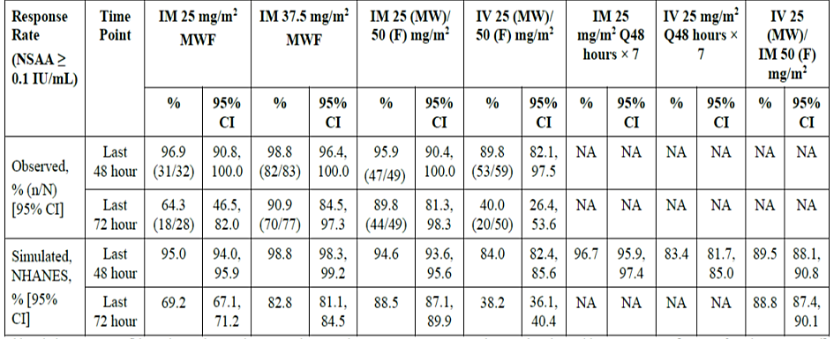
Abbreviations: CI = confidence interval; IM = intramuscular; IV = intravenous: MWF = Monday. Wednesday, Friday: NHANES = [Centers for Disease Control] National Health and Nutrition Examination Survey Data; NSAA = Nadir serum asparaginase activity.
Note: Response rate is defined as the proportion of participants maintaining NSAA levels ≥ 0.1 IU/mL at the specified time point.
Exposure response (E-R) analyses of safety found a significant relationship between exposure (measured by AUC₃₃₆, C_{max}, C_{48,L}, and C_{72,L}) and hypersensitivity. There seemed to be an apparent increasing trend for higher incidence of hepatotoxicity with exposure, but logistic regression modelling did not find a statistically significant association between hepatotoxicity and any of the four tested exposure metrics using currently available data. A relationship was not detected between exposure and pancreatitis or hypertriglyceridaemia. There were too few subjects with thrombosis to allow conclusions regarding an E-R relationship. There were significant E-R relationships between L-asparagine depletion and SAA exposures (the higher the SAA, the more asparagine depletion is observed), with a similar relationship between L-glutamine and SAA exposure.

Pharmacodynamics
The pharmacodynamics (PD) endpoints L-asparagine and L-glutamine concentrations were evaluated in study 201.
Complete asparagine depletion was defined as asparagine level <0.025 μg/mL, below the lower limit of quantification of the assay for all 7 post-dose samples collected in Course 1 of treatment. Complete asparagine depletion was reported in 49% of patients following IM administration of doses at 25 mg/m² MWF (Monday. Wednesday, Friday), 37.5 mg/m² MWF, and IM or IV 25/25/50mg/m² MWF.
Nearly complete depletion (asparagine levels < 0.05 μg/mL, or 2 times the LLOQ, for all 7 post-dose samples collected in Course 1) was reported in around 80% of patients.
Depletion of plasma L-glutamine was observed at the end of the IV infusion in Part B patients but was not completely depleted using any of the IM dosing regimens.
Serum asparaginase activity (SAA) is higher than is achieved with Erwinase at the end of course 1. Sufficient data were provided to satisfy the evaluator that SAA level is maintained during subsequent courses of treatment and no apparent correlation between JZP-458 exposure antidrug antibody (ADA) or nAb development and SAA was observed.

Efficacy
Study JZP458-201 was an open-label, multicentre, single-arm, dose confirmation and PK study that commenced in 2019, and had a final data cut in November 2022. It enrolled 229 adult and paediatric patients with Acute Lymphoblastic Leukemia (ALL)/Lymphoblastic Lymphoma (LBL) following hypersensitivity (allergic reaction or silent inactivation) to E. coli-derived asparaginases.
The study aimed to assess the tolerability and efficacy of JZP-458. Efficacy was measured using SAA.
The study comprised 2 parts.
Part A had three Cohorts:
- Cohort 1a (IM 25 mg/m² on a MWF schedule, N=33)
- Cohort 1b (IM 37.5 mg/m² on a MWF schedule, N=83)
- Cohort 1c (IM 25/25/50 mg/m² on a MWF schedule, N=51)
Part B
- Cohort 1a (IV 25/25/50 mg/m² on a MWF schedule, N=62)
Participants could commence on the nearest available treatment day (M, W, or F). Results were analysed for the overall cohort and a separate analysis was provided based on the commencement day of the cycle.
Prophylactic medication to prevent hypersensitivity reactions was not specified in the protocol and was left to the investigator’s discretion and/or local standard of care.
The key inclusion and exclusion criteria are outlined in Table 5.
Table 5: Study 201 Key Inclusion and Exclusion Criteria
Key Inclusion Criteria | Key Exclusion Criteria
Paediatric and adult participants with a diagnosis of ALL or LBL  Had a ≥ Grade 3 allergic reaction (per CTCAE v5.0) to a long-acting E. coli-derived asparaginase or had silent inactivation  Had ≥ courses of E. coli-derived asparaginase (to allow for ≥ 6 doses of JZP-458) remaining in his/her treatment plan  Had, in the opinion of the Investigator, fully recovered from their prior allergic reaction to E. coli-derived asparaginase with undetectable SAA levels prior to enrolment in the study, except for participants who received < 10% of an E. coli-derived asparaginase IV infusion prior to the reaction | Had previously received asparaginase Erwinia chrysanthemi or JZP-458  Had relapsed ALL or LBL  Concurrently receiving another investigational agent and/or being treated with an investigational device at the same time as JZP-458 (within 48 hours) during Course 1 of JZP-458  Had a history of ≥ Grade 3 pancreatitis (per CTCAE v5.0)  Prior history of asparaginase-associated ≥ Grade 3 (per CTCAE v5.0) haemorrhagic event or asparaginase-associated thrombus that required anticoagulation therapy, excluding catheter-related thrombotic events

Table 6. Baseline Patient Demographic and Disease Characteristics
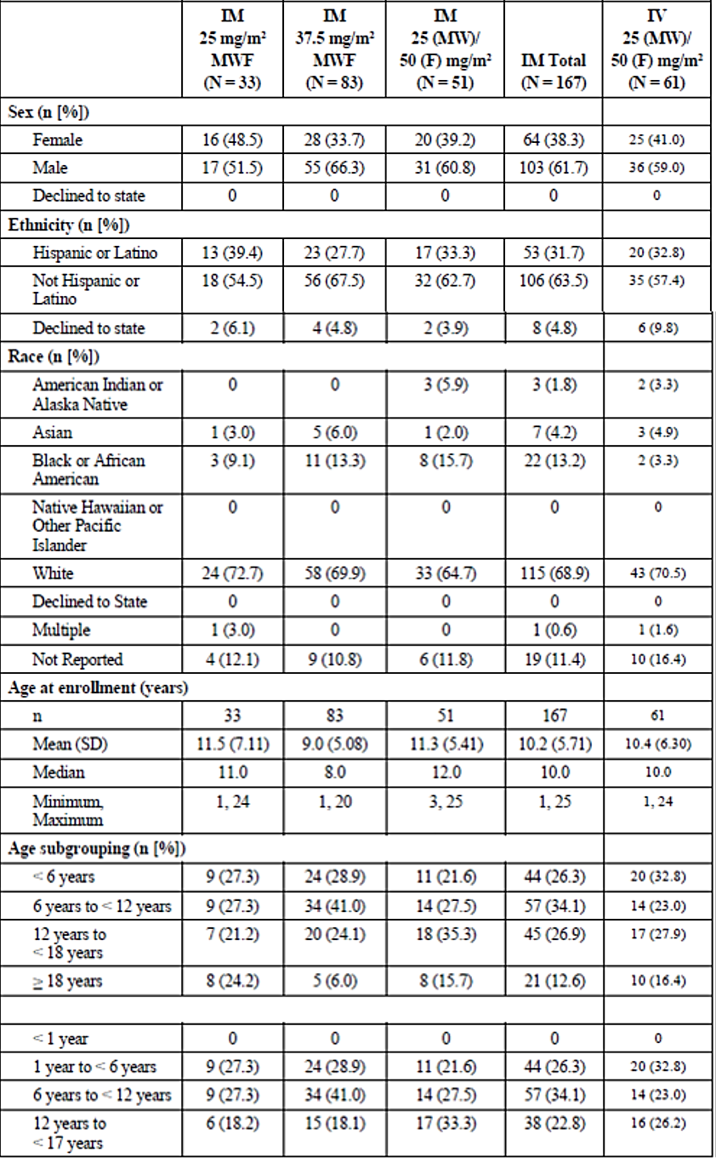
Table 6. Baseline Patient Demographic and Disease Characteristics (continued)
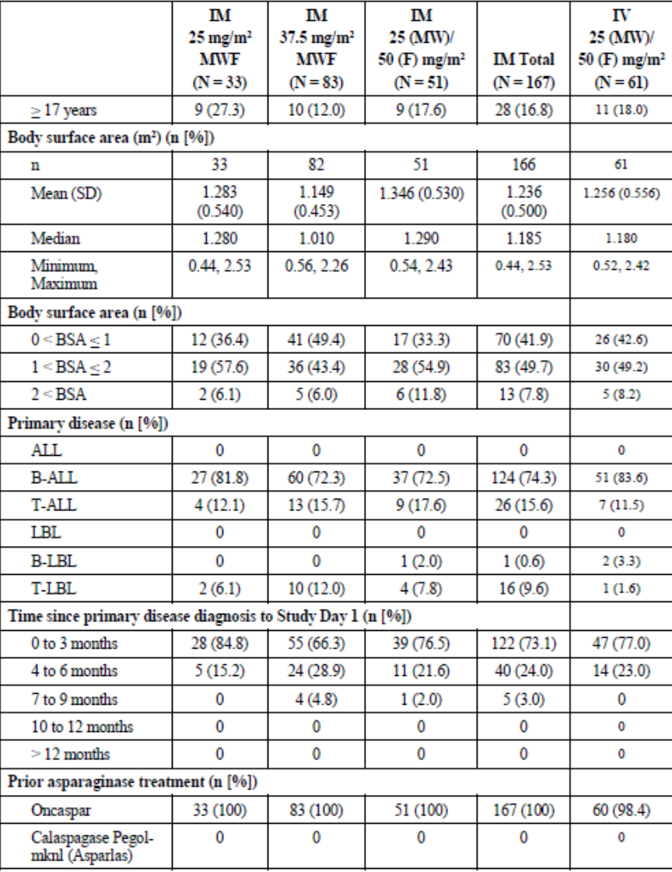
Patient disposition for all cohorts of Part A and for Part B are summarised in Table 7 below.
Table 7. Study 201 Participant Disposition
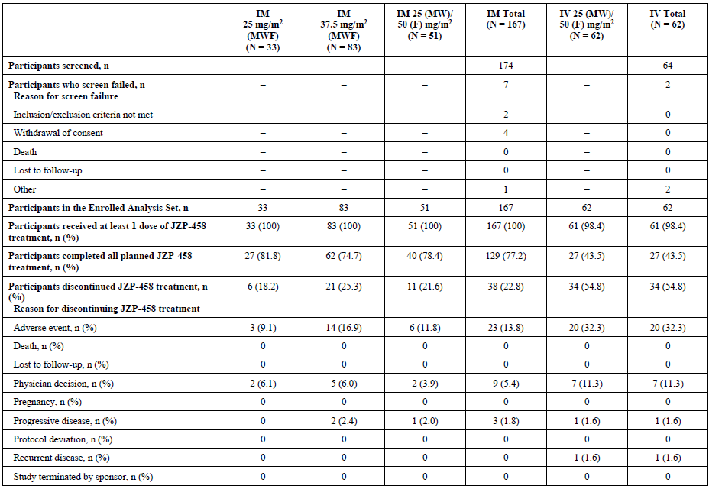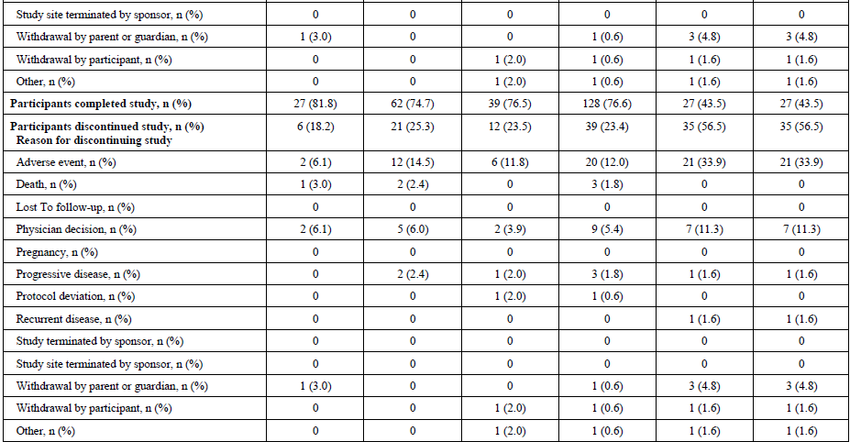
Abbreviations: F = Friday; IM = intramuscular; IV = intravenous; MW = Monday, Wednesday; MWF = Monday, Wednesday, Friday.
Percentages were calculated with the number of participants in the Enrolled Analysis Set as the denominator.
Major protocol deviations were reported for 27.5% of Part A and 37.7% of Part B. Because the primary endpoint is reliant on laboratory testing and the timing of the testing is important for the interpretation of the results, the 16.8% of Part A and 8.2% of Part B that had laboratory deviations as major protocol deviations could be important. The sponsor has clarified only 7% of all patients had a protocol deviation related to the collection of SAA levels. Further, the actual collection time was included in the PK analysis.
The primary efficacy outcome was serum asparaginase activity (SAA). This is a surrogate marker for asparagine depletion. A NSAA level of ≥0.1 IU/mL was set as the accepted threshold for the analysis.,

Efficacy outcomes
- The primary endpoint was response rate (last 72-hour NSAA level ≥ 0.1 IU/mL during course 1 for IM dosing) at the intended IM dosing regimen of 25mg/m² Monday, 25 mg/m² Wednesday and Friday 50 mg/m²
  - 89.8% (5% CI: 81.3%, 98.3%) achieved a 72-hour NSAA of ≥0.1 IU/mL.
Table 8. Study 201 - Nadir Serum Asparaginase Activity – thresholds of ≥ 0.1 IU/mL and 0.4 IU/mL
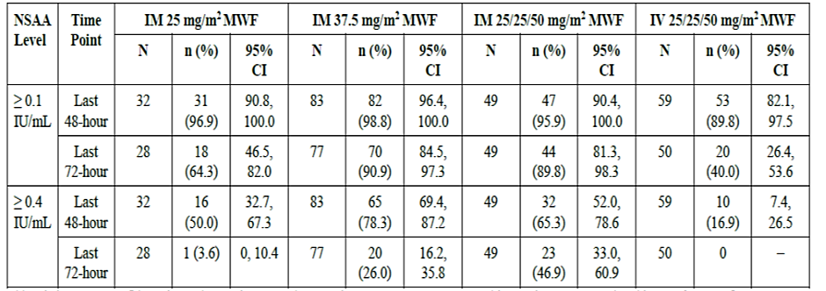
Abbreviations: CI = confidence interval; IM = intramuscular; IV = intravenous; JZP-458 = recombinant crisantaspase produced in Pseudomonas fluorescens; RC-P (also referred to as JZP458); MWF = Monday, Wednesday, Friday; NSAA = nadir serum asparaginase activity.
Percentages were calculated with the number of participants for each course and schedule as the denominator.
The Efficacy Analysis Set at 48 hours (i.e., key secondary efficacy endpoint) included participants who received at least 1 dose of JZP-458 with at least one 48-hour NSAA assessment collected within the protocol-defined sample collection window (± 2 hours) in Course 1.
The Efficacy Analysis Set at 72 hours (i.e., primary efficacy endpoint) included participants who received at least 1 dose of JZP-458 with at least one 72-hour NSAA assessment collected within the protocol-defined sample collection window (± 2 hours) in Course 1.
95% CI was calculated by the Wald method.
- The key secondary endpoints was response rate (last hour 48-hour NSAA level ≥ 0.1 IU/mL during course 1) for IM dosing at the intended IM dosing regimen of 25 mg/m² Monday, 25 mg/m² Wednesday and Friday 50 mg/m²
  - 95.9% (95% CI: 90.4%, 100.0%) achieved a 48-hour NSAA of ≥0.1 IU/mL.
- Other secondary endpoints were:
  - Response rate- last hour 72-hour NSAA level ≥ 0.4 IU/mL during course 1 for IM dosing at the intended IM dosing regimen of 25mg/m² Monday, 25 mg/m² Wednesday and Friday 50 mg/m²
- 46.9% (95% CI: 33.0%, 60.9%)
  - Response rate- last hour 48-hour NSAA level ≥ 0.4 IU/mL during course 1 for IM dosing at the intended IM dosing regimen of 25mg/m² Monday, 25 mg/m² Wednesday and Friday 50 mg/m²
- 65.3% (95% CI: 52.0%, 78.6%)
- Exploratory endpoints were:
  - Response rate - last hour 48-hour NSAA level ≥ 0.4 IU/mL during course 1 for IV dosing at the intended IV dosing regimen of 25mg/m² Monday, 25 mg/m² Wednesday and Friday 50 mg/m²
- 16.9% (95% CI: 7.4%, 26.5%)
  - Response rate - last hour 48-hour NSAA level ≥ 0.1 IU/mL during course 1 for IV dosing at the intended IV dosing regimen of 25mg/m² Monday, 25 mg/m² Wednesday and Friday 50 mg/m²
- 89.8% (95% CI: 82.1%, 97.5%)
  - Response rate - last hour 72-hour NSAA level ≥ 0.4 IU/mL during course 1 for IV dosing at the intended IV dosing regimen of 25mg/m² Monday, 25 mg/m² Wednesday and Friday 50 mg/m²
- No patients
  - Response rate- last hour 72-hour NSAA level ≥ 0.1 IU/mL during course 1 for IV dosing at the intended IV dosing regimen of 25mg/m² Monday, 25 mg/m² Wednesday and Friday 50 mg/m² (on a MWF dosing schedule)
- 40.0% (95% CI: 26.4%, 53.6%)
Table 9. Study 201 Summary of Serum Asparaginase Activity – Course 1
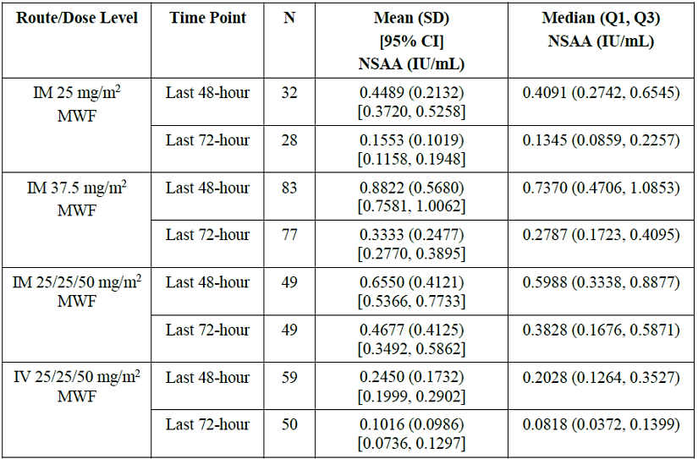
Abbreviations: CI = confidence interval; IM = intramuscular: IV = intravenous: JZP-458 = recombinant crisantaspase produced in Pseudomonas fluorescens; RC-P (also referred to as JZP458): LLOQ = lower limit of quantitation: MWF = Monday. Wednesday. Friday: NSAA = nadir serum asparaginase activity: Q1 = first quartile; Q3 = third quartile: SD = standard deviation.
The Efficacy Analysis Set included participants who received at least 1 dose of JZP-458 with at least one 48-hour or 72-hour NSAA assessment collected within the protocol-defined sample collection window (+ 2 hours) in Course 1. If mean < LLOQ, then SD and CIs were not calculated.
The day of the week of the commencement of the cycle appears less important for IM dosing than IV dosing for suppression of asparagine levels throughout the treatment cycle. MWF and WFM scheduling (not shown below) appear similar. The Delegate notes the subgroups will be small in this analysis.
Figure 4. Study 201 Part B Serum Asparaginase Activity and Asparagine level by day of commencement of dosing in MWF schedule for IV dosing (linear scale for both results – left graph, semilogarithmic scale for SAA only – right graph)
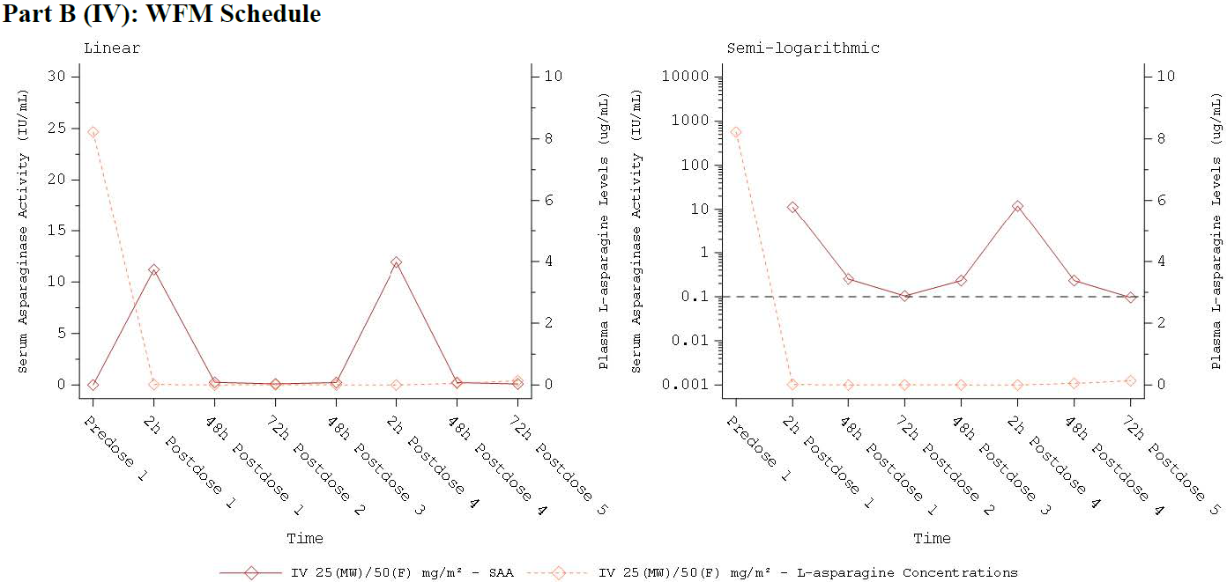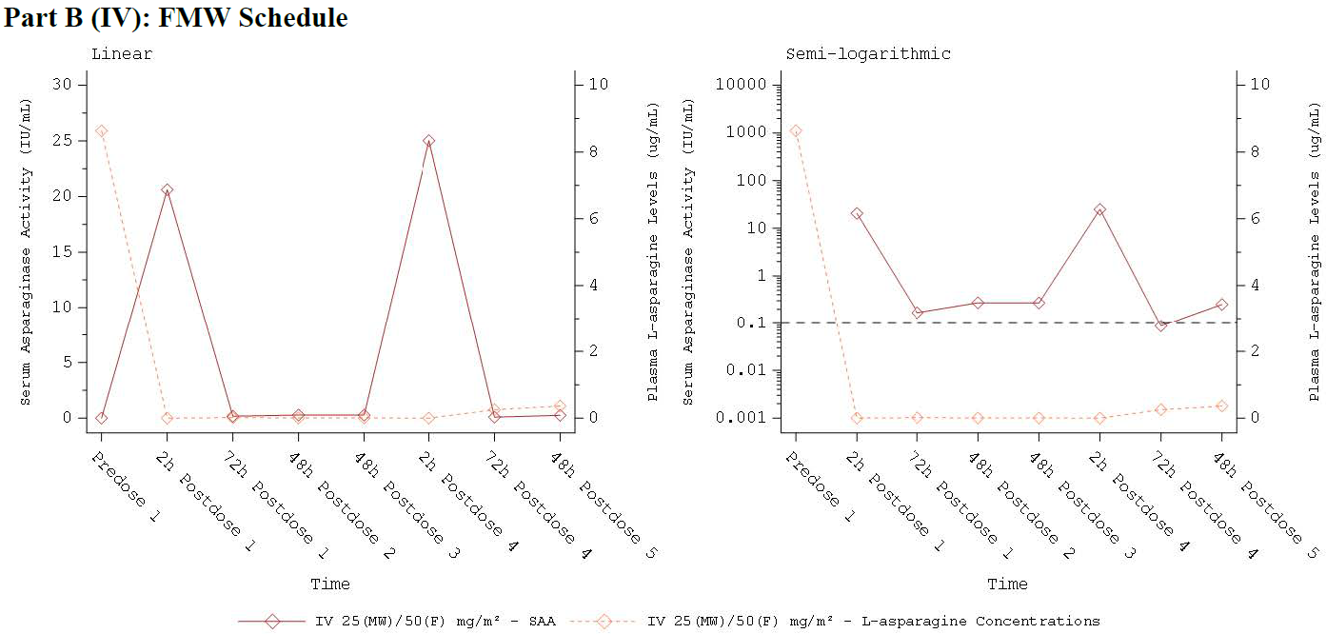
Abbreviations: F = Friday; FMW = Friday, Monday, Wednesday; IM =intramuscular; IV = intravenous; JZP-458 = recombinant crisantaspase Pseudomonas fluorescens, also referred to as RC-P; LLOQ = lower limit of quantitation; MW = Monday, Wednesday; MWF = Monday, Wednesday, Friday; SAA = serum asparaginase activity; WFM = Wednesday, Friday, Monday. LLOQ: SAA 0.0350 IU/mL, L-asparagine = 0.0250 μg/mL. Values below the LLOQ (i.e., below the limit of quantitation) were set to 0. For the semilogarithmic plot, only SAA is on a semilogarithmic scale. If the mean was 0, the value appears as missing on the semilogarithmic plot because the scale is undefined at 0.
Ancillary analyses tabulated results for all patients, noting the maximum number of courses administered was 10 for the proposed dosing regimens. In the observed data (below) with IV dosing, the mean SAA was above the NSAA threshold of ≥ 0.1 IU IU/mL at the 72 hours timepoint.
Table 10. Summary of mean Serum Asparaginase Activity Results with JZP-458 with IM and IV dosing using the proposed regimen for each route of administration. Courses 1 to 10
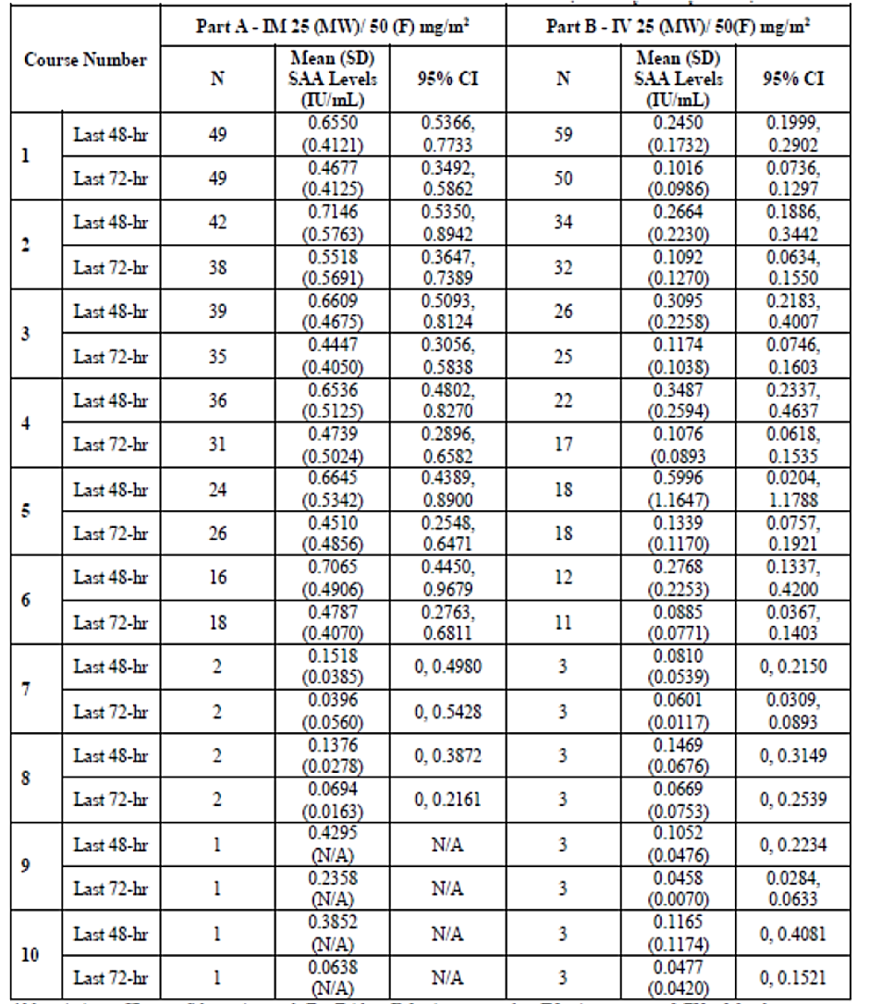
Abbreviations: CI = confidence interval; F = Friday; IM = intramuscular; IV = intravenous; MW = Monday. Wednesday; MWF = Monday, Wednesday, Friday: NSAA = Nadir serum asparaginase activity; SAA = serum asparaginase activity; SD = standard deviation.
The Efficacy Analysis Set included participants who received at least ] dose of JZP-458 with at least one 48-hour or 72-hour NSAA assessment collected within the protocol-defined sample collection window (= 2? hours) in Course 1. If mean < lower limit of quantitation, then SD and CI were not calculated.

Safety
Clinical safety information is derived from 167 patients who received JZP458 in Study 201 – from Part A, 33 in Cohort 1a, 83 in Cohort 1b and 51 in Cohort 1c, and 61 patients from Part B.
Of those 44 were aged < 6 years, 57 were aged 6 to < 12 years, 45 were aged 12 to < 18 years, and 21 were aged > 18 years. The median number of courses completed was 15 for the those receiving IM dosing, and 3 for those receiving IV dosing. Overall, 68% of participants completed the planned treatment. A summary of adverse events is presented in the Table 11 below.
Table 11. Study 201 Summary of Adverse Events (Safety Analysis Set)
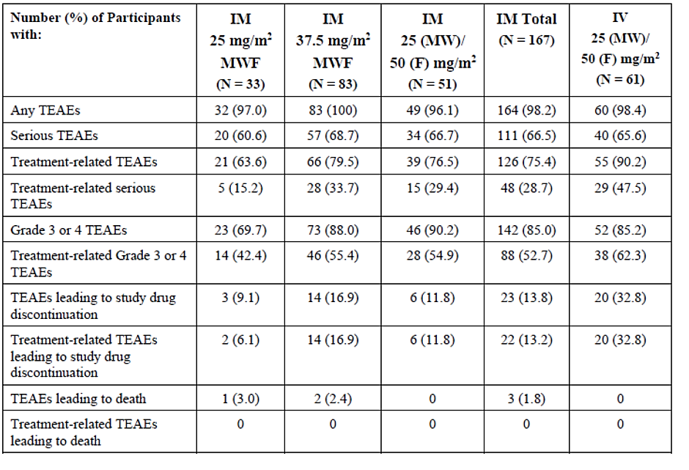
Abbreviations: CTCAE = Common Terminology Criteria for Adverse Events: F = Friday; IM = intramuscular; IV = intravenous; MedDRA = Medical Dictionary for Regulatory Activities: MW = Monday. Wednesday: MWF = Monday. Wednesday. Friday, PT = preferred term; SOC = system organ class; TEAE = treatment-emergent adverse event.
Percentages were calculated with the number of participants in the Safety Analysis Set as the denominator.
Adverse events were coded to SOC and PT using MedDRA 22.1. The severity of AEs was recorded using CTCAE 5.0.
A TEAE was defined as any event with an onset date on or after the first dose of study treatment through the end of the study or any ongoing event that worsened in severity after the date of the first dose of study treatment through the end of the study.
The most frequently reported TEAEs (occurring in ≥10%) are summarised in the Table 12 below.
In Part A (IM), the most frequently reported treatment-related TEAEs (TRAEs) (occurring in ≥10%) were nausea (24.0%), vomiting (23.4%), neutrophil count decreased (22.2%), anaemia (18.0%), decreased appetite and ALT increased (14.4%), platelet count decreased (13.2%), fatigue (13.8%), white blood cell count decreased (11.4%), AST increased (10.8%) and abdominal pain and AST increased (10.2% each).
In Part B (IV), the most frequently reported TRAEs (occurring in ≥10%) were vomiting (59.0%), nausea (44.3%), ALT increased (18.0%), drug hypersensitivity (16.4%) and anaemia and hyperglycaemia (11.5% each).
Table 12. Study 201 Summary of Treatment Emergent Adverse Events
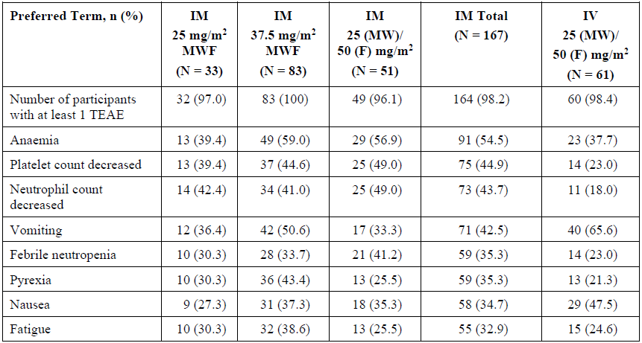
Table 12. Study 201 Summary of Treatment Emergent Adverse Events (continued)
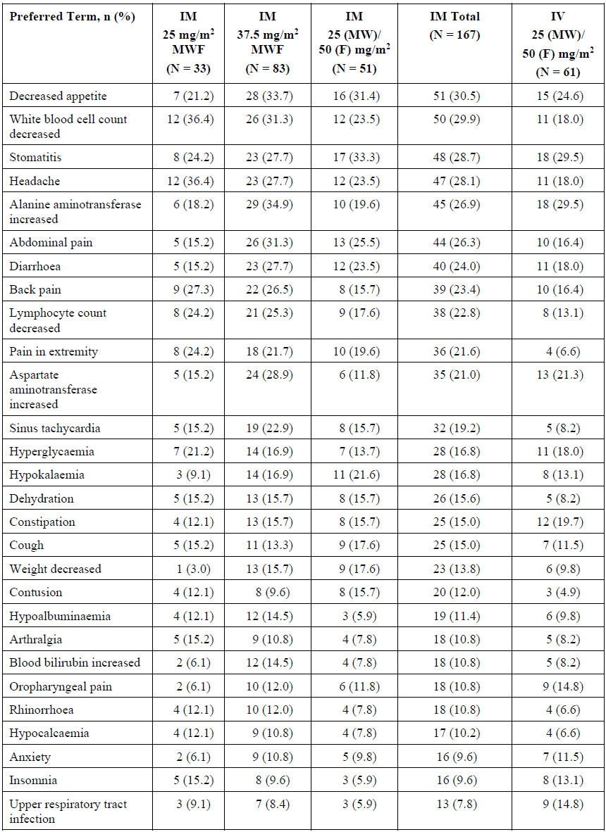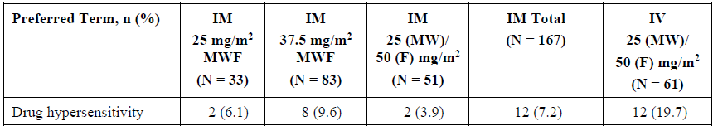
Abbreviations: F = Friday; IM = intramuscular; IV = intravenous; MedDRA = Medical Dictionary for Regulatory Activities; MW = Monday, Wednesday; MWF = Monday, Wednesday, Friday; PT = preferred term; TEAE = treatment-emergent adverse event.
Percentages were calculated with the number of participants in the Safety Analysis Set as the denominator.
Adverse events were coded to PT using MedDRA 22.1.
Preferred terms were sorted by decreasing order of IM total frequency.
A TEAE was defined as any event with an onset date on or after the first dose of study treatment through the end of the study or any ongoing event that worsened in severity after the date of the first dose of study treatment through the end of the study.
Participants who reported a TEAE more than once within a PT were counted only once for that PT.
In Part A (IM), Grade 3 or 4 TEAEs (occurring ≥20% patients) were anaemia (45.5%), neutrophil count decreased (43.1%), platelet count decreased (35.9%), febrile neutropenia (35.9%), and white blood cell count decreased (25.7%). Grade 3 or 4 TEAEs were reported in the System Organ Classes, gastrointestinal disorders (26.9%), General disorders and administration site conditions (8.4%), Immune system disorders (6.0%), Infections and infestations (25.1%), Injury, poisoning and procedural (4.2%), Investigation (64.7%), Metabolism and nutrition (22.2%), Musculoskeletal and connective tissue disorders (7.8%]), Nervous system disorders (8.4%), and Renal and urinary disorders (6.6%).
In Part B (IV), Grade 3 or 4 TEAEs (occurring ≥20% patients) was anaemia (32.8%), febrile neutropenia (23%), platelet count decreased and ALT increased (21.3%). Grade 3 or 4 TEAEs were reported in the System Organ Classes, gastrointestinal disorders (29.5%), General disorders and administration site conditions (3.3%), Immune system disorders (21.3%), Infections and infestations (9.8%), Injury, poisoning and procedural (6.6%), Investigation (45.9%), Metabolism and nutrition (19.7%), Musculoskeletal and connective tissue disorders (3.3%), Nervous system disorders (14.8%), and Renal and urinary disorders (4.9%).

Serious treatment-emergent Adverse Events (SAE)
In Part A (IM), 66.5% of patients experienced at least 1 SAE. The most frequently (in ≥ 5%) were febrile neutropenia (31.7%), pyrexia (11.4%), dehydration (9.0%), sepsis (7.8%), stomatitis and vomiting (6.6%] each) and nausea (5.4%).
In Part B (IV), 65.6% of patients experienced at least 1 SAE. The most frequently (in ≥ 5%) were febrile neutropenia (23.0%), vomiting (9.8%), drug hypersensitivity and hyperglycaemia (8.2% each), and nausea (6.6%).
Treatment-related serious TEAEs reported by ≥2 patients included: febrile neutropenia (8.4% [14/167]); drug hypersensitivity (4.8%); nausea and pancreatitis (3.6% each); pancreatitis acute (3.0%); vomiting and anaphylactic reaction (1.8% each); colitis, sepsis, hyperammonaemia, hyperglycaemia, and pulmonary embolism (1.2% each).

Deaths
Three patients (1 in the 25 mg/m2 MWF dose cohort and 2 in the 37.5 mg/m2 MWF dose cohort) died. Grade 5 TEAEs included sepsis, aspiration pneumonia, and multiple organ dysfunction syndrome. None were attributed to JZP458.

Events of special interest
Adverse events of interest for asparaginase include allergic reactions, pancreatitis, and thrombosis.
In Part A (IM), allergic reactions including hypersensitivity and anaphylaxis, were reported in 39.5%, although 10.8% of patients had at least 1 event considered related to study treatment, and 6% of patients experienced a Grade 3 events.
Overall, the most frequently (≥5%) reported events related to allergic reactions included rash maculopapular (7.8%), drug hypersensitivity (7.2%), allergic transfusion reaction (6.0%) and drug eruption and rash (5.4% each). Study drug-related allergic reactions included drug hypersensitivity (6.0%); anaphylactic reaction and rash maculopapular (1.8%), rash erythematous (1.2%); and rash, and urticaria (0.6% each).
Grade 3 study-drug related allergic reactions reported in 15.2% included drug hypersensitivity (7 patients) and anaphylactic reaction (3 patients).
In Part B, allergic reactions including hypersensitivity and anaphylaxis, were reported in 52.4%), although 26.2.% had at least 1 event that related to study treatment. All events considered study related resolved.
Overall, the most frequently (≥5%) reported events related events related to allergic reactions included drug hypersensitivity (19.7%), rash maculopapular (9.8%), and catheter site rash and infusion-related reaction (6.6% each).
Pancreatitis was reported in 7.2% of Part A and 4.9% of Part B. Of these most (80%) were Grade ≥3 and resulted in study drug discontinuation.
Abnormal coagulation profile and thromboembolic events have been reported with other asparaginases and are specifically mentioned in the Rylaze US label. Thromboembolism was reported in 1.8% of Part A and 3.3% of Part B. Only one event led to study drug discontinuation. Platelet count decreased was reported for 44.9% of Part A and 23.0% of Part B. Platelet count decreased was Grade 3 or 4 for 35.9% of Part A, and Grade 4 for 21.3% of Part B.
Hyperglycaemia was reported in 16.8% of Part 1 and 18.00% of Part B. It was reported as a TRSAE in 1.2% of Part A and 8.2% of Part B.
Hepatotoxicity has been reported with the use of crisantaspases. No age-related trend was demonstrated for hepatic events.
Hepatotoxicity was observed in 34.1% of Part A, of which 20.4% were considered treatment related. The most frequently reported (in ≥ 5%) were ALT increased (14.4%), AST increased (10.8%), and blood bilirubin increased (6.6%).
Hepatotoxicity was observed in 32.8% of Part B, of which 21.3% were considered treatment related. The most frequently (in ≥ 5%) were ALT increased (18.0%) and AST increased (9.8%).
ALT increased was reported for 14.4% of Part A and 21.3% of Part B In Part A, Grade 3 events of ALT increased were reported in 13.2% and Grade 4 events in 1.2%. In Part B, Grade 3 events were reported in 16.4% and Grade 4 events in 4.9%.
The US FDA has included a warning about veno-occlusive hepatotoxicity with this class of drugs. The sponsor suggests there is a relationship between pegylated asparaginases and veno-occlusive liver disease but does not agree with the FDA view that this is a class effect. The Delegate notes that while hepatotoxicity is included in the Enrylaze SmPC, veno-occlusive disease has not been included.
One event of veno-occlusive disease was reported in Study 201, in a patient also receiving cytarabine and 6 TG.
The Delegate notes the June 2024 publication of findings from the FDA Adverse Event Reporting System Database. The Delegate agrees with the sponsor that most of the events occurred with pegylated products, and that a single event was reported for Enrylaze. The Delegate also notes most of the events also occurred in patients with pre-existing hepatotoxicity.
Adverse events of pancreatitis and thrombosis were more frequently reported in patients aged ≥12 years.
Anti-JZP-458 ADAs were reported in 49.1% of patients who received IM dosing. Of these 12.9% experienced a treatment-related hypersensitivity reaction, and 4.7% developed NAb. In comparison, 8.2% of the 50.9% JZP-458 ADA negative patients experienced treatment-related hypersensitivity reaction.
Anti-JZP-458 ADAs were reported in 55.7% who received IV dosing. Of these 35.3% experienced a treatment-related hypersensitivity reaction and 3.3% developed NAb. In comparison, 14.8% of the 44.3% who were Anti-JZP-458 ADA negative experienced a treatment-related hypersensitivity reaction and none had NAbs.
Real World Evidence was not included in this submission.
A separate companion diagnostic plan was not required for this submission. This is consistent with the position taken for the Erwinase crisantaspase.

Risk management plan
The RMP evaluator considered EU-RMP version 1.0 (dated 27 July 2023; DLP 22 November 2022) and ASA version 0.1 (dated 28 September 2023) supplied with this application.
There are no safety concerns proposed in the ASA, consistent with the EU-RMP. There are no additional pharmacovigilance or risk minimisation activities.
Medication error was raised as important risk in the Australian clinical landscape. The current crisantaspase is dosed in IU/m², the proposed product is does in mg/m². The evaluator also noted an absence of evidence of interchangeability with Erwinase. After the recommended modifications to the Enrylaze PI had been made to the language in the dosing section, the evaluator was satisfied the risks are mitigated from a RMP perspective.

Risk-benefit analysis
The clinical setting for Enrylaze is patients who have commenced therapy for ALL using conventional algorithms that contain asparaginase but who are unable to complete therapy or in whom therapy is futile because of hypersensitivity reactions to the pegylated asparaginase.
The sponsor has utilised the comparable overseas regulator pathway to support registration. The sponsor has identified the EMA as the comparable overseas regulator and the EMA reports and responses to questions have been considered in reaching a preliminary view.
The Delegate considers there are aspects of this submission that warrant specific comment:

The pivotal data are from a single arm study
In 2019, when Study 201 commenced, there was no approved treatment option in Australia for patients who experienced a hypersensitivity reaction to pegylated asparaginase and needed to continue treatment. Whilst they remained unapproved at that time and access in Australia was instead through the Special Access Scheme, the use of crisantaspases in this clinical situation was considered an accepted part of clinical practice in Australia and internationally at the time the study commenced. It would therefore not have been feasible to include a placebo arm in Study 201: based on mechanistic rationale and existing single arm data for crisantaspases there would not have been genuine clinical equipoise in randomisation against placebo.
At the time of acceptance of the Enrylaze submission in October 2023 there were no registered goods in Australia for the requested indication. Erwinase was approved in Australia in February 2024. One of the reasons for developing a crisantaspase using recombinant technology was shortages of the Erwinia chrystanthemi derived version. It is not clear whether it would have been feasible to conduct a head-to-head study with Erwinia chrystanthemi derived crisantaspase because of issues with supply.
Taking the above into account, single arm data are acceptable.

NSAA as a surrogate endpoint
The acceptance of SAA and asparagine depletion is essentially historical.
The nadir of serum asparaginase has been previously accepted as a surrogate for asparaginase activity suppression with other asparaginases. Correlation between SAA and asparagine depletion has been established in the submission.
Depletion of asparagine has been linked to more favourable outcomes in ALL, and unfavourable outcomes if asparagine depletion was not achieved because of lack of available drug has been demonstrated.
This study is a single arm study, so time to event endpoints are difficult to interpret. Given the single arm design is acceptable in this context, a surrogate endpoint for clinical outcomes is also acceptable.

IM vs IV dosing regimens
Both IM and IV dosing regimens were studied in a MWF regimen, that allows patients a two-day break from treatment visits. The Delegate appreciates the clinical value of such a treatment regimen for patients and families of patients if it is possible to use such without a loss of efficacy.
The Delegate also recognises that there may be a patient preference for IV dosing. While there is a small increased risk of hypersensitivity, the overall tolerability of IV compared with IM dosing is noteworthy as there is significant pain associated with IM dosing.
Therapeutic drug monitoring (TDM) was conducted in Study 201 – NSAA was the clinical endpoint. The current data demonstrates that not all patients will achieve a NSAA of ≥ 0.1 IU/mL with IV dosing; that TDM will be needed if the IV dosing option is selected, and that the MWF regimen will not be suitable for all patients.

48-hour dosing option has no direct clinical evidence
Study 201 supports MWF dosing via either route of administration, with the limitations outlined in the above dot point: i.e. that TDM is essential for IV dosing to be safely and effectively used.
There were no direct clinical data to support the 48-hour dosing regimens for both IM and IV dosing that are proposed for approval. Modelling and simulation are instead the supporting evidence for the 48-hourly dosing regimens. While the modelling is considered adequate to supports efficacy (NSAA) of 48-hourly dosing, there is particular uncertainty about the safety of this more frequent dosing approach. It is unclear whether the use of multiple courses of IV dosing every 48 hours over time carries an increased risk of exposure–related adverse effects, including hypersensitivity. There is therefore important clinical uncertainty with the proposed regimens for 48-hour dosing.
In support of allowing the 48-hourly dosing alternatives, a publication describes the observed outcomes for high risk and standard risk patients who did not receive all prescribed asparaginase doses during treatment. The PFS HR for high-risk patients who did not receive all doses compared to those who did was 1.5 (95% CI 1.2, 1.9, P= 0.002). The PFS HR for standard risk patients who did not receive all doses compared to those who did was 1.2 (95% CI 0.9, 1.6, P= 0.23); but standard risk patients who had a slow early response and who had therapy intensification the impact was greater (HR 1.7, 95% CI 1.1, 2.7, P=0.03).
The Delegate notes the inclusion of 48-hour dosing for Enrylaze in the ANZCHOG guidelines.
The Delegate recognises there will be certain patients who may benefit from continued asparaginase treatment if they have had a hypersensitivity response to pegylated asparaginase, have transitioned to a crisantaspase and have not achieved a NSAA with a MWF regimen. For those patients a further transition to a 48-hour regimen could be justified provided the limitations of the evidence to support such a strategy are clear to the prescriber so an informed decision about the use of this regimen can be made. The presentation of the information in the Enrylaze PI is critical in order to convey this.

Concomitant administration with other medicines
There are no data to determine whether Enrylaze can be admixed with other intravenous chemotherapy agents, and if administered in sequence, the optimal order. The evaluator noted administration of asparaginase concurrently or immediately before vincristine may be associated with increased toxicity of vincristine as asparaginase inhibits hepatic clearance of vincristine.
Although not specifically demonstrated in the submission, the sponsor proposes to include evidence from literature, that administration with or immediately before glucocorticoids may change coagulation parameters such as a decrease in fibrinogen and antithrombin III levels in the Enrylaze PI.

Interchangeability with other asparaginases
The dosing for Enrylaze is expressed as mg/m² whereas it is expressed as IU/m² for Erwinase. The potential for dosing error has already been raised by the RMP evaluator. The Delegate notes the proposed statement to the effect that this version of crisantaspase is not interchangeable with others that it has followed. Further, the sponsor proposes to include a package insert with a QR code that links to the approved PI and CMI.
The Delegate finds this is an acceptable strategy to provide ready access to the dosing and administration information, in addition to the safety information, and that it has the potential to mitigate against the risk of obsolescence of the contents of these documents.

Safety
The expected safety profile of asparaginases has been established with other products, and with decades of use. The safety profile of JZP-458 overall appears similar, however there are some uncertainties in the data set that limit the conclusions that can be drawn.
The adverse events reported in the study should be presented in a treatment-emergent sense in the table in the product information, as causality is inherently subjective and no comparator arm is available to allow inference of non-causality.
Thrombosis and haemorrhage are expected adverse effects with the use of asparaginase. Use of concomitant prophylactic anticoagulants was neither mandated nor prohibited in the protocol, and the use of these medicines was not routinely captured, but it was reported for 7 participants. The Delegate considers these events, which could be life-threatening, warrant specific consideration in the Enrylaze PI. Changes have been proposed in the draft PI accordingly.
Hepatotoxicity is a very common event with Enrylaze, and dose adjustment is required based on severity. In the preliminary overview, the sponsor was asked to consider whether a contraindication to the commencement of therapy in patients with severe hepatic impairment could be a way to mitigate risk. The Sponsor’s response was as follows:
The sponsor acknowledges that hepatotoxicity is a known Adverse Event of Special interest (AESI) for asparaginase products. However, veno-occlusive disease (VOD) has a distinct pathophysiology which differs from asparaginase-related hepatotoxicity, and it does not necessarily follow that the risk of VOD from asparaginase products is analogous to other forms of hepatotoxicity. VOD primarily results from endothelial injury, whereas asparaginase hepatotoxicity is understood to involve direct inhibition of hepatic protein synthesis. There is also a difference in the clinical presentation of VOD when compared with asparaginase hepatotoxicity – VOD frequently presents with extra-hepatic manifestations including refractory thrombocytopenia and multiorgan dysfunction, whereas asparaginase hepatotoxicity involves rapid onset steatosis and jaundice.
VOD is challenging to diagnose with its unpredictable nature and dynamic presentation ranging from 1-3 weeks from exposure to a delayed chronic presentation; weeks, months or even years after starting therapy. Additionally, within the ALL/LBL treatment landscape, multiple agents have been associated with risk of VOD including antibody-drug conjugate inotuzumab ozogamicin, 6-thioguanine, 6-mercaptopurine and vincristine. The variable latency of onset of VOD and the multitude of confounding treatments present challenges in establishing causality. This is particularly relevant given that asparaginase therapy is given as part of multi-agent chemotherapy in varying combinations typically over a 2-3 year treatment period for ALL/LBL.
Given the differences in pathogenesis, clinical features, and the presentation of VOD when compared with asparaginase hepatotoxicity, along with the complexities of accurately identifying the exact cause in the context of multidrug chemotherapy and the rarity of reported cases of VOD in patients treated with short-acting asparaginases it is The sponsor’s assertion that neither biological plausibility of a relationship between Enrylaze and VOD, nor a clear temporal relationship are present. There is no evidence to suggest that VOD is a safety issue for Enrylaze alongside other short-acting asparaginases.
The current label language informs prescribers of the risk of asparaginase hepatotoxicity and provides appropriate dose modification guidance. As VOD could be considered a theoretical risk only. The sponsor concludes a contraindication of severe hepatic impairment is not warranted. Furthermore, the introduction of an inappropriate contraindication could adversely impact appropriate prescribing for Enrylaze, particularly in patients with hepatic involvement from underlying malignancy. In one study, elevated liver transaminases were found in 34% of patients with ALL at presentation, suggesting a high burden of baseline hepatic impairment with this condition. The sponsor is concerned a contraindication, as an absolute prohibition, could discourage clinicians from considering asparaginase therapy in appropriate patients with disease-related severe hepatic impairment. It is important to consider the potential consequences of not adequately treating with asparaginase therapy. An analysis examined over 8,000 patients enrolled in two historical Children’s Oncology Group (COG) studies of patients with ALL and found a significantly inferior event free survival (EFS) in all high risk and slow early responding standard risk patients with ALL who did not complete their prescribed courses of asparaginase.
The Delegate accepted that an absolute contraindication is not required, partly as this is a very specific scenario and the expert prescriber group would be expected to be adept at managing risk in such scenarios. Nevertheless, the publication on which the FDA’s class warning is based clearly states that VOD has occurred at least once in a patient receiving Enrylaze. Changes to the Warning and Precautions section of the PI are requested as tracked, including commentary regarding the possibility of VOD, acknowledging the uncertainty and the differential risk by comparison to pegaspargase.
Age has previously been reported as a risk factor for asparaginase toxicities., No patient aged > 25 years was included in the safety analysis. The eviQ guidelines do not recommend dosing for patients aged > 40 years because of the increased toxicity described in the literature. The sponsor has proposed related PI text.

Conclusions
In the limited clinical circumstances of usage for patients for whom treatment with pegylated asparaginase is no longer clinically feasible, following a specific safety or efficacy event related to hypersensitivity of pegylated asparaginases, and in the context of the importance of completion of therapy, for patients with high-risk disease or with slow response to early treatment in standard risk disease, the level of evidence in this submission is considered sufficient. However, it is important that the limitations of the evidence are adequately communicated to prescribers through Product Information. Detailed tracked changes have been requested in the Product Information draft.

Assessment outcome
Based on a review of quality, safety, and efficacy, the TGA decided to register Enrylaze (crisantaspase) for the following indication:
Enrylaze is indicated as a component of a multi-agent chemotherapeutic regimen, for the treatment of acute lymphoblastic leukemia (ALL) and lymphoblastic lymphoma (LBL) in adults and paediatric patients (1 month and older) who have developed hypersensitivity or silent inactivation to E. coli-derived asparaginase

Specific conditions of registration
Enrylaze (crisantaspase) is to be included in the Black Triangle Scheme. The PI and CMI for Enrylaze must include the black triangle symbol and mandatory accompanying text for five years, which starts from the date of first supply of the product.
The Enrylaze EU-Risk Management Plan (RMP) (version 1.0, dated 27 July 2023, data lock point 22 November 2022), with Australian Specific Annex (version 0.1, dated 28 September 2023), included with submission PM-2023-04267-1-6, and any subsequent revisions, as agreed with the TGA will be implemented in Australia.
An obligatory component of risk management plans is routine pharmacovigilance. Routine pharmacovigilance includes the submission of periodic safety update reports (PSURs).
Reports are to be provided in line with the current published list of EU reference dates and frequency of submission of PSURs until the period covered by such reports is not less than three years from the date of this approval letter. Each report must be submitted within ninety calendar days of the data lock point for that report.
The reports are to at least meet the requirements for PSURs as described in the European Medicines Agency’s Guideline on good pharmacovigilance practices (GVP) Module VII-periodic safety update report (Rev 1), Part VII.B Structures and processes. Note that submission of a PSUR does not constitute an application to vary the registration.
Laboratory testing & compliance with Certified Product Details (CPD)
- All batches of ENRYLAZE recombinant crisantaspase supplied in Australia must comply with the product details and specifications approved during evaluation and detailed in the Certified Product Details (CPD).
- When requested by the TGA, the Sponsor should be prepared to provide product samples, specified reference materials and documentary evidence to enable the TGA to conduct laboratory testing on the Product. Outcomes of laboratory testing are published biannually in the TGA Database of Laboratory Testing Results http://www.tga.gov.au/ws-labs-index and periodically in testing reports on the TGA website.
Certified Product Details
- The Certified Product Details (CPD), as described in Guidance 7: Certified Product Details of the Australian Regulatory Guidelines for Prescription Medicines (ARGPM), in PDF format, for the above products should be provided upon registration of these therapeutic goods. In addition, an updated CPD should be provided when changes to finished product specifications and test methods are approved in a Category 3 application or notified through a self-assessable change.
- A template for preparation of CPD for biological prescription medicines can be obtained from the TGA website
- [for the form] https://www.tga.gov.au/form/certified-product-details-cpd-biological- prescription-medicines
- [for the CPD guidance] https://www.tga.gov.au/guidance-7-certified-product-details.

Product Information and Consumer Medicine Information
For the most recent Product Information (PI) and Consumer Medicine Information (CMI), please refer to the TGA PI/CMI search facility.

Therapeutic Goods Administration
PO Box 100 Woden ACT 2606 Australia
Email: info@tga.gov.au Phone: 1800 020 653 Fax: 02 6203 1605
https://www.tga.gov.au

This is the original indication proposed by the sponsor when the TGA commenced the evaluation of this submission. It may differ to the final indication approved by the TGA and registered in the Australian Register of Therapeutic Goods.
Cancer data in Australia, last updated 15 August 2024 Blood cancer incidence and survival by histology (experimental data) Cancer data in Australia, Blood cancer incidence and survival by histology (experimental data) - Australian Institute of Health and Welfare, accessed 29 November 2024
Daniel A. Arber, Attilio Orazi, Robert Hasserjian, Jürgen Thiele, Michael J. Borowitz, Michelle M. Le Beau, Clara D. Bloomfield, Mario Cazzola, James W. Vardiman; The 2016 revision to the World Health Organization classification of myeloid neoplasms and acute leukemia. Blood 2016; 127 (20): 2391–2405. doi: https://doi.org/10.1182/blood-2016-03-643544
Asselin B, Rizzari C, Asparaginase pharmacokinetics and implications of therapeutic drug monitoring Leuk Lymphoma 2015; 56(8):2273-2280
Dolowy WC, Henson D, Cornet J, Sellin H. Toxic and antineoplastic effects of L-asparaginase. Study of mice with lymphoma and normal monkeys and report on a child with leukemia Cancer 1966;19:1813-1819
Hill JM, Robertson J, Loeb E, Khan A, MacLellan A, Hill RW L-asparaginase therapy for leukemia and other malignant neoplasms. Remission in human leukemia JAMA 1967;202:882-888
Avramis IV, Panosyan EH, Pharmacokinetic/Pharmacodynamic relationships of asparaginase formulations. The past, the present and Recommendations for the Future. Clin Pharmacokinet 2005; 44(4):367-393
Viera Pinheiro JP, Ahlke E, Nowak-Göttl U, Hempel G, et al. Pharmacokinetic dose adjustment of Erwinia asparaginase in protocol II of the paediatric ALL/NHL-BFM treatment protocols. Br J Haematol. 1999 Feb;104(2):313-20. doi: 10.1046/j.1365-2141.1999.01192.x. PMID: 10050714
Tong WH, Pieters R, Kaspers GJ, te Loo DM, et al. A prospective study on drug monitoring of PEG asparaginase and Erwinia asparaginase and asparaginase antibodies in pediatric acute lymphoblastic leukemia. Blood. 2014 Mar 27;123(13):2026-33. doi: 10.1182/blood-2013-10-534347. Epub 2014 Jan 21. PMID: 24449211; PMCID: PMC3968389
Jarrar M, Gaynon PS, Periclou AP, Fu C, et al. Asparagine depletion after pegylated E. coli asparaginase treatment and induction outcome in children with acute lymphoblastic leukemia in first bone marrow relapse: a Children's Oncology Group study (CCG-1941). Pediatr Blood Cancer. 2006 Aug;47(2):141-6. doi: 10.1002/pbc.20713. PMID: 16425271.
Panosyan EH, Grigoryan RS, Avramis IA, Seibel NL, et al. Deamination of glutamine is a prerequisite for optimal asparagine deamination by asparaginases in vivo (CCG-1961). Anticancer Res. 2004 Mar-Apr;24(2C):1121-5.
Stock, W., D. Douer, D. J. DeAngelo, et al. 2011. "Prevention and management of asparaginase/pegasparaginase-associated toxicities in adults and older adolescents: recommendations of an expert panel." Leuk Lymphoma 52(12):2237-2253
NSW Government, Management of asparaginase therapy, eviQ, 2023
National Comprehensive Cancer Network (NCCN) Guidelines Version 2.2021 Acute Lymphoblastic Leukemia ALL-C 3
Hijiya N, van der Sluis IM. Asparaginase-associated toxicity in children with acute lymphoblastic leukemia. Leuk Lymphoma. 2016;57(4):748-57. doi: 10.3109/10428194.2015.1101098. Epub 2015 Nov 20. PMID: 26457414; PMCID: PMC4819847
Vrooman LM, Stevenson KE, Supko JG, O'Brien J, et al. Postinduction dexamethasone and individualized dosing of Escherichia Coli L-asparaginase each improve outcome of children and adolescents with newly diagnosed acute lymphoblastic leukemia: results from a randomized study--Dana-Farber Cancer Institute ALL Consortium Protocol 00-01. J Clin Oncol. 2013 Mar 20;31(9):1202-10.
Mondelaers V, Ferster A, Uyttebroeck A, Brichard B, van der Werff Ten Bosch J, Norga K, Francotte N, Piette C, Vandemeulebroecke K, Verbeke C, Schmidt S, Benoit Y, Lammens T, De Moerloose B. Prospective, real-time monitoring of pegylated Escherichia coli and Erwinia asparaginase therapy in childhood acute lymphoblastic leukaemia and non-Hodgkin lymphoma in Belgium. Br J Haematol. 2020 Jul;190(1):105-114.
Cooper SL, Young DJ, Bowen CJ, Arwood NM, Poggi SG, Brown PA. Universal premedication and therapeutic drug monitoring for asparaginase-based therapy prevents infusion-associated acute adverse events and drug substitutions. Pediatr Blood Cancer. 2019 Aug;66(8):e27797. doi: 10.1002/pbc.27797. Epub 2019 May 16. PMID: 31099154; PMCID: PMC8294186.
NSW Government, Management of asparaginase therapy, eviQ, 2023
Australian and New Zealand Children’s Haematology/Oncology Group. Serum asparaginase activity monitoring in children and adolescents. August 2024.
Vrooman LM, Stevenson KE, Supko JG, O'Brien J, et al. Postinduction dexamethasone and individualized dosing of Escherichia Coli L-asparaginase each improve outcome of children and adolescents with newly diagnosed acute lymphoblastic leukemia: results from a randomized study--Dana-Farber Cancer Institute ALL Consortium Protocol 00-01. J Clin Oncol. 2013 Mar 20;31(9):1202-10
Asselin B, Rizzari C Asparaginase pharmacokinetics and implications of therapeutic drug monitoring Leuk Lymphoma 2015; 56(5):2273-2280
Van der Sluis IM, Vrooman LM, Pieters, et al Consensus expert recommendations for identification and management of asparaginase hypersensitivity and silent inactivation Haematological 2016; 1001(3):279-285
Cheng C, Dores GM, Nayernama A, Christopher Jones S, & Rabik CA Hepatic veno-occlusive disease with asparaginase products: a review of cases reported to the FDA adverse event reporting system and published in the literature Pediatric Hematology and Oncology 2024, 41(7): 319-529
Gupta S, Wang C, Raetz EZ, et al Impact of Asparaginase Discontinuation on Outcome in Childhood Acute Lymphoblast Leukemia: A Report from the Children’s Oncology Group J Clin Oncol 2020; 38(17) doi.org/10.1200/JC).19.03024
Mall V, Thomas KB, Sauter S, et al Effect of glucocorticoids, E, coli- and Erwinia L-asparaginase on hemostatic proteins in children with acute lymphoblastic leukemia Klin Padiatr 1999;211(04):205-210
De Stefano V, Za T, Ciminello A, et al Haemostatic alterations induced by treatment with asparaginases and clinical consequences Thromb Haemost 2015;113(02):247-261
Stock W, Douer D, DeAngelo DJ, et al Prevention and management of asparaginase/pegasparaginase-associated toxicities in adults and older adolescents: recommendations of an expert panel Leuk. Lymphoma 2011; 52(12):2237-2253
Aldoss E, Douer D How I treat the toxicities of pegasparaginase in adults with acute lymphoblastic leukemia Blood 202;135(13):987-995

