
This medicinal product is subject to additional monitoring in Australia. This will allow quick identification of new safety information. Healthcare professionals are asked to report any suspected adverse reactions at www.tga.gov.au/reporting-problems.

AUSTRALIAN PRODUCT INFORMATION – NEMLUVIO (NEMOLIZUMAB) INJECTION

- NAME OF THE MEDICINE
Nemolizumab, 30 mg powder and solvent for solution for injection in pre-filled pen Nemolizumab, 30 mg powder and solvent for solution for injection in pre-filled syringe

QUALITATIVE AND QUANTITATIVE COMPOSITION
One pre-filled pen or syringe contains 30 milligrams of Nemolizumab. For the full list of excipients, see Section 6.1 List of excipients.

PHARMACEUTICAL FORM
Powder and solvent for solution for injection Powder, lyophilised white powder.
Solvent, a clear, colourless solution.

CLINICAL PARTICULARS

Therapeutic indications
Atopic Dermatitis
Nemluvio is indicated for the treatment of moderate-to-severe atopic dermatitis (AD) in combination with topical corticosteroids and/ or topical calcineurin inhibitors in adults and patients aged 12 years and above who weigh at least 30 kg, who are candidates for systemic therapy.
Prurigo Nodularis
Nemluvio is indicated for the treatment of adults with moderate-to-severe prurigo nodularis who are candidates for systemic therapy.

Dose and method of administration

Dosage

Atopic dermatitis (AD)
Treatment with Nemluvio should be initiated and supervised by a dermatologist or physician with expertise in management of atopic dermatitis.
The recommended dose of Nemluvio is:
    - An initial dose of 60 mg (two 30 mg injections), followed by 30 mg given every 4 weeks.
    - After 16 weeks of treatment, for patients who achieve clinical response, the recommended maintenance dose of Nemluvio is 30 mg every 8 weeks.
Consideration should be given to discontinuing treatment in patients who have shown no response after 16 weeks of treatment for atopic dermatitis.
Concomitant topical therapies:
Use NEMLUVIO with topical corticosteroids and/or topical calcineurin inhibitors. When the disease has sufficiently improved, taper and subsequently discontinue use of topical therapies.

Prurigo Nodularis
The recommended dose of Nemluvio is
    - For patients weighing < 90 kg, an initial dose of 60 mg (two 30 mg injections), followed by 30 mg given every 4 weeks.
    - For patients weighing > 90 kg, an initial dose of 60 mg (two 30 mg injections), followed by 60 mg every 4 weeks.
Nemolizumab is intended for long-term treatment. Consideration should be given to discontinuing treatment in patients who have shown no response after 16 weeks of treatment for prurigo nodularis.
Missed dose
If a dose is missed, administer the dose as soon as possible. Thereafter, resume dosing at the regular scheduled time.

Special populations Elderly patients
No dose adjustment is recommended for elderly patients.

Renal impairment and Hepatic impairment
No dose adjustment is needed for patients with renal or hepatic impairment. Very limited data is available in patients with severe renal or hepatic impairment.

Body weight
No dose adjustment for body weight is recommended for patients 12 years of age and older with atopic dermatitis.
For patients with prurigo nodularis and with body weight ≥ 90 kg, the 60 mg dose (two 30 mg injections) is recommended.

Paediatric population
The safety and efficacy of Nemluvio in children with moderate-to-severe atopic dermatitis below 12 years old have not been established.
The safety and efficacy of Nemluvio in paediatric patients with prurigo nodularis have not been established.

Method of administration
Subcutaneous use.
Administer subcutaneous injection into the front upper thighs or abdomen avoiding the 5 centimetre area around the navel. Injection into the upper arm should only be performed by a caregiver or healthcare professional.
For the initial dose, administer each of the two Nemluvio injections at different injection sites. For subsequent doses, it is recommended to rotate the injection site with each dose.
Nemluvio should not be injected into skin that is tender, inflamed, swollen, damaged or that has bruises, scars or open wounds. Nemluvio is intended for use under the guidance of a healthcare provider. A patient may self-inject Nemluvio or the patient’s caregiver may administer Nemluvio. Prior to first injection, patients and/or caregivers should be given proper instructions for preparation and administration of Nemluvio according to the Instructions for Use (IFU).
Product is for single use in one patient only. Discard any residue.

Contraindications
- Hypersensitivity to the active substance or to any of the excipients listed in section
6.1. List of excipients

Special warnings and precautions for use

Identified precautions
Traceability
In order to improve the traceability of biological medicinal products, the name and batch number of the administered product should be clearly recorded.
Hypersensitivity
Cases of hypersensitivity reactions, including urticaria and angioedema, have been reported with use of Nemluvio. If a systemic hypersensitivity reaction (immediate or delayed) occurs, administration of Nemluvio should be discontinued and appropriate therapy initiated.
Vaccinations
Consider completing all age-appropriate vaccinations as recommended by current immunization guidelines prior to initiating treatment with Nemluvio. Avoid use of live vaccines in patients treated with Nemluvio. It is unknown if administration of live vaccines during Nemluvio treatment will impact the safety or efficacy of these vaccines. No data are available on the response to non-live vaccines.

Uncontrolled asthma
Patients with uncontrolled asthma were excluded from the trials and no data with Nemluvio are available in this population.
Reduction of Corticosteroid Dosage
Upon initiation of therapy with Nemluvio, do not discontinue corticosteroid abruptly. Reductions in corticosteroid dose, if appropriate, should be gradual and performed under the direct supervision of a physician. Reduction in corticosteroid dose may be associated with systemic withdrawal symptoms and/or unmask conditions previously suppressed by systemic corticosteroid therapy.

Use in the elderly
Of the 1192 patients with atopic dermatitis exposed to Nemluvio in the phase 3 placebo- controlled studies, a total of 72 were 65 years or older. Of the 370 patients with prurigo nodularis exposed to Nemluvio in the phase 3 placebo-controlled studies, a total of 99 were 65 years or older. Although no differences in safety or efficacy were observed between older and younger adult atopic dermatitis and prurigo nodularis patients, the number of patients aged 65 and over is not sufficient to determine whether they respond differently from younger patients.

Paediatric use
The safety and efficacy of Nemluvio in children with moderate-to-severe atopic dermatitis below 12 years old have not been established.
The safety and efficacy of Nemluvio in paediatric patients with prurigo nodularis have not been established.

Effects on laboratory tests
No data available.

Interactions with other medicines and other forms of interactions

Effect of Nemluvio on other medicinal products
Interactions with cytochrome P450
The effects of nemolizumab on the pharmacokinetics of midazolam (CYP3A4/5 substrate), warfarin (CYP2C9 substrate), omeprazole (CYP2C19 substrate), metoprolol (CYP2D6 substrate), and caffeine (CYP1A2 substrate) were evaluated in a study in 14 subjects with moderate to severe AD receiving an initial subcutaneous dose of 60 mg followed by a 30-mg subcutaneous dose every 4 weeks for 12 weeks. No clinically significant changes in the exposure of CYP450 substrates before and after multiple nemolizumab injections were observed, with Cmax and AUC ratios ranging from 88.24 to 107.81%. An effect of nemolizumab on the PK of co- administered medications is not expected.

Fertility, Pregnancy and Lactation

Effects on fertility
No effects on surrogate fertility parameters such as reproductive organ morphology, menstrual cycle length, or sperm/testicular analysis were observed in sexually mature cynomolgus monkey that were chronically administered by the subcutaneous route at doses up to 25 mg/kg/2-week (AUC exposure approximately 50-fold higher than in patients, at the 60 mg/4- week Maximal Recommended Human Dose[MRHD]).

Use in pregnancy – Pregnancy Category B1
There are no adequate and well-controlled studies on Nemluvio in pregnant women. The limited available information on Nemluvio use during pregnancy is not sufficient to inform a drug-associated risk of major birth defects or miscarriage in humans. Human IgG antibodies are known to cross the placental barrier; therefore, Nemluvio may be transmitted from the mother to the developing fetus.
The estimated background risk of major birth defects and miscarriage for the indicated populations are unknown. All pregnancies have a background risk of birth defects, loss or other adverse outcomes. In the USA general population, the estimated background risk of major birth defects and miscarriage in clinically recognised pregnancies is 2% to 4% and 15% to 20% respectively.
Clinical Considerations
There is a limited amount of data on the use of Nemluvio in pregnant women. Animal studies do not indicate direct or indirect harmful effects with respect to fetal toxicity. Nemluvio should be used during pregnancy only if the potential benefit justifies the potential risk to the fetus.
Animal data
In an enhanced pre- and post-natal development toxicity study, pregnant cynomolgus monkeys were subcutaneously administered with up to 25 mg/kg nemolizumab every two weeks (approximately 30 times the patient systemic exposure (AUC) at the MRHD of 60 mg/4-week) from the beginning of organogenesis to parturition. No treatment-related adverse effects were seen on dams or on embryofetal development. Nemolizumab was administered subcutaneously to infant at doses up to 25 mg/kg every two weeks for 6 months (105 times the AUC at the MRHD) starting on postnatal day 35. No adverse effects on morphological, functional and immunological development were observed in the treated offspring.

Use in lactation
No data are present on the excretion of nemolizumab in human milk. In humans, excretion of IgG antibodies in milk occurs during the first few days after birth, which is decreasing to low concentrations soon afterwards. Consequently, transfer of IgG antibodies to the newborns through milk, may happen during the first few days. In this short period, a risk to the breastfed child cannot be excluded. Afterwards, nemolizumab could be used during breast-feeding if clinically needed.

Effects on ability to drive and use machines
Nemluvio has no or negligible influence on the ability to drive and use machines.

Adverse effects (Undesirable effects)

Summary of safety profile
The Nemluvio safety data were evaluated in a pool of three randomised, concomitant topical background therapy, placebo-controlled trials in subjects with atopic dermatitis (1192 patients receiving Nemluvio and 640 patients receiving placebo) with duration of 24 and 16 weeks , and two randomised, monotherapy, placebo-controlled trials in subjects with prurigo nodularis (370 patients receiving Nemluvio and 186 patients receiving placebo) with duration of 24 and 16 weeks.
The most common adverse reaction in patients with atopic dermatitis is urticaria. The most common adverse reactions in patients with prurigo nodularis are headache, dermatitis atopic, eczema and eczema nummular.
Uncommon cases of hypersensitivity reactions were reported in both indications.

Tabulated list of adverse reactions
Listed in table 1 are adverse reactions observed in clinical trials presented by system organ class and frequency, using the following categories: very common (≥ 1/10); common (≥ 1/100 to < 1/10); uncommon (≥ 1/1,000 to < 1/100); rare (≥ 1/10,000 to < 1/1,000); very rare (< 1/10,000). Within each frequency grouping, adverse reactions are presented in order of decreasing seriousness.

Table 1. List of adverse reactions
MedDRA System Organ Class | Frequency | Adverse reactions
General disorders and administration site conditions
 | Uncommon | Injection site reactions (includes erythema, pruritis, pain†, irritation†, bruising*)
 | Rare | Injection site oedema†.
Skin and subcutaneous tissue disorders
 | Common | Urticaria†  Dermatitis atopic*, Eczema*, Eczema nummular*
 | Uncommon | Angioedema*
Nervous system disorders
 | Common | Headache (incl. tension headache)*
†Occurred in atopic dermatitis studies
*Occurred in prurigo nodularis studies
In atopic dermatitis, the safety profile of Nemluvio through Week 52 in the open-label trial (ARCADIA LTE) was generally consistent with the safety profile observed at Week 16.
In prurigo nodularis, the safety profile of Nemluvio through Week 52 in the open-label trial (OLYMPIA LTE) was generally consistent with the safety profile observed at week 16 and at Week 24.

Description of selected adverse drug reactions
Hypersensitivity
Type1 hypersensitivity reactions (IgE mediated reactions) were reported in patients treated with Nemluvio in atopic dermatitis and prurigo nodularis. These included mild urticaria and one report of mild facial (peri-ocular) angioedema (0.3%) that did not lead to discontinuation of treatment. There were no reports of anaphylactic shock or serum sickness.
Injection site reactions
Then incidence of injection site reactions during the initial period was low in patients with atopic dermatitis treated either with Nemluvio (1.3% subjects) or placebo (1.1% subjects); during the maintenance period, the incidence remained low with Nemluvio every 4 weeks (0.6%), Nemluvio every 8 weeks (0%) and placebo (0.5%).
In patients with prurigo nodularis, the incidence of injection site reactions was low when treated either with Nemluvio (1.1%) or placebo (1.6%). There were no severe injection site reactions.
For both indications, none of the reactions led to discontinuation of treatment.
Headache
In patients with prurigo nodularis, headache was more frequently reported in Nemluvio-treated patients (7.0%) compared to patients treated with placebo (3.6%). Headache was more frequently observed in female patients in both groups. In the Nemluvio group, headache was mostly mild or moderate in severity and did not lead to discontinuation of treatment.
Eczematous reactions
In patients with prurigo nodularis, eczematous reactions such as dermatitis atopic, eczema nummular or eczema were more frequently reported in Nemluvio-treated patients compared to patients treated with placebo: dermatitis atopic (4.6% subjects versus 0.5% subject respectively), eczema (3.8% subjects versus 2.2% subjects respectively) and eczema nummular (3.5% subjects versus 0% subjects respectively). These eczematous reactions were mild or moderate in severity. Dermatitis atopic led to Nemluvio discontinuation in 2 (0.5%) patients. No event of eczema nummular or eczema led to study discontinuation.
Immunogenicity
As with all therapeutic proteins, there is a potential for immunogenicity with Nemluvio.
The observed incidence of anti-drug antibodies is highly dependant on the sensitivity and specificity of the assay. Differences in assay methods preclude meaningful comparisons of the incidence of anti-drug antibodies in the trials described below with the incidence of anti-drug antibodies in other trials, including those with Nemolizumab.

Anti-Drug-Antibodies (ADA) responses were not generally associated with impact on nemolizumab exposure, safety, or efficacy.
In the Phase 3 atopic dermatitis pivotal trials (ARCADIA 1, ARCADIA 2) and ARCADIA LTE trial up to 128 weeks, the incidence of treatment-emergent ADAs was 11.2%’; neutralising antibodies were seen in 0.5% of subjects.
In the Phase 3 prurigo nodularis pivotal trials (OLYMPIA 1, OLYMPIA 2) and OLYMPIA LTE trial up to 116 weeks, the incidence of treatment-emergent ADAs was 12.8%; neutralizing antibodies were seen in 3.5% of subjects.

Treatment Emergent Adverse Events Adverse events reported in clinical trials
Table 2 and Table 3 summarize the Treatment Emergent Adverse Events that were reported in the nemolizumab and placebo groups in subjects with atopic dermatitis and in subjects with prurigo nodularis.

Table 2. Treatment Emergent Adverse Events in at least 1% of nemolizumab-treated participants in initial treatment period (Week 0 to 16) for atopic dermatitis indication safety analysis seta

Event | Nemolizumab 30 mg Q4W (N=1192)  n (%) | Placebo (N=640) n (%)
Dermatitis atopic | 124 (10.4) | 66 (10.3)
Headache | 50 (4.2) | 28 (4.4)
Asthma | 48 (4.0) | 21 (3.3)
Nasopharyngitis | 42 (3.5) | 31 (4.8)
COVID-19 | 24 (2.0) | 14 (2.2)
Upper respiratory tract infection | 20 (1.7) | 20 (3.1)
Diarrhoea | 19 (1.6) | 12 (1.9)
Back Pain | 18 (1.5) | 9 (1.4)
Nausea | 14 (1.2) | 6 (0.9)
Arthralgia | 15 (1.3) | 3 (0.5)
Cough | 15 (1.3) | 8 (1.3)
Urinary tract infection | 14 (1.2) | 7 (1.1)
Dyspnea | 13 (1.1) | 5 (0.8)
Urticaria | 13 (1.1) | 3 (0.5)
Sinusitis | 12 (1.0) | 5 (0.8)
Fatigue | 12 (1.0) | 3 (0.5)
a Safety analysis set includes ARCADIA 1, ARCADIA 2 and SPR.114322 studies

Table 3. Treatment Emergent Adverse Events in at least 1% of nemolizumab-treated participants during treatment period for prurigo nodularis indication safety analysis seta

Event | Nemolizumab 30 mg Q4W (N=370)  n (%) | Placebo (N=186) n (%)
Headache | 25 (6.8) | 6 (3.2)
Neurodermatitis | 25 (6.8) | 29 (15.6)
COVID-19 | 23 (6.2) | 17 (9.1)
Dermatitis atopic | 17 (4.6) | 1 (0.5)
Nasopharyngitis | 16 (4.3) | 12 (6.5)
Fatigue | 14 (3.8) | 5 (2.7)
Cough | 14 (3.8) | 7 (3.8)
Eczema | 14 (3.8) | 4 (2.2)
Eczema nummular | 13 (3.5) | 0
Dyspnoea | 9 (2.4) | 6 (3.2)
Hypertension | 9 (2.4) | 4 (2.2)
Back pain | 8 (2.2) | 2 (1.1)
Upper respiratory tract infection | 7 (1.9) | 4 (2.2)
Urinary tract infection | 7 (1.9) | 2 (1.1)
Oedema peripheral | 7 (1.9) | 2 (1.1)
Peak expiratory flow rate decreased | 7 (1.9) | 0
Pain in extremity | 7 (1.9) | 1 (0.5)
Diarrhea | 6 (1.6) | 3 (1.6)
Sinusitis | 6 (1.6) | 1 (0.5)
Arthralgia | 6 (1.6) | 2 (1.1)
Osteoarthritis | 6 (1.6) | 1 (0.5)
Asthma | 6 (1.6) | 3 (1.6)
Pyrexia | 5 (1.4) | 0
Dermatitis contact | 5 (1.4) | 0
Pharyngitis | 4 (1.1) | 2 (1.1)
Cystitis | 4 (1.1) | 1 (0.5)
Pneumonia | 4 (1.1) | 0
Dizziness | 4 (1.1) | 3 (1.6)
Dry skin | 4 (1.1) | 2 (1.1)
Rash | 4 (1.1) | 1 (0.5)
a Safety analysis set includes OLYMPIA 1 and OLYMPIA 2 studies

Special populations
Atopic dermatitis
Adolescents (12 to 17 years of age)
The safety of Nemluvio was assessed in 176 adolescent subjects 12 to 17 years of age with moderate-to-severe atopic dermatitis enrolled in the ARCADIA 1 and ARCADIA 2 trials. The safety profile of Nemluvio in these subjects through Week 16 was similar to the safety profile seen in adults with atopic dermatitis.

The safety profile of Nemluvio in adolescent subjects followed through Week 48 was similar to the safety profile observed at Week 16. The long-term safety profile of Nemluvio in adolescent subjects 12 to 17 years of age was consistent with that seen in adults with atopic dermatitis (ARCADIA LTE).

Reporting suspected adverse effects
Reporting suspected adverse reactions after registration of the medicinal product is important. It allows continued monitoring of the benefit-risk balance of the medicinal product. Healthcare professionals are asked to report any suspected adverse reactions at www.tga.gov.au/reporting-problems.

Overdose
There is no specific treatment for Nemluvio overdose. In the event of overdosage, monitor the patient for any signs or symptoms of adverse reactions and institute appropriate symptomatic treatment immediately.
For information on the management of overdose, contact the Poisons Information Centre on 13 11 26 (Australia).

PHARMACOLOGICAL PROPERTIES

Pharmacodynamic properties
Pharmacotherapeutic group: Other dermatological preparations, agents for dermatitis, excluding corticosteroids, ATC code: D11AH121

Mechanism of action
Nemolizumab is a humanised monoclonal antibody of the IgG2 subclass that inhibits IL-31 signalling by binding selectively to IL-31RA. IL-31 is a neuroimmune cytokine that drives pruritus and inflammation, which are important pathophysiological components of atopic dermatitis and prurigo nodularis. IL-31 has an additional barrier dysfunction effect in atopic dermatitis, and epidermal differentiation and profibrotic effect in prurigo nodularis. Multiple cell types express IL-31RA and are activated by IL-31. Those involved in the pathophysiology of atopic dermatitis and prurigo nodularis include immune cells (e.g. mononuclear phagocytes, granulocytes) and structural cells (e.g. neurons, fibroblasts, keratinocytes). Blocking IL-31RA with nemolizumab ameliorates pruritus and inhibits inflammatory responses in both atopic dermatitis and prurigo nodularis.

Clinical trials
Clinical efficacy and safety in atopic dermatitis
Adults and adolescents with atopic dermatitis
The efficacy and safety of Nemluvio with concomitant topical background therapy was evaluated in two randomized, double-blind, placebo-controlled pivotal studies (ARCADIA 1 and ARCADIA 2) that enrolled a total of 1728 subjects 12 years of age and older with moderate-to- severe atopic dermatitis not adequately controlled by topical treatments. Disease severity was defined by an Investigator’s Global Assessment (IGA) score of 3 (moderate) and 4 (severe) in the overall assessment of atopic dermatitis, an Eczema Area and Severity Index (EASI) score of ≥16, a minimum body surface area (BSA) involvement of ≥10%, and a Peak Pruritus Numeric Rating Scale (PP NRS) score of ≥ 4.
EASI scores range from 0 to 72 points and reflect the severity and extent of AD. EASI-75 indicates at least a 75% improvement in EASI score from baseline. The IGA is a 5-category scale, including “0 = clear”, “1 = almost clear”, “2 = mild”, “3 = moderate” or “4 = severe” indicating the investigator’s overall assessment of the AD. The PP NRS score is a weekly average of daily PP NRS scores on an 11-point scale from 0-10 that assesses the maximal intensity of pruritus in the last 24 hours with 0 being no itch and 10 being worst itch imaginable.
Subjects in the studies received initial subcutaneous injections of either Nemluvio 60 mg, followed by 30 mg injections every 4 weeks (Q4W), or matching placebo. Concomitant low and/ or medium potency topical corticosteroids (TCS) and/or topical calcineurin inhibitors (TCI) were administered both in Nemluvio and placebo groups for at least 14 days prior to baseline and continued during the trial. Based on disease activity, these concomitant therapies could be tapered and/or discontinued at investigator discretion.
After 16 weeks, subjects achieving either EASI-75 or IGA success continued into the trial maintenance period for another 32 weeks to evaluate the maintenance of response achieved at Week 16. Nemluvio responders were re-randomized to either Nemluvio 30 mg every 4 weeks, Nemluvio 30 mg every 8 weeks or placebo every 4 weeks (all groups continued background TCS/TCI). Subjects randomized to placebo in the initial treatment period who achieved the same clinical response at Week 16 continued to receive placebo every 4 weeks. Non-responders at Week 16, subjects who lost clinical response during the maintenance period and subjects who completed maintenance period had the opportunity to enrol into the open-label trial (ARCADIA LTE) and receive treatment with Nemluvio 30 mg every 4 weeks up to 200 weeks.

Endpoints
Both ARCADIA 1 and ARCADIA 2 assessed the primary endpoints of:

- Proportion of subjects with an IGA success (defined as an IGA of 0 [clear] or 1 [almost clear] and a ≥2-point reduction from baseline) at Week 16
- Proportion of subjects with EASI-75 (≥75% improvement in EASI from baseline) at Week 16

Key secondary endpoints included PP NRS improvement ≥4 from baseline at Weeks 1, 2, 4 and 16, PP NRS <2 at Week 4 and Week 16, Sleep Disturbance Numeric Rating Scale (SD NRS) improvement ≥4 from baseline at Week 16, subjects with both EASI-75 and PP NRS improvement ≥4 from baseline at Week 16, and subjects with both IGA success and PP NRS improvement ≥4 from baseline at Week 16..

Baseline characteristics
In these studies, at baseline, 51.0% of subjects were male, 79.9% were White, and 15.4% of subjects were 12-17 years of age. 70% of subjects had a baseline IGA score of 3 (moderate AD), and 30% of subjects had a baseline IGA score of 4 (severe AD). The mean baseline EASI score was 27.5, the baseline weekly average PP NRS was 7.1 (severe itch), baseline weekly average SD NRS was 5.8 and the mean baseline DLQI was 15.0. Overall, 63.3% of patients received other previous systemic treatments for atopic dermatitis.

Clinical Response

ARCADIA 1 and ARCADIA 2 – Adults and Adolescents - induction period, week 0 to week 16

Nemluvio was statistically significantly superior to placebo with respect to skin-related co- primary endpoints IGA success and EASI-75 over 16 weeks (Table 4).

Table 4. Efficacy results on IGA and EASI-75 for Nemluvio with concomitant TCS/TCI in ARCADIA 1 and ARCADIA 2 at Week 16
 | ARCADIA 1 |  | ARCADIA 2
 | Nemluvio  + TCS/ TCI | Placebo + TCS/ TCI | Nemluvio + TCS/ TCI | Placebo + TCS/ TCI
Number of subjects randomized and dosed (Baseline PP NRS ≥4) | 620 | 321 | 522 | 265
% of subjects with IGA 0 or 1a | 35.6# | 24.6 | 37.7# | 26.0
% of subjects with EASI-75 a | 43.5* | 29.0 | 42.1# | 30.2
Number of subjects with severe pruritus (Baseline PP NRS≥7) | 406 | 210 | 316 | 164
% of subjects with IGA 0 or 1a | 35.5# | 21.4 | 36.7# | 22.0
% of subjects with EASI-75 a | 41.6* | 23.8 | 41.1# | 25.0
a Subjects who received rescue treatment of with missing data were considered as non- responders
*p-value <0.0001, #p-value <0.001
Strata adjusted p-value is based on the CMH test stratified by PP NRS and IGA score at baseline.
Figure 1 and Figure 2 represent the proportion of subjects with IGA success and EASI-75 from baseline to Week 16 in ARCADIA 1 and ARCADIA 2.

Figure 1 – Proportion of subjects with IGA success from baseline to Week 16 in ARCADIA 1 and ARCADIA 2
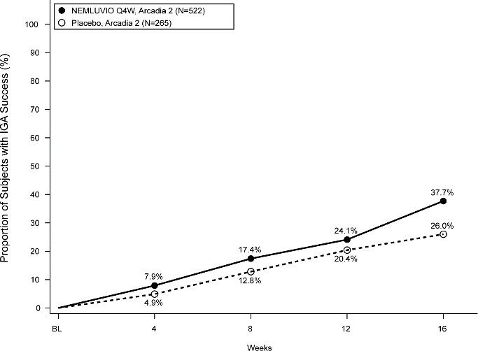
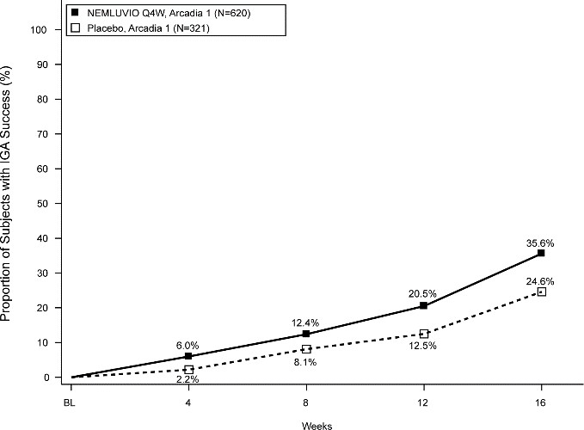

Figure 2 – Proportion of subjects with EASI-75 from baseline to week 16 in ARCADIA 1 and ARCADIA 2
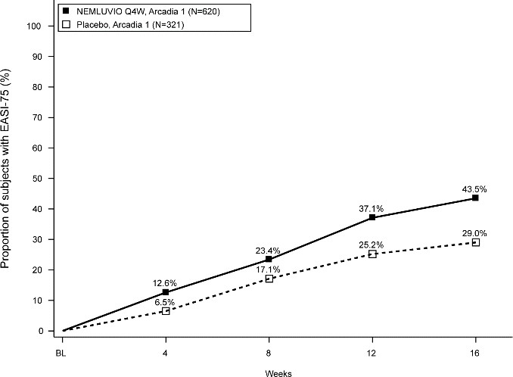
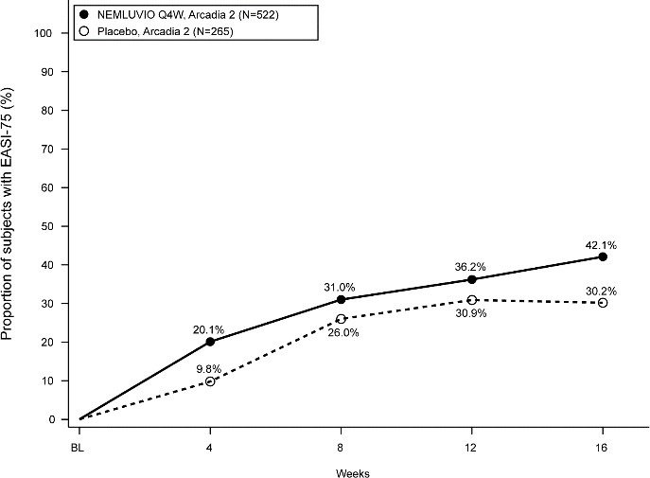

Significant improvement in pruritus for patients treated with Nemluvio in ARCADIA 1 and ARCADIA 2 compared to placebo based on PP NRS improvements ≥4 and PP NRS percent change from baseline was observed starting at Week 1 and was maintained up to Week 16 (Table 5, Figure 3a-3b and Figure 4a-4b).

Table 5 Efficacy results on Itch for Nemluvio with concomitant TCS/TCI in ARCADIA 1 and ARCADIA 2 up to Week 16
 | ARCADIA 1 |  | ARCADIA 2
 | Nemluvio + TCS/TCI | Placebo + TCS/TCI | Nemluvio + TCS/TCI | Placebo + TCS/TCI
Number of subjects randomized and dosed  (Baseline PP NRS improvement ≥4)a | 620 | 321 | 522 | 265
% of subjects with PP NRS improvement ≥4a
At Week 1 | 4.7§ | 1.2 | 6.7* | 0.4
At Week 2 | 17.7* | 3.1 | 16.9* | 1.9
At Week 4 | 27.4* | 6.5 | 26.1* | 5.3
At Week 16 | 42.7* | 17.8 | 41.0* | 18.1
% of subjects with PP NRS <2a
At Week 4 | 16.0* | 3.7 | 15.9* | 2.6
At Week 16 | 30.6 | 11.2 | 28.4* | 11.3
Number of subjects with severe pruritus (Baseline PP NRS≥7) | 406 | 210 | 316 | 164
% of subjects with PP NRS improvement ≥4a
At Week 1 | 6.2§ | 1.9 | 8.5# | 0.6
At Week 2 | 20.7* | 3.8 | 19.3* | 3.0
At Week 4 | 28.3* | 7.1 | 30.4* | 7.9
At Week 16 | 46.1* | 18.6 | 48.4* | 21.3
% of subjects with PP NRS <2a
At Week 4 | 12.6* | 2.9 | 11.1* | 1.2
At Week 16 | 27.8* | 7.6 | 26.9* | 8.5
a Subjects who received rescue treatment or with missing data were considered as non- responders, *p-value <0.001, §p-value <0.05
Strata adjusted p-value is based on the CMH test stratified by PP NRS and IGA score at baseline

Figure 3a -Proportion of subject with PP NRS improvement of ≥4 from baseline up to Week 16 in ARCADIA 1
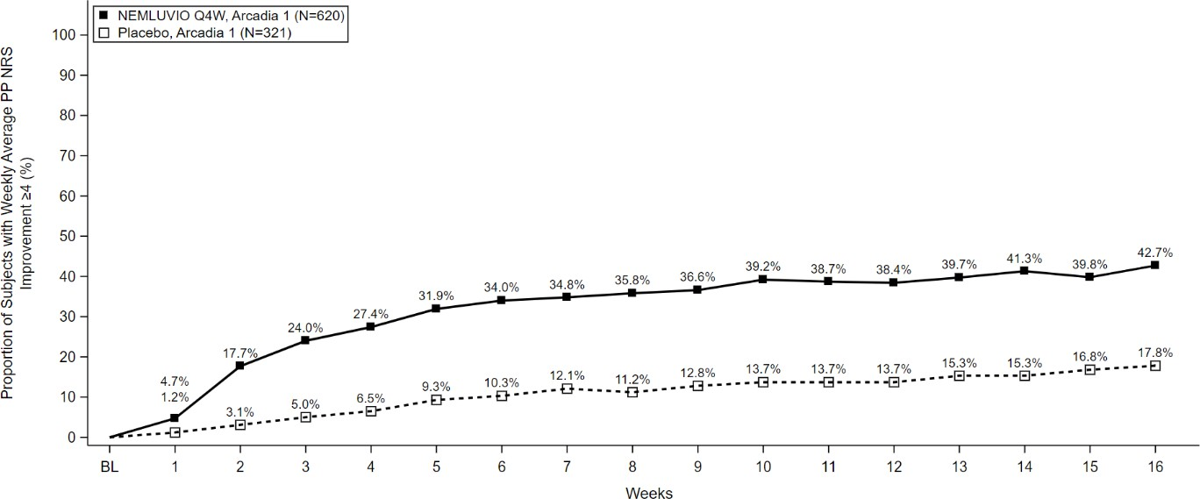

Figure 3b -Proportion of subject with PP NRS improvement of ≥4 from baseline up to Week 16 in ARCADIA 2
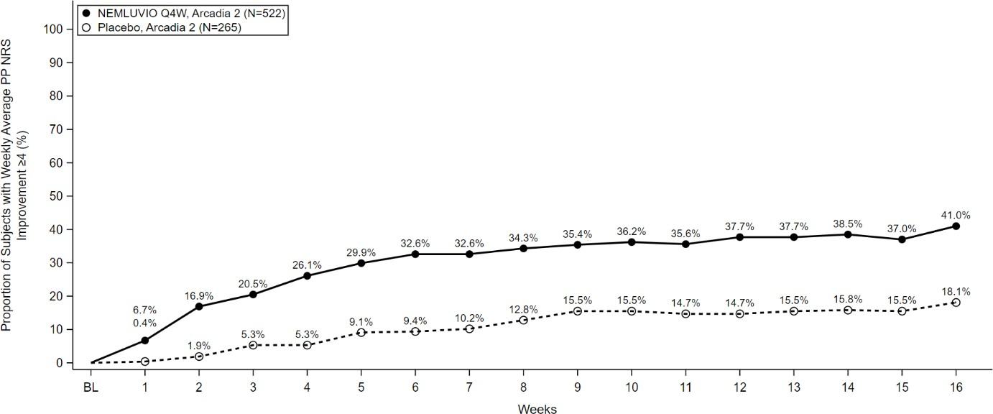

Figure 4a -Mean percent change from baseline in PP NRS up to week 16 in ARCADIA 1
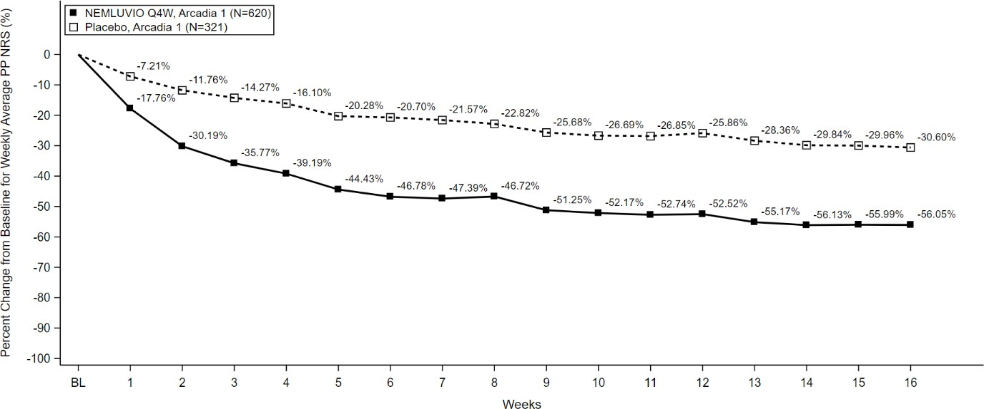

Figure 4B -Proportion of subject with PP NRS improvement of ≥4 from baseline up to Week 16 in ARCADIA 2
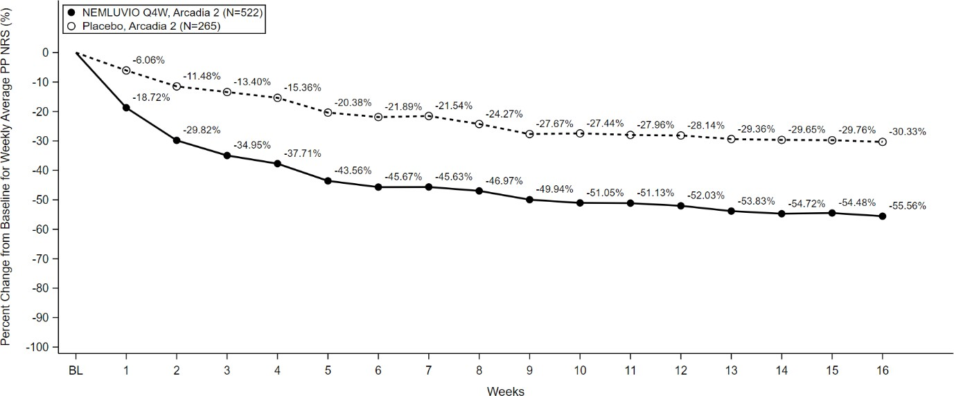

The SD NRS is a daily scale used by the subjects to report the degree of their sleep loss related to atopic dermatitis. A significant improvement in sleep disturbance was observed at Week 16 when compared to placebo (Table 6).

Table 6. Efficacy on Sleep Disturbance for Nemluvio with concomitant TCS/TCI in ARCADIA 1 and ARCADIA 2 at Week 16
 | ARCADIA 1 |  | ARCADIA 2
 | Nemluvio + TCS/TCI | Placebo + TCS/TCI | Nemluvio + TCS/TCI | Placebo + TCS/TCI
Number of subjects randomized and dosed  (Baseline PP NRS ≥4) | 620 | 321 | 522 | 265
% of subjects with SD NRS  improvement ≥4a | 37.9* | 19.9 | 33.5* | 16.2
Number of subjects with severe pruritus  (Baseline PP NRS≥7) | 406 | 210 | 316 | 164
% of subjects with SD NRS  improvement ≥4a | 42.1* | 22.4 | 42.7* | 20.7
aSubjects who received rescue treatment or with missing data were considered as non- responders, *p-value <0.0001. Strata adjusted p-value is based on the CMH test stratified by PP NRS and IGA scores at baseline
ARCADIA 1 and ARCADIA 2 – Adults and Adolescents – maintenance period, week 16 to week 48 The clinical response in Nemluvio responders (IGA 0.1 or EASI-75 at Week 16) was evaluated between Week 16 and Week 48 in ARCADIA 1 and ARCADIA 2 studies. For the maintenance
treatment period, 507 Nemluvio responders were re-randomized to Nemluvio 30 mg every 4 weeks, Nemluvio 30mg every 8 weeks or placebo every 4 weeks (Nemluvio withdrawal) with concomitant TCS/TCI. The pooled efficacy results for this period in the pivotal studies (ARCADIA 1 and ARCADIA 2) with Nemluvio at Week 48 are presented in Table 7.

Table 7. Maintenance Period Pooled Efficacy Results for Nemluvio with concomitant TCS/TCI in ARCADIA 1 and ARCADIA 2 at Week 48
 | Nemluvio + | Nemluvio + | Placebo +TCS/TCI
 | TCS/TCI | TCS/TCI | Q4W (Nemluvio
 | Q4W | Q8W | withdrawal)
 | N=169 | N=169 | N=169
% of subjects with IGA 0 or 1a
Week 16 (maintenance baseline) | 84.0 | 84.0 | 77.5
Week 48 | 61.5* | 60.4* | 49.7
% of subjects with EASI-75a
Week 16 (maintenance/baseline) | 96.4 | 96.4 | 92.9
Week 48 | 76.3* | 75.7* | 63.9
aSubjects who received rescue treatment or with missing data were considered as non- responders, *p-value <0.05
Strata adjusted p-value is based on the CMH test stratified by PP NRS and IGA scores at baseline
Treatment effects in subgroups (weight, age, gender race, and prior treatment, including immunosuppressants) in ARCADIA 1 and ARCADIA 2 were generally consistent with the results in the overall study population.

Adolescents with atopic dermatitis (12 to 17 years of age)
The efficacy results of the ARCADIA 1, ARCADIA 2 studies at Week 16 for adolescent patients 12 to 17 years of age are presented in Table 8. The results in the adolescent patient population were generally consistent with the results in the adult population.

Table 8. Efficacy Results for Nemluvio (30 mg Q4W) with concomitant TCS/TCI in ARCADIA 1 and ARCADIA 2 at Week 16 in adolescent patients 12 to 17 years of age
 | ARCADIA 1 AND ARCADIA 2
 | Nemluvio + TCS/TCI | Placebo + TCS/TCI
Number of subjects randomized and dosed (Baseline PP NRS≥4) | 179 | 90
% of subjects with IGA 0 or 1a | 48.9* | 34.4
% of subjects with EASI-75a | 53.4§ | 43.3
Number of subjects with severe pruritus (Baseline PP NRS≥7) | 120 | 61
% of subjects with IGA 0 or 1a | 54.2* | 32.8
% of subjects with EASI-75a | 57.5# | 42.6
a Subjects who received rescue treatment or with missing data were considered as non- responders, *p-value <0.05, #p-value =0.1025, §p-value =0.1824
Strata adjusted p-value is based on the CMH test stratified by PP NRS and IGA score at baseline Clinical efficacy and safety in adults with prurigo nodularis
The efficacy and safety of Nemluvio as monotherapy was evaluated in two randomized, double- blind, placebo-controlled pivotal studies (OLYMPIA 1 and OLYMPIA 2) that enrolled a total of 560 subjects 18 years of age and older with prurigo nodularis. Disease severity was defined using an Investigator’s Global Assessment (IGA) in the overall assessment of prurigo nodularis nodules on a severity scale of 0 to 4. Subjects enrolled in these two studies had an IGA score ≥ 3, severe pruritus as defined by a weekly average of the peak pruritus numeric rating scale (PP- NRS) score of ≥7 on a scale of 0 to 10, and greater than or equal to 20 nodular lesions. OLYMPIA 1 and OLYMPIA 2 assessed the effect of Nemluvio monotherapy on the signs and symptoms of prurigo nodularis, targeting improvement in skin lesions and pruritus over 16 weeks. OLYMPIA 1 had a 24-week treatment period and OLYMPIA 2 a 16-week treatment period.
Subjects completing OLYMPIA 1 and OLYMPIA 2 had the opportunity to enrol into the open- label trial (OLYMPIA LTE) and receive treatment with Nemluvio every 4 weeks up to 184 weeks. Subjects weighing less than 90 kg in the Nemluvio monotherapy group received subcutaneous injections of Nemluvio 60 mg (2 injections of 30 mg) at Week 0, followed by 30 mg injections every 4 weeks. Subjects weighing 90 kg or more in the Nemluvio monotherapy group received subcutaneous injections of Nemluvio 60 mg (2 injections of 30 mg) at Week 0 and every 4 weeks.
The PP NRS score is a weekly average of daily PP NRS scores on an 11-point scale from 0-10 that assesses the maximal intensity of pruritus in the last 24 hours with 0 being no itch and 10 being worst itch imaginable. The IGA is a 5-category scale, including “0 = clear”, “1 = almost clear”, “2 = mild”, “3 = moderate” or “4 = severe” indicating the investigator’s overall assessment of the pruriginous nodules.

Endpoints
Both OLYMPIA 1 and OLYMPIA 2 assessed the same two primary endpoints:

- Proportion of subjects with an improvement of ≥4 from baseline in Peak Pruritus Numeric Rating Scale (PP NRS) at Week 16
- Proportion of subjects with an IGA success (defined as an IGA of 0 [Clear] or 1 [Almost Clear], and a ≥2-point improvement from baseline) at Week 16

Key secondary endpoints included PP NRS improvement ≥4 from baseline at Week 4, PP NRS <2 at Week 4 and Week 16, SD NRS improvement ≥4 from baseline at Week 4 and 16.

Baseline characteristics
In these studies, at baseline, 59.6% of subjects were female, 81.4% were white, 25.4% of subjects were older than 65 years of age. The baseline weekly average PP NRS score was a mean (SD) of 8.4 (0.9). Fifty-eight (58)% of subjects had a baseline IGA score of 3 (moderate PN), 42% of subjects had a baseline IGA of 4 (severe PN) and the mean baseline DLQI was 16.9.
Clinical response
Monotherapy studies (OLYMPIA 1 and OLYMPIA 2) – week 0 to week 16
Results of the pivotal studies evaluating treatment of Nemluvio in OLYMPIA 1 and OLYMPIA 2 are presented in Table 9 and show significant improvement in Nemluvio treated subjects, compared to placebo for both primary endpoints (Figure 5 and Figure 6) and key secondary endpoints (Figure 7).

Table 9. Efficacy Results for Nemluvio monotherapy (every 4 weeks) in OLYMPIA 1 and OLYMPIA 2 at Week 16
 | OLYMPIA 1 |  | OLYMPIA 2
 | Nemluvio | Placebo | Nemluvio | Placebo
Number of subjects randomized | 190 | 96 | 183 | 91
% of subjects with improvement of PP NRS ≥4 from baselinea
Week 16 | 58.4* | 16.7 | 56.3* | 20.9
% of subjects with PP NRS <2a
Week 16 | 34.2* | 4.2 | 35.0* | 7.7
% of subjects with IGA 0 or 1 at Week 16a | 26.3# | 7.3 | 37.7* | 11
% of subjects with improvement of SD NRS ≥4 from baselinea
Week 16 | 50.0* | 11.5 | 51.9* | 20.9
aIf a subject received any rescue therapy, composite variable strategy is applied, the underlying data at/after receipt of rescue therapy is set at worst possible value, and the response is derived from underlying data value. Subjects with missing results are considered as non-responders. bNot adjusted for multiplicity
*p-value <0.0001, #p-value =0.0025 Strata adjusted using the randomized stratification variables (analysis centre and baseline body weight (<90 kg, ≥90 kg)
§p-value <0.0001 Strata adjusted vs placebo (ANCOVA MI-MAR)

Figure 5 – Proportion of Subjects with PP-NRS Improvement ≥4 from baseline to Week 16
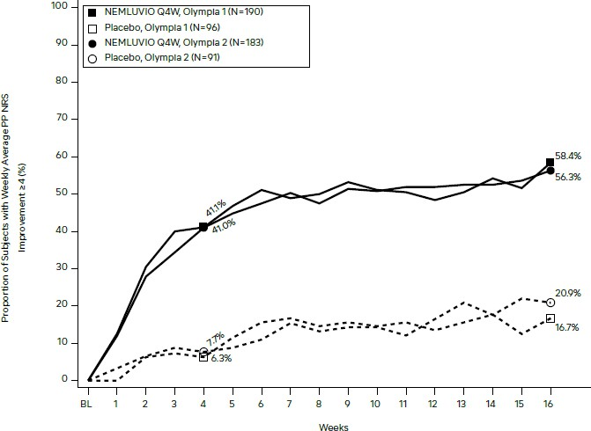

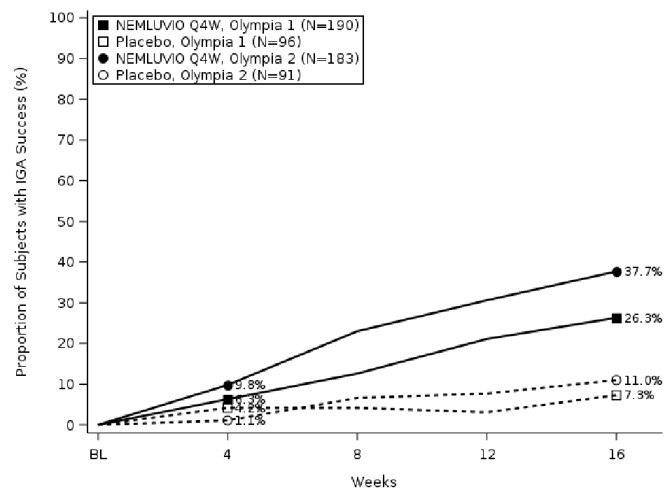
Figure 6 – Proportion of IGA responders from baseline to Week 16

Figure 7 – Proportion of Subjects achieving PP-NRS <2 at Week 4 and Week 16
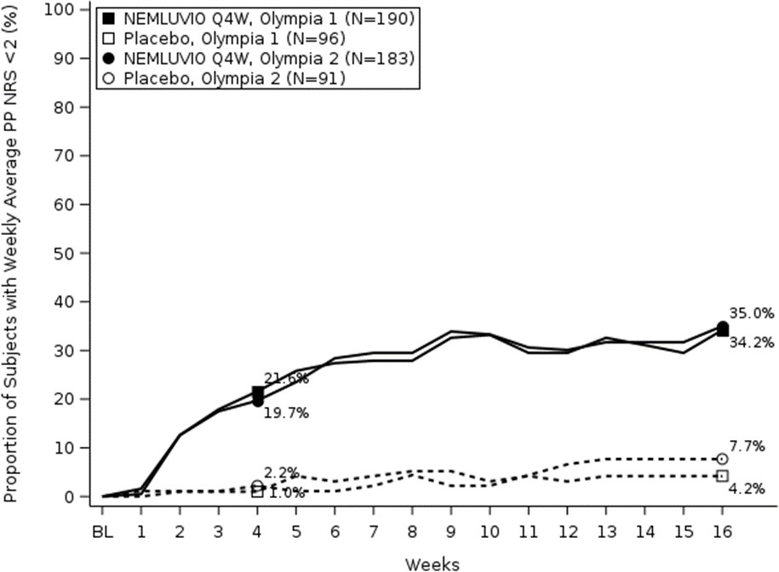

Treatment effects in subgroups (weight, age, gender, race, history of atopy, and prior treatment, including immunosuppressants) in OLYMPIA 1 and OLYMPIA 2 were generally consistent with the results in the overall study population.

Pharmacokinetic properties

Absorption
No difference was identified in the Nemolizumab PK profiles between subjects with atopic dermatitis and with prurigo nodularis, thus confirming that the disease does not impact the Nemolizumab PK profile.
Following an initial subcutaneous dose of 60 mg in a phase1 trial (96 subjects per arm), Nemolizumab reached peak mean (SD) concentrations (Cmax) of 7.5 (2.31) μg/mL by approximately 6 days post dose.

Following multiple doses of Nemluvio in subjects with AD, the population PK estimated mean (SD) steady-state trough concentrations of nemolizumab were 2.63 (1.27) μg/mL for 30 mg administered every 4 weeks and 0.74 (0.44) μg/mL for 30 mg administered every 8 weeks.

Following multiple doses of Nemluvio in subjects with PN, the population PK estimated mean (SD) steady-state trough concentrations of nemolizumab 3.04 (1.23) μg/mL in patients with body weight <90 kg for 30 mg administered every 4 weeks; and 3.66 (1.63) μg/mL in patients with body weight ≥90 kg for 60 mg administered every 4 weeks.

In both the atopic dermatitis and prurigo nodularis populations, steady state concentrations of nemolizumab were achieved by week 4 after a 60 mg loading dose and by week 12 without a loading dose.
Linearity/non-linearity
After a single dose, nemolizumab exhibited linear pharmacokinetics with exposures increasing in dose proportional manner between 0.03 and 3 mg/kg.
After multiple doses, nemolizumab systemic exposure increased in an approximately dose- proportional manner across the SC dose range up to 30 mg. There was a slight decrease in bioavailability by 9% with the 60 mg SC dose and by 15% with the 90 mg SC dose.

Distribution
Based on a population PK analysis, the volume of distribution for Nemolizumab was 7.67.

Metabolism
Specific metabolism studies were not conducted because nemolizumab is a protein. Nemolizumab is expected to be metabolised into small peptides by catabolic pathways.

Excretion
Nemolizumab is expected to be degraded in the same manner as endogenous IgG. In the population PK analysis, the terminal elimination half-life (SD) of nemolizumab was estimated to be 18.9 (4.96) days and systemic clearance was estimated to be 0.263 L/day.

Special Populations
Gender
Gender was not found to be associated with any clinically meaningful impact on the systemic exposure of nemolizumab determined by population PK analysis.
Age
No clinically significant difference in the pharmacokinetics of nemolizumab was estimated based on age (18 – 65 years and > 65 years) determined by population PK analysis. A total of 181 subjects above 65 years were included in the analysis. Dose adjustment in this population is not recommended.
Race
Race was not found to be associated with any clinically meaningful impact on the systemic exposure of nemolizumab by population PK analysis.
Hepatic impairment
Nemolizumab, as a monoclonal antibody, is not expected to undergo significant hepatic elimination. No clinical studies have been conducted to evaluate the effect of hepatic impairment on the pharmacokinetics of nemolizumab. Mild to moderate hepatic impairment was not found to affect the PK of nemolizumab determined by population PK analysis. No data are available in patients with severe hepatic impairment.

Renal impairment
Nemolizumab, as a monoclonal antibody, is not expected to undergo significant renal elimination. No clinical studies have been conducted to evaluate the effect of renal impairment on the pharmacokinetics of nemolizumab. Population PK analysis did not identify mild or moderate renal impairment as having a clinically meaningful influence on the systemic exposure of nemolizumab. Very limited data are available in patients with severe renal impairment.
Body weight
In both atopic dermatitis and prurigo nodularis populations, steady state concentrations of Nemolizumab were achieved by week 4.

Table 10 – PK parameters by weight Quartile (geometric mean)

Body weight (kg) | 1st Quartile [30.8 to 62.0] | 2nd Quartile [62.0 to 74.0] | 3rd Quartile [74.0 to 87.1] | 4th Quartile [87.1 to 181]
C_{max,ss} (µg/mL) | 6.64 | 5.48 | 4.86 | 3.99
Ctrough,ss (µg/mL) | 2.92 | 2.39 | 2.18 | 1.72
AUC 𝜏,ss (µg•day/mL) | 137 | 113 | 101 | 81.6
AUCt,ss Area under the concentration-time curve during a dosing interval (τ) at steady state; Cmax,ss Maximum concentration at steady state; Ctrough,ss PPredose concentration at steady state
PK parameters calculated with population PK model (N=1952)
Atopic Dermatitis
The difference in systemic exposure due to body weight had no clinically meaningful impact on efficacy in subjects with AD. Dose adjustment based on body weight is not needed (see section 4.2).
Prurigo Nodularis
The variability in systemic exposure due to body weight had a clinically meaningful impact on skin lesion efficacy as assessed by IGA response but not on pruritus improvement and does require dose adjustment in subjects with PN.(see section 4.2).
Paediatric population Atopic dermatitis
In the population PK analysis, no clinically significant difference in the pharmacokinetics of nemolizumab was estimated in 12 -17 years paediatric subjects compared to adults. Dose adjustment in this population is not recommended.

Preclinical safety data

Genotoxicity
No genotoxicity studies have been conducted with nemolizumab. Due to its nature and pharmacological properties, direct DNA or other genetic material interaction is not expected for a recombinant humanised monoclonal immunoglobulin such as nemolizumab.

Carcinogenicity
Animal studies have not been conducted to evaluate the carcinogenic potential of nemolizumab.

PHARMACEUTICAL PARTICULARS

List of excipients

Powder for solution for injection:
- Sucrose
- Trometamol
- Trometamol hydrochloride (for pH-adjustment)
- Arginine hydrochloride
- Poloxamer

Solvent
- Water for injections

Incompatibilities
In the absence of compatability studies, this medicinal product must not be mixed with other medicinal products.

Shelf life
    - Pre-filled pen: 24 months
    - Pre-filled syringe: 36 months
If necessary, the carton containing the pre-filled pen or pre-filled syringe can be removed from the refrigerator at room temperature (up to 30°C) for a single period of up to 90 days. Write the date first removed from the refrigerator in the space provided on the inner partition for the pen or on the outer carton for the syringe.
Do not use Nemluvio beyond the expiration date or 90 days after the date it was first removed from the refrigerator (whichever is earlier).
Nemluvio must be removed from the refrigerator for 30-45 min before reconstitution. Once reconstitution steps are completed, Nemluvio must be used within 4 hours or discarded.
Information on the shelf life can be found on the public summary of the Australian Register of Therapeutic Goods (ARTG). The expiry date can be found on the packaging.

Special precautions for storage
Store in a refrigerator (2°C – 8°C). Do not freeze.
Store in the original carton in order to protect from light.
For storage conditions after reconstitution of the medicinal product, see section 6.3.

Nature and contents of container

Pre-filled pen
Single-use dual-chamber borosilicate glass type 1 cartridge in an auto-injector, with a stainless- steel staked needle.
Pack size:
    - 1 pre-filled pen
    - Multipack containing 2 (2 packs of 1) pre-filled pens

Pre-filled syringe
Single-use dual-chamber pre-filled syringe in a borosilicate glass type 1, co-packaged with a 27G needle (stainless steel) with safety shield.
Pack size:
    - 1 pre-filled syringe
Not all pack sizes may be marketed.

Special precautions for disposal

Any unused medicinal product or waste material should be disposed of in accordance with local requirements.

Physicochemical properties
Australian Approved Name (AAN): NEMOLIZUMAB
Chemical structure:
(Heavy chain)
QVQLVQSGAE VKKPGASVKV SCKASGYTFT GYIMNWVRQA PGQGLEWMGL INPYNGGTDY NPQFQDRVTI TADKSTSTAY MELSSLRSED TAVYYCARDG YDDGPYTLET WGQGTLVTVS SASTKGPSVF PLAPSSKSTS GGTAALGCLV KDYFPEPVTV SWNSGALTSG VHTFPAVLQS SGLYSLSSVV TVPSSNFGTQ TYTCNVDHKP SNTKVDKTVE RKSCVECPPC PAPPVAGPSV FLFPPKPKDT LMISRTPEVT CVVVDVSQED PEVQFNWYVD GVEVHNAKTK PREEQFNSTF RVVSVLTVVH QDWLNGKEYK CKVSNKGLPA PIEKTISKTK GQPREPQVYT LPPSQEEMTK NQVSLTCLVK GFYPSDIAVE WESNGQPENN YKTTPPMLDS DGSFFLYSKL TVDKSRWQEG NVFSCSVMHE ALHNHYTQKS LSLSP
(Light chain)
DIQMTQSPSS LSASVGDRVT ITCQASEDIY SFVAWYQQKP GKAPKLLIYN AQTEAQGVPS RFSGSGSGTD FTLTISSLQP EDFATYYCQH HYDSPLTFGG GTKVEIKRTV AAPSVFIFPP SDEQLKSGTA SVVCLLNNFY PREAKVQWKV DNALQSGNSQ ESVTEQDSKD STYSLSSTLT LSKADYEKHK VYACEVTHQG LSSPVTKSFN RGEC
(Disulfide bridge: H22-H96, H148-H204, H224-L214, H227-h227, H230-h230, H261- H321, H367-H425, h22-h96, h148-h204, h224-l214, h261-h321, h367-h425, L23-L88, L134-L194, l23-l88, l134-l194)

Molecular Formula: C6384H9814N1678O2034S48 Molecular Weight: 145.5 KD.
CAS number: 1476039-58-3

MEDICINE SCHEDULE (POISONS STANDARD)
S4 – Prescription Only Medicine

SPONSOR
Galderma Australia Pty Ltd Level 18, 1 Denison Street North Sydney NSW 2060
Ph: 1800 800 765
Australian Registration Number: AUST R 444530
AUST R 444531

DATE OF FIRST APPROVAL
dd mmmm yyyy

DATE OF REVISION

Summary table of changes

Section Changed | Summary of new information

