Australian Public Assessment Report for Nemluvio
  - Active ingredient: Nemolizumab
  - Sponsor: Galderma Australia Pty Ltd
August 2025

About the Therapeutic Goods Administration (TGA)
- The Therapeutic Goods Administration (TGA) is part of the Australian Government Department of Health, Disability and Ageing and is responsible for regulating therapeutic goods, including medicines, medical devices, and biologicals.
- The TGA administers the Therapeutic Goods Act 1989 (the Act), applying a risk management approach designed to ensure therapeutic goods supplied in Australia meet acceptable standards of quality, safety, and efficacy.
- The work of the TGA is based on applying scientific and clinical expertise to decision-making, to ensure that the benefits to the Australian public outweigh any risks associated with the use of therapeutic goods.
- The TGA relies on the public, healthcare professionals and industry to report problems with therapeutic goods. The TGA investigates reports received to determine any necessary regulatory action.
- To report a problem with a therapeutic good, please see the information on the TGA website.

About AusPARs
- The Australian Public Assessment Report (AusPAR) provides information about the evaluation of a prescription medicine and the considerations that led the TGA to approve or not approve a prescription medicine submission. Further information can be found in Australian Public Assessment Report (AusPAR) guidance.
- AusPARs are prepared and published by the TGA.
- AusPARs are static documents that provide information that relates to a submission at a particular point in time. The publication of an AusPAR is an important part of the transparency of the TGA’s decision-making process.
- A new AusPAR may be provided to reflect changes to indications or major variations to a prescription medicine subject to evaluation by the TGA.

Copyright
© Commonwealth of Australia 2025
This work is copyright. You may reproduce the whole or part of this work in unaltered form for your own personal use or, if you are part of an organisation, for internal use within your organisation, but only if you or your organisation do not use the reproduction for any commercial purpose and retain this copyright notice and all disclaimer notices as part of that reproduction. Apart from rights to use as permitted by the Copyright Act 1968 or allowed by this copyright notice, all other rights are reserved and you are not allowed to reproduce the whole or any part of this work in any way (electronic or otherwise) without first being given specific written permission from the Commonwealth to do so. Requests and inquiries concerning reproduction and rights are to be sent to the TGA Copyright Officer, Therapeutic Goods Administration, PO Box 100, Woden ACT 2606 or emailed to <tga.copyright@tga.gov.au>.

Contents
List of abbreviations 4
Nemluvio (nemolizumab) submission 5
Proposed indication 6
The conditions 7
Atopic dermatitis 7
Prurigo nodularis 8
Current treatment options 9
Clinical rationale 10
Regulatory status 10
Registration timeline 11
Assessment overview 11
Quality evaluation summary 11
Nonclinical evaluation summary 14
Clinical evaluation summary 16
Summary of clinical studies 16
Pharmacology 17
Efficacy 20
Safety 33
Risk management plan evaluation summary 40
Risk-benefit analysis 41
Proposed indication 42
Efficacy 42
Safety 45
Conclusions 47
Advisory Committee considerations 47
Assessment outcome 48
Specific conditions of registration 48
Product Information and Consumer Medicines Information 49

List of abbreviations
Abbreviation | Meaning
ACM | Advisory Committee on Medicines
AESI | Adverse event(s) of special interest
AD | Atopic dermatitis
ARTG | Australian Register of Therapeutic Goods
AUC | Area under the serum concentration-time curve
AUC_{inf} | Area under the serum concentration-time curve from time zero to infinity
AUC_{last} | Area under the serum concentration-time curve from 0 to the time of the last measurable serum concentration
CL/F | Apparent total clearance corrected for bioavailability
C_{max} | Maximum serum concentration
DCC-AI | Dual-chamber cartridge assembled with an autoinjector
DCS | Dual-chamber syringe
EASI | Eczema Area and Severity Index
IGA | Investigator’s Global Assessment
ITT | Intention-To-Treat
PD | Pharmacodynamic(s)
PI | Product Information
PK | Pharmacokinetic(s)
PN | Prurigo nodularis
popPK | Population pharmacokinetic(s)
PP NRS | Peak Pruritus Numerical Rating Scale
Q4W | Dosing every four weeks
Q8W | Dosing every eight weeks
RMP | Risk management plan
SAEs | Serious adverse events
SC | Subcutaneous
t_{1/2} | Elimination half-life
TEAE | Treatment emergent adverse event
T_{max} | Time to reach maximum serum concentration
TGA | Therapeutic Goods Administration
V/F | Apparent volume of distribution

Nemluvio (nemolizumab) submission
Type of submission: | New biological entity
Product name: | Nemluvio
Active ingredient: | nemolizumab
Decision: | Approved
Date of decision: | 12 May 2025
Approved therapeutic use for the current submission: | Atopic Dermatitis  Nemluvio is indicated for the treatment of moderate-to-severe atopic dermatitis (AD) in combination with topical corticosteroids and/ or topical calcineurin inhibitors in adults and patients aged 12 years and above who weigh at least 30 kg, who are candidates for systemic therapy.  Prurigo Nodularis  Nemluvio is indicated for the treatment of adults with moderate-to-severe prurigo nodularis who are candidates for systemic therapy.
Date of entry onto ARTG: | 27 May 2025
ARTG numbers | Nemluvio nemolizumab 30mg powder and solution for injection prefilled pen (444530)
Black Triangle Scheme: | Yes
sponsor’s name and address: | Galderma Australia Pty Ltd Level 18, 1 Denison Street North Sydney NSW 2060
Dose form: | Powder and solvent for solution for injection
Strength: | One pre-filled pen or syringe contains 30 milligrams of nemolizumab
Container/pack size | Pre-filled pen  Single-use dual-chamber borosilicate glass type 1 cartridge in an auto-injector, with a stainless- steel staked needle.  Pack size:  - 1 pre-filled pen  - Multipack containing 2 (2 packs of 1) pre-filled pens  Pre-filled syringe  Single-use dual-chamber pre-filled syringe in a borosilicate glass type 1, co-packaged with a 27G needle (stainless steel) with safety shield.  Pack size:  - 1 pre-filled syringe  Not all pack sizes may be marketed
Route of administration: | Subcutaneous injection
Dosage: | Atopic dermatitis  - An initial dose of 60 mg (two 30 mg injections), followed by 30 mg given every 4 weeks.  - After 16 weeks of treatment, for patients who achieve clinical response, the recommended maintenance dose of Nemluvio is 30 mg every 8 weeks.  Prurigo Nodularis  - For patients weighing < 90 kg, an initial dose of 60 mg (two 30 mg injections), followed by 30 mg given every 4 weeks.  - For patients weighing > 90 kg, an initial dose of 60 mg (two 30 mg injections), followed by 60 mg every 4 weeks.  For further information regarding dosage refer to the Product Information.
Pregnancy category: | Category B1  Drugs which have been taken by only a limited number of pregnant women and women of childbearing age, without an increase in the frequency of malformation or other direct or indirect harmful effects on the human fetus having been observed.  Studies in animals have not shown evidence of an increased occurrence of fetal damage.  The use of any medicine during pregnancy requires careful consideration of both risks and benefits by the treating health professional. The pregnancy database must not be used as the sole basis of decision making in the use of medicines during pregnancy. The TGA does not provide advice on the use of medicines in pregnancy for specific cases. More information is available from obstetric drug information services in your state or territory.

Proposed indication
This AusPAR describes the submission by Galderma Australia Pty Ltd (the sponsor) to register Nemluvio (nemolizumab) for the following proposed indication:
Atopic Dermatitis
Nemluvio is indicated for the treatment of moderate-to-severe atopic dermatitis in patients
aged 12 years and older who are candidates for systemic therapy.
Prurigo Nodularis
Nemluvio is indicated for the treatment of prurigo nodularis.

The conditions

Atopic dermatitis
Atopic dermatitis (AD), commonly known as eczema, is a chronic inflammatory skin disorder characterised by recurrent, pruritic, localised erythematous skin lesions. AD most commonly manifests in childhood and may persist into adulthood, though can start later in life, and may coexist with allergic asthma, allergic rhinitis, food allergies and other immediate hypersensitivity allergies. Global prevalence is estimated at 15-20% among children and up to 10% among adults, though prevalence varies between geographic regions, with increasing prevalence noted in high-income, industrialised countries in recent decades., AD appears to be slightly more common in females compared to males. In Australia, recently published data shows highest prevalence rates among the 0-4 years age group (lifetime prevalence 18.8%, current prevalence 13.8%) and 5-9 years age group (lifetime prevalence 22.1%, current prevalence 8.3%), with current prevalence between 5-10% among adults. It is estimated that AD first manifesting in childhood persists into adulthood in approximately 25% of patients, whilst Australian primary care data suggests that around 20% of patients with AD have moderate-to-severe disease.
Clinical manifestations are highly variable depending on a patient’s age and severity of illness. In infants and young children AD typically involves pruritic, red, scaly, crusted lesions affecting extensor surfaces, cheeks or scalp, whilst peeling of the skin or exudation of lesions can also occur., Over time, the skin may become lichenified, that is, thickened and leathery with changes in pigmentation. Common triggers include various environmental stimuli, such as heat, sweating, stress or infection. AD patients carry a higher risk of bacterial, viral and fungal skin infection, owing to skin barrier defects, colonisation of the skin, and an altered skin microbiome. Environmental factors that may predispose to, or exacerbate, AD include extremes of temperature, ultraviolet radiation, air pollution, increased water hardness, and increased use of household cleaning products.
Factors involved in pathogenesis include genetics, skin barrier dysfunction, microbial imbalance, immune dysregulation, and environmental triggers of skin inflammation. Inflammation is thought predominantly mediated by Th2 cells, with cytokines including IL-4, IL-13 and IL-31 activating downstream Janus kinase (JAK) pathways. These cytokines promote inflammation, pruritus, and production of antigen-specific IgE.1. Mutations in the filaggrin gene have been identified as predisposing to AD via skin barrier dysfunction.,

Prurigo nodularis
Prurigo nodularis (PN) is a chronic inflammatory skin disorder characterised by pruritic hyperkeratotic nodules. Epidemiology data is somewhat scarce, however, published estimates of prevalence in the United States range from 58 to 72 per 100,000,, and recently published data from the United Kingdom estimated prevalence of 3.27 per 10,000 (equivalent to 327 per 100,000). There is limited published Australian epidemiological data. PN can occur in all ages, though appears to be most common in the fifth and sixth decades of life, and is slightly more common in females. PN may be more common in people of non-white ethnicity. Comorbid dermatologic conditions are common, particularly AD with estimated rates of comorbidity 30-50%, whilst other atopic, autoimmune, infectious and malignant conditions occur more commonly in patients with PN.,
Intractable pruritus and hyperkeratotic nodules are the cardinal clinical features of PN. The number of nodules can range from several to >100, often occurring in groups, and symmetrically distributed on the extensor surfaces of the extremities, and the trunk; skin on the upper part of the back is typically spared, the so-called ‘butterfly sign’., Nodules range from several millimetres to up to 2cm in diameter, and they commonly appear excoriated or crusted owing to the itch-scratch cycle.,
Whilst exact pathogenesis of PN remains unknown, both immune and neural dysregulation is implicated. Histopathologic studies have demonstrated dermal, interstitial and perivascular infiltrates of T lymphocytes, mast cells, and eosinophilic granulocytes, whilst inflammation and pruritus appears mediated by various cytokines including IL-31, tryptase, histamine, and prostaglandins. Neuronal dysregulation has been evidenced by altered nerve fibre density between the dermis and epidermal layers in PN, with relative hyperplasia in the dermis. Dysregulated signalling via neuropeptides has also been demonstrated.,

Current treatment options

Atopic dermatitis
Treatment approach is generally guided by severity of disease, extent of body-surface area involved, degree of associated pruritus, age, and patient preferences. Key elements of treatment for all patients are identification and avoidance of aggravating factors, improving skin condition via regular application of emollients, treatment of areas of inflammation, and treatment of infection if present.
Topical corticosteroids, available in various strengths and dosage forms, are a mainstay of treatment in all age groups. They may be used on an as needed basis with the goal of achieving clear skin and, particularly in mild to moderate AD, may be the only treatment required., Additional topical preparations are available as steroid-sparing options or for use on more sensitive areas such as the face, groin or axillae; available products include the topical calcineurin inhibitor pimecrolimus, the topical phosphodiesterase-4 inhibitor crisaborole, or compounded tar preparations.,
In moderate to severe AD, or AD not adequately responsive to topical therapies, systemic treatment options are available, generally requiring input from a dermatologist. Ultraviolet phototherapy is an option in moderate to severe disease whilst systemic immunosuppressants such as azathioprine, cyclosporine or systemic corticosteroids may be used under certain circumstances. Biologic therapies currently approved in Australia with an AD indication include dupilumab, for moderate to severe AD in adolescents and adults and severe disease in children aged from 6 months, lebrikizumab, in adults and adolescents from 12 years of age, whilst the JAK-inhibitors abrocitinib and baricitinib are indicated for moderate to severe AD in adults, and upadacitinib in adults and adolescents from 12 years of age.

Prurigo nodularis
Historically, treatment of PN has been inadequate due to a lack of therapies targeting the pathophysiologic components of PN. The primary aim of PN treatment is to break the itch-scratch cycle and reduce pruritus to achieve healing of nodules. Treatment can use a combination of topical and systemic therapies, and is guided by disease severity, patient’s age and comorbidities. Topical therapies including high-potency corticosteroids and calcineurin inhibitors may be used, but with limited clinical study data to support efficacy, whilst topical anaesthetics may provide some symptomatic relief from itch. Ultraviolet phototherapy can reduce pruritus and is a therapeutic option in PN. A significant proportion of patients with PN will require some form of systemic treatment due to inadequate response to topical therapies.
Off-label use of systemic immunomodulatory agents such as methotrexate, cyclosporine, and azathioprine, or systemic neuromodulatory agents including gabapentin, pregabalin antidepressants and naltrexone are suggested options in published literature., Dupilumab is the first biologic agent approved both in Australia and internationally with an indication for PN.

Clinical rationale
Nemolizumab is a humanized, immunoglobulin G2 (IgG2) interleukin-31 receptor A (IL-31RA) monoclonal antibody which competitively blocks binding of IL-31 to its receptor, thus blocking subsequent IL-31 mediated signalling. IL-31 signalling is implicated in pruritus associated with conditions including AD and PD, and in inflammation, epidermal differentiation, and skin barrier integrity. The sponsor’s stated rationale for clinical development includes unmet therapeutic need relating to treatment of pruritus in patients with AD, and that current treatments used in AD may not adequately address inflammation and skin barrier function, key factors in pathophysiology. Regarding PD, the sponsor notes the established role of IL-31 in pathophysiology of the disease, the limited disease-specific treatment options, and the lack of efficacy data to support use of current topical and systemic treatments advocated in consensus treatment guidelines.

Regulatory status

Australian regulatory status
This product is a new biological entity for Australian regulatory purposes.

International regulatory status
At the time of submission of this application nemolizumab had been approved by the Pharmaceuticals and Medical Devices Agency in Japan (date of approval 28 March 2022), with trade name MITCHGA, and approved indication
treatment of pruritus associated with AD (only when existing treatments are inadequate) in patients aged 13 years and older.
Separate Biologics License Applications (BLAs) for an AD indication and PN indication were submitted to the US FDA in December 2023. Subsequently, nemolizumab (as Nemluvio) in the 30 mg/0.49 mL pre-filled pen presentation, received FDA approval via the priority review pathway, with the approved indication:
treatment of adults with prurigo nodularis.
On 13 December 2024 the BLA for the AD indication received FDA approval, with the approved indication:
Nemluvio is indicated for the treatment of adults and pediatric patients 12 years of age and older with moderate-to-severe AD in combination with topical corticosteroids and/or calcineurin inhibitors when the disease is not adequately controlled with topical prescription therapies.
An application had been submitted in the EU via the European Medicines Agency (EMA) centralised procedure in January 2024. On 12 December 2024 the Committee for Medicinal Products for Human Use (CHMP) adopted a positive opinion, recommending the granting of marketing authorisation for Nemluvio in both AD and PN indications. The AD indication accepted by the CHMP is:
Nemluvio is indicated for the treatment of moderate-to-severe AD in patients aged 12 years and older who are candidates for systemic therapy
whilst the accepted PN indication is:
Nemluvio is indicated for the treatment of adults with moderate-to-severe prurigo nodularis who are candidates for systemic therapy.

Registration timeline
Table 1 captures the key steps and dates for this submission.
This submission was evaluated under the standard prescription medicines registration process.
This submission was evaluated as part of the Australia-Canada-Singapore-Switzerland-United Kingdom (ACCESS) Consortium with work-sharing between the TGA, Health Sciences Authority Singapore, Swissmedic and the Medicines and Healthcare Products Regulatory Agency. Each regulator made independent decisions regarding approval (market authorisation) of the new medicine.
Table 1. Registration timeline for Nemluvio (nemolizumab)
Description | Date
Submission dossier accepted and evaluation commenced | 3 May 2024
Evaluation completed | 29 January 2025
Advisory committee meeting | 4 April 2025
Registration decision (Outcome) | 12 May 2025
Registration in the ARTG completed | 27 May 2025
Number of working days from submission dossier acceptance to registration decision* | 260 days
*Statutory timeframe for standard submissions is 255 working days

Assessment overview

Quality evaluation summary
The finished product is presented as a powder and solution for injection in either a pre-filled pen or pre-filled syringe for subcutaneous (SC) administration containing 30 mg/dose of nemolizumab as active substance. Other ingredients, and their concentration, are summarised in Table 2.
Table 2. Nemluvio formulation
Active ingredient | Quantity (mg/vial)
Nemolizumab | 30
Excipients | Quantity (mg/vial) | Role in formulation | Standards
Sucrose | 25.8 | Bulking agent | Ph. Eur./USP-NF
Trometamol | 0.10 | Buffer | Ph. Eur./USP-NF
Trometamol hydrochloride | q.s. pH 7.0 | pH adjustment | In house
Arginine hydrochloride | 9.5 | Stabiliser | Ph. Eur./USP-NF
Poloxamer 188 | 0.15 | Surfactant | Ph. Eur./USP-NF
Water for injections |  | Diluent for reconstitution | Ph. Eur./USP-NF

The product is available in either a dual chamber syringe or dual chamber cartridge within a pen. In both cases, one chamber contains the lyophilised powder and the other water for injection. The dual chamber syringe consists of a type I glass barrel with bromobutyl rubber middle and rear plungers, siliconized bromobutyl closure cone and tip cap with a polypropylene snap-on cap. The dual chamber cartridge consists of a type I glass barrel with bromobutyl rubber middle and rear plungers, bromobutyl closure disk and polypropylene snap-on cap.
The formulation intended for marketing was used in the phase 3 clinical studies. All excipients are well known pharmaceutical ingredients, and their quality is compliant with Ph. Eur/BP/USP/JP standards. There is no novel excipients used in the finished product formulation. The container closure is considered suitable for its intended use as demonstrated by compatibility and stability studies.
Nemolizumab is a glycosylated IgG2 kappa monoclonal antibody that selectively binds IL-31 receptor. The molecular weight is approximately 144 kDa comprising two heavy chain molecules and two light chain molecules. The active ingredient was produced using recombinant DNA technology. Information about the manufacturing, storage and control facilities for the active substance has been provided in the dossier. Good manufacturing practice (GMP) compliance has been demonstrated.
The manufacturing process is a cultivation process with nutritive feeds. One vial of the working cell bank is thawed and the cell culture is expanded in shake flasks, wave bags and seeding bioreactors. The production bioreactor is harvested after a defined production period and a clarification is performed. The purification process includes three chromatography steps as well as viral inactivation/clearance steps, ultrafiltration/diafiltration, final formulation and final filtration (0.22 μm). The purification process has been described in sufficient detail, providing lists of process parameters and their acceptance criteria, for each step.
Nemolizumab active substance is stored in ethylene vinyl acetate single-use bags at -50 ± 10°C and shipped to the finished product manufacturing facility at controlled conditions. Details and specifications of the bags, compatibility of the container and a summary of an extractable and leachable study was presented and concluded that the risk for patients due to substances leaching into nemolizumab active substance is negligible.
The overall quality of the active substance was demonstrated via adequate control of the starting material, control of critical steps and intermediates, process validation, extensive characterisation using orthogonal and state-of-the-art analytical methods, control of impurities and contaminants, generation of robust reference materials and batch analyses that covered multiple manufacturing campaigns.
Nemolizumab quality control testing for batch release includes appearance (Ph. Eur.), pH (Ph. Eur.), purity, identity, quantity, potency, process-related impurities and endotoxins/bioburden (Ph. Eur.). The biological activity is tested using a cell-based bioassay. The proposed release specification for the active substance is found acceptable, with respect to test methods chosen. The proposed specification limits are based on batch analysis and stability study results. This approach is considered acceptable.
The sponsor proposed a shelf life of 48 months at -50 ± 10°C and protection from light.
Stability data have been generated under real time and stressed conditions to characterise the stability profile of the active ingredient and to establish a shelf life. The real time data submitted support a shelf life of 48 months when stored at -50 ± 10°C.
The drug product manufacturing process is conducted with defined manufacturing procedures, process validations, critical process parameters, in-process parameters and batch analyses of multiple manufacturing campaigns. Finished product (and active substance) comparability studies were conducted in order to demonstrate that the quality of the commercial manufacturing process is comparable to the pre-change product. These were assessed and considered satisfactory.
All analytical methods used for testing of the finished product are satisfactorily described in the dossier and non-compendial methods have been validated. Many test methods used for release testing and stability testing of the finished product are the same as those used for release testing and stability testing of the active substance.
The reference standard used in the testing and release of nemolizumab finished product is the same as the one used for the testing and release of nemolizumab active substance.
The finished product quality control for batch release includes identity, potency, purity, impurities, sterility (Ph. Eur.), bacterial endotoxin (Ph. Eur.) and several other general tests.
Stability data have been generated under stressed and real time conditions to characterise the stability profile of the product. Following evaluation, the recommended storage condition for the presentations are:
- Dual chamber syringe 36 months, 2°C - 8°C, protected from light
- Dual chamber cartridge pen, 24 months, 2°C - 8°C, protected from light
In-use stability data have also been submitted. The recommended shelf life and storage conditions for the reconstituted product are 4 hours when stored at ≤ 30°C.
A patient convenience condition is included where the products may be stored at ≤ 30°C for up to 90 days and then discarded.
Sterility, adventitious agents (viral, transmissible spongiform encephalopathies and mycoplasma), container, and endotoxin safety assessments were carried out with the aim of ensuring product quality and safety. These include (where appropriate) control/testing of starting materials, containers, in-process steps, decontamination/reduction steps active ingredient and finished product tests. Adequate data has been presented which give reassurance on removal/reduction (to safe levels) of contaminants.
The quality of this product is considered to be acceptable when used in accordance with the conditions defined in the PI, labels, consumer medicines information and the ARTG. Physicochemical and biological aspects relevant to the uniform clinical performance of the product have been investigated and are controlled in a satisfactory way. Information on development, manufacture and control of the active substance and finished product has been presented in a satisfactory manner. The results of tests carried out indicate consistency and uniformity of important product quality characteristics, and these in turn lead to the conclusion that the product should have a satisfactory and uniform performance in clinical use. From quality perspective, compliance with Therapeutic Goods Legislation (Therapeutic Goods Act/Regulations) and relevant Therapeutic Goods Orders as well as consistency with relevant guidelines and the Australian Regulatory Guidelines for Prescription Medicines has been demonstrated.
There are no objections on quality grounds to the approval of Nemluvio.

Nonclinical evaluation summary
Under the agreed ACCESS partner work-sharing arrangements for this application the UK MHRA was the lead agency for nonclinical data evaluation; a TGA nonclinical evaluation report has been completed based on the MHRA report.
The submitted nonclinical dossier was in accordance with the relevant ICH guideline for biological medicines (ICH S6[R1]1). The overall quality of the nonclinical dossier was high and acceptable.
In vitro, nemolizumab bound the soluble form of IL-31RA from cynomolgus monkeys and human subjects with similar affinity (0.19 and 0.37 nM, respectively). No significant binding was seen on IL-31RA from mice, rats or rabbits. Nemolizumab inhibited IL-31 binding to IL-31RA (human and cynomolgus monkey) and inhibited IL-31-dependent signalling (STAT3 phosphorylation in human cell lines) and downstream effects (proliferation of monkey cell lines, cytokine production and apoptosis in human cell lines).
In vivo, nemolizumab inhibited itch in an IL-31-induced systemic itch model in cynomolgus monkeys at ≥40 μg/kg IV (but not 10 μg/kg IV) and 1 mg/kg SC (the only SC dose assessed). Inhibition of itching was still seen in animals lacking anti-drug antibodies up to 56 days following dosing. The minimum plasma nemolizumab concentrations inhibiting itch were below or within the clinical C_{trough} levels.
In a murine mite antigen-induced AD model, a mouse surrogate of nemolizumab inhibited dermatitis symptoms while there was a trend for a lowering in scratching activity.
The primary pharmacology studies lend support for the use of nemolizumab in the proposed indications and the selection of animal species (cynomolgus monkey) for the toxicity studies.
Nemolizumab did not affect signalling of cytokines (IL-6 and OSM) that utilise gp130, a cytokine receptor that has homology to IL-31RA, indicating specificity for IL-31RA.
Consistent with being an IgG2-based antibody, nemolizumab had low binding to Fcγ receptors and C1q with no evident antibody-dependent cell-mediated cytotoxicity, complement-dependent cytotoxicity or direct cell death of IL-31RA-expressing cells. These activities are not predicted during clinical use.
Nemolizumab had significant binding to FcRn, which may contribute to its long half-life as well as placental transfer during pregnancy.
In a tissue cross-reactivity study, the pattern of staining of nemolizumab to human tissues was considered similar to the expected IL-31RA expression pattern, suggesting no off-target binding. A similar binding profile was seen between human and cynomolgus monkey tissues, confirming the selection of animal species for safety assessments.
In the submitted repeat-dose toxicity studies, no effects on CNS, respiratory or cardiovascular function were seen in cynomolgus monkeys up to 25 mg/kg SC (exposure ratio [ER] based on C_{max} [ERC_{max}] at least 40). Based on animal data, no adverse effects on CNS, respiratory or cardiovascular function are expected in patients.
The pharmacokinetic (PK) profile of nemolizumab was consistent with that of an antibody, characterised by a long half-life (3–15 days in cynomolgus monkeys and 19 days in human subjects) and low volume of distribution. The latter is suggestive of limited extravascular distribution which was confirmed in a tissue distribution study in cynomolgus monkeys. Following SC dosing, T_{max} was typically reached 3–4 days post-dose in monkeys and 7 days post-dose in human subjects. There were no consistent sex differences in PK parameters and no significant accumulation with twice weekly SC dosing of cynomolgus monkeys (omitting the first dose).
Anti-drug antibodies were detected in a number of animals in the repeat-dose toxicity studies. Lower exposures were generally seen in these animals.
Overall, the PK profile of nemolizumab was sufficiently similar in cynomolgus monkeys and human subjects.
As nemolizumab is a monoclonal antibody, co-administered inhibitors/inducers of CYP450 enzymes are unlikely to affect nemolizumab exposures. The mechanism of action of nemolizumab is to reduce IL-31 signalling. Therapeutic proteins that reduce cytokine levels have the potential to increase CYP450 expression and activity. In accordance with ICH M12, the sponsor conducted separate clinical drug interaction studies with nemolizumab and CYP3A4/5, 2C9, 2C19, 2D6 and 1A2 substrates.
Repeat-dose toxicity studies of up to 6 months were conducted in cynomolgus monkeys. The selection of species is acceptable. The clinical route (SC) was used. Dosing was more frequent than that proposed clinically (Q2W cf. Q4W or Q8W clinically), which is appropriate given the shorter half-life in the animal species. The conduct of the studies and parameters examined are considered acceptable. Immunophenotyping and T-cell dependent antibody responses were included in assessments. Neutralising antibodies were formed in a number of animals in each treatment group in the 6-month study which compromises the study somewhat given the initial small group sizes. No adverse effects were noted in either study. High relative exposures were seen at the NOAEL of 25 mg/kg SC Q2W (ER_{AUC} ~50).
No genotoxicity or carcinogenicity studies were conducted which is considered acceptable. Nemolizumab is a monoclonal antibody and is unlikely to interact directly with DNA. The only pharmacologically-responsive animal species is cynomolgus monkeys and it is not practical or ethical to conduct carcinogenicity studies in this species. Based on a weight of evidence approach, it was concluded that nemolizumab poses a low carcinogenicity risk.
Reproductive and developmental studies consisted of one enhanced pre/postnatal development (ePPND) study in cynomolgus monkeys. Surrogates for fertility were assessed in repeat-dose toxicity studies, which is acceptable; both males and females were sexually mature in these studies. There were no adverse effects on menstrual cycle, sperm analysis, testicular size measurement or histological evaluation of reproductive organs at doses up to 25 mg/kg SC Q2W (ER_{AUC} ~50).
Nemolizumab binds the FcRn receptor, consistent with an IgG2 antibody, and placental transfer was suggested in cynomolgus monkeys based on similar plasma concentrations in infants and mothers on postnatal day 7; there was minimal excretion of nemolizumab into milk.
The ePPND study was conducted in accordance with the design in ICH S5(R3). In addition to maternal dosing during pregnancy, infants were directly dosed in the postnatal period (starting on postnatal day 35) to assess potential effects on postnatal development up until weaning. No adverse effects in either mothers or infants (at birth or following direct dosing) were seen at doses up to 25 mg/kg SC Q2W (maternal ER_{AUC} ~30; infant ER_{AUC} 105). The absence of effects on embryofetal and infant development are consistent with findings in IL31-RA-knockout mice where no abnormalities in organ development were seen.
The sponsor has proposed Pregnancy Category B3. This category is for drugs that studies in animals have shown evidence of an increased occurrence of fetal damage, the significance of which is considered uncertain in humans. Given the absence of effects on embryofetal and infant development in cynomolgus monkeys and the absence of embryofetal development effects in IL-31RA knockout mice, Pregnancy Category B1 is considered more appropriate for this product.
No injection site reactions were seen following SC dosing of rabbits or cynomolgus monkeys. However, the exact clinical formulation was not used. The 6-month repeat-dose toxicity study used a similar formulation to the proposed clinical formulation but differed in the concentration of excipients. However, the concentrations of nemolizumab in dose solutions covered the proposed clinical concentration.
The risk of cytokine release syndrome was estimated to be low based on an in vitro study using whole blood from healthy adult donors and an absence of cytokine release in repeat-dose toxicity studies in cynomolgus monkeys. Additionally, nemolizumab treatment had no effect on the T-cell dependent antibody response or the composition of immune cells in the 6-month repeat-dose toxicity study in cynomolgus monkeys.
In summary,
- No major deficiencies were noted in the nonclinical dossier.
- The primary pharmacology studies lend support for the use of nemolizumab in the proposed indications.
- No clinically-relevant safety concerns were identified in the set of animal safety studies.
There are no nonclinical objections to the registration Nemluvio for the proposed indications.

Clinical evaluation summary

Summary of clinical studies
The dossier included two Phase 1 studies, 201590 and CIM001JP, with evaluable (PK and safety data submitted in support of both AD and PN indications. Key studies submitted specific to the AD indication included two pivotal Phase 3 efficacy/safety studies (studies 118161-AD and 118169-AD), one supportive long-term extension Phase 3 efficacy/safety study (study 118163-AD) with an interim report provided, and three supportive Phase 2 studies (studies 114322-AD, 116912-AD, and CIM003JG-AD). There were 16 additional studies identified by the sponsor as supporting the AD indication, including studies in PN and chronic kidney disease associated pruritus, and studies conducted by another sponsor; four of the additional studies remained ongoing with clinical study reports not available at the time of submission.
Key studies submitted specific to the PN indication included two pivotal Phase 3 studies (203065-PN, and 202685-PN), one supportive long-term extension Phase 3 study (202699-PN) with an interim report provided, and one supportive Phase 2 study (study 115828-PN). There were 14 additional studies identified by the sponsor as supporting the PN indication, including studies in AD and chronic kidney disease associated pruritus, and studies conducted by another sponsor; four of the additional studies remained ongoing with clinical study reports not available at the time of submission.
Two formulations of nemolizumab were used during clinical development, a lyophilized and a solution formulation, presented in either a vial, a dual-chamber cartridge assembled with an autoinjector (DCC-AI), or dual-chamber syringe (DCS). The vial containing liquid formulation was only used in the first-in-human study, CIMP001JP. The final drug product for which marketing authorisation is sought is a lyophilized powder for solution for SC injection, in either a single-use, single-dose DCS or DCC-AI containing 30 mg nemolizumab and water for injection; following reconstitution the drug product is formulated as 61.5 mg/mL nemolizumab. Bioequivalence was established between the DCS and DCC-AI presentations.

Pharmacology

Pharmacokinetics
Evaluable PK data was provided in two phase 1 PK studies, whilst population PK (popPK) analyses submitted included PK data from AD and PN patients obtained in four phase 2 and six phase 3 studies. This section will proceed by briefly summarising the PK studies and popPK analyses, before summarising key PK parameters for nemolizumab.

Study 201590
This was a phase 1, randomised, open-label, single-dose, parallel-group study in healthy adult subjects to compare PK, safety and immunogenicity between nemolizumab administered via an auto-injector or DCS. Subjects received a single 60 mg dose, administered via two 30 mg SC injections. In total 192 subjects with comparable demographics were randomised 1:1 between treatment groups, with PK sampling performed pre-dose, 12 hours and 24 hours post dose, then regularly up to 85 days post-dose. Key PK parameters were similar between treatment groups; C_{max} (mean±SD) was 8.0±2.34 µg/mL in the auto-injector group and 7.6±2.31 µg/mL in the DCS group, T_{max} 5 days and 6 days respectively, AUC_{0-inf} 270±85.8 µg.day/mL and 279±89.7 µg.day/mL respectively, and t_{1/2} 18.0±5.91 days and 18.5±4.52 days respectively.
Statistical analysis was undertaken using a linear model to assess log-transformed PK parameters (AUC_{0-inf} and C_{max} in the primary analysis) of nemolizumab, with delivery method (auto-injector[test] or DCS [reference]), injection site (abdomen, arm, or thigh), and interaction between delivery method and injection site as fixed effects. The 90% CI of the geometric least squares mean (LSM) was contained within bioequivalence limits of 80%-125% for the primary PK parameters AUC_{0-inf} and C_{max}, as well as secondary PK parameters analysed. There were no significant differences observed between abdomen, arm and thigh injection site strata.

Study CIM001JP
This was a phase 1, randomised, double-blind, placebo-controlled, interindividual, dose-escalation study conducted over three parts; with healthy Japanese adult male subjects (Part A, 42 subjects randomised to study treatment and 14 to placebo), with healthy White male adult subjects (Part B, 18 study treatment subjects and 6 placebo), and Japanese subjects with AD (Part C, 27 study treatment subjects and 9 placebo).
Overall, concentration-time relationship was similar between healthy Japanese and Caucasian male subjects. Based on descriptive statistics and a single regression analysis of the relationships between dose (mg/kg) and AUC_{inf}, AUC_{last} and C_{max}, exposure parameters increased in a dose-dependent manner in the range of 0.03 mg/kg to 3 mg/kg in healthy Japanese males and in the range 0.3 mg/kg to 3 mg/kg in both health Caucasian males and Japanese patients with AD. Based on statistical analysis of exposure PK parameters, overall exposure to study treatment tended to be lower in Japanese AD patients compared to healthy adults.

Study CIM003JG
This phase 2, randomised, double-blind, placebo-controlled, multiple-dose study conducted in adults with AD inadequately controlled or intolerant to topical therapy was primarily a dose-ranging, efficacy and safety study, however, included PK objectives. It was conducted over two parts; Part A was 12-weeks duration, involving parallel-group comparison of 4 different dosing regimens, whilst Part B was an extension phase conducted over a further 52 weeks (weeks 12 to 64) in which patients continued to receive nemolizumab and those initially randomised to placebo were re-randomised to the study drug. Doses included 0.1 mg/kg SC Q4W, 0.5 mg/kg SC Q4W, 2.0 mg/kg Q4W, and 2.0 mg/kg SC Q8W. PK parameters (AUC, C_{max}, clearance, volume of distribution and t_{1/2}) were characterised in Part A, and drug accumulation assessed in Part B.
Descriptive statistics for C_{max} and AUC_{0-28d} showed evidence of dose proportionality; mean C_{max} was 1.26 µg/mL in the 0.1 mg/kg Q4W group, 3.45 µg/mL in the 0.5 mg/kg Q4W group, 12.7 µg/mL in the 2.0 mg/kg Q4W group and also 12.7 µg/mL in the 2.0 mg/kg Q8W group, whilst respective AUC_{0-28d} in each group was 21.3 µg.day/mL, 64.9 µg.day/mL, 228.0 µg.day/mL, and 231.0 µg.day/mL. T_{max} ranged from 7.18 to 8.59 days across groups, mean half-life was 15.7 days, mean Cl/f 0.473 L/day, and mean volume of distribution 9.86 L. Serum trough levels over time showed steady-state reached at least 16 weeks after first administration of nemolizumab. In Part B of the study, in patients who had been administered at least 4 doses, serum trough concentrations at the last study visit were compared to first trough concentrations to estimate accumulation, with accumulation ratios ranging 1.46 to 1.84.

Study 114322
This was a phase 2, randomised, placebo-controlled, double-blind, parallel-group, dose ranging study, evaluating efficacy and safety of different nemolizumab doses in adult patients with moderate to severe AD with severe pruritus receiving topical corticosteroids, and included secondary PK objectives. Based on descriptive statistics for PK parameters dose proportionality was not established in this multiple-dose study, in contrast to single-dose administration. Based on time-consistency and calculated accumulation ratios for C_{trough} levels, steady-state was reached following loading doses in the 10 mg (loading dose 20 mg on study day 1, then 10 mg Q4W) and 30 mg (60 mg loading dose on study day 1, then 30 mg Q4W) dosing groups. C_{trough} was relatively constant across the 24-week exposure period in these groups with accumulation ratios below 1; in the higher 90 mg dosing group, some accumulation was observed, and steady-state was reached after week 16.

Study 116912
This phase 2 open-label, multicentre study assessed PK and safety of nemolizumab in adolescents aged 12-17 years with moderate to severe AD and pruritus enrolled 20 patients, with loading dose of 60 mg given study day 1, followed by 30 mg every 4 weeks for 12 weeks. Steady-state was achieved by week 4. Mean trough concentrations at study weeks 4, 8, 12, and 16 ranged from 2.94 µg/mL to 3.29 µg/mL, and were similar to model-predicted values for adolescents.

Population pharmacokinetics
Study GAL-FTE-669 was a popPK analysis which included data from studies CIM001JP, CIM003JG, and 114322, comprising 3038 PK observations from 407 subjects with AD, over the dose range 0.1 to 3 mg/kg for weight-based dosing and 10 to 90 mg for flat dosing. The model was a one-compartment distribution model with first-order absorption. A dose effect on bioavailability was identified, centred on the 30 mg dose, with decreasing bioavailability for higher doses. Covariates tested included age, body weight, eGFR and serum creatinine, bilirubin, albumin, IgE and total protein. Covariate effects of body weight, albumin, IgE and total protein on apparent clearance were statistically significant. The clinical evaluator determined that the final popPK model performed adequately. In an appendix to the study, the popPK model was used to predict nemolizumab serum concentrations in patients with PN enrolled in study 115828. Based on comparability of observed versus predicted concentrations similar PK of nemolizumab between AD and PN patients was inferred.
Study GALD-PMX-NEMOLIZUMAB-1787 was a popPK analysis in which the popPK model incorporated data from the same three studies as in GAL-FTE-669, with addition of PK data from adolescents with AD (study 116912), children with AD (study M525101-03, which enrolled 13 paediatric patients with AD), and adults with PN (study 115828). The three phase 3 studies included were conducted in Japanese subjects. Serum concentrations were well described by a 1-compartment model with first-order absorption and elimination, and a dose-effect on bioavailability. Bioavailability was slightly reduced for doses greater than 30 mg; for the 90 mg dose bioavailability was decreased by 14%. The final adult PK model was able to describe nemolizumab exposure in the adolescent population, and performed adequately overall. Simulations were conducted to assess impact of body weight on nemolizumab PK. There was large overlap in serum concentrations comparing the 0.5 mg/kg Q4W weight-based dosing and 30 mg Q4W (with loading dose) flat dosing, particularly in the 50 kg to 80 kg weight range. With the flat dosing exposures were lower for <50 kg body weight and lower for >80 kg. Both dosing regimens gave concentrations within the range observed in the 60 mg loading dose + 30 mg Q4W arm of study 114322, the phase 2 dose ranging study referenced above. There was no difference observed in PK between subjects with AD and PN.
Study GALD-PMX-NEMOLIZUMAB-1787-POPPK-Final included PK data from 10 clinical studies in total, including those in the previous popPK analysis, comprising 1555 subjects with AD and 397 with PN. A one-compartment model with first order absorption and linear elimination with a dose effect on relative bioavailability adequately described the concentration time profiles of nemolizumab administered SC to subjects with AD and PN. Systemic exposure to nemolizumab increased proportionally with dose up to 30 mg, with less than dose-proportional relationship at higher doses. No covariates examined resulted in clinically meaningful effects except body weight. Based on simulations for a 74 kg subject dosed with nemolizumab 30 mg Q4W, steady state is reached at week 1 with a 60 mg loading dose and at week 12 without a loading dose. Accumulation index of nemolizumab following multiple dose administration was estimated at 1.6, considered by the clinical evaluator to be relatively small. Notably, in the maintenance period, steady-state systemic exposure was approximately 3.6 times lower with Q8W compared to Q4W dosing interval. In PN patients, comparable steady state exposure was seen following administration of 30 mg Q4W with a body weight <90 kg, and 60 mg Q4W with body weight ≥90 kg.

PK summary and clinical evaluator commentary
In response to a question posed by the clinical evaluator, the sponsor argued that the less than dose-proportional increase in bioavailability seen at doses >30 mg was not likely to be clinically meaningful, with the clinical evaluator concluding this issue was unlikely to impact on overall benefit-risk assessment. The impact of a missed dose on steady-state PK was not investigated in popPK analyses, however, the sponsor submitted simulations for missed doses using popPK and PK/PD models, with the clinical evaluator concluding that instructions in the proposed PI were reasonable, namely to administer the missed dose as soon as possible and resume dosing at the regular scheduled time thereafter.
Based on popPK analyses the mean estimate of apparent volume of distribution (V/F) was 7.67 L, CL/F estimated at 0.263 L/day and mean t_{1/2} was 18.9±4.96 days. Given that renal and hepatic impairment is not expected to impact PK of monoclonal antibodies the lack of dedicated studies in these populations was deemed appropriate by the evaluator. No effects of mild or moderate renal or hepatic impairment were noted in popPK analyses. Based on data in study CIM001JP, and popPK analyses, race and ethnicity did not significantly impact PK for nemolizumab. In adolescents with moderate-to-severe AD administration of a 30 mg Q4W dose (with a 60 mg loading dose) gave comparable trough concentrations to those observed in adult patients with AD, and age was not identified as a statistically significant covariate in popPK analyses.

Study 201593, PK drug interaction study
This phase 2, open-label drug-drug interaction study enrolled 17 adult subjects with moderate-to-severe AD to assess effects of nemolizumab on cytochrome P450 (CYP450) substrates. Subjects received a 60 mg loading dose at the week 1 visit, followed by 30 mg at weeks 5 and 9. The primary objective was to evaluate effect of nemolizumab on PK of drugs representative of specific CYP450 substrates, including caffeine (primarily metabolised by CYP1A2), warfarin (CYP2C9), midazolam (CYP3A4/5), omeprazole (CYP2C19) and metoprolol (CYP2D6), with substrates administered 1 week prior to nemolizumab dosing, and at week 10, 1 week after the last nemolizumab dose. Multiple blood samples were taken up to 120 hours after administration of warfarin and 24 hours for all other substrates to characterise serum concentration profiles. Statistical comparison was undertaken comparing PK exposure parameters for each substrate before and after administration of nemolizumab. 90% CIs of the ratio of geometric LSM before and after nemolizumab were contained within bioequivalence margins (80-125%) for midazolam and warfarin. The lower limit of the 90% CIs were slightly below 80% for Cmax and AUC0-last of omeprazole (CYP2C19), and for Cmax of metoprolol (CYP2D6). For baseline-corrected caffeine, lower limits of the 90% CIs for all of Cmax, AUC0-last, and AUC0-inf were slightly below 80%, indicating borderline weak interaction with CYP1A2. Overall, however, the clinical evaluator agreed with the sponsor that these results did not signify clinically meaningful CYP-mediated drug interaction.

Pharmacodynamics
Nemolizumab is a humanized anti-human IL-31 receptor A monoclonal antibody which competitively blocks binding of IL-31 to its receptor, thereby inhibiting IL-31 signal transduction. Exploratory proteomic and transcriptomic analyses were conducted in phase 3 studies. No studies concerning PD interactions of nemolizumab were conducted.
During clinical development population PK/PD analyses were undertaken, using the models described above for popPK, primarily to evaluate the exposure-efficacy relationship and guide dose selection for phase 3 studies. Dose adjustment for PN patients with body weight ≥90 kg was based on exposure-response relationship for Investigator’s Global Assessment (IGA) using the model from study GALD-PMX-NEMOLIZUMAB-1787. PK/PD simulations incorporating efficacy endpoints supported phase 3 dosing regimens for low and high body weight AD patients. Exposure-safety analyses found no significant associations with specific treatment emergent adverse events (TEAEs).

Efficacy

Dose finding
Two studies primarily contributed to dose selection for pivotal trials, studies CIM003JG and 114322, with PK data from both studies summarised above. In CIM003JG, the two-part, multiple-dose study in adults with AD inadequately controlled with topical therapy, all three doses of nemolizumab tested showed statistically significant greater reduction in pruritus at week 12 compared to placebo. Maximum effect was observed at the 0.5 mg/kg dose, with no further improvement in this endpoint seen in the 2.0 mg/kg dose at either 4-week or 8-week dosing intervals. In study 114332, adult subjects with moderate-to-severe AD with severe pruritus were randomised to receive 10 mg, 30 mg, 90 mg fixed doses of nemolizumab or placebo Q4W, with the 10 mg and 30 mg groups given loading doses of 20 mg and 60 mg respectively. Based on a primary efficacy endpoint of change from baseline in Eczema Area and Severity Index (EASI), the 30 mg dose (with 60 mg loading dose) showed similar efficacy to the 90 mg dose, with the 10 mg dose not statistically significantly better than placebo.
Population PK and PK/PD modelling was primarily used to justify choice of dose for phase 3 studies in PN. For flat dosing popPK modelling confirmed reduced nemolizumab exposure with increasing body weight, whilst simulations suggested this would result in lower IGA responder rates in patients with higher body weights. PK/PD analyses suggested 60 mg Q4W dosing in those ≥90 kg maintained comparable exposure and IGA responder rate as those observed in the overall population with 0.5 mg/kg weight-based dosing.
The clinical evaluator found justification of doses for the pivotal studies acceptable.

Main efficacy measures for pivotal studies
The IGA measures the investigator’s assessment of the participant’s overall severity of AD, as shown in Table 3.
Table 3. Investigator’s Global Assessment.
Score | Category | Description
0 | Clear | Minor, residual hypopigmentation/hyperpigmentation, no erythema or induration/papulation, no oozing/crusting.
1 | Almost Clear | Trace faint pink erythema, with barely perceptible induration/papulation and no oozing/crusting.
2 | Mild | Faint pink erythema with mild induration/papulation and no oozing/crusting.
3 | Moderate | Pink-red erythema with moderate induration/papulation with or without oozing/crusting.
4 | Severe | Deep or bright red erythema with severe induration/papulation with oozing/crusting.

The EASI score assesses extent of disease at four body regions, head and neck, trunk, upper limbs and lower limbs, and measures the following four clinical signs on a scale of 0 (none) to 3 (severe): erythema, induration/papulation, excoriation, and lichenification. The score for each region is multiplied by a region-specific multiplier, with scores for each region added to give a total EASI score, with maximum score 72, and higher scores denoting more severe disease.
For the PN pivotal trials the sponsor engaged in discussions with FDA. The IGA scale used in the phase 2 study 115828 was not considered acceptable for pivotal trials and as such the sponsor proposed the PN specific IGA-PN-S scale, however, this was not deemed suitable by FDA. A modified version of this scale was developed by the sponsor, Galderma, and found suitable by the FDA, further endorsed by the EMA scientific committee subsequently. These three scales are summarised in Table 4.
Table 4. Efficacy measures proposed for prurigo nodularis pivotal studies
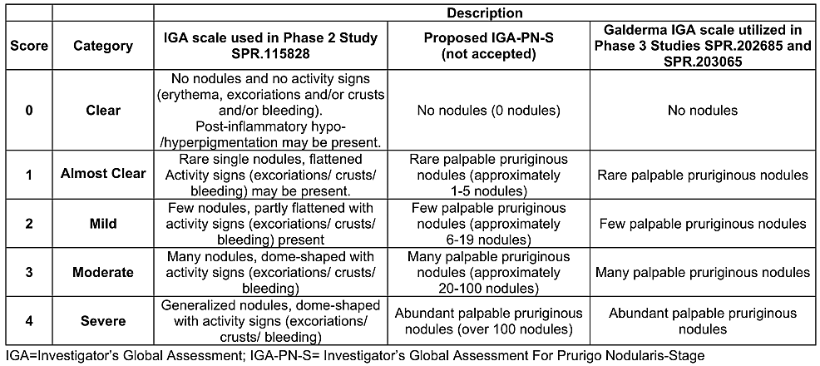
The Peak Pruritus Numerical Rating Scale (PP NRS) is a validated, patient-reported, single-item, 11-point scale, in which subjects rate their worst itch over the preceding 24 hours, ranging from 0-10 with 10 corresponding to ‘worst itch imaginable’. The minimum clinically important difference is generally accepted to be 3 points, with 4 points a more conservative measure.

Efficacy in atopic dermatitis
There were two pivotal efficacy studies in the AD indication, studies 118161 and 118169, identical phase 3, randomised, double-blind, placebo-controlled, parallel-group, multicentre 48-week studies evaluating efficacy and safety of nemolizumab in adults and adolescents aged 12 years and older with moderate-to-severe AD and inadequate response to topical treatment. There was an ongoing phase 3 open-label, long term extension study, 118163, with interim data submitted, however, efficacy results were not considered supportive by the clinical evaluator given that the maintenance dosing regimen differed from that sought in this application.

Study 118161
Patients were to be randomised 2:1 to receive either nemolizumab 30 mg Q4W (with a loading dose of 60 mg at baseline) or placebo, stratified by disease severity according to IGA and PP NRS, until week 16. Nemolizumab-treated subjects who were clinical responders at week 16, denoted by IGA score of 0 or 1 or achieving EASI-75 (≥75% improvement in EASI score from baseline) were re-randomised 1:1:1 to different treatment regimens: nemolizumab Q4W or Q8W, or placebo Q4W. Placebo-treated subjects who were clinical responders at week 16 continued to receive placebo Q4W. Subjects who did not meet response criteria at week 16 could enrol in a long-term extension study (study 118163) if eligible. This section will summarise results of the initial treatment period from study baseline to week 16, with results for the maintenance treatment period from week 16 to week 48 summarised below in pooled maintenance results.
Subjects applied moisturiser at least once daily and authorised topical background therapy included medium-potency topical corticosteroid for the body and low potency topical corticosteroid or topical calcineurin inhibitor for the face, neck, and intertriginous areas. Background therapy could be adjusted according to disease activity, based on investigator clinical judgement. Rescue therapies including high-potency topical corticosteroids, phototherapy and systemically acting agents could be initiated if deemed necessary by the investigator. Study design is summarised in Figure 1.
Figure 1. Study design, study 118161
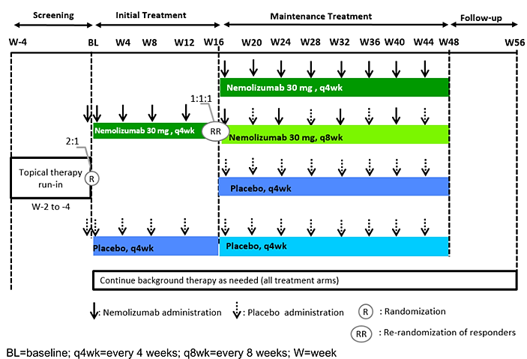
Co-primary efficacy endpoints were the proportion of subjects with IGA success, defined as an IGA of 0 (clear) or 1 (almost clear) and a ≥2-point reduction from baseline, and the proportion of subjects with EASI-75 at week 16. Key secondary efficacy endpoints were, in hierarchical order:
- Proportion of subjects with an improvement of PP NRS ≥4 at Week 16,
- Proportion of subjects with PP NRS <2 at Week 16,
- Proportion of subjects with an improvement of sleep disturbance NRS (SD NRS) ≥4 at Week 16,
- Proportion of subjects with an improvement of PP NRS ≥4 at Week 4,
- Proportion of subjects with PP NRS <2 at Week 4,
- Proportion of subjects with an improvement of PP NRS ≥4 at Week 2,
- Proportion of subjects with an improvement of PP NRS ≥4 at Week 1,
- Proportion of subjects with EASI-75 and improvement of PP NRS ≥4 at Week 16,
- Proportion of subjects with IGA success and improvement of PP NRS ≥4 at Week 16.
Study inclusion criteria were male or female subjects aged ≥12 years, with a diagnosis of chronic AD of at least 2 years duration, with an EASI score ≥16, IGA score ≥3, a PP NRS score of at least 4.0 and AD involvement of ≥10% body surface area, with a documented history within the preceding 6 months of inadequate response to topical therapies, namely topical corticosteroids with or without topical calcineurin inhibitor. Main exclusion criteria included body weight <30 kg, asthma exacerbation requiring hospitalisation in the preceding 12 months, asthma that is not well-controlled, an asthma control test ≤19 or peak expiratory flow <80% predicted, or a history of chronic obstructive pulmonary disease/chronic bronchitis.
In appraising the study design the clinical evaluator noted acceptability to demonstrate efficacy of nemolizumab for AD in combination with concomitant topical therapy only. Drawing on principles from EMA guidance on fixed combination therapies, the evaluator noted the lack of clinical study data regarding use of nemolizumab as a monotherapy in AD. Co-primary endpoints were considered acceptable for the purpose of assessing efficacy in AD, whilst the number of key secondary efficacy endpoints evaluating itch using the PP NRS score was noted, with AD-specific endpoints such as EASI-50 and EASI-90 not used, in contrast to efficacy trials for some other products seeking an AD indication. Inclusion and exclusion criteria were considered appropriate and aligned with the indication sought.
Analysis populations included the full population, all patients with baseline PP NRS ≥4, and severe pruritus population, including all patients with PP NRS ≥7, whilst primary inference for all efficacy analyses was based on the Intention-To-Treat (ITT) population at week 16. In terms of statistical analysis, an estimand framework was applied, with treatment discontinuation and rescue therapy specified as intercurrent events; treatment discontinuation was handled using treatment policy strategy (use observed response), and rescue therapy handled using composite strategy (non-response imputation). Missing values were treated as non-response. Primary and key secondary endpoints were analysed using a Cochran-Mantel-Haenszel test adjusted for the randomised stratification variables (IGA severity and PP NRS ≥7 <7 for the full population, IGA severity only in the severe pruritus population). Planned sensitivity analyses included tipping point analysis, Multiple Imputation (MI) under Missing At Random (MAR) assumption, and Last Observation Carried Forward (LOCF).
In terms of sample size, with 2:1 randomisation 180 subjects in the nemolizumab arm and 90 in the placebo arm would be required to detect the differences in both co-primary endpoints at 90% power, assuming IGA response in the nemolizumab group of 30% and placebo group 12% at week 16 (treatment difference 18%), and assuming EASI-75 response in the nemolizumab group of 49% and placebo group 19% at week 16 (treatment difference 30%). On the basis of ensuring sufficient nemolizumab exposure and size of the safety database the sample size was increased to 750 subjects in total, resulting in >99% power to detect treatment difference for the co-primary endpoints at the two-sided 2.5% significance level. The co-primary endpoints were to be tested at two-sided 2.5% for each population, and if found to be significant, the key secondary endpoints in the corresponding population could be tested sequentially. If p<2.5% for co-primary and key secondary endpoints in at least one population, then 2.5% could be recycled to test the other population at 5%.
For the initial treatment period, up to week 16, 1333 subjects were screened and 941 randomised, 620 to nemolizumab and 321 to placebo; the planned sample size of 750 was exceeded as recruitment was extended to reach the protocol-specified goal of 130 adolescent subjects, which was agreed with FDA. The clinical evaluator noted that the difference between the calculated sample size required to detect treatment differences, and the final sample size for the study resulted in the study being overpowered for the purpose of evaluating the efficacy endpoints. Of the 941 randomised subjects 856 (91.0%) completed the initial treatment period, and proportion of subjects with a major protocol deviation was similar between treatment and placebo groups, 27.1% and 27.7% respectively, with the most common deviation relating to stratification based on PP NRS and IGA. Mean treatment compliance was 96% in both groups.
For the maintenance period, at week 16, 272 nemolizumab-treated subjects who were clinical responders were re-randomised to receive nemolizumab Q4W (n=90), nemolizumab Q8W (n=91) or placebo (n=91). For the placebo group in the initial period 100 subjects were determined to be clinical responders and continued to receive placebo Q4W in the maintenance period. Of the 272 re-randomised subjects, 224 (82.4%) completed maintenance period treatment, with the lowest proportion in the nemolizumab to placebo group (75.8%). Treatment compliance ranged from 92-95% across groups in the maintenance period.
Demographic and baseline characteristics were generally similar between treatment groups. The majority of subjects were male (52.1% in the nemolizumab group, and 55.1% in the placebo group, in the initial treatment period) and White (72.7% and 76% respectively). Mean age was 33.5 years for the nemolizumab group and 33.3 years for the placebo group, whilst mean weight in each group was 75.1 kg and 76.9 kg respectively. There were 85 (13.7%) adolescent subjects in the nemolizumab group and 49 (15.3%) in the placebo group, whilst only 30 (4.8%) and 9 (2.8%) subjects in each group respectively were aged >65 years. In terms of disease severity, in the nemolizumab group 70.6% of subjects were IGA 3 at baseline and 29.4% IGA 4, compared to 73.5% and 26.5% respectively in the placebo group. Mean EASI score was 27.77 in the nemolizumab group and 27.06 in the placebo group, and mean weekly average PP NRS 7.17 and 7.15 in each group respectively. Most patients, 99.7% in the nemolizumab group and 99.4% in the placebo group, used at least 1 background topical therapy, with the groups well balanced in terms of type and potency of topical therapy. The most commonly used background agent was mometasone furoate (51.8% in the nemolizumab group, and 52.0% in the placebo group), followed by topical tacrolimus monohydrate (26.8% in the nemolizumab group, and 25.2% in the placebo group).
Results for the co-primary efficacy endpoints, measured at study week 16, are presented in Tables 5 and 6, showing pre-specified tests of statistical significance met for both endpoints, and both unadjusted and strata-adjusted proportion difference between treatment groups being slightly higher in the severe pruritus population compared to the full population for both endpoints.
Table 5. Proportion of subjects with IGA success at week 16, initial treatment period, ITT population (study 118161)
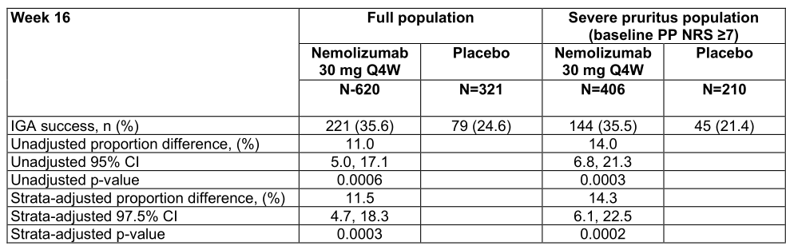
IGA=Investigator’s Global Assessment; |TT=intent-to-treat; N=number of subjects in the population; n=number of
subjects with IGA success; PP NRS=Peak Pruritus Numeric Rating Scale; Q4W=every 4 weeks
Note: IGA success was defined as subjects with 0 (clear) or 1 (almost clear) and at least a 2-grade improvement from
baseline. Percentages were based on n. Baseline value was the last valid value prior to first injection of study treatment of the Initial Treatment Period. If a subject received any rescue therapy, the data on/after receipt of rescue therapy were considered as treatment failures. Subjects with missing results were considered as non-responders. Unadjusted p-values were from the Mantel-Haenszel Chi-square test. Strata-adjusted p-values were from Cochran-Mantel-Haenszel test adjusting the randomized stratification variables (IGA severity [3=moderate, 4=severe] and PP NRS (27, <7] for full population; IGA severity only for Baseline PP NRS 27 population).
Table 6. Proportion of subjects with EASI-75 at week 16, initial treatment period, ITT population (study 118161)
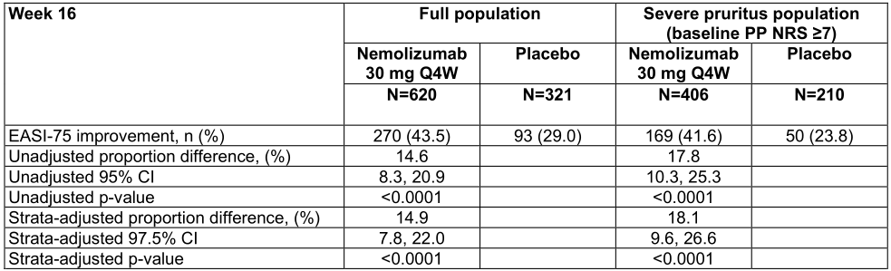
EASI=Eczema Area and Severity Index; EASI-75=275% improvement in EASI from baseline; IGA=Investigator's
Global Assessment; ITT=intent-to-treat; N=number of subjects in the treatment group; n=number of subjects with
EASI-75; PP NRS=Peak Pruritus Numeric Rating Scale.
Note: Percentages were based on number of subjects in each treatment group. If a subject received any rescue
therapy, the data on or after receipt of rescue therapy were considered treatment failures. Subjects with missing
results at a visit were considered non-responders for that visit. Unadjusted p-value was from Mantel-Haenszel Chi-
square test. Strata-adjusted p-values were from Cochran-Mantel-Haenszel test adjusting the randomized
stratification variables (IGA severity and PP NRS for full population; IGA severity only for baseline PP NRS 27
population).

Results for the co-primary efficacy endpoints were consistent across sensitivity analyses. Results for key secondary efficacy endpoints are summarised in Table 7, with all endpoints met according to pre-specified testing procedures.
Table 7. Key secondary efficacy endpoints, initial treatment period, ITT population (study 118161).
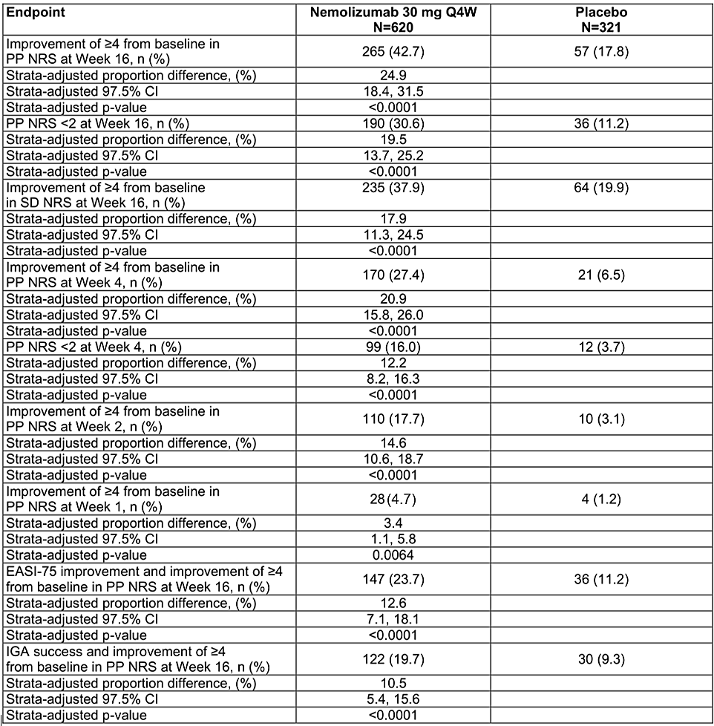
EASI=Eczema Area and Severity Index; EASI-75=275% improvement in EAS! from baseline; IGA=Investigator’s
Global Assessment; ITT= Intent to treat; N=number of subjects in the population; n=number of subjects with available
and imputed data; Q4W=every 4 weeks; SD NRS=Sleep Disturbance Numeric Rating Scale
Note: Percentages were based on number of subjects in each treatment group. Weekly PP NRS score was calculated
using 7 consecutive days diary data and set to missing if less than 4 days data available. Weekly SD NRS score was
calculated using 7 consecutive days diary data and set to missing if less than 4 days data available. IGA success was
defined as subjects with O (clear) or 1 (almost clear) and at least 2-grade improvement from baseline. Baseline value
was the last valid value prior to first injection of study drug of the Initial Treatment Period, and baseline PP NRS was
derived using 7 consecutive days diary data prior to first injection of study drug. If a subject received any rescue
therapy, the data on or after receipt of rescue therapy were considered treatment failures. Subjects with missing results at a visit were considered non-responders for that visit. Strata-adjusted p-values were from Cochran-Mantel-Haenszel test adjusting the randomized stratification variables (IGA severity and PP NRS).
Use of a topical potent corticosteroid rescue therapy was similar between groups in the initial treatment period, 3.4% in the nemolizumab group compared to 4.0% in the placebo group, whilst use of systemic rescue therapy was higher in the placebo group at 4.7%, compared to 2.4% in the nemolizumab group. Mean number of days free of topical AD therapy was 16 days in the nemolizumab group and 13 days in the placebo group.
The clinical evaluator noted that interpretation of results for the co-primary endpoints requires caution considering the study was overpowered. Rates of IGA response and EASI-75 in the treatment group were considered by the clinical evaluator to be clinically relevant, though the relatively modest treatment difference compared to placebo for each measure was unexpected, due in part to an unexpectedly high response rate in the placebo group. The clinical evaluator speculated that the high placebo response rate may be related to concomitant topical therapies and noted that, in this context, clinical studies evaluating nemolizumab as a monotherapy may have assisted interpretation of the treatment effect.

Study 118169
Study design, inclusion and exclusion criteria, statistical analysis plan, and efficacy endpoints were the same as for study 118161 outlined above.
For this pivotal study, 787 subjects were randomised, 522 to nemolizumab and 265 to placebo for the initial treatment period, with 90.3% of subjects completing to week 16. Rates of major protocol deviation were similar between groups and reflective of deviations in study 118161. There was high mean treatment compliance, 97% in the nemolizumab group and 96% in the placebo group. At week 16, 235 nemolizumab-treated subjects who were clinical responders were re-randomised to receive nemolizumab Q4W (n=79), nemolizumab Q8W (n=78), or placebo (n=78) during the maintenance period. There were 85 responders in the placebo group, who continued to receive placebo Q4W in the maintenance period. The clinical evaluator similarly noted that this study was overpowered, when comparing actual sample size to sample size calculation. This section will summarise results of the initial treatment period from study baseline to week 16, with results for the maintenance treatment period from week 16 to week 48 summarised below in pooled maintenance results.
Demographic and baseline characteristics were similar between treatment groups, with some differences compared to study 118161. A slight majority of subjects were female, 51.7% in the nemolizumab group and 51.3% in the placebo group, and mean age 34.9 years and 35.2 years respectively. The majority of subjects in each group were White. The proportion of adolescent subjects were comparable between groups, 17.4% in the nemolizumab group and 15.5% in the placebo group, with 7.1% and 5.7% respectively aged >65 years in each group. Mean weight in the nemolizumab group was 74.64 kg and in the placebo group was 73.44 kg. In terms of disease characteristics at baseline, in the nemolizumab group 67.4% were IGA 3 compared to 69.8% in the placebo group, with the remainder in each group IGA 4. Mean EASI score was 27.43 in the nemolizumab group, and 27.58 in the placebo group, whilst mean weekly average PP NRS was 7.04 and 7.16 in each group respectively. As for study 118161, most patients in both groups used at least 1 topical background therapy, and the groups were well balanced in terms of type and potency of concomitant therapy.
Results for the co-primary efficacy endpoints are shown in Tables 8 and 9, showing similar IGA success rates and EASI-75 rates to study 118161, with similar treatment difference between groups.
Table 8. Proportion of subjects with IGA success at week 16, initial treatment period, ITT population (study 118169).
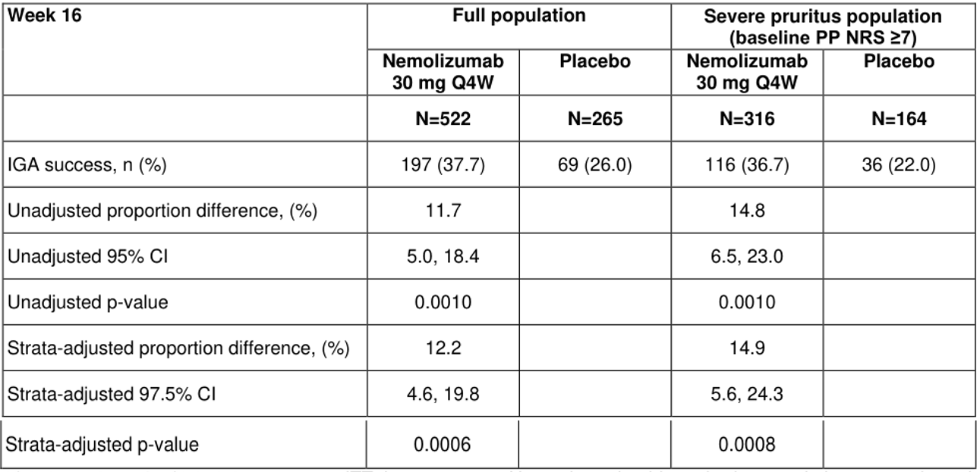
IGA=Investigator's Global Assessment; ITT=intent-to-treat; N=number of subjects in the population; n=number of
subjects with available and imputed data; PP NRS=Peak Pruritus Numeric Rating Scale; Q4W=every 4 weeks
Note: IGA success was defined as subjects with 0 (clear) or 1 (almost clear) and at least a 2-grade improvement from
baseline. Percentages were based on n. Baseline was defined as the last non-missing weekly value before the first
dose of study drug. If a subject received any rescue therapy, the data on/after receipt of rescue therapy were
considered as treatment failures. Subjects with missing results were considered as non-responders. Unadjusted
p-values for between-group comparisons were from the Mantel-Haenszel Chi-square test. Strata-adjusted p-values
were from Cochran-Mantel-Haenszel test adjusting the randomized stratification variables (IGA severity [3=moderate,
4=severe] and PP NRS [27, <7] for full population: IGA severity only for Baseline PP NRS 27 population).
Table 9. Proportion of subjects with EASI-75 at week 16, initial treatment period, ITT population (study 118169).
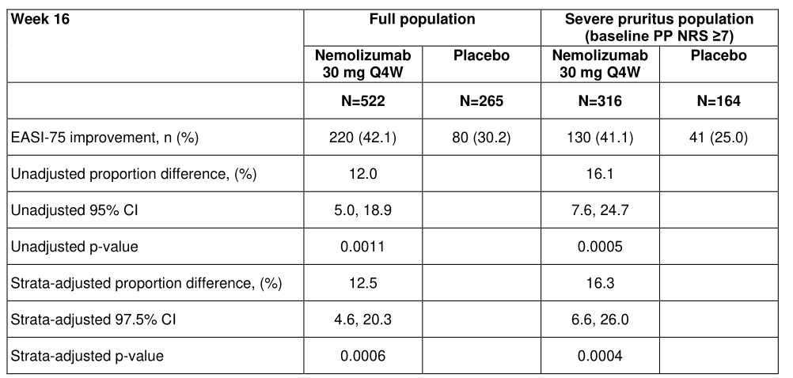
EASI=Eczema Area and Severity Index; EASI-75=275% improvement in EASI from baseline; IGA=Investigator’s
Global Assessment; ITT=intent-to-treat; N=number of subjects in the population; n=number of subjects with EASI-75;
PP NRS=Peak Pruritus Numeric Rating Scale
Note: Percentages were based on number of subjects in each treatment group. If a subject received any rescue
therapy, the data on or after receipt of rescue therapy were considered treatment failures. Subjects with missing result at a visit were considered non-responders for that visit. Unadjusted p-value was from Mantel-Haenszel Chi-square test. Strata-adjusted p-values were from Cochran-Mantel-Haenszel test adjusting the randomized stratification
variables (IGA severity and PP NRS for full population; IGA severity only for baseline PP NRS 27 population).
Results for the co-primary efficacy endpoints were consistent across sensitivity analyses. All key secondary efficacy endpoints met statistical significance according to pre-specified testing procedures, with results comparable to those seen for the same endpoints in study 118161.
Percentage of subjects using very potent topical corticosteroid rescue therapy in the initial treatment period was lower in the nemolizumab group compared to the placebo group, 2.1% and 4.2% respectively, however, use of systemic rescue therapy was slightly higher in the nemolizumab group at 1.5%, compared to 0.8%. Mean number of days free of topical AD therapy was similar as for study 118161, at 16 days in the nemolizumab group and 12 days in the placebo group.

Pooled results by age
Table 10 shows pooled results from studies 118161 and 118169 for the co-primary efficacy endpoints and one key secondary efficacy endpoint according to age group, showing that response rates were generally more favourable for adolescents aged 12-17 years compared to older age groups, however, with a corresponding higher placebo response rate seen for the co-primary endpoints. The >65 years age group was characterised by a high placebo response rate, markedly higher than other age groups, though low overall numbers of subjects in this age group limit interpretability of these results.
Table 10. Co-primary efficacy and selected key secondary efficacy endpoints in pooled studies, 118161 and 118169, initial treatment period, ITT population [full population]
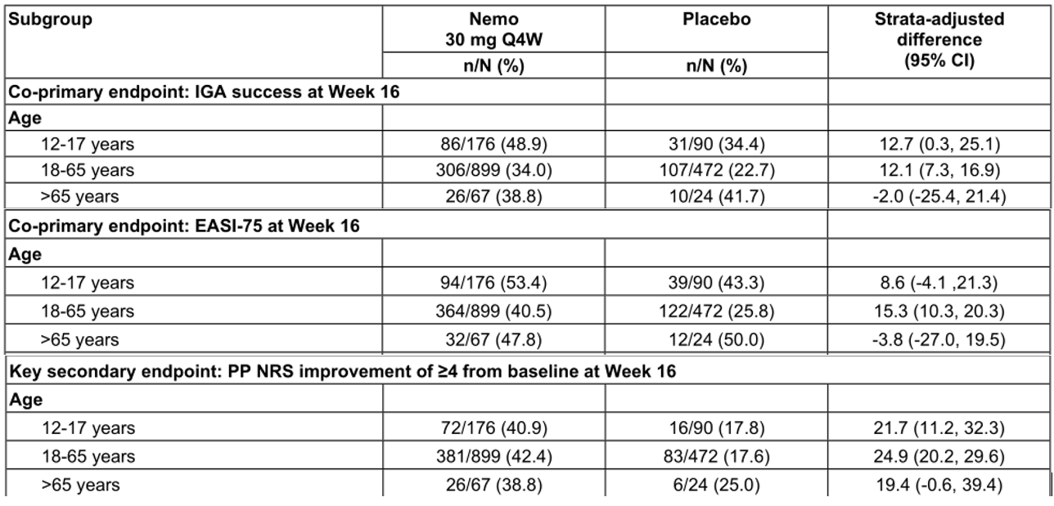

Pooled maintenance results
Pooled results from studies 118161 and 118169 for the maintenance treatment period from study week 16 to week 48 were provided. Using non-responder imputation, IGA success was recorded at week 48 for 104/169 (61.5%) in the nemolizumab 30 mg Q4W to Q4W cohort, 102/169 (60.4%) in the nemolizumab 30 mg Q4W to Q8W cohort, and 84/169 (49.7%) in the nemolizumab 30 mg Q4W to placebo cohort. With respect to EASI-75 at week 48, using non-responder imputation, EASI-75 was recorded for 129/169 (76.3%) in the nemolizumab 30 mg Q4W to Q4W cohort, 128/169 (75.7%) in the nemolizumab 30 mg Q4W to Q8W cohort, and 108/169 (63.9%) in the nemolizumab 30 mg Q4W to placebo cohort. The clinical evaluator noted that similar, or slightly better, results for the Q8W maintenance dosing regimen in terms of the co-primary efficacy endpoints supported the proposed dosing for AD in this application.

Study 118163, Long term extension study
This ongoing phase 3, open-label, multicentre long term extension study evaluating safety and efficacy of nemolizumab 30 mg Q4W dosing in adolescents and adults with moderate-to-severe AD enrolled subjects from seven preceding studies, including the pivotal AD studies 118161 and 118169, with a total of 1751 subjects enrolled. Whilst efficacy results in terms of IGA 0-1 and EASI-75 at each visit showed sustained improvement with prolonged nemolizumab treatment, given that this application seeks maintenance dosing of 30 mg Q8W, the clinical evaluator did not consider results relevant to the application. Safety results are considered below.

Efficacy in prurigo nodularis
There were two pivotal efficacy studies for the PN indication, 202685 and 203065. Both were phase 3, randomised, double-blind, placebo-controlled, parallel-group, multicentre studies conducted with adult subjects. Objectives and primary efficacy endpoints at week 16 were the same between the studies, with study 202685 extended to 24-weeks to provide additional placebo-controlled data.

Study 202685
In this 24-week study subjects were randomised 2:1 nemolizumab to placebo, with stratification by study site and body weight, with those <90 kg receiving nemolizumab 30 mg (with a 60 mg loading dose) Q4W or placebo Q4W, and those ≥90 kg receiving nemolizumab 60 mg Q4W without a loading dose, or placebo Q4W. Prohibited concomitant therapies included topical corticosteroids and topical calcineurin inhibitors, systemic corticosteroids, topical vitamin D analogues, anti-histamines and immunosuppressive or biologic therapies, whilst basic skin care, moisturisers, and topical anaesthetics were permitted. Co-primary efficacy endpoints were proportion of subjects with improvement of ≥4 from baseline in PP NRS at week 16, and proportion of subjects with an IGA success at week 16, defined as IGA of 0 (clear) or 1 (almost clear) and a ≥2-point improvement from baseline. Key secondary efficacy endpoints included different measures using the PP NRS, and two endpoints using the Sleep Disturbance Numeric Rating Scale (SD NRS).
Inclusion criteria were adults with a clinical diagnosis of PN for at least 6 months, with PN lesions on the upper limbs, trunk, and/or lower limbs, at least 20 lesions on the entire body with a bilateral distribution, an IGA score ≥3, and a PP NRS score of ≥7.0. Key exclusion criteria were body weight <30 kg, chronic pruritus due to a condition other than PN, unilateral PN lesions, and a history of confounding skin condition. Also excluded were patients with asthma exacerbation requiring hospitalisation in the preceding 12 months, poorly controlled asthma within the preceding 3 months, an Asthma Control Test ≤19, or PEF <80% predicted, or with a history of chronic obstructive pulmonary disease or chronic bronchitis. The clinical evaluator commented that these criteria represented a moderate-to-severe PN population.
The ITT population was the primary population for efficacy analyses. Estimand framework was used, with treatment discontinuation and rescue therapy specified as intercurrent events. As primary analysis, treatment discontinuation was handled using treatment policy strategy (= use observed value), mirroring the approach in AD pivotal studies, whilst composite strategy was use for rescue therapy, where binary outcome was to be derived based on imputing all values after rescue therapy by the worst score, a distinct approach to that for the AD pivotal studies. Missing values were treated as nonresponse. Primary and key secondary endpoints were analysed using a Cochran-Mantel-Haenszel test. Sensitivity analyses were similar to those for the AD studies.
In terms of sample size calculation, to achieve at least 90% power for both primary endpoints at 5% significance level 270 subjects were required, 180 in the nemolizumab group and 90 in the placebo group. This assumed a 15% dropout rate, and detection of 30% treatment difference in terms of PP NRS responders between nemolizumab and placebo, and 20% difference in IGA response rate between the two groups. To control the type I error at two-sided 5%, a fixed sequential testing approach was implemented.
In total 286 subjects were randomised, 190 to nemolizumab and 96 to placebo, of which 253 (88.5%) completed the initial treatment period to week 16. Demographic and baseline characteristics were comparable between groups; the majority were female (57.9% nemolizumab group, 58.3% placebo group) and White, with mean age 57.5 years and 57.6 years in the nemolizumab and placebo groups respectively. Mean weight was higher in the nemolizumab group at 87.1 kg, compared to 80.8 kg for the placebo group. There was a slightly higher baseline severity in terms of IGA in the nemolizumab group, with 56.3% having a baseline score of 3 and 43.7% a score of 4, compared to 64.6% and 35.4% respectively in the placebo group, whilst baseline mean weekly average PP NRS was similar at 8.5 and 8.4 in each group respectively. Topical corticosteroid was the most common prior medication used for PN, at around 50% in both groups.
Results for the co-primary endpoints are summarised in Tables 11 and 12, showing statistically significant treatment difference favouring the nemolizumab group.
Table 11. Proportion of subjects with an improvement ≥4 from baseline in weekly average peak pruritus numeric rating scale at week 16, ITT population, study 202685.
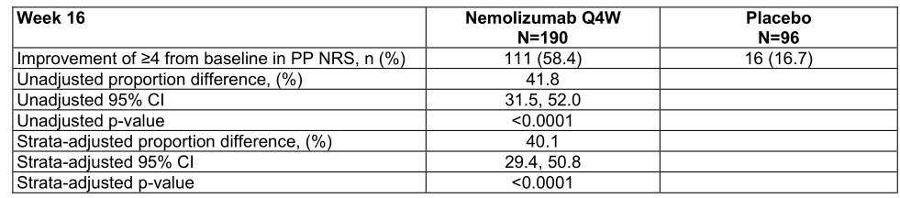
CMH=Cochran-Mantel-Haenszel; N=number of subjects in the treatment group; n=number of subjects with available
and imputed data; PP NRS=Peak Pruritus Numeric Rating Scale; Q4W=every 4 weeks
Note: Weekly values were calculated as the average of 7 consecutive days of data up to the target study day
(excluding) and set to missing, if less than 4 days data were available. Baseline was defined as the last non-missing
weekly value before the first dose of study drug. If a subject received any rescue therapy, composite variable strategy
was applied, the underlying data at/after receipt of rescue therapy were set as worst possible value, and the response
was derived from underlying data value. Subjects with missing results were considered as non-responders.
Unadjusted and strata-adjusted p-values for between-group comparisons were from the CMH test. Strata-adjusted
p-values were from the CMH test using the randomized stratification variables (analysis center and body weight at
randomization [<90 kg, ≥90 kg]).
Table 12. Proportion of subjects with an investigator’s global assessment of success at week 16, ITT population, study 202685
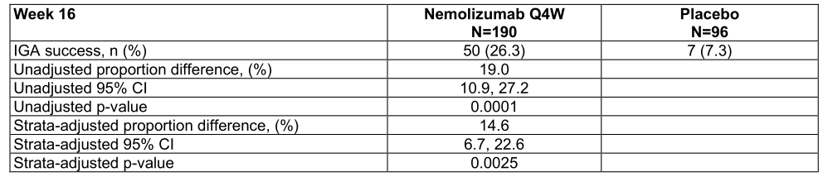
CMH=Cochran-Mantel-Haenszel; IGA=Investigator’s Global Assessment; N=number of subjects in the treatment group; n=number of subjects with available and imputed data; Q4W=every 4 weeks
Note: IGA success was defined as subjects with 0 (clear) or 1 (almost clear) and at least a 2-grade improvement from baseline. Baseline was defined as the last non-missing weekly value before the first dose of study drug. If a subject received any rescue therapy, composite variable strategy was applied, the underlying data at/after receipt of rescue therapy were set as worst possible value, and the response was derived from underlying data value. Subjects with missing results were considered as non-responders. Unadjusted and strata-adjusted p-values for between-group comparisons were from the CMH test. Strata-adjusted p-values were from the CMH test using the randomized stratification variables (analysis center and baseline body weight at randomization [<90 kg, ≥90 kg]).
Results for sensitivity analyses were supportive of results on primary analysis for both co-primary endpoints. The clinical evaluator concluded that these results were both statistically significant and clinically meaningful.
All key secondary efficacy endpoints favoured the nemolizumab group and met pre-specified criteria for statistical significance, with results similarly appraised as clinically meaningful by the clinical evaluator. Use of rescue medication was higher in the placebo group at 19.8% of subjects, compared to 6.3% of subjects in the nemolizumab group. Whilst not type I error controlled, results at week 24 appeared to show maintenance of the effect demonstrated at week 16; PP NRS response criteria was met in 47.4% in the nemolizumab group compared to 14.6% in the placebo group, and rate of IGA success was 30.5% and 9.4% in each group respectively.

Study 203065
Except for the 16-week study duration, study design, inclusion and exclusion criteria, and efficacy endpoints were the same as for study 202685 outlined above and will not be repeated here. The statistical analysis plan was similar to that for study 202685, however, the primary estimand for rescue therapy used nonresponse imputation as opposed to treatment failure imputation.
In total 274 subjects were randomised, 183 to the nemolizumab group and 91 to placebo, with 262 (95.6%) in total completing the initial treatment period. As for study 202685, the majority of subjects were female, 61.7% in the nemolizumab group and 60.4% in the placebo group, and White, with mean age of 53.7 years and 50.8 years in each group respectively, and similar mean weight of 79.7 kg and 80.8 kg respectively. Slightly more subjects in the nemolizumab group were classified as IGA moderate (score 3) as opposed to severe (score 4), and baseline PP NRS score was similar between groups. The majority in both groups had previously used topical corticosteroids to treat PN, 78.1% in the nemolizumab group and 79.1% in the placebo group.
In terms of results for the co-primary efficacy endpoints, strata-adjusted proportion difference for improvement of ≥4 from baseline in weekly average PP NRS at week 16 favoured the nemolizumab group at 37.4% (95% CI 26.3, 48.5, p<0.0001), slightly lower than the corresponding result in study 202685, whilst the strata-adjusted proportion difference for IGA success at week 16 favoured the nemolizumab group at 28.5% (95% CI 18.8, 38.2, p<0.0001), higher than the corresponding result in study 202685. Sensitivity analyses supported the primary analyses. All key secondary efficacy endpoints favoured the nemolizumab group and met pre-specified criteria for statistical significance. The clinical evaluator noted both the statistically significant and clinically meaningful nature of efficacy results in this study.

Study 202699, long term extension study
This ongoing phase 3, open-label, long-term extension study enrolled subjects from the two pivotal studies for PN, 232 subjects from study 202685 and 255 subjects from study 203065, as well as 21 subjects from the phase 2a study 115828. Nemolizumab dosing was the same as for the pivotal studies. Efficacy results up to week 52 were available: the proportion of subjects with IGA score 0 or 1 at LTE baseline was 29.3% increasing to 68.1% at week 52, proportion with IGA ≤2 at LTE baseline 28.3% increasing to 66% at week 52, and proportion with an improvement of ≥4 from baseline in PP NRS at LTE baseline was 52.5% increasing to 85.5% at week 52. As noted by the clinical evaluator, this study was open-label and uncontrolled, limiting interpretability.

Safety
Evaluable safety data is provided separately for the AD and PN indications.

Atopic dermatitis
The AD exposure pool population pooled data from the ongoing LTE study 118163, and all feeder studies; 118161, 118169, 114322, 116912, and 201593. In the AD exposure pool population, mean treatment duration for nemolizumab 30 mg subjects was 405.2 days, with a mean number of 13.8 treatments, and a total of 1148 subjects having ≥1 year of exposure to nemolizumab 30 mg. Of 307 adolescent subjects aged 12 to 17 years who received at least 1 dose of nemolizumab 30 mg, 180 (58.6%) had ≥1 year exposure.
The primary safety population was defined as all randomised or enrolled subjects who received at least 1 dose of study drug in the two pivotal phase 3 studies, 118161 and 118169, and in the phase 2b study 114322. This population included 55 subjects in the nemolizumab 10 mg Q4W group, 1192 subjects in the nemolizumab 30 mg Q4W group, 57 subjects in the nemolizumab 90 mg Q4W group and 640 subjects in the placebo group. Within this population the initial treatment period denoted the time from start of treatment up to and including week 16 for studies 118161 and 118169, and up to and including week 24 for study 114322, whilst the maintenance period denoted time up to and including week 48 after the initial treatment period and did not include study 114322 which was 24 weeks in duration. The ‘treatment period’ refers to both the initial treatment period and maintenance period.
Table 13 summarises TEAEs occurring across the treatment period, presented by initial period and maintenance period.
Table 13. Overall summary of treatment emergent adverse events during the treatment period, primary safety population.
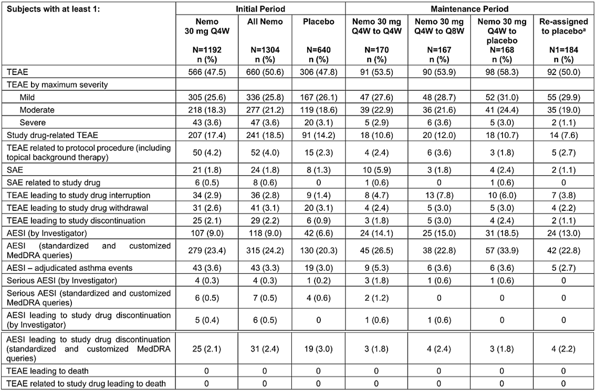
AESI=adverse event of special interest; ISS=Integrated Summary of Safety; MedDRA=Medical Dictionary for Regulatory Activities; N=number of subjects in the population; N1=number of subjects who responded to placebo and continued to receive placebo in the Maintenance Period; n=number of subjects who experienced the events; Nemo=nemolizumab; Q4W=every 4 weeks; Q8W=every 8 weeks; SAE=serious adverse event; TEAE=treatment-emergent adverse event.
Note: Adverse events were coded using MedDRA Version 25.0. Percentages were based on the number of subjects in each treatment group. All TEAEs that started/worsened on or after the first dosing date were summarized by period based on the onset date. For Studies SPR.118161 and SPR.118169, the Initial Period was defined as the period from start of treatment up to and including Week 16. For Study SPR.114322, the whole Treatment Period from the start of treatment up to and including Week 24 was included in the Initial Period. The Maintenance Period was defined as the period up to and including Week 48 after the Initial Period (not applicable to subjects from Study SPR.114322). In case of early discontinuation, the Treatment Period extended from the start of treatment until 4 weeks after the last dosing date or early termination date.
Subjects randomized to placebo in the Initial Period and continuing on placebo in the Maintenance Period.

Treatment emergent adverse events
In the primary safety population the most common TEAEs reported in the initial treatment period were dermatitis atopic (10.4% nemolizumab 30 mg Q4W group, 10.3% placebo group), headache (4.2% and 4.4% in each group respectively), nasopharyngitis (3.5% and 4.8% respectively), asthma (4.0% and 3.3% respectively), COVID-19 (2.0% and 2.2% respectively), and upper respiratory tract infection (1.7% and 3.1% respectively).
The most common TEAEs reported in the maintenance period across all treatment groups were COVID-19 (range 7.6% to 11.3%), dermatitis atopic (range 6.6% to 10.7%), nasopharyngitis (range 4.8% to 8.2%), upper respiratory tract infection (range 2.4% to 6.0%), asthma (range 2.7% to 3.6%) and headache (range 1.8% to 4.2%).
Among the most common TEAEs the following occurred with a higher frequency in nemolizumab treated subjects compared to placebo: arthralgia (1.3% nemolizumab 30 mg Q4W group, 0.5% placebo group), urticaria (1.1% and 0.5% in each group respectively), fatigue (1% and 0.5% respectively), and asthma (4.0% and 3.3% respectively).

Deaths
There were no recorded deaths during the overall treatment period. One subject who had received nemolizumab 10 mg Q4W died in the follow-up period, having developed pneumonia aspiration on day 70 and cardio-respiratory arrest on day 83; this was considered not related to study treatment by the investigator.

Serious adverse events
The only treatment-emergent serious adverse events (SAEs) recorded in >1 subject in the initial treatment period in either group were dermatitis atopic (6 [0.5%] nemolizumab 30 mg Q4W subjects, and 3 [0.5%] placebo subjects), and intervertebral disc protrusion (2 [0.2%] nemolizumab 30 mg Q4W subjects, and 0 placebo subjects). There were no treatment-emergent SAEs recorded in the maintenance period.

Treatment-emergent adverse events leading to study discontinuation
The only TEAE leading to study discontinuation experienced by >1 subject during the initial treatment period in either group was dermatitis atopic (15 [1.3%] nemolizumab 30 mg Q4W subjects, 5 [0.8%] placebo subjects). This was similarly the only TEAE recorded by >1 subject leading to study discontinuation in the maintenance period.

Adverse events of special interest
For the AESI injection site reactions, rates were similar between nemolizumab (1.3%) and placebo (1.1%) groups, with all except one event classified as mild.
Newly diagnosed asthma or worsening of asthma was defined as an AESI. In total during the initial treatment period 51 (4.3%) nemolizumab 30 mg Q4W subjects and 20 (3.1%) placebo subjects experienced an AESI meeting this pre-specified definition. None were classified as serious in the initial treatment period. In the maintenance period there was a slightly higher rate of this AESI in the nemolizumab 30 mg Q4W to 30 mg Q4W group, with 7 (4.1%) subjects, compared to 6 (3.6%) subjects in the nemolizumab 30 mg Q4W to 30 mg Q8W group, and 5 (2.7%) subjects in the nemolizumab 30 mg Q4W to placebo group. One AESI in the maintenance period was classified as serious.
With respect to the AESI of infections, in the initial treatment period a total of 232 (19.5%) subjects in the nemolizumab group experienced a TEAE in the System Organ Class (SOC)of infections and infestations, compared to 144 (22.5%) in the placebo group. Serious AESIs of infection were recorded in 3 (0.3%) nemolizumab subjects and 1 (0.2%) placebo subject; for the nemolizumab-treated subject this was ophthalmic herpes zoster, infected cyst and bacterial superinfection. Non-serious herpetic infections were recorded in 24 (2.0%) nemolizumab subjects and 17 (2.7%) placebo subjects. Rates of TEAEs in the SOC infections and infestations were similar across groups in the maintenance period; serious AESIs were recorded in 2 (1.2%) subjects in the nemolizumab 30 mg Q4W to Q4W group (appendicitis, and COVID-19), 1 (0.6%) subjects in the nemolizumab Q4W to Q8W group (cellulitis), and 1 (0.6%) in the nemolizumab to placebo group (erysipelas). TEAEs of herpetic infection were reported in 8 (4.7%) subjects in the nemolizumab 30 mg Q4W to Q4W group, 6 (3.6%) in the Q4W to Q8W group, 4 (2.4%) in the nemolizumab to placebo group, and 5 (2.7%) in the re-assigned to placebo group.
Peripheral/facial oedema was also identified as an AESI, recorded in 19 (1.6%) nemolizumab 30 mg Q4W subjects compared to 2 (0.3%) placebo subjects in the initial treatment period. This AESI was also recorded in 1 (0.6%) subject in the nemolizumab 30 mg Q4W to Q4W group, 2 (1.2%) subjects in the Q4W to Q8W group, and 3 (1.8%) subjects in the nemolizumab to placebo group during the maintenance period.

Laboratory values
The main finding of note was elevated eosinophils worst post-baseline value, seen in the initial treatment period in 10.2% in the nemolizumab group compared to 5.8% in the placebo group. Only 2 (0.2%) subjects in the nemolizumab group had a TEAE of eosinophilia recorded. One event of mild eosinophilia was associated with a clinical manifestation of exfoliative dermatitis. One case of severe eosinophilia (>5 g/L) was transient and reversible under nemolizumab treatment.

Electrocardiograms
Rates of clinically significant electrocardiogram (ECG) finding at week 16 were similar as rates at baseline, with 5 (0.5%) and 4 (0.3%) respectively in the nemolizumab group, and 1 (0.2%) and 1 (0.2%) respectively in the placebo group.

Safety in adolescents
During the initial treatment period the proportion of adolescent subjects with TEAEs, severe TEAEs, and SAEs were generally lower compared to adult age groups. The TEAEs nasopharyngitis and upper respiratory tract infection were the only to occur at a higher rate among adolescents; among the nemolizumab-treated cohort, 9 (5.1%) adolescent subjects aged 12-17 years experienced nasopharyngitis compared to 32 (3.4%) in the 18 to 65 years group, whilst for upper respiratory tract infection these rates were 2.8% and 1.5% respectively. Acknowledging the limitation of low overall numbers of adolescent subjects in each treatment group in the maintenance period there were no major imbalances identified between age groups.

Interim safety results from long term extension study 118163
Most reported TEAEs were classified as mild to moderate in severity, with most common recorded TEAEs being COVID-19 (16.1%), dermatitis atopic (13.0%), nasopharyngitis (9.5%), and upper respiratory tract infection (5.6%). One subject who had received the first dose of study drug died approximately 2 months later from asphyxia, and one subject developed non-small cell lung cancer leading to study drug discontinuation, and subsequently died 4 months post study discontinuation; neither death was deemed attributable to the study treatment by investigators. Treatment-emergent SAEs were reported by 72 (4.1%) subjects, most common being dermatitis atopic (8 [0.5%] subjects), with the following recorded in 2 (0.1%) subjects each: myocardial infarction, cholecystitis, COVID-19, COVID-19 pneumonia, cellulitis, syncope, and urinary retention. Nemolizumab dosing in this study was Q4W, a shorter dosing interval than the Q8W maintenance dosing sought in this application.

Prurigo nodularis
The primary safety population comprised all randomised or enrolled subjects who received at least 1 dose of study treatment in the two pivotal phase 3 studies, 202685 and 203065, with 370 subjects in the nemolizumab group and 186 subjects in the placebo group. The PN exposure pool population was used for exposure data only, comprising safety data from the long-term extension study 202699, and its feeder studies 202685, 203065, and 115828; mean treatment duration in this population was 441.5 days, with subjects in the all nemolizumab group receiving a mean of 15.1 treatments, and 375 (64.9%) of subjects having at least 1 year of exposure.
Table 14 provides an overall summary of TEAEs in the primary safety population, showing a slightly higher rate of TEAEs in the nemolizumab group compared to placebo, however, a slightly lower rate of SAEs.
Table 14. Overall summary of TEAEs during the overall period, primary safety population
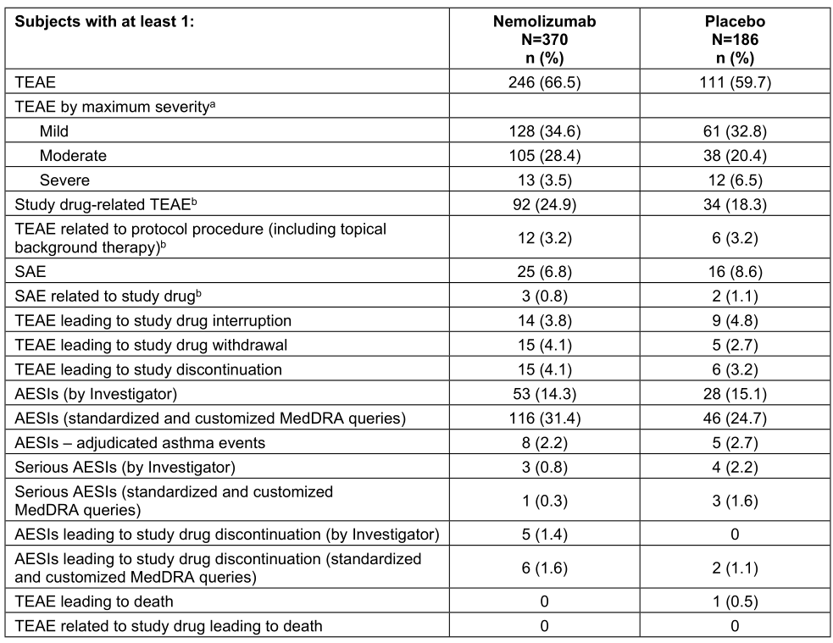
AESI=adverse event of special interest; ISS=Integrated Summary of Safety; MedDRA=Medical Dictionary for
Regulatory Activities; N=number of subjects in the population; n=number of subjects who experienced the events:
SAE=serious adverse event; TEAE=treatment-emergent adverse event
Note: Subjects were summarized according to the treatment they actually received at the time of adverse event onset.
Percentages were based on the number of subjects in each treatment group. Adverse events were coded using
MedDRA Version 25.0. All TEAEs were defined as adverse events that occurred or worsened on or after the first study
treatment date. All adverse events that were judged related to study treatment were classified as TEAEs, regardless of
their occurrence date. The Overall Period included both the Treatment Period and Follow-up Period; TEAEs during the Overall Period were defined as TEAEs with an onset date on or after the first dose date until the follow-up visit date. If a subject had multiple occurrences of a TEAE within a treatment group, the subject was presented only once in the respective subject count for that treatment group.
a) If subjects experienced multiple events, the subjects were counted once at the event with maximum severity. If
severity was missing then the greatest severity, i.e., “severe” was imputed.
b) The relationship to study treatment or protocol procedure of “reasonable possibility” was defined as “related”. If
relationship to study treatment or protocol procedure was missing then the closest relationship, i.e., “related” was
imputed.

Treatment emergent adverse events
The most common TEAEs observed were neurodermatitis (coded term for worsening PN), 6.8% in the nemolizumab group and 15.6% in the placebo group, COVID-19, 6.5% and 9.1% in each group respectively, nasopharyngitis, 4.6% and 6.5% respectively, and headache, 6.8% and 3.2% respectively. The TEAEs fatigue and back pain occurred at a slightly higher rate in the nemolizumab group compared to placebo; the sponsor provided justification as to why these adverse events should not be classified as adverse drug reactions, which was accepted by the clinical evaluator.

Deaths
One (0.5%) subject in the placebo group died on study day 128 of cardiogenic shock with a medical history of congestive cardiac failure, considered by the investigator not related to study drug or protocol.

Serious adverse events
In total 25 (6.8%) subjects in the nemolizumab group and 16 (8.6%) in the placebo group experienced treatment-emergent SAEs, including neurodermatitis (4 [1.1%] nemolizumab subjects, 2 [1.1%] placebo subjects), pemphigoid (3 [0.8%] nemolizumab subjects, 0 placebo), and osteoarthritis (2 [0.5%] nemolizumab subjects, 1 [0.5%] placebo subjects).

Treatment emergent adverse events leading to study discontinuation
Fifteen (4.1%) nemolizumab subjects and 6 (3.2%) placebo subjects experienced a TEAE leading to study discontinuation, the most common being pemphigoid (3 nemolizumab subjects, 0 placebo) and dermatitis atopic (2 nemolizumab subjects, 1 placebo).

Adverse events of special interest
In terms of the AESI of newly diagnosed asthma or worsening of asthma, 12 (3.2%) nemolizumab subjects and 5 (2.7%) placebo subjects met the pre-specified criteria for this AESI.
With respect to the AESI infections, overall, 98 (26.5%) subjects in the nemolizumab group and 47 (25.3%) in the placebo group experienced a TEAE in the SOC infections and infestations; the majority in both groups related to COVID-19. For nemolizumab-treated patients serious AESI infections included campylobacter colitis in 1 subject, pneumonia and pneumococcal sepsis in 1 subject, and mild urinary tract infection in 1 subject. There were 5 herpes infections in nemolizumab subjects, compared to 3 in placebo subjects.
There was an imbalance between groups in the AESI peripheral/facial oedema, recorded in 11 subjects (3.0%) in the nemolizumab group and 3 subjects (1.6%) in the placebo group, all classified as moderate severity. Facial oedema specifically was only recorded in nemolizumab-treated subjects, with 1 event coded as angioedema.

Laboratory values
The proportion of subjects with potentially clinically significant elevated eosinophils was 5.5% in the nemolizumab group and 2.7% in the placebo group. There were no instances of severe eosinophilia > 5 x 109/L.

Interim data from long term extension study 202699
The majority of recorded TEAEs were mild to moderate in severity, with the most common being COVID-19 (22.2%), nasopharyngitis (13.8%), and neurodermatitis (10.8%). Two subjects experienced a TEAE leading to death; one experienced a fatal myocardial infarction and the other fatal end-stage renal disease. Both events were considered not related to study treatment. Treatment-emergent SAEs were recorded in 54 (10.6%) subjects, including neurodermatitis in 4 (0.8%) subjects, myocardial infarction in 3 (0.6%) subjects, and angina pectoris, cardiac failure congestive, cholelithiasis, pneumonia, osteoarthritis, and carotid artery stenosis in 2 (0.4%) subjects each. Given the frequency of cardiovascular AEs a question was posed to the sponsor at round 1 evaluation, with justification provided that this did not represent a safety signal, which was accepted by the clinical evaluator.

Other safety issues
Autoimmune disease
For the event of autoimmune disease in PN, 1 (<0.1%) subject in the nemolizumab 30 mg Q4W group experienced alopecia areata, compared to 3 subjects (0.5%) in the placebo group. In the maintenance period 1 subject (0.6%) in the nemolizumab 30 mg Q4W to nemolizumab 30 mg Q4W group developed alopecia areata on day 167. There was one case each of autoimmune thyroiditis and pemphigoid in nemolizumab-treated subjects, with both re-starting nemolizumab after treatment-interruption and completing the study.
For the event of autoimmune disease in AD, 3 (0.8%) subjects in the nemolizumab group developed pemphigoid, psoriasis was recorded in 2 (0.5%) nemolizumab subjects and 1 (0.5%) placebo subject, whilst there were 1 episode of each of alopecia areata and polymyalgia rheumatic recorded in the nemolizumab group. Overall incidence of injection site reactions was low and balanced between the groups, 1.1% in the nemolizumab group and 1.6% for placebo.

Malignancies
Across clinical development a total of 23 malignancies have been reported in 21 subjects, with highest frequency in the AD population being non-Hodgkin lymphoma (3 events), lung cancer and colorectal cancer (2 events each), whilst in the PN population highest frequency were squamous cell carcinoma of the skin, colorectal cancer (3 events each), Hodgkin’s lymphoma and basal cell carcinoma (2 events each). In response to a round 1 question the sponsor confirmed no new malignancies up to data cut-off 21 July 2024 in ongoing studies. The clinical evaluator concluded that, based on time-course of disease development for some cases and the relatively low incidence of lymphomas and colorectal cancer in nemolizumab-treated subjects, there is no evidence of higher rates of malignancies associated with nemolizumab treatment.

Immunogenicity
In the pivotal AD studies, 118161 and118169, and long-term extension study 118163, the incidence of treatment-emergent anti-drug antibodies (ADAs) was 123 (11.2%), which were treatment induced (N=120) or treatment boosted (N=3). Among the 120 subjects with treatment induced ADA persistent ADA were observed in 73 (6.6%) subjects and transient ADA were observed in 47 (4.3%) subjects. Neutralising ADAs were observed in 5 (0.5%) subjects. The median time to the development of first post-baseline anti-drug antibody (ADA) was 24 weeks (range: 2.14-108 weeks).
In the pivotal PN studies, 202685 and 203065, and long-term extension study 202699, with up to 116 weeks of treatment, the incidence of treatment-emergent ADAs was 12.8% (46 out of 358 subjects), which were treatment induced (N=44) or treatment boosted (N=2). Among the 44 subjects with treatment induced ADA, persistent were observed in 32 (8.9%) subjects and transient ADA were observed in 12 (3.4%) subjects. Neutralising antibodies were observed in 12 (3.4%) subjects. The median time to the development of first post-baseline ADA was 24 weeks (range: 7.9 to 75.7 weeks).
There was no identified clinically significant effect of anti-drug antibodies on pharmacokinetics, safety or efficacy of nemolizumab in both indications (AD and PN).
The clinical evaluator noted that, despite low subject numbers, subgroup analyses showed no evidence of reduced efficacy or higher number of TEAEs in ADA positive subjects in the AD indication.

Risk management plan evaluation summary
Safety concerns and their associated risk monitoring and mitigation strategies are summarised in Table 15.
The TGA may request an updated risk management plan (RMP) at any stage of a product's life-cycle, during both the pre-approval and post-approval phases.
Table 15. Summary of safety concerns
Summary of safety concerns |  | Pharmacovigilance |  | Risk Minimisation
 |  | Routine | Additional | Routine | Additional
Important identified risks | None | – | – | – | –
Important potential risks | None | – | – | – | –
Missing Information | Use in pregnancy | ü*§ | ü | ü | –
Missing Information | Long-term safety beyond 1 year of treatment with nemolizumab | ü | ü† | – | –
*PASS A Study of Pregnancy and Infant Outcomes
† Long term extension studies RD.06.SPR.118163 and RD.06.SPR.202699
§ AU Pregnancy Form for Consumer and AU Pregnancy Form for Healthcare Professional (ASA only)
The summary of safety concerns in the Australia-specific annex (ASA) aligns with the draft EU-RMP. The sponsor was requested to include ‘Long term safety beyond 1 year of treatment with nemolizumab’ as missing information in the ASA to align with the EU-RMP. This safety concern was added to the ASA, and the missing information ‘Use in lactation’ was removed from the EU-RMP and ASA. The summary of safety concerns in the ASA aligns with the EU-RMP and is acceptable from an RMP perspective.
The sponsor only proposed routine pharmacovigilance activities and was asked to clarify if the follow up forms in the EU-RMP will be implemented in Australia. The sponsor later included in the ASA the additional pharmacovigilance PASS (to study outcomes in pregnancy and infants) and two long term extension studies to characterise long term safety that were included in the EU-RMP, as requested. The sponsor also confirmed that follow up forms would be used in Australia to characterise safety in pregnancy. The sponsor also updated the follow-up forms to include a field to collect ethnicity data. The pharmacovigilance plan is acceptable from an RMP perspective.
Only routine risk minimisation activities were proposed initially. The sponsor later agreed to include an instruction for use leaflet in the product packaging. The RMP is acceptable from an RMP perspective.

Risk-benefit analysis
This application seeks to register the new biological entity nemolizumab (Nemluvio) in two distinct presentations, a 30 mg/0.49 mL pre-filled pen and a 30 mg/0.49 mL pre-filled syringe both intended for SC injection, for two distinct indications, namely AD in adults and adolescents, and PN in adult patients only. Evaluation of the application was shared between TGA, SwissMedic, MHRA and HSA via the ACCESS consortium New Active Substance Work-Sharing Initiative.
Nemolizumab is a humanized, immunoglobulin G2 (IgG2) interleukin-31 receptor A (IL-31RA) monoclonal antibody which competitively blocks binding of IL-31 to its receptor, thus blocking subsequent IL-31 mediated signalling within the cell. IL-31 signalling is implicated in pruritus associated with conditions including AD and prurigo nodularis, and in inflammation, epidermal differentiation, and skin barrier integrity. The sponsor’s rationale for clinical development includes unmet therapeutic need relating to treatment of pruritus in patients with AD, whilst for PN includes the established role of IL-31 in pathophysiology of disease, the limited disease-specific treatment options, and lack of evidence base to support commonly used topical and systemic treatments.
The application is primarily supported by four pivotal efficacy and safety studies, two for each of the AD and PN indications sought, all of which are phase 3, randomised, double-blind, placebo-controlled, multicentre studies. For the AD indication the pivotal studies 118161 and 118169 enrolled adults and adolescents aged 12 years and older with moderate-to-severe AD, with most patients continuing to use concomitant topical therapies throughout the study period. For the PN indication the two pivotal studies 202685 and 203065 enrolled adult patients with moderate-to-severe PN and compared nemolizumab as a monotherapy against placebo. Additional supportive evidence is provided via ongoing phase 3, open-label long-term extension studies in each indication.
Based on evidence submitted the overall benefit-risk balance for Nemluvio appears to be favourable in both indications sought, however, there are outstanding uncertainties relating to the proposed AD indication, and interpretation of the clinical relevance of efficacy data in the AD pivotal studies.

Proposed indication

Atopic dermatitis
The proposed Australian AD indication as it stands, ‘Nemluvio is indicated for the treatment of moderate-to-severe AD in patients aged 12 years and older who are candidates for systemic therapy’, omits important and clinically relevant aspects of the pivotal study design. The indication should be amended to incorporate additional information, as for the sponsor’s proposed AD indication for MHRA and SwissMedic. The Delegate proposes the following AD indication which captures this additional information, and aligns with approved AD indications for other systemic biologic medicines in Australia:
Nemluvio is indicated for the treatment of moderate-to-severe atopic dermatitis (AD) in combination with topical corticosteroids and/or topical calcineurin inhibitors in adults and patients aged 12 years and above who weigh at least 30 kg, who are candidates for systemic therapy.
Additional advice regarding the AD indication will be sought from the Advisory Committee on Medicines (ACM).

Prurigo nodularis
The proposed Australian PN indication is acceptable:
Nemluvio is indicated for the treatment of adults with moderate-to-severe prurigo nodularis who are candidates for systemic therapy’, reflects the patient population and disease severity included in pivotal studies for PN.

Efficacy

Atopic dermatitis
Pivotal studies 118161 and 118169 followed the same study design, with identical study treatments, pre-specified statistical analysis plans, inclusion and exclusion criteria, and efficacy endpoints. Both were conducted over two parts, the first part up to study week 16 at which point primary and key secondary efficacy endpoints were evaluated, whilst efficacy data from the second part, from study week 16 to week 48, served as dose-finding for maintenance treatment. For part one subjects were randomised 2:1 to nemolizumab 30 mg Q4W (with 60 mg loading dose at baseline) or placebo, and for part two clinical responders based on IGA success or EASI-75 were re-randomised 1:1:1 to one of two nemolizumab maintenance regimens, 30 mg Q4W or 30 mg Q8W, or placebo Q4W. In the absence of TGA-adopted guidance relating to new medicines for the treatment of AD this study design is considered adequate for the demonstration of efficacy. Whilst evaluation of key efficacy endpoints at week 16 could be considered inadequate duration for a chronic condition typically requiring long-term treatment this duration is in line with pivotal studies for other systemic therapies approved for treatment of AD, and the dossier includes accompanying supportive longer-term efficacy data.
Inclusion criteria for the pivotal studies adequately reflect the patient population and AD disease severity sought in the AD indication. Exclusion criteria included uncontrolled asthma, adjudged based on hospitalisation in the preceding 12 months, patient-reported symptoms, an asthma control test, or peak-flow testing, and a medical history of chronic obstructive pulmonary disease and/or chronic bronchitis. Given the epidemiology of AD, being more prevalent in younger age groups, and frequent coexistence of atopic diseases, the Delegate considers it appropriate to include information relating to patients with uncontrolled asthma in the PI.
Study 118161 randomised 941 subjects, 641 to the nemolizumab group and 321 to the placebo group for the first part of the study including 85 (13.7%) and 49 (15.3%) adolescent subjects in each group respectively, with 91% of randomised subjects completing to week 16. Baseline demographics were comparable between groups, with most patients graded as moderate disease severity at baseline according to IGA (70.6% in the nemolizumab group, 73.5% in the placebo group), with baseline EASI score and mean weekly PP NRS well balanced between groups. Almost all randomised subjects used at least one background topical therapy during the initial study period. For the co-primary efficacy endpoint of IGA treatment success in the ITT population, 221/620 (35.6%) subjects in the nemolizumab group and 79/321 (24.6%) subjects in the placebo group were classified as responders at week 16, an unadjusted difference of 11.0% (95% CI 5.0, 17.1, p= 0.0006). The strata-adjusted proportion difference, accounting for stratification variables IGA severity, and PP NRS ≥7 or <7 at baseline, was 11.5% (97.5% CI 4.7, 18.3, p= 0.0003). Responder rate in the severe pruritus population (baseline PP NRS ≥7) was similar in the nemolizumab group and slightly lower in the placebo group, giving a marginally higher proportion difference compared to the full study population. For the co-primary endpoint EASI-75 (75% reduction in EASI score compared to baseline) at week 16 response rate was higher in both nemolizumab and placebo groups than for the IGA co-primary endpoint, with a higher treatment difference; 270/620 (43.5%) subjects in the nemolizumab group and 93/321 (29.0%) subjects in the placebo group, corresponding to an unadjusted difference of 14.6% (95% CI 8.3, 20.9, p<0.0001). There was a higher treatment difference for EASI-75 observed in the severe pruritus population, however, this was mainly attributable to a lower placebo response rate. Sensitivity analyses were supportive, whilst the study met all key secondary efficacy endpoints, all of which assessed improvement in itch.
Study 118169 was smaller with 787 subjects randomised, 522 to the nemolizumab group (17.4% adolescent subjects) and 265 to the placebo group (15.5% adolescent subjects) for the initial treatment period to week 16. As for study 118161, the groups were well balanced in terms of baseline demographics and disease characteristics, with a slightly higher proportion of subjects in both groups graded as severe AD (IGA 4), as opposed to moderate (IGA 3), at baseline compared to study 118161. Almost all randomised subjects used at least one background topical therapy in the initial study period. For the co-primary efficacy endpoint IGA treatment success at week 16 in the ITT population, 197/522 (37.7%) subjects in the nemolizumab group and 69/265 (26.0%) subjects in the placebo group were responders, for an unadjusted proportion difference of 11.7% (95% CI 5.0, 18.4, p= 0.0010), and a strata-adjusted proportion difference of 12.2% (97.5% CI 4.6, 19.8, p= 0.0006). Treatment difference was higher in the severe pruritus population, mainly attributable to a lower placebo response rate. For the co-primary efficacy endpoint EASI-75 at week 16, response rate was 220/522 (42.1%) in the nemolizumab group and 80/265 (30.2%) in the placebo group giving an unadjusted proportion difference of 12.0% (95% CI 5.0, 18.9, p= 0.0011), with the strata-adjusted proportion difference being slightly higher. Again, for the severe pruritus population the observed treatment difference was higher, mainly attributable to a lower placebo response rate. As for study 118161, sensitivity analyses for the co-primary endpoints were supportive, and all key secondary efficacy endpoints were met.
Efficacy results across the two pivotal AD studies were consistent and statistically significant based on the pre-specified analysis plan, with co-primary endpoints considered to be clinically relevant and reflective of those used in pivotal studies for other approved systemic medicines with AD indications. Both studies, however, were overpowered for the purpose of detecting treatment difference for the co-primary endpoints; calculated sample size to achieve 90% power was 180 subjects in the nemolizumab group and 90 subjects in the placebo group, contrasted with the final sample sizes in study 118161, 641 in the nemolizumab group and 321 in the placebo group, and study 118169, 522 in the nemolizumab group and 265 in the placebo group. The rationale for increased sample sizes was to ensure both sufficient size of the safety database, and adequate recruitment of adolescent subjects. Moreover, the fact that both studies were overpowered for the comparison of treatment groups must be considered in conjunction with the relatively modest difference in IGA treatment success and EASI-75 response between treatment groups. This appears at least partially attributable to higher-than-expected placebo response rates. In this context, the lack of nemolizumab monotherapy studies in AD makes it difficult to discern clinical benefit of nemolizumab over that of topical corticosteroids or calcineurin inhibitors alone. All systemic biologic therapies currently included in the ARTG with approved indications for AD were supported by efficacy data from both monotherapy studies, and studies in combination with topical therapies. Whilst the overpowered pivotal studies and lack of monotherapy studies are not considered prohibitive to registration, advice regarding interpretation of the clinical relevance of efficacy data for AD in the context of these uncertainties was sought from the ACM.
Pooled efficacy results analysed by age groups showed higher IGA success and EASI-75 response rates in both the nemolizumab and placebo groups in adolescents aged 12-17 years when compared to adult age groups, whilst low overall numbers in the >65 years age group limits interpretability of results.
In both pivotal studies 118161 and 118169 the maintenance treatment period from week 16 to week 48 functioned as dose-ranging for maintenance therapy. Pooled results for IGA success at week 48 and EASI-75 response at week 48 showed comparable efficacy for the cohort randomised to Q8W dosing from study week 16 to those randomised to Q4W dosing at week 16. Among subjects randomised to nemolizumab 30 mg Q8W in part two of the study, 60.4% recorded IGA success at week 48, and EASI-75 recorded in 75.7%, appraised by the clinical evaluator as clinically relevant effect after approximately one year.
The proposed dosing of nemolizumab for the AD indication, namely an initial dose of 60 mg followed by 30 mg given every 4 weeks until week 16, and maintenance dosing of 30 mg every 8 weeks thereafter, is supported by efficacy data in the pivotal studies.

Prurigo nodularis
Pivotal studies 202685 and 203065 evaluated nemolizumab as monotherapy in adult patients with moderate-to-severe PN. Nemolizumab dosing, efficacy endpoints and study inclusion and exclusion criteria were consistent between the studies. Weight-based nemolizumab dosing was used, subjects <90kg receiving a 60 mg loading dose then 30 mg Q4W, and those ≥90kg receiving 60 mg Q4W. Co-primary endpoints were proportion of subjects with improvement of ≥4 from baseline in PP NRS at week 16, and proportion of subjects with IGA success at week 16. The modified IGA scoring framework adapted for PN was agreed with the FDA during clinical development. Key secondary efficacy endpoints centred on PP NRS, and SD NRS. Choice of efficacy endpoints is considered rational and clinically relevant, being similar to efficacy endpoints in pivotal studies supporting registration of dupilumab for PN. Study inclusion criteria reflected moderate-to-severe PN and adequately reflect the patient population sought for the PN indication. As for the AD pivotal studies, subjects with uncontrolled asthma, chronic obstructive pulmonary disease or chronic bronchitis were excluded.
Study 202685 was conducted over 24 weeks with 286 subjects randomised, 190 to the nemolizumab group and 96 to the placebo group. Baseline demographics were comparable between groups and reflect a typical PN patient population based on published epidemiology data. Baseline disease severity according to IGA grade was slightly higher in the nemolizumab group, whilst baseline itch measured by mean weekly average PP NRS was similar between treatment groups. Results for the co-primary efficacy endpoints showed statistically significant greater effect of nemolizumab compared to placebo. In terms of the PP NRS co-primary endpoint, 111/190 (58.4%) subjects in the nemolizumab group achieved the requisite improvement compared to 16/96 (16.7%) subjects in the placebo group, with unadjusted proportion difference 41.8% (95% CI 31.5, 52.0, p<0.0001), with similar strata-adjusted results. In terms of IGA treatment success, 50/190 (26.3%) subjects in the nemolizumab group and 7/96 (7.3%) in the placebo group were responders, giving an unadjusted proportion difference of 19.0% (95% CI 10.9, 27.2, p=0.0001), with the strata-adjusted proportion difference being slightly lower. Sensitivity analyses supported results of the primary analysis. Results for all key secondary efficacy endpoints favoured the nemolizumab group and were statistically significant.
Study 203065 was shorter in duration at 16 weeks, and randomised 274 subjects in total, 183 to nemolizumab and 91 to placebo. Baseline demographics and disease characteristics were generally balanced between treatment groups. Results for the co-primary efficacy endpoints were consistent with those for study 202685. The strata-adjusted proportion difference for the improvement in weekly average PP NRS from baseline to week 16 favoured the nemolizumab group at 37.4% (95% CI 26.3, 48.5, p<0.0001), slightly lower than the corresponding result in study 202685, and the strata-adjusted proportion difference for the IGA treatment success endpoint favoured the nemolizumab group at 28.5% (95% CI 18.8, 38.2, p<0.0001), higher than the corresponding result in study 202685. Results for all key secondary efficacy endpoints favoured the nemolizumab group and were statistically significant.
Interim results from the ongoing long-term extension study 202699 must be interpreted with caution given the open-label, uncontrolled nature of the study design, however, provide evidence to support efficacy past 16 weeks.
Efficacy results for nemolizumab in PN were consistent across two well-designed pivotal studies, met pre-specified criteria for statistical significance and are considered clinically meaningful. The weight-based dosing regimen sought for the PN indication is adequately supported by dosing in the pivotal studies.

Safety
Safety data was presented separately for AD and PN in the dossier, with placebo-controlled data of 48 weeks total in AD and 24 weeks total in PN. Additional open-label safety data was provided for each indication via interim analyses of long-term extension studies.
Rates of TEAEs were generally similar between nemolizumab-treated subjects and placebo-treated subjects in the AD primary safety population and higher for nemolizumab-treated subjects in the PN cohort, with most recorded TEAEs categorised as mild or moderate severity. The profile of TEAEs by SOC and PT was similar between the indications; in the AD population to week 16 the most common TEAEs were AD (10.4% nemolizumab vs 10.3% placebo), headache (4.2% vs 4.4%), nasopharyngitis (3.5% vs 4.8%), asthma (4.0% vs 3.3%), COVID-19 (2.0% vs 2.2%), and upper respiratory tract infection (1.7% vs 3.1%), similar to those observed in the PN population, neurodermatitis (6.8% nemolizumab vs 15.6% placebo), COVID-19 (6.5% vs 9.1%), nasopharyngitis (4.6% vs 6.5%), and headache (6.8% vs 3.2%). From week 16 to week 48 in the AD safety population TEAEs by PT were the same as the initial treatment period, with differing frequencies. TEAEs asthma, arthralgia, urticaria, and fatigue occurred with a higher frequency in nemolizumab-treated subjects compared to placebo among the AD safety population.
There were no deaths recorded during the treatment period for the AD safety population, with one death recorded in the follow-up period due to aspiration pneumonia and cardio-respiratory arrest for a subject treated with nemolizumab 10 mg Q4W. This was considered by the investigator and sponsor not related to study treatment or protocol. In the PN safety population one subject who received placebo died during the treatment period due to cardiogenic shock with identifiable cardiovascular risk factors, determined not related to study treatment or protocols by the investigator and sponsor. In study 202699, the PN long-term extension study, a further two deaths were recorded, one due to myocardial infarction and the other due to end stage renal disease, again assessed as not related to study treatment or protocol by investigators. In response to questions at round 1 clinical evaluation the sponsor provided additional data and justification relating to cardiovascular adverse events, and the Delegate agrees with the opinion of the clinical evaluator that there is no identifiable safety signal.
SAEs occurred at a generally low frequency across the safety populations, though at a higher rate among subjects with PN (6.8% in nemolizumab-treated subjects, 8.6% placebo-treated subjects) compared to AD, whilst the nemolizumab 30 mg Q4W to 30 mg Q4W maintenance treatment cohort in the AD safety population recorded the highest frequency of SAE (5.9%) across all treatment periods. In the AD population the most common treatment-emergent SAE was AD, a rate of 0.5% in both nemolizumab- and placebo-treated subjects, whilst in the PN population the most common treatment-emergent SAE was neurodermatitis (coded term for PN), with a rate of 1.1% in both treatment groups. Of note, in the PN safety population there was an imbalance evident for the SAE of the autoimmune skin condition pemphigoid, recorded in 3 nemolizumab-treated subjects and no subjects given placebo. Autoimmune disease more broadly was considered as an AESI in both safety populations; in the AD population, in the initial treatment period, there was one case of alopecia areata recorded in a nemolizumab-treated subject and 3 cases in placebo-treated subjects, whilst in the maintenance period there was one further case of alopecia areata in a subject in the nemolizumab 30 mg Q4W to Q4W cohort, and one case each of autoimmune thyroiditis and pemphigoid in subjects in the nemolizumab 30 mg Q4W to Q8W cohort. In the PN safety population, aside from the aforementioned cases of pemphigoid, the only other AESI recorded in more than one subject was psoriasis (2 nemolizumab-treated subjects). Overall, the Delegate agrees with the conclusion of the clinical evaluator that there is no safety signal relating to autoimmune disease based on submitted safety data.
In terms of other AESIs, overall rates of injection site reactions were low and well balanced between treatment groups. Infections were a relatively common occurrence across the safety populations, most events classified as mild to moderate in severity, and relatively balanced between treatment groups. Considering infections classified as serious, no specific infection type occurred in more than one subject in either the AD or PN safety populations. Of note, herpetic infections were recorded at a higher rate among the nemolizumab 30 mg Q4W to Q4W cohort in the AD maintenance treatment period compared to the nemolizumab 30 mg Q4W to Q8W, or nemolizumab to placebo, and placebo to placebo cohorts (rates of 4.7%, 3.6%, 2.4%, and 2.7% respectively), however, in both the initial treatment period for the AD population and the overall PN safety population herpetic infections were slightly more common in subjects receiving placebo. For the AESI newly diagnosed asthma or worsening of asthma, overall rates were low across the safety populations, and whilst rates were generally slightly higher among nemolizumab-treated subjects compared to placebo this is not considered sufficient to constitute a safety signal.
There was an imbalance between nemolizumab- and placebo-treated subjects in peripheral and facial oedema across both safety populations. In response to round 2 questions the sponsor has provided justification to support their position that this TEAE does not represent an adverse drug reaction (ADR), citing applicable EMA guidance for assessment of causality, results from non-clinical studies, and a review of individual case narratives. Whilst the Delegate finds this justification acceptable, that there is insufficient evidence to determine that peripheral and/or facial oedema represents an ADR for nemolizumab, according to the TGA’s form for providing Product Information, a table of adverse events comparing frequency with placebo is required in section 4.8 of the PI. The sponsor will therefore be required to include peripheral/facial oedema accordingly as part of this table, further detailed in Appendix 1 below.
Overall, evaluable safety data supports an acceptable safety profile for nemolizumab. Whilst exposure during clinical development is insufficient to comment on long-term use, relevant considering the chronic nature of both AD and PN, this can be adequately addressed via routine pharmacovigilance and risk management strategies, as reflected in the RMP. There is no evidence to suggest major differences in the safety profile between the AD and PN indications.

Conclusions
The submitted data support a favourable benefit-risk profile for Nemluvio for the treatment of moderate-to-severe AD in adults and adolescents aged 12 years and over, and for the treatment of moderate-to-severe PN in adults. Expert advice was requested from the ACM regarding wording of the AD indication, and interpretation of the clinical relevance of efficacy data in the pivotal studies for AD.

Advisory Committee considerations
The Advisory Committee on Medicines (ACM), having considered the evaluations and the Delegate’s overview, as well as the sponsor’s response to these documents, advised the following.
Does the ACM support the Delegate’s proposed alternative atopic dermatitis indication?
The ACM were supportive of the Delegate’s proposed indication, noting that the stipulation of topical therapies is prescriptive, but would be highly unlikely to exclude the use of nemolizumab in practice. Use of topical therapies would be expected with most AD or Prurigo Nodularis presentations. The ACM agreed that this indication would be more in line with other existing systemic therapies.
Please comment on the clinical relevance of efficacy results from the pivotal studies supporting the atopic dermatitis indication, with reference to the identified uncertainties.
ACM held the opinion that a better response was achieved in subjects with more severe AD at baseline, particularly for those with a high baseline itch score. Nemolizumab would therefore be a more appealing option for those who have failed other systemic therapies, before moving on to other alternative therapies with less favourable side effect profile, such as JAK inhibitors. The ACM acknowledged that nemolizumab could potentially provide an alternative option for patients who don’t respond completely to dupilumab or those who can’t tolerate its adverse effects.
Does the ACM have any additional concerns regarding approval for both the atopic dermatitis and prurigo nodularis indications?
The ACM didn’t have any concerns regarding the approval of the indications for both AD and prurigo nodularis, noting the favourable side effect profile of nemolizumab.

ACM conclusion
The ACM considered this product to have an overall positive benefit-risk profile for the indication:
“Treatment of moderate-to-severe atopic dermatitis (AD) in combination with topical corticosteroids and/or topical calcineurin inhibitors in adults and patients aged 12 years and above who weigh at least 30 kg, who are candidates for systemic therapy.’
And
“Treatment of adults with moderate-to-severe prurigo nodularis who are candidates for systemic therapy”

Assessment outcome
Based on a review of quality, safety, and efficacy, the TGA decided to register (Nemluvio) nemolizumab for the following indications:
Atopic Dermatitis
Nemluvio is indicated for the treatment of moderate-to-severe atopic dermatitis in combination with topical corticosteroids and/ or topical calcineurin inhibitors in adults and patients aged 12 years and above who weigh at least 30 kg, who are candidates for systemic therapy.

Prurigo Nodularis
Nemluvio is indicated for the treatment of adults with moderate-to-severe prurigo nodularis who are candidates for systemic therapy.

Specific conditions of registration
- Nemluvio (nemolizumab) is to be included in the Black Triangle Scheme. The PI and CMI for Nemluvio must include the black triangle symbol and mandatory accompanying text for five years, which starts from the date of first supply of the product.
- The Nemluvio EU-Risk Management Plan (RMP) (version 2.0, dated 18 December 2024, data lock point 21 July 2023), with Australia-Specific Annex (ASA) (version 1.2, dated 19 December 2024), included with submission PM-2024-01000-1-1, to be revised to the satisfaction of the TGA, and any subsequent revisions, will be implemented in Australia.
- An obligatory component of risk management plans is routine pharmacovigilance. Routine pharmacovigilance includes the submission of periodic safety update reports (PSURs).
Unless agreed separately between the supplier who is the recipient of the approval and the TGA, the first report must be submitted to TGA no later than 15 calendar months after the date of this approval letter. The subsequent reports must be submitted no less frequently than annually from the date of the first submitted report until the period covered by such reports is not less than three years from the date of this approval letter. The annual submission may be made up of two PSURs each covering six months. If the sponsor wishes, the six monthly reports may be submitted separately as they become available.
If the product is approved in the EU during the three years period, reports can be provided in line with the published list of EU reference dates no less frequently than annually from the date of the first submitted report until the period covered by such reports is not less than three years from the date of this approval letter.
The reports are to at least meet the requirements for PSURs as described in the European Medicines Agency’s Guideline on good pharmacovigilance practices (GVP) Module VII-periodic safety update report (Rev 1), Part VII.B Structures and processes. Note that submission of a PSUR does not constitute an application to vary the registration. Each report must be submitted within ninety calendar days of the data lock point for that report.
- Laboratory testing & compliance with Certified Product Details (CPD)
  - All batches of Nemluvio nemolizumab 30 mg powder and solution for injection pre filled pen and Nemluvio nemolizumab 30 mg powder and solution for injection pre filled syringe supplied in Australia must comply with the product details and specifications approved during evaluation and detailed in the Certified Product Details (CPD).
  - When requested by the TGA, the sponsor should be prepared to provide product samples, specified reference materials and documentary evidence to enable the TGA to conduct laboratory testing on the Product. Outcomes of laboratory testing are published biannually in the TGA Database of Laboratory Testing Results http://www.tga.gov.au/ws-labs-index and periodically in testing reports on the TGA website.
- The Certified Product Details (CPD), as described in Guidance 7: Certified Product Details of the Australian Regulatory Guidelines for Prescription Medicines (ARGPM), in PDF format, for the above products should be provided upon registration of these therapeutic goods. In addition, an updated CPD should be provided when changes to finished product specifications and test methods are approved in a Category 3 application or notified through a self-assessable change.
A template for preparation of CPD for biological prescription medicines can be obtained from the TGA website
[for the form] https://www.tga.gov.au/form/certified-product-details-cpd-biological- prescription-medicines
[for the CPD guidance] https://www.tga.gov.au/guidance-7-certified-product-details

Product Information and Consumer Medicines Information
For the most recent Product Information (PI) and Consumer Medicines Information (CMI), please refer to the TGA PI/CMI search facility.

Therapeutic Goods Administration
PO Box 100 Woden ACT 2606 Australia
Email: info@tga.gov.au Phone: 1800 020 653 Fax: 02 6203 1605
https://www.tga.gov.au

Stander S. Atopic Dermatitis. N Engl J Med. 2021;384:1136-1143.
Hadi HA, Tarmizi AI, Khalid KA, Gajdacs M, Aslam A, Jamshed S. The Epidemiology and Global Burden of Atopic Dermatitis: A Narrative Review. Life (Basel). 2021;11(9):936.
Tian J, Zhang D, Yang Y, Huang Y, Wang L, Yao X, Lu Q. Global epidemiology of atopic dermatitis: a comprehensive systematic analysis and modelling study. British Journal of Dermatology. 2024;190(1):55-61.
Tian J, et. al.¸2024.
Chidwick K, Busingye D, Pollack A, Osman R, Yoo J, Blogg S, Rubel D, Smith S. Prevalence, incidence and management of atopic dermatitis in Australian general practice using routinely collected data from MedicineInsight. Australas J Dermatol. 2020;61(3):e319-e327.
Goh MSY, Yun JSW, Su JC. Management of atopic dermatitis: a narrative review. Med J Aust. 2022;216(11):587-593.
Stander S, et. al., 2021.
Hadi, HA, et. al., 2021.
Stander S, et. al., 2021.
Hadi, HA, et. al., 2021.
Stander S, et. al., 2021.
Stander S, et. al., 2021.
Stander S, et al, 2021.
Hadi, HA, et al, 2021.
Muller S, Zeidler C, Stander S. Chronic Prurigo Including Prurigo Nodularis: New Insights and Treatments. Am J Clin Dermatol. 2024;25(1):15-33.
Huang AH, Williams KA, Kwatra SG. Prurigo nodularis Epidemiology and clinical features. J Am Acad Dermatol. 2020;83(6):1559-1565.
Huang AH, et al, 2020.
Muller S, et al, 2024.
Huang AH, et al, 2020.
Huang AH, et al, 2020.
Huang AH, et al, 2020.
Leis M, Fleming P, Lynde CW. Prurigo Nodularis: Review and emerging treatments. Skin therapy letter. 2021;26(3).
Huang AH, et al, 2020.
Leis M, et al, 2020.
Williams KA, Huang AH, Belzberg M, Kwatra SG. Prurigo nodularis: Pathogenesis and management. J Am Acad Dermatol. 2020;83(6):1567-1575.
Leis M, et al, 2020.
Williams KA, Huang AH, Belzberg M, Kwatra SG. Prurigo nodularis: Pathogenesis and management. J Am Acad Dermatol. 2020;83(6):1567-1575.
Stander S, et al, 2021.
Therapeutic Guidelines. Atopic Dermatitis. August 2022
Frazier W, Bhardwaj N. Atopic Dermatitis: Diagnosis and Treatment. American Family Physician. 2020;101(10):590-598.
Therapeutic Guidelines. Atopic Dermatitis. August 2022
Frazier W, et al, 2020.
Therapeutic Guidelines. Atopic Dermatitis. August 2022.
Frazier W, et al, 2020.
Stander S, et al, 2021.
Williams KA, et al, 2020.
Williams KA, et al, 2020.
Muller S, et al, 2024.
Williams KA et al, 2020.
International Conference on Harmonisation of Technical Requirements for Registration of Pharmaceuticals for Human Use. ICH S6 (R1) Preclinical safety evaluation of biotechnology-derived pharmaceuticals - Scientific guideline. 2011
ICH M12 Guideline on drug interaction studies (https://www.ema.europa.eu/en/documents/scientific- guideline/ich-m12-guideline-drug-interaction-studies-step-5_en.pdf)
ICH S5 (R3) Guideline on detection of reproductive and developmental toxicity for human pharmaceuticals - Scientific guideline, 2020. (https://www.ema.europa.eu/en/documents/scientific-guideline/ich-s5-r3-guideline-detection-reproductive-and-developmental-toxicity-human-pharmaceuticals-step-5-revision-4_en.pdf)
Perrigoue J.G., Li J., Zaph C., Goldschmidt M., Scott P., de Sauvage F.J. et al. (2007) IL-31-IL-31R interactions negatively regulate type 2 inflammation in the lung. J. Exp. Med. 204: 481–487.

