Australian Public Assessment Report for Lazcluze
  - Active ingredient: Lazertinib
  - Sponsor: Janssen-Cilag Pty Ltd
August 2025

About the Therapeutic Goods Administration (TGA)
- The Therapeutic Goods Administration (TGA) is part of the Australian Government Department of Health, Disability and Ageing and is responsible for regulating therapeutic goods, including medicines, medical devices, and biologicals.
- The TGA administers the Therapeutic Goods Act 1989 (the Act), applying a risk management approach designed to ensure therapeutic goods supplied in Australia meet acceptable standards of quality, safety, and efficacy.
- The work of the TGA is based on applying scientific and clinical expertise to decision-making, to ensure that the benefits to the Australian public outweigh any risks associated with the use of therapeutic goods.
- The TGA relies on the public, healthcare professionals and industry to report problems with therapeutic goods. The TGA investigates reports received to determine any necessary regulatory action.
- To report a problem with a therapeutic good, please see the information on the TGA website.

About AusPARs
- The Australian Public Assessment Report (AusPAR) provides information about the evaluation of a prescription medicine and the considerations that led the TGA to approve or not approve a prescription medicine submission. Further information can be found in Australian Public Assessment Report (AusPAR) guidance.
- AusPARs are prepared and published by the TGA.
- AusPARs are static documents that provide information that relates to a submission at a particular point in time. The publication of an AusPAR is an important part of the transparency of the TGA’s decision-making process.
- A new AusPAR may be provided to reflect changes to indications or major variations to a prescription medicine subject to evaluation by the TGA.

Copyright
© Commonwealth of Australia 2025
This work is copyright. You may reproduce the whole or part of this work in unaltered form for your own personal use or, if you are part of an organisation, for internal use within your organisation, but only if you or your organisation do not use the reproduction for any commercial purpose and retain this copyright notice and all disclaimer notices as part of that reproduction. Apart from rights to use as permitted by the Copyright Act 1968 or allowed by this copyright notice, all other rights are reserved and you are not allowed to reproduce the whole or any part of this work in any way (electronic or otherwise) without first being given specific written permission from the Commonwealth to do so. Requests and inquiries concerning reproduction and rights are to be sent to the TGA Copyright Officer, Therapeutic Goods Administration, PO Box 100, Woden ACT 2606 or emailed to <tga.copyright@tga.gov.au>.

Contents
List of abbreviations 4
Lazcluze (lazertinib) submission 5
Proposed indication 6
The condition 6
Current treatment options 6
Clinical rationale 7
Regulatory status 7
Registration timeline 9
Assessment overview 9
Quality evaluation summary 9
Nonclinical evaluation summary 10
Clinical evaluation summary 11
Pharmacology 11
Efficacy 14
Safety 19
Risk management plan evaluation summary 22
Risk-benefit analysis 23
Advisory Committee considerations 29
Assessment outcome 30
Specific conditions of registration 30
Product Information and Consumer Medicines Information 31

List of abbreviations
Abbreviation | Meaning
ACM | Advisory Committee on Medicines
AE | adverse event(s)
ARTG | Australian Register of Therapeutic Goods
AUC | area under the plasma concentration-time curve
BICR | blinded independent central review
CI | confidence interval
C_{max} | maximum concentration
DoR | duration of response
EGFR | epidermal growth factor receptor
NSCLC | non-small cell lung cancer
ORR | objective response rate
OS | overall survival
PD | progressive disease
PI | Product Information
PK | pharmacokinetic(s)
PFS | progression-free survival
PFS2 | progression-free survival after first subsequent therapy
RMP | risk management plan
TEAE | treatment emergent adverse event
TGA | Therapeutic Goods Administration
TKI | tyrosine kinase inhibitor
T_{max} | time to reach the maximum plasma concentration
TTSP | time to symptomatic progression

Lazcluze (lazertinib) submission
Type of submission: | New chemical entity
Product name: | Lazcluze
Active ingredient: | lazertinib
Decision: | Approved
Date of decision: | 9 April 2025
Approved therapeutic use for the current submission: | Lazcluze in combination with amivantamab is indicated for the first-line treatment of adult patients with locally advanced or metastatic non-small cell lung cancer (NSCLC) with epidermal growth factor receptor (EGFR) exon 19 deletions or exon 21 L858R substitution mutations.
Date of entry onto ARTG: | 15 April 2025
ARTG numbers: | Lazcluze lazertinib 240 mg film-coated tablets blister pack (444770)  Lazcluze lazertinib 240 mg film-coated tablets bottle (444771)  Lazcluze lazertinib 80 mg film-coated tablets blister pack (444772)  Lazcluze lazertinib 80 mg film-coated tablets bottle (444773)
Black Triangle Scheme: | Yes
Sponsor’s name and address: | Janssen-Cilag Pty Ltd, 1-5 Khartoum Road, Macquarie Park NSW, 2113
Dose form: | film-coated tablet
Strength: | Each film-coated tablet contains 80 mg or 240 mg of lazertinib (as mesilate monohydrate).
Container/pack sizes | Blister pack  Polyvinyl chloride – polychlorotrifluoroethylene (PVC-PCTFE) film and aluminum push-through foil.  - 80 mg tablets packaged in 56-count blister pack (2 dosepaks containing 28 tablets each).  - 240 mg tablets packaged in 14-count blister pack (1 dosepak containing 14 tablets) or 28-count blister pack (2 dosepaks containing 14 tablets each).  Bottle  White opaque high-density polyethylene (HDPE) bottle with polypropylene child-resistant closure.  - 80 mg tablets packaged in a 60-count bottle or 90-count bottle.  - 240 mg tablets packaged in a 30-count bottle.
Route of administration: | oral
Dosage: | 240 mg orally once daily in combination with amivantamab until disease progression or no longer tolerated by the patient.  For further information regarding dosage refer to the Product Information.
Pregnancy category: | Category D  Drugs which have caused, are suspected to have caused or may be expected to cause, an increased incidence of human fetal malformations or irreversible damage. These drugs may also have adverse pharmacological effects.  The use of any medicine during pregnancy requires careful consideration of both risks and benefits by the treating health professional. The pregnancy database must not be used as the sole basis of decision making in the use of medicines during pregnancy. The TGA does not provide advice on the use of medicines in pregnancy for specific cases. More information is available from obstetric drug information services in your state or territory.

Proposed indication
This AusPAR describes the submission by Janssen-Cilag Pty Ltd (the Sponsor) to register Lazcluze (lazertinib) for the following proposed indication:
Lazcluze in combination with amivantamab is indicated for the first-line treatment of adult patients with locally advanced or metastatic non-small cell lung cancer (NSCLC) with epidermal growth factor receptor (EGFR) exon 19 deletions or exon 21 L858R substitution mutations.

The condition
Lung cancer is one of the most common types of cancer and is the most common cause of death from cancer worldwide. NSCLC accounts for approximately 80-85% of lung cancers. The most prevalent gene mutations that are actionable are those that result in the activation of EGFR. The most frequently identified EGFR mutations, exon 19 deletions and exon 21 L858R substitution mutations, are seen in approximately 85% of patients with NSCLC harbouring activating EGFR mutations.

Current treatment options
The current standard of care (SOC) for the first-line treatment of EGFR mutation-positive NSCLC is a third-generation EGFR tyrosine kinase inhibitor (TKI), most commonly osimertinib. Despite the improved initial disease control for EGFRm NSCLC, almost all patients treated with first-line osimertinib will develop resistance. There are currently no approved targeted therapies for treatment of these patients once resistance has developed.

Clinical rationale
Lazertinib is an oral, highly potent, third-generation, EGFR TKI that selectively inhibits both primary activating EGFR mutations (exon 19del and exon 21 L858R substitution) and the EGFR T790M resistance mutation, while having less activity versus wild-type EGFR. Preclinical study results suggest that lazertinib is efficacious in a brain metastasis model with NSCLC cells carrying the T790M mutation, as well as demonstrating a favourable blood-brain barrier penetration profile. Lazertinib, in combination with amivantamab, a bispecific antibody targeting EGFR and mesenchymal-epithelial transition, have the potential to inhibit the EGFR pathway more potently than either agent alone. The combination of amivantamab and lazertinib offers synergistic anti-EGFR activity, targeting EGFR- and MET-based resistance proactively, and the potential recruitment of Fc-bearing immune cells in the anti-tumour response for the treatment of EGFRm NSCLC.

Regulatory status

Australian regulatory status
This product is a new chemical entity for Australian regulatory purposes. The TGA has provisionally approved amivantamab (tradename RYBREVANT).

International regulatory status
The foreign regulatory status at the commencement of submission is shown in Table 1.
Table 1. International regulatory status for Lazcluze
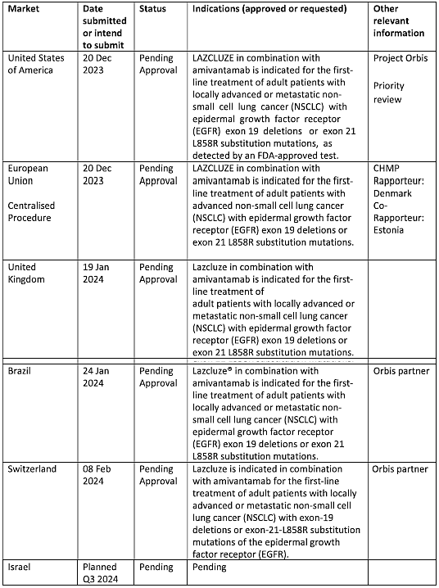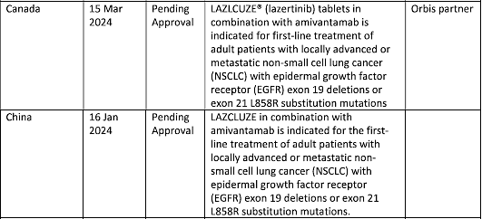

Registration timeline
Table 2 captures the key steps and dates for this submission.
This submission was evaluated under the standard prescription medicines registration process.
This evaluation was facilitated through Project Orbis, an initiative of the United States Food and Drug Administration (FDA) Oncology Center of Excellence. Under this project, the FDA and the TGA collaboratively reviewed the submission. This evaluation process provided a framework for process alignment and management of evaluation issues in real-time across jurisdictions. Each regulator made independent decisions regarding approval (market authorisation) of the new medicine. The publicly available version of the FDA’s evaluation report can be found at https://www.accessdata.fda.gov/drugsatfda_docs/nda/2024/219008Orig1s000MultidisciplineR.pdf
Table 2. Registration timeline for Lazcluze
Description | Date
Submission dossier accepted and evaluation commenced | 30 April 2024
Evaluation completed | 3 December 2023
Advisory committee meeting | 7 February 2025
Registration decision (Outcome) | 9 April 2025
Registration in the ARTG completed | 15 April 2025
Number of working days from submission dossier acceptance to registration decision* | 243 days
*Statutory timeframe for standard submissions is 255 working days

Assessment overview

Quality evaluation summary
There were no significant issues identified from the quality evaluation of the submitted data that would indicate the product should not be registered on the basis of quality, or safety-related issues arising from the quality of the product. The Sponsor has satisfied all requirements with respect to:
- Good Manufacturing Practice compliance,
- stability and release specifications,
- history, control and traceability of cell lines/cell banks,
- validation of analytical procedures,
- appropriate choice/synthesis and validation of reference materials,
- appropriate in-process controls within the manufacturing process and identification of critical manufacturing steps,
- consistency of medicine manufacture verified by process validation and demonstrated through batch analysis,
- satisfactory control of impurities,
- adequate characterisation and justification of excipients,
- medicine sterility/appropriate control of infectious disease & adventitious agents,
- appropriate/compatible container closure systems and
- labelling that conformed to Therapeutic Goods Order 91.
- There were no objections to registration from a quality perspective.

Nonclinical evaluation summary
The submitted nonclinical dossier was in accordance with the relevant ICH guideline for the nonclinical assessment of anticancer pharmaceuticals (ICH S9). The overall quality of the nonclinical dossier was high. All pivotal safety-related studies were good laboratory practice (GLP)-compliant.
In vitro, lazertinib covalently binds to the cysteine residue 797 in mutant EGFR, with nanomolar affinity and selective for mutant cf wild-type EGFR (IC50 values for EGFR with del19, L858R, T790M, del19/T790M and L858R/T790M mutations 1.7-20.6 nM cf. 25.2 nM for wild type cellular EGFR). Xenografts in immunocompromised mice of human NSCLC-derived cell lines expressing mutant EGFR showed dose-dependent tumour regression, whereas xenografts expressing wild-type EGFR showed only modest responses to lazertinib dosing. The combination therapy of lazertinib and amivantamab also demonstrated better anti-tumour response in NSCLC xenografts.
Secondary pharmacodynamics studies did not reveal any clinically relevant interactions with transmembrane and soluble receptors, ion channels or transporters. In a kinase panel screen lazertinib exhibited moderate inhibitory activity against MLK1, which is involved in the MEK/ERK pathway.
Safety pharmacology studies assessed effects on the cardiovascular, respiratory and central nervous systems. No significant adverse effects were seen on cardiovascular function in dogs, or on respiratory and central nervous systems in rats. No significant inhibition of hERG channel current was observed at clinically relevant concentrations.
Lazertinib was rapidly absorbed with similar T_{max} in all species. Bioavailability is low in rats (34-48%), moderate in dogs (58-78%) and high in mice (75-80%). Plasma half-life (t_{1/2}) of lazertinib was longer in humans compared to animal species (~70 hours cf. ~5 -13 h, respectively). Plasma protein binding of lazertinib was high in all animal species and humans, while tissue distribution studies in rats found high distribution of lazertinib-related radioactivity concentrations to the liver, adrenal gland, Harderian gland, lung, and melanin-containing structures of the eye. Studies with human NSCLC-derived xenografts in mice showed that lazertinib distributed into both subcutaneous tumours and brain metastases. lazertinib undergoes glutathione (GSH) conjugation, primarily by glutathione s-transferase M1-1, while oxidative metabolism, primarily by CYP3A4 is a minor pathway. Unchanged lazertinib was the dominant circulating species across all species. Circulating metabolites included GSH adduct (M11), and cysteinylglycine and cysteine conjugates (M12 and M14, respectively). Route of excretion of lazertinib was predominantly via faeces in humans, rats and dogs. Overall, the pharmacokinetic studies suggested that rats and dogs are reasonable models of human exposure to lazertinib.
Lazertinib is a substrate of P-glycoprotein but with efflux ratio of < 2; active transport does not seem clinically relevant. Lazertinib is also a substrate of CYP3A4; thus, inhibitors and inducers of 3A4 may affect lazertinib exposures. Lazertinib moderately inhibited CYP3A4/5 at clinically relevant concentrations, suggesting possible effects on systemic exposures to CYP3A4/5 substrates. Lazertinib also inhibited efflux and uptake transporters BCRP and OCT1, respectively, at clinically relevant concentrations, suggesting that lazertinib may increase exposures to co-administered substrates of these transporters.
The maximum non-lethal dose of orally administered lazertinib in dogs was around 20 mg/kg and 600 mg/kg in rats, suggesting that the lazertinib is of moderate toxicity.
Repeat-dose toxicity studies using daily oral dosing up to 3 months, were conducted in rats and dogs. Exposure ratios (as AUC) achieved at the highest dose in the pivotal studies were low (< 4). Histological changes (degeneration and inflammation), noted in rats and dogs following dosing, were commonly associated with the epithelium lining organs such as skin, eye, lung, kidney, liver, heart and the gastrointestinal and reproductive tracts. Inflammation was a prominent finding and appeared to be secondary to lazertinib induced changes to epithelial structures. There were also treatment-related decreases in RBC, haemoglobin, haematocrit and reticulocytes, lower albumin concentration, lower albumin/globulin ratio, and higher globulin concentration. Most treatment-related effects were partially or completely reversible during drug-free recovery period.
Lazertinib was not mutagenic in the bacterial reverse mutation assay or clastogenic in the in vitro mammalian chromosomal aberration assay or the in vivo rat micronucleus test. No carcinogenicity studies were conducted, which is considered acceptable.
Male rats and dogs in the 4-week repeat dose toxicity studies, showed tubular degeneration, epididymis luminal cellular debris, reduced sperm in epididymis (in dog only) and decreased prostate secretion (in dog only) at low relative exposures. In females, decreased corpora lutea, and atrophy of uterus and vagina were observed. In the dedicated rat fertility study, higher incidences of early reabsorption and post-implantation loss were observed, which led to decrease in number of live fetuses. lazertinib dosing of pregnant rats and pregnant rabbits was associated with increased pre-/post-implantation loss and decreased fetal weight in rats, and increased incidence of skeletal abnormalities in rabbits at low to subclinical exposure, respectively.
Lazertinib was not phototoxic in in vitro and in vivo (pigmented rats).
Lazertinib is classified as a skin sensitizer with a stimulation index 3 based on an estimated concentration of 3.6% of lazertinib.
Two specified impurities proposed at levels above the ICH qualification threshold are considered adequately qualified by toxicity data.
There were no objections to registration from a nonclinical perspective.

Clinical evaluation summary

Pharmacology
- The primary evidence of efficacy and safety is provided by a randomized Study 73841937NSC3003 (MARIPOSA)
- The recommended dosage regimen of lazertinib in combination with amivantamab in the proposed population (as outlined in the proposed Australian PI) is acceptable based on the clinical pharmacology review considerations. Based on available data from MARIPOSA at only one dose level, there are no apparent exposure-response relationships for efficacy or safety for both lazertinib and amivantamab.

Efficacy
The rationale of adding amivantamab to lazertinib is to broaden coverage against the development of resistance pathways, such as MET amplification, in EGFR mt NSCLC. The proposed dosage of amivantamab in combination with lazertinib is the same as the approved monotherapy dosage of amivantamab for EGFR ex20ins NSCLC, whose disease has progressed on or after platinum-based chemotherapy.
- Lazertinib monotherapy was studied over a dose range of 20-320 mg administered once daily, and the data showed positive exposure-response relationships for efficacy, supporting selection of 240 mg QD as the lazertinib monotherapy dosage for the proposed patient population.
- In the MARIPOSA study, a substantial improvement in progression-free survival (PFS) was observed in the combination arm compared to the osimertinib or lazertinib monotherapy arms.
- Lazertinib 240 mg QD monotherapy showed similar efficacy and safety profiles compared to osimertinib monotherapy.

Safety
- An approximately 2-fold exposure (e.g., C_{max} and C_{trough}) difference in lazertinib was observed in patients due to the glutathione-S-transferase mu 1 (GSTM1) polymorphism. Despite 2-fold difference in lazertinib exposure between GSTM1 non-null (i.e., with at least one GSTM1 normal function allele) and null (i.e., with two GSTM1 no-function alleles, no enzyme activities) groups, there were similar incidences of dosage modifications and discontinuations between the two groups in the combination arm.
- Although higher incidences of adverse events (AE) were observed in combination arm, a lower dose of lazertinib with the same dose of amivantamab may not improve safety due to synergistic EGFR-associated toxicities.

Dosing in patient subgroups – intrinsic and extrinsic factors
- No dose adjustment is recommended in patients with renal impairment.
- No dose adjustment is recommended in patients with mild or moderate hepatic impairment.
- No dose adjustment is required based on age, sex, body weight and GSTM1 genotype.

Drug-drug interactions
- The current submission adequately addressed lazertinib’s potential for drug-drug interactions. Adequate dosage recommendations for patients receiving strong, moderate, or weak CYP3A inducers are included in the PI.
- There were no clinically significant differences in lazertinib PK when used concomitantly with gastric acid-reducing agents.
- Avoid concomitant use with strong or moderate CYP3A inducers
- Monitor for adverse reactions associated with a CYP3A substrate where minimal concentration changes may lead to serious adverse reactions as recommended in the approved product labelling for the CYP3A substrate.
- Monitor for adverse reactions associated with a BCRP substrate where minimal concentration changes may lead to serious adverse reactions as recommended in the approved product labelling for the BCRP substrate pharmacokinetics

Mechanism of action
- Amivantamab is a bispecific antibody that binds to the extracellular domains of EGFR and MET. In in vitro and in vivo studies amivantamab was able to disrupt EGFR and MET signalling functions in mutation models of exon 19 deletions, exon 21 L858R substitutions, and exon 20 insertions through blocking ligand binding or degradation of EGFR and MET.
- Lazertinib is a third generation, EGFR TKI. It inhibits both primary activating EGFR mutations (exon 19 deletions and exon 21 L858R substitution mutations) and the EGFR T790M resistance mutation

Dose proportionality
- Lazertinib showed dose proportional increase in AUC and C_{max} across 20-320 mg dose range

Accumulation
- Approximately 2-fold accumulation was observed at steady state with lazertinib 240mg QD dose

Absorption
- The median time to reach single dose and steady state C_{max} was comparable and ranged from 2 to 4 hours. Following administration of 240 mg lazertinib with a high-fat meal, the C_{max} and AUC of lazertinib were comparable to that under fasting conditions.

Distribution
- Volume of distribution = 4262L
- Mean plasma protein binding ~99%

Metabolism
Primarily metabolised by glutathione conjugation, either enzymatic via glutathione-S-transferase or non-enzymatic, as well as by CYP3A4

Elimination
Elimination half life~65h

Excretion
Following single oral dose of radiolabelled lazertinib, ~86% of the dose was recovered in faeces (<5% as unchanged) and 4% in urine (<0.2% as unchanged)

Drug-drug interaction potential – effect of other drugs on lazertinib
Effect of CYP3A inducers on lazertinib: Concomitant use of rifampin (Strong CYP3A inducer) with Lazcluze decreased lazertinib C_{max} by 72% and AUC by 83%. Concomitant use of efavirenz (moderate CYP3A inducer) with Lazcluze is predicted to decrease lazertinib steady state C_{max} by at least 32% and AUC by at least 44%. The effect of concomitant use of weak CYP3A inducers on lazertinib C_{max} or AUC is unknown.
Effect of Strong CYP3A inhibitors on lazertinib: Concomitant use of itraconazole (strong CYP3A inhibitor) with Lazcluze increased lazertinib C_{max} increased by 1.2-fold and AUC by 1.5-fold.
Effect of ARAs on lazertinib: No clinically significant differences in lazertinib pharmacokinetics were observed when used concomitantly with ARAs

Drug-drug interaction potential – effect of lazertinib on other drugs
Concomitant use of Lazcluze increased midazolam (CYP3A substrate) C_{max} by 1.4-fold and AUC by 1.5-fold.
Concomitant use of Lazcluze increased rosuvastatin C_{max} by 2.2-fold and AUC by 2-fold.
No clinically significant differences in the pharmacokinetics of the following were observed or predicted when used concomitantly with lazertinib: metformin (OCT1 substrate) or raltegravir (UGT1A1 substrate).

Efficacy
The following clinical studies provide efficacy and safety data to support the registration of Lazcluze:
- 73841937NSC3003 (MARIPOSA, Phase 3): Pivotal study for efficacy and safety
- 61186372EDI1001 (CHRYSALIS, Phase 1): Supportive study for efficacy and safety (combination with amivantamab) and Supportive study for safety (amivantamab monotherapy)
- 73841937NSC1001 (CHRYSALIS-2, Phase 1/1b): Supportive study for safety
- 73841937NSC2001/ YH25448-201 (Phase 1/2): Supportive study for efficacy and safety
- YH25448-301 (Phase 3): Supportive study for efficacy and safety
The efficacy of the combination of lazertinib and amivantamab for the proposed indication is supported by data from the pivotal MARIPOSA study.
The clinical evaluation for this submission focussed on the review of efficacy and safety data from MARIPOSA; data from other supportive trials were not independently verified.

Pivotal study - MARIPOSA (73841937NSC3003)
MARIPOSA is an ongoing, randomised, multicentre Phase 3 study comparing the efficacy and safety of the combination of amivantamab and lazertinib versus the current SOC osimertinib monotherapy in treatment-naïve adult participants with locally advanced or metastatic NSCLC with EGFR exon 19 deletions or exon 21 L858R substitution mutations (EGFRm NCSLC).

Design
Phase 3, randomized study of the combination of amivantamab and lazertinib versus osimertinib and versus lazertinib.
Figure 1. Schematic Overview of MARIPOSA (73841937NSC3003) Study Design
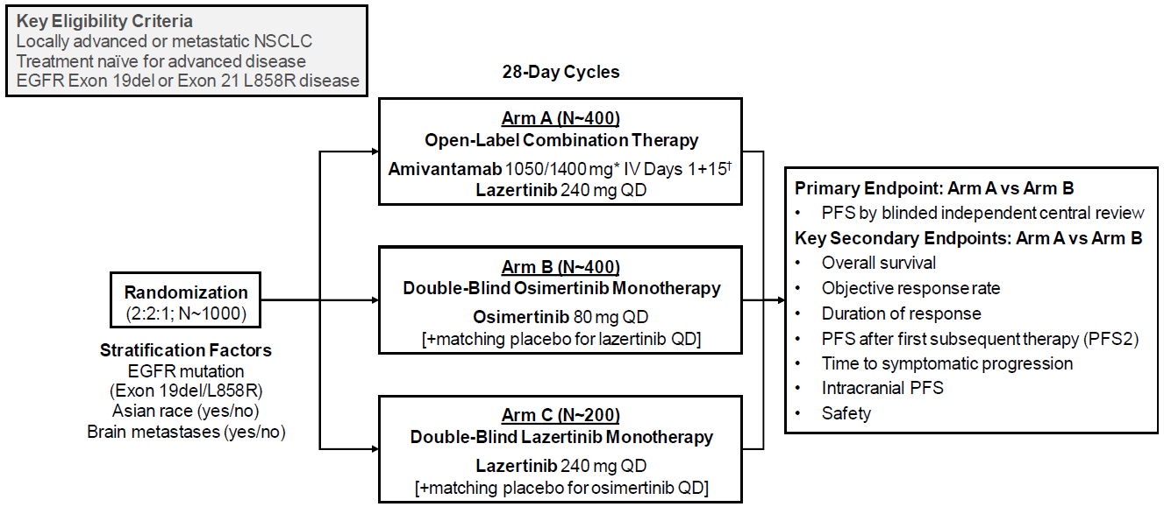
EGFR=epidermal growth factor receptor; IV=intravenous; NSCLC=non-small cell lung cancer; PFS=progression free survival;
QD=once daily
Arm A=amivantamab+lazertinib arm; Arm B=osimertinib arm; Arm C=lazertinib arm
*Weight-based dosing: <80 kg/≥80 kg
†Cycle 1: Days 1/2 (split dose), 8, 15, 22; Cycles 2+: Days 1, 15

Trial location
The study was conducted at 262 study centres in 27 countries: Argentina, Australia, Belgium, Brazil, Canada, China, France, Germany, Hungary, India, Israel, Italy, Japan, Malaysia, Mexico, Netherlands, Poland, Portugal, Russian Federation, South Korea, Spain, Taiwan, Thailand, Turkey, Ukraine, UK, and the US (including Puerto Rico).

Diagnostic criteria
Table 3. MARIPOSA diagnostic criteria
Patients | Key inclusion criteria:  - Histologically or cytologically confirmed locally advanced or metastatic NSCLC, not amenable to curative therapy including surgical resection or chemoradiation  - Treatment naïve for advanced disease  - Exon 19del or Exon21 L858R EGFR mutations  - 18+ years  - ECOG (Eastern Cooperative Oncology Group) score: 0 or 1  - Measurable disease by RECIST 1.1  - Adequate organ/bone marrow function  - Patients with asymptomatic or previously treated and stable intracranial metastases were eligible to enrol
Intervention | Randomisation 2:2:1  - Arm A (n= 429): Open-Label combination therapy  - Amivantamab 1050mg (<80kg)/1400mg (≥80kg), intravenous once weekly for 4 weeks, then intravenous D1&15 thereafter starting at week 5  - lazertinib 240mg orally daily  - Arm C (n=216): lazertinib Monotherapy (to evaluate the contribution of the components in the combination treatment arm)  - lazertinib 240mg orally daily (+ matching placebo for osimertinib daily)
Comparator | Arm B (n=429): osimertinib Monotherapy  - osimertinib 80mg orally daily (+ matching placebo for lazertinib daily)
Endpoints | - Primary endpoint (Arm A vs Arm B)  - PFS by BICR (blinded independent central review)  - Key secondary endpoints  - OS (overall survival)  - ORR (objective response rate)  - DoR (duration of response)  - PFS2 (progression-free survival after first subsequent therapy)  - TTSP (time to symptomatic progression)  - Intracranial PFS  - Safety
*Stratified by EGFR mutation (Exon 19del/L858R), Asian Race (Y/N), Brain metastases (Y/N)

Patient disposition
1074 participants randomised (429 to combination, 429 to osimertinib, 216 to lazertinib), 1062 randomised participants received at least 1 dose of study treatment and were included in the safety population.
At the time of the clinical cutoff (11 August 2023), 45.4%, 50.2%, and 50.2% of participants randomized to amivantamab + lazertinib, osimertinib, and lazertinib, respectively, had discontinued study treatment, most commonly for progressive disease, observed in 20.4%, 36.0%, and 33.8% of participants, respectively (in the safety population, discontinuations due to PD: 24% for the amivantamab in combination with lazertinib arm, 40% for the osimertinib arm, and 39% for the lazertinib arm discontinuation due to TEAEs were reported in 20.4%, 11.7%, and 13.6% of participants, respectively; in the safety population, discontinuation of all study drugs due to TEAEs were 21% for the amivantamab in combination with lazertinib arm, 13% for the osimertinib arm, and 15% for the lazertinib arm.)

Baseline characteristics
- Age, median: 63 years (range: 15-88)
- Female: 61%
- Asian: 58%; White:38%
- Smoking history: 31%; never smoked: 69%
- ECOG 0: 34%, ECOG 1: 66%
- Prior brain metastases: 41%
- Stage IV at initial diagnosis: 89%
- Ex19 del: 60%; ex21 L858R mut: 40%

Results

PFS by BICR
The study demonstrated a statistically significant improvement in PFS by BICR assessment for lazertinib in combination with amivantamab compared to osimertinib.
Table 4. MARIPOSA results by BICR assessment
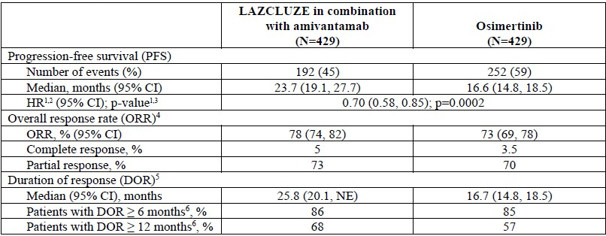
CI = confidence interval; NE = not estimable
1 Stratified by mutation type (Exon 19del or Exon 21 L858R). prior brain metastases (yes or no), and Asian race (yes or no).
2 Stratified Cox proportional hazards regression.
3 Stratified log-rank test.
+ — Confirmed responses based on the ITT population.
> In confirmed responders.
§ Based on observed rates.
Figure 2. Kaplan-Meier curve of PFS in previously untreated NSCLC patients by BICR assessment
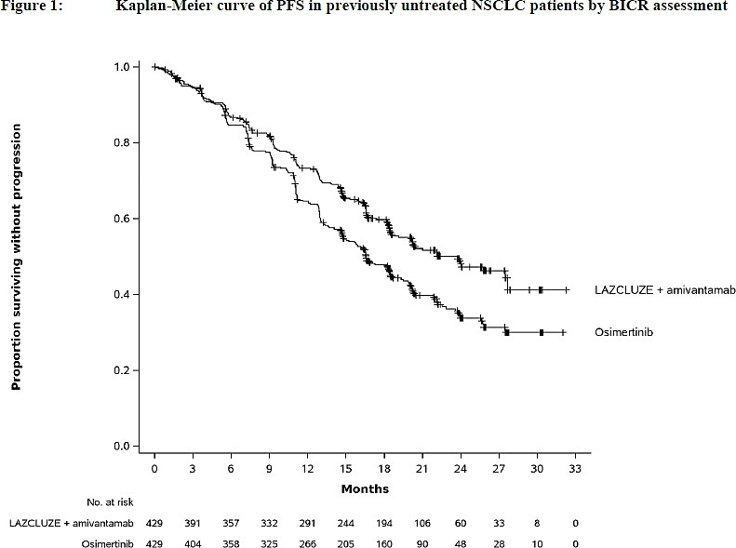

PFS - pre-specified sub-groups
PFS per BICR was also evaluated in clinically relevant subgroups. The PFS benefit is mostly consistent across subgroups except for patients 65 years or older with the hazard ratio of 1.06 (95% CI: 0.80, 1.41)

Contribution of components
Evaluation of contribution of components for PFS was conducted descriptively comparing the combination arm vs the lazertinib monotherapy arm. In this descriptive analysis, the PFS hazard ratio was 0.72 (95% CI: 0.57, 0.90) with a median PFS of 23.7 months in the combination arm vs 18.5 months in the lazertinib monotherapy arm. These results suggest a potential improvement in PFS with the addition of amivantamab to lazertinib. However, the comparison in PFS between the combination arm and the lazertinib monotherapy arm was not formally tested and should be interpreted with caution.

Efficacy results – secondary and other endpoints
Table 5. Analysis of secondary endpoints for the MARIPOSA study
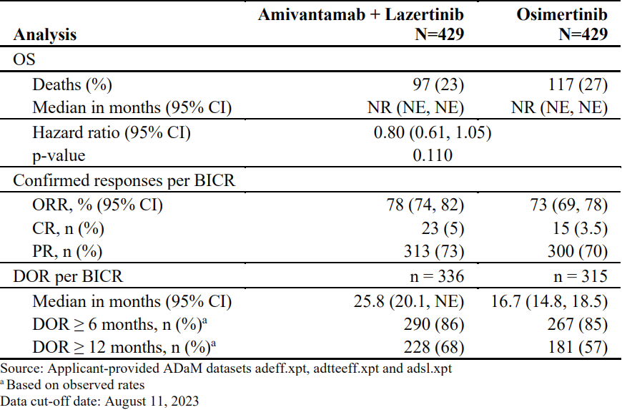
OS results are immature; with 55% of pre-specified deaths for the final analysis reported, no trend towards a detriment was observed. In an additional ad-hoc analysis requested by the European Medicines Agency, the descriptive OS HR was 0.77 (95% CI: 0.61, 0.96) at 82% information fraction.

Safety
Given that the safety data from MARIPOSA were deemed robust and sufficient to evaluate the safety profile of amivantamab in combination with lazertinib for the proposed indication, the supportive trials (CHRYSALIS, CHRYSALIS-2, YH254448-201 and YH25448-301) were not formally reviewed as a part of this clinical evaluation. In addition, trials YH254448-201 and YH- 25448-301 evaluated lazertinib monotherapy, which is not under consideration for approval. Therefore, the safety data from YH254448-201 and YH-25448-301 were not considered relevant for the primary safety evaluation of amivantamab in combination with lazertinib.
The primary review of safety consists of evaluations of safety events occurring in 421 patients who received at least one dose of study treatment in the amivantamab with lazertinib arm (Arm A) and 428 patients who received at least one dose of osimertinib in Arm B.

Exposure
For the 421 patients treated in Arm A, the median duration of treatment with amivantamab in combination with lazertinib was 18.5 months (range: 0.2, 31.4). For the 428 patients treated in Arm B, the median duration of treatment with osimertinib was 18.0 months (range: 0.2, 32.7). In Arm A, the median number of treatment cycles was 16 (range: 1, 35).

Characteristics of the safety population
For the primary safety population (amivantamab in combination with lazertinib, n=421), the median age was 64 years (range: 25, 88), 45% of patients were age 65 years or older, 64% were female, 59% were Asian, 38% were White, 1.7% were American Indian or Alaska Native, 0.7% were Black or African American, 0.5% were of unknown race, 0.2% were Hawaiian or Other Pacific Islander, 13% were Latino, 33% had ECOG PS 0, 67% had ECOG PS 1, 60% had NSCLC harbouring EGFR exon 19 deletions, and 40% had EGFR exon 21 L858R substitution mutations. The distribution of baseline characteristics was well-balanced between Arms A and B

Categorisation of AEs
Table 6. MARIPOSA study adverse events summary
Adverse event | amivantamab + lazertinib (n=421) | osimertinib (n=428)
All-grade AEs | 100% | 99%
Grade 3-4 AEs | 67% | 36%
Grade 3 AEs | 62% | 32%
Grade 4 AEs | 5% | 3.7%
Grade 5 of fatal AEs | 7% | 7%
SAEs | 48% | 33%

Deaths
The incidence of deaths due to TEAEs within 30 days of the last dose of study therapy in MARIPOSA was similar for the lazertinib + amivantamab and osimertinib arms.
Of note, 0.5% of patients experienced fatal TEAEs due to potential thrombotic events (i.e., VTE, pulmonary embolism) in lazertinib + amivantamab arm. This should be detailed in the relevant section of the Australian PIs.

Serious adverse events
Table 7. MARIPOSA study serious adverse events summary
Adverse event | amivantamab + lazertinib (n=421) | osimertinib (n=428)
All-grade AEs | 100% | 99%
Grade 3-4 AEs | 67% | 36%
Grade 3 AEs | 62% | 32%
Grade 4 AEs | 5% | 3.7%
Grade 5 of fatal AEs | 7% | 7%
SAEs | 48% | 33%

While the incidence of SAEs was similar for most types of events across the arms A and B, VTEs occurred more frequently in the amivantamab + lazertinib combination arm.

Significant adverse events
Table 8. MARIPOSA – grades 3-4 AEs occurring in ≥10% of patients treated in Arms A and B
Adverse event | amivantamab + lazertinib (n=421) | osimertinib (n=428)
All grade 3 or 4 AEs | 67% | 36%
Rash | 27% | 1.1%
Nail toxicity | 11% | 0.7%
Venous thromboembolism | 11% | 2.8%

Specific safety issues:

Rash
A high incidence of rash associated with the use of amivantamab and lazertinib was noted. 362 patients (86%) with an event of rash as of the 120-day safety update DCO. In addition, 26% of patients had Grade 3 rash, 37% had rash leading to dose interruptions of amivantamab, 30% had rash leading to dose interruptions of lazertinib, 23% had rash leading to dose reduction of amivantamab, 19% had rash leading to dose reduction of lazertinib, 5% had rash leading to permanent discontinuation of amivantamab, and 1.9% had rash leading to permanent discontinuation of lazertinib.

Infusion-related reactions
A high incidence of infusion-related reactions (IRR) associated with the use of amivantamab was noted. In patients treated with amivantamab in combination with lazertinib (Arm A) in MARIPOSA, as of the 120-day safety update, 63% developed infusion related reactions (IRRs) of any Grade, 5% experienced Grade 3 IRRs, and 1% experienced Grade 4 IRRs. A total of 54% of patients had dose interruptions of amivantamab due to IRRs, 0.7% had dose reductions of amivantamab due to IRRs, and 4.5% of patients had amivantamab permanently discontinued due to IRRs.

Pneumonitis/interstitial lung disease
In patients treated with amivantamab in combination with lazertinib (Arm A) in MARIPOSA, as of the 120- day safety update, 3.1% developed interstitial lung disease (ILD)/pneumonitis of any Grade. In Arm A, the incidence of grade 3 ILD/pneumonitis was 1.0% and the incidence of Grade 4 ILD/pneumonitis was 0.2%. In addition, one patient (0.2%) died of ILD/pneumonitis and 2.9% permanently discontinued lazertinib and amivantamab due to ILD/pneumonitis. Although most ILD/pneumonitis events are Grade 1 or 2, severe or fatal events may occur.

Venous thromboembolism
- As of the 120- day safety update, in patients treated with amivantamab in combination with lazertinib (Arm A), the incidence of all-Grade VTEs was 36%.
- The incidence of Grade 3 VTEs was 10% and 0.5% of patients developed Grade 4 VTEs.
- Two patients (0.5%) died of VTEs consisting of pulmonary embolism.
- Dose interruptions of amivantamab due to VTEs occurred in 9% of patients and dose interruptions of lazertinib due to VTEs occurred in 7% of patients.
- Dose reductions of amivantamab due to VTEs occurred in 1.0% of patients and dose reductions of lazertinib due to VTEs occurred in 0.5% of patients.
- The development of VTEs led to permanent discontinuation of amivantamab in 3.1% of patients and of lazertinib in 1.9% of patients.
- Of the 151 patients who developed VTEs during treatment with amivantamab in combination with lazertinib in MARIPOSA, 94 (62%) had the first VTE within the first 4 months of study treatment. The median time to VTE onset was 84 days (range 6 to 777).

Expectations on safety in the post-market setting
The FDA issued a post marketing requirements requiring additional safety analyses of VTEs in patients treated with amivantamab in combination with lazertinib who did not receive prophylactic anticoagulation, who received prophylactic anticoagulation during the initial 4 months of treatment and discontinued anticoagulants, and who received prophylactic anticoagulation during and after the initial 4 months of treatment.

Risk management plan evaluation summary
Safety concerns and their associated risk monitoring and mitigation strategies are summarised in Table 9.
Table 9. Summary of safety concerns.
Summary of safety concerns |  | Pharmacovigilance |  | Risk Minimisation
 |  | Routine | Additional | Routine | Additional
Important identified risks | Venous thromboembolic  (VTE) events* | ü | – | ü | –
Important potential risks | Hepatotoxicity | ü | – | ü | –
Important potential risks | Impaired fertility  and embryofetal  toxicity | ü | – | ü | –
Missing information | None | – | – | – | –
*Applies only to the combination of lazertinib and amivantamab

Risk-benefit analysis
Lung cancer is the leading cause of cancer-related mortality worldwide. Metastatic NSCLC harbouring ex19del or ex21 L858R mutations is a fatal, incurable disease.
For patients with advanced NSCLC with EGFR ex19del or ex21 L858R mutations, osimertinib
+/- chemotherapy is currently the recommended first line treatment option in Australia, however, virtually all patients will develop resistance to this. Consequently, an unmet need exists for more effective systemic therapies for patients in this setting.
Lazertinib is an oral third generation TKI of the EGFR protein, with activity in NSCLC tumours harbouring EGFR exon 19del and ex21 L858R mutations, in addition to ex20 T790M mutations. Treatment with lazertinib in combination with amivantamab have shown promising results in the pre-clinical space.

Proposed indication
The Sponsor proposes to register lazertinib (LACLUZE), a new therapeutic entity, for the following indication:
“Lazcluze in combination with amivantamab is indicated for the first-line treatment of adult patients with locally advanced or metastatic non-small cell lung cancer (NSCLC) with epidermal growth factor receptor (EGFR) exon 19 deletions or exon 21 L858R substitution mutations.”
The recommended dosage of lazertinib is 240 mg once daily, in combination with amivantamab.
The same indication is proposed for amivantamab (RYBREVANT) via a Category 1 Type C application PM-2024-01139-1-4, which is being submitted concurrently with this application.

Benefits / Uncertainties of benefit
The Sponsor has provided adequate evidence of effectiveness to support approval of amivantamab and lazertinib for the proposed patient population, based on the large, adequate, well-controlled, multicentre MARIPOSA trial.
MARIPOSA is an ongoing, randomised, multicentre Phase 3 study evaluating the combination of amivantamab and lazertinib for the first line treatment of patients with locally advanced or metastatic NSCLC with EGFR exon 19 deletions or exon 21 L858R substitution mutations (EGFRm NCSLC). Patients were randomised (2:2:1) to receive amivantamab + lazertinib (n=429), osimertinib (n=429) or lazertinib monotherapy. (The lazertinib monotherapy arm was included to allow for a descriptive comparison with the other treatment arms to evaluate the contribution of components of the combination regimen.)
The primary evaluation of efficacy relied upon the comparison between patients treated with lazertinib (240mg once daily) in combination with amivantamab (intravenous, 1050mg for patients <80kg or 1400mg for patients ≥80kg) once weekly for 4 weeks, then every 2 weeks thereafter from Wk5), versus osimertinib (80mg once daily). The primary endpoint was PFS by BICR; OS was to be tested if PFS was statistically significant.
MARIPOSA met its primary endpoint, demonstrating a statistically significant and clinically meaningful improvement in PFS by BICR for the combination of amivantamab and lazertinib as compared to osimertinib, with a 30% reduction in the risk of disease progression or death (HR=0.70 [95% CI: 0.58, 0.85], p=0.0002, median PFS 23.7 months for the combination of amivantamab and lazertinib vs 16.6 months for osimertinib).
Secondary endpoint OS results are immature; interim OS analyses appear to indicate no obvious detrimental effect of the combination regimen (82% information fraction).

Uncertainties
Overall survival data remain immature. It is expected, as a condition of registration, that the Sponsor will submit the final dataset and analysis of the MARIPOSA trial (including the results of the final overall survival analysis).

Risks / Uncertainties of risk
The safety profile is acceptable in the context of the observed efficacy in the proposed population.
The primary safety population was derived from the MARIPOSA trial, consisting of 421 patients who received at least one dose of amivantamab and lazertinib and 428 patients who received at least one dose of osimertinib. Overall, the toxicity profile of amivantamab in combination with lazertinib reflects the on-target inhibition of the EGFR and MET pathways induced by each agent comprising the regimen. While this combination was generally associated with higher incidence and severity of AEs when compared to osimertinib, the incremental toxicities of the combination are considered acceptable in the context of the increased efficacy of the combination regimen vs osimertinib for the proposed population.
Table 10. Adverse events, MARIPOSA trial, from Cho, BC et. al., 2024.
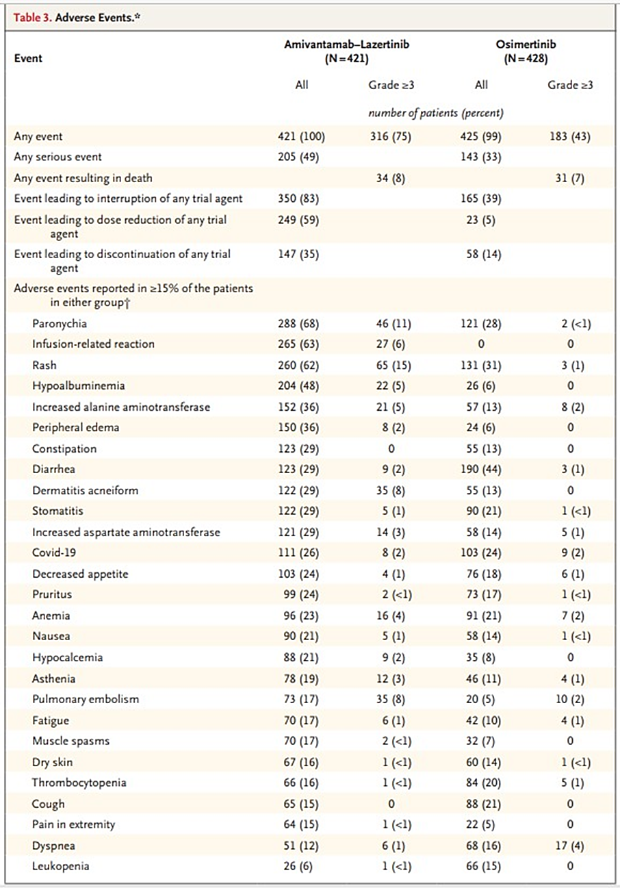
*The safety population included all the patients who had undergone randomization and received at least one dose of any trial treatment. Adverse events were coded according to preferred terms in the Medical Dictionary for Regulatory Activities, version 25.1. Covid-19 denotes coronavirus disease 2019.
†Events in this category are listed according to decreasing incidence in the amivantamab–lazertinib group.

Most common TEAEs:
For amivantamab + lazertinib: decreased albumin (89%), rash (86%), nail toxicity (71%), increased ALT (65%), IRR (63%), increased AST (52%), musculoskeletal pain (47%), stomatitis (43%), peripheral oedema (43%), decreased calcium (41%), VTE (36%), increased GGT (39%), decreased sodium (38%), paraesthesia (35%), fatigue (32%), decreased potassium (30%), diarrhoea (31%), constipation (29%)
For osimertinib: rash (48%), diarrhoea (45%), musculoskeletal pain (39%), increased AST (36%), decreased sodium (35%), increased creatinine (35%), nail toxicity (34%), increased ALT (29%), stomatitis (27%)

Grade 3-4 TEAEs: 67% (amivantamab + lazertinib) vs 36% (osimertinib)
- For amivantamab + lazertinib: rash (26%), paronychia (11%), VTE (11%), hypalbuminaemia (8%), ALT increased (7%), IRR (6%)
- For osimertinib: no grade 3-4 AEs ≥5%. Rash (1.2%), paronychia (0.7%), VTE (2.8%), IRR (0%), hypalbuminaemia (0.2%), ALT increased (2.6%).

SAEs: 49% (amivantamab + lazertinib) vs 33% (osimertinib)
- For amivantamab + lazertinib: VTE (11%)*, pneumonia (4%), rash (3%), ILD/pneumonitis (3%), covid-19 (2.4%), pleural effusion (2.1%), IRR (2.1%)
- For osimertinib: pneumonia (5%), pleural effusion (4%), VTE (3.3%), ILD/pneumonitis (3%), covid-19 (2.3%), rash (0), IRR (0)

Venous thromboembolism
Mostly occur during first 4 months of combination therapy; of the 151 patients who developed VTEs during treatment with the amivantamab + lazertinib combination in MARIPOSA, 94 (62%) had the first VTE within the first 4 months of study treatment, with the median tine to VTE onset of 84 days (range: 6 to 777). For patients in the amivantamab + lazertinib arm:
- All-grade VTEs: 36%
- Grade 3 VTEs: 10%
- Grade 4 VTEs: 0.5%
- 2 patients (0.5%) died of PE
- VTEs led to permanent discontinuation of amivantamab in 3.1% of patients and lazertinib in 1.9% of patients
- Dose interruptions of amivantamab due to VTEs occurred in 9% of patients
- Dose interruptions of lazertinib due to VTEs occurred in 7% of patients
- Dose reductions of amivantamab due to VTEs occurred in 1.0% of patients
- Dose reductions of lazertinib due to VTEs occurred in 0.5% of patients
During the study, the Sponsor reported a higher incidence of VTEs for amivantamab + lazertinib, leading to urgent safety measure for recommendation of prophylactic anticoagulation per local guidelines during initial 4 months of combination therapy (only 12 patients were eligible for prophylaxis as enrolment in MARIPOSA had completed)
For patients in whom anti-coagulation was initiated after the onset of a VTE event, bleeding events occurred in 8% of those in the amivantamab + lazertinib group vs 3% in the osimertinib group. Recurrent VTE events occurred in 2% of those in the amivantamab + lazertinib group vs 0% in the osimertinib group.

Fatal adverse events
7.4% (amivantamab + lazertinib) vs 6.8% (osimertinib). Cardiopulmonary, cerebrovascular and infection-related deaths predominated in these groups.

Drug interruption (any study drug) due to AE
83%* (amivantamab + lazertinib) vs 39% (osimertinib). (It is noted from the TGA analysis that 88% of patients experienced AEs leading to interruption of amivantamab, differing from the Sponsor’s findings of 78%).

Drug interruption (tyrosine kinase inhibitor) due to AE
72% (amivantamab + lazertinib) vs 39% (osimertinib) Dose reduction (any drug) due to AE: 59% (amivantamab + lazertinib) vs 5% (osimertinib) Dose reduction (TKI) due to AE: 42% (amivantamab + lazertinib) vs 5% (osimertinib)

Drug discontinuation (any drug) due to AE
35% (amivantamab + lazertinib) vs 14% (osimertinib)

Drug discontinuation (tyrosine kinase inhibitor) due to AE
21% (amivantamab + lazertinib) vs 14% (osimertinib)
To summarise, there was a 31% absolute increase in Grade 3/4 events with the combination vs osimertinib and a 16% absolute increase in SAEs with the combination vs osimertinib. Despite a substantial increase in drug interruptions, dose modifications and dose discontinuations observed in the combination amivantamab + lazertinib arm vs osimertinib, the incidence of fatal AEs were similar and improvement in PFS is substantial. VTE is a new safety signal (37% vs 9%); this should be addressed in the PI.

Uncertainties

Venous thromboembolism
Effect of prophylactic anticoagulation remains uncertain, however, the currently proposed recommendation of prophylactic anticoagulation per local guidelines during initial 4 months of combination therapy (as per MARIPOSA protocol, amendment 3, and based on the additional information from PALOMA-3) by the Sponsor and evaluator is considered to be reasonable. To further characterise the risk of VTEs in the relevant clinical studies of lazertinib + amivantamab, the Sponsor has conducted a safety/VTE study as per the corresponding FDA post-marketing requirement, and is expected to submit the final analysis and report of this data post approval; this may help inform the use of prophylactic anticoagulation.

Recurrent VTE in the setting of therapeutic anticoagulation
There is some uncertainty regarding the use of lazertinib or amivantamab in patients who develop recurrent VTE despite therapeutic anticoagulation.
The Sponsor recommends the following in the proposed Australian PI:
Treatment can continue with either Lazcluze or amivantamab, but not both at the discretion of the treating physician.
Recurrent VTE event despite therapeutic level anticoagulation: permanently discontinue Lazcluze or amivantamab. Treatment can resume with either but not both at the discretion of the treating physician.
The FDA recommends the following:
Permanently discontinue amivantamab and continue Lazcluze for Recurrent VTE despite therapeutic level anticoagulation.
In MARIPOSA, resumption of study treatment was permitted following resolution of a grade 3 or 4 VTE event at the discretion of the investigator (after withholding study treatment, and after consultation with the medical monitor). However, the protocol did not include any specific directions for dose modifications in the event of recurrent VTE despite therapeutic anticoagulation.
The additional data from PALOMA-3 (clinical cutoff 16 April 2024) provided some details regarding outcomes of VTE events for patients who received “treatment-level” (i.e. therapeutic) anticoagulation. However, these data do not provide sufficient or relevant information to help guide the use of either lazertinib monotherapy or amivantamab monotherapy in patients who have experienced recurrent VTE despite therapeutic anticoagulation.
It therefore remains unclear as to whether the use of either amivantamab or lazertinib in this situation should be recommended. The delegate will seek the opinion/advice of ACM regarding the use of either Lazertinib or amivantamab monotherapy in this situation, and corresponding recommendations for Sections 4.2 and 4.4 of the Australian PI.
Although the combination of lazertinib plus amivantamab in the proposed population does have notable toxicity with 49% of patients experiencing a serious adverse event, the risks are considered to be outweighed by the magnitude of PFS benefit and supportive OS results, in the context of a life-threatening disease.

Conclusion
Overall, the benefit-risk assessment for lazertinib in combination with amivantamab for the proposed population is considered to be favourable. The delegate supports the registration of lazertinib + amivantamab for the following indication:
Lazcluze in combination with amivantamab is indicated for the first-line treatment of adult patients with locally advanced or metastatic non-small cell lung cancer (NSCLC) with epidermal growth factor receptor (EGFR) exon 19 deletions or exon 21 L858R substitution mutations.
In relation to PI recommendations for patients on lazertinib + amivantamab who experience recurrent VTE despite therapeutic anticoagulation, the delegate will seek ACM advice regarding the acceptability of use of either lazertinib or amivantamab monotherapy in this situation.

Advisory Committee considerations
The Advisory Committee on Medicines (ACM), having considered the evaluations and the Delegate’s overview, as well as the sponsor’s response to these documents, advised the following:
Does ACM agree with the proposed PI recommendations that treatment can continue with either lazertinib or amivantamab in the proposed population in the event of recurrent VTE despite therapeutic anticoagulation?
The ACM noted that 37% of patients on lazertinib + amivantamab developed VTE, compared to 9% on osimertinib. Two patients (0.5%) died of VTEs consisting of pulmonary embolism. About 1.9% of patients permanently discontinued lazertinib due to VTE.
Lazertinib alone has shown efficacy noninferior to osimertinib in NSCLC in MARIPOSA, although lazertinib monotherapy was not formally tested.
There is limited safety data on monotherapy with amivantamab or lazertinib in patients with recurrent VTE despite anticoagulation. Some patients may benefit from continued treatment after stabilisation and individualised patient risk assessments should be undertaken to determine continuation.
Would ACM support the following alternative PI recommendation: “In the event of recurrent VTE despite therapeutic anticoagulation, withhold Lazcluze and amivantamab until clinically stable. Thereafter, continuation of lazertinib monotherapy may be an option if clinically warranted”
The ACM advised that it would be appropriate to include the PI recommendation as stated above.
Prolonged anticoagulation therapy was not shown to further reduce VTE incidence after the first 4 months.
The ACM also advised that the indication should include the recommendation for prophylactic anticoagulation for at least the first 4 months of therapy and ongoing anticoagulation at clinician discretion. This reflects that the baseline (pretreatment) risk of VTE in the NSCLC patient population is approximately 10%, which increases to approximately 30% upon initiation of amivantamab with lazertinib without prophylactic anticoagulation for up to 4 months, before returning to baseline.
The ACM recommended that OS data from the final study report from MARIPOSA (expected end 2025) should be reviewed by the TGA.

ACM conclusion
The ACM considered lazertinib (Lazcluze) to have an overall positive benefit-risk profile for the indication:
Lazcluze in combination with amivantamab is indicated for the first-line treatment of adult patients with locally advanced or metastatic non-small cell lung cancer (NSCLC) with epidermal growth factor receptor (EGFR) exon 19 deletions or exon 21 L858R substitution mutations. Prophylactic anticoagulation is recommended for at least the first 4 months of therapy and ongoing anticoagulation is at clinician discretion.
For lazertinib (Lazcluze) the ACM advised the inclusion in the PI of words to the effect:
In the event of recurrent VTE despite therapeutic anticoagulation, withhold lazertinib and amivantamab until clinically stable. Thereafter, continuation of lazertinib monotherapy may be an option if clinically warranted.

Assessment outcome
Based on a review of quality, safety, and efficacy, the TGA decided to register Lazcluze (lazertinib) for the following indication:
Lazcluze in combination with amivantamab is indicated for the first-line treatment of adult patients with locally advanced or metastatic non-small cell lung cancer (NSCLC) with epidermal growth factor receptor (EGFR) exon 19 deletions or exon 21 L858R substitution mutations.

Specific conditions of registration
Lazcluze (Lazertinib) is to be included in the Black Triangle Scheme. The PI and CMI for Lazcluze must include the black triangle symbol and mandatory accompanying text for five years, which starts from the date of first supply of the product.
The Lazcluze EU-Risk Management Plan (RMP) (version 1.1, dated 15 December 2023, data lock point 11 August 2023), with Australian Specific Annex (version 1.0, dated 11 March 2024), included with submission PM-2024-01143-1-4 and any subsequent revisions, as agreed with the TGA will be implemented in Australia.
An obligatory component of risk management plans is routine pharmacovigilance. Routine pharmacovigilance includes the submission of periodic safety update reports (PSURs).
Unless agreed separately between the supplier who is the recipient of the approval and the TGA, the first report must be submitted to TGA no later than 15 calendar months after the date of this approval letter. The subsequent reports must be submitted no less frequently than annually from the date of the first submitted report until the period covered by such reports is not less than three years from the date of this approval letter. The annual submission may be made up of two PSURs each covering six months. If the sponsor wishes, the six monthly reports may be submitted separately as they become available.
If the product is approved in the EU during the three years period, reports can be provided in line with the published list of EU reference dates no less frequently than annually from the date of the first submitted report until the period covered by such reports is not less than three years from the date of this approval letter.
The reports are to at least meet the requirements for PSURs as described in the European Medicines Agency’s Guideline on good pharmacovigilance practices (GVP) Module VII-periodic safety update report (Rev 1), Part VII.B Structures and processes. Note that submission of a PSUR does not constitute an application to vary the registration. Each report must be submitted within ninety calendar days of the data lock point for that report.
Complete, and submit the final dataset and analysis of, the MARIPOSA trial and include the results of the final OS analysis once the anticipated 390 death events have occurred in the amivantamab in combination with lazertinib and osimertinib arms to further characterise the clinical benefit of amivantamab in combination with lazertinib for the first line treatment of adult patients with metastatic NSCLC harbouring EGFR exon 19 deletion or L858R mutations.
Conduct and submit results of comprehensive safety analyses from clinical studies that further characterise the known serious risk of VTEs in patients treated with amivantamab intravenously and patients treated with amivantamab subcutaneously in combination with lazertinib. Provide the incidence, timing, and outcome of VTEs by grade in patients who did not receive prophylactic anticoagulation, who received prophylactic anticoagulation for the initial 4 months of study therapy only, who continued prophylactic anticoagulation beyond 4 months of study therapy, and who required initiation of treatment-level anticoagulation. Monitor patients for VTEs throughout study therapy until treatment discontinuation.

Product Information and Consumer Medicines Information
For the most recent Product Information (PI) and Consumer Medicines Information (CMI), please refer to the TGA PI/CMI search facility.

Therapeutic Goods Administration
PO Box 100 Woden ACT 2606 Australia
Email: info@tga.gov.au Phone: 1800 020 653 Fax: 02 6203 1605
https://www.tga.gov.au

International Conference on Harmonisation of Technical Requirements for Registration of Pharmaceuticals for Human Use. ICH S9 Non-clinical evaluation for anticancer pharmaceuticals - Scientific guideline. 2013.
Table from FDA lazertinib Multi-disciplinary Review and Evaluation report: https://www.accessdata.fda.gov/drugsatfda_docs/nda/2024/219008Orig1s000MultidisciplineR.pdf
Cho BC, Lu S, Felip E, Spira AI, Girard N, Lee JS, Lee SH, Ostapenko Y, Danchaivijitr P, Liu B, Alip A, Korbenfeld E, Mourão Dias J, Besse B, Lee KH, Xiong H, How SH, Cheng Y, Chang GC, Yoshioka H, Yang JC, Thomas M, Nguyen D, Ou SI, Mukhedkar S, Prabhash K, D'Arcangelo M, Alatorre-Alexander J, Vázquez Limón JC, Alves S, Stroyakovskiy D, Peregudova M, Şendur MAN, Yazici O, Califano R, Gutiérrez Calderón V, de Marinis F, Passaro A, Kim SW, Gadgeel SM, Xie J, Sun T, Martinez M, Ennis M, Fennema E, Daksh M, Millington D, Leconte I, Iwasawa R, Lorenzini P, Baig M, Shah S, Bauml JM, Shreeve SM, Sethi S, Knoblauch RE, Hayashi H; MARIPOSA Investigators. Amivantamab plus Lazertinib in Previously Untreated EGFR-Mutated Advanced NSCLC. N Engl J Med. 2024 Oct 24;391(16):1486-1498. doi: 10.1056/NEJMoa2403614. Epub 2024 Jun 26. PMID: 38924756.

