Australian Public Assessment Report for Dexrazoxane-Reach
  - Active ingredient: Dexrazoxane
  - Sponsor: Reach Pharmaceuticals Pty Ltd
October 2025

About the Therapeutic Goods Administration (TGA)
- The Therapeutic Goods Administration (TGA) is part of the Australian Government Department of Health, Disability and Ageing and is responsible for regulating therapeutic goods, including medicines, medical devices, and biologicals.
- The TGA administers the Therapeutic Goods Act 1989 (the Act), applying a risk management approach designed to ensure therapeutic goods supplied in Australia meet acceptable standards of quality, safety, and efficacy.
- The work of the TGA is based on applying scientific and clinical expertise to decision-making, to ensure that the benefits to the Australian public outweigh any risks associated with the use of therapeutic goods.
- The TGA relies on the public, healthcare professionals and industry to report problems with therapeutic goods. The TGA investigates reports received to determine any necessary regulatory action.
- To report a problem with a therapeutic good, please see the information on the TGA website.

About AusPARs
- The Australian Public Assessment Report (AusPAR) provides information about the evaluation of a prescription medicine and the considerations that led the TGA to approve or not approve a prescription medicine submission. Further information can be found in Australian Public Assessment Report (AusPAR) guidance.
- AusPARs are prepared and published by the TGA.
- AusPARs are static documents that provide information that relates to a submission at a particular point in time. The publication of an AusPAR is an important part of the transparency of the TGA’s decision-making process.
- A new AusPAR may be provided to reflect changes to indications or major variations to a prescription medicine subject to evaluation by the TGA.

Copyright
© Commonwealth of Australia 2025
This work is copyright. You may reproduce the whole or part of this work in unaltered form for your own personal use or, if you are part of an organisation, for internal use within your organisation, but only if you or your organisation do not use the reproduction for any commercial purpose and retain this copyright notice and all disclaimer notices as part of that reproduction. Apart from rights to use as permitted by the Copyright Act 1968 or allowed by this copyright notice, all other rights are reserved, and you are not allowed to reproduce the whole or any part of this work in any way (electronic or otherwise) without first being given specific written permission from the Commonwealth to do so. Requests and inquiries concerning reproduction and rights are to be sent to the TGA Copyright Officer, Therapeutic Goods Administration, PO Box 100, Woden ACT 2606 or emailed to <tga.copyright@tga.gov.au>.

Contents
List of abbreviations 4
Product submission 6
Submission details 6
Product background 7
Disease or condition 7
Current treatment options 8
Clinical rationale 8
Regulatory status 8
Australian regulatory status 8
International regulatory status 9
Registration timeline 9
Assessment overview 9
Quality evaluation summary 10
Nonclinical evaluation summary 10
Clinical evaluation summary 11
Pharmacology 11
Efficacy 13
Safety 22
Risk management plan 24
Risk-benefit analysis 24
Delegate’s considerations 24
Assessment outcome 25
Specific conditions of registration 26
Product Information and Consumer Medicine Information 26

List of abbreviations
Abbreviation | Meaning
5FU | Fluorouracil
AE(s) | Adverse event(s)
ARTG | Australian Register of Therapeutic Goods
ASA | Australia-specific annex
AUC | Area under the concentration/time curve
AUC_{0-inf} | Area under the concentration/time curve extrapolated to time infinity
CCF | Congestive cardiac failure
CFT | Cyclophosphamide, 5-fluorouracil, and tamoxifen
CHF | Congestive heart failure
CL | Clearance
CLcr | Creatine clearance
CLea | Early clearance
CL_{NR} | Non-renal clearance
CLren or CL_{R} | Renal clearance
CLss | Clearance at steady state
CLtot | Total clearance
C_{max} | Maximum concentration
CMI | Consumer Medicines Information
CR | Complete response
Css | Steady-state plasma concentrations
DEX | Dexrazoxane reach/dexrazoxane/ICRF-187/ADR-529/NSC 169780
DHOase | Dihydroorotase
DHPase | Dihydropyrimidine amidohydrolase or dihydropyrimidinase
EDTA | Ethylene diamine tetra-acetic acid
EF | ejection fraction
EMC | Electronic Medicines Compendium
EPI | Epirubicin
FDA | Food and Drug Administration (USA)
Fe²⁺ | Ferrous ion
ICH Q3A | International Council for Harmonisation- Impurities in new drug substances - Scientific guideline
ICRF-187 | Dexrazoxane reach
IP | Intraperitoneal
IV | Intravenous
KPS | Karnofsky performance status
LLOQ | Lower limit of quantitation
LVEF | Left ventricular ejection fraction
LVSD | left ventricular systolic dysfunction
Mg²⁺ | Magnesium ion
MHRA | Medicines and Healthcare Products Regulatory Agency, UK Gov.
min | Minute/s
MRT | Mean residence time
MUGA | Multigated radionuclide
NYHA | New York Heart Association Grade measure
OS | Overall survival
PBS | Pharmaceutical Benefits Scheme
PD | Pharmacodynamics
PFS | Progression-free survival
PI | Product information
PK | Pharmacokinetics
PR | Partial response
PSUR | Periodic safety update report
RMP | Risk management plan
t_{1/2} | Half-life
t_{1/2α} | Half-life alpha
t_{1/2β} | Half-life beta
T_{max} | Time after administration of a drug when the maximum plasma concentration is reached
TGA | Therapeutic Goods Administration
UK | United Kingdom
US(A) | United States (of America)
Vd | Volume of distribution
Zn²⁺ | Zinc ion

Product submission

Submission details
Type of submission: | New chemical entity
Product name: | Dexrazoxane-Reach
Active ingredient: | dexrazoxane
Decision: | Approved
Date of decision: | 20 March 2025
Date of entry onto ARTG: | 24 March 2025
ARTG numbers: | 428033 and 428034
Black Triangle Scheme  for the current submission: | Yes
Sponsor’s name and address: | Reach Pharmaceuticals Pty Ltd  Ground Floor, Corporate One  84 Hotham Rd,  Preston VIC 3072
Dose forms: | 250 mg vial: Each vial of powder contains 250 mg of dexrazoxane.  500 mg vial: Each vial of powder contains 500 mg of dexrazoxane.
Container: | Clear moulded glass vial
Pack sizes: | Single packs only.
Approved therapeutic use for the current submission: | Dexrazoxane-Reach is indicated for reducing the incidence and severity of cardiomyopathy associated with doxorubicin administration in women with metastatic breast cancer who have received a cumulative doxorubicin dose of 300 mg/m2 and who will continue to receive doxorubicin therapy to maintain tumour control.
Route of administration: | Intravenous infusion
Dosage: | Dexrazoxane-Reach is a cardio-protective agent for use in conjunction with doxorubicin, for intravenous administration.  Administer dexrazoxane for injection via intravenous infusion over 15 minutes. The recommended dosage ratio of dexrazoxane for injection to doxorubicin is 10:1. Do not administer doxorubicin before dexrazoxane for injection. Administer doxorubicin within 30 minutes after the completion of dexrazoxane for injection infusion.  For further information regarding dosage, such as dosage modifications to manage adverse reactions, refer to the Product Information.
Pregnancy category: | Pregnancy Category D  There are no adequate data from the use of dexrazoxane in pregnant women.  The use of any medicine during pregnancy requires careful consideration of both risks and benefits by the treating health professional. The pregnancy database must not be used as the sole basis of decision making in the use of medicines during pregnancy. The TGA does not provide advice on the use of medicines in pregnancy for specific cases. More information is available from obstetric drug information services in your state or territory.

Product background
This AusPAR describes the submission by Reach Pharmaceuticals to register Dexrazoxane-Reach (dexrazoxane) 250 mg and 500 mg powder for injection for the following proposed indication:
DEXRAZOXANE-REACH is indicated for reducing the incidence and severity of cardiomyopathy associated with doxorubicin administration in women with metastatic breast cancer who have received a cumulative doxorubicin dose of 300 mg/m2 and who will continue to receive doxorubicin therapy to maintain tumour control.

Disease or condition
An important complication of chemotherapy seen with anthracyclines is cardiotoxicity and the potential development of life-threatening cardiomyopathy. Whilst the precise pathogenesis of anthracycline-induced cardiotoxicity is uncertain, an oxidative stress-based hypothesis involving intramyocardial production of reactive oxygen species is considered as the most likely possibility.
The use of an agent such as dexrazoxane, a derivative of EDTA (ethylene diamine tetra-acetic acid), through the metal-chelating activity of its intracellular hydrolysis product in the myocardium, is biologically plausible. This involves chelation of free iron and iron-bounded anthracycline complexes, thus preventing formation of cardiotoxic reactive oxygen radicals.
The process by which dexrazoxane (DEX) has its claimed cardio-protective effect is uncertain although it is known that the dose-dependent cardiotoxicity seen with anthracycline administration is due to anthracycline-induced, iron-dependent free radical oxidative stress on relatively unprotected cardiac muscle. Dexrazoxane is an analogue of EDTA and is hydrolysed in cardiac cells to the ring-opened product ICRF-198. Both dexrazoxane (ICRF-187) and ICRF-198 are able to chelate metal ions. Thus, cardio-protection is thought to occur by scavenging metal ions, thereby preventing the Fe3+-anthracycline complex from redox cycling and forming reactive radicals. There are currently no dexrazoxane products on the ARTG, but dexrazoxane injections are supplied in Australia under the Special Access Scheme.

Current treatment options
Nil available.

Clinical rationale
In Australia, doxorubicin accounts for the majority of anthracycline use, to treat a variety of cancers which may include leukaemia, lymphomas, multiple myeloma, sarcomas, breast and small cell lung cancers.
The prevalence of anthracycline use in Australia is low, with an estimated 1,925 to 10,435 people receiving anthracyclines in 2022. This represents a prevalence of less than 1/10,000 to 4/10,000 individuals, in Australia, per year. This conclusion is supported by data from the literature review, Pharmaceutical Benefits Scheme (PBS) and health department data from New South Wales, Queensland, and Victoria.
Anthracyclines used in breast cancer treatment are known to cause irreversible cardiac dysfunction classified as type I cardiotoxicity leading to another cause of mortality after treatment of breast cancer. In Australia, there is no approved treatment for cardiotoxicity caused by the administration of doxorubicin or other anthracyclines. Dexrazoxane is the only product available globally offering cardio-protection and is currently used under the Special Access Scheme in Australia.
The exact mechanism by which dexrazoxane exerts its cardio-protective effect has not been fully elucidated, however based on the available evidence the following mechanism has been suggested. The dose-dependent cardiotoxicity observed during anthracycline administration is due to anthracycline-induced iron-dependent free radical oxidative stress on the relatively unprotected cardiac muscle. Dexrazoxane, an analogue of EDTA (ethylene diamine tetra-acetic acid), is hydrolysed in cardiac cells to the ring-opened product ICRF-198. ICRF-198 is capable of chelating metal ions. It is generally thought that they can provide cardio-protection by scavenging metal ions thus preventing the Fe3+-anthracycline complex from redox cycling and forming reactive radicals. Dexrazoxane also inhibits topoisomerase IIb, which may also contribute to protection of anthracycline-induced cardiotoxicity.
The products dexrazoxane 250 mg and 500 mg powder for solution for injection are generic products of the reference medicinal product Marketing Authorization holder Clinigen Healthcare. Dexrazoxane is a well-established drug and has been used since 1995 as a cytoprotective agent indicated for reducing the incidence and severity of cardiomyopathy associated with doxorubicin administration in women with metastatic breast cancer who have received a cumulative doxorubicin dose of 300 mg/m² and who will continue to receive doxorubicin therapy to maintain tumour control.

Regulatory status

Australian regulatory status
This product is considered a new chemical entity for Australian regulatory purposes.

International regulatory status
Dexrazoxane (different sponsor) is under review by the Food and Drug Administration
(FDA-submitted 30 August 2021) for a similar indication as proposed for Australia. Dexrazoxane (Zinecard) (Pfizer) has been available in the United States since 1995 for the following indication:
ZINECARD is a cytoprotective agent indicated for reducing the incidence and severity of cardiomyopathy associated with doxorubicin administration in women with metastatic breast cancer who have received a cumulative doxorubicin dose of 300 mg/m2 and who will continue to receive doxorubicin therapy to maintain tumor control. Do not use ZINECARD with doxorubicin initiation.
There is also another brand of dexrazoxane registered in the US – Totect (Clinigen Group)- which received approval for the reduction of cardiotoxicity indication in November 2020. It has previously received approval in 2007 for the treatment of extravasation resulting from intravenous anthracycline chemotherapy.
Dexrazoxane has been registered in the EU since July 2006 and currently has the following indication:
Use in adults for the prevention of chronic cumulative cardiotoxicity caused by anthracycline use in advanced and/or metastatic breast cancer patients who have received a prior cumulative dose of 300 mg/m2 of doxorubicin or a prior cumulative dose of 540 mg/m2 of epirubicin when further anthracycline treatment is required.

Registration timeline
The following table captures the key steps and dates for this submission.
This submission was evaluated under the standard prescription medicines registration process.
Table 2: Timeline for Submission PM-2023-05309-1-4
Description | Date
Designation (Orphan) | 11 October 2023
Submission dossier accepted and first round evaluation commenced | 31 January 2024
Evaluation completed (End of round 2) | 30 September 2024
Registration decision (Outcome) | 20 March 2025
Registration in the ARTG completed | 24 March 2025
Number of working days from submission dossier acceptance to registration decision* | 193
*Statutory timeframe for standard submissions is 255 working days

Assessment overview
A summary of the TGA’s assessment for this submission is provided below.

Quality evaluation summary
Dexrazoxane is produced by chemical synthesis in four synthetic steps (and one chiral resolution step). The proposed specification adequately controls the identity, potency, purity and chemical and physical properties of the drug substance relevant to the dose form. As the drug substance is fully dissolved during manufacture of the drug product, control of polymorphic form and particle size of the drug substance is not required. The synthetic impurities are controlled to either ICH Q3A or where higher were adequately qualified.
The analytical methods used to analyse the product were adequately described and validated.
Risk evaluations on the potential presence of nitrosamines and elemental impurities were performed. No significant risk was identified. Dexrazoxane is a cytotoxic substance.
The proposed product is an off white to pale yellow lyophilised cake or powder. After reconstitution, the product yields a clear, colourless to light pink solution free of visible particles. Two strengths (250 mg and 500 mg) are proposed. The different strengths are direct scales.
The drug product specifications adequately control the quality of the drug product at release and throughout the shelf-life. The impurities are controlled to either ICH Q3B or where higher were adequately qualified. The analytical methods used to analyse the product were adequately described and validated. A risk assessment on the potential contamination of the product with nitrosamine impurities did not identify any significant risk.
A shelf life of 24 months when stored below 25 °C is supported. In-use period of 1 hour at room temperature or 4 hours when refrigerated (2–8 °C) following reconstitution is supported.
The labelling is considered acceptable from a pharmaceutical quality perspective.
The Module 3 evaluator has recommended approval from a quality perspective.

Nonclinical evaluation summary
This is a literature-based submission for the nonclinical assessment. The submitted dossier was adequate given the long history of clinical use in other countries including United States of America (USA), United Kingdom (UK) and Canada. There are no data on safety pharmacology. Information on carcinogenicity and reproductive and developmental toxicity were limited, and the latter was assessed based on US FDA summary evaluation reports. As a literature-based submission, the sponsor has provided most available relevant published studies. Carcinogenicity studies conducted by the National Institute of Health was not provided by the sponsor but was sourced by the TGA evaluator.
Cardiac protection by dexrazoxane was demonstrated in animal models. Efficacy of dexrazoxane was time and dose dependent. It reduced DOX-induced cardiomyopathy in mice, rabbits, and dogs at various IP or IV doses, administered 15 or 30 min before DOX injection. The exact mechanism of action is unclear, but antioxidant/free radical scavenging activity and inhibition of topoisomerase IIb (Top2B) were observed both in vitro and in vivo, which might contribute to the reduction of anthracycline-induced cardiomyopathy.
Pharmacokinetic profiles available in rats, rabbits, and dogs (species used in the repeat-dose toxicity studies) were similar to humans, making it an appropriate species for the assessment of dexrazoxane toxicity. Primary pharmacology studies support the proposed clinical use of dexrazoxane for cardiac protection associated with DOX.
Based on published literature and the US FDA evaluation, the toxicity profile of dexrazoxane has been adequately characterised. dexrazoxane may cause haematological, lymphoid, testicular, kidney and liver toxicity. The absence of safety pharmacology studies is considered a minor deficiency and should not preclude approval.
There are no nonclinical objections to the proposed clinical use. The evaluator has recommended approval from a nonclinical perspective.

Clinical evaluation summary
The current submission is a Literature-Based Submission based on the availability of dexrazoxane products on global markets for over 15 years. No new clinical studies have been completed by the sponsor. The clinical evaluators considered that the literature-based survey conducted by the sponsor was appropriate for the proposed indication.

Pharmacology

Pharmacokinetics (PK)
The literature studies submitted in support of the current application were primarily undertaken in cancer patients. Therefore, where no data in healthy subjects are available the following sections will describe dexrazoxane PKs in cancer patients.
- Dexrazoxane is to be administered via IV infusion over 15 min. In healthy subjects, the T_{max} was attained 0.3h after dosing.
- In patients with histologically proven cancer, there was no difference in PKs between Cardioxane and dexrazoxane sourced from the NCI.
- Across the dosage range of 125 to 250 mg/m2/day, dexrazoxane Css increased linearly with dose, whereas dexrazoxane CLss and t1/2 appeared to be independent of dose.
- Across a dosage range of 60 to 900 mg/m2, dexrazoxane concentration versus time data was best described by a two-compartment model and no variations were identified in dexrazoxane t1/2 or CL. Between dexrazoxane doses of 300 and 600 mg, mean Cmax and AUC values increased greater than proportionally with dose and then at higher doses Cmax remained relatively unchanged, whereas AUC continued to increase, albeit marginally, with dose.
- A 2-compartment analysis indicated that mean dexrazoxane Cmax levels decreased as infusion length increased, i.e. from 75.3 µg/mL for the 30 min infusion to 2.9 µg/mL for the 48h infusion. By contrast, the Vc values were similar, regardless of infusion length, as were the micro rate constants for drug transfer between compartments.
- Vda estimated from the AUC was 1.3 ± 0.4 L/kg and plasma protein binding is considered low (2%).
- Dexrazoxane undergoes base-catalysed hydrolysis via DHPase to two open-ring intermediate products, B and C, which undergo further metabolism by DHOase to form the fully opened-ring, metal ion-chelating form, which is identified as ADR-925.
- Dexrazoxane is considered a prodrug of its active iron-chelating metabolite ADR-925. However, recent animal studies possibly suggest that dexrazoxane itself has cardio-protective effects.
- The metabolic intermediates B and C could be identified in plasma shortly following dexrazoxane administration and levels of the intermediates were detectable for 8h. Over this period, levels of C were a nearly constant 3–5% of dexrazoxane plasma levels, whereas plasma levels of B increased from an initial 8% to a maximum of 29% of the dexrazoxane levels at 3h. The t1/2 values for B and C were 2.5±1.1 and 0.6±0.2 h, respectively and Cmax values were 19.3±5.2 and 9.1±3.0 µM, respectively.
- ADR-925 was detected in the first sample post-dexrazoxane infusion. ADR-925 levels then rapidly increased nearly 3-fold to 29±9 µM by 15 min following the infusion. Levels then remained relatively constant for the next 4h before slowly decreasing to approximately half by 24h. By 16h, total ADR-925 levels exceeded that of dexrazoxane, B or C.
- Dexrazoxane displays biphasic elimination kinetics. The t1/2α for the initial component of elimination ranged from approximately 10 min to 1.0h and the t1/2β ranged from approximately 2 to 9.1h. Cardioxane CLtot and CLren values were 13.8 L/h and 5.9 L/h, respectively. Across the studies, the mean percentage of administered dexrazoxane recovered in the urine was consistent and ranged from 33.7% to 56%.

Impaired renal function
- Dexrazoxane AUC0-inf and t1/2 values increased, and mean CL values decreased as kidney function declined in a non-linear fashion. For AUC, the values ranged from 19.3 µg.h/mL for subjects with normal kidney function to 39.1 µg.h/mL with severe dysfunction. By contrast, a linear relationship existed between the decrease in mean CLren and decline in kidney function.
- Simulations were also undertaken that indicated a 50% dose reduction would normalise dexrazoxane AUC to healthy levels in subjects with creatinine clearance of <40 mL/min (i.e. moderate to severe renal impairment).

PK interactions
- As the dose of dexrazoxane was increased from 60 to 900 mg/m2, there was little change in doxorubicin AUC0-inf and CL.
- Compared to when a dose of 120 mg/m2 epirubicin was given alone, co-administration with 600 mg/m2 dexrazoxane resulted in an approximate 28% decrease in epirubicin Cmax, whereas there was little effect on AUC. By contrast, following co-administration of 900 mg/m2 dexrazoxane, epirubicin Cmax and AUC decreased by 56% and 34%, respectively. Compared to a dose of 135 mg/m2 epirubicin given alone, co-administration with 900 or 1200 mg/m2 dexrazoxane resulted in decreases in epirubicin Cmax and AUC of approximately 95% and 70%, respectively.
- Epirubicin dosing from 60-100 mg/m2 appeared to have little effect on dexrazoxane t1/2α, t1/2β, MRT, CLtot and Vd when administered with CFT. In contrast to the preceding study, when epirubicin was administered with CFT, increasing the dose of dexrazoxane from 0 to 1000 mg/m2 had little to no effect on epirubicin PKs. Given the relative lack of information provided regarding the methodologies used in the literature-based studies, it is difficult to reconcile this finding with the results of the previous epirubicin study.

Population PK data (popPK)
Not applicable.

Pharmacodynamics (PD)
The exact mechanism by which dexrazoxane exerts its cardio-protective effect has not been fully elucidated.

Primary PDs
Compared with pre-infusion levels, Fe2+ and Zn2+ ion excretion increased in 12 of 18 and 19 of 19 patients studied, by a median of 3.7- and 2.4-fold, respectively on day 3 during a dexrazoxane infusion of 125 to 250 mg/m2/day. The magnitude of the change in excretion of Fe2+ and Zn2+ was unrelated to dexrazoxane dose, Css, or renal clearance. By contrast, urinary excretion of Mg2+ ions was unchanged by dexrazoxane infusion.
In patients administered dexrazoxane doses ranging from 125 to 250 mg/m2/day for 4 days, as well as 5 µg/kg G-CSF daily starting 24h after the end of the dexrazoxane infusion, there were no objective responses in 21 evaluable patients.
In 66 evaluable patients with solid tumours who were administered dexrazoxane doses ranging from 0.85 to 7.42 g/m2/week for 4 weeks, three patients experienced partial responses.

Secondary PDs
In patients with advanced malignancies dexrazoxane plasma concentration correlated with the occurrence of dose-limiting toxicity. For instance, 4 out of 4 patients who experienced dose-limiting toxicity had dexrazoxane Css values greater than 1300 µg/L, whereas none of the patients (0 of 17) with a Css less than 1300 µg/L experienced a dose-limiting toxicity.
A MTD study identified that in “heavily pretreated patients”, dexrazoxane 3.8 g/m2/week x 4 was a practical dose for future Phase II trials, on the proviso that most patients may tolerate only 3 weekly doses. By contrast, in “good-risk patients”, dexrazoxane 7.42 g/m2/week x 4 was considered a reasonable dose and schedule for future Phase II trials.

PD interactions
When given in combination the MTDs of epirubicin and dexrazoxane were determined to be 135 mg/m2 and 1,200 mg/m2, respectively. The dose-limiting toxicities encountered were grade 4 neutropenia (two patients) and stomatitis (one patient) and occurred at doses of dexrazoxane 900 mg/m2 and epirubicin 150 mg/m2.
Hochster et al. investigated the PKs of the cardio-protector dexrazoxane in escalating doses combined with a fixed dose of 60 mg/m². The proposed dexrazoxane doses for marketing are in line with those previously approved for use by the MHRA, UK and MedEffect, Canada.

Efficacy

Controlled breast cancer studies
Marty, M., Espié, M., Llombart, A., Monnier, A., Rapoport, B. L., Stahalova, V., & Dexrazoxane Study Group et al. (2006)
A multicentre, randomised phase 3 study of dexrazoxane use in 164 advanced/metastatic breast cancer patients previously treated with anthracyclines and receiving an anthracycline-based chemotherapy either with (n=85) or without (n=79) dexrazoxane, for a maximum of 6 cycles, was reported.

Treatment
Treatment included dexrazoxane administration 30 minutes before infusion of the anthracycline, given IV over approximately 15 minutes and 20:1 dexrazoxane: doxorubicin dose ratio or at a 10:1 dexrazoxane: epirubicin dose ratio. Treatment cycles were given every 3 weeks provided a neutrophil count was less than or equal to 1.5x10⁹/L and the platelet count was greater than or equal to 100x10⁹/L. Treatment was withheld if neutrophil and platelet count values were below 1x10⁹/L and below 75x10⁹/L, respectively. Doses were reduced by 50% in case of a bilirubin value between 1.5 and 3.0 mg/dL and by 75% for a value more than 3.0 mg/dL.

Exclusion criteria
Patients with cardiac history including myocardial infarction in the previous year, history of uncontrolled angina, congestive cardiac failure (CCF) or symptomatic valvular heart disease.

Primary efficacy endpoint
The incidence of cardiac events, defined as a reduction in LVEF by 10% or more as measured by MUGA scan or 15% or more as measured by echocardiography; reduction in absolute LVEF as measured by MUGA scan or echocardiograph to a value below 45%; or the appearance of clinical signs of cardiac failure.
The cardiac assessment modality (MUGA scan or echocardiography) was used throughout the study in each individual patient and echocardiography was performed by the same operator on each occasion. Cardiac assessments were performed after each cycle during treatment, up to a cumulative dose of 500 mg/m² doxorubicin or 900 mg/m² epirubicin. Cardiac assessments were performed at the first follow-up visit and during long-term follow-up (3 monthly during the first 2 years and 6 monthly during the next 3 years).
Thirty-six centres in the Czech Republic, France, Germany, Poland, South Africa and Spain enrolled patients between December 2000 and September 2003, all receiving either anthracycline (doxorubicin or epirubicin)-based combination chemotherapy with or without concomitant dexrazoxane.

Demographic characteristics
Patients in both treatment groups were comparable at baseline. The median age was 52 years (range 30-76) and most patients were caucasian, non-smokers and with an ECOG PS of 0-1. The median time between relapse and start of treatment was 4.8 months (range 0.1-200 months). All patients had received prior systemic therapy, and the median cumulative anthracycline dose received before study entry was similar in both groups. All 6 cycles of study treatment were given to 49 patients (58%) in the dexrazoxane group and 36 (46%) in the control group. Fewer patients discontinued treatment due to adverse events (AEs) in the dexrazoxane group versus the control group (11% versus 19%). In most cases the adverse event causing study discontinuation was a decrease in LVEF (dexrazoxane 5% versus control group 13%).

Results
There were significantly fewer cardiac events in the dexrazoxane group versus the control group (p<0.001). Ten (10) patients (13%, 95% CI 6%-22%) receiving dexrazoxane had a cardiac event versus 29 patients (39%, 95% CI 28%-51%) in the control group (Figure 1).
There were fewer cases of CCF in the dexrazoxane group (p=0.015) and these were less severe than those experienced in the control group. Thus, 1 patient (1%, 95% CI 0.032%-7%) in the dexrazoxane group developed CCF (NYHA Grade 2) versus 8 patients (11%, 95% CI 5%-20%) in the control group (1 NYHA Grade 2, 3 NYHA Grade 3 and 4 NYHA Grade 4), a relative risk reduction of 88%.
Figure 1: (A) Incidence of cardiac events. (B) Incidence of CHF. One patient did not have evaluable data.⁵
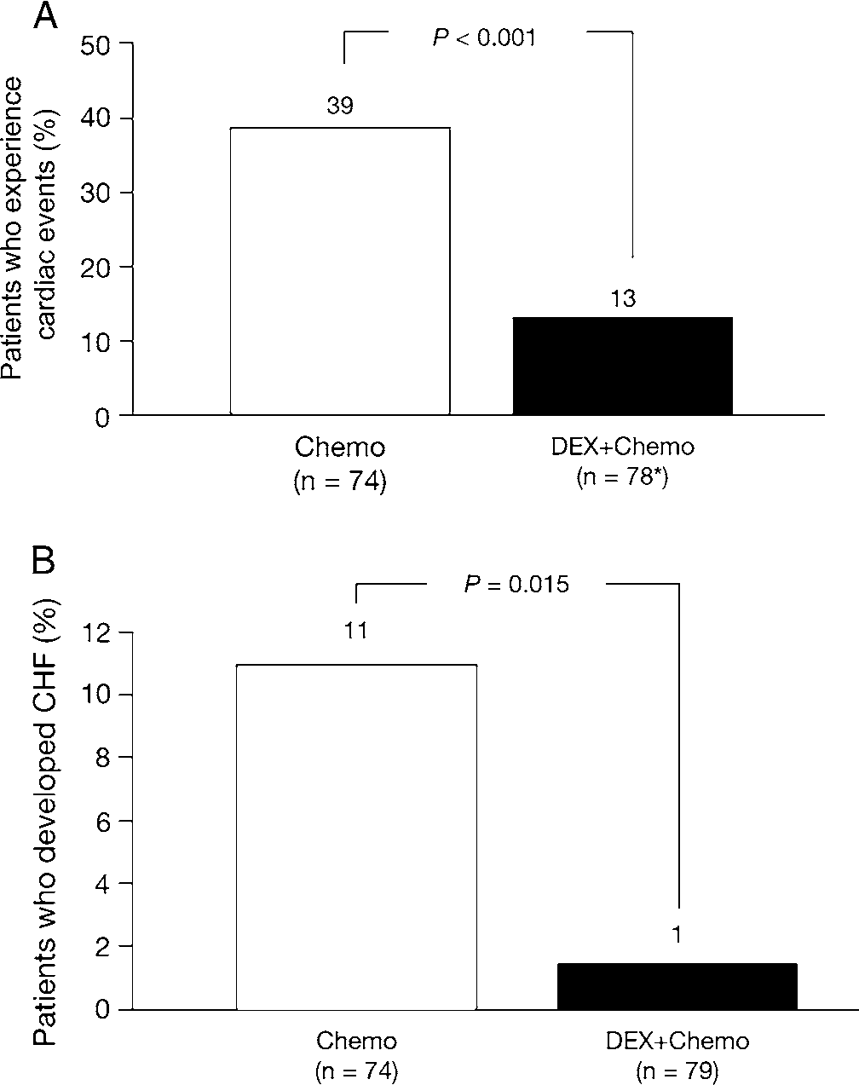
Patients in the dexrazoxane group had a significantly longer cardiac event-free survival time (median not reached for dexrazoxane [range 0.8 – 28+ months] versus 7.1 months [1.3-13.4+ months] for control, p=0.004). The patients in the dexrazoxane group having significantly longer cardiac event-free survival time received significantly higher total cumulative anthracycline doses prior to the occurrence of a cardiac event, when compared to those receiving chemotherapy alone (Figure 2).
Figure 2: Kaplan–Meier analysis of (A) cardiac event-free survival and (B) total cumulative anthracycline dose until occurrence of a cardiac event.⁵
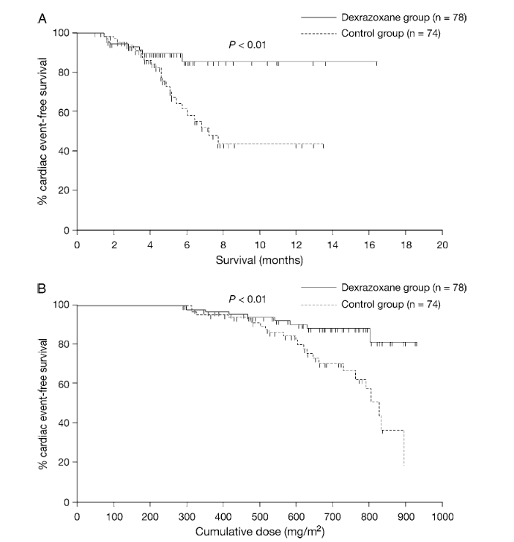
There were no statistically significant differences in either progression-free survival (PFS) or overall survival (OS) (Figure 3).
Figure 3: Kaplan–Meier analysis of (A) progression-free survival and (B) overall survival.⁵
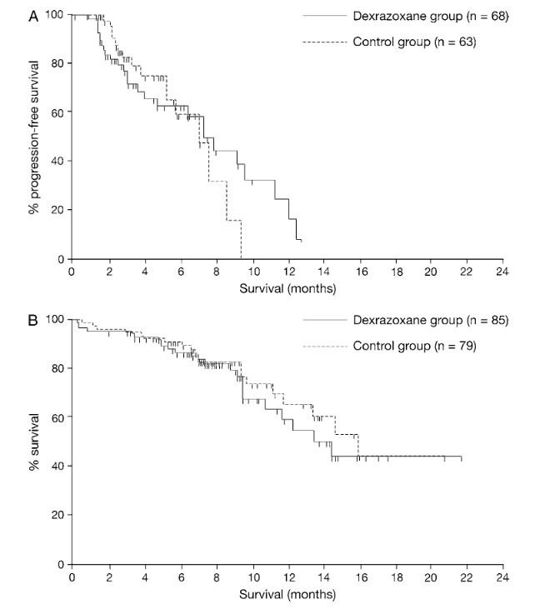
Speyer, J. L., Green, M. D., Kramer, E., Rey, M., Sanger, J., Ward, C., Dubin, N., Ferrans, V., Stecy, P., & Zeleniuch-Jacquotte, A. (1988).
A randomised trial in 92 women with advanced breast cancer comparing fluorouracil, doxorubicin and cyclophosphamide given every 21 days with the same regimen, preceded by dexrazoxane (ICRF-187).

Inclusion criteria
All patients had advanced or metastatic carcinoma of the breast not previously treated with doxorubicin or other anthracyclines and were stratified according to whether they had previously received adjuvant chemotherapy and whether they had cardiac risk factors. These risk factors included age over 65 years, previous radiation to the heart, mediastinum or chest wall, history of hypertension, cardiac failure, diabetes mellitus, angina, rheumatic heart disease or abnormality on echocardiogram.

Treatments
Patients were randomised to chemotherapy with or without dexrazoxane. The chemotherapy regimen was IV doxorubicin bolus dose of 50 mg/m² given over 5-15 minutes followed by IV cyclophosphamide (500 mg/m²) and IV fluorouracil (500 mg/m²). Dexrazoxane was given as 1000 mg/m² IV over 15 minutes, 30 minutes before chemotherapy (i.e., dexrazoxane: doxorubicin ratio of 20:1). Treatment was repeated every 21 days. Treatments were delayed if white cell count on the first day of each planned cycle was less than 4.0x10⁹/L or platelet count was less than 100x10⁹/L and if the nadir white blood cell count was less than 1.5x10⁹ or if the granulocyte count was less than 1.0x10⁹ and the platelet count ranged from 75-100x10⁹, 75% of the dose of fluorouracil and cyclophosphamide was given. If the corresponding white cell count was less than 1.5 or granulocyte count less than 1 or platelet count less than 75, 50% of the dose of chemotherapy was given and if counts remained low after reductions were made during the first 2 cycles, the dose of doxorubicin was reduced according to the same guidelines.
Cardiac toxicity was assessed by clinical examination, determination of left ventricular ejection fraction by multigated nuclear scans and endomyocardial biopsy.
Both treatment arms were balanced in terms of baseline demographic characteristics and previous therapies

Results
Of the 44 evaluable patients for response in each treatment arm, there were 3 CR and 17 PR in the chemotherapy alone group and 4 CR and 17 PR responses in the combination group with dexrazoxane. The overall response rates were 45% and 48%, respectively. The median time to progression of disease was 9.3 and 10.3 months in the chemotherapy alone and chemotherapy plus dexrazoxane groups, respectively.
There were 11 episodes of clinical cardiac toxicity in the combination chemotherapy arm and 2 episodes in the combination chemotherapy plus dexrazoxane arm (p=0.02). In the combination chemotherapy arm, there were 3 patients with NYHA Grade 1, 1 with Grade 2, 2 with Grade 3 and 4 with Grade 4. Both patients in the combination chemotherapy with dexrazoxane arm who had clinical toxicity had NYHA Grade 2 status.
The change in resting LVEF as measured by multigated nuclear scans in the combination chemotherapy arm was from a baseline of 66.1% and in the combination chemotherapy plus dexrazoxane arm of 63.6%. For cumulative doses of doxorubicin between 250-599 mg/m², the mean fall from baseline was significantly less in the combination chemotherapy plus dexrazoxane arm. For the range from 250-399 mg/m², the mean fall was 1.6% for combination plus dexrazoxane and 6.6% for combination chemotherapy alone (p=0.02). For 400-499 mg/m², these values were 1.4% versus 15.4% (p<0.001) and from 500-599 mg/m² it was 3.0% vs. 15.8% (p=0.003). There was no apparent decrease in LVEF with dose ranges over 600 mg/m² as only 1 patient in the combination chemotherapy arm remained in the study compared to 11 patients in the combination chemotherapy plus dexrazoxane.
A total of 28 endomyocardial biopsies were conducted, 15 in patients with chemotherapy alone and 13 in those receiving chemotherapy plus dexrazoxane (representing 52% and 48% of patients respectively receiving the cumulative dose of doxorubicin reaching 450 mg/m²). The Billingham biopsy scores in the chemotherapy alone group were grade 2 in 5 patients, grade 1.5 in 1 patient, grade 1 in 3 patients, grade 0.5 in 1 patient and grade 0 in 3 patients. In the chemotherapy plus dexrazoxane arm, the scores were grade 1 in 6 patients and grade 0 in 7.
Speyer, J. L., Green, M. D., Sanger, J., Zeleniuch-Jacquotte, A., Kramer, E., Rey, M., Wernz, J. C., Blum, R.H., Hochster, H., Meyers, M. & Muggia F.M. (1990)
Speyer et al. subsequently reported a single institutional prospective RCT of dexrazoxane in 150 women with advanced carcinoma of the breast randomly assigned to receive either a standard regimen of 5FU (Fluorouracil) 500 mg/m², doxorubicin 50 mg/m² and cyclophosphamide 500 mg/m² IV (FDC) every 21 days, or the same regimen given 30 minutes after infusion with dexrazoxane 1000 mg/m². A total of 74 patients were treated with FDC alone and 76 with FDC plus dexrazoxane.
A total of 135 patients were evaluable. Patients were evenly balanced between the treatment arms. Dexrazoxane showed cardiac protection: 35/74 (47%) on the FDC arm had clinical cardiac toxicity versus 5/76 (6%) on the FDC plus dexrazoxane arm (p<0.001). Patients on the FDC alone arm were more likely to be removed from treatment at earlier timepoints. Moreover, patients receiving dexrazoxane were able to receive higher cumulative doses of doxorubicin with at least 10 receiving cumulative doxorubicin doses in excess of 1g/m².
Speyer, J. L., Green, M. D., Zeleniuch-Jacquotte, A., Wernz, J. C., Rey, M., Sanger, J., Kramer, E., Ferrans, V., Hochster, H., & Meyers, M. (1992).
In a further publication by Speyer et al. patients received the chemotherapy regimen for advanced breast cancer together with or without prior dexrazoxane 1000 mg/m² (IV).
Objective response rates were similar in both treatment groups (CR in 7 [9%] in the dexrazoxane group versus 5 [7%] in the control group [NS] and PR in 21 [28%] versus 25 [34%] for the dexrazoxane and control groups, respectively [NS]). There was no statistical difference in either PFS (median 10.1 months for dexrazoxane versus 9.4 months for control) or OS (median 18.3 months for dexrazoxane versus 16.7 months for control).
In terms of cardiac toxicity, 43 patients (37 in the control group and 6 in the dexrazoxane group) were taken off study for cardiac toxicity. Moreover, more severe events were seen in the control groups (NYHA 1 to 3 and 4 in 5-17 patients, compared to NYHA 1 and 2 seen in 4 and 2 patients receiving dexrazoxane, respectively). One death in the control arm was attributable to CCF while on study. In addition, 1 other patient in the dexrazoxane group developed CCF and subsequently died of CCF 1 month after being removed from the study.
For all dose ranges of cumulative doxorubicin, the median decrease in LVEF from baseline was greater for the control patients compared to the dexrazoxane group.
The probability of remaining free of clinical cardiac toxicity with increasing dose of doxorubicin and free of off-study criteria for change in LVEF are shown in Figure 4 and Figure 5.
Figure 4: Probability of remaining free of clinical cardiac toxicity and free of off study criteria for change in LVEF.⁸
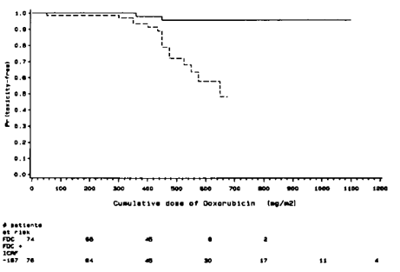
Figure 5: Probability of remaining free of any off study criteria.⁸
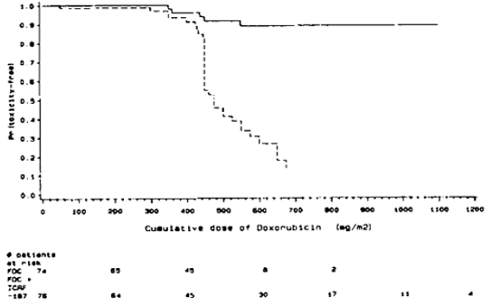
Swain, S. M., Whaley, F. S., Gerber, M. C., Weisberg, S., York, M., Spicer, D., Jones, S. E., Wadler, S., Desai, A., Vogel, C., Speyer, J., Mittelman, A., Reddy, S., Pendergrass, K., Velez-Garcia, E., Ewer, M. S., Bianchine, J. R., & Gams, R. A. (1997).
This multicentre US study recruited 534 patients with advanced breast cancer between November 1988 and January 1991 and were randomised to the 2 multicentre, double-blind studies receiving either FAC with dexrazoxane (dexrazoxane: doxorubicin ratio 10:1) or placebo every 3 weeks and monitored with serial MUGA scans.
A cardiac event was defined as congestive heart failure (CHF) or a decline in LVEF from baseline by equal to or greater than 20 percentage points, from baseline by equal to or greater than 10 percentage points and to a value below the locally defined lower limit of normal or to a value equal to or greater than 5 percentage points below the local lower limit of normal. Ejection fractions were measured by MUGA scans after patients received 150, 300, 400 and 500 mg/m² of doxorubicin.
A total of 26% of placebo/dexrazoxane groups received at least 15 courses of therapy compared with 5% of patients in the placebo group. In terms of cardio protection, there were 25 cardiac events (25%) in the placebo/dexrazoxane group compared with 59 events (60%) in the placebo group. The hazards ratio was 3.5 (95% CI, 2.2-5.7, p<0.001 by Log-Rank test and p<0.001 by Wilcoxon test). The overall CHF incidence in the placebo/dexrazoxane group was 3% versus 22% in the placebo group (p<0.001, Fisher’s exact test).
Despite the differences in baseline and on study disease characteristics, the time to progression revealed no significant difference between the 2 treatment groups (p=0.72 by Log-Rank test or 0.58 by Wilcoxon test). The HR was 0.8 after adjustment for disease-related prognostic factors (p=0.18, Wald X² test).
Venturini, M., Michelotti, A., Del Mastro, L., Gallo, L., Carnino, F., Garrone, O., Tibaldi, C., Molea, N., Bellina, R. C., Pronzato, P., Cyrus, P., Vinke, J., Testore, F., Guelfi, M., Lionetto, R., Bruzzi, P., Conte, P. F., & Rosso, R. (1996).
A multicentre, European study (Italy, Switzerland and The Netherlands) which sought to assess the efficacy of dexrazoxane in terms of cardio protection given at a dose of 10:1 versus epirubicin, in women receiving chemotherapy for advanced breast cancer.
A total of 162 patients were randomised to receive epirubicin-based chemotherapy with or without dexrazoxane. Patients who had previously received adjuvant chemotherapy containing anthracyclines were treated with cyclophosphamide 600 mg/m² IV, epirubicin 60 mg/m² IV and fluorouracil 600 mg/m² IV on day 1 every 3 weeks. Other patients were treated with epirubicin 120 mg/m² IV on day every 3 weeks.
Patient eligibility was clinical or histologic evidence of metastatic, locally advanced or inflammatory breast cancer; either measurable or assessable disease; ECOG performance status equal to or less than 2 and WBC >4000 x 10²L platelet count >100 x 10⁹/L and haemoglobin >10g/dL. Patients were to have a baseline resting LVEF greater than or equal to 50% determined by MUGA scanning. Criteria for exclusion were myocardial infarction within the previous year, history of CHF, symptomatic valvular heart disease, previous chemotherapy with the exception of adjuvant chemotherapy and bilirubin greater than or equal to 3 mg/dL and creatinine greater than or equal to 2 mg/dL.
There were no statistically significant differences in baseline characteristics.
Cardiotoxicity was defined as clinical signs of CHF, a decrease in resting LVEF to equal to or less than 45% or decrease from baseline resting LVEF of greater than or equal to 20EF units.
Cardiotoxicity was seen in 18/78 patients (23.1%) in the control arm and in 6/82 (7.3%) in the dexrazoxane arm. A cumulative probability of developing cardiotoxicity was significantly lower in the dexrazoxane-treated patients than in control patients (p=0.006, OR 0.29; 95% CI: 0.09-0.78).
Cochrane reviews by de Baat et al. and Van Dalen et al. showed cardio-protection without impact on cancer progression in adults. These did overlap with studies provided in the current clinical evaluation summary.

Safety

Breast Cancer Studies
Marty, M., Espié, M., Llombart, A., Monnier, A., Rapoport, B. L., Stahalova, V., & Dexrazoxane Study Group et al. (2006)⁵
A phase 3 RCT of anthracycline versus anthracycline plus dexrazoxane in breast cancer patients.
Most patients had at least one adverse event (AE), the most common being alopecia, nausea, neutropenia, vomiting, leukopenia and anaemia. The incidence of AEs was comparable between the two groups with the possible exceptions of anaemia which appeared to be more common in the dexrazoxane group and asthenia and mucosal inflammation appearing more frequently in the control group, although grade 3 and 4 events were comparable across groups. These were usually anaemia, febrile neutropaenia, leukopenia and neutropaenia, consistent with chemotherapy usage. Six deaths occurred within 28 days of final administration of chemotherapy, 4 in the dexrazoxane group and two in the control group, none being considered related to dexrazoxane. There appeared no differences between groups with respect to biochemical or haematological laboratory measurements.
Speyer, J. L., Green, M. D., Kramer, E., Rey, M., Sanger, J., Ward, C., Dubin, N., Ferrans, V., Stecy, P., & Zeleniuch-Jacquotte, A. (1988).⁶
In the randomised study, non-cardiac toxicity did not differ significantly between the two treatment groups of chemotherapy versus chemotherapy plus dexrazoxane in patients with breast cancer.
Speyer, J. L., Green, M. D., Sanger, J., Zeleniuch-Jacquotte, A., Kramer, E., Rey, M., Wernz, J. C., Blum, R.H., Hochster, H., Meyers, M. & Muggia F.M. (1990)⁷
In Speyer et al.⁷, there were no major differences in toxicities between the two treatment arms. There were 5 non-cardiotoxic deaths in the FDC arm and two in the FDC plus dexrazoxane arm. Fever and neutropaenia occurred in 18% and 15% of the FDC and FDC plus dexrazoxane arms, respectively. There were no differences in alopecia, stomatitis, nausea and vomiting between the two treatment arms, however these data were not systematically presented. Haematologic toxicities revealed a tendency for the addition of dexrazoxane to increase neutropaenia in the second course of treatment although not in the first course of treatment. There was no difference in the amount of anaemia or transfusion requirement between the two treatment arms.
Speyer, J. L., Green, M. D., Zeleniuch-Jacquotte, A., Wernz, J. C., Rey, M., Sanger, J., Kramer, E., Ferrans, V., Hochster, H., & Meyers, M. (1992). ⁸
Speyer et al.⁸ found there were minimal differences in the non-cardiac toxicities for the two treatment groups. Though seen in small numbers, they included fever, alopecia, stomatitis, nausea and vomiting.
Swain, S. M., Whaley, F. S., Gerber, M. C., Weisberg, S., York, M., Spicer, D., Jones, S. E., Wadler, S., Desai, A., Vogel, C., Speyer, J., Mittelman, A., Reddy, S., Pendergrass, K., Velez-Garcia, E., Ewer, M. S., Bianchine, J. R., & Gams, R. A. (1997).⁹
Swain et al.⁹ reported there was more injection site pain in the placebo/dexrazoxane versus placebo group (13% versus 0%, p=0.001) and dysphagia was reported more frequently in placebo patients (5% versus 0%). There were no other significant differences reported in the AE profile.
Venturini, M., Michelotti, A., Del Mastro, L., Gallo, L., Carnino, F., Garrone, O., Tibaldi, C., Molea, N., Bellina, R. C., Pronzato, P., Cyrus, P., Vinke, J., Testore, F., Guelfi, M., Lionetto, R., Bruzzi, P., Conte, P. F., & Rosso, R. (1996).¹⁰
Haematologic parameters and biochemistry were not systematically presented. On visual inspection there appeared to be no overall difference between treatment groups. However, there were numerically greater clinical signs of phlebitis with dexrazoxane versus the control group, being 12.2% and 3.8%, respectively.

Cochrane review
de Baat, E. C., van Dalen, E. C., Mulder, R. L., Hudson, M. M., Ehrhardt, M. J., Engels, F. K., Feijen, E. A. M., Grotenhuis, H. B., Leerink, J. M., Kapusta, L., Kaspers, G. J. L., Merkx, R., Mertens, L., Skinner, R., Tissing, W. J. E., de Vathaire, F., Nathan, P. C., Kremer, L. C. M., Mavinkurve-Groothuis, A. M. C., & Armenian, S. (2022).¹¹
In terms of haematologic effects, grade 3 or 4 thrombocytopaenia was assessed and could be extracted from 3 studies, with a total of 452 participants. There was no significant difference between treatment groups. In the adult studies, there were no significant differences in small numbers of studies with documented evidence of fever, bone marrow aplasia or febrile neutropaenia. There was no difference in the adult studies of nausea, vomiting, stomatitis or diarrhoea. Similarly, there was no differences between treatment groups, where data could be extracted, in limited study numbers having liver function abnormality.
The sponsor also confirmed that a search of the literature did not result in new information relating to the risk of second malignancies following dexrazoxane use in adult populations.

Risk management plan
Reach Pharmaceuticals Pty Ltd has submitted AU-RMP version 2.0 (dated 27 August 2024; data lock point 20 August 2024) in support of this application.
The summary of safety concerns and their associated risk monitoring and mitigation strategies are summarised in Table 3. The TGA may request an updated RMP at any stage of a product's life cycle, during both the pre-approval and post-approval phases.
Table 3: Summary of safety concerns
Summary of safety concerns |  | Pharmacovigilance |  | Risk Minimisation
 |  | Routine | Additional | Routine | Additional
Important identified risks | Myelosuppression |  | – |  | –
Important identified risks | Secondary malignant neoplasm (SMN) |  | – |  | –
Important potential risks | Serious infections |  | – |  | –
Important potential risks | Early death |  | – |  | –
Missing information | None | – | – | – | –

The summary of safety concerns is consistent with the warnings and precautions in the PI and is satisfactory from an RMP perspective.
Routine pharmacovigilance activities only are proposed which is acceptable for a Literature Based Submission.
Routine risk minimisation activities only are proposed. As dexrazoxane will be administered by HCPs in specialised settings this is adequate to address the safety concerns.
The RMP evaluation recommended conditions of registration relating to the versions of the risk management plan, requirement for periodic safety update reports, and inclusion of the medicine in the Black Triangle Scheme.

Risk-benefit analysis

Delegate’s considerations

Quality
The Module 3 evaluator has recommended approval from a quality perspective with no outstanding issues.

Efficacy
The current submission is a Literature-Based Submission based on the availability of dexrazoxane products on global markets for over 15 years. No new clinical studies have been completed by the sponsor. The literature-based survey conducted by the sponsor was appropriate for the proposed indication.
The mechanism of action of dexrazoxane is believed to be related to chelation of metal ions, resulting in a reduction in iron-dependent free-radical oxidative stress on cardiac muscle.
Several pertinent reports were provided, including those that utilised 10:1 or 20:1 dexrazoxane: doxorubicin ratios. These reports relate to controlled and uncontrolled phase 3 and phase 2 studies that were conducted on patients with advanced breast cancer who were receiving doxorubicin-containing regimens.
In a multicentre phase 3 study of dexrazoxane use in 164 breast cancer patients treated with anthracyclines with or without dexrazoxane for a maximum of 6 cycles⁵, there were significantly fewer cardiac events in the dexrazoxane versus control group (p<0.001). This was observed in 13% of patients who received dexrazoxane compared to 39% who did not receive dexrazoxane. Furthermore, the dexrazoxane-containing group had a lower incidence of CCF than the non-dexrazoxane-containing group.
These results were reiterated in additional studies^{6,7,8} that involved 74 and 76 patients, respectively, who received combination chemotherapy for advanced breast cancer with fluorouracil, doxorubicin, and cyclophosphamide (FDC) or FDC plus dexrazoxane. Swain et al.⁹ also discovered that dexrazoxane was cardio-protective in patients with advanced breast cancer who were treated with fluorouracil, doxorubicin, and cyclophosphamide (FAC). This was after a cumulative doxorubicin dose of 300 mg/m2.
The use of dexrazoxane does not seem to have an overall impact on the overall survival or progression-free survival of breast cancer in comparison to the absence of dexrazoxane.
Cochrane reviews^{11,12} showed cardio-protection without impact on cancer progression in adults.

Safety
Several relevant research reports were furnished. There were no discernible differences in the common adverse effects with or without dexrazoxane, including alopecia, nausea, neutropenia, vomiting, leukopenia and anaemia., within the confines of a literature-based submission. The pharmacovigilance and risk minimisation activities were confirmed acceptable by the RMP team.

Proposed action
Overall, the PK data presented in the proposed PI is consistent with the submitted literature.
The use of dexrazoxane in women with advanced breast cancer who were receiving doxorubicin-containing chemotherapy regimens appeared to provide cardio-protection in terms of MUGA, echocardiographic findings, and clinical features of heart failure in several randomised, controlled trials. No significant safety concerns were identified.
The Delegate considers the overall benefit risk profile favourable for Dexrazoxane-Reach for the following indication and subject to all GMP clearances being current at approval.
DEXRAZOXANE-REACH is indicated for reducing the incidence and severity of cardiomyopathy associated with doxorubicin administration in women with metastatic breast cancer who have received a cumulative doxorubicin dose of 300 mg/m² and who will continue to receive doxorubicin therapy to maintain tumour tumour control.

Assessment outcome
Based on a review of quality, safety, and efficacy, the TGA decided to register Dexrazoxane-Reach (dexrazoxane) 250 mg and 500 mg- Powder for injection for infusion vial, indicated for:
Dexrazoxane-Reach is indicated for reducing the incidence and severity of
cardiomyopathy associated with doxorubicin administration in women with metastatic
breast cancer who have received a cumulative doxorubicin dose of 300 mg/m2 and who
will continue to receive doxorubicin therapy to maintain tumour control.

Specific conditions of registration
- Dexrazoxane Reach (dexrazoxane) is to be included in the Black Triangle Scheme. The PI and CMI for Dexrazoxane Reach must include the black triangle symbol and mandatory accompanying text for five years, which starts from the date of first supply of the product.
- The Dexrazoxane Reach AU-Risk Management Plan (RMP) version 2.0 (dated 27 August 2024, data lock point 20 August 2024), included with submission PM-2023-05309-1-4, and any subsequent revisions, as agreed with the TGA will be implemented in Australia.
- An obligatory component of risk management plans is routine pharmacovigilance. Routine pharmacovigilance includes the submission of periodic safety update reports (PSURs).
Unless agreed separately between the supplier who is the recipient of the approval and
the TGA, the first report must be submitted to TGA no later than 15 calendar months
after the date of this approval letter. The subsequent reports must be submitted no less
frequently than annually from the date of the first submitted report until the period
covered by such reports is not less than three years from the date of this approval
letter. The annual submission may be made up of two PSURs each covering six months.
If the sponsor wishes, the six-monthly reports may be submitted separately as they
become available.
If the product is approved in the EU during the three years period, reports can be
provided in line with the published list of EU reference dates no less frequently than
annually from the date of the first submitted report until the period covered by such
reports is not less than three years from the date of this approval letter.
The reports are to at least meet the requirements for PSURs as described in the
European Medicines Agency’s Guideline on good pharmacovigilance practices (GVP)
Module VII-periodic safety update report (Rev 1), Part VII.B Structures and processes.
Note that submission of a PSUR does not constitute an application to vary the
registration. Each report must be submitted within ninety calendar days of the data lock point for that report.

Product Information and Consumer Medicine Information
For the most recent Product Information (PI) and Consumer Medicine Information (CMI), please refer to the TGA PI/CMI search facility.

Therapeutic Goods Administration
PO Box 100 Woden ACT 2606 Australia
Email: info@tga.gov.au Phone: 1800 020 653 Fax: 02 6203 1605
https://www.tga.gov.au
Reference/Publication #

This is the original indication proposed by the sponsor when the TGA commenced assessment of this submission. It may differ to the final indication approved by the TGA and registered in the Australian Register of Therapeutic Goods.
Simůnek, T., Stérba, M., Popelová, O., Adamcová, M., Hrdina, R., & Gersl, V. (2009). Anthracycline-induced cardiotoxicity: overview of studies examining the roles of oxidative stress and free cellular iron. Pharmacological reports : PR, 61(1), 154–171. https://doi.org/10.1016/s1734-1140(09)70018-0
Hochster, Howard MD; Wasserheit, Carolyn MD; Speyer, James MD. Cardiotoxicity and cardioprotection during chemotherapy. Current Opinion in Oncology 7(4):p 304-309, July 1995.
Product monograph ZINECARD - https://pdf.hres.ca/dpd_pm/00029924.PDF
Marty, M., Espié, M., Llombart, A., Monnier, A., Rapoport, B. L., Stahalova, V., & Dexrazoxane Study Group (2006). Multicenter randomized phase III study of the cardioprotective effect of dexrazoxane (Cardioxane) in advanced/metastatic breast cancer patients treated with anthracycline-based chemotherapy. Annals of oncology: official journal of the European Society for Medical Oncology, 17(4), 614–622. https://doi.org/10.1093/annonc/mdj134
Speyer, J. L., Green, M. D., Kramer, E., Rey, M., Sanger, J., Ward, C., Dubin, N., Ferrans, V., Stecy, P., & Zeleniuch-Jacquotte, A. (1988). Protective effect of the bispiperazinedione ICRF-187 against doxorubicin-induced cardiac toxicity in women with advanced breast cancer. The New England journal of medicine, 319(12), 745–752. https://doi.org/10.1056/NEJM198809223191203
Speyer, J. L., Green, M. D., Sanger, J., Zeleniuch-Jacquotte, A., Kramer, E., Rey, M., Wernz, J. C., Blum, R.H., Hochster, H., Meyers, M. & Muggia F.M. (1990) A prospective randomized trial of ICRF-187 for prevention of cumulative doxorubicin-induced cardiac toxicity in women with breast cancer. Cancer Treatment Review; 17,161-163.
Speyer, J. L., Green, M. D., Zeleniuch-Jacquotte, A., Wernz, J. C., Rey, M., Sanger, J., Kramer, E., Ferrans, V., Hochster, H., & Meyers, M. (1992). ICRF-187 permits longer treatment with doxorubicin in women with breast cancer. Journal of clinical oncology: official journal of the American Society of Clinical Oncology, 10(1), 117–127. https://doi.org/10.1200/JCO.1992.10.1.117
Swain, S. M., Whaley, F. S., Gerber, M. C., Weisberg, S., York, M., Spicer, D., Jones, S. E., Wadler, S., Desai, A., Vogel, C., Speyer, J., Mittelman, A., Reddy, S., Pendergrass, K., Velez-Garcia, E., Ewer, M. S., Bianchine, J. R., & Gams, R. A. (1997). Cardioprotection with dexrazoxane for doxorubicin-containing therapy in advanced breast cancer. Journal of clinical oncology : official journal of the American Society of Clinical Oncology, 15(4), 1318–1332. https://doi.org/10.1200/JCO.1997.15.4.1318
Venturini, M., Michelotti, A., Del Mastro, L., Gallo, L., Carnino, F., Garrone, O., Tibaldi, C., Molea, N., Bellina, R. C., Pronzato, P., Cyrus, P., Vinke, J., Testore, F., Guelfi, M., Lionetto, R., Bruzzi, P., Conte, P. F., & Rosso, R. (1996). Multicenter randomized controlled clinical trial to evaluate cardioprotection of dexrazoxane versus no cardioprotection in women receiving epirubicin chemotherapy for advanced breast cancer. Journal of clinical oncology : official journal of the American Society of Clinical Oncology, 14(12), 3112–3120. https://doi.org/10.1200/JCO.1996.14.12.3112
de Baat, E. C., van Dalen, E. C., Mulder, R. L., Hudson, M. M., Ehrhardt, M. J., Engels, F. K., Feijen, E. A. M., Grotenhuis, H. B., Leerink, J. M., Kapusta, L., Kaspers, G. J. L., Merkx, R., Mertens, L., Skinner, R., Tissing, W. J. E., de Vathaire, F., Nathan, P. C., Kremer, L. C. M., Mavinkurve-Groothuis, A. M. C., & Armenian, S. (2022). Primary cardioprotection with dexrazoxane in patients with childhood cancer who are expected to receive anthracyclines: recommendations from the International Late Effects of Childhood Cancer Guideline Harmonization Group. The Lancet. Child & adolescent health, 6(12), 885–894. https://doi.org/10.1016/S2352-4642(22)00239-5
van Dalen, E. C., Caron, H. N., Dickinson, H. O., & Kremer, L. C. (2011). Cardioprotective interventions for cancer patients receiving anthracyclines. The Cochrane database of systematic reviews, 2011(6), CD003917. https://doi.org/10.1002/14651858.CD003917.pub4

