Australian Public Assessment Report for Vyloy
  - Active ingredient: zolbetuximab
  - Sponsor: Astellas Pharma Australia Pty Ltd
September 2025

About the Therapeutic Goods Administration (TGA)
- The Therapeutic Goods Administration (TGA) is part of the Australian Government Department of Health, Disability and Ageing and is responsible for regulating therapeutic goods, including medicines, medical devices, and biologicals.
- The TGA administers the Therapeutic Goods Act 1989 (the Act), applying a risk management approach designed to ensure therapeutic goods supplied in Australia meet acceptable standards of quality, safety, and efficacy.
- The work of the TGA is based on applying scientific and clinical expertise to decision-making, to ensure that the benefits to the Australian public outweigh any risks associated with the use of therapeutic goods.
- The TGA relies on the public, healthcare professionals and industry to report problems with therapeutic goods. The TGA investigates reports received to determine any necessary regulatory action.
- To report a problem with a therapeutic good, please see the information on the TGA website.

About AusPARs
- The Australian Public Assessment Report (AusPAR) provides information about the evaluation of a prescription medicine and the considerations that led the TGA to approve or not approve a prescription medicine submission. Further information can be found in Australian Public Assessment Report (AusPAR) guidance.
- AusPARs are prepared and published by the TGA.
- AusPARs are static documents that provide information that relates to a submission at a particular point in time. The publication of an AusPAR is an important part of the transparency of the TGA’s decision-making process.
- A new AusPAR may be provided to reflect changes to indications or major variations to a prescription medicine subject to evaluation by the TGA.

Copyright
© Commonwealth of Australia 2025
This work is copyright. You may reproduce the whole or part of this work in unaltered form for your own personal use or, if you are part of an organisation, for internal use within your organisation, but only if you or your organisation do not use the reproduction for any commercial purpose and retain this copyright notice and all disclaimer notices as part of that reproduction. Apart from rights to use as permitted by the Copyright Act 1968 or allowed by this copyright notice, all other rights are reserved and you are not allowed to reproduce the whole or any part of this work in any way (electronic or otherwise) without first being given specific written permission from the Commonwealth to do so. Requests and inquiries concerning reproduction and rights are to be sent to the TGA Copyright Officer, Therapeutic Goods Administration, PO Box 100, Woden ACT 2606 or emailed to <tga.copyright@tga.gov.au>.

Contents
List of abbreviations 4
Vyloy (zolbetuximab) submission 5
Proposed indication 6
The condition 6
Current treatment options 7
Clinical rationale 8
Regulatory status 9
Registration timeline 11
Assessment overview 11
Quality evaluation summary 12
Nonclinical evaluation summary 12
Clinical evaluation summary 13
Summary of clinical studies 13
Pharmacology 13
Efficacy 20
Safety 40
Risk management plan evaluation summary 45
Risk-benefit analysis 46
Assessment outcome 49
Specific conditions of registration 49
Product Information and Consumer Medicines Information 50

List of abbreviations
Abbreviation | Meaning
AEs | adverse event(s)
AESIs. | adverse event(s) of special interest
ARTG | Australian Register of Therapeutic Goods
AUCτ | Area under the concentration-time curve from the time of dosing to the start of the next dosing interval
BSA | body surface area
CAPOX | capecitabin and oxaliplatin
C_{ave} | average concentration throughout the treatment
CI | confidence interval
CLDN | Claudin
C_{max} | maximum concentration
C_{trough} | trough concentration immediately prior to dosing at multiple dosing
DOR | duration of response
EOX | epirubicin, oxaliplatin, and capecitabine chemotherapy
E-R | exposure-response (E-R)
GOJ | gastro oesophageal junction
HER2 | human epidermal growth factor receptor 2
HR | hazard ratio
IRRs | infusion-related reactions
K-M | Kaplan-Meier
mFOLFOX6 | leucovorin (folinic acid), fluorouracil (5-FU), and oxaliplatin
PD | pharmacodynamic(s)
PI | product information
PFS | progression-free survival
PK | pharmacokinetic(s)
PKPD | pharmacokinetic-pharmacodynamic(s)
popPK | population pharmacokinetic(s)
RMP | risk management plan
SAEs | serious adverse event(s)
SOD | sum of diameters
TEAE | treatment emergent adverse event
TGA | Therapeutic Goods Administration

Vyloy (zolbetuximab) submission
Type of submission: | New biological entity
Product name: | Vyloy
Active ingredient: | zolbetuximab
Decision: | Approved
Date of decision: | 12 March 2025
Approved therapeutic use for the current submission: | Vyloy, in combination with fluoropyrimidine- and platinum-containing chemotherapy, is indicated for the first-line treatment of adult patients with locally advanced unresectable or metastatic human epidermal growth factor receptor 2 (HER2)-negative gastric or gastro-oesophageal junction (GOJ) adenocarcinoma whose tumours are Claudin (CLDN) 18.2 positive.
Date of entry onto ARTG: | 17 March 2025
ARTG numbers: | Vyloy zolbetuximab 100 mg vial powder for concentrate for solution for infusion (428330)
Black Triangle Scheme: | Yes
Sponsor’s name and address: | Astellas Pharma Australia Pty Ltd Suite 2.01, 2 Banfield Road Macquarie Park NSW 2113
Dose form: | Lyophilised powder for reconstitution
Strength: | 20 mg/mL
Container: | Clear Type I 20 mL glass vial with European blow-back feature Gray bromobutyl rubber stopper with ethylene tetrafluoroethylene film 20 mm aluminum seal with a green cap
Route of administration: | Intravenous
Dosage: | For information regarding dosage refer to the Product Information.
Pregnancy category: | Category B2  Drugs which have been taken by only a limited number of pregnant women and women of childbearing age, without an increase in the frequency of malformation or other direct or indirect harmful effects on the human fetus having been observed.  Studies in animals are inadequate or may be lacking, but available data show no evidence of an increased occurrence of fetal damage.  The use of any medicine during pregnancy requires careful consideration of both risks and benefits by the treating health professional. The pregnancy database must not be used as the sole basis of decision making in the use of medicines during pregnancy. The TGA does not provide advice on the use of medicines in pregnancy for specific cases. More information is available from obstetric drug information services in your state or territory.

Proposed indication
This AusPAR describes the submission by Astellas Pharma Australia Pty Ltd (the Sponsor) to register Vyloy (zolbetuximab) for the following proposed indication:
Vyloy, in combination with fluoropyrimidine- and platinum-containing chemotherapy, is indicated for the first-line treatment of adult patients with locally advanced unresectable or metastatic human epidermal growth factor receptor 2 (HER2)-negative gastric or gastro-oesophageal junction (GOJ) adenocarcinoma whose tumours are Claudin (CLDN) 18.2 positive (see section 4.2 Dose and method of administration).

The condition
Gastric cancer is the fifth most common cancer and the fourth leading cause of cancer death worldwide. In 2020, there were an estimated 1.1 million new cases and approximately 770 000 deaths worldwide from gastric cancer. Eastern Asia (primarily China) comprises about 60% of the global cases of gastric cancer and about 57% of the gastric cancer-related mortality. Incidence and mortality of gastric cancer is about 2-fold higher in males vs females. Gastric cancer mostly affects older people with an average age at diagnosis of approximately 60 years.
In Australia, estimates of the age-standardised incidence rate of gastric cancer range from 4.5 to 7.6 per 100,000. For Australians 65 years or older, the incidence has been estimated at 34.1 per 100,000. The annual age-standardised mortality rates for gastric cancer in Australia are 2.0 per 100,000 overall, and 16.4 per 100,000 for people aged ≥65 years. The observed 5-year survival of Australians with all stages of gastric cancer remains low at 33.7%, although this has slowly increased compared to 17.2% in 1991-95.
Cancer outcomes among Indigenous Australians, particularly cancer survival, are generally poorer than among non-Indigenous Australians. No data were available for the incidence or survival of gastric cancer specifically among First Nations Australians, or for other ethnic subgroups in Australia.
Most patients in the United States have symptoms of advanced stage gastric cancer at the time they are diagnosed. In patients with metastatic disease, prognosis is poor, with an estimated 5-year survival rates similar in the US (6%), Japan (6.6%), and South Korea (5.6%). Globally, median survival for unresectable advanced or metastatic HER2-negative gastric or gastro oesophageal junction (GOJ) adenocarcinoma with currently available standard of care is just under 1 year based on “all comers” data from the CheckMate 649 study.
The epidemiology of GOJ adenocarcinoma is complex due to reporting methods commonly presenting pooled data on ‘oesophageal cancer’ without differentiating between histology types (i.e. squamous cell carcinoma versus adenocarcinoma). It has been reported that distal oesophageal and GOJ malignancy is the fastest growing cancer in the Western population, especially in the US. This increase is primarily attributed to the increase in rates of obesity that in turn causes increased gastroesophageal reflux disease leading to Barrett’s oesophagus and eventually adenocarcinoma of the oesophagus especially at the GOJ. Gastro-oesophageal adenocarcinoma is characterized by a worldwide variation in incidence, with a peak in Japan and South Korea, and lower incidence observed in the United States, Canada, India, and Middle Eastern countries. Beyond their higher rates of gastric cancer, Asian patients tend to have more distal gastric tumours, often associated with Helicobacter pylori infection, with less frequent GOJ tumours, adenocarcinomas of the oesophagus or Barrett’s oesophagus disease.
Other risk factors not mentioned above include tobacco smoking (GOJ adenocarcinoma), consumption of ≥ 3 alcoholic drinks per day, and higher consumption of salt-preserved foods.

Molecular biomarkers
Studies reporting on human epidermal growth factor receptor 2 (HER2) expression in tumour samples from locally advanced or metastatic gastric or GOJ adenocarcinoma have reported HER2 expression ranging from 10% to 25%.
The prevalence of CLDN18.2-positivity (≥75%) in gastric or GEJ adenocarcinomas is reported to range from 24.0% to 38.4%.

Current treatment options
The current recommended first-line therapies for locally advanced unresectable or metastatic gastric or GOJ adenocarcinoma include a chemotherapy backbone (fluoropyrimidine- and platinum-containing cytotoxic drugs) in combination with targeted therapies if relevant. Relevant targeted therapies and their respective approved Australian indications are:
Trastuzumab is “indicated in combination with cisplatin and either capecitabine or 5-FU for the treatment of patients with HER2 positive advanced adenocarcinoma of the stomach or gastro-oesophageal junction who have not received prior anti-cancer treatment for their metastatic disease”.
Nivolumab “in combination with fluoropyrimidine- and platinum-based combination chemotherapy, is indicated for the first-line treatment of patients with HER2 negative advanced or metastatic gastric or gastro-oesophageal junction or oesophageal adenocarcinoma”.
Pembrolizumab:
“is indicated for the treatment of adult and paediatric patients with unresectable or metastatic solid tumours that are MSI-H or dMMR, as determined by a validated test, that have progressed following prior treatment and when there are no satisfactory alternative treatment options.”
“in combination with fluoropyrimidine- and platinum-containing chemotherapy, is indicated for the first-line treatment of patients with locally advanced unresectable or metastatic gastric or gastroesophageal junction (GOJ) adenocarcinoma that is not HER2-positive.”
“in combination with trastuzumab, fluoropyrimidine- and platinum-containing chemotherapy, is indicated for the first-line treatment of patients with locally advanced unresectable or metastatic HER2-positive gastric or gastroesophageal junction (GOJ) adenocarcinoma, whose tumours express PD-L1 [Combined Positive Score (CPS) ≥1] as determined by a validated test.”
“in combination with platinum and fluoropyrimidine based chemotherapy, is indicated for the first-line treatment of patients with locally advanced or metastatic carcinoma of the oesophagus or HER2-negative gastroesophageal junction (GOJ) adenocarcinoma (tumour centre 1 to 5 centimetres above the GOJ) that is not amenable to surgical resection or definitive chemoradiation”
The most recent National Comprehensive Cancer Network (NCCN) treatment guidelines for gastric cancer and oesophageal/GOJ adenocarcinoma 8have been updated to include zolbetuximab for CLDN18.2 positive tumours following its approval by the US FDA, although the medication is not yet registered for use in Australia.
Treatment approaches for advanced gastric and GOJ adenocarcinoma largely overlap. The NCCN Gastric Cancer guidelines note that “Systemic therapy regimens recommended for advanced esophageal adenocarcinoma, EGJ adenocarcinoma, and gastric adenocarcinoma may be used interchangeably (except as indicated)”. The European Society For Medical Oncology (ESMO) guidelines clinical practice guideline (CPG) for oesophageal cancer makes a similar comment: “Treatment of advanced AC [adenocarcinoma] of the oesophagus and OGJ [oesophagogastric junction] should be in line with the ESMO CPG for gastric cancer”.
The most recent NCCN treatment guidelines for gastric cancer and oesophageal/GOJ adenocarcinoma have been updated to include zolbetuximab for CLDN18.2 positive tumours following its approval by the US FDA, although the medication is not yet registered for use in Australia.
Treatment approaches for advanced gastric and GOJ adenocarcinoma largely overlap. The NCCN Gastric Cancer guidelines note that “Systemic therapy regimens recommended for advanced esophageal adenocarcinoma, EGJ adenocarcinoma, and gastric adenocarcinoma may be used interchangeably (except as indicated)”. The ESMO CPG for oesophageal cancer makes a similar comment: “Treatment of advanced AC [adenocarcinoma] of the oesophagus and OGJ [oesophagogastric junction] should be in line with the ESMO CPG for gastric cancer”.

Clinical rationale
Zolbetuximab is a first-in-class chimeric (mouse/human) monoclonal antibody with IgG1 constant regions directed against the tight junction molecule claudin-18 splice variant 2 (CLDN18.2). There are currently no registered CLDN18.2-targeting therapies in Australia.
CLDN18.2 is a member of the claudin family that is involved in the formation of tight junctions in epithelia and endothelia. Claudin-18 has two alternatively spliced variants: CLDN-18.1 which is highly expressed in the lung, and CLDN18.2 which is primarily expressed in differentiated epithelial cells of the gastric mucosa. CLDN18.2 of the gastric epithelium regulates cell lineage differentiation and blocks paracellular gastric acid leak. CLDN18.2 is highly expressed in gastric tumour cells and can also be found in pancreatic, oesophageal, ovarian, lung, and colitis associated colorectal tumours.,
CLDN18.1 shares a high degree (91%) of sequence homology with that of CLDN18.2. However, zolbetuximab does not bind to the CLDN18.1 isoform. In normal epithelial cells, tight junction molecules are expressed on the apical side of the cell; however, CLDN18.2 is overexpressed in cancer cells and is expressed on both the apical and basolateral sides of cells allowing binding of zolbetuximab (Figure 1). Zolbetuximab binds to CLDN18.2 on the surface of target cells, followed by antibody-dependent cell-mediated cytotoxicity (ADCC) and complement-dependent cytotoxicity (CDC) that are mediated by the monoclonal antibody Fc region.
Figure 1: Action of zolbetuximab on CLDN18.2 in cancer cells
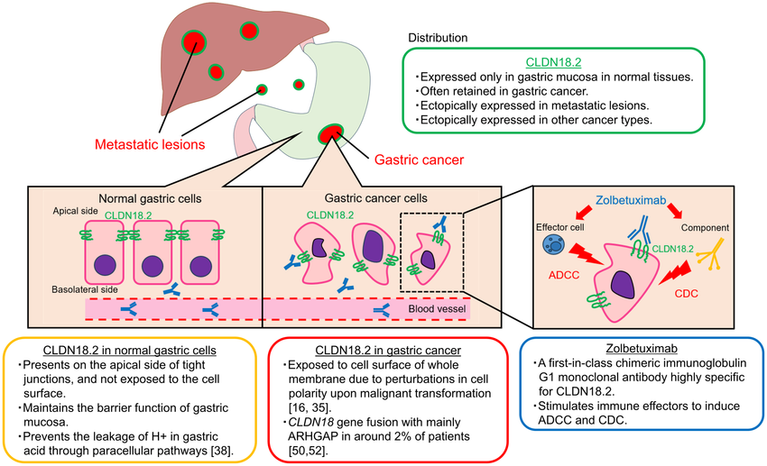

Regulatory status

Australian regulatory status
This product is a new biological entity for Australian regulatory purposes. On 9 August 2023, zolbetuximab (Vyloy) was designated as an orphan drug. The orphan indication is for “treatment of gastric cancer”.

International regulatory status
At the time the TGA considered this submission, a similar submission had been considered by other regulatory agencies. Table 1 summarises these submissions and provides the indications where approved.
Table 1. International regulatory status for Vyloy
Jurisdiction | Date of approval | Approved therapeutic indication | Approved dosage
Canada | 13 Dec 2024 | Vyloy (zolbetuximab for injection), in combination with fluoropyrimidine- and platinum-containing chemotherapy, is indicated for the first-line treatment of adult patients with locally advanced unresectable or metastatic human epidermal growth factor receptor 2 (HER2)-negative gastric or gastroesophageal junction (GEJ) adenocarcinoma whose tumours are Claudin (CLDN) 18.2 positive as determined by a validated test (see 4.1 Dosing Considerations and 14 CLINICAL TRIALS). | Single loading dose: 800 mg/m²  Maintenance dosing:  600 mg/m² every 3 weeks  OR  400 mg/m² every 2 weeks
European Union | 19 Sep 2024 | Vyloy, in combination with fluoropyrimidine- and platinum-containing chemotherapy, is indicated for the first-line treatment of adult patients with locally advanced unresectable or metastatic HER2-negative gastric or gastro-oesophageal junction (GEJ) adenocarcinoma whose tumours are Claudin (CLDN) 18.2 positive (see section 4.2). | Single loading dose: 800 mg/m²  Maintenance dosing:  600 mg/m² every 3 weeks  OR  400 mg/m² every 2 weeks
Japan | 26 Mar 2024 | CLDN18.2-positive unresectable advanced or recurrent gastric cancer | Single loading dose: 800 mg/m²  Maintenance dosing:  600 mg/m² every 3 weeks  OR  400 mg/m² every 2 weeks
United Kingdom | 14 Aug 2024 | Vyloy, in combination with fluoropyrimidine- and platinum-containing chemotherapy, is indicated for the first-line treatment of adult patients with locally advanced unresectable or metastatic human epidermal growth factor receptor 2 (HER2)-negative gastric or gastro-oesophageal junction (GEJ) adenocarcinoma whose tumours are Claudin (CLDN) 18.2 positive (see section 5.1) | Single loading dose: 800 mg/m²  Maintenance dosing:  600 mg/m² every 3 weeks  OR  400 mg/m² every 2 weeks
United States | 18 Oct 2024 | Vyloy, in combination with fluoropyrimidine- and platinum-containing chemotherapy, is indicated for the first-line treatment of adults with locally advanced unresectable or metastatic human epidermal growth factor receptor 2 (HER2)-negative gastric or gastroesophageal junction (GEJ) adenocarcinoma whose tumors are claudin (CLDN) 18.2 positive as determined by an FDA-approved test [see Dosage and Administration (2.1) and Clinical Studies (14)]. | Single loading dose: 800 mg/m²  Maintenance dosing:  600 mg/m² every 3 weeks  OR  400 mg/m² every 2 weeks

Registration timeline
Table 2 captures the key steps and dates for this submission.
This submission was evaluated under the standard prescription medicines registration process.
The active ingredient with its proposed indication was given orphan drug designation.
Table 2. Registration timeline for Vyloy (zolbetuximab)
Description | Date
Designation (Orphan) | 9 August 2023
Submission dossier accepted and evaluation commenced | 22 December 2023
Evaluation completed | 30 July 2024
Registration decision (Outcome) | 12 March 2025
Registration in the ARTG completed | 17 March 2025
Number of working days from submission dossier acceptance to registration decision* | 308 days
*Statutory timeframe for standard submissions is 255 working days

Assessment overview
This submission was evaluated as part of the Australia-Canada-Singapore-Switzerland-United Kingdom (ACCESS) Consortium with work-sharing between the TGA, Swissmedic and the Health Sciences Authority. Each regulator made independent decisions regarding approval (market authorisation) of the new medicine.

Quality evaluation summary

Drug substance and manufacturing process
Zolbetuximab is a chimeric (mouse/human) antibody produced in the Chinese hamster ovary (CHO) cell line by standard recombinant expression technology.
There are no raw materials directly derived from animals or humans used in the DS manufacturing process other than the CHO production cell line.

Drug product
Zolbetuximab drug product (DP) is a sterile, preservative-free, white to off-white lyophilized powder, supplied in a single-dose vial (100 mg/vial). Prior to administration, the DP is reconstituted with 5.0 mL of sterile water for injection. The composition of reconstituted DP is 20 mg/mL zolbetuximab, arginine, sucrose, and polysorbate 80, phosphoric acid . The reconstituted solution is subsequently diluted in sterile 0.9% w/v sodium chloride in an intravenous infusion bag prior to administration.
The proposed composition and manufacturing process for the commercial product are comparable to those used for Phase 3 clinical studies as well as the primary stability batches.
Shelf-life is up to 48 months at 2 to 8°C for the DP; 6 hours at 30°C for the reconstituted powder; 24 hours at 2 to 8°C or 12 hours at 30°C for a prepared infusion bag, including infusion time from the end of preparation.
At the conclusion of the evaluation period, there were no outstanding concerns from the Swissmedic or TGA quality evaluators.

Nonclinical evaluation summary
In vitro, zolbetuximab binds to the CLDN18.2 receptor in human gastric cancer cell lines, which constitutively express CLDN18.2, with nanomolar affinity (11-17.3 nM). Binding to CLDN18.2 was proportional to the surface density of CLDN18.2 on tumour cells. Zolbetuximab did not bind to CLDN18.2-negative cells or cells expressing CLDN18.1. Selective binding to CLDN18.2 tissues (predominately to tumour xenografts and to a much lesser extent to normal stomach tissue) was also demonstrated in vivo in a murine human gastric cancer model.
Expression of CLDN18.2 was observed in human samples of primary gastric adenocarcinomas, oesophageal adenocarcinomas, and in tissue samples of gastro-oesophageal cancer metastases.
Zolbetuximab induced ADCC and CDC in tumour cells expressing human or monkey CLDN18.2. Zolbetuximab inhibited proliferation of gastric cancer cells (up to 71% at 500 µg/mL) and induced direct apoptosis of gastric cancer cells (81.5% in NUGC-4 cells). Zolbetuximab in combination with chemotherapeutics increased CLDN18.2 mRNA and protein levels, and ADCC and CDC in CLDN18.2 positive cells. In immunocompetent mouse models, zolbetuximab in combination with chemotherapeutics significantly improved tumour inhibition, compared with zolbetuximab or chemotherapeutics alone. However, tumour growth inhibition was not different from chemotherapeutics alone in immunocompromised mice.
No off-target binding by zolbetuximab was identified in cross-reactivity studies using panels of human, mouse and cynomolgus monkey tissues. There were no treatment-related effects of zolbetuximab on CNS function in mice or on cardiovascular and respiratory functions in monkeys at doses up to 100 mg/kg/week IV for 4 weeks (9 times the clinical C_{max}). Zolbetuximab was generally well tolerated in both mice and monkey, with no target organs for toxicity identified. Vomiting and diarrhoea were observed in monkeys and in ferrets (other toxicity studies). Mechanistic studies in ferrets showed that concomitant treatment of zolbetuximab with antiemetics reduced the severity of emesis and, to a lesser extent, stomach histopathology findings (mucosal atrophy, inflammation, erosion, detachment and mineral deposition).
No genotoxicity or carcinogenicity studies were conducted. Given the protein nature of the drug and the absence of proliferative lesions in repeat-dose toxicity studies, this is considered acceptable. The effects on male or female fertility and pre-/post-natal development were not investigated, which is acceptable for the proposed clinical indication. Embryofetal development studies revealed no obvious treatment-related adverse effects on embryofetal development in mice.
At the conclusion of the evaluation process, the nonclinical evaluator had no objections to the registration of zolbetuximab for the proposed indication.

Clinical evaluation summary

Summary of clinical studies
The Sponsor submitted two pivotal efficacy studies and several supporting clinical studies in support of the application (Table 3).
Table 3. Submitted clinical studies.
Study type | Study number
Pivotal efficacy studies | SPOTLIGHT (8951-CL-0301) - Phase 3, double-blind, randomised. Zolbetuximab plus leucovorin (folinic acid), fluorouracil (5-FU), and oxaliplatin (mFOLFOX6) versus placebo plus mFOLFOX6.  GLOW (8951-CL-0302) - Phase 3, double-blind, randomised. Zolbetuximab plus capecitabin and oxaliplatin (CAPOX) versus placebo plus CAPOX.
Supporting studies | FIM (GM-IMAB-001) – Phase 1, Single-dose escalation, first-in-human  8951-CL-0104 – Phase 1, Japan dose escalation and safety study  8951-CL-0105 – Phase 1, Pharmacokinetics and safety of zolbetuximab in Chinese subjects  PILOT (GM-IMAB-001-04) – Phase 1, Safety and efficacy of zolbetuximab in combination with zoledronic acid with or without IL-2  MONO (GM-IMAB-001-02) – Phase 2, Efficacy and safety of zolbetuximab monotherapy  FAST (GM-IMAB-001-03) – Phase 2, Efficacy and safety of zolbetuximab in combination with EOX chemotherapy  ILUSTRO (8951-CL-0103) – Phase 2, Efficacy and safety of zolbetuximab (single agent or in combination with mFOLFOX6 or in combination with pembrolizumab)

Pharmacology

Pharmacokinetics (PK)
Zolbetuximab pharmacokinetic (PK) and immunogenicity profiles were evaluated in all clinical studies listed in Table 5, except for PILOT, in which only the immunogenicity profile was evaluated. Population PK (popPK) analyses were also conducted which are discussed in the relevant section below.
Following intravenous administration, zolbetuximab exhibited dose-proportional PK at 33 to 1000 mg/m². Zolbetuximab exposure was generally similar across the clinical studies/cohorts using the same dosing regimens. The peak concentration was usually achieved 2-5 hours after the infusion started.
The 800/600 mg/m² Q3W regimen was chosen based on the observed data from the proof-of-concept study FAST, in which the addition of 800/600 mg/m² Q3W zolbetuximab to epirubicin, oxaliplatin, and capecitabine chemotherapy (EOX) showed a statistically significant improvement in progression-free survival (PFS) and overall survival (OS) compared to EOX alone in the target patient population. A 1000 mg/m² Q3W regimen was also investigated in FAST but did not demonstrate superior efficacy to the 800/600 mg/m² regimen.

Drug-drug interactions
ILUSTRO investigated the potential for drug-drug interactions between zolbetuximab and the components of mFOLFOX6, and between zolbetuximab and pembrolizumab.
Zolbetuximab exposure (C_{max} and AUC_{τ}) was generally comparable across cohorts after single and multiple doses, indicating that co-administration of zolbetuximab with mFOLFOX6 or pembrolizumab did not impact zolbetuximab PK.
Co-administration of zolbetuximab was not observed to cause clinically meaningful changes to the PK of oxaliplatin (as total and free platinum) or fluorouracil.

Race/ethnicity
Study 8951-PK-0003 analysed data from ILUSTRO, study 8951-CL-0104 and study 8951-CL-0105 to compare zolbetuximab PK in Chinese, Japanese, and Global (White, Korean and Taiwanese) participants who received zolbetuximab monotherapy at the 800/600 mg/m² Q3W dose. The results suggested no meaningful differences in C_{max} between Chinese, Japanese and global study participants after single doses of zolbetuximab, as the 95% CI for these comparisons fell within the conventional bioequivalence acceptance range of 80.00-125.00%. There was considerable variability in terms of AUC_{τ} for the comparisons between the 3 ethnic groups, although a statistically significant difference was not shown for any of the 3 comparisons. Race was also assessed as a covariate in population PK (popPK) analyses.

Population pharmacokinetics

Population PK modelling (8951-pk-0005)
Population PK analyses were conducted using data from all clinical studies with pharmacokinetic information. The combined dataset comprised 714 participants (540 with gastric adenocarcinoma; 174 with GOJ adenocarcinoma), corresponding to 5066 non-below the quantification limit (BQL) serum concentration records and 68 BQL records. BQL records were excluded from the analysis.

PK parameters
Zolbetuximab appeared to approach steady state after about 18 weeks of treatment with the 800/600 mg/m2 Q3W regimen. The population mean clearance (CL) and half-life (t_{1/2}) of zolbetuximab were estimated to be 0.0150 L/h and 43.6 days, respectively.

Renal and hepatic impairment
No formal clinical study has been conducted to assess the effect of organ impairment on zolbetuximab PK. Based on the popPK analysis, no PK difference was observed between participants with mild or moderate renal impairment and participants with normal renal function, and no PK difference was observed between participants with mild hepatic impairment and participants with normal hepatic function. There was not sufficient data to evaluate the effect of moderate/severe hepatic or severe renal impairment on zolbetuximab PK.

Ethnicity
No ethnic differences were observed among the populations evaluated in the popPK model (White, Asian [all subgroups], Chinese, Japanese, Korean) and dose adjustment is not required.

Other intrinsic and extrinsic factors
The popPK analysis evaluated various intrinsic and extrinsic factors (including demographics, baseline chemistry laboratory values, disease state, organ impairment and chemotherapy backbone) and identified body surface area (BSA), albumin, sex, and gastrectomy status as statistically significant covariates to zolbetuximab PK. The magnitude of these covariate effects was not considered clinically meaningful, except for gastrectomy status. History of gastrectomy was predicted to increase C_{ave} by 36.1% and C_{trough} (and time over C_{trough} thresholds) by > 40% compared to having not undergone gastrectomy. This increase in C_{ave} or C_{trough} with gastrectomy is not expected to increase the safety risk of zolbetuximab thus no dose adjustment is required.

Exposure-response analysis (8951-pk-0006)
The exposure-response (E-R) analysis was conducted using data from the proof-of-concept phase 2 study FAST and both phase 3 studies SPOTLIGHT and GLOW. In total, 135 participants in FAST, 553 participants in SPOTLIGHT, and 497 participants in GLOW were included in the analysis dataset (total = 1185 patients). The exposure metrics were derived from the popPK model based on the individual PK parameters and actual dosing records.
From the Kaplan-Meier (K-M) curves, the PFS/OS curves from the lower quartiles of zolbetuximab exposure (Q1, Q2) appeared to be similar or sometimes worse than the chemotherapy control. However, from the clinical study report of FAST, the 1000 mg/m2 regimen produced higher C_{max} and AUC_{0-21d} at cycles 1 and 4 but this higher exposure did not translate into superior efficacy.
In the multivariable Cox proportional hazard modelling, worse baseline Eastern Cooperative Oncology Group (ECOG) status, chemotherapy EOX or CAPOX, initial tumour diameter, and lower CLDN18.2 positivity were significantly associated with shorter PFS. Non-measurable lesion was significantly associated with longer PFS. All exposure metrics were statistically significant predictors of PFS (p<0.0001). For OS, ECOG status, measurable disease, and chemotherapy backbone were all significant covariates. All exposure metrics were statistically significant predictors of OS (p<0.0001).
In general, patients with higher exposures tended to have a higher probability of experiencing toxicities than patients with lower exposures. A statistically significant relationship was shown between C_{max_1st} and C_{max_last} for Grade ≥ 3 and Grade ≥ 2 combined gastrointestinal toxicity (GITX), Grade ≥ 3 and Grade ≥ 2 nausea and vomiting, and infusion-related reactions (IRRs) (confirmed and potential). Neutropenia was found to be positively correlated with AUC_{tau_last} of zolbetuximab; however, this apparent relationship may be confounded by the longer duration of exposure to chemotherapy, which can induce neutropenia. The models suggested that females may have a higher probability of experiencing Grade ≥ 2 nausea/vomiting or GITX, and people of Asian race may have a lower probability of Grade ≥ 2 nausea/vomiting.
The clinical pharmacology evaluator made the following comment: “Overall, the results indicate a positive relationship between exposure metrics and efficacy endpoints and some safety endpoints, hence a higher dose may be expected to result in greater efficacy but also a higher safety risk. However, the results from this analysis should be regarded with caution as the efficacy/safety endpoints are complex and may be easily confounded by factors not accounted for by the covariates, especially in the absence of a model evaluation step. Although the K-M curves for PFS and OS suggest the possibility of lower efficacy in patients at the lower quartiles of exposure, raising the dose to obtain higher overall exposures would also increase the risk of toxicities associated with the treatment.”

Tumour dynamic analysis (8951-pk-0007)
This analysis aimed to characterise the pharmacokinetic-pharmacodynamics (PKPD) of zolbetuximab exposure and tumour dynamics. It was conducted using data from studies FAST, SPOTLIGHT, and GLOW. Only the data of individuals who had baseline tumour sum of diameters (SOD) recorded and at least one additional SOD record were included in the analysis. A total of 395 participants who received zolbetuximab plus chemotherapy and 435 participants who received chemotherapy alone (with or without placebo) were included in the analysis. The covariates examined were identified as statistically significant in the previous E-R analyses for PFS and ORR. These were SOD, ECOG, measurable disease, CLDN18.2 positivity (high vs intermediate) , and combination therapy (EOX vs mFOLFOX6 vs CAPOX).
In the final model, CLDN18.2 expression and measurable disease were not tested due to limited participants with intermediate CLDN18.2 expression (n=27/830; 3.3%) and non-measurable disease lesions (n=9/830; 1.1%).
The outcome of the stepwise covariate modelling was ECOG on kgrow (as kgrow in ECOG = 0 was 70.2% of that in ECOG ≥ 1, i.e. more rapid tumour growth with worse baseline ECOG status), and chemotherapy backbone of EOX or CAPOX on kchemo (as kchemo by EOX and CAPOX was 74.8% and 97.8% of that by mFOLFOX6, respectively).

Evaluation of alternative dosing (8951-pk-0005; 8951-pk-0006; 8951-pk-0007)
The established popPK, E-R, and tumour dynamics models were used separately and together to simulate four different dosing regimens of zolbetuximab:
- Q3WBSA (used in phase 3 studies): A loading dose of 800 mg/m² on cycle 1 day 1 followed by subsequent doses of 600 mg/m² every 3 weeks.
- Q2WBSA: A loading dose of 800 mg/m² on cycle 1 day 1 followed by subsequent doses of 400 mg/m² every 2 weeks
- Q3WFIX: A loading dose of 1400 mg on cycle 1 day 1 followed by subsequent doses of 1000 mg every 3 weeks
- Q2WFIX: A loading dose of 1400 mg on cycle 1 day 1 followed by subsequent doses of 700 mg every 2 weeks

Simulated PK (8951-PK-0005)
Zolbetuximab concentration-time profiles were simulated for the Q2WBSA regimen for all participants included in the popPK analysis (8951-PK-0005) and for subpopulations by BSA quartiles. These profiles were compared with those from the Q3WBSA regimen used in phase 3 studies. In general, Q3WBSA was shown to result in lower trough concentrations and higher peaks than Q2WBSA (Figure 2), which is expected due to the higher maintenance dose. C_{ave} was similar. Q3WFIX and Q2WFIX resulted in higher variability of exposure than BSA-normalised dosing regimens, although the differences were smaller than the inter-individual variability (IIV).
Figure 2. Simulated Concentration-Time Profiles of zolbetuximab at Q2WBSA and Q3WBSA
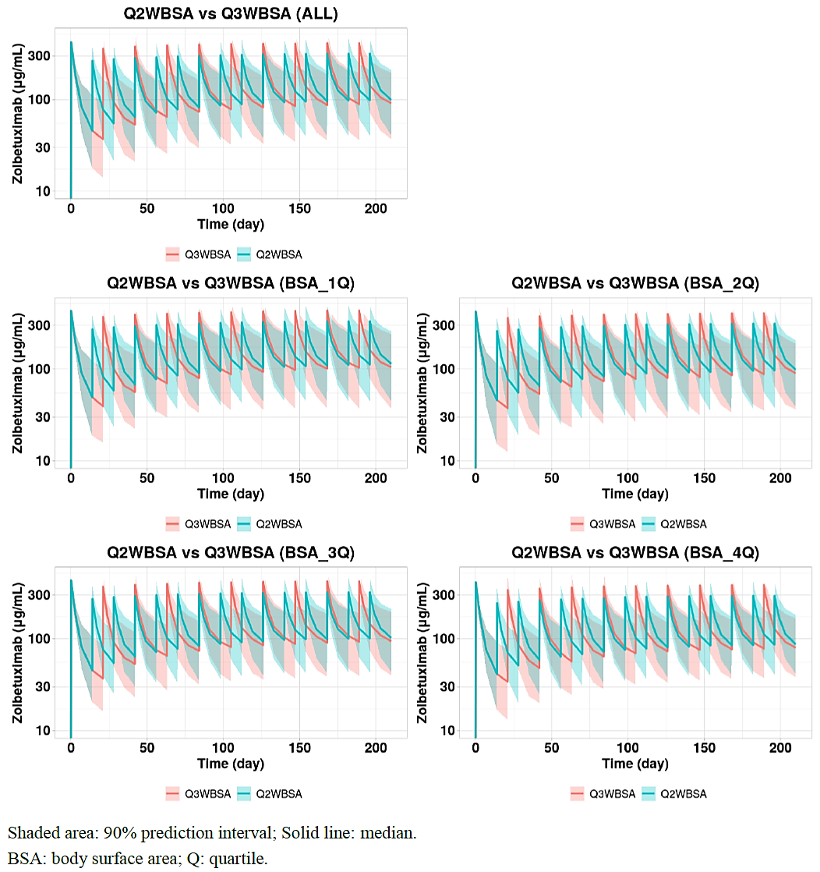
In comparing the geometric mean ratios (GMRs) for Q3WBSA and Q2WBSA, most of the exposure metrics indicated equivalence between the two regimens, regardless of BSA subpopulation, as the 90% CI fell within the conventional 80.00-125.00% acceptance range. Differences were seen in C_{max_ss_42d}, C_{trough_1st_42d} in the overall population, which can be attributed to the different maintenance doses.

Simulated exposure-response (8951-PK-0006)
Exposure metrics were derived from the popPK model and the predicted hazard ratio or probability of efficacy/safety of the alternative regimens was compared to those for the Q3WBSA regimen. C_{ave_last} was prioritised for the evaluation of efficacy since it was found to be a significant predictor of response in most cases. C_{max_1st} was used for the evaluation of safety.

Efficacy
The predicted efficacy endpoints (HRs for PFS, OS and duration of response [DOR]; probability for objective response rate by investigator [ORRL]) were generally similar for Q2WBSA and Q3WBSA regardless of BSA quartile (Figure 3).
Figure 3. Predicted Efficacy of Q2WBSA in Comparison with Q3WBSA by Quartiles based on BSA
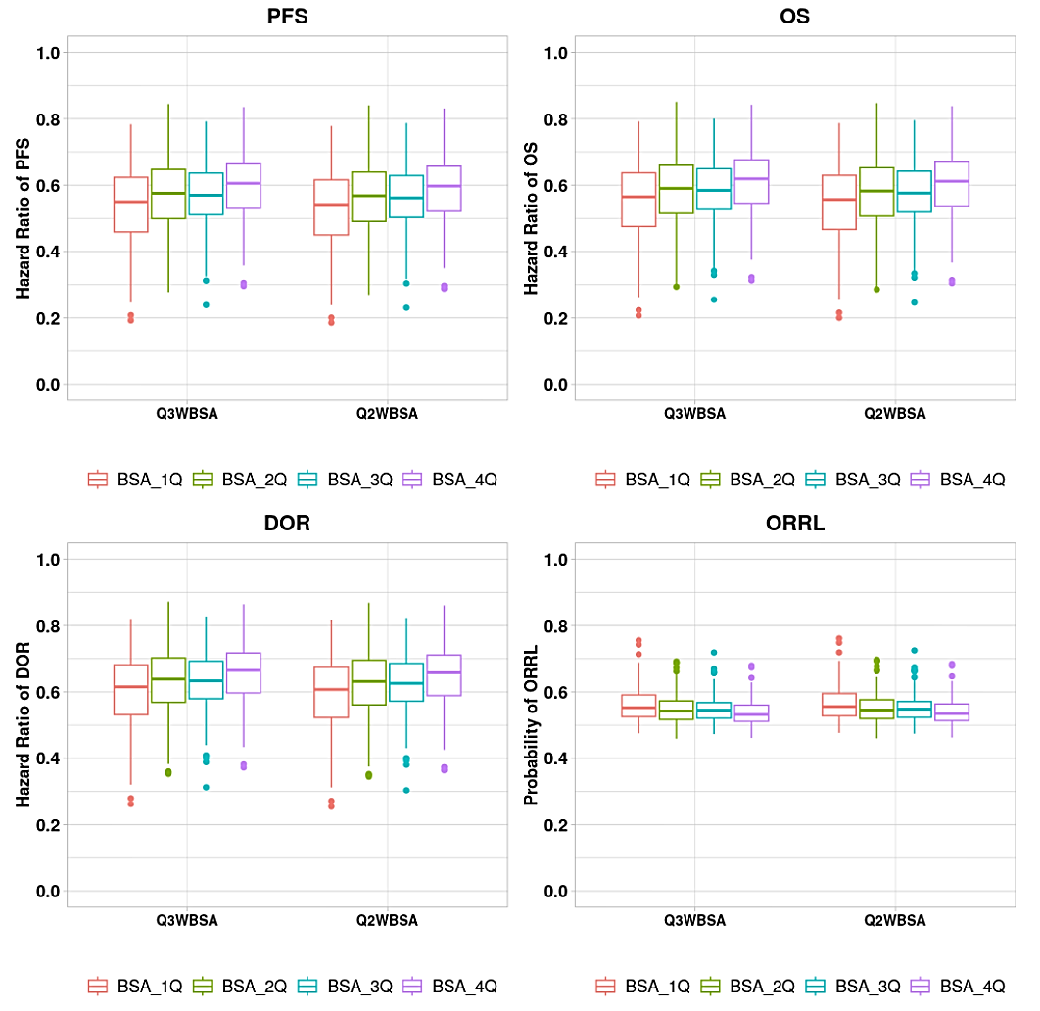
Q3WFIX and Q2WFIX regimens were observed to result in greater variability of efficacy across BSA quartiles compared to Q3WBSA, with worsening efficacy as BSA quartile increased in the fixed dose regimens.

Safety
The predicted probabilities of the evaluated safety endpoints were similar for Q2WBSA and Q3WBSA regardless of body size (Figure 4).
Figure 4. Predicted Safety of Q2WBSA in Comparison with Q3WBSA by Quartiles based on BSA
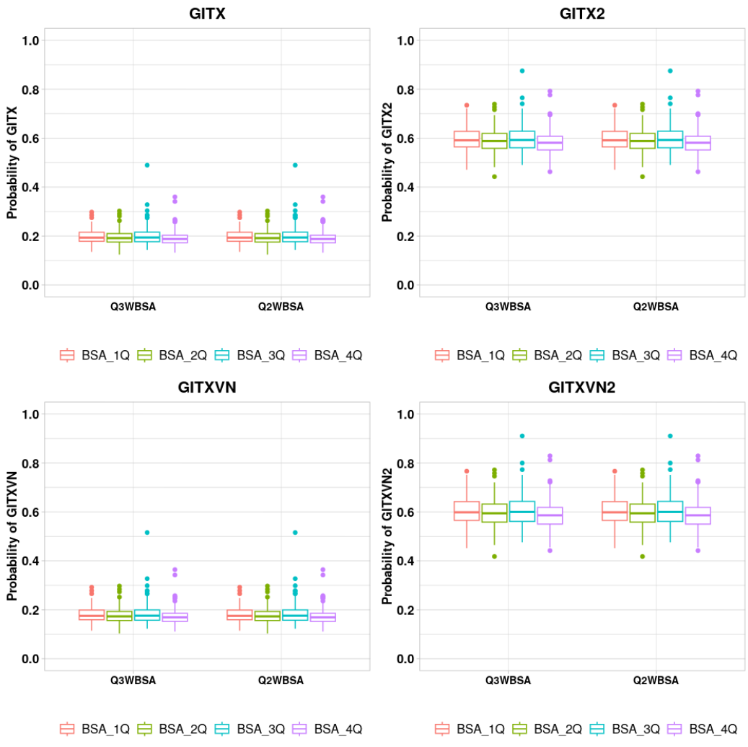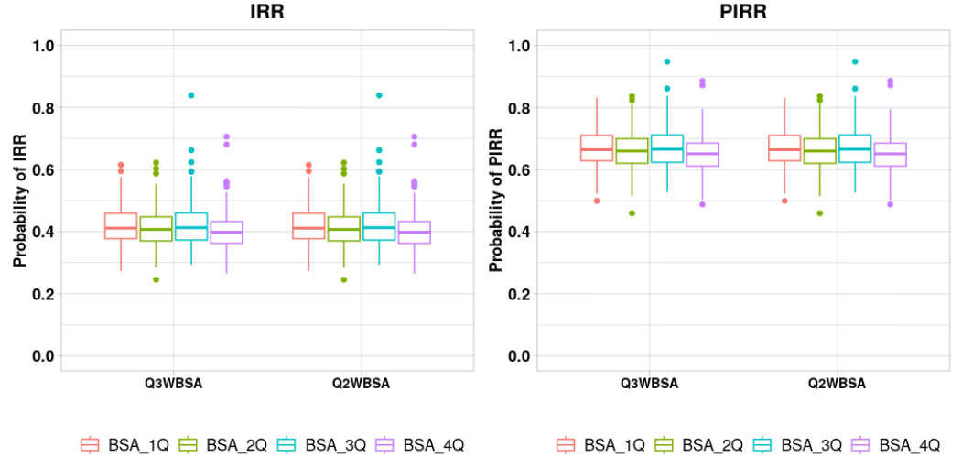
BSA: body surface area; GITX: combined gastrointestinal toxicity (vomiting, nausea and abdominal pain) of Grade ≥ 3; GITX2: gastrointestinal toxicity of Grade ≥ 2; GITXVN: combined gastrointestinal toxicity (nausea and vomiting) of Grade ≥ 3; GITXVN2: combined gastrointestinal toxicity (nausea and vomiting) of Grade ≥ 2; IRR: infusion related reaction flagged by investigator; PIRR: potential infusion related reaction; Q: quartile.
Similar to the predicted efficacy profiles, greater variability was observed with both the Q3WFIX and Q2WFIX regimens in terms of safety events. The chance of predicted safety events decreased with increasing BSA quartiles.

Simulated tumour dynamics (8951-PK-0007)
The tumour dynamics model was used to simulate change-from-baseline SOD vs time for each dosing regimen and placebo control in combination with mFOLFOX6.
The simulations showed a clear separation in terms of tumour growth inhibition between the zolbetuximab + mFOLFOX6 treatment compared to mFOLFOX6 alone, regardless of zolbetuximab dosing regimen, with greater tumour growth inhibition in the zolbetuximab group compared to placebo.
The change-from-baseline SOD-time profiles in all four tested zolbetuximab dosing regimens appeared to be superimposable. Comparing Q3WBSA and other regimens, the simulated change from baseline SOD did not suggest a clinically meaningful difference. Hence, both the proposed Q3WBSA and Q2WBSA regimens are expected to lead to similar tumour growth profiles for target lesions.

Pharmacodynamics

Immunogenicity
The risk of immunogenicity was assessed by the detection of zolbetuximab anti-drug antibodies (ADA) in all nine submitted clinical studies.
An assessment of zolbetuximab serum concentration-time profiles in ILUSTRO, SPOTLIGHT and GLOW subjects who were ADA-positive compared to those who were ADA-negative did not show any noticeable effect of ADA status on zolbetuximab PK.

Risk of QT prolongation (8951-PK-0004)
The risk of QT prolongation due to zolbetuximab treatment was assessed based on data from ILUSTRO Cohort 1A and study 8951-CL-0104. A total of 44 patients were included in this analysis.
No patients had a QT interval corrected using Fridericia’s formula (QTcF) >480 msec or a change from baseline in QTcF interval > 60 msec.
There was shallow and positive gradient in the relationship between zolbetuximab exposure and QTcF change based on the scatter plot. When assessed via linear mixed-effects modelling, the estimated slope was statistically significant (p = 0.02). However, the upper limit of the 1-sided 95% CI of the model-predicted change in QTcF values was < 20 msec at the estimated geometric mean Cmax regardless of zolbetuximab dosing regimen, which is not expected to be clinically meaningful.

Efficacy
Nine clinical studies were submitted in support of this application. The two pivotal phase 3 efficacy studies, SPOTLIGHT and GLOW, will be summarised here.

SPOTLIGHT (Study 8951-CL-0301)
SPOTLIGHT is an ongoing Phase 3, global, multicentre, double-blind, randomised study with the primary objective to evaluate the efficacy of first-line treatment with zolbetuximab plus mFOLFOX6 (Arm A) compared to placebo plus mFOLFOX6 (Arm B) as measured by PFS in adult patients with CLDN18.2-positive, HER2-negative, locally advanced unresectable or metastatic gastric or GOJ adenocarcinoma. CLDN18.2 status was assessed prospectively at entry to the trial. The key secondary endpoint is OS.

Study dates, locations, and trial design
The first participant was screened on 21 Jun 2018 and the study is still ongoing. Reports have been provided for the primary analysis (data cut-off [DCO] 09 Sep 2022; docuBridge seq 0000) and the final OS analysis (DCO 08 Sep 2023; docuBridge seq 0003).
This study was conducted at 232 sites in 20 countries. Of the 232 sites, 215 sites screened at least one participant, including 5 sites in Australia which enrolled 7 subjects. The greatest number of participants were enrolled in Spain (n=71), the US (n=68), Japan (n=65), and Italy (n=64).
The study schema is depicted in Figure 5
Figure 5. Study design of SPOTLIGHT
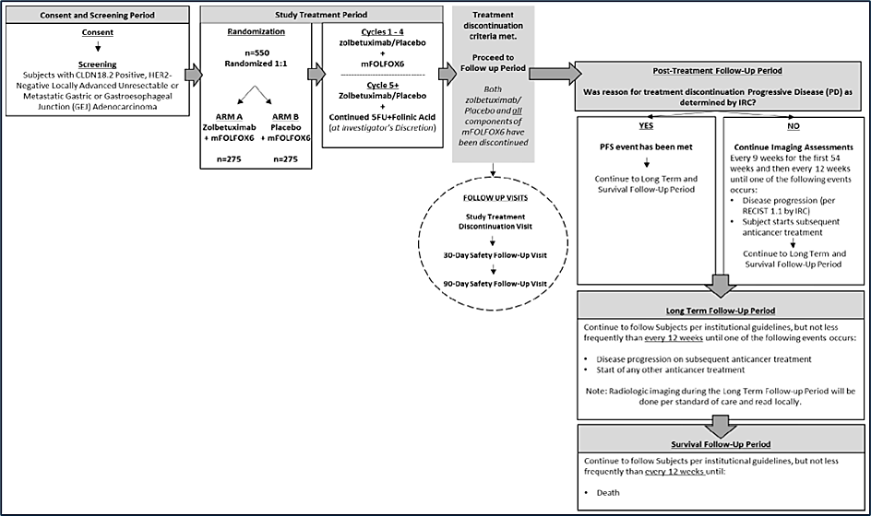

Randomisation and treatment
Participants were randomised 1:1 to zolbetuximab plus mFOLFOX6 (Arm A) or placebo plus mFOLFOX6 (Arm B). Placebo was normal saline infusion. Randomisation was stratified by region (Asia vs non-Asia), number of metastatic sites (0 to 2 vs ≥3) and prior gastrectomy (Yes or No). Subjects and investigator were blinded to treatment allocation.
Participants were treated with either zolbetuximab or placebo on days 1 and 22 of each cycle (each cycle was approximately 42 days) starting at Cycle 1 Day 1, until primarily disease progression, unacceptable toxicity, or start of another anticancer treatment. Participants also received up to 12 treatments of mFOLFOX6 (or a portion of mFOLFOX6 depending on whether some components were discontinued due to toxicity) over 4 or more cycles in which mFOLFOX6 was administered on days 1, 15 and 29 of each cycle. A maximum of 12 doses of oxaliplatin were permitted. After 12 mFOLFOX6 treatments, participants might have continued to receive fluorouracil and folinic acid on days 1, 15 and 29 of each cycle at the investigator’s discretion until the participant met study treatment discontinuation criteria.
In Arm A, zolbetuximab was administered intravenously as an 800 mg/m2 loading dose on Cycle 1 Day 1 followed by subsequent doses of 600 mg/m2 every 3 weeks as an infusion for a minimum of 2 hours. Treatment was continued until disease progression, unacceptable toxicity, start of another anticancer treatment, or other treatment discontinuation criteria.
Antiemetic premedication was administered prior to each study treatment, including (but not limited to) NK-1 receptor blockers and/or 5-HT3 receptor blockers according to institutional standard of care, published guidelines and the respective product package inserts.

Sample size
The study planned to randomise approximately 550 participants.
The planned 300 PFS events during the study provide 93.4% power to detect a difference in PFS between zolbetuximab plus mFOLFOX6 with the assumption of 9 months median PFS time and placebo plus mFOLFOX6 with the assumption of 6 months median PFS time (HR = 0.67) at the 1-sided 0.025 significance level. Similarly, the planned 396 OS events during the study provide 81% power to detect a difference in OS between zolbetuximab plus mFOLFOX6 with the assumption of 14.7 months median survival time and placebo plus mFOLFOX6 with the assumption of 11 months median survival time (HR = 0.75) at the 1-sided 0.025 significance level.

Results: Study Participants
Overall, 565 participants were randomised and analysed in the full analysis set (FAS). Of these, 283 were randomised to Arm A (zolbetuximab+mFOLFOX6) and 282 to Arm B (placebo+mFOLFOX6). The safety analysis set (SAF) comprised 557 subjects (Arm A n=279; Arm B n=278) who received at least one dose of any study drug.
Most participants were male (62.1%), White (53.3%), and the median age was 61.0 years (range: 20 to 86 years). Approximately half of subjects reported a history of tobacco use (41.2% former and 9.1% current). Demographic characteristics were generally well balanced between the treatment arms (Table 4).
Table 4. Baseline demographic characteristics (FAS) in SPOTLIGHT
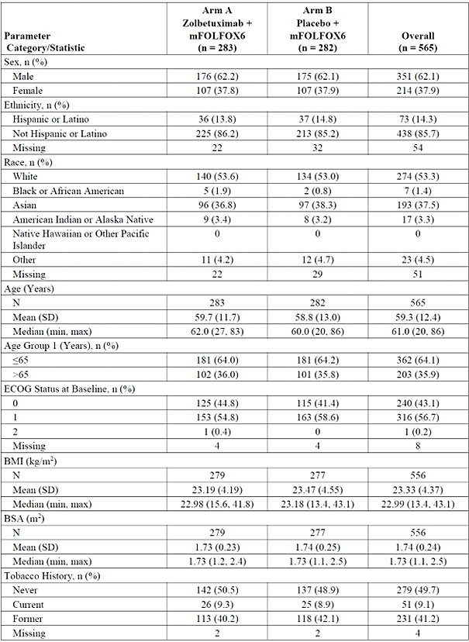
Most participants had a primary diagnosis of gastric adenocarcinoma (75.9%), and the remainder had GOJ adenocarcinoma. The median duration since initial diagnosis was 56.0 days (range: 2 to 5366 days). Primary tumour stage was T3 to T4a for 64.5% of participants. There was a wide range of lymph node involvement (N1 to N3b); 14.0% reported none (N0) and 22.5% could not be assessed. The majority of participants had metastatic disease (84.4%), which was most commonly located in the lymph nodes (37.2%), peritoneum (30.1%), and/or liver (24.2%). Disease characteristics were generally well balanced between the treatment arms.

Results: Efficacy by PFS (Primary endpoint)
At the time of primary analysis (DCO 09 Sep 2022), the median duration of follow-up was 12.9 months in Arm A, and 12.7 months in Arm B, and 313 PFS events had been reported (Arm A: 146 participants with a PFS event; Arm B: 167 participants).
The median PFS was 10.61 months (95% CI: 8.90, 12.48) in the zolbetuximab plus mFOLFOX6 arm and 8.67 months (95% CI: 8.21, 10.28) in the placebo plus mFOLFOX6 arm. The hazard ratio (HR) was 0.751 (95% CI: 0.598, 0.942) and statistically significant in favour of zolbetuximab (1-sided p = 0.0066) (Table 5). A Kaplan-Meier plot of PFS is provided in Figure 6.
Table 5: Summary of PFS Assessed by Independent Review Committee (FAS) in SPOTLIGHT
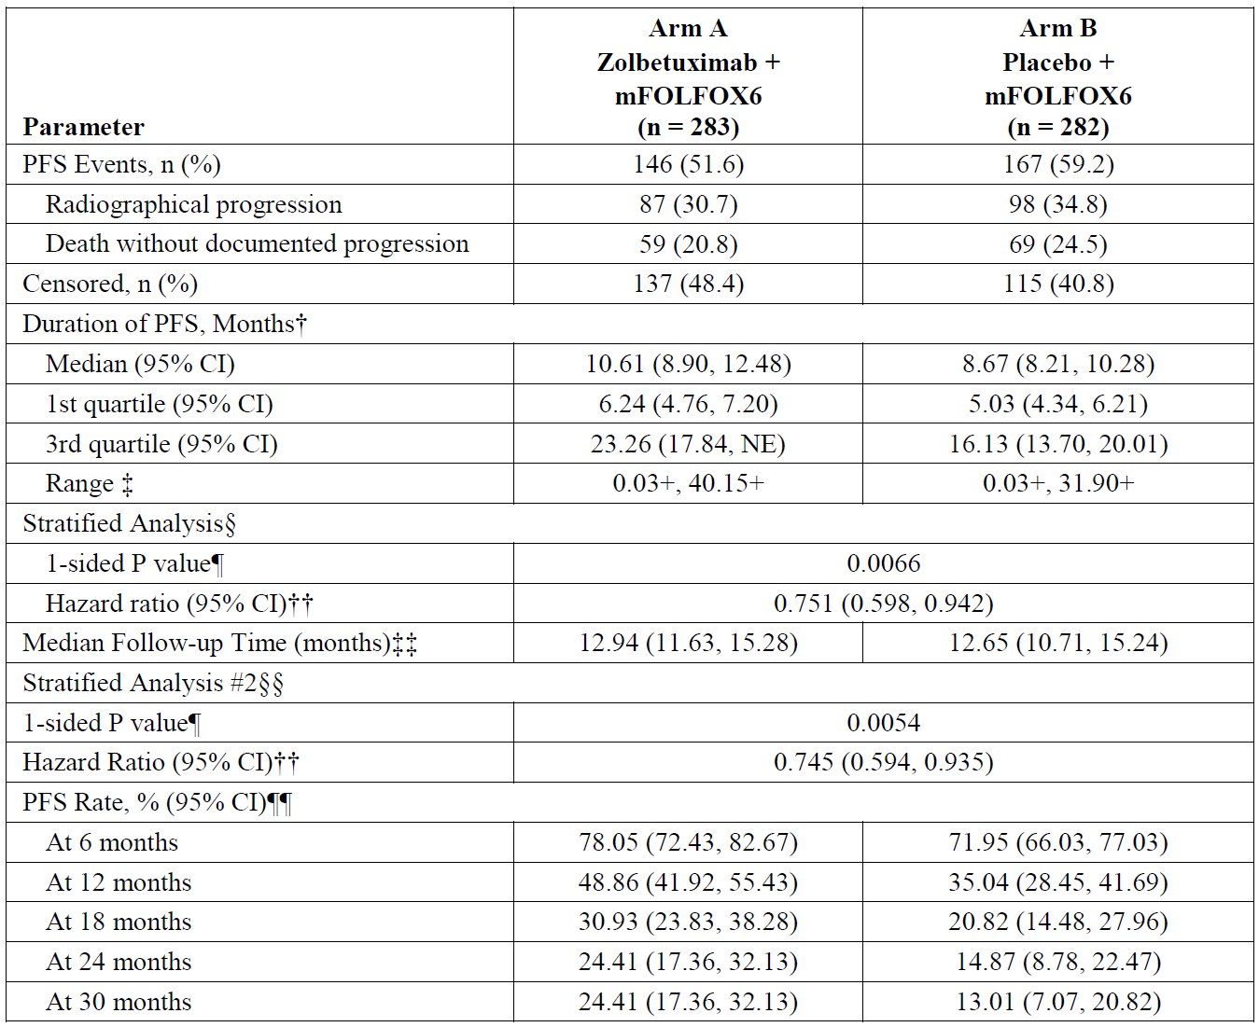
† Based on Kaplan-Meier estimate.
‡ + indicates censoring.
§ Stratification factors were region, number of organs with metastatic sites, and prior gastrectomy from IRT.
¶ Based on 1-sided log-rank test.
†† Based on Cox proportional hazards model with treatment, region, number of organs with metastatic sites and prior gastrectomy as the explanatory variables. Assuming proportional hazards, a hazard ratio < 1 indicates a reduction in the hazard rate in favour of the treatment arm.
‡‡ Based on reverse Kaplan-Meier estimate.
§§ Stratification factors are region, number of organs with metastatic sites, and prior gastrectomy from eCRF.
¶¶ PFS rate and 95% CI were estimated using Kaplan-Meier method and Greenwood formula.
Figure 6. Kaplan-Meier Plot of PFS assessed by Independent Review Committee (FAS) in SPOTLIGHT
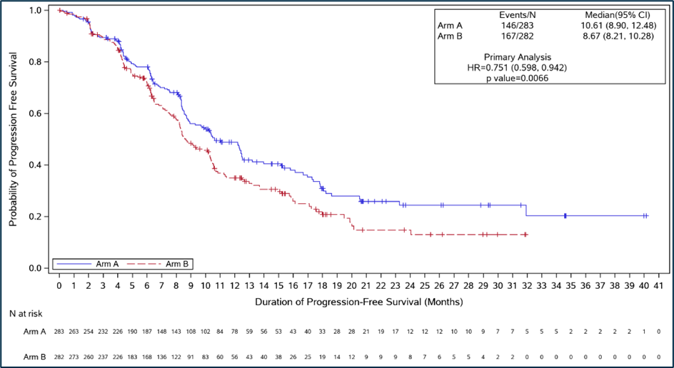
P value was generated from stratified 1-sided log-rank test for the comparison of Arm A and Arm B.
HR with 95% CI is based on stratified Cox proportional hazard model, with region, number of organs with metastatic sites, and prior gastrectomy as the explanatory variables.

PFS in subgroups
PFS in subgroups is presented in Figure 7. This analysis was prespecified, but it was an exploratory endpoint and not statistically powered.
Figure 7. Forest plot of PFS assessed by IRC - subgroup analysis (FAS) in SPOTLIGHT
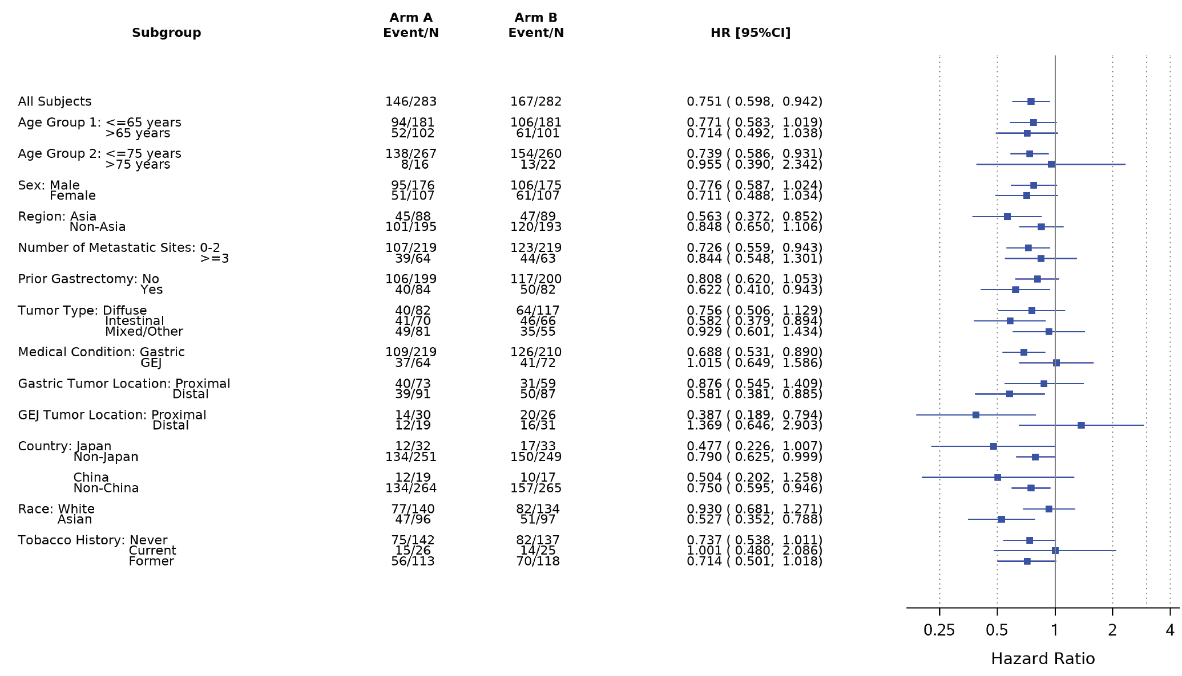
In each subgroup, the HR was estimated using unstratified Cox proportional hazards model with treatment as the only explanatory variable. Assuming proportional hazards, HR < 1 indicates a reduction in hazard rate in favour of treatment arm. The HR reported for all participants was based on stratified analysis.
A less favourable HR is noted in some subgroups, including White race, GOJ tumour, and age >75 years. Other evidence relevant to these results is presented in ‘Special populations’ below.
As noted above, the subgroup analysis was exploratory, not powered for assessments of statistical significance, and has small sample sizes for some subgroups. Therefore, any findings should be interpreted with caution.

Results: Efficacy by OS (Key secondary endpoint)
In the primary analysis (final PFS and interim OS), the SPOTLIGHT study demonstrated a statistically significant benefit in PFS (as assessed by IRC) and OS for patients who received zolbetuximab in combination with mFOLFOX6 compared with patients who received placebo in combination with mFOLFOX6 treatment. The PFS HR was 0.751 (95% CI: 0.598, 0.942; 1-sided P = 0.0066) and the OS HR was 0.750 (95% CI: 0.601, 0.936; 1-sided P = 0.0053).
At the time of final OS analysis (DCO 08 Sep 2023), the median duration of follow-up was 33.3 months in Arm A, and 31.4 months in Arm B. Death had occurred in 197 (69.6%) participants in Arm A and 217 (77.0%) participants in Arm B.
The final OS analysis showed HR 0.784 (95% CI: 0.644, 0.954; 1-sided p = 0.0075). Median duration of OS was 18.23 months (95% CI: 16.13, 20.63) in Arm A and 15.57 months (95% CI: 13.67, 16.92) in Arm B (Table 6). A Kaplan-Meier plot of OS is provided in Figure 8.
Table 6. Summary of OS (FAS) in SPOTLIGHT
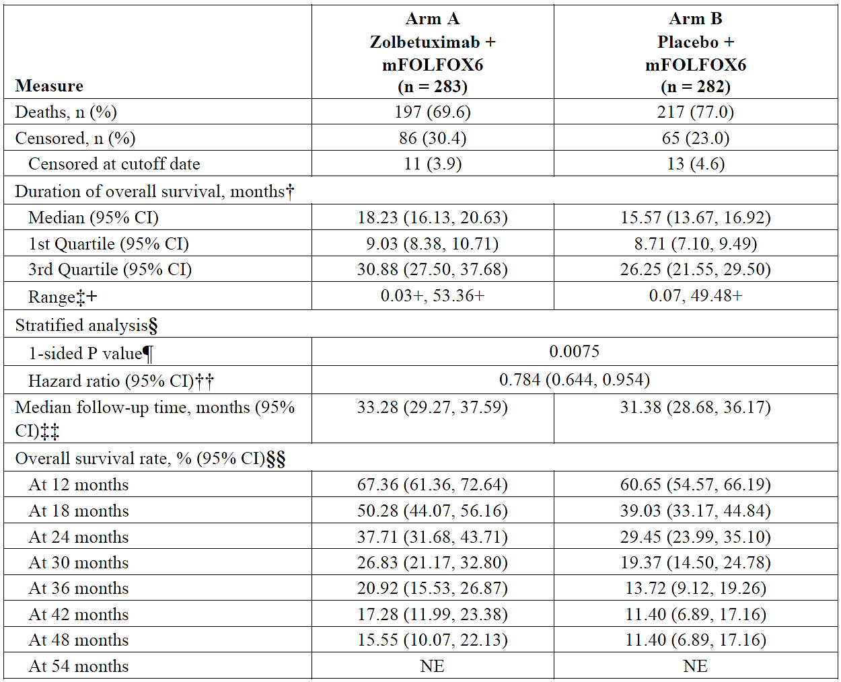
† Based on Kaplan-Meier estimate.
‡ + indicates censoring.
§ Stratification factors were region, number of metastatic sites and prior gastrectomy from eCRF.
¶ Based on 1-sided log-rank test.
†† Based on Cox proportional hazards model with treatment as the explanatory variable. Assuming proportional hazards, a hazard ratio < 1 indicates a reduction in the hazard rate in favour of the treatment arm.
‡‡ Based on reverse Kaplan-Meier estimate.
§§ Survival rate and 95% CI were estimated using Kaplan-Meier method and Greenwood formula.
Figure 8. Kaplan-Meier plot of OS (FAS) in SPOTLIGHT
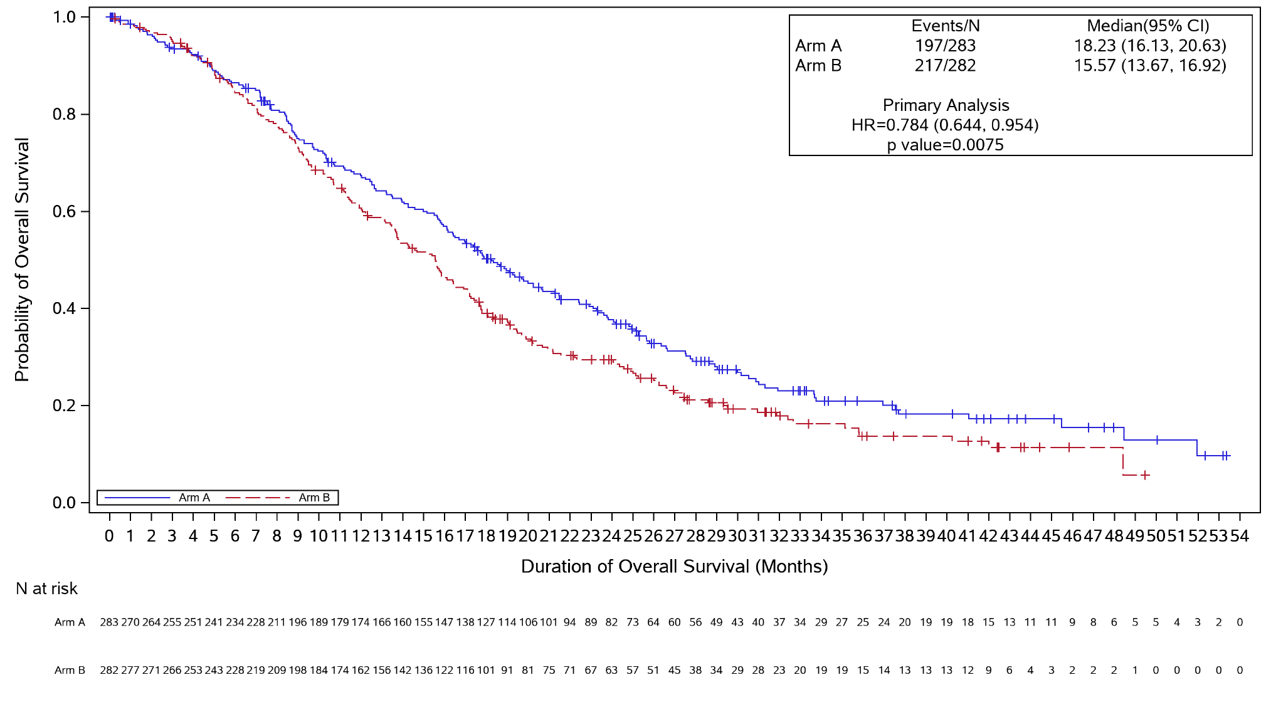
P value was generated from stratified 1-sided log-rank test for the comparison of Arm A and Arm B.
HR with 95% CI is based on stratified Cox proportional hazard model, with region, number of organs with metastatic sites, and prior gastrectomy as the explanatory variables.

OS in subgroups
The trends of OS in subgroups were largely the same as for PFS in subgroups.

Results: TTCD (key secondary endpoint)
Time to confirmed deterioration (TTCD) was assessed for physical function (PF), Oesophago-Gastric Questionnaire on Abdominal Pain and Discomfort (OG25-Pain), and Global Health Status/Quality of Life (GHS/QoL).
To maintain overall type I error rate at the 0.025 significance level, the hypothesis testing on TTCD endpoints was to be performed only if the null hypothesis on the OS was rejected at the 1-sided 0.025 significance level using the gatekeeping procedure with the following order:
- Non-inferiority testing for TTCD in PF at 0.025 significance level
- Non-inferiority testing for TTCD in OG25-Pain at 0.025 significance level
- Non-inferiority testing for TTCD in GHS/QoL at 0.025 significance level
- Superiority testing for TTCD in PF at 0.025 significance level
- Superiority testing for TTCD in OG25-PA at 0.025 significance level
- Superiority testing for TTCD in GHS/QoL at 0.025 significance level
Non-inferiority for TTCD in PF was not met (1-sided p=0.028) and, as such, no confirmatory conclusions can be drawn from lower order endpoints in the above hierarchy.

GLOW (Study 8951-CL-0302)
GLOW is an ongoing Phase 3, global, multicentre, double-blind, randomised study with the primary objective to evaluate the efficacy of first-line treatment with zolbetuximab plus CAPOX (Arm A) compared with placebo plus CAPOX (Arm B) as measured by PFS in adult patients with CLDN18.2-positive§, HER2-negative, locally advanced unresectable or metastatic gastric or GOJ adenocarcinoma. CLDN18.2 status was assessed prospectively at entry to the trial. The key secondary endpoint is OS.

Study dates, locations, and trial design
The first participant was screened on 28 Nov 2018 and the study is still ongoing. Reports have been provided for the primary analysis (DCO 07 Oct 2022) and the final OS analysis (DCO 12 Jan 2024).
This study was conducted at 176 sites in 18 countries. Of the 176 sites, 166 sites screened at least one participant, none of which were in Australia. The greatest number of participants were enrolled in China (n=145), Spain (n=57), Japan, (n=51), and the Republic of Korea (n=50)
The study schema is depicted in Figure 9.
Figure 9. Study design of GLOW
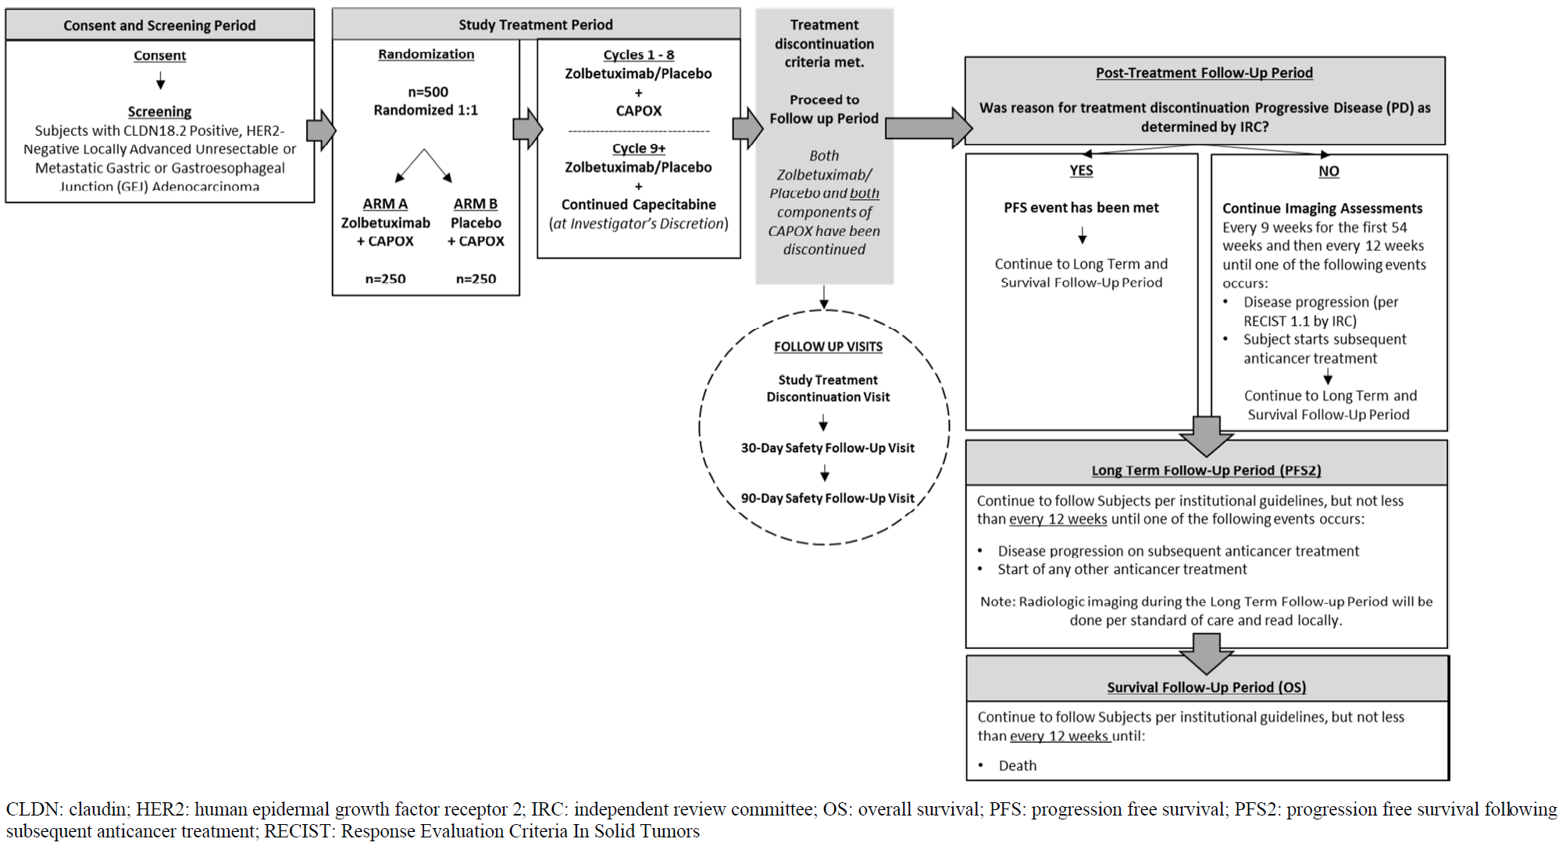

Randomisation and treatment
Participants were randomised 1:1 to zolbetuximab plus CAPOX (Arm A) or placebo plus CAPOX (Arm B). Placebo was normal saline infusion. Randomisation was stratified by region (Asia vs non-Asia), number of metastatic sites (0 to 2 vs ≥3) and prior gastrectomy (Yes or No). Subjects and investigator were blinded to treatment allocation.
Participants were treated with either zolbetuximab (Arm A) or placebo (Arm B) on day 1 of each cycle until disease progression, unacceptable toxicity, or start of another anticancer treatment. For all study treatments, a cycle was defined as approximately 21 days. Participants also received up to 8 treatments of CAPOX treatment. Oxaliplatin was administered on day 1 of each cycle, and capecitabine was taken twice daily on days 1 through 14. After a maximum of 8 treatments of oxaliplatin, participants may have continued to receive capecitabine taken twice daily on days 1 through 14 of each cycle at the investigator’s discretion until the participant met study treatment discontinuation criteria.
In Arm A, zolbetuximab was administered intravenously as an 800 mg/m² loading dose on Cycle 1 Day 1 followed by subsequent doses of 600 mg/m² every 3 weeks as an infusion for a minimum of 2 hours.
Antiemetic premedication was administered prior to each study treatment, including (but not limited to) NK-1 receptor blockers and/or 5-HT3 receptor blockers according to institutional standard of care, published guidelines and the respective product package inserts.

Sample size
The study planned to randomise approximately 500 participants.
The planned 300 PFS events during the study provide 93.4% power to detect a difference in PFS between Arm A with the assumption of 9 months median PFS time and Arm B with the assumption of 6 months median PFS time (HR = 0.67) at the overall 1-sided 0.025 significance level. Similarly, the planned 386 OS events during the study provide 80% power to detect a difference in OS between Arm A with the assumption of 14.7 months median OS time and Arm B with the assumption of 11 months median OS time (HR = 0.75) at the overall 1-sided 0.025 significance level.

Results: Study Participants
Overall, 507 participants were randomised and analysed in the FAS. Of these, 254 were randomised to Arm A (zolbetuximab + CAPOX) and 253 to Arm B (placebo + CAPOX). The SAF comprised 503 subjects (Arm A n=253; Arm B n=250) who received at least one dose of any study drug.
Most participants were male (62.1%), Asian (63.2%), and the median age was 60.0 years (range: 21 to 83 years). Approximately half reported a history of tobacco use (34.9% former and 13.0% current). Demographic characteristics were generally well balanced between the treatment arms (Table 7).
Table 7: Baseline demographic characteristics (FAS) in GLOW
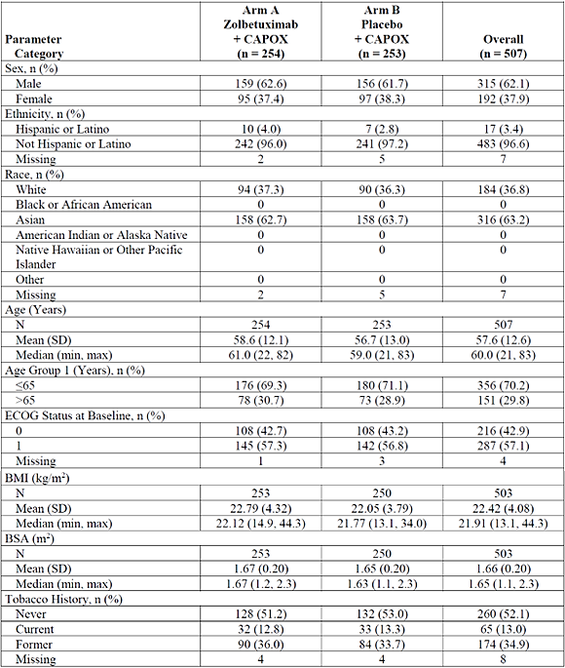
The majority of participants had a primary diagnosis of gastric adenocarcinoma (84.4%) and the remainder had GOJ adenocarcinoma. The median duration since initial diagnosis was 44 days (range: 2 to 6010 days). Primary tumour stage was T3 to T4a for 62.2% of participants. There was a wide range of lymph node involvement (N1 to N3b); 9.5% reported none (N0) and 28.8% could not be assessed. Most of the participants had metastatic disease (87.6%), which was most commonly located in the lymph node(s) (49.3%), peritoneum (34.3%), and/or liver (25.6%). Disease characteristics were generally well balanced between the treatment arms.

Results: Efficacy by PFS (Primary endpoint)
At the time of primary analysis (data cut-off 07 Oct 2022), the median duration of follow-up was 12.6 months in Arm A, and 12.1 months in Arm B, and 309 PFS events had been reported (Arm A: 137 participants with a PFS event; Arm B: 172 participants).
The median PFS was 8.21 months (95% CI: 7.46, 8.84) in the zolbetuximab plus CAPOX arm and 6.80 months (95% CI: 6.14, 8.08) in the placebo plus CAPOX arm. The HR was 0.687 (95% CI: 0.544, 0.866) and statistically significant in favour of zolbetuximab (1-sided p = 0.0007) (Table 8). A Kaplan-Meier plot of PFS is provided in Figure 10.
Table 8: Summary of PFS Assessed by Independent Review Committee (FAS) in GLOW
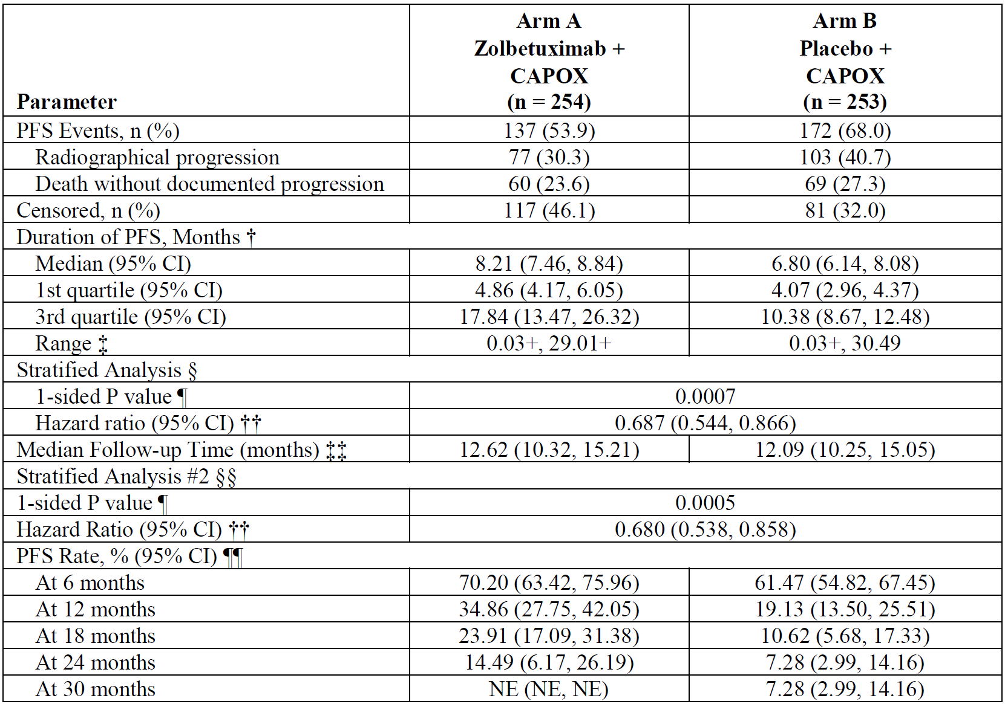
† Based on Kaplan-Meier estimate
‡ + indicates censoring
§ Stratification factors were region, number of organs with metastatic sites, and prior gastrectomy from IRT.
Based on 1-sided log-rank test
†† Based on Cox proportional hazards model with treatment, region, number of organs with metastatic sites and prior gastrectomy as the explanatory variables. Assuming proportional hazards, a hazard ratio < 1 indicates a reduction in the hazard rate in favor of the treatment arm.
‡‡ Based on reverse Kaplan-Meier estimate
§§ Stratification factors are region, number of organs with metastatic sites, and prior gastrectomy from eCRF.
PFS rate and 95% CI were estimated using Kaplan-Meier method and Greenwood formula.
Figure 10. Kaplan-Meier Plot of PFS Assessed by Independent Review Committee (FAS) in GLOW
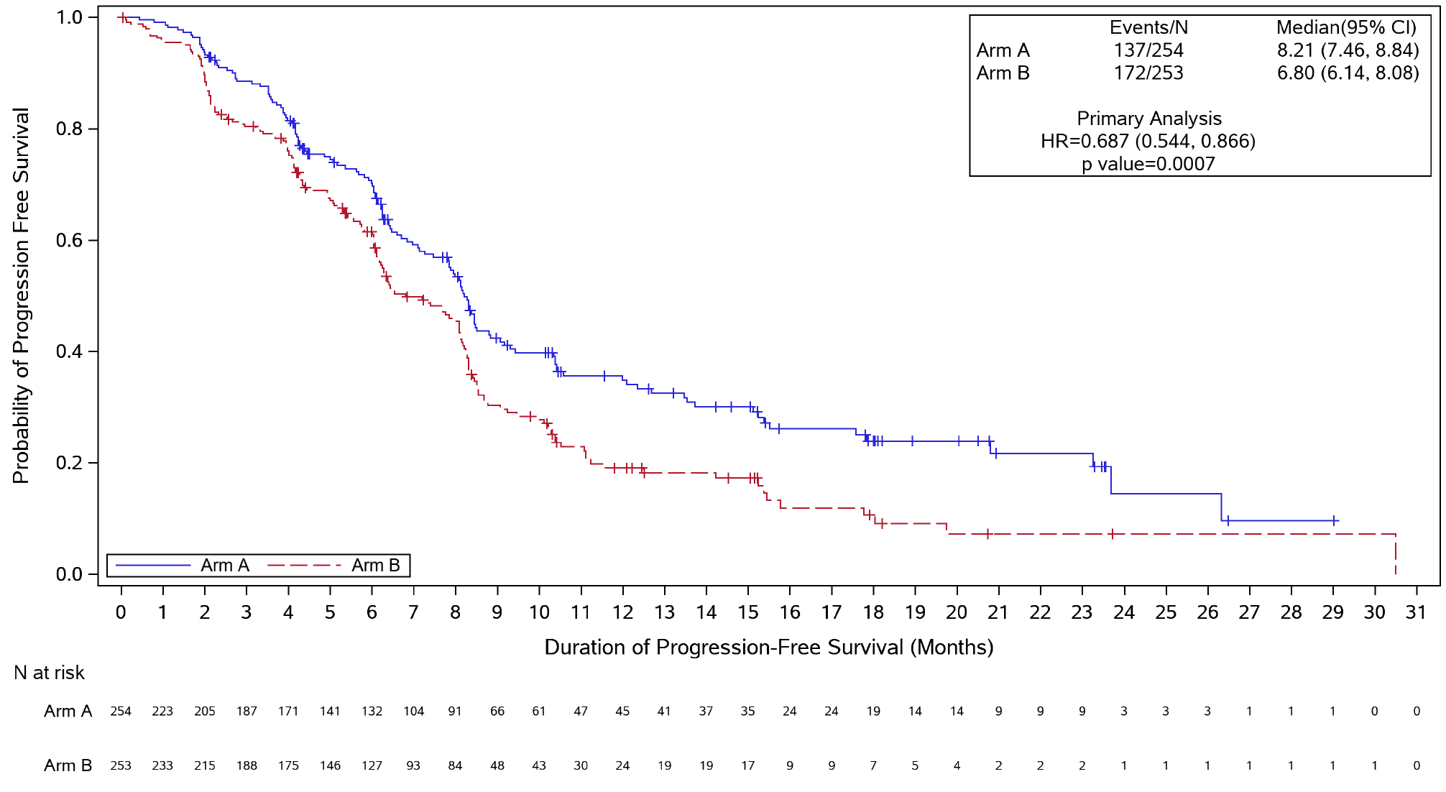

PFS in subgroups
PFS in subgroups is presented in Figure 11. This analysis was prespecified, but it was an exploratory endpoint and not statistically powered.
Figure 11. Forest Plot of PFS assessed by Independent Review Committee - Subgroup Analysis (FAS) in GLOW
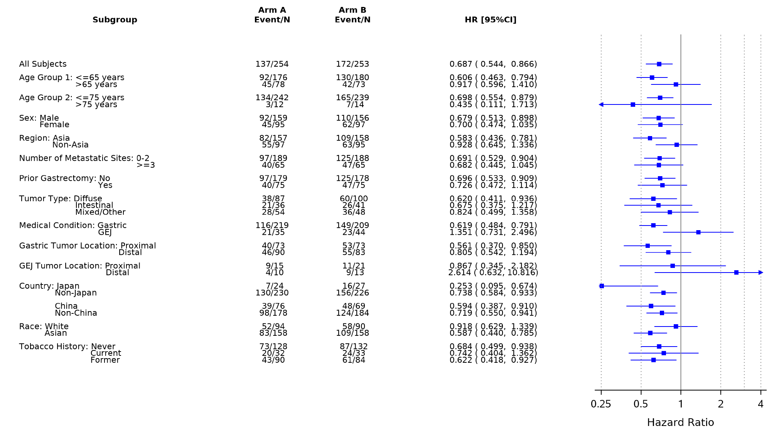
In each subgroup, the HR was estimated using unstratified Cox proportional hazards model with treatment as the only explanatory variable. Assuming proportional hazards, HR < 1 indicates a reduction in hazard rate in favour of treatment arm. The HR reported for all subjects was based on stratified analysis.
Subgroup analyses were exploratory, not powered for assessments of statistical significance, and have small sample sizes for some subgroups. Therefore, any findings should be interpreted with caution.

Results: Efficacy by OS (Key secondary endpoint)
In the Primary Analysis (final PFS and interim OS), the GLOW study demonstrated a statistically significant benefit in PFS (as assessed by IRC) and OS for patients who received zolbetuximab in combination with CAPOX compared with patients who received placebo in combination with CAPOX treatment. The PFS HR was 0.687 (95% CI: 0.544, 0.866; 1-sided P = 0.0007) and the OS HR was 0.771 (95% CI: 0.615, 0.965; 1-sided P = 0.0118).
At the time of final OS analysis (data cut-off 12 Jan 2024), the median duration of follow-up was 31.7 months in Arm A, and 33.0 months in Arm B. Death had occurred in 180 (70.9%) participants in Arm A and 207 (81.8%) participants in Arm B.
The final OS analysis showed HR 0.763 (95% CI: 0.622, 0.936; 1-sided p = 0.0047). Median duration of OS was 14.32 months (95% CI: 12.09, 16.39) in Arm A and 12.16 months (95% CI: 10.28, 13.67) in Arm B (Table 9). A Kaplan-Meier plot of OS is provided in Figure 12.
Table 9. Summary of Overall Survival (FAS) in GLOW
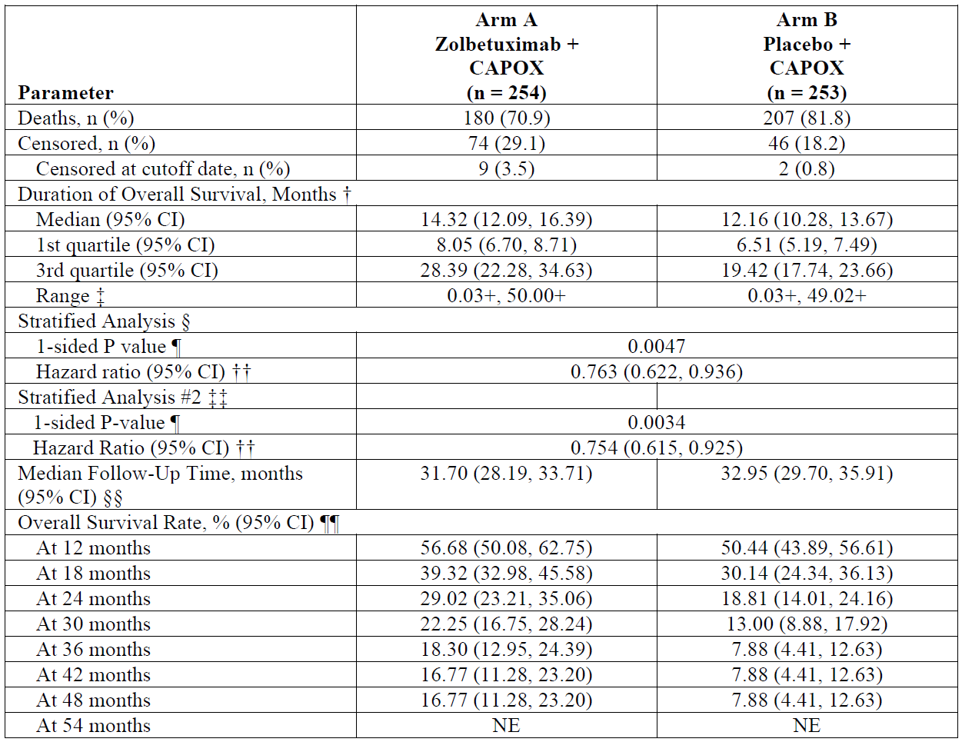
† Based on Kaplan-Meier estimate
‡ + indicates censoring
§ Stratification factors were region, number of organs with metastatic sites and prior gastrectomy from IRT.
¶ Based on 1-sided log-rank test
†† Based on Cox proportional hazards model with treatment, region, number of organs with metastatic sites and
prior gastrectomy as the explanatory variables. Assuming proportional hazards, a hazard ratio < 1 indicates a
reduction in the hazard rate in favor of the treatment arm.
‡‡ Based on reverse Kaplan-Meier estimate
§§ Survival rate and 95% CI were estimated using Kaplan-Meier method and Greenwood formula.
Figure 12. Kaplan-Meier plot of overall survival (FAS) in GLOW
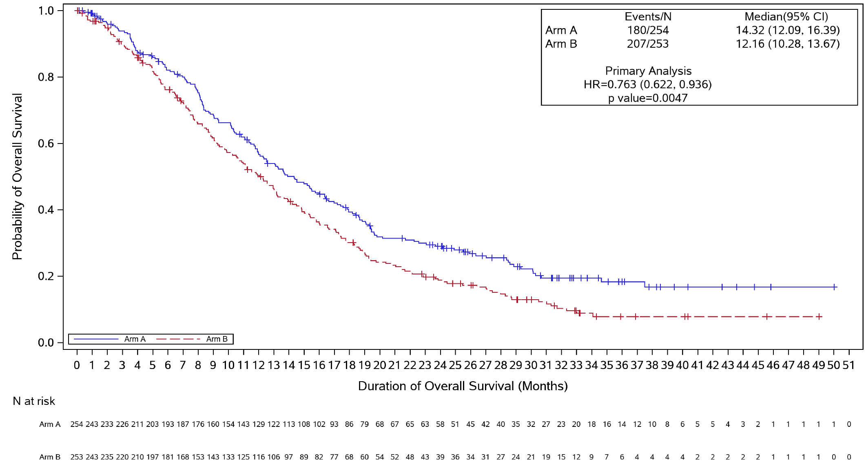
P value was generated from stratified 1-sided log-rank test for the comparison of Arm A and Arm B.
HR with 95% CI is based on stratified Cox proportional hazard model, with region, number of organs with metastatic sites, and prior gastrectomy as the explanatory variables.

OS in subgroups
The trends of OS in subgroups were largely the same as for PFS in subgroups.

Results: TTCD (key secondary endpoint)
TTCD was assessed for PF, OG25-Pain, and GHS/QoL.
To maintain overall type I error rate at the 0.025 significance level, the hypothesis testing on TTCD endpoints was to be performed only if the null hypothesis on the OS was rejected at the 1-sided 0.025 significance level using the gatekeeping procedure with the following order:
- Non-inferiority testing for TTCD in PF at 0.025 significance level
- Non-inferiority testing for TTCD in OG25-Pain at 0.025 significance level
- Non-inferiority testing for TTCD in GHS/QoL at 0.025 significance level
- Superiority testing for TTCD in PF at 0.025 significance level
- Superiority testing for TTCD in OG25-PA at 0.025 significance level
- Superiority testing for TTCD in GHS/QoL at 0.025 significance level
Non-inferiority for TTCD in PF was not met (1-sided p=0.47) and, as such, no confirmatory conclusions can be drawn from lower order endpoints in the above hierarchy.

SPECIAL POPULATIONS (studies SPOTLIGHT and GLOW)
As noted above, exploratory analyses suggest a less favourable PFS and/or OS outcomes in some subgroups, including White race (SPOTLIGHT and GLOW), GOJ tumour location (SPOTLIGHT and GLOW), age >75 years (SPOTLIGHT), and age >65 years (GLOW).
Subgroup analyses were exploratory, not powered for assessments of statistical significance, and have small sample sizes for some subgroups. Therefore, any findings should be interpreted with caution.

White race
Race (White vs. non-White; Asian vs. non-Asian) was not identified as a significant covariate in the popPK or E-R analyses.
The Sponsor attributed the apparent numerically higher HR in efficacy outcome in the White subgroup to lower exposures to zolbetuximab, due to higher rates of treatment interruptions and discontinuations primarily due to nausea and vomiting in White compared to Asian participants. Additional post-hoc analyses of SPOTLIGHT and GLOW were conducted to support this argument.
Early discontinuation of zolbetuximab (<9 weeks of treatment) was more frequently due to an adverse event (AE) among White participants (45% of early discontinuations) compared to Asian subjects (20%) in SPOTLIGHT/GLOW. The same pattern was not seen for participants receiving placebo (early discontinuation of placebo was due to an AE in 7.7% of White patients versus 22.2% of Asian patients).
Any treatment-emergent adverse event (TEAE) leading to interruption of zolbetuximab/placebo was more likely to be reported for White participants receiving zolbetuximab (72%) or placebo (43%), compared to Asian patients receiving zolbetuximab (58%) or placebo (26%). This pattern was similar for the TEAEs of vomiting and nausea (Table 10).
Table 10: Treatment-emergent adverse events of nausea and vomiting leading to interruption in White and Asian subgroups and overall population (Safety Analysis Set)
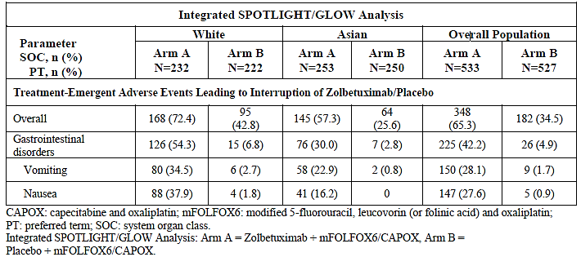
The Sponsor provided a sensitivity analysis of PFS and OS by zolbetuximab exposure and racial subgroup, which suggested that the efficacy outcomes were similar for White and Asian participants after accounting for zolbetuximab exposure (Table 11).
Table 11: Summary of median PFS and OS duration in zolbetuximab group (SPOTLIGHT/GLOW) by TEAEs leading to dose interruption of any study drug with <75% REI of zolbetuximab or TEAE leading to withdrawal of any study drug with zolbetuximab treatment discontinuation within 180 days (Full Analysis Set)
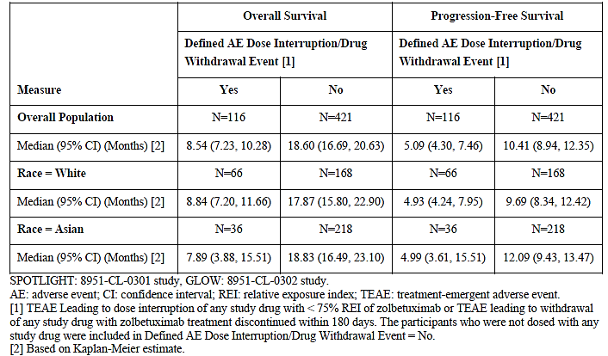

Gastro-oesophageal junction adenocarcinoma
Primary tumour location (gastric vs GOJ vs both) was not identified as a significant covariate in the popPK or E-R analyses.
The sample sizes for patients with GOJ were small in SPOTLIGHT (Arm A: n=64; Arm B: n=72) and GLOW (Arm A: n=35; Arm B: n=44). Furthermore, the possibly reduced efficacy in GOJ patients appears to be driven largely by people with distal GOJ tumour location (c.f. proximal GOJ). The sample sizes for distal GOJ are smaller again in SPOTLIGHT (Arm A: n=19; Arm B: n=31) and GLOW (Arm A: n=10; Arm B: n=13).
The Sponsor conducted additional post-hoc analyses to better understand possible reasons for the difference in efficacy outcomes in the GOJ subgroup compared with the overall population of SPOTLIGHT/GLOW.
In general, for studies SPOTLIGHT and GLOW, the GOJ adenocarcinoma subgroups had similar baseline demographic and disease characteristics that were balanced between the treatment arms and were also similar compared with those of the overall population. A higher proportion of patients with GOJ were White compared to the overall population, which is consistent with established epidemiology of GOJ adenocarcinoma. The Sponsor considered that no difference in baseline characteristics was observed that may have contributed to the efficacy outcomes observed in the GOJ subgroup analysis.
A reduced median duration of zolbetuximab treatment was observed for participants with GOJ compared with the overall population (SPOTLIGHT: 16 days less; GLOW: 31 days less), along with a slightly higher rate of infusion interruptions (SPOTLIGHT: GOJ 63.5% vs overall 59.5%; GLOW: GOJ 50.0% vs overall 42.5%). However, the proportion of patients with zolbetuximab relative dose intensity (RDI) >80% was similar between the GOJ subgroups and the overall population in (SPOTLIGHT: 85.7% vs 85.7%) and GLOW (91.7% vs 93.7%).
The rate of zolbetuximab discontinuation was similar for the overall pooled population of SPOTLIGHT/GLOW (85.7%) and the pooled GOJ subgroup (88.9%). The reasons for discontinuation were similar between the GOJ and overall populations, including the frequency of AE leading to discontinuation of zolbetuximab (overall: 14.2%; GOJ: 15.2%) (Table 12).
Table 12: End-of-Treatment Reasons – Discontinuation of Zolbetuximab/Placebo (Full Analysis Set)
Parameter  Category, n (%) | Overall Population  SPOTLIGHT/GLOW |  | GOJ Subgroup  SPOTLIGHT/GLOW
Parameter  Category, n (%) | Arm A  N=537 | Arm B  N=535 | Arm A  N=99 | Arm B  N=116
Discontinuation
No | 77 (14.3) | 60 (11.2) | 11 (11.1) | 15 (12.9)
Yes | 460 (85.7) | 475 (88.8) | 88 (88.9) | 101 (87.1)
Primary Study Drug Treatment Status
Adverse Event | 76 (14.2) | 29 (5.4) | 15 (15.2) | 4 (3.4)
Death | 37 (6.9) | 38 (7.1) | 9 (9.1) | 9 (7.8)
Lost to Follow-up | 2 (0.4) | 1 (0.2) | 0 | 0
Progressive Disease | 235 (43.8) | 334 (62.4) | 45 (45.5) | 74 (63.8)
Protocol Deviation | 3 (0.6) | 1 (0.2) | 1 (1.0) | 0
Withdrawal by Participant | 64 (11.9) | 41 (7.7) | 15 (15.2) | 7 (6.0)
Other | 43 (8.0) | 31 (5.8) | 3 (3.0) | 7 (6.0)
The rate of overall TEAEs leading to interruption and permanent discontinuation of zolbetuximab is similar between the overall pooled SPOTLIGHT/GLOW population (65.3%) and the pooled GOJ subgroup (65.7%). No differences of ≥ 10% (rate chosen in the Sponsor’s analysis for possible meaningful impact) were detected in the rate of TEAEs by SOC and PT between the overall and GOJ populations, including rates of nausea (interruption: 37.6% vs 35.4%; permanent discontinuation: 3.4% vs 3.0%) and vomiting (interruption: 28.1% vs 24.2%; permanent discontinuation: 3.8% vs 4.0%).

Age >65 (GLOW) or >75 years (SPOTLIGHT)
Age (year) was not identified as a significant covariate in the popPK or E-R analyses.
The sample sizes for patients in the relevant age categories were small. Age >75 in SPOTLIGHT – Arm A: n=16; Arm B: n=22. Age >65 in GLOW – Arm A: n=78; Arm B: n=73.
There was notable inconsistency in the efficacy outcomes for these age subgroups between SPOTLIGHT and GLOW, particularly for OS in the >75 years old subgroup (Table 13). The Sponsor stated: “Given the inconsistency of HR values between the 2 pivotal studies for both PFS and OS in this age group, it is likely that this is due to chance because of the small sample size, and not a true efficacy effect.”
Table 13: Age Groups ≤ 75 Years and > 75 Years Analyses of Progression-Free Survival (by IRC Assessment) and Overall Survival for SPOTLIGHT and GLOW: Zolbetuximab/Placebo (Full Analysis Set)
Parameter |  | PFS |  | OS
 |  | Arm A | Arm B | Arm A | Arm B
SPOTLIGHT
Age Group  ≤75 Years | N | 267 | 260 | 267 | 260
Age Group  ≤75 Years | HR(95% CI) | 0.739 (0.586, 0.931) |  | 0.713 (0.568, 0.895)
Age Group  > 75 Years | N | 16 | 22 | 16 | 22
Age Group  > 75 Years | HR(95% CI) | 0.955 (0.390, 2.342) |  | 1.315 (0.578, 2.996)
Overall Population | N | 283 | 282 | 283 | 282
Overall Population | HR(95% CI) | 0.751 (0.598, 0.942) |  | 0.750 (0.601, 0.936)
GLOW
Age Group  ≤ 75 Years | N | 242 | 239 | 242 | 239
Age Group  ≤ 75 Years | HR(95% CI) | 0.698 (0.544, 0.897) |  | 0.755 (0.602, 0.948)
Age Group  > 75 Years | N | 12 | 14 | 12 | 14
Age Group  > 75 Years | HR(95% CI) | 0.435 (0.111, 1.713) |  | 0.544 (0.183, l.617)
Overall Population | N | 254 | 253 | 254 | 253
Overall Population | HR(95% CI) | 0.687 (0.544, 0.866) |  | 0.771 (0.615, 0.965)
CAPOX: capecitabine and oxaliplatin; CI: confidence interval; HR: hazard ratio; IRC: Independent Review Committee; mFOLFOX6: modified 5-fluorouracil, leucovorin (or folinic acid) and oxaliplatin; OS: overall survival; PFS: progression-free survival.
SPOTLIGHT Analysis: Arm A = Zolbetuximab + mFOLFOX6, Arm B = Placebo + mFOLFOX6. GLOW Analysis: Arm A = Zolbetuximab + CAPOX, Arm B = Placebo + CAPOX.
The HR reported for all subjects was based on stratified analysis. For the Overall Population, the HR with 95% CI is based on stratified Cox proportional hazard model, with region, number of metastatic sites and prior gastrectomy as the explanatory variables. For each subgroup analysis, the HR was estimated using unstratified Cox proportional hazards model with treatment as the only explanatory variable. Assuming proportional hazards, an HR < 1 indicates a reduction in hazard rate in favor of treatment arm.

Safety

SPOTLIGHT (Study 8951-CL-0301)

Exposure
At the time of primary analysis, 557 subjects had received at least one dose of zolbetuximab (n=279) or placebo (n=278).
The median duration of treatment was 190.0 days (range: 1, 1246) with zolbetuximab, and 195.0 days (range: 1, 1016) with placebo. The median number of infusions administered per participant was 9.0 (range: 1, 60) for zolbetuximab, and 9.0 (range: 1, 46) for placebo. RDI was >80% for 85.7% of zolbetuximab recipients, and 98.6% of placebo recipients.
Exposure to mFOLFOX6 components was similar between Arm A and Arm B. 24 weeks of mFOLFOX6 treatment was completed by 36.9% of subjects in Arm A and 35.6% in Arm B.

Safety results summary
At the time of primary analysis, at least 1 TEAE had been reported for 99.6% of study participants (Arm A: 99.3%; Arm B: 96.4%). The most frequently reported TEAEs (zolbetuximab vs control arm) were nausea (82.4% vs 60.8%) and vomiting (67.4% vs 35.6%), which were also the most frequent treatment-related TEAEs (nausea: 68.8% vs 37.1%; vomiting: 57.7% vs 15.1%).
Grade ≥3 TEAEs were reported in 242 (86.7%) participants in Arm A and 216 (77.7%) participants in Arm B. The most frequent Grade ≥ 3 TEAEs were neutropenia (28.3% vs 23.4%), neutrophil count decreased (24.7% vs 24.8%), vomiting (16.1% vs 5.8%), and nausea (16.1% vs 6.5%).
Serious AEs (SAEs) were experienced by 125 (44.8%) participants in Arm A and 121 (43.5%) participants in Arm B. The most frequently reported SAEs were vomiting (8.2% vs 4.7%), nausea (6.8% vs 4.0%) and malignant neoplasm progression (3.6% vs 4.3%).
TEAEs leading to death occurred in 22 (7.9%) Arm A subjects and 24 (8.6%) Arm B participants. The most frequent TEAEs causing death were malignant neoplasm progression (3.2% vs 4.3%) and pneumonia (0.7% vs 0.4%).
TEAEs leading to discontinuations of zolbetuximab or placebo were reported in 55 (19.7%) participants in Arm A and 30 (10.8%) participants in Arm B, and were mostly due to nausea (4.3% vs 0.4%) or vomiting (4.7% vs 0). Dose interruption of zolbetuximab or placebo was reported in 208 (74.6%) participants and 111 (39.9%) participants, respectively. The most frequently reported TEAEs leading to interruption of zolbetuximab or placebo were nausea (36.9% vs 1.4%), vomiting (31.5% vs 1.4%), and neutropenia (15.1% vs 15.1%).
Updated safety data at the time of final OS analysis were consistent with the primary analysis results.

GLOW (Study 8951-CL-0302)

Exposure
At the time of primary analysis, 503 subjects had received at least one dose of zolbetuximab (n=254 or placebo (n=249).
The median duration of treatment was 134.0 days (range: 1, 933) with zolbetuximab, and 148.0 days (range: 1, 848) with placebo. The median number of infusions administered per participant was 6.0 (range: 1, 40) for zolbetuximab, and 7.0 (range: 1, 38) for placebo. RDI was >80% for 93.7% of zolbetuximab recipients, and 99.6% of placebo recipients.
Exposure to CAPOX components was similar between Arm A and Arm B. 24 weeks of CAPOX treatment was completed by 27.6% of subjects in Arm A and 27.7% in Arm B.

Safety results summary
At the time of primary analysis, at least 1 TEAE had been reported for 98.4% of study participants (Arm A: 98.8%; Arm B: 98.0%). The most frequently reported TEAEs (zolbetuximab vs control arm) were nausea (68.5% vs 50.2%) and vomiting (66.1% vs 30.9%), which were also the most frequent treatment-related TEAEs (nausea: 60.6% vs 34.9%; vomiting: 60.6% vs 18.1%).
Grade ≥3 TEAEs were reported in 185 (72.8%) participants in Arm A and 115 (46.2%) participants in Arm B. The most frequent Grade ≥ 3 TEAEs were vomiting (12.2% vs 3.6%), anaemia (10.6% vs 11.2%), neutrophil count decreased (10.2% vs 9.6%), and nausea (8.7% vs 2.4%).
SAEs were experienced by 120 (47.2%) participants in Arm A and 124 (49.8%) participants in Arm B. The most frequently reported SAEs were vomiting (5.9% vs 4.4%), nausea (4.3% vs 2.4%) and malignant neoplasm progression (3.5% vs 5.2%).
TEAEs leading to death occurred in 27 (10.6%) Arm A subjects and 32 (12.9%) Arm B participants. The most frequent TEAEs causing death were malignant neoplasm progression (2.8% vs 5.2%) and septic shock (0.8% vs 0.8%).
TEAEs leading to permanent discontinuations of zolbetuximab or placebo were reported in 51 (20.1%) participants in Arm A and 36 (14.5%) participants in Arm B, and were most frequently due to vomiting (2.4% vs 1.2%). Dose interruption of zolbetuximab or placebo was reported in 140 (55.1%) participants and 71 (28.5%) participants, respectively. The most frequently reported TEAEs leading to interruption of zolbetuximab or placebo were vomiting (24.4% vs 2.0%), nausea (17.3% vs 0.4%), and neutropenia (7.1% vs 3.6%).
Updated safety data at the time of final OS analysis were consistent with the primary analysis results.

Pooled safety results
The Sponsor provided integrated data based on clinical studies SPOTLIGHT, GLOW, ILUSTRO (Cohort 2) and FAST. This consisted of the pooled data from study participants who received at least 1 dose of zolbetuximab 800/600 mg/m² Q3W or placebo in combination with EOX (FAST), mFOLFOX6 (ILUSTRO or SPOTLIGHT) or CAPOX (GLOW). This dataset is referred to as the combined phase 2/phase 3 group.

Exposure
In SPOTLIGHT and GLOW combined, 533 participants received at least one dose of zolbetuximab and 527 received at least one dose of placebo. The median duration of exposure was 171.0 days for zolbetuximab, and 173.0 days for placebo.
In FAST, 77 participants in received at least one dose of zolbetuximab 800/600 mg/m² Q3W. Median duration of exposure was 128.0 days, and median number of infusions per participant was 6.0.
In Cohort 2 of phase 2 study ILUSTRO, 21 participants in received at least one dose of zolbetuximab 800/600 mg/m2 Q3W. Median duration of exposure was 231.0 days, and median number of infusions per participant was 10.0.

Safety results summary
Nearly all study participants in the combined phase 2/phase 3 zolbetuximab group (98.9%) and the combined phase 2/phase 3 control group (99.0%) experienced at least 1 TEAE. The most frequently reported TEAEs (zolbetuximab vs control group) were nausea (77.0% vs 58.6%) and vomiting (66.9% vs 36.2%).
Grade ≥3 TEAEs were reported in 79.2% of zolbetuximab recipients and 72.3% of control group participants. The most frequent Grade ≥ 3 TEAEs were neutropenia (20.1% vs 14.6%), neutrophil count decreased (16.2% vs 15.4%), vomiting (13.6% vs 4.6%), and nausea (11.6% vs 4.6%).
SAEs were reported for 43.1% zolbetuximab recipients and 44.5 of control group participants. The most frequently reported SAEs were vomiting (4.3% vs 1.0%), and nausea (3.6% vs 1.0%).
There were 54 (8.6%) participant deaths due to TEAEs in the pooled zolbetuximab group and 71 (11.6%) in the pooled control group. TEAEs leading to death considered by the investigator to be related to zolbetuximab or placebo were reported in 8 (1.3%) and 6 (1.0%) participants, respectively.
TEAEs leading to permanent discontinuations of zolbetuximab or placebo were reported in 19.0% of zolbetuximab recipients and 10.8% of control group participants, and were most frequently due to vomiting (3.8% vs 0.5%) and nausea (3.3% vs 0.3%). Dose interruption of zolbetuximab or placebo was reported in 60.4% and 29.8% of participants, respectively. The most frequently reported TEAEs leading to interruption of zolbetuximab or placebo were vomiting (26.5% vs 1.5%), nausea (25.5% vs 0.8%), neutropenia (9.8% vs 8.3%) and neutrophil count decreased (5.7% vs 5.4%).

Adverse events of special interest
Based on observations during the clinical development of zolbetuximab, nausea, vomiting, hypersensitivity reactions, IRRs, anaemia, and neutropenia were identified as AEs of special interest (AESIs).
In an integrated analysis of data from SPOTLIGHT and GLOW, anaemia was reported in comparable frequencies in the zolbetuximab (36.0%) and control (37.2%) groups. Grade ≥ 3 anaemia was reported in 9.8% of zolbetuximab recipients, compared to 10.3% of control group participants. SAEs of anaemia were reported in 1.9% of participants in each treatment arm.
In an integrated analysis of data from SPOTLIGHT and GLOW, neutropenia was reported in 57.2% of zolbetuximab recipients, compared to 52.0% of control group participants. Grade ≥ 3 neutropenia occurred in 35.7% of participants in the zolbetuximab group, compared to 31.1% of participants in the control group. SAEs of neutropenia were reported in low frequencies in both treatment groups (3.9% in the zolbetuximab group and 2.8% in the control group).
Summary tables are provided below for the AESIs of nausea and/or vomiting (Table 14), hypersensitivity reactions (Table 15), and IRRs (Table 16) in the combined phase 2/phase 3 group.
Table 14: Summary of TEAEs of interest: nausea and vomiting in the integrated FAST, ILUSTRO (cohort 2), SPOTLIGHT and GLOW studies (safety analysis set)
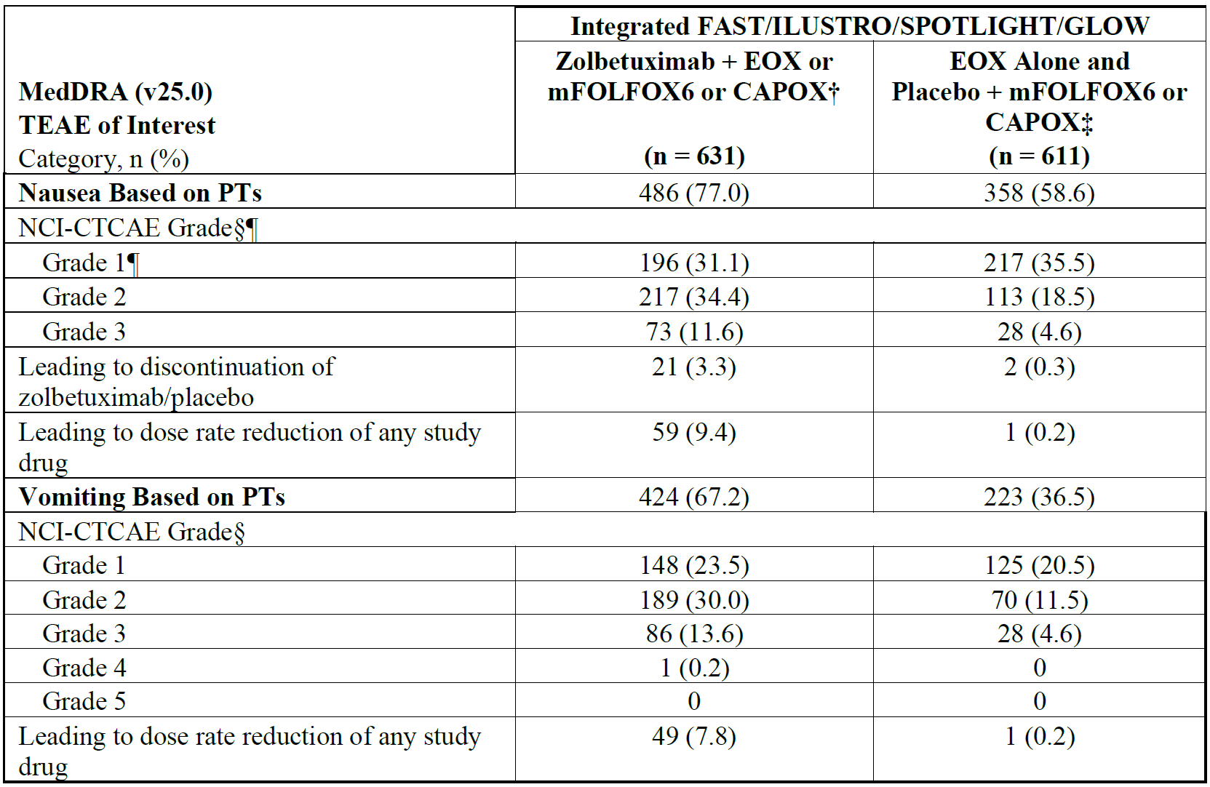
† Participants who received at least 1 dose of zolbetuximab plus EOX (FAST), mFOLFOX6 (ILUSTRO or SPOTLIGHT) or CAPOX (GLOW) (SAF).
‡ Participants who received at least 1 dose of EOX alone (FAST) and participants who received at least 1 dose of placebo plus mFOLFOX6 (SPOTLIGHT) or CAPOX (GLOW) (SAF).
§ Participant counted once under maximum severity. If a participant had an event more than once with missing severity grade and non-missing severity grade, then the participant was counted as the highest non-missing grade.
¶ Grade 3 is the highest NCI-CTCAE (v4.03) grade for nausea.
Table 15: Summary of TEAEs of interest: hypersensitivity reactions based on standardised MedDRA queries (SMQ; Broad) in the integrated FAST, ILUSTRO (cohort 2), SPOTLIGHT and GLOW studies (safety analysis set)
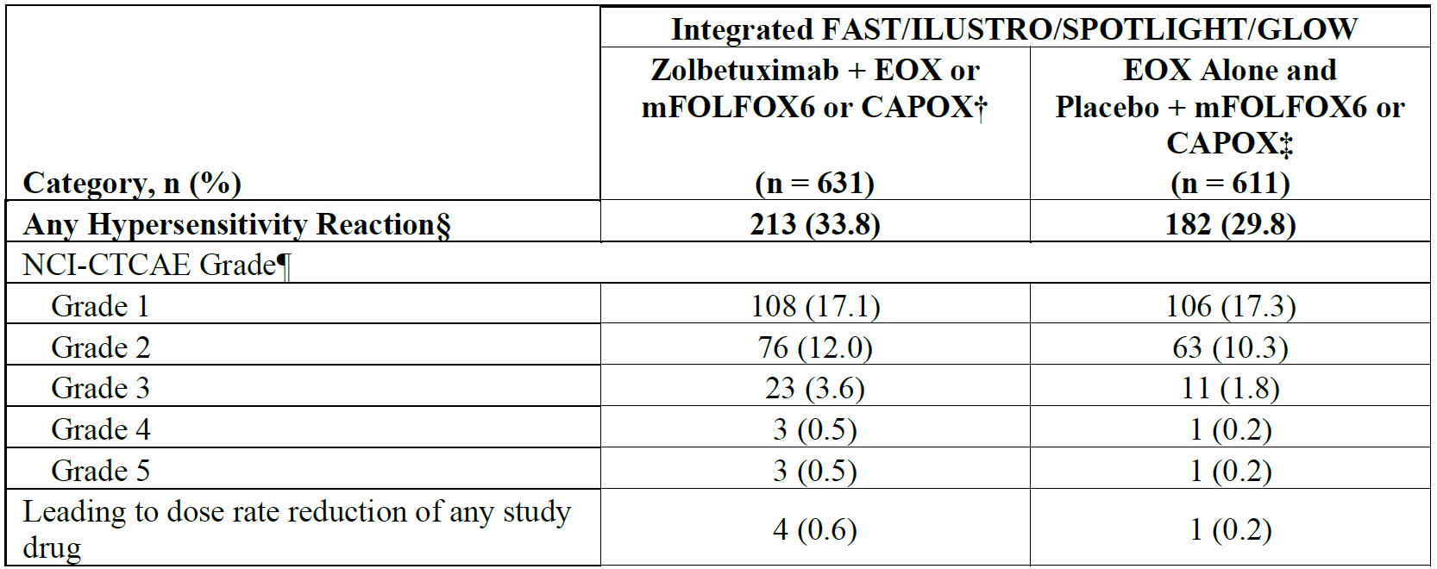
† Participants who received at least 1 dose of zolbetuximab plus EOX (FAST), mFOLFOX6 (ILUSTRO or SPOTLIGHT) or CAPOX (GLOW) (SAF).
‡ Participants who received at least 1 dose of EOX alone (FAST) and participants who received at least 1 dose of placebo plus mFOLFOX6 (SPOTLIGHT) or CAPOX (GLOW) (SAF).
§ Hypersensitivity reactions were identified based on the PTs in hypersensitivity SMQ broad.
¶ Participant counted once under maximum severity. If a participant had an event more than once with missing severity grade and non-missing severity grade, then the participant was counted as the highest non-missing grade.
Table 16: Summary of TEAEs of interest: infusion-related reactions (assessed by investigator) in the integrated FAST, ILUSTRO (cohort 2), SPOTLIGHT and GLOW studies (safety analysis set)
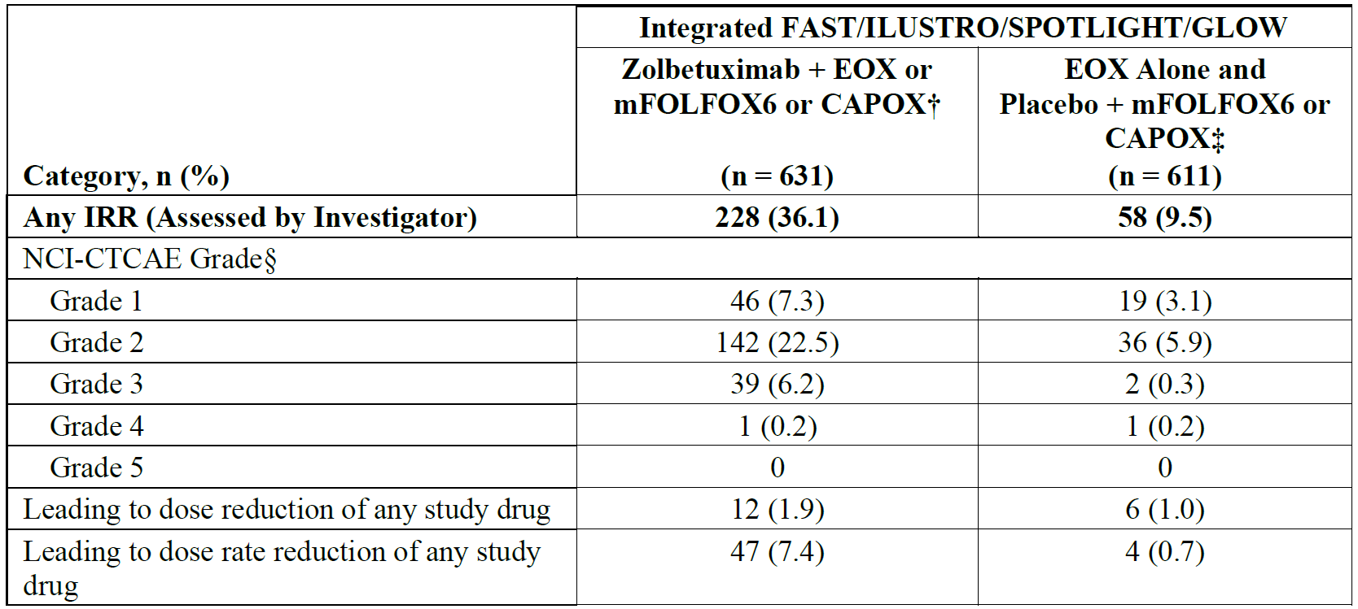
† Participants who received at least 1 dose of zolbetuximab plus EOX (FAST), mFOLFOX6 (ILUSTRO or SPOTLIGHT) or CAPOX (GLOW) (SAF).
‡ Participants who received at least 1 dose of EOX alone (FAST) and participants who received at least 1 dose of placebo plus mFOLFOX6 (SPOTLIGHT) or CAPOX (GLOW) (SAF).
§ Participant counted once under maximum severity. If a participant had an event more than once with missing severity grade and non-missing severity grade, then the participant was counted as the highest non-missing grade.
Regarding the differing overall rate of IRRs in the combined phase2/phase 3 zolbetuximab group (36.1%) compared to controls (9.5%), the IRRs by PT with a ≥ 2% higher incidence in the zolbetuximab group than in the control group were nausea (24.0% vs 2.8%), vomiting (21.4% vs 1.5%), abdominal pain (3.8% vs 0.8%), chills (2.4% vs 0.4%) and hypertension (2.4% vs 0.2%).

Anti-Drug antibodies (ADA)
There were 8/253 (3.2%) and 13/226 (5.8%) of participants with confirmed ADA positivity after receiving zolbetuximab in studies SPOTLIGHT and GLOW, respectively.
The clinical evaluator made the following comment: “The available evidence does not suggest that immunogenicity impacted efficacy and safety in ADA-positive participants. However, in view that the proportion of participants who were ADA-positive was low, any meaningful interpretation of the corresponding efficacy and safety results of these participants is limited.”

Safety in subgroups
In an integrated analysis of data from SPOTLIGHT and GLOW, safety was evaluated by age (≤ 65 vs > 65 years), sex (male vs female), race (White vs Asian), number of metastatic sites (0-2 vs ≥3), gastrectomy status (yes vs no), and region (Asia vs non-Asia). No notable imbalances of other safety signals were observed, except for the previously noted higher rate of interruptions and discontinuations for White compared to Asian subjects.

Other (e.g. companion diagnostic considerations, drug delivery device)
An application has been submitted for inclusion of a Companion Diagnostic (CDx) product, VENTANA CLDN18 (43-14A) RxDx Assay, on the ARTG (DA-2023-07258-1; DV-2023-IVA-21708-1). The CDx is intended for laboratory use in the assessment of claudin 18 (CLDN18) protein in formalin-fixed, paraffin-embedded (FFPE) gastric adenocarcinoma including gastroesophageal junction (GOJ) tissue specimens by light microscopy.
The assay is indicated as an aid in identifying patients with gastric or GOJ adenocarcinoma who may be eligible for treatment with Vyloy (zolbetuximab) in accordance with the product labelling.

Risk management plan evaluation summary
The Sponsor has submitted EU-RMP version 0.1 (date 5 June 2023; DLP 7 October 2022) and Australia-specific version (ASA) version 1.0 (date October 2023) in support of this application.
Safety concerns and their associated risk monitoring and mitigation strategies are summarised in Table 17.
Table 17. Summary of safety concerns
Summary of safety concerns |  | Pharmacovigilance |  | Risk minimisation
 |  | Routine | Additional | Routine | Additional
Important identified risks | Hypersensitivity reactions |  | - |  | -
Important identified risks | Infusion-related reactions |  | - |  | -
Important potential risks | None | - | - | - | -
Missing information | None | - | - | - | -

The RMP evaluator has commented that the summary of safety concerns and pharmacovigilance plan are both acceptable from an RMP perspective.
The nonclinical evaluator commented that key safety concerns arising from nonclinical data are adequately identified in the safety specification of the risk management plan.

Risk-benefit analysis
Locally advanced unresectable and metastatic gastric and gastro-oesophageal adenocarcinoma are aggressive malignancies with very poor prognosis. Whilst not curable, there continues to be a need for more effective treatment options to improve quality and length of life for patients with this condition.
Recent advances in therapeutics have been biomarker driven, such as trastuzumab for HER-positive cancers, and pembrolizumab or nivolumab for PD-L1 receptor positive or dMMR/MSI-H tumours.
Zolbetuximab, as a first-in-class CLDN18.2 directed antibody, is a novel therapeutic with the potential to improve outcomes when given in addition to chemotherapy to appropriately selected patients with locally advanced unresectable and metastatic gastric or GOJ adenocarcinomas expressing CLDN18.2.

Efficacy
The phase 3, double-blind, randomised trials SPOTLIGHT and GLOW both demonstrated a statistically significant survival advantage (PFS and OS) with the addition of zolbetuximab to mFOLFOX6 or CAPOX, when compared to placebo, for the first line treatment of adults with CLDN 18.2-positive, HER2-negative, locally advanced unresectable or metastatic gastric or GOJ adenocarcinoma.
The populations included in SPOTLIGHT and GLOW, and the choice of backbone chemotherapy regimens, were sufficiently similar to the Australian landscape, and thus the external generalisability of the results is acceptable. This provides robust and convincing evidence for the efficacy of zolbetuximab in the overall study populations.

Safety
A consistent safety profile for zolbetuximab 800/600 mg/m2 Q3W has been established across phase 2 and phase 3 studies, including analysis of pooled data.
Nausea and vomiting are important and clinically significant AEs associated with add-on zolbetuximab therapy. Rates of nausea and vomiting were >20% greater in zolbetuximab arms compared to placebo, and nausea or vomiting were reported for between 66.1% (vomiting in GLOW) and 82.4% (nausea in SPOTLIGHT) of zolbetuximab recipients. Reassuringly, Grade ≥3 nausea or vomiting was uncommon, although each was reported for approximately 10-15% of zolbetuximab recipients, depending on the dataset.
Nausea or vomiting necessitated dose interruptions in approximately 25-30% of patients in zolbetuximab arms, although each resulted in permanent discontinuation in less than 5% of participants.
Whilst the nausea and vomiting experienced with zolbetuximab is generally low grade and uncommonly necessitates treatment discontinuation, efforts to mitigate these AEs remain of high importance. This is illustrated by the apparent loss of zolbetuximab efficacy for White race in the subgroup analyses of SPOTLIGHT and GLOW which, on further evaluation, appears very likely to be due to high rates of interruption or discontinuation due to nausea and/or vomiting (discussed below).
In addition to the standard presentation of adverse events in the PI, the Sponsor has strengthened the PI guidance regarding anti-emetic prophylaxis by recommending that this comprises (at least) two different classes of medication along with measures to optimize the toxicity management and improve the tolerability in clinical practice. This is an appropriate measure which is likely to mitigate some of the risk associated with the high rates of nausea and vomiting associated with zolbetuximab treatment.

Subgroups: White race
Participants in the “White” race group comprised a sizeable proportion of all subjects enrolled in SPOTLIGHT and GLOW (n=454/1,060; 42.8%). For this reason, it initially raised concern when the subgroup analyses for PFS and OS of both studies showed a potential loss of efficacy of add-on zolbetuximab for White subjects compared to chemotherapy plus placebo, even though this outcome was not statistically powered.
However, the supplementary post-hoc analyses conducted by the Sponsor were reassuring. There was a pronounced imbalance in early discontinuation or interruption of zolbetuximab due to the AEs of nausea and vomiting, which occurred at higher rates among White participants, compared to Asian subjects. When zolbetuximab recipients were examined by whether a defined AE dose interruption/withdrawal event occurred, the PFS and OS of White participants were similar to those of Asian participants, and to the overall population with largely overlapping 95% CIs.
The analysis of safety by subgroups did not identify any issues disproportionately affecting White subjects other than the nausea and vomiting related interruptions/withdrawals of zolbetuximab.
With additional measures to minimise the impact of nausea and/or vomiting previously described, the efficacy and safety of zolbetuximab for the proposed indication in White patients are established and acceptable.

Subgroups: GOJ adenocarcinoma
According to the post-hoc analyses, the Sponsor’s interpretation that the reason for apparent reduced efficacy in patients with GOJ tumours is lower exposure, is unlikely. Although the median duration in days was shorter for patients with GOJ adenocarcinoma than the overall population, and the rate of infusion interruptions was higher, these differences were small, and other measures of exposure (e.g. RDI) did not show meaningful differences. The reason for the GOJ results in the subgroup efficacy analyses remains unknown.
Despite this, it is recommended that patients with locally advanced unresectable or metastatic, CLDN18.2-positive, GOJ adenocarcinoma be included in the approvable indication for zolbetuximab. The reasoning is presented below.

Biological implausibility
In studying the genomics of oesophageal carcinomas, it has been proposed that “oesophageal adenocarcinomas strongly resembled the chromosomally unstable variant of gastric adenocarcinoma, suggesting that these cancers could be considered a single disease entity”. This supports the notion that GOJ and gastric adenocarcinomas have significant shared biology. Clinically, these tumours are often approached in the same way, as seen in the NCCN13 and ESMO15 guidelines for unresectable and metastatic disease, further reflecting their shared behaviours.
Therefore, it is unlikely that zolbetuximab would have a meaningfully different effect on GOJ adenocarcinoma compared to gastric tumours.

Sample size
The sample sizes for all patients with GOJ adenocarcinomas, and specifically for distal GOJ tumours, are small and the studies (SPOTLIGHT and GLOW) were not powered to draw any statistical conclusions about these subgroups of subjects. These factors limit the internal validity of the analyses, and mean that it is quite plausible that the findings are a result of chance rather than representing the true efficacy of zolbetuximab in these subgroups.
Whilst a chance finding (if this were the case) may imply that the true result could be better or worse, it is highly improbable that zolbetuximab would confer a survival disadvantage in the GOJ subgroup due to the biological similarity to gastric adenocarcinoma discussed above.

Pragmatics of future data collection
Although the data regarding patients with GOJ adenocarcinoma has deficiencies, primarily due to the small sample sizes, the epidemiology of the disease and the biomarker CLDN18.2 means that it would be challenging for future research to recruit sufficient numbers of patients to produce statistically robust results. Therefore, it would be unrealistic to defer a decision regarding GOJ adenocarcinoma until definitive data are available.

Clinical need
There is an unmet need for new therapeutic options for patients with unresectable and metastatic GOJ adenocarcinoma due to the aggressive nature of the disease and resultant dire prognosis. Including GOJ adenocarcinoma in the indication for zolbetuximab would provide the option for oncologists and patients with CLDN18.2-positive tumours to consider this as a treatment option.

Safety
No different safety signals were detected in the subset of patients with GOJ tumours compared to the overall study population.

Conclusion
The subgroup analyses were not statistically robust and it is biologically plausible that zolbetuximab may provide a survival benefit in some patients with unresectable or metastatic, CLDN18.2-positive GOJ adenocarcinoma, in the setting of high unmet need and a low chance of more statistically robust data becoming available in the near future.

Subgroups: Older age
Due to the small sample sizes of subjects >65 years old, and >75 years old, the following statement from the Sponsor is valid: “Given the inconsistency of HR values between the 2 pivotal studies for both PFS and OS in this age group, it is likely that this is due to chance because of the small sample size, and not a true efficacy effect.”

Indication
The following amendments to the indication are required to clarify that the indicated population constitues adults, to account for Australian spelling, and to provide a clear cross-reference to important information in the PI about assessing CLDN18.2 status.
Vyloy, in combination with fluoropyrimidine- and platinum-containing chemotherapy, is indicated for the first-line treatment of adult patients with locally advanced unresectable or metastatic human epidermal growth factor receptor 2 (HER2)-negative gastric or gastroesophageal gastro-oesophageal junction (GEJGOJ) adenocarcinoma whose tumours are Claudin (CLDN) 18.2 positive (see section 4.2)

Dosage
The phase 2, proof-of-concept clinical study FAST, and the pivotal phase 3 clinical studies SPOTLIGHT and GLOW, evaluated zolbetuximab when given as a single 800 mg/m² loading dose, followed by 600 mg/m2 Q3W.
In addition to the regimen studied in the pivotal clinical trials, the Sponsor has applied for the approval of an alternative dosing regimen of a single 800 mg/m² loading dose, followed by 400 mg/m² Q2W. The rationale for the alternative dosing is so that the zolbetuximab can be administered during routine visits for backbone chemotherapy when this is scheduled for Q2W (i.e. mFOLFOX6), as opposed to Q3W (i.e. CAPOX). This is likely to improve patient convenience and be a more efficient use of healthcare resources.
The 800/400 mg/m² Q2W regimen has not been evaluated clinically, but instead is proposed based on modelling and simulations. The clinical pharmacology evaluator had no concerns with the validity of the modelling used. The proposal of a lower dose more frequently avoids the potential safety concerns of higher C_{max} or efficacy concerns of lower C_{trough} which may accompany a regimen with a higher dose less frequently. The results of the modelling are reassuring with similar C_{ave} and the majority of exposure metrics falling within the range of bioequivalence. Additionally, the E-R and tumour dynamics simulations did not suggest any detrimental impacts of the 800/400 mg/m² Q2W regimen compared to 800/600 mg/m² Q3W.

Assessment outcome
Based on a review of quality, safety, and efficacy, the TGA decided to register Vyloy (zolbetuximab) for the following indication:
Vyloy, in combination with fluoropyrimidine- and platinum-containing chemotherapy, is indicated for the first-line treatment of adult patients with locally advanced unresectable or metastatic human epidermal growth factor receptor 2 (HER2)-negative gastric or gastro-oesophageal junction (GOJ) adenocarcinoma whose tumours are Claudin (CLDN) 18.2 positive

Specific conditions of registration
Vyloy (zolbetuximab)is to be included in the Black Triangle Scheme. The PI and CMI for Vyloy must include the black triangle symbol and mandatory accompanying text for five years, which starts from the date of first supply of the product.
The Vyloy EU-Risk Management Plan (RMP) (version 0.1, date 5 June 2023; DLP 7 October 2022), with Australia-Specific Annex (version 1.0, dated October 2023), included with submission PM-2023-05350-1-4, and any subsequent revisions, as agreed with the TGA will be implemented in Australia.
An obligatory component of risk management plans is routine pharmacovigilance. Routine pharmacovigilance includes the submission of periodic safety update reports (PSURs).
Unless agreed separately between the supplier who is the recipient of the approval and the TGA, the first report must be submitted to TGA no later than 15 calendar months after the date of this approval letter. The subsequent reports must be submitted no less frequently than annually from the date of the first submitted report until the period covered by such reports is not less than three years from the date of this approval letter. The annual submission may be made up of two PSURs each covering six months. If the Sponsor wishes, the six monthly reports may be submitted separately as they become available.
If the product is approved in the EU during the three years period, reports can be provided in line with the published list of EU reference dates no less frequently than annually from the date of the first submitted report until the period covered by such reports is not less than three years from the date of this approval letter.
The reports are to at least meet the requirements for PSURs as described in the European Medicines Agency’s Guideline on good pharmacovigilance practices (GVP) Module VII-periodic safety update report (Rev 1), Part VII.B Structures and processes. Note that submission of a PSUR does not constitute an application to vary the registration. Each report must be submitted within ninety calendar days of the data lock point for that report.
Laboratory testing & compliance with Certified Product Details (CPD)
- All batches of Vyloy supplied in Australia must comply with the product details and specifications approved during evaluation and detailed in the Certified Product Details (CPD).
- When requested by the TGA, the Sponsor should be prepared to provide product samples, specified reference materials and documentary evidence to enable the TGA to conduct laboratory testing on the Product. Outcomes of laboratory testing are published biannually in the TGA Database of Laboratory Testing Results http://www.tga.gov.au/ws-labs-index and periodically in testing reports on the TGA website.
The CPD, as described in Guidance 7: Certified Product Details of the Australian Regulatory Guidelines for Prescription Medicines (ARGPM), for the above products should be provided upon registration of these therapeutic goods. In addition, an updated CPD should be provided when changes to finished product specifications and test methods are approved in a Category 3 application or notified through a self-assessable change.
A template for preparation of CPD for biological prescription medicines can be obtained from the TGA website
[for the form] https://www.tga.gov.au/form/certified-product-details-cpd-biological- prescription-medicines
[for the CPD guidance] https://www.tga.gov.au/guidance-7-certified-product-details

Product Information and Consumer Medicines Information
For the most recent Product Information (PI) and Consumer Medicines Information (CMI), please refer to the TGA PI/CMI search facility.

Therapeutic Goods Administration
PO Box 100 Woden ACT 2606 Australia
Email: info@tga.gov.au Phone: 1800 020 653 Fax: 02 6203 1605
https://www.tga.gov.au

A sponsor is a person or company who does one or more of the following: a) exports therapeutic goods from Australia, b) imports therapeutic goods into Australia, c) manufactures therapeutic goods for supply in Australia or d) elsewhere arranges for another party to import, export or manufacture therapeutic goods
AIHW. (9 Dec 2024). Cancer relative and observed survival over time data visualisation. Accessed Jan 2025. https://www.aihw.gov.au/reports/cancer/cancer-data-in-australia/contents/survival
Gambardella, V., Fleitas, T., Tarazona, N., et al. (2020). Precision Medicine to Treat Advanced Gastroesophageal Adenocarcinoma: A Work in Progress. Journal of Clinical Medicine, 9(9), 3049. https://doi.org/10.3390/jcm9093049
Australian PI for Herzuma (trastuzumab). Version dated 17/08/2021. https://www.ebs.tga.gov.au/ebs/picmi/picmirepository.nsf/pdf?OpenAgent&id=CP-2021-PI-01298-1
Australian PI for Opdivo (nivolumab). Version dated 31 Oct 2024. https://www.ebs.tga.gov.au/ebs/picmi/picmirepository.nsf/pdf?OpenAgent&id=CP-2016-PI-01052-1
Australian PI for Keytruda (pembrolizumab). Version dated 09 December 2024. https://www.ebs.tga.gov.au/ebs/picmi/picmirepository.nsf/pdf?OpenAgent&id=CP-2023-PI-01512-1
Obermannová R, Alsina M, Cervantes A, Leong T, Lordick F, Nilsson M, van Grieken NCT, Vogel A, Smyth EC; ESMO Guidelines Committee. Electronic address: clinicalguidelines@esmo.org. Oesophageal cancer: ESMO Clinical Practice Guideline for diagnosis, treatment and follow-up. Ann Oncol. 2022 Oct;33(10):992-1004. doi: 10.1016/j.annonc.2022.07.003. Epub 2022 Jul 29. PMID: 35914638.
NCCN. (20 Dec 2024). NCCN Guidelines Version 5.2024: Gastric Cancer. Accessed Jan 2025. https://www.nccn.org/professionals/physician_gls/pdf/gastric.pdf
NCCN. (20 Dec 2024). NCCN Guidelines Version 5.2024: Esophageal and Esophagogastric Junction Cancers. Accessed Jan 2025. https://www.nccn.org/professionals/physician_gls/pdf/esophageal.pdf
Niimi T., Nagashima K., Ward J.M., et al. (2001) Claudin-18, a novel downstream target gene for the T/EBP/NKX2.1 homeodomain transcription factor, encodes lung- and stomach-specific isoforms through alternative splicing. Mol. Cell. Biol. 21: 7380–7390
Tureci O., Koslowski M., Helftenbein G., et al. (2011) Claudin-18 gene structure, regulation, and expression is evolutionary conserved in mammals. Gene 481: 83–92
Sahin U., Koslowski M., Dhaene K., et al. (2008) Claudine-18 splice variant 2 is a pan-cancer target suior therapeutic antibody development. Clin. Cancer. Res. 14: 7624-34
Kyuno D., Takasawa A., Takasawa K., et al. (2022) Claudin-18.2 as a therapeutic target in cancers: cumulative findings from basic research and clinical trials. Tissue Barriers 10: e1967080
Tureci O, 2011.
Kyuno D, 2022.
Kubota Y, Shitara K. Zolbetuximab for Claudin18.2-positive gastric or gastroesophageal junction cancer. Ther Adv Med Oncol. 2024 Jan 3;16:17588359231217967. doi: 10.1177/17588359231217967. PMID: 38188462; PMCID: PMC10768589.

