Australian Public Assessment Report for Leqembi
Active ingredient: Lecanemab
Sponsor: EISAI Australia Pty Ltd
September 2025

About the Therapeutic Goods Administration (TGA)
- The Therapeutic Goods Administration (TGA) is part of the Australian Government Department of Health and Aged Care and is responsible for regulating therapeutic goods, including medicines, medical devices, and biologicals.
- The TGA administers the Therapeutic Goods Act 1989 (the Act), applying a risk management approach designed to ensure therapeutic goods supplied in Australia meet acceptable standards of quality, safety, and efficacy.
- The work of the TGA is based on applying scientific and clinical expertise to decision-making, to ensure that the benefits to the Australian public outweigh any risks associated with the use of therapeutic goods.
- The TGA relies on the public, healthcare professionals and industry to report problems with therapeutic goods. The TGA investigates reports received to determine any necessary regulatory action.
- To report a problem with a therapeutic good, please see the information on the TGA website.

About AusPARs
- The Australian Public Assessment Report (AusPAR) provides information about the evaluation of a prescription medicine and the considerations that led the TGA to approve or not approve a prescription medicine submission. Further information can be found in Australian Public Assessment Report (AusPAR) guidance.
- AusPARs are prepared and published by the TGA.
- AusPARs are static documents that provide information that relates to a submission at a particular point in time. The publication of an AusPAR is an important part of the transparency of the TGA’s decision-making process.
- A new AusPAR may be provided to reflect changes to indications or major variations to a prescription medicine subject to evaluation by the TGA.

Copyright
© Commonwealth of Australia 2025
This work is copyright. You may reproduce the whole or part of this work in unaltered form for your own personal use or, if you are part of an organisation, for internal use within your organisation, but only if you or your organisation do not use the reproduction for any commercial purpose and retain this copyright notice and all disclaimer notices as part of that reproduction. Apart from rights to use as permitted by the Copyright Act 1968 or allowed by this copyright notice, all other rights are reserved and you are not allowed to reproduce the whole or any part of this work in any way (electronic or otherwise) without first being given specific written permission from the Commonwealth to do so. Requests and inquiries concerning reproduction and rights are to be sent to the TGA Copyright Officer, Therapeutic Goods Administration, PO Box 100, Woden ACT 2606 or emailed to <tga.copyright@tga.gov.au>.

Contents
List of abbreviations 4
Leqembi (lecanemab) submission 7
Leqembi (lecanemab) – proposed indication 8
Alzheimer’s disease 8
Current treatment options for Alzheimer’s disease 9
Clinical rationale for the use of Leqembi in Alzheimer’s Disease 9
Regulatory status 12
Registration timeline 13
Evaluation overview 14
Regulatory guidance 14
Quality evaluation summary 14
Nonclinical evaluation summary 15
Clinical evaluation summary 16
Pharmacology 16
Efficacy 26
Safety 44
Risk Management Plan (RMP) evaluation 50
Discussion 51
Efficacy 51
Safety 52
Conclusion 54
Recommendation following the clinical evaluation 55
Risk-benefit analysis 55
Advisory Committee considerations – June 2024 55
Advisory Committee considerations – June 2024 – Sponsor response 58
Advisory Committee considerations – August 2024 58
Delegate’s Assessment post-ACM 59
Delegate’s Assessment post-ACM Conclusion 61
Outcome 61
Section 60 review 61
Administrative Review Tribunal 62
Final outcome 62

List of abbreviations
Abbreviation | Meaning
ACM | Advisory Committee on Medicines
ADA | Anti-drug antibodies
ADAS-Cog | Alzheimer’s Disease Assessment Scale - Cognitive subscale
AD | Alzheimer’s disease
ADCOMS | Alzheimer’s Disease Composite Score
ADCS MCI-ADL | Alzheimer's Disease Cooperative Study-Activities of Daily Living Scale for MCI
ADRs | Adverse drug reactions
AE | Adverse events
Aβ | amyloid β
ARGPM | Australian Regulatory Guidelines for Prescription Medicines
ARIA | Amyloid-related imaging abnormalities
ARIA-E | Amyloid-related imaging abnormalities-edema/effusion
ARIA-H | Amyloid-related imaging abnormalities-hemorrhage
ARTG | Australian Register of Therapeutic Goods
ASA | Australia-specific annex
AUC | Area under the concentration-time curve
AUC_{0-tau} | Area under the concentration-time curve during a dosing interval
AUC_{0-tlast} | Area under the curve from time 0 to the last quantifiable sample
AUC_{inf} | Area under the curve from time 0 extrapolated to infinite time
C_{avg} | Average concentration
CDR | Clinical Dementia Rating scale
CDR–SB | Clinical Dementia Rating–Sum of Boxes
CI | Confidence intervals
Cl/F | Oral clearance
C_{max} | The maximum concentration that a drug attains in a specified compartment
CMI | Consumer Medicines Information
CSDv | Clinically significant difference
CSF | Cerebrospinal fluid
DLP | Data lock point
EAD | Early Alzheimer’s Disease
EMA | European Medicines Agency
FAS | Full analysis set
FDA | Food and Drug Administration (United States of America)
HR | Hazard ratio
iADRS | Integrated Alzheimer's Disease Rating Scale
ITT | Intention to treat
IV | Intravenous
LLOD | Lower limit of detection
LSM | Least Squares Means
mAb | Monoclonal antibody
MedDRA | Medical Dictionary for Medical Activities
MCI | Mild Cognitive Impairment
MCID | Minimum clinically important difference
MMRM | Mixed model for repeated measures
MMSE | Mini-Mental State Examination
MRI | Magnetic resonance imaging
OLE | Open-label extension
OR | Odds ratio
ORR | Objective response rate
PBO | Placebo
PBPK | Physiologically-based pharmacokinetic modelling
PD | Pharmacodynamics
PET | Positron emission tomography
PI | Product Information
PK | Pharmacokinetics
popPK | Population pharmacokinetics
PPS | Per protocol set
PSUR | Periodic safety update report
RMP | Risk management plan
SAEs | Serious adverse event(s)
SC | Subcutaneous
SD | Standard deviation
SEM | Standard error of the mean
t_{1/2} | Half life
TEAE | Treatment emergent adverse event(s)
TGA | Therapeutic Goods Administration
V_{d} | Volume of distribution
V_{ss}/F | Apparent volume of distribution at steady-state
V_{c}/F | Apparent central volume of distribution

Leqembi (lecanemab) submission
Type of submission: | New biological entity
Product name: | Leqembi
Active ingredient: | lecanemab
Approved therapeutic use for the current submission: | Leqembi is indicated in adult patients with a diagnosis of mild cognitive impairment and mild dementia due to Alzheimer’s disease (Early Alzheimer’s disease) that are apolipoprotein E ε4 (ApoE ε4) non-carriers or heterozygotes.  Beta amyloid evidence consistent with Alzheimer’s disease (AD) should be confirmed using a validated test prior to initiating treatment.
Date of initial TGA decision: | Submission rejected, 1 October 2024
Date of Sponsor lodgement to Administrative Review Tribunal (ART): | 26 March 2025
Date of ART remittal to TGA:  Date of final registration decision outcome: | 11 September 2025  23 September 2025
Date of entry onto ARTG: | 24 September 2025
ARTG numbers: | 409060 and 409061
Black Triangle Scheme: | Yes
Sponsor’s name and address: | Eisai Australia Pty. Ltd., Level 6, 60 City Road, Southbank, VIC, 3006
Dose form: | Injection, concentrated  - 5 mL contains 500 mg of lecanemab (500 mg/5 mL)  - 2 mL contains 200 mg of lecanemab (200 mg/2 mL)
Strength: | 100 mg/mL
Container: | Glass vial with an elastomeric closure.
Route of administration: | Intravenous Infusion
Dosage: | The recommended dose of Leqembi is 10 mg/kg, that must be diluted then administered as an intravenous infusion over approximately one hour, once every 2 weeks  For further information regarding dosage refer to the Product Information.
Pregnancy category: | Category B2  Drugs which have been taken by only a limited number of pregnant women and women of childbearing age, without an increase in the frequency of malformation or other direct or indirect harmful effects on the human fetus having been observed.  Studies in animals are inadequate or may be lacking, but available data show no evidence of an increased occurrence of fetal damage.  The use of any medicine during pregnancy requires careful consideration of both risks and benefits by the treating health professional. The pregnancy database must not be used as the sole basis of decision making in the use of medicines during pregnancy. The TGA does not provide advice on the use of medicines in pregnancy for specific cases. More information is available from obstetric drug information services in your state or territory.

Leqembi (lecanemab) – proposed indication
Lecanemab belongs to a class of anti-amyloid monoclonal antibody agents intended to treat Alzheimer’s disease (AD). Lecanemab is a recombinant humanised IgG1 monoclonal antibody that selectively binds to soluble amyloid β (Aβ) aggregates known as protofibrils, and also has high affinity for insoluble fibrillar Aβ, a major component of amyloid plaques. It is proposed that lecanemab mediates its therapeutic effect by clearing Aβ plaques and neutralising and clearing Aβ aggregates that elicit synaptotoxic effects in AD patients.
In this submission, the Sponsor sought approval for the following indication for lecanemab:
“Leqembi is indicated as a disease modifying treatment in patients with Mild Cognitive Impairment (MCI) due to Alzheimer’s disease and Mild Alzheimer’s dementia (Early Alzheimer’s disease).”

Alzheimer’s disease
Alzheimer’s Disease is the most commonly diagnosed form of dementia, and it accounts for 60% to 80% of dementia cases,. The incidence and prevalence of AD increases substantially with increasing age,,. AD leads to slowly progressive cognitive decline, initially with a dominant effect on memory and then other cognitive domains, and eventually it causes personality changes and a decline in motor skills. Ultimately, it is a fatal condition, though many elderly subjects with AD are likely to die of other age-related diseases before the AD reaches its end stage. AD was estimated to account for 1.4 to 1.9 million deaths in 2016. For individuals diagnosed in the early stages of AD, a life expectancy of 20 years or more may be possible, but much of this time is spent with a markedly degraded quality of life. Within 3 years of being diagnosed with early cognitive decline due to AD, a majority of subjects will have dementia.

Current treatment options for Alzheimer’s disease
There are no disease-modifying agents approved for the treatment of AD.
Some treatments have been approved for AD, but these treatments are directed at symptom management. They generally attempt to improve cognition by addressing imbalances in neurotransmitter function. In particular, a few drugs (donepezil, rivastigmine, and galantamine) have been approved that inhibit cholinesterase and thereby increase cerebral acetylcholine, which is often deficient in subjects with AD because of early loss of cholinergic neurons. In another approach, the drug memantine antagonises a subtype of glutamate receptor (N-methyl-D-aspartate antagonist).
None of these treatments addresses the primary problem in AD: the functional compromise and death of cerebral neurons with subsequent loss of brain volume and irreversible disruption of brain circuitry. The clinical benefit of existing treatments is also modest. Minor improvements have been seen on cognitive testing, relative to untreated patients, but the progressive decline in cognition continues while on treatment.
There is, accordingly, a clear and important unmet clinical need for effective disease-modifying treatments in AD.

Clinical rationale for the use of Leqembi in Alzheimer’s Disease
The fundamental idea behind the use of anti-amyloid therapies in AD is that the accumulation of aggregated forms of amyloid beta (Aβ), including amyloid plaques, leads to neuronal damage, and that this is the primary pathogenic mechanism of AD. Removing the accumulated amyloid before it causes neuronal death and dysfunction might reduce the main adverse pathological consequences of AD.
The pathogenesis of AD is understood moderately well. At the microscopic level, AD is characterised by two hallmark proteinopathies: extraneuronal amyloid plaques, which represent accumulations of aggregated forms of Aβ and intraneuronal neurofibrillary tangles, which are composed of hyperphosphorylated tau protein. The relative contributions of these two proteinopathies (amyloid vs tau) were debated during the early years of Alzheimer’s research, but converging lines of evidence suggest that amyloid, even though it is largely extraneuronal, is likely to play the major pathogenic role. In what has been called the “amyloid cascade hypothesis”, it is proposed that the driving force behind the disease process is the accumulation of Aβ, resulting from an imbalance between Aβ production and Aβ clearance in the brain. Accumulation of tau is a later process that may be a non-specific marker of neurodegeneration, though a contributory pathogenic role cannot be entirely excluded.
Much of the evidence in favour of the amyloid cascade hypothesis comes from genetic forms of AD and the identification of genes that confer an increased risk for AD. Researchers estimate that between 40-65% of people diagnosed with Alzheimer’s Disease have the ApoE ε4 gene (APOE4), whereas only 20-30% of individuals in the United States have one or two copies of ApoE ε4. Aβ deposition is increased in ApoE ε4 carriers.
There are some rare genes that lead to AD with high penetrance, but these account for <1% of AD. These mutations give some insights into the likely aetiology of sporadic AD. The first mutations predisposing to AD were described in the amyloid precursor protein (APP) gene, and all familial forms of AD have been shown to involve mutations in either the APP or the presenilin genes (PSEN1 and PSEN2). APP is the precursor of the Aβ peptide, which is produced upon sequential enzymatic cleavage by β and γ secretases, and the PSEN1 and PSEN2 proteases are two catalytic subunits of the γ-secretase complex. The autosomal dominant mutations causing familial forms of AD result in an increased amount of longer Aβ peptides (Aβ42 and Aβ43) that are more hydrophobic and can self-aggregate; some of these mutations also directly increase the self-aggregation properties of the Aβ peptide. One rare protective APP variant (linked to a decreased risk of AD) has been shown to lead to reduced production of Aβ.
In both genetic and sporadic AD, the accumulation of a substantial Aβ amyloid load is very slow. Patients with familial forms of AD have been followed longitudinally, and Aβ deposition begins decades prior to the observable clinical decline,.
In addition to the genetic evidence, there is some experimental evidence that the accumulation of Aβ plays a pathogenic role rather than being an epiphenomenon. In the laboratory, aggregated forms of amyloid, including soluble oligomers and amyloid plaques, can be both synaptotoxic and neurotoxic,,. Amyloid plaques have also been shown to act as a reservoir of -synaptotoxic oligomers,.
The immune system also plays a complex role in AD. Inflammatory reactions involving microglia and astrocytes have been described in the vicinity of amyloid plaques; the immune system plays a role in the pathogenesis of AD, contributing to inflammation that may be damaging, while also helping to clear amyloid.
Similarly, neuropathologists have long suggested that the brain’s innate immune system, including the microglial response to plaque formation, was an important factor in AD pathogenesis. For example, the early observation of multiple elements of the classical complement cascade in and around neuritic plaques was prescient . In the last few years, genetic variability in that system has emerged as a compelling determinant of AD risk, implicating many components of innate immunity and the complement cascade as risk factors in the disease.
Regardless of whether the immune system plays a net positive or negative role in the pathogenesis of untreated AD, it clearly plays an important role with both beneficial and deleterious elements,. Consistent with this, studies of anti-amyloid mAbs have shown that AD produces cerebral inflammation in the form of amyloid-related imaging abnormalities (ARIA), consisting of oedema and haemorrhage seen on magnetic resonance imaging (MRI) scans. These abnormalities are seen in untreated AD and become more prominent with attempts to remove amyloid with immune mechanisms such as mAbs.
Although the amyloid cascade hypothesis is plausible and amyloid represents a worthy therapeutic target, it cannot be assumed that targeting amyloid with immune mechanisms will have a straightforward net positive effect.
Importantly, a submission for aducanumab, an agent from the same therapeutic class as lecanemab with a very similar mechanism of action, was withdrawn in Australia because of a low likelihood of approval in the context of conflicting efficacy results across two pivotal trials. Conversely, donanemab showed favourable results in its pivotal studies and was approved by the FDA this year (2024).
The failure of other mAbs in this class to produce consistently favourable results suggests that the precise balance between amyloid clearance and immune-mediated neuronal injury is important in determining the overall benefit-risk balance for each agent.

Regulatory status

Australian regulatory status
Leqembi (lecanemab) is considered a new biological medicine for Australian regulatory purposes. The application was submitted to TGA on 19 May 2023.

International regulatory status
USA: An application for accelerated assessment was submitted on 6 May 2022 and approved on 6 January 2023. The accelerated approval was based on reduction in Aβ plaques observed in patients treated with Leqembi, with continued approval contingent on verification of clinical benefit in a confirmatory trial. A supplemental new drug application was submitted on 13 January 2023 and approved on 6 July 2023. The approved indication is:
Leqembi is indicated for the treatment of Alzheimer’s disease. Treatment with Leqembi should be initiated in patients with mild cognitive impairment or mild dementia stage of disease, the population in which treatment was initiated in clinical trials.
Japan: Submitted 9 January 2023, approved 25 September 2023:
Slowing of progression in mild cognitive impairment or mild dementia due to Alzheimer’s disease
China: Submitted 21 December 2022, approved 5 January 2024:
Treatment of mild cognitive impairment (MCI) due to Alzheimer’s disease (AD) and mild AD dementia
EU: In July 2024, EMA’s human medicines committee, the CHMP (Committee for Medicinal Products for Human Use), considered that the observed effect of Leqembi on delaying cognitive decline did not counterbalance the risk of serious side effects associated with the medicine. As of 14 November 2024, after re-examining its initial opinion, the Agency recommended that marketing authorisation could be granted for a restricted indication in adults with early Alzheimer’s disease who have only 1 or no copy of a gene called apolipoprotein E4 (ApoE4). During the re-examination, the CHMP re-assessed the data submitted by the company. The company proposed to restrict the use of Leqembi to patients with only 1 or no copy of ApoE4 and provided additional analyses of data from the main study, which excluded data from 274 patients who carried 2 copies of the ApoE4 gene and were therefore at highest risk of Amyloid-related imaging abnormalities (ARIA).
Update as of 28 January 2025:
As part of its decision-making process, the European Commission has asked the CHMP to consider information on the safety of Leqembi that became available after the adoption of the CHMP opinion in November 2024 and whether this may require an update of the opinion. The Commission also asked the CHMP to consider whether the wording of the risk minimisation measures in Annex II of the opinion is clear enough to ensure correct implementation. The CHMP will now consider the Commission’s request and provide a response after its plenary meeting in February 2025.
UK: Submitted 19 May 2023, approved 22 August 2024.
Lecanemab is approved to treat adults in the early stages of Alzheimer’s disease who have one or no copies of the apolipoprotein E4 gene (ApoE4).
Canada: Submitted 30 March 2023, under evaluation.
Switzerland: Submitted 23 May 2023, under evaluation.

Registration timeline
Table 1 captures the key steps and dates for this submission.
This submission was evaluated under the standard prescription medicines registration process.
Table 1. Timeline for Leqembi (lecanemab) submission (PM-2023-02164-1-1)
Description | Date
Submission dossier accepted and first round evaluation commenced | 30 June 2023
Evaluation completed | 8 March 2024
Delegate’s Overall benefit-risk assessment and request for Advisory Committee advice | 6 May 2024
Advisory Committee meeting 1 | 7 June 2024
Advisory Committee meeting 2 | 2 August 2024
Initial registration decision (Outcome) | 1 October 2024 (submission rejected)
Date of Sponsor lodgement to Administrative Review Tribunal (ART) | 26 March 2025
Date of ART remittal to TGA | 11 September 2025
Date of final registration decision outcome | 23 September 2025
Number of working days from submission dossier acceptance to registration decision* | 569 days
*Statutory timeframe for standard submissions is 255 working days

Evaluation overview

Regulatory guidance
The Sponsor engaged extensively with international regulatory authorities in relation to the lecanemab clinical development program. Formal End of Phase 2 meetings were held with the US FDA, the PMDA (Japan), and the EMA to discuss the results from Study 201 Core and proposed Study 301 study design. At these meetings, agreement was obtained (based on PBO decline in Study 201 Core) that the design (Clinical Dementia Rating–Sum of Boxes [CDR–SB] as primary endpoint) and patient population (EAD) to be studied in Study 301 were appropriate to support the potential registration of lecanemab as a treatment for EAD. The development program took into consideration relevant FDA, PDMA, EMA/CHMP, and ICH guidelines. TGA-adopted clinical guidelines of particular relevance to this application include:
- Guideline on the clinical investigation of medicines for the treatment of Alzheimer’s disease, CPMP/EWP/553/95 Rev. 2
- Points to consider on application with 1. Meta-analyses; 2. One pivotal study. CPMP/EWP/2330/99.

Quality evaluation summary
The Quality Evaluator was satisfied that the Sponsor had provided sufficient evidence that all requirements were met with respect to:
- stability and release specifications (therefore adequately defining the physicochemical properties, biological activity/potency, immunochemical properties and purity of lecanemab). The recommended shelf life for the drug substance is 12 months when stored at -40° ± 10°C. The recommended shelf life for the drug product is 24 months when stored at 2˚C to 8˚C (Refrigerate. Do not freeze. Do not shake.) Leqembi drug product that has been diluted and is ready for infusion can be stored at 2 - 8°C for 4 hours and should not be frozen.
- appropriately conducted stability studies that support the proposed shelf life/storage conditions.
- documentation of the history, control and traceability of cell lines, cell banks and synthesis of recombinant DNA.
- validation of analytical procedures utilised to assess drug specifications.
- appropriate choice/synthesis and validation of reference standards and reference materials.
- appropriate in-process controls within the manufacturing process and identification of critical manufacturing steps.
- consistency of medicine manufacture verified by process validation and demonstrated through batch analysis (consecutive data from multiple campaigns and sampling from multiple batches and different manufacturing processes (validation, prevalidation, clinical, commercial batches).
- satisfactory control of impurities.
- adequate characterisation and justification of excipients.
- medicine sterility/appropriate control of infectious disease & adventitious agents.
- appropriate/compatible container closure systems.
- labelling that conformed to Therapeutic Goods Order 91.
Good Manufacturing Practice (GMP) clearance is not current for all manufacturing sites.
The Sponsor was advised throughout the evaluation regarding the need for GMP clearances. The Sponsor advised the Evaluator on 19 April 2024 that they are communicating with the Manufacturing Quality Branch of the TGA; this issue was resolved on 1 October 2024.

Nonclinical evaluation summary
The submitted Module 4 dossier was in accordance with the relevant ICH guideline for the non-clinical assessment of biological medicines (ICH S6[R1]). The overall quality of the non-clinical dossier was adequate. All pivotal safety-related studies were Good Laboratory Practice compliant. The absence of some key safety studies was adequately justified.
In vitro, lecanemab (and the mouse surrogate mAb158) bound to Aβ protofibrils with high (nanomolar) affinity and inhibited Aβ-protofibril binding to dendritic spines in cell culture models. mAb158 efficacy in vivo (decreased Aβ-protofibril levels) was demonstrated in three independent transgenic mouse models of AD with a minimum effective dose over 17 weeks of 0.3 mg/kg/week IP. However, mAb158 did not affect contextual fear memory in behavioural tests.
In vitro, lecanemab bound to FcγRI, FcγRIIIa/b and (to a lesser extent) FcRn, but not to FcγRIIb/c. Blockade of FcR function inhibited lecanemab-induced Aβ-protofibril uptake in mouse and human microglial cells, supporting lecanemab's proposed mechanism of action (FcR-mediated ADCP). Lecanemab is not expected to induce antibody-dependent cellular cytotoxicity (ADCC) or complement-dependent cytotoxicity (CDC) since its target (soluble Aβ) is not cellular; consequently, ADCC/CDC evaluations were not conducted.
In silico, several peptides in the lecanemab variable region were suggestive of immunogenicity risk. However, the frequency of immunogenic reactions in healthy donors (<10%) indicates that the risk of clinical immunogenicity is low, though this should be confirmed by the clinical Evaluator. The only potential off-target protein was thrombospondin-1; however, no effects were seen in the submitted toxicity studies to indicate this occurred in vivo.
Safety pharmacology parameters (incorporated into repeat-dose toxicity studies in cynomolgus monkeys) revealed no adverse off-target effects of lecanemab on the cardiovascular system, CNS, or respiratory system. Potential on-target effects, in particular effects on CNS function, will need to be addressed by clinical data.
The pharmacokinetic profile of lecanemab in animals and human subjects was generally consistent with the protein nature of the drug: low clearance rates, long half-lives, and limited extravascular distribution. Tissue distribution studies with a mouse surrogate antibody indicated target-dependent clearance from the brain and low exposures in the CSF. Overall, the pharmacokinetic profile of lecanemab was considered acceptably similar in cynomolgus monkeys and human subjects.
Lecanemab is considered to have a low order of acute IV toxicity in rats and cynomolgus monkeys.
Repeat-dose toxicity studies by the IV route were conducted in cynomolgus monkeys (up to 9 months duration). The studies were adequately conducted and achieved acceptable relative exposures (AUC). Since young cynomolgus monkeys lack aggregated Aβ, these studies addressed off-target toxicity. Lecanemab was well tolerated; the only significant finding (increased spleen weights with germinal centre activity) likely represent a low-level immune response to a foreign protein and was not considered adverse. On-target toxicity evaluations in Tg2576 and APP_{ArcSwe} mice revealed no treatment-related microhaemorrhage or histopathological changes in brain at exposures (AUC) up to 2 times the clinical exposure.
No genotoxicity or carcinogenicity studies were submitted. This is acceptable. A weight of evidence assessment based on submitted non-clinical data and literature review indicated a minimal or no potential for cancer risk in humans.
No dedicated reproductive and developmental toxicity studies were submitted. This is acceptable based on the age of the intended patient population.
The pharmacology studies lend support for the mechanism of action (clearance of aggregated Aβ in the brain) at the proposed clinical dose. Support for the proposed indication is less clear as no improvements in cognitive function were demonstrated. The combined animal safety studies raise no issues of potential clinical relevance. The draft Product Information is acceptable from a non-clinical perspective.
There is no non-clinical objection to the registration of Leqembi for the proposed indication.

Clinical evaluation summary

Summary of clinical studies
The clinical dossier included:
- three Phase 1 clinical PK studies
- one Phase 2 efficacy study (Study 201)
- one pivotal Phase 3 efficacy study (Study 301)
- an efficacy analysis of the open-label extension (OLE) for the Phase 2 study. The OLE for the pivotal Phase 3 study is ongoing and no data were available.
- an assessment of amyloid biomarkers (including imaging-related biomarkers) in the two efficacy studies and two of the PK studies
- population-PK analyses of the two PK studies and clinical efficacy studies
- PK/PD analysis of clinical endpoints, imaging and fluid biomarkers and safety (ARIA-E , ARIA-H) of two clinical efficacy studies
- clinical summary documents, including integrated summaries of efficacy, safety, and immunogenicity.

Pharmacology
The lecanemab clinical pharmacology program was designed to:
- describe lecanemab pharmacokinetics (PK)
- assess the relationship between lecanemab exposure and efficacy outcomes (Clinical Dementia Rating – Sum of Boxes [CDR-SB] and Alzheimer’s Disease Assessment Scale - Cognitive subscale 14 [ADAS-Cog14])
- assess the relationship between lecanemab exposure and safety outcomes (amyloid-related imaging abnormalities-edema/effusion [ARIA-E] and isolated amyloid-related imaging abnormalities-hemorrhage [isolated ARIA-H])
- assess the relationship between lecanemab exposure and pharmacodynamic/biomarker outcomes (amyloid PET, plasma Aβ42/40 ratio, plasma p-tau181, tau PET)
- evaluate the effects of intrinsic factors (e.g., age, race, sex) on lecanemab PK and exposure-response relationships
- evaluate the effects of extrinsic factors (manufacturing process/formulation) on lecanemab PK.

Pharmacokinetics (PK)
The dossier included three Phase 1 clinical PK studies:
- Study BAN2401-A001-101 (Study 101) was conducted in subjects with mild to moderate AD. The study consisted of two parts: a single ascending dose part which evaluated doses of 0.1, 0.3, 1, 3, 10, and 15 mg/kg versus placebo, and a multiple ascending dose part which evaluated doses of 0.3, 1, and 3 mg/kg monthly for four doses and 10 mg/kg bi-weekly (two-weekly) for seven doses. Study drug was administered IV over 60 to 75 minutes (Figure 1, Table 2 and Table 3).
- BAN2401-J081-104 (Study 104) was conducted in Japanese subjects with MCI due to AD, and mild AD. Study 104 evaluated doses of 2.5, 5, or 10 mg/kg or placebo, administered IV over 60±10 minutes. Following a 6-week washout period after the 1st dose, subjects received lecanemab or placebo two-weekly for a total of 5 infusions (Figure 2, Table 4 Table 5).
- Study BAN2401-A001-004 (Study 004) evaluated the absolute bioavailability of a single subcutaneous (SC) dose of lecanemab in healthy subjects and also assessed the PK of SC lecanemab in Japanese subjects compared to non-Japanese subjects. SC administration is not proposed in this application.
Lecanemab C_{max} and AUC increased dose proportionally in the dose range 0.3 to 15 mg/kg following a single IV dose. Following repeat dosing at 2-weekly intervals, steady state is achieved after 3-4 doses and systemic accumulation is approximately 1.4-fold. Volume of distribution at steady state was estimated to be 0.0619 L/kg (Study 104), consistent with predominantly intravascular distribution. The concentration-time profiles were characterised by a rapid distribution phase followed by a long terminal elimination phase. Mean terminal elimination half-life was ∼5-7 days. As a monoclonal antibody, lecanemab is expected to be degraded by protein catabolism, similar to endogenous antibodies. Hepatic impairment and renal impairment are not expected to impact the PK of lecanemab, and drug-drug interactions are not expected.
Figure 1. Mean Serum Concentration-Time Profile of Lecanemab - Study 101 (PK Analysis Set)
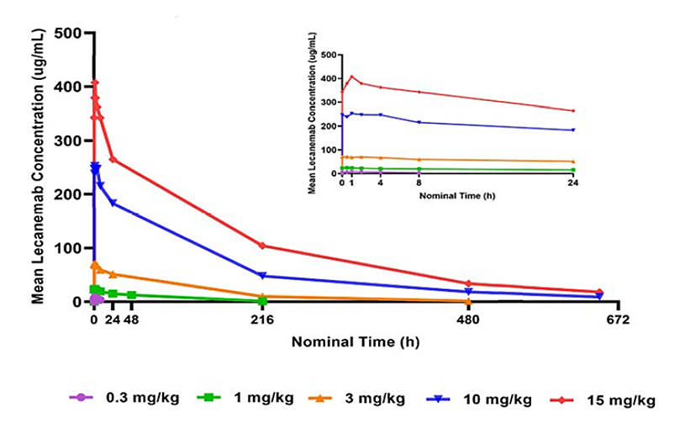
Table 2. PK Parameters of Lecanemab after Single IV Administration in Study 101 (PK Analysis Set)
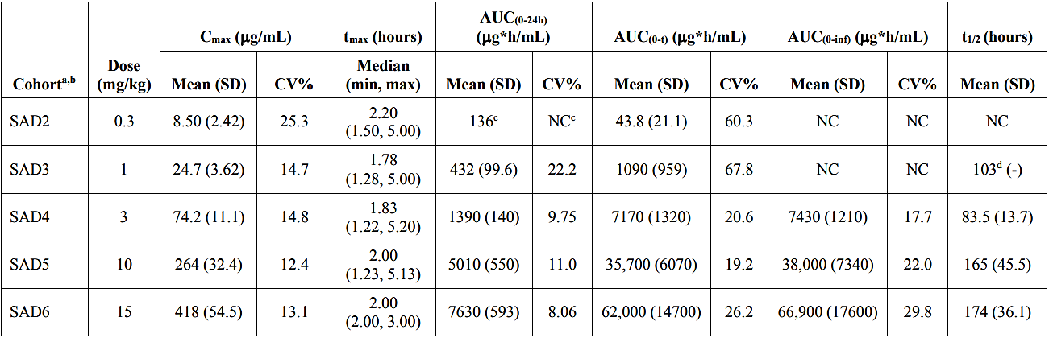AUC(0-24h) = area under the concentration-time curve from zero time to fixed time-point 24 h, AUC(0-t) = area under the concentration-time curve from zero time to time of last quantifiable concentration, AUC(0-inf) = area under the concentration-time curve from zero time extrapolated to infinite time, CV% = coefficient of variance, IV = intravenous, min = minimum, max = maximum, NC = not calculated due to insufficient data, PK = pharmacokinetic, SAD = single ascending dose, t½ = terminal elimination phase half- life, tmax = time at which the highest drug concentration occurs. a: No parameters were calculated for the SAD1 (0.1 mg/kg) cohort due to insufficient data. b: 6 subjects per cohort. c: n= 2 hence SD and CV not calculated. d: n = 1.
Table 3. Lecanemab PK Parameters after the 1st and Last IV Administration in Study 101 (PK Analysis Set).
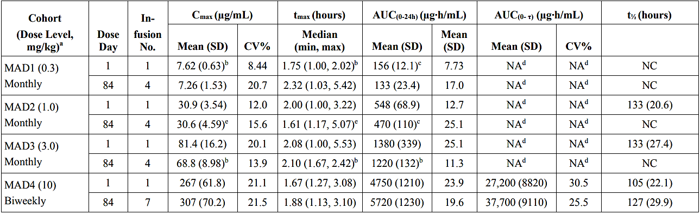
AUC(0-24h) = area under the concentration-time curve from zero (predose) to fixed time-point 24 h, AUC(0-τ) = area under the concentration-time curve form zero time to time of last quantifiable time concentration, CV% = coefficient of variance, MAD = multiple ascending dose, min = minimum, max = maximum, NA = not applicable, NC = mean of the PK parameter not calculated due to insufficient data, PK = pharmacokinetic, t½ = terminal elimination phase t½, tmax = time at which the highest drug concentration occurs. a: In the MAD4 cohort, 6 subjects were treated with lecanemab, and PK parameters were available for all 6 subjects. b: n = 5. c: n = 3. d: Not applicable in MAD1, MAD2, and MAD3 cohorts as there was minimal or no accumulation in these cohorts with successive doses such that steady state was not reached. e: n =4.
Figure 2. Mean Serum Concentration-Time Profile of Lecanemab after Single IV Administration on Linear Scale - Study 104 (PK Analysis Set).
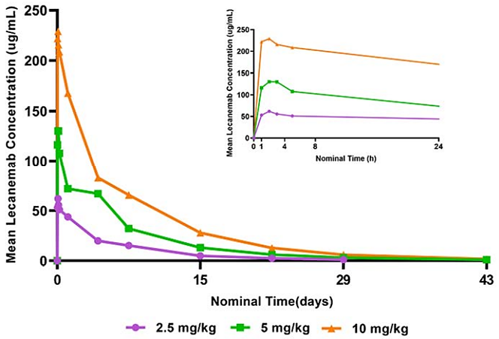
Table 4. Summary of PK Parameters of Lecanemab After Single IV Administration in Study 104 (PK Analysis Set).
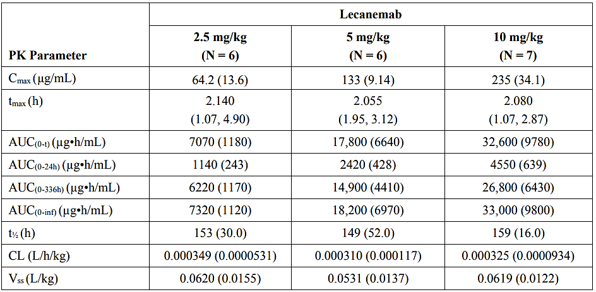
PK Analysis Set: (N=19). Data are shown as mean (SD) except tmax, for t_{max, median (min, max)} is shown. AUC_{(0-24h)} = area under the concentration-time curve from zero (predose) to fixed time-point 24 h, AUC_{(0-336h)} = area under the concentration-time curve from zero (predose) to fixed time-point 336 h, AUC_{(0-inf)} = area under the concentration-time curve from zero time extrapolated to infinite time, AUC_{(0-t)} = area under the concentration-time curve from zero time to time of last quantifiable concentration, CL = clearance, max = maximum, min = minimum, PK = pharmacokinetic, t_{½} = terminal elimination t_{½}, t_{max} = time at which the highest drug concentration occurs, V_{ss} = volume of distribution at steady state.
Table 5. Lecanemab PK Parameters after Multiple Dose Administration Once Every 2 Weeks for a Total of 5 Infusions - Study 104 (PK Analysis Set).
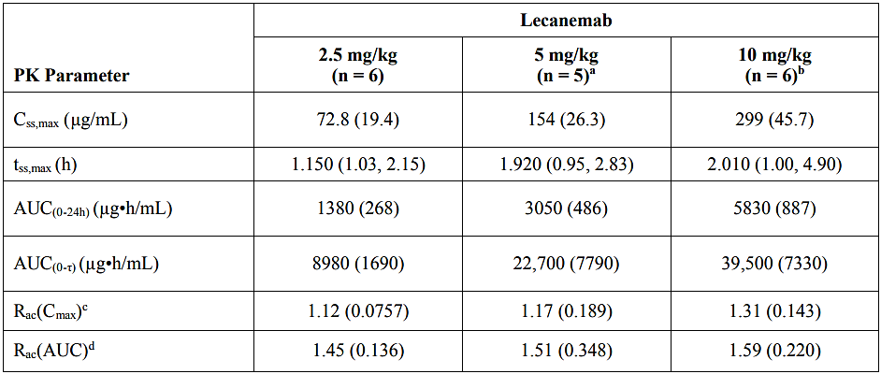
Data are shown as mean (SD) except t_{ss,max}, for t_{ss,max}, median (min, max) is shown. AUC_{(0-24h)} = AUC from zero (predose) to fixed time-point 24 h, AUC_{(0-336h)} = AUC from zero (predose) to fixed time-point 336 h, AUC_{(0-τ)} = AUC over the dosing interval on multiple dosing, Css,max = maximum concentration at steady state, max = maximum, min = minimum, PK = pharmacokinetic, Rac(AUC) = accumulation ratio based on AUC, defined as AUC_{(0-τ)}/AUC_{(0-336h)} after the 1st dose, Rac(C_{max}) = accumulation ratio based on C_{max}, t_{ss,max} = time at which the highest drug concentration occurs at steady state. a: One of 6 subjects in 5 mg/kg group was excluded from noncompartmental analysis because the 6th dose was not administered. b: One of 7 subjects in 10 mg/kg group was excluded from noncompartmental analysis because the 6th dose was not administered. c: Rac(C_{max}) = C_{ss,max} (after the 6th dose)/C_{max} (after the 1st dose). d: Rac(AUC) = AUC_{(0-τ) (after the 6th dose)}/AUC_{(0-336h) (after the 1st dose)}.

Population PK data
The Sponsor developed a pop-PK model for lecanemab using pooled data from two Phase 1 Studies (Studies 101 and 104) and the two efficacy studies (Studies 201 [Core and OLE Phase] and 301 [Core and OLE Phase]). The dataset included subjects receiving single or multiple lecanemab doses and involved 21,929 serum lecanemab observations from 1619 subjects. Of the 21,929 PK samples, 3.0% were from Study 101, 1.8% from Study 104, 36.4% from Study 201 (Core and OLE Phase), and 58.8% from Study 301 (Core and OLE Phase). 39.2% of the PK samples were from subjects dosed with lecanemab from manufacturing process A-1 (Studies 101, 104, and 201 Core) and 60.8% were from subjects dosed with lecanemab from manufacturing process B-1 (Studies 201 OLE Phase and 301 Core and OLE Phase).
The PK of lecanemab was found to be well described by a 2-compartment model with zero-order input and 1st-order elimination from the central compartment. The population estimate of clearance was 0.0154 L/h, with an inter-individual variability of 34.9%. The estimate of central volume of distribution was 3.24 L, with an inter-subject variability of 12.2%.
The final popPK model identified statistically significant covariate effects on clearance (ADA status as time-variant, body weight, albumin, and gender), central volume of distribution (body weight, sex, and Japanese race), and peripheral volume of distribution (Japanese race). The effect of these covariates on lecanemab AUC and C_{max} at steady state (10 mg/kg IV two-weekly) are shown in Figure 3 relative to a reference subject defined as a 72 kg male, non-Japanese subject with albumin of 43 g/L who was administered Process A-1 drug product and who was consistently ADA negative. Females had an average of 26% higher AUC than males, consistent with the lower clearance for females found in the model. ADA positivity decreased the AUC of lecanemab by 11%. A subject with a low (5th percentile) bodyweight (49 kg) had 22% lower AUC, whereas a subject with high (95th percentile) bodyweight (99 kg) had 23% higher AUC relative to a 72 kg subject. The estimated bioavailability for drug produced by Process B-1 relative to Process A-1 was 90%, with the 90% CI within the standard bioequivalence range of 80% to 125%. The Evaluator concluded that these covariates are unlikely to have a clinically meaningful effect but noted the lower exposure in low bodyweight subjects with the proposed weight-based regimen of 10 mg/kg two-weekly.
Figure 3. Effect of Covariates on Lecanemab AUC and C_{max} at Steady State for LEC10-BW.
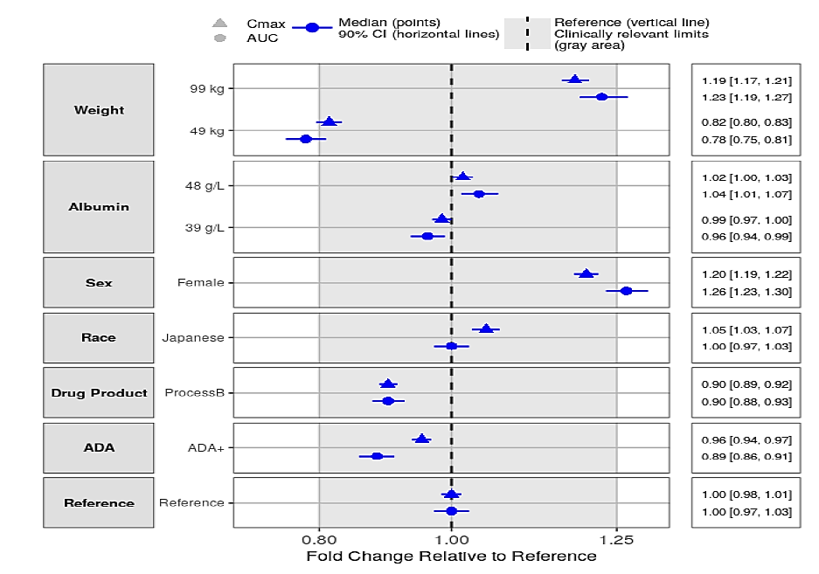

Pharmacodynamics (PD)
PD variables were assessed in the Phase 1 studies in subjects with EAD (Studies 101 and 104) but the exposure to lecanemab was too limited to provide evidence of significant modification of PD biomarkers. Many PD variables were assessed in Studies 201 and 301, including cerebral amyloid as measured by positron emission tomography (PET), plasma biomarkers, CSF biomarkers, and volumetric MRI scans. Reduction in brain amyloid as measured by amyloid PET using Centiloids at 18 months was a key secondary endpoint in the pivotal study and is discussed further in the efficacy section. Findings for PD variables evaluated in the efficacy studies are summarised in Table 6. Biomarker endpoints were generally not part of the formal statistical testing plan and should be viewed as nominally significant. The correlation between improvements in the PD biomarkers and improvement in clinical outcomes is not yet well established, so clinical benefit should not be inferred from the PD findings.
Table 6. PD Biomarkers – Study 301 Core (PD Analysis Set) and Study 201 Core (PD Analysis Set).
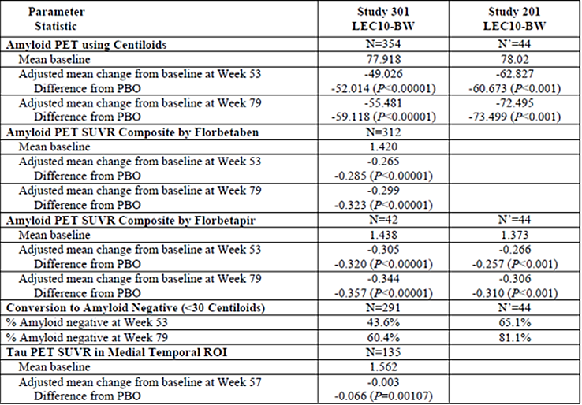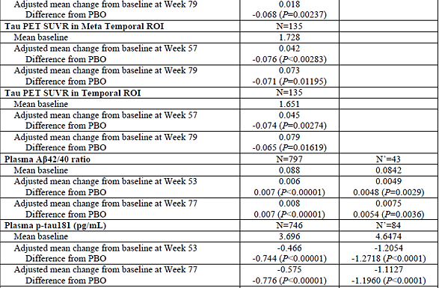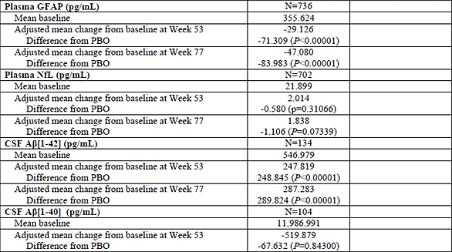

Exposure-Response (E-R) analyses
The Sponsor performed E-R analyses for PD biomarkers including amyloid PET and plasma Aβ42/40 ratio, for cognitive measures including CDR-SB and ADAS-Cog14, and for safety outcomes including ARIA-E and ARIA-H. The relationship between serum lecanemab concentration and plasma p-tau181 was characterised by an indirect response model with lecanemab exposure acting to reduce the input rate associated with plasma p-tau181.
The E-R analysis for amyloid PET included 4129 observations from 1088 subjects, including 2332 observations from 622 subjects assigned lecanemab and 1797 observations from 466 subjects assigned placebo. Lecanemab treatment resulted in exposure-dependent and time-dependent reduction in brain amyloid (Figure 4). Age was the only significant covariate, with older subjects predicted to have higher rate of amyloid removal (Figure 5).
Figure 4. Model-Predicted Amyloid PET Following 18 Months Treatment with LEC10-BW or LEC10-M in APOE4 Noncarriers.
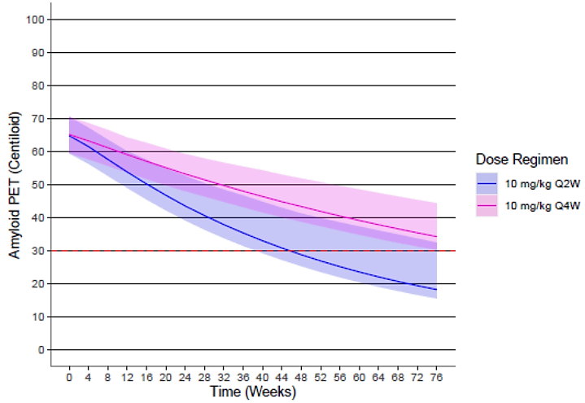
Solid line and shaded area show predicted median and 95% CI, respectively. Dashed line represents Centiloid = 30.0, indicating amyloid negative line; Q2W=every two weeks; Q4W=every four weeks.
Figure 5. Model-Predicted Amyloid PET Following 18 Months Treatment with LEC10-BW in Younger (57 years) or Older (83 years) APOE4 Non-carrier Subjects.
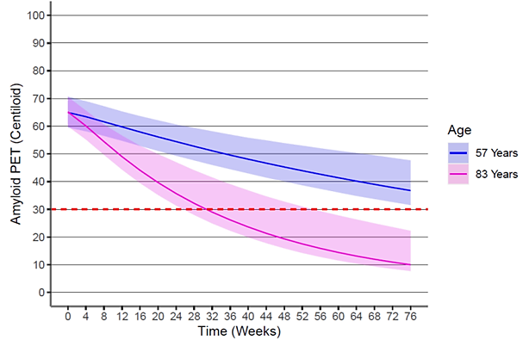
Simulations were conducted for APOE4 noncarriers, weighing 70 kg. Solid line and shaded area show predicted median and 95% CI, respectively. Dashed line represents Centiloid = 30.0, indicating amyloid negative line.
The E-R modelling for cognitive scores suggested that the most important exposure parameter was the average concentration at steady state (C_{ss,av}). The modelling of the relationship between lecanemab exposure and CDR-SB scores provides some support for the proposed dose, with a greater reduction in disease progression rate as measured by CDR-SB predicted with the higher C_{ss.av} achieved with 10 mg/kg two-weekly compared to 10 mg/kg four-weekly (Figure 6).
Figure 6 Relationship between Lecanemab Exposure and Predicted Percent Decrease in Disease Progression Rate in CDR-SB.
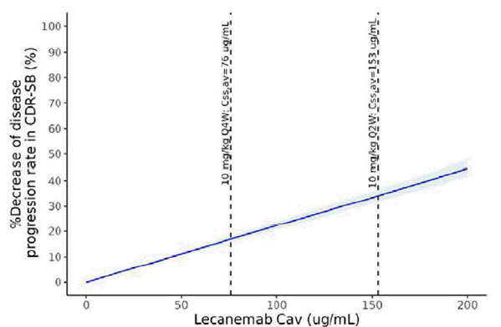
The E-R analysis showed that higher ARIA-E incidence correlated with increasing lecanemab C_{ss,max} (Figure 7). Of the covariates explored, only ApoE ε4 carrier status was a significant predictor of ARIA-E incidence, with the highest risk in homozygous ApoE ε4 carriers (Figure 8).
Figure 7 Observed and Model-Predicted ARIA-E Incidence vs Model-Predicted Lecanemab C_{ss,max}
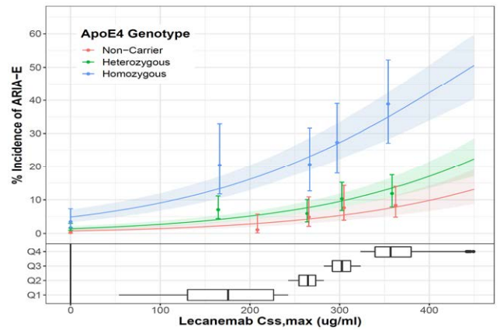
In the top pane, filled circles represent pooled Study 301 Core and Study 201 Core observed incidence of ARIA-E for each lecanemab Css,max quartile (1Q-4Q) and PBO, plotted at the median Css,max of each group. Whiskers represent 95% confidence interval of the observed ARIA-E incidence. Solid simulated lines represent the model-predicted % incidence of ARIA-E in APOE4 genotypes. The shaded areas represent the 95% confidence interval of the predicted incidence. In the bottom pane, the range of model-predicted Css,max values for the total Study 301 Core and Study 201 Core analysis set in each quartile is displayed.

Efficacy
The efficacy of lecanemab in the proposed indication is based primarily on one pivotal Phase 3 study (Study 301), supported by a Phase 2 dose-finding study (Study 201) and its OLE. The OLE for the pivotal Phase 3 study is ongoing and no efficacy data were available for this application.
The efficacy studies used validated clinical measures of cognition and functioning, as well as many PD biomarker endpoints. Clinical measures of cognition and functioning included the Clinical Dementia Rating scale (CDR), Alzheimer’s Disease Assessment Scale-Cognitive (ADAS-Cog), Alzheimer's Disease Cooperative Study-Activities of Daily Living Scale for MCI (ADCS MCI-ADL), Mini-Mental State Examination (MMSE), Alzheimer’s Disease Composite Score (ADCOMS), and Modified Integrated Alzheimer's Disease Rating Scale (iADRS).
The CDR is obtained through semi-structured interviews of patients and informants, and cognitive functioning is rated in 6 domains of functioning: memory, orientation, judgment and problem solving, community affairs, home and hobbies, and personal care. For the sum of boxes score (CDR-SB), each domain is rated on a 5-point scale (except for personal care which is rated on a 4-point scale without a 0.5 rating available) as follows: 0, no impairment; 0.5, questionable impairment; 1, mild impairment; 2, moderate impairment; 3, severe impairment (Figure 8). The CDR-SB has a total possible score of 0 to 18, with higher scores indicating greater impairment. The relevant portion of the scale for EAD is 0.5 to 6. Change in CDR-SB was used as the primary endpoint in the pivotal study. There is not a clearly defined minimum clinically important difference (MCID) for CDR-SB, but a 2019 study concluded that a 1-to-2-point increase (on average) in CDR-SB is indicative of a clinically meaningful decline for an individual. The Sponsor emphasised that MCIDs are based on within-patient changes and should not be applied to group-level treatment differences in clinical studies. A global CDR score (ranging from 0 to 3) is derived by a weighted calculation of the scores on each of the 6 domains.
Figure 8. CDR-SB Scale
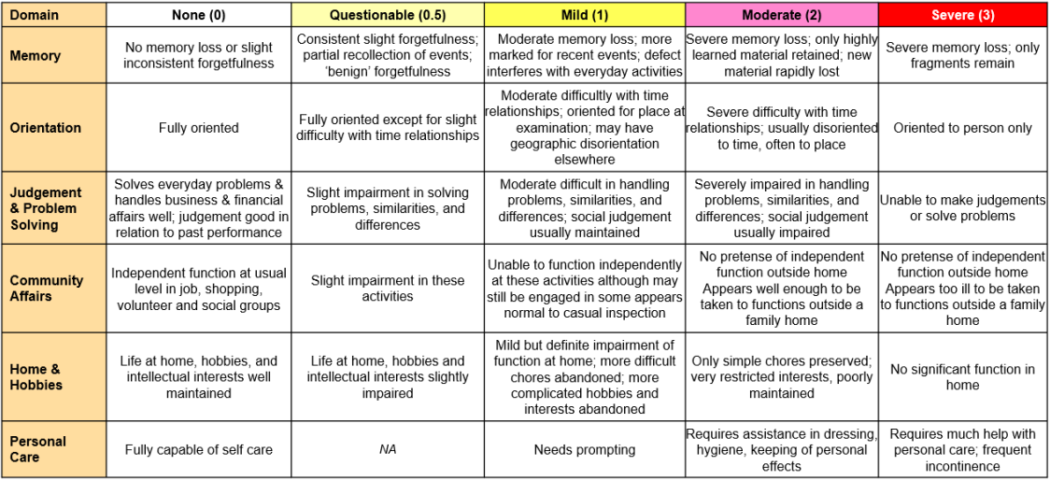
The ADAS-Cog is a structured scale that evaluates memory (word recall, delayed word recall, and word recognition), reasoning (following commands), language (naming, comprehension), orientation, ideational praxis (placing a letter in an envelope) and constructional praxis (copying geometric designs). It also provides ratings of spoken language, language comprehension, word finding difficulty, ability to remember test instructions, performance on mazes, and a number cancellation task. The ADAS-Cog14 version used in the pivotal study is scored from 0 to 90 points, with a score of 0 indicating no impairment, and a score of 90 indicating maximum impairment.
The ADCS MCI-ADL is a measure of 18 items relating to performance of everyday activities, as reported by the caregiver. It provides a measure of functional status by assessing the extent to which the patient performs home and community activities independently, with supervision, or requires physical help. A caregiver reports changes in function over a month, with scores ranging from 0 to 53, and lower scores indicating decline in function. For context, a 1-point change can mean a shift from performing an activity unsupervised to requiring supervision, or a shift from requiring supervision to requiring physical assistance by the caregiver.
The MMSE is a quick cognitive assessment instrument commonly used in clinics and hospitals for screening purposes but also measured longitudinally in many AD clinical studies. It is a 30-point scale with higher scores indicating less impairment and lower scores indicating more impairment. it contains seven items measuring orientation to time and place, registration, recall, attention, language, and drawing.
The ADCOMS is derived from the CDR (all 6 items), the ADAS-Cog14 (4 items), and the MMSE (2 items). These items were selected on the basis that they are more sensitive to clinical progression compared to the established validated measures, so there is interest in the use of this measure to detect change in EAD.
The modified iADRS is a composite scale based on the ADAS-Cog14 (all items) and ADCS MCI-ADL (all items). The modified iADRS score ranges from 0 to 143, with lower scores indicating worsening of disease. It is a non-validated measure which was included for internal comparison purposes with other reported results.

Study BAN2401-G000-301 (Study 301)
The pivotal study was a Phase 3, global, multicentre, randomised, double-blind, placebo-controlled, parallel-group, 18-month study to confirm the safety and efficacy of lecanemab in subjects with EAD. The study was conducted between March 2019 and August 2022 at 235 sites in North America (112 sites), Europe (including Australia, 55 sites), Asia-Pacific (47 sites), and China (21 sites). Subjects completing the core study could be enrolled in a 4-year OLE phase which is on-going.
The primary objective was to evaluate the efficacy of lecanemab 10 mg/kg two-weekly (LEC10-BW) in subjects with EAD by determining the superiority of LEC10-BW compared with placebo (PBO) on the change from baseline in the CDR-SB at 18 months of treatment.
The key secondary objectives were:
- To determine whether LEC10-BW is superior to PBO in reducing brain amyloid levels as measured by amyloid PET using Centiloids at 18 months.
- To evaluate the efficacy of LEC10-BW in subjects with EAD by determining the superiority of LEC10-BW compared with PBO on the change from baseline in the ADAS-Cog14 at 18 months of treatment.
- To evaluate the efficacy of LEC10-BW in subjects with EAD by determining the superiority of LEC10-BW compared with PBO on the change from baseline in the ADCOMS at 18 months of treatment.
- To evaluate the efficacy of LEC10-BW in subjects with EAD by determining the superiority of LEC10-BW compared with PBO on the change from baseline in the ADCS MCI-ADL at 18 months of treatment.
Other secondary objectives were:
- To evaluate the safety and tolerability of LEC10-BW.
- To evaluate the popPK of LEC10-BW.
The study also had numerous biomarker and exploratory objectives, including various quality of life measures (detailed in the clinical evaluation report).
Study 301 included subjects aged 50 to 90 years with MCI due to AD or mild AD dementia based on National Institute of Aging-Alzheimer’s Association (NIA-AA) clinical criteria. Key inclusion criteria that had to be met by all subjects included:
- objective impairment in episodic memory in the Wechsler Memory Scale-IV Logical Memory (subscale) II (WMS-IV LMII): ≤15 for age 50 to 64 years, ≤12 for age 65 to 69 years, ≤11 for age 70 to 74 years, ≤9 for age 75 to 79 years, ≤7 for age 80 to 90 years.
- Positive biomarker for brain amyloid pathology as measured by amyloid PET or CSF t-tau/Aβ [1-42].
- Subjects receiving approved treatments for AD had to have been on a stable dose for at least 12 weeks prior to Baseline.
Subjects with any other neurological condition that could be contributing to cognitive impairment were excluded, as were subjects with significant pathological findings on MRI at screening, including multiple lacunar infarcts or stroke involving a major vascular territory, severe small vessel or white matter disease, >4 microhaemorrhages, cerebral haemorrhage >1 cm, superficial siderosis, vasogenic oedema, cerebral contusion, aneurysm, and vascular malformation.
Subjects receiving symptomatic treatment for AD had to be on stable doses. Subjects receiving antiplatelet agents or anticoagulants were not excluded.
Subjects were randomised 1:1 to treatment with lecanemab 10 mg/kg by intravenous infusion every two weeks (LEC10-BW) or matching placebo (PBO). Study drug was temporarily interrupted in patients with symptomatic or radiographically moderate or severe ARIA-E, or any of the following types of ARIA-H (macrohaemorrhage >10 mm, >10 microhaemorrhages cumulatively, symptomatic microhaemorrhage, or symptomatic superficial siderosis). Study drug was permanently discontinued in subjects with severe ARIA-E associated with SAE, or following a 3rd occurrence of ARIA-E or ARIA-H meeting the criteria for study drug interruption. To address the risk of treatment-induced radiological changes (ARIA-E and ARIA-H) impacting on blinding, clinicians involved in rating cognitive performance were not involved in clinical management or safety assessments.
1795 subjects were randomised into the study, 898 to LEC10-BW and 897 to PBO, and all randomised subjects received at least one dose of study drug. 729 (81.2%) subjects in the LEC10-BW group and 757 (84.4%) subjects in the PBO group completed the core study. 113 (6.3%) subjects missed 4 or more consecutive visits, mostly related to COVID-19 pandemic.
There were no important demographic differences between the two treatment groups. Overall, the median age was 72.0 (range: 50 to 90) years. 52.3% of subjects were female. 76.9% were White, 16.9% Asian, and 2.6% Black. Baseline disease characteristics were similar across the treatment groups. The mean time since disease diagnosis was 1.38 years (range: 0 to 11.2), and the mean time since the onset of symptoms was 4.15 years. At baseline, 61.7% of subjects had MCI and 38.3% had mild dementia, 80.7% had a global CDR score of 0.5 and 19.3% had a score of 1, and mean and median CDR-SB scores were 3.2 and 3.0, respectively. 53.3% of subjects were heterozygous ApoE ε4 carriers, 15.3% were homozygous ApoE ε4 carriers, and 31.4% were non-carriers.
The primary endpoint was the change from baseline in the CDR-SB at 18 months. The key secondary endpoints (in hierarchical testing order) were:
- Change from baseline in amyloid PET using Centiloids at 18 months.
- Change from baseline in ADAS-Cog14 at 18 months.
- Change from baseline in ADCOMS at 18 months.
- Change from baseline in ADCS MCI-ADL at 18 months
The primary and key secondary endpoints were tested hierarchically at a significance level of two-sided alpha=0.05. Prior to unlocking and analysing the data, the Sponsor prospectively identified different statistical approaches for the primary efficacy analysis. For the FDA, the Sponsor used the ITT FDA Full Analysis Set (FDA FAS), which excluded subjects randomised “on or before the end date of dosing hold at the sites which had dosing hold with 6 or more weeks (≥42 days, which was equal to 3 consecutive doses) during COVID-19 period of 01 Mar to 31 Jul 2020.” The rationale was that these subjects were potentially not representative of the likely clinical course under normal circumstances. The analysis for the EMA and PDMA was based on the ITT Full Analysis Set (FAS+), which included these subjects. The Australian application focussed on the FAS+ analysis, but findings in the FDA FAS analysis were similar.
Study 301 met the primary and all key secondary endpoints.

Change from baseline in CDR-SB at 18 months (Primary endpoint)
There was a highly statistically significant difference between LEC10-BW and PBO for change from baseline in CDR-SB at 18 months, consistent with slowing of clinical disease progression. The adjusted mean treatment difference was -0.451 points, representing a 27.1% reduction in decline in CDR-SB with LEC10-BW compared to PBO (Table 7). The difference in disease progression as measured by CDR-SB was statistically significant by 6 months and the curves continued to separate at all subsequent time points (Figure 9). Pre-specified sensitivity analyses showed similar estimates of the treatment benefit, supporting the primary analysis.
Table 7, Change from Baseline in CDR-SB Score at 18 Months – mixed model for repeated measures (MMRM) – Study 301 (FAS+)
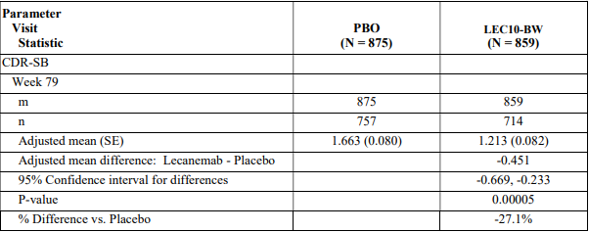
m shows the number of subjects who are included in MMRM, n shows the number of subjects at each visit. The change from baseline for overall population is analysed using the MMRM with treatment group, visit, treatment group by visit interaction, clinical subgroup, use of AD symptomatic medication at baseline, APOE4 carrier status, region, baseline value by visit interaction as fixed effects, and baseline value as covariate. Missing values are not imputed and assumed to be missing at random. % difference is calculated as adjusted mean difference divided by adjusted mean for placebo group. AD = Alzheimer’s disease, APOE4 = apolipoprotein E4, CDR-SB = Clinical Dementia Rating – Sum of Boxes, m = number of subjects included in the MMRM, MMRM = mixed model for repeated measures, N = number of subjects in treatment group.
Figure 9. Adjusted Mean Change from Baseline in CDR-SB – Study 301 (FAS+)
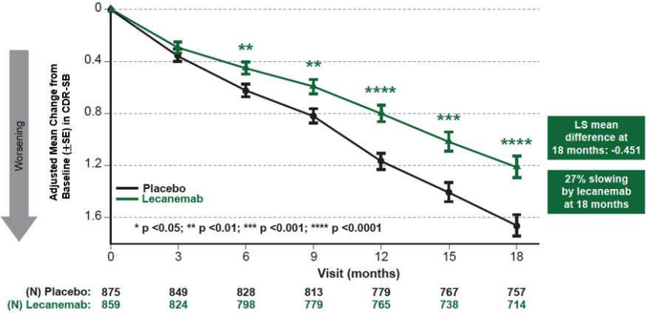

Change from baseline in amyloid PET using Centiloids at 18 months (key secondary endpoint)
The PET substudy (MMRM analysis: PBO 344 subjects; LEC10-BW 354 subjects) demonstrated a highly statistically significant reduction in brain amyloid burden as measured by amyloid PET using Centiloids at 18 months with LEC10-BW compared to placebo (Figure 10). The adjusted mean change in amyloid PET using Centiloids for brain amyloid levels at 18 months was -55.5 in the LEC10-BW group and +3.6 in the placebo group (adjusted mean treatment difference -59.1; P<0.00001). A statistically significant difference was apparent from 3 months, with the absolute treatment difference increasing over time to 18 months.
Figure 10. Adjusted Mean of Change from Baseline in Amyloid PET Using Centiloids for Brain Amyloid Levels – Study 301 (PD Analysis Set)
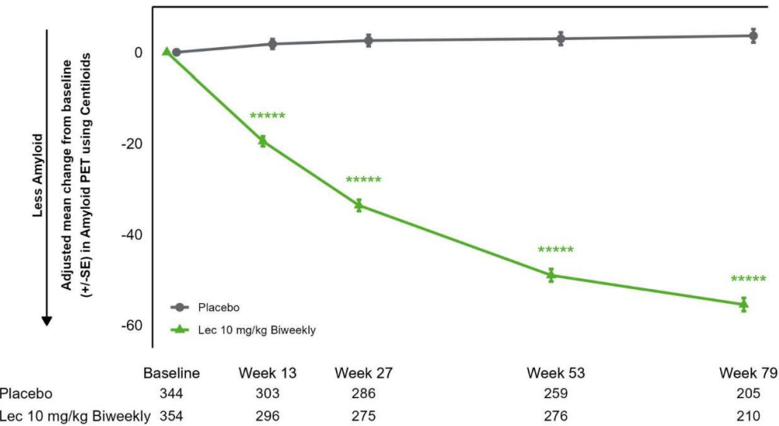
***** P<0.00001

Change from baseline in ADAS-Cog14 at 18 months (key secondary endpoint)
The study demonstrated a highly statistically significant difference between LEC10-BW and PBO for change from baseline in ADAS-Cog14 at 18 months, consistent with slowing of disease progression. The adjusted mean treatment difference was -1.442 (P=0.00065), representing a 25.8% reduction in decline in ADAS-Cog14 with LEC10-BW compared to PBO (Figure 11). A statistically significant difference was apparent from 6 months.
Figure 11. Change from Baseline in ADAS-Cog14 – Study 301 (FAS+)
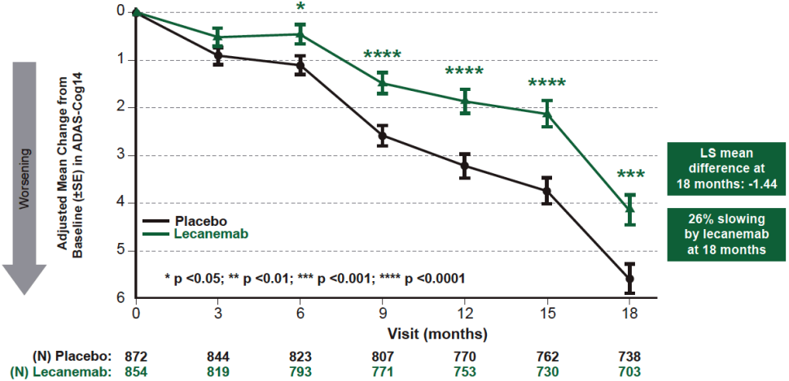

Change from baseline in ADCOMS at 18 months (key secondary endpoint)
The study demonstrated a highly statistically significant difference between LEC10-BW and PBO for change from baseline in ADCOMS at 18 months, consistent with slowing of disease progression. The adjusted mean treatment difference at 18 months was -0.050, representing a 23.5% reduction in decline in ADCOMS with LEC10-BW compared to PBO (P=0.00002). A statistically significant difference was apparent from 6 months (Figure 12).
Figure 12. Change from Baseline in ADCOMS – Study 301 (FAS+) 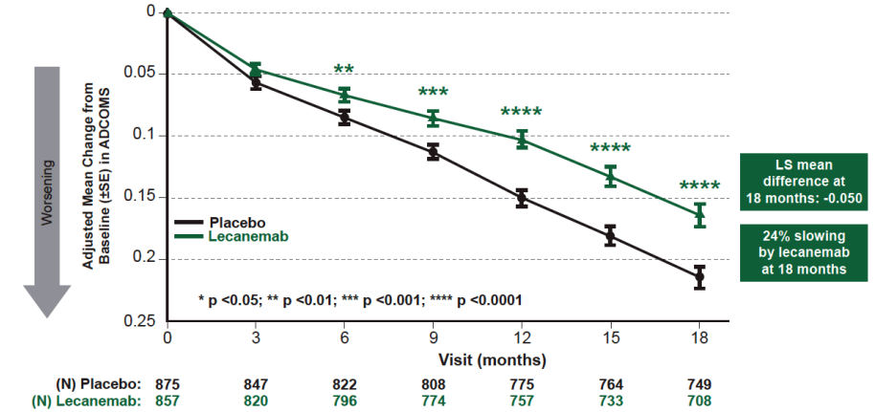

Change from baseline in ADCS MCI-ADL at 18 months (key secondary endpoint)
The study demonstrated a highly statistically significant difference between LEC10-BW and PBO for change from baseline in ADCS MCI-ADL at 18 months, indicating a significant difference in functional decline between the groups. The adjusted mean treatment difference at 18 months was 2.016, representing a 36.6% reduction in decline in ADCS MCI-ADL with LEC10-BW compared to PBO (P<0.00001). A statistically significant difference was apparent from 6 months and the absolute treatment difference increased over time to 18 months (Figure 13).
Figure 13. Change from Baseline in ADCS MCI-ADL –Study 301 (FAS+)
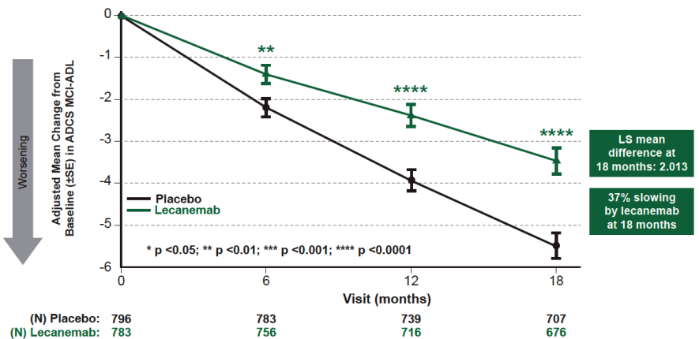

Exploratory analyses of efficacy endpoints
An exploratory analysis of rate of change of CDR-SB over time was performed to provide context for the observed difference in the rate of decline of CDR-SB over time. This showed that the decline in CDR-SB observed in LEC10-BW subjects at 18 months was reached by placebo subjects ∼5.3 months earlier (Figure 14). Similarly, the decline in ADCS-MCI-ADL observed in LEC10-BW subjects at 18 months was reached by placebo subjects ∼7.5 months earlier (Figure 15). Caution should be applied in extrapolating differences beyond the 18-month timeframe of the study because this relies on the assumption that the decline in each group will continue on the same trajectory beyond Month 18.
Figure 14. Rate of Change over Time of CDR-SB – Linear Mixed Effects Model – Study 301 (FAS+)
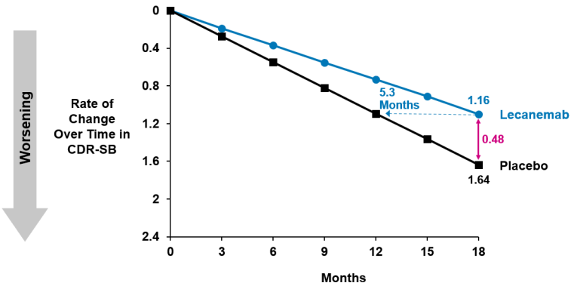
Figure 15. Rate of Change over Time of ADCS-MCI-ADL – Linear Mixed Effects Model – Study 301 (FAS+)
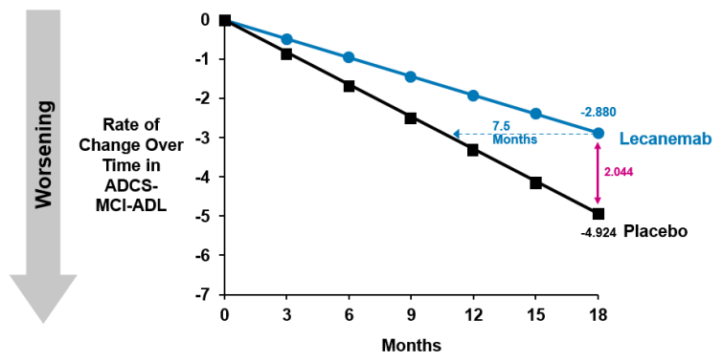
Treatment with LEC10-BW was associated with a delay in the time to worsening of global CDR score (defined as time from randomisation to the first worsening where there is an increase from baseline by at least 0.5 points on the global CDR score in 2 consecutive visits) compared to PBO (Figure 16). The hazard ratio of disease progression on the global CDR score was 0.69, (95% CI 0.57, 0.83), indicating a 31% reduction in the risk of progression on global CDR score with LEC10-BW compared to PBO.
Figure 16. Kaplan–Meier Curves for Time to Worsening of Global CDR Scores – Study 301 (FAS+)
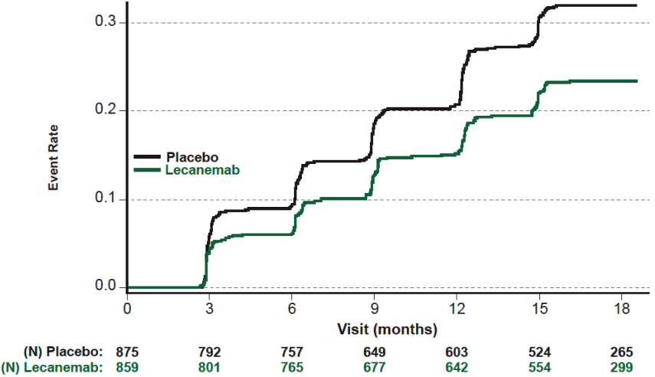
Findings for the non-validated measure, modified iADRS, were broadly consistent with other efficacy measures. There was a nominally significant difference between LEC10-BW and PBO for change from baseline in modified iADRS at 18 months (Figure 17). The adjusted mean treatment difference at 18 months was 3.157, representing a 30.2% reduction in decline in modified iADRS with LEC10-BW compared to PBO.
Figure 17. Plot of Adjusted Mean of Change from Baseline in Modified iADRS – Study 301 (FAS+)
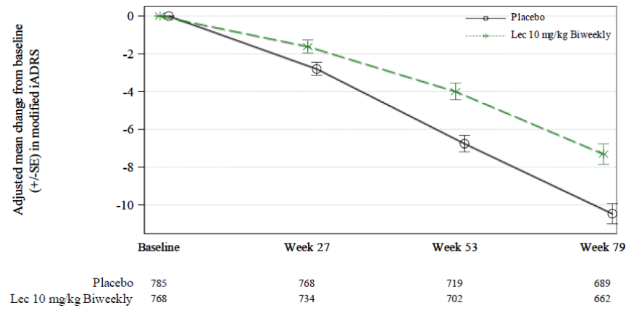

Exploratory Quality of Life endpoints
At 18 months, there was a nominally significant treatment effect on change from baseline in EQ-5D-5L in the Subject’s Survey but no significant difference in the Partner as Proxy Survey and Partner’s Survey. For the QOL-AD total score, there was a nominally significant treatment effect observed in the Subject’s Survey and the Partner as Proxy Survey. For the Zarit’s Burden Interview (which assesses carer burden rather than carer perceptions of patient quality of life), there was a nominally significant treatment effect on change from baseline for the Study Partner Total Score.

Subgroup analyses
Subgroup analyses based on stratification factors (use of symptomatic AD medication, clinical subgroup, ApoE ε4 carrier status, and region) were generally consistent across the subgroups, noting the limitations of smaller sample sizes (Figure 18). Across the key endpoints, there was a trend towards greater benefit in patients with mild dementia compared to MCI, and ApoE ε4 non-carriers compared to carriers.
The evaluation included a detailed review of subgroup findings for ApoE ε4 homozygotes as the result for CDR-SB in this subgroup favoured placebo over lecanemab, whereas results for ADAS-Cog 14, ADCS MCI-ADL numerically favoured lecanemab. ApoE ε4 Homozygotes represented only 15.3% of the overall study population so analysis in this subgroup is expected to be underpowered. In addition, subsequent analyses of the placebo arm showed an unexpected finding of less decline for ApoE ε4 homozygotes than for other ApoE ε4 subgroups receiving placebo. Overall, the evaluation concluded that the finding for CDR-SB in homozygous ApoE ε4 carriers likely reflects an underpowered analysis.
Figure 18. Lecanemab vs Placebo by Randomisation Strata – Study 301 – Intent to Treat (FAS+)
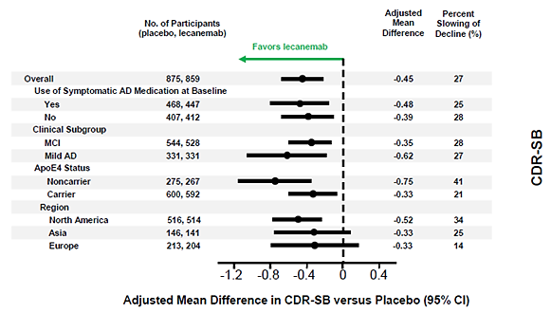
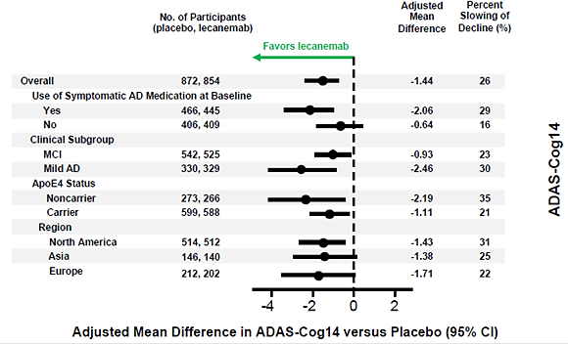
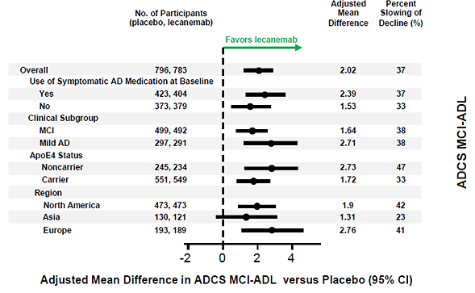

Study BAN2401-G000-201 (Study 201)
The supportive study was a Phase 2, placebo-controlled, double-blind, parallel-group, Bayesian adaptive randomisation design and dose regimen-finding study, with an OLE phase, to evaluate the safety, tolerability and efficacy of lecanemab in subjects with EAD (MCI due to AD, or mild AD dementia). The study was conducted between December 2012 and July 2018 (21-month data, Core study) at 149 sites in North America (93 sites), Europe (34 sites), Asia-Pacific (22 sites).
Study 201 was primarily designed as a dose-ranging study and used a Bayesian adaptive randomisation approach (response adaptive randomisation) to increase subject randomisation to the most promising dose group, based on frequent interim analyses; this approach also allowed for the possibility of early stopping of the study on the grounds of futility or clear benefit.
The primary objectives were:
- To evaluate the efficacy of lecanemab compared to placebo by establishing the dose regimen with at least 90% of the maximum effective dose (d_{max}) treatment effect (ED₉₀) for lecanemab on the Alzheimer’s Disease Composite Score (ADCOMS) at 12 months of treatment in subjects with Early Alzheimer’s Disease (EAD), defined as mild cognitive impairment (MCI) due to Alzheimer’s disease (AD) – intermediate likelihood or mild AD dementia.
- To assess the safety and tolerability of 3 doses and 2 dose regimens of lecanemab in subjects with EAD.
The key secondary objectives were:
- To evaluate the effects of lecanemab compared to placebo on brain amyloid pathophysiology at 18 months of treatment in subjects with EAD as measured by amyloid positron emission tomography (PET).
- To evaluate the efficacy of lecanemab compared to placebo on the ADCOMS at 18 months of treatment in subjects with EAD.
- To evaluate the efficacy of lecanemab compared to placebo on the Clinical Dementia Rating-Sum of Boxes (CDR-SB) at 18 months of treatment in subjects with EAD.
- To evaluate the efficacy of lecanemab compared to placebo on the Alzheimer Disease Assessment Scale - Cognitive Subscale14 (ADAS–Cog14) in subjects with EAD at 18 months.
- To evaluate the efficacy of lecanemab compared to placebo at 18 months on clinical status separately within subjects with MCI and mild AD dementia for the following assessments: ADCOMS, CDR-SB, and ADAS–Cog14.
- To evaluate the effects of lecanemab compared to placebo on cerebrospinal fluid (CSF) biomarkers – Aβ monomer from amino acid 1 to 42 (Aβ[1–42]), total-tau (t-tau), and phospho-tau (p-tau) – at 18 months of treatment in subjects with EAD.
- To evaluate the effects of lecanemab compared to placebo on total hippocampal volume using volumetric MRI (vMRI) at 18 months of treatment in subjects with EAD.”
The study consisted of a Pre-randomisation Phase (Screening Period and Baseline Period), and a Randomisation Phase with a planned 18-month treatment period (Core Study) followed by a 3-month Follow-Up Period. An Open-Label Extension Phase was implemented to allow for up to 24 months (2 years) of additional treatment.
The key inclusion and exclusion criteria were broadly similar to Study 301. During the course of the study, safety concerns arose in relation to the risk of ARIA-E in subjects who were homozygous for ApoE ε4 and receiving the highest lecanemab dose. Consequently, the Drug Safety Monitoring Board (DSMB) for the study recommended that the highest dose (LEC10-BW) no longer be administered to ApoE ε4 homozygous subjects, and this approach was implemented for all subsequent randomisations beginning in Protocol Amendment 04. Additionally, the study design was amended to add a Week 9 safety MRI scan for earlier detection of ARIA–E, and at milder stages (radiographically and clinically). Subjects could receive concurrent symptomatic AD treatments, but were required to keep these at a stable dose.
Study treatment was lecanemab or matching placebo by IV infusion. Doses of lecanemab evaluated in this study included 2.5, 5, or 10 mg/kg two-weekly, or 5 or 10 mg/kg monthly. Randomisation in this study was complex. The initial protocol specified that the first 196 subjects were to be randomised to study treatment using a fixed 2:1:1:1:1:1 randomisation ratio (PBO, LEC 2.5 mg/kg biweekly, 5 mg/kg monthly, 5 mg/kg biweekly, 10 mg/kg monthly or 10 mg/kg biweekly). After 196, 250, 300, 350, 400, 450, 500, 550, 600, 650, 700, and 750 subjects were enrolled, the randomisation ratios were to be updated to maximise the chance of finding the dose associated with achieving the ED₉₀ for lecanemab. Before the interim analysis of 350 subjects, the European Health Authorities introduced a restriction around APOE4 carrier randomisation because of concerns about increased ARIA risk in this group. Subsequently, subjects confirmed as ApoE ε4 carriers (hetero- or homozygous) were not to be randomised to the 10 mg/kg biweekly dose.
The primary endpoint was the change from Baseline in ADCOMS at 12 months. Key secondary endpoints were:
- Change from Baseline at 18 months in brain amyloid pathophysiology as measured by amyloid PET.
- Change from Baseline in ADCOMS at 18 months.
- Change from Baseline in CDR-SB at 18 months.
- Change from Baseline in ADAS-Cog14 at 18 months.
- Change from Baseline in CSF biomarkers (Aβ[1-42], t-tau, and p-tau, as well as other AD biomarkers determined by the Sponsor; see Section 9.5.1.3.4) at 18 months.
- Change from Baseline in total hippocampal volume at 18 months using vMRI.
The primary endpoint was analysed using prespecified Bayesian methods. A 25% reduction in the rate of decline over 1 year was chosen as a clinically significant difference (CSD) from placebo. The statistical analysis plan specified that interim monitoring for early success will begin at the 350 subject interim analysis. If there is greater than a 95% probability that the ED₉₀ achieves a clinically significant difference from placebo during the accrual period, the trial will stop randomisation and will be declared an early success. If the trial continues to completion, the trial will be considered a success if there is at least an 80% probability that the ED₉₀ achieves the clinically significant difference from placebo. The study also included conventional analyses of the primary endpoint using a mixed-effects model with repeated measures (MMRM) that compared placebo to the identified ED₉₀ dose from the Bayesian analysis, with no adjustment for the multiple doses, multiple interim analyses, and the potential for early stopping.
After screening, 856 subjects were randomised to study treatment, and 854 subjects actually received study treatment. Following the Bayesian adaptive randomisation strategy, the largest active treatment group was 10 mg/kg monthly (n=253), followed by 10 mg/kg biweekly (LEC10-BW, n=161), 5 mg/kg biweekly (n=92), 2.5 mg/kg biweekly (n=52) and 2.5 mg/kg monthly (n=51).
Study 201 failed to meet the primary efficacy endpoint for the Bayesian analysis of ADCOMS at 12 months. LEC10-BW was identified as the ED₉₀, but the probability of this dose achieving the CSD compared to placebo at 12 months was 64% (Table 8), which missed the pre-specified 80% threshold for success. A similar analysis conducted at 18 months (not corrected for multiplicity) estimated the probability of LEC10-BW exceeding the CSD compared to placebo to be 76%. To provide some context to the primary efficacy outcome, this result is an estimate of the probability that the ED₉₀ dose of lecanemab slows progression on the ADCOMS by 25% or more compared to placebo. The probability that LEC10-BW was superior to placebo at 12 months was estimated to be 97.6%, which would be consistent with a positive study finding if the study design was based on a more conventional superiority analysis.
Table 8. Bayesian Analysis of ADCOMS at 12 months – Full Analysis Set
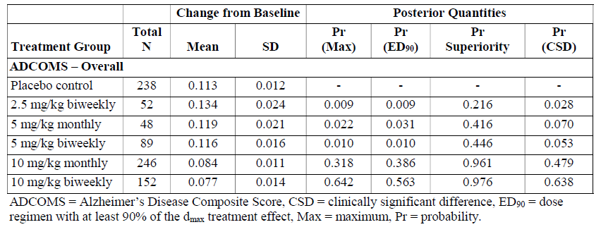
Study 201 showed dose-dependent and time-dependent reductions in brain amyloid as measured by amyloid PET, with nominally significant reductions in brain amyloid observed for all doses of lecanemab compared to placebo at 12 and 18 months (Table 9, Figure 19).
Table 9. Change from Baseline in Brain Amyloid Levels as measured by Amyloid PET SUVR normalised to whole cerebellum mask in Centiloid scales – MMRM, PD Analysis Set, Study 201
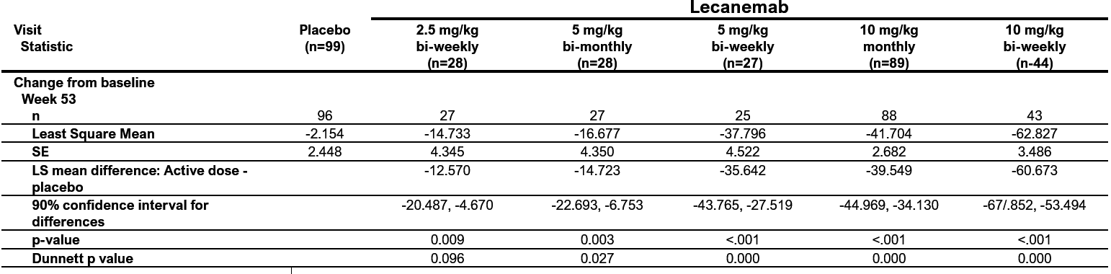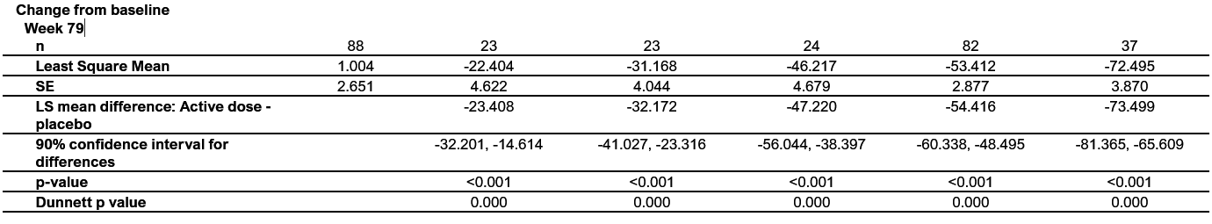
Figure 19 Adjusted Mean (± SE) Change From Baseline in Brain Amyloid Levels as Measured by Amyloid PET in Centiloid Scales by Visit – Overall – Study 201 Core (PD Analysis Set)
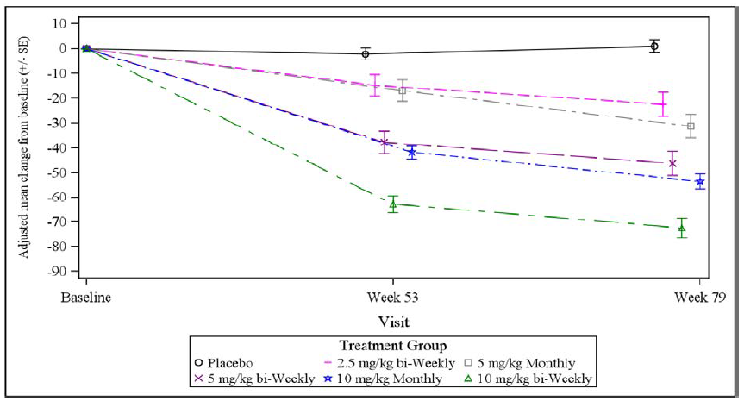
The MMRM analyses of ADCOMS at 12 months (Table 10) and 18 months (key secondary endpoint, Table 11) showed nominal significance for LEC10-BW versus placebo. The findings at 12 and 18 months represent a 35% and 30% reduction, respectively, in decline in ADCOMS for LEC10-BW compared to placebo. The MMRM analyses were not adjusted for multiplicity so all p-values should be viewed as nominal. The MMRM analysis of change from baseline in CDR-SB at 18 months did not achieve nominal significance for any dose group (Table 12), but the LEC10-BW dose produced a 26% reduction in decline in CDR-SB score compared to placebo. In the Bayesian analysis, the probability of lecanemab being superior to placebo at 18 months was greatest for the LEC10-BW dose (96.4%).
Table 10. MMRM Analyses of Change From Baseline in ADCOMS at 12 Months – FAS Set, Study 201
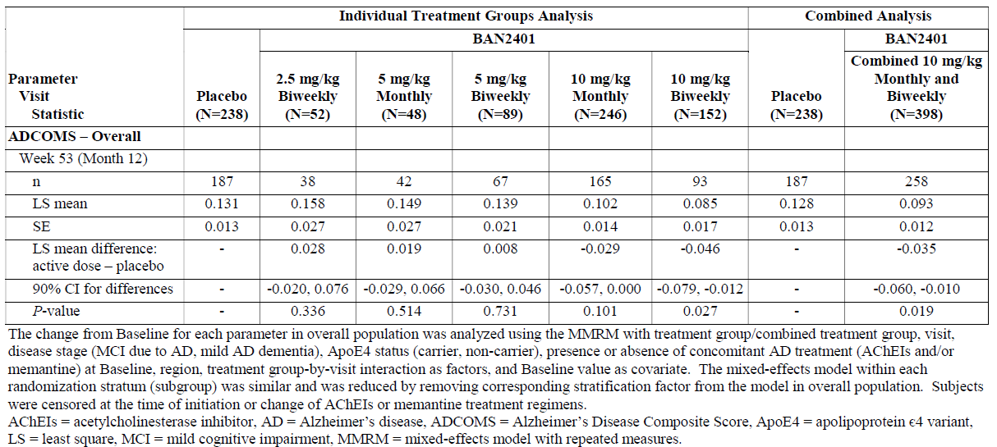

Table 11. MMRM Analyses of Change From Baseline in ADCOMS at 18 Months – FAS, Study 201
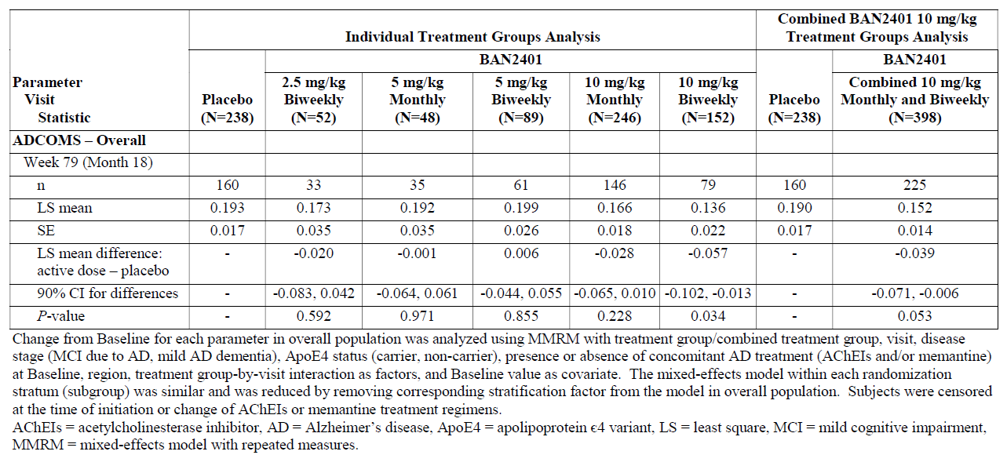
Table 12. MMRM Analyses of Change From Baseline in CDR-SB at 18 Months - FAS, Study 201
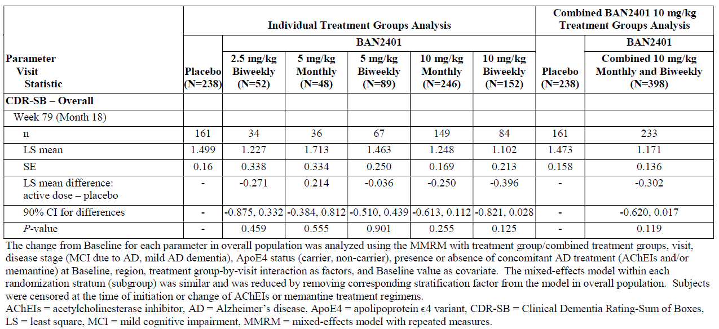
The MMRM analysis of change from baseline in ADAS-Cog14 at 18 months (Table 13) showed nominal significance for LEC10-BW versus placebo. In the Bayesian analysis of ADAS-Cog14, the probability of lecanemab being superior to placebo at 18 months was greatest for the LEC10-BW dose (98.8%).
Table 13. MMRM Analyses of Change From Baseline in ADAS–Cog14 at 18 Months – FAS, Study 201
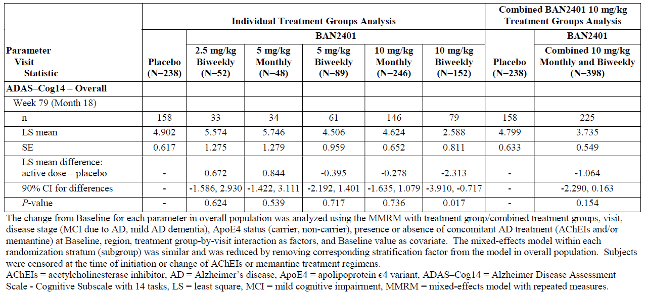

Study 201 open label extension (OLE)
Study 201 included an OLE phase with a primary focus on safety, but it collected some unblinded, uncontrolled efficacy data (evaluable n=180 at the time of the submission). Subjects who been enrolled in Study 201 and had not progressed beyond EAD were eligible to entire the OLE phase, in which all subjects received open-label active treatment with lecanemab. Patients who had previously received placebo switched to active treatment, and subjects who had received lecanemab re-started it after a variable gap between the study phases (the gap period off-treatment ranging from 9-59 months, with a mean of 24 months).
Most subjects (n=180) received LEC10-BW, the dose proposed for registration, but subjects who entered a dosing regimen sub-study could receive one of two alternative dosing regimens: lecanemab 10 mg/kg once every 4 weeks (Q4W) or lecanemab 10 mg/kg once every 3 months (Q3M). Data for these alternate doses were not assessed for efficacy in the Sponsor’s submission, as these low doses are not being proposed for registration.
The study lacked a formal statistical hypothesis, so efficacy results were presented with descriptive statistics. The primary endpoint was based on safety monitoring, secondary endpoints were based entirely on amyloid PET results, and clinical endpoints were exploratory.
Conclusions on exploratory clinical endpoints in an uncontrolled, open-label study are limited, but the gap period between completing the core study and commencing active treatment in the OLE provides some insights regarding disease progression off treatment. The clinical treatment effect for LEC10-BW relative to placebo observed in the core study appeared to be maintained during the gap period up to the OLE Baseline, with similar rates of progression for CDR-SB (Figure 20) and ADCOMS (Figure 21) in the active and placebo treatment groups during the off-treatment gap period.
Figure 20 Line Plot of Adjusted Mean Change (± SE) From Core Baseline in CDR-SB by Visit– MMRM – Study 201 Core and Gap Period (OLE Enrolled Set Excluding Those Who Progressed Beyond EAD)
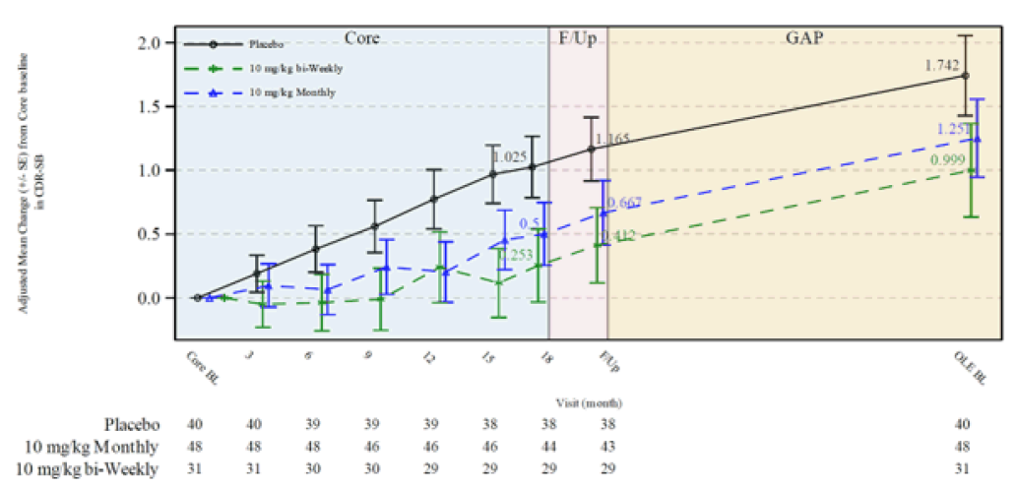
Figure 21 Line Plot of Adjusted Mean Change (± SE) From Core Baseline in ADCOMS by Visit– MMRM – Study 201 Core and Gap Period (OLE Enrolled Set Excluding Those Who Progressed Beyond EAD)
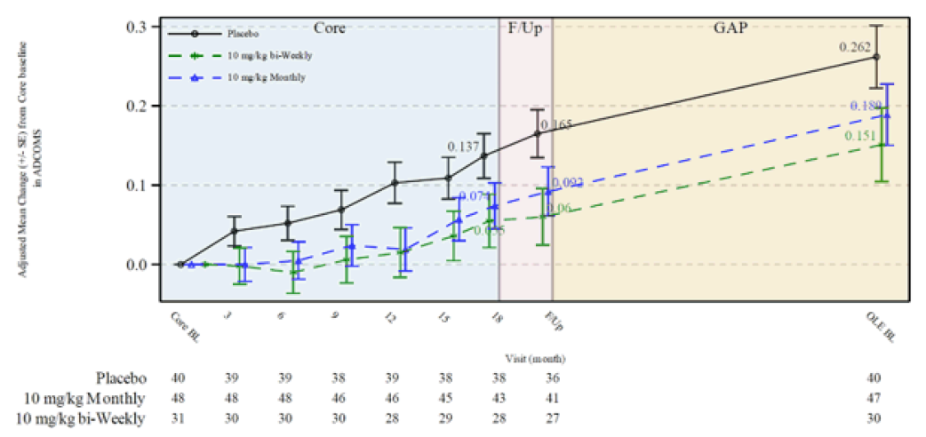

Safety
The Sponsor’s Integrated Summary of Safety presented safety data from 8 studies, including the three Phase 1 studies (Studies 101, 104, and 004), the two efficacy studies (Studies 201 and 301) and their OLE, and early safety data from one ongoing Phase 3 efficacy study (Study 303) in subjects with preclinical AD (i.e. no cognitive impairment). Study 301 Core provides the largest dataset (1795 subjects, 898 LEC10-BW) balanced for randomisation strata, so this was the main focus of the safety evaluation. Study 201 and pooled safety data from Study 301 (Core and OLE) and Study 201 (Core and OLE) were also evaluated, but a protocol amendment in Study 201 resulted in an imbalance of ApoE ε4 carriers in the LEC10-BW group.
Overall exposure to lecanemab included 1190 lecanemab-treated subjects exposed for >12 months in placebo-controlled studies. In Study 301, 811 subjects were exposed to lecanemab at the proposed dose for at least 6 months, 757 subjects were exposed to lecanemab for at least 12 months, and 513 subjects were exposed to lecanemab for at least 18 months. The mean duration of exposure was 16.49 months for PBO and 15.74 months for LEC10-BW.
The overall profile of TEAEs in Study 301 Core is summarised in Table 14. Treatment-related TEAEs, TEAEs leading to dose interruption, TEAEs leading to study drug withdrawal, and TEAEs of special interest were notably higher in the lecanemab group compared to placebo. TEAEs by preferred term (≥5% of subjects in any treatment group) are presented in Table 15. Treatment with lecanemab was associated with a substantial excess of infusion-related reactions, ARIA-E, and ARIA-H compared to placebo.
Table 14. Treatment-Emergent Adverse Events – Study 301 Core (Safety Analysis Set)
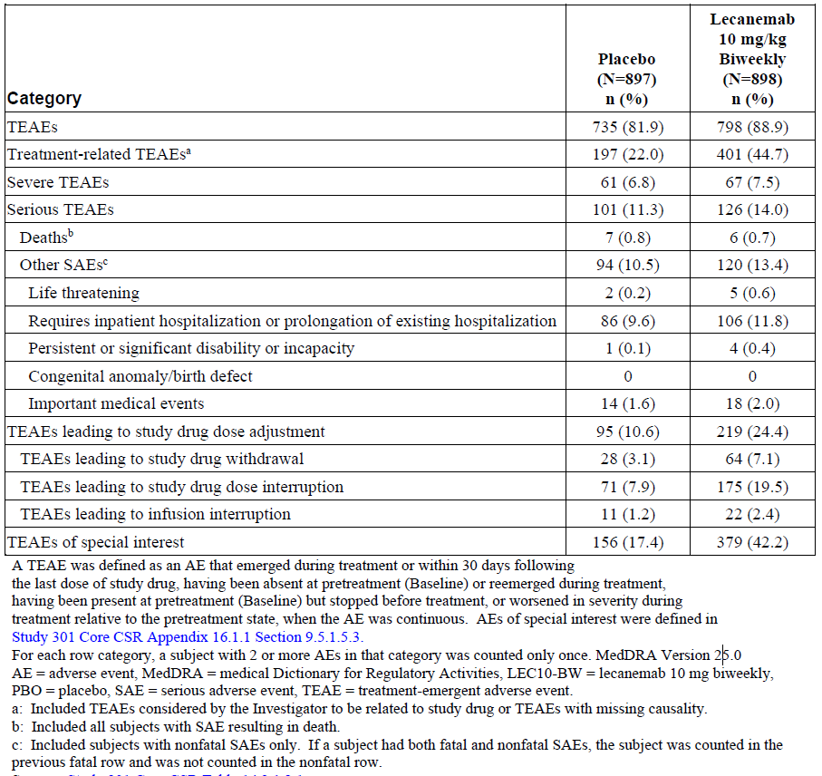
Table 15. Treatment-Emergent Adverse Events With Incidence in at Least 5% of Subjects in Any Treatment Group By Decreasing Frequency - Study 301 Core (Safety Analysis Set)
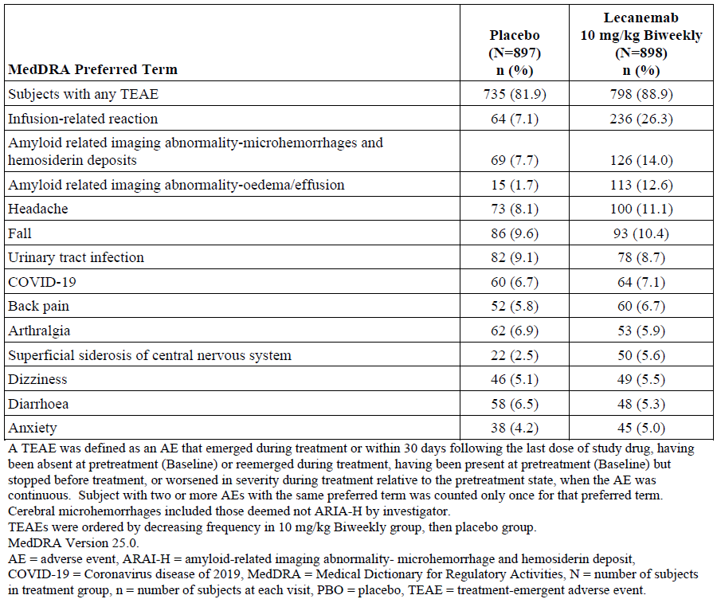
Infusion-related reactions were mostly mild or moderate (Grade 1 or 2), but 7 (0.8%) subjects experienced severe infusion-related reactions (6 Grade 3, 1 Grade 4) on LEC10-BW. Of these 7 subjects, 6 permanently discontinued from the study due to the infusion reaction and 1 discontinued from study treatment due to subject’s choice.
ARIA-E was reported in 113 (12.6%) subjects in the LEC10-BW group and 15 (1.7%) subjects in the placebo group, with a higher incidence in ApoE ε4 carriers compared to non-carriers, and highest in APOE4 homozygotes (Table 16). Almost one in three homozygote carriers treated with lecanemab experienced ARIA-E. Most ARIA-E in the LEC10-BW group was radiographically mild (37 [4.1%]) or moderate (66 [7.3%]). 9 (1.0%) subjects in the LEC10-BW group and none in the placebo group were rated as having radiographically severe ARIA-E. Symptomatic ARIA-E was reported in 25 (2.8%) subjects in the lecanemab group and none in the placebo group. There were 7 SAEs due to ARIA-E in the lecanemab group (2 [0.7%] ApoE ε4 non-carriers, 2 [0.4%] heterozygous ApoE ε4 carriers, 3 [2.1%] homozygous ApoE ε4 carriers) and none in the placebo group. 68 (7.6%) lecanemab subjects had a TEAE of ARIA-E leading to dose interruption, and 14 (1.6%) discontinued study treatment due to ARIA-E. Most events of ARIA-E with lecanemab occurred within three months of starting treatment.
Table 16. Treatment-Emergent ARIA-E – Study 301 Core, (Safety Analysis Set)
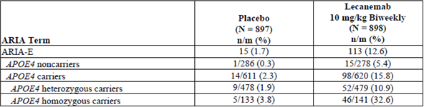
ARIA-H was reported in 155 (17.3%) of subjects in the lecanemab group and 81 (9.0%) subjects in the placebo group, with a higher incidence in ApoE ε4 carriers compared to non-carriers, and highest in ApoE ε4 homozygotes (Table 16). Most treatment-emergent ARIA-H events were asymptomatic and radiographically mild to moderate. Most cases of ARIA-H were rated as ongoing at the conclusion of the studies, reflecting that imaging abnormalities may remain visible for years after the event because of the deposition of haemosiderin. Cerebral haemorrhage (macrohaemorrhage) occurred infrequently, but at a numerically higher rate in lecanemab recipients than placebo recipients (Table 17).
Table 17. Treatment-Emergent ARIA-H – Study 301 Core Study (Safety Analysis Set)
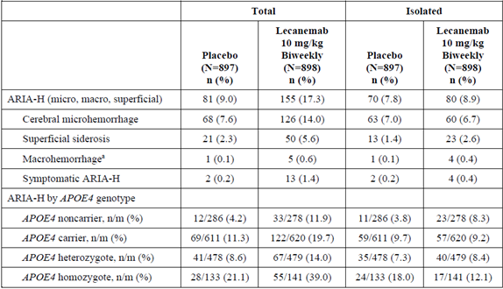
ARIA-H = amyloid-related imaging abnormality-haemorrhage. a: Incidence in this table is presented for TEAEs; considering not treatment emergent events, in Study 301 Core, the subtype of macrohaemorrhage (including not treatment emergent events) occurred in 2/897 subjects with PBO (0.2%) and 6/898 subjects with LEC10-BW (0.7%). Source: Table 17, SCS.
Subjects receiving antiplatelet agents or anticoagulants were not excluded from the study, so the safety evaluation assessed ARIA risk based on anticoagulant and antiplatelet therapy (Table 18). Treatment with lecanemab was associated with an increased risk of ARIA, but the risk of ARIA was not impacted by the use of antiplatelet agents or anticoagulants. The risk of macrohaemorrhage was slightly higher when lecanemab was used with anticoagulant treatment compared to no anticoagulant treatment, but this should be interpreted with caution due to the small number of events.
Table 18. ARIA Incidence by use of Antiplatelet or Anticoagulant Therapy – Study 301 Core (Safety Analysis Set)
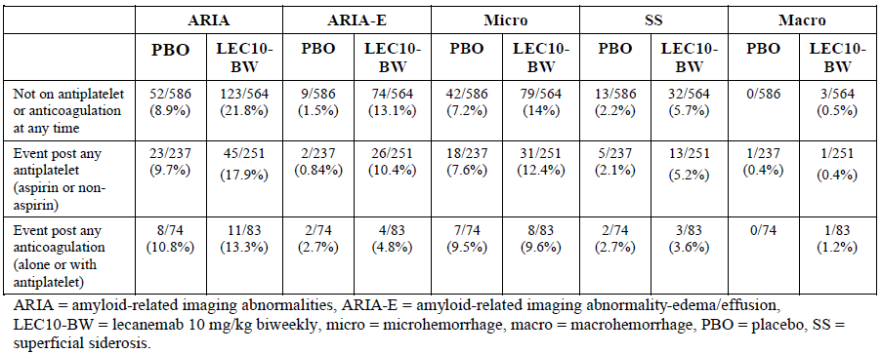
TEAEs of atrial fibrillation were reported in 2.7% of subjects in the lecanemab group versus 1.6% in the placebo group. An increased incidence of TEAE of atrial fibrillation was also observed in Study 201 Core (4% of LEC10-BW subjects versus 1% placebo). There is no known mechanism that would explain the observed increase in atrial fibrillation, but given the imbalance in the incidence of atrial fibrillation across both studies, atrial fibrillation was classified as an adverse drug reaction.
Assessment of TEAEs as adverse drug reactions was based on an excess incidence in the lecanemab relative to placebo, investigator opinion about the likelihood of causality and the exclusion of other potential causes, and an appropriate temporal relationship. The following TEAEs have been classified as adverse drug reactions: infusion-related reaction, ARIA-H, ARIA-E, headache, superficial siderosis of CNS, and atrial fibrillation.
TEAEs leading to study drug dose interruption were largely due to ARIA-E, ARIA-H, and infusion related-reactions. In Study 301 Core, the most frequently reported TEAEs leading to study drug dose interruption in the LEC10-BW group were ARIA-E (LEC10-BW 70 subjects [7.8%] vs PBO 6 [0.7]), ARIA-H (LEC10-BW 35 subjects [3.9%] vs PBO 4 [0.4%]), infusion-related reaction (LEC10-BW 13 subjects [1.4%] vs PBO 6 [0.7%]), and superficial siderosis of CNS (LEC10-BW 13 subjects [1.4%] vs PBO 2 [0.2%]). In Study 301 Core, the most frequently reported TEAEs leading to discontinuation of study drug in the LEC10-BW group were ARIA-H (LEC10-BW 15 subjects [1.7%] vs PBO 1 [0.1%]), ARIA-E (14 subjects [1.6%] vs PBO 0), infusion-related reaction (LEC10-BW 12 subjects [1.4%] vs PBO 1 [0.1%]).
Serious TEAEs (SAEs) reported in ≥3 subjects in the lecanemab group are shown in Table 19.
Table 19. Treatment-Emergent Serious Adverse Events Occurring in ≥3 Subjects in the lecanemab group – Study 301 Core (Safety Analysis Set)
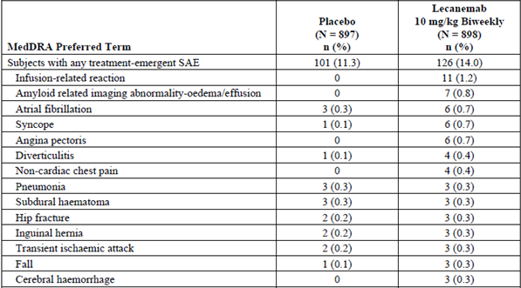
30 subjects died in the reporting period for this submission (up to 13 Sep 2022 for Study 301 Core and 15 Apr 2022 for ongoing studies), including 13 treatment-emergent deaths in Study 301 Core occurring at a similar rate in the two treatment groups (PBO 7 [0.8%] and LEC10-BW 6 [0.7%]). All deaths were assessed as not related to study drug except for a single subject in Study 201 Core who received the lowest dose of lecanemab (LEC2.5-BW). Autopsy revealed a high-grade infiltrating astrocytic neoplasm seen in the left anterior temporal lobe which showed necrosis and microvascular proliferation, indicating the pathological diagnosis of glioblastoma (WHO Grade IV). There is no other evidence that lecanemab is associated with an increased risk of brain neoplasms or other malignancies.
Two further deaths in Study 301 OLE occurred outside the data cut-off, both involving cerebral haemorrhage. In both cases, alternative or additional explanations for haemorrhage were present (tPA in one case; aspirin, apixaban and heparin in the other case), but this does not rule out a contributory role from lecanemab, particularly given the demonstrated association with ARIA. Another death associated with severe ARIA-E and ARIA-H (cerebral haemorrhage) and linked to lecanemab was published on 21 December 2022.
The safety evaluation of laboratory parameters and ECG findings raised no substantial concerns.
Analyses of TEAEs by age showed that TEAEs were more common in subjects ≥65 years, but the differences between placebo and lecanemab were similar across age groups.
The incidence of treatment-emergent anti-drug antibodies (ADAs) and neutralising antibodies (Nabs) in the LEC10-BW group in Study 301 Core was 5.5% and 4.1%, respectively. The emergence of ADAs and NAbs was not associated with an excess of adverse events.
In the long-term OLE of the two efficacy studies, the types of TEAEs were similar to the core studies. In Study 301 OLE, the most common (>10%) TEAEs were: infusion-related reaction (24%), ARIA-H (12.8%) and ARIA-E (11.9%). In Study 201 OLE, the most common (>10%) TEAEs were: fall (22%), infusion-related reaction (21%), urinary tract infection (15%), ARIA-H (13.3%), and nasopharyngitis (10%). Interpretation of the frequency of TEAEs in open-label, uncontrolled studies is limited.

Other
Real world evidence was not evaluated in this submission. Patient reported outcomes, including quality of life measures, were evaluated as exploratory endpoints in the pivotal study.

Risk Management Plan (RMP) evaluation
The risk management plan for lecanemab is detailed in EU-RMP version 0.2 (dated 7 September 2023; DLP 13 September 2022) in association with ASA version 1.3 (dated 22 March 2024). The summary of safety concerns and the associated risk monitoring and mitigation strategies are outlined Table 20. Prescriber educational material is being developed and will be submitted to the TGA for review and approval prior to product launch. All other recommendations from the RMP evaluation have been addressed.
Table 20 Summary of Safety Concerns
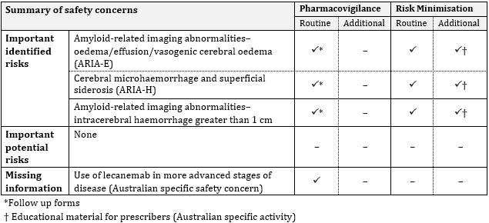

RMP Evaluator recommendations regarding conditions of registration
- The Leqembi EU-Risk Management Plan (RMP) (version 0.2, dated 7 September 2023, data lock point 13 September 2022), with Australian Specific Annex (version 1.3, dated 22 March 2024), included with submission PM-2023-02164-1-1, and any subsequent revisions, as agreed with the TGA will be implemented in Australia.
- An obligatory component of risk management plans is routine pharmacovigilance. Routine pharmacovigilance includes the submission of periodic safety update reports (PSURs).
Unless agreed separately between the supplier who is the recipient of the approval and the TGA, the first report must be submitted to TGA no later than 15 calendar months after the date of this approval letter. The subsequent reports must be submitted no less frequently than annually from the date of the first submitted report until the period covered by such reports is not less than three years from the date of this approval letter. The annual submission may be made up of two PSURs each covering six months. If the Sponsor wishes, the six-monthly reports may be submitted separately as they become available.
If the product is approved in the EU during the three years period, reports can be provided in line with the published list of EU reference dates no less frequently than annually from the date of the first submitted report until the period covered by such reports is not less than three years from the date of this approval letter.
The reports are to at least meet the requirements for PSURs as described in the European Medicines Agency’s Guideline on good pharmacovigilance practices (GVP) Module VII-periodic safety update report (Rev 1), Part VII.B Structures and processes. Note that submission of a PSUR does not constitute an application to vary the registration. Each report must be submitted within ninety calendar days of the data lock point for that report.
- Leqembi (lecanemab) is to be included in the Black Triangle Scheme. The PI and CMI for Leqembi must include the black triangle symbol and mandatory accompanying text for five years, which starts from the date of first supply of the product.

Discussion

Efficacy
The evidence of efficacy of lecanemab in the proposed indication rests largely on a single pivotal study, Study 301, which used a randomised, placebo-controlled, parallel-group design to compare the efficacy and safety of lecanemab at the proposed dose (10 mg/kg by IV infusion every two weeks) versus placebo in 1795 patients with Early Alzheimer’s Disease (EAD), 62% of whom had mild cognitive impairment (MCI) and 38% had mild dementia. The target population was well defined, and matches the proposed indication. The study used an accepted and appropriate measure of cognition (the Clinical Dementia Rating-Sum of Boxes (CDR-SB) score) as the primary endpoint at 18 months, and other accepted measures of cognition and functional status as key secondary endpoints. Change in brain amyloid levels as measured by amyloid PET using Centiloids at 18 months as also assessed as a key secondary endpoint. The study also explored a large range of other biomarker endpoints and Quality of Life measures.
Study 301 met its primary and all key secondary endpoints. Compared to placebo, lecanemab 10 mg/kg two-weekly slowed the decline on all of the key clinical measures: CDR-SB, ADAS-Cog14, ADCOMS, and ADCS MCI-ADL. For each of these measures, a statistically significant treatment effect was apparent at 6 months of treatment and this became more pronounced by the primary efficacy timepoint, 18 months. The difference between placebo and lecanemab was highly statistically significant for all key measures of clinical efficacy at 18 months. Compared with placebo, lecanemab was associated with a 27.1% reduction in clinical decline as measured by CDR-SB (P=0.00005), a 25.8% reduction in clinical decline as measured by ADAS-Cog14 (P<0.00065), a 23.5% reduction in clinical decline as measured by ADCOMS (P=0.00002), and a 36.6% reduction in clinical decline as measured by ADCS MCI-ADL (P<0.00001). These findings were statistically strong, and the observed treatment effect was consistent across the primary and key secondary endpoints, providing strong support for the internal validity of the study. The clinical findings were associated with a highly statistically significant reduction in brain amyloid burden as measured by amyloid PET using Centiloids at 18 months, with a statistically significant difference apparent from 3 months and the absolute treatment difference increasing over time to 18 months.
An important consideration in the evaluation of efficacy was the magnitude of the treatment effect and the clinical relevance of the benefit to patients and carers. In Study 301, the adjusted mean change from baseline in CDR-SB score at 18 months was 1.66 in the placebo group and 1.21 in the lecanemab group, a treatment difference of -0.45. The median CDR-SB score at baseline was 3.0. The evaluation noted that the observed treatment difference for CDR-SB was less than the MCID of 1-2 points reported by Andrews et. al., 2019; however, the Sponsor emphasised that MCIDs are based on within-patient changes that require change in management, and should not be applied to group-level treatment differences in clinical trials. An exploratory analysis of the rate of change of CDR-SB over time showed that the decline in CDR-SB observed in lecanemab subjects at 18 months was reached by placebo subjects ∼5.3 months earlier, providing an estimate of the impact of lecanemab in delaying the progression of cognitive decline over the course of the study. The hazard ratio of disease progression on the global CDR score (defined as time from randomisation to the first worsening where there is an increase from baseline by at least 0.5 points on the global CDR score in 2 consecutive visits) was 0.69, indicating a 31% reduction in the risk of progression on global CDR score with lecanemab compared to placebo (pre-specified exploratory analysis). Whilst the absolute magnitude of the treatment effect over 18 months was small, the evaluation concluded that the demonstrated reduction in the progression of cognitive and functional decline is likely to be viewed by clinicians, patients, and carers as clinically meaningful.
The assessment of efficacy is based largely on the single pivotal study as the supportive Phase 2 study did not meet its primary endpoint. Study 201 was primarily designed as a dose-ranging study and used a Bayesian adaptive randomisation approach to increase subject randomisation to the most promising dose group, based on frequent interim analyses. Study 201 identified lecanemab 10 mg/kg two-weekly as the most effective dose, but failed to meet its primary endpoint based on Bayesian analysis of change from Baseline in ADCOMS at 12 months. The probability of the 10 mg/kg two-weekly dose achieving a clinically significant difference (defined as a 25% reduction in the rate of decline relative to placebo) at 12 months was 64%, which missed the pre-specified 80% threshold for success. Despite failing to meet the primary endpoint, conventional analyses of superiority suggested a benefit with lecanemab 10 mg/kg two-weekly compared to placebo, and findings for the key clinical endpoints were generally of a magnitude similar to that observed in the subsequent pivotal study, even where nominal statistical significance was not achieved. Given that Study 201 was negative for its primary endpoint, it does not provide independent evidence of the efficacy of lecanemab but it did inform dose selection for the pivotal study and provides some support to the pivotal study in terms of the direction and magnitude of changes in key clinical endpoints and biomarkers.

Safety
The presented safety dataset is of adequate size and duration to characterise the safety of lecanemab for the purpose of registration in the proposed indication, noting that safety will continue to be monitored in line with the pharmacovigilance plan described in the risk management plan.
Treatment with monoclonal antibodies directed against Aβ has been shown to be associated with ARIA-E and ARIA-H, so this was a key focus of the safety evaluation. ARIA-E and ARIA-H are imaging abnormalities which reflect pathophysiological processes in the brain associated with therapies targeting Aβ. The pathophysiology of ARIA is not fully understood but it is thought to be related to amyloid angiopathy and treatment-related disruption to vessel integrity (immune inflammatory response). There remains some uncertainty regarding long-term clinical consequences of ARIA-E and ARIA-H, particularly on cognition and functioning. In the lecanemab clinical studies, ARIA-H was assessed on the basis of the MedDRA Preferred Term (amyloid related imaging abnormality – microhemorrhage and hemosiderin deposit), and cerebral haemorrhage (macrohaemorrhage) was assessed separately.
Study 301 provides the largest safety dataset for the proposed use balanced for randomisation strata, so was the key focus of the safety evaluation. In Study 301 Core, TEAEs were reported in 88.9% of subjects in the LEC10-BW arm and 81.9% of subjects in the placebo arm. Treatment-related TEAEs, TEAEs leading to dose interruption, TEAEs leading to study drug withdrawal, and TEAEs of special interest were notably higher in the lecanemab group than placebo. Treatment with lecanemab was associated with a substantial excess of infusion-related reactions, ARIA-E, and ARIA-H compared to placebo. TEAEs classified as adverse drug reactions include infusion-related reaction, ARIA-H, ARIA-E, headache, superficial siderosis of CNS, and atrial fibrillation.
In Study 301 Core, ARIA-E and ARIA-H were reported in 113 (12.6%) and 155 (17.3%) subjects, respectively, in the LEC10-BW group and 15 (1.7%) and 81 (9.0%) subjects, respectively, in the placebo group. The risk of ARIA was highest in ApoE ε4 homozygotes. Concurrent use of antithrombotic agents or anticoagulants did not influence the risk of ARIA. Most of the ARIA events reported in the pivotal study were mild or moderate radiographic severity and asymptomatic, but 1.0% of subjects in the lecanemab arm of Study 301 had radiographically severe ARIA-E and 2.8% had symptomatic ARIA-E. ARIA mostly appeared within three months of starting treatment with lecanemab. Dose interruption and treatment discontinuation criteria were used to manage the risk of ARIA. In the lecanemab group, 7.8% and 3.9% of subjects had dose interruption due to ARIA-E and ARIA-H, respectively, and 1.6% and 1.7% discontinued study treatment due to ARIA-E and ARIA-H, respectively. The proposed guidance in the Product Information regarding dose interruption or discontinuation for ARIA-E and ARIA-H is based on experience from the pivotal study.
Cerebral haemorrhage (macrohaemorrhage) occurred infrequently, but at a numerically higher rate in the lecanemab group compared to placebo. Two deaths associated with cerebral haemorrhage were reported in Study 301 OLE, and a further death associated with severe ARIA-E and ARIA-H (cerebral haemorrhage) has been reported in published literature. Cerebral haemorrhage is classified as an important identified risk in the EU-RMP/ASA and the risk of cerebral haemorrhage is addressed as a precaution in section 4.4 of the Product Information. Cerebral haemorrhage has not been classified as an adverse drug reaction despite an imbalance in reported events (albeit small numbers) and a plausible link to causality in the setting of established risks of ARIA-E and ARIA-H. The clinical Evaluator advised that the safety data support cerebral haemorrhage being classified as an adverse drug reaction, and I support that position.

Uncertainties and limitations of the data
The pathogenesis of AD is not yet fully elucidated. Accumulation of Aβ plaques in the brain is a defining pathophysiological feature of Alzheimer’s disease, but there remains uncertainty regarding the degree to which Aβ deposition and other pathologic processes contribute to the disease process.
The assessment of efficacy is based largely on one pivotal study, Study 301. The supportive Phase 2 dose-ranging Study 201 identified lecanemab 10 mg/kg two-weekly as the most effective dose, but failed to meet its primary endpoint based on Bayesian analysis of change from Baseline in ADCOMS at 12 months. Other findings from the Phase 2 study provide some support for the pivotal study.
The pivotal study demonstrated significant reductions in the rate of cognitive and functional decline with lecanemab compared to placebo in patients with Early Alzheimer’s Disease, but patients in both treatment arms still experienced progression in cognitive and functional decline over the course of the study. The findings from the study indicate that progression in cognitive and functional decline is expected in patients treated with lecanemab, albeit at a slower rate than untreated patients. The benefit-risk balance for lecanemab is expected to become less favourable as cognition and functional status progressively decline. Clinicians, patients, and medical decision-makers will need to manage uncertainties regarding the benefits and risks, and the timing of stopping treatment, in the setting of disease progression.
As with other monoclonal antibodies targeting Aβ, treatment with lecanemab is associated with ARIA-E and ARIA-H. There remains uncertainty regarding long-term clinical consequences of ARIA-E and ARIA-H, particularly with regard to cognition and functioning.
The safety profile is less favourable for ApoE ε4 homozygotes, as there is a correlation between ARIA and ApoE ε4 carrier status, with the highest rates of ARIA observed in ApoE ε4 homozygotes. This is addressed in a precaution in the Product Information, including a recommendation that testing of APOE4 status should be performed prior to initiation of treatment to inform the risk of developing ARIA. From an efficacy perspective, subgroup analyses in the pivotal study showed a trend to greater benefit in ApoE ε4 non-carriers compared to carriers, and a subgroup analysis of the primary endpoint in ApoE ε4 homozygotes favoured placebo over lecanemab, whereas results for ADAS-Cog 14, ADCS MCI-ADL numerically favoured lecanemab. These subgroup findings may reflect the limitations of analyses within small subsets. With the increased risk of ARIA, there is greater uncertainty regarding the benefit-risk in ApoE ε4 homozygotes.
The treatment and monitoring regimen presents a considerable burden for patients with EAD. Lecanemab is administered by intravenous infusion over approximately one hour every two weeks. Treatment with lecanemab requires frequent clinical monitoring and brain imaging, particularly in the early months of treatment. The Product Information recommends enhanced clinical vigilance during the first 14 weeks of treatment and brain MRI prior to the 5th, 7th, and 14th infusions, plus additional brain MRI if clinically indicated. The burden of treatment and monitoring would be particularly challenging in rural and remote settings. The burden of treatment and clinical monitoring should be considered by physicians, patients, carers and medical decision-makers, in addition to the direct benefits and risks of treatment.
Subjects with significant coexistent cerebrovascular disease or other risk factors for cerebral haemorrhage were excluded from the pivotal study, so there is uncertainty regarding the efficacy and safety of lecanemab in this population at higher risk of cerebrovascular events. There is uncertainty regarding the safety of thrombolytic therapy in patients receiving lecanemab given the identified risks of ARIA-E, ARIA-H, and cerebral haemorrhage. The clinical Evaluator advises against the use of lecanemab in patients with mixed AD and vascular dementia or patients with AD plus a history of stroke or significant cerebral haemorrhage. The Product Information contains precautions for patients with risk factors for cerebral haemorrhage. Advice is sought from ACM regarding specific guidance advising against the use of lecanemab in patients with significant cerebrovascular disease.
Concomitant use of antiplatelet agents or anticoagulants did not appear to increase the risk of ARIA-E or ARIA-H. The risk of cerebral haemorrhage was slightly higher when lecanemab was used with anticoagulant treatment compared to no anticoagulant treatment, but this was based on a very small number of events. The Product Information contains precautions regarding use of anticoagulants.

Conclusion
The benefit-risk for lecanemab in the proposed indication is finely balanced. The pivotal study demonstrated significant clinical benefit compared to placebo in reducing the rate of cognitive and functional decline in patients with EAD. This benefit was consistent across all of the key clinical efficacy endpoints and the findings were statistically robust. The magnitude of the benefit compared to placebo was small, but in the Delegate’s view, it is likely to be considered clinically meaningful by patients and clinicians. However, this benefit needs to be considered in the context of important safety risks, particularly ARIA-E, ARIA-H, and cerebral haemorrhage.
ARIA occurs mostly in the early months of treatment. Most cases of ARIA are expected to be mild, asymptomatic, and manageable, but some cases will be symptomatic and some cases will require interruption or discontinuation of treatment. There remains some uncertainty regarding long-term clinical consequences of ARIA-E and ARIA-H, particularly on cognition and functioning. There is a strong correlation between ApoE ε4 carrier status and risk of ARIA, with the highest rate of ARIA observed in ApoE ε4 homozygotes. Testing of ApoE ε4 carrier status is recommended prior to initiation of treatment to inform the risk of developing ARIA.
The number of cerebral haemorrhages (macrohaemorrhage) across the clinical study program was small but there was an imbalance between the lecanemab and placebo groups, and there is plausible causality given the established risks of ARIA-E and ARIA-H. The risk of cerebral haemorrhage may be increased in patients taking anticoagulants. Cerebral haemorrhage is a concerning safety risk which can have serious health consequences for patients in terms of mortality, cognition, and functioning. The safety data support cerebral haemorrhage being classified as an adverse drug reaction.
The proposed treatment and monitoring regimen presents a substantial treatment burden for patients with EAD, with two-weekly intravenous infusions plus regular clinical review and MRI imaging, particularly in the early months of treatment. Individual patients will likely have different perspectives regarding the intensity of treatment and the risks that they are prepared to accept for the demonstrated clinical benefit. As such, treating physicians, patients, carers, and medical decision-makers will need to consider the benefits and risks on an individualised basis. Some patients with EAD may view the treatment as too onerous and/or associated with excessive risk, whereas other patients would be willing to accept the treatment and its associated risks to delay the progression of the disease and the associated loss of functional independence.
The safety risks are critical considerations for patients contemplating treatment with lecanemab. As such, the Product Information and the Consumer Medicine Information require stronger messaging in the form of a boxed warning describing the risks of ARIA-E, ARIA-H, and cerebral haemorrhage to ensure that clinicians, patients, carers, and medical decision-makers are well informed of the safety risks.

Recommendation following the clinical evaluation
The Delegate sought expert advice from ACM prior to making a decision on this application. The preliminary view of the Delegate was that the overall benefit-risk was favourable provided that treatment decisions were based on careful consideration of the individual circumstances of the patient, the expected benefits, and the safety risks. Communication of the key safety risks in the Product Information and Consumer Medicine Information required strengthening to support informed decision-making.

Risk-benefit analysis

Advisory Committee considerations – June 2024
The Advisory Committee on Medicines (ACM) having considered the evaluations and the Delegate’s overview, as well as the Sponsor’s response to these documents, advised the following.
- What is the committee’s perspective on the clinical benefit demonstrated in the pivotal study?
The ACM noted that there is evidence of a statistically significant reduction in amyloid-β plaques.
The ACM noted there is evidence of a small positive effect on the clinical course of the disease. The ACM considered whether the trial achieved a minimally clinically important difference (MCID) and if the 18-month outcomes were clinically meaningful. The ACM noted that while there are diverse views on what constitutes a clinically meaningful change, the ACM did not view the treatment difference to be clinically meaningful. Patients on lecanemab and placebo showed decline at all time-points and no patient showed an improvement in their condition.
Until further data become available from the open-label extension trial, it is unknown whether the small effect seen at 18 months represents the full effect of Leqembi or if a slower rate of deterioration will be maintained.
The ACM noted that in published subgroup analysis there was less beneficial effect in women. This gender difference is unexplained. As women comprise the majority of patients with Alzheimer’s disease this finding requires further research.
While Leqembi does modify brain pathology, this does not amount to a ‘disease modifying treatment’.
The ACM noted that from the approximately 6000 people screened for potential inclusion in the trial, at randomisation (following application of inclusion and exclusion criteria) approximately 1800 patients were randomised to the 2 treatment groups. That is, the majority of persons screened for potential involvement in the trial were determined to be ineligible due to either 1) the subject not having MCI due to AD or mild AD and 2) the subject not being amyloid positive.
- What is the committee’s advice regarding the clinical implications of ARIA-E and ARIA-H, and the impact on the overall benefit-risk?
The ACM noted that the proposed Product Information includes a boxed warning on amyloid related imaging abnormalities (ARIA) indicating that the use of Leqembi comes with significant risk of harm. However, clinical harm may not be as high as the ARIA event rate as the majority of cases of ARIA-E and ARIA-H will be expected to be asymptomatic or have minimal symptoms. The burden of surveillance imaging will be high, with a minimum of 3 MRI in the first 14 weeks of treatment.
ARIA can be fatal and the long-term impact of an ARIA event is unknown; these points should be included in the boxed warning.
Accelerated changes to brain volume, termed pseudoatrophy, occur with anti-amyloid therapies including lecanemab. The volume of pseudoatrophy is strongly correlated with ARIA frequency. The ACM advised that the assessment score post ARIA does not provide reassurance on the absence of long-term impact following the ARIA event.
- What is the committee’s advice regarding the risk of cerebral haemorrhage with lecanemab, and the impact on the overall benefit-risk?
The number of cerebral haemorrhages (macrohaemorrhages) across the clinical study program was small but not balanced (in core Study 301, in 2/897 (0.2%) placebo recipients and 6/898 (0.7%) lecanemab recipients). The impact of cerebral haemorrhage is significant in people with minimal functional impairment: at baseline, 80.7% of participants had a global Clinical Dementia Rating (CDR) score of 0.5, indicative of minimal impairment.
The safety of administration of stroke thrombolysis should be discussed in the PI.
A requirement for baseline platelet count should be included in the PI, as people with low platelet count were excluded from the pivotal trial.
The ACM also noted that atrial fibrillation is a common adverse event (2.7% in Leqembi group compared to 1.6% in placebo group), as well as a comorbidity that increases with age. There will need to be clear clinical guidance on use of Leqembi and/or anticoagulation in these populations.
- What is the committee’s perspective on the adequacy of the warnings and precautions in the Product Information?
The ACM advised that the current draft PI is inadequate, as it should give greater emphasis to the potential for severe and fatal ARIA events. The proposed boxed warning on ARIA should also specify that ARIA-H refers to microhaemorrhage as well as haemosiderin deposition.
The ACM highlighted that while seizure can be part of the course of AD, the pivotal study had excluded persons who had had a seizure within 12 months of screening. The ACM advised the PI should include a warning on the absence of data for patients with seizure history.
The PI advised the use of clinical judgement in considering whether to continue treatment after radiographic stabilisation and resolution of symptoms or permanently discontinue Leqembi. The ongoing trial may provide further information on this.
- What is the committee’s advice regarding including additional guidance in the Product Information advising against the use of lecanemab in patients with evidence of significant cerebrovascular disease?
The ACM noted that patients with vascular/mixed dementia, previous intracranial haemorrhage, stroke/TIA in previous 12 months, multiple lacunar infarcts, severe small vessel disease, and stroke involving major vascular territory had been excluded from the trials. There are no data on this group of people to describe their risk and so Leqembi should be used with caution.
Leqembi should not be used in Cerebral Amyloid Angiopathy or Amyloid-Beta–related Angiitis (ABRA) due to risk of bleeding.
The ‘additional caution’ regarding administration of anticoagulants or a thrombolytic agent (e.g., tissue plasminogen activator) to a patient already being treated with Leqembi should be strengthened. The implications for stroke management are concerning.
- What is the committee’s perspective on the proposed guidance regarding ApoE ε4 carriers and risk of ARIA?
The ACM noted the competing influences on this benefit-risk assessment: there will be a desire to treat these patients as the presence of ApoE ε4 has been identified as conferring higher risk of Alzheimer’s disease with earlier onset and faster progression, while both homozygous and heterozygous ApoE ε4 carriers have higher incidences of ARIA events.
Subgroup analyses showed a trend to lesser benefit in ApoE ε4 carriers compared to non-carriers: in homozygous carriers the adjusted mean difference was 0.28 in favour of placebo.
For patients receiving Leqembi, there was a higher incidence of ARIA-E in ApoE carriers compared to non-carriers (15.8% vs 5.4%) and in homozygous carriers compared to heterozygous carriers (32.6% vs 10.9%). The boxed warning regarding homozygous carriers should be extended to heterozygous carriers.

ACM Conclusion - June 2024
The proposed indication considered by the ACM was:
Leqembi is indicated for the treatment of patients with Mild Cognitive Impairment (MCI) due to Alzheimer’s disease and Mild Alzheimer’s dementia (Early Alzheimer’s disease).
The ACM advised that Leqembi had an overall negative benefit-risk profile for the proposed indication as the evidence submitted did not satisfactorily establish the efficacy and safety of the product. In providing this advice the ACM cited the lack of clinically meaningful efficacy and the safety concerns related to amyloid related imaging abnormalities (ARIA), the long-term effects of which are unclear.
If the medicine is approved, as proposed by the Delegate:
- the proposed Product Information should be revised regarding potential adverse events including cerebral haemorrhage, safety of stroke thrombolysis, use in patients with bleeding disorders or on anticoagulants or antithrombotic agents, use in patients with seizure history, use in patients who are heterozygous carriers of ApoE ε4, and use in women.
- the Consumer Medicine Information should provide appropriate information on the administration of the medicine.

Advisory Committee considerations – June 2024 – Sponsor response
The Sponsor provided responses to the ACM Minutes on 21 June 2024 that included additional responder analyses and a summary of data from the open-label extension of the pivotal study 301.
All patients from Study 301 who transitioned to the OLE received open-label lecanemab. Patients who received placebo in the main study appeared to track on a similar trajectory in the OLE to patients who received lecanemab in the main study (Figure 22). A pre-specified matched observational cohort from the Alzheimer’s Disease Neuroimaging Initiative (ADNI) was used to provide context regarding disease progression as measured by CDR-SB. These data suggest increasing separation in adjusted mean change in CDR-SB from baseline for OLE patients compared to the ADNI cohort over the 18 months of the OLE study. However, this needs to be viewed in the context of known limitations in interpreting efficacy outcomes in OLE data without a randomised control group.
Figure 22. Adjusted Mean Change (±SE) from Baseline in CDR-SB in Context of Observational Cohort Through 36 Months – Study 301 Core and OLE (ITT FAS+)
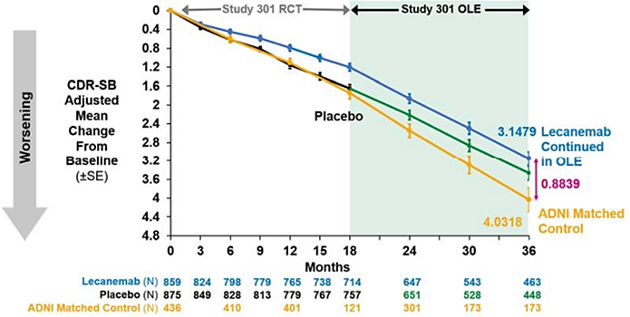

Advisory Committee considerations – August 2024
- What is the committee’s perspective on the additional data and the extent to which it informs the benefit-risk assessment?
The ACM’s view is that the Minimal Clinically Important Difference (MCID) of the primary outcome is an appropriate measure. MCID is an indicative measure to interpret the magnitude of a change/difference.
The ACM’s view is that responder, time to event (worsening) and time saved analyses are not yet standard approaches in dementia research. The ACM also noted the expectation in the relevant EMA guidance that definitions should be pre-specified in the protocol and should be clinically convincing.
The ACM noted that there is no information on whether the putative ‘delayed progression’ is enduring.
The seriousness of amyloid related imaging abnormalities (ARIA) should be considered in the context of the small beneficial effect.

ACM conclusion – August 2024
The proposed indication considered by the ACM was:
Lecanemab is indicated for the treatment of patients with Mild Cognitive Impairment (MCI) due to Alzheimer’s disease and Mild Alzheimer’s dementia (Early Alzheimer’s disease)
The ACM reiterated its previous advice that Leqembi had an overall negative benefit-risk profile for the proposed indication as the evidence submitted did not satisfactorily establish the efficacy and safety of the product. In providing this advice the ACM advised that while the additional preliminary data suggests lecanemab slows down to a modest extent, but does not halt, the patient’s deterioration with MCI or mild dementia, there remains a lack of clinically meaningful efficacy outcomes. The safety concerns related to amyloid related imaging abnormalities (ARIA), the long-term effects of which are unclear, in a population with minimal symptoms outweigh any modest benefit.

Delegate’s Assessment post-ACM
In the Delegate’s Overview for the June ACM, the view was presented that the benefit-risk for lecanemab in the proposed indication was finely balanced, and that the treatment benefit with lecanemab was small but was likely to be viewed as clinically meaningful by patients and clinicians. The Delegate reflected on the submitted dataset in the context of the advice from ACM 045 on 6 June 2024, the subsequent responses from the Sponsor submitted on 21 June 2024 and 13 July 2024, and the subsequent advice from ACM 046 on 2 August 2024.
A key issue in this application has been the magnitude of the treatment effect and the clinical meaningfulness of that effect. A statistically significant treatment effect was demonstrated across all key clinical efficacy measures; however, the treatment effect relative to placebo was small and the advice from ACM was that the observed treatment effect is not clinically meaningful. For the primary endpoint based on CDR-SB, the ACM considered that the treatment difference of -0.45 at 18 months was not clinically meaningful, particularly when viewed in the context of the MCID reported in another study (-0.98 for patients with MCI and -1.63 for patients with mild dementia). Similarly, ACM advised that the treatment effect as measured by ADAS-Cog was not clinically meaningful.
The dataset included responder analyses showing that the decline in CDR-SB observed in lecanemab subjects at 18 months was reached by placebo subjects ∼5.3 months earlier, and that the hazard ratio of disease progression on the global CDR score (defined as an increase from baseline by at least 0.5 points on the global CDR score in 2 consecutive visits) was 0.69. The ACM did not accept that the demonstrated difference in decline over 18 months was clinically meaningful, and highlighted uncertainty as to whether this difference would increase, decrease, or be maintained with ongoing treatment beyond 18 months. The ACM highlighted that the small magnitude of treatment effect is of particular concern in the context of important identified safety risks including ARIA-E, ARIA-H, and cerebral haemorrhage (macrohaemorrhage). The effect of ARIA on the course of the disease remains unknown.
In response to the ratified minute of the June ACM, the Sponsor referenced a 13 June 2024 publication by the EU-US CTAD Task Force advising that MCID thresholds are not intended to inform the required magnitude or evaluate the meaningfulness of between-group differences in mean change from baseline. ACM commented further on the issue of MCID on 2 August 2024, taking into account the published views on MCID, and reaffirmed the advice that the MCID is an important consideration in interpreting the clinical relevance and meaningfulness of the treatment effect.
The Delegate acknowledged the contention regarding the use of the MCID to define the meaningfulness of between-group differences. In the pivotal study, the mean treatment difference in CDR-SB at 18 months of -0.45 was notably smaller than the published MCID for patients with MCI and mild dementia. The Delegate found the advice of the ACM more persuasive on this issue and formed the view that the magnitude of the demonstrated treatment effect on the primary endpoint was not clinically meaningful.
The Delegate reviewed the additional data submitted on 13 July 2024 and considered advice from the ACM regarding that data. The additional data included a further presentation of responder analyses, summary of findings from the low tau PET substudy, and summary of findings from the 18-month open-label extension of Study 301. The additional responder analyses and the low tau PET substudy are exploratory findings and the Delegate concluded that that they are not sufficiently compelling to overcome the concern regarding the magnitude of the treatment effect in the pivotal efficacy data.
All patients from Study 301 who transitioned to the OLE received open-label lecanemab. With regard to CDR-SB (the primary endpoint in the pivotal study), patients who received placebo in the core study appeared to track on a similar trajectory in the OLE to patients who received lecanemab in the core study (Figure 22). For the group that received lecanemab in the core study, the slope appears to become steeper (indicating worsening decline) from 18 months. A pre-specified matched observational cohort from the Alzheimer’s Disease Neuroimaging Initiative (ADNI) was used to provide context regarding disease progression as measured by CDR-SB. These data suggest increasing separation in adjusted mean change in CDR-SB from baseline for OLE patients compared to the ADNI cohort over the 18 months of the OLE study. However, this needs to be viewed in the context of known limitations in interpreting efficacy outcomes in OLE data without a randomised control group. All patients in the OLE received open-label lecanemab and there is a risk of bias arising from patients withdrawing from the study, with just over half of the original study population remaining in the study at 36 months.
At the August ACM meeting, the committee reaffirmed the advice that the efficacy and safety of lecanemab have not been satisfactorily established and lecanemab has an overall negative benefit-risk profile. The ACM advised that while the additional data suggests lecanemab slows down to a modest extent, but does not halt, the patient’s deterioration, there remains a lack of clinically meaningful efficacy outcomes. The safety concerns related to ARIA, the long-term effects of which are unclear, in a population with minimal symptoms outweigh any modest benefit.
From a safety perspective, important identified safety risks include ARIA-E, ARIA-H, and cerebral haemorrhage (macrohaemorrhage). The risk of ARIA is increased in APOE4 carriers, particularly homozygotes. The effect of ARIA on the course of the disease remains uncertain. Other uncertainties in the safety profile include patients with co-morbidities associated with increased risk of cerebrovascular disease, and patients requiring anticoagulation and/or thrombolysis.

Delegate’s Assessment post-ACM Conclusion
The Delegate reviewed their position on this application after considering expert advice from ACM on 6 June 2024, the subsequent responses from the Sponsor, and subsequent advice from ACM on 2 August 2024. The Delegate acknowledged that there are different opinions internationally regarding interpretation of MCID and the clinical benefit with lecanemab treatment, but ultimately, found the advice of ACM more persuasive with regard to the clinical meaningfulness of the demonstrated treatment effect and concluded that the demonstrated treatment effect is not of sufficient magnitude to be clinically meaningful. The small magnitude of treatment effect is of particular concern when viewed in the context of the identified safety risks of ARIA-E, ARIA-H and cerebral haemorrhage, and uncertainty regarding the long-term impact of ARIA. The Delegate was not satisfied that the additional data submitted following the June ACM meeting are sufficiently compelling to overcome these concerns and has decided not to approve the registration of lecanemab.

Outcome
Based on a review of quality, safety, and efficacy, the TGA decided NOT to register Leqembi for the following proposed indication:
“Leqembi is indicated as a disease modifying treatment in patients with Mild Cognitive Impairment (MCI) due to Alzheimer’s disease and Mild Alzheimer’s dementia (Early Alzheimer’s disease).”

Section 60 review
Following the initial decision to exclude Leqembi from the ARTG, the sponsor sought a review under the provisions of section 60 of the Act. During the 60-day timeframe of the reconsideration process, a number of additional proposals were put forward by the applicant. The quality, safety and efficacy of a medicine must be satisfactorily established for the purpose for which it is proposed to be used (as set out in the indication proposed by the Applicant and PI) in order for it to be registered.
After evaluation of the information provided, the Delegate found that neither safety nor efficacy are established for APOE4 homozygote carriers. Accordingly, the Delegate did not register the Medicine in respect to the First Alternative Indication, which includes APOE4 homozygous carriers.
While the Delegate found that efficacy is satisfactorily established for APOE4 heterozygous carriers, they were not satisfied that safety had been satisfactorily established due to the observed occurrence of ARIA-E, ARIA-H, and cerebral haemorrhage in that population. Accordingly, the Delegate did not register the Medicine in respect to the Second Alternative Indication, which includes APOE4 heterozygous carriers.
The Delegate found that both safety and efficacy are satisfactorily established for APOE4 noncarriers. In the course of the reconsideration of the initial decision, the Delegate proposed an alternative indication limited to APOE4 noncarriers, however, the Applicant indicated it is not willing to agree to seek an indication restricted to this population. The Applicant proposed that APOE4-heterozygotes and homozygotes should be treated in specialist centres and supervised by physicians with expertise in monitoring for ARIA. For the reasons outlined above, the Delegate was not satisfied that this wording would be specific enough to support clinicians and address the outstanding safety concerns for patients who are APOE4 heterozygous carriers, in addition to the efficacy concerns in patients who are APOE4 homozygote carriers.
As the delegate was not satisfied that the safety and efficacy of the Medicine has been satisfactorily established for the purposes for which it was proposed to be used, the Delegate made a decision to confirm the initial decision to refuse to register the Medicine.
The TGA’s decision to confirm the initial decision to not register the medicine is reviewable by the Administrative Review Tribunal pursuant to subsection 60(8) of the Act.

Administrative Review Tribunal
On 26 March 2025, the Sponsor applied to the Administrative Review Tribunal (ART) for review of the reconsideration decision. During the course of the ART dispute resolution process, the TGA received several additional submissions from the Sponsor focused on establishing the safety of the medicine in patients who are APOE4 heterozygous carriers. These submissions included new risk management proposals and updated Product Information designed to address the outstanding safety concerns raised by the TGA. After thorough review and detailed discussions with the Sponsor, the TGA determined that the additional submissions satisfactorily address the outstanding concerns regarding the safety of the Medicine. By consent of the parties, the ART made a decision to remit the matter back to the TGA on 11 September 2025. On 22 September 2025 the TGA made the decision to approve the registration of lecanemab (Leqembi).

Final outcome
Based on the updated information provided and review of quality, safety, and efficacy, the TGA decided to register Leqembi for the following proposed indication:
“Leqembi is indicated in adult patients with a diagnosis of mild cognitive impairment and mild dementia due to Alzheimer’s disease (Early Alzheimer’s disease) that are apolipoprotein E ε4 (ApoE ε4) non-carriers or heterozygotes.
Beta amyloid evidence consistent with Alzheimer’s disease (AD) should be confirmed using a validated test prior to initiating treatment.”
Therapeutic Goods Administration
PO Box 100 Woden ACT 2606 Australia
Email: info@tga.gov.au Phone: 1800 020 653 Fax: 02 6203 1605
https://www.tga.gov.au

Rizzuto D, Bellocco R, Kivipelto M, Clerici F, Wimo A, Fratiglioni L. Dementia after age 75: survival in different severity stages and years of life lost. Curr Alzheimer Res. 2012 Sep;9(7):795-800. doi: 10.2174/156720512802455421. PMID: 22299618.
Winblad B, Amouyel P, Andrieu S, Ballard C, Brayne C, Brodaty H, Cedazo-Minguez A, Dubois B, Edvardsson D, Feldman H, Fratiglioni L, Frisoni GB, Gauthier S, Georges J, Graff C, Iqbal K, Jessen F, Johansson G, Jönsson L, Kivipelto M, Knapp M, Mangialasche F, Melis R, Nordberg A, Rikkert MO, Qiu C, Sakmar TP, Scheltens P, Schneider LS, Sperling R, Tjernberg LO, Waldemar G, Wimo A, Zetterberg H. Defeating Alzheimer's disease and other dementias: a priority for European science and society. Lancet Neurol. 2016 Apr;15(5):455-532. doi: 10.1016/S1474-4422(16)00062-4. PMID: 26987701.
Australian Institute of health and Welfare. Prevalence of Dementia. Dementia in Australia. https://www.aihw.gov.au/reports/dementia/dementia-in-aus/contents/population-health-impacts-of-dementia/prevalence-of-dementia
Niu H, Álvarez-Álvarez I, Guillén-Grima F, Aguinaga-Ontoso I. Prevalence and incidence of Alzheimer's disease in Europe: A meta-analysis. Neurologia. 2017;32(8):523-532.
Qiu C, Kivipelto M, von Strauss E. Epidemiology of Alzheimer's disease: occurrence, determinants, and strategies toward intervention. Dialogues Clin Neurosci. 2009;11(2):111-28. doi: 10.31887/DCNS.2009.11.2/cqiu. PMID: 19585947; PMCID: PMC3181909.
GBD Dementia Collaborators. Global, regional, and national burden of Alzheimer's disease and other dementias, 1990-2016: a systematic analysis for the Global Burden of Disease Study 2016. The Lancet. Neurology. 2019;18(1), 88–106.
Vermunt L, Sikkes SAM, van den Hout A, Handels R, Bos I, van der Flier WM, Kern S, Ousset PJ, Maruff P, Skoog I, Verhey FRJ, Freund-Levi Y, Tsolaki M, Wallin ÅK, Olde Rikkert M, Soininen H, Spiru L, Zetterberg H, Blennow K, Scheltens P, Muniz-Terrera G, Visser PJ; Alzheimer Disease Neuroimaging Initiative; AIBL Research Group; ICTUS/DSA study groups. Duration of preclinical, prodromal, and dementia stages of Alzheimer's disease in relation to age, sex, and APOE genotype. Alzheimer’s Dement. 2019 Jul;15(7):888-898. doi: 10.1016/j.jalz.2019.04.001. Epub 2019 Jun 1. PMID: 31164314; PMCID: PMC6646097.
Hardy J, Selkoe DJ. The amyloid hypothesis of Alzheimer's disease: progress and problems on the road to therapeutics. Science. 2002 Jul 19;297(5580):353-6. doi: 10.1126/science.1072994. Erratum in: Science 2002 Sep 27;297(5590):2209. PMID: 12130773.
Is Alzheimer’s genetic? Alzheimer’s Association. https://www.alz.org/alzheimers-dementia/what-is-alzheimers/causes-and-risk-factors/genetics
Goate A, Chartier-Harlin MC, Mullan M, Brown J, Crawford F, Fidani L, Giuffra L, Haynes A, Irving N, James L, et al. Segregation of a missense mutation in the amyloid precursor protein gene with familial Alzheimer's disease. Nature. 1991 Feb 21;349(6311):704-6. doi: 10.1038/349704a0. PMID: 1671712.
Jonsson T, Atwal JK, Steinberg S, Snaedal J, Jonsson PV, Bjornsson S, Stefansson H, Sulem P, Gudbjartsson D, Maloney J, Hoyte K, Gustafson A, Liu Y, Lu Y, Bhangale T, Graham RR, Huttenlocher J, Bjornsdottir G, Andreassen OA, Jönsson EG, Palotie A, Behrens TW, Magnusson OT, Kong A, Thorsteinsdottir U, Watts RJ, Stefansson K. A mutation in APP protects against Alzheimer's disease and age-related cognitive decline. Nature. 2012 Aug 2;488(7409):96-9. doi: 10.1038/nature11283. PMID: 22801501.
Villemagne VL, Burnham S, Bourgeat P, Brown B, Ellis KA, Salvado O, Szoeke C, Macaulay SL, Martins R, Maruff P, Ames D, Rowe CC, Masters CL; Australian Imaging Biomarkers and Lifestyle (AIBL) Research Group. Amyloid β deposition, neurodegeneration, and cognitive decline in sporadic Alzheimer's disease: a prospective cohort study. Lancet Neurol. 2013 Apr;12(4):357-67. doi: 10.1016/S1474-4422(13)70044-9. Epub 2013 Mar 8. PMID: 23477989.
Vermunt L, Sikkes SAM, van den Hout A, Handels R, Bos I, van der Flier WM, Kern S, Ousset PJ, Maruff P, Skoog I, Verhey FRJ, Freund-Levi Y, Tsolaki M, Wallin ÅK, Olde Rikkert M, Soininen H, Spiru L, Zetterberg H, Blennow K, Scheltens P, Muniz-Terrera G, Visser PJ; Alzheimer Disease Neuroimaging Initiative; AIBL Research Group; ICTUS/DSA study groups. Duration of preclinical, prodromal, and dementia stages of Alzheimer's disease in relation to age, sex, and APOE genotype. Alzheimers Dement. 2019 Jul;15(7):888-898. doi: 10.1016/j.jalz.2019.04.001. Epub 2019 Jun 1. PMID: 31164314; PMCID: PMC6646097.
Koffie RM, Meyer-Luehmann M, Hashimoto T, Adams KW, Mielke ML, Garcia-Alloza M, Micheva KD, Smith SJ, Kim ML, Lee VM, Hyman BT, Spires-Jones TL. Oligomeric amyloid beta associates with postsynaptic densities and correlates with excitatory synapse loss near senile plaques. Proc Natl Acad Sci U S A. 2009 Mar 10;106(10):4012-7. doi: 10.1073/pnas.0811698106. Epub 2009 Feb 19. PMID: 19228947; PMCID: PMC2656196.
Kuchibhotla KV, Goldman ST, Lattarulo CR, Wu HY, Hyman BT, Bacskai BJ. Abeta plaques lead to aberrant regulation of calcium homeostasis in vivo resulting in structural and functional disruption of neuronal networks. Neuron. 2008 Jul 31;59(2):214-25. doi: 10.1016/j.neuron.2008.06.008. PMID: 18667150; PMCID: PMC2578820.
Meyer-Luehmann M, Spires-Jones TL, Prada C, Garcia-Alloza M, de Calignon A, Rozkalne A, Koenigsknecht-Talboo J, Holtzman DM, Bacskai BJ, Hyman BT. Rapid appearance and local toxicity of amyloid-beta plaques in a mouse model of Alzheimer's disease. Nature. 2008 Feb 7;451(7179):720-4. doi: 10.1038/nature06616. PMID: 18256671; PMCID: PMC3264491.
Benilova I, Karran E, De Strooper B. The toxic Aβ oligomer and Alzheimer's disease: an emperor in need of clothes. Nat Neurosci. 2012 Jan 29;15(3):349-57. doi: 10.1038/nn.3028. PMID: 22286176.
Kayed R, Lasagna-Reeves CA. Molecular mechanisms of amyloid oligomers toxicity. J Alzheimers Dis. 2013;33 Suppl 1:S67-78. doi: 10.3233/JAD-2012-129001. PMID: 22531422.
Frost GR, Jonas LA, Li YM. Friend, Foe or Both? Immune Activity in Alzheimer's Disease. Front Aging Neurosci. 2019 Dec 10;11:337. doi: 10.3389/fnagi.2019.00337. PMID: 31920620; PMCID: PMC6916654.
Selkoe DJ, Hardy J. The amyloid hypothesis of Alzheimer's disease at 25 years. EMBO Mol Med. 2016 Jun 1;8(6):595-608. doi: 10.15252/emmm.201606210. PMID: 27025652; PMCID: PMC4888851.
McGeer PL, Akiyama H, Itagaki S, McGeer EG. Activation of the classical complement pathway in brain tissue of Alzheimer patients. Neurosci Lett. 1989 Dec 15;107(1-3):341-6. doi: 10.1016/0304-3940(89)90843-4. PMID: 2559373.
Jones L, Holmans PA, Hamshere ML, Harold D, Moskvina V, Ivanov D, Pocklington A, Abraham R, Hollingworth P, Sims R, Gerrish A, Pahwa JS, Jones N, Stretton A, Morgan AR, Lovestone S, Powell J, Proitsi P, Lupton MK, Brayne C, Rubinsztein DC, Gill M, Lawlor B, Lynch A, Morgan K, Brown KS, Passmore PA, Craig D, McGuinness B, Todd S, Holmes C, Mann D, Smith AD, Love S, Kehoe PG, Mead S, Fox N, Rossor M, Collinge J, Maier W, Jessen F, Schürmann B, Heun R, Kölsch H, van den Bussche H, Heuser I, Peters O, Kornhuber J, Wiltfang J, Dichgans M, Frölich L, Hampel H, Hüll M, Rujescu D, Goate AM, Kauwe JS, Cruchaga C, Nowotny P, Morris JC, Mayo K, Livingston G, Bass NJ, Gurling H, McQuillin A, Gwilliam R, Deloukas P, Al-Chalabi A, Shaw CE, Singleton AB, Guerreiro R, Mühleisen TW, Nöthen MM, Moebus S, Jöckel KH, Klopp N, Wichmann HE, Rüther E, Carrasquillo MM, Pankratz VS, Younkin SG, Hardy J, O'Donovan MC, Owen MJ, Williams J. Genetic evidence implicates the immune system and cholesterol metabolism in the aetiology of Alzheimer's disease. PLoS One. 2010 Nov 15;5(11):e13950. doi: 10.1371/journal.pone.0013950. Erratum in: PLoS One. 2011;6(2). doi:10.1371/annotation/a0bb886d-d345-4a20-a82e-adce9b047798. Heun, Reinhard [added]; Kölsch, Heike [added]. PMID: 21085570; PMCID: PMC2981526.
Frost, 2019.
Selkoe et. al., 2016
FDA approves treatment for adults with Alzheimer’s disease. https://www.fda.gov/drugs/news-events-human-drugs/fda-approves-treatment-adults-alzheimers-disease
The ‘Delegate’ is the Delegate of the Secretary of the Department of Health and Aged Care who made the final decision to either include the new medicine/indication on the ARTG or reject the submission, under section 25 of the Therapeutic Goods Act
https://www.tga.gov.au/resources/resource/international-scientific-guidelines/international-scientific-guideline-ich-guideline-s6-r1-preclinical-safety-evaluation-biotechnology-derived-pharmaceuticals
A standardised scale for measuring Aβ burden in the brain using PET, allowing comparison of results across different studies/trials.
Andrews, JS Desai U, Kirson NY, Zichlin ML, Ball DE, Matthews BR. Disease severity and minimal clinically important differences in clinical outcomes assessments for Alzheimer’s disease clinical trials. Alzheimers Dement (NY). 2019;5:354-63.
Met the NIA-AA core clinical criteria for MCI due to AD–intermediate likelihood, had a global CDR score of 0.5 and a CDR Memory Box score ≥0.5 at Screening and Baseline, and reported a history of subjective memory decline with gradual onset and slow progression over the last 1 year before Screening (corroborated by an informant).
Met the NIA-AA core clinical criteria for probable AD dementia, and had a global CDR score of 0.5 to 1.0 and a CDR Memory Box score ≥0.5 at Screening and Baseline.
TEAEs of special interest included ARIA-E, ARIA-H, infusion-related reaction, skin rash, other hypersensitivity reaction.
ARIA-E: amyloid related imaging abnormality – oedema/effusion
ARIA-H: amyloid related imaging abnormality – microhemorrhage and hemosiderin deposit
RWE is defined as data regarding the usage, or the potential benefits or risks, of a therapeutic good derived from sources other than traditional clinical trials.
The data cut-off date for ongoing studies was 15 April 2022 and for post-marketing data was 05 July 2023.
Andrews JS, Desai U, Kirson NY, Zichlin ML, Ball DE, Matthews BR. Disease severity and minimal clinically important differences in clinical outcome assessments for Alzheimer's disease clinical trials. Alzheimers Dement (N Y). 2019 Aug 2;5:354-363. doi: 10.1016/j.trci.2019.06.005. PMID: 31417957; PMCID: PMC6690415.
Angioni D, Cummings J, Lansdall CJ, Middleton L, Sampaio C, Gauthier S, Cohen S, Petersen RC, Rentz DM, Wessels AM, Hendrix SB, Jessen F, Carrillo MC, Doody RS, Irizarry M, Andrews JS, Vellas B, Aisen P. Clinical Meaningfulness in Alzheimer's Disease Clinical Trials. A Report from the EU-US CTAD Task Force. J Prev Alzheimers Dis. 2024;11(5):1219-1227. doi: 10.14283/jpad.2024.112. PMID: 39350367; PMCID: PMC11446471.

