Australian Sunscreen Exposure Model
  - Publication

Version 1.0, August 2025

Copyright

© Commonwealth of Australia 2025
This work is copyright. You may reproduce the whole or part of this work in unaltered form for your own personal use or, if you are part of an organisation, for internal use within your organisation, but only if you or your organisation do not use the reproduction for any commercial purpose and retain this copyright notice and all disclaimer notices as part of that reproduction. Apart from rights to use as permitted by the Copyright Act 1968 or allowed by this copyright notice, all other rights are reserved and you are not allowed to reproduce the whole or any part of this work in any way (electronic or otherwise) without first being given specific written permission from the Commonwealth to do so. Requests and inquiries concerning reproduction and rights are to be sent to the TGA Copyright Officer, Therapeutic Goods Administration, PO Box 100, Woden ACT 2606 or emailed to <tga.copyright@tga.gov.au>.

Contents
Introduction 5
Background 5
How ingredients in therapeutic sunscreens are regulated 5
Margin of safety 6
Systematic Exposure Dose 6
Factors affecting exposure 7
Why an Australian sunscreen exposure model was developed 7
Australian Sunscreen Exposure Model 8
How does it work? 8
ASEM Formula 9
ASEM Scenarios 10
How the ASEM scenarios estimate days sunscreen is applied in a year 10
Six ASEM scenarios 12
Scenario 1 – Indoor Worker (Adults) 12
Scenario 2 – Non-Occupational Daily (Adults) 12
Scenario 3 – Childcare / School (Children) 13
Scenario 4 – Outdoor Worker (Adults) 14
Scenario 5 – Sun Smart Clothing (Adults and Children) 14
Scenario 6 – Minimal Beach Wear (Adults and Adolescents) 15
Calculations to establish highest estimated average daily sunscreen exposure 16
Attachment 1: Background: Determining Australian sunscreen usage and application 17
Sunscreen use by the general Australian population 17
Sunscreen use in children 18
Sunscreen use by outdoor workers 19
Application thickness of sunscreens 20
Correct sunscreen application 20
Evidence-based sunscreen use guidelines 20
How sunscreens should be used to achieve the labelled SPF rating 23
Challenge of aligning recommended sunscreen application with the risk assessment 24
Attachment 2: Background: ASEM calculations 25
ASEM calculations 25
Variables for calculating estimated daily sunscreen exposure 25
Calculating estimated daily sunscreen exposure 26
Calculating highest estimated daily sunscreen exposure 27
Scenarios 28
Body weight data 28
Skin surface area data 28
Key Terms 31
References 32

Introduction
The Therapeutic Goods Administration (TGA) regulates therapeutic sunscreens that protect Australians against the sun’s harmful ultraviolet radiation (UVR). UVR is a major health concern linked to approximately 95% of melanoma cases in the country (Cancer Australia 2019). Exposure to UVR is a significant risk factor and is known to cause skin cancer in humans (IARC 1992). Preventative UVR exposure measures include seeking shade, wearing UV protective clothing, and using sunscreen.
Australia has the highest incidence of melanoma and non-melanoma skin cancer globally (Ferlay et al. 2020), a depleted ozone layer (DCCEEW 2022), and a vast coastline and sunny climate that promotes a culture of outdoor activities. Sunscreens that primarily protect the skin from UVR are integral to public health and as such, are regulated as therapeutic goods in Australia with stricter standards than required for cosmetic products.
While Australians widely use sunscreen as one of the measures to prevent UVR exposure, individual application varies based on factors such as daily habits, occupational exposure and recreational activities. Australia's unique environmental and lifestyle factors underscore the need for a tailored approach to therapeutic sunscreen regulation.
Sunscreen use varies among individuals. How much sunscreen is applied to the skin and how often will vary based on: habits, climate where you live, time spent outside vs indoors (due to occupation or recreation), cost of sunscreens, socioeconomic factors, organisational policies (such as for childcare, school or work), perception of skin cancer risk, susceptibility to sunburn and whether sunscreen is available when needed. This makes it difficult to estimate an exposure amount that covers all different situations for the Australian population that can be used for risk assessments.
The Australian Sunscreen Exposure Model (ASEM) performs sunscreen exposure calculations that reflect the unique conditions and practices in Australia

Background

How ingredients in therapeutic sunscreens are regulated
Before a sunscreen product can be marketed and supplied to consumers in Australia, the TGA must have approved its ingredients and their maximum safe concentration. Sponsors of therapeutic sunscreens can only use pre-approved low risk ingredients included in the Therapeutic Goods (Permissible Ingredients) Determination for listed medicines. Any new ingredients must be evaluated for safety and quality and assessed as being low risk by the TGA before it can be added to this list.
Sponsors (who are product owners or manufacturers) are legally bound to adhere to TGA-mandated requirements associated with the use of approved sunscreen ingredients.
The safety data for new ingredients must be comprehensive, covering both short-term (acute) and long-term (chronic) effects on human health and safety from exposure to the ingredients. The Understanding the Regulation of Therapeutic Sunscreens (URTS) specify that sponsors must consider the safety of the substance across different population groups, as sunscreens are used by individuals of all ages, genders, and could be used frequently (daily) for extended periods.
Risk assessments for sunscreen ingredients typically focus on long-term exposure to the ingredient, but they also address acute safety concerns like potential skin irritation. The risks associated with use of ingredients are characterised by calculating the Margin of safety (MoS), which compares the associated (health) hazards to the expected systemic (or internal) exposure of the ingredient. The MoS calculation helps ascertain the maximum safe concentration of an ingredient. The internal exposure dose is referred to as the Systemic Exposure Dose or ‘SED’, which is the amount of an ingredient absorbed through the skin into the systemic circulation.

Margin of safety
When considering the risks to human health and safety from a wide range of substances, a MoS approach is used by many regulators. The MoS compares the expected SED of a substance within the human population to a toxicological threshold, known as the NOAEL. The NOAEL is the level at which no specific adverse effects were observed in humans or animals, adjusted for body weight.
Typically, the NOAEL is derived from long-term, repeat-dose toxicity studies in animals. As such, the MoS value indicates the likelihood of an adverse health effect occurring under specific exposure conditions.
To correct for the uncertainty in the data, the internationally accepted methodology utilises a correction factor of 10 to account for interspecies differences between animals and humans, and a further correction factor of 10 for intraspecies differences to account for variations in the human population.
These factors are multiplied together to arrive at a value of 100. MoS below 100 are generally considered unacceptable. In addition, as the MoS increases, the potential risk decreases.
Determining the adequacy of the MoS requires expert judgment, which is typically exercised on a case-by-case basis. This judgment should account for uncertainties in the risk assessment process, such as data completeness and quality, the nature and severity of the adverse effects, and intra/inter species variability.
The following formula is used to calculate the MoS:

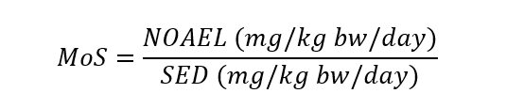

Systematic Exposure Dose
Determining the SED is based on how much sunscreen is applied to the skin daily (i.e. the external exposure dose), which is difficult to estimate as sunscreen usage varies greatly among individuals. Figure 1 describes the relationship between the external exposure and systemic exposure.
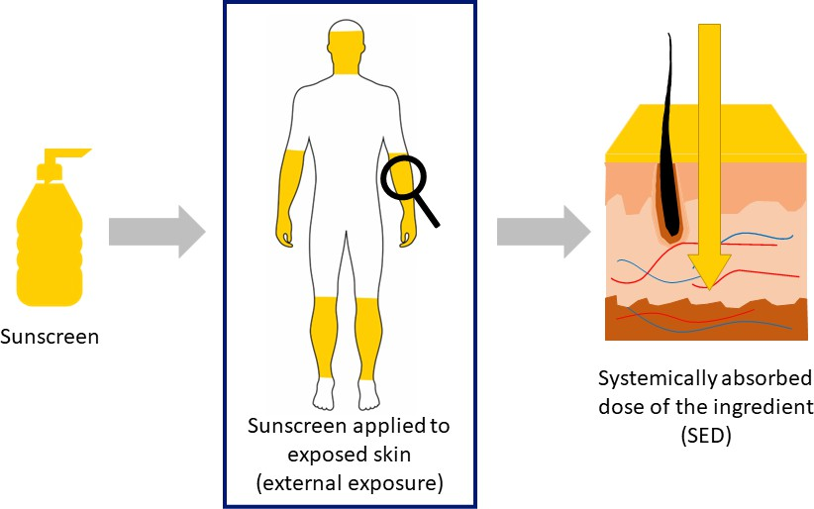
Figure 1: Relationship between sunscreen applied externally to skin and systemic exposure

Factors affecting exposure
Exposure can be characterised by the site of contact e.g. dermally applied sunscreen on skin; the period of time that the contact was in place; and whether that contact was a singular event, regular exposure over a short-term, e.g. hours or days, or regular exposure over a long-term, e.g. weeks or years. Exposure also characterises the level/concentration of specific substances at the site of contact and their distribution to other areas within the human body.
All manner of substances may be absorbed by the human body after contact or application (this is known as systemic exposure). How much is absorbed into the body is dependent on a number of factors related to the human body interface and the substance itself (see Table 1). Any systemic exposure of a substance, and adverse effects related to systemic effects must be considered when assessing the risk, and subsequent suitability for the use of a substance in humans.
Table 1: Factors affecting absorption and systemic distribution of dermally applied substances
Human body interface | Substance
Route of exposure: skin, eyes, nasal, respiratory, gastrointestinal, etc.  Integrity of the interface: irritated, inflamed, abraded, etc.  pH of the interface.  Contact time with the product or substance.  Enzymatic metabolism (e.g. metabolism into smaller molecules) or clearance of the substance at the site of contact.  Movement of the substance from the site of contact e.g. washing of the skin; flushing of the eyes; aspiration by the lungs; vomiting, transit and/or enzymatic degradation in the gastrointestinal tract following ingestion. | Molecular weight pKa  Lipophilicity (log KOW)  Photoreactivity/stability  Co-formulation with other substances that can affect absorption e.g. solvents that alter skin permeability.  Concentration  Vapour pressure
In general, small and lipophilic substances, in contrast to large and hydrophilic substances, are more likely to penetrate the skin and distribute systemically around the body. While some medicines are formulated to be absorbed into the body (e.g. transdermal patches), sunscreens are not, as their primary role is to provide either a physical barrier (reflector) to UVR e.g. zinc oxide and titanium dioxide, or absorb the UVR e.g. avobenzone and octocrylene, and prevent the penetration of this radiation through to deeper layers of the skin.

Why an Australian sunscreen exposure model was developed
Risk assessments for sunscreen ingredient safety that may end up being absorbed into the body, can employ various methodologies to calculate the amount of sunscreen applied to the skin. Some of these assessments may be excessively conservative or fail to consider the unique Australian context. For example, the Scientific Committee on Cosmetic and Non-Food Products intended for Consumers (SCCNFP) models are based on European and other country usage patterns and do not account for Australian use patterns or the amount of sunscreen application required to achieve the labelled Sun Protection Factor (SPF) rating.
A standardised, evidence-based approach is essential for regulatory certainty and to ensure that sunscreens are safe, effective, and reflective of actual usage patterns in Australia, rather than relying on different approaches or international assessment models. This provides a consistent framework for evaluating the safety of therapeutic sunscreen ingredients, aligning with Australian conditions and consumer practices.
The ASEM was developed to perform sunscreen exposure calculations that reflect the unique conditions and practices in Australia. It aims to calculate safe levels of new ingredients proposed for use in Australian sunscreens, as well as reassess existing ingredients when new evidence suggests potential risks. The ASEM ensures that the approval of sunscreen ingredients is based on current information and scientific best practice so that sunscreens continue to be used safely and effectively by all Australians as one of the measures to prevent skin cancer.

Australian Sunscreen Exposure Model
The ASEM accurately calculates sunscreen use that accounts for the diverse needs of Australians and integrates the expected sunscreen application practices that align with current Australian recommendations. This ensures that sunscreen ingredients are evaluated for safety based on how they are, and recommended to be, used in Australia today.
The objective of this approach is to affirm the safety of sunscreen ingredients, considering the highest plausible sunscreen use throughout the year, for the most sensitive population. To achieve this, six theoretical ASEM scenarios were developed to represent a broad spectrum of regular sunscreen usage patterns across different demographics across Australia (see Six ASEM Scenarios). These scenarios provided the highest estimated daily sunscreen exposure, to calculate maximum safe concentration of a sunscreen ingredient using the SED and MoS formulas.
 | It is crucial to recognise that the ASEM scenarios were constructed to reflect the higher end of sunscreen usage in Australia, rather than the average Australian’s usage. This approach ensured that the risk assessments for sunscreen ingredients, when based on the highest usage scenarios, will also guarantee safety for lower usage cases where less of the ingredient may be applied to the skin.

How does it work?
The ASEM calculates the estimated daily sunscreen exposure using a formula, and the input into that formula is based on Australian expected sunscreen use scenarios. For the purpose of regulatory risk assessments, the TGA has established the highest estimated daily sunscreen exposure using the ASEM, that is proposed to be used to calculate SED and MoS. The highest estimated daily sunscreen exposure values are expressed below depending on how dermal absorption data for the ingredient is reported:
Table 2: ASEM Ingredient dermal absorption data
How dermal absorption data is reported | ASEM highest estimated daily sunscreen exposure
Method 1 (%) | 673 mg/kg bw/day
Method 2 (µg/cm2) | 336 cm2/kg bw/day

The following aspects of the ASEM that establish the above highest estimated daily sunscreen exposure values are discussed below:
- ASEM formula
- ASEM scenarios
- Calculations for establishing the highest estimated daily sunscreen exposure

ASEM Formula
The ASEM formula calculates and estimates how much sunscreen is used daily. It is based on data for skin surface area, age, and body weight for the Australian population. The formula calculates
the average daily sunscreen exposure by considering how many times it is applied a day, number of days of the year it is applied, and the skin surface area of each body part it is applied to.

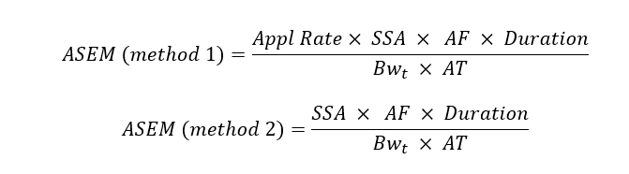

Where:
Table 3: ASEM Parameters
Parameter | Description | Explanation
ASEM | Estimated daily sunscreen exposure (mg/kg bw/d) or (cm²/kg bw/day) | The ASEM formula provides the amount of sunscreen applied to the skin per day relative to body weight (kg). The amount is expressed in units of either mass (mg) or surface area (cm²), depending on how the data for dermal absorption of an ingredient is reported.
Appl Rate | Application rate of product mg/cm² | For a sunscreen product to reach the labelled sun protection factor (SPF), it must be applied in quantities similar to those used in SPF testing. This application rate of 2 mg/cm² is specified in the Sunscreen Standard.  NOTE: Appl rate is not required for Method 2 calculations because it is accounted for as part of the dermal absorption study protocol.
SSA | Surface area of skin sunscreen applied to (cm²) per application | The skin surface area exposed to sunscreen (per application) is predicted based on the practices outlined in the ASEM scenarios see Six ASEM scenarios for different population groups and activities e.g. an individual working outdoors may be wearing a hat, shorts, half-sleeved shirt and footwear, and therefore the exposed skin where sunscreen is applied would include the face, neck, hands, forearms, and lower legs. The scenarios account for parts of Australia with warmer climates where less clothing may be worn year-round.  The Australian Exposure Factor Guidance publication (enHealth) (DOHAC 2012) provides the most up-to-date information that can assist with assessing the human health risks from environmental hazards. It contains information on skin surface area (for different body parts) and body weight for adults and children. The data underlying this information is reliant on overseas data derived from either empirical data (actual measurements of skin areas) or algorithms that have extrapolated from weight and height measurements to generate skin (body) surface area values. The data utilised for the ASEM is based on enHealth (DOHAC 2012) data in:  - Table 3.2.3 and 3.2.5 for skin surface area of body parts for adults, adolescents and children  - Table 2.2.1 and E2 for body weights for adults (≥18 years), adolescents and children  enHealth reports both mean and 95th percentile value for SSA and BW (DOHAC 2012). The TGA has referred to the 95th percentile SSA and BW data for the ASEM calculations.
Bwt | Body weight linked to SSA (kg)
AF | Application Frequency (applications/day) | Application frequency is expressed as the number of sunscreen applications per day. This can range from 2 – 3 applications per day for the different exposure scenarios outlined in ASEM Scenarios.
Duration | Annual Use (days) | Duration is expressed as the number of days in a year sunscreen application/exposure is expected to occur. The ASEM scenarios for the use of sunscreens in Australia provides information on the duration anticipated by different population groups.
AT | Averaging time (365 days) | An average daily dose based on exposure over a 1-year period (i.e. 365) is being calculated.

All the variables in the ASEM formula (SSA, BW, Age, AF and Duration) can change based on how the sunscreen is used and who it is used by. The respective input values for these variables are described in the ASEM scenarios below.

ASEM Scenarios
It is clear that the use of a single maximum daily-use scenario, i.e. a full day at the beach with multiple reapplications of sunscreen (that would amount to ~140 mL application daily), is not useful for determining the safety of sunscreen ingredients for the Australian population as a whole. Hence six sunscreen use scenarios have been developed to account for the Australian context, the most current Australian research, and national guidelines and policies, with consideration given to:
- The frequency of sunscreen application in both occupational and recreational contexts.
- How sunscreen may be used by different age groups.
- The environment (sun exposure) that an individual may be in.
- Clothing that an individual is likely to be wearing in that environment.
- The total skin surface area for exposed skin where sunscreen is likely to be used.
- The number of days sunscreen is applied in a year, factoring in variables such as weather conditions, and different use based on weekday vs weekend activity.

How the ASEM scenarios estimate days sunscreen is applied in a year
The ASEM scenarios see Six ASEM Scenarios consider sunscreen exposure across weekdays and weekends to account for the highest-use case across a year, which is divided by 365 to give the average daily sunscreen exposure. The use of sunscreen is required when exposed to the sun year-round for parts of Australia where the UV index consistently exceeds 3, such as Darwin, Brisbane, and Perth etc. as discussed under ‘Evidence-based sunscreen use guidelines’ below.
Weekday exposure is estimated based on a 5-day work week (i.e. 5 x 52 = 260 days annually), then adjusted for days of heavy rainfall (>10 mm). It is acknowledged that low rainfall days (rainfall ≥1 mm) with a UV index ≥3 may still necessitate sunscreen use (e.g. partly cloudy days, rainfall only for small period or in evening) as sun damage is also possible on cloudy days, since UVR can penetrate some clouds, and may even be more intense due to reflection off the clouds (Cancer Council Australia 2024c). Additionally, people are likely to be indoors on heavy rainfall days (rainfall ≥10 mm), thereby negating the use of sunscreens on such days. Average heavy rainfall days were calculated using BOM climate data (BOM 2024e) for rainfall for the past 3 years (2021-2023) for locations across Australia (see Table 4). The average weekly total heavy rainfall days was assumed to be 20 days (i.e. 5/7 x 29). Total weekdays of exposure were calculated as 240 days (260 – 20). This has been used for the assumed highest-use plausible duration of sunscreen use on weekdays in scenarios 1 to 4.
Table 4: Average heavy rainfall days for Australia (2021-2023)
Location |  | Rainfall ≥ 10mm days
Station | City | 2021 | 2022 | 2023
94029 | Hobart | 17 | 20 | 13
86232 | Melbourne | 23 | 21 | 13
23034 | Adelaide | 11 | 8 | 13
9021 | Perth | 27 | 26 | 18
14015 | Darwin | 50 | 58 | 43
40913 | Brisbane | 42 | 45 | 22
66006 | Sydney | 42 | 77 | 32
70351 | Canberra | 28 | 30 | 25
3-year average |  | 29
Weekend exposure is estimated for recreational activities that involve extended sun exposure, such as beach outings or outdoor activities such as water sports and fishing. This exposure is calculated for one day each weekend over a 6-month period from October to April, which is conducive to these activities due to warmer weather. The calculation does not deduct the average annual heavy rainfall days for weekends (2/7 x 29 days = 9 days) because the estimated exposure already accounts for only 25% of all weekend days annually, and 50% of all weekend days from October to April. It is assumed that the remaining 50-75% of weekend days would cover non-exposure days, including those with weather not suitable for prolonged outdoor activities. Therefore, the exposure duration for scenarios 5 and 6 is set at 26 days, representing one day of sunscreen exposure for each of the 26 weekends in the 6-month warmer weather period

Six ASEM scenarios
Yellow areas represent sunscreen applied to skin.

Scenario 1 – Indoor Worker (Adults)
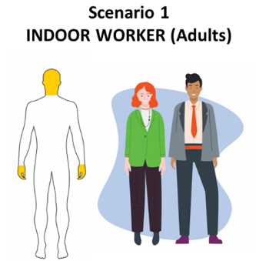 | Sun exposure: Infrequent sun exposure  Sunscreen usage: Limited sunscreen use  Type of activity: Office, retail, hospitality, health worker, vehicle operator  Parts of body applied: Head (including face and neck), hands  AF (applications/day): Up to 2  Duration (days/year): 240
Scenario 1 accounts for daily sunscreen application practice for adults undertaking indoor work during the weekdays. This population is likely to wear formal or semi-formal clothing that fully covers the torso, arms, legs, and footwear. It presumes that sunscreen is applied once in the morning and once again during morning tea, lunch, or afternoon.
This is supported by the ‘Evidence-based sunscreen use guidelines’ discussed below. Also see Whiteman et al. (2019).

Scenario 2 – Non-Occupational Daily (Adults)
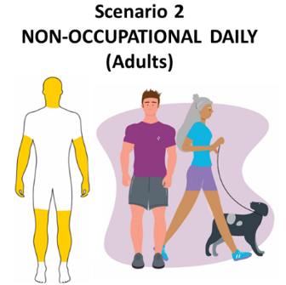 | Sun exposure: Regular sun exposure  Sunscreen usage: Limited sunscreen use  Type of activity: Daily exercise, dog walking, gardening, other recreation  Parts of body applied: Head (including face and neck), hands, ¾ arms, ¾ legs  AF (applications/day): Up to 2  Duration (days/year): 240
Scenario 2 accounts for daily sunscreen application for adults (including active retirees) undertaking outdoor recreational activities during weekdays.
This population, particularly in warmer regions of Northern Australia, are likely to wear sport/casual clothing that may cover approximately ¼ of the arms and legs, torso and footwear. It presumes that sunscreen is applied once in the morning/start of the activity and once again halfway into the activity.
This is supported by the ‘Evidence-based sunscreen use guidelines’ discussed below. Also see ASSC (2023) and Whiteman et al. (2019).

Scenario 3 – Childcare / School (Children)
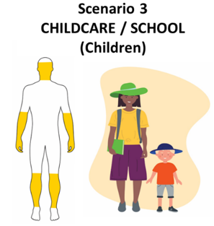 | Sun exposure: Frequent sun exposure  Sunscreen usage: Regular sunscreen use  Type of activity: Childcare (1-2 years), school children (under 18 years old)  Parts of body applied: Face, neck, hands, ½ arms, ½ legs  AF (applications/day): Up to 3 (Childcare), Up to 2 (School)  Duration (days/year): 240
Scenario 3 accounts for daily sunscreen application for children (above one year of age) attending sun smart childcare services (and schools) during the weekdays.
This population, particularly in warmer parts of Australia, are likely to wear hats and clothing that covers the torso, ½ arms and legs, and footwear. Sunscreen is applied frequently as a policy/practice in the majority of the early childhood centres but sun protection behaviours tend to reduce in older children and therefore sunscreen has been assumed to be applied up to two applications per day in older children.
This is supported by the evidence under the heading ‘Sunscreen use in children’ discussed below, in particular see Cancer Council SA (2018).
The estimation of sunscreen exposure for childcare settings is based on toddlers aged above 12 months instead of 6 to 12 months, as children normally learn to walk on their own between 12-15 months of age (DOHAC 2023; ACECQA 2024) and are more likely to be exposed to the sun (and consequently sunscreens) in a childcare setting relative to a 6-12-month-old child. Moreover, as discussed under the heading ‘Sunscreen for infants (birth to 12 months)’, infants under 12 months are not recommend to be exposed to the sun, and children under 6 months are not recommended to use sunscreen.

Scenario 4 – Outdoor Worker (Adults)
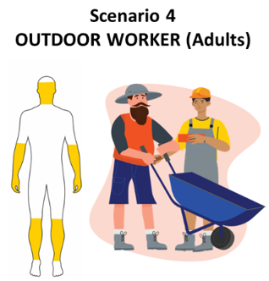 | Sun exposure: Frequent sun exposure  Sunscreen usage: Regular sunscreen use  Type of activity: Agricultural worker, grounds keeper, landscaper, tradesperson, surf lifeguard  Parts of body applied: Face, neck, hands, ½ arms, ½ legs  AF (applications/day): Up to 3  Duration (days/year): 240
Scenario 4 accounts for daily sunscreen application practice for adults engaging in outdoor work (as their main occupation) during weekdays.
This population, particularly in warmer regions of Australia, are likely to wear specific workwear including a hat, clothing that fully covers the torso, ½ arms and legs, and footwear. Sunscreen is applied once in the morning, during lunch/midday and in the afternoon as this would include professions that are expected to spend long periods of time during the day (~6 hours) during peak UV periods.
This is supported by the evidence under ‘Sunscreen use by outdoor workers’ discussed below.

Scenario 5 – Sun Smart Clothing (Adults and Children)
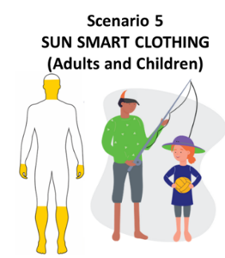 | Sun exposure: Prolonged sun exposure  Sunscreen usage: Extensive sunscreen use  Type of activity: Full day in the sun (beach or other activities)  Parts of body applied: Face, neck, hands, ½ legs, feet  AF (applications/day): Up to 3  Duration (days/year): 26
Scenario 5 accounts for daily sunscreen application for sun-smart adults and children, undertaking outdoor recreational activities that lead to prolonged sun exposure on weekends.
This population is likely to wear hats and clothing such as a long sleeve shirt/rashie, shorts/boardies that cover ½ legs. Sunscreen is applied once in the morning/start of the activity and twice again during the day, particularly due to swimming, sweating or towel drying that may remove the product.
This is supported by the evidence under ‘Sunscreen use by the general population’ and ‘Evidence-based sunscreen use guidelines’ discussed below.

Scenario 6 – Minimal Beach Wear (Adults and Adolescents)
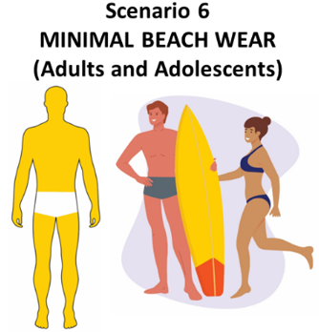 | Sun exposure: Prolonged sun exposure  Sunscreen usage: Extensive sunscreen use  Type of activity: Full day at the beach  Parts of body applied: Full body  AF (applications/day): Up to 3  Duration (days/year): 26
Scenario 6 accounts for sunscreen application for adults and adolescents spending full day at the beach leading to prolonged sun exposure on weekends.
This population is likely to wear minimal swimwear. It presumes that sunscreen is applied once in the morning and twice again during the day, particularly due to swimming, sweating or towel drying that may remove the product.
This is supported by the ‘Evidence-based sunscreen use guidelines’ discussed below for sunscreen application if the full body is exposed to the sun.
This scenario does not include children, as they are typically supervised by parents and expected to wear sun-smart attire, including hats and protective clothing, as outlined in scenario 5.

Calculations to establish highest estimated average daily sunscreen exposure
The TGA calculated the sunscreen exposure for each ASEM scenario and combined the weekday and weekend scenarios to provide a yearly realistic exposure. These yearly exposure scenarios are:
- For adults: Scenarios 4 + 6.
- For secondary school children: Scenarios 3 + 6.
- For other children, including toddlers, pre-school, and primary school children: Scenarios 3 + 5.
To derive the estimated average daily sunscreen exposure, the output was divided by 365 days.

Scenarios 3 and 5 for toddlers aged 1-2 years old provided the highest estimated average daily sunscreen exposure per kg/bw due to:
- their high skin surface area to body weight ratio
- high estimated sunscreen exposure based on the scenarios

All the calculations for the estimated daily sunscreen exposure for each age group and scenario, and the combinations of the above scenarios (including how Australian skin surface area and body weight data have been used) were provided in Attachment 2. The calculations for Scenario 3 and 5 for toddlers aged 1-2 years are provided below:

Estimated daily sunscreen exposure for Method 1 (%)
Scenario 3 = 607 mg/kg bw/day
Scenario 5 = 66 mg/kg bw/day

Highest estimated average daily sunscreen exposure Method 1 (%)
Scenario 3 + Scenario 5 = 607 + 66 = 673 mg/kg bw/day

Estimated daily sunscreen exposure for Method 2 (µg/cm2)
Scenario 3 = 303 cm2/kg bw/day
Scenario 5 = 33 cm2/kg bw/day
Highest estimated average daily sunscreen exposure for Method 2 (µg/cm2)
Scenario 3 + Scenarios 5 = 303 + 33 = 336 cm²/kg bw/day
As the ASEM formula calculates the highest estimated sunscreen exposure as a proportion of kg body weight per day, risk assessments using the SED and MoS calculations can be conducted using this value to account for any body weight (i.e. accounting for adults or children). This approach ensures that our risk assessment comprehensively cover the highest exposure for all Australians and ensure ingredients are safe to be used by everyone, no matter their age, weight, or outdoor activity.

Attachment 1: Background: Determining Australian sunscreen usage and application

Sunscreen use by the general Australian population
The actual use of sunscreen by consumers may not always align with recommendations for how sunscreens are to be used effectively.
National Sun Protection Surveys conducted by Cancer Council Australia captures Australian adults’ and adolescents’ sun protection behaviours on summer weekends in 2003-2017. Consistently over the years the surveys were conducted, more than 40% of adults and more than 25% of adolescents used 2 or more sun protection methods, such as sunscreen (Cancer Australia 2019). However, the percentage of people who use sunscreen as one of the sun protection methods was not reported in these surveys.
A representative survey prepared for Cancer Council Australia of Australian adolescents’ and adults’ sun protection behaviours in 2016-17 found that on a summer weekend the most common sun protective behaviour used by adolescents was using sunscreen with an SPF of at least 15 (40%) and the most common sun protective behaviours among adults were wearing sunglasses (61%), wearing a hat (49%), and using sunscreen with SPF 15 or higher (42%) (Tabbakh and Dobbinson 2018).
A survey conducted by Cancer Council Victoria of Melbourne residents’ sun-related attitudes and behaviour over 3 decades, between 1987 and 2017, shows a significant and sustained improvement in sun protection behaviour, including increased sunscreen use, after the implementation of the SunSmart program. The timing and size of the shift in preventive behaviours implies that Cancer Council Victoria’s SunSmart campaign is likely to have contributed to the reduced incidence in melanoma among younger cohorts (Tabbakh et al. 2019). Conversely, a systematic review exploring the use of sun-protection by outdoor sporting participants in Australasia concluded that adequate sun-protective behaviours are lacking despite 40 years of ‘Slip Slop Slap’ health promotion (Morton et al. 2023).
A study of adults who participated in a skin cancer prevention trial between 1992 and 1996, found that 56% of the eligible participants applied sunscreen at least 5 days per week, although 27% used sunscreen infrequently at 2 or fewer days per week (Neale et al. 2002). Almost 50% of the participants who reported less than daily sunscreen use stated that they did not think sunscreen application was necessary given the weather conditions or their planned activities. Of these respondents, 45% reported that they generally spent almost no time outdoors during the day.
A survey conducted on 670 beachgoers in the Newcastle district found that sunscreen was the most frequently used form of sun protection (Foot et al. 1993). Among the participants, 82% applied sunscreen to at least one body area. Among these participants, 69% had applied sunscreen with an SPF value higher than 15. The authors also reported that children under the age of 15 years were more likely to have used sunscreen compared to the older age groups.
Queensland preventive health telephone surveys (QPHS 2023) conducted by Queensland Health captured summer sun protection habits of 12,500 adults and the parents of 2,500 children aged 5 through 17 years. Based on the ‘Sunburn and protection’ data reported in the Queensland Survey Analytic System, just over 20% of adults were using, presumably, combined sun protection methods of ‘broad brimmed hat, SPF 30+ [sunscreen], clothing’ in summer between 2010 and 2020. However, the percentage of adults using sunscreen as one of the sun protection methods was not reported.
The Cancer Council Australia has advised that recent research suggests men are less likely than women to use sun protection (Cancer Council Australia 2022). Almost half (47%) of men reported they often or always spent time outdoors during peak UVR hours during summer. Less than one third (29%) of men reported using sunscreen (broad-spectrum with SPF 30 or higher) often or always during peak UVR hours during summer. Less than half (49%) of men reported often or always seeking shade to protect themselves from the sun during peak UVR hours during summer. More than half of respondents (55%) reported being sunburnt at least once during the summer, with the most common activity being during a walk, jog or run (15%).

Sunscreen use in children
A multi-year survey reported child-related sun protection practices from 2008, 2013 and 2018, covering 3,243 early-childhood services (i.e. childcare and/or pre-education services for infants and children aged ≤5 years) across Australia (Hunkin and Morris 2020). The authors reported significant increases over the last decade in the proportion of services requiring the use of sun-protective hats, sunscreen and protective clothing, as well as those services supplying sunscreen (98.4% of the services required the use of sunscreen in 2018). The proportion of services applying sunscreen to children 15-20 minutes before going outside and re-applying sunscreen every 2 hours while outdoors also significantly increased (in 2018, 68.3% of services required sunscreen to be applied regularly, every 2 hours if outdoors).
It is noted that the percentage of services that required children to wear sun-protective clothing outside significantly increased from 68% (2008) to 88.8% (2018), however, the percentage of services requiring children to wear long sleeves significantly decreased from 45.1% (2008) to 17.9% (2018). The percentage of services requiring children to wear longer shorts/skirts remained below 30% throughout the survey years. The authors suggested that suboptimal UVR protection can result from incorrect sunscreen application in terms of amount used, time of application (relative to sun exposure) and reapplication, and therefore, appropriate sunscreen application techniques are an important target for future promotion efforts.
The (at the time of the ASEM publication) unpublished report of 1,189 Australian early childhood centres surveyed in the 2018 National Early Childhood Sun Protection Policy and Practice Survey (Cancer Council SA 2018), which was the most recent survey data analysed by Hunkin and Morris (2020), reported further information on sunscreen use practices in early childhood centres. The report indicated a trend in increasing sunscreen practices in children. In 2018 most services required children to wear sunscreen all year, and more services applied sunscreen more frequently throughout the day, and required sunscreen when the UV index was 3 or more, rather than only part of the year. The data showed that in 2018, 49% of services across Australia applied sunscreen to children twice a day, 26% 3 times a day, and 11% more than 3 times. Western Australia had higher rates, with 40% of centres applying sunscreen 3 times daily and 20% more than 3 times.
Between 2008 and 2018, there was a significant increase in the number of services providing sunscreen for children, promoting self-application, and encouraging application by parents or caregivers. There was also a rise in the practice of applying sunscreen 15-20 minutes before outdoor activities, assigning staff the responsibility of applying sunscreen to children, and regularly reapplying sunscreen. Conversely, there was a decline in the number of services that encouraged parents to provide sunscreen for their children. In addition, over 99% of services enforced hat wearing for children and 98% for staff members. Most services followed a policy of taking infants (under 12 months) outdoors only in shaded areas (71%), while 22% limited the duration of outdoor time for this age group. The use of UV levels as a criterion for implementing sun protection measures during certain times of the year increased to 61% in 2018, up from 35% in 2008. These findings underscore the evolving practices in early childhood centres to enhance sun protection for children, reflecting a growing awareness and implementation of recommended sunscreen use.
In a survey conducted for 187 childcare services in the Hunter region, 150 centres (87%) reported that the centre’s policy required children to wear hats, and 122 (71%) required sunscreen be applied to children before outdoor play (Parkinson et al. 2003).
However, the self-reported sun protection practices were lower, and 36% of children wore a hat and 57% applied sunscreen before outdoor play.
The Queensland QPHS survey conducted in 2020 found 74.9% of children aged 5-7 frequently use sunscreens with SPF 30+ (Queensland Government 2023). This percentage gradually decreases with increasing age, as 49.3% of children aged 16-17 frequently use sunscreens. Remoteness and socioeconomic status also impact sunscreen use. Children from remote areas or from disadvantaged socioeconomic backgrounds are less likely to use sunscreen frequently. The survey also found that 16% of children apply sunscreen as part of the morning routine.
A study conducted with children aged 5-12 years in Queensland found that children in the youngest school grades (1 and 2) applied significantly more sunscreen than the older children (Diaz et al. 2012). The authors recommended that educational interventions may help to improve sunscreen application thickness to maximise the protection received from sunscreen. The authors also commented that sunscreen is often the only form of sun protection used by children, therefore, children may be less well protected from the sun than parents might expect.
A survey conducted with 3,655 Queensland students (in grades 7, 9 and 11) reported that negative views of sun protection measures were associated with poorer sun protective behaviour; this association was strongest among older students and in larger schools (Balanda et al. 1999). Similarly, lower perceived parental sun protective behaviour was associated with poorer sun protective behaviours and older students had poorer sun protective behaviours than younger students.

Sunscreen use by outdoor workers
An unpublished independent report commissioned by Safe Work Australia conducted between January and July 2008 that comprised 4,500 telephone interviews with indoor and outdoor workers in all Australian industries, investigated the exposure to direct sunlight and the control measures provided in workplaces relating to direct sunlight exposure. Workers in northern states (QLD, NT, WA) exhibiting a 37% higher probability of high-level exposure to direct sunlight compared to southern states (NSW, ACT, SA, VIC, TAS). Male workers were 2.9 times more likely to be exposed than female workers. The disparity was more pronounced within industry sectors, with outdoor workers facing considerably higher exposure odds, being 18 times greater in agriculture, forestry, and fishing, and 8.8 times greater in construction, relative to manufacturing. The average daily exposure duration exceeded 4 hours for outdoor workers, with those in agriculture and construction experiencing upwards of 5.5 hours.
Most common forms of protection were sunscreen, hats, or protective clothing. Sunscreen was reported to be provided by over half of the workers in most industries. The likelihood of sunscreen provision was 1.7 times higher in agriculture, forestry, and fishing (69% of workers provided with sunscreen), 2.4 times higher in construction (75%), and 6.2 times higher in government administration and defence (91%) compared to manufacturing (58%). Protective clothing followed a similar trend, with 1.9 times higher provision in construction (76% of workers provided with protective clothing) and 4.1 times higher in government administration and defence (87%) compared to manufacturing. Notably, despite the high exposure risk in agriculture, forestry, and fishing, only 68% of workers reported receiving protective clothing. The report concluded that there is limited evidence that workers exposed to longer durations of UVR are more likely to have access to protective controls than workers with a low level of exposure.
Another study by Girgis and colleagues investigated 184 outdoor workers’ sun protection behaviour when outdoors between 11 am and 3 pm when there was no rain (Girgis et al. 1994). A body region was considered adequately protected if it was fully covered by clothing/hat or shaded at the time of the interview, and/or if sunscreen with an SPF 15 or higher had been applied to that region. Participants who had more than 75% of the body protected were classified as having high protection. The authors reported more than 49% participants used high level sun protection; however, the sunscreen use by outdoor workers was not reported.

Application thickness of sunscreens
There is some limited contemporary research indicating that Australians apply, on average, a thickness that was less than the 2 mg/cm2 sunscreen needed to achieve the labelled SPF rating. The amount of sunscreen used also depends on the formulation and dispenser type, for example roll-on versus pump-pack (Diaz et al. 2012; Neale et al. 2002) and could be influenced by how much the user perceives needs to be applied based on its visual appearance and feel after application. While research indicates an approximate average application thickness between 0.5 mg/cm2 and 0.99 mg/cm2 (Diaz et al. 2012; Neale et al. 2002) and Diaz et al. commented that an application thickness of 2 mg/cm2 in children was infeasible, both studies report that some participants actually applied the correct thickness of 2 mg/cm2 or more. Further, another Australian study using spectrophotometric analysis estimated an average application thickness of 1.4 mg/cm2, with some participants also meeting the ideal application rate of 2 mg/cm2 (Bauer et al. 2010).

Correct sunscreen application
The level of protection provided by sunscreens, and therefore the ability to reduce the risk of skin cancer, is determined not only by the labelled sun protection factor (SPF) rating but also by the amount of product applied and its conditions of use. As such, it is important they are safe and effective for their intended uses. The effectiveness is significantly reduced by inadequate application, infrequent reapplication, and loss of product due to sweat, swimming, or friction from clothing or towel drying.
Most people do not apply enough sunscreen or reapply frequently enough which can result in an SPF that is 20-50% less than what is specified on the product label (Diaz et al. 2012; Stokes and Diffey 1997).

Evidence-based sunscreen use guidelines
In the 1960s the risks of overexposure to UVR were first identified in Australia. Twenty years later, the iconic “Slip! Slop! Slap!” campaign was launched in 1980 to raise awareness of the dangers of UV, featuring Sid the Seagull. This campaign is credited with playing a key role in changing sun protection attitudes and behaviour in Australia. In 2007, the messaging was updated to “Slip, Slop, Slap, Seek, Slide”, with which many Australians are familiar with.
The Australian Government has delivered a National Skin Cancer Prevention Campaign in partnership with Cancer Council Australia each summer since 2021-22. State and territory governments also fund skin cancer prevention activities, as do a number of non-government organisations. Funding of $15 million has been provided in the May 2024 Budget for a national skin cancer prevention campaign targeting groups most at risk, including men over 40 and young adults with activity to occur over the 2024-26 summers.
As the amount of sun protection is based on the amount of sunscreen applied, there is a concerted effort from government, researchers and other organisations through education and campaigns (such as the Cancer Council Australia’s well-known SunSmart program (Cancer Council Australia n.d. - a) to encourage the correct application of sunscreen. For example, leading Australian organisations, including the Cancer Council Australia (2024a), Melanoma Institute Australia (n.d.), Australasian College of Dermatologists (2019), Safe Work Australia (2019), and Surf Life Saving Australia (2006), provide evidence-based recommendations on proper sunscreen usage to ensure effective sun protection. Consumers expect sunscreens to be safe for daily use in Australia (Cancer Council Australia 2017).
The Cancer Council Australia (n.d. - b) recommends adults use a teaspoon for the face, neck and ears; a teaspoon for each arm and leg; and a teaspoon each for the front and back of the body. It is also recommended to reapply every 2 hours or after activities that may remove the product, such as swimming, sweating or towel drying (Cancer Council Queensland n.d.). The Cancer Council Australia does not recommend sunscreen as the only method of protection even if the UV is 3 or above every day of the year and encourage the five forms of sun protection:
- slipping on sun protective clothing
- slopping on SPF 30 or above broad-spectrum water-resistant sunscreen
- slapping on a broad brim hat
- seeking shade when possible
- sliding on sunglasses.
In the 2023 position statement by Australian Skin and Skin Cancer Research Centre (ASSC) aimed at balancing the risks and benefits of sun exposure, it is recommended that sun protection behaviour should be tailored to the individual’s risk of skin cancer (ASSC 2023). People who are at high risk of skin cancer (i.e. very pale skin and/or olive/pale brown skin but with other risk factors) are advised to adopt an extremely cautious approach to sun exposure including avoiding time outdoors when the UV index is ≥3. On days when the UV index is forecast to reach ≥3, irrespective of the length of time, sunscreen of at least SPF 30 should be used in the mornings as part of the usual daily routine and applied to all parts of the body not covered by clothing. Sun protection should also be used if these people planned to spend >2 hours (cumulatively across the day) outdoors when the UV index is between 1 and 3, and outdoor workers always use sun protection, irrespective of the UV index (ASSC 2023).
Sunscreen, often viewed as a protective measure for prolonged sun exposure during outdoor activities, but also the last line of UVR defence, is equally essential for daily protection against the often-overlooked incidental UV exposure that occurs during everyday tasks such as running errands or commuting. In 2019, an Australian and New Zealand evidence-based consensus statement was published recommending routine sunscreen application for adults and children on body parts not covered by clothing when the UV index is predicted to be 3 or above irrespective of their anticipated activities (Whiteman et al. 2019). This recommendation aims to reduce the incidence of skin cancer by accounting for incidental UV exposure resulting in cumulative skin damage, such as from everyday activities such as shopping, travelling to work, or household chores.
The Australian and New Zealand evidence-based consensus statement on when to apply sunscreen is relevant year-round for parts of Australia where the UV index consistently exceeds 3, such as Darwin, Brisbane, and Perth (Table 5) and where the UV index reaches above 3 between 11 am and 1 pm (Figure 2). Darwin for instance has a very high average UV index at solar noon above 8 every month of the year; however, the recommendation may not apply to lower latitudes where the sun is lower in the sky such as Kingston in Tasmania during the 4 months it experiences an average UV index below 3 (ARPANSA 2024).
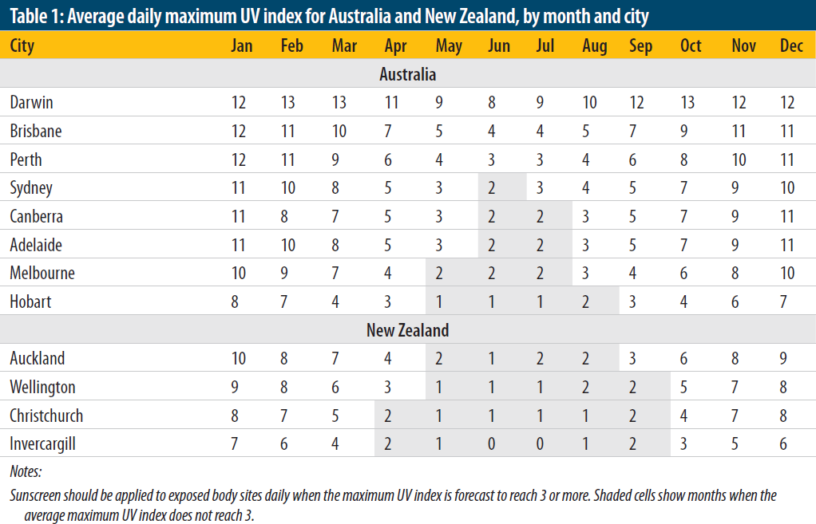
Table 5: Average daily maximum UV index for Australia by month and city, reproduced from Whiteman et al. (2019)

Figure 2: Average annual UV Index for Australia, for 1979-2007 under cloud-free conditions at local noon. These values are also representative of UV Index expected between 11 am and 1 pm local time (12 pm and 2 pm daylight saving time) under clear skies (BOM 2024a).
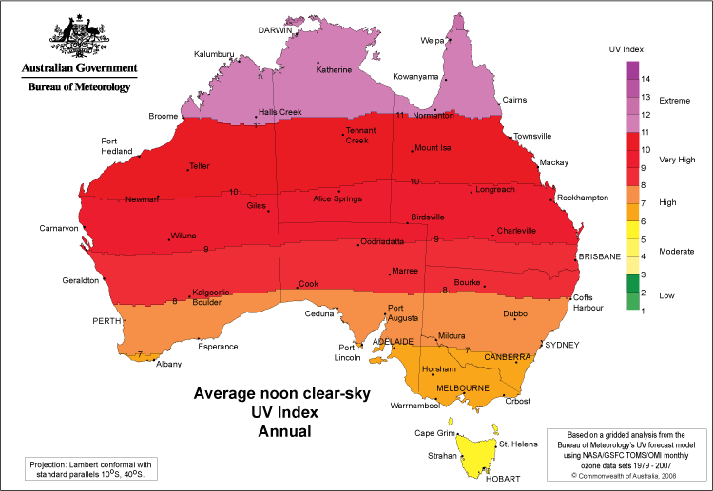

Northern regions of Australia are closer to the equator and typically have warmer climates (Figure 3) that encourage lighter clothing and increased time outdoors. With last year ranking as Australia's equal eighth-warmest on record (BOM 2024b), and the projected trend towards warmer climates continuing (BOM 2024c), sunscreen will continue to be an important sun protection measure in the future. This geographical variance in UV exposure and climate conditions highlights the importance of a model that ensures adequate protection for all Australians, regardless of their location.
Figure 3: Average annual maximum temperatures over the period 1991 to 2020 (BOM 2024d).
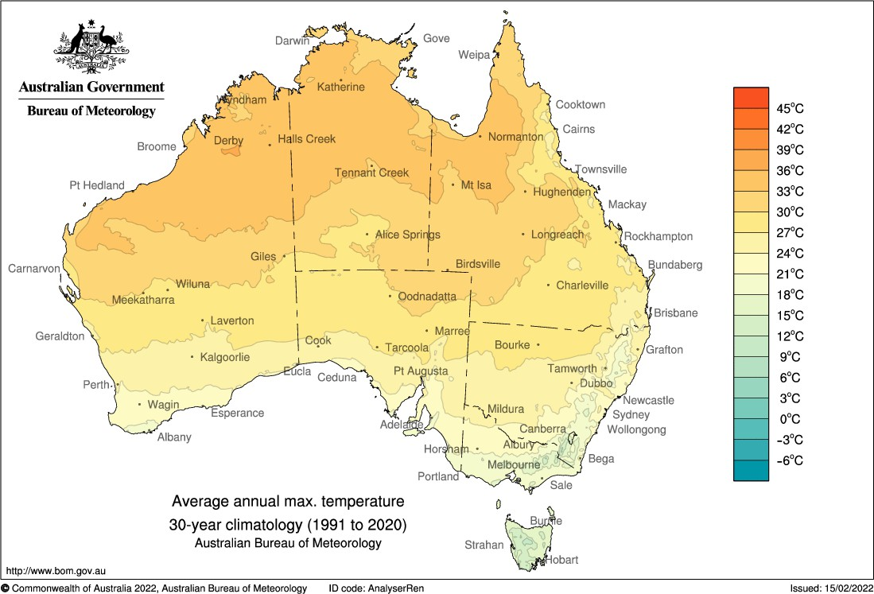

How sunscreens should be used to achieve the labelled SPF rating
Therapeutic sunscreens must comply with the requirements of the Australian/New Zealand Standard: Sunscreen products – Evaluation and classification (AS/NZS 2604:2021) (amended) (the Australian Sunscreen Standard). The Australian Sunscreen Standard was adopted into therapeutic goods legislation on 1 July 2024.
The standard acknowledges that in circumstances where the dosage used in the measurement of the SPF (2 mg/cm2) is not applied, the expected sun protection will not be achieved. This is supported by research that demonstrates reduced application thickness exponentially decreases the SPF (Faurschou and Wulf 2007; Schalka et al. 2009). The standard also requires primary sunscreens to be labelled with clear and appropriate directions so the labelled claims will be achieved, advising that the instructions should state the product should be applied generously. The SunSmart 2024 guidelines also recommend applying more sunscreen than one might think is necessary to achieve adequate application.
Sunscreen for infants (birth to 12 months)
Both the Australasian College of Dermatologists and Cancer Council Australia advise that infants under 12 months should not be exposed to direct sunlight when the UV Index is 3 or higher and sunscreen is not recommended for infants under 6 months (Australasian College of Dermatologists 2018 and Cancer Council Australia 2024b). For infants over 6 months, sunscreen can be applied to small areas of skin not covered by clothing or hats, but it should be considered as the last line of defence after other sun protection measures, including covering as much skin as possible with clothing.

Challenge of aligning recommended sunscreen application with the risk assessment
Reflecting on the complexities involved, it is evident that calculating sunscreen exposure to effectively cater to the diverse Australian population is a complicated task. That given, it is vital to integrate the expected sunscreen application practices, which align with the current Australian recommendations, into the risk assessment of sunscreen ingredients. Further, this assessment should take into account the concerted government and community efforts to refine sun protection behaviours, ensuring that the evaluations are prepared for future sunscreen usage trends. This ensures that sunscreens not only meet the protective needs of Australians but also adhere to public health directives, thereby reinforcing the safety and integrity of sunscreen products for all Australians.

Attachment 2: Background: ASEM calculations

ASEM calculations

Variables for calculating estimated daily sunscreen exposure
Table 6: Variables for calculating estimated daily sunscreen exposure
Scenario | 1 | 2 | 3 | 4 | 5 | 6
AF (application frequency) | 2 | 2 | 2 or 3* | 3 | 3 | 3
Duration (days) | 240 | 240 | 240 | 240 | 26 | 26
AT (averaging time, days) | 365 | 365 | 365 | 365 | 365 | 365
Appl Rate (application rate, mg/cm²) | 2 | 2 | 2 | 2 | 2 | 2
*3 applications for toddler (1 - <2 year olds)/(2 - 3 year olds) and 2 applications for other children
Table 7: Skin surface are exposed to sunscreen for each ASEM scenario
SSA (skin surface area exposed to sunscreen, m², 95th percentile) | 1 | 2 | 3 | 4 | 5 | 6
Toddler (1 - <2 year olds) | - | - | 0.20 | - | 0.20 | -
Toddler (2 - <3 year olds) | - | - | 0.21 | - | 0.22 | -
Preschool student (3 - <6 year olds) | - | - | 0.33 | - | 0.33 | -
Primary school student (6 - <11 year olds) | - | - | 0.47 | - | 0.48 | -
Secondary school student (11 - <16 year olds) | - | - | 0.67 | - | 0.69 | 2.06
Adult | 0.26 | 1.09 | - | 0.76 | 0.65 | 2.43

Table 8: Body weight link to skin surface area for each ASEM scenario
Bw_{t} (body weight linked to SSA, kg, 95th percentile) | 1 | 2 | 3 | 4 | 5 | 6
Toddler (1 - <2 year olds) | - | - | 13 | - | 13 | -
Toddler (2 - <3 year olds) | - | - | 17 | - | 17 | -
Preschool student (3 - <6 year olds) | - | - | 36 | - | 36 | -
Primary school student (6 - <11 year olds) | - | - | 58 | - | 58 | -
Secondary school student (11 - <16 year olds) | - | - | 83 | - | 83 | 83
Adult | 107 | 107 | - | 107 | 107 | 107

Notes:
- Appl Rate, SSA, AF, Duration, Bw_{t} and AT are variable used to calculate the estimated daily sunscreen exposure for each scenario.
- Where:
- Application Rate Application rate of product (2 mg/cm²) (Sunscreen Standard)
- SSA Surface area of skin sunscreen applied to (cm²) per application
- AF Application Frequency (applications/day)
- Duration Annual Use (days)
- Bw_{t} Body weight linked to SSA (kg)
- AT Averaging time (365 days)

Calculating estimated daily sunscreen exposure
Table 9: Daily sunscreen exposure using Method 1 for each ASEM scenario
Daily sunscreen exposure (Method 1, mg/kg bw/day) | 1 | 2 | 3 | 4 | 5 | 6
Toddler (1 - <2 year olds) | N.A. | N.A. | 607 | N.A. | 66 | N.A.
Toddler (2 - <3 year olds) | N.A. | N.A. | 487 | N.A. | 55 | N.A.
Preschool student (3 - <6 year olds) | N.A. | N.A. | 237 | N.A. | 39 | N.A.
Primary school student (6 - <11 year olds) | N.A. | N.A. | 211 | N.A. | 35 | N.A.
Secondary school student (11 - <16 year olds) | N.A. | N.A. | 211 | N.A. | 36 | 106
Adult | 63 | 267 | N.A. | 279 | 26 | 97
N.A = Not Applicable
Table 10: Daily sunscreen exposure using Method 2 for each ASEM scenario
Daily sunscreen exposure (Method 2, cm²/kg bw/day) | 1 | 2 | 3 | 4 | 5 | 6
Toddler (1 - <2 year olds) | N.A. | N.A. | 303 | N.A. | 33 | N.A.
Toddler (2 - <3 year olds) | N.A. | N.A. | 244 | N.A. | 28 | N.A.
Preschool student (3 - <6 year olds) | N.A. | N.A. | 119 | N.A. | 19 | N.A.
Primary school student (6 - <11 year olds) | N.A. | N.A. | 105 | N.A. | 18 | N.A.
Secondary school student (11 - <16 year olds) | N.A. | N.A. | 105 | N.A. | 18 | 53
Adult | 31 | 134 | N.A. | 140 | 13 | 48
N.A = Not Applicable

Formulae:
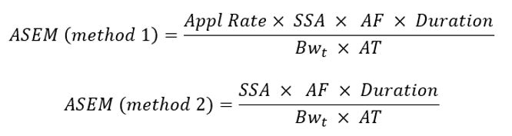
Notes:
- Method 1 is used if dermal absorption is based on the percentage of the ingredient dermally absorbed (%).
- Method 2 is used if dermal absorption is based on absolute amount of the ingredient that is bioavailable (μg/cm²).

Calculating highest estimated daily sunscreen exposure
Table 11: Calculating highest estimated daily sunscreen exposure using Method 1
Method 1 (mg/kg bw/day) | Scenarios 4+6 | Scenarios 3+5 | Scenarios 3+6
Toddler (1 - <2 year olds) | N.A. | 673 | N.A.
Toddler (2 - <3 year olds) | N.A. | 543 | N.A.
Preschool student (3 - <6 year olds) | N.A. | 276 | N.A.
Primary school student (6 - <11 year olds) | N.A. | 246 | N.A.
Secondary school student (11 - <16 year olds) | N.A. | N.A. | 317
Adult | 376 | N.A. | N.A.
N.A = Not Applicable
Table 12: Calculating highest estimated daily sunscreen exposure using Method 2
Method 2 (cm²/kg bw/day) | Scenarios 4+6 | Scenarios 3+5 | Scenarios 3+6
Toddler (1 - <2 year olds) | N.A. | 336 | N.A.
Toddler (2 - <3 year olds) | N.A. | 271 | N.A.
Preschool student (3 - <6 year olds) | N.A. | 138 | N.A.
Primary school student (6 - <11 year olds) | N.A. | 123 | N.A.
Secondary school student (11 - <16 year olds) | N.A. | N.A. | 158
Adult | 188 | N.A. | N.A.
N.A = Not Applicable
Formulae:
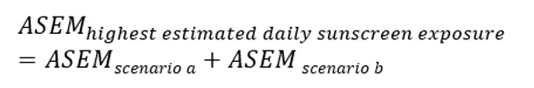
Notes:
- The TGA has calculated the sunscreen exposure for each ASEM scenario and combined the weekday and weekend scenarios to provide a realistic yearly exposure:
  - For adults a combination of scenarios 4 and 6.
  - For secondary school children a combination of scenarios 3 and 6.
  - For other school children, including toddlers, pre-school and primary school children a, combination of scenarios 3 and 5.
- To derive the estimated daily exposure, scenarios 3 and 5 for toddlers aged 1 to 2 years old provided the highest estimated daily sunscreen exposure, Therefore, this can be calculated as below:
  - ASEM (Method 1) scenario 3 + scenario 5 = 607 + 66 = 673 mg/kg bw/day
  - ASEM (Method 2) scenario 3 + scenario 5 = 303 + 33 = 336 cm²/kg bw/day

Scenarios
Refer to ASEM scenarios on page 12.

Body weight data
Table 13: Body weight data used in ASEM calculations
Age groups | Body weight* (95th percentile, kg)
Toddler (1 - <2 year olds) | 13
Toddler (2 - <3 year olds) | 17
Preschool student (3 - <6 year olds) | 36
Primary school student (6 - <11 year olds) | 58
Secondary school student (11 - <16 year olds) | 83
Adult** | 107
*Data based on enHealth (2012), Table 2.2.1 and E2 for body weights for adults (18 years and older), adolescents and children.
**enHealth reports male and female 95th percentile body weight data, which has been averaged.

Skin surface area data
Table 14: Skin surface area of individual body parts (Adult, 95th percentile, m²)
Body part (adult) | Male 95th percentile | Female 95th percentile
Head | 0.15 | 0.12
Trunk (including neck) | 1.10 | 0.85
Upper extremities | 0.47 | 0.35
Arms | 0.40 | 0.27
Upper arms | 0.22 | NR
Forearms | 0.20 | NR
Hands | 0.13 | 0.11
Lower extremities | 0.97 | 0.88
Legs | 0.85 | 0.76
Thighs | 0.52 | 0.48
Lower legs | 0.32 | 0.29
Feet | 0.16 | 0.15
Total BSA | 2.52 | 2.33
*Data based on enHealth (2012), Table 3.2.3 and 3.2.5 for skin surface area of body parts for adults, adolescents and children. It is based on rounded data from US EPA (2009, Tables 7-11 and 7-12.
Note: NR – Not Reported, data for upper arms and forearms were not reported in US EPA (2009).
Table 15: Skin surface are exposed to sunscreen used to calculate estimated daily sunscreen exposure per scenario for adults (m²)
ASEM Scenario | Male 95th percentile | Female 95th percentile | Person 95th percentile
Scenario 1 | 0.28 | 0.23 | 0.26
Scenario 2 | 1.17 | 1.00 | 1.09
Scenario 4 | 0.83 | 0.69 | 0.76
Scenario 5 | 0.69 | 0.61 | 0.65
Scenario 6 | 2.52 | 2.33 | 2.43

Notes:
- Person 95th percentile body weight is the average male and female 95th percentile body weight.
- Nil SSA data for neck alone, therefore SSA for neck I estimated to be ‘0’.
- Nill SSA data for hat coverage, or face alone, therefore SSA estimated to be ‘half head’.
- Upper extremities SSA include upper arms, lower arms or arms and hands.
- Lower extremities SSA include thighs, lower legs or legs and feet.
- Trunk SSA include chest, abdomen and pelvis area.
Table 16: Skin surface area of individual body parts (Child, 95th percentile, m²)
Body part (child) | Toddler (1 - <2 year olds) | Toddler (2 - <3 year olds) | Preschool student (3 - <6 year olds) | Primary school student (6 - <11 year olds) | Secondary school student (11 - <16 year olds)
Head | 0.10 | 0.10 | 0.13 | 0.19 | 0.19
Trunk | 0.22 | 0.27 | 0.30 | 0.51 | 0.69
Arms | 0.08 | 0.08 | 0.14 | 0.19 | 0.27
Hands | 0.04 | 0.04 | 0.06 | 0.07 | 0.11
Legs | 0.14 | 0.16 | 0.26 | 0.41 | 0.65
Feet | 0.04 | 0.05 | 0.07 | 0.11 | 0.16
Total SSA | 0.61 | 0.70 | 0.95 | 1.48 | 2.06
*Data based on enHealth (2012), Table 3.2.5 for skin surface area of body parts for adults, adolescents and children. It is based on rounded data from US EPA (2008, Table 7-2).
Note: Data are for both sexes combined.
Table 17: Skin surface area exposed to sunscreen used to calculate estimated daily sunscreen exposure per scenario for children (m²)
ASEM Scenario | Toddler (1- <2 year olds) | Toddler (2- <3 year olds) | Preschool student (3 - <6 year olds) | Primary school student (6 - <11 year olds) | Secondary school student (11 - <16 year olds)
Scenario 3 | 0.20 | 0.21 | 0.33 | 0.47 | 0.67
Scenario 5 | 0.20 | 0.22 | 0.33 | 0.48 | 0.69
Scenario 6 | N.A. | N.A. | N.A. | N.A. | 2.06

Note:
- Nil SSA data for neck alone, therefore SSA for neck is estimated to be ‘0’.
- Nil SSA data for hat coverage or face alone, therefore SSA estimated to be ‘half head’.

Key Terms
Abbreviation | Explanation
AICIS | Australian Industrial Chemicals Introduction Scheme
ARPANSA | Australian Radiation Protection and Nuclear Safety Agency
ASEM | Australian Sunscreen Exposure Model
ASSC | Australian Skin and Skin Cancer Research Centre
BoM | Bureau of Meteorology
Excluded Goods Determination | Therapeutic Goods (Excluded Goods) Determination 2018
MoS | Margin of Safety
NOAEL | No Observed Adverse Effect Level
Poisons Standard | Standard for the Uniform Scheduling of Medicines and Poisons (SUSMP)
SCCNFP | Scientific Committee on Cosmetic and Non-Food Products intended for Consumers
SED | Systemic Exposure Dose
SPF | Sun Protection Factor
SSA | Skin Surface Area
Sunscreen Standard | Australian/New Zealand Standard Sunscreen products - Evaluation and classification AS/NZS 2604:2021 Amd 1:2022
TGA | Therapeutic Goods Administration
The Act | Therapeutic Goods Act 1989
The Regulations | Therapeutic Goods Regulations 1990
Therapeutic sunscreen | Primary and some secondary sunscreens regulated under the Therapeutic Goods Act 1989
UF | Uncertainty Factor
URNS | Understanding the application requirements for a new substance in listed medicines (formerly Application Requirements for New Substances in listed medicines)
URTS | Understanding the Regulation of Therapeutic Sunscreens (formerly Australian Regulatory Guidelines for Sunscreens)
UV | Ultraviolet
UVR | Ultraviolet radiation

References
Australasian College of Dermatologists (2018). Media release new guideline warnings: sunscreen is not a suit of armour. [online] Available at: https://www.dermcoll.edu.au/wp-content/uploads/Sunscreen- is-not-a-suit-of-armour-12-January-2017.pdf. [Accessed 20 June 2024].
Australasian College of Dermatologists (2019). Sun Protection & Sunscreens. [online] Available at: https://www.dermcoll.edu.au/atoz/sun-protection-sunscreens/. [Accessed 20 June 2024].
Australian Children’s Education & Care Quality Authority – ACECQA (2024) Pregnancy, Birth and Baby. Your child’s development 1 to 2 year olds. [online] Available at: https://www.startingblocks.gov.au/resources/parenting-and-home/your-childs-development/your- childs-development-1-to-2-years. [Accessed 20 June 2024].
Australian Radiation Protection and Nuclear Safety Agency – ARPANSA (2024). Ultraviolet radiation model. [online] Available at: https://www.arpansa.gov.au/our-services/monitoring/ultraviolet-radiation- monitoring/uv-index-model. [Accessed on 20 June 2024].
Australian Skin and Skin Cancer Research Centre – ASSC (2023). POSITION STATEMENT BALANCING THE HARMS AND BENEFITS OF SUN EXPOSURE [online] Available at:
https://www.assc.org.au/wp-content/uploads/2023/01/Sun-Exposure-Summit- PositionStatement_V1.9.pdf. [Accessed on 20 June 2024].
Balanda, K.P., Stanton, W.R., Lowe, J.B. and Purdie, J. (1999). Predictors of Sun Protective Behaviors Among School Students. Behavioral Medicine, 25(1), pp.28–35. doi: https://doi.org/10.1080/08964289909596736.
Bauer, U., O’Brien, D.S. and Kimlin, M.G. (2010). A New Method to Quantify the Application Thickness of Sunscreen on Skin. Photochemistry and Photobiology, 86(6), pp.1397–1403. doi: https://doi.org/10.1111/j.1751-1097.2010.00816.x.
Bureau of Meteorology – BOM (2024a). Ultra Violet Index climate averages maps. [online] Available at: http://www.bom.gov.au/climate/maps/averages/uv-index/. [Accessed on 20 June 2024].
Bureau of Meteorology – BOM (2024b). Annual Statement 2023. [online] Available at: http://www.bom.gov.au/climate/current/annual/aus. [Accessed 20 June 2024].
Bureau of Meteorology – BOM (2024c). State of the Climate 2022: Bureau of Meteorology. [online] Available at: http://www.bom.gov.au/state-of-the-climate/. [Accessed 20 June 2024].
Bureau of Meteorology – BOM (2024d). Average monthly and annual temperature maps, Bureau of Meteorology. [online] Available at: http://www.bom.gov.au/climate/maps/averages/temperature/?maptype=mxt&period=an&region=aus. [Accessed 20 June 2024].
Bureau of Meteorology – BOM (2024e). Climate Data Online, Bureau of Meteorology. [online] Available at: http://www.bom.gov.au/climate/data/index.shtml. [Accessed 20 June 2024].
Cancer Australia (2019). Sunburn and sun protection. [online] Available at: https://ncci.canceraustralia.gov.au/prevention/sun-exposure/sunburn-and-sun-protection [Accessed on 20 June 2024].
Cancer Council Australia (n.d. - a). Slip, Slop, Slap, Seek, Slide. [online] Available at: https://www.cancer.org.au/cancer-information/causes-and-prevention/sun-safety/campaigns-and- events/slip-slop-slap-seek-slide. [Accessed on 20 June 2024].
Cancer Council Australia (n.d. - b). Be SunSmart. [online] Available at: https://www.cancer.org.au/cancer-information/causes-and-prevention/sun-safety/be-sunsmart. [Accessed on 20 June 2024].
Cancer Council Australia (2017). Media Release: Almost half of Australians confused about sunscreen. [online] Available at: Almost half of Australians confused about sunscreen | Cancer Council. [Accessed on 20 June 2024].
Cancer Council Australia (2022). Australian men urged to reduce their risk of skin cancer with new research showing they are less likely than women to use sun protection. [online] Available at: https://www.cancer.org.au/assets/pdf/australian-men-urged-to-reduce-their-risk-of-skin-cancer-with- new-research-showing-they-are-less-likely-than-women-to-use-sun-protection. [Accessed on 20 June 2024].
Cancer Council Australia (2024a). About sunscreen. [online] Available at: https://www.cancer.org.au/cancer-information/causes-and-prevention/sun-safety/about-sunscreen. [Accessed on 20 June 2024].
Cancer Council Australia (2024b). Fact sheet: Sun protection and babies | National Cancer Prevention Policy UV radiation. [online] Available at: https://www.cancer.org.au/about-us/policy-and- advocacy/prevention-policy/national-cancer-prevention-policy/uv/related-resources/sun-protection- babies. [Accessed 20 June 2024].
Cancer Council Australia (2024c). Sun protection 101: essential tips from Cancer Council for UV safety. [online] Available at: https://www.cancer.org.au/cancer-information/causes-and-prevention/sun- safety/10-myths-about-sun-protection. [Accessed on 20 June 2024].
Cancer Council Queensland (n.d.). Correct Sunscreen Application. [online] Available at: correct Sunscreen Application.pdf (cancerqld.org.au). [Accessed on 20 June 2024].
Cancer Council SA (2018). Sun protection policies and practices of Australian early childhood services
- Results of the 2018 National Early Childhood Sun Protection Policy and Practice Survey. Unpublished.
Department of Climate Change, Energy, the Environment and Water – DCCEEW (2022). The ozone layer - DCCEEW. [online] Available at: https://www.dcceew.gov.au/environment/protection/ozone/ozone-science/ozone-layer. [Accessed on 20 June 2024]
Department of Health and Aged Care – DOHAC (2012). enHealth guidance – Australian exposure factor guide. [online] Available at: https://www.health.gov.au/resources/publications/enhealth- guidance-australian-exposure-factor-guide?language=en. [Accessed 20 June 2024].
Department of Health and Aged Care – DOHAC (2023). Pregnancy, Birth and Baby – Development milestones - your child 12 to 18 months. [online] Available at: https://www.pregnancybirthbaby.org.au/development-milestones-12-to-18-months. [Accessed 20 June 2024].
Diaz, A., Neale, R.E., Kimlin, M.G., Jones, L. and Janda, M. (2012). The Children and Sunscreen Study. Archives of Dermatology, [online] 148(5). doi: https://doi.org/10.1001/archdermatol.2011.2586.
Faurschou, A. and Wulf, H.C. (2007). The relation between sun protection factor and amount of suncreen applied in vivo. British Journal of Dermatology, 156(4), pp.716–719. doi: https://doi.org/10.1111/j.1365-2133.2006.07684.x.
Ferlay J, Ervik M, Lam F, Colombet M, Mery L, Piñeros M, et al. (2020) Global Cancer Observatory: Cancer Today - IARC. [online] Available at: https://gco.iarc.fr/today. [Accessed on 20 June 2024].
Foot, G., Girgis, A., Boyle, C.A. and Sanson-Fisher, R.W. (1993). Solar protection behaviours: a study of beachgoers. Australian Journal of Public Health, 17(3), pp.209–214. doi: https://doi.org/10.1111/j.1753-6405.1993.tb00137.x.
Girgis, A., Sanson-Fisher, R.W. and Watson, A. (1994). A workplace intervention for increasing outdoor workers’ use of solar protection. American Journal of Public Health, 84(1), pp.77–81. doi: https://doi.org/10.2105/ajph.84.1.77.
Hunkin, H. and Morris, J. (2020). A decade of sun protection in Australian early-childhood services: analysis of cross-sectional and repeated-measures data. Health Education Research, 35(2), pp.99–109. doi: https://doi.org/10.1093/her/cyaa005.
International Agency for Research on Cancer – IARC (1992). IARC Monographs on the Evaluation of Carcinogenic Risks to Humans. [online] Available at: https://www.ncbi.nlm.nih.gov/books/NBK401588/. [Accessed on 20 June 2024].
Melanoma Institute Australia (n.d.). Sunscreen FAQs. [online] Available at: https://melanoma.org.au/about-melanoma/how-to-prevent-melanoma/sunscreen-faqs/. [Accessed 20
June 2024].
Morton, S.K. and Harrison, S.L. (2023). Slip, Slop, Slap, Slide, Seek and Sport: A Systematic Scoping Review of Sun Protection in Sport in Australasia. Current Oncology, [online] 30(1), pp.401–415. doi: https://doi.org/10.3390/curroncol30010033.
Neale, R., Williams, G. and Green, A. (2002). Application Patterns Among Participants Randomized to Daily Sunscreen Use in a Skin Cancer Prevention Trial. Archives of Dermatology, 138(10). doi: https://doi.org/10.1001/archderm.138.10.1319.
Parkinson, L., Astley, B., Peterkin, D., Page, C. and Hampson, A. (2003). Health promotion in childcare centres: a survey of sun protection policy and practice. Australian and New Zealand Journal of Public Health, 27(5), pp.520–523. doi: https://doi.org/10.1111/j.1467-842x.2003.tb00826.x.
Queensland Government (2023). Figure 3: Characteristics of sunburn and sun safety of Queensland children, 2020. [online] Available at: https://www.choreport.health.qld.gov.au/our-lifestyle/sun- safety#section latest-results. [Accessed on 20 June 2024]
Queensland Preventive Health Surveys – QPHS (2023). Detailed Queensland and regional preventive health survey results. [online] Available at: https://www.health.qld.gov.au/research-reports/population- health/preventive-health-surveys/detailed-data#queensland. [Accessed on 20 June 2024].
Safe Work Australia (2019). Guide on exposure to solar ultraviolet radiation (UVR) National Guidance. [online] Available at: https://www.safeworkaustralia.gov.au/system/files/documents/2001/guide- exposure-solar-ultraviolet-radiation_1.pdf. [Accessed 20 June 2024].
Schalka, S., dos Reis, V.M.S. and Cucé, L.C. (2009). The influence of the amount of sunscreen applied and its sun protection factor (SPF): evaluation of two sunscreens including the same ingredients at different concentrations. Photodermatology, Photoimmunology & Photomedicine, 25(4), pp.175–180. doi: https://doi.org/10.1111/j.1600-0781.2009.00408.x.
Stokes, R. and Diffey, B. (1997). How well are sunscreen users protected? Photodermatology, Photoimmunology & Photomedicine, 13(5-6), pp.186–188. doi: https://doi.org/10.1111/j.1600- 0781.1997.tb00227.x.
SunSmart (2024). Protect your skin - SunSmart. [online] Available at: https://www.sunsmart.com.au/protect-your-skin#sunscreen. [Accessed 20 June 2024].
Surf Life Saving Australia (2006). Surf Life Saving Australia Policy. [online] Available at: https://sls.com.au/wp-content/uploads/2015/10/sun-safety-july2006.pdf. [Accessed 20 June 2024].
Tabbakh, T., Volkov, A., Wakefield, M. and Dobbinson, S. (2019). Implementation of the SunSmart program and population sun protection behaviour in Melbourne, Australia: Results from cross- sectional summer surveys from 1987 to 2017. PLOS Medicine, 16(10), p.e1002932. doi: https://doi.org/10.1371/journal.pmed.1002932.
Tabbakh, T. and Dobbinson, S (2018). 2016–2017 National Sun Protection Survey: Report 2 Sun Protective Behaviours and Sunburn Incidence on Weekends among Australians in Summer 2016– 2017; Centre for Behavioural Research in Cancer, Cancer Council of Victoria: Melbourne, Australia, [online] Available at: https://www.cancer.org.au/about-us/policy-and-advocacy/prevention-policy/national-cancer-prevention-policy/skin-cancer-statistics-and-issues/trends-in-sun-protection- behaviours [Accessed 20 June 2024].
Whiteman, D.C., Neale, R.E., Aitken, J., Gordon, L., Green, A.C., Janda, M., Olsen, C.M. and Soyer,
H.P. (2019). When to apply sunscreen: a consensus statement for Australia and New Zealand. Australian and New Zealand Journal of Public Health, 43(2), pp.171–175. doi: https://doi.org/10.1111/1753-6405.12873.

Version history
Version | Description of change | Author | Effective date
V1.0 | Original publication | Complementary & Over the Counter Medicines Branch  Therapeutic Goods Administration  Department of Health, Disability and Ageing Care | August 2025

The acceptable MoS cutoff should reflect the quality of safety data available. Acceptance of lower MoS values may be deemed appropriate when the NOAEL is based upon human toxicological data. Conversely, a requirement for higher MoS values may arise such as, in instances where the duration of the toxicological study does not adequately reflect the intended duration of exposure.
The SPF is the level of protection a sunscreen offers against sunburn. It relates to the amount of time it takes for redness to appear on the skin compared to when no sunscreen is applied.
See Table 3 and 4 under the ‘About the data’ tab.
QPHS survey result can be visualised in Queensland survey analytic system (QSAS)
‘Prevalence table’ tab of Figure 3: Characteristics of sunburn and sun safety of Queensland children
‘Introduction’ tab of Figure 3: Characteristics of sunburn and sun safety of Queensland children
Report provided to the TGA by Safe Work Australia
The SPF rating serves as a guide for consumers, indicating the level of protection a sunscreen offers against sunburn. It assists individuals to choose a product that aligns with their skin's sensitivity and expected sun exposure.
SunSmart (2024). Protect your skin - SunSmart. [online] Available at: https://www.sunsmart.com.au/protect-your-skin#sunscreen. [Accessed 20 June 2024].

