Australian Public Assessment Report for YORVIPATH
  - Active ingredient: Palopegteriparatide
  - Sponsor: Specialised Therapeutics Pharma Pty Ltd
July 2025

About the Therapeutic Goods Administration (TGA)
- The Therapeutic Goods Administration (TGA) is part of the Australian Government Department of Health, Disability and Ageing and is responsible for regulating therapeutic goods, including medicines, medical devices, and biologicals.
- The TGA administers the Therapeutic Goods Act 1989 (the Act), applying a risk management approach designed to ensure therapeutic goods supplied in Australia meet acceptable standards of quality, safety, and efficacy.
- The work of the TGA is based on applying scientific and clinical expertise to decision-making, to ensure that the benefits to the Australian public outweigh any risks associated with the use of therapeutic goods.
- The TGA relies on the public, healthcare professionals and industry to report problems with therapeutic goods. The TGA investigates reports received to determine any necessary regulatory action.
- To report a problem with a therapeutic good, please see the information on the TGA website.

About AusPARs
- The Australian Public Assessment Report (AusPAR) provides information about the evaluation of a prescription medicine and the considerations that led the TGA to approve or not approve a prescription medicine submission. Further information can be found in Australian Public Assessment Report (AusPAR) guidance.
- AusPARs are prepared and published by the TGA.
- AusPARs are static documents that provide information that relates to a submission at a particular point in time. The publication of an AusPAR is an important part of the transparency of the TGA’s decision-making process.
- A new AusPAR may be provided to reflect changes to indications or major variations to a prescription medicine subject to evaluation by the TGA.

Copyright
© Commonwealth of Australia 2025
This work is copyright. You may reproduce the whole or part of this work in unaltered form for your own personal use or, if you are part of an organisation, for internal use within your organisation, but only if you or your organisation do not use the reproduction for any commercial purpose and retain this copyright notice and all disclaimer notices as part of that reproduction. Apart from rights to use as permitted by the Copyright Act 1968 or allowed by this copyright notice, all other rights are reserved and you are not allowed to reproduce the whole or any part of this work in any way (electronic or otherwise) without first being given specific written permission from the Commonwealth to do so. Requests and inquiries concerning reproduction and rights are to be sent to the TGA Copyright Officer, Therapeutic Goods Administration, PO Box 100, Woden ACT 2606 or emailed to <tga.copyright@tga.gov.au>.

Contents
List of abbreviations 4
YORVIPATH (palopegteriparatide) submission 5
Proposed indication 6
Hypoparathyroidism 6
Current treatment options for hypoparathyroidism 8
Regulatory status 8
Registration timeline 9
Assessment overview 9
Quality evaluation summary 9
Nonclinical evaluation summary 10
Clinical evaluation summary 11
Summary of clinical studies 11
Pharmacology 13
Efficacy 25
Safety 45
Risk management plan evaluation summary 65
Advisory Committee considerations 66
Risk/benefit assessment 67
Efficacy 67
Safety 68
Assessment outcome 69
Specific conditions of registration 69
Product Information and Consumer Medicines Information 69

List of abbreviations
Abbreviation | Meaning
ACM | Advisory Committee on Medicines
ARTG | Australian Register of Therapeutic Goods
AUC_{τ} | area under the concentration-time profile during the dosing interval
C_{max} | maximum plasma concentration
HPES | hypoparathyroidism patient experience scale
mPEG | methoxypolyethylene glycol
PD | pharmacodynamic(s)
PI | Product Information
PK | pharmacokinetic(s)
popPK | population pharmacokinetic(s)
PRN | Pro Re Nata
PTH | parathyroid hormone
PTH(1-34) | Amino acid 1 to 34 of PTH, the active moiety of palopegteriparatide
RMP | Risk management plan
sCa | Serum calcium
TEAE | Treatment emergent adverse event
TGA | Therapeutic Goods Administration

YORVIPATH (palopegteriparatide) submission
Type of submission: | New chemical entity
Product name: | YORVIPATH
Active ingredient: | palopegteriparatide
Decision: | Approved
Approved therapeutic use for the current submission: | YORVIPATH (palopegteriparatide) is a parathyroid hormone (PTH) analogue indicated for the treatment of chronic hypoparathyroidism in adults.
Date of decision: | 17 February 2025
Date of entry onto ARTG: | 19 February 2025
ARTG numbers: | YORVIPATH palopegteriparatide 168 micrograms / 0.56 mL solution for injection in multidose pre-filled pen (443870)  YORVIPATH palopegteriparatide 294 micrograms / 0.98 mL solution for injection in multidose pre-filled pen (443871)  YORVIPATH palopegteriparatide 420 micrograms / 1.4 mL solution for injection in multidose pre-filled pen (443872)
Black Triangle Scheme | Yes
Sponsor’s name and address: | Specialised Therapeutics Pharma Pty Ltd Level 2, 17 Cotham Road, Kew, Victoria 3101 Australia
Dose form: | Solution for injection.
Strength: | Yorvipath 168 micrograms/0.56 mL solution for injection in pre-filled pen  Each pre-filled pen contains 1935 micrograms palopegteriparatide equivalent to 168 micrograms of PTH (1-34) in 0.56 mL of solvent*. The concentration based on PTH (1-34) is 0.3 mg/mL.  Each pre-filled pen delivers doses of 6, 9, or 12 micrograms of PTH (1-34)  Yorvipath 294 micrograms/0.98 mL solution for injection in pre-filled pen  Each pre-filled pen contains 3387 micrograms palopegteriparatide equivalent to 294 micrograms of PTH (1-34) in 0.98 mL of solvent*. The concentration based on PTH (1-34) is 0.3 mg/mL.  Each pre-filled pen delivers doses of 15, 18, or 21 micrograms of PTH(1-34).  Yorvipath 420 micrograms/1.4 mL solution for injection in pre-filled pen  Each pre-filled pen contains 4838 micrograms palopegteriparatide equivalent to 420 micrograms of PTH(1-34) in 1.4 mL of solvent*. The concentration based on PTH(1-34) is 0.3 mg/mL.  Each pre-filled pen delivers doses of 24, 27, or 30 micrograms of PTH(1-34).  *The strength indicates the quantity of the PTH(1-34) moiety without consideration of the methoxypolyethylene glycol (mPEG) linker.
Container: | A cartridge (type 1 glass) with a plunger (halobutyl) and a laminate rubber sheet (halobutyl/isoprene) contained in a pre-filled multidose disposable pen made of polypropylene.
Pack size: | Packs of two pre-filled pens and 30 disposable needles
Route of administration: | Subcutaneous injection
Dosage: | The recommended starting dose is 18 mcg once daily with dose adjustments in 3 mcg increments thereafter every 7 days. The dose range is 6 to 60 mcg per day. For further information regarding dosage, refer to the Product Information.
Pregnancy category: | Category B3  Drugs which have been taken by only a limited number of pregnant women and women of childbearing age, without an increase in the frequency of malformation or other direct or indirect harmful effects on the human fetus having been observed.  Studies in animals have shown evidence of an increased occurrence of fetal damage, the significance of which is considered uncertain in humans.  The use of any medicine during pregnancy requires careful consideration of both risks and benefits by the treating health professional. The pregnancy database must not be used as the sole basis of decision making in the use of medicines during pregnancy. The TGA does not provide advice on the use of medicines in pregnancy for specific cases. More information is available from obstetric drug information services in your state or territory.

Proposed indication
This AusPAR describes the submission by Specialised Therapeutics Pharma Pty Ltd (the Sponsor) to register YORVIPATH (palopegteriparatide) for the following proposed indication:
PTH replacement therapy indicated for the treatment of hypoparathyroidism in adults.

Hypoparathyroidism
Hypoparathyroidism is a rare disease that results in hypocalcaemia and absent or deficient PTH. Symptoms, when present, range from paraesthesia and muscle cramps to seizures and laryngospasm. The most common cause is injury to or removal of the parathyroid gland during anterior neck surgery (around 75% of cases). Other genetic or autoimmune causes may be found or be present as part of a syndrome.,
PTH is critical for maintaining the level of circulating calcium within a narrow normal range through its actions on bone, kidney, and intestine. PTH secretion is regulated primarily by the calcium-sensing receptor (CaSR) found on parathyroid chief cells; when ambient calcium levels are low, the CaSR is inactive and PTH synthesis and secretion are increased. PTH then regulates calcium and phosphate levels by actions on the bone, kidney, and, indirectly, intestine (Figure 1).,
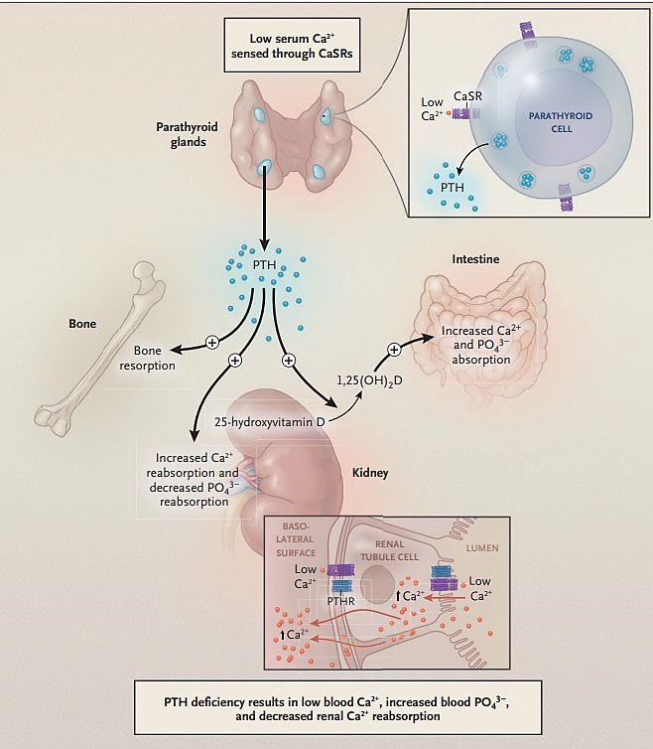
Figure 1 – Parathyroid hormone and its effects

Hypoparathyroidism leads to dysfunctional neurological, cognitive, muscular, and cardiac systems. The critical electrolyte imbalance causes effects such as paraesthesia or prolonged QT on electrocardiogram. Chronic hypocalcaemia and hyperphosphatemia, with an elevated serum calcium-phosphate product, can also lead over the years to soft tissue calcifications, untreated or as a function of the need for large amounts of supplemental calcium and active vitamin D. These calcifications are typically seen in the brain (basal ganglia in particular) and in the kidney (stones and nephrocalcinosis) but can also be seen in joints, eyes, skin, vasculature, and other organ systems. Almost all patients also have a severely reduced quality of life, with nonspecific symptoms that can include general fatigue, a lack of focus (often referred to as “brain fog”), cramping and spasming as well as depression, anxiety and other neuropsychiatric issues.,
The diagnosis of hypoparathyroidism is aided by the measurement of albumin-corrected or ionized serum calcium below the lower limits of the normal range and an unexpectedly normal or low level of PTH.,

Current treatment options for hypoparathyroidism
For chronic hypoparathyroidism, the goal of treatment is to maintain the blood calcium level at or slightly below the lower end of the normal range while preventing symptoms of hypocalcaemia and this is conventionally achieved with oral calcium and active vitamin D (calcitriol or alfacalcidol) supplementation. Frequent monitoring of blood calcium, phosphate, magnesium, and creatinine levels and of urinary calcium excretion are essential to avoiding overtreatment or undertreatment.,
However, given the issues of pill burden, frequent monitoring, side effects of long term supplementation and the profound impact on overall health and lifestyle despite conventional management, there exists an important unmet medical need for newer therapies for chronic hypoparathyroidism.

Regulatory status

Australian regulatory status
This product is a new chemical entity for Australian regulatory purposes.
Palopegteriparatide was granted orphan status and priority determination by the TGA on 16 February 2024.

International regulatory status
YORVIPATH was approved by the European Medicines Agency on 17 November 2023 for the following indication:
“Yorvipath is a parathyroid hormone (PTH) replacement therapy indicated for the treatment of adults with chronic hypoparathyroidism.”
The United States Food and Drug Administration approved YORVIPATH for the following indication in Aug 2024:
“YORVIPATH is indicated for the treatment of hypoparathyroidism in adults.”
Limitations of Use:
YORVIPATH was not studied for acute post-surgical hypoparathyroidism.
YORVIPATH’s titration scheme was only evaluated in adults who first achieved an albumin-corrected serum calcium of at least 7.8 mg/dL using calcium and active vitamin D treatment.”

Registration timeline
Table 1 captures the key steps and dates for this submission.
This submission was evaluated under the priority registration process.
Table 1: Registration timeline for YORVIPATH (palopegteriparatide), submission PM-2024-01089-1-5
Description | Date
Priority determination | 16 February 2024
Designation (Orphan) | 16 February 2024
Submission dossier accepted and evaluation commenced | 30 April 2024
Evaluation completed | 25 October 2024
Advisory Committee meeting | 6 December 2024
Registration decision (Outcome) | 17 February 2025
Registration in the ARTG completed | 19 February 2025
Number of working days from submission dossier acceptance to registration decision* | 206 days
*Target timeframe for priority submissions is 150 working days from acceptance for evaluation to the decision.

Assessment overview

Quality evaluation summary
The proposed product is available as a ready-to-use pre-filled pen. The strength of the product is given as the total volume of the pen, to give a concentration of 0.3 mg/mL for all 3 strengths. Each pre-filled pen is designed to deliver doses of 6, 9, or 12 micrograms (for the lowest strength); 15, 18, or 21 micrograms (for the middle strength); or 24, 27, or 30 micrograms (for the highest strength). The purported strength of the product (0.3 mg/mL) is given for PTH(1-34) equivalents.
Palopegteriparatide is a PTH analogue designed to release the active moiety [PTH(1-34)] in a sustained manner.
The proposed product is supplied as two pre-filled pens with 30 disposable needles for 28 days of treatment (co-packaged in two inner cartons).
There are no pharmacopeial monographs for palopegteriparatide.
The manufacturing process for PTH(1-34) linker thiol consists of solid phase peptide synthesis, cleavage and purification.
The proposed specifications adequately controls the identity, potency, purity and chemical and physical properties of the drug substance relevant to the dose form.
The proposed retest period of 60 months when stored at -20 °C is supported by the stability data.
Palopegteriparatide prefilled pen consists of a solution in a 1.5 mL cartridge assembled in a single-patient-use pen injector.
The drug constituent part is a sterile, colourless, and clear solution for injection, with a nominal concentration of 0.3 mg PTH(1-34)/mL, in a 1.5 mL cartridge. Three different volumes of palopegteriparatide compounded solution are filled into the cartridges, with extractable volumes of 0.56, 0.98 and 1.4 mL.
The manufacturing process involves compounding of the excipients and palopegteriparatide followed by sterile filtration and filling into cartridges before final assembly of the prefilled pens. The drug substance was found to not be stable to terminal sterilisation. Therefore, filtration was chosen as the sterilisation method.
The drug product specifications adequately control the quality of the drug product at release and throughout the shelf-life.
The dose accuracy specification is given as ±5 μL (±1.5 μg) at each dose level. This level of accuracy ensures safe and effective dosing, as confirmed in phase 2 and phase 3 clinical trials for palopegteriparatide.
A shelf life of 36 months when stored at 2-8 °C, stored in the original package to protect from light, with a 14-day in-use period at 30°C, is supported.
The Product Information and package labelling is acceptable from a quality perspective.

Nonclinical evaluation summary
The submitted nonclinical data was of adequate quality and scope, broadly consistent with ICH M3 (R2). All pivotal safety-related studies were Good Laboratory Practice (GLP)-compliant.
In vitro, PTH(1-34) released from palopegteriparatide bound to parathyroid hormone 1 receptor (PTH1R) with a K_{D} of 3.85 μM, while palopegteriparatide had no significant affinity for PTH1R. In a cell based assay, the bioactivity of PTH(1-33) was similar to that for PTH(1-34). In vivo, palopegteriparatide was associated with increased serum calcium, decreased serum phosphate levels and changes to bone turnover parameters (decreased trabecular bone mineral density and content and increased bone turnover markers) in the thyroparathyroidectomy (TPTx) rat model of hypoparathyroidism.
No secondary pharmacodynamic studies with palopegteriparatide were conducted. There was no evidence of off-target effects in the set of repeat-dose toxicity studies.
Safety pharmacology and other studies indicated no likely direct adverse effects on CNS, cardiovascular, respiratory function in patients. However, hypocalcaemia and hypercalcaemia were seen in patients in clinical trials. Either of these could lead to CNS or cardiovascular effects.
Overall, the pharmacokinetic profile in animals was qualitatively similar to that of humans. The concentration-time profile of Free PTH (released from palopegteriparatide) plasma levels in rats and monkeys resembled an infusion-like profile with once daily SC dosing. Plasma half-life values for Total PTH (surrogate for palopegteriparatide) and Free PTH were long in all species. The volume of distribution indicated that the prodrug was primarily confined to the intravascular compartment. Similar steady state concentrations of methoxypolyethylene glycol (mPEG)- linker and mPEG in the systemic circulation in rats and monkeys indicated that the linker moiety remained attached to the mPEG carrier following auto-cleavage of palopegteriparatide.
Repeat-dose toxicity studies by the SC route were conducted in rats (up to 26 weeks) and cynomolgus monkeys (up to 6 months). Maximum exposures (AUC for Free PTH) were moderate in rats and subclinical in monkeys. The primary systemic effects produced by palopegteriparatide were either directly or indirectly related to its known pharmacological actions (hypercalcaemia with associated mineralisation in kidneys and effects on bone turnover). Palopegteriparatide had a net catabolic effect on bone mass at exposures 2-fold above clinical exposures to Free PTH, while a net anabolic effect was seen at higher exposures. The pattern of effect on bone can be attributed to the pharmacokinetic profile of PTH(1-34) released from palopegteriparatide resulting in continuous sustained exposures.
Palopegteriparatide was not mutagenic in the bacterial mutation assay or clastogenic in vitro (in human lymphocytes) or in vivo (in the rat micronucleus test). No carcinogenicity studies were conducted; a weight of evidence approach was taken. The risk of carcinogenicity with palopegteriparatide appears to be low but cannot be dismissed.
Fertility was unaffected in male and female rats treated with palopegteriparatide. In the pivotal embryofetal development study in rats, an increased incidence and severity of dilated ureter was seen in fetuses in a dose-related manner. The incidence was outside the historical control value at a dose which caused increased maternal serum calcium levels and decreased bodyweight gain and food consumption. No treatment-related embryofetal effects were seen in the pivotal rabbit embryofetal development study. Pregnancy Category B3 is recommended.
There are no nonclinical objections to registration of palopegteriparatide for the proposed indication.

Clinical evaluation summary

Summary of clinical studies
There were 5 clinical studies submitted and other relevant additional analyses in the clinical dossier for the submission (Table 2):
Table 2. Summary of clinical studies
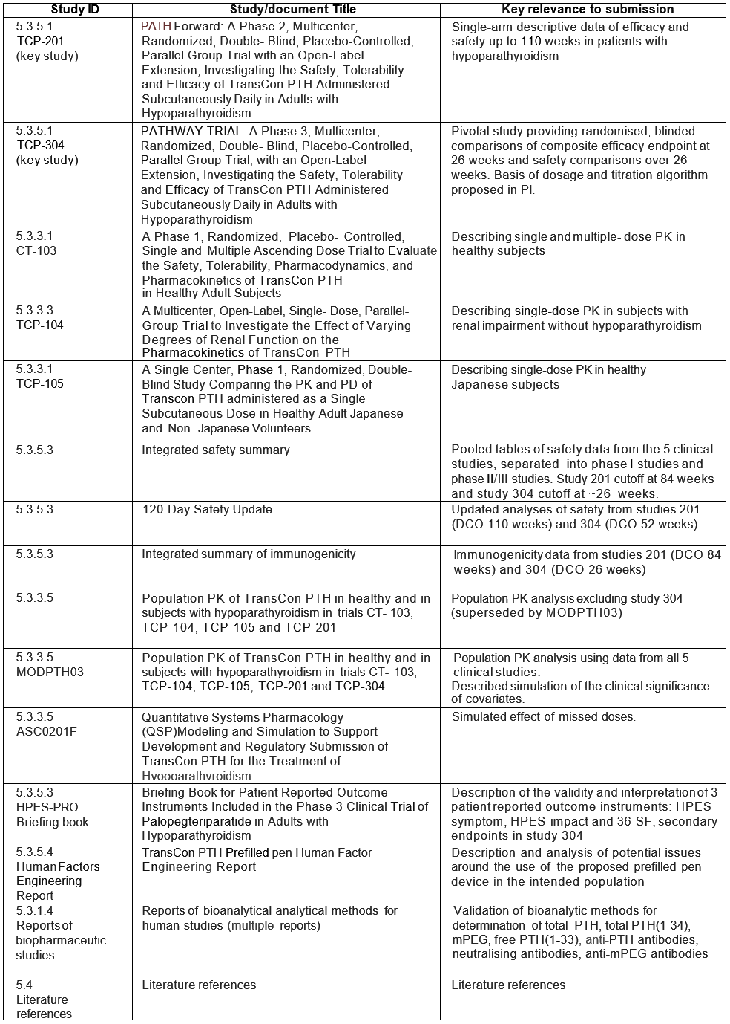

Pharmacology
Three studies provide PK information among healthy subjects: studies 103, 104 and 105. Valid PK samples were available among some of the patients with hypoparathyroidism in studies 201 and 304 and incorporated into the popPK model. Study 201 also included a dedicated PK-PD sub-study.

Pharmacokinetics
Palopegteriparatide is a prodrug consisting of PTH(1-34) transiently conjugated to an inert carrier via a TransCon Linker. PTH(1-34) is identical to the first 34 amino acids of the full length, 84 amino acid human PTH, and is essentially inactive when connected to the carrier (Figure 2). The carrier is a branched 40 kDa (2×20 kDa) mPEG moiety. At physiologic pH and temperature, active PTH is released from the prodrug via auto- cleavage.
Figure 2. Structural Elements of Palopegteriparatide
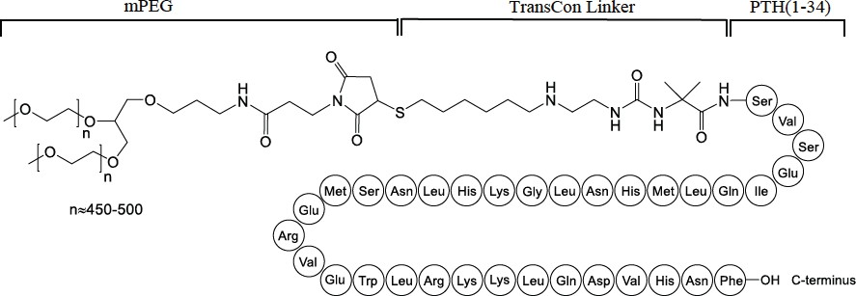
The two key pharmacokinetic analytes are:
- Total PTH, a surrogate measure of the palopegteriparatide prodrug, with either PTH(1- 34) or PTH(1-33) still attached to mPEG
- Free PTH, a measure of PTH released from the prodrug, consisting of the sum of free/released PTH(1-34) and free/released PTH(1-33)
PTH(1-33) is the main active metabolite of PTH(1-34). It is assumed that conversion of PTH(1- 34) to PTH(1-33) occurs both before and after its release from the prodrug.

Study 103
Study 103 was a phase 1 single and multiple ascending dose trial that evaluated the pharmacokinetics and pharmacodynamics of palopegteriparatide in healthy adult subjects. Single doses of 3.5 to 124 µg and multiple doses of 3.5 to 24 µg daily for 10 days were administered (n≤8 for each dose).
Palopegteriparatide is administered as a daily subcutaneous injection of the prodrug. Free PTH, consisting of free PTH(1-34) and free PTH(1-33), are the active molecules. Both the prodrug (measured as total PTH) and free PTH reach the systemic circulation. On Day 10, average Tmax was 8-24 hours for total PTH and 4-8 hours for free PTH.
Following once daily dosing for 10 days, for all dose levels, Total PTH appeared to still be increasing after the end of the dosing interval on Day 10. However, trough concentrations flattened out suggesting that concentrations were approaching steady state (Figure 3).
Concentrations of Free PTH between 16 to 24 µg/day PTH appeared to be approaching steady state levels by approximately Day 8, based on visual inspection of the concentration vs. time profile (Figure 4). The 7-8 days required to reach steady-state for free PTH and dose proportionality being demonstrated up to 30 µg/L are of particular relevance to dosing and titration.
Accumulation of Total PTH in plasma following 10 days of once daily dosing was observed, with the mean accumulation ratios, based on AUC_{0-τ} and C_{max} between 7.49 and 18.3 (individual range: 6.00 to 102) and 4.62 and 12.5 (individual range: 4.01 to 57.9), respectively (Table 3).
A summary of the PK parameters of free PTH following multiple subcutaneous doses in Study 103 are found in Table 4.
Concentrations of mPEG, for all dose levels, appeared to be increasing after end of the dosing interval on Day 10; therefore, steady state had not been achieved during 10 days of once daily SC injection. Accumulation of mPEG in plasma with multiple dosing was detected. Based on
AUC_{0-τ} accumulation ratios were between 13.5 and 25.2 and based on C_{max} mean accumulation ratios were between 9.23 and 19.4 (individual range: 8.55 to 29.0).
Figure 3. Arithmetic Mean (±SE) Plasma Concentrations of Total PTH Following Multiple Subcutaneous Doses (Linear Scale) (Days 1 to 10) – study 103
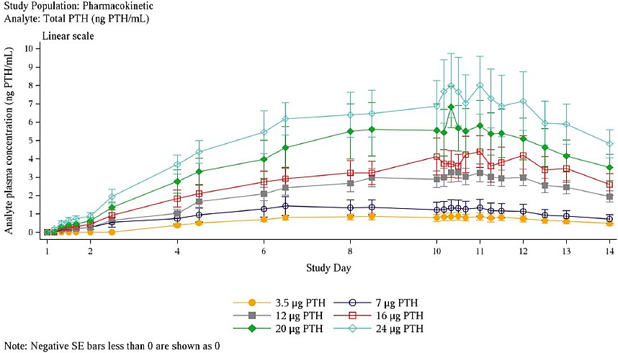
Figure 4. Arithmetic Mean Plasma (±SE) Concentrations of Free PTH Following Multiple Subcutaneous Doses (Linear Scale) (Days 1 to 10) – study 103
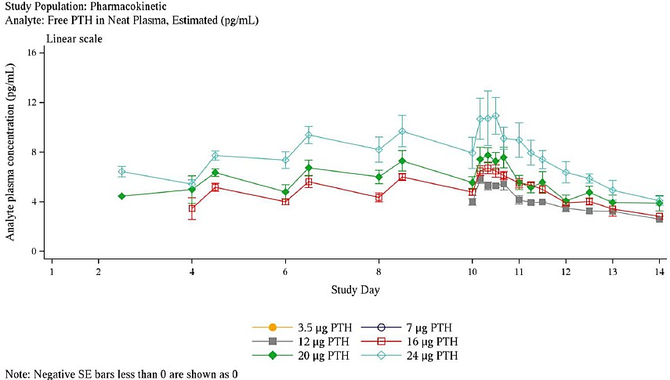
Table 3. Summary of the Pharmacokinetic Parameters of Total PTH Following Multiple Subcutaneous Doses – study 103
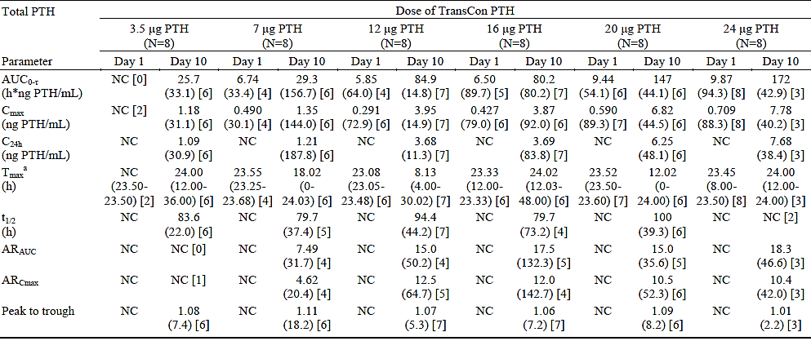
Abbreviations: n = number of observations; N = number of subjects dosed; NC = not calculated. Note: Geometric mean (CV%) [n] data are presented, except Median (min-max); Dosing error on Day 1 & 2 for all subjects in the 7 pg PTH dose group, actual dose received was 8.96 pg. Day 1 parameters are based on the actual dose received.
Table 4. Summary of the Pharmacokinetic Parameters of Free PTH Following Multiple Subcutaneous Doses – study 103
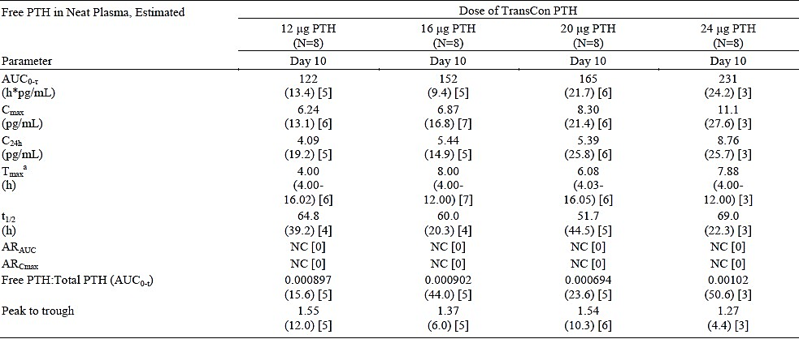
Abbreviations: n = number of observations; N = number of subjects dosed; NC = not calculated. Note: Geometric mean (CV%) [n] data are presented, except ª Median (min-max); Dosing error on Day 1 & 2 for all subjects in the 7 pg PTH dose group, actual dose received was 8.96 pg. Day 1 parameters are based on the actual dose received.

Study 304 and 201
Pharmacokinetic results in the target population are difficult to interpret as patients would have switched between dose groups overtime as per the titration schedule. mPEG concentrations reached steady state around Week 8 in alignment with the t_{½} (approximately 200 h). After Week 8, a flat curve was observed with no increasing and decreasing except for the high variability (Figure 5).
Dose normalised free PTH(1-34) and free PTH(1-33) concentrations in study 304 (Figure 6), while somewhat non-linear between 9 and 15µg, appear to be broadly linear between 18 and
30 µg, with insufficient data for interpretation at doses higher than 30 µg. Further, doses >30 µg day were given using two pens, and it is unknown whether this affects proportionality.
Figure 5. Arithmetic Mean (SE) Plasma Concentrations-time Profiles in Linear Scale – mPEG (ng/mL) – (PK Population) (Without Treatment Boosted Anti-PEG Positive Subjects) – study 201
‘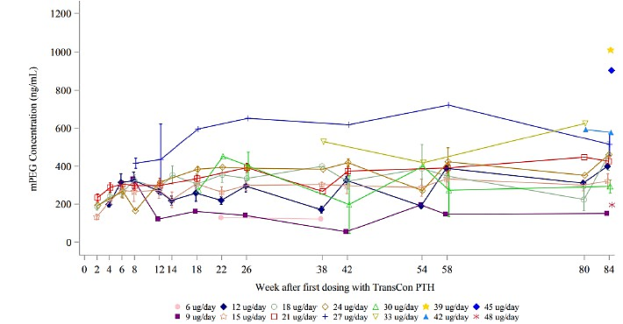Note: Week after dosing with TransCon PTH: Week 0 corresponds to Week 5, when the TransCon PTH administration started for subjects administered placebo during the first 4 weeks. Blinded period: 15 pg PTH(1-34)/day: N = 16 to 18, 18 pg PTH(1-34)/day: N =17 to 18 and 21 pg PTH(1-34)/day: N = 14 Extension period across all dose levels: N = 1 to 14.
Figure 6. Dose-normalized Free PTH(1-34) and Free PTH(1-33) Concentration Versus Daily Dose of Palopegteriparatide in Trial TCP-304
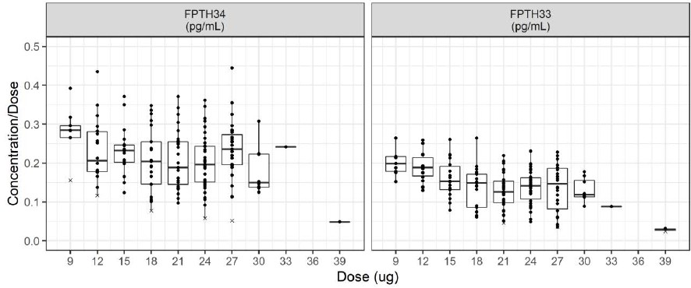
Dose-normalized Free PTH(1-34) (FPTH34) and Free PTH(1-33) (FPTH33) observations versus dose. Dose of palopegteriparatide refers to dose of PTH(1-34)/day administered Abbreviation: PTH: Parathyroid hormone

Study 104
Study 104 was an open-label, parallel-group trial to evaluate the safety, tolerability, and pharmacokinetics of palopegteriparatide in subjects without hypoparathyroidism and with varying degrees of renal impairment, to whom healthy control subjects with normal renal function were demographically matched. Male and female subjects aged between 18 and 75 years (inclusive) with a BMI between 18.0 and 36.0 kg/m² (inclusive) and a body weight ≥40 kg were included. A single dose of ~50 µg palopegteriparatide was administered. No formal sample size determination was performed.
Results for free PTH(1-34) in subjects with severe renal impairment should be interpreted with caution. The sponsor proposes secondary hyperparathyroidism in patients with chronic kidney disease as a factor to consider when interpreting the increased free PTH exposure in subjects with severe renal impairment.
While a dedicated renal study in patients with hypoparathyroidism has not been performed, Total PTH concentrations does not appear to be impacted by renal impairment.

Study 105
Study 105 is a Phase I study comparing the PK of single dose palopegteriparatide in healthy male Japanese subjects to weight-matched non-Japanese subjects. Three doses were administered: 50 µg, 75 µg and 100 µg. 48 subjects were recruited, including 6 who received placebo. The overall mean age was 36 years. The primary endpoint was free PTH(1-34) exposure.
Free PTH(1-34) AUC₀₋₁₂₀ and C_{max} were broadly comparable between Japanese and non- Japanese subjects, with the exception of Cmax at the 75 µg dose, with the difference unlikely clinically meaningful.

Population pharmacokinetic data
Plasma PK was available from 178 subjects in phase 1 studies and 103 subjects with hypoparathyroidism in phase 2 and 3 studies (Tables 5 and 6). A semi-mechanistic PK model structure was chosen to describe the mechanism of the prodrug and PTH metabolism and to simultaneously describe plasma PK with a single model. Predicted Day-84 C_{max} and AUC per dose and analyte are summarised in Table 7.
Table 5. Number and percentage of observations in PK analysis dataset excluding ree PTH observations – MODPTH03
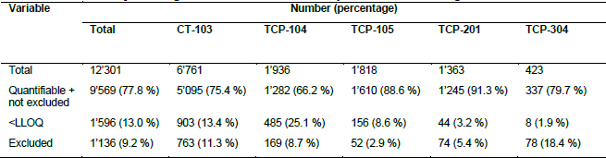
Table 6. Baseline covariate summary statistics from the PK analysis data set – MODPTH03
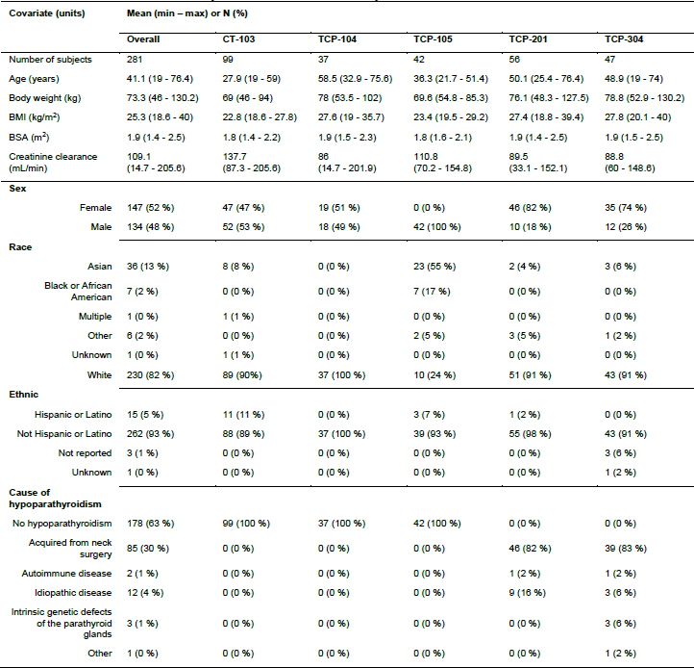

Table 7. Predicted Day-84 C_{max} and AUC per dose and analyte. Units of C_{max} as indicated in the analyte column. Units of AUC in concentration*hour. Numbers rounded to 3 significant digits – MODPTH03
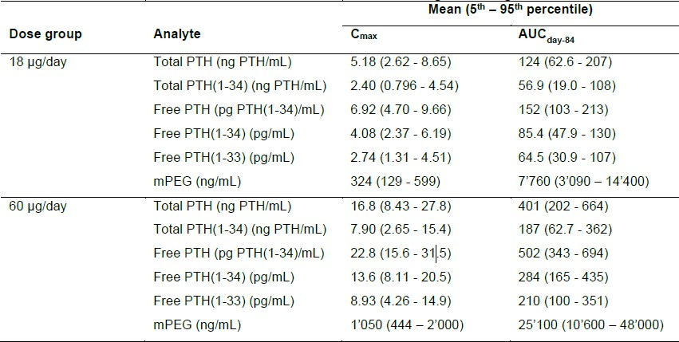
Missed doses were predicted to temporarily lower Free PTH exposure with a 20 and 40% reduction of the median Free PTH Ctrough for 1 or 2 consecutive missed doses, and a larger effect for 4 or 7 consecutive missed doses (60 and 80% reduction, respectively). For 7 missed doses, the median exposure was predicted to return to steady state within 1-2 weeks.
For the Pop PK analysis, only 77.8% of PK observations were included which risks selection bias. Results show that a difference in PK was found between the phase I and phase II/III trials. The popPK report suggests that this was a result of differences between trials, in particular differences in sampling handling procedures, rather than between healthy subjects and patients with hypoparathyroidism. The fraction of Free PTH in a sample is sensitive to temperature and pH as the release half-life is depending on temperature and pH. This adds uncertainty to the validity of PK samples collected, therefore data from selected sites from study304 was excluded from the evaluation to ensure only valid results were used for the subsequent estimation of PK parameters and covariate assessment.

ASC0201F. Quantitative Systems Pharmacology (QSP) Modeling and Simulation to Support Development and Regulatory Submission of TransCon PTH for the Treatment of Hypoparathyroidism
The over-arching aim of this analysis was to extend a quantitative systems pharmacology (QSP) model to mechanistically substantiate the physiologic responses to, and the pharmacologic responses from, TransCon PTH following administration to patients with hypoparathyroidism. Data from studies 103, 104, 105 and 201 were included.
In the context of comparing expectations with the QSP model descriptions of physiology, pathophysiology and pharmacology, the mechanistic TransCon PTH exposure-response was demonstrated on a number of levels, including the resulting effect on 24 hour urine calcium excretion, serum calcium and phosphate, and the intricate feedback of the phosphate-FGF23- vitamin D axis.
Simulations to evaluate the impact of one, two, four, or seven consecutive days of missed TransCon PTH dosing (18 mcg QD) from a steady-state PTH exposure, indicated that, in an otherwise dose-compliant scenario, shorter discontinuations (one to two days, possibly up to four days) were unlikely to result in marked drops in serum calcium. Longer disruptions (e.g., four or seven or greater days without TransCon PTH treatment) would more likely result in a notable serum calcium decrease.
Limitations of the model are noted. The main relevance of the QSP model to the current submission is providing an estimate on the effect on serum calcium from missed doses (Figure 7).
Figure 7. Patient Model - Study TCP-201: The active PTH concentration, serum calcium concentration, serum calcium concentration change from steady-state, and urine calcium excretion rate over time, for patients with 18 mcg QD of TransCon PTH , dietary calcium of approximately 1 g/d, and dose holiday of 2 days.
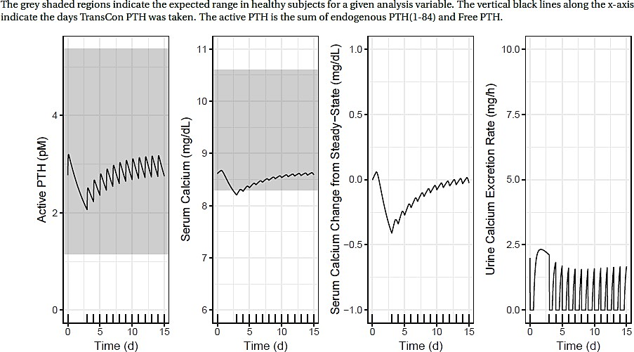

Pharmacodynamics
A sub-study within study 201 that examined PK-PD relationship over 24 hours in patients who have had at least ~58 weeks of palopegteriparatide exposure and have been on a stable dose for ≥7 days.
The proposed mechanism of palopegteriparatide is consistent with the known physiology of endogenous parathyroid hormone. As expected, palopegteriparatide increases serum calcium in healthy subjects and in patients with hypoparathyroidism. Among healthy subjects, dose- dependent increases are observed up to 24 µg. However, data are scarce in patients with hypoparathyroidism, in whom dose-dependent increases in serum calcium have not been shown.
Endogenous parathyroid hormone is suppressed by palopegteriparatide in healthy subjects.

Dosage selection
In study 103, multiple daily dosing of 20 µg in healthy subjects was considered the maximum tolerated dose based on adverse events. Dose-dependent increase in serum calcium was seen.
In the 4-week blinded period of study 201, subjects were randomised to 3 dose groups, 15 µg, 18 µg and 21 µg, as well as placebo. By week 4, the proportion of subjects with serum calcium within the normal range and not taking active vitamin D was similar between the dose groups. Overall safety profiles were also similar.
By week 84 (open-label extension), individual doses ranged from 9 to 54 µg, with 18 and 21 µg being the most common doses.
In the phase 3 pivotal study 304, a starting dose of 18 µg was used for all subjects randomised to the palopegteriparatide arm. The starting dose was followed by titration to 6 to 60 µg/day.

Starting dose and initiation instructions
The selection of 18 µg in study 304 was overall appropriate based on efficacy and safety data in study 201. The resulting mean average actual daily dose over 26 weeks in the palopegteriparatide arm was 21.4 µg, only slightly above the starting dose.
The proposed initiation instructions in the PI differ from the study 304 protocol in the following ways:
- Additional PI instructions on decreasing or ceasing calcium for patients not taking active vitamin D at baseline
- PI instructions to completely cease active vitamin D at baseline if serum calcium was ≥ 2.07 mmol/L, rather than having all patients reduce calcitriol by 50% regardless of baseline serum calcium
In addition, in study 304, only patients with a baseline requirement of calcitriol ≥0.5 μg/day and calcium ≥800 mg/day were enrolled. While the above adjusted PI initiation instructions are expected to partially attenuate the risk of hypercalcaemia when used in patients requiring less calcitriol or calcium at baseline compared to study 304, these PI instructions have not been formally studied. These factors add uncertainty, especially during the initial weeks of treatment, to whether the frequencies of hypercalcaemia and hypocalcaemia observed under clinical use would be similar or different to what were observed in study 304.

Dose range
Whether higher doses have a favourable risk-benefit profile was a main point of concern. In studies 304 and 201, most patients were using ≤30 µg at week 26, week 52 and week 110, respectively (Figures 8 - 11).
Figure 8. Distribution of Maintenance Doses of Palopegteriparatide at End of Blinded Period (Week 26, TCP- 304)
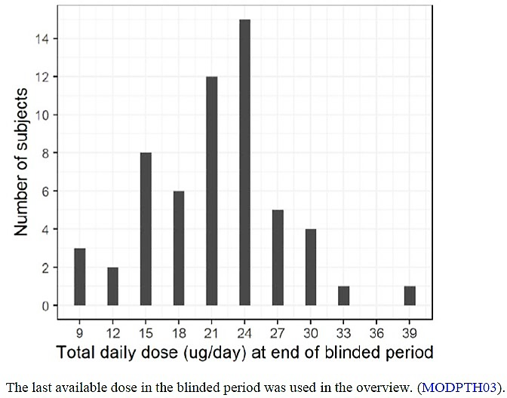
Figure 9. TransCon PTH Actual Dose Exposure: TCP-304 at Week 52 (Safety Analysis Population) – study 304
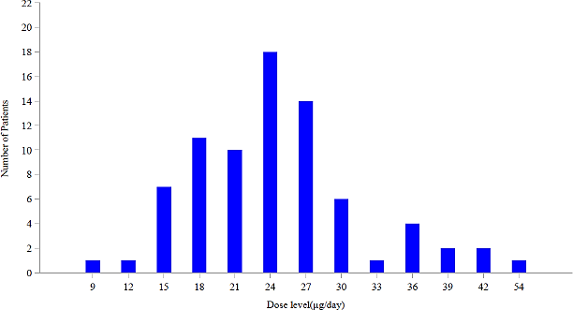

Figure 10. Actual Palopegteriparatide Dose Exposure at Week 84 (Safety Population) – study 201
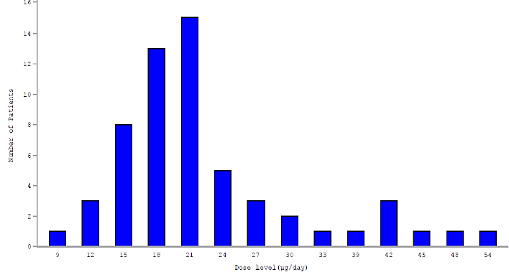
Note: TransCon PTH is expressed as µg of PTH(1-34)
Figure 11. Exposure at Week 110 – study 201
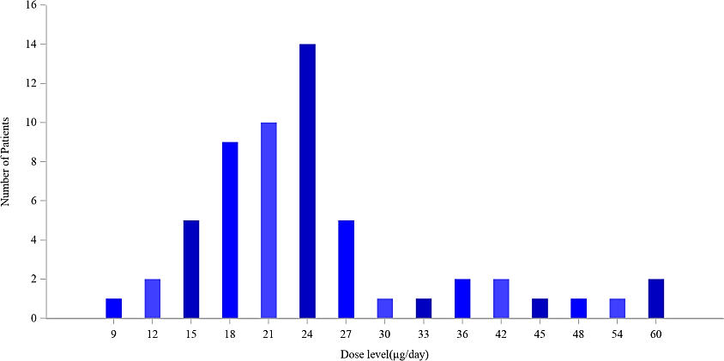
PK data above 30 µg/day are limited. Data supporting proportionality between dose and PK exposure do not cover dose ranges above 30 µg/day. The peak-to-trough ratio of Free PTH, which may impact the risk of hypo- or hypercalcaemia, at doses above 30 µg/day is unknown. PopPK modelling is of limited value in this regard given the lack of underlying data for multiple dosing above 30 µg/day. The TGA’s External popPK Evaluator also noted that the model should not be used for extrapolation.
The Sponsor was requested to provide safety data and serum calcium assessments over weeks 42-52 in patients requiring > 30 µg/day at week 52 in study 304, and data over weeks 84-110 in patients requiring > 30 µg/day at week 110 in study 201. The timeframe specified aligned with study visits and were chosen by the Clinical Evaluator to reflect a relevant period of time over which exposure to doses >30 µg/day would have occurred (Table 8).
Table 8. TCP-304: Requested Adverse Events and Serum Calcium Results for Weeks 42 to 52 for Palopegteriparatide Arm Only (Safety Population)
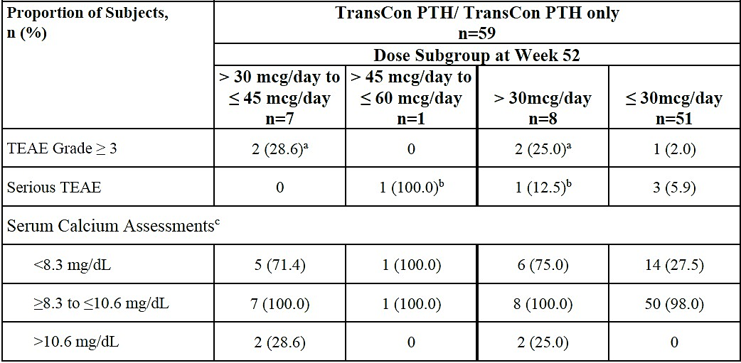
Note: Safety population includes subjects who had at least one dose of TransCon PTH. TEAEs occurring on or after the first dose of TransCon PTH are included up to Week 52.
ª Two non-serious TEAEs were recorded in two subjects. One Subject experienced a Grade 3 TEAE of hypocalcemia along with TEAE of medication error on Day 183 (First day of OLE) on dose of 27 mcg. At Week 52, subject was receiving 36 mcg. One subject experienced Grade 3 TEAE of lumbar radiculopathy on Day 277 on dose of 27 mcg. At Week 52, subject was receiving 33 mcg.
^{b} One subject experienced a Grade 2 SAE of hypocalcemia on Day 113 at a dose of 39 mcg/day. At Week 52, subject was receiving dose of 54 mcg/day.
^{c} Number of subjects with at least one sCa assessment in each category between the Weeks 42 to 52
Eight patients used a dose >30 µg/day at week 52, 25% and 12.5% of whom experienced a Grade ≥3 TEAE and a serious TEAE, respectively, compared to 2% and 5.9% respectively among patients using ≤30 µg/day. While small numbers obscure the interpretation, this at least raises concerns around the safety profile of >30 µg/day.
Seventy five percent of patients in the >30 µg/day group had serum calcium <2.07 mmol/L between weeks 42 to 52 (10-week duration). In the same study, 76.2% and 47.4% of patients in the placebo arm had serum calcium <2.07 mmol/L over months 0-3 and 3-6, respectively (blinded period, 13-week duration each). Acknowledging the limitations of such comparisons, this at least raises concern around the efficacy in terms of serum calcium in patients who require >30 µg/day, and whether these patients are actually better-off with palopegteriparatide compared to conventional therapy alone.
As a separate comparison, 75% of patients in the >30 µg/day group had serum calcium <2.07 mmol/L compared to 27.5% in the ≤30 µg/day group over weeks 42 to 52. The sponsor’s suggestion that higher doses may be a consequence of laboratory calcium abnormalities, rather than the cause of those abnormalities, is acknowledged. However, this does not negate the concern some patients may be poor responders to palopegteriparatide treatment. That is, patients who require doses >30 µg/day may not experience improvements in serum calcium to the same extent as patients who require ≤30 µg/day. Further, the sponsor’s suggestion does not address the higher frequency of serum calcium >2.64 mmol/L in the >30 µg/day group (25%) compared to the ≤30 µg/day group (0%), which is evidence of an increased risk of hypercalcaemia caused by >30 µg/day of palopegteriparatide.
Serum calcium data over weeks 84-110 from study 201 are similar to study 304, with 100% of the >30 µg/day group experiencing serum calcium <2.07 mmol/L compared to 44.7% in the ≤30 µg/day group.
The overall limited number of patients exposed to doses >30 µg/day (~14% at week 52 in study 304) add uncertainty to the risk-benefit profile of this dose range and in patients who require this dose range.
A related issue is that Module 3 data suggest a variability in device-delivered volume of ± 5 µL, corresponding to ±1.5 µg of palopegteriparatide. Using two pens, which is necessary to administer doses over 30 µg/day, double this variability to ± 3 µg, which based on clinical evaluation was found acceptable.

Dose adjustment and calcium monitoring instructions
Differences exist between the titration algorithm proposed in the PI and compared to the pivotal study:
- Relatively intense serum calcium monitoring schedule in study 304 vs. more relaxed recommendations in the proposed PI
- The amount the dose of calcitriol should be reduced by when serum calcium was normal or high was specified by the study 304 protocol but not the proposed PI
In addition, no data have been presented on the doses of conventional therapy required if palopegteriparatide is discontinued after prolonged use. Given palopegteriparatide suppresses endogenous parathyroid hormone, it is possible that the dose requirements of conventional therapy would be higher, especially in patients with some residual parathyroid function. No data are available on the risks associated with such transitions, or the proportion of patients who would have difficulties or fail such transitions, if any.

Efficacy
Two studies provide efficacy data:
- TransCon PTH TCP-201. PaTH Forward: A Phase 2, Multicenter, Randomized, Double- Blind, Placebo-Controlled, Parallel Group Trial with an Open-Label Extension, Investigating the Safety, Tolerability and Efficacy of TransCon PTH Administered Subcutaneously Daily in Adults with Hypoparathyroidism
- TransCon PTH TCP-304. PaTHway TRIAL: A Phase 3, Multicenter, Randomized, Double- Blind, Placebo-Controlled, Parallel Group Trial, with an Open-Label Extension, Investigating the Safety, Tolerability and Efficacy of TransCon PTH Administered Subcutaneously Daily in Adults with hypoparathyroidism
Study 304 is the pivotal study providing randomised efficacy data from week 1-26. Study 201 only had a randomised period of 0-4 weeks but provides supportive single-arm efficacy data up to week 110.

Study 304
Study 304 is a phase 3, multicentre, randomised, double-blind trial comparing palopegteriparatide + conventional treatment to placebo + conventional treatment over 26 weeks followed by an open-label extension (OLE) of 156 weeks thereafter (total 182 weeks).
This trial was conducted at 21 sites in 7 countries (Canada, Denmark, Germany, Hungary, Italy, Norway, and United States).
Date First Subject Screened: 15 Feb 2021. Data Cutoff Date: 12 Jan 2022. Interim Report: 15 Jul 2022.

Primary Objective
The primary objective of the study was to assess the treatment effect of daily palopegteriparatide on serum calcium levels and therapeutic doses of active vitamin D (i.e., calcitriol or alfacalcidol) and calcium at 26 weeks of treatment.

Secondary Objectives
The secondary objectives of the study were as follows:
- To assess the safety and tolerability of daily palopegteriparatide
- To assess the treatment effect of daily palopegteriparatide on hypoparathyroidism patient experience scale (HPES) and Short Form-36 (SF-36) domain scores
- To assess the treatment effect of daily palopegteriparatide on PD markers (including serum calcium) and active vitamin D and calcium doses
- To assess the treatment effect of daily palopegteriparatide on serum phosphate, calcium × phosphate (albumin-adjusted serum calcium-phosphate product) and serum magnesium
- To assess anti-PTH, anti-TransCon PTH and anti-polyethylene glycol (PEG) antibody responses
- To assess the treatment effect during the Extension Period
- To assess the treatment effect of daily palopegteriparatide on
  - BMD and trabecular bone score (TBS) by DXA
  - Bone turnover markers (serum P1NP and CTx)
- To assess the effect of treatment on patient-reported health-related QOL and a clinician reported outcome (ClinRO) assessment.

Inclusion criteria
- Males and females, ≥18 years of age
- Subjects with postsurgical chronic hypoparathyroidism, or auto-immune, genetic, or idiopathic hypoparathyroidism for at least 26 weeks. Diagnosis of hypoparathyroidism was established based on a history of hypocalcemia in the setting of inappropriately low serum PTH levels (hypocalcemia was defined as a value below the reference range for normal at the performing laboratory. Inappropriately low serum PTH levels were defined as at or below the median value of the reference range for normal at the performing laboratory while the concomitant serum calcium was low. If specific lab results at the time of original diagnosis were not available, as historical diagnosis affirming these two components was adequate for inclusion)
- Requirement for doses of conventional therapy (e.g., calcitriol, alfacalcidol, calcium supplements) at or above a minimum threshold:
  - For countries other than Japan: requirement for a dose of calcitriol ≥0.5 μg/day, or alfacalcidol ≥1.0 μg/day and (elemental) calcium ≥800 mg/day (e.g., calcium citrate, calcium carbonate etc.) for at least 12 weeks prior to Screening*. In addition, the dose of calcitriol, or alfacalcidol, or calcium had to be stable** for at least 5 weeks prior to Screening
  - For Japan: requirement for a dose of calcitriol ≥1.0 μg/day, or alfacalcidol ≥2.0 μg/day for at least 12 weeks prior to Screening*. In addition, the dose of calcitriol or alfacalcidol had to be stable** for at least 5 weeks prior to Screening. In Japan only (due to local practice and dietary patterns), there was no requirement to exceed a minimum dose of calcium supplements
*excluding individuals receiving PTH-like drugs within 12 weeks of the screening visit, who needed only demonstrate a stable requirement for elemental calcium and active vitamin D above minimum thresholds for 5 weeks prior to the screening visit.
**did not preclude occasional (≤2/week) PRN doses of calcium and/or active vitamin D for symptomatic hypocalcemia.
- Optimization of supplements prior to randomization to achieve the target serum levels of:
  - 25(OH) vitamin D levels of 20-80 ng/mL (49-200 nmol/L) and
  - Magnesium level in the normal range, or just below the normal range i.e.: ≥1.3 mg/dL (0.53 mmol/L) and
  - Albumin-adjusted or ionized serum calcium level in the normal range, or *just below the normal range, i.e.:
- Albumin-adjusted serum calcium 7.8-10.6 mg/dL (or 1.95-2.64 mmol/L)
- Ionised serum calcium 4.40-5.29 mg/dL (or 1.10-1.32 mmol/L)
*Just below the normal range implied the numerical range of 7.8-8.2 mg/dL (or 1.95-2.06 mmol/L) for albumin-adjusted serum calcium and the numerical range of 4.40-4.636 mg/dL (or 1.10-1.159 mmol/L) for ionized serum calcium.
- The subject demonstrated a 24-hour urine calcium excretion of ≥125 mg/24h (on a sample collected within 52 weeks prior to Screening or during the Screening Period)
Note: Although 24-hour urine samples prior to Screening could be done on or off thiazide therapy, thiazide therapy was prohibited during the trial; and the 24-hour urine collection scheduled prior to Visit 1 had to be done while off thiazides for at least 4 weeks prior to collection.
- Body mass index (BMI) 17 to 40 kg/m² at Screening
- If ≤25 years of age, radiological evidence of epiphyseal closure based on X-ray of non- dominant wrist and hand
- Thyroid-stimulating hormone (TSH) within normal laboratory limits within the 6 weeks prior to Visit 1; if on suppressive therapy for a history of thyroid cancer, TSH level had to be ≥0.2 mIU/L
- If treated with thyroid hormone replacement therapy, the dose had to have been stable for at least 5 weeks prior to Screening
- eGFR ≥30 mL/min/1.73 m2 during Screening
- Able to perform daily SC self-injections of study drug (or have a designee to perform injections) via a pre-filled injection pen
- Able and willing to provide written and signed ICF in accordance with GCP
- For France only: The subject was obligated to be affiliated with, or beneficiary of a social security system or assimilated.

Key exclusion criteria
Any of the following was regarded as a criterion for exclusion from the trial:
- Impaired responsiveness to PTH (pseudohypoparathyroidism), characterized as PTH- resistance, with elevated PTH levels in the setting of hypocalcemia
- Any disease that might have affected calcium metabolism or calcium-phosphate homeostasis or PTH levels other than hypoparathyroidism, such as active hyperthyroidism; Paget disease of bone; severe hypomagnesemia; type 1 diabetes mellitus or poorly controlled type 2 diabetes mellitus (HbA1c >9%, documented HbA1c result drawn within 12 weeks prior to Screening was acceptable); severe and chronic liver, or renal disease; Cushing syndrome; multiple myeloma; active pancreatitis; malnutrition; rickets; recent prolonged immobility; active malignancy (other than low-risk well differentiated thyroid cancer or non-melanoma skin cancer); active hyperparathyroidism; parathyroid carcinoma within 5 years prior to Screening; acromegaly; or multiple endocrine neoplasia types 1 and 2
- High risk thyroid cancer within 2 years, requiring suppression of TSH <0.2 mIU/L
- Use of loop diuretics, phosphate binders (other than calcium supplements), digoxin, lithium, methotrexate, biotin >30 μg/day, or systemic corticosteroids (other than as replacement therapy)
- Use of thiazide diuretic within 4 weeks prior to the 24-hour urine collection scheduled to occur within 1 week prior to Visit 1
- Use of PTH-like drugs (whether commercially available or through participation in an investigational trial), including PTH(1-84), PTH(1-34), or other N-terminal fragments or analogs of PTH or PTH-related protein, within 4 weeks prior to Screening
- Use of other drugs known to influence calcium and bone metabolism, such as calcitonin, fluoride tablets (>0.5 mg/day), strontium, or cinacalcet hydrochloride, within 12 weeks prior to Screening
- Use of osteoporosis therapies known to influence calcium and bone metabolism, i.e., bisphosphonate (oral or intravenous [IV]), denosumab, raloxifene, or romosozumab therapies within 2 years prior to Screening

Study treatments
Subjects were randomized in a 3:1 ratio into 2 treatment groups:
- Palopegteriparatide 18 µg/day*, co-administered with conventional therapy
- Placebo for palopegteriparatide (excipient solution) 18 µg/day, co-administered with conventional therapy
*Dose of palopegteriparatide refers to dose of PTH(1-34) administered
See inclusion criterion 4 for optimisation of 25(OH) vitamin D, magnesium and calcium levels during the ≤4-week screening period prior to randomisation. At visit 1 after randomisation, study drug was started at 18 µg/day and active vitamin D dose was decreased by 33 to 50%. Subsequently, study drug and conventional therapy were individually and progressively titrated as shown in Figure 12.
Figure 12. Titration algorithm – study 304
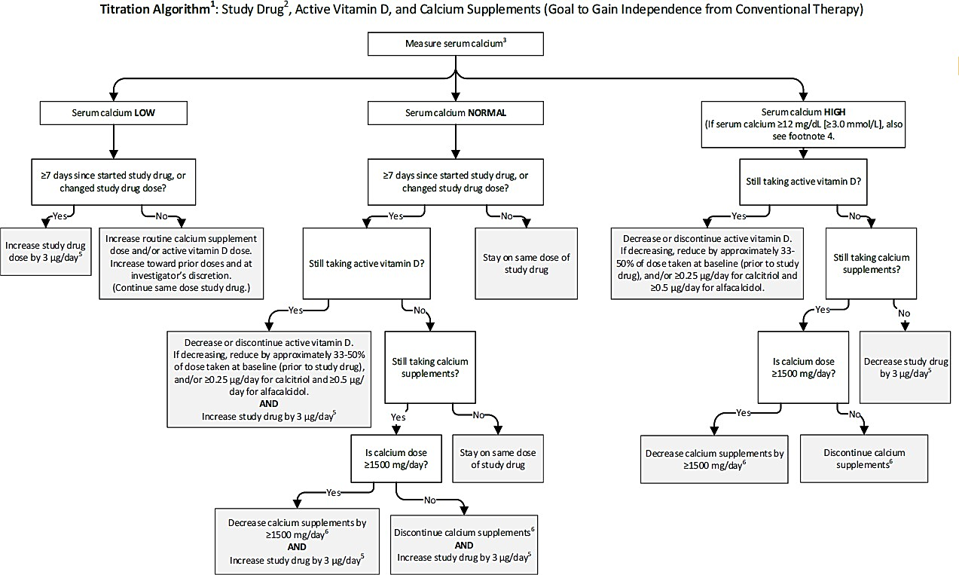
¹ At Visit I (Week 0, Day 1), study drug was started at 18 pg/day and active vitamin D dose was decreased by 33-50% (e.g., slap second dose of the day if taking BID, and skip final dose of the day if taking TID).
² Study drug referred to palopegteriparatide or placebo.
³ Serum calcium referred to either albumin-adjusted serum calcium and/or ionized calcium. For the purposes of this trial, the normal ranges were: albumin-adjusted serum calcium 8.3 to 10.6 mg/dL (2.07 to 2.64 mmol/L); ionized calcium 1.16 to 1.32 mmol/L.
⁴ If albumin-adjusted serum calcium ≥12.0 mg/dL (3.00 mmol/L) or ionized calcium ≥1.50 mmol/L study drug was held for approximately 2 to 3 days. Study drug was then resumed. Also study drug, active vitamin D, or calcium were reduced as per algorithm.
5 Check sCa within 7-14 days after any changes in study drug dote: standing calcium, standing vitamin D doses, or Ca outside the normal range. A scheduled visit or LV within 7-14 days meets this requirement When scheduled study suits occur less frequently (e g . 13 weeks apart) then an ULV was pursued
⁶ The goal was to demonstrate independence from therapeutic doses of calcium supplements. In case needed to meet recommended dietary intake of calcium. it was permitted to take calcium supplements ≤600 mg/day as a nutritional supplement for the sake of reaching the recommended dietary intake.
Notes:
Adjustments of study drug, calcium and/or active vitamin D was made per the titration algorithm based on the results of the most recent laboratory results whether scheduled or unscheduled. When central and local calcium values were obtained concurrently, local values were used to guide titration. At all times during the trial subjects with symptoms of hypocalcemia could take PRN doses of calcium (preferred) and/or active vitamin D, and/or do an ULV visit to measure serum calcium. Subjects with symptoms of hypocalcaemia could hold doses of study drug for 1 day and/or do an ULV to measure serum calcium. An ULV was performed within 7 days of a PRN supplement dose or a held dose. If due to symptoms >2 PRN doses of conventional therapy were taken or >2 doses of conventional therapy and/or study drug were held within those 7 days, an ULV was required within 2 days of the third PRN or held dose.
Following successful completion of the Blinded Treatment Period, subjects were allowed to enter the open-label Extension Period during which all subjects received palopegteriparatide.

Efficacy variables and outcomes primary endpoint
Proportion of subjects with the following at 26 weeks of treatment:
- Albumin-adjusted serum calcium measured within 4 weeks prior to and on Week 26 visit within the normal range (8.3-10.6 mg/dL) *; and
- Independence from active vitamin D within 4 weeks prior to Week 26 visit (i.e., all daily standing dose of active vitamin D equal to zero AND use of pro re nata (PRN, as needed/rescue) ≤7 days during the 4 weeks); and
- Independence from therapeutic doses of calcium within 4 weeks prior to Week 26 visit (i.e., average daily standing dose of elemental calcium ≤600 mg AND use of PRN doses on ≤7 days during the 4 weeks). This dose of elemental calcium ≤600 mg/day in the form of tablets, powder, liquid suspension, or transdermal patch was considered as “supplemental” to meeting recommended daily intake for general health, as opposed to a “therapeutic” dose to treat hypoparathyroidism; and
- No increase in prescribed study drug within 4 weeks prior to Week 26 visit. **
*Except for at the Week 26 visit, confirmation that an albumin-adjusted serum calcium is “abnormal” requires 2 consecutive results outside the normal range within 4 weeks prior to the Week 26 visit.
** Dose decrease permitted for safety reasons.

Secondary endpoints
Key secondary endpoints included the change from baseline at 26 weeks of treatment for the following parameters:
- HPES - Symptom - Physical domain score
- HPES - Symptom - Cognitive domain score
- HPES - Impact – Physical Functioning domain score
- HPES - Impact – Daily Life domain score
- 36-Item Short Form Survey (SF-36) Physical Functioning subscale score
The following endpoints were evaluated at predefined timepoints during the Blinded Treatment and will be evaluated during the Extension Period:
- Calcium and active vitamin D doses
- Daily “pill burden” of active vitamin D and calcium (as oral tablets, powder, liquid solutions, liquid suspensions, or transdermal patches) assessed
- Serum phosphate
- Albumin-adjusted serum calcium-phosphate product, including proportion of subjects with albumin-adjusted serum calcium-phosphate product ≤55 mg²/dL², ≤52 mg²/dL², and ≤44 mg²/dL²
- Albumin-adjusted serum calcium
- BMD and TBS by DXA
- Bone turnover markers (serum P1NP and CTx)
- Serum magnesium
- EQ-5D
- CGI-S
- HPES: HPES - Impact domain scores (Psychological Well-being and Social Life and Relationships) and HPES - Symptom and Impact total scores
- SF-36: SF-36 subscale scores (Role Limitations due to Physical Health Problems, Bodily Pain, General Health, Vitality, Social Functioning, Role Limitations due to Emotional
- Problems, and Mental Health) and SF-36 component summary scores (Physical component score [PCS] and Mental component score [MCS])
The following safety endpoints were assessed during the Blinded Treatment and Extension Periods:
- Incidence of adverse events (AEs), adverse events of special interest (AESI) and serious adverse events (SAEs)
- Serum chemistry and hematology
- 24-hour urine chemistry (including urine calcium and urine creatinine clearance) Clinical events of hypo- or hypercalcemia (emergency/urgent care visits and hospitalizations)
- Injection site tolerability (based on AEs)
- Evaluation of anti-PTH, anti-TransCon PTH and anti-PEG antibody responses
- Vital signs

Randomisation and blinding methods
Randomization was stratified by aetiology of hypoparathyroidism (post-surgical versus all other). Randomization was conducted via Interactive Web Randomization System.
The study was double-blind so that neither the sponsor, subject, nor site personnel involved in study conduct knew the identity of a subject’s treatment. Both palopegteriparatide and placebo were provided in identical pens by the site pharmacist.

Analysis populations
Randomized Population: all subjects who were randomized to a treatment group in the study. Intent to Treat (ITT) Population: all subjects in the Randomized Population who received at least one dose of blinded study drug. Subjects were analyzed according to study treatment per randomization.
Safety Analysis Population: all subjects in the Randomized Population who received at least one dose of blinded study drug. Subjects were analyzed according to actual study treatment received.

Sample size
Assuming that the response rate was 70% for palopegteriparatide and 15% for placebo for the primary endpoint at 26 weeks, 68 subjects randomized 3:1 to active palopegteriparatide vs. placebo would have approximate statistical powers of 99% at alpha = 0.05, and 95% at alpha =
0.01 (two-sided) to demonstrate statistically significant difference between palopegteriparatide and placebo.

Statistical methods
In the Blinded Treatment Period analysis, the Cochran–Mantel–Haenszel (CMH) test controlling for randomization stratification factor (etiology of hypoparathyroidism: post-surgical versus other) was used for the primary analysis and other categorical endpoints. The continuous efficacy endpoints were analyzed using ANCOVA model. In general, the continuous endpoint of interest or change from baseline was included in the model as a response variable. Treatment assignment and etiology of hypoparathyroidism were entered as fixed effects and the baseline value of the variable of interest was entered as a covariate, unless otherwise specified.
For the primary analysis, the 2-sided CMH test controlling for etiology of hypoparathyroidism (post-surgical versus other) was conducted to test the following hypothesis for the primary efficacy endpoint with alpha = 0.05:
H₀: OR_{Post} = OR_{Other} = 1,
where OR_{Post} and OR_{Other} were the odds ratios (i.e., the odds of meeting the primary endpoint in the palopegteriparatide group compared to the odds in the placebo group) within post-surgical and other groups, respectively.
Multiplicity adjustment was applied to control the family-wise type-I error rate for all key secondary endpoints.

Participant flow
Figure 13. Subject Disposition – Blinded Period (All Subjects) – study 304
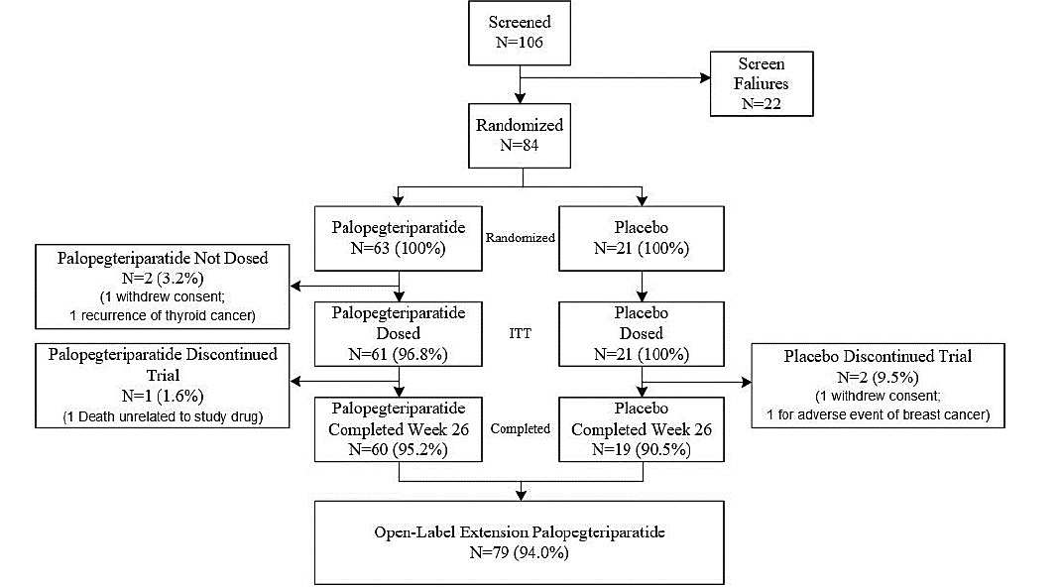
Abbreviations: ITT Population: Intent-to-treat Population: defined as all randomized subjects who received at least 1 dose of blinded study drug. Note: the Randomized Population is the denominator used to support the data presented in the figure.

Major protocol violations/deviations
Table 9. Major Protocol Deviations – Blinded Period (ITT Population) – study 304
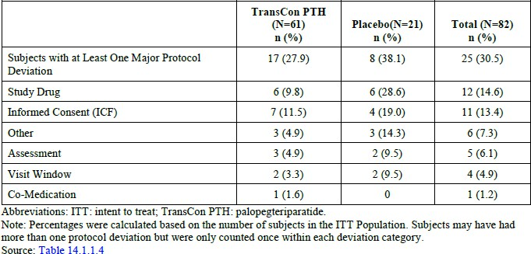
Abbreviations: ITT: intent to treat; TransCon MI: palopegteriparatide. Note: Percentages were calculated based on the number of subjects in the ITT Population. Subjects may have had more than one protocol deviation but were only counted once within each deviation category.

Baseline data
Table 10. Demographics and Baseline Characteristics - Blinded Period (ITT Population) – study 304
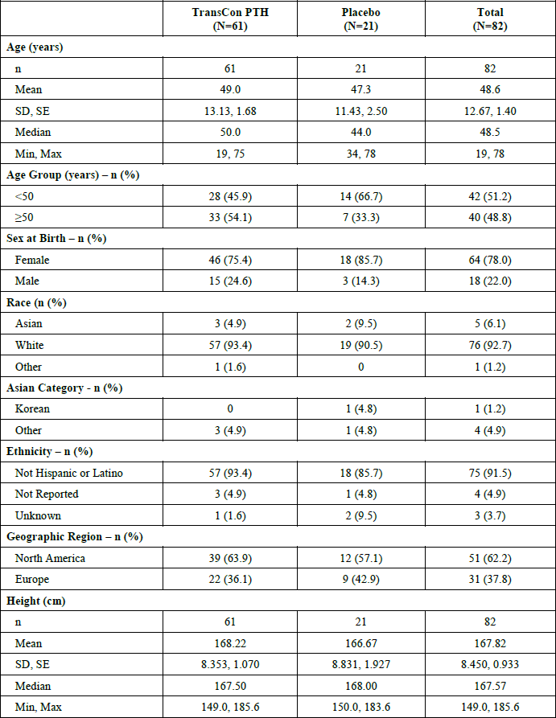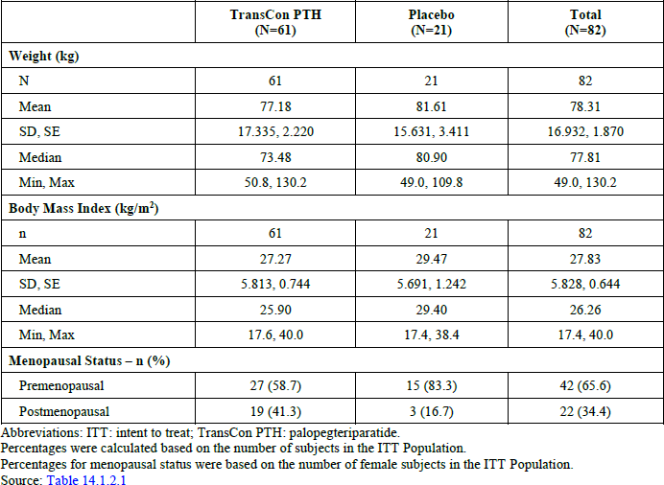
Table 11. Hypoparathyroidism History and Characteristics at Baseline – Blinded Period (ITT Population) – study 304
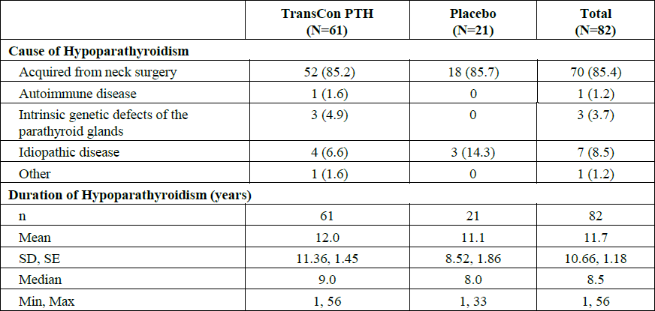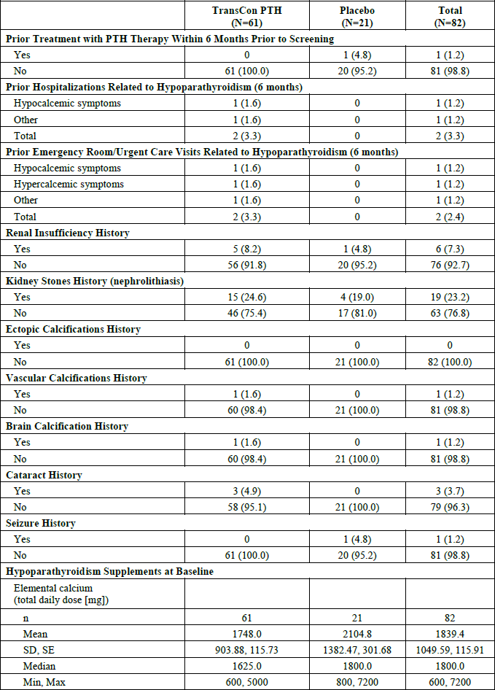
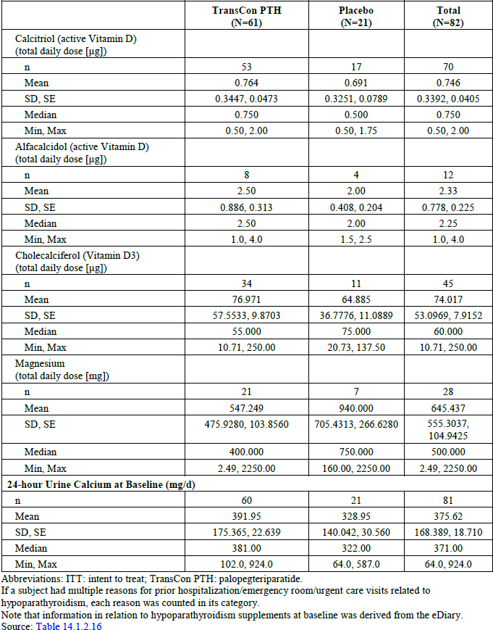

Results for the primary efficacy outcome
Table 12. Primary Efficacy Analysis – Blinded Period (ITT Population) – study 304
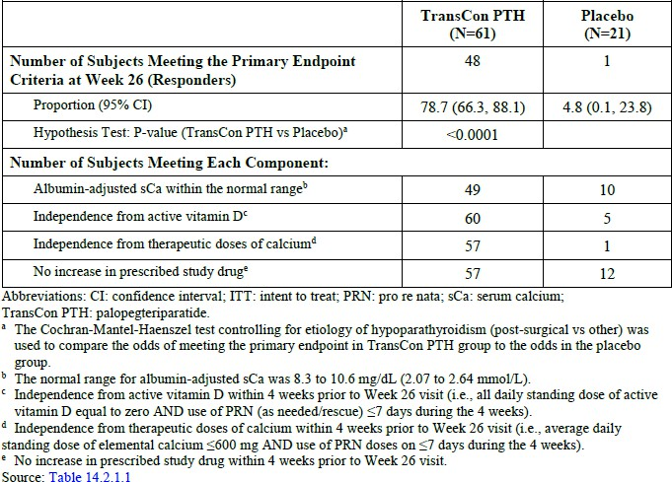
Abbreviations: CI: confidence interval; ITT: intent to treat; PRN: pro re nata; sCa: serum calcium; TransCon PTH: palopegteriparatide.
ª The Cochran-Mantel-Haenszel test controlling for etiology of hypoparathyroidism (post-surgical vs other) was used to compare the odds of meeting the primary endpoint in TransCon PTH group to the odds in the placebo group.
^{b} The normal range for albumin-adjusted sCa was 8.3 to 10.6 mg/dL (2.07 to 2.64 mmon).
^{c} Independence from active vitamin D within 4 weeks prior to Week 26 visit (i.e., all daily standing dose of active vitamin D equal to zero AND use of PRN (as needed/rescue) <7 days during the 4 weeks).
^{d} Independence from therapeutic doses of calcium within 4 weeks prior to Week 26 visit (i.e., average daily standing dose of elemental calcium <600 mg AND use of PRN doses on <7 days during the 4 weeks).
^{e} No increase in prescribed study drug within 4 weeks prior to Week 26 visit.
Table 13. Post Hoc Primary Endpoint Sensitivity Analysis 7 – Blinded Period (ITT Population) – study 304
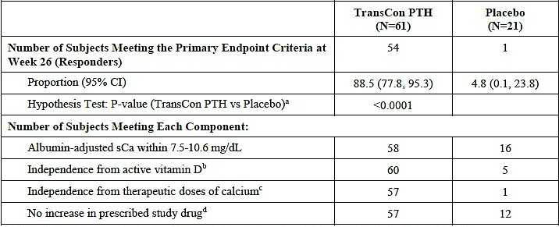
Abbreviations- CI: confidence interval; ITT: intent to treat; PRN: pro re nata; sCa: serum calcium; TransCon PTH: palopegteriparatide.
ª The Cochran-Mantel-Haenszel test controlling for etiology of hypoparathyroidism (post-surgical vs other) was used to compare the odds of meeting the primary endpoint in TransCon PTH group to the odds in the placebo group.
^{b} Independence from active vitamin D within 4 weeks prior to Week 26 visit (i.e., all daily standing dose of active vitamin D equal to zero AND use of PRN (as needed/rescue) <7 days during the 4 weeks)
^{c} Independence from therapeutic doses of calcium within 4 weeks prior to Week 26 visit (i.e., average daily standing dose of elemental calcium <600 mg AND use of PRN doses on <7 days during the 4 weeks)
^{d} No increase in prescribed study drug within 4 weeks prior to Week 26 visit.

Results for other efficacy outcomes
Table 14. Overview of Key Secondary Efficacy Endpoint Results (Mean) for Palopegteriparatide Subjects - Blinded Period (ITT Population) – study 304
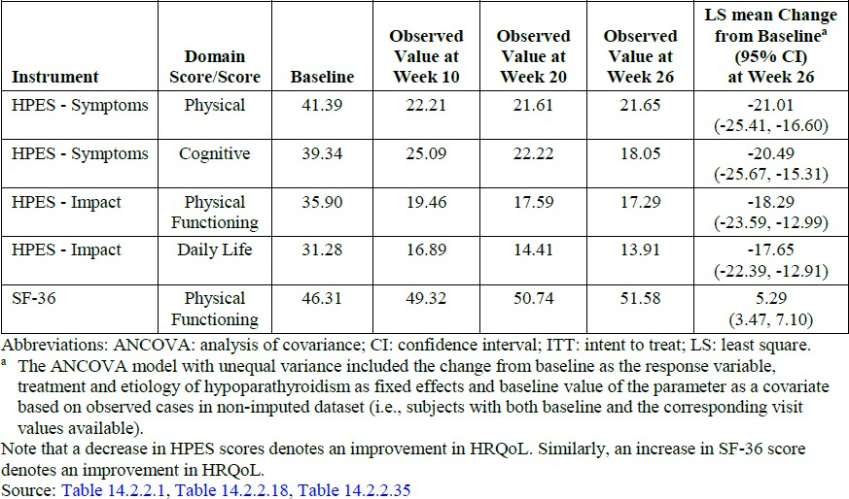
Abbreviations: ANCOVA: analysis of covariance: CI: confidence interval; ITT: intent to treat; LS: least square.
a The ANCOVA model with unequal variance included the change from baseline as the response variable. treatment and etiology of hypoparathyroidism as fixed effects and baseline value of the parameter as a covariate based on observed cases in non-imputed dataset (i.e.. subjects with both baseline and the corresponding visit values available). Note that a decrease in HPES scores denotes an improvement in HRQoL. Similarly. an increase in SF-36 score denotes an improvement in HRQoL.
Table 15. Secondary Endpoints: Conventional Therapy Intake at Week 26 – Blinded Period (ITT Population) (TCP-304)
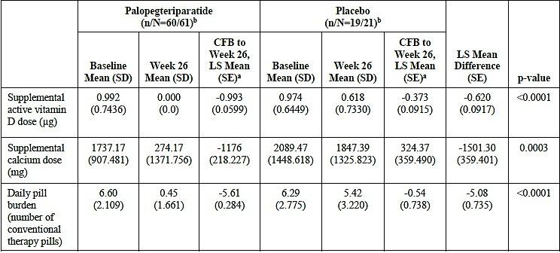
Abbreviations- LS = Least squares; ITT = intent to treat; SE = Standard Error.
ª The ANCOVA model with unequal variance includes the change from baseline as the response variable, treatment and etiology of hypoparathyroidism as fixed effects and baseline value of the parameter as a covariate.
^{b} N is the number of subjects in ITT population; n is the number of subjects with data at both baseline and Week 26. Change from baseline is calculated for subjects with data at both baseline and Week 26.
Figure 14. Serum Calcium (Mean ± SE) by Visit – Blinded Period (ITT Population)
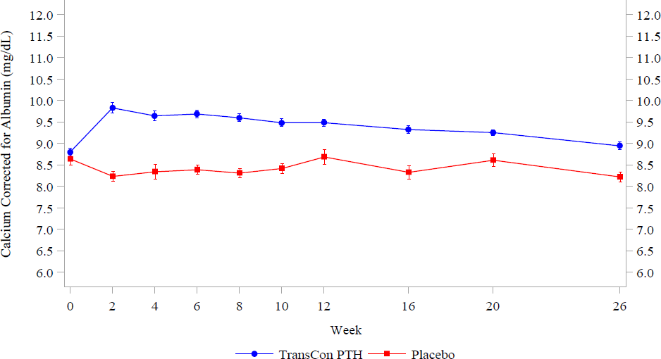
Figure 15. Serum Phosphate (Mean ± SE) by Visit – Blinded Period (ITT Population) – study 304
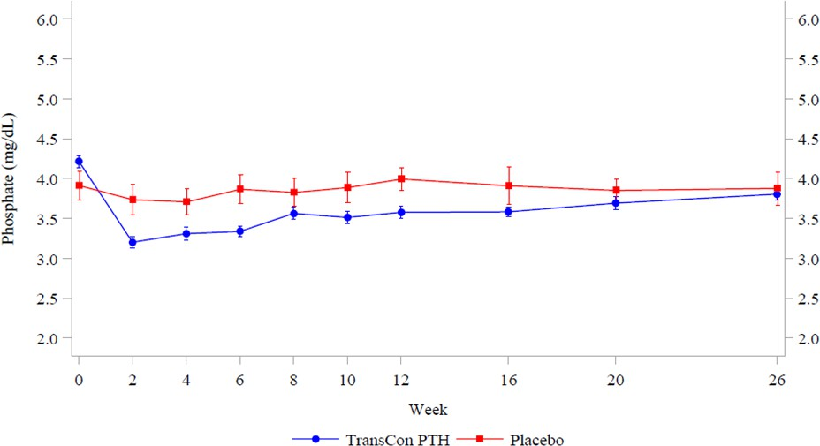

Figure 16. Serum Calcium-Phosphate Product (Mean ± SE) by Visit – Blinded Period (ITT Population) – study 304
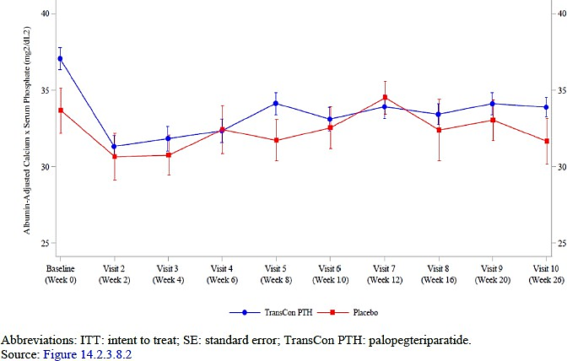

Study 201
Study 201 is a phase 2 study comparing fixed doses of palopegteriparatide (15 µg/day, 18 µg/day and 21 µg/day) to placebo over a 4-week blinded period. During the extension phase from weeks 4 to 214, all subjects were treated with individually titrated doses of palopegteriparatide, with a starting dose of 15 µg/day for patients taking active vitamin D. The data cutoff for the submitted CSR was week 84.
Inclusion and exclusion criteria were similar to that of study 304. Baseline demographics and disease characteristics were also broadly similar, with an overall mean age of 49.8 years and ~80% females. Overall, ~80% of subjects had hypoparathyroidism acquired from neck surgery, and the mean duration of hypoparathyroidism was ~11.9 years. A notable exception is that ~20% of patients had prior treatment with parathyroid hormone therapy within 6 months prior to screening, compared to 1.2% in study 304.
Figure 17. Subject Disposition (All Subjects) – study 201
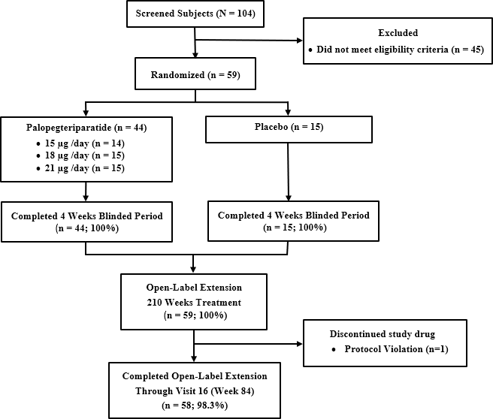
Table 16. TransCon PTH titration for subjects taking daily active vitamin D (starting at visit 4) – study 201
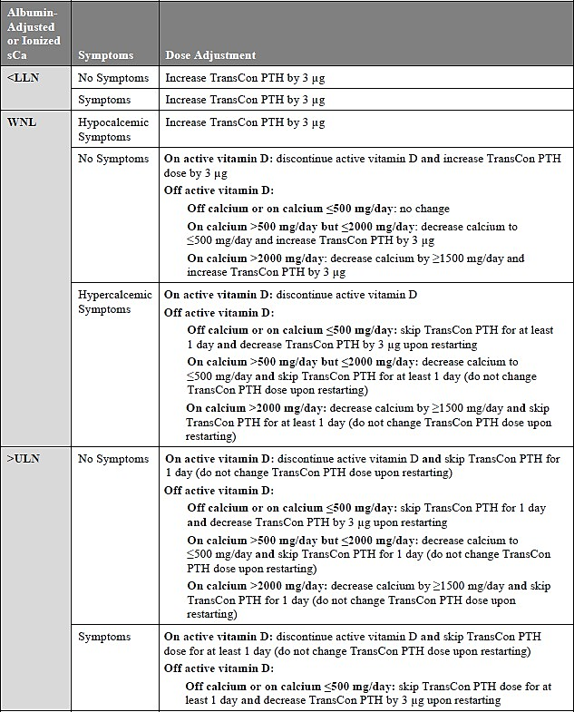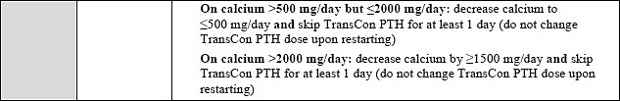
Table 17. Primary Efficacy Analysis (Full Analysis Population) – study 201 (blinded period)
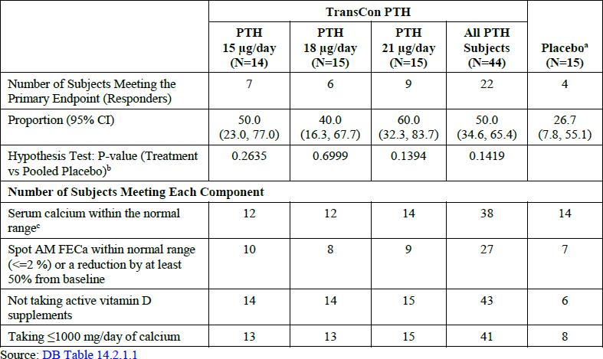
Abbreviations: CI = confidence interval; FECa = fractional excretion of calcium; mg = milligram; N = number of subjects; TransCon PTH = palopegteriparatide '
ª Consists of pooled dosage placebo groups.
^{b} Fisher's exact test is used to compare differences in proportions.
^{c} The normal range for albumin-adjusted serum calcium is 8.3 to 10.6 mg/dL (2.07 to 2.64 mmol/L) and the normal range for ionized serum calcium is 1.16 to 1.32 mmol/L.
Table 18. TCP-201: Multi-Component Efficacy Endpoint at Weeks 26, 58, 84, and 110 of the Open-Label Period (Full Analysis Population)
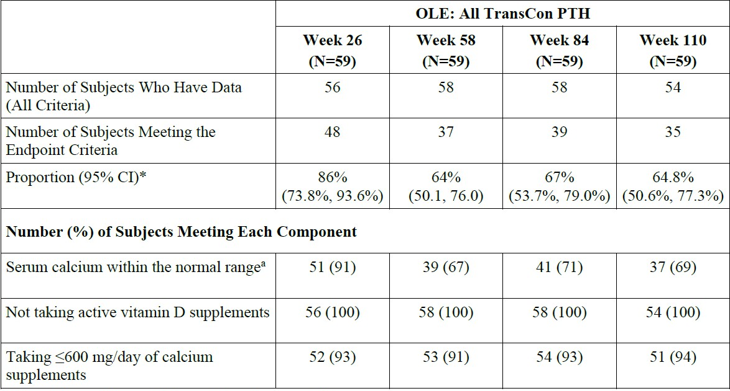
Abbreviations: CI = confidence interval; mg = milligram
Note: All TransCon PTH are the group of subjects who received palopegteriparatide during the Blinded Period and/or during the Open-label Extension.
*Percentages are based on the number of subjects who have data on all criteria at each Week.
a The normal range for albumin-adjusted serum calcium is 8.3 to 10.6 mg/dL (2.07 to 2.64 mmol/L).
Table 19. Sensitivity Analysis 6 (ad hoc) – Primary Endpoint at Week 4 of the Blinded Period and Weeks 26, 58, and 84 of the Open-Label Period – Serum Calcium Range: 7.5-10.6 mg/dL (Full Analysis Population) – study 201
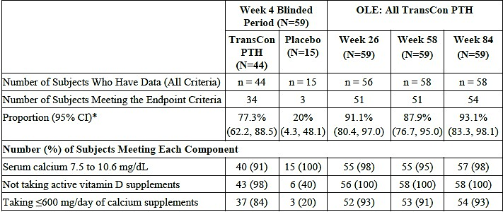
Abbreviations- CI = confidence interval; mg = milligram
Note: All TransCon PTH are the group of subjects who received palopegteriparatide during the Blinded Period and/or during the Open-label Extension.
*Percentages are based on the number of subjects who have data on all criteria at each week.
Table 20. Secondary Endpoints: Conventional Therapy Intake at Week 84 – OLE Period (Full Analysis Population) (TCP-201)
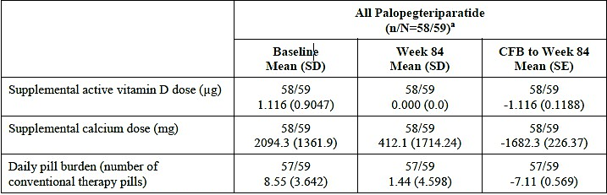
Abbreviations: CFB = change from baseline; SD = Standard Deviation; SE = Standard Error. At each post-baseline visit, only data from subjects with both baseline and the corresponding visit values available are used to compute the statistical summaries. Consists of pooled dosage placebo groups.
Figure 18. TCP-201: Serum Calcium (Mean ±SE) by Visit (Full Analysis Population). n/N= 54/59 at week 110.
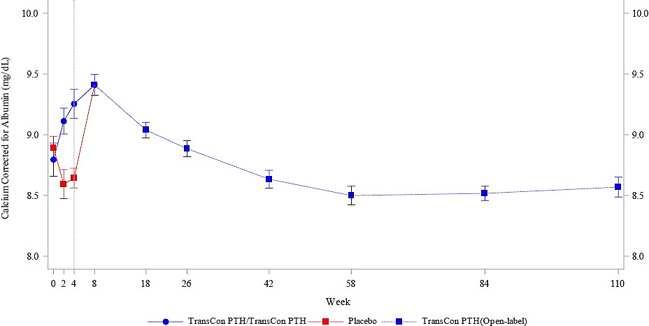
Figure 19. TCP-201: Serum Phosphate (Mean ±SE) by Visit (Full Analysis Population). n/N = 53/59 at week 110.
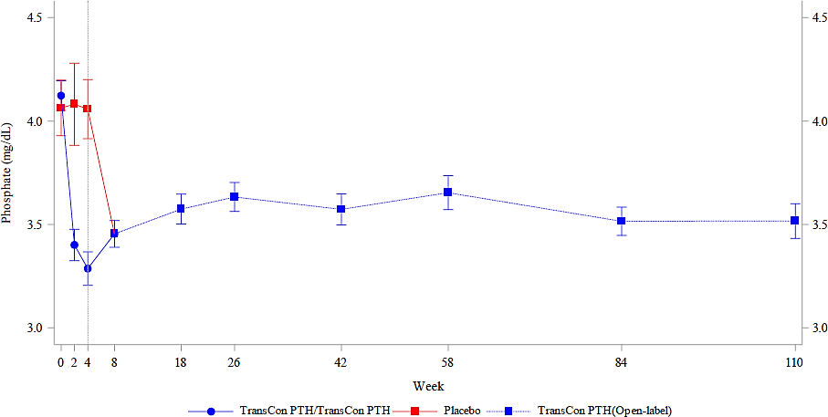
Figure 20. TCP-201: Serum Calcium × Serum Phosphate Product (Mean ±SE) by Visit (Full Analysis Population). n/N = 53/59 at week 110.
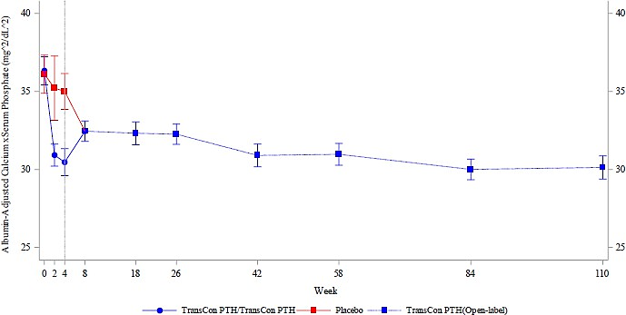
Table 21. Palopegteriparatide Dose by Visit - Mean (SD) and Range in TCP-201 (Safety Analysis Population) – study 201
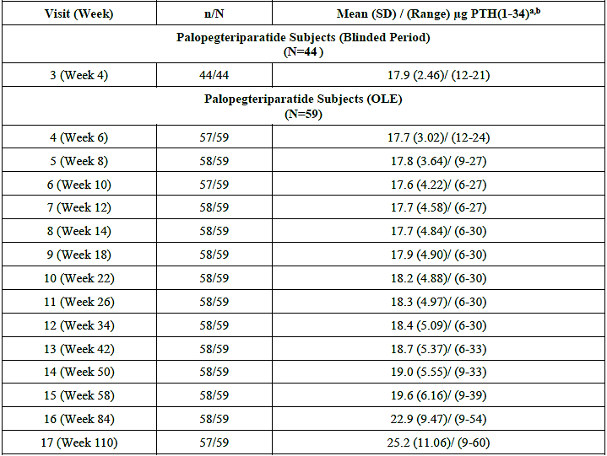
--= not applicable; TransCon PTH = palopegteriparatide, OLE = open-label extension, SD = standard deviation Palopegteriparatide dose is expressed as µg PTH(1-34).
Note: Original SCS data cutoff dates for TCP-201: 24 September 2021 (Week 84); 120-day safety update data cutoff date for TCP-201: 01 June 2022 (Week 110).
a Palopegteriparatide dose by visit in the TCP-201 trial is summarized from Week 4 which was the start of the OLE period and included placebo subjects being titrated to optimal dose.
b The maximum permitted palopegteriparatide dose in TCP-201 was 30µg/day, until TCP-201 Protocol Amendment 3 permitted an increase to a maximum of 60 µg/day. Protocol Amendment 3 was approved on 10 March 2021, and implemented within a year across various sites. This protocol change is reflected in higher mean/median doses after its implementation.

Longer term efficacy in Study 201
The relevance of the efficacy data from Study 201 over longer- term use (weeks 4-110) was highlighted. Data on the proportion of subjects with abnormal serum calcium alongside dose data are suggestive of a possible loss of efficacy over 110 weeks. The majority (38/48; 79%) of patients who achieved serum calcium within normal range, were not taking active vitamin D and were taking ≤600 mg/day of calcium at week 26 required dose increases after week 26. Among these patients, there was a trend of increasing dose from week 50 onwards, coinciding with an increased proportion of subjects with abnormal serum calcium at week 58 that was steady through to week 110. It should be noted that no patients had serum calcium above normal after week 12, so all the events of abnormal calcium represent serum calcium < 2.07 mmol/L.
Among all 59 subjects, 69% had serum calcium within the normal range at week 110, a decrease from the 91% at week 26. This is despite an overall increase in mean dose from 18.3 µg/day to 25.2 µg/day over the same period. Although dose fluctuations are not necessarily significant, data from study 201 suggest an ongoing increase of dose requirement beyond week 50, which coincided with a large proportion (~30%) of patients experiencing decreased serum calcium despite the overall higher doses.

Safety

Exposure
Figure 21. TCP-304 and TCP-201 - Composition of TransCon PTH Period Groups (Cumulative Exposure to Palopegteriparatide)
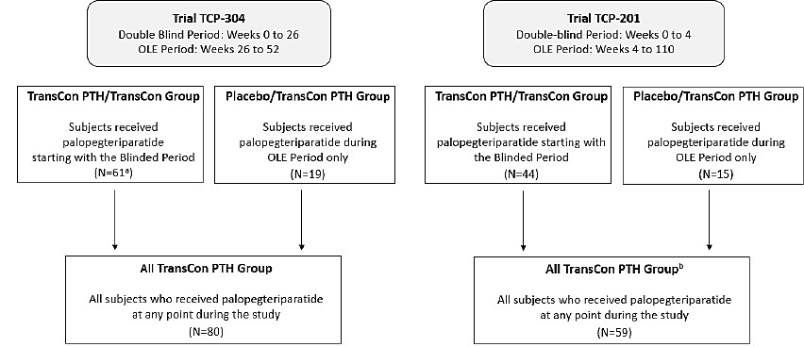
Abbreviations: OLE = open-label extension; TransCon PTH = palopegteriparatide
Note: the TransCon PTH Period for TCP-304 and TCP-201 was defined as the period of cumulative exposure to palopegteriparatide All subjects included in the TransCon PTH Period of either trial received at least 1 dose of palopegteriparatide.
Note: Blinded Treatment Period TEAEs are defined as TEAEs occurring prior to the first dose of open-label palopegteriparatide. TransCon PTH Period TEAEs are defined as TEAEs occurring after the first dose of palopegteriparatide. TEAEs discussed in the report are TransCon PTH Period TEAEs unless otherwise indicated.
ª In TCP-304. one subject who receive palopegteriparatide in Blinded Treatment Period discontinued before entering OLE. The subject is not included in the OLE period (N=79) but is included in the TCP-304 TransCon Pm Period as shown above (N=80).
^{b} In TCP-201. all subjects completed the Blinded Treatment Period and entered the OLE period. Therefore all 59 subjects are included in the TCP-201 TransCon PTH Period.
Table 22. Extent of Palopegteriparatide Exposure – TCP-304, TCP-201, and Safety Pool II TransCon PTH Period (Safety Analysis Population)
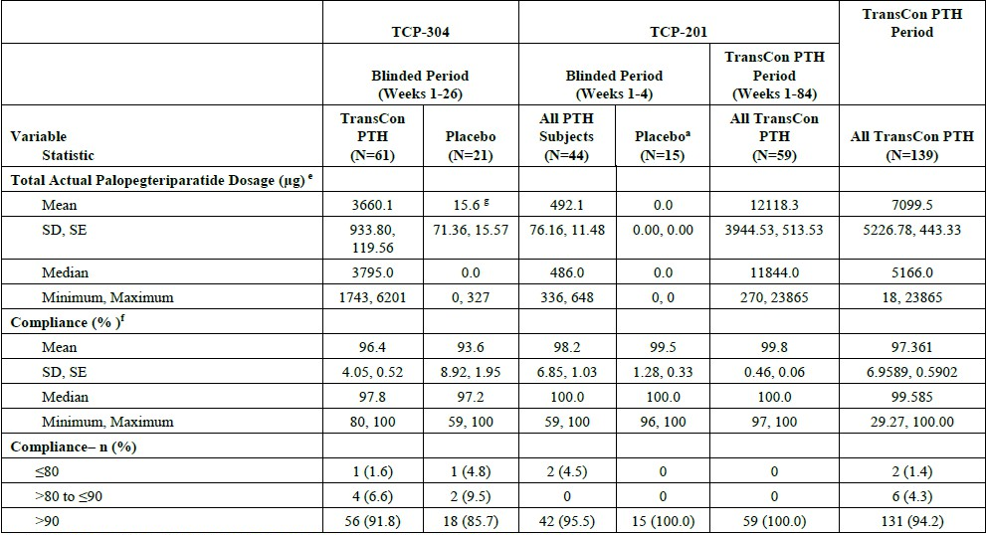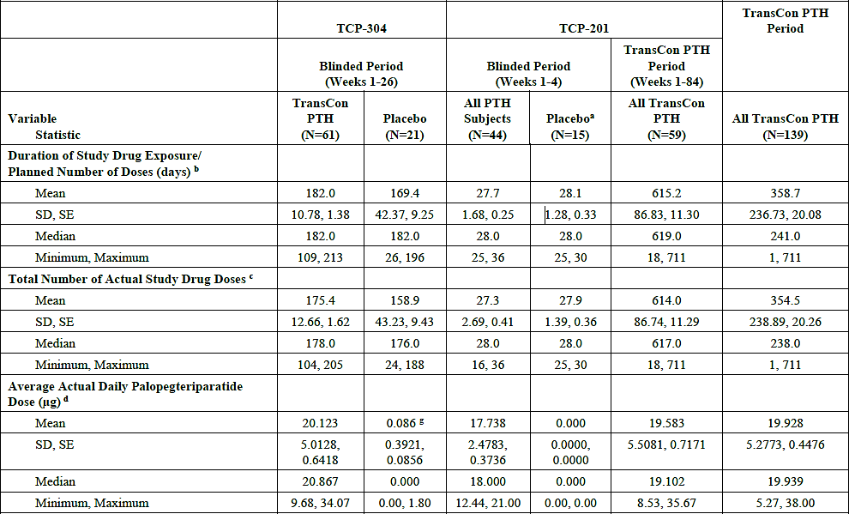
Abbreviations: Max = maximum; Min = minimum; n, N = number of subjects; SD = standard deviation; SE = Standard Error. TransCon PTH = palopegteriparatide. Palopegteriparatide dose was expressed as pg of PTH(1-34).
ª Consists of pooled placebo group.
^{b} For the Blinded Period, duration of exposure is calculated as the last dose date of blinded study drug — first dose date of blinded study drug + 1 day. For the TransCon PTH Period, duration of exposure is calculated as the last dose date of palopegteriparatide — first dose date of palopegteriparatide + 1 day.
^{c} For the Blinded Period. total number of actual study drug doses is the number of blinded study drug doses. For the TransCon PTH Period, total number of actual study drug doses is the number of palopegteriparatide doses.
^{d} Average actual daily dose is calculated as: Total actual dosage/ Duration of exposure.
^{e} Total actual dosage (itg) is calculated as the sum of all daily palopegteriparatide doses.
^{f} Study drug compliance is calculated as: Total number of actual doses/total number of planned doses x 100.
^{g} Represents dosage received by subjects from the placebo group who entered OLE prior to the study cutoff date.
Table 23. Safety Pool II: Palopegteriparatide Exposure Duration Greater Than or Equal to 26 Weeks (Safety Analysis Population) – Pool II
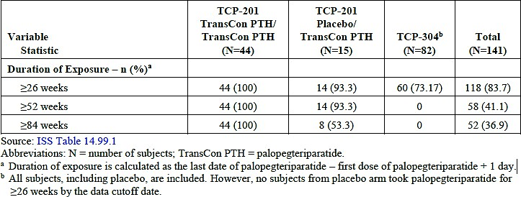
Abbreviations: N = number of subjects; TransCon PTH = palopegteriparatide.
ª Duration of exposure is calculated as the last date of palopegteriparatide — first dose of palopegteriparatide
+ 1 day-1.
^{b} All subjects, including placebo, are included. However, no subjects from placebo arm took palopegteriparatide for >26 weeks by the data cutoff date.
Table 24. Extent of Palopegteriparatide Exposure in TCP-304 and TCP-201 During the TransCon PTH Period (Safety Analysis Population) – 120-Day safety update
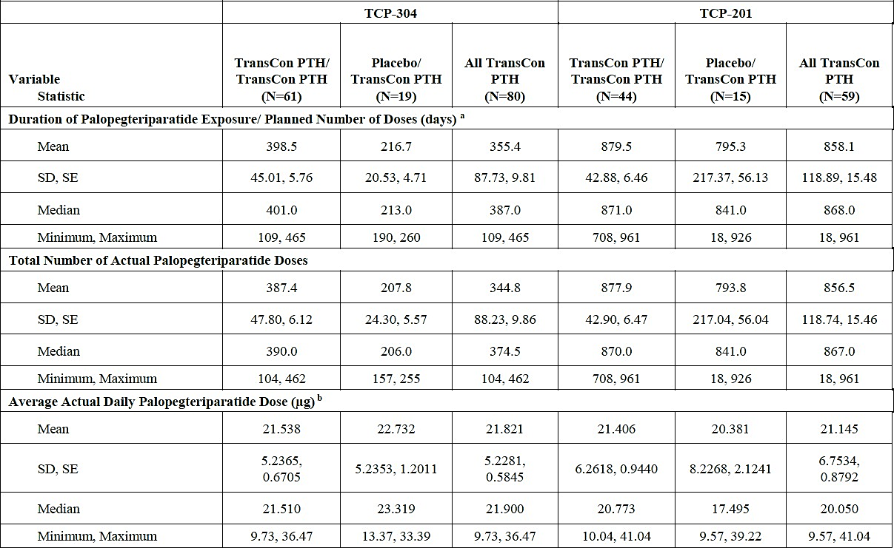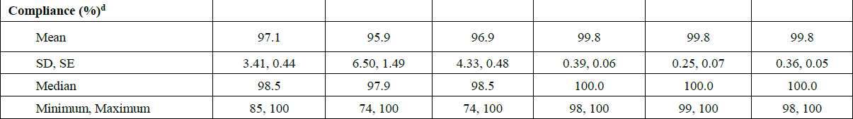
Abbreviations: n, N = number of subjects; SD = standard deviation; SE = standard error. TransCon PTH = palopegteriparatide. Palopegteriparatide dose was expressed as pg of PTH(1-34).
Note: Original SCS data cutoff dates: TCP-304: 12 January 2022 (Week 26); TCP-201: 24 September 2021 (Week 84). 120-day safety update data cutoff dates: TCP-304: 20 July 2022 (Week 52), TCP-201: 01 June 2022 (Week 110).
a For the TransCon PTH Period, duration of palopegteriparatide exposure is calculated as the last dose date of palopegteriparatide — first dose date of palopegteriparatide + 1 day.
b For the TransCon PTH Period, the average actual daily palopegteriparatide dose (pg) is calculated as: total actual palopegteriparatide dosage/ duration of palopegteriparatide exposure.
c Total actual palopegteriparatide dosage (pg) is calculated as the sum of all daily palopegteriparatide doses. ci Study drug compliance is calculated as: total number of actual palopegteriparatide doses/total number of planned doses x 100.
Key data periods include:
- Weeks 1-26 (blinded period) in study 304. Data for palopegteriparatide vs. placebo are available, and are the most suitable data for assessing causation.
- Safety pool II. It forms the basis of the frequencies proposed under PI section 4.8. Safety data were pooled from:
  - 61 subjects in study 304 randomised to palopegteriparatide, with ~26 weeks of exposure
  - 19 subjects in study 304 randomised to placebo, with only minor palopegteriparatide exposure as they have just entered the OLE
  - 59 subjects in study 201, with ~84 weeks of exposure
- The 120-day safety update, including:
  - Weeks 1-52, palopegteriparatide/palopegteriparatide arm, study 304, ~52 weeks of exposure
  - Week 27-52, study 304, placebo/palopegteriparatide arm, ~26 weeks of exposure.
  - Weeks ~1-110, study 201, ~110 weeks of exposure No pooling was conducted for the 120-day safety update.
The available data should be considered in the context that hypoparathyroidism is a chronic illness, and it is expected that some patients may remain on therapy for 20+ years, considering the mean age of ~50 years in the trials.
Table 25. Overview of Treatment Emergent Adverse Events (Blinded Treatment Periods and TransCon PTH Periods) – TCP-304, TCP-201, and Safety Pool II (Safety Analysis Population)
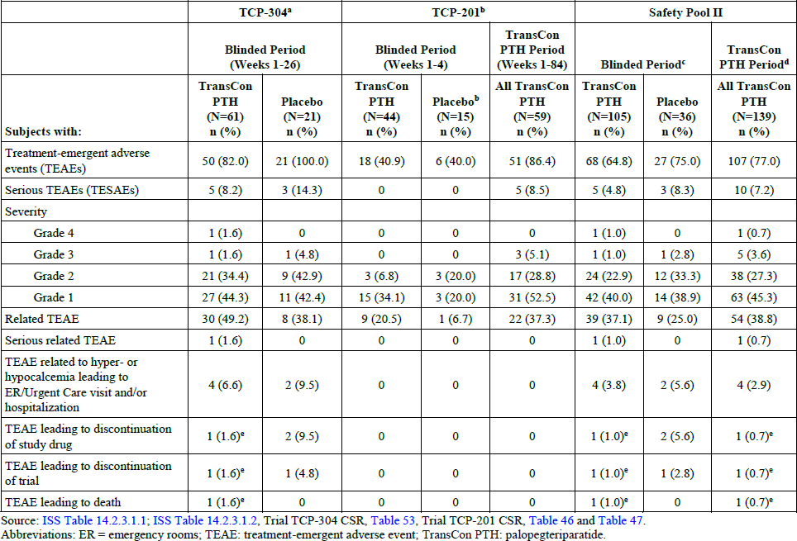
Percentages were calculated based on the number of subjects in the Safety Analysis Population. In the severity categories, subjects are displayed for the highest severity only. AE severity was assessed by WHO toxicity grading scale.
ª For TCP-304, TEAEs occurring prior to the first dose of open-label treatment are included.
^{b} For TCP-201. All TransCon PTH are the group of subjects who received palopegteriparatide during the Blinded Period and/or during the Open-label Extension. A TEAE was considered a TransCon PTH Period TEAE if it occurred after the first dose of palopegteriparatide. The placebo group consists of pooled dosage placebo groups.
^{c} In Safety Pool II, a Blinded Treatment Period TEAE is defined as TEAE occurring prior to the first dose of open-label palopegteriparatide.
^{d} In Safety Pool II, TransCon PTH Period TEAE is defined as TEAE occurring after the first dose of palopegteriparatide.
^{e} One subject, who suffered a fatal cardiac arrest (considered unrelated to study drug). Death led to discontinuation of study drug and withdrawal from the trial.
Table 26. Most Common Treatment-Emergent Adverse Events (≥5% of Palopegteriparatide-Treated Subjects in Any TransCon PTH Group in TCP-304, TCP-201, or Safety Pool II) (Safety Analysis Population)
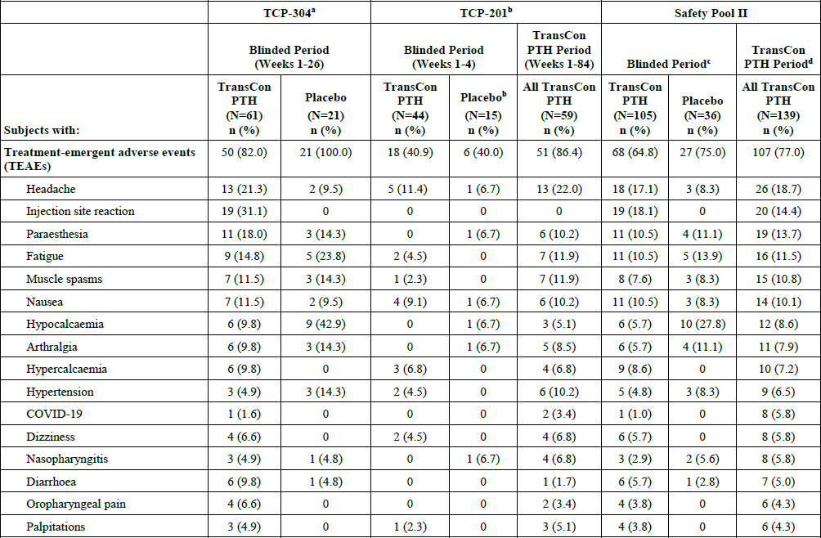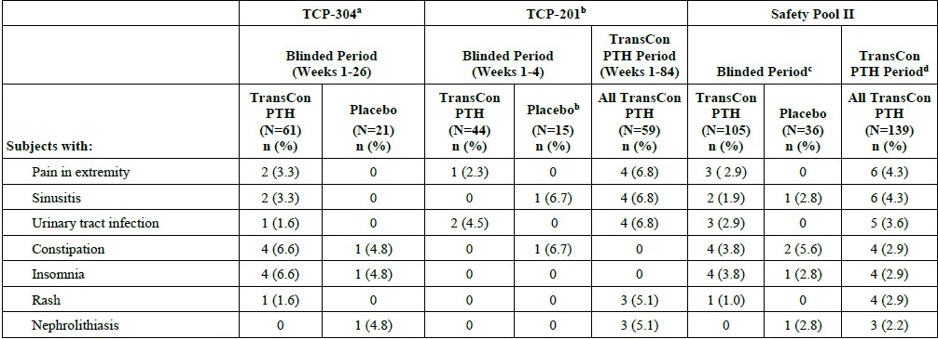
Abbreviations: TEAE = treatment-emergent adverse event; TransCon PTH = palopegteriparatide.
Note: MedDRA version 24.0 for TCP-201 and 24.1 for TCP-304. Percentages are calculated based on the number of subjects in the Safety Analysis Population. TEAEs within the table are sorted by decreasing frequency of preferred terms within the TransCon PTH Period of Safety Pool U.
ª For TCP-304. TEAEs occurring prior to the first dose of open-label treatment are included.
^{b} For TCP-201, All TransCon PTH are the group of subjects who received palopegteriparatide during the Blinded Period and/or during the Open-label Extension. A TEAE was considered a TransCon PTH period TEAE if it occurred after the first dose of palopegteriparatide. The placebo group consists of pooled dosage placebo groups.
^{c} In Safety Pool II, a Blinded Treatment Period TEAE is defined as TEAE occurring prior to the first dose of open-label palopegteriparatide.
^{d} In Safety Pool II, TransCon PTH Period TEAE is defined as TEAE occurring after the first dose of palopegteriparatide.
Table 27. Overview of Treatment-Emergent Adverse Events During the TransCon PTH Period in TCP-304 and TCP-201 (Safety Analysis Population) – 120-Day Safety Update
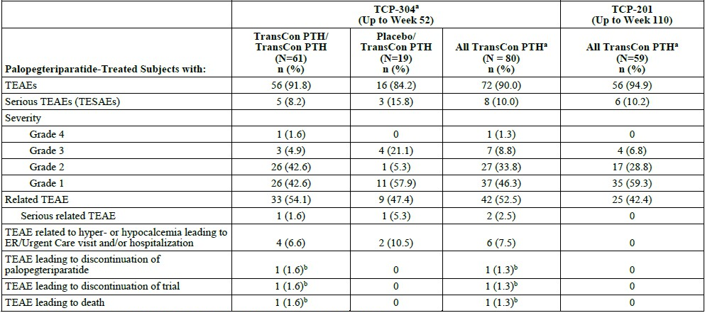
Note: A TEAS is considered a TransCon PTH Period TEAS if it occurred after the first dose of palopegteriparatide. Only subjects from the Safety Analysis population who had at least 1 dose of palopegteriparatide (it, were in the TransCon PTH group) are included in the table. Percentages were calculated based on the number of subjects in the Safety Analysis Population.
In the severity categories, subjects are displayed for the highest severity only. AE severity was assessed by WHO toxicity grading scale. Note: Original SCS data cutoff dates: TCP-304: 12 January 2022 (Week 26); TCP-201: 24 September 2021 (Week 84). 120-day safety update data cutoff dates: TCP-304: 20 July 2022 (Week 52), TCP-201: 01 June 2022 (Week 110).
ª The All TransCon PTH column for TCP-304 and TCP-201 is the sum of TransCon PTH/TransCon PTH and Placebo/TransCon PTH columns for each trial. For TCP-201, the TransCon PTH/TransCon PTH and Placebo/TransCon PTH columns are shown in the cited source tables.
^{b} One subject, who suffered a fatal cardiac arrest (unrelated to palopegteriparatide). The death led to discontinuation of study drug and withdrawal from ,the trial, as described in the original SCS.

Table 28. Most Common Treatment-Emergent Adverse Events (≥5% of Palopegteriparatide-Treated Subjects in the All TransCon PTH Groups in TCP-304 and TCP-201) (Safety Analysis Population) – 120 Day-Safety Update
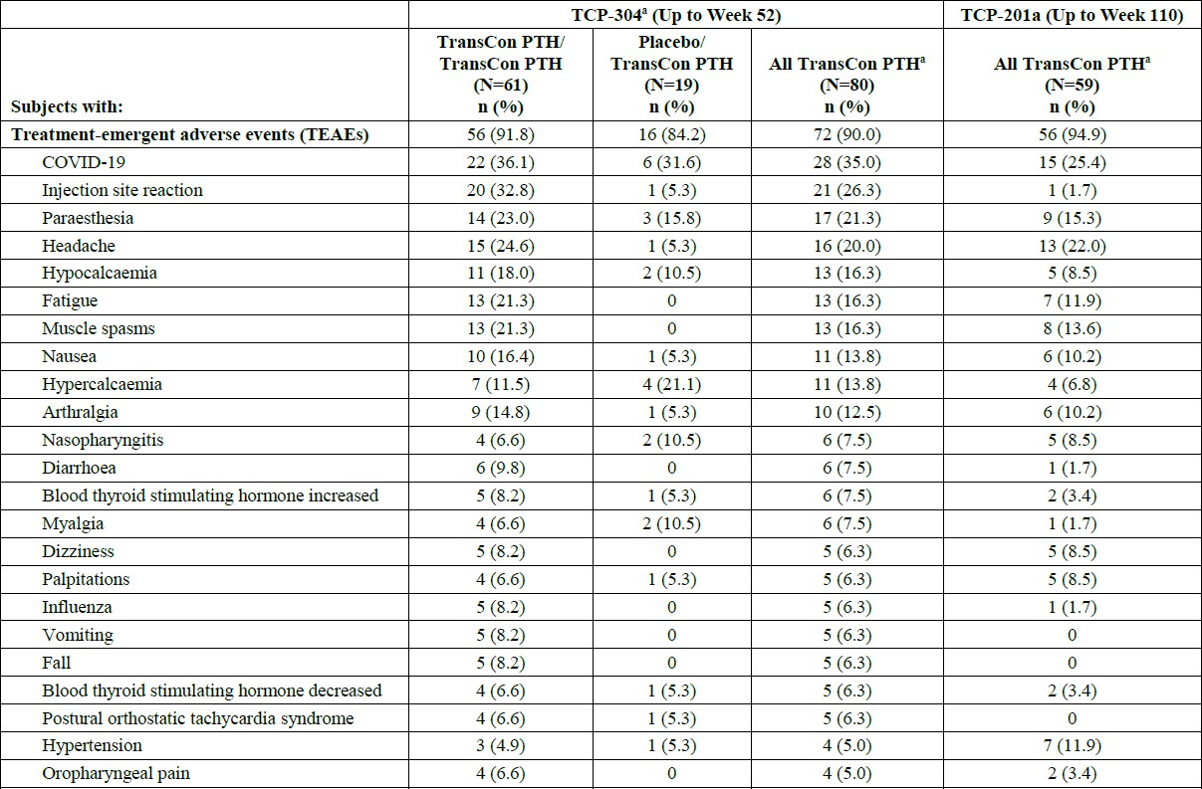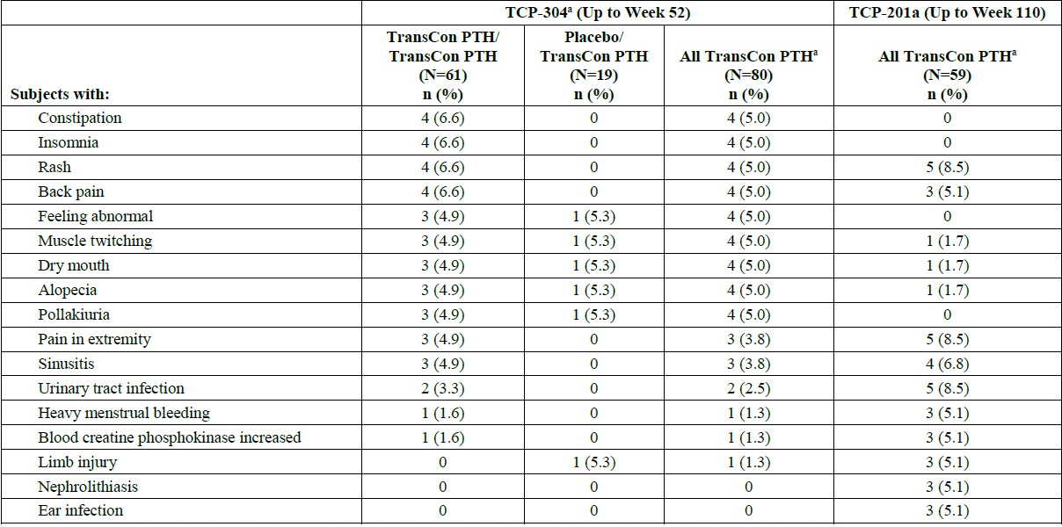
Abbreviations: TEAE = treatment-emergent adverse event; TransCon PTH = palopegteriparatide. Note: MedDRA version 24.0 for TCP-201 and 24.1 for TCP-304. Percentages were calculated based on the number of subjects in the Safety Analysis Population. A TEAE is considered a TransCon PTH Period TEAE if it occurred after the first dose of palopegteriparatide. Only TransCon PTH Period TEAEs are included in the table.
Note: Original SCS data cutoff dates: TCP-304: 12 January 2022 (Week 26); TCP-201: 24 September 2021 (Week 84). 120-day safety update data cutoff dates: TCP-304: 20 July 2022 (Week 52) , TCP-201: 01 June 2022 (Week 110).
Note: TEAEs within the table are sorted by decreasing frequency of preferred terms within the All TransCon PTH group of TCP-304.
ª The All TransCon PM column for TCP-304 and TCP-201 is the sum of TransCon PTH/TransCon PTH and Placebo/TransCon PTH columns for each trial. For TCP-201, the TransCon PTH/TransCon PTH and Placebo/TransCon PM columns are shown in the cited source tables.
Table 29. Overview of Treatment-Emergent Adverse Events – pooled (studies 103, 104 and 105)
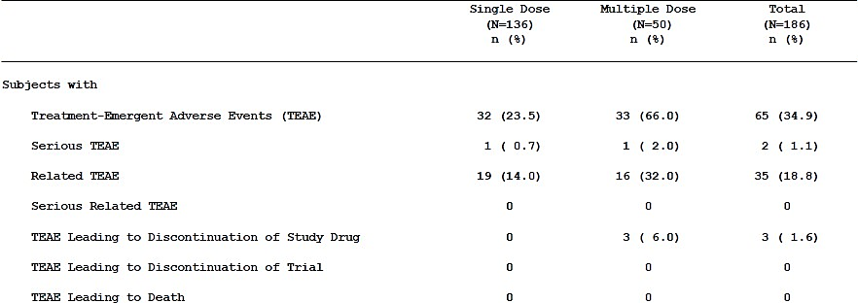
TransCon PTH dose is expressed as pg of PTH(1-34). Percentages are calculated based on the number of subjects in the Safety Analysis Population.
Table 30. Most Common Treatment-Related Treatment-Emergent Adverse Events (≥5% in Subjects in All TransCon PTH Groups in TCP-304 or TCP-201) (Safety Analysis Population) – 120-day safety Update
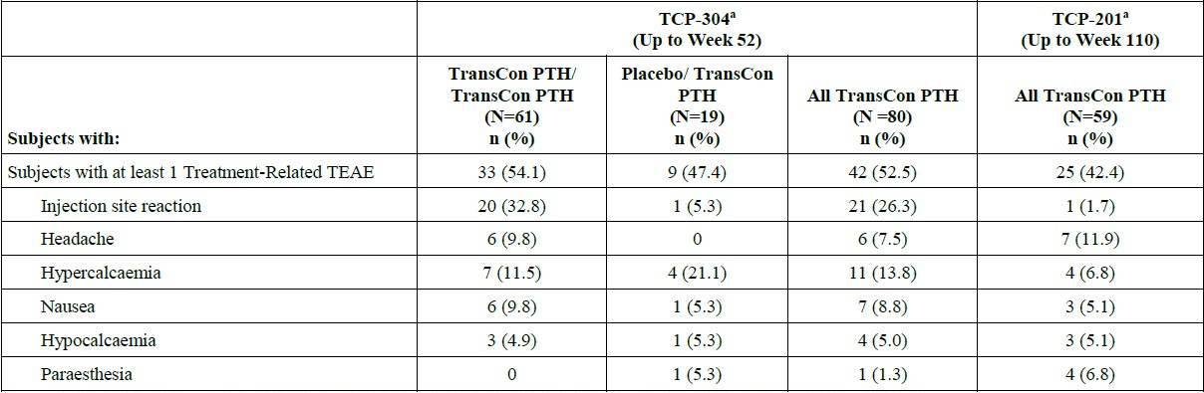
Abbreviations: TEAE = treatment-emergent adverse event; TransCon PTH = palopegteriparatide. Note: MedDRA version 24.0 for TCP-201 and 24.1 for TCP-304. TransCon PTH Period TEAE is defined as TEAE occurring after the first dose of palopegteriparatide. Percentages are calculated based on the number of subjects in the Safety Analysis Population. Subjects from the Safety Analysis Population who had at least 1 dose of TransCon PTH were included in this table.
Note: TEAEs within the table are sorted by decreasing frequency of preferred terms within the TCP-304 All TransCon PTH group.
Note: Original SCS data cutoff dates: TCP-304: 12 January 2022 (Week 26); TCP-201: 24 September 2021 (Week 84). 120-day safety update data cutoff dates: TCP-304: 20 July 2022 (Week 52) TCP-201: 01 June 2022 (Week 110).
ª The All TransCon PTH column for TCP-304 and TCP-201 is the sum of TransCon PTH/TransCon PTH and Placebo/TransCon PTH columns for each trial. For TCP-201, the TransCon PTH/TransCon PTH and Placebo/TransCon PTH columns are shown in the cited source tables.

Table 31. Drug-related Treatment-emergent Adverse Events Occurring in ≥2 Subjects in Either Treatment Group by System Organ Class and Preferred Term - Blinded Period (Safety Analysis Population) – study 304
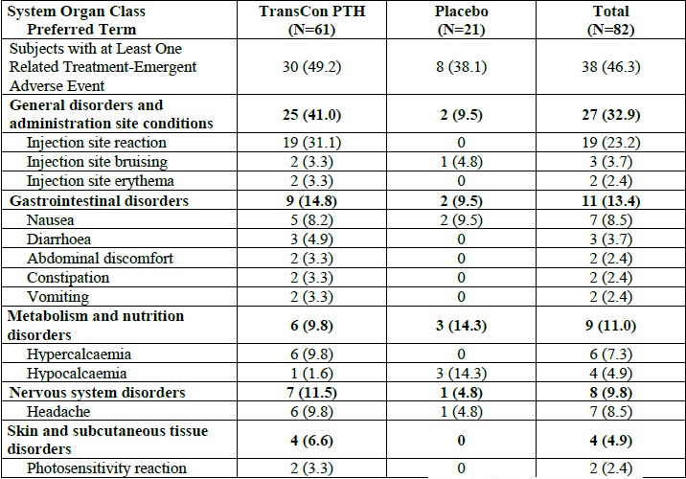
Abbreviations: MedDRA: Medical Dictionary for Regulatory Activities; TransCon PTH: palopegteriparatide. MedDRA version 24.1. Percentages were calculated based on the number of subjects in the Safety Analysis Population. TEAEs occurring prior to the first dose of open-label treatment are included. Sorted in descending order of frequency based on the "total" column.
Table 32. Summary of Serious Treatment-Emergent Adverse Events by System Organ Class and Preferred Term – pooled (studies 103, 104 and 105)
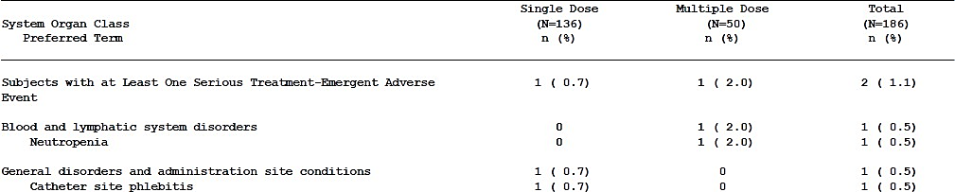
TransCon PTH dose is expressed as pg of PTH(1-34). MedDRA version 20.0 for CT-103 and version 22.1 for TCP-104 and TCP-105. Percentages are calculated based on the number of subjects in the Safety Analysis Population.
One death occurred in the blinded period of study 304. A 74-year-old male with a BMI of 40 kg/m² and no reported history of clinical cardiovascular disease died from cardiac arrest on Day 111 of palopegteriparatide treatment. At the time of the event, the subject was receiving a dose of 30 µg/day. According to the eDiary, study drug doses were taken as prescribed. There were no adverse events related to calcium abnormalities at any point during the trial, and the subject’s last available calcium levels were within normal range.
Table 33. Serious Treatment-emergent Adverse Events by System Organ Class and Preferred Term - Blinded Period (Safety Analysis Population) – study 304
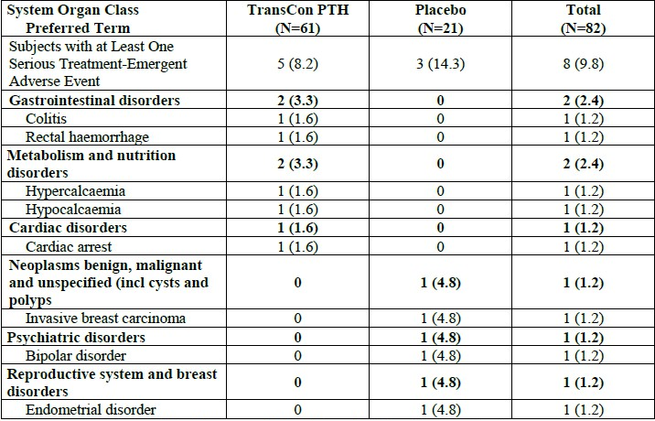
Abbreviations: MedDRA: Medical Dictionary for Regulatory Activities; TEAE: treatment-emergent adverse event; TransCon PTH: palopegteriparatide.
MedDRA version 24.1.
Percentages were calculated based on the number of subjects in the Safety Analysis Population. TEAEs occurring prior to the first dose of open-label treatment are included. Sorted in descending order of frequency based on the "total" column.
Table 34. Serious Treatment-Emergent Adverse Events Assessed by Preferred Term – TransCon PTH Period (Safety Population) – study 201
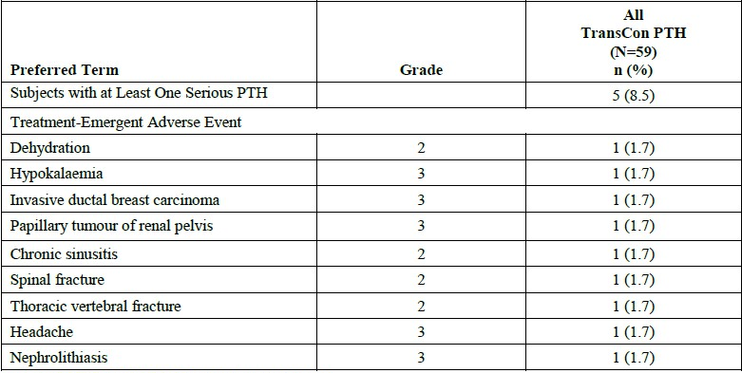
Note: All TransCon PTH are the group of subjects who received palopegteriparatide during the Blinded Period and/or during the Open-label Extension. TransCon PTH dose is expressed as Fig of PTH(1-34). MedDRA version 24.0. Percentages were calculated based on the number of subjects in the Safety Population. A TEAE was considered a PTH 'TEAE if it occurred after the first dose of TransCon PTH.

TCP-305 and TCP-306
The Phase 3 trials TCP-305 (open-label) in Japan and TCP-306 (double-blind) in China are ongoing. TCP-306 is currently in the Blinded Treatment Period. In TCP-305, a total of 13 subjects were exposed to at least 1 dose of palopegteriparatide. In TCP-306, a total of 80 subjects were exposed to at least 1 dose of blinded study drug.
In TCP-305 the most commonly reported TEAE was orthostatic hypotension (2 subjects, 15.4%). No serious TEAE was reported. TEAEs, including a serious TEAE of angina pectoris, were described for TCP-306 but are not interpretable as treatment assignment has not yet been unblinded. No deaths have been reported in either trial.

Serum calcium
Serum calcium excursions up to week 52 based on laboratory criteria are summarised in Table 40. The trend of increased risk of hypercalcaemia with palopegteriparatide is confirmed, with the majority of hypercalcaemic measurements occurring in the first three months.
Palopegteriparatide treatment was associated with serious hypercalcaemia in study 304. During the 26-week blinded period, 3 (5%) palopegteriparatide treated patients had an ER/urgent care visit and/or hospitalization related to hypercalcaemia, compared to zero in placebo. The overall incidence of symptomatic hypercalcaemia is likely higher than the 9.8% reported and is at least 13.1%. Abnormally elevated serum calcium was observed almost exclusively in the first 3 months of palopegteriparatide treatment.
Palopegteriparatide treatment was associated with serious hypocalcaemia. The higher incidence of the hypocalcaemia TEAE in the placebo group over 26 weeks should be interpreted with caution, as the placebo arm did not receive typical standard care. Among palopegteriparatide-treated patients, serum calcium below the normal range was common throughout the entire 52 weeks and 110 weeks. The hypocalcaemia TEAE continued to occur over weeks 27-52 in study 304 and over weeks 84-110 in study 201, including a case of serious hypocalcaemia TEAE in study 304 roughly 4 months into palopegteriparatide treatment.
Table 35. TCP-304: Summary of Central Clinical Laboratory Assessments – Incidence (%) of Low and High Serum Calcium by Period (Safety Analysis Population)
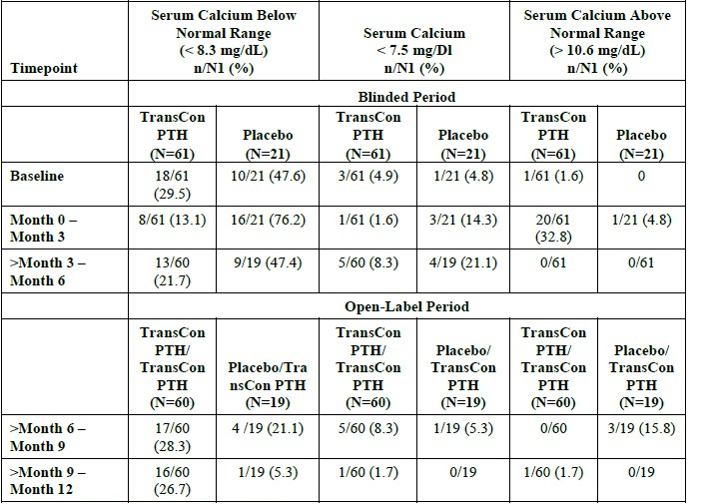
Abbreviations- TransCon Pill: palopegteriparatide
Note: The normal range for albumin-adjusted serum calcium is 8.3-10.6 mg/dL (2.07-244 mmol/L). Any value below the lower limit is considered as Low (Below Normal Range); any value above the upper limit is considered as High (Above Normal Range). Ni is the number of subjects who had a serum calcium assessment at the indicated timepoint; n is the number of subjects with a calcium excursion at the indicated timepoint.
Note: TCP-304 original SCS cutoff date: 12 January 2022 (Week 26); 120-day safety update data cutoff date: 20 July 2022
Table 36. TCP-201: Summary of Central Clinical Laboratory Assessments – Incidence (%) of Low and High Serum Calcium by Period (Safety Analysis Population)
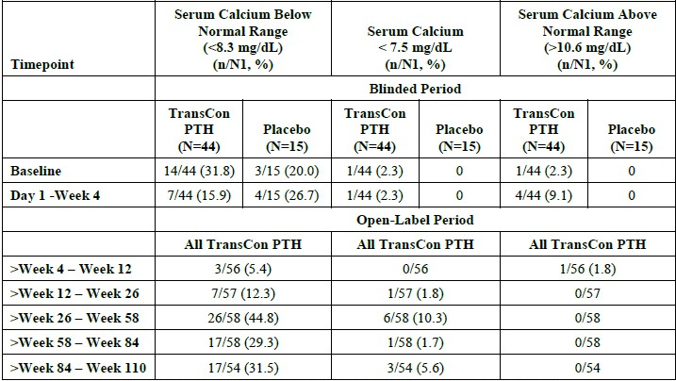
Abbreviations: TransCon PTH: palopegteriparatide.
Note: The normal range for albumin-adjusted serum calcium is 8.3-10.6 mg/dL (2.07-2.64 mmol/L). Any value below the lower limit is considered as Low (Below Normal Range); any value above the upper limit is considered as High (Above Normal Range).
N1 is the number of subjects who had a serum calcium assessment at the indicated timepoint; n is the number of subjects with a calcium excursion at the indicated timepoint. The lower limit for the alternative range is 7.5 mg/dL. Note: TCP-201 Original SCS data cutoff date: 24 September 2021 (Week 84):1120-day safety update data cutoff date: 01 June 2022 (Week 110).

24-hour urine calcium
Table 37. Change in 24-hour Urine at Week 26 – Blinded Period (Safety Analysis Population) – study 304
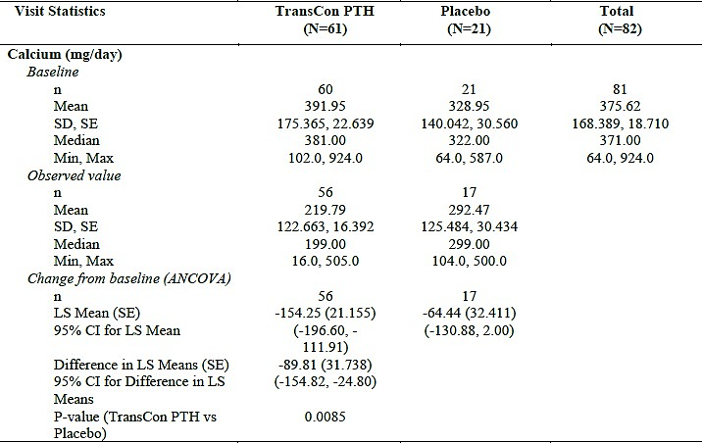
Abbreviations- ANCOVA: analysis of covariance; CI: confidence interval; ITT: intent to treat; LS: least square; Max: maximum; Min- minimum; SD: standard deviation; SE: standard error; TransCon PTH: palopegteriparatide. At each post-baseline visit, only data from subjects with both baseline and the corresponding visit values available were used to compute the statistical summaries. The ANCOVA model with unequal variance included the change from baseline as the response variable, treatment and etiology of hypoparathyroidism as fixed effects and baseline value of the parameter as a covariate.
Table 38. 24-hour Urine Calcium Excretion at Week 26 – Blinded Period (Safety Analysis Population) – study 304
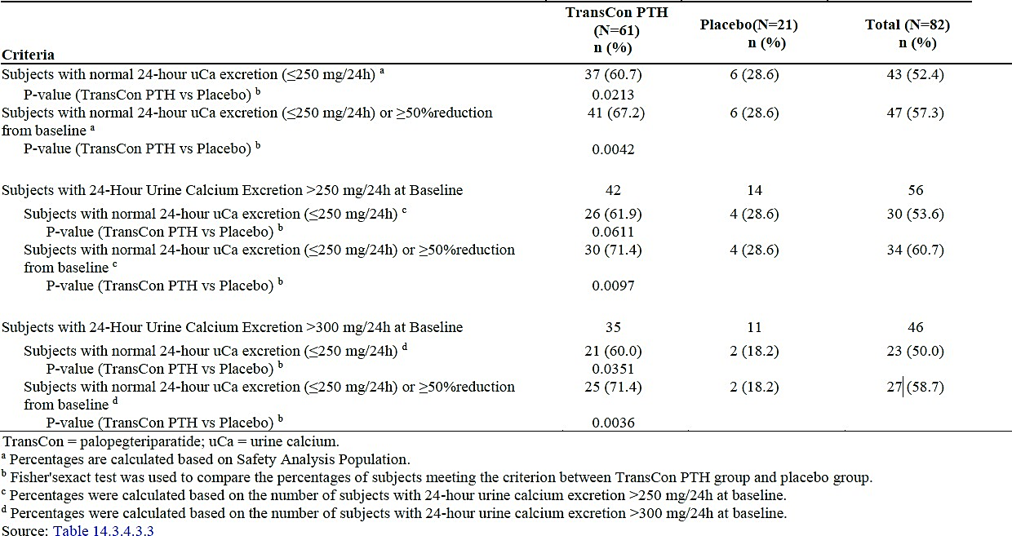
Table 39. TCP-201: Change from Baseline in 24-Hour Urinalysis Values for Calcium, Citrate, and Phosphate – All TransCon PTH Subjects (Safety Analysis Population)
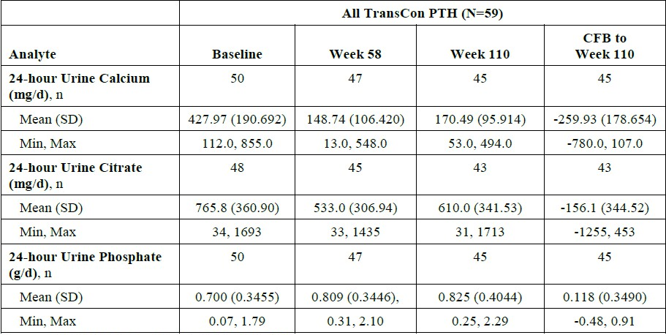
Abbreviations: TransCon PTH = palopegteriparatide; CFB = change from baseline.
Note: At each post-baseline visit, only data from subjects with both baseline and the corresponding visit values available are used to compute the statistical summaries. Baseline is the original study baseline.
Note: TCP-201 Original SCS data cutoff date: 24 September 2021 (Week 84); 120-day safety update data cutoff date: 01 June 2022 (Week 110).
N is the total number of subjects taking at least one dose of palopegteriparatide as of the cutoff date; n is the number of subjects with a 24-hour urinalysis assessment at the indicated timepoint.

Cardiac disorder TEAEs
Patients with chronic or severe cardiac disease within 26 weeks prior to screening were excluded.
See Table 38 for cardiac disorders (SOC) during the 26-week blinded period. Between weeks 1- 52, cardiac disorders occurred in 13.1% of the palopegteriparatide/palopegteriparatide arm.
There appears to be a potential risk of cardiac toxicity in association with palopegteriparatide treatment. During the blinded period of study 304, 9.8% of patients using palopegteriparatide experienced cardiac disorders (SOC), compared to 0% in placebo. While some of the TEAEs may be attributable to the vasodilatory effect of palopegteriparatide, there was a case of death by cardiac arrest and an event of atrial fibrillation in the palopegteriparatide group. This occurred despite the study excluding patients with chronic or severe cardiac disorder. ECGs were not routinely conducted post-baseline in study 304 to provide reassurance.
Table 40. Cardiac disorders TEAEs – Blinded Period Safety Analysis Population – study 304
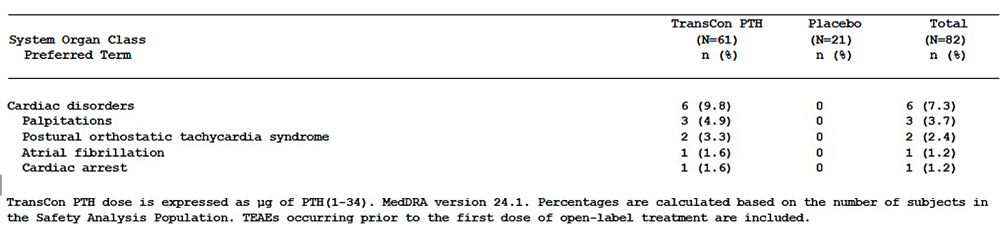

Bone mineral density
Table 41. Bone Mineral Density by Dual-Energy X-Ray Absorptiometry in Palopegteriparatide-treated Subjects (left) and placebo subjects (right) – Blinded Period (ITT Population) – study 304
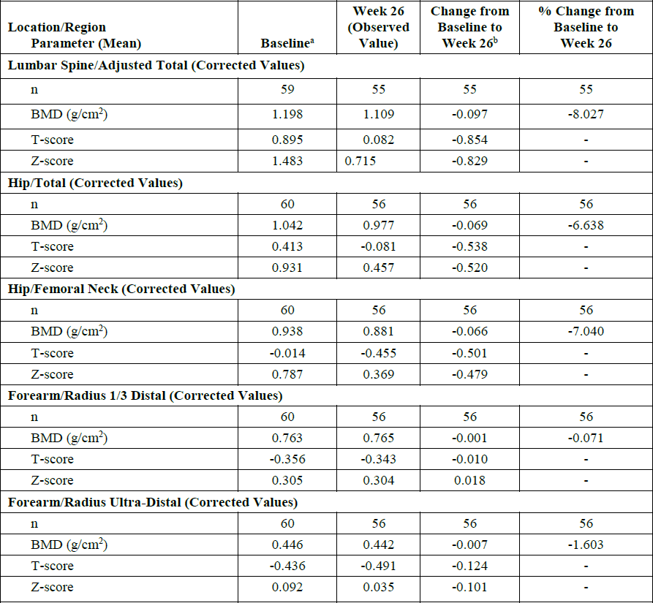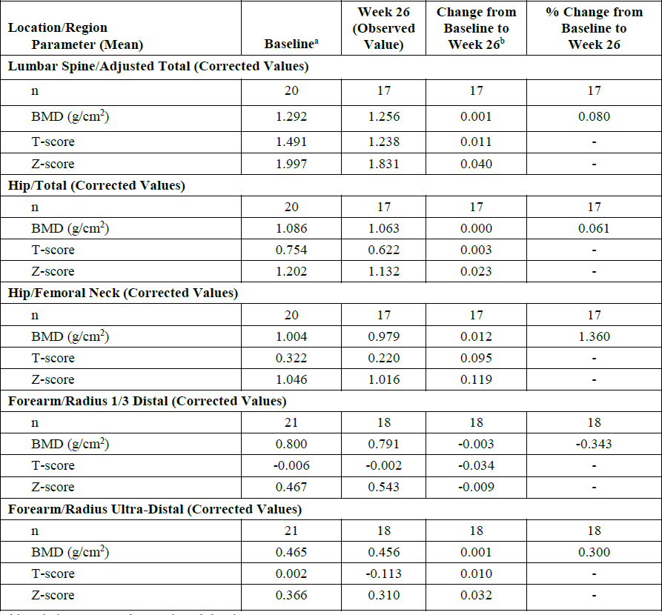

Study 201 (weeks 1-110)
Table 42. TCP-201: Bone Mineral Density by Dual-Energy X-Ray Absorptiometry in All Palopegteriparatide- treated Subjects – Baseline to Week 110 (FAS Population)
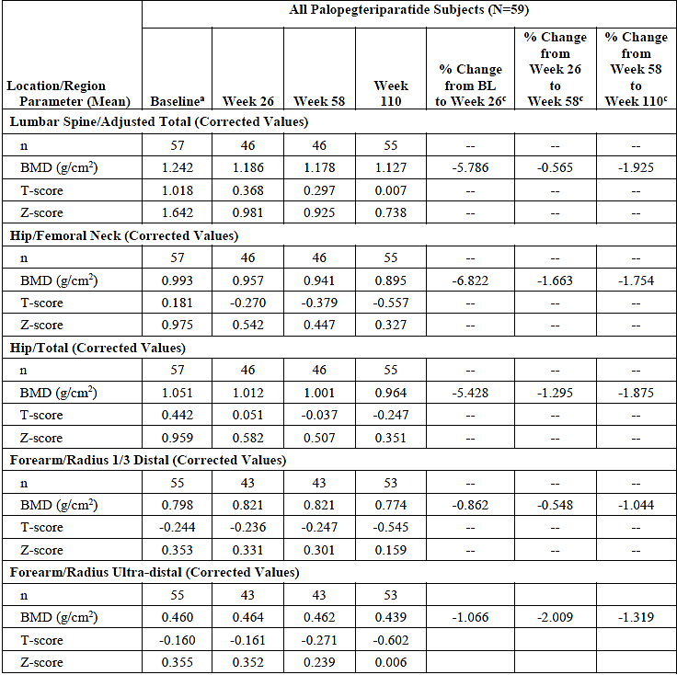
Abbreviation: BMD = bone mineral density, FAS = Full Analysis Set Note: TCP-201 Original SCS data cutoff date: 24 September 2021 (Week 84); 120-day safety update data cutoff date: 01 June 2022 (Week 110). ª Included all subjects with baseline data available. ^{b} Only data from subjects with results available from both visits were used to compute the statistical summaries (percent change).
Palopegteriparatide reduces bone mineral density, with ongoing reductions observed at 110 weeks across all measured regions compared to week 58. There are no data on whether bone mineral density plateaus or continues to decline beyond 110 weeks. Additional study 201 data on the effect of palopegteriparatide on bone mineral density were requested by the Clinical Evaluator (Figure 22 and Table 43). While greater decreases in BMD T-scores appeared to be seen in patients with higher baseline BMDs, it’s unclear whether changes in T-scores can be interpreted in a linear fashion, given its definition is based on standard deviations. That is, small decreases in T-score in patients with low baseline scores may be just as significant or even more significant than larger decreases in patients with higher baseline scores.
Further, the confidence interval for patients with the lowest BMDs at baseline extended from the osteopenia range to the osteoporotic range by week 110. Table 41 confirms that there was a small increase in the proportion of patients with T-scores <-2.5 for lumbar spine and hip/femoral neck between baseline and weeks 110. A definite increase in the proportion of patients with T-scores < -1.5 was seen across all regions.
Figure 22. TCP-201: Mean (SD) Corrected T-Score by Subgroup of Baseline T-Score Categories
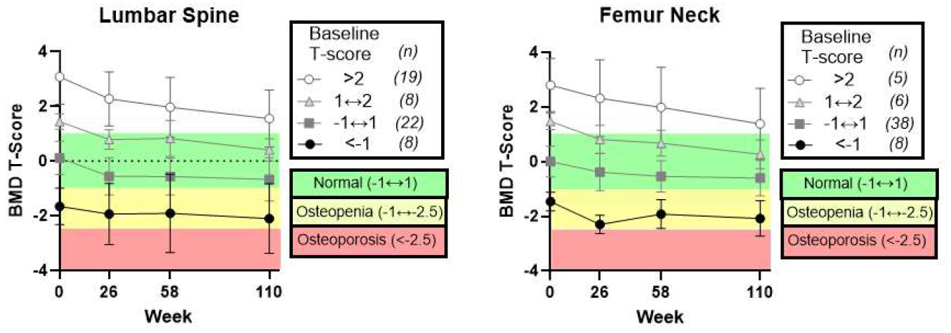
Table 43. TCP-201: Proportion of Subjects with BMD Corrected T-Scores of <-2.5 – Full Analysis Population
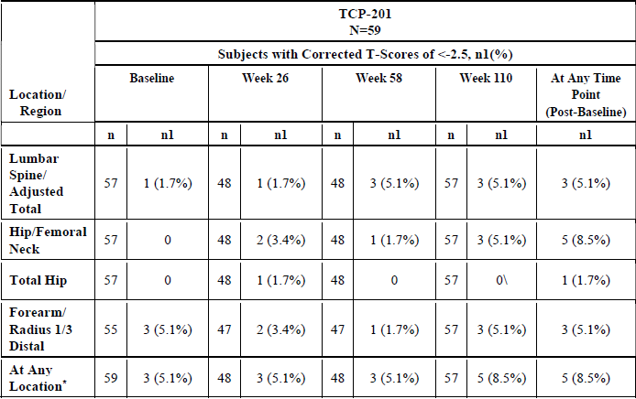
Abbreviations: N= total number of subjects in trial; n = number of subjects with data available at timepoint; n1 = number of subjects meeting the criteria Any location referring to the location/region of Lumbar Spine/Adjusted Total. Hip/Femoral Neck. Total Hip. Forearm/Radius 1/3 Distal.
Further data tables reveal one case of a fragility fracture of the rib that occurred at ~32 weeks, and the patient’s T-score at week 58 was -2.78 for lumbar spine, compared to -2.25 at baseline. The Clinical Evaluator considered this event of fragility fracture as possibly related to palopegteriparatide. Causal relations among the other 5 patients who developed fractures in study 201 were less clear, though certainly not excluded.
Overall, the data suggest that the reduction in BMD may be clinically relevant in some patients, considering a diagnostic T-score cut-off of -2.5 for osteoporosis and the at least one event of fragility fracture observed. Patients were prohibited from using osteoporosis therapies during trials, and there are no data on the effects on serum calcium or BMD during concurrent use with palopegteriparatide. The incidence of osteoporotic fractures beyond weeks 110 is unknown.

Dosing errors
Table 44. Dosing errors in study 304
 | Weeks 1-26 (Blinded)
 | Palopegteriparatide | Placebo
Overdose (n,) | 2 | -
Underdose (n) | - | -
Incorrect dose not otherwise specified (n) | - | 1
 | Weeks 27-52 (open label)
 | Palopegteriparatide/ palopegteriparatide | Placebo/ palopegteriparatide
Overdose (n) | 3 | 1
Underdose (n) | - | -
Medication error not otherwise specified (n) | 1 (concurrent hypocalcaemia) | -
Total over weeks 1-52 (%) | 6 (9.8%) | -

Errors in dosing and device use increase the risk of hypercalcaemia and hypocalcaemia. 10 cases of overdose and/or medication error were described in studies 201 and 304 (Table 42), with at least half occurring after 26 weeks, suggesting that the risk remains the same despite increasing familiarity with the medicine and device. Reviewing the listing of important protocol deviations in study 304 revealed further examples of subjects mistakenly using the same pen to inject a 15th dose (maximum number of doses per pen is 14), misinterpretation of dosing algorithm by investigator, misunderstanding of dosing instructions by subjects, missed doses, inability to optimally adjust doses due the appropriate strength not being available, and dosing error due to insufficient dose remaining in pen, with at least some issues occurring on multiple occasions. At least some of these deviations occurred on top of what is described in Table 42.
Errors of device use were common in the human factor validation study, including but not limited to errors in pen priming, dialling to the correct dose and adequately holding the pen down for 5 seconds. Issues such as using the pen for more than the specified ≤14 days were not assessed.
Considering the common nature of dosing and device use errors under trial conditions, and that frequencies are expected to be higher under clinical settings, it is recommended that “medication error” be added to the RMP as an important potential risk.

Recommendation following the clinical evaluation
The benefit-risk balance of palopegteriparatide for the treatment of hypoparathyroidism in adults is favourable. An improvement in calcium control was demonstrated at 26 weeks compared to conventional therapy without an overall increase in serious adverse events. A numerical reduction in urinary calcium excretion is seen.
Lack of data in acute hypoparathyroidism and the unclear benefit-risk balance for doses >30 µg/day should be mitigated by restricting the indication to chronic hypoparathyroidism
Risks of hypercalcaemia and hypocalcaemia, along with appropriate instructions for serum calcium monitoring, should be adequately described in the PI. Uncertainties around the long-term efficacy and safety should be mitigated through post-market submission of trial data, including from the pivotal study 304. An adequate post-market pharmacovigilance plan should be in place to monitor areas of unknown risk and detect uncommon but potentially significant safety signals.

Recommendation regarding authorisation
Based on the evaluation of the clinical data, the approval of YORVIPATH (palopegteriparatide) is recommended. The recommendation for approval is subject to the following conditions:
- Restricting treatment to chronic hypoparathyroidism
- Modification of the PI

Risk management plan evaluation summary
Safety concerns and their associated risk monitoring and mitigation strategies are summarised in Table 45.
The TGA may request an updated RMP at any stage of a product's life-cycle, during both the pre-approval and post-approval phases.
Table 45: Summary of safety concerns
Summary of safety concerns |  | Pharmacovigilance |  | Risk minimisation
 |  | Routine | Additional | Routine | Additional
Important identified risks | Hypercalcaemia | ✓ | †‡ | ✓ | –
Important potential risks | None | – | – | – | –
Missing information | Use in pregnant and breastfeeding women | ✓* | – | ✓ | –
Missing information | Use in patients with severe and chronic renal impairment | ✓* | – | ✓ | –
Missing information | Long-term safety (including long-term effects on bone health and adverse drug reactions potentially related to mPEG exposure) | ✓ | ✓†‡ | – | –
* Follow up questionnaires
† Open label extension study TCP-201
‡ Open label extension study TCP-304
The following conditions have been recommended by the Delegate:
- “Medication error” be added as an important potential risk
- “Cardiac toxicity” be added as an important potential risk, or at a minimum be specifically reported in the Periodic Safety Update Reports
- Infections and Infestations (SOC) be specifically reported in the Periodic Safety Update Reports
- That the missing information on long-term safety be amended to “Long-term safety (including but not limited to long term effects on bone health and adverse drug reactions potentially related to mPEG exposure)”

Advisory Committee considerations
The Advisory Committee on Medicines (ACM), having considered the evaluations and the Delegate’s overview, as well as the sponsor’s response to these documents, advised the following.
The ACM advised the following in response to the Delegate’s specific request for advice:
- In the Committee’s opinion, is the proposed dosing regimen for YORVIPATH acceptable? In particular, does the Committee agree with restricting the maximum palopegteriparatide dose to 30 µg/day on the basis of the submitted trial efficacy, safety and quality data?
The ACM did not reach a consensus on this question. The Committee considered the question of a maximum palopegteriparatide dose of 30 µg/day in detail, and the alternative that doses up to 60 µg/day could be approved.
The arguments in favour of a maximum dose of 30 µg/day included:
- For higher doses, there are insufficient data to demonstrate favourable benefit-risk, for example, the number of subjects was limited to 6 and the time exposure to doses above 30 µg/day was limited as higher doses were administered only towards the end of the study
- Dose finding studies demonstrate effective response in healthy individuals at doses as low as 12mcg daily with suppression of endogenous PTH secretion and hypercalcaemia demonstrated in doses less than 30mcg daily.
- A clear pharmacological or therapeutic rationale for the need for doses greater than 30mcg/day in some individuals was not provided
- There is a possibility that need for higher doses serves to identify a non-responder group that may be exposed to increased adverse effects
- Effective outcome in this group may be better achieved with re-addition of conventional therapy, acting synergistically with PTH replacement rather than dose escalation
- The maximum recommended dosage is 30 µg/day in the USA
The arguments in favour of a maximum dose of 60 µg/day included:
- A small number of patients required up to 60 µg/day, with median dose of 24 µg/day (range 9 to 54 µg/day) in the open-label extension trial
- Hypocalcaemia, reported as a treatment-emergent adverse event, indicates under- dosing
- There is a low risk of hypercalcaemia beyond the initial change-over of therapy
- There is a possibility that a need for higher doses serves to identify PTH resistance
- Similarity to insulin dosing (that is, dose to achieve effect)
- A maximum dose of 60 µg/day is approved in the EU and was within the design of the clinical trial.
In the Committee’s opinion, is the lack of long-term efficacy data for this indication concerning enough to refuse registration of YORVIPATH?
The ACM advised that long-term efficacy data are accumulating, with recently published 52- week data of a trial to continue out to 3 years.
The ACM highlighted that longer-term data are required on bone quality and density and fracture risk, nephrocalcinosis and renal function, and extra-renal calcium deposition. The ACM also advised that the indication should include ‘chronic hypoparathyroidism’ in the indication. Chronic hypoparathyroidism should be defined in the PI.
The ACM advised that the draft PI statement ‘optimal dose, is the dose that maintains serum calcium within the normal range without the need for active forms of vitamin D or calcium supplementation’ is not adequately supported.

ACM conclusion
The ACM considered this product to have an overall positive benefit-risk profile for the indication:
Replacement of endogenous PTH in adult patients with chronic hypoparathyroidism

Risk/benefit assessment

Efficacy
In the pivotal phase III study 304, superiority to placebo at 26-weeks in the composite primary efficacy endpoint was methodologically robust and statistically significant, with 78.7% of the palopegteriparatide arm achieving normal serum calcium, independence from conventional therapy and no increase in study drug dose, compared to 4.8% of the placebo arm (p<0.0001). A modified primary efficacy endpoint that requires doses to remain ≤30 µg/day still yields an overall response of 73.8% in the palopegteriparatide arm at 26-weeks.
A greater reduction in 24-hour urinary calcium excretion was also observed compared to conventional therapy although this was not formally tested as an efficacy endpoint.
Important uncertainties include a smaller between-group difference in the proportion of patients with normal serum calcium if the normal calcium range is relaxed, and that placebo treatment may not reflect the standard of care.
Efficacy has not been demonstrated in patients with acute hypoparathyroidism and efficacy in patients who require less calcium and/or active vitamin D at baseline compared to trial patients rely on indirect extrapolation.

Long-term efficacy
Robust efficacy data beyond week 26 are not available for pivotal study 304.
There appears to be a potential loss of efficacy over 110 weeks when data from the phase II study 201 are reviewed. Increasing dose requirements were concurrently observed with an increased and sustained proportion of patients with serum calcium below normal. Available data suggest an overall increase in dose requirements between weeks 26 and 52 among patients who achieved the primary endpoint at week 26, concurrent with a higher proportion of subjects who had decreased serum calcium at week 52 (15.8% compared to 0% at week 26).
The possible loss of efficacy over the long term raises several concerns. Higher doses may be associated with more adverse events and ongoing needs to escalate doses may represent a disadvantage compared to conventional therapy. In study 201, less patients (69%) had normal serum calcium at week 110 compared to the placebo group at week 4 (93%), which casts doubts on the superiority of palopegteriparatide over placebo in maintaining calcium control over the long term. The implications for patients reaching or approaching the maximum dose are also unclear, especially if efficacy is still suboptimal or decreasing at the maximal dose. In study 201, there was at least one patient who still required 33 pills of active vitamin D/calcium at week 84 despite palopegteriparatide treatment.

Dose selection
Overall, PK data above 30 µg/day are limited in the submission. Multiple daily dosing of 20 µg in healthy subjects was considered the maximum tolerated dose based on adverse events in Study 103.
Efficacy data from studies 304 and 201 raise concerns regarding maintenance of target serum calcium with palopegteriparatide doses above 30 µg/day. The limited data currently available (number of patients exposed to doses >30 µg/day was ~14% at week 52 in study 304) adds uncertainty to the benefit of this dose range.
From a safety point of view, in studies 304 and 201, 8 patients used a dose >30 µg/day at week 52. Of these, 25% and 12.5% experienced a Grade ≥3 TEAE and a serious TEAE, respectively, compared to 2% and 5.9% respectively among patients using ≤30 µg/day. Although these are small numbers, the concerns around the safety profile of >30 µg/day particularly for serious TEAEs is certainly highlighted.
The ±1.5µg variability in the device-delivered dose of the 30 µg palopegteriparatide pen (which increases to ±3 µg with the use of two pens to achieve doses >30 µg/day) and the resulting potential cumulative risk of calcium excursions adds to the risk of doses >30 µg/day.
Although there are limited data for dosing > 30 µg/day, the overall benefit of dosing for this group of patients is considered positive and a dosing up to 60 µg/day is recommended.

Safety
Assessable safety data were available from 61 patients in the palopegteriparatide arm in study 304 and 59 patients in study 201, with minor contributions from the 19 subjects initially randomised to placebo in study 304 (total n=139). The small numbers, while reflective of the rare nature of hypoparathyroidism, precludes the detection of uncommon safety signals. Causal relationships of adverse events reported in study 201 and beyond week 26 in study 304 are difficult to assess due to the lack of a comparator arm. No data beyond week 110 are available, when it is expected that some patients may remain on therapy for 20+ years or lifelong. No safety data are available in patients with acute hypoparathyroidism.
The similar incidence of serious adverse events compared to placebo during the blinded period of study 304 is reassuring, with current data suggesting small increases only beyond week 26. Tolerance was good, with minimal number of patients withdrawing due to TEAEs.
Symptomatic hypercalcaemia, including serious hypercalcaemia, is a notable adverse reaction. It was reported in 9.8% of treated patients over 26 weeks, with almost all events reported in the first 3 months, however this incidence is likely an underestimate. Symptomatic hypocalcaemia continued to occur beyond week 84, and serious hypocalcaemia was only reported in association with palopegteriparatide treatment. Other common adverse reactions include paraesthesia, vasodilatory symptoms (e.g., headache, dizziness, syncope), injection site reactions, gastrointestinal disorders (SOC) and musculoskeletal and connective tissue disorders (SOC).
Significant safety concerns regarding cardiac toxicity, dosing and device use errors, and the long-term effects on bone health are important to consider in the overall risk assessment.

Assessment outcome
Based on a review of quality, safety, and efficacy, the TGA decided to register YORVIPATH (palopegteriparatide) for the following indication:
YORVIPATH (palopegteriparatide) is a parathyroid hormone (PTH) analogue indicated for the treatment of chronic hypoparathyroidism in adults.

Specific conditions of registration
YORVIPATH (palopegteriparatide) is to be included in the Black Triangle Scheme. The PI and CMI for YORVIPATH must include the black triangle symbol and mandatory accompanying text for five years, which starts from the date of first supply of the product.
The YORVIPATH EU-Risk Management Plan (RMP) (version 0.4, dated 06 September 2023, data lock point 12 January 2022), with Australian Specific Annex (version 0.2, dated June 2024), included with submission PM-2024-01089-1-5, and any subsequent revisions, as agreed with the TGA will be implemented in Australia.
An obligatory component of risk management plans is routine pharmacovigilance. Routine pharmacovigilance includes the submission of periodic safety update reports (PSURs).
Reports are to be provided in line with the current published list of EU reference dates and frequency of submission of PSURs until the period covered by such reports is not less than three years from the date of this approval letter. Each report must be submitted within ninety calendar days of the data lock point for that report.
The reports are to at least meet the requirements for PSURs as described in the European Medicines Agency’s Guideline on good pharmacovigilance practices (GVP) Module VII-periodic safety update report (Rev 1), Part VII.B Structures and processes. Note that submission of a PSUR does not constitute an application to vary the registration.

Product Information and Consumer Medicines Information
For the most recent Product Information (PI) and Consumer Medicines Information (CMI), please refer to the TGA PI/CMI search facility.

Therapeutic Goods Administration
PO Box 100 Woden ACT 2606 Australia
Email: info@tga.gov.au Phone: 1800 020 653 Fax: 02 6203 1605
https://www.tga.gov.au

A sponsor is a person or company who does one or more of the following: a) exports therapeutic goods from Australia, b) imports therapeutic goods into Australia, c) manufactures therapeutic goods for supply in Australia or d) elsewhere arranges for another party to import, export or manufacture therapeutic goods
Brandi, ML, Bilezikian, JP, Shoback D, Bouillon R, Clarke, BL, Thakker, RV, Khan AA, Potts, Jr, JT, Management of Hypoparathyroidism: Summary Statement and Guidelines, J Clin Endocrinol Metab 2016; 101: 2273–2283.
Bilezikian JP, Khan A, Potts JT Jr, et al. . Hypoparathyroidism in the adult: epidemiology, diagnosis, pathophysiology, target-organ involvement, treatment, and challenges for future research. J Bone Miner Res. 2011;26:2317–2337.
Gafni, RI and Collins, MT, Hypoparathyroidism, N Engl J Med 2019; 380:1738-47.
Brown EM. PTH secretion in vivo and in vitro. Regulation by calcium and other secretagogues. Miner Electrolyte Metab. 1982;8:130–150.
Gafni, RI et al., 2019.
Brandi, ML, et al., 2016.
Gafni, RI et al., 2019.
Brandi, ML, et al., 2016.
Bollerslev J, Rejnmark L, Marcocci C, et al. European Society of Endocrinology clinical guideline: treatment of chronic hypoparathyroidism in adults. Eur J Endocrinol 2015;173(2):G1-G20
Gafni, RI et al., 2019.
Bollerslev J, et al., 2015.
International Council for Harmonisation of Technical Requirements for Pharmaceuticals for Human Us. ICH M3 (R2) Non-clinical safety studies for the conduct of human clinical trials for pharmaceuticals - Scientific guideline. 2013.
A "Delegate" refers to a person within the TGA who has been conferred the authority to make decisions about the approval of therapeutic goods for supply in Australia, under section 25 of the Therapeutic Goods Act.

