▼This medicinal product is subject to additional monitoring in Australia. This will allow quick identification of new safety information. Healthcare professionals are asked to report any suspected adverse events at www.tga.gov.au/reporting-problems.

AUSTRALIAN PRODUCT INFORMATION
YORVIPATH® (palopegteriparatide) SOLUTION FOR INJECTION
- NAME OF THE MEDICINE
Palopegteriparatide

QUALITATIVE AND QUANTITATIVE COMPOSITION

Yorvipath 168 micrograms/0.56 mL solution for injection in pre-filled pen
Each pre-filled pen contains 1935 micrograms palopegteriparatide equivalent to 168 micrograms of PTH(1-34) in 0.56 mL of solvent*. The concentration based on PTH(1-34) is 0.3 mg/mL.
Each pre-filled pen delivers doses of 6, 9, or 12 micrograms of PTH(1-34).

Yorvipath 294 micrograms/0.98 mL solution for injection in pre-filled pen
Each pre-filled pen contains 3387 micrograms palopegteriparatide equivalent to 294 micrograms of PTH(1-34) in 0.98 mL of solvent*. The concentration based on PTH(1-34) is 0.3 mg/mL.
Each pre-filled pen delivers doses of 15, 18, or 21 micrograms of PTH(1-34).

Yorvipath 420 micrograms/1.4 mL solution for injection in pre-filled pen
Each pre-filled pen contains 4838 micrograms palopegteriparatide equivalent to 420 micrograms of PTH(1-34) in 1.4 mL of solvent*. The concentration based on PTH(1-34) is 0.3 mg/mL.
Each pre-filled pen delivers doses of 24, 27, or 30 micrograms of PTH(1-34).
*The strength indicates the quantity of the PTH(1-34) moiety without consideration of the mPEG-linker. For the full list of excipients, see Section 6.1 List of excipients.

PHARMACEUTICAL FORM
Solution for injection.
Clear and colourless with a pH of 3.7 - 4.3.

CLINICAL PARTICULARS

Therapeutic indications
Yorvipath (palopegteriparatide) is a parathyroid hormone (PTH) analogue indicated for the treatment of chronic hypoparathyroidism in adults.

Dose and method of administration

Treatment should be initiated and monitored by physicians or qualified healthcare professionals experienced in the diagnosis and management of patients with hypoparathyroidism.
Yorvipath’s titration scheme was only evaluated in adults who first achieved an albumin-adjusted serum calcium of at least 1.95 mmol/L using calcium and active vitamin D treatment (see section 5.1).

Dosage
Dose recommendations of Yorvipath refer to micrograms of PTH(1-34). The dose should be individualised based on albumin-adjusted serum calcium. The optimal dose after titration is the minimum dose required to prevent hypocalcaemia and maintain serum calcium within the normal range. Doses of active forms of vitamin D and calcium supplements may need to be adjusted at initiation of and during treatment with Yorvipath based on serum calcium value.
Some patients may require an increase in the Yorvipath dose over time to maintain the same therapeutic effect. Patients receiving the maximum Yorvipath dose of 60 mcg per day who experience ongoing hypocalcaemia may require co-administration of therapeutic calcium and/or active vitamin D and/or seek other treatment options.
Before initiation of Yorvipath
Serum 25(OH) vitamin D should be within the normal range and albumin-adjusted serum calcium should be stable within or slightly below the normal range (1.95 - 2.64 mmol/L [7.8 - 10.6 mg/dL]). Each should be confirmed on at least 1 laboratory value within two weeks prior to the first dose of treatment.

Ensure patients have access to laboratory testing of biochemical parameters. Patients and caregivers who will administer Yorvipath should receive appropriate training by a healthcare professional prior to first use.
Initiation of Yorvipath
The recommended starting dose is 18 mcg once daily with dose adjustments in 3 mcg increments thereafter every 7 days (see figure 1). The dose range is 6 to 60 mcg per day.
When initiating treatment with Yorvipath, the dose of active vitamin D or calcium supplements should be adjusted:
- If taking active vitamin D:
  - If albumin-adjusted serum calcium is ≥ 2.07 mmol/L [≥ 8.3 mg/dL], active vitamin D (calcitriol) should be discontinued on the same day as the first dose of Yorvipath. Doses of calcium supplements should be maintained.
  - If albumin-adjusted serum calcium is < 2.07 mmol/L [< 8.3 mg/dL], active vitamin D should be reduced by ≥ 50% on the same day as the first dose of Yorvipath. Doses of calcium supplements should be maintained.
- If not taking active vitamin D:
  - Calcium supplements should be decreased by at least 1 500 mg on the same day as the first dose of Yorvipath. If taking elemental calcium doses ≤ 1 500 mg per day, calcium supplements should be discontinued entirely.
- If calcium supplements are indicated to meet dietary requirements, continuing dietary calcium supplements at doses ≤ 600 mg elemental calcium per day may be considered instead of discontinuing entirely.

Dose adjustment and maintenance of Yorvipath
Albumin-adjusted serum calcium concentration must be monitored during titration (see section 4.4). Yorvipath dose may be increased in increments of 3 mcg if at least 7 days have elapsed since a prior dose change (see figure 1). The dose must not be increased more often than every 7 days.
Yorvipath may be reduced in increments of 3 mcg no more often than every 3 days in response to hypercalcaemia (see figure 1).

Albumin-adjusted serum calcium should be measured 7 days after the first dose and figure 1 should be followed for appropriate Yorvipath, active vitamin D, and calcium supplement dosing. After any subsequent dose change in Yorvipath, active vitamin D, or calcium supplements, serum calcium should be measured within 7 to 14 days and patients should be monitored for clinical symptoms of hypocalcaemia or hypercalcaemia. Yorvipath, active vitamin D, and/or calcium supplements should be adjusted as per figure 1. Dose adjustments of Yorvipath, active vitamin D, and calcium supplements should be made on the same day.

The maintenance dose should be the dose that achieves serum calcium within the normal range, without the need for active vitamin D or therapeutic doses of calcium. Optionally, calcium supplementation sufficient to meet dietary requirements (≤ 600 mg elemental calcium per day) may be continued. Once the Yorvipath maintenance dose is achieved, serum calcium should be measured as indicated for symptoms of hypocalcaemia or hypercalcaemia, and regular monitoring of serum calcium should generally occur at least once every 6 weeks. Some patients may require further dose titration after the initial maintenance dose is achieved.
Serum 25(OH) vitamin D should be measured as per standard of care when a maintenance dose is achieved. 25(OH) vitamin D (non-active vitamin D) supplementation may be needed to reach normal serum levels. In the phase III study, the 25(OH) vitamin D target range was 75 to 200 nmol/L during treatment phases of the trial.
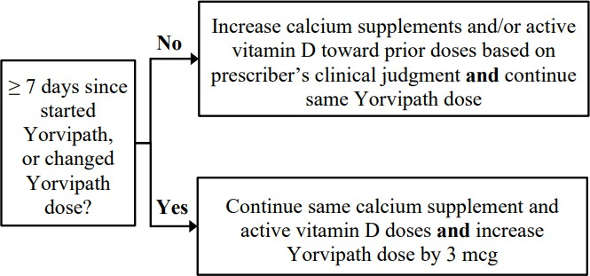
Figure 1: Titration of Yorvipath, active vitamin D, and calcium supplements Albumin-adjusted serum calcium low (< 2.07 mmol/L [< 8.3 mg/dL]):

Albumin-adjusted serum calcium normal (≥ 2.07 to ≤ 2.64 mmol/L [≥ 8.3 to ≤ 10.6 mg/dL]):
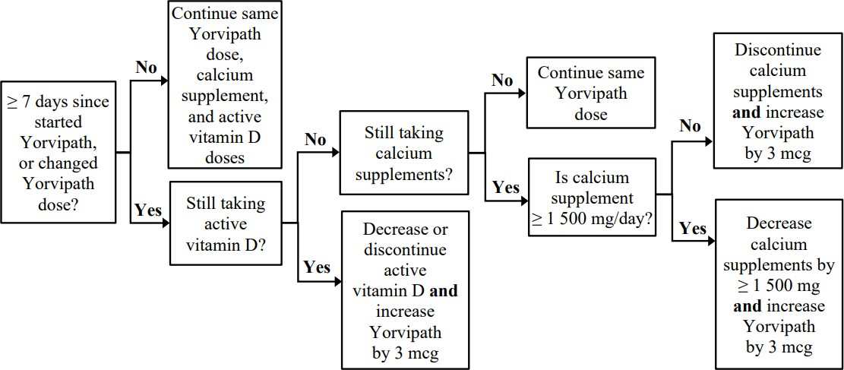

Albumin-adjusted serum calcium high (≥ 2.65 to < 3.00 mmol/L [≥ 10.7 to < 12.0 mg/dL]):
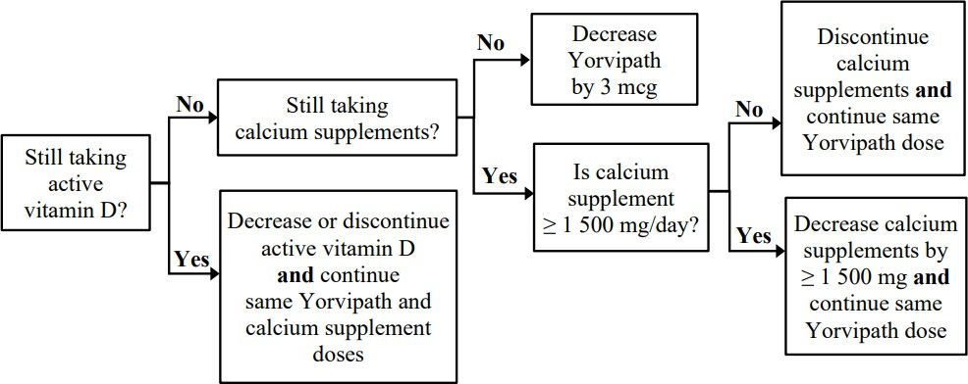
Albumin-adjusted serum calcium very high (≥ 3.00 mmol/L [≥ 12 mg/dL]):

Yorvipath should be withheld for 2 to 3 days and then serum calcium should be rechecked. If subsequent albumin-adjusted serum calcium is < 3.00 mmol/L [< 12 mg/dL], titration of Yorvipath, active vitamin D, and calcium supplements should be resumed as per the applicable section of figure 1 using the most recent serum calcium value obtained. If serum calcium remains ≥ 3.00 mmol/L [≥ 12 mg/dL], Yorvipath should be withheld for an additional 2 to 3 days and then serum calcium should be rechecked. See section 4.4 for more information on hypercalcaemia.
Missed dose
If a dose is missed by less than 12 hours, it should be administered as soon as possible. If a dose is missed by more than 12 hours, it should be skipped and the next dose should be administered as scheduled.

Interruption or discontinuation of Yorvipath
Interruption of daily administration should be avoided to minimise serum PTH fluctuations. Interruption or discontinuation of treatment can result in hypocalcaemia. If Yorvipath treatment is interrupted or discontinued for 3 or more consecutive doses, monitor patients for signs and symptoms of hypocalcaemia and consider measuring serum calcium. If indicated, treatment with calcium supplements and active vitamin D should be resumed or increased in dose. Treatment at the prescribed dose should be resumed as soon as possible after an interruption. When resuming treatment after an interruption, serum calcium should be measured and doses of Yorvipath, active vitamin D, and calcium supplements should be adjusted as per figure 1.

Special populations Elderly
Dose adjustment is not required based on age (see section 5.2).

Hepatic impairment
No dedicated hepatic impairment study was conducted. Yorvipath should be used with caution in patients with severe hepatic impairment (see section 4.4).
Renal impairment
Dose adjustment is not required in patients with an estimated glomerular filtration rate (eGFR)
≥ 30 mL/min. Serum calcium levels should be measured more frequently when used in patients with eGFR < 45 mL/min (see section 4.4). Yorvipath has not been studied in patients with hypoparathyroidism and severe renal impairment (eGFR < 30 mL/min) (see section 5.2).

Paediatric population

The safety and efficacy of Yorvipath in children and adolescents less than 18 years of age have not yet been established. No data are available.

Method of administration
Yorvipath must be administered as a subcutaneous injection to the abdomen or front of the thigh. The injection site should be rotated between four possible sites: abdomen (left or right) and front of the thigh (left or right). A new site should be chosen each day for doses ≤ 30 mcg/day, and two new sites should be chosen each day for doses > 30 mcg/day.
Doses > 30 mcg per day (sequential injections)

All doses > 30 mcg per day should be administered as two single doses injected sequentially at different injection sites (table 1). It is recommended to use a different Yorvipath pen for the second daily injection, even if the two pens have the same-coloured push button (same strength).

Table 1: Recommended scheme for Yorvipath dosing > 30 mcg/day

Dose | Dosing scheme | Pen combination
33 mcg/day | 15 mcg/day + 18 mcg/day | Two pre-filled pens of Yorvipath 294 mcg/0.98 mL (orange push button)*
36 mcg/day | 18 mcg/day + 18 mcg/day
39 mcg/day | 18 mcg/day + 21 mcg/day
42 mcg/day | 21 mcg/day + 21 mcg/day
45 mcg/day | 21 mcg/day + 24 mcg/day | One pre-filled pen of Yorvipath 294 mcg/0.98 mL (orange push button)  +  One pre-filled pen of Yorvipath 420 mcg/1.4 mL (burgundy push button)**
48 mcg/day | 24 mcg/day + 24 mcg/day | Two pre-filled pens of Yorvipath 420 mcg/1.4 mL (burgundy push button)
51 mcg/day | 24 mcg/day + 27 mcg/day
54 mcg/day | 27 mcg/day + 27 mcg/day
57 mcg/day | 27 mcg/day + 30 mcg/day
60 mcg/day | 30 mcg/day + 30 mcg/day
*Yorvipath 294 micrograms/0.98 mL delivers doses of 15, 18, or 21 mcg of PTH(1-34) (with orange push button)
**Yorvipath 420 micrograms/1.4 mL delivers doses of 24, 27, or 30 mcg of PTH(1-34) (with burgundy push button)

Contraindications

    - Hypersensitivity to the active substance or to any of the excipients listed in section 6.1
    - Patients with pseudohypoparathyroidism

Special warnings and precautions for use

Hypercalcaemia
Serious events of hypercalcaemia have been reported with Yorvipath (see section 4.8). The risk is highest when starting or increasing the dose. During treatment, serum calcium should be measured (see section 4.2) and patients should be monitored. Additional serum calcium measurements should be performed for any for signs or symptoms of hypercalcaemia. If severe hypercalcaemia occurs, treatment should be as per clinical guidelines and dose adjustment of Yorvipath should be as per section 4.2.

Hypocalcaemia
Serious events of hypocalcaemia have been reported with Yorvipath (see section 4.8). The risk is highest when treatment is abruptly discontinued but may occur at any time, including in patients who have been on stable doses of Yorvipath. During treatment, serum calcium should be measured and patients should be monitored for signs and symptoms of hypocalcaemia (see section 4.2). If severe hypocalcaemia occurs, treatment should be as per clinical guidelines, dose adjustment of Yorvipath should be considered, and dose adjustment of standing or as needed doses of active vitamin D and/or calcium supplements should be considered (see section 4.2).

Concomitant use with cardiac glycosides
Hypercalcaemia of any cause may predispose to digitalis toxicity. Digoxin efficacy may be reduced if hypocalcaemia is present. In patients using Yorvipath concomitantly with cardiac glycosides (such as digoxin or digitoxin), serum calcium and cardiac glycoside levels should be monitored and patients should be observed for signs and symptoms of digitalis toxicity (see section 4.5).

Severe renal or hepatic disease
No studies have been performed in patients with severe renal impairment (eGFR < 30mL/min) or severe hepatic impairment. Use with caution in these patient populations. Patients with eGFR of < 45 mL/min may be more susceptible for hypercalcaemic reactions and transient eGFR decrease, particularly when initiating treatment. If treatment is initiated in these patients, it is recommended to closely monitor serum calcium levels.

Use in patients at increased risk of osteosarcoma
Yorvipath has not been studied in and should be used with caution in patients;
- with skeletal malignancies or bone metastases
- who are receiving or who have received radiation therapy to the skeleton
- with unexplained elevations of alkaline phosphatase
- with metabolic bone diseases who are at increased baseline risk for osteosarcoma (e.g., Paget’s disease of the bone)
- with open epiphyses
- with hereditary disorders predisposing to osteosarcoma

Osteoporosis
Screening for and monitoring of osteoporosis should be considered for patients treated with palopegteriparatide, taking into account individual patient risk factors. A reduction in bone mineral density compared to baseline may occur with palopegteriparatide use.
There are no data available on the concurrent use of osteoporosis therapies such as bisphosphonates and denosumab with palopegteriparatide.

Sodium content
This medicinal product contains less than 1 mmol sodium (23 mg) per dose, that is to say essentially ‘sodium-free’.

Use in the elderly
The pharmacokinetics of released PTH were not influenced by age (range 19 to 76 years). In the Phase III study, 12% of all subjects were > 65 years old. Data on clinical response in this subgroup are limited.

Paediatric use
The safety and effectiveness of Yorvipath in children and adolescents below 18 years of age have not been established.

Effects on laboratory tests
In clinical trials, mean alkaline phosphatase (ALP) increased by approximately 50% over 26 weeks in patients treated with palopegteriparatide. Concurrent changes in alanine aminotransferase (ALT), aspartate aminotransferase (AST) or bilirubin were not observed. No further increases in ALP were observed beyond 26 weeks.

Interactions with other medicines and other forms of interactions

No interaction studies have been performed.

Cardiac glycosides (such as digoxin or digitoxin) have a narrow therapeutic index and are affected by calcium. Patients should be monitored for signs and symptoms of digitalis toxicity when taking Yorvipath and cardiac glycosides.
Other medicinal products can exert effects on serum calcium and may alter the therapeutic response to Yorvipath, including but not limited to bisphosphonates, denosumab, romosozumab, thiazide and loop diuretics, systemic corticosteroids, and lithium. Patients should be monitored for changes in serum calcium when treated concomitantly with these medicinal products.

Fertility, pregnancy and lactation

Effects on fertility
No studies have been performed on the effects of palopegteriparatide on human fertility. There were no effects on male or female fertility in rats treated with SC doses of palopegteriparatide up to 20
μg PTH(1-34)/kg/day (yielding exposure to released PTH ~ 10 times higher than in patients at the maximum recommended human dose [MRHD] of 60 μg/day based on plasma AUC).

Use in pregnancy Category B3
There are no human data from the use of Yorvipath in pregnant females. No malformations or effects on embryofetal survival were seen in rats or rabbits treated with daily SC doses of palopegteriparatide up to 30 μg PTH(1-34)/kg/day or 6 μg PTH(1-34)/kg/day, respectively, during the period of organogenesis (yielding exposure to released PTH 8 and 7 times higher than in patients at the maximum recommended human dose [MRHD] of 60 μg/day based on plasma AUC, for rat and rabbit, respectively).
Maternotoxicity (increased serum calcium and decreased body weight gain) and a higher fetal incidence of dilated ureter were seen in rats at this dose level, however, the fetal incidence of dilated ureter was within the historical range at 8 μg PTH(1-34)/kg/day (yielding exposure to released PTH 1.5 times higher than in patients at a human dose [MRHD] of 60 μg/day based on plasma AUC).
A risk to the pregnant female or developing fetus cannot be excluded. A decision to initiate or discontinue treatment with Yorvipath during pregnancy should take into account the possible risks versus the benefits for the pregnant female. It is recommended to closely monitor maternal serum calcium levels in pregnant females with hypoparathyroidism, including if treated with Yorvipath.

Use in lactation
It is unknown whether palopegteriparatide or its metabolites are excreted in human milk, and there are no data available on the effects on the breastfed infant or milk production. A decision to discontinue breast-feeding or Yorvipath therapy should take into account the benefit of breast- feeding for the child, the benefit of therapy for the female, and any potential adverse effects on the child from Yorvipath or from the underlying sub-optimally treated maternal condition. It is recommended to closely monitor maternal serum calcium levels if breast-feeding with hypoparathyroidism, including if treated with Yorvipath. Infants breastfed by females treated with Yorvipath should be monitored for signs and symptoms of hypercalcaemia or hypocalcaemia.

Effects on ability to drive and use machines

Yorvipath has no or negligible influence on the ability to drive and use machines. However, dizziness, presyncope, syncope and/or orthostatic hypotension was observed in some patients. These patients should refrain from driving or the use of machines until symptoms have subsided.

Adverse effects (undesirable effects)

Summary of the safety profile

Data from 139 patients were pooled from the phase 2 study and the phase 3 study, with a median exposure to palopegteriparatide of 241 days (range 1 to 711). The most frequently reported adverse reactions were injection site reactions (21.6%), headache (18.7%), and paraesthesia (13.7%).

Tabulated list of adverse reactions

Table 2 presents the adverse reactions for palopegteriparatide-treated patients identified within the MedDRA system organ class. The adverse reactions listed in the table below are presented by system organ class (n=139) and frequency categories, defined using the following convention: very common (≥ 1/10); common (≥ 1/100 to < 1/10), uncommon (≥ 1/1 000 to < 1/100), rare (≥ 1/10 000 to < 1/1 000), very rare (< 1/10 000), and frequency not known (cannot be estimated from the available data). Within each frequency grouping, adverse reactions are presented in the order of decreasing seriousness.

Table 2. Frequency of adverse reactions of palopegteriparatide
MedDRA system organ class | Frequency | Adverse reaction
Metabolism and nutrition disorders | Common | Hypercalcaemia^{a,} ^{d}, Hypocalcaemia^{d}
Nervous system disorders | Very common | Headache, Paraesthesia
Nervous system disorders | Common | Dizziness^{c}, Syncope, Presyncope
Cardiac disorders | Common | Palpitations, Postural orthostatic tachycardia syndrome
Vascular disorders | Common | Orthostatic hypotension, Hypertension
Respiratory, thoracic and mediastinal disorders | Common | Oropharyngeal pain
Gastrointestinal disorders | Very common | Nausea
Gastrointestinal disorders | Common | Diarrhoea, Constipation, Vomiting, Abdominal discomfort, Abdominal pain
Skin and subcutaneous tissue disorders | Common | Rash, Photosensitivity reaction
Musculoskeletal and connective tissue disorders | Common | Arthralgia, Myalgia, Muscle twitching, Musculoskeletal pain
Renal and urinary disorders | Uncommon | Nocturia
Renal and urinary disorders | Frequency not known | Polyuria
General disorders and administration site conditions | Very common | Injection site reactions^{b}, Fatigue
General disorders and administration site conditions | Common | Asthenia, Thirst
General disorders and administration site conditions | Uncommon | Chest discomfort, Chest pain
Investigations | Frequency not known | Bone density decreased

ª For these adverse reactions, the first occurrence was almost exclusively within the first 3 months of treatment (titration period).
^{b} Injection site reactions include injection site reaction, injection site erythema, injection site bruising, injection site pain, injection site haemorrhage, injection site rash, and injection site swelling.
^{c} Dizziness includes dizziness and dizziness postural.
d Frequencies of symptomatic events.

Description of selected adverse reactions
Hypercalcaemia
Serious events of hypercalcaemia have been reported with Yorvipath. The incidence of hypercalcemia was greater in patients treated with Yorvipath compared to placebo. During the 26- week blinded period of the phase III study, symptomatic hypercalcemia was reported in 9.8% (6/61) of patients treated with Yorvipath, and all occurred within the first 3 months after initiation of Yorvipath.
Immunogenicity
Patients may develop antibodies to palopegteriparatide. The proportion of patients testing positive for binding antibodies at any time during treatment was low, with 0.7% (1 out of 139) having low titre, non-neutralising antibodies towards PTH and 5% having low titre treatment-emergent antibodies against PEG. In 2.2% of the palopegteriparatide-treated patients with pre-existing and treatment-induced anti-PEG antibodies, a transient impact on pharmacokinetics of palopegteriparatide and serum calcium was observed. However, therapeutic effectiveness was maintained by dose adjustment of palopegteriparatide according to the trial titration algorithm.
Injection site reactions

Injection site reactions were the most common adverse reactions reported in clinical trials. In the phase III study, all reactions included <5cm of redness and were mild or moderate (grade 1 or 2), with a median duration of 72 hours. No injection site reactions required treatment; none were serious or led to discontinuation.

Vasodilatory symptoms
Vasodilatory symptoms have been reported with Yorvipath. None led to treatment discontinuation. Associated signs and symptoms may include decreased blood pressure, orthostatic hypotension, dizziness (including postural dizziness), headache, palpitations, postural orthostatic tachycardia syndrome, presyncope and syncope. If symptoms occur, dosing at bedtime while reclining is recommended.

Reporting suspected adverse effects
Reporting suspected adverse reactions after registration of the medicinal product is important. It allows continued monitoring of the benefit-risk balance of the medicinal product. Healthcare professionals are asked to report any suspected adverse reactions at www.tga.gov.au/reporting- problems and drugsafety-STA@stbiopharma.com.

Overdose
In the event of overdose, the patient should be carefully monitored by a medical professional.
Overdose can cause hypercalcaemia, the manifestations of which may include dehydration, heart palpitations, ECG changes, hypotension, nausea, vomiting, dizziness, muscle weakness, and confusion. Severe hypercalcaemia may require medical care and careful monitoring (see section 4.4).
One instance of accidental overdose of approximately 3-fold the prescribed dose lasting more than 7 consecutive days resulted in albumin-adjusted serum calcium as high as 4 mmol/L. The patient was symptomatic and required medical intervention. After withholding palopegteriparatide, calcium, and active vitamin D, the patient recovered and restarted on the correct dose.
For information on the management of overdose, contact the Poisons Information Centre on 13 11 26 (Australia).

PHARMACOLOGICAL PROPERTIES

Pharmacodynamic properties
Pharmacotherapeutic group: Calcium homeostasis, parathyroid hormones and analogues ATC code: H05AA05

Mechanism of action
Endogenous parathyroid hormone (PTH) is secreted by the parathyroid glands as a polypeptide of 84 amino acids. PTH exerts its action via cell-surface parathyroid hormone receptors, for example, expressed in bone, kidney and nerve tissue. Activation of PTH1R stimulates bone turnover, increases renal calcium reabsorption and phosphate excretion and facilitates synthesis of active vitamin D.
Palopegteriparatide is a prodrug, consisting of PTH(1-34) conjugated to a methoxypolyethylene glycol carrier (mPEG) via a proprietary TransCon Linker. PTH(1-34) and its metabolite, PTH(1-33), have similar affinity to and activation of PTH1R as endogenous PTH. At physiological conditions, PTH is cleaved from palopegteriparatide in a controlled manner to provide a continuous systemic exposure of active PTH.

Clinical trial

Study in patients with established hypoparathyroidism
The pivotal phase 3 PaTHway clinical trial (TCP-304) assessed the efficacy and safety of Yorvipath in adults with hypoparathyroidism. The 26-week double-blind, placebo-controlled period of the clinical trial included patients randomised (3:1) to Yorvipath at a starting dose of 18 micrograms/day or placebo, co-administered with conventional therapy (calcium supplement and active vitamin D). Randomisation was stratified by aetiology of hypoparathyroidism (i.e., postsurgical vs. all other causes). Study treatment (palopegteriparatide or placebo) and conventional therapy were subsequently titrated according to a dosing algorithm guided by albumin-adjusted serum calcium levels.
Patients’ mean age at recruitment was 49 years (19 to 78 years of age; 12% were ≥ 65 years old), and the majority of patients were female (78%) and Caucasian (93%). Eighty-five percent (85%) of patients had hypoparathyroidism acquired from neck surgery. Of the patients with other aetiologies of hypoparathyroidism, 7 (8.5%) patients had idiopathic disease, 2 had autoimmune polyglandular syndrome type 1 (APS-1), 1 had autosomal dominant hypocalcaemia type 1 (ADH1, CaSR mutation), 1 had DiGeorge Syndrome, and 1 had hypoparathyroidism, sensorineural deafness and renal dysplasia (HDR) syndrome (GATA3 mutation). At baseline, the median duration of hypoparathyroidism was 8.5 years (range 1 to 56 years).
Prior to randomisation, all patients underwent an approximate 4-week screening period in which calcium and active vitamin D supplements were adjusted to achieve an albumin-adjusted serum calcium concentration between 1.95 to 2.64 mmol/L (7.8 to 10.6 mg/dL), a magnesium concentration ≥ 0.53 mmol/L (≥ 1.3 mg/dL) and below the upper reference range of normal, and a 25(OH) vitamin D concentration between 50 to 200 nmol/L (20 to 80 ng/mL). For conventional therapy, patients were treated with mean baseline doses of calcium (elemental) of 1 839 mg/day. Mean baseline doses of active vitamin D were 0.75 micrograms/day in calcitriol-treated patients (n=70), and 2.3 micrograms/day in alfacalcidol-treated patients (n=12). Baseline mean albumin- adjusted serum calcium and mean 24-hour urine calcium were similar between treatment groups: mean serum calcium was 2.2 mmol/L (8.8 mg/dL) and 2.15 mmol/L (8.6 mg/dL) and mean 24- hour urine calcium was 392 mg/day and 329 mg/day, for Yorvipath and placebo, respectively.

Primary endpoint

The composite primary efficacy endpoint was defined as the proportion of patients at week 26 who achieved: serum calcium levels in the normal range (2.07 to 2.64 mmol/L [8.3 to 10.6 mg/dL]), independence from conventional therapy defined as requiring no active vitamin D and ≤ 600 mg/day of calcium supplementation, and no increase in prescribed study treatment within 4 weeks prior to week 26. Key secondary endpoints included a subset of Hypoparathyroidism Patient Experience Scale (HPES) domain scores and 36-Item Short Form Survey (SF-36) subscale scores.
The number of patients meeting the composite primary endpoint compared with the placebo group and each component of the primary endpoint at week 26 is presented in table 3.

Table 3: TCP-304: Response rate based on primary endpoint at week 26
 | Yorvipath  (N=61) (n, %) | Placebo (N=21) (n, %) | Response rate  difference (95% CI)
Response at week 26 | 48 (78.7%) | 1 (4.8%) | 74.0%  (60.4%, 87.6%)  p < 0.0001
Response for each component
Albumin-adjusted serum  calcium within normal rangea | 49 (80.3%) | 10 (47.6%) | 32.7%  (9.2%, 56.3%)
Independence from active  vitamin Db | 60 (98.4%) | 5 (23.8%) | 74.6%  (56.1%, 93.1%)
Independence from therapeutic doses of calciumc | 57 (93.4%) | 1 (4.8%) | 88.7%  (77.7%, 99.7%)
No dose increase in Yorvipathd | 57 (93.4%) | 12 (57.1%) | 36.4%  (14.2%, 58.5%)
ª The normal range for albumin-adjusted serum calcium was 2.07 to 2.64 mmol/L (8.3 to 10.6 mg/dL).
^{b} All daily standing doses of active vitamin D equal to zero AND use of PRN doses for ≤ 7 days within 4 weeks prior to week 26 visit.
^{c} Average daily standing doses of elemental calcium ≤ 600 mg AND use of PRN doses on ≤ 7 days within 4 weeks prior to week 26 visit.
^{d} No dose increase in Yorvipath within 4 weeks prior to week 26 visit. Abbreviations: CI: confidence interval; PRN: pro re nata.

Secondary endpoints

Conventional therapy intake: calcium and active vitamin D doses
The reduction in conventional therapy intake from baseline to week 26 compared to placebo is shown in table 4.

Table 4: TCP-304: conventional therapy intake at week 26 - blinded period
 | Yorvipath (n/N=60/61)a |  | Placebo (n/N=19/21)a
 | Baseline | Week 26 | Baseline | Week 26
Active vitamin D dose  (mcg), mean (SD)b | 1.0 (0.7) | 0.0 (0.0) | 1.0 (0.6) | 0.6 (0.7)
Calcium dose (mg), mean (SD) | 1 737 (907) | 274 (177) | 2 089 (1  448) | 1 847 (1  326)
Daily pill burden  (active vitamin D and calcium), mean (SD) | 6.6 (2.1) | 0.5 (1.7) | 6.3 (2.8) | 5.4 (3.2)
ª N is the number of patients in the intent to treat population; n is the number of patients with data at both baseline and week 26.
b Doses of calcitriol and alfacalcidol were aggregated regardless of potency.

Serum calcium
There was an initial increase in mean serum calcium in palopegteriparatide-treated patients (figure 2). The least squares mean treatment difference between Yorvipath and placebo was 0.17 mmol/L (95% CI: 0.100, 0.247) at week 26.

Figure 2: TCP-304: Serum calcium (mean ± SE) by visit - blinded period
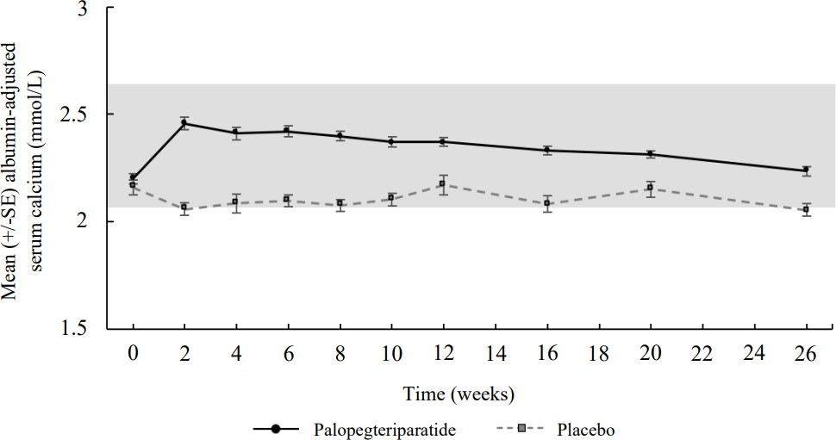

24-hour urine calcium excretion
Yorvipath therapy was associated with a numerically greater reduction in 24-hour urine calcium excretion compared to placebo by week 26.

Pharmacokinetic properties

Absorption

Palopegteriparatide is a prodrug that releases PTH via autocleavage of the TransCon Linker. At steady state, administration of palopegteriparatide to patients with hypoparathyroidism resulted in continuous exposure to released PTH throughout the 24-hour dosing period (figure 3). The median time to reach maximum concentrations (Tmax) for released PTH was 4 hours (figure 3).

Figure 3: Mean released PTH* following subcutaneous administration of palopegteriparatide at steady state in patients with hypoparathyroidism
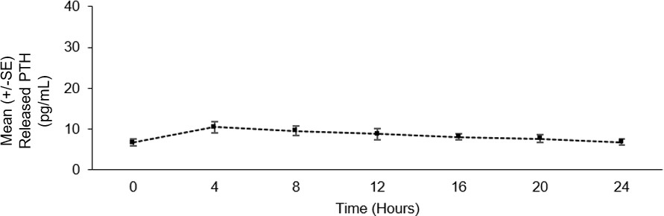
* Mean palopegteriparatide dose (range): 22.3 (12-33) mcg PTH(1-34)/day, n=7: released PTH: sum of PTH(1-34) and PTH(1-33).

Following multiple subcutaneous doses of palopegteriparatide in the range of 12 to 24 mcg PTH(1- 34)/day in healthy adults, the palopegteriparatide and released PTH concentrations increased in a dose-proportional manner reaching steady-state within approximately 10 and 7 days, respectively. The peak-to-trough ratio was approximately 1.1 and 1.5 over 24 hours at steady state for palopegteriparatide and released PTH, respectively. Palopegteriparatide accumulated after multiple dosing by up to 18-fold for AUC.

Distribution
The apparent volume of distribution (CV%) of palopegteriparatide is estimated to 4.8 L (50%) and to
8.7 L (18%) for released PTH.

Metabolism
PTH released from palopegteriparatide is composed of PTH(1-34) and the active metabolite PTH(1- 33). The clearance of PTH and its fragments is believed to occur predominantly in the liver via metabolism and in the kidney via metabolism and/or filtration.

Excretion
The clearance (CV%) of palopegteriparatide at steady state is estimated to be
0.58 L/day (52%). The apparent half-life of PTH released from palopegteriparatide is approximately 60 hours.

Pharmacokinetic/pharmacodynamic relationship
Serum calcium concentration increased in a dose-related manner when palopegteriparatide was administered to healthy volunteers. Exposure-response is not established in subjects with hypoparathyroidism.

In a pharmacodynamic/pharmacokinetic sub-study in hypoparathyroid patients, subcutaneous administration of palopegteriparatide (mean dose (range): 22.3 (12-33) mcg PTH(1-34)/day) at steady-state increased serum calcium levels to within the normal range (see figure 4).

Figure 4: Mean albumin-adjusted serum calcium concentrations following subcutaneous administration of palopegteriparatide at steady state in patients with hypoparathyroidism
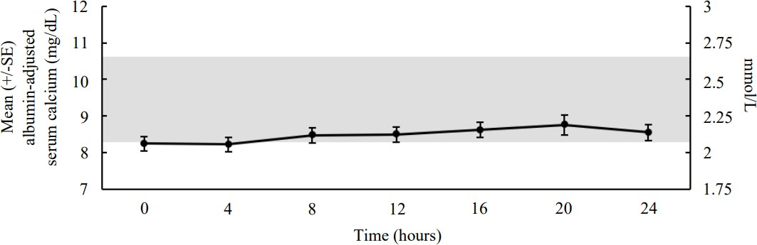

The normal range for albumin-adjusted serum calcium is 2.07 to 2.64 mmol/L (8.3 to 10.6 mg/dL) as denoted by the grey shading. Mean palopegteriparatide dose (range): 22.3 (12-33) mcg PTH(1-34)/day, n=7.

Special populations
The pharmacokinetics of released PTH was not influenced by sex or body weight. The data for race and ethnicity did not show any trends indicating differences, but the available data are too limited to make definitive conclusions.

Elderly

The pharmacokinetics of released PTH was not influenced by age (19 to 76 years old).
Renal impairment
Yorvipath has been administered to patients with hypoparathyroidism with an eGFR of ≥ 30 mL/min in clinical trials. No clinical trials were conducted in patients with hypoparathyroidism with severe renal impairment (< 30 mL/min) or on dialysis. In a trial where Yorvipath was administered as a single dose to non-hypoparathyroid subjects with renal impairment, palopegteriparatide exposure was similar in subjects with mild, moderate, and severe renal impairment as compared to subjects without renal impairment.

Preclinical safety data

Genotoxicity
Palopegteriparatide was not genotoxic in any of the following test systems: the bacterial reverse mutation (Ames) assay, the chromosomal aberration assay in human peripheral blood lymphocytes, with and without metabolic activation, and the in vivo micronucleus test in rats.

Carcinogenicity
No carcinogenicity studies have been conducted with palopegteriparatide. Increased occurrence of osteosarcomas has been observed in carcinogenicity studies with short-lived PTH analogues in rats. The relevance of these findings to the clinical use of palopegteriparatide is uncertain. An increased risk of osteosarcoma has not been reported in humans with up to 2 years of exposure to short-lived teriparatide (Forteo®).

PHARMACEUTICAL PARTICULARS

List of excipients
Succinic acid Mannitol Metacresol Sodium hydroxide
Hydrochloric acid (for pH adjustment) Water for injections

Incompatibilities
In the absence of compatibility studies, this medicinal product must not be mixed with other medicinal products.

Shelf life
In Australia, information on the shelf life can be found on the public summary of the Australian Register of Therapeutic Goods (ARTG). The expiry date can be found on the packaging.

Special precautions for storage

Store at 2 to 8 °C. Do not freeze.
Store in the original package with the pen cap on in order to protect from light. After first opening
Store below 30 °C.
Keep the pen cap on the pre-filled pen in order to protect from light. Yorvipath must be discarded after 14 days.

Nature and contents of container

A cartridge (type 1 glass) with a plunger (halobutyl) and a laminate rubber sheet (halobutyl/isoprene) contained in a pre-filled multidose disposable pen made of polypropylene.
Packs of two pre-filled pens and 30 disposable needles for 28 days of treatment (co-packaged in two inner cartons). Each inner carton contains one pre-filled pen and 15 needles for 14 days of treatment.

Yorvipath 168 micrograms/0.56 mL solution for injection in pre-filled pen
- Each pre-filled pen contains palopegteriparatide equivalent to 168 micrograms of PTH(1-34) in 0.56 mL of solvent.
- Pre-filled pen delivering doses of 6, 9, or 12 micrograms
- The strength colour on the outer carton, pen label and push button is blue

Yorvipath 294 micrograms/0.98 mL solution for injection in pre-filled pen
- Each pre-filled pen contains palopegteriparatide equivalent to 294 micrograms of PTH(1-34) in 0.98 mL of solvent.
- Pre-filled pen, delivering doses of 15, 18, or 21 micrograms
- The strength colour on the outer carton, pen label and push button is orange

Yorvipath 420 micrograms/1.4 mL solution for injection in pre-filled pen
- Each pre-filled pen contains palopegteriparatide equivalent to 420 micrograms of PTH(1-34) in 1.4 mL of solvent.
- Pre-filled pen, delivering doses of 24, 27, or 30 micrograms
- The strength colour on the outer carton, pen label and push button is burgundy

Special precautions for disposal and other handling
In Australia, any unused medicine or waste material should be disposed of by taking to your local pharmacy.

Dose preparation
A new Yorvipath pen should be taken out of the refrigerator 20 minutes before first opening.
The solution should appear clear, colourless and free of visible particles. Do not inject the medicinal product if it is cloudy, or contains particulate matter.
The pen flow should be tested before the first time a new pen is used.
Each pre-filled pen is for use by a single patient. A pre-filled pen must never be shared between patients, even if the needle is changed.
If a pre-filled pen has been frozen or exposed to heat, it must be discarded.
Every time a pre-filled pen is prepared for administration, a new needle must be attached.
Needles must not be re-used. This may prevent blocked needles, contamination, infection, leakage of solution and inaccurate dosing. The injection needle should be removed after each injection and the pen should be stored without a needle attached. Discard the needles after each injection.
Instructions for the preparation and administration of Yorvipath are given in the consumer medicine information and the instructions for use leaflet.

Physicochemical properties

Chemical structure
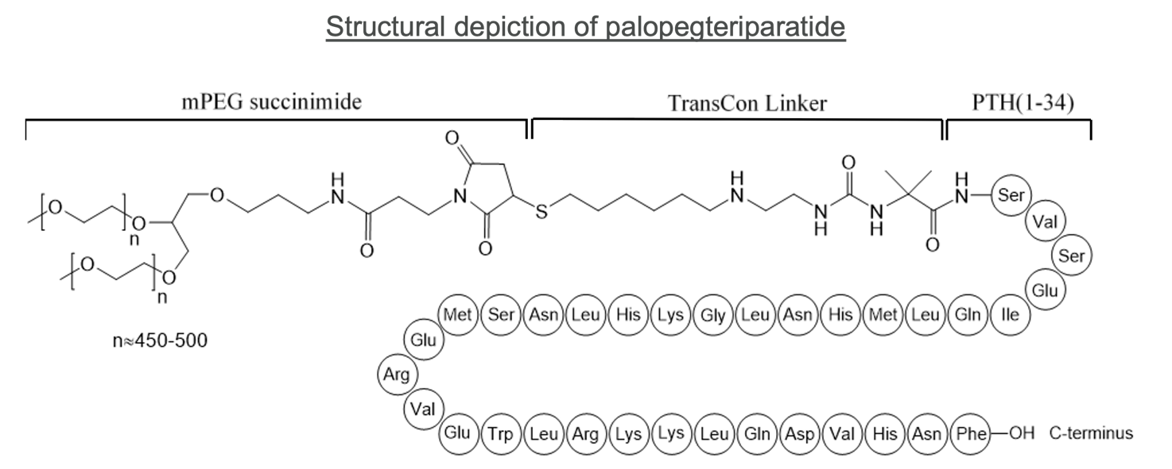
Chemical name: Human parathyroid hormone (PTH) synthetic peptide fragment (1-34), conjugated at the N-terminal amino group via a cleavable linker to O-methylpolyethylene glycol (2 x 20 kDa mPEG); 2- methylalanyl-(1-34)-peptide of parathyroid hormone (Homo sapiens parathyrin, parathormone, PTH) conjugated with O-methylpolyethylene glycol via a cleavable linker at the N-terminal amino group: N-({2- [(6-{[(3RS)-1-{3-[(3-{(2Ξ)-2,3-bis[αmethylpoly(oxyethylene)-ω-oxy]propoxy}propyl)amino]-3-oxopropyl}-2,5-dioxopyrrolidin-3- yl]sulfanyl}hexyl)amino]ethyl}carbamoyl)-2-methylalanyl-Lseryl-L- valyl-L-seryl-L-α-glutamyl-L-isoleucyl-L-glutaminyl-Lleucyl-L-methionyl-L-histidyl-L-asparaginyl-L- leucylglycyl-Llysyl-L-histidyl-L-leucyl-L-asparaginyl-L-seryl-L-methionyl-Lα-glutamyl-L-arginyl-L-valyl-L-α- glutamyl-L-tryptophyl-Lleucyl-L-arginyl-L-lysyl-L-lysyl-L-leucyl-L-glutaminyl-L-αaspartyl-L-valyl-L- histidyl-L-asparaginyl-L-phenylalanine
Molecular Formula: C209H340N60O59S3 +2 x (C2H4O)n, where n is between approximately 450 and 500. Molecular Weight: The average molecular weight is approximately 47.4 kDa.
CAS number: 2222514-07-8.

MEDICINE SCHEDULE (POISONS STANDARD)
S4 - Prescription Only Medicine

SPONSOR
Specialised Therapeutics Pharma Pty Ltd Level 2, 17 Cotham Road
Kew, Victoria 3101 Australia

Phone: +61 3 9859 1493
Website: www.stbiopharma.com

DATE OF FIRST APPROVAL
DD/Month/YYYY

DATE OF REVISION

Summary table of changes

Section Changed | Summary of new information

