Australian Public Assessment Report for Winrevair
  - Active ingredient: Sotatercept
  - Sponsor: Merck Sharp & Dohme (Australia) Pty Ltd
August 2025

About the Therapeutic Goods Administration (TGA)
- The Therapeutic Goods Administration (TGA) is part of the Australian Government Department of Health, Disability and Ageing and is responsible for regulating therapeutic goods, including medicines, medical devices, and biologicals.
- The TGA administers the Therapeutic Goods Act 1989 (the Act), applying a risk management approach designed to ensure therapeutic goods supplied in Australia meet acceptable standards of quality, safety, and efficacy.
- The work of the TGA is based on applying scientific and clinical expertise to decision-making, to ensure that the benefits to the Australian public outweigh any risks associated with the use of therapeutic goods.
- The TGA relies on the public, healthcare professionals and industry to report problems with therapeutic goods. The TGA investigates reports received to determine any necessary regulatory action.
- To report a problem with a therapeutic good, please see the information on the TGA website.

About AusPARs
- The Australian Public Assessment Report (AusPAR) provides information about the evaluation of a prescription medicine and the considerations that led the TGA to approve or not approve a prescription medicine submission. Further information can be found in Australian Public Assessment Report (AusPAR) guidance.
- AusPARs are prepared and published by the TGA.
- AusPARs are static documents that provide information that relates to a submission at a particular point in time. The publication of an AusPAR is an important part of the transparency of the TGA’s decision-making process.
- A new AusPAR may be provided to reflect changes to indications or major variations to a prescription medicine subject to evaluation by the TGA.

Copyright
© Commonwealth of Australia 2025
This work is copyright. You may reproduce the whole or part of this work in unaltered form for your own personal use or, if you are part of an organisation, for internal use within your organisation, but only if you or your organisation do not use the reproduction for any commercial purpose and retain this copyright notice and all disclaimer notices as part of that reproduction. Apart from rights to use as permitted by the Copyright Act 1968 or allowed by this copyright notice, all other rights are reserved and you are not allowed to reproduce the whole or any part of this work in any way (electronic or otherwise) without first being given specific written permission from the Commonwealth to do so. Requests and inquiries concerning reproduction and rights are to be sent to the TGA Copyright Officer, Therapeutic Goods Administration, PO Box 100, Woden ACT 2606 or emailed to <tga.copyright@tga.gov.au>.

Contents
List of abbreviations 4
Product submission 6
Submission details 6
Product background 7
Disease 7
Current treatment options 8
Clinical rationale 8
Regulatory status 8
Australian regulatory status 8
International regulatory status 8
Registration timeline 10
Assessment overview 10
Quality evaluation summary 11
Nonclinical evaluation summary 11
Clinical evaluation summary 13
Summary of clinical studies 13
Pharmacology 14
Efficacy 18
Safety 26
Risk management plan 36
Risk-benefit analysis 36
Delegate’s considerations 36
Proposed action 38
Questions for the sponsor 39
Advisory Committee considerations 42
Assessment outcome 43
Specific conditions of registration 43
Product Information and Consumer Medicine Information 44

List of abbreviations
Abbreviation | Meaning
6MWD | 6-Minute walk distance
ACM | Advisory Committee on Medicines
ActRIIA | Activin Receptor type IIA
ADA | Antidrug antibody
AE | Adverse event
AEOI | Adverse event of interest
AESI | Adverse event of special interest
ARTG | Australian Register of Therapeutic Goods
ASA | Australia-specific annex
AUC | Area under the curve
BMPR2 | Bone morphogenetic protein receptor type II
CL | Clearance
CMI | Consumer Medicines Information
CTCAE | Common Terminology Criteria for Adverse Events
DLP | Data lock point
ER_{AUC} | Exposure ratio by Area under the curve
E−R | Exposure-response
FAS | Full analysis set
FC | Functional Class
FSH | Follicle-stimulating hormone
IgG | Immunoglobulin G
LS | Least squares
MK7962 | Company product code for sotatercept
Nab | Neutralising antibody
NT-proBNP | N-terminal prohormone of brain natriuretic peptide
PAH | Pulmonary arterial hypertension
PAH-CTD | Pulmonary arterial hypertension associated with connective tissue disease
PAH-SYMPACT | Pulmonary Arterial Hypertension Symptoms and Impact Questionnaire
PI | Product Information
PK | Pharmacokinetics
popPK | Population pharmacokinetics
PSUR | Periodic safety update report
PVR | Pulmonary vascular resistance
RMP | Risk management plan
SAE | Serious adverse events
SUR1 [or 2] | Safety updated report 1 [or 2]
t_{1/2} | Half-life
TAR-EAIR | Time-at-risk exposure-adjusted incidence rate
TEAE | Treatment-emergent adverse event
TGA | Therapeutic Goods Administration
V_{c} | Central volume of distribution
WHO | World Health Organization

Product submission

Submission details
Type of submission: | New biological entity
Product name: | Winrevair
Active ingredient: | sotatercept
Decision: | Approved
Date of decision: | 7 November 2024
Date of entry onto ARTG: | 8 November 2024
ARTG numbers: | 433670, 433671
Black Triangle Scheme  for the current submission: | Yes
Sponsor’s name and address: | Merck Sharp & Dohme (Australia) Pty Limited  Level 1, Building A, 26 Talavera Road  Macquarie Park NSW 2113
Dose form: | Powder for injection
Strengths: | 45 mg and 60 mg
Container: | Vial
Pack sizes: | 1 or 2 vials
Approved therapeutic use for the current submission: | WINREVAIR is indicated for the treatment of adults with pulmonary arterial hypertension (PAH) in WHO Functional Class (FC) II or III, in combination with standard therapy.  Efficacy has been shown in idiopathic and heritable PAH, PAH associated with connective tissue disease, drug or toxin-induced PAH and PAH associated with congenital heart disease with repaired shunts.
Route of administration: | Subcutaneous injection
Dosage: | Winrevair is administered once every 3 weeks by subcutaneous injection according to patient weight. The starting dose of Winrevair is 0.3 mg/kg.  For further information regarding dosage, such as the target dose and dosage modifications due to increased haemoglobin or decreased platelet count, refer to the Product Information.
Pregnancy category: | Use in pregnancy Category D: Drugs which have caused, are suspected to have caused or may be expected to cause, an increased incidence of human fetal malformations or irreversible damage. These drugs may also have adverse pharmacological effects. Accompanying texts should be consulted for further details.  The use of any medicine during pregnancy requires careful consideration of both risks and benefits by the treating health professional. The pregnancy database must not be used as the sole basis of decision making in the use of medicines during pregnancy. The TGA does not provide advice on the use of medicines in pregnancy for specific cases. More information is available from obstetric drug information services in your state or territory.

Product background
This AusPAR describes the submission by Merck Sharp & Dohme (Australia) Pty Ltd (the sponsor) to register Winrevair (sotatercept) 45 mg and 60 mg powder for injection in vials for the following proposed indication:
TRADEMARK is indicated for the treatment of pulmonary arterial hypertension (PAH) in adult patients on standard of care with WHO Functional Class (FC) II to III, to improve exercise capacity, provide clinical improvement, improve WHO FC and delay disease progression, including to reduce the risk of death and hospitalization for PAH.
Efficacy has been shown in a PAH population including aetiologies of idiopathic and heritable PAH, PAH associated with connective tissue disease, drug or toxin-induced PAH, or PAH associated with congenital heart disease with repaired shunts.

Disease
Pulmonary arterial hypertension (PAH) is characterised by vasculopathy and remodelling of the pulmonary circulation leading to increased pulmonary arterial resistance and pressure. Initial symptoms are exertional dyspnoea and fatigue. As the disease progresses, right heart failure develops and then worsens, with its associated burden of morbidity and mortality.
Pulmonary arterial hypertension is synonymous with Group 1 Pulmonary Hypertension in the World Health Organization (WHO) system. It has a number of recognised aetiologies, with idiopathic being the most common (this reflects available registry data which are generally from areas without endemic schistosomiasis). Other aetiologies include heritable and associated with congenital heart disease, liver disease, HIV, connective tissue disease and use of certain drugs (such as anorectics).
PAH may be suspected on testing such as echocardiography or cross-sectional imaging. It is confirmed by invasive haemodynamic testing (that is, measurement of an elevated pulmonary artery pressure and resistance, together with a normal or insufficiently high left sided pressure / pulmonary capillary wedge pressure). Current haemodynamic definitions (2022) for PAH are a mean pulmonary artery pressure (mPAP) of > 20 mmHg, pulmonary artery wedge pressure ≤ 15 mmHg and pulmonary vascular resistance (PVR) > 2 Wood units.

Current treatment options
The following medicines appear in the ARTG:
- Phosphodiesterase-5 inhibitors (PDE5i), such as sildenafil and tadalafil
- Endothelin receptor antagonists (ERA), such as ambrisentan, bosentan and macitentan
- Prostacyclin receptor agonists, such as iloprost, epoprostenol and selexipag
- Soluble guanylate cyclase stimulator, such as riociguat.
Aside from these standard drug therapies, other important medical treatments include oxygen, diuretics, and other supportive care. Bilateral lung transplant with or without heart transplant is the only potentially curative option.

Clinical rationale
Sotatercept is an activin signalling inhibitor with high selectivity for Activin A. Activin A is a ligand of the TGF-β superfamily that binds to Activin Receptor type IIA (ActRIIA). Biological effects through this pathway include inflammation, cell proliferation, apoptosis and tissue homeostasis. In PAH there is overactive Activin A-ActRIIA signalling (Smad2/3 mediated) and a simultaneous decrease in anti-proliferative Bone morphogenetic protein receptor type II (BMPR2) signalling (Smad1/5/8 mediated). This imbalanced ActRIIA-BMPR2 signalling in PAH leads to pulmonary arterial wall remodelling, luminal narrowing, increased vascular resistance, high pulmonary pressures and eventually right ventricular dysfunction. Antagonising the ActRIIA pathway can potentially rebalance the signalling and interfere with the deleterious processes in PAH.
According to the sponsor’s overview in the dossier most heritable PAH and a proportion of idiopathic PAH involve mutations in BMPR2. These mutations reduce the pathway’s signalling. Therefore, it is biologically plausible that sotatercept could treat PAH by rebalancing ActRIIA-BMPR2 signalling. It is worth noting that BMPR2 seems to be downregulated in PAH, regardless of the mutational status, and therefore sotatercept may be broadly effective in other subtypes.
Sotatercept is a fusion protein comprised of a recombinant homodimer ActRIIA and the Fc portion of immunoglobulin. The receptor portion functions as a ligand trap, scavenging Activin A and other ActRIIA ligands.

Regulatory status

Australian regulatory status
This product is considered a new biological entity for Australian regulatory purposes.

International regulatory status
This submission was evaluated as part of the Australia-Canada-Singapore-Switzerland-United Kingdom (ACCESS) Consortium with work-sharing between the TGA, Health Canada, Health Sciences Authority Singapore and Swissmedic. Each regulator made independent decisions regarding approval (market authorisation) of the new medicine.
At the time the TGA considered this submission, a similar submission had been considered by other regulatory agencies. The following table summarises these submissions and provides the indications where approved.
Table 1: International regulatory status
Region | Submission date | Status | Approved indications
USA | 26 July 2023 | Approved on 26 March 2024 | WINREVAIR is indicated for the treatment of adults with pulmonary arterial hypertension (PAH, World Health Organization [WHO] Group 1) to increase exercise capacity, improve WHO functional class (FC), and reduce the risk of clinical worsening events.
EU | 4 October 2023 | Approved on 22 August 2024 | Winrevair, in combination with other pulmonary arterial hypertension (PAH) therapies, is indicated for the treatment of PAH in adult patients with WHO Functional Class (FC) II to III, to improve exercise capacity.
Canada | 31 January 2024 | Approved on 28 August 2024 | WINREVAIR (sotatercept) is indicated: In combination with standard pulmonary arterial hypertension (PAH) therapy, for the treatment of adults with World Health Organization [WHO] Group 1 PAH and Functional Class (FC) II or III.  Efficacy has been shown in a PAH population including etiologies of idiopathic PAH, heritable PAH, PAH associated with connective tissue disease, drug- or toxin-induced PAH, or PAH associated with congenital heart disease with repaired shunts (see 14 CLINICAL TRIALS).
Switzerland | 26 January 2024 | Under consideration | Under consideration
Singapore | 30 January 2024 | Under consideration | Under consideration
UK | 3 September 2024 | Under consideration | Under consideration

Registration timeline
The following table captures the key steps and dates for this submission.
This submission was evaluated under the priority registration process.
The active ingredient with its proposed indication was given orphan drug designation.
Table 2: Timeline for Submission PM-2024-00043-1-3
Priority review pathway
Description | Date
Designation (Orphan) | 19 September 2023
Priority determination | 3 October 2023
Submission dossier accepted and first round evaluation commenced | 1 March 2024
Second round evaluation completed | 21 June 2024
Delegate’s Overall benefit-risk assessment and request for Advisory Committee advice | 27 August 2024
Advisory Committee meeting | 3 to 4 October 2024
Registration decision (Outcome) | 7 November 2024
Administrative activities and registration in the ARTG completed | 8 November 2024
Number of working days from submission dossier acceptance to registration decision* | 150 days
*Target timeframe for priority submissions is 150 working days from acceptance for evaluation to the decision.

Assessment overview
A summary of the TGA’s assessment for this submission is provided below.
This section is a TGA summary of wording used in TGA’s evaluation report, which discussed numerous aspects of overseas evaluation reports and included some information that was commercial-in-confidence.
Relevant guidelines or guidance documents referred to by the delegate are listed below:
- Guideline on the Clinical Investigations of Medicinal Products for the Treatment of Pulmonary Arterial Hypertension. Refer EMEA/CHMP/EWP/356954/2008.
- The Extent of Population Exposure to Assess Clinical Safety for Drugs Intended for Long-Term Treatment of Non-Life-Threatening Conditions. E1 Current Step 4 version dated 27 October 1994.

Quality evaluation summary
Sotatercept is a homodimeric recombinant fusion protein expressed in Chinese Hamster Ovary cells and has a calculated molecular weight of 78 kDa (as the homodimer). It consists of the extracellular domain of the human activin receptor type IIA (ActRIIA) linked to the human IgG1 Fc domain.
The finished product, sotatercept for injection, is a sterile, preservative free, white to off-white lyophilised cake or powder in single dose vials intended for reconstitution and subcutaneous injection. The excipients are citric acid monohydrate, polysorbate 80, sucrose and sodium citrate dihydrate. It is intended for reconstitution with water for injection. It is packaged in a glass vial, stoppered with a FluroTec coated bromobutyl rubber stopper and sealed with an aluminium crimp seal with flip-off cap. The manufacturing process for the finished product was described in sufficient detail and acceptable.
The drug product has a 36-month shelf life when stored at +2°C to +8°C and protected from light. When reconstituted the solution should be used within 4 hours. These and additional storage condition details are presented appropriately in the Product Information (PI), ARTG and product labels.
The quality evaluation included secondary evaluations for infectious disease/viral safety, container safety, microbiology (sterility) and endotoxin.
There was no objection from a quality perspective to approval of Winrevair.
Conditions of registration were recommended relating to laboratory testing and Certified Product Details.

Nonclinical evaluation summary
In vitro, sotatercept binds various human TGF-β ligands, in particular, Activin A, Activin B, GDF11. BMP10 and GDF8. Sotatercept is also expected to have similar binding to these ligands in other species (mouse, rat, rabbit, cynomolgus monkey). Sotatercept inhibited Smad2/3 signalling in cellular assays through binding GDF11, Activin A and Activin B. There was minimal inhibitory activity on Smad 1/5/8 signalling via BMP6, BMP9, BMP10.
A rodent model of PAH was tested using a similar molecule to sotatercept (same ActRIIA domain with a murine IgG2a Fc). The molecule induced positive effects on PAH disease aspects including pulmonary vascular remodelling, pressure and right heart function.
Secondary pharmacology studies were not conducted. Given the range of ligands that sotatercept can bind, off-target activity is possible, depending on plasma levels. Sotatercept is not expected to have clinically relevant antibody dependant cell-mediated cytotoxicity or complement dependant cytotoxicity.
There was no relevant hERG inhibition in vitro (that is, no in vitro signal for QT prolongation). Central nervous system, respiratory and cardiovascular safety assessments were done as part of the 9-month repeat dose monkey study. No adverse effects were seen at 10 mg/kg subcutaneous, which corresponds to an exposure ratio by maximum observed plasma (peak) concentration (C_{max}) of 17.
While animal pharmacokinetics (PK) were studied, no distribution, metabolism or excretion studies were conducted given that sotatercept is a protein. Overall PK similarity was considered acceptable in terms of the pre-clinical species chosen.
Across the single dose toxicology studies, no acute effects were observed.
Repeat dose toxicology studies were conducted in rats (3 months) and monkeys (9 months) using the subcutaneous route. Major findings were as follows:
- Dose-dependent increases in red blood cell count, haemoglobin, haematocrit, reticulocytes and red cell distribution width in rats and monkeys (likely due TGF-β signalling). The changes were reversible.
- Lower platelet counts were seen in rats and monkeys.
- Renal injury associated with membranoproliferative glomerulonephritis in rats and monkeys (lower exposures; likely direct effect rather than related to antidrug antibodies) and interstitial inflammation and fibrosis (higher exposure). Two monkeys at high exposure (ER_{AUC} 32) had renal failure and were terminated. There was partial recovery for the changes.
- Adrenal cortical toxicity in rats (zona fasciculata or zona reticularis). Considered to be pharmacologically mediated and related to being given to rats during early life when adrenal gland still in development. Not considered relevant to adult humans.
- Spermatogenesis defects in testes of rats.
- Inflammatory infiltrate in choroid plexus of all treated monkeys, but without an effect on function (that is, neurological function).
- Lower heart weights in rats that was reversible and not considered adverse.
Genotoxicity studies were not conducted.
Long-term rodent studies were not conducted due to potential for antidrug antibodies to affect exposure. A weight of evidence approach was taken and sotatercept was considered to have a low carcinogenic potential.
A set of reproductive and developmental toxicology studies were done and considered sufficiently comprehensive and acceptable. There were deleterious findings in all of the studies, and these were generally attributable to sotatercept pharmacology (Activin A stimulates follicle-stimulating hormone (FSH) and has significant direct effects on reproductive organs). The findings are outlined as follows:
- A fertility study was conducted in male rats. Male rats were allowed to mate naturally with untreated females following at least 10 weeks of sotatercept dosing. Sperm analysis and detailed reproductive organ examination was also done at the end of 13 weeks. Effects were seen in the efferent ducts, epididymis and testis/seminiferous tubules. Some of the effects were seen at the lowest dose (ER_{AUC} 0.5) and some of the effects were severe (for example, decreased sperm cellularity in the epididymis). At high exposure (ER_{AUC} 20) there was lower sperm density and lower fertility and pregnancy indices. There was partial recovery after a treatment free period. These effects on male reproductive organs and function are consistent with pharmacological effects of sotatercept (via Activin A). The sponsor suggested that the effects seen in rats are less likely to occur in humans due to anatomical differences. The nonclinical evaluation stated there to be potential risk and that effects may be seen at lower concentrations in humans (due to greater susceptibility to changes in sperm number and/or quality). The potential risks for male patients should be reflected in the PI and risk management plan (RMP).
- Prolonged oestrous cycling in female rats was seen, as were lower mating and fertility indices (ER_{AUC} 9). There were adverse effects on early embryonic development (higher pre- and post-implantation loss and total litter loss). The no-observed-effect level for female fertility and embryonic development was at a dose corresponding to an ER_{AUC} of 2. These adverse effects are attributable to sotatercept inhibiting Activin A and are relevant in humans.
- Embryo-fetal development studies were conducted in rats and rabbits. An increase in embryo-fetal death was seen in rats (ER_{AUC} 15) and rabbits (ER_{AUC} 4). There was no evidence of teratogenicity. Lower fetal weights with ossification problems were seen in both species. Rats had an increased incidence of extra ribs with corresponding vertebral changes. All of these effects occurred in the absence of maternal toxicity (that is, could not be attributed to that, rather than direct effects). The embryofetal effects occurred at clinically relevant exposures (ER_{AUC} 2 in rats and ER_{AUC} 0.4 in rabbits).
- When sotatercept was commenced in rats during gestation, lower pup birth weights were seen. The effects did not persist upon cessation of maternal dosing. When maternal dosing occurred during lactation, lower weights and delayed sexual maturation were seen in the offspring (ER_{AUC} 2).
The sponsor proposed Pregnancy Category C. The nonclinical evaluation proposed Pregnancy Category D as the appropriate pregnancy classification due to the severity of effects in animal studies at clinically relevant exposure. The similarly acting drug luspatercept also has Pregnancy Category D.
Juvenile toxicity studies found similar findings as in adults, as well as delayed sexual maturation in males, together with lower mating, fertility and copulation indices. Delayed sexual maturation was also seen in females. The sponsor has not requested a paediatric indication for sotatercept, so these data are currently of limited relevance.
There were no additional issues found for the RMP to consider.
There was no nonclinical objection to registration.

Clinical evaluation summary

Summary of clinical studies
The clinical dossier consisted of:
- two Phase I studies, 7962-009 and 7962-010
- one Phase II study, 7962-001 (PULSAR)
- one Phase IIa study, 7962-002 (SPECTRA)
- one Phase III study 7962-003 (STELLAR).

Pharmacology

Pharmacokinetics
Study 7962-009 was a single centre, randomised, double-blind, placebo-controlled, single dose, dose escalation study of the safety, tolerability, pharmacokinetics and pharmacodynamics (PD) of sotatercept administered to healthy, postmenopausal women. Eight cohorts with 5 participants receiving sotatercept and one participant receiving placebo were dosed. Single doses given by either intravenous (between 0.01 mg/kg and 3.0 mg/kg) and subcutaneous administration (between 0.03 mg/kg and 0.1 mg/kg) resulted in dose proportional increases in exposure. The half-life (t_{1/2}) in this study was approximately 25 to 30 days for all doses and absolute bioavailability was 100% (note: this is higher than the bioavailability based on the population pharmacokinetic (popPK) modelling, as below).
Study 7962-010 was a randomised, double-blind, placebo-controlled, multiple dose, dose escalation study of the safety, tolerability and pharmacodynamics of sotatercept administered to healthy postmenopausal women. Single doses of 0.1, 0.3, 1.0 and 2.0 mg/kg were administered subcutaneously every 28 days for a total of 4 doses. Dosing did not actually proceed to 2.0 mg/kg because of a serious event of hypertension in one participant at 1.0 mg/kg (also, participants in the 0.3 mg/kg cohort only received 3 of 4 doses and in the 1 mg/kg cohort only 2 of 4 doses). The accumulation ratio based on the 0.1 mg/kg dose was 2.25 and the half-life was independent of dose level.
Other studies (not included in the dossier) of the pharmacokinetics of sotatercept in patients with malignancy, myeloproliferative and lymphoproliferative diseases, and beta thalassemia, found the following:
- PK appeared linear
- t_{1/2} was similar to the healthy volunteer studies
- inter-participant variability was > 50% for t_{1/2} and clearance corrected for fraction absorbed
- no apparent sex differences
- PK in patients with end stage kidney disease was similar to healthy post-menopausal women, however with greater variability (that is, linear PK). Sotatercept was not removed by haemodialysis.

Population PK data
A popPK model was developed based on the healthy volunteer studies (P009 and P010) and PAH studies (PULSAR, SPECTRA and STELLAR). The final analysis included 3906 sotatercept serum concentrations from 350 participants. The analysis included both intravenous and subcutaneous dosing.
The population was characterised as mainly female (85%) and white (83%), with a median age of 60 years (range 18 to 81 years) and a median weight of 67.2 kg (range 39.6 kg to 136 kg). In terms of renal function, 33% had normal function, 52% had mild impairment and 15% moderate impairment.
A 2-compartment model with first order absorption for subcutaneous dosing and linear disposition described the PK in healthy people and participants with PAH. Following development of the base model the influence of covariates on CL (clearance) and V_{c} (central volume of distribution) was examined. The examined covariates were time varying body weight, baseline albumin, age, disease status, race, sex, baseline estimated glomerular filtration rate, baseline background PAH therapy, baseline WHO FC and time varying antidrug antibody (ADA) status. The only significant covariates identified were time varying bodyweight (on both CL and V_{c}) and baseline albumin (on CL). Higher baseline body weight was related to higher CL and higher V_{c}. Higher albumin was related to lower CL. Using weight-based dosing reduces any influence of body weight on sotatercept PK. The effect of albumin concentration is small and not clinically significant.
Model qualifications were performed using simulation-based, prediction-corrected, visual predictive checks. The central tendency of the observed data was captured by the model, as was the distribution, which fell within the 5th and 95th percentiles (that is, of the model-stimulated data).
Over the dose range 0.03 mg/kg to 1 mg/kg given via the subcutaneous route, the sotatercept exposure increase is dose proportional. The PK remains linear over time with an accumulation ratio of approximately 2.2 after multiple every 3-week dosing. The geometric mean half-life is 21 days. Steady state is achieved at approximately 15 weeks. Pharmacokinetic variability is moderate at 34% CV. Steady state PK based on the popPK model is shown below.
Table 3: Integrated Population pharmacokinetics model. Steady state pharmacokinetic parameter following 0.3 mg/kg once every 3 weeks or 0.7 mg/kg once every 3 weeks
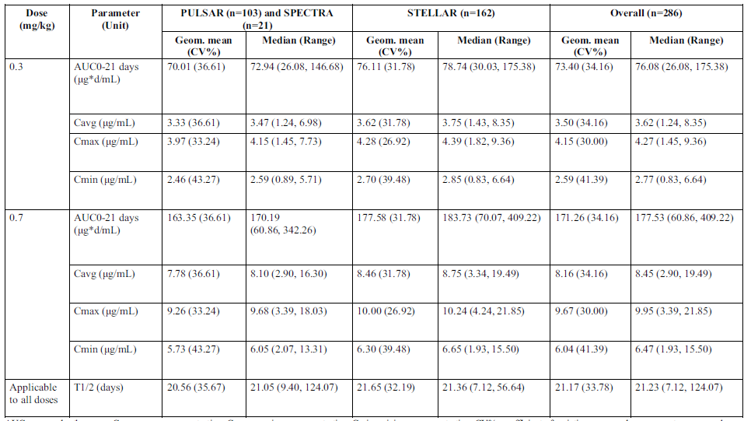
AUC=area under the curve; Cavg=average concentration; Cmax=maximum concentration; Cmin=minimum concentration; CV%=coefficient of variation expressed as a percentage; n=number of participants; NA=not applicable.
Following subcutaneous injection the absorption rate is slow (time to maximum level of approximately 7 days) and the estimated bioavailability is 66%. The central volume of distribution is approximately 3.6 L and the peripheral volume of distribution is 1.7 L. Metabolism is expected to be via protein degradation processes. Elimination is not via renal or biliary pathways.
Sotatercept has been tested for another indication in haemodialysis patients and was not removed by dialysis. As detailed above, a significant number of participants in the PAH program had renal impairment (mild and moderate). Renal function did not influence exposure as determined by the popPK analysis.
Antidrug antibodies did not influence sotatercept exposure.

Population PD data
Exposure-response models were developed to investigate the relationship between sotatercept exposure and various effects (6-minute walk distance [6MWD], PVR, N-terminal prohormone of brain natriuretic peptide [NT-proBNP], haemoglobin). The outcome data were sourced from the SPECTRA, PULSAR and STELLAR clinical trials.
For both participants in placebo arms and sotatercept arms the 6MWD increased by Week 24, although the change was significantly greater in the active arm. The increase in 6MWD was greater with the 0.7 mg/kg dose than with 0.3 mg/kg. A range of average concentrations was experienced by participants at each dose level. The clinical effect appeared to only plateau at the highest exposure in those taking 0.7 mg/kg (see figure below). Within the exposures experienced by participants at the target clinical dose of 0.7 mg/kg, the dose-response curve was not flat (that is, at 0.7 mg/kg a participant’s clinical benefit was related to the exposure achieved).
Figure 1: Model predicted 6-minute walk distance (total and change from baseline) versus Week 24 average concentration of sotatercept
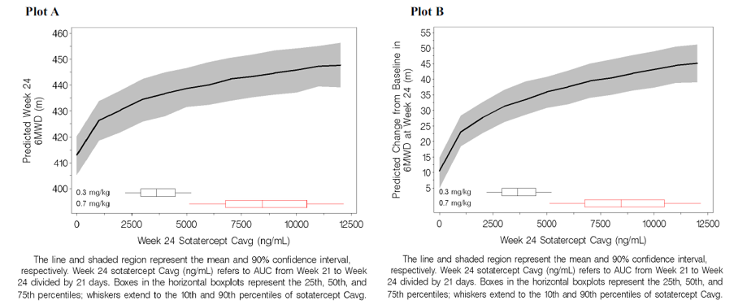
No covariates were identified as impacting the relationship between Week 24 sotatercept average concentration and 6MWD.
The relationship between sotatercept exposure and pulmonary vascular resistance (PVR) was best described by a saturable inhibitory function (that is, sotatercept reduced the PVR steeply initially at a relatively low concentration, followed by a shallower curve across most of the exposure range) (see figure below). Interesting most of the change in PVR was achieved at low concentrations, even below those associated with the lower, sub-target dose of 0.3 mg/kg.
Figure 2: Model predicted pulmonary vascular resistance versus Week 24 average concentration of sotatercept
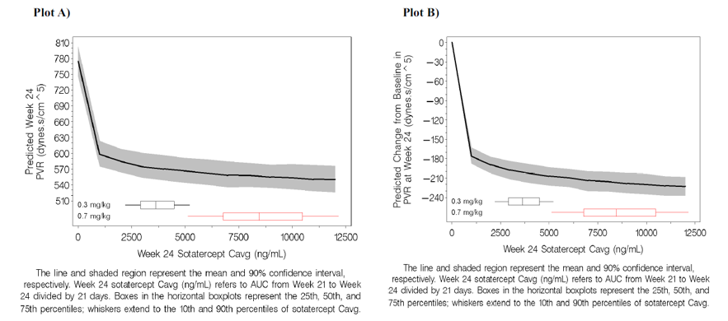
Covariates affecting the exposure-response (E−R) relationship for PVR were PAH duration, baseline PVR and prostacyclin infusion.
The E-R relationship for time to NT-proBNP < 300 pg/mL was described by a Cox proportional hazard model. The probability of achieving this low NT-proBNP increased with increasing sotatercept exposures and approached a plateau in the range of exposures associated with the 0.7 mg/kg dose.
The E-R model for the relationship to haemoglobin also included data from the Phase I studies in post-menopausal women. Haemoglobin increased with increasing sotatercept concentration and approached a plateau at the exposures associated with 0.7 mg/kg (see figure below). Iron supplementation influenced this E-R relationship (slightly increasing haemoglobin at a given concentration).
Figure 3: Model predicted haemoglobin response (absolute and change from baseline) versus Week 24 average concentration of sotatercept
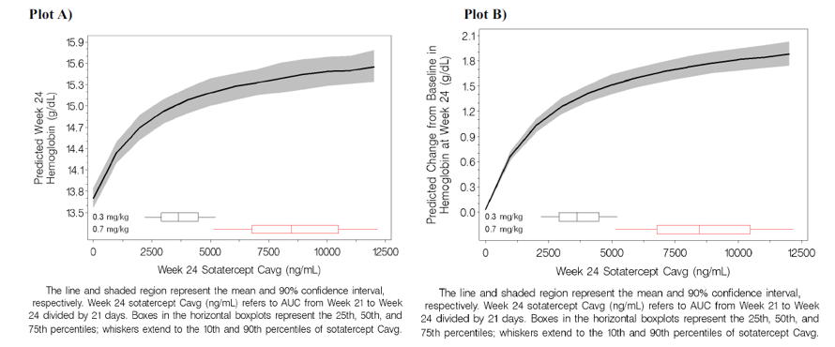
The sponsor has described ‘clinical comparability bounds’ which define a concentration range that balances efficacy (6MWD, PVR) and safety (increased haemoglobin). Based on a totality of data a lower bound of 0.6-fold (of the median average concentration with the target clinical dose of 0.7 mg/kg) and an upper bound of 1.4-fold was proposed.

Efficacy
The formulation used in the Phase II (PULSAR and SPECTRA) and Phase III (STELLAR) studies was a lyophilised powder for reconstitution. The Phase III study used drug material produced with the proposed commercial manufacturing process.

Pivotal study

STELLAR (MK-7962-003/A011-11)
STELLAR (MK-7962-003/A011-11) was a Phase III, randomised, double-blind, placebo-controlled, parallel group study to evaluate the efficacy and safety of sotatercept in adults with WHO Group 1 PAH and functional class II and III on stable background treatment. The study was conducted at 126 centres in 21 countries across Europe, the Americas (North, Central, South), Asia and Australia.
The study comprised a 24-week double-blind period followed by a long-term double-blind period lasting a maximum of 72 weeks (that is, participants could continue either sotatercept or placebo following the first 24 weeks of the study). Randomisation occurred in 1:1 ratio to sotatercept (starting dose 0.3 mg/kg with a target dose of 0.7 mg/kg) or placebo given by subcutaneous injection, with stratification by baseline WHO functional class (II or III) and background PAH therapy (that is, mono, double, triple).
Dose adjustments (escalation, delay, reduction or discontinuation) were determined based on the haemoglobin and platelet count. Escalation from 0.3 mg/kg to 0.7 mg/kg was planned to follow the first dose.
Major inclusion criteria were:
- males and females ≥ 18 years of age
- confirmed diagnosis of PAH that was idiopathic, heritable, drug/toxin induced, PAH associated with connective tissue disease (PAH-CTD) or simple, congenital systemic-pulmonary shunts (≥ 1 year) post repair
- WHO FC II or III
- right heart catheterisation measures of PVR ≥5 Wood units, PCWP ≤ 15 mmHg
- 6MWD of 150 m to 500 m
- stable background PAH therapy for at least 90 days.
Major exclusion criteria were:
- PAH associated with HIV, portal hypertension or schistosomiasis, pulmonary veno-occlusive disease
- pulmonary hypertension from WHO groups 2 to 5
- haemoglobin > upper limit of normal
- platelets < 50 x 10⁹/L
- uncontrolled hypertension.
The primary efficacy endpoint was the change from baseline to Week 24 in the 6MWD. The primary safety endpoints included adverse events, laboratory tests, vital signs, ADAs and electrocardiograms. There were also 9 secondary efficacy endpoints, as below. Note that all of the secondary efficacy endpoints were measured at Week 24 except for time to death or the first occurrence of a clinical worsening event (which was limited by the data cut point). A number of tertiary/exploratory endpoints (including additional haemodynamic parameters, echo parameters and patient questionnaires) were documented.
Secondary efficacy endpoints were:
- Multicomponent improvement endpoint measured by the proportion of participants achieving all of the following at Week 24 relative to baseline:
- improvement in 6MWD (increase ≥ 30 m)
- improvement in NT-proBNP (decrease in NT-proBNP ≥ 30%) or maintenance/achievement of NT-proBNP level < 300 ng/L
- improvement in WHO FC or maintenance of WHO FC II
- Change from baseline in PVR at Week 24
- Change from baseline in NT-proBNP levels at Week 24
- Proportion of participants who improve in WHO FC at Week 24 from baseline
- Time to death or the first occurrence of any of the following clinical worsening events (time to clinical worsening
- worsening-related listing for lung and/or heart transplant
- need to initiate rescue therapy with an approved background PAH therapy or the need to increase the dose of infusion prostacyclin by 10% or more
- need for atrial septostomy
- hospitalisation for worsening of PAH (≥ 24 hours)
- deterioration of PAH defined by both of the following events occurring at any time, even if they began at different times, as compared to their baseline values:
- worsened WHO FC
- decrease in 6MWD by ≥ 15% confirmed by 2 tests at least 4 hours apart, but no more than 1 week
- Proportion of participants who maintain or achieve a low-risk score at Week 24 versus baseline using the simplified French Risk score calculator
- Change from baseline in the Physical Impacts domain score of Pulmonary Arterial Hypertension-Symptoms and Impact (PAH-SYMPACT) at Week 24
- Change from baseline in the Cardiopulmonary Symptoms domain score of PAH-SYMPACT at Week 24
- Change from baseline in the Cognitive/Emotional Impacts domain score of PAH-SYMPACT at Week 24.
The primary analysis population for efficacy endpoints was the full analysis set (FAS) (all randomised participants). A gatekeeping method-controlled Type 1 error rate for the primary and secondary efficacy endpoints, all using a 2-sided alpha = 0.05. Safety analyses were based on the Safety Set. A total of 284 participants were planned.
A total of 323 participants were randomised (163 in sotatercept arm and 160 in placebo arm). All randomised participants were treated and more completed the double-blind placebo-controlled period in sotatercept arm compared to placebo (159 versus 148). Overall (initial 24 weeks and afterwards) more participants discontinued treatment in the placebo arm compared with sotatercept arm (35 versus 9), as was the case with withdrawals (16 versus 8). In the placebo group the reasons for discontinuing were clinical worsening event (10 participants), death (6 participants) and other (11 participants). In the sotatercept group discontinuations were due to death (2 participants) and adverse events (AE) (4 participants) and singular events. Nearly all (99.4%) of participants were able to reach the target dose, 6.1% required dose reductions and 3% were re-escalated.
Considering both the double-blind placebo-controlled period and the long-term double-blind period, the median exposure was longer in the sotatercept arm (252 days) than in the placebo arm (229.5 days). This duration was influenced by both study discontinuations and the data cut-off date.
Major protocol deviations were categorised and generally balanced between the arms. None required exclusion of patient data from analysis. There was no serious Good Clinical Practice compliance issue. Protocol amendments were made during the course of the study to help manage issues (for example, telangiectasia, thrombocytopenia) and documented in the clinical study report.
In terms of baseline characteristics, the median age was 48 years (range 18 years to 82 years), and most participants were female (79.3%) and white (89.2%). The median weight was 68.2 kg (range 38 kg to 141.3 kg). The most common group 1 subtypes were idiopathic (58.5%), heritable (18.3%) and PAH-CTD (14.9%). The other represented subtypes were drug or toxin induced (7 in sotatercept arm and 4 in placebo arm) and congenital systemic-to-pulmonary shunts (9 in sotatercept and 7 in placebo arm).
The median time of PAH diagnosis was 7.26 years (0.08 years to 40.21 years) and the split between WHO FC II and III was nearly equal (48.6% class II and 51.4% class III). All were taking other PAH therapies (4% monotherapy, 34.7% double therapy, 61.3% triple therapy). Common comorbidities were gastro-oesophageal reflux (19.2%), hypothyroidism (18.9%) and hypertension (18.6%). Baseline thrombocytopenia was unbalanced between the arms (9.8% in placebo arm and 2.5% in sotatercept arm).
In terms of the primary efficacy endpoint, there was a statistically significant greater change from baseline in 6MWD with sotatercept compared to placebo. The median treatment difference (Hodges-Lehmann Location Shift) was 40.8 m (p < 0.001) (see below).
Table 4: STELLAR Analysis of change from baseline in 6-Minute Walk Distance (meters) at Week 24 (Full Analysis Set)
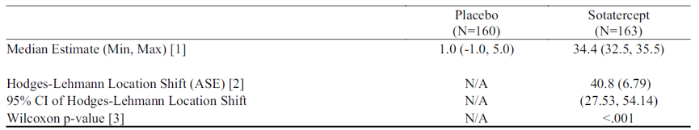
N=number of subjects in the treatment group. Min=minimum. Max=maximum. N/A=not applicable. ASE=asymptotic standard error. CI=confidence interval.
[1] Average, minimum, and maximum of the medians across the imputed datasets if missing data imputed.
[2] Hodges-Lehmann location shift from placebo estimate (median of all paired differences).
[3] Wilcoxon p-value refers to p-value from the aligned rank stratified Wilcoxon test with randomisation factors as strata. Change from baseline in 6MWD at Week 24 for subjects who died was assigned a value of -2,000 meters to receive the worst rank. Change from baseline in 6MWD at Week 24 for subjects who have missing data due to a non-fatal clinical worsening event was imputed to -1,000 meters to receive the next worst-rank.
Sensitivity analyses using alternative imputation methods all found consistent results. Subgroup analysis found the same direction of change for all subgroups, with most reaching statistical significance (see figure below). Of note, the subgroup with connective tissue disease only showed an 8.7 m difference in 6MWD (this distance contrasted with another subgroup of similar size – heritable PAH).
Figure 4: STELLAR Forest Plot: Change from baseline in 6-Minute Walk Distance (meters) at Week 24 in Subgroups (Full Analysis Set)
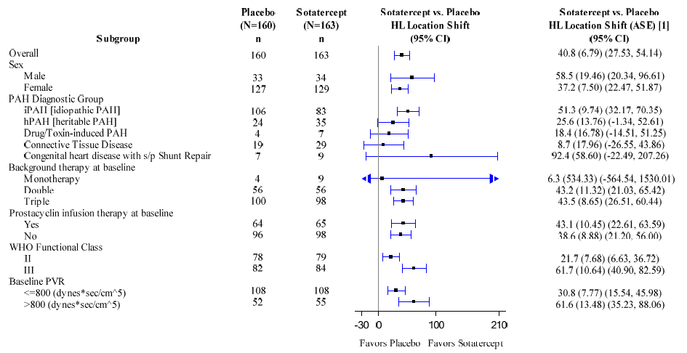
[1] Hodges-Lehmann location shift from placebo estimate (median of all paired differences).
Change from baseline in 6MWD at Week 24 for subjects who died was assigned a value of to -2,000 meters to receive the worst rank. Change from baseline in 6MWD at Week 24 for subjects who have missing data due to a non-fatal clinical worsening event was imputed to -1,000 meters to receive the next worst-rank.
All except the final secondary endpoint found statistically significant differences between sotatercept and placebo, favouring the former (for continuous variables, the median differences are estimated using Hodges-Lehmann Location Shift):
- The proportion of patients achieving multicomponent improvement was greater with sotatercept than placebo (38.9% versus 10.1%; p < 0.001). Multicomponent improvement was defined as an increase in 6MWD of at least 30 m, decrease in NT-proBNP of at least 30% or NT-proBNP < 300 pg/mL, improvement of WHO FC or maintenance of FC II.
- The median difference in PVR between sotatercept and placebo was −234.6 dynes*sec/cm⁵ (p < 0.001).
- The median difference in NT-proBNP between sotatercept and placebo was −441.6 pg/mL (p < 0.001).
- The proportion of participants with improvement in WHO FC was greater with sotatercept than placebo (29.4% versus 13.8%; p < 0.001).
- The risk of death or a first clinical worsening event was 84% lower in the sotatercept group than in placebo group (p < 0.001). Most of the difference in clinical worsening events was due to need for PAH specific rescue therapy, PAH specific hospitalisation, and deterioration of PAH (see table below).
- The proportion of participants who maintained or achieved a low-risk French risk score was higher with sotatercept than placebo (39.5% versus 18.2%; p < 0.001).
- The median difference in the Physical Impacts Domain of PAH-SYMPACT questionnaire between sotatercept and placebo was −0.26 (p = 0.010).
- The median difference in Cardiopulmonary Symptoms Domain of PAH-SYMPACT questionnaire between sotatercept and placebo was −0.13 (p = 0.028).
- There was no significant difference between sotatercept and placebo in scores for the Cognitive/Emotional Impacts Domain of PAH-SYMPACT questionnaire.
Table 5: STELLAR Secondary endpoint of clinical worsening and breakdown of events (Full Analysis Set)
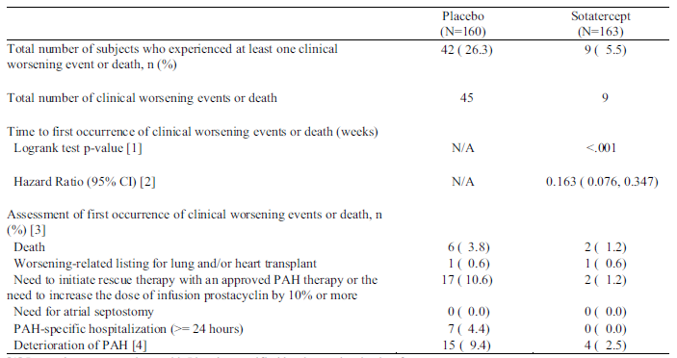
[1] Logrank test comparison with Placebo stratified by the randomisation factors.
[2] The hazard ratio (Sotatercept / Placebo) is derived from a Cox proportional hazard model with treatment group as the covariate stratified by the randomisation factors.
[3] A subject can have more than one assessment recorded for their first event of clinical worsening or death.
[4] Deterioration of PAH therapy is defined by both of the following events occurring at any time, even if they began at different times, as compared to their baseline values: (a) Worsened WHO functional class (II to III, III to IV, II to IV, etc), (b) Decrease in 6MWD by ≥ 15% (confirmed by two 6MWTs at least 4 hours apart but no more than one week).
N=number of subjects in FAS population. n=number of subjects in the category. Percentages are calculated as (n/N)*100. N/A = not applicable.
Figure 5: STELLAR Kaplan-Meier plot of clinical worsening (Full Analysis Set)
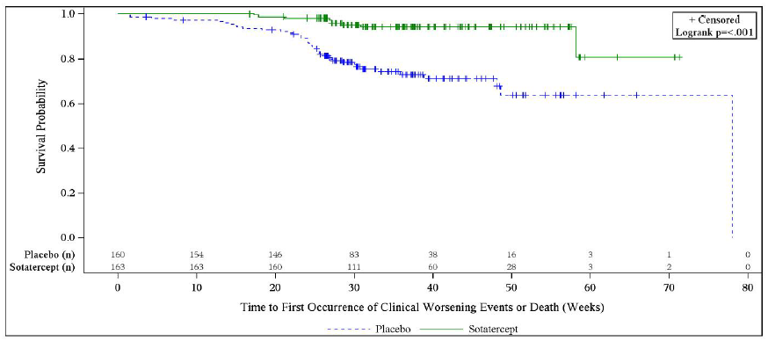
n=Number of subjects at Risk
Following the initial 24-week period, participants receiving sotatercept tended to maintain the benefit in terms of 6MWD, including in comparison to participants still receiving placebo (see figure below). Note: the placebo group size was reducing more rapidly than the sotatercept group size.
Figure 6: STELLAR Change from baseline in 6-minute walk distance by visit (Full Analysis Set)
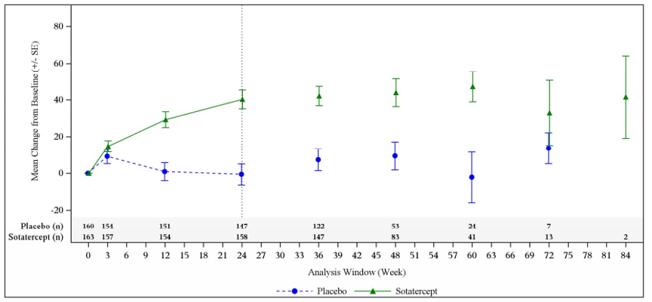
Only visits with at lease 2 subjects are shown.
N=Number of subjects in the analysis window. BL=Baseline, SE=Standard error.

Supportive studies

PULSAR (MK-7962-001/A011-09)
PULSAR (MK-7962-001/A011-09) was a Phase II, double-blind, placebo-controlled, randomised study of the efficacy and safety of sotatercept when added to standard of care for the treatment of PAH. Participants were randomised to placebo, sotatercept 0.3 mg/kg or sotatercept 0.7 mg/kg every 3 weeks (initially 1:1:1, then 3:3:4 to increase statistical power of 0.7 mg/kg arm). The primary endpoint was change in PVR at 24 weeks compared to baseline. The key secondary endpoint was change from baseline in 6MWD at 24 weeks. There were 7 other secondary endpoints (change in FC, change in NT-proBNP, change in tricuspid annular plane systolic excursion (TAPSE) on echocardiogram, clinical worsening, quality of life, safety and tolerability, PK). The extension period (see below) had similar endpoints. The study was conducted at 43 centres in 8 countries.
PULSAR had similar inclusion criteria and design as STELLAR, including males and females ≥18 years old with group 2 PAH, FC II and III on stable background PAH treatment for ≥90 days. Eligible participants had PVR ≥5 units on right heart catheterisation and the baseline 6MWD was 150 m to 550 m (50 m longer than STELLAR). Some of the key exclusion criteria were recent change in general supportive care (for example, diuretics), recent inotropes, recent atrial septostomy, portal hypertension, chronic liver disease and HIV infection. There was 24-week placebo-controlled double-blind period followed by an extension period (up to 30 months). Participants already receiving sotatercept continued at the same dose. At the start of the extension period placebo participants were re-randomised to sotatercept 0.3 mg/kg or 0.7 mg/kg.
The planned enrolment was 100 participants. The Evaluable Population was a subset of the FAS who received at least 6 doses of the same dose strength during the placebo-controlled period (overall it was 85.8% of the FAS). The primary efficacy endpoint was analysed with an analysis of covariance (ANCOVA) model. Multiplicity was accounted for using a hierarchical testing procedure.
A total of 106 participants were randomised and all received at least 1 dose of treatment. More participants discontinued the study in the sotatercept 0.7 mg/kg arm (14.3%), compared with sotatercept 0.3 mg/kg (3.1%) and placebo (6.3%). The most common reason for discontinuation was a treatment-emergent adverse event (TEAE). There was one death in the sotatercept 0.7 mg/kg arm during the placebo-controlled period. Approximately 90% of participants completed both the double-blind and extension period, and there was no trend in disposition. During the extension part, there were 3 deaths in the continuing sotatercept group and 1 death in the placebo-crossed group.
During the study major protocol deviations were reported for 71 participants, with the most common being related to study procedures and/or assessments and study treatment. They were broadly balanced across the treatment groups. A significant number of the deviations were related to the COVID-19 pandemic. One site had serious Good Clinical Practice noncompliance.
Participants were mainly female (86.8%), white (92.5%) and the most common PAH aetiology was idiopathic (57.5%), followed by PAH-CTD (17.9%), heritable (16%), drug/toxin induced (5.7%) and PAH associated with congenital systemic-pulmonary shunt (2.8%). Just over half were in FC II and most were on either triple (55.7%) or double (34.9%) background PAH therapy. Prostacyclin infusion was used by 36.8%.
In terms of the primary efficacy outcome (placebo-controlled period), there was a statistically significant difference between sotatercept and placebo for the change from baseline to Week 24 in PVR. At 0.3 mg/kg there was a least squares (LS) mean -151.1 dynes*sec/cm⁵ difference compared to placebo (p = 0.0030). At 0.7 mg/kg there was a LS mean -269.4 difference (p < 0.0001). Results were consistent between the Evaluable population and the FAS. Subgroup analysis (according to background PAH therapy, WHO FC and cardiac index) found consistent results. Haematocrit-adjusted PVR analysis was also consistent.
In the extension part of PULSAR those participants who crossed over from placebo to sotatercept generally experienced a similar magnitude of effect (that is, change from baseline) on PVR. A delayed start analysis also showed similar decreases in PVR when comparing participants who had been on sotatercept for the whole trial and those who had crossed over later to sotatercept. The figure below summarises the effects on PVR for all sotatercept doses, placebo across both the initial 24-week period and the extension period. In addition to what is described above, there is a maintenance of effect on PVR with ongoing sotatercept (although, as this is not placebo-controlled it is possible that other factors have contributed to the effect).
Figure 7: PULSAR Change from baseline in pulmonary vascular resistance (Full Analysis Set; standard multiple imputation)
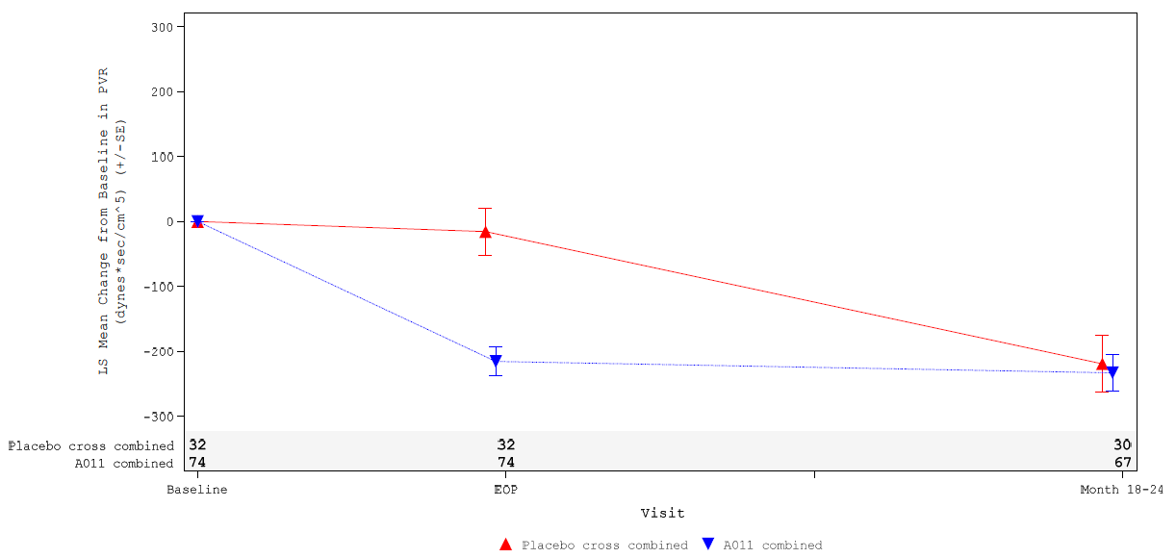
EOP is defined as End of placebo-controlled treatment period. Month 18-24 is defined as the timepoint at which the 3rd Right Heart Catheterisation is performed. The first PVR measurement is used during Month 18-24.
FAS is based on the placebo-controlled period and Month 18-24 result is based on the extension period FAS-E.
The key secondary endpoint of change in 6MWD also showed statistically significant effects for 0.3 mg/kg and 0.7 mg/kg (note that the prespecified alpha level for this assessment was 0.2) compared to the placebo arm. There was a LS mean difference at 0.3 mg/kg of 24.6 m (p = 0.0790) and at 0.7 mg/kg of 22.3 m (p = 0.1072). As with the primary efficacy endpoint, placebo-crossed participants were able to achieve similar benefit when exposed to sotatercept and there appeared to be maintenance of effect out to Month 18 to 24 (not placebo-controlled at that stage).

SPECTRA (MK-7962-002/A011-10)
SPECTRA (MK-7962-002/A011-10) was a single-group, open label study designed to evaluate the effects of sotatercept on invasive cardiopulmonary exercise testing, as well as safety. Sotatercept was dosed at 0.3 mg/kg (first dose) and 0.7 mg/kg (subsequent doses). Again, the inclusion criteria were similar to PULSAR and STELLAR, however the FC was limited to III, background PAH monotherapy was not permitted, the PVR cut-off was lower at 4 Wood units and the allowed baseline 6MWD range was 100 m to 550 m. The primary treatment period went for 24 weeks and the extension period was up to 18 months.
Of 21 allocated participants, 20 completed the 24-week treatment period (1 withdrawal due to personal reasons) and continued in the extension study. There was 1 discontinuation during the extension period due to an adverse event (AE). Most participants eventually transitioned to SOTERIA.
Participants were mainly female and white (both 81%), and the median age was 44 years. The most common aetiologies were idiopathic (66.7%) and PAH-CTD (28.6%). Participants were receiving either dual (47.6%) or triple (52.4%) background PAH therapy and 57.1% were receiving a prostacyclin infusion. All participants were in WHO FC III.
There was a statistically significant (prespecified 0.10 one-sided alpha level) increase in mean peak oxygen update from baseline (1.28 mL/min/kg; p = 0.0624). The effect was maintained at month 12.
In terms of right ventricular (RV) measurements, there was no mean improvement from baseline in RV stroke volume. There were mean improvements from baseline at 24 weeks and 12 months in RV end systolic volume, RV end diastolic volume, RV stroke volume index and RV mass.
Improvements were also noted in PVR, 6MWD, WHO FC and NT-proBNP.

SOTERIA
SOTERIA is an ongoing, open label extension study to provide long-term safety and efficacy data on participants treated with sotatercept. It received participants from the above-described Phase II and Phase III clinical trials. Adult participants who completed one of the aforementioned sotatercept studies without early discontinuation were eligible to be enrolled. Participants received subcutaneous sotatercept (≤0.7 mg·kg⁻¹ once every 21 days) in addition to background therapy. Dose modifications were allowed per protocol.

Safety
The key safety data for sotatercept in the treatment of PAH come from the 3 previously described studies – PULSAR, SPECTRA (both Phase II) and STELLAR (Phase III). Safety data from the Phase III open label extension study SOTERIA are included in the pooled safety analysis (Pool B, see below).
The integrated safety summary utilised 2 pools and based on the safety set (that is, all participants who received at least one dose of sotatercept or placebo):
- Pool A – 24-week placebo-controlled data from STELLAR and PULSAR combined to form the ‘overall sotatercept’ and ‘overall placebo group’. (The table below for Pool A also shows the results for the individual studies). Note that some of the data in this pool represent participants in PULSAR who were randomised to the lower dose of 0.3 mg/kg.
- Pool B – cumulative data from STELLAR, PULSAR (double-blind placebo-controlled and extension periods), SPECTRA and SOTERIA. SOTERIA data were mapped into the treatment groups from the parent studies. Pool B is further divided into SUR1 (safety updated report 1), which has a data cutoff date of 6 December 2022, and SUR2, which has a data cut-off of 8 November 2023. The most complete version of Pool B is the SUR2 cumulative dataset.

Pool A safety results
In Pool A the median duration of exposure was 168 days in both the placebo and sotatercept groups. The duration of treatment was 114 patient-years with sotatercept and 91.4 patient-years with placebo. Dose reductions during this period were more frequent with sotatercept than placebo (11.4% versus 2.6%) and also occurred earlier in treatment. There were 237 participants in the ‘overall sotatercept group’ and 192 in the ‘overall placebo group’.
The overall 24-week completion rate was high (95.8% with sotatercept; 92.7% with placebo). The proportion discontinuing treatment was lower with sotatercept compared with placebo (4.2% versus 7.3%). Discontinuation due to a non-fatal TEAE was more frequent with sotatercept than placebo (3% versus 1.6%), unlike discontinuation due to death (0% with sotatercept; 2.6% with placebo) or due to worsening PAH (0% sotatercept; 1% placebo).
Treatment-emergent adverse events frequency was similar between the overall placebo and overall sotatercept groups (see table below). Adverse event types that were more frequent with sotatercept than placebo included TEAE related to treatment (43.9% versus 26%), TEAE leading to dose reduction (3.4% versus 1%) or dose delay (10.5% versus 2.6%), AE of interest (43.5% versus 35.9%) and AE of special interest (7.2% versus 2.6%). Adverse event types that were more frequent with placebo than sotatercept included severe TEAE (13.5% versus 11.4%), serious TEAE (20.3% versus 14.8%), TEAE leading to discontinuation (5.7% versus 3.8%) and TEAE leading to death (3.1% versus 0.4%).
Table 6: Pool A Overall summary of treatment-emergent adverse events (safety set)
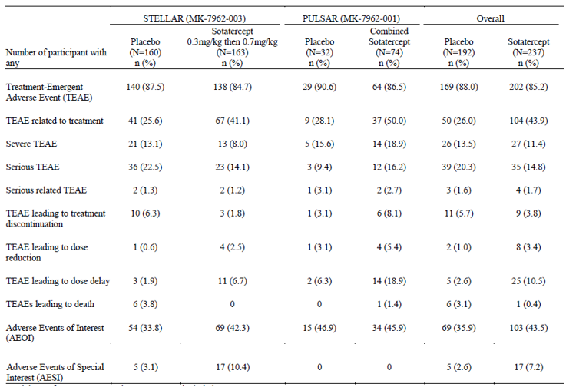
Participants from PULSAR and STELLAR are included.
All participants received standard of care in addition to receiving study drug.
The Combined Sotatercept group from PULSAR includes participants treated with sotatercept during the first 6 months (Placebo-controlled Period).
Treatment-emergent adverse events, by preferred term that occurred in at least 5% of subjects in either treatment group in Pool A are below. Of these, TEAEs occurring significantly more frequently with sotatercept compared to placebo were headache, diarrhoea, epistaxis, dizziness, hypokalaemia, telangiectasia, thrombocytopenia, haemoglobin increased, upper respiratory tract infection and pain in extremity.
Table 7: Pool A Treatment-emergent adverse events with at least 5% in any treatment group by preferred term
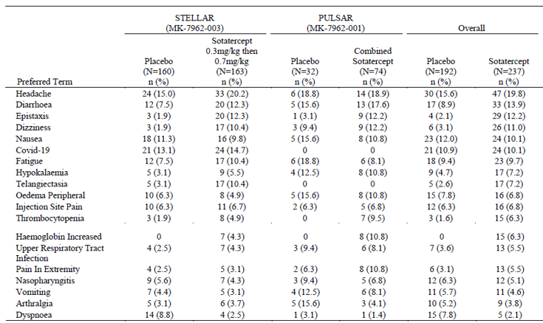
Participants from PULSAR and STELLAR are included.
All participants received standard of care in addition to receiving study drug.
The Combined Sotatercept group from PULSAR includes participants treated with sotatercept during the first 6 months (Placebo-controlled Period).
Adverse Events were coded using MedDRA Version 25.0. System organ class were ordered alphabetically and Preferred Terms were ordered by descending frequency based on overall Sotatercept.
Adverse events that were considered as related to study intervention were more frequent with sotatercept compared with placebo (43% versus 26%). Treatment-emergent adverse events in this category included headache, telangiectasia, diarrhoea and haemoglobin increased.
In Pool A there was one death in the overall sotatercept group and 6 deaths in the overall placebo group. The death in the sotatercept group was due to cardiac arrest and was not considered related to the study intervention. As already noted, serious AEs were less frequent with sotatercept. No notable pattern of serious AEs (SAEs) was observed in the overall sotatercept group. Serious AEs occurring in more than one participant (all occurred in 2 participants) in the overall sotatercept group were atrial flutter, fall, haemoptysis, bronchitis and respiratory tract infection. The only severe AE reported in more than one participant in the overall sotatercept group was haemoptysis (reported in 2 participants).

Pool B safety results
The Pool B overall sotatercept group included 431 participants. The median duration of exposure was 657 days (range 21 to 1973 days), representing 923.7 person-years of exposure. The median number of doses received was 30 (range 1 to 93 doses). A total of 343 participants were exposed to sotatercept for at least one year.
A very high proportion of participants completed their parent studies and were rolled over into SOTERIA (see table below). At the time of data cutoff 87.7% of Pool B participants were continuing with sotatercept treatment. Of the 12.3% (n=53) of participants discontinuing the study, the 2 common reasons were ‘adverse event’ (4.6%) and ‘death’ (3.2%).
Table 8: Pool B Safety update report 2 Patient disposition
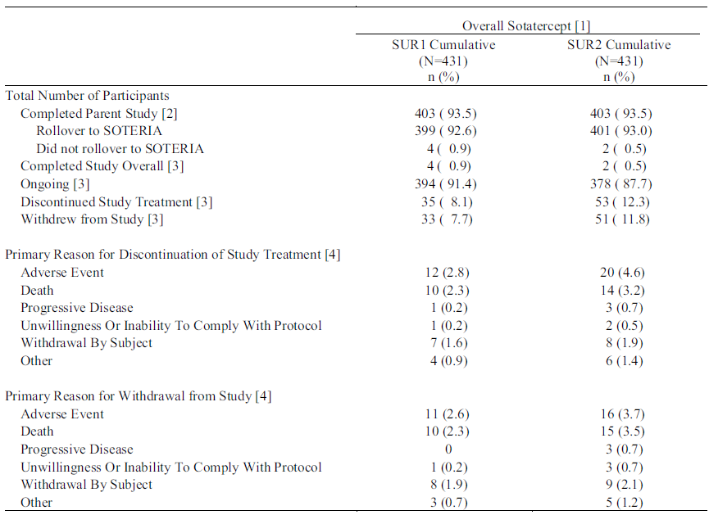
N=total number of participants randomised. n=number of participants in the category. Percentages are calculated as (n/N)*100, except where noted.
Note: Column SUR1 Cumulative includes completed studies PULSAR, SPECTRA, STELLAR and the ongoing SOTERIA study with data cut of 6 December 2022. Column SUR2 Cumulative includes the same set of completed studies as SUR1 Cumulative but with new data cut from SOTERIA of 8 November 2023.
Participants from PULSAR, SPECTRA, STELLAR and SOTERIA are included. SOTERIA with data cut as of 8 November 2023.
Other studies are completed studies.
[1] Overall Sotatercept includes all participants who were treated with at least one dose of Sotatercept.
[2] A participant that completes the study (STELLAR, PULSAR, or SPECTRA) is said to have completed the requirements of the study per protocol and is eligible to rollover to SOTERIA provided the participant consents to such a rollover.
[3] Status indicates overall treatment or study status, that is, if a participant has rolled over to SOTERIA then the status is from SOTERIA, if the participant has not rolled over to SOTERIA then the status is from the parent study.
[4] Participants may have only one primary reason for discontinuation and withdrawal.
Given the different durations of exposure for participants in Pool B it is important to consider exposure adjusted measures of AE frequency. The integrated safety analysis utilised TAR-EAIR (time-at-risk exposure-adjusted incidence rate).
Nealy all participants (96.3%) experience a TEAE, including 35.5% with a severe TEAE and 40.1% with a serious TEAE (see table below). Only 4.6% experienced a serious TEAE that was considered as related to study treatment. Overall, 16 participants (3.7%) had a TEAE that led to death.
Table 9: Pool B Safety update report 2 Summary of adverse events
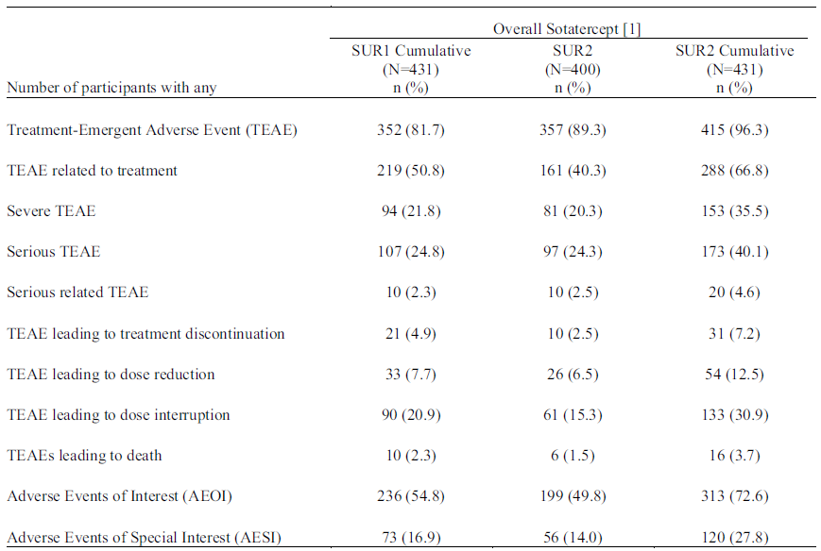
N=total number of participants randomised. n=number of participants in the category. Percentages are calculated as (n/N)*100, except where noted.
Note: Column SUR1 Cumulative includes completed studies PULSAR, SPECTRA, STELLAR and the ongoing SOTERIA study with data cut of 6 December 2022. Column SUR2 Cumulative includes the same set of completed studies as SUR1 Cumulative but with new data cut from SOTERIA of 8 November 2023.
[1] Overall Sotatercept includes all participants who were treated with at least one dose of Sotatercept.
Serious AEs occurring in 5 or more participants were thrombocytopenia (5), anaemia (5), atrial flutter (5), atrial fibrillation (5), gastrointestinal haemorrhage (7), pneumonia (17), sepsis (6), acute kidney injury (7), haemoptysis (8), pulmonary arterial hypertension (8) and dyspnoea (6).
Of the deaths, the 2 most common system organ classes were cardiac disorders (4) and infections and infestations (5). Individual causes were cardiac arrest (2), acute myocardial infarction (1), right ventricular failure (1), gastrointestinal haemorrhage (2), multi-organ dysfunction (1), pneumonia (2), brain abscess (1), bronchopulmonary aspergillosis (1), sepsis (1), adenocarcinoma of colon (1), malignant brain neoplasm (1), intracranial haemorrhage (1) and pulmonary hypertension (1).
Adverse events occurring in at least 10% of participants exposed to sotatercept were (in decreasing order of frequency) epistaxis, COVID-19, headache, telangiectasia, diarrhoea, nausea, fatigue, dizziness, peripheral oedema, nasopharyngitis, increased haemoglobin, upper respiratory tract infection, arthralgia, hypokalaemia, thrombocytopenia, iron deficiency, urinary tract infection, dyspnoea, pain in extremity, vomiting, respiratory tract infection and sinusitis (see table below).
Pool B provided data about dose reductions, which is highly relevant to use of sotatercept in clinical practice. Overall, 12.5% of participants experienced a dose reduction. The most common reasons for dose reductions were polycythaemia (1.9% of Pool B), thrombocytopenia (1.2%), increased haemoglobin (that is, listed as an abnormal investigation rather than clinical TEAE, 1.4%), decreased platelet count (0.7%), headache (0.7%), epistaxis (1.9%) and telangiectasia (3%).
Table 10: Pool B Safety update report 2 Treatment-emergent adverse events experienced by at least 10%
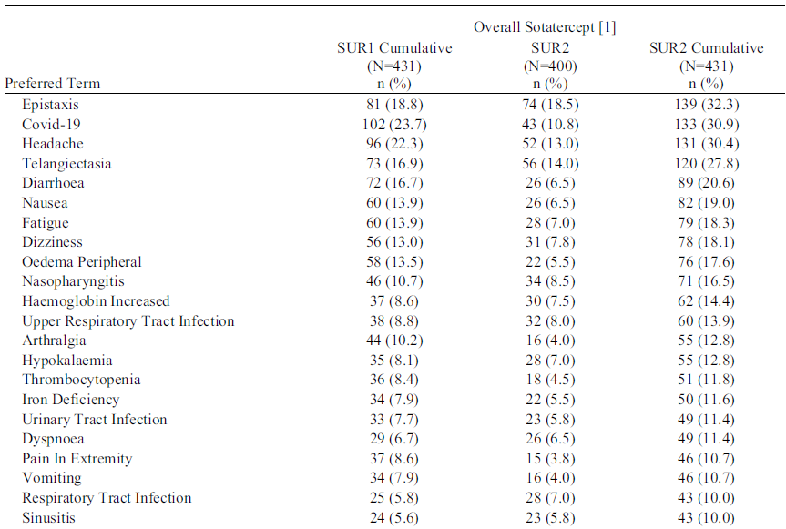
N=total number of participants randomised. n=number of participants in the category. Percentages are calculated as (n/N)*100, except where noted.
Note: Column SUR1 Cumulative includes completed studies PULSAR, SPECTRA, STELLAR and the ongoing SOTERIA study with data cut of 6 December 2022. Column SUR2 Cumulative includes the same set of completed studies as SUR1 Cumulative but with new data cut from SOTERIA of 8 November 2023.
[1] Overall sotatercept includes all participants who were treated with at least one dose of sotatercept.
Adverse Events were coded using MedDRA Version 25.0. Preferred Terms were ordered by descending frequency based on overall sotatercept for the SUR2 Cumulative column.

Adverse event of special interest - telangiectasia
As no events of telangiectasia were reported during PULSAR, Pool A and STELLAR (double-blind placebo-controlled period) results were the same. The incidence of telangiectasia was higher in the sotatercept group compared to the placebo group (10.4% versus 3.1%). The median time to onset was 10.6 weeks in the sotatercept group.
The TAR-EAIR in SUR2 Cumulative Pool B was 15.6 per 100 patient-years at risk. None of the events were serious and 2 led to discontinuation of study treatment. Of the participants with telangiectasia, 52.5% also had epistaxis and 4.2% a serious bleeding event (that is, higher than the rates of these events in the overall group).

Adverse events of interest
Although the Phase II and Phase III studies had different items under AEs of special interest (AESI) and AEs of interest, the AEs of interest (AEOI) from STELLAR were used for analysis of Pools A and B. These were increased haemoglobin, immunogenicity, increased blood pressure, bleeding events, renal toxicity and embryo-fetal toxicity. In addition, telangiectasia was considered as an AESI.
Increased haemoglobin
As can be seen in the table below, just over half of participants in the all sotatercept group in Pool A maintained a normal haemoglobin during 24 weeks of treatment (the change from baseline in the STELLAR study was generally between 1.0 and 1.5 g/dL during the initial 24 weeks of sotatercept treatment). The remainder mainly experienced a change to CTCAE grade 1 (increase of 0-2 g/dL) and less frequently to grade 2 (increase of > 2-4 g/dL). There were no grade 3 or 4 increases in haemoglobin.
Table 11: Pool A Shift from Baseline Common Terminology Criteria for Adverse Events severity grade for haemoglobin
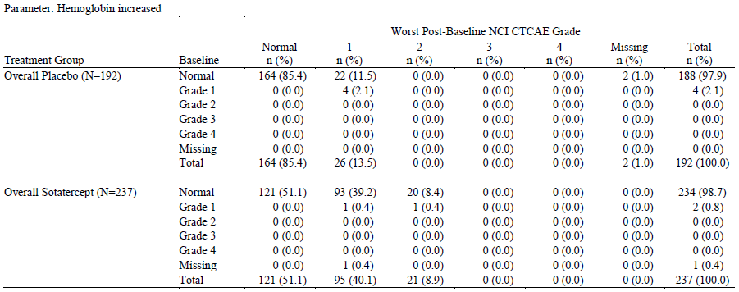
Participants from PULSAR and STELLAR are included.
All participants received standard of care in addition to receiving study drug.
The Combined Sotatercept group from PULSAR includes participants treated with sotatercept during the first 6 months (Placebo-controlled Period).
The version of the NCI Common Terminology Criteria for Adverse Events Criteria is 4.03.
The TAR-EAIR for increased haemoglobin (as category) in Pool B (SUR2 cumulative) was 11.9 per 100 patient-years at risk. Overall, one participant had a serious event of increased haemoglobin and 3 discontinued study treatment due to increased haemoglobin. Overall, 58.2% of participants included in the Pool B SUR2 cumulative safety set had at least one haemoglobin increase of > 2.0 g/dL.

Decreased platelets
In pool A, of participants treated with sotatercept who had normal baseline platelets, around 25% experienced CTCAE grade 1 thrombocytopenia (from lower limit of normal to 75,000 mm³). Of participants with baseline grade 1 thrombocytopenia (43 in total), around 20% progressed to grade 2 thrombocytopenia (50,000 to < 75,000 mm³) and 5% to grade 3 (25,000 to < 50,000 mm³). There was no grade 4 thrombocytopenia in pool A. In the STELLAR study the typical change in platelet count from baseline was around 20,000 mm³ (see below).
Figure 8: STELLAR Change from baseline in platelet count (safety set)
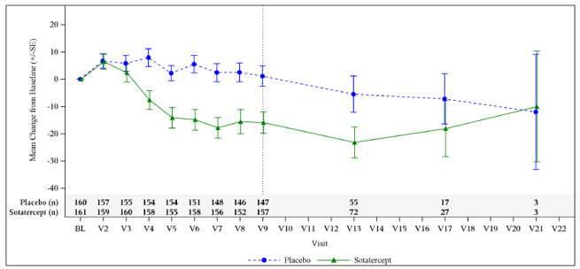
N=Number of subjects in the analysis window. BL=Baseline, SE=Standard error.
The TAR-EAIR for thrombocytopenia (as category) in Pool B (SUR2) was 6.6 per 100 patient years at risk. In Pool B (SUR2 cumulative) 5 participants had a serious event of thrombocytopenia, including 3 admitted to hospital (note there were other significant factors involved in at least 2 of the hospital admissions). Only one participant discontinued treatment due to thrombocytopenia. Overall, in SUR2 Pool B only 3.9% of participants ever had a platelet count < 50,000/m³.

Epistaxis and other bleeding events
In pool A, bleeding events affected more participants in the sotatercept group than the placebo group (48.1% versus 38%) (see table below). The most common event types were epistaxis, anaemia and gingival bleeding.
Table 12: Pool A Bleeding events
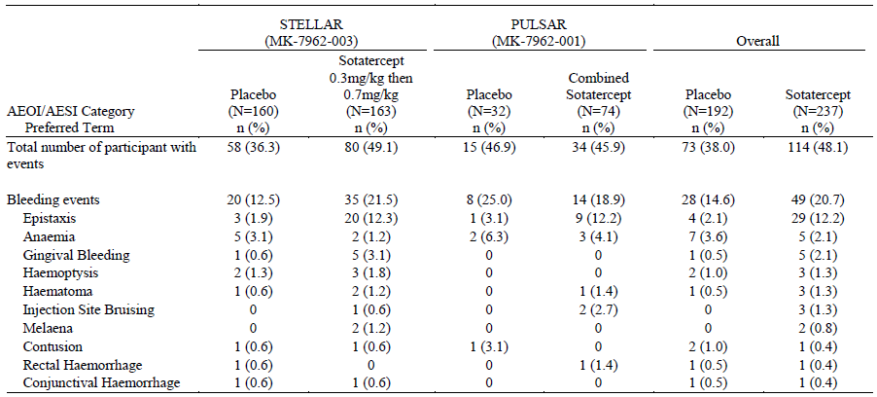
AEOI=Adverse Events of Interest; AESI=Adverse Events of Special Interest
Participants from PULSAR and STELLAR are included.
All participants received standard of care in addition to receiving study drug.
The Combined Sotatercept group from PULSAR includes participants treated with sotatercept during the first 6 months (Placebo-controlled Period).
Adverse Events were coded using MedDRA Version 25.0. AEOI/AESI Category were ordered alphabetically and Preferred Terms were ordered by descending frequency based on overall Sotatercept.
In Pool B SUR2 cumulative dataset the TAR-EAIR for bleeding events was 36.4 per 100 patient-years at risk and for epistaxis was 19.2 per 100 patient years at risk. Five participants in the whole dataset discontinued due to bleeding events and 30 had serious bleeding events. The most common serious bleeding events were haemoptysis (1.9% of participants), gastrointestinal haemorrhage (1.6% of participants) and anaemia (1.2% of participants). Other serious events not covered by ‘gastrointestinal haemorrhage’ were 3 participants with upper gastrointestinal haemorrhage, 1 with lower gastrointestinal haemorrhage and 1 with gastric haemorrhage. A significant number of participants with AEs of haemorrhage had more than one event. There were 3 fatal bleeding events (2 gastrointestinal haemorrhages, 1 intracranial haemorrhage).

Increased blood pressure
In Pool B SUR2 the TAR-EAIR for increased blood pressure was 3 per 100 patient-years at risk. One participant overall had a serious AE of hypertension requiring hospitalisation. No participant had an event that led to discontinuation of study intervention. Although not necessarily documented as blood pressure related AEs, participants in the STELLAR study receiving sotatercept had modestly higher blood pressure compared with placebo (see below).
Figure 9: STELLAR Systolic blood pressure by visit
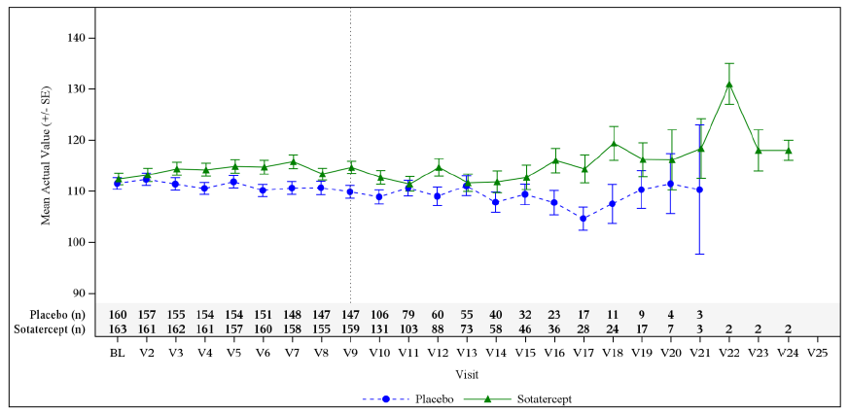

Embryo-fetal toxicity
One pregnancy was reported in Pool B in a patient treated with sotatercept. The pregnancy resulted in a missed abortion. There are also no data on sotatercept in human milk or effects on lactation.
No safety signal was detected for the following AEs of interest in Pools A or B (to 6 December 2022): FSH suppression, immunogenicity-related TEAEs, thromboembolic events, renal toxicity, hepatic toxicity, cardiac events, leucopoenia and neutropenia.

Immunogenicity
Initial testing involved screening and confirmation using a sensitive and drug tolerant ADA assay. Positive samples were then tested for titre and neutralising antibody (Nab) activity. A number of assays were developed during the clinical development of sotatercept. Cut-points were determined based on the study population and regulatory requirements.
Across PULSAR, SPECTRA and STELLAR there were 287 participants evaluable for post dose ADA status.
Across PULSAR and SPECTRA 10.4% (13 of 125patients) developed ADAs and 1 of these was Nab positive as well. Across STELLAR 25.9% (42 of 162 patients) developed ADAs and 6.8% (11 of 162 patients) were Nab positive as well. The difference in ADA incidence between the Phase II and Phase III studies could be due to the lower cut-point and optimised assay in the later phase study.
Antidrug antibody development occurred after the initial dose and were transient in 55% of positive participants. The median maximum titre was 40 (range < 20 to 620) in PULSAR/SPECTRA and 30 (range < 20 to 640) in STELLAR.
In terms of clinical correlation with ADA status, a positive result did not impact PK, PD, efficacy or safety (the latter including hypersensitivity related AEs).

Other analyses of note
The relationship between background PAH therapies and AE incidence was investigated in the STELLAR dataset. The following were noted.
- During the initial 24-week period, in the sotatercept group flushing and nasal congestion were more commonly reported for participants on triple therapy than on double therapy.
- During the initial 24-week period, in the sotatercept group thrombocytopenia was more commonly reported in users versus non-users of prostacyclin infusion.
- During both the initial 24 weeks and subsequent extension period, in the sotatercept group flushing, nasal congestion, dizziness, thrombocytopenia atrial fibrillation and hypokalaemia were more commonly reported for participants on triple therapy than on double therapy.

Other safety data
In the Phase I study P009 (see Population PK data), sotatercept was generally well tolerated. Events occurring in more than one participant were headache, infusion site reaction, injection site haemorrhage and toothache. There were no deaths or serious AEs. Reversible changes were noted in red blood cell counts, haemoglobin, reticulocytes, liver function tests, glucose, uric acid, amylase and lipase.
In Phase I study P010, most participants reported TEAEs, although none were severe or life-threatening. Abnormal high haemoglobin occurred in most participants at the 1 mg/kg dose level (3 required phlebotomies). There were 2 serious AEs (persistent and progressive hypertension, joint injury) and 7 participants discontinued study intervention. The SAE of hypertension led to no further dose escalation being pursued. Dose dependant reductions in FSH in this population of postmenopausal women (with baseline high FSH) were observed.
A total of 350 participants were exposed to sotatercept in 8 non-PAH Phase II studies. The most frequently reported events were headache (20%), nausea (14.6%), hypertension (14%), diarrhoea (12.3%), vomiting (11.4%) and dizziness (10%). Serious AEs were most frequent in the system organ classes of Blood and lymphatic system disorders and Cardiac disorders.

Risk management plan
The summary of safety concerns and their associated risk monitoring and mitigation strategies is provided below. The TGA may request an updated RMP at any stage of a product's life-cycle, during both the pre-approval and post-approval phases.
Table 13: Summary of safety concerns
Summary of safety concerns |  | Pharmacovigilance |  | Risk minimisation
 |  | Routine | Additional | Routine | Additional
Important identified risks | Erythrocytosis | ü | − | ü | −
Important potential risks | Severe thrombocytopenia | ü | − | ü | −
Important potential risks | Recurrent medication error by HCP-trained lay user causing overdose leading to erythrocytosis | ü | − | ü | −
Missing information | Use in the paediatric population | ü | ü* | ü | −
Missing information | Long-term safety | ü | ü† | ü | −
* MOONBEAM paediatric study
† SOTERIA long-term follow-up study
The RMP evaluation concluded that the summary was satisfactory. Questions were raised to the sponsor about the absence in the RMP’s summary of safety concerns of embryofetal toxicity, impaired fertility and serious bleeding with concomitant prostacyclin/antithrombotic agents or low platelets. Adequate evidence was provided as to why these were not included in the summary of safety concerns.
The RMP evaluation recommended conditions of registration relating to the versions of the risk management plan, requirement for periodic safety update reports, and inclusion of the medicine in the Black Triangle Scheme.

Risk-benefit analysis

Delegate’s considerations

Proposed indication
The Delegate does not consider it necessary to list the potential benefits of sotatercept in the indication. The indication should identify the disease (that is, pulmonary arterial hypertension) and the patient group (that is, adults, WHO class etc). It may also describe which PAH subtypes efficacy has been shown in (with the intention to provide information to the prescriber, rather than formally limit usage). A suitable indication would be:
Sotatercept is indicated for the treatment of adults with pulmonary arterial hypertension (PAH) in WHO Functional Class (FC) II or III, in combination with standard therapy.
Efficacy has been shown in idiopathic and heritable PAH, PAH associated with connective tissue disease, drug or toxin-induced PAH, and PAH associated with congenital heart disease with repaired shunts.

Efficacy
The STELLAR study demonstrated a statistically and clinically significant benefit of sotatercept (0.3 mg/kg, followed by 0.7 mg/kg, every 3 weeks) over placebo on its primary outcome, the 6MWD. This was in a population of patients with PAH (mainly idiopathic, heritable, associated with connective tissue disease) and in WHO functional classes II and III who were already treated with at least one other agent, but much more commonly 2 or 3 other agents. This population has a significant symptom burden, impaired quality of life, and risk of clinical deterioration despite standard of care therapies. It stands to benefit significantly from an additional efficacious therapy.
In addition to the primary efficacy outcome, all but one secondary endpoint found significant differences favouring sotatercept over placebo. Some of these endpoints are consistent with benefit on aspects of PAH of major importance to patients and physicians, such as a large improvement in the risk of death or first clinical worsening event (as a composite endpoint), and a better chance of achieving a low-risk French risk score.
Following the 24-week double-blind placebo-controlled period of STELLAR, patients appeared to maintain benefit in terms of their 6MWD. In addition, a high proportion of patients completed their parent studies and rolled over into the long-term, open-label SOTERIA study. These facts suggest that the effectiveness of sotatercept may be durable over 12 months and potentially beyond. Supportive studies PULSAR and SPECTRA also provided data consistent with the major conclusions from the pivotal study.
The Delegate considers the efficacy of sotatercept for PAH as sufficiently established.

Safety
The safety set derived from STELLAR, PULSAR and SPECTRA included 431 patients exposed to sotatercept. The median duration of exposure was 657 days and the overall exposure was 923.7 person-years of exposure. A total of 343 were exposed to sotatercept for at least a year. This represents exposure that is consistent with the TGA-adopted guideline The Extent of Population Exposure to Assess Clinical Safety and is also sufficient to allow an overall benefit–risk assessment to be made.
During the combined double-blind placebo-controlled periods of STELLAR and PULSAR (that is, Pool A) there were less severe AEs, serious AEs or AEs leading to death in the sotatercept arms, implying a generally favourable safety profile.
Safety signals for sotatercept include increased haemoglobin, thrombocytopenia, telangiectasia and bleeding events. The first 2 of these can be reasonably managed through monitoring and dose adjustment (including withholding dosing) and the telangiectasia were generally not serious in their own right (although potentially associated with bleeding events). Bleeding events remain a concern and there were 3 fatal events in patients on sotatercept (2 gastrointestinal bleeds and 1 intracranial haemorrhage). Potential risk factors for bleeding include thrombocytopenia, antithrombotic drugs and prostacyclin use. These issues are covered in the PI in section 4.4 on Special Warnings and Precautions.
The nonclinical toxicological signal for embryo-fetal toxicity has resulted in a pregnancy Category D and strict contraception requirements. Nonclinical fertility impairments were also evident and considered relevant to clinical use. Both of these issues are treated in section 4.4 of the PI.
The Delegate considers the safety profile of sotatercept as reasonably well defined, by both the number of patients already exposed and the duration of exposure. There are risks, including some that are serious and potentially fatal (bleeding, increased haemoglobin, thrombocytopenia), but are considered manageable through information and warnings in the PI, instructions on dose modification, and avoiding use in high-risk situations.
The sponsor has proposed use in extremes of weight not covered by the clinical trials (that is, 30−40 kg and > 140 kg) and the sponsor and the ACM will be asked about this.

Deficiencies in the data
Certain aetiologies of PAH were not included in the studies (for example, HIV associated, liver disease associated) and there are no data about use of sotatercept in such patients. This is not unexpected given the rarity of those conditions.
Of note, the subgroup analysis of the STELLAR trial found smaller increases in 6MWD for certain subgroups, in particular those patients with connective tissue disease (+8.7 m difference between sotatercept and placebo). Whilst there are limitations to this analysis based on the connective tissue disease subgroup size (29 exposed to sotatercept; 19 to placebo), it is also possible that the effect size is smaller. Reduced efficacy could be related to other aspects of connective tissue disease affecting the 6MWD, such as pulmonary fibrosis, arthritis or corticosteroid-related myopathy.

Risk-benefit-uncertainty assessment
The Delegate considers the benefit−risk assessment as favouring use of sotatercept in adults with PAH in WHO functional class II and III and who are receiving standard of care therapy. Sotatercept is likely to result in improvement in exercise capacity, reduction in symptoms and reduced clinical worsening events, in particular the need for rescue therapy, hospitalisation or deterioration. There may be a mortality benefit from adding sotatercept to background PAH therapy, although this is not proven as yet.
The risks of sotatercept can be managed through monitoring, appropriate warnings (for example, to seek early medical attention) and avoiding use in high-risk situations, such as pregnancy. Although there is still likely to be residual risk, including for severe bleeding events and death, it appears to be outweighed by the benefits of sotatercept.

Proposed action
The Delegate supports approval of sotatercept for treating adults with PAH in WHO FC II and III, in combination with standard therapy.

Questions for the sponsor
The sponsor provided the following response to questions from the Delegate.
- See International status
- Is the increased bleeding risk associated with telangiectasia development or connective tissue disease?
Among participants with the Adverse Event of Special Interest (AESI) telangiectasia treated with sotatercept, epistaxis was reported approximately twice as frequently relative to all sotatercept-treated participants. No participant with the AESI telangiectasia was reported with a serious bleeding event.
A greater proportion of participants (9 of 70; 12.9%) on sotatercept in the Safety Update Report 2 (SUR2) population who developed serious bleeding had PAH associated with connective tissue disease when compared with all sotatercept-treated participants (30 of 431; 7.0%). The relatively low numbers of participants with PAH associated with connective tissue disease who experienced serious bleeding events limits interpretability.
- There is a warning in the PI about ‘serious bleeding events (e.g., gastrointestinal, intracranial)’. Is there a signal for lower respiratory tract bleeding / haemoptysis with use of sotatercept?
The data are insufficient to determine whether there is a signal of lower respiratory tract bleeding with sotatercept. Haemoptysis occurred at similar rates in the placebo (3 of 160; 1.9%) and sotatercept (4 of 163; 2.5%) groups in STELLAR. No serious adverse events (SAEs) of haemoptysis were reported in the placebo group. Of the 4 participants in the sotatercept group with haemoptysis events, 2 experienced SAEs of haemoptysis, 1 of which was considered to be related to study intervention by the investigator. No other event was considered to be related to study intervention by the investigator.
- What changes to background PAH therapy occurred in the placebo and sotatercept arms during the double-blind, placebo-controlled period of STELLAR?
Per protocol, STELLAR enrolled participants who were on stable background PAH therapy for at least 90 days before screening, and the background therapy regimen was expected to remain stable throughout the study. During the double-blind, placebo-controlled treatment period, few participants experienced changes in their background therapy, such as transitioning between mono-, double-, or triple-therapy (n=4) or shifts in prostacyclin use (n=1) during the double-blind, placebo-controlled Treatment Period, although the study was not designed to evaluate such changes. There were 3 participants (all in the placebo group) who experienced a reduction in their background PAH therapy, from triple therapy to either double therapy (2 cases) or to mono therapy (1 case). In each of these cases, the reduction of background PAH therapy was not a result of clinical improvement, but instead, was due to either deterioration of PAH leading to death (2 PAH background therapies withdrawn just before death), an issue with tolerability (macitentan being stopped due to elevated hepatic enzymes), or temporary use of selexipag.
Changes in background PAH therapy associated with clinical worsening were evaluated in the composite endpoint ‘time to death or the first occurrence of a worsening event’, which included participants with a need to initiate rescue therapy with an approved PAH therapy or the need to increase the dose of prostacyclin infusion by 10% or more. Through the double-blind,
placebo-controlled treatment period, the proportion of participants who initiated rescue therapy or increased prostacyclin by at least 10% was higher in the placebo group (17 patients; 10.6%) than in the sotatercept group (2 patients; 1.2%).
- There is a warning for thrombosis in the luspatercept label. Is such a warning relevant to sotatercept?
The warning for thrombosis in the luspatercept (…) label is not relevant to sotatercept. Although there are some similarities in the erythropoietic effects of sotatercept and luspatercept, the warning for thrombosis and thromboembolic events in the luspatercept label is for a specific patient population. An increased risk of thromboembolic events exists in the subgroup of the ꞵ-thalassaemia population who have undergone splenectomy; the important identified risk that is included in the luspatercept label is specific for the splenectomised ꞵ-thalassaemia population. This warning does not apply to the sotatercept population with PAH. Moreover, the occurrence of thromboembolic events in the luspatercept study population did not correlate with the haemoglobin levels.
Because of the erythropoietic effects of sotatercept and the potential for severe erythrocytosis to predispose to thrombosis and thromboembolic events, the sponsor analysed the occurrence of thromboembolic events. In STELLAR, the numbers of occurrences of thrombotic and thromboembolic events were too low to determine a possible contribution from sotatercept. Furthermore, the nature of events returned by the search strategy included occlusions of devices (central lines) that reflect technical issues with the device, rather than systemic changes that predispose to thrombosis. When SAEs for the adverse event of interest (AEOI) thrombotic events were compared from the 6 December 2022 data cut (N=431) with those from the 8 November 2023 data cut (N=431), the numbers of participants with events had risen from 9 (2.1%) to 13 (3.0%); however the exposure-adjusted incidence rates (95% CI) were steady at 1.6 (0.7, 3.1) and 1.4 (0.8, 2.5) per 100 person-years at risk, respectively. The 13 participants with AEOI thrombotic events included 4 participants with the following thrombotic events: device occlusion (2), thrombosis in device, or vascular device occlusion. Epidemiological data on thromboembolic events from a retrospective cohort study conducted by the sponsor show a background rate of 6.6 (6.3, 6.8) per 100 person-years. In view of the increased risk of thromboembolic events in patients with PAH and corresponding background rates, the sponsor’s position is that the rates of thrombotic and thromboembolic events observed in the PAH Pool B data cuts are lower than the background rates in patients with PAH, do not show an increase over time, and do not suggest a meaningful effect of sotatercept. Accordingly, the sponsor’s position is that the available data do not support inclusion of a warning for thrombosis or thromboembolic events.
- The weight-based dosing tables cover the weight range 30 kg to 180 kg. The weight range of sotatercept exposed participants in the STELLAR and PULSAR trials was 39.6 kg to 136.4 kg. What is the predicted exposure at these weights and justify using the same dose at weights for which there are no direct clinical data.
The exposure of sotatercept when administered as recommended to participants with body weight between 30 kg to < 39.6 kg and > 136.4 kg to 180 kg is predicted to be within the clinically effective and safe sotatercept exposure in patients with PAH. Sotatercept exposure−response relationship (6MWD, PVR, and haemoglobin) indicated that up to 40% change (lower or higher) in sotatercept exposure is not expected to impact sotatercept efficacy or safety. Therefore, any marginal deviation in exposure of sotatercept when administered as recommended to participants with body weight 30 kg to < 39.6 kg and > 136.4 kg to 180 kg is expected to have no meaningful impact on efficacy and safety.
As noted by the reviewer, the sotatercept population pharmacokinetics model was developed using data from healthy participants (Phase I) as well as participants with PAH (PULSAR, SPECTRA, and STELLAR) with body weight ranging from 39.6 kg to 136.4 kg. Since body weight is identified to significantly impact the systemic exposure of sotatercept, body weight normalised (mg/kg) dosing of sotatercept is recommended to ensure consistent exposure is achieved across the body weight range. Compared to the observed median exposure in the global PAH population (39.6 kg to 136.4 kg), predictions using the current popPK model indicate that sotatercept exposure is 0.7% to 16.3% lower in participants with body weight ranging between 30 kg to 40 kg and is 16.1% to 22.4% higher in participants with body weight ranging between 140 kg to 180 kg. These predicted exposures are well within the 40% margins to have any impact on safety or efficacy.
- Comment on what appears to be limited data for the efficacy of maintaining a patient at 0.3 mg/kg (if limited by adverse effects). There is a consideration that the PI should advise on the limited data to support efficacy in the situation where a patient only tolerates 0.3 mg/kg.
The sponsor wishes to clarify that there are, indeed, data to support efficacy at the 0.3 mg/kg dose, albeit not as optimal as the target dose of 0.7 mg/kg, as well as data to support that most participants were able to tolerate the target dose of 0.7 mg/kg even after needing a dose hold or dose reduction. Thus, the sponsor would maintain the current label language, which allows physician discretion for patients who cannot tolerate 0.7 mg/kg. The number of such patients is expected to be small.
Data from the STELLAR study demonstrate that the majority of participants were able to achieve the target dose of 0.7 mg/kg, even if a small number needed dose holds or dose reductions. The majority of sotatercept-treated participants through the double-blind, placebo-controlled Treatment Period in STELLAR tolerated the dosing regimen and required neither dose delays (92.6%) nor dose reductions (93.9%). In STELLAR, 99.4% of the sotatercept-treated participants reached the target dose with at least 1 dose of 0.7 mg/kg in the double-blind, placebo-controlled period. One participant did not up-titrate to the 0.7 mg/kg dose due to consistently high haemoglobin levels. All the other participants reached the 0.7 mg/kg dose. Among the 10 participants with at least 1 dose reduction, 5 experienced at least 1 dose re-escalation.
At the end of the Week 24 double-blind, placebo-controlled (Visit 9), 150 participants (92.0%) in the sotatercept group received the target 0.7 mg/kg dose. Nine (5.5%) participants did not receive a 0.7 mg/kg dose at Week 24 (including participants who either had a dose hold or a dose modification at that specific time or who never escalated to the target dose). At the end of the study, 140 participants (85.9%) were receiving the target 0.7 mg/kg dose compared to 15 participants (9.2%) who were not. These percentages are based on the entire sotatercept Full Analysis Set (N=163) and do not include those who dropped out of the study for any reason.
Results from PULSAR showed that both the 0.3 mg/kg and the 0.7 mg/kg dose levels resulted in significant improvement in PVR and 6MWD compared with placebo. Additionally, significant improvement in echocardiographic outputs (namely, right ventricular-pulmonary artery coupling, right ventricular end-diastolic area, right ventricular end-systolic volume, and pulmonary artery systolic pressure) were observed in both sotatercept dose levels compared with placebo; however, participants treated with 0.7 mg/kg sotatercept for 24 weeks trended towards more favourable right ventricular function outcomes compared with those treated with 0.3 mg/kg. Given numerically better PVR response in the 0.7 mg/kg group and manageable haemoglobin profile, 0.7 mg/kg once every 3 weeks was selected as the target dose for STELLAR, although dose reductions to 0.3 mg/kg were permitted based on the dose modification guidelines or investigator discretion.
In summary, while sotatercept has demonstrated efficacy at both 0.3 mg/kg and 0.7 mg/kg doses, the 0.7 mg/kg dose of sotatercept provided the highest probability of achieving clinically meaningful outcomes. The majority of participants in STELLAR were able to reach and maintain the target dose of 0.7 mg/kg through the double-blind, placebo-controlled Treatment Period, and many of those who did have a dose reduction were able to subsequently re-escalate to 0.7 mg/kg. A temporary dose reduction may be warranted due to AEs or based on dose modification guidelines; however, dose reescalation should be considered once the event resolves or laboratory values stabilise. The sponsor maintains that the current proposed label has sufficient guidance for the prescriber to modify the dose, as appropriate, based on laboratory reports and any adverse reactions, and then re-escalate to the target dose if tolerated. If the patient does not tolerate the target dose, then the physician has the flexibility to exercise clinical judgement and engage in shared decision-making with the patient to determine how to proceed.

Advisory Committee considerations
The Advisory Committee on Medicines (ACM), having considered the evaluations and the Delegate’s overview, as well as the sponsor’s response to these documents, advised the following.

Specific advice to the Delegate
- What is ACM’s view of the Delegate’s proposed indication?
The ACM noted that the sponsor wants the removal of FC II and III from the proposed indication. However, the inclusion criteria in the pivotal STELLAR study required study subjects to have WHO FC II or III PAH. The ACM advised that the FC restriction should remain as the available clinical data were restricted to patients with PAH functional class II and III. Furthermore, this was required to maintain consistency in the approach taken for other products for the treatment of PAH.
The ACM expressed a general preference for consistency of wording of indications for the same condition, where supported by evidence.
The ACM noted that the endpoints ‘to increase exercise capacity, improve WHO functional class, and reduce the risk of clinical worsening events’ were included in the indication approved by FDA. However, the ACM was of the view that these endpoints should not be included in the indication statement as this information does not help identify the appropriate patient group and is elsewhere in the PI. Overall, the ACM supported the Delegate’s proposed indication.
What is ACM’s view of the proposed dosing in adults across the weight range 30 kg-180 kg?
The ACM noted that the pivotal and supportive trials only included patients from the weight range 40 kg to 136 kg, and there was lack of direct data in patients from the weight ranges 30 kg to 40 kg and 135 kg to180 kg. The ACM advised that sotatercept would be managed by specialists. Furthermore, patients would be closely monitored and dose adjustments would be closely aligned to any side effects.
The ACM considered the sponsor’s Pre-ACM response reassuring and were supportive of the proposed dosing in adults across the weight range 30 kg to 180 kg.
What is ACM’s view of the instructions in 4.2 of the PI ‘Dosage modifications in adults due to haemoglobin increase or platelet count decrease’?
The ACM considered the pre-ACM revised instructions in 4.2 section of the PI ‘Dosage modifications in adults due to haemoglobin increase or platelet count decrease’ to be satisfactory.

Advisory committee conclusion
The ACM considered this product to have an overall positive benefit-risk profile for the indication:
Sotatercept is indicated for the treatment of adults with pulmonary arterial hypertension (PAH) in WHO Functional Class (FC) II or III, in combination with standard therapy.
Efficacy has been shown in idiopathic and heritable PAH, PAH associated with connective tissue disease, drug or toxin-induced PAH and PAH associated with congenital heart disease with repaired shunts.

Assessment outcome
Based on a review of quality, safety, and efficacy, the TGA decided to register Winrevair (sotatercept) 45 mg and 60 mg powder for injection in vials, indicated for:
WINREVAIR is indicated for the treatment of adults with pulmonary arterial hypertension (PAH) in WHO Functional Class (FC) II or III, in combination with standard therapy.
Efficacy has been shown in idiopathic and heritable PAH, PAH associated with connective tissue disease, drug or toxin-induced PAH and PAH associated with congenital heart disease with repaired shunts.

Specific conditions of registration
- Winrevair (sotatercept) is to be included in the Black Triangle Scheme. The PI and CMI for Winrevair must include the black triangle symbol and mandatory accompanying text for 5 years, which starts from the date of first supply of the product.
- The Winrevair Core-Risk Management Plan (RMP) (version 2.1, dated 19 January 2024, data lock point 26 August 2022), with Australian Specific Annex (version 0.2, dated 29 January 2024), included with submission PM-2024-00043-1-3, and any subsequent revisions, as agreed with the TGA will be implemented in Australia.
- An obligatory component of risk management plans is routine pharmacovigilance. Routine pharmacovigilance includes the submission of periodic safety update reports (PSURs).
  - 1.Unless agreed separately between the supplier who is the recipient of the approval and the TGA, the first report must be submitted to TGA no later than15 calendar months after the date of the approval letter. The subsequent reports must be submitted no less frequently than annually from the date of the first submitted report until the period covered by such reports is not less than 3 years from the date of the approval letter. The annual submission may be made up of two PSURs each covering 6 months. If the sponsor wishes, the 6-monthly reports may be submitted separately as they become available.
  - 2.If the product is approved in the EU during the 3 year period, reports can be provided in line with the published list of EU reference dates no less frequently than annually from the date of the first submitted report until the period covered by such reports is not less than 3 years from the date of the approval letter.
  - 3.The reports are to at least meet the requirements for PSURs as described in the European Medicines Agency’s Guideline on good pharmacovigilance practices (GVP) Module VII-periodic safety update report (Rev 1), Part VII.B Structures and processes. Note that submission of a PSUR does not constitute an application to vary the registration. Each report must be submitted within 90 calendar days of the data lock point for that report.
- Laboratory testing & compliance with Certified Product Details (CPD)
  - i. All batches of Winrevair supplied in Australia must comply with the product details and specifications approved during evaluation and detailed in the Certified Product Details (CPD).
  - ii. When requested by the TGA, the sponsor should be prepared to provide product samples, specified reference materials and documentary evidence to enable the TGA to conduct laboratory testing on the Product. Outcomes of laboratory testing are published biannually in the TGA Database of Laboratory Testing Results Laboratory test results | Therapeutic Goods Administration (TGA) and periodically in testing reports on the TGA website.
  - The Certified Product Details (CPD), as described in Guidance 7: Certified Product Details of the Australian Regulatory Guidelines for Prescription Medicines (ARGPM), in PDF format, for the above products should be provided upon registration of these therapeutic goods. In addition, an updated CPD should be provided when changes to finished product specifications and test methods are approved in a Category 3 application or notified through a self-assessable change.
  - A template for preparation of CPD for biological prescription medicines can be obtained from the TGA website:
[for the form] https://www.tga.gov.au/form/certified-product-details-cpd-biological-prescription-medicines
[for the CPD guidance] https://www.tga.gov.au/guidance-7-certified-product-details
  - The CPD should be emailed to Biochemistry.Testing@tga.gov.au as a single PDF document.

Product Information and Consumer Medicine Information
For the most recent Product Information (PI) and Consumer Medicines Information (CMI), please refer to the TGA PI/CMI search facility.

Therapeutic Goods Administration
PO Box 100 Woden ACT 2606 Australia
Email: info@tga.gov.au Phone: 1800 020 653 Fax: 02 6203 1605
https://www.tga.gov.au
D25-2632426

This is the original indication proposed by the sponsor when the TGA commenced the evaluation of this submission. It may differ to the final indication approved by the TGA and registered in the Australian Register of Therapeutic Goods.
Humbert M, Kovacs G, Hoeper MM, Badagliacca R, Berger RMF, Brida M, et al. 2022 ESC/ERS Guidelines for the diagnosis and treatment of pulmonary hypertension. Eur Respir J (2023); 61(1);1-141. doi: 10.1183/13993003.00879-2022.
Macitentan was first registered in Australia on 5 February 2014.
Iloprost was first registered in Australia on 21 January 2004.
Selexipag was first registered in Australia on 24 March 2016.
Riociguat was first registered in Australia on 14 April 2014.
In this report the ‘delegate’ is the Delegate of the Secretary of the Department of Health, Disability and Ageing who decided the submission under section 25 of the Therapeutic Goods Act 1989.
Now adopted by the TGA as ICH Topic E1 – Population exposure: the extent of population exposure to assess clinical safety | Therapeutic Goods Administration (TGA)
Luspatercept was first registered in Australia on 30 August 2021, for the treatment of adult patients with transfusion-dependent anaemia (requiring 2 or more RBC units over 8 weeks) due to very low, low and intermediate-risk myelodysplastic syndromes with ring sideroblasts (MDS-RS), and also for the treatment of adult patients with transfusion-dependent anaemia associated with beta thalassaemia.

