Australian Public Assessment Report for VOYDEYA
  - Active ingredient: Danicopan
  - Sponsor: Alexion Pharmaceuticals Australasia Pty Ltd
July 2025

About the Therapeutic Goods Administration (TGA)
- The Therapeutic Goods Administration (TGA) is part of the Australian Government Department of Health, Disability and Ageing and is responsible for regulating therapeutic goods, including medicines, medical devices, and biologicals.
- The TGA administers the Therapeutic Goods Act 1989 (the Act), applying a risk management approach designed to ensure therapeutic goods supplied in Australia meet acceptable standards of quality, safety, and efficacy.
- The work of the TGA is based on applying scientific and clinical expertise to decision-making, to ensure that the benefits to the Australian public outweigh any risks associated with the use of therapeutic goods.
- The TGA relies on the public, healthcare professionals and industry to report problems with therapeutic goods. The TGA investigates reports received to determine any necessary regulatory action.
- To report a problem with a therapeutic good, please see the information on the TGA website.

About AusPARs
- The Australian Public Assessment Report (AusPAR) provides information about the evaluation of a prescription medicine and the considerations that led the TGA to approve or not approve a prescription medicine submission. Further information can be found in Australian Public Assessment Report (AusPAR) guidance.
- AusPARs are prepared and published by the TGA.
- AusPARs are static documents that provide information that relates to a submission at a particular point in time. The publication of an AusPAR is an important part of the transparency of the TGA’s decision-making process.
- A new AusPAR may be provided to reflect changes to indications or major variations to a prescription medicine subject to evaluation by the TGA.

Copyright
© Commonwealth of Australia 2025
This work is copyright. You may reproduce the whole or part of this work in unaltered form for your own personal use or, if you are part of an organisation, for internal use within your organisation, but only if you or your organisation do not use the reproduction for any commercial purpose and retain this copyright notice and all disclaimer notices as part of that reproduction. Apart from rights to use as permitted by the Copyright Act 1968 or allowed by this copyright notice, all other rights are reserved and you are not allowed to reproduce the whole or any part of this work in any way (electronic or otherwise) without first being given specific written permission from the Commonwealth to do so. Requests and inquiries concerning reproduction and rights are to be sent to the TGA Copyright Officer, Therapeutic Goods Administration, PO Box 100, Woden ACT 2606 or emailed to <tga.copyright@tga.gov.au>.

Contents
List of abbreviations 4
VOYDEYA (danicopan) submission 5
Proposed indication 6
The condition 7
Current treatment options 8
Clinical rationale 9
Regulatory status 9
Registration timeline 10
Assessment overview 10
Quality evaluation summary 10
Nonclinical evaluation summary 10
Clinical evaluation summary 12
Pharmacology 12
Efficacy 14
Safety 18
Risk management plan evaluation summary 20
Risk-benefit analysis 20
Assessment outcome 21
Specific conditions of registration 21
Product Information and Consumer Medicines Information 22

List of abbreviations
Abbreviation | Meaning
AA | Aplastic anaemia
AP | Alternative pathway
ARTG | Australian Register of Therapeutic Goods
AUC | Area under the curve
BTH | Breakthrough haemolysis
C3 | Complement factor 3
C3G | C3 glomerulopathy
CI | Confidence interval
CNS | Central nervous system
DILI | Drug-induced liver injury
EVH | Extravascular haemolysis
FB | Complement factor B
FD | Complement factor D
GLP | Good laboratory practice
GPI | Glycosylphosphatidylinositol
Hb | Haemoglobin
IC-MPGN | Immune-complex membranoproliferative glomerulonephritis
IVH | Intravascular haemolysis
LDH | Lactate dehydrogenase
LFC | Liquid-filled capsule
LS | Least squares
PD | Pharmacodynamic(s)
PIGA | Phosphatidylinositol N- acetylglucosaminyltransferase subunit A
PK | Pharmacokinetics(s)
PNH | Paroxysmal Nocturnal Haemoglobinuria
PSUR | Periodic Safety Update Report
QTcF | Corrected Q-T interval (Fridericia formula)
RBC | Red blood cell
RWE | Real world evidence
SD | Standard deviation
TE | Thromboembolism
TEAE | Treatment-emergent adverse event

VOYDEYA (danicopan) submission

Type of submission: | New chemical entity
Product name: | VOYDEYA
Active ingredient: | Danicopan
Decision: | Approved
Approved indication: | VOYDEYA is indicated as an add-on to ravulizumab or eculizumab for the treatment of the signs or symptoms of extravascular haemolysis (EVH) in adult patients with paroxysmal nocturnal haemoglobinuria (PNH).
Date of decision: | 11 November 2024
Date of entry onto ARTG: | 25 November 2024
ARTG numbers: | VOYDEYA danicopan 100 mg film-coated tablets, bottle (416090)  VOYDEYA 50 + 100 mg film-coated tablets, composite bottle pack (416091)  VOYDEYA 50 + 100 mg danicopan film-coated tablets, composite blister pack (416092)  VOYDEYA danicopan 100 mg film-coated tablets, blister pack (416093)
Black Triangle Scheme | Yes
Sponsor’s name and address: | Alexion Pharmaceuticals Australasia Pty Ltd Level 4, 66 Talavera Road, Macquarie Park, NSW 2113
Dose form: | Film-coated tablet.
Strength: | 50mg, 100mg
Container/pack size | Bottle  Each HDPE bottle contains 90 film-coated tablets with desiccant and child resistant seal, packed inside a carton. Each carton contains 2 bottles (180 film-coated tablets).  Pack sizes:  - VOYDEYA 50 mg and 100 mg film-coated tablets: each pack contains 1 bottle of 90 × 50 mg film-coated tablets and 1 bottle of 90 × 100 mg film-coated tablets  - VOYDEYA 100 mg film-coated tablets: each pack contains 2 bottles of 90 × 100 mg film-coated tablets.  Blister packs  PVC/PCTFE/PVC blister with aluminium foil. Each pack contains 168 film-coated tablets.  Pack sizes:  - VOYDEYA 50 mg and 100 mg film-coated tablets: each pack contains 4 blister wallet cards, each containing 21 × 50 mg film-coated tablets and 21 × 100 mg film-coated tablets  - VOYDEYA 100 mg film-coated tablets: each pack contains 4 blister wallet cards, each containing 42 × 100 mg film-coated tablets.
Route of administration: | Oral
Dosage: | The recommended starting dose is 150 mg three times a day administered orally, approximately 8 hours apart (± 2 hours). Depending on clinical response the dose can be increased to 200 mg three times a day.  For further information regarding dosage, refer to the Product Information.
Pregnancy category: | Category B3  Drugs which have been taken by only a limited number of pregnant women and women of childbearing age, without an increase in the frequency of malformation or other direct or indirect harmful effects on the human fetus having been observed.  Studies in animals have shown evidence of an increased occurrence of fetal damage, the significance of which is considered uncertain in humans.  The use of any medicine during pregnancy requires careful consideration of both risks and benefits by the treating health professional. The pregnancy database must not be used as the sole basis of decision making in the use of medicines during pregnancy. The TGA does not provide advice on the use of medicines in pregnancy for specific cases. More information is available from obstetric drug information services in your state or territory.

Proposed indication
This AusPAR describes the submission by Alexion Pharmaceuticals Australasia Pty Ltd (the Sponsor) to register VOYDEYA – (danicopan) for the following proposed indication:
VOYDEYA is indicated as an add-on to ravulizumab or eculizumab for the treatment of the signs or symptoms of extravascular haemolysis (EVH) in adult patients with paroxysmal nocturnal haemoglobinuria (PNH).

The condition
Paroxysmal Nocturnal Haemoglobinuria (PNH) is a rare, clonal, haematological disorder that presents with haemolysis, severe thrombophilia and bone marrow failure. It arises due to a somatic mutation in the gene encoding the phosphatidylinositol
N- acetylglucosaminyltransferase subunit A (PIGA) in a haematopoietic stem cell, that survives, giving rise to the clonal cell line. The clone of mutated cells can survive due to a failure of the normal T-cell mediated processes that normally destroy mutated cell lines. Aplastic anaemia and myelodysplastic syndromes are associated with PNH and may have some involvement in the ability of the mutated clone to proliferate.
The mutation in the haematopoietic stem cell clone results in all of the mature progeny cells from this line not expressing any glycosylphosphatidylinositol (GPI) proteins. These GPI proteins include the two redundant complement inhibitors, CD55 and CD59. Consequently, erythrocytes arising from this cell line cannot modulate complement activation at their cell surfaces, leading to haemolysis.
There are two mechanisms for the haemolysis. The first is intravascular haemolysis (IVH), mediated by complement factor 3 (C3) transforming into C3bBb (C3 convertase) and subsequently C3bBbC3b (C5 convertase). C5 convertase transforms C5 to C5b which leads to the complement cascade with C6, C7, C8 and C9 forming the membrane attack complex, leading to haemolysis (Figure 1).
Figure 1. Complement pathways
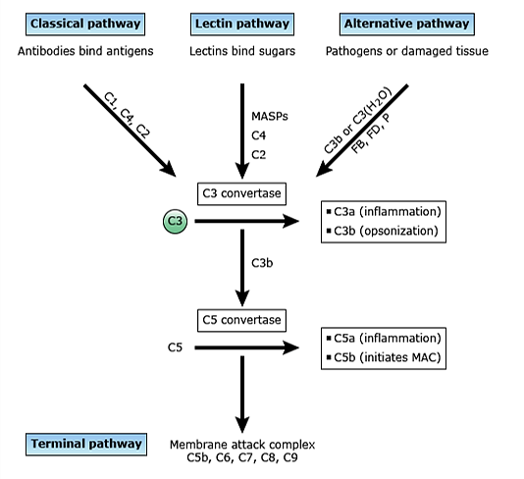
The second mechanism is extravascular haemolysis (EVH). This occurs due to opsonisation of haemocytes with C3dg (from transformed C3). The opsonised cells are recognised by C3-specific receptors on macrophages in the liver and spleen, leading to haemolysis.
The thrombophilia also arises as a consequence of the mutation and also the haemolysis and leads to an increased risk of intravascular thrombosis. Other presenting features include fatigue, dysphagia, abdominal pain, dyspnoea, dark urine, and erectile dysfunction.
In the UK, the incidence of detectable PNH clones by flow cytometric detection is 0.35 cases/100,000 population per year. The prevalence rate is 3.81 /100,000 persons. This might be extrapolated to the Australian population, using the ABS population calculation on 31st March 2023 of 26,473,055, as 93 new cases per year and 1009 persons affected by the condition. However, not all of these persons would require danicopan. The Sponsor reports, in Part II.I of the risk management plan, that in the Alexion-sponsored ravulizumab studies approximately 22% of patients had Hgb <9.5 g/dL and elevated reticulocytes >120x10⁹/L in the 52-week Extension Period. Hence, the target population in Australia might be estimated as 222 persons.
In the UK, of the incident patients in one study, 88% had aplastic anaemia (AA), 8% classical PNH and 3% myelodysplastic syndrome. This indicates a high level of comorbidity. In addition, common complications of PNH include thrombosis including hepatic, cerebral, and abdominal and both venous and arterial thrombosis, acute or chronic renal disease, pulmonary hypertension, erectile dysfunction, and dysphagia.

Current treatment options
The current standard of care for all patients with symptomatic PNH is treatment with C5 inhibitors, which currently are monoclonal antibodies:
- ULTOMIRIS (ravulizumab): approved in Australia for the treatment of patients with PNH.
- SOLIRIS (eculizumab): approved in Australia for PNH to reduce haemolysis.
Newer treatments include:
- FABHALTA (iptacopan): an oral, proximal complement inhibitor that binds factor B and inhibits the alternative complement pathway. This was approved by the TGA on 7th August 2024 for the treatment of all adult patients with PNH.
- EMPAVELI (pegcetacoplan), a C3 inhibitor: approved in Australia for the treatment of adult patients with PNH who have an inadequate response to, or are intolerant of, a C5 inhibitor. There is a submission currently under evaluation by the TGA to extend the indications to include all adult patients with PNH.
Other management options include, for control of complications:
- Blood transfusion: for the control of refractory anaemia
- Anticoagulation treatment: for patients with thromboembolism (TE) or a high risk of TE
- Dialysis: for patients with secondary renal failure
- Infection: anti-meningococcal prophylaxis, for example, penicillin, vaccination
- Allogenic bone marrow transplantation: may be considered for patients with severe haemolysis, life‐threatening TE, and bone marrow failure.

Clinical rationale
Danicopan is a small molecule, reversible inhibitor of complement factor D (FD) that selectively blocks the complement alternative pathway but not the complement classical pathway or lectin pathway. The Sponsor states danicopan to be first in class.
Complement FD is a serine protease that is required for activation of the complement. FD mediates the cleavage of complement factor B (FB) into Ba and Bb fragments, when FB is bound to activated forms of complement component 3 (C3), to generate the C3 convertase C3bBb. This C3 convertase elicits further complement activation and promotes the multiple effector functions of the complement system.
A small subset of patients with PNH who achieve durable IVH control and associated disease control with ravulizumab or eculizumab may experience emergence of clinically significant EVH and may require transfusions. Clinically significant EVH occurs in approximately 20% of C5 inhibitor-treated patients, with approximately 10% of these patients requiring RBC transfusions. Based on its ability to inhibit complement FD, danicopan as add-on treatment to background ravulizumab or eculizumab addresses the manifestations of EVH.

Regulatory status

Australian regulatory status
This product is a new chemical entity for Australian regulatory purposes.

International regulatory status
At the time the TGA considered this submission:
Danicopan was approved by the EMA on 19 April 2024:
as an add-on to ravulizumab or eculizumab for the treatment of adult patients with paroxysmal nocturnal haemoglobinuria who have residual haemolytic anaemia
and by the FDA in March 2024:
as add-on therapy to ravulizumab or eculizumab for the treatment of extravascular haemolysis (EVH) in adults with paroxysmal nocturnal hemoglobinuria.
Similar applications have been submitted, and are under review, in the following countries: Japan (19th May 2023), Brazil (16th May 2023), Switzerland (15th May 2023) and Canada (31st May 2023).
The clinical data submitted in Australia is the same as that for the US, Canada and Switzerland. The dossier differs from that for the EU in that the cutoff time for Study ALXN2040 PNH 301 is the later date of 20th September 2022.

Registration timeline
Table 1 captures the key steps and dates for this submission.
This submission was evaluated under the standard prescription medicines registration process.
Table 1. Registration timeline for VOYDEYA (danicopan), submission PM-2023-03280-1-6
Description | Date
Submission dossier accepted and evaluation commenced | 31 August 2023
Evaluation completed | 31 May 2024
Registration decision (Outcome) | 11 November 2024
Registration in the ARTG completed | 25 November 2024
Number of working days from submission dossier acceptance to registration decision* | 274 days
*Statutory timeframe for standard submissions is 255 working days

Assessment overview

Quality evaluation summary
The application and the supporting data relating to the composition, development, manufacture, quality control, stability and bioavailability of the product were assessed and checked for compliance, as applicable, with Australian legislation and requirements for new medicines and in accordance with pharmacopoeial standards and the technical guidelines adopted by the TGA.

Nonclinical evaluation summary
The nonclinical dossier was of good overall quality and adequate in scope, consistent with ICH M3 (R2). All pivotal safety-related studies were conducted according to GLP.
Danicopan is an inhibitor of complement factor D (a protease of the alternative complement pathway) and represents a novel pharmacological class. In vitro experiments established that the drug possesses very high affinity for human complement factor D, inhibiting its proteolytic activity with nanomolar potency. Inhibition of alternative pathway-mediated C3 fragment deposition and haemolysis by danicopan were demonstrated in vitro in experiments with rabbit and human (artificial and patient PNH) erythrocytes in human serum. Synergism in combination with eculizumab and another anti-C5 antibody was apparent. Inhibition of the alternative pathway after oral administration was demonstrated in rabbits, dogs and monkeys. Danicopan is not pharmacologically active in rodents (accordingly, the dog and rabbit are the most appropriate laboratory animal species to model danicopan toxicity). Relevant animal models of PNH are not available. The primary pharmacology studies offer support for the utility of danicopan for the proposed indication.
The MT1 melatonin receptor was identified as a key secondary pharmacological target for danicopan. Danicopan displays potent antagonist activity against the human MT1 melatonin receptor, with the Ki of 3.5 nM being almost 30 times lower than the peak unbound plasma concentration in patients at the maximum recommended human dose. Reducing clinical concern, CNS or other effects attributable to MT1 melatonin receptor antagonism were not apparent in toxicity studies in dogs (with danicopan targeting the dog form of the MT1 melatonin receptor with similar affinity cf. human) and CNS penetration was shown to be limited in rats.
Inhibition of serum bactericidal activity against Neisseria meningitidis was seen with danicopan in pre-vaccination human serum, consistent with the known role of the alternative complement pathway in the clearance of encapsulated bacteria. Contraindication in patients with unresolved Neisseria meningitidis infection and who are not up to date on their meningococcal vaccines is included in the Product Information document and warranted.
Safety pharmacology and other studies indicated no likely pharmacologically mediated adverse effects on CNS, cardiovascular or respiratory function in patients treated with VOYDEYA.
Rapid absorption after oral administration, similar to humans, could be demonstrated in all laboratory animal species studied, though was often more delayed (dose- and formulation-dependent). Oral bioavailability in rats and dogs was low to moderate. Plasma half-life was short in the laboratory animal species (~1–3 h) and longer in humans (~8 h). Exposure became saturated in rats. Plasma protein binding was moderate or high, and broadly similar across species. Rapid and wide tissue distribution of ¹⁴C-danicopan-derived radioactivity was demonstrated in rats, with only limited penetration of the blood-brain barrier apparent. Danicopan binds to melanin. Ocular accumulation was observed with repeated dosing in pigmented rabbits.
Metabolism of danicopan involves amide hydrolysis, oxidation and reduction. CYP involvement is minimal. Two major circulating human metabolites are identified (M426 [M8] and M428 [M5]); these display little or no primary pharmacological activity. Excretion of danicopan and/or its metabolites was predominantly via the faeces in rats, dogs and humans. Significant biliary excretion was demonstrated in rats.
In vitro data suggest the potential for danicopan to cause pharmacokinetic drug interactions through inhibition of CYP3A (at the intestinal level), UGT1A1, UGT2B7, P glycoprotein, BCRP and OATP1B1. Clinical drug-interaction studies investigating such effects have been conducted.
Danicopan has a low order of acute toxicity by the oral route in animals.
Repeat-dose toxicity studies by the oral route were conducted in mice (up to 4 weeks), rats (up to 6 months) and dogs (up to 9 months). The liver was the key target for toxicity. Hepatobiliary cholestasis is identified as a potential clinical concern based on findings in dogs and from in vitro data showing disruption of bile acid homeostasis and inhibition of bile acid transporters/regulators.
Danicopan was shown to not be genotoxic in the standard battery of in vitro and in vivo tests, and not to be carcinogenic in transgenic mice or in rats.
Impairment of fertility could be demonstrated with danicopan in male and female rabbits, but only at a dose level producing substantial toxicity. Danicopan did not produce malformations or cause direct embryofetal lethality in rats or rabbits. Fetal weight was reduced in both species and a few rabbits aborted at the highest dose level tested, but this was secondary to maternal toxicity. Postnatal development was unaffected in rabbits. Assignment to Pregnancy Category B3 (rather than B2 as the Sponsor proposes) is warranted.
Phototoxic potential was demonstrated for danicopan in vitro and ocular phototoxicity was evident in vivo in rats. Concerns for potential ocular phototoxicity in patients are held based on nonclinical data.
The impurity profile is toxicologically acceptable.
There are no nonclinical objections to the registration of VOYDEYA for the proposed indication, provided a favourable risk/benefit balance is shown from clinical data

Clinical evaluation summary

Pharmacology

Pharmacokinetics

Absorption
- Danicopan is administered orally and absorbed from the gastrointestinal tract. Peak plasma concentrations (T_{max}) are reached within 1.13 hours on average.
- Food increases danicopan exposure significantly, with up to 44% higher exposure noted in fed states.

Distribution
- The mean volume of distribution (V_{z}/F) was 733 L, indicating extensive distribution.
- Plasma protein binding was high, with 5.7-8.5% of the drug unbound.
- Erythrocyte distribution was minimal, with a blood/plasma ratio of around 0.55.
- Tissue distribution was extensive.

Metabolism
- Danicopan is extensively metabolised (96%) primarily through oxidation, reduction, and hydrolysis, with minimal CYP-mediated metabolism.
- Thirteen metabolites were identified, with the major metabolite (M8) constituting 47.2% of the dose. The drug’s metabolism is mostly non-renal.

Excretion
The drug is primarily excreted via faeces (69.2%) and urine (24.8%). Unchanged danicopan accounts for a small fraction of the dose excreted in both urine (0.48%) and faeces (3.57%).

Pharmacokinetics in special populations
- Hepatic impairment: no significant difference in AUC but reduced C_{max} in moderate hepatic impairment.
- Renal impairment: increased AUC in severe renal impairment, but C_{max} remains similar.
- Age: in older adults (≥65 years), pharmacokinetics (PK) is similar to younger populations.

Population pharmacokinetics
The final model includes effects for weight, sex, formulation, and food. Severe renal impairment decreases apparent clearance (CL/F) by 42.7%.

Drug Interactions:
- Midazolam: increases midazolam exposure by 23%.
- Fexofenadine: increases fexofenadine exposure by around 60%.
- Mycophenolate: no significant effect on mycophenolate exposure.
- Cyclosporine: increases cyclosporine exposure by around 18%, and vice versa.
- Tacrolimus: increases tacrolimus exposure by about 55%.
The PK information in the Product Information is supported by the PK data submitted in the dossier. The only significant intrinsic effect on danicopan PK was severe renal failure, but the increase was not clinically significant and would not require dose adjustment. Drug interactions were not clinically significant, except for tacrolimus (due to the toxicity of tacrolimus) which could be addressed by more frequent monitoring and dose adjustments for tacrolimus.

Pharmacodynamics

Mechanism of Action
Danicopan is a reversible inhibitor of complement FD that specifically targets the complement alternative pathway but not the complement classical pathway or lectin pathway. FD is crucial for activating this pathway by converting complement factor B (FB) into Ba and Bb fragments, which then form the C3 convertase C3bBb. This process leads to further complement activation.

Primary pharmacodynamic effects
- Inhibition of alternative complement pathway: studies showed that danicopan effectively inhibits the alternative complement pathway (AP). Higher doses led to longer durations of inhibition. In various studies, maximal inhibition was achieved at all tested doses, with more prolonged effects and a greater decrease in Bb fragment concentrations at higher doses.
- Effects in different populations: in subjects with severe renal impairment, baseline levels of Bb were higher, but danicopan still decreased these levels. The AP activity reduction was greater in normal renal function individuals compared to those with severe impairment.

Secondary pharmacodynamic effects
QTc Interval: In a thorough QT study, danicopan did not significantly affect the QTc interval at doses up to 1200 mg. The QTc interval changes remained within regulatory safety limits.

Time course and dose relationship
- Time course: the effects of danicopan were closely related to plasma concentrations. A single 200 mg dose showed effects starting within one hour, peaking at two hours, and diminishing by 16 hours.
- Dose-response relationship: pharmacokinetic-pharmacodynamic (PK-PD) analyses identified the target plasma concentration (EC₉₀) for effective inhibition. The exposure-response relationship for adverse effects was less clear but the concentration-response relationship for efficacy was well defined.

Pharmacodynamic interactions
Warfarin interaction: co-administration with warfarin resulted in a minor decrease in INR (international normalized ratio) values, suggesting a mild interaction.

Overall conclusion
The pharmacodynamics of danicopan are well-characterized, with clear efficacy profiles and a defined concentration-response relationship. The exposure-response relationship for adverse effects was not defined, but this may have been a consequence of study design. Patients with inadequate response were titrated to higher doses, and patients that were susceptible to adverse events were not titrated to higher doses. This would obscure a dose-effect relationship for response and for AEs. Although the exposure-response relationship for adverse effects is less clear than for efficacy, there were no significant knowledge gaps in the pharmacodynamic profile of danicopan.

Efficacy

Pivotal Study ALXN2040-PNH-301
This study was a confirmatory Phase III clinical trial (Table 2, Figure 2). The study had a randomised, double blind, placebo-controlled treatment period for 12 weeks (Treatment Period 1 [TP1]), followed by a second 12-week treatment period where all the participants received danicopan (Treatment Period 2 [TP2]), followed by a 2-year extension study. The study is ongoing, and an interim report was provided. The study commenced on 28th June 2022 and the interim analysis cutoff date was 20th September 2022.
Table 2: Study ALXN2040-PNH-301, PICO table
Population | Adults with PNH and clinically evident EVH (Hb <9.5 g/dL), who had been receiving a C5 inhibitor for at least 6 months.  Patients with evidence of aplastic anaemia or other bleeding disorders, or with other unrelated significant comorbidities were excluded.  The study was conducted at 50 centres in 15 countries: Brazil (2 centres), Canada (1), Czech Republic (1), France (4), Greece (2), Israel (2), Italy (6), Japan (9), Korea, Republic of (4), Malaysia (3), Poland (1), Spain (5), Thailand (1), UK (3), and the US (6).
Intervention | Danicopan 150 mg, 3 times daily (tds), potentially increasing to 200 mg tds.
Control | Placebo (blinded).  All participants received background therapy with eculizumab or ravulizumab. The initial treatment phase was for 12 weeks, after which all participants received danicopan for a further 12 weeks.
Outcome | Primary endpoint:  - Change in Hb relative to baseline. A change of ≥2 g/dL (≥20 g/L) was considered clinically meaningful.  Secondary endpoints  - Hb improvement in the absence of transfusion  - Transfusion avoidance  - Transfusion requirements  - FACIT-Fatigue scores  - Absolute reticulocyte counts  - Hb stabilisation (avoidance of a decrease in Hb at Week 24 from Week 12)  - PNH-related laboratory markers: total and direct bilirubin; PNH RBC clone size; LDH values; C3 fragment deposition on PNH RBCs  - Hb normalisation  There was no multiplicity adjustment.

Figure 2: Study ALXN2040-PNH-301, Trial Design
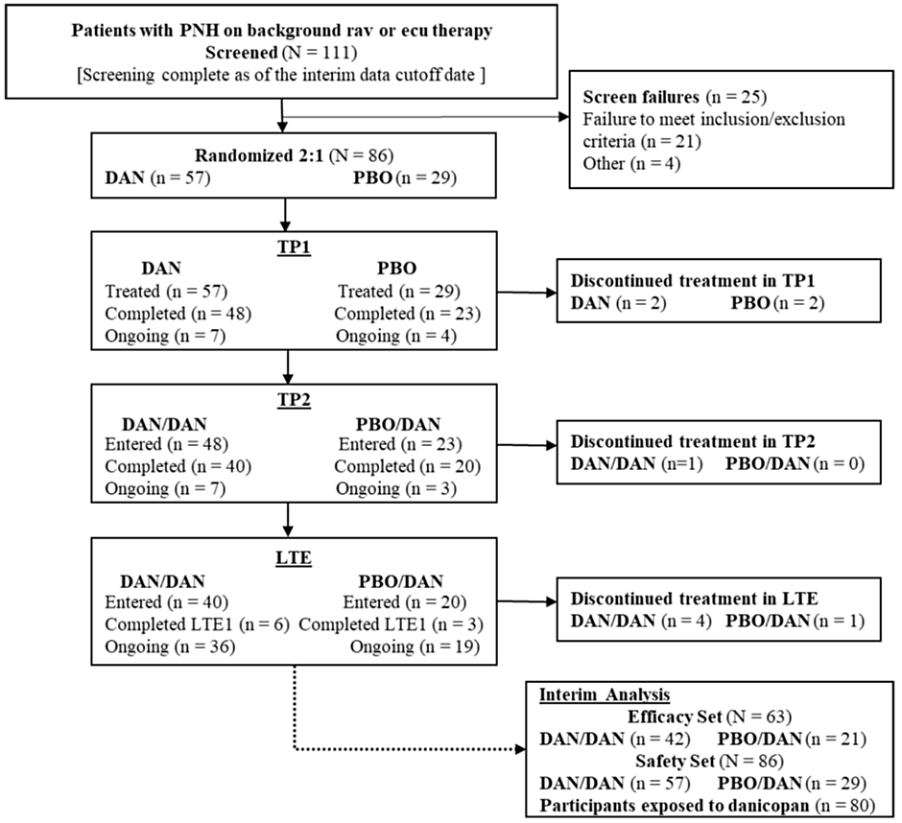
Note: DAN/DAN = participants received danicopan in TP1 and continued with danicopan during TP2 and LTE; PBO/DAN = participants received placebo in TP1, switched to danicopan during TP2, and continued on danicopan during LTE; Other = screen failure reasons other than failure to meet inclusion/exclusion criteria
Abbreviations: CONSORT = Consolidated Standards of Reporting Trials; DAN = danicopan; ecu = eculizumab; LTE = Long-term Extension; LTEI = Long-term Extension Year 1; PBO = placebo; PNH = paroxysmal nocturnal hemoglobinuria; rav = ravulizumab; TP1 = Treatment Period I; TP2 = Treatment Period 2

Baseline data
There were 37 (58.7%) females, 26 (41.3%) males and the age range was 25 to 82 years, with a median of 57 years. There were 28 (44.4%) White subjects and 25 (39.7%) Asian. The treatment groups were similar in baseline characteristics, including age, disease history and haematological parameters (Table 3). Mean (SD) baseline Hb was 76.6 (9.39) g/L in the danicopan group and 77.4 (10.35) g/L in the placebo. The median (range) duration of C5 inhibitor was 4.53 (0.7 to 16.8) years. Overall, there were 37 (58.7%) patients treated with ravulizumab and 26 (41.3%) with eculizumab. In the danicopan arm, a higher proportion of patients received treatment with ravulizumab (64.3%) than in the placebo arm (47.6%). The mean (SD) number of packed red blood cell infusions in the preceding 24 weeks was 2.5 (2.16) in the danicopan group and 2.6 (2.11) in the placebo.
Table 3. Selected Baseline Disease Characteristics – Interim Efficacy Analysis Set
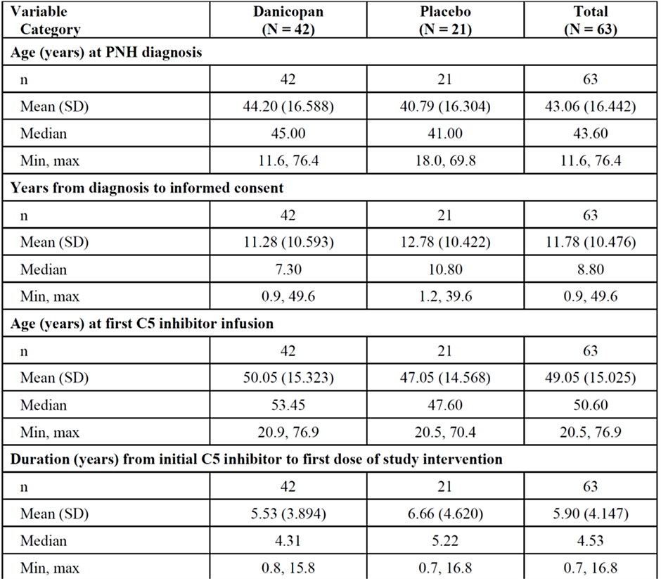

Results
There was a clinically and statistically significant improvement in Hb in the danicopan group compared to placebo. The LS mean (95% CI) change from baseline in Hb was 29.40 (25.16 to 33.64) g/L in the danicopan group and 4.96 (-1.33 to 11.24) g/L in the placebo; LS mean (95% CI) difference, danicopan-placebo, 24.44 (16.90 to 31.99) g/L, p <0.0001. The benefit occurred in the first four weeks of treatment and was maintained for the full 12 weeks of treatment (Figure 3).
Figure 3: Plots of LS means +/- SE for change from baseline in Hb during treatment period 1
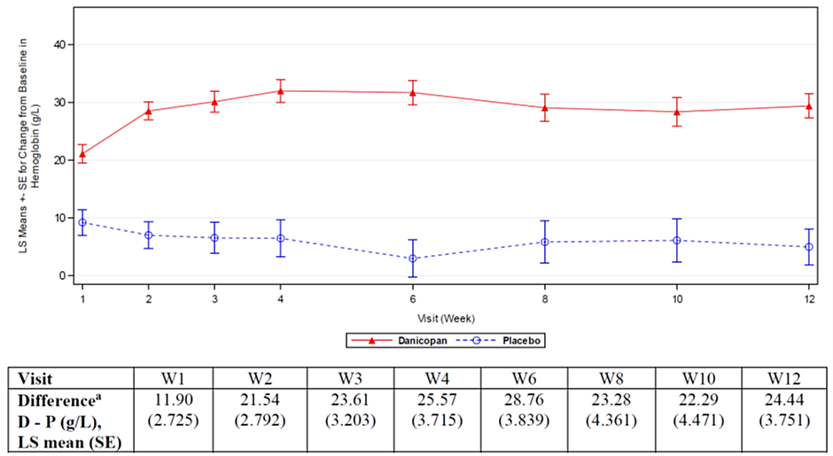
Note: Baseline is defined as the lowest Hgb value observed between and including Screening and Day 1. LS means and SE are from MMRM. Hgb values collected within 4 weeks after transfusion were not included in the MMRM.
ª p-values < 0.0001 (MMRM analysis) for treatment difference in Hgb values at Weeks 1, 2, 3, 4, 6, 8, 10, 12.
Abbreviations: D = danicopan; Hgb = haemoglobin; LS = least squares; MMRM = mixed-effect model for repeated measures; P = placebo; SE = standard error; W = week.
The changes were consistent across subgroups of concomitant C5 inhibitor treatment. At Week 12, the mean (SD) change from baseline in the danicopan group for those patients treated with eculizumab was 27.4 (0.09) g/L and with ravulizumab was 33.3 (13.82) g/L.
There were also statistically significant results in the following secondary outcomes (Table 4)
Table 4. Study ALXN2040-PNH-301 efficacy results
Measure | Danicopan | Placebo | p value
Hb increase >20 g/dL | 59.5% | 0% | <0.0001
Transfusion avoidance | 83.3% | 38.1% | 0.0004
Change from baseline in number of RBC units transfused | -1.48 | -0.18 | 0.0072
Change from baseline in number of transfusion instances | -0.92 | -0.21 | 0.0207
FACIT-Fatigue score improvement | 7.97 | 1.85 | 0.0021
Change in absolute reticulocyte count | -0.0838 | +0.0035 | <0.0001
Change in total bilirubin | -9.77 | -2.15 | 0.0101
Change in direct bilirubin | -2.88 | +0.30 | <0.0001
Patients with Hb normalisation | 28.6% | 0% | 0.0080

In summary, there was a statistically significant and clinically meaningful improvement in the primary outcome measure. This was supported by a number of statistically significant secondary outcomes, which comprised laboratory measures indicating the degree of EVH and clinically meaningful outcomes relating to the need for transfusions. There were no secondary outcome results which contradicted the primary outcome finding.
However, this was an interim analysis with a relatively short study period, especially when considering that patients with PNH are likely to require lifelong C5 inhibitor therapy. It is not known whether the benefits shown over the study period would be sustained. The results of the final analysis should be submitted when available.

Safety
Danicopan is well tolerated, and there was no indication of increased susceptibility to encapsulated organisms. However, there are some remaining concerns with regard to hepatic injury.
Safety data were compiled from several studies, in which 102 patients with PNH (92 as add-on therapy, 10 as monotherapy), 37 patients with C3G/IC-MPGN and 348 healthy volunteers were exposed to danicopan. For patients with PNH treated with danicopan as add-on therapy, 13 were treated with 100 mg TID for a median (range) of 84 (1 to 1183) days, 91 with 150 mg TID for 84 (5 to 1231) days and 63 with 200 mg TID for 252 (6 to 1094) days. There were no reports of discontinuation of eculizumab or ravulizumab in the study population.
TEAEs were common but were mostly non-serious. The most frequently reported TEAEs were pyrexia in 50 (30.2%) patients, headache in 50 (30.2%), upper respiratory tract infection in 31 (18.7%) and diarrhoea in 31 (18.7%). In the pivotal Study ALXN2040-PNH-301, in the 12-week TP1, pyrexia was reported in three (5.3%) participants in the danicopan group and none in the placebo. This raises the possibility that the high frequency of reports of pyrexia and upper respiratory tract infection may be related to danicopan and would be consistent with the known effects on the complement system. Headache was reported at the same frequency in the danicopan and placebo groups. Treatment-related TEAEs were not reported at a greater frequency with danicopan than with placebo.
There were no deaths reported from any of the clinical studies.
SAEs were uncommon, and apart from elevated liver enzymes, there was no apparent pattern to the SAEs. Elevations in liver enzymes were common but did not appear to be treatment or dose limiting. In most studies, liver function abnormalities were either not clinically significant or resolved without intervention. For example, in the pivotal study PNH-301, during a 12-week period, 14% of participants in the danicopan group had elevated ALT levels, compared to 3.4% in the placebo group. Overall, 15% of danicopan-treated participants experienced ALT elevations greater than 3 times the upper limit of normal (ULN). None of these cases met the criteria for Hy’s law. However, in Study ALXN2040-GA-201 there were two reports of DILI as SAEs (see below).
Breakthrough haemolysis (BTH) is characterized by the reoccurrence of signs and symptoms of haemolysis in patients being treated with a complement inhibitor. BTH may occur after discontinuation of a drug being used to treat PNH or with incomplete inhibition of the proximal or terminal complement pathways. There were six episodes of BTH in five subjects, all of whom recovered. None of the episodes of BTH were considered to be related to danicopan.
Danicopan was well tolerated, and in the 139 patients exposed to danicopan, a total of 12 TEAEs leading to discontinuation were reported in eight (5.8%) patients. The dose escalation studies did not have any dose-limiting toxicity.
A thorough QT study (ACH471-013) was performed that showed increase in QTcF above the level of regulatory concern. This study examined single, ascending doses of 400 mg, 800 mg and 1200 mg (administered as 100 mg tablets). For each of the dosing levels, there were no significant increases in QTcF and the upper 90% CI for the predicted change in QTcF was <10 ms.
There were no infections with N. meningitidis reported during the development program. Infections with encapsulated bacteria were not more common in the danicopan groups than placebo. Vaccination against N. meningitidis was a requirement for inclusion in the pivotal study ALXN2040-PNH-301.
There were insufficient patients exposed to danicopan to determine the risk of uncommon or rare adverse events. Only 139 patients have been exposed to danicopan in clinical trials, and in the double-blind phase of the pivotal study only 86 patients were studied: 57 treated with danicopan and 29 with placebo. The primary ongoing safety concern is hepatic injury due to danicopan.

Drug-induced liver injury
Study ALXN2040-GA-201 is an ongoing Phase 2 double-blinded, placebo-controlled study to evaluate the efficacy, safety, and PK of danicopan in patients aged 60 years or older with geographic atrophy secondary to age-related macular degeneration. Participants have been randomised to 1 of 4 treatments arms: 100 mg 2 times a day (bid), 200 mg bid, 400 mg once daily, or matching placebo. This is a different dosage regimen than the PNH patient population, with overall a slightly lower total daily dose.
There were two cases of DILI reported from this study:
- Participant 0504-004, from day 26 of blinded study treatment (either danicopan or placebo) had ALT >8xULN, AST >3xULN and total bilirubin 2xULN. No other cause of liver injury was identified. The biochemical abnormalities resolved after the study drug was tapered. Hence, this presentation is positive for Hy’s Law and consistent with DILI.
- Participant 0409-007, from day 51 of blinded study treatment (either danicopan or placebo), had ALT 1.4xULN, ALP 1.6xULN and GGT 9xULN. No alternative cause of liver injury was identified. Her biochemical abnormalities resolved after the study treatment was tapered. She was diagnosed by a hepatologist as having DILI, although the criteria for Hy’s Law were not strictly met.
The Sponsor has not unblinded these two subjects, and it is not known whether they were treated with danicopan, and if so which dose, or placebo. However, given the seriousness of DILI and evoking the precautionary principle, we must assume these subjects were treated with danicopan. Treatment with placebo would not offer an alternative cause of liver injury.
Although these cases may have been exposed to different dosing regimens to those proposed in the present application, and were treated for a different indication, all patients exposed to the investigational drug provide data for the evaluation of safety.
The Sponsor has highlighted the different study population and dosing regimen used in this study. However, unlike PNH, neither the condition of nor the established treatments for geographic atrophy and age-related macular degeneration are known to be associated with liver injury, although there may be different potential drug interactions in this different study population. The dosing regimen does not offer any additional assurance of safety, since PNH patients would be receiving higher daily doses than those given in Study ALXN2040-GA-201.
Other (e.g. companion diagnostic considerations, drug delivery device)
There are no barriers to registration resulting from other technological considerations. The proposed indication is as an add-on therapy and does not present any additional diagnostic requirements. Inclusion in the pivotal study was based on several readily available haematological parameters.
Real-world evidence (RWE) was not specifically included in the submission.

Risk management plan evaluation summary
Alexion Pharmaceuticals Australasia Pty Ltd has submitted EU-RMP version 1 succession 1 (dated 17 February 2023; DLP 28 June 2022) and ASA version 1.0 (dated 15 June 2023) in support of this application.
The summary of safety concerns is outlined in Table 5.
Table 5. Summary of safety concerns
Summary of safety concerns |  | Pharmacovigilance |  | Risk Minimisation
 |  | Routine | Additional | Routine | Additional
Important identified risks | None | - | - | - | -
Important potential risks | Meningococcal infection | ü* | ü† | ü | -
Important potential risks | Serious infections‡ | ü | ü† | ü | -
Important potential risks | Malignancies and haematologic abnormalities‡ | ü | ü† | ü | -
Important potential risks | Drug induced liver injury^{ǁ} | ü | - | ü | -
Missing information | Use in pregnant and breastfeeding women | ü* | ü† | ü | -
Missing information | Use in patients with severe hepatic impairment | ü | ü† | ü | –
Missing information | Long-term safety | ü | ü†§ | ü | –
*Specific adverse reaction follow-up questionnaire
† Post-authorisation safety study (Study ALX-PNH-502)
§ Long-term Extension Studies (ALXN2040-PNH-303 and Studies ALXN2040-PNH-301)
‡ Safety concerns added at later stage of evaluation
ǁ Australian specific safety concern

Risk-benefit analysis
There is sufficient evidence of clinical meaningful and statistically significant benefit of danicopan for the proposed indication. Benefits were seen across a range of clinical outcomes and haematological parameters, with substantial benefits over placebo for the primary outcome and many secondary outcomes. The evidence is somewhat limited by small sample sizes, as would be expected in a rare condition such as PNH. The potential Australian target population is small and is likely to remain so.
Danicopan appears to be reasonably safe in general; however, there remain concerns about uncommon but serious drug-induced liver injury. At this stage it is not clear whether the reported cases of DILI are causally related to danicopan. The Sponsor disputes the definition of these cases as DILI; while in one case (0409-007) this disagreement appears justified, the other (0504-004) appears to meet the criteria for DILI.
The two cases in question are participants in an ongoing trial, and the Sponsor has declined the request from the Evaluator to unblind these cases. Given that the biochemical and clinical abnormalities resolved in each case, this approach from the Sponsor seems reasonable. However, uncertainty remains regarding a possible association between the active substance in the trial (danicopan) and the adverse events. Neither the FDA nor the EMA included patients from this study in their pooled safety populations.
The Sponsor has made the argument that the cases of liver injury occurred in a trial of patients with a different indication than PNH, and that therefore these adverse events are not relevant to the current submission. However, there is no apparent reason (nor has the Sponsor provided any evidence) that patients with geographic atrophy and age-related macular degeneration are more prone to liver injury.
In summary, evoking the precautionary principle, it may be wiser to include in the PI as a potential adverse effect of danicopan. As the evidence base matures, and in particular when the ongoing Study ALXN2040-GA-201 is unblinded, it may be possible to revise this section of the PI.

Assessment outcome
Based on a review of quality, safety, and efficacy, the TGA decided to register VOYDEYA (danicopan) for the following indication:
VOYDEYA is indicated as an add-on to ravulizumab or eculizumab for the treatment of the signs or symptoms of extravascular haemolysis (EVH) in adult patients with paroxysmal nocturnal haemoglobinuria (PNH).

Specific conditions of registration
VOYDEYA (danicopan) is to be included in the Black Triangle Scheme. The PI and CMI for VOYDEYA must include the black triangle symbol and mandatory accompanying text for five years, which starts from the date that the sponsor notifies the TGA of supply of the product.
The VOYDEYA EU-Risk Management Plan (RMP) (Version 1.0 Succession 5, dated 23 January 2024, data lock point 31 March 2023), with Australian Specific Annex (Version 1.2, dated 23 April 2024), included with submission PM-2023-03280-1-6, and any subsequent revisions, as agreed with the TGA will be implemented in Australia.
An obligatory component of risk management plans is routine pharmacovigilance. Routine pharmacovigilance includes the submission of periodic safety update reports (PSURs).
Unless agreed separately between the supplier who is the recipient of the approval and the TGA, the first report must be submitted to TGA no later than 15 calendar months after the date of this approval letter. The subsequent reports must be submitted no less frequently than annually from the date of the first submitted report until the period covered by such reports is not less than three years from the date of this approval letter. The annual submission may be made up of two PSURs each covering six months. If the sponsor wishes, the six monthly reports may be submitted separately as they become available.
If the product is approved in the EU during the three years period, reports can be provided in line with the published list of EU reference dates no less frequently than annually from the date of the first submitted report until the period covered by such reports is not less than three years from the date of this approval letter.
The reports are to at least meet the requirements for PSURs as described in the European Medicines Agency’s Guideline on good pharmacovigilance practices (GVP) Module VII-periodic safety update report (Rev 1), Part VII.B Structures and processes. Note that submission of a PSUR does not constitute an application to vary the registration. Each report must be submitted within ninety calendar days of the data lock point for that report.
The Sponsor should provide safety evidence from Study ALXN2040-GA-201 following unblinding.

Product Information and Consumer Medicines Information
For the most recent Product Information (PI) and Consumer Medicines Information (CMI), please refer to the TGA PI/CMI search facility.

Therapeutic Goods Administration
PO Box 100 Woden ACT 2606 Australia
Email: info@tga.gov.au Phone: 1800 020 653 Fax: 02 6203 1605
https://www.tga.gov.au

A sponsor is a person or company who does one or more of the following: a) exports therapeutic goods from Australia, b) imports therapeutic goods into Australia, c) manufactures therapeutic goods for supply in Australia or d) elsewhere arranges for another party to import, export or manufacture therapeutic goods
Risitano AM, Frieri C, Urciuoli E, Marano L. The complement alternative pathway in paroxysmal nocturnal hemoglobinuria: From a pathogenic mechanism to a therapeutic target. Immunological Reviews. 2023;313:262–278
Risityano AM, 2023.
Liszewski KM, Atkinson JP, Overview and clinical assessment of the complement system. Nov 14, 2024. https://www.uptodate.com/contents/overview-and-clinical-assessment-of-the-complement-system
Patriquin CJ, Kiss T, Caplan S, Chin-Yee I, Grewal K, Grossman J, Larratt L, Marceau D, Nevill T, Sutherland DR, Wells RA, Leber B. How we treat paroxysmal nocturnal hemoglobinuria: A consensus statement of the Canadian PNH Network and review of the national registry. Eur J Haematol. 2019 Jan;102(1):36-52. doi: 10.1111/ejh.13176
Richards SJ, Painter D, Dickinson AJ, Griffin M, Munir T, Arnold L, Payne D, Pike A, Muus P, Newton DJ, McKinley C, Jones R, Kelly R, Smith A, Roman E, Hillmen P. The incidence and prevalence of patients with paroxysmal nocturnal haemoglobinuria and aplastic anaemia PNH syndrome: A retrospective analysis of the UK’s population-based haematological malignancy research network 2004-2018. Eur J Haematol. 2021; 107(2): 211-218.
Richards SJ, 2021.
Shah N, Bhatt H. Paroxysmal Nocturnal Hemoglobinuria. 2023 Jul 31. In: StatPearls [Internet]. Treasure Island (FL): StatPearls Publishing; 2025 Jan–. PMID: 32965963.
Patriquin CJ, 2019.
International Council for Harmonisation of Technical Requirements for Pharmaceuticals for Human Us. ICH M3 (R2) Non-clinical safety studies for the conduct of human clinical trials for pharmaceuticals - Scientific guideline. 2013.

