Australian Public Assessment Report for UPLIZNA
  - Active ingredient: Inebilizumab
  - Sponsor: Amgen Australia Pty Ltd
July 2025

About the Therapeutic Goods Administration (TGA)
- The Therapeutic Goods Administration (TGA) is part of the Australian Government Department of Health, Disability and Ageing and is responsible for regulating therapeutic goods, including medicines, medical devices, and biologicals.
- The TGA administers the Therapeutic Goods Act 1989 (the Act), applying a risk management approach designed to ensure therapeutic goods supplied in Australia meet acceptable standards of quality, safety, and efficacy.
- The work of the TGA is based on applying scientific and clinical expertise to decision-making, to ensure that the benefits to the Australian public outweigh any risks associated with the use of therapeutic goods.
- The TGA relies on the public, healthcare professionals and industry to report problems with therapeutic goods. The TGA investigates reports received to determine any necessary regulatory action.
- To report a problem with a therapeutic good, please see the information on the TGA website.

About AusPARs
- The Australian Public Assessment Report (AusPAR) provides information about the evaluation of a prescription medicine and the considerations that led the TGA to approve or not approve a prescription medicine submission. Further information can be found in Australian Public Assessment Report (AusPAR) guidance.
- AusPARs are prepared and published by the TGA.
- AusPARs are static documents that provide information that relates to a submission at a particular point in time. The publication of an AusPAR is an important part of the transparency of the TGA’s decision-making process.
- A new AusPAR may be provided to reflect changes to indications or major variations to a prescription medicine subject to evaluation by the TGA.

Copyright
© Commonwealth of Australia 2025
This work is copyright. You may reproduce the whole or part of this work in unaltered form for your own personal use or, if you are part of an organisation, for internal use within your organisation, but only if you or your organisation do not use the reproduction for any commercial purpose and retain this copyright notice and all disclaimer notices as part of that reproduction. Apart from rights to use as permitted by the Copyright Act 1968 or allowed by this copyright notice, all other rights are reserved and you are not allowed to reproduce the whole or any part of this work in any way (electronic or otherwise) without first being given specific written permission from the Commonwealth to do so. Requests and inquiries concerning reproduction and rights are to be sent to the TGA Copyright Officer, Therapeutic Goods Administration, PO Box 100, Woden ACT 2606 or emailed to <tga.copyright@tga.gov.au>.

Contents
List of abbreviations 4
UPLIZNA (inebilizumab) submission 6
Proposed indication 7
The condition 7
Current treatment options 8
Clinical rationale 8
Regulatory status 9
Registration timeline 10
Assessment overview 10
Quality evaluation summary 10
Nonclinical evaluation summary 11
Clinical evaluation summary 13
Pharmacology 13
Efficacy 25
Safety 34
Risk management plan evaluation summary 47
Risk-benefit analysis 48
Efficacy 48
Safety 50
Advisory Committee considerations 54
Assessment outcome 55
Specific conditions of registration 55
Product Information and Consumer Medicines Information 56

List of abbreviations
Abbreviation | Meaning
AC | Adjudication committee
ACM | Advisory Committee on Medicines
ADAs | Anti-drug antibodies
AQP4 | Aquaporin-4
ARTG | Australian Register of Therapeutic Goods
AUC_{0-inf} | Area under the concentration-time curve extrapolated to infinity post dose
AUC_{0-last} | Area under the concentration-time curve from dosing to last measurable time point
CL | Systemic clearance
C_{max} | Maximum observed concentration
EDSS | Expanded Disability Status Scale
HR | Hazard ratio
ITT | Intention to treat
IV | Intravenous
LLOQ | Lower limit of quantitation
MEDI-551 | Inebilizumab
MS | Multiple sclerosis
NMOSD | Neuromyelitis optica spectrum disorder
OLP | Open label period
PD | pharmacodynamic(s)
PI | Product Information
PK | pharmacokinetic(s)
popPK | population pharmacokinetic(s)
PT | Preferred term
Q | Inter-compartmental clearance
RCP | Randomized control period
RMP | Risk management plan
SC | Sub-cutaneous
SSc | Systemic sclerosis
t_{1/2} | Terminal elimination half-life
TEAE | Treatment emergent adverse event
TESAE | Treatment emergent serious adverse events
TGA | Therapeutic Goods Administration
V_{c} | Volume of distribution in the central compartment
V_{max} | Maximum velocity of Michaelis-Menten equation
V_{p} | Volume of distribution in the peripheral compartment
V_{ss} | Steady-state volume of distribution

UPLIZNA (inebilizumab) submission
Type of submission: | New biological entity
Product name: | UPLIZNA
Active ingredient: | inebilizumab
Decision: | Approved
Approved therapeutic use for the current submission: | UPLIZNA is indicated as monotherapy for the treatment of adult patients with neuromyelitis optica spectrum disorders (NMOSD) who are anti-aquaporin-4 immunoglobulin G  (AQP4-IgG) seropositive.
Date of decision: | 11 March 2025
Date of entry onto ARTG: | 12 March 2025
ARTG number: | UPLIZNA inebilizumab 100 mg/10 mL concentrated injection vial (446050)
Black Triangle Scheme | Yes
Sponsor’s name and address: | Amgen Australia Pty Ltd, Level 11, 10 Carrington Street, Sydney NSW 2000
Dose form: | Concentrated injection for infusion
Strength: | 10 mg/mL
Container: | Type 1 glass vial with an elastomeric stopper and a flip-off aluminium seal.
Pack size: | Three vials/pack
Route of administration: | Intravenous infusion
Dosage: | For further information regarding dosage refer to the Product Information.
Pregnancy category: | Category C  Drugs which, owing to their pharmacological effects, have caused or may be suspected of causing, harmful effects on the human fetus or neonate without causing malformations. These effects may be reversible.  The use of any medicine during pregnancy requires careful consideration of both risks and benefits by the treating health professional. The pregnancy database must not be used as the sole basis of decision making in the use of medicines during pregnancy. The TGA does not provide advice on the use of medicines in pregnancy for specific cases. More information is available from obstetric drug information services in your state or territory.

Proposed indication
This AusPAR describes the submission by Amgen Australia Pty Ltd (the Sponsor) to register UPLIZNA (inebilizumab) for the following proposed indication:
Treatment of adult patients with neuromyelitis optica spectrum disorders (NMOSD) who are anti-aquaporin-4 immunoglobulin G (AQP4-IgG) seropositive
This submission was submitted through the TGA’s Comparable Overseas Regulator (COR-B) process, using evaluation reports from the Europeans Medicines Agency. The full dossier was submitted to the TGA.

The condition
Neuromyelitis optica spectrum disorder (NMOSD) is an immune-mediated inflammatory disorder of the central nervous system with demyelination and axonal damage being characteristic features that principally target the optic nerve and spinal cord.
The pathophysiology of NMOSD is thought to be autoimmune. The AQP4-IgG antibody is found in approximately 90% of patients diagnosed with NMOSD. This autoantibody targets the AQP4 water channel protein which is found in astrocytes that are expressed in the spinal cord, periaqueductal and periventricular regions of the brain. The serum anti-AQP4 Ab titres also correlate with clinical disease activity. NMSOD is commonly associated with other autoimmune diseases including hypothyroidism, pernicious anaemia, ulcerative colitis and systemic lupus erythematosus. Pathogenic AQP4-IgG antibodies are produced by a subpopulation of CD19+ and CD20- B cells, showing morphological and phenotypical properties of plasmablasts. A small number of AQP4-seronegative individuals with clinical features suggestive of NMOSD have serum antibodies against myelin oligodendrocyte glycoproteins, however differences in clinical features have been noted in the sub-group compared to AQP4-seropositive patients.
The median age at onset is approximately 32-41 years of age with a higher proportion of cases in females compared to males. The prevalence of NMOSD is approximately between 1-10 per 100,000.
Diagnostic criteria involve displaying one of the 6 core clinical features of NMSOD (Optic neuritis, Acute myelitis, Area postrema syndrome: episode of otherwise unexplained hiccups or nausea and vomiting, Acute brainstem syndrome, Symptomatic narcolepsy or acute diencephalic clinical syndrome with NMOSD-typical diencephalic MRI lesions, Symptomatic cerebral syndrome with NMOSD-typical brain lesions) usually combined with a positive AQP4-Ab test and exclusion of alternative diagnosis.
The most common clinical manifestations of NMSOD are acute attacks of bilateral (or initially unilateral that rapidly becomes bilateral) optic neuritis or transverse myelitis with a relapsing course being typical. These events can lead to visual loss, limb weakness, trunk or limb pain, sensory loss or bladder dysfunction. NMOSD has a relapsing course in 90% of cases with 60% experiencing a relapse within 1 year and 90% within 3 years. Deficits often remain after resolution of an attack, which can lead to rapid development of disability due to blindness and severe motor weakness . Mortality is high with one cohort study finding of 88 patients diagnosed with neuromyelitis optica there were 24 deaths within 5 years, often from neurogenic respiratory failure due to cervical myelitis. An MRI brain scan can be initially normal, but over time MRI changes in the brain develop in up to 85% of patients with lesions usually noted in the medulla, hypothalamus, diencephalon and subcortical white matter.

Current treatment options
Initial treatment in acute attacks usually consists of high dose intravenous glucocorticoids and if there is a suboptimal treatment response then plasma exchange is a further option.
For prevention of attacks commonly used less specific immunosuppressive agents such as mycophenolate, methotrexate and azathioprine can be considered.
Targeted biological treatment to prevent relapse are also commonly used with multiple targeted biological treatments currently registered for treatment of NMSOD in Australia. Eculizumab is approved for treatment of NMSOD and is a monoclonal antibody binding to complement component C5 inhibiting the formation of the C5b membrane attack complex. Ravulizumab is another monoclonal antibody approved for treatment of NMSOD in Australia that works similarly to eculizumab by binding the complement component C5 thus inhibiting formation of C5b attack complex. Satralizumab is approved for NMSOD treatment in Australia and is a monoclonal antibody that binds to interlukin-6 (IL-6) with goal of suppressing inflammation signalling pathways.

Clinical rationale
Inebilizumab is a humanised immunoglobulin G1 kappa monoclonal antibody that binds to the
B cell surface antigen CD19 resulting in depletion of B cells (pre–B and mature B lymphocytes) via NK cell-mediated depletion of B cells via antibody-dependent cellular cytotoxicity (ADCC) and antibody-dependent cellular phagocytosis (ADCP) mechanisms.
Proposed contributions of B cells to NMOSD include production of autoantibodies, secretion of pro-inflammatory factors, and antigen presentation. The role of B cells in NMOSD is further supported by results of numerous uncontrolled studies with rituximab, a B cell-depleting chimeric monoclonal antibody against the human CD20 molecule, which collectively point to a therapeutic benefit of B-cell depletion in NMOSD.,,,,

Regulatory status

Australian regulatory status
This product is a new biological medicine for Australian regulatory purposes.

International regulatory status
At the time the TGA considered this submission, a similar submission had been considered by other regulatory agencies. Table 1 summarises these submissions and provides the indications where approved.
Table 1. International regulatory status for UPLIZNA
Country | Date of Submission | Approval date | Indication (approved or proposed)
EU (centralised procedure) | 20 Nov 2020 | 25 Apr 2022 | UPLIZNA is indicated as monotherapy for the treatment of adult patients with neuromyelitis optica spectrum disorders (NMOSD) who are anti-aquaporin-4 immunoglobulin G (AQP4-IgG) seropositive
US | 11 Jun 2019 | 11 Jun 2020 | UPLIZNA is indicated for the treatment of neuromyelitis optica spectrum disorder (NMOSD) in adult patients who are anti-aquaporin-4 (AQP4) antibody positive.
Brazil | 26 May 2022 | 19 Dec 2022 | UPLIZNA is indicated as monotherapy for the treatment of adult patients with neuromyelitis optica spectrum disorders (NMOSD) who are anti-aquaporin4 immunoglobulin G (AQP4-IgG) seropositive
Japan | 26 Jun 2020 | 23 Mar 2021 | Preventing recurrence of NMOSD (including neuromyelitis optica)
Canada | 30 Dec 2022 | 15 Dec 2023 | UPLIZNA (inebilizumab for injection) is indicated as monotherapy for the treatment of adult patients with neuromyelitis optica spectrum disorders (NMOSD) who are anti-aquaporin-4 immunoglobulin G (AQP4- IgG) seropositive.
Switzerland | 1 Jun 2023 | 4 Mar 2024 | UPLIZNA is indicated as monotherapy for the treatment of adult patients with neuromyelitis optica spectrum disorders (NMOSD) who are anti-aquaporin 4 immunoglobulin G (AQP4-IgG) seropositive
United Kingdom | 15 Apr 2024 | 31 Oct 2024 | UPLIZNA is indicated as monotherapy for the treatment of adult patients with neuromyelitis optica spectrum disorders (NMOSD) who are anti- aquaporin 4 immunoglobulin G (AQP4-IgG) seropositive

Registration timeline
Table 2 captures the key steps and dates for this submission.
This submission was submitted through the TGA’s Comparable Overseas Regulator (COR-B) process, using evaluation reports from the European Medicines Agency The full dossier was submitted to the TGA.
Table 2. Registration timeline for UPLIZNA (inebilizumab), submission PM-2024-01533-1-1
Description | Date
Submission dossier accepted and evaluation commenced | 31 May 2024
Evaluation completed | 18 November 2024
Advisory committee meeting | 2 February 2025
Registration decision (Outcome) | 11 March 2025
Registration in the ARTG completed | 12 March 2025
Number of working days from submission dossier acceptance to registration decision* | 199 days
* The COR-B process has a 175 working day evaluation and decision timeframe.

Assessment overview

Quality evaluation summary
The finished product, UPLIZNA is presented as a concentrated solution for intravenous infusion containing 100 mg/vial of inebilizumab as active substance.
Other ingredients are histidine, histidine hydrochloride monohydrate, sodium chloride, trehalose dihydrate, polysorbate 80 and water for injections.
The product is available in a carton with 3×10-ml glass vial (10R type I glass) with an elastomeric stoppers, capped with an aluminium seal and a package insert for distribution inebilizumab is approximately 149kDa composed of 2 identical heavy chains and light chains.
The formulation development has been adequately described and the final formulation intended for marketing was used in the phase III clinical trials.
All excipients are well known pharmaceutical ingredients and their quality is compliant with Ph. Eur/NF/USP/JP standards. There are no novel excipients used in the finished product formulation. The container closure is considered suitable for its intended use as demonstrated by compatibility and stability studies.
The inebilizumab finished product manufacturing process consists of active substance pooling, sterile filtration, aseptic filling of the pre formulated active substance and visual inspection. All filled containers (vials) are visually checked, discarding those with defects. After the inspection process, the vials are stored at 5°C ± 3°C pending labelling and packaging. The description of the manufacturing process has been provided in sufficient detail.
The drug product manufacturing process was developed with well defined manufacturing procedures, process validations, critical process parameters, in-process parameters and batch analyses of multiple manufacturing campaigns. Finished product comparability studies were conducted to demonstrate that the quality of the commercial manufacturing process is comparable to the pre-change product. These were assessed and considered satisfactory.
All analytical methods used for testing of the finished product are satisfactorily described in the dossier and non-compendial methods have been validated. Many test methods used for release testing and stability testing of the finished product are the same as those used for release testing and stability testing of the active substance.
The reference standard used in the testing and release of inebilizumab finished product is the same as the one used for the testing and release of inebilizumab active substance.
Sterility, adventitious agents, container and endotoxin safety assessments were carried out with the aim of ensuring product quality and safety. These include (where appropriate) control/testing of starting materials, containers, in-process steps, decontamination/reduction steps active ingredient and finished product tests. Adequate data has been presented which give reassurance on removal/reduction (to safe levels) of contaminants.
The quality of this product is acceptable when used in accordance with the conditions defined in the PI, labels, consumer medicines information and the ARTG. Physicochemical and biological aspects relevant to the uniform clinical performance of the product have been investigated and are controlled in a satisfactory way. Information on development, manufacture and control of the active substance and finished product has been presented in a satisfactory manner. The results of tests carried out indicate consistency and uniformity of important product quality characteristics, and these in turn lead to the conclusion that the product should have a satisfactory and uniform performance in clinical use. From a quality perspective, compliance with Therapeutic Goods Legislations and relevant Therapeutic Goods Orders as well as consistency with relevant guidelines and the ARGPM has been demonstrated.
Approval is recommended from a quality perspective.

Nonclinical evaluation summary
The submitted nonclinical dossier was in accordance with the relevant ICH guidelines for the nonclinical assessment of a biopharmaceutical therapeutics. The overall quality of the nonclinical dossier was high. All pivotal safety-related studies were Good Laboratory Practice compliant.
In vitro, inebilizumab bound to CD19 in blood, spleen with nanomolar affinity. Inebilizumab did not bind to rat, wild type mouse or monkey CD19 (four species). inebilizumab demonstrated ADCC and/or ADCP in several B cell expressing tumour cell lines in vitro and killed B-cells in human plasma cells and PBMCs from patients and health donors. inebilizumab did not induce CDC (complement-dependent cytotoxicity) in B-cell lymphoma cell lines. In vivo, inebilizumab demonstrated efficacy (B lymphocyte depletion) in huCD19 transgenic (Tg) mice and in various huCD19 Tg mouse models of autoimmune diseases. There are no relevant animal models of NMOSD. These studies lend support for the proposed indication.
Immunohistochemical assays examining cross-reactivity showed staining of B-cells in normal human, rat and huCD19 Tg mouse tissues. There was no evidence of off-target effects in the set of repeat-dose toxicity studies.
Safety pharmacology parameters (effects on cardiovascular, respiratory and CNS function) were examined in the repeat dose toxicity studies and were found unremarkable. No adverse effects on cardiovascular, respiratory or CNS function are predicted during clinical use. inebilizumab showed a pharmacokinetic profile typical of an IgG antibody in mice and humans, characterised by a long serum half-life and limited volume of distribution.
Repeat-dose toxicity studies by the intravenous route were conducted in huCD19 Tg mouse (up to 26 weeks). Maximum exposures were moderate. No major effects/target organs were identified that were not anticipated based on primary pharmacology of inebilizumab. inebilizumab administration resulted in reversible decreases reduced B-lymphocyte counts in whole blood, spleen and bone marrow, decreases in spleen weights, decreased size and cellularity of the white pulp compartment of the spleen and reduction in the size and cellularity of the B cell follicles in the cortex of the mesenteric and mediastinal lymph nodes.
No genotoxicity studies were submitted, which is acceptable for a protein drug. Carcinogenicity studies were not performed and are not required, with no cause for concern for carcinogenicity based on the weight of evidence including findings in the general repeat-dose toxicity program and knowledge of other B cell depleting drugs.
Fertility was reduced in huCD19 Tg mice treated with inebilizumab at clinically relevant exposures (decreased fertility index in both males and females). While there were no treatment related effects on embryofetal development (malformations or variations), a marked decrease in B lymphocytes were observed in fetal livers and in pups of treated dams. While B cell depletion in offspring was transient, inebilizumab had irreversible impact on normal B cell function at clinically relevant doses. Placental transfer has been demonstrated, and milk secretion is likely given the high serum levels of inebilizumab in pups.
inebilizumab was well tolerated locally in huCD19 Tg mice by the IV route.
In conclusion:
- The pharmacology studies lend support the proposed clinical dose and indication.
- Given the pharmacological action of the drug, a risk of infections exists in patients. If used during pregnancy, a risk of infections in neonates also exists.
- Pregnancy Category C is considered appropriate.
There are no nonclinical objections to registration of UPLIZNA (inebilizumab) for the proposed indication.

Clinical evaluation summary
The clinical evidence supporting the use of inebilizumab in patients with NMOSD is primarily supported by the pivotal study, Study 1155, a Phase 2/3 multinational double-blind, placebo-controlled study with open-label period to evaluate the efficacy and safety of inebilizumab in adult patients with NMOSD. Additionally, data from two supportive Phase 1 studies in scleroderma (Study MI-CP200) and Multiple Sclerosis (Study 1102) were also provided.

Pharmacology
Study CP200 and Study 1102 examined PK parameters for inebilizumab and the pharmacodynamic endpoint of CD20+ B cell counts on peripheral blood samples. It is noted that due to inebilizumab interfering with the assay to detect CD19+ B cells the markers of CD20+ B cells have been used as a pharmacodynamic endpoint in these studies. The pathogenic AQP4-IgG antibody is thought to be produced by a population of CD19+ and CD20- B cells. It must be noted that the CD20+ B cells measured as the pharmacodynamic endpoint in these studies may not be the specific subpopulation of B cells which produce the pathogenic AQP4-IgG antibody associated with NMSOD.

Pharmacokinetics

Study CP200
This was a Phase 1, randomized, double-blind, placebo-controlled study to evaluate the safety and tolerability of escalating single intravenous doses of MEDI-551 (inebilizumab) in adult subjects with scleroderma. The study was conducted between March 2010 and March 2014.
The study design involved randomization of subjects into 5 different cohorts with each cohort receiving one of 5 single doses intravenous doses of the investigation product MEDI-551 or placebo. The 5 escalating dose cohorts were 0.1mg/kg, 0.3mg/kg, 1.0mg/kg, 3.0mg/kg or 10.0mg/kg. A total of 28 subjects were randomized in this study with 1 subject receiving 0.1mg/kg in open label fashion. In Cohort 2 there were 5 subjects randomized in 4:1 ratio to receive MEDI-551 or placebo. Each of cohort 3 (1mg/kg), Cohort 4 (3mg/kg) and cohort 5 (10mg/kg) were randomized in a 6:1 ratio to receive either MEDI-551 or placebo respectively. The study design is outlined in Figure 2. Subjects were followed up for 84 days after administration the investigational medicinal product.
The primary objective of this study was to evaluate safety and tolerability of escalating IV single doses of MEDI-551 in adults with scleroderma with at least moderate skin thickening. Secondary objectives included to evaluate the PK of MEDI-551, evaluate the PD of MEDI-551 via number of B-cells on blood sampling and evaluate the immunogenicity of MEDI-551.
Figure 2. Study design for study CP200
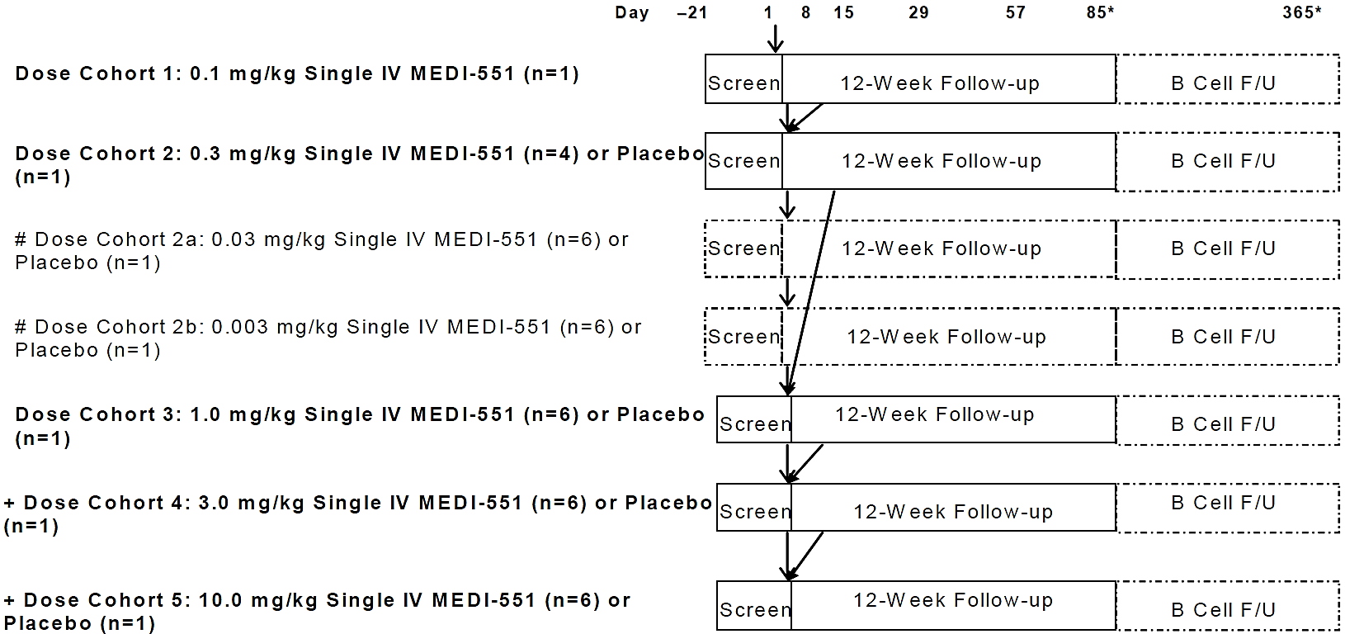
The median age of the subject population was 48.5 years (range, 21-64 years); the majority of subjects were female (67.9%) and White (85.7%). All subjects had systemic sclerosis (SSc) with at least moderate skin thickening.
Following single IV administration in this study inebilizumab (MEDI-551) exhibited nonlinear PK in the dose range investigated (0.1mg/kg-10.0mg/kg). The C_{max} of inebilizumab demonstrated a dose-proportional increase, whilst both areas under time curve indicating total systemic exposure (AUC_{last} and AUC_{inf}) increased more than dose proportionally (Table 3).
Table 3. PK parameters for inebilizumab by dose group in Study CP200.
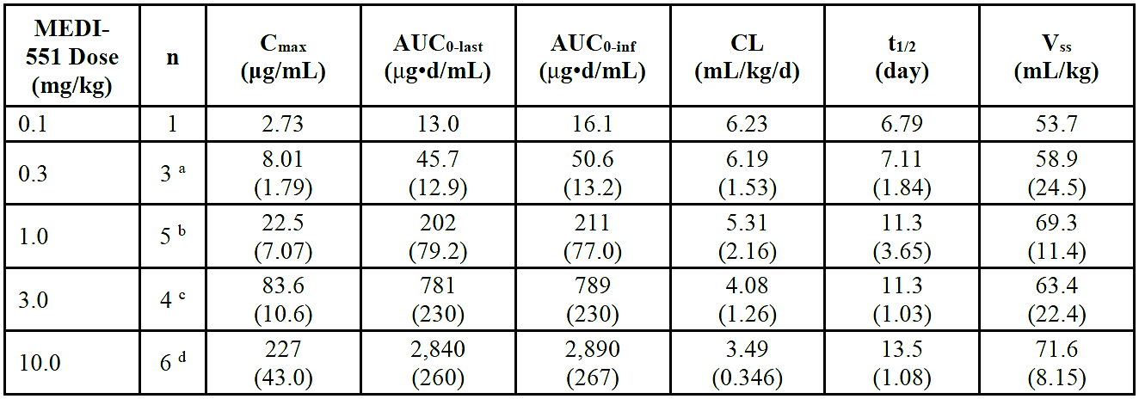
AUC_{0-inf}=area under the concentration-time curve extrapolated to infinity post dose; AUC_{0-last}= area under the concentration-time curve from dosing to last measurable time point; CL = systemic clearance; C_{max} = maximum observed concentration; d = day; n = number of subjects included in PK parameter summary statistics; PK = pharmacokinetic; t_{1/2}= terminal elimination half-life; V_{ss}=steady-state volume of distribution. Parameters are shown as mean (± standard deviation); parameter values are rounded to 3 significant figures.
ª N=4 for C_{max}
^{b} N=6 for C_{max}
^{c} N=5 for t_{1/2}
^{d} N=7 for C_{max}

Study 1102
This was a Phase 1, multicentre, multinational, randomized, blinded, placebo-controlled, dose-escalation study to evaluate the safety and tolerability of intravenous or subcutaneous doses of MEDI-551 in adult subjects with relapsing forms of multiple sclerosis (MS). The study was conducted between July 2012 and June 2016.
A total of 28 subjects were randomised into 5 different cohorts, with each cohort randomized in a 3:1 ratio to receive the investigational product inebilizumab (MEDI-551) or placebo with different doses as well as different routes of administration (subcutaneous or intravenous) in each cohort as follows:
- Cohort 1: 30 mg × 2 IV MEDI-551 (n = 6) or IV placebo × 2 (n = 2)
- Cohort 2: 100 mg × 2 IV MEDI-551 (n = 3) or IV placebo × 2 (n = 1)
- Cohort 3: 60 mg × 1 SC MEDI-551 (n = 3) or SC placebo × 1 (n = 1)
- Cohort 4: 300 mg × 1 SC MEDI-551 (n = 3) or SC placebo × 1 (n = 1)
- Cohort 5: 600 mg × 2 IV MEDI-551 (n = 6) or IV placebo × 2 (n = 2)
Cohorts 1,2 and 5 received intravenous doses of inebilizumab that were administered twice as fixed dose intravenous doses on day and day 15. The study period consisted of 3 periods: Screening (Day -28 to Day -1), Treatment/Follow-up (Day 1 to Day 169), and long term follow up for B-cell Recovery (Day 170 to 18 months or longer). The study design is outlined in Figure 3.
Figure 3. Study design for Study 1102
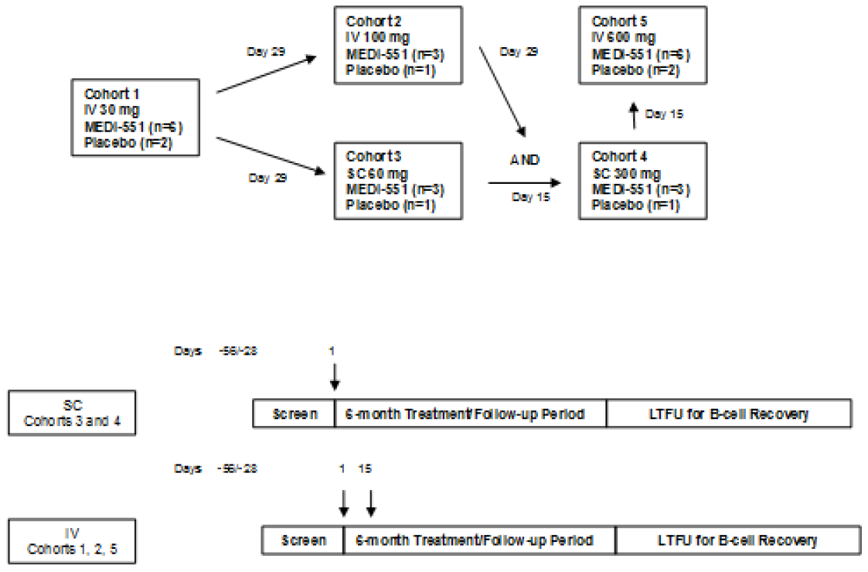
IV = intravenous; LTFU = Long-term Follow-up; SC = subcutaneous.
Note: Dosing for IV cohorts was to be on Days 1 and 15; SC cohorts were to be dosed on Day 1 only. Dosing in
Cohorts 2 and 3 was to begin after the last subject in Cohort 1 completed Day 29 and following confirmation that no significant safety events occurred in any subjects. Enrolment in Cohorts 2 and 3 could occur in parallel.
The primary objective was to evaluate safety and tolerability of ascending IV and SC doses of inebilizumab in adults with relapsing forms of multiple sclerosis (MS). Secondary objectives were to evaluate the PK and immunogenicity of inebilizumab and describe the PD effect of inebilizumab by assessing B cell depletion and repletion rates in peripheral blood samples.
The median age of the subject population was 44.0 years (range, 21 to 65 years); the majority of subjects were female (67.9%), not Hispanic or Latino (96.4%), and White (82.1%). All subjects had relapsing MS, with a median age of symptom onset of 29.7 years, median age at MS diagnosis of 32.7 years, and the median Expanded Disability Status Scale (EDSS) score was 4.0.
The primary objective to evaluate PK parameters reported that for the doses of 100mg and 600mg intravenously C_{max} and AUC_{0-last} and AUC_{0-inf} showed dose proportionality between these doses. The Sponsor has proposed intravenous doses of 300mg initially, then 300mg 2 weeks later then 300mg 6 monthly thereafter. The terminal eliminated half-life (t_{1/2}) of inebilizumab for the 100mg and 600mg IV doses was 17.7 days and 18.7 days respectively, this is in a similar range to other monoclonal antibodies (Table 4). The mean serum concentration profile is presented in Figure 4.
Table 4. PK parameters for study 1102
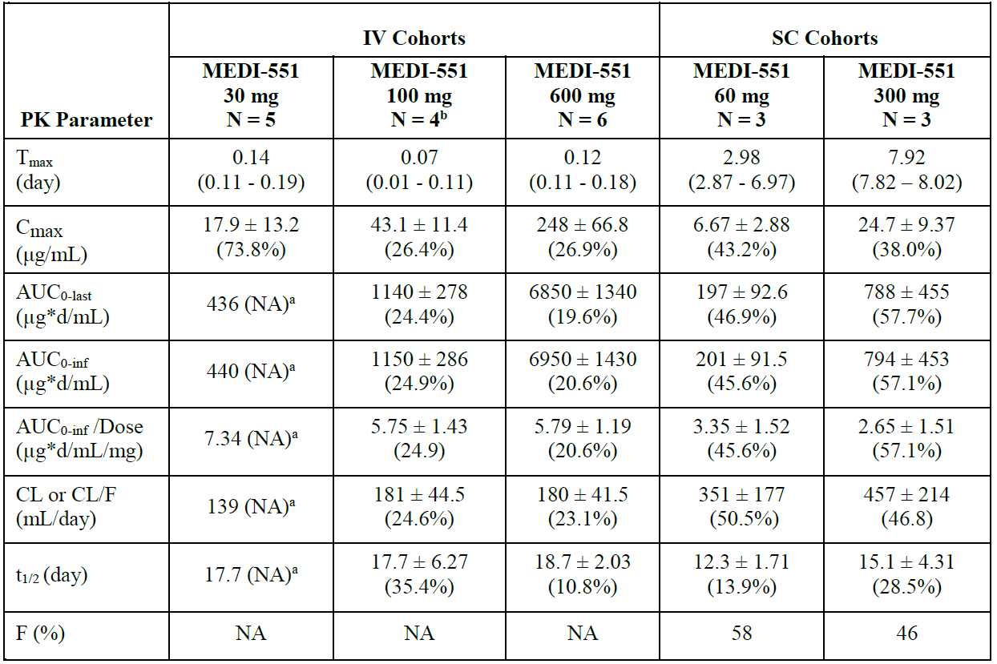
Note: All PK parameters are rounded to 3 significant figures except T_{max} (rounded to 2 decimal places) and bioavailability (presented as integer); Parameters are presented as arithmetic mean ± standard deviation (CV%) apart from T_{max}, displayed as median (range: min - max).
ª Standard deviation was not calculated due to limited sample size (n = 2). 2/5 subjects received only one dose and 1 subject had insufficient data.
^{b} Parameters presented were determined based on sample size of 3 as one subject received lower total dose (130 mg) compared to others; all data from this subject were excluded from summary statistics.
Figure 4. Mean serum inebilizumab concentration-time profile of different cohorts in study 1102.
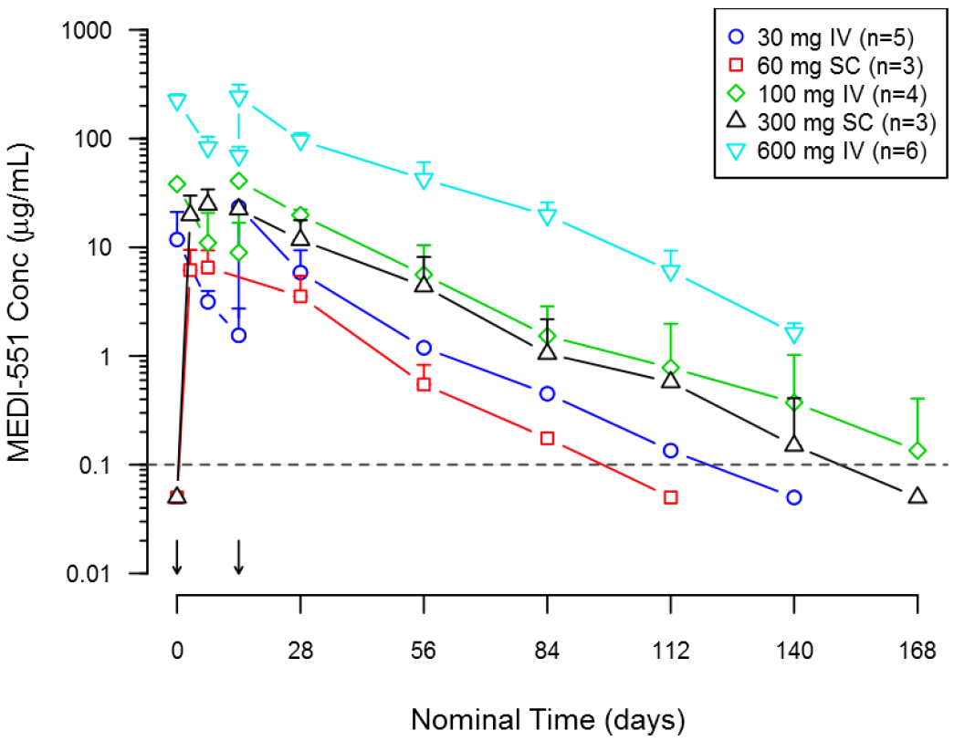
IV= intravenous; LLOQ = lower limit of quantitation; MS = multiple sclerosis; SC = subcutaneous.
Note: Data below LLOQ (0.1 μg/mL; as shown by dashed line) are plotted at 1/2 LLOQ for illustrative purposes only. Error bars represent standard deviation of the mean. Arrows indicate dosing events (IV on Days 1 and 15 and SC on Day 1).

Population PK data

Study PopPK-TS-001
The objectives of this population PK study were to:
- To characterize the PK properties of inebilizumab.
- To evaluate the potential impact of specified demographic and pathological covariates and concomitant medications usage on the PK exposure of inebilizumab in subjects with NMOSD.
As per the EMA evaluation the PopPK analysis included data from the 3 clinical studies with 213 adult subjects with NMOSD, SSc and relapsing MS, from single-dose or multiple-dose administrations, in a ~7 mg – ~700 mg dose range (Total of 1617 PK samples from 213 participants). 13.1% of subjects were ADA positive. The base model consisted in a two compartment population PK model with parallel linear and nonlinear elimination pathways. The target-mediated drug disposition model suggests that inebilizumab undergoes the receptor (CD19)-mediated CL. Because the total target amount (CD19) in subjects is expected to reduce after treatment of inebilizumab , the target-mediated drug CL may decrease over time, resulting in time-varying PK. An empirical time function that was introduced as a first-order process accounted for the reduction of the maximum velocity (V_{max}) of the nonlinear elimination pathway.
As per the EMA evaluation a correlation matrix plot of candidate covariates with respect to the 4 IIV of the parameters i.e., CL, volume of distribution in the central compartment (V_{c}), V_{p} (volume of distribution in the peripheral compartment) and V_{max}, included in the base model was used to screen the candidate covariates before the formal covariate search using the model-based likelihood ratio test. The final model considered body weight as the covariate that affects CL, V_{c}, inter-compartmental clearance (Q) and V_{p} and Study CP200 on V_{max} (with a 200% increase over the values estimated for the remaining studies). The final estimates for both the fixed and random parameters presented acceptable statistics (except for the first-order rate constant for decrease in V_{max}) and low Shrinkage (except for the V_{max}), were confirmed by bootstrapping and the overall look of the goodness-of-fit is acceptable. The visual predictive check is also generally acceptable with the observed lines contained in the prediction intervals except on the very last times where some underprediction is observed. Overall, the model seems appropriate for describing the PK of inebilizumab.
According to the PopPK model, inter-subject variability in CL and V_{c} was around 30% and 20% respectively. The residual (proportional) variability was also around 20%. Variability in AUC and C_{max} was around 30-40% in the studies where these parameters were determined.
The pop PK analysis did not indicate any impact of creatinine clearance/eGFR on CL of inebilizumab. However, data are sparse comprising 63 subjects with mild and only 3 with moderate impairment, and no subjects with creatinine clearance below 50ml/min were included in the analysis.
The pop PK analysis did not indicate any impact of hepatic impairment on inebilizumab CL. However, data are sparse comprising 19 subjects with mild, 2 subjects with moderate, and no subjects with severe impairment.
The PopPK included subjects from 18 to 73 years of age. Although the elderly were in very small number, age as a covariate was not included in the final PK model, and no dose adjustment is proposed for this population.
The descriptive statistics of the baseline categorical and continuous covariates are shown in Table 5.
Table 5. Descriptive statistics of baseline categorical and continuous covariates
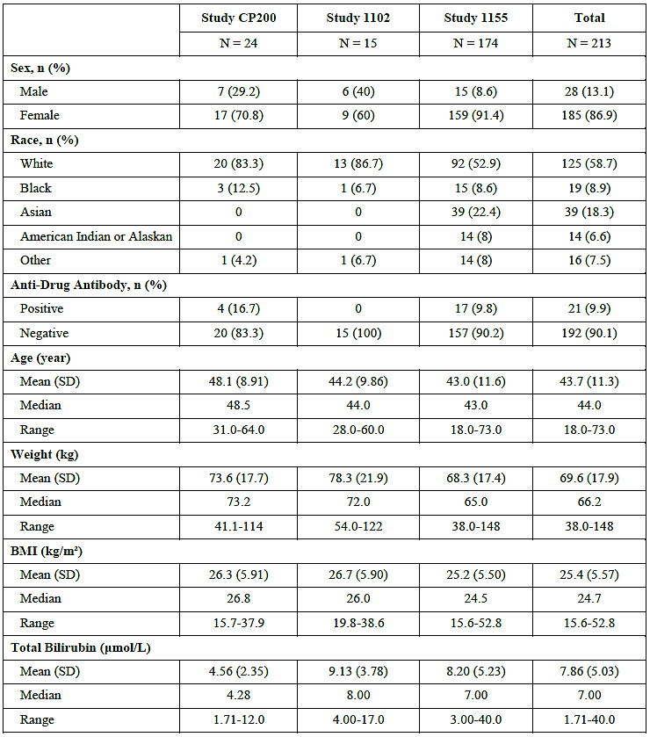
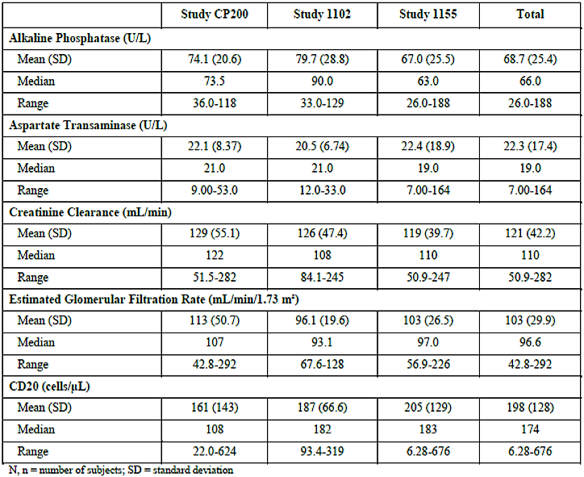
The Sponsor’s summary of this PopPK report regarding pharmacokinetic covariate assessment states:
- Body weight was included in the structural model for linear clearance and V_{c}, Q, and V_{p} as body weight has been proven to be a typical significant covariate on PK of monoclonal antibodies.
- The estimated V_{max} of Study CP200 (SSc) 1102 (MS) was different to that of Study 1102 (MS) and Study 1155 (NMOSD) by almost 2-fold. Each study enrolled subjects with different types of diseases, which confounds the interpretation of the effect on V_{max}. Nevertheless, at the therapeutic dose level where the nonlinear target-mediated elimination pathway is saturated, the difference in V_{max} is not expected to be clinically relevant.
- Several baseline covariate candidates that may affect PK of inebilizumab via various degrees of hepatic function (i.e., AST, ALP, TB), renal function (i.e., CrCL and eGFR) and target pool size [i.e., B cell (CD20) count] were evaluated from the Study 1155 data. The various levels of each baseline clinical chemistry measure were not associated with the individual CL estimate of inebilizumab.
- Physiologically, the effect of time-varying ADA status on clearance was regarded relevant in understanding PK of inebilizumab. Although there was a trend that the clearance of inebilizumab in ADA+ subjects was higher than that of ADA- subjects, the model that accounts for time-varying ADA status effect on clearance was not significant.
- The PK effect by prophylactic medications given prior to inebilizumab dosing was evaluated from Study 1155 data. They include paracetamol, diphenhydramine, prednisolone, and methylprednisolone. The fractional effect of each co-medication on clearance, compared to the model-estimated typical population parameter value, was similar.
- The impact of clinically relevant pathology measures at baseline on the PK was evaluated from Study 1155 data. The pathology baselines include aquaporin-4-antibody (AQP4-IgG) seropositive vs seronegative status; EDSS grouped as EDSS < 5 or EDSS ≥ 5; number of prior neuromyelitis optica spectrum disorders attacks as < 2 or ≥ 2; and disease duration category as < 5 years or ≥ 5 years. The 2 grouped distributions of the individual parameter estimates from each baseline measure were almost overlapped, indicating that these pathologically related clinical baseline measures had no impact on PK of inebilizumab.

Pharmacodynamics

Study CP200
The secondary endpoint of circulating B cell levels in study CP200 showed that there was rapid and sustained depletion of circulating CD20+ B cells based on blood samples in all subjects after a single dose of inebilizumab. In the subjects administered 0.3mg/kg-10.0mg/kg there was an approximate 75% depletion of CD20 B cells by day 15 after administration with more then 90% depletion for all dose group by day 57. There was higher and longer lasting CD20- B cell depletion in the dose groups 3.0mg/kg and 10.0mg/kg compared to the other dose groups, with the dose group 10mg/kg clearly having a significantly longer lasting effect on CD20 B Cell depletion compared to other dose groups. The maximum reduction in peripheral CD20+ B cells from baseline was 89.8, 98.2, 99.1 and 99.7% for 0.3, 1.0, 3.0, and 10.0 mg/kg IV dose groups respectively (Figure 5).
Figure 5. Median depletion of CD20 B cells in subjects administered different single doses of IV inebilizumab.
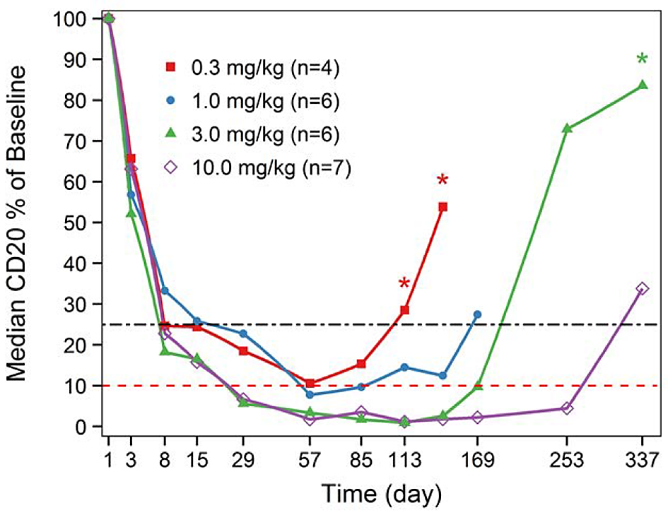
CD20 = cluster of differentiation 20; IV = intravenous.
* Denotes where sample size (n = 2); Depletion of the B-cell absolute counts was calculated relative to each subject’s baseline sample and shown as % of baseline. The median B-cell percentages of baseline were calculated for all subjects in a particular dose group at each time point. Rapid peripheral B-cell depletion after a single IV infusion of MEDI-551 was observed at all doses with earlier repletion at lower doses. Reference lines: upper black dot-dash line indicates 75% reduction from baseline; lower red dashed line indicates 90% reduction from baseline. The x-axis was square-root transformed for visualization purposes.

It should be noted that CD19 receptors are expressed in a wider lineage of B cells compared to CD20, with AQP4 antibodies originating from a subpopulation of CD19+ and CD20- B cells. The performed studies used CD20+ B cells as their marker of B cell depletion due to inebilizumab interfering with the recognition of the cell surface CD19 receptor in CD19 assays. This means the cells being measured are not the same B cells that are producing the AQP4 auto-antibodies.

Study 1102
Study 1102 showed there was a >99% and sustained B-cell depletion observed across all inebilizumab -treated groups. B cell levels reach ~90% reduction from baseline prior to the second IV dose on day 15 for all IV cohorts. Figure 6 shows median depletion and recovery of CD20+ B cells in each treatment cohort. Figure 7 shows median CD20 B cell counts as a percentage of baseline comparing placebo with all inebilizumab treatment groups.
Figure 6. Median depletion and recovery of CD20+ B cells in each treatment cohort.
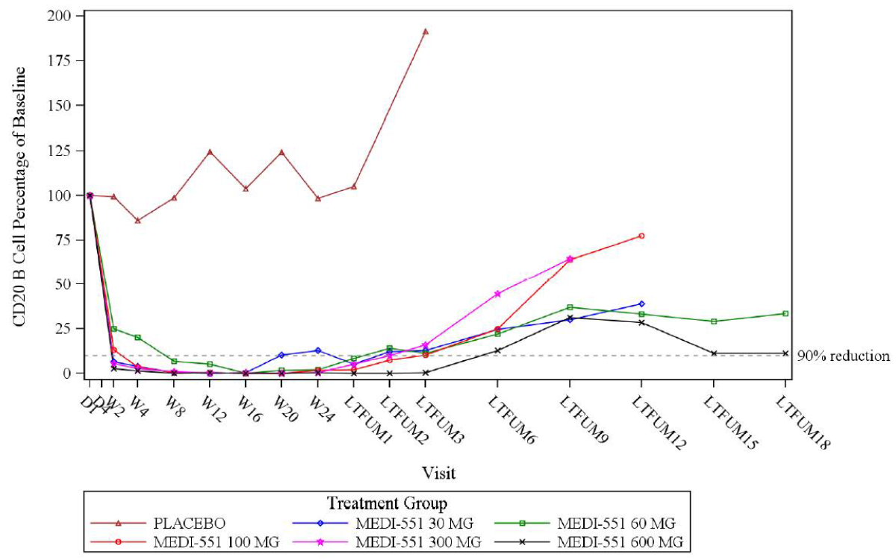
CD20 = cluster of differentiation 20; D = day; IV = intravenous; LTFUM = long-term follow-up month;
SC = subcutaneous; W = week.
Reference line indicates 90% reduction from baseline.

Study 1155
This randomised placebo-controlled study in subjects with diagnosed NMSOD had total of 174 subjects receiving inebilizumab compared to 56 in the placebo group.
Following treatment with inebilizumab, there was a profound decrease in CD20+ B cells during the 28-week randomized control period (RCP). CD20+ B cells were significantly reduced 8 days after inebilizumab infusion with these cell counts remaining below lower limit of normal in 100% of inebilizumab treated subjects at 4 weeks and 94% at 28 weeks after initial treatment.
Figure 7. Median CD20 B cell counts as percentage of baseline over time in the RCT intention to treat population.
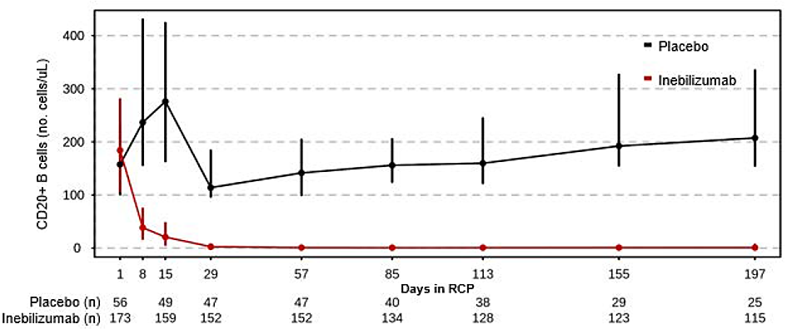
IQR = inter-quartile range; ITT = intent-to-treat; RCP = randomized control period.
Median blood CD20+ B-cell count as a percentage of baseline over time in inebilizumab and placebo-treated subjects plotted on a linear scale. Whiskers represent 25th to 75th IQR.
The presence of ADA did not appear to influence CD20+ B cell depletion throughout the 28-week RCP period with no statistically significant B cell count difference noted in inebilizumab treated subjects at any time point (Figure 8).
Figure 8. Peripheral blood median absolute CD20 B-cell count in inebilizumab and placebo-treated subjects in RCP by ADA status
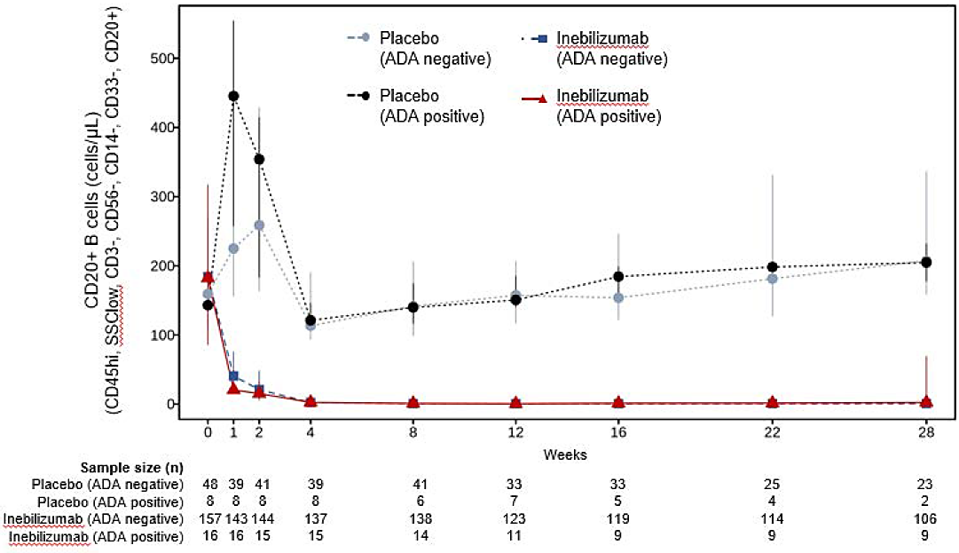
ADA = antidrug antibody; n = sample size; RCP = randomized-controlled period; SSC = side scatter.
Error bars represent the 25% and 75% percentile of each ADA group. CD20 counts between ADA positive and ADA negative inebilizumab -treated subjects were compared at each time point using a Mann-Whitney U test. No statistically significant differences (p < 0.05) were observed.
Following treatment with inebilizumab there was ongoing profound reduction in CD20+ B cell counts during the 28-week study period. The mean duration of suppression of ≥90% of CD20+ B cells for the IV 100mg treatment group was a mean of 182 days (min=140 days, max=229 days), for the SC 300mg group this mean was 200 days (min=175 days, max=213 days) and for the IV 600mg group the mean was 282 days (min=244 days, max=332 days).

Immunogenicity
No Subjects in study 1102 tested positive for anti-drug antibodies (ADAs).

Study CP200
In this study, anti-drug antibodies 4/24 (16.7%) were detected in inebilizumab-treated subjects (one in each treatment cohort). No subjects receiving placebo tested positive (N=4). All pre-dose ADA measurements were negative. All 4 ADA positive subjects had reduced serum levels of inebilizumab, and faster clearance compared to ADA negative subjects in the same dosing cohort. The development of ADA had no clear impact on B-cell depletion in subjects following a single dose of inebilizumab.

Study 1155
During the RCP period the ADA prevalence at any time, including baseline for the inebilizumab treated subjects was 17/174 (9.8%) and for the placebo subjects was 8/56 (14.3%). Population analysis comparing clearance in ADA positive, and ADA negative subjects showed no statistically significant difference in clearance between these two groups. Comparison of PK between ADA positive and ADA negative subjects is shown in Figure 11.
Figure 11. Comparison of PK between ADA positive and ADA negative subjects in study 1155.
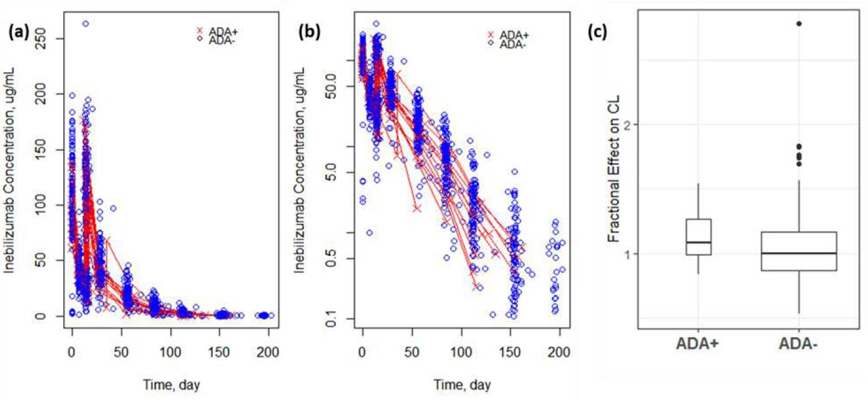
ADA+ = anti-drug antibody positive; ADA- = anti-drug antibody negative; CL = clearance; PK = pharmacokinetic;
The plots of (a) and (b) are in linear and log scale y-axis. The data from the ADA+ subjects are connected with lines. For the boxplot (c): the lower and upper hinges correspond to the first and third quartiles (inter-quartile: IQR), while the line inside in the box is the median of the distribution. The upper whisker extends from the hinge to the largest value no further than 1.5 * IQR from the hinge. The lower whisker extends from the hinge to the smallest value at most 1.5 * IQR of the hinge. Data beyond the end of the whiskers are called "outlying" points and are plotted individually as solid circles. Boxes are drawn with widths proportional to the square-roots of the number of observations in the groups.

Efficacy

Study 1155
Study 1155 is the pivotal study providing supportive evidence of efficacy, safety and tolerability for use of inebilizumab in treating NMOSD.
This was a phase 2/3, Double-masked, Placebo-controlled Study with Open-label Period to Evaluate the Efficacy and Safety of MEDI-551 in Adult Subjects with Neuromyelitis Optica and Neuromyelitis Optica Spectrum Disorders. The study was conducted at 81 sites across 24 countries. The study ran from January 2015 to November 2020.
Subjects were randomized in a 3:1 ratio to receive either inebilizumab 300mg intravenously on day 1 and day 15 or matching placebo. A total of 231 subjects were randomized to each treatment group with 175 randomized to inebilizumab (174 received the investigational medicinal product) and 56 received matching placebo. Overall, 223 (97%) completed the RCP with 6 (3.4%) of subjects discontinuing in the inebilizumab group and 2 (3.7%) discontinuing in the placebo group. Subjects were not allowed to be on other immunosuppressant treatment during the trial period, subjects were treated with equivalent of prednisolone 20mg/day of glucocorticoids for the first 14 days after inebilizumab infusion to provide prophylaxis against an NMOSD attacks during the time period in which inebilizumab was having the previously observed PD effect.
The primary objective of this study was to compare efficacy of inebilizumab versus placebo in reducing the risk of an NMOSD attack in subjects with NMOSD. Other secondary efficacy outcomes examined between treatment groups included comparing the expanded disability status scale (EDSS) between treatment groups, comparing change from baseline in low contrast visual acuity, compare the cumulative active MRI lesion count, compare rates of hospitalization due to NMSOD attacks. Further study endpoints included evaluating the safety and tolerability of a single course of inebilizumab in the RCP period and repeated course in the open label period (OLP). Characterization of the PK profile and immunogenicity were also secondary objectives. During the RCP period an independent adjudication committee (AC) evaluated possible NMSOD attacks. The protocol defined criteria for an NMSOD attack are listed in Table 6.
Table 6. Protocol-defined criteria for an NMOSD attack
Example Symptoms of an NMOSD Attack ª | Attack Type ^{b} | Protocol-Defined Attack Criteria
- Blurred vision  - Loss of vision  - Eye pain | ON | - > 15-character drop in high-contrast Landolt C Broken Rings Chart from last visit as measured in a previously affected eye and no other ophthalmological explanation  - ≥ 2-step drop in CF to NLP from last visit as measured in a previously affected eye and no other ophthalmological explanation  - ≥ 7-character drop in low-contrast Landolt C Broken Rings Chart from last visit as measured in either eye alone (monocular) AND a new RAPD in affected eye  - ≥ 7-character drop in low-contrast Landolt C Broken Rings Chart from last visit as measured in either eye alone (monocular) AND loss of a previously documented RAPD in fellow eye  - ≥ 5-character drop in high-contrast Landolt C Broken Rings Chart from last visit as measured in either eye alone (monocular) AND a new RAPD in affected eye  - ≥ 5-character drop in high-contrast Landolt C Broken Rings Chart from last visit as measured in either eye alone (monocular) AND loss of a previously documented RAPD in fellow eye  - ≥ 1-step drop ^{d} in CF to NLP from last visit as measured in a previously affected eye AND a new RAPD in affected eye  - ≥ 1-step drop ^{d} in CF to NLP from last visit as measured in a previously affected eye AND loss of a previously documented RAPD in fellow eye  - ≥ 7-character drop in low-contrast Landolt C Broken Rings Chart from last visit as measured in either eye alone (monocular) AND a new Gd-enhancing or new/enlarging T2 MRI lesion in the corresponding optic nerve ^{f}  - ≥ 5- or more character drop in high-contrast Landolt C Broken Rings Chart from last visit as measured in either eye alone (monocular) AND a new Gd-enhancing or new/enlarging T2 MRI lesion in the corresponding optic nerve. ^{f}  - ≥ 1-step drop ^{d} in CF to NLP from last visit as measured in a previously affected eye AND a new Gd-enhancing or new/enlarging T2 MRI lesion in the corresponding optic nerve ^{f}
- Deep or radicular pain  - Extremity  - paraesthesia Weakness  - Sphincter dysfunction  - Lhermitte’s sign (not in isolation) | Myelitis ^{e} | - ≥ 2-point worsening in 1 or more of the relevant (pyramidal, bladder/bowel, sensory) FSS compared to last visit  - ≥ 1-point worsening in EDSS score compared to last visit if previous EDSS score is 5.5 or more  - ≥ 1-point worsening in 2 or more of the relevant (pyramidal, bladder/bowel, sensory) FSS compared to last visit when the last visit score was 1 or greater AND a new Gd-enhancing or new/enlarging T2 MRI lesion in the spinal cord  - ≥ 0.5-point worsening in EDSS score compared to last visit if previous EDSS score is 5.5 or more AND a new Gd-enhancing or new/enlarging T2 MRI lesion in the spinal cord
- Nausea  - Intractable vomiting  - Intractable hiccups  - Other neurological signs ^{g} | Brainstem | - Isolated (not present at last visit) intractable nausea, vomiting, and/or hiccups lasting for greater than 48 hours AND a new Gd-enhancing or new/enlarging T2 MRI lesion in the brainstem  - ≥ 2-point worsening in 1 or more of the relevant (brainstem, cerebellar) FSS compared to last visit AND a new Gd-enhancing or new/enlarging T2 MRI lesion in the brainstem
Encephalopathy Hypothalamic dysfunction | Brain | 18. ≥ 2-point worsening in 1 or more of the relevant (cerebral, sensory, pyramidal) FSS (with a score of 3 or more at the current visit) compared to last visit AND a new Gd-enhancing or new/enlarging T2 MRI lesion in the brain consistent with the clinical presentation
CF = counting fingers; EDSS = Expanded Disability Severity Score; FSS = Functional System Scores;
Gd = gadolinium; HM = hand motion; LP = light perception; MRI = magnetic resonance imaging; NLP = no light
perception; NMOSD = neuromyelitis optica spectrum disorders; ON = optic neuritis; RAPD = relative afferent
pupillary defect.
a The symptoms listed are examples and are not inclusive of all NMOSD symptoms.
b Four major areas of the body may be affected by an attack: the optic nerve, resulting in ON; the spinal cord,
resulting in myelitis; the brainstem, resulting in a number of outcomes; and the brain.
c At least 2-step drop can be any of the following worsening: on Landolt C Broken Rings Chart to HM, LP,
or NLP; CF to LP or NLP; HM to NLP.
d At least 1-step drop can be any of the following worsening: on Landolt C Broken Rings Chart to CF, HM,
LP, or NLP; CF to HM or LP or NLP; HM to LP or NLP; LP to NLP.
e Note: A 1-point change in a single FSS without a change in the EDSS, with or without a new Gd-enhancing
or new/enlarging T2 MRI lesion in the spinal cord, is not considered a clinically significant change and will not
count as an attack per this protocol.
f Lesions seen in the optic chiasm also count toward these criteria.
g Other neurological signs may include double vision, dysarthria, dysphagia, vertigo, oculomotor palsy,
weakness, nystagmus, or other cranial nerve abnormality.
Subjects first entered a 28-day screening period and the randomized into each treatment group in a 3:1 ratio (IV inebilizumab 300 mg on Day 1 and on Day 15, or matching placebo). Subjects were followed for a period of 197 days for the RCP period. Subjects who experienced an AC attack or who completed the day 197 visit without an attack exited the RCP and had the option to enrol into the OLP and initiate or continue treatment with inebilizumab in a manner that did not unblind their RCP treatment. In the OLP subjects received an infusion of 300mg inebilizumab on day 1 and either inebilizumab or placebo on day 15 (depending on whether subject was receiving placebo or active treatment prior). Infusion of a single dose of 300mg inebilizumab then occurred every 6 months for remainder of the OLP (Figure 12). During both the RCP and OLP, all subjects were premedicated with IV methylprednisolone (80-125 mg or equivalent glucocorticoid), oral diphenhydramine (25-50 mg or equivalent antihistamine), and oral paracetamol (acetaminophen; 500-650 mg) to reduce infusion reactions.
Figure 12. Study 1155 design
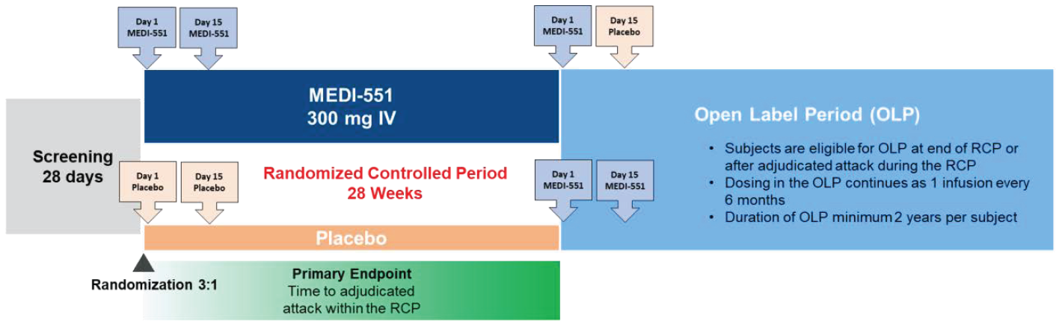
IV = intravenous; MEDI-551 = inebilizumab ; OLP = open-label period; RCP = randomized-controlled period.
The key inclusion criteria for the pivotal study 1155 were:
- adults aged 18 years and older
- EDSS score ≤ 7.5 (≤ 8.0 if the Investigator and medical monitor agreed that the subject was reasonably able to participate in the study).
- a diagnosis of NMOSD at the time of screening, and a documented history of one of the following:
  - ≥ 1 NMOSD attacks that required rescue therapy in the previous year
  - ≥ 2 NMOSD attacks that required rescue therapy in the preceding 2 years
- evidence of recent disease activity (≥ 1 relapse in the prior year, or ≥ 2 in the prior 2 years, that required rescue therapy). If recent relapse must have had stable symptoms since relapse for at least 4 weeks.
The key exclusion criteria were:
- uncontrolled hypertension
- any concomitant disease other than NMOSD that required treatment with oral or IV steroids at doses > 20 mg/day for > 21 days within the 6 months prior to screening.
- any concurrent autoimmune disease that is either uncontrolled or required the use of disease-modifying agents or immunosuppressive agents.
- any live or attenuated vaccine within 3 weeks prior to Day 1, Bacillus of Calmette and Guérin vaccine within 1 year of signing the ICF.
- clinically significant serious active or chronic viral or bacterial infection within 60 days prior to randomization.
- known history of a primary immunodeficiency (congenital or acquired) or an underlying condition such as human immunodeficiency virus (HIV) infection or splenectomy that predisposed the subject to infection.
- total Ig < 600 mg/dL or absolute neutrophil count < 1200 cells/μL or CD4 T lymphocyte count < 300 cells/μL at screening, confirmed positive test for hepatitis B/hepatitis C serology, positive QuantiFERON®-TB Gold test (unless an appropriate course of anti-tuberculosis treatment had been documented).
- history of cancer (apart from squamous cell or basal cell carcinoma of the skin treated with documented success of curative therapy > 3 months prior to randomization).
- prior use of Alemtuzumab or total lymphoid irradiation or bone marrow transplant or T-cell vaccination therapy.
- use of rituximab or any experimental B-cell depleting agent within the 6 months prior to screening unless the subject has B-cell counts above the LLN according to the central laboratory.
- receipt of intravenous immunoglobulin (IVIG) within one month prior to randomization.
- receipt of natalizumab or cyclosporin or methotrexate or mitoxantrone or cyclophosphamide or tocilizumab or eculizumab within 3 months prior to randomization.
- severe drug allergic history or anaphylaxis to 2 or more food products or medicine.
- estimated glomerular filtration rate of < 60 mL/minute.
- lactating or pregnant females or females who intend to become pregnant anytime from signing the ICF through the study plus 6 months following last dose of investigational product.
- any of the following blood test abnormalities at screening: AST or ALT > 2.5 × ULN, total bilirubin > 1.5 × ULN (unless due to Gilbert’s syndrome), platelet count < 75,000/μL (or < 75 × 109/L), haemoglobin < 8 g/dL (or < 80 g/L), glycosylated haemoglobin > 8% at screening (subjects with diabetes only), CD19+ B cell counts below the LLN according to the central laboratory.
Of note both AQP4-IgG seropositive and seronegative subjects were allowed to be included in this study.
Using the primary efficacy outcome of AC determined NMSOD attack the study was aimed at detecting a relative reduction of 60% in risk for time from day 1 to onset of an AC-determined NMSOD attack on or before day 197 with at least 90% power and a=0.05 (two-sided). This would require a total of 67 AC-determined NSMOD attacks for the intention to treat (ITT) population. The comparable overseas regulator (EMA) has used a multiplicity adjustment strategy based on Bonferroni-based chain procedure for testing of the 10 hypothesis proposed by the Sponsor, with the primary efficacy outcome receiving initial weight of 1 (the alpha level = 0.05).
Demographic characteristics of the ITT population included a mean age of 42.9 years, which was similar in both treatment groups. >90% of subjects were female in the ITT population which was similar across both treatment groups. >82% had been diagnosed with NMSOD in the last 5 years, with mean duration of 2.49 years .10 (4.3%) of subjects were ≥65 years old. Overall, 120 (52.2%) subjects were defined as white, 47 (20.4%) were defined as Asian, 20 (8.7%) as black or African American and 19 (8.3%) as American Indian/Alaskan native. Race appeared to be well balanced across treatment groups. 213 (92.6%) subjects were AQP4-IgG seropositive and 17 were AQP4-IgG seronegative in the ITT population.
A total of 467 people were screened for eligibility with 231 randomised (Figure 13). The most common reason for screening failure was not meeting the inclusion/exclusion criteria (n=236). A total of 175 subjects were allocated to inebilizumab treatment, 56 subjects were randomised to the placebo group. 169 subjects completed the RCP in the inebilizumab group and 54 subjects completed the RCP in the placebo group. The 6 subjects who did not complete the RCP in the inebilizumab group were due to adverse event (n=2), withdrawal of consent (n=1) and other (n=3). 223 subjects (97%) completed the RCP and 213 entered into the OLP period.
Figure 13: Subject disposition during the RCP.
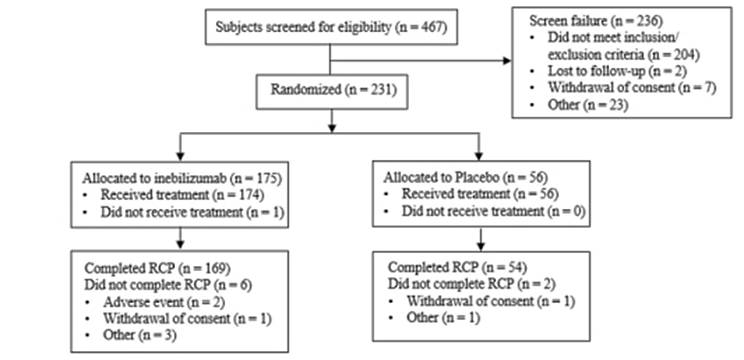
230 subjects were included in the ITT analyses. 1 subject not included in the ITT did not receive the IMP and was excluded from efficacy and safety analysis as this subjects had an NMSOD attack prior to receiving the IMP resulting in discontinuation from the RCP.
The primary endpoint was time (days) from day 1 to onset of AC-determined NMSOD attack on or before day 197. Overall, the number of subjects in the ITT population during the RCP period determined to have an NMSOD attack was 22 (39.3%) in the placebo group compared to 21 (12.1%) in the inebilizumab group. The hazard ratio (HR) of an AC determined attack was 0.272 (95% CI 0.1496, 0.4961) with a p-value = <0.0001. Similar results were noted in the AQP4-IgG seropositive group with 22 (42.3%) in placebo experiencing an attack of NMSOD compared to 18 (11.2%) in the inebilizumab treatment group with a HR of 0.227 (95% CI 0.1214, 0.4232) and p-value = <0.0001 (Table 7).
Table 7. Time to AC-determined NMSOD attack in ITT population during the RCP period.
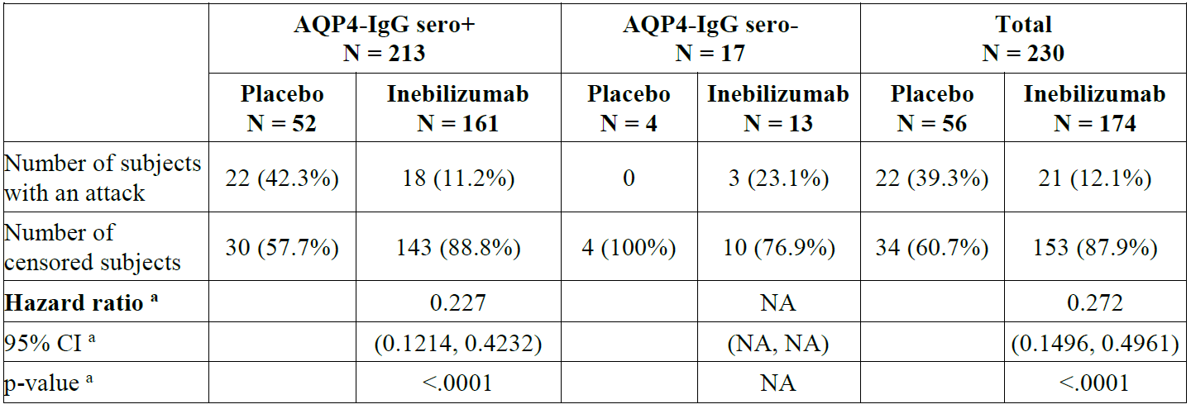
AQP4-IgG = autoantibodies against aquaporin-4; CI = confidence interval; NA = not applicable;
ITT = intent-to-treat; NMOSD = neuromyelitis optica spectrum disorders; sero- = seronegative; sero+ = seropositive.
a Based on Cox regression method, with placebo as the reference group.
Figure 14: Time to AC-determined NMSOD attach during RCP period in AQP4-IgG seropositive ITT population.
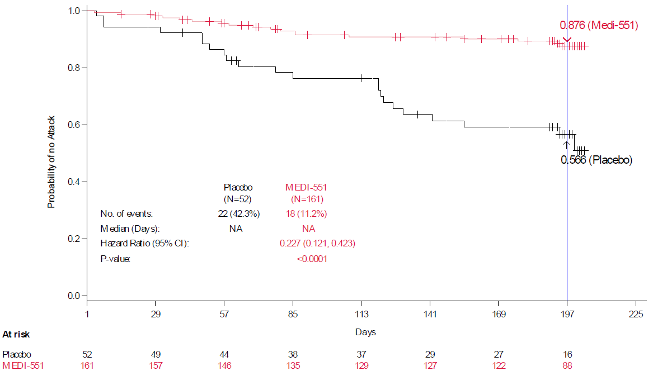AQP4-IgG = autoantibodies against aquaporin-4; CI = confidence interval; ITT = intent-to-treat; MEDI-551 = inebilizumab ; NA = not applicable; NMOSD = neuromyelitis optica spectrum disorders
Table 8: Results of multiple sensitivity analysis for RCP in ITT population
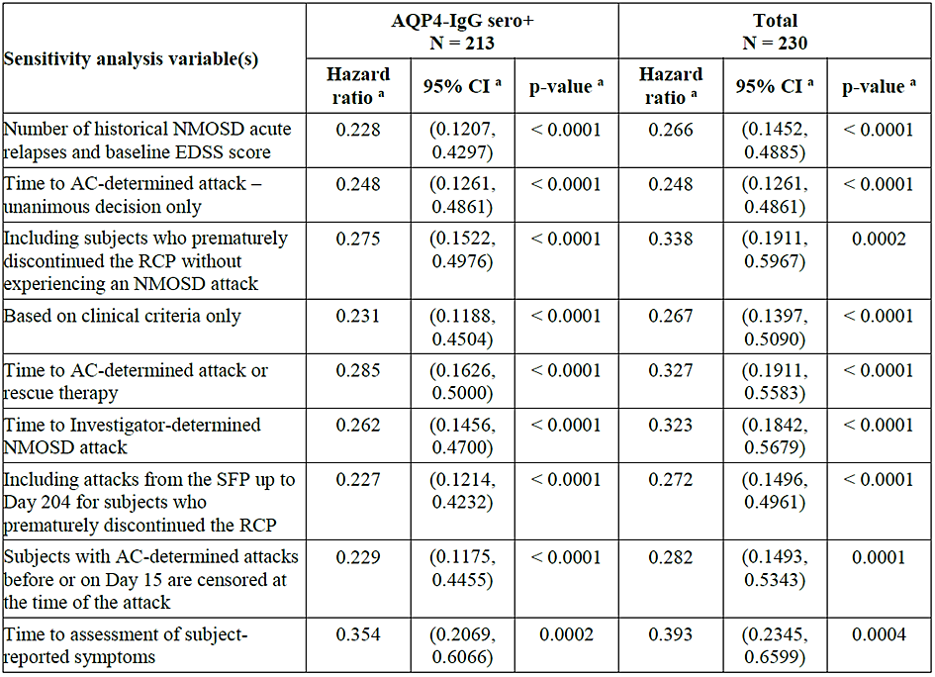
AQP4-IgG = autoantibodies against aquaporin-4; AC = Adjudication Committee; CI = confidence interval;
EDSS = Expanded Disability Status Scale; ITT = intent-to-treat; NMOSD = neuromyelitis optica spectrum disorders; RCP = randomized-controlled period; sero+ = seropositive; SFP = safety follow-up period.
a Based on Cox regression method, with placebo as the reference group
Other variables measured were consistent with the primary efficacy outcome showing HR between 0.20-0.354 for the measured variables with all outcomes being statistically significant.
A key secondary efficacy outcome was worsening from baseline in EDSS at last visit (Table 9). 18(34.6%) subjects in the placebo and 25 (15.5%) in the AQP4-IgG positive groups were defined as having worsening from baseline in EDSS from baseline to last visit. The OR for this value is 0.371 (95% CI 0.1807, 0.7633) and p-value = 0.007.
Table 9: Worsening from baseline in EDSS score using logistical regression model during RCP period in ITT population.
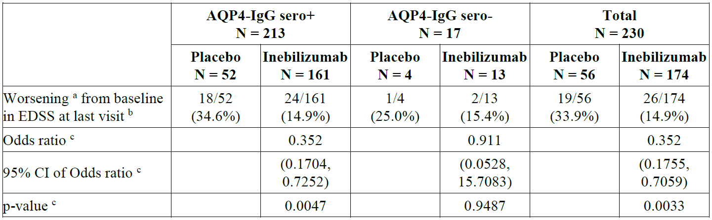
AQP4-IgG = autoantibodies against aquaporin-4; CI = confidence interval; EDSS = Expanded Disability Status
Scale; ITT = intent-to-treat sero+ = seropositive; sero- = seronegative.
a A subject was considered to have a worsening in EDSS score if one of the following criteria was met:
(1) Worsening of 2 or more points in EDSS score for subjects with baseline score of 0; (2) Worsening of 1 or more points in EDSS score for subjects with baseline score of 1 to 5; (3) Worsening of 0.5 points or more in EDSS score for subjects with baseline score of 5.5 or more.
b Subjects with missing data are imputed as 'worsening'. Denominator represents the total number of subjects in each treatment group with baseline.
c Odds ratio, its 95% CI, and p-value are estimated by logistic regression model, using non-responder imputation, i.e., missing values will be considered as 'worsening'.
Low contrast visual acuity score least square mean changes from baseline to last RCP visit were similar between the placebo and inebilizumab groups. No statistically significant changes between groups were noted.
Cumulative total active MRI lesions (new gadolinium enhancing or new/enlarging T2 lesions) were measured as a secondary endpoint during the RCP. Subjects were only included in calculations of mean number of new MRI lesions if they had at least one MRI lesion. Mean cumulative number of active MRI lesions using a negative binomial regression model over the RCP period in the AQP4 IgG seropositive ITT population was 2.3 in the placebo group (n=31) and 1.7 (n=74) in the inebilizumab treatment group. The rate ratio (which is rate ratio reduction in cumulative active MRI lesions based in all subjects in the entire ITT population, not just those who had event) in the AQP4-IgG seropositive group was 0.568 (95% CI 0.3851, 0.8363) with a p-value = 0.0042. During the RCP period in the whole ITT population 45.3% subjects in the inebilizumab group had new gadolinium-enhancing MRI lesions compared to 59.6% in the placebo group. Of note in the AQP4-IgG seropositive group 21.7% in the inebilizumab group had new MRI lesions compared to 40.4% in placebo.
Number of NMSOD related inpatient hospitalizations was also measured, as defined by more than an overnight stay in hospital. In the AQP4-IgG seropositive ITT population over the RCP period there was a mean of 1.4 hospitalizations in the placebo group (n=52) compared to 1.0 (n=161) in the inebilizumab group. The rate ratio was 0.258 (95% CI 0.0904, 0.7384) with a p-value = 0.0115.
The secondary efficacy outcomes included use of an annualized AC-adjudicated NMSOD attack rate expressed as an annualized attack rate, this was measured over the RCP and open label period. In the day 80 EMA report an updated annualized AC-determined NMOSD attack rate was provided on 6th June 2019. This showed an annualized attack rate of 0.118 in the AQP4-IgG seropositive group (Table 10).
Table 10. Annualized AC determined NMOSD attack rate provided on day 120 safety update (6th June 2019)
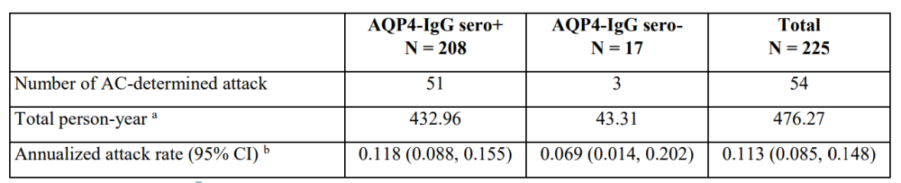
AC = Adjudication Committee; AQP4-IgG = autoantibodies against aquaporin-4; NMOSD = neuromyelitis optica spectrum disorders; SFP = safety follow-up period; sero- = seronegative; sero+ = seropositive.
a Total person-years will be calculated as the sum of the person-years for individual subject. Person-year for individual subject is defined as (Date of last day before SFP - first inebilizumab dose date +1)/365.25.
b Annualized attack rate is defined as total number of AC-determined attacks divided by total person-years.
Severity of attacks was a secondary outcome measured using an exploratory scale (opticospinal impairment scale [OSI]) based on degree of neurological worsening since prior assessment. During the RCP in the AQP4-IgG seropositive group 6 (33.3%) subjects in the inebilizumab group experienced a major NMOSD attack compared to 10 subjects (45.5%) in the placebo group (Table 11).
Table 11. Annualized AC determined NMOSD attack rate by recovery grades
Table 11. Annualized AC determined NMOSD attack rate by recovery grades
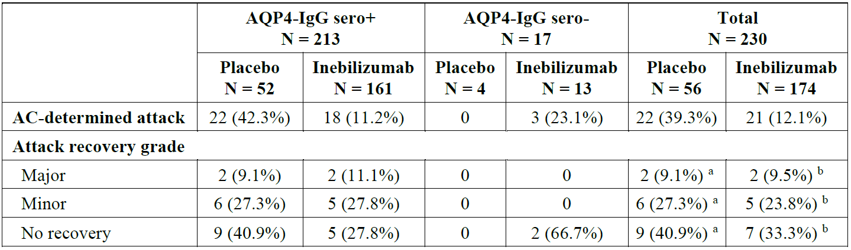
AC = Adjudication Committee; AQP4-IgG = autoantibodies against aquaporin-4; ITT = intent-to-treat;
NMOSD = neuromyelitis optica spectrum disorders; RCP = randomized-controlled period; sero+ = seropositive; sero- = seronegative.
a In the placebo group, the number of subjects for whom recovery data were collected was 17. Using this as a denominator to calculate percentages yields the following: Major, 11.8%; Minor, 35.5%; No recovery, 52.9%.
b In the inebilizumab group, the number of subjects for whom recovery data were collected was 13. Using this as a denominator to calculate percentages yields the following: Major, 15.4%; Minor, 38.5%; No recovery, 46.2%.
Attack domains with subscale scores from both attack visit and attack follow-up visit equal to 0 are not presented in the table; Attack follow-up visits are within 35 days of the attack visits.
Percentages for AC-determined attack are based on the number of subjects in each treatment group.
Percentages for each domain are based on the number of subjects with AC-determined attacks in each treatment group.
The exploratory outcome of comparison of modified ranking scale between inebilizumab treated subjects and placebo was analysed. This treatment effect was evaluated by the Wilcoxon-Mann-Whitney odd approach. During the RCP the AQP4-IgG seropositive subjects were 75.2% more likely to report less disability compared to placebo. In 53% of possible pairs of inebilizumab and placebo subjects, inebilizumab subjects had a better than placebo at the last visit and in 25.6% of pairs placebo subjects had a better outcome, in 21.4% of pairs inebilizumab subjects were tied with placebo. This gave a Wilcoxon-Mann-Whitney odds of 1.752 (p-value=0.0013).
Exploratory analysis of time to first NMSOD attack in the combined RCP and OLP period showed that the product limit survival estimates for time to first AC determined NMSOD attack for the inebilizumab group were 88.7% at day 197 (end of RCP period) and 85.1% at day 365 (end of open label period). In the placebo group product limit survival estimate for time to first NMSOD attack at the end of the RCP was 57.7%, at which time placebo treated subjects were rolled over to inebilizumab treatment and at day 365 of the open label period the survival estimate was 46.9%. The risk of first NMSOD attack seemed to be significantly higher in the placebo group during the RCP period compared to the open label period, when subjects were treated with inebilizumab (Figure 15).
Figure 15: Time to first AC-determined NMSOD attack during RCP and OLP in AQP4-IgG seropositive subjects
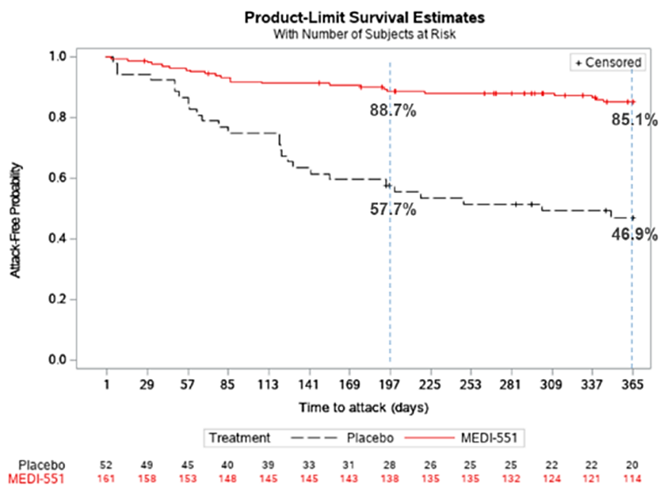
In subgroup analysis of the primary endpoint there was no significant difference in hazard ratio (HR) between all ADA positive subjects compared to ADA negative subjects in inebilizumab treated subjects compared to placebo.

Safety
The evaluation of safety of inebilizumab for treatment of patients with NMSOD is based on data from the previously discussed 3 trials:
- Single pivotal study 1155.
- Supporting phase I study CP200
- Supporting phase I study 1102.
Table 12: Clinical studies submitted that contribute to safety evaluation
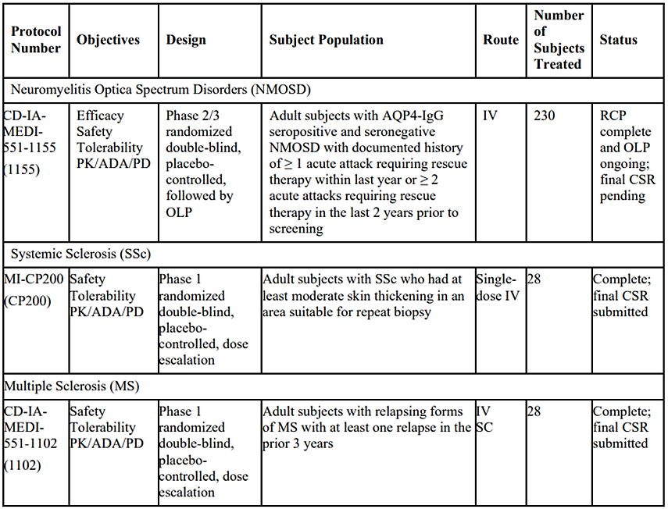
ADA = anti-drug antibodies; AQP4-IgG = aquaporin 4 immunoglobulin G; CSR = clinical study report, IV = intravenous, MS = multiple sclerosis; NMOSD = neuromyelitis optica spectrum disorders; OLP = open label period; PD = pharmacodynamic, PK = pharmacokinetic, RCP = randomized controlled period; SC = subcutaneous; SSc = systemic sclerosis.
A total of 225 adult subjects with NMSOD (study 1155), 24 adult subjects with scleroderma (Study CP200) and 21 subjects with multiple sclerosis (MS) (study 1102).

Safety analysis study 1155
During the RCP period 96.6% in the inebilizumab group and 94.6% in the placebo group received the doses of investigational product on day 1 and day 15. The total person-years exposure in the RCP was 82.51 in the inebilizumab group and 24.25 in the placebo group.
Two subjects (3.6%) in the placebo group and 6 (3.4%) in the inebilizumab group did not complete the RCP. Of the 6 subjects in the inebilizumab group who withdrew from the RCP, 2 discontinued due to AEs: 1 subject with worsening of myasthenia gravis and 1 subject with atypical pneumonia. The other 4 subjects in the inebilizumab group who discontinued the RCP were due to due to “other” (n=3) and “withdrawal of consent” (n=1). Two patients discontinued inebilizumab in the open-label extension period due to AEs (due to “steroid withdrawal syndrome” and “neutropenia”, respectively).
Across both the RCP and the OLP, 225 subjects received one or more doses of inebilizumab , 62.3% across both periods in any inebilizumab group received the investigational product for >548 days. As of end of study, the total person years of inebilizumab exposure was 730.36. Exposure during these trial periods is presented in Tables 13 and 13. Two (3.6%) subjects in the placebo group and 6 (3.4%) in the inebilizumab group did not complete the RCP. From the inebilizumab group 2 discontinued due to adverse events (1 with worsening myasthenia gravis and 1 with atypical pneumonia), 3 discontinuations from the inebilizumab group were due to reason of “other” and 1 was “withdrawal of consent”.
Table 13. Exposure to inebilizumab, RCP (as-treated population, study 1155)
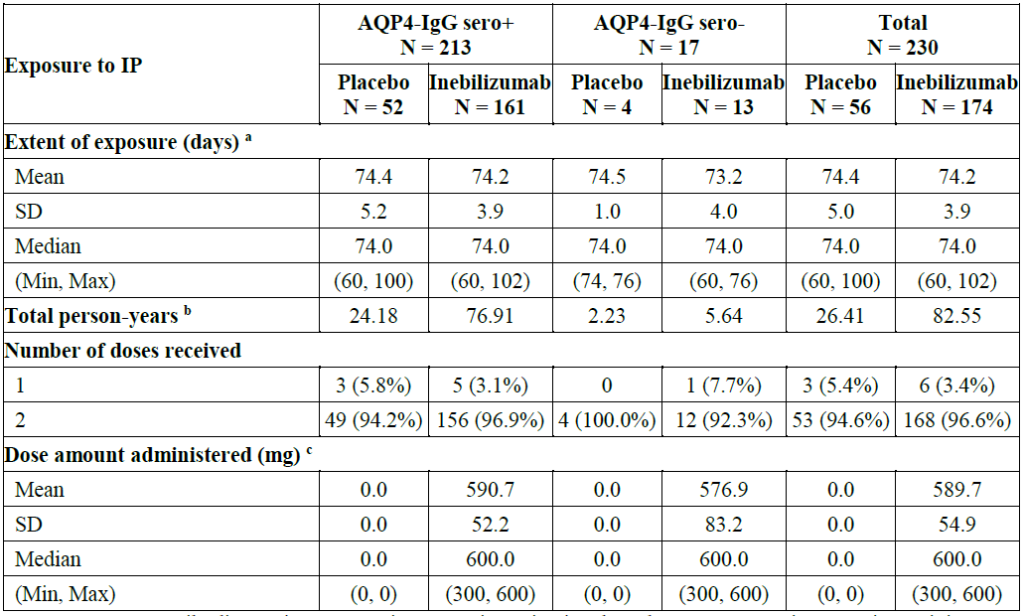
AQP4-IgG = autoantibodies against aquaporin-4; Max = maximum; Min = minimum; N = number of subjects; OLP = open-label period; RCP = randomized, controlled period; SD = standard deviation; sero- = seronegative; sero+ = seropositive; SFP = safety follow-up period. a Extent of exposure is defined as last RCP dose date -1st RCP dose date + 60 (based on 5 half-lives of inebilizumab) b Total person-years will be calculated as the sum of the person-years for individual subject. Person-year for individual subject is defined as (Date of last day before OLP or SFP - 1st RCP dose date +1)/365.25.
Total dose will be estimated based on actual volume administered, if dose was not fully administered.
Table 14. Exposure to inebilizumab, OLP and any inebilizumab population (study 1155)
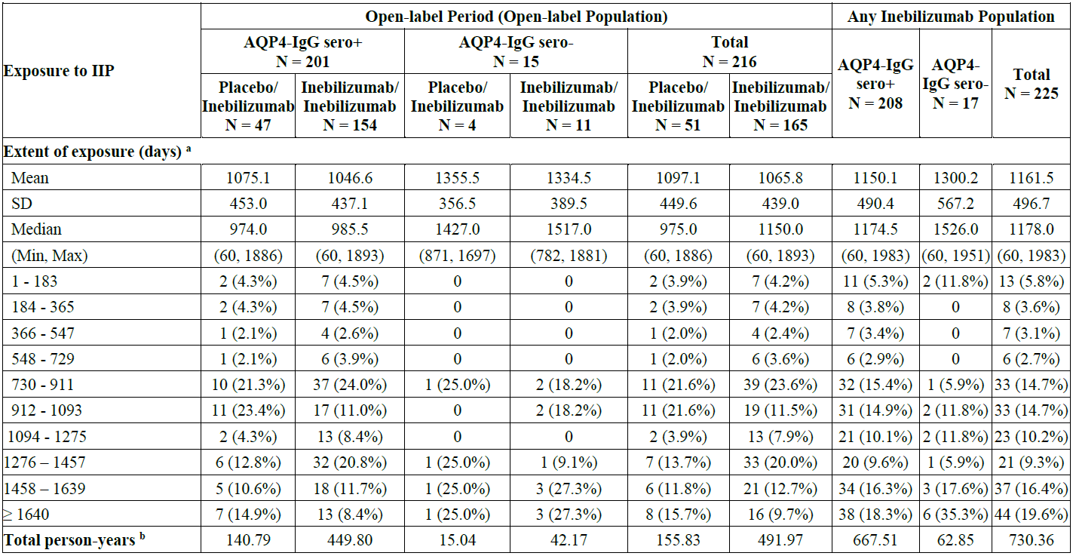
AQP4-IgG = autoantibodies against aquaporin-4; IP = investigational product; Max = maximum; Min = minimum; OLP = Open-label period; SD = standard
deviation; sero+ = seropositive; sero- = seronegative; SFP = safety follow-up period.
ª Extent of exposure was defined as last inebilizumab dose date (OLP) excluding placebo dose at Day 15 - first inebilizumab dose date + 60 (based on 5 half-lives of inebilizumab ).
^{b} Total person-years was calculated as the sum of the person-years for individual subject. Person-year for individual subject was defined as (Date of last day before SFP - first inebilizumab dose date + 1)/365.25.
During the RCP similar proportions of subjects had at least one treatment emergent adverse event TEAE with 41 (73.2%) in the placebo group and 127 (73.0%) in the inebilizumab group experiencing at least one TEAE (Table 15).
Table 15. Overall summary of treatment-emergent adverse events, randomized-controlled period (as-treated population, study 1155)
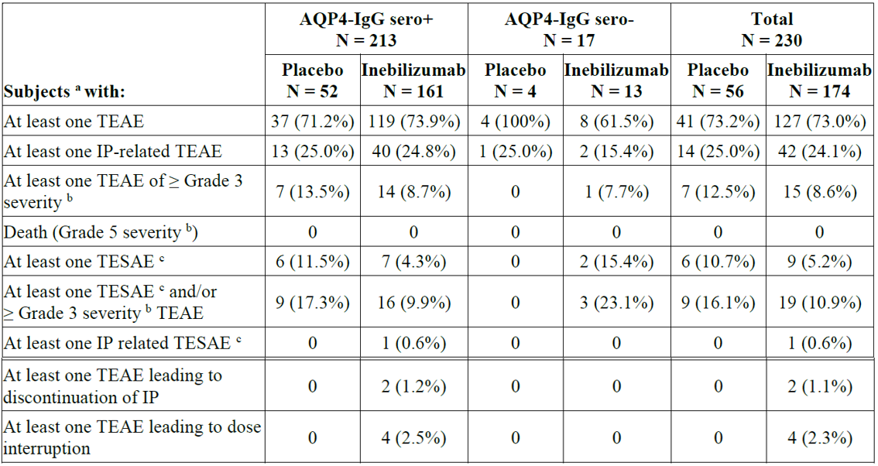
AQP4-IgG = autoantibodies against aquaporin-4; IP = investigational product; sero+ = seropositive;
sero- = seronegative; TEAE = treatment-emergent adverse event; TESAE = treatment-emergent serious adverse event.
ª Subjects are counted once for each category regardless of the number of events.
^{b} Grade 3: Severe, Grade 4: Life-threatening, Grade 5: Fatal.
^{c} Serious adverse event criteria: death, life-threatening, required inpatient hospitalization, prolongation of existing hospitalization, persistent or significant disability/incapacity, important medical event, congenital anomaly/birth defect (in the offspring of the subject).
During the OLP 61 (28.2%) subjects had at least one TESAE and/or ≥ Grade 3 TEAE with 21 (41.2%) in the placebo/inebilizumab group and 40 (24.2%) in the inebilizumab /inebilizumab groups (Table 16)
Table 16. Overall summary of treatment-emergent adverse events, open-label period (as-treated population, study 1155)
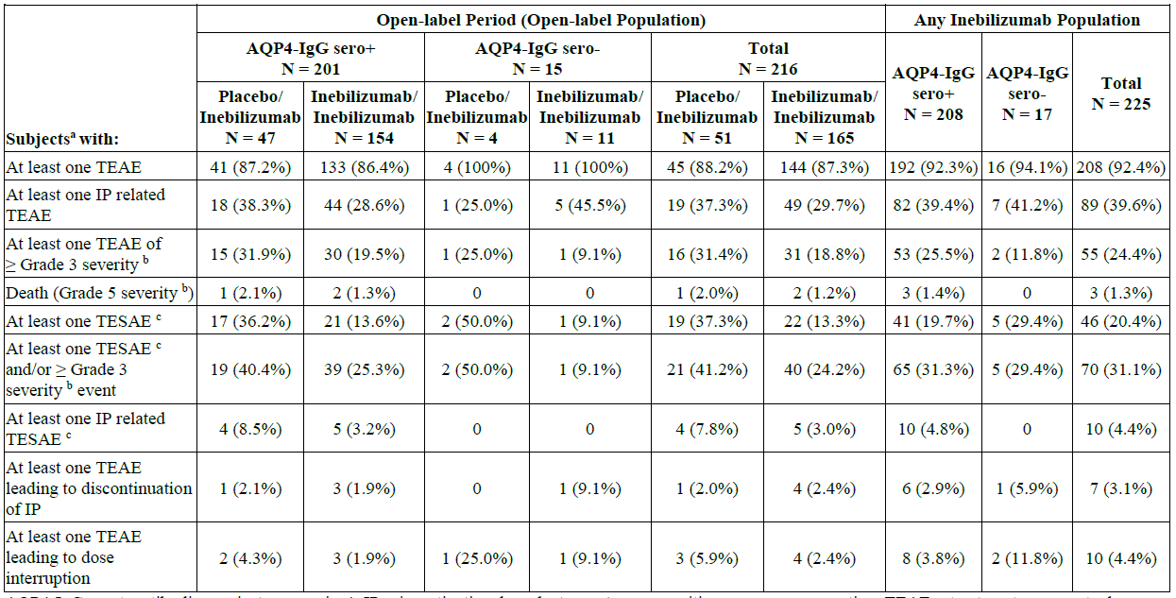
AQP4-IgG = autoantibodies against aquaporin-4; IP = investigational product; sero+ = seropositive; sero- = seronegative; TEAE = treatment-emergent adverse event; TESAE = treatment-emergent serious adverse event.
ª Subjects are counted once for each category regardless of the number of events.
^{b} Grade 3: Severe, Grade 4: Life-threatening, Grade 5: Fatal.
^{c} Serious adverse event criteria: death, life-threatening, required inpatient hospitalization, prolongation of existing hospitalization, persistent or significant disability/incapacity, important medical event, congenital anomaly/birth defect (in the offspring of the subject).
During the RCP period the most common, the most common TEAEs by preferred term (PT) in the inebilizumab group were urinary tract infection in 20 (11.5%) subjects, arthralgia in 17 (9.8%), and infusion-related reaction in 16 (9.2%). In the placebo group, the most common TEAEs were infusion-related reaction in 6 (10.7%) subjects, nasopharyngitis in 6 (10.7%), urinary tract infection in 5 (8.9%), depression (8.9%), and pruritus (8.9%) (Table 17).
Table 17. Treatment-emergent adverse events (≥ 5% in total inebilizumab group) by system organ class and preferred term, randomized controlled period (as-treated population, study 1155)
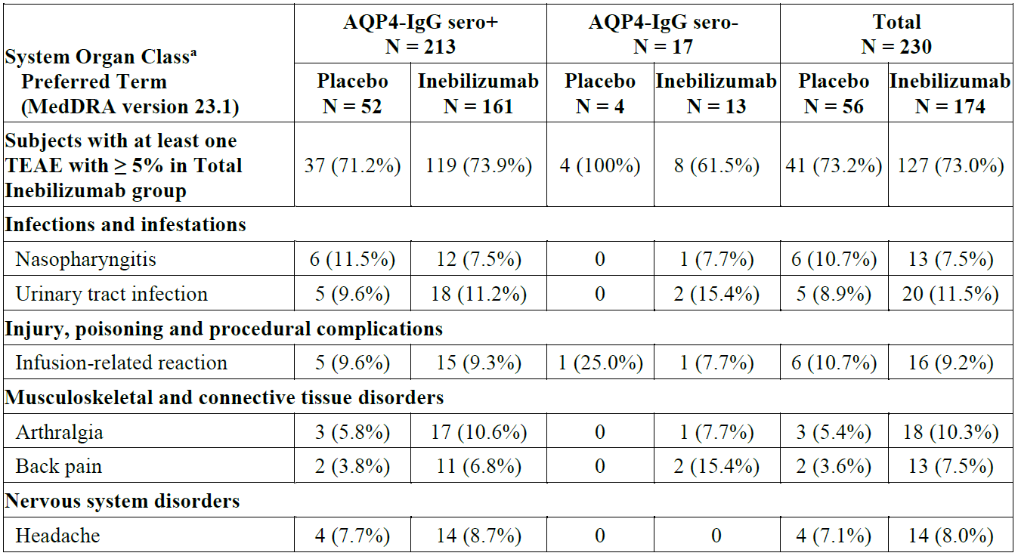
AQP4-IgG = autoantibodies against aquaporin-4; MedDRA = Medical Dictionary for Regulatory Activities;
sero+ = seropositive; sero- = seronegative; TEAE = treatment-emergent adverse event.
ª Subjects are counted once for each System Organ Class and Preferred Term regardless of the number of events.
Across both the RCP and OLP in any inebilizumab population, the most common TEAEs by PT were urinary tract infection in 50 (22.2%) subjects, nasopharyngitis in 37 (16.4%), infusion related reaction in 28 (12.4%), back pain in 28 (12.4%), upper respiratory tract infection in 27 (12.0%), arthralgia in 26 (11.6%), and headache in 25 (11.1%) (Table 18).
Table 18. Treatment-emergent adverse events (≥ 5% in total inebilizumab group) by system organ class and preferred term (any inebilizumab population, study 1155)
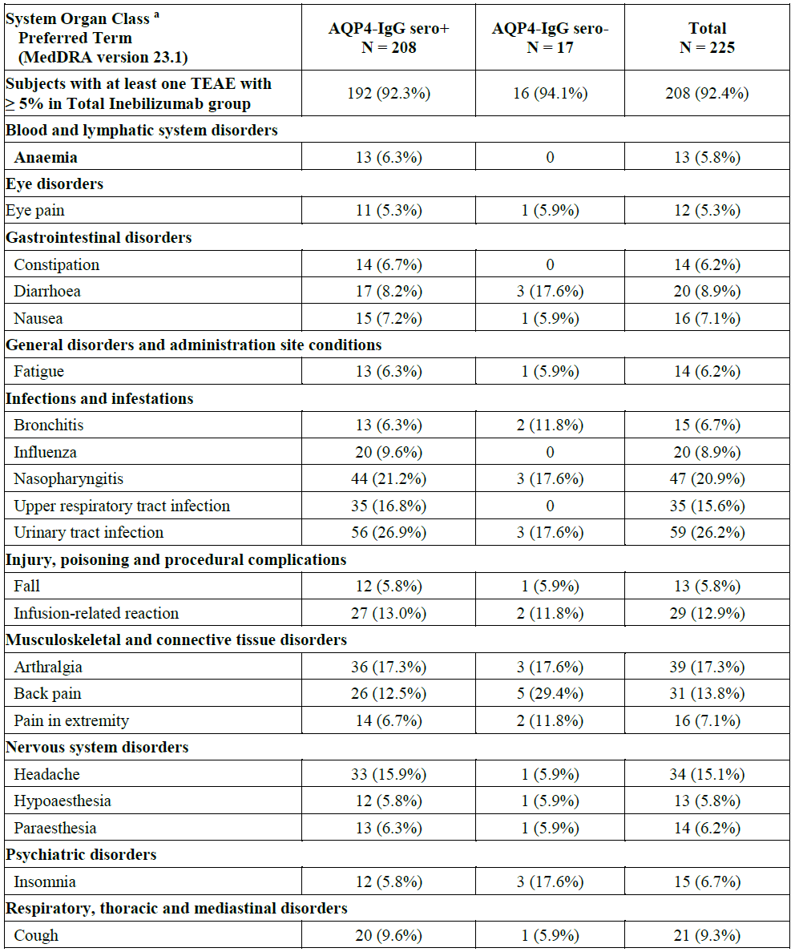
AQP4-IgG = autoantibodies against aquaporin-4; MedDRA = Medical Dictionary for Regulatory Activities;
sero+ = seropositive; sero- = seronegative; TEAE = treatment-emergent adverse event.
ª Subjects are counted once for each System Organ Class and Preferred Term regardless of the number of events.
TEAE’s occurring in ≥ 2% in the total inebilizumab Group during the RCP period (Table 19)
Table 19. Treatment-emergent adverse events (≥ 2% in total inebilizumab group) by system organ class and preferred term (randomized controlled period, as-treated population, study 1155)
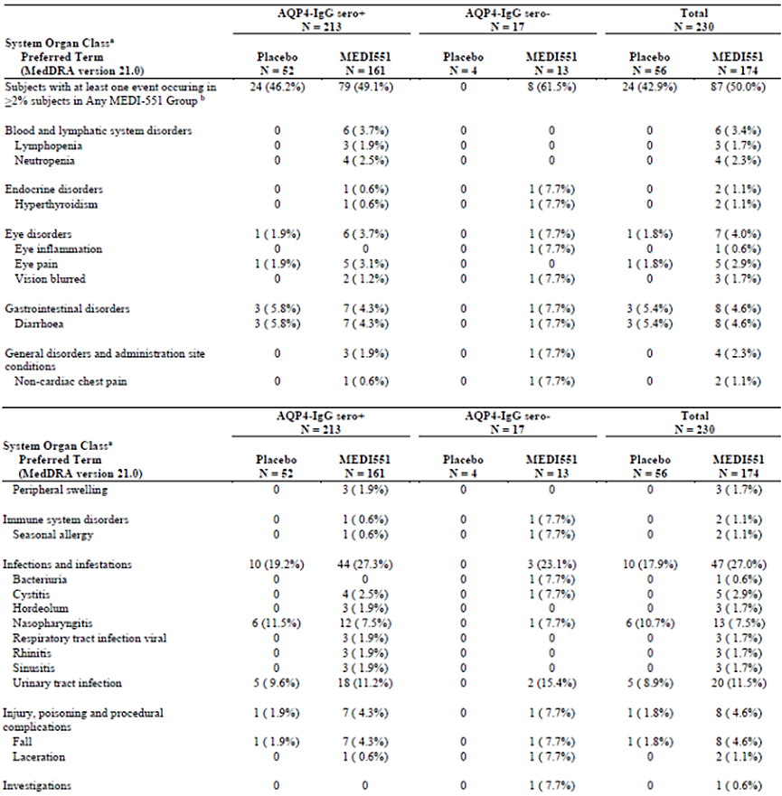
Of the TEAEs occurring at ≥2% in the total inebilizumab group compared to placebo during the RCP period there are several TEAE’s of note. Lymphopaenia occurred in 3 (1.7%) and neutropenia occurred in 4 (2.3%) of the subjects in the inebilizumab group compared to no reports of this in the placebo group. Eye inflammation occurred in 1 (0.6%) subject in the inebilizumab group with 0 reports in the placebo group, eye pain was reported in 5 (2.9%) in the inebilizumab group compared to 1 (1.8%) in the placebo group. Total infections and infestation reports in the inebilizumab group were 47 (27%) compared to 10 (17.9%) in the placebo group. The most frequent infections occurring more often in the inebilizumab group compared to placebo were cystitis ( 5 [2.9%] reports in inebilizumab group compared to 0 in placebo), urinary tract infection (20 [11.5%] reports in inebilizumab group compared to 5 [8.9%] in placebo). The TEAE of arthralgia was significantly more frequent in the inebilizumab group compared to placebo (17 [9.8%] reports in inebilizumab group compared to 2 [3.6%] in placebo). Similarly, higher rates were also seen for the TEAE of back pain in the inebilizumab group compared to placebo (13 [7.5%] reports in inebilizumab group compared to 2 [3.6%] in placebo). The TEAE of rash was reported in 4 (2.3%) in the inebilizumab group compared to0 in placebo.
Most TEAEs reported during the RCP and OLP in both the inebilizumab and placebo groups were mild or moderate in severity. The proportion of subjects with severe (Grade 3) events was slightly higher in the placebo group (12.5% compared to 7.5% in the inebilizumab group in the RCP). TEAE by severity during the 2 trial periods (Tables 20 and 21).
Table 20. Summary of treatment-emergent adverse events by severity, randomized-controlled period (as-treated population)
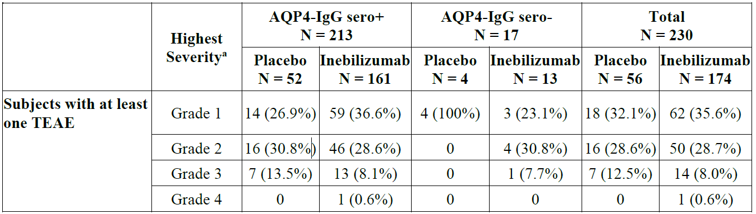
AQP4-IgG = autoantibodies against aquaporin-4; sero+ = seropositive; sero- = seronegative;
TEAE = treatment-emergent adverse event.
ª Grade 1= Mild, Grade 2=Moderate, Grade 3= Severe, Grade 4= Life-threatening, Grade 5= Fatal. Severity grade displays if there is an occurrence in at least one group.
Table 21. Summary of treatment-emergent adverse events highest severity, open-label period (open-label population)
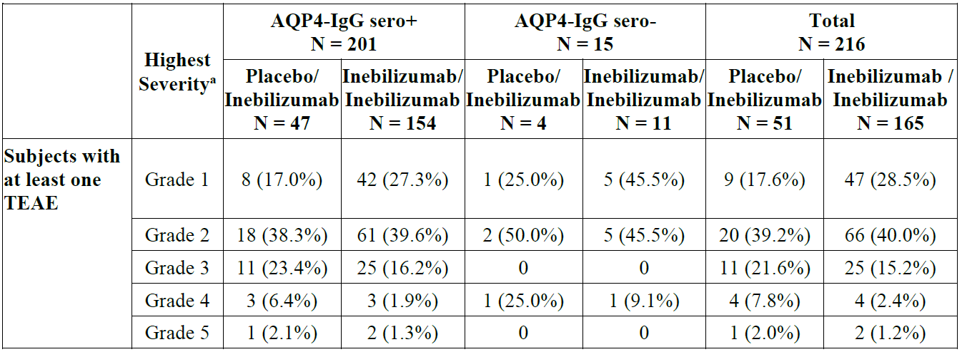
AQP4-IgG = autoantibodies against aquaporin-4; sero+ = seropositive; sero- = seronegative.
a Grade 1= Mild, Grade 2=Moderate, Grade 3= Severe, Grade 4= Life-threatening, Grade 5= Fatal. Severity
grade displays if there is an occurrence in at least one group.
A single grade 4 TEAE in both the RCP and OLP occurred and is outlined below:
- 42-year-old female with grade 4 TEAE of atypical (klebsiella) pneumonia during the RCP in the inebilizumab group. Subject first hospitalized on study day 18. Lymphocyte and neutrophil count at this time was within reference range. The Sponsor considered this possibly related to study drug, but subject had additional risk factors including history of tuberculosis and prior treatment with mycophenolate mofetil within 30 days of this event. Overall, the EMA evaluator felt a clear casual link between study drug treatment and this grade 4 TEAE could not be established.
- 47-year-old female with grade 4 TEAE of respiratory failure during the OLP initially randomized to the inebilizumab group. Narrative states subject hospitalized on multiple occasions due to immunosuppression requiring IV immunoglobulin. Respiratory failure diagnosed on study day 948, 166 days since last inebilizumab dose. Sputum cultures were positive for Candida albicans, Haemophilus influenzae and strep pneumoniae. A specialist in acquired immune deficiency concluded that laboratory results showed clear evidence of B and T lymphocyte immunosuppression. The EMA evaluator stated that there appeared to be ample evidence that this life-threatening TEAE was related to treatment with inebilizumab . This is presumably due to opportunistic pathogens causing a lower respiratory tract infection in setting of immunosuppression, thus causing respiratory failure.
Two deaths occurred during the OLP in study 1155 with the cases discussed below:
- The first was a 31-year-old man with longstanding NMSOD who was initially randomised to placebo. The clinical picture suggested a new NMOSD-related proximal CNS lesion affecting respiratory function as likely cause of the subject’s rather sudden demise: a protocol-defined relapse occurred two days prior to death, during which the subject experienced increased extremity weakness and new bladder/bowel dysfunction.
- The second death involved a 67-year-old woman randomised to inebilizumab who after several months of treatment was admitted to hospital who had a CNS event of unknown cause. Differential diagnoses included progressive multifocal leukoencephalopathy (PML), acute disseminated encephalomyelitis, and atypical neuromyelitis optica spectrum disorder attack. CSF samples were sent to test for John Cunningham Virus (JCV) testing via PCR at the national institutes of health in Bethesda, Maryland and JCV PCR analysis showed JCV was “not detectable”. The subject died on study day 245 from ventilator associated pneumonia, after 244 days of inebilizumab exposure.
During the RCP, 15 subjects had at least one treatment emergent serious adverse event (TESAE) with 9 (5.2%) subjects in the inebilizumab group and 6 (10.7%) of subjects in the placebo group. The TESAE in the SOC of infections and infestations were reported in 2 (3.6%) of subjects in the placebo group and 3 (1.7%) in the inebilizumab group during the RCP. There were no clear trends or predominant events in SOC or PT for the TESAE’s.
During the OLP, 30 subjects had at least one TESAE. In total (14 [27.5% in placebo/inebilizumab and 16 [9.7%) in inebilizumab /inebilizumab ]). 17 subjects had TESAEs in the SOC of Infections and Infestations, including 6 subjects with Urinary tract infections and 2 subjects with Pneumonia, one of which was fatal. 5 subjects had TESAEs in the SOC of Nervous System Disorders, including 3 subjects with NMOSD, one of which was fatal. All other TESAEs by PT were experienced by 1 subject each. 1 subject had a TESAE of “colon cancer stage III” (PT), which was the first malignancy in the study for a subject treated with the IP.
No clinically meaningful trends were identified in the average changes from baseline during the RCP or OLP in hematologic variables of haemoglobin, haematocrit, eosinophils, eosinophils/leukocytes (%), basophils, basophils/leukocytes (%), erythrocytes, mean corpuscular haemoglobin concentration, mean corpuscular volume, and platelets.
At Week 4, the lymphocyte count was at baseline levels in the placebo group and was 13.8% lower than baseline in the inebilizumab group, likely due to B-cell depletion. During the RCP overall, lymphocyte counts were lower in the inebilizumab group than the placebo group, which is consistent with the mechanism of action of the drug. With longer-term exposure during the OLP, the lymphocyte levels trended back to the baseline level.
Neutrophil levels returned to the baseline level at Week 4. Mean percent change from baseline at Week 28 in neutrophil levels was similar between the treatment groups (0.87% for inebilizumab 1.1% placebo). During the OLP, there was no trend for neutrophil counts.
No clinically meaningful trends were identified in the average changes from baseline in albumin, alkaline phosphatase, ALT, AST, bilirubin, cholesterol, creatinine, gamma glutamyl transferase, magnesium, potassium, sodium, triglycerides, urate, or glucose.
During the RCP, a higher proportion of subjects in the inebilizumab group had at least a 2-grade worsening from baseline compared to the placebo group in the following laboratory parameters:
- Leukocytes: inebilizumab 6.4% versus placebo 1.8%
- Lymphocytes (decreased): inebilizumab 20.2% versus placebo 8.9%
- Neutrophils: inebilizumab 5.2% versus placebo 0%.
By analysis of laboratory results in the RCP, a neutrophil level of 1.0 to 1.5 × 109/L was observed in 6.9% of inebilizumab -treated patients versus 1.8% of placebo-treated patients. A neutrophil level of 0.5 to 1.0 × 109/L was observed in 1.7% of inebilizumab -treated patients versus 0% of placebo treated patients. Neutropenia was generally transient, and no subject with laboratory-defined Grade 2 or higher neutropenia experienced a serious infection.
Of note during the RCP:
- Grade 2 leukopenia was numerically more common in the inebilizumab group (3.3% inebilizumab, 0% placebo at RCP Week 28).
- There were no Grade 3 or higher leukopenia events.
- Neutropenia was numerically more common in the inebilizumab group, though overall rates were low: 2.3% vs 0% in placebo during the RCP; 2.2% in the Any inebilizumab population. Reduced neutrophil counts have been reported for other B-cell depleting monoclonal antibodies and may be a class effect.
Regarding hepatic enzyme changes there was a single case single case of Grade 4 ALT increase in connection with a case of acute cholangitis requiring biliary drainage; the subject had a history of cholecystitis with cholelithiasis, and the investigator reported the causal relationship to IP as not related. No other data related to hepatic enzyme measurements indicated that inebilizumab caused increased levels of hepatic transaminases during the RCP.
Anti-tetanus toxoid IgG levels were measured to evaluate the effect on inebilizumab on vaccine-generated antibody titres. At RCP Week 28, results were available for 87 inebilizumab and 22 placebo subjects. Median percent change from baseline was 6.8% for inebilizumab and -5.1% for placebo. During the OLP, for the group originally randomized to inebilizumab, the median percent change from baseline in titre at OLP Week 52 was 14.1% (n = 75) and at OLP Week 104 was 12.5% (n = 33). These results indicate no reduction in tetanus vaccine titres after 3.5 years of inebilizumab treatment.
During the RCP, there were no notable differences between treatment groups in the incidence of changes in vital signs.
During the RCP, there were no notable differences between treatment groups in ECG changes and QTc intervals.
While pregnancy or lactation constituted exclusion criteria in the clinical study programme, pregnancies occurred in 3 inebilizumab-treated patients. All 3 children were delivered with no abnormalities or health problems reported.
There are no data on the presence of inebilizumab in human milk, the effect on a breastfed child, or the effect on milk production. There are also no data on the presence of inebilizumab in the milk of lactating mice from the pre- and post-natal development toxicology study.
No drug-drug interactions were conducted for inebilizumab given the well-known elimination pathway for monoclonal antibodies via the reticuloendothelial system: the risk of drug-drug interactions are low.
There is no evidence or anticipation of abuse or dependence with use of inebilizumab.

Safety analysis study CP200
In Study CP200, 28 subjects were treated: 24 randomized to inebilizumab (0.1 mg/kg [n = 1], 0.3 mg/kg [n = 4], 1.0 mg/kg [n = 6], 3.0 mg/kg [n = 6], and 10.0 mg/kg [n = 7]) and 4 subjects randomized to placebo. Of these 28 subjects, 24 completed the study (21 randomized to inebilizumab and 3 randomized to placebo). All 28 randomized subjects received a single IV dose of IP according to their randomized treatment group.
The median age of the subject population was 48.5 years (range, 21-64 years); the majority of subjects were female (67.9%) and White (85.7%). All subjects had scleroderma with at least moderate skin thickening.
The majority of subjects in the total inebilizumab and placebo groups had at least one TEAE in the study (23 subjects [95.8%] of the total inebilizumab group and 3 subjects [75.0%] of the placebo group), with IP-related, acute, Grade 3 (severe) or Grade 4 (life threatening), serious, and fatal TEAEs occurring only in the total inebilizumab group. One subject in the 3.0 mg/kg inebilizumab group died due to scleroderma renal crisis. Treatment-emergent SAEs occurred in 6/24 subjects (25.0%), with 4/24 (16.7%) occurring between Days 1 and 85 and 2/24 (8.3%) occurring after Day 85.
There were no TEAEs in the placebo group that occurred in more than one subject; in the total inebilizumab group, the most frequent (incidence > 15%) TEAEs by PT were arthralgia, fatigue, pain in extremity, infusion-related reaction, and nausea, of which nausea and infusion-related reaction only occurred in the total inebilizumab group.
Infusion-related reactions occurred in no subjects in the placebo group and 4/24 subjects (16.7%) in the total inebilizumab group. All but one event was Grade 1 or Grade 2 in severity, none were serious, and all resolved within 2 days. No infusion related reactions occurred in subjects who were premedicated with oral acetaminophen or equivalent dose of paracetamol, oral diphenhydramine, and IV methylprednisolone or equivalent glucocorticoid prior to administration of IP. No TEAEs of hypersensitivity, immune complex disease, cytopenia, serious infection, or PML, occurred in either the placebo or total inebilizumab groups.
One subject in the 3.0 mg/kg inebilizumab group had a scleroderma renal crisis with onset on Day 62 that led to death 47 days later. The subject also had Grade 3 gastric antral vascular ectasia with onset on Day 62 and Grade 4 respiratory failure with onset on Day 67. None of these TESAEs were assessed as related to IP by the Investigator.
No (0/4) subjects in the placebo group and 6/24 subjects (25.0%) in the total inebilizumab group had at least one TESAE (total of 15 TESAEs in these subjects). All but 2 events (supraventricular tachycardia and subclavian vein thrombosis) were judged by the Investigator as not related to IP and, in both cases, alternative aetiologies were provided.
In Study CP200, there were no clinically meaningful trends in laboratory values, or frequency or severity of occurrence of abnormal values for any of the chemistry parameters in either the placebo or total inebilizumab groups.
In Study CP200, there were no clinically meaningful trends in vital signs or ECGs observed following administration of inebilizumab.

Safety analysis study 1102
In Study 1102, 28 subjects were treated: 21 randomized to inebilizumab (30 mg IV [n = 6], 60 mg SC [n = 3], 100 mg IV [n = 3], 100 mg SC [n = 3], and 600 mg IV [n = 6]) and 7 subjects randomized to placebo. One of the 6 subjects in the inebilizumab 30 mg IV group received 100 mg instead of 30 mg; therefore, 5 subjects received 30 mg IV and 4 subjects received 100 mg IV. Of the 28 subjects, 24 completed the study (17 randomized to inebilizumab and 7 randomized to placebo). All 28 randomized subjects received either 2 IV doses (Days 1 and 15) or a single SC dose (Day 1) of IP and were included in the Safety population.
The median age of the subject population was 44.0 years (range, 21 to 65 years); the majority of subjects were female (67.9%), not Hispanic or Latino (96.4%), and White (82.1%). All subjects had relapsing MS, with a median age of symptom onset of 29.7 years, median age at MS diagnosis of 32.7 years, and the median EDSS score was 4.0.
In Study 1102, the majority of subjects in the total inebilizumab and placebo groups had at least one TEAE in the study. In the placebo group, at the PT level, only TEAEs of MS relapse occurred in more than one subject. The most frequent (incidence ≥ 14%) TEAEs in the total inebilizumab group by PT were nasopharyngitis, upper respiratory infection, blood pressure increased, pyrexia, urinary tract infection, urinary tract inflammation, and infusion-related reaction. Two of 7 subjects (28.6%) in the placebo group and 7/21 subjects (33.3%) in the total inebilizumab group had TEAEs that were severe, life threatening, or fatal. There was one death in the 30 mg inebilizumab IV group due to sedation drugs overdose.
In Study 1102, the most frequent (incidence ≥ 14%) TEAEs in the total inebilizumab group by PT were nasopharyngitis, upper respiratory infection, blood pressure increased, pyrexia, urinary tract infection, urinary tract inflammation, and infusion related reaction. In the placebo group, only TEAEs of MS relapse occurred in more than one subject. Infusion-related reactions were reported in 6/15 subjects (40.0%) in the total IV inebilizumab group and 2/5 subjects (40.0%) in the IV placebo group. All were Grade 1 or Grade 2 in severity. Of the subjects in the SC dose groups, 2/6 subjects (33.3%) in the total SC inebilizumab group (300 mg) and no subjects in the SC placebo group had a TEAE of injection site reaction.
Two of 5 subjects (40.0%) in the IV placebo group and 6/15 subjects (40.0%) in the total IV inebilizumab group had TEAEs of infusion-related reaction. All TEAEs of infusion related reaction were Grade 1 or Grade 2 in severity and assessed as related to IP. No TEAEs of hypersensitivity, immune complex disease, serious infection, or PML, which are associated with potential risks of inebilizumab, occurred in either the placebo or the total inebilizumab group. One of 7 subjects (14.3%) in the placebo group experienced a TEAE of anaemia. No TEAEs of neutropenia, febrile neutropenia, or thrombocytopenia occurred in either the placebo or the total inebilizumab group.
A subject in the inebilizumab 30 mg IV group died during the study, 133 days after the subject had received the last dose of IP. According to the autopsy report, the cause of death was due to mixed drug intoxication resulting in accidental fatal overdose. The death was assessed as not related to IP by the Investigator.
One of 7 subjects (14.3%) in the placebo group and 3/21 subjects (14.3%) in the inebilizumab groups had at least one TESAE. A total of 4 events occurred in the total inebilizumab group, with all but 1 event (pyrexia in the inebilizumab 300mg subcutaneous group, assessed as injection related reaction) assessed by the Investigator as not related to IP.
In Study 1102, there were no clinically meaningful trends in hematology, serum chemistry, or urinalysis laboratory values with the exception of Ig levels. Decreases from baseline were observed in all inebilizumab dose groups for total Ig and all Ig subtypes (IgA, IgE, IgG, IgM) during the treatment period and in all subjects who entered LTFU. The most notable decreases from baseline in inebilizumab dose groups were in IgM. There was no apparent clinical significance to the decrease in IgM or other Ig subtypes.

Risk management plan evaluation summary
Amgen Australia Pty Ltd has submitted EU-RMP version 1.0 (dated 05 November 2021; DLP 18 December 2020) and ASA version 1.0 (dated 12 April 2024) in support of this application. At round 2, the Sponsor has submitted ASA version 2.0 (dated 9 October 2024) in association with previously submitted EU-RMP version 1.0 (dated 05 November 2021; DLP 18 December 2020) in support of this application.
The proposed summary of safety concerns and their associated risk monitoring and mitigation strategies are summarised in Table 22:
Table 22. Summary of safety concerns
Summary of safety concerns |  | Pharmacovigilance |  | Risk Minimisation
 |  | Routine | Additional | Routine | Additional
Important identified risks | Infusion reaction |  | †§ |  | –
Important identified risks | Neutropenia |  | – |  | –
Important potential risks | Serious infections, viral reactivation, and opportunistic infections |  | †§ |  | ǁ
Important potential risks | Progressive multifocal leukoencephalopathy (PML) | * | †§ |  | ǁ
Important potential risks | Blood disorders, particularly decrease in B-cell levels in foetal and newborns exposed to inebilizumab in pregnant women |  | ‡ |  | –
Important potential risks | Malignancy |  | †§ |  | –
Missing information | Safety in patients > 65 years |  | †§ |  | –
Missing information | Use during pregnancy and lactation | * | †‡§ |  | –
Missing information | Patients concomitantly receiving other immunosuppressive agents |  | †§ |  | –
*Targeted follow-up questionnaire
† CorEvitas SPHERES
‡ Pregnancy Registry (planned)
§ Planned Post Authorisation Safety Studies (Real-world observational study in Europe and N-MOMENTUM study)
ǁ Patient Alert Card
The summary of safety concerns in the Australia-specific annex (ASA) align with the EU RMP at round 2 and is acceptable from an RMP perspective. Nonclinical consideration of the safety specifications is still pending. The Sponsor has assured that for any safety concerns identified by the nonclinical evaluator, that impact on the safety specification of UPLIZNA will be addressed in an updated ASA.
The Sponsor proposes routine pharmacovigilance activities for all safety concerns including a targeted follow-up questionnaire for ‘PML’ and ‘use during pregnancy and lactation’. Additional pharmacovigilance activities (ongoing and planned) are also proposed to characterise all safety concerns for UPLIZNA except important identified risk ‘neutropenia’. This aligns with the EU RMP and is acceptable from an RMP perspective.
The Sponsor has proposed routine risk minimisation for all safety concerns. Additional risk minimisation is proposed for the important potential risks of ‘serious infections, viral reactivation, and opportunistic infections’ and ‘PML’ in the form of a patient alert card. A mock-up of the patient alert card, along with its dissemination plan and plan to evaluate its effectiveness will be provided in a later update prior to launch. The risk minimisation plan in the ASA aligns with the EU RMP and is acceptable from an RMP perspective.

Risk-benefit analysis

Efficacy
Efficacy for the proposed indication has been provided primarily through the single pivotal study 1155. Efficacy endpoints for the primary outcome were achieved with the number of subjects in the ITT population during the RCP period determined to have an NMSOD attack was 22 (39.3%) in the placebo group compared to 21 (12.1%) in the inebilizumab group. The HR of an AC determined attack was 0.272 (95% CI 0.1496, 0.4961) with a p-value = <0.0001, similar rates were noted in the AQP4-IgG seropositive population. Of note there were only small numbers of subjects with NMSOD who were AQP4-IgG seronegative in this study, of this population (N=17) 0 subjects in the placebo group (N=4) and 3 (23.1%) in the inebilizumab group (N=17) had an NMSOD attack with a p-value=0.9977. Given the low number of subjects in the seronegative group with no clear significant reduction in NMSOD attacks efficacy for patients diagnosed with NMSOD who are AQP4- IgG negative has not been established in this study. Multiple sensitivity analysis showed statistically significant results for all variables tested relating to the primary efficacy outcome. The Delegate accepts the primary efficacy outcome of time to first independent AC determined NMOSD attack is an acceptable primary endpoint to measure the efficacy of UPLIZNA for this indication. Given the heterogenous symptoms of acute attacks of NMOSD, the protocol defined criteria combined with AC review is accepted as a satisfactory way to try to ensure that a consistent and reliable definition of an acute NMSOD attack has been applied to participants during the randomized control period of pivotal study 1155.
The key secondary efficacy outcome of worsening from baseline in EDSS at last visit, showed 18 (34.6%) of participants in the placebo group and 25 (15.5%) in the AQP4-IgG positive group were defined as having worsening from baseline in EDSS from baseline to last visit. The OR for this value is 0.371 (95% CI 0.1807, 0.7633) and p-value = 0.007. Whilst the EDSS has been developed to monitor functional outcomes primarily for the multiple sclerosis population, this scale covers a broad range of neurological systems including: pyramidal, cerebellar, brainstem, sensory and bowel/bladder systems with a score from 0-10 for each system. Given the common signs and symptoms of NMSOD this scale appears appropriate to measure disability in this population. A statistically significant difference between the inebilizumab treatment group and placebo in worsening of EDSS from baseline to last visit provides supportive evidence of efficacy for inebilizumab in treatment of the proposed indication.
Low contrast visual acuity score change from baseline to last visit in RCP was similar between treatment groups. Currently it is unclear if there is benefit from inebilizumab in low contrast binocular visual acuity.
The secondary outcome of mean cumulative number of active MRI lesions using a negative binomial regression model over the RCP period in the AQP4 IgG seropositive ITT population was 2.3 in the placebo group (n=31) and 1.7 (n=74) in the inebilizumab treatment group. The rate ratio (which is rate ratio reduction in cumulative active MRI lesions based in all subjects in the entire ITT population, not just those who had event) in the AQP4-IgG seropositive group was 0.568 (95% CI 0.3851, 0.8363) with a p-value = 0.0042. During the RCP period in the whole ITT population 45.3% subjects in the inebilizumab group had new gadolinium-enhancing MRI lesions compared to 59.6% in the placebo group.
The secondary outcome of number of NMSOD related inpatient hospitalizations was measured, as defined by more than an overnight stay in hospital. In the AQP4-IgG seropositive ITT population over the RCP period there was a mean of 1.4 hospitalizations in the placebo group (n=52) compared to 1.0 (n=161) in the inebilizumab group. The rate ratio was 0.258 (95% CI 0.0904, 0.7384) with a p-value = 0.0115.
The primary efficacy outcome of time to NMSOD attack and key secondary outcomes of Change from baseline in EDSS score, mean cumulative number of MRI lesions and number of hospitalization due to NMSOD attack all showed statistically significant differences between treatment groups with all outcomes favouring treatment with inebilizumab. Although change from baseline in low contrast visual acuity showed no statistical significance this is a single secondary outcome with unclear sensitivity and specificity for overall disease activity in NMSOD. Based on the submitted results the Delegate feels that efficacy has only been established for those patients diagnosed with NMSOD who are AQP4-IgG seropositive, this is due to small numbers of subjects in this trial who were AQP4-IgG negative and the AQP4-IgG seronegative population not achieving the primary efficacy endpoint. Based on the results of the primary and secondary efficacy outcomes the Delegate believes Sponsor has established the efficacy of inebilizumab for the proposed indication of “monotherapy for the treatment of adult patients with neuromyelitis optica spectrum disorders (NMOSD) who are anti-aquaporin-4 immunoglobulin G (AQP4-IgG) seropositive”.

Uncertainties and limitations
During the RCP period the total immunoglobulin percentage compared to baseline is higher in placebo group compared to inebilizumab treatment group until the end of the RCP period. After day 197 during the OLP the total immunoglobulin percentage compared to baseline slowly and progressively decreased over time with the median percentage for placebo at day 1107 being approximately 70% and for inebilizumab approximately 75%.
This reduction in total immunoglobulin fits with inebilizumab mechanism of action resulting in profound depletion of CD19 positive B cells. The EMA evaluator has noted that this progressive gradual decrease in total immunoglobulins over time is a concern as this could result in an increase in serious and/or opportunistic infections. There was no clear plateau that the total immunoglobulin levels reached during the measured time period, thus there is uncertainty around whether total median immunoglobulin levels for this group could continue to slowly drop further over time with ongoing inebilizumab treatment.
It is stated in the proposed PI that based on study 1155 B-cell counts were reduced below the lower limit of normal by 4 weeks in 100% of patients and remained below the lower limit of normal in 94% of patients for 28 weeks after initiation of treatment. No information is provided on how long it will take B-cell counts to improve to the normal reference range after last dose of UPLIZNA, especially after repeated dosing. The Delegate noted in phase I study CP200 in the subjects administered a single dose of inebilizumab 3.0mg/kg (n=6) it took 169 days for the median CD20 B cell count to reach approximately 10% of the subject’s baseline CD20 count and approximately 230 days to reach approximately 70% of the subjects median baseline CD20 count, which suggests B cell repletion and increased risk of infection is present for a long period after last UPLIZNA dose is given. This information would be important for prescribers to be aware of, especially in regard to timing and use of other immunosuppressive agents if UPLIZNA were to be ceased. This is due to long duration of B cell depletion evident from the provided studies and risk of severe immunosuppression if additional immunosuppressive agents are used after UPLIZNA has been ceased if additional immunosuppressants are added whilst there is still profound B-cell count depletion, which lasts at least 6 months after last dose of UPLIZNA. To align with the comparable overseas regulator (EMA) and their SmPC the Sponsor is asked to provide a more robust warning regarding the duration of B cell depletion after last dose of UPLIZNA and the risk of adding further immunosuppressive agents, even after UPLIZNA has been ceased. The recommended warning is contained in the “review of product information” section of this document and the Sponsor is asked to align this warning to the EMA SmPC.
There is uncertainty regarding the assay used as the PD marker for inebilizumab activity, being CD20 positive B cells. The pathophysiology of NMSOD is thought to be related to AQP4 autoantibody product in a sub-population od CD19 positive B cells. The presence of inebilizumab interferes with the recognition of cell surface CD19 in the CD19 assay. Due to this CD20 positive B cells were used as the primary PD marker of inebilizumab activity in the submitted studies, however this means that the B cell population being measured is not the same as the CD19 positive B cell population that produces the AQP4 autoantibody. In the EMA document day 120 list of questions and responses, in response to question 88 the Sponsor responded to this query saying that there is a low frequency of CD19+/CD20- plasmablasts thought to produce AQP4 autoantibodies and this precluded the development of a high performing PD assay for this specific cell population subset. The Sponsor responded that they felt a higher performing and reproducible flow cytometry method measuring total B cells yielded equivalent results using either anti-CD20 or anti-CD19 detection antibodies. The Sponsor in response also said they had evaluated via exploratory plasma cell/plasmablast-specific gene expression signature assay (which does not rely on CD19 or CD20 protein expression) the depletion of the specific B cell population thought to produce AQP4 autoantibodies, and that this method showed a rapid and durable depletion of the B cell subpopulation thought the produce the AQP4 autoantibody. Based on the Sponsors justification and the efficacy results demonstrated in the pivotal study the Delegate agrees that the CD20 positive B cell population is a reasonable surrogate PD marker of inebilizumab activity and results of the CD20 positive assay are likely to also reflect depletion of the target CD19 B-cell subpopulation thought to produce the AQP4 autoantibody.

Safety
The most common TEAE during the RCP period were urinary tract infections (UTIs). This occurred at a similar rate between the placebo (8.9%) and inebilizumab (11.5%) groups. Even though there are higher rates of UTIs observed in the inebilizumab group, given the small percentage difference, it is unclear whether this is due to inebilizumab. Similarly, nasopharyngitis had a higher rate in the placebo group compared to the inebilizumab group. Infusion related reactions were similar in the placebo (10.7%) compared to the inebilizumab (9.2%) groups.
There were significant differences between the placebo group and inebilizumab group in rates of arthralgia and back pain. Arthralgia occurred at significantly higher rates in the inebilizumab group (9.8%) compared to placebo (3.6%). Back pain was reported at higher rates in the inebilizumab group (7.5%) compared to placebo (3.6%). There is no clear mechanism of action for inebilizumab that would explain these higher rates of arthralgia and back pain. No subject discontinued inebilizumab in study 1155 due to arthralgia or back pain. Whilst the difference is statistically significant, the clinical significance of this is unclear. Further safety related warnings regarding these symptoms are not required.
Rates of TESAE during the RCP were not higher in the inebilizumab group compared to placebo. (8 (4.6%) subjects in the inebilizumab group and 5 (8.9%) of subjects in the placebo group). TESAE in the SOC of infections and infestations were reported in 2 (3.6%) of subjects in the placebo group and 3 (1.7%) in the inebilizumab group. Over the period studied in the randomized control period when comparing placebo to inebilizumab there were no significantly higher rates of TESAE related to infection in the inebilizumab group compared to placebo.
There were two grade 4 TEAE’s recorded during study 1155. The first was a 42-year-old female in the inebilizumab group who developed the grade 4 TEAE of atypical (klebsiella) pneumonia on day 18 of the RCP. The Sponsor suggested that a causal link between this event and the study drug could not be definitively established. The second grade 4 TEAE was an episode of respiratory failure in a 47-year-old female subject during the OLP on study day 948, sputum cultures showed candida albicans, haemophilus influenzae and strep pneumoniae. The EMA evaluator felt there was significant evidence that this TEAE was related to inebilizumab treatment. The Delegate agrees that the first case of atypical klebsiella pneumoniae cannot be definitively causally linked to the use of inebilizumab. The second case of respiratory failure in a 47-year-old female with evidence of multiple possible pathogens identified on sputum culture after prolonged treatment with inebilizumab and specific B and T lymphocyte testing showing signs of suppression does suggest a causal link between inebilizumab use contributing to immunosuppression and the development of lower respiratory tract infection with multiple pathogens. The Delegate acknowledges that this population is particularly susceptible to lower respiratory tract infections likely due to a combination of immobility and swallowing difficulties increasing the risk of aspiration and the use of other immunosuppressive agents but attributes a causal link between inebilizumab use and this TEAE for the second case. The proposed PI states that an increased risk of infections has been observed with other B-cell depleting therapies and that UPLIZNA may increase susceptibility to infections. This is sufficient warning to healthcare professionals regarding the possible increased risk of infection and no further change is recommended to the proposed PI.
There were 2 deaths recorded, the first was a 31-year-old man with longstanding NMSOD who was initially randomised to placebo. The clinical picture suggested a new NMOSD-related proximal CNS lesion affecting respiratory function as likely cause of the subject’s rather sudden demise: a protocol-defined relapse occurred two days prior to death, during which the subject experienced increased extremity weakness and new bladder/bowel dysfunction. The likely cause of death after discussion with Sponsor and investigator was felt to be NMSOD involvement of high cervical spinal cord affecting respiration. The Delegate agrees with the Sponsors conclusion and that it is unlikely this death was related to inebilizumab use. The second death involved a 67-year-old woman randomised to inebilizumab who after several months of treatment was admitted to hospital who had a CNS event of unknown cause. Differential diagnoses included progressive multifocal leukoencephalopathy (PML), acute disseminated encephalomyelitis, and atypical neuromyelitis optica spectrum disorder attack. CSF samples were sent to test for John Cunningham Virus (JCV) testing via PCR at the national institutes of health in Bethesda, Maryland and JCV PCR analysis showed JCV was “not detectable”. The subject died on study day 245 from ventilator associated pneumonia, after 244 days of inebilizumab exposure. The Sponsor states after discussion with multiple experts that the available data could not establish definitively the cause of this subject’s brain lesions. The provided information does not mention alternative causes of brain lesions noted on CT brain or MRI, these would include results of herpes simplex virus PCR, varicella zoster virus PCR, culture results, gram stain results, whether autoimmune encephalitis markers were measured and cryptococcal Antigen on CSF samples. Furthermore, there is no mention of the lymphocyte or polymorphonuclear leukocyte counts from the CSF samples which may help point toward a bacterial versus viral aetiology. After review of the provided information the Delegate agrees it is difficult to determine a definitive cause for the subject’s brain lesions, but an infectious aetiology remains a significant possibility in this case based on the mechanism of action of inebilizumab combined with the presented information. The Delegate finds stroke an unlikely diagnosis given no findings of acute stroke on MRI and the reported subacute presentation of neurological symptoms. The discrepancy between laboratories in outcomes of JCV PCR results is of uncertain significance, with 1 out of 3 laboratories reporting JCV “detectable” on CSF sample. Based on the proposed PI the Delegate finds that there is sufficient warning regarding the risk of progressive multifocal leukoencephalopathy (PML) noting a specific subheading in section 4.4 “progressive multifocal leukoencephalopathy (PML)”, this section outlined: the cause of PML, the uncertainty surrounding the above case and cause of new brain lesions and recommendation to withhold UPLIZNA and perform an appropriate diagnostic evaluation if PML is suspected. There is also a short outline of typical signs and symptoms of PML. The Delegate feels that the warnings provided in section 4.4 on the possible increased risks of infection with UPLIZNA and the subheading on PML provide adequate information to prescribers regarding these issues. It is noted under section 4.4 in the proposed PI that recommendations are made that patients have full blood counts and immunoglobulin levels done prior to commencing UPLIZNA and periodically throughout treatment, which the Delegate supports.
Infusion reactions during the RCP occurred in 10.7% in the placebo group and 9.2% in inebilizumab group. The EMA evaluator has noted that the placebo treatment had the same excipients as the active investigation product. The most common infusion related reactions in the inebilizumab population were headache reported in 6 (2.7%) of subjects and nausea in 5 (2.2%) subjects. There were no anaphylactic or other serious allergic reactions noted, all infusion related reactions were grade 1 or 2 in severity. A single serious AE related to infusion reaction occurred during the OLP which was reported as a migraine during an infusion, resulting in a single night hospitalization. The Delegate finds that based on the presented data severe infusion related reactions are rare and usually well tolerated with the Sponsors recommended pre-medication administered prior to commencing UPLIZNA infusion as per the proposed PI. (corticosteroid, antihistamine and paracetamol 30-60min prior to UPLIZNA infusion).
Using the Common terminology criteria for adverse events (CTCAE) during the RCP grade 2 leukopenia was reported in 2.3% in the inebilizumab group and 0% in this placebo group, no grade 3 events or higher of leukopenia were reported. Neutropenia was reported in 2.3% of the inebilizumab group compared to 0% in the placebo group. A single case of severe anaemia (CTCAE grade ≥3) occurred in a single subject with a baseline haemoglobin of 12.4g/dL, from study day 57 to week 65 of the OLP this subject had severe anaemia with haemoglobin values ranging from 4.4g/dL to 7.8g/dL. There were 5 subjects who experienced grade 3 Neutropenia during the entire study period and 1 subject discontinued study medication due to grade 3 neutropenia. None of these subjects were reported to have serious infection. No cases of grade 4 neutropenia were reported. The EMA evaluator has noted that neutropenia has been reported with other B cell depleting treatments and this may be considered a class effect. Under section 4.8 of the proposed PI ‘decreased neutrophil count’ is listed as an adverse effect and the rates of grade 2 and grade 3 neutropenia after 6.5 months of treatment are given. The Delegate finds that the information provided in the proposed PI regarding reduced neutrophil count is adequate in communicating the risk of neutropenia.

Proposed dosage
The proposed dosage for this indication is 300 mg (3 vials of 100 mg) intravenous infusion followed 2 weeks later by a second 300 mg intravenous infusion followed by Subsequent doses (starting 6 months from the first infusion): single 300 mg intravenous infusion every 6 months. The day 80 EMA evaluation report (section 3.2 ‘dose response studies’) states based on PK and PD data from study CP200 a fixed dose of 300mg inebilizumab on day 1 and 15 was predicted to fully deplete peripheral B cells to undetectable levels and maintain B cells suppression for 28 weeks. The second dose inebilizumab on day 15 is administered because of additional B cells being released out of lymphoid tissue into the circulation, thus a second dose is recommended to deplete newly released B cells from lymphoid tissue into the peripheral circulation. The EMA report has referenced multiple sources of clinical data stating that for other intravenous monoclonal antibody regimens that deplete B cells dosing on day 1 and day 15 provides optimal B-cell depletion in blood and tissues.,
It is noted in study CP200 that after a single dose if inebilizumab at 3.0 mg/kg there is B cell recovery to 10% of baseline at day 169 with rapid recovery to approximately 70% of baseline between day 169 to day 253. If a single dose of inebilizumab 300mg were given with significant recovery of peripheral B cells this raised the possibility of loss of efficacy prior to the next dose (recommended ongoing 6 monthly). Study 1155 showed further support for an initial dosing of inebilizumab 300mg IV on day 1 and day 15 with the inebilizumab treatment group showing sustained CD20 B cell depletion out to 28 weeks from initial dosing with minimal repletion of B cells over this time period. Based on evidence provided in the EMA report and provided PK/PD results the Delegate agrees with the proposed dosing regimen and that initial dosing on day 1 and day 15 be recommended to ensure sustained B cells depletion, thus reducing chances of loss of efficacy prior to the next inebilizumab dose.
In study 1155 the inebilizumab dosing regimen of 300mg IV corresponding to a weight-based dose range of 2mg/kg to 7.9mg/kg across the lowest and highest weights of participants in this study. Weight is a significant covariate that affects the volume distribution and clearance of inebilizumab, the effects of weight were tested against efficacy with a Kaplan-Meier plot of time to AC-determined NMOSD attack during the RCP with participants divided into low, medium and high body weight (Figure 16). The results of this analysis did not show a relevant impact of the weight of participants on efficacy, based on this the Delegate agrees that a fixed dose regimen as proposed is reasonable with no adjustment required for body weight.
Figure 16. Kaplan-Meier plot for time to AC-determined NMOSD attack during RCP in participants with low, medium and high body weight (Study 1155)
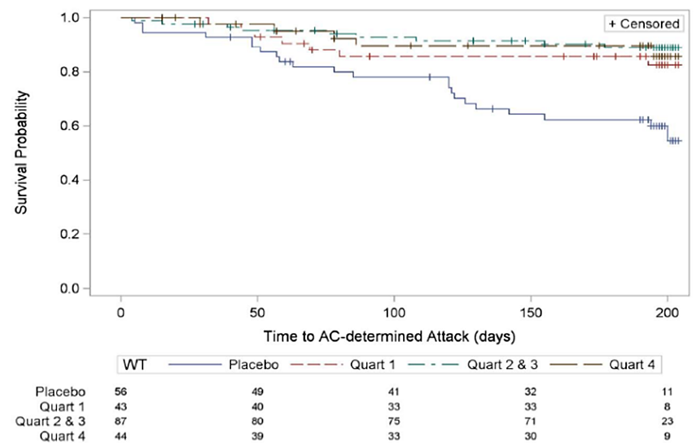
Quart — quartile: Quart 1— inebilizumab treated subjects with lowest quartile body weight: Quart 2 & 3 — inebilizumab -treated subjects with interquartile range (2nd and 3rd Quartile) of body weight; Quart 4 = inebilizumab -treated subjects with large quartile of body weight. The numbers under the legend represent the corresponding number of subjects for placebo. Quartile 1. Quartile 2 and 3 and Quartile 4 at the X axis time to AC-determined Attack (days). The hazard ratio and 95% confidence interval were 0.371 (0.158 — 0.872) for body weight Quartile 1. 0.225 (0.103 - 0.489) for body weight Quartile 2 and 3. and 0.275 (0.104 - 0328) for Quartile 4.

Advisory Committee considerations
The Advisory Committee on Medicines (ACM), having considered the evaluations and the Delegate’s overview, as well as the Sponsor’s response to these documents, advised the following.
What is the ACM opinion on the adequacy of warnings in the proposed PI regarding: immunosuppression with use of UPLIZNA, CD20+ depletion and the unknown B-cell repletion time after treatment with UPLIZNA?
The ACM advised that the warnings in the proposed Product Information (PI) with respect to CD19+ B-cell depletion were adequate.
The ACM also considered the description of the associated risk of prescriber’s commencing other immunosuppressive treatments when the patient has a low CD20+ B-cell count (even many months after cessation of UPLIZNA), as adequate.
What is ACM opinion on Delegates recommendation that breast-feeding should be discontinued during treatment with UPLIZNA
The ACM were of the opinion that there was a negligible likelihood of active drug reaching the infant which required secretion in breastmilk, avoidance of proteolytic breakdown and gut absorption of an intact large molecule. They were satisfied that the murine neonatal drug levels appear to be from placental transfer and additionally noted that simpler organisms such as mice and rats tend to display more direct gut absorption of molecules such as UPLIZNA compared to more complex organisms like humans.
The ACM noted that a recent review of the use of ocrelizumab (a similar monoclonal antibody used in the treatment of multiple sclerosis) in lactation was conducted in which, the treatment was considered to be safe to the neonate¹.
The ACM considered inclusion of wording that suggested avoiding breastfeeding for 3 months after the most recent dose of UPLIZNA, based on the identified half-life of the molecule. However, the ACM held concerns that some patients may voluntarily withhold treatment, risking relapse of NMOSD out of a perceived benefit of breast milk to the neonate.
The ACM advised that the language in the annotated PI was adequately guarded, highlighting the lack of information available in humans. The ACM were of the opinion however, that the wording could be altered to emphasise the health of the mother, due to the lack of data to support a risk to the neonate. The ACM proposed the following wording be added to section 4.6 of the PI:
“The mother’s clinical need for UPLIZNA and the potential adverse effect on the breastfed infant should be considered along with the developmental benefits of breastfeeding”

ACM conclusion
The ACM considered this product to have an overall positive benefit-risk profile for the indication:
“UPLIZNA is indicated as monotherapy for the treatment of adult patients with neuromyelitis optica spectrum disorders (NMOSD) who are anti-aquaporin-4 immunoglobulin G (AQP4- IgG) seropositive.”

Assessment outcome
Based on a review of quality, safety, and efficacy, the TGA decided to register UPLIZNA (inebilizumab) for the following indication:
UPLIZNA is indicated as monotherapy for the treatment of adult patients with neuromyelitis optica spectrum disorders (NMOSD) who are anti-aquaporin-4 immunoglobulin G (AQP4-IgG) seropositive

Specific conditions of registration
UPLIZNA (inebilizumab) is to be included in the Black Triangle Scheme. The PI and CMI for UPLIZNA must include the black triangle symbol and mandatory accompanying text for five years, which starts from the date of first supply of the product.
The UPLIZNA EU-Risk Management Plan (RMP) (version 1.0, dated 5 November 2021, data lock point 18 December 2020), with Australian Specific Annex (version 2.0, dated 9 October 2024), included with submission PM-2024-01533-1-1, and any subsequent revisions, as agreed with the TGA will be implemented in Australia.
An obligatory component of risk management plans is routine pharmacovigilance. Routine pharmacovigilance includes the submission of periodic safety update reports (PSURs).
Reports are to be provided in line with the current published list of EU reference dates and frequency of submission of PSURs until the period covered by such reports is not less than three years from the date of this approval letter. Each report must be submitted within ninety calendar days of the data lock point for that report.
The reports are to at least meet the requirements for PSURs as described in the European Medicines Agency’s Guideline on good pharmacovigilance practices (GVP) Module VII-periodic safety update report (Rev 1), Part VII.B Structures and processes. Note that submission of a PSUR does not constitute an application to vary the registration.
All batches of UPLIZNA supplied in Australia must comply with the product details and specifications approved during evaluation and detailed in the Certified Product Details (CPD).
When requested by the TGA, the Sponsor should be prepared to provide product samples, specified reference materials and documentary evidence to enable the TGA to conduct laboratory testing on the Product. Outcomes of laboratory testing are published biannually in the TGA Database of Laboratory Testing Results http://www.tga.gov.au/ws-labs-index and periodically in testing reports on the TGA website.
The Certified Product Details (CPD), as described in Guidance 7: Certified Product Details of the Australian Regulatory Guidelines for Prescription Medicines (ARGPM), in PDF format, for the above products should be provided upon registration of these therapeutic goods. In addition, an updated CPD should be provided when changes to finished product specifications and test methods are approved in a Category 3 application or notified through a self-assessable change.
A template for preparation of CPD for biological prescription medicines can be obtained from the TGA website:
- [for the form] https://www.tga.gov.au/form/certified-product-details-cpd-biological- prescription-medicines
- [for the CPD guidance] https://www.tga.gov.au/guidance-7-certified-product-details

Product Information and Consumer Medicines Information
For the most recent Product Information (PI) and Consumer Medicines Information (CMI), please refer to the TGA PI/CMI search facility.

Therapeutic Goods Administration
PO Box 100 Woden ACT 2606 Australia
Email: info@tga.gov.au Phone: 1800 020 653 Fax: 02 6203 1605
https://www.tga.gov.au

A sponsor is a person or company who does one or more of the following: a) exports therapeutic goods from Australia, b) imports therapeutic goods into Australia, c) manufactures therapeutic goods for supply in Australia or d) elsewhere arranges for another party to import, export or manufacture therapeutic goods
Glisson C.C.. Neuromyelitis optica spectrum disorder (NMOSD): Clinical features and diagnosis. In: UpToDate, Connor RF (Ed), Wolters Kluwer. (Accessed on 30th May, 2024).
Glisson C.C., 2024.
National Organization for Rare Disorders. 2022. Neuromyelitis Optica Spectrum Disorder. Accessed 31st May 2024.
Cabre P et al. 2009. Relapsing neuromyelitis optica: long term history and clinical predictors of death. Journal of Neurology, Neurosurgery & Psychiatry 2009;80:1162-1164.
Bennett JL, O’Connor KC, Bar-Or A, Zamvil SS, Hemmer B, Tedder TF, et al. B lymphocytes in neuromyelitis optica. Neurol Neuroimmunol Neuroinflamm. 2015;2(3):e104.
Browning JL. B cells move to centre state: novel opportunities for autoimmune disease treatment. Nat Rev Drug Discov. 2006;5(7):564-76.
Cree BA, Lamb S, Morgan K, Chen A, Waubant E, Genain C. An open-label study of the effects of rituximab in neuromyelitis optica. Neurology. 2005;64(7):1270-2.
Jacob A, Weinshenker BG, Violich I, McLinsky N, Kurpp L, Fox RJ, et al. Treatment of neuromyelitis optica with rituximab: retrospective analysis of 25 patients. Arch Neurol. 2008;65(11):1443-8.
Bedi GS, Brown AD, Delgado SR, Usmani N, Lam BL, Sheremata WA. Impact of rituximab on relapse rate and disability in neuromyelitis optica. Mult Scler. 2011;17(10):1225-30.
Kim SH, Kim W, Li XF, Jung IJ, Kim HJ. Repeated treatment with rituximab based on the assessment of peripheral circulating memory B cells in patients with relapsing neuromyelitis optica over 2 years. Arch Neurol. 2011 Nov;68(11):1412-20.
Ip VH, Lau AY, Au LW, Fan FS, Chan AY, Mok VC, et al. Rituximab reduces attacks in Chinese patients with neuromyelitis optica spectrum disorders. J Neurol Sci. 2013;324:38 9.
A "Delegate" refers to a person within the TGA who has been conferred the authority to make decisions about the approval of therapeutic goods for supply in Australia, under section 25 of the Therapeutic Goods Act.
Hauser S.L et al. 2008. B-cell depletion with Rituximab in relapsing-remitting Multiple Sclerosis. New England Journal of Medicine. 358:676-88.
Kappos L. et al. 2011. Ocrelizumab in relapsing-remitting multiple sclerosis: a phase 2, randomised, placebo-controlled, multicentre trial. The Lancet. Vol 378, Issue 9805

