Australian Public Assessment Report for Tyruko
  - Active ingredient/s: natalizumab
  - Sponsor: Sandoz Pty Ltd
August 2025

About the Therapeutic Goods Administration (TGA)
- The Therapeutic Goods Administration (TGA) is part of the Australian Government Department of Health, Disability and Ageing and is responsible for regulating therapeutic goods, including medicines, medical devices, and biologicals.
- The TGA administers the Therapeutic Goods Act 1989 (the Act), applying a risk management approach designed to ensure therapeutic goods supplied in Australia meet acceptable standards of quality, safety, and efficacy.
- The work of the TGA is based on applying scientific and clinical expertise to decision-making, to ensure that the benefits to the Australian public outweigh any risks associated with the use of therapeutic goods.
- The TGA relies on the public, healthcare professionals and industry to report problems with therapeutic goods. The TGA investigates reports received to determine any necessary regulatory action.
- To report a problem with a therapeutic good, please see the information on the TGA website.

About AusPARs
- The Australian Public Assessment Report (AusPAR) provides information about the evaluation of a prescription medicine and the considerations that led the TGA to approve or not approve a prescription medicine submission. Further information can be found in Australian Public Assessment Report (AusPAR) guidance.
- AusPARs are prepared and published by the TGA.
- AusPARs are static documents that provide information that relates to a submission at a particular point in time. The publication of an AusPAR is an important part of the transparency of the TGA’s decision-making process.
- A new AusPAR may be provided to reflect changes to indications or major variations to a prescription medicine subject to evaluation by the TGA.

Copyright
© Commonwealth of Australia 2025
This work is copyright. You may reproduce the whole or part of this work in unaltered form for your own personal use or, if you are part of an organisation, for internal use within your organisation, but only if you or your organisation do not use the reproduction for any commercial purpose and retain this copyright notice and all disclaimer notices as part of that reproduction. Apart from rights to use as permitted by the Copyright Act 1968 or allowed by this copyright notice, all other rights are reserved and you are not allowed to reproduce the whole or any part of this work in any way (electronic or otherwise) without first being given specific written permission from the Commonwealth to do so. Requests and inquiries concerning reproduction and rights are to be sent to the TGA Copyright Officer, Therapeutic Goods Administration, PO Box 100, Woden ACT 2606 or emailed to <tga.copyright@tga.gov.au>.

Contents
List of abbreviations 4
Product submission 6
Submission details 6
Product background 7
The disease 7
Current treatment options 8
Clinical rationale 9
Regulatory status 9
Australian regulatory status 9
International regulatory status 9
Registration timeline 10
Submission overview and risk/benefit assessment 10
Quality 11
Nonclinical 12
Clinical 12
Summary of clinical studies 12
Pharmacology 12
Efficacy 15
Safety 18
Risk management plan 22
Risk-benefit analysis 23
Delegate’s considerations 23
Proposed action 24
Advisory Committee considerations 24
Outcome 26
Specific conditions of registration applying to these goods 26
Attachment 1. Product Information 26

List of abbreviations
Abbreviation | Meaning
α4β1 | Alpha4 beta1
α4β7 | Alpha4 beta7
ACM | Advisory Committee on Medicines
ADAs | Antidrug antibodies
AE(s) | Adverse event(s)
ARR | Annualised relapse rates
ARTG | Australian Register of Therapeutic Goods
ASA | Australia-specific annex
AUC_{0-inf} | Area under the concentration time curve from time zero to infinity
AUC_{0-t} | Area under concentration-time curve from time zero to the time of last measurable concentration
CHO | Chinese hamster ovary
C_{max} | Maximum concentration
CMI | Consumer Medicines Information
DLP | Data lock point
EDSS | Expanded disability status scale
EMA | European Medicines Agency
EU | European Union
FAS | Full analysis set
Fc | Fragment crystallisable
Fcγ | Fragment crystallisable gamma
FDA | United States Food and Drug Administration
GdE | gadolinium-enhancing
Ig | Immunoglobulin
IV | Intravenous
JCV | John Cunningham virus
MRI | Magnetic resonance imaging
MS | Multiple sclerosis
PD | Pharmacodynamic(s)
PI | Product Information
PK | Pharmacokinetic(s)
PML | Progressive multifocal leukoencephalopathy
PPP | Per protocol population
RRMS | Relapsing remitting multiple sclerosis
RMP | Risk management plan
SAE(s) | Serious adverse event(s)
SD | Standard deviation
TEAE(s) | Treatment-emergent adverse event(s)
TGA | Therapeutic Goods Administration
VCAM1 | Vascular cell adhesion molecule 1

Product submission

Submission details
Type of submission: | Biosimilar
Product name: | Tyruko
Active ingredient: | Natalizumab
Decision: | Approved
Date of decision: | 11 September 2024
Date of entry onto ARTG: | 4 April 2025
ARTG number: | 425612
Black Triangle Scheme  for the current submission: | No
Sponsor’s name and address: | Sandoz Pty Ltd  100 Pacific Highway, North Sydney, NSW, 2060  Australia
Dose form: | Concentrate for injection
Strength: | 300 mg/15 mL
Container: | Vial
Pack size: | One vial
Approved therapeutic use for the current submission: | Tyruko is indicated as monotherapy for the treatment of patients with relapsing remitting multiple sclerosis (MS) to delay the progression of physical disability and to reduce the frequency of relapse.
Route of administration: | Intravenous infusion
Dosage: | Tyruko therapy is to be initiated and supervised by neurologists, with timely access to MRI. Administration is to be performed by a healthcare professional and patients are to be monitored for early signs and symptoms of progressive multifocal leukoencephalopathy (PML).  For adults the recommended dose of Tyruko by intravenous infusion is 300 mg every four weeks.  For further information regarding dosage, such as dosage modifications to manage adverse reactions, refer to the Product Information.
Pregnancy category: | C  Drugs which, owing to their pharmacological effects, have caused or may be suspected of causing, harmful effects on the human fetus or neonate without causing malformations. These effects may be reversible. Accompanying texts should be consulted for further details.  The use of any medicine during pregnancy requires careful consideration of both risks and benefits by the treating health professional. The pregnancy database must not be used as the sole basis of decision making in the use of medicines during pregnancy. The TGA does not provide advice on the use of medicines in pregnancy for specific cases. More information is available from obstetric drug information services in your state or territory.

Product background
This AusPAR describes the submission by Sandoz Pty Ltd (the sponsor) to register Tyruko (natalizumab) 300 mg/15 mL, concentrate for injection, vial for the following proposed indication:
Tyruko is indicated as monotherapy for the treatment of patients with relapsing remitting multiple sclerosis (MS) to delay the progression of physical disability and to reduce the frequency of relapse.

The disease
Multiple sclerosis (MS) is an inflammatory disease of the central nervous system. Earlier in its course, damage is from discrete demyelinating lesions that result in axonal and neuronal dysfunction. Later, diffuse inflammation and neurodegeneration worsen central nervous system dysfunction. The disease is characterised by progressive disability.
Specific symptoms of acute attacks include painful vision loss (due to optic neuritis), limb weakness (due to transverse myelitis) and ataxia/facial numbness/diplopia (due to brainstem lesions). Typical demyelinating lesions seen on magnetic resonance imaging (MRI) occur in juxtacortical regions, pericallosal regions, spinal cord and the posterior fossa.
Diagnosis is based on clinical presentation and MRI findings, as well as other tests such as cerebrospinal fluid analysis and visual evoked potentials. The radiological diagnosis is based on the findings of characteristic MRI lesions disseminated in time and space. The modified McDonald criteria (2017) require that:
- the dissemination in space includes at least one lesion in at least two out of four areas of the central nervous system (juxtacortical/intracortical, periventricular, infratentorial, spinal cord)
- the dissemination in time includes either a new T2/gadolinium enhancing lesion on MRI compared to Baseline, or simultaneous asymptomatic gadolinium-enhancing and non-enhancing at a single point in time (that is, using the latter formulation, MS could be diagnosed on a single MRI with the appropriate clinical presentation).
Treatment of MS is for acute attacks, prevention of relapse and symptomatic. Broadly speaking, acute attacks are treated with corticosteroids and prevention of relapse is with various forms of immunotherapy (see below for list of Australian approved drugs). Symptomatic treatment may be for pain, spasticity, bladder dysfunction, psychiatric symptoms or a range of other problems.

Current treatment options
Tysabri (natalizumab) is one of several options available in Australia for treatment of relapsing-remitting MS.
Other drugs in the Australian Register of Therapeutic Goods (ARTG) with an indication for multiple sclerosis are:
- Immunomodulatory
  - Alemtuzumab
  - Cladribine
  - Dimethyl fumarate
  - Diroximel fumarate
  - Fingolimod
  - Ozanimod
  - Siponimod
  - Glatiramer
  - Interferon beta-1a
  - Interferon beta-1b
  - Methylprednisolone
  - Ocrelizumab
  - Ofatumumab
  - Teriflunomide
  - Tetracosactide
- Symptomatic
  - Baclofen
  - Botulinum toxin
  - Carbamazepine
  - Dantrolene
  - Fampridine
  - Nabiximols

Clinical rationale
Natalizumab is a recombinant humanised immunoglobulin (Ig) G4 monoclonal antibody which binds to alpha4 beta1 (α4β1) and alpha4 beta7 (α4β7) integrins and inhibits the trafficking of lymphocytes into tissues. Integrin α4β1 is involved with lymphocyte movement into the brain and is involved in the therapeutic effect of natalizumab in the inflammatory demyelinating disease multiple sclerosis.
The innovator product Tysabri is indicated as ‘monotherapy for the treatment of patients with relapsing remitting multiple sclerosis (MS) to delay the progression of physical disability and to reduce the frequency of relapse’.
The sponsor submitted a COR-B submission based on the European Union (EU) centralised procedure which resulted in marketing authorisation being granted to Tyruko on 22 September 2023. The indication for Tyruko mirrored that of the innovator product, as follows:
- Tysabri is indicated as single disease modifying therapy in adults with highly active relapsing remitting multiple sclerosis (RRMS) for the following patient groups:
  - Patients with highly active disease despite a full and adequate course of treatment with at least one disease modifying therapy
  - Patients with rapidly evolving severe RRMS defined by 2 or more disabling relapses in one year, and with 1 or more Gadolinium enhancing lesions on brain Magnetic Resonance Imaging (MRI) or a significant increase in T2 lesion load as compared to a previous recent MRI.

Regulatory status

Australian regulatory status
This product is considered a new biosimilar medicine for Australian regulatory purposes.
The innovator product Tysabri has been in the ARTG since 2006.

International regulatory status
This submission was submitted through the TGA’s Comparable Overseas Regulator B (COR-B) process, using evaluation reports from European Medicines Agency (EMA). The full dossier was submitted to the TGA.
At the time the TGA considered this submission, a similar submission had been approved in the EU on 22 September 2023, the USA on 24 August 2023, Great Britain on 9 October 2023, Switzerland on 5 November 2024 and New Zealand on 18 July 2024. A similar submission was under consideration in Canada. Marketing authorisation has not been refused or withdrawn in any country.

Registration timeline
The following table captures the key steps and dates for this submission.
This submission was evaluated under the standard prescription medicines registration process.
Table 1: Timeline for Submission PM-2023-04610-1-1
Description | Date
Submission dossier accepted and first round evaluation commenced | 30 November 2023
First round evaluation completed | 2 April 2024
Sponsor provides responses on questions raised in first round evaluation | 17 May 2024
Second round evaluation completed | 13 June 2024
Delegate’s Overall benefit-risk assessment and request for Advisory Committee advice | 2 July 2024
Sponsor’s pre-Advisory Committee response | 12 July 2024
Advisory Committee meeting | 1 and 2 August 2024
Registration decision (Outcome) | 11 September 2024
Administrative activities and registration in the ARTG completed | 4 April 2025
Number of working days from submission dossier acceptance to registration decision* | 158
* The COR-B process has a 175 working day evaluation and decision timeframe.

Submission overview and risk/benefit assessment
A summary of the TGA’s assessment for this submission is provided below.
This section is a TGA summary of wording used in TGA’s evaluation report, which discussed numerous aspects of overseas evaluation reports and included some information that was commercial-in-confidence.
Relevant guidelines or guidance documents referred to by the Delegate are listed below:
- European Medicines Agency (EMA): Guideline on similar biological medicinal products. (CHMP/437/04 Rev. 1).
TGA-adopted, effective date: 25 May 2015.
- EMA: Guideline on similar biological medicinal products containing monoclonal antibodies - non-clinical and clinical issues (EMA/CHMP/BMWP/403543/2010) .
TGA-adopted, effective date: 17 August 2015
- EMA: Guideline on clinical investigation of medicinal products for the treatment of multiple sclerosis (EMA/CHMP/771815/2011, Rev. 2)
TGA-adopted, effective date: 1 October 2015

Quality
Tyruko (also referred to as PB006) is a full length IgG4 monoclonal antibody targeting the α4 integrin. It is intended as a biosimilar to the Tysabri reference product. Only the intravenous (IV) dosage form has been requested for marketing authorisation (Tysabri also has a subcutaneous formulation).
As expected for an IgG4 antibody, PB006 demonstrates reduced binding to fragment crystallisable gamma (Fcγ) receptors and lack of complement fixing ability in vitro. Its intact deglycosylated molecular weight is 146 kDa.
All sites involved with manufacture, storage and quality control operate in accordance with EU Good Manufacturing Practices. PB006 active substance is manufactured on a Chinese hamster ovary (CHO) cell line, whereas as Tysabri active substance is produced in non-secreting murine myeloma cells. Standard steps in monoclonal antibody manufacture apply, including fed batch expansion phase, Protein A chromatography, low pH virus inactivation, cation-exchange chromatography, anion-exchange chromatography, virus filtration and ultra/diafiltration. Overall, the manufacturing process was sufficiently described.
PB006 is a recombinant anti-α4-integrin produced in a CHO cell line. The finished product is presented as a sterile, colourless and clear to slightly opalescent concentrate for solution for intravenous infusion (each vial contains 300 mg in 15 mL). The other ingredients are sodium chloride, histidine, histidine hydrochloride monohydrate, polysorbate 80 and water for injections. The formulation is not identical to that of EU-Tysabri and was developed with regard to long-term stability. The product is presented in a single use type I borosilicate glass vial with a bromo-butyl stopper and aluminium seal with a flip-top cap.
The sponsor has conducted extensive analytical assessment of PB006 and Tysabri to support biosimilarity. PB006 was shown to be identical in amino acid sequence and similar in physiochemical and functional tests to EU-Tysabri. It was noted to have modest differences in glycosylation profiles (higher galactosylation and lower sialylated glycans). In addition, many analyses were also carried on US-Tysabri to form a bridge to this product which was used in clinical Study PB006-01-03. Any observed differences between EU-Tysabri and PB006 were adequately accounted for by the sponsor as not clinically relevant. Also, US-Tysabri was satisfactorily bridged to EU-Tysabri.
In terms of functional similarity, the three products were shown to be highly similar in terms of binding to α4β1 and α4β7 and also inhibition of the vascular cell adhesion molecule 1 (VCAM1)- α4 interaction. As expected, there was no fragment crystallisable (Fc) effector functions found in any of the products (that is, antibody dependant cellular cytotoxicity, complement dependant cytotoxicity, antibody dependant cellular phagocytosis). The EU considered similarity of biological function to have been adequately demonstrated.
At the quality level biosimilarity between PB006 and EU-Tysabri was demonstrated for most attributes during comprehensive testing. EU- and US-Tysabri were adequately bridged from a quality perspective. Overall, taking into account the totality of provided data, biosimilarity is considered demonstrated from a quality point of view.

Nonclinical
The nonclinical dossier was in accordance with the relevant EU guideline for similar monoclonal antibodies and the overall quality was high.
A set of comparative pharmacology studies were performed for Tyruko and EU-Tysabri, looking at fragment antigen binding (Fab) arm exchange, inhibition of VCAM1/ mucosal addressin cell adhesion molecule 1 (MadCAM1) and α4 integrin interaction, α4β7 binding and cytotoxicity, phagocytosis, Fc receptor and Fcγ binding, and complement activation.
There was one repeat dose 28-day comparative study in cynomolgus monkeys (Good Laboratory Practices (GLP) compliant), with EU-Tysabri as the reference. No differences in terms of mortality, clinical signs, local tolerance, electrocardiogram (ECG), clinical pathology, histopathology or toxicokinetics were found. The inherent issues related to cynomolgus studies (small groups and inter-individual variability) reduce the sensitivity for detecting differences between treatments.
The formulation of Tyruko differs slightly from the reference as it contains histidine/histidine monohydrochloride monohydrate sucrose as buffer, instead of monobasic sodium phosphate monohydrate and dibasic sodium phosphate heptahydrate as buffer agent. The evaluation considered the absence of local tolerability studied to be acceptable given all of the excipients are commonly used in approved biologic medicines at the same exposure and with the same route of administration.
There were no nonclinical objections to the registration of Tyruko.

Clinical

Summary of clinical studies
Four clinical studies were submitted for evaluation. The two pivotal studies were a three arm pharmacokinetic (PK)/pharmacodynamic (PD) study (Tyruko, US-Tysabri, EU-Tysabri) in healthy subjects and a Phase III randomised clinical trial in patients with relapsing-remitting multiple sclerosis (RRMS). The other two studies included a pilot PK/PD study with EU-Tysabri and a supportive safety study of PB006 in healthy subjects.
Clinical development was discussed with both the US Food and Drug Administration (FDA) and EMA. As the agencies had different requirements with regard the demonstration of similar efficacy (for example MRI versus sensitive PD endpoints) the sponsor developed studies that would ultimately satisfy both. In addition, the FDA requested data to be generated on switching from a reference product to the biosimilar.

Pharmacology

Pharmacokinetics
Study PB006-01-03 was a multicentre PK/PD study in healthy subjects with randomisation to three treatment arms consisting of single doses of 3 mg/kg PB006, EU-Tysabri or US-Tysabri. Treatment was given as a 60 minute intravenous infusion followed by PK and PD sampling over 85 days. Final follow up visit was at 6 months. Safety assessments were conducted throughout the study, as was immunogenicity.
Participants were healthy males and females aged 18 to 65 years (subsequently reduced to 54 years on account of the COVID-19 pandemic), with body mass index 18.5 to 30 kg/m², negative for anti-John Cunningham virus (JCV) antibody and COVID-19.
The primary PK endpoint was the area under the concentration time curve from time zero to infinity (AUC_{0-inf}) of total natalizumab, which was then compared between the products for a three way comparison. As a pre-requisite for the pooling of the two reference products, PK similarity needed to be established between EU-Tysabri and US-Tysabri (that is, bridging). Similarity was established if the 90% confidence interval for AUC_{0-inf} comparison ratios was between 80% and 125%. Secondary PK endpoints included the area under concentration-time curve from time zero to the time of last measurable concentration (AUC_{0-t}), maximum concentration (C_{max}) and time to maximum concentration. Unexchanged natalizumab was evaluated in further secondary analyses (unexchanged natalizumab is a separate assay for detecting ‘functional’ bivalent antibodies which have not undergone Fab-arm exchange).
In total, 453 participants were randomised and nearly all received treatment (PB006 = 149, EU-Tysabri = 151, US-Tysabri = 150) and completed the study. The primary PK set consisted of PB006 = 142, EU-Tysabri = 147 and US-Tysabri = 148. During the course of the study there were amendments to inclusion/exclusion criteria, changes to manage COVID-19 risk and changes to the endpoints (including CD19+ as a primary PD endpoint). The participants were of mean age 31 and weight 71.4 to 72.5 kg, approximately evenly split male and female and mainly White (83.1 to 89.2%).
Exposures to total natalizumab were similar across the three treatment groups over the entire sampling period (Figure 1). Concentration increased rapidly to a maximum following the end of the infusion period, remained high to Day 3 and subsequently declined. After Day 57 natalizumab was undetectable.
Figure 1: Study 01-03 total natalizumab time-concentration for the three treatment arms
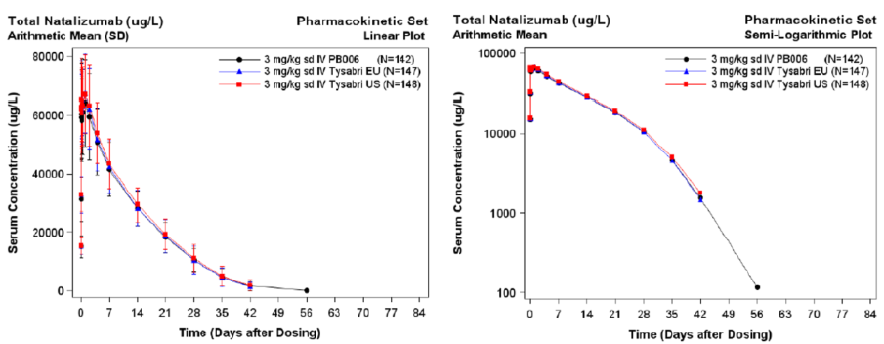
Formal comparison of the ratio of the AUC_{0-inf} geometric least square (LS) means for PB006 versus the marketed Tysabri products, as well as EU-Tysabri versus US-Tysabri, demonstrated PK bioequivalence (that is, 90% confidence interval contained within 0.8 and 1.25) (Table 2). The secondary PK comparisons of C_{max} and AUC_{0-t} also demonstrated PK bioequivalence. Unexchanged natalizumab also demonstrated PK bioequivalence across the three treatment arms.
Table 2: Study 01-03 comparison of AUC_{0-inf} of total natalizumab in the PK population
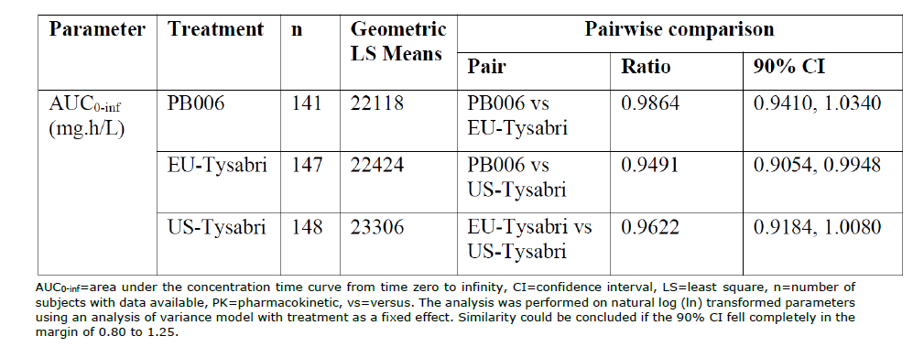
In the Phase III clinical study natalizumab total trough concentrations were measured at Weeks 8, 16, 24, 32 and 48. Although not formally compared, they were generally similar and with similar coefficient of variations (shown up to Week 24 in Table 3).
Table 3: Trough concentrations (total natalizumab) in the clinical efficacy study
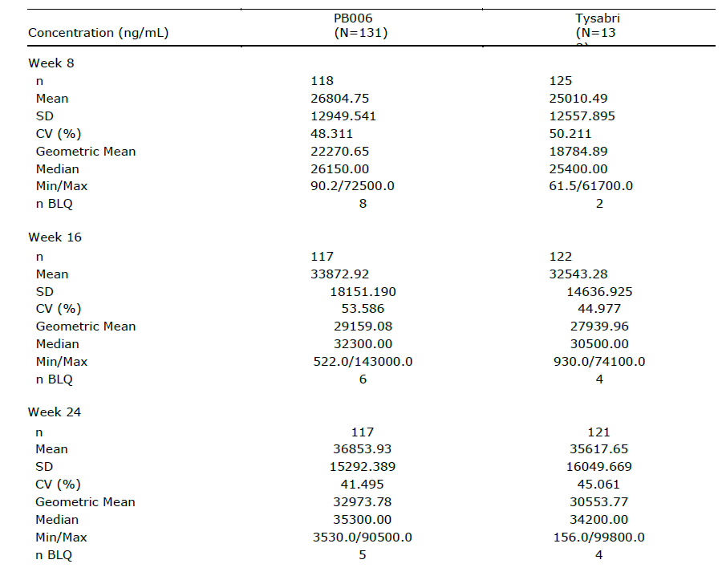
BLQ = below limit of quantification, CV = coefficient of variation, Max = maximum, Min = minimum, N = number of patients in group, n = number of patients with data available, SD = standard deviation.

Pharmacodynamics
In Study PB006-01-03 the two co-primary PD endpoints were the area under the effect curve from time zero to 12 weeks for Baseline adjusted CD19+ (AUEC_{0-12w} CD19+; natalizumab is expected to increase CD19+ cell counts) and the area under the effect curve from time zero to 12 weeks of the percentage saturation of the integrin receptor (AUEC_{0-12w} α4 integrin % receptor saturation; as natalizumab binds α4 integrin it is expected to increase the receptor saturation). These endpoints were used to support PD biosimilarity. Secondary PD endpoints, which included CD34+ and soluble adhesion molecules, were also analysed but were not considered further.
Pharmacodynamic biosimilarity for the above CD19+ (Table 4) and integrin related (Table 5) primary outcomes was demonstrated between PB006 and pooled Tysabri (pooling was permitted under pre-specified conditions).
Table 4: Study 01-03 comparison of PB006 and pooled Tysabri on CD19+ primary pharmacodynamic outcome
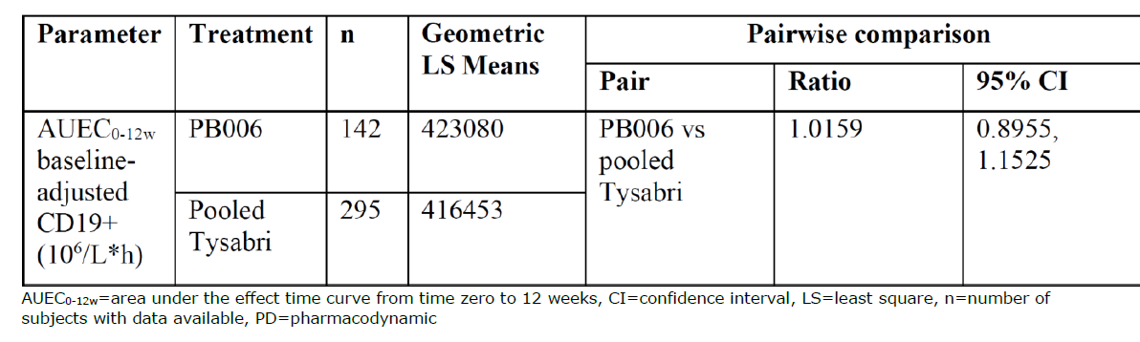
Table 5: Study 01-03 comparison of PB006 and pooled Tysabri on alpha4 integrin primary pharmacodynamic outcome
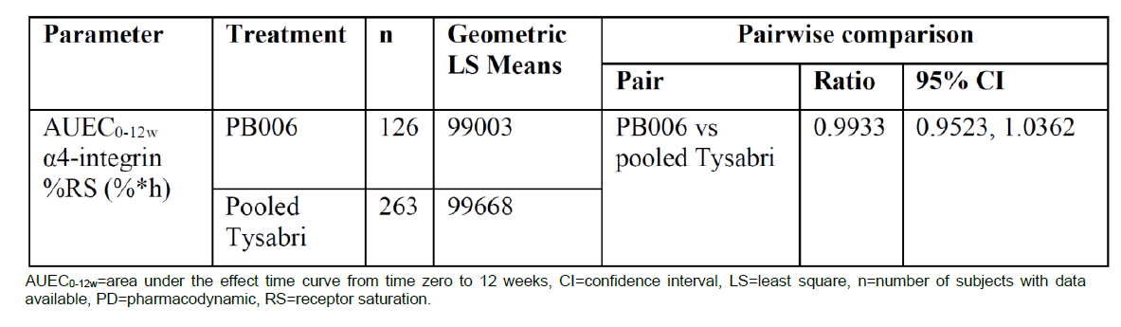
Secondary PD endpoints related to CD43+ cells (which increase following natalizumab administration), soluble VCAM and soluble MAdCAM, were also very similar between the three treatments arms.
Study Tysabri Pilot-01-01 was a randomised, single dose (at three different dose levels) Phase I pilot study to characterise the PK and PD of the reference product EU-Tysabri. It aimed to understand the PK/PD relationship of various PD markers to help determine appropriate endpoints for subsequent studies. It was not considered further.

Efficacy
Study PB006-03-01 was a multicentre, randomised, active-control clinical trial to compare the efficacy and safety of PB006 and EU-Tysabri in patients with relapsing-remitting multiple sclerosis (RRMS). The study was conducted at 48 centres in 7 countries in mainly Eastern Europe.
The primary objective was to evaluate and compare the number of new active lesions over 24 weeks and the secondary endpoints were to evaluate and compare the following:
- new active lesions over 48 weeks
- new gadolinium-enhancing (GdE) T1-weighted lesions over 24 and 48 weeks
- number of patients without new GdE T1-weighted lesions over 24 and 48 weeks
- number of new/enlarging T2-weighted lesions over 24 and 48 weeks
- number of patients without new/enlarging T2-weighted lesions over 24 and 48 weeks
- number of persistent lesions after 24 and 48 weeks
- annualised relapse rates and changes in expanded disability status scale (EDSS) after 24 and 48 weeks
- local and systemic adverse events (AEs) and serious adverse events (SAEs) after 24 and 48 weeks
- immunogenic profile after 24 and 48 weeks and after switching
- natalizumab trough concentration over time
- safety profile over 24 and 48 weeks
Patients were randomised 1:1 to receive either 4 weeks intravenous infusions of 300 mg PB006 or EU-Tysabri, for a total of 12 infusions. Patients in the EU-Tysabri group were re-randomised at Week 24 to either continue the same treatment or switch to PB006.
The major inclusion criteria included male and female patients, aged 18 to 60 years, with RRMS (defined by the 2010 revised McDonald criteria), at least one relapse in the prior year, at least one gadolinium enhancing T1-weighted brain lesion or at least 9 T2-weighted brain lesions at screening and a Kurtzke EDSS score of 0 to 5 (inclusive). Major exclusion criteria included an MS manifestation other than RRMS, relapse from 30 days before screening until study drug administration, prior treatment with immunomodulators/suppressants as specified in the protocol, active infections, JCV index > 1.5, past or current progressive multifocal leukoencephalopathy (PML), malignancies within 5 years (except cured skin basal cell carcinoma and squamous cell carcinoma), severe cardiac or pulmonary disease, uncontrolled hypertension or poorly controlled diabetes and serum creatinine > 120 µmol/L.
A total of 230 patients providing evaluable data to 24 weeks were required to achieve 90% power with respect to equivalence estimation of the primary efficacy outcome. Randomisation was stratified for gadolinium enhancing lesions, ≤ or >15 T2 lesions and JCV status for safety (negative, positive).
The analysis sets were the safety population, the safety-switch population, full analysis set (FAS) and per protocol population (PPP). The primary endpoint was analysed in the PPP. The primary efficacy data were analysed using a negative binomial generalised linear model with fixed effects for the treatment group. Similarity was to be tested based on the corresponding 95% confidence interval. An equivalence margin for the mean difference of 2.1 lesions was chosen.
A total of 265 patients were randomised and 264 were treated with study drug (131 with PB006, 133 with EU-Tysabri). As can be seen in Figure 2 most (93.6%) patients completed the 24 week primary efficacy period, with only a few further dropouts before the 48 week timepoint. Following Week 24 re-randomisation of the EU-Tysabri group, 30 patients were switched over to PB006. Overall, 161 patients were exposed to PB006 in this study.
Figure 2: Antilope study participant flow
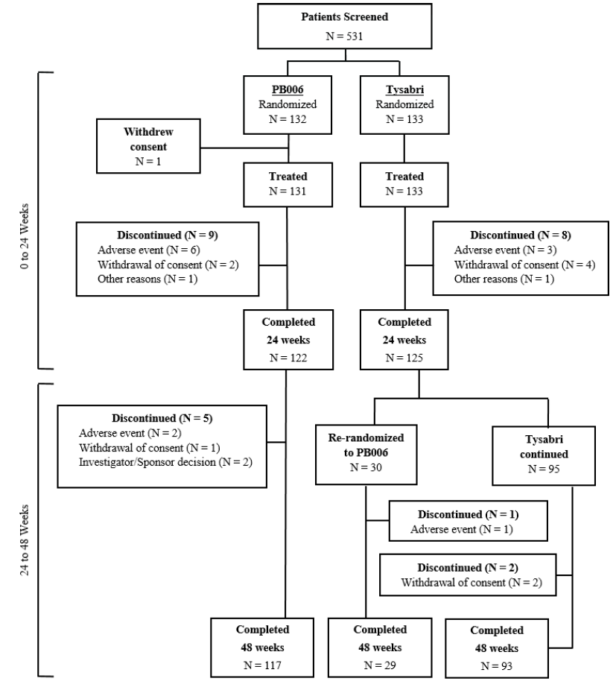
N = Number of patients with the specified event/reason.
Baseline characteristics were similar between treatment groups. Most patients were female (58.6 to 64.1%) and White (100%), with a mean age of 36.7 years and weight of 70.3 kg. In terms of baseline disease characteristics 53% had no gadolinium enhancing lesions and nearly all (96.6%) had more than 15 T2 lesions. In terms of JCV safety, 59.8% were negative. The mean time since most recent relapse was 2.86 to 3.038 months. A single relapse in the preceding year was most common in both groups (65.6% to 68.4%).
For the primary efficacy outcome (PPP), the exponentiated difference between EU-Tysabri and PB006 of the cumulative number of new lesions over 24 weeks was 0.17. The 90% confidence interval was -0.488 and 0.819 and the 95% confidence interval was -0.613 and 0.944. Both confidence intervals included 0 (that is, no difference in the number of cumulative active lesions between the treatments). Furthermore, the confidence intervals were contained within the specified margins of -2.1 and 2.1. The primary outcome was met (that is, no difference between EU-Tysabri and PB006). Sensitivity analysis using the FAS found the same result. All other sensitivity analyses were consistent.
Secondary efficacy analyses showed the following (FAS):
- new active lesions over 48 weeks – the mean (standard deviation (SD)) was 1.5 (3.72) in the PB006 arm and 2.3 (5.68) in the EU-Tysabri arm.
- new GdE T1-weighted lesions over 24 and 48 weeks – the mean (SD) was 0.3 (1.01) at Week 24 and 0.3 (1.02) at Week 48 in the PB006 arm and 0.4 (1.25) at Week 24 and 0.4 (1.39) at Week 48 in the EU-Tysabri arm.
- number of patients without new GdE T1-weighted lesions over 24 and 48 weeks – the percentage was similar at 24 weeks (83.2% with PB006 and 78.9% with EU-Tysabri) and at 48 weeks (80.2% with PB006 and 77.7% with EU-Tysabri).
- number of new/enlarging T2-weighted lesions over 24 and 48 weeks – the cumulative mean at Week 24 was 1.5 with PB006 and 2.0 with EU-Tysabri; at Week 48 it was 1.6 with PB006 and 2.4 with EU-Tysabri.
- number of patients without new/enlarging T2-weighted lesions over 24 and 48 weeks – the percentage was similar at 24 weeks (57.3% with PB006 and 54.1% with EU-Tysabri) and 48 weeks (54.2% with PB006 and 50.5% with EU-Tysabri).
- number of persistent lesions after 24 and 48 weeks – the mean cumulative number at Week 24 was 0.5 with PB006 and 0.4 with EU-Tysabri; at Week 48 it was 0.5 with PB006 and 0.6 with EU-Tysabri.
- annualised relapse rates (ARR) after 24 and 48 weeks – the ARR after 24 weeks was 0.206 with PB006 and 0.152 with EU-Tysabri; after 48 weeks it was 0.174 with PB006 and 0.133 with EU-Tysabri. Note that no patients in either group had more than one relapse in the first 24 weeks.
- changes in EDSS after 24 and 48 weeks – the mean changes in EDSS were minimal and similar between the two arms.

Safety
Safety of PB006 was based on Study PB006-01-02 (Phase I study in which 10 healthy subjects were treated with a single 300 mg IV dose of PB006), Study PB006-01-03 and Study PB006-03-01.
PB006 was administered to 159 healthy subjects and to 161 patients with RRMS.
As the dosing in the main Phase I Study 01-03 was weight based, the lowest dose given was 156 mg and the highest dose was 274 mg (very similar doses were given for EU-Tysabri and US-Tysabri). The dosing in Phase III Study 03-01 was the same as the standard clinical dose, that is, 300 mg every 4 weeks. Patient disposition in this study was similar for PB006 and the reference product.
In Study 01-02 all treatment-emergent adverse events (TEAEs) were mild or moderate and there were no serious AEs, fatal AEs or AEs leading to discontinuation. The most common TEAEs occurring in more than one subject were headache, catheter site pain, fatigue and injection site haematoma.
In Study 01-03, AE frequency was similar across the arms. Three were two SAEs and one severe TEAE reported, all in the US-Tysabri arm. There were no AEs leading to study discontinuation and no fatal AEs. The most common TEAEs were headache and injection site reaction. Adverse events were generally balanced across the arms.
In the Phase III Study 03-01 the percentages of patients with TEAEs, SAEs and TEAEs related to study drug were similar across the arms (Table 6). There were no fatal AEs. The frequency of TEAEs of at least Grade 3 was numerically higher with PB006 than EU-Tysabri (3.1% versus 1%), as was discontinuation due to any AE (6.1% versus 2.9%). The date from the 30 subjects who switched to PB006 from EU-Tysabri at Week 24 did not suggest an increase in development of AEs from that time point.
Table 6: Summary of adverse events by treatment sequence in Study PB006-03-01 safety population
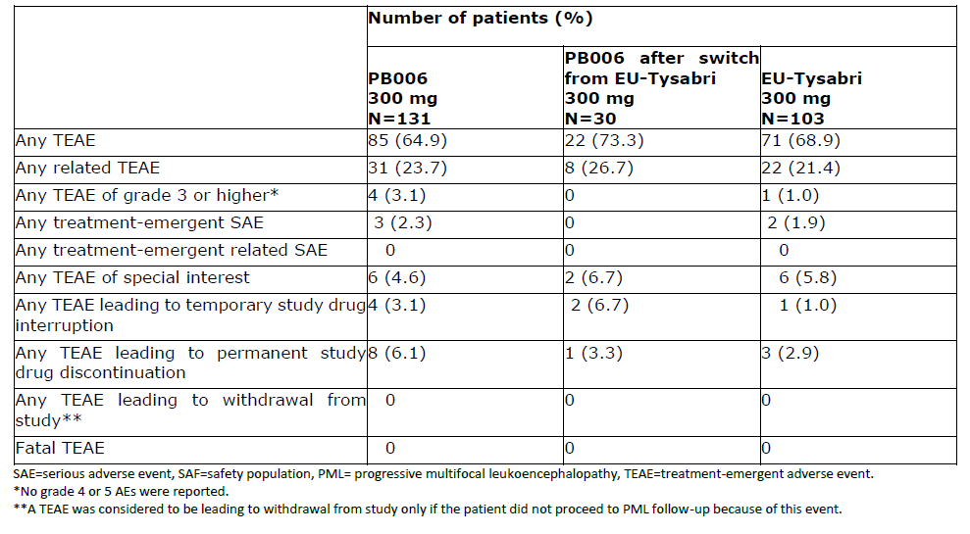
The most frequently reported events, with exposure adjusted event rates (this metric was relevant given the re-randomisation in the EU-Tysabri group) greater than 10 events per 100 patient-years in at least one group were nasopharyngitis, COVID-19, headache and tension headache. Although there were differences in AE rates for individual AEs between arms, the overall safety profile appeared similar for PB-006 and the reference product.

Adverse events of special interest

Progressive multifocal leukoencephalopathy
Throughout clinical development the STRATIFY JCV DxSelect assay was used for screening study subjects. In parallel, a new assay (ImmunoWELL JCV IgG assay) was developed for clinical use. The ImmunoWELL test was validated for precision, selectivity, a potential hook-effect and robustness and was deemed suitable for intended use (qualitative detection of antibodies to JC virus in human serum or plasma).
Samples from Studies PB006-01-03 and 03-01 were used to validate ImmunoWELL JCV IgG assay against STRATIFY JVC DxSelect (that is, using matching samples). An equivocal zone of results of 0.25 to 0.50 was set to balance sensitivity and specificity (similar to the 0.20 to 0.40 zone for the STRATIFY assay). ImmunoWELL assay characteristics are shown in Table 7.
Table 7: ImmunoWELL assay characteristics
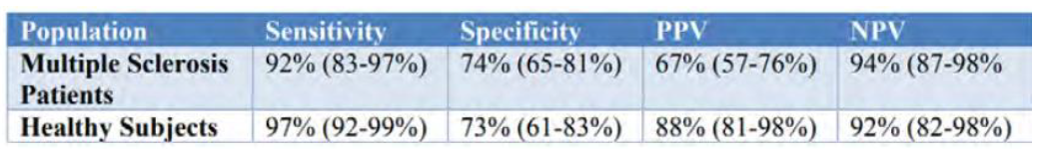
The STRATIFY and ImmunoWELL perform very similarly between the index values of 0.9 and 1.5 which is critical for stratifying patients according to JCV risk (that is, low is <0.09, intermediate is 0.9 to 1.5 and high is 1.5 to 2.5) (Figure 3). In terms of comparing the two assays, if a minor offset exists it is expected to be below 0.1 index values.
Figure 3: Study 03-01 Correlation of index values from ImmunoWELL John Cunningham virus immunoglobulin G versus STRATIFY John Cunningham virus DxSelect using combined dataset from multiple sclerosis patient samples
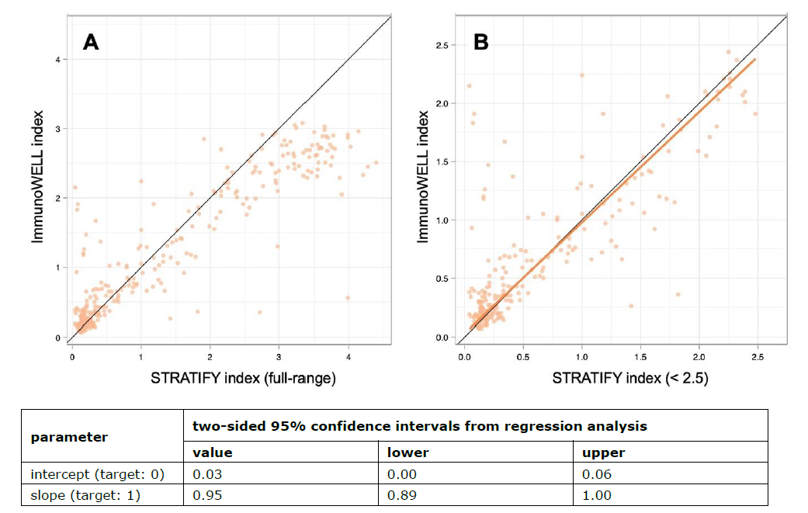
Using slightly different threshold values for each assay (0.8 and 1.4 for ImmunoWELL JCV and 0.9 and 1.5 for STRATIFY JCV DxSelect), there was strong agreement between the assays and acceptable sensitivity and specificity.
In Study PB006-0102 no JCV-positive subjects were enrolled and no PML cases were reported (to Day 169).
In Study PB006-01-03 all randomised subjects tested negative for anti-JCV antibodies at screening. On Day 85, 19 subjects tested positive (9 with PB006, 4 with EU-Tysabri and 6 with US-Tysabri). No PML cases were detected.
In Study PB-006-03-01, no patients had a JCV index > 1.5 at Baseline. At Week 48, 6% in the PB006 arm and 5.9% in the EU-Tysabri arm developed a JCV index > 1.5. Although 5 patients had MRI findings suspicious for PML, no cases of PML occurred in the study. Clinical monitoring for PML extended to 6 months after discontinuing natalizumab and was undertaken by most patients (253 out of 265).

Laboratory findings
In Study PB006-01-03, transient and modest increases in various leukocyte types were seen (leukocytes, lymphocytes, eosinophils, monocytes) and were similar across the treatment arms.
In Study PB006-03-01, modest increases in eosinophils, leukocytes, lymphocytes and monocytes were seen in both treatment groups (slightly numerically higher in the PB006 group). Small changes in haemoglobin were also seen (mean change -5.3 g/L in PB006 arm and -1.5 g/L in EU-Tysabri arm).
Other laboratory findings were similar between groups in Study 03-01.
Most other AESI did not occur (JCV granule neuronopathy, opportunistic infections, liver injury, hypersensitivity, encephalitis, meningitis). The most frequent occurring were urticaria and herpes.

Immunogenicity
During Tysabri development persistent antidrug antibodies (ADAs) were associated with a substantial decrease in the effectiveness of natalizumab and increased hypersensitivity reactions. Antidrug antibodies were detected in approximately 10% in the 2 year controlled trials and persistent ADAs developed in 6%.
The sponsor validated a 3-tier testing approach to ADAs for PB006 (that is, screening, confirmation and quantification). A qualitative assay for neutralising ADAs was also developed.
In Study PB006-01-02, 30% of subjects developed treatment emergent ADAs.
In Study PB006-01-03 the immunogenicity profile of PB006 was essentially the same as both of the reference products. Treatment emergent ADAs occurred in 87% of subjects (87 to 92% with the reference products) and neutralising ADAs occurred in 82% of ADA positive subjects (75 to 84% with reference products; that is, most ADAs were found to be neutralising). Titres were also similar across groups. There were no effects on PK (AUC_{0-inf} and C_{max}) and PD biomarkers.
In Study PB-006-03-01 after 24 weeks, 79% of subjects with PB006 and 74% with EU-Tysabri developed treatment emergent ADAs (Table 8). Most of the antibodies were classified as persistent and were at similar percentages in each treatment group. Geometric mean maximal ADA titre was 223.6 with PB006 and 150.7 with EU-Tysabri. In general ADA incidence was similar with PB006 and the reference, with somewhat higher geometric mean titres. There were fewer ADA positive subjects by Week 48 in both the PB006 and EU-Tysabri groups.
Most of the ADAs detected were neutralising (approximately 87% of ADA positive subjects) and were spread similarly across the treatment groups.
In terms of differential effects on natalizumab exposure at Week 24, ADA positive subjects treated with PB006 had a slightly higher geometric mean trough concentration than those treated with EU-Tysabri (11375.8 ng/mL versus 10405.1 ng/mL, respectively). This was more pronounced amongst neutralising ADA positive subjects, where concentrations were 8350.6 ng/mL with PB006 and 6957.4 ng/mL with EU-Tysabri. Whilst exposure was significantly lower in ADA positive subjects, the difference appeared similar with PB006 and EU-Tysabri (trough concentrations in ADA positive subjects were 30 to 31% those of ADA negative subjects).
No treatment-related difference in the impacts of ADA or neutralising status were detected.
Table 8: Study 03-01 antidrug antibodies related parameters with PB006 and EU-Tysabri
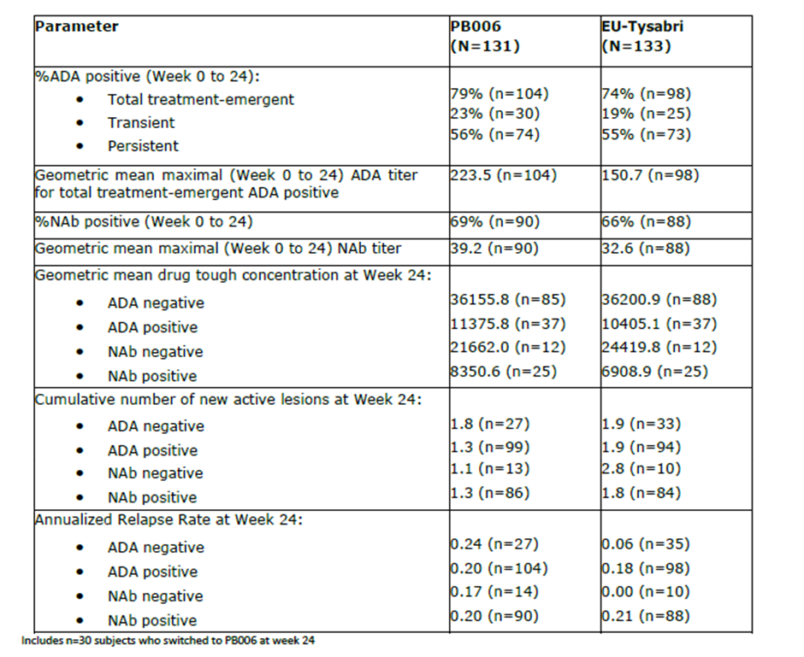

Risk management plan
The sponsor has submitted EU-risk management plan (RMP) version 1.2 (dated 9 May 2023; data lock point (DLP) 21 October 2021) and Australia-Specific Annex (ASA) version 1.0 (dated 21 September 2023) in support of this application. The sponsor has submitted ASA version 1.1 (dated 2 May 2024) in association with previously submitted EU RMP version 1.2 (dated 9 May 2023; DLP 21 October 2021).
The summary of safety concerns and their associated risk monitoring and mitigation strategies are summarised in Table 9. The TGA may request an updated RMP at any stage of a product's life-cycle, during both the pre-approval and post-approval phases.
Table 9: Summary of safety concerns
Summary of safety concerns |  | Pharmacovigilance |  | Risk Minimisation
 |  | Routine | Additional | Routine | Additional
Important identified risks | Progressive multifocal leukoencephalopathy (PML) | * | – |  | †‡§ǁ
Important identified risks | Serious herpes infections | * | – |  | †
Important potential risks | Malignancies | * | – |  | –
Missing information | PML risk following switch from disease modifying therapies with immunosuppressant effect |  | – |  | –
* Targeted follow-up forms
† Physician Information and Management Guideline including reference to an MRI learning platform
‡ Patient Alert Card
§ Pre-Administration Questionnaire
ǁ MRI learning material
The summary of safety concerns in the EU RMP align with the safety concerns proposed in the ASA. It is noted that the EU RMP for the reference product Tysabri, includes missing information ‘immunogenicity potential of subcutaneously administered Tysabri (anti-natalizumab antibody formation resulting in a potential adverse clinical consequence of serious hypersensitivity reactions, including anaphylaxis)’. This risk is not relevant to the proposed product as no subcutaneous dosage form is proposed for Tyruko. The summary of safety concerns is acceptable from an RMP perspective.
The sponsor proposes only routine PV activities for Tyruko including targeted follow up questionnaires for PML, serious herpes infections and malignancies. There are no additional pharmacovigilance activities for the safety concerns of Tyruko. This is acceptable from an RMP perspective; however the sponsor should be aware of any changes to the reference product’s RMP (Tysabri) as a result of the ongoing observational studies. Consideration should be made if the changes to the reference product are also relevant for Tyruko. If so and the changes are considered significant, a revised ASA should be provided to the TGA for review and approval via the post approval RMP update process.
The proposed RMP in the ASA aligns with the EU RMP for the reference product. Mock ups of the Physician Information and Management Guideline have been provided and require further review. The sponsor should also provide the Patient Alert Card and Pre-Administration Questionnaire to the TGA for review and approval prior to product launch. It is noted that the PML Risk Estimates Algorithm is not included, and prescribers are required to refer to the guideline for this information. This is not the case with the reference product’s PI where the figure is included. This approach taken by the biosimilar is raised to the Delegate to consider.

Risk-benefit analysis

Delegate’s considerations

Proposed indication
Given that Tyruko is a biosimilar to AU-Tysabri it needs to have the same indication, that is, ‘Tysabri is indicated as monotherapy for the treatment of patients with relapsing remitting multiple sclerosis (MS) to delay the progression of physical disability and to reduce the frequency of relapse’.
The wording and details are different to the EU indication on which the COR-B submission was based. The Delegate considers it nevertheless an appropriate indication in Australia on the basis that it has the same wording as AU-Tysabri, the disease is the same (relapsing remitting multiple sclerosis) and it reflects the patient population studied in the pivotal Phase III trial. The details of disease severity are absent in the Australian indication and this reflects how it was previously evaluated and registered. Despite the lack of restriction in the Australian indication, natalizumab would almost certainly only be used in a more severe and refractory patient group, given the risk of progressive multifocal leukoencephalopathy (PML).

Efficacy
The efficacy of Tyruko is established on the basis that the pivotal clinical trial met its primary outcome measure and that its confidence interval was within the pre-specified boundaries. Results from Tyruko and the reference product treated arms were similar in terms of secondary endpoints. The annualised relapse rates were numerically higher with Tyruko than EU-Tysabri. However, the absolute annualised relapse rates were low for both. Some MRI based secondary endpoints, such as number of new active lesions over 48 weeks, demonstrated a numerically lower number of lesions with Tyruko.

Safety
The size of the dataset allowed adequate assessment of the safety profile, including 131 patients treated for up to a year. The immunogenicity profiles were very similar between the biosimilar and reference products, impact of ADA on serum drug trough levels were similar between arms. No treatment-related difference in the impacts of ADA or neutralising status were detected.

Proposed changes to the assessment of progressive multifocal leukoencephalopathy risk in the Product Information
The Delegate’s position is that the Tyruko Product Information (PI) should essentially reflect the innovator Tysabri’s PI, except for the addition of relevant data generated for the biosimilar (that is, PK, efficacy, safety, immunogenicity). This is appropriate for a biosimilar and reflects the practice of the TGA. The PI content around PML risk guidance, index values and assay descriptions (STRATIFY JCV) should be reinstated. The Delegate would consider statements around how the index value threshold for risk assessment may be somewhat different for different assays and the prescriber should ensure the appropriate assay and threshold are used for decision making.

Proposed action
Following agreement on the content of the Product Information, the Delegate intends to approve Tyruko.

Advisory Committee considerations
The Advisory Committee on Medicines (ACM), having considered the evaluations and the Delegate’s overview, as well as the sponsor’s response to these documents, advised the following.

Specific advice to the Delegate
The ACM advised the following in response to the Delegate’s specific request for advice:
- What is ACM’s view of the Delegate’s position of retaining the JCV risk assessment/management information as it is found in the innovator PI?
The ACM was of the view that retaining the JCV risk assessment information as it was in the innovator PI was likely to cause confusion, given there are differences between the STRATIFY and ImmunoWELL assays. The ACM suggested a generic risk stratification table be included in the Product Information, with no reference to proprietary platforms, but noted that there are slightly different values between assays that might complicate this. The ACM concluded that the inclusion of the specific assay values in Physician’s information guidelines would be acceptable, but that references to that should be made in the PI. The ACM were satisfied that the STRATIFY and ImmunoWELL assays were substantially comparable.
The ACM noted that in the Australian setting, Tyruko would primarily be prescribed by specialist neurologists, who would often be sub-specialised in MS treatment and management, but not always, especially in regional settings. The risks of immunomodulatory treatment are well known to these prescribers.
The ACM advised that the clinical management flowchart found in the PI should be consistent between Tyruko and the reference product to minimise confusion. There was concern that if a patient were switched between two different regimens, this could suggest significant differences be taken in the clinical approach, which would be inappropriate given their equivalence.
The ACM debated whether a requirement for more frequent MRI scans for high-risk patients could increase burden on patients, as well as public hospital imaging departments. However, it was acknowledged that the more frequent imaging recommendation is for high-risk patients only, of whom there are not many in practice. The wording pertaining to imaging surveillance should be consistent between innovator and biosimilar unless there is compelling evidence to justify a difference. The ACM was of the view that the wording in the innovator product’s PI was permissive enough to justify more frequent MRI scans if appropriate, and alternative wording would be unnecessary and potentially confusing.
- What is the current landscape for JCV antibody testing for patients using natalizumab (Tysabri) in Australia (i.e. what assay is used, where is it done)?
The ACM advised that patients who are being treated with Tysabri are assessed for JCV antibodies using the STRATIFY assay, which is performed in Denmark. Results are returned in approximately 4-6 weeks. This service is provided by the innovator sponsor free of charge.
The ACM noted that there are no equivalent Australian-based assays available for screening JCV antibodies. Patients who would be prescribed Tyruko would be screened using a unique proprietary platform ImmunoWELL, under development by Sandoz, which has not yet been registered in Australia. The ACM noted that Sandoz states its ImmunoWELL assay would also be provided free of charge, with reading to be conducted in Romania, but sought clarification on the inclusion of shipping charges in that scheme, which is a prominent issue due to Australia’s geographic isolation.
- Does ACM have comments on the safety/efficacy data for Tyruko as presented in the overview?
The ACM held the view that the efficacy and safety data were sufficient and would support approval of this application if the outstanding issues with the PI are resolved.

Conclusion
The ACM considered this product to have an overall positive benefit-risk profile for the indication:
Monotherapy for the treatment of patients with relapsing remitting multiple sclerosis (MS) to delay the progression of physical disability and to reduce the frequency of relapse.

Outcome
Based on a review of quality, safety, and efficacy, the TGA decided to register Tyruko (natalizumab) 300 mg/15 mL, concentrate for injection, indicated for:
Tyruko is indicated as monotherapy for the treatment of patients with relapsing remitting multiple sclerosis (MS) to delay the progression of physical disability and to reduce the frequency of relapse.

Specific conditions of registration applying to these goods
- The Tyruko EU-Risk Management Plan (RMP) (version 1.2, dated 9 May 2023, data lock point 21 October 2021), with Australia-Specific Annex (version 1.1, dated 2 May 2024), included with submission PM-2023-04610-1-1, and any subsequent revisions, as agreed with the TGA will be implemented in Australia.

Attachment 1. Product Information
The Product Information (PI) approved with the submission for Tyruko which is described in this AusPAR can be found as Attachment 1. It may have been superseded. For the most recent PI and Consumer Medicines Information (CMI), please refer to the TGA PI/CMI search facility.
Therapeutic Goods Administration
PO Box 100 Woden ACT 2606 Australia
Email: info@tga.gov.au Phone: 1800 020 653 Fax: 02 6203 1605
https://www.tga.gov.au
Reference/Publication #

This is the original indication proposed by the sponsor when the TGA commenced the evaluation of this submission. It may differ to the final indication approved by the TGA and registered in the Australian Register of Therapeutic Goods.
Therapeutic Guidelines Neurology. Australia. Retrieved June 18, 2024, from https://tgldcdp.tg.org.au/viewTopic?etgAccess=true&guidelinePage=Neurology&topicfile=multiple-sclerosis&guidelinename=Neurology&sectionId=toc_d1e1503#toc_d1e1503
Tysabri was first registered in Australia on 1 November 2006. ARTG number: 112372.
The TGA makes use of assessments from comparable overseas regulators (CORs), where possible, in the evaluation of prescription medicines. Under the COR-B approach, the TGA regulatory decision will be mostly based on a critical review of the COR assessment reports. The COR-B process has a 175 working day evaluation and decision timeframe, allowing for TGA evaluation of certain data, in addition to the label, Product Information (PI) and Risk Management Plan (RMP). The amount and type of additional data requiring evaluation will determine whether the application is best processed under the COR-B approach or as a Category 1 application. Examples of additional data that may be considered under the COR-B process include updated stability data, validation data for an additional manufacturing site and updates to pivotal studies that support the proposed indication.
In this report the ‘Delegate’ is the Delegate of the Secretary of the Department of Health, Disability and Ageing who decided the submission under section 25 of the Act.

