Australian Public Assessment Report for Tepezza
  - Active ingredient: teprotumumab
  - Sponsor: Amgen Australia Pty Ltd
August 2025

About the Therapeutic Goods Administration (TGA)
- The Therapeutic Goods Administration (TGA) is part of the Australian Government Department of Health, Disability and Ageing and is responsible for regulating therapeutic goods, including medicines, medical devices, and biologicals.
- The TGA administers the Therapeutic Goods Act 1989 (the Act), applying a risk management approach designed to ensure therapeutic goods supplied in Australia meet acceptable standards of quality, safety, and efficacy.
- The work of the TGA is based on applying scientific and clinical expertise to decision-making, to ensure that the benefits to the Australian public outweigh any risks associated with the use of therapeutic goods.
- The TGA relies on the public, healthcare professionals and industry to report problems with therapeutic goods. The TGA investigates reports received to determine any necessary regulatory action.
- To report a problem with a therapeutic good, please see the information on the TGA website.

About AusPARs
- The Australian Public Assessment Report (AusPAR) provides information about the evaluation of a prescription medicine and the considerations that led the TGA to approve or not approve a prescription medicine submission. Further information can be found in Australian Public Assessment Report (AusPAR) guidance.
- AusPARs are prepared and published by the TGA.
- AusPARs are static documents that provide information that relates to a submission at a particular point in time. The publication of an AusPAR is an important part of the transparency of the TGA’s decision-making process.
- A new AusPAR may be provided to reflect changes to indications or major variations to a prescription medicine subject to evaluation by the TGA.

Copyright
© Commonwealth of Australia 2025
This work is copyright. You may reproduce the whole or part of this work in unaltered form for your own personal use or, if you are part of an organisation, for internal use within your organisation, but only if you or your organisation do not use the reproduction for any commercial purpose and retain this copyright notice and all disclaimer notices as part of that reproduction. Apart from rights to use as permitted by the Copyright Act 1968 or allowed by this copyright notice, all other rights are reserved and you are not allowed to reproduce the whole or any part of this work in any way (electronic or otherwise) without first being given specific written permission from the Commonwealth to do so. Requests and inquiries concerning reproduction and rights are to be sent to the TGA Copyright Officer, Therapeutic Goods Administration, PO Box 100, Woden ACT 2606 or emailed to <tga.copyright@tga.gov.au>.

Contents
List of abbreviations 4
Tepezza (teprotumumab) submission 5
Proposed indication 6
The condition 6
Current treatment options 6
Clinical rationale 6
Regulatory status 7
Registration timeline 7
Assessment overview 8
Quality evaluation summary 8
Nonclinical evaluation summary 8
Clinical evaluation summary 10
Summary of clinical studies 10
Pharmacology 11
Efficacy 14
Safety 24
Risk management plan evaluation summary 29
Risk-benefit analysis 31
Clinical trial program 31
Main issues 32
Advisory Committee considerations 35
Implementation of risk minimisation measures 36
Assessment outcome 37
Specific conditions of registration 37
Product Information and Consumer Medicines Information 38
Appendix – Additional tables and figures 38

List of abbreviations
Abbreviation | Meaning
ACM | Advisory Committee on Medicines
ARTG | Australian Register of Therapeutic Goods
AUC_{ss} | steady-state exposures
CAS | clinical activity score
CL | central clearance
C_{max} | maximum concentration
C_{max,ss} | maximum serum concentration at steady state
C_{min,ss} | minimum serum concentration at steady state
GO-QoL | Graves' Ophthalmopathy Quality of Life
IGF-1R | insulin-like growth factor-1 receptor
ITT | intent-to-treat
PD | pharmacodynamic(s)
PI | Product Information
PK | pharmacokinetic(s)
popPK | population pharmacokinetic(s)
Q | inter-compartment clearance
RMP | Risk management plan
SD | standard deviation
SE | standard error
TEAE | Treatment emergent adverse event
TED | Thyroid eye disease
TGA | Therapeutic Goods Administration
Vc | volume of distribution in the central compartment
Vp | volume of distribution in the peripheral compartment

Tepezza (teprotumumab) submission

Type of submission: | New biological entity
Product name: | Tepezza
Active ingredient: | teprotumumab
Decision: | Approved
Date of decision: | 13 March 2025
Approved therapeutic use for the current submission: | Tepezza is indicated for the treatment of moderate to severe thyroid eye disease (TED)
Date of entry onto ARTG: | 27 March 2025
ARTG numbers: | Tepezza teprotumumab 500 mg injection powder vial (444610)
Black Triangle Scheme: | Yes
Sponsor’s name and address: | Amgen Australia Pty Ltd Level 11, 10 Carrington St, Sydney NSW 2000
Dose form: | Powder for injection.
Strength: | Each vial contains 500 mg of teprotumumab. The reconstituted Tepezza solution contains 47.6 mg/mL (500 mg / 10.5 mL) of teprotumumab.
Container: | 20 mL type I clear glass vial, with a grey stopper (flurotec coated chlorobutyl) and an aluminium seal with a polypropylene matte red flip-off cap.
Pack size: | Each carton contains one vial.
Route of administration: | intravenous infusion
Dosage: | 10 mg/kg for the initial dose followed by 20 mg/kg every three weeks for 7 additional doses.  For further information regarding dosage refer to the Product Information.
Pregnancy category: | Category X  Drugs which have such a high risk of causing permanent damage to the fetus that they should not be used in pregnancy or when there is a possibility of pregnancy  The use of any medicine during pregnancy requires careful consideration of both risks and benefits by the treating health professional. The pregnancy database must not be used as the sole basis of decision making in the use of medicines during pregnancy. The TGA does not provide advice on the use of medicines in pregnancy for specific cases. More information is available from obstetric drug information services in your state or territory.

Proposed indication
This AusPAR describes the submission by Amgen Australia Pty Ltd (the Sponsor) to register Tepezza (teprotumumab) for the following proposed indication:
Tepezza is indicated for the treatment of thyroid eye disease (TED)

The condition
Thyroid Eye Disease (TED), also known as thyroid-associated ophthalmopathy, Graves’ ophthalmopathy or Graves’ orbitopathy, is a serious, debilitating and painful autoimmune disease associated with major comorbidities that can lead to blindness. Although it is most commonly associated with Graves’ disease hyperthyroidism, TED may also occur in patients with other autoimmune thyroid diseases.

Current treatment options
Treatment typically involves correction of thyroid dysfunction, i.e., restoration of a euthyroid state. Supportive therapy includes smoking cessation, alleviation of exposure symptoms, reduction of periorbital oedema using cool compresses and head elevation, temporary management of diplopia by monocular occlusion or prisms. In moderate-to-severe TED the following are usually considered (some are off-label; treatments may be combined):
- Immunosuppressive therapy (e.g., with corticosteroids, rituximab, tocilizumab)
- External orbital radiation/radiotherapy
- Orbital decompression surgery

Clinical rationale
Teprotumumab is a fully human IgG1 monoclonal antibody produced in Chinese Hamster Ovary (CHO-DG44) cells by recombinant DNA technology that binds to the insulin-like growth factor-1 receptor (IGF-1R) and blocks its activation and signalling.
At the molecular level, the two major autoantigens implicated in TED include thyroid-stimulating hormone receptor and IGF-1R,,, which have been shown to be physically and functionally coupled in a macromolecular signaling complex.,, These molecular events underpin the pathophysiology of acute TED. Inhibiting IGF-1R function using an anti-IGF-1R mAb similar to teprotumumab blocks pathophysiological responses specifically elicited by autoantibodies on orbital fibroblasts from TED patients.,,. Consistent with this, teprotumumab inhibits the activation of fibrocytes, which are the cellular progenitors for a subtype of orbital fibroblast critical to TED pathogenesis.,. As such, teprotumumab has the potential to be a disease modifying therapeutic.

Regulatory status

Australian regulatory status
This product is a new biological entity for Australian regulatory purposes.

International regulatory status
At the time the TGA considered this submission, a similar submission had been considered by the Medicines and Healthcare products Regulatory Agency (submitted 18 March 2024), Health Canada (submitted 25 March 2024), European Medicines Agency (submitted 25 April 2024) and Swissmedic (submitted 24 June 2024).

Registration timeline
Table 1 captures the key steps and dates for this submission.
This submission was evaluated under the priority registration process.
Table 1. Registration timeline for Tepezza (teprotumumab)
Description | Date
Priority determination | 20 March 2024
Submission dossier accepted and evaluation commenced | 30 April 2024
Evaluation completed | 14 October 2024
Advisory Committee meeting | 6 December 2024
Registration decision (Outcome) | 13 March 2025
Registration in the ARTG completed | 27 March 2025
Number of working days from submission dossier acceptance to registration decision* | 224 days
*Target timeframe for priority submissions is 150 working days from acceptance for evaluation to the decision.

Assessment overview

Quality evaluation summary
There were no significant issues identified from the quality evaluation of the submitted data that would indicate the product should not be registered on the basis of quality, or safety-related issues arising from the quality of the product. The Sponsor has satisfied all requirements with respect to:
- Good Manufacturing Practice compliance,
- stability and release specifications,
- history, control and traceability of cell lines/cell banks,
- validation of analytical procedures,
- appropriate choice/synthesis and validation of reference materials,
- appropriate in-process controls within the manufacturing process and identification of critical manufacturing steps,
- consistency of medicine manufacture verified by process validation and demonstrated through batch analysis,
- satisfactory control of impurities,
- adequate characterisation and justification of excipients,
- medicine sterility/appropriate control of infectious disease & adventitious agents,
- appropriate/compatible container closure systems and
- labelling that conformed to Therapeutic Goods Order 91.
There were no objections to registration from a quality perspective.

Nonclinical evaluation summary
The nonclinical dossier was of good overall quality and adequate in scope, consistent with ICH S6 (R1). All pivotal safety-related studies were GLP-compliant except one, which was otherwise well documented and conducted in a well-established laboratory.
Teprotumumab is a monoclonal antibody (IgG1) directed against the insulin like growth factor-1 receptor (IGF1R), and represents a novel pharmacological class.
In vitro experiments established that teprotumumab possesses nanomolar affinity for human IGF1R, blocking the binding of the receptor’s endogenous ligands, inhibiting receptor activation and reducing its cell surface expression (by promoting receptor internalisation). Teprotumumab was shown to inhibit IGF 1-induced stimulation of proliferation of mouse fibroblasts expressing human IGF1R. Inhibition of thyroid stimulating hormone-induced production of pro inflammatory cytokines in cultured human fibrocytes (precursor cells to orbital fibroblasts) by teprotumumab is reported in the literature. There are no relevant animal models of TED. The primary pharmacology studies offer support for the utility of teprotumumab for the proposed indication.
Teprotumumab also recognises the cynomolgus monkey form of IGF1R (displaying similar affinity cf. human), but did not bind to the mouse, rat or marmoset forms of IGF1R.
Teprotumumab was shown not to additionally bind to the human insulin receptor (which shares a high degree of sequence homology with IGF1R), and not to induce antibody-dependent cell-mediated cytotoxicity in vitro.
Immunohistochemical assays involving a panel of human and cynomolgus monkey tissues revealed a staining pattern for teprotumumab consistent with the known extensive expression of IGF 1R.
Safety pharmacology assessment — incorporated into the general repeat-dose toxicity program — revealed no effect of teprotumumab on CNS, cardiovascular or respiratory function in cynomolgus monkeys.
Teprotumumab showed a pharmacokinetic profile typical of an IgG antibody in cynomolgus monkeys and humans, characterised by a long serum half-life and limited volume of distribution.
A low order of acute toxicity by the IV route was evident for teprotumumab in cynomolgus monkeys.
Repeat-dose toxicity studies by the IV route were conducted in cynomolgus monkeys (up to 9 months duration). Thymic lymphoid depletion was identified as the key toxicity for teprotumumab, with effects on body weight and bone turnover also observed. These effects are consistent with the drug’s primary pharmacological activity, inhibiting IGF 1R-mediated signalling. Clinical relevance cannot be excluded.
No genotoxicity studies were submitted, which is acceptable for a protein drug. Carcinogenicity studies were not performed and are not required, with no cause for concern for carcinogenicity seen from findings in the general repeat-dose toxicity program or from knowledge of the physiological role of IGF1R and the drug’s mechanism of action.
No functional fertility studies were performed. While examination of surrogate endpoints in a 3 month repeat-dose toxicity study in monkeys revealed no treatment-related effects on reproductive organ weights or histology, potential for impairment of fertility in patients is seen from knowledge of the physiological role of IGF 1R and the drug’s mechanism of action.
While Tepezza is not proposed for paediatric use, a juvenile toxicity study was included in the submission. Treatment of juvenile cynomolgus monkeys caused suppression of skeletal growth, decreased bone mineral density and content, and effects on the spleen in addition to effects seen in adult animals.
Teprotumumab was shown to be well tolerated locally by the IV route in cynomolgus monkeys.
Teprotumumab was shown to be clearly teratogenic in cynomolgus monkeys. Every fetus exposed to teprotumumab either died or displayed multiple malformations, including misshapen cranium, closely set eyes, micrognathia, and pointing and narrowing of the nose; impaired/abnormal ossification of the skull, teeth, sternebrae, carpals and tarsals was also observed. Teprotumumab caused generalised suppression of fetal growth, with final fetal weight almost halved, and decreased placental weight and size, and reduced amniotic fluid volume. These adverse effects on embryofetal development occurred in the absence of maternal toxicity, and at a clinically relevant dose (based on the extent of IGF 1R inhibition as well as relative exposure). Concerns for embryofetal harm with teprotumumab are held at the highest level, and warrant assignment to Pregnancy Category X rather than Category D as the Sponsor proposes.
Teprotumumab is to be contraindicated in pregnancy, and women of childbearing potential directed to use effective contraception prior to initiation of treatment, during treatment and for 6 months after the last dose of Tepezza.
There are no nonclinical objections to the registration of Tepezza for the proposed indication.

Clinical evaluation summary

Summary of clinical studies

Pharmacology
Pharmacology data were derived from one dedicated pharmacokinetic (PK) study:
- Study HZNP-TEP-102: A Phase 1, Open-Label, Single Ascending Dose Study to Evaluate the Safety, Tolerability, and Pharmacokinetics of Tepezza Subcutaneous Administration in Healthy Adult Participants.
PK and immunogenicity of teprotumumab were also evaluated as exploratory endpoints in the following Phase 2/3/4 studies in patients with TED:
- TED01RV, HZNP-TEP-301 (OPTIC), HZNP-TEP-303 (OPTIC-J), HZNP-TEP-302 (OPTIC-X), HZNP-TEP-403, and HZNP-TEP-401.
The population pharmacokinetics (PopPK) report Horizon-PopPK-003 was a PopPK analysis with data from clinical studies HZNP-TEP-102, TED01RV, HZNP-TEP-301, HZNP-TEP-302, HZNP-TEP-303, and HZNP-TEP-403.

Efficacy/Safety

Pivotal studies
- HZNP-TEP-301 (OPTIC): Phase 3, Randomised, Double-Masked, Placebo-Controlled, Parallel-Group, Multicentre Study Evaluating Teprotumumab (HZN-001) Treatment in Participants with Active TED (OPTIC).
- HZNP-TEP-303 (OPTIC-J): A Phase 3, Randomised, Double-Masked, Placebo-Controlled, Parallel-Group, Multicentre Trial Evaluating Teprotumumab (HZN-001) Treatment in Japanese Patients with Active TED.
- HZNP-TEP-403: A Phase 4, Randomised, Double-masked, Placebo-controlled, Multicentre Trial to Evaluate the Efficacy and Safety of Tepezza in Treating Patients with Chronic (Inactive) TED.

Supportive studies:
- HZNP-TEP-302 (OPTIC-X) (extension of OPTIC): Phase 3, Multicentre, Safety and Efficacy, Open-label Extension Study Evaluating Teprotumumab (HZN-001) Treatment in Participants with TED.
- Study TED01RV: A Phase 2, Multicentre, Double-masked, Placebo-controlled, Efficacy and Safety Study of Teprotumumab (HZN-001), an Insulin-Like Growth Factor-1 Receptor Antagonist Antibody (Fully Human), Administered Every 3 Weeks by IV Infusion in Patients Suffering from Active TED.
- Study HZNP-TEP-401: A Phase 3b 24-week open-label, multicentre, single-arm expanded access protocol (EAP).

Pharmacology

Pharmacokinetics
The PK information for IV teprotumumab was derived from the following studies using both non-compartmental and population PK analyses:
- 10 healthy participants in Phase 1 study HZNP-TEP-102
- 135 participants with acute TED in studies TED01RV, OPTIC, OPTIC-J and OPTIC-X, and 41 participants with chronic TED in study HZNP-TEP-403
- PopPK Report Horizon-PopPK-003

Absorption
The absorption of teprotumumab was not evaluated as it is intended for IV use only.

Distribution
The PopPK estimated means for central and peripheral volume of distribution of teprotumumab were 2.91 L and 3.67 L, respectively following the proposed teprotumumab dosing regimen. No plasma protein binding study was conducted as the proposed product is a therapeutic protein.

Metabolism
The metabolism of teprotumumab has not been fully characterised. The Sponsor has justified this with the known mechanism of proteolysis clearance for IgG antibodies are through mostly intracellular catabolism by lysosomal degradation to amino acids after uptake by either pinocytosis, an unspecific fluid phase endocytosis, or by a receptor-mediated endocytosis process.

Excretion and elimination
The population estimate of clearance was 0.255 L/day and the geometric mean elimination half-life 21.4 days (%CV: 16.9) in TED participants, consistent with other IgG1 mAbs.

Dose proportionality
At the dose range of 3 to 20 mg/kg, teprotumumab displayed linear PK, but nonlinear PK at low doses (< 3 mg/kg), suggesting a contribution of target-mediated clearance and saturation of target-mediated clearance at higher doses.

Immunogenicity
Of 111 TED participants (Studies TED01RV, HZNP-TEP-301, and HZNP-TEP-303) who received teprotumumab treatment, 4 participants were confirmed ADA-positive at post-baseline visits. Testing for neutralising antibodies was not conducted in any trial. Overall, the immunogenicity results in the trials appeared not to be clinically significant.

Pharmacokinetics in the target population
Teprotumumab concentration-time profiles were simulated using the Bayesian post hoc estimates of individual PK parameters based on the PopPK model for 176 participants with TED in the dataset following 10 mg/kg for the first IV infusion and 20 mg/kg Q3W for the remaining 7 infusions.
Overall, the PK findings in patients with chronic/inactive TED were similar to those observed in patients with acute/active TED. A summary of actual serum concentrations is in Table 17 (Appendix).

Drug-drug interaction studies
No dedicated drug interactions studies were conducted. Drug-drug interactions between teprotumumab and thyroid medications (e.g., levothyroxine, propylthiouracil) commonly taken by TED patients are not expected, as teprotumumab and small molecule drugs do not share common or overlapping clearance pathways. Monoclonal antibodies are not expected to directly affect the hepatic, renal or biliary elimination of small molecules.

Population PK data from study Horizon-PopPK-003

Methods
The PopPK analysis was performed using the non-linear mixed effects modelling approach. This approach estimates the typical (mean) value of parameters and their variances. PopPK estimation was performed using the first order conditional estimation with interaction (FOCEI) method in NONMEM.
The PopPK model was developed based on data from the following 6 studies involving patients with TED: TED01RV, HZNP-TEP-102 (healthy subjects via both SC and IV routes), HZNP-TEP-301, HZNP-TEP-302 (open-label, long-term extension study), HZNP-TEP-303, and HZNP-TEP-403 (chronic TED). The final analysis dataset included 1168 teprotumumab serum concentration measurements from 186 participants.

Results
Model: Teprotumumab PK following IV dosing in the proposed clinical dose range can be described by a two-compartment model with first-order elimination from the central compartment and redistribution from the peripheral compartment. The final base model was chosen based on the objective function value, goodness-of-fit (GOF) plots, and reliability of model parameter estimates.
Estimated parameters: For a typical 73 kg participant, the estimated central clearance (CL) was 0.255 L/day, the volume of distribution in the central compartment (Vc) was 2.91 L, the inter-compartment clearance (Q) was 0.478 L/day, and the volume of distribution in the peripheral compartment (Vp) was 3.67 L. The inter-individual variability values for CL, Vc, and Vp were 20.4%, 24.4%, and 32.4%, respectively. The geometric mean elimination half-life of teprotumumab was 21.4 days with a CV of 16.9% in participants with TED.
Table 1. PopPK Study Horizon-PopPK-003. Summary of Population PK parameters of IV Teprotumumab in a typical 73 kg adult.
CL=central clearance: PK=pharmacokinetic; Q=intercompartmental clearance; Vc=volume of distribution in the central compartment: Vp=volume of distribution in the peripheral compartment.
Covariate analyses suggest that no dosage adjustments based on weight, age, sex, ethnicity, race, health status, trial region, smoking status or renal or hepatic function are required. The following differences in the geometric mean steady-state exposures (AUC_{ss}) maximum serum concentration at steady state (C_{max,ss}), and minimum serum concentration at steady state (C_{min,ss}) were simulated:
- between male and female participants (≤6.23%)
- between adults aged ≥65 years and <65 years (<0.70%)
- between Japanese region and non-Japanese region (≤18.0%)
- between Hispanic and non-Hispanic (≤13.6%)
- between smoker and non-smoker (≤11.8%)
- across studies (within ±17.3%)
- across race groups (within ±16.9%)
- across body weight quartiles (within ±12.9%)
- across health status groups (within ±17.3%)
- across renal function categories (within ±4.91%)
- across hepatic categories (≤2.88%)
Simulated concentration-time profiles: The predicted trough C_{min} was 20.37 μg/mL after the first infusion and 68.71 μg/mL at steady state, i.e. consistently above 20 μg/mL for the dosing regimen used in the Phase 3 trials (that is also proposed as the recommended dosage regimen).
Following the proposed dose regimen (first infusion at 10 mg/kg followed by 7 repeated doses of 20 mg/kg Q3W), the mean (± standard deviation [SD]) estimates for AUC_{ss} was 139 (±27) mg*hr/mL, C_{max} was 675 (±147) μg/mL, and C_{min} trough concentration was 159 (±38) μg/mL.
Figure 1. PopPK Study Horizon-PopPK-003. Simulated teprotumumab concentration-time profile in participants with TED.
'Q3W=every 3 weeks; TED=thyroid eye disease. Red line is the median of model predictions and blue shaded areas represent the spread (5%ile and 95%ile) of the model predictions.
Table 3. PopPK Study Horizon-PopPK-003. Model-predicted teprotumumab exposures in participants with TED (10 mg/kg followed by of 20 mg/kg Q3W).

Pharmacodynamics

Mechanism of action
Teprotumumab appears to bind to IGF-1R and blocks its activation and signalling. However, the mechanism of action of teprotumumab in TED has not been fully characterised.

ER analysis
No clinically relevant exposure-response relationships were observed between teprotumumab exposure and the efficacy or safety endpoints in studies TED01RV, HZNPTEP- 301, HZNP-TEP-302, HZNP-TEP-303, and HZNP-TEP-403 for TED patients. Although the median AUC_{ss} and C_{max,ss} of teprotumumab were slightly higher in subjects with muscle spasm (than without muscle spasm) and in those with infusion related reactions (IRRs) (than those without IRRs), this was not confirmed in logistic regression analysis.

Efficacy

Phase 2, 3, and 4 studies TED01RV, OPTIC, OPTIC-J and 403

Design
The trial design, main inclusion and exclusion criteria, and endpoints is shown in Table 4.
Table 4. Studies TED01RV, OPTIC, OPTIC-J and 403. Trial design, main inclusion and exclusion criteria, and endpoints.
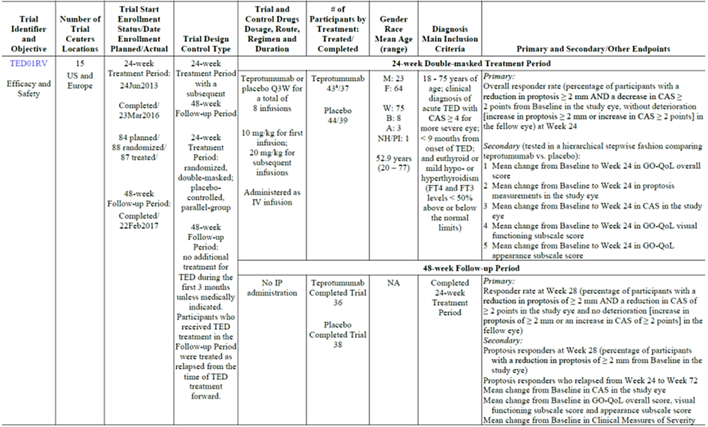
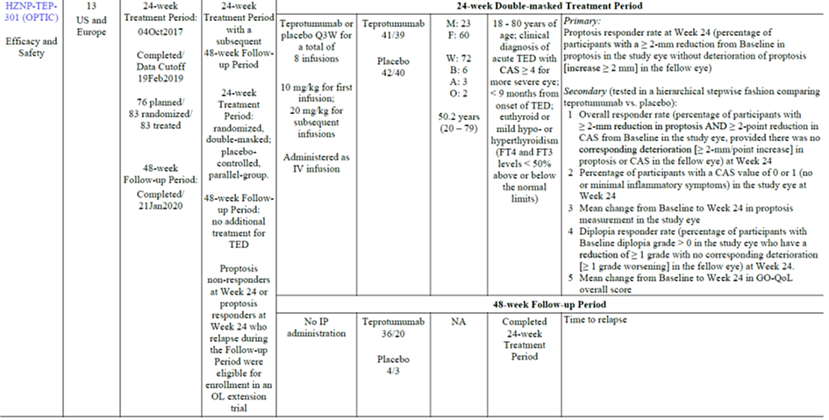
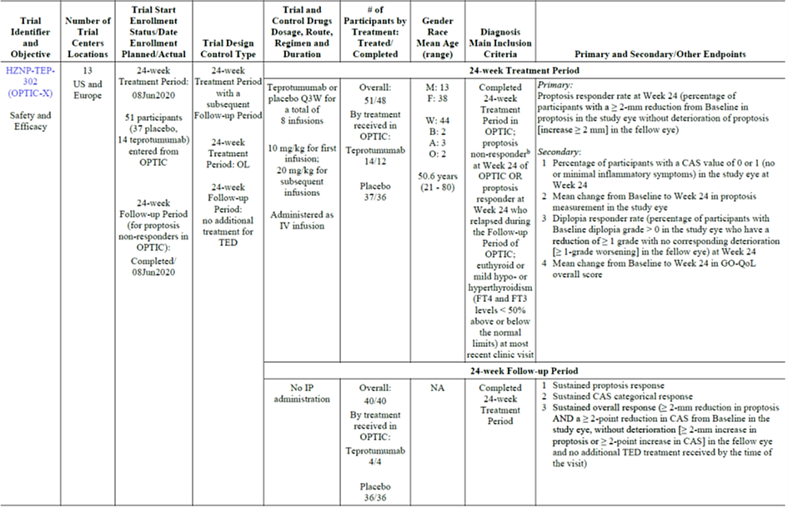
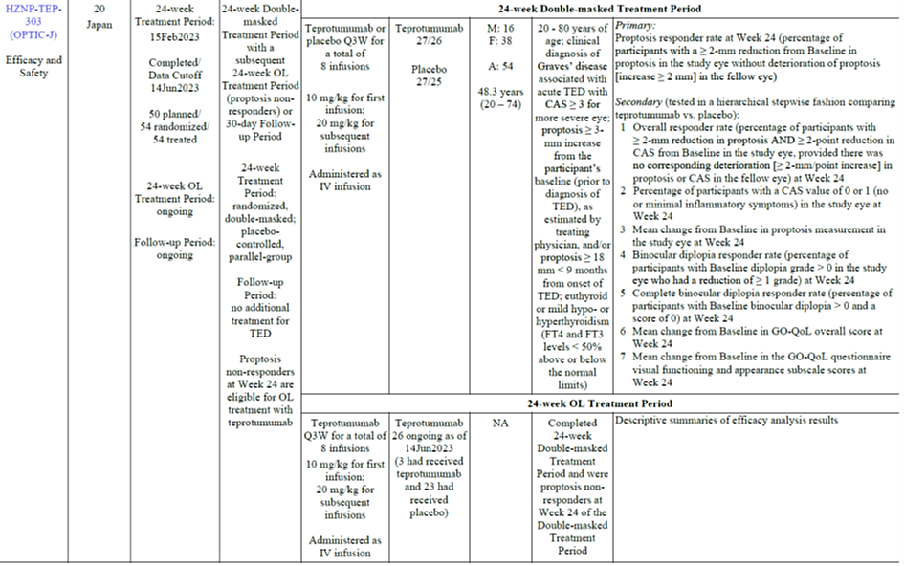
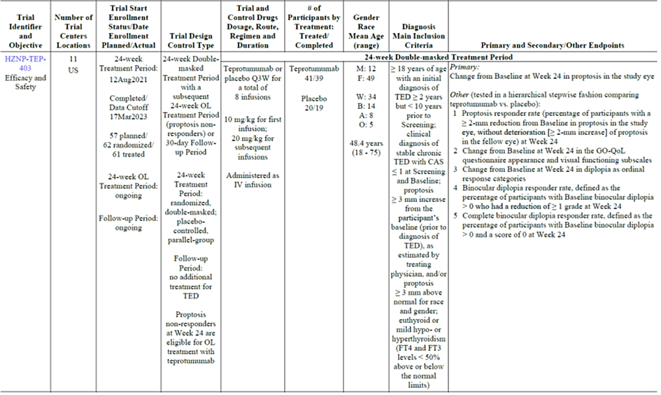
Inclusion and exclusion criteria are shown in Table 18 (Appendix), and Table 19 (Appendix), respectively.

Treatments
An infusion Q3W (a total of 8 infusions) of
- IV teprotumumab (10 mg/kg for first infusion; 20 mg/kg for subsequent infusions) or
- Placebo (no active).

Randomisation
IRT randomisation was used and stratified by tobacco use status at baseline (non-user, user).
Table 5. Studies TED01RV, OPTIC, OPTIC-J and 403. Patient disposition.
ITT = intent-to-treat: TED = thyroid eye disease: Tepro = teprotumumab
- Scheduled for back surgery (placebo). dispensed incorrect treatment at Week 3 in error and Sponsor decided to discontinue the participant (placebo). optic disc edema left eye (placebo) and voluntary withdrawal due to difficulties with placing an intravenous line before receiving investigational product (teprotumumab).

Baseline characteristics:
- Patient demographics: The baseline demographic characteristics are shown in Table 20 (Appendix). They were generally comparable between the treatment groups in each trial with the notable exception of a larger portion of female participants in the placebo vs. active groups in TED01RV (80.0% vs. 67.4%), OPTIC-J (74.1% vs. 66.7%), and Study 403 (90.0% vs. 76.2%), also likely owing to the small sample sizes. Across trials, the age range was 18 to 79 years (mean range: 46.6 to 53.7 years) with more females overall as expected in a TED population. The majority of participants in TED01RV and OPTIC were white (all participants in OPTIC-J were Japanese).
- Disease characteristics: The baseline disease characteristics were reasonably balanced between groups (Error! Reference source not found.21Error! Reference source not found.). In the acute TED trials, the mean time since TED diagnosis was 5.74 months (range: 4.27 to 6.42 months) (combined placebo vs. combined active: 5.98 vs. 5.49 months). The mean study eye Clinical Activity Score (CAS) was 5.0 (range 4.0 to 5.3) (combined placebo vs. combined active: 5.0 vs. 4.9). The mean study eye proptosis was 22.52 mm. In the chronic TED trial 403, the mean time since TED diagnosis was 64.57 months (placebo) vs. 61.09 months (active). The mean study eye CAS was 0.5 (placebo) and 0.3 (active). The mean study eye proptosis was 24.40 mm.
- Patient disposition: shown in Error! Reference source not found..

Magnitude of the treatment effect and its clinical significance
For CAS assessment, the 7-item European Group on Graves’ Ophthalmopathy (EUGOGO) amended CAS was used (Table 22, Appendix).
Primary efficacy endpoint: The primary endpoint was the proptosis responder rate at Week 24 (defined differently in TED01RV as shown below):
- OPTIC and OPTIC-J: percentage of participants with a ≥ 2 mm reduction from baseline in proptosis in the study eye, without deterioration of proptosis (increase ≥ 2 mm) in the fellow eye.
- TED01RV: percentage of participants with a ≥ 2 mm reduction in proptosis AND a decrease in CAS ≥ 2 points from baseline in the study eye, without deterioration (increase in proptosis ≥ 2 mm or an increase in CAS ≥ 2 points) in the fellow eye.
In each TED trial, a greater proportion of participants treated with teprotumumab were proptosis responders at Week 24 compared to placebo:
- In the combined analysis of acute TED trials: the proportion of proptosis responders at Week 24 was 80.2% (combined teprotumumab group) vs. 14.0% (combined placebo group), i.e. a stratified treatment difference of 66.40% (95% CI: 56.44, 76.36).
- In the chronic TED trial 403, the proportion of proptosis responders at Week 24 was 61.9% in the teprotumumab group vs. 25.0% in the placebo group, i.e. a stratified treatment difference of 36.42% (95% CI: 12.34, 60.50).
Individual primary endpoint results are shown in Table 6.
Main secondary efficacy endpoints: A significant secondary efficacy endpoint was: the mean change from baseline in proptosis in the study eye at Week 24. In each TED trial, a greater LS mean decrease from baseline in proptosis at Week 24 was observed in participants treated with teprotumumab vs. placebo:
- In the combined analysis of acute TED trials: the mean reduction was -2.96 mm (combined teprotumumab group) vs. -0.38 mm (combined placebo group) i.e. a treatment difference (95% CI) of -2.58 mm (-2.98, -2.19 mm).
- In the chronic TED trial 403, the mean reduction was -2.24 mm (teprotumumab group) vs. -0.75 mm (placebo) i.e. a treatment difference (95% CI) of -1.50 mm (-2.30, -0.70 mm).
Other selected secondary efficacy endpoints are shown in Table 7.
Table 2. Studies TED01RV, OPTIC, OPTIC-J and 403. Primary endpoint results.
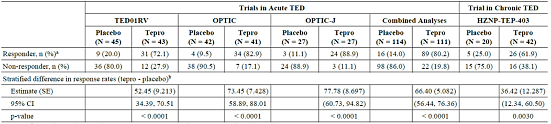
CI - confidence interval: ITT = intent-to-treat: SE = standard error: TED = thyroid eye disease: Tepro = teprotumumab
a Proptosis responders were defined as participants with a > 2-mm reduction from Baseline in proptosis in the study eye, without deterioration (> 2-nun increase) of proptosis in the fellow eye at Week 24. A participant missing the Week 24 evaluation was considered a non-responder.
b Results were estimated from Cochran-Mantel-Haenszel test adjusted for trial (combined analysis) and tobacco use status.
Table 7. Studies TED01RV, OPTIC, OPTIC-J and 403. Selected secondary endpoint results.
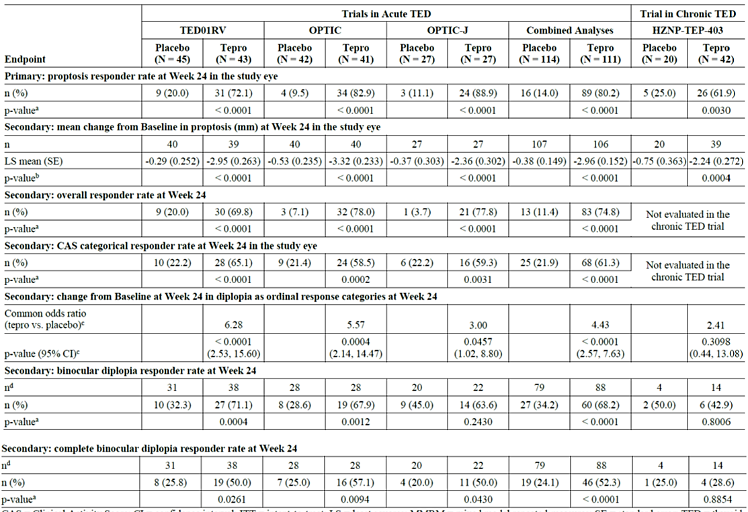
CAS = Clinical Activity Score: CI = confidence interval: ITT = intent-to-treat: LS = least squares: MMRM = mixed model repeated-measures: SE = standard error. TED = thyroid eye disease: Tepro = teprotumumab
Note: A participant with a missing assessment at Week 24 was considered a non-responder.
Note: All p-values are nominal and compare teprotumumab versus placebo.
Note: In TEDOIRV. smoking status (smoker. non-smoker) was mapped to tobacco use status (user, non-user). For OPTIC and OPTIC-J. participants whose tobacco use status was current were considered users and participants whose tobacco use status was never or former were considered non-users. as collected on the substance use electronic case report form.
a. The p-value was estimated from Cochran-Mantel-Haenszel test adjusted for trial (combined analysis) and tobacco use status.
b. The p-value was estimated from an MMRM analysis with unstructured variance-covariance 'matrix including change from Baseline value as the dependent variable and the following covariates: Baseline value, treatment group, tobacco use status, trial, visit, visit-by-treatment and visit-by-Baseline value interactions. A change from Baseline value of 0 was imputed at the first post-Baseline visit for any participants without post-Baseline values.
c. Common proportional odds ratio. 95% CI and p-value were obtained from a logistic regression with treatment and tobacco use status as the model effect.
d. Number of participants who had binocular diplopia at Baseline.
Subgroups
The subgroup analyses were generally supportive of the primary analysis (Figure 4 and Figure 5, Appendix), noting the smaller samples size in the chronic TED trial.

Time course
The LS mean change from baseline is shown in Figure 2 (combined acute trials) and Figure 3 (chronic trial 403).
Figure 2. Studies TED01RV, OPTIC, and OPTIC-J. LS mean change from baseline in proptosis over time in the Acute TED Trials (ITT Analysis Set; Study Eye).
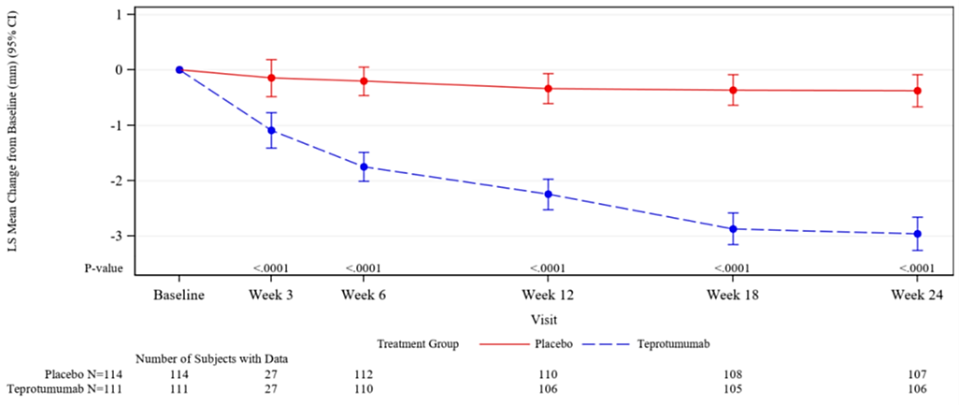
Figure 3. Study 403. LS mean change from baseline in proptosis over time in the Chronic TED Trial (ITT Analysis Set; Study Eye).
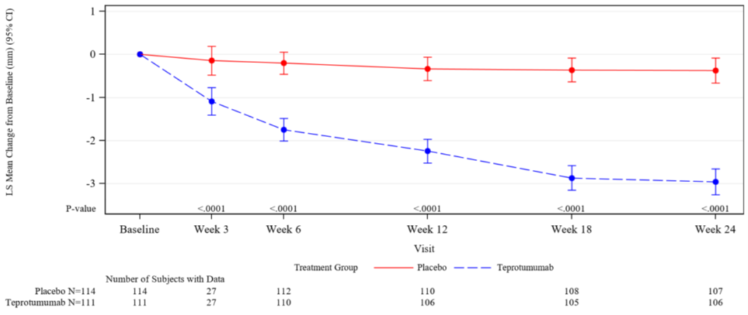

OPTIC study biomarker evaluation
At Baseline, all 83 patients in the ITT Population were positive for thyroid-stimulating antibody and the majority (37/42 [88.1%] for placebo vs. 34/41 [82.9%] for teprotumumab) were positive for thyrotropin receptor blocking immunoglobulins.
At Weeks 12 and 24, 97.6% (40/41) vs. 97.5% (39/40), and 92.3% (36/39) vs. 95.0% (38/40) respectively, were positive for thyroid-stimulating antibody.
At Weeks 12 and 24, 88.9% (32/36) vs. 88.9% (32/36), and 90.9% (30/33) and 88.2% (30/34), respectively, were positive for thyrotropin receptor blocking immunoglobulins.
All subjects were negative for thyroid blocking antibody on Day 1 and at Weeks 12 and 24.

OPTIC longer-term data (no study drug administration)
At the end of the Double-Masked Treatment Period (Week 24) of the OPTIC study, subjects who were proptosis non-responders (study eye had <2 mm decrease in proptosis) were eligible to enter the open-label extension study OPTIC-X. Proptosis responders, as well as non-responders who chose not to enrol in OPTIC-X, entered an OPTIC study Follow-Up Period, during which no study drug was administered.
Week 72: 21 subjects originally randomised to teprotumumab had evaluable Week 72 data. Of those, 90.5% of patients in the teprotumumab group were proptosis responders, and 100% in the placebo group (from a sample size of 3 patients, and thus less meaningful) (observed cases as denominator; Table 8).
When considering the efficacy results in relation to Week 24 responders: 55.9% (19/34) were sustained proptosis responders (but using a conservative approach of imputing lack of data as lack of response; Table 9).
The mean decrease from baseline in proptosis remained consistent with Week 24 during the Follow-Up Period (-3.32 mm at Week 24 for 40 subjects, -3.51 mm at Week 28 for 35 subjects, and -3.62 mm at Week 72 for 21 subjects).
Table 8. OPTIC study Follow-Up Period. Efficacy results at Week 72 (ITT population, observed cases as denominator).
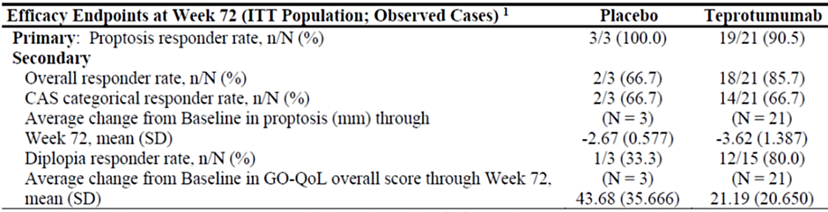
CAS = clinical activity score; GO-QoL = Graves' Ophthalmology Quality of Life; ITT = intent-to-treat; SD = standard deviation. Note: Although 20 teprotumumab subjects completed the 48-week Follow-Up Period of the study, 1 additional subject had evaluable data that fell within the Week 72 Visit window and was included in analysis.
- The denominator for each endpoint is the number of subjects with non-missing evaluations at the Week 72 Visit, except for diplopia which' only includes subjects with diplopia at Baseline and non-missing evaluations at the Week 72 Visit.
Table 9. OPTIC study Follow-Up Period. Efficacy results at Week 72 (Week 24 responders as denominator with lack of data imputed as lack of response).
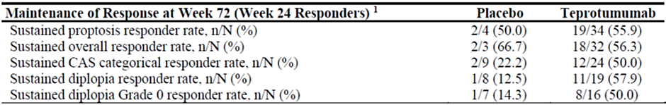
CAS = clinical activity score For sustained responder rates, a subject missing the Week 72 evaluation was considered a non-responder.
- The denominator for each sustained responder rate is based on the number of subjects who were responders for that specific endpoint at Week 24.

Week 120 addendum (dated 18 May 2021)
23 subjects (3 placebo, 20 teprotumumab) completed the Week 72 Visit and had a successful contact in the Follow-Up Contact Period. One subject could not be contacted at Week 120. During the Follow-Up Contact Period, no subject underwent decompression or strabismus surgery.

Supportive study results

Study HZNP-TEP-302 (OPTIC-X)
This was a multicentre, open-label extension trial of the efficacy and safety of teprotumumab in subjects who completed the 24-week double-masked Treatment Period in HZNP-TEP-301 (OPTIC).
All subjects were to receive 8 infusions of teprotumumab every 3 weeks (q3W) (10 mg/kg for the first infusion followed by 20 mg/kg for the remaining 7 infusions). The Baseline (Day 1) Visit occurred within 14 days after the final visit of OPTIC (Week 24 for proptosis non-responders and up to Week 72 for proptosis responders who relapsed).
51 patients entered the trial. In the earlier OPTIC study, 37 had received placebo and 14 had received teprotumumab. In OPTIC-X, the 37 patients were in the “first-course” group (received placebo in OPTIC) and 14 in the “second-course” group (received teprotumumab in OPTIC, but were non-responders).
- First-course group results: the percentage of proptosis responders at week 24 from study baseline was 89.2% (similar to the teprotumumab results in OPTIC: 82.9%) despite a longer duration of TED compared to OPTIC (mean duration since TED diagnosis: 12.3 months (range 7 to 16 months) vs. 6.2 (1 to 10 months; Table 10).
- Second-course group results: 14 non-responder patients from the OPTIC study (“second course”). 53.8% (7/13) were proptosis responders: Of the 5 patients who were proptosis non-responders at Week 24 in OPTIC, 2 were proptosis responders at Week 24 in OPTIC-X. Of the 8 patients who relapsed during the Follow-up Period of OPTIC, entered OPTIC-X and had Week 24 data, 5 (62.5%) were proptosis responders at Week 24 in OPTIC-X relative to Study Baseline (Table 10).
Table 10. Study OPTIC-X. Summary of main results (and comparison to OPTIC).
CAS = clinical activity score; COVID-19 = coronavirus disease 2019; GO-QoL = Graves' Ophthalmopathy Quality of Life; ITT = intent-to-treat; SD = standard deviation
Note: For responder rates, per the statistical analysis plan, subjects missing Week 24 values were considered non-responders. aside from those with missing data related to the COVID-19 pandemic. Second-course Subject US-I03-006 was excluded from all Week 24 summaries due to COVID-19 pandemic (visit delayed).
1. Proptosis responders were defined as subjects with a ≥22-mm reduction from Study Baseline in proptosis in the study eye, without deterioration (≥2-mm increase) of proptosis in the fellow eye at Week 24.
2. CAS responders were defined as subjects with a reduction to a CAS of 0 or 1 (no or minimal inflammatory symptoms) as a categorical response variable at Week 24. The denominators in OPTIC-X are the numbers of subjects with CAS >1 at Study Baseline.
3. Diplopia responders were defined as subjects with 1 grade or greater reduction in diplopia in the study eye without worsening by at least 1 grade in the fellow eye at Week 24. Denominators are the number of subjects with diplopia at Baseline (OPTIC or OPTIC-X, as applicable).

Study HZNP-TEP-401
A Phase 3b, uncontrolled, multicentre, open-label, expanded access program (EAP) to collect data on the efficacy and safety of teprotumumab in patients in the U.S. with moderate-to-severe active TED. Enrolment was closed upon approval of Tepezza by the FDA on 21 January 2020 and commercial availability in the U.S. The EAP was conducted from 2 Dec 2019 to 14 Oct 2020 at 8 sites in the USA.
Teprotumumab was administered by intravenous (IV) infusion q3W for a total of 8 infusions during the 24-week treatment period; the first dose was 10 mg/kg and subsequent doses were 20 mg/kg.
Efficacy was only assessed using the Go-QoL.35 Patients’ assessment of the effects of TED were evaluated by determining the mean change from Baseline to Week 12 and Week 21 in the GO-QoL questionnaire visual functioning, appearance and overall combined scores.
The change from baseline in GO-QoL visual functioning, appearance and overall mean transformed scores was > 20 points at both week 12 and week 21 study visits (Table 23, Appendix).

Safety
The integrated safety data was summarised in two main safety analysis populations (Table 11):
- Double-masked Population: any participant who received at least 1 dose of IP (placebo or teprotumumab) during the Double-masked Treatment Period in TED01RV, OPTIC, OPTIC-J or HZNP-TEP-403.
- All Teprotumumab Population: any participant who received teprotumumab in TED01RV, OPTIC, OPTIC-X, OPTIC-J, the EAP trial or HZNP-TEP-403.
This overview focusses on the double-masked period of the studies.

Exposure
The Double-masked Population included a total of 285 participants (152 and 133 in the teprotumumab and placebo groups, respectively; Table 11).
93.4% vs. 94% of participants in the teprotumumab and placebo groups, respectively, completed the double-masked treatment period (Table 24, Appendix); the incidence of discontinuations due to TEAEs was low but numerically higher in the teprotumumab compared to placebo group (3.9% (6/152) vs. 2.3% (3/133)). 87.5% vs. 90.2% of participants received all 8 infusions of IP (Table 12).
The ‘All teprotumumab’ population included a total of 246 patients who received teprotumumab across the 6 clinical studies. The mean total duration of teprotumumab treatment was similar in acute (151.9 days) and chronic TED (150.3 days).
Table 11. Safety analysis: Exposure summary by Integrated Safety Analysis Population and Treatment Group.

Table 12. Safety analysis: Extent of Exposure (Double-masked Population).

Adverse event overview
Double-masked Population: In the double-masked treatment period, 83.6% vs 72.9% experienced at least one TEAE (Table 13).
The SOCs with highest TEAE incidence (≥ 15.0% and greater in teprotumumab vs. placebo) were: Gastrointestinal disorders (36.8% vs. 18%), Infections and infestations (32.9% vs. 24.8%), Musculoskeletal and connective tissue disorders (34.9% vs. 14.3%), Skin and subcutaneous tissue disorders (30.9% vs. 18%), Nervous system disorders (25% vs. 18.8%), Ear and labyrinth disorders (19.7% vs. 5.3%), Metabolism and nutrition disorders (16.4% vs. 3.8%) and nail disorders (5.9% vs. 0.8%).
The most commonly reported TEAEs (≥ 5.0% and greater in teprotumumab vs. placebo) were: muscle spasms (27.6% vs. 6%), hearing impairment42 (14.0% vs. 2.3%), hyperglycaemia (13.2% vs. 3%), fatigue (12.5% vs. 6%), alopecia (13.2% vs. 5.3%), diarrhoea (14.5% vs. 9%), nausea (10.5% vs. 6.8%), dry skin (9.9% vs. 0%) and dysgeusia (8.6% vs. 0.8%; Table 14).
Table 13. Safety analysis: Summary of TEAEs (Double-masked Population).
IP = investigational product: TEAE = treatment-emergent adverse event: TED = thyroid eye disease; Tepro = teprotumumab
- A TEAE was defined as an adverse event occurring after the first dose of IP (placebo or teprotumumab) on Day 1 through 3 weeks following the last dose of IP.
Table 14. Summary of TEAEs in ≥ 5.0% of teprotumumab participants with a greater incidence than Placebo by PT (Double-masked Treatment Period, Double-masked Population).
COVID-19 = coronavirus disease 2019; TEAE = treatment-emergent adverse event
Note: Un-italicized terms indicate groupings of Preferred Terms. Italicized terms are single Preferred Terms.
a. Hearing impairment includes Autophony. Conductive deafness. Deafness. Deafness unilateral, Eustachian
tube dysfunction. Eustachian tube patulous, Hyperacusis. Hypoacusis. Neurosensory hypoacusis, Tinnitus
and Tympanic membrane disorder.
b. Hyperglycaemia includes Blood glucose increased. Diabetes mellitus. Diabetic ketoacidosis. Glucose tolerance
impaired, Glycosylated haemoglobin increased and Hyperglycaemia.
c. Fatigue includes Fatigue and Asthenia.
d. Dysgeusia includes Dysgeusia and Taste disorder.
e. Nail disorder includes Ingrowing nail, Nail bed disorder. Nail discolouration. Nail disorder and Onvchoclasis.

Treatment related adverse event (adverse drug reaction) overview
Double-masked Population: 62.5% vs. 32.3% (teprotumumab vs. placebo) experienced at least one treatment-related TEAE (adverse drug reaction) during the Double-masked Treatment Period (Table 15). Most adverse drug reactions during the Double-masked Treatment Period were considered mild or moderate in intensity. Serious adverse drug reactions are listed in the serious adverse event section below.
Table 15. Summary of treatment-related TEAEs in ≥ 2.0% of teprotumumab participants with a greater incidence than Placebo (Double-masked Treatment Period, Double-masked Population).
IP = investigational product: TEAE = treatment-emergent adverse event: TED = thyroid eye disease; Tepro = teprotumumab
- A TEAE was defined as an adverse event occurring after the first dose of IP (placebo or teprotumumab) on Day 1 through 3 weeks following the last dose of IP.

Deaths
No deaths occurred in the teprotumumab clinical studies for TED.

Serious adverse events
Double-masked Population: serious TEAEs in teprotumumab-treated patients included Conductive deafness, Diarrhoea, Inflammatory bowel disease, COVID-19, Escherichia sepsis, IRRs, Hashimoto’s encephalopathy, Urinary retention and Pneumothorax. All of these event terms were of single occurrence. 5 were considered severe (Conductive deafness, Diarrhoea, Inflammatory bowel disease, COVID-19 and Escherichia sepsis) and 1 was considered life-threatening (Pneumothorax).
Serious TEAEs considered related to IP and all leading to IP discontinuation were: Hashimoto’s encephalopathy, Diarrhoea (exacerbation of inflammatory bowel disease [IBD]), IRRs, and Conductive deafness.

Adverse event of special interest: hearing impairment
TEAEs associated with hearing impairment were reported as Autophony, Conductive deafness, Deafness, Deafness unilateral, Eustachian tube dysfunction, Eustachian tube patulous, Hyperacusis, Hypoacusis, Neurosensory hypoacusis, Tinnitus or Tympanic membrane disorder.
Across the TED clinical program, a total of 40 (40/246, 16.3%) participants experienced 52 events of hearing impairment while receiving teprotumumab or during the Follow-up Period after receipt of teprotumumab. The Sponsor stated that the majority of hearing impairment events were non-serious and mild in intensity did not lead to premature discontinuation of IP.
In the Double-masked Population, they were observed in 21 (13.8%) teprotumumab-treated participants (28 events) vs. 3 (2.3%) for placebo. One of the 21 patients also experienced hearing impairment (Deafness unilateral) during the Follow-up Period. An additional patient experienced hearing impairment (Hypoacusis) during the Follow-up Period of OPTIC (ongoing and resolved during OPTIC-X).
In the Double-masked Population, 7 teprotumumab-treated participants and 2 placebo-treated participants had hearing impairment events that were noted as not recovered/not resolved as of the data lock point for the trial or the primary Week 24 analysis (for OPTIC-J and TEP-403) and had been ongoing for ≥ 6 months after the participant’s last double-masked infusion of IP.
In Study 403, a patient in the teprotumumab group (with history of hearing impairment) experienced a serious TEAE of Conductive deafness (severe) leading to premature withdrawal of IP during the Open-label Treatment Period. This event was assessed as possibly related to IP.
In OPTIC-J, a patient in the teprotumumab group experienced a TEAE of Neurosensory hypoacusis (moderate) that led to premature IP withdrawal during the Double-masked Treatment Period. This event was assessed as related to IP (despite the patient’s history of Eustachian tube stenosis and neurosensory hypoacusis in both ears).
The Sponsor has been asked to provide a summary of pre- and post-market data on hearing loss and tinnitus, in particular permanent hearing loss (full or partial), including a line listing of patients with permanent hearing loss, and a causality assessment. This is briefly summarised below:
- Pre-market clinical trials: the Sponsor concluded that a review of clinical trial cases of unresolved hearing impairment found 7 cases of deafness (6 non-serious and 1 serious). 7 cases of tinnitus were also reported. Investigators assessed causality as ‘related’ to investigational product in 3 nonserious cases and one serious case; and as ‘not-related’ in the other three non-serious cases.
- Post-market experience (cumulative search of the safety database through 20 July 2024): Teprotumumab was first approved in the United States on 21 January 2020 (International Birth Date) for the treatment of thyroid eye disease and is also approved in Brazil and Saudi Arabia.

Other adverse events of special interest
Adverse events of special interest (AESI) for the teprotumumab clinical trials are IRRs, hyperglycaemia, hearing impairment, new onset IBD and exacerbation of IBD.
Hyperglycaemia: A higher incidence of TEAEs was observed in teprotumumab-treated participants compared with placebo-treated participants (13.2% [20/152] teprotumumab vs. 3.0% [4/133] placebo). Participants with diabetes (69.2% [9/13] teprotumumab vs. 9.1% [1/11] placebo) or pre-diabetes (18.4% [7/38] teprotumumab vs. 0% [0/30] placebo) at baseline were at greatest risk. The majority of hyperglycaemia events were non-serious, Grade 1 or 2 in severity and managed as needed with medications used for glycaemic control. No participants in the Double-masked Population discontinued IP due to a hyperglycaemic event.
Higher mean glucose levels were seen in teprotumumab-treated participants at every visit compared with placebo-treated participants and more teprotumumab-treated participants shifted from normal to Grade 1 or 2 high glucose levels compared with placebo; 1 teprotumumab participant shifted from normal to Grade 3.
New onset IBD: No events were observed.
Exacerbation of IBD: Exacerbation of IBD was reported for 1 of 152 (1.2%) participants who received teprotumumab and no participants who received placebo. The severe, serious event of occurred in a patient with a surgical history of partial bowel resection and IBD.

Post-market experience
The Sponsor considers the post marketing safety profile to be consistent with the clinical trial experience.
However, a signal of increased severity of hearing impairment was confirmed, with a subsequent update of the US prescribing information. No clear risk factors for hearing impairment were identified.

Risk management plan evaluation summary
Amgen Australia Pty Ltd has submitted a draft EU-RMP (no version number; 17 Jan 2024; DLP 14 Jun 2023) and Australia-specific annex (ASA) version 1.0 (25 Mar 2024) in support of this application. On 17 September 2024, the Sponsor has provided EU-RMP version 0.1 (03 April 2024; DLP 20 January 2024) and ASA version 2.0 (05 September 2024).
The proposed summary of safety concerns and their associated risk monitoring and mitigation strategies documented in the EU-RMP are summarised below.
Table 16. Summary of safety concerns
Summary of safety concerns |  | Pharmacovigilance |  | Risk minimisation
 |  | Routine | Additional | Routine | Additional
Important identified risks | Hyperglycaemia |  | * |  | –
Important identified risks | Exacerbation of inflammatory bowel disease (IBD) |  | * |  | –
Important identified risks | Infusion related reaction |  | * |  | –
 | Hearing impairment |  | *† |  | –
Important potential risks | New onset IBD |  | * | – | –
Missing information
*PASS HZNP-TEP-402
†Sub-study HZNP-TEP-402
The Sponsor has proposed routine and additional pharmacovigilance activities. The following additional pharmacovigilance activities have been summarised from ASA version 2.0 and the results will be applicable to the Australian population:
Study Details | Rationale and Study Objectives | Study Population | Milestones
Study HZNP-TEP-402  A Phase 3b/4, Double-masked, Randomized, International, Parallel-assignment, Multicentre Trial in Patients with Thyroid Eye Disease to Evaluate the Safety and Tolerability of Different Dosing Durations of Teprotumumab  Category 3 | Rationale:  An FDA post marketing requirement for a descriptive trial to evaluate the safety, efficacy and need for re-treatment of 3 different teprotumumab treatment durations for TED. In addition, serum samples from patients with a Baseline CAS ≥ 3 will be evaluated for biomarkers of disease.  Objectives:  • To evaluate the safety and tolerability of 3 treatment durations of teprotumumab (4, 8, and 16 infusions) and the need for retreatment.  Safety concerns addressed:  • Hyperglycaemia  • Exacerbation of inflammatory bowel disease  • Infusion-related reactions  • Hearing impairment  • New onset inflammatory bowel disease | Male or non-pregnant female adult (≥ 18 years) patients with TED. | Final Clinical Study Report (CSR): May 2026
Study HZNP-TEP-402 hearing evaluation sub-study  Category 3 | Rationale: This substudy is an independent, trial to investigate hearing impairment.  Objectives:  • To assess the incidence of hearing impairment among TED patients treated with teprotumumab.  • To assess the reversibility of hearing impairment at 3 or 6 months post teprotumumab treatment.  • To explore potential risk factors associated with ototoxicity among TED patients treated with teprotumumab  Safety concerns addressed:  • Hearing impairment | Male or non-pregnant female adult (≥ 18 years) patients with TED. | Final CSR: May 2026
CAS = Clinical Activity Score; TED = Thyroid eye disease

Risk-benefit analysis
Teprotumumab, a monoclonal insulin-like growth factor-1 receptor (IGF-1R) antagonist, appears to bind to IGF-1R and blocks its activation and signalling. However, the mechanism of action of teprotumumab in TED has not been fully characterised.

Clinical trial program
The main efficacy, safety, and pharmacology results are shown in sections 2.4.2, 2.4.3, and 2.4.1, respectively. Specific issues or concerns are discussed below.
The main clinical data for TED are derived from Studies TED01RV, OPTIC, OPTIC-J and 403 with supportive data from OPTIC-X and Study 401.

Endpoints
The main endpoint used the main trial involved the measurement of proptosis, and this is considered a reasonable choice of endpoint. The Clinical Activity Score (CAS) assessment used the 7-item European Group on Graves’ Ophthalmopathy (EUGOGO) and covered other clinical features of TED. Additionally, the Graves’ Orbitopathy Quality of Life (GO-QOL) survey is a common and validated TED QoL outcome measure.
A visual acuity endpoint (e.g. Best-corrected visual acuity [BVCA]) or measurements of intraocular pressure appear not to have been utilised and should have been considered. The clinical trials excluded patients with a decrease BCVA due to optic neuropathy.

Study contributions to efficacy
Studies TED01RV, OPTIC, OPTIC-J demonstrated efficacy in acute (active) TED patients, and Study 403 demonstrated some efficacy in chronic (inactive) TED patients (clinically stable chronic TED). Overall, the sample size was rather small, and particularly so for patients with chronic TED. The studies in active TED only evaluated patients with moderate to severe active TED, and this should be reflected in the indication.
In the combined analysis of acute TED trials: the proportion of proptosis responders at Week 24 was 80.2% (combined teprotumumab group) vs. 14.0% (combined placebo group), i.e. a stratified treatment difference of 66.40% (95% CI: 56.44, 76.36). The beneficial effect appeared to be consistent in all three studies.
In the chronic TED trial 403, the proportion of proptosis responders at Week 24 was 61.9% in the teprotumumab group vs. 25.0% in the placebo group, i.e. a stratified treatment difference of 36.42% (95% CI: 12.34, 60.50).
The OPTIC study Follow-Up Period provided evidence for the persistence of a treatment effect after IP cessation. Of 21 patients with evaluable Week 72 data, 90.5% in the teprotumumab group were proptosis responders, and 100% in the placebo group (from a sample size of 3 patients, and thus less meaningful) (observed cases as denominator) (Table 8).
When considering the efficacy results in relation to Week 24 responders: 55.9% (19/34) were sustained proptosis responders (but using a conservative approach of imputing lack of data as lack of response) (Table 9).
OPTIC-X included 14 patients in a “second-course” group (i.e. those who received teprotumumab in OPTIC, but were previous non-responders or relapsed in the OPTIC Follow-up Period). This indicates a role for the treatment of patients that had been unresponsive previously, even though the sample size had been rather small.
Overall, efficacy has been demonstrated mainly in the acute TED trials.

Safety
Safety data are outlined in section 2.4.3. The incidence of adverse events was consistently higher in the teprotumumab group compared to placebo. In the Double-Masked Population, the incidence of treatment-related adverse events was almost twice as high in the teprotumumab vs placebo group (62.5% vs 32.3%). The size of the safety database is discussed below.
The AESIs of hyperglycaemia, new onset IBD, and exacerbation of IBD are not uncommonly associated with certain monoclonal antibodies, with accompanying prescriber awareness. The may be no such specific awareness of hearing impairment associated with teprotumumab use (discussed below).

Main issues
The main issues are:
- Safety: The size of the safety database
- Safety: Managing the risk of hearing impairment, including permanent impairment
- Safety: Managing the risk of teratogenicity
- The overall benefit-risk balance
- Regulatory considerations: indication wording

Safety: The size of the safety database
The safety database is rather small. The Double-masked Population included a total of 285 participants (152 and 133 in the teprotumumab and placebo groups, respectively) (Table 11). The ‘All teprotumumab’ population included a total of 246 patients who received teprotumumab across the 6 clinical studies. The mean total duration of teprotumumab treatment was similar in acute (151.9 days) and chronic TED (150.3 days).
The Sponsor has justified the size of the safety database mainly with the prevalence data and quoted a prevalence of approx. 9 per 10,000 for TED, and less than 5 per 10,000 for moderate to severe TED. These quoted figures are at the lower end of common European estimates (9 to 15 per 10,000 for TED). However, the Sponsor proposes an indication that does not restrict itself to moderate to severe TED.
A post-marketing trial (Study 402 referenced in the RMP) examining the safety and tolerability of teprotumumab in the treatment of Thyroid Eye Disease (TED) in adult participants is currently conducted in the US and five European countries. This trial started in September 2021 and the expected completion date is mid-2026. Enrolment in this trial has completed, with 310 patients receiving teprotumumab were enrolled with a substudy that enrolled 99 patients to further assess the safety of teprotumumab in hearing impairment.
If registered, submission of the Study 402 data would be required as a condition of registration.

Safety: Managing the risk of hearing impairment, including permanent impairment
Insulin-like growth factor-1, which binds the IGF-1 receptor, is involved in cochlear development, and its mutations are associated with hearing loss. The mechanism of teprotumumab-associated hearing impairment is uncertain, but likely related. Specific risk factors could not be identified, but it appears that both a de novo hearing impairment and worsening of an existing hearing impairment may occur.
Hearing impairment has been described as an important AESI, and acknowledged by the Sponsor as a signal.
In the post-market space, for hearing loss and tinnitus, 3806 post-marketing cases (3078 solicited, 710 spontaneous, and 18 were from post-marketing noninterventional studies) were identified. For cases suggestive of permanent hearing loss, 176 cases (containing 370 events) were identified (120 spontaneous, 56 solicited). 92 cases were medically confirmed. 194 events were considered nonserious and 176 were serious. Given the likely non-systematic collection of hearing impairment events, the actual number of cases may be greater.
At the stage, the Sponsor is proposing the following wording in the PI (only relevant wording shown), and no additional risk minimisation activities:
Section 4.2
Hearing impairment
Assess patients’ hearing before, during and after treatment with Tepezza (see section 4.4 Special warnings and precautions for use, Hearing impairment).
Section 4.4.
Hearing impairment
Tepezza may cause severe hearing impairment including hearing loss, which in some cases may be permanent. Assess patients’ hearing before, during and after treatment with Tepezza and consider the benefit-risk of treatment with patients.
Section 4.8
Hearing impairment
The majority of hearing impairment events were nonserious, mild in intensity and did not lead to premature discontinuation of study drug. For clinical management of hearing impairment see section 4.4 Special warnings and precautions for use, Hearing impairment.
The risk of hearing impairment (in particular permanent impairment) represents a serious and significant risk that require appropriate risk mitigation. A boxed warning (in the PI and/or label) may be needed to draw the attention to this serious issue. Furthermore, a strengthening of the language in the PI, including the need for regular monitoring, is needed. Information on the number of cases of non-permanent and permanent hearing loss from post-market reports may need to be included to draw attention to this matter, to fully inform prescribers (and consequently the patients) for the purposes of an individual benefit-risk assessment, and for a decision whether to continue or cease treatment with teprotumumab. Additional risk minimisation activities may also be necessary.
Advice from the Advisory Committee on Medicines (ACM) is kindly requested.
Question (to the ACM): Can the ACM comment on managing the risk of hearing impairment associated with teprotumumab use?

Safety: Managing the risk of teratogenicity
The nonclinical evaluation revealed that teprotumumab was shown to be clearly teratogenic in cynomolgus monkeys. Every fetus exposed to teprotumumab either died or displayed multiple malformations, including misshapen cranium, closely set eyes, micrognathia, and pointing and narrowing of the nose; impaired/abnormal ossification of the skull, teeth, sternebrae, carpals and tarsals was also observed.
Teprotumumab caused generalised suppression of fetal growth, with final fetal weight almost halved, and decreased placental weight and size, and reduced amniotic fluid volume. These adverse effects on embryofetal development occurred in the absence of maternal toxicity, and at a clinically relevant dose (based on the extent of IGF 1R inhibition as well as relative exposure). Concerns for embryofetal harm with teprotumumab are held at the highest level, and warrant assignment to Pregnancy Category X rather than Category D as the Sponsor proposes.
Teprotumumab is to be contraindicated in pregnancy, and women of childbearing potential directed to use effective contraception prior to initiation of treatment, during treatment and for 6 months after the last dose of Tepezza.
For RMP purposes, the Sponsor has not included ‘Embryofoetal toxicity’ as an important potential risk, as requested by the RMP evaluator. The Sponsor noted the median age at onset of TED of 50 years. The Sponsor states that only ~0.5% of women becoming pregnant have Graves’ Disease, and that the risk of exposure to Tepezza during pregnancy is considered negligible, and that the embryofetal toxicity concern is adequately addressed in the relevant sections of the draft Product Information.
The Sponsor’s proposed approach is not considered adequate. Most monoclonal antibody medicines are currently classified in Australian Pregnancy Categories C or D, and it is very important to communicate a Category X status.
The PI needs to be updated to change the Pregnancy Category from D to X, as requested in the NCER. Furthermore, a boxed warning in the PI and/or the label are required. Further additional risk minimisation activities may be needed.
Advice from the ACM is kindly requested.
Question (to the ACM): Can the ACM comment on managing the risk of teratogenicity associated with teprotumumab use?

Overall benefit-risk balance
The question remains whether the rather significant potential safety issues with regard to hearing loss can be sufficiently mitigated and despite their presence contribute to an overall favourable benefit-risk balance. These potential safety issues may prevent use in less severe disease and a restriction of the indication should be performed.
Overall, there appears to be a role for teprotumumab in the physician’s or ophthalmologist’s armamentarium.
This would be dependent on managing the above described risks appropriately, including, but not limited to boxed warnings for the risk of hearing impairment and Pregnancy Category X, as well as appropriate risk minimisation activities.

Regulatory considerations: indication wording
The currently Sponsor-proposed indication wording is not considered acceptable, as too broad:
Tepezza is indicated for the treatment of Thyroid Eye Disease (TED).
If registered, the indication should reflect the population studied in the clinical trial program, and may reference to section 5.1. in the PI with regard to use in chronic TED, retreatment, and the maintenance effect, for example:
Tepezza is indicated for the treatment of moderate to severe Thyroid Eye Disease (TED) (see section 5.1 Pharmacodynamic properties – Clinical trials).
Question (to the ACM): Can the ACM comment on the indication wording?

Advisory Committee considerations
The Advisory Committee on Medicines (ACM), having considered the evaluations and the Delegate’s overview, as well as the Sponsor’s response to these documents, advised the following.
Can the ACM comment on managing the risk of hearing impairment associated with teprotumumab use?
The ACM considered the provided trial data, which indicated that the incidence of hearing impairment was approximately 15% of participants receiving treatment experiencing some level of hearing impairment (16.3% (40/246) in the overall clinical trial population, and in the double-masked population: 13.8% (21/152) for teprotumumab vs. 2.3% (3/152) for placebo). Most cases of hearing impairment associated with use of Tepezza were mild, with 75% of cases resolved within 6 months. Approximately 4.6% of cases (7/152) of hearing loss were considered to be permanent or unresolved in the double-masked population vs. 1.3% (2/152) in the placebo group.
The ACM agreed that patients should be screened for hearing impairment prior to treatment, due to a noted higher level of hearing impairment for patients with pre-existing hearing loss. The ACM also suggested ongoing monitoring with serial audiograms in addition to a boxed warning explaining the risk of possible permanent hearing impairment.
The ACM advised that the Consumer Medicine Information (CMI) and Product Information (PI) should be more strongly worded to reinforce the possibility of permanent hearing impairment emerging from treatment. as well as the provision of additional post market data being a requirement of registration.
Can the ACM comment on managing the risk of teratogenicity associated with teprotumumab use?
The ACM advised that the designation of Pregnancy Category X was appropriate, and that the PI includes strong wording on the risks involved if used in pregnancy. The ACM highlighted the strict requirement in the teprotumumab clinical trials for women of childbearing potential to use 2 reliable forms of contraception. The ACM recommended that a boxed warning for the risk of major foetal malformation would be appropriate for this product, as the teratogenicity is a risk that would be unexpected among monoclonal antibody therapies, as prescribers may not expect them in Category X.
Can the ACM comment on the indication wording?
The ACM agreed that it would be appropriate to limit the indication to moderate to severe Thyroid Eye Disease (TED). Additionally, the ACM supported limiting the indication to an adult population due to the mechanism of action and effects on growth and development.
The committee is also requested to provide advice on any other issues that it thinks may be relevant to a decision on whether or not to approve this application.
The ACM advised that further information on the follow-up treatment regimen be provided in the PI, in line with the protocol used when transitioning initial non-responsive trial participants to the extension studies.

Advisory committee conclusion
The ACM considered this product to have an overall positive benefit-risk profile for the indication:
Tepezza is indicated for the treatment of moderate to severe Thyroid Eye Disease (TED) in adults.

Implementation of risk minimisation measures

Hearing impairment – final risk management approach
A boxed warning was not implemented. This risk is managed through routine and additional risk minimisation measures. In the Product Information (PI), Section 4.4 (Special warnings and precautions for use) contains prominently formatted warning text regarding the risk of hearing impairment, including potential permanence, and outlines specific clinical measures (e.g. assessment of hearing before, during and after treatment, and management advice if impairment occurs). The Consumer Medicines Information (CMI) also alerts patients to this risk in suitable language.
In addition, the sponsor will implement an education program for healthcare professionals as an additional risk minimisation activity.

Embryofoetal toxicity – final risk management approach
A boxed warning was not implemented. This risk is managed through routine and additional risk minimisation measures to clearly alert prescribers to the risk of major foetal harm. In the PI, Section 4.3 (Contraindications) and Section 4.6 (Fertility, pregnancy and lactation) include Pregnancy Category X, a contraindication in pregnancy, requirements for effective contraception during treatment and for the specified post-treatment period, and prominent warning statements describing the embryofoetal risk. The CMI communicates these precautions to consumers.
In addition, the sponsor will implement an education program for healthcare professionals as an additional risk minimisation activity.

Assessment outcome
Based on a review of quality, safety, and efficacy, the TGA decided to register Tepezza (teprotumumab) for the following indication:
Tepezza is indicated for the treatment of moderate to severe thyroid eye disease (TED)

Specific conditions of registration
Tepezza (teprotumumab) is to be included in the Black Triangle Scheme. The PI and CMI for Tepezza must include the black triangle symbol and mandatory accompanying text for five years, which starts from the date of first supply of the product.
The teprotumumab EU-Risk Management Plan (RMP) (version 0.1, dated 03 April 2024, data lock point 20 January 2024), with Australian Specific Annex (version 2.0, dated 05 September 2024), included with submission PM-2024-01236-1-5, and any subsequent revisions, as agreed with the TGA will be implemented in Australia.
An obligatory component of risk management plans is routine pharmacovigilance. Routine pharmacovigilance includes the submission of periodic safety update reports (PSURs).
Unless agreed separately between the supplier who is the recipient of the approval and the TGA, the first report must be submitted to TGA no later than 15 calendar months after the date of this approval letter. The subsequent reports must be submitted no less frequently than annually from the date of the first submitted report until the period covered by such reports is not less than three years from the date of this approval letter. The annual submission may be made up of two PSURs each covering six months. If the Sponsor wishes, the six monthly reports may be submitted separately as they become available.
If the product is approved in the EU during the three years period, reports can be provided in line with the published list of EU reference dates no less frequently than annually from the date of the first submitted report until the period covered by such reports is not less than three years from the date of this approval letter.
The reports are to at least meet the requirements for PSURs as described in the European Medicines Agency’s Guideline on good pharmacovigilance practices (GVP) Module VII-periodic safety update report (Rev 1), Part VII.B Structures and processes. Note that submission of a PSUR does not constitute an application to vary the registration. Each report must be submitted within ninety calendar days of the data lock point for that report.
All batches of Tepezza teprotumumab supplied in Australia must comply with the product details and specifications approved during evaluation and detailed in the Certified Product Details (CPD).
When requested by the TGA, the Sponsor should be prepared to provide product samples, specified reference materials and documentary evidence to enable the TGA to conduct laboratory testing on the Product. Outcomes of laboratory testing are published biannually in the TGA Database of Laboratory Testing Results http://www.tga.gov.au/ws-labs-index and periodically in testing reports on the TGA website.
The CPD, as described in Guidance 7: Certified Product Details of the Australian Regulatory Guidelines for Prescription Medicines (ARGPM) http://www.tga.gov.au/industry/pm-argpm-guidance-7.htm, in PDF format, for the above products should be provided upon registration of these therapeutic goods. In addition, an updated CPD should be provided when changes to finished product specifications and test methods are approved in a Category 3 application or notified through a self-assessable change.
The Sponsor must finalise the additional risk minimisation activity education program materials submitted to the TGA on 7 March 2025 to the satisfaction of the post-market evaluation area of the TGA. The education program must be implemented prior to supply of Tepezza in Australia.

Product Information and Consumer Medicines Information
For the most recent Product Information (PI) and Consumer Medicines Information (CMI), please refer to the TGA PI/CMI search facility.

Appendix – Additional tables and figures
Table 17. TED studies. Summary of actual serum concentrations (μg/ml) of teprotumumab.
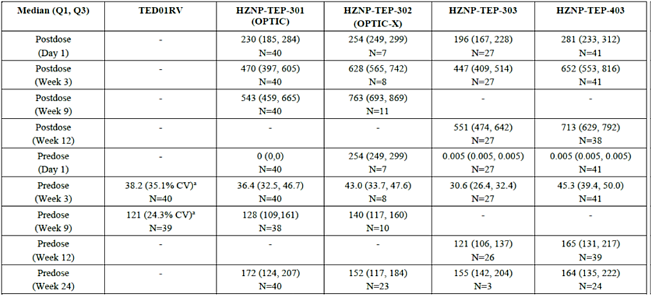
N=number of participants, CV=coefficient of variation. Q1=1st quartile; Q3=3rd quartile.
Serum concentrations of teprotumumab were summarized as median (Q1. Q3).
a Values from Study TED01RV are mean (CV%).
Table 18. Studies TED01RV, OPTIC, OPTIC-J and 403. Inclusion criteria.
Table 19. Studies TED01RV, OPTIC, OPTIC-J and 403. Exclusion criteria.
Table 20. Studies TED01RV, OPTIC, OPTIC-J and 403. Baseline demographic characteristics.
Table 21. Studies TED01RV, OPTIC, OPTIC-J and 403. Baseline disease characteristics
Table 22. Clinical Activity Score (CAS) Assessment.
Figure 4. Studies TED01RV, OPTIC, and OPTIC-J. Difference in Proptosis Responder Rate at Week 24 by Subgroup in the Acute TED Trials (ITT Analysis Set; Study Eye; Combined Analysis).
Figure 5. Study 403. Difference in Proptosis Responder Rate at Week 24 by Subgroup in the Chronic TED Trial (ITT Analysis Set; Study Eye).
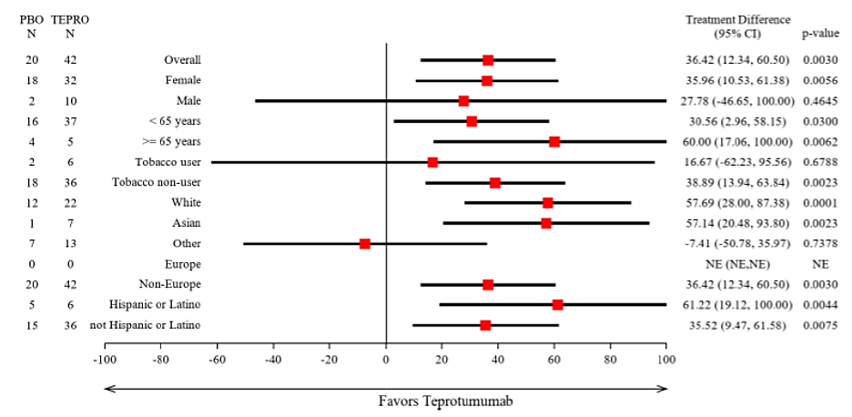
Table 23. Study HZNP-TEP-401. Mean change from baseline in GO-QoL Visual Function, Appearance and Overall Scores at Week 12 and Week 21 (Treated Population).
Table 24. Safety analysis: Patient disposition (Double-masked Population).
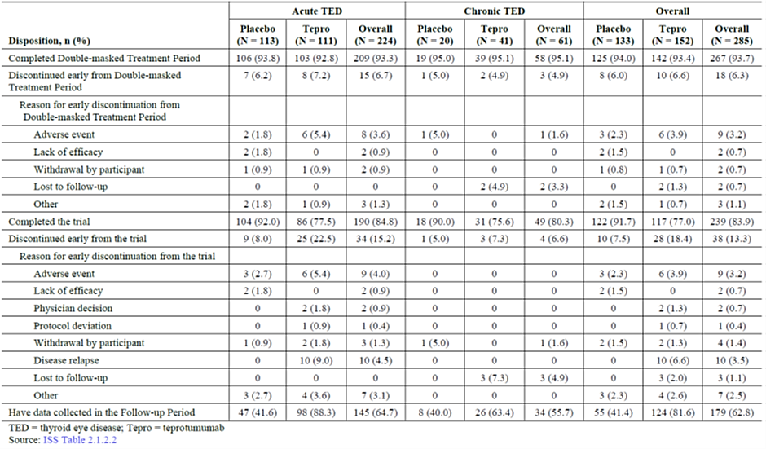

Therapeutic Goods Administration
PO Box 100 Woden ACT 2606 Australia
Email: info@tga.gov.au Phone: 1800 020 653 Fax: 02 6203 1605
https://www.tga.gov.au

Boschi A, Daumerie Ch, Spiritus M, Beguin C, Senou M, Yuksel D, et al. Quantification of cells expressing the thyrotropin receptor in extraocular muscles in thyroid associated orbitopathy. Br J Ophthalmol. 2005;89(6):724-9. doi:10.1136/bjo.2004.050807
Bahn RS. Graves’ ophthalmopathy. N Engl J Med. 2010;362(8):726-38. doi:10.1056/NEJMra0905750
Smith TJ. Insulin-like growth factor-I regulation of immune function: a potential therapeutic target in autoimmune diseases? Pharmacol Rev. 2010;62(2):199-236. doi:10.1124/pr.109.002469.
Smith TJ, Hoa N. Immunoglobulins from patients with Graves’ disease induce hyaluronan synthesis in their orbital fibroblasts through the self-antigen, insulin-like growth factor-I receptor. J Clin Endocrinol Metab. 2004;89(10):5076-80. doi:10.1210/jc.2004-0716.
Tsui S, Naik V, Hoa N, Hwang CJ, Afifiyan NF, Sinha Hikim A, et al. Evidence for an association between thyroid-stimulating hormone and insulin-like growth factor 1 receptors: a tale of two antigens implicated in Graves’ disease. J Immunol. 2008;181(6):4397-405. doi:10.4049/jimmunol.181.6.4397.
Kumar S, Iyer S, Bauer H, Coenen M, Bahn RS. A stimulatory thyrotropin receptor antibody enhances hyaluronic acid synthesis in graves’ orbital fibroblasts: inhibition by an IGF-I receptor blocking antibody. J Clin Endocrinol Metab. 2012;97(5):1681-7. doi:10.1210/jc.2011-2890.
Pritchard J, Han R, Horst N, Cruikshank WW, Smith TJ. Immunoglobin activation of T cell chemoattractant expression in fibroblasts from patients with Graves’ disease is mediated through the insulin-like growth factor I receptor pathway. J Immunol. 2003;170(12):6348-54. doi:10.4049/jimmunol.170.12.6348.
Smith and Hoa, 2004.
Hoa N, Tsui S, Afifiyan NF, Hikim AS, Li B, Douglas RS, et al. Nuclear targeting of IGF-1 receptor in orbital fibroblasts from Graves’ disease: apparent role of ADAM17. PLoS ONE. 2012;7(4):e34173. doi:10.1371/journal.pone.0034173.
Chen H, Mester T, Raychaudhuri N, Kauh CY, Gupta S, Smith TJ, et al. Teprotumumab, an IGF-1R blocking monoclonal antibody inhibits TSH and IGF-1 action in fibrocytes. J Clin Endocrinol Metab. 2014;99(9):E1635-40. doi:10.1210/jc.2014-1580.
Chen H, Shan SJC, Mester T, Wei Y-H, Douglas RS. TSH-mediated TNFα production in human fibrocytes is inhibited by Teprotumumab, and IGF-1R antagonist. PloS ONE. 2015`;10(6)e0130322. doi:10.1371/journal.pone.0130322.
International Conference on Harmonisation of Technical Requirements for Registration of Pharmaceuticals for Human Use. ICH S6 (R1) Preclinical safety evaluation of biotechnology-derived pharmaceuticals - Scientific guideline. 2011.

