 This medicinal product is subject to additional monitoring in Australia. This will allow quick identification of new safety information. Healthcare professionals are asked to report any suspected adverse events at https://www.tga.gov.au/reporting-problems.

AUSTRALIAN PRODUCT INFORMATION – TEPEZZA® (TEPROTUMUMAB)
- NAME OF THE MEDICINE
Teprotumumab

QUALITATIVE AND QUANTITATIVE COMPOSITION
Each vial contains 500 mg of teprotumumab. Teprotumumab is a fully human IgG1 monoclonal antibody produced in Chinese Hamster Ovary (CHO-DG44) cells by recombinant DNA technology.
The reconstituted TEPEZZA solution contains 47.6 mg/mL (500 mg / 10.5 mL) of teprotumumab.
For the full list of excipients, see section 6.1 List of excipients.

PHARMACEUTICAL FORM
Powder for injection.
White to off-white lyophilised powder in a single-dose 20 mL vial for reconstitution and dilution.

CLINICAL PARTICULARS

Therapeutic indications
TEPEZZA is indicated for the treatment of moderate to severe Thyroid Eye Disease (TED) (see section 5.1 Pharmacodynamic properties – Clinical trials).

Dose and method of administration
Dosage (dose and interval)
The recommended dose of TEPEZZA in adults is an intravenous infusion of 10 mg/kg for the initial dose followed by an intravenous infusion of 20 mg/kg every three weeks for 7 additional doses.

Method of administration
Reconstitution and preparation
Step 1: Calculate the dose (mg) and determine the number of vials needed for the 10 or 20 mg/kg dosage based on patient weight. Each TEPEZZA vial contains 500 mg of the teprotumumab antibody.
Step 2: Using appropriate aseptic technique, reconstitute each TEPEZZA vial with 10 mL of sterile water for injections. Ensure that the stream of diluent is not directed onto the lyophilised powder, which has a cake-like appearance. Do not shake, but gently swirl the solution by rotating the vial until the lyophilised powder is dissolved. The reconstituted solution has a volume of 10.5 mL. Withdraw 10.5 mL of reconstituted solution to obtain 500 mg. After reconstitution the final concentration is 47.6 mg/mL.
Step 3: The reconstituted TEPEZZA solution must be further diluted in 0.9% sodium chloride solution prior to infusion. To prepare the diluted solution, use 100 mL infusion bags for a dose less than 1800 mg, and 250 mL infusion bags for a dose equal or greater than 1800 mg. To maintain a constant volume in the infusion bag, a sterile syringe and needle should be used to remove the volume equivalent to the amount of the reconstituted TEPEZZA solution to be placed in the infusion bag. Discard the volume of 0.9% sodium chloride solution withdrawn.
Step 4: Withdraw the required volume from the reconstituted TEPEZZA vial(s) based on the patient’s weight (in kg) and transfer into an intravenous bag containing 0.9% sodium chloride solution. Mix diluted solution by gentle inversion. Do not shake. If refrigerated prior to administration, allow the diluted solution to reach room temperature prior to infusion.
Upon reconstitution, TEPEZZA is a nearly colourless or slightly brown, clear to opalescent solution which is free of foreign particulate matter. Inspect the reconstituted solution visually for particulate matter and discolouration prior to administration. Discard the solution if any particulate matter or discolouration are observed.
Administration
Administer the diluted solution intravenously over at least 90 minutes for the first two infusions. If well tolerated, the minimum time for subsequent infusions can be reduced to 60 minutes. If not well tolerated, the minimum time for subsequent infusions should remain at 90 minutes, the rate of infusion should be reduced, and pre-medication is recommended for subsequent infusions.

Do not administer as an intravenous push or bolus. TEPEZZA should not be infused concomitantly with other agents through the same infusion line.
Dosage adjustment
Renal impairment
No clinically significant differences in the pharmacokinetics of teprotumumab were observed in patients with mild to moderate renal impairment (see section 5.2 Pharmacokinetic properties, Special populations).
Hepatic impairment
The effect of hepatic impairment on the pharmacokinetics of teprotumumab is unknown (see section 5.2 Pharmacokinetic properties, Special populations).
Monitoring
Infusion reactions
If an infusion reaction occurs interrupt or slow the rate of infusion. Consider pre- medicating with an antihistamine, antipyretic, corticosteroid and/or administering all subsequent infusions at a slower rate (see section 4.4 Special warnings and precautions for use, Infusion reactions).
Exacerbation of pre-existing inflammatory bowel disease (IBD)
Monitor patients with pre-existing IBD for flare of disease (see section 4.4 Special warnings and precautions for use, Exacerbation of pre-existing inflammatory bowel disease (IBD)). Discontinue TEPEZZA if IBD worsens.
Hyperglycaemia
Assess patients for elevated blood glucose and symptoms of hyperglycaemia prior to infusion, and continue to monitor while on treatment with TEPEZZA (see section 4.4 Special warnings and precautions for use, Hyperglycaemia).
Hearing impairment
Assess patients’ hearing before, during and after treatment with TEPEZZA (see section 4.4 Special warnings and precautions for use, Hearing impairment)

Contraindications
TEPEZZA is contraindicated in patients with known hypersensitivity to teprotumumab or any other components of this product (see section 6.1 List of excipients).

TEPEZZA is contraindicated in pregnancy (see section 4.6 Fertility, Pregnancy and Lactation, Use in pregnancy).

Special warnings and precautions for use
Hearing impairment
TEPEZZA may cause severe hearing impairment including hearing loss, which in some cases may be permanent (see section 4.8 Adverse Effects (Undesirable Effects)). In clinical trials, events associated with hearing impairment included hearing loss (reported as deafness, including sensorineural deafness, eustachian tube dysfunction, eustachian tube patulous, hyperacusis, hypoacusis, autophony and tinnitus and tympanic membrane disorder), have been observed.
Consider the benefit-risk of treatment for each patient individually, including those with pre-existing hearing impairment, as pre-existing impairment may worsen. Patients should be advised to stop smoking and avoid high intensity noises during treatment with TEPEZZA. Additionally, blood pressure and blood glucose should be appropriately controlled before and while receiving TEPEZZA.
Caution is needed when co-administering teprotumumab in patients who are receiving concomitant therapies known to cause ototoxicity (e.g. aminoglycosides, vancomycin, platinum containing chemotherapeutic medicinal products, loop diuretics) due to the potential risk of additive effects on hearing impairment.
Patients should be informed of potential adverse effects prior to commencement of treatment. Patients should be advised to report symptoms of altered hearing promptly to their healthcare professional.
Assess patients’ hearing before, and routinely during and after treatment with TEPEZZA, including use of audiograms where clinically warranted. For patients at high risk of hearing impairment, consider multidisciplinary co-management of patients being treated with TEPEZZA. For patients who experience severe or profound hearing impairment during treatment, a careful benefit-risk assessment should inform whether treatment should continue.
Infusion reactions
TEPEZZA may cause infusion reactions. Infusion reactions have been reported in approximately 4% of patients treated with TEPEZZA. Signs and symptoms of infusion- related reactions include transient increases in blood pressure, feeling hot, tachycardia, dyspnoea, headache, and muscular pain. Infusion reactions may occur during any of the

infusions or within 1.5 hours after an infusion. Reported infusion reactions are usually mild or moderate in severity and can usually be successfully managed with corticosteroids and antihistamines. In patients who experience an infusion reaction consideration should be given to pre-medicating with an antihistamine, antipyretic, corticosteroid and/or administering all subsequent infusions at a slower infusion rate. For patients who experience an anaphylactic reaction, discontinue TEPEZZA.
Exacerbation of pre-existing inflammatory bowel disease (IBD)
TEPEZZA may cause an exacerbation of pre-existing IBD. Monitor patients with IBD for flare of disease. If IBD exacerbation is suspected consider discontinuation of TEPEZZA.
Hyperglycaemia
Hyperglycaemia or increased blood glucose may occur in patients treated with TEPEZZA. In double-masked TED clinical trials, 10% of patients (two thirds of whom had pre-existing diabetes or impaired glucose tolerance) experienced hyperglycaemia.
Hyperglycaemic events should be managed with medications for glycaemic control, if necessary.
Assess patients for elevated blood glucose and symptoms of hyperglycaemia prior to infusion and continue to monitor while on treatment with TEPEZZA. Ensure patients with hyperglycaemia or pre-existing diabetes are under appropriate glycaemic control before and while receiving TEPEZZA.
Traceability
To improve the traceability of biological medicinal products, the name and the batch number of the administered product should be recorded.
Use in the elderly
Of the 285 patients in the four randomised trials, 14% were 65 years of age or older; the number of patients 65 years or older was similar between treatment groups. No overall differences in efficacy or safety were observed between patients 65 years or older and younger patients (less than 65 years of age).
There are no special requirements for elderly patients (see section 5.2 Pharmacokinetic properties, Special populations).
Paediatric use
Safety and effectiveness have not been established in paediatric patients.

Effects on laboratory tests
No data are available.

Interaction with other medicines and other forms of interaction
No studies evaluating the drug interaction potential of TEPEZZA have been conducted.

Fertility, pregnancy and lactation
Effects on fertility
No fertility data are available for TEPEZZA in humans and no fertility studies have been performed in animals. No changes in reproductive organ weights or histology to suggest potential impairment of male or female fertility were observed in sexually mature cynomolgus monkeys treated with teprotumumab (≤ 75 mg/kg/week; yielding 5 times the systemic exposure [serum AUC] in patients at the maximum recommended human dose of 20 mg/kg every three weeks).
Women of childbearing potential / contraception
Women of childbearing potential should have a negative pregnancy test before starting treatment with TEPEZZA, and monthly during treatment and for 6 months after cessation of treatment.
Women of childbearing potential should use effective contraception prior to initiation of treatment, during treatment and for 6 months after the last dose of TEPEZZA. Advice on effective contraception, including consideration of the need for two forms of contraceptive, should be given to the patient.
Menstrual disorders including irregular menstruation and amenorrhoea may occur very commonly in menstruating women treated with TEPEZZA. Pregnancy should be excluded in these cases.
Use in pregnancy
Australian Pregnancy Category: X
TEPEZZA is contraindicated in pregnancy. Based on findings in animals and its mechanism of action inhibiting IGF-1R signalling, TEPEZZA may cause fetal loss and malformations when administered to a pregnant woman.
Adequate and well-controlled studies with TEPEZZA have not been conducted in pregnant women.

Fetal loss was increased in pregnant cynomolgus monkeys given teprotumumab intravenously at 75 mg/kg/week (yielding 2.8 times the systemic exposure [serum AUC] in patients at the maximum recommended human dose) (see section 5.3 Preclinical safety data, Pregnancy and developmental toxicity).
Counsel patients on the risk of harm to the fetus. Advise patients to contact their healthcare provider if they become pregnant or suspect they may be pregnant. If the patient becomes pregnant during treatment TEPEZZA should be discontinued, and the patient advised of the potential risk to the fetus, in conjunction with the patient’s obstetrician.
Use in lactation
It is unknown whether teprotumumab is excreted in human milk. However, IgG antibodies are known to be present in human milk. Risk to the breastfed child cannot be excluded.
There is no information regarding the effects of TEPEZZA on the breastfed infant, or the effects on milk production.
A decision must be made whether to discontinue breast-feeding or to discontinue/abstain from using TEPEZZA, taking into account the benefit and risk of breast-feeding for the child and the benefit of therapy for the mother.

Effects on ability to drive and use machines
No studies on the effects on the ability to drive and use machines have been performed.

Adverse effects (Undesirable effects)
Summary of safety profile
The safety of TEPEZZA was evaluated in four randomised, double-masked, placebo controlled clinical studies consisting of 285 patients with TED (152 received TEPEZZA and 133 received placebo). Patients were treated with TEPEZZA or placebo given as an intravenous infusion every 3 weeks for a total of 8 infusions, consistent with the dosing recommended in section 4.2. Most patients completed 8 infusions (88% of TEPEZZA patients and 90% of placebo patients).
The most commonly reported adverse reactions (occurring in ≥ 10% of patients) observed in clinical trials are: muscle spasm (27.6%), diarrhoea (14.5%), hearing impairment (13.8%), alopecia (13.2%), hyperglycaemia (13.2%), fatigue (12.5%), nausea
(10.5%) and headache (10.5%)

No deaths occurred in the TEPEZZA TED clinical trial program. Nine (5.9%) TEPEZZA patients and 2 (1.5%) placebo patients experienced a serious treatment emergent adverse effect during the double masked-period. Seven (4.6%) TEPEZZA patients and 4 (3.0%) placebo patients experienced treatment emergent adverse effects that led to discontinuation of therapy. The most common serious adverse reactions are: diarrhoea, inflammatory bowel disease, infusion-related reaction.
Tabulated list of adverse reactions
The adverse reaction frequencies from clinical trials are based on all-cause adverse event frequencies, where a proportion of the events for an adverse reaction may have other causes than the medicinal product, such as the disease, other medicines or unrelated causes.
Adverse reactions reported in clinical trials are listed below in table 1. The adverse reactions are listed by MedDRA System Organ Class and by frequency.
Frequencies of adverse reactions are defined according to the following convention: very common (≥ 1/10); common (≥ 1/100 to < 1/10); uncommon (≥ 1/1 000 to < 1/100); rare (≥ 1/10 000 to < 1/1 000); very rare (< 1/10 000).

Table 1: Adverse reactions

MedDRA system organ class | Adverse Reaction | Frequency | Overall subject incidence
MedDRA system organ class | Adverse Reaction | Frequency | TEPEZZA arm N=152 n (%) | Placebo arm N=133 n (%)
Infections and infestations | COVID-19 | Common | 10 (6.6%) | 5 (3.8%)
Metabolism and nutrition disorders | Hyperglycaemia4 | Very common | 20 (13.2%) | 4 (3.0%)
Metabolism and nutrition disorders | Diabetic ketoacidosis | Uncommon | 1 (0.7%)a | 0
Nervous system disorders | Headache | Very common | 16 (11%) | 10 (7.5%)
Nervous system disorders | Dysgeusia5 | Common | 13 (8.6%) | 1 (0.8%)
Ear and labyrinth disorders | Hearing impairment1 | Very common | 21 (13.8%) | 3 (2.3%)
Ear and labyrinth disorders | Ear discomfort | Common | 10 (6.6%) | 2 (1.5%)
Gastrointestinal disorders | Diarrhoea | Very common | 22 (14.5%) | 12 (9.0%)
Gastrointestinal disorders | Nausea | Very common | 16 (10.5%) | 9 (6.8%)
Gastrointestinal disorders | Inflammatory bowel disease | Uncommon | 1 (0.7%) | 0
Skin and subcutaneous tissue disorders | Alopecia | Very common | 20 (13.2%) | 7 (5.3%)
Skin and subcutaneous tissue disorders | Dry skin | Common | 15 (9.9%) | 0
Skin and subcutaneous tissue disorders | Nail disorder7 | Common | 9 (5.9%) | 1 (0.8%)
Musculoskeletal and connective tissue disorders | Muscle spasms | Very common | 42 (27.6%) | 8 (6.0%)
Reproductive system and breast disorders | Menstrual disorders6 | Very common | 7 (13.0%) | 1 (2.2%)
General disorders and administration site conditions | Fatigue2 | Very common | 19 (12.5%) | 8 (6.0%)
Injury, poisoning and procedural complications | Infusion-related reactions3 | Common | 6 (3.9%) | 4 (3.0%)
1 Hearing impairment includes: autophony, conductive deafness, deafness unilateral, eustachian tube dysfunction, eustachian tube patulous, hyperacusis, hypoacusis, neurosensory hypoacusis, tinnitus, tympanic membrane disorder.
2 Fatigue includes: asthenia, fatigue.
3 Infusion-related reaction includes: feeling hot, hypertension, infusion-related reaction, rash, tachycardia.
4 Hyperglycaemia includes blood glucose increased, diabetes mellitus, glucose tolerance impaired, glycosylated haemoglobin increased, hyperglycaemia.
5 Dysgeusia includes: dysgeusia, taste disorder.
6 Menstrual disorders denominator included menstruating women only. Menstrual disorders includes: amenorrhoea, hypomenorrhoea, dysmenorrhoea, irregular menstruation, heavy menstrual bleeding.
7 Nail disorder includes: ingrowing nail, nail bed disorder, nail discolouration, nail disorder, onychoclasis.
a Event of diabetic ketoacidosis was reported in a subject randomised to placebo arm with undiagnosed and untreated diabetes mellitus inadvertently administered Tepezza for the first infusion. All subsequent infusions were placebo.

Description of selected adverse reactions
Infusion-related reactions
Infusion-related reactions were usually mild or moderate in intensity and can be successfully managed with antihistamines and/or corticosteroids, if needed. No infusion- related reactions in TED trials were reported as anaphylactic reactions. See section 4.4 Special warnings and precautions for use, Infusion reactions for action to be taken in case of infusion-related reactions.
Inflammatory bowel disease
In study 1, two teprotumumab-treated participants with a history of IBD reported serious treatment-emergent adverse events (TEAEs) that led to discontinuation of study drug. No events of new-onset IBD have been observed in the TED trials; see section 4.4 Special warnings and precautions for use, Exacerbation of pre-existing inflammatory bowel disease (IBD).
Hyperglycaemia
The majority of hyperglycaemia events were nonserious, mild or moderate in severity and managed as needed with medications used for glycaemic control.
Recommendations for management of hyperglycaemia are provided in section 4.4 Special warnings and precautions for use, Hyperglycaemia.
Hearing impairment
Events associated with hearing impairment, including hearing loss, have been observed in clinical trials and post-marketing experience.
In the double-masked treatment period (Studies 1, 2, 3, and 4), 13.8% of patients treated with TEPEZZA experienced hearing impairment compared to 2.3% for placebo (Table 1). In 7 of 152 cases (4.6%) of patients treated with TEPEZZA (compared to 1.5% for placebo), the hearing impairment was considered to be unresolved at the end of treatment.
The majority of hearing impairment events were non-serious, mild to moderate in intensity and did not lead to premature discontinuation of study drug. One patient with pre-existing hearing impairment reported a serious event of deafness (0.7%) that led to discontinuation of teprotumumab. For clinical management of hearing impairment see section 4.4 Special warnings and precautions for use, Hearing impairment.

Immunogenicity
As with all therapeutic proteins, there is potential for immunogenicity. The detection of antibody formation is highly dependent on the sensitivity and specificity of the assay.
In randomised placebo-controlled studies with TEPEZZA in acute TED patients, 3.3% (5 of 151 patients) who received teprotumumab treatment had detectable levels of anti-drug antibodies (ADAs) with low titre values at post-baseline visits. From the rest of the clinical studies, no teprotumumab-treated participants had detectable ADAs at post- baseline visits based on the data to date. The presence of ADAs did not impact pharmacokinetics, efficacy or safety.
Post-marketing experience
The following adverse reactions have been identified during post-marketing use of TEPEZZA. Because these reactions are reported voluntarily from a population of uncertain size, it is not always possible to reliably estimate their frequency or establish a causal relationship to drug exposure.
Metabolism and Nutrition Disorders: diabetic ketoacidosis, hyperosmolar hyperglycaemic state (HHS)
Ear and Labyrinth Disorders: severe hearing impairment including hearing loss, which in some cases may be permanent
Reporting of suspected adverse effects
Reporting suspected adverse reactions after registration of the medicinal product is important. It allows continued monitoring of the benefit-risk balance of the medicinal product. Healthcare professionals are asked to report any suspected adverse reactions at https://www.tga.gov.au/reporting-problems.

Overdose
No information is available for patients who have received an overdosage in TEPEZZA in clinical studies.
For advice on the management of overdose contact the Poisons Information Centre on 131126.

PHARMACOLOGICAL PROPERTIES

Pharmacodynamic properties
Mechanism of action
Teprotumumab is a monoclonal antibody (IgG1) that binds to the insulin-like growth factor-1 receptor (IGF-1R) and blocks its activation and signalling. Teprotumumab’s mechanism of action in patients with TED has not been fully characterised but is suggested to involve inhibition of the action of stimulatory autoantibodies that cause activation and proliferation of orbital fibroblasts through activation of IGF-1R-mediated signalling.
Pharmacodynamic effects
No formal pharmacodynamic studies have been conducted with teprotumumab. Clinical trials
The efficacy and safety of teprotumumab was assessed in 287 patients with thyroid eye disease in four randomised, double-masked, placebo-controlled clinical studies.
Studies 1, 2, and 3 enrolled 225 patients 18 years and older with acute thyroid eye
disease (111 randomised to teprotumumab, and 114 to placebo). Study 4 enrolled 62 patients with chronic thyroid eye disease (42 randomised to teprotumumab, and 20 to placebo). In all studies, patients received teprotumumab administered as an initial 10 mg/kg intravenous infusion followed by 20 mg/kg infusions every 3 weeks for a total of 8 infusions.
Demographics and baseline characteristics were generally similar between the placebo and teprotumumab groups in the four studies. Age ranged from 20 to 77 years (mean 51.1 years) in the placebo recipients and from 20 to 79 years (mean 50.3 years) in the teprotumumab recipients in the double-masked phase of the three acute TED studies. The majority of each treatment group in the acute TED studies was female (76.3% placebo, 68.5% teprotumumab). The majority of the participants in studies 1 and 2 were white (87.4% placebo, 84.5% teprotumumab), while all participants in study 3 were Japanese. In study 4, the chronic TED study, the mean age of placebo recipients in the double-masked phase was 49.0 years (range 23 to 75 years) and the mean age of teprotumumab recipients in the double-masked phase was 48.6 years (range 18 to 73 years). Females comprised the majority of each treatment group in study 4 (90.0% placebo and 76.2% teprotumumab), whilst the majority of participants were white (60.0% placebo and 52.4% teprotumumab).

Patients with acute thyroid eye disease had a mean time since diagnosis of TED of 5.74 months, mean proptosis for the study eye of 22.52 mm, and mean clinical activity score (CAS) for the study eye of 5.0. Patients with chronic thyroid eye disease had a mean time since diagnosis of TED of 62.8 months, mean proptosis for the study eye of 24.40 mm, and mean CAS for the study eye of 0.4.
The primary endpoint in study 1, a Phase 2 study, was the overall responder rate, defined as the percentage of participants with ≥ 2-point reduction in CAS and ≥ 2-mm reduction in proptosis measurement from baseline in the study eye, provided there is no corresponding deterioration (≥ 2-point increase in CAS or ≥ 2-mm increase in proptosis in the fellow eye) at week 24.
The primary endpoint in Phase 3 studies 2 and 3 was the proptosis responder rate defined as the percentage of participants with a ≥ 2-mm reduction from baseline in proptosis in the study eye, without deterioration (≥ 2-mm increase) of proptosis in the fellow eye at week 24.
The primary endpoint in study 4 was the mean change from baseline in proptosis at week 24 in the study eye. The first secondary endpoint was the proptosis responder rate defined as the percentage of participants with a ≥ 2-mm reduction from baseline in proptosis in the study eye, without deterioration (≥ 2-mm increase) of proptosis in the fellow eye at week 24.
The proportion of patients achieving the proptosis responder rate and overall responder rate was statistically significantly higher in those receiving teprotumumab compared to those who received placebo. Similarly, the mean change from baseline in proptosis was higher in teprotumumab-treated patients. Among patients with binocular diplopia at baseline, a greater proportion of patients treated with teprotumumab were complete binocular diplopia responders at week 24 compared with patients who received placebo. The results for the primary and secondary endpoints are presented in table 2.

Table 2. Efficacy results for primary and secondary endpoints during the 24-week double-masked treatment period

Endpoint | Trials in Acute TED |  |  |  |  |  |  |  | Trial in Chronic TED
Endpoint | TED01RV  (Study 1) |  | OPTIC  (Study 2) |  | OPTIC-J  (Study 3) |  | Combined Analyses |  | HZNP-TEP-403  (Study 4)
Endpoint | Placebo (N = 45) | TEP (N = 43) | Placebo (N = 42) | TEP (N = 41) | Placebo (N = 27) | TEP (N = 27) | Placebo (N = 114) | TEP (N = 111) | Placebo (N = 20) | TEP (N = 42)
Primary: proptosis responder rate at Week 24 in the study eye
n (%) | 9 (20.0) | 31 (72.1) | 4 (9.5) | 34 (82.9) | 3 (11.1) | 24 (88.9) | 16 (14.0) | 89 (80.2) | 5 (25.0) | 26 (61.9)
p-valueª |  | <0.0001 |  | <0.0001 |  | <0.0001 |  | <0.0001 |  | 0.0030
Secondary: mean change from Baseline in proptosis (mm) at Week 24 in the study eye
n | 40 | 39 | 40 | 40 | 27 | 27 | 107 | 106 | 20 | 39
LS mean (SE) | -0.29 (0.252) | -2.95 (0.263) | -0.53  (0.235) | -3.32 (0.233) | -0.37 (0.303) | -2.36 (0.302) | -0.38  (0.149) | -2.96 (0.152) | -0.75  (0.363) | -2.24 (0.272)
p-value^{b} |  | <0.0001 |  | <0.0001 |  | <0.0001 |  | <0.0001 |  | 0.0004
Secondary: overall responder rate at Week 24
n (%) | 9 (20.0) | 30 (69.8) | 3 (7.1) | 32 (78.0) | 1 (3.7) | 21 (77.8) | 13 (11.4) | 83 (74.8) | Not evaluated in the chronic TED trial
p-valueª |  | <0.0001 |  | <0.0001 |  | <0.0001 |  | <0.0001
Secondary: CAS categorical responder rate at Week 24 in the study eye
n (%) | 10 (22.2) | 28 (65.1) | 9(21.4) | 24 (58.5) | 6 (22.2) | 16 (59.3) | 25 (21.9) | 68 (61.3) | Not evaluated in the chronic TED trial
p-value |  | <0.0001 |  | 0.0002 |  | 0.0031 |  | <0.0007
Secondary: change from Baseline at Week 24 in diplopia as ordinal response categories at Week 24
Common odds ratio  (tepro vs placebo)^{c} |  | 6.28 |  | 5.57 |  | 3.00 |  | 4.43 |  | 2.41
p-value (95% CI)^{c} |  | <0.0001  (2.53, 15.60) |  | 0.0004  (2.14, 14.47) |  | 0.0457  (1.02, 8.80) |  | <0.0001  (2.57, 7.63) |  | 0.3098  (0.44, 13.08)
Secondary: binocular diplopia responder rate at Week 24
nd | 31 | 38 | 28 | 28 | 20 | 22 | 79 | 88 | 4 | 14
n (%) | 10 (32.3) | 27 (71.1) | 8 (28.6) | 19 (67.9) | 9 (45.0) | 14 (63.6) | 27 (34.2) | 60 (68.2) | 2 (50.0) | 6 (42.9)
p-valueª |  | 0.0004 |  | 0.0012 |  | 0.2430 |  | <0.0001 |  | 0.8006
Secondary: complete binocular diplopia responder rate at Week 24
nd | 31 | 38 | 28 | 28 | 20 | 22 | 79 | 88 | 4 | 14
n (%) | 8 (25.8) | 19 (50.0) | 7 (25.0) | 16 (57.1) | 4 (20.0) | 11 (50.0) | 19 (24.1) | 46 (52.3) | 1 (25.0) | 4 (28.6)
p-valueª |  | 0.0261 |  | 0.0094 |  | 0.0430 |  | <0.0001 |  | 0.8854
CI = confidence interval; LS = least squares; MMRM = mixed model repeated-measures; SE = standard error
    - The p-value was estimated from Cochran-Mantel_Haenszel test adjusted for trial (combined analysis) and tobacco use status
    - The p-value was estimated from a MMRM analysis with unstructured variance-covariance matrix, including change from Baseline value as the dependent variable and the following covariates: Baseline value, treatment group, tobacco use status, trial, visit, visit-by-treatment and visit-by-Baseline value interactions. A change from Baseline value of 0 was imputed at the first post-Baseline visit for any participants without post-Baseline values
    - Common proportional odds ratio, 95% CI and p-value were obtained from a logistic regression with treatment and tobacco use status as the model effect
    - Number of participants who had binocular diplopia at Baseline

In patients with acute and chronic TED, a greater LS mean decrease from baseline in proptosis was observed for patients treated with teprotumumab compared with patients who received placebo at all trial visits. The LS mean decrease from baseline in proptosis was larger at the later visits (See figures 1, 2, 3 and 4).

(ITT, Analysis Set; Study Eye)
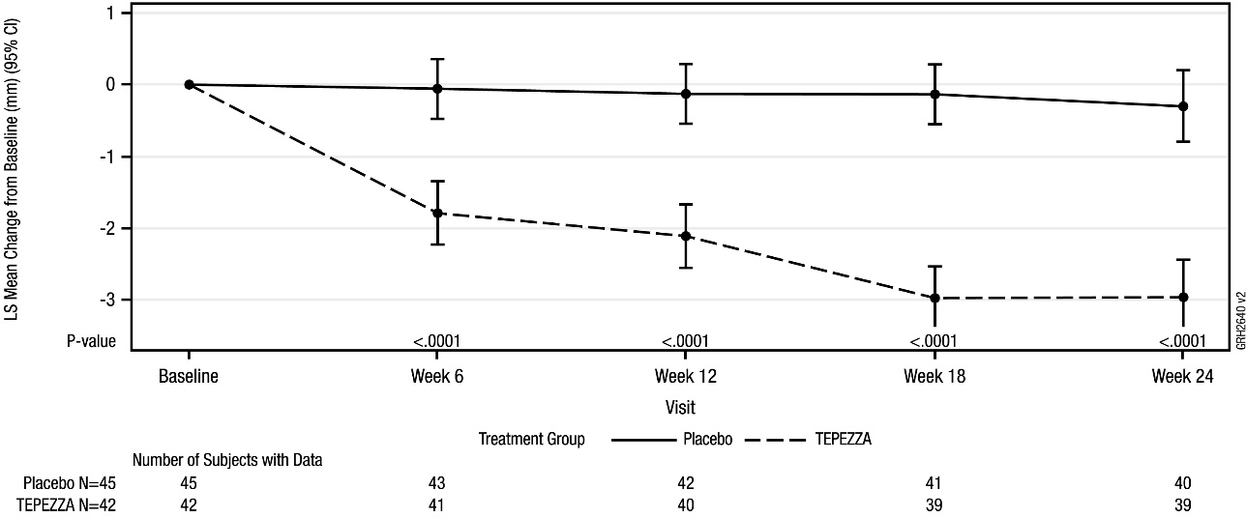

CI = Confidence Interval; ITT = intent-to-treat; LS = Least Squares

Figure 2. Change from Baseline in Proptosis Over 24 Weeks in Acute TED Study 2 (ITT Analysis Set; Study Eye)
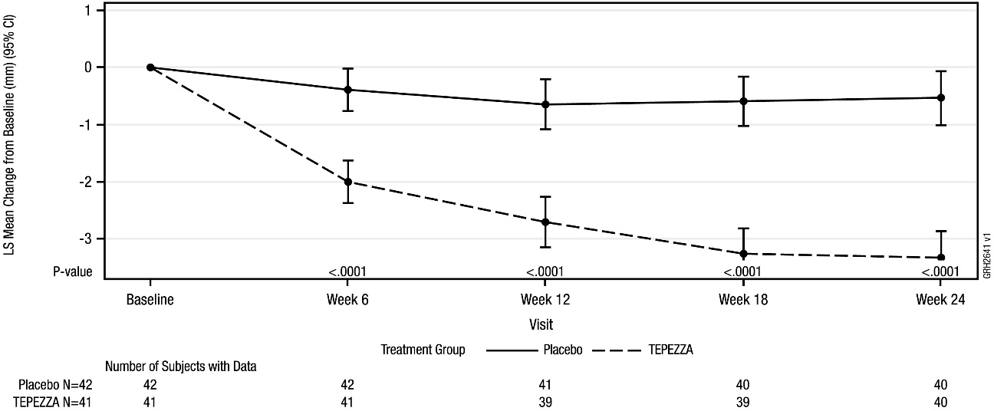
CI = Confidence Interval; ITT = intent-to-treat; LS = Least Squares

Figure 3. Change from Baseline in Proptosis Over 24 Weeks in Acute TED Study 3 (ITT Analysis Set; Study Eye)
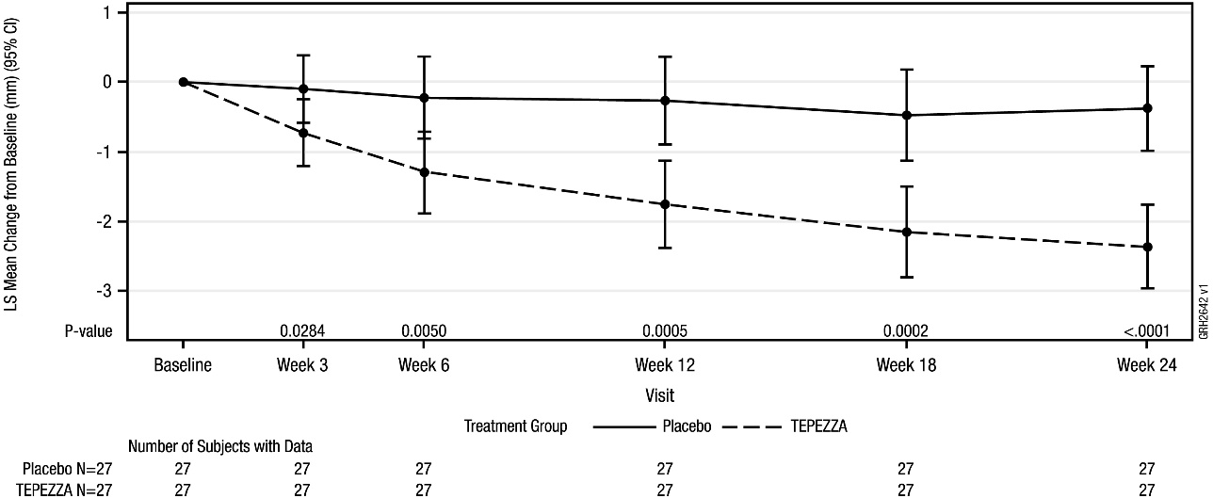

CI = Confidence Interval; ITT = intent-to-treat; LS = Least Squares

Figure 4. Change from Baseline in Proptosis Over 24 Weeks in Chronic TED Study 4 (ITT Analysis Set; Study Eye)
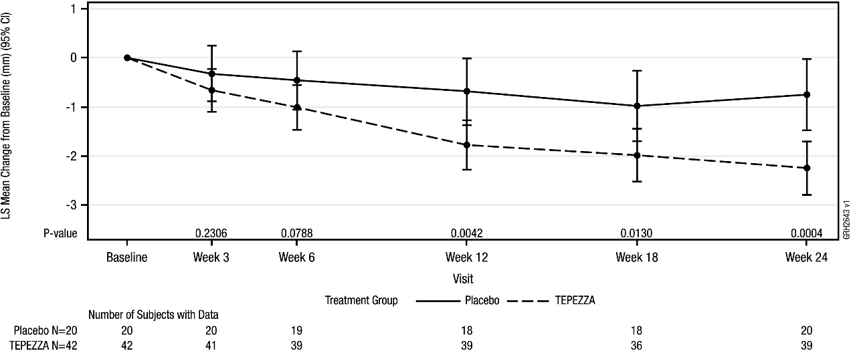

CI = Confidence Interval; ITT = intent-to-treat; LS = Least Squares

Pharmacokinetic properties
The pharmacokinetics of teprotumumab was described by a two-compartment population pharmacokinetic (PK) model based on data from 10 healthy subjects (dose of 1500 mg) single IV and 176 patients with TED (first infusion at 10 mg/kg, followed by 7 repeated doses of 20 mg/kg TEPEZZA every 3 weeks). Following the recommended dose regimen the mean (± SD) estimates for AUCss, Cmax, and Ctrough concentrations of teprotumumab were 139 (± 27) mg*hr/mL, 675 (± 147) µg/mL, and 159 (± 38) µg/mL, respectively.

Distribution
Following the recommended TEPEZZA dosing regimen, the population PK estimated mean (± standard deviation) for central and peripheral volume of distribution of teprotumumab were 3.01 (± 0.77) L and 3.76 (± 0.60) L, respectively.
Metabolism
Metabolism of teprotumumab has not been fully characterised. However, teprotumumab is expected to undergo metabolism via proteolysis.
Excretion
Following the recommended teprotumumab dosing regimen, the population PK estimated mean (± standard deviation) for the clearance of teprotumumab was 0.27 (± 0.07) L/day and for the elimination half-life was 22 (± 4) days.
Special populations
Age, gender, race, weight
No clinically significant differences in the pharmacokinetics of teprotumumab were observed following administration of teprotumumab based on patient’s age, gender, race/ethnicity or weight.
Renal impairment
No clinically significant differences in the pharmacokinetics of teprotumumab were observed following administration of TEPEZZA to patients with mild to moderate renal impairment (creatinine clearance 30 to 89 mL/min estimated by Cockcroft-Gault Equation).
Hepatic impairment
The effect of hepatic impairment on the pharmacokinetics of teprotumumab is unknown. However, no clinically significant differences in the pharmacokinetics of teprotumumab were observed following administration of TEPEZZA to patients with elevated bilirubin levels (2.7-24.3 micromoles/L), aspartate aminotransferase (AST) levels (11-221 U/L) or alanine aminotransferase (ALT) levels (7-174 U/L).

Preclinical safety data
Genotoxicity
No genotoxicity studies have been conducted with teprotumumab. As a large protein molecule, teprotumumab is not expected to interact directly with DNA or other chromosomal material.
Carcinogenicity
No carcinogenicity studies have been conducted with teprotumumab. Pregnancy and developmental toxicity
Teratogenicity was demonstrated for teprotumumab in monkeys.
In an abridged pilot embryofetal development study, fetal loss was increased in pregnant cynomolgus monkeys given teprotumumab intravenously at 75 mg/kg/week (yielding 2.8 times the systemic exposure [serum AUC] in patients at the maximum recommended human dose).
Teprotumumab caused generalised suppression of fetal growth, with final fetal weight almost halved, and decreased placental weight and size, and reduced amniotic fluid volume. Every surviving exposed fetus displayed multiple malformations, including misshapen cranium, closely set eyes, micrognathia, and pointing and narrowing of the nose; impaired/abnormal ossification of the skull, teeth, sternebrae, carpals and tarsals was also observed.
These adverse effects on embryofetal development occurred in the absence of maternal toxicity.

PHARMACEUTICAL PARTICULARS

List of excipients
Histidine
Histidine hydrochloride monohydrate Polysorbate 20
Trehalose dihydrate

Incompatibilities
No incompatibilities between TEPEZZA and polyethylene (PE), polyvinyl chloride (PVC), polyurethane (PUR) or polyolefin (PO) bags and intravenous administration sets have been observed.

Shelf life
In Australia, information on the shelf life can be found on the public summary of the Australian Register of Therapeutic Goods (ARTG). The expiry date can be found on the packaging.
Reconstituted and diluted infusion solution
The product does not contain any preservative. The combined storage time of reconstituted TEPEZZA solution in the vial and the diluted solution in the infusion bag containing 0.9% sodium chloride (until administration of the infusion solution is completed) is a total of 4 hours at room temperature (20°C to 25°C) or up to 48 hours under refrigerated conditions (2°C to 8°C), protected from light. If refrigerated prior to administration, allow the diluted solution to reach room temperature prior to infusion.

Special precautions for storage
Refrigerate at 2°C to 8°C in original carton until time of use to protect from light. Do not freeze.

Nature and contents of container
TEPEZZA is supplied in 20 mL type I clear glass vial, with a grey stopper (flurotec coated chlorobutyl) and an aluminium seal with a polypropylene matte red flip-off cap.
Each carton contains one vial.

Special precautions for disposal
In Australia, any unused medicine or waste material should be disposed of in accordance with local requirements.

Physicochemical properties
Chemical structure

Light chain C1041H1614N282O333S5 Heavy chain C2197H3396N592O667S15
CAS number
89957-37-9

MEDICINE SCHEDULE (POISONS STANDARD)
SCHEDULE 4 – PRESCRIPTION ONLY MEDICINE

SPONSOR
Amgen Australia Pty Ltd Level 11, 10 Carrington St
Sydney NSW 2000
Ph: 1800 803 638
www.amgenmedinfo.com.au
Email: medinfo.JAPAC@amgen.com

DATE OF FIRST APPROVAL
Date of first inclusion in the Australian Register of Therapeutic Goods: {DD month YYYY}

DATE OF REVISION
{DD month YYYY}

SUMMARY TABLE OF CHANGES

Section changed | Summary of new information

© 2025 Amgen Inc. All rights reserved.

TEPEZZA® is a registered trademark of Horizon Therapeutics Ireland DAC

