Australian Public Assessment Report for Skytrofa
  - Active ingredient: lonapegsomatropin
  - Sponsor: Specialised Therapeutics Pharma Pty Ltd
July 2025

About the Therapeutic Goods Administration (TGA)
- The Therapeutic Goods Administration (TGA) is part of the Australian Government Department of Health, Disability and Ageing and is responsible for regulating therapeutic goods, including medicines, medical devices, and biologicals.
- The TGA administers the Therapeutic Goods Act 1989 (the Act), applying a risk management approach designed to ensure therapeutic goods supplied in Australia meet acceptable standards of quality, safety, and efficacy.
- The work of the TGA is based on applying scientific and clinical expertise to decision-making, to ensure that the benefits to the Australian public outweigh any risks associated with the use of therapeutic goods.
- The TGA relies on the public, healthcare professionals and industry to report problems with therapeutic goods. The TGA investigates reports received to determine any necessary regulatory action.
- To report a problem with a therapeutic good, please see the information on the TGA website.

About AusPARs
- The Australian Public Assessment Report (AusPAR) provides information about the evaluation of a prescription medicine and the considerations that led the TGA to approve or not approve a prescription medicine submission. Further information can be found in Australian Public Assessment Report (AusPAR) guidance.
- AusPARs are prepared and published by the TGA.
- AusPARs are static documents that provide information that relates to a submission at a particular point in time. The publication of an AusPAR is an important part of the transparency of the TGA’s decision-making process.
- A new AusPAR may be provided to reflect changes to indications or major variations to a prescription medicine subject to evaluation by the TGA.

Copyright
© Commonwealth of Australia 2025
This work is copyright. You may reproduce the whole or part of this work in unaltered form for your own personal use or, if you are part of an organisation, for internal use within your organisation, but only if you or your organisation do not use the reproduction for any commercial purpose and retain this copyright notice and all disclaimer notices as part of that reproduction. Apart from rights to use as permitted by the Copyright Act 1968 or allowed by this copyright notice, all other rights are reserved and you are not allowed to reproduce the whole or any part of this work in any way (electronic or otherwise) without first being given specific written permission from the Commonwealth to do so. Requests and inquiries concerning reproduction and rights are to be sent to the TGA Copyright Officer, Therapeutic Goods Administration, PO Box 100, Woden ACT 2606 or emailed to <tga.copyright@tga.gov.au>.

Contents
List of abbreviations 4
Skytrofa (lonapegsomatropin) submission 5
Proposed indication 6
The condition 6
Current treatment options 7
Clinical rationale 7
Regulatory status 8
Australian regulatory status 8
International regulatory status 8
Registration timeline 11
Assessment overview 11
Quality evaluation summary 11
Nonclinical evaluation summary 12
Clinical evaluation summary 13
Summary of clinical studies 13
Pharmacology 14
Efficacy 21
Safety 36
Risk management plan evaluation summary 40
Risk-benefit analysis 41
Advisory Committee considerations 42
Assessment outcome 43
Specific conditions of registration 43
Product Information and Consumer Medicines Information 44

List of abbreviations
Abbreviation | Meaning
ACM | Advisory Committee on Medicines
ACP-001 | predecessor molecule biologically equivalent to lonapegsomatropin
AHV | Annualized height velocity
ARTG | Australian Register of Therapeutic Goods
GH | growth hormone
GHD | growth hormone deficiency
GHRH | growth hormone releasing hormone
hGH | human growth hormone
IGF-1 | Insulin-like growth factor 1
mPEG | methoxypolyethylene glycol
PD | pharmacodynamic(s)
PI | Product Information
PK | pharmacokinetic(s)
popPK | population pharmacokinetic(s)
RMP | Risk management plan
SC | subcutaneous
SDS | standard deviation score
TEAE | Treatment emergent adverse event(s)
TGA | Therapeutic Goods Administration

Skytrofa (lonapegsomatropin) submission
Type of submission: | New biological entity
Product name: | Skytrofa
Active ingredient: | lonapegsomatropin
Decision: | Approved
Date of decision: | 20 May 2025
Approved therapeutic use for the current submission: | Growth failure in children and adolescents aged from 3 years up to 18 years due to insufficient endogenous growth hormone secretion
Date of entry onto ARTG: | 23 May 2025
ARTG numbers: | 445796 - Skytrofa lonapegsomatropin 11 mg powder and solvent for solution for injection dual chamber glass cartridge  445797 - Skytrofa lonapegsomatropin 13.3 mg powder and solvent for solution for injection dual chamber glass cartridge  445798 - Skytrofa lonapegsomatropin 3 mg powder and solvent for solution for injection dual chamber glass cartridge  445799 - Skytrofa lonapegsomatropin 3.6 mg powder and solvent for solution for injection dual chamber glass cartridge  445800 - Skytrofa lonapegsomatropin 4.3 mg powder and solvent for solution for injection dual chamber glass cartridge  445801 - Skytrofa lonapegsomatropin 5.2 mg powder and solvent for solution for injection dual chamber glass cartridge  445803 - Skytrofa lonapegsomatropin 7.6 mg powder and solvent for solution for injection dual chamber glass cartridge  445804 - Skytrofa lonapegsomatropin 9.1 mg powder and solvent for solution for injection dual chamber glass cartridge  475726 - Skytrofa lonapegsomatropin 6.3 mg powder and solvent for solution for injection dual chamber glass cartridge
Black Triangle Scheme: | Yes
Sponsor’s name and address: | Specialised Therapeutics Pharma Pty Ltd, Level 2, 17 Cotham Road, Kew, Victoria 3101
Dose form: | Powder and solvent for solution for injection
Strength: | Each dual-chamber cartridge:  3 mg, 3.6 mg, 4.3 mg, 5.2 mg (11 mg/mL somatropin protein after reconstitution);  6.3 mg, 7.6 mg, 9.1 mg, 11 mg or 13.3 mg (22 mg/mL somatropin protein after reconstitution).
Container: | Glass cartridge (Type I glass) with two chambers separated by a rubber stopper (bromobutyl). The cartridge is closed by a rubber stopper (bromobutyl) in one end and by a rubber closure disc (bromobutyl) in the other end. The cartridge is mounted in a plastic needle adaptor.
Pack size: | Each pack contains 4 single use dual chamber cartridges packed in individual blisters and 6 disposable injection needles 0.25 mm x 4 mm (31G x 5/32”).
Route of administration: | Powder and solvent for solution for injection
Dosage: | The dosage and administration is individualised for each patient.  For further information regarding dosage refer to the Product Information.
Pregnancy category: | Category B2  Drugs which have been taken by only a limited number of pregnant women and women of childbearing age, without an increase in the frequency of malformation or other direct or indirect harmful effects on the human fetus having been observed.  Studies in animals are inadequate or may be lacking, but available data show no evidence of an increased occurrence of fetal damage.  The use of any medicine during pregnancy requires careful consideration of both risks and benefits by the treating health professional. The pregnancy database must not be used as the sole basis of decision making in the use of medicines during pregnancy. The TGA does not provide advice on the use of medicines in pregnancy for specific cases. More information is available from obstetric drug information services in your state or territory.

Proposed indication
This AusPAR describes the submission by Specialised Therapeutics Pharma Pty Ltd (the Sponsor) to register Skytrofa (lonapegsomatropin) for the following proposed indication:
Growth failure in children and adolescents aged from 3 years up to 18 years due to insufficient endogenous growth hormone secretion (growth hormone deficiency [GHD]).

The condition
Growth hormone deficiency (GHD) is a rare disorder characterized by insufficient secretion of growth hormone (GH), somatropin, by the pituitary gland, occurring in approximately 1 in 4,000 to 10,000 children. GH promotes growth, maintenance of normal body composition, and organ development, and has important impacts on cardiovascular function, cognition, metabolism and overall endocrine health. Although short stature is the most common manifestation of GHD, other comorbidities include impaired musculoskeletal development, cardiovascular disease, and decreased quality of life.,,
GH production by the somatotroph cells of the anterior pituitary gland is stimulated by growth hormone releasing hormone (GHRH) and inhibited by somatostatin, both of which are produced by the hypothalamus. GHD is usually associated with defects arising in the pituitary gland or the hypothalamus due to:
- Congenital (organic causes such as pituitary aplasia, primary empty sella syndrome, etc, or genetic causes including various mutations)
- Acquired (tumours of the hypothalamic-pituitary region, most commonly craniopharyngioma, head trauma, infection, cranial irradiation)
- Idiopathic aetiologies
The aetiology of childhood GHD is usually of hypothalamic origin with impaired GHRH secretion, most commonly being idiopathic. In neonates, clinical presentations of congenital pituitary GHD can include profound hypoglycaemia, hypoglycaemic seizures, prolonged jaundice, and microphallus and cryptorchidism in boys. Patients whose condition is diagnosed at younger ages generally have more severe GHD, are more likely to suffer from multiple pituitary hormone deficiencies and tend to have more complications at birth. A substantial reduction in growth rate may become apparent within the first few months of life.

Current treatment options
For over 35 years, GHD has been treated with daily recombinant human growth hormone (hGH). While daily hGH is both safe and effective, its frequency of administration is burdensome for both children and their caregivers. Although children with GHD treated with daily hGH replacement have the potential to achieve normal adult height, real-world outcomes have not matched expectations. Due to nonadherence, many children do not reach their target genetic height leaving an opportunity to improve treatment outcomes in children with GHD.

Clinical rationale
Lonapegsomatropin (Skytrofa), is a long-acting prodrug consisting of the parent drug, somatropin, an inert methyoxy polyethelene glycol carrier, and a TransCon linker (Figure 1). The carrier has a shielding effect that minimizes renal excretion and receptor-mediated clearance of lonapegsomatropin, thus increasing the half-life. Lonapegsomatropin has been developed to reduce the dosing frequency from daily to weekly.
Figure 1: Release of Somatropin from the Prodrug, Lonapegsomatropin
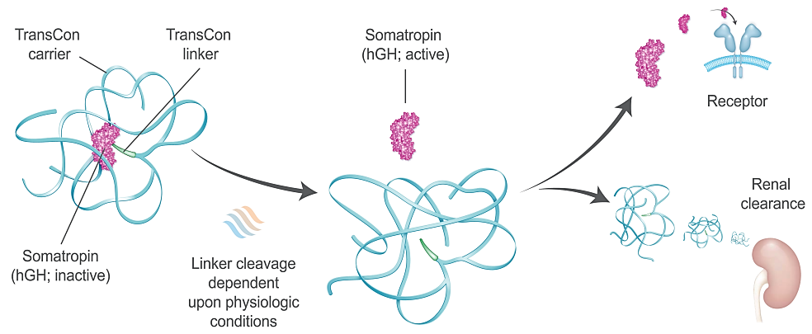
Lonapegsomatropin is a long-acting prodrug consisting of the parent drug, unmodified somatropin; an inert carrier; and a proprietary linker that temporarily binds the somatropin and carrier. The carrier has a shielding effect that minimizes renal excretion and receptor-mediated clearance. Following autocleavage of the linker under physiologic conditions, lonapegsomatropin predictably releases somatropin within therapeutic levels over one week.

Regulatory status

Australian regulatory status
This product is a new biological entity for Australian regulatory purposes.

International regulatory status
At the time the TGA considered this submission, a similar submission had been considered by other regulatory agencies. The following table summarises these submissions and provides the indications where approved.
Table 1. International regulatory status for Skytrofa
Country | Approval Date | Launch Date | Trade Name | Strength | Indication
Europe | 11 January 2022 | 15 September 2023 in Germany | Skytrofa | 3 mg, 3.6 mg,  4.3 mg, 5.2 mg  (11 mg/mL after reconstitution).  6.3 mg, 7.6 mg,  9.1 mg, 11 mg,  13.3 mg (22 mg/mL after reconstitution | Growth failure in children and adolescents aged from 3 years up to 18 years due to insufficient endogenous growth hormone secretion (growth hormone deficiency [GHD]).
United States of America | 25 August 2021 | 15 October  2021 | Skytrofa | 3 mg, 3.6 mg,  4.3 mg, 5.2 mg  (11 mg/mL after reconstitution);  6.3 mg, 7.6 mg,  9.1 mg, 11 mg,  13.3 mg (22 mg/mL after reconstitution) | Skytrofa (lonapegsomatropin- tcgd) is a human growth hormone indicated for the treatment of pediatric patients 1 year and older who weigh at least 11.5 kg and have growth failure due to inadequate secretion of endogenous growth hormone (GH).
UK | 17 October 2022 | Not launched | Skytrofa | 3 mg, 3.6 mg,  4.3 mg, 5.2 mg  (11 mg/mL after reconstitution).  6.3 mg, 7.6 mg,  9.1 mg, 11 mg,  13.3 mg (22 mg/mL after reconstitution) | Growth failure in children and adolescents aged from 3 years up to 18 years due to insufficient endogenous growth hormone secretion (growth hormone deficiency [GHD]).

Registration timeline
Table 2 captures the key steps and dates for this submission.
This submission was evaluated under the standard prescription medicines registration process.
Table 2. Registration timeline for Skytrofa
Description | Date
Submission dossier accepted and evaluation commenced | 31 May 2024
Evaluation completed | 3 March 2025
Advisory committee meeting | 4 April 2025
Registration decision (Outcome) | 20 May 2025
Registration in the ARTG completed | 23 May 2025
Number of working days from submission dossier acceptance to registration decision* | 249 days
*Statutory timeframe for standard submissions is 255 working days

Assessment overview

Quality evaluation summary
There were no significant issues identified from the quality evaluation of the submitted data that would indicate the product should not be registered on the basis of quality, or safety-related issues arising from the quality of the product. The Sponsor has satisfied all requirements with respect to:
- Good Manufacturing Practice compliance,
- stability and release specifications,
- history, control and traceability of cell lines/cell banks,
- validation of analytical procedures,
- appropriate choice/synthesis and validation of reference materials,
- appropriate in-process controls within the manufacturing process and identification of critical manufacturing steps,
- consistency of medicine manufacture verified by process validation and demonstrated through batch analysis,
- satisfactory control of impurities,
- adequate characterisation and justification of excipients,
- medicine sterility/appropriate control of infectious disease & adventitious agents,
- appropriate/compatible container closure systems and
- labelling that conformed to Therapeutic Goods Order 91.
There were no objections to registration from a quality perspective.

Nonclinical evaluation summary
The nonclinical dossier was of high quality with no critical deficiencies. All pivotal safety-related studies were GLP-compliant.
In lonapegsomatropin, somatropin is transiently conjugated to a methoxypolyethylene glycol (mPEG) carrier (4 × 10 kDa) via a proprietary TransCon linker. Lonapegsomatropin is designed to release unmodified hGH (somatropin) in a controlled manner in vivo (at physiological pH and temperature [enzyme-independent]), and allowing for once weekly dosing with this product cf. daily administration for existing somatropin products.
Slow release of hGH from lonapegsomatropin was demonstrated under physiological conditions in vitro. The hGH released from lonapegsomatropin is unmodified, and displays potency equivalent to that of somatropin reference standard. In vitro experiments indicated that hGH is largely inactivated when bound to the mPEG carrier. Increased body weight gain and serum
IGF-1 were demonstrated with lonapegsomatropin (and a predecessor molecule featuring a larger mPEG moiety) in vivo in laboratory animals.
Safety pharmacology and other studies indicated no likely pharmacologically mediated adverse effects on CNS, cardiovascular or respiratory function in patients treated with Skytrofa.
The pharmacokinetic profile was characterised by slow absorption after SC administration and a long serum half-life, and similar in laboratory animal species and humans. Intact lonapegsomatropin is expected to be largely restricted to the vascular compartment.
Lonapegsomatropin showed a low order of acute toxicity in rats and monkeys.
Repeat-dose toxicity studies of up to 6 months duration were performed in rats and 12 months in cynomolgus monkeys. Juvenile animals were used in the pivotal monkey studies and provided appropriate coverage of the age range of the intended patient population. The studies involved once weekly SC administration (as clinically). Notable effects reflected the pharmacological activity of hGH (mammary duct/gland dilation and mammary gland lobular hyperplasia) or distribution/accumulation of mPEG (vacuolation of choroid plexus epithelial cells and interstitial macrophages). All treatment-related findings are regarded as non-adverse.
Lonapegsomatropin was negative in the standard battery of tests for genotoxicity.
No carcinogenicity studies have been performed with lonapegsomatropin. No particular concern for carcinogenicity is held for lonapegsomatropin therapy from consideration of available data.
Male and female fertility were found to be unaffected by lonapegsomatropin in rats, but the development of anti hGH antibodies limits the predictive value of the study. No microscopic changes in male or female reproductive organs to indicate potential impairment of fertility were observed in monkeys treated with lonapegsomatropin. No adverse effects on embryofetal development were observed with lonapegsomatropin in rats, but weekly dosing in the animals (so that just two doses were given during pregnancy) yielded intermittent exposure during critical periods of organogenesis, limiting the predictive value of the study. Malformations and embryofetal lethality were observed with lonapegsomatropin in rabbits, but these findings are most likely secondary to maternotoxicity. Limitations in the embryofetal development studies warrant assignment to Pregnancy Category B2 (rather than B1 as the Sponsor proposes).
In a pre- and postnatal developmental study performed with a structurally related transiently pegylated somatropin prodrug (ACP-001) in rats there were no adverse effects on the development of the conceptus or the offspring with maternal weekly administration from implantation through weaning.
While no local tolerance concerns are identified from nonclinical data, the highest tested strength of lonapegsomatropin in animals is well below that proposed for administration to patients. Clinical data to address this deficiency are available.
There are no nonclinical objections to the registration of Skytrofa for the proposed indication.

Clinical evaluation summary

Summary of clinical studies
Five clinical studies were conducted with lonapegsomatropin in the clinical development: two phase 1 (healthy adult volunteers) and three phase 3 studies (children with GHD). An additional phase 2 study CT-004 was conducted with a biologically equivalent predecessor molecule (ACP-001) and provides supportive data. (Table 3)
Additionally, there were 3 population pharmacokinetic (popPK)/pharmacodynamic (PD) analyses included in this submission: Analysis MODHGH003 – Average IGF-1 Analysis MODHGH001 – mPEG Modelling and Analysis MODHGH002 – POPPK.
The main efficacy data came from the pivotal Phase III – CT-301, as well as CT-302 and the CT-301 Extension Study. The phase 3 trials included a pivotal, randomized, active-controlled, 52-week trial (CT-301), an, open-label, single-arm, 26-week trial (CT-302), and an ongoing, open-label, single-arm, long-term extension trial for children previously participating in CT-301 or CT-302 (CT-301EXT).
Table 3. Summary of Clinical Studies in Clinical Development Program
Phase/ Trial Design/ Treatment Duration | Trial ID No. of Site Locations | Primary/ Secondary Objectives | Trial Population | No. of Subjects Included in Safety Analysis
3/  Randomized,  open-label, active  control/  52 weeks | CT-301  54 sitesª | Efficacy/  PK, PD, and safety | Children with  GHD | 161  Lonapegsomatropin: 105  Genotropin: 56
3/  Open-label,  uncontrolled/  26 weeks | CT-302  24 sites  Australia, Canada,  New Zealand, United  States | Safety/  Efficacy and PD | Children with  GHD | 146
3/  Long-term, Open-label,  extension,  uncontrolled/  Ongoing | CT-301EXT  63 sites ª | Long-term safety/  Long-term safety  and efficacy | Children with  GHD | 296
1/  Randomized,  open-label, crossover,  bridging (ACP-011 vs  ACP-001) | CT-101  Single-center  United States | Safety/  PK and PD | Healthy adult  volunteers | 46  Group 1: 28  Group 2: 18
1/  Randomized, open-  label, crossover,  bioequivalence  (syringe/needle vs GH  Auto-Injector) | CT-102  Single-center  Australia | PK/  PD and safety | Healthy adult  male volunteers | 28
2/  Randomized, open-  label, active-control/ 26 weeks | CT-004  (ACP-001)  20 sites^{b} | Safety/  PK, PD and,  efficacy | Children with  GHD | 53  ACP-001: 40  Genotropin: 13
Abbreviations: ACP-001=biologically equivalent predecessor molecule to lonapegsomatropin; ACP-011=lonapegsomatropin; GHD=growth hormone deficiency; PD=pharmacodynamics; PK=pharmacokinetics; vs=versus.
- Armenia, Australia, Belarus, Bulgaria, Canada (CT-301EXT only), Georgia, Greece, Italy, New Zealand, Poland, Romania, Russia, Turkey, Ukraine, United States
- Belarus, Bulgaria, Egypt, Greece, Hungary, Poland, Romania, Russia, Turkey, Ukraine

Pharmacology
Lonapegsomatropin is a long-acting prodrug of hGH, designed to maintain the same mode of action and distribution as once-daily somatropin products, but with a once-weekly injection. Lonapegsomatropin consists of a parent drug, somatropin, that is transiently conjugated to a mPEG carrier via a proprietary TransCon linker (Figure 1)
The hGH contained in lonapegsomatropin is synthesized by recombinant technology, from a strain of Escherichia coli modified by the introduction of the human gene for GH; the amino acid sequence is therefore identical (191 amino acids) to that of human origin, as is the size of the somatropin released. The hGH released from lonapegsomatropin has the same mode of action, distribution, and cellular signalling as endogenous GH.
Lonapegsomatropin has been designed to release unmodified hGH in a controlled manner over a week. The sustained release of hGH in the bloodstream after lonapegsomatropin administration is believed to improve hGH diffusion into the growth plate and in turn mediate a more pronounced effect on stem cell mobilization and local insulin-like growth factor 1 (IGF-1) production, resulting in increased chondrocyte proliferation and hypertrophy.
The clinical development program used two molecules, ACP-001 (predecessor molecule) and ACP-011 (current molecule: lonapegsomatropin). They differ in the size of the mPEG molecule: 40 kDa for lonapegsomatropin versus 80 kDa for ACP-001. Lonapegsomatropin superseded ACP-001 as it is less viscous allowing a more concentrated dosage formulation, and smaller injection volumes compatible with administration via the dual-chamber cartridge (DCC)/GH Auto-Injector device. Extensive in vitro and in vivo nonclinical tests, and a Phase 1 bridging clinical trial (CT-101) have shown biological equivalence/comparability between the two molecules.
To exert its PD effects, free somatropin binds to a dimeric hGH receptor in the cell membrane of target cells resulting in intracellular signal transduction and a host of PD effects. Somatropin has direct tissue and metabolic effects, and indirect effects mediated by IGF-1, including stimulation of chondrocyte differentiation and proliferation, stimulation of hepatic glucose output, protein synthesis and lipolysis. Somatropin stimulates skeletal growth in paediatric patients with GHD due to effects on the growth plates (epiphyses) of bones. IGF-1 is found in association with specific IGF-binding proteins, such as insulin-like growth factor binding protein 3 (IGFBP-3), that extends the IGF-1 terminal elimination half-life (t_{½}) in the circulation, to transport IGF-1 to the target cells, and to modulate its biological action. IGF-1 and IGFBP-3 were assessed as biomarkers in adult volunteer and paediatric GHD subjects in the lonapegsomatropin program.

Pharmacokinetics and pharmacodynamics
Two clinical pharmacology trials were conducted to investigate pharmacokinetics (PK) and pharmacodynamic (PD) of lonapegsomatropin (CT-101 and CT-102). Both were randomized, open-label, single dose trials in healthy volunteers. In addition, PK and PD assessments were made in phase 2 (CT-004) and phase 3 studies (CT-301 and CT-302) in paediatric subjects.
- CT-101 compared (for bridging purposes) in a single dose, cross-over design, PK and PD, measured as hGH and IGF-1, between lonapegsomatropin and ACP-001 (predecessor molecule of lonapegsomatropin). ACP-001 was used in the dose finding Phase 2 trial, CT-004, which was conducted before CT-101. Furthermore, CT-101 investigated PK and PD of lonapegsomatropin at three different dose levels.
- CT-102 was a single dose, cross-over bioequivalence trial comparing PK and PD, measured as hGH and IGF-1, of lonapegsomatropin administered via syringe/needle (reconstituted drug from single-use glass vial) or via GH Auto-Injector.
- Trial CT-004 was performed using ACP-001 (predecessor of lonapegsomatropin (ACP-011). The study provided multiple dose/exposure-response information in paediatric GHD subjects, and was the dose finding study.
- PK data was collected in all lonapegsomatropin-treated subjects in the pivotal paediatric trial CT-301, and intensive PK sampling was performed in a subset of 11 lonapegsomatropin-treated subjects. Sparse PK sampling was performed in a limited number of subjects in trial CT-302.
Three population PK/PD analyses were performed.
- MODHGH003 used the IGF-1 data from trial CT-301 and CT-004 to characterize the PD over the time course of study and simulate average (and variability) IGF-1 concentrations within the weekly cycle of treatment in trial CT-301 and in addition the proportion of time, where concentrations remained in 0 to 2 standard deviation score (SDS) range.
- MODHGH001 was performed to predict the PK of mPEG in serum and choroid plexus in paediatric subjects. This was based on established blood PK of mPEG in animals and humans and mPEG distribution in animals.
- MODHGH002 was performed to develop a model to characterize the PK of lonapegsomatropin and hGH/IGF-1 response following administration of lonapegsomatropin to paediatric GHD subjects and to assess any impact of covariates.

Summary pharmacokinetics

Somatropin pharmacokinetics

Absorption
Following subcutaneous administration, lonapegsomatropin releases somatropin in a controlled manner that follows first-order kinetics and distributes slowly from the administration site to the systemic circulation. Due to the autocleavage mechanism, hGH can be liberated from lonapegsomatropin both at the administration site and in the systemic circulation.
In paediatric GHD patients, following subcutaneous dose administration of lonapegsomatropin 0.24 mg somatropin/kg/week, the observed mean (CV%) steady state peak serum concentration (C_{max}) of lonapegsomatropin was 1230 (86.3) ng somatropin/mL at median T_{max} of 25 hours, and for released somatropin C_{max} was 15.2 (83.4) ng/mL with a median time to reach C_{max} of 12 hours. The mean (CV%) somatropin exposure over the one-week dose interval (area under the curve) was 500 (83.8) h*ng/mL. Accumulation of lonapegsomatropin or somatropin following repeat dose administration was not observed.
The absolute bioavailability of lonapegsomatropin following subcutaneous dose administration has not been investigated.

Distribution
In paediatric GHD patients, the mean (CV%) steady state apparent volume of distribution of lonapegsomatropin after subcutaneous administration of 0.24 mg somatropin/kg/week was 0.13 (109) L/kg. Somatropin released from lonapegsomatropin is expected to have a similar volume of distribution as endogenous GH.

Metabolism
Lonapegsomatropin is converted via a non-enzymatic first-order process that is pH and temperature-dependent, releasing hGH. Recombinant hGH, when released from lonapegsomatropin, is considered to be metabolised in the same manner as endogenous GH. Endogenous GH is metabolized in the liver and kidneys, where GH is catabolized to its constitutive amino acids.

Excretion
In paediatric GHD patients, the mean (CV%) steady state apparent clearance of lonapegsomatropin after subcutaneous administration of 0.24 mg somatropin/kg/week was 3.2 (67) mL/h/kg with a mean (±SD) observed half-life of 30.7 (± 12.7) hours. The apparent half-life of somatropin released from lonapegsomatropin was approximately 25 hours.

mPEG pharmacokinetics
During SC administration of the drug product, relatively high levels of mPEG are expected in the patients' serum. An important potential safety issue that has been raised for other pegylated product is the chance of vacuolisation in the choroid plexus.
The metabolic fate of mPEG has been investigated extensively, and the metabolism and excretion of mPEG are understood. High molecular weight mPEGs such as from lonapegsomatropin are expected to be predominantly excreted unchanged in the urine by renal filtration.
A 2-compartment semi-physiological population PK model (MODHGH001) was developed to predict potential distribution of mPEG (after release from lonapegsomatropin) to the choroid plexus of paediatric subjects. The aim of this analysis was to develop a population PK model of mPEG in healthy volunteers and paediatric patient populations and to predict the choroid plexus concentration of mPEG in children after the proposed clinical weekly dose of 0.24 mg hGH/kg ACP-011 and to compare this to the prediction in cynomolgus monkeys, where vacuole formation has been investigated.
To build the model, mPEG PK data from the lonapegsomatropin nonclinical and clinical programs were used in conjunction with literature data for Nonacog beta pegol (N9-GP), a human recombinant coagulation factor IX (rFIX) conjugated to a 40 kDa mPEG moiety, for which data on mPEG distribution into rat choroid plexus were available. This allowed predicting the PK of mPEG in choroid plexus in children, as well as comparison to systemic exposures in nonclinical toxicology studies.
mPEG distribution into choroid plexus is likely a passive process as receptors for mPEG do not exist and receptor interaction for hGH while bound in the prodrug is hindered by local conditions Lonapegsomatropin as a prodrug has a very low binding affinity to the GHR, due to the shielding effect of the mPEG carrier, protecting the prodrug from interacting with the GHR. In addition, GHR binding in the CNS is further hampered by the cell-surface glycocalyx that surrounds the cell membrane of cells in the CNS, preventing access of lonapegsomatropin to the membrane-associated GHRs.
Total serum mPEG PK concentration profiles were available from the 27-week SC repeated-dose toxicity study in rat (1704-037), the 52-week SC repeated-dose toxicity study in cynomolgus monkey (1704-035), the single dose phase 1 clinical study in healthy volunteers (CT-101), and the 52-week phase 3 clinical study in children with GHD (CT-301).
mPEG serum PK in rat and human were best described with a one-compartmental model with first order absorption from the administration depot. In cynomolgus monkey, a dose dependency was found.
Modelling of the serum mPEG PK in 3 to 13-year-old children with GHD and in adults demonstrated that the volume of distribution and the clearance scaled well via an allometric relationship within a body weight range of 12-70 kg. Therefore, the human PK model for serum mPEG could be used to predict the concentrations down to a body weight of 12 kg that corresponds to an age of approximately 3 to 4 years in children with GHD.
To assess the concentration of mPEG in the choroid plexus of children, weekly dosing of the proposed clinical dose of 0.24 mg hGH/kg was simulated. After 1 year, the predicted concentration in choroid plexus was close to the systemic steady state concentration of 15 μg/mL. To assess the concentration of mPEG in the choroid plexus of children, weekly dosing of the proposed clinical dose of 0.24 mg hGH/kg was simulated. After 1 year, the predicted concentration in choroid plexus was close to the systemic steady state concentration of 15 μg/mL. Furthermore, the simulated average steady state level in serum (15 μg/mL) and choroid plexus in children was 1.5-fold below the steady state level in cynomolgus monkeys which was not associated with vacuolation based on H&E staining (Figure 2).
Figure 2. Predicted plasma or serum steady-state concentrations (lines) across different permanently PEGylated compounds, N9-GP and ACP-011 and observed H&E choroid plexus epithelial cell vacuolation.
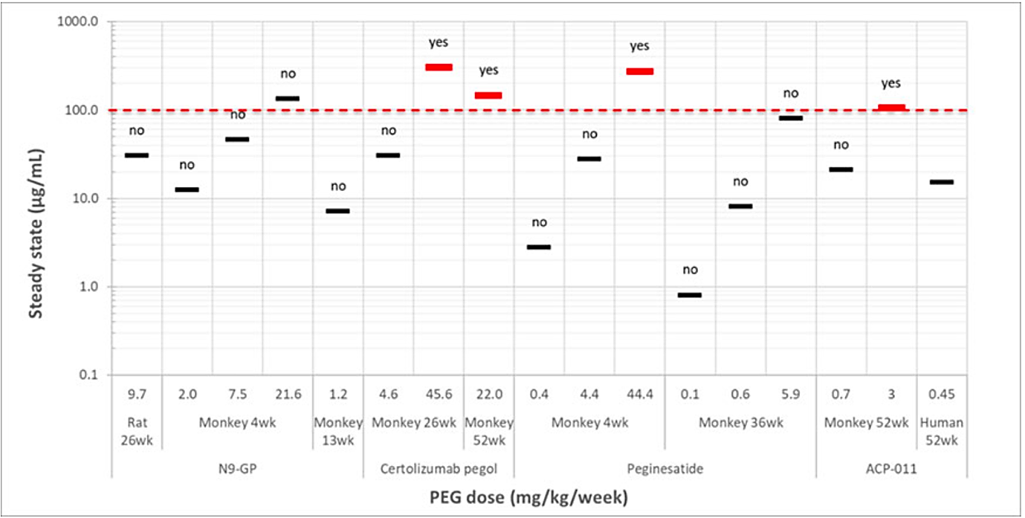

Bioequivalence
Results of bioequivalence Study CT-101 indicate that hGH levels are comparable for lonapegsomatropin and predecessor molecule ACP-001 at the 0.24 mg hGH/kg dose level, with the 90% CIs for the ratios for hGH AUC0-168, AUC0-336, and Cmax within the standard bioequivalence limits of 80-125%. Further, PD equivalence concerning the serum concentration-time profiles of IGF-1 was demonstrated. Based on this outcome, PK data obtained with the predecessor molecule ACP-001 (e.g. in Study CT-004) are considered valuable for evaluating lonapegsomatropin PK a dose-finding.
Results from Study CT-102 indicate that SC administration of lonapegsomatropin either via a syringe/needle or via the GH Auto-Injector results in comparable serum hGH and IGF-1 exposure, since relevant 90% CI of Cmax, AUC0-168, AUC0-t, and AUC0-inf were all within the standard bioequivalence range of 80-125%. No appreciable difference in hGH or IGF-1 inter-subject variation was observed between the two injection modalities. Based on this outcome, the clinical data obtained with lonapegsomatropin administered via a needle/syringe can be used to support the registration of lonapegsomatropin with the GH Auto-Injector.

Pharmacokinetics in special patient populations
No sex-specific pharmacokinetic studies have been performed with lonapegsomatropin. The literature indicates that the PK of somatropin is similar in males and females.
Based on a population pharmacokinetic analysis, age, sex, race/ethnicity, and body weight do not have a clinically meaningful effect on the pharmacokinetics, however it is noted that recruitment was predominantly White and male participants. No studies in patients with renal or hepatic impairments have been conducted with lonapegsomatropin. A reduction in somatropin clearance following administration of daily somatropin has been noted in patients with severe liver and kidney dysfunction. The clinical significance of this decrease is unknown. Lonapegsomatropin has not been studied in patients below 6 months of age.
The PK of the mPEG carrier of lonapegsomatropin is expected to be dependent on renal function but has not been assessed in patients with renal impairment.

Summary pharmacodynamics
Pharmacology, primary PD and safety pharmacology endpoints have been obtained from in vitro and in vivo studies conducted with lonapegsomatropin. PD data was collected throughout the clinical program. Lonapegsomatropin is a long-acting ‘prodrug’ of somatropin. Somatropin (191 amino acids) has the same mode of action and distribution as daily somatropin, but with a once-weekly subcutaneous injection. With its linker and mPEG protein, the handling of the drug is different, however there is an assumption that once somatropin is unbound that it will act similarly to support bone growth as the other somatropin drugs.
Human GH has two mechanisms of effect: direct action and indirect action. The direct effects of human GH on the body are through its action on binding to target cells to stimulate a response (production of IGF-1 by hepatocytes, decreasing the ability of the fat cell to accumulate fat and growth-promoting effect on the growth plate). The indirect effects occur primarily by the action of IGF-1, which hepatocytes primarily secrete in response to elevated human GH binding to surface receptors (muscle growth, growth-promoting effect on the growth plate).
The sustained systemic human GH exposure to the growth plate is expected to be associated with a more pronounced effect on stem cell mobilization and increased local IGF-1 production resulting in increased chondrocyte proliferation and hypertrophy, compared to the pharmacokinetic profile following daily somatropin administration.
IGF-1 increases metabolism, anabolism, and cellular replication and division. It also acts to inhibit apoptosis of the cell, thus prolonging the lifespan of existing cells.
IGF-1 is found in association with specific IGF-binding proteins, such as IGFBP-3, whose main functions are to extend the IGF-1 terminal elimination half-life (t_{½}) in the circulation, to transport IGF-1 to the target cells, and to modulate its biological action.
Somatropin released from lonapegsomatropin produces a dose linear IGF-1 response, with a change in dose of 0.02 mg somatropin/kg resulting in an approximate change in average weekly IGF-1 SDS of 0.17. At steady-state, IGF-1 SDS levels peaked about 2 days post-dose, with the average weekly IGF-1 SDS coinciding with approximately 4.5 days post-dose. IGF-1 SDS levels were in the normal range for GHD patients for most of the week, similar to daily somatropin.

Relationship between plasma concentration and effect
IGF-1 Response to treatment in paediatric GHD patients was initially assessed in study CT-004 that employed ACP-001, the predecessor molecule of lonapegsomatropin ACP-011. Although ACP-001 contains an 80kD mPEG versus a 40kD mPEG moiety in lonapegsomatropin, they contain the same linker moiety and are bioequivalent hGH in study CT-101.
Study CT-004 is a Phase 2, randomized, open-label active-controlled study in which the clinical effects of three different dose levels of weekly ACP-001, a predecessor of lonapegsomatropin, were compared with those of daily Genotropin somatropin treatment over a study period of 26 weeks. The study assessed IGF-1 at doses of 0.14 (N=12), 0.21 (N=14) and 0.30 mg hGH/kg/week (N=14) in pre-pubertal paediatric GHD subjects versus the active comparator Genotropin administered once daily at 0.03 mg hGH/kg/day (equivalent to 0.21 mg hGH/kg/week, n=13).
ACP-001 produced elevated levels of IGF-1 throughout the study and generally higher doses of ACP-001 were associated with greater IGF-1 increases (Figure 3). Furthermore, across ACP-001 dose groups, a dose-dependent response at week 27 was observed for the annualized height velocity (12.0 to 13.58 cm/year) and change from baseline in height SDS (0.69 to 0.84).
Figure 3. IGF-1 serum concentration arithmetic means (+SD) over time following once-weekly administration of ACP-001 (Study CT-004)
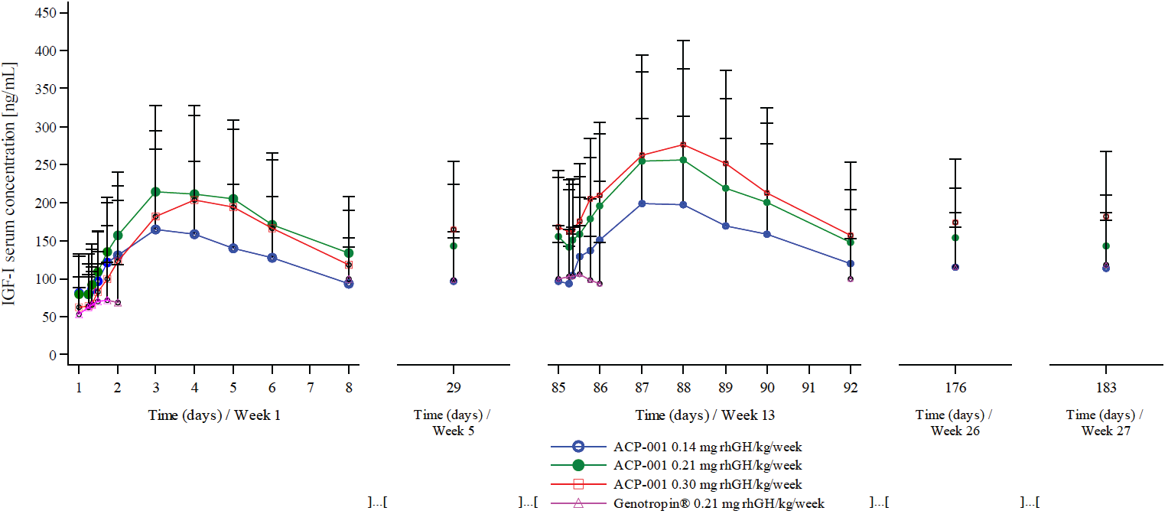
In study CT-101 lonapegsomatropin displayed dose-related PK exposure and PD response across the doses 0.24, 0.30 and 0.42 mg hGH/kg. The kinetics of 0.24 mg hGH/kg lonapegsomatropin provided sustained release of hGH and associated sustained increase in
IGF-1 over the course of a week.
Lonapegsomatropin dosing is targeted to achieve IGF-1 SDS levels within the range between -2 and +2. The observed IGF-1 SDS levels of study patients categorized by the IGF-1 SDS range is presented for the clinical studies is as follows:

Study 301
- IGF-1 SDS levels were ≥50% of the time within the range of -2 to +2 in 104/105 (99.0%) of lonapegsomatropin-treated and 53/56 (94.6%) of somatropin-treated study patients.
- IGF-1 SDS levels >+2 were observed in 7.6% of lonapegsomatropin-treated and 3.6% of somatropin-treated study patients.
- In the lonapegsomatropin treatment arm, the proportions of study patients with IGF-1 SDS levels >+2 tended to increase with time (week 13: 0%, week 26: 1.9%, week 39: 2.9%, week 52: 7.7%). Such a trend was not observed for the proportions of somatropin-treated study patients with IGF-1 SDS levels >+2 (week 13: 3.6%, week 26: 1.8%, week 39: 1.8%, week 52: 1.9%).

Study 302
- At each time point, the majority of study patients had IGF-1 SDS levels in between -2 and +2 at baseline (78.1%), week 13 (61.8%), and week 26 (60.6%).
- In the majority of patients (56.8%) serum IGF-1 SDS levels >+2 were observed at any point during the study, including baseline. In 25.3% of study patients, IGF-1 SDS levels >+3 were observed.
- The proportions of study patients with IGF-1 SDS levels >+2 (baseline: 21.9%, week 13: 38.2%, week 26: 38.7%) and >+3 (baseline: 3.4%, week 13: 11.8%, week 26: 15.5%) increased during follow-up.
- IGF-1 SDS levels above +2 were observed in all GHD study patients under 3 years of age.

Study CT-301 EXT
- In CT-301, average IGF-1 SDS > +2 was observed in 7.7% of the lonapegsomatropin-treated group versus 1.9% of the somatropin-treated group at week 52 and no average IGF-1 SDS >+3.
- At week 104, the proportions of patients who had IGF-1 SDS levels >+2 were 19.0% and 22.6% for study patients who had been treated with respectively lonapegsomatropin and somatropin in study CT- 301 (data lock-off June 2020). For paediatric GHD patients enrolled into study CT-302, the proportions of study patients with IGF-1 SDS >+2 and >+3 at each visit was approximately 30% and 15%, respectively, through week 91 (data cut-off June 2020).
The hGH/IGF-1 response; the effect of age and gender on IGF concentration was assessed in POPPK(PD) modelling analysis MODHGH002. The data highlighted the lack of linearity for some individuals in the relationship of drug dose to hGH to IGF-1 and IGFBP concentrations and bone growth, however on a population basis the relationships and the covariates to explain such variability became clearer.

Pharmacology conclusions
Overall, the PK of lonapegsomatropin has been well described. This includes both somatropin and mPEG.
GH stimulates the hepatic production and release of IGF-1 which in turn acts on target tissues and is likely responsible for most activities of GH. GH also stimulates production and release of IGF-1 from other peripheral tissues such as muscles. IGF-1 is also produced locally in the growth plate in response to GH, where it acts locally as a paracrine autocrine growth factor. IGF-1 is found in association with specific IGF-binding proteins, such as IGFBP-3, whose main functions are to extend the IGF-1 terminal elimination half-life (t½) in the circulation, to transport IGF-1 to the target cells, and to modulate its biological action.
Therefore these (IGF-1 and IGFBP-3) were appropriate biomarkers to assess in the clinical studies. Further, the relationship of hGH to IGF-1 was a key and important concept.
A dose of 0.24 mg hGH/kg/week lonapegsomatropin was selected for the phase 3 studies as a similar dose of 0.21 mg hGH/kg/week ACP-001 achieved efficacy in trial CT-004 and it matched the weekly dose of somatropin (0.034 mg hGH/kg/day = 0.24 mg hGH/kg/week).
In considerable proportions of paediatric GHD study patients, IGF-1 SDS levels above +2 were observed, especially in studies with a deliberate IGF-1 SDS monitoring strategy. This observation is of concern since supratherapeutic IGF-1 SDS levels may be associated with particular long-term safety risks such as the development of neoplasms and diabetes mellitus type 2.

Efficacy

Study CT-301 (heiGHt study)
Study CT-301 was a randomized, open-label Phase 3 clinical study evaluating once-weekly lonapegsomatropin as compared to the once daily somatropin product Genotropin over a period of 52 weeks. Study patients who successfully completed the study were eligible to participate in extension study CT- 301EXT.

Methodology

Subjects
- Treatment-naive prepubertal males (aged 3-12) and females (aged 3-11) with GHD (either isolated or part of multiple pituitary hormone deficiency) were eligible.
- The diagnosis of GHD was defined as peak GH ≤10 ng/mL confirmed via 2 different GH stimulation tests.
- Additional criteria included height SD score (SDS) ≤‒2.0, IGF-1 SDS ≤‒1.0, and delayed bone age (≥6 months relative to chronological age).
- Subjects born small for gestational age, with idiopathic short stature, or with other non-GH causes of short stature were excluded.

Treatments
- Patients were randomized 2:1 to receive once weekly lonapegsomatropin (0.24 mg hGH/kg/wk) or an equivalent dose of daily somatropin (0.034 mg hGH/kg/ day) subcutaneously for 52 weeks.
- Randomization strata included age (≤6 and ˃6 years), peak stimulated GH levels (≤5 ng/mL or >5 ng/mL), and sex.
- Dosing was based on weight at the first visit and adjusted as patients grew. This trial was designed to be fixed-dose throughout the 52-week period, although doses could be adjusted due to symptoms or lab results.
- Both drugs were recommended to be administered in a rotating fashion to the buttocks, thighs, and abdomen.

Endpoints
- Primary efficacy endpoint
  - Annualized height velocity (AHV) at 52 weeks: AHV = (Δ height [cm] ÷ Δ time [days]) x 365 days
- Secondary efficacy endpoints
  - Annualized height velocity over 52 weeks
  - Change in height SDS over 52 weeks
  - Serum IGF-1 and IGFBP-3 levels, IGF-1 SDS and IGFBP-3 SDS; & normalization of IGF-1 SDS over 52 weeks
- Safety end points: incidence of AEs, local tolerability, laboratory parameters, immunogenicity
For the primary efficacy analysis, a 2-sided 95% confidence interval was calculated for the difference in least-square means between the 2 treatment groups [lonapegsomatropin minus somatropin] at week 52. If the lower confidence bound was >-2.0 cm, non-inferiority was demonstrated in terms of effectiveness. If the lower confidence bound was >0, superiority was established.

Analysis populations
- The safety analysis population included all randomised subjects who had received at least 1 dose of active treatment.
- The intention-to-treat (ITT) Population included all randomised subjects who had received at least 1 dose of active treatment.
- Per-protocol population (PP): The PP population included subjects in the ITT population who
- PK/PD Population: The PK/PD population included all subjects in the safety population who had PK/PD assessments.

Results
A total of 162 subjects were randomised to the study in a 2:1 manner. Among randomised subjects, 161 were dosed with a study drug.
Of the 161 patients who were randomised and dosed, 159 completed the study. Two patients (1 from each group) withdrew from the study.
Compliance during the study was >95% and ≤100% for most subjects (lonapegsomatropin: 104 [99.0%], somatropin: 53 s [94.6%]).

Demographics
- The demographics and baseline data were generally balanced between groups
- Subjects were 3.2 to 13.1 years of age; mean age of 8.5 (< 6 years: 24.2%, ≥ 6 years: 75.8%).
- Nearly all were White (94.4%) and male (82.0%).
- At baseline, subjects had diminished growth with a mean HV of 3.93 cm/year and a mean height SDS of -2.93.
- The mean change from baseline in average-parental height SDS was -2.40.
- Bone age was delayed by an average of 2.42 years relative to chronological age.
- Most (65.2%) had isolated, idiopathic aetiology of GHD
- Equal proportions of patients had isolated, organic aetiology of GHD (17.4%) and multiple pituitary hormone deficiencies (17.4%).
Table 4. Baseline demographics and clinical characteristics
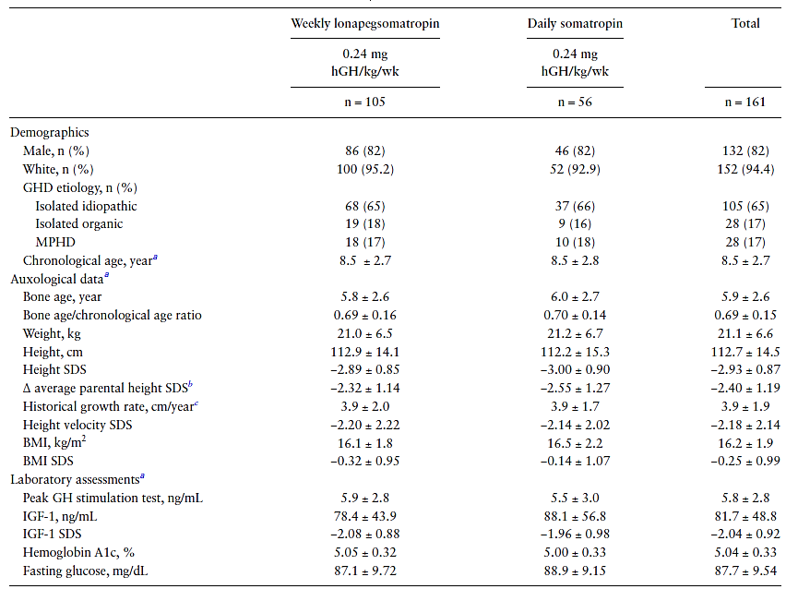
BMI, body mass index; GH, growth hormone; GHD, growth hormone deficiency; hGH, human growth hormone (somatropin); IGF-1, insulin-like growth factor 1; MPHD, multiple pituitary hormone deficiencies; SDS, SD score.
a Plus-minus values are means SD. bΔ average parental height SDS is the difference between the patient’s height SDS and the average parental height SDS where average parental height SDS = [height SDSmother + height SDSfather]/2. c Historical growth rates based on best available medical records (weekly lonapegsomatropin n = 94 and daily somatropin n = 54).

Primary efficacy endpoint: annualized height velocity at week 52
- For lonapegsomatropin, the mean (SD) annualized height velocity at week 52 was 10.90 (2.29) cm/year, and for somatropin, the mean (SD) annualized height velocity was 10.22 (2.37) cm/year. Consistent results were seen in the analyses of the per-protocol set.
- The LS mean (SE) of annualized height velocity at week 52 was 11.17 (0.23) cm/year for lonapegsomatropin compared with 10.31 (0.30) cm/year for somatropin, with a difference in LS means (SE) of 0.86 (0.33) cm/year (95% CI: 0.22 to 1.50). The treatment difference was statistically significant in favour of lonapegsomatropin (P = 0.0088).
- Since the lower confidence bound was above the non-inferiority margin of -2.0 cm/year, non-inferiority was demonstrated.
- The superiority outcome in week 52 annualized height velocity in study CT-301 for lonapegsomatropin vs somatropin is supported by a consistently larger annualized height velocity for lonapegsomatropin at all visits during the study, with differences from week 26 onwards.
- The observed AHV range was 5.9 to 18.0 cm/year and 4.7 to 16.3 cm/year for lonapegsomatropin and daily somatropin, respectively.
Table 5. Summary of efficacy for study CT-301
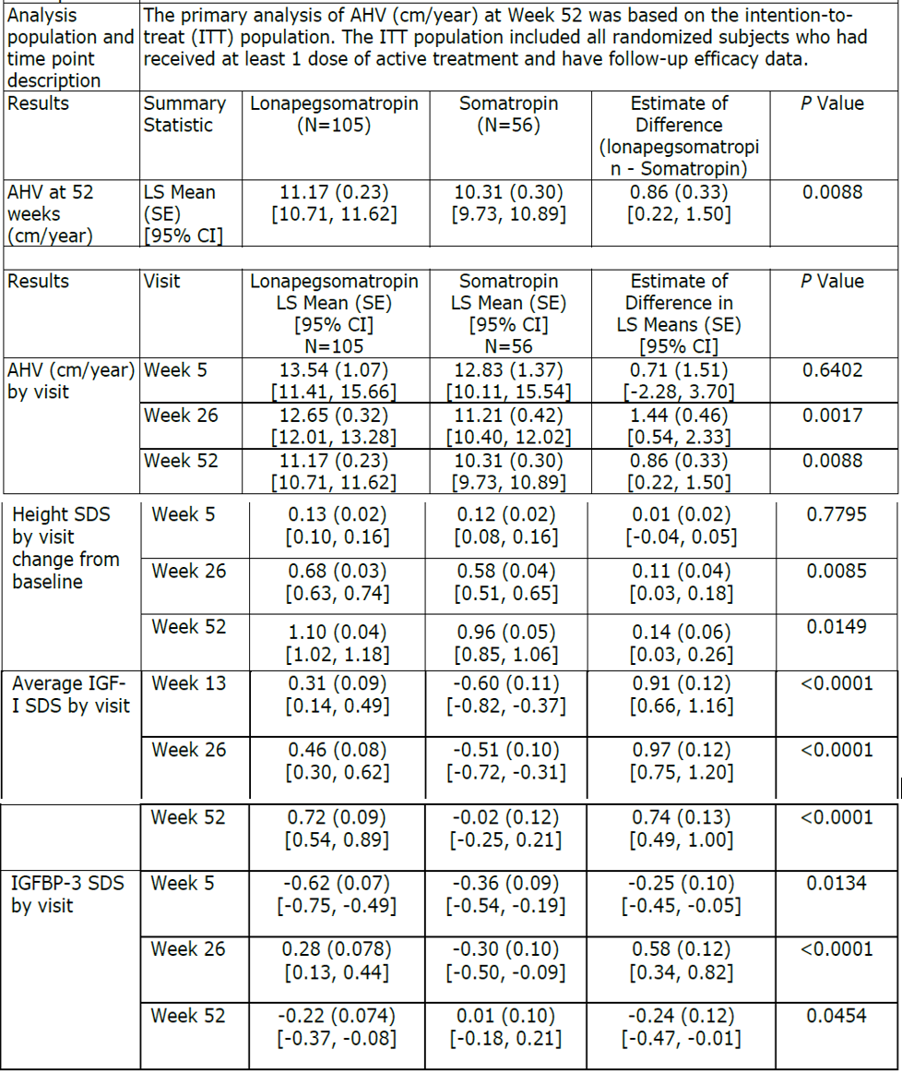

Key secondary analyses in study CT-301
- Statistical significance for annualized height velocity by visit using ANCOVA was met at week 26 and maintained through the end of the study at week 52.
- The reported annualized height velocities correspond to a mean (SD) height velocity SDS of 5.87 (2.76) for once weekly lonapegsomatropin and 5.27 (3.01) for somatropin.
- The treatment difference in height SDS favoured once weekly lonapegsomatropin over daily somatropin and continued to increase from week 5 to week 52 (Figure 4). The outcomes were comparable to those of annualized height velocity in the study.
- In both treatment arms, IGF-1 SDS values increased relative to baseline following treatment initiation and increased over time at subsequent visits. Compared to the somatropin arm, the once-weekly lonapegsomatropin arm reached the clinically desirable range of IGF-1 SDS 0-2 sooner and stayed within this range, with a higher average observed IGF-1 SDS throughout the study (Figure 5).
- Average IGF-1 SDS exceeded 2.0 at any time in 7.6% in the once-weekly lonapegsomatropin arm vs. 3.6% in the somatropin arm) and never exceeded 3.0 in either arm.
Figure 4. Distribution of Change from baseline in Height SDS Over 52 Weeks for Weekly Lonapegsomatropin and Daily hGH Treatment Groups – Observed Cases (ITT Population)
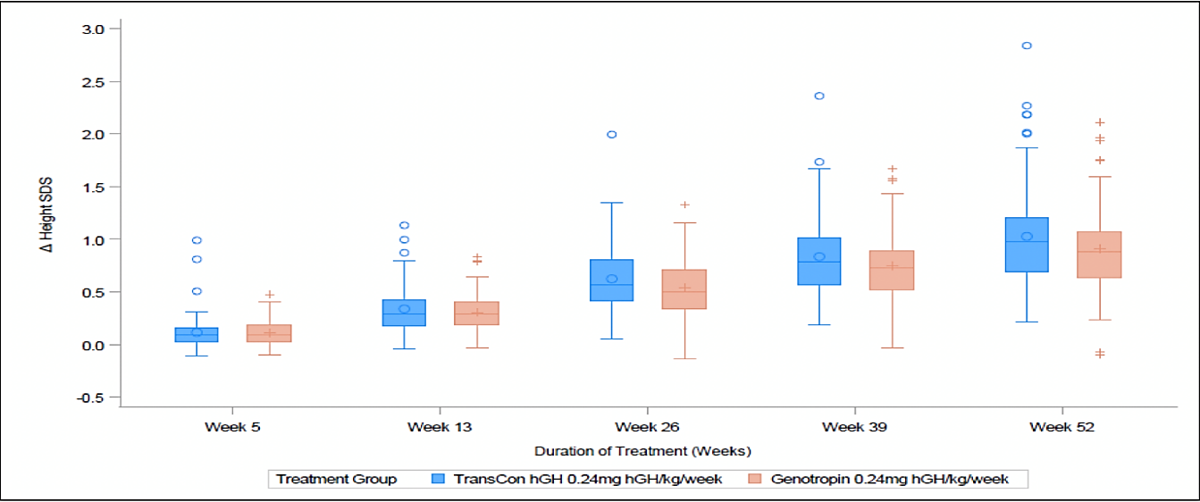
Figure 5. Distribution of Average IGF-1 SDS Over 52 Weeks by Treatment Group (ITT Population).
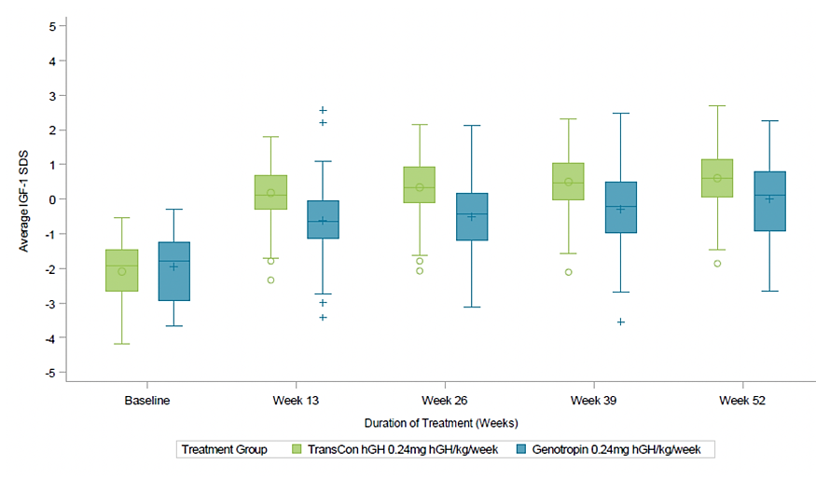

Subgroup analyses for annualized height velocity at week 52.
- In each subgroup analysis, the clinical effects of once weekly lonapegsomatropin tended to be larger relative to daily somatropin.
- The treatment-by-age interaction was found to be statistically significant. Based on an ANCOVA model with treatment-by-age interaction, AHV at Week 52 resulted in a statistically significant treatment difference favouring lonapegsomatropin (P=0.0073) at the mean baseline age of 8.5 years, consistent with the primary efficacy analysis (Figure 6).
Figure 6. CT-301 forest plot of subgroups: annualized height velocity (cm/year) at week 52 (ANCOVA model with multiple imputation, ITT Population)
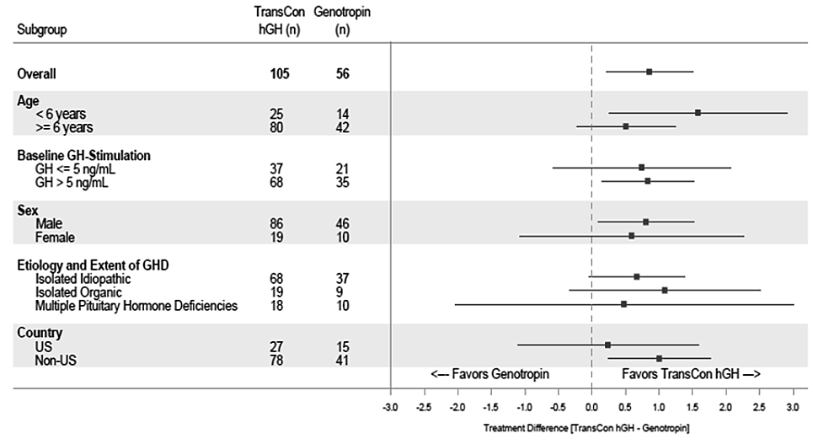
ANCOVA = analysis of covariance; AHV = annualized height velocity; CI = confidence interval; GH = growth hormone; GHD = growth hormone deficiency; ITT = intention-to-treat; LS = least square; TransCon hGH = lonapegsomatropin; SDS = standard deviation score; US = United States Note: LS means with 95% CI are shown. Missing data were imputed with a multiple imputation method. For each imputed data set, an ANCOVA model with by visit annualized height velocity as the dependent variable, treatment and gender as factors, baseline age, baseline peak growth hormone levels (log transformed) at stimulation test, and baseline height SDS − average SDS of parental height SDS as covariates are fitted. The LS means and CIs are the overall estimates combined from all 100 models.

PK and PD trial results
The lonapegsomatropin released hGH in a sustained manner, resulting in a prolonged profile of hGH. and a sustained IGF-1 response. The observed Cmax range of hGH released from lonapegsomatropin was generally overlapping with Genotropin hGH concentration data obtained at the assumed Tmax of daily hGH. Lonapegsomatropin and hGH did not accumulate in the systemic circulation following once-weekly dose for 52 weeks. Systemic mPEG steady state was reached at or before Week 26.
In the PK/PD subset, IGF-1 and IGFBP-3 levels reached steady state at or before Week 13. There was an approximate +1 increase in IGF-1 SDS observed from baseline to Week 13 pre dose. Both PD analytes peaked at a median time of 72 h post dose at Week 13.

Study CT-302 (fliGHt study)
Study CT-302 was a Phase 3, global, open-label, single-arm 26-week clinical study that evaluated the clinical effects of once-weekly lonapegsomatropin in 146 paediatric GHD patients aged 6 months up to 17 years. Children ≥6 months but <3 years old with GHD may have been hGH treatment-naïve (n=3) or have been treated with daily hGH (≥0.20 mg hGH/kg/week) for ≤130 weeks. Children 3 to 17 years old, inclusive, must have been treated with daily hGH (≥0.20 mg hGH/kg/week) for ≥13 weeks but ≤130 weeks and without evidence of closed epiphyses.

Methodology
The study schema is shown in Figure 7.
Figure 7. CT-302 Study design
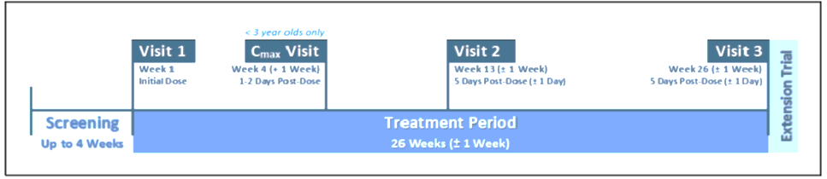

Dosing
The initial dose of lonapegsomatropin was 0.24 mg human GH /kg/week for all study patients, regardless of any prior dose of daily human GH. Lonapegsomatropin was administered via vial and syringe/needle.
At visit 2, the lonapegsomatropin dose was adjusted by the investigator based on weight. The goal for IGF-1 SDS levels was to be between 0 and +2.0 SDS.

Objective
The primary objective was to assess the safety of undergoing the switch from commercially available daily human GH to weekly lonapegsomatropin through the first 6 months of treatment in children with GHD aged 6 months to 17 years.

Endpoints
The efficacy endpoints after 26 weeks of lonapegsomatropin included annualized height velocity, change in height SDS, IGF-1 SDS, and the proportion of study patients in each category (cut points of 0 to 2.0, −2.0 to 2.0, and −1.0 to 2.0), and IGFBP-3 SDS.
Preference for current once weekly lonapegsomatropin or prior daily somatropin therapy and treatment burden was assessed in subjects ≥9 years old and their parents. Convenience and satisfaction in parents were also assessed.

Results
A total of 162 patients were screened, and 146 patients were enrolled into study CT-302 and received at least one lonapegsomatropin dose with 144 (98.6%) completing the study and included in the Full Analysis Set.

Demographics
The study patients enrolled in the study spanned a wide range of ages (1.2 to 17.4 years). Four study patients (2.7%) were less than 3 years old. Most were male (75.3%), white (84.9%), and enrolled at sites in North America (95.2%). The mean (SD) age at baseline was 10.6 (3.9) years (range: 1.2-17.4 years) with the greatest proportion (45.9%) in the age category of ≥11 years (girls) or ≥12 years (boys); 4 subjects (2.7%) were <3 years old. Most subjects (65.1%) were assessed as Tanner stage 1.
At baseline, mean (SD) height SDS was -1.4 (0.8) and mean (SD) IGF-1 SDS was 0.85 (1.29). Almost all subjects (97.9%) received GH treatment before enrolment in this trial and received prior daily hGH at a mean (SD) dose of 0.29 (0.05) mg/kg/week at baseline. There were 3 subjects (2.1%) who were treatment-naïve, and all were <3 years old at Visit 1, the remainder having been treated with somatropin prior to enrolment in study CT 302.
Mean treatment compliance (SD) during the study was 98.4% (3.97%), with a range of 76.0 to 104.0%. The majority of study patients (132 study patients, 90.4%) had compliance rates >95%; 8 study patients (5.5%) had compliance rates of ≤90%.

Annualized height velocity
Annualized height velocity expressed in LS mean was 9.16 at week 13 and 8.72 at week 26. Height SDS increased during the study (Table 6). More pronounced growth rates were observed for younger study patients and those with more severe GHD.
Table 6. Summary Statistics for Height, Change from Baseline, and Annualized Height Velocity by Visit (Full Analysis Set).
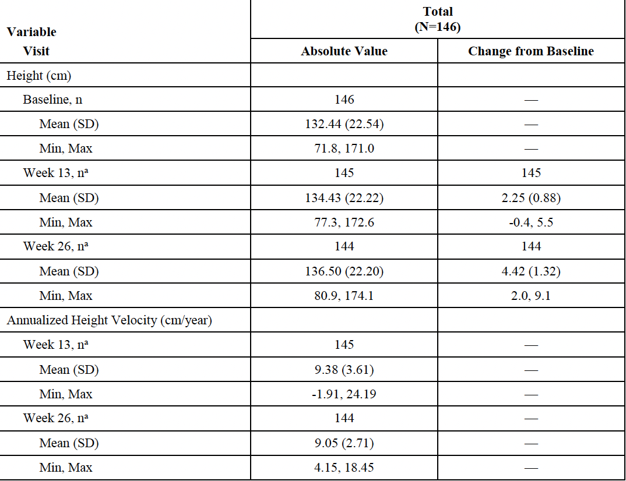

Average IGF-1 concentrations
Table 7 summarizes IGF-1 SDS and changes from baseline by visit. At baseline in study CT-302, the mean (SD) IGF-1 SDS was 0.85 (1.29). For the 4 subjects who were <3 years old, mean (SD) change from baseline in IGF-1 SDS at Week 4 was 0.79 (0.53). Upon switching from daily somatropin products to once-weekly lonapegsomatropin, average IGF-1 SDS increased by approximately 0.7.
Table 7. Summary Statistics for Serum IGF-1 SDS Change from Baseline by Visit (Full Analysis Set).
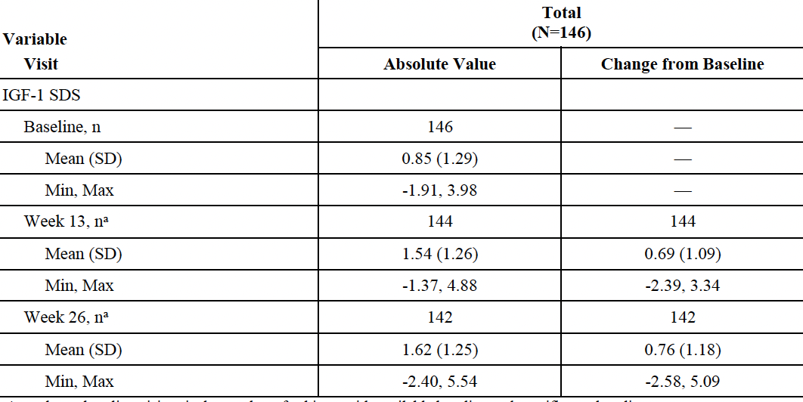

Patient preference questionnaire
- At Week 13, most subjects (79.4%) indicated that they would prefer to continue taking lonapegsomatropin after the end of the study, and 75.0% would recommend lonapegsomatropin to other children who needed GH treatment.
- Most parents/legal guardians/caregivers also preferred lonapegsomatropin over their child’s previous daily hGH treatment, and their preference also increased with continued use (87.7% at Week 6 and 90.1% at Week 13; Table 8)
- In general, among children and parents, the most commonly cited reason for preferring lonapegsomatropin was the (reduced) frequency of injections.
Table 8. CT-302 Treatment preference
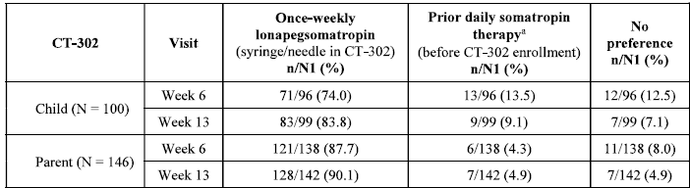
Preference was assessed for children ≥ 9 years old and the parents of all children of all ages. N1 represents number of responses at each visit. Response to Question 1 (which treatment do you prefer)

Treatment burden
- The Child Sheehan Disability Score (CSDS) for child (CSDS-C) and parent (CSDS-P) assess the impact of GH treatments across work/school, social, and family life domains.
- The summary score for the CSDS-C decreased from 2.5 at baseline to 1.4 (p=0.0086) at Week 26 (Table 9).
- For the CSDS-P, the summary score decreased from 5.7 at baseline to 1.9 (p,0.0001) at Week 26.
Table 9. Child Sheehan Disability Scores
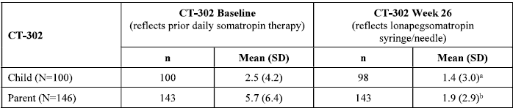

Convenience and satisfaction (parent)
The mean summary score for convenience and satisfaction at baseline were 69.3, and 80.6 respectively (prior to receiving lonapegsomatropin), and after commencement of lonapegsomatropin scores were 64.6 and 80.9 at 6 weeks and 69.0 and 83.0 at week 13.

Study CT-301EXT (enliGHten study)
Study CT-301EXT is an ongoing, global, open-label, single-arm, Phase 3, long-term extension clinical study. This study is conducted to evaluate the long-term efficacy and safety data for once-weekly lonapegsomatropin (0.24 mg hGH/kg/week) in eligible paediatric patients with GHD who had previously participated in study CT-301 or study CT-302.

Methodology
Patients who were previously treated with lonapegsomatropin in CT-301 continued lonapegsomatropin treatment in CT-301EXT; those who were previously treated with somatropin in CT-301 switched to lonapegsomatropin upon rolling over to CT-301EXT (Figure 8). Data were analysed longitudinally across both trials. Patients in study CT-302 continued weekly treatment.
Figure 8. CT-301 and CT-301EXT

Objectives

Primary:
- To assess the long-term safety of weekly lonapegsomatropin in children with GHD previously treated in a phase 3 lonapegsomatropin trial.

Secondary:
- To assess annualized height velocity (AHV) with long-term dosing of weekly lonapegsomatropin treatment
- To assess the proportion of subjects with IGF-1 SDS in the normal range of 0.0 to +2.0 with long-term dosing of weekly lonapegsomatropin treatment
- To evaluate the change from baseline in height SDS with long-term dosing of weekly lonapegsomatropin treatment
- To determine the incidence of antibodies against lonapegsomatropin (anti-human GH and anti-polyethylene glycol [PEG]) with long-term dosing of weekly lonapegsomatropin treatment
- To assess the preference for weekly lonapegsomatropin or daily Genotropin
- To assess the treatment satisfaction of weekly lonapegsomatropin over time
- In subjects using the GH auto-injector: to assess comfort, ease-of-use, and safety

Results
Overall, 298 subjects entered the extension trial: 103 subjects from the CT-301 Lonapegsomatropin group, 55 subjects from the CT-301 Genotropin group, and 140 subjects from the CT-302 Lonapegsomatropin group. A total of 259 (86.9%) subjects completed the study.

Baseline characteristics
Most subjects were male (235 [78.9%]), white (270 [90.6%]), and enrolled in North America (175 [58.7%]). The mean age (SD) at baseline for subjects overall was 10.3 (3.4) years (range: 1.7-17.8 years) with a mean bone age of 8.4 years (range: 1.5-14.5 years) and a mean delay in bone age of 1.8 years (range: -1.5-7.2 years). Just over two-thirds (214 [71.8%]) of subjects were assessed as Tanner Stage 1 and had peak stimulated GH levels at diagnosis of >5 ng/mL (188 [63.1%]). The mean (SD) height SDS overall at baseline was -1.56 (0.88). Collected at different post-dose time points according to parent-trial treatment group, the overall mean (SD) IGF-1 SDS at baseline was 0.52 (1.58) and for IGFBP-3 SDS was 0.35 (1.12).
Treatment compliance during the trial was high, with a mean (SD) compliance of 97.4% (5.2) Most (246 [82.6%]) subjects reported compliance rates of >95%; 15 subjects (5.0%) had rates of ≤90%.

Efficacy outcomes
- The mean (SD) AHV at Week 208 was 6.5 (1.9) cm/year. Figure 9 presents the mean (SE) AHV for the overall group by visit week.
- The overall mean AHV of 8.9 cm/year starting at Week 13 gradually declined to 6.5 cm/year by Week 208 at the end of a mean of 4 years of treatment.
- The mean (SD) height SDS overall at baseline was -1.56 (0.88) and at Week 208 (the last visit for which adequate data were available) was -0.39 (0.90), corresponding to a mean (SD) change of +1.24 (0.65).
- The mean (SD) IGF-1 SDS at baseline was 0.52 (1.58) and at Week 208 was 1.60 (1.18), corresponding to a mean (SD) change of 1.53 (1.55).
- At each post-baseline visit to Week 234 ≥50% of subjects had an IGF-1 SDS between 0.0 to 2.0.
- The group mean (SD) IGFBP-3 SDS at baseline was 0.35 (1.12); and Week 208 was 0.67 (0.77).
- At each post-baseline visit to Week 234, the mean IGFBP-3 SDS remained stable, ranging between a mean minimum of 0.58 (Weeks 13 and 26) and 0.87 (Weeks 104 and 156).
- Overall, 48 (59.3%) subjects met or exceeded the average parental height SDS with a mean difference of 0.08 SDS between the last visit height SDS and the average parental height SDS.
Figure 9. Annualized Height Velocity by Visit Week (Full Analysis Set)
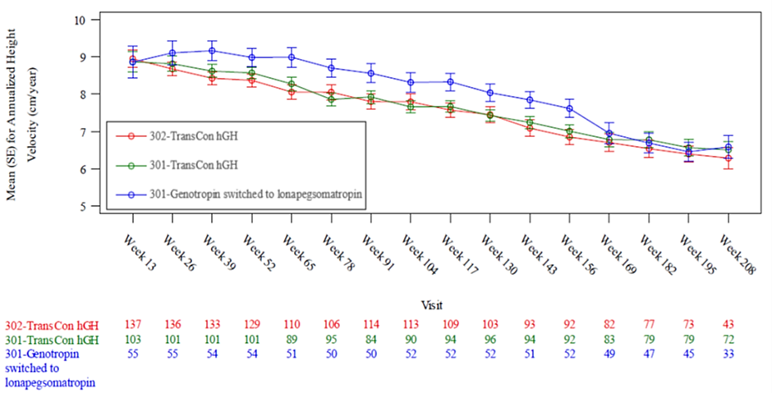
Figure 10. Categorical analysis of IGF-1 SDS by visit across the parent study and extension study
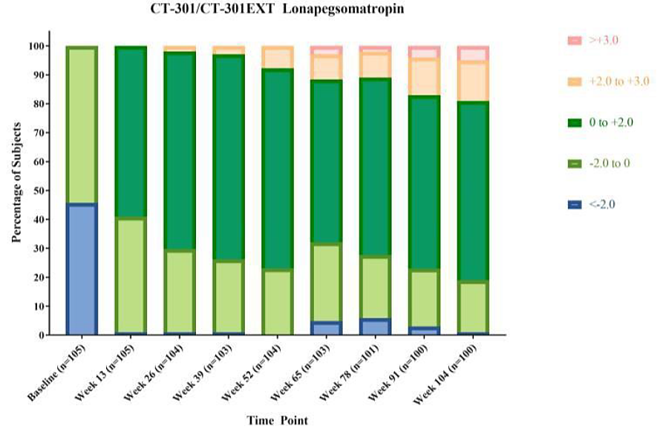
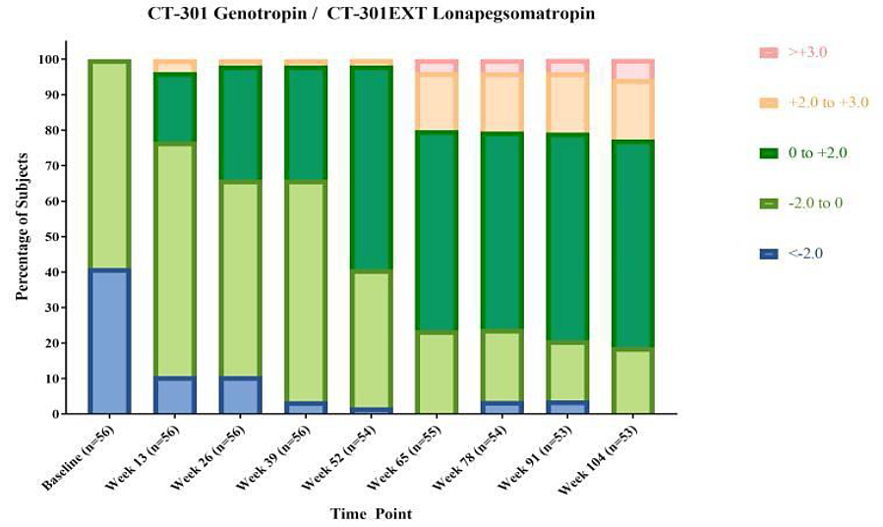
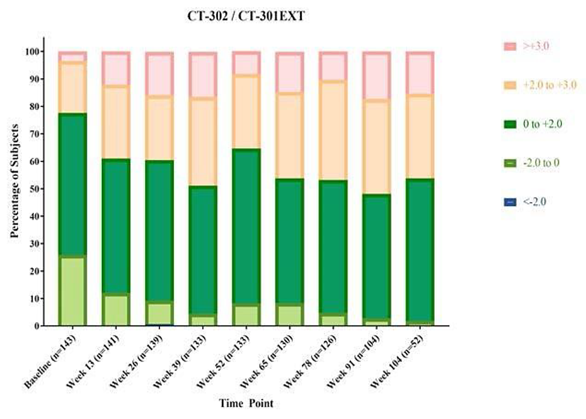
- The majority of children (≥9 years old at Visit 1) from the CT-301 Genotropin group preferred weekly lonapegsomatropin over their previous daily Genotropin treatment, and this preference increased with continued use. (57.6% of subjects at Week 6 and 62.5% of subjects at Week 13).
- Most parents from the CT-301 Genotropin group preferred weekly lonapegsomatropin over the previous daily Genotropin treatment. (76.4% at Week 6 and 85.2% at Week 13).
- Compared with prior daily Genotropin treatment, weekly lonapegsomatropin reduced the treatment burden for children and their caregivers in the CT-301 Genotropin group, as assessed by the CSDS assessment. Reductions from baseline were observed at Weeks 6 and 13.
- In subjects who switched to the GH auto-injector, the majority of subjects strongly agreed that the device was comfortable, easy to use, and safe.

Pharmacokinetic results
Based on long-term PK data for mPEG, steady-state levels were reached at or before 6 months and stable levels (around 12 μg/mL) were observed up to 5 years (Week 260) of lonapegsomatropin treatment.

Safety

Patient exposure
A total of 379 individuals [306 children with GHD (Studies CT 301, CT-302, CT-301EXT) and 73 healthy adult subjects (Studies CT 101, CT-102)] have been exposed to at least 1 dose of lonapegsomatropin (Figure 11). The exposure duration for children with GHD is shown in Table 10.
Of the 306 children included in the clinical programme, and exposed to at least 1 dose of lonapegsomatropin, 252 had more than one year of exposure. Lonapegsomatropin treatment was initiated under 3 years of age in four paediatric GHD patients.
The mean duration of lonapegsomatropin treatment was 70.2 weeks and the mean number of actual doses of trial drug was 69.4. The starting dose was 0.24 mg hGH/kg/week (regardless of prior hGH therapy dose). The actual mean weekly dose was 0.23 mg hGH/kg/week, suggesting that most subjects maintained the planned dosage. Overall, dose reductions occurred in 68 subjects (22.3%), and dosage was increased in total of 20 subjects (6.6%).
Adult subjects received 1 or 2 doses of lonapegsomatropin.
Figure 11. Schematic of Pooling Strategy for children with GHD
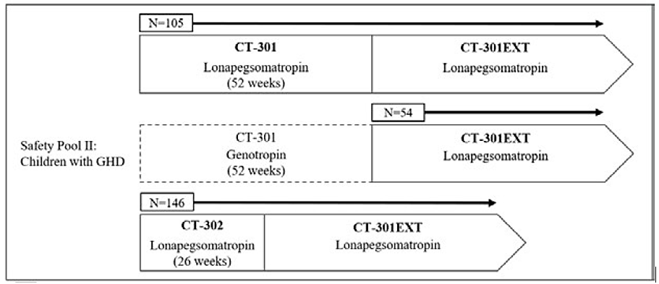
Table 10. Summary of Lonapegsomatropin Exposure Duration for Children with GHD
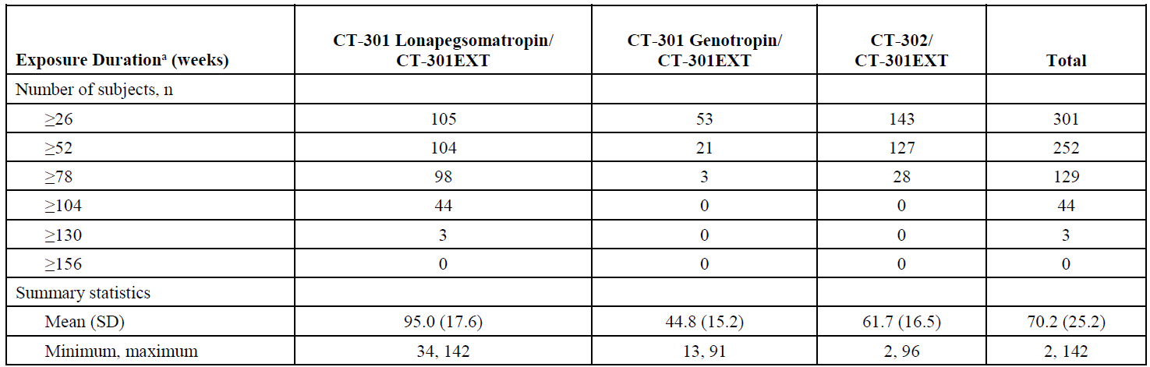

Adverse events (Safety pool: children with GHD)
- Overall, almost three-quarters of subjects experienced at least 1 TEAE (221/305; 72.5%).
- The incidence of TEAEs increased with longer treatment exposure.
- The CT-301 Genotropin/CT 301EXT group had the lowest incidence of TEAEs (44.4%) with the shortest exposure
- The CT-301 Lonapegsomatropin/CT-301EXT had highest incidence (81.0%), & longest exposure
- The incidence of TEAEs considered by the Investigator to be related to trial drug was 8.5%
- 7 subjects (2.3%) experienced a serious adverse event; none related to trial drug by the Investigator.
- There were no TEAEs that led to discontinuation of trial drug,
- No deaths were reported.
Table 11. Safety Pool II: Overall AE Experience (Safety Analysis Set)
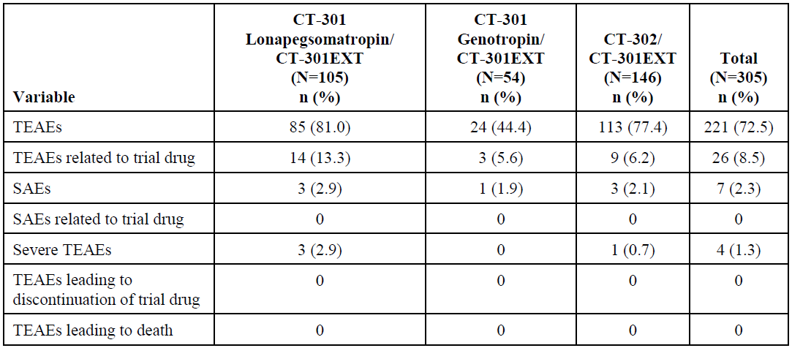

Common adverse events (safety pool II)
- Of 221 subjects (72.5%) who experienced at least 1 TEAE, they included
  - Infections and infestations (54.8%),
  - Respiratory, thoracic and mediastinal disorders (21.3%),
  - General disorders and administration site conditions (18.4%),
  - Gastrointestinal disorders (18.0%),
  - Injury, poisoning and procedural complications (14.4%),
  - Nervous system disorders (13.4%)
  - Musculoskeletal and connective tissue disorders (11.5%)
- The most common TEAEs (≥10%) by PT were upper respiratory tract infection (17.7%), pyrexia (14.8%), nasopharyngitis (12.5%), and headache (11.1%).
- The incidence and type of TEAEs are similar to those reported for CT-301 and CT-302
- The safety profile of lonapegsomatropin was consistent with that of daily somatropin products
- The exposure-adjusted event rates for any TEAE are 3.11 events/person-year for the CT-301 Lonapegsomatropin/CT-301EXT group, 1.73 events/person-year for the CT-301 Genotropin/CT-301EXT group, and 3.05 events/person-year for the CT-302/CT-301EXT group.
- The only SOC with an exposure-adjusted event rate of >1 event/person-year was Infections and infestations (rates: 1.15, 0.73, and 1.34 events/person-year for CT-301 Lonapegsomatropin/CT-301EXT, CT-301 Genotropin/CT-301EXT, and CT-302/CT-301EXT groups, respectively.
- Overall, most subjects experienced TEAEs that were mild (47.5%) or moderate (23.6%); 4 subjects (1.3%) experienced TEAEs that were severe.
- 26 (8.5%) subjects experienced treatment-related treatment-emergent adverse events. Commonly reported events (≥ 2 subjects) were treatment-related treatment-emergent adverse events were headache (2.0%), increased IGF-1 (1.3%), growing pains and injection site atrophy (0.7% each).

Serious adverse events
- Serious adverse events were experienced by 7 subjects (2.3%) overall; none were considered related to the study drug by the investigator.
- Serious adverse events included epilepsy (including generalized tonic-clonic seizure; N=2), pyrexia (N=1), gastrointestinal infection (N=1), vomiting (N=1), adenoidal hypertrophy (N=1), and rash (N=1).

Adverse events of special interest (safety pool II)
- Local reactions
  - In comparison with somatropin (study CT-301) the incidence was reported 15 minutes after the administration of study patients was greater in the lonapegsomatropin group (redness (20% vs 3.6%), swelling (5.7% vs 0.0%), or other injection-related symptoms (1.0% vs 0.0%)). The incidence of bruising was comparable between both arms.
  - In the open-label study (study CT-302), 15 minutes after the administration, study patients reported symptoms of redness (47.3%), swelling (12.3%) or pain (3.5%).
- Severe hypersensitivity: no subjects reported TEAEs indicative of a severe hypersensitivity reaction related to trial drug.
- Increased risk of neoplasms: no clinical signs or symptoms signalled an increased risk of neoplasms.
- Glucose intolerance: there were no clinical signs, symptoms, or laboratory parameters that suggested evidence of glucose intolerance.
- Intracranial hypertension: there was no clinical evidence of intracranial hypertension with treatment with lonapegsomatropin.
- Fluid retention: clinical manifestations of fluid retention (e.g., oedema, arthralgia, and myalgia) were sparsely reported
- Hypoadrenalism: patients receiving hGH therapy who have or are at risk for pituitary hormone deficiency(ies) may be at risk for reduced serum cortisol levels and/or unmasking of central (or secondary) hypoadrenalism. Within the phase 3 program, a total of 4 subjects reported TEAEs associated with hypoadrenalism: 3 subjects while treated with lonapegsomatropin and 1 subject while treated with Genotropin.
- Hypothyroidism: in patients with GHD, central (secondary) hypothyroidism may first become evident or worsen during hGH treatment. Within the phase 3 program, a total of 11 subjects reported TEAEs associated with central (or secondary) hypothyroidism: 7 subjects in the lonapegsomatropin group during CT-301 and 4 subjects in the Genotropin group during CT-301.
- Slipped capital femoral epiphyses in paediatric patients: no TEAEs of slipped capital femoral epiphyses were reported after lonapegsomatropin treatment.
- Progression of pre-existing scoliosis: there was only 1 subject who reported a TEAE of scoliosis.
- Pancreatitis: there were no reported TEAEs of pancreatitis.
- Lipoatrophy: in the CT-301 active-controlled trial, the incidence of subjects who reported injection site reactions were similarly low (<2%) in both the lonapegsomatropin and Genotropin groups and remained low throughout studies.

Immunological events
- Overall, transient positive results for anti-hGH binding antibodies were seen after baseline in 4.3% to 6.7% of the patients. In 2 patients, a boost in anti-GH antibodies was observed.
- Treatment-emergent positive anti-lonapegsomatropin binding antibodies were reported for 3.6% - 3.8% of the patients had results. Antibodies were persistent in 5 subjects (1.6%); this did not impact height velocity.
- Treatment-emergent, transient positive results for anti-mPEG binding antibodies were reported for 0.7% (safety pool II) and 1.9% (study CT301) of the patients.

Auto injector safety
The experience of the 45 patients using the GH auto-injector for 10.1 weeks (range: 6-14 weeks) did not reveal serious or unexpected safety issues.

Post marketing experience
Lonapegsomatropin is authorised for use in the US, Great Britain, and all EEA countries.
- Lonapegsomatropin (0.24 mg hGH/kg body weight once weekly) was first approved in the US on 25 August 2021 for the treatment of paediatric patients 1 year and older who weigh at least 11.5 kg and have growth failure due to inadequate secretion of endogenous GH.
- On 11 January 2022, the European Commission issued a marketing authorisation in the EEA with indication for use in children and adolescents aged from 3 years up to 18 years with growth failure due to insufficient endogenous GHD.
- On 17 October 2022, marketing authorisation was granted in Great Britain with indication for use in children and adolescents aged from 3 years up to 18 years with growth failure due to insufficient endogenous GHD.
Estimated Cumulative Clinical Trials Exposure (as of 25 August 2023)
- Approximately 1014 subjects have been exposed to lonapegsomatropin during the clinical development program for GHD. This includes completed and ongoing trials.
Estimated Interval and Cumulative Exposure from Marketing Experience (as of 25 August 2023)
- Cumulatively 4721 patients have been exposed to lonapegsomatropin up to the DLP, 376 patients had received lonapegsomatropin in this post-marketing setting.
Serious hypersensitivity reaction (including angioedema) was added to the label as an identified risk.
A new safety signal evaluation for avascular necrosis (osteonecrosis) was received from US FDA for all somatropin products. No cases of avascular necrosis (osteonecrosis) have been received for lonapegsomatropin to date.

Risk management plan evaluation summary
The Sponsor has provided EU-RMP v3.0 (dated 24 March 2023; DLP 25 February 2022) and Australia-specific annex v2.0 (December 2024) in support of this application.
The proposed summary of safety concerns and their associated risk monitoring and mitigation strategies are summarised below.
Table 12. Summary of safety concerns
Summary of safety concerns |  | Pharmacovigilance |  | Risk Minimisation
 |  | Routine | Additional | Routine | Additional
Important identified risks | None | – | – | – | –
Important potential risks | Neoplasms (benign, malignant, unspecified) | ü* | ü† | ü | –
Important potential risks | Diabetes mellitus Type 2 | ü | ü† | ü | –
Important potential risks | Medication errors | ü | ü† | ü | –
Missing information | Long-term safety (including adverse drug reactions Potentially related to mPEG exposure) | – | ü† | – | –
*Targeted follow-up questionnaire †PASS
The summary of safety concerns in the approved EU-RMP and draft Australia-specific annex generally align and is considered acceptable.
The Sponsor has proposed routine pharmacovigilance activities for all important potential risks including a targeted follow-up questionnaire for neoplasm. The Sponsor has proposed a PASS study as an additional pharmacovigilance activity, for all the safety concerns which will not include the Australian population. The proposed pharmacovigilance plan is acceptable from an RMP perspective.
The Sponsor has proposed routine risk minimisation activity for all safety concerns. No additional risk minimisation activities have been proposed which aligns with the EU-RMP. The proposed risk minimisation plan is acceptable from an RMP perspective.

Risk-benefit analysis
Lonapegsomatropin (ACP-011, TransCon hGH) is a long-acting, pegylated somatropin GH. It is designed to maintain the same mode of action and distribution as once daily somatropin products, but with a once-weekly injection. It is proposed to be used for growth failure in paediatric patients due to insufficient secretion of GH (i.e. GHD) Whilst GHD is a rare condition, it has profound impact on the lives of children with the condition and untreated results in short stature, delayed skeletal maturation and puberty, and deficiency can affect cognitive function and have a profound impact on the individual’s health and quality of life long term. A key aim of GHD treatment is the normalization of the growth rate during childhood and attainment of normal adult height.

Efficacy
Submitted clinical studies support the clinical efficacy of lonapegsomatropin treatment in paediatric GHD patients who have or have not received prior GH treatment. The study design and outcome measurements are appropriate.
Results with respect to growth-related parameters were in line with each other, also across different studies. Lonapegsomatropin also promotes growth in paediatric GHD patients who have received prior somatropin treatment. Growth was maintained in GHD patients irrespective whether they were naïve to GH treatment at baseline. Bone age was similar in study patients treated for one year with either lonapegsomatropin or somatropin. Efficacy results persisted beyond the first year of treatment. The efficacy of lonapegsomatropin was also supported by several patient/parent-reported outcomes. An improvement with respect to different patient/parent-reported outcomes was also demonstrated.

Safety
A total of 379 individuals (306 children with GHD and 73 healthy adult subjects) have been exposed to at least 1 dose of lonapegsomatropin, with 252 exposed for more> 1 year, and 44 with follow-up of ≥2 years. The mean exposure (SD) was 70.2 (25.2) weeks. The overall occurrence of treatment-related treatment-emergent adverse events (e.g. headache, injection site atrophy) was low (8.5% of subjects). The safety profile was generally similar to daily somatropin treatment. The experience with the GH auto-injector did not reveal serious or unexpected safety issues.
Limitations and uncertainties
- One of the major issues with the clinical efficacy data is the lack of controlled studies (only 1 and this was open label).
  - The total number of paediatric patients (N=306) included in the clinical studies included in this submission is small. However, somatropin itself is a well-known active substance, with adequate safety and efficacy demonstrated previously, and with generally similar results in this submission.
  - Long term efficacy (data on final height should be generated).
  - There is a degree of uncertainty regarding the long-term safety risks -i.e. for 10 years and beyond- of lonapegsomatropin, particular concerning the long-acting properties of lonapegsomatropin and the mPEG exposure associated with lonapegsomatropin.
- Lonapegsomatropin dosing is targeted to achieve IGF-1 SDS levels within the normal range between -2 and +2 apart from clinical benefit. Though IGF-1 SDS levels within this target range were achieved in the majority of study patients in conducted studies, the proportions of GHD study patients with IGF-1 SDS levels above +2 increased with time, especially in the youngest non-naïve patients. This is of concern, since the safety risks of lonapegsomatropin (e.g. malignancies, diabetes mellitus type 2) are expected to be higher with higher IGF-1 SDS levels.
- Limited data are available on the effects of lonapegsomatropin in GHD patients < 3 years of age.
- It is however unclear how potential safety risks due to long-term mPEG exposure can be determined in a valid manner in paediatric GHD patients in clinical practice.
The benefit/risk profile for lonapegsomatropin (Skytrofa) is positive and approval is recommended.

Advisory Committee considerations
The Advisory Committee on Medicines (ACM), having considered the evaluations and the Delegate’s overview, as well as the Sponsor’s response to these documents, advised the following:
Please provide advice of whether the regarding whether approve/not approve the registration of Skytrofa (lonapegsomatropin) for the following indication
“Growth failure in children and adolescents aged from 3 years up to 18 years due to insufficient endogenous GH secretion (growth hormone deficiency)”.
The ACM was of the view that this indication was supported by the available efficacy data and aligned with the EU/UK indication.
In Australia, this indication may result in treatment being available to a more restricted patient population than elsewhere, noting the lower cut-off for GHD applied here. However, the ACM advised that the issue of cut-offs and most appropriate access to treatment would be explored in greater detail when considered by the PBS GH replacement program and there would be limited value in further refining the indication to address it for the purposes of registration.
Please provide advice regarding the safety of long-term usage in paediatric patients.
The ACM considered that in the 6 years of safety data available, no concerning safety signals have been observed.
The ACM discussed the theoretical risk of increased malignancy that could arise from the observed increases in IGF-1 levels with weekly GH dosing compared to daily injections. It was noted that this potential risk of GH replacement therapy has been of interest for decades with no conclusive evidence identified to date, and that as a long-term risk, it is not something that could be realistically studied within the time frame of a clinical trial. The ACM was of the view that while this risk should be well described in the PI and addressed in the RMP and through post-market pharmacovigilance, at present there is no concrete evidence to suggest that the risks presented by this long acting formulation differ substantially from those presented by short acting preparations.
Please comment of the appropriateness of the dosing and end points (ie IGF-1 levels). “Recommended starting dose of Skytrofa is 0.24mg somatropin/kg body weight, given once weekly. The dose of lonapegsomatropin should be individually adjusted for each patient based on clinical response, adverse reactions, and/or serum insulin-like growth factor-1 (IGF-1) concentrations outside the targeted range.”
The ACM advised that IGF-1 levels are the established measure used to guide dose adjustments for GH and are appropriate for this product.
The ACM was of the view that the titration section of the PI was reasonable, but that greater emphasis should be placed on down-titrating based on IGF-1 levels rather than up-titrating. Evidence to support up-titration beyond dose levels seen in clinical trials does not exist. Inclusion of a maximum dose of 0.24mg/kg/week could be considered based on clinical trial protocols. If doses higher than this were to be supported, the PI should note that these have not been studied in clinically relevant trial settings.
The ACM also suggested that the ‘/or’ should be removed from the dose adjustment text (“The dose of lonapegsomatropin should be individually adjusted for each patient based on clinical response, adverse reactions, and/or serum insulin-like growth factor-1 (IGF-1) concentrations outside the targeted range”) and that clearer advice in the PI on what constitutes routine monitoring would be of value.
The committee is also requested to provide advice on any other issues that it thinks may be relevant to a decision on whether to approve this application.
The ACM discussed the potential usage of this product in children who have been treated for known cancers or have known pre-malignant conditions such as Fanconi anaemia. These patients were excluded from trial data but in practice would be likely to be considered for treatment with this product. However, it was agreed that there is no solid basis at present to consider that Skytrofa would present a greater risk in this regard than the existing short acting formulations.

ACM conclusion
The ACM considered this product to have an overall positive benefit-risk profile for the indication:
“Growth failure in children and adolescents aged from 3 years up to 18 years due to insufficient endogenous growth hormone secretion”

Assessment outcome
Based on a review of quality, safety, and efficacy, the TGA decided to register Skytrofa (lonapegsomatropin) for the following indication:
Growth failure in children and adolescents aged from 3 years up to 18 years due to insufficient endogenous growth hormone secretion.

Specific conditions of registration
Skytrofa (lonapegsomatropin) is to be included in the Black Triangle Scheme. The PI and CMI for Skytrofa must include the black triangle symbol and mandatory accompanying text for five years, which starts from the date of first supply of the product.
The Lonapegsomatropin (Skytrofa) EU-Risk Management Plan (RMP) (version 3.0, dated 24 March 2023, data lock point 25 February 2022), with Australia-Specific Annex (ASA) (version 2.0, dated December 2024), included with submission PM-2024-01550-1-5, and any subsequent revisions, as agreed with the TGA will be implemented in Australia.
An obligatory component of risk management plans is routine pharmacovigilance. Routine pharmacovigilance includes the submission of periodic safety update reports (PSURs).
Reports are to be provided in line with the current published list of EU reference dates and frequency of submission of PSURs until the period covered by such reports is not less than three years from the date of this approval letter. Each report must be submitted within ninety calendar days of the data lock point for that report.
The reports are to at least meet the requirements for PSURs as described in the European Medicines Agency’s Guideline on good pharmacovigilance practices (GVP) Module VII-periodic safety update report (Rev 1), Part VII.B Structures and processes. Note that submission of a PSUR does not constitute an application to vary the registration.
Laboratory testing & compliance with Certified Product Details (CPD)
All batches of Skytrofa lonapegsomatropin supplied in Australia must comply with the product details and specifications approved during evaluation and detailed in the Certified Product Details (CPD).
When requested by the TGA, the Sponsor should be prepared to provide product samples, specified reference materials and documentary evidence to enable the TGA to conduct laboratory testing on the Product. Outcomes of laboratory testing are published biannually in the TGA Database of Laboratory Testing Results http://www.tga.gov.au/ws-labs-index and periodically in testing reports on the TGA website.
Certified Product Details
The Certified Product Details (CPD), as described in Guidance 7: Certified Product Details of the Australian Regulatory Guidelines for Prescription Medicines (ARGPM), in PDF format, for the above products should be provided upon registration of these therapeutic goods. In addition, an updated CPD should be provided when changes to finished product specifications and test methods are approved in a Category 3 application or notified through a self-assessable change.
A template for preparation of CPD for biological prescription medicines can be obtained from the TGA website
[for the form] https://www.tga.gov.au/form/certified-product-details-cpd-biologicalprescription-medicines
[for the CPD guidance] https://www.tga.gov.au/guidance-7-certified-product-details

Product Information and Consumer Medicines Information
For the most recent Product Information (PI) and Consumer Medicines Information (CMI), please refer to the TGA PI/CMI search facility.

Therapeutic Goods Administration
PO Box 100 Woden ACT 2606 Australia
Email: info@tga.gov.au Phone: 1800 020 653 Fax: 02 6203 1605
https://www.tga.gov.au

Ahmid M, Ahmed SF, Shaikh MG. Childhood-onset growth hormone deficiency and the transition to adulthood: current perspective. Ther Clin Risk Manag. 2018 Nov 23;14:2283-2291. doi: 10.2147/TCRM.S136576. PMID: 30538484; PMCID: PMC6260189.
Brod M, Alolga SL, Beck JF, Wilkinson L, Højbjerre L, Rasmussen MH. Understanding burden of illness for child growth hormone deficiency. Qual Life Res. 2017 Jul;26(7):1673-1686. doi: 10.1007/s11136-017-1529-1. Epub 2017 Feb 28. PMID: 28247315; PMCID: PMC5486907.
De Leonibus C, De Marco S, Stevens A, Clayton P, Chiarelli F, Mohn A. Growth Hormone Deficiency in Prepubertal Children: Predictive Markers of Cardiovascular Disease. Horm Res Paediatr. 2016;85(6):363-71. doi: 10.1159/000444143. Epub 2016 Mar 10. PMID: 26960169.
Di Iorgi N, Morana G, Allegri AE, Napoli F, Gastaldi R, Calcagno A, Patti G, Loche S, Maghnie M. Classical and non-classical causes of GH deficiency in the paediatric age. Best Pract Res Clin Endocrinol Metab. 2016 Dec;30(6):705-736. doi: 10.1016/j.beem.2016.11.008. Epub 2016 Nov 24. PMID: 27974186.
Brod M, Højbjerre L, Alolga SL, Beck JF, Wilkinson L, Rasmussen MH. Understanding Treatment Burden for Children Treated for Growth Hormone Deficiency. Patient. 2017;10(5):653-666. Burt MG. Metabolic Actions
Fisher BG, Acerini CL. Understanding the growth hormone therapy adherence paradigm: a systematic review. Horm Res Paediatr. 2013;79:189-196
Thornton PS, Maniatis AK, Aghajanova E, Chertok E, Vlachopapadopoulou E, Lin Z, Song W, Christoffersen ED, Breinholt VM, Kovalenko T, Giorgadze E, Korpal-Szczyrska M, Hofman PL, Karpf DB, Shu AD, Beckert M. Weekly Lonapegsomatropin in Treatment-Naïve Children With Growth Hormone Deficiency: The Phase 3 heiGHt Trial. J Clin Endocrinol Metab. 2021 Oct 21;106(11):3184-3195. doi: 10.1210/clinem/dgab529. PMID: 34272849; PMCID: PMC8530727.

