Australian Public Assessment Report for Rystiggo
  - Active ingredient: rozanolixizumab
  - Sponsor: UCB Australia Pty Ltd T/A UCB Pharma Division of UCB Australia
July 2025

About the Therapeutic Goods Administration (TGA)
- The Therapeutic Goods Administration (TGA) is part of the Australian Government Department of Health and Aged Care and is responsible for regulating therapeutic goods, including medicines, medical devices, and biologicals.
- The TGA administers the Therapeutic Goods Act 1989 (the Act), applying a risk management approach designed to ensure therapeutic goods supplied in Australia meet acceptable standards of quality, safety, and efficacy.
- The work of the TGA is based on applying scientific and clinical expertise to decision-making, to ensure that the benefits to the Australian public outweigh any risks associated with the use of therapeutic goods.
- The TGA relies on the public, healthcare professionals and industry to report problems with therapeutic goods. The TGA investigates reports received to determine any necessary regulatory action.
- To report a problem with a therapeutic good, please see the information on the TGA website.

About AusPARs
- The Australian Public Assessment Report (AusPAR) provides information about the evaluation of a prescription medicine and the considerations that led the TGA to approve or not approve a prescription medicine submission. Further information can be found in Australian Public Assessment Report (AusPAR) guidance.
- AusPARs are prepared and published by the TGA.
- AusPARs are static documents that provide information that relates to a submission at a particular point in time. The publication of an AusPAR is an important part of the transparency of the TGA’s decision-making process.
- A new AusPAR may be provided to reflect changes to indications or major variations to a prescription medicine subject to evaluation by the TGA.

Copyright
© Commonwealth of Australia 2025
This work is copyright. You may reproduce the whole or part of this work in unaltered form for your own personal use or, if you are part of an organisation, for internal use within your organisation, but only if you or your organisation do not use the reproduction for any commercial purpose and retain this copyright notice and all disclaimer notices as part of that reproduction. Apart from rights to use as permitted by the Copyright Act 1968 or allowed by this copyright notice, all other rights are reserved and you are not allowed to reproduce the whole or any part of this work in any way (electronic or otherwise) without first being given specific written permission from the Commonwealth to do so. Requests and inquiries concerning reproduction and rights are to be sent to the TGA Copyright Officer, Therapeutic Goods Administration, PO Box 100, Woden ACT 2606 or emailed to <tga.copyright@tga.gov.au>.

Contents
List of abbreviations 4
Product submission 6
Submission details 6
Product background 7
Myasthenia gravis (MG) 7
Current treatment options 7
Clinical rationale 8
Regulatory status 8
Australian regulatory status 8
International regulatory status 8
Registration timeline 9
Assessment overview 10
Quality evaluation summary 10
Nonclinical evaluation summary 10
Pregnancy category 11
Recommendation 11
Clinical evaluation summary 11
Summary of clinical studies 11
Pharmacology 12
Efficacy 14
Clinical safety 28
Risk management plan 39
Risk-benefit analysis 40
Overview 40
Efficacy comments 40
Safety comments 42
Safety data limitation 43
Delegate’s considerations 44
Proposed action 44
Advisory Committee considerations 44
Assessment outcome 45
Specific conditions of registration applying to these goods 45
Product Information and Consumer Medicine Information 46

List of abbreviations
Abbreviation | Meaning
AChR | acetylcholine receptor
ACM | Advisory Committee on Medicines
ADA | Anti-drug antibody
AE | Adverse event
ARTG | Australian Register of Therapeutic Goods
ASA | Australia-specific annex
CMI | Consumer medicines information
CPD | Certified product details
DLP | Data lock point
FcRn | Neonatal Fc receptor
gMG | Generalised myasthenia gravis
Ig | Immunoglobulin
IV | Intravenous
IVIg | Intravenous immunoglobulin
LS | Least square
mAb | Monoclonal antibody
MedDRA | Medical Dictionary for Regulatory Activities
MG | Myasthenia gravis
MG-ADL | Myasthenia Gravis Activities of Daily Living scale
MG-C | Myasthenia Gravis Composite
MGFA | Myasthenia Gravis Foundation of America
MuSK | Muscle-specific tyrosine kinase
NAb | Neutralising antibody
NMJ | Neuromuscular junctions
PD | Pharmacodynamic
PI | Product Information
PLEX | Plasma exchange
PK | Pharmacokinetic
PND1 | Postnatal day 1 (the day of birth)
PopPK | Population pharmacokinetic
PRO | Patient-reported outcome
PSUR | Periodic safety update report
PT | Preferred Term, in MedDRA
QMG | Quantitative Myasthenia Gravis
RMP | Risk management plan
SC | Subcutaneous
SCLE | Subacute cutaneous lupus erythematosus
SMQ | Standardised MedDRA query
SOC | System Organ Class, in MedDRA
TE-ADA | Treatment-emergent anti-drug antibody
TEAE | Treatment-emergent adverse event
TE-POS | Treatment-emergent ADA positive

Product submission

Submission details
Type of submission: | New biological entity
Product name: | Rystiggo
Active ingredient: | rozanolixizumab
Decision: | Approved
Date of decision: | 28 January 2025
Date of entry into ARTG: | 7 February 2025
ARTG number: | 427684
Black Triangle Scheme  for the current submission: | Yes
Sponsor’s name and address: | UCB Australia Pty Ltd, trading as UCB Pharma Division of UCB Australia  Level 1, 1155 Malvern Road, MALVERN, VIC, 3144
Dose form: | Solution for injection for infusion
Strength: | 140 mg/mL
Container: | Vial
Pack size: | 2 mL
Approved therapeutic use for this submission: | Rystiggo is indicated as an add-on to standard therapy for the treatment of generalised myasthenia gravis (gMG) in adult patients who are anti-acetylcholine receptor (AChR) or anti-muscle-specific tyrosine kinase (MuSK) antibody positive.
Route of administration: | Subcutaneous
Dosage: | Weight-tiered dose of approximately 7 mg/kg per week for 6 weeks administered via subcutaneous (sc) infusion. Treatment cycles are to be repeated based on clinical evaluation.  For further information regarding dosage, including dose calculation by body weight, home administration and criteria for discontinuation, refer to the Product Information.
Pregnancy category: | Category D: Drugs which have caused, are suspected to have caused or may be expected to cause, an increased incidence of human fetal malformations or irreversible damage. These drugs may also have adverse pharmacological effects. Accompanying texts should be consulted for further details.  The use of any medicine during pregnancy requires careful consideration of both risks and benefits by the treating health professional. The pregnancy database must not be used as the sole basis of decision making in the use of medicines during pregnancy. The TGA does not provide advice on the use of medicines in pregnancy for specific cases. More information is available from obstetric drug information services in your state or territory.

Product background
This AusPAR describes the submission by UCB Australia Pty Ltd trading as UCB Pharma Division of UCB Australia (the sponsor) to register Rystiggo (rozanolixizumab) 140 mg/mL solution for injection for infusion in vials for the following proposed indication:
Rozanolixizumab is indicated for the treatment of generalised myasthenia gravis (gMG) in adult patients.

Myasthenia gravis (MG)
Myasthenia gravis (MG) is a rare, organ-specific, antibody-mediated autoimmune disease characterised by variable levels of weakness and fatigability of skeletal muscles caused by a defect in the action of acetylcholine at neuromuscular junctions (NMJ). The pathogenic autoantibodies against the acetylcholine receptor (AChR) are primarily of the immunoglobulin G (IgG)1 or IgG3 isotype and induce a complement-dependent, T-cell mediated immunological attack directed at proteins in the postsynaptic membrane of the NMJ resulting in a decrease in the number of available AChR. Other autoantibodies are directed against Muscle-Specific Kinase (MuSK), that is an NMJ protein specifically expressed at the postsynaptic membrane, where it co-localises with AChR. MuSK plays a critical role in the maintenance of the normal functional integrity of the NMJ by mediating clustering of AChR. The inhibition of MuSK synthesis has been found to cause AChR dispersion and endplate disruption.
In approximately 85% of patients, MG progresses beyond the ocular muscles to affect multiple muscle groups throughout the body, a condition that is typically referred to as generalised myasthenia gravis (gMG). In case of respiratory and bulbar muscle involvement, severely impaired breathing and swallowing can become life-threatening (MG crisis).
In 2021, the global prevalence of MG was estimated to be 12.4 people (ranging from 10.6 to 14.5) per 100,000 population. In Australia in 2009, there were 2,574 prevalent cases of MG, corresponding to an annual crude prevalence rate of 117.1 people per 1 million population.

Current treatment options
Current treatment options include:
- anticholinesterase therapy– an attempt to strengthen neuromuscular transmission with the use of drugs such as pyridostigmine bromide and neostigmine
- immunosuppressant therapy – including ravulizumab, zilucoplan, prednisone, azathioprine, cyclophosphamide, ciclosporin, and mycophenolate mofetil
- other medicines – atropine, propantheline, ephedrine
- non-medicine therapies such as plasma exchange, plasmapheresis, thymectomy, and intravenous immunoglobulin.

Clinical rationale
Rozanolixizumab is a humanised IgG4P monoclonal antibody (mAb) that binds with high affinity to the neonatal Fc receptor (FcRn) at both neutral and acidic pH and thereby inhibits the activity of FcRn without blocking the binding and recycling of albumin. By blocking the activity of FcRn, rozanolixizumab accelerates the catabolism of IgG antibodies, including IgG autoantibodies. The aim is to reduce the concentration of pathogenic IgG in patients with autoimmune diseases mediated by the action of IgG autoantibodies.

Regulatory status

Australian regulatory status
This product is considered a new biological entity for Australian regulatory purposes.

International regulatory status
This submission was evaluated as part of the Australia-Canada-Singapore-Switzerland-United Kingdom (ACCESS) Consortium with work-sharing between the TGA, Health Canada and Swissmedic. Each regulator made independent decisions regarding approval (market authorisation) of the new medicine.
At the time the TGA considered this submission, a similar submission had been considered by other regulatory agencies. The following table summarises these submissions and provides the indications where approved.
Table 1: International regulatory status at the time of TGA approval
Region | Submission date | Status | Approved indications
USA | 24 October 2022 | Approved on 26 June 2023 | Treatment of generalised myasthenia gravis (gMG)in adult patients who are anti-acetylcholine receptor (AChR) or anti-muscle-specific tyrosine kinase (MuSK) anti-body positive.
Japan | 28 February 2023 | Approved on 25 September 2023 | Treatment of generalised myasthenia gravis (only for patients inadequately responding to corticosteroids or non-corticosteroid immunosuppressants).
Europe | 3 November 2022 | Approved on 5 January 2024 | Rystiggo is indicated as an add-on to standard therapy for the treatment of generalised myasthenia gravis (gMG) in adult patients who are anti-acetylcholine receptor (AChR) or anti-muscle-specific tyrosine kinase (MuSK) antibody positive.
UK | 13 November 2023 | Approved on 7 March 2024 | Rystiggo is indicated as an add-on to standard therapy for the treatment of generalised myasthenia gravis (gMG) in adult patients who are anti-acetylcholine receptor (AChR) or anti-muscle- specific tyrosine kinase (MuSK) antibody positive.
Canada | 5 October 2023 | Under consideration | Under consideration
Switzerland | 16 October 2023 | Under consideration | Under consideration

Registration timeline
The following table captures the key assessment steps and dates for this submission.
This submission was evaluated under the standard prescription medicines registration process.
Table 2: Timeline for Submission PM-2023-04561-1-1
Description | Date
Submission dossier accepted and first round evaluation commenced | 20 November 2023
First round evaluation completed | 15 April 2024
Second round evaluation completed | 9 October 2024
Delegate’s Overall benefit-risk assessment and request for Advisory Committee advice | 5 November 2024
Sponsor’s pre-Advisory committee response | 19 November 2024
Advisory committee meeting | 6 December 2024
Registration decision (Outcome) | 28 January 2025
Administrative activities and registration in the ARTG completed | 7 February 2025
Number of working days from submission dossier acceptance to registration decision* | 204 days
*Statutory timeframe for standard submissions is 255 working days

Assessment overview
A summary of the TGA’s assessment for this submission is provided below.
This section is a TGA summary of TGA’s evaluation report, which discussed numerous aspects of overseas evaluation reports and included some information that was commercial-in-confidence.

Quality evaluation summary
The quality of this product is considered to be acceptable when used in accordance with the conditions defined in the product information (PI), labels, consumer medicines information (CMI) and the ARTG. Physicochemical and biological aspects relevant to the uniform clinical performance of the product have been investigated and are controlled in a satisfactory way. Information on development, manufacture and control of the active substance and finished product has been presented in a satisfactory manner. The results of tests carried out indicate consistency and uniformity of important product quality characteristics, and these in turn lead to the conclusion that the product should have a satisfactory and uniform performance in clinical use. From a quality perspective, compliance with therapeutic goods legislation and relevant therapeutic goods orders, as well as consistency with relevant guidelines and the Australian Regulatory Guidelines for Prescription Medicines (ARGPM), has been demonstrated.
There is no objection on quality grounds to the approval of Rystiggo.

Nonclinical evaluation summary
Overall, the applicant submitted a comprehensive set of studies to the pharmacology, pharmacokinetics and toxicology of rozanolixizumab. The proof of concept was shown. In the toxicity studies in a pharmacologically relevant species, no safety risks were identified that would preclude the use of rozanolixizumab in patients with myasthenia gravis. Potential safety risks due to the pharmacological mode of action are adequately addressed in the PI, but changes regarding the description of the nonclinical data are recommended.
No genotoxicity studies were conducted. As a monoclonal antibody, rozanolixizumab is not expected to interact with DNA.
Based on a carcinogenicity risk assessment it cannot be excluded that the inhibition of FcRn by rozanolixizumab could affect the anti-tumour immune response. However, based on the weight of evidence there is no major concern that would require a specific measure. Potential adverse events of malignancies could be monitored through pharmacovigilance activities.
While no effect on postnatal development parameters (neurobehavioural tests, grip strength, skeletal development, immunotoxicity endpoints) was seen in the enhanced pre/postnatal development (ePPND) study, no exposure was seen in infants and most mothers past postnatal Day 1. Therefore, the ePPND study only assessed effects associated with exposure during pregnancy. No firm conclusions can be drawn from the negative postnatal development effects, particularly the immunocompetence assessment. Given the pharmacological action of the drug, it may not be readily excreted into milk. However, as FcRn is involved in the excretion of IgG molecules into breast milk, rozanolixizumab may reduce the excretion of IgGs into breast milk and affect mucosal immunity in breast-fed infants.
Pregnancy category
As an association between rozanolixizumab treatment and the higher incidence of pregnancy loss in the ePPND study cannot be dismissed, Pregnancy Category D is considered more appropriate (Cat B1 is proposed by the sponsor). This category is for drugs which have been shown to cause irreversible fetal damage (including death) in animal studies.
Recommendation
There are no nonclinical objections to the proposed registration of Rystiggo.

Clinical evaluation summary

Summary of clinical studies
The rozanolixizumab clinical pharmacology program includes pharmacokinetic (PK), pharmacodynamic (PD), and immunogenicity data from 8 completed and ongoing clinical studies. These included:
- Phase I studies
  - UP0018
  - UP0060
  - UP0106 (modelling and simulation)
- Population PK-PD (PopPK-PD) models
  - an exploratory PopPK-PD model was developed on observed PK and total IgG data from 2 Phase II studies and 2 Phase I studies. The purpose of the model was to support dose selection for the Phase III studies.
  - A second PopPK-PD model was developed on observed PK and total IgG data from 3 Phase I studies, 2 Phase II studies, and 2 Phase III studies, and MG-ADL data from MG0003. The models were extended with disease-specific autoantibody data from 1 Phase II study and 2 Phase III studies in gMG. The purpose of these models was to describe the PK and PK-PD properties of rozanolixizumab, including the effect of covariates.
- Phase II and III studies
  - MG0002 (phase 2A study)
  - MG0003 (pivotal study)
  - MG0004 (observational extension study with treatment cycles administered weekly)
  - MG0007 (observational extension study with treatment cycles based on clinical needs)

Pharmacology

Pharmacokinetics

Absorption
Following subcutaneous (SC) administration, the maximum concentrations of rozanolixizumab were reached after approximately 2 days in healthy subjects (studies UP0018 and UP0060). Based on the population PK analysis, absolute bioavailability was estimated at 67% using intravenous (IV) and SC data from healthy subjects and patients with immune thrombocytopenia.
The trough concentrations were close to or below the limit of quantification in the majority of patients suggesting limited rozanolixizumab accumulation.
In line with target-mediated drug disposition, non-linear PK was observed for rozanolixizumab. Overall, rozanolixizumab exposure increased greater than dose-proportionally over a dose range from 1 mg/kg to 20 mg/kg.
No relevant exposure differences between healthy subjects and generalised myasthenia gravis (gMG) patients were noted.
Based on the simulations with the population PK/PD model, it is recommended that rozanolixizumab may be administered up to 4 days after the scheduled time point in case of a missed dose. Thereafter, the original dosing schedule may be resumed until the treatment cycle is completed.

Distribution, metabolism, and elimination
Based on the population PK analyses, the mean estimate of the apparent volume of distribution was 6.6 L for a typical gMG patient of 76 kg.
No studies regarding the metabolism of rozanolixizumab have been conducted considering the biological nature of the molecule.
In line with target-mediated drug disposition, rozanolixizumab has a biphasic elimination phase consisting of a FcRn-independent linear clearance pathway and a non-linear elimination pathway driven by target binding. The FcRn-independent linear clearance is considered a minor pathway for rozanolixizumab at clinically relevant doses of approximately (≈) ≈7 mg/kg and ≈10 mg/kg, respectively.
Based on population PK analysis, the mean estimate for apparent clearance was 0.89 L/day for a typical gMG patient of 76 kg. Since the half-life of unbound rozanolixizumab is concentration-dependent, it was not calculated. Within one week after administration, rozanolixizumab plasma concentrations were undetectable.

Interactions
No in vitro or clinical interaction studies were conducted.
Rozanolixizumab has been designed not to interfere with albumin binding to FcRn. In the Phase III studies, only minimal reductions of the albumin levels were observed. Therefore, no interactions with highly-protein bound drugs are expected.

Special populations/Intrinsic factors
Renal and hepatic impairment is not expected to have an impact on the PK of mAbs, therefore, no dedicated studies in these populations were conducted.
The population PK analysis revealed that mild to moderate renal impairment did not have an impact on the clearance of rozanolixizumab.
As expected for a mAb, body weight had the largest impact on the PK of rozanolixizumab. However, it did not translate into a clinically relevant effect on total IgG. Overall, no dose adjustments are required based on any of the investigated covariates including age, sex or race.

Pharmacodynamics

Mechanism of action and primary pharmacology
Rozanolixizumab is a recombinant, humanised anti-neonatal Fc receptor (FcRn) IgG4P mAb. By binding to IgG and albumin, FcRn reduces their lysosomal degradation. By blocking FcRn, treatment with rozanolixizumab is thought to enhance the catabolism of IgGs and thereby potentially reducing pathogenic autoantibodies.
Total serum IgG and IgG subclasses were evaluated in the Phase I, Phase II, and Phase III studies. In the Phase I studies, dose-dependent decreases in total IgG serum concentrations as well in IgG subclasses (IgG1-4) concentrations were observed in healthy subjects following IV and SC administration.
Additionally, the levels of disease-specific autoantibodies (anti-AChR autoantibodies for AChR antibody-positive participants and anti-MuSK autoantibodies for MuSK antibody-positive participants) were also evaluated in the Phase II and Phase III studies (see population PK/PD analyses and clinical assessment).

Pharmacodynamic interactions with other drugs or substances
Due to the mechanism of action of rozanolixizumab, exposures of concomitantly administered IgG-based drugs and Fc–peptide fusion proteins may be decreased.
Vaccination during rozanolixizumab treatment has not been studied.
The use of high dose oral steroids can induce low IgG levels. as part of the population PK/PD analyses, baseline steroid usage was identified as a statistically significant covariate on baseline total IgG and maximum effect (E_{max}) of the PK-IgG model. However, the difference in IgG reduction was not considered clinically relevant. No impact on the Myasthenia Gravis Activities of Daily Living (MG-ADL) score was observed.

Exposure efficacy/safety relationship
Using MG-ADL score data from the Phase III study MG0003, an exposure-efficacy analysis was conducted. The effect of rozanolixizumab on the MG-ADL score was linked to IgG inhibition, which was well described by a direct response model with a placebo effect. Myasthenia Gravis Foundation of America (MGFA) disease class at baseline was included as a predictor of the baseline MG-ADL score. No other evaluated covariates including baseline IgG concentration, age, sex, region, type of autoantibody, baseline steroid usage, duration of disease, and prior thymectomy were found to be statistically significant. Since very few subjects with a body weight >100 kg were included, the predictive performance of the model in patients >100 kg is limited. Of note, body weight was not identified as statistically significant covariate on MG-ADL score.
The models were extended with anti-AChR and anti-MuSK autoantibody data from one Phase II study and 2 Phase III studies in gMG. Higher baseline anti-AChR concentration was associated with increased E_{max MG–ADL}, whereas no other evaluated covariates including age, sex, region, baseline steroid usage, duration of disease, and thymectomy at baseline were found statistically significant. Only limited data on MuSK-positive participants were available.
Graphical exploration of adverse events of focus (AEOF) revealed that the frequency of headache of any grade was increased at dose higher than 300 mg. Gastrointestinal disturbances of any grade increased with dose, which was driven by moderate events.

Dose finding
The Phase I study UP0018 was a randomised, double-blind, placebo-controlled, single ascending dose study in healthy adult volunteers. The subjects (randomised 3:1) received ≈1 mg/kg, ≈4 mg/kg, or ≈7 mg/kg either IV or SC as a one-hour infusion. This study provided evidence that the SC route is the appropriate route of administration for multiple dosing of rozanolixizumab up to 7 mg/kg for future clinical studies.
Phase II study MG0002, was a multicentre, randomised, double-blind, placebo-controlled, 2-arm, repeat-dose study in moderate to severe gMG patients. In this study rozanolixizumab SC was administered using body weight-based dosing (mg/kg) at doses of 4 mg/kg and 7 mg/kg (rozanolixizumab or placebo was administered once a week for 3 weeks in 2 dosing periods followed by an 8-week follow−up period starting from the last dose). Results showed clinically relevant improvements in MG-ADL following treatment with rozanolixizumab 7 mg/kg compared with placebo. PD data showed maximum reductions in total IgG serum concentrations of approximately 70% from Baseline after repeated doses of 7 mg/kg.
Two doses (≈7 mg/kg and ≈10 mg/kg) were chosen for pivotal Phase III study MG0003. The ≈7 mg/kg dose was selected to replicate and confirm clinical improvements in MG-ADL achieved in MG0002, and the ≈10 mg/kg dose was introduced to assess if additional benefit could be gained through either a greater magnitude of effect or shorter time to onset of clinical response, while maintaining a positive benefit-risk profile.

Efficacy
Clinical efficacy is mainly based on the single pivotal Phase III study MG0003. To assess the efficacy of MG symptom-driven repeat 6-week cyclic treatment with rozanolixizumab, MG0007 data (cut-off 8 July 2022) and limited data from MG0004 (first 6 weeks) are integrated with MG0003 for the pooled analyses.
Figure 1: Flow of study participants in the Phase III studies
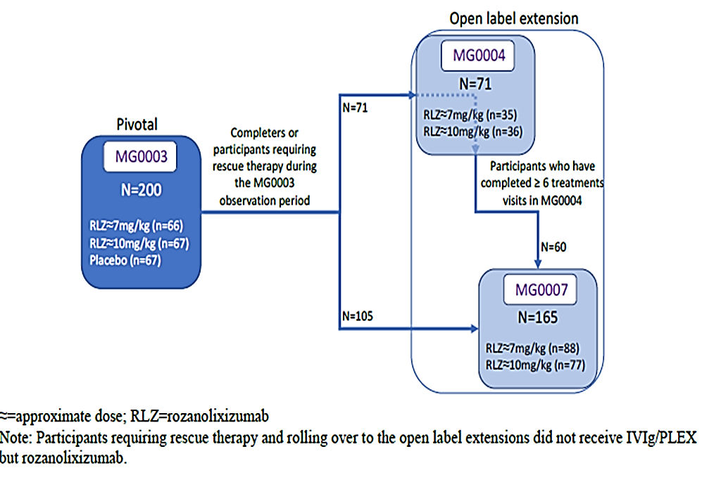

Pivotal Study MG0003
Study MG0003 was a Phase III, randomised, double-blind, placebo-controlled study of rozanolixizumab in adult subjects with gMG who are anti-AChR or anti-MuSK antibody positive and experience moderate to severe symptoms and being considered for additional treatment such as intravenous immunoglobulin (IVIg) or plasma exchange (PLEX).

Statistical methodology
MG0003 was set up using an adaptive design with 2 stages, with a formal interim analysis at the end of the first stage (cut-off date 13 April 2021, 92 eligible study patients evaluable for the primary endpoint) allowing for early termination for futility of one or both dose groups, or an increase in the planned sample size for Stage 2 if the study continued.

Objectives and end points
The primary objective was to evaluate the clinical efficacy of rozanolixizumab as assessed by the change from Baseline to Day 43 in MG-ADL score after the 6-week treatment cycle in the anti−AChR or anti−MuSK seropositive gMG subject population.
The secondary objective was to assess safety and tolerability of rozanolixizumab in gMG patients.
Other objectives of this study were:
- to assess PK characteristics of rozanolixizumab
- to assess the PD effects of rozanolixizumab on IgG, disease-specific autoantibodies
- to evaluate the emergence and incidence of anti-drug antibodies (ADAs) and impact on PK and PD (added in Protocol Amendment 3, 29 July 2020)
- to evaluate the effects of rozanolixizumab on the concentration of total protein, IgM, IgA, and IgE, serum and plasma complement levels, and serum cytokines (added in Protocol Amendment 3, 29 July 2020)
- to assess the effect of rozanolixizumab on tetanus IgG antibodies (added in Protocol Amendment 1, 30 October 2019)
- to assess the effect of rozanolixizumab on exploratory biomarkers and protein expression and explore the relationship between protein and metabolite biomarkers and cause, progression, and appropriate treatment of gMG (Note: results for this exploratory objective were not summarised in the clinical study report).
Primary endpoint: Change from Baseline to Day 43 in MG-ADL score.
Secondary endpoints: Change from Baseline to Day 43 in Myasthenia Gravis Composite (MG-C_ score, quantitative Myasthenia Gravis (QMG) score, MG Symptom Patient-Reported Outcome (PRO) Muscle Weakness Fatigability, Physical Fatigue, and Bulbar Muscle Weakness scores, MG-ADL responder rate at Day 43 (defined as ≥2 points improvement from Baseline).
Key other efficacy endpoints. Responder rate for MG-C (defined as ≥3 points improvement from Baseline), responder rate for QMG (defined as ≥3 points improvement from Baseline), the time to MG-ADL response, minimal symptom expression (defined as study participants achieving a score of 0 or 1 on the MG-ADL at any visit), use of rescue therapy due to worsening (IVIG, PLEX), time to first rescue therapy, time to MG-ADL response (defined as 2 points improvement from Baseline), improvement in individual MG symptoms (MG Symptoms PRO) and health-related quality of life (Myasthenia Gravis Quality of Life 15-item Scale).

Sample size
Stage 2 sample size required to achieve a target conditional power of 90% was calculated using a formula derived from formula 7.4 of Group Sequential and Confirmatory Adaptive Designs in Clinical Trials. The total sample size of the study could have ranged between 150 and 240 study participants if the study was not futile at Stage 1. Up to 388 study participants were planned to be screened at approximately 135 study sites from North America, Europe, and Asia to achieve the targeted number of a minimum of 150 to a maximum of 240 evaluable study participants.

Main Inclusion criteria
Study enrolled patients (aged ≥18 years) with acetylcholine receptor (AChR) or muscle-specific kinase (MuSK) autoantibody-positive generalised myasthenia gravis (Myasthenia Gravis Foundation of America Class II to IVa), a MG-ADL score of at least 3 (non-ocular symptoms), and a QMG score of at least 11.

Randomisation and Blinding
Randomisation into treatment groups was 1:1:1 and was stratified by MG-specific autoantibody, AChR+ or MuSK+. Blinding of participants and investigator was achieved through treatment allocation by interactive response technology.

Participants
Figure 2: Study MG0003 study schema
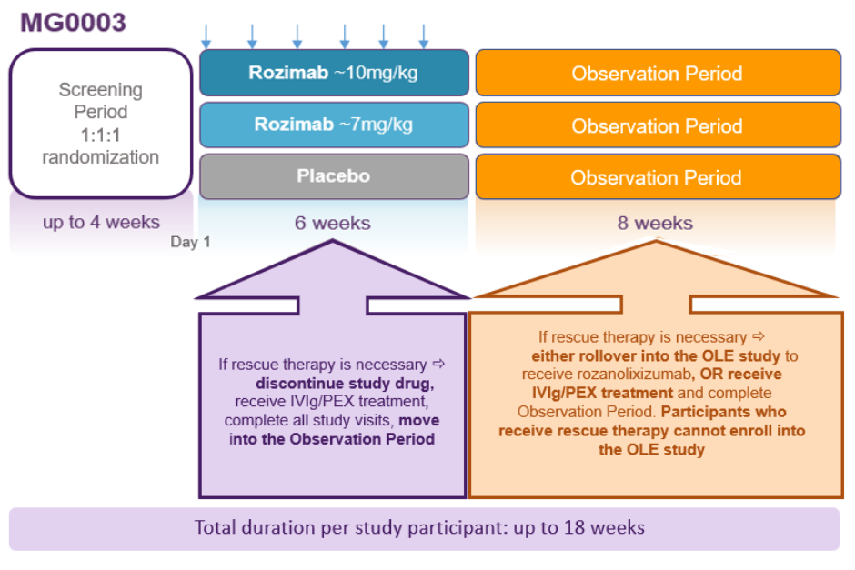

Demographic and other baseline characteristics
In the total study population, mean (SD) age was 51.8 (16.3) years (median: 52.0 years; range: 18 to 89 years, 24.5% being ≥ 65 years of age). 121 (60.5%) of participants were female and 136 (68.0%) were White. The overall number of Japanese (13 [6.5%]) and Asian (21 [10.5%]) participants was low. More than 50% of participants has been recruited in 4 countries (USA, Poland, Canada and France).
Treatment groups were well-balanced for demographics with the following exceptions:
- female sex was characteristic of 47 (70.1%) of the placebo group, 39 (59.1%) of the rozanolixizumab ≈7mg/kg group, and 35 (52.2%) of the rozanolixizumab ≈10mg/kg group
- body weight <50kg was characteristic of 4 (6.0%) of the placebo group, 7 (10.61%) of the rozanolixizumab ≈7mg/kg group, and 1 (1.5%) of the rozanolixizumab ≈10mg/kg group .
Table 3: Study MG0003 baseline characteristics (Randomised Set)
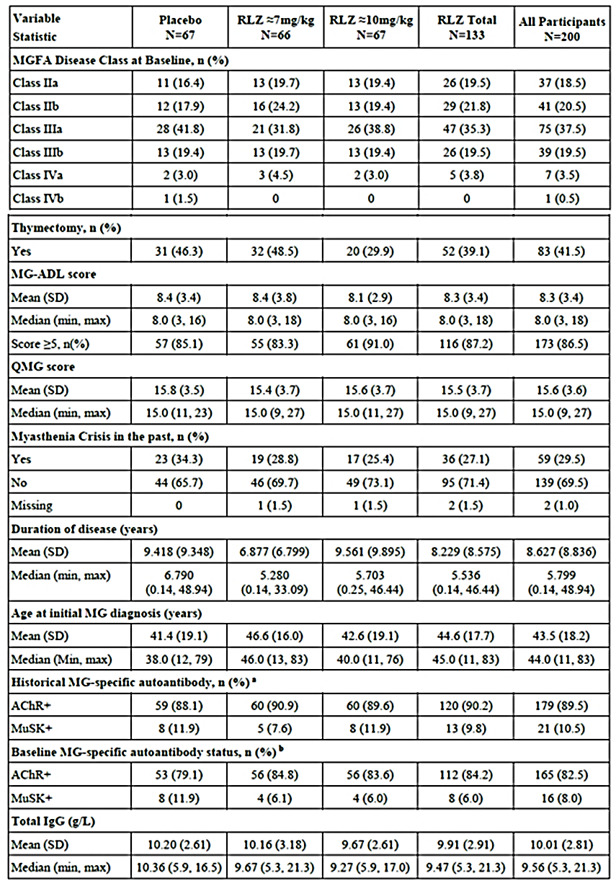
≈=approximate dose, AChR=acetylcholine receptor; CRF=case report form; IgG=immunoglobulin G; Max=maximum; MG=Myasthenia Gravis; MG-ADL=Myasthenia Gravis Activities of Daily Living; MGFA=Myasthenia Gravis Foundation of America; Min=minimum; MuSK=muscle specific kinase; n=number of study participants; N=total number of study participants in treatment group; QMG=Quantitative Myasthenia Gravis; RLZ=rozanolixizumab; RS=randomised set; SD=standard deviation
Note: Combined data are shown (that is, from all study participants, including Stage 1 and Stage 2); the clinical study report included all data for the dichotomous variables which are provided here.
a AChR and MuSK autoantibody status are captured from ‘Confirmatory (Historical) Diagnostic Tests for Primary Condition’ case report form.
b AChR and MuSK autoantibody status are captured from Baseline Visit.
Treatment groups were generally well-balanced with regards to Baseline characteristics. The only notable difference was the lower proportion of study participants who had undergone thymectomy in the rozanolixizumab ≈10 mg/kg group (20 [29.9%]) compared with the ≈7 mg/kg (32 [48.5%]) and placebo (31 [46.3%]) groups. Use of Baseline gMG medications was generally balanced across treatment groups, The majority of patients reported treatment with either corticosteroids and/or immunosuppressants at Baseline: 51.5% of patients received immunosuppressant treatment at baseline, 64.5% of participants received steroids for systemic use at baseline, and 86.0% of patients received parasympathomimetics.

Primary end point results
Reductions in MG-ADL score from Baseline to Day 43 were greater in the rozanolixizumab ≈7 mg/kg group (least-squares mean change –3·37 [SE 0·49]) and in the rozanolixizumab ≈10 mg/kg group (–3·40 [0·49]) than with placebo (–0·78 [0·49]; for ≈7 mg/kg, least-squares mean difference −2·59 (95% CI:−4·09, −1·25; p<0·0001); for ≈10 mg/kg, −2·62 (95% CI:−3·99, −1·16; p<0·0001).
Table 4: Study MG0003 Myasthenia Gravis Activities of Daily Living score change from Baseline to Day 43 (Visit 10) (Hypothetical & Treatment Policy Strategy, Randomised Set)
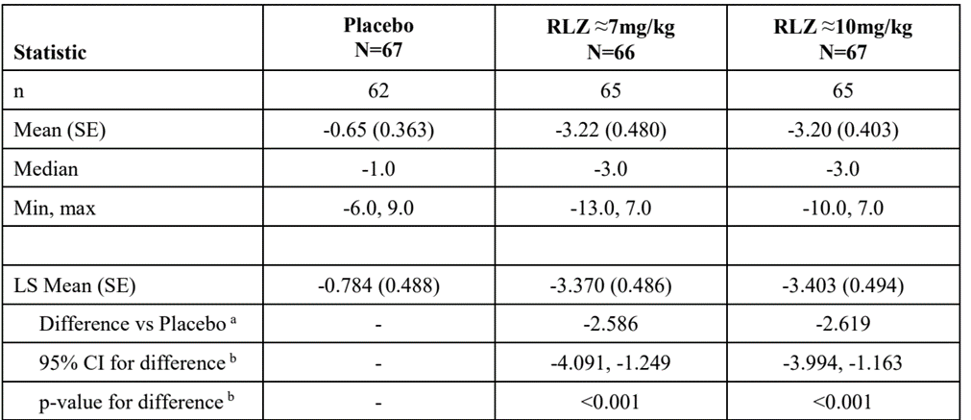
≈=equivalent dose; COVID-19=coronavirus disease 2019; CI=confidence interval; ICE=intercurrent event; IMP=investigational medicinal product; LS=Least Square; MAR=missing at random; Max=maximum; MG−ADL=Myasthenia Gravis Activities of Daily Living; Min=minimum; MMRM=mixed model repeated measure; n=number of study participants with data at Day 43; N=total number of study participants in treatment group; RLZ=rozanolixizumab; SE=standard error; TEAE=treatment-emergent adverse event.
Note: Combined data are shown (that is, from all study participants, including Stage 1 and Stage 2).
Note: The total MG-ADL score ranges from 0 to 24 with a higher score indicating more severe disability.
Note: The analysis is based on the Hypothetical & Treatment Policy Strategy, where study participants who experience ICEs regarding use of rescue therapy were treated as missing at and after the point of the ICE for the purpose of analysis. Data from study participants who discontinued treatment or the study due to TEAEs or COVID-19 infection or non-COVID-19 infection-related issues before Day 43 were used regardless of whether ICEs occurred. Any missing MG-ADL scores (including missing data after the ICEs) were handled based on maximum likelihood estimation under MAR assumption.
Note: Baseline is defined as the last available value before or on the same date (and same time if time is collected for the individual assessment) of the first infusion of IMP in the Treatment Period, or if missing, the Screening value.
a The differences presented is RLZ (≈7 mg/kg or ≈10 mg/kg) minus placebo.
b All outputs are from the combined MMRM, except CIs and p-values, which are based on stagewise inverse normal combination using the Lehmacher and Wassmer method.
Figure 3: Study MG0003 Boxplot of MG-ADL change from Baseline to Day 43 (randomised set)
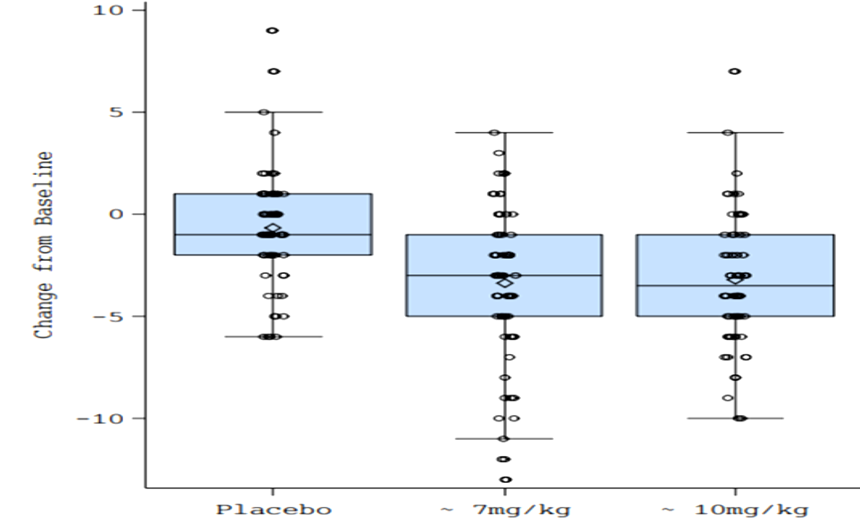
Table 5: Study MG0003 Change from Baseline to Day 43 in the primary and the secondary efficacy endpoints included in the sequential hierarchical procedure (Hypothetical & Treatment Policy Strategy, randomised set)
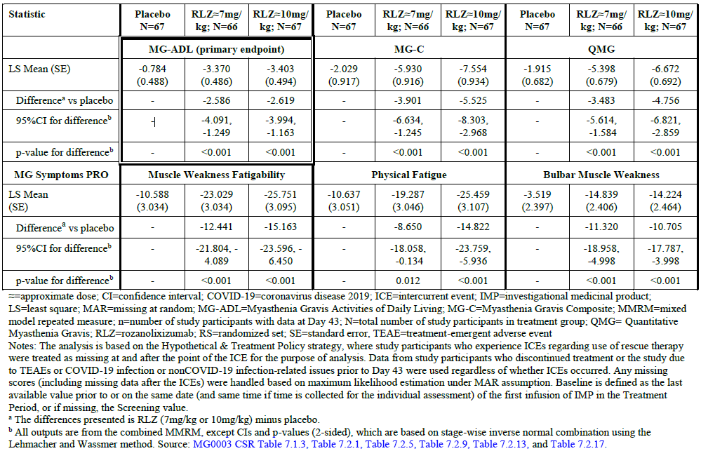
Median time to first MG-ADL response was estimated to be 16 days and 22 days for the ≈7 mg/kg and ≈10 mg/kg rozanolixizumab treatment groups, respectively (indicating that the probability of a response is 50% at those timepoints). However, a time-to-event analysis for such a short period is of limited value.
Figure 4: Study MG0003 median time to first MG-ADL response
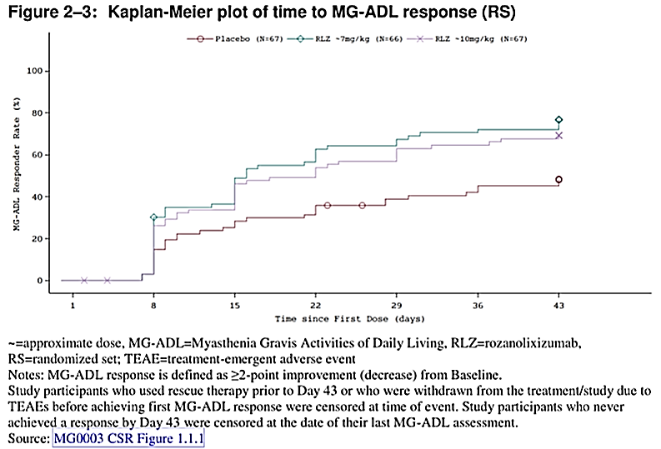

Key secondary efficacy endpoints
Change from Baseline to Day 43 in MG-C Score and change from Baseline to Day 43 in QMG score were 2 key secondary endpoints. The rest of the secondary end points results are shown in Table 5.

Change from Baseline to Day 43 (Visit 10) in the MG-Composite (MG-C) score.
The difference in least square (LS) mean change from baseline in MG-C score between rozanolixizumab of ≈7 mg/kg dose level group and placebo group were −3.90 (95% CI: −6.63, −1.25; p<0.001) and −5.53 (95% CI: −8.30, −2.97; p<0.001) in 10 mg/kg dose group (Table 5).

Change from baseline to day 43 in QMG score
The difference in LS mean change from baseline in QMG score between rozanolixizumab of ≈7 mg/kg dose level group and placebo group were −3.48 (95% CI: −5.61, −1.58; p<0.001) and −4.76 (95% CI: −6.82, −2.86; p<0.001) in the 10 mg/kg dose level group.

Key other secondary efficacy endpoints

MG-ADL responder (≥2.0 points improvement from Baseline) at Day 43 (Visit 10)
Table 6: Study MG0003 Myasthenia Gravis Activities of Daily Living responder (≥2.0 points improvement from Baseline) at Day 43 (Visit 10) (Composite Strategy, Randomised Set)
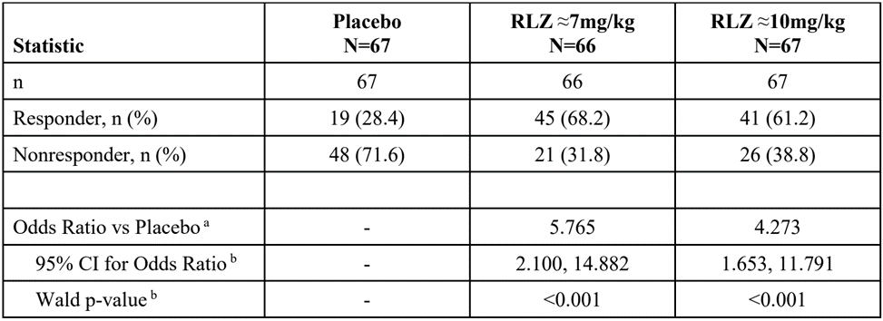

Subgroup efficacy with baseline medications
Post hoc analyses of efficacy outcome measures across participants with different types and numbers of gMG Baseline medications in MG0003: the analyses provided by the sponsor to Swissmedic indicated that there was no impact of the types (corticosteroids, nonsteroidal immunosuppressants, parasympathomimetics, and combinations thereof) and number of gMG Baseline medication on efficacy outcome measures.

Supportive Study MG0007
The ongoing study MG0007 enrolled 165 patients who rolled over from MG0003 (105) and MG0004 (60) studies (35 participants having received placebo in MG0003 rolled over directly to MG0007).
Each cycle consisted of 6 weeks of treatment followed by an observation period. Initiation of additional treatment cycles were based on clinical evaluation of gMG symptoms. Four weeks were to be maintained between cycles unless IgG levels returned to ≥ 2 g/L within the 4 weeks, then additional treatment cycles could be initiated earlier.
Respectively, 88 (52 from MG0003 and 36 from MG0004) and 77 (53 from MG0003 and 24 from MG0004) study participants were assigned to the ≈7 mg/kg and ≈10 mg/kg rozanolixizumab treatment groups in Cycle 1. At the time of data-cut-off for the interim clinical study report (8 July 2022), 157 study participants had received rozanolixizumab in their first MG0007 cycle (safety set); no participants had completed the study, most of them (n=123) were ongoing in the study and 34 had discontinued the study (21.7%). The most common reason for discontinuation was TEAEs (20 participants).
Overall, 142 (90.4%) study participants completed Cycle 1 up to Day 43, 113 (93.4%) Cycle 2 up to Day 43, 83 (86.5%) Cycle 3 up to Day 43, 65 (92.9%) Cycle 4 up to Day 43, and 41 (78.8%) Cycle 5 up to Day 43. The number of study participants completing subsequent cycles up to Day 43 was low.
Figure 5: Study MG0007 study participant disposition
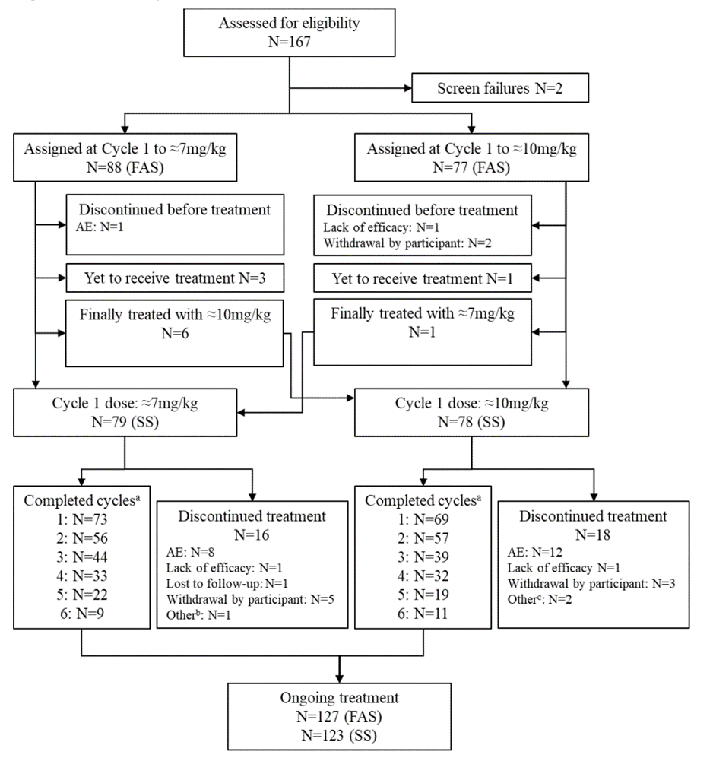
The median age was 54.0 years, and most patients were White (68.8%) and female (59.2%). The median time since diagnosis of gMG was 5.7 years, the median MG-ADL total score was 8.0, and the median QMG total score was 14.0. The number of study participants who needed additional therapies in the observation period of MG0003 and entered MG0007, n (%), were 14 (17.7%) and 16 (20.5%) in the rozanolixizumab ≈7 mg/kg and ≈10 mg/kg groups, respectively. There were 76.4% of patients were AChR-Ab seropositive and 5.7% were MuSK seropositive at MG0007 baseline. There were lower proportion of study participants who had undergone thymectomy in the rozanolixizumab ≈7 mg/kg group (28 [35.4%]) compared with the ≈10 mg/kg group (37 [47.4%]) and the higher proportion of study participants who were MuSK+ at MG0003 Baseline in the rozanolixizumab ≈7 mg/kg group (8 [10.1%]) compared with the ≈10 mg/kg group (2 [2.6%]).
During MG0007, 6 (7.6%) study participants in the rozanolixizumab ≈7 mg/kg group and 8 (10.3%) in the rozanolixizumab ≈10 mg/kg group received any rescue therapy (that is, rescue medication or rescue procedure). Five (6.3%) study participants in the rozanolixizumab ≈7 mg/kg group received rescue medication (4 received immunoglobulins [1 of which continued treatment with efgartigimod alfa] and 1 received methylprednisolone sodium succinate); 2 (2.5%) study participants required a rescue procedure (1 received plasma exchange and 1 received IvIG. Seven (9.0%) study participants in the rozanolixizumab ≈10 mg/kg group received rescue medication (6 received immunoglobulins [1 of which continued treatment with plasma, human albumin, and calcium chloride dihydrate/potassium chloride/sodium chloride/sodium lactate], 1 received methylprednisolone sodium succinate, and 1 received plasma [reported term: plasma exchange]); 3 (3.8%) study participants required a rescue procedure (all required plasmapheresis). All study participants who received rescue therapies discontinued the study.
Observed results and changes from Baseline in the MG-ADL score by subgroup and study cycle were explored for subgroups of age, sex, region, weight, MG-specific autoantibodies, duration of disease at Baseline, MGFA disease class at Baseline, thymectomy at Baseline, and Baseline MG-ADL category.
Overall, a numerically smaller improvement in MG-ADL scores was observed at Day 43 among the elderly population (≥65 years) compared with the younger population (≥18 years to <65 years) in MG0007 (Cycle 1: −2.8 vs −3.6, Cycle 2: −2.0 vs −3.9, Cycle 3: −1.6 vs −3.9, Cycle 4: −2.2 vs −4.0, Cycle 5: −2.6 vs −4.7).Generally, a trend towards a higher response in anti-MuSK+ study participants than in the overall population at Day 43 was observed for Cycle 1 (−5.1 vs −3.4) and Cycle 2 (−5.0 vs −3.5). The response was similar for Cycle 3 (−3.8 vs −3.4) and Cycle 4 (−3.0 vs −3.7). Conclusions should be drawn with caution due to the low number of participants in this subgroup (n≤8 per treatment group and cycle).
Participants with a shorter duration of disease (<5.7 years) showed a better clinical improvement at Day 43 with repeated cyclic treatment (Cycle 1: −2.9, Cycle 2: −3.4, Cycle 3: −4.1, Cycle 4: −4.3, Cycle 5: −6.2) compared with participants with a longer duration of disease (≥5.7 years) (Cycle 1: −4.0, Cycle 2: −3.5, Cycle 3: −2.8, Cycle 4: −3.1, Cycle 5: −3.2) and participants with a Baseline MG-ADL category <5 showed a better clinical improvement at Day 43 with repeated cyclic treatment (Cycle 1: −0.9, Cycle 2: −2.9, Cycle 3: −5.4, Cycle 4: −8.5) compared with participants with a Baseline MG-ADL category ≥5 (Cycle 1: −4.0, Cycle 2: −3.5, Cycle 3: −3.2, Cycle 4: −3.4). However, conclusions should be drawn with caution due to the low number of participants in the <5 subgroup after Cycle 3 (n≤7 per cycle). Following treatment, the absolute MG-ADL values in the <5 subgroup remained consistently lower compared with the ≥5 subgroup.
Table 7: Study MG0007 Myasthenia Gravis Activities of Daily Living score change from Baseline to Day 43 during each treatment cycle (Safety Set)
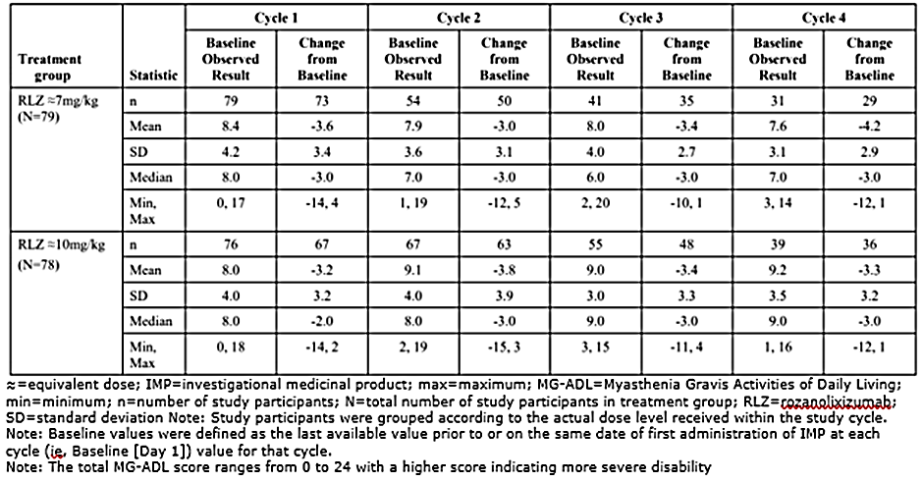
The estimated (Kaplan-Meier analysis) time to MG-ADL response was 15 days for the majority of cycles. Of note, a difference in time to response was observed in the first cycle between the 2 treatment groups (10 days for the ≈7 mg/kg treatment group vs 23 days for the ≈10 mg/kg treatment group).
The treatment−free interval (that is, time between the last infusion of the previous cycle to the first infusion of the next cycle) between the first 2 cycles was ≈9 weeks in both rozanolixizumab treatment groups and ≈7 to 8 weeks between Cycle 2 and Cycle 3. For a subset of participants with a higher frequency of treatment cycles, shorter treatment−free intervals of ≈5 weeks were observed.
Subgroup analyses performed by administered fixed dose for selected efficacy variables showed similar improvement in MG-ADL, MG-C, and QMG scores at Day 43 of the first 3 cycles for the 420 mg, 560 mg, 840 mg, and 1120 mg doses. A lower response was observed for the 280 mg dose. Four or fewer study participants received the 280 mg dose and all other doses were administered to at least 15 study participants in the first 3 cycles.
For the proposed 2-fixed doses of 420 mg (<50kg) and 560 mg (≥50kg to <100kg), responder rates for MG-ADL, MG-C and QMC were consistent with those for the weight-tiered doses in the first 5 cycles. In addition, the 560 mg dose showed high responder rates across the ≥50 kg to <70 kg and ≥70 kg to <100 kg weight groups (>60% in the first 3 cycles, n>30).

Supportive Study MG0004
Study MG0004 enrolled 71 patients (among which 12 had received placebo in MG0003) for up to 60 weeks to evaluate the safety and efficacy of weekly rozanolixizumab treatment of up to 52 weeks followed by an observation period of 8 weeks. Patients were randomised to receive rozanolixizumab ≈7 mg/kg (n=35) or ≈10 mg/kg(n=36); all but one received at least 1 dose of treatment. Primary objectives were to evaluate the long-term safety and tolerability, and secondary objectives were to evaluate efficacy of up to 52 weeks of weekly administered rozanolixizumab.
Once MG0007 study was initiated, MG0004 enrolment closed (the number of study participants in MG0004 decreased steadily after Week 22), and ongoing MG0004 patients after a minimum of 6 visits were eligible to enter MG0007. Eight (11.3%) study participants completed the study. The majority of participants permanently discontinued the study, principally to transition to the MG0007 study (n=53, 74.6%). Three (4.2%) participants permanently discontinued the study due to TEAEs while 2 (2.8%) participants withdrew from the study.
The population enrolled in the study was representative of a gMG patient population with moderate to severe disease: at MG0004 Baseline, the mean (SD) MG-ADL score was 8.4 (3.6), the mean (SD) MG-C score was 15.4 (7.3), and the mean (SD) QMG score was 15.3 (5.3). In addition, >80% of study participants were anti-AChR+ and ≈10% were anti-MuSK+ (assessed at MG0003 Baseline).
In both treatment groups, >75% of study participants had an exposure ≥3 months and approximately one-third had an exposure ≥6 months. Study participants in MG0004 were allowed to switch treatment groups for tolerability and efficacy reasons at the discretion of the investigator. Efficacy analyses in MG0004 were conducted by first administered dose (that is, study participants as randomised).
Improvements (reduction from Baseline) were observed for MG-ADL, MG-C and QMG in both rozanolixizumab treatment groups with a consistent trend observed up to Week 33 (beyond that timepoint the number of study participants that continued in the study was ≤10 per treatment group at any scheduled timepoint). Overall, the mean reduction from Baseline up to Week 33 ranged between:
- MG-ADL: across visits during rozanolixizumab treatment, the mean decrease from Baseline for rozanolixizumab overall ranged between −2.9 and −3.6 in MG0004 (up to Week 33)
- MG-C: across visits during rozanolixizumab treatment, the mean decrease from Baseline for rozanolixizumab overall ranged between −5.0 and −7.4 in MG0004 (up to Week 33) compared with −2.9 and −6.6 in MG0003
- QMG: across visits during rozanolixizumab treatment, the mean decrease from Baseline for rozanolixizumab overall ranged between −3.7 and −5.6 in MG0004 (up to Week 33) compared with −2.3 and −4.9 in MG0003.
Table 8: Study MG0004 Myasthenia Gravis Activities of Daily Living total score observed results and changes from Baseline over time (Safety Set)
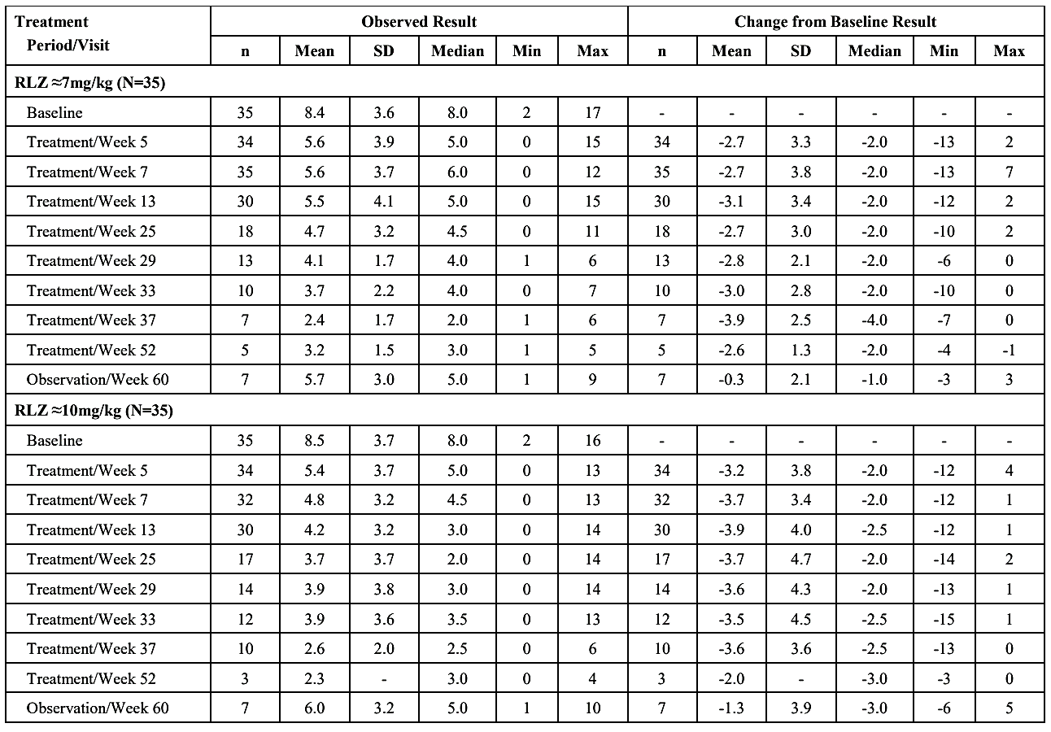
≈=equivalent dose; IMP=investigational medicinal product; max=maximum; MG-ADL=Myasthenia Gravis Activities of Daily Living; min=minimum; n=number of study participants; N=total number of study participants in treatment group; RLZ=rozanolixizumab; SD=standard deviation
Note: Not all timepoints are shown.
Note: Baseline was defined as the last available value before or on the same date of first administration of IMP in MG0004.
Note: The total MG-ADL score ranges from 0 to 24 with a higher score indicating more severe disability.
The use of rescue medication was low (total of 4 [5.7%] study participants overall, only 2 of them while receiving rozanolixizumab).
The subgroup of anti-AChR+ study participants showed a trend in MG-ADL, MG-C and QMG score change from Baseline similar to the overall population. This improvement in clinical scales was associated with a decrease in the percentage change from Baseline in total serum IgG and AChR autoantibody levels.
For study participants who worsened before entering MG0004, the majority were MG-ADL, MG-C, and QMG responders up to Week 45.
Overall, 37 (53.6%) study participants developed ADA against rozanolixizumab, and approximately half of them (18 [26.1%]) developed ADA that were neutralising. For most study participants, the first occurrence of treatment emergent anti-drug antibodies (TE-ADA) positivity was at Week 5 (14 [20.3%] study participants overall) or Week 9 (6 [9.8%]); only 7 study participants were TE-ADA positive for the first time at a later timepoint. The increase in the incidence of ADA positivity in study participants who restarted rozanolixizumab compared with those who were previously treated with placebo (46.2% vs 38.1%), in combination with the overall higher incidence of ADA positivity in MG0004 compared with MG0003 (53.6% vs 37.2%), suggest an increase in immunogenicity upon reinitiation of rozanolixizumab treatment.
Irrespective of the treatment cycle, the majority of study participants had treatment-free intervals between 4 and 13 weeks. The estimated median for the first treatment-free interval was approximately 9 weeks and remained unchanged for the next interval. For the subset of patients with a higher frequency of treatment cycles, shorter treatment-free intervals of 5 to 7 weeks were observed. From cycle to cycle around 10% of the study participants had a treatment-free interval shorter than 4 weeks.
In the pool of placebo-controlled study MG0003 and long-term extension study MG0007 data, after one treatment cycle of 6 rozanolixizumab weekly doses, 27.1% (42/155) of patients developed ADA and 10.3% (16/155) had antibodies that were classified as neutralising antibodies (NAb). Upon reinitiating therapy, the proportion of patients who developed ADA and NAb increased to 65.0% (13/20) and 50.0% (10/20) after 5 treatment cycles. There was a small, non-clinically relevant effect of ADA on PK and PD, and no impact on efficacy and safety.

Clinical safety

Exposure
The safety evaluation of rozanolixizumab in gMG is primarily based on a comparison of data from 200 patients who received placebo (N=67) or rozanolixizumab administered at approximate doses of ≈7 mg/kg (N=64) or ≈10 mg/kg (N=69) in MG0003 (that is, the pivotal Phase III double-blind, randomised study).
Pooled analyses of rozanolixizumab-treated patients from MG0003, and open-label extension (OLE) studies MG0007 (cyclic treatment, data cut off 8 July 2022) and MG0004 (chronic weekly treatment) are presented to provide evidence of the extent of exposure, and the safety of rozanolixizumab with repeated cyclic treatment. For this pooled analysis, the MG0003 Treatment Period is regarded as the first Treatment Cycle in those who had been randomised to rozanolixizumab in MG0003.
Table 9: Clinical studies contributing to the Integrated Review of Safety
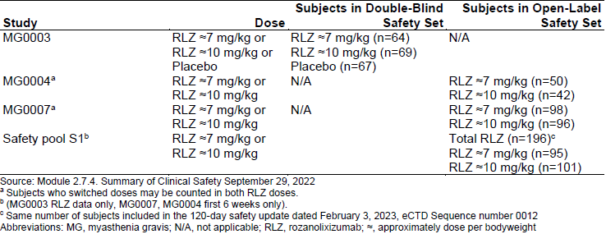

Safety pools
For the purposes of summarising AEs, 2 pools have been defined and for the purposes of immunogenicity analysis, 1 pool has been defined.

Pool S1
All rozanolixizumab-treated subjects who have undergone ≥1 Treatment Cycle (that is, ≥1 SC infusion of rozanolixizumab in any 6-week Treatment Period). The aim of this group is to characterise the total time receiving rozanolixizumab and the safety profile of rozanolixizumab during treatment periods. The database includes patients from MG0003 (rozanolixizumab treatment arm only), MG0007 (up until the interim cut-off date), and first 6 weeks of data (to represent 1 Treatment Cycle) from MG0004.

Pool S2
Subset of Pool S1 including all rozanolixizumab-treated study participants who have undergone ≥1 treatment cycle (that is, ≥1 dose of rozanolixizumab in any 6-week Treatment Period) and the treatment cycle has been followed by an (up to) 8 week Follow-up Period starting from the last infusion.
The purpose of this group is to characterise the safety profile of rozanolixizumab during each treatment Period and follow-up Period. Pool S2 is the main safety pool.

Pool S3
To assess the immunogenicity of rozanolixizumab and impact on PK, PD, efficacy and safety. This pool excludes data generated in MG0004 (under a chronic weekly treatment regimen), and any data generated in MG0007 (under a cyclic treatment regimen) from study participants that had previously received rozanolixizumab under a chronic weekly treatment regimen in MG0004.
Table 10: Overview of safety pools
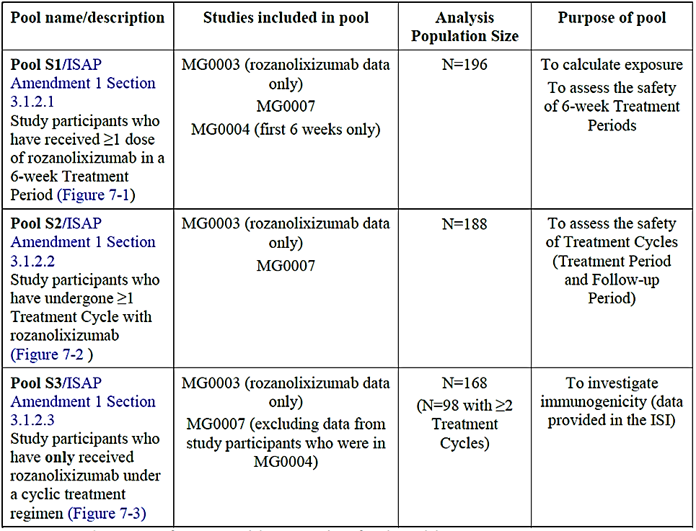N=number of study participants.
Note: Treatment Cycle is defined as at least one dose of rozanolixizumab in a 6-week Treatment Period and an (up to) 8-week Follow-up Period starting from the last infusion.

Overview of adverse events

Study MG0003
Overall, the incidence of TEAEs was similar in the rozanolixizumab ≈7 mg/kg and ≈10 mg/kg groups (81.3% and 82.6%, respectively) and lower in the placebo group (67.2%; see following table). No deaths were reported during the study. The incidence of serious TEAEs was similar across placebo and rozanolixizumab ≈7 mg/kg and ≈10 mg/kg treatment groups (9.0%, 7.8%, and 10.1%, respectively). Severe TEAEs were also more frequent in rozanolixizumab ≈10 mg/kg (18.8%) than rozanolixizumab ≈7 mg/kg (4.7%) or placebo (4.5%). The incidence of TEAEs considered by the investigator to be related to rozanolixizumab was similar in the rozanolixizumab ≈10 mg/kg and rozanolixizumab ≈7 mg/kg groups (56.5% and 50.0%, respectively) and lower in the placebo group (32.8%).
Table 11: Study MG0003 Overview of Treatment-emergent adverse events (Safety Set)
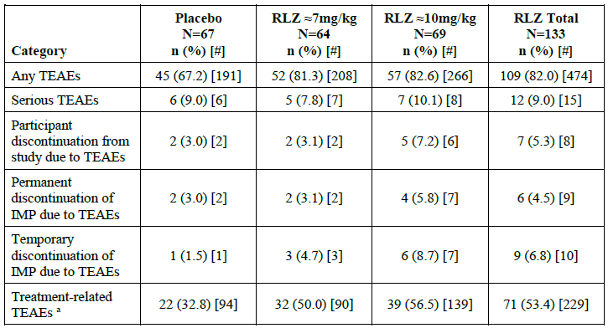
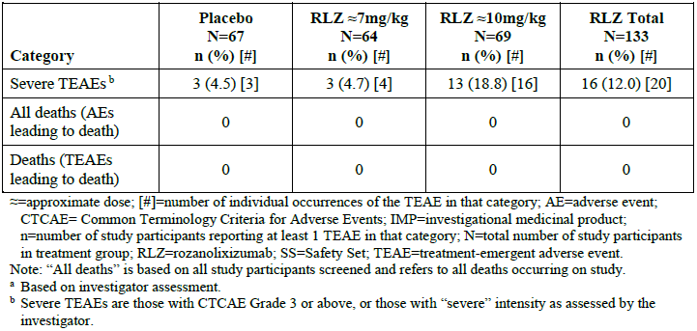

Pooled data

Pool S2
In Pool S2, 169 (89.9%) study participants experienced any TEAE. Across all TEAE categories, the incidence of TEAEs was higher in the rozanolixizumab ≈10 mg/kg than in the ≈7 mg/kg dose group.
In general, the incidence of TEAEs across all categories did not increase with repeated cyclic treatment compared with Cycle 1.

Pool S1
In Pool S1 (n=196), 176 (89.8%) study participants experienced any TEAE, and the incidence was similar in the rozanolixizumab ≈7 mg/kg (116 [81.7%] participants) and ≈10 mg/kg (120 [82.8%]) dose groups. In all TEAE categories except for ‘temporary discontinuation of [rozanolixizumab] due to TEAEs’ the incidence of TEAEs appeared higher in the rozanolixizumab ≈10 mg/kg dose. Compared with Cycle 1, temporary discontinuation of rozanolixizumab showed no clear trends in incidence throughout Treatment Cycles, and the incidence of TEAEs in all other categories did not generally increase with repeated cyclic treatment. Generally, the incidence of TEAE categories in Pool S1 was consistent with TEAEs occurring during the Treatment Period of Pool S2.

Pool S3
Like Pool S2, Pool S3 includes data from Treatment and Follow-up Periods, and excludes data generated in MG0004, however, Pool S3 also excludes data generated in MG0007 from study participants that had previously received rozanolixizumab in MG0004.Overall, the safety profile across categories in Pool S3 were consistent with Pool S2.

Common treatment-emergent adverse events

Study MG0003
Treatment-emergent AEs were most frequently reported in the Medical Dictionary for Regulatory Activities (MedDRA) System Organ Class (SOC) of Nervous system disorders (57.8%, 47.8%, and 31.3% of study participants in the rozanolixizumab ≈7 mg/kg, rozanolixizumab ≈10 mg/kg, and placebo groups, respectively) followed by Gastrointestinal disorders (32.8%, 30.4%, and 23.9%, respectively), General disorders and administration site conditions (25.0%, 39.1%, and 19.4%, respectively), Infections and infestations (15.6%, 30.4%, and 19.4%, respectively), and Musculoskeletal and connective tissues disorders (23.4%, 18.8%, and 13.4%, respectively). Across rozanolixizumab treatment groups, the most common TEAEs were headache, diarrhoea, pyrexia, nausea, and arthralgia. Headache was the most common TEAE in all groups, occurring in 45.3%, 37.7%, and 19.4% of study participants in the rozanolixizumab ≈7 mg/kg, ≈10 mg/kg, and placebo groups, respectively. The following TEAEs were also reported in ≥5% of study participants in any treatment group: myalgia, vomiting, hypertension, nasopharyngitis (in either rozanolixizumab treatment group), and urinary tract infection (placebo treatment group).

Pool S2
In total, 169 (89.9%) study participants experienced 1526 TEAEs in Pool S2. The incidence of TEAEs was higher in the rozanolixizumab ≈10 mg/kg than in the ≈7 mg/kg dose group (91.6% vs 77.4% of participants). Overall, TEAEs were most frequently reported in the SOCs of Nervous system disorders (59.6% of study participants), Infections and infestations (45.2%), Gastrointestinal disorders (42.6%), and General disorders and administration site conditions (42.6%). The most common TEAEs across both dose groups were headache (46.3% of study participants), diarrhoea (28.7%), pyrexia (18.1%), nausea (14.9%), COVID-19 infection (13.8%), arthralgia (11.2%), and blood IgG decreased (10.6%).Overall, the incidence of any TEAEs did not increase with repeated treatment cycles, including in the most common SOCs of Nervous System Disorders, Infections and infestations, and Gastrointestinal Disorders. With repeated cyclic treatment, the incidence of the most common TEAEs of headache, diarrhoea, pyrexia, nausea, and arthralgia, did not increase, while a trend for an increase in the incidence of blood IgG decrease was observed.

Pool S1
In total, 176 (89.8%) study participants experienced 1394 TEAEs in Pool S1 (N=196). The safety profile of Pool S1 was consistent with Pool S2. Overall, TEAEs were most frequently reported in the SOCs of Nervous system disorders (108 [55.1%] study participants), Gastrointestinal disorders (86 [43.9%]), General disorders and administration site conditions (85 [43.4%]), and Infections and infestations (73 [37.2%]). The most common TEAEs in Pool S1 were headache (94 [48.0%] study participants), diarrhoea (57 [29.1%]), pyrexia (35 [17.9%]), nausea (30 [15.3%]), and blood IgG decreased (24 [12.2%]), which occurred with a similar incidence as observed in Pool S2. With repeated cyclic treatment, the incidence of TEAEs occurring in the most common SOCs, as well as the most common TEAEs of headache, diarrhoea, pyrexia, and nausea did not increase, while a trend for an increase in the incidence of blood IgG decrease was observed.

Severe treatment-emergent adverse events

Study MG0003
In MG0003, TEAEs were predominantly mild or moderate in intensity in all treatment groups. The incidence of severe TEAEs was higher in the rozanolixizumab ≈10 mg/kg group (13 [18.8%] participants) than in the rozanolixizumab ≈7 mg/kg (3 [4.7%] participants) and placebo (3 [4.5%] participants) groups (see following table). Severe TEAEs most frequently occurred in the SOC Nervous System Disorders. Within this SOC, headache was the most common severe TEAE and drove the imbalance between the ≈10 mg/kg and ≈7 mg/kg treatment groups (6 [8.7%] and 1 [1.6%] participants, respectively). No placebo-treated participant experienced severe headache. The other TEAEs of severe intensity occurring in >1 study participant in the rozanolixizumab ≈10 mg/kg or ≈7 mg/kg treatment groups were diarrhoea (nil and 2 [2.9%] participants, respectively, vs nil in placebo) and myasthenia gravis (1 [1.6%] and 2 [2.9%], respectively vs 1 [1.5%] in placebo). All other TEAEs of severe intensity occurred in no more than 1 study participant.
Table 12: Study MG0003 Severe treatment-emergent adverse events (Safety Set)
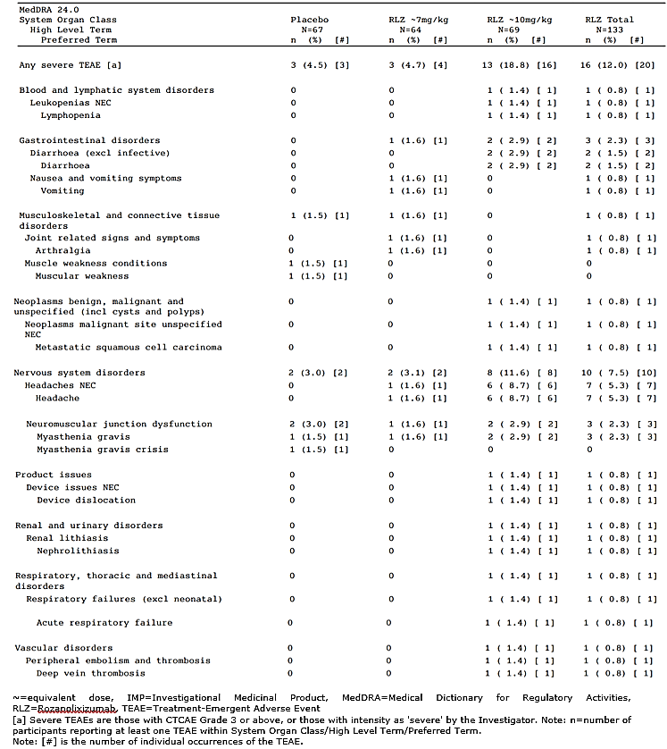

Pool S2
In total, 50 (26.6%) study participants experienced TEAEs of severe intensity in Pool S2, with incidence higher in the rozanolixizumab ≈10 mg/kg than in the ≈7 mg/kg dose group (39 [29.8%] vs 12 [9.0%]).

Pool S1
In Pool S1 (N=196), 41 (20.9%) study participants experienced TEAEs of severe intensity, including 13 (9.2%) and 29 (20.0%) participants in the rozanolixizumab ≈7 mg/kg (N=142) and ≈10 mg/kg (N=145), respectively. Consistent with Pool S2, the most common TEAEs in Pool S1 were headache (12 [6.1%] participants) and myasthenia gravis (5 [2.6%]). Compared with Cycle 1, the incidence of severe TEAEs did not increase with repeated cyclic treatment.

Serious adverse event/deaths/other significant events

Deaths
In total, 5 participants died including 4 participants who died before the data cut-off (8 July 2022), and 1 participant who died post data cut-off. Of the 4 participants who died before the data cut off, 2 participants had TEAEs leading to death, 1 participant had TEAEs and non-TEAEs leading to death, and 1 participant had a non-TEAE leading to death. All deaths occurred in MG0007.

Serious adverse events

Study MG0003
The incidence of serious TEAEs was low and similar across the rozanolixizumab ≈7 mg/kg (7.8% of participants), rozanolixizumab ≈10 mg/kg (10.1%), and placebo (9.0%) groups (see following table).
The most frequent serious TEAEs were related to MG worsening and comprised myasthenia gravis (1.6%, 2.9%, and 1.5% participants) and myasthenia gravis crisis (0, 0, and 3.0%) in the rozanolixizumab ≈7 mg/kg, ≈10 mg/kg, and placebo group, respectively.
Table 13: Study MG0003 Incidence of serious treatment-emergent adverse events (Safety Set)
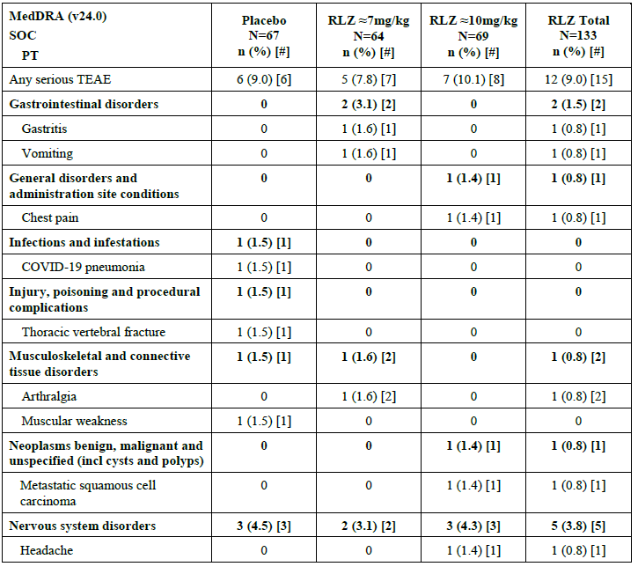
Table 14 (continued): Study MG0003 Incidence of serious treatment-emergent adverse events (Safety Set)
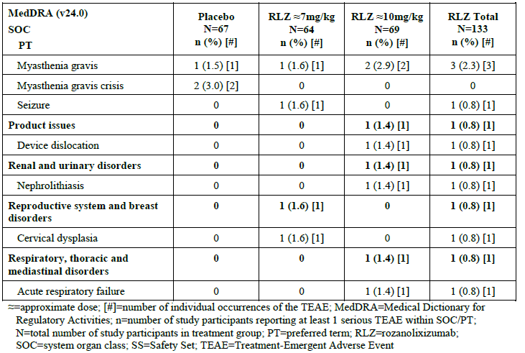

Pool S2
In Pool S2, 42 (22.3%) study participants experienced 56 serious TEAEs (see following table). Overall, serious TEAEs were most frequently reported in the SOCs of Nervous system disorders (19 [10.1%] participants), Infections and infestations (8 [4.3%]), and Gastrointestinal disorders (5 [2.7%]). The only serious TEAEs occurring in >1 participant was myasthenia gravis (12 [6.4%] participants), myasthenia gravis crisis (4 [2.1%]), and COVID-19 (3 [1.6%]). Although the incidence of serious TEAEs was higher in the rozanolixizumab ≈10 mg/kg than in the ≈7 mg/kg dose group (29 [22.1%] vs 14 [10.5%] participants), this difference was predominantly driven by serious TEAEs of myasthenia gravis (8 [6.1%] vs 4 [3.0%]), myasthenia gravis crisis (4 [3.1%] vs 0), and serious TEAEs with a single incidence occurring more frequently at the higher dose.
There was 1 case of subacute cutaneous lupus erythematosus (SCLE). This participant, previously treated with rozanolixizumab ≈7 mg/kg in both MG0003 and MG0004 and with a medical history of rheumatoid arthritis and evaluation for skin lesions and lupus, experienced a serious and severe TEAE of SCLE, 30 days after the last dose of rozanolixizumab ≈7 mg/kg.
Compared with Cycle 1, the incidence of serious TEAEs did not increase with repeated cyclic treatment. At the time of the data cut-off, there were no serious TEAEs in Cycles 6 and 7.
Table 15: Pool S2 Incidence of serious treatment-emergent adverse events by Preferred term and treatment Cycle in ≥2 study participants in the rozanolixizumab total group and Cycle-adjusted treatment-emergent adverse event rates
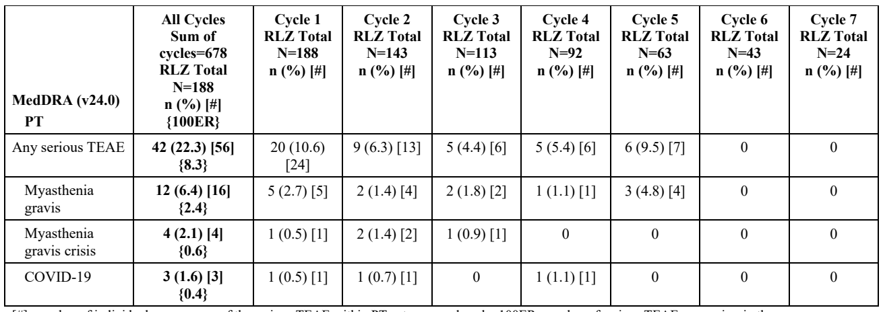
[#]=number of individual occurrences of the serious TEAE within PT category and cycle; 100ER=number of serious TEAEs occurring in the respective cycle treatment group divided by the sum of cycles from all study participants in the respective cycle treatment group and multiplied by 100; COVID-19=coronavirus disease 2019; MedDRA=Medical Dictionary for Regulatory Activities; n=number of study participants reporting at least 1 serious TEAE within the PT category and cycle; N=number of study participants treated with RLZ at least once; PT=preferred term; RLZ=rozanolixizumab; TEAE=treatment-emergent adverse event
Note: Summary data and the 100ER in the in the ‘Sum of Cycles’ column are derived from a ‘most recent dose’ analysis. Data for each individual Cycle are derived from a ‘by Cycle’ analysis. Therefore, the number of events presented by Cycle may not equal the number of events occurring in All Cycles.

Pool S1
In total, 22 (11.2%) study participants experienced 27 serious TEAEs in Pool S1 (N=196), including 8 (5.6%) and 14 (9.7%) participants in rozanolixizumab ≈7 mg/kg (N=142) and ≈10 mg/kg (N=145) dose groups, respectively. Consistent with Pool S2, the most common serious TEAEs in Pool S1 were myasthenia gravis (5 [2.6%] participants) and COVID-19 (3 [1.5%]). The TEAE of myasthenia gravis crisis occurred in 1 (0.5%) participant.
One participant (0.5%) experienced a TEAE of pericarditis in Pool S1 (not included in Pool S2).
Compared with Cycle 1, the incidence of serious TEAEs did not increase with repeated cyclic treatment.

Adverse events of focus
The TEAE of headache, infections including opportunistic infections, hypersensitivity reactions including anaphylactic and injection site reactions, drug-related hepatic disorders, effects on the kidney, and effects on lipids are discussed in this section.

Headache

Study MG0003
In total, TEAEs meeting criteria for headache occurred in 31 (48.4%), 27 (39.1%), and 13 (19.4%) participants in the rozanolixizumab ≈7 mg/kg, ≈10 mg/kg, and placebo groups, respectively. Most study participants had events that were of mild or moderate maximum intensity. Severe events occurred in 1 (1.6%) and 6 (8.7%) study participants in the rozanolixizumab ≈7 mg/kg and ≈10 mg/kg group, respectively, and led to study discontinuation for the participant in the rozanolixizumab ≈7 mg/kg group.

Pool S2
In total, 89 (47.3%) study participants experienced any headache in Pool S2, with the incidence similar across the ≈7 mg/kg and ≈10 mg/kg dose groups, and higher during the Treatment Period compared with the Follow-up Period. Compared with Cycle 1, the incidence of any headache did not increase with repeated cyclic treatment.

Infections, including opportunistic infections

Study MG0003
In total, 31 (23.3%) rozanolixizumab-treated participants and 13 (19.4%) placebo-treated participants reported TEAEs within the infections and infestations SOC. Overall, the incidence of infections was similar between the rozanolixizumab and placebo treatment groups; however, incidence was higher with rozanolixizumab ≈10 mg/kg group (21 [30.4%] participants) compared with placebo (13 [19.4%]).

Pool S2
In total, 85 (45.2%) study participants experienced a TEAE within the SOC Infections and infestations in Pool S2, including 43 (32.3%) and 54 (41.2%) participants in the rozanolixizumab ≈7 mg/kg and ≈10 mg/kg dose groups, respectively. The most common infections by MedDRA Preferred Term (PT) were COVID-19, upper respiratory tract infection, nasopharyngitis, and oral herpes. The incidence of TEAEs within this SOC did not increase with repeated cyclic treatment. In total, TEAEs within this SOC led to discontinuations from the study and/or rozanolixizumab in <5% of participants (both 6 [3.2%] participants).
Serious TEAEs within the SOC Infections and infestations occurred in 8 (4.3%) participants in Pool S2 (N=188), including 2 (1.5%) and 6 (4.6%) participants in the rozanolixizumab ≈7 mg/kg and ≈10 mg/kg dose groups, respectively. The most common serious TEAE within this SOC was COVID-19 (3 [1.6%] of participants). There was no increase in serious infections with repeated cyclic treatment. Of the 8 participants with serious infections, 3 participants had fatal outcomes, and 5 participants (with 6 events) fully recovered from the event. There were 2 events that were considered related to rozanolixizumab by the sponsor: a fatal event of severe pneumonia and aseptic meningitis. There have been 3 reports of aseptic meningitis (reported as drug-induced aseptic meningitis) in the rozanolixizumab development program.

Hypersensitivity reactions

Study MG0003
Treatment-emergent AEs mapping to the Standardised MedDRA Query (SMQ) Hypersensitivity occurred in 7 (10.9%), 4 (5.8%), and 1 (1.5%) participant in the rozanolixizumab ≈7 mg/kg, ≈10 mg/kg, and placebo groups, respectively. The most common event was rash. All events were mild or moderate in intensity. There were no severe or serious events.

Pool S2
In Pool S2 (N=188), the incidence of TEAEs mapping to the SMQ hypersensitivity was low, occurring in 25 (13.3%) study participants, including 14 (10.5%) and 11 (8.4%) participants, in the rozanolixizumab ≈7 mg/kg (N=133) and ≈10 mg/kg (N=131) dose groups, respectively. Excluding injection site reactions (which are discussed below), common TEAEs were rash (11 [5.9%] participants) and urticaria (3 [1.6%]). Hypersensitivity-related TEAEs were all nonserious and except for severe rash in 1 (0.5%) participant were of mild to moderate intensity. This participant with severe rash was subsequently diagnosed with SCLE. There were no hypersensitivity TEAEs that led to permanent discontinuation. Overall, the incidence of TEAEs by Cycle did not increase with repeated cyclic treatment (<7% of participants per Cycle). No anaphylaxis was reported.

Hepatic events

Study MG0003
Treatment-emergent AEs meeting the search criteria for drug-related hepatic disorders were reported in 1 (1.6%) study participant in the rozanolixizumab ≈7 mg/kg group, 4 (5.8%) in the ≈10 mg/kg group, and 1 (1.5%) in the placebo group. The following PT were reported: hepatic fibrosis, blood bilirubin increased, prothrombin time prolonged, transaminases increased, and non-alcoholic fatty liver disease. None of these events were reported in >1 study participant in any treatment group except for blood bilirubin increased which was reported in 2 (2.9%) study participants in the rozanolixizumab ≈10 mg/kg group.
All events were mild or moderate in intensity and there were no serious events or events that led to discontinuation from the study.

Pool S2
In total, 9 (4.8%) study participants had 13 TEAEs that met search criteria for drug-related hepatic disorders in Pool S2 (N=188), including 2 (1.5%) participants in the ≈7 mg/kg dose group (3 events) and 7 (5.3%) in the ≈10 mg/kg dose group (10 events). There were no serious TEAEs and 1 severe TEAE. None of the TEAEs occurred in >2 (1.1%) participants. By Cycle, the incidence of any drug-related hepatic disorders did not increase with repeated cyclic treatment.
One of the TEAEs of ‘liver function tests increase’ in the rozanolixizumab ≈10 mg/kg group resulted in study discontinuation.

Effects on the kidney

Study MG0003
Treatment-emergent AEs meeting criteria for effects on the kidney comprised of renal impairment in 3 (4.3%) participants in the rozanolixizumab ≈10 mg/kg group. No study participants had severe or serious TEAEs of renal impairment. All 3 participants had pre-existing medical conditions and/or low estimated glomerular filtration rate (eGFR) at the Baseline.

Pool S2
There were no additional participants with TEAEs related to effects on the kidney beyond the 3 (1.6%) participants who reported events in MG0003.

Immunological events

Pool S3
In total, 2 of 162 (1.2%) study participants had pre-existing anti-drug antibody (ADA) before their first dose of rozanolixizumab (in either MG0003 or MG0007), and 1 of these 2 study participants (50.0%) had pre-existing NAb.
No impact on the clinical safety of rozanolixizumab was observed in study participants who tested positive for ADA. The incidences of TEAEs were lower or comparable in treatment-emergent ADA positive (TE-POS) study participants compared with ADA-NEG study participants.
Immunogenicity-related AEs may include hypersensitivity reactions, anaphylactic reactions, and injection site reactions. The incidences of TEAEs that met criteria for hypersensitivity reactions (SMQ Hypersensitivity [narrow search]) and for injection site reactions (MedDRA high-level terms: injection site reactions, infusion site reactions, and administration site reactions not elsewhere classified) were comparable between TE-POS and ADA-NEG study participants. There were no anaphylactic reactions reported.

Discontinuation due to adverse events

Study MG0003
The TEAEs leading to permanent study discontinuation occurred in 2 (3.1%) study participants in the rozanolixizumab ≈7 mg/kg group (arthralgia, headache), 5 (7.2%) participants in the ≈10 mg/kg group with 6 TEAEs (diarrhoea, upper abdominal pain, vomiting, device [tracheal prosthesis] dislocation, pruritus and metastatic squamous cell carcinoma) and 2 (3.0%) participants in the placebo group (myasthenia gravis and myasthenia gravis crisis).

Pool S2
In Pool S2, TEAEs that led to permanent discontinuation from the study occurred in 29 (15.4%) study participants, including 8 (6.0%) and 21 (16.0%) participants in the rozanolixizumab ≈7 mg/kg and ≈10 mg/kg dose groups, respectively. Differences between dose groups were driven by a higher incidence of TEAEs in the ≈10 mg/kg dose group for the SOCs of Investigations and Infections and infestations (both 5 [3.8%] participants) compared with the ≈7 mg/kg dose group (0% and 1 [0.8%] and respectively), and with single incidence TEAEs across various PTs leading to permanent discontinuation also occurring more frequently at the higher dose. The incidence of TEAEs leading to study discontinuation was highest in the SOC Nervous system disorders (8 [4.3%] participants), and within this SOC, the most frequently reported TEAEs were myasthenia gravis (5 [2.7%]) and myasthenia gravis crisis (2 [1.1%]). Participants with TEAEs related to MG worsening received rescue therapy and therefore met protocol-mandated withdrawal criteria.

Risk management plan
The summary of safety concerns and their associated risk monitoring and mitigation strategies are presented in Table 16. The TGA may request an updated RMP at any stage of a product's life cycle, during both the pre-approval and post-approval phases.
Table 16: Summary of safety concerns
Summary of safety concerns |  | Pharmacovigilance |  | Risk minimisation
 |  | Routine | Additional | Routine | Additional
Important identified risks | Aseptic meningitis (drug-induced aseptic meningitis (DIAM)) | ü* | ü†‡ | ü | −
Important potential risks | Serious infections | ü | ü†‡ | ü | −
Missing information | Use during pregnancy | ü | ü† | ü | −
Missing information | Long-term safety | ü | ü†‡ | − | −
* Specific follow up questionnaire; †MG0007 (ongoing); ‡ MG0027 (planned)
The RMP evaluation recommended conditions of registration relating to the version of the risk management plan, requirement for periodic safety update reports, and inclusion of the medicine in the Black Triangle Scheme.
The PI and CMI will be accessible via a quick response code in the packaging and a pack insert in the form of an Instructions for Use document.

Risk-benefit analysis

Overview
This submission is to register a new biological entity, rozanolixizumab (RYSTIGGO), a recombinant, humanised anti-neonatal Fc receptor (FcRn) monoclonal antibody for treatment of generalised myasthenia gravis (gMG) in adult patients. RYSTIGGO is to be administered as a subcutaneous infusion once a week in a treatment cycle of 6 weeks. The recommended dose is approximately 7 mg/kg. Each subsequent treatment cycle may be administered based on clinical evaluation of symptom recurrence.
This submission has been evaluated via ACCESS Consortium New Active Substance Work Sharing Initiative (NASWSI), with Health Canada and Swissmedic. The clinical evaluation was led by Swissmedic.

Efficacy comments
Three Phase III studies have been submitted to support this submission, the pivotal study MG0003 with 2 open label extension (OLE) studies MG0004 and MG0007.
Study MG0003 was a multi-centre, randomised, double-blind, placebo-controlled, 3-arm repeat dose study evaluating the efficacy and safety of 2 doses of rozanolixizumab (≈ 7 mg/kg and ≈ 10 mg/kg) and matching placebo in adult gMG patients with MGFA Class II to IVa, being considered for additional treatment such as IVIg or PLEX and with a historic positive record of autoantibodies against AChR or MuSK. Patients with severe weakness affecting oropharyngeal or respiratory muscles or (immanent) MG crisis were excluded from the study program. rozanolixizumab is used as an add-on to the patient’s established medication.
At Day 43, the primary endpoint changes in MG-ADL scores from baseline showed clinically meaningful improvement that was statistically significantly different compared to placebo for both ≈7mg/kg and ≈10mg/kg rozanolixizumab treatment groups (<0.001). MG-ADL responder status was achieved by 68% in the ≈7mg/kg and 61% in the ≈10mg/kg dose group as compared to 28% of placebo treated subjects. Median time to first MG-ADL response was estimated to be 16 days and 22 days for the ≈7mg/kg and ≈10mg/kg rozanolixizumab treatment groups, respectively (indicating that the probability of a response is 50% at those timepoints).
Major secondary efficacy endpoints MG-C and QMG also yielded clinically meaningful improvement in least square (LS) mean score from Baseline that were statistically significantly different compared to placebo for both rozanolixizumab treatment groups (all p-values <0.001).
In anti-AChR+ patients at Baseline, improvements from Baseline to Day 43 observed in subgroup analyses were consistent with the results in the overall study population. The observed mean improvement from Baseline to Day 43 for the primary endpoint observed for both treatment groups in subgroup anti-MuSK+ at baseline was numerically even greater compared to the overall study population even though this subpopulation was small (≤8 patients per treatment group). Even if the impact of these results is challenged by the very small group size, this finding appears remarkable regarding the ineffectiveness of conventional immune therapies and thymectomy in this subgroup.
While study MG0003 evaluated one cycle, further cycles are evaluated in MG0007. Study MG007 is ongoing and with the data included from study MG0004, 115 AChR-Ab seropositive patients (127 overall) received 2 consecutive symptom driven cycles, only 69 of them followed up to 4 cycles. Preliminary results from ongoing OLE study provides exploratory efficacy data up to 4 cycles and are supportive. Around two-thirds (65%) of the 23 subjects who rolled over from MG0003 due to MG worsening during MG observation period achieved responder status at Week 5 and Week 7, and more than half (56%) at Week 9 ofMG0004. The numbers of patients treated in later cycles decline continuously and do not allow robust conclusions. Efficacy regarding repeated cyclic treatment in the anti-MuSK+ subgroup was clinically meaningful and similar to the benefits observed in MG0003. The long-term efficacy should be investigated further.
The sponsor proposes a broad indication for adult gMG patients. This does neither reflect the study population nor the add-on therapy reflected in the study program. The evidence of efficacy and safety does not support a broad indication. The clinical study program refers to repeated cyclic treatment with rozanolixizumab as an add-on to standard therapy of gMG subjects MGFA Class II to IV with autoantibodies to anti-acetylcholine receptor (AChR) or anti-muscle-specific tyrosine kinase (MuSK). Patients with negative AChR/MuSK autoantibody and MGFA Class V were excluded. Pivotal study MG0003 refers to a single treatment cycle. Repeated cyclic treatment has been studied in OLE MG0007. The latter study provides evidence for a clinical meaningful treatment benefit in at least 50% of gMG subjects receiving rozanolixizumab as an add-on to their established therapy. For this group, rozanolixizumab represents a promising treatment option if clinical response cannot be achieved with conventional gMG therapy.
Frequent dose switches across both dosing groups in MG0007 caused inconsistent drug exposure which are not fully captured in the efficacy (group comparison according to first dose in study) (most recent dose for all cycle analyses and dose in the respective cycles for individual cycle analyses). This prevents the actual evaluation regarding efficacy and safety of the respective dose and the assessment of dosing effects.
In response to a round 2 question, the sponsor informed that, the final study population included 25 out of 80 subjects randomised to the ≈7mg/kg dose group at the beginning of MG0007 who needed a permanent dose switch to high rozanolixizumab dose during later cycles. Among the cases with known causality, about 80% were due to lack of efficacy. This suggests incomplete efficacy for the ≈7mg/kg dose proposed for Rystiggo. Real-world patients though will not have the option of a dose increase. The problem of limited participant numbers is further aggravated by missing efficacy results at Day43 for variable numbers of low rozanolixizumab dose treated subjects across cycles.
Other uncertainties arise from limited numbers of subjects in the subgroups <50 kg, ≥65 years, MG-ADL <5 and MGFA Class IV: Based upon final study data, the treatment benefit in the subgroup <50 kg appears much lower as compared to the overall group of subjects treated exclusively with low rozanolixizumab dose. Similarly, mean change in MG-ADL scores reported for repeated cyclic treatment in the subgroup ≥65 years remained below the threshold for clinical meaningfulness during the first 3 cycles. At the same time, the safety profile in the elderly treated exclusively with low rozanolixizumab dose was less favourable as compared to subjects <65 years of age. It is to note that TEAEs differing between both age groups were not limited to the typical TEAE PTs with a higher rate in the general population ≥65 years but included MG and MG crisis thereby reflecting the inconsistent benefit in this age group. It is worth noting that MG severity tends to decrease with the age while the mortality of MG crisis increases with age.
Another issue with efficacy is the 10 to 20% rate of spontaneous remission with considerable improvement or even complete remission of symptoms. This phenomenon is poorly understood and interferes with efficacy analyses in gMG trials.
From a clinical point of view, an on-demand treatment strategy is supported over a chronic treatment strategy. With respect to efficacy this concerns potential loss of efficacy in the treatment-free intervals or increased risk of ADA upon re-exposure in the on-demand study arm in contrast to the continuous treatment arm.

Safety comments
In study MG0003 the incidence of TEAEs was similar in the rozanolixizumab ≈7mg/kg and ≈10mg/kg groups (81.3% and 82.6%, respectively) and lower in the placebo group (67.2%). Severe TEAEs were more frequent in rozanolixizumab ≈10 mg/kg (18.8%) than rozanolixizumab ≈7 mg/kg (4.7%) and placebo (4.5%). Participant discontinuations due to TEAEs were also reported more frequent in rozanolixizumab ≈10 mg/kg (7.2%) compared to rozanolixizumab ≈7 mg/kg (3.2%) and placebo (3.0%). The same pattern was seen in permanent and temporary discontinuation of Rystiggo due to TEAEs.
In Pool S2, across all TEAE categories, the incidence of TEAEs were higher in the rozanolixizumab ≈10 mg/kg compared to the ≈7mg/kg group.
In study MG0003 the most frequent TEAEs were reported in the SOCs of nervous system disorders (57.8%, 47.8%, and 31.3% of study participants in the rozanolixizumab ≈7 mg/kg, rozanolixizumab ≈10 mg/kg, and placebo groups, respectively). Headache was the most frequent PT within the SOC (45.3%, 37.7%, and 19.4% of study participants in the rozanolixizumab ≈7 mg/kg, ≈10 mg/kg, and placebo groups, respectively). Further, severe TEAEs most frequently occurred in the SOC Nervous System Disorders (11.6% in ≈10 mg/kg, 3.1% in ≈7 mg/kg treatment groups and 3.0% in placebo group). Within this SOC, headache was the most common severe TEAE with 8.7% in the ≈10 mg/kg group and 1.6% in the ≈7 mg/kg treatment group.
TEAEs for GI disturbances occurred in 31.3%, 27.5% and 19.4% of participants in the rozanolixizumab ≈7 mg/kg, ≈10 mg/kg, and placebo groups, respectively. The most common TEAEs in the rozanolixizumab groups compared with the placebo group were diarrhoea (20.3%), nausea (9.8%), vomiting (4.5%) and abdominal pain upper (3.8%) in the total rozanolixizumab group.
As expected with the mechanism of action, 23.3% of rozanolixizumab-treated participants and 19.4% placebo-treated participants reported TEAEs within the infections and infestations SOC. Infections, decreased IgG, and diarrhoea incidence was higher with rozanolixizumab ≈10 mg/kg group (30.4%) compared rozanolixizumab ≈7 mg/kg (15.6%).
TEAEs of hypersensitivity occurred in 10.9%, 5.8% and 1.5% of participant in the rozanolixizumab ≈7 mg/kg, ≈10 mg/kg, and placebo groups, respectively. All events were mild or moderate in severity. Injection site reactions occurred in 6.3%, 5.8% and 3.0% of study participants in the rozanolixizumab ≈7 mg/kg, ≈10 mg/kg group and placebo groups, respectively.
In Pool S2 the most common TEAEs across both dose groups were headache (42.0% vs. 40.6% of study participants), diarrhoea (22.9% vs. 22.6%), pyrexia (18.3% vs. 10.5%), nausea (14.5% vs. 9.8%), COVID-19 infection (11.5% vs. 8.3%), arthralgia (9.2% vs. 6.8%), and blood IgG decreased (10.7% vs. 4.5%). Myasthenia gravis was reported in 8.4% and 5.3% in the rozanolixizumab ≈10 mg/kg group and the rozanolixizumab ≈7 mg/kg group, respectively. The most frequently reported severe TEAEs in the total S2 group were myasthenia gravis (5.9%) and headache (4.3%). For both PTs the frequency was higher in the ≈10 mg/kg dosing group compared to ≈7 mg/kg. The incidence of serious TEAEs was higher in the rozanolixizumab ≈10 mg/kg than in the ≈7 mg/kg dose group (22.1% vs. 10.5% participants). This difference was predominantly driven by serious TEAEs of myasthenia gravis (6.1% vs. 3.0%) and myasthenic crisis (3.1% vs. 0).
An event of aseptic meningitis in MG0007 was assessed as related by the sponsor. Overall, there have been 3 cases of aseptic meningitis in the clinical development program, all assessed as related to study drug.. Aseptic meningitis is included in the safety specification as an important identified risk.
Five deaths were reported in study MG0007. All were assessed as unrelated to study treatment by investigator and sponsor. Overall, 4 of 5 deaths were associated with infections. Three out of the 4 infections were in the participants receiving rozanolixizumab 10 mg/kg.
The incidence of ADA and NAb were very high and increased with repeated cyclic treatment. Up to Day 43, the proportion of study participants who developed ADA increased from Cycle 1 (TE-POS: 27.1%) to Cycle 5 (65.0%) and the proportion of study participants that were NAb-POS increased from Cycle 1 (TE-POS, NAb-POS: 10.3%) to Cycle 5 (50.0%). Further, an increase in ADA and NAb incidence was observed up to Day 99 between Cycles 1 and 2: the proportion of study participants who developed ADA (TE-POS) increased from 34.8% in Cycle 1 to 45.6% in Cycle 2; the proportion of study participants that were NAb positive (TE-POS, NAb-POS) increased from 19.4% in Cycle 1 to 27.8% in Cycle 2.

Safety data limitation
Pivotal study MG0003 was limited to 16 weeks and many subjects had an early roll-over (after Day 43) into either of the OLE studies MG0004 and MG0007. This limits the meaningfulness of MG0003 safety data. Regarding the assessment of long-term safety risks in OLE, it should also be noted that the number of subjects treated over 5 cycles is limited to 46 and over 7 cycles to 17 subjects. This limits the reliability of the safety data.
In OLE studies, different treatment regimens were investigated (chronic weekly use and repeated cyclic use). Due to the time overlap of both studies with roll-over of MG0004 patients to MG0007 after stop of MG0004, the exposure is not consistent across patients in MG0007.

Delegate’s considerations
Overall, the submitted data and subsequent responses by the sponsor, support the registration for RYSTIGGO (rozanolixizumab).
The sponsor has proposed following therapeutic indication for RYSTIGGO:
- Treatment of generalised Myasthenia gravis in adult patients.
The Delegate, however, recommends the following therapeutic indication for Rystiggo, as the submitted data does not support the sponsor’s proposed broad indication:
- Rystiggo is indicated as an add-on to standard therapy for the treatment of generalised myasthenia gravis (gMG) in adult patients who are anti-acetylcholine receptor (AChR) or anti-muscle-specific tyrosine kinase (MuSK) antibody positive.
The sponsor’s proposed broad indication is not fully supported by the provided efficacy and safety data. The Delegate’s recommended indication reflects the patient population covered in the pivotal study MG0003, the majority of whom were on background medications (Rystiggo use in MG0003 was as add-on therapy) and anti-acetylcholine receptor (AChR) or anti-muscle-specific tyrosine kinase (MuSK) antibody positive.

Proposed action
The final decision will be made following the ACM discussion and satisfactory resolutions of the PI issues/recommendation.

Advisory Committee considerations
The Advisory Committee on Medicines (ACM), having considered the evaluations and the Delegate’s overview, as well as the sponsor’s response to these documents, advised the following.

Specific advice to the Delegate
Does the ACM agree that overall benefit to risk is favourable?
The ACM agreed that the efficacy of rozanolixizumab is clearly established, with clear benefit to patients with gMG. The ACM noted that the identified risks are manageable and outweigh risks such as the inability to work, which is significantly worse.
The ACM further noted the need for better early therapy to improve acute presentation of MG and more effective therapy for patients who have not improved despite existing therapies. The ACM were of the view that it is helpful to have a range of options for MG, as patients vary in their response and side effects.
Does the ACM agree with sponsor’s proposed ‘broad’ indication?
The ACM noted that the Delegate’s recommended indication aligns with the indications for ravulizumab and zilucoplan. However, the ACM advised that ‘add-on to standard therapy’ lacks a clear definition and may place patients at unnecessary risk of being on combination immunosuppression therapy. The ACM advised ‘inadequately controlled by oral medications’ as an alternative.
The ACM also noted that a minority of patients are antibody negative and some of these patients do badly.

Does the ACM agree with the dosing regimen?
The ACM agreed with the proposed dosing regimen as per the MG0003 trial. The ACM advised that 7 mg per kg per week is reasonable and prescribers should treat to get an effect and then review.
The committee is also requested to provide advice on Product Information or any other issues that it thinks may be relevant to this application?
The ACM noted that it is difficult for patients and doctors to distinguish aseptic meningitis from a migraine. The ACM advised that the PI and CMI should include more explicit and up-front warnings about aseptic meningitis and how to differentiate this from migraine.
The ACM noted that the CMI combines information on the disease and drug in the same sentence, which is confusing. The ACM advised splitting this respective information into 2 separate sentences.
The ACM noted that additional long-term data is needed to determine unintended adverse effects of treatments that deplete immune cells.

ACM conclusion
The ACM considered this product to have an overall positive benefit-risk profile for the indication:
RYSTIGGO is indicated for:
Generalised myasthenia gravis (gMG)
Rystiggo is indicated for the treatment of generalised myasthenia gravis (gMG) in adult patients who are anti-acetylcholine receptor (AChR) or anti-muscle-specific tyrosine kinase (MuSK) antibody positive and inadequately controlled by oral medications.

Assessment outcome
Based on a review of quality, safety, and efficacy, the TGA decided to register Rystiggo (rozanolixizumab) 140 mg/mL solution for injection for infusion in vials indicated for:
Rystiggo is indicated as an add-on to standard therapy for the treatment of generalised myasthenia gravis (gMG) in adult patients who are anti-acetylcholine receptor (AChR) or anti-muscle-specific tyrosine kinase (MuSK) antibody positive.

Specific conditions of registration applying to these goods
- Rystiggo (rozanolixizumab) is to be included in the Black Triangle Scheme. The PI and CMI for Rystiggo must include the black triangle symbol and mandatory accompanying text for 5 years, which starts from the date of first supply of the product.
- The Rystiggo EU-Risk Management Plan (RMP) (version 1.0, dated 7 November 2023, data lock point 8 July 2022), with Australian Specific Annex (version 2.0, dated 3 June 2024), included with submission PM-2023-04561-1-1, and any subsequent revisions, as agreed with the TGA will be implemented in Australia.
An obligatory component of risk management plans is routine pharmacovigilance. Routine pharmacovigilance includes the submission of periodic safety update reports (PSURs).
Reports are to be provided in line with the current published list of EU reference dates and frequency of submission of PSURs until the period covered by such reports is not less than 3 years from the date of this approval letter. Each report must be submitted within 90 calendar days of the data lock point for that report.
The reports are to at least meet the requirements for PSURs as described in the European Medicines Agency’s Guideline on good pharmacovigilance practices (GVP) Module VII-periodic safety update report (Rev 1), Part VII.B Structures and processes. Note that submission of a PSUR does not constitute an application to vary the registration.
- Laboratory Testing and Compliance with Certified Product Details (CPD)
  - All batches of RYSTIGGO supplied in Australia must comply with the product details and specifications approved during evaluation and detailed in the CPD.
  - When requested by the TGA, the Sponsor should be prepared to provide product samples, specified reference materials and documentary evidence to enable the TGA to conduct laboratory testing on the Product. Outcomes of laboratory testing are published biannually in the TGA Database of Laboratory Testing Results Laboratory test results and periodically in testing reports on the TGA website.
- Certified Product Details
The Certified Product Details (CPD), as described in Guidance 7: Certified Product Details of the Australian Regulatory Guidelines for Prescription Medicines (ARGPM), in PDF format, for the above product should be provided upon registration of the therapeutic good. In addition, an updated CPD should be provided when changes to finished product specifications and test methods are approved in a Category 3 application or notified through a self-assessable change.
A template for preparation of CPD for biological prescription medicines can be obtained from the TGA website:
  - [for the form] Certified product details (CPD) - Biological prescription medicines
  - [for the CPD guidance] Submitting Certified Product Details (CPD) for biological prescription medicines
  - The CPD should be emailed to <Biochemistry.Testing@tga.gov.au> as a single PDF document.
- Submit final clinical study report for MG0007, when available.

Product Information and Consumer Medicine Information
For the most recent Product Information (PI) and Consumer Medicine Information (CMI), please refer to the TGA PI/CMI search facility.

Therapeutic Goods Administration
PO Box 100 Woden ACT 2606 Australia
Email: info@tga.gov.au Phone: 1800 020 653 Fax: 02 6203 1605
https://www.tga.gov.au
D25-2768525

Salari Nader et al (2021) Global prevalence of myasthenia gravis and the effectiveness of common drugs in its treatment: a systematic review and meta-analysis. Journal of Translation Medicine, Dec 20;19(1):516.
Gattellari M et al (2012) A national epidemiological study of Myasthenia Gravis in Australia. European Journal of Neurology, Nov; 19(11): 1468-1331
MedDRA is an internationally used set of terms relating to medical conditions, medicines and medical devices. It was created to assist regulators to share information. It is also used by industry, academics, health professionals and other organisations that communicate medical information.
In MedDRA, System Organ Classes (SOC) is the highest (most general) level grouped by aetiology, manifestation site or purpose. There are 27 terms at the SOC level.
In MedDRA, Preferred Terms (PT) are single concepts for symptoms, signs, disease diagnosis, therapeutic indications, investigations, procedures, and characteristics. There are over 20,000 Preferred Terms.

