▼This medicinal product is subject to additional monitoring in Australia. This will allow quick identification of new safety information. Healthcare professionals are asked to report any suspected adverse events at https://www.tga.gov.au/reporting-problems.

AUSTRALIAN PRODUCT INFORMATION
RYSTIGGO® (ROZANOLIXIZUMAB) 140MG/ML SOLUTION FOR INJECTION

- NAME OF THE MEDICINE
Rozanolixizumab

QUALITATIVE AND QUANTITATIVE COMPOSITION
Rystiggo (rozanolixizumab) is a recombinant, humanised anti-neonatal Fc receptor (FcRn) IgG4P monoclonal antibody produced from a dihydrofolate reductase-deficient Chinese Hamster Ovary DG44 cell line.
Each vial contains 140 mg of rozanolixizumab per mL of solution. For the full list of excipients, see Section 6.1.

PHARMACEUTICAL FORM
Solution for injection, for subcutaneous (SC) infusion.
Colourless to pale brownish-yellow, clear to slightly opalescent solution.

CLINICAL PARTICULARS

THERAPEUTIC INDICATIONS
Rystiggo is indicated as an add-on to standard therapy for the treatment of generalised myasthenia gravis (gMG) in adult patients who are anti-acetylcholine receptor (AChR) or anti-muscle-specific tyrosine kinase (MuSK) antibody positive.

DOSE AND METHOD OF ADMINISTRATION
Treatment should be initiated and supervised by specialist healthcare professionals experienced in the management of patients with neuromuscular or neuro-inflammatory disorders.

Rystiggo is administered as SC infusion once a week in a treatment cycle of 6 weeks. Table 1 indicates the recommended total weekly dose of Rystiggo.

Table 1: Recommended Total Weekly Dose of Rystiggo
Body weight | ≥ 35 to <50 kg | ≥ 50 to < 70 kg | ≥ 70 to < 100 kg | ≥ 100 kg
Weekly dose (mg) | 280 mg | 420 mg | 560 mg | 840 mg
Weekly dose (mL) | 2 mL | 3 mL | 4 mL | 6 mL
Number of vials to be used* | 1 | 2 | 2 | 3
*each vial contains excess volume for priming of the infusion line, see “Method of administration.”

Each subsequent treatment cycle may be administered based on clinical evaluation of symptom recurrence.
Treatment with Rystiggo must be discontinued in patients who have not demonstrated a response within 3, 6-week treatment cycles (a response is defined as a decrease of ≥2 points on the MG-ADL scale from baseline).

The frequency of treatment cycles may vary by patient. In the clinical development program, most participants had treatment-free intervals of 4-13 weeks between cycles. From cycle to cycle approximately 10% of participants had a treatment-free interval of less than 4 weeks. The safety of initiating subsequent cycles sooner than 4 weeks from the last infusion of the previous treatment cycle has not been established.

If a scheduled infusion is missed, Rystiggo may be administered up to 4 days after the scheduled time point. Thereafter, resume the original dosing schedule until the treatment cycle is completed.

Method of administration
For SC infusion, (dilution is not required).

Rystiggo does not contain preservatives and each vial is for single use only, use in 1 patient on 1 occasion only and discard any remaining product. Rystiggo should only be prepared and infused by a healthcare professional and under appropriate medical supervision.

Home administration may be considered for patients who have tolerated administration of Rystiggo well in the clinic, and after evaluation and recommendation from the treating physician. Home administration should be performed by a qualified healthcare professional.

The infusion should be delivered by a pump which is appropriate for SC administration of medicinal products. It is recommended to use a pump where the administered volume can be pre-set as each vial contains excess volume for priming the infusion line.

All the materials from a range of commercially available infusion sets typically used for subcutaneous infusions were found compatible with Rystiggo. Do not use administration devices labelled as containing di(2-ethylhexyl)phthalate (DEHP).

Rystiggo is administered at a constant flow rate up to 20 mL/hr.
However, as this is a small volume infusion; in order to avoid potential interruptions in drug delivery the following criteria should be considered:
- the length of tubing should be 61 cm or shorter,
- an infusion set with a needle of 26 gauge or with a larger diameter, and
- syringe pump occlusion alarm limits must be set to the maximum setting.

The preferred site for SC administration of Rystiggo is into the lower right or lower left part of the abdomen, below the belly button. Infusions should not be given into areas where the skin is tender, erythematous, or indurated.

A population pharmacokinetic (PK) analysis did not reveal a clinically significant impact of age, sex or race on the PK of Rystiggo. No dose adjustments are required.
Hepatic impairment
No data are available in patients with hepatic impairment. No dose adjustment is considered necessary as the PK of rozanolixizumab is unlikely to be affected by hepatic impairment (see Section 5.2 Pharmacokinetic Properties).
Renal impairment
Limited safety and efficacy data are available in patients with mild to moderate renal impairment (eGFR > 45 ml/min/1.73 m2). No data are available in patients with severe renal impairment. No dose adjustment is considered necessary as the pharmacokinetics of rozanolixizumab are unlikely to be affected by renal impairment (see Section 5.2 Pharmacokinetic Properties).

CONTRAINDICATIONS
Hypersensitivity to the active substance or to any of the excipients (see Section 6.1 List of Excipients).

SPECIAL WARNINGS AND PRECAUTIONS FOR USE

Aseptic meningitis
Aseptic meningitis (drug-induced aseptic meningitis) has been reported in patients treated with Rystiggo (see Section 4.8 Adverse Effects (Undesirable Effects)). If symptoms consistent with aseptic meningitis develop, diagnostic workup and treatment should be initiated according to the standard of care.

Infections
Based on its mechanism of action, Rystiggo may increase the risk of infection. Treatment with Rystiggo should not be initiated in patients with a clinically important active infection until the infection resolves or is adequately treated. During treatment monitor for clinical signs and symptoms of infections. If a clinically important active infection occurs, consider withholding Rystiggo until the infection has resolved.

Hypersensitivity
If a systemic hypersensitivity reaction occurs during administration, discontinue Rystiggo infusion and institute appropriate supportive measures if needed.

Hyperprolinaemia
This medicinal product contains 29 mg of proline in each ml. The use in patients suffering from hyperprolinaemia should be restricted to cases where no alternative treatment is available (see Section 6.1 List of excipients).

Body weight <50kg
In the clinical study program only a limited number of patients with a body weight below 50 kg were examined. The efficacy of repeated cyclic treatment with rozanolixizumab has not yet been reliably demonstrated in this group.

Use in the elderly
Limited safety and efficacy data are available in patients ≥65 years of age treated with Rystiggo at the recommended dose in the placebo-controlled study (n=17). The number of patients aged 65 years or older is not sufficient to determine whether they respond differently from younger adult patients (see section 5.1 Pharmacodynamic Properties).

Paediatric use
The safety and efficacy of Rystiggo in children and adolescents aged <18 years have not been established. No data are available.

Effects on laboratory tests
No data available

Clinical monitoring
In the clinical study program, a limited number of patients received Rystiggo repeated cyclic treatment at the recommended dose (see section 5.1 Pharmacodynamic Properties). Rystiggo is a symptom driven cyclic treatment. Close monitoring of patients for MG symptoms requiring a new cycle should be performed.

INTERACTIONS WITH OTHER MEDICINES AND OTHER FORMS OF INTERACTIONS
Drug interaction studies have not been conducted with rozanolixizumab. However, because rozanolixizumab binds to the FcRn blocking IgG uptake into the cell, IgG serum concentration decreases and Fc–peptide fusion proteins will decrease if administered concomitantly with Rystiggo (see Section 5.1 Pharmacodynamics). IgG based drugs (e.g., monoclonal antibodies and IVIg) may be affected. It is recommended to initiate these drugs 2 weeks after a Rystiggo infusion and monitor for attenuated efficacy of these medications when administered concomitantly.

Human immunoglobulin treatment may decrease serum concentrations of rozanolixizumab.

Vaccination during rozanolixizumab treatment has not been studied and the response to any vaccine is unknown. Because rozanolixizumab causes a reduction in IgG levels, vaccination with live-attenuated or live vaccines is not recommended during treatment. Evaluate the need to administer age-appropriate vaccines according to immunisation guidelines before initiation of a treatment cycle with Rystiggo.

Administration to cynomolgus monkeys resulted in the expected reduction in IgG. Vaccination during the treatment phase elicited normal IgM levels and a low IgG response due to accelerated IgG degradation. However, boost vaccination after rozanolixizumab clearance resulted in normal IgM and IgG responses.

Interactions with highly-protein bound medications or medications that are substrates, inducers or inhibitors of cytochrome P450 enzymes or transporters are unlikely.

FERTILITY, PREGNANCY AND LACTATION

Effects on Fertility
The effect of rozanolixizumab on human fertility is not known.
No dedicated animal fertility studies have been conducted with rozanolixizumab. In a repeat-dose toxicity study in cynomolgus monkeys with rozanolixizumab, no treatment-related effects were seen in assessments of menstrual cycling in females, male reproductive endpoints (ejaculate weight, sperm count, sperm motility, and morphology) and histological examination of male and female reproductive tissues at a subcutaneous dose of 150 mg/kg every 3 days for 26 weeks (approximately 210 times the AUC at a human dose of 7 mg/kg).

Use in Pregnancy (Category D)
There are no or limited amount of data from the use of rozanolixizumab in pregnant women to inform any drug associated risks. As rozanolixizumab inhibits the neonatal Fc receptor that is involved in the placental transfer of maternal IgGs, rozanolixizumab treatment during the third trimester may affect immunocompetence in neonates.
In a study with treatment of pregnant cynomolgus monkeys from gestation day 20 to parturition, a higher incidence of early pregnancy loss (mainly between gestation days 20 and 50) was seen with subcutaneous doses of 50 and 150 mg/kg rozanolixizumab every 3 days (9 and 122 times the AUC at a human dose of 7 mg/kg). However, no effects were observed on the fetal or postnatal development. Although, offsprings from treated mothers had very low levels of IgG at birth, levels were comparable to control levels approximately 2 months after birth. There was no impact on immune cell number, lymphoid organ architecture and immune function of the pups of treated mothers as assessed by a T- cell Dependent Antibody Response (TDAR) assay.
As a precaution, Rystiggo treatment during pregnancy should be avoided, unless the benefit of the treatment to the mother clearly outweighs the potential risk to the fetus.

Use in Lactation
It is unknown whether Rystiggo is excreted in human breast milk. The decision whether to discontinue Rystiggo or breastfeeding should consider the potential benefits of breastfeeding along with the mother's clinical need for Rystiggo as well as any potential adverse effects on the breastfed infant from Rystiggo.

EFFECTS ON ABILITY TO DRIVE AND USE MACHINES
Rystiggo has no or negligible influence on the ability to drive and use machines.

ADVERSE EFFECTS (UNDESIRABLE EFFECTS)
The most commonly reported adverse drug reactions (ADRs) were headache, diarrhoea and pyrexia.

Adverse reactions from clinical studies in gMG (pooled safety data from 188 patients) are listed in Table 2 below, classified by MedDRA System Organ Class (SOC). Within each SOC, the adverse reactions are ranked by frequency, with the most frequent reactions first.

Frequency categories are defined as follows: Very common (≥ 1/10); Common (≥ 1/100 to < 1/10); Uncommon (≥ 1/1 000 to < 1/100); Rare (≥ 1/10 000 to < 1/1 000); Very rare (< 1/10 000), not known (cannot be estimated from the available data).

Table 2: List of Adverse Reactions
MedDRA system organ class | Adverse reactions | Frequency category
Infections and infestations | Upper respiratory tract infections¹  Herpes viral infections² | Common  Common
Nervous system disorders | Headache³ | Very common
Nervous system disorders | Aseptic meningitis* | Not known
Gastrointestinal disorders | Diarrhoea | Very common
 | Rash⁴ | Common
Skin and subcutaneous tissue  disorders | Angioedema⁵ | Common
Musculoskeletal and  connective tissue disorders | Arthralgia | Common
General disorders and administration site conditions | Pyrexia | Very common
General disorders and administration site conditions | Injection site reactions⁶ | Common
1 Includes cases of nasopharyngitis, upper respiratory tract infection, rhinitis and sinusitis
2 Includes herpes simplex, oral herpes and herpes zoster
3 Includes headache and migraine
4 Includes rash, rash papular and rash erythematous
5 Includes swollen tongue
6 Includes injection site rash, injection site reaction, injection site erythema, injection site inflammation, injection site discomfort, infusion site erythema, infusion site pain, and injection site urticaria.
*From spontaneous post-marketing reporting

Description of selected adverse drug reactions
Aseptic meningitis has been reported in MG open-label extension study with an overall incidence of 0.5% (1/196) in gMG patients in phase 3 clinical trials.

Adverse Events
A total of 133 patients have been treated with Rystiggo in a phase 3 double-blinded placebo- controlled clinical study (MG0003) in gMG. Treatment Emergent Adverse Events (TEAEs) in the placebo-controlled phase 3 study is summarised by dose, (as Rystiggo ≈7 mg/kg or ≈10 mg/kg, and total Rystiggo patients) alongside placebo, presented in Table 3, using a cut-off of ≥5% in any treatment group.

Table 3: Percentage of Treatment Emergent Adverse Events (TEAE) in Patients in Study MG0003 at a Cut-off ≥5% study patients

TEAE (%) | Placebo (N=67) | RLZ ≈7mg/kg (N=64) | RLZ  ≈10mg/kg (N=69) | RLZ Total  (≈7 or ≈10mg/kg*) (N=133)
Gastrointestinal disorders
Diarrhea | 13.4 | 25.0 | 15.9 | 20.3
Nausea | 7.5 | 7.8 | 11.6 | 9.8
Vomiting | 1.5 | 3.1 | 5.8 | 4.5
General disorders and administration site conditions
Pyrexia | 1.5 | 12.5 | 20.3 | 16.5
Infections and infestations
Nasopharyngitis | 4.5 | 1.6 | 7.2 | 4.5
Urinary tract infection | 6.0 | 3.1 | 2.9 | 3.0
Musculoskeletal and connective tissue disorders
Arthralgia | 3.0 | 6.3 | 7.2 | 6.8
Myalgia | 1.5 | 3.1 | 5.8 | 4.5
Nervous system disorders
Headache | 19.4 | 45.3 | 37.7 | 41.4
Vascular disorders
Hypertension | 0 | 7.8 | 0 | 3.8

Immunogenicity
In the pooled cyclic treatment data from the from the phase 3 program, after 1 treatment cycle (6 Rystiggo weekly doses), 26.9% (42/156) of patients developed antidrug antibodies (ADA) and 10.3% (16/156) had antibodies that were classified as neutralising. Upon reinitiating therapy, the proportion of patients who developed ADA and neutralising antibodies increased to 61.4% (35/57) and 43.9.0% (25/57) after 5 treatment cycles. There was no apparent impact of immunogenicity on efficacy and overall safety (see Sections 5.1 Pharmacodynamic Properties and 5.2 Pharmacokinetic Properties).

The rate for certain events (dyslipidemia, upper respiratory tract infections, dyspnea) was at least two times higher in patients with ADAs than in patients without ADAs. A direct causal relationship between the occurrence of these events and ADAs has not been demonstrated.

Reporting suspected adverse effects
Reporting suspected adverse reactions after registration of the medicinal product is important. It allows continued monitoring of the benefit-risk balance of the medicinal product. Healthcare professionals are asked to report any suspected adverse reactions at http://www.tga.gov.au/reporting- problems.

OVERDOSE
There are no data on symptoms associated with an overdose.
A single SC dose of up to 20 mg/kg (2162 mg) and weekly SC doses of approximately 10 mg/kg (1120 mg) for up to 52 weeks have been administered in clinical studies without dose limiting toxicity.

In case of overdose, it is recommended that patients are monitored closely for any adverse effects, and appropriate supportive measures should be instituted immediately.

For information on management of overdose, contact the Poisons Information Centre on 131126 (Australia).

PHARMACOLOGICAL PROPERTIES

PHARMACODYNAMIC PROPERTIES

Mechanism of action
Rozanolixizumab is a humanised immunoglobulin (Ig) G4 monoclonal antibody which decreases serum IgG concentration by inhibiting the binding of IgG to FcRn, a receptor that normally protects IgG from intracellular degradation and recycles IgG back to the cell surface. By the same mechanism, rozanolixizumab is expected to decrease the concentration of pathogenic IgG autoantibodies associated with gMG. Clinical data with rozanolixizumab have not identified any clinically relevant impact on levels of albumin, which binds at a different site on FcRn.
Pharmacodynamic effects
Weekly SC administration of Rystiggo resulted in a rapid and sustained reduction in total IgG serum concentrations, with significant lowering of IgG compared with baseline within 1 week, and a maximum decrease of 73% at about 3 weeks. After stopping administration, IgG concentrations recovered towards baseline levels within approximately 8 weeks. Similar effects were also observed for all subclasses of IgG.

Clinical trials
The efficacy and safety of Rystiggo were evaluated versus placebo in the pivotal phase 3 study MG0003. Two further phase 3 open label extension (OLE) studies evaluated the long-term safety, tolerability and efficacy of Rystiggo administered either weekly for 52 weeks (MG0004), or for treatment cycles of 6-week duration, repeated based on clinical assessment of patient symptoms (MG0007). Patients in study MG0003 who experienced worsening of symptoms had the opportunity to either receive a rescue therapy (IVIg, PLEX) and complete the observation phase, or roll over into an OLE study.

Study MG0003
The study MG0003 evaluated 200 patients for up to 18 weeks. Patients were randomised to receive weight-tiered doses of Rystiggo equivalent to approximately 7 mg/kg (corresponding to the recommended dose; see section 4.2) or a higher dose or placebo. Treatment consisted of 1 dose per week for a period of 6 weeks followed by an 8-week observation period.
Patients selected for MG0003 were at least 18 years of age with a body weight ≥35 kg and had:
- a diagnosis of gMG with autoantibodies against AChR or MuSK,
- a Myasthenia Gravis Foundation of America (MGFA) Class II to IVa,
- a MG-Activities of Daily Living (MG-ADL, a patient reported outcome measure) score of at least (with ≥3 points from non-ocular symptoms),
- a Quantitative Myasthenia Gravis (QMG) score of at least 11
- and has considered additional treatment such as IVIg or PLEX.

Patients were not permitted if they had:
- severe (Grade 3 MG-ADL scale) weakness affecting oropharyngeal respiratory muscles or MG crisis or impending crisis at screening or baselineand clinically relevant active infection or serious infections, mycobacterial infections, hepatitis B, hepatitis C, HIV infections.

The efficacy of Rystiggo was evaluated with respect to impact on MG-ADL, Myasthenia Gravis- Composite (MG-C), QMG and a range of other patient reported outcomes (PRO) instruments.

The primary endpoint was the change from Baseline to Day 43 in the MG-ADL score. Secondary efficacy endpoints included a change from Baseline to Day 43 in the MG-C, QMG and MG-ADL response at Day 43 (≥2.0 points improvement [decrease] from Baseline). Results for the primary and secondary efficacy endpoints are provided in Table 4.

Treatment with Rystiggo resulted in a statistically significant and clinically meaningful mean change from Baseline to Day 43 in MG-ADL score in the Rystiggo treatment group, with a mean decrease of approximately 2.6 points, compared with placebo (p-value for difference <0.001).

A statistically significant and clinically meaningful improvement at Day 43 in symptoms was also observed in MG-C and QMG for the Rystiggo treatment group versus placebo.

Table 4: Efficacy outcomes change from Baseline to Day 43 (Study MG0003)
Efficacy endpoints | Placebo  (N=67) | Rystiggo ≈7 mg/kg  (N=66)
MG-ADL
LS Mean (SE) | -0.784 (0.488) | -3.370 (0.486)
Difference vs Placebo | NA | -2.586
95% CI for difference | NA | -4.091, -1.249
P-value for difference | NA | <0.001
MG-C
LS Mean (SE) | -2.029 (0.917) | -5.930 (0.916)
Difference vs Placebo | NA | -3.901
95% CI for difference | NA | -6.634, -1.245
P-value for difference | NA | <0.001
QMG
LS Mean (SE) | -1.915 (0.682) | -5.398 (0.679)
Difference vs Placebo | NA | -3.483
95% CI for difference | NA | -5.614, -1.584
P-value for difference | NA | <0.001
≈ = approximate dose; CI= confidence interval; N=total number of patients in treatment group; n=number of patients; LS=least square; SE=standard error.
.

All PRO captured by MG-ADL and the additional supportive endpoint scores MG-QoL15r, and MG Impairment Index, consistently demonstrated Rystiggo’s benefit in improving MG symptoms and health-related quality of life.
Clinical Responders
A patient’s MG-ADL response was defined as ≥2 point improvement from Baseline. The proportion of clinical responders at Day 43 in the Rystiggo treatment group (46 [71.9%])was more than double compared with the placebo group (20 [31.3%]). The minimum symptom expression (MSE) represents a MG-ADL total score of 0 or 1 at any time during the study. The proportion of patients achieving MG-ADL MSE at any time was greater in the Rystiggo treatment group (17 [25.8%])compared with the placebo group (2 [3.0%]).

Rystiggo treatment was associated with a rapid improvement in MG-ADL, MG-C and QMG response in patients, within 1 week of initial dose. The greatest improvement in symptoms occurred at the end of the 6-week treatment period from Day 36 to Day 43 for both Rystiggo treatment groups (Figure 1, 2 and 3).

Figure 1: Observed mean change from Baseline in MG-ADL score (Study MG0003)
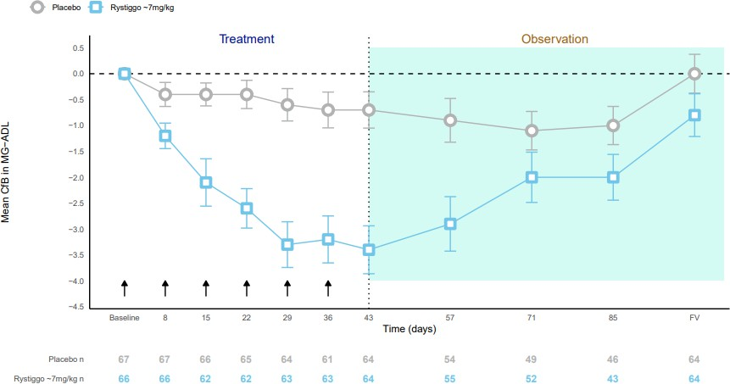

CfB=Change from Baseline; MG−ADL=Myasthenia Gravis Activities of Daily Living; RLZ=Rystiggo

Figure 2: Observed mean change from Baseline in MG-C score (Study MG0003)
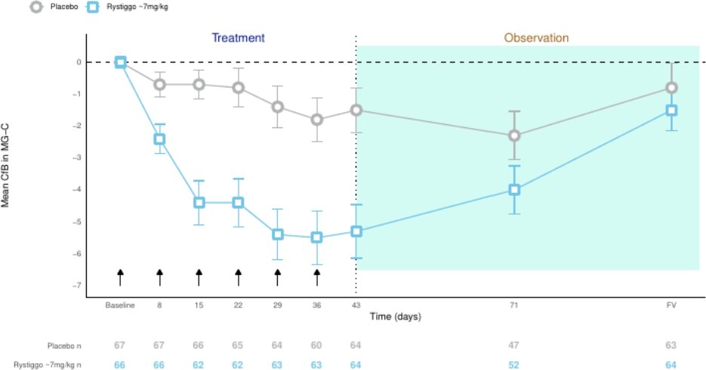
CfB=Change from Baseline; MG−C=Myasthenia Gravis Composite score; RLZ=Rystiggo

Figure 3: Observed mean change from Baseline in QMG score (Study MG0003)
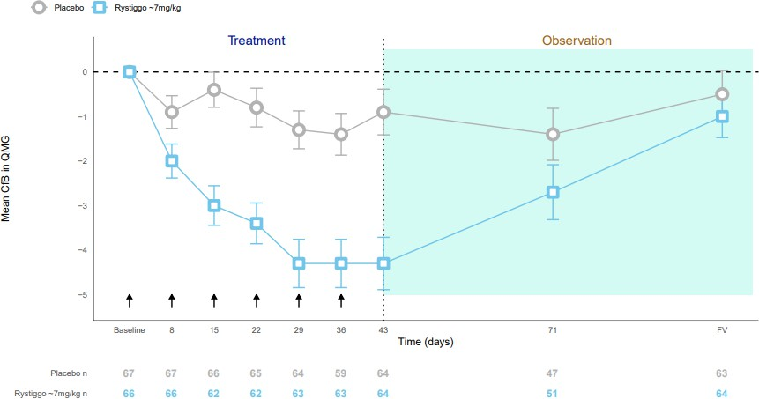

CfB=Change from Baseline; QMG=Quantitative Myasthenia Gravis; RLZ=Rystiggo

Need for rescue therapy
No Rystiggo treated patients and 3 placebo-treated patients received rescue therapy during the treatment period. During the course of the observation period, amongst the patients treated with
≈7 mg/kg, one patient received rescue therapy and 19 patients rolled over early to an open label extension study to receive treatment with Rystiggo.
Efficacy in AChR and MuSK autoantibody positive patients
Subgroup analysis by MG-specific autoantibodies, MuSK+ and AChR+, was performed. Clinical efficacy of Rystiggo was observed for AChR+ and MuSK+ patients with improvements from Baseline in MG-ADL, MG-C and QMG scores that were consistent with the results observed in the overall population.

For the 5 MuSK+ patients who received approximately 7 mg/kg Rystiggo treatment and had data available at Day 43, all were MG-ADL,MG-C and QMG responders. (Table 5).

Table 5: Responder rate in historical MuSK+ patients at Day 43 (Study MG0003)

 | Placebo  (N=7) | Rystiggo ≈7mg/kg  (N=5)
MG-ADL responder, n  (%) | 1 (14.3%) | 5 (100%)
MG-C responder, n (%) | 0 (0%) | 5 (100%)
QMG responder, n (%) | 2 (28.6%) | 5 (100%)
≈ = approximate dose; N=total number of patients in treatment group; n=number of patients.
Historical MuSK+ patients= a confirmed positive record of autoantibodies against MuSK confirmed by the investigator; Percentages are based on the number of patients with non-missing data at Day 43

Efficacy in elderly population
Study MG0003 also evaluated the efficacy of Rystiggo treatment groups versus placebo in elderly patients (≥65 years of age) which represented approximately 26% of the study population. The subgroup analysis of the difference over placebo in the primary endpoint (MG-ADL change from Baseline to Day 43) for the patients of ≥65 years of age was similar to those of <65 years of age for the Rystiggo treatment group: -2.287 (97.5% CI:-5.187; 0.613) versus 2.577 (97.5% CI:-3.960; -
1.195).
Improvements in MG-C and QMG total score to Day 43 for elderly patients were observed.

OLE studies
Study MG0004 evaluated 71 patients to evaluate the safety and efficacy of weekly Rystiggo treatment of up to 52 weeks. Patients were randomised to receive Rystiggo approximating 7 mg/kg or a higher dose. . Enrolment to MG0004 closed when MG0007 was initiated, ongoing patients were eligible to enter MG0007.

Study MG0007 enrolled 165 patients to evaluate the safety and efficacy of repeated cycles of Rystiggo treatment. Treatment consisted of 6 weekly doses followed by an observation period. During the observation period, patients were assessed for worsening symptoms at 4-week intervals. Initiation of additional treatment cycles were based on clinical evaluation of individual MG symptoms. Patients were randomised to receive Rystiggo, approximating 7 mg/kg or a higher dose.

Long-term response to treatment cycles
To assess the efficacy of repeated 6-week cycles of treatment, data from MG0003, MG0007, and MG0004 (first 6 weeks) were pooled and evaluated.

For each 6-week treatment cycle change from Baseline to Day 43 in MG-ADL, QMG and MG-C showed consistent clinically meaningful improvement. At cycle 1 high rates of responders were observed at Day 43 for each score with more than 70% responders for MG-ADL and MG-C and
approximately 70% for QMG. These high response rates were consistently reported following repeated cycles of treatment (Figure 4).

Figure 4: MG-ADL, MG-C, and QMG Response Rate at Day 43 by cycle for the ≈7 mg/kg dose group
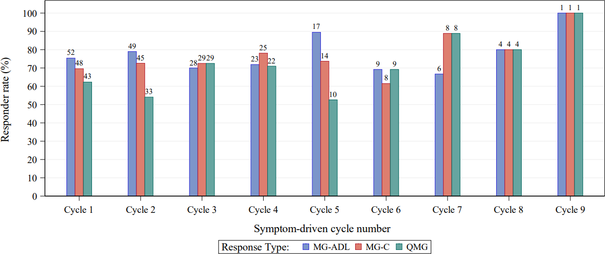
MG-ADL=Myasthenia Gravis-Activities of daily Living; MG-C= Myasthenia Gravis Composite score; QMG=quantitative Myasthenia Gravis
Numbers on top of bar represents the number of patients with a response.
Responder is a patient with an improvement in a particular score from Baseline at the given visit without use of rescue medication.
Results are presented according to the treatment group the participant was assigned to in a respective cycle.

During the first cycle, 18 (26.1%) patients achieved MSE and more than 30% patients reached MSE following repeated cycles of treatment. At least 39% of patients experienced MG-ADL response as early as Day 8 following the first Rystiggo infusion. T Therefore, Rystiggo treatment resulted in consistent clinically meaningful and rapid onset of responses to repeated treatment cycles.

Exposure and treatment-free interval
Analyses were conducted to explore the duration of treatment-free interval corresponding to the time between the end of 1 cycle (last infusion) to the beginning (first infusion) of the next cycle of Rystiggo treatment as driven by symptoms. The estimated median for the first treatment-free interval was approximately 9 weeks. However, shorter treatment-free intervals were observed, the majority of patients had treatment-free intervals between 4 and 13 weeks. From cycle to cycle around 10% of the study patients had a treatment-free interval <4 weeks.

Efficacy in AChR and MuSK autoantibody positive patients
Subgroup analysis in the OLE by MG-specific autoantibodies, MuSK+ and AChR+, was performed. Consistent clinical improvement in MG-ADL, MG-C, and QMG total scores was observed at Day 43 for each cycle.

High MG-ADL, MG-C and QMG responder rates >60% for anti-AChR+ and >80% for anti-MuSK+ patients were observed at Day 43 upon repeated treatment cycles.

PHARMACOKINETIC PROPERTIES

Population PK models were developed based on observed PK and total IgG data from phase 1 and phase 2 studies.

Absorption
Following SC administration of rozanolixizumab, peak plasma levels are achieved after approximately 2 days. The absolute bioavailability of rozanolixizumab after SC administration was approximately 70 % as estimated by population PK analysis.

Distribution
The apparent volume of distribution of rozanolixizumab is approximately 7 L estimated by population PK analysis.

Metabolism
Rozanolixizumab is expected to be degraded into small peptides and amino acids via catabolic pathways in a manner similar to the metabolism of endogenous IgG.

Excretion
The apparent linear clearance for the free drug is approximately 0.9 L/day. The half-life of rozanolixizumab is concentration-dependent and cannot be calculated. Rozanolixizumab plasma concentrations are undetectable within one week after dosing.

Dose linearity
Rozanolixizumab exhibited nonlinear PK typical for a monoclonal antibody that undergoes target- mediated drug disposition.
At steady-state, maximum plasma concentrations and area under the concentration time curve (AUC) were predicted to be 3-fold and 4-fold higher at weight-tiered doses of ≈10 mg/kg as compared to
≈7 mg/kg, respectively.

Special populations
Age, sex, or race
A population PK analysis did not indicate a clinically significant impact of age, sex or race on the PK of rozanolixizumab.

Renal or hepatic impairment
No dedicated studies have been conducted in patients with renal or hepatic impairment. However, renal or hepatic impairment is not expected to affect the PK of rozanolixizumab. Based on a population PK analysis, renal function (estimated glomerular filtration rate [eGFR] 38-161 mL/min/1.73m2) or hepatic biochemical and function tests (ALT, AST, alkaline phosphatase and bilirubin) had no clinically significant effect on rozanolixizumab apparent linear clearance.

Immunogenicity
Development of neutralising antibodies was associated with a 24% decrease in overall plasma exposure of rozanolixizumab. There was no apparent impact of immunogenicity on efficacy and overall safety (see Section 4.8 Adverse Effects (undesirable effects)).

PRECLINICAL SAFETY DATA

Genotoxicity
The genotoxic potential of rozanolixizumab has not been evaluated; however, monoclonal antibodies are not expected to alter DNA or chromosomes.

Carcinogenicity
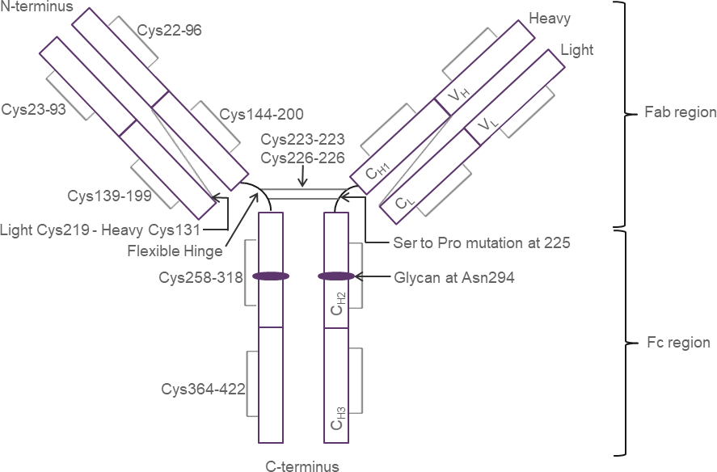
Carcinogenicity studies have not been conducted with rozanolixizumab.

PHARMACEUTICAL PARTICULARS

LIST OF EXCIPIENTS

The inactive ingredients are histidine, histidine hydrochloride monohydrate, proline, polysorbate 80 and water for injection.

INCOMPATIBILITIES
In the absence of compatibility studies, this medicinal product must not be mixed with other medicinal products for infusion.

SHELF LIFE
36 months.

SPECIAL PRECAUTIONS FOR STORAGE

Store in a refrigerator (2-8°C). Do not freeze. Keep the vial in the outer carton in order to protect from light.

NATURE AND CONTENTS OF CONTAINER
Vial (Type I glass) with a rubber stopper sealed with a crimp seal and flip off cap. Pack size of 1 vial.

SPECIAL PRECAUTIONS FOR DISPOSAL
In Australia, any unused medicine or waste material should be disposed of by taking to your local pharmacy.

PHYSICOCHEMICAL PROPERTIES
Chemical Name: Immunoglobulin G4P, anti-FcRn Molecular mass: approximately 147,846 Da
Chemical structure

CAS number
1584645-37-3

MEDICINE SCHEDULE (POISONS STANDARD)
Schedule 4

SPONSOR
UCB Pharma
A division of UCB Australia Pty Ltd Level 1, 1155 Malvern Road Malvern VIC 3144, Australia
Phone: +613 9828 1800
Website: www.ucbaustralia.com.au E-mail: ucbcares.au@ucb.com

DATE OF FIRST APPROVAL
TBC

DATE OF REVISION
Not applicable

SUMMARY TABLE OF CHANGES

Section Changed | Summary of new information
1.0 | Not applicable

