Australian Public Assessment Report for RELFYDESS
  - Active ingredient: RelabotulinumtoxinA
  - Sponsor: Ipsen Pty Ltd
July 2025

About the Therapeutic Goods Administration (TGA)
- The Therapeutic Goods Administration (TGA) is part of the Australian Government Department of Health, Disability and Ageing and is responsible for regulating therapeutic goods, including medicines, medical devices, and biologicals.
- The TGA administers the Therapeutic Goods Act 1989 (the Act), applying a risk management approach designed to ensure therapeutic goods supplied in Australia meet acceptable standards of quality, safety, and efficacy.
- The work of the TGA is based on applying scientific and clinical expertise to decision-making, to ensure that the benefits to the Australian public outweigh any risks associated with the use of therapeutic goods.
- The TGA relies on the public, healthcare professionals and industry to report problems with therapeutic goods. The TGA investigates reports received to determine any necessary regulatory action.
- To report a problem with a therapeutic good, please see the information on the TGA website.

About AusPARs
- The Australian Public Assessment Report (AusPAR) provides information about the evaluation of a prescription medicine and the considerations that led the TGA to approve or not approve a prescription medicine submission. Further information can be found in Australian Public Assessment Report (AusPAR) guidance.
- AusPARs are prepared and published by the TGA.
- AusPARs are static documents that provide information that relates to a submission at a particular point in time. The publication of an AusPAR is an important part of the transparency of the TGA’s decision-making process.
- A new AusPAR may be provided to reflect changes to indications or major variations to a prescription medicine subject to evaluation by the TGA.

Copyright
© Commonwealth of Australia 2025
This work is copyright. You may reproduce the whole or part of this work in unaltered form for your own personal use or, if you are part of an organisation, for internal use within your organisation, but only if you or your organisation do not use the reproduction for any commercial purpose and retain this copyright notice and all disclaimer notices as part of that reproduction. Apart from rights to use as permitted by the Copyright Act 1968 or allowed by this copyright notice, all other rights are reserved and you are not allowed to reproduce the whole or any part of this work in any way (electronic or otherwise) without first being given specific written permission from the Commonwealth to do so. Requests and inquiries concerning reproduction and rights are to be sent to the TGA Copyright Officer, Therapeutic Goods Administration, PO Box 100, Woden ACT 2606 or emailed to <tga.copyright@tga.gov.au>.

Contents
List of abbreviations 4
RELFYDESS (relabotulinumtoxinA) submission 5
Proposed indication 6
The condition 6
Current treatment options 6
Clinical rationale 7
Regulatory status 7
Australian regulatory status 7
International regulatory status 7
Registration timeline 7
Assessment overview 8
Quality evaluation summary 8
Nonclinical evaluation summary 8
Clinical evaluation summary 9
Summary of clinical studies 9
Pharmacology 9
Efficacy 10
Safety 19
Risk Management Plan (RMP) evaluation summary 21
Risk-benefit analysis 22
Efficacy 22
Safety 23
Uncertainties and limitations of the data 23
Assessment outcome 23
Specific conditions of registration 23
Product Information and Consumer Medicines Information 25

List of abbreviations
Abbreviation | Meaning
ACM | Advisory Committee on Medicines
AE | adverse event(s)
ARTG | Australian Register of Therapeutic Goods
ASA | Australia-specific annex
CMI | Consumer Medicines Information
DP | drug product
DS | drug substance
FLTSQ | Facial Lines Treatment Satisfaction Questionnaire
GL | glabellar lines
GL-ILA | Glabellar Lines Investigator Live Assessment
GL-SLA | Glabellar Lines Subject Live Assessment
ITT | intention to treat
KM | Kaplan-Meier
LCL | lateral canthal lines
LCL-ILA | lateral canthal lines Investigator Live Assessment
LCL-SLA | lateral canthal lines subject Live Assessment
mITT | modified intention-to-treat
PI | Product Information
PK | Pharmacokinetic(s)
PSUR | Periodic safety update report
RBTA | relabotulinumtoxinA
RMP | Risk management plan
SD | Standard deviation
TEAE | treatment-emergent adverse event(s)
TGA | Therapeutic Goods Administration

RELFYDESS (relabotulinumtoxinA) submission
Type of submission: | New biological entity
Product name: | RELFYDESS
Active ingredient: | relabotulinumtoxinA
Decision: | Approved
Date of decision: | 7 June 2024
Date of entry onto ARTG: | 1 July 2024
ARTG number: | 405864
Black Triangle Scheme | Yes
Sponsor’s name and address: | Ipsen Pty Ltd  Level 5, 627 Chapel Street South Yarra, VIC 3141
Dose form: | Solution for Injection
Strength: | 100 units/mL
Container: | 2 mL Type I glass vial, bromobutyl stopper and aluminium overseal with polypropylene flip-off top. Each vial contains 150 units of botulinum toxin type A in 1.5 mL of solution.
Pack size: | 1 or 10 vials
Approved therapeutic use for the current submission: | RELFYDESS is indicated in adult patients for the temporary improvement in the appearance of:  - Moderate to severe glabellar lines at maximum frown  - Moderate to severe lateral canthal lines seen at maximum smile.
Route of administration: | Intramuscular injection
Dosage: | For further information regarding dosage, refer to the Product Information.
  Treatment(s) | Total Recommended Dose | Dose per injection
  Glabellar Lines (GL) | 50 units/0.5 mL | 5 injections of 10 units/0.1 mL: 2 injections on each side at the corrugator muscle and 1 injection at the procerus muscle near the nasofrontal angle
  Lateral Canthal Lines (LCL) | 60 units/0.6 mL | 6 injections of 10 units/0.1 mL: 3 injections on each side at the orbicularis oculi muscle
  Combined treatment of GL and LCL | 110 units/1.1 mL | 11 injections total of 10 units/0.1 mL for combined GL and LCL
Pregnancy category: | Category B3  Drugs which have been taken by only a limited number of pregnant women and women of childbearing age, without an increase in the frequency of malformation or other direct or indirect harmful effects on the human fetus having been observed.  Studies in animals have shown evidence of an increased occurrence of fetal damage, the significance of which is considered uncertain in humans.  The use of any medicine during pregnancy requires careful consideration of both risks and benefits by the treating health professional. The pregnancy database must not be used as the sole basis of decision making in the use of medicines during pregnancy. The TGA does not provide advice on the use of medicines in pregnancy for specific cases. More information is available from obstetric drug information services in your state or territory.

Proposed indication
This AusPAR describes the submission by Ipsen Pty Ltd (the sponsor) to register RELFYDESS (relabotulinumtoxinA) for the following proposed indication:
Moderate to severe glabellar lines at maximum frown
Moderate to severe lateral canthal lines seen at maximum smile alone or in combination.

The condition
Glabellar lines (GL) are caused by contraction of the corrugator muscles above the eyebrows and lateral canthal lines (LCL) are caused by basal tone or spasm of the lateral orbicularis oculi muscles at rest, and by a combination of the zygomaticus, elevator and orbicularis oculi groups at smiling.

Current treatment options
Treatment of GL and/or LCL is performed for cosmetic reasons. Botulinum toxin products registered in Australia for the treatment of GL and/or LCL include:
- BOTOX (botulinum toxin type A, onabotulinumtoxinA): for the temporary improvement in the appearance of upper facial rhytides (glabellar lines, crow’s feet and forehead lines) in adults.
- DYSPORT (clostridium botulinum type A toxin - haemagglutinin complex): for the treatment of moderate to severe glabellar lines and/or lateral canthal lines (crow’s feet) in adults.
- XEOMIN (incobotulinumtoxinA): for the treatment of upper facial lines in adults (glabellar frown lines, lateral periorbital lines (crow’s feet), horizontal forehead lines).
- NUCEIVA (prabotulinumtoxinA): for the temporary improvement in the appearance of moderate to severe glabellar lines in adult patients.
- LETYBO (letibotulinumtoxinA): indicated for the temporary improvement in the appearance of moderate to severe glabellar frown lines in adults.

Clinical rationale
The mechanism of action of botulinum toxin is well characterised. It is a neuromuscular blocking agent which, when injected into muscle, acts by blocking the release of acetylcholine from the presynaptic neuronal synapse. Return of muscle function depends on regrowth of the axon terminals and takes approximately 3 months.

Regulatory status

Australian regulatory status
This product is considered a new biological entity for Australian regulatory purposes.

International regulatory status
At the time the TGA considered this submission, a similar submission was under consideration in The United States of America (submitted 29 September 2022), Canada (submitted 8 February 2023), the European Union (submitted 24 July 2023) and Switzerland (submitted 29 October 2023).
Regarding terminology, during the clinical development phase, Relfydess was referred to as QM1114/QM1114-DP (the company code name) and this terminology has been used in certain documents such as the clinical study protocols, clinical study reports and the marketing authorization application documents. It contains the active substance botulinum toxin type A (known as in the EU) or relabotulinumtoxinA (United States Adopted Name [USAN] as known in Australia and used in certain scientific publications).

Registration timeline
Table 1 captures the key steps and dates for this submission.
This submission was evaluated under the standard prescription medicines registration process.
Table 1: Timeline for RELFYDESS (relabotulinumtoxinA), submission PM-2023-00708-1-1
Description | Date
Submission dossier accepted and evaluation commenced | 31 March 2023
Evaluation completed | 1 November 2023
Registration decision (Approved) | 7 June 2024
Registration in the ARTG completed | 1 July 2024
Number of working days from submission dossier acceptance to registration decision* | 458
*Statutory timeframe for standard submissions is 255 working days

Assessment overview

Quality evaluation summary
RELFYDESS (relabotulinumtoxinA) 100 units/mL is formulated as a ready-to-use solution for injection. All currently registered botulinum toxin type A products are formulated as a lyophilised powder and require reconstitution with sterile diluent prior to use.
The drug substance (DS) is a purified Clostridium botulinum type A1 neurotoxin with a molecular weight of approximately 150 kDa consisting of two protein subunits – a 100 kDa heavy chain and a 50 kDa light chain, connected by a disulphide bond of two cysteine residues. The DS is free from complexing proteins and animal or human derived proteins. The DS was well characterised for structure, physicochemical properties, purity, and biological activity using various analytical procedures. The process- and product-related impurities were characterised with appropriate analytical procedures and controls.
The drug product (DP) is supplied as a sterile, single-use preservative-free solution for intramuscular injection. Each vial of RELFYDESS contains relabotulinumtoxinA 150 units in 1.5 mL of solution for injection. The formulation also contains sodium acetate, sodium chloride, sodium phosphate, and polysorbate 20 in water for injections. No reconstitution is required. The physicochemical and biological properties of the DP relevant to the safety, clinical performance and manufacturability of the DP were identified and appropriately characterised or controlled in accordance with ICH guidelines. Overall, DP batches tested were comparable and there were no site- or scale-specific trends noted for any of the attributes tested. The compatibility of finished product was acceptably demonstrated by the extractables and leachables study and stability data. The release and stability specifications for the DS and DP are suitable for control of commercial lots.
All manufacturing sites responsible for all steps of the DS and DP manufacture are performed by previously authorised Good Manufacturing Practice facilities, and all clearances are up to date.
The proposed trade name RELFYDESS is acceptable. The Product Information (PI) is acceptable from a quality perspective. The product labels are in accordance with Therapeutic Goods Order No. 91 – Standard for labels of prescription and related medicines (TGO 91). Requirements with respect to container safety, infectious disease/viral safety, endotoxins, and microbiology/sterility have been met.
There are no significant issues identified from the quality evaluation of the submitted data that would indicate the product should not be registered. The manufacturing quality data submitted by the Sponsor support the registration of RELFYDESS relabotulinumtoxinA.

Nonclinical evaluation summary
The set of nonclinical studies submitted by the sponsor (2 in vivo pharmacodynamic and 4 toxicity studies) is adequate for this application given the extensive knowledge of the toxicity profile and clinical experience with Clostridium botulinum type A neurotoxin products. RelabotulinumtoxinA is of the same serotype and has the same amino acid sequence as onabotulinumtoxinA, the active ingredient in BOTOX (OnabotulinumtoxinA), however RelabotulinumtoxinA does not have any complexing proteins and therefore a lower molecular weight of 150kDa compared to approximately 900kDa of OnabotulinumtoxinA including its complexing proteins.
Two different Master Cell Banks (MCBs) were used during the non-clinical testing. 100315 MCB A was used in the single dose toxicity studies and subsequently it was replaced by MCB QM01 that was used in the repeat-dose toxicity study, local ocular tolerance study, and Phase I clinical study. The quality evaluator has reviewed the analytical comparability data and confirmed the comparability of 100315 MCB A and MCB QM01.
The set of toxicity studies submitted was similar to that for the registered botulinumtoxinA products. No new safety concerns are raised in regard to the formulation.
Adverse embryofetal developmental effects, likely secondary to maternotoxicity, have been reported in animal studies with other botulinum toxin A products. Therefore, relabotulinumtoxinA should be classified in the same pregnancy category as other botulinum toxin A products (Pregnancy Category B3).
There is no nonclinical objection to the registration of RELFYDESS.

Clinical evaluation summary

Summary of clinical studies
The clinical dossier included six clinical trials:
- one Phase 1 dose-escalation study: 43QM1302.
- one Phase 2 dose-finding study: 43QM1313.
- three Phase 3, placebo-controlled, single treatment, efficacy and safety studies: 43QM1602, 43QM1901, 43QM1902.
- one Phase 3, open label, single-arm, long-term, repeated treatment study: 43QM1903.
Integrated analyses of cardiac safety, immunogenicity, safety and efficacy were also included. The formulation used in the clinical trials was the same as the proposed commercial formulation. The clinical evaluator has no objection to the registration of RELFYDESS.

Pharmacology

Pharmacokinetics
There were no clinical pharmacokinetic (PK) studies because the product is injected in nanogram amounts into the target muscle and is not systemically detectable.

Dose finding studies
Dose selection for the pivotal studies was informed by findings from two dose finding studies: 43QM1302 and 43QM1313.
Study 43QM1302 was a Phase I, randomised, double-blind, placebo-controlled, single-treatment, dose escalation study of relabotulinumtoxinA in healthy adults with moderate to severe upper face wrinkles. The study evaluated four dose levels: 2 units/injection site, total dose 10 units; 5 units/injection site, total dose 25 units; 10 units/injection site, total dose 50 units; 15 units/injection site, total dose 75 units. Effect was similar for the dose range 10 to 75 units for GL, but adverse effects, including eyelid ptosis, were more apparent with 75 units.
Study 43QM1313 was a Phase II, randomised, double-blind, placebo-controlled, single-treatment, dose evaluation study in healthy adults with moderate to severe GL. The effect over time profiles were similar for the three dose levels (6 units/injection site, total dose 30 units; 9 units/injection site, total dose 45 units; 12 units/injection site, total dose 60 units). The effect peaked at Day 14 and decreased through to Month 6. There was a noticeable decrease in effect from Month 3 post-dose, by which time effect had approximately halved.
Based on efficacy and safety findings from these studies, the dose selected for the treatment of GL in the pivotal studies was 50 units, comprising five injections of 10 units (0.1 mL). 10 units per injection was also selected for LCL, for a total dose of 60 units per treatment (3 injections on each side of the face).

Efficacy
There were 3 pivotal efficacy studies (43QM1602, 43QM1901, 43QM1902) and two supportive efficacy studies (43QM1313, 43QM1903).

Study 43QM1602 (GL)
This was a Phase 3, randomised, double-blind, placebo-controlled study to evaluate the efficacy and safety of a single dose of relabotulinumtoxinA (RBTA) for the treatment of moderate to severe GL. The study was conducted at 10 centres (9 in USA, 1 in Canada) from February 2020 to January 2021. The primary efficacy objective was to evaluate a single dose of 50 U of RBTA compared to placebo for the treatment of moderate-to-severe glabellar lines using the validated Glabellar Lines Investigator Live Assessment (GL-ILA) 4-Point photographic scale at maximum frown.
The study included male or female subjects 18 years of age or older with moderate-to-severe GL, assessed as grade 2 or 3 on the 4-Point Photographic Scale ranging from 0 [none] to 3 [severe] at maximum frown as assessed by the investigator (GL-ILA) and grade 2 or 3 on the Static 4-Point Categorical Scale ranging from 0 [no wrinkles] to 3 [severe wrinkles] at maximum frown as assessed by the subject (GL-SLA). Subjects with previous use of any botulinum toxin in facial areas within 9 months of study treatment were excluded.
Study treatment was a single dose of RBTA 50 units (0.5 mL) divided into 5 equal aliquots of 10 units (0.1 mL) or matching placebo injected by the Investigator into 5 sites in the glabellar region (Figure 1). Prior to injection, the treatment area was cleaned with a suitable antiseptic solution. An appropriately sized syringe and needle (30-33 gauge) was used to administer treatment.
Figure 1: Injection Sites for Treating Glabellar Lines
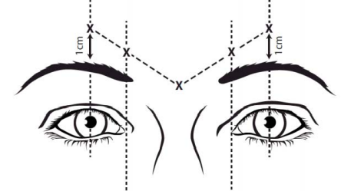
Following injection of study product, all subjects were monitored for safety and efficacy for 6 months. Study visits were conducted at screening, baseline, Days 7 and 14, and monthly (every 30 days) through Month 6 or premature discontinuation.
340 subjects were screened, 300 were randomised (225 to RBTA and 75 to placebo), and 297 received study treatment (3 in the RBTA group did not receive study treatment). 210 (93.3%) in the RBTA group and 66 (88.0%) in the placebo group completed the study. Seven subjects (4 RBTA and 3 placebo) terminated the study prior to Month 1 and 6 subjects (4 RBTA and 2 placebo) had a Month 1 visit out of window or missed the Month 1 visit. Each of the Month 1 out of window visit deviations was due to COVID-19. These subjects were excluded from the per protocol analysis.
The primary efficacy analysis was based on the modified intention-to-treat (mITT) population and all secondary efficacy and exploratory variables were analysed based on the ITT population. The mITT population excluded subjects with a photographic and categorical scale Month 1 assessment via a remote visit. 199 (88.4%) subjects in the RBTA group and 67 (89.3%) in the placebo were included in the mITT population.
There were 268 (90.2%) females and 29 (9.8%) males and the age range was 21 to 81 years. The treatment groups were balanced in demographic and baseline characteristics. 163 (54.9%) subjects reported prior botulinum toxin use. At baseline, 61 (20.5%) subjects were grade 2 (moderate) and 236 (79.5%) were grade 3 (severe) on the GL-ILA 4-point Photographic Scale at maximum frown, and 97 (32.7%) subjects were grade 2 (moderate) and 200 (67.3%) were grade 3 (severe) on the GL-SLA Static 4-point Categorical Scale at maximum frown.
The primary efficacy endpoint was the responder rate at Month 1, with a responder defined as a subject who achieved a score of 0 or 1 on the GL-ILA 4-Point Photographic Scale at maximum frown at Month 1. The secondary efficacy endpoints were:
- Facial Lines Treatment Satisfaction Questionnaire (FLTSQ, Appearance Module) change from baseline in Rasch-transformed total scores at Month 1.
- time to onset of treatment response based on the subject’s diary card.
- FACE-Q Psychological Function Scale change from baseline in Rasch-transformed total scores at Month 1.
- time to loss of a score of 0 or 1 on both the GL-ILA and GL-SLA at maximum frown.
- percentage of subjects who achieved a score of 0 or 1 at each post-treatment visit using the GL-ILA at maximum frown.
There were also numerous exploratory endpoints which are described in the evaluation report.
The study met its primary endpoint. At Month 1, there were 192 (96.3%) responders in the RBTA group compared to 3 (4.5%) in the placebo group, a treatment difference of 91.8% (95% CI 86.17, 97.44, p <0.001). No significant subgroup effects were observed for age, study centre, Fitzpatrick skin type, baseline severity, or prior botulinum toxin use. The responder rate was higher in female than male subjects (97.7% vs 82.2%) but this was based on only 24 male subjects, of whom 18 received RBTA and 6 received placebo.
The secondary efficacy outcomes were:
- The mean (SD) change from baseline in subject satisfaction at Month 1 using the FLTSQ was 34.5 (19.54) for RBTA and 1.8 (11.80) for placebo.
- The median number of days to treatment response based on the subject diary card was 2.0 days in the RBTA group and non-evaluable in the placebo group.
- The mean (SD) change from baseline at Month 1 in psychological impact using the FACE-Q Psychological Function Scale was 13.5 (21.84) for RBTA and 0.6 (23.46) for placebo.
- The Kaplan-Meier (KM) median (95% CI) duration of response using time to loss of a score of 0 or 1 on both the GL-ILA and GL-SLA at maximum frown was 168.0 (165.0 to 170.0) days in the RBTA group and 113 (29.0 to 167.0) days in the placebo group.
- There was a greater percentage of subjects in the RBTA group who achieved a score of 0 or 1 at each post-treatment visit using the GL-ILA at maximum frown from Day 7 through to Month 6 (Figure 2).
Figure 2: Responder Rate Based on the GL-ILA 4-Point Photographic Scale at Maximum Frown Over Time (Intention-to-Treat Population)
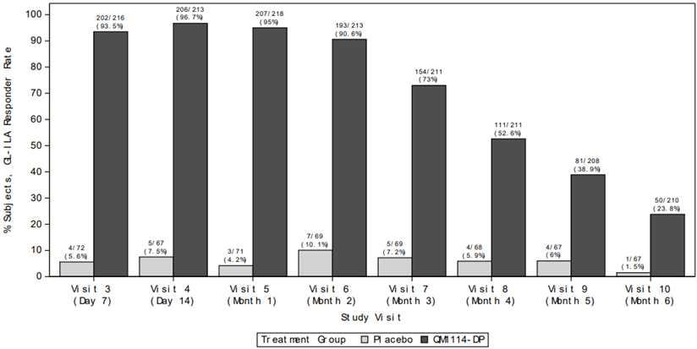

Study 43QM1901 (LCL)
This was a Phase 3, randomised, double-blind, placebo-controlled study to evaluate the efficacy and safety of a single dose of RBTA for the treatment of moderate-to-severe LCL. The study was conducted at 10 centres (8 in USA, 2 in Canada) from February 2020 to February 2021. The primary efficacy objective was to evaluate a single dose of 60 U of RBTA compared to placebo for the treatment of moderate-to-severe lateral canthal lines using the lateral canthal lines Investigator Live Assessment (LCL-ILA) 4-Point Photographic Scale at maximum smile.
The study included male or female subjects 18 years of age or older with moderate-to-severe bilaterally symmetrical LCL, grade 2 or 3 on the 4-Point Photographic Scale at maximum smile as assessed by the Investigator (LCL-ILA), and level 2 or 3 on the 4-Point Photographic Scale ranging from 0 [none] to 3 [severe] at maximum smile as assessed by the subject (LCL-SLA). Subjects with previous use of any botulinum toxin in facial areas within 9 months of study treatment were excluded.
Study treatment was a single dose of RBTA 60 units (0.6 mL) divided into 6 equal aliquots of 10 units (0.1 mL) or matching placebo injected by the Investigator into 3 sites in the lateral canthal area on each side of the face (Figure 3). Option 1 was used if lines were both above and below the lateral canthus and option 2 was used if lines were mainly below the lateral canthus. Prior to injection, the treatment area was cleaned with a suitable antiseptic solution. An appropriately sized syringe and needle (30-33 gauge) was used to administer treatment.
Figure 3: Injection Sites for Treating Lateral Canthal Lines
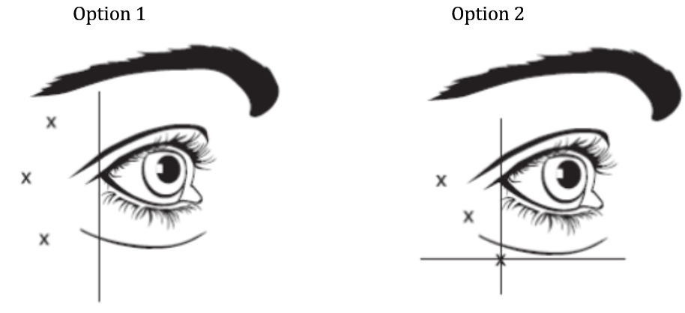
Following injection of study product, all subjects were monitored for safety and efficacy for 6 months. Study visits were conducted at screening, baseline, Days 7 and 14, and monthly (every 30 days) through Month 6 or premature discontinuation.
314 subjects were screened, 303 were randomised and received treatment (230 in the RBTA group and 73 in the placebo group). 223 (97.0%) in the RBTA group and 67 (91.8%) in the placebo group completed the study. The most common protocol deviation was an out-of-window visit, and many of these were due to COVID-19.
There were 263 (86.8%) females and 40 (13.2%) males and the age range was 24 to 75 years. The treatment groups were balanced in demographic and baseline characteristics. 163 (54.9%) subjects reported prior botulinum toxin use. At baseline, 175 (57.8%) subjects were grade 2 (moderate) and 128 (42.2%) were grade 3 (severe) on the LCL-ILA 4-point Photographic Scale at maximum smile.
The primary efficacy analysis was based on the mITT population and all secondary efficacy and exploratory variables were analysed based on the ITT population. The mITT population excluded subjects with a photographic and categorical scale Month 1 assessment via a remote visit. 204 (88.7%) subjects in the RBTA group and 69 (94.5%) in the placebo were included in the mITT population.
The primary efficacy endpoint was the responder rate at Month 1, with a responder defined as a subject who achieved a score of 0 or 1 on the LCL-ILA 4-Point Photographic Scale at maximum smile at Month 1 for both left and right sides. The secondary efficacy endpoints were:
- FLTSQ (Appearance Module) change from baseline in Rasch-transformed total scores at Month 1.
- time to onset of treatment response based on the subject’s diary card.
- FACE-Q Psychological Function Scale change from baseline in Rasch-transformed total scores at Month 1.
- time to loss of a score of 0 or 1 on both the LCL-ILA and LCL-SLA at maximum smile.
- percentage of subjects who achieved a score of 0 or 1 at each post-treatment visit using the LCL-ILA at maximum frown.
The study met its primary endpoint. At Month 1, there were 178 (87.2%) responders in the RBTA group compared to 8 (11.9%) in the placebo group, a treatment difference of 75.3% (95% CI 66.14, 84.41, p <0.001). No significant subgroup effects were observed for age, study centre, gender, Fitzpatrick skin type, baseline severity, or prior botulinum toxin use.
The secondary efficacy outcomes were:
- The mean (SD) FLTSQ (Appearance Module) change from baseline in Rasch-transformed total scores at Month 1 was 29.0 (21.97) for RBTA and 2.0 (12.48) for placebo.
- The KM median (95% CI) time to onset based on the subject’s diary card was 2.0 (2.0 to 3.0) for RBTA, and not evaluable for placebo.
- The mean (SD) FACE-Q Psychological Function change from baseline in Rasch-transformed total scores at Month 1 was 14.0 (20.21) for RBTA and 0.9 (14.71) for placebo.
- The KM median (95% CI) time to loss of a grade/level of 0 or 1 on both the LCL-ILA and lateral canthal lines Subject Live Assessment (LCL-SLA) at maximum smile was 162 (140.0 to 168.0) days for RBTA and not estimable for placebo.
- There was a greater percentage of subjects in the RBTA group who achieved a score of 0 or 1 at the same visit for both left and right sides at each post-treatment visit using the LCL-ILA at maximum frown at all study visits from Day 7 through to Month 6 (Figure 4).
Figure 4: Responder Rate Based on the LCL-ILA 4-Point Photographic Scale at Maximum Smile Over Time (ITT Population)
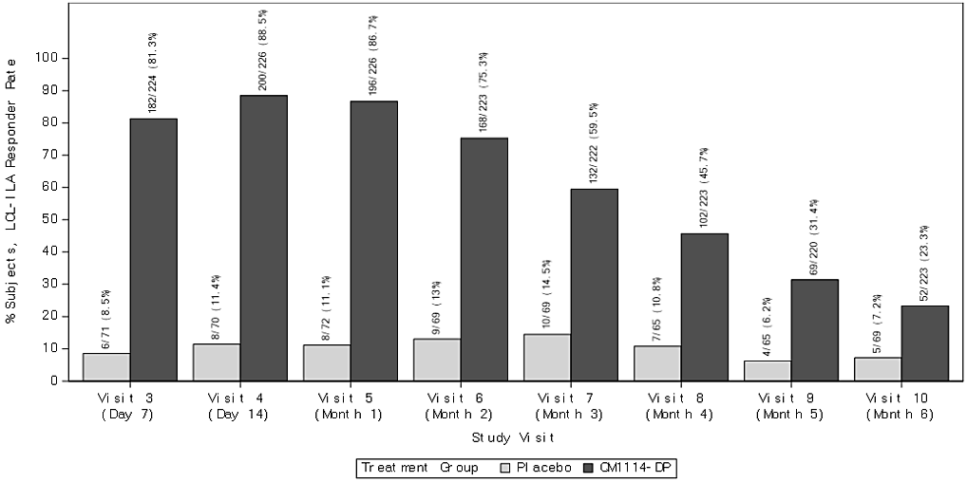

Study 43QM1902 (LCL & GL)
This was a Phase 3, randomised, double-blind, placebo-controlled study to evaluate the efficacy and safety of a single dose of RBTA for the treatment of moderate-to-severe LCL and GL alone or in combination. The study was conducted at 12 centres (11 in USA and 1 in Canada) from February 2020 to March 2021.
The primary efficacy objective of this study was to evaluate the efficacy of a single dose of 60 U of RBTA in the lateral canthal lines and 50 U of RBTA in the glabellar lines, alone or in combination, compared to placebo for the treatment of moderate-to-severe LCL using the LCL-ILA at maximum smile and for the treatment of GL using the validated GL-ILA at maximum frown.
The study included male or female subjects ≥18 years with moderate-to-severe bilaterally symmetrical LCL (grade of 2 or 3 on the 4-Point Photographic Scale) at maximum smile as assessed by the Investigator (LCL-ILA), bilaterally symmetrical LCL graded as level 2 or 3 on the 4-Point Photographic Scale at maximum smile as assessed by the subject (LCL-SLA), moderate-to-severe GL (grade of 2 or 3 on the 4-Point Photographic Scale) at maximum frown as assessed by the Investigator (GL-ILA), and moderate-to-severe GL (grade of 2 or 3 on the Static 4-Point Categorical Scale) at maximum frown as assessed by the subject (GL-SLA). Subjects with previous use of any botulinum toxin in facial areas within 9 months of study treatment were excluded.
Study treatments were:
- RBTA 50 units in the GL region and placebo in the LCL areas.
- RBTA 60 units in the LCL areas and placebo in the GL region.
- RBTA 60 units in the LCL areas and 50 units in the GL region.
- placebo in both the LCL areas and GL region.
Prior to injection, the treatment area was cleaned with a suitable antiseptic solution. An appropriately sized syringe and needle (30-33 gauge) was used to administer treatment. Study treatment was injected by the Investigator in the same manner as described in Studies 43QM1602 for GL and 43QM1901 for LCL.
436 subjects were screened, 413 were randomised (121 to GL/LCL-placebo, 118 to LCL/GL-placebo, 115 to LCL/GL, and 59 to placebo only) and 412 received study treatment. 386 (93.5%) subjects completed the study: 116 (95.9%) in the GL/LCL-placebo group, 111 (94.1%) in the GL-placebo/LCL group, 107 (93.0%) in the GL/LCL group and 52 (88.1%) in the placebo only group. In the mITT population as randomised, there were 106 subjects in the GL/LCL-placebo group, 117 in the GL-placebo/LCL group, 108 in the GL/LCL group, and 55 in the placebo only group. In the ITT population as randomised, there were 113 subjects in the GL/LCL-placebo group, 126 in the GL-placebo/LCL group, 115 in the GL/LCL group, and 58 in the placebo only group.
Overall, there were 368 (89.3%) females and 44 (10.7%) males and the age range was 23 to 78 years. The treatment groups were balanced in demographic and baseline characteristics. 263 (63.8%) subjects reported prior botulinum toxin use. Of 286 subjects with GL, 86 (30.1%) were grade 2 (moderate) and 200 (69.9%) were grade 3 (severe) on the GL-ILA 4-point photographic scale at maximum frown. Of 299 subjects with LCL, 172 (57.5%) were grade 2 (moderate) and 127 (42.5%) were grade 3 (severe) on the LCL-ILA 4-point photographic scale at maximum smile on the left and right sides.
Pandemic-related study disruption impacted 11 study sites. There were 567 protocol deviations, of which 177 (31.2%) were related to COVID-19. The shelter-in-place mandate prevented in-clinic study visits from being conducted on 111 subjects (remote study visits conducted) and resulted in 6 missed study visits and 64 out-of-window visits for those subjects.
The two co-primary efficacy endpoints were:
- Responder rate for GL-ILA 4-Point Photographic Scale at maximum frown at Month 1, with a responder defined as a subject who achieved a score of 0 or 1 on the GL-ILA scale at Month 1.
- Responder rate for LCL-ILA 4-Point Photographic Scale at maximum smile at Month 1, with a responder defined as a subject who achieved a score of 0 or 1 on the LCL-ILA scale at Month 1 for both left and right sides.
The secondary efficacy outcome measures were:
- FLTSQ (Appearance Module) change from baseline in Rasch-transformed total scores at Month 1.
- Time to onset of treatment response based on the subject’s diary card.
- FACE-Q Psychological Function change from baseline in Rasch-transformed total scores at Month 1.
- Time to loss of score of 0 or 1 on both the GL-ILA and GL-SLA at maximum frown.
- Time to loss of score/level of 0 or 1 on both the LCL-ILA and LCL-SLA at maximum smile.
- % of subjects who achieved a score of 0 or 1 at each post-treatment visit using the GL-ILA at maximum frown.
- % of subjects who achieved a score of 0 or 1 at the same visit for both left and right sides summarised for each post-treatment visit using the LCL-ILA at maximum smile.
The primary efficacy analysis was based on the mITT population as randomised and the secondary efficacy and exploratory analyses were based on the ITT population as randomised. The mITT population excluded subjects with a photographic and categorical scale Month 1 assessment via a remote visit. For the co-primary efficacy analyses, the responder rates were compared using the Cochran-Mantel-Haenszel test stratified by site at the 5% significance level (2-sided). To control the type I error rate among the 4 primary efficacy comparisons, a fixed sequence testing procedure was used, which required no adjustment to the level of significance: 1. GL alone vs placebo on the GL scale, 2. GL and LCL vs placebo on the GL scale, 3. LCL alone vs placebo on the LCL scale, 4. GL and LCL vs placebo on the LCL scale.
RBTA was superior to placebo for both co-primary endpoints (Table 2 for GL-ILA responder rate, Table 3 for LCL-ILA responder rate), for the treatment of GL/LCL alone and in combination.
Table 2: Month 1 Responder Rate Based on the GL-ILA 4-Point Photographic Scale at Maximum Frown (Modified Intent-to-Treat Population as Actually Randomised)
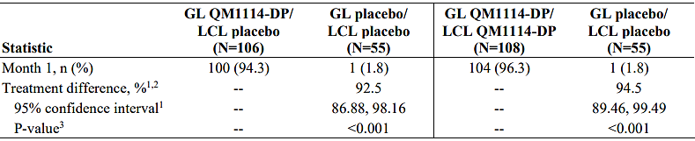
1. 95% confidence interval for responder rates and difference were calculated using the normal approximation (Wald) method.
2. Difference = QM1114-DP responder rate – placebo responder rate (where difference >0 indicated a higher percentage of responders in the QM1114-DP group). 3 P-value was from the Cochran-Mantel-Haenszel test stratified by site.
Table 3: Month 1 Responder Rate Based on the LCL-ILA 4-Point Photographic Scale at Maximum Smile (Modified Intent-to-Treat Population as Actually Randomised)
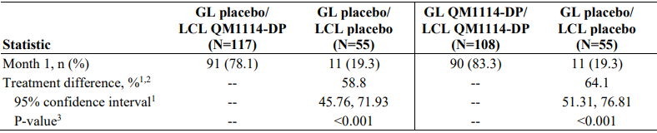
1. 95% confidence interval for responder rates and difference were calculated using the normal approximation (Wald) method.
2. Difference = QM1114-DP responder rate – placebo responder rate (where difference >0 indicated a higher percentage of responders in the QM1114-DP group). 3 P-value was from the Cochran-Mantel-Haenszel test stratified by site.
Subgroup analyses of the co-primary endpoints based on age, study site, skin type, gender, baseline severity, and prior botulinum toxin use generally showed similar treatment effects, noting that the size of some of the subgroups was small.
The results for the secondary efficacy outcome measures were:
- The mean (SD) GL FLTSQ (Appearance Module) change from baseline in Rasch-transformed total scores at Month 1 was 30.5 (22.70) for GL/LCL-placebo, 7.6 (20.34) for GL-placebo/LCL, 32.5 (22.56) for GL/LCL and 0.4 (9.69) for placebo only.
- The mean (SD) LCL FLTSQ (Appearance Module) change from baseline in Rasch-transformed total scores at Month 1 was 9.2 (21.66) for GL/LCL-placebo, 21.8 (25.72) for GL-placebo/LCL, 33.3 (24.11) for GL/LCL and 1.1 (14.34) for placebo only.
- The KM median (95% CI) time to onset of GL treatment response based on the subject’s diary card was 2.0 (2.0 to 3.0) days for GL/LCL-placebo, 3.0 (2.0 to 3.0) days for GL/LCL and was inestimable for placebo only.
- The KM median (95% CI) time to onset of LCL treatment response based on the subject’s diary card was 3.0 (3.0 to 4.0) days for GL-placebo/LCL, 4.0 (3.0 to 4.0) days for GL/LCL and was inestimable for placebo only.
- The mean (SD) FACE-Q Psychological Function change from baseline in Rasch-transformed total scores at Month 1 was 11.5 (21.16) for GL/LCL-placebo, 2.3 (20.92) for GL-placebo/LCL, 15.2 (23.09) for GL/LCL and -5.3 (21.18) for placebo only.
- The KM median (95% CI) time to loss of score of 0 or 1 on both the GL-ILA and glabellar lines Subject Live Assessment (GL-SLA) at maximum frown was 139.0 (117.0 to 145.0) days for GL/LCL-placebo, 140.0 (115.0 to 165.0) days for GL/LCL and 71.0 (56.0 to 86.0) for placebo only.
- The KM median (95% CI) time to loss of score/level of 0 or 1 on both the LCL-ILA and lateral canthal lines Subject Live Assessment (LCL-SLA) at maximum smile was 140.0 (135.0 to 164.0) days for GL-placebo/LCL, 142.0 (136.0 to 166.0) days for GL/LCL and 84.0 (15.0 to NE) for placebo only.
- There was a greater percentage of subjects who achieved a score of 0 or 1 at each post-treatment visit using the GL-ILA at maximum frown from Day 7 to Month 6 in the GL/LCL-placebo and GL/LCL groups compared with placebo only.
- There was a greater percentage of subjects who achieved a score of 0 or 1 at the same visit for both left and right sides summarised for each post-treatment visit using the LCL-ILA at maximum smile from Day 7 to Month 5 GL-placebo/LCL and GL/LCL groups compared with placebo only.

Study 43QM1903
This was a Phase 3, open-label, multiple-dose, long-term trial to assess the safety of repeated injections of RBTA for the treatment of GL and/or LCL. The primary objective of the study was to evaluate safety, and efficacy outcomes were secondary objectives. The study was of one year duration and was conducted at 30 centres in the USA from January 2020 to May 2021.
The study included adult subjects with moderate-to-severe GL at maximum frown as assessed by GL-ILA and GL-SLA and moderate-to-severe bilaterally symmetrical LCL at maximum smile as assessed by LCL-ILA and LCL-SLA.
The study treatment was a total dose of up to 110 units of RBTA administered as 50 units of RBTA divided into 5 equal aliquots injected into the glabellar area (10 units [0.1 mL] per injection point) and/or 60 units of RBTA divided into 6 equal aliquots injected into the lateral canthal areas (10 units [0.1 mL] per injection point) at baseline. Subjects could receive up to four treatment cycles over the course of the study. Additional treatment (re-treatments) could be administered at any of the follow-up visits from Week 12 to Week 40, provided:
- it had been at least 12 weeks since the previous treatment.
- moderate or severe GL and/or LCL at maximum contraction (i.e. frown or smile, respectively) as assessed by the GL-ILA and LCL-SLA, respectively. In order to treat LCL, both sides were to meet severity criteria and be treated at the same visit.
- there were no ongoing adverse events (AEs) assessed as related to the treatment, which could have excluded the subject from re-treatment.
- the subject agreed to receive re-treatment.
Follow-up visits for treated subjects were conducted at Day 7 and Day 14 after each treatment. Follow-up visits that were not treatment-dependent were conducted at Week 4, 8, 12, 16, 20, 24, 28, 32, 36, 40, 44, 48, and 52.
961 subjects were screened, 902 (93.9%) enrolled, and 416 (46.1%) completed to Week 52. Overall, 112 (12.4%) did not complete the study: 49 (5.4%) withdrew consent, 16 (1.8%) withdrew consent related to COVID-19, 36 (4.0%) were lost to follow-up, seven (0.8%) withdrew due to AEs and four (0.4%) for other reasons. There were 775 (85.9%) females, 127 (14.1%) males, and the age range was 20 to 81 years. There were 834 (92.5%) White subjects, 31 (3.4%) Black/African American and 17 (1.9%) Asian. 440 (48.8%) subjects had prior botulinum toxin treatment.
Responder rates over time based on GL-ILA (Figure 5), GL-SLA, LCL-ILA (Figure 6), and LCL-SLA generally showed similar response to Week 12 post-treatment with each treatment cycle. Treatment satisfaction as measured by FLTSQ was sustained for GL and LCL over each re-treatment cycle. The responder rate as assessed by the 7-Point Global Aesthetic Improvement Scale was similar across the re-treatment cycles.
Figure 5: Responder Rates Over Time Using the GL-ILA 4-Point Photographic Scale at Maximum Frown (Achieved a Score of 0 or 1) (FAS Population)
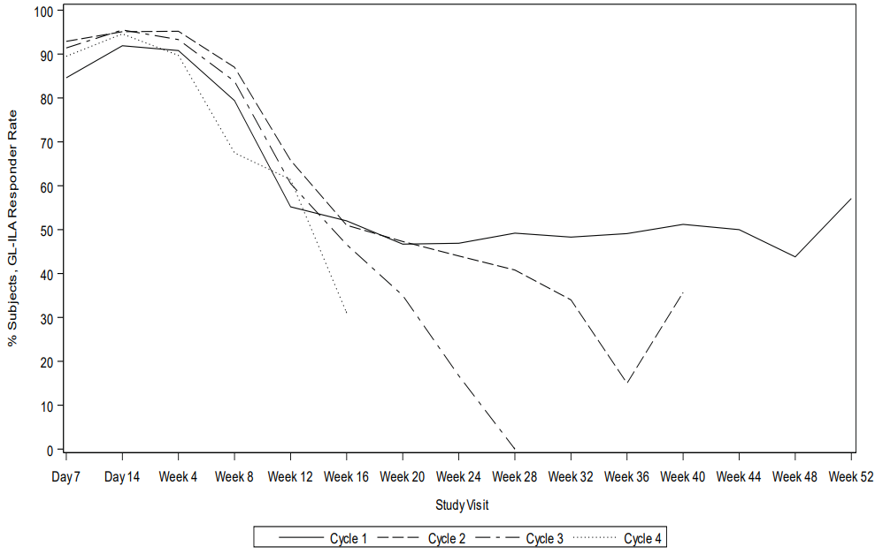
Figure 6: Responder Rates Over Time Using the LCL-ILA 4-Point Photographic Scale at Maximum Smile (Achieved a Score of 0 or 1) (FAS Population)
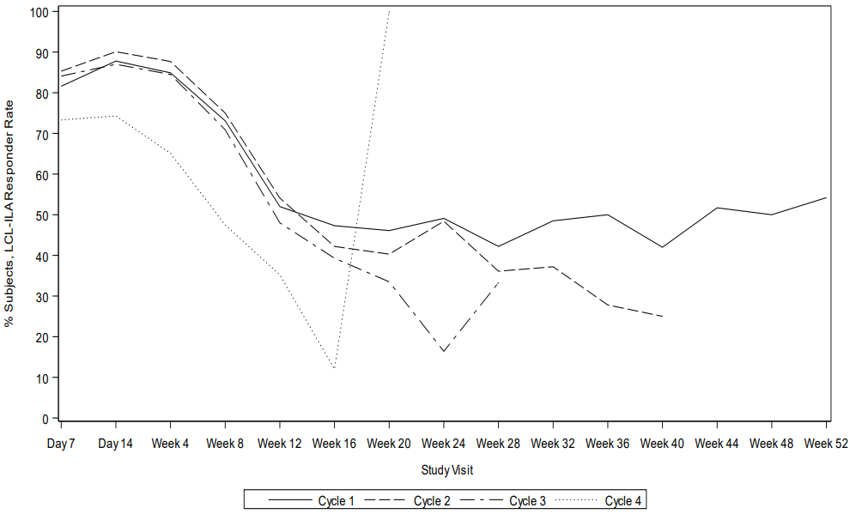

Safety
The clinical development program for GL and LCL included 2059 unique subjects who received at least one treatment with RBTA of any dose (10 units to 140 units), including 1844 unique subjects who received RBTA 50 units or greater. Of these, 1394 were followed up for 6 months and 529 for 9 months. In the 5 double-blind, placebo-controlled studies, a total of 1220 (1218 unique) subjects have been treated including 945 (943 unique) subjects with RBTA and 275 subjects with placebo.
In the 50 U or Greater Placebo-Controlled Pool, 28.54% of RBTA subjects and 26.97% of placebo subjects experienced at least one treatment-emergent adverse event (TEAE), and there were no TEAEs leading to discontinuation (Table 4). Treatment-related TEAEs were reported more frequently in the RBTA group compared to placebo overall (12.24% of RBTA subjects vs 8.04% of placebo subjects) and in the GL only treatment pool (15.56% of RBTA subjects vs 7.55% of placebo subjects).
TEAEs by system organ class and PT in the 50 U or greater Placebo-Controlled Pool are summarised in Table 5. The most frequently reported TEAE was headache (5.09% RBTA vs 3.15% placebo). Eyelid ptosis was reported in 15 (1.73%) subjects in the RBTA group and none in the placebo group. Vision blurred was reported in 3 (0.34%) subjects in the RBTA group and none in the placebo group. In the 50 U or Greater Placebo-Controlled Pool, 1.19% of RBTA subjects and 1.25% of placebo subjects experienced at least one serious TEAE, and there were no deaths. In Study 43QM1903, there was one death from suicide on Day 55 which was not considered to be related to study drug.
Table 4: Overall Summary of TEAEs (50 U or Greater Placebo-Controlled Pool – Safety Population)
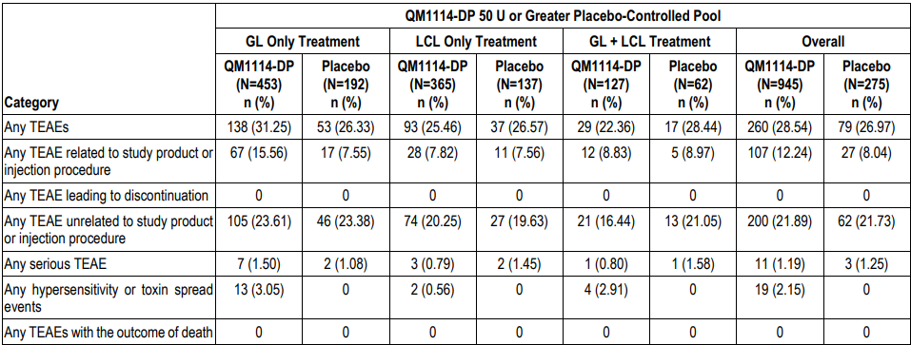
Table 5: TEAEs Experienced by ≥2.0% and at Least 2 Subjects in any Treatment Group by System Organ Class and PT (50 U or Greater Placebo-Controlled Pool – Safety Population)
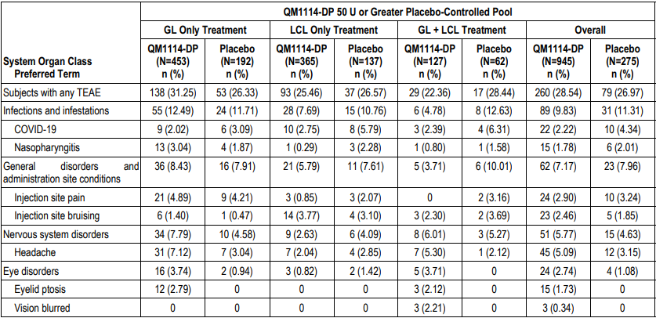
In the open-label, multiple-dose, long-term Study 43QM1903, 960 TEAEs were reported in 396 (43.9%) subjects. The rate of TEAEs was similar across the treatment cycles. The most frequently reported TEAEs were injection site pain in 65 (7.2%) subjects, injection site bruising in 59 (6.5%) subjects, and headache in 54 (6.0%) subjects. Eyelid ptosis was reported in seven (0.8%) subjects, urticaria in 4 (0.4%) subjects, dry eye in 3 (0.3%) subjects, and vision blurred in two (0.2%) subjects.
The safety evaluation did not identify concerns in relation to laboratory findings, serious skin reactions, ECG findings, and cardiovascular safety.
The Integrated Analysis of Immunogenicity included 1919 subjects treated with RBTA and 265 with placebo. Antidrug antibodies (ADAs) were detected in 23 (1.4%) subjects treated with RBTA and one (0.4%) treated with placebo. None of the ADA positive subjects had a severe or serious immune-related TEAE.
Patient reported outcomes, including GL-SLA score, LCL-SLA score, FLTSQ score, and FACE-Q Psychological Function Scale, were evaluated in the pivotal trials.

Risk Management Plan (RMP) evaluation summary
The risk management plan for this application is presented in Core-RMP version 1.0 (dated 14 December 2022; DLP 20 July 2022) and Australian Specific Annex version 2.0 (dated 15 November 2023). The summary of safety concerns is acceptable (Table 6). The proposed pharmacovigilance and risk minimisation plans are consistent with registered botulinum toxin products.
Table 6: Summary of Safety Concerns
Summary of safety concerns |  | Pharmacovigilance |  | Risk minimisation
 |  | Routine | Additional | Routine | Additional
Important identified risks | None | - | - | - | -
Important potential risks | Distant spread of toxin |  | - |  | -
Important potential risks | Hypersensitivity |  | - |  | -
Important potential risks | Exacerbation of pre-existing or subclinical neuromuscular disorders* |  | - |  | -
Missing information | Use in pregnancy* |  | - |  | -
Missing information | Long-term use* |  | - |  | -

Risk-benefit analysis

Efficacy
The efficacy of RBTA was demonstrated in 3 pivotal studies: one in adults with moderate-to-severe GL (Study 43QM1602), one in adults with moderate-to-severe LCL (Study 43QM1901), and one in adults with moderate-to-severe GL and LCL (Study 43QM1902). Study 43QM1902 evaluated the treatment of GL and LCL alone and in combination. The dosing regimens used in the pivotal studies were the same as proposed for registration. The studies used well-defined clinician-reported and patient-reported measures of efficacy. Across the pivotal studies, there were numerous protocol deviations relating to the COVID-19 pandemic, but the evaluation concluded that the efficacy findings were robust and the protocol deviations did not meaningfully detract from the efficacy conclusions.
The efficacy of 50 U RBTA for the treatment of moderate-to-severe GL was confirmed in Studies 43QM1602 and 43QM1902. In Study 43QM1602, the GL-ILA responder rate at Month 1 (primary endpoint) was 96.3% in the RBTA group compared to 4.5% in the placebo group, a treatment difference of 91.8% (95% CI 86.17, 97.44, p <0.001). The study also demonstrated improvements in patient-reported measures of treatment satisfaction and psychological impact. The onset of effect was 2 days post-treatment and lasted for up to ∼6 months.
The efficacy of 60 U RBTA for the treatment of moderate-to-severe LCL was confirmed in Studies 43QM1901 and 43QM1902. In Study 43QM1901, the LCL-ILA responder rate at Month 1 (primary endpoint) was 87.2% in the RBTA group compared to 11.9% in the placebo group, a treatment difference of 75.3% (95% CI 66.14, 84.41, p <0.001). The study also demonstrated improvements in patient-reported measures of treatment satisfaction and psychological impact. The onset of effect was 2 days post-treatment and lasted for up to ∼6 months.
Study 43QM1902 confirmed the superiority of RBTA versus placebo for moderate-to-severe GL and LCL when treated alone and in combination.
The open-label long-term safety and efficacy study, 43QM1903, supports the efficacy of repeat treatments for GL and LCL over the course of one year. Although the study was open-label, the outcome measures were objective and sufficiently sensitive to demonstrate the treatment benefit. Similar treatment effects were observed following each subsequent treatment (up to 4 treatment cycles over the course of 12 months), and subject satisfaction was found to be sustained.

Safety
The safety profile of RBTA in the clinical trial program was consistent with the known safety profile of other botulinumtoxinA products.
Overall, TEAEs were reported slightly more frequently in subjects treated with RBTA (28.54%) compared to placebo (26.97%). There were few serious TEAEs, and these occurred at a similar rate for RBTA (1.19%) and placebo (1.25%). The most frequently reported TEAEs with RBTA were headache (5.09% RBTA vs 3.15% placebo), injection site pain (2.90% RBTA vs 3.24% placebo), and injection site bruising (2.46% RBTA vs 1.85% placebo). Eyelid ptosis was reported in 15 (1.73%) subjects in the RBTA group and none in the placebo group, and vision blurred was reported in 3 (0.34%) subjects in the RBTA group and none in the placebo group. Headache and eyelid ptosis were mostly reported after treatment for GL rather than LCL.
Overall, the safety of RELFYDESS has been adequately characterised, though long-term safety data are limited, as the longest duration of treatment in the clinical development program was up to four treatment episodes over 12 months.

Uncertainties and limitations of the data
Evidence of efficacy and safety of RELFYDESS is based on comparisons with placebo that indicate a high level of efficacy and acceptable safety profile. There are no data directly comparing the efficacy and safety of relabotulinumtoxinA to an active comparator, but the observed treatment effect versus placebo is considered adequate to establish efficacy.
Efficacy and safety beyond 12 months have not been evaluated in the clinical development program.

Assessment outcome
Based on a review of quality, safety, and efficacy, the TGA decided to register RELFYDESS - relabotulinumtoxinA for the following indication:
RELFYDESS is indicated in adult patients for the temporary improvement in the appearance of:
- Moderate to severe glabellar lines at maximum frown
- Moderate to severe lateral canthal lines seen at maximum smile.

Specific conditions of registration
RELFYDESS relabotulinumtoxinA is to be included in the Black Triangle Scheme. The PI and CMI for RELFYDESS must include the black triangle symbol and mandatory accompanying text for five years, which starts from the date that the sponsor notifies the TGA of supply of the product.
The RELFYDESS Core-RMP (version 1.0, dated 14 December 2022, data lock point 20 July 2022), with Australian Specific Annex (version 2.0, dated 15 November 2023), included with submission. PM-2023-00708-1-1, and any subsequent revisions, as agreed with the TGA will be implemented in Australia.
An obligatory component of risk management plans is routine pharmacovigilance. Routine pharmacovigilance includes the submission of periodic safety update reports (PSURs).
Unless agreed separately between the supplier who is the recipient of the approval and the TGA, the first report must be submitted to TGA no later than 15 calendar months after the date of this approval letter. The subsequent reports must be submitted no less frequently than annually from the date of the first submitted report until the period covered by such reports is not less than three years from the date of this approval letter. The annual submission may be made up of two PSURs each covering six months. If the sponsor wishes, the six monthly reports may be submitted separately as they become available.
If the product is approved in the EU during the three years period, reports can be provided in line with the published list of EU reference dates no less frequently than annually from the date of the first submitted report until the period covered by such reports is not less than three years from the date of this approval letter.
The reports are to at least meet the requirements for PSURs as described in the European Medicines Agency’s Guideline on good pharmacovigilance practices (GVP) Module VII-periodic safety update report (Rev 1), Part VII.B Structures and processes. Note that submission of a PSUR does not constitute an application to vary the registration. Each report must be submitted within ninety calendar days of the data lock point for that report.
All relevant manufacturing sites require approved and current GMP Clearances prior to Australian supply. A commitment is required from the Sponsor that they maintain the validity of all manufacturer GMP Clearances for the duration of product supply to Australia. Additionally, that adherence to the conditions of GMP Clearance approval is upheld.
The Sponsor is required to provide commitment to continue the ongoing stability studies presented in the stability studies protocol. Additionally, 1 batch of DP per year for all relevant products will be placed on long-term stability program and on accelerated stability testing where significant changes are made to the manufacturing process. The Sponsor should commit to communicate any out of specifications stability test results to the TGA.
The Sponsor has committed to perform a risk assessment based on sound QRM principles to qualify the future commercial cold chain route (2-8°C) from the drug product (DP) manufacturing/ storage site to Australia prior to the first commercial shipment to Australia.
All batches of RELFYDESS supplied in Australia must comply with the product details and specifications approved during evaluation and detailed in the Certified Product Details (CPD).
When requested by the TGA, the Sponsor should be prepared to provide product samples, specified reference materials and documentary evidence to enable the TGA to conduct laboratory testing on the Product.
An electronic copy of the Certified Product Details (CPD) as described in Guidance 7: Certified Product Details of the Australian Regulatory Guidelines for Prescription Medicines (ARGPM) https://www.tga.gov.au/guidance-7-certified-product-details should be provided upon registration of the therapeutic good. In addition, an updated CPD, for the above products incorporating the approved changes is to be provided within one month of the date of approval letter. A template for preparation of CPD for biological prescription medicines and Vaccines can be obtained from the TGA website https://www.tga.gov.au/form/certified-product-details-cpd-biological-prescriptionmedicines ]. The CPD should be sent as a single bookmarked PDF document to Vaccines@health.gov.au as soon as possible after registration/approval of the product or any subsequent changes as indicated above.

Product Information and Consumer Medicines Information
For the most recent Product Information (PI) and Consumer Medicines Information (CMI), please refer to the TGA PI/CMI search facility.

Therapeutic Goods Administration
PO Box 100 Woden ACT 2606 Australia
Email: info@tga.gov.au Phone: 1800 020 653 Fax: 02 6203 1605
https://www.tga.gov.au

This is the original indication proposed by the sponsor when the TGA commenced the evaluation of this submission. It may differ to the final indication approved by the TGA and registered in the Australian Register of Therapeutic Goods.

