Australian Public Assessment Report for Pyrazinamide AFT
  - Active ingredient: Pyrazinamide
  - Sponsor: AFT Pharmaceuticals Pty Ltd
August 2025

About the Therapeutic Goods Administration (TGA)
- The Therapeutic Goods Administration (TGA) is part of the Australian Government Department of Health, Disability and Ageing and is responsible for regulating therapeutic goods, including medicines, medical devices, and biologicals.
- The TGA administers the Therapeutic Goods Act 1989 (the Act), applying a risk management approach designed to ensure therapeutic goods supplied in Australia meet acceptable standards of quality, safety, and efficacy.
- The work of the TGA is based on applying scientific and clinical expertise to decision-making, to ensure that the benefits to the Australian public outweigh any risks associated with the use of therapeutic goods.
- The TGA relies on the public, healthcare professionals and industry to report problems with therapeutic goods. The TGA investigates reports received to determine any necessary regulatory action.
- To report a problem with a therapeutic good, please see the information on the TGA website.

About AusPARs
- The Australian Public Assessment Report (AusPAR) provides information about the evaluation of a prescription medicine and the considerations that led the TGA to approve or not approve a prescription medicine submission. Further information can be found in Australian Public Assessment Report (AusPAR) guidance.
- AusPARs are prepared and published by the TGA.
- AusPARs are static documents that provide information that relates to a submission at a particular point in time. The publication of an AusPAR is an important part of the transparency of the TGA’s decision-making process.
- A new AusPAR may be provided to reflect changes to indications or major variations to a prescription medicine subject to evaluation by the TGA.

Copyright
© Commonwealth of Australia 2025
This work is copyright. You may reproduce the whole or part of this work in unaltered form for your own personal use or, if you are part of an organisation, for internal use within your organisation, but only if you or your organisation do not use the reproduction for any commercial purpose and retain this copyright notice and all disclaimer notices as part of that reproduction. Apart from rights to use as permitted by the Copyright Act 1968 or allowed by this copyright notice, all other rights are reserved and you are not allowed to reproduce the whole or any part of this work in any way (electronic or otherwise) without first being given specific written permission from the Commonwealth to do so. Requests and inquiries concerning reproduction and rights are to be sent to the TGA Copyright Officer, Therapeutic Goods Administration, PO Box 100, Woden ACT 2606 or emailed to <tga.copyright@tga.gov.au>.

Contents
List of abbreviations 4
Product submission 6
Submission details 6
Product background 7
Disease or condition 7
Current treatment options 7
Clinical rationale 8
Regulatory status 8
Australian regulatory status 8
International regulatory status 9
Registration timeline 9
Assessment overview 9
Quality evaluation summary 9
Nonclinical evaluation summary 10
Clinical evaluation summary 11
Summary of clinical studies 11
Pharmacology 13
Efficacy 20
Safety 21
Risk management plan 21
Risk-benefit assessment 23
Delegate’s considerations 23
Assessment outcome 23
Specific conditions of registration 23
Product Information and Consumer Medicine Information 24

List of abbreviations
Abbreviation | Meaning
2HRZE/4HR | Isoniazid, rifampicin, pyrazinamide and ethambutol, for 2 months followed by isoniazid and rifampicin for 4 months
ACM | Advisory Committee on Medicines
ACV | Advisory Committee on Vaccines
ALT | Alanine aminotransferase
ARTG | Australian Register of Therapeutic Goods
ASA | Australia-specific annex
AST | Aspartate aminotransferase
AT | Aminotransferases
AUC | Area under the concentration-time curve
AUC₀₋₂₄ | Area under the concentration time curve from time zero to 24 hours
BCG | Bacille Calmette-Guérin vaccine
CE | Clinical Evaluator
C_{max} | Maximum concentration
CMI | Consumer Medicines Information
CNS | Central nervous system
CSF | Cerebrospinal fluid
DLP | Data lock point
DNA | Deoxyribonucleic acid
ETH | Ethambutol
FDC | Fixed dose combination
HIV | Human immunodeficiency viruses
HPLC | High-performance liquid chromatography
INH | Isoniazid
LF | Loose formulation
MDR | Multi-drug resistant
MIC | Minimum inhibitory concentration
PAS | Para-aminosalicylic acid
PD | Pharmacodynamics
PI | Product Information
PK | Pharmacokinetics
POA | Pyrazinoic acid (POA)
PSUR | Periodic safety update report
PZA | Pyrazinamide
RIF | Rifampicin
RMP | Risk management plan
T_{1/2β} | Elimination half-life
TB | Tuberculosis
TBM | Tuberculous meningitis
TGA | Therapeutic Goods Administration
T_{max} | Time after administration of a drug when the maximum plasma concentration is reached
TTCC | Time to culture conversion
WHO | World Health Organisation

Product submission

Submission details
Type of submission: | New chemical entity
Product name: | Pyrazinamide AFT
Active ingredient: | Pyrazinamide
Decision: | Approved
Date of decision: | 30 April 2025
Date of entry onto ARTG: | 2 May 2025
ARTG number: | 413090
Black Triangle Scheme  for the current submission: | Yes  The PI and CMI for Pyrazinamide-AFT must include the black triangle symbol and mandatory accompanying text for five years, which starts from the date of first supply of the product.
Sponsor’s name and address: | AFT Pharmaceuticals Pty Ltd  Suite 301, 113 Wicks Road,  North Ryde,  NSW 2113
Dose form: | 500 mg tablet
Pack size: | HDPE bottles of 100 tablets
Approved therapeutic use for the current submission: | Pyrazinamide-AFT is indicated in adult patients of more than 12 years of age with active drug-sensitive tuberculosis caused by Mycobacterium tuberculosis. Pyrazinamide-AFT is an anti-tuberculosis agent used in combination with other anti- tuberculosis agents and is commonly used in the first 2 months of treatment.
Route of administration: | Oral
Dosage: | 15 to 30 mg/kg once daily  For further information regarding dosage, such as dosage modifications to manage adverse reactions, refer to the Product Information (PI).
Pregnancy category: | Category B2  There are no well-controlled studies in pregnant women. Pyrazinamide-AFT should be used during pregnancy only if the potential benefit justifies the potential risk to the foetus.  The use of any medicine during pregnancy requires careful consideration of both risks and benefits by the treating health professional. The pregnancy database must not be used as the sole basis of decision making in the use of medicines during pregnancy. The TGA does not provide advice on the use of medicines in pregnancy for specific cases. More information is available from obstetric drug information services in your state or territory.

Product background
This AusPAR describes the submission by AFT Pharmaceuticals Pty Ltd to register Pyrazinamide AFT (pyrazinamide) 500 mg tablet for the following proposed indication:
Pyrazinamide-AFT is indicated in patients with active tuberculosis caused by Mycobacterium tuberculosis.
Pyrazinamide is a mainstay of tuberculosis treatment and has been in use since the 1950s. There is, however, no presentation of pyrazinamide currently included in the ARTG and a lack of evidence to determine whether it has been on the ARTG in recent history.

Disease or condition
Tuberculosis (TB) is a complex communicable disease that has many presentations, although the majority of disease is pulmonary in origin. The rate of endemic transmission in Australia is low but movement of people from areas of greater TB burden, as well as reactivation of latent TB in older Australians who were exposed to disease earlier in life, means a baseline prevalence of TB is maintained.
Most TB diagnosed in Australia is sensitive to therapy with isoniazid, rifampicin, ethambutol and pyrazinamide, on which a protocol of 4-6 months treatment achieves both non-contagious levels of TB bacteria and eventual cure. Resistant strains of TB can emerge with interrupted treatment, treatment complicated by other medical conditions (e.g. immunosuppression) or when resistant strains are imported to Australia.

Current treatment options
According to recent state guidelines for healthcare providers (such as the ‘Management, control and prevention of tuberculosis’, Department of Health and Human Services, Victorian Government, 2015), the initial phase of TB treatment in patients for whom no drug resistance is suspected is the use of 4 antibiotics:
- isoniazid (H) 300 mg orally daily (in a child 10 mg/kg up to 300 mg)
- rifampicin (R): 600 mg orally daily (in adult <50 kg, and in child 10 mg/kg up to 600 mg)
- ethambutol (E): 15 mg/kg orally daily (up to 1200 mg; in adults and children 6 years or older)
- pyrazinamide (Z) 25 mg/kg (up to 2 g) orally daily, with pyridoxine 25 mg orally daily.
The duration of the initial phase is for a minimum of 2 months or at least until sputum is culture negative for pulmonary TB and, in culture-positive cases, until drug susceptibilities are known, whichever is longer.
For drug-sensitive TB, treatment is continued after the initial phase for at least another 4 months with rifampicin and isoniazid, for a total treatment course of 6 months (2HRZE/4HR). In patients who have drug-sensitive TB who have not responded well to the intensive initial phase, the initial phase can be extended e.g., to a total of 3 months of pyrazinamide.
For drug resistant TB, with isoniazid-resistant TB, the recommended regimen is 2 months of the initial standard regimen followed by 7 months of rifampicin, pyrazinamide and ethambutol. For multi-drug resistant (MDR) TB, second line anti-TB drugs are used and include fluoroquinolones, amikacin, prothionamide and PAS (para-aminosalicylic acid). Regimens are for at least 18 to 24 months in duration.
In patients with disseminated, central nervous system (CNS) or skeletal TB (extra-pulmonary TB), it is recommended that treatment be for 9-12 months, 12 months and at least 6-9 months, respectively. However, it is noted in the Victorian guidelines that there were no good prospective data supporting these recommended durations.

Clinical rationale
Pyrazinamide (PZA) is a prodrug that is converted to the active form pyrazinoic acid (POA) by pyrazinamidase/nicotinamidase encoded by the pncA gene in Mycobacterium tuberculosis. PZA is generally active only at an acid pH. The precise mechanism of action is unknown.
Possible mechanisms of antibacterial activity include:
- activation of the sigma factor (SigE)-dependent cell envelope stress response,
- binding of POA to asparate decarboxylase (PanD), and
- POA binding to ribosomal protein S1 (RpsA) of M. tuberculosis.
Inhibition of fatty acid synthesis may also contribute to the activity of POA.
Resistance develops rapidly if pyrazinamide is used as sole antitubercular agent. Loss of pyrazinamidase activity, mutations in pncA, RpsA or pan D genes may confer PZA resistance. Pyrazinamide is readily absorbed from the gastro-intestinal tract with peak serum concentration being reached about 2 hours after taking the dose. Plasma concentrations of pyrazinoic acid, which is the major metabolite, are generally greater than those of pyrazinamide and peak 4-8 hours after dosing.
Pyrazinamide is widely distributed in body tissues and fluids including the liver, lungs and CSF. It is not known if pyrazinamide crosses the placenta, but it is excreted in breast milk. Pyrazinamide is metabolised primarily in the liver by hydrolysis to pyrazinoic acid which is subsequently hydroxylated to the major excretory product 5-hydroxypyrazinoic acid. It is excreted via the kidney mainly by glomerular filtration. Approximately 70% of a dose appears in the urine within 24 hours (mainly as metabolites with 4-14% as pyrazinamide).
The plasma half-life is 9-10 hours in patients with normal renal and hepatic function. The plasma half-life may be prolonged in patients with impaired renal or hepatic function.

Regulatory status

Australian regulatory status
This product is considered a new chemical entity for Australian regulatory purposes.

International regulatory status
Pyrazinamide 500mg tablets are available in many regulatory jurisdictions including the US, Canada, UK and New Zealand. It has been in routine clinical use for several decades.

Registration timeline
The following table captures the key steps and dates for this submission.
This submission was evaluated under the standard prescription medicines registration process.
Table 2: Timeline for submission PM-2023-03087-1-2
Description | Date
Designation (Orphan) | 27 April 2023
Submission dossier accepted and first round evaluation commenced | 8 September 2023
Evaluation completed (End of round 2) | 31 January 2025
Registration decision (Outcome) | 30 April 2025
Registration in the ARTG completed | 2 May 2025
Number of working days from submission dossier acceptance to registration decision* | 196
*Statutory timeframe for standard submissions is 255 working days

Assessment overview
A summary of the TGA’s assessment for this submission is provided below.
This application was evaluated as a Literature Based Submission (LBS) supported by published literature. This is appropriate given the age of the medicine and the lack of a modern regulatory dossier.

Quality evaluation summary
The precise mechanism of action has not been fully determined but partly depends on the conversion of pyrazinamide to pyrazinoic acid. Pyrazinamide is bactericidal against Mycobacterium tuberculosis. Pyrazinamide has no activity against other Mycobacteria. Susceptible strains of Mycobacterium tuberculosis produce pyrazinamidase which deaminates pyrazinamide to pyrazinoic acid.
Pyrazinamide-AFT is presented as a white to off-white colour round tablet. Each tablet contains 500 mg pyrazinamide. Pyrazinamide is proposed to be administered as 15 – 30 mg/kg once daily orally. It is proposed that 3 g/day should not be exceeded.
Alternatively, a twice weekly dosing regimen (50-75 mg/kg twice weekly) has been proposed to promote compliance. Pyrazinamide is to be given with at least 1 other anti-tuberculous medicine.
Pyrazinamide-AFT presents in a HDPE bottle of 100 tablets. The expiry date can be found on the packaging, with storage recommended for 12 months, at below 30 °C.
The module 3 evaluator has raised no concerns with registration of this product.

Nonclinical evaluation summary
There are no data on secondary pharmacology or safety pharmacology. Repeat dose toxicity, reproductive and developmental toxicity were not adequately assessed. Therefore, the submitted Module 4 dossier was deemed inadequate. However, as a literature-based submission, the sponsor has provided most available relevant published studies. Reproductive toxicity and carcinogenicity studies conducted by the National Institute of Health were not provided by the sponsor, but they were sourced by the TGA evaluator.
Pyrazinamide (PZA) is a prodrug that is converted to the active form pyrazinoic acid (POA) by pyrazinamidase /nicotinamidase. PZA is generally active only at an acid pH. The minimum inhibitory concentration (MIC) against M. tuberculosis varied widely in various cell cultures and assay conditions and ranged from <6.25 μg/mL to 128 μg/mL. Nutrient-starved conditions enhanced the activity of PZA in cell cultures.
In vivo studies in a range of animal models of TB showed combinations of PZA with a range of drugs including the commonly used first line anti-TB drugs (isoniazid [INH], rifampicin [RIF], ethambutol [ETH]) was effective in sterilising affected tissues. Combination of RIF/PZA/INH drug treatment and BCG vaccination was more effective than drug treatment alone in reducing disease reactivation in guinea pigs infected with M. tuberculosis. Since PZA has been extensively used in clinical settings, its efficacy and dosing would be appropriately determined by the extensive clinical data available.
Combination of clarithromycin and PZA was found to be synergistic against M. tuberculosis in human macrophages with MICs 4-8-fold lower for this combination than they were for either drug alone.
Pharmacokinetic profiles available in mice and rats (species used in the repeat-dose toxicity studies) were incomplete. PZA was well absorbed in mice. No absorption data was available for rats, but excretion data indicate that PZA is orally bioavailable in rats. Metabolites and excretion profiles in rats (no data for mice) were similar to humans making it an appropriate species for the assessment of PZA toxicity.
PZA and its active metabolite, POA are converted to 5-hydroxyPZA and 5-hydroxyPOA, respectively, by xanthine oxidase. Drugs that affect xanthine oxidase activity such as caffeine and allopurinol may affect PZA metabolism. Pyrazinamide inhibited the expression of hepatic transporters, BSEP and OATP1A1 in rats. It may reduce the elimination of drugs that are cleared by BSEP-mediated biliary excretion or OATP1A1 substrates that are predominantly cleared by hepatic metabolism.
Repeat-dose toxicity via the oral route of PZA on its own was examined in mice (2 x 1 week study) and rats (9 x 1–13-week studies). These studies concentrated on hepatotoxicity. Effects of PZA on other organs were not investigated, which is considered a major deficiency. Clinical doses of PZA in rats caused liver hepatotoxicity. Metabolites POA and 5-OHPOA were more potent than PZA in the induction of hepatotoxicity, based on histopathological and serum biochemical analysis (including ALT, AST, bilirubin and bile acid), liver oxidative stress in rats and cytotoxicity in HepG2 cells in vitro. Hepatic toxicity of PZA was alleviated by obeticholic acid, a FXR agonist approved for the treatment of primary biliary cholangitis.
Based on the study findings, PZA is considered to be genotoxic. PZA increased bone marrow micronuclei in mice (after a single IP dose of PZA). Chromosomal aberrations of bone marrow cells and DNA damage of spleen cells were increased in rats treated with PZA in combination with INH and RIF. In another rat study, micronuclei in blood cells were not increased following treatment with PZA or PZA in combination with other anti-TB drugs, but DNA damage was evident in liver, kidney and blood cells. PZA was not mutagenic in the Ames assay.
PZA was not carcinogenic in rats or male mice. No conclusion was possible for female mice due to insufficient numbers of surviving control mice in the 78-week carcinogenicity study.
Effects on fertility and early embryonic were not adequately assessed. In female rats, subclinical doses of PZA elicited significant disruption of endocrine balance (reduced levels of luteinizing hormones, prolactin and estrogen), and induced ovarian and uterine oxidative stress (increased oxidative stress markers) and histopathology of reproductive organs (including erosion of uterine mucosa, and congestion and underdeveloped follicles in ovaries). In male mice, subclinical doses of PZA caused histological lesions in testes (such as irregular seminiferous tubules, reduction of seminiferous epithelium, necrotic spermatogenic cells, and degeneration of Sertoli cells). Decreased testis volume and spermatogonia numbers, epithelium desquamation and exfoliation were seen in rats. Testis and epididymis DNA fragmentation were reported in male rats treated with PZA. Male rats dosed with PZA, INH, RIF and ETH at 217, 62, 74.4 and 155 mg/kg/day PO, respectively, had significantly lower fertility index and increased pre- and post-implantation losses than the control group. Considering the effects on male and female reproductive organs, and the significant decrease in fertility in the combination study, both male and female fertility and early embryonic development may be affected in patients.
In mice, embryofetal development was unaltered by PZA at PO doses up to 3000 mg/kg/day (9 times the maximum recommended clinical dose per body surface area) administered during organogenesis, but visceral and skeletal malformations were not examined in the study. Effects of embryofetal development has not been adequately assessed in nonclinical studies.
The non-clinical evaluator concluded that:
- Primary pharmacology studies support the proposed mode of action and clinical use for the treatment of TB.
- Pyrazinamide may cause liver toxicity in humans based on animal studies.
- A number of major deficiencies in the submitted nonclinical data were identified:
  - the absence of secondary and safety pharmacology data
  - repeat dose toxicity investigation limited to liver toxicity
  - absence of adequate embryofetal developmental studies (visceral and skeletal malformations were not examined)
- The major deficiencies of nonclinical toxicology data may be overcome by the long history of clinical use and available clinical data on safety and efficacy.
- The Risk Management Plan should include the mutagenic potential of PZA.

Clinical evaluation summary

Summary of clinical studies
A total of 68 publications were submitted as clinical data following a structured search of online databased which found 278 potential studies.
Table 3: Studies submitted in support of application PM-2023-03087-1-2
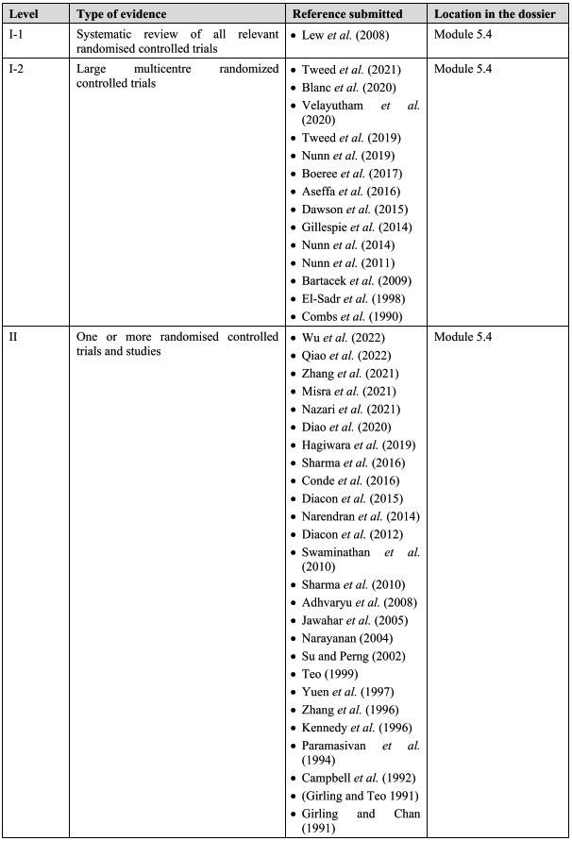
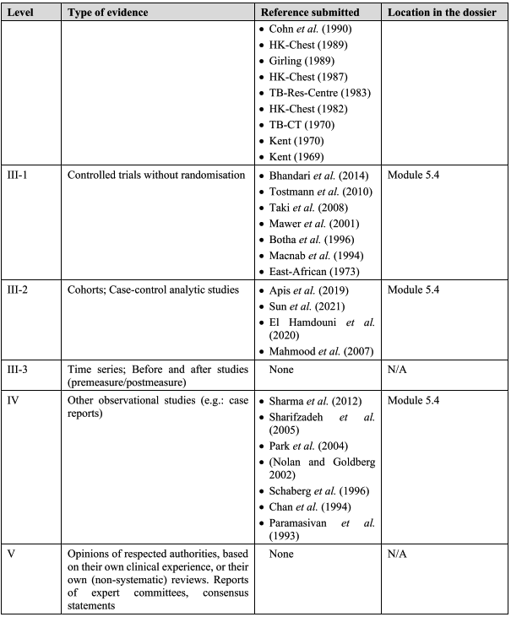

Pharmacology
The Delegate noted that the pharmacology of pyrazinamide is relatively well understood given the duration of its clinical use.

Pharmacokinetics
An appropriate and thorough search of literature-based studies was provided. Table 4 summarises studies with pharmacokinetic (PK) data. Individual studies are described further below.
Table 4: Pharmacokinetic parameter of pyrazinamide observed in humans (values are in blood/plasma /serum unless specified)
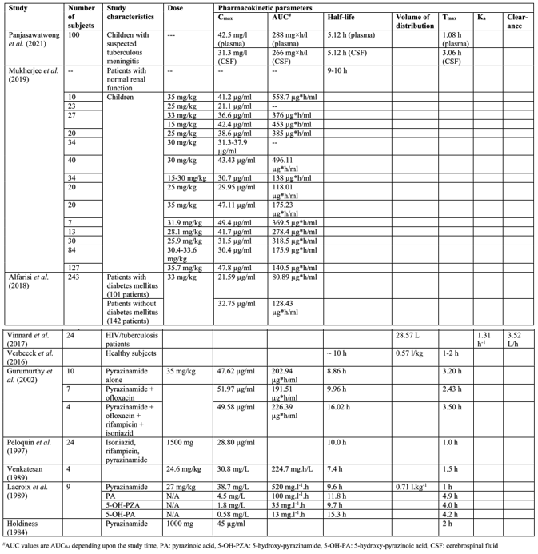
Panjasawatwong et al. (2021) assessed the population PK of isoniazid, rifampicin, pyrazinamide and ethambutol in Vietnamese children with tuberculous meningitis (TBM) to provide an optimal dosing for such patients. A total of 100 children with TBM were treated with an 8-month anti-TB regimen. Non-linear mixed-effects modelling was used to evaluate the PK properties of the drugs. The PK properties of rifampicin and pyrazinamide in plasma were described by 1-compartment disposition models whilst those of isoniazid and ethambutol were described by 2-compartment disposition models. Whilst CSF penetration of rifampicin was relatively poor, this was good with isoniazid and pyrazinamide. It was found that recommended doses of isoniazid and pyrazinamide but not ethambutol and rifampicin were adequate to achieve target exposures.
For pyrazinamide, the population PK parameter estimates at steady state in this target population are shown in Table 5. Thus, AUC₀₋₂₄ in plasma CSF (median [range]) was 288 (108-569) and 266 (98.9-522) mg x h/L, respectively. C_{max} was similarly slightly greater in plasma vs. CSF at 42.5 (29.8-92.7) and 31.3 (19.4-72.2) mg/L, respectively. Half-life in plasma and CSF were the same, at 5.12 (3.01-14.5) hours for both groups.
Table 5: Population PK parameter estimates and post hoc secondary PK parameters from the final population PK model of pyrazinamide in children with TBMª
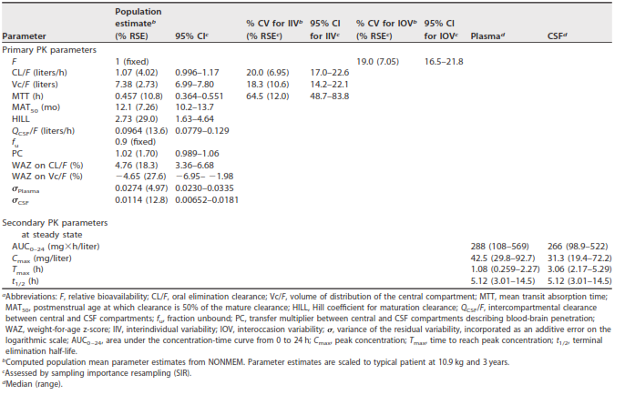
The PK of isoniazid, rifampicin and pyrazinamide was studied in 24 healthy males as part of a randomised, cross-over, phase I study of 2 dosage forms (Peloquin et al. 1997). Single doses of isoniazid, rifampicin and pyrazinamide of 250 mg, 600 mg and 1500 mg, respectively were administered. Plasma was collected for 36 hours and measured by HPLC. Population PK modelling was conducted. The data were analysed by non-compartmental and non-parametric modelling methods. Fast and slow acetylators of isoniazid had median concentrations in plasma (C_{max}) of 2.44 and 3.64 µg/ml, respectively occurring 1.0 hours post-dose. Pyrazinamide produced a median C_{max} of 28.80 µg/ml, a T_{max} of 1.0 hours and a T_{½} of 10.0 hours.
Mukherjee et al. (2019) was a review article of the PK of first-line anti-tuberculosis drugs. Relevant PK studies on pyrazinamide in children are summarised in Table 6.
Table 6: Summary of PK studies on pyrazinamide in children
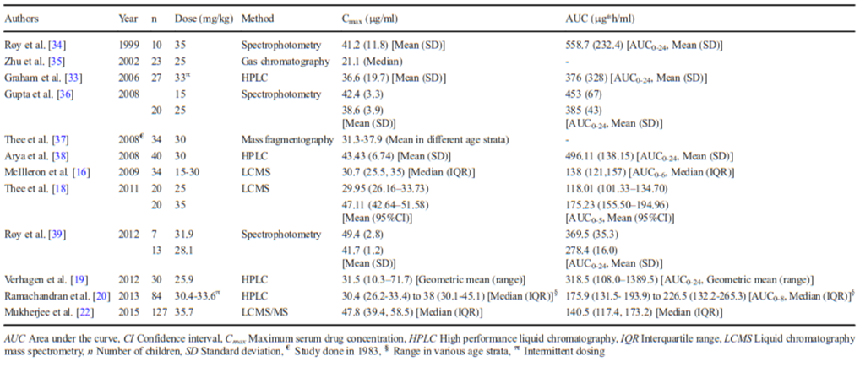
In a study by Graham et al. (2006) a group of 27 Malawian children with TB received 3 times weekly anti-tuberculosis drugs, with a mean dose of 33 (range 25-48) mg/kg/dose of pyrazinamide. The mean (SD) C_{max} achieved was 36.6 (19.7) µg/ml and 9 (33%) of children had a concentration of <20 µg/ml. The mean (SD) AUC₀₋₂₄ was 376 (328) µg x h/ml. In view of subtherapeutic levels of pyrazinamide being seen in some children despite increases in doses, in the PHATISA study involving 31 children <10 years of age, suboptimal C_{max} and AUC of pyrazinamide was seen in 45% and 19%, respectively. The lower systemic exposure seen in the study by Graham et al. (2006)⁵ in children suggests a higher metabolism compared to adults, as seen in other publications.
In the paper by Zhang et al. (2021), pyrazinamide PK-PD and PK-toxicity analyses were performed from extraction of the TB trials consortium (TBTC) studies 27 and 28 and pan-African consortium for the evaluation of anti-TB antibiotics (PanACEA) multi-arm, multi-stage TB (MAMS-TB), multicentre phase 2 trials, in which patients received rifampicin (10-35 mg/kg), pyrazinamide (20-30 mg/kg) and 2 companion drugs.
It was found that in the TBTC studies (n=77), higher pyrazinamide C_{max} was associated with shorter time to culture conversion (TTCC) and higher probability of 2-months, culture conversion (p<0.001). In the PanACEA MAMS-TB (n=363), TTCC decreased as pyrazinamide C_{max} increased and varied by rifampicin AUC (p<0.01).
Diabetes effect on PK
In Alfarisi et al. (2018) an assessment of the effect of diabetes mellitus and HbA1c values on the PK of anti-TB drugs was assessed in newly diagnosed TB patients with and without diabetes mellitus starting a fixed dose, 3 times weekly treatment regimen. PK sampling pre-dose and 0.5, 2- and 6-hours post-dose was conducted. Of 243 patients studied, 101 had diabetes. Univariate analysis showed significant reductions in C_{max} of pyrazinamide (and isoniazid) with diabetes with increasing HbA1c values. After adjusting for age, sex and weight, diabetes was associated with reduced pyrazinamide concentrations (adjusted GMR = 0.74, p=0.03). Thus, diabetes/higher HbA1c patients increased the risk of not achieving therapeutic targets for pyrazinamide but not rifampicin or isoniazid.
HIV and PK
In the article by Vinnard et al. (2017) a prospective cohort study of pyrazinamide PK in HIV/TB patients in Botswana was provided. A total of 40 HIV/TB patients completed the first PK sampling visit and 24 had a second visit following anti-retroviral therapy initiation. It was found that with compartmental PK modelling, the pyrazinamide concentration vs. time data were best described by a 1-compartment model with first-order elimination and a combined additive and proportional residual error model. HIV-associated immune activation (expression of CD38 and HLA-DR on CD8 positive T-cells) was adversely related to pyrazinamide clearance with increase in immune activation being associated with decreased pyrazinamide clearance.
Ofloxacin interactions
The report by Gurumurthy et al. (2002) assessed the bioavailability of ofloxacin following single oral administration together with rifampicin, isoniazid or pyrazinamide or combination of the 3 drugs. This study was undertaken in 12 healthy male volunteers on 4 different occasions at weekly intervals, in India. A partially balanced, incomplete blocked design was applied where the drugs were given to the healthy volunteers a week apart at random. These data are summarised in Figures 1 & 2. Similarly, Figure 3 reveals the mean plasma concentration-time profiles of pyrazinamide given alone or in combination. The PK parameters are summarised in Table 7 and the PK of pyrazinamide when given alone or in combination is summarised in Table 8. Plasma concentrations of each drug as well as urinary excretion of the drugs together with their primary metabolites was determined. The results confirmed that the bioavailability of ofloxacin was not affected when given with the other 3 tuberculosis drugs. Similarly, the bioavailability of other anti-TB drugs, rifampicin, isoniazid or pyrazinamide, was not affected when given with ofloxacin.
Figure 1: Mean plasma concentration – time profiles of ofloxacin when given alone and in combinations
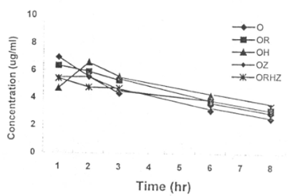
Figure 2: Urinary excretion of ofloxacin
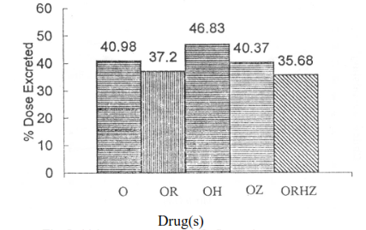
Figure 3: Mean plasma concentration-time profiles of pyrazinamide when given alone and in combinations
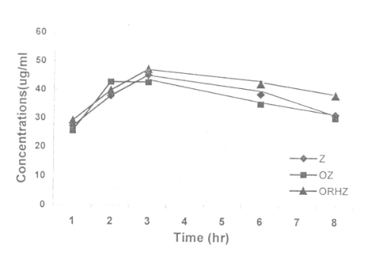
Table 7: PKs of ofloxacin in plasma when given alone and in combinations
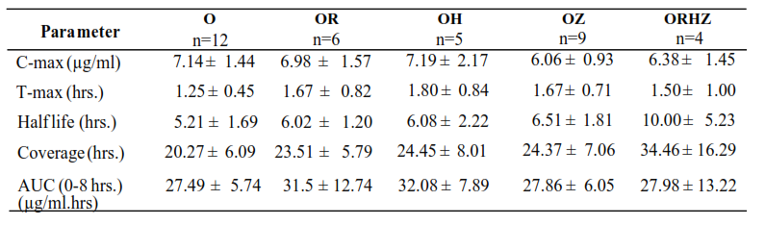
Table 8: PKs of pyrazinamide in plasma when given alone and in combinations
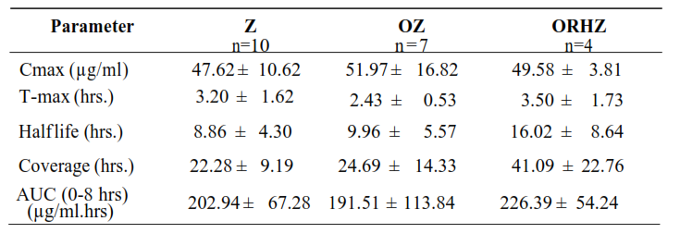
Single dose PK
The study by Lacroix et al. (1989) described plasma and urine PK parameters of pyrazinamide and its metabolites after a single oral dose of 27 mg/kg in 9 healthy subjects. Pyrazinamide was found to be rapidly absorbed with a T_{max} <1 hour and an elimination T_{1/2β} of 9.6 hours. Similar elimination rates of the metabolites (pyrazinoic acid, 5-hydroxy-pyrazinamide, 5-hydroxy-pyrazinoic acid and pyrazinuric acid) were seen.
CSF PK
In the publication by Holdiness (1985), this publication reviewed CSF PK of anti-TB drugs and quoted at that time penetration of pyrazinamide in CSF in only 1 case of active meningitis.

Evaluator’s overall conclusion of PKs
- The literature-based submission provided a number of studies in healthy subjects and patients with TB, examining PK after 15-35 mg/kg oral pyrazinamide (n=4-23 subjects per study). C_{max} ranged from 21.1-51.97 µg/mL, AUC ~200-500 µg.h/mL, T_{max} ~1-4 hours and T_{½} ~5-10 hours.
- Diabetes mellitus was associated with reduced pyrazinamide exposure.
- In HIV patients with TB, increase in immune activation was associated with reduced pyrazinamide clearance.

In summary, after a 15-35 mg/kg dose C_{max} ranged from 21.1-51.2 micrograms/mL, with a T_{max} of 1-4 hours and a plasma half-life of 5-10 hours.
The Delegate noted (as per US FDA labelling) that pyrazinamide is well absorbed and metabolized in the lever with a single major excretory product, 5-hydrozypyrazinoic acid. Approximately 70% of the dose is excreted (as transformed) in urine. The plasma half-life may be prolonged in patients with impaired hepatic or renal function.
No data is provided for Pharmacodynamics.

Efficacy
The use of pyrazinamide in combination with other anti-tuberculous agents in the treatment of active tuberculosis was solely supported by the literature-based submission provided by the sponsor, as described above. The search was carried out to identify clinical studies assessing efficacy and safety, from Medline and EMBASE databases using the TGA-approved search strategy and selection criteria.
Most studies reported after 2000 were conducted after seeking ethics approval. It was also difficult to blind investigators or patients in most studies technically because of comparison of single vs. multiple dose or combined treatments vs. separate drugs. The studies covered ranged from 13 years of age upwards to 89 years of age. They were from a large range of geographic locations, although ethnicity was not specified.
All studies used conventional oral formulations of pyrazinamide, as proposed. All studies furthermore investigated oral pyrazinamide in combination with other anti-tuberculous agents, as proposed. The main study outcome in most of the studies was absence of bacteriological response or a negative culture or disappearance of clinical symptoms at the end of treatment. This is an appropriate endpoint.
The efficacy of pyrazinamide was supported by the submission of published versions of study reports. The studies mostly examined the efficacy of pyrazinamide in the proposed dosage but in combination with other anti-TB medications, which the CE has noted is standard clinical practice.
As pyrazinamide is a standard component of initial TB treatment protocols the submitted literature does not provide evidence of its efficacy versus protocols that do not include it. However, the submitted studies have demonstrated the efficacy of pyrazinamide in a range of combination protocols and treatment durations (e.g. 6 months vs 4 months daily therapy).

Evaluator’s conclusions on clinical efficacy
- Pyrazinamide is a component of an initial anti-TB regimen used in accord with guidelines promoted through Australian states as well as the WHO.
- A range of randomised, literature-based trials in the current submission involving pyrazinamide in combination with other anti-TB treatments, usually as a regimen in the first 2 months of treatment, has shown it is an efficacious component of treatment of pulmonary TB, due to Mycobacterium tuberculosis.
- When used as part of a multi-modal drug combination, pyrazinamide is associated with microbiological, clinical and radiological clearance in up to 80-100% of cases.
- The bulk of data for pyrazinamide use in this fashion is in patients >12 years of age. There are a lack of data in childhood use.
- The use of pyrazinamide as part of a treatment regimen for extra-pulmonary TB is less well documented but in relevant studies does show some efficacy.
- The efficacy of pyrazinamide is best demonstrated in patients with drug-sensitive TB. The use of pyrazinamide in MDR TB is not well documented.

Safety
The current submission, being literature-based, presented a range of RCT studies which were uneven in terms of safety reporting. Furthermore, the safety of pyrazinamide per se was not examined in the studies presented as the medicine was used in combination with other potentially toxic medications (e.g. ethambutol, isoniazid). Individual publications generally do not provide a statistical analysis of adverse events to the same degree of detail as do primary clinical trial reports.
The toxicity of pyrazinamide is, however, relatively well understood given its decades of use in the treatment of TB. The most frequently reported adverse effect is hepatotoxicity with increases in AT (aminotransferases), jaundice or potential hepatitis, as well as other gastrointestinal changes such as nausea and vomiting. This may be dose related, with hepatotoxicity occurring in about 15% of patients, and jaundice in 2-3%.
Pyrazinamide inhibits renal excretion of urates and frequently results in hyperuricaemia and symptomatic gout. Non-gouty polyarthralgia can occur in up to 40% of patients.
Anaemia and hypersensitivity have rarely occurred.
Generally, the medication is well tolerated in the context of supervised administration, and TB being a severe and potentially life-threatening infection.

Evaluator’s conclusions on clinical safety
- Pyrazinamide when used in combination for initial induction treatment of TB (usually 2 months) is associated with varying degrees of hepatotoxicity, but other gastrointestinal side effects such as anorexia, nausea and vomiting in addition to hyperuricaemia, as highlighted in the literature-based survey, are described in up to >25-50% of patients.
- Liver function should be closely monitored during treatment which may also include other anti-TB drugs used in combination treatment and may necessitate withdrawal of treatment.

Risk management plan
The summary of safety concerns and their associated risk monitoring and mitigation strategies are summarised in Table 9. The TGA may request an updated RMP at any stage of a product's life cycle, during both the pre-approval and post-approval phases.
Table 9: Summary of safety concerns
Summary of safety concerns |  | Pharmacovigilance |  | Risk minimisation
 |  | Routine | Additional | Routine | Additional
Important identified risks | Severe liver disorders | ✓ | _ | ✓ | _
Important identified risks | Porphyria | ✓ | _ | ✓ | _
Important potential risks | Interaction with other medicinal products | ✓ | _ | ✓ | _
Missing information | Use in children and adolescent | ✓ | _ | ✓ | _
Missing information | Use in pregnant women | ✓ | _ | ✓ | _

RMP evaluator recommendations regarding conditions of registration
- Pyrazinamide-AFT (pyrazinamide) is to be included in the Black Triangle Scheme. The PI and CMI for Pyrazinamide-AFT must include the black triangle symbol and mandatory accompanying text for five years, which starts from the date of first supply of the product.
- The Pyrazinamide-AFT AU-Risk Management Plan (RMP) version 0.3 (dated 19 February 2024, data lock point 19 February 2024), included with submission PM-2023-03087-1-2, to be revised to the satisfaction of the TGA, and any subsequent revisions, will be implemented in Australia.
- An obligatory component of risk management plans is routine pharmacovigilance. Routine pharmacovigilance includes the submission of periodic safety update reports (PSURs).
Unless agreed separately between the supplier who is the recipient of the approval and the TGA, the first report must be submitted to TGA no later than 15 calendar months after the date of this approval letter. The subsequent reports must be submitted no less frequently than annually from the date of the first submitted report until the period covered by such reports is not less than three years from the date of this approval letter. The annual submission may be made up of two PSURs each covering six months. If the sponsor wishes, the six-monthly reports may be submitted separately as they become available.
If the product is approved in the EU during the three years period, reports can be provided in line with the published list of EU reference dates no less frequently than annually from the date of the first submitted report until the period covered by such reports is not less than three years from the date of this approval letter.
The reports are to at least meet the requirements for PSURs as described in the European Medicines Agency’s Guideline on good pharmacovigilance practices (GVP) Module VII-periodic safety update report (Rev 1), Part VII.B Structures and processes. Note that submission of a PSUR does not constitute an application to vary the registration. Each report must be submitted within ninety calendar days of the data lock point for that report.
Further information regarding the TGA’s risk management approach can be found in risk management plans for medicines and biologicals and the TGA's risk management approach. Information on the Australia-specific annex (ASA) can be found on the TGA website.

Risk-benefit assessment

Delegate’s considerations
Pyrazinamide was one of the first successful treatments for TB; developed and entering into clinical practice in 1952. In combination with rifampicin, ethambutol and isoniazid it remains the most common medication used for the initial treatment of drug-susceptible TB, and this is reflected in Australian and World Health Organisation (WHO) treatment guidelines.
The Delegate has considered this application in the context of this nearly 90-year history of clinical use, which provides a significant amount of ‘real world’ information about the safety and efficacy of pyrazinamide. However, the age of this medication also precludes basing an approval decision on a modern regulatory dossier. In particular, there is a lack of controlled trials demonstrating the absolute efficacy of pyrazinamide in comparison to treatment protocols that do not include it for first line treatment of drug susceptible TB.
The clinical evaluator has noted that there is a paucity of data supporting the use of pyrazinamide in children in this submission. That being so, TB does rarely occur in children and pyrazinamide is generally recommended for use. The Delegate feels that it is appropriate to provide an advisory regarding the lack of robust data for use in children, while acknowledging that clinical practice does include this use of necessity to treat TB.

Assessment outcome
Based on a review of quality, safety, and efficacy, the TGA decided to register Pyrazinamide AFT (pyrazinamide) 500 mg tablet indicated for:
Pyrazinamide-AFT is indicated in adult patients of more than 12 years of age with active drug-sensitive tuberculosis caused by Mycobacterium tuberculosis. Pyrazinamide-AFT is an anti-tuberculosis agent used in combination with other anti- tuberculosis agents and is commonly used in the first 2 months of treatment.

Specific conditions of registration
- Pyrazinamide-AFT (pyrazinamide) is to be included in the Black Triangle Scheme. The PI and CMI for Pyrazinamide-AFT must include the black triangle symbol and mandatory accompanying text for five years, which starts from the date of first supply of the product.
- The Pyrazinamide-AFT AU-Risk Management Plan (RMP) version 0.3 (dated 19 February 2024, data lock point 19 February 2024), included with submission PM-2023-03087-1-2, and any subsequent revisions, as agreed with the TGA will be implemented in Australia.
- An obligatory component of risk management plans is routine pharmacovigilance. Routine pharmacovigilance includes the submission of periodic safety update reports (PSURs). Unless agreed separately between the supplier who is the recipient of the approval and the TGA, the first report must be submitted to TGA no later than 15 calendar months after the date of this approval letter. The subsequent reports must be submitted no less frequently than annually from the date of the first submitted report until the period covered by such reports is not less than three years from the date of this approval letter. The annual submission may be made up of two PSURs each covering six months. If the sponsor wishes, the six-monthly reports may be submitted separately as they become available.
If the product is approved in the EU during the three years period, reports can be provided in line with the published list of EU reference dates no less frequently than annually from the date of the first submitted report until the period covered by such reports is not less than three years from the date of this approval letter.
The reports are to at least meet the requirements for PSURs as described in the European Medicines Agency’s Guideline on good pharmacovigilance practices (GVP) Module VII-periodic safety update report (Rev 1), Part VII.B Structures and processes.
Note that submission of a PSUR does not constitute an application to vary the registration. Each report must be submitted within ninety calendar days of the data lock point for that report.

Product Information and Consumer Medicine Information
For the most recent Product Information (PI) and Consumer Medicine Information (CMI), please refer to the TGA PI/CMI search facility.

Therapeutic Goods Administration
PO Box 100 Woden ACT 2606 Australia
Email: info@tga.gov.au Phone: 1800 020 653 Fax: 02 6203 1605
https://www.tga.gov.au
Reference/Publication #

This is the original indication proposed by the sponsor when the TGA commenced the evaluation of this submission. It may differ to the final indication approved by the TGA and registered in the Australian Register of Therapeutic Goods.
Department of Health & Human Services (2015) Management, control and prevention of tuberculosis’, Victorian Government. https://www.health.vic.gov.au/sites/default/files/migrated/files/collections/policies-and-guidelines/t/tb-guidelines-2015.pdf
Panjasawatwong NWattanakul THoglund RMBang ND, Pouplin TNosoongnoen W, Ngo VN, Day JN, Tarning J 2020. Population Pharmacokinetic Properties of Antituberculosis Drugs in Vietnamese Children with Tuberculous Meningitis. Antimicrob Agents Chemother 65:10.1128/aac.00487-20. https://doi.org/10.1128/aac.00487-20
Peloquin, C. A., Jaresko, G. S., Yong, C. L., Keung, A. C., Bulpitt, A. E., & Jelliffe, R. W. (1997). Population pharmacokinetic modeling of isoniazid, rifampin, and pyrazinamide. Antimicrobial agents and chemotherapy, 41(12), 2670–2679. https://doi.org/10.1128/AAC.41.12.2670
Mukherjee, A., Lodha, R., & Kabra, S. K. (2019). Pharmacokinetics of First-Line Anti-Tubercular Drugs. Indian journal of pediatrics, 86(5), 468–478. https://doi.org/10.1007/s12098-019-02911-w
Graham SM, Bell DJ, Nyirongo S, Hartkoorn R, Ward SA, Molyneux EM.2006.Low Levels of Pyrazinamide and Ethambutol in Children with Tuberculosis and Impact of Age, Nutritional Status, and Human Immunodeficiency Virus Infection. Antimicrob Agents Chemother 50. https://doi.org/10.1128/aac.50.2.407-413.2006
Hiruy H., Rogers Z., Mbowane C., Adamson J., Ngotho L., Karim, F., Gumbo T., Bishai W., Jeena P. Subtherapeutic concentrations of first-line anti-TB drugs in South African children treated according to current guidelines: the PHATISA study, Journal of Antimicrobial Chemotherapy, Volume 70, Issue 4, April 2015, Pages 1115–1123. https://doi.org/10.1093/jac/dku478
Ramachandran, G., Kumar, A. K., Kannan, T., Bhavani, P. K., Kumar, S. R., Gangadevi, N. P., Banurekha, V. V., Sudha, V., Venkatesh, S., Ravichandran, N., Kalpana, S., Mathevan, G., Sanjeeva, G. N., Agarwal, D., & Swaminathan, S. (2016). Low Serum Concentrations of Rifampicin and Pyrazinamide Associated with Poor Treatment Outcomes in Children with Tuberculosis Related to HIV Status. The Pediatric infectious disease journal, 35(5), 530–534. https://doi.org/10.1097/INF.0000000000001069
Zhang, A., Teng, L., & Alterovitz, G. (2021). An explainable machine learning platform for pyrazinamide resistance prediction and genetic feature identification of Mycobacterium tuberculosis. Journal of the American Medical Informatics Association : JAMIA, 28(3), 533–540. https://doi.org/10.1093/jamia/ocaa233
Alfarisi O, Mave VGaikwad S, Sahasrabudhe T, Ramachandran G, Kumar H, Gupte NKulkarni V, Deshmukh S, Atre S, Raskar S, Lokhande R, Barthwal M, Kakrani A, Chon S, Gupta AGolub JE, Dooley KE.2018.Effect of Diabetes Mellitus on the Pharmacokinetics and Pharmacodynamics of Tuberculosis Treatment. Antimicrob Agents Chemother 62:10.1128/aac.01383-18. https://doi.org/10.1128/aac.01383-18
Vinnard C, Ravimohan S, Tamuhla N, Pasipanodya J, Srivastava S, Modongo C, et al. (2017) Pyrazinamide clearance is impaired among HIV/tuberculosis patients with high levels of systemic immune activation. PLoS ONE 12(11): e0187624. https://doi.org/10.1371/journal.pone.0187624
Gurumurthy, Prema and Hemanth Kumar, A K and Rajasekharan, A and Rehman, Fathima and Sekar, L and Narayanan, P R (2002) The Pharmacokinetics of ofloxacin, rifampicin, isoniazid and pyrazinmide when administered alone and in combination. Biomedicine, 22 (3&4). pp. 13-26. ISSN 0970 2067 https://eprints.nirt.res.in/569/1/200221.pdf
Lacroix, C., Phan Hoang, T., Nouveau, J. et al. Pharmacokinetics of pyrazinamide and its metabolites in healthy subjects. Eur J Clin Pharmacol 36, 395–400 (1989). https://doi.org/10.1007/BF00558302
Holdiness M. R. (1984). Clinical pharmacokinetics of the antituberculosis drugs. Clinical pharmacokinetics, 9(6), 511–544. https://doi.org/10.2165/00003088-198409060-00003
Forgan-Smith R, Ellard G.A, Newton D, Mitchison D.A. Pyrazinamide and other drugs in Tuberculous Meningitis. Lancet 1973; 302:374 https://doi.org/10.1016/S0140-6736(73)93211-X
CDNA National Guidelines for Public Health Units: Tuberculosis, CDNA (2022) https://www.health.gov.au/sites/default/files/documents/2022/06/tuberculosis-cdna-national-guidelines-for-public-health-units.pdf
WHO consolidated guidelines on tuberculosis module 4: drug susceptible tuberculosis treatment, WHO (2022) https://iris.who.int/bitstream/handle/10665/353829/9789240048126-eng.pdf?sequence=1

