Australian Public Assessment Report for Inrebic
  - Active ingredient: Fedratinib (as hydrochloride)
  - Sponsor: Bristol Myer Squibb Australia Pty Ltd
July 2025

About the Therapeutic Goods Administration (TGA)
- The Therapeutic Goods Administration (TGA) is part of the Australian Government Department of Health, Disability and Ageing and is responsible for regulating therapeutic goods, including medicines, medical devices, and biologicals.
- The TGA administers the Therapeutic Goods Act 1989 (the Act), applying a risk management approach designed to ensure therapeutic goods supplied in Australia meet acceptable standards of quality, safety, and efficacy.
- The work of the TGA is based on applying scientific and clinical expertise to decision-making, to ensure that the benefits to the Australian public outweigh any risks associated with the use of therapeutic goods.
- The TGA relies on the public, healthcare professionals and industry to report problems with therapeutic goods. The TGA investigates reports received to determine any necessary regulatory action.
- To report a problem with a therapeutic good, please see the information on the TGA website.

About AusPARs
- The Australian Public Assessment Report (AusPAR) provides information about the evaluation of a prescription medicine and the considerations that led the TGA to approve or not approve a prescription medicine submission. Further information can be found in Australian Public Assessment Report (AusPAR) guidance.
- AusPARs are prepared and published by the TGA.
- AusPARs are static documents that provide information that relates to a submission at a particular point in time. The publication of an AusPAR is an important part of the transparency of the TGA’s decision-making process.
- A new AusPAR may be provided to reflect changes to indications or major variations to a prescription medicine subject to evaluation by the TGA.

Copyright
© Commonwealth of Australia 2025
This work is copyright. You may reproduce the whole or part of this work in unaltered form for your own personal use or, if you are part of an organisation, for internal use within your organisation, but only if you or your organisation do not use the reproduction for any commercial purpose and retain this copyright notice and all disclaimer notices as part of that reproduction. Apart from rights to use as permitted by the Copyright Act 1968 or allowed by this copyright notice, all other rights are reserved and you are not allowed to reproduce the whole or any part of this work in any way (electronic or otherwise) without first being given specific written permission from the Commonwealth to do so. Requests and inquiries concerning reproduction and rights are to be sent to the TGA Copyright Officer, Therapeutic Goods Administration, PO Box 100, Woden ACT 2606 or emailed to <tga.copyright@tga.gov.au>.

Contents
List of abbreviations 4
Product submission 6
Submission details 6
Product background 7
Disease or condition 7
Current treatment options 8
Clinical rationale 9
Regulatory status 10
Australian regulatory status 10
International regulatory status 10
Registration timeline 11
Assessment overview 12
Quality evaluation summary 12
Nonclinical evaluation summary 12
Nonclinical evaluation summary conclusions 14
Clinical evaluation summary 14
Pharmacology 14
Efficacy 18
Safety 36
Risk management plan 49
Risk-benefit analysis 51
Delegate’s considerations 51
Conclusion 53
Assessment outcome 53
Specific conditions of registration 53
Product Information and Consumer Medicine Information 54

List of abbreviations
Abbreviation | Meaning
ACM | Advisory committee on medicines
ACV | Advisory committee on vaccines
ADR | Adverse drug reaction
AE(s) | Adverse event(s)
ALP | Alkaline phosphatase
ALT | Alanine aminotransferase
AML | Acute myeloid leukemia
ARTG | Australian Register of Therapeutic Goods
ASA | Australia-specific annex
AST | Aspartate aminotransferase
AUC | Area under the concentration-time curve
AUC_{inf} | Area under the curve over time to infinity
AUC_{0-∞} | Area under the concentration time curve from time zero to infinity
BAT | Best available therapy
CALR | Calreticulin
C_{max} | Maximum concentration
CMI | Consumer medicines information
CML | Chronic Myeloid Leukemia
CT | Computed tomography
CTCAE | Common terminology criteria for adverse events
DDI | Drug-drug interaction
DIPSS | Dynamic international prognostic scoring system
DLP | Data lock point
ER | Exposure-response
ET | Essential thrombocythaemia
EU | European Union
FDA | Food and Drug Administration (US)
FLT3 | FMS-like tyrosine kinase 3
GLP | Good Laboratory Practice(s)
Hb | Haemoglobin
HSC | Hematopoietic stem cell
HSCT | Hematopoietic stem cell transplantation
ICH | International Council for Harmonisation (European Medicine Agency)
IPSS | International prognostic scoring system
IWG-MRT | International working group- Myelofibrosis research and treatment (2008)
JAK 2 | Janus associated kinase 2
LFT | Liver function test
MPN | Myeloproliferative neoplasms
MRI | Magnetic resonance imaging
PI | Product information
PK | Pharmacokinetic(s)
PMF | Primary myelofibrosis
PopPK | Population pharmacokinetic
PSUR | Periodic safety update report
PV | Polycythaemia vera
QD | Once daily
RMP | Risk management plan
SCT | Stem cell transplantation
STAT3 | Signal Transducer and Activator of Transcription-3
SV | Spleen volume
TGA | Therapeutic Goods Administration
T_{max} | Time after administration of a drug when the maximum plasma concentration is reached
US | United States (of America)
WE | Wernicke’s encephalopathy
WHO | World Health Organisation

Product submission

Submission details
Type of submission: | New chemical entity
Product name: | Inrebic
Active ingredient: | fedratinib (as hydrochloride)
Decision: | Approved
Date of decision: | 12 February 2025
Date of entry into ARTG: | 13 February 2025
ARTG number: | 433750
Black Triangle Scheme  for the current submission: | Yes  The PI and CMI for Inrebic must include the black triangle symbol and mandatory accompanying text for five years, which starts from the date of first supply of the product.
Sponsor’s name and address: | Bristol-Myers Squibb Australia Pty Ltd  Level 2, 4 Nexus Court  Mulgrave VIC 3170
Dose form: | 100mg
Container: | Reddish, brown hard capsule.
Pack size: | 120 capsules
Approved therapeutic use for the current submission: | Inrebic is indicated for the treatment of disease-related splenomegaly or symptoms in adult patients with primary myelofibrosis, post polycythaemia vera myelofibrosis or post essential thrombocythaemia myelofibrosis who are Janus Associated Kinase (JAK) inhibitor naïve or have been treated with ruxolitinib.
Route of administration: | Oral
Dosage: | 400 mg taken orally once daily for patients with a baseline platelet count of ≥50 x 10⁹/L.  For further information regarding dosage, such as dosage modifications to manage adverse reactions, refer to the Product Information.
Pregnancy category: | Category D  There are no studies with the use of Inrebic in pregnant women to inform drug-associated risks. Inrebic was shown to cause embryofetal lethality in animals at exposure levels well below that of patients. If Inrebic is used during pregnancy, or if the patient becomes pregnant while taking this drug, advise the patient of the potential risk to a foetus.  Advise females of reproductive potential to avoid becoming pregnant while receiving Inrebic and to use effective contraception during treatment with Inrebic and for at least 1 month after the last dose.  The use of any medicine during pregnancy requires careful consideration of both risks and benefits by the treating health professional. The pregnancy database must not be used as the sole basis of decision making in the use of medicines during pregnancy. The TGA does not provide advice on the use of medicines in pregnancy for specific cases. More information is available from obstetric drug information services in your state or territory.

Product background
This AusPAR describes TGA’s assessment of the submission by Bristol-Myer Squibb Australia to register Inrebic (fedratinib as hydrochloride) 100mg capsule for the following proposed indication:
INREBIC is indicated for the treatment of disease-related splenomegaly or symptoms in adult patients with primary myelofibrosis, post polycythaemia vera myelofibrosis or post essential thrombocythaemia myelofibrosis who are Janus Associated Kinase (JAK) inhibitor naïve or have been treated with a JAK inhibitor.

Disease or condition
The classic Philadelphia chromosome-negative myeloproliferative neoplasms (MPN) consist of myelofibrosis (MF), polycythaemia vera (PV), and essential thrombocythaemia (ET) and are a heterogeneous group of clonal blood disorders characterised by an overproduction of blood cells. MF may occur de novo as primary MF (PMF) or arise from pre-existing PV or ET.
MPNs are the result of a driver mutation (such as the JAK2V617F mutation in the JAK2 gene, or mutations in calreticulin [CALR] or myeloproliferative leukemia virus [MPL]) occurring in a hematopoietic stem cell (HSC). This results in aberrant activation of the JAK-signal transducers and activators of transcription (JAK-STAT) pathway, clonal expansion of the mutant HSCs and therefore high populations of downstream mature cells peripherally. Further somatic mutation amongst the clone can lead to a malignant clonal evolution and progression (i.e. to MPN secondary acute myeloid leukemia). Clonal expansion of the lymphoid compartment is not conspicuous, because JAK2 is increasingly expressed in the myeloid lineage and in the more mature cell populations.
JAK2, CALR, and MPL mutations are mutually exclusive in up to 50% of patients with MPN, and between them, almost all MPN are explained by one of these three driver mutations (or the Philadelphia chromosome, in CML). Still, a classic driver mutation is not detected in up to 10% of patients with ET or MF, defined as “triple negative.”
Symptoms vary and patients may initially be asymptomatic. As the disease progresses, all patients become symptomatic due to bone marrow fibrosis/failure, systemic inflammation, and/or organomegaly. Patients may experience symptoms such as fatigue, night sweats, fever, cachexia, bone pain, and pruritus; anaemia, sometimes in association with thrombocytopenia or other cytopenias; and extramedullary haematopoiesis resulting in organomegaly principally of the spleen, which can cause associated symptoms such as abdominal pain and discomfort.
The diagnosis of MPN should be based on the 2017 World Health Organisation’s (WHO) diagnostic criteria and requires a combination of clinical, laboratory, cytogenetic, and molecular testing. The diagnosis of PMF requires meeting all 3 major criteria and at least one minor criterion as outlined in the revised 2017 WHO criteria. The diagnosis of PV requires meeting either all three major criteria or the first two major criteria and the minor criterion, whereas the diagnosis of ET requires meeting all four major criteria or the first three major criteria and the minor criterion as outlined in the revised 2017 WHO criteria. The diagnosis of post-PV MF or post-ET MF is based on the 2008 IWG-MRT diagnostic criteria, requiring the documentation of a previous diagnosis of PV or ET as defined by the WHO criteria and the development of European bone marrow fibrosis grade MF-2 to MF-3 (or 3–4+, depending on the scale) and at least 2 minor criteria.
The International Prognostic Scoring System (IPSS), dynamic IPSS (DIPSS), and DIPSS-Plus are the three most common prognostic scoring systems used for the risk stratification of patients with MF. Other prognostic models incorporating cytogenetic information and mutational status such as Mutation-Enhanced International Prognostic Scoring System 70 (MIPSS70), MIPSS70-Plus, and Genetically Inspired Prognostic Scoring System (GIPSS) have been developed to refine the risk stratification. The IPSS, DIPSS, and DIPSS plus prognostic models for PMF all include Hb < 10 g/dL as a risk factor. For patients with post-PV or post-ET MF, the MYSEC-PM is a prognostic model that stratifies patients with post-PV or post-ET MF into 4 risk groups, with distinct survival outcomes (low risk, intermediate-1, intermediate-2, and high risk) based on age, haemoglobin level (<11 g/dL), circulating blasts (≥3%), CALR mutation status, platelet count (<150 × 10⁹/L), and constitutional symptoms can be applied.

Current treatment options
Allogeneic hematopoietic stem cell transplantation (HSCT) is the only potentially curative therapy for MF. However, it is associated with high morbidity and mortality, particularly in older adults, and is thus generally considered for only a limited subset of patients aged over 70 years with suitable donors, lack of significant comorbidities, and good performance status. Medicinal treatments are largely palliative and directed toward amelioration of disease sequelae, such as splenomegaly, hypercatabolic symptoms, and anaemia. While the emergence of JAK2 inhibition has provided substantial benefit for splenomegaly and systemic symptoms, anaemia and thrombocytopenia have remained challenges in the management of MF and are glaring unmet needs.
There are no registered therapies specific to the treatment of MF, but there are therapeutic goods that are approved in Australia for symptom control. Ruxolitinib is an inhibitor of JAK1 and JAK2, with registered indications that include – the treatment of disease-related splenomegaly or symptoms in patients with primary myelofibrosis, post-polycythemia vera myelofibrosis or post-essential thrombocythemia myelofibrosis.
Ruxolitinib is associated with dose-dependent anaemia, thrombocytopenia and neutropenia. Discontinuation due to adverse events (AEs), regardless of causality, was observed in 30.0% of patients treated with ruxolitinib in clinical trials for MF symptoms. The safety of ruxolitinib in MF patients was evaluated using long term follow-up data from the two phase 3 studies COMFORT-I and COMFORT-II including data from patients initially randomised to Jakavi (n=301) and patients who received Jakavi after crossing over from control treatments (n=156). The median exposure on which the adverse drug reaction (ADR) frequency categories for MF patients are based was 30.5 months (range 0.3 to 68.1 months). The most frequently reported ADRs were anaemia (83.8%) and thrombocytopenia (80.5%). Haematological ADRs (any CTCAE grade; Common Terminology Criteria for Adverse Events) included anaemia (83.8%), thrombocytopenia (80.5%) and neutropenia (20.8 %). Anaemia, thrombocytopenia and neutropenia are dose related effects.
Busulfex (busulfan) is indicated for use in combination with cyclophosphamide, melphalan or fludarabine in conditioning prior to haematopoietic stem cell transplantation. Busulfan use in MF is very limited and not included in current treatment guidelines. Its use was predominantly before availability of JAK inhibitors. As for busulfan, Hydrea (hydoxyurea) was predominantly an option prior to JAK Inhibitors. Its therapeutic indications are – Significant tumour response to HYDREA has been demonstrated in chronic myelocytic leukaemia (pretreatment phase and palliative care) and recurrent, metastatic, or inoperable carcinoma of the ovary.

Clinical rationale
Fedratinib is an oral kinase inhibitor with activity against wild type and mutationally activated Janus associated kinase 2 (JAK2) and FMS-like tyrosine kinase 3 (FLT3). In cell models expressing mutationally active JAK2 or FLT3, fedratinib reduced phosphorylation of STATs, inhibited cell proliferation, and induced apoptotic cell death.
The Sponsor has provided the following clinical rationale in the clinical overview:
- Myelofibrosis is a serious condition that is associated with significant morbidity and mortality.
- Allogeneic stem cell transplantation (SCT) is currently the only curative treatment and can induce long-term remission. However, its use is limited due to the treatment-related morbidity and mortality. Most patients are not eligible for SCT due to age, comorbidities and overall frail condition.
- Ruxolitinib, a JAK1/2 inhibitor, is the only approved drug for the treatment of disease-related splenomegaly or symptoms in adult patients with primary myelofibrosis (also known as chronic idiopathic myelofibrosis), post polycythaemia vera myelofibrosis or post essential thrombocythaemia myelofibrosis. Despite the availability of ruxolitinib, there is a need for additional effective therapies for patients with MF. Ruxolitinib 1-, 2-, and 3-year discontinuation rates are 49%, 71%, and 86%, respectively, with the main reasons for discontinuation of ruxolitinib therapy being loss of therapeutic effect, lack of response, and drug-induced cytopenias. This poses a major limitation to this treatment option.
- More than half of the patients on ruxolitinib require dose reductions due to myelosuppression. The myelosuppression is a great limitation specifically for patients with low baseline platelet counts (< 100 x 109/L).
- The majority of patients will ultimately stop benefitting from ruxolitinib treatment. Currently, there is no approved treatment option or standard of care for patients who have been treated with ruxolitinib, and the prognosis for these patients is poor with median survival of 6 to 16 months.

Regulatory status

Australian regulatory status
This product is considered a new chemical entity for Australian regulatory purposes.
Inrebic has not been designated as an orphan drug in Australia, however it has orphan drug status in the USA and European Union.
The sponsorship of the drug product was changed from Celgene Pty Ltd to Bristol-Myers Squibb Australia Pty Ltd in November 2024.

International regulatory status
At the time the TGA considered this submission, similar submissions had been approved in 41 countries worldwide. The following table summarises several of these submissions and provides the indications where approved.
Table 1: International regulatory status
Country/ Region | Submission date | Approval date | Approved indication
United States of America | 4 Jan 2019 | 16 Aug 2019 | Inrebic is indicated for the treatment of adult patients with intermediate-2 or high-risk primary or secondary (post-polycythemia vera or post- essential thrombocythaemia) myelofibrosis (MF).
EU | 20 Dec 2019 | 8 Feb 2021 | Inrebic is indicated for the treatment of disease- related splenomegaly or symptoms in adult patients with primary myelofibrosis, post- polycythemia vera myelofibrosis or post essential thrombocythaemia myelofibrosis who are Janus Associated Kinase (JAK) inhibitor naïve or have been treated with ruxolitinib.
Singapore | 31 Mar 2022 | 29 Sep 2022 | Inrebic is indicated for the treatment of splenomegaly and/or disease related symptoms in adult patients with intermediate-2 or high-risk primary myelofibrosis, post-polycythemia vera myelofibrosis or post essential thrombocythaemia myelofibrosis, including patients who have been previously exposed to ruxolitinib.
Canada | 19 Jul 2019 | 27 Jul 2020 | Inrebic is indicated for the treatment of splenomegaly and/or disease related symptoms in adult patients with intermediate-2 or high-risk primary myelofibrosis, post-polycythemia vera myelofibrosis or post-essential thrombocythemia myelofibrosis, including patients who have been previously exposed to ruxolitinib.
Switzerland | 28 Nov 2019 | 1 Jul 2021 | Indicated for the treatment of splenomegaly or disease-associated symptoms in intermediate or high-risk patients who have failed or are intolerant to ruxolitinib;  - with primary myelofibrosis,  - with secondary myelofibrosis a complication of polycythaemia vera or essential thrombocythemia.

Registration timeline
The following table captures the key steps and dates for this submission.
This submission was evaluated under the standard prescription medicines registration process.
Table 2: Timeline for Submission PM-2024-00081-1-4
Description | Date
Submission dossier accepted and first round evaluation commenced | 29 February 2024
Evaluation completed (End of round 2) | 29 November 2024
Registration decision (Outcome) | 12 February 2025
Registration in the ARTG completed | 13 February 2025
Number of working days from submission dossier acceptance to registration decision* | 215
*Statutory timeframe for standard submissions is 255 working days

Assessment overview
A summary of the TGA’s assessment for this submission is provided below.

Quality evaluation summary
Fedratinib is a kinase inhibitor with activity against wild type and mutationally activated Janus associated Kinase 2 (JAK 2) and FMS-like tyrosine kinase 3 (FLT3).
The proposed dosage form is a reddish brown, size 0 opaque hard capsule for oral administration. The cap and body of the capsule are marked with the texts ‘FEDR’ and ‘100 mg’ respectively in white ink. The hard capsules are proposed to be packaged in 215 mL high-density polyethylene bottles with a polypropylene child resistant closure and an induction seal. The proposed pack size is 120 capsules.
The specifications of the drug substance and drug product are adequate to ensure their quality. These specifications include all critical quality attributes and meet necessary regulatory requirements. The analytical methods were validated appropriately and are deemed acceptable.
Based on the 36-month long-term stability data and ICH Q1E decision tree, the proposed shelf life of 48 months when stored below 30 °C is recommended.

Nonclinical evaluation summary
In vitro, fedratinib inhibited wild type and mutationally activated JAK2 and FLT3 with nanomolar potency. Fedratinib displayed greater potency at JAK2 and its associated signalling pathways than other JAKs.
In cell models expressing mutationally active JAK2 or FLT3, fedratinib reduced phosphorylation of STATs, inhibited cell proliferation, and induced apoptotic cell death, with nanomolar potency. The main circulating human metabolites were pharmacologically active but with lower potency than the parent. In mouse models of JAK2V617F-driven myeloproliferative disease, and of acute myeloid leukemia (AML) (including FLT3-ITD positive patient-derived xenografts), fedratinib blocked phosphorylation of STAT3/5 and improved disease-associated symptoms, including splenomegaly. The pharmacology results support the proposed clinical indication.
Fedratinib inhibited ligand binding at several central nervous system (CNS) receptors and transporters (M1 muscarinic receptor, M5 muscarinic receptor and the dopamine transporter, with IC₅₀s 21-71 nM), suggesting a potential for neurological effects. Some effects associated with inhibition of JAK1/3 signalling and TYK2 may be seen during clinical use. No clinically relevant effect on thiamine uptake mediated by ThTr1 or ThTr2 is predicted by the nonclinical data. Since there was no clinically relevant inhibitory activity on other 77 receptors/ transporters, no other off-target activities are predicted.
Safety pharmacology studies assessed effects on the cardiovascular, respiratory, and central nervous systems. Adverse cardiovascular, respiratory and CNS effects are not predicted during clinical use.
Overall, the pharmacokinetic profile in animals was qualitatively similar to that of humans. Fedratinib was readily and rapidly absorbed with a similar T_{max} in all species. Half-life values were longer in dogs (~9-19 h) than in rodents (~3-6 h). Plasma protein binding of fedratinib was moderate to high in all animal species and humans. Tissue distribution of fedratinib was wide but penetration into brain and spinal cord was low to moderate. Retention in melanin-containing tissues was high in pigmented rats, but fedratinib was not phototoxic. There were no unique human metabolites. The unchanged parent drug was the major compound found in plasma in animals and humans. The main circulating metabolite in humans (SAR317981 or metabolite 2/M2) was detected in rodents at higher exposures than in human (it was the only metabolite in rat plasma) but not detected in quantifiable amounts in dog plasma. Drug-related material was excreted via faeces and urine with faeces as the predominant route of excretion in humans and animal species. Significant biliary excretion was demonstrated in rats.
In vitro studies indicated a major role of CYP3A4, flavine-containing monooxygenase and to a lesser extent, other CYPs, in the metabolism of fedratinib. Therefore, co-administration of an inhibitor or inducer of these enzymes may alter the exposure to fedratinib. Fedratinib has the potential to alter the exposure of co-administered drugs that are substrates of CYP3A4, CYP2C19, CYP2D6, P-gp, BCRP, MATE1, MATE2-K, OATP1B1, OATP1B3, OCT1 and OCT2.
Repeat-dose toxicity studies by the oral route were conducted in mice (up to 29 days), rats (up to 6 months) and dogs (up to 9 months). No marked differences were noted in the toxicity profiles in rats and dogs and the major findings occurred in the liver (bile duct hypertrophy/necrosis/fibrosis, with increased ALP, ALT and AST), bone marrow (hypocellularity/hypoplasia; effects on erythropoiesis such as decreased red blood cell parameters), lymphoid tissues (lymphoid depletion/atrophy of the thymus, spleen and lymph nodes; decreased circulating lymphocytes), and the gastrointestinal tract (gastric ulceration/inflammation, vomiting and diarrhoea). There was also minimal to mild cardiomyopathy only in rats. There was a trend towards reversibility for these effects after cessation of treatment. Although dose levels were acceptable, only subclinical exposures were achieved, therefore these findings are clinically relevant. Opportunistic infections, as a result of prolonged immunosuppression, were seen in treated dogs. Due to decreases in circulating and tissue lymphocytes, immunocompetence in patients may be compromised with an associated increased risk of infection and malignancies.
Fedratinib was not mutagenic in the bacterial mutation assay or clastogenic in vitro (in Chinese hamster ovary cells) or in vivo (in the rat micronucleus test). There were no fedratinib -related neoplastic findings in a 6-month carcinogenicity study in transgenic Tg.rasH2 mice; however, the relative exposure at the highest tested dose was subclinical. Fedratinib is an immunosuppressive agent, and as such, an increased risk for the development of cancer (either lymphoproliferative disorders or as a result of latent viral infections) exists in patients on long term treatment.
A standard set of GLP-compliant reproductive toxicity studies was submitted and examined fertility and early embryonic development (in rats), embryofetal development (rats and rabbits) and pre-/postnatal development (rats). Fertility was unaffected in rats when both males and females at doses resulting in subclinical relative exposures. Placental transfer of fedratinib was not evaluated but fedratinib produced evidence of embryofetal toxicity in rats. At subclinical exposures, embryofetal toxicity (increased post-implantation loss, lower foetal body weights) was observed in rats, as well as skeletal effects (additional ossification centres on the cervical vertebral neural arches) without teratogenicity. The excretion of fedratinib and/or its metabolites into milk was not investigated. Fedratinib was not phototoxic in an in vitro study.

Nonclinical evaluation summary conclusions
The pharmacology studies support the proposed indication.
In vitro studies indicated a major role of CYP3A4, flavine-containing monooxygenase and to a lesser extent, other CYPs, in the metabolism of fedratinib. Therefore, co-administration of an inhibitor or inducer of these enzymes may alter the exposure to fedratinib. Fedratinib has the potential to alter the exposure of co-administered drugs that are substrates of CYP3A4, CYP2C19, CYP2D6, P-gp, BCRP, MATE1, MATE2-K, OATP1B1, OATP1B3, OCT1 and OCT2D
Inhibitors/inducers of CYP3A4, other CYPs and flavine-containing monooxygenase may alter the exposure to fedratinib. Fedratinib may alter the exposure of co-administered drugs that are substrates of CYP3A4, CYP2C19, CYP2D6, P-gp, BCRP, MATE1, MATE2-K, OATP1B1, OATP1B3, OCT1 and OCT2.
The collective safety studies indicate the following as potentially clinically relevant:
- decreases in lymphocytes and immunosuppression with a consequent higher risk of infection and an increased risk for the development of malignancies
- mild anaemia
- increases in liver enzymes
- gastrointestinal disturbances (vomiting and diarrhoea).
Pregnancy category D was recommended and has been agreed with the sponsor.

Clinical evaluation summary

Pharmacology
The clinical pharmacology profile of fedratinib has been characterised based on the results of 11 clinical pharmacology studies. The clinical pharmacology profile of fedratinib included assessments of pharmacokinetics (PK), food effect, [14C] mass balance, effect of intrinsic factors (renal and hepatic impairment) and extrinsic factors (effect of other drugs on fedratinib PK), effect of fedratinib on other drugs, and effect on ventricular repolarization. The in vitro and in vivo drug interaction results were supplemented with prediction of drug interaction using physiologically based PK (PBPK) simulations. The intrinsic sources of variability of fedratinib PK, such as age, gender, race, body weight, renal impairment, and hepatic impairment, were investigated using population pharmacokinetic (PopPK) analysis. Exposure-response (ER) analyses were also conducted.
Three additional studies (FEDR-CP-001, FEDR-CP-002, and FEDR-CP-003) were conducted after the approval of fedratinib in the US and EU. These studies assessed the following:
- fedratinib PK in subjects with hepatic impairment (FEDR-CP-001)
- the effect of multiple doses of rifampin and efavirenz on the PK of fedratinib in healthy subjects (FEDR-CP-002)
- the influence of fedratinib on the PK of transporter probe substrates (digoxin, rosuvastatin, and metformin) and the influence of fedratinib on the antihyperglycemic PD effect of metformin in healthy adult subjects (FEDR-CP-003)
The effect of multiple doses of fluconazole on the PK of fedratinib in healthy subjects was discussed in a supplementary Clinical Overview however the study report was not included in the submission (FEDR-CP-004).
The drug product for the proposed clinical dose of 400 mg once daily (OD) is a capsule formulation containing the hydrochloride salt, at a single strength of 100 mg (in terms of the free base). A capsule formulation was used in all the clinical studies, except the oral solution in the radiolabelled mass-balance and metabolic profiling study, and a prototype tablet formulation in a relative bioavailability study that was not intended for commercialisation.
A comparison to assess the impact of different formulations (Formulations initial, 1A1 and 1B1) on fedratinib PK exposure in humans was conducted using PK data from healthy subjects in studies FED12258, ALI13451, BDR12462, TDU12620, POP13449, POP13450, INT12893, INT12894, and PK data from patients with primary myelofibrosis in studies TED12037, ARD12888, ARD11936, ARD12181 and EFC12153. Formulation 1C2 is the intended commercial product, which is formulation 1B1 with an ink print on capsule shell: “FEDR” on the cap and “100 mg” on the body in white ink. The results in healthy subjects and in MF patients suggested that the PK exposures were similar between formulations.

Pharmacokinetics (PK)
In fasted healthy subjects, fedratinib was absorbed rapidly with a time to maximum concentration (T_{max}) ranging from 2- to 4-hours following a single oral doses of 400 mg. After single oral administration of 400 mg dose to patients, fedratinib was absorbed rapidly, with a T_{max} of between 1- to 4 hours. Based on a mass balance study in humans, oral absorption of fedratinib was estimated to be approximately 77%.⁵
Over the range of 300 mg to 500 mg in patients with MF after single and multiple doses, AUC and C_{max} were found to be dose proportional. Food had a minimal effect on AUC_{0-∞} and median T_{max}. Compared to fasted conditions, a high fat meal delayed T_{max} by a median of 30 mins after a 100 mg dose of fedratinib and of 2 hours after a 500 mg dose of fedratinib. Gastric pH had no significant impact on exposure.
PK was approximately dose proportional in the 100mg to 500 mg dose range. After repeated QD oral fedratinib doses, steady state occurred by Cycle 1 Day 15, with approximately 3-fold accumulation at the 400 mg QD dose level. The volume of distribution (V/F) at steady state in patients with MF was 1770L, indicating wide tissue distribution.
Fedratinib is approximately 95% bound to plasma protein, chiefly alpha1-acid glycoprotein. There was limited distribution of fedratinib and/or its metabolites into red blood cells (blood to plasma ratio of 0.615 to 0.753). Fedratinib is metabolised in the liver by multiple cytochrome enzyme systems (CYP3A4 and CYP2C19 from in vitro). Overall, 3 metabolic pathways were identified in humans. The major pathway corresponded to the oxidation on the pyrrolidine moiety of fedratinib followed either by the ring opening leading to SAR318031 or by oxidations on ethyl chain followed by N-dealkylation. The 2 other metabolic pathways were minor and involved oxidation on the tricyclic aromatic moiety (including TAG methyl group).
Fedratinib PK is characterised by a biphasic disposition with an effective half-life of 41 hours, and a terminal half-life of approximately 114 hours in patients with myelofibrosis. At steady state in patients with myelofibrosis, the mean apparent clearance (CL/F) was approximately 13 L/h (CV% 51). The majority of fedratinib (77%) is excreted in the faeces and 5% in urine. Unchanged drug was the major component in excreta, accounting on average for approximately 23% and 3% of the dose in faeces and urine, respectively. Gender, age, race, and body weight did not significantly influence fedratinib exposure. Hepatic impairment had no effect on exposure. Severe renal impairment increased exposure with a 2-fold increase in exposure in severe renal impairment. A dose adjustment is necessary.
Fedratinib is metabolised by the cytochrome P450 system and is an inhibitor of a number of isoforms including CYP2C19 and 3A4. Fedratinib is a substrate of P-glycoprotein (P-gp), but not a substrate of organic anion transporting polypeptide (OATP1B1, OATP1B3), organic anion transporter (OAT1, OAT3), organic cation transporter (OCT2), and multidrug and toxin extrusion proteins (MATE1, MATE2K). Strong inhibitors of CYP3A4 increase fedratinib exposure by approximately 3-fold and based on physiologically based PK modelling by an extra 10% and a dose reduction should be considered.
Based on in vivo data from the cocktail drug-drug interaction (DDI) Study INT12497, concomitant administration of fedratinib with the CYP3A4 substrate midazolam, the CYP2C19 substrate omeprazole, and the CYP2D6 substrate metoprolol, increases midazolam, omeprazole, and metoprolol AUC_{inf} by 3.8-, 2.8-, 1.8-fold respectively. Dose modifications of CYP3A4, CYP2C19, or CYP2D6 substrate drugs should be considered based on these results, with close monitoring of safety and efficacy.
The dual CYP -2C19 -3A4 inhibitor, fluconazole increased fedratinib exposure by approximately 1.5-fold and dose modification should be considered when co-administered. Cytochrome P450 enzyme inducers reduced fedratinib exposure by between 50% to 80%.
Fedratinib inhibited OATP1B1- and OATP1B3-mediated transport of [3H]-estradiol-17β-glucuronide and [3H]-CCK8 in HEK cells expressing human OATP1B1 or OATP1B3, with IC50 values of 16.4 and 9.51μM, respectively (Report TRE0075). Fedratinib inhibited OCT1- and OCT2-mediated transport of [14C]-TEA and [14C]-metformin, respectively, in CHO cells expressing human OCT1 or OCT2, with IC50 values of 6.06 and 0.780 M, respectively. Fedratinib did not inhibit OAT3-mediated transport of [3H] estrone-3-sulfate up to a concentration of 100µM. Although fedratinib inhibited OCT1 with an IC50 value of 6.06μM, considering unbound C_{max} value relative to IC50, potential DDI with OCT1 substrates is not anticipated.
Fedratinib inhibited multi-antimicrobial extrusion protein, MATE1- and MATE2-K-mediated transport of [14C]-metformin and [14C] tetraethylammonium, respectively, in HEK293 cells expressing human MATE1 or MATE2-K, with IC50 values of 0.352 and 0.227M, respectively.

Pharmacodynamics (PD)
The effect of fedratinib on the JAK-STAT pathway was assessed in Study TDU12620, a double-blind, randomised, placebo-controlled, sequential ascending single-dose study in healthy adult males. The pharmacodynamic effect of fedratinib on JAK2 inhibition was determined by changes in G-CSF-induced Signal Transducer and Activator of Transcription-3 (STAT3) phosphorylation in peripheral blood leukocytes. STAT3 phosphorylation was inhibited by 24.19%, 49.95%, and 57.80% at 3 hours post dose following administration of a single dose of fedratinib at 300 mg, 500 mg, and 680 mg respectively. Phosphorylated STAT3 (pSTAT3) values returned to near baseline levels at 24 hours post dose.
Study ARD11936 was a dose-finding study in 31 subjects who received fedratinib doses of 300 mg (n=10), 400 mg (n=10 and 500 mg (n=11). This study included an investigation of phosphorylated STAT3 (pSTAT3) inhibition in MF patients. All treatment groups (300 mg, 400 mg, and 500 mg) showed inhibition of STAT3 of 46.4% and 50.3% respectively. The top 4 up-regulated circulating proteins at the end of each treatment cycle were EPO, ferritin, adiponectin, and leptin, with fold changes versus baseline of 3.9, 1.9, 1.7 and 1.7 at End of Cycle 3, respectively. The top 4 down-regulated cytokines at the end of each cycle were C-reactive protein, RANTES, EN-RAGE, and BDNF with fold changes versus baseline of 3.9, 3.5, 3.2, and 2.8 at the End of Cycle 3, respectively.
Study TES13519 assessed the effect of fedratinib (500 mg) administered as 14-day repeated doses on the QTcF interval compared to 1-day placebo in subjects with advanced solid tumours. Fedratinib was not associated with clinically significant increases in QT interval with daily dosing of fedratinib 500 mg (1.25 times the recommended dose of 400 mg) for 14 days.
Exposure-efficacy analyses and exposure-safety analyses were conducted to better assess the relationship between dose, exposure, and treatment effect of fedratinib at the selected doses from 300 mg to 500 mg QD used in clinical studies. The analyses of linear regression for fedratinib pharmacokinetic (PK) exposure versus percent change in spleen volume (SV) at the end of Cycle 6 were performed using the REG procedure implemented in the SAS (version 9.3) software package. The analyses of logistic regression for fedratinib PK versus other efficacy endpoints (spleen volume response and total symptom score response) and all safety endpoints (anaemia, thrombocytopenia, nausea and vomiting, and diarrhoea) were performed using the LOGISTIC procedure implemented in the SAS software package.
A total of 200 subjects from two Phase 2 studies (ARD12181 and ARD11936) and one Phase 3 study (EFC12153), who had both post-hoc estimated PK exposures (logAUC_{C1-C6}) from the final PopPK model and SV percent change at the end of Cycle 6 were included in the exposure-spleen volume percent change analysis. Exposure-response analyses demonstrated fedratinib reduced spleen volume at the end of Cycle 6, spleen volume response and total symptom score response were positively related to fedratinib exposure. This relationship was less clear at doses over 400 mg daily.
The increasing fedratinib exposure increases probability of nausea/vomiting of any grade. Increasing exposure to fedratinib appeared to increase the probability of anaemia and thrombocytopenia of Grade 3 or above. Baseline haemoglobin level and the baseline platelet count were more strongly associated with the Grade 3 anaemia and thrombocytopenia, as shown below.
Figure 1: Logistic Model of Probability of Anaemia of Grade 3 or Above Versus LogAUC₀₋₂₄, _{ss}
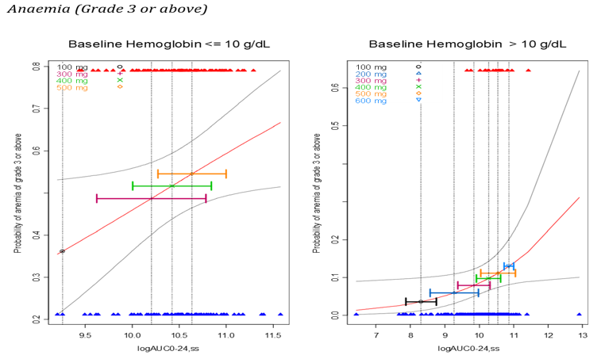
Figure 2: Logistic Model of Probability of Thrombocytopenia of Grade 3 or Above Versus LogAUC₀₋₂₄, _{ss}
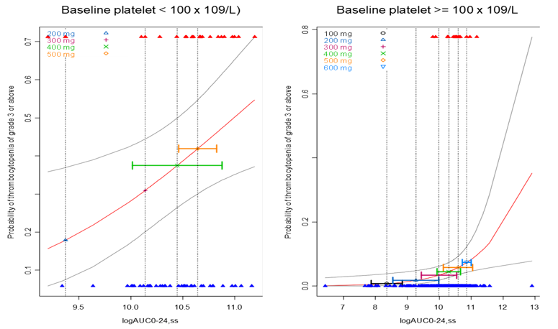

Efficacy
There are five clinical studies to support the proposed indication. Two of these studies are considered pivotal (EFC12153 and ARD11281).
Studies FEDR MF-001 and 002 were not included in the original FDA/EMA applications and are considered supportive. Interim reports for these studies were submitted. The full CSRs are expected in 2025. ARD11281, FEDR-MF-001 and FEDR-MF-003 were single arm open label studies. Studies EFC12153 and FEDR-MF-002 were controlled studies versus placebo and best available therapy (BAT) respectively. EFC12153 was the only double-blind study.

Comparative studies

EFC12153 (JAKARTA)
EFC12153 was a Phase 3, randomised, double-blind, multicentre, placebo-controlled, 3-arm study of fedratinib in patients with intermediate-2 or high-risk primary myelofibrosis (PMF), post-polycythaemia vera myelofibrosis (post-PV MF) or post-essential thrombocythaemia myelofibrosis (post-ET MF) with splenomegaly who were naïve to JAK2 inhibitors. The study was undertaken in 94 active centres in 24 countries including Australia. It took place between December 2011 and June 2014.

Method
Phase 3, multicentre, randomised, double-blind, placebo-controlled, 3-arm study of 2 doses of fedratinib in subjects with intermediate-2 or high-risk PMF, post-PV MF, or post-ET MF with splenomegaly. Eligible subjects were randomised (1:1:1) to receive either 400 or 500 mg/day fedratinib or matching placebo orally, once a day for at least 6 consecutive 28-day cycles. No stratification criteria were applied for these randomisations.
Subjects in the placebo arm were allowed to crossover and receive either treatment with either 400 or 500 mg fedratinib. To protect the blind, subjects in the 400 mg and 500 mg treatment arms were re-randomised to the same treatment assigned at the initial randomisation. Re-randomisation in the placebo arm occurred either when a subject had completed 6 cycles of treatment and had completed the End-of-Cycle 6 imaging assessments, or when a subject experienced PD prior to completing the first 6 cycles of treatment based on ≥ 1 of the protocol-defined criteria for PD. Subjects were to continue study treatment beyond Cycle 6 as long as they benefitted (as defined by the modified IWG-MRT response criteria) or had unacceptable toxicity requiring discontinuation of study treatment.
Dosing must be interrupted for the following events:
- Grade 4 thrombocytopenia (platelet count <25 × 10⁹/L) or neutropenia (ANC <0.5 × 10⁹/L). In such cases, dosing may be held for up to 28 days and may be reinitiated if values return to the following levels (≤Grade 2, according to Common Terminology Criteria for Adverse Events [CTCAE], version 4.03):
  - for platelet count: ≥50 × 10⁹/L
  - for ANC: ≥1.0 × 10⁹/L
- Grade 3 or higher nausea, vomiting, diarrhoea, constipation, or fatigue which does not respond to therapeutic or supportive measures within 48 hours. In such cases, dosing may be held for up to 14 days and may be reinitiated if the toxicity resolves to Grade 1.
- Any Grade ≥3 non-haematologic/non-gastrointestinal toxicity or Grade ≥2 peripheral neuropathy. In such cases, dosing may be held for up to 14 days and may be reinitiated if the toxicity resolves to Grade 1.
Dose reduction was to be considered for patients who become transfusion-dependent and were previously considered not to be.
Following submission of cases consistent with events of Wernicke’s encephalopathy (WE) in subjects treated with fedratinib across the fedratinib clinical development program, the United States Food and Drug Administration (FDA) placed the fedratinib Investigational New Drug (IND) application (IND 078286) on full clinical hold on 15 Nov 2013. Consequently, Sanofi terminated the development of fedratinib on 18 Nov 2013. All subjects worldwide were permanently discontinued from fedratinib, and all subjects worldwide (including those who had previously discontinued from the study) were given the option to receive thiamine supplementation for at least 90 days and were followed for safety for 90 ± 3 days after initiation of thiamine supplementation. This period was referred to as the ‘Thiamine Supplementation Period’. Median exposure in each dose group was 24 weeks, mean (SD) exposure was 19.5(7.42) weeks for placebo, 22.0(6.06) weeks for fedratinib 400 mg and 19.8(8.48) weeks for fedratinib 500 mg.

Major inclusion criteria
- Diagnosis of PMF or post-PV MF or post-ET MF, according to the 2008 World Health Organization (WHO) and International Working Group for Myelofibrosis Research and Treatment (IWG-MRT) criteria (Cervantes, F).
- Myelofibrosis classified as high-risk or intermediate-risk level 2, as defined by modified IWG-MRT criteria.
- Enlarged spleen, palpable at least 5 cm below costal margin.
- At least 18 years of age
- Eastern Cooperative Oncology Group (ECOG) performance status (PS) score of 0, 1, or 2 at study entry
Subjects were also required to have the following laboratory values within 14 days prior to the initiation of fedratinib or placebo:
- Absolute neutrophil count (ANC) ≥1.0 x 10⁹/L
- Platelet count ≥50 x 10⁹/L
- Serum creatinine ≤1.5 x upper limit of normal (ULN)
- Serum amylase and lipase ≤1.5 x ULN
Subjects with prior treatment with a JAK2 inhibitor were excluded from the study.

Primary Efficacy Endpoint
Spleen response rate (RR): Defined as the proportion of subjects with ≥ 35% spleen volume reduction (SVR) at the End of Cycle 6 (EOC6). A confirmatory MRI/CT was required 4 weeks later. The IRC reviewed the MRI/CT images in a blinded manner.

Secondary Efficacy Endpoints
- Symptom response rate (SRR) using a modified myelofibrosis symptom assessment form (MSAF) (Mesa, R.A.). The total symptom score was defined as the average value of the daily total score of the 6-item measures of the week: night sweats, pruritus (itching), abdominal discomfort, early satiety, pain under ribs on left side, and bone or muscle pain with each item rated from 0 (absent) to 10 (worst imaginable).
  - Symptom RR: Defined as the proportion of subjects with ≥ 50% reduction in the total symptom score (TSS) from baseline to the End of Cycle 6. Baseline TSS was the TSS value the week before randomisation or the week before an on-treatment assessment.
  - Total symptom score (TSS): Defined as the average value of the daily total score, which was calculated as the sum of the daily scores of the 6 items of the modified MFSAF.
- Overall survival (OS): Defined as the time interval from the date of randomisation to the date of death due to any cause. In the absence of confirmation of death, OS was censored at the last date the subject was known to be alive.
- Progression-free survival (PFS): Defined as the time interval from the date of randomization to the date of the first investigator-assessed disease progression or the date of death due to any cause, whichever came first. In the absence of progressive disease (PD) or death, PFS was censored at the date of the last valid assessment performed.
- Spleen RR of ≥ 25% SVR (RR25) at the End of Cycle 6 and confirmed 4 weeks later. The IRC reviewed the MRI/CT images in a blinded manner.
- Duration of spleen response: Defined as the time from the date of the first response by IRC to the date of subsequent PD by IRC or death, whichever was earlier.

Statistical methods
Primary analysis of spleen RR: A chi-square test was performed to compare the RR at each dose to the placebo RR at a 2-sided 2.5% alpha level. The RRs and 95% confidence intervals (CIs) were provided for each arm as well as for the difference in RRs and 97.5% CI of the difference for each dose to placebo. Confidence intervals were calculated using normal approximation.
Patients without a valid spleen volume assessment at the end of Cycle 6 measured by MRI (or CT scan in patients with contraindications for MRI) and patients without a valid confirmation spleen volume assessment at 4 weeks after the end of Cycle 6 measured by MRI (or CT scan in patients with contraindications for MRI) that is ≥ 35% reduction from baseline (confirmation of response at end of Cycle 6) will be considered non-responders; patients who had disease progression before end of Cycle 6 will also be considered non-responders.
Sensitivity analysis of spleen RR – Regardless of confirmation 4 weeks later: A chi-square test similar to the primary analysis of RR, but regardless of whether a subject had a confirmatory MRI/CT 4 weeks after the End of Cycle 6.
Primary analysis of Symptom RR: A chi-square test was performed to compare each dose with the placebo at a 2-sided 2.5% alpha level. The symptom RR (proportion of subjects with ≥ 50% reduction in the TSS from baseline to the End of Cycle 6) and 95% CIs were provided for each arm as well as for the difference in proportions and 97.5% CI of the difference for each dose to placebo. The primary population was the ITT Population excluding subjects with missing baseline TSS. This analysis was also performed using the Symptom Analysis Population.
Overall survival and PFS analyses were not performed due to the short follow-up period (i.e., due to the early termination of the study).

Results
Of 351 subjects screened, 62 were screen failures and 289 (ITT population) were randomised: 96 to 400 mg; 97 to 500 mg; 96 to placebo. One subject randomised to placebo died before receiving treatment. Overall, 71 subjects in the placebo arm were re-randomised: 35 subjects to fedratinib 400 mg and 36 subjects to 500 mg (Figure 3).
Figure 3: Disposition of Subjects During the Entire Treatment Duration (ITT Population) study EFC12153 (JAKARTA)
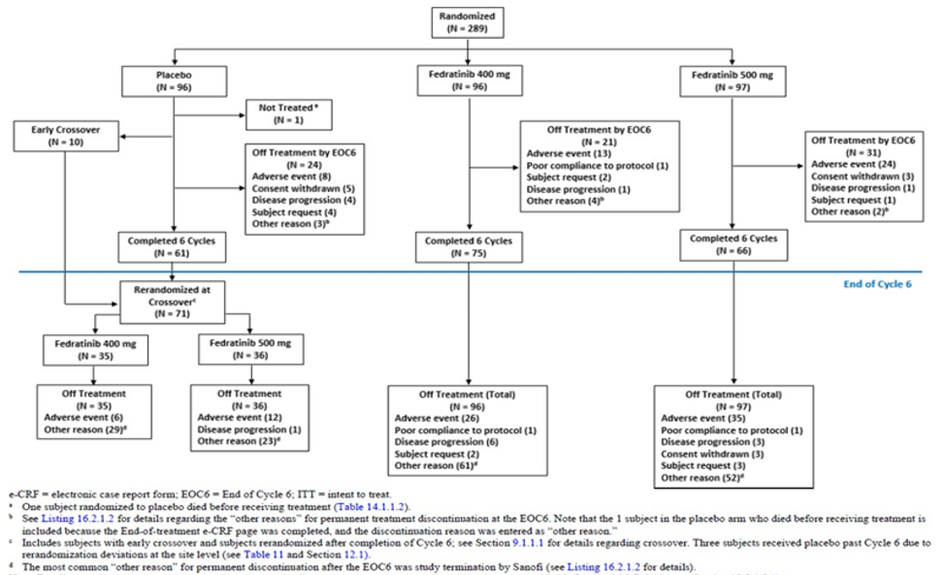
At the time of study termination, all subjects had either completed the first 6 cycles or had previously permanently discontinued treatment. A total of 144 subjects were still receiving fedratinib: 51 of the 96 subjects randomised to 400 mg, 45 of the 97 subjects randomised to 500 mg, 26 subjects who crossed over from placebo to 400 mg, and 22 subjects who crossed over from placebo to 500 mg.
The majority of the 45 subjects who permanently discontinued treatment due to an adverse event up to 6 cycles discontinued during the first 3 cycles: 6/8 (75.0%) subjects in the placebo arm, 7/13 (53.8%) subjects in the 400 mg arm, and 18/24 (75.0%) subjects in the 500 mg arm.
Demographic characteristics: Overall, the ITT Population consisted of 58.8% men and 41.2% women; subjects were mostly white (88.9%), mean (SD) age was 64.2 (9.49) years (mean age 65.0 years). The proportion of subjects who were ≤ 65 years of age was higher in the 400 mg arm (63.5%) compared with the placebo and 500 mg arms (45.8% and 50.5%, respectively). Overall, 9.0% of the ITT Population was older than 75 years. The highest proportion of subjects in each of the 3 treatment arms lived in Western Europe (43.6% overall) and Eastern Europe (26.0% overall).
Disease characteristics: Overall, the largest proportion of subjects in the ITT Population had PMF (63.3%), followed by post-PV MF (26.3%) and post-ET MF (10.4%). The overall median time since diagnosis of MF was 27.8 months. The overall frequency of subjects with intermediate-2 or high-risk status was 51.9% and 48.1%, respectively. Most subjects (66.8%) had a mutant JAK2 allele profile. Most subjects had baseline fibrosis Grade 2 (38.1%) or 3 (48.8%). Overall, 73.7% of subjects had constitutional symptoms, and most subjects (93.4%) were not transfusion dependent. Most subjects had an ECOG PS score of 0 (35.6%) or 1 (54.7%). The median baseline TSS (using modified MFSAF) for all subjects was 14.7. Most subjects (70.6%) had a spleen size > 10 cm. Prior hydroxyurea was taken by 63.0% of all subjects.
The disease characteristics at baseline were generally well balanced across the 3 treatment arms, with the following exceptions.
- The median time since diagnosis of MF was longer in the 400 mg arm (43.0 months) than in the placebo and 500 mg arms (28.3 and 22.0 months, respectively).
- A lower proportion of subjects in the 400 mg arm had high-risk status (40.6%) compared with the placebo and 500 mg arms (52.1% and 51.5%, respectively).
- A higher proportion of subjects in the 500 mg arm had mutant JAK2 profile (74.2%) compared with the placebo and 400 mg arms (61.5% and 64.6%, respectively).
- A higher proportion of subjects in the 400 mg arm had a baseline ECOG PS score of 0 (42.7%) compared with the placebo and 500 mg arms (32.3% and 32.0%, respectively).
- The median baseline TSS was lower in the placebo arm (12.43) compared with the 400 and 500 mg arms (15.3 and 16.0, respectively).
- A higher proportion of subjects in the 400 mg arm had received prior hydroxyurea (71.9%) compared with the placebo and 500 mg arms (56.3% and 60.8%, respectively).
Table 3: Proportion of subjects with prior myelofibrosis therapies (ITT Population) study EFC12153 (JAKARTA)
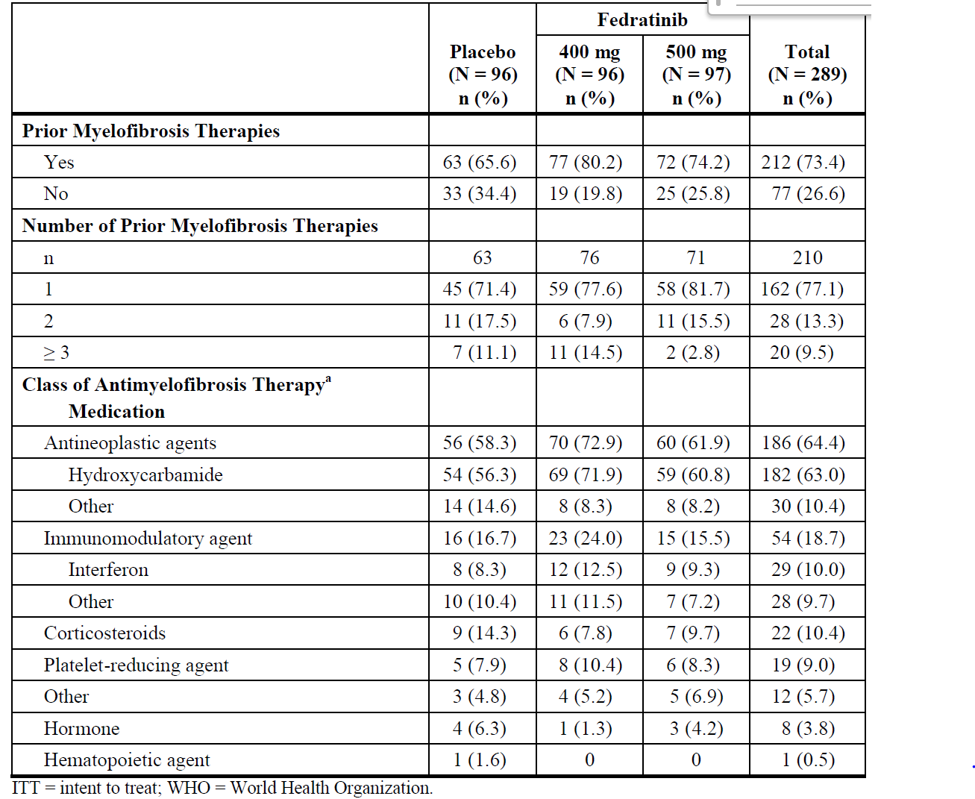
Primary efficacy outcome: 36.5% and 40.2% of subjects receiving fedratinib at doses of 400mg and 500mg, respectively and 1% of subjects given placebo experienced a spleen volume reduction of ≥35% at the end of Cycle 6, confirmed by a scan conducted 4 weeks after Cycle 6 completion (Table 4). Superiority of both doses of fedratinib over placebo was demonstrated. No statistical comparisons between the 400 mg and 500 mg fedratinib doses were performed and the difference does not appear to be clinically significant.
Table 4: Spleen Response Rate (≥ 35% SVR) at the EOC6 confirmed 4 weeks later (ITT Population) study EFC12153 (JAKARTA)
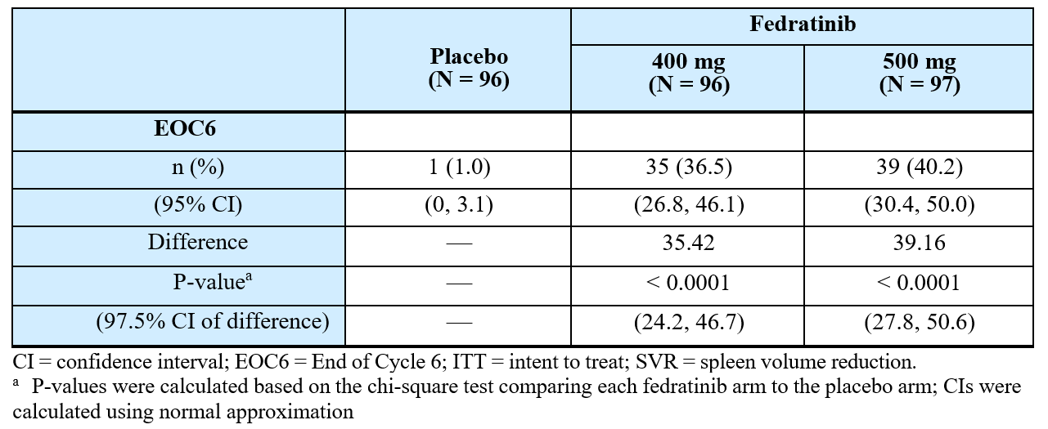
The first of the secondary endpoints was symptom response rate, defined as the proportion of subjects with ≥ 50% reduction in the total symptom score (TSS) from baseline to the End of Cycle 6. The study met its key secondary endpoint, symptom RR (using the modified MFSAF). Of the 289 subjects in the ITT Population, 267 had an available TSS at baseline (85/96 in the placebo arm, 91/96 in fedratinib 400 mg treatment arm, and 91/97 in fedratinib 500 mg treatment arm).
The proportion of subjects in the ITT Population with non-missing baseline TSS (including subjects with baseline TSS = 0) who had ≥ 50% reduction in the TSS from baseline to the End of Cycle 6 was 8.2% in the placebo arm, 39.6% in the 400 mg arm, and 34.1% in the 500 mg arm (Table 5).
Table 5: Symptom Response Rate (≥ 50% Reduction in Total Symptom Score) at the EOC6 – Subjects in the ITT Population with Non-missing Baseline Total Symptom Score. Study EFC12153 (JAKATA)
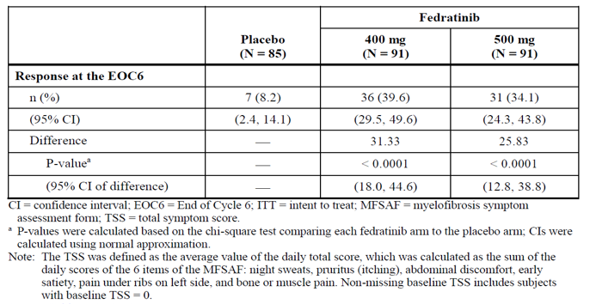
Given the early termination of the study, PFS and OS were not reported.

FEDR-MF-002 (FREEDOM2)
FREEDOM2 was a phase 3, multicentre, open-label, randomised study to evaluate the efficacy and safety of fedratinib compared to best available therapy (BAT) in subjects with DIPSS-intermediate or high-risk primary myelofibrosis, post-polycythaemia vera myelofibrosis, or post-essential thrombocythaemia myelofibrosis and previously treated with ruxolitinib.
Subjects were randomised at 74 sites in 15 countries. All sites in Russia were closed prematurely in 2022 due to supply chain constraints and operational challenges. The study commenced in September 2019, recruitment ended in June 2022, and the study is ongoing. The data cut-off date for the interim report included in the submission was 27 December 2022.

Method
The study consisted of 3 periods: a Screening Period, a Treatment Period including a 30-Day Follow-up after last dose visit and a Survival Follow-up Period. Treatment cycles were defined as 28-day periods irrespective of the assigned treatment arm. Subjects continued with study treatment until unacceptable toxicity, lack of therapeutic effect, progression of disease according to the IWG-MRT 2013 criteria or until consent was withdrawn.
Randomisation and treatment assignment occurred at the end of the Screening Period. Subjects were randomised 2:1 to fedratinib or BAT. Stratification at randomisation was done according to:
- Spleen size by palpation: < 15 cm below LCM versus ≥ 15 cm below LCM.
- Platelets ≥ 50 to < 100 x 10⁹/L versus platelets ≥ 100 x 10⁹/L.
- Refractory or relapsed to ruxolitinib treatment versus intolerance to ruxolitinib treatment. If both options applied, subjects were stratified as refractory/relapsed.
Subjects were allowed to crossover from the BAT arm to the fedratinib arm at any time before EOC6 response assessment in the event of a confirmed progression of splenomegaly (by MRI/CT scan) or, otherwise, after EOC6 response assessment.
All subjects who discontinued from therapy for any reason were followed up:
- For a period of 30 days following the last dose of study drug to collect safety data.
- For survival, subsequent therapies, new malignancy, and progression of myelofibrosis to acute myeloid leukemia (AML) every 3 months until death, lost to follow-up or withdrawal of consent for further data collection.

Main Inclusion Criteria
- Subject had an ECOG PS of 0, 1 or 2.
- Subject had diagnosis of PMF according to the 2016 WHO criteria, or diagnosis of post-ET MF or post-PV MF according to the IWG-MRT 2007 criteria, confirmed by the most recent pathology report.
- Subject had a DIPSS Risk score of Intermediate-2 or High.
- Subject had a measurable splenomegaly during the Screening Period as demonstrated by spleen volume of ≥ 450 cm³ by MRI or CT scan and by palpable spleen measuring ≥ 5 cm below LCM.
- Subject had a measurable TSS (≥1) as measured by the MFSAF.
- Subject had been previously exposed to ruxolitinib, and met at least one of the following criteria (a and/or b)
- Treatment with ruxolitinib for ≥ 3 months with inadequate efficacy response (refractory) defined as < 10% spleen volume reduction by MRI or < 30% decrease from baseline in spleen size by palpation or regrowth (relapsed) to these parameters following an initial response.
- Treatment with ruxolitinib for ≥ 28 days complicated by any of the following (intolerant):
- Development of an RBC transfusion requirement (at least 2 units/month for 2 months) or
- Grade ≥ 3 AEs of thrombocytopenia, anaemia, hematoma, and/or haemorrhage while on treatment with ruxolitinib.
- Subject had treatment-related toxicities from prior therapy resolved to Grade 1 or pre-treatment baseline before start of last therapy prior to randomization.
- Subject understood and voluntarily signed an ICF prior to any study-related assessments/procedures being conducted.

Main Exclusion Criteria
- Any of the following laboratory abnormalities:
- Platelets < 50 x 10⁹/L.
- ANC < 1.0 x 10⁹/L.
- WBC > 100 x 10⁹/L.
- Myeloblasts ≥ 5 % in peripheral blood.
- Estimated GFR < 30 mL/min/1.73 m2 (as per MDRD formula).
- Serum amylase or lipase > 1.5 x ULN.
- AST or ALT > 3 x ULN.
- Total bilirubin > 1.5 x ULN, subject’s total bilirubin between 1.5 – 3.0 x ULN was eligible if the direct bilirubin fraction was < 25% of the total bilirubin.
- Subject was pregnant or lactating female.
- Subject with previous splenectomy.
- Subject with previous or planned hematopoietic cell transplant.
- Subject with prior history of encephalopathy, including WE.
- Subject with signs or symptoms of encephalopathy, including WE (e.g., severe ataxia, ocular paralysis or cerebellar signs).
- Subject with thiamine deficiency, defined as thiamine levels in whole blood below normal range according to the central laboratory and not demonstrated to be corrected prior to randomization.
- Subject with concomitant treatment with or use of pharmaceutical, herbal agents or food known to be strong or moderate inducers of CYP3A4, or dual CYP2C19 and CYP3A4 inhibitors. Subject on any chemotherapy, immunomodulatory drug therapy (e.g., thalidomide, interferon-alpha), anagrelide, immunosuppressive therapy, systemic corticosteroids > 10 mg/day prednisone or equivalent. Subjects who had prior exposure to hydroxyurea in the past could be enrolled into the study as long as it was not administered within 14 days prior to randomisation.
- Subject had received ruxolitinib within 14 days prior to randomisation.
- Subject with previous exposure to JAK inhibitor(s) other than ruxolitinib treatment.
- Subject on treatment with aspirin with doses > 150 mg daily.
- Subject with major surgery within 28 days prior to randomization.
- Subject with diagnosis of chronic liver disease (e.g., chronic alcoholic liver disease, autoimmune hepatitis, sclerosing cholangitis, primary biliary cirrhosis, hemochromatosis, non-alcoholic steatohepatitis).
- Subject with prior malignancy other than the disease under study unless the subject had not required treatment for the malignancy for at least 3 years prior to randomization. However, subjects with the following history/concurrent conditions provided successfully treated were allowed for enrolment: non-invasive skin cancer, in situ cervical cancer, carcinoma in situ of the breast, incidental histologic finding of prostate cancer (T1a or T1b using the TNM clinical staging system), or were free of disease and on hormonal treatment only.
- Subject with uncontrolled congestive heart failure (NYHA Classification 3 or 4).
- Subject with known human immunodeficiency virus, known active infectious hepatitis B, and/or know active infectious hepatitis C.
- Subject with serious active infection.
Subjects on BAT were allowed to crossover to fedratinib treatment if one of the following criteria was fulfilled:
- Subject had completed the EOC6 response assessment including MRI/CT scan within 28 days before crossover.
- Subject had not completed the EOC6 response assessment but had demonstrated confirmed progression of splenomegaly.
Confirmed progression of splenomegaly was defined as enlargement of spleen volume by MRI/CT scan (within 28 days before crossover) of ≥ 25% compared to the subject’s baseline as assessed by the central imaging laboratory.
The presence of any of the following excluded a subject from crossover to fedratinib treatment:
- Any of the following laboratory abnormalities assessed within 28 days before crossover:
  - Platelets < 25 x 10⁹/L or platelets < 50 x 10⁹/L if associated with major bleeding.
  - ANC < 0.5 x 10⁹/L.
  - Myeloblasts ≥ 5 % in peripheral blood.
  - eGFR < 30 mL/min/1.73 m2.
  - Serum amylase or lipase > 2.0 x ULN.
  - AST or ALT > 3 x ULN.
  - Total bilirubin > 1.5 x ULN; subject’s total bilirubin between 1.5 – 3.0 x ULN was eligible if the direct bilirubin fraction was < 25% of the total bilirubin.
- Signs indicating transformation/progression to blast phase of myelofibrosis.
- Having received ruxolitinib or any other JAK inhibitor or hydroxyurea within 14 days prior to crossover.
- Thiamine deficiency, defined as thiamine levels in whole blood below normal range according to the central laboratory and not demonstrated to be corrected prior to crossover.
- Signs or symptoms of WE (e.g., severe ataxia, ocular paralysis or cerebellar signs) without Documented exclusion of WE by thiamine level and brain MRI.
- Subject with concomitant treatment with or use of pharmaceutical, herbal agents or food known to be strong inducers of CYP3A4, sensitive CYP3A4 substrates with narrow therapeutic range, sensitive CYP2C19 substrates with narrow therapeutic range, or sensitive Cytochrome P450 2D6 (CYP2D6) substrates with narrow therapeutic range.
- Subject with serious active infection.

Study treatments
4 x 100 mg fedratinib capsules self-administered orally once daily, preferably together with an evening meal, at the same time each day. Dose reductions to 300 mg or 200 mg were allowed according to protocol-defined criteria. A comprehensive dose modification schedule was provided for subjects with grade 3 or 4 TEAE as shown below.
Table 6: Fedratinib Dose Modification Schedule FEDR-MF-002 (FREEDOM2)
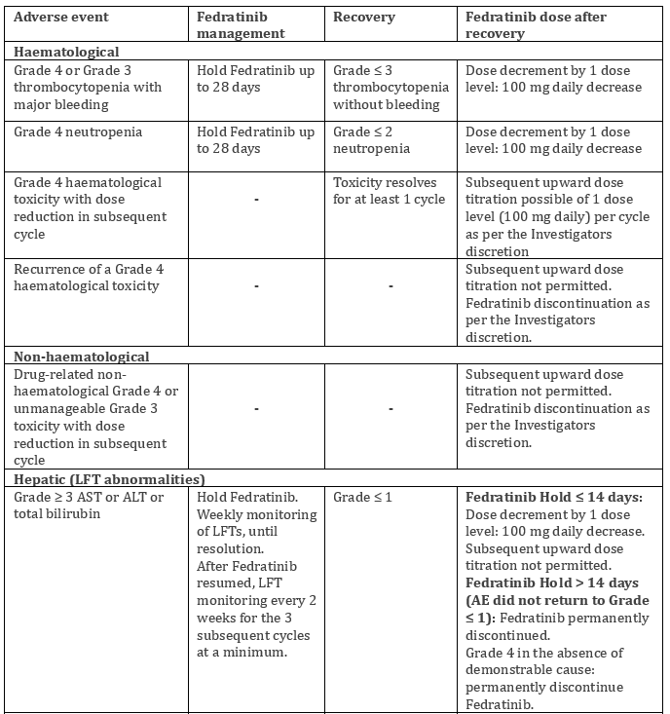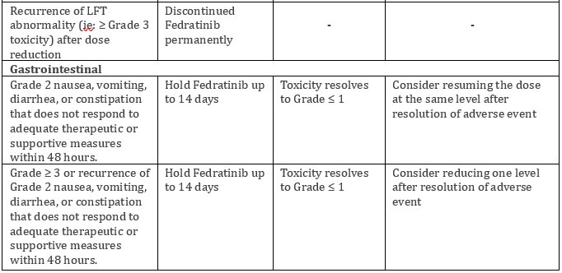
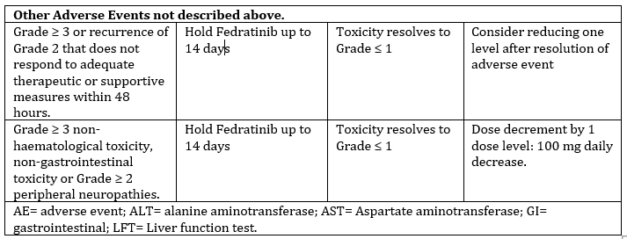
BAT was provided by the local site. It included any investigator-selected treatment and was not limited to JAK inhibitors, chemotherapy, anagrelide, corticosteroids, hematopoietic growth factor, immunomodulating agents, androgens, or interferons, and could also include ‘no treatment’ and symptom-directed treatment. BAT did not include investigational agents, fedratinib (if approved during the course of the study) and hematopoietic stem cell transplantation.

Endpoints
Table 7: Primary and key secondary endpoints study FEDR-MF-002 (FREEDOM2)
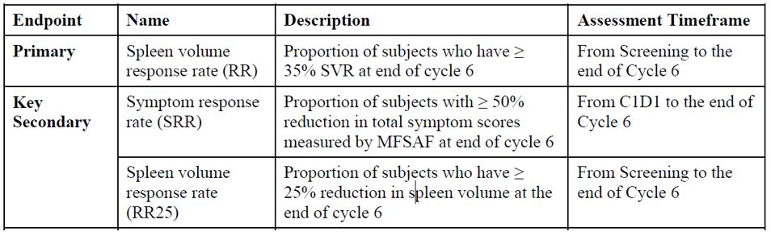
The primary endpoint was the percentage of subjects with at least 35% spleen volume reduction (SVR) in the fedratinib and Best Available Therapy (BAT) arms at the endo of Cycle 6 (Table 7). Spleen RR was based on MRI or CT imaging results generated by central review and on the ITT population.
The myelofibrosis symptom assessment form (MFSAF) was MFSAF version 4.0 using a 7-day recall period. This questionnaire assesses 7 key MF-associated symptoms (night sweats, pruritus, abdominal discomfort, early satiety, pain under ribs on left side, bone or muscle pain, and fatigue).
Due to the number of different questionnaires used in clinical trials for patient-reported MF symptoms, this version was developed following harmonization work conducted in collaboration with industry and the FDA with the aim to create a publicly available, consensus-based and harmonised version of MF symptoms questionnaire.
A stepdown procedure was used to control the family-wise Type 1 error rate. The primary efficacy endpoint (RR) was tested first. A CMH test using the Greenland and Robins method to adjust for planned stratification factors (spleen size by palpation, platelet count and refractory/relapsed or intolerance to ruxolitinib treatment) was performed to compare fedratinib to BAT. In case of stratification errors, the actual stratification factors were the source for the main analysis.
The key secondary endpoints (SRR, RR25) were tested only after the primary efficacy endpoint demonstrated superiority of fedratinib over BAT. Furthermore, to control the overall family-wise Type I error rate at 0.025 (one-sided) for the 2 secondary endpoints, SRR was tested firstly at α = 0.025 (one-sided); RR25 was tested at α = 0.025 (one-sided) only after SRR showed superiority for fedratinib over BAT.

Results
A total of 201 subjects were randomised, 134 to fedratinib and 67 to BAT. For the entire ITT population, the median age was 70 years, ranging from 38 to 91 years and 52% were male. The study population included 141 (70.1%) subjects who were > 65 years old. Most of the subjects were White (n = 164 [81.6%]).
Table 8: Key Baseline Disease Characteristics from Anamnesis (ITT Population) Study FEDR-MF-002 (FREEDOM2)
Parameter | Fedratinib | BAT
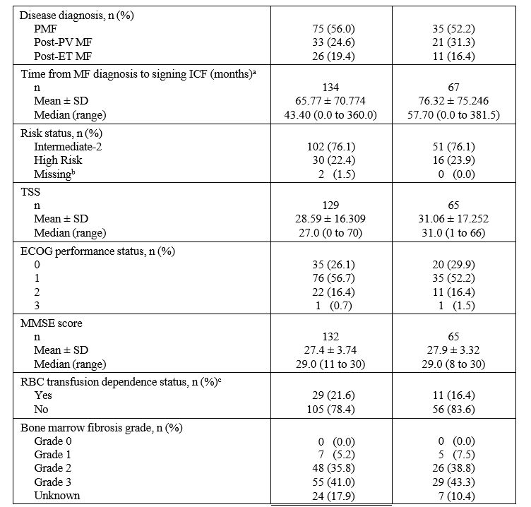
The treatment groups are similar with regard to disease status. The most frequent BAT was ruxolitinib which was reported for 52 (77.6%) subjects of the BAT group. The second most frequent BAT was/were RBC transfusion(s) which was/were reported for 19 (28.4%) subjects. Based on aggregated groups, ruxolitinib alone or with other medications/RBC transfusions other than hydroxyurea was used in 47 (70.1%) subjects. Hydroxyurea alone or with other medications/RBC transfusions excluding ruxolitinib was used in 7 (10.4%) subjects. A total of 5 (7.5%) subjects were treated with the combination of ruxolitinib and hydroxyurea with or without other medications/RBC transfusions.
In the fedratinib group, at least one dose reduction or interruption was reported for 70 (52.2%) subjects during the first 6 treatment cycles and for 86 (64.2%) subjects during the entire treatment time. In the BAT group, at least one dose reduction or interruption was reported for 20 (29.9%) subjects during the first 6 treatment cycles and for 34 (50.7%) subjects during the entire treatment time.
Table 9: Spleen Volume Response Rate at EOC6 (≥ 35% Spleen Volume Reduction) by MRI or CT (ITT Population) Study FEDR-MF-002(FREEDOM2)
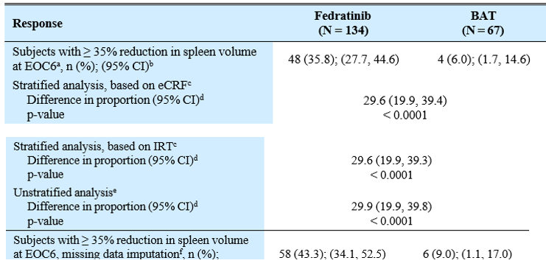
Subjects with missing assessment at the end of Cycle 6, including those who met the criteria for progression of splenomegaly before the end of Cycle 6, were considered non-responders. They were included in the denominator.
The two-sided 95% CI was based on the exact Clopper-Pearson method.
The stratified p-value was one-sided based on CMH test using the Greenland and Robins method to adjust for stratification factors: spleen size by palpation and platelet counts. The third stratification factor 'refractory/relapsed or intolerance to ruxolitinib treatment' was dropped due to small cell count issue.
The 95% CI of the difference was based on Greenland and Robins method.
The unstratified p-value was one-sided based on the z-test with an un-pooled estimate of variance.
For subjects with missing assessment at the end of Cycle 6, data was imputed using multiple imputation methods. Thirty imputed datasets were created. The proportion with 95% CI for each arm and the difference in proportion with 95% CI were calculated for each imputed dataset and combined using Rubin’s rules. The number of responders was back-calculated from the pooled adjusted response rate.
Statistical superiority of fedratinib demonstrated in the stratified analysis based on e-case report form (eCRF) data and based on interactive response technology (IRT) data as well as in the unstratified analysis. After imputation of missing data, the percentage of subjects with at least 35% SVR at EOC6 was 43.3 in the fedratinib group and 9.0 in the BAT group.
In the BAT arm, the majority of subjects (n = 46) crossed over to fedratinib after EOC6. In subjects remaining in the BAT arm, the spleen volume reduction was at least 23%, as measured at EOC12 and EOC18.
Figure 4: Spleen Volume Reduction by ≥ 35% at EOC6, Subgroup Analysis, Forest Plot, ITT Population
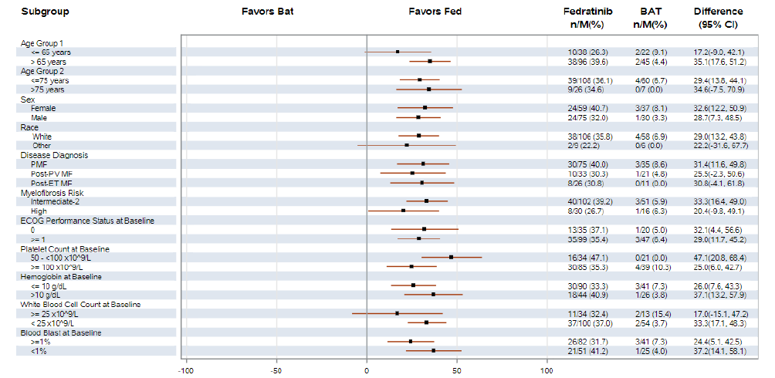
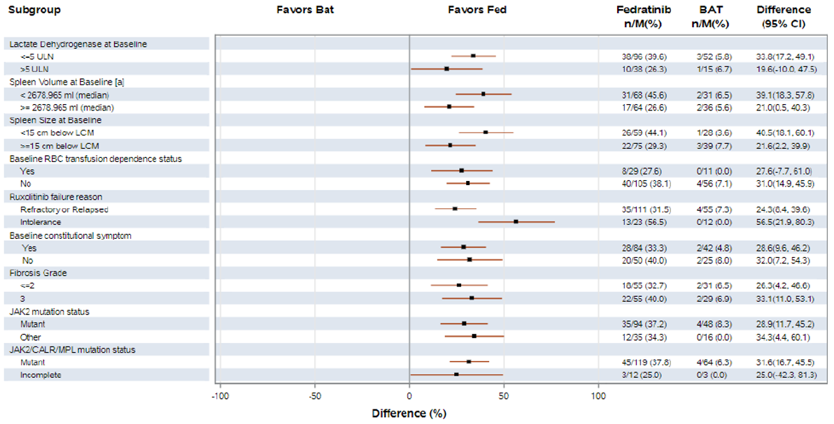
Table 10: Key Secondary Endpoint: Symptom Response Rate, ≥ 50% Reduction in TSS (SRR; ITT Population with Non-zero Baseline TSS) Study FEDR-MF-002 (FREEDOM2)
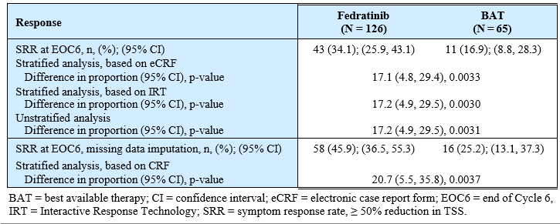
Table 11: Key Secondary Endpoint: Spleen Volume Response Rate by MRI or CT scan, ≥ 25% Reduction (RR25; ITT Population) Study FEDR-MF-002
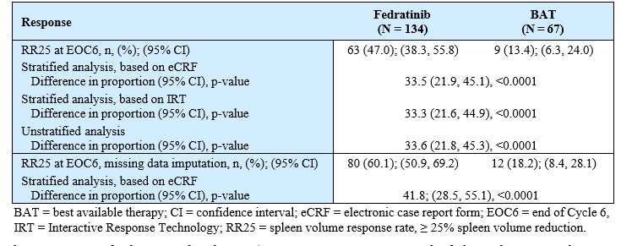

Supportive studies

ARD11281 (JAKARTA 2)
A Phase 2, single arm, open-label, multicentre study of fedratinib in subjects previously exposed to ruxolitinib and who, at study entry, had a diagnosis of intermediate-1 with symptoms, intermediate-2 or high-risk primary myelofibrosis (PMF), post-polycythaemia vera myelofibrosis (post-PV MF), or post-essential thrombocythaemia myelofibrosis (post-ET MF). This study was conducted at 40 sites in North America and the EU, with the first subject enrolled in April 2012 and the last subject completed in May 2024.
The main criteria for inclusion were: adult subjects; diagnosis of PMF or post-PV MF or post-ET MF, according to the 2008 World Health Organization and International Working Group for Myeloproliferative Neoplasms Research and Treatment (IWG-MRT) criteria; previous receipt of ruxolitinib treatment for PMF or post-PV MF or post-ET MF or PV or ET for ≥ 14 days (exposure of < 14 days was allowed for subjects who discontinued ruxolitinib due to intolerability or allergy) and discontinued treatment ≥ 14 days prior to the first dose of fedratinib; diagnosis of myelofibrosis classified as intermediate-1 with symptoms, intermediate-2 or high risk Dynamic International Prognostic Scoring System; and spleen ≥ 5 cm below costal margin as measured by palpation.
Subjects included those resistant or intolerant to prior ruxolitinib treatment per investigator’s assessment. Resistance included a lack of response (absence of response), disease progression (spleen size increase during ruxolitinib treatment), or loss of response at any time during ruxolitinib treatment. Intolerance included haematologic toxicity (anaemia, thrombocytopenia, or other) or non-haematologic toxicity.
The study consisted of a Screening Period followed by a Treatment Period of six 28-day cycles. A Follow-up Visit was performed approximately 30 days following the last administration of fedratinib. Fedratinib was administered orally, once a day, in consecutive 28-day cycles at a dose of 400 mg/day.
As in the JAKARTA study, following submission of cases consistent with events of Wernicke’s encephalopathy (WE) in subjects treated with fedratinib, the United States (US) Food and Drug Administration (FDA) placed the fedratinib Investigational New Drug (IND) application on full clinical hold on 15 Nov 2013.
The primary efficacy endpoint was the same for the JAKARTA study i.e. Spleen response rate (RR) defined as the proportion of subjects with a ≥ 35% spleen volume reduction (SVR) at End of Cycle 6 relative to baseline as measured by magnetic resonance imaging (MRI)/computed tomography (CT).
The primary efficacy analysis was of the per-protocol population (treated subjects with evaluable baseline and ≥ 1 post-baseline MRI/CT scan of spleen volume, and no important protocol deviations that could impact the efficacy outcome). Efficacy of the ITT (all subjects enrolled) was also conducted.
The ITT population comprised 97 subjects. There were comparable proportions of men (54.6%) and women (45.4%), most subjects were white (94.8%), the median age was 67.0 years (range: 38 to 83 years) and median weight was 73.0 kg (range: 47 to 105.7 kg). A total of 83 subjects were included in the per protocol analysis.
The PP population comprised 83 subjects, 48.2% (95% CI: 37.1% to 59.4%) of the PP population achieved a spleen RR (≥ 35% SVR; using the LOCF method) at End of Cycle 6. Consistent results were seen across all 3 supportive analyses of spleen RR (≥ 35% SVR) at End of Cycle 6 without using the LOCF method in the PP Population (36.1%), using the LOCF method in the ITT Population (41.2%), and without using the LOCF method in the ITT Population (30.9%).
The first of the secondary endpoints was Spleen RR at the end of Cycle 3, defined as the proportion of subjects who had a ≥ 35% reduction from baseline in spleen volume at End of Cycle 3 relative to baseline as measured by MRI/CT. The spleen RR at End of Cycle 3 was 47.0% in the PP Population.
Additional analysis was subsequently conducted using the ITT population and more stringent criteria for relapsed, recurrent and intolerance to ruxolitinib. Spleen RRs in subjects who were relapsed or refractory (R/R) or intolerant to ruxolitinib were consistent with the overall study ITT Population (N = 97). In the ITT Population the spleen RR was 30.4% of subjects (95% CI: 20.5% to 41.8%). In the subgroup of subjects who were R/R or intolerant to ruxolitinib treatment and who, at the time of early termination, either: had received Cycle 6 of fedratinib treatment, or had discontinued fedratinib treatment before Cycle 6 due to reasons other than “Study terminated by the sponsor the Spleen RR was36.4% (95% CI: 24.9% to 49.1%) at End of Cycle 6.

FEDR-MF-001(FREEDOM)
This is a Phase 3b, multicentre, single-arm, open-label study in subjects with Dynamic International Prognostic Scoring System (DIPSS) intermediate or high-risk primary MF, post-PV or post-ET MF. Subjects had been previously treated with ruxolitinib. The study consisted of 3 periods: a Screening Period, a Treatment Period including a 30-Day Follow-up after last dose visit, and a Survival Follow-up Period.
The first patient was enrolled in March 2019. In October 2020, the sponsor decided to close the study because of difficulties enrolling subjects due to availability of commercial drug in regions where this study was conducted as well as due to COVID-19.
In Mar 2021, the sponsor communicated to the investigators about the sponsor’s decision to close enrolment early. The communication announced the closing of screening at the end of April 2021 and the closing of enrolment by the end of May 2021.
The CSR reported the results for the primary endpoint while some subjects were still in the Treatment and Survival Follow-up Period. The final CSR is anticipated to be available in 2025. Key eligibility, dosing, and study endpoints are shown in the study design diagram below.
Figure 5: Overall study design FEDR-MF-001 (FREEDOM)
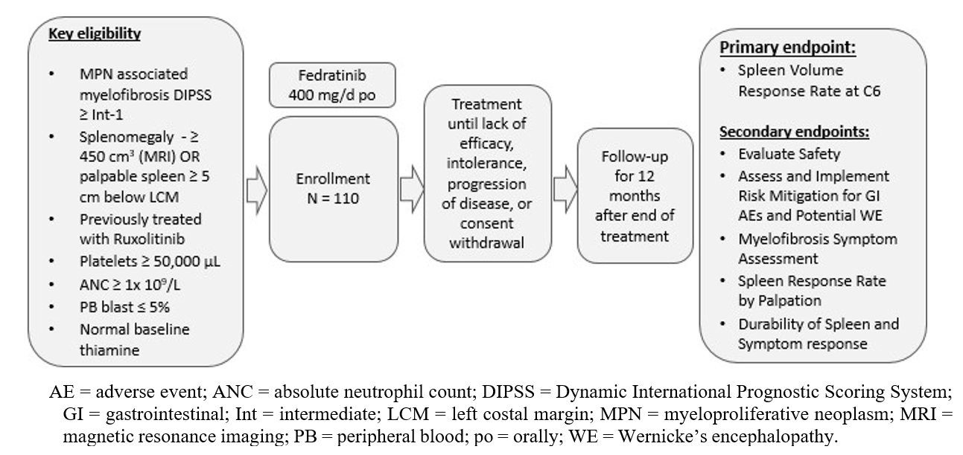
The primary endpoint was proportion of subjects who have a ≥ 35% SVR at End of Cycle 6 confirmed by independent central review. Each cycle was 28 days. The starting dose of fedratinib was 400 mg daily. Dose modifications were allowed based on observed toxicity to a 300 mg or 200 mg daily dose. Provisions were in place to allow further dose reduction for subjects with co-medication with moderate or strong Cytochrome P450 3A4 (CYP3A4) inhibitors. Efficacy and safety data were available from 38 subjects.
The primary analysis was of the efficacy evaluable population, defined as all subjects who enrolled and received at least one dose of fedratinib, had an evaluable spleen volume at baseline (based on MRI/CT scan) and at least one post-baseline response assessment by MRI/CT scan. A total of 9/35 (25.7%, 95% CI: 12.5%, 43.3%) subjects in the EE Population had a ≥ 35% SVR at the End of Cycle 6 as depicted by MRI/CT and based on central review. Based on the LOCF method, the proportion of subjects with ≥ 35% SVR at the End of Cycle 6 was 37.1%.

FEDR-MF-003
A Phase 1/2, multicentre, single-arm, open-label study to evaluate the efficacy and safety of fedratinib in Japanese subjects with DIPSS (Dynamic International Prognostic Scoring System)-intermediate or high-risk primary myelofibrosis (PMF), post-polycythaemia vera myelofibrosis (post-PV MF), or post-essential thrombocythaemia myelofibrosis (post-ET MF). Subjects were untreated with ruxolitinib or had failed to respond to ruxolitinib due to intolerance or were resistant. This was a bridging study initiated in Oct 2020. A total of 31 Japanese subjects were enrolled. 20/28 (71.4%) subjects had a ≥35% reduction in spleen volume at EOC6.

Safety

Exposure
As of 15 Aug 2023, approximately 1349 subjects have been assigned to treatment (i.e., assigned to treatment with the investigational medicinal product [IMP], active comparator, and/or placebo control) in company-sponsored clinical trials, with approximately 1263 subjects exposed to fedratinib and 200 subjects exposed to placebo/active comparator as subjects who participated in a crossover study were only counted once. The longest exposure to the proposed 400 mg daily dose of fedratinib occurred in study FEDR-MF-002 (FREEDOM2).
Overall, the treatment duration was longer in the fedratinib arm (146.47 P-Y) vs the BAT arm (39.62 P-Y). In the fedratinib arm, 100 (74.6%) subjects completed 6 treatment cycles, 85 (63.4%) subjects completed 9 treatment cycles, and 66 (49.3%) subjects completed 12 treatment cycles. In the BAT arm, 59 (88.1%) subjects completed 6 treatment cycles, 8 (11.9%) subjects completed 9 treatment cycles, and 7 (10.4%) subjects completed 12 treatment cycles.
The median average daily fedratinib dose for the full treatment period was 398.4 mg, which included dose interruptions and modifications, and the relative dose intensity (the percent of the planned weekly dose in mg actually received) was 96.7%. This study is ongoing, and the data included in the interim report in this submission had a cut-off date of 27-Dec-2022.
A single integrated summary of safety was not presented, there were 3 safety summaries: The Summary of Clinical Safety (SCS) submitted with the initial application had safety data from 18 clinical studies encompassing the fedratinib clinical development program at that time (report dated 20 Dec 2019); safety results of FEDR-MF-002 (FREEDOM2) with DCO 27 Dec 2022; and a clinical summary of 6 clinical studies conducted in subjects with MF (report dated 9 Oct 2024). A PSUR covering from 16 Feb to 15 Aug 2023 was also included in the submission. Emphasis here is on integrated report of the 6 studies in subjects with MF.

Integrated safety report studies in subjects with MF
Safety data from the following studies were included in this safety summary.
EFC12153 (JAKARTA, Phase 3, Randomised): Last Patient Last Visit (LPLV): 09 June 2014 ARD12181 (JAKARTA2, Phase 2, Single Arm): LPLV: 07 May 2014
ARD11936 (Phase 2, Randomised): LPLV: 12 May 2014
FEDR-MF-001 (FREEDOM 1; Phase 3b, Single Arm): Database Lock (DBL): 13 Dec 2023, Data Cut-off, 8 Nov 2023,
FEDR-MF-002 (FREEDOM2; Phase 3, Randomized): DBL: 10 May 2023, Data Cut-off, 27 Dec 2022
FEDR-MF-003 (Phase 1/2, Single Arm, Japan): DBL: 06 Dec 2023, Data Cut-off, 05 Oct 20231 (n=31)
The disease characteristics of subjects are relatively balanced between the pre-approval
and post-approval fedratinib 400 mg groups. The primary MF with positive JAK2 mutational profile was the predominant diagnosis type in both the pre- and post-approval fedratinib 400 mg groups. The majority of subjects (> 60%) had intermediate-risk MF in both pre and post approval fedratinib 400 mg groups, but the proportion was higher in the post approval (77.6%) than the preapproval fedratinib 400 mg group (60.9%).
The median time since first diagnosis of MF was similar between the pre- and post-approval
fedratinib 400 mg groups. At baseline, less than 20% of subjects were RBC transfusion dependent, with a higher proportion in the post-approval group compared to the pre-approval group. At baseline, the majority of subjects (> 60%) in both treatment groups had platelet levels ≥ 100 × 10⁹/L. A higher proportion of subjects in the pre-approval compared to the post-approval fedratinib 400 mg group had Hb levels ≥ 10 g/dL at baseline. The ECOG performance status was 0 or 1 in majority (approx. > 80%) of subjects in the preapproval and the post-approval fedratinib 400 mg group, indicating that the subjects were either fully active or had minor restrictions in physically strenuous activities. The baseline spleen volume and size were larger in the pre-approval than in the post-approval fedratinib 400 mg group.
Of these 6 studies, 2 studies (FEDR-MF-002 and FEDR-MF-003) are ongoing. The remaining 4 studies have either been completed, terminated, or closed.

Treatment-emergent adverse events (TEAEs)
In the first 6 cycles treat-related TEAEs, any Grade 3 /4 TEAE, Grade 3 / 4 TEAEs, TEAE leading to dose interruption and dose reduction were all more frequent in subjects given fedratinib compared with placebo and BAT as shown below.
The TEAEs of Grade 3/4 by PT that had higher frequency by more than 5% in the total fedratinib 400 mg group compared with placebo and BAT were: Anaemia: Placebo (7.4%), BAT (19.4%), and total fedratinib 400 mg group (32.0%); and Thrombocytopenia: Placebo (6.3%), BAT (6.0%), and total fedratinib 400 mg group (16.3%).
Table 12: Overview of Treatment-Emergent Adverse Events - First 6 Cycles Safety and Crossover Population
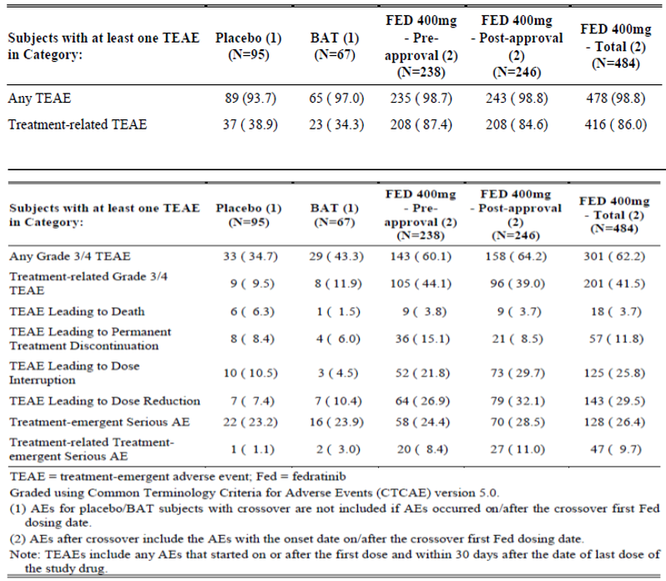
The Grade 3/4 TEAEs by PTs reported in the total fedratinib 400 mg group in ≥2% of subjects during with first 6 cycles and Cycle 7 and beyond were:
- First 6 Cycles: Anaemia (32.0%), thrombocytopenia (16.3%), neutropenia (3.5%), hyperkalaemia (3.3%), diarrhoea (2.7%), and pneumonia (2.3%),
- Cycle 7 and Beyond: Anaemia (23.0%), thrombocytopenia (11.9%), pneumonia (2.7%), neutropenia (2.1%), and hyperkalaemia (2.1%).
The following table shows the incidences of TEAE of any grade and of grades ≥3/4 in subjects with MF given the proposed 400 mg daily dose of fedratinib compared with subjects given comparative treatments during the first 6 months of study treatment. Safety data from 6 clinical studies was included in the table: EFC12153 (JAKARTA), ARD11281 (JAKARTA2), FEDR-MF-001 (FREEDOM), FEDR-MF-002 (FREEDOM2), ARD11936 and FEDR-MF-003. This table allows a comparison of the more frequent adverse events associated with fedratinib and alternative treatments of MF. The frequency of TEAEs was notably higher in the total fedratinib 400 mg group compared with the placebo and/or BAT groups in the follows SOCs:
- Gastrointestinal Disorders: Placebo: 49.5%, BAT: 47.8%, and total fedratinib 400 mg group: 77.3%
- Investigations: Placebo: 14.7%, BAT: 13.4%, and total fedratinib 400 mg: 37.8%
- Blood and lymphatic system disorders: The incidence of TEAEs was higher in the total fedratinib 400 mg group (55.4%) compared to placebo (24.2%) but was comparable to BAT group (50.7%).
Table 13: TEAEs by MedDRA SOC and PT with Cut-off of 5% by PTs (Any Grade TEAEs) in any treatment group- First 6 Cycles- Safety and Crossover Population
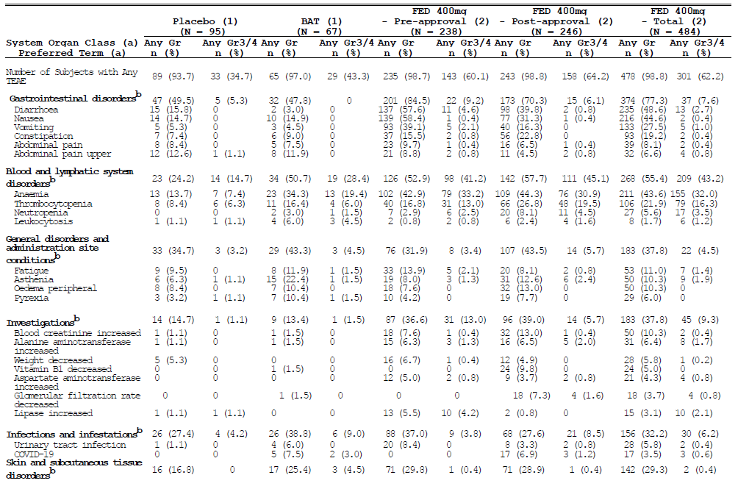
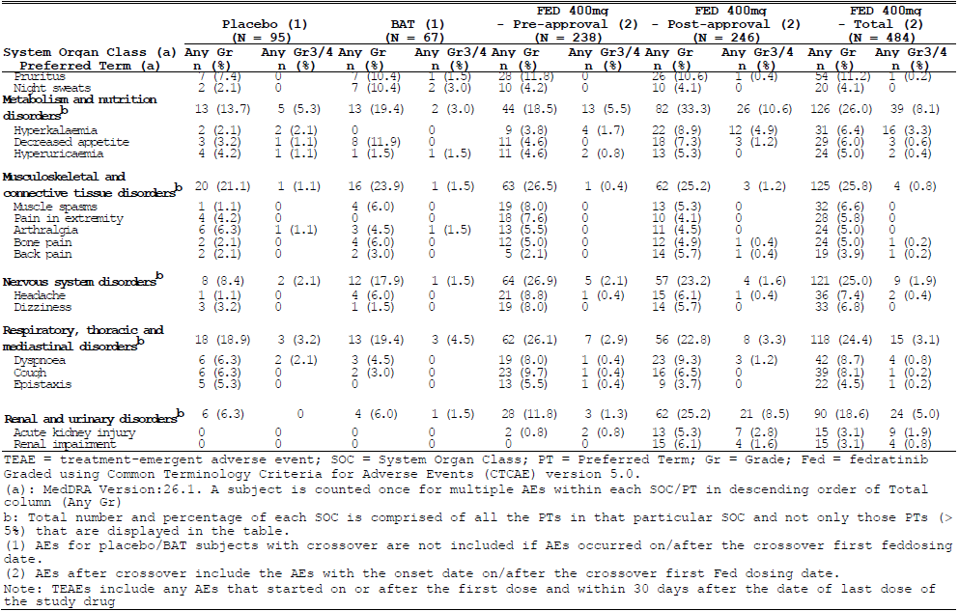

Deaths and serious TEAEs
Overall, the incidence of deaths was higher in the total fedratinib 400 mg group compared with placebo and BAT groups. Disease progression is the most common cause of deaths, followed by AEs in the placebo and total fedratinib 400 mg groups. In the BAT group, ‘other’ was the most common cause of deaths, followed by disease progression. No deaths were reported due to AEs in the BAT group.
Table 14: Summary of Deaths- Safety and Crossover Population
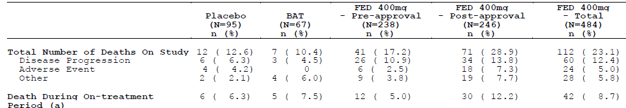
Table 15: TEAEs leading to Death by MedDRA SOC and PT in the Total Fedratinib Group - First 6 Cycles and Cycle 7 and Beyond- Safety and Crossover Population
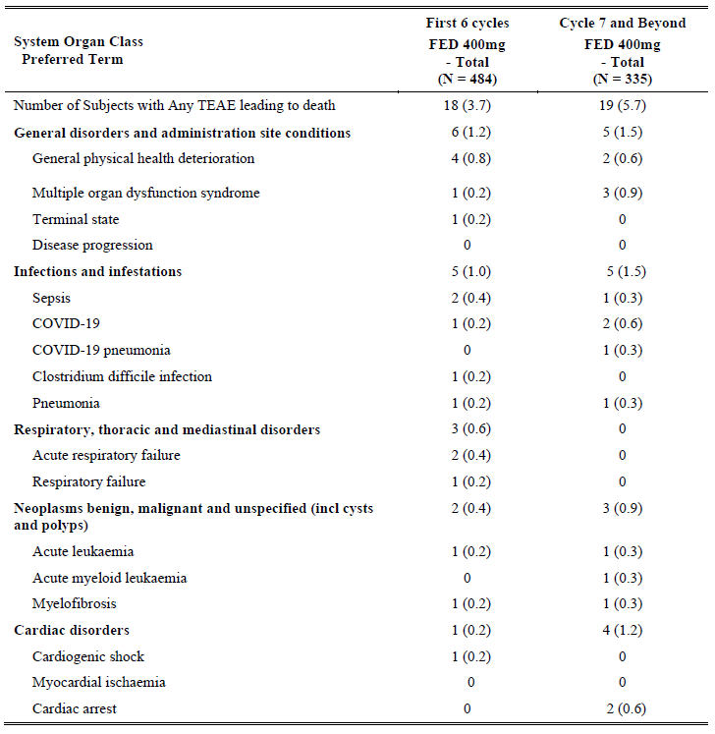
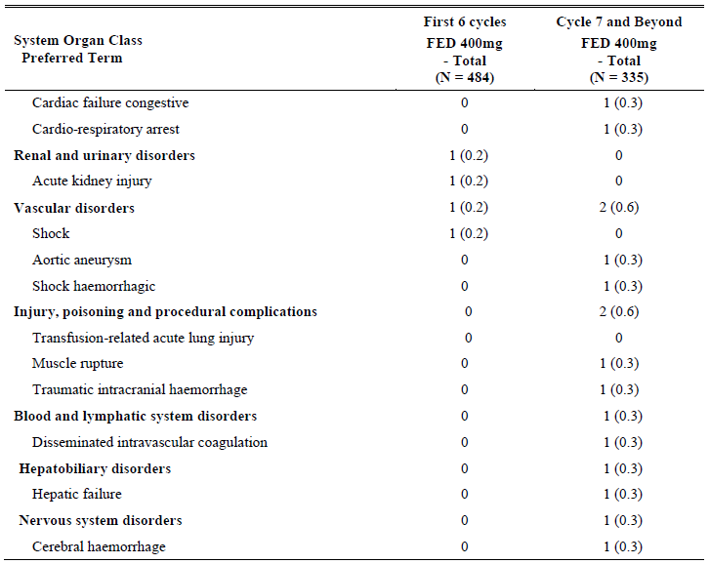
Less than 10% of subjects experienced treatment related SAEs in all three treatment groups during the first 6 cycles. None of the treatment related SAEs by PT occurred in more than one subject in the placebo and BAT groups. In the total fedratinib 400 mg group, the treatment related SAEs experienced by more than 2 subjects were: Anaemia (8 subjects, 1.7%), acute kidney injury (5 subjects, 1%), and hyperkalaemia (3 subjects, 0.6%). The incidence of treatment emergent SAEs was comparable between the first 6 cycles and Cycle 7 and beyond. The GI toxicity (diarrhoea, nausea, and vomiting) SAEs were low (<1%) in the total fedratinib 400 mg group during both first 6 cycles and cycle 7 and beyond.

TEAEs leading to discontinuation, interruption or dose reduction
TEAEs leading to treatment discontinuation occurred in 57/484 subjects treated with fedratinib 400 mg daily in the first 6 cycles. The most frequent events were: thrombocytopaenia (1.9%), diarrhoea and nausea (both 1%). In the subsequent cycles thrombocytopaenia was the most frequent cause of discontinuation (0.9%).
Dose interruptions occurred in 25.8% of subjects treated with fedratinib in the first 6 cycles, in the pre-approval studies dose interruptions occurred in 21.8% of fedratinib subjects cf. 29.7% in the post approval studies. This difference is likely to reflect the more stringent protocol mandated dose adjustment criteria in the latter studies. The most frequent causes of dose interruptions in subjects randomised to fedratinib 400 mg daily were: GIT disorders (8.3%), mostly diarrhoea and nausea; and blood and lymphatic disorders (7.2%), including 3.3% with thrombocytopaenia and 2.9% with anaemia. The incidence of TEAEs leading to dose interruptions were higher by at least 15% in the total fedratinib 400 mg group compared with both the placebo and BAT groups during the first 6 cycles. Gastrointestinal disorder was the only SOC in which the incidence of TEAEs leading to dose interruptions were higher by more than 5% in the total fedratinib 400 mg group compared with placebo and BAT groups.
Dose reductions due to TEAEs during the first 6 cycles and subsequently are shown below:
Table 16: TEAEs Leading to Dose Reduction in the Total Fedratinib 400 mg Group - with Cut-off of ≥1% subjects by PT in any Group - First 6 Cycles and Cycle 7 and Beyond- Safety and Crossover Population
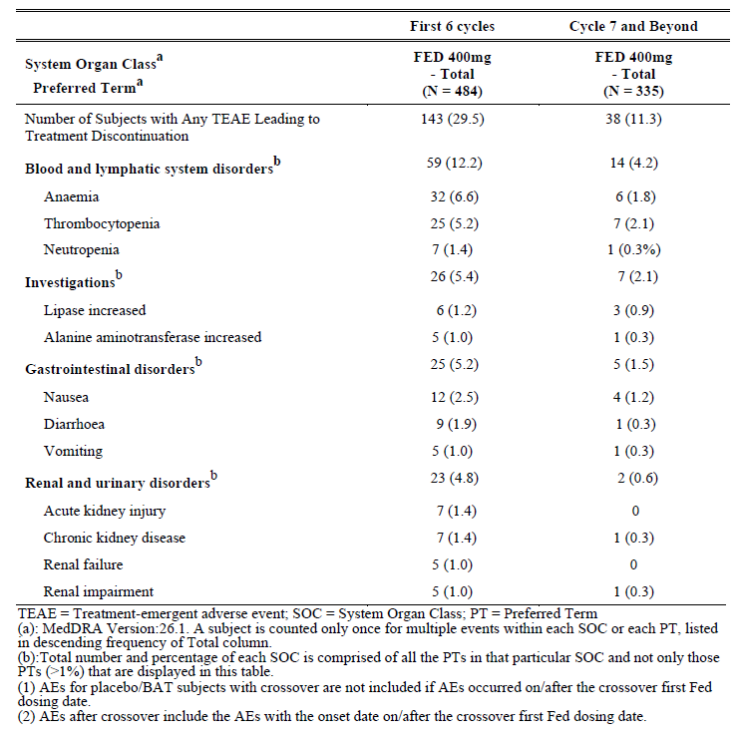

Events of special interest
- Grade 3/4 Anaemia
- Grade 3 or 4 Thrombocytopenia
- Cardiac failure/cardiomyopathy
- Encephalopathy, including WE
- Thiamine levels below normal range with or without signs or symptoms of WE
- Grade 3/4 Hyperamylasemia or Hyperlipasemia
- Grade 3/4 ALT, AST or total Bilirubin Elevation
- Secondary Malignancies
The incidences of these events occurring in the first 6 cycles of the 6 clinical studies are shown below, allowing a comparison of these events occurring with fedratinib at the proposed dose of 400 mg daily with the comparators of placebo and BAT (which was primarily ruxolitinib).
Table 17: AESIs by Category and MedDRA PT with cut off of ≥2% in any group by PTs- First 6 Cycles- Safety and Crossover Population
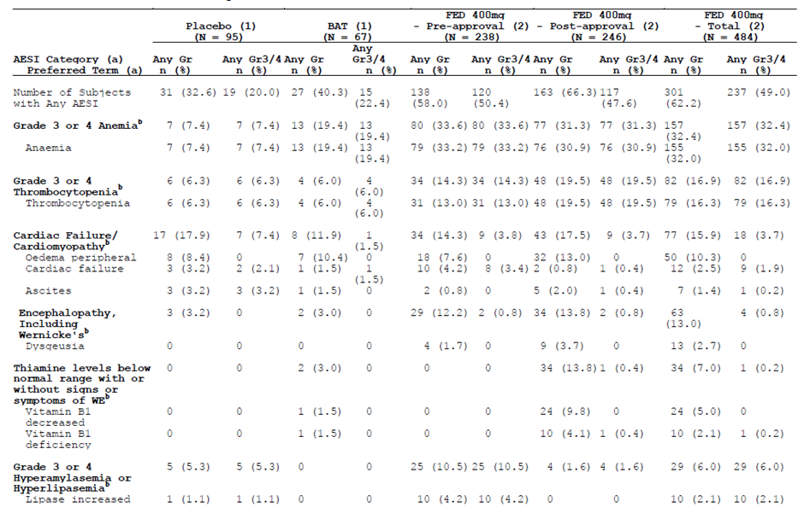
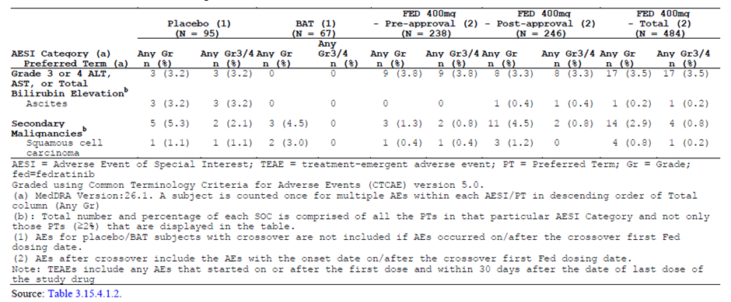
The incidence of Grade 3 or 4 anaemia based on laboratory values was higher in the total fedratinib 400 mg group (45.7%) compared with both placebo (24.2%) and BAT group (29.9%) during the first 6 cycles.
The incidence of Grade 3 or 4 thrombocytopenia based on laboratory values was higher in the total fedratinib 400 mg group (19%) compared with the placebo (9.5%) but was comparable with BAT group (17.9%) during the first 6 cycles.
During the first 6 cycles, the incidence of any grade and Grade 3/4 cardiac failure or cardiomyopathy was comparable between the three treatment groups:
- Any Grade: Placebo (17.9%), BAT (11.9%), and total fedratinib 400 mg group (15.9%)
- Grade 3/4: Placebo (7.4%), BAT (1.5%), and total fedratinib 400 mg group (3.7%)
Oedema peripheral of any grade was the only PT in the category of cardiac failure/ Cardiomyopathy that was experienced by more than 5% of subjects in all three treatment groups. The incidence of oedema peripheral of any grade was similar between the placebo, BAT, and total fedratinib 400 mg group. In all three treatment groups, none of the subjects reported Grade 3/4 oedema peripheral during the first 6 cycles.
The incidence of Grade 3 or 4 hyperamylasemia based of laboratory values was 3.3% in the total fedratinib 400 mg group during the first 6 cycles. All subjects reported the PT of lipase increased. None of the subjects in the placebo and BAT groups reported hyperamylasemia based of laboratory values.

Liver injury
The incidence of Grade 3 or 4 ALT, AST, or total bilirubin elevation based on laboratory values was 1.1% in the placebo group and 1.9% in the total fedratinib 400 mg group. No subjects reported Grade 3 or 4 ALT, AST, or total bilirubin elevation in the BAT group. During the first 6 cycles, the placebo group had 2 subjects who experienced > 3 x ULN AST and 1 subject who experienced > 5 x ULN AST that met Hy’s law criteria. None of the subjects in the BAT and total fedratinib 400 mg groups met Hy’s law criteria during the first 6 cycles. None of the subjects met Hy’s law criteria in all three groups during Cycle 7 and beyond.
The Hy’s law case was subject 840006015 (ARD11936) in the 300 mg group (who had decreased to 200 mg due to an event of polyarthritis in Cycle 1, had Grade 4 elevations in ALT, AST, and bilirubin in Cycle 3, reported as the serious AESI of hepatic failure. Maximum ALT and AST elevations of 1974 IU/L (43.9 × ULN) and 2421 IU/L (56.3 × ULN), respectively, were observed at the end of Cycle 3 (Day 85). Maximum bilirubin was 268.47 IU/L (15.7 × ULN) at an unscheduled visit on Day 99. Study drug was withdrawn due to hepatic failure. Alanine aminotransferase and AST fell to 221 IU/L (4.9 × ULN; Grade 2) and 96 IU/L (2.2 × ULN; Grade 1), respectively, at follow-up (Day 109) and bilirubin fell to 99.18 IU/L (5.8 × ULN; Grade 3).
The subject’s treatment included prednisone, zinc, rifaxamine, and lactulose (CSR ARD11936 Listing 16.2.4.4). The AESI of hepatic failure was considered related to treatment with fedratinib and was resolved on Day 106. Alanine aminotransferase, AST, and bilirubin decreased to within the normal range (Grade 0) by Day 169. There was no alternative explanation for these elevations after investigation. These events led to permanent discontinuation from the study (this case qualified for Hy’s Law).

Secondary malignancies
Secondary malignancies of any grade were comparable in the placebo (5.3%), BAT group
(4.5%), and the total fedratinib 400 mg group (2.9%). One subject reported acute myeloid leukaemia in the total fedratinib 400 mg group, while none of the subjects reported it in both placebo and BAT groups.

Wernicke’s encephalopathy and low thiamine levels
Before approval of fedratinib, cases of WE were reported within the fedratinib clinical program and led to a clinical hold of all ongoing studies in November 2013. Potential cases of WE in fedratinib-treated subjects were reviewed and adjudicated by several independent experts in neurology, and neuroradiology. The rate of serious encephalopathy, including (but not limited to) WE in the clinical program, was 1.3% (8/608 across all clinicals studies (including studies in solid tumours), with one fatal event (1/608=0.16%). Seven out of the 8 subjects were taking fedratinib at a higher dose than the approved daily 500 mg daily dose prior to the onset of neurologic findings and had predisposing factors such as malnutrition, gastrointestinal AEs, and other risk factors that could lead to thiamine deficiency. One subject (1/608) was determined to have had hepatic encephalopathy. On 18 Aug 2017, the clinical hold was lifted, with provision of risk mitigation in the two ongoing clinical protocols (FEDR-MF-001 and FEDR-MF-002) in MF subjects evaluating efficacy and safety in the post-ruxolitinib setting.
The overall incidence of any grade events potentially suggestive of encephalopathy, including Wernicke's was higher in the total fedratinib 400 mg group (13.0%) compared to placebo (3.2%) and BAT (3.0%) during the first 6 cycles.
The events potentially suggestive of encephalopathy, including Wernicke's was distributed across PTs in the placebo and the BAT group and none was reported in more than 2 subjects. In the total fedratinib 400 mg group, the TEAEs by PTs that were experienced by more than 2 subjects were: dysgeusia (13 subjects, 2.7%), paraesthesia and peripheral sensory neuropathy (9 subjects, 1.9% in each PT), hypoaesthesia (7 subjects, 1.4%), vision blurred (6 subjects, 1.2%), neuropathy peripheral (5 subjects, 1.0%), confusional state (4 subjects, 0.8%), palmar-plantar erythrodysesthesia syndrome and taste disorder (3 subjects, 0.6% in each PT).
Grade 3/4 events potentially suggestive of encephalopathy, including Wernicke's was reported in less than 1% of subjects in the total fedratinib 400 mg group (4 subjects, 0.8%). These Grade 3/4 events were reported under the following PTs: peripheral sensory neuropathy, neuropathy peripheral, aphonia, and metabolic encephalopathy. None of the subjects in the placebo or BAT groups had Grade 3/4 events potentially suggestive of encephalopathy, including Wernicke's. The protocol for FREEDOM2 was amended in April 2021 to include daily thiamine supplements and monitoring of serum thiamine.
To demonstrate the effect of fedratinib on thiamine levels in the absence of thiamine supplementation, the figure below shows subject-level changes in thiamine levels, excluding data after thiamine prophylaxis was implemented, and excluding data after the first low thiamine level was detected. When viewed from the first dose of fedratinib without thiamine supplementation (Day 0), decreases in thiamine levels were observed in two-thirds of subjects treated with fedratinib from baseline. While the decrease in thiamine was not universal, approximately two-thirds who received fedratinib without thiamine supplementation had a decrease in thiamine levels.
Figure 6: Change in Thiamine Level from Baseline, Spider Plot – Safety Population - Fedratinib Arm (FEDR-MF-002)
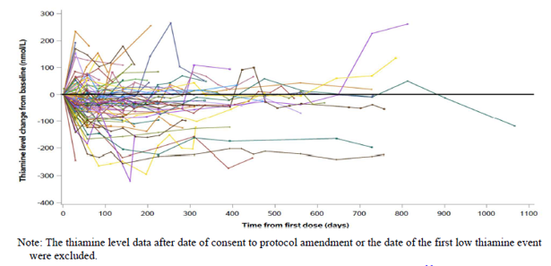
To demonstrate the effect of prophylactic thiamine supplementation on thiamine levels, the figure below shows subject-level thiamine levels relative to date of consent to PA4 (Day 0 in the graph), at which time prophylactic thiamine supplementation was implemented. Prior to PA4, 26/106 (24.5%) subjects had at least one low thiamine level. After PA4, 3/68 (4.4%) subjects had at least one low thiamine level. In general, following consent to PA4, there was an upward trend in overall thiamine levels.
Figure 7: Thiamine Levels Following the First Low Thiamine Event, Spaghetti Plot - Safety Population - Fedratinib Arm (FEDR-MF-002)
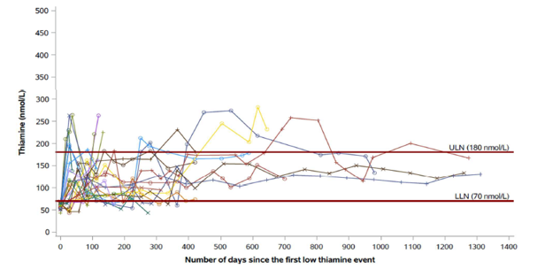
Bleeding events, severe infection and opportunistic infection were also assessed as being of special interest. In the first 6 cycles bleeding events the frequency of any grade bleeding TEAEs was similar in the total fedratinib 400 mg group (18.4%) compared with placebo (15.8%), and the BAT group (13.4%). The bleeding TEAEs by PT that were reported in more than 2% of subjects were - Placebo: Epistaxis and gingival bleeding; BAT: Contusion and haematoma and Total Fedratinib 400 mg: Epistaxis, contusion, and haematoma. The frequency of Grade 3/4 TEAE of bleeding were low (<5%) and comparable in all three treatment groups in the first 6 cycles.
The frequency of any grade severe infection and opportunistic infection TEAEs were comparable in the total fedratinib 400 mg group (3.2%) compared with placebo (3.2%), and BAT group (6.0%) in the first 6 cycles. The frequency of Grade 3/4 severe infection and opportunistic infection TEAEs were <2% in the total fedratinib 400 mg group and the BAT group in the first 6 cycles. None of the subjects reported Grade 3/4 severe infection and opportunistic infection TEAEs in the placebo group. The PTs and frequencies for these events are shown below.
Table 18: Treatment-emergent Bleeding AEs and Serious Infection and Opportunistic Infection AEs by PT with a cut off of 1% in any group - First 6 Cycles -Safety and Crossover Population
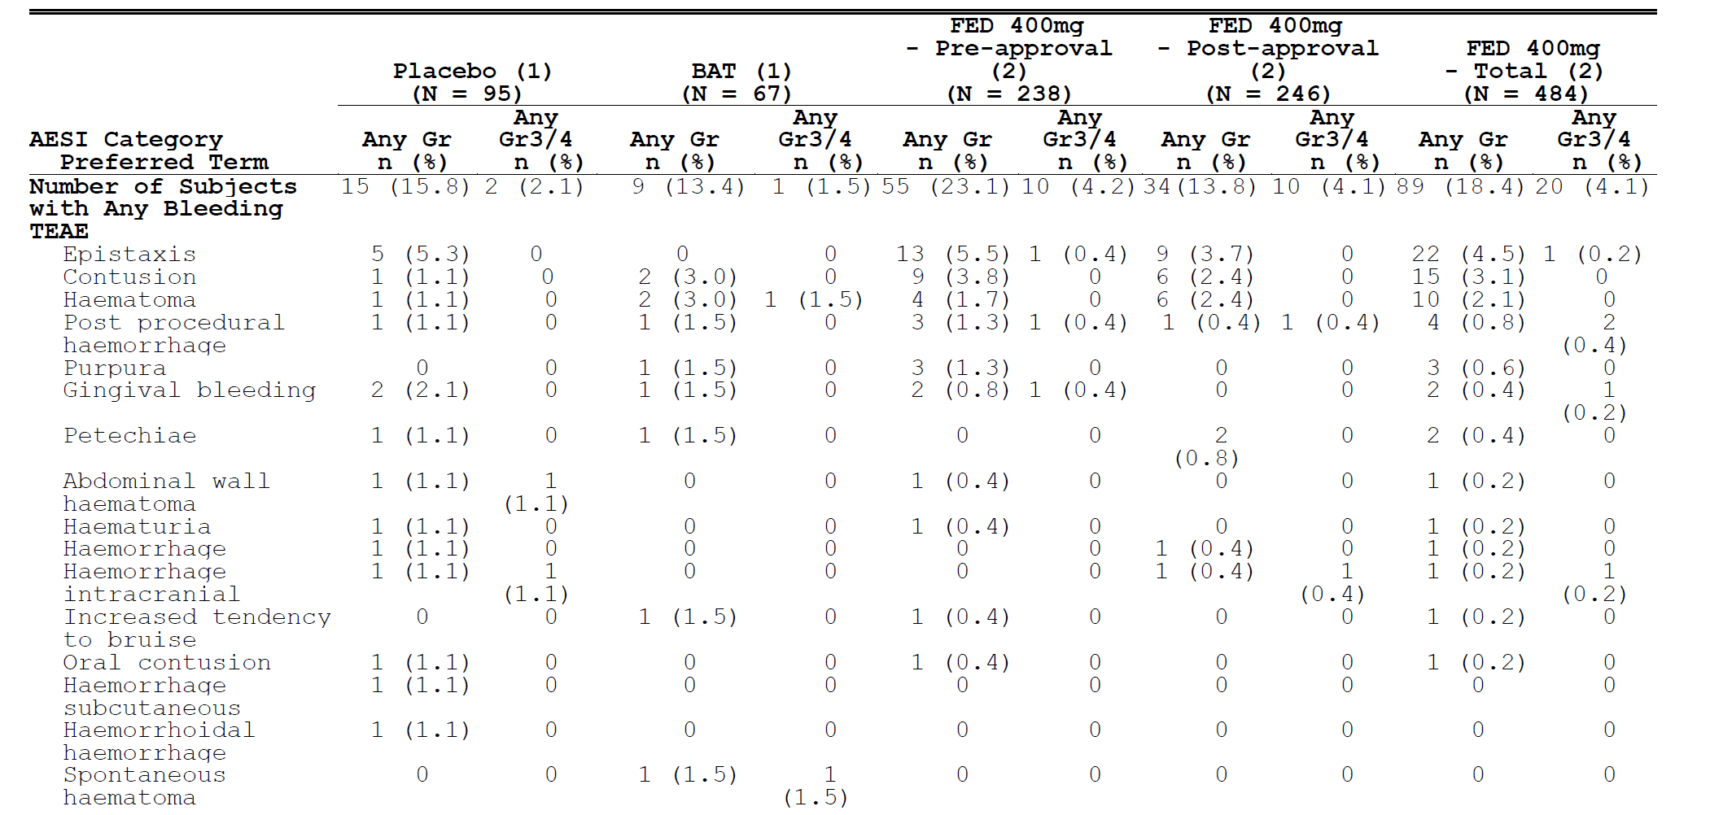

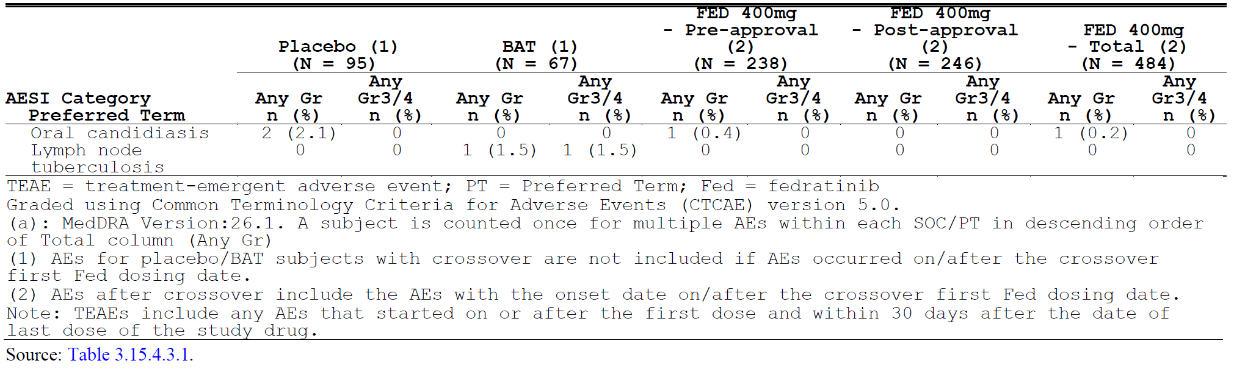

Uveitis
A signal report of uveitis with cumulative data (cut-off of 05 Aug 2024) was prepared by the cross-functional study management team to review events observed only in post-approval clinical studies of fedratinib. The post-approval studies (FEDR-MF-001 and MF-002, and MF-003) evaluated the safety and efficacy of fedratinib in subjects with myelofibrosis. All subjects in MF-001 and MF-002 were previously treated with ruxolitinib and received 400 mg daily. The MF-003 trial (Japan, n=31) included both subjects previously treated with ruxolitinib and ruxolitinib-naive subjects receiving 300 mg and 400 mg daily dose levels, respectively. In contrast to the pre-approval studies (JAKARTA1 and JAKARTA2) stopped in 2013 due to a clinical hold, the three post-approval studies had provided exposure data beyond 6 cycles in a larger number of subjects. Since uveitis is a late-onset event, the sponsor postulated that this likely explains why this safety signal was only detected in the post-approval trials.
Overall, in the BMS-sponsored post-approval studies, 11 of 251 subjects treated in studies MF- 001, MF-002 and MF-003 reported uveitis, with an overall incidence of 4.4%. Of the 11 subjects with uveitis episodes, 6 (55%) subjects experienced more than 1 episode of uveitis.
The uveitis episodes varied in grade, with Grade 1/2 reported in 12/20 (60%) episodes, and Grade 3/4 reported in 8/20 (40%) episodes. Uveitis episodes were reported as serious in four subjects, all from FEDRMF-002. Topical steroids were sufficient for treatment in 15/20 (75%) episodes, and systemic steroids were required in 5/20 (25%) episodes. Fedratinib was discontinued due to uveitis in 3/11 (27%) of subjects. At the time of data cutoff for the signal report, 12/20 (60%) of episodes had resolved and 8/20 (40%) were ongoing.
All episodes occurred in subjects actively taking fedratinib. Uveitis is a late-onset adverse event, with the first episode occurring at a median of 14 months after starting fedratinib, with a range of 8 to 22.2 months. Consistent with this late onset, a trend of increasing incidence with increased duration of therapy was noted. In the pooled population, the incidence increases from 4.4% for subjects receiving any duration of therapy to 7.2% for subjects receiving at least 24 months of therapy. There is significant variability in incidence of uveitis by study, with the highest incidence occurring in the Japanese MF-003 trial (19.4%), suggesting that certain ethnic groups (such as Asians) may be at higher risk of developing uveitis.

Dose-related toxicities
Dose-related toxicities can be examined in study EFC12153 (JAKARTA) in which subjects were randomised (1:1:1) to receive either 400 or 500 mg/day fedratinib or matching placebo orally, once a day for at least 6 consecutive 28-day cycles.
The table below shows increasing TEAE, Grade 3 or 4 TEAE, TESAEs, TEAE leading to death, treatment discontinuation and dose reduction or interruption were all more frequent with the 500 mg fedratinib dose cf. the 400 mg dose. Differences in efficacy between the 2 doses were minor.
Table 19: Overall Summary of Treatment-emergent Adverse Events up to 6 Cycles (All Treated Population) study EFC12153 (JAKARTA)
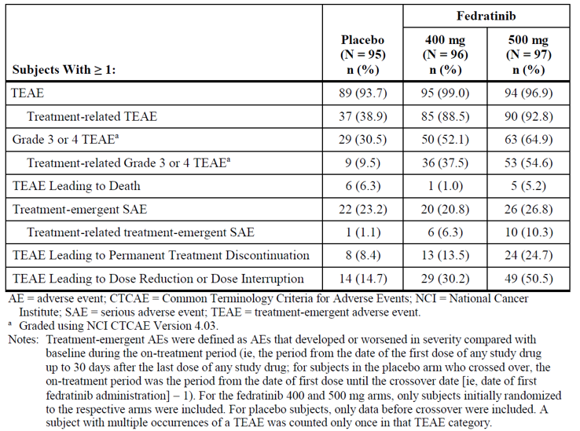
The most common Grade 4 TEAEs (≥ 2% of subjects) reported for the entire treatment duration were:
- 400 mg arm: Thrombocytopenia (5.2%), neutropenia (3.1%), and sepsis (2.1%)
- 500 mg arm: Thrombocytopenia (7.2%); anaemia and neutropenia (5.2% each); and acute myocardial infarction, AST increased, hyperuricemia, lipase increased, neutrophil count decreased, and pulmonary oedema (2.1% each).
Common (≥5%) grade 3 or 4 TEAEs for the 500 mg dose and with a ≥5% difference compared to the 400 mg dose were Grade 3 or 4 TEAEs reported during the entire treatment duration with a ≥ 5% difference between the fedratinib arms were:
- Higher in the 400 mg arm versus the 500 mg arm: None
- Higher in the 500 mg arm versus the 400 mg arm: Thrombocytopenia (18.6% vs.11.5%), neutropenia (10.3% vs. 4.2%), vomiting (9.3% vs. 3.1%), blood product transfusion dependent (8.2% vs 3.1%), and nausea (6.2% vs 0%).

Risk management plan
The sponsorship of the drug product was changed from Celgene Pty Ltd to Bristol-Myers Squibb Australia Pty Ltd in November 2024. Therefore, Celgene Pty Ltd submitted EU-RMP version 1.0 (dated 19 January 2021; DLP 31 May 2020) and Australia Specific Annex (ASA) version 1.0 (dated 20 November 2023) in support of this application. In its Section 31 response, the sponsor submitted an updated ASA version 2.0 (dated 09 September 2024) associated to the EU-RMP version 2.0 (dated 08 November 2023; DLP 15 August 2023).
The summary of safety concerns and their associated risk monitoring and mitigation strategies are summarised in Table 20. The TGA may request an updated Risk Management Plan (RMP) at any stage of a product's life cycle, during both the pre-approval and post-approval phases.
Table 20: Summary of safety concerns
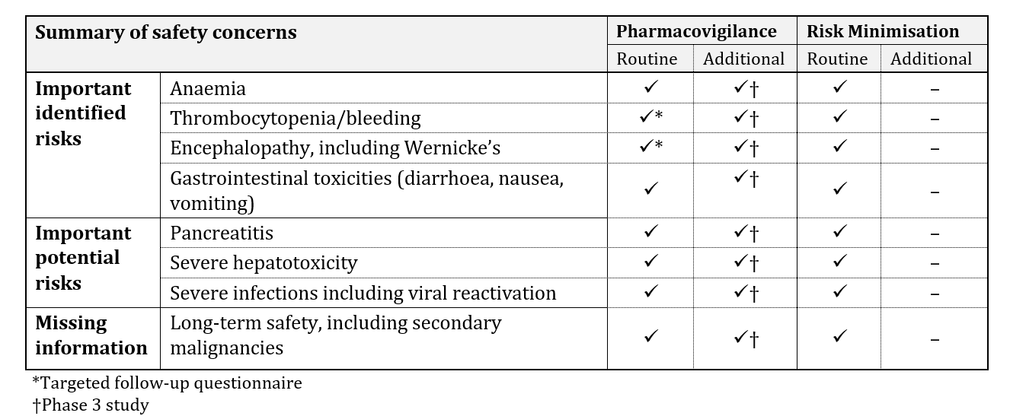
The summary of safety concerns is identical in the EU RMP and the ASA. This summary of safety concerns has been approved by the EMA. The missing information ‘use in patients with severe hepatic impairment’ has been removed from the updated EU-RMP and ASA following the completion of the FEDR-CP-001 (Category 3) study, which has demonstrated that a different starting dose is not required for this patient group. This summary of safety concerns is acceptable from an RMP perspective.
The proposed pharmacovigilance plan is acceptable.
Routine risk minimisation measures have been proposed. Routine risk minimisation measures are acceptable to address the risks associated with this product. This is the same as the approach approved by the EMA.

RMP evaluator recommendations regarding conditions of registration
The summary of safety concerns is identical in the EU RMP and the ASA. This summary of safety concerns has been approved by the EMA. The missing information ‘use in patients with severe hepatic impairment’ has been removed from the updated EU-RMP and ASA following the completion of the FEDR-CP-001 (Category 3) study, which has demonstrated that a different starting dose is not required for this patient group. This summary of safety concerns is acceptable from an RMP perspective.
The proposed pharmacovigilance plan is acceptable.
Only routine risk minimisation measures have been proposed. Routine risk minimisation measures are acceptable to address the risks associated with this product. This is the same as the approach approved by the EMA.
Any changes to which the sponsor has agreed should be included in a revised RMP and ASA. However, irrespective of whether or not they are included in the currently available version of the RMP document, the agreed changes become part of the risk management system.
The suggested wording is:
The Inrebic EU-Risk Management Plan (RMP) (version 2.0, dated 08 November 2023, data lock point 15 August 2023), with Australian Specific Annex (version 2.0, dated 09 September 2024), included with submission PM-2024-00081-1-6, and any subsequent revisions, as agreed with the TGA will be implemented in Australia.
The TGA may request an updated RMP at any stage of a product's life cycle, during both the pre-approval and post-approval phases. Further information regarding the TGA’s risk management approach can be found in risk management plans for medicines and biologicals and the TGA's risk management approach. Information on the Australia-specific annex (ASA) can be found on the TGA website.

Risk-benefit analysis

Delegate’s considerations
Clinical pharmacology of fedratinib has been well characterised. No relationship was identified between fedratinib exposure and WE or encephalopathy. Multiple drug interactions are associated with fedratinib involving CYP P450 enzymes and transport proteins. The most important are strong CYP3A4 inhibitors, strong and moderate CYP3A4 Inducers and dual CYP3A4 and CYP2C19 inhibitors e.g. fluconazole. The fedratinib dose should be reduced in patients taking concomitant strong CYP3A4 inhibitors. Dose modifications should be made as needed for agents that are renally excreted via OCT2 and MATE1/2-K such as metformin. Renal clearance of metformin was decreased by 36% in the presence of fedratinib.
Dose reductions are required for various grades of thrombocytopaenia, neutropenia, severe GI symptoms, liver enzyme abnormalities, and for severe renal impairment.

Efficacy
Two comparative studies were included in the submission: EFC12153 (JAKARTA) compared 400 mg and 500 mg daily doses of fedratinib with placebo in JAK2 naïve subjects. Both doses of fedratinib were clinically and statistically superior to placebo in reducing spleen volume over the 12 weeks of the double-blind assessment period with ≥35% reduction from baseline in spleen volume at the end of 6 x 28-day treatment cycles with SVR rates of 36.5% for subjects treated with fedratinib 400 mg daily and 40.2% for subjects treated fedratinib 500 mg daily.
This study also met its key secondary endpoint of symptom response rate, defined as the proportion of subjects with ≥ 50% reduction in the total symptom score (TSS) from baseline to the End of Cycle 6. These reductions occurred in 8.2% of subjects treated with placebo, 39.6% of subjects treated with 400 mg fedratinib daily and 34.1% of subjects treated with fedratinib 500 mg daily. The 500 mg daily dose of fedratinib did not improve efficacy compared with the 400 mg daily dose to a clinically significant extent and was associated with increased TEAE.
The second comparative study, FREEDOM2, compared fedratinib with BAT in patients who were either intolerant to ruxolitinib or who had failed to achieve a spleen response or had relapsed after an initial spleen response to ruxolitinib. Given 77.6% of patients in the BAT were continuing to receive RUX it is not surprising that the spleen volume response rate was low in the BAT group. Dose adjustments for fedratinib were similar to those proposed in the draft Product Information.
In that study, superiority was demonstrated for the primary efficacy endpoint with ≥35% reduction from baseline in spleen volume at the end of 6 x 28-day treatment cycles in 35.8% of subjects treated with fedratinib and in 6.0% of subjects treated with BAT. Reductions in total symptom score of ≥50% from baseline to EOC6 occurred in 34.1% of subjects given fedratinib and in 16.9% given BAT. Subgroup analyses from this study support the use of fedratinib in patients with prior exposure to ruxolitinib and subjects with haemoglobin >10g/dL and in subjects with haemoglobin ≤10g/dL. This study is ongoing. Given that patients with MF are likely to require fedratinib for substantially longer than 6 months and clinical trial data for longer than 6 months exposure to fedratinib is limited, it is important that longer term safety and efficacy data be obtained. The final study report should be submitted to the TGA when available, I note that it is due to be available in 2025.
The remaining efficacy studies were open, uncontrolled single arm studies. ARD11281 (JAKARTA 2) gives additional support to the efficacy of fedratinib following ruxolitinib in patients with MF. FEDR-MF-001(FREEDOM) added little to efficacy considerations given its early closure and limited patient population.

Safety
The most important safety issue for fedratinib is its association with Wernicke’s encephalopathy which can be prevented with prophylactic thiamine. This should be highlighted to prescribers, other HCPs and patients. Wernicke’s encephalopathy has not been associated with other JAK inhibitors and was not expected with fedratinib.
Encephalopathy including Wernicke’s encephalopathy was reported in 18/134 (13.4%) subjects given 400 mg fedratinib and in 2/67 (3%) subjects given BAT in FREEDOM2. The protocol for this study was amended to include daily thiamine supplements and monitoring of thiamine levels. Patients taking fedratinib should be strongly advised of the need to take supplementary thiamine and their levels of thiamine should be assessed periodically and if neurological symptoms arise.
The most frequent grade 3/ 4 TEAEs associated with fedratinib in the first 6 cycles, when given at the proposed dose are: anaemia (32.0%), thrombocytopenia (16.3%), neutropenia (3.5%), hyperkalaemia (3.3%), diarrhoea (2.7%), and pneumonia (2.3%). The incidence of Grade 3 or 4 anaemia based on laboratory values was higher in the total fedratinib 400 mg group (45.7%) compared with both placebo (24.2%) and BAT group (29.9%) during the first 6 cycles. The incidence of thrombocytopenia was similar in fedratinib and BAT.
The potential for hepatic injury, pancreatitis and secondary malignancies is not clear from the data presented. This should be clearer once data on a larger pool of patients assessed over a longer period of time are available.
There are multiple potential drug interactions associated with fedratinib, and dose interruptions and reductions are likely to be required in a large proportion of patients. Close monitoring of patients will be required. The sponsor has recommended baseline testing of thiamine (vitamin B1) levels, complete blood count, hepatic panel, amylase/lipase, blood urea nitrogen (BUN) and creatinine be obtained prior to starting treatment with fedratinib, periodically during treatment and as clinically indicated. Detailed instructions for dose reductions and interruptions are included in the draft PI and are consistent with those that applied in the FREEDOM2 study. Instructions for management of serum thiamine levels are also included in the PI.
Given the high incidence of nausea and vomiting associated with fedratinib, the sponsor has also recommended prophylactic anti-emetics be used according to local practice for the first 8 weeks of treatment and continued thereafter as clinically indicated.
Fedratinib provides an alternative JAK1/2 inhibitor for patients naïve to ruxolitinib and has also demonstrated efficacy in patients who’ve failed ruxolitinib, allowing a follow-on JAK 1/ 2 inhibitor therapy.

Conclusion
I propose to approve registration of INREBIC (fedratinib, as hydrochloride) 100 mg capsule with the following indication:
INREBIC is indicated for the treatment of disease-related splenomegaly or symptoms in adult patients with primary myelofibrosis, post polycythaemia vera myelofibrosis or post essential thrombocythaemia myelofibrosis who are Janus Associated Kinase (JAK) inhibitor naïve or have been treated with ruxolitinib.
Registration is subject to satisfactory negotiation of the conditions of approval including the content of the PI and CMI and agreement on the submission of the final study report for study FEDR-MF-002 (FREEDOM2).

Assessment outcome
Based on a review of quality, safety, and efficacy, the TGA decided to register Inrebic (fedratinib) 100 mg capsule bottle, indicated for:
INREBIC is indicated for the treatment of disease-related splenomegaly or symptoms in adult patients with primary myelofibrosis, post polycythaemia vera myelofibrosis or post essential thrombocythaemia myelofibrosis who are Janus Associated Kinase (JAK) inhibitor naïve or have been treated with ruxolitinib

Specific conditions of registration
- Inrebic (fedratinib) is to be included in the Black Triangle Scheme. The PI and CMI for Inrebic must include the black triangle symbol and mandatory accompanying text for five years, which starts from the date of first supply of the product.
- The Inrebic EU-Risk Management Plan (RMP) version 2.0 (dated 08 November 2023, DLP 15 August 2023), with Australian Specific Annex (ASA) version 2.0, (dated 09 September 2024), included with submission PM-2024-00081-1-6, and any subsequent revisions, as agreed with the TGA will be implemented in Australia.
- An obligatory component of risk management plans is routine pharmacovigilance. Routine pharmacovigilance includes the submission of periodic safety update reports (PSURs).
- Reports are to be provided in line with the current published list of EU reference dates and frequency of submission of PSURs until the period covered by such reports is not less than three years from the date of this approval letter. Each report must be submitted within ninety calendar days of the data lock point for that report.
- The reports are to at least meet the requirements for PSURs as described in the European Medicines Agency’s Guideline on good pharmacovigilance practices (GVP) Module VII-periodic safety update report (Rev 1), Part VII.B Structures and processes. Note that submission of a PSUR does not constitute an application to vary the registration.
- The final study report for study FEDR-MF-002 (FREEDOM2) should be submitted to the TGA by the first quarter of 2026.

Product Information and Consumer Medicine Information
For the most recent Product Information (PI) and Consumer Medicines Information (CMI), please refer to the TGA PI/CMI search facility.

Therapeutic Goods Administration
PO Box 100 Woden ACT 2606 Australia
Email: info@tga.gov.au Phone: 1800 020 653 Fax: 02 6203 1605
https://www.tga.gov.au

This is the original indication proposed by the sponsor when the TGA commenced the evaluation of this submission. It may differ to the final indication approved by the TGA and registered in the Australian Register of Therapeutic Goods.
V. Giai et al. Philadelphia-negative MPN: A Molecular Journey from Stem Cell to Clinical Features. Medicina 2021, 57(10), 1043; https://doi.org/10.3390/medicina57101043
A. Tefferi. Primary myelofibrosis: 2021 update on diagnosis, risk-stratification and management. Am J Hematol. 2021 Jan;96(1):145-162. doi: 10.1002/ajh.26050. Epub 2020 Dec 2. PMID: 33197049.
Gerds AT et al. Myeloproliferative Neoplasms, Version 3.2022, NCCN Clinical Practice Guidelines in Oncology. J Natl Compr Canc Netw. 2022 Sep;20(9):1033-1062. doi: 10.6004/jnccn.2022.0046. PMID: 36075392.
Tiribelli M. The role of allogeneic stem-cell transplant in myelofibrosis in the era of JAK inhibitors: a case-based review. Bone Marrow Transplantation (2020) 55:708–716 https://doi.org/10.1038/s41409-019-0683-1
Naymagon L, Mascaren J. Myelofibrosis-Related Anemia: Current and Emerging Therapeutic Strategies. HemaSphere (2017) 1:1(e1). http://dx.doi.org/10.1097/HS9.0000000000000001
Australian Product Information JAKAVI (ruxolitinib) 03 July 2023 https://www.ebs.tga.gov.au/ebs/picmi/picmirepository.nsf/pdf?OpenAgent&id=CP-2013-PI-01918-1&d=20230920172310101
Gwaltney C, Paty J, Kwitkowski VE, Mesa RA, Dueck AC, Papadopoulos EJ, Wang L, Feliciano J, Coons SJ. Development of a harmonized patient-reported outcome questionnaire to assess myelofibrosis symptoms in clinical trials. Leuk Res. 2017 Aug;59:26-31. doi: 10.1016/j.leukres.2017.05.012.

