Australian Public Assessment Report for Elucirem / Vueway
  - Active ingredient: gadopiclenol
  - Sponsor: Guerbet Australia
July 2025

About the Therapeutic Goods Administration (TGA)
- The Therapeutic Goods Administration (TGA) is part of the Australian Government Department of Health, Disability and Ageing and is responsible for regulating therapeutic goods, including medicines, medical devices, and biologicals.
- The TGA administers the Therapeutic Goods Act 1989 (the Act), applying a risk management approach designed to ensure therapeutic goods supplied in Australia meet acceptable standards of quality, safety, and efficacy.
- The work of the TGA is based on applying scientific and clinical expertise to decision-making, to ensure that the benefits to the Australian public outweigh any risks associated with the use of therapeutic goods.
- The TGA relies on the public, healthcare professionals and industry to report problems with therapeutic goods. The TGA investigates reports received to determine any necessary regulatory action.
- To report a problem with a therapeutic good, please see the information on the TGA website.

About AusPARs
- The Australian Public Assessment Report (AusPAR) provides information about the evaluation of a prescription medicine and the considerations that led the TGA to approve or not approve a prescription medicine submission. Further information can be found in Australian Public Assessment Report (AusPAR) guidance.
- AusPARs are prepared and published by the TGA.
- AusPARs are static documents that provide information that relates to a submission at a particular point in time. The publication of an AusPAR is an important part of the transparency of the TGA’s decision-making process.
- A new AusPAR may be provided to reflect changes to indications or major variations to a prescription medicine subject to evaluation by the TGA.

Copyright
© Commonwealth of Australia 2025
This work is copyright. You may reproduce the whole or part of this work in unaltered form for your own personal use or, if you are part of an organisation, for internal use within your organisation, but only if you or your organisation do not use the reproduction for any commercial purpose and retain this copyright notice and all disclaimer notices as part of that reproduction. Apart from rights to use as permitted by the Copyright Act 1968 or allowed by this copyright notice, all other rights are reserved and you are not allowed to reproduce the whole or any part of this work in any way (electronic or otherwise) without first being given specific written permission from the Commonwealth to do so. Requests and inquiries concerning reproduction and rights are to be sent to the TGA Copyright Officer, Therapeutic Goods Administration, PO Box 100, Woden ACT 2606 or emailed to <tga.copyright@tga.gov.au>.

Contents
List of abbreviations 4
Elucirem / Vueway (gadopiclenol) submission 5
Proposed indication 7
Regulatory status 8
Registration timeline 10
Assessment overview 11
Quality evaluation summary 11
Nonclinical evaluation summary 11
Clinical evaluation summary 12
Summary of clinical studies 12
Pharmacology 12
Efficacy 14
Safety 22
Risk management plan evaluation summary 24
Risk-benefit analysis 24
Advisory Committee considerations 25
Assessment outcome 26
Specific conditions of registration 26
Product Information and Consumer Medicines Information 27

List of abbreviations
Abbreviation | Meaning
ACM | Advisory Committee on Medicines
ARTG | Australian Register of Therapeutic Goods
AUC | area under the concentration-time curve
EMA | European Medicines Agency
GBCA | gadolinium-based contrast agents
MRI | magnetic resonance imaging
NSF | nephrogenic systemic fibrosis
PD | pharmacodynamic(s)
PI | product information
PK | pharmacokinetic(s)
RMP | risk management plan
TGA | Therapeutic Goods Administration

Elucirem / Vueway (gadopiclenol) submission
Type of submission: | New chemical entity
Product name: | Elucirem / Vueway
Active ingredient: | gadopiclenol
Decision: | Approved
Date of decision: | 15 April 2025
Approved therapeutic use for the current submission: | Elucirem/Vueway (gadopiclenol) is indicated in adults and children aged 2 years and older for contrast-enhanced magnetic resonance imaging (MRI) to detect and visualise lesions with abnormal blood brain barrier or abnormal vascularity in:  - the central nervous system (brain, spine, and associated tissues);  - the body (head and neck, thorax, abdomen, pelvis and musculoskeletal system).
Date of entry onto ARTG: | 22 April 2025
ARTG numbers: | 441270 - Elucirem gadopiclenol 1.46 mg/3 mL injection solution vial  444259 - Elucirem gadopiclenol 3.64 mg/7.5 mL injection solution vial  444260 - Elucirem gadopiclenol 4.85 mg/10 mL injection solution vial  444261 - Elucirem gadopiclenol 14.56 mg/30 mL injection solution vial  444262 - Elucirem gadopiclenol 24.26 mg/50 mL injection solution vial  444263 - Elucirem gadopiclenol 48.1 mg/100 mL injection solution vial  444264 - Vueway gadopiclenol 1.46 mg/3 mL injection solution vial  444265 - Vueway gadopiclenol 3.64 mg/7.5 mL injection solution vial  444266 - Vueway gadopiclenol 4.85 mg/10 mL injection solution vial  444267 - Vueway gadopiclenol 14.56 mg/30 mL injection solution vial  444268 - Vueway gadopiclenol 24.26 mg/50 mL injection solution vial  444269 - Vueway gadopiclenol 48.1 mg/100 mL injection solution vial  444270 - Elucirem gadopiclenol 3.64 mg/7.5 mL injection solution prefilled syringe  444271 - Elucirem gadopiclenol 4.85 mg/10 mL injection solution prefilled syringe  444290 - Elucirem gadopiclenol 7.28 mg/15 mL injection solution prefilled syringe  444291 - Elucirem gadopiclenol 7.28 mg/ 15 mL injection solution vial  444292 - Vueway gadopiclenol 7.28 mg/ 15 mL injection solution vial
Black Triangle Scheme: | Yes
Sponsor’s name and address: | Guerbet Australia Pty Ltd Level 2, 166 Epping Road, Lane Cove, NSW, 2066, Australia
Dose form: | Solution for injection
Strength: | gadopiclenol 485.1 mg/mL (equivalent to 0.5 mmol/mL of gadopiclenol and to 78.6 mg of gadolinium).
Container/pack size: | For vials  3 mL, 7.5 mL, 10 mL and 15 mL vials in packs of 1 or 25.  30 mL, 50 mL and 100 mL in packs of 1.  Type I clear glass vials sealed with an elastomeric chlorobutyl stopper and sealed with an aluminium crimped cap.  For pre-filled syringes  7.5 mL, 10 mL and 15 mL pre-filled syringes in packs of 1 and 10.  Plastic (polypropylene) pre-filled syringe, graduated every 0.5 mL, with an elastomeric bromobutyl plunger stopper and capped with an elastomeric bromobutyl tip cap.
Route of administration: | Intravenous
Dosage: | Adults (≥ 18 years)  The recommended dose of Elucirem is 0.1 mL/kg body weight (BW) (equivalent to 0.05 mmol/kg BW) to provide diagnostically adequate contrast for all indications.  Paediatrics (2 years and older)  The recommended and maximum dose of Elucirem is 0.1 mL/kg BW (equivalent to 0.05 mmol/kg BW) for all indications. More than one dose should not be used during a scan.  For further information regarding dosage refer to the Product Information.

Proposed indication
This AusPAR describes the submission by Guerbet Australia Pty Ltd (the Sponsor) to register Elucirem and Vueway (gadopiclenol) for the following proposed indication:
for the use in adults and children aged 2 years and older for contrast-enhanced magnetic resonance imaging (MRI) to detect and visualise lesions with abnormal blood brain barrier or abnormal vascularity in:
  - the central nervous system (CNS) (brain, spine, and associated tissues),
  - the body.
Gadopiclenol is an MRI contrast agent based on the paramagnetic metal, gadolinium. It is a new generation macrocyclic Gadolinium-based contrast agents (GBCA). Due to its high relaxivity (2 to 3 times higher than other GBCA), gadopiclenol can be administered at half-dose compared to conventional GBCA, without compromising efficacy.
GBCAs are commonly used in present day clinical practice and comprise gadolinium complexed to a carrier molecule. In the case of gadopiclenol the carrier molecule is a non-ionic macrocyclic structure. This is intended to have a better safety profile and less chance of releasing free gadolinium than ionic linear carrier molecules. Gadopiclenol also binds more water in the macrocyclic structure, which increases the intensity of the MRI signal and so potentially improves the acquisition of images. Nephrogenic systemic fibrosis (NSF) is a rare but potentially fatal adverse effect of gadolinium imaging, which may potentially relate to the extent of gadolinium exposure, and so it is currently recommended that exposure be minimised.
Currently marketed GBCA are presented in Table 1.
Table 1. Currently marketed GBCAs in Australia.
Product name | Sponsor | Agent type | Indication(s)
DOTAREM –  gadoteric acid | Guerbet Australia Pty Ltd | Macrocyclic | DOTAREM is indicated, in adults and children, for use with magnetic resonance imaging to provide contrast enhancement for intracranial and spinal lesions with abnormal blood-brain barrier or abnormal vascularity, and for whole body imaging
GADOVIST - gadobutrol | Bayer Australia Ltd | Macrocyclic | GADOVIST is indicated in adults and children including full-term newborns for:  - Contrast enhancement in cranial and spinal magnetic resonance imaging (MRI)  - Contrast enhancement in whole body MRI including head and neck region, thoracic space, breast, abdomen (pancreas, liver and spleen), pelvis (prostate, bladder and uterus), retroperitoneal space (kidney), extremities and musculoskeletal system  - Use in first–pass MRI studies of cerebral perfusion  - Contrast enhancement in magnetic resonance  - angiography  - Contrast enhancement in cardiac MRI including assessment of rest and pharmacological stress perfusion and delayed enhancement.
PROHANCE- gadoteridol | Bracco Pty Ltd | Macrocyclic | PROHANCE is indicated for use in adults and children from 2 years of age for enhancement of magnetic resonance images of intracranial and spinal lesions where there is an abnormal blood-brain barrier or abnormal vascularity. PROHANCE can also be used for whole body MRI.

Regulatory status

Australian regulatory status
This product is a new chemical entity for Australian regulatory purposes.

International regulatory status
At the time the TGA considered this submission, a similar submission had been considered by other regulatory agencies. Table 2 summarises these submissions and provides the indications where approved.
Table 2. International regulatory status for Elucirem/Vueway (gadopiclenol)
Country/ Region | Submission date | Status | Indications (approved or requested) | Other relevant information
USA | 21 January  2022 | Approved  21 September  2022 | Elucirem is a gadolinium-based contrast agent indicated in adult and pediatric patients aged 2 years and older for use with magnetic resonance imaging (MRI) to detect and visualize lesions with abnormal vascularity in:  - the central nervous system (brain, spine, and associated tissues),  - the body (head and neck, thorax, abdomen, pelvis, and musculoskeletal system). | Priority review
European Union (including Norway and Iceland) | 26 January  2022 | Approved  07 December  2023 | This medicinal product is for diagnostic use only.  Elucirem is indicated in adults and children aged 2 years and older for contrast-enhanced magnetic resonance imaging (MRI) to improve detection and visualization of pathologies with disruption of the blood-brain-barrier (BBB) and/or abnormal vascularity of:  - the brain, spine, and associated tissues of the central nervous system (CNS);  - the liver, kidney, pancreas, breast, lung, prostate, and musculoskeletal system.  It should be used only when diagnostic information is essential and not available with unenhanced MRI. | Application type: centralised  Rapporteur country: The Netherlands  Co-rapporteur country: Ireland
Great Britain | 17 October  2023 | Approved  12 December  2023 | This medicinal product is for diagnostic use only.  Elucirem is indicated in adults and children aged 2 years and older for contrast-enhanced magnetic resonance imaging (MRI) to improve detection and visualization of pathologies with disruption of the blood-brain-barrier (BBB) and/or abnormal vascularity of:  - the brain, spine, and associated tissues of the central nervous system (CNS);  - the liver, kidney, pancreas, breast, lung, prostate, and musculoskeletal system.  It should be used only when diagnostic information is essential and not available with unenhanced MRI. | Application type: ECDRP  (European Commission Decision Reliance Procedure)  Same dossier as EU eCTD.
Switzerland | 12 May 2022 | Approved  21 December  2023 | Elucirem is a gadolinium-based contrast agent indicated in adults for use with magnetic resonance imaging (MRI) to detect and visualise lesions with abnormal vascularity  - in the CNS area (see warnings and precautions and properties/effects)  - in other areas of the body (see warnings and precautions and properties/effects)  Elucirem should be used only if diagnostic information is significant and cannot be obtained by non-contrast- enhanced magnetic resonance imaging (MRI). | Paediatric indication not included.
South Korea | 31 October  2023 | Under review | Elucirem is a gadolinium-based contrast agent indicated in adult and pediatric patients aged 2 years and older for use with magnetic resonance imaging (MRI) to detect and visualize lesions with abnormal vascularity in:  - the central nervous system  - the body | -

Registration timeline
Table 3 captures the key steps and dates for this submission.
This submission was evaluated under the standard prescription medicines registration process.
Table 3. Registration timeline for Elucirem and Vueway (gadopiclenol)
Description | Date
Submission dossier accepted and evaluation commenced | 2 April 2024
Evaluation completed | 28 February 2025
Advisory committee meeting | 7 February 2025
Registration decision (Outcome) | 15 April 2025
Registration in the ARTG completed | 22 April 2025
Number of working days from submission dossier acceptance to registration decision* | 266 days
*Statutory timeframe for standard submissions is 255 working days

Assessment overview

Quality evaluation summary
There were no significant issues identified from the quality evaluation of the submitted data that would indicate the product should not be registered on the basis of quality, or safety-related issues arising from the quality of the product. The Sponsor has satisfied all drug substance/product quality requirements.

Nonclinical evaluation summary
The submitted nonclinical dossier was of good quality, with the package of studies conducted in accordance with ICH M3 (R2). All pivotal safety-related studies were GLP-compliant.
Gadopiclenol showed ≥ 2-fold higher relaxivity than currently approved linear and macrocyclic GBCAs in vitro. For a range of in vivo imaging applications (brain tumour and metastatic lesion imaging in C6 glioma rats, brain perfusion imaging in healthy rats and rat brain tumour model), gadopiclenol performed significantly better (contrast-to-noise ratio and lesion detection) than current approved GBCAs at the same dose. Gadopiclenol performance was comparable to that of current approved GBCAs when administered at half the dose recommended for these products.
No secondary pharmacodynamic studies were submitted. This is acceptable, since gadopiclenol is proposed to be used as a diagnostic agent.
Safety pharmacology studies assessed effects on the central nervous, respiratory, renal, and cardiovascular systems. No clinically relevant adverse effects were seen on CNS function in rats, respiratory function in rats or guinea pigs, renal function in rats, or cardiovascular function in rats and dogs. Although gadopiclenol dose-dependently inhibited hERG K+ channel tail current in vitro, this was artifactual; gadopiclenol had no effect on action potentials in isolated rabbit Purkinje fibres. Gadopiclenol is not predicted to prolong the QT interval in patients.
Overall, the pharmacokinetic profile in animals was qualitatively similar to that of humans. Half-life values were similar in rats and dogs but longer in humans. Plasma protein binding of gadopiclenol was minimal in all animal species and humans. Tissue distribution of gadopiclenol was rapid and wide, with highest concentration in the kidney. Gadopiclenol was not metabolised and was excreted unmodified in urine, with minor excretion via faeces.
Gadopiclenol had a low order of acute oral toxicity in mice, rats, and dogs.
Repeat-dose toxicity studies by the IV route were conducted in rats and dogs (up to 4 weeks), Maximum exposures (area under the curve; AUC) were high in both species. The main target organ for toxicity was the kidney (increase in weight, accompanied by partially reversible tubular vacuolation). This is a class effect of GBCAs.
Gadopiclenol was not mutagenic in the bacterial mutation assay or clastogenic in vitro (in human lymphocytes) or in vivo (in the rat micronucleus test). No carcinogenicity studies were conducted, which is considered acceptable.
Fertility was unaffected in male and female rats treated with gadopiclenol at exposure levels ≥60 times the clinical AUC. Decreased fetal weight (rabbits) were seen in embryofetal development studies, but only in the context of maternotoxicity. Lower birth weight occurred in pups of rats treated with gadopiclenol during pregnancy and lactation. Findings in juvenile rats were similar to those in adults (reversible renal tubular vacuolation).
Gadopiclenol was well tolerated by the IV route (rabbits), did not induce hypersensitivity in guinea pigs, and did not induce fibrosis in renally-impaired rats.
The proposed limit for five impurities in the drug substance and product have been adequately qualified by submitted toxicity data.
There are no nonclinical objections to registration of gadopiclenol.

Clinical evaluation summary

Summary of clinical studies
The clinical dossier contain pharmacokinetics data in patients and volunteers, including those with renal impairment and paediatric patients aged 2-17 years.
The clinical efficacy dossier comprised studies in CNS imaging (PICTURE study) and whole of body scanning (PROMISE study).

Pharmacology

Pharmacokinetics
Gadopiclenol has 100% bioavailability with a rapidly achieved C_{max} of 525µg/mL. Contrast is distributed rapidly into extracellular fluid with negligible protein or red-cell binding, giving a VD at steady state of 12.9±1.7L in adults. This corresponds to a volume of distribution (V_{D}) of 0.11L/kg across the indicated age range using a population PK model.
Gadopiclenol is not metabolised and 98% of drug is recovered unchanged within 48 hours from urine. The elimination half-life in healthy adults was 1.5 hours with a clearance of 100mL/min.
There is low inter-individual variability in the pharmacokinetics of gadopiclenol, and the pharmacokinetic (PK) parameters are similar between patients with brain lesions compared to healthy volunteers. There is, however, an increased variability in gadopiclenol concentrations is paediatric populations for unknown reasons (this may be due to difficulties in sampling in this population).
In patients with renal impairment gadopiclenol clearance was lower and resulting in longer half-life and higher AUC. AUC increased proportionally to the severity of renal impairment (2.5- 8.7 fold increases in moderate and severe impairment respectively). This is considered relevant as increased exposure may pose an increased risk of NSF.
It was noted that 4 hours of haemodialysis was effective in removing 95-98% of gadopiclenol from the circulation, and levels below the limit of quantification were achieved after 1.5 hours of the second dialysis session.
In children, the PK parameters were estimated to be comparable to adults when adjusted for body weight (Table 4).
Table 4. Gadopiclenol PK parameters in children stratified by age
 | Age
Parameter | 2-6 years | 7-11 years | 12-17 years | ≥18 years
CL (L/h/kg) | 0.12  (0.05;0.28) | 0.10  (0.04;0.24) | 0.08  (0.04;0.20) | 0.08  (0.05;0.14)
t1/2 (h) | 1.3 (0.7;3.4) | 1.5 (0.8;3.2) | 1.8 (1.0;3.6) | 1.8 (0.9;3.7)
AUCinf (mg.h/L) | 403  (169;964) | 478  (183;1077) | 582  (267;1291) | 590  (353;937)
C10 (mg/L) | 303  (167;544) | 328  (174;612) | 350  (174;607) | 363  (180;710)
C20 (mg/L) | 236  (136;387) | 260  (151;401) | 286  (155;441) | 296  (166;485)
C30 (mg/L) | 189  (103;300) | 212  (100;320) | 238  (139;355) | 244  (151;356)
Values are presented as median (min;max)
No effect of age on PK was noted but the average age of patients in the PK study was 56 years (range 18-71 years). The Sponsor has recommended renal impairment be considered as a comorbidity when gadopiclenol is used in patients 65 years and older.

Population PK data
A population PK analysis was performed including the studies in adolescents/children and patients with renal impairment. No additional variables affecting PK were identified other than weight. Age was not a factor in the pharmacokinetic of gadopiclenol other than through reduced weight in young patients.

Pharmacodynamics
Gadopiclenol does not exert a pharmacological action and its effects are mediated by the physical characteristics of gadolinium interacting with the magnetic field of an MRI scanner. It is believed that this agent acts similarly to other GBCAs when used as a contrast agent for MRI scanning.
Study GDX-44-003 assessed contrast-to-noise ratio and signal-to-noise ratio for choroid plexus, nasal membrane and pituitary gland scans and showed a positive variation between pre- and post-contrast images with gadopiclenol at 0.05, 0.075, and 0.1 mmol/kg. The gadopiclenol dose recommended for use in Australia is 0.05 mmol/kg. However, for other macrocyclic GBCA available in Australia the recommended dose is 0.1 mmol/kg.

Efficacy

Study GDX-44-010 (CNS imaging)
Study GDX-44-010 (Figure 1) was randomised, blinded, cross-over phase III study which examined the safety and efficacy of gadopiclenol 0.05 mmol/kg compared to gadobutrol at 0.1 mmol/kg in imaging CNS and spinal lesions in adult patients (n=256).
Included patients had at least one known or highly suspected brain or spine lesion with focal areas of blood-brain disruption identified within 12 months of enrolment, and were scheduled to undergo a clinically indicated CNS MRI. Patients with severe renal impairment (estimated glomerular filtration rate<30ml/min/1.73m²), patients with extracranial lesions or relapses of multiple sclerosis were excluded (due to the rapid change in these lesions).
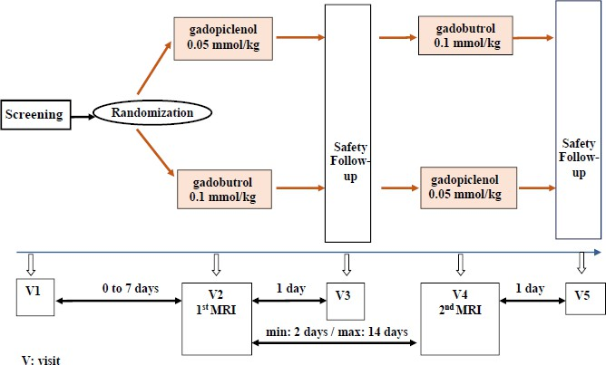
Figure 1. Trial design of study GDX-44-010
The primary objectives were
- superiority of gadopiclenol enhanced images to pre-contrast images
- non-inferiority of gadopiclenol enhanced MRI to gadobutrol enhanced images.
For each patient up to 3 of the largest, potentially enhancing lesions were chosen for study from the pre-contrast images.
For each site an experienced radiologist was appointed to read all the images for patients included at the site (on-site read) while blinded to the contrast medium used. Image evaluations were also conducted by 3 independent readers off-site (off-site read) blinded to the contrast medium used.
Imaging of chosen lesions was scored on a 4 point scale for border delineation, internal morphology and degree of contrast enhancement. Images were compared pre and post contrast (primary objective 1).
Table 5. GDX-44-010: Primary objective 1 (paired vs pre readings, FAS1, N=239)
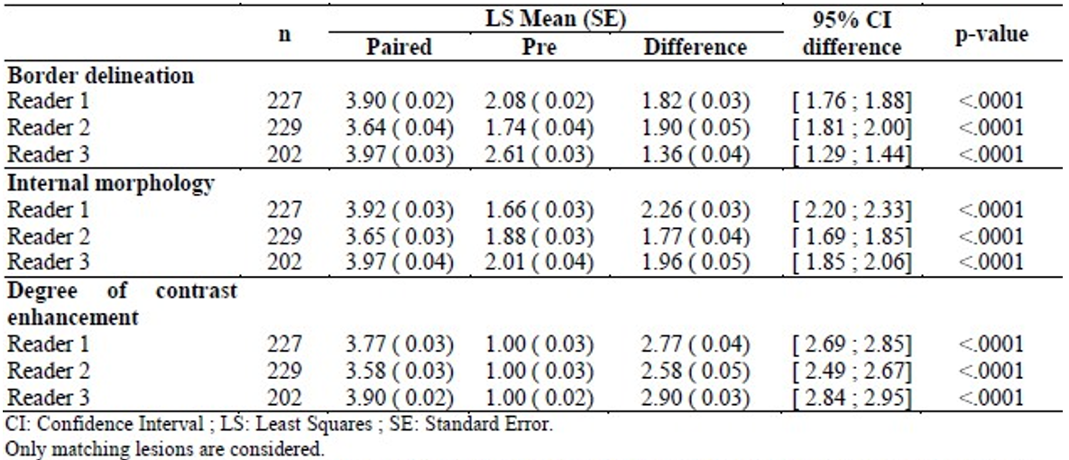
The superiority of gadopiclenol enhanced over non-enhanced images was demonstrated for all criteria.
While not analysed as a trial objective, the similar analysis demonstrated the superiority of gadobutrol enhanced to pre-contrast images.
Table 6. GDX-44-010 primary objective 2 (paired images, PPS 2, N=236)
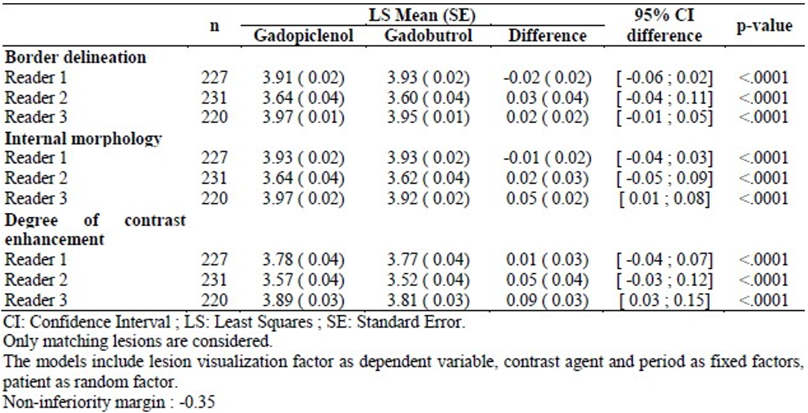
Visualisation with gadopiclenol contrast enhancement was shown to be non-inferior to gadobutrol enhancement for all three criteria, applying a non-inferiority margin of -0.06 at the most in the mean score for each criteria, much lower than the pre-defined non-inferiority margin of 0.35. The observed difference between the scores achieved for the two contrast agents was close to zero.
Inter-reader variability was assessed for a random 10% of images, and correlation on the assessment scores was between 0.89 and 0.98 for the three parameters.
No difference in the scoring of images was observed when results were stratified for lesion size (<1cm, 1-2cm and >2cm).
Table 7. GDX-44-010: Number of lesions detected with gadopiclenol vs gadobutrol enhanced images (extended FAS 2, N=241).
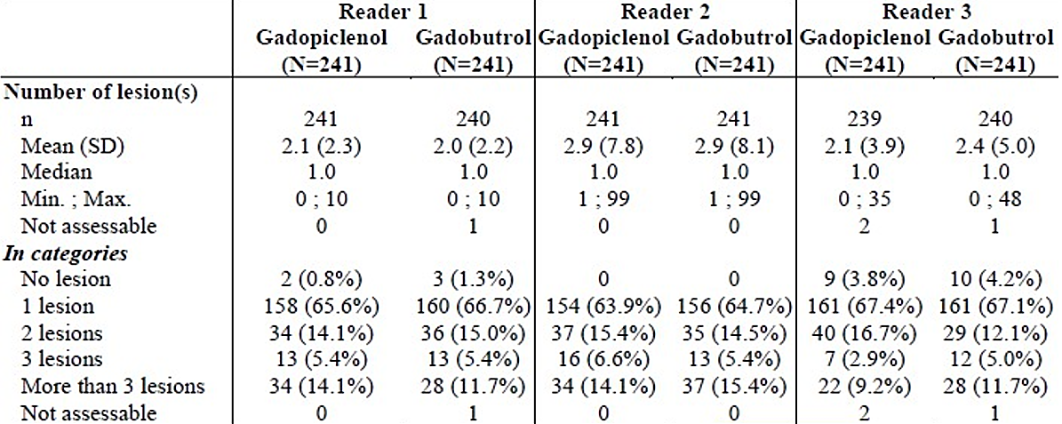
Table 8. GDX-44-010: concordance of patients with lesions detected with each GBCA (EMA analysis).

 |  | N  patients | # patients in which more lesions detected by gadobutrol | # patients in which more lesions detected by gadopiclenol | # patients in which each GBCA  detected the same number and set of  lesions | # patients in which each GBCA detected the same number but a different set of  lesions
CNS (GDX-44-010) | Reader 1 | 235 | 13 (5.5%) | 10 (4.3%) | 202 (86.0%) | 10 (4.3%)
CNS (GDX-44-010) | Reader 2 | 235 | 7 (3.0%) | 15 (6.4%) | 198 (84.3%) | 15 (6.4%)
CNS (GDX-44-010) | Reader 3 | 235 | 16 (6.8%) | 16 (6.8%) | 199 (84.7%) | 4 (1.7%)
The overall number of lesions detected with gadopiclenol and gadobutrol was similar and in 84% to 86% of patients, was the same number and set of lesions detected using both agents.
The European Medicines Agency (EMA) noted that among the 60 patients with discordant lesions for at least one reader, no potential clinical impact was identified in 40 patients. The main reason was that the lesions were in patients with multiple metastases, where additionally defined lesions had little diagnostic impact (Table 9).
Table 9. Study GDX-44-010 Assessment of potential clinical impact at patient level
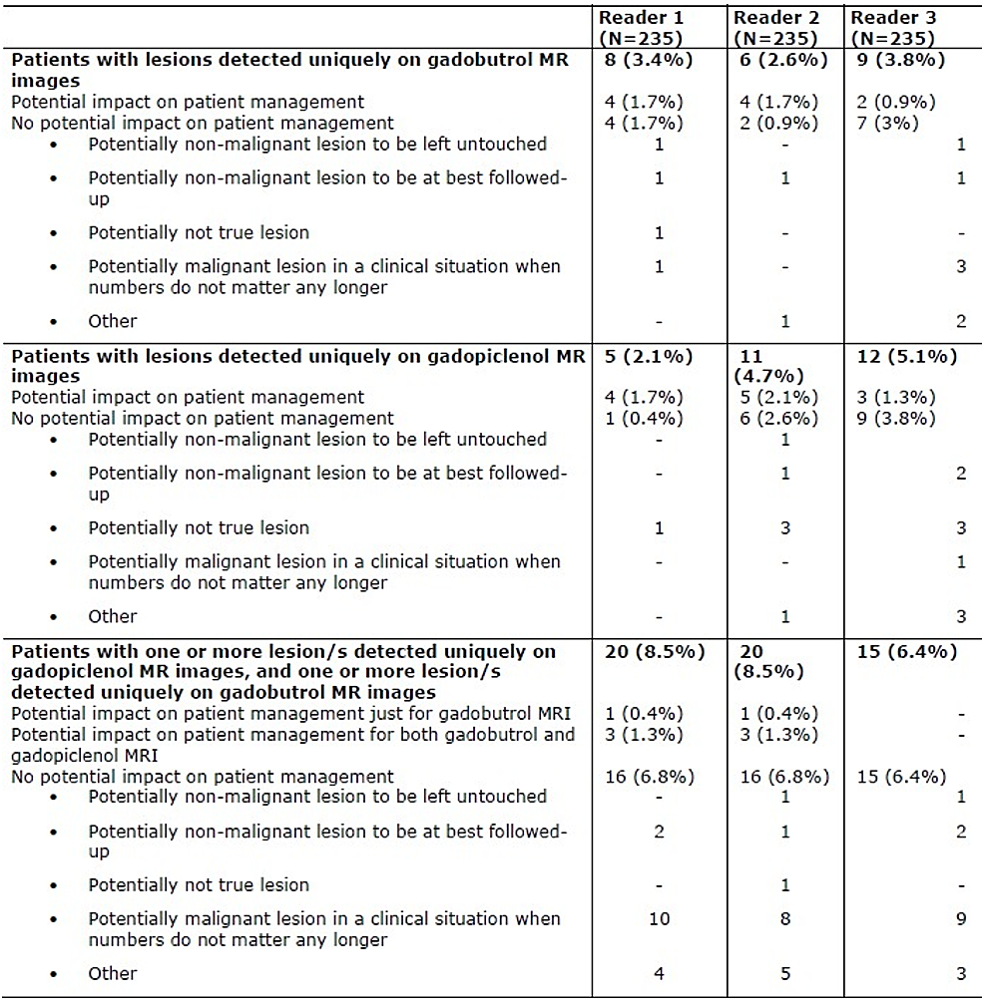

Study GDX-44-011 (Body imaging)
This was a randomised double blinded phase III cross-over study that compared the efficacy and safety of gadopiclenol 0.05 mmol/kg with gadobutrol 0.1 mmol/kg in MRI imaging of adults (n=304) with known or suspected lesions of at least one body region.
The trial methodology was almost identical to GDX-44-010 other than the enrolled population.
Included patients had known or suspected lesions of at least one body region: head and neck, thorax, abdomen, pelvis or musculoskeletal. Head and spine lesions were allowed but had to be extradural/extracranial (matching the exclusion criteria for GDX-44-010). Patients with severe renal impairment were excluded from the study.
Table 10. Baseline demographics of included patients by body region
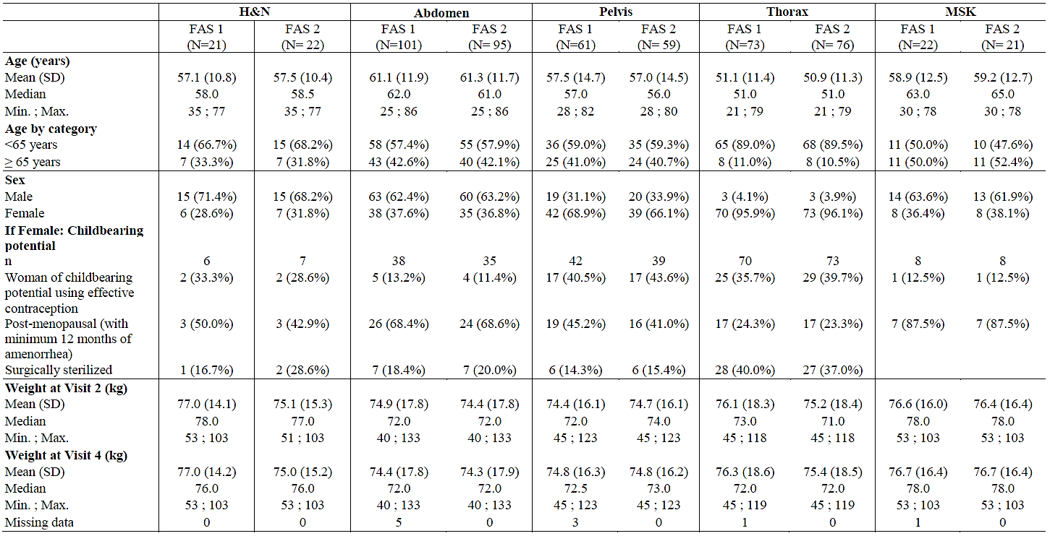
The most frequent diseases included for examination were metastases to liver (9.4-9.5%), and breast cancer (8.6-9.2%).
Table 11. GDX-44-011: Primary objective 1 (paired vs pre readings, FAS 1, N=278)
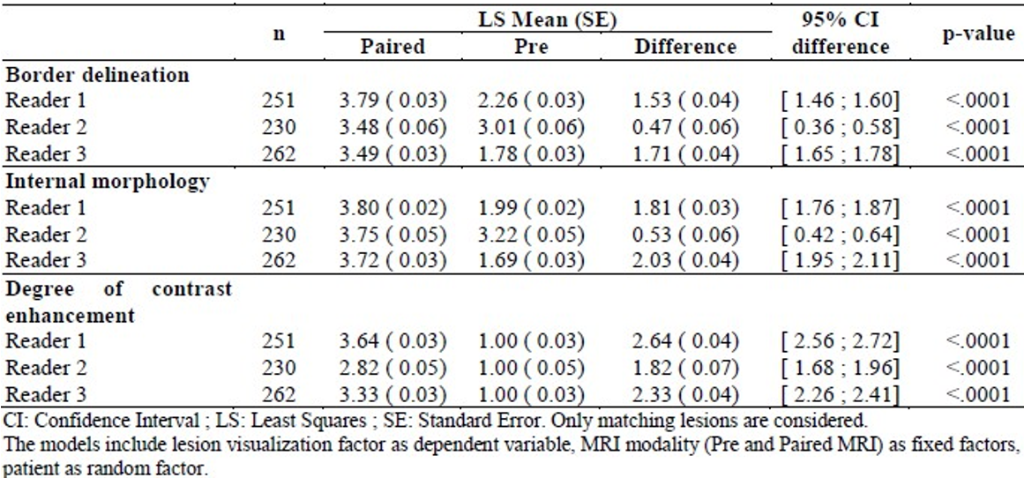
The superiority of gadopiclenol enhanced over non-enhanced images was demonstrated for all criteria.
Table 12. GDX-44-011 primary objective 2 (paired images, PPS 2, N=260)
Visualisation with gadopiclenol contrast enhancement was shown to be non-inferior to gadobutrol enhancement for all three criteria, applying a non-inferiority margin of -0.35 in the mean score for each criteria. The observed difference between the scores achieved for the two contrast agents was close to zero.
The number of lesions detected was, overall, similar between gadopiclenol and gadabutrol, but with a concordance in the number of lesions detected of about 60%. Of all the lesions examined, 18.9-20.3% were observed only on gadopiclenol enhanced images and 17.7-19.2% were observed only with gadobutrol enhanced images. The rate of concordance was very high for musculoskeletal lesions.
The EMA conducted a review of the data with paired gadopiclenol and gadobutrol images. There was a non-trivial number of patients in whom more lesions were observed with one agent over another but there was no clear trend to gadopiclenol or gadobutrol detecting more or fewer lesions.
Table 13. GDX-44-011: concordance of patients with lesions detected with each GBCA by body region (EMA analysis).
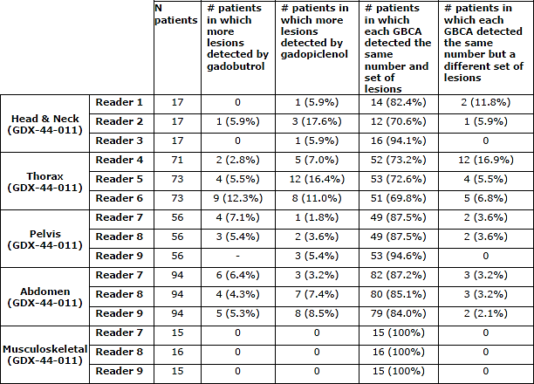
The EMA analysis of discordance indicated that in 75/84 cases where there was different reporting for at least one reader between the two contrast agents there was no impact on patient management. In these cases, the reasons included ‘malignant lesion where number of lesions no longer matter’ or ‘potentially non-malignant lesion to be left untouched’. In the remaining 9 cases, the lesion detected by one contrast agent but not the other was considered to be a potential target of therapy or to modify treatment plans.

Non-pivotal study GDX-44-007 (children and adolescents)
This was an open-label study that examined a single dose of 0.05mmol/kg gadopiclenol in 80 patients 2-17 years of age undergoing either CNS (n=60) or body (n=20) MRI scanning. The study assessed primarily PK endpoints but image quality was assessed by a single unblinded reader using the same criteria as in GDX-44-010.
In the CNS and body-imaging cohorts there were 45 patients in whom a lesion was detected and who received contrast enhanced MRI and had paired pre- and post- contrast images.
Lesion border delineation and internal morphology were not different between pre- and post- contrast images, although there was an increase in contrast enhancement with gadopiclenol.
The investigator considered that their diagnostic confidence had increased in 55.6% of patients and remained unchanged in 44.4% of patients.
Table 14. GDX-44-007: Sum of lesion scores (FAS, N=80).
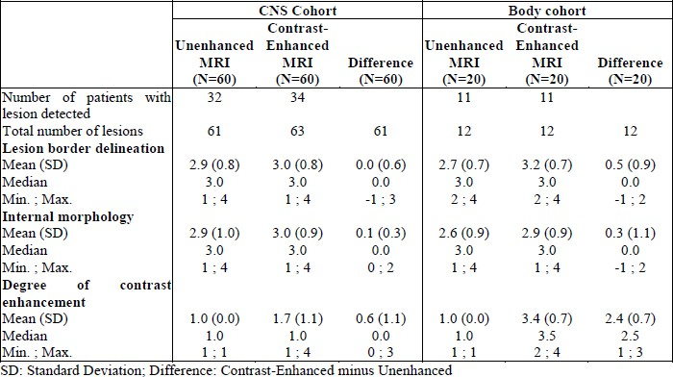
The relatively small numbers in this study, lack of a comparator and unblinded analysis in this study limit the conclusions which can be drawn. However, it does support extrapolation of the findings from the two pivotal studies conducted in adults and indicates that gadopiclenol is likely to act similarly in younger patients.

Pooled analysis of data GDX-44-010 and GDX-44-011
The Sponsor pooled the data from the two pivotal trials to provide an analysis of 551 patients between the ages of 18 and 86 (mean 56±13 years) receiving a contrast enhanced scan. The CE has noted that this pooling is appropriate given the near identical protocols of the two studies, but increases the heterogeneity of the study population.
The Sponsor conducted a post-hoc analysis of ‘lesion detectability’ using 9 ‘blinded readers’, 3 being assigned to the CNS, Thorax and other body regions respectively. The blinded readers reviewed the MRI images from the pivotal trials in a random order, blinded to both the contrast agent used and patient’s clinical details. Three additional ‘concordance readers’ (one for each region) then tracked the lesions identified by each blinded reader, assigning a unique numbered identifier to each lesion. This allowed it to be confirmed when a lesion was detected by one contrast agent, but not another. The percentage of lesions detected with gadopiclenol that were also detected with gadobutrol was calculated, as well as concordance in the number of lesions detected with gadopiclenol and gadobutrol in each patient. Each blinded readers concordance was calculated, giving a range of results as presented in the Table 15.
Table 15. Pooled data: Summary of concordance in lesion detectability between gadopiclenol and gadobutrol (from EMA evaluation report).
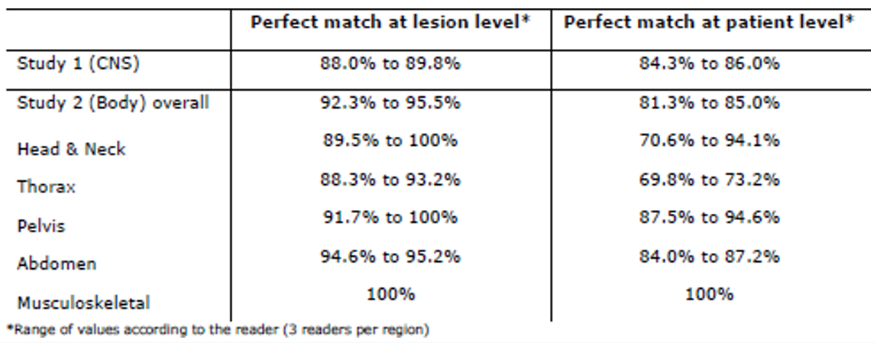

Safety
The majority of the safety data from clinical trials is provided by the pivotal studies. However, these were short term studies run over about 14 days in order to provide two scanning visits in the cross-over trial design. GDX-44-007 provided information on exposure in children and adolescents.
No post-marketing data was provided initially in the dossier.
Table 16. Exposure to gadopiclenol and comparators in clinical studies.
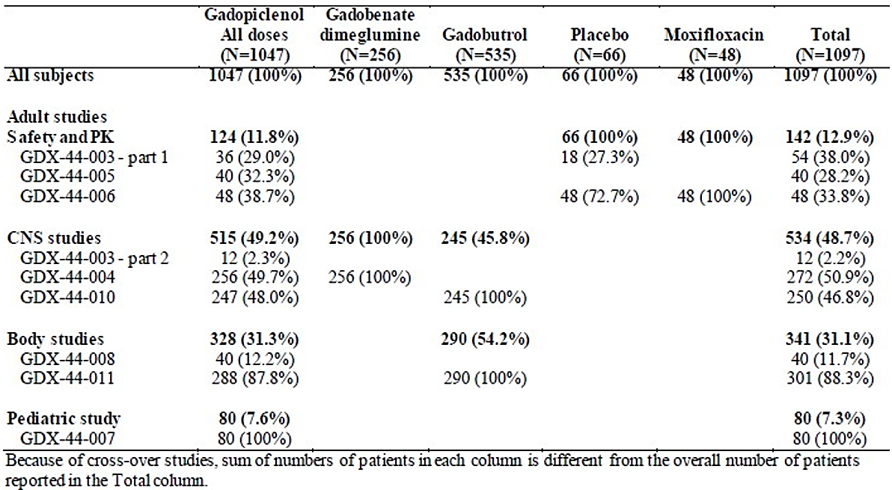
Overall, 23.6% of patients receiving gadopiclenol experienced at least 1 adverse event, but serious adverse events occurred in only 1.1% of patients. Reported adverse events were mostly mild (84.8%) or moderate (12.3%) intensity with a small proportion (2.7%) of severe intensity. Overall, 96.1% of adverse events had resolved by the end of the study with the remaining mostly being unresolved laboratory values, worsening pre-existing disease or local reactions.
Table 17. Pooled data: most frequent treatment-emergent adverse events (occurring in at least 5 subjects)
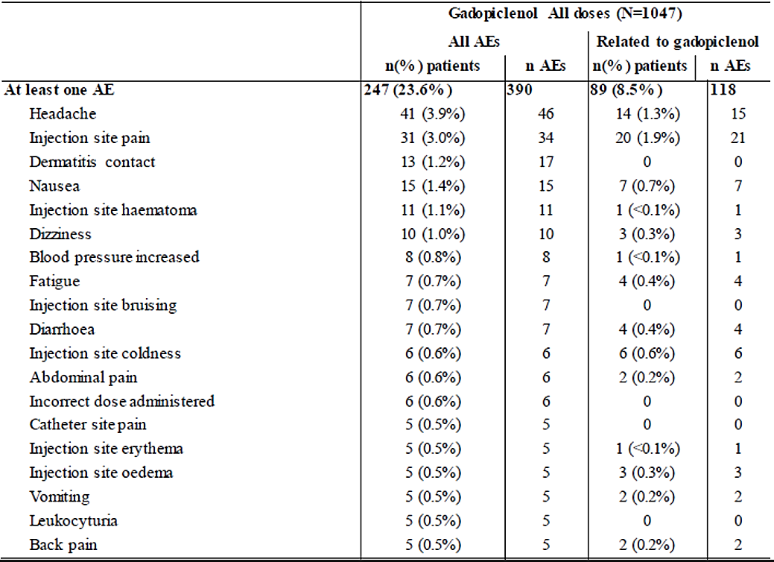
The most commonly reported adverse events were headache (3.9%), nausea (1.4%), dizziness (1.0%) and injection site reactions such as pain (3.0%), haematoma (1.1%) and bruising (0.7%).
Overall, 8.5% of subjects in the trials had a treatment related adverse event, the ones most frequently reported as related to gadopiclenol being injection site reactions (pain, coldness, oedema, haematoma, erythema), gastrointestinal disorders (nausea, diarrhoea, vomiting, abdominal pain), headache, fatigue or dizziness.
Two deaths were reported in the pooled safety analysis, both of which were not related to gadopiclenol.
Serious adverse events were reported in 11 patients after gadopiclenol . One, raised creatinine, was thought to be related to gadopiclenol.
Seizures are a recognised risk of GBCA contrast agents as a class, mostly with intrathecal administration. One seizure was noted in a patient 65 days post gadopiclenol but was considered unrelated.
In the pooled safety analysis, increased creatinine was reported in 4 patients, leukocyturia was reported in 5 patients, proteinuria was reported in 3 patients and bilirubinaemia was reported in 2 patients. A total of six of these AEs were considered related to gadopiclenol, including blood creatinine increased (n=3, 0.3%), Cystatin C increased, renal failure, and hyperkalaemia (n=1 each, 0.1%). These occurred in the same frequency as the comparator GBCAs.
No cases of NSF were reported.
It was concluded that overall, no new safety signals were detected for gadopiclenol as compared to the known adverse events of macrocyclic GBCAs.

Risk management plan evaluation summary
Safety concerns and their associated risk monitoring and mitigation strategies are summarised in Table 18.
The Gadopiclenol (Elucirem/Vueway) EU-Risk Management Plan (RMP) (version 0.3, dated 19 April 2023; DLP 18 November 2021), with Australian Specific Annex (version 1.1, dated 23 October 2024), included with submission PM- 2023-06087-1-2, and any subsequent revisions, as agreed with the TGA will be implemented in Australia.
Table 18. Summary of safety concerns
Summary of safety concerns |  |  | Pharmacovigilance |  |  |  | Risk Minimisation
 |  |  | Routine |  | Additional |  | Routine |  | Additional
Important identified risks | Nephrogenic Systemic Fibrosis (NSF) | * |  | – |  |  |  | –
Important potential risks | Adverse clinical effects of accumulation and retention of gadolinium in organs and tissues other than brain tissues | * |  | # |  |  |  | –
Important potential risks | Adverse clinical effects of accumulation and retention of gadolinium in the brain | * |  | # |  |  |  | –
Missing information | Safety in pregnancy and lactation | * |  | – |  |  |  | –
Missing information | Clinical significance of gadolinium accumulation and retention in organs and tissues other than brain tissues | * |  | # |  |  |  | –
Missing information | Clinical significance of gadolinium accumulation and retention in the brain | * |  | # |  |  |  | –
*Follow-up forms
#Preclinical and clinical studies

Risk-benefit analysis
The submitted studies demonstrate that gadopiclenol is a potential useful contrast agent for use in MRI scanning. It has the theoretical advantage of higher relaxivity over existing GBCAs due to more water being retained by the cyclic carrier molecule. Efficacy and safety have been directly examined for imaging CNS and somatic lesions, which were predominantly tumours of various sorts. The Delegate feels this is appropriate within the indications proposed by the Sponsor. There is no direct demonstration of gadopiclenol’s comparative performance in broader imaging tasks.
The proposed dose contains less gadolinium than the comparator GBCA, gadobutrol. The Delegate notes that the dose finding studies may suggest this is not the optimal dose of gadobutrol for imaging performance, but acknowledges that sparing gadolinium exposure is also an important clinical consideration. The safety profile of gadopiclenol appears very similar to other macrocyclic GBCA’s in clinical studies. As expected given the condition’s rarity, there was no direct evidence of a reduced rate of NSF with gadopiclenol.
The Delegate notes that while gadopiclenol enhanced images had a high rate of diagnostic concordance with gadobutrol enhanced images, particularly in post-hoc examination conducted on pooled data from the pivotal studies, the rate of discordance was still significant. This included lesions detected with gadobutrol but not with gadopiclenol and vice versa. The Delegate has concluded (and the FDA and EMA reports both noted) that this is unavoidable in assessing a contrast agent since there is no ‘absolute truth’ in the trial design. What can be concluded is that gadopiclenol is as good as the existing standard, and the rate at which lesions are misidentified by the existing standard is not objectively known. However, the Sponsor has made an effort to clarify the rate at which discordant reading of images was likely to be clinically relevant, and in the majority of cases it appears that the differences were not likely to change patient management or diagnosis.

Advisory Committee considerations
The Advisory Committee on Medicines (ACM), having considered the evaluations and the Delegate’s overview, as well as the sponsor’s response to these documents, advised the following:
Is the gadopiclenol imaging as demonstrated in the clinical trials sufficient compared to existing agents?
The ACM discussed whether the 0.35 non-inferiority margin was appropriate, noting that while the FDA had questioned the clinical significance of this target on a 4-point scale, the EMA considered this acceptable. The ACM noted the subjective nature of the target margin and advised that a smaller noninferiority margin would require larger numbers of observations. Additionally, the ACM noted that achieving an exact equivalence margin would theoretically require an infinite sample size.
The ACM noted that additional lesion detectability analysis by both the FDA and EMA showed an increased number of lesions with gadopiclenol in most patients. Notably, only one patient was identified where clinical management could potentially be impacted by the failure to detect a lesion.
The ACM considered the potential for discordance in the clinical study data, advising that discrepancies can arise due to the very small size of lesions and the imaging techniques used. The ACM also advised that it is a common phenomenon for 1-2 mm nodules, which may be clinically significant, to result in inconsistencies in the data.
Additionally, the ACM considered the potential limitations of the patient groups included in the pivotal phase III studies. The ACM noted that both studies primarily included patients with neoplasms, and study GDX-44-010 excluded patients with multiple sclerosis (MS). The ACM advised that the crossover design of study GDX-44-010 and study GDX-44-011 required patients with a high likelihood of lesions that exhibit relatively stable enhancement over time. The ACM also advised that CNS contrast studies typically include patients with neoplasms due to challenges identifying patients with a high yield of enhancing inflammatory lesions.
Additionally, the ACM advised that MS patients were likely excluded from GDX-44-010 due to their younger age and the higher likelihood of requiring more contrast investigations, which increases their risk of over exposure.
The ACM advised that the evidence presented sufficiently demonstrates that gadopiclenol performance is comparable to existing GBCAs, at half-dose. The ACM noted that gadopiclenol's high relaxivity accounts for its efficacy at a lower dose compared to other GBCAs.
The ACM was of the view that the lower dose of gadopiclenol is beneficial from risk management/toxicological and environmental perspectives. The ACM acknowledged concerns regarding gadolinium accumulation in the environmental water cycle, where it is not naturally found. The ACM agreed that less gadopiclenol accumulating in the water supply is an important environmental consideration.
The ACM advised that the sponsor’s proposed wording of the indication appears appropriate and is similar to the US FDA-approved indication.

ACM conclusion
The ACM considered this product to have an overall positive benefit-risk profile for the indication:
This medicinal product is for diagnostic use only.
Elucirem/Vueway (gadopiclenol) is indicated in adults and children aged 2 years and older for contrast-enhanced magnetic resonance imaging (MRI) to detect and visualise lesions with abnormal blood brain barrier or abnormal vascularity in:
  - the central nervous system (brain, spine, and associated tissues);
  - the body.

Assessment outcome
Based on a review of quality, safety, and efficacy, the TGA decided to register Elucirem/Vueway for the following indication:
Elucirem/Vueway (gadopiclenol) is indicated in adults and children aged 2 years and older for contrast-enhanced magnetic resonance imaging (MRI) to detect and visualise lesions with abnormal blood brain barrier or abnormal vascularity in:
  - the central nervous system (brain, spine, and associated tissues);
  - the body (head and neck, thorax, abdomen, pelvis and musculoskeletal system).

Specific conditions of registration
Elucirem/Vueway (gadopiclenol) is to be included in the Black Triangle Scheme. The PI and CMI for Elucirem/Vueway must include the black triangle symbol and mandatory accompanying text for five years, which starts from the date of first supply of the product.
The Gadopiclenol (Elucirem/Vueway) EU-Risk Management Plan (RMP) (version 0.3, dated 19 April 2023; DLP 18 November 2021), with Australian Specific Annex (version 1.1, dated 23 October 2024), included with submission PM-2023-06087-1-2, and any subsequent revisions, as agreed with the TGA will be implemented in Australia.
An obligatory component of risk management plans is routine pharmacovigilance. Routine pharmacovigilance includes the submission of periodic safety update reports (PSURs). Reports are to be provided in line with the current published list of EU reference dates and frequency of submission of PSURs until the period covered by such reports is not less than three years from the date of this approval letter. Each report must be submitted within ninety calendar days of the data lock point for that report.
The reports are to at least meet the requirements for PSURs as described in the European Medicines Agency’s Guideline on good pharmacovigilance practices (GVP) Module VII-periodic safety update report (Rev 1), Part VII.B Structures and processes. Note that submission of a PSUR does not constitute an application to vary the registration.

Product Information and Consumer Medicines Information
For the most recent Product Information (PI) and Consumer Medicines Information (CMI), please refer to the TGA PI/CMI search facility.

Therapeutic Goods Administration
PO Box 100 Woden ACT 2606 Australia
Email: info@tga.gov.au Phone: 1800 020 653 Fax: 02 6203 1605
https://www.tga.gov.au

A sponsor is a person or company who does one or more of the following: a) exports therapeutic goods from Australia, b) imports therapeutic goods into Australia, c) manufactures therapeutic goods for supply in Australia or d) elsewhere arranges for another party to import, export or manufacture therapeutic goods
International Council for Harmonisation of Technical Requirements for Pharmaceuticals for Human Us. ICH M3 (R2) Non-clinical safety studies for the conduct of human clinical trials for pharmaceuticals - Scientific guideline. 2013.

