Australian Public Assessment Report for DATROWAY
  - Active ingredient: datopotamab deruxtecan
  - Sponsor: AstraZeneca Pty Ltd
July 2025

About the Therapeutic Goods Administration (TGA)
- The Therapeutic Goods Administration (TGA) is part of the Australian Government Department of Health, Disability and Ageing and is responsible for regulating therapeutic goods, including medicines, medical devices, and biologicals.
- The TGA administers the Therapeutic Goods Act 1989 (the Act), applying a risk management approach designed to ensure therapeutic goods supplied in Australia meet acceptable standards of quality, safety, and efficacy.
- The work of the TGA is based on applying scientific and clinical expertise to decision-making, to ensure that the benefits to the Australian public outweigh any risks associated with the use of therapeutic goods.
- The TGA relies on the public, healthcare professionals and industry to report problems with therapeutic goods. The TGA investigates reports received to determine any necessary regulatory action.
- To report a problem with a therapeutic good, please see the information on the TGA website.

About AusPARs
- The Australian Public Assessment Report (AusPAR) provides information about the evaluation of a prescription medicine and the considerations that led the TGA to approve or not approve a prescription medicine submission. Further information can be found in Australian Public Assessment Report (AusPAR) guidance.
- AusPARs are prepared and published by the TGA.
- AusPARs are static documents that provide information that relates to a submission at a particular point in time. The publication of an AusPAR is an important part of the transparency of the TGA’s decision-making process.
- A new AusPAR may be provided to reflect changes to indications or major variations to a prescription medicine subject to evaluation by the TGA.

Copyright
© Commonwealth of Australia 2025
This work is copyright. You may reproduce the whole or part of this work in unaltered form for your own personal use or, if you are part of an organisation, for internal use within your organisation, but only if you or your organisation do not use the reproduction for any commercial purpose and retain this copyright notice and all disclaimer notices as part of that reproduction. Apart from rights to use as permitted by the Copyright Act 1968 or allowed by this copyright notice, all other rights are reserved and you are not allowed to reproduce the whole or any part of this work in any way (electronic or otherwise) without first being given specific written permission from the Commonwealth to do so. Requests and inquiries concerning reproduction and rights are to be sent to the TGA Copyright Officer, Therapeutic Goods Administration, PO Box 100, Woden ACT 2606 or emailed to <tga.copyright@tga.gov.au>.

Contents
List of abbreviations 4
DATROWAY (datopotamab deruxtecan) submission 6
Proposed indication 7
The condition 7
Current treatment options 8
Clinical rationale 9
Regulatory status 9
Registration timeline 10
Assessment overview 11
Quality evaluation summary 11
Nonclinical evaluation summary 11
Clinical evaluation summary 11
Summary of clinical studies 11
Pharmacology 12
Efficacy 18
Safety 32
Risk management plan evaluation summary 39
Risk-benefit analysis 40
Assessment outcome 42
Specific conditions of registration 42
Product Information and Consumer Medicines Information 43

List of abbreviations
Abbreviation | Meaning
ADA | anti-drug antibody
AE | adverse event(s)
ARTG | Australian Register of Therapeutic Goods
BC | breast cancer(s)
BOR | best objective response
CPH | Cox proportional hazard
CR | complete response
CTCAE | common toxicity criteria for adverse events
Dato-DXd | datopotamab deruxtecan
DCO | data cut-off
ER | Oestrogen receptor(s)
ET | endocrine therapy
FISH | fluorescence in situ hybridization
HER2 | human epidermal growth factor receptor 2
HR | hormone receptor(s)
ICC | investigational choice of chemotherapy
IHC | immunohistochemistry
ILD | Interstitial lung disease
NSCLC | non small cell lung cancer
ORR | objective response rate
OS | overall survival
PD | progressive disease
PFS | progression-free survival
PI | Product Information
PK | pharmacokinetic(s)
popPK | population pharmacokinetic(s)
PR | partial response
RMP | risk management plan
SAE | serious adverse event(s)
SD | stable disease
TEAE | treatment emergent adverse event
TGA | Therapeutic Goods Administration
TNBC | triple negative breast cancer
TROP2 | trophoblast cell surface antigen 2

DATROWAY (datopotamab deruxtecan) submission
Type of submission: | New biological entity
Product name: | DATROWAY
Active ingredient: | datopotamab deruxtecan
Decision: | Approved
Date of decision: | 15 May 2025
Approved therapeutic use for the current submission: | DATROWAY as monotherapy is indicated for the treatment of adult patients with unresectable or metastatic hormone receptor (HR)-positive, HER2-negative (IHC 0, IHC 1+ or IHC 2+/ISH-) breast cancer who have received endocrine therapy and at least one additional systemic therapy in the locally advanced or metastatic setting.
Date of entry onto ARTG: | 20 May 2025
ARTG numbers: | DATROWAY datopotamab deruxtecan 100 mg powder for injection vial (444066)
Black Triangle Scheme: | Yes
Sponsor’s name and address: | AstraZeneca Pty Ltd, 66 Talavera Road, MACQUARIE PARK NSW 2113
Dose form: | Powder for injection
Strength: | One vial of lyophilised powder for concentrate for solution for infusion delivers 100 mg of datopotamab deruxtecan. After reconstitution, one vial of 5 mL solution delivers 20 mg/mL of datopotamab deruxtecan
Container: | 10 R Type 1 amber borosilicate glass vial sealed with a fluoro-resin laminated butyl rubber stopper and a polypropylene/aluminium blue flip-off crimp cap.
Pack size: | Each carton contains 1 glass vial
Route of administration: | intravenous infusion
Dosage: | 6 mg/kg (up to a maximum of 540 mg for patients ≥90 kg) administered as an intravenous infusion once every three weeks (21-day cycle) until disease progression or unacceptable toxicity  For further information regarding dosage refer to the Product Information.
Pregnancy category: | Category D  Drugs which have caused, are suspected to have caused or may be expected to cause, an increased incidence of human fetal malformations or irreversible damage. These drugs may also have adverse pharmacological effects.  The use of any medicine during pregnancy requires careful consideration of both risks and benefits by the treating health professional. The pregnancy database must not be used as the sole basis of decision making in the use of medicines during pregnancy. The TGA does not provide advice on the use of medicines in pregnancy for specific cases. More information is available from obstetric drug information services in your state or territory.

Proposed indication
This AusPAR describes the submission by AstraZeneca Pty Ltd (the Sponsor) to register DATROWAY (datopotamab deruxtecan) for the following proposed indication:
DATROWAY is indicated for the treatment of adult patients with unresectable or metastatic hormone receptor (HR)-positive, HER2-negative (IHC 0, IHC 1+ or IHC 2+/ISH-) breast cancer who have received prior systemic therapy for unresectable or metastatic disease.

The condition
Tumours expressing receptors for oestrogens and/or progesterones are considered hormone-receptor (HR)-positive, whereas tumours that do not express ERs, PRs or human epidermal growth factor receptor 2 (HER2) are defined as triple negative breast cancer (TNBC). This subtype is characterised by HR positivity (> 1% immunohistochemistry [IHC] expression of the ER and/or PR) and lack of HER2 expression (IHC score of 0, 1+, or 2+ confirmed as negative by fluorescence in situ hybridization [FISH]). Approximately 70% of all breast cancers (BC)are of the subtype HR-positive, HER2-negative. Traditionally HER2-negative definition is IHC 0, IHC 1+ or IHC 2+/ in situ hybridization [ISH]- as per the American Society of Clinical Oncology and the College of American Pathologists criteria. However, based on emerging data and recent approvals, HER2-low BC (IHC 1+ or IHC 2+/ISH-) is potentially a new classification.
The Surveillance, Epidemiology, and End Results (SEER) Program has reported an increasing incidence of HR+/HER2- BC in females in the USA (SEER registries).
Figure 1. HR+/HER2- Breast Cancer (Female only) Recent Trends in SEER Age-Adjusted Incidence Rates, 2010-2021 Female By Race/Ethnicity, Delay-adjusted SEER Incidence Rate, All Ages, All Stages
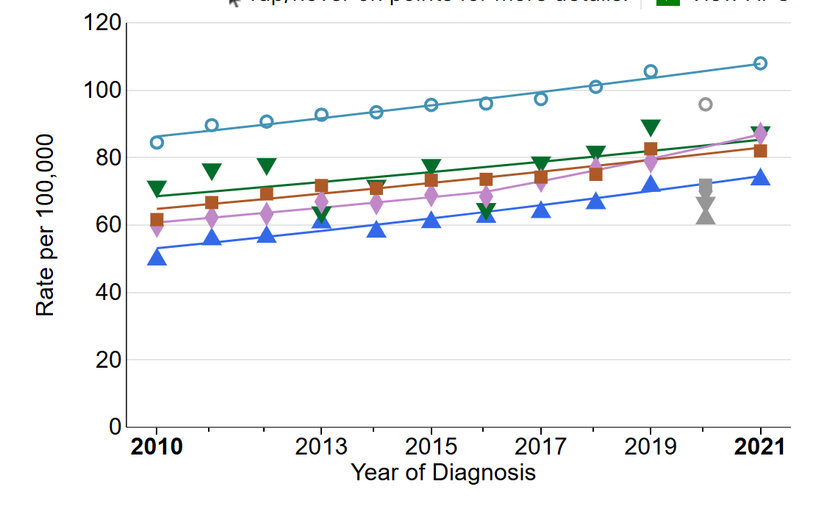
Key: Blue circle non-Hispanic white; Pink diamond non-Hispanic Asian/ Pacific Islander; Green triangle non-Hispanic American Indian/ Alaska native; Brown square non-Hispanic black, Blue triangle Hispanic any race.

Current treatment options
Patients with ER-positive metastatic BC often respond to endocrine therapy (ET) alone or in combination with targeted agents, which can reduce tumour burden and symptoms with generally fewer side effects and toxicities than chemotherapy. Furthermore, modern ETs appear to prolong progression and possibly survival compared with older ETs. However, few if any patients with metastatic BC will be cured, and the goal of therapy is, principally, palliation. We choose the therapy that is most likely to stabilise or reduce the burden of disease with the fewest side effects and maintain that therapy until either unacceptable toxicities are evident or disease progression occurs. The treatment protocol, based on the current European Society For Medical Oncology (ESMO) protocol, is listed below:
- The preferred standard first-line treatment for patients with locally advanced/ metastatic HR-positive, HER2-negative BC is the combination of a CDK4/6i (palbociclib, abemaciclib, or ribociclib) with ET (usually an aromatase inhibitor or fulvestrant).
- On disease progression, for those in whom hormone receptor positivity is confirmed, tumour tissue and/or blood for genomic alterations, including PIK3CA/ AKT1/PTEN and ESR1 status should be performed. Treatment then is dependent on genomic alterations.
  - If HER2-low (IHC 1+ or IHC 2+/ ISH−) → trastuzumab deruxtecan
  - If no imminent organ failure and long progression-free survival (PFS) on prior ET
- everolimus + exemestante OR everolimus + fulvestrant OR switch ET + CDK 4/6inhibitor OR fulvestrant monotherapy.
- If PIC3CAm+ → fulvestrant + alpelisib.
- If ERS1m+ → elacestrant.
- If germline BRCA/PALB2m+ → PARP inhibitor
  - If imminent organ failure or short PFS on prior ET or progression on above regimens
- If HER20 → sacituzumab govitecan
- If HER2 low → trastuzumab deruxtecan
- If further progression → traditional chemotherapy OR sacituzumab govitecan (if not used before).
In Australia, chemotherapy is usually recommended when patients are no longer deriving benefit from ET-based regimens or have a fast-growing cancer, especially if it’s in the liver or lungs. The targeted therapies, trastuzumab deruxtecan and sacituzumab govitecan have also been approved for patients with HR+/HER2- (IHC 0, IHC 1+ or IHC 2+/ISH–) BC who received chemotherapy.
Datopotamab deruxtecan (Dato-DXd, also ‘DS-1062a’) was jointly developed by AstraZeneca and Daiichi Sankyo using Daiichi Sankyo’s proprietary DXd ADC technology. Both companies previously collaborated to develop and commercialise trastuzumab deruxtecan (ENHERTU), which contains the same drug linker (MAAA-1181a) as DATROWAY, i.e. only the monoclonal antibody has been changed. While trastuzumab deruxtecan targets HER2 via trastuzumab, DATROWAY targets TROP2 via datopotamab.

Clinical rationale
DATROWAY is an antibody-drug conjugate that comprises a recombinant humanised anti- trophoblast cell surface antigen 2 (TROP2) IgG1 monoclonal antibody, which is covalently conjugated to a drug linker via thioether bonds. TROP2 is a transmembrane glycoprotein that is widely expressed in patients with BC including HR-positive BC. Increased TROP2 mRNA in BC is a predictor of lymph node involvement, distant metastasis, and poor overall survival. Pre-clinical data demonstrate that DATROWAY is internalised in TROP2-expressing tumour cells, where the linker is cleaved by lysosomal enzymes, releasing the cytotoxic payload, deruxtecan, and inducing damage to the tumour cell’s DNA, thereby causing tumour cell death. Subsequently, the membrane-permeable payload allows for a bystander antitumour effect in surrounding cells, regardless of TROP2 expression.

Regulatory status

Australian regulatory status
This product is a new biological entity for Australian regulatory purposes.

International regulatory status
At the time the TGA considered this submission, a similar submission had been considered by other regulatory agencies. The following table summarises these submissions and provides the indications where approved.
Table 1. International regulatory status for DATROWAY
Country | Submission date | Approval date | Comment
European Union | 12 February 2024 | Positive CHMP opinion 31 Jan 2025  Approval date  04 Apr 2025 | DATROWAY as monotherapy is indicated for the treatment of adult patients with unresectable or metastatic hormone receptor (HR)- positive, HER2-negative breast cancer who have received endocrine therapy and at least one line of chemotherapy in the advanced setting
Japan |  | Approval date 27 Dec 2024 | Treatment of adult patients with hormone receptor (HR) positive, HER2 negative (IHC 0, IHC 1+ or IHC 2+/ISH-) unresectable or recurrent breast cancer after prior chemotherapy.
Singapore | 20 March 2024 | Approval date  10 May 2025 | Submitted via the Access Consortium NAS Work-Sharing Initiative (NASWI) with Australia and Switzerland.  DATROWAY is indicated for the treatment of adult patients with unresectable or metastatic hormone receptor (HR)-positive, HER2-negative (IHC 0, IHC 1+ or IHC 2+/ISH-) breast cancer who have received prior endocrine-based therapy and chemotherapy for unresectable or metastatic disease.
Switzerland | 29 March 2024 | Under evaluation | Submitted via the Access Consortium NAS Work-Sharing Initiative (NASWI) with Australia and Singapore
United States | 20 December 2023 | 17 January 2025 | DATROWAY is indicated for the treatment of adult patients with unresectable or metastatic, hormone receptor (HR)-positive, human epidermal growth factor receptor 2 (HER2)-negative (IHC 0, IHC 1+ or IHC 2+/ISH-) breast cancer who have received prior endocrine-based therapy and chemotherapy for unresectable or metastatic disease.

Registration timeline
Table 2 captures the key steps and dates for this submission.
This submission was evaluated under the standard prescription medicines registration process.
This submission was evaluated as part of the Australia-Canada-Singapore-Switzerland-United Kingdom (ACCESS) Consortium with work-sharing between the TGA, Health Sciences Authority Singapore and Swissmedic. Each regulator made independent decisions regarding approval (market authorisation) of the new medicine.
Table 2. Registration timeline for DATROWAY
Description | Date
Submission dossier accepted and evaluation commenced | 15 May 2024
Evaluation completed | 22 January 2025
Registration decision (Outcome) | 15 May 2025
Registration in the ARTG completed | 20 May 2025
Number of working days from submission dossier acceptance to registration decision* | 255 days
*Statutory timeframe for standard submissions is 255 working days

Assessment overview

Quality evaluation summary
There were no issues identified from the quality evaluation of the submitted data that would indicate the product should not be registered on the basis of quality, or safety-related issues arising from the quality of the product. The Sponsor has satisfied all quality requirements and there are no objections to registration from a quality perspective.

Nonclinical evaluation summary
- The pharmacological properties as well as the pharmacokinetic and toxicity profiles of DATROWAY were adequately characterised.
- Target organs of toxicity include lungs, liver, reproductive organs, eye, skin, intestines, and lymphatic/haematopoietic systems.
- DATROWAY is expected to impair fertility and embryofetal development (teratogenic). Pregnancy Category D is considered appropriate.
- There are no nonclinical objections to the approval of DATROWAY for the proposed indications.

Clinical evaluation summary

Summary of clinical studies
Clinical data supporting this application included a Phase 1 first in human study, a Phase 2 supportive PK/safety study, a Phase 3 comparative study, population PK analyses, PKPD exposure efficacy and exposure safety analyses, and reports on DDI, QTc analysis and dose justification.

Pharmacology
The Dato-DXd clinical pharmacology program included nonclinical studies with human biomaterials and clinical Studies TB01, TL01, TL05, and TP01 (BC and non small cell lung cancer [NSCLC] patients). Additionally, data from DDI study DS8201-A-A104 of trastuzumab deruxtecan (T-DXd, DS-8201a) was included to support the content related to drug-drug interactions (DDI). Plasma concentrations of 3 analytes (Dato-DXd, total anti-TROP2 antibody, and DXd) were determined in the clinical studies to characterise the pharmacokinetic (PK) of Dato-DXd.

Pharmacokinetics
Pharmacokinetics was assessed from individual efficacy and safety studies and from PK modelling. A summary of PK results from the population PK (popPK) analysis for the proposed dose of 6 mg/kg IV every 21 days is shown below.
Table 3. Parameter estimations of the final Dato-DXd model
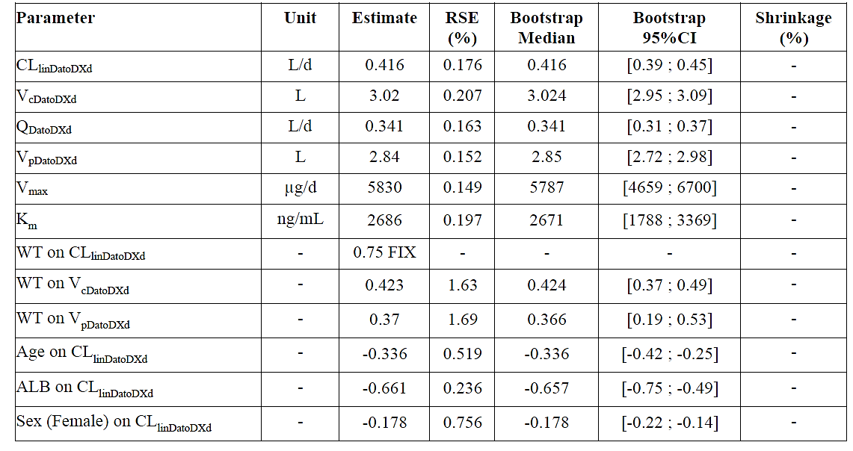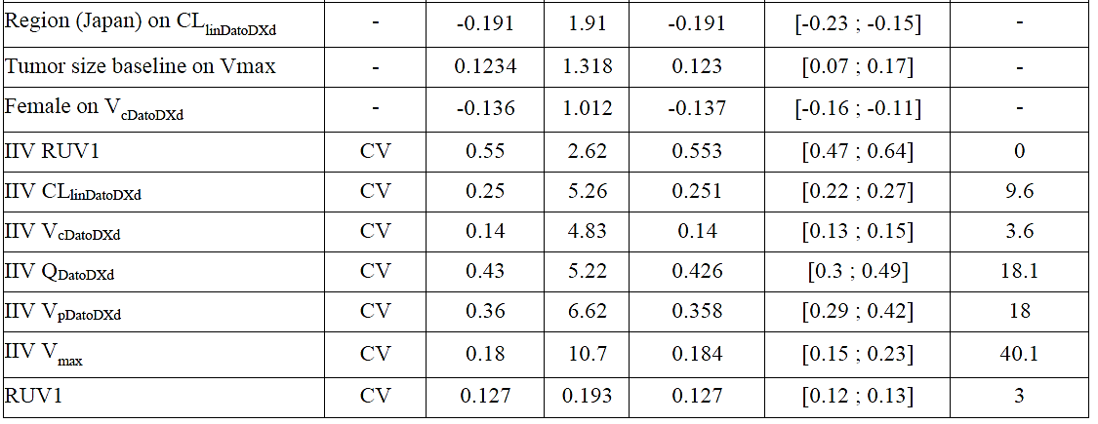
ALB = baseline albumin; CLlinDatoDXd = Dato-DXd linear clearance; IIV = Inter-individual variability; QDatoDXd Dato-DXd inter-compartmental clearance; RUV = Residual unexplained variability; RUV1 = Additive component for Dato-DXd; VCDatoDXd = Dato-DXd central volume of distribution; Vmax = maximum elimination capacity of CLnonlinDatoDXd; VpDatoDXd Dato-DXd peripheral volume of distribution; WT = weight.
Table 4. Parameter Estimations of the Updated Final DXd Model
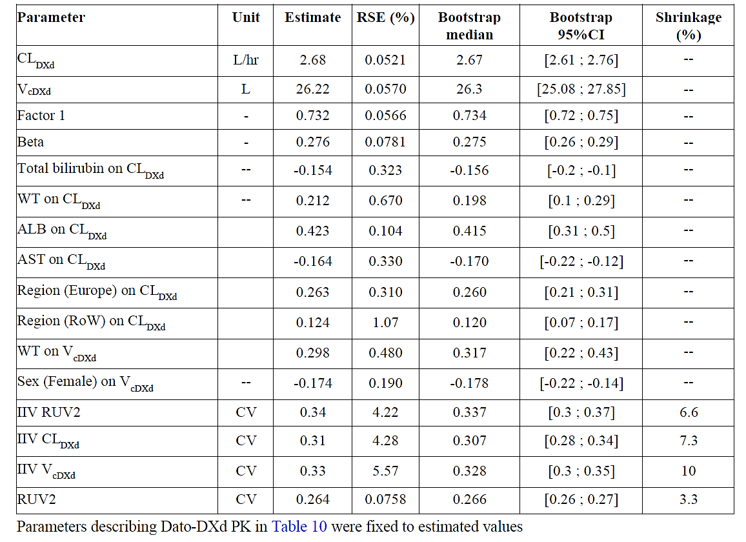
ALB = baseline albumin; CLDXd DXd linear clearance; IIV = Inter-individual variability; RoW = rest of world; RUV = residual unexplained variability; RUV2 = additive component for DXd; VcDXd DXd central compartment; WT = weight.
Dato-DXd PK after multiple dosing was evaluated in Study TP01, in which intensive PK sampling in both Cycle 1 and Cycle 3 was performed in patients with NSCLC and TNBC, and Cycle 1 only in patients with HR-positive HER2-negative BC. Following multiple doses of 6 mg/kg, Dato-DXd t½ was approximately 5 days, indicating that the steady state would be reached by Cycle 3 following multiple doses of Dato-DXd 6 mg/kg Q3W. The accumulation index based on geometric mean AUCtau was 1.29 for Dato-DXd.
Immunogenicity: While no clinically significant effect was demonstrated to be associated with pharmacokinetic parameters or safety, the FDA noted that the anti-drug antibody (ADA) assay was inadequate to detect ADA in the presence of Dato-DXd at clinically relevant concentrations. The FDA issued a post-market commitment to complete ADA assay validation including high resolution drug tolerance data.
No study has been conducted in paediatric patients. No dose adjustments are required for hepatic or renal impairment or for elderly patients. Sex was a significant covariate on the volume of distribution for Dato-DXd and DXd in population PK modelling but was confounded with body weight, which was a significant covariate for AUC, CL and Vd.
Dato-DXd exposure increases with increasing body weight.

Population PK data
Data for the PopPK analysis originated from studies TROPION-Breast01(TB01), NSCLC and BC patients in TROPION-PanTumor01 (DS1062-A-J101; TP01; J101), TROPION-Lung01 (TL01), and TROPION-Lung05 (TL05). Individual exposure metrics were derived from the population PK analysis (MS-2023-02). The objective of this analysis was to characterise the PK of Dato-DXd and DXd and to derive individual exposures for further exposure-response analyses.
A total of 1081 patients, including 644 subjects with lung cancer and 437 subjects with BC were included in the analysis, resulting in 12911 Dato-DXd observations, and 12873 DXd observations in the dataset. There were 1122 below the lower limit of quantification (BLQ) Dato-DXd samples (8.69%) and 1100 BLQ DXd samples (8.55%) excluded from current analysis. Covariants included in the model are shown below.
Table 5. Covariants evaluated in the PopPK analysis
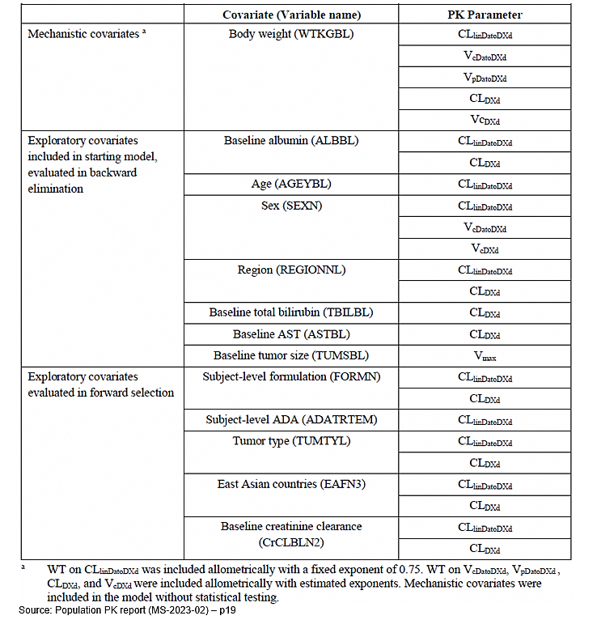
This analysis was implemented by nonlinear mixed-effects modelling software (NONMEM), v.7.3.0. The model structure for Dato-DXd was 2-compartmental distribution model with parallel Dato-DXd linear clearance (CLlinDatoDXd) and Dato-DXd nonlinear Michaelis-Menten clearance (CLnonlinDatoDXd) from the central compartment. For DXd the model structure was one-compartment model with first-order elimination from the central compartment. The release of DXd from the intact Dato-DXd was equal to the total (linear + nonlinear) elimination rate of Dato -DXd.
The impact of significant covariates identified in the final model on the exposure of Dato-DXd and DXd was evaluated using univariate assessment. The impacts of WT, albumin, age, sex, region, and tumour baseline on the Dato-DXd exposure (first-cycle and third-cycle Dato-DXd AUC and C_{max}) were not deemed to be clinically relevant, as the impacts on Dato-DXd exposure are generally within 80-125% range, except for WT at 95th percentile (96.96 kg). At the 95th percentile of observed WT in the analysis population, DXd exposure changed greater than 30% for both AUC and C_{max}. Subjects with relatively high WT (Q4, 75.8 kg – 155.9 kg) had 25.8% higher DXd first-cycle C_{max} (3.2 ng/mL vs. 2.6 ng/mL, respectively), and exposure at other quartiles had less than 25% difference from population median values. Race was not included as a significant covariate. However, region was a significant covariate on CLlinDatoDXd and CLDXd. The difference in Cycle-3 AUC and C_{max} of Dato-DXd and DXd were less than 15% between East-Asian countries and non-East-Asian countries, between China or Japan and other countries and between Asian and non-Asian countries.

Drug interactions
Coadministration of Dato-DXd with CYP3A and OATP1B1 inhibitors (i.e., itraconazole and ritonavir) did not result in clinically meaningful changes in DXd (the payload) exposure.
Intrinsic factors including age, sex, mild or moderate renal impairment, mild hepatic impairment, tumour type, and Trop2 expression are unlikely to have clinically meaningful effects on the exposure of Dato-DXd. No dosage adjustment is recommended based on intrinsic factors other than body weight. Patients with mild or moderate renal impairment have an increased risk of interstitial lung disease (ILD) compared to patients with normal renal function and should be monitored for increased adverse respiratory reactions.
Limited data were available from patients with moderate hepatic impairment. However, based on the available PK data, DXd exposure is increased in patients with moderate HI compared to patients with normal hepatic function. Based on the available PK data and positive exposure-response (E-R) relationships for safety, patients with moderate HI should be monitored for increased adverse reactions. The effects of race on PK of Dato-DXd and DXd were not fully characterised in the population PK (PopPK) analysis. The effects of ethnicity on Dato-DXd and DXd were not assessed.

Pharmacodynamics
In in vitro studies, Dato-DXd exhibited specific binding activity to human TROP2 protein in a study involving recombinant human TROP proteins, EpCAM and TROP2.
DXd inhibits human topoisomerase I in a dose-dependent manner (IC₅₀ = 3581.19 nmol/L).
QTc prolongation was predicted to exceed by not more than 2ms at 6 mg/kg dose, hence the risk of prolongation is low.
Exposure-efficacy and safety relationships
This analysis used data from the same 4 studies included in the PopPK analysis. The objectives of this modelling were to evaluate the potential exposure-response (ER) relationships in the TB01 population.
- Exposure-efficacy models to describe the association between Dato-DXd exposure and efficacy endpoints for HR+HER- BC patients as well as pooling with TNBC patients
- Exposure safety models to describe the association between Dato-DXd or DXd exposure and safety endpoints in subjects with NSCLC and BC
Individual exposure metrics were derived from the population PK analysis (MS-2023-02) and used in the investigation of the potential relationship between exposure and response in HR-positive/HER2-negative-BC for efficacy and all tumour types for safety. Only Dato-DXd exposure (AUC1, Cmax1) was considered for efficacy endpoints, while Dato-DXd and DXd exposures (AUC1, Cmax1, Cavg1) were considered for the safety endpoints.
Efficacy endpoints in the ER analysis were: overall survival (OS), PFS and objective response rate (ORR), based on the best objective response (BOR). BOR was subcategorised as complete response (CR), partial response (PR), stable disease (SD) and progressive disease (PD).
OS and PFS were analysed using Cox proportional hazard (CPH) modelling using data from TB01 only and TB01 + TP01 pooled. Relationships between PK exposure and ORR and the safety endpoints were analysed by logistic regression models. Only TB01 HR-positive/HER2-negative BC patients were considered for the ORR analysis, while all patients from TB01, TP01, TL01, and TL05 were used for adverse events (AEs).
A total of 352 PK evaluable patients in HR-positive/HER2-negative were included in the exposure OS, PFS and ORR analysis from TB01 alone. A total of 393 subjects and 392 subjects in TP01+TB01 HR-positive/HER2-negative pool were used for the OS-PFS and ORR analysis, respectively, hence there was a total of 437 and 436 subjects respectively in the TP01 + TB01 HR-positive/HER2-negative and TNBC pool.
A total of 1081 PK evaluable patients were evaluated in the exposure safety analyses, besides Grade 3+ TEAE (N = 1079), TEAE associated with dose reduction (N = 1080), and TEAE associated dose interruption (N = 647, TROPION-PanTumor01 + TROPION-Breast01 pooled).
The CPH modelling analyses of the OS and PFS data and logistic regression analysis of the ORR and AE data were performed. The potential exposure-response relationships were evaluated as first step and other covariates were evaluated using a stepwise-forward addition, backward elimination approach. The evaluated exposure metrics included the Dato-DXd area under the concentration time-curve in cycle 1 (AUC_{1DD}) for OS and AUC_{1DD} and average concentration (C_{AVDD}) to the end of the cycle that included the event for PFS and ORR. The relationship of OS and AUC1 of Dato-DXd was evaluated even though the OS data was considered immature (DCO 17 July 2023).
The multivariate CPH model analysis identified Dato-DXd exposure as a significant (p<0.001) for OS.
Figure 2. Overall survival stratified by Dato-DXd exposure
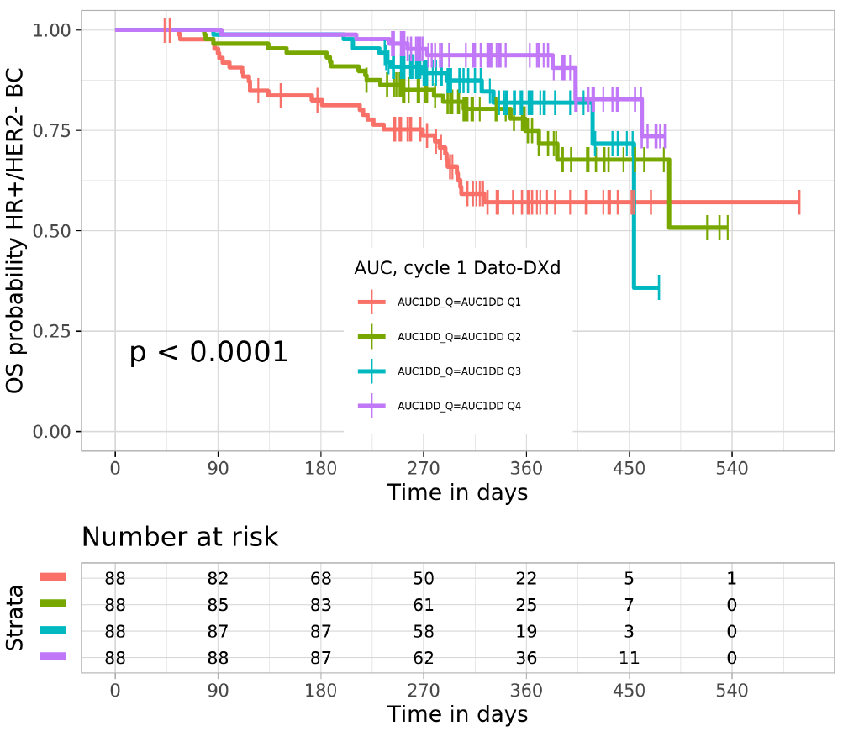
The Red, green, blue and purple lines represent the exposure metric quartiles with Q1 being the lowest and Q4 the highest; The solid lines represent the % of subjects alive; Vertical bars indicate where one or multiple subjects have been censored in time; The count indicates the number of patients.
Kaplan-Meier estimates of PFS stratified by the quartile exposure of TB01 patients indicated possible exposure-response relationship, i.e. an apparent lower PFS for the lowest quartile of Dato-DXd exposure, however a CPH regression could not detect a statistically significant (p > 0.001) correlation between Dato-DXd PK exposure metrics and PFS. Baseline tumour size was a significant covariant for PFS (p<0.001).
The pooling of HR-positive/HER2-negative BC patients from TP01 (n=41) and TNBC patients from TP01 (n=44) with the TB01 patients (n=352) yielded identical results for the graphical explorations and significant covariates for OS, PFS, and ORR. Overall, the E-R analyses for efficacy suggested a potential for reduced efficacy with lower dosages (i.e., ≤ 6mg/kg Q3W).
The following covariates of clinical interest were evaluated in the exposure-safety analyses: baseline demographics (race, age, sex, body weight, region), albumin, tumour size, number of prior lines of therapy, last prior line therapy being immune-oncology, history of CNS metastasis, history of liver metastasis, Eastern Cooperative Oncology Group (ECOG) performance status, smoking status, tumour type and prior use of CDK4/6 inhibitor.
Analysed safety endpoints included: Grade 3+ treatment emergent adverse events (TEAEs); serious TEAEs; TEAE leading to dose interruption; TEAE leading to dose reduction; TEAE leading to treatment discontinuation; any grade or grade 2+ oral mucositis or stomatitis; any grade or grade 2+ ocular surface toxicity; and adjudicated drug-related ILD. The analysis of mucosal inflammation of any grade and gr2+ from the exposure-safety analysis was excluded due to the low incidence (5 out of 352 in TB01 for mucosal inflammation of any grade) and different definitions across studies.
Among the 1081 evaluable patients in the exposure-safety analysis population, 919 patients received 6.0 mg/kg. The remaining patients received a dose of < 4.0 mg/kg (n = 22), 4.0 mg/kg (n = 50), or ≥ 8.0 mg/kg (n = 90). Statistically significant ER relationships were observed for the following eight AE endpoints: Grade ≥ 3 TEAEs, serious TEAEs, TEAEs associated with dose interruption, TEAEs associated with dose reduction, oral mucositis/stomatitis (any grade), oral mucositis/stomatitis (Grade ≥ 2), ocular surface toxicity (any grade), and ocular surface toxicity (Grade ≥ 2). Adjudicated drug-related ILD and TEAEs associated with treatment discontinuation did not have an exposure-response relationship to Dato-DXd or DXd.
The exposure-safety analysis results demonstrated that all safety endpoints showed an apparent ER relationship with respect to Dato-DXd and/or DXd except adjudicated drug-related ILD and TEAEs associated with treatment discontinuation within the dose range tested (0.27 to 10 mg/kg).
An exploratory analysis of TROP expression in patients in study TB01 was performed to examine how tumour cell membrane TROP2 expression, as assessed by visual scoring of IHC-stained tumour slides by pathologists, may associate with response to Dato-DXd. IHC analysis of the screening samples was performed retrospectively using the exploratory IHC Ventana RPA EPR20043. The majority of subjects (92%) had some level of TROP2 expression in tumour cell membranes as assessed by IHC and quantitated by H-score. There was no apparent association between the level of TROP2 expression and efficacy response in either of the treatment arms.

Efficacy
The clinical efficacy of Dato-DXd in the treatment of unresectable or metastatic hormone receptor (HR)-positive, HER2-negative (IHC 0, IHC 1+ or IHC 2+/ISH-) BC who have received one or two prior systemic chemotherapies for unresectable or metastatic disease was based on one pivotal study TROPION-Breast01 (Study TB01) and the supportive Phase 1 dose-finding study, TROPION-PanTumor-01 (Study TP01).

Study TB01
Study TB01 is a Phase 3, open-label, randomised, multi-centre study conducted in 732 patients to assess the safety and efficacy of Dato-DXd monotherapy vs. investigational choice of chemotherapy (ICC) in the target patient population. The first patient was enrolled on 18 October 2021. An interim analysis was initially submitted. A second interim analysis and the final analysis were submitted during the evaluation process. The study was conducted at 166 active sites in 20 countries/regions. The DCO for the final report was 24 July 2024.
The primary objectives were to demonstrate the superiority of Dato-DXd compared to ICC by assessment of PFS OR OS in patients with inoperable or metastatic HR-positive, HER2-negative BC, who have been treated with one or 2 lines of chemotherapy in the inoperable/metastatic setting, per blinded independent central review (BICR).

Study patients
Patients have inoperable or metastatic HR-positive/HER2-negative (defined per the American Society of Clinical Oncology - College of American Pathologists [ASCO - CAP] criteria as IHC 0, IHC 1+, and IHC 2+ with a negative in situ hybridization [ISH] test) BC who had been treated with one or 2 prior lines of systemic chemotherapy in the inoperable or metastatic setting. Key exclusion factors were: active brain metastases, bone only metastases, history of ILD/pneumonitis requiring treatment with steroids, ongoing ILD/pneumonitis, clinically significant corneal disease at screening. Patients were also excluded for Eastern Cooperative Oncology Group (ECOG) performance status >1.

Randomisation
Patients were randomly assigned to treatment arm (Dato-DXd or ICC) in a 1:1 ratio using interactive response technology. This was an open-label study for the personnel at study sites; however, the trial was conducted as “Sponsor-blind”. For patients randomised to ICC, chemotherapy was determined by the investigator prior to randomisation.
Randomisation was stratified by: the number of previous lines of chemotherapy (1 vs. 2); geographic region (United States, Canada, Europe vs rest of the world); and prior use of CDK4/6i (yes/no). The study report included the following justification for stratification factors:
“… randomisation was stratified based on previous lines of chemotherapy (1 versus 2 previous lines) and prior CDK4/6 inhibitor use since both these factors are expected to impact the magnitude of effect of proposed dual primary endpoints, PFS and OS. Furthermore, there are global regions where CDK4/6 inhibitors are not yet adopted, and as such patients may be enrolled, stratification based on prior CDK4/6 inhibitor use was implemented. In addition, given that the mortality rate may differ between geographical regions due to treatment practice and availability of therapy, stratification based on geographical region (United States, Canada, Europe versus Rest of World) was also included.
Figure 3. Flow chart of study design TROPION-Breast01 (TB01)
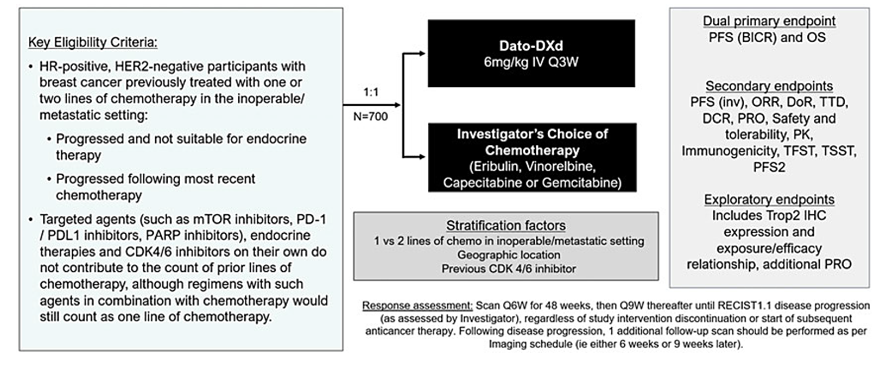

Study endpoints
The dual primary endpoints are PFS by blinded, independent central review (BICR) and OS. The following justification for selection of the primary endpoints was included in the study report:
The primary and secondary endpoints in Study TB01 are in line with the guidelines outlined by the NCI Breast Cancer Steering Committee Working Group Report. The study has dual primary efficacy endpoints, PFS by BICR and OS and the trial could be declared positive if either of these endpoints were statistically significant. Per EMA and FDA guidance, PFS is an objective endpoint and is potentially less affected by subsequent therapy compared to OS, and therefore can be a relevant measure of clinical benefit, particularly in settings where patients frequently change chemotherapy agents due to side effects or PD. A robust treatment effect based on PFS may therefore be considered a clinically relevant effect, in itself provided detriments on other important endpoints (i.e., OS) can be excluded and the benefit/risk profile is acceptable.
The following secondary and exploratory endpoints were assessed: PFS by investigator, Overall response rate (by BRIC and by Investigator), Best Objective response (BOR), Disease control rate (DCR) (by BICR), Duration of response (DoR) and time to onset of response (BICR), Time to first subsequent therapy or death (TFST), Time to second subsequent therapy (TST), Time to second progression or death (PFS2) and Patient-reported outcomes for pain, physical functioning and global health status.

Study treatments
Eligible patients were randomised 1:1 to receive either:
- Dato-DXd at 6 mg/kg IV on Day 1, Q3W; or
- ICC from the following choices:
- Capecitabine at 1000 or 1250 mg/m2 (choice of dose per standard institutional practice) oral twice daily on Days 1 to 14, Q3W
- Gemcitabine at 1000 mg/m2 IV on Day 1 and Day 8, Q3W
- Eribulin mesylate at 1.4 mg/m2 IV on Days 1 and 8, Q3W
- Vinorelbine at 25 mg/m2 IV on Days 1 and 8, Q3W
Dose delays were permitted for Dato-DXd treatment and the dosing interval for the next Dato-DXd cycle could be shortened, as clinically feasible; however, 2 consecutive doses had to be administered at least 19 days apart. A dose could be delayed for up to 3 consecutive cycles from the planned date of administration. If a patient was assessed as requiring a dose delay longer than 3 consecutive cycles (i.e., up to 84 days from last infusion date to the planned date of administration), the patient was to discontinue study treatment. Up to 2 dose reductions were permitted for patients receiving Dato-DXd (4.0 or 3.0 mg/kg IV, Q3W). Once the dose of Dato-DXd was reduced, no dose re-escalation was permitted.
The following justification for choice of comparator agents was provided in the study report: Chemotherapy (single agent or doublet) was considered the main treatment option for patients who had exhausted or were not suitable for ET in the metastatic setting. Combination chemotherapy has shown higher ORR, however, could not clearly show an OS benefit (Schott 2021). In addition, to balance the OS benefits with the toxicities between single agent and combination therapy, single agent sequential chemotherapies were recommended. Preferred agents in this setting include eribulin, capecitabine, vinorelbine, and gemcitabine (NCCN Guidelines 2020, Cardoso et al 2020).
Crossover between study intervention arms of the study was not permitted.
Excluded concomitant medications included: other anticancer therapies, chloroquine or hydroxychloroquine, other investigational agents, radiotherapy, chronic systemic corticosteroids, or other immunosuppressive medications.
Study treatment was administered until disease progression (per RECIST 1.1) or until unacceptable toxicity, withdrawal of consent, or meeting another protocol prespecified treatment discontinuation criteria. Tumour imaging was performed Q6W (±7 days) for 48weeks, then Q9W (7 days) thereafter until Investigator assessed RECISTl.1 PD, regardless of study intervention or start of subsequent anticancer therapy. Following PD,1 additional follow-up scan should be performed per discontinuation imaging schedule (i.e., 6 weeks or 9 weeks later).

Statistical planning
The study is event driven, the accrual of the predetermined number of events included in the study endpoints determines the duration of the data collection phase of the study. There are 4 planned data cut-offs (DCOs) for this study consisting of an ophthalmologic data review (DCO1), primary analysis of PFS/first OS interim analysis (DCO2), second OS interim analysis (DCO3) and primary analysis of OS (DCO4).
The DCO for the primary analysis of PFS/first OS interim analysis (DCO2) is planned to occur when approximately 419 PFS Blinded independent central review (BICR) events have been observed in the FAS. The primary and final analysis of PFS was performed approximately 2 months after the last patient was randomized in the study.
For OS, the smallest treatment difference that could be statistically significant at the final analysis is an OS hazard ratio of 0.824. If the PFS primary analysis does not cross the efficacy threshold, the OS analysis will have 83% power to demonstrate statistical significance at the 4.0% level (using a 2-sided test). The smallest treatment difference that could be statistically significant at the final analysis is a hazard ratio of 0.817. Calculations assume median OS times of 19.0 months and 25.3 months in ICC and Dato-DXd, respectively when the survival times are exponentially distributed.
PFS and OS were analysed using a log-rank test stratified by number of previous lines of chemotherapy, geographic region and prior use of CDK4/6 inhibitors. The effect of Dato-DXd versus ICC was estimated by the HR together with its corresponding CI and p-value from a stratified CPH and Kaplan-Meier plots presented by treatment group.
Since no alpha was allocated to endpoints other than PFS per BICR assessment and OS, all other endpoints are considered exploratory.

Patient disposition
A total of 1003 patients were screened, with 732 patients randomised in a 1:1 ratio to either the Dato-DXd arm (365 patients) or the ICC arm (367 patients). A total of 360 (98.6%) patients in the Dato-DXd arm and 351 (95.6%) patients in the ICC arm received study intervention.
In the ICC arm patients received the following treatments: eribulin n= 220 (60%), capecitabine n= 76 (21%), vinorelbine n= 38 (10%), and gemcitabine n=33 (9%).
Overall, 579 patients (81.4%) discontinued the study intervention, with a higher proportion discontinuing in the ICC arm (312 [88.9%]) compared to the Dato-DXd arm (267 [74.2%]). The primary reason for discontinuation was objective disease progression, which was reported for more patients in the ICC arm (240 [68.4%]) than the Dato-DXd arm (229 [63.6%]). Other common reasons were patient decision (13 [3.6%] patients in the Dato-DXd arm and 32 [9.1%] patients in the ICC arm) and “Other (clinical or subjective disease progression and physician decision” (12 [3.3%] patients in the Dato-DXd arm and 23 [6.6%] patients in the ICC arm).
At the time of DCO 17 July 2023, 93 (25.8%) patients were still being treated in the Dato-DXd arm and 39 (11.1%) in the ICC arm.
A total of 209 (28.6%) patients withdrew from the study; 97 (26.6%) in the Dato-DXd arm and 112 (30.5%) in the ICC arm, with the most common reason for study withdrawal being death, with 76 (20.8%) patients in the Dato-DXd arm and 86 (23.4%) patients in the ICC arm.
At the time of DCO, the median total duration of exposure was 1.6 times longer in the Dato-DXd arm (6.7 months) than in the ICC arm (4.1 months) The median number of treatment cycles received in the Dato-DXd arm was 9.0 cycles, compared to 4.0 cycles in the ICC arm.

Baseline characteristics
Table 6. Demographic and key baseline characteristics TB01
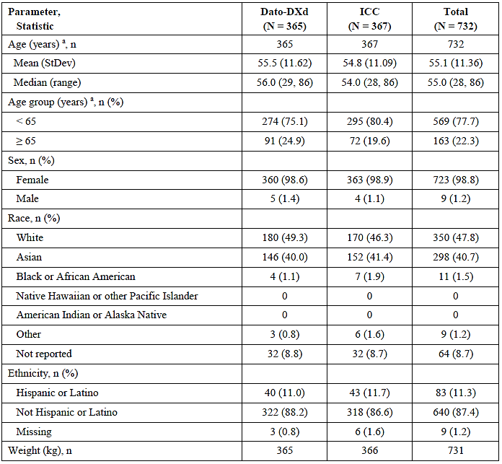
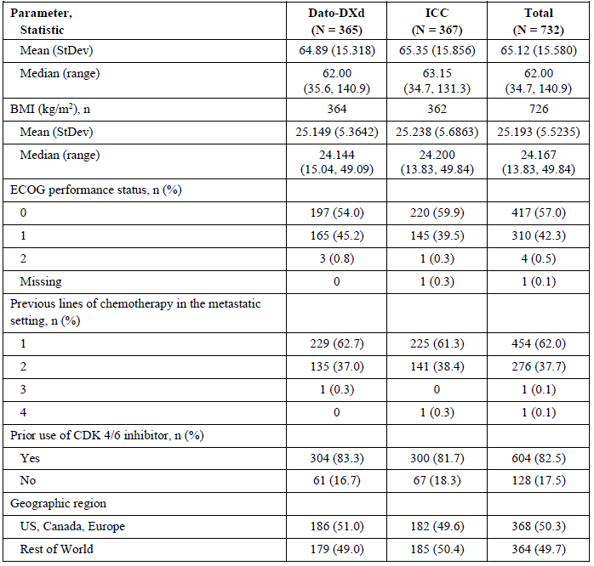
a Age calculated using date of randomization.
n = number of subjects in analysis for a continuous variable and number of subjects per category for a categorical variable; N = number of subjects per treatment group
The most common sites of metastasis in study patients at study entry were liver (526 [71.9%]), bone (511 [69.8%]), lung (179 [24.5%]), pleura (96 [13.1%]), other metastatic sites (161 [22.0%]), and brain (58 [7.9%]). A higher proportion of patients had liver metastases and metastases at other metastatic sites at study entry in the Dato-DXd arm (75.3% and 24.9%, respectively) compared with the ICC arm (68.4% and 19.1%, respectively).
In the ICC arm patients received the following treatments: eribulin for 220 (60%) patients, capecitabine for 76 (21%) patients, vinorelbine for 38 (10%) patients, and gemcitabine for 33 (9%) patients.
The most commonly received prior anticancer therapies in the inoperable or metastatic setting were cytotoxic chemotherapy in 731 (99.9%) patients, hormonal therapy in 648 (88.5%) patients, and targeted therapy in 621 (84.8%) patients. This was generally balanced across the two arms.
Table 7. Prior Anticancer Therapy (Full Analysis Set) TB01
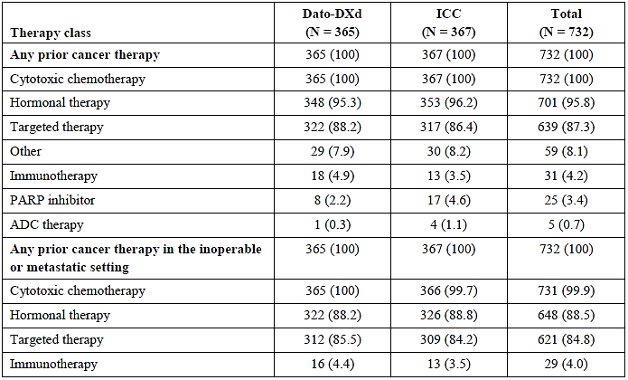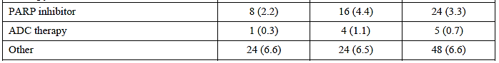
Prior cancer therapy is any cancer therapy that stopped prior to start of treatment with investigational product. Subjects are counted once per therapy class regardless of the frequency of medication usage. Inoperable or metastatic setting includes first line, second line, third line and > third line. N = number of subjects per treatment group.
In the final study report, DCO 24 July 2024, the following post-study drug discontinuation therapies were reported: In the Dato-DXd arm, 269 (73.7%) patients received post-discontinuation anticancer therapies, compared with 289 (78.7%) patients in the ICC arm. The most commonly received post-discontinuation anticancer therapies by ATC classification in the Dato-DXd arm were pyrimidine analogues (115 [31.5%] patients), other antineoplastic agents (103 [28.2%] patients), taxanes (72 [19.7%] patients), and anthracyclines and related substances (54 [14.8%] patients). In the ICC arm the most commonly received post-discontinuation anticancer therapies were pyrimidine analogues (105 [28.6%] patients), taxanes (92 [25.1%] patients), HER2 inhibitors (85 [23.2%] patients, the majority of which received trastuzumab deruxtecan in this category), and anthracyclines and related substances (77 [21.0%] patients).
Post-discontinuation trastuzumab deruxtecan and/or sacituzumab govitecan was taken by more patients (88 [24.0%]) in the ICC arm than in the Dato-DXd arm (45 [12.3%]). Trastuzumab deruxtecan was taken by 34 (9.3%) patients in the Dato-DXd arm and 80 (21.8%) in the ICC arm. Sacituzumab govitecan was taken by 15 (4.1%) patients in the Dato-DXd arm and 26 (7.1%) in the ICC arm. Four (1.1%) patients in the Dato-DXd arm and 18 (4.9%) patients in the ICC arm received both trastuzumab deruxtecan and sacituzumab govitecan post-discontinuation.
Table 8. Summary efficacy data IA1 DCO 17 July 2023, Primary Analysis for PFS, (Full Analysis Set) TB01
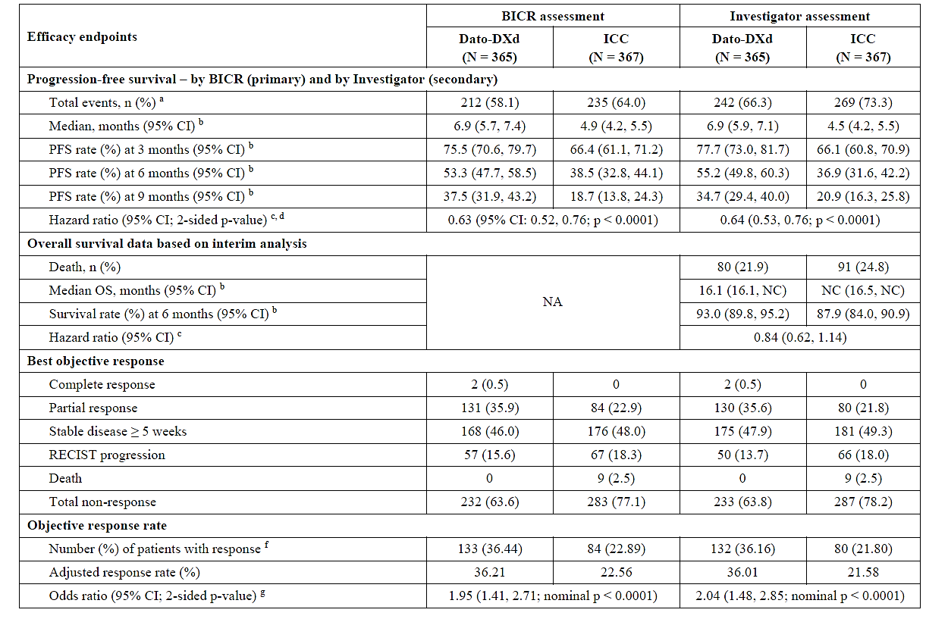
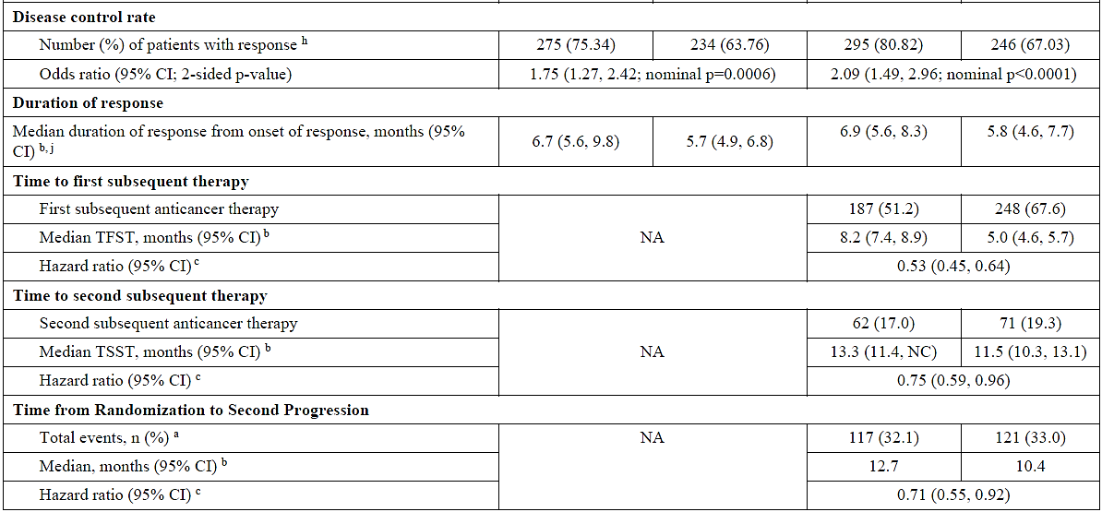
- Only includes progression events that occur within 2 assessments of the last evaluable assessment.
- Calculated using the Kaplan-Meier technique.
- The analysis was performed using a stratified Cox Proportional Hazards model with stratification variables, number of previous lines of chemotherapy, geographic region. and prior use of CDK4/6 inhibitor. A hazard ratio < 1 favours Dato-DXd to be associated with a longer progression-free survival than ICC.
- The P-value is calculated using a stratified log-rank test adjusting for the stratification factors of the number of previous lines of chemotherapy, geographic region. and prior use of CDK4/6 inhibitor. Per the pooling strategy, the CDK4/6 strata was pooled.
- Response required confirmation
- Responses exclude unconfirmed responses.

Progression-free survival
At the first interim analysis (1AI) with DCO 17 July 2023, a total of 447 out of 732 patients had BICR PFS events, with 212 (58.1%) events in the Dato-DXd arm and 235 (64.0%) events in the ICC arm. There was a 37% reduction in the risk of disease progression or death (hazard ratio of 0.63; 95% CI: 0.52, 0.76; p < 0.0001; two-sided alpha level of 0.01) with a median PFS of 6.9 months (95% CI: 5.7, 7.4) for Dato-DXd versus 4.9 months (95% CI: 4.2, 5.5) for ICC. The median duration of PFS follow-up in censored patients was 8.1 months (range: 0.0 to 15.4 months) in the Dato-DXd arm and 4.0 months (range: 0.0 to 15.4 months) in the ICC arm.
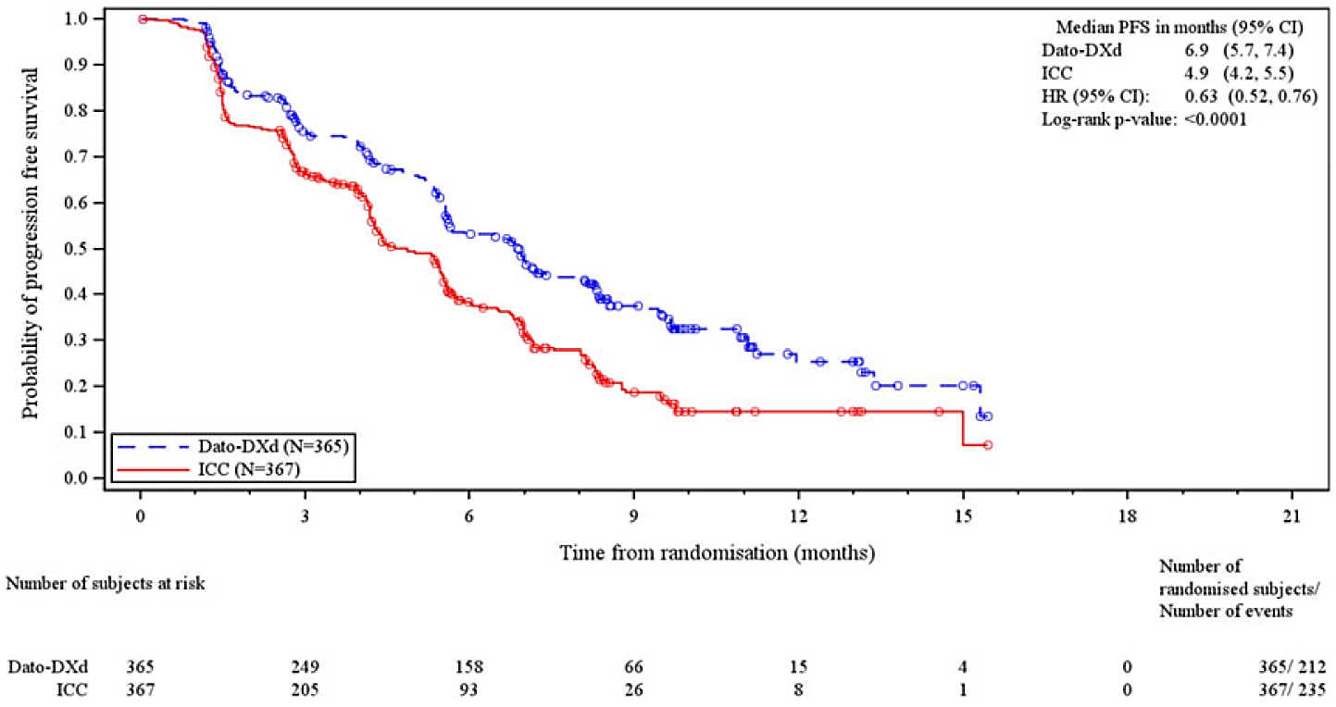
Circle indicates a censored observation. RECIST 1.1.
2-sided p-value.
HR = hazard ratio; N = number of subjects per treatment group
Subgroup analyses of PFS (by BICR): The PFS benefit of Dato-DXd over ICC was consistent across all prespecified subgroups favouring the Dato-DXd arm.

Figure 4. Progression-free Survival, Forest Plot, by Subgroup, BICR Data (Full Analysis Set)
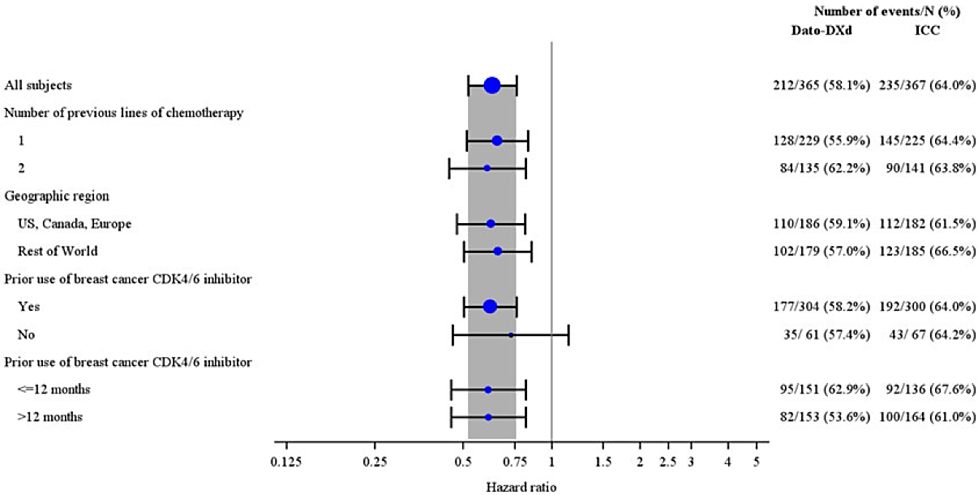
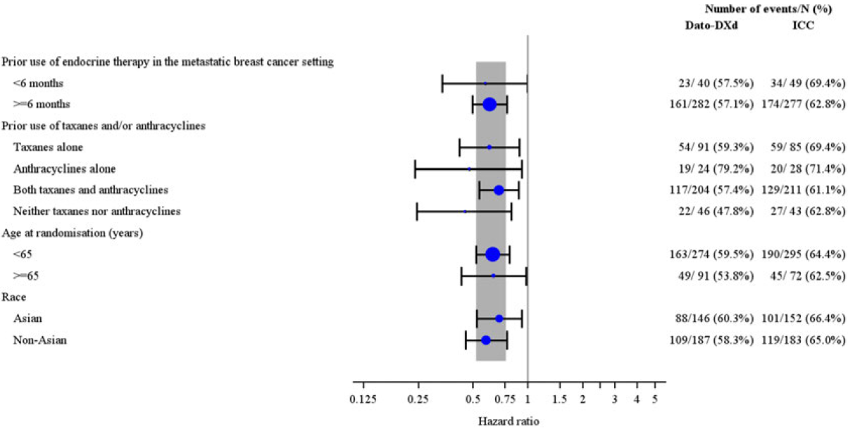
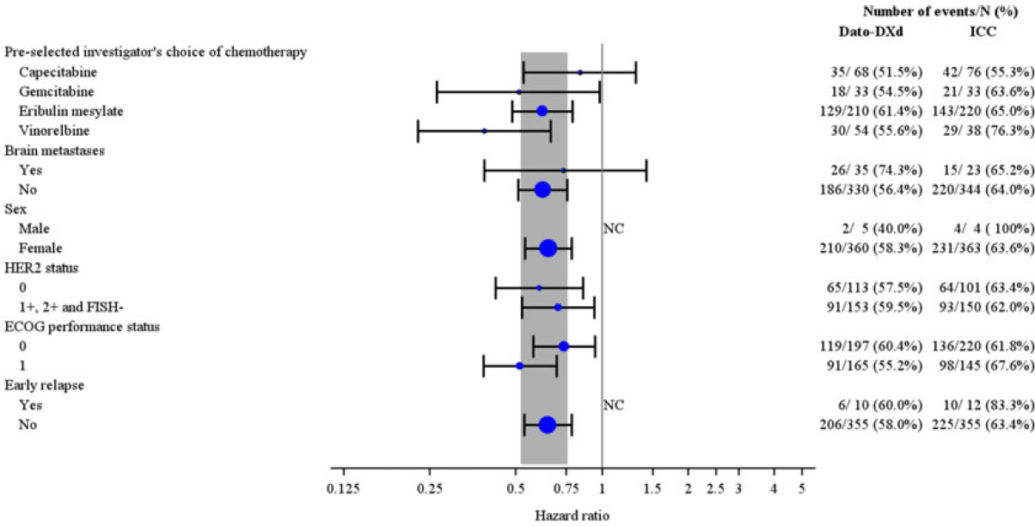
Hazard ratio (Dato-DXd: ICC) and 95% CI. A hazard ratio < 1 implies a lower risk of progression on Dato-DXd.
The overall analysis was performed using a stratified Cox Proportional Hazards model with stratification variables number of previous lines of chemotherapy, geographic region, and prior use of
CDK4/6 inhibitor. The subgroup analysis was performed using a Cox Proportional Hazards model with treatment as the only covariate. Size of circle is proportional to the number of events. Grey band
represents the 95% CI for the overall (all subjects) hazard ratio.
Progression includes deaths in the absence of RECIST progression. Progression events that did not occur within 2 assessments of the last evaluable assessment (or randomization) are censored.
Three Canadian subjects were incorrectly stratified to rest of world rather than United States, Canada, Europe.
FISH = Fluorescence in situ hybridization; N = number of subjects per treatment group
Overall survival: At the first OS interim analysis (IA1), DCO: 17 July 2023, there were 80 OS events in the Dato-DXd arm compared with 91 events in the ICC arm (23.4% maturity, 38.5% information fraction). The hazard ratio was 0.84 (95% CI: 0.62, 1.14) with a stratified p value of 0.2615 that did not cross the prespecified IA1 efficacy stopping boundary of 0.000608.
At the Second interim analysis (IA2) with DCO 29 April 2024, there were 195 OS events in the Dato-DXd arm compared with 200 events in the ICC arm (54.0% maturity, 89% information fraction). The OS analysis was conducted with a total 2-sided alpha level of 5%. The hazard ratio was 0.93 (95% CI: 0.76, 1.13) with a p value of 0.4712 that did not cross the prespecified IA2 efficacy stopping boundary of 0.0348. The median follow-up for OS was 17.4 months at IA2 (range: 0 to 29.1 months).
At the final analysis, DCO 24 July 2024, there were 436 OS events (59.6% maturity, 98.2% information fraction) in 732 patients, 223 (61.1%) OS events in the Dato-DXd arm and 213 (58%) events in the ICC arm. Median OS was 18.6 months and 18.3 months in the Dato-DXd and ICC arms respectively, HR (95%CI) 1.01 (0.83, 1.22), p value 0.9445. Median (range) FU of all patients by treatment arm was 17.8 (0-32) months for Dato-DXd and 17.5 (0-31.1) months for ICC.
Figure 5. Overall Survival, Kaplan-Meier Plot (Full Analysis Set) TB01
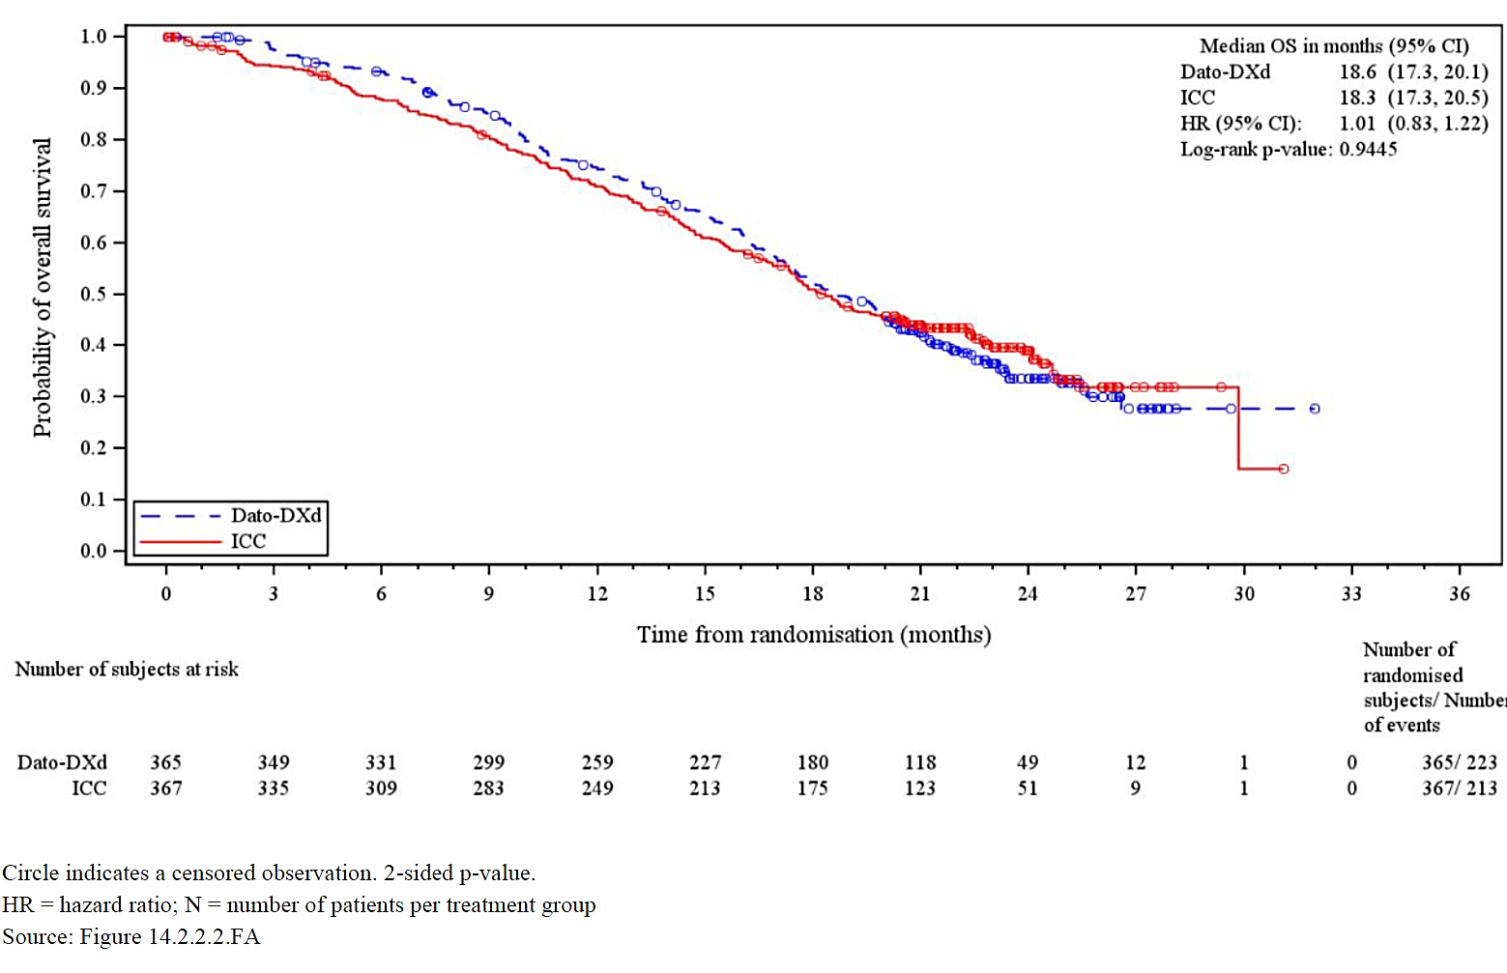
Circle indicates a censored observation. 2-sided p-value.
HR = hazard ratio; N = number of subjects per treatment group
Sensitivity analyses were also performed using stratification variables of number of previous lines of chemotherapy, geographical region and prior use of CDK4/6 inhibitor. These analyses also showed no statistical difference in OS between treatment arms.
Further analyses of OS within subgroups was performed. The Sponsor noted the higher rate of subsequent therapy (other anti-cancer therapies: 78.5% vs 72.1%; trastuzumab deruxtecan and sacituzumab govitecan: 23.3% vs 10.1%) in the ICC arm compared to Dato-DXd arm which might have confounded the OS results at IA2. The exploratory post-hoc OS sensitivity analysis using Inverse Probability of Censoring Weighting (IPCW) was conducted to adjust for subsequent use of trastuzumab deruxtecan and sacituzumab govitecan. This analysis estimated an adjusted hazard ratio of 0.78 (95% CI: 0.63, 0.97), indicating a potential OS benefit for patients in the Dato-DXd arm compared to those in the ICC arm. After this adjustment, the probability of survival at 12 months was higher in the Dato-DXd arm (74.9%) compared to the ICC arm (69.0%). Similarly, at 18 months, the adjusted survival probability was 53.4% in the Dato-DXd arm versus 47.4% in the ICC arm.
All subgroup analyses are considered exploratory or hypothesis generating, and no formal statistical inference can be drawn. Several subgroups had a hazard ratio point estimate greater than 1. However, all confidence intervals included 1, some subgroups had smaller sample size, baseline patient characteristics could be imbalanced within subgroups, and there was no clear biological rational to support differential efficacy between subgroups. Therefore, subgroup results should be interpreted with caution. Overall, the post-hoc exploratory OS analysis showed a trend somewhat favouring Dato-DXd.
Figure 6. Forest plot of Overall Survival, final analysis by subgroup TB01
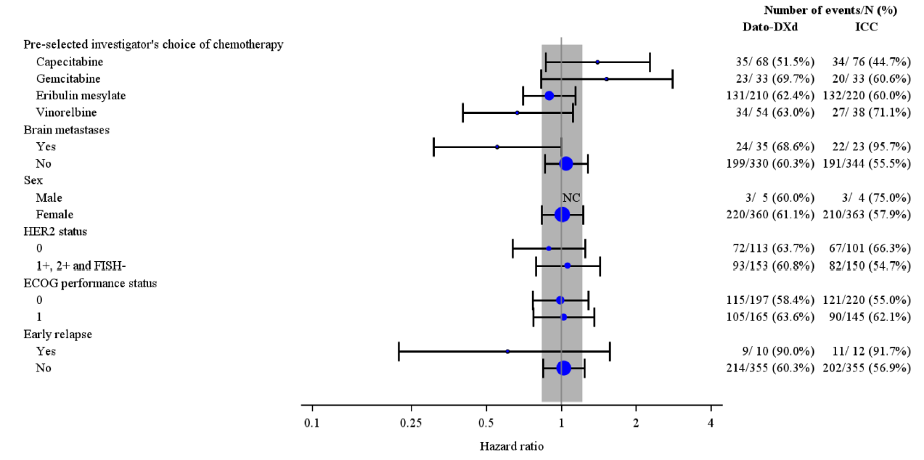
Hazard ratio (Dato-DXd: ICC) and 95% CI. A hazard ratio <1 implies a lower risk of death on Dato-DXd. The overall analysis was performed using a stratified Cox Proportional Hazards model with stratification variables number of previous lines of chemotherapy, geographic region, and prior use of CDK4/6 inhibitor. The subgroup analysis was performed using a Cox proportional hazards model with treatment as the only covariate. Size of circle is proportional to the number of events. Grey band represents the 95% confidence interval for the overall (all subjects) hazard ratio. Three Canadian subjects were incorrectly stratified to geographic region rest of world rather than US, Canada, Europe. Per the pooling strategy, the CDK4/6 strata was pooled. CI Confidence interval. ECOG Eastern cooperative oncology Group. HER2 Human epidermal growth factor receptor 2. ICC Investigator's choice chemotherapy. N Number of subjects per treatment group. NC Not calculated.

Secondary and exploratory endpoints final analysis
Results of selected secondary and exploratory endpoints from the final analysis are listed below.

PFS by investigator
Total of 289 (81.6%) events in the Dato-DXd arm and 298 (81.2%) events in the CCI arm. Median (95%CI) PFS 6.9 (5.9, 7.2) months and 4.5 (4.2, 5.5) months in the Dato-DXd and CCI arms respectively.

ORR by investigator
The ORR by investigator was higher at 36.55% in the Dato-DXd arm compared with 21.83% in the ICC arm (odds ratio = 2.06; 95% CI: 1.49, 2.87; nominal p < 0.0001). Analysis based on confirmed response by investigator data, logistic regression

Best objective response
Best objective response (investigator data data) was reported as CR for 3 (0.8%) patients in the Dato-DXd arm and no patients in the ICC arm, and as PR for 131 (35.9%) patients in the Dato-DXd arm and 81 (22.1%) in the ICC arm.

Duration of response and time to onset of response (investigator)
The median (95% CI) Kaplan-Meier estimate of DoR for patients with confirmed CR/PR was 7.2 (5.7, 8.7) months in the Dato-DXd arm and 6.0 (4.6, 7.7) months in the ICC arm.

Time to first subsequent therapy or death
Time to first subsequent therapy or death (TFST) was delayed in the Dato-DXd arm compared with the ICC arm (hazard ratio of 0.57 [95% CI: 0.49, 0.67]; median 8.0 months Dato-DXd vs 5.2 months ICC). A lower proportion of patients moved on to receive a first subsequent anticancer therapy in the Dato-DXd arm (84.4%) compared with the ICC arm (90.7%).

Time to second subsequent therapy or death
There were 249 (68.2%) events in the Dato-DXd arm and 263 (71.7%) events in the ICC arm. The delay in PFS2 was greater in the Dato-DXd arm compared with the ICC arm (HR ratio of 0.71 [95% CI: 0.55, 0.92]; median 13.7 months Dato-DXd vs 12.3 months ICC).

Quality of life endpoints
In the final analysis, time to deterioration in pain was slightly delayed in the Dato-DXd arm compared with the ICC arm (hazard ratio of 0.84 [95% CI: 0.67, 1.06]; median 3.5 months in Dato-DXd vs 2.8 months in ICC). The proportion of patients without deterioration in pain was consistently higher in the Dato-DXd arm compared with the ICC arm at 6, 12, and 15 months.

Time to deterioration
Time to deterioration (TTD) was assessed using European Organisation for Research and Treatment of Cancer quality of life questionnaire. TDD was delayed in the Dato-DXd arm vs the ICC arm for dyspnoea (hazard ratio of 0.68; median 8.4 months in the Dato-DXd arm vs 4.9 months in the ICC arm) and diarrhoea (hazard ratio of 0.75; median 12.4 months in the Dato-DXd arm vs 8.4 months in the ICC arm); while TTD in constipation was in favour of the ICC arm vs the Dato-DXd arm (hazard ratio of 1.47; median 2.2 months in the Dato-DXd arm vs 4.2 months in the ICC arm).
Table 9. Time to deterioration per EORTC QLQ-C30 (full analysis set) TB01
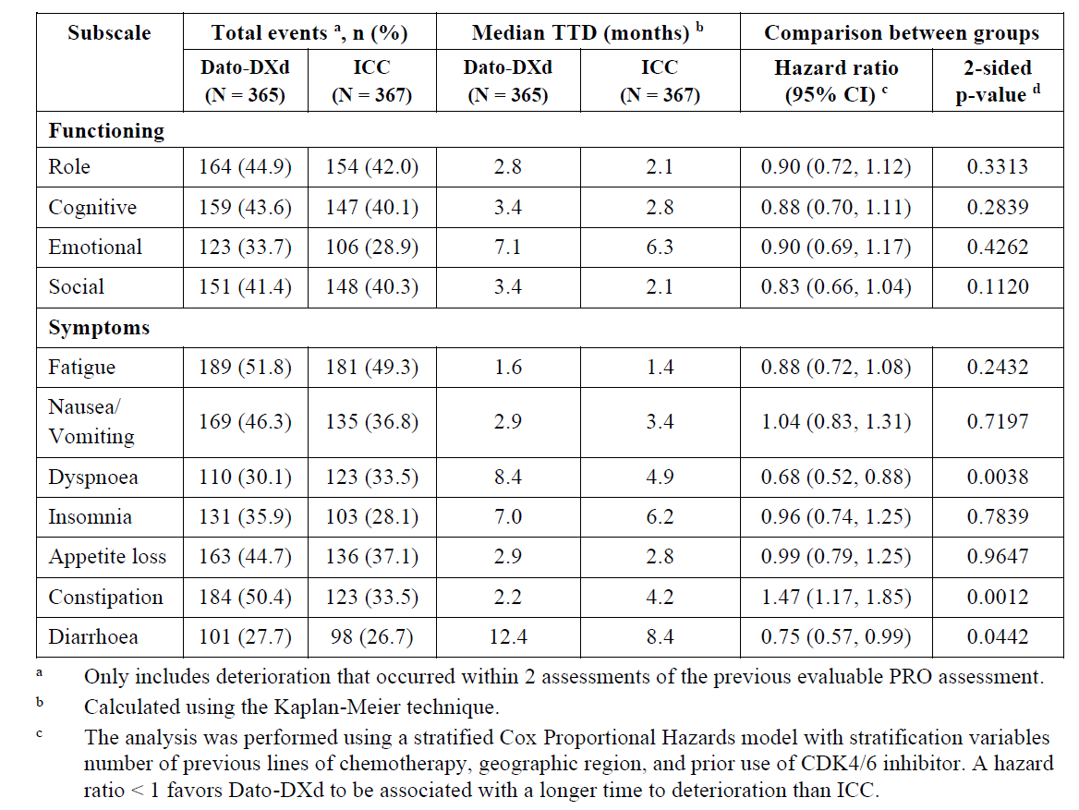
- Only includes deterioration that occurred within 2 assessments of the previous evaluable PRO assessment.
- Calculated using the Kaplan-Meier technique.
- The analysis was performed using a stratified Cox Proportional Hazards model with stratification variables number of previous lines of chemotherapy, geographic region, and prior use of CDK4/6 inhibitor. A hazard ratio < 1 favours Dato-DXd to be associated with a longer time to deterioration than ICC.

Supportive study TROPION-PanTumor-01 (TP01)
TROPION-PanTumor-01 (TP01) was a Phase 1, two-part, multicentre, open-label, multiple dose, first-in-human study of Dato-DXd in subjects with advanced solid tumours.
PK data from this study was discussed in the pharmacology section of this overview. TP01 was primarily a dose-finding study. It was conducted in 2 parts. The dose escalation part examined doses from 0.27 to 10 mg/kg in patients with NSCLC and TNBC. The dose expansion part included 41subjects with HR+/HER2-BC received 6 mg/kg IV on Day 1, Q3W. Each subject received the initial dose of IV Dato-DXd for approximately 90 minutes on Day 1 of Cycle 1. If no IRR occurred after the initial dose, the next dose of IV Dato-DXd was infused for approximately 30 minutes. The number of treatment cycles was not fixed. Subjects who continued to derive clinical benefit from study treatment in the absence of withdrawal of consent, PD, or unacceptable toxicity may have continued study treatment.
The primary efficacy parameter was ORR. None of the 41 subjects with HR+/HER2-BC had CR and 11 (26.8%) had PR and 23 (56.1%) had SD. For subjects with PR, the duration of response ranged from 1.4 to 12.6+ months with DOR ≥6 months for 4 subjects with HR+/HER2-BC.

Safety

Exposure
The primary evaluation (IA1) in this application includes data from the Dato-DXd arm and the ICC arm of pivotal Study TB01. The largest dataset pooled all study subjects who received ≥4 mg/kg Dato-DXd in studies TB01 (n=360), TP01 BC (n=85), TP01 NSCLC (n=188), TL05 (n=137), TL01 (n=297), giving a total of 1067 subjects. Summary results for patients given Dato-DXd in that population are shown below.
Table 10. Adverse Drug Reactions in Pooled Data of TB01, TL01, TL05, and TP01 (6 mg/kg), by Grouped/MedDRA SOC, Grouped Term/Preferred Term and Frequency (Safety Analysis Set) IA1
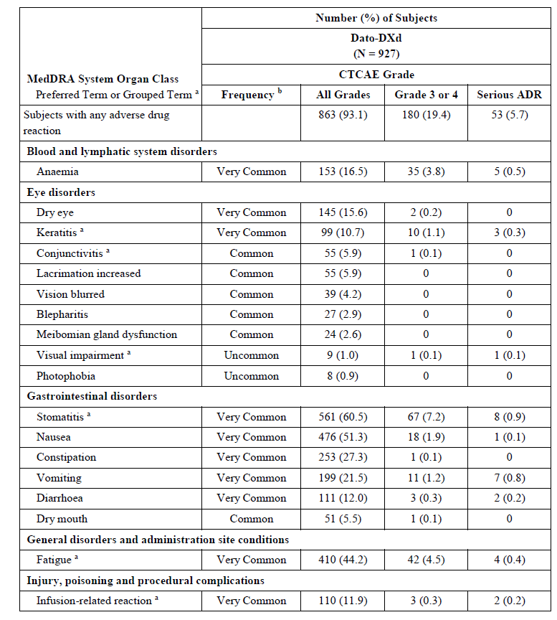
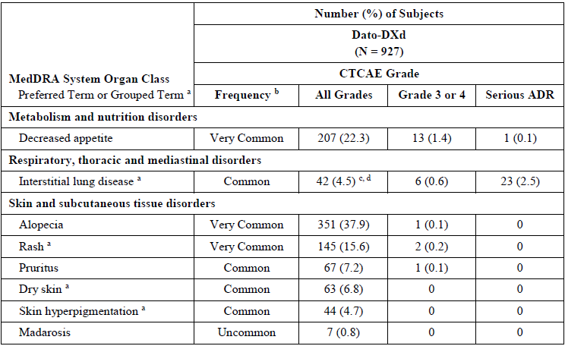
b. Frequency: (1) very common (1/10 subjects); (2) common 1/100 to < 1/10 subjects); (3) uncommon (1/1,000 to < 1/100 subjects); (5) very rare (1/10,000 subjects) and (6) not known (cannot be estimated from available data).
c. Interstitial lung disease was reported as CTCAE Grade 5 in 8 (0.9%) subjects.
d. In study TL01, one subject in the Dato-DXd arm had a drug-related Grade 2 ILD event according to the Adjudication Committee, but the event was removed from the clinical database by the Investigator as the Investigator considered it disease progression. With this subject included, frequency of ILD increased to 43 (4.6%1 subjects).
In this review most emphasis is given to study TB01 because it assessed safety in the population that is proposed to receive Dato-DXd. Differences in baseline characteristics between the NSCLC and BC patient groups are likely to result in differences in reported AEs, thereby giving a less accurate view of the AE profile of Dato-DXd in patients with BC. Data reported below is from the final study report for TB01, with DCO 24 July 2024.
In the final CSR for Study TB01, 360 patients in the Dato-DXd arm and 351 patients in the ICC arm received study treatment. The median total treatment duration was 6.8 months in the Dato-DXd arm and 4.1 months in the ICC arm. Mean duration was 8.3 months and 5.34 months for Dato-DXd and ICC respectively.
Dose interruption occurred in 6 (1.7%) patients in the Dato-DXd arm and in 5 (1.4%) in the ICC arm. The primary reason for dose interruption was AEs (5 [1.4%] and 4 [1.1%] in the Dato-DXd and ICC arms respectively. Dose reduction was required for 94 (26.1%) patients in the Dato-DXd arm and 115 (32.8%) patients in the ICC arm. The primary reason for dose reduction in the Dato-DXd and ICC arms was AE (86 [23.9%] and 104 [29.6%], respectively. Dose delay was required for 152 (42.2%) patients in the Dato-DXd arm and 113 (32.2%) in the ICC arm (note: dose delay information was not collected for patients who received capecitabine [oral administration] in the ICC arm). The majority of patients in both treatment arms required 1 or 2 dose delays.

Deaths
In that analysis, a total of 436 patients died during the study: 223 (61.1%) in the Dato-DXd arm and 213 (58.0%) in the ICC arm. One fatal AE was reported in the Dato-DXd arm by the investigator (sepsis) that was not considered related to study intervention by the investigator. One patient in the Dato-DXd arm had an event of pneumonitis and died; this event was assessed by the investigator as Grade 3 and death due to disease progression. This event was subsequently assessed as fatal drug-related ILD by the Adjudication Committee. In the ICC arm, 3 fatal AEs were reported during study intervention or 35-day FU (sepsis, febrile neutropenia, and respiratory distress. Febrile neutropenia was assessed by the investigator as possibly related to study intervention. Also in the ICC arm, one fatal AE was reported outside the safety follow-up period. All other reported deaths were attributed to the disease under investigation, unrelated to an AE or disease (BC), or for unknown reasons.

Serious adverse events
In the Dato-DXd arm, urinary tract infection and COVID-19 were the most common serious adverse events (SAE) reported (5 [1.4%] and 4 [1.1%] patients, respectively, vs 3 [0.9%] and 3 [0.9%] patients, respectively, in the ICC arm). In the ICC arm, febrile neutropenia (5 [1.4%]) and pneumonia and femur fracture (4 [1.1%] each) were the most common SAEs reported (no patients, 2 [0.6%] and 1 [0.3%], respectively, in the Dato-DXd arm).
All other SAEs were reported in ≤ 2 patients in both treatment arms, with the exception of sepsis (3 [0.8%] vs 1 [0.3%] patients in the Dato-DXd vs ICC arm, respectively), urosepsis (3 [0.8%] vs 0 patients), pleural effusion (2 [0.6%] vs 3 [0.9%] patients), and pneumonitis (3 [0.8%] vs 0 patients).
Table 11. Serious AEs with incidence ≥1% study TB01
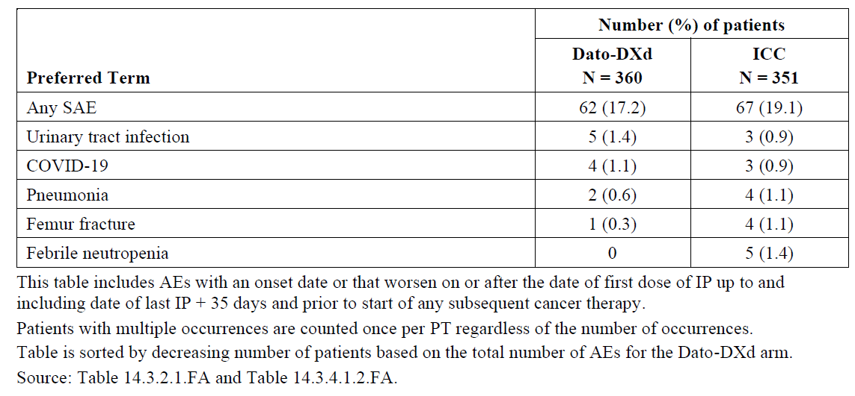
This table includes AEs with an onset date or that worsen on or after the date of first dose of IP up to and including date of last IP + 35 days and prior to start of any subsequent cancer therapy. Patients with multiple occurrences are counted once per PT regardless of the number of occurrences. Table is sorted by decreasing number of patients based on the total number of AEs for the Dato-DXd arm.
Serious AEs of common toxicity criteria for adverse events (CTCAE) ≥ Grade 3 were reported in 14.2% and 17.9% of patients in the Dato-DXd arm and ICC arm respectively. In both treatment arms, all SAEs of CTCAE Grade ≥ 3 were reported in < 1% of patients, except urinary tract infection in the Dato-DXd arm (5 [1.4%]; 3 [0.9%] in the ICC arm) and femur fracture and febrile neutropenia in the ICC arm (femur fracture: 4 [1.1%]; 1 [0.3%] in the Dato-DXd arm; febrile neutropenia: 5 [1.4%]; none in the Dato-DXd arm).
Table 12. Adverse Drug Reactions in Study TB01 by Grouped/MedDRA SOC and Grouped Term/Preferred Term, and Frequency (Safety Analysis Set)
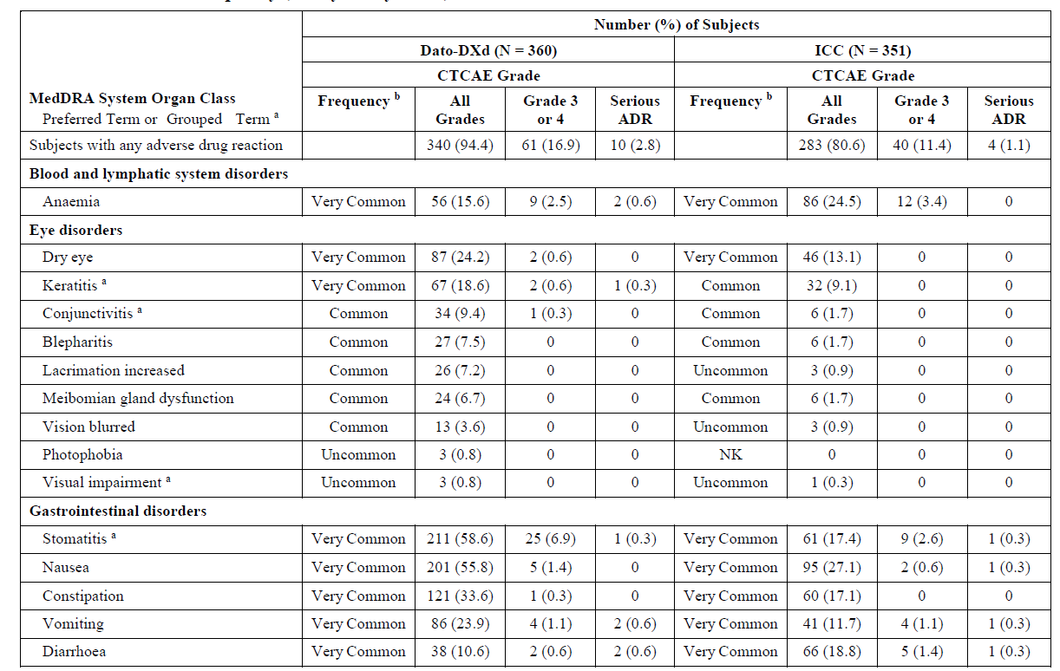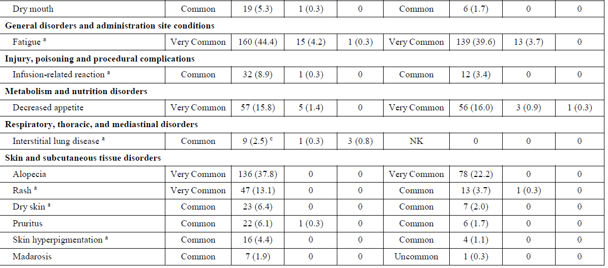

Laboratory adverse events
Worsening in CTCAE grade shifts in haemoglobin was reported in 133 (37.0%) of patients in the Dato-DXd arm and 177 (52.1%) of patients in the ICC arm. In both treatment arms, the majority of CTCAE grade shifts were 1-grade. Two patients in the Dato-DXd arm and 6 in the ICC arm had 3-grade shifts. No 4-grade shifts were reported in either treatment arm.
Anaemia was observed in 62 (17.2%) patients in the Dato-DXd arm and 87 (24.8%) patients in the ICC arm. All events of anaemia, except 2 (0.6%) in the Dato-DXd arm and 1 (0.3%) in the ICC arm were non-serious.
Worsening in CTCAE grade shifts in leukocyte count was reported in 152 (42.3%) of patients in the Dato-DXd arm and 217 (63.6%) in the ICC arm. In both treatment arms, the majority of CTCAE grade shifts were 1-grade or 2-grade. Grade 3 shifts occurred in 1 (0.3%) patient and 45 (13.2%) of patients in the Dato-DXd arm and ICC arm respectively; 1 (0.3%) patient in the Dato-DXd arm and 9 (2.6%) patients in the ICC arm had 4-grade shifts. Thirteen (3.6%) patients in the Dato-DXd arm and 29 (8.3%) in the ICC arm had an AE of leukopenia, none were assessed as serious.
Eight (2.2%) patients in the Dato-DXd arm and 12 (3.4%) in the ICC arm had an AE of lymphopenia, all were non-serious. Lymphopenia was reported as CTCAE ≥ Grade 3 and related to study treatment in 1 (0.3%) patient in the ICC arm (none in the Dato-DXd arm).
Neutropenia occurred in 21 (5.8%) patients in the Dato-DXd arm and 91 (25.9%) patients in the ICC arm, all events were non-serious in the Dato-DXd arm; 1 patient had an SAE of neutropenia in the ICC arm. One (0.3%) patient in the Dato-DXd arm had neutropenia reported as CTCAE ≥ Grade 3. Febrile neutropenia was reported only in the ICC arm, 8 (2.3%). CTCAE Grade 3 and Grade 4 events were reported in 6 (1.7%) and 1 (0.3%) patient, respectively. One patient experienced a Grade 5 febrile neutropenia event (Section 12.3.1). One patient, in the ICC arm discontinued study treatment due to an AE of neutropenia, neutrophil count decreased, or febrile neutropenia; In the Dato-DXd arm 1 (0.3%) patient had a dose modification due to neutropenia compared with 54 (15.4%) patients in the ICC arm. No patient had dose modification due to neutrophil count decreased in the Dato-DXd arm compared with 40 (11.4%) in the ICC arm. In the ICC arm, 4 (1.1%) patients had a dose modification due to febrile neutropenia. Colony stimulating factor is a common therapy used for the treatment of neutropenia and was used in a clinically significantly higher proportion of patients in the ICC arm than the Dato-DXd arm (22.6% patients in the ICC arm compared with 2.7% patients in the Dato-DXd arm).
Thrombocytopenia was reported in 3 (0.8%) patients in the Dato-DXd arm and 15 (4.3%) in the ICC arm. All events in the Dato-DXd arm were non-serious; in the ICC arm, 1 (0.3%) patient had a serious event of thrombocytopenia. Thrombocytopenia was reported as CTCAE ≥ Grade 3 and related to study treatment in 1 (0.3%) patient in the ICC arm (none in the Dato-DXd arm). No patient in the Dato-DXd arm discontinued study treatment due to an AE of thrombocytopenia or platelet count decreased, 1 (0.3%) patient in the ICC arm discontinued study treatment due to an AE of thrombocytopenia. No patient in the Dato-DXd arm had a dose modification (i.e., interruption or reduction) due to these events. In the ICC arm, 6 (1.7%) patients had a dose modification due to thrombocytopenia and 3 (0.9%) due to platelet count decreased.
Clinical chemistry value shifts were observed in both treatment arms did not indicate any clinically relevant differences between arms. There were no clinically relevant changes in median values of clinical chemistry parameters observed during treatment in the majority of patients. There was a low frequency of reported AEs associated with abnormal clinical biochemistry
Seven (1.9%) patients in the Dato-DXd arm and 6 (1.8%) patients in the ICC arm had elevated ALT or AST ≥ 3 × ULN or ALT ≥ 5 × ULN or AST ≥ 5 × ULN and total bilirubin ≥ 2 × ULN at any time during treatment. Seven (1.9%) potential Hy’s law cases were observed in the Dato-DXd arm and 6 (1.8%) in the ICC arm. All potential Hy’s law cases were reviewed as per the CSP and were assessed as being due to disease progression or underlying disease; no indication of a causal relationship to study treatment was reported and therefore no cases of Hy’s law were reported.

Adverse events of special interest
AESI data reported below is from the IA1 study report for TB01, with DCO 17 July 2023, except ILD/pneumonitis for which data from IA1 and FA DCO is presented:

Ocular surface toxicity
Ocular surface toxicity is an AESI that is monitored in the Dato-DXd clinical development program. This AESI is based on the emerging clinical safety data as well as nonclinical data including the expression of the TROP2 protein in the corneal tissues, detection of the topoisomerase I warhead in ocular surface tissues, and ocular findings in the non-human primates. These data suggest a possible MOA by which Dato-DXd may cause the observed clinical toxicity.
An ophthalmologic analysis set was added in clinical study protocol prior to the start of patient recruitment, in response to a request from a Health Authority. Current risk mitigation strategies include mandatory ophthalmologic assessments and preventative measures such as use of artificial tears. Management guidelines were provided the protocol for study TB01 was amended to include the collection of a specified series of ocular assessments by an eyecare specialist at baseline, every 3 cycles, as clinically indicated and at end of study treatment.
In study TB01 ocular surface toxicity occurred in 48.6% of patients in the Dato-DXd arm and in 23.1% in the ICC arm. Most ocular surface toxicity events were CTCAE Grade 1. In the Dato-DXd arm, ocular surface toxicity AESIs were recovered/resolved in 13.6% of patients (5.7% in the ICC arm) at the time of DCO. Few patients in the Dato-DXd and ICC arms had dose reduction due to ocular surface toxicity AESIs (4 [1.1%] and 1 [0.3%] patients, respectively). Dose interruption was reported for 9 (2.5%) patients in the Dato-DXd arm (none in the ICC arm). One patient in the Dato-DXd arm discontinued from study treatment due to an ocular surface toxicity AESI (none in the ICC arm).
During treatment, patients receiving Dato-DXd were advised to use artificial tears and avoid using contact lenses. Participants in the Dato-DXd arm used more artificial tears per day than those in the ICC arm, and increased use with progressive cycles.

ILD/pneumonitis
In the safety summary for IA1, adjudicated drug-related ILD occurred in 2.5% of patients in the TB01 Dato-DXd arm and 4.6% of patients in the BC + NSCLC 6 mg/kg pool. Grade ≥ 3 adjudicated drug-related ILD occurred in 0.6% patients in the TB01 Dato-DXd arm and 1.6% patients in the BC + NSCLC 6 mg/kg pool.
One patient (0.3%) in the TB01 Dato-DXd arm and 9 (1.0%) patients in the BC + NSCLC 6 mg/kg pool had adjudicated drug-related ILD with an outcome of death. Median time to first onset of adjudicated drug-related ILD was similar between the TB01 Dato-DXd arm and BC + NSCLC 6 mg/kg pool (43.0 days and 44.0 days, respectively). Investigator-reported median duration of the first event, for which an end date was captured, was 42.0 days in the TB01 Dato-DXd arm and 39.0 days in the BC + NSCLC 6 mg/kg pool.
The most common preferred terms contributing to adjudicated drug-related ILD in the TB01 Dato-DXd arm and BC + NSCLC 6 mg/kg pool were pneumonitis (6 [1.7%] and 32 [3.5%] patients, respectively) and ILD (3 [0.8%] and 6 [0.6%] patients, respectively).
In the final study report for TB01 adjudicated drug-related ILD was reported in the Dato-DXd arm only, in 15 (4.2%) patients. Two patients had Grade 3 pneumonitis. One patient had a Grade 5 pneumonitis. This event was assessed by the investigator as Grade 3 and death due to disease progression and was subsequently assessed as fatal drug-related ILD by the Adjudication Committee. Six patients in the Dato-DXd arm had study treatment discontinued (none in the ICC arm).

Infusion-related reactions
Infusion-related reaction is an identified risk for Dato-DXd based on the available clinical and nonclinical experience with Dato-DXd. To be considered an infusion-related reaction, events from a list of pre-defined infusion-related reaction preferred terms were required to start on the same day of an infusion. Risk mitigation guidelines are currently in place in all study protocols in the Dato-DXd clinical program.
In study TB01 8.9% and 3.4% of the Dato-DXd arm and ICC arm respectively had infusion-related reactions. The majority of these were CTCAE Grade 1 or Grade 2 and recovered/resolved. No patient in either treatment arm required a dose reduction due to infusion-related reaction AESIs. Five (1.4%) patients in the Dato-DXd arm required dose interruption and none in the ICC arm). One patient in the Dato-DXd arm discontinued from study treatment (none in the ICC arm).
Oral mucositis/ stomatitis: Oral mucositis/stomatitis is an identified risk for Dato-DXd and AESI based on the available clinical and nonclinical experience with Dato-DXd. In study TB01 58.6% and 17.4% of patients in the Dato-DXd arm and CCI arm respectively had an AESI of oral mucositis/stomatitis. Most events were Grade 1 or Grade 2 and recovered/resolved. Dose reduction was required for 48 (13.3%) patients in the Dato-DXd arm and 5 (1.4%) in the ICC arm, and dose interruption for 7 (1.9%) and 3 (0.9%) patients, respectively. One patient in the Dato-DXd arm (none in the ICC arm) discontinued study treatment due to an oral mucositis/stomatitis AESI.
Mucosal inflammation other than mucositis/stomatitis was reported in 5 (1.4%) patients in the Dato-DXd arm compared with 1 (0.3%) in the ICC arm. All events reported were Grade 1 or Grade 2 in the Dato-DXd arm and Grade 1 only in the ICC.

Risk management plan evaluation summary
AstraZeneca Pty Ltd has submitted EU-RMP version 0.1 (dated 1 February 2024; DLP 17 July 2023 (Lung and Breast cancer), ASA version 1.0 succession 1.0 (dated 13 March 2024 (Lung cancer)) and ASA version 2.0 succession 1.0 (dated 13 March 2024 (Breast cancer) in support of this application.
The proposed summary of safety concerns and their associated risk monitoring and mitigation strategies are summarised below.
Table 13. Summary of safety concerns
Summary of safety concerns |  | Pharmacovigilance |  | Risk Minimisation
 |  | Routine | Additional | Routine | Additional
Important identified risks | Interstitial lung disease / pneumonitis | ü* | – | ü | ü†
Important identified risks | Keratitis | ü* | – | ü | –
Important potential risks | Embryo-foetal toxicity | ü | – | ü | –
Missing information | Use in patients with moderate or severe hepatic impairment | ü | – | ü | –
*Targeted follow-up questionnaires
† HCP Guide and Patient Guide (including Patient Alert Card)
Routine and additional risk minimisation activities are proposed. Additional risk minimisation activities are proposed for the Important Identified Risk “Interstitial lung disease / pneumonitis” and includes an HCP Guide and Patient Guide including a Patient Alert Card. This aligns with what is proposed in the EU-RMP. The Sponsor has provided an outline of these activities and should provide the material at least 6 weeks prior to product launch for adequate review by the TGA. A distribution plan should also be outlined in the ASA when available. The black triangle symbol and accompanying text should be included in any additional risk minimisation materials. In addition, use of the symbol and text is strongly encouraged in promotional materials.

Risk-benefit analysis
In advanced/metastatic disease irrespective of the choice of primary endpoint, ORR, DoR and if relevant, rate of tumour stabilisation for, e.g. 3 or 6 months should be reported. Overall consistency in outcomes is expected across endpoints, unless justified, e.g. in terms of mechanism of action and tumour biology. This was not the case for Dato-DXd in the pivotal trial for HR+/HER2- BC.
Study TB01 had dual primary endpoints, PFS by blinded, independent central review (BICR) and OS. The study could be declared positive if either of these endpoints were statistically significant. PFS showed clear statistical superiority difference in PFS of Dato-DXd over ICC with 212 (58.1%) events in the Dato-DXd arm and 235 (64.0%) in the ICC arm, a 2 month absolute difference in median PFS and a 37% reduction in the risk of disease progression or death (hazard ratio of 0.63; 95% CI: 0.52, 0.76; p < 0.0001; two-sided alpha level of 0.01) with a median PFS of 6.9 months (95% CI: 5.7, 7.4) for Dato-DXd versus 4.9 months (95% CI: 4.2, 5.5) for ICC. All 3 analyses of OS (IA1, IA2 and the final analysis) failed to show a statistically significant OS benefit from Dato-DXd compared with ICC. A justification for the lack of substantial difference in OS between the study groups was provided in the final CSR for TB01 and is reproduced below.
The OS results are confounded by imbalanced, higher subsequent ADC treatment in the ICC arm, which has increased since IA1. During the course of TROPION-Breast01, ADCs were approved for the treatment of BC, resulting in subsequent use. Current treatment guidelines now include sacituzumab govitecan and trastuzumab deruxtecan as systemic therapy options for patients with HR-positive and HER2-negative/HER-2 low BC, respectively.
At IA2 (DCO: 29 April 2024), an OS sensitivity analysis (IPCW) adjusting for subsequent ADC treatment suggested benefit of Dato-DXd treatment for OS, with an adjusted hazard ratio of 0.78 (95% CI: 0.63, 0.97). At the final analysis, the same OS sensitivity analysis continues to suggest benefit of Dato-DXd treatment for OS, with an adjusted hazard ratio of 0.86 (95% CI: 0.70, 1.06). At Month 27 and Month 30, the point estimate for the RMST difference in OS between arms continues to suggest that Dato-DXd does not have a detrimental effect on OS.
Taken together, the multiple prespecified and post hoc sensitivity analyses support no detriment of OS in Dato-DXd arm.
The results for the secondary efficacy endpoint of PFS as assessed by investigators were consistent with the primary analysis at DCO: 17 July 2023 and IA2 at DCO: 29 April 2024, showing a nominally statistical and clinically meaningful benefit of Dato-DXd vs ICC.
Results from the secondary efficacy endpoints of TFST, TSST, and PFS2 support a continuing benefit of Dato-DXd vs ICC beyond the first progression which was consistent with the analysis at DCO: 17 July 2023 and DCO: 29 April 2024. The median times to first and second subsequent therapies or death were both longer in the Dato-DXd arm compared with the ICC arm, as was the median time to second progression or death (PFS2).
The other secondary efficacy endpoints analysed at DCO: 24 July 2024 continued to support the efficacy of Dato-DXd without exception: ORR, DoR, and DCR by investigator assessment consistently demonstrated improvements for Dato-DXd-treated patients compared with ICC-treated patients. Notably, ORR at DCO: 24 July 2024 was higher for patients in the Dato-DXd arm compared with the ICC arm by investigator assessment (36.55% vs 21.83%, respectively; odds ratio = 2.06; 95% CI: 1.49, 2.87; nominal p < 0.0001).
Consistent with the results at DCO: 17 July 2023 and DCO: 29 April 2024, the secondary time to deterioration endpoints showed that TTD in pain, physical functioning, and GHS/QoL were delayed in Dato-DXd compared with ICC.
The patient-reported disease-related symptoms, including pain, fatigue, arm symptoms, and breast symptoms, continued to be better or similar in the Dato-DXd arm compared with the ICC arm, supporting the finding of the efficacy endpoint analysis. Patient-reported overall treatment tolerability was comparable between Dato-DXd and ICC, and the findings on specific patient-reported symptomatic AEs were generally consistent with clinician-reported safety data, without showing significant impact on patients’ usual or daily activities. Together, better or similar functioning (physical, role, social, cognitive, and emotional) and GHS/QoL were observed in Dato-DXd vs ICC.
Like Dato-DXd, sacituzumab govitecan is a Trop-2-directed antibody-drug conjugate with a small molecule that targets topoisomerase 1. The topoisomerase I inhibitor component of Dato-DXd, an exatecan derivative, is approximately 10 times more potent than SN 38, the active metabolite of irinotecan and the small molecule component of sacituzumab govitecan. TROPiCS-02 is the pivotal study in the PI for sacituzumab govitecan (Trodelvy) in which a similar patient population received sacituzumab govitecan or the same chemotherapy agents given as the comparator in TB01. The median PFS for sucituzumab govitecan was 5.5 months compared with 4.0 months for the comparator chemotherapy. The median OS for sucituzumab govitecan was 14.4 months. The OS with Dato-DXd was 18.6 months. The introduction of ADCs into SOC for this patient group during the course of TB01 may have affected the OS differences between treatments.
The absolute difference in median PFS between DatoDXd and ICC is fairly small at 2 months but is in the region that has been accepted with other therapies for BC. The OS differences between Dato-DXd and ICC have not approached statistical or clinical significance at any of the 3 planned analyses for OS.
The TB01 control arm chemotherapy comparator was appropriate when the trial started however some patients eligible for TB01 would now have additional SOC treatment options. Patients who have HER2-low (IHC 1+ or 2+/ISH-) tumours (formerly included in the HER2-negative category) and have received one prior line of chemotherapy in the metastatic setting may be eligible for trastuzumab deruxtecan (T-DXd) and patients who have received prior ET and at least two additional lines of chemotherapy in the metastatic setting may be eligible for sacituzumab govitecan (Trodelvy). The activity of Dato-DXd following other approved ADCs and the activity of approved ADCs following Dato-DXd hasn’t been examined.
The immunogenicity of Dato-DXd has not been adequately examined and the Sponsor should submit evidence of a valid ADA assay as a post-registration commitment, as has been required by the FDA.
The indication proposed by the Sponsor does not specify the class (other than endocrine-based therapy) or the number of prior lines of therapy for treatment with Dato-DXd. I consider that the patient population in the indication should reflect the patient population in the pivotal study i.e. as a minimum the indication should require prior endocrine-based therapy and at least one line of chemotherapy. Dato-DXd was given as a monotherapy in TB01 and this should also be reflected in the indication.
Safety: Overall, the AE profile, was comparable to the ICC arm. Dato-DXd was associated with fewer Grade ≥ 3 AEs despite the longer median duration of exposure for the Dato-DXd arm relative to the ICC arm. There were also fewer dose reductions and dosage interruptions with Dato-DXd compared to ICC. There were fewer haematologic AEs in the Dato-DXd arm and more infusion-related reactions (IRRs), stomatitis, gastrointestinal AEs and ocular-related toxicities in the Dato-DXd arm compared to ICC arm. Adjudicated related ILD events were reported in Dato-DXd arm with none in ICC arm. The Sponsor proposed an HCP guide and patient guide for monitoring and minimising risks.
The toxicity profile of Dato-DXd was different from that of sacituzumab govitecan, another TROP2-directed antibody drug conjugate in which the small molecule is a topoisomerase 1 inhibitor. Dato-DXd had a higher incidence of TROP-2 targeted side effects such as stomatitis/ mucositis/skin reactions/ocular toxicities whereas sacituzumab govitecan had lower incidence of these events but had higher incidence of haematologic AEs. ILD events were not reported for sacituzumab govitecan but reported for Dato-DXd and trastuzumab deruxtecan which has the same payload and linker as Dato-DXd. Overall, the risk profile is acceptable and manageable.
The FDA has required submission of ADA assay validation including report addendums containing high resolution drug tolerance data and justification to support that the ADA assays are fit-for-purpose to characterise the effects of ADA on pharmacokinetics, pharmacodynamics, safety, and effectiveness of datopotamab deruxtecan. This report was to be submitted to the FDA in June 2025. It should also be submitted to the TGA when it is available.

Assessment outcome
Based on a review of quality, safety, and efficacy, the TGA decided to register DATROWAY (datopotamab deruxtecan) for the following indication:
DATROWAY as monotherapy is indicated for the treatment of adult patients with unresectable or metastatic hormone receptor (HR)-positive, HER2-negative (IHC 0, IHC 1+ or IHC 2+/ISH-) breast cancer who have received endocrine therapy and at least one additional systemic therapy in the locally advanced or metastatic setting.

Specific conditions of registration
DATROWAY (datopotamab deruxtecan) is to be included in the Black Triangle Scheme. The PI and CMI for DATROWAY must include the black triangle symbol and mandatory accompanying text for five years, which starts from the date of first supply of the product.
The DATROWAY EU- RMP (version 0.1, dated 1 February 2024, data lock point 17 July 2023), with Australian Specific Annex (ASA) (version 2.0 succession 1.0 (dated 13 March 2024), included with submission PM-2024-01148-1-4, and any subsequent revisions, as agreed with the TGA will be implemented in Australia.
An obligatory component of risk management plans is routine pharmacovigilance. Routine pharmacovigilance includes the submission of periodic safety update reports (PSURs).
Unless agreed separately between the supplier who is the recipient of the approval and the TGA, the first report must be submitted to TGA no later than 15 calendar months after the date of this approval letter. The subsequent reports must be submitted no less frequently than annually from the date of the first submitted report until the period covered by such reports is not less than three years from the date of this approval letter. The annual submission may be made up of two PSURs each covering six months. If the Sponsor wishes, the six-monthly reports may be submitted separately as they become available.
If the product is approved in the EU during the three years period, reports can be provided in line with the published list of EU reference dates no less frequently than annually from the date of the first submitted report until the period covered by such reports is not less than three years from the date of this approval letter.
The reports are to at least meet the requirements for PSURs as described in the European Medicines Agency’s Guideline on good pharmacovigilance practices (GVP) Module VII-periodic safety update report (Rev 1), Part VII.B Structures and processes. Note that submission of a PSUR does not constitute an application to vary the registration. Each report must be submitted within ninety calendar days of the data lock point for that report.
The Sponsor should submit the final study report for ADA assay validation and include report addendums containing high resolution drug tolerance data and justification to support that the ADA assays are fit-for-purpose to characterise the effects of ADA on pharmacokinetics, pharmacodynamics, safety, and effectiveness of datopotamab deruxtecan. This report is to be submitted to the FDA in June 2025 and should be submitted to the TGA within 6 months of being finalised.

Product Information and Consumer Medicines Information
For the most recent Product Information (PI) and Consumer Medicines Information (CMI), please refer to the TGA PI/CMI search facility.

Therapeutic Goods Administration
PO Box 100 Woden ACT 2606 Australia
Email: info@tga.gov.au Phone: 1800 020 653 Fax: 02 6203 1605
https://www.tga.gov.au

Harbeck N et al. Breast cancer. Nat Rev Dis Primers. 2019;5(1):66.
Wolffe AC et al. Human Epidermal Growth Factor Receptor 2 Testing in Breast Cancer American Society of Clinical Oncology/College of American Pathologists. Clinical Practice Guideline Focused Update. Arch Pathol Lab Med 2018; 142:1364-1382.
Howlader N et al. US incidence of breast cancer subtypes defined by joint hormone receptor and HER2 status. J Natl Cancer Inst. 2014;106(5).
Modi S et al, DESTINY-Breast04 Trial Investigators. Trastuzumab deruxtecan in previously treated HER2-low advanced breast cancer. N Engl J Med. 2022;387(1):9-20.
https://seer.cancer.gov/
Ma, C X et. al. Treatment for hormone receptor-positive, HER2-negative advanced breast cancer. 2025. UpToDate, accessed 13 March 2025.
Pau Ni IB et al. Gene expression patterns distinguish breast carcinomas from normal breast tissues: the Malaysian context. Pathol Res Pract. 2010;206(4):223-8.
Zhao W et al. Trop2 is a potential biomarker for the promotion of EMT in human breast cancer. Oncol Rep. 2018;40(2):759-66.
⁹ Seidman A et al. National Cancer Institute Breast Cancer Steering Committee Working Group Report on Meaningful and Appropriate End Points for Clinical Trials in Metastatic Breast Cancer. Journal of Clinical Oncology 2018; 36(32): 3259-68.

