Australian Public Assessment Report for Capvaxive

  - Active ingredient: Pneumococcal 21-valent Conjugate Vaccine

  - Sponsor: Merck Sharp & Dohme (Australia) Pty Ltd
August 2025

About the Therapeutic Goods Administration (TGA)
- The Therapeutic Goods Administration (TGA) is part of the Australian Government Department of Health, Disability and Ageing and is responsible for regulating therapeutic goods, including medicines, medical devices, and biologicals.
- The TGA administers the Therapeutic Goods Act 1989 (the Act), applying a risk management approach designed to ensure therapeutic goods supplied in Australia meet acceptable standards of quality, safety, and efficacy.
- The work of the TGA is based on applying scientific and clinical expertise to decision-making, to ensure that the benefits to the Australian public outweigh any risks associated with the use of therapeutic goods.
- The TGA relies on the public, healthcare professionals and industry to report problems with therapeutic goods. The TGA investigates reports received to determine any necessary regulatory action.
- To report a problem with a therapeutic good, please see the information on the TGA website.

About AusPARs
- The Australian Public Assessment Report (AusPAR) provides information about the evaluation of a prescription medicine and the considerations that led the TGA to approve or not approve a prescription medicine submission. Further information can be found in Australian Public Assessment Report (AusPAR) guidance.
- AusPARs are prepared and published by the TGA.
- AusPARs are static documents that provide information that relates to a submission at a particular point in time. The publication of an AusPAR is an important part of the transparency of the TGA’s decision-making process.
- A new AusPAR may be provided to reflect changes to indications or major variations to a prescription medicine subject to evaluation by the TGA.

Copyright
© Commonwealth of Australia 2025
This work is copyright. You may reproduce the whole or part of this work in unaltered form for your own personal use or, if you are part of an organisation, for internal use within your organisation, but only if you or your organisation do not use the reproduction for any commercial purpose and retain this copyright notice and all disclaimer notices as part of that reproduction. Apart from rights to use as permitted by the Copyright Act 1968 or allowed by this copyright notice, all other rights are reserved, and you are not allowed to reproduce the whole or any part of this work in any way (electronic or otherwise) without first being given specific written permission from the Commonwealth to do so. Requests and inquiries concerning reproduction and rights are to be sent to the TGA Copyright Officer, Therapeutic Goods Administration, PO Box 100, Woden ACT 2606 or emailed to <tga.copyright@tga.gov.au>.

Contents
List of abbreviations 4
Product submission 6
Submission details 6
Product background 7
Disease or condition 7
Current treatment options 8
Clinical rationale 8
Regulatory status 10
Australian regulatory status 10
International regulatory status 10
Registration timeline 11
Assessment overview 11
Quality evaluation summary 12
Nonclinical evaluation summary 12
Clinical evaluation summary 13
Summary of clinical studies 13
Risk management plan evaluation summary 35
Risk-benefit assessment 36
Delegate’s considerations 36
Advisory Committee on Vaccines considerations 36
Assessment outcome 39
Specific conditions of registration applying to these goods 39
Product Information and Consumer Medicine Information 41

List of abbreviations

Abbreviation | Meaning
13vPCV | 13-valent pneumococcal conjugate vaccine (Prevenar 13)
15vPCV | 15-valent pneumococcal conjugate vaccine (Vaxneuvance)
20vPCV | 20-valent pneumococcal conjugate vaccine (Prevenar 20)
21-valent PCV | 21-valent pneumococcal conjugate vaccine (Capvaxive)
23vPPV | 23-valent pneumococcal polysaccharide vaccine (Pneumovax 23)
ACV | Advisory Committee on Vaccines
AE | Adverse Event
ARTG | Australian Register of Therapeutic Goods
ASA | Australia-specific annex
ATSI | Aboriginal and Torres Straits Islanders
BTS | Black Triangle Scheme
CMI | Consumer Medicines Information
CAP | Community acquired pneumonia
DLP | Data lock point
ECL | Electrochemiluminescent
EMA | European Medicines Agency
FDA | Food & Drug Administration (USA)
GMC(s) | Geometric mean concentration(s)
GMFR | Geometric mean fold rise
GMT | Geometric mean titre
HIV | Human immunodeficiency virus
IgG | Immunoglobulin G
IM | Intramuscular
IPD | Invasive pneumococcal disease
MBC | Monovalent bulk conjugates
MOPA | Multiplexed opsonophagocytic killing assay
NIP | National Immunisation Program
Non-IPD | Non-invasive pneumococcal disease
NPI | Nonpharmaceutical interventions
OPA | Opsonophagocytic activity
PCV | Pneumococcal Conjugate Vaccine
PD | Pneumococcal disease
PFS | Prefilled syringe
PI | Product Information
PSUR | Periodic safety update report
RMP | Risk management plan
SAEs | Serious adverse events
TGA | Therapeutic Goods Administration

Product submission

Submission details
Type of submission: | New biological entity
Product name: | Capvaxive
Active ingredient: | Pneumococcal 21-valent Conjugate Vaccine
Decision: | Approved
Date of decision: | 30 January 2025
Date of entry onto ARTG: | 5 February 2025
ARTG number: | 429290
Black Triangle Scheme  for the current submission: | Yes  The PI and CMI for Capvaxive must include the black triangle symbol and mandatory accompanying text for five years, which starts from the date of first supply of the product.
Sponsor’s name and address: | Merck Sharp & Dohme (Australia) Pty Ltd  Level 1, Building A, 26 Talavera Road  Macquarie Park,  NSW, 2113
Dose form: | 0.5 mL solution for injection.
Strength: | Each 0.5 ml dose contains 84 micrograms of pneumococcal purified capsular polysaccharide antigen conjugated to approximately 65 mcg of CRM197 carrier protein.
Container: | Single-dose pre-filled glass syringes.
Pack size: | Pre-filled syringes in packs of 1 and 10.
Approved therapeutic use for the current submission: | Capvaxive is indicated for active immunisation for the prevention of pneumococcal disease caused by Streptococcus pneumoniae serotypes (3, 6A, 7F, 8, 9N, 10A, 11A, 12F, 15A, 15B, 15C, 16F, 17F, 19A, 20A, 22F, 23A, 23B, 24F, 31, 33F, and 35B) in adults 18 years of age and older.  Capvaxive may not prevent disease cause by S. pneumoniae serotypes that are not listed in the indications.  The use of Capvaxive should be guided by official recommendations.
Route of administration: | Intramuscular injection.
Dosage: | Administer a 0.5 mL dose of Capvaxive intramuscularly, in the deltoid muscle region of the upper arm.  For vaccination of individuals previously vaccinated with one or more doses of other pneumococcal vaccines, administer a single dose of Capvaxive.  The dosing interval after the last dose of the prior pneumococcal vaccine should be guided by official recommendations.  For further information regarding dosage, refer to the Product Information (PI).
Pregnancy category: | B1  Drugs which have been taken by only a limited number of pregnant women and women of childbearing age, without an increase in the frequency of malformation or other direct or indirect harmful effects on the human foetus having been observed.  Studies in animals have not shown evidence of an increased occurrence of foetal damage.  The use of any medicine during pregnancy requires careful consideration of both risks and benefits by the treating health professional. The pregnancy database must not be used as the sole basis of decision making in the use of medicines during pregnancy. The TGA does not provide advice on the use of medicines in pregnancy for specific cases. More information is available from obstetric drug information services in your state or territory.

Product background
This AusPAR describes TGA’s assessment of the submission by Merck Sharp & Dohme (Australia) to register Capvaxive (Pneumococcal 21-valent Conjugate Vaccine) 0.5 mL solution for injection in single dose pre-filled syringes for the following proposed indication:
Capvaxive is indicated for active immunisation for the prevention of pneumococcal disease caused by Streptococcus pneumoniae serotypes (3, 6A, 6C, 7F, 8, 9N, 10A, 11A, 12F, 15A, 15B, 15C, 16F, 17F, 19A, 20A, 22F, 23A, 23B, 24F, 31, 33F, and 35B) in adults 18 years of age and older.

Disease or condition
Streptococcus pneumoniae continues to be a major cause of morbidity and mortality despite being a vaccine-preventable disease. S pneumoniae has invasive capacity and may cause meningitis, bacteraemia, sepsis, bacteraemic pneumonia, and septic arthritis. Pneumococcal pneumonia includes bacteraemic pneumococcal pneumonia and nonbacteraemic pneumococcal pneumonia and remains one of the most important causes of death from infection in many regions.
Most community-acquired pneumonia caused by pneumococci among adults is non-invasive. The incidence of non-invasive pneumococcal disease is difficult to estimate due to diagnostic challenges. In Australia, a 2016 study suggested that S. pneumoniae accounted for 20.6% (13.9–27.3%) of all-cause pneumonia hospitalisations, with an incidence of 274 per 100,000 population.
The incidence of invasive pneumococcal disease is impacted by ethnicity and age, with the highest rates of invasive pneumococcal disease seen in people of Aboriginal and Torres Strait Island descent and those over 70 years of age.

Current treatment options
Treatment of disease caused by S. pneumoniae is based on clinical presentation and antimicrobial susceptibility data. Initial treatment generally includes broad-spectrum antibiotics that have efficacy against S. pneumoniae as well as other likely pathogens. The increase of pneumococcal resistance to penicillin and other frequently used antimicrobial agents complicates treatment decisions and may lead to treatment failures with subsequent increased morbidity and health care costs.
Vaccination with pneumococcal conjugate vaccines has provided significant protection against invasive disease and pneumonia due to the vaccine serotypes, with benefits extending to all age groups through the induction of herd protection by immunisation of infants and toddlers.
The Australian Immunisation handbook states that ‘the optimal pneumococcal vaccination program for Australia is currently under review. At present Prevenar 13 (13vPCV) and Pneumovax 23 (23vPPV) are the pneumococcal vaccines funded under the National Immunisation Program (NIP) for eligible individuals. Updates to this chapter include interim recommendations for use of extended valency vaccines (Vaxneuvance [15vPCV] and Prevenar 20 [20vPCV]) in the populations for whom they have recently been registered by the Therapeutic Goods Administration (TGA); these vaccines are not currently NIP-funded.’
Please refer to the Australian Immunisation Handbook infographics for people with risk conditions for pneumococcal disease and pneumococcal vaccination for all Australians.,
Non-Indigenous adults aged 70 years and over are recommended to receive a single dose of 13vPCV. Aboriginal and Torres Strait Islander adults aged 50 yrs and over, without risk conditions for pneumococcal disease (PD) are recommended to receive 1 dose of 13vPCV, followed by a first dose of 23vPPV after 12 months and a second dose of 23vPPV at least 5 years later. People with risk conditions for PD are recommended to receive a single dose of 13vPCV at diagnosis, and 2 subsequent doses of 23vPPV also after 12 months and 5 years thereafter. 15vPCV and 20vPCV are available as alternatives to 13vPCV in those aged 18 years or older but are not currently NIP funded.

Clinical rationale
Capvaxive is a conjugated polysaccharide vaccine that protects against invasive disease and pneumonia caused by S. pneumoniae.
Pneumococcal conjugate vaccines have decreased the frequency of disease in populations vaccinated (direct impact), and in populations not vaccinated through reduction of colonisation and transmission (indirect impact). Capvaxive contains serotype‑specific pneumococcal purified capsular polysaccharides, which are known to contribute to the pathogenicity of pneumococci in adults. Each serotype of activated polysaccharide is individually conjugated to a carrier protein (diphtheria CRM197 protein), and elicits antibodies that enhance opsonization, phagocytosis, and killing of pneumococci to protect against pneumococcal disease. Capvaxive elicits a T-cell dependent immune response. Carrier protein-specific helper T-cells support specificity, functionality, and maturation of serotype-specific B-cells.
Immune responses following natural exposure to S. pneumoniae or following pneumococcal vaccination can be determined through the assessments of OPA (opsonophagocytic activity) responses, to assess functional antibodies capable of opsonizing pneumococcal purified capsular polysaccharides for presentation to phagocytic cells for engulfment and subsequent killing. OPA responses are considered an important immunologic surrogate measure of protection against pneumococcal disease in adults. Specific threshold values that correlate with protection in adults have not been defined. There is a positive correlation between OPA responses and anti-capsular IgG responses.
Serotype-specific immune responses (OPA and IgG) for the 21 serotypes contained in Capvaxive and 2 cross-reactive serotypes (15B and 6C) were measured using a validated multiplexed opsonophagocytic assay (MOPA) and pneumococcal electrochemiluminescence (Pn ECL) assay. Serotype 15C represents the immune response to the deOAc15B polysaccharide as the molecular structure for deOAc15B and 15C are similar.
As with any vaccine, Capvaxive may not protect all vaccine recipients.

Burden of disease
Pneumococcal disease in adults is associated with significant morbidity and mortality worldwide, with disease incidence varying by age, region, and race. Mortality rates are elevated in older adults, adults with comorbid conditions (e.g., diabetes mellitus, chronic lung disease, chronic liver disease), and immunocompromised individuals (e.g., HIV infection, cancer, transplant, immunosuppressive therapies). Adults with two or more comorbid conditions may have a risk of pneumococcal disease that is comparable to that of immunocompromised individuals. Furthermore, the incidence of invasive pneumococcal disease in Aboriginal and Torres Straits Islanders adults is higher than non-Aboriginal and Torres Straits Islanders adults.
Pneumococcal disease is classified as invasive pneumococcal disease (IPD) or non-invasive pneumococcal disease (non-IPD). IPD is defined by the isolation of S. pneumoniae in body fluids that are otherwise sterile and includes bacteraemic pneumonia, bacteraemia without focus, meningitis, pleuritis, and arthritis. Non-IPD mainly consists of nonbacteraemic pneumococcal pneumonia and acute otitis media. Community acquired pneumonia (CAP) remains one of the most important causes of death from infection in many countries, with S. pneumoniae being one of the most commonly identified bacterial pathogens.
Due to the severity of IPD and the health care burden of residual disease due to non-vaccine serotypes, prevention of pneumococcal disease remains an unmet medical need. Capvaxive was developed to provide significantly broader pneumococcal disease coverage in adults compared with currently licensed pneumococcal vaccines. Capvaxive specifically targets residual disease in adults with the inclusion of key serotypes common to licensed vaccines and further unique serotypes not contained in any currently licensed pneumococcal conjugate vaccine.

Regulatory status

Australian regulatory status
This product is considered a new biological entity for Australian regulatory purposes.

International regulatory status
At the time the TGA considered this submission, a similar submission had been approved in the United States (17 June 2024) and Canada (15 July 2024). A similar submission was under consideration in the EU and Japan. The following table includes the approved indications for Capvaxive for the FDA and Health Canada.
Table 1: International regulatory status
Region | Submission | Status | Approved indications
United States (FDA) | 18 October 2023 | Approved on  17 June 2024 | Capvaxive is indicated for:  • active immunization for the prevention of invasive disease caused by Streptococcus pneumoniae serotypes 3, 6A, 7F, 8, 9N, 10A, 11A, 12F, 15A, 15B, 15C, 16F, 17F, 19A, 20A, 22F, 23A, 23B, 24F, 31, 33F, and 35B in individuals 18 years of age and older.  • active immunization for the prevention of pneumonia caused by S. pneumoniae serotypes 3, 6A, 7F, 8, 9N, 10A, 11A, 12F, 15A, 15C, 16F, 17F, 19A, 20A, 22F, 23A, 23B, 24F, 31, 33F, and 35B in individuals 18 years of age and older.  The indication for the prevention of pneumonia caused by S. pneumoniae serotypes 3, 6A, 7F, 8, 9N, 10A, 11A, 12F, 15A, 15C, 16F, 17F, 19A, 20A, 22F, 23A, 23B, 24F, 31, 33F, and 35B is approved under accelerated approval based on immune responses as measured by OPA. Continued approval for this indication may be contingent upon verification and description of clinical benefit in a confirmatory trial.
Canada (Health Canada) | 8 December 2023 | Approved on 15 July 2024 | Capvaxive (Pneumococcal 21-valent Conjugate Vaccine) is indicated for active immunization for the prevention of invasive pneumococcal disease (including sepsis, meningitis, bacteremic pneumonia, pleural empyema and bacteremia) caused by Streptococcus pneumoniae serotypes (3, 6A, 6C, 7F, 8, 9N, 10A, 11A, 12F, 15A, 15B, 15C, 16F, 17F, 19A, 20A, 22F, 23A, 23B, 24F, 31, 33F, and 35B) in adults 18 years of age and older

Registration timeline
The following table captures the key steps and dates for this submission.
This submission was evaluated under the standard prescription medicines registration process.
Table 2: Timeline for Submission PM-2023-05219-1-2
Description | Date
Submission dossier accepted and first round evaluation commenced | 2 January 2024
First round evaluation completed | 31 May 2024
Sponsor provides responses on questions raised in first round evaluation | 1 August 2024
Second round evaluation completed | 9 September 2024
Delegate’s Overall benefit-risk assessment and request for Advisory Committee advice | 6 November 2024
Sponsor’s pre-Advisory Committee response | 19 November 2024
Advisory Committee meeting | 4 December 2024
Registration decision (Outcome) | 30 January 2025
Administrative activities and registration in the ARTG completed | 5 February 2025
Number of working days from submission dossier acceptance to registration decision* | 226
*Statutory timeframe for standard submissions is 255 working days

Assessment overview
A summary of the TGA’s assessment for this submission is provided below.

Quality evaluation summary
There were no significant issues identified from the quality evaluation of the submitted data that would indicate the product should not be registered on the basis of quality or safety-related issues. The manufacturing quality information submitted by the sponsor support the registration of Capvaxive Pneumococcal 21-valent Conjugate Vaccine 0.5 mL Solution for Injection pre-filled syringe.
Capvaxive is a pneumococcal conjugate vaccine (21-valent PCV) that comprises of Streptococcus pneumoniae polysaccharide (PnPs) serotypes 3, 6A, 7F, 8, 9N, 10A, 11A, 12F, 15A, deOAc15B (de-O-acetylated serotype 15B), 16F, 17F, 19A, 20A, 22F, 23A, 23B, 24F, 31, 33F and 35B conjugated to the CRM197 carrier protein. The CRM197 carrier protein is a non-toxic mutant of the diphtheria toxin originating from Corynebacterium diphtheriae.
The drug product is formulated such that each 0.5 mL dose contains 4 µg of each of the 21 serotypes. The 21 PnPs are conjugated to CRM197 carrier protein to create 21 distinct serotype-specific drug substance monovalent bulk conjugates (MBC) that elicit antibodies that enhance opsonisation, phagocytosis, and killing of pneumococci to protect against pneumococcal disease. As a conjugate vaccine, it elicits a T-cell dependent immune response, and carrier protein-specific helper T-cells support specificity, functionality, and maturation of serotype-specific B cells.
The formulation development of the drug product utilises extensive experience gained from the established Pneumococcal polysaccharide and MBC platform, and previous experience gained from the company’s 15 Valent Pneumococcal vaccine, Vaxneuvance. The formulation has remained consistent throughout development other than the increase of the Drug Substance. The differences between the Capvaxive and Vaxneuvance drug product are as follows:
- without adjuvant,
- optimised polysorbate 20 (PS-20) concentration,
- higher target Drug Substance concentration (8 μg/mL compared to 4 μg/mL) for common serotypes.
The final product is sterile filtered as it is filled into a 1.5 mL glass syringe barrel assembly and stoppered with a plunger stopper to make a pre-filled syringe (PFS). Device assembly includes the addition of the plunger rod to the PFS. The combination product consists of the syringe barrel assembly, filled, and stoppered, and with plunger rod inserted. The drug product is a liquid solution for injection and is stored at 2-8 °C.

Nonclinical evaluation summary
There were no non-clinical objections to the registration of Capvaxive.
The submitted non-clinical dossier was in accordance with the relevant World Health Organisation’s (WHO) guidelines on nonclinical evaluation of vaccines. The evaluator concluded that the sponsor had conducted adequate pharmacodynamic studies and repeat-dose toxicity study of the vaccine. An adequate reproductive toxicity study (combined fertility, embryofetal development and pre/postnatal study) for the vaccine was also submitted.
The submitted pharmacodynamics studies demonstrated the immune response to Capvaxive in mice and monkeys by measuring IgG titre and opsonophagocytic activity. In two studies, vaccinated mice were challenged with a lethal dose of S. pneumoniae serotype 24F, all vaccinated mice survived, demonstrating the presence of protective antibodies. Generation of cross reactive and functional antibodies between serotype 15B, deOAc15B and 15C, and between 6A and 6C have been demonstrated in pharmacodynamic studies.
Safety pharmacology and single dose toxicity studies were not submitted, which is considered acceptable given the available data from the repeat-dose study Genotoxicity and carcinogenicity data were not submitted which is also acceptable given the proposed single vaccine dose for recipients and is in line with international guidelines.
The repeat-dose toxicity study was performed in rats (2 intramuscular doses at 3 weeks interval) at half the clinical dose (42 μg/dose/animal), which is about 100 times margin on a dose per kg basis. The only vaccine-related finding was limited to injection site reactions. A higher number and severity grade of injection site related changes in treatment group compared to saline control was noted. The injection site related changes showed resolution at the recovery necropsy.
In the combined fertility, embryofetal developmental and pre- and postnatal study, Capvaxive showed no maternal toxicity and no adverse effects on female fertility. Embryofetal development was not affected and there was no evidence of teratogenic potential. Pup post-natal viability, growth and development to weaning were not affected. The exposure of foetuses and pups to vaccine-specific maternal antibodies was demonstrated.
Capvaxive was well tolerated in rats when administered intramuscularly at half the clinical dose.
The primary pharmacology studies sufficiently demonstrated immunogenicity of the vaccine.
The repeat-dose toxicity study did not reveal any unexpected adverse effects.
The combined fertility, embryofetal developmental and pre- and postnatal study did not reveal any adverse effects of the vaccine. The proposed Pregnancy Category B1 is acceptable.

Clinical evaluation summary

Summary of clinical studies
The application is based on immunogenicity, tolerability and safety data obtained from one Phase 2 study (V116-001), and four Phase 3 studies, including V116-003 (Pivotal study), V116-004 (Lot Consistency Study), V116-005 (Study with Concomitant Administration of Influenza Vaccine) and V116-006 (Study in Pneumococcal Vaccine-experienced Adults).
Module 5 also included validation reports (methodology & statistical analysis) for the multiplexed opsonophagocytic killing assay (MOPA) and the electrochemiluminescent (ECL) Assay and measurement of antibodies against S. pneumoniae serotypes represented in V116; validation of measurement of the influenza haemagglutination inhibition (HAI) test; integrated statistical analysis plan and an integrated safety summary.
The delegate noted that the efficacy data were not provided. As part of planned post-marketing activities, the sponsor plans to conduct a real-world effectiveness test-negative design case-control study to further investigate the effectiveness of V116 against pneumococcal pneumonia.
As several of the included trials have been published, relevant tables and figures have been included in the description of each study in the summary. Trials V116-005, V116-004 and V116-001 have been described more briefly than studies V116-003 and V116-006. A brief description of the safety results has been included for each study, followed by an overview of the Integrated Safety Summary.

Immunogenicity
Table 3. V116 trials in support of registration
Trial | Title | Design | Dosing | Population and number of subjects randomised | Follow up
V116-001 | A Phase 1/Phase 2, Randomised, Double-blind Study to evaluate the safety, tolerability, and immunogenicity of a Polyvalent Pneumococcal Conjugate Vaccine in Adults. | Randomised, active comparator controlled, parallel-group, multisite,  double-blind | Phase 1  0.5 mL IM dose of V116 (V116-1) or 1.0 mL IM dose of V116 (V116-2) or 0.5 mL IM dose of  PPSV23 on Day 1  Phase 2  1.0 mL IM dose of V116(V116-2) or 0.5 mL IM dose of  PPSV23 on Day 1 | Adult males/females  without prior administration of any pneumococcal vaccine  Phase 1- Age: 18 – 49 years  Phase 2 - Age: ≥50 years  Phase 1: 90 subjects randomised:  30: V116-1,  30: V116-2,  30: PPSV23  Phase 2  Number of subjects randomised:  254: V116  256: PPSV23 | 30 days post vaccination: immunogenicity  180 days post vaccination: safety
V116-003 (pivotal) | A Phase 3, Randomised,  Double-blind, Active Comparator-controlled Clinical Study to evaluate the safety, tolerability, and immunogenicity of V116 in Pneumococcal Vaccine-naïve Adults | Multicentre immunogenicity, safety, tolerability, parallel assignment, double blind,  active comparator | 0.5 mL IM dose of V116 or 0.5 mL IM dose of  PCV20 on Day 1 | Adult males/female  without prior  administration of  any pneumococcal  vaccine  Cohort 1: Age: ≥50 years  Cohort 2: Age: 18 to 49 years  Number of subjects randomised:  Cohort 1: V116 group 1181 randomised  PCV20 group: 1181 randomised  Cohort 2:  V116 group: 201 randomised  PCV20 group: 100 randomised | 30 days post vaccination: immunogenicity  180 days post vaccination: safety
V116-004 | A Phase 3 Randomised, Double-blind, Active Comparator-controlled, Lot-to-Lot Consistency Study to evaluate safety, tolerability, and immunogenicity of V116 in adults 18 to 49 years of age | Multicentre, immunogenicity, safety, tolerability, parallel assignment, double blind,  active comparator | 0.5 mL IM dose of V116 Lot 1, Lot 2, or Lot 3- or 0.5-mL IM dose of PPSV23 on Day 1 | Pneumococcal vaccine-naïve adults 18 to 49 years of age  2162 participants were randomised (541 in V116 Lot 1 group, 540 in V116 Lot 2 group, 541 in V116 Lot 3 group, and 540 in the PPSV23 group) | 30 days post vaccination: immunogenicity  180 days post vaccination: safety
V116-005 | A Phase 3 Randomised, Double-blind, Placebo-Controlled Clinical Study to evaluate safety, tolerability, and  immunogenicity of V116 administered Concomitantly with Influenza Vaccine in Adults 50 Years of Age or Older | Multicentre, immunogenicity,  safety, tolerability, parallel assignment, double-blind,  placebo-controlled | Concomitant Group: 0.5 mL IM doses of: Day 1: V116 + QIV; Day 30: Placebo  Sequential Group: 0.5 mL IM doses of: Day 1: Placebo+ QIV; Day 30: V116 | Adult males or females with or without prior administration of any pneumococcal vaccine  Age: ≥50 years  1080 participants were randomised (n=540 concomitant group; n=540 sequential group). | 30 days post vaccination: immunogenicity  210 days: safety
V116-006 | A Phase 3 Clinical Study to evaluate the safety, tolerability, and immunogenicity of V116 in  Pneumococcal Vaccine-Experienced Adults 50 Years of Age or Older | Multicentre, immunogenicity, safety, tolerability  Cohort 1 (prior PPSV23): Parallel assignment, double-blind, active comparator  Cohort 2 (prior PCV13):  Parallel assignment, double-blind, active comparator  Cohort 3(prior PCV13+PPSV23, PCV15+PPSV23, PPSV23+PCV13, PCV15): Single arm, open-label | Cohort 1: 0.5 mL IM  dose of V116 or PCV15 on Day 1  Cohort 2: 0.5 mL IM  dose of V116 or PPSV23 on Day 1  Cohort 3: 0.5 mL IM  dose of V116 on Day 1 | Adult males/females aged ≥50 years with prior pneumococcal  vaccine experience.  717 participants were randomised/allocated:  • Cohort 1: 350 participants (231 in the V116 group; 119 in the PCV15 group)  • Cohort 2: 261 participants (176 in the V116 group; 85 in the PPSV23 group)  • Cohort 3: 106 participants in the V116 group | 30 days post vaccination: immunogenicity  180 days post vaccination: safety
PPSV23: 23-valent pneumococcal polysaccharide vaccine PNEUMOVAX™23, V116: 21-valent PCV, V116-1 contains 2 μg per pneumococcal polysaccharide, V116-2 contains 4 μg per pneumococcal polysaccharide, PCV13: 13-valent Pneumococcal Conjugate Vaccine, Prevenar 13, PCV15: 15-valent Pneumococcal Conjugate Vaccine, Vaxneuvance

Pivotal Study: V116-003 (pivotal), STRIDE 3
This study was a phase 3, randomised, double-blind, active comparator-controlled clinical study to evaluate the safety, tolerability, and immunogenicity of V116 in Pneumococcal vaccine-naïve adults.
Objectives and endpoints
Objectives and endpoints were evaluated in pneumococcal vaccine-naïve adults in Cohort 1 (≥50 years of age) and/or Cohort 2 (18 to 49 years of age) who are administered a single dose of V116 or PCV20.
Primary objective safety:
To evaluate the safety and tolerability of V116 as assessed by the proportion of participants with adverse events (AEs).
Primary objectives immunogenicity:
- Cohort 1: To compare the serotype-specific OPA GMTs (geometric mean titre) at 30 days postvaccination with V116 versus PCV20; to compare the proportions of participants with a ≥4-fold rise in serotype-specific OPA responses from baseline to 30 days postvaccination with V116 vs. PCV20 for the unique serotypes in V116.
- Cohort 2: To compare the serotype-specific OPA GMTs in adults 18 to 49 yrs of age from Cohort 2 to adults 50 to 64 yrs of age from Cohort 1 at 30 days postvaccination with V116.
Secondary objectives immunogenicity:
- Cohort 1 and Cohort 2: To evaluate serotype-specific cross-reactive OPA responses at 30 days post vaccination with V116 in adults aged ≥50 yrs of age from Cohort 1 and adults 18-49 yrs of age from Cohort 2 for serotypes within a serogroup.
- Cohort 1: To evaluate the serotype-specific IgG GMCs at 30 days postvaccination with V116 compared with PCV20.
- Cohort 1: To evaluate the serotype specific geometric mean fold rise (GMFR) and proportions of participants with a ≥4-fold rise in serotype-specific OPA and IgG responses from baseline to 30 days postvaccination with V116 and separately for PCV20.
Inclusion criteria
Adults who were naive to pneumococcal vaccination, aged 18 years or over, and with or without chronic stable medical conditions were eligible for inclusion. Key exclusion criteria were history of culture-positive pneumococcal disease, impaired immunological function, and receipt of systemic corticosteroids or immunosuppressive therapy.⁴
Immunogenicity and safety endpoints
For the objectives in this study, the serotypes are categorised as follows:
- 10 common serotypes in V116 and PCV20 (3, 6A, 7F, 8, 10A, 11A, 12F, 19A, 22F, and 33F)
- 11 unique serotypes in V116 (9N, 15A, 15C, 16F, 17F, 20A, 23A, 23B, 24F, 31, and 35B)
- 2 cross-reactive serotypes (6C and 15B)
Primary safety endpoints: Solicited injection-site AEs from Day 1 through Day 5 postvaccination; Solicited systemic AEs from Day 1 through Day 5 postvaccination; vaccine-related SAEs from Day 1 through the duration of participation in the study.
Primary Immunogenicity endpoints: Serotype-specific OPA responses.
Secondary Immunogenicity endpoints:
Serotype-specific OPA responses, and IgG responses.
- Cohort 1: Participants aged ≥50 yrs were randomised (1:1 ratio) to receive V116 or PCV20. Randomisation was stratified by age at enrolment (50-64 yrs, 65-74 yrs, 75-84 yrs, and ≥85 yrs).
- Cohort 2: Participants aged 18-49 yrs were randomised (2:1 ratio) to receive V116 or PCV20. The comparator vaccine was PCV20.
Results
Participant flow
2663 participants were randomised with 2362 participants in Cohort 1 (1181 in each intervention group) and 301 in Cohort 2 (201 in the V116 and 100 in the PCV20 intervention group).
Participant Disposition
Cohort 1: V116 group: 1181 randomised, 1179 vaccinated, 1160 completed, 21 discontinued; PCV20 group: 1181 randomised, 1177 vaccinated, 1152 completed, 29 discontinued.
Cohort 2: V116 group: 201 randomised, 200 vaccinated, 195 completed, 6 discontinued; PCV20 group: 100 randomised, 100 vaccinated, 96 completed, 4 discontinued.
Demographic and baseline characteristics were generally similar between intervention groups.
Immunogenicity
Primary objectives immunogenicity
- In adults equal to or over 50 yrs of age (Cohort 1), V116 met the predefined criterion for noninferiority to PCV20 (lower bound (LB) of 95% CI of the OPA GMT ratio [V116/PCV20] >0.5) for each of the 10 common serotypes at 30 days postvaccination (Figure 1a).
- In adults equal to or over 50 yrs of age (Cohort 1), V116 met the predefined criterion for superiority to PCV20 (LB of the 95% CI of the OPA GMT ratio [V116/PCV20] >2.0) for 10 of 11 serotypes unique to V116 at 30 days postvaccination. V116 did not meet the predefined criterion for superiority to PCV20 for serotype 15C (LB of the 95% CI of the OPA GMT ratio was 1.77) (Figure 1b).
- In adults equal to or over 50 yrs of age (Cohort 1), V116 met the predefined criterion for superiority to PCV20 (LB of 95% CI of the differences [V116 – PCV20] >0.1 [10 percentage points]) for 10 of 11 serotypes unique to V116 based on the proportion of participants with a ≥4-fold rise in serotype-specific OPA responses from baseline to 30 days postvaccination. V116 did not meet the predefined criterion for superiority to PCV20 for serotype 15C (LB of 95% CI of the percentage point difference [V116 –PCV20] was 5.6 percentage points).
- The predefined criteria for immunobridging were met for V116 in participants 18-49 yrs of age (Cohort 2) compared with V116 in participants 50-64 yrs of age (Cohort 1) for all 21 serotypes (LB of the 95% CI of the OPA GMT ratio [V116 18 to 49 Yrs group/V116 50 to 64 Yrs group] >0.5) as assessed by serotype-specific OPA GMTs at 30 days postvaccination (Figure 2).
Figure 1. Analysis of OPA GMTs on day 30 in cohort 1 (adults ≥50 years) (A) Non-inferiority analysis for the ten serotypes in both V116 and PCV20. (B) Superiority analysis for the 11 serotypes unique to V116.⁸
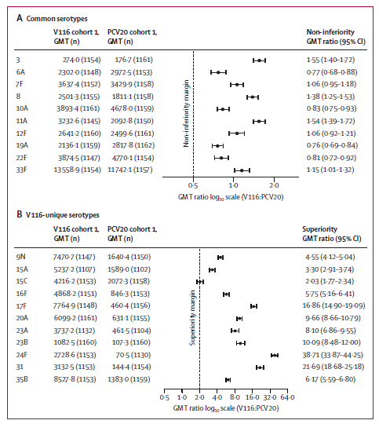
OPA=opsonophagocytic activity. GMT=geometric mean titre.

Figure 2. Immunobridging analysis of OPA GMTs on day 30 after vaccination with V116.⁸
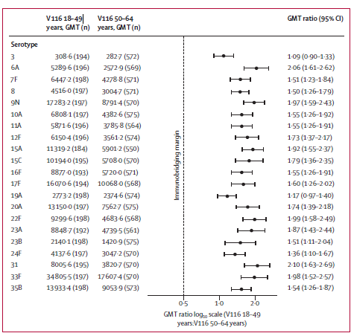
OPA=opsonophagocytic activity. GMT=geometric mean titre.
Secondary objectives immunogenicity
The immune responses to serotypes 15B and 6C (cross-reactive immune responses) were measured based on an expectation of cross-reactivity from serotypes 6A and 15C.
In adults equal to or over 50 yrs of age (Cohort 1), the percentage of participants with a ≥4-fold rise in cross-reactive OPA responses from baseline to 30 days postvaccination was 49.3% (95% CI: 46.0, 52.6) for serotype 6C (cross reactive to serotype 6A) and 64.7% (95% CI: 61.4, 67.8) for serotype 15B (cross reactive to serotype 15C).
V116 met the predefined criterion for an acceptable antibody response (LB of 95% CI of the percentage of participants with a ≥4-fold rise in OPA responses >50%) for serotype 15B; V116 did not meet the predefined criterion for an acceptable antibody response for serotype 6C.
For serotype 15B (cross reactive to serotype 15C), V116 in participants 18 to 49 yrs of age (Cohort 2) met the predefined criterion for immunobridging to V116 in participants 50 to 64 yrs of age (Cohort 1) (LB of the 95% CI of the OPA GMT ratio [V116 18 to 49 Yrs group/V116 50 to 64 Yrs group] >0.5) as assessed by serotype-specific OPA GMTs at 30 days post-vaccination. The immunobridging hypothesis was not tested for serotype 6C (cross reactive to serotype 6A) in accordance with the statistical analysis plan.

Safety
In adults equal to or over 50 yrs of age (Cohort 1) and adult 18 to 49 yrs of age (Cohort 2):
- The proportions of participants with AEs were generally comparable between the V116 and PCV20 intervention groups.
- The most frequently reported (≥5%) AEs in both intervention groups were injection-site pain, fatigue, headache, injection-site erythema, injection-site swelling, and myalgia.
- The proportions of participants with SAEs were low (≤3%) and generally comparable between the V116 and PCV20 intervention groups. No vaccine-related SAEs were reported.
- 6 deaths were reported in Cohort 1 (4 in the V116 group and 2 in the PCV20 group). None were considered related to study intervention. No deaths were reported in Cohort 2 (Table 4. Platt et al., 2024).
Table 4. Adverse events STRIDE 3⁸
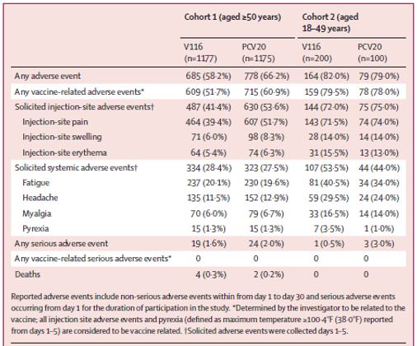
Conclusions
The evaluator concluded that in adults equal to or over 50 yrs of age, V116 was demonstrated to be immunologically noninferior to PCV20 for the 10 common serotypes by serotype-specific OPA GMTs at 30 days postvaccination, using the predefined criteria for non-inferiority i.e. LB of the 95% CI of the OPA GMT Ratio for V116 versus. PCV20 >0.5, although the immune responses to V116 were lower for serotypes 6A, 10A, 19A and 22F compared to PCV20.
In adults equal to or over 50 yrs of age, V116 was statistically significantly superior (serotype-specific OPA GMTs at 30 days postvaccination and the proportions with a ≥4-fold rise from baseline to 30 days postvaccination for serotype-specific OPA responses) for 10 of 11 serotypes unique to V116 – and not represented in PCV20, except for serotype 15C where V116 did not meet the predefined criterion for superiority to PCV20. In 19 of the 21 serotypes, V116 elicits similar immune response (immunobridges) in participants aged 18-49 yrs of age and those aged 50-64 yrs of age, as assessed by serotype-specific OPA GMTs at 30 days postvaccination. Lower immune responses were elicited in the older population for serotypes 3 and 19A. The clinical significance of this is unknown.
In pneumococcal vaccine-naïve adults ≥18 yrs of age, V116 and PCV20 were well tolerated across all age groups enrolled in the trial, the safety profile of V116 was generally similar to PCV20.

Study V116-006, STRIDE-6
This was a Phase 3 study to evaluate the safety, tolerability, and immunogenicity of V116 in participants equal to or over 50 years of age who were pneumococcal vaccine-experienced ≥1 year before enrolment. There were three parallel cohorts based on prior pneumococcal vaccination history:
Cohort 1 | Participants who had been vaccinated with PPSV23 ≥1 year prior to enrolment were randomised in a 2:1 ratio to receive either V116 or PCV15 on Day 1. Cohort 1 was double-blind, parallel group, and active comparator controlled.
Cohort 2 | Participants who had been vaccinated with PCV13 ≥1 year prior to enrolment were randomised in a 2:1 ratio to receive either V116 or PPSV23 on Day 1. Cohort 2 was double-blind, parallel group, and active comparator controlled. In Cohort 1 and Cohort 2, randomisation was stratified by participant age at enrolment and time since prior pneumococcal vaccination.
Cohort 3 | Participants who had been vaccinated with PCV13+PPSV23, PCV15+PPSV23, PCV15, PCV20, or PPSV23+PCV13 ≥1 year prior to enrolment received V116 on Day 1. Cohort 3 was open-label and single group.

Objectives and endpoints
Objectives and endpoints were evaluated in pneumococcal vaccine-experienced adults ≥50 yrs of age and were evaluated separately within each vaccination group in each of the three cohorts.
Primary objectives
Safety: To evaluate the safety and tolerability of V116 as assessed by the proportion of participants with AEs.
Immunogenicity: To evaluate the serotype-specific OPA GMTs at 30 days postvaccination for all serotypes included in V116.
Secondary objectives
Immunogenicity: To evaluate the serotype-specific IgG GMCs at 30 days postvaccination for all serotypes included in V116; to evaluate the serotype-specific GMFR and the proportion of participants who achieve a serotype-specific ≥4-fold increase from baseline to 30 days postvaccination for both OPA and IgG responses for all serotypes included in V116.
Immunogenicity and safety endpoints
Primary endpoint safety: Solicited injection-site AEs from Day 1 through Day 5 postvaccination; Solicited systemic AEs from Day 1 through Day 5 postvaccination; Vaccine-related SAEs from Day 1 through the duration of participation in the study.
Primary immunogenicity endpoint: Serotype-specific OPA responses.
Secondary immunogenicity endpoints: Serotype-specific IgG responses and/or OPA responses.
Statistical methods and sample size - Please refer to the published paper⁹ for details of the statistical methods and sample size.
Participant flow
As of database lock (June 2023), 717 participants were randomised/allocated:
- Cohort 1: 350 participants (231 in the V116 group; 119 in the PCV15 group)
- Cohort 2: 261 participants (176 in the V116 group; 85 in the PPSV23 group)
- Cohort 3: 106 participants in the V116 group
Of the 717 participants randomised, 712 participants received study intervention. The majority (710, 99.0%) completed the study (Figure 3).
Figure 3. Participant disposition
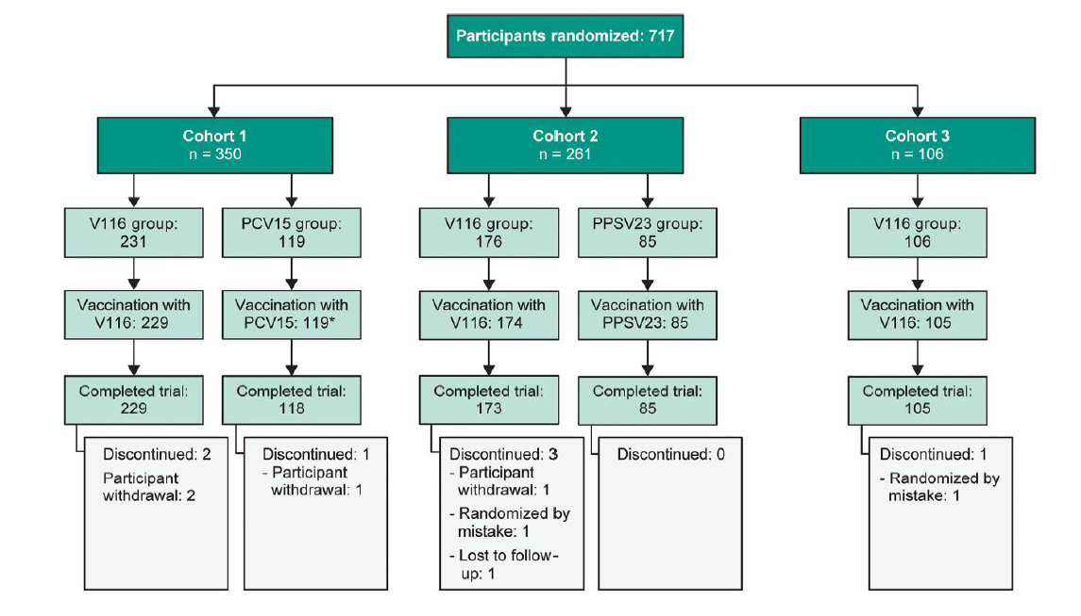
*One hundred seventeen participants received PCV15, and 2 were cross-vaccinated with 21-valent pneumococcal conjugate vaccine (V116) and PPSV23 (1 each).⁹
Results
Immunogenicity
Across all three cohorts, V116 was immunogenic for all 21 serotypes contained in the vaccine as assessed by serotype-specific OPA GMTs at 30 days postvaccination.
In Cohort 1, V116 elicited immune responses as assessed by OPA GMTs at 30 days post vaccination, that were generally comparable to PCV15 for the 6 common serotypes and higher than PCV15 for the 15 serotypes unique to V116.
In Cohort 2, V116 elicited immune responses that were generally comparable to PPSV23 for the 12 common serotypes and higher than PPSV23 for the 9 serotypes unique to V116, as assessed by OPA GMT at 30 days postvaccination.
Cohort 3 (who received only a single dose of V116) had similar immunological responses as assessed by OPA GMTs at 30 days postvaccination to those receiving V116 in Cohorts 1 and 2.
Figure 4. Serotype-specific opsonophagocytic activity (OPA) geometric mean titres (GMTs) at 30 days following vaccination. OPA GMTs and 95% confidence intervals are shown for each serotype by cohort (A, Cohort 1; B, Cohort 2; C, Cohort 3), with serotypes shared in both vaccines or unique to V116 shown on the x-axis.
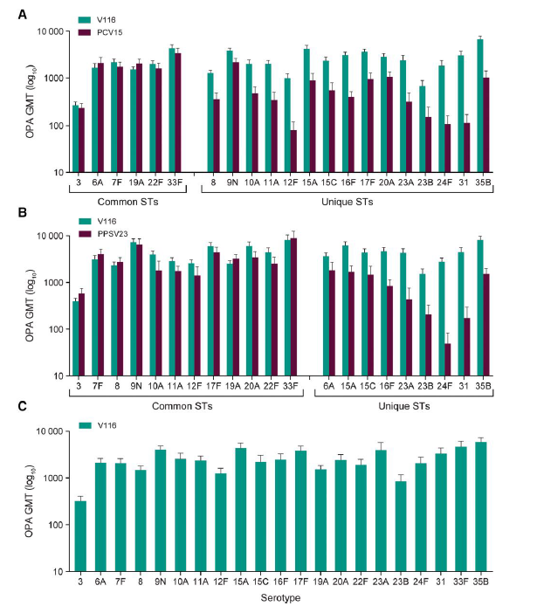
Secondary Immunogenicity Endpoints
Across all 3 cohorts, V116 was immunogenic for all 21 serotypes contained in the vaccine as assessed by serotype-specific IgG GMCs, serotype-specific OPA and IgG GMFRs and the proportions of participants with a ≥4- fold increase in serotype-specific OPA and IgG response from pre-vaccination to 30 days postvaccination.
Figure 5. Proportions of participants with a ≥4-fold rise in serotype-specific opsonophagocytic activity geometric mean titres from pre-vaccination to 30 days following vaccination. Proportions and 95% confidence intervals are shown for each serotype by cohort (A, cohort 1; B, cohort 2; C, cohort 3), with serotypes shared in both vaccines or unique to V116 shown on the x-axis.
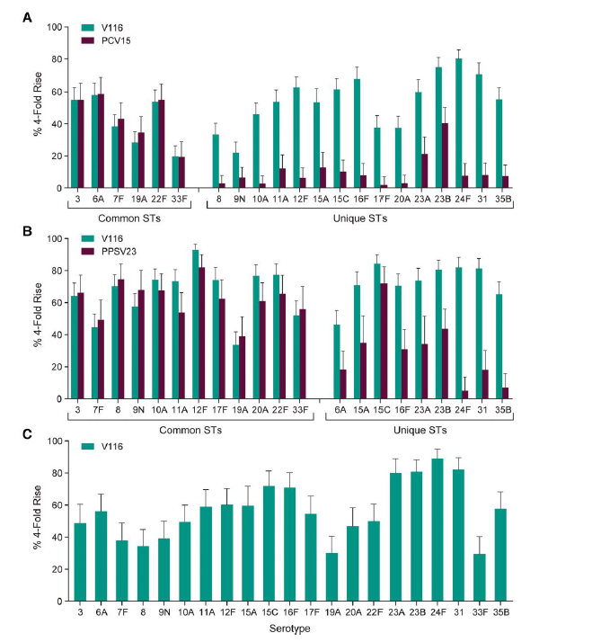
Safety
The proportions of participants with AEs were generally comparable among participants who received V116, PCV15, or PPSV23, regardless of pneumococcal vaccination history.
The proportions of participants with solicited injection-site and solicited systemic AEs were generally comparable among participants who received V116, PCV15, or PPSV23, regardless of pneumococcal vaccination history.

Table 5. Adverse events, STRIDE 6
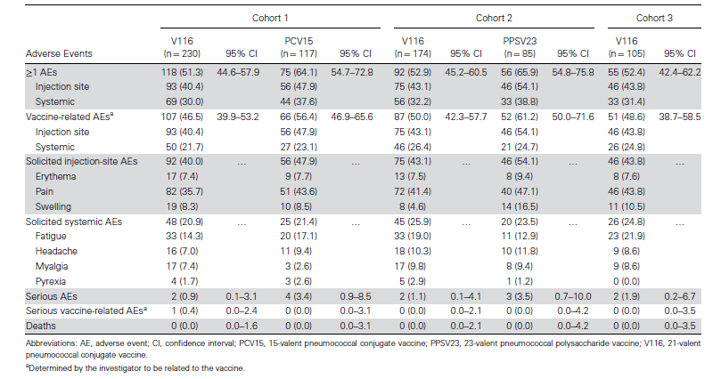
Conclusions
In pneumococcal vaccine-experienced participants aged 50 years or above, V116 was immunogenic for all 21 serotypes regardless of pneumococcal vaccination history. Serotype-specific OPA GMTs and IgG GMCs were generally comparable in the V116, PCV15, and PPSV23 groups for the common serotypes and higher in the V116 group for the serotypes unique to V116. There was some boosting of immune responses seen for the common serotypes in those who were pneumococcal vaccine experienced. V116 was well tolerated.
In the publication of this trial, it was noted that 47% of the participant population had prespecified medical history conditions associated with increased risk of PD and the majority of participants in the study were equal to or over 65 years of age.⁹

Study V116-005
A Phase 3 Randomized, Double-blind, Placebo-Controlled Clinical Study to Evaluate the Safety, Tolerability, and Immunogenicity of V116 When Administered Concomitantly with Influenza Vaccine in Adults 50 Years of Age or Older
This was a randomised, placebo-controlled, parallel-group, multicentre, double-blind study of V116 to evaluate the safety, tolerability, and immunogenicity of V116 when administered concomitantly with quadrivalent influenza vaccine (QIV) in adults equal to or over 50 years of age.
Participants were randomly assigned in a 1:1 ratio to receive either V116 administered concomitantly with QIV or V116 administered sequentially with QIV.
Randomisation was stratified by age at enrolment (50 to 64 years, 65 to 74 years, 75 to 84 years, and ≥85 years) and by prior pneumococcal vaccination status.
Primary Objectives
Safety Objective: To evaluate the safety and tolerability of V116 when administered concomitantly with QIV compared with V116 administered sequentially with QIV as assessed by the proportion of participants with AEs.
Immunogenicity objectives:
  - To compare the serotype-specific OPA GMTs at 30 days postvaccination with V116 administered concomitantly with QIV compared with V116 administered sequentially with QIV.
  - To compare the strain-specific haemagglutination inhibition (HAI) GMTs at 30 days postvaccination with QIV administered concomitantly with V116 compared with QIV administered sequentially with V116.
Primary endpoint
Immunogenicity: Serotype-specific OPA responses; Strain-specific HAI responses.
Primary endpoint safety: Solicited injection-site AEs from Day 1 through Day 5 postvaccination; Solicited systemic AEs from Day 1 through Day 5 postvaccination; Vaccine-related SAEs from Day 1 through the duration of participation in the study.
Results
V116 administered concomitantly with QIV was noninferior to V116 administered sequentially with QIV for 20 of 21 pneumococcal serotypes using OPA GMTs at 30 days postvaccination with V116, the exception was serotype 23B (Table 6). QIV administered concomitantly with V116 is noninferior to QIV administered sequentially with QIV for 3 of 4 influenza strains using HAI GMTs at 30 days postvaccination with QIV. The exception was for strain A/H3N2 (Table 7). Between-group comparisons of IgG GMCs at 30 days postvaccination with V116 were consistent with the between-group comparisons of OPA GMTs. Concomitant administration of V116 and QIV was generally well tolerated, with a safety profile comparable to V116 alone.
Delegate comment
Fluzone Quadrivalent was the influenza vaccine administered in this study. Minor amendments to the PI were requested for this study and the Advisory Committee on Vaccines (ACV) was requested to comment on the clinical significance of the findings for this study for the A/H3N2 strain.
Table 6: Analysis of Postvaccination OPA GMTs (Per-Protocol Population)
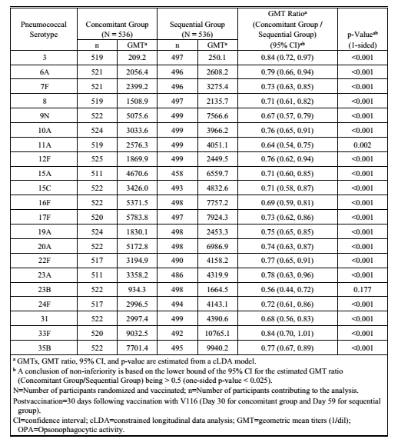

Table 7: Analysis of Postvaccination HAI GMTs (Per-Protocol Population)
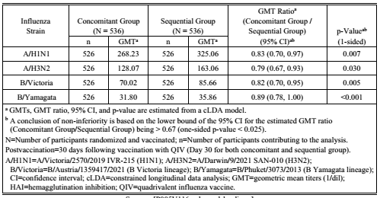

Study V116-004 Lot to lot consistency
This was a randomised, active comparator-controlled, parallel-group, multisite, double-blind study of V116 in pneumococcal vaccine-naïve adults 18 to 49 yrs of age. This study served as a clinical lot consistency study for licensure of V116 and was conducted to demonstrate the consistency of the antibody response to 3 different manufactured lots of V116 in vaccine-naïve adults 18 to 49 yrs of age. PPSV23 was included as the active comparator in this study to better characterise the safety profile of V116.
Primary Objectives
Safety Objective: To evaluate the safety and tolerability profile of V116 as assessed by the proportion of participants with AEs.
Immunogenicity: To compare the serotype-specific OPA GMTs at 30 days postvaccination across 3 different lots of V116 for all serotypes included in V116.
Primary safety endpoints
Solicited injection-site AEs from Day 1 through Day 5 postvaccination; solicited systemic AEs from Day 1 through Day 5 postvaccination; vaccine-related SAEs from Day 1 through the duration of participation in the study.
Primary Immunogenicity endpoints
Serotype-specific OPA responses. For the objectives in this study, the serotypes were categorised as follows:
21 serotypes in V116 (3, 6A, 7F, 8, 9N, 10A, 11A, 12F, 15A, 15C, 16F, 17F, 19A, 20A, 22F, 23A, 23B, 24F, 31, 33F, 35B)
12 common serotypes in V116 and PPSV23 (3, 7F, 8, 9N, 10A, 11A, 12F, 17F, 19A, 20A, 22F, 33F)
9 unique serotypes in V116 (6A, 15A, 15C, 16F, 23A, 23B, 24F, 31, 35B)
2 cross-reactive serotypes (6C and 15B)
Results
Safety
In adults 18 to 49 yrs of age, V116 was well tolerated with a safety profile that was consistent across manufacturing lots and generally comparable to PPSV23.
Overall proportions of participants with AEs and solicited AEs were comparable across the 3 lots of V116.
Overall proportions of participants with AEs were generally comparable between the V116 (combined lots) and the PPSV23 intervention groups (80.4% vs. 74.9%).
The proportions of participants with solicited AEs were generally comparable between the V116 (combined lots) and the PPSV23 groups, except for injection-site pain, which was higher in the V116 (combined lots) versus PPSV23 group (73.3% vs. 60.6%).
Immunogenicity
All three lots of V116 met equivalence criteria as assessed by serotype-specific OPA GMTs at 30 days post-vaccination for all 21 serotypes in V116. For each pairwise V116 lot-to-lot comparison, the lower and upper limits of the 95% CI of the OPA GMT ratios were within 0.5 and 2.0 for all serotypes in V116.
The Delegate noted the FDA review⁹ highlighted the strengths of this study include the large number of participants who received V116 across the three lots (Lot 1: n=539; Lot 2: n=536; Lot 3: n=541), and the inclusion of V116 vaccinated participants (n= 406 [25.1%] in the combined lots) with more than one prespecified medical history condition.

Study V116-001, Phase 1/2 study
This was a Phase 1/Phase 2, randomised, double-blind Study to evaluate the safety, tolerability, and immunogenicity of a polyvalent pneumococcal conjugate vaccine in adults.
Study design
Multicentre, immunogenicity, safety, tolerability, parallel assignment, double blind, active comparator controlled, conducted in 2 Phases.
Phases 1 and 2: Primary objective
Phase 1
Primary:
- To evaluate the safety and tolerability of V116 (2 different doses) with respect to the proportion of participants with AEs.
Secondary:
- To describe the serotype-specific OPA GMTs and IgG geometric mean concentrations (GMCs) as measured at 30 days postvaccination.
- To describe the serotype-specific geometric mean fold rise (GMFR) from pre-vaccination (Day 1) to 30 days postvaccination (Day 30) for both OPA and IgG responses.
Phase 2
Primary:
- To evaluate the safety and tolerability of V116 with respect to the proportion of participants with AEs.
- To evaluate the serotype-specific OPA GMTs at 30 days postvaccination.
Secondary:
- To evaluate serotype-specific IgG GMCs at 30 days postvaccination
- To evaluate serotype-specific GMFR from prevaccination (Day 1) to 30 days postvaccination (Day 30) for both OPA and IgG responses.
- To evaluate the proportion of participants who achieve a ≥4-fold increase in serotype-specific OPA responses from prevaccination (Day 1) to 30 days postvaccination (Day 30).
Results
Primary Immunogenicity Endpoints
Phase 1
Secondary Immunogenicity Endpoints
- Serotype-specific OPA GMTs and IgG GMCs at 30 days postvaccination were generally comparable in the V116-1 and V116-2 groups compared with the PPSV23 group for the common serotypes.
- Serotype-specific OPA GMTs and IgG GMCs at 30 days postvaccination were higher in the V116-1 and V116-2 groups compared with the PPSV23 group for the serotypes unique to V116.
Phase 2
Primary Immunogenicity Endpoints
- V116 met noninferiority criteria for the common serotypes as assessed by serotype-specific OPA GMTs at 30 days postvaccination. The lower bound of the 95% CI of the estimated OPA GMT ratio (V116/PPSV23) was >0.33 for all common serotypes.
- Serotype-specific OPA GMTs at 30 days postvaccination were statistically significantly greater in the V116 group compared with the PPSV23 group for all unique serotypes in V116. The lower bound of the 95% CI of the estimated OPA GMT ratio (V116/PPSV23) was >1.0 for all unique serotypes in V116.
Secondary Immunogenicity Endpoints
- V116 met noninferiority criteria for the common serotypes as assessed by serotype-specific IgG GMCs at 30 days postvaccination. The lower bound of the 95% CI of the estimated IgG GMC ratio (V116/PPSV23) was >0.5 for all common serotypes.
- Serotype-specific IgG GMCs at 30 days postvaccination were statistically significantly greater in the V116 group compared with the PPSV23 group for all unique serotypes in V116. The lower bound of the 95% CI of the estimated IgG GMC ratio (V116/PPSV23) was >1.0 for all unique serotypes in V116.
- Serotype-specific GMFRs from prevaccination to 30 days postvaccination for both OPA responses and IgG responses were generally comparable in both intervention groups for the common serotypes and higher in the V116 group compared with the PPSV23 group for the serotypes unique to V116.
- The proportions of participants with a ≥4-fold increase in serotype-specific OPA responses from pre-vaccination to 30 days postvaccination were generally comparable in both intervention groups for the common serotypes and higher in the V116 group compared with the PPSV23 group for the unique serotypes.
Safety
The adverse event profile of V116-1 (2 μg per pneumococcal polysaccharide (PnP) per 0.5 mL) and V116-2 (4 μg per PnP per 1.0 mL) in phase 1 in adults aged 18–49 years, and of V116 in phase 2 in adults aged 50 years or older was generally similar to the safety profile of PPSV23. In the publication, it was further stated that,
the phase 1, first-in-human study in adults aged 18-49 years showed acceptable safety for initiation of the phase 2 studies in adults aged 50 years or older. Although the phase 1 study was not designed to directly compare V116-1 and V116-2, it was observed that the higher dose formulation in V116-2 elicited higher OPA and IgG immune responses for nearly all serotypes. These data supported the dose selection of 4 μg per PnP for the phase 2 study.¹¹

Safety
Patient exposure in the Phase 3 program of V116 is summarised in Table 8. Overall, there were 6557 patients of whom 4556 and 2021 were V116 and control recipients respectively; 6038 (4020 and 2018 V116 and control recipients respectively) were included in the integrated analysis. Of the 4556 recipients of V116, 1816 were participants aged 18-49 years and 2204 were aged 50 years or older. At least one risk factor for pneumococcal disease was observed in 34.1% of participants (n=1,555) (Table 9).
Table 8. Number of Participants Who Received V116 or Control (V116-003, V116-004, V116-005, V116-006)
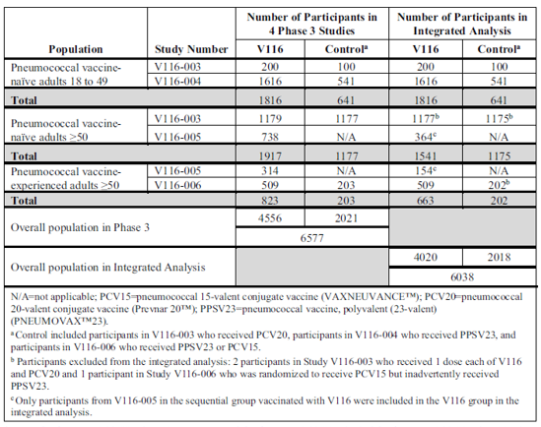
Table 9. Participants With Prespecified Medical History Conditions Associated With Increased Risk of Pneumococcal Disease (All Vaccinated Participants)(V116-003, V116-004, V116-005, V116-006)
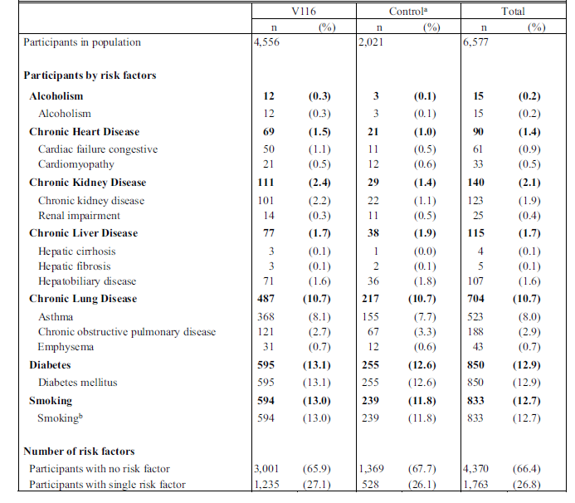
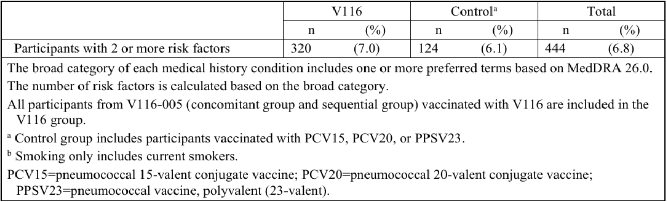

Table 10. Participants With Solicited Adverse Events (Incidence > 0% in One or More Vaccination Groups) (All Participants as Treated Population) (V116-003, V116-004, V116-005ª, V116-006)
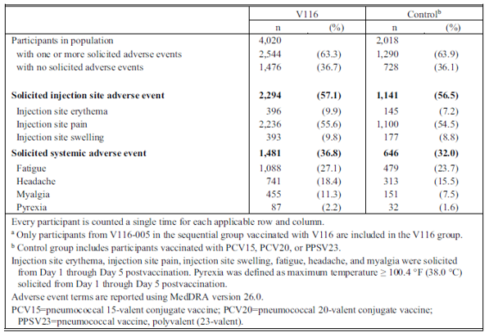

Integrated safety summary conclusions
The safety data from the integrated safety analysis demonstrated that V116 was well tolerated in adults who are pneumococcal vaccine naïve or pneumococcal vaccine experienced (Table 10). There was no safety concerns revealed in subgroups analysed by age, sex, race, and the number of risk factors for pneumococcal disease. The safety profile of V116 was similar to the comparator pneumococcal vaccines.
Real world data
Real world data were not included in the submission, however the TGA acknowledges the FDA condition under accelerated approval for the pneumonia indication to provide adequate and well-controlled confirmatory studies to verify clinical benefit. The sponsor has agreed to conduct a Phase 4 post marketing observational real-world effectiveness (RWE) test negative design (TND) case control study titled ‘A Test-Negative Case-Control Study to Evaluate the Effectiveness of V116 Against Pneumococcal Pneumonia in Older Adults’ as the confirmatory study to verify and describe clinical benefit of Capvaxive against pneumonia., The Delegate noted similar post marketing conditions to verify clinical benefit for the FDA accelerated approval for Prevenar 20 for the prevention of pneumonia in adults caused by the seven new serotypes in Prevenar 20.

Risk management plan evaluation summary
The summary of safety concerns and their associated risk monitoring and mitigation strategies are summarised in Table 11. The TGA may request an updated RMP at any stage of a product's life cycle, during both the pre-approval and post-approval phases.
Table 11: Summary of safety concerns
Summary of safety concerns |  | Pharmacovigilance |  | Risk Minimisation
 |  | Routine | Additional | Routine | Additional
Important identified risks | None | - | - | - | -
Important potential risks | None | - | - | - | -
Missing information | None | - | - | - | -

No safety concerns are proposed. This is similar to other pneumococcal vaccines and is acceptable from an RMP perspective. The summary of safety concerns aligns with the Core-RMP.
Only routine pharmacovigilance measures have been proposed. This is acceptable from an RMP perspective.
Only routine risk minimisation activities have been proposed noting there are no safety concerns. This is acceptable from an RMP perspective.

RMP evaluator recommendations regarding conditions of registration
Merck Sharp & Dohme (Australia) submitted Core-RMP version 1.0 (dated 7 November 2023; DLP 12 September 2023) and ASA version 0.1 (dated 10 November 2023) in support of this application.
In response to the section 31 request, the sponsor provided ASA version 0.2 (dated 24 July 2024) in association with the previously submitted Core-RMP version 1.0 (dated 7 November 2023; DLP 12 September 2023).
As Capvaxive is a new biological entity it should be included in the Black Triangle Scheme as a condition of registration. The following wording is recommended for the condition of registration:
‘Capvaxive (Pneumococcal 21-valent Conjugate Vaccine) is to be included in the Black Triangle Scheme. The PI and CMI for Capvaxive must include the black triangle symbol and mandatory accompanying text for five years, which starts from the date of first supply of the product.’
The following wording is recommended for the PSUR requirement:
‘An obligatory component of risk management plans is routine pharmacovigilance. Routine pharmacovigilance includes the submission of periodic safety update reports (PSURs).’
The sponsor is required to comply with product vigilance and risk minimisation requirements.
The TGA may request an updated RMP at any stage of a product's life cycle, during both the pre-approval and post-approval phases. Further information regarding the TGA’s risk management approach can be found in risk management plans for medicines and biologicals and the TGA's risk management approach. Information on the Australia-specific annex (ASA) can be found on the TGA website.

Risk-benefit assessment

Delegate’s considerations
The submitted data are sufficient to recommend registration of Capvaxive, with minor amendments to the indication.
Opsonophagocytic activity (OPA) and ECL assays are accepted surrogate immunological endpoints, however there is no established immunological threshold level of antibody concentration that correlates with protection against pneumococcal disease.
Efficacy data were not included in the application, however the TGA acknowledges the FDA condition under accelerated approval for the pneumonia indication to provide adequate and well-controlled confirmatory studies. The immunobridging strategy has been used for other recently registered pneumococcal vaccines and ongoing post-marketing surveillance will be critical, given the lack of efficacy data in the pre-registrational trials.
In the pivotal trial, STRIDE 3, there was a trend towards lower immune responses with increasing age strata.⁷ Immunogenicity data were limited to 30 days post-vaccination in all trials, there were no data in immunocompromised groups or for concomitant vaccination with COVID-19 and RSV vaccines.
There was a pre-marketing safety database of 4556 participants who received Capvaxive in the Phase 3 studies and Capvaxive demonstrated a similar safety profile to comparator pneumococcal vaccines.
Recommendations for pneumococcal vaccination programs are becoming more complex with the recent registration of Vaxneuvance and Prevenar 20 and the anticipated registration of Capvaxive. The role of vaccination with 23vPPV for people at increased risk of pneumococcal disease in the event of registration of Capvaxive will require review by the Australian Technical Advisory Group on Immunisation.

Proposed action
Registration of Capvaxive is recommended, subject to satisfactory resolution of the product information and implementation of the RMP and Quality conditions of registration.

Advisory Committee on Vaccines considerations
The Advisory Committee on Vaccines (ACV), having considered the evaluations and the Delegate’s overview, as well as the sponsor’s response to these documents, advised the following.

Specific advice to the Delegate
Please comment on the Delegate’s amended wording of the indication.
The ACV advised that the Delegate’s amended wording of the indication was appropriate for this vaccine:
Active immunisation for the prevention of pneumococcal disease caused by Streptococcus pneumoniae serotypes (3, 6A, 7F, 8, 9N, 10A, 11A, 12F, 15A, 15B, 15C, 16F, 17F, 19A, 20A, 22F, 23A, 23B, 24F, 31, 33F, and 35B) in adults 18 years of age and older.
Capvaxive may not prevent disease caused by S. pneumoniae serotypes that are not contained in the vaccine.
The use of Capvaxive should be in accordance with official recommendations.
The wording in the second paragraph is consistent with other pneumococcal vaccines, and the wording in the third paragraph is consistent with vaccines generally. There was no reason to vary the wording for Capvaxive.
Please comment on the clinical relevance of the immunogenicity results for the cross-reactive serotypes 15B and 6C which are not included in the vaccine formulation for Capvaxive and the Delegate’s request to exclude serotype 6C from the proposed indication for Australia.
The ACV noted that a minority of participants experienced a ≥4-fold rise in serotype 6C-specific OPA response (49.5%; 95% CI 46.0, 52.6). The ACV also noted that the data from studies of 13vPCV suggest the development of cross-protection against 6C when both 6A and 6B antigens are present in a vaccine; V116 contains only serotype 6A antigens. For these reasons, the ACV advised that prevention of disease caused by serotype 6C should not be included in the indication. Further immunogenicity or epidemiological data relating to V116 are required to make a claim for prevention of disease caused by serotype 6C.
The ACV noted that a majority of participants experienced a ≥4-fold rise in serotype 15B (64.7%; 95% CI 61.4, 67.8). Inclusion of serotype 15B in the indication was appropriate.
Please comment on the proposed rewording of Section 4.2 in the PI. Does the ACV accept the justification for a minimum 8-week dosing interval as part of sequential adult pneumococcal vaccination?
Study V116-006 had enrolled participants who had had another pneumococcal vaccine at least 12 months previously. While there were no data presented to support minimum intervals for Capvaxive, it would not seem unreasonable to extrapolate from previous pneumococcal conjugate vaccines and refer to official guidelines (23vPPV followed by 21-valent PCV at 12 months interval; 21-valent PCV followed by 23vPPV at 12 months (preferred) but 2 to 12 months permissible).
The ACV noted that the post-market effectiveness study may provide relevant data.
Please comment on the clinical significance of the results for Study V116-005, including the results for the A/H3N2 strain.
The ACV noted that immune responses to both vaccines were lower but only failed non-inferiority criteria for serotype 23B and A/H3N2 when administered concomitantly. The population group most likely to seek both pneumococcal and influenza vaccines are older people, and weaker immune responses are likely in this group.
The ACV advised that data describing the reduced responses to both vaccines should be included in the PI and clearly state that the data indicate that it would be prudent to avoid co-administration of Capvaxive with an influenza vaccine. However, the ACV noted that in practice the clinical decision regarding co-administration reflects additional factors such as risk of IPD, risk of influenza (including vaccine efficacy which differs year by year), likelihood the patient may be lost to follow up, and convenience.
The ACV noted that the presented data from 1080 participants did not reveal additional safety concerns with co-administration.
What would be the role of 23-valent pneumococcal polysaccharide vaccine in various at-risk groups in the event of registration of Capvaxive?
The ACV noted that the optimal pneumococcal vaccination program for Australia is currently under review, and that this was a cost-effectiveness question and beyond the scope of the regulatory advice for Capvaxive.
Advice on this question is not possible without data on the effectiveness of Capvaxive including the effectiveness of Capvaxive in people who have previously received any other pneumococcal vaccine.
Capvaxive has been developed to specifically target residual pneumococcal disease in adults. Pneumococcal vaccines which are currently registered include indications in infants and children. What are the potential consequences of inadvertent off-label use in the paediatric population? How can these risks be minimised?
The ACV acknowledged that when several vaccines are available ‘for the same disease’ there is a risk of administration to patients in an unapproved age group.
The ACV advised that the RMP should include monitoring for inadvertent off-label use; such use should be captured in the AIR.
The ACV supported labelling that clearly states the appropriate age group.
The ACV noted that a clinical trial of V116 in children and adolescents with increased risk of pneumococcal disease is underway. Early insights from this study would assist in assessing risk, if any, from inadvertent use in children and adolescents.
The ACV is also requested to provide advice on any other issues that it thinks may be relevant.
The ACV noted that increased valency of pneumococcal vaccines has generally been associated with decreased immune responses. This is important to monitor and correlate with vaccine effectiveness studies as an emerging concern given the correlate of protection based on OPA is still unclear.
Australian systems for monitoring IPD will contribute to an understanding of vaccine effectiveness and serotype replacement.
The ACV suggested consistent use of ‘months’ for dose intervals throughout the PI

Conclusion
The ACV considered this vaccine to have an overall positive benefit-risk profile for the indication:
Active immunisation for the prevention of pneumococcal disease caused by Streptococcus pneumoniae serotypes (3, 6A, 7F, 8, 9N, 10A, 11A, 12F, 15A, 15B, 15C, 16F, 17F, 19A, 20A, 22F, 23A, 23B, 24F, 31, 33F, and 35B) in adults 18 years of age and older.
Capvaxive may not prevent disease caused by S. pneumoniae serotypes that are not contained in the vaccine.
The use of Capvaxive should be in accordance with official recommendations.

Assessment outcome
Based on a review of quality, safety, and efficacy, the TGA decided to register Capvaxive (Pneumococcal 21-valent Conjugate Vaccine) 0.5 mL solution for injection- pre-filled syringe, indicated for:
Capvaxive is indicated for active immunisation for the prevention of pneumococcal disease caused by Streptococcus pneumoniae serotypes (3, 6A, 7F, 8, 9N, 10A, 11A, 12F, 15A, 15B, 15C, 16F, 17F, 19A, 20A, 22F, 23A, 23B, 24F, 31, 33F, and 35B) in adults 18 years of age and older.

Capvaxive may not prevent disease cause by S. pneumoniae serotypes that are not listed in the indications.

The use of Capvaxive should be guided by official recommendations.

Specific conditions of registration applying to these goods
- Capvaxive (Pneumococcal 21-valent Conjugate Vaccine) is to be included in the Black Triangle Scheme. The PI and CMI for Capvaxive must include the black triangle symbol and mandatory accompanying text for five years, which starts from the date of first supply of the product.
- The Capvaxive Core-Risk Management Plan (RMP) version 1.0 (dated 7 November 2023, data lock point 12 September 2023), with Australian Specific Annex, version 0.2 (dated 24 July 2024), included with submission PM-2023-05219-1-2, and any subsequent revisions, as agreed with the TGA will be implemented in Australia.
- An obligatory component of risk management plans is routine pharmacovigilance. Routine pharmacovigilance includes the submission of periodic safety update reports (PSURs).
Unless agreed separately between the supplier who is the recipient of the approval and the TGA, the first report must be submitted to TGA no later than 15 calendar months after the date of the approval letter. The subsequent reports must be submitted no less frequently than annually from the date of the first submitted report until the period covered by such reports is not less than three years from the date of the approval letter. The annual submission may be made up of two PSURs each covering six months. If the sponsor wishes, the six-monthly reports may be submitted separately as they become available.
If the product is approved in the EU during the three years period, reports can be provided in line with the published list of EU reference dates no less frequently than annually from the date of the first submitted report until the period covered by such reports is not less than three years from the date of the approval letter.
The reports are to at least meet the requirements for PSURs as described in the European Medicines Agency’s Guideline on good pharmacovigilance practices (GVP) Module VII-periodic safety update report (Rev 1), Part VII.B Structures and processes. Note that submission of a PSUR does not constitute an application to vary the registration. Each report must be submitted within ninety calendar days of the data lock point for that report.
- GMP clearance for listed manufacturers: All relevant manufacturing sites require approved and current GMP clearances prior to Australian supply. A commitment is required from the Sponsor that they maintain the validity of all manufacturer GMP Clearances for the duration of product supply to Australia. Additionally, that adherence to the conditions of GMP Clearance approval is upheld.
- Post-approval stability protocol and stability commitment: The manufacturer has provided commitment to continue the ongoing stability studies presented in the stability studies protocol. Additionally, one (1) batch of DP per year will be placed on long-term stability program and on accelerated stability testing where significant changes are made to the manufacturing process. The manufacturer has committed to communicate any out of specifications stability test results to the TGA.
- It is a condition of registration that all independent batches of Capvaxive vaccine imported into Australia are not released for sale until samples and the manufacturer’s release data have been assessed and you have received notification acknowledging release from the Laboratories Branch, TGA.
For each independent batch of the product imported into Australia, the Sponsor must supply the following:
  - A completed Request for Release Form, available from vaccines@health.gov.au.
  - Complete summary protocols for manufacture and QC, including all steps in production in the agreed format.
  - At least 20 (twenty) vials (Samples) of each manufacturing batch of Capvaxive vaccine with the Australian approved labels, PI and packaging (unless an exemption to supply these has been granted) representative of all batches of product seeking distribution in Australia.
  - At least 5 (five) vials (Samples) of any further consignments of a manufacturing batch of Capvaxive vaccine with the Australian approved labels, PI and packaging (unless an exemption to supply these has been granted). Further consignments cover batches previously supplied to TGA for the purposes of batch release testing but are seeking to be supplied again.
  - If the manufacturing batch has been released in Europe or United Kingdom a copy of the EU Official Control Authority Batch Release (OCABR) certificate (or equivalent from the UK) must be provided.
  - Any reagents, reference material and standards required to undertake testing, as requested by Laboratories Branch, TGA.
Sponsors must provide all requested Samples and data in sufficient time (at least 5 business days) prior to any distribution date to allow the TGA to perform testing and review. Distribution of each batch of vaccine is conditional upon fulfilment of these conditions and receipt of a letter from the Laboratories Branch acknowledging release.
Samples and data should be forwarded to the Biotherapeutics Section, Laboratories Branch before release of each batch and with sufficient lead time to allow for Laboratories Branch testing. The address for courier delivery is:
ATTN: Batch Release Coordinator
Batch Release Unit
TGA Laboratories Branch
1 Tindal Lane
Canberra Airport
ACT 2609

The shipments (including reagents) to TGA are the responsibility of the Australian Sponsor/Agent who will be required to facilitate the import and customs clearance process.
- An electronic copy of the Certified Product Details (CPD) as described in Guidance 7: Certified Product Details of the Australian Regulatory Guidelines for Prescription Medicines (ARGPM) https://www.tga.gov.au/guidance-7-certified-product-details should be provided upon registration of the therapeutic good. In addition, an updated CPD, for the above products incorporating the approved changes is to be provided within one month of the date of the approval letter. A template for preparation of CPD for biological prescription medicines and Vaccines can be obtained from the TGA website https://www.tga.gov.au/form/certified-product-details-cpd-biological-prescription-medicines]. The CPD should be sent as a single bookmarked PDF document to Vaccines@health.gov.au as soon as possible after registration/approval of the product or any subsequent changes as indicated above.

Product Information and Consumer Medicine Information
For the most recent Product Information (PI) and Consumer Medicines Information (CMI), please refer to the TGA PI/CMI search facility.

Therapeutic Goods Administration
PO Box 100 Woden ACT 2606 Australia
Email: info@tga.gov.au Phone: 1800 020 653 Fax: 02 6203 1605
https://www.tga.gov.au

This is the original indication proposed by the sponsor when the TGA commenced the evaluation of this submission. It may differ to the final indication approved by the TGA and registered in the Australian Register of Therapeutic Goods.
Earle K, Williams S. Pneumonia (2016) 8:9
Plotkin’s Vaccines. 8th Edition. Chapter 47. Pneumococcal Conjugate Vaccine and Pneumococcal Common Protein Vaccines.
https://immunisationhandbook.health.gov.au/contents/vaccine-preventable-diseases/pneumococcal-disease
https://immunisationhandbook.health.gov.au/resources/publications/pneumococcal-vaccination-for-all-australians
https://immunisationhandbook.health.gov.au/resources/publications/pneumococcal-vaccination-for-people-with-risk-conditions-for-pneumococcal-disease
In this report the ‘Delegate’ is the Delegate of the Secretary of the Department of Health, Disability and Aging who decided the submission under section 25 of the Act.
Platt HL, Bruno C, Buntinx E, et al. Safety, tolerability, and immunogenicity of an adult pneumococcal conjugate vaccine, V116 (STRIDE-3): a randomised, double-blind, active comparator controlled, international phase 3 trial. Lancet Infect Dis. 2024 Oct;24(10):1141-1150. doi: 10.1016/S1473-3099(24)00344-X. Epub 2024 Jul 1. PMID: 38964361.
Scott P, Haranaka M, Choi JH, et al. STRIDE-6 Study Group. A Phase 3 Clinical Study to Evaluate the Safety, Tolerability, and Immunogenicity of V116 in Pneumococcal Vaccine-Experienced Adults 50 Years of Age or Older (STRIDE-6). Clin Infect Dis. 2024 Dec 17;79(6):1366-1374. doi: 10.1093/cid/ciae383. PMID: 39082735; PMCID: PMC11650886.
FDA BLA Clinical Review Memorandum STN 125814/0 Capvaxive
Platt H, Omole T, Cardona J, et al. Safety, tolerability, and immunogenicity of a 21-valent pneumococcal conjugate vaccine, V116, in healthy adults: phase 1/2, randomised, double-blind, active comparator-controlled, multicentre, US-based trial. Lancet Infect Dis. 2023 Feb;23(2):233-246. doi: 10.1016/S1473-3099(22)00526-6. Epub 2022 Sep 15. PMID: 36116461.
Summary Basis for Regulatory Action, STN 125814/0, June 17, 2024, https://www.fda.gov/media/180070/download
STN 125814/0 Post-marketing Real world evidence memorandum https://www.fda.gov/vaccines-blood-biologics/capvaxive
https://www.fda.gov/media/150021/download
Australian Immunisation Handbook chapter on Pneumococcal disease, accessed 4 December 2024.

