▼This medicinal product is subject to additional monitoring in Australia. This will allow quick identification of new safety information. Healthcare professionals are asked to report any suspected adverse events at www.tga.gov.au/reporting-problems.

AUSTRALIAN PRODUCT INFORMATION BYLVAY®
odevixibat hard capsules
- NAME OF THE MEDICINE
odevixibat

QUALITATIVE AND QUANTITATIVE COMPOSITION
Each BYLVAY hard capsule contains odevixibat 200 micrograms, 400 micrograms, 600 micrograms, or 1200 micrograms.
For the full list of excipients, see Section 6.1 List of excipients.

PHARMACEUTICAL FORM
The opaque, hard capsules contain white to off-white pellets containing odevixibat (as sesquihydrate).
BYLVAY 200 micrograms hard capsules are size 0 capsules with an opaque white body and an opaque ivory cap with “A200” printed in black ink on the cap.
BYLVAY 400 micrograms hard capsules are size 3 capsules with an opaque white body and a medium orange opaque cap with “A400” printed in black ink on the cap.
BYLVAY 600 micrograms hard capsules are size 0 capsules with an opaque ivory body and cap with “A600” printed in black ink on the cap.
BYLVAY 1200 micrograms hard capsules are size 3 capsules with a medium orange opaque body and cap with “A1200” printed in black ink on the cap.

CLINICAL PARTICULARS

THERAPEUTIC INDICATIONS
BYLVAY is indicated for the treatment of progressive familial intrahepatic cholestasis (PFIC) in patients aged 6 months or older.

DOSE AND METHOD OF ADMINISTRATION
Treatment must be initiated and supervised by physicians experienced in the management of PFIC.

Dosage
The recommended dose of odevixibat is 40 micrograms/kg administered orally once daily in the morning. Odevixibat can be taken with or without food.
Table 1 shows the strength and number of capsules that should be administered daily based on body weight to approximate a 40 micrograms/kg/day dose.

Table 1: Number of BYLVAY capsules needed to achieve the nominal dose of 40 micrograms/kg/day

Body weight (kg) | Number of 200 microgram capsules |  | Number of 400 microgram capsules
4 to < 7.5 | 1 | or | N/A
7.5 to < 12.5 | 2 | or | 1
12.5 to < 17.5 | 3 | or | N/A
17.5 to < 25.5 | 4 | or | 2
25.5 to < 35.5 | 6 | or | 3
35.5 to < 45.5 | 8 | or | 4
45.5 to < 55.5 | 10 | or | 5
≥ 55.5 | 12 | or | 6
Capsule strength/number in bold is recommended based on predicted ease of administration.
Dose escalation
Improvement in pruritus and reduction of serum bile acid levels may occur gradually in some patients after initiating odevixibat therapy. If an adequate clinical response has not been achieved after 3 months of continuous therapy, the dose may be increased to
120 micrograms/kg/day (see Section 4.4).
Table 2 shows the strength and number of capsules that should be administered daily based on body weight to approximate a 120 micrograms/kg/day dose, with a maximum daily dose of 7200 micrograms per day.

Table 2 Number of BYLVAY capsules needed to achieve the nominal dose of 120 micrograms/kg/day

Body weight (kg) | Number of 600 microgram capsules |  | Number of 1200 microgram capsules
4 to < 7.5 | 1 | or | N/A
7.5 to < 12.5 | 2 | or | 1
12.5 to < 17.5 | 3 | or | N/A
17.5 to < 25.5 | 4 | or | 2
25.5 to < 35.5 | 6 | or | 3
35.5 to < 45.5 | 8 | or | 4
45.5 to < 55.5 | 10 | or | 5
≥ 55.5 | 12 | or | 6
Capsule strength/number in bold is recommended based on predicted ease of administration.
Alternative treatment should be considered in patients for whom no treatment benefit can be established following 6 months of continuous daily treatment with odevixibat.
Missed doses
If a dose of odevixibat is missed, the patient should take the forgotten dose as soon as possible without exceeding one dose per day.

Special Populations
Patients with renal impairment
No dose adjustment is required for patients with mild or moderate renal impairment. There are no available clinical data for the use of odevixibat patients with moderate or severe renal impairment or end-stage renal disease (ESRD) requiring haemodialysis (see Section 5.2 Pharmacokinetic properties).
Patients with hepatic impairment
No dose adjustment is required for patients with mild or moderate hepatic impairment (see Sections 5.1 and 5.2).
No data are available for PFIC patients with severe hepatic impairment (Child Pugh C). Additional monitoring for adverse reactions may be warranted in these patients when odevixibat is administered (see Section 4.4).

Method of administration
BYLVAY is for oral use. To be taken with or without food in the morning (see Section 5.2).
The larger 200 micrograms and 600 micrograms capsules are intended to be opened and sprinkled on food but may be swallowed whole.
The smaller 400 micrograms and 1200 micrograms capsules are intended to be swallowed whole but may be opened and sprinkled on food.
If the capsule is to be swallowed whole, the patient should be instructed to take it with a glass of water in the morning.
For capsules to be opened, the patient should be instructed to:
- place a small quantity (30 mL/2 tablespoons) of soft food (yoghurt, apple sauce, oatmeal porridge, banana puree, carrot puree, chocolate-flavoured pudding or rice pudding) in a bowl. The food should be at or below room temperature.
- hold the capsule horizontally at both ends, twist in opposite directions and pull apart to empty the pellets into the bowl of soft food. The capsule should be gently tapped to ensure that all pellets will come out.
- repeat the previous step if the dose requires more than one capsule.
- gently mix the pellets with a spoon into the soft food.
- administer the entire dose immediately after mixing. Do not store the mixture for future use.
- drink a glass of water following the dose.
- dispose all empty capsule shells.

CONTRAINDICATIONS
Hypersensitivity to the active substance or to any of the excipients (see Section 6.1 List of excipients).

SPECIAL WARNINGS AND PRECAUTIONS FOR USE
The mechanism of action of odevixibat requires that the enterohepatic circulation of bile acids and bile salt transport into biliary canaliculi is preserved. Conditions, medications or surgical procedures that impair either gastrointestinal motility, or enterohepatic circulation of bile acids, including bile salt transport to biliary canaliculi have the potential to reduce the efficacy of odevixibat. For this reason, e.g. patients with PFIC2 who have a complete absence or lack of function of Bile Salt Export Pump (BSEP) protein (i.e. patients with BSEP3 subtype of PFIC2) will not respond to odevixibat.
There are limited or no clinical data with odevixibat in PFIC subtypes other than 1 and 2.

Diarrhoea
Diarrhoea has been reported as a common adverse reaction when taking odevixibat. Diarrhoea may lead to dehydration. Patients should be monitored regularly to ensure adequate hydration during episodes of diarrhoea (see Section 4.8).

Fat-soluble vitamin deficiency
Assessment of fat-soluble vitamin levels (Vitamins A, D, E) and international normalised ratio (INR) are recommended for all patients prior to initiating BYLVAY, with monitoring per standard clinical practice.
Treatment with odevixibat may impact the absorption of fat-soluble medicinal products (see Section 0).

Liver test abnormalities
In clinical trials, increased levels in liver function tests were observed in some patients receiving odevixibat. Assessment of liver function tests is recommended for patients prior to initiating BYLVAY, with monitoring per standard clinical practice.

Use in hepatic impairment
Patients with severe hepatic impairment (Child-Pugh C) have not been studied (see Section 5.2). Periodic liver function tests should be considered for patients with severe hepatic impairment.

Use in the elderly
No data available.

Paediatric use
Bylvay is indicated for use in paediatric patients aged 6 months or older (see Section 4.2 for details).

Effects on laboratory tests
No data available.

INTERACTIONS WITH OTHER MEDICINES AND OTHER FORMS OF INTERACTIONS

Transporter-mediated interactions
Odevixibat is a substrate for the efflux transporter P--glycoprotein (P--gp). In adult healthy subjects, co-administration of the strong P--gp inhibitor itraconazole increased the plasma exposure of a single dose of odevixibat 7200 micrograms by approximately 50-60%. This increase is not considered clinically relevant. No other potentially relevant transporter- mediated interactions were identified in vitro (see Section 5.2).

Cytochrome P450-mediated interactions
In vitro, odevixibat did not induce CYP enzymes (see Section 5.2).
In in vitro studies, odevixibat was shown to be an inhibitor of CYP3A4/5 (see Section 5.2).
In adult healthy subjects, concomitant use of odevixibat decreased the area under the curve (AUC) of oral midazolam (a CYP3A4 substrate) by 30% and 1-OH--midazolam exposure by less than 20%, which is not considered clinically relevant.
No interaction studies have been conducted with UDCA and rifampicin.
In an interaction study with a lipophilic combination oral contraceptive containing ethinyl estradiol (EE) (0.03 mg) and levonorgestrel (LVN) (0.15 mg) conducted in adult healthy females, concomitant use of odevixibat had no impact on the AUC of LVN and decreased the AUC of EE by 17%, which is not considered clinically relevant. Interaction studies with other lipophilic medicinal products have not been performed, therefore, an effect on the absorption of other fat-soluble medicinal products cannot be excluded.
In clinical trials, decreased levels of fat-soluble vitamins were observed in some patients receiving odevixibat. Levels of fat-soluble vitamins should be monitored (see Section 4.4).
In vitro studies
In in vitro studies, odevixibat did not inhibit CYPs 1A2, 2B6, 2C8, 2C9, 2C19 or 2D6 at clinically relevant concentrations, but was shown to be an inhibitor of CYP3A4/5.
Odevixibat does not inhibit the transporters P-gp, breast cancer resistance protein (BCRP), organic anion transporter (OATP1B1, OATP1B3, OAT1, OAT3), organic cation transporter (OCT2), multidrug and toxin extrusion transporter (MATE1 or MATE2-K).
Odevixibat is not a BCRP substrate.

Paediatric population
No interaction studies have been performed in paediatric patients. No differences are expected between the adult and paediatric populations.

FERTILITY, PREGNANCY AND LACTATION

Effects on fertility
No fertility data are available in humans. Odevixibat had no effects on fertility or reproductive function in male and female rats at oral doses of up to 1,000 mg/kg/day.

Use in pregnancy (Category D)
There are no or limited data from the use of odevixibat in pregnant women. Animal studies have shown reproductive toxicity. Based on findings from animal studies, BYLVAY may cause cardiac malformations when a fetus is exposed during pregnancy (see below).
BYLVAY is not recommended during pregnancy and in women of childbearing potential not using contraception.
Women of childbearing potential should use an effective method of contraception when treated with BYLVAY. Since the uptake of lipophilic oral contraceptives may be affected by odevixibat, a barrier contraceptive method should be used (see Sections 4.4 and 4.5.)
In pregnant New Zealand White rabbits, early delivery/abortion was observed in two rabbits receiving oral odevixibat (up to 100 mg/kg/day, equivalent to up to exposure multiples 4.4 of the anticipated clinical exposure, based on AUC0‒24h) during the period of fetal organogenesis at an exposure multiple of ≥ 2.3 of the anticipated clinical exposure (based on total plasma odevixibat AUC0-24). Reductions in maternal body weight and food consumption were noted in all dose groups (transient at the exposure multiple 1.1 of the anticipated dose).
Starting from the exposure multiple of 1.1 of the clinical human exposure (based on total plasma odevixibat AUC024), 7 fetuses (1.3% of all fetuses from odevixibat exposed does) in all dose groups were found to have cardiovascular defects (i.e. ventricular diverticulum, small ventricle and dilated aortic arch). No such malformations were observed when odevixibat was administered to pregnant rats. Because of the findings in rabbits, an effect of odevixibat on cardiovascular development cannot be excluded.
Odevixibat had no effect on embryo-fetal development, or prenatal/postnatal development in rats at the exposure multiple of 133 of the anticipated clinical exposure (based on total plasma odevixibat AUC0-24), including juveniles (exposure multiple of 63 of the anticipated human exposure).

Use in lactation
It is unknown whether odevixibat or its metabolites are excreted in human milk. There is insufficient information on the excretion of odevixibat in animal milk.
A risk to newborns/infants cannot be excluded. A decision must be made whether to discontinue breast-feeding or to discontinue/abstain from BYLVAY therapy, taking into account the benefit of breast-feeding for the child and the benefit of therapy for the mother.
The presence of odevixibat in breast milk was not measured in animal studies. Odevixibat exposure was demonstrated in the pups of lactating dams in the pre- and post-natal
developmental toxicity study with rats (3.2-52.1% of the odevixibat plasma concentration of the lactating dams). It is therefore possible that odevixibat is present in breast milk.

EFFECTS ON ABILITY TO DRIVE AND USE MACHINES
BYLVAY has no or negligible influence on the ability to drive and use machines.

ADVERSE EFFECTS (UNDESIRABLE EFFECTS)

Reporting suspected adverse effects
Reporting suspected adverse reactions after registration of the medicinal product is important. It allows continued monitoring of the benefit-risk balance of the medicinal product.
Healthcare professionals are asked to report any suspected adverse reactions at www.tga.gov.au/reporting-problems.

Summary of safety profile
The most commonly reported adverse reaction was diarrhoea reported in (7%) of patients.

Tabulated list of adverse events
Table 3 summarises the frequency of adverse events reported in ≥5%, or at least two patients for all odevixibat doses, and at a rate greater than placebo, in patients treated with BYLVAY in Trial 1. The most common adverse events observed in Trial 1 included diarrhoea, pyrexia and upper respiratory tract infection followed by ALT and blood bilirubin increased.

Table 3 Adverse events reported in ≥5 % of PFIC patients or at least two patients for all odevixibat doses in the clinical study (Trial 1)

System Organ Class  Prefer Term | Placebo N = 20  n (%) / E | Odevixibat 40 µg/kg/day  N = 23  n (%) / E | Odevixibat 120 µg/kg/day  N = 19  n (%) / E | Odevixibat All Doses  N = 42  n (%) / E
Blood and lymphatic system disorder
Splenomegaly | 0 | 0 | 2 (10.5) / 2 | 2 (4.8) / 2
Gastrointestinal disorders
Abdominal pain | 0 | 2 (8.7) / 2 | 1 (5.3) / 1 | 3 (7.1) / 3
Abdominal pain upper | 0 | 1 (4.3) / 1 | 1 (5.3) / 1 | 2 (4.8) / 2
Diarrhoea | 1 (5.0) / 1 | 9 (39.1) | 4 (21.1) | 13 (31.0)
Vomiting | 0 | 4 (17.4) / 5 | 3 (15.8) / 4 | 7 (16.7) / 9
General disorders and administration site conditions
Pyrexia | 5 (25.0) / 7 | 7 (30.4) / 10 | 5 (26.3) / 13 | 12 (28.6) / 23
Infections and infestations
Nasopharyngitis | 1 (5.0) / 1 | 1 (4.3) / 1 | 2 (10.5) / 2 | 3 (7.1) / 3
Otitis media | 0 | 0 | 2 (10.5) / 2 | 2 (4.8) / 2
Rhinitis | 0 | 2 (8.7) / 3 | 0 | 2 (4.8) / 3
Upper respiratory tract infection | 3 (15.0) / 5 | 3 (13.0) / 4 | 5 (26.3) / 7 | 8 (19.0) / 11
Viral upper  respiratory tract infection | 1 (5.0) / 1 | 2 (8.7) / 2 | 0 | 2 (4.8) / 2
Investigations

Alanine aminotransferase increased | 1 (5.0) / 1 | 3 (12.0) / 3 | 3 (15.8) / 3 | 6 (14.3) / 6
Aspartate aminotransferase  increased | 1 (5.0) / 1 | 2 (8.7) / 2 | 1 (5.3) / 1 | 3 (7.1) / 3
Blood alkaline phosphatase increased | 1 (5.0) / 1 | 1 (4.3) / 1 | 2 (10.5) / 3 | 3 (7.1) / 4
Blood bilirubin increased | 2 (10.0) / 2 | 3 (13.0) / 4 | 2 (10.5) / 3 | 5 (11.9) / 7
Metabolism and nutrition disorders
Vitamin D deficiency | 1 (5.0) / 1 | 0 | 2 (10.5) / 2 | 2 (4.8) / 2
Skin and subcutaneous tissues disorder
Pruritus | 1 (5.0) / 1 | 2 (8.7) / 2 | 1 (5.3) / 1 | 3 (7.1) / 3
Note: TEAE: Treatment-emergent adverse event; AE: adverse n = number of patients with events
E = number of events

Description of selected adverse reactions
Gastrointestinal adverse reactions
Gastrointestinal adverse reactions occurred at a frequency of 11% in patients treated with BYLVAY. Adverse reactions of diarrhoea, abdominal pain and faeces soft were of short duration with most events ≤ 5 days in duration; median time to first onset was 16 days. All reports were mild to moderate in severity and non-serious. Two patients experienced an adverse reaction of clinically significant diarrhoea defined as diarrhoea that persisted for
21 or more days without any other aetiology, was severe in intensity, required hospitalisation or was considered an important medical event, or presented with concurrent dehydration requiring treatment with oral or intravenous rehydration and/or other treatment intervention (see Section 4.4). Treatment interruption was reported for diarrhoea in 4% of patients and discontinuation of BYLVAY due to diarrhoea was reported in 1%.

Post-marketing experience
In post-marketing experience, gastrointestinal disorders and investigations have been the most frequently reported adverse reactions. Data are insufficient to provide an estimate of incidence in the PFIC population.

OVERDOSE
For information on the management of overdose, contact the Poisons Information Centre on 13 11 26 (Australia).
An overdose may result in symptoms resulting from an exaggeration of the known pharmacodynamic effects of the medicinal product, mainly diarrhoea and gastrointestinal effects.
The maximum dose administered to healthy subjects in clinical trials was odevixibat 10 mg as a single dose, without any adverse consequences.
In the event of an overdose, the patient should be treated symptomatically, and supportive measures instituted as required.

PHARMACOLOGICAL PROPERTIES

PHARMACODYNAMIC PROPERTIES
Pharmacotherapeutic group: Bile and liver therapy, other drugs for bile therapy.
ATC code: A05AX05

Mechanism of action
Odevixibat is a reversible and selective inhibitor of the ileal bile acid transporter (IBAT).

Pharmacodynamic effects
Odevixibat acts locally in the distal ileum to decrease the reuptake of bile acids and increase the clearance of bile acids through the colon, reducing the concentration of bile acids in the serum. The extent of reduction of serum bile acids does not correlate with systemic PK.

Clinical trials
The efficacy of BYLVAY in patients with PFIC was evaluated in two phase 3 trials. Trial 1 was a 24-week, randomised, double-blind, placebo-controlled trial conducted in 62 patients with a confirmed diagnosis of PFIC Type 1 or Type 2. Patients were randomised 1:1:1 to placebo, or 40 or 120 micrograms/kg/day odevixibat and stratified by PFIC Type (1 or 2) and age (6 months to 5 years, 6 to 12 years, and 13 to ≤ 18 years). Patients with pathologic variations of the ABCB11 gene that predict complete absence of the BSEP protein and those with ALT > 10 × ULN or bilirubin > 10 × ULN were excluded. 13% of the patients had prior biliary diversion surgery. Patients completing Trial 1 were eligible to enrol in Trial 2, a
72-week open-label extension trial. The primary endpoint in Trial 1 was the proportion of patients with at least a 70% reduction in fasting serum bile acid levels or who achieved a level ≤ 70 μmol/L at week 24.
The proportion of positive pruritus assessments at the patient level over the 24-week treatment period based on an observer-reported outcome (ObsRO) instrument was a secondary endpoint. A positive pruritus assessment was a score of ≤ 1 or at least 1-point improvement from baseline. Pruritus assessments were conducted in the morning and evening using a 5-point scale (0-4). Additional secondary endpoints included changes from baseline to end of treatment in growth, sleep parameters (per ObsRO) and ALT.
Median (range) age of patients in Trial 1 was 3.2 (0.5 to 15.9) years; 50% were male and 84% were white. 27% of patients had PFIC Type 1 and 73% had PFIC Type 2. At baseline, 81% of patients were treated with UDCA, 66% with rifampicin, and 89% with UDCA and/or rifampicin. Baseline hepatic impairment per Child-Pugh classification was mild in 66% and moderate in 34% of patients. Baseline mean (SD) eGFR was 164 (30.6) mL/min/1.73 m².
Baseline mean (SD) ALT, AST and bilirubin levels were 99 (116.8) U/L, 101 (69.8) U/L, and
3.2 (3.57) mg/dL, respectively. Baseline mean (SD) pruritus score (range: 0-4) and serum bile acids levels were similar in odevixibat-treated patients (2.9 [0.089] and
252.1 [103.0] μmol/L, respectively) and placebo-treated patients (3.0 [0.143] and
247.5 [101.1] μmol/L, respectively).
Table 4 presents the results of the comparison of the key efficacy results in Trial 1 between odevixibat and placebo. These data are displayed graphically over the 24-week treatment period in Figure 1 (serum bile acids) and Figure 2 (scratching scores).

Table 4 Comparison of key efficacy results for odevixibat vs. placebo over the 24-week treatment period in patients with PFIC in trial 1

Efficacy endpoint | Placebo (N=20) | Odevixibat
Efficacy endpoint | Placebo (N=20) | 40 µg/kg/day (N=23) | 120 µg/kg/day (N=19) | Total (N=42)
Proportion of patients with reduction in serum bile acids at end of treatment
n (%) | 0 | 10 (43.5) | 4 (21.1) | 14 (33.3)
(95% CI) | (0.00, 16.84) | (23.19, 65.51) | (6.05, 45.57) | (19.57, 49.55)
Difference in |  | 0.44 | 0.21 | 0.33
proportion vs. placebo |  | (0.22, 0.66) | (0.02, 0.46) | (0.09, 0.50)
(95% CI)
One-sided p-valueª |  | 0.0015 | 0.0174 | 0.0015
Proportion of positive pruritus assessments over the treatment period
Proportion | 28.74 | 58.31 | 47.69 | 53.51
Difference in |  | 28.23 (9.18) | 21.71 (9.89) | 24.97 (8.24)
proportion (SE) vs. |  | (9.83, 46.64) | (1.87, 41.54) | (8.45, 41.49)
placebo (95% CI)^{b}
ªBased on Cochran Mantel Haenszel test stratified by PFIC Type. P-values for the dose groups are adjusted for multiplicity.
^{b}Based on least squares means from an analysis of covariance model with daytime and night-time baseline pruritus scores as covariates and treatment group and stratification factors (PFIC Type and age category) as fixed effects.

Figure 1 Mean (±SE) change from baseline in serum bile acid concentration (μmol/L) over time
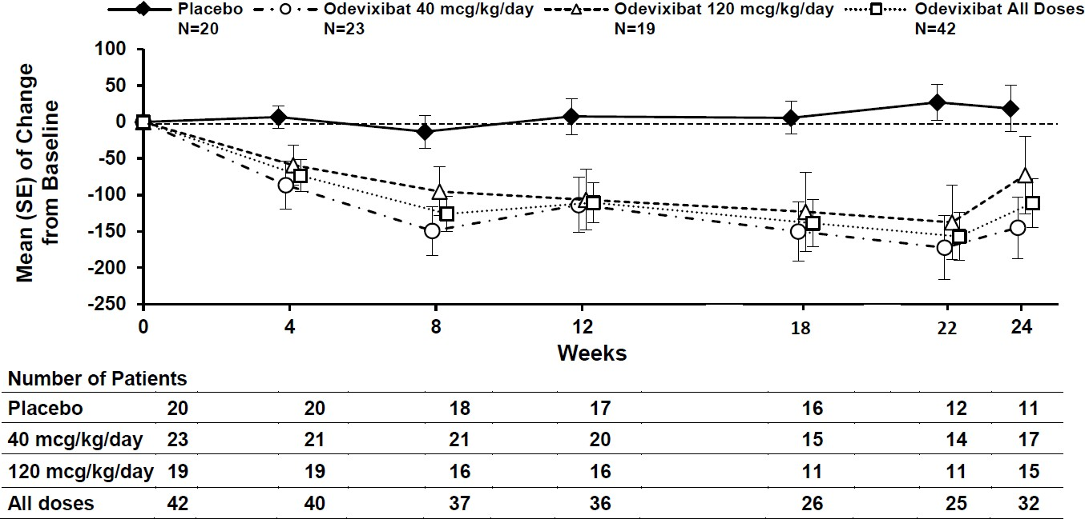
Note: mcg = µg (micrograms)

Figure 2 Mean (±SE) change from baseline in pruritus (scratching) severity score over time
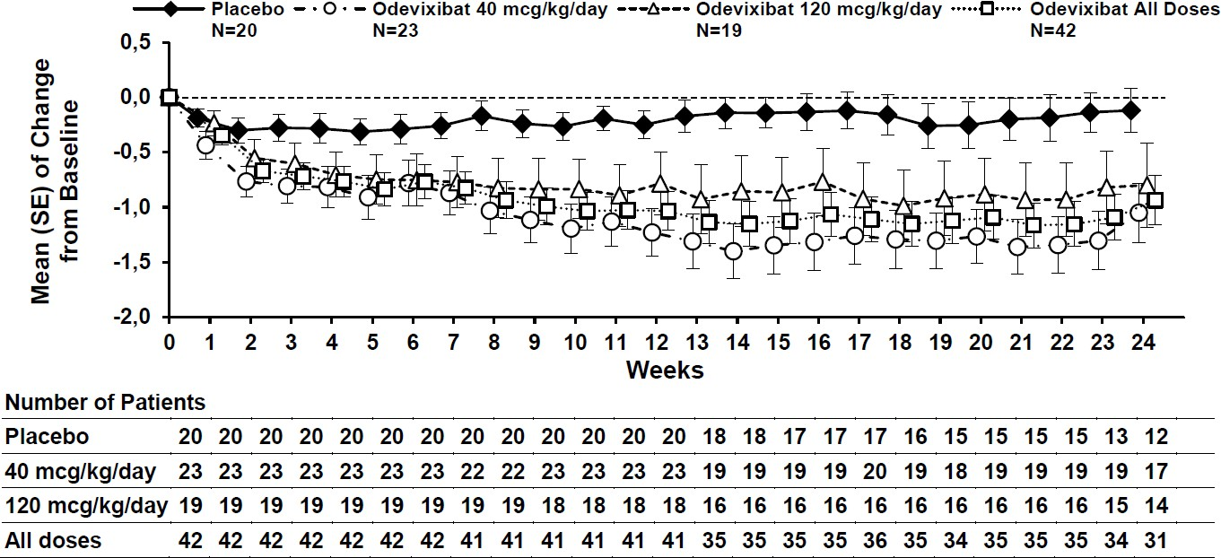
Note: mcg = µg (micrograms)

In line with the results for reduction of pruritus (scratching), odevixibat reduced the percentage of days the patient required soothing, and patients less often required help falling asleep and had fewer days needing to sleep with a caregiver. Treatment with odevixibat also led to improvements from baseline in liver function test results (Table 5). The effect of odevixibat on growth parameters over 24 weeks is also presented.

Table 5 Comparison of efficacy results for growth and hepatic biochemical parameters for odevixibat vs. placebo over the 24-week treatment period in patients with PFIC in trial 1

Efficacy endpoint | Placebo (N=20) | Odevixibat
Efficacy endpoint | Placebo (N=20) | 40 µg/kg/day (N=23) | 120 µg/kg/day (N=19) | Total (N=42)
Alanine aminotransferase (U/L) (mean [SE])
Baseline | 76.9 (12.57) | 127.7 (34.57) | 89.1 (19.95) | 110.2 (20.96)
Change to Week 24 | 3.7 (4.95) | -27.9 (17.97) | -25.3 (22.47) | -26.7 (13.98)
Mean difference vs. placebo (95% CI)ª |  | -14.8 (16.63)  (-48.3, 18.7) | -14.9 (17.25)  (-49.6, 19.9) | -14.8 (15.05)  (-45.1, 15.4)
Aspartate aminotransferase (U/L) (mean [SE])
Baseline | 90.2 (11.59) | 114.2 (17.24) | 96.0 (16.13) | 106.0 (11.87)
Change to Week 24 | 4.7 (5.84) | -36.7 (12.21) | -27.0 (19.42) | -32.1 (11.02)
Total bilirubin (μmol/L) (mean [SE])
Baseline | 53.3 (12.97) | 52.2 (10.13) | 57.0 (18.05) | 54.4 (9.75)
Change to Week 24 | -9.6 (15.16) | -23.7 (9.23) | -19.3 (13.62) | -21.7 (7.92)
Height z-scores (mean [SE])
Baseline | -2.26 (0.34) | -1.45 (0.27) | -2.09 (0.37) | -1.74 (0.23)
Change to Week 24 | -0.16 (0.10) | 0.05 (0.11) | 0.00 (0.16) | 0.03 (0.09)
Mean difference vs. placebo (95% CI)ª |  | 0.32 (0.16)  (0.00, 0.65) | 0.15 (0.17)  (-0.18, 0.48) | 0.24 (0.14)  (-0.05, 0.53)
Weight z-scores (mean [SE])
Baseline | -1.52 (0.32) | -0.74 (0.27) | -1.19 (0.35) | -0.94 (0.21)
Change to Week 24 | 0.10 (0.10) | 0.29 (0.11) | 0.15 (0.12) | 0.22 (0.08)
Mean difference vs. placebo (95% CI)ª |  | 0.28 (0.14)  (-0.01, 0.57) | 0.08 (0.15)  (-0.22, 0.37) | 0.18 (0.13)  (-0.08, 0.44)
ªBased on least squares means from a mixed model for repeated measures (MMRM) with baseline value as a covariate, and treatment group, visit, treatment-by-visit interaction, treatment-by-baseline interaction and stratification factors (PFIC type and age category) as fixed effects.
Trial 2 is an interim cut of data from an ongoing 72-week open-label extension trial in PFIC patients treated with BYLVAY 120 micrograms/kg/day. The 112 patients (PFIC1 [31%], PFIC2 [59%], PFIC3 [6%], PFIC4 [2%] or PFIC6 [2%]) treated with 120 micrograms/kg/day for up to 72 or more weeks experienced a durable effect on serum bile acids reduction, improvement in pruritus score, ALT, AST and total bilirubin. Across the 112 patients,
68 had assessments on or after 72 weeks of treatment with odevixibat, including 24, 37, 5, 0 and 2 patients with PFIC1, PFIC2, PFIC3, PFIC4 and PFIC6, respectively; 8, 10, 0,
2 and 0 patients, respectively, had not reached 72 weeks of treatment and were ongoing at the data cut-off. Overall, 26 patients had discontinued prior to 72 weeks of treatment with odevixibat. Improvements in z-scores for height and weight indicate an enhanced growth velocity and the potential for catch-up growth in actively growing children.

PHARMACOKINETIC PROPERTIES

Absorption
Odevixibat is minimally absorbed following oral administration; absolute bioavailability data in humans are not available, and estimated relative bioavailability is < 1%. Peak odevixibat plasma concentration (Cmax) is reached within 1 to 5 hours. Simulated Cmax values in a paediatric PFIC patient population for the 40 and 120 micrograms/kg/day doses are
0.211 ng/mL and 0.623 ng/mL, respectively, and AUC values were 2.26 ng × h/mL and
5.99 ng × h/mL, respectively. There is minimal accumulation of odevixibat following once-daily dosing.
Effect of food
Systemic exposure of odevixibat does not predict efficacy. Therefore, no dose adjustment for food effects is considered necessary. Concomitant administration of a high-fat meal
(800 - 1000 calories with approximately 50% of total caloric content of the meal from fat) resulted in decreases of approximately 72% and 62% in Cmax and AUC0-24, respectively, compared to administration under fasted conditions. When odevixibat was sprinkled on apple sauce, decreases of approximately 39% and 36% in Cmax and AUC0-24, respectively, were observed compared to administration under fasted conditions. Taking into account the lack of PK/PD relationship and need for sprinkling the odevixibat capsule contents on food for younger children, odevixibat can be administered with food.

Distribution
Odevixibat is more than 99% bound to human plasma proteins. The mean body weight adjusted apparent volumes of distribution (V/F) in paediatric patients for the 40 and 120 micrograms/kg/day dose regimens are 40.3 and 43.7 L/kg, respectively.

Metabolism
Odevixibat is minimally metabolised in humans.

Excretion
Following administration of a single oral dose of 3000 micrograms of radiolabeled odevixibat in healthy adults, the average percent recovery of the administered dose was 82.9% in faeces; less than 0.002% was recovered in the urine. More than 97% of faecal radioactivity was determined to be unchanged odevixibat.
The mean body weight normalised apparent total clearances CL/F in paediatric patients for the 40 and 120 micrograms/kg/day dose regimens are 26.4 and 23.0 L/kg/h, respectively, and the mean half-life is approximately 2.5 hours.

Linearity/non-linearity
The Cmax and AUC0-t increase with increasing doses in a dose-proportional manner; however due to the high interindividual variability of approximately 40%, it is not possible to estimate the dose proportionality accurately.
Pharmacokinetic/pharmacodynamic relationship(s)
Consistent with the mechanism and site of action of odevixibat in the gastrointestinal tract no relationship between systemic exposure and clinical effects is observed. Also, no dose- response relationship could be established for the investigated dose range
10-200 micrograms/kg/day and the PD parameters C4 and FGF19.

Pharmacokinetics in special patient populations
No clinically significant differences in the pharmacokinetics of odevixibat were observed based on age, sex or race.
Renal impairment
There are no clinical data in patients with renal impairment, but the impact of renal impairment is expected to be small due to low systemic exposure and odevixibat is not excreted in urine.
Hepatic impairment
The majority of patients with PFIC presented with some degree of hepatic impairment because of the disease. Hepatic metabolism of odevixibat is not a major component of the elimination of odevixibat. Analysis of data from a placebo-controlled study in patients with PFIC Types 1 and 2 did not demonstrate a clinically important impact of mildly impaired hepatic function (Child Pugh A) on the pharmacokinetics of odevixibat. Although, body weight adjusted CL/F values were lower and body weight adjusted V/F values were larger in paediatric patients with PFIC with Child Pugh B compared to healthy subjects, the safety profile was comparable between the patient groups. Patients with severe hepatic impairment (Child Pugh C) have not been studied.

PRECLINICAL SAFETY DATA

Genotoxicity
Odevixibat was negative in the in vitro bacterial reverse mutation (Ames) assay, the in vitro
mouse lymphoma cell gene mutation assay, and the in vivo rat micronucleus test.

Carcinogenicity
In 2-year carcinogenicity studies, odevixibat was not tumorigenic in rats or mice at oral doses up to 100 mg/kg/day. Systemic exposure to odevixibat (AUC) at the maximum dose studied in rats and mice was approximately 140 and 233 times the maximum recommended dose, respectively.

PHARMACEUTICAL PARTICULARS

LIST OF EXCIPIENTS
Capsule content:
Hypromellose Microcrystalline cellulose
Capsule shell:
Hypromellose Titanium dioxide Iron oxide yellow
Iron oxide red (400 and 1200 micrograms strengths only)
Printing ink (Opacode monogramming ink S-1-17822 Black (ARTG PI No. 12390)): Shellac
Propylene glycol
Strong ammonia solution Isopropyl alcohol
Butan-1-ol
Iron oxide black

INCOMPATIBILITIES
Incompatibilities were either not assessed or not identified as part of the registration of this medicine.
See Section 0
Interactions with other medicines and other forms of interactions for other medicinal products which should be avoided during treatment with BYLVAY.

SHELF LIFE
In Australia, information on the shelf life can be found on the public summary of the Australian Register of Therapeutic Goods (ARTG). The expiry date can be found on the packaging.

SPECIAL PRECAUTIONS FOR STORAGE
Store below 25°C. Keep in original container to protect from light.

NATURE AND CONTENTS OF CONTAINER
Capsules are packaged in a HDPE bottle with a child-resistant polypropylene closure. Each pack contains 30 hard capsules.

SPECIAL PRECAUTIONS FOR DISPOSAL
In Australia, any unused medicine or waste material should be disposed of by taking to your local pharmacy.

PHYSICOCHEMICAL PROPERTIES
Odevixibat sesquihydrate is a white to off-white, slightly hygroscopic, crystalline solid. Its solubility in aqueous solutions is pH-dependent and increases with increased pH.

Chemical structure
The molecular formula of odevixibat sesquihydrate is C37H48N4O8S2•1.5H2O.
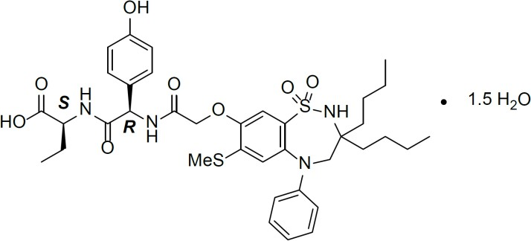

IUPAC name: (2S)-2-{[(2R)-2-(2-{[3,3-dibutyl-7-(methylsulfanyl)-1,1-dioxo-5-phenyl- 2,3,4,5-tetrahydro-1H-1λ6,2,5-benzothiadiazepin-8-yl]oxy}acetamido)-2-(4- hydroxyphenyl)acetly]amino}butanoic acid sesquihydrate
Molecular weight: 768.0 g/mol (sesquihydrate form)

CAS number
2409081-01-0 (hydrate form)

MEDICINE SCHEDULE (POISONS STANDARD)
S4

SPONSOR
Ipsen Pty Ltd
Level 5, 627 Chapel Street South Yarra VIC 3134

Telephone: 1800 317 033

DATE OF FIRST APPROVAL
TBC

DATE OF REVISION
N/A

