Australian Public Assessment Report for AVTOZMA
  - Active ingredient: tocilizumab
  - Sponsor: Celltrion HealthCare Australia Pty Ltd
July 2025

About the Therapeutic Goods Administration (TGA)
- The Therapeutic Goods Administration (TGA) is part of the Australian Government Department of Health, Disability and Ageing and is responsible for regulating therapeutic goods, including medicines, medical devices, and biologicals.
- The TGA administers the Therapeutic Goods Act 1989 (the Act), applying a risk management approach designed to ensure therapeutic goods supplied in Australia meet acceptable standards of quality, safety, and efficacy.
- The work of the TGA is based on applying scientific and clinical expertise to decision-making, to ensure that the benefits to the Australian public outweigh any risks associated with the use of therapeutic goods.
- The TGA relies on the public, healthcare professionals and industry to report problems with therapeutic goods. The TGA investigates reports received to determine any necessary regulatory action.
- To report a problem with a therapeutic good, please see the information on the TGA website.

About AusPARs
- The Australian Public Assessment Report (AusPAR) provides information about the evaluation of a prescription medicine and the considerations that led the TGA to approve or not approve a prescription medicine submission. Further information can be found in Australian Public Assessment Report (AusPAR) guidance.
- AusPARs are prepared and published by the TGA.
- AusPARs are static documents that provide information that relates to a submission at a particular point in time. The publication of an AusPAR is an important part of the transparency of the TGA’s decision-making process.
- A new AusPAR may be provided to reflect changes to indications or major variations to a prescription medicine subject to evaluation by the TGA.

Copyright
© Commonwealth of Australia 2025
This work is copyright. You may reproduce the whole or part of this work in unaltered form for your own personal use or, if you are part of an organisation, for internal use within your organisation, but only if you or your organisation do not use the reproduction for any commercial purpose and retain this copyright notice and all disclaimer notices as part of that reproduction. Apart from rights to use as permitted by the Copyright Act 1968 or allowed by this copyright notice, all other rights are reserved and you are not allowed to reproduce the whole or any part of this work in any way (electronic or otherwise) without first being given specific written permission from the Commonwealth to do so. Requests and inquiries concerning reproduction and rights are to be sent to the TGA Copyright Officer, Therapeutic Goods Administration, PO Box 100, Woden ACT 2606 or emailed to <tga.copyright@tga.gov.au>.

Contents
List of abbreviations 4
AVTOZMA (tocilizumab) submission 5
Proposed indication 7
The conditions 7
Regulatory status 9
Registration timeline 9
Assessment overview 9
Quality evaluation summary 9
Nonclinical evaluation summary 10
Clinical evaluation summary 11
Summary of clinical studies 11
Pharmacology 12
Efficacy 16
Safety 20
Recommendation following the clinical evaluation 25
Risk management plan evaluation summary 25
Risk-benefit analysis 26
Assessment outcome 27
Specific conditions of registration 28
Product Information and Consumer Medicines Information 29

List of abbreviations
Abbreviation | Meaning
AUC_{0-inf} | area under the concentration-time curve from time zero to infinity
AUC_{0-last} | area under the concentration-time curve from time zero to the last quantifiable concentration
AI | autoinjector
ARTG | Australian Register of Therapeutic Goods
CI | confidence interval
CRS | cytokine release syndrome
C_{max} | maximum serum concentration
DAS 28-ES | Disease Activity Score-28 for Rheumatoid Arthritis with ESR
GCA | giant cell arteritis
JIA | juvenile idiopathic arthritis
PD | pharmacodynamic(s)
PFS | pre-filled syringe
PI | Product Information
PK | pharmacokinetic(s)
popPK | population pharmacokinetic(s)
RA | rheumatoid arthritis
RMP | risk management plan
TEAE | treatment emergent adverse event(s)
TGA | Therapeutic Goods Administration

AVTOZMA (tocilizumab) submission
Type of submission: | New biosimilar (to ACTEMRA)
Product name: | AVTOZMA
Active ingredient: | tocilizumab
Decision: | Approved
Date of decision: | 8 May 2025
Approved therapeutic use for the current submission: | Refer to the Product Information for a list of indications.
Date of entry onto ARTG: | 30 May 2025
ARTG numbers: | 444939 - AVTOZMA tocilizumab (rch) 200 mg/10 mL injection concentrated vial  444940 - AVTOZMA tocilizumab (rch) 80 mg/4 mL injection concentrated vial  444941 - AVTOZMA tocilizumab (rch) 162 mg/0.9 mL solution for injection prefilled pen, AVTPen Autoinjector  444942 - AVTOZMA tocilizumab (rch) 162 mg/0.9 mL solution for injection prefilled syringe  444943 - AVTOZMA tocilizumab (rch) 400 mg/20 mL injection concentrated vial
Black Triangle Scheme: | Yes (vial presentation only)
Sponsor’s name and address: | Celltrion Healthcare Australia Pty Ltd,  Suite 1303 / Level 13, 31 Market Street, Sydney NSW 2000, AUSTRALIA
Dose form: | Concentrated solution for intravenous infusion,  Solution for subcutaneous injection
Strength: | AVTOZMA 80 mg/ 4 mL concentrate solution for intravenous infusion vial contains 80 mg tocilizumab  AVTOZMA 162 mg/ 0.9 mL solution for subcutaneous injection contains 162 mg tocilizumab  AVTOZMA 200 mg/ 10 mL concentrate solution for intravenous infusion vial contains 200 mg tocilizumab  AVTOZMA 400 mg/ 20 mL concentrate solution for intravenous infusion vial contains 400 mg tocilizumab
Container/pack size: | Concentrated solution for intravenous infusion  AVTOZMA is supplied in preservative-free, non-pyrogenic single-use, clear glass vials.  - Single use vial containing 80 mg of AVTOZMA in 4 mL (20 mg/mL). Packs of 1 and 4 vials.  - Single use vial containing 200 mg of AVTOZMA in 10 mL (20 mg/mL). Packs of 1 and 4 vials.  - Single use vial containing 400 mg of AVTOZMA in 20 mL (20 mg/mL). Packs of 1 and 4 vials.  Solution for subcutaneous injection  AVTOZMA is supplied as a preservative-free, non-pyrogenic solution presented in a ready-to-use, single-use pre-filled syringe with needle guard and pre-filled pen (AVTPen)  The AVTOZMA pre-filled syringe with needle guard for patient use is available in packs containing:  - 1 pre-filled syringe  - 4 pre-filled syringes  - 12 (3 packs of 4) pre-filled syringes (Multipacks)  Single-use pre-filled syringe with needle safety device. Each syringe with needle guard contains 162 mg of AVTOZMA a in 0.9 mL. Available in packs of 1 ,4 and 12 syringes.  The AVTOZMA pre-filled pen for patient use is available in packs containing:  - 1 pre-filled pen  - 4 pre-filled pens  - 12 (3 packs of 4) pre-filled pens (Multipacks)  Single-use pre-filled pen (AVTPen), each pen contains 162 mg of AVTOZMA a in 0.9 mL Available in packs of 1 ,4 and 12 pens.  Component of a multipack cannot be sold separately. 162 mg/0.9 mL.  Some pack sizes may not be marketed
Route of administration: | Intravenous infusion, subcutaneous injection
Dosage: | For information regarding dosage refer to the Product Information.
Pregnancy category: | Category C  Drugs which, owing to their pharmacological effects, have caused or may be suspected of causing, harmful effects on the human fetus or neonate without causing malformations. These effects may be reversible.  The use of any medicine during pregnancy requires careful consideration of both risks and benefits by the treating health professional. The pregnancy database must not be used as the sole basis of decision making in the use of medicines during pregnancy. The TGA does not provide advice on the use of medicines in pregnancy for specific cases. More information is available from obstetric drug information services in your state or territory.

Proposed indication
This AusPAR describes the submission by Celltrion Healthcare Australia Pty Ltd (the Sponsor) to register AVTOZMA (tocilizumab) for the following proposed indications:
all indications that are currently approved for AU-approved ACTEMRA, which is as follows
- Rheumatoid arthritis (RA)
- Giant cell arteritis (GCA)
- Juvenile idiopathic polyarthritis (pJIA; rheumatoid factor positive or negative and
extended oligoarthritis)
- Systemic juvenile idiopathic arthritis (sJIA)
- Cytokine release syndrome (CRS) (adult and paediatrics)
- Coronavirus Disease 2019 (COVID-19)
Tocilizumab is a recombinant humanised monoclonal antibody of the Ig1 subclass. It consists of two heavy chain and two light chain molecules, with a molecular weight of approximately
145 kDa. It binds to both soluble and membrane-bound IL-6 receptors, inhibiting signalling. IL-6 has paracrine as well as distal actions, including induction of immunoglobulin secretion, T-cell activation, induction of hepatic acute phase proteins and stimulation of haematopoiesis. In terms of immune function, IL-6 is secreted by macrophages in response to protein signals from various pathogens (i.e., innate immunity). It is involved in the pathogenesis of both classical autoimmune disease such as rheumatoid arthritis, as well as conditions such as diabetes and cancer.

The conditions
AVTOZMA is being proposed to treat multiple conditions, all inflammatory in nature.

Rheumatoid arthritis
Rheumatoid arthritis (RA) is a chronic autoimmune disease characterised by persistent synovitis, systemic inflammation and autoantibodies. Chronic arthritis, typically symmetrical and polyarticular, is destructive, leading to bony erosions, cartilage and tendon degradation and joint deformity. Patients may experience joint pain, stiffness, swelling, deformity and progressive loss of function. Extra-articular sites of disease include skin, eyes, heart and lungs.
Early treatment with disease modifying anti-rheumatic drugs (DMARDs) is indicated with a treatment goal of complete remission. Conventional synthetic DMARDs are first line, with frequently used agents being leflunomide, sulfasalazine, hydroxychloroquine and methotrexate. Corticosteroids and NSAIDs have a role in relieving inflammatory symptoms, especially whilst DMARDs take effect. For patients who do not achieve remission with csDMARDs, second line agents biological DMARDs and targeted synthetic DMARDs. There are multiple biological DMARDs registered in Australia for RA. Commonly used biological agents target TNFα (e.g. adalimumab, golimumab), T-cell co-stimulation (abatacept) and interleukin 6 (tocilizumab). TsDMARDs for RA target JAK (baricitinib, tofacitinib, upadacitinib).

Giant cell arteritis
Giant cell arteritis (GCA) is a systemic vasculitis typically affecting cranial arteries, including the ophthalmic artery (with risk of monocular blindness). It predominantly occurs in patients over 50 years of age, with women affected more than men. In patients with suspected GCA, immediate treatment is warranted to protect vision, even before diagnosis is confirmed with biopsy or specialised imaging.
High dose corticosteroids are the mainstay of treatment. Tocilizumab has a role as a steroid-sparing agent and can be used as monotherapy following a successful steroid-taper. It may also have a role in managing disease relapse. Tocilizumab inhibits IL-6 mediated synthesis of acute phase reactants, and this impairs the usefulness of biochemical monitoring of patients with GCA (e.g. CRP measurement). Methotrexate can also be used as a steroid-sparing agent, though it’s only moderately effective.

COVID19
Severe COVID19 infection is characterised by extensive lung involvement, dyspnoea with hypoxia, as well as multi-organ dysfunction.
Systemic immunomodulatory drugs have a role in treating hospitalised patients with hypoxia (i.e. moderate to severe COVID19). Dexamethasone is the most used treatment, with baricitinib and tocilizumab considered for patients with worsening clinical status and/or evidence of significant inflammation. Such patients are also generally treated with the antiviral drug remdesivir.

Polyarticular juvenile idiopathic arthritis and systemic juvenile idiopathic arthritis
Juvenile idiopathic arthritis (JIA) affects patients under 16 who have experienced prolonged arthritis with no underlying cause found. It is the most common rheumatological disease in childhood. JIA is heterogenous with subtypes related to the pattern of joint involvement and extra-articular manifestations. Major subtypes are oligoarticular, polyarticular, systemic, enthesitis-related and psoriatic.
Treatment depends on the subtype and patient characteristics and consists of intra-articular corticosteroid, NSAIDs, systemic corticosteroids, csDMARDs and biological DMARDs. The latter group includes adalimumab, etanercept and tocilizumab.

Cytokine release syndrome
Cytokine release syndrome(CRS) is an acute systemic inflammatory syndrome characterised by fever and multi-organ dysfunction. It can result from chimeric antigen receptor T cell (CAR-T) therapy, used to treat various haematological cancers, bispecific T cell engagers and some monoclonal antibodies.
Treatment of severe CAR-T cell-induced CRS is usually with a combination of glucocorticoids and tocilizumab.

Regulatory status

Australian regulatory status
This product is a new biosimilar medicine for Australian regulatory purposes.

International regulatory status
In December 2024 the EMA’s CHMP recommended marketing authorisation for AVTOZMA.
In January 2025 AVTOZMA received marketing authorization by the US FDA.

Registration timeline
Table 1 captures the key steps and dates for this submission.
This submission was evaluated under the standard prescription medicines registration process.
Table 1. Registration timeline for AVTOZMA (tocilizumab)
Description | Date
Submission dossier accepted and evaluation commenced | 30 April 2024
Evaluation completed | 10 January 2025
Registration decision (Outcome) | 8 May 2025
Registration in the ARTG completed | 30 May 2025
Number of working days from submission dossier acceptance to registration decision* | 261 days
*Statutory timeframe for standard submissions is 255 working days

Assessment overview

Quality evaluation summary
AVTOZMA is a recombinant humanized IgG1 monoclonal antibody. It has one N-linked glycosylation site in the CH2 domain of each heavy chain. Each heavy chain consists of 449 amino acids with 11 cysteine residues and each light chain consists of 214 amino acids with 5 cysteine residues. AVTZOMA was called CT-P47 during clinical development.
In vitro comparability was undertaken with EU-approved ROACTEMRA as the reference product. The Sponsor provided a bridging comparability study between the Australian product ACTEMRA and the EU product, to ensure validity of the main comparability exercise. Overall, the primary, secondary and tertiary structures, physicochemical properties and biological activities were similar between AVTOZMA and EU-ROACTEMRA. Differences, without expected clinical significance include:
- AVTOZMA SC had slightly lower level of N-terminal pyroglutamate than ROACTEMRA.
- AVOTZMA IV had slightly lower oxidation of methionine residues in the heavy and light chains than ROACTEMRA.
- AVOTZMA had slightly higher level of heavy chain with C-terminal lysine than ROACTEMRA.
- AVTOZMA had a slightly higher level of glycation than ROACTEMRA (not in epitope or Fc binding regions).
- AVTOZMA had slightly higher levels of mannose and slightly lower level of galactosylated and sialylated glycans than ROACTEMRA.
- AVTOZMA had slightly lower levels of low molecular weight and high molecular weight species and higher levels of monomer species than ROACTEMRA.
- AVTOZMA had slightly lower levels of intact IgG than ROACTEMRA.
- AVTOZMA had slightly higher levels of free thiol groups than ROACTEMRA.
- AVTOZMA had lower levels of FcγRIIIa (V-type), FcγRIIIa (F-type) and FcγRIIIb binding affinity than ROACTEMRA.
The active substance is produced using recombinant DNA technology. Manufacturing commences with a cultivation process with nutritive feeds. Following harvest, the following purification processes are undertaken: chromatography steps, viral inactivation, viral clearance, ultrafiltration/diafiltration, final formulation and final filtration. Quality of the active substance has been adequately demonstrated and is acceptable. Release specifications of the active substance, test methods chosen and proposed limits are all acceptable.
The five proposed products include three strengths of concentrated injection vials (concentration 20mg/mL), a prefilled syringe (concentration 180mg/mL) and a prefilled autoinjector (AI) pen (concentration 180mg/mL). All products contain standard excipients, as follows: histidine, histidine hydrochloride monohydrate, methionine, threonine, polysorbate 80, water for injections. This formulation is somewhat different to the reference product ROACTEMRA. ROACTEMRA prefilled syringe (for SC injection) also contains arginine and arginine hydrochloride and does not contain threonine. ROACTEMRA vials (for IV infusion) only contain as excipients dibasic sodium phosphate dodecahydrate, monobasic sodium phosphate dihydrate and sucrose. The intravenous product is presented in a glass vial with a chlorobutyl rubber stopper and 20mm flip-off seal. The subcutaneous products are presented in a borosilicate glass syringe with half inch fixed 26G needle and closed with a siliconized elastomeric plunger stopper and a needle shield. These prefilled syringes are fitted with either finger flange/plunger rod/safety guard (i.e. prefilled syringe) or with a customised AI.
The finished product quality control for batch release include identity, potency, purity, impurities, sterility, bacterial endotoxin and several other general tests.
The recommended shelf life for the prefilled syringe and AI (for subcutaneous use) is 36 months at 5 ± 3ºC protected from light and up to a maximum of 30ºC for a period of up to 21 days. The shelf life for the vial presentation (for intravenous infusion) is 24 months at 5 ± 3ºC protected from light. The in-use diluted product should be used within 96 hours at 5 ± 3ºC or 6 hours at room temperature.
Overall, the quality evaluator was satisfied that the data provided supports AVTZOMA registration from a quality perspective.

Nonclinical evaluation summary
The nonclinical dossier contained a comparative repeat dose toxicity study using subcutaneous dosing and this was considered adequate and consistent with the relevant EU guideline. EU-sourced ROACTEMRA was used for the nonclinical study.
There were no significant differences in tocilizumab pharmacokinetics between AVTOZMA and EU-ROACTEMRA in cynomolgus monkeys following subcutaneous dosing.
No significant differences in toxicity were found for AVTOZMA and EU-ROACTEMRA in the repeat dose monkey study.
There were no nonclinical objections to the registration of AVTOZMA. The Nonclinical Safety Specification in the RMP and the draft PI were also acceptable.

Clinical evaluation summary
Relevant guidelines or guidance documents referred to by the Delegate are listed below:
- Guideline on similar biological medicinal products containing biotechnology-derived proteins as active substance: non-clinical and clinical issues - EMEA/CHMP/BMWP/42832/2005 Rev1.
- Guideline on the investigation of bioequivalence - CPMP/EWP/QWP/1401/98 Rev. 1/. This guideline has been adopted by the TGA.
- Guideline on similar biological medicinal products - CHMP/437/04 Rev. 1. This guideline has been adopted by the TGA.
- Guideline on immunogenicity assessment of biotechnology-derived therapeutic proteins (EMEA/CHMP/BMWP/14327/2006). This guideline has been adopted by the TGA.
- Guideline on similar biological medicinal products containing monoclonal antibodies - non-clinical and clinical issues - EMA/CHMP/BMWP/403543/2010. This guideline has been adopted by the TGA.
- Guideline on clinical investigation of medicinal products for treatment of rheumatoid arthritis - CPMP/EWP/556/95 Rev. 2. This guideline has been adopted by the TGA.

Summary of clinical studies
The pivotal efficacy trial in the dossier (study 3.1) was in rheumatoid arthritis. The primary efficacy outcome was the change from baseline in Disease Activity Score-28 for Rheumatoid Arthritis with Erythrocyte Sedimentation Rate (DAS 28-ESR) and is acceptable as per the above EU guideline. The DAS 28 has limitations including the use of acute phase reactants (which may be directly affected by the treatment rather than reflecting joint inflammation) and its ability to define remission. The DAS 28 is calculated based on tenderness and swelling in 28 joints (Figure 1) and can be combined with acute phase reactants, to give DAS 28-ESR or DAS-28 CRP.
Figure 1. Joints used to calculate DAS28
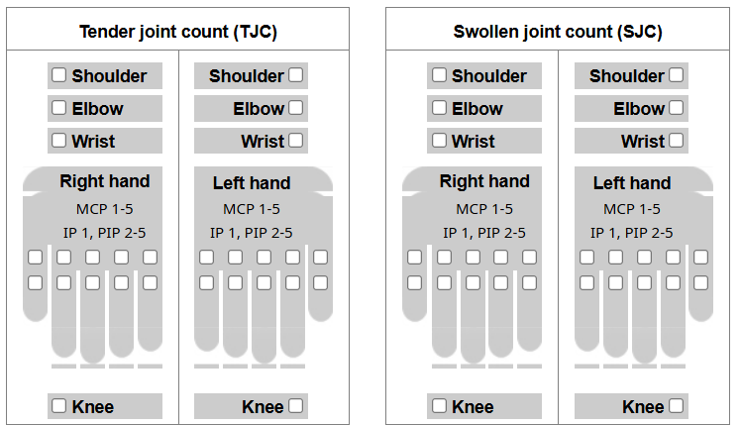
DAS-28 cut points for disease activity are: remission (<2.6), low disease activity (2.6-3.2), moderate disease activity (>3.2 – 5.1), high disease activity (>5.1).
AVTOZMA was designated CT-P47 during clinical development, and this designation is used frequently in the subsequent section.

Pharmacology

Pharmacokinetics (PK)
Study CT-P47 1.1 was a phase 1, randomised, double-blind, two-arm, parallel group, single-dose study to compare PK and safety of CT-P47 and EU-ROACTEMRA given by subcutaneous administration from prefilled syringe in healthy subjects. The study was conducted in South Korea.
Part 1 evaluated 14 subjects given CT-P47 162mg/0.9mL and 15 subjects EU-ROACTEMRA 162mg/0.9mL. One subject in the CT-P47 discontinued the study. This was primarily a safety study before commencing the larger PK study.
Part 2 evaluated 144 subjects treated with CT-P47 162mg/0.9mL and 140 with EU-ROACTEMRA 162mg/0.9mL. Three subjects from each arm discontinued the study. PK sampling occurred out to day 43 and similarity was defined by AUC_{inf}, AUC_{last} and C_{max}. The PK endpoints were analysed as log-transformed endpoints based on an ANCOVA model with covariates of body weight, gender and study centre. The endpoints for each treatment arm were compared as the ratio of geometric means. Similarity was concluded if the 90% confidence interval for the ratio was contained within the 80% to 125% bounds (i.e. the standard bioequivalence definition). PK similarity/equivalence was demonstrated for CT-P47 and EU-ROACTEMRA (Table 2).
Table 2. PK results and comparison Study 1.1
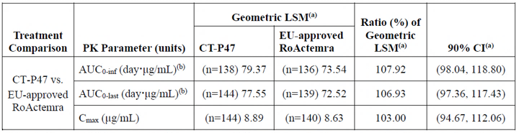
Abbreviations: ANCOVA, analysis of covariance: AUC0-inf, area under the concentration-time curve from time zero to infinity: AUC0-last, area under the concentration-time curve from time zero to the last quantifiable concentration; CI, confidence interval: Cmax, maximum serum concentration: EU, European Union: LSM, least squared mean; PK, pharmacokinetic(s).
Note: An ANCOVA was performed with the natural log-transformed PK parameters as the dependent variable, treatment as a fixed effect and stratification factors (body weight at Day -1. gender. and study center) as covariates,
Study CT-P47 1.2 was a phase 1, randomised, double-blind, three-arm, parallel group, single-dose study to compare the PK and safety of CT-P47, EU-ROACTEMRA and US-ACTEMRA given by IV administration in healthy Japanese subjects. The primary objective was to demonstrate PK similarity for the IV infusion in Japanese subjects. A single dose of 8mg/kg given was administered by IV infusion over 1 hour. Overall, 132 subjects received study drug (CT-P47, n=45; EU-ROACTEMRA, n=43; US-ACTEMRA, n=44) and 1 subject in the US-ACTEMRA arm discontinued the study.
The ratio of geometric least squares means for AUC_{inf}, AUC_{last} and C_{max} (comparing CT-P47 with each reference drug, as well as the 2 reference drugs to each other) demonstrated similarity/equivalence for all comparisons (Table 3).
Table 3. Ratio of geometric least squares means for PK parameters, study 1.2
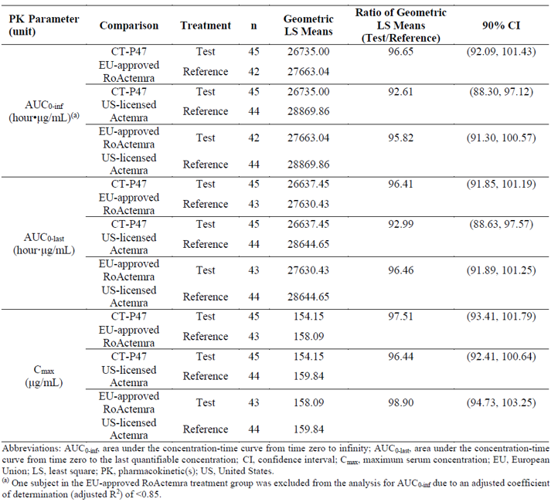
Abbreviations: AUC0-inf, area under the concentration-time curve from time zero to infinity: AUC0-last, area under the concentration-time curve from time zero to the last quantifiable concentration; CI, confidence interval; Cmax, maximum serum concentration; EU, European Union: LS, least square; PK. pharmacokinetic(s); US, United States.
One subject in the EU-approved RoActemra treatment group was excluded from the analysis for AUC0-inf due to an adjusted coefficient of determination (adjusted R2) of <0.85.
Study CT-P47 1.3 was a phase 1, randomised, open-label, two-arm, parallel group, single-dose study to compare the PK and safety of CT-P47 given by AI or pre-filled syringe (PFS) in healthy subjects. The study was conducted in South Korea. Study treatments were CT-P47 162mg/0.9mL given by SC injection via AI or a PFS to the outer upper arm.
Overall, 153 were treated using the AI (147 completed the study) and 157 using the PFS (153 completed the study). Bioequivalence assessment utilised the AUC_{inf} and C_{max}. Bioequivalence was shown as the 90% confidence interval for the ratio of geometric means of both parameters were within the 80% to 125% boundaries (Table 4).

Table 4. Primary serum PK parameters and ratios for CT-P47 study 1.3
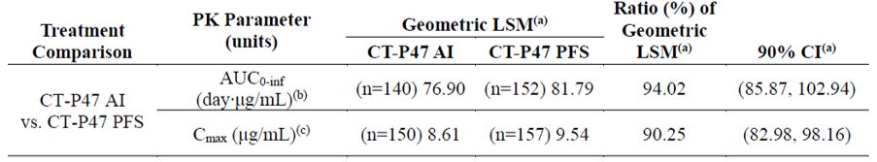
Abbreviations: AI, auto-injector; ANCOVA. analysis of covariance: AUC0-inf, area under the concentration-time curve from time zero to infinity; CI, confidence interval; Cmax, maximum serum concentration; LSM, least squared mean; PFS, pre-filled syringe; PK, pharmacokinetic(s).
Note: An ANCOVA was performed with the natural log-transformed PK parameters as the dependent variable treatment as a fixed effect and stratification factors (body weight at Day -1. gender. and study center) as covariates.
- The LSM differences and 90% confidence intervals for the differences were exponentiated to provide estimates of the ratio of adjusted geometric least square means (CT-P47 AI/CT-P47 PFS) and 90% confidence intervals for the ratios.
- 12 subjects (9 subjects in the CT-P47 AI group and 3 subjects in the CT-P47 PFS group) who had an adjusted coefficient of determination (adjusted R2) of <0.85 were excluded from the AUC0-inf, analysis. Four subjects and 2 subjects in the CT-P47 AI and PFS groups, respectively, did not have at least 3 timepoints after Cmax and thus AUC0-inf analysis was not available.
- There were 3 subjects in AI group (S02-0047. S03-0083. S03-0161) who had their last observed concentration as the highest value: all were early withdrawal before Day 4. Since truncated profiles of these subjects may not represent real PK profiles, all parameters (Cmax, Tmax, and AUC0-last) derived from these subjects were considered not reliable and excluded from the analysis.
The pivotal phase 3 efficacy study CT-P47 3.1 also evaluated tocilizumab exposure during treatment period 1 (out to week 24) and period 2 following re-randomisation (of subjects initially randomised to ROACTEMRA to either continued treatment or a switch to CT-P47 out to week 32). In this study, all subjects recorded their highest pre-dose concentration at week 32 (Table 5). Modest numerical differences in trough concentrations can be seen across groups at this time point, with the highest in the group initially randomised to ROACTEMRA who switched at week 24 to CT-P47.
Table 5. Tocilizumab concentration (ng/mL) for the period 1 PK set and the period 2 PK subset.
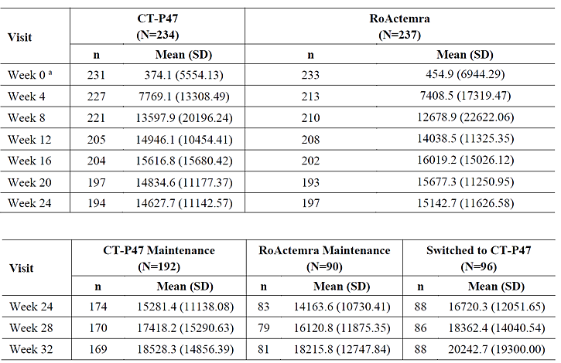
Abbreviations: PK. pharmacokinetics: SD, standard deviation.
* A total of 7 patients (3 patients in the CT-P47 and 4 patients in the RoActemra) did not perform pharmacokinetic tests at baseline due to site mistaken.

Pharmacodynamics
In study 3.1, sIL-6R (soluble IL-6 receptor) concentration was measured. It rose significantly
(> 10 fold), but to a similar level, in subjects treated with CT-P47, EU-ACTEMRA and EU-ACTEMRA/CT-P47 switch (see trial explanation below).

Efficacy
Study CT-P47 3.1 was a phase 3, randomised, active-controlled, double-blind, multicentre study of CT-P47 and EU-ROACTEMRA in patients with moderate to severe active rheumatoid arthritis (RA). The primary objective of the study was to establish similar efficacy in terms of change from baseline to week 12 in disease activity, using Disease Activity Score in 28 joints and ESR (DAS 28-ESR). Following 24 weeks of treatment, subjects in the EU-ROCTEMRA arm were re-randomised to either continued treatment or a switch to CT-P47 for the remainder of the trial (i.e. to week 52). The study was unblinded for reporting purposes for data up to week 32 for all patients (week 32 data were used for regulatory purposes, although a report covering the period 32 to 52 weeks was submitted during the course of evaluation). The study was conducted in 22 centres in Poland. Study structure is shown in Figure 2.
Figure 2. Study CT-P47 3.1
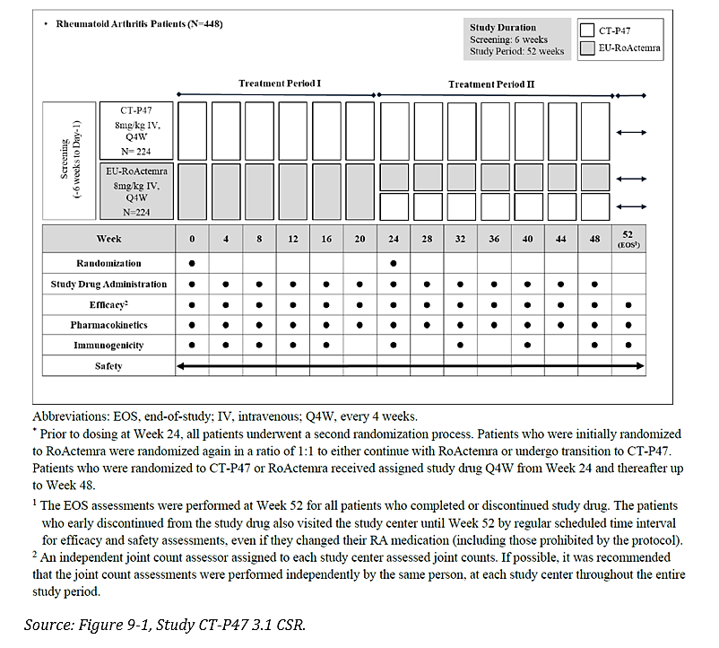
Abbreviations: EOS, end-of-study: IV, intravenous: Q4W, every 4 weeks.
* Prior to dosing at Week 24. all patients underwent a second randomization process. Patients who were initially randomized to RoActemra were randomized again in a ratio of 1:1 to either continue with RoActemra or undergo transition to CT-P47. Patients who were randomized to CT-P47 or RoActemra received assigned study drug Q4W from Week 24 and thereafter up to Week 48.
1.The EOS assessments were performed at Week 52 for all patients who completed or discontinued study drug. The patients who early discontinued from the study drug also visited the study center until Week 52 by regular scheduled time interval for efficacy and safety assessments. even if they changed their RA medication (including those prohibited by the protocol).
2. An independent joint count assessor assigned to each study center assessed joint counts. If possible. it was recommended that the joint count assessments were performed independently by the same person at each study center throughout the entire study period.
Major inclusion criteria were male or female aged 18 – 75 years, diagnosis of RA of at least 24 weeks duration according to 2010 ACR/EULAR criteria, moderate or severe disease activity at screening (6 or more tender joints, 6 or more swollen joints, raised ESR or CRP, DAS28 (ESR or CRP) ≥ 3.2) and being on a stable dose of methotrexate. Major exclusion criteria were previous exposure to targeted synthetic DMARDs or an IL-6 inhibitor, previous use of > 1 biologic for RA and criteria related to medical history and specific drug exposures (see CER for details).
Treatment was with CT-P47 or EU-ROACTEMRA 8mg/kg (maximum dose 800mg) by IV infusion every 4 weeks. Methotrexate, a required comedication, was given orally or via IM or SC injection, at a dose of 10mg – 25mg/week, with folic acid.
The primary efficacy outcome was mean change from baseline of DAS 28-ESR at week 12.
Secondary endpoints were:
- ACR20, ACR50, and ACR70
- Individual components of the ACR
- Hybrid ACR response
- DAS28 (C-reactive protein [CRP])
- DAS28 (erythrocyte sedimentation rate [ESR]) except for Week 12
- Individual components of the DAS28
- EULAR response criteria (ESR/CRP)
- Simplified disease activity index (SDAI) and clinical disease activity index (CDAI)
- ACR/EULAR remission (Boolean-based definition)
- 36-item short form health survey (SF-36)
- Joint damage progression based on radiographic evaluation
Analysis populations were the intention to treat set (ITT), the per protocol set (PP), the PK set and the safety set. The sample size was calculated based on an equivalence margin of ±0.6 (difference of mean change from baseline of DAS28-ESR), two one-sided 2.5% significance level and a 90% power. Taking into account dropout, 448 subjects (224 in each arm) were determined to be required. Participant flow in period 1 and period 2 is shown in Figure 3.
Figure 3. Participant flow - study 3.1
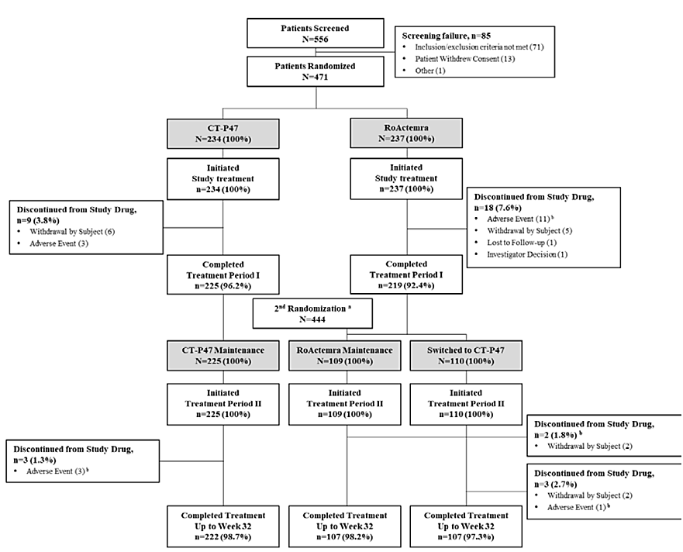
Abbreviations: Q4W, every 4 weeks
* Prior to dosing at Week 24, all patients underwent a second randomization process. Patients who were initially randomized to RoActemra were randomized again in a ratio of 1:1 to either continue with RoActemra or undergo transition to CT-P47. Patients who were randomized to CT-P47 or RoActemra received assigned study dmg Q4W from Week 24 and thereafter up to Week 48.
Of the total study population 100% were white, 76.7% were female, 88.5% had weight < 100kg, 97.5% had a baseline DAS28-ESR score > 5.1 and 25.5% had prior biological medicine use. Other characteristics were similar across the treatment arms.
In terms of the primary efficacy outcome, for the ITT set, the least squares mean change in DAS28-ESR at week 12 was -3.01 with CT-P47 and -3.00 with EU-ROACTEMRA. For the PPS, the changes were -3.05 and -3.09 in each arm respectively. The mean differences for both analysis sets were negligible and well within the pre-specified equivalence margins (Table 6). Sensitivity analyses were consistent with these findings.
Table 6. Primary efficacy outcome for ITT and PPS sets, study 3.1
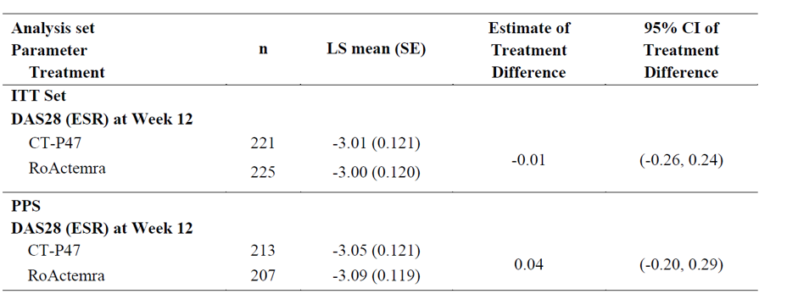
Abbreviations: ANCOVA, analysis of covariance: CI, confidence interval: DAS28, Disease Activity Score using 28 joint counts: ESR, erythrocyte sedimentation rate: ITT, intent-to-treat: LS, least squares: PPS, per-protocol set: RA, rheumatoid arthritis: SE, standard error.
Note: An ANCOVA comparing the mean change from baseline of DAS28 (ESR) at Week 12 between two treatment groups. CT-P47 and RoActema. was conducted considering the treatment as fixed effect. and body weight (<100 kg or >100 kg) measured on Day |. baseline DAS28 (ESR) score and prior biologic use approved for RA treatment (yes or no) as covariates.
Secondary endpoints also supported similarity of CT-P47 and EU-ROACTEMRA. There were no clinically significant differences observed between treatments in period 1, nor between groups in period 2 (including the group that switched from EU-ROACTEMRA to CT-P47).
During treatment period 2 (up to week 32) the mean changes from baseline of DAS28-ESR and DAS28-CRP tended to decrease somewhat (i.e. consistent with ongoing improvement), and remained similar across the different arms. The period 2 data are consistent with a switch from the reference EU-ROACTEMRA to CT-P47 not affecting drug efficacy.
Although additional efficacy data have not been formally evaluated (and are generally not accepted after the initial submission) the efficacy outcomes measured at week 52 are consistent with maintenance of benefit. Furthermore, the outcomes were similar across the different treatment arms at week 52.
Study CT-P47 3.2 was a phase 3, single arm, open-label, multiple-dose study in subjects with moderate to severe active RA. This was primary a usability study of the AI in subjects based on an assessment questionnaire undertaken at week 2. Safety, efficacy and immunogenicity up to week 12 was also assessed. The study was conducted at 3 centres in Poland.
The study included males or females aged 18 – 70, and with a diagnosis of RA according to 2010 ACR/EULAR classification of at least 24 weeks duration. Moderate or severe disease activity was required and defined by 6 or more swollen joints, 6 or more tender joints and either raised ESR or CRP. Subjects were required to be taking a stable dose of methotrexate. Major exclusion criteria included previous exposure to targeted synthetic DMARDs for RA or any exposure to IL-6 inhibiting drugs.
In this study subjects injected CT-P47 162mg/0.9mL via the AI at week 0 and week 2 (i.e. first 2 doses), and then dosed either weekly or 2nd weekly (based on investigator discretion) using the PFS, with final dose given at week 10.
Usability evaluation was with PRE-SIAQ (Self-injection assessment questionnaire), POST-SIAQ and self-injection assessment checklist for AI.
In total, 33 subjects received at least one dose of CT-P47 and 29 completed the study. The mean age 53.2 years, 72.7% were female and all were white.
At week 2, all POST-SIAQ mean scores were between 7.11 – 9.62, indicating positive usability aspects of the AI. Importantly for subjects with RA, “ease of use of the self-injection device” mean score was 8.3 and “satisfaction with self-injection” was 7.98. During the study all subjects were able to complete all instructions from the self-injection assessment checklist.
In terms of efficacy, reductions were seen for DAS28-CRP, DAS28-ESR, swollen joint count and tender joint count. Patient’s Global Assessment of Disease Activity substantially improved.
Although all efficacy studies were in subjects with RA, the Sponsor has proposed extrapolation to all indications currently approved for tocilizumab. This is on the basis that the action of tocilizumab across its range of indications is inhibition of IL-6 and that PK and safety have been found to be similar across indications. AVTOZMA (i.e. CT-P47) is therefore expected to perform the same in all indications currently approved for ACTEMRA.

Safety
During the clinical development program 513 healthy subjects were exposed to single doses of CT-P47. In the RA studies, 267 subjects were only exposed to treatment with CT-P47 and 110 were exposed to a combination of EU-ROACTEMRA and CT-P47.
In study 3.1, which provides the major safety dataset, 222/234 subjects continued treatment up to week 32 with CT-P47 and 107/110 continued treatment up to week 32 with a combination of EU-ROACTEMRA and CT-P47.
Overall TEAEs were reported at similar rates in each group in the overall period up to week 32. Noteworthy, although of unclear clinical significance if any, is a higher % of subjects with TEAE special interest classified as infection (54% with CT-P47 vs. 41.4% with EU-ROACTEMRA, which includes those who switched at week 24) and a lower % with TEAE special interest classified as hepatic event (29.9% with CT-P47 vs. 35.9% with EU-ROACTEMRA, which includes those who switched at week 24).
AEs by system order class reported in ≥ 3% of subjects in any treatment group are shown in Table 7. Of note, more subjects in the CT-P47 arm than EU-ROACTEMRA overall experienced drug-induced liver injury (3.4% vs. 0.4%, respectively).
Table 7. Summary of TEAEs reported in at least 3% of subjects, study 3.1
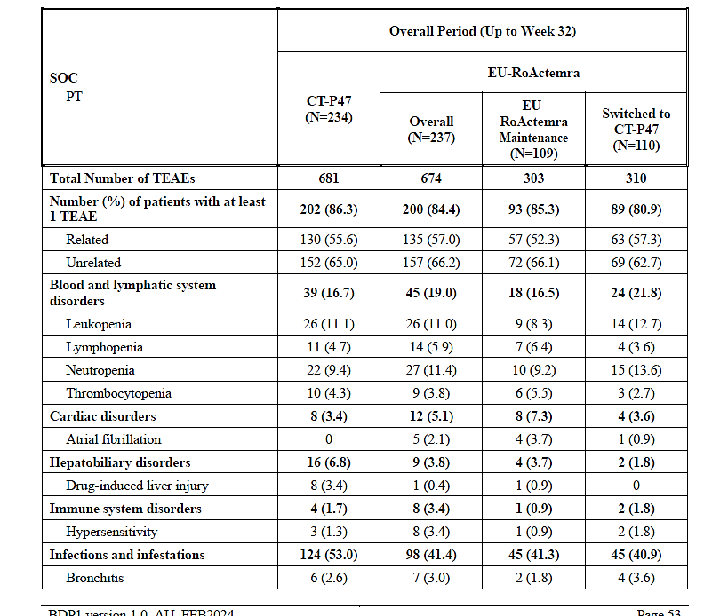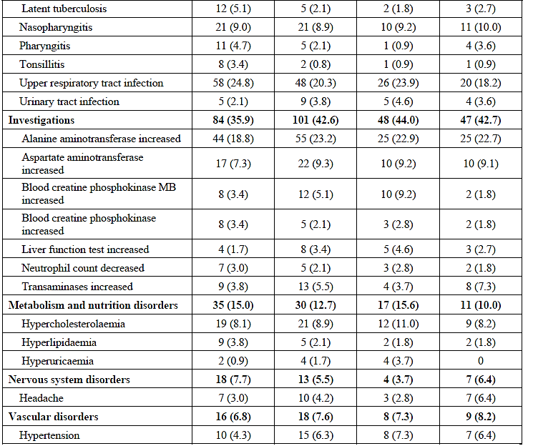
Note: For SOC, the number and percentage of patients with at least 1 TEAE for each treatment period were summarized by SOC. For PT, only TEAEs reported for at least 3% of patients by PT in any treatment group were included. At each level of summarization, patients were counted once if they reported one or more events. Only the most severe event was counted. The event was considered to be related if the relationship was defined as ‘Possible’, ‘Probable’, ‘Definite’.
Abbreviation: MB, myoglobin binding
There were similar incidences of grade 3 or higher TEAEs in all treatment arms across both periods. The only TEAE of this severity occurring in at least 1% of subjects was neutropoenia (again with similar incidences across the treatment arms).
One subject in the CT-P47 maintenance group (i.e. period 2) died of peritonitis, which occurred after gastroscopy and was considered as unrelated to study drug by the investigator. Serious AEs were reported at low and similar rates during period 1 and period 2.
Mean changes from baseline in all clinical chemistry, haematology and urinalysis laboratory parameters were similar across the treatment arms in periods 1 and 2. Infrequent events of grade 3 or more parameters were noted for ALT increased, AST increased, blood bilirubin increased, CPK increased, cholesterol high, hyperkalaemia, hypocalcaemia, hypertriglyceridaemia, hypoglycaemia, hypokalaemia, lymphocyte count decreased, neutrophil count decreased and white blood cell count decreased.

Evaluation of specific adverse events
Hepatic events – In treatment period 1 28.2% treated with CT-P47 and 30.8% treated with EU-ROACTEMRA experience treatment emergent hepatic events. More of these were considered as related in subjects treated with EU-ROACTEMRA than CT-P47 (19.4% vs. 15%). The most common event was increased ALT. In treatment period 2, hepatic events affected similar proportions of subjects in each of the three arms. Most of the events were grade 1 or 2 in severity and none met Hy’s law.
Infection – In treatment period 1 there were slightly more infection-related TEAEs in the CT-P47 group compared to the EU-ROACTEMRA group (47% vs. 35.4%). Most infections were grade 1 or 2 intensity and considered unrelated. TEAEs were reported for similar proportions of subjects in each arm in period 2.
Of note there were more TEAEs of latent tuberculosis reported in the CT-P47 than in EU-ROACTEMRA (+/- switch) arms during both periods. Looking specifically at IGRA (interferon gamma release assay) conversions (possibly a more objective measure than reported latent TB which is dependent on investigator discretion and could also be reported using an alternative term), in period 1, 11 subjects in the CT-P47 arm converted and 4 in the EU-ROACTEMRA arm. Looking at conversions during period 2 (out to week 52), there were 4 in the CT-P47 arm, 1 in the EU-ROACTEMRA arm and 2 in the switched to CT-P47 arm. The Sponsor was asked about this imbalance and noted that all associated TEAEs were grade 1 or 2, there was no active TB and there were more patients > 65 years in the CT-P47 maintenance group (i.e. at higher risk of IGRA conversion).
Hypersensitivity reactions – there was 1 event of anaphylaxis in the EU-ROACTEMRA arm in period 1. Otherwise, hypersensitivity related TEAEs were infrequent in both arms. Hypersensitivity-related TEAEs were not reported in period 2.
Haemorrhage – in the overall period (i.e. periods 1 and 2) the proportion of subjects who experienced at least 1 TEAE of haemorrhage occurred in 1.7% of the CT-P47 and 2.8% of the EU-ROACTEMRA groups. All were grade 1 or 2 and not medically significant, except for a uterine haemorrhage (treatment period 2, switch to CT-P47 arm).
Gastrointestinal perforation – In period 2 in the CT-P47 maintenance group one subject experienced peritonitis that was classified as a GI perforation event (and was considered as unrelated to study drug by the investigator).
Injection site reaction – these were not evaluated in pivotal study 3.1 as intravenous administration as utilised.
There was 1 malignancy in the EU-ROACTEMRA group during period 1. There were no de-myelinating disorders.
Since the initial dossier was submitted, the Sponsor submitted an updated CSR for study 3.1 which included data out to week 52 (this data was not originally intended to be used for initial registration purposes). Of note, there was 1 additional event of gastrointestinal perforation (grade 2 anal fistula) in the CT-P47 maintenance group, which was considered related and which recovered with treatment. Also of note, was the incidence of IGRA in the different treatment arms – 8% in CT-P47 maintenance, 2.8% in EU-ROACTEMRA maintenance and 4.5% in the switched to CT-P47 groups. These were also recorded as TEAEs (latent TB or IGRA positive). Most of these subjects started “proper TB prophylaxis” and no active TB was reported. Overall, the data between weeks 24 and 52 was consistent with that seen earlier in the study (i.e. safety similarity between CT-P47, EU-ROACTEMRA and switched to CT-P47).

Additional safety data
In study 1.1 part 2, 2.8% of subjects receiving CT-P47 and 3.6% receiving EU-ROACTEMRA experienced at least 1 TEAE classified as injection site reaction. All of these were grade 1 in intensity. In study 1.3 TEAEs classified as injection site reactions occurred in 9.2% of subjects using the AI and 3.2% of subjects using the PFS. In study 3.2, 9.1% of subjects had at least 1 TEAE classified as injection site reactions. All were ISR grade 1 or 2 and recovered without treatment within 3 days.
Other safety data from the healthy subject studies did not detect differences between CT-P47 and the reference products, or between CT-P47 given by AI or PFS.

Immunogenicity / antidrug antibodies (ADAs)
In healthy subjects the proportion of subjects who had at least 1 post-treatment ADA positive and Nab positive results found CT-P47 to be similar to the reference products (both the IV and SC formulations/routes of administration).
In study 3.1 the frequency of ADA and Nab incidences at each timepoint was similar between the treatment groups (Table 7). The incidence of ADAs was lower after receiving study drug, than at baseline (although Nab only occurred after receiving study drug).
Table 7. Summary of immunogenicity results - safety set to week 24
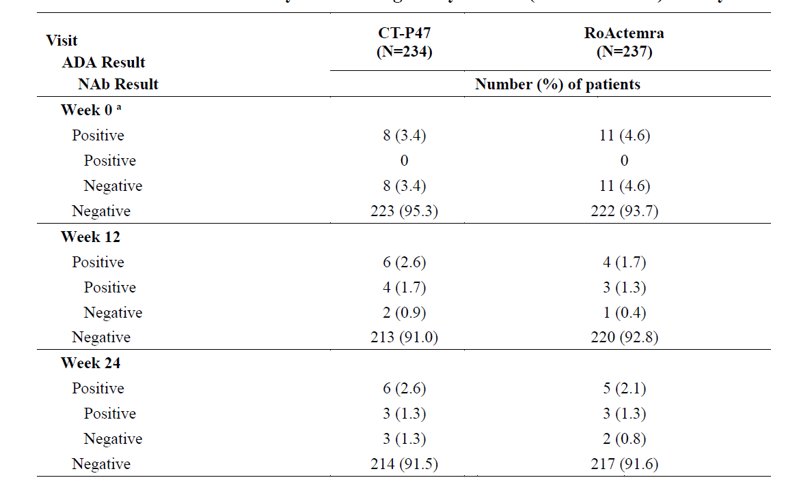
ADA incidence did not change in those subjects switched from EU-ROCTEMRA to CT-P47. The proportion of ADA positive subjects at all timepoints was below 5%, which is line with what has been historically reported for tocilizumab.
ADA titration results were generally similar up to week 32 across arms, as were the incidences of positive conversion (either to ADA positivity or Nab positivity) during periods 1 and 2 (Table 8).
Table 8. Positive conversion in ADA or Nab, by treatment period, safety set
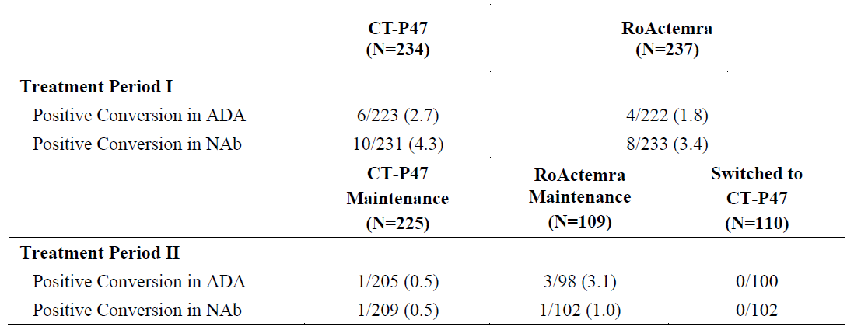
Abbreviations: ADA. antidrug antibody: EOS. end-of-study: NAb. neutralizing antibody.
Note: For Treatment Period I, the numerator was the number of patients with at least one ADA or NAb positive result after first study drug administration in Treatment Period I (including EOS visit) and before the first study drug administration in Treatment Period I. The denominator was the number of patients who had at least one ADA result after first study drug administration in Treatment Period I and before the first study drug administration in Treatment Period II (including EOS visit). and had not any ADA positive (in case of ADA summary) or NAb positive (in case of NAb summary) result before the first study drug administration. For Treatment Period II. the numerator was the number of patients with at least one ADA or NAb positive result after first study drug administration in Treatment Period II (including the EOS visit). The denominator was the number of patients who had at least one ADA result after first study drug administration in Treatment Period II (including the EOS visit). and had not any ADA positive (in case of ADA summary) or NAb positive (in case of NAb summary) result before the first study drug administration in Treatment Period II.
Subsequent to the initial evaluation of the immunogenicity data to week 32, the Sponsor submitted the updated CSR containing data to week 52. In terms of immunogenicity, at week 52 0.9% of subjects in the CT-P47 arm, 0% in the EU-ROACTEMRA arm and 2.7% in the switched to CT-P47 had positive ADA results, none of which were neutralizing. Between 0 – 4 subjects, depending on the arm, had positive conversion to either ADA or Nab positivity between weeks 24 and 52.
In study 3.2, 6.1% of subjects had post-treatment ADA positive (all Nab positive as well) results up to end of the study.
No correlation was detected between ADA positivity and safety.

Recommendation following the clinical evaluation
Efficacy – pivotal efficacy study 3.1 met its primary non-inferiority endpoint and therefore demonstrated similar efficacy between CT-P47 and EU-ROACTEMRA. Secondary efficacy endpoints did not find any clinically significant differences between the treatments. The small numbers of subjects with ADAs were insufficient to determine any effects of ADAs on efficacy and therefore this issue remains somewhat unresolved.
Safety – the safety of CT-P47 was very similar to that seen for the reference products (EU-ROACTEMRA and US-ACTEMRA). Any differences in rates observed between these drugs were not considered to be clinically meaningful. When looking at AEs of special interest (i.e. hepatic events, infection, hypersensitivity, haemorrhage, gastrointestinal perforation, malignancy, immunogenicity/immunological events, injection site reactions) no concerning differences between CT-P47 and the reference products were seen. It was noted that the timeframe of the provided studies is too short to reliably detect any differences in malignancy rate. The AI and PFS demonstrated similar safety.
Overall, the risk-benefit balance was considered positive for AVTOZMA and approval was recommended.

Risk management plan evaluation summary
Safety concerns and their associated risk monitoring and mitigation strategies are summarised in Table 9.
The TGA may request an updated RMP at any stage of a product's life-cycle, during both the pre-approval and post-approval phases.
Table 9. Summary of safety concerns
Summary of safety concerns |  |  | Pharmacovigilance |  |  | Risk Minimisation
 |  |  | Routine | Additional | Routine |  | Additional
Important identified risks | Serious infection | * |  | – |  |  | ^{†‡§ǁ}
Important identified risks | Complications of diverticulitis | * |  | – |  |  | ^{†‡§ǁ}
Important identified risks | Neutropenia | * |  | – |  |  | ^{‡§ǁ}
Important identified risks | Hepatotoxicity | * |  | – |  |  | †‡§
Important potential risks | Thrombocytopenia and the potential risk of bleeding | * |  | – |  |  | ‡§
Important potential risks | Elevated lipid levels and the potential risk of cardiovascular and cerebrovascular events | * |  | – |  |  | ^{‡§ǁ}
Important potential risks | Malignancies | * |  | – |  |  | ^{‡§ǁ}
Important potential risks | Demyelinating disorders | * |  | – |  |  | §
Important potential risks | Immunogenicity |  |  | – |  |  | –
Missing information | None | – |  | – |  | – | –
*Follow-up questionnaires; †Patient alert card; ‡Patient brochure; §HCP brochure; ǁDosing guide
The risk minimisation measures such as the patient alert card, patient brochure, health care professional brochure and dosing guide will be provided to the RMP team by the Sponsor prior to product launch.

Risk-benefit analysis

Proposed indications
The proposed indications for AVTOZMA include all of those currently in the ARTG for the reference product, ACTEMRA. The Sponsor provided adequate justification for this extrapolation of indications (i.e. from the pivotal trial’s RA indication to the others). Major arguments include the specificity of tocilizumab as an IL-6 inhibiting drug and the known important role for IL-6 in the diseases covered by the indications. The PK of tocilizumab is well understood and consistent across its various indications, further supporting the extrapolation. Finally, the comprehensive comparability exercise shown AVTOZMA to be similar in terms of structure and function to EU-ROACTEMRA (and via bridging to the Australian approved ACTEMRA). These arguments are sufficient to support the registration of AVTOZMA for all proposed indications.

Efficacy
The efficacy of AVTOZMA to treat patients with moderate to severe active RA was shown to be statistically similar (i.e. 95% confidence interval for difference in primary outcome feel within the pre-specified boundary) to the reference product EU-ROACTEMRA in study 3.1. The study utilised a continuous variable (DAS28-ESR) as the primary efficacy outcome, which is also supported by EMA guidance on RA studies. Given the relatively large effect size difference expected for AVTOZMA (if it was to be compared with placebo), RA is considered a suitably sensitive indication to demonstrate non-inferiority. Furthermore, there is a large amount of clinical trial data for tocilizumab in RA allowing for more extensive cross-study comparison to confirm the results of the pivotal study. AVTZOMA has been shown to be highly similar to the reference EU-ROACTEMRA in terms of clinical efficacy in RA.

Safety
There was a substantial safety set comprised of subjects with RA treated with CT-P47/AVTOZMA in studies 3.1 and 3.2. In study 3.1 there was safety data to week 32 for 222 subjects treated only with AVTOZMA. In that study a further 107 were treated to week 32 with a combination of EU-ACTEMRA (for first 24 weeks), followed by AVTOZMA. Subsequently, safety data from that study out to week 52 were also submitted. Overall, AVTOZMA and EU-ACTEMRA showed similar safety profiles. Some discrepancy was noted for drug induced liver injury events (less with EU-ACTEMRA) and the Sponsor will be asked about this.
The other discrepancy was noted for latent TB, as discussed above. There was a higher rate of IGRA conversion in both treatment periods in study 3.1. The Delegate notes that the numbers overall were small (e.g. 15 patients overall in period 1), that there was no active TB reported and that there were differences between baseline IGRA status between arms (although this is distinct from IGRA conversion whilst on study, it shows that there could have been some underlying differences between groups). The Sponsor also pointed out that there were more subjects > 65 years in the CT-P47/AVTOZMA maintenance arm and that they considered safety similar in regard to latent TB. The Delegate concurs with this.

Risk-benefit-uncertainty
The risk-benefit for AVTOZMA appears to be very similar to that for the reference product ACTEMRA and therefore is positive. There could be some uncertainty with regard to long term use of AVTOZMA, as TGA has not been presented with data beyond 52 weeks. It would seem unlikely that efficacy or safety would show a significant departure from the reference at a later time point. Post-marketing pharmacovigilance should help reduce this uncertainty.
The Delegate supports the registration of AVTOZMA, for all proposed strengths and presentations, and for all proposed indications. AVTOZMA biosimilarity to the reference ACTEMRA has been adequately demonstrated.

Assessment outcome
Based on a review of quality, safety, and efficacy, the TGA decided to register AVTOZMA (tocilizumab) for the following indication:
Rheumatoid Arthritis (IV and SC formulations): AVTOZMA is indicated for the treatment of moderate to severe active rheumatoid arthritis (RA) in adult patients in combination with methotrexate (MTX) or other nonbiological disease- modifying anti-rheumatic drugs (DMARDs) in case of either an inadequate response or intolerance to previous therapy with one or more DMARDs. AVTOZMA is indicated for the treatment of moderate to severe active rheumatoid arthritis in adult patients with poor prognostic factors (see section 5.1 Pharmacodynamic Properties, Clinical Trials) in combination with MTX in those not intolerance to MTX or where continued treatment with MTX is inappropriate. AVTOZMA has been shown to inhibit the progression of joint damage in adults, as measured by X-ray, when given in combination with methotrexate.
Giant Cell Arteritis (SC formulations only): AVTOZMA is indicated for the treatment of giant cell arteritis (GCA) in adult patients.
Coronavirus disease 2019 (COVID-19) (IV formulation only): AVTOZMA has provisional approval for the treatment of coronavirus disease 2019 (COVID-19) in hospitalised adults who are receiving systemic corticosteroids and require supplemental oxygen or mechanical ventilation. Provisional approval has been made on the basis of short-term efficacy and safety data. Continued approval depends on the evidence of longer-term efficacy and safety from ongoing clinical trials and post-market assessment.
Polyarticular Juvenile Idiopathic Arthritis (IV and SC formulations): AVTOZMA is indicated for the treatment of moderate to severe active polyarticular juvenile idiopathic arthritis in patients 2 years of age and older who have had an inadequate response to or intolerance to methotrexate (MTX). AVTOZMA can be given alone or in combination with MTX.
Systemic Juvenile Idiopathic Arthritis (IV and SC formulations) Intravenous formulation: AVTOZMA is indicated for the treatment of active systemic juvenile idiopathic arthritis in patients 2 years of age and older. Subcutaneous formulation: AVTOZMA is indicated for the treatment of active systemic juvenile idiopathic arthritis in patients 1 year of age and older. AVTOZMA IV and SC can be given alone or in combination with methotrexate (MTX).
Cytokine Release Syndrome (CRS) (IV formulation only): AVTOZMA is indicated for the treatment of chimeric antigen receptor (CAR) T cell-induced severe or life-threatening cytokine release syndrome (CRS) in adults and paediatric patients 2 years of age and older.

Specific conditions of registration
AVTOZMA (tocilizumab) is to be included in the Black Triangle Scheme. The PI and CMI for AVTOZMA must include the black triangle symbol and mandatory accompanying text. The black triangle and text is to be used until the time that the black triangle symbol and text is removed from innovator Product Information.
The tocilizumab (rch) (AVTOZMA) EU-Risk Management Plan (RMP) (version 0.1, dated 23 January 2024; data lock point 25 October 2023), with Australia-Specific Annex (ASA) (version 1.1, dated 6 November 2024), included with submission PM-2024- 00865-1-3, and any subsequent revisions, as agreed with the TGA will be implemented in Australia.
An obligatory component of risk management plans is routine pharmacovigilance. Routine pharmacovigilance includes the submission of periodic safety update reports (PSURs).
Unless agreed separately between the supplier who is the recipient of the approval and the TGA, the first report must be submitted to TGA no later than 15 calendar months after the date of this approval letter. The subsequent reports must be submitted no less frequently than annually from the date of the first submitted report until the period covered by such reports is not less than three years from the date of this approval letter, or the entire period of provisional registration, whichever is longer. Each report must be submitted within ninety calendar days of the data lock point for that report.
If the product is approved in the EU during the three years period, reports can be provided in line with the published list of EU reference dates until the period covered by such reports is not less than three years from the date of this approval letter.
The reports are to at least meet the requirements for PSURs as described in the European Medicines Agency’s Guideline on good pharmacovigilance practices (GVP) Module VII-periodic safety update report (Rev 1), Part VII.B Structures and processes. Note that submission of a PSUR does not constitute an application to vary the registration.
All batches of AVTOZMA tocilizumab supplied in Australia must comply with the product details and specifications approved during evaluation and detailed in the Certified Product Details (CPD).
When requested by the TGA, the Sponsor should be prepared to provide product samples, specified reference materials and documentary evidence to enable the TGA to conduct laboratory testing on the Product. Outcomes of laboratory testing are published biannually in the TGA Database of Laboratory Testing Results http://www.tga.gov.au/ws-labs-index and periodically in testing reports on the TGA website.
The Certified Product Details (CPD), as described in Guidance 7: Certified Product Details of the Australian Regulatory Guidelines for Prescription Medicines (ARGPM), in PDF format, for the above products should be provided upon registration of these therapeutic goods. In addition, an updated CPD should be provided when changes to finished product specifications and test methods are approved in a Category 3 application or notified through a self-assessable change.
A template for preparation of CPD for biological prescription medicines can be obtained from the TGA website:
[for the form] https://www.tga.gov.au/form/certified-product-details-cpd-biologicalprescription-medicines
[for the CPD guidance] https://www.tga.gov.au/guidance-7-certified-product-details

Product Information and Consumer Medicines Information
For the most recent Product Information (PI) and Consumer Medicines Information (CMI), please refer to the TGA PI/CMI search facility.

Therapeutic Goods Administration
PO Box 100 Woden ACT 2606 Australia
Email: info@tga.gov.au Phone: 1800 020 653 Fax: 02 6203 1605
https://www.tga.gov.au

Calculator: Rheumatoid arthritis Disease Activity Score with Erythrocyte Sedimentation Rate (DAS28-ESR) in adults. UpToDate.com

