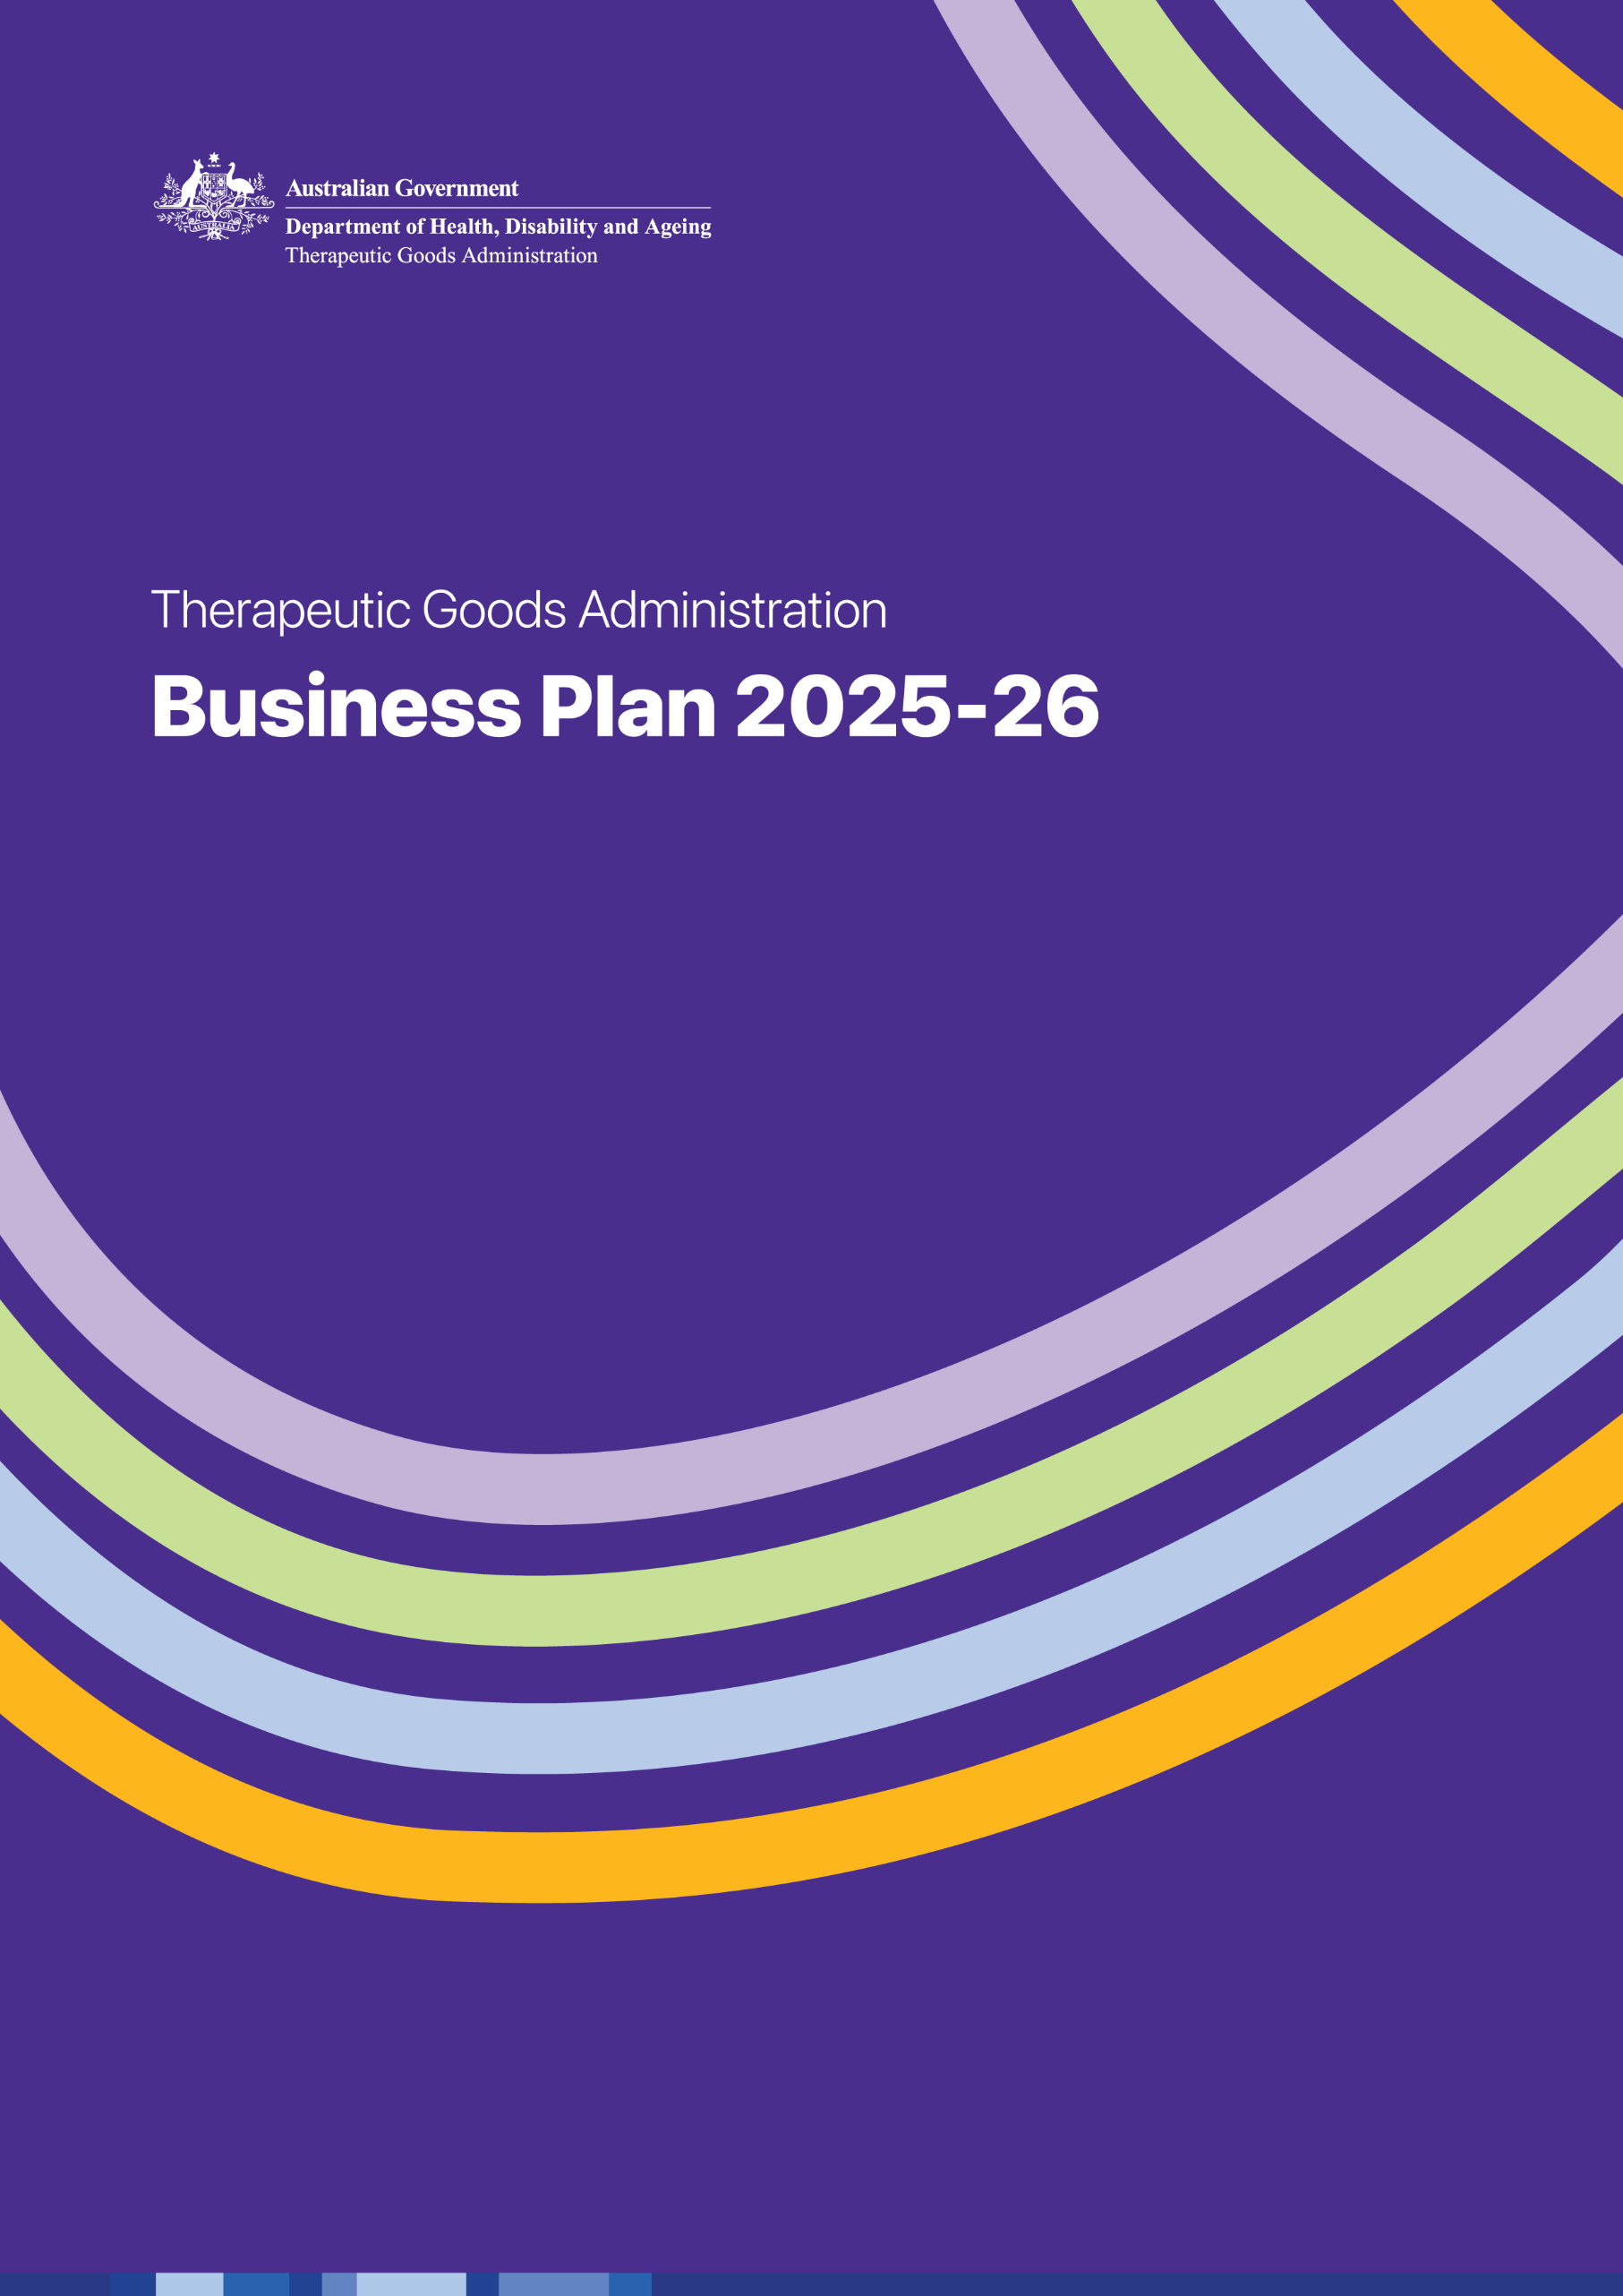


Acknowledgement of Country
The Therapeutic Goods Administration proudly acknowledges the Traditional Owners and Custodians of Country throughout Australia and pays respect to those who have preserved and cared for the lands on which we live, work, and benefit from each day.
We recognise the inherent strengths and knowledge Aboriginal and Torres Strait Islander peoples provide to the health and aged care system and thank them for their existing and ongoing contributions to the wider community. We extend this gratitude to all health and aged care workers who contribute to improving health and wellbeing outcomes with, and for, First Nations peoples and communities.
We also recognise and respect Aboriginal and Torres Strait Islander people’s continuing connections and relationships to the lands, waters, culture, and community, and pay respect to all Elders past and present.

Contents
Acknowledgement of Country 2
Message from the Deputy Secretary 4
Our Purpose and Strategic Intent 6
Our Strategic Objectives 7
Strategic Objective 1 – Improve public health outcomes through best practice regulation 8
Strategic Objective 2 – Build trust by actively engaging with our stakeholders 10
Strategic Objective 3 – Promote and enforce compliance with regulatory requirements 11
Strategic Objective 4 – Innovate and continuously improve 12
Reporting 13

Copyright
© Commonwealth of Australia 2025

With the exception of the Commonwealth Coat of Arms, the Department’s logo, any material protected by a trade mark and where otherwise noted all material presented in this document is provided under a Creative Commons Attribution 4.0 International licence.
The details of the relevant licence conditions are available on the Creative Commons website (accessible using the links provided) as is the full legal code for the CC BY 4.0 International.
This work is copyright. You may reproduce the whole or part of this work in unaltered form for your own personal use or, if you are part of an organisation, for internal use within your organisation, but only if you or your organisation do not use the reproduction for any commercial purpose and retain this copyright notice and all disclaimer notices as part of that reproduction. Apart from rights to use as permitted by the Copyright Act 1968 or allowed by this copyright notice, all other rights are reserved, and you are not allowed to reproduce the whole or any part of this work in any way (electronic or otherwise) without first being given specific written permission from the Commonwealth to do so. Requests and inquiries concerning reproduction and rights are to be sent to the TGA Copyright Officer, Therapeutic Goods Administration, PO Box 100, Woden ACT 2606 or emailed to tga.copyright@tga.gov.au.


Message from the Deputy Secretary

It is my pleasure to present the 2025-26 Business Plan for the Therapeutic Goods Administration (TGA), which lays out our strategic direction and key priorities for the coming 12 months. Our mission is to help protect and improve the health of Australians by regulating therapeutic goods to ensure their safety, efficacy, performance and quality. We aim to provide a rigorous but adaptable assessment framework that balances an appropriate focus on safety, with the need to facilitate Australians’ access to new and innovative treatments as soon as possible.
In 2025-26 we are implementing measures introduced by the Australian Government to bolster our ability to identify and act when there is a risk of patient harm or injury. This includes the establishment of the Australian Unique Device Identification (UDI) system for medical devices. The UDI system will improve the tracking of medical devices so that healthcare facilities, health professionals and patients can be notified earlier after a safety issue has been identified. The UDI system will be implemented over the next 5 years, starting with implanted medical devices from 2026.
Artificial intelligence (AI) presents increasing opportunities and challenges for therapeutic goods and their regulation. We are working closely with other government agencies to consider and respond to the impact of AI on our regulatory framework to ensure we can evolve our processes as required. We will also carefully consider how AI might support our administrative, evaluation and decision-making processes.
Our Academic Outreach Program and its accompanying Horizon Scanning Framework are helping to improve our responsiveness to emerging technologies. Through formal partnerships with academic institutions, including universities and National Health and Medical Research Council-accredited Research Translation Centres, we are sharing expertise on emerging medical technologies and innovations while raising the awareness of our regulatory role. A goal of this work is to ensure our regulatory processes remain flexible and responsive, enabling earlier access to emerging therapies. This work aligns with the outcomes of the health technology assessment (HTA) review.
While we actively monitor emerging medical technologies and innovations with the potential to improve the lives of Australians, we are equally focused on responding to products that may present a risk to the wellbeing of the public. Following the introduction of Australia’s historic vaping reforms in 2024, early evidence suggests that vaping rates among young Australians are already declining. Many of these vaping products have targeted young children and adolescents who have never used nicotine products, and their use can lead to serious health problems now and in the future. We remain focused on regulating the lawful supply chain for therapeutic vaping goods, while maintaining strong compliance and enforcement activities to deter and disrupt illegal activities, including unlawful import, advertising and supply.
It is an unfortunate reality that medicine shortages regularly affect health professionals, health services and Australian consumers. We are further improving how we monitor and mitigate the impact of medicine shortages and discontinuations through a range of initiatives including strengthened legislative frameworks, improved data collection and reporting, and close collaboration with therapeutic goods sponsors to better forecast demand and potential shortages.
As a respected regulatory authority both regionally and globally, the TGA continues to play a vital role in advancing international regulatory harmonisation and collaboration. We will continue to collaborate and cooperate with like-minded regulatory bodies for efficient and evidence-based regulation, including supporting capacity-building with our neighbors in the Indo-Pacific region.
As always, our work will be underpinned by a commitment to meaningful engagement with our stakeholders. Over the next 12 months, the TGA will focus on improving the ability of stakeholders to conduct business with us through the Health Business Service portal. This will enable more services to be delivered digitally, leading to greater efficiencies and transparency for both the TGA and our stakeholders. We are also undertaking a major project to review and improve the structure and navigation of our website, TGA.gov.au. This will make it easier for applicants, sponsors and everyday Australians to find the information they need about the regulation of therapeutic goods in Australia.
These efforts will strengthen our preparedness for future challenges and reinforce our commitment to continuous improvement. On behalf of the TGA, I thank our stakeholders and partners for your continued dedication and collaboration as we move forward together to build a robust and adaptive regulatory framework for therapeutic goods.
Professor Anthony Lawler
FACEM, FRACMA, MBBS, MBA (Health Mgmt), FIFEM, GAICD, BMedSci


Our Purpose and Strategic Intent
The TGA was established under the Therapeutic Goods Act 1989 (the Act) to regulate the safety, quality, performance and efficacy of therapeutic goods in a timely manner. By doing this, we help protect the health, safety and wellbeing of all Australians. Our work makes a critical contribution to the Health Protection, Emergency Response and Regulation program of the Australian Government Department of Health, Disability and Ageing (the department).
We regulate the manufacture, import, export, supply and advertising of prescription medicines, non-prescription medicines, vaccines, sunscreens and complementary medicines, including vitamins, minerals, and herbal and traditional medicines. We regulate medical devices, blood and blood products, cellular therapies, biologicals, and software used as a medical device, including AI where appropriate.

Under the Act we:
- apply scientific and clinical expertise to assess whether the benefits of a therapeutic good outweigh any risks to health and safety
- assess the suitability of therapeutic goods for supply, import and export from Australia
- regulate manufacturers of therapeutic goods to ensure they meet acceptable standards of manufacturing quality
- assess the quality and compliance of therapeutic goods on the market, including through laboratory testing where appropriate, and
- implement a range of regulatory actions that are proportionate to the potential risk arising from non-compliance or emerging safety concerns.
Our strategic focus is to enhance public health outcomes through best practice regulation, build trust through active stakeholder engagement, and foster innovation to address emerging regulatory challenges. We undertake our regulatory functions in alignment with the Resource Management Guide 128 (RMG 128) which promotes the following 3 principles for regulators:
- Continuous improvement and building trust- regulators adopt a whole-of-system perspective, continuously improving their performance, capability and culture to build trust and confidence in Australia’s regulatory settings.
- Risk based and data driven- regulators manage risks proportionately and maintain essential safeguards while minimising regulatory burden, leveraging data and digital technology to support those they regulate to comply and grow.
- Collaboration and engagement- regulators are transparent and responsive communicators, implementing regulations in a modern and collaborative way.


Our Strategic Objectives
Informed by internal and external stakeholder consultation and the 3 principles of best practice regulation, our strategic objectives are:
1 | Improve public health outcomes through best practice regulation
2 | Build trust by actively engaging with our stakeholders
3 | Promote and enforce compliance with regulatory requirements
4 | Innovate and continuously improve


Strategic Objective 1 – Improve public health outcomes through best practice regulation
We will balance the dual regulatory responsibilities of facilitating access to and ensuring the safety, quality, performance and efficacy of therapeutic goods.
Australia’s expertise in regulation is globally recognised. The safety of the Australian community will be maintained by our high standards of therapeutic goods regulation and our role in shaping and responding to world-wide best practices. We continue to implement regulatory reforms with a focus on simplifying pathways and processes for consumers, healthcare professionals and industry, while delivering efficient, best practice regulatory decisions.
Guiding Principles
1.1 | Ensure product approvals and regulatory assessments are delivered in accordance with both statutory timeframes and non-statutory targets, to maintain trust and reliability and to ensure timely access to innovative therapies and emerging technologies.
1.2 | Where appropriate, adapt regulatory approaches to facilitate expedited access to critical therapies and technologies in response to public health need.
1.3 | Propose and support the design of regulatory reforms based on evidence of value and benefit, or appropriate risk management, to ensure regulatory frameworks remain fit-for-purpose.
Our focus for 2025-26
1A | Conduct pre-market evaluations of therapeutic products and ingredients, and post-market safety and compliance monitoring of products and manufacturers in a manner consistent with best practice regulatory processes, leveraging technology such as AI where appropriate.
1B | Facilitate timely availability of safe, high-quality therapeutic goods by optimising regulatory pathways, reforming business processes, supporting applicants and sponsors in navigating regulatory requirements, and ensuring regulatory efficiency.
1C | Review and reform clinical trials regulation to provide clear guidance, streamlined processes and effective oversight.

1D | Monitor and mitigate the impact of medicine shortages and discontinuations and medical device supply disruptions to support continued patient access to important therapeutic goods.
1E | Review and reform regulatory frameworks for unapproved therapeutic goods, including exempt goods, closed-loop supply chains, compounding, and point-of-care manufacturing and distribution by authorised healthcare professionals, to facilitate safe, risk-based access while maintaining regulatory compliance.
1F | Modernise regulatory frameworks by integrating updated quality standards and streamlining therapeutic good testing regulations to enhance efficiency, flexibility and alignment with current scientific and industry standards.
1G | Continue the implementation of reforms to improve recall processes for all therapeutic goods, ensuring timely and effective action to mitigate public health risks.
1H | Identify and evaluate potential new uses for medicines through research and evidence, leveraging insights and lessons from the first tranche of the Medicines Repurposing Program.


Strategic Objective 2 – Build trust by actively engaging with our stakeholders
We will be open and responsive to feedback about our practices and regulatory decisions.
We engage regularly with our stakeholders, using a range of mechanisms with health practitioners, regulated entities and the public. Ongoing collaboration and engagement with experts and industry bodies has enabled us to build confidence and trust in our decision-making and the globally aligned regulatory framework in which we operate. It also ensures we are responsive to risk and the latest medical and scientific developments.
Guiding Principles
2.1 | Be responsive to enquiries and provide clear, timely explanations of our regulatory decisions, to build trust and transparency.
2.2 | Communicate effectively to empower health practitioners and industry with the information they need to understand and meet their regulatory obligations, and consumers to safely and effectively use therapeutic goods.
2.3 | Engage and collaborate proactively with stakeholders impacted by our regulatory activities, to ensure their perspectives are considered.
2.3 | Collaborate with domestic and international health system stakeholders to address regulatory issues and adapt to evolving policies, practices and services.
Our focus for 2025-26
2A | Enhance engagement and collaboration with domestic and international regulators, co-regulators, enforcement agencies and established networks to improve regulatory efficiency, harmonise practices, and proactively address compliance risks through a range of initiatives and fora such as the International Medical Device Regulators Forum (IMDRF), Medical Device Single Audit Program (MDSAP), the International Coalition of Medicine Regulatory Authorities (ICMRA), and the Access Consortium.
2B | Provide comprehensive education and public awareness programs about regulatory obligations and the safe use of therapeutic goods.
2C | Continue collaboration with regulatory bodies and health authorities within the Pacific and South-East Asian regions, primarily through the Regulatory Strengthening Program and the Pacific Medicines Testing Program.
2D | Transition our World Health Organization status from Stringent Regulatory Authority (SRA) to WHO-Listed Authority (WLA), which replaces SRA under WHO’s regulatory system strengthening framework.
2E | Improve the reporting and management processes for complaints made to the TGA.

Strategic Objective 3 – Promote and enforce compliance with regulatory requirements
We will encourage compliance, foster best practice, establish trust with the regulated community, and assist businesses and individuals to comply with the requirements of the law.
Information collected from risk and intelligence assessments, allegations we receive, and our monitoring activities will be used to identify trends in non-compliance, prioritise our activities and allocate resources proportionate to risk.
Guiding Principles
3.1 | Use data and intelligence to identify and manage non-compliance risks.
3.2 | Prioritise and address serious non-compliance through a risk-based approach.
3.3 | Ensure proportional assessment of and response to product safety, quality, efficacy and performance issues.
Our focus areas for 2025-26
3A | Implement enhancements to medical device and medicine adverse event reporting, including progressing the Medicine Adverse Event Data Exchange (MAEDX) Project, implementing mandatory reporting related to medical devices by healthcare facilities, and managing relevant programs.
3B | Promote and enforce compliance with regulatory requirements through targeted education initiatives including communication campaigns encouraging voluntary compliance and intelligence-informed risk-based enforcement activities.
3C | Implement and enforce vaping regulatory reforms through system development and risk-based compliance activities.

Strategic Objective 4 – Innovate and continuously improve
We will continuously improve our performance and make regulatory decisions in the context of their impact on the whole health system.
We will do this by building staff capability and sustaining a culture that identifies, develops and implements improved practices.
Guiding Principles
4.1 | Continuously improve services, processes and systems to ensure they are fit-for-purpose.
4.2 | Continue to grow an impartial, capable, flexible and innovative workforce.
Our focus areas for 2025-26
4A | Enhance the TGA’s capability to identify and effectively regulate emerging technologies across medicines and medical devices, including by implementing elements of the Regulatory Science Strategy.
4B | Progress digital transformation initiatives and continuously improve digital platforms and systems to provide a user-centred, modern service experience that supports stakeholder engagement and regulatory interactions whilst reducing risks of legacy systems.
4C | Improve the technology, systems and business processes of TGA laboratories.
4D | Enhance the TGA’s funding model to support sustainable funding arrangements for its cost-recovered and public good activities, ensuring those arrangements are consistent with the Australian Government Charging Framework and eliminate cross subsidisation.


Reporting
The TGA contributes to the department’s reporting obligations under the Public Governance, Performance and Accountability Act 2013 through the department’s Corporate Plan, Annual Report and Portfolio Budget Statements.
While this TGA Business Plan complements these documents, it can also be read as a stand-alone document. The corresponding TGA Performance Report will be published at the conclusion of the 2025-26 reporting period and will detail how we performed against the focus areas outlined above.
We will also continue to publish a range of performance information on the TGA website (www.tga.gov.au), including:
- laboratory testing results and summary reports,
- vaping product testing results
- monitoring, compliance and investigations outcomes
- advertising compliance reports
- post-market reviews
- annual stakeholder surveys, and

- publications detailing how we are improving access to therapeutic goods for consumers.

