Australian Public Assessment Report for ZILBRYSQ
  - Active ingredient: Zilucoplan
  - Sponsor: UCB Australia Pty Ltd
July 2025

About the Therapeutic Goods Administration (TGA)
- The Therapeutic Goods Administration (TGA) is part of the Australian Government Department of Health, Disability and Ageing and is responsible for regulating therapeutic goods, including medicines, medical devices, and biologicals.
- The TGA administers the Therapeutic Goods Act 1989 (the Act), applying a risk management approach designed to ensure therapeutic goods supplied in Australia meet acceptable standards of quality, safety, and efficacy.
- The work of the TGA is based on applying scientific and clinical expertise to decision-making, to ensure that the benefits to the Australian public outweigh any risks associated with the use of therapeutic goods.
- The TGA relies on the public, healthcare professionals and industry to report problems with therapeutic goods. The TGA investigates reports received to determine any necessary regulatory action.
- To report a problem with a therapeutic good, please see the information on the TGA website.

About AusPARs
- The Australian Public Assessment Report (AusPAR) provides information about the evaluation of a prescription medicine and the considerations that led the TGA to approve or not approve a prescription medicine submission. Further information can be found in Australian Public Assessment Report (AusPAR) guidance.
- AusPARs are prepared and published by the TGA.
- AusPARs are static documents that provide information that relates to a submission at a particular point in time. The publication of an AusPAR is an important part of the transparency of the TGA’s decision-making process.
- A new AusPAR may be provided to reflect changes to indications or major variations to a prescription medicine subject to evaluation by the TGA.

Copyright
© Commonwealth of Australia 2025
This work is copyright. You may reproduce the whole or part of this work in unaltered form for your own personal use or, if you are part of an organisation, for internal use within your organisation, but only if you or your organisation do not use the reproduction for any commercial purpose and retain this copyright notice and all disclaimer notices as part of that reproduction. Apart from rights to use as permitted by the Copyright Act 1968 or allowed by this copyright notice, all other rights are reserved and you are not allowed to reproduce the whole or any part of this work in any way (electronic or otherwise) without first being given specific written permission from the Commonwealth to do so. Requests and inquiries concerning reproduction and rights are to be sent to the TGA Copyright Officer, Therapeutic Goods Administration, PO Box 100, Woden ACT 2606 or emailed to <tga.copyright@tga.gov.au>.

Contents
List of abbreviations 4
ZILBRYSQ (zilucoplan) submission 6
Proposed indication 7
The condition 8
Current treatment options 8
Clinical rationale 8
Regulatory status 8
Registration timeline 9
Assessment overview 9
Quality evaluation summary 9
Nonclinical evaluation summary 11
Clinical evaluation summary 13
Pharmacology 13
Efficacy 19
Safety 27
Risk management plan evaluation summary 38
Risk-benefit analysis 39
Efficacy 39
Proposed indication 39
Safety 39
Deficiencies in the data 40
Risk-benefit-uncertainty assessment 40
Proposed action 41
Advisory Committee considerations 41
Assessment outcome 43
Specific conditions of registration 43
Product Information and Consumer Medicines Information 43

List of abbreviations
Abbreviation | Meaning
AChR | acetylcholine receptor
ACM | Advisory Committee on Medicines
ADAs | antidrug antibodies
AE | adverse event(s)
ARTG | Australian Register of Therapeutic Goods
ASA | Australia-specific annex
AUC₀₋₂₄ | area under the drug concentration-time curve from time 0 to 24 hours
AUC_{inf} | area under the concentration-time profile from time zero extrapolated to infinite time
AUC_{last} | area under the plasma concentration-time curve from time zero to the last measurable concentration
AUCτ | area under the drug concentration-time curve over the dosing interval (24h)
CL/F | apparent total body clearance after extravascular administration
C_{max} | maximum observed concentration
CI | confidence interval
CMI | Consumer Medicines Information
EAIR | exposure-adjusted incidence rate
ER | exposure ratio
gMG | generalised myasthenia gravis
MedDRA | Medical Dictionary for Regulatory Activities
MG | myasthenia gravis
MG-ADL | Myasthenia Gravis-Activities of Daily Living
MG-QOL15r | Myasthenia Gravis Quality of Life 15 item scale revised
MGC | Myasthenia Gravis Composite
OR | odds ratio
PD | pharmacodynamic(s)
PI | Product Information
PK | pharmacokinetic(s)
popPK | population pharmacokinetic(s)
PSUR | periodic safety update report
RMP | risk management plan
QMG | Quantitative Myasthenia Gravis
SAE | serious adverse event
sRBC | sheep red blood cell
t_{1/2} | apparent first-order terminal elimination half-life
TEAE | Treatment emergent adverse event
TGA | Therapeutic Goods Administration
t_{max} | time to maximum observed concentration
V_{Z}/F | apparent total volume of distribution at the terminal phase after extravascular administration

ZILBRYSQ (zilucoplan) submission
Type of submission: | New chemical entity
Product name: | ZILBRYSQ
Active ingredient: | zilucoplan
Decision: | Approved
Date of decision: | 31 July 2024
Approved therapeutic use for the current submission: | ZILBRYSQ is indicated as an add-on to standard therapy for the treatment of generalised myasthenia gravis (gMG) in adult patients who are anti-acetylcholine receptor (AChR) antibody positive.
Date of entry onto ARTG: | 20 August 2024
ARTG numbers: | ZILBRYSQ zilucoplan (as tetrasodium) 16.6 mg/ 0.416 mL solution for injection pre-filled syringe (410994)  ZILBRYSQ zilucoplan (as tetrasodium) 23.0 mg/ 0.574 mL solution for injection pre-filled syringe (414648)  ZILBRYSQ zilucoplan (as tetrasodium) 32.4 mg/ 0.810 mL solution for injection pre-filled syringe (414649)
Black Triangle Scheme | Yes
Sponsor’s name and address: | UCB Australia Pty Ltd T/A UCB Pharma Division of UCB Australia, Level 1, 1155 Malvern Road  Malvern VIC 3144
Dose form: | Solution for injection. Zilucoplan is a 15 amino acid, synthetic macrocyclic peptide.
Strength: | - A pre-filled syringe of 0.416 mL contains zilucoplan tetrasodium, equivalent to 16.6 mg of zilucoplan  - A pre-filled syringe of 0.574 mL contains zilucoplan tetrasodium, equivalent to 23.0 mg of zilucoplan  - A pre-filled syringe of 0.810 mL contains zilucoplan tetrasodium, equivalent to 32.4 mg of zilucoplan
Container: | Each pre-filled syringe is type I glass with a 29G ½” thin wall needle closed with a grey fluoropolymer-laminated bromobutyl rubber plunger stopper. The needle is protected with a rigid needle shield consisting of a thermoplastic elastomer needle shield and a polypropylene rigid shield. The pre-filled syringe components are not made with natural rubber latex.  Each pre-filled syringe is pre-assembled with a needle safety device, a finger grip and a coloured plunger.  The pre-filled syringes are available as 3 different presentations, with different volumes to allow patients to receive the appropriate dose based on a weight range:  - 0.416 mL pre-filled syringe with RUBINE RED plunger  - 0.574 mL pre-filled syringe with ORANGE plunger  - 0.810 mL pre-filled syringe with DARK BLUE plunger
Pack size: | 7 pre-filled syringes. Multipack contains 28 (4 packs of 7) pre-filled syringes.
Route of administration: | Subcutaneous injection
Dosage: | Approximately 0.3 mg/kg:  For further information regarding dosage, refer to the Product Information.
  Body Weight of Patient | Dose | Number of pre-filled syringes (PFS) (Colour)
  ≥43 to <56 kg | 16.6 mg | 1 RUBINE RED
  ≥56 to <77 kg | 23.0 mg | 1 ORANGE
  ≥77 to <150 kg | 32.4 mg | 1 DARK BLUE
Pregnancy category: | Category D  Drugs which have caused, are suspected to have caused or may be expected to cause, an increased incidence of human fetal malformations or irreversible damage. These drugs may also have adverse pharmacological effects.  The use of any medicine during pregnancy requires careful consideration of both risks and benefits by the treating health professional. The pregnancy database must not be used as the sole basis of decision making in the use of medicines during pregnancy. The TGA does not provide advice on the use of medicines in pregnancy for specific cases. More information is available from obstetric drug information services in your state or territory.

Proposed indication
This AusPAR describes the submission by UCB Australia Pty Ltd (the sponsor) to register ZILBRYSQ (zilucoplan) for the following proposed indication:
ZILBRYSQ is indicated for the treatment of generalised myasthenia gravis (gMG) in adult patients who are anti acetylcholine receptor (AChR) antibody positive.

The condition
Myasthenia gravis (MG) is an antibody and completement mediated autoimmune disease which affects the neuromuscular junction and leads to muscle weakness. In the most common form of MG antibodies to the acetylcholine receptor (AChR) are present.
The prevalence of MG globally is estimated at 12.4 per 100 000 persons. It most commonly affects women under 40 and men over 60. Affected muscles are confined to the ocular group in 15% and generalised in 85%.
Diagnosis is based on history and demonstration of muscle fatigability, together with autoantibodies (including anti-AChR) and characteristic electrophysiology findings. Symptoms may become life threatening when muscles of respiration are affected, resulting in a myasthenic crisis.
Immune complex formation and activation of the classical complement pathway degrades the post-synaptic neuromuscular junction, leading to manifestations of the disease. Terminal complement inhibition is a proven therapeutic pathway in MG.

Current treatment options
Treatments either augment acetylcholine function at the neuromuscular junction (i.e. through inhibition of acetylcholinesterase with pyridostigmine) or interrupt the immune processes underlying the disease. Treatment of myasthenic crisis includes supportive care in hospital, plasma exchange and intravenous immunoglobulin. Long term immunomodulation is usually required, and commonly used drugs include corticosteroids, azathioprine and mycophenolate.
A C5 inhibiting monoclonal antibody ravulizumab appears in the Australian Register of Therapeutic Goods (ARTG) for treatment of generalised MG in patients who are anti-AChR antibody positive. The indication wording is “as an add-on to standard therapy for the treatment of adult patients with generalised myasthenia gravis (gMG) who are anti-acetylcholine receptor (AChR) antibody-positive”.

Clinical rationale
Zilucoplan binds to complement protein C5 and inhibits its cleavage into C5a and C5b. In addition, specific binding to any C5b that forms, prevents it from interacting with C6 (i.e. C5b antagonism). Zilucoplan is a terminal complement inhibitor that prevents formation of the membrane attack complex. Zilucoplan targeting of C5 is shared with other drugs known to be efficacious in the treatment of MG (the monoclonal antibodies eculizumab and ravulizumab).

Regulatory status

Australian regulatory status
This product is a new chemical entity for Australian regulatory purposes.

International regulatory status
Zilucoplan was approved in the US in 2023 for:
“the treatment of generalized myasthenia gravis (gMG) in adult patients who are anti-acetylcholine receptor (AChR) antibody positive”.
Zilucoplan was approved in the EU in 2023 as:
“an add-on to standard therapy for the treatment of generalised myasthenia gravis (gMG) in adult patients who are anti-acetylcholine receptor (AChR) antibody positive”.

Registration timeline
Table 1 captures the key steps and dates for this submission.
This submission was evaluated under the standard prescription medicines registration process.
Table 1: Registration timeline for ZILBRYSQ (zilucoplan), submission PM-2023-02775-1-1
Description | Date
Submission dossier accepted and evaluation commenced | 31 July 2023
Evaluation completed | 30 April 2024
Advisory committee meeting | 7 June 2024
Registration decision (Outcome) | 31 July 2024
Registration in the ARTG completed | 20 August 2024
Number of working days from submission dossier acceptance to registration decision* | 255 days
*Statutory timeframe for standard submissions is 255 working days

Assessment overview

Quality evaluation summary
Zilucoplan is a 15-amino acid macrocyclic peptide with an amino ethylene glycol moiety (24 ethylene glycol subunits) and a palmitic acid moiety (Figure 1).
Figure 1. Structure of zilucoplan
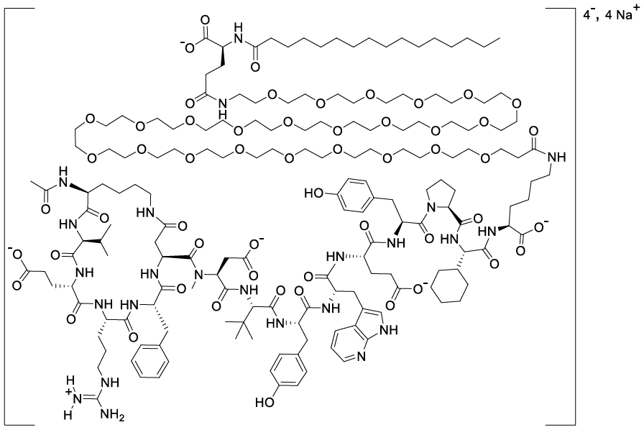
The proposed product is a sterile solution for injection packed in a single-use disposable prefilled syringe delivery device. The proposed pack sizes are 7 pre-filled syringes in a single pack and a multipack of 28 pre-filled syringes. The primary packaging is a 1mL long glass syringe fitted with a 29G 0.5 inch thin wall needle, fluoropolymer-laminated bromobutyl rubber plunge stopper, a thermoplastic elastomer rigid needle shield and a polypropylene rigid shield.
The drug substance is manufactured as zilucoplan tetrasodium and is a white to off-white powder that is very soluble in water at pH > 6.4. Manufacture involves several synthetic steps, starting with solid phase synthesis of the linear peptide followed by cyclization, cleavage from resin and purification. This product is conjugated to the PEG and lipid containing intermediate and purified, desalted, lyophilized and declumped to obtain the drug substance. Reprocessing may be undertaken.
Zilucoplan, its starting materials and manufacturing reagents have been assessed for genotoxic structures, which have been adequately managed according to ICH guidelines. There is no risk of nitrosamine formation during manufacturing. The quality of the drug substance is considered acceptable.
The drug product is formulated as an iso-osmotic buffered solution of monobasic sodium phosphate/dibasic sodium phosphate, sodium chloride and water for injection. This is contained within a single-use safety syringe. The formulation and manufacturing process has been adequately developed and optimised, and has accounted for osmolality, pH, viscosity, particulates and thermal stress.
The drug product does not contain any preservatives and each syringe is for single use. The manufacturing process includes sterile filtration and vial filling under aseptic conditions.
The safety syringe component, including extractable volume and function of the needle shield, is satisfactory.
The proposed shelf-life of 36 months when stored at 2-8 °C is appropriate for the product. An in-use shelf-life of 2 months when stored below 30 °C is appropriate for the product unless the sponsor tightens the release limit for total impurities (to NMT 2.5%), in which case a shelf-life of 3 months would be acceptable.

Nonclinical evaluation summary
The overall quality of the nonclinical dossier was acceptable.
In in vitro studies, the IC₅₀ for inhibition of complement-dependant haemolysis (5-10 nM) was similar to the clinical free plasma concentration (3.5-35 nM). Zilucoplan also inhibited C5 with variants known to confer resistance to eculizumab. Although the mechanism of its action is well understood, as is the role for complement in myasthenia gravis, no animal models for efficacy were presented.
In secondary pharmacology studies zilucoplan demonstrated antagonism of the orexin-1 receptor (IC₅₀ 44µM), CCK2 receptor (62% inhibition 30µM) and the GABA transporter (IC₅₀ 11 µM). RA102758 was an antagonist at CCK1 receptor (57.4% inhibition at 30 µM). No other off-target findings were noted and the relevant concentrations were much higher than the clinical concentration (i.e. unlikely to be of concern).
The cynomolgus monkey was a suitably sensitive animal species in terms of pharmacokinetics (PK), protein binding and actions on complement of zilucoplan.
Safety pharmacology studies in cynomolgus monkeys showed no adverse effects on CNS, cardiovascular or respiratory function at exposures of 5 – 6 times the clinical exposure for zilucoplan.
In vitro studies demonstrated that CYP 4F2 is mainly responsible for ω-hydroxylation of the palmitic acid moiety. The PEG moiety is expected to be excreted in the urine. The peptide-PEG bond undergoes hydrolysis, with the peptide component likely rapidly metabolised after formation. Mass balance studies indicated that the palmitic acid moiety (or metabolite or modification thereof) is mainly found in fat, with a smaller proportion excreted in the faeces.
In vitro studies were conducted to examine zilucoplan and metabolites as substrates and inhibitor/inducers of various CYPs, UGTs and transporters. As mentioned zilucoplan is a substrate for CYP4F2, however this is not expected to be clinically relevant. Zilucoplan did show inhibitory activity against the MRP3 transporter and the significance remains uncertain (not clinical studies subsequently conducted). The nonclinical Evaluator noted that EMA guidelines do not require specific investigation of this transporter. Overall zilucoplan and metabolites are predicted to have minimal effect on exposures to co-administered drugs that are subjects of major CYPs, UGTs and transporters.
Repeat dose toxicity studies were conducted in rats (4 weeks) and cynomolgus monkeys (4 weeks, 13 weeks, 39 weeks) with zilucoplan being given daily via the subcutaneous route. Whilst the rat was not considered a sensitive species, it can provide information about off-target effects (noting, however, that the rat study may be too short to capture some the toxicities).
Exposures significantly higher than the human clinical exposure were achieved in both species.
The major toxicities found in the 39 week monkey study involved epithelial tissues, pancreas, liver, thymus and uterus. The findings were reversible or showed a trend towards reversibility. The Sponsor claimed that many of these findings were related to opportunistic infection, however the nonclinical evaluator considered this less likely on the basis that such infections were not documented, a clear dose-response was evident (despite near complete complement inhibition at less than maximal doses) and similar findings have not been seen with other C5 inhibitors. Whether any of this toxicity is related to unnatural amino acids in the peptide moiety is unknown.
- Epithelial tissues – mainly seen in the 39 week monkey study, findings included vesicular degeneration of the tongue, female genital tract (cervix, which also involved metaplasia, vagina) and skin. These were seen at exposures similar to approximately 2-fold higher than the human exposure. Two animals at the highest dose (exposure ratio [ER] for AUC = 7) were terminated prematurely due to the severity of skin erosions and ulcerations.
- Inflammatory infiltrates – seen in multiple organs including the pancreas, kidney, tongue, gallbladder, parathyroid gland, uterus, lung, oesophagus, salivary gland, thyroid, rectum, ileum, stomach and urinary bladder (ER for AUC = 0.4). Dose dependant increases in severity were observed. Increased cellularity was seen in the thymus.
- Pancreas – pancreatic acinar cell degeneration with fibrosis/fibroplasia and elevated lipase/amylase was seen in some monkeys (ER for AUC = 2.1) in the 39 week study. In the 13 week monkey study one animal had clear pancreatitis (ER for AUC = 13). In the shorter term studies, related biochemical changes were consistently seen. The module 4 evaluator notes that from a nonclinical perspective zilucoplan is implicated as a cause of pancreatitis and that this is reflected in the US label (but not the proposed Australian PI).
- Liver – in the high dose group in the 13 week monkey study all animals had elevated liver enzymes, although consistent histopathological findings were not seen.
- Uterus – endometrial degeneration was seen (ER for AUC = 1.1). At a higher exposure (ER for AUC = 7) the severity was marked, with loss of glandular mucosal structure and mononuclear infiltrates.
Injection site reactions were more severe with formulations containing higher zilucoplan concentrations.
Genotoxicity – the AMES test and in vivo study (rat micronucleus) - were negative. The in vitro clastogenicity study using human lymphocytes found an equivocal result due to a dose-response being observed despite all values being within the historical control range. The nonclinical evaluator considered that, in this situation, the in vivo results should override the in vitro findings. The genotoxicity of the unnatural amino acids found in zilucoplan was only tested in silico and no alerts were present.
Carcinogenicity – no rodent carcinogenicity studies were conducted due to that specie’s lack of on-target relevance. The Sponsor believes that the overall weight of evidence (i.e. pre-clinical and clinical data, as well as understanding from other C5 inhibitors) is consistent with a low concern for carcinogenic potential.
Reproductive and developmental toxicity – male fertility and enhanced pre- and postnatal studies were conducted at concentrations similar to and up to 8 times the expected human exposures.
In the male fertility study minimal to slight unilateral or bilateral testicular germ cell depletion / degeneration was observed at all doses and did not recover after 8 weeks off treatment. The Sponsor argued this was consistent with background observations in the species, but it was noted that such findings were not seen in concurrent controls. Some problems with the study were documented (sperm number and quality not examined and some males in the study may have not reached sexual maturity). This toxicology finding is referenced in the EU and US product labels.
No specific female fertility studies were conducted. Endometrial degeneration was noted in the above described toxicology studies.
Placental transfer was minimal using an ex vivo model.
In the enhanced pre and postnatal development study, there was an increase in embryo-fetal death in all treatment groups and was higher than concurrent controls and historical data (based on being in categories of “can occur” and “unusual”). A relationship with treatment should be assumed according to the nonclinical evaluator. There were no effects on stillbirth or infant loss. No treatment related effects were noted in offspring (including on malformations, neuromuscular function, organ gross pathology, haematology and clinical chemistry).
The nonclinical evaluator has proposed a pregnancy category of D.
There were no objections to registration from a nonclinical perspective.

Clinical evaluation summary

Pharmacology

Pharmacokinetics
In the PK studies, zilucoplan was measured along with 2 major plasma metabolites (RA102758 which is inactive and RA103488 which is active). From in vitro summaries it is known that zilucoplan is stable in human plasma. Hydrolysis appears to be the predominant metabolic pathway. Formation of the active metabolite RA103488 is by the omega-oxidation of zilucoplan, mainly by CYP4F2. In vitro evaluations of zilucoplan or RA102758 to affect various CYPs, UGTs and transporters suggest interactions are unlikely (where zilucoplan or metabolite act as “perpetrators”). Zilucoplan is not a substrate of major CYPs, Pgp, BCRP, OATP1B1 or OATP1B3. It is highly bound to plasma proteins (unbound fraction < 1% for the parent and metabolites).
The qualitative and quantitative composition of the formulation used during the clinical studies described below has remained unchanged.
Study UP0112 was a phase 1 single ascending and multiple ascending dose study in healthy volunteers. Single doses were 0.05, 0.1, 0.2 and 0.4mg/kg. The only multiple dose studied was 0.2mg/kg. Following single doses (Table 2), C_{max} increase was approximately dose proportional whereas AUClast was less than dose proportional. Clearance increased with increasing dose and the volume of distribution ranged from 62mL/kg to 105 mL/kg (i.e. small volume of distribution). Half life ranged from 155.6h to 185.4h. Following 7 days of dosing (Figure 2) the accumulation index (for both AUC_{τ} and C_{max}) was approximately 3. Whilst the half life would suggest that steady state would not be reached by 7 days, the concentration appeared to be plateauing. Of note, the volume of distribution increased substantially following multiple doses (312 mL/kg).
Table 2. Summary PK parameters following single doses in UP0112
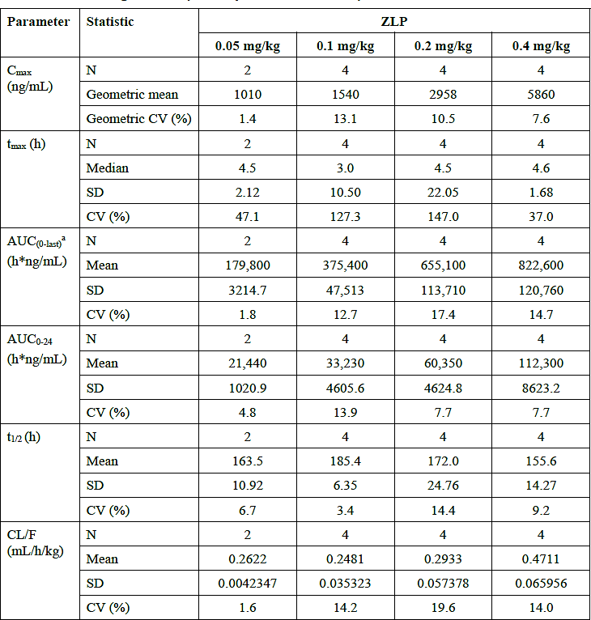
Figure 2. Semi-log mean zilucoplan (RA101405) concentration over time following 0.2mg/kg/day for 7 days (study UP0112)
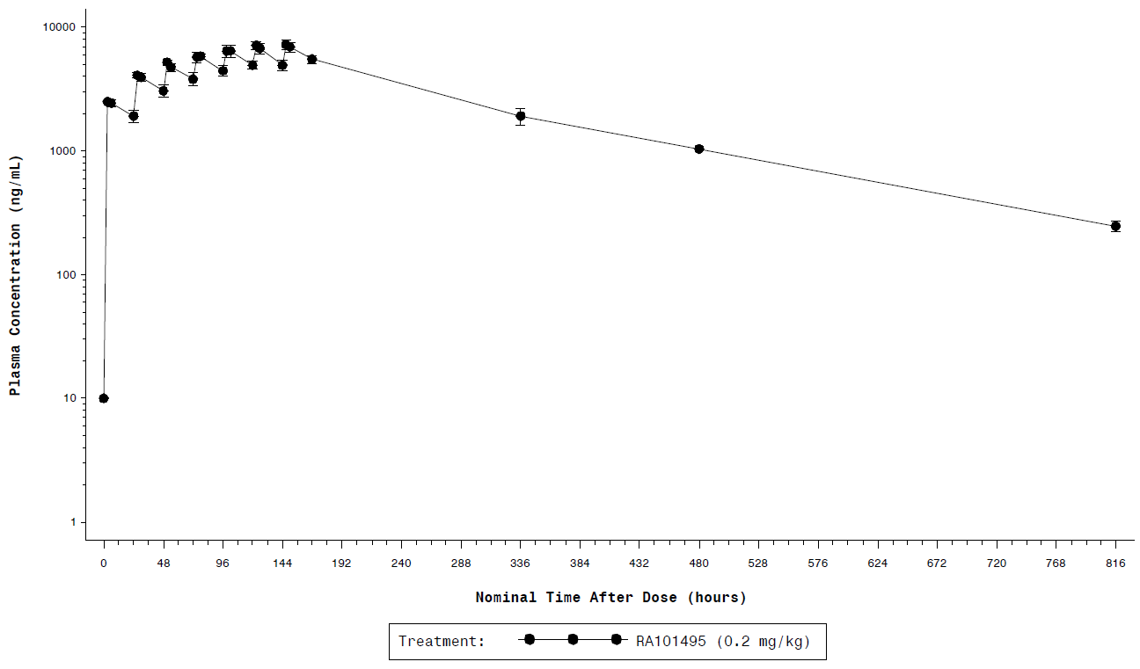
Error bars represent the SD.
Following 7 days of dosing, the active metabolite RA103488 was present at 16% of zilucoplan concentration and the inactive metabolite at 12% (these values do not appear to be corrected for molecular weight, however RA103488 has a very similar MW to zilucoplan). The kinetics of zilucoplan and the metabolites appeared to be similar.
Study UP0113 was a phase 1 safety and tolerability study in healthy Japanese and healthy Caucasian participants. Single dose levels were 0.1 and 0.3mg/kg and multiple doses were dosed at 0.3mg/kg/day. Following single doses, the geometric mean ratios for AUC were 114- 126% consistent with slightly higher exposure to zilucoplan in Japanese participants. Exposure to the active metabolite RA103488 was lower (mean ratios for AUC 70-84%) in Japanese participants. Following multiple doses, the AUC_{τ} geometric main ratio was 108% for zilucoplan and 78% for RA103488. Overall, exposures were similar in Caucasian and Japanese participants.
UP0094 was a phase 1 study of a single 0.3mg/kg dose of zilucoplan in participants with normal hepatic function and moderate hepatic impairment. Eight participants with moderate impairment (Child-Pugh 7-9) and eight with normal function were enrolled. Zilucoplan AUC geometric least squares mean ratio was 0.76 (90% CI 0.65-0.88) with hepatic impairment compared to normal hepatic function. Zilucoplan clearance mean ratio was 1.32 (90% CI 1.13- 1.55) consistent with slightly higher clearance with moderate hepatic impairment. Faecal excretion of zilucoplan and the active metabolite were assessed and found to be below the level of quantification.
Study UP0114 was a phase 1 study of a single 0.3mg/kg dose of zilucoplan in participants with normal renal function and severe renal impairment (8 participants in each group). The geometric least squares mean ratios comparing severe renal impairment and normal renal function were 0.87 for AUC_{last} and 0.93 for C_{max} (zilucoplan) and 1.48 for AUC_{last} and 1.47 for C_{max} (RA103488). Zilucoplan, RA103488 and RA102758 were minimally renally excreted in both the normal and severe renal impairment groups.
Study UP0115 evaluated the relative bioavailability of a single injection of zilucoplan at different administration sites. Three body sites were studied: abdomen (reference), thigh and upper arm (test sites). The ratios of exposure between the test sites and the abdomen and their 90% confidence intervals were consistent with bioequivalence (i.e. no effect of administration site).

Population pharmacokinetics
A population PK (popPK) analysis was performed using data from UP0112, UP0113, UP0114, UP0093, MG0009, MG0010. The final model was a 2-compartment model with first order absorption, followed by a target-mediated exposure enhancement model (without incorporating the C5 concentration). The model was implemented using the quasi-steady-state approximation to the target-mediated drug disposition equations and using only total zilucoplan concentrations.
Estimated allometric coefficients were used to describe the effect of body weight on several PK parameters (clearance, intercompartmental clearance, central volume of distribution, peripheral volume of distribution). Other potential covariates investigated included age at baseline, sex, race and population (healthy vs. subjects with gMG). None of these covariates were found to significantly influence clearance or R_{max} (maximum target density) and were therefore not included in the final model.
The model was evaluated using goodness of fit plots and visual predictive checks (i.e. to confirm the model described the observed zilucoplan concentrations) and was adequate.
The popPK model was used to explore the expected zilucoplan exposures within the three weight categories that determine the recommended daily dose. The distribution also gives information about the expected exposures for different weights within a particular weight category. The model expects exposures that are quite similar within the weight categories 43kg to<56kg and 56kg to<77kg (Figure 3). The weight category 77kg to <150kg has the broadest range of weights and as expected, those with the lower weights have a higher exposure than those with the highest weights. The model predicts steady state AUC for a patient weighing 150kg to have a minimum value of around 230 h*ng/mL.
Figure 3. Distribution of steady state AUC by weight using the final popPK model
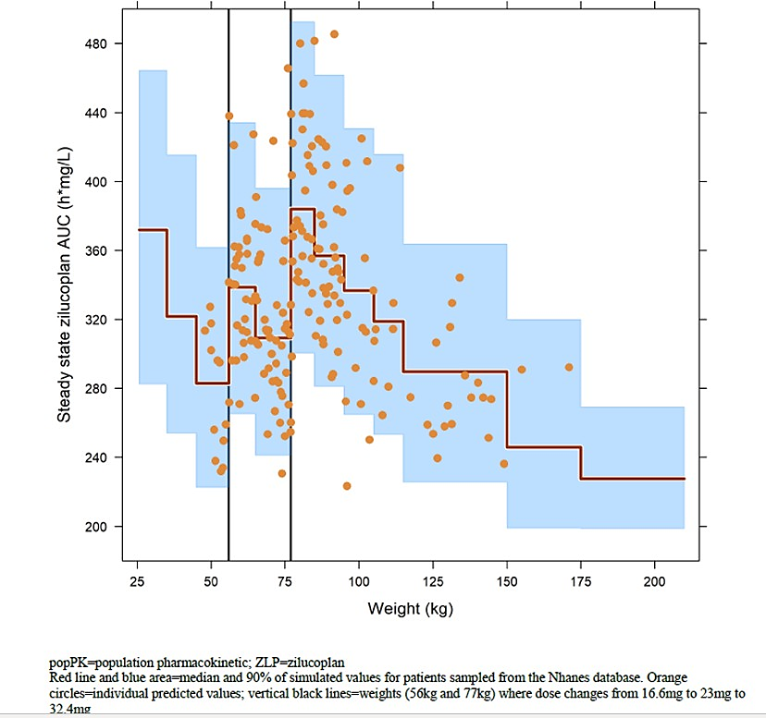
popPK=population pharmacokinetic; ZLP=zilucoplan
Red line and blue area=median and 90% of simulated values for patients sampled from the Nhanes database. Orange circles=individual predicted values; vertical black line=weights (56kg and 77kg) where dose changes from 16.6mg to 23mg to 32.4mg.

Pharmacodynamics
During the zilucoplan clinical development program, basic pharmacodynamic evaluation was achieved through measurement of sRBC (sheep red blood cell) lysis activity, CH₅₀ (inhibition of 50% of lysis) and MAC production (via ELISA assay). sRBC lysis is considered sensitive and also highly relevant to the classical complement pathway and myasthenia gravis pathogenesis.
Following single doses of zilucoplan in healthy participants in UP0112, sRBC lysis inhibition > 90% was achieved with all doses ≥ 0.1mg/kg and then recovered over subsequent days (Figure 4).
Figure 4. Mean sRBC lysis over time following single injection of zilucoplan (study UP0112)
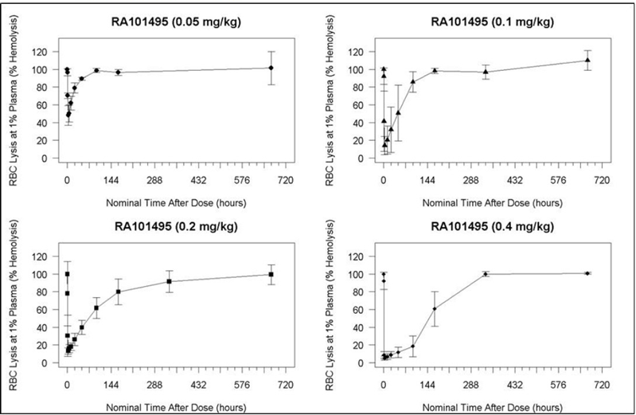
BLQ=below the limit of quantification; CSR=clinical study report; PK=pharmacokinetic: RA101495=zilucoplan; SC=subcutaneous; SD=standard deviation; sRBC=sheep red blood cell: ZLP-zilucoplan
Note: Error bars represent the SD. BLQ values set to zero for the calculation of summary statistics.
Seven days of dosing results in sustained inhibition of sRBC lysis. The recovery time after multiple doses appears considerably longer than after a single dose. The 0.3mg/kg/day dose was considered to provide rapid (i.e. day 1) and sustained near complete inhibition of complement. As described below, study MG0009 also provided some support for 0.3mg/kg/day being a potentially more efficacious dose than 0.1mg/kg/day, hence its selection for the pivotal study.
Moderate hepatic impairment did not have a significant influence on the PD of zilucoplan (as measured by sRBC lysis). Severe renal impairment did not have a significant influence on the PD of zilucoplan (as measured by change in C5 concentration).
Study UP0093 was a phase 1 study of the effects of a supratherapeutic zilucoplan dose (0.6mg/kg/day for 7 days) on cardiac repolarisation in healthy adults. This study had a nested crossover design and moxifloxacin was used as a positive control. The day 7 mean Cmax was 23 940 ng/mL and mean AUC_{τ} was 459 100 h X ng/mL (this exposure was approximately 3-fold higher than that seen with 0.2mg/kg/day on day 7). Modelling of zilucoplan exposure vs. change in QTcF is, together with the 90% confidence interval is shown in Figure 5. Zilucoplan did not have a meaningful effect on QTcF across the concentrations studied. An effect on QTcF exceeding 10ms can also be excluded. Moxifloxacin demonstrated adequate assay sensitivity.
Figure 5. Model-predicted change in QTcF and estimated change in QTcF across deciles of plasma concentration.
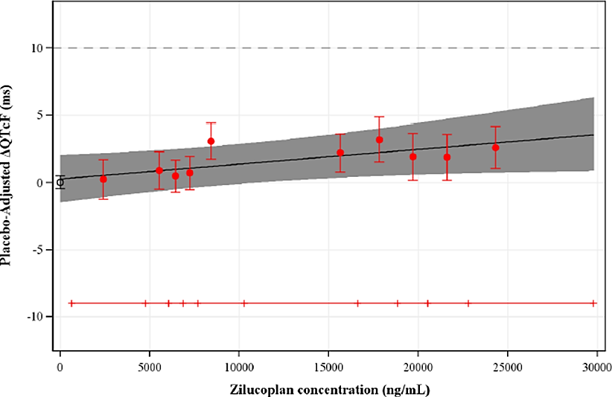
The time course for clinically relevant PD effects (e.g. improvement in MG-ADL score) is readily observable in the efficacy studies described below.

Efficacy
The scales used as major endpoints in the efficacy studies were as follows:
- MG-ADL (Myasthenia Gravis-Activities of Daily Living) – 8 item patient-reported outcome designed to evaluate symptom severity. It reflects ocular function (2 questions), oropharyngeal function (3 questions), respiratory function (1 question) and extremity function (2 questions), with scores assigned as either none, mild, moderate or severe (0-3). The total MG-ADL score is out of 24 and a 2 point change is considered clinically meaningful.
- MGC (Myasthenia Gravis Composite) – 10 item scale to measure clinical status of patients (3 ocular, 3 bulbar, 1 respiratory, 1 neck and 2 limb items). The total score is out of 50 and a 3 point change is considered clinically meaningful.
- MG-QOL15r (Myasthenia Gravis Quality of Life 15 item scale revised) – a 15 item self- administered scale to assess quality of life in patients with MG. The total score ranges from 0 to 30, with higher scores representing a worse quality of life.
- QMG (Quantitative Myasthenia Gravis) - strength scoring system based on 13 items and includes ocular, bulbar, respiratory and limb function. With each item scored 0-3, the total score is out of 39 (higher scores reflects more severe weakness). A 3 point change in QMG is considered significant.
Study MG0010 was a randomised, double-blind, placebo-controlled study comparing the efficacy and safety of subcutaneous zilucoplan 0.3mg/kg/day and placebo in subjects with gMG over 12 weeks. The study was conducted in multiple countries including Japan, France, Germany, Italy, Norway, Poland, Spain, United Kingdom, Canada and the United States.
The primary endpoint was the change from baseline in MG-ADL at week 12. The key secondary endpoints were QMG, MGC and MG-QOL. Other secondary endpoints are shown in Table 3. The secondary objective of the MG0010 was to confirm safety and tolerability and exploratory objectives included assessment of PK, PD, additional efficacy endpoints, antidrug antibodies (ADAs) and biomarkers.
Table 3. Endpoints in studies MG0009 and MG0010
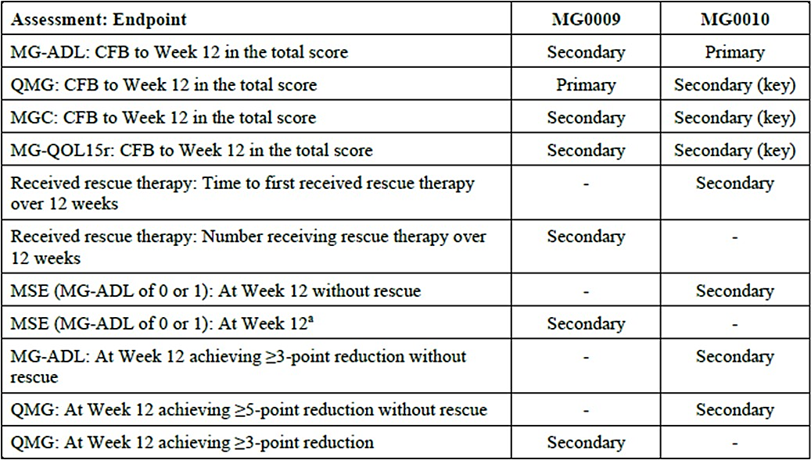
CFB=change from Baseline; MG-ADL=Myasthenia Gravis-Activities of Daily Living; MGC=Myasthenia Gravis Composite; MG-QOL15r=Myasthenia Gravis Quality of Life 15-item scale revised; MSE=Minimal Symptom Expression; QMG=Quantitative Myasthenia Gravis; SAP=Statistical Analysis Plan. ªThis endpoint was defined in the SAP before database lock.
The exploratory endpoints were (note that the first of these endpoints is akin to clinical remission):
- Achievement of Minimal Manifestation Status per Myasthenia Gravis Foundation of America (MGFA) Post-Intervention Status (MGFA-PIS) at Week 12 without rescue therapy
- Change from Baseline to Week 12 in Work Productivity and Activity Impairment Questionnaire: Specific Health Problem (WPAI:SHP)
- Change from Baseline to Week 12 in EQ-5D five levels (EQ-5D-5L) (5-item questionnaire and visual analogue scale [VAS])
- Change from Baseline to Week 12 in QMG subscores: ocular, bulbar, respiratory, limb
- Change from Baseline to Week 12 in Quality of Life in Neurological Disorders (Neuro- QOL) Short Form fatigue scale
- Responder analysis for changes in QMG, MG-ADL, MG-QOL15r, and MGC scores from Baseline without rescue therapy
- Change from Baseline to Week 12 in subscores (ocular, bulbar, respiratory, and limb/axial) of the QMG, MG-ADL, MG-QOL15r, and MGC scores.
Major inclusion criteria included being 18 to <75 years of age, a diagnosis of gMG, with Myasthenia Gravis Foundation of American severity class II-IV (i.e. mild, moderate or severe weakness affecting non-ocular muscles +/- ocular involvement, but without intubation) and positive for anti-AChR antibodies. In addition, subjects were required to have scores for MG- ADL ≥ 6, QMG ≥ 12 and ≥ 4 QMG tests items scoring ≥2. Corticosteroid and immunosuppressive therapy must have been stable for at least 30 days prior to baseline (or anticipated to occur during the 12 week treatment period). Vaccination against Neisseria meningitidis was required (quadrivalent and, where available, serotype B). Major exclusion criteria included thymectomy within 12 months or scheduled for the 12 week treatment period, abnormal thyroid function, positive serology for muscle-specific kinase, history of meningococcal disease, rituximab within 12 months, IVIG or plasma exchange with 4 weeks and active malignancy.
The dose of 0.3mg/kg/day was administered as a discrete dose according to 3 weight categories (Table 4) and reflects the proposed dosing in the PI. Subjects were randomised 1:1 to either zilucoplan or placebo.
Table 4. Weight-based dosing
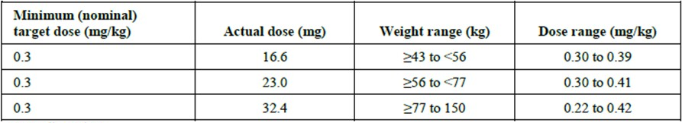
In case of deterioration in symptoms during the study, rescue therapy was to be with IVIG or plasma exchange.
There were eight different analysis populations, with the key ones being the randomised set, modified intention to treat set (i.e. received at least 1 dose and had at least 1 post-dose MG-ADL score), per protocol set (i.e. completed the 12 week treatment and had no important protocol deviations) and safety set.
In terms of statistical methods, the primary endpoint was assessed using a mixed model repeated measure analysis of covariance. Missing or censored data were imputed using baseline or last available, whichever was worse following use of rescue therapy, death or myasthenic crisis. Multiplicity was accounted for with a hierarchical approach for primary and key secondary endpoints. A more complex approach to accounting for multiplicity of other secondary endpoints is described in more detail in the Clinical Evaluation Report. In order to detect at least a 2.3 point least squares mean difference between baseline and week 12 MG-ADL score, with a 2-sided alpha of 0.05 and power 94%, at least 156 subjects would be required.
In total 174 subjects were randomised (86 to zilucoplan and 88 to placebo) and 95.4% completed the study (similar in each group). Reasons for discontinuation included withdrawal by participant (zilucoplan: 1; placebo: 2), death (1 in each group), adverse events (zilucoplan: 2) and physician decision (placebo: 1).
“Important” protocol violations affected 65 of 174 subjects. Some of these were related to the COVID19 pandemic (e.g. failure to attend visit). A few were related to violations of entry criteria and exposure to prohibited concomitant medications.
The mean age of subjects was 53 years; mean weight was 89.1kg and mean BMI was 31 kg/m2 and these were balanced between the groups. More than a quarter (27.6%) of subjects were ≥ 65 years of age. There were slightly more females in the zilucoplan group compared to placebo (60.5% vs. 53.4%). Subjects were white (73.6%), Asian (12.1%) or black (7.5%). In terms of baseline disease characteristics, MG-ADL scores were 10.9 and 10.3 and QMG scores were 19.4 and 18.7, in the placebo and zilucoplan arms respectively. In terms of prior treatment (started prior to start of study, but ongoing at that time), 68.4% received steroids, 42% azathioprine or mycophenolate, 13.2% IVIG and 85.6% cholinesterase inhibitors.
The LS mean change from baseline MG-ADL at week 12, was -4.39 in the zilucoplan arm and - 2.30 in the placebo arm (mITT population). The treatment effect was estimated to be an LS mean difference of -2.09 (p<0.001; 95% confidence interval: -3.24 to -0.95). A separation in the study arms can be seen within the first 2 weeks of the study (Figure 6). Sensitivity analyses (COVID free set, per protocol set) were consistent with the primary outcome.
Figure 6. LS mean change from baseline to week 12 in MG-ADL score
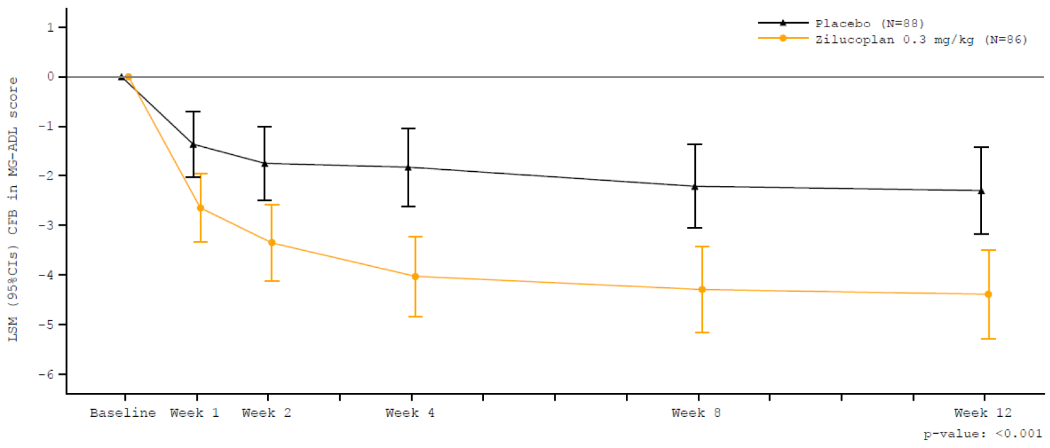
ANCOVA=analysis of covariance; CFB=change from Baseline; CI=confidence interval; LSM=least squares mean;
MG-ADL=Myasthenia Gravis Activities of Daily Living; mITT=modified Intent-to-Treat; MMRM=mixed model repeated measure; QMG=quantitative myasthenia gravis
Note: The MG-ADL total score ranged from 0 to 24; higher score indicated more severe disability. A decrease from Baseline indicated improvement.
Note: Week 12 p-value was derived by a MMRM ANCOVA model (based on imputed data following to treatment failure) using an unstructured correlation matrix with treatment, Baseline MG-ADL score, Baseline QMG score, region (North America, Europe, and East Asia) and interactions terms treatment-by-visit and Baseline MG-ADL score-by-visit as fixed effects; study participants were added as random effects in the model.
Positive results were also seen for the key secondary endpoints. For the QMG score, the LS mean difference in the change from baseline at week 12 between the two arms was -2.94 (p<0.001).
This is just short of the 3 point change considered clinically meaningful. For the MGC score, the LS mean difference in the change from baseline between the two arms was -3.20 (p=0.0023). This difference is considered clinically meaningful. For MG-QOL15r, the LS mean difference in the change from baseline between the two arms was -2.49 (p=0.0128). Improvements in the key secondary endpoints were evident as early as 2 – 4 weeks.
Other secondary and exploratory endpoints also generally favoured the zilucoplan arm. Of note, in the zilucoplan arm compared to the placebo arm, there was nominally greater pharmacological remission (2.6% vs. 0%) and minimal manifestations (28.2% vs. 19.3%).
Responder analysis looked at the odds ratio (OR) for achieving defined reductions or absolute scores by 12 weeks, as follows:
- OR for being a MG-ADL responder (≥3 point reduction in MG-ADL score without rescue therapy) was 3.184 (95% CI: 1.662-6.101).
- OR for being a QMG responder (≥5 point reduction in QMG score without rescue therapy) was 2.865 (95% CI: 1.518-5.409).
- OR for achieving MG-ADL of 0 or 1 (i.e. minimal symptom expression) was 2.608 (95% CI crosses 1, i.e. non-significant).
Table 5 shows the % responders with zilucoplan and placebo for each of the definitions above.
Table 5. week 12 responder analysis (mITT)
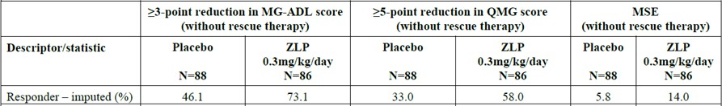
Subgroup analysis of the primary efficacy endpoint (i.e., difference in week 12 MG-ADL score compared to baseline) showed nominally superior efficacy with zilucoplan for multiple subgroups. This is consistent with efficacy being driven by activity across a broad range of patients (disease severity, age, ethnicity, prior treatments).
Study MG0009 was a phase 2, randomised, double-blind, placebo-controlled study comparing zilucoplan 0.1mg/kg/day, zilucoplan 0.3mg/kg/day and placebo. It enrolled 45 subjects and provides supportive evidence for the efficacy of zilucoplan, as well as the proposed clinical dose. Subjects with seropositive gMG were randomised 1:1:1 to the aforementioned treatments.
Inclusion and exclusion criteria were similar, though not the same, as study MG0010. After the 12 week primary treatment period, subjects could continue in an extension portion (placebo subjects were randomised to one of the 2 doses of zilucoplan, though at some point during the extension and following protocol emendation, everyone was treated with 0.3mg/kg/day).
The primary efficacy outcome was the change from baseline to week 12 in the QMG score. Secondary efficacy variables were:
- Change from Baseline to Week 12 in the MG-ADL score
- Change from Baseline to Week 12 in the MG-Quality of Life 15r (MG-QOL15r) score
- Change from Baseline to Week 12 in the MG Composite (MGC) score
- Study participants with ≥3-point reduction in QMG score at Week 12
- Study participants who required rescue therapy over the 12-week Treatment Period
The main analysis population was the modified ITT population (randomised subjects who received at least one dose). The zilucoplan arms were compared with placebo based on the ANCOVA model at a 1 sided 0.10 significance level (i.e. less stringent than the typical significance level). The secondary efficacy variables were analysed for significance, although there was no correction for multiplicity.
In total 45 subjects (15 in each treatment group) were randomised and 95.6% completed the main portion. Two subjects in the 0.3mg/kg/day arm discontinued during the main portion (due to loss to follow up and “other”). One subjects did not receive any treatment and the mITT therefore had 44 subjects in it.
Overall, there were slightly more females in the study, but the proportions were different across treatment arms (e.g. 73.3% were female in the placebo arm, 53.5% in the 0.1mg/kg/day arm and 33.3% in the 0.3mg/kg/day arm). Most subjects were white (80%) and the average age was 49.5 years (range 20 to 76). Mean weight was 96.31kg and mean BMI was 33.157. Mean weight was lower in the placebo group compared with the 0.1mg/kg/day and 0.3mg/kg/day groups (85.27kg, 93.71kg , 110.94kg, respectively). Mean baseline MG-ADL score was 7.8 and mean baseline QMG was 18.8. Nearly all patients had received some sort of immune modulating treatments.
In terms of the primary efficacy outcome, at week 12 the LS mean difference in QMG score change between placebo and 0.1mg/kg/day was -2.3 (1-sided p=0.0941), between placebo and 0.3mg/kg/day was -2.8 (1-sided p=0.0538) and between placebo and pooled zilucoplan was - 2.5 (1-sided p=0.0444). These results were statistically significant according to the pre-specified significance level and less than the 3 point change usually considered clinically meaningful for QMG. Although this study did not meet usual criteria for statistical significance it is consistent with the effect seen in the pivotal phase 3 study.
In terms of the most relevant secondary efficacy outcomes, the mean difference in week 12 MG- ADL score change between placebo and pooled zilucoplan was -2.3 (1-sided p=0.0233). In terms of potential differences between the 0.1mg/kg/day and 0.3mg/kg/day doses (i.e. dose effect), although not formally compared, there appeared to be both a more rapid and a greater magnitude response for QMG and other outcome measures. Three placebo subjects, 1 subject receiving 0.1mg/kg/day and none receiving 0.3mg/kg/day required rescue therapy.
Interpretation of the extension data is somewhat difficult as subjects received a range of treatments at various times (i.e. combinations were placebo/0.1mg, placebo/0.3mg, placebo/0.1mg/0.3mg, 0.1mg/0.3mg, 0.3mg) with placebo control ending after week 12. What appears to be apparent is that effect is probably maintained beyond week 12 (and there is possibly ongoing improvement beyond 12 weeks).
Study MG0011 is an ongoing open-label study providing long-term zilucoplan treatment to subjects who completed either MG0009 or MG0010. All subjects receive 0.3mg/kg/day and are required to be vaccinated against meningococcal infection. The primary objective is to evaluate long-term safety and tolerability and the secondary objective is to evaluate long-term efficacy. It is being conducted at 70 sites in North America, Europe and Japan. The data cut-off date for inclusion in this submission (PM-2023-02775-1-1) was 18 February 2022.
The main efficacy endpoints are the change from Baseline to Extension Week 12 (E12) in the MG-ADL score, QMG score, MGC score, MG-QOL15r score and the use of rescue therapy. Given that MG0009 had its own extension portion, subject data from the first 12 weeks of the extension portion are reported as part of MG0011 for the corresponding endpoints.
At the time of data cut-off, 199 subjects had enrolled in MG0011 (165 from MG0010 and 34 from MG0009) and 158 had completed up to E12. Most subjects remained in the study for ongoing treatment with zilucoplan.
A small number of subjects received 0.1mg/kg for a variable period of time (during first 12 weeks of MG0009 and for a period of time during the extension portion) before switching to 0.3mg/kg/day. Most subjects, however, received the clinical dose of 0.3mg/kg/day throughout their treatment (90 initially randomised to 0.3mg/kg at the start of their feeder study and 90 initially randomised to placebo at the start of their feeder study).
Subjects who had already received 12 weeks of zilucoplan 0.3mg/kg had a plateauing / small ongoing improvement in MG-ADL score with a further 12 weeks of treatment. Subjects who received placebo initially and switched to zilucoplan 0.3mg/kg experienced a rapid improvement in MG-ADL score that resulted in a similar change from baseline at week E12 (i.e. compared to those who received continuous zilucoplan, Figure 7).
Figure 7 Change from parent study baseline to week E12 in MG-ADL score, study MG0011
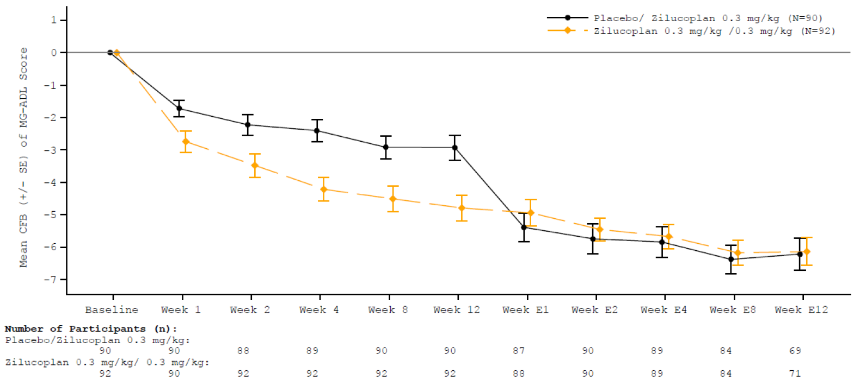
CFB=change from Baseline; E=Extension; gMG=generalized myasthenia gravis;
MG-ADL=Myasthenia Gravis- Activities of Daily Living; mITT=modified Intent-to-Treat; QMG=quantitative myasthenia gravis; SE=standard error.
Note: The MG-ADL Total Score ranged from 0 to 24, with a higher score indicating more severe symptoms of gMG. A decrease from Baseline indicated improvement.
Note: Baseline was defined as the last available assessment before first administration in the 'double-blind study' or 'parent study'.
Subjects who had already received 12 weeks of zilucoplan 0.3mg/kg had a plateauing / small ongoing improvement in QMG score with a further 12 weeks of treatment . Subjects who received placebo initially and switched to zilucoplan 0.3mg/kg experienced a rapid improvement in QMG score that approached the continuous zilucoplan group by week E12 (Figure 8).
Figure 8. Changes from parent study baseline to week E12 in QMG score, study MG0011
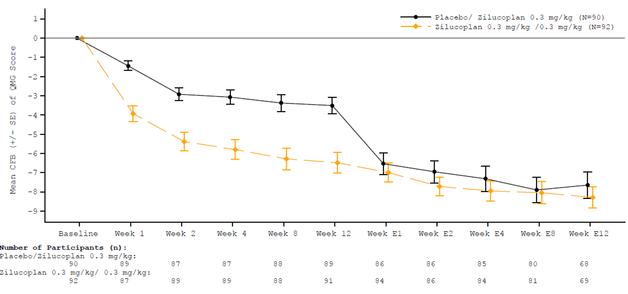
CFB=change from Baseline; E=Extension; mITT=modified Intent-to-Treat; MMRM=mixed model repeated measure; QMG=quantitative myasthenia gravis; SE=standard error; ZLP=zilucoplan
Note: The total score was the sum of the individual scores, ranged 0 to 39, with a higher score indicating more severe disability.
Note: Baseline was defined as the last available assessment before first administration in the 'double-blind study' or 'parent study'.
Note: A decrease from Baseline indicates improvement.
A similar pattern of change was seen for other efficacy endpoints. Although the extension study was not placebo-controlled and efficacy results could be influenced by factors such as changes to treatment other than zilucoplan, the results are consistent with at least maintenance of effect out to 24 weeks at the proposed clinical dose.
The Sponsor presented a number of pooled analyses. Of particular interest, is the pool E1 set which included all subjects who received the proposed clinical dose of 0.3mg/kg/day during a 12 week placebo-controlled period (N=100;placebo N=103). At week 12 the LS mean difference between zilucoplan and placebo changes from baseline was -2.18 (95% CI: -3.23,-1.14) (Figure 9).
Figure 9. Analysis of pool E1 change from baseline in MG-ADL at week 12
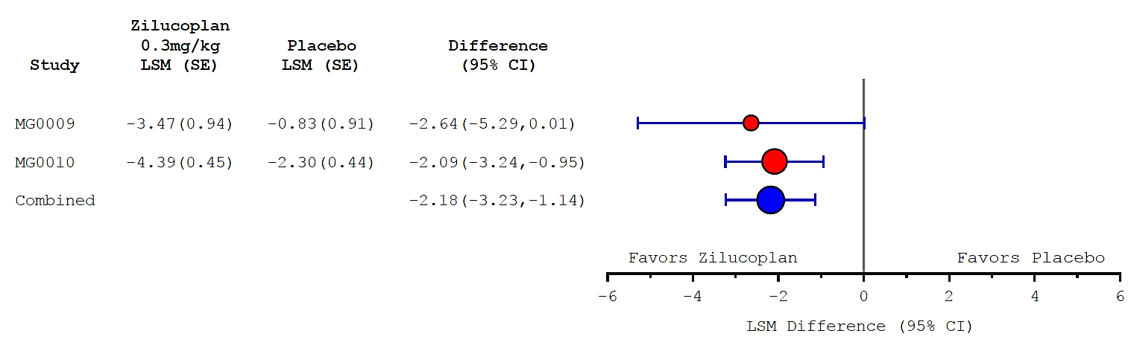
CI=Confidence Interval, ICE=Intercurrent event, LS=Least Square, MG-ADL=Myasthenia Gravis Activities of Daily Living, MMRM=mixed model repeated measures, MAR= missing at random, SE=standard error.
Note: Area of circle in the figure based on weight of the studies calculated as 1/SE2 Note: In Stage 1 of the meta-analysis, MG-ADL total scores after rescue use (ICE1) or any adverse event of death or myasthenic crisis (ICE2) are censored and imputed with the Baseline score or the last available score, whichever is worst. Other missing scores are handled based on the maximum likelihood estimation method under the MAR assumption. The MMRM model includes treatment, treatment-by-time (interaction), Region (MG0010 only), Baseline MG-ADL total score, Baseline QMG total score and Baseline MG-ADL total score-by-time (interaction) as fixed effects, and subject as a random effect. The MMRM ANCOVA includes Weeks 1, 2, 4, 8, and 12.
Note: In Stage 2, the estimated LSMean and SE from MG0009 and MG0010 are combined in a fixed-effects meta-analysis using the inverse-variance method.
Other efficacy variables analysed in pool E1 found results consistent with the pivotal study.
Pool E2 consisted of all subjects treated with zilucoplan during the clinical development program, including those exposed to placebo and/or the 0.1mg/kg/day doses. The pool also extends beyond the placebo-controlled period. Pool E2 shows the duration of treatment with various dose and placebo combinations as well as the associated clinical measures, such as MG- ADL, at various timepoints (Table 6). Note that efficacy measures beyond week 12 are not placebo controlled.
Table 6. Pool E2 and MG-ADL score at various timepoints
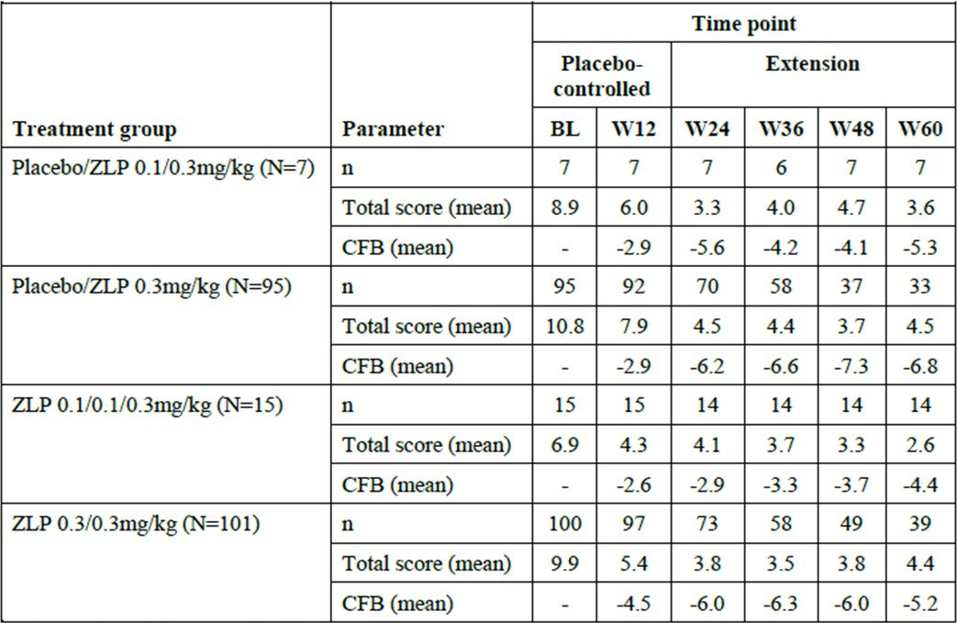
BL=Baseline; CFB=change from Baseline; MG=myasthenia gravis; MG-ADL=Myasthenia Gravis Activities of Daily Living; SCE=Summary of Clinical Efficacy; W=Week; ZLP=zilucoplan
Note: The MG-ADL total score ranges from 0 to 24 with a higher score indicating more severe symptoms of MG. Note: This includes efficacy data collected at or after the time point of rescue use or myasthenic crisis with no imputation of missing data.
Note: Baseline is defined as the Day 1/Baseline value from MG0009 or MG0010.
Pool E3 consists of subjects who switched from placebo to zilucoplan.

Safety
The safety data are derived from:
- six phase 1 studies
- MG0009
- MG0010
- MG0011
- Additional studies in indications other than MG
  - PNH002 – 12 week phase 2 study of 0.3mg/kg/day in paroxysmal nocturnal haemoglobinuria (PNH)
  - PNH003 – 12 week phase 2 study of 0.3mg/kg/day in PNH that has not responded adequately to eculizumab
  - PNH001 – phase 2 extension study for PNH002/3 of 0.3mg/kg/day
  - IMNM01 – 8 week plus extension study of 0.3mg/kg/day in immune-mediated necrotizing myopathy (IMNM)
  - UP01017 – 14 day phase 2 study of 32.4mg in COVID19 with hypoxic respiratory failure
  - UP0108 – 14 day phase 2 study of 32.4mg in COVID19 requiring hospitalisation
  - UP0109 – 14 day phase 3 study of 32.4mg in COVID19 requiring hospitalisation
  - ALS001 – 24 week plus extension, platform study of 0.3mg/kg in amyotrophic lateral sclerosis (ALS)
The main datasets presented were:
- S1A – placebo-controlled safety pool in subjects with gMG (MG0009, MG0010)
- S1B – long term safety pool in subjects with gMG (MG0009, MG0010, MG0011)
- S2A – placebo-controlled safety pool in subjects with either gMG or IMNM (MG0009, IMNM01)
- S2B – long-term safety pool in subjects with gMG or IMNM (MG0009, MG0010, MG0011, IMNM01).
The gMG and IMNM indications were considered by the Sponsor as sufficiently similar to allow pooled analyses.
The dossier included the main integrated safety summary (up to 18 Feb 2022) and an update (up to 8 Sep 2022). The update is only relevant to the long term data sets (i.e. S1B and S2B). As the datasets presented in the update did not always parallel those initially presented, the following information is derived from both. Unless specified, the data in S1B and S2B should relate to the later data cutoff date of 18 Feb 2022.
In terms of exposure in the gMG only studies, 15 subjects were treated with 0.1mg/kg and 100 with 0.3mg/kg, during the placebo-controlled study periods (S1A). The mean duration of treatment was 82 days (range 15 to 94 days) and total exposure was 25.8 participant-years. In long term studies (S1B-data cutoff 8 Sep 2022), the mean duration of treatment was 600.7 days (range 14 to 1707) and total exposure was 350.3 participant-years (>93% of this exposure was at the clinical dose of 0.3mg/kg/day). One hundred and thirty-five were exposed for 12 or more months (131 at the proposed clinical dose) and 54 for 24 or more months. Overall, 213 subjects were exposed to zilucoplan across the gMG studies.

S1A dataset
There were slightly more treatment emergent adverse events (TEAEs) with zilucoplan compared with placebo, mainly driven by mild events. Serious adverse events were similar in each arm and there was one death with placebo and one with zilucoplan (Table 7).
Table 7. S1A incidence of TEAEs
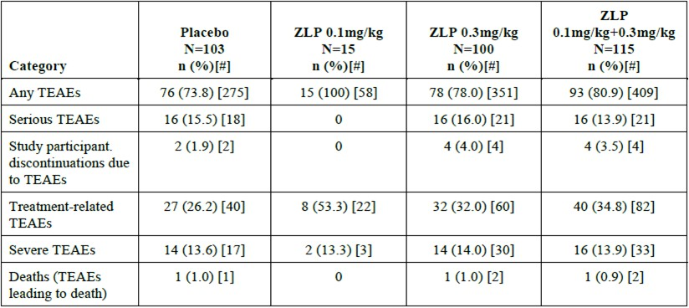
AE=adverse event; ISS=Integrated Summary of Safety; TEAE--treatment-emergent adverse event; ZLP=zilucoplan Note: n=number of participants reporting at least 1 TEAE in that category.
Note: [#] is the number of individual occurrences of the TEAE in that category.
Note: Treatment-related TEAEs are those defined as related by the Investigator.
Note: There were no additional nontreatment-emergent AEs leading to death.
Of the severe AEs experienced during the placebo-controlled periods, only COVID19 and myasthenia gravis occurred in at least 1% of zilucoplan participants (0.9 and 3.5% respectively) and this was less frequent than in the placebo arm.
There was 1 death in the placebo arm (cerebral haemorrhage) and 1 death in the zilucoplan arm (COVID-19, not considered treatment related). Serious AEs during the placebo controlled period were generally balanced between zilucoplan and placebo. All events except for myasthenia gravis were single events, although serious infections overall did appear more frequent with zilucoplan (Table 8).
Table 8. SAEs in pool S1A
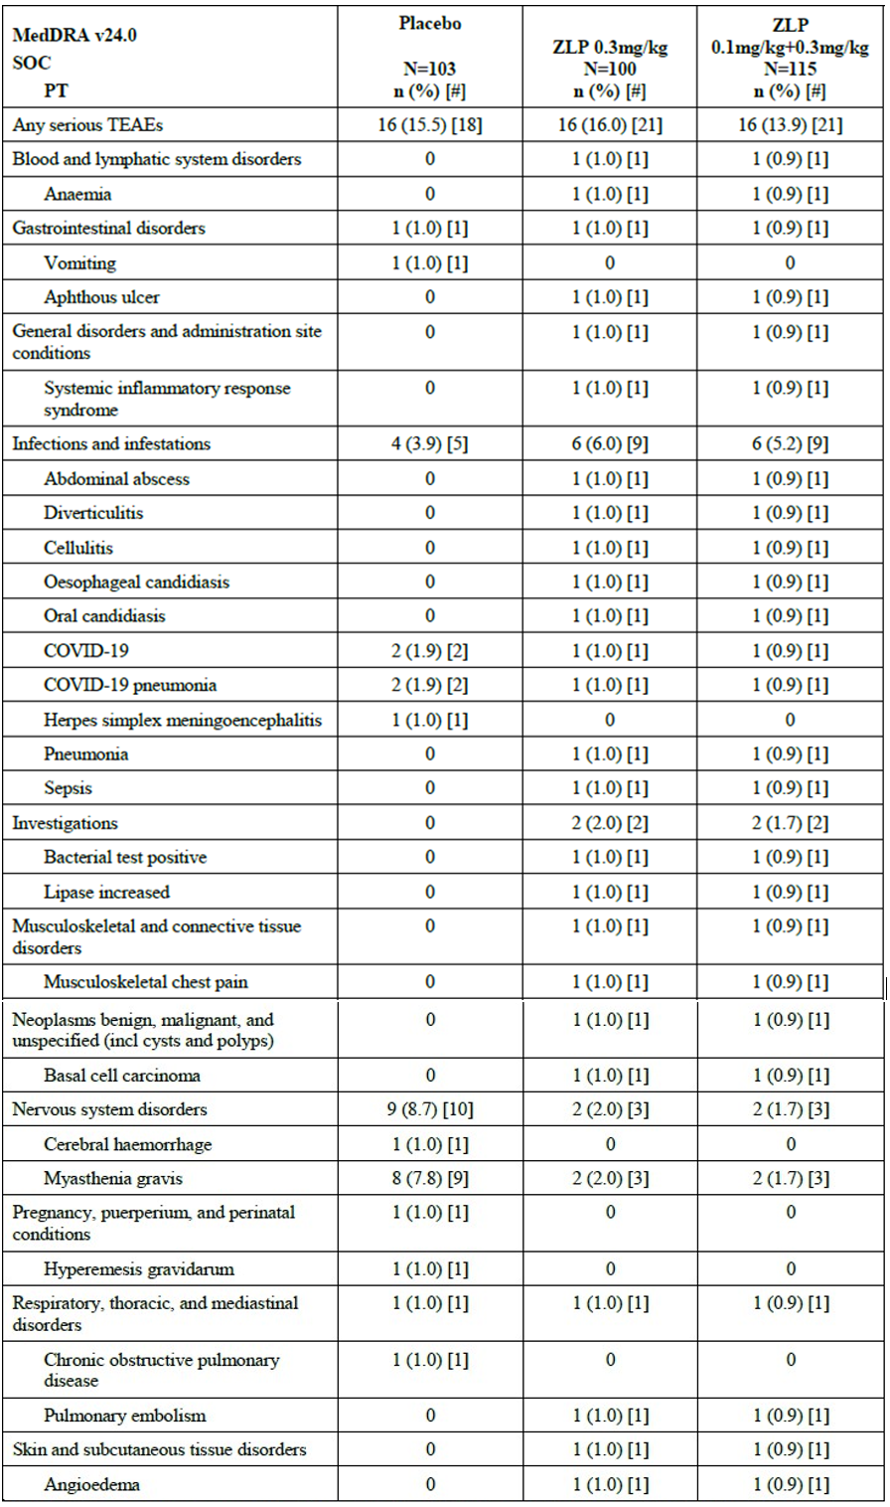
COVID-19=coronavirus disease 2019; incl.=including; ISS=Integrated Summary of Safety; MedDRA=Medical Dictionary for Regulatory Activities; PT=Preferred Term; SAE=serious adverse event; SOC=System Organ Class; ZLP=zilucoplan Note: number of participants reporting at least 1 serious TEAE. Note: [#] is the number of individual occurrences of the serious TEAE. Note: No serious TEAEs were reported in the ZLP 0.1 mg/kg group
Considering TEAEs reported in ≥ 5% of participants in S1A, the events more frequent with zilucoplan than placebo were diarrhoea, nausea, injection site bruising/pain, peripheral oedema, nasopharyngitis, urinary tract infection, confusion, lipase increased and amylase increased. Headache was frequent and higher with zilucoplan than placebo, but this appeared to be driven by a high frequency in the 0.1mg/kg/arm (i.e. in MG009).
TEAEs occurring in >5% in the pivotal gMG study are shown in Table 9.
Table 9. Common TEAEs reported in >5% of study participants in MG0010 study
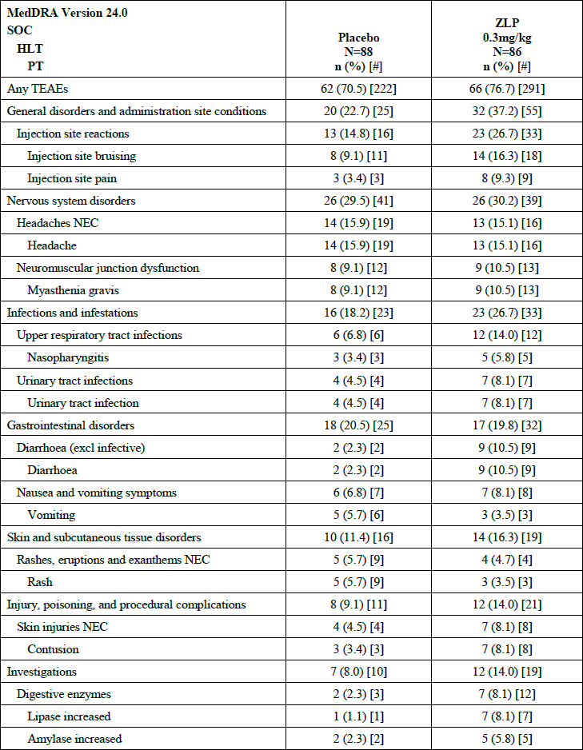
When adding the subjects in IMNM01 to pool S1A (making pool S2A), a similar frequency distribution of TEAEs was observed.

S1B dataset
Of the 213 subjects who continued zilucoplan after the 12 week placebo controlled period, 43 (20.2%) discontinued, for reasons of adverse event (3.8%), death (4.2%), COVID19 (0.9%), withdrawal by participant (6.6%), investigator or sponsor decision based on safety or study interests (0.5%) and other (4.2%). Most (77.9%) of subjects who entered the extension studies were continuing at time of data cutoff.
In S1B incidences of subjects with TEAEs were common (EAIR/exposure adjusted incidence rate 510.6 per 100 participant-years), as were serious AEs (EAIR 28.6 per 100 participant- years) and severe AEs (EAIR 26.3 per 100 participant-years). Subject discontinuation due to TEAEs were less common (EAIR 6.9 per 100 participant-years), as were deaths (2.3 per 100 patient-years).
A large number of AE types were reported for the extension MG studies. Individual TEAEs that occurred with an incidence (EAIR) greater than 10 per 100 patient-years were diarrhoea (13.8), nausea (12.8), injection site bruising (13.7), COVID19 (12.2), nasopharyngitis (15.2), upper respiratory tract infection (10.3), urinary tract infection (10.1), headache (24.8) and myasthenia gravis (20.0). (These EAIRs relate to the 18 Feb 2022 data cut off as the EAIR data for the 8 Sep 2022 was not summarised in study report tables. The additional reporting period did not reveal substantial differences in safety.)
In terms of TEAEs that were considered severe in S1B, there were infrequent events of myocardial infarction (EAIR 1.2), cardiac arrest (EAIR 1.1), COVID19/COVID19 pneumonia/pneumonia (each of these TEAEs had EAIR 1.5), sepsis (EAIR 1.2) and myasthenia gravis (EAIR 5.6). (These EAIRs relate to the 18 Feb 2022 data cut off as the EAIR data for the 8 Sep 2022 was not summarised in study report tables. The additional reporting period did not reveal substantial differences in safety.)
In S1B, 36.6% of participants reported serious AEs. Serious AEs that occurred in more than 2 subject were myasthenia gravis (8.9%), COVID19 pneumonia (2.8%), pneumonia (2.8%), COVID19 (2.3%), myocardial infarction (1.4%), cardiac arrest (1.4%), sepsis (1.4%), cholecystitis (1.4%), cellulitis (1.9%), diverticulitis (1.4%). No serious AE reported in > 1 subject was considered treatment related by the investigator. There was 1 serious and severe injection site infection, considered related, occurring in a 63 year old female 536 days after the first zilucoplan dose.
Of note, in S1B there were 17 serious AEs of cardiac disorders in 13 subjects. The EAIR was 3.80 per 100 participant-years and this compared with 0 during the 12 week placebo-controlled phase. The 3 deaths associated with SAEs in this category are discussed below. Six cases involved ischaemic heart disease and 2 involved cardiac failure. There were “major and multiple cardiovascular risk factors” in all of them. Two of these participants experienced atrial fibrillation/flutter and were on amiodarone. The other 2 subjects had sinus bradycardia with a history of the same and pulseless electrical activity due to tracheostomy bleeding during treatment for severe COVID19 infection. Except for the 3 deaths, all events were resolved or resolving. The Sponsor commented in the safety summary that all serious AEs of cardiac disorders had “major predisposing factors and/or strong alternative explanations and none of these events were considered related by the investigator”.
There were 8 deaths in the open label extension studies (3 in MG0009 and 5 in MG0011). One of the deaths in MG0011 was non-treatment emergent. None of the deaths were considered treatment related and all cases had predisposing factors and/or strong alternative explanations. Five deaths were reported as cardiac arrest or unknown cause and had either significant preceding medical events such as infection or major cardiovascular risk factors. The non- treatment emergent death was likely due to underlying malignancy. The other deaths were due to COVID19, pancreatic cancer and head injury.
Adding the patients who were enrolled in the immune-mediated necrotizing myopathy study (IMNM01), i.e. pool S2B, did not change the pattern of AEs seen with longer term use. There was one death in this study and it was due to COVID19.

Adverse events of special interest
Neisseria infections – no infections were reported in the zilucoplan development program during which all participants were required to be vaccinated and/or using prophylactic antibiotics.
Serious infections – as mentioned above, there were slightly more serious infection with zilucoplan compared with placebo in S1A. In terms of opportunistic infection, there was one event of oesophageal candidiasis with zilucoplan in S1A (balanced by a herpes simplex meningoencephalitis in the placebo arm during the same period). In the open label period, endocarditis (other risk factors central line, total parenteral nutrition, cardiac pacemaker), liver abscesses (other risk factors ERCP, pancreatitis), Legionella pneumonia, MRSA infection, polymicrobial cholecystitis with cholangitis and sepsis and Enterococcal bacteraemia could have represented opportunistic infections.
Injection site reactions – in the placebo controlled period of the gMG trials these occurred in 26.7% of subjects receiving zilucoplan and 14.8% receiving placebo. Most of these reactions were characterised as bruising and pain. None were serious or severe.
Hypersensitivity reactions – there was one serious hypersensitivity reaction of angio-oedema with zilucoplan in S1A. This event of angio-oedema was mild in intensity, did not recur with rechallenge and timing was not suggestive of an acute allergy. Overall, there were more frequent non-serious reactions with zilucoplan compared with placebo, mainly driven by dermatitis and urticaria (Table 10). In S2A there was more frequent stomatitis and ulceration with zilucoplan compared to placebo (3.9% vs. 1.7%, respectively).
Table 10. Incidence of hypersensitivity reaction TEAEs in pool S1A and S1B
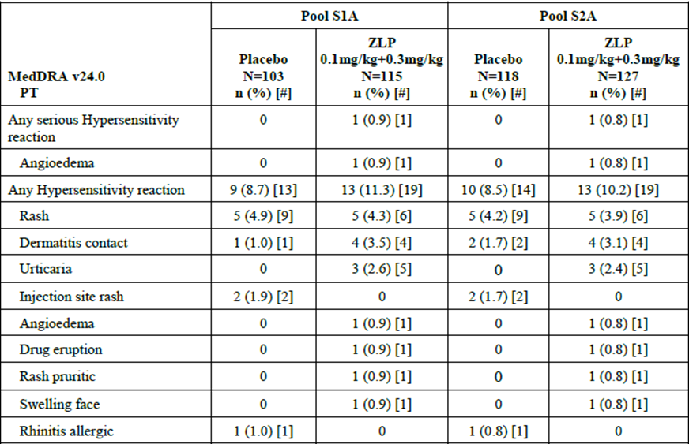
ISS=Integrated Summary of Safety; MedDRA=Medical Dictionary for Regulatory Activities; PT=Preferred Term; SMQ=Standard MedDRA Query; TEAE=treatment-emergent adverse event; ZLP=zilucoplan Note: Defined as TEAEs in MedDRA SMQ 'Hypersensitivity (narrow scope)'. Note: n=number of study participants reporting at least 1 TEAE within PT.
Note: [#] is the number of individual occurrences of the TEAE.

Hepatic events
No serious hepatic events were reported in S1A and there were 2 non-serious events (hepatic pain and hepatic enzyme increased). The hepatic enzyme increased TEAE resulted in withdrawal of zilucoplan but was considered to not be treatment related (other risk factors of multiple medications, morbid obesity and potential fluid overload). Hepatic events were infrequent during the open label study periods. There was one event of serious transaminase increase. No Hy’s law cases were reported. The most frequent non-serious event was alanine aminotransferase increase (1.9% of subjects).

Malignancy
There were 2 basal cell carcinomas and 2 squamous cell carcinomas in S1A (zilucoplan 3 subjects; placebo 0 subjects). In S1B there were 15 malignant or unspecified tumours in 5.6% of subjects. Six of these were non-melanoma skins cancers and the others all occurred as single tumour types (except for 2 bone neoplasms that occurred in the same subject). In S2A the EAIR for malignant or unspecified tumours was 10.76 per 100 participant- years.

Laboratory results
In the S2A pool there were increases in both amylase and lipase (more frequently for the latter) (Table 11).
Table 11. Shift from baseline to maximum post-baseline results for amylase and lipase (pool S2A)
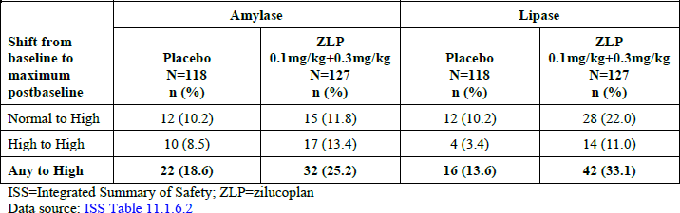
In S2A the incidence of grade 3 and 4 amylase elevations was higher with zilucoplan than placebo (6.3% vs. 0%), as was the case with lipase (11.8% vs. 5.1% respectively). Most elevations were not associated with significant changes in liver function, had one or more confounding risk factors and improved or resolved. Amylase and lipase improved for patients regardless of whether treatment was interrupted.
Pool S2B (up to 18 Feb 2022) was searched for events consistent with acute pancreatitis or pancreas pathologies. Ten events were found, including pancreatitis (3) and other pancreas pathologies (7). All occurred in the myasthenia gravis trials. For the events of pancreatitis there were other likely causes (e.g. post ERCP, COVID vaccination). All of the events of pancreas pathology were considered as not related, zilucoplan was continued in all but one, and they nearly all resolved (except for a pancreatic cyst and a pancreatic mass).
In S1B (up to 8 Sep 2022) the maximum post-baseline CTCAE graded increases in amylase and lipase are shown in Table 12. The majority of affected subjects only experienced a grade 1 increase and grade 4 increases were uncommon.
Table 12. Exposure-adjusted incidence rates of increases in amylase/lipase by CTCAE grade
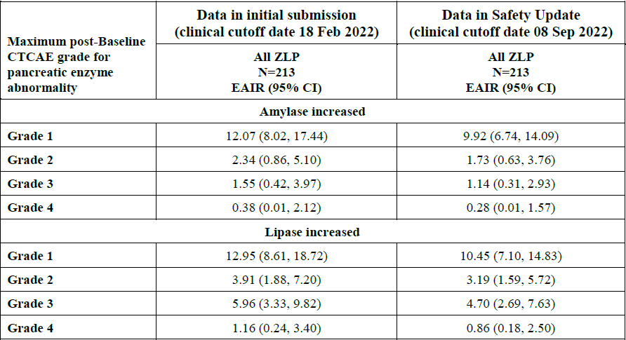
CI=confidence interval; EAIR=exposure adjusted incidence rate; CTCAE=Common Terminology Criteria for Adverse Events; ISS=Integrated Summary of Safety; ZLP=zilucoplan.
Eosinophilia occurred more frequently with zilucoplan than with placebo (pool S2A; 16.5% vs. 1.7%, respectively) and nearly always from a normal baseline value. Six zilucoplan subjects experienced eosinophils ≥ 1.5 X 10⁹/L, all at the day 57 visit and all returned to normal. None of the participants experienced fever or clinically significant organ dysfunction and in 3 there was concomitant use of other potential drugs (cephalosporins). In the long term studies (pool S1B) the EAIR for elevated eosinophils was 16.89. The elevations tended to resolve over time even with continued zilucoplan exposure. The pattern of elevation appears to be a maximal rise around day 50 and then improvements/fluctuations beyond that stage (including values still above the normal range), as seen in Figure 10. All except 1 of the eosinophil elevations in S2A were NOT reported as AEs.
Although a variety of mild to moderate skin and oral mucosal ulcerations events were reported (aphthous ulceration, mouth ulceration, lip ulceration, stomatitis), there were relevant confounding factors and evidence was not suggestive of a causal relationship to zilucoplan. The EAIR in S1B was 3.10 per 100 participant-years for this group of events.
Figure 10. Eosinophil values over time for gMG subjects treated only with zilucoplan
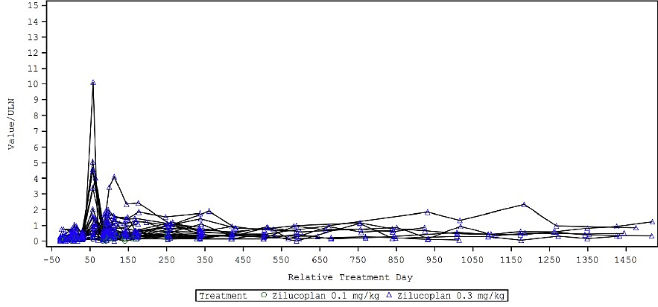
gMG=generalised myasthenia gravis; ULN=upper limit of normal; ZLP=zilucoplan

Non-myasthenia gravis studies
During these studies (listed above) 378 subjects were exposed to at least one dose of zilucoplan. Most of these were in studies for either ALS (153 subjects) or COVID19 (171 subjects). In terms of duration, 139 subjects in the non-gMG studies were exposed for a period of at least 6 months.
PNH002 was a phase 2, multicentre, uncontrolled study in adults with PNH. The study utilised 0.1mg/kg/day for the first 12 weeks, with an option for continuing treatment with 0.3mg/kg/day. Nearly all subjects experienced TEAEs, with headache and haemolysis being the most frequent. There were no deaths. The serious AEs were not considered treatment related and consisted of febrile non-haemolytic transfusion reaction, pyrexia and urinary tract infection. AEs leading to discontinuation were breakthrough haemolysis, worsening PNH, upper abdominal pain and increased LDH. One subject had a TEAE of increased LFTs that was moderate in severity and not considered related.
PNH003 was a phase 2, multicentre, uncontrolled study in adults with PNH who had responded inadequately to eculizumab. The study utilised a dose of 0.1mg/kg/day with an option to increase to 0.3mg/kg/day after as soon as 2 weeks if the response was inadequate. Only 3 subjects were treated and there were no SAEs, deaths or TEAEs leading to discontinuation.
There was one grade 3 lipase increase, which recovered despite ongoing zilucoplan.
PNH001 was a phase 2, multicentre, uncontrolled, extension study for subjects completing PNH002 and PNH003. The most common TEAEs were fatigue, diarrhoea, nasopharyngitis, upper respiratory tract infection and headache. There were no deaths. There were 12 SAEs in 6 subjects: anaemia (X2), headache, nausea, osteoarthritis, rotator cuff injury, tongue haematoma, enterocolitis infectious, DVT, encephalopathy, pneumococcal pneumonia and suicide attempt.
UP0108 was a phase 2, adaptive, randomised, placebo-controlled platform study of hospitalized COVID19 patients. Zilucoplan was dosed for 14 days or stopped at the time of hospital discharge. Twenty-two subjects were in the zilucoplan plus standard of care arm. Two (9.1%) of these died (compared with 21.7% in the standard of care only arm). A preliminary review of the safety did not identify any safety signals.
UP0107 was a phase 2, open-label study of zilucoplan in subjects with COVID-19 related hypoxic respiratory failure. Fifty-four subjects received zilucoplan 32.4mg (i.e. 0.3mg/kg dosed for the highest weight category) plus prophylactic antibiotics. The control arm received prophylactic antibiotics. Zilucoplan did not lead to an increase in overall or infectious SAEs.
UP0109 was a phase 3, adaptive, randomised, placebo-controlled platform study of various treatments for COVID19 in hospitalised patients. Zilucoplan was dosed at 32.4mg/day for 14 days and given together with standard of care treatment. One hundred subjects were randomised to receive zilucoplan. The most frequent TEAEs with zilucoplan were constipation, hypotension, respiratory failure and hypertension. There were less deaths in the zilucoplan arm (21.1% of subjects vs. 28.8% with placebo). Overall, the safety profile revealed no new safety signals.
ALS001 is a multicentre, perpetual, multi-regimen, randomised, placebo-controlled adaptive platform clinical study in patients with ALS. Regimen A consisted of 24 weeks of placebo- controlled zilucoplan dosed at 0.3mg/kg/day, followed by an open label extension. Regimen A was stopped as it did not meet the required efficacy threshold at interim analysis. One hundred and sixty two patients were randomised in the placebo controlled portion (approximately ¾ of whom were randomised to zilucoplan) and 101 continued in the open label extension. Common TEAEs were falls, muscular weakness and injection site bruising. The most common serious AEs were respiratory failure, pneumonia aspiration and pulmonary embolism. Many of these AEs were consistent with ALS.

Safety update 26 Feb 2024
The TGA was notified of an update to the Company Core Data Sheet to include a newly identified adverse drug reaction, morphea. Morphea is considered a “non important” risk for zilucoplan. Safety signal assessment involved cumulative review through to 10 Feb 2023 of occurrences of the preferred terms “morphea” and “scleroderma” in the Sponsor’s database. A systematic search of the literature was also undertaken.
Overall, in the zilucoplan clinical development program 11 events of morphea (i.e. localised scleroderma) were reported in 10 study participants (7 female). All events were in the open- label extension gMG study MG0011. The time to onset ranged from 430 to 1262 days. This latency was considered consistent with morphea. All events were non-serious and mild- moderate (except for 1 severe). The severe event related to morphea on both upper and lower arms, thighs and shins, and was treated with methotrexate with unknown outcome. Zilucoplan was continued in all but 1 subject. Overall, 8 events were not resolved. No extracutaneous manifestations were reported.
Nine out of the 10 subjects had a skin biopsy and all were consistent with morphea (although in 2, other pathologies could not be excluded). In nearly all cases other possible triggers for morphea were identified (Borrelia burgdorferi infection, COVID19 vaccination, COVID19 infection, concomitant autoimmune thyroiditis).
The EAIR for morphea has been calculated at 1.9 per 100-patient years. The incidence (note, not the incidence rate) of morphea in the literature has been reported between 0.34 and 2.7.
Despite the difficulties in comparing the EAIR from the open-label studies with the literature, the Sponsor believes the incidence of morphea in the zilucoplan program “appears to be significantly higher compared to an expected background incidence in the MG population”.

Immunogenicity
In MG0010 the incidence of antidrug antibodies (ADAs) was low. At baseline 1 subject in the zilucoplan arm was ADA positive and following 12 weeks of treatment, 2 subjects in the zilucoplan arm and 2 in placebo were positive. No differences were found in terms of pharmacodynamic effects (RBC lysis assay) between ADA positive and negative subjects.
Zilucoplan concentration was modestly lower in ADA positive subjects and the mean in change in MG-ADL was greater (i.e. greater clinical effect). Given the low number of ADA positive subjects, it is difficult to draw any conclusions.
Anti-PEG antibodies were also assessed. In MG0010 5 zilucoplan subjects and 7 placebo subjects were positive at baseline. Following 12 weeks of treatment, 8 zilucoplan subjects developed antibodies, as did 6 placebo subjects. Two subjects in the open label study developed anti-PEG antibodies. Two subjects who developed anti-PEG antibodies experienced 4 TEAEs in the category of hypersensitivity/injection site reaction (rash, rash pruritic, urticaria, injection site lump).

Clinical evaluator’s opinion
The clinical dataset was considered consistent with the guidelines on utilisation of a single pivotal study, as well as adequate extent of exposure. Despite this, the evaluator did note that the single pivotal trial was somewhat short for assessment of a complex chronic condition and that the supportive trial was underpowered and statistically weak. The safety data set was noted to be of borderline quality (mainly due to number of subjects and short duration of placebo-controlled data), however ultimately considered adequate. The clinical evaluator recommended approval of zilucoplan for the proposed indication.

Risk management plan evaluation summary
The summary of safety concerns is outlined in Table 13.
Table 13. Summary of safety concerns
Summary of safety concerns |  |  | Pharmacovigilance |  |  |  | Risk minimisation
 |  |  | Routine |  | Additional |  | Routine |  | Additional
Important identified risks | None | - |  | - |  | - |  | -
Important potential risks | Neisseria infection, particularly meningococcal infections | † |  | * |  |  |  | ‡
Missing information | Use during pregnancy and lactation |  |  | * |  |  |  | -
Missing information | Long-term safety |  |  | * |  |  |  | -
*post authorisation safety study
†follow up questionnaire
‡HCP guide, patient/carer guide, patient alert card, annual vaccination reminder
The RMP evaluator considered the summary of safety concerns acceptable from an RMP perspective.
Additional risk minimisation activities include a healthcare professional guide, annual vaccination reminder for prescribers, patient / carer guide and patient alert card.
The RMP evaluator has also requested the implementation of a controlled access program, which aims to ensure that only patients vaccinated against Neisseria meningitidis are able to receive zilucoplan. This is consistent with other C5 inhibitors available in Australia.

Risk-benefit analysis

Efficacy
The primary efficacy outcome in pivotal study MG0010 - i.e. a 2.09 point difference in MG-ADL between zilucoplan and placebo – was highly statistically significant and within the magnitude that is generally considered as clinically significant.
Despite the achievement of the primary efficacy outcome in the pivotal trial, it should be noted that the data actually suggests a somewhat limited magnitude of effect. In this regard, the absolute changes in MG-ADL (just over 2 points in a scale that goes up to 24 points) and other scoring system were relatively modest. Furthermore, the achievement of remission or near remission was not common (e.g. minimal symptom expression was achieved by 14.0%).
The study was in a relatively refractory population as subjects were still significantly symptomatic at baseline despite treatment with standard therapies, which included pyridostigmine, corticosteroids, azathioprine/mycophenolate, IVIG and to a lesser extent plasma exchange. Achieving benefit in this population, even if incremental, is worthwhile. Overall the efficacy is considered established.

Proposed indication
The current indication does not specify what line of therapy zilucoplan should be considered. Generalised MG has several established treatments that have better understood safety profiles and simpler administration (i.e. oral compared to subcutaneous). In the clinical development program for zilucoplan subjects were generally somewhat refractory to those established treatments. Therefore the Delegate considers it appropriate to limit zilucoplan to patients who have not responded adequately to standard immune suppressive treatments.

Safety
There is considerable experience with terminal complement inhibitors in both gMG (i.e. eculizumab, ravulizumab) and other diseases and the issue of meningococcal risk is relatively well defined. Management of this risk with mandatory meningococcal vaccination, prophylactic antibiotics and risk minimisation activities, is planned to follow a similar framework as the already registered complement inhibitors. This is considered acceptable. It will be important to define the rate of meningococcal infection with zilucoplan to better understand how it compares to the other agents (i.e. eculizumab, ravulizumab).
There did appear to be an increase in the risk of infections with zilucoplan, including serious infections. This is not unexpected and must be presented adequately in the PI. Currently the Delegate considers the PI as generally too brief on safety issues and not providing adequate information for prescribers.
Increases in amylase and lipase were seen more frequently in zilucoplan treated subjects. These tended to improve despite ongoing treatment and were not clearly associated with events of drug-induced pancreatitis. However, the safety data set is relatively small at this stage and the signal was clearly seen in the preclinical studies as well. There remains the possibility that zilucoplan could lead to clinically important pancreatitis. The US drug label is noted to list pancreatitis as a risk. The Sponsor and ACM will be asked further about this (including its absence from the RMP) and the PI must adequately present this information.
In addition to pancreatitis, other pancreas related events also occurred in the gMG trials and should be included in the PI.
The increase in eosinophils is noted and was markedly elevated in some subjects. Although not clearly seen as yet, there is the possibility of it being associated with eosinophilic inflammation (e.g. of the lung, oesophagus, skin), which can be serious.
The newly detected safety signal for morphea is noted.
The imbalance in malignancy occurrence during the placebo controlled period (4 skin cancers with zilucoplan, 0 with placebo) is noted. However, it seems unlikely for skin cancer development to be influenced during a 12 week period. In S1B 5.6% of subjects experienced a malignancy, leading to an EAIR of 4.78 per 100 patient-years. Whilst this seems somewhat higher than expected, the dataset is small, the latency was not particularly long and there did not appear to be a trend in tumour type. The Sponsor will be asked about this.
In addition to the risks raised by the clinical dataset, the nonclinical dataset has identified risks that require consideration and management. Of particular concern are the potential effects on both female and male fertility that do not seem to have been addressed in any clinical study.
Female monkeys experienced dose-dependent endometrial degeneration and males experienced testicular and germ cell effects (slight to minimal). There was increased pregnancy loss at all doses in the relevant monkey study. The nonclinical evaluator considered all of these issues as potentially clinically relevant and has requested updates to the PI. At the current time these are not resolved.

Deficiencies in the data
The major deficiency in the dataset relates to the number of subjects included in the clinical development program. Efficacy, at least out to a year, is reasonably well defined. The size of the safety dataset, whilst meeting guideline standards, is relatively small and the post-market pharmacovigilance will be important. Whilst zilucoplan is not the first terminal complement inhibitor, it is sufficiently dissimilar from the monoclonal antibodies (in terms of molecular size, structure and current safety signals) to expect a different safety profile.

Risk-benefit-uncertainty assessment
Currently, the risk-benefit, in an appropriately targeted population of patients with refractory myasthenia gravis, remains positive and supportive of registration.

Proposed action
The safety concerns raised by the non-clinical and clinical datasets require further clarification by the Sponsor and input from ACM. Modifications are required to the PI (and potentially the RMP and other aspects of the registration) and the listed quality issues must be resolved before approval can be granted.

Advisory Committee considerations
The Advisory Committee on Medicines (ACM), having considered the evaluations and the Delegate’s overview, as well as the sponsor’s response to these documents, advised the following.
The ACM advised the following in response to the Delegate’s specific request for advice:
- The Delegate is inclined toward the indication specifying that zilucoplan is intended “as an add on to standard immune suppressing therapy when symptoms have not adequately responded” or similar. What is ACM’s view of this issue and wording of the indication?
The ACM noted that patients in MG0010 had extensive prior treatment, and that entry criteria included stability of corticosteroid and immunosuppressants for 30 days, with no IVIG, SC IVIG or plasma exchange four weeks before treatment. With these restrictions, the ACM considered that the results indicated recent clinical stability rather than specifically failure of other therapies.
The ACM discussed whether the study demonstrated that the drug was an add-on, given the pre-requisite that patients had to be stable and have not taken IVIG, but that many patients were on other treatments. For the 70% of patients were on steroids, it was likely they would have to remain on the same dose of steroids.
The ACM discussed when it would be appropriate to start zilucoplan, in the context of a broader treatment plan. Standard therapy commences with pyridostigmine and steroids, in addition to plasma exchange or IVIG to stabilise the patient. In the longer term, plasma exchange and IVIG are impractical and long-term steroids have known side effects. As such, once stable, patients are weaned off steroids with azathioprine, methotrexate or ciclosporin. The ACM was of the view that zilucoplan would not be first line treatment.
The ACM considered the sponsor’s suggestion of aligning with the EU’s indication:
ZILBRYSQ is indicated as add-on to standard therapy for the treatment of gMG in adult patients who are ACh antibody positive.
The ACM also considered the ARTG listing of ravulizumab, a similar C5-inhibiting monoclonal antibody:
…as an add-on to standard therapy for the treatment of adult patients with gMG who are AChR antibody positive.
The ACM expressed concern that the Delegate’s proposed wording might unnecessarily restrict prescribing. The ACM noted that consensus guidelines from 2016 and 2020 were vague, being more permissive than prescriptive, and considered the concept of “standard therapy” as not meaningful. The ACM considered that this definition would be unlikely to achieve the intended goal of limiting use to refractory cases. Instead, the restriction may put patients at risk by allowing them to be placed on combination immunosuppressants unnecessarily. Overall, the ACM concluded that aligning with other regulators/comparable agents would be the most reasonable outcome.
To clarify the issue of “standard therapy”, the ACM suggested an alternative descriptor of “inadequately controlled by oral medications” or “when symptoms have not responded adequately to standard immunomodulatory therapy”.
- Whilst the risk : benefit appears to favour zilucoplan, what is ACM’s view of the safety signals for this drug based on the non-clinical and clinical data sets?
The ACM considered that the limited data of one study, with limited supporting studies, showed clinical significance for efficacy but that its effect size was small. This suggested a marginally positive risk: benefit ratio. However, the ACM noted that pre-clinical safety concerns around both female and male fertility remain unsolved by the limited real world safety data available for consideration, and that this is of concern given that young women < 40 yrs are a key patient group affected by MG. Early safety signals with limited post-marketing experience suggest that zilucoplan should not be first-line treatment, and that post market surveillance for pancreatic disorders is necessary.
- Are the safety data, related clinical restrictions and recommendations adequate in the PI? Any further advice on these?
The ACM suggested adding “morphea (localised scleroderma)” to further explain the term, which is infrequently encountered.
The ACM suggested the revision of sections 4.6 and 5.3 of the PI to reflect concerns around female and male fertility, with the risk of increased embryofetal loss shown at all doses in the relevant monkey study. The ACM considered the current wording of the pre-clinical data in the PI to be misleading and recommended revision of this text in order to more accurately describe currently available data and adequately convey the safety concerns regarding fertility. The ACM recommended a change from pregnancy category B1 to at least B3.
Aside from this concern, the ACM considered that the adverse effects were otherwise well presented in the table with balanced descriptions in the text. The ACM also praised the repeated and up-front meningococcal warning.
- Does ACM have any comments about how the potential risk for pancreatitis and pancreas related events are dealt with in the PI?
The ACM considered the Australian PI sufficient, containing the relevant facts regarding elevations of lipase and amylase and their possible link to pancreatitis. The ACM noted that there was only one case each of cysts and pancreatitis, and that there were other possible reasons for the pancreatitis.

Advisory committee conclusion
The ACM considered this product to have an overall positive benefit-risk profile for the indication:
ZILBRYSQ is indicated as an add-on to standard therapy for the treatment of generalized myasthenia gravis (gMG) in adult patients who are anti-acetylcholine receptor (AChR) antibody positive.

Assessment outcome
Based on a review of quality, safety, and efficacy, the TGA decided to register ZILBRYSQ (zilucoplan) for the following indication:
ZILBRYSQ is indicated as an add-on to standard therapy for the treatment of generalised myasthenia gravis (gMG) in adult patients who are anti-acetylcholine receptor (AChR) antibody positive.

Specific conditions of registration
ZILBRYSQ (zilucoplan) is to be included in the Black Triangle Scheme. The PI and CMI for ZILBRYSQ must include the black triangle symbol and mandatory accompanying text for five years, which starts from the date of first supply of the product.
Submission to the TGA of the Post Approval Safety Study (PASS) interim and final reports when they become available.
The ZILBRYSQ EU-Risk Management Plan (RMP) (version 0.4, date 1 September 2023; DLP 31 March 2022), with Australia-Specific Annex (version 2.0, date 22 February 2024), included with submission PM-2023-02775-1-1, and any subsequent revisions, as agreed with the TGA will be implemented in Australia.
An obligatory component of risk management plans is routine pharmacovigilance. Routine pharmacovigilance includes the submission of periodic safety update reports (PSURs).
Reports are to be provided in line with the current published list of EU reference dates and frequency of submission of PSURs until the period covered by such reports is not less than three years from the date of this approval letter. Each report must be submitted within ninety calendar days of the data lock point for that report.
The reports are to at least meet the requirements for PSURs as described in the European Medicines Agency’s Guideline on good pharmacovigilance practices (GVP) Module VII-periodic safety update report (Rev 1), Part VII.B Structures and processes. Note that submission of a PSUR does not constitute an application to vary the registration.

Product Information and Consumer Medicines Information
For the most recent Product Information (PI) and Consumer Medicines Information (CMI), please refer to the TGA PI/CMI search facility.

Therapeutic Goods Administration
PO Box 100 Woden ACT 2606 Australia
Email: info@tga.gov.au Phone: 1800 020 653 Fax: 02 6203 1605
https://www.tga.gov.au

A sponsor is a person or company who does one or more of the following: a) exports therapeutic goods from Australia, b) imports therapeutic goods into Australia, c) manufactures therapeutic goods for supply in Australia or d) elsewhere arranges for another party to import, export or manufacture therapeutic goods.
Evaluators are TGA experts, or external experts engaged by the TGA, that assess the safety, quality, and efficacy of therapeutic goods before they can be registered and supplied in Australia.
A "Delegate" refers to a person within the TGA who has been conferred the authority to make decisions about the approval of therapeutic goods for supply in Australia, under section 25 of the Therapeutic Goods Act.

