Australian Public Assessment Report for VISTELLA
  - Active ingredient: Calcifediol
  - Sponsor: Aspen Pharmacare Australia Pty Ltd
July 2025

About the Therapeutic Goods Administration (TGA)
- The Therapeutic Goods Administration (TGA) is part of the Australian Government Department of Health, Disability and Ageing and is responsible for regulating therapeutic goods, including medicines, medical devices, and biologicals.
- The TGA administers the Therapeutic Goods Act 1989 (the Act), applying a risk management approach designed to ensure therapeutic goods supplied in Australia meet acceptable standards of quality, safety, and efficacy.
- The work of the TGA is based on applying scientific and clinical expertise to decision-making, to ensure that the benefits to the Australian public outweigh any risks associated with the use of therapeutic goods.
- The TGA relies on the public, healthcare professionals and industry to report problems with therapeutic goods. The TGA investigates reports received to determine any necessary regulatory action.
- To report a problem with a therapeutic good, please see the information on the TGA website.

About AusPARs
- The Australian Public Assessment Report (AusPAR) provides information about the evaluation of a prescription medicine and the considerations that led the TGA to approve or not approve a prescription medicine submission. Further information can be found in Australian Public Assessment Report (AusPAR) guidance.
- AusPARs are prepared and published by the TGA.
- AusPARs are static documents that provide information that relates to a submission at a particular point in time. The publication of an AusPAR is an important part of the transparency of the TGA’s decision-making process.
- A new AusPAR may be provided to reflect changes to indications or major variations to a prescription medicine subject to evaluation by the TGA.

Copyright
© Commonwealth of Australia 2025
This work is copyright. You may reproduce the whole or part of this work in unaltered form for your own personal use or, if you are part of an organisation, for internal use within your organisation, but only if you or your organisation do not use the reproduction for any commercial purpose and retain this copyright notice and all disclaimer notices as part of that reproduction. Apart from rights to use as permitted by the Copyright Act 1968 or allowed by this copyright notice, all other rights are reserved and you are not allowed to reproduce the whole or any part of this work in any way (electronic or otherwise) without first being given specific written permission from the Commonwealth to do so. Requests and inquiries concerning reproduction and rights are to be sent to the TGA Copyright Officer, Therapeutic Goods Administration, PO Box 100, Woden ACT 2606 or emailed to <tga.copyright@tga.gov.au>.

Contents
List of abbreviations 4
VISTELLA (calcifediol) submission 5
Product background 6
Vitamin D deficiency 6
Current treatment options 6
Regulatory status 7
Registration timeline 8
Assessment overview 9
Quality evaluation summary 9
Nonclinical evaluation summary 10
Clinical evaluation summary 10
Summary of clinical studies 10
Pharmacology 10
Efficacy 18
Safety 25
Risk Management Plan evaluation summary 27
Discussion 27
Assessment outcome 30
Specific conditions of registration 30
Product Information and Consumer Medicine Information 30

List of abbreviations
Abbreviation | Meaning
25(OH)D | calcifediol or 25-hydroxyvitamin D
AE | adverse event
ARTG | Australian Register of Therapeutic Goods
AUC | Area under the concentration-time curve
CKD | chronic kidney disease
CMI | Consumer Medicines Information
CSR | clinical study reports
C_{max} | maximum measured serum concentration
eGFR | eGFR
ITT | intention to treat
PD | pharmacodynamic
PI | Product Information
PK | pharmacokinetics
PSUR | Periodic safety update report
RMP | Risk management plan
SAE | Serious adverse events
T_{1/2} | Half life
TEAE | treatment emergent adverse event
TGA | Therapeutic Goods Administration
T_{max} | Time to maximal serum concentration

VISTELLA (calcifediol) submission
Type of submission: | New chemical entity
Product name: | VISTELLA
Active ingredient: | calcifediol
Decision: | Approved
Date of decision: | 16 July 2024
Date of entry onto ARTG: | 6 March 2025
ARTG number: | 413380
Black Triangle Scheme | Yes
Sponsor’s name and address: | Aspen Pharmacare Australia Pty Ltd 34-36 Chandos Street Leonards NSW 2065
Dose form: | Capsule
Strength: | Each VISTELLA capsule contains 255 micrograms of calcifediol
Container: | PVC/PVDC-Al blisters
Pack sizes: | 1 (starter pack), 3, 4, 5, 6, 10 and 12 capsules
Approved therapeutic use for the current submission: | Treatment of vitamin D deficiency in adults, and maintenance treatment as required.
Route of administration: | Oral
Dosage: | One capsule (255 micrograms of calcifediol) once a month.  For further information regarding dosage refer to the Product Information.
Pregnancy category: | Category B3  Drugs which have been taken by only a limited number of pregnant women and women of childbearing age, without an increase in the frequency of malformation or other direct or indirect harmful effects on the human fetus having been observed.  Studies in animals have shown evidence of an increased occurrence of fetal damage, the significance of which is considered uncertain in humans.  The use of any medicine during pregnancy requires careful consideration of both risks and benefits by the treating health professional. The pregnancy database must not be used as the sole basis of decision making in the use of medicines during pregnancy. The TGA does not provide advice on the use of medicines in pregnancy for specific cases. More information is available from obstetric drug information services in your state or territory.

Product background
This AusPAR describes the submission by Aspen Pharmacare Australia Pty Ltd (the Sponsor) to register VISTELLA (calcifediol) for the following proposed indications:
- Treatment of vitamin D deficiency (i.e., 25(OH)D levels < 25 nmol/L) in adults.
- Prevention of vitamin D deficiency in adults with identified risks such as in patients with malabsorption syndrome, chronic kidney disease mineral and bone disorder (CKD-MBD) or other identified risks.
- As adjuvant for the specific treatment of osteoporosis in patients with vitamin D deficiency or at risk of vitamin D deficiency
Calcifediol is a form of vitamin D3. It is the metabolite of colecalciferol and the precursor of calcitriol, the active form of vitamin D3. Colecalciferol is mostly produced in the skin through the action of sunlight (ultraviolet radiation) on 7-dehydrocholesterol, with a small contribution from dietary sources (mainly fatty fish). Colecalciferol undergoes a two-step metabolic process to become active:
- hydroxylation in the liver to produce 25-hydroxycholecalciferol (calcifediol, 25(OH)D)
- hydroxylation in the kidney (primarily) to produce 1,25-dihydroxycholecalciferol (calcitriol).
Production of calcitriol is regulated by its own concentration, by parathyroid hormone, and by serum calcium and phosphate concentration. Calcitriol is transported from the kidney to target tissues (intestine, bone, and possibly kidney and parathyroid gland) by binding to specific plasma proteins.

Vitamin D deficiency
Vitamin D is a fat-soluble vitamin which upregulates calcium and phosphate absorption from the gut and is essential for musculoskeletal health throughout life. Severe vitamin D deficiency can cause rickets in children, osteomalacia and muscle weakness (with corresponding falls risk) in adults, and can also contribute to osteopenia and osteoporosis.
Blood testing for vitamin D in Australia measures circulating levels of 25(OH)D and the result is reported in nmol/L units. The definition of vitamin D deficiency in Australia is generally accepted to be a serum 25(OH)D level of less than 50 nmol/L at the end of winter. Using this level, the Australian Bureau of Statistics has estimated that most Australians are replete in vitamin D, however, 23% are deficient (with <1% having severe deficiency [<13 nmol/L]). The prevalence of vitamin D deficiency is higher in winter, in southern parts of Australia, in people with darker skin pigmentation, and in people who extensively cover their skin.

Current treatment options
The Australian Register of Therapeutic Goods (ARTG) includes many products containing cholecalciferol, calcifediol, or calcitriol.
For colecalciferol, preparations containing 25 micrograms (1000 IU) or less per recommended daily dose are unscheduled and are widely available over-the-counter. Preparations containing 175 micrograms (7000 IU) per recommended weekly dose are Schedule 3 (pharmacist only medicine). Other preparations for human internal therapeutic use are Schedule 4 (prescription medicine) but there are no registered products in this category in Australia.
For calcifediol, preparations containing 10 micrograms or less per recommended daily dose are unscheduled and are widely available over-the-counter. There are 13 listed medicines on the ARTG containing 10 micrograms or less of calcifediol per recommended daily dose. Calcifediol for human internal use in preparations containing more than 10 micrograms of calcifediol per recommended daily dose is Schedule 4 (prescription medicine). There is no calcifediol prescription medicine registered in Australia. The rationale for the scheduling of calcifediol on 1 June 2020 is detailed in the interim and final decisions of the scheduling Delegate.

Regulatory status

Australian regulatory status
This product is considered a new chemical entity for Australian regulatory purposes. The initially proposed trade name HIDROFEROL was not acceptable so was changed during the evaluation to ASPEN CALCIFEDIOL and subsequently to VISTELLA.

International regulatory status
There is a long history of marketing authorisation of calcifediol internationally, particularly in Spain where HIDROFEROL 266 mcg oral solution (ampoules) has been marketed since 1977 and HIDROFEROL 266 mcg soft gelatin capsules since 2015. FAES FARMA S.A. developed these products, Sponsored the clinical studies, and markets the products internationally.
The history of regulatory approvals in Europe via the decentralised procedure and the mutual recognition procedure. Countries where marketing authorisation is approved are shown in Table 1.
An application in January 2023 under the mutual recognition procedure with Spain as Reference Member State and Portugal and Germany as Concerned Member States was withdrawn in February 2024 as it was not possible to reach a consensus regarding the approvable indications between the Reference Member State and Germany.
In UK, DOMNISOL 266 mcg soft capsules (Sponsor: FAES FARMA S.A.) were approved in June 2023 for the following indications:
Treatment of vitamin D deficiency in adults.
Prevention of vitamin D deficiency in adults with identified risks.
As an adjunct to specific therapy for osteoporosis in patients with vitamin D deficiency or at risk of vitamin D insufficiency.
Table 1. Countries where HIDROFEROL 266 mcg capsules is approved
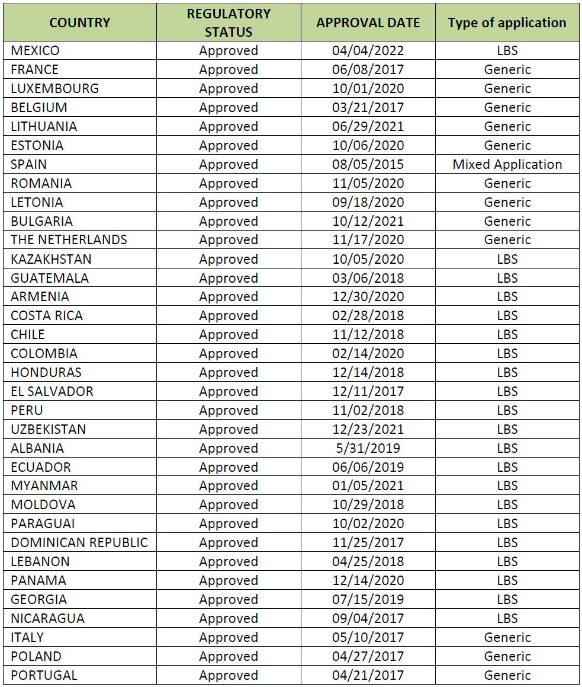
LBS=literature-based submission
The proposed capsules are not approved in USA. In USA, calcifediol 30 mcg extended-release capsules (RAYALDEE) have been approved since 2016 for the treatment of secondary hyperparathyroidism in adults with stage 3 or 4 chronic kidney disease and serum total 25-hydroxyvitamin D levels less than 30 ng/mL. This product is administered orally once daily, so has a substantially different dosing regimen to the product proposed in this application.

Registration timeline
Table 2 captures the key steps and dates for this submission.
This submission was evaluated under the standard prescription medicines registration process.
Table 1. Timeline for submission PM-2023-02298-1-1, VISTELLA (calcifediol)
Description | Date
Submission dossier accepted and evaluation commenced | 31 August 2023
Evaluation completed | 30 May 2024
Registration decision (Approved) | 16 July 2024
Registration in the ARTG completed | 6 March 2025
Number of working days from submission dossier acceptance to registration decision* | 190
*Statutory timeframe for standard submissions is 255 working days

Assessment overview

Quality evaluation summary
VISTELLA is an orange, soft gelatin capsule containing a clear, low viscous liquid free from particles. The capsule contains 255 microgram calcifediol (as monohydrate), carrier medium chain triglycerides (due to water insolubility) and a small amount of ethanol included as a manufacturing aid to solubilise the active and ensure all it is completely transferred to the mixing vessel. The soft capsule is primarily gelatin (bovine), glycerol and sorbitol, with added colorant (sunset yellow FCF) and opacifier (titanium dioxide). The capsules are packaged in PVC/PVDC/Al blisters, in a cardboard carton. The pack sizes include a starter pack of 1 capsule, and commercial pack sizes of 3, 4, 5, 6, 10 or 12 capsules (commensurate with monthly dosing).
The drug substance is white to almost write crystals. Calcifediol is practically insoluble in water, freely soluble in ethanol and soluble in fatty oils. The active is dissolved in the excipient matrix during manufacture of the capsules and remains in this state in the finished product.
The product is manufactured by non-aqueous mixing of the active in the carrier, followed by typical encapsulation in soft gelatin capsule. No nitrosamine risk was identified from the manufacture of the active, product or packaging.
The proposed specifications control identity, purity, dose uniformity and other physical, chemical and microbiological properties relevant to the clinical use of the product. The specification parameters and criteria are based on the European Pharmacopeia monograph for capsules. Acceptable analytical methods have been demonstrated to be appropriately validated.
Stability data have been generated under stressed, accelerated and real time conditions to characterise the stability profile of the product. The product is stable for 48 months when stored below 30 ℃.
All sites of manufacture have current and appropriate GMP clearances for the relevant steps of manufacture.
The Product Information is acceptable from a quality perspective and product labels conform to Therapeutic Goods Order No. 91 (Standard for labels of prescription and related medicines).
Approval of the registration of VISTELLA is recommended from a pharmaceutical chemistry perspective.

Nonclinical evaluation summary
The nonclinical dossier was based on published literature as well as studies from the non-clinical development program of calcifediol conducted in the 1970s.
Calcifediol is a precursor of the active form of vitamin D3 (calcitriol). The primary pharmacology of calcifediol in vitro and in vivo conformed with known biological functions of calcitriol. Calcifediol administered via clinical route improved circulating vitamin D levels supporting the drug’s use for the proposed indication.
Safety pharmacology studies were not submitted. Similar to hypervitaminosis D, high doses of calcifediol are expected to lead to hypercalcemia and associated symptoms including neuropsychiatric manifestations, hypertension, shortened QT interval, and ST segment elevation. The absence of non-clinical data does not allow comment on the dose when such manifestations might occur. These manifestations are not expected if 25(OH)D levels are monitored and maintained within the recommended physiological range.
Calcifediol binds to vitamin D binding protein and its plasma half life in humans is ~3 weeks. Tissue distribution of calcifediol in pregnant ewes was wide but penetration into brain, spinal cord or adipose tissue was not investigated. Vitamin D metabolites are mainly excreted through bile with <5% excreted through urine.
Several P450 cytochromes are involved in endogenous calcifediol and vitamin D metabolism. Consequently, inhibitors or inducers of CYP2R1, CYPD25, CYP3A4, CYP27B1 and CYP27A1 could alter the systemic exposure to calcifediol. Calcifediol may be expected to alter the exposure of co-administered drugs that are CYP24A1 substrates. Calcifediol may decrease the exposure of co-administered drugs that are substrates of P glycoprotein.
No carcinogenicity or genotoxicity studies were submitted for evaluation. Calcifediol monohydrate was not mutagenic in the bacterial mutation assay or clastogenic in vitro (in human lymphocytes or mouse lymphoma cells) or in vivo (in the rat micronucleus test). Considering that calcifediol is an endogenous human metabolite, calcifediol monohydrate is unlikely to pose a carcinogenicity risk.
Fertility was unaffected in male and female rats treated with calcifediol. Calcifediol was teratogenic in rats and rabbits. The proposed pregnancy category B3 is acceptable.
There is no non-clinical objection to the registration of VISTELLA.

Clinical evaluation summary

Summary of clinical studies
The clinical dossier included published studies from the systematic literature review plus four clinical study reports (CSR), including two comparative bioavailability studies (RD 526/21330, FEDIOL-0113/BE CSR) and two controlled efficacy/safety studies (HIDR-0217/OST, HIDR-0520/POS). The calcifediol capsules evaluated in the clinical studies contained calcifediol 255 microgram (as calcifediol monohydrate 266 microgram).

Pharmacology

Pharmacokinetics
The pharmacokinetics (PK) was informed by two clinical study reports (FEDIOL-0113/BE and RD 526/21330) plus 17 published clinical PK studies from the systematic literature review. Studies FEDIOL-0113/BE and RD 526/21330 were bioequivalence studies comparing the bioavailability of the proposed capsule to calcifediol oral solution (0.266 mg calcifediol monohydrate oral solution ampoules) in healthy subjects.

Study FEDIOL-0113/BE
This was a single dose, open-label, randomised, two-stage, two-sequence, two-period crossover study with blind determination of plasma concentration of 25(OH)D. It was conducted from October 2013 to June 14 and evaluated 70 healthy adults (36 male, 34 female) aged 18-35 years at a single centre in Spain. Study treatment was a single dose of two capsules of 0.266 mg calcifediol monohydrate or two ampoules of 0.266 mg calcifediol monohydrate oral solution, with a 105-day washout period. The treatment was administered after an overnight fast of at least 8 hours.
The key PK findings are presented in Table 3 and Figure 1. For the primary PK parameters C_{max} and AUC_{0-72h}, the adjusted 94.12% confidence intervals for the ratios of test to reference product were outside the acceptance range for bioequivalence (Table 4). The ratio for AUC_{0-∞} (secondary endpoint) was within the bioequivalence acceptance range.
Table 3. Mean serum 25(OH)D3 PK parameters following a single oral dose of two 0.266 mg calcifediol capsules (Test) or two 0.266 mg ampoules (Reference) in Study FEDIOL-0113/BE
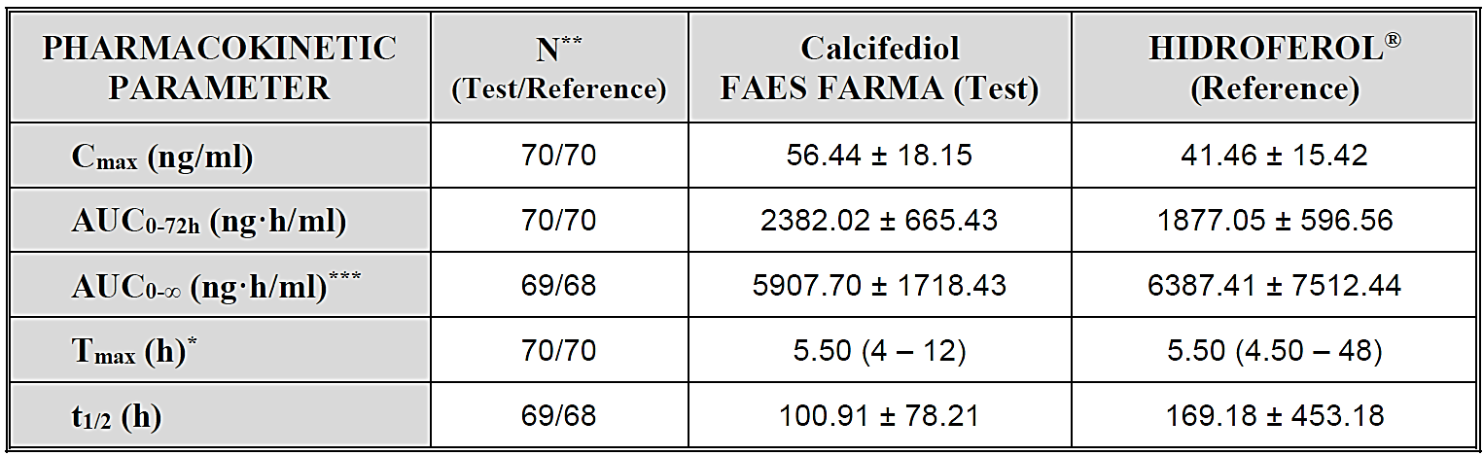
*Median (Range); **Number of subjects included in the analysis for each formulation; ***[footnote for this notation was not provided in the source table]. Calcifediol FAES FARMA (Test) = two 0.266 mg soft gelatin capsules; HIDROFEROL (Reference) = two 0.266 mg oral solution ampoule.
Figure 1. Mean baseline-corrected concentration (ng/ml)/time curves for calcifediol capsules (Test) and ampoules (Reference) in Study FEDIOL-0113/BE
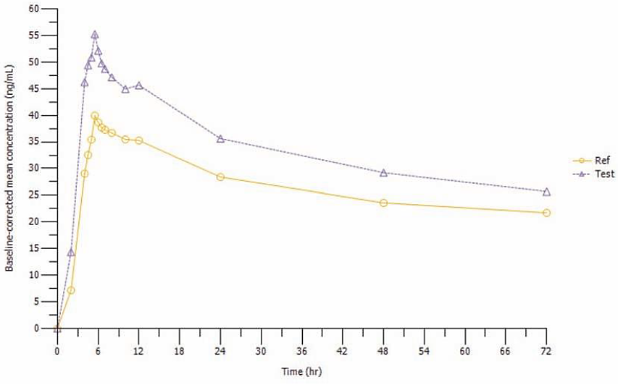
Table 4. Statistical comparative analysis of baseline-corrected calcifediol PK parameters in Study FEDIOL-0113/BE
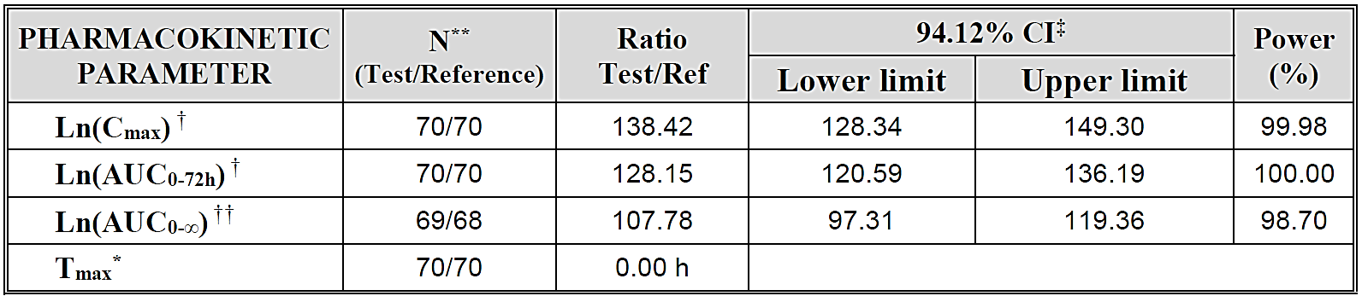
*Median of the differences; **Number of subjects included in the analysis for each formulation; † Sequence and Formulation effect (P<0.0001); †† Sequence effect (P<0.0001); ‡ α = 0.0294.

Study RD 526/21330
This was a single dose, open-label, randomised, crossover study to determine the bioequivalence of two formulations of calcifediol. The study was conducted in 1997 at a single centre in Wales and involved 24 healthy adults (14 male, 10 female) aged 18 to 50 years (mean age 33 years). Subjects were randomised to receive a single dose of four 0.266 mg HIDROFEROL capsules or four 0.266 mg HIDROFEROL ampoules, with a 14-day washout period. The treatment was administered after an overnight fast of at least 8 hours. The Evaluator noted that the washout period of 14 days is unlikely to allow for complete elimination of the drug between treatments and may have impacted on the reliability of the results.
The key PK findings are presented in Table 5 and Figure 2. For the PK parameters Cmax, AUCτ, and AUC₀₋₂₄, the 90% confidence intervals for the ratios of test to reference product were outside the acceptance range for bioequivalence (Table 6).
Table 5. Mean serum PK of 25(OH)D following single dose oral administration of four calcifediol 0.266mg capsules or four 0.266 mg ampoules in Study RD 526/21330 (Change from baseline)
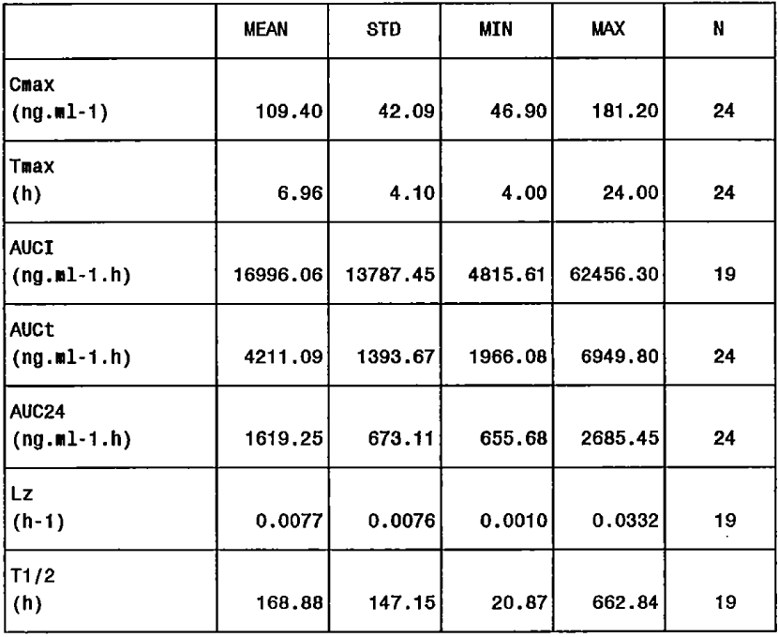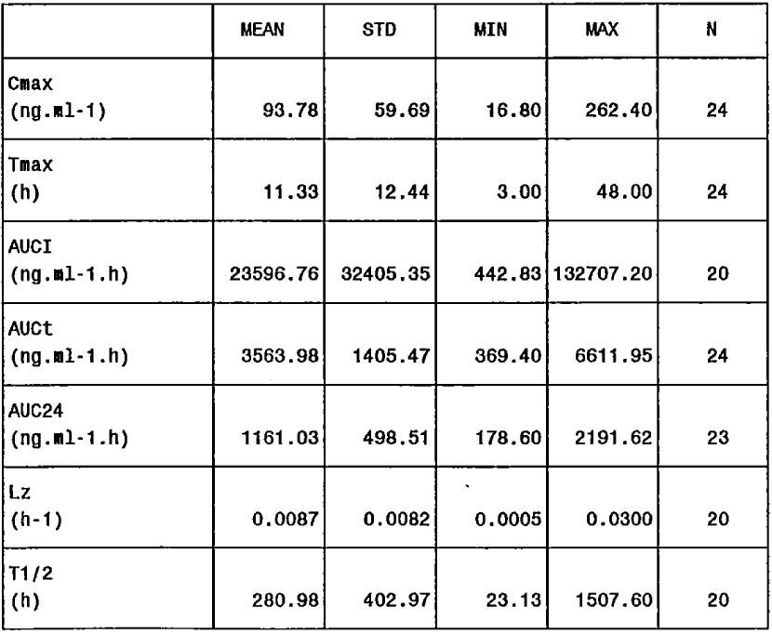
Figure 2. Mean serum 25(OH)D3 concentrations following single dose oral administration of four calcifediol 0.266mg capsules or four 0.266 mg ampoules in Study RD 526/21330
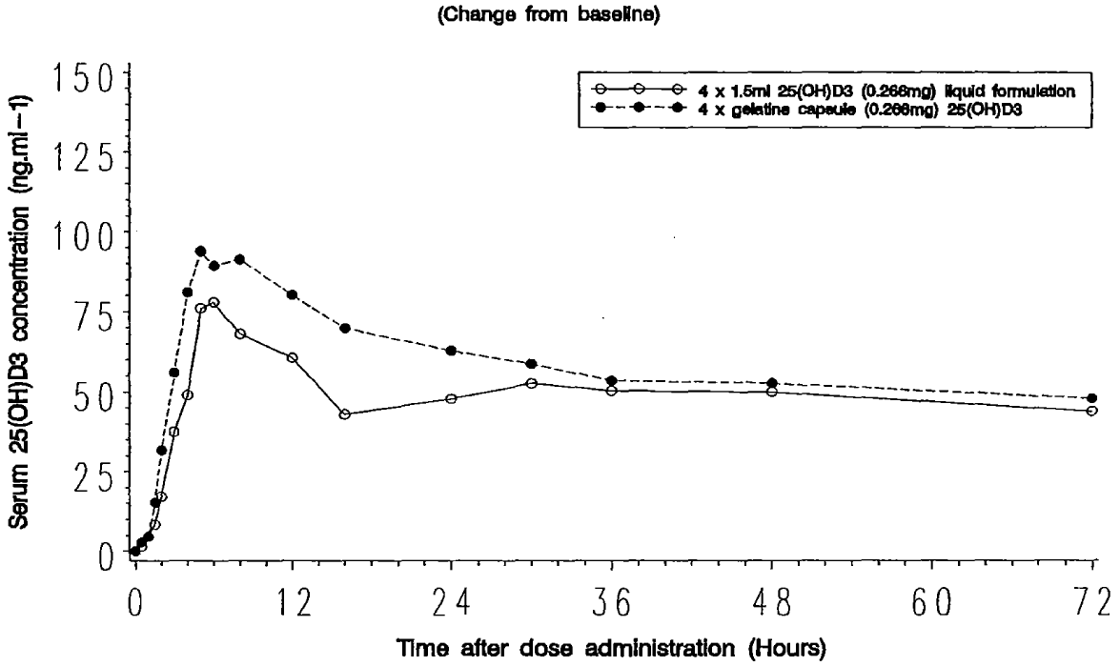
Table 6. 90% Confidence Intervals For The Ratio (Capsules [Test]/Ampoules [Reference]) of 25(OH)D3 PK parameters in Study RD 526/21330
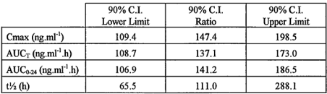

Published studies
The published literature included 10 studies comparing calcifediol and cholecalciferol pharmacology and 7 studies of the PK of calcifediol in various populations including healthy subjects, patients with chronic kidney disease (CKD), patients with disordered calcium metabolism and/or gastrointestinal function, osteopenic/osteoporotic women, and postmenopausal women. None of the studies from the published literature evaluated the capsule proposed for registration or HIDROFEROL oral solution. The main literature findings are summarised below.
Haddad Jr and Rojanasathit (1976) evaluated responses to oral doses of calcifediol in healthy subjects. Peak serum 25(OH)D levels occurred 4 to 8 hours after doses of 1.5, 5, and 10 mcg per kg of body weight. The mean increments above baseline serum 25(OH)D3 concentrations at 4 hours were linear over this dose range.
Russo et al., (2011) examined 18 healthy women aged 24-72 years at a single centre in Italy who received 500 mcg of oral calcifediol monthly for four months. The dose was given in the fasting state and with a glass of milk. The authors found a significant increase in serum 25(OH)D after the first administration, peaking at day three. Values tended to stabilise after day 30 and persisted significantly higher compared to the basal values (P < 0.001).
Jones et al., (2014) evaluated the plasma half-lives of 25(OH)D2 and 25(OH)D3 (calcifediol) in 36 healthy men aged 24 to 39 years, resident in The Gambia (n = 18) or the UK (n = 18) in the 33 days following a single dose of deuterated-25(OH)D2 and deuterated-25(OH)D3 (both 40 nmol). The mean half-life (SD) of 25(OH)D3 for all participants was 15.1 (3.1) days. There was no significant difference in the half-life of 25(OH)D3 between participants from The Gambia compared to the UK.
Minisola et al., (2017) evaluated 87 post-menopausal Italian women aged 55 years or older, with vitamin D inadequacy (serum 25(OH)D levels < 75 nmol/L). Mean ± SD baseline serum 25(OH)D level was 41 ± 19 nmol/L. Participants were randomised to receive three different dosages of oral calcifediol: 20 mcg/day (group 1; n=27), 40 mcg/day (group 2; n=28), or 125 mcg/week (group 3; n=29) for 3 months. In all the three groups, serum 25(OH)D values significantly rose during the first 30 days of treatment and plateaued thereafter.
Vaes, et al., (2018) conducted a randomised, double-blind study of 59 Dutch subjects aged 65 years and older (mean age 79, 53% men) who had serum 25(OH)D3 concentration between 25 and 50 nmol/L. Participants received either 5, 10 or 15 mcg calcifediol or 20 mcg colecalciferol per day, for 24 weeks. Steady state was achieved from week 12 onwards with serum 25(OH)D levels stabilising between 84 and 89 nmol/L in the 10 mcg calcifediol group.
Hsu et al., (2021) evaluated 87 adults (mean age 64 years) in the USA with serum 25(OH)D levels between 25 and 125 nmol/L. Of the included subjects, 43 had normal renal function (eGFR ≥60 ml/min/1.73m2), 24 had CKD (eGFR < 60 ml/min/1.73m2) not requiring dialysis, and 20 had end stage kidney disease treated with haemodialysis. All participants received a single IV injection of deuterated-25(OH)D3. After adjustment for age, sex, race, and estimated blood volume, lower eGFR was associated with reduced 25(OH)D clearance.
Jetter et al., (2014) conducted a seven-arm, randomised, double-blind, controlled parallel-group study in Switzerland with 35 healthy women (5 per treatment group) aged 50 to 70 years. The participants received 20 mcg calcifediol or colecalciferol daily, 140 mcg calcifediol or colecalciferol weekly, for 15 weeks, or a single dose of either 140 mcg calcifediol, or colecalciferol, or both. The AUC_{0–24h} was 28% or 67% higher, for daily or weekly dosing respectively, after the first dose of calcifediol than colecalciferol. After 15 weeks, this difference was 123% or 178%, respectively. A single dose of 140 mcg calcifediol led to 117% higher 25(OH)D3 AUC_{0–96h} values than 140 mcg colecalciferol, while the simultaneous intake of both did not further increase exposure.
Graeff-Armas et al., (2020) performed a randomised, double-blind, active comparator-controlled, long-term PK trial in England. Participants were 91 healthy Caucasian men (n=38) and post-menopausal women (n=53) over 50 years of age. The aim of the study was to compare the PK of three doses of calcifediol (10, 15, and 20 mcg daily) to colecalciferol (20 mcg daily) over 6 months of supplementation followed by 6 months of observation. Calcifediol was ∼3 times as effective as colecalciferol at raising serum 25(OH)D3 concentrations (Figure 3).
Figure 3 Serum 25(OH)D AUC over the intervention period (183 days), Graeff-Armas, Bendik, et al. (2020)
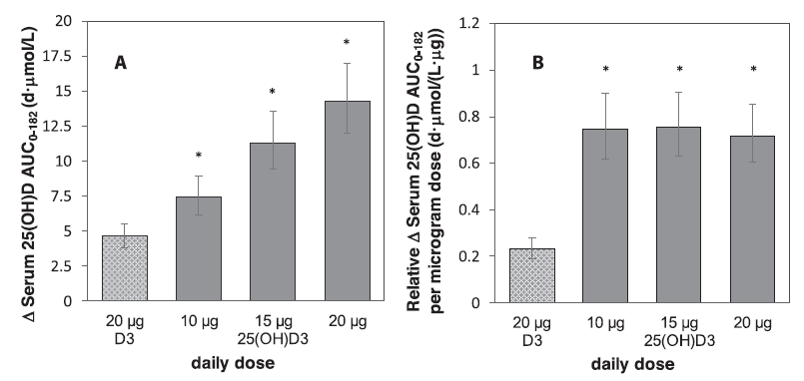
(A) AUC for the increment in serum 25(OH)D above baseline values. (B) Relative AUC per μg of intervention for the increment in serum 25(OH)D above baseline values. Least squares mean values are shown with error bars of lower and upper 95% CI, n = 21–24. ∗Different from D3 (P < 0.001, all pairwise treatment comparisons, not adjusted for multiplicity). D3 = colecalciferol; 25(OH)D or 25(OH)D3 = calcifediol.
Davies et al., (1980) examined 13 British patients with malabsorption due to coeliac disease, partial gastrectomy, or short gut (due to Crohn’s, bowel infarct, or tuberculosis), and compared them to five control patients with no detectable gastrointestinal disease. All participants received a single dose of an oral mixture containing radiolabelled calcifediol and colecalciferol with milk after a light breakfast. Malabsorption of colecalciferol and calcifediol occurred in patients with steatorrhoea, however malabsorption of colecalciferol was greater than calcifediol. The magnitude of malabsorption of these compounds was related to the severity of the steatorrhoea. Compared to the control group, calcifediol absorption was no different in coeliac disease, lower in the partial gastrectomy group at 8 and 24 hours, and lower in people with short bowel throughout the study period. The maximum concentration of radiolabelled calcifediol was always higher than that of colecalciferol and was reached significantly earlier (P<0.01).
Charoenngam et al., (2021) undertook a randomised, double-blind crossover trial in Boston, USA, which assessed the PK of a single oral dose of 900 mcg of either calcifediol or colecalciferol with a washout period of at least 28 days in six people with malabsorption and 10 healthy participants. For colecalciferol, malabsorptive patients had 64% lower AUC than healthy participants (P < 0.05). For calcifediol, the AUCs were not significantly different between the two groups (P = 0.540).
Sitrin and Bengoa (1987) studied 13 subjects in the USA, of whom four were healthy (aged 32 to 43 years) and nine had mild (n=5) or severe (n=4) cholestatic liver disease (aged 36 to 63 years). All participants received a single dose of an oral mixture containing radiolabelled calcifediol and colecalciferol after an overnight fast. Absorption of calcifediol peaked earlier and was greater than absorption of colecalciferol in all three groups and at all time points. Patients with mild cholestasis (normal bilirubin and faecal fat excretion) absorbed both forms of the vitamin normally. Those with severe cholestasis (jaundice and steatorrhoea) had minimal absorption of colecalciferol but relatively preserved absorption of calcifediol. Absorption of colecalciferol and calcifediol was inversely related to faecal fat excretion.
Leichtmann et al., (1991) evaluated twelve US patients with small bowel resections due to Crohn’s disease and four healthy controls. Subjects received radiolabelled colecalciferol or calcifediol. Absorption of both forms of the vitamin decreased with extent of resection but calcifediol absorption was always greater than colecalciferol.

Pharmacodynamics
The systematic literature review identified 5 clinical pharmacodynamic (PD) studies, all of which examined the effect of calcifediol on calcium absorption. None of the studies evaluated the proposed capsules or the proposed dosing regimen. Rutherford et al., (1975) reported that calcifediol can improve calcium absorption in uraemic patients, even in the absence of renal tissue. Colodro et al., (1978) reported an increase in calcium absorption and urinary calcium excretion in healthy subjects receiving calcifediol 20 mcg/day, while doses of 500 or 1000 mcg/day were required to augment calcium absorption in renal failure patients. Francis et al., (1983) evaluated calcium absorption in 48 British women aged >65 years who were randomised to receive 5, 10, 20, 40, 80, or 120 mcg of oral calcifediol daily for 7 days. They reported that calcium malabsorption was associated with low baseline serum 25(OH)D concentrations and was corrected by treatment with oral calcifediol. Francis and Peacock (1987) studied the effects of oral calcifediol (40 mcg once daily for 7 days) and calcitriol (0.25 mcg twice a day for 7 days) on plasma 1,25(OH)2D and calcium absorption in 20 post-menopausal British women with vertebral osteoporosis (n=10 in each treatment group). Calcium absorption increased more with calcitriol than calcifediol despite both groups having a similar increase in plasma 1,25-(OH)2D.

Dose selection for the efficacy studies
The calcifediol dosage of one capsule per month evaluated in Studies HIDR-0217/OST and HIDR-0520/POS was selected based on the approved posology and extensive history of use in Spain. Study HIDR-0520/POS also evaluated a dosage of one capsule per fortnight in subjects with baseline 25(OH)D <25 nmol/L. This was based on clinical guidelines and experience.

Efficacy

Study HIDR-0217/OST
This was a randomised, controlled, double-blind, double-dummy, multicentre, 12-month, phase III-IV study to determine the efficacy and safety of treatment with calcifediol capsules in the correction and maintenance of normal values of vitamin D in post-menopausal women with or without osteoporosis. It was conducted at nine study sites in Spain and one in Italy from March 2018 to August 2020.
The primary efficacy objective was to assess the percentage of patients achieving 25(OH)D levels >75 nmol/L at 4 months of treatment in each of the treatment groups. The key secondary efficacy objective was to assess the percentage of patients achieving 25(OH)D levels >75 nmol/L at 1, 8, and 12 months of treatment in each of the treatment groups. The study specified other secondary objectives and safety objectives.
The study included postmenopausal women with vitamin D deficiency, defined as 25(OH)D levels <50 nmol/L. Subjects could be non-osteoporotic and not receiving treatment with drugs affecting bone metabolism, or osteoporotic and receiving treatment with anti-resorptives, bisphosphonates or denosumab. Subjects taking drugs or nutritional supplements which can modify vitamin D levels were excluded.
303 subjects were randomised 1:1:1 to one of three treatment groups:
- Group A1 (n=102)
  - 1 HIDROFEROL soft gelatin capsule (266 mcg) once a month for 12 months.2.5 mL placebo oral solution once a month for 12 months.
  - Group A2 (n=101)
- 1 HIDROFEROL soft gelatin capsule (266 mcg) once a month for 4 months.
  - 1 placebo soft gelatin capsule once a month from month 5 to 12.
  - 2.5 mL placebo oral solution once a month for 12 months.
- Group B (n=100)
  - 2.5 mL colecalciferol (Dibase 25000 IU) oral solution once a month for 12 months
  - 1 placebo soft gelatin capsule once a month for 12 months.
Overall, the mean age was 63.4 years and 98% were Caucasian. Mean baseline 25(OH)D level was 32.5 nmol/L. Baseline 25(OH)D level was ≤25 nmol/L in 24.8% of subjects and >25 to 50 nmol/L in 75.2%. The ITT population included only 32 (10.7%) subjects with osteoporosis, 12 in Group A1, 9 in Group A2, and 11 in Group B.
The primary efficacy endpoint was the percentage of patients achieving 25(OH)D levels >75 nmol/L at month 4, for each treatment group. The key secondary efficacy endpoint was percentage of patients achieving 25(OH)D level >75 nmol/L at months 1, 8, and 12. Other secondary endpoints included time to achieve the treatment goal (i.e. 25(OH)D level >75 nmol/L), mean change from baseline of 25(OH)D serum level at months 1, 4, 8 and 12, endpoints relating to bone and mineral metabolism, bone remodelling biomarkers, and effects of phenotype and genotype on 25(OH)D levels.
The primary efficacy analysis assessed the superiority of Group A (A1+A2) versus Group B at month 4. According to the protocol, group A would be superior to group B if the proportion difference between groups was superior to 20% (minimum effect) in favour of Group A, and the 95% asymptotic CI lower limit for the proportion difference was superior to 0%, based on the intention to treat ITT population. If the superiority criteria could not be met, a non-inferiority efficacy analysis would be applied. Group A would be non-inferior to group B, if the 95% asymptotic CI lower limit for the proportion difference was superior to -10% (non-inferiority margin), based on the PP population at month 4.
Findings for the primary endpoint are shown in Table 7. The pre-specified superiority criteria for the primary efficacy analysis were met, so non-inferiority analysis was not required.
Table 7. Patients achieving 25(OH)D levels > 30 ng/mL [> 75 nmol/L] at month 4. Superiority analysis using the ITT population in Study HIDR-0217/OST
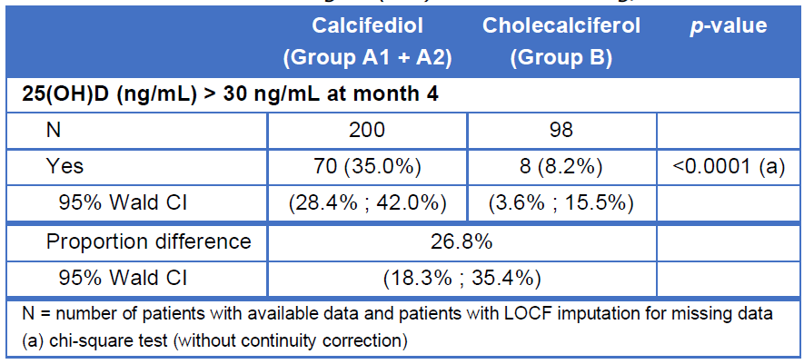
For the key secondary efficacy endpoint, a significantly greater proportion of subjects in Group A1 compared to group B achieved 25(OH)D levels >75 nmol/L at month 1, 8, and 12 (Table 8). In Group A1, median time to achieve 25(OH)D levels >75 nmol/L was 8.1 months (Figure 4). Serum 25(OH)D levels for each group over time are shown in Figure 5.
No clinically relevant differences between treatment groups were observed for bone and mineral metabolism markers (total serum calcium, phosphorus, albumin, PTH, total alkaline phosphatase) or bone turnover markers (ß-CTX, P1NP).
Table 8. Patients with 25(OH)D level >30 ng/mL (>75 nmol/L) at months 1, 8, & 12, Study HIDR-0217/OST
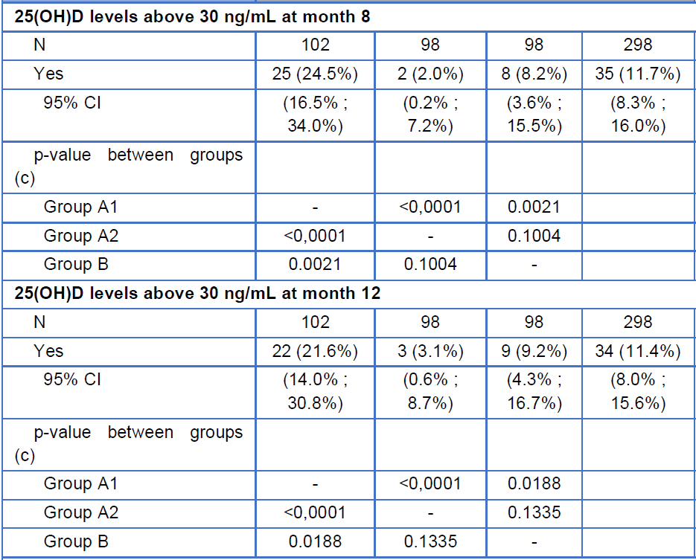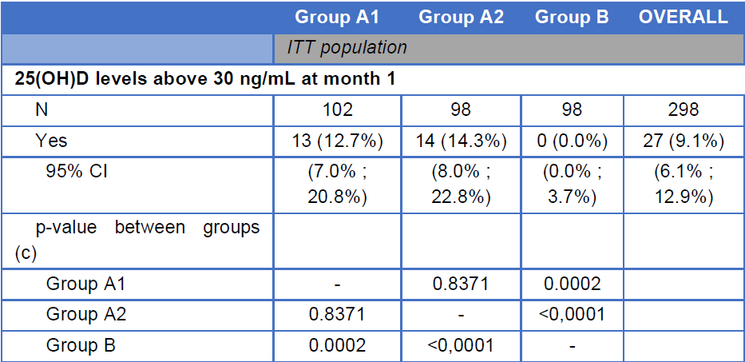
Figure 4 Time to achieve 25(OH)D levels >30 ng/mL (>75 nmol/L), HIDR-2017/OST (ITT)
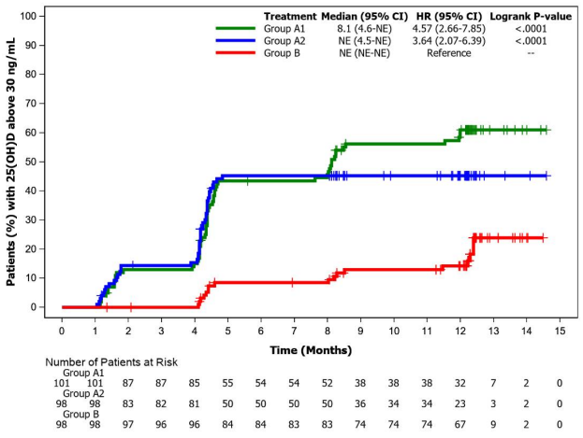
Figure 5 Serum 25(OH)D concentration (ng/mL) over time HIDR-2017/OST (ITT)
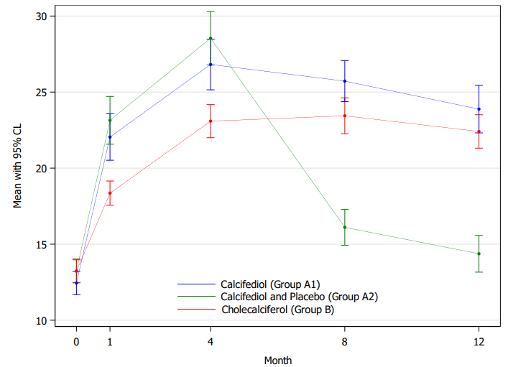
In additional exploratory analyses, the percentage of subjects in Group A1 achieving 25(OH)D levels >50 nmol/L at months 1, 4, 8, and 12 was 55.9%, 79.4%, 83.3%, and 69.6%, respectively. In Group B, 33.7%, 71.4%, 72.4%, and 61.2% achieved 25(OH)D levels >50 nmol/L at months 1, 4, 8, and 12 respectively (Figure 6).
Figure 6. Time to achieve 25(OH)D levels >20 ng/mL (>50 nmol/L), HIDR-2017/OST (ITT)
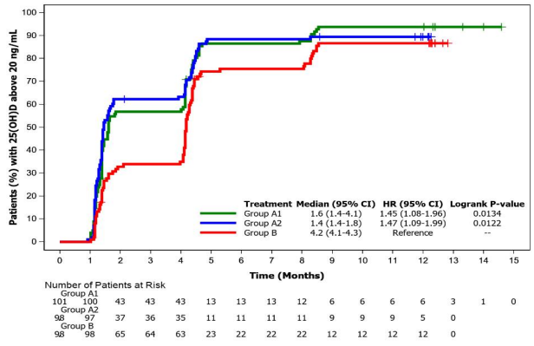

Study HIDR-0520/POS
This study comprised an open-label treatment phase lasting 4-6 months, and a randomised, double-blind, placebo-controlled follow-up phase lasting 5 months. The study was conducted at 3 centres in Spain between August 2020 and March 2022.
The primary objective was to determine the proportion of subjects with vitamin D deficiency (25(OH)D < 50 nmol/L) who were able to achieve 25(OH)D level within the defined optimal therapeutic range 50 – 150 nmol/L after four months of treatment with calcifediol monohydrate (266 mcg), with two different frequencies of administration (once or twice per month).
For the treatment phase, the dose of calcifediol was based on the 25(OH)D level:
- subjects with mild to moderate deficiency (baseline 25(OH)D level 25 to <50 nmol/L) received one capsule monthly for four months
- subjects with severe deficiency (<25 nmol/L) received one capsule bi-weekly (every 15 days) for four months.
At Month 4, 25(OH)D levels were evaluated and the treatment regimen was adjusted according to the 25(OH)D level at that time:
- subjects with 25(OH)D level 25 to <50 nmol/L received one capsule monthly for two additional months, after which 25(OH)D levels were re-checked.
- subjects with 25(OH)D level <25 nmol/L received one capsule bi-weekly for two additional months, after which 25(OH)D levels were re-checked.
- subjects with 25(OH)D level 50 to 150 nmol/L entered the follow-up phase.
- subjects with 25(OH)D level > 150 nmol/L received no further treatment and were re-evaluated after 5 months (Month 9).
For the follow-up phase, subjects with 25(OH)D level 50 to 150 nmol/L at the end of the treatment phase were randomised to monthly treatment with calcifediol capsule or placebo capsule for 5 months. Subjects with 25(OH)D level < 50 nmol/L at the end of the treatment phase were withdrawn from the study.
The study included 101 adult subjects aged 18 to 50 with baseline 25(OH)D level <50 nmol/L. At baseline, mean age was 29.8 years, 65% were female, and 80% were Caucasian. 94 subjects had baseline 25(OH)D level 25 to <50 nmol/L and 7 subjects had baseline 25(OH)D level <25 nmol/L. 89 subjects completed the treatment phase, and 87 were randomised in the follow-up stage, all of whom completed the study.
The primary efficacy endpoint was the percentage of subjects who achieved 25(OH)D levels within the defined optimal therapeutic range (50 to 150 nmol/L) at Month 4.
Secondary efficacy endpoints in the treatment phase were:
- 25(OH)D levels at all time-points from baseline to Month 4
  - individual and mean values at baseline, Month 1, and Month 4.
  - percentage of subjects within the optimal range at Month 1.
  - percentage of subjects with levels < 50 nmol/L at Month 4.
  - percentage of subjects with levels >150 nmol/L at Month 4
- percentage of subjects with 25(OH)D levels within the range 75–150 nmol/L at Month 4.
- mean change in 25(OH)D levels at Month 4, from baseline and Month 1, and mean change in 25(OH)D levels at Month 1, from baseline.
- 25(OH)D levels (individual/mean values) at Month 6:
  - percentage of subjects with levels within the optimal range.
  - percentage of subjects with levels <50 nmol/L.
  - percentage of subjects with levels >150 nmol/L.
- percentage of subjects with 25(OH)D levels within the range 75–150 nmol/L at Month 6.
- mean change in 25(OH)D levels at Month 6, from baseline and Month 4
Secondary efficacy endpoints in the follow-up phase were:
- 25(OH)D levels (individual/mean values) at the end of the follow-up phase (at Month 9 and Month 11, separately and together) in calcifediol and placebo groups, and specifically:
  - Comparison of the percentage of subjects with levels within 50 to 150 nmol/L.
  - Comparison of the percentage of subjects with levels <50 nmol/L (deficiency, 25-50 nmol/L, and severe deficiency <25 nmol/L)
  - Comparison of the percentage of subjects with levels >150 nmol/L.
- Comparison of the mean change in 25(OH)D levels from the beginning (Month 4 or Month 6) to the end (Month 9 or Month 11, respectively) of the follow-up phase of each group (calcifediol and placebo).
- Compliance was evaluated from an electronic patient diary which records the subject's compliance. For the analysis, full compliance was required to be considered adherent.
For the primary endpoint, 79 of 96 subjects (82%) achieved 25(OH)D levels within the range 50 to 150 nmol/L at Month 4 (Table 9). Of the 7 subjects with baseline 25(OH)D level <25 nmol/L who received bi-weekly treatment, 25(OH)D levels at Month 4 were within the optimal range for 6 subjects and above the optimal range for 1 subject (198 nmol/L) without any symptoms of toxicity or adverse event.
Table 9. Percentage of subjects who achieved serum 25(OH)D levels of 20-60 ng/mL [50 – 150 nmol/L] at Month 4 of calcifediol 0.266 mg treatment (Full Analysis Set, Study HIDR-0520/POS)
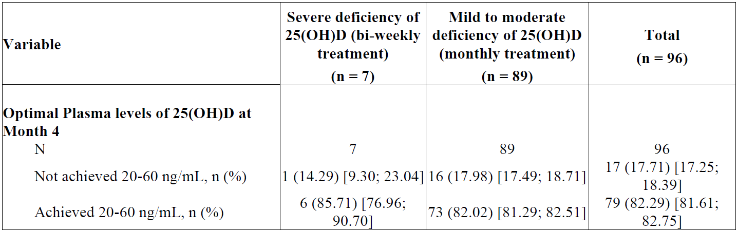
Data presented as n (%) [99% CI]. Bi-weekly treatment = one capsule every 15 days.
At Month 4, 16 subjects with baseline 25(OH)D levels 25 – 50 nmol/L required an extra 2 months of treatment in the treatment phase, after which 11 of the subjects achieved the optimal range. None of the 7 subjects with baseline 25(OH)D levels <25 nmol/L required the extra 2 months of treatment.
Mean changes in 25(OH)D levels (ng/mL) from baseline during the treatment phase are presented in Figure 7. The mean increase in 25(OH)D levels from baseline to the end of the treatment phase was 100 nmol/L in patients with severe deficiency (bi-weekly treatment) and 38 nmol/L in patients with mild to moderate deficiency (monthly treatment).
Figure 7. Change in plasma levels of 25(OH)D (ng/mL) during the treatment phase (FAS, Study HIDR-0520/POS)
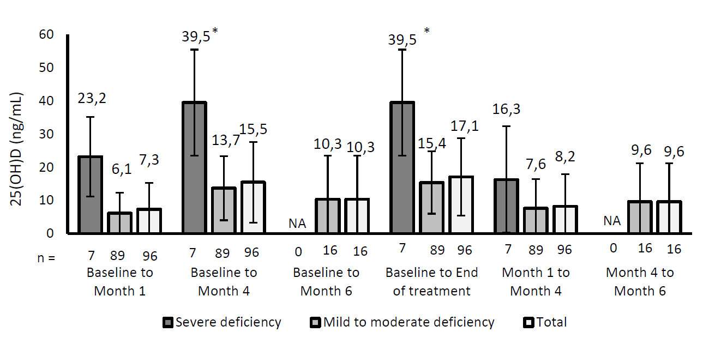
Data presented as mean change ± standard deviation. NA: not applicable. * One patient with 25(OH)D levels of 79 ng/ml [198 nmol/L] at Month 4 was included.
The analysis of efficacy in the follow-up phase was performed in the Per-Protocol population (n=75). A significantly higher proportion of patients treated with calcifediol compared to placebo achieved 25(OH)D levels within the optimal range (50 to 150 nmol/L) at Month 9 (88% vs. 51%; p = 0.001), and at the end of the follow-up phase (89% vs. 49%; p < 0.001). From the end of the treatment stage to the end of the follow-up stage, the mean decrease in 25(OH)D levels was 28 nmol/L in the placebo group and 15 nmol/L in the calcifediol group.

Published studies
The Sponsor’s systematic literature review identified 50 published studies informing efficacy, including two publications reporting the findings of Studies HIDR-0520/POS and HIDR-0217/OST. The other published studies reported the efficacy of different formulations and dosage regimens of calcifediol, so do not provide pivotal evidence for the proposed product.

Safety
The safety of VISTELLA was informed primarily by safety findings from the two efficacy/safety studies, supported by safety data from the two single-dose bioequivalence studies. The safety of calcifediol was also informed by published literature, noting the limitation that the published data related to different dose forms and dosage regimens.
In the two main studies, 347 subjects were exposed to at least one dose of calcifediol. Of the 340 subjects receiving once monthly dosing, 144 were treated for 4-6 months (HIDR-0217/OST n=93; HIDR-0520/POS n= 51), and 138 were treated for 9-12 months (HIDR-0217/OST n=95; HIDR-0520/POS n= 43). The 7 subjects on twice monthly dosing received treatment for 4 months.

Study HIDR-0217/OST
This was a randomised, double-blind study comparing treatment with one calcifediol capsule monthly versus colecalciferol oral solution 25000 IU monthly. Overall, 129 (42.6%) subjects reported at least one treatment emergent adverse event (TEAE), with similar rates across all three treatment groups (Group A.1 = 44.1%; Group A.2 = 42.6%; Group B = 41.0%). A total of 215 TEAEs were reported. Overall, the most frequent TEAEs by preferred term (PT) were bronchitis (n= 9, 3.0%); arthralgia, back pain (n= 7, 2.3%); gastroenteritis, urinary tract infection, and headache (n= 5, 1.7%). The majority of TEAEs were of mild severity. Two subjects, both in Group A.2, reported TEAEs assessed as treatment-related: abdominal discomfort and dyspepsia, both assessed as mild. Serious adverse events (SAEs) were reported in 17 (5.6%) subjects (8 in Group A1, 4 in Group A2, 5 in Group B), none of which were assessed as treatment-related. One TEAE leading to discontinuation of study treatment was reported in Group A.1 which was assessed as not treatment-related (breast neoplasm). No deaths were reported in the calcifediol groups (A.1, A.2). One death in Group B (colecalciferol) due to acute kidney injury was assessed as not treatment-related.
Haematology and biochemistry parameters showed no differences between treatment groups. There were no significant changes in serum total calcium concentrations over the duration of the study. No cases of clinically significant hypercalcemia or hypervitaminosis D were reported. Serum 25(OH)D level >150 nmol/L was reported in one subject whose 25(OH)D level was 160 nmol/L at Month 1 after taking calcifediol weekly instead of monthly. No TEAE was reported for this patient. The subject discontinued treatment at Month 1 and was withdrawn from the study because the dosing error constituted a major protocol violation. The subject was followed up at Month 4, at which time their serum 25(OH)D was 105 nmol/L.

Study HIDR-0520/POS
Overall, 66 TEAEs were reported in 36 (35.6%) subjects during the study. In the treatment phase, 40 TEAEs were reported in 27 (26.73%) subjects (4 subjects in the bi-weekly group and 23 subjects in the monthly group). During the follow-up phase, 26 TEAEs were reported in 17 (16.8%) subjects (10 subjects in the placebo group, 7 subjects in the calcifediol group). 9 TEAEs assessed as treatment-related were reported in 5 subjects, all in the treatment phase with monthly dosing (headache, nausea, abdominal discomfort, decreased appetite, blood parathyroid hormone increased (one subject each), and diarrhoea (two subjects). No SAEs or TEAEs leading to discontinuation or death were reported. There were no clinically significant changes in haematology or clinical chemistry parameters, including serum calcium. One participant receiving 1 capsule bi-weekly was withdrawn from treatment at Month 4 due to 25(OH)D level of 197.5 nmol/L, in accordance with the study protocol. No TEAE was reported for this subject.

Published studies
39 studies from the systematic literature review reported on safety outcomes. Most of the studies evaluated different dose forms and dosage regimens of calcifediol. Key safety findings from the published studies are described in the clinical evaluation report.
10 published studies reported safety outcomes in patients with CKD. Across these studies, significant serum calcium increases were either not observed or were similar between the calcifediol and comparator groups. No deleterious impacts on renal function were reported. One study (Pérez-García et al., [2012]) found an increase in the need for phosphate binders with calcifediol treatment, but this was not reported in any other studies.

Post-marketing experience
Cumulatively, 31,458,496 units of HIDROFEROL soft capsules have been sold from the launch date until 31 December 2023, equivalent to 20,905,118 patient‐years exposed to this product. FAES FARMA markets other medicinal products containing calcifediol (oral solution and oral drops). From the launch date until 31 December 2023, a total of 19,864,809 units of HIDROFEROL oral solution and oral drops were sold, equivalent to 15,801,266 patient‐years exposed.
Up to 31 December 2023, 32 cases reporting hypercalcemia and Vitamin D overdose were received. In 9 of them the suspect product was calcifediol soft capsules and in the remaining 23 the suspect product was calcifediol oral solution.

Special populations
There are no adequate or well controlled studies using calcifediol in pregnant women. One subject became pregnant during the follow-up phase of Study HIDR-0520/POS. The subject completed the study and took the study drug according to the protocol. After the final study visit and during the pregnancy, the subject was prescribed calcifediol 266 mcg monthly by her obstetrician. The delivery was normal at week 38 of the pregnancy without maternal complications or birth-related problems. The Sponsor is not proposing use of VISTELLA in pregnancy or breast-feeding.
The efficacy and safety of VISTELLA have not been evaluated in paediatric patients. VISTELLA is proposed only for use in adults.

Other
This was a mixed application based on clinical studies of the proposed product plus published data, including observational studies identified in the systematic literature search.

Risk Management Plan evaluation summary
The Risk Management Plan (RMP) is presented in EU-RMP version 2.6 (dated 23 January 2024; DLP 31 December 2023) and Australian Specific Annex version 3.0 (dated 1 May 2024). The summary of safety concerns in the ASA aligns with the EU-RMP and does not include any important identified risks, important potential risks, or missing information. Routine pharmacovigilance and routine risk minimisation will apply for VISTELLA in Australia. The Black Triangle Scheme will apply as VISTELLA is a new prescription medicine in Australia. The Sponsor has included the Black Triangle Scheme symbol and statement in the proposed Product Information and Consumer Medicine Information.

Discussion

Efficacy
The efficacy of calcifediol for the treatment of vitamin D deficiency was informed primarily by two randomised, controlled clinical studies of the Sponsor’s product supplemented by published studies identified from the systematic literature search.
Study HIDR-0217/OST was a randomised, double-blind, active-controlled study to evaluate the efficacy of calcifediol (one capsule monthly) compared to colecalciferol (oral solution 25000 IU monthly) for the treatment of vitamin D deficiency (25(OH)D level <50 nmol/L) in postmenopausal women. The formulation and dosage of colecalciferol evaluated in this study is not registered in Australia, but the monthly dosage evaluated in the study would equate to a daily dose of ∼800 IU colecalciferol. The primary objective was to assess the percentage of patients achieving 25(OH)D levels >75 nmol/L at 4 months of treatment. At 4 months, 35.0% of subjects treated with calcifediol one capsule monthly achieved serum 25(OH)D level >75 nmol/L, compared to 8.2% of subjects treated with colecalciferol 25000 IU monthly. In subjects treated with calcifediol monthly for 12 months, 25(OH)D levels >75 nmol/L were reported in 24.5% at month 8 and 21.6% at month 12, and the percentage of subjects achieving 25(OH)D levels >50 nmol/L at months 1, 4, 8, and 12 was 55.9%, 79.4%, 83.3%, and 69.6%, respectively. The mean 25(OH)D level peaked at Month 4 and remained stable through to Month 12. No clinically relevant differences between treatment groups were observed for bone and mineral metabolism markers or bone turnover markers.
Study HIDR-0520/POS was a 2-stage study of adult subjects with vitamin D deficiency (25(OH)D < 50 nmol/L). It comprised an open-label treatment stage lasting 4-6 months and a randomised, double-blind, placebo-controlled follow-up stage lasting 5 months. In the treatment stage, subjects received one calcifediol capsule monthly or bi-weekly (every 15 days) depending on their baseline 25(OH)D level. In the follow-up stage, subjects were randomised to treatment with one calcifediol capsule monthly or matching placebo. The primary objective was to determine the proportion of subjects who were able to achieve 25(OH)D levels within the defined optimal range (50 – 150 nmol/L) after four months of treatment with calcifediol capsules. At Month 4, 82.3% of participants achieved 25(OH)D levels in the optimal range. The mean increase in 25(OH)D levels from baseline to the end of the treatment stage was 100 nmol/L in patients with severe deficiency receiving bi-weekly treatment, and 38 nmol/L in patients with mild to moderate deficiency receiving monthly treatment. In the analysis of the follow-up stage, a significantly higher proportion of patients treated with calcifediol compared to placebo achieved 25(OH)D levels within the optimal range (50 to 150 nmol/L) at Month 9 (88% vs. 51%; p = 0.001), and at the end of the follow-up stage (89% vs. 49%; p < 0.001).
Findings from Studies HIDR-0217/OST and HIDR-0520/POS support the efficacy of VISTELLA capsules for increasing serum 25(OH)D levels when taken once monthly for adults with vitamin D deficiency. Study HIDR-0520/POS also provides support for the proposed option for more frequent dosing (up to one capsule per fortnight) in selected patients after analytical verification of the extent of vitamin D deficiency. The dosing guidance in the Product Information advises that serum concentrations of 25(OH)D should be monitored after initiation of treatment, usually after 3-4 months or as per doctor’s recommendations.

Safety
The safety of VISTELLA was informed primarily by safety findings from the two efficacy/safety studies, supported by safety data from the two single-dose bioequivalence studies. The safety of calcifediol was also informed by published literature, noting the limitation that the published data related to different dose forms and dosage regimens.
All of the subjects in the main efficacy/safety studies had confirmed vitamin D deficiency (25(OH)D <50 nmol/L). Most of the safety data from the main efficacy/safety studies was for the proposed dose of one capsule monthly. Safety data for two-weekly dosing is more limited, with only 7 subjects in HIDR-0520/POS exposed to this regimen. The clinical studies did not evaluate weekly dosing and this has been removed as a dosing option.
VISTELLA was well tolerated in the clinical studies. The published literature was also broadly supportive of the safety of calcifediol in adults, including older people and patients with comorbidities including osteoporosis and CKD.
Hypercalcaemia is a known risk associated with excessive dosing of vitamin D products, including calcifediol. The submitted safety dataset is reassuring with regard to the risk of hypercalcaemia with the proposed dosing regimen of VISTELLA. This risk is further mitigated by the recommendation to monitor 25(OH)D levels during treatment, which is addressed in sections 4.2 and 4.4 of the Product Information.
The safety of VISTELLA for the proposed use is supported by extensive post-market safety data.
The Delegate agreed with the clinical Evaluator that the submitted clinical studies do not adequately establish the efficacy and safety of the proposed product for the prevention of vitamin D deficiency in adults with identified risks, or as adjuvant for the specific treatment of osteoporosis. The Sponsor’s clinical studies did not address these indications and the published studies evaluated other formulations and dosage regimens. Consequently, the efficacy and safety of the proposed product have not been satisfactorily established for those indications.
With regard to the revised indication, the Delegate’s perspective is that the inclusion of “and management” is superfluous and confusing, as there is no meaningful difference between “treatment” and “management”. The Delegate’s view is that the indication should be:
Treatment of vitamin D deficiency in adults.
This indication would include initial treatment to correct vitamin D deficiency as well as maintenance treatment of vitamin D deficiency if required, as described in the dosing guidance in section 4.2 of the Product Information.

Proposed dose
The proposed dose of VISTELLA is one capsule once a month. Higher doses may be necessary in some patients after analytical verification of the extent of vitamin D deficiency. In these cases, the maximum dose administered should not exceed one capsule per fortnight. Once the plasma 25(OH)D levels are stabilised within the desired range, the treatment should be discontinued, or the frequency of administration lowered.
Clinical data supporting the efficacy and safety of dosing VISTELLA more frequently than monthly are limited. The submission did not present any clinical studies evaluating the safety of weekly dosing of VISTELLA, so this has been removed from the proposed dosing regimen. The submitted clinical data support the efficacy and safety of monthly and two-weekly dosing, provided that 25(OH)D levels are monitored during treatment.

Uncertainties and limitations of the data
The submission included two clinical study reports comparing the bioavailability of the calcifediol capsules to calcifediol oral solution, and two efficacy/safety studies evaluating the calcifediol capsules. Published studies provided further data regarding the pharmacology, efficacy and safety of calcifediol. However, the published studies did not evaluate the calcifediol capsules proposed for registration, and the bioequivalence studies showed that the capsules proposed for registration are not bioequivalent to calcifediol oral solution. This limits the extent to which the findings reported in published studies can be applied to the proposed product. The published studies are therefore viewed as supportive evidence rather than pivotal evidence.
The application did not present a cohesive dose-finding strategy for the proposed product. The monthly dosing regimen evaluated in the efficacy/safety studies was based on the extensive history of use of the product in Spain.

Conclusions
This is the first application to register calcifediol as a prescription medicine in Australia.
The submitted data are sufficient to establish the efficacy and safety of VISTELLA for the treatment of vitamin D deficiency in adults. This includes initial treatment to correct vitamin D deficiency, as well as maintenance treatment of vitamin D deficiency if required.
The main safety risk is hypercalcaemia associated with hypervitaminosis D arising from excessive dosing. The submitted safety dataset is reassuring for this risk with the proposed dosing regimen of VISTELLA. Monitoring of 25(OH)D levels whilst on treatment is necessary to mitigate this risk, and this is adequately addressed in the proposed Product Information.

Assessment outcome
Based on a review of quality, safety, and efficacy, the TGA decided to register VISTELLA - calcifediol, indicated for the:
Treatment of vitamin D deficiency in adults, and maintenance treatment as required.

Specific conditions of registration
VISTELLA (calcifediol monohydrate) is to be included in the Black Triangle Scheme. The PI and CMI for VISTELLA must include the black triangle symbol and mandatory accompanying text for five years, which starts from the date of first supply of the product.
The VISTELLA EU-Risk Management Plan (RMP) (version 2.6, dated 23 January 2024, data lock point 31 December 2023), with Australian Specific Annex (version 3.0, dated 1 May 2024), included with submission PM-2023-02298-1-1, and any subsequent revisions, as agreed with the TGA will be implemented in Australia.
An obligatory component of risk management plans is routine pharmacovigilance. Routine pharmacovigilance includes the submission of periodic safety update reports (PSURs).
Reports are to be provided in line with the current published list of EU reference dates and frequency of submission of PSURs until the period covered by such reports is not less than three years from the date of this approval letter. Each report must be submitted within ninety calendar days of the data lock point for that report.
The reports are to at least meet the requirements for PSURs as described in the European Medicines Agency’s Guideline on good pharmacovigilance practices (GVP) Module VII-periodic safety update report (Rev 1), Part VII.B Structures and processes. Note that submission of a PSUR does not constitute an application to vary the registration.

Product Information and Consumer Medicine Information
For the most recent Product Information (PI) and Consumer Medicines Information (CMI), please refer to the TGA PI/CMI search facility.

Therapeutic Goods Administration
PO Box 100 Woden ACT 2606 Australia
Email: info@tga.gov.au Phone: 1800 020 653 Fax: 02 6203 1605
https://www.tga.gov.au

Colecalciferol is the Australian Approved Name (AAN) but it is also referred to as cholecalciferol.
RCPA (2023). Use and Interpretation of Vitamin D testing. https://www.rcpa.edu.au/Library/College-Policies/Position-Statements/Use-and-Interpretation-of-Vitamin-D-Testing
Australian Bureau of Statistics. (2013). National Health Measures Survey: Vitamin D. https://www.abs.gov.au/articles/vitamin-d
Therapeutic Goods Administration, Interim decision in relation to calcifediol, TGA, 6 February 2020.
Therapeutic Goods Administration, Calcifediol monohydrate, TGA, 7 May 2020.
Haddad JG Jr, Rojanasathit S. Acute administration of 25-hydroxycholecalciferol in man. J Clin Endocrinol Metab. 1976 Feb;42(2):284-90. doi: 10.1210/jcem-42-2-284. PMID: 177440.
Russo S, Carlucci L, Cipriani C, Ragno A, Piemonte S, Fiacco RD, Pepe J, Fassino V, Arima S, Romagnoli E, Minisola S. Metabolic changes following 500 μg monthly administration of calcidiol: a study in normal females. Calcif Tissue Int. 2011 Sep;89(3):252-7. doi: 10.1007/s00223-011-9513-1. Epub 2011 Jun 24. PMID: 21701937.
Jones KS, Assar S, Harnpanich D, Bouillon R, Lambrechts D, Prentice A, Schoenmakers I. 25(OH)D2 half-life is shorter than 25(OH)D3 half-life and is influenced by DBP concentration and genotype. J Clin Endocrinol Metab. 2014 Sep;99(9):3373-81. doi: 10.1210/jc.2014-1714. Epub 2014 Jun 2. PMID: 24885631; PMCID: PMC4207933.
Minisola S, Cianferotti L, Biondi P, Cipriani C, Fossi C, Franceschelli F, Giusti F, Leoncini G, Pepe J, Bischoff-Ferrari HA, Brandi ML. Correction of vitamin D status by calcidiol: pharmacokinetic profile, safety, and biochemical effects on bone and mineral metabolism of daily and weekly dosage regimens. Osteoporos Int. 2017 Nov;28(11):3239-3249. doi: 10.1007/s00198-017-4180-3. Epub 2017 Aug 16. PMID: 28815282.
Vaes AMM, Tieland M, de Regt MF, Wittwer J, van Loon LJC, de Groot LCPGM. Dose-response effects of supplementation with calcifediol on serum 25-hydroxyvitamin D status and its metabolites: A randomized controlled trial in older adults. Clin Nutr. 2018 Jun;37(3):808-814. doi: 10.1016/j.clnu.2017.03.029. Epub 2017 Mar 31. PMID: 28433267.
Hsu S, Zelnick LR, Lin YS, Best CM, Kestenbaum B, Thummel KE, Rose LM, Hoofnagle AN, de Boer IH. Differences in 25-Hydroxyvitamin D Clearance by eGFR and Race: A Pharmacokinetic Study. J Am Soc Nephrol. 2021 Jan;32(1):188-198. doi: 10.1681/ASN.2020050625. Epub 2020 Oct 28. PMID: 33115916; PMCID: PMC7894669.
Jetter A, Egli A, Dawson-Hughes B, Staehelin HB, Stoecklin E, Goessl R, Henschkowski J, Bischoff-Ferrari HA. Pharmacokinetics of oral vitamin D(3) and calcifediol. Bone. 2014 Feb;59:14-9. PMID: 24516879.
Graeff-Armas LA, Bendik I, Kunz I, Schoop R, Hull S, Beck M. Supplemental 25-Hydroxycholecalciferol Is More Effective than Cholecalciferol in Raising Serum 25-Hydroxyvitamin D Concentrations in Older Adults. J Nutr. 2020 Jan 1;150(1):73-81. doi: 10.1093/jn/nxz209. PMID: 31518424.
Davies M, Mawer EB, Krawitt EL. Comparative absorption of vitamin D3 and 25-hydroxyvitamin D3 in intestinal disease. Gut. 1980 Apr;21(4):287-92. doi: 10.1136/gut.21.4.287. PMID: 6253363; PMCID: PMC1419609.
Charoenngam N, Kalajian TA, Shirvani A, Yoon GH, Desai S, McCarthy A, Apovian CM, Holick MF. A pilot-randomized, double-blind crossover trial to evaluate the pharmacokinetics of orally administered 25-hydroxyvitamin D3 and vitamin D3 in healthy adults with differing BMI and in adults with intestinal malabsorption. Am J Clin Nutr. 2021 Sep 1;114(3):1189-1199. doi: 10.1093/ajcn/nqab123. PMID: 34008842; PMCID: PMC8408845.
Sitrin MD, Bengoa JM. Intestinal absorption of cholecalciferol and 25-hydroxycholecalciferol in chronic cholestatic liver disease. Am J Clin Nutr. 1987 Dec;46(6):1011-5. doi: 10.1093/ajcn/46.6.1011. PMID: 2825501.
Leichtmann GA, Bengoa JM, Bolt MJ, Sitrin MD. Intestinal absorption of cholecalciferol and 25-hydroxycholecalciferol in patients with both Crohn's disease and intestinal resection. Am J Clin Nutr. 1991 Sep;54(3):548-52. doi: 10.1093/ajcn/54.3.548. PMID: 1652198.
Rutherford WE, Blondin J, Hruska K, Kopelman R, Klahr S, Slatopolsky E. Effect of 25-hydroxycholecalciferol on calcium absorption in chronic renal disease. Kidney Int. 1975 Nov;8(5):320-4. doi: 10.1038/ki.1975.119. PMID: 1195563.
Colodro IH, Brickman AS, Coburn JW, Osborn TW, Norman AW. Effect of 25-hydroxy-vitamin D3 on intestinal absorption of calcium in normal man and patients with renal failure. Metabolism. 1978 Jun;27(6):745-53. doi: 10.1016/0026-0495(78)90013-6. PMID: 651659.
Francis RM, Peacock M, Storer JH, Davies AE, Brown WB, Nordin BE. Calcium malabsorption in the elderly: the effect of treatment with oral 25-hydroxyvitamin D3. Eur J Clin Invest. 1983 Oct;13(5):391-6. doi: 10.1111/j.1365-2362.1983.tb00119.x. PMID: 6416853.
Pérez-García R, Albalate M, de Sequera P, Alcázar R, Puerta M, Ortega M, Corchete E. On-line haemodiafiltration improves response to calcifediol treatment. Nefrologia. 2012 Jul 17;32(4):459-66. English, Spanish. doi: 10.3265/Nefrologia.pre2012.Jan.11189. PMID: 22652556.

