Australian Public Assessment Report for TALVEY
  - Active ingredient: Talquetamab
  - Sponsor: Janssen-Cilag Pty Ltd
July 2025

About the Therapeutic Goods Administration (TGA)
- The Therapeutic Goods Administration (TGA) is part of the Australian Government Department of Health, Disability and Ageing and is responsible for regulating therapeutic goods, including medicines, medical devices, and biologicals.
- The TGA administers the Therapeutic Goods Act 1989 (the Act), applying a risk management approach designed to ensure therapeutic goods supplied in Australia meet acceptable standards of quality, safety, and efficacy.
- The work of the TGA is based on applying scientific and clinical expertise to decision-making, to ensure that the benefits to the Australian public outweigh any risks associated with the use of therapeutic goods.
- The TGA relies on the public, healthcare professionals and industry to report problems with therapeutic goods. The TGA investigates reports received to determine any necessary regulatory action.
- To report a problem with a therapeutic good, please see the information on the TGA website.

About AusPARs
- The Australian Public Assessment Report (AusPAR) provides information about the evaluation of a prescription medicine and the considerations that led the TGA to approve or not approve a prescription medicine submission. Further information can be found in Australian Public Assessment Report (AusPAR) guidance.
- AusPARs are prepared and published by the TGA.
- AusPARs are static documents that provide information that relates to a submission at a particular point in time. The publication of an AusPAR is an important part of the transparency of the TGA’s decision-making process.
- A new AusPAR may be provided to reflect changes to indications or major variations to a prescription medicine subject to evaluation by the TGA.

Copyright
© Commonwealth of Australia 2025
This work is copyright. You may reproduce the whole or part of this work in unaltered form for your own personal use or, if you are part of an organisation, for internal use within your organisation, but only if you or your organisation do not use the reproduction for any commercial purpose and retain this copyright notice and all disclaimer notices as part of that reproduction. Apart from rights to use as permitted by the Copyright Act 1968 or allowed by this copyright notice, all other rights are reserved and you are not allowed to reproduce the whole or any part of this work in any way (electronic or otherwise) without first being given specific written permission from the Commonwealth to do so. Requests and inquiries concerning reproduction and rights are to be sent to the TGA Copyright Officer, Therapeutic Goods Administration, PO Box 100, Woden ACT 2606 or emailed to <tga.copyright@tga.gov.au>.

Contents
List of abbreviations 4
TALVEY (talquetamab) submission 5
Proposed indication 6
The condition 6
Current treatment options 7
Clinical rationale 9
Regulatory status 10
Registration timeline 11
Assessment overview 11
Quality evaluation summary 11
Nonclinical evaluation summary 13
Clinical evaluation summary 13
Pharmacology 18
Efficacy 22
Safety 23
Risk management plan evaluation summary 28
Risk-benefit analysis 29
Key issues for the submission 29
Assessment outcome 32
Specific conditions of registration 32
Black triangle scheme 32
Risk management plan 32
Laboratory testing & compliance with Certified Product Details 33
Product Information and Consumer Medicines Information 33

List of abbreviations
Abbreviation | Meaning
ARTG | Australian Register of Therapeutic Goods
AUC τ | area under the concentration-time profile during the dosing interval
C_{max} | maximum plasma concentration
CR | complete response
CRS | cytokine release syndrome
GPRC5D | G protein-coupled receptor family C group 5 member D
ICANS | immune effector cell-associated neurotoxicity syndrome
IV | intravenous
ISS | International Staging System for multiple myeloma
MM | multiple myeloma
ORR | overall response rate
PBPK | Physiologically-based pharmacokinetic(s)
PD | pharmacodynamic(s)
PK | pharmacokinetic(s)
popPK | population pharmacokinetic(s)
PSUR | Periodic safety update report
Q2W | once every 2 weeks
QW | once weekly
RR or R/R | relapsed refractory
RMP | Risk management plan
SAE | serious adverse event
sCR | stringent complete response
SC | subcutaneous
TEAE | treatment emergent adverse event
TGA | Therapeutic Goods Administration
V/F | apparent volume of distribution
VGPR | very good partial response

TALVEY (talquetamab) submission
Type of submission: | New biological entity
Product name: | TALVEY
Active ingredient: | talquetamab
Decision: | Approved
Date of decision: | 24 September 2024
Date of entry onto ARTG: | 26 September 2024
ARTG numbers: | TALVEY talquetamab 40 mg/mL solution for injection vial (409912)  TALVEY talquetamab 2 mg/mL solution for injection vial (409913)
Black Triangle Scheme | Yes
Sponsor’s name and address: | Janssen-Cilag Pty Ltd 66 Waterloo Road Macquarie Park NSW 2113
Dose form: | solution for injection
Strength: | Each 1.5 mL vial contains 3 mg of talquetamab (2 mg of talquetamab per mL)  Each 1.0 mL vial contains 40 mg of talquetamab (40 mg of talquetamab per mL)
Container: | Type 1 glass vial with an elastomeric stopper and a flip-off seal
Pack size: | 1 vial
Approved therapeutic use for the current submission: | TALVEY as monotherapy has provisional approval in Australia and is indicated for the treatment of adult patients with relapsed or refractory multiple myeloma, who have previously received at least four prior therapies, including a proteasome inhibitor, an immunomodulatory agent, and an anti-CD38 antibody. The decision to approve this indication has been made on the basis of the overall response rate in a single arm study. Continued approval of this indication depends on verification and description of benefit in confirmatory trials.
Route of administration: | subcutaneous injection
Dosage: | For further information regarding dosage, refer to the Product Information.
Pregnancy category: | Category C  Drugs which, owing to their pharmacological effects, have caused or may be suspected of causing, harmful effects on the human fetus or neonate without causing malformations. These effects may be reversible.  The use of any medicine during pregnancy requires careful consideration of both risks and benefits by the treating health professional. The pregnancy database must not be used as the sole basis of decision making in the use of medicines during pregnancy. The TGA does not provide advice on the use of medicines in pregnancy for specific cases. More information is available from obstetric drug information services in your state or territory.

Proposed indication
This AusPAR describes the submission by Janssen-Cilag Pty Ltd (the Sponsor) to register TALVEY (talquetamab) for the following proposed indication:
TALVEY as monotherapy has provisional approval and is indicated for the treatment of adult patients with relapsed or refractory multiple myeloma, who have previously received at least four prior therapies, including a proteasome inhibitor, an immunomodulatory agent, and an anti-CD38 antibody.
The decision to approve this indication has been made on the basis of the overall response rate in a single arm study. Continued approval of this indication depends on verification and description of benefit in confirmatory trials.

The condition
Multiple myeloma (MM) is a malignant plasma cell (B-cell) disorder in which there is clonal proliferation of terminally differentiated plasma cells in the bone marrow. Multiple myeloma is the second most common haematological malignancy, and the thirteenth most common cancer in Australia. Australia has one of the highest age-standardised incidence rates internationally, with the 2023 estimated incidence of 10.1 per 100,000 population. It most commonly affects patients aged > 60 years and affects more men than women.
Disease is produced by the proliferation of plasma cells and their production of paraprotein (M protein), abnormal immunoglobulin in serum and/or urine, or free immunoglobulin light chain.
There are two phases that precede MM – a premalignant phase termed monoclonal gammopathy of uncertain significance (MGUS) and smouldering (or asymptomatic myeloma).
MM is defined by the evidence of end-organ harm; the CRAB features (hypercalcaemia, renal impairment, anaemia, and bone lesions). The International Myeloma Working Group (IMWG) has set out criteria for the diagnosis of MM: 10% clonal BM plasma cells or biopsy-proven bony or extra-medullary plasmacytoma and evidence of end organ damage that can be attributed to the underlying plasma cell proliferative disorder, or biomarkers of malignancy (60% clonal BM plasma cells or involved/uninvolved serum-free light chain (FLC) ratio > 100 provided the FLC is ≥100 mg/L or >1 focal lesion on MRI).
Bone lesions, either lytic lesions or diffuse osteopenia, are a hallmark of MM. Myeloma cells promote osteoclast differentiation and activation and there is a decrease in osteoblast activity. Hypercalcaemia can result from the increased osteoclast activity and can contribute to renal disease. Renal involvement is common and can include immunoglobulin related and immunoglobin unrelated mechanisms. A complex interplay between myeloma cells, bone marrow cells and cytokine regulation contribute to immune dysfunction, and crowding of marrow with myeloma cells can result in cytopenias.
Risk is stratified by the presence of del(17p), t(4:14), t(14:16), t(14:20), gain 1q, del13q/monosomy 13 or TP53 mutations, which are considered high risk cytogenetic findings. The presence of two risk factors is considered double-hit and three risk factors is considered a triple-hit.
MM is a heterogenous disease with multiple clones or subclones, that can emerge with dominance or develop drug-resistance throughout its course. The disease typically has a period of control after the first therapy then relapse. With each subsequent therapy the duration of response (time to relapse) decreases, and with disease progression there is a greater likelihood of end-organ damage (renal, bone marrow, etc). Newer treatments have improved life expectancy, but multiple myeloma is incurable. The Cancer.org 2023 relative survival estimates (using data from the Surveillance, Epidemiology, and End Results database) patients with localised disease (solitary plasmacytoma) have a 5-year relative survival of 79%, but if there is distant spread the 5-year survival for multiple myeloma is 57%.

Current treatment options
The general principles of myeloma treatment are that the best treatment option should be used early in the disease.
There is no standard sequence or algorithm of treatment for patients with relapsed MM. The choice of regimen is influenced by patient age and frailty, the rate of relapse and disease risk factors, and the response to prior treatments. The Medical Scientific Advisory Group (MSAG) to Myeloma Australia guidelines note ‘the first 3 lines of treatment are perhaps the most important in dictating a person’s overall survival, as…..less than 40% of people with MM reach 4th line therapy’.
The main treatment options include an immunomodulator (e.g. thalidomide, lenalidomide or pomalidomide) and proteasome inhibitor (e.g. bortezomib or carfilzomib), anti-CD38 monoclonal antibody (e.g. daratumumab), usually given in combination doublet or triplet regimens, or alkylating agents, anthracyclines, corticosteroids, and in some patients, high dose therapy followed by autologous stem cell transplant (ASCT). Elotuzumab (a signalling lymphocytic activation molecule, family member 7, SLAMF7) in combination with lenalidomide and dexamethasone is a second line option. Selinexor is registered for use after 4 prior therapies.
In relapsed MM the Australian MSAG guidelines recommend:
- Enrolment in a clinical trial (if available) as a first option
- Switching drug class, especially if remission to prior drug was short or the patient has concerning toxicity.
- If relapse occurs > 12 months following cessation of the last treatment regimen, the same regimen can be considered although there is likely to be an inferior duration and quality of response.
- A second ASCT can be considered for patient who achieved at least a partial response and durable remission (e.g. >9 months) to the first ASCT
- When all novel agents and different treatment combinations have been exhausted, conventional moderate doses of cyclophosphamide, non-myeloablative doses of melphalan, or low-modest doses of corticosteroids remain viable options as is palliation in patients who cannot tolerate any further therapy.
The proposed treatment is in patients with relapsed/refractory (RR) MM who have had four prior treatments. The MSAG guidelines note the options for these patients are limited. Carfilzomib + dexamethasone or pomalidomide + bortezomib + dexamethasone are suggested if the regimens have not been used in earlier treatment lines. The response rate and progression-free survival (PFS) gains are modest with these regimens in later lines of treatment.
The 2024 National Comprehensive Cancer Network (NCCN) guidelines have the following recommendations for patients with relapsed or refractory disease after three prior therapies.
Table 1. NCCN Guidelines recommendation for previously treated R/R MM after three prior therapies.
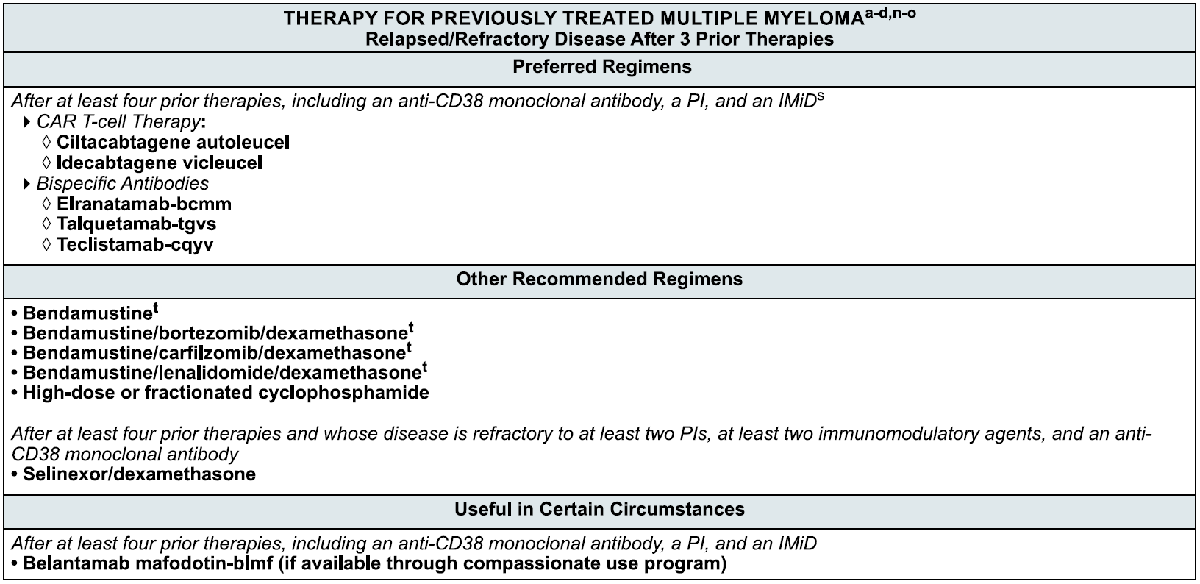
ª Selected, but not inclusive of all regimens. The regimens under each preference category are listed by order NCCN Category of Evidence and Consensus alphabetically. ^{b} Supportive Care Treatment for Multiple Myeloma (MYEL-H). ^{c} General Considerations for Myeloma Therapy (MYEL-F). ^{d} Management of Renal Disease in Multiple Myeloma (MYEL-K-). ^{n} Regimens included under 1-3 prior therapies can also be used later in the disease course. Attempt should be made to use drugs/drug classes the patients have not been exposed to or exposed to >1 line prior. ° Autologous HCT should be considered in patients who are eligible and have not previously received HCT or had a prolonged response to initial HCT. ^{S} Patients can receive more than one B-cell maturation antigen (BCMA) targeted therapy, but optimal sequencing is unclear. ^{t} Agents such as bendamustine can impact the ability to collect T cells for CAR T-cell therapy.
Of the late line options for triple class refractory patients in the above list only CARVYTKI (ciltacabtagene autoleucel) has full registration in Australia. CARVYTKI was registered in June 2023 for adult patients with relapsed or refractory multiple myeloma, who have received at least three prior lines of therapy, including a proteasome inhibitor, an immunomodulatory agent and an anti-CD38 antibody. Idecabtagene is not registered in Australia. Teclistamab has provisional registration in Australia. XPOVIO, mentioned in the “Other Recommended Regimens” sections of the Table 1, is registration in combination with other medicines in earlier and late line multiple myeloma.

Clinical rationale
Talquetamab is a humanised immunoglobulin G-4 (IgG4) bispecific antibody designed to target CD3 (cluster of differentiation 3) receptors on T cells and GPRC5D (G protein-coupled receptor family C group 5 member D)-expressing multiple myeloma cells. GPRC5D is a transmembrane protein encoded by the GPRC5D gene on chromosome 12p. It primarily expressed in plasma cells and hard keratinized tissues but has low expression in normal tissue. It has enriched expression in malignant plasma cells. It is not part of the B cell maturation antigen (BCMA) and represents a different target for immunotherapy. The binding and proposed mechanism of action of talquetamab is summarised in Figure 1.
Figure 1. Talquetamab Mechanism of Action
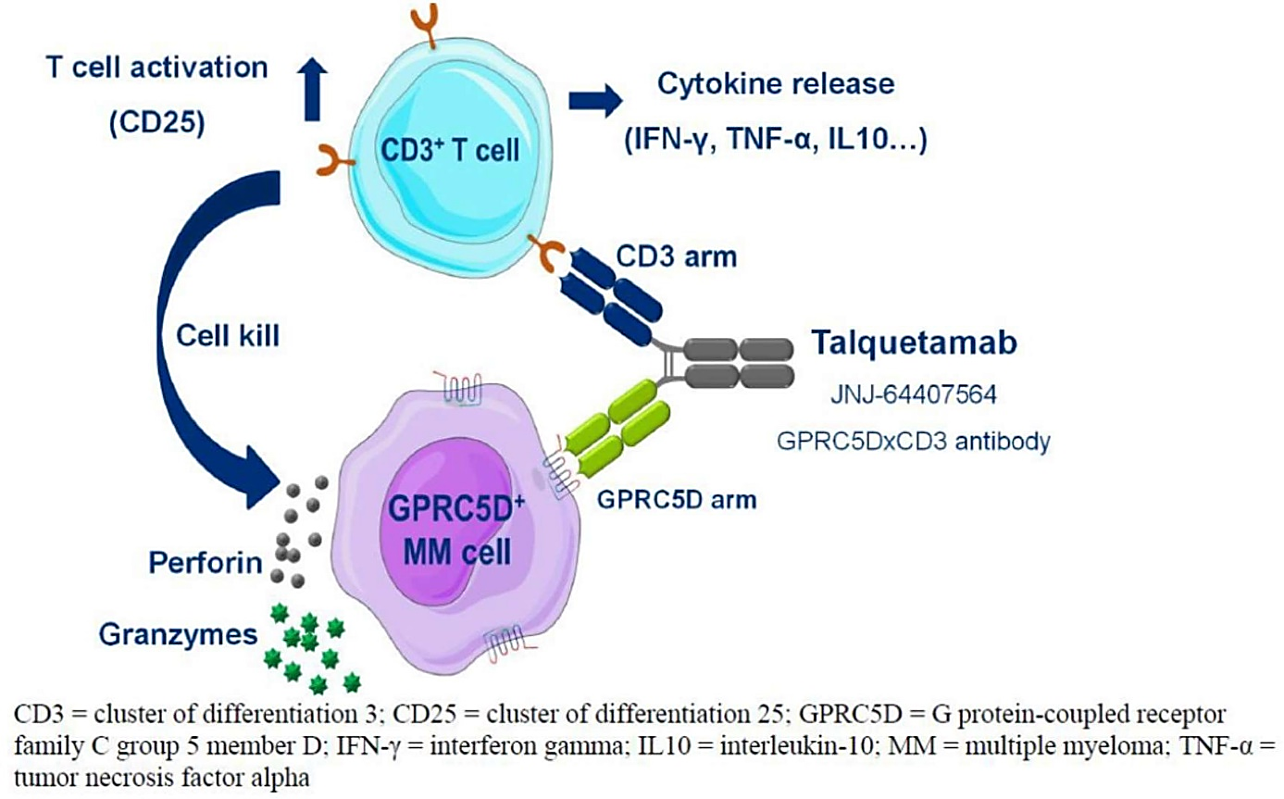
CD3 = cluster of differentiation 3: CD25 = cluster of differentiation 25: GPRC5D = G protein-coupled receptor family C group 5 member D: IFN-y = interferon gamma: IL10 = interleukin-10: MM = multiple myeloma: TNF-α = tumour necrosis factor alpha.

Regulatory status

Australian regulatory status
This product is a new biological entity for Australian regulatory purposes.

International regulatory status
This evaluation was facilitated through Project Orbis, an initiative of the United States Food and Drug Administration (FDA) Oncology Center of Excellence. Under this project, the FDA and the TGA collaboratively reviewed the submission. This evaluation process provided a framework for process alignment and management of evaluation issues in real-time across jurisdictions. Each regulator made independent decisions regarding approval (market authorisation) of the new medicine.
Talquetamab is approved internationally.
In the USA, talquetamab was granted conditional approval on 9 August 2023. The approved indication is TALVEY is a bispecific GPRC5D-directed CD3 T-cell engager indicated for the treatment of adult patients with relapsed or refractory multiple myeloma who have received at least four prior lines of therapy, including a proteasome inhibitor, an immunomodulatory agent and an anti-CD38 monoclonal antibody.
This indication is approved under accelerated approval based on response rate and durability of response. Continued approval for this indication may be contingent upon verification and description of clinical benefit in a confirmatory trial(s).
In the US, the talquetamab prescribing information includes a boxed warning about cytokine release syndrome and neurological effects including immune effector cell-associated neurotoxicity syndrome (ICANS). Prescriber and dispenser access is restricted through a risk evaluation and mitigation strategy.
In Europe, talquetamab has condition marketing authorisation on 21 August 2023. The approved indication is TALVEY is indicated as monotherapy for the treatment of adult patients with relapsed and refractory multiple myeloma. Who have received at least 3 prior therapies, including an immunomodulatory agent, a proteasome inhibitor, and an anti-CD38 antibody and have demonstrated disease progression on the last therapy.
In the UK, TALVEY was approved using a reliance on the EMA approval for the same indication.
In Canada a notice of compliance with conditions was issued on 30 April 2024. The approved indication is TALVEY, indicated for the treatment of adult patients with relapsed or refractory multiple myeloma who have received at least three lines of therapy, including a proteasome inhibitor, an immunomodulatory agent and an anti-CD38 monoclonal antibody, and who have shown progression to the last line of therapy, has been issued market authorization with conditions, pending the results of trials to verify its clinical benefit.
In Switzerland, talquetamab was granted temporary registration on 30 October 2023. The approved indication is TALVEY is indicated as monotherapy for the treatment of adult patients with relapsed or refractory multiple myeloma who have received at least three lines of therapy, including a proteasome inhibitor, an immunomodulatory agent and an anti-CD38 monoclonal antibody, and who have shown progression to the last line of therapy.

Registration timeline
Table 2 captures the key steps and dates for this submission.
This submission was evaluated under the provisional registration process.
Table 2: Registration timeline for TALVEY (talquetamab), submission PM-2023-02222-1-6
Description | Date
Submission dossier accepted and evaluation commenced | 30 June 2023
Evaluation completed | 29 February 2024
Registration decision (approved) | 24 September 2024
Registration in the ARTG completed | 26 September 2024
Number of working days from submission dossier acceptance to registration decision* | 170 days
*The provisional registration process has a target timeframe of 220 working days.

Assessment overview

Quality evaluation summary
Talquetamab is a humanised bispecific antibody of the immunoglobulin subclass 4 (IgG4) variant that selectively binds CD3 and GPRC5D. The molecular weight is approximately 147,200 Daltons comprising two heavy chain molecules and two light chains joined by disulphide bonds (Figure 2).
Figure 2. Disulfide bonds in talquetamab
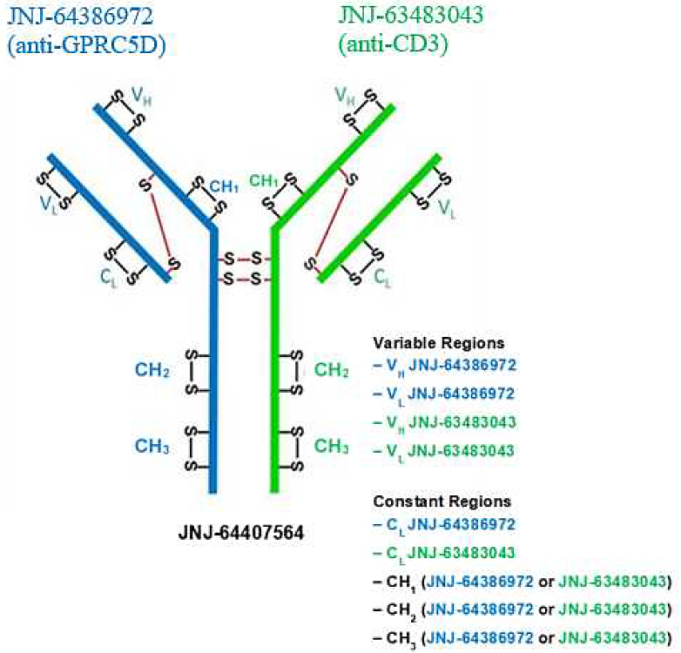
The active ingredient is produced using recombinant DNA technology in Chinese hamster ovary cells.
The overall quality of the active substance was demonstrated via adequate control of the starting material, control of critical steps and intermediates, process validation, extensive characterisation using orthogonal and state-of-the-art analytical methods, control of impurities and contaminants, generation of robust reference materials and batch analyses that covered multiple manufacturing campaigns.
Based on the stability data provided by the Sponsor, the drug substance has a recommended shelf life of 24 months when stored at -70 (±10) to -40 (±10) °C.
Talquetamab finished product, TALVEY, is a solution for subcutaneous injection presented at the concentrations of 2 mg/mL or 40 mg/mL. The product is available in a vial (Type I glass) with a halobutyl rubber stopper, and an aluminium seal fitted with a flip-off plastic cap. One vial of 1.5 mL (2 mg/mL presentation) contains 3 mg of talquetamab, and one vial of 1 mL (40 mg/mL presentation) contains 40 mg of talquetamab. Both presentations also contain sucrose, disodium edetate, polysorbate 20 in a preservative-free acetate-buffered solution pH 5.2. Excipients in the formulation for the drug product are well established and the quality is compliant with pharmacopeial (Ph. Eur/BP/USP/JP) standards.
All analytical methods used for testing of the finished product are satisfactorily described in the dossier and non-compendial methods have been validated. The reference standard used in the testing and release of talquetamab finished product is the same as the one used for the testing and release of the active substance.
The finished product quality control for batch release includes identity, potency, purity, impurities, sterility (Ph. Eur.), bacterial endotoxin (Ph. Eur.) and several other general tests.
Stability data have been generated under stressed and real time conditions to characterise the stability profile of the product. The recommended storage condition is 24 months when stored at 5 ± 3oC and protected from light. The product is not photostable.
In-use stability data have also been generated. The recommended shelf life and storage conditions for the prepared syringe are up to 24 hours refrigerated at 2°C to 8°C followed by up to 24 hours at ambient temperature of 15°C to 30°C.
Stability excursion studies have been submitted and requested. The permitted temperature excursions are 10 days at -20°C – 1°C and 10 days at 9°C to 30°C.
There were no objections to registration from a quality perspective.

Nonclinical evaluation summary
The nonclinical evaluator had no objections to the registration of talquetamab provided safety is satisfactorily addressed in clinical studies.
The key findings of the nonclinical evaluation are:
- Talquetamab demonstrated antitumour activity in vitro against various human GPRC5D- expressing MM cell lines and bone marrow (mononuclear cell) samples from MM patients and in vivo GPRC5D-expressing human MM tumour-bearing humanised mice.
- GPRC5D was shown to be expressed in plasma cells, and keratinised tissues such as skin, tongue, including epithelial cells in hair follicles, cells of eccrine sweat glands of the skin, and filiform papillae of tongue. In published studies high to moderate levels of GPRC5D mRNA has been detected in pancreas and testis by RT-PCR.
- Talquetamab did not bind to B cells, NK cells, monocytes or neutrophils.
- Due to the poor to absent binding of talquetamab to primate GPRC5D, a surrogate GPRC5D x CD3 bi-specific DuoBody antibody, described in the submission as a tool molecule, was developed for studies in cynomolgus monkey studies. It had similar binding affinity and in vitro functional activity against cynomolgus GPRC5D as talquetamab has against human GPRC5D.
- Talquetamab does not bind to the CD3 of most laboratory animals. The safety assessment was limited to the tool molecule safety studies making the nonclinical aspects unsatisfactory for the prediction of safety in humans.
- Genotoxicity and carcinogenicity studies were not conducted for talquetamab, in line with ICH guidelines.
- No reproductive and developmental toxicity studies were conducted for talquetamab, but given the potential for secondary effects on the developing fetus associated with the pharmacological effect in the mother, the evaluator recommended Pregnancy Category C

Clinical evaluation summary
The pharmacology, clinical efficacy and safety provided to support the provisional registration of talquetamab is derived from study 64407564MMY1001 (herein, MMY1001, also called MonumenTAL-1) that enrolled participants with relapsed or refractory multiple myeloma RRMM).
This ongoing phase 1/2 study commenced on 3 January 2018 was conducted in Europe, the Republic of Korea and the United States at 47 centres.
Figure 3. Study Schematic Study MMY1001
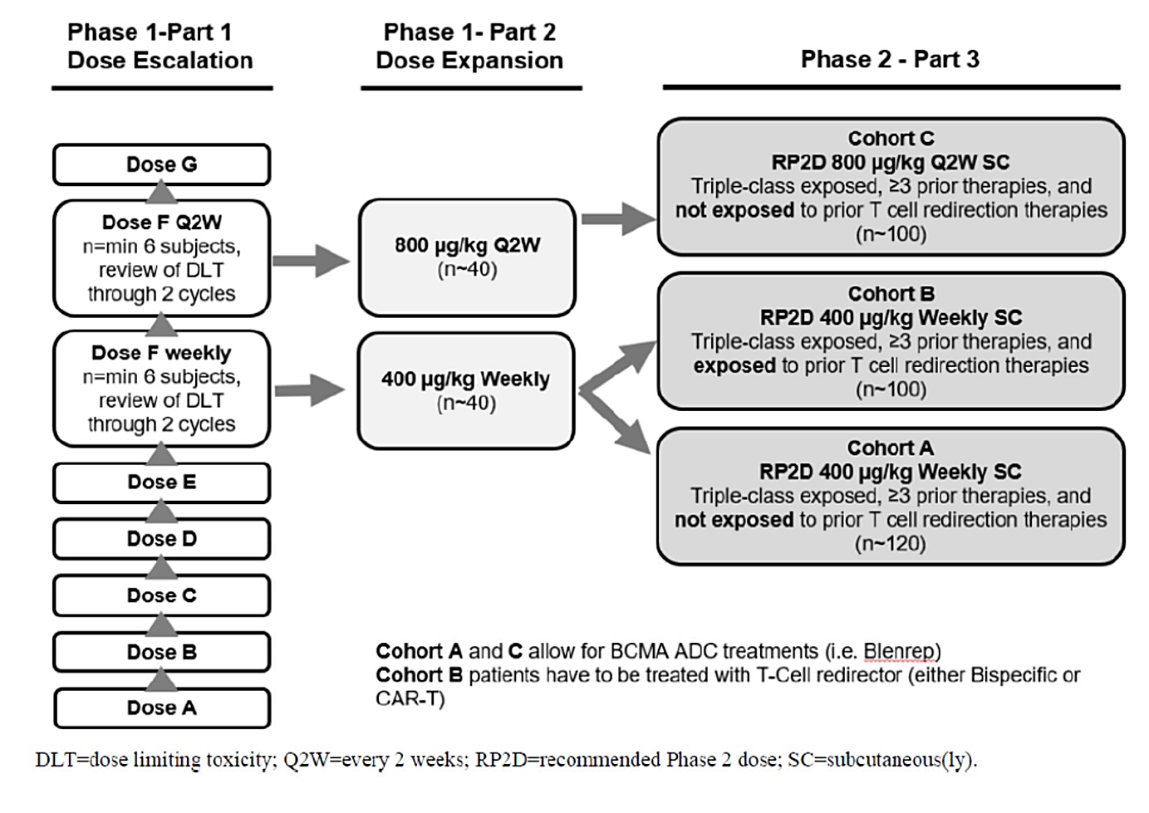

Phase 1
The Phase 1 portion of the study enrolled 102 patients assigned intravenous (IV) dosing and 134 patients assigned subcutaneous (SC) dosing.

Part 1
Part 1 was a dose escalation study of talquetamab IV. Doses administered commenced at 0.0005 mg/kg Q2W, with subsequent dosing ranging from 0.0001mg/kg to 0.00338 mg/kg Q2W and 0.015 mg/kg to 0.18 mg/kg QW. Most doses were preceded by step-up dosing.
Dose escalation for SC dosing commenced at 0.005 mg/kg QW with subsequent dosing ranging from 0.015 to 0.8 mg/kg QW, 0.8 to 1.2 mg/kg Q2W, or 1.6 mg/kg Q4W. All SC doses were preceded by step-up dosing.

Part 2
Part 2 was the dose expansion part of the study. Part 1 identified a recommended phase 2 dose (RP2D) of 0.4 mg/kg QW (preceded by two step-up doses of 0.01 mg/kg and 0.16 mg/kg SC) given on days 1, 8 and 15 of a 21-day cycle. For the Q2W regimen the RP2D dose was 0.8 mg/kg (preceded by step-up doses of 0.01 mg/kg and 0.16 mg/kg) On Days 1 and 15 of a 28-day cycle.

Phase 2
The Phase 2 portion of the study enrolled 265 participants: 122 in Cohort A, 34 in Cohort B and 109 in Cohort C.

Part 3
Subcutaneous dosing occurred in three cohorts.
Cohort A enrolled patients who were triple class exposed, had received at least three prior therapies and who had previously received no prior T cell redirection therapies. The step-up schedule was 0.01 and 0.06 mg/kg. The treatment dose of 0.4 mg/kg was scheduled at Days 1, 8, 15 and 22 of a 28-day cycle.
Cohort B enrolled patients who were triple class exposed, had received at least three prior therapies and who had previously received prior T cell redirection therapies. The step-up schedule was 0.01 and 0.06 mg/kg. The treatment dose of 0.4 mg/kg was scheduled at Days 1, 8, 15 and 22 of a 28-day cycle.
Cohort C enrolled patients who were triple class exposed, had received at least three prior therapies and who had previously received no prior T cell redirection therapies. The step-up schedule was talquetamab at 0.01, 0.06 and 0.3 mg/kg. The treatment dose of 0.8 mg/kg was scheduled Days 1 and 15 of a 28-day cycle.

Inclusion and exclusion criteria
The study inclusion and exclusion criteria are summarised in Table 2.
Table 2. Study MMY1001 inclusion and exclusion criteria
Inclusion criteria | Exclusion criteria
18 years of age  Laboratory values:  - Haemoglobin ≥8 g/dL without RBC transfusion ≤ 7 days  - Platelets ≥50×10⁹ /L (no transfusion support ≤ 7 days before laboratory test)  - Absolute Neutrophil Count (ANC)  - ≥1.0×10⁹ /L (no growth factor support ≤ 7  - days)  - AST or ALT ≤3.0×ULN  - Creatinine clearance: ≥40 mL/min/1.73 m²  - Total bilirubin ≤2.0×ULN; unless congenital bilirubinemia  Corrected serum calcium ≤3.5 mmol/L or free ionised calcium <1.6 mmol/L  Women of childbearing potential must have a negative pregnancy test at screening and prior to first dose  Women of childbearing potential must have a sole partner who is vasectomised or practicing at least 1 highly effective user independent method until 100 days after last dose  Men must wear a condom and female partners of childbearing potential must also practice a highly effective method of contraception  Part 1 MM  Documented MM diagnosis per IMWG diagnostic criteria.  ECOG 0 or 1  Part 2 or 3 MM  Documented MM diagnosis per IMWG diagnostic criteria and:  Serum monoclonal paraprotein (M- protein) levels ≥1.0 g/dL or urine M- protein level ≥200mg/24 hours  Light chain MM without measurable disease in the serum or the urine: serum immunoglobulin FLC ≥10 mg/dL and abnormal serum immunoglobulin kappa lambda FLC ratio  ECOG 0 or 1 (Part 2)  ECOG 0, 1 or 2 (Part 3) | Prior grade ≥3 cytokine release syndrome (CRS) related to any T cell redirection therapy or prior GPRC5D targeting therapy.  Prior antitumour therapy before the first dose of study drug with:  Targeted therapy, epigenetic therapy, or treatment with investigational drug or used invasive investigational medical device within 21 days or ≥ 5 half-lives, whichever is less.  - Monoclonal antibody treatment for MM within 21 days.  - Cytotoxic therapy within 21 days.  - Proteasome inhibitor therapy within 14 days.  - Immunomodulatory agent therapy within 7 days.  - Gene modified adoptive cell therapy (e.g., CAR-T cells, natural killer [NK] cells) within 3 months  - Radiotherapy within 14 days or focal radiation within 7 days, unless palliative.  Toxicities from previous anticancer therapies not resolved to baseline levels or to ≤Grade 1 except alopecia or peripheral neuropathy.  Cumulative corticosteroid dose equivalent to ≥140 mg of prednisone ≤ 14-days before the first dose of study drug  Stem cell transplantation:  - Allogeneic stem cell transplant within 6 months. Recipients must be off all immunosuppressive medications for 6 weeks with no signs of GvHD disease.  - Autologous stem cell transplant ≤12 weeks before the first dose of study drug.  CNS involvement or clinical signs of meningeal involvement of MM  Plasma cell leukaemia, Waldenström’s macroglobulinemia, POEMS syndrome (polyneuropathy, organomegaly, endocrinopathy, monoclonal protein, and skin changes), or primary amyloid light-chain amyloidosis.  HIV or AIDS.  Hepatitis B infection defined per guidelines or Hepatitis C infection determined by HCV RNA testing.  Pulmonary disease requiring supplemental oxygen.  Known allergies, hypersensitivity, or intolerance to the study drug (talquetamab) or its excipients.  Additional criteria for exclusion for Part 3  - Stroke or seizure within 6 months  - New York Heart Association stage III or IV congestive heart failure  - History of significant ventricular arrhythmia or syncope not thought to be vasovagal  - History of severe non-ischaemia cardiomyopathy  - Active malignancies other than multiple myeloma requiring treatment of progressing in the previous 24 months (some exceptions)

Baseline characteristics
Baseline characteristics were presented in different ways in the submission – by phase of study, by treatment received and by lines of previous therapy. The following is a summary by phase and cohort.
In Phase 1 of the study, overall, the median age was 64.0 years (range 33, 84), most participants were White (81.5%), approximately half (51.3%) had an ECOG of 1. The median time from MM diagnosis to first dose of talquetamab was 6.4 years (range: 0.8, 27 years). At least one extramedullary plasmacytoma was reported in 24.6%. Of the 206 participants with baseline cytogenic data, 14.8% had one high risk abnormality. Of the 229 participants with baseline staging reported, 45.0% were Stage I, 32.8% were Stage II, 22.3% were Stage III. The median number of prior therapies was 6 (range 2, 20), with most triple class exposed (99.2%0 and 85.6% having received at least 4 prior therapies.
Phase 2 Cohort A comprised 122 participants with a median age of 67.0 years (range 47, 86). Most were male (53.3%) and White (91.8%). The baseline ECOGs were 0 (27.9%), 1 (61.5%), and 2 (10.7%). The median time from MM diagnosis to first dose of talquetamab was 7.08 years (range 1.4, 20.8 years). At least one extramedullary plasmacytoma was reported in 19.7%. High risk cytogenetics (at least one of del (17p), t(4;14), t(14:16)) were present in 35.4%. Baseline International Staging System for Multiple Myeloma (ISS) staging was 41.8% Stage I, 38.5% Stage II, and 19.7% Stage III. Of the 117 participants with data, the median GPRC5D expression was 98.5 (range: 74.7, 100.0). The median number of prior therapies was 5 (range: 3, 13) and 81.8% had received at least 4 prior therapies. All participants were triple class exposed and 73.4% were penta-class exposed (at least two proteasome inhibitors, two immunomodulators, and al least 1 anti-CD38 monoclonal antibody).
Phase 2 Cohort B comprised 34 participants with a median age of 60.0 years (range 38, 78). Most were male (60.8%) and White (92.2%). Most had an ECOG of 1 (54.0%) and 2.0% had an ECOG of 2. The median time from MM diagnosis to first dose of talquetamab was 7.03 years (range 2.1, 15.5). At least one extramedullary plasmacytoma was reported in 29.4%. High risk cytogenetics (at least one of del (17p), t(4;14), t(14:16)) were present 46.7%. Baseline ISS staging was 47.1% Stage I, 35.3% Stage II, and 17.6% Stage III. Of the 29 participants with data, the median GPRC5D expression was 85.00 (range 55.9, 95.5), with a mean (SD)(%) ranging from 2.48 (4.26) to 3.75 (10.3), with the highest mean % expression in the Cohort with prior T- cell directed therapy. The median number of prior therapies was 6.0 (range 3, 15 years) and 94.1% had received at least 4 prior therapies. All participants were triple class exposed, and 76.5% were penta-exposed. T-cell redirection therapy included prior CAR T-cell therapy (82.4%), and prior bispecific antibody treatment (23.5%).
Phase 2 Cohort C comprised 109 participants with a median age of 67.0 years (range 38, 82). Most were male (61.5%), and White (87.2%). The baseline ECOGs were 0 (33.9%), 1 (58.7%), and 2 (7.3%). The median time from MM diagnosis to first dose of talquetamab was 6.45 years (range: 1.1, 25.4 years). At least one extramedullary plasmacytoma was reported in 25.7%. High risk cytogenetics (at least one of del (17p), t(4;14), t(14:16)) were present in 33.0%. Baseline ISS staging was 43.1% Stage I, 31.2% Stage II, and 25.7% Stage III. Of the 94 participants with data, the median GPRC5D expression was 98.15 (55.4, 100.0). The median number of prior therapies was 5 (range: 3, 12) and 77.9% had received at least 4 prior therapies. All participants were triple class exposed and 69.7% were penta-class exposed.

Participant flow
Phase 1 – 236 participants (102 in the IV cohorts and 134 in the SC cohorts) received at least one dose of talquetamab. At the clinical cut-off (16 May 2022) 21.6% remained on treatment and 78.4% had discontinued. Most discontinued due to progressive disease, although 4.25% discontinued due to AE and 1.7% due to death.
Phase 2 Cohort A - 122 participants received at least one dose of talquetamab. In the analysis dated 20 July 2022, 64.8% remained on treatment, 49.2% had progressive disease, and 6.6% discontinued treatment due to an adverse event.
Phase 2 Cohort B – 34 participants received at least one dose of talquetamab. In the analysis dated 20 July 2022, 61.8% remained on treatment, 26.5% had progressive disease, and 5.9% discontinued treatment due to an adverse event.
Phase 2 Cohort C – 109 participants received at least one dose of talquetamab. In the analysis dated 20 July 2022, 71.6% remained on treatment, 16.5% had progressive disease, and 6.4% discontinued treatment due to an adverse event.
The submission also includes an efficacy update with analyses dated January 2024.

Pharmacology
Participants from all parts of the study contributed pharmacology data. The pharmacology results are based on analyses from 6 May 2022 data.

Pharmacokinetics
Noncompartmental analyses for talquetamab pharmacokinetics (PK) were calculated for IV and SC doses. The results of direct relevance to the requested dosing were for the 0.4 mg/kg QW and 0.8 mg/kg Q2W SC dosing regimens.
The PK parameters following the first treatment dose (with step-up doses) of 0.4 mg/kg SC QW are summarised in Table 3.
Table 3. Talquetamab pharmacokinetic parameters 0.4 mg/kg once weekly dosing
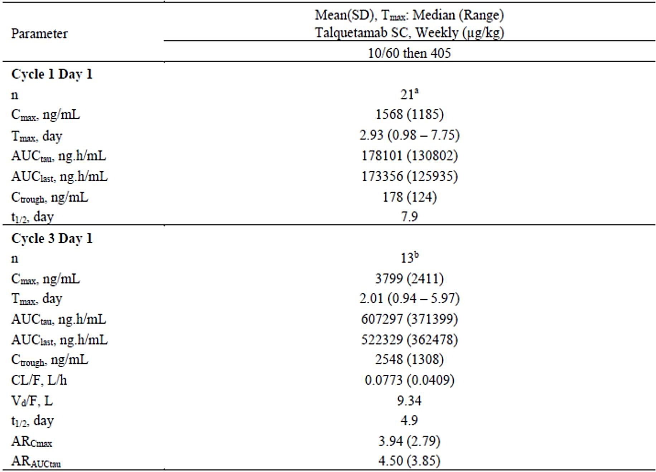
The PK parameters following the first treatment dose (with step-up doses) of 0.8 mg/kg Q2W SC in cycle 1 and 3 are summarised in Table 4.
Table 4. Talquetamab pharmacokinetic parameters 0.8 mg/kg second weekly dosing
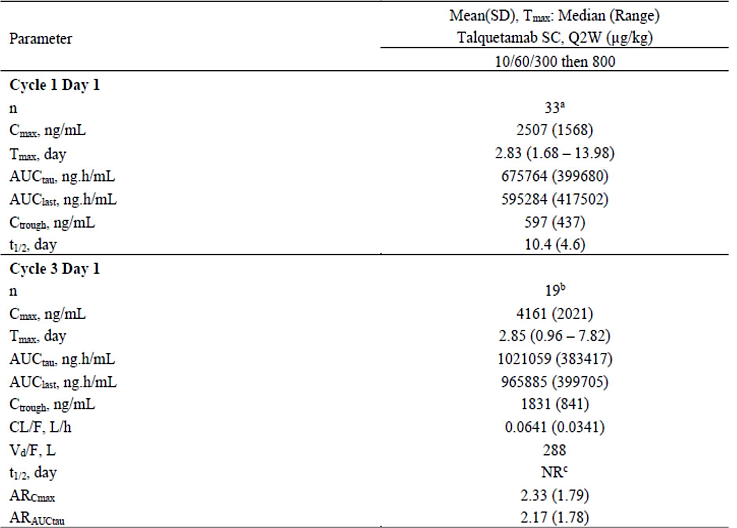

Population pharmacokinetic data
The population pharmacokinetics (PopPK) modelling utilised serum concentration data from 5354 measured concentrations from 492 RR MM participants who had received at least 1 dose of talquetamab, from all three parts of Study MMY1001 from the 22 April 2022 data cut off. It included data from 100 participants who received IV dosing and 392 participants who received SC dosing.
A 2-compartment model with sequential zero and first-order absorption and 2 parallel linear clearances (one time-dependent and one time-independent) adequately described the observed PK data. The Sponsor provides a detailed account of the model parameterisation and the covariates considered.
After covariate selection, the covariate effects retained in the final model were the effect of body weight BW on CL0 and V1 and myeloma subtype (IgG versus non-IgG) and ISS stage (II and III versus I) on CL0. Other covariates tested were not statistically significant.
Table 5. Parameter estimates for base and final talquetamab population pharmacokinetics model
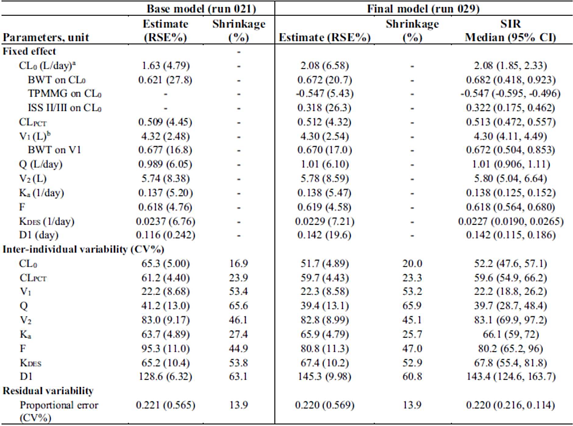
Simulations suggested the following:
- Absorption: After 0.4 mg/kg talquetamab administration, Tmax is reached at 2 days. Mean Cmax is 3799 ng/mL and mean AUC is 607.3 μg.h/mL. After 0.8 mg/kg talquetamab administration, Tmax is reached at 2.8 days. Mean Cmax is 4161 ng/mL and mean AUC is 1021 μg.h/mL. SC bioavailability at Cycle 3 Day 1 was approximately 74% using the observed data, and 62% based on popPK estimates.
- Distribution: Using the observed data from the Vd from the 0.4 mg/kg dose was 9.34 L and for the 0.8mg/kg was 13.1 L. Using the PopPK analysis, typical V1 was 4.3 L. V1 increased with body weight with an allometric exponent of 0.67. Typical V2 was estimated to be 5.78L.
- Elimination: Elimination of talquetamab was described by parallel linear clearance processes. One clearance process is time-dependent and attributed to endogenous catabolic processes common to immunoglobulin degradation. The other clearance process reflects target mediated drug disposition, that changes with changes in disease state (target burden) and patient disease state.
- The typical total clearance was 2.08 L/day at treatment initiation and 1.06 L/day at steady state for participants with IgG subtype of myeloma and ISS stage I, and KDES was 0.0229 d-1. The median terminal phase t1/2 based on the post-hoc parameters of all SC populations (n=392) was 7.56 days at treatment initiation, and 12.2 days at steady state.
- Dose proportionality and accumulation: Following talquetamab SC administration, exposure (C_{max} and AUC) increased in an approximately dose-proportional manner at Cycle 1 and Cycle 3 across the range of 0.005 mg/kg to 0.8 mg/kg QW and 0.8 mg/kg to 1.2 mg/kg Q2W.
- Following SC administration, for weekly dosing schedule in Cycle 3, the mean accumulation ratio of C_{max} was 3.9 and 4.5 for AUCτ. For Q2W dosing schedule at Cycle 3, the mean accumulation ratio of C_{max} was 2.33 and 2.17 for AUCτ. Steady state seems to be achieved at week 16.

Special populations
In the popPK model there was no clinically meaningful impact of the covariates of weight, gender and race or ethnicity, region, formulation, hepatic or renal impairment on the PK of talquetamab. There were no paediatric patient data in the submission, in keeping with the natural history of MM.
In the PopPK analysis, age (median 65 years, range: 33, 86 years) mild or moderate renal impairment and mild or moderate hepatic impairment did not significantly impact PK parameters. The effects of severe hepatic or renal impairment on talquetamab PK are unknown.

CYP interactions: physiologically-based pharmacokinetic modelling
While talquetamab is not expected to be metabolised by CYP enzymes, the initial doses of treatment may result in increased IL-6 and other cytokines. A physiologically-based pharmacokinetic modelling (PBPK) model was developed to explore the influence of IL-6 on CYP substrates. The modelling and simulation predicted the highest risk of drug-drug interactions occurs in two settings: within 1-7 days of the first step-up dose, and during cytokine release syndrome events. However, the evaluation noted this is based on nonclinical data. The Sponsor recommends clinical monitoring of CYP substrates with a narrow therapeutic index in those clinical settings. It is noted the US label includes a recommendation to monitor for 14 days.

Exposure response relationships
The dose response relationships for efficacy were almost flat for both dosing regimens. The exposure response for safety is less clear. While there was no apparent exposure response relationship for adverse events overall, there are insufficient data to draw definitive conclusions for the relationships between individual adverse events and exposure.

Pharmacodynamics
T-cell activation was induced by IV and SC doses in the Phase 1 study. T-cell redistribution (reduction in peripheral CD4+ and CD8+ T cells) was observed in 0.4 mg/kg QW and 0.8 mg/kg Q2W after initial talquetamab doses. No significant changes in CD19+ B cells were observed in the first cycle, but increases were noted from cycle 3 in the 0.4 mg/kg QW and cycle 2 in the 0.8 mg/kg Q2W.
Increased serum concentrations of IL-6, IL-10, and IL-2R were detected after the first three treatment doses at 0.4 mg/kg QW, and the first two treatment doses at 0.8 mg/kg Q2W. Increased soluble BCMA is a surrogate marker of tumour burden. The evaluation found a greater reduction of soluble BCMA among responders compared with participants who did not respond.

Immunogenicity
Anti-drug antibody results were available from 260 participants who received 0.4 mg/kg QW and 0.8 mg/kg Q2W. Of those, 64 (24.6%) developed anti-talquetamab antibodies.
There was no apparent clinically significant impact of anti-drug antibody development on PK, safety, or efficacy.

Efficacy
While the main study report was based on a data cut off of 6 May 2022, the submission includes an efficacy update dated 12 September 2022. The relevant population to the requested indication is limited to the group of patients who had received at least 4 prior therapies. In response to questions dated 5 June 2024, the Sponsor provided analyses dated 30 May 2024 for patients who had received ≥4 lines of therapy and who were triple class exposed.
The analysis included data from 117 patients who received 400 mcg/kg QW: 17 who received the R2P2 dose in the Phase 1 component of the study and 100 from Phase 2 Cohort A.
Data were provided from the 113 patients who received 800 mcg/kg Q2W dosing, including 87 from Phase 2 Cohort C.
Data from patients who had received prior T-cell redirection therapy were provided from 8 Phase 1 patients and 32 Phase 2 Cohort B patients who received 400 mcg/kg QW dosing and 7 Phase 1 patients who received 800 mcg/kg Q2W dosing.
The primary efficacy endpoint was overall response rate (ORR) by the Independent Review Committee. The most robust data are from the Phase 2 Cohorts.

400 mcg/kg QW Phase 2 Cohort A and triple class exposed
The median duration of follow-up in Phase 2 Cohort A was 18.7 months (range 0.46, 21.39 months).
ORR: 73.0% (95% CI: 63.2%, 81.4%)
- Stringent complete response (sCR) 26.0% (95% CI: 17.7%, 35.7%)
- Complete response (CR) 9.0% (95% CI: 4.2%, 16.4%)
- Very good partial response (VGPR) 22.0% (95% CI: 14.3%, 31.4%) Median duration of response: 9.5 months (95% CI: 6.6, N.E).
Minimal residual disease (MRD) negativity rate was presented for 10-5 and 10-6 thresholds, using the total patient numbers as a denominator, however MRD negativity was only assessed in patients with a CR or better.
Using CR or better (n=73) as the denominator MRD negativity rate (10-5) was 47.9%, and MRD negativity rate (10-6) was 35.6%.

800 mcg/kg Q2W Phase 2 Cohort C and triple class exposed
The median duration of follow up in Phase 2 Cohort C was 11.96 months (range 0.16, 15.01 months)
- ORR: 71.3% (95% CI: 60.6%, 80.5%)
- Stringent complete response (sCR) 29.9% (95% CI: 20.5%, 40.6%)
- Complete response (CR) 8.0% (95% CI: 3.3%, 15.9%)
- Very good partial response (VGPR) 23.0% (95% CI: 14.6%, 33.2%) Median duration of response was not estimable.
MRD negativity rate was presented for 10-5 and 10-6 thresholds, using the total patient numbers as a denominator, however MRD negativity was only assessed in patients with a CR or better.
Using CR or better (n=16) as the denominator MRD negativity rate (10-5) was 56.3%, and MRD negativity rate (10-6) was 37.5%.

Efficacy after T cell redirection therapy
The median duration of follow up in Phase 2 Cohort B was 14.0 months (range 0.99, 23.29 months)
ORR: 75.0% (95% CI: 56.6%, 88.5%)
- stringent complete response (sCR) 40.6% (95% CI: 23.7%, 59.4%)
- complete response (CR) 9.4% (95% CI: 2.0%, 25.0%)
- very good partial response (VGPR) 12.5% (95% CI: 3.5%, 29.0%) median duration of response was not estimable.
MRD Negativity Rate was presented for 10-5 and 10-6 thresholds, using the total patient numbers as a denominator, however MRD negativity was only assessed in patients with a CR or better. Using CR or better (n=33) as the denominator MRD Negativity Rate (10-5) was 81.8%, and MRD Negativity Rate (10-6) was 54.5%.

Safety
All patients had reported at least on treatment emergent adverse event.
The Sponsor provided an updated safety assessment from a clinical cut-off date of 17 January 2023, adding around 8 months of safety data compared with the initial submission. As this is the most recent safety information, emphasis is placed on safety from this later data cut.
In this analysis 339 participants had received either of the proposed doses of 0.4 mg/kg QW or 0.8 mg/kg Q2W SC. Participants were treated for a median of 7.43 months, with a median relative dose intensity of 90.2%. The duration of follow-up depended on the phase of entry into the study. Overall, the median duration of follow up was 18.86 months for the 0.4 mg/kg QW dosing and 12.88 months for the 0.8 mg/kg Q2W dosing. The median duration of follow up for any patient who had prior T-cell redirection therapy was 15.28 months.
The summary included an analysis of events defined by the Sponsor as Adverse Drug Reactions, defined as treatment-emergent adverse events (TEAEs) with a cutoff of ≥10% (Table 6) or ≥2% serious adverse events (SAE), clinically and medically significant events or laboratory abnormalities worsening from baseline in ≥30%).
Safety was generally similar between the two dosing regimens. There were no clear patterns showing safety preferability of one regimen over the other.
Table 6. Study MMY001 Treatment Emergent Adverse Reactions (per Sponsor definition)
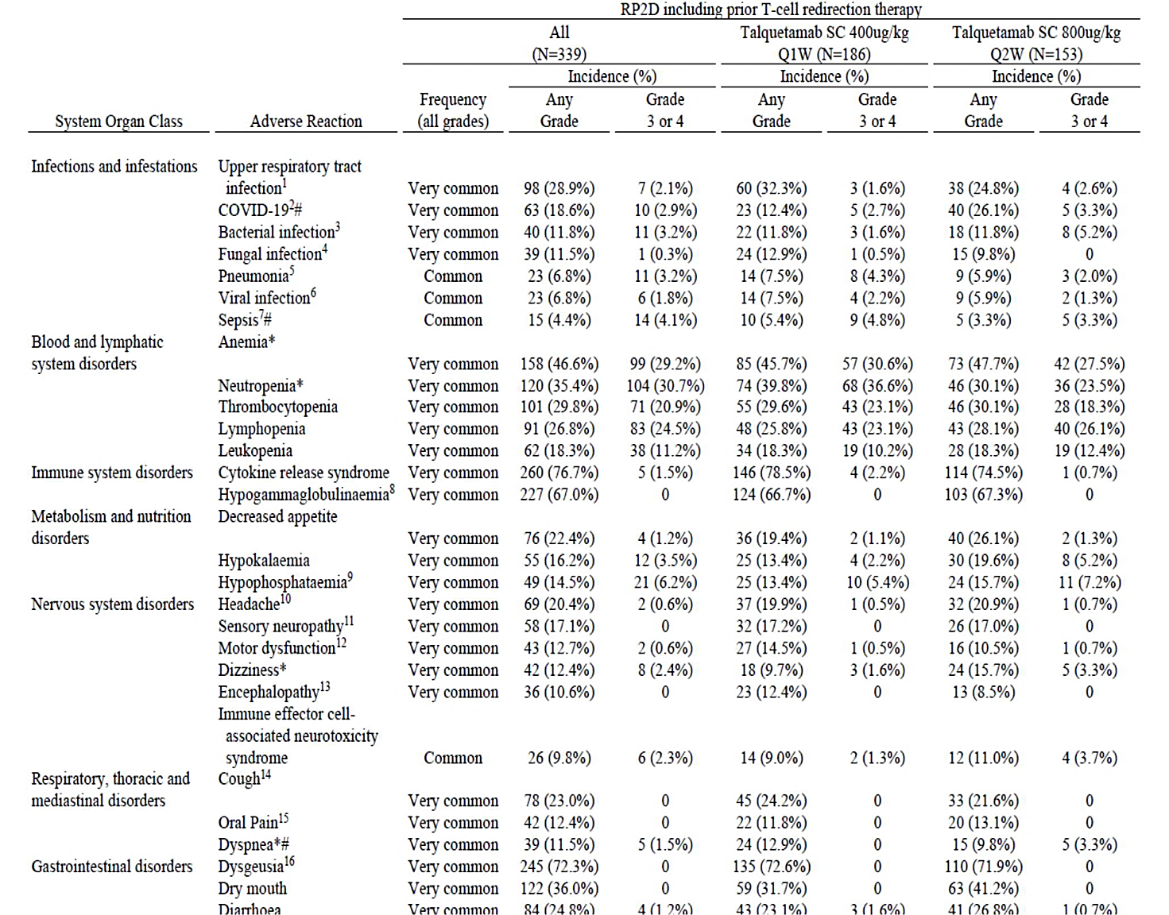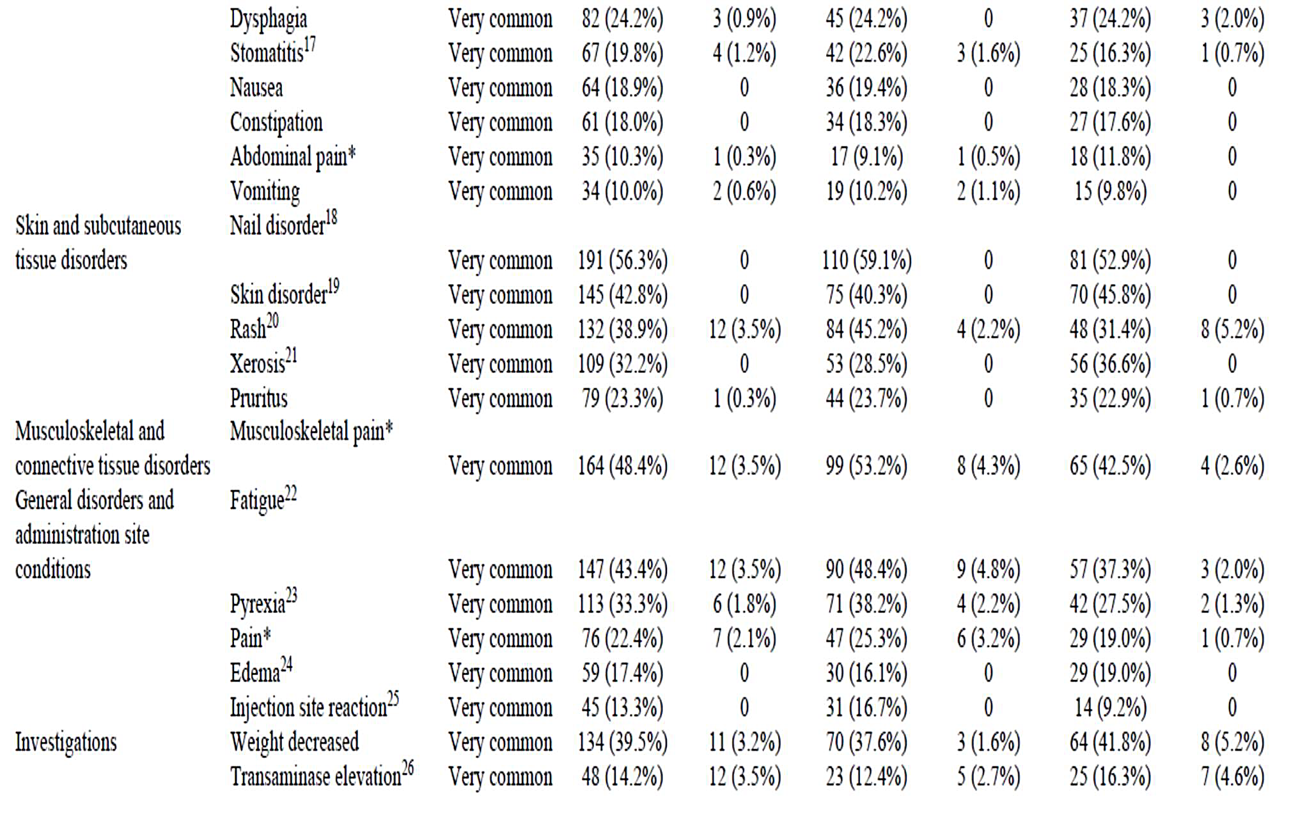
Key: RP2D = recommended phase 2 dose, CRS = cytokine release syndrome, ICANS = immune effector cell-associated neurotoxicity syndrome, * Based on grouped term. # Contains fatal outcome(s).
Note: RP2D includes Phase 1 RP2D cohorts and Phase 2 cohorts A, B and C.
Note: Adverse events are reported until 100 days (Phase 1) or 30 days (Phase 2) after the last dose of talquetamab or until the start of subsequent anticancer therapy, if earlier.
Note: Adverse events are graded according to the NCI-CTCAE Version 4.03, with the exception of ICANS and CRS. CRS was originally graded by Lee criteria in Phase 1 and by ASTCT consensus grading system in Phase 2, with conversion of grade in Phase 1 to ASTCT based on data in eCRF. Toxicity grade for CRS by ASTCT is presented in this table, for both Phase 1 and Phase 2. Toxicity grade for ICANS by ASTCT is also presented in this table.
Note: Subjects are counted only once for any given event, regardless of the number of times they actually experienced the event. Adverse events are coded using MedDRA Version 25.0. Note: The output includes the diagnosis of CRS and ICANS; the symptoms of CRS or ICANS are excluded. Note: ICANs were only collected for phase 2. Denominators are based on number of subjects in Phase 2: 156 in the 400 ug/kg weekly group and 109 in the 800 ug/kg Bi-weekly group.
¹Upper respiratory tract infection includes: Bronchiolitis, Bronchitis, Nasopharyngitis, Pharyngitis, Respiratory tract infection, Respiratory tract infection bacterial, Rhinitis, Rhinovirus infection, Sinusitis, Tonsillitis, Upper respiratory tract infection and Viral upper respiratory tract infection.
²COVID-19 includes: Asymptomatic COVID-19, COVID-19, COVID-19 pneumonia, Coronavirus infection and Multisystem inflammatory syndrome.
³Bacterial infection includes: Campylobacter infection, Carbuncle, Cellulitis, Citrobacter infection, Clostridium difficile colitis, Clostridium difficile infection, Cystitis escherichia, Cystitis klebsiella, Diverticulitis, Escherichia pyelonephritis, Folliculitis, Gastroenteritis Escherichia coli, Helicobacter gastritis, Human ehrlichiosis, Impetigo, Klebsiella sepsis, Moraxella infection, Otitis media acute, Pitted keratolysis, Pseudomonal bacteraemia, Pyuria, Relapsing fever, Renal abscess, Skin infection, Staphylococcal infection, Tooth abscess, Tooth infection, Urinary tract infection enterococcal and Urinary tract infection pseudomonal.
⁴Fungal infection includes: Body tinea, Candida infection, Ear infection fungal, Fungal foot infection, Fungal infection, Fungal skin infection, Genital candidiasis, Oesophageal candidiasis, Onychomycosis, Oral candidiasis, Oral fungal infection, Oropharyngeal candidiasis, Tinea pedis, Vulvovaginal candidiasis and Vulvovaginal mycotic infection.
⁵Pneumonia includes: Pneumonia and Pneumonia streptococcal.
⁶Viral infection includes: Conjunctivitis viral, Disseminated varicella zoster virus infection, Gastroenteritis viral, HCoV-HKU1 infection, Herpes ophthalmic, Influenza, Metapneumovirus infection, Norovirus infection, Parainfluenzae virus infection, Respiratory syncytial virus bronchiolitis, Respiratory syncytial virus infection, Retinitis viral and Viral infection.
⁷Sepsis includes: Bacteraemia, Enterobacter bacteraemia, Escherichia sepsis, Fungal sepsis, Pneumococcal sepsis, Salmonella sepsis, Sepsis, Septic shock. Staphylococcal bacteraemia, Staphylococcal sepsis and Streptococcal bacteraemia.
⁸Hypogammaglobulinaemia includes: Hypogammaglobulinaemia and/or subjects with laboratory IgG levels below 500mg/dL following treatment with talquetamab. ⁹Hypophosphataemia includes: Blood phosphorus decreased and Hypophosphataemia. 10Headache includes: Headache, Migraine, Procedural headache and Tension headache. ¹¹Sensory neuropathy includes: Dysaesthesia, Hyperaesthesia, Hypoaesthesia, Hypoaesthesia oral, Immune-mediated neuropathy, Neuralgia, Neuropathy peripheral, Paraesthesia, Peripheral sensory neuropathy, Polyneuropathy, Sciatica and Vestibular neuronitis.
¹²Motor dysfunction includes: Dysarthria, Dysgraphia, Dysmetria, Dysphonia, Gait disturbance, Muscle atrophy, Muscle spasms, Muscular weakness and Tremor.
¹³Encephalopathy includes: Agitation, Amnesia, Aphasia, Bradyphrenia, Confusional state, Delirium, Disorientation, Disturbance in attention, Encephalopathy, Hallucination, Lethargy, Memory impairment, Restlessness, Sleep disorder and Somnolence.
¹⁴Cough includes: Cough, Productive cough and Upper-airway cough syndrome.
¹⁵0ral Pain includes: Oropharyngeal pain
¹⁶Dysgeusia includes: Ageusia, Dysgeusia, Hypogeusia and Taste disorder.
¹⁷Stomatitis includes: Cheilitis, Glossitis, Glossodynia, Mouth ulceration, Oral discomfort, Oral mucosal erythema, Oral pain, Stomatitis, Swollen tongue, Tongue discomfort, Tongue erythema, Tongue oedema and Tongue ulceration.
¹⁸Nail disorder includes: Koilonychia, Nail bed disorder, Nail cuticle fissure, Nail discolouration, Nail disorder, Nail dystrophy, Nail hypertrophy, Nail pitting, Nail ridging, Nail toxicity, Onychoclasis, Onycholysis and Onychomadesis.
¹⁹Skin disorder includes: Pahnar-plantar erythrodysaesthesia syndrome, Palmoplantar keratoderma, Skin discolouration, Skin exfoliation and Skin fissures.
²⁰Rash includes: Dermatitis, Dermatitis acneiform, Dermatitis contact, Dermatitis exfoliative, Dermatitis exfoliative generalised. Erythema, Exfoliative rash, Rash, Rash erythematous. Rash macular, Rash maculo-papular, Rash papular, Rash pruritic, Rash pustular, Rash vesicular and Stasis dermatitis.
²¹Xerosis includes: Dry eye, Dry skin and Xerosis.
²²Fatigue includes: Asthenia, Fatigue, Malaise and Muscle fatigue.
²³Pyrexia includes: Pyrexia and Tumour associated fever.
²⁴Edema includes: Face oedema, Fluid retention, Gingival swelling, Hypervolaemia, Joint swelling, Lip swelling, Oedema, Oedema peripheral, Periorbital oedema, Peripheral swelling and Swelling.
²⁵Injection site reaction includes: Injection site discomfort Injection site erythema, Injection site haemorrhage, Injection site inflammation, Injection site incitation, Injection site plaque, Injection site pruritus, Injection site rash and Injection site reaction.
²⁶Transaminase elevation includes: Alanine aminotransferase increased and Aspartate aminotransferase increased. V common >1/10 common 1/100 to <1/10 • uncommon 1/1.000 to <1/100 -, rare 1/10000 to <1/1,000 v- rare <1/10000.

Serious adverse events
Serious adverse events were reported for 49.0% of participants. The most frequently reported events (≥22%) were CRS (9.8%), pyrexia (5.2%), COVID-19 (4.6%), ICANS (3.7%), bacterial infection (3.3%), and sepsis and viral infection (2.6% each).
Events resulting in treatment discontinuation that occurred in more than one patient were ICANS (1.1%), weight decreased (0.9%), dysgeusia, rash and skin disorder (0.6% each).

Deaths
The most safety update did not include a reanalysis of deaths in the study. At the data lock point of May 2022, 30 participants from the 0.4 mg/kg QW group and 18 participants from the 0.8 mg/kg Q2W group were included in the analysis of deaths. Of those, 16 deaths occurred within 30 days of the last dose of talquetamab, 15 within 60 days. Of those, most were due to disease progression, the evaluation analysis of these events found 3.5% were attributable, at least in part to events other than disease progression. Infection, COVID-19 pneumonia, fungal sepsis, and septic shock were among fatal adverse events that may have had a contribution from talquetamab in their event.

Cytokine release syndrome
Cytokine release syndrome was reported for 76.7% of all patients, regardless of dosing group or prior T-cell redirection therapy. Overall, 58.7% were Grade 1 events, 16.5% were grade 2 events and 1.5% were Grade 3 events with no grade 4 or 5 events. While 31.0% had multiple CRS events, 4.4% had a worsening grade with subsequent events. It led to the discontinuation of 0.3% of the patients.
Tocilizumab was used in 38.6% of patients with 4.7% having received multiple doses at any time during the study and 1.8% having received multiple doses for a single CRS event.
Corticosteroids were used in 5.3%. Events were most frequent in the first cycle of treatment, but 3.5% of patients experienced an event in later cycles. Of the events occurring during step-up dosing, most occurred at dose 2.
Events occurred at a median of 26.6 hours after the last talquetamab dose and lasted for a median of 17 hours. Most (99.8%) were reported as having been recovered.

Immune Effector Cell Associated Neurotoxicity Syndrome
Neurological toxicities including ICANS were reported in 29% (17% Grade 1, 10% Grade 2, 2.4% Grade 3 and 0.3% Grade 4). Two thirds of the events occurred concurrently with CRS. The most common event was headache. ICANS was reported for 9.8% (3.4% Grade 1, 4.2% Grade 22, 1.9% Grade 3 and 0.4% Grade 4). Overall, it led to the discontinuation of 1.1% of patients, and 10.8% of events were reported as not resolved or not recovered.

Oral toxicity
Oral toxicities included dysgeusia, ageusia, hypogeusia and taste disorder. These occurred in 79.6%. Most (in 77.6% of patients) were Grade 1 or 2, and 2.1% experienced Grade 3 events. While these events were common, 0.7% of patients discontinued treatment, and 12.6% had a dose modification (delay, skip or reduced) as a result. Events lasted a median of 71 days.
Around 62% of patients had weight loss ≥5% at any time, around 29% had a ≥ 10%. It is unclear whether there was an on-target effect of talquetamab or a consequence of the oral toxicity.

Rash, skin and nail disorders
Skin disorders, including palmar-plantar erythrodysaesthesia syndrome, palmoplantar keratoderma, skin discolouration, exfoliation and fissures were reported in 42.8% participants, but no events were of grade 3 or 4 severity.
Nail disorders, including koilonychia, onycholysis, onychomadesis, and onychoclasis were also very common, and were reported by 56.3% of participants in the study but no events were of grade 3 or 4 severity.
Overall, 34.8% patients experienced rash, and 3.5% were Grade 3 events. While no patient discontinued because of rash, 16.5% received topical steroids and 4.7% received oral steroids. Around half of the patients had events occurred in the first cycle of treatment and lasted a median of 25 days.

Haematological toxicity
Haematological adverse events were very common. Grade 3 or 4 events were reported for 29.2% for anaemia, 30.7% for neutropenia, 20.9% for thrombocytopenia, 24.5% for lymphopenia, and 11.2% for leukopenia.

Infections
Across the safety set infection occurred in 64.0%, with 18.6% experiencing a Grade 3 or 4 event and 1.5% experiencing a Grade 5 event. The most common events were COVID-19 (16.2%), URTI (11.8%), nasopharyngitis and urinary tract infection (7.7% each), and pneumonia (6.8%). Sepsis was reported in 0.9% (including Grade 3 or 4 events, and one event of septic shock).

Recommencement of treatment after dose delay
The safety update included an analysis of events after recommencement of talquetamab to support a window of 35 days for restarting treatment without requiring repeat step-up doses if the dose delay occurred after a dose of at least 0.4 mg/kg. A delay of at least 28 days was reported for 57 participants from both dosing groups, with a total of 86 events and 17 participants experiencing more than one event. CRS events, all Grade 1, occurred in 10.5%, and all but one patient continued treatment.
Of the 36 participants from both dosing groups experienced 47 drug delay events of between 29 and 35 days. Of those, 36/39 drug delay events recommenced treatment without step up dosing and did not experience CRS or ICANS. For the remaining 3 cases, Grade 1 ICANs or CRS events were reported.
Of the 33 participants from both dosing groups experienced 39 drug delay events of > 35 days. Of those, 31/39 drug delay events recommenced treatment with steps up dosing. Three of these participants experience Grade 1 CRS and/or Grade 1 ICANs events. The remaining 8 drug delay events were not followed by step-up dosing without CRS or ICANS adverse events on recommencement of treatment.

Other (e.g. companion diagnostic considerations, drug delivery device)
Patient reported outcomes were included in this submission. The results are considered exploratory because of the study design, small sample size, particularly in some subgroups and the heterogeneous nature of the study.
This submission did not rely on clinical data derived from sources other than clinical trials.

Risk management plan evaluation summary
Safety concerns and their associated risk monitoring and mitigation strategies are summarised in Table 7.
The RMP evaluator considered EU-RMP versions 1.2 (dated 11 May 2023; DLP 17 January 2023) and 2.1 (dated 16 January 2024; DLP 17 January 2023), together with ASA versions 1.0 (dated 15 May 2023) and 2.0 (dated 17 January 2024).
The TGA may request an updated RMP at any stage of a product's life-cycle, during both the pre-approval and post-approval phases.
Table 7: Summary of safety concerns
Summary of safety concerns |  | Pharmacovigilance |  | Risk minimisation
 |  | Routine | Additional | Routine | Additional
Important identified risks | Cytokine release syndrome | P | P* | P | P†
Important identified risks | Neurologic toxicity including ICANS | P | P* | P | P†
Important identified risks | Serious infections | P | P* | P | -
Important potential risks | None | - | - | - | -
Missing information | Long-term safety | P | P* | - | -
Missing information | Safety in patients with prior CAR-T cell therapy | P | P* | - | -
*Study 64407564MMY1001 † Patient Card ‡ Boxed Warning
The risk minimisation activities include a patient card that aims to inform patients and HCPs of CRS and potential neurological toxicities including ICANS associated with talquetamab, to highlight symptoms requiring immediate medical action.
The TGA may request an updated RMP at any stage of a product's life-cycle, during both the pre-approval and post-approval phases. Further information regarding the TGA’s risk management approach can be found in risk management plans for medicines and biologicals and the TGA's risk management approach. Information on the Australia-specific annex (ASA) can be found on the TGA website.

Risk-benefit analysis
This application seeks provisional registration for talquetamab, a novel bispecific T cell enhancer for late line relapsed or refractory multiple myeloma. The main point of difference between this medicine and other bispecific antibodies provisionally approved in this setting is the myeloma cell target. GPR5D has not previously been a target for bispecific treatments for RRMM.

Key issues for the submission

Efficacy considerations
The Sponsor has presented preliminary clinical evidence to support the activity of talquetamab in MM. Study MMY1001 is a Phase 1/2 study a Phase 1 /2 study conducted in three Parts: Part 1 dose finding, Part 2 dose escalation, and Part 3 (Phase 2) PK safety and efficacy of the two proposed dosing regimens proposed for provisional registration.
The clinical evidence most relied on in reaching a view regarding the establishment of efficacy and safety is that derived from the Phase 2 component of the study. The Phase 2 component of the study comprised three patient Cohorts: Cohort A who were triple-class exposed, had received at least 3 prior therapies but no prior T cell redirection therapies dosed at 0.4 mg/kg QW; Cohort B who were triple-class exposed, had received at least 3 prior therapies and prior T cell redirection therapies dosed at 0.4 mg/kg QW; Cohort C who were triple-class exposed, had received at least 3 prior therapies but no prior T cell redirection therapies dosed at 0.8 mg/kg Q2W.
Single arm study data is consistent with the type of clinical evidence considered sufficient to support provisional registration of a medicine in RRMM. The proposed indication is in a late line setting, in which there is currently no clearly defined single standard of care regimen.
The Delegate gave specific consideration to two specific aspects of the efficacy data.

Is there sufficient preliminary clinical evidence that targeting GPR5D produces a clinical efficacy benefit?
The main efficacy evidence is derived from Phase 2 Cohorts A (0.4 mg/kg QW) and C (0.8 mg/kg Q2W). After a median duration of follow-up of 18.7 months (range 0.46, 21.39 months), the ORR was 73.0% (95% CI: 63.2%, 81.4%), the sCR and CR were 26.0% and 9% and the median duration of response was 9.5 months. For the 0.8 mg/kg Q2W dosing, the median follow-up was 11.96 months (range 0.16, 15.01 months), and the ORR was 71.3% (95% CI: 60.6%, 80.5%), the sCR and CR were 29.9% and 8.0%, respectively, and the duration of response was not yet estimable. MRD negativity was supportive for both dosing cohorts.
In this highly treated population these results are clinically meaningful and supportive of clinical efficacy benefit. The results were replicated in the two dosing cohorts comprising 187 patients from the phase 2 component of the study. The results from the phase 1 cohorts are considered supportive but not the main evidence for these conclusions.
The duration of clinical benefit is not yet determined as the study is still ongoing. Other uncertainties relating to efficacy include the impact of GPRC5D targeted treatment on subsequent treatments, where targeting GPRC5D is optimally placed in the MM treatment algorithm, and if used in combination with other targeting agents, what the optimal combinations will be. These types of uncertainty are commonplace in the setting of provisional registration.

Is there preliminary clinical evidence benefit in patients who have already received prior T-cell redirection therapy?
There is no evidence in the submission to suggest a lack of benefit following prior T-cell direction therapy. The Phase 2 Cohort B and 15 phase 1 patients from both proposed dosing cohorts contribute evidence to address this clinical question, but sample size is small, limiting the conclusions that can be drawn. The ORR results were consistent with the main Cohorts, and the sCR and CR rates are promising.
It should be noted time to event endpoints are not included with the main evidence of efficacy. Time to event endpoints are difficult to interpret in a single arm study, due to failure to account for known and unknown confounders. 25

Safety considerations
The safety data were derived from all participants in study MMY1001 who had received one of the two doses proposed for provisional registration. The majority, but not all patients experienced an adverse event in the study.
The key safety issues for this submission were CRS, and ICANs. The Sponsor has proposed a boxed warning for CRS and for neurological toxicity including ICANS. The warning references Section 4.2 for instructions for the management of patients with either of these conditions, in consultation with the patient’s physician. The Delegate considers this is an appropriate. The Advisory Committee on Medicines (ACM) at the April 2024 meeting advised all bispecific T-cell engagers should carry a boxed warning for both types of events.
Most of the patients experienced a CRS event, and around 30% experienced multiple events. While the events were mostly Grade 1 or 2, patients received inpatient care during the initial dosing, so their events during early dosing would have been detected earlier and managed potentially decreasing the severity of the individual events.
The Sponsor proposes patients should remain within proximity of a healthcare facility for 48 hours. The type of care available at the healthcare facility and access to definitive CRS or ICANS treatment including supportive care is not specified. The clinical trial patients were monitored as inpatients. The Sponsor has not defined the term proximity, in terms of distance or time to travel so the term is ambiguous. The type of service available at the healthcare facility is also not defined and could vary depending on the setting. For example, not all healthcare facilities will be able to offer in-patient care or have access to tocilizumab. The US label recommends hospitalisation for all patients, and the Canadian Product Monograph has hospitalisation as an option. The submission does not include safety data comprehensively collected from patient treatment in a community setting. The Delegate considers in-hospital monitoring is preferred as this is a new target for RR MM treatment. This position may be revised following clinical experience with use of the medicine in the Australian community, outside the clinical trial setting.
Oral toxicities and weight loss, infections, cytopenias, skin toxicity, hepatotoxicity and embryo- foetal toxicity are also important toxicities. The Sponsor proposes to include statements in the Section 4.4 Special Warnings and Precautions section of the PI highlighting these safety issues.

Long term safety
Study MMY1001 is ongoing. Pharmacovigilance data including safety data for CRS, neurological toxicity including ICANS, serious infections, long term safety and safety in patients with prior CAR T-cell therapy will continue to be collected. The Phase 3 study (see clinical development plan, below) is expected to contribute additional safety data in earlier line treatment.
Overall, the Delegate considers there is sufficient data to establish the safety of the medicine for the proposed use provided the points raised about the setting of initial step-up dosing is satisfactorily addressed.

Indication
The Sponsor was granted a provisional determination for an indication that includes four prior therapies. The indication sought for provisional registration cannot be broader than the provisional determination, indication granted. Alignment with the indication granted in the EMA, Canada, the UK, and Switzerland is not an option within the current submission.
The Delegate finds the evidence is sufficient to support the requested indication of TALVEY as monotherapy has provisional approval in Australian and is indicated for the treatment of adult patients with relapsed or refractory multiple myeloma, who have previously received at least four prior therapies, including a proteasome inhibitor, an immunomodulatory agent, and an anti-CD38 antibody.
The decision to approve this indication has been made on the basis of the overall response rate in a single arm study. Continued approval of this indication depends on verification and description of benefit in confirmatory trials.

Dosing
Direct patient evidence has been presented to support both 400 mcg/kg QW and 800 mcg/kg Q2W dosing. The Delegate accepts there is sufficient evidence to support both dosing regimens.
The proposed TALVEY dosing instructions that guide step up dosing after a dose delay are supported by the most recent safety analysis. The Delegate notes these step-up doses instructions have already been adopted by the EMA and MHRA.

Clinical development plan
The Sponsor proposes that study 64407564MMY3002 will be the main study to provide confirmation of clinical benefit and to support transition from provisional to full registration.
This Phase 3 study proposes to randomise 810 patients with RRMM who have received at least 1 prior therapy including a proteasome inhibitor and lenalidomide to one of three arms: talquetamab + daratumumab + pomalidomide (Tal-DP), daratumumab + pomalidomide + dexamethasone (DPd) or talquetamab + daratumumab (Tal-D). The primary endpoint is PFS. Overall survival is one of the secondary endpoints, and the study will run until there are 526 OS events.
PFS is considered an acceptable primary endpoint for a confirmatory study in earlier line RRMM, because of the response-relapse nature of the condition with existing therapies.
The Sponsor expects the interim analysis 2 of study 64407564MMY3002 is likely to be available in the second half of 2026.
Additional follow up from study 64407564MMY1001 is also expected.
Completion of the study plan and the provision of clinical study reports for evaluation by the TGA are both proposed to be imposed as conditions of registration for this submission.
The study plan is likely to provide confirmatory data within six years of provisional registration. Overall, the study timeline for submission of the confirmatory clinical data is acceptable.

Assessment outcome
Based on a review of quality, safety, and efficacy, the TGA decided to register TALVEY (talquetamab) for the following indication:
TALVEY as monotherapy has provisional approval in Australia and is indicated for the treatment of adult patients with relapsed or refractory multiple myeloma, who have previously received at least four prior therapies, including a proteasome inhibitor, an immunomodulatory agent, and an anti-CD38 antibody. The decision to approve this indication has been made on the basis of the overall response rate in a single arm study. Continued approval of this indication depends on verification and description of benefit in confirmatory trials.

Specific conditions of registration

Black triangle scheme
TALVEY (talquetamab) is to be included in the Black Triangle Scheme. The PI and CMI for TALVEY must include the black triangle symbol and mandatory accompanying text for five years, which starts from the date that the Sponsor notifies the TGA of supply of the product.

Risk management plan
The TALVEY EU-Risk Management Plan (RMP) (version 2.1, dated 16 January 2024, data lock point 17 January 2023), with Australian Specific Annex (version 2.0, dated 17 January 2024), included with submission PM-2023-02222-1-6, and any subsequent revisions, as agreed with the TGA will be implemented in Australia.
An obligatory component of risk management plans is routine pharmacovigilance. Routine pharmacovigilance includes the submission of periodic safety update reports (PSURs).
Unless agreed separately between the supplier who is the recipient of the approval and the TGA, the first report must be submitted to TGA no later than 15 calendar months after the date of this approval letter. The subsequent reports must be submitted no less frequently than annually from the date of the first submitted report until the period covered by such reports is not less than three years from the date of this approval letter, or the entire period of provisional registration, whichever is longer.
The reports are to at least meet the requirements for PSURs as described in the European Medicines Agency’s Guideline on good pharmacovigilance practices (GVP) Module VII-periodic safety update report (Rev 1), Part VII.B Structures and processes. Note that submission of a PSUR does not constitute an application to vary the registration.
The Sponsor must conduct studies as described in the clinical study plan in version 2.0 (dated 17 January 2024) of the Australia-Specific Annex.
Submit the following study reports to the TGA for evaluation:
- Study 64407564MMY1001 (MonumenTAL-1)
- Study 64407564MMY3002 (MonumenTAL-3)

Laboratory testing & compliance with Certified Product Details
- All batches of TALVEY talquetamab supplied in Australia must comply with the product details and specifications approved during evaluation and detailed in the Certified Product Details (CPD).
- When requested by the TGA, the Sponsor should be prepared to provide product samples, specified reference materials and documentary evidence to enable the TGA to conduct laboratory testing on the Product. Outcomes of laboratory testing are published biannually in the TGA Database of Laboratory Testing Results http://www.tga.gov.au/ws-labs-index and periodically in testing reports on the TGA website.

Certified Product Details
- The Certified Product Details (CPD), as described in Guidance 7: Certified Product Details of the Australian Regulatory Guidelines for Prescription Medicines (ARGPM), in PDF format, for the above products should be provided upon registration of these therapeutic goods. In addition, an updated CPD should be provided when changes to finished product specifications and test methods are approved in a Category 3 application or notified through a self-assessable change.
- A template for preparation of CPD for biological prescription medicines can be obtained from the TGA website:
[for the form] https://www.tga.gov.au/form/certified-product-details-cpd-biological-prescription-medicines.
[for the CPD guidance] https://www.tga.gov.au/guidance-7-certified-product-details.

Product Information and Consumer Medicines Information
For the most recent Product Information (PI) and Consumer Medicines Information (CMI), please refer to the TGA PI/CMI search facility.
Therapeutic Goods Administration
PO Box 100 Woden ACT 2606 Australia
Email: info@tga.gov.au Phone: 1800 020 653 Fax: 02 6203 1605
https://www.tga.gov.au

A Sponsor is a person or company who does one or more of the following: a) exports therapeutic goods from Australia, b) imports therapeutic goods into Australia, c) manufactures therapeutic goods for supply in Australia or d) elsewhere arranges for another party to import, export or manufacture therapeutic goods
Palumbo A Anderson K Multiple Myeloma N Engl J Med 2011;264(11):1046-1060
Overview of Cancer in Australia 2023 Australian Institute of Health and Welfare (Cancer data in Australia, Overview of cancer in Australia, 2023 - Australian Institute of Health and Welfare (aihw.gov.au)) accessed 28 January 2024
Quach, H et al., Medical Scientific Advisory Group (MSAG) to Myeloma Australia. Myeloma Clinical Practice Guideline, 2022.
Cancer Data in Australia; AIHW-can-122-CDiA Book 1a – cancer incidence (age standardised rates and 5-year age groups) downloaded from Cancer data in Australia, Data - Australian Institute of Health and Welfare (aihw.gov.au)
Rajumkumar SV, Merlini G, San Miguel JF Haematological cancer: Redefining Myeloma Nat Rev Clin Oncol 2012;9:494-496
Landgren O, Kyle RA, Pfeiffer RM et al monoclonal Gammopathy of Undetermined Significance (MGUS) consistently precedes multiple myeloma: a prospective study Blood 2009;113:5412-5417
American Cancer Society: Survival Rates for Multiple Myeloma Survival Rates for Multiple Myeloma | American Cancer Society, accessed 28 January 2024.
MSAG, 2022
MSAG, 2022
MSAG, 2022
Kumar SK, Callander NS, Adekola K et al Multiple Myeloma, Version 2.2024, NCCN Clinical Practice Guidelines in Oncology J Nat Compr Canc Netw 2023;21(12):1281-1301
Lee H, Ahn S, Maity R, Leblay N, Ziccheddu B et al Mechanisms of antigen escape from BCMA- or GPRC5D-targeted immunotherapies in multiple myeloma Nature Medicine 2023; 29:2295-2306
Chari A, Minnema MC, Bereja JG Oriol A et al Talquetamab, a T-cell-Redirecting GPRC5D Bispecific Antibody for Multiple Myeloma NEngl J Med 2022;387:2232-2244
A "Delegate" refers to a person within the TGA who has been conferred the authority to make decisions about the approval of therapeutic goods for supply in Australia, under section 25 of the Therapeutic Goods Act.

